SOUTHWEST OHIO ROCKETRY ASSOCIATION (SORA)
September 20, 2020 LAUNCH REPORT 1 PM TO 4 PM
NAR SECTION #624
Launch Conditions: Blue Skies, wind 0-12MPH

Total Number of Launches: 23 Rockets Recovered: 23

Total Number of 100% Fully Successful Flights (excluding simple fin breaks on landing): 21

Number of Launch Participants: 4

Number of Family/Friends/Observers/Non-launching rocketeers: 6

Teams and Competitions: 1

Types and Number of Motors:
A: 6 B: 8 C: 2 D: 3 E: 2 F: 4 G: 0 H: 0 I: 0 Higher: 0
One 3-stage rocket (Comanche), C6-0 to B6-0 to A8-3

Ground Fires: 0 Medical Incidents: 0 Damage to vehicles/facilities: None

Donations: $10

Rocket Items and Issues:
- First time at Hisey: 3-stage rocket (Estes Comanche). C6-0 to B6-0 to A8-3, flight OK but arched over during transition of C to B engine. First stage should be D engine. Rocket did lose one fin that was never found. May also have been the cause of the arc and lower than expected altitude.
- Streamer duration using “B” engine was won by Rick Forrester on a homemade scratch rocket designed using RockSim. 22.37 seconds aloft. Alas, there was only one contestant Sunday.
- Shock cord on Rick’s Bull Pup broke on ejection. Rocket OK on landing. Cord was rubber and old.
- Tim Morley’s many-times-successful Pershing unfortunately impacted ground after attaining too low altitude. F27-4. Will rebuild. Get that 3-D printer going!
- Rocket Recovery Award goes to Jon for finding and recovering two expensive rockets way downrange.
- First time use of a rail launch system Dicks’s Specktor rocket. Great flight!

Contest for next launch (October 25):
Glider Duration
Dick Tohline’s Acme Spitfire. Remember “Wile E Coyote and the Roadrunner”, and all the wacky ideas coyote had. Dick’s rocket flew just great!  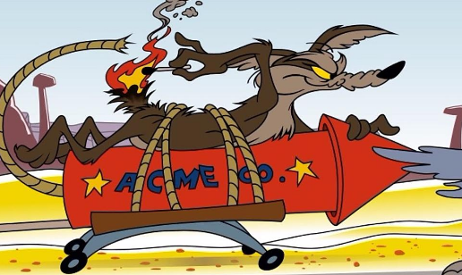 | 