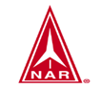

SOUTHWEST OHIO ROCKETRY ASSOCIATION (SORA)
LAUNCH REPORT SEPTEMBER 26, 2021
1:00PM TO 5:30PM NAR SECTION #624

Launch Conditions: Clear skies, winds up to 5.6 mph, high of 75 degrees

Total Number of Launches: 27 Rockets Recovered: 26

Total Number of 100% Fully Successful Flights (excluding simple fin breaks on landing): 19

Number of Individuals Who Launched Their Rockets: 9 Number of Family/Friends/Observers: 5

Teams and Competitions: 0

Types and Number of Motors:
A: 3 B: 8 C: 11 D: 3 E: 1 F: 1 G: 0 H: 0 I: 0 Higher: 0

Ground Fires: 0 Medical Incidents: 0 Damage to vehicles/facilities: None

Donations and drink/food sale, sale of merchandise:
$20 for sale of logo t-shirt
$13 for donations and sale of drinks
Total: $ 33 Net: $ 18

Rocket Topics and Issues:
- Welcome to SORA as new member: Bill Gabbard. Bill launched several novel rockets with great success at the launch.
- Thanks go to Rick for being safety officer for this month’s launch.
- Proper chute deployment again was the cause of most of the rocket problems this month. Chutes not deploying and chutes tangling in the shock cord lead the list.
- An E9-6 was used in a Phoenix rocket. Even with a longer launch rod, the rocket thrust was substandard causing the rocket to arc and the delay charge lasted much longer than listed. The rocket impacted hard on descent on the baseball diamond and was a complete loss. Engine was a couple of years old but had been stored properly. Estes has had problems with “E” engines in the past but has now remedied the manufacturing issues.
- Tim’s Pershing was damaged (but repairable) also due to poor engine performance. D12-5
- There were lots of great launches such as Jeremy’s Saturn V on a F15-4 and Jon’s StarSeeker on a 1/2A-4T. Keep up the good work!
- Remember to get those Arienne V James Webb telescope rockets ready for launch next time!

Next Zoom (or in-person?) business meeting: October 19, 2021 7PM
Next SORA launch: Hisey Park, October 24, 2021 1-5PM

Parting words……“Sapientia ducet ad astra” – Knowledge leads to the stars
May the winds be light, may the skies be blue, and may all your rockets fly straight and true.

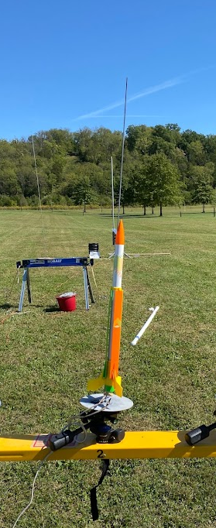 | 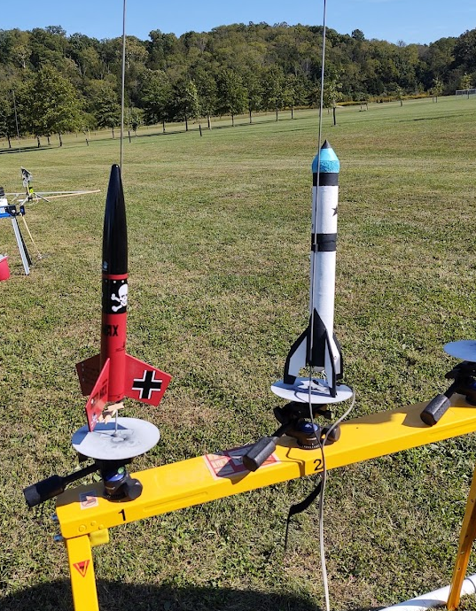
Helicopter rockets are fun!  Tim Morley’s FlipFlyer | Clay Barclay’s Der Red Maxx and Bill Gabbards #10
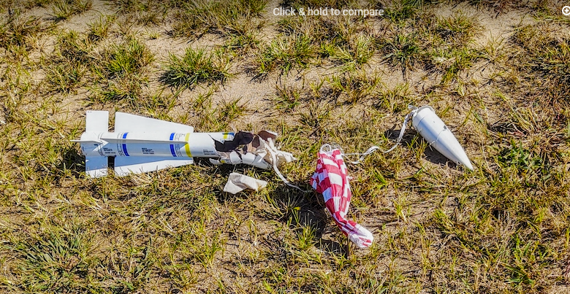 | 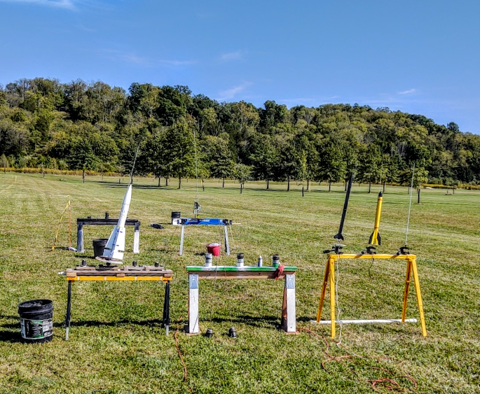
Rick’s Phoenix after E9-6 motor fail and impact | Ready to go!
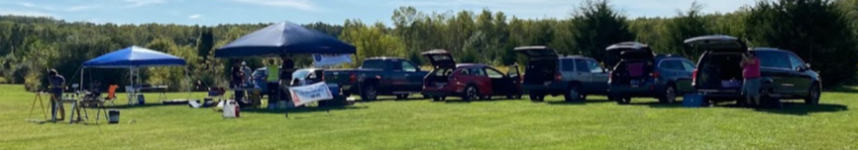
Beautiful day to enjoy the sport.
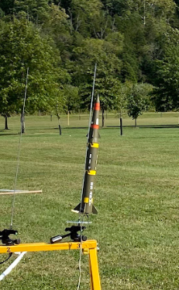 | 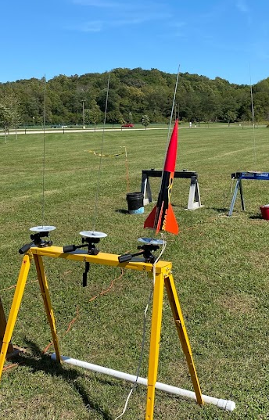
Tim Morely’s Pershing 2 | Jeremy Wheeler’s nicely done Roar on a D12-3
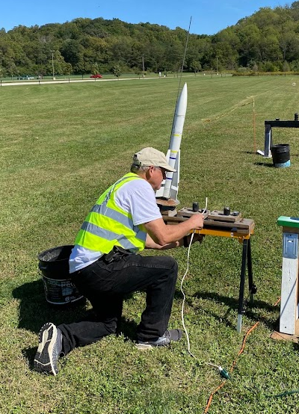 | 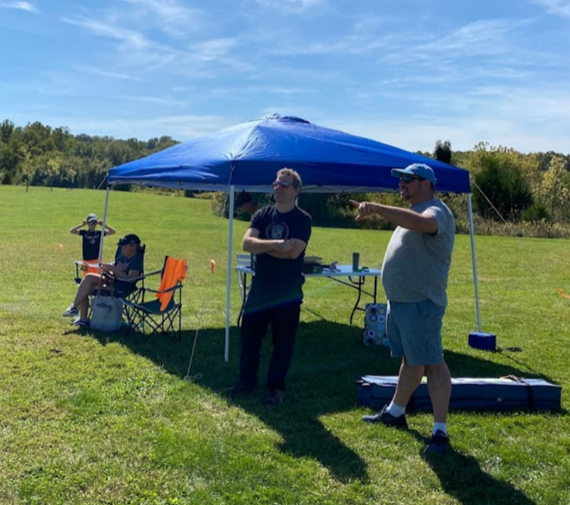
“Now, do I cut the red wire, or the blue wire?” | Discussing the finer points of rocket science.
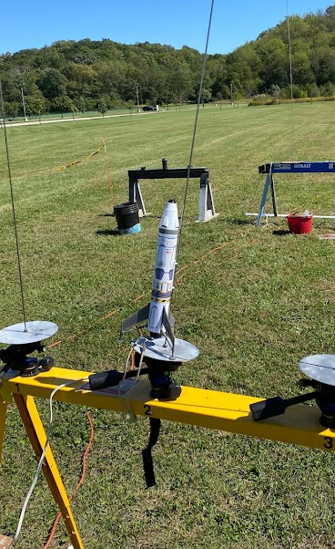 | 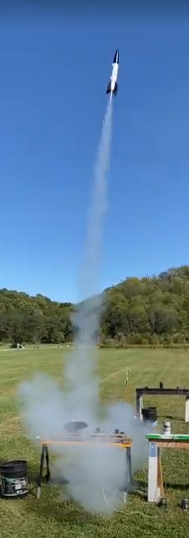
Looks “spacey” doesn’t it?? | V2 on a D12-5

