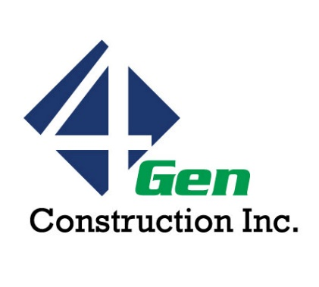 | 4-Gen Construction Inc.  101 SE 30th St.  Lee’s Summit, MO 64082  816.702.7888

Employment Application

Applicant Information
Full Name: |  |  |  | Date:
 | Last | First | M.I.

Address:
 | Street Address | Apartment/Unit #

 | City | State | ZIP Code

Phone: |  | Email

Date Available: |  | Social Security No.:

Position Applied for: |  | Apprentice/Journeyman:

Are you a citizen of the United States? | YES | NO | If no, are you authorized to work in the U.S.? | YES | NO

Have you ever worked for this company? | YES | NO | If yes, when?

Referred by:

Education
High School: |  | Address:

From: |  | To: |  | Did you graduate? | YES | NO | Diploma:

College: |  | Address:

From: |  | To: |  | Did you graduate? | YES | NO | Degree:

Other: |  | Address:

From: |  | To: |  | Did you graduate? | YES | NO | Degree:

References
Please list professional references.
Full Name: |  | Relationship:
Company: |  | Phone:
Address:
Full Name: |  | Relationship:
Company: |  | Phone:
Address:

Previous Employment
Company: |  | Phone:
Address: |  | Supervisor:

Job Title: | __________________________

From: |  | To: |  | Reason for Leaving:

May we contact your previous supervisor for a reference? | YES | NO

Company: |  | Phone:
Address: |  | Supervisor:

Job Title:

From: |  | To: |  | Reason for Leaving:

May we contact your previous supervisor for a reference? | YES | NO

Scale of 1-10, please circle the numbers that best fits your skills. 1 being worst and 10 being best

- Blueprint reading – 1 2 3 4 5 6 7 8 9 10
- Floor Layout – 1 2 3 4 5 6 7 8 9 10
- Metal framing – 1 2 3 4 5 6 7 8 9 10
- Framing Soffits – 1 2 3 4 5 6 7 8 9 10
- Sheet Rocking – 1 2 3 4 5 6 7 8 9 10
- Drywall finishing, hand tools – 1 2 3 4 5 6 7 8 9 10
- Drywall finishing with Tools – 1 2 3 4 5 6 7 8 9 10
- Acoustical Ceiling Grid install – 1 2 3 4 5 6 7 8 9 10
- Acoustical Ceiling tile install – 1 2 3 4 5 6 7 8 9 10
- Doors and Hardware – 1 2 3 4 5 6 7 8 9 10
- Cabinets – 1 2 3 4 5 6 7 8 9 10
- Wood trim – 1 2 3 4 5 6 7 8 9 10
- Paint – 1 2 3 4 5 6 7 8 9 10

Disclaimer and Signature

I certify that my answers are true and complete to the best of my knowledge.
If this application leads to employment, I understand that false or misleading information in my application or interview may result in my release.
Signature: |  | Date:

