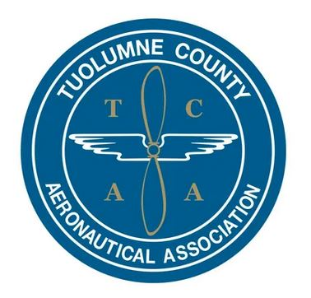  As a non-profit 501c3 organization, TCAA exists to promote and champion aviation in Tuolumne County through airport projects, community education and scholarships for aeronautical training. | Tuolumne County  Aeronautical Association  2024-25 Aviation Scholarship Application  Submission Deadline: February 28, 2025  Awards to be announced: April 2, 2025

Eligibility: Anyone can apply for the annual TCAA Scholarship as there is no age limit; however, Tuolumne County residents will be given priority along with applicants who are clearly pursuing career paths related to aviation careers, e.g., Pilot/Flight Crew, FAA aircraft maintenance certification (A&P), Aeronautical Engineering, Airline Operations & dispatch, Air Traffic Control, etc.
Step 1: Please provide your contact and basic background information:
Applicant Information | If Applicant is under 18 years old:  Additional Information Required
Name: | Parent/Guardian Name:
Address (Street, City, zip): | Address (if other than applicant):
Phone (cell):  Phone (other): | Parent/Guardian’s Phone (cell):  Parent/Guardian’s Phone (other):
Email: | Parent/Guardian’s Email:
Name of the TCAA member (sponsor): | School Attending / Education level:
Current Employment (if any): | Grade Point Average:
Step 2: Tell us about your goals in aviation or in STEM (Science, Technology, Engineering, Math) careers and why you want to pursue an aviation or aviation-related career or avocation?

- Please list the STEM courses you are taking (or have taken including online) and the institutions you have attended, are attending, or plan to attend, and how these will help you meet your goal:

Step 3: Please indicate any flight training you have completed to date:
Total flight hours _________ (and where) ______________
Aircraft Maintenance (A&P) training hours ________ (and where)_____________
- Have you passed any FAA Knowledge Tests (written tests)?
Private, Commercial, CFI, A&P, Other--specify.
- Have you earned any FAA Certificates?
Student Pilot, Private PPL, Commercial, CFI, Other--specify
- Are you Instrument rated? Yes No

Step 4: Tell us a little about your community activities, e.g., sports, hobbies, volunteerism, etc., and indicate any online and/or social media sites you use to obtain content related to your aviation interests:

Step 5: Explain your financial situation as it relates to meeting your aeronautical goals. Include whether you have applied for, or will you be applying for other scholarships in addition to TCAA:

Step 6: Please attach two letters of reference or recommendations from persons other than relatives, spouse/partner, or personal friends. (These are typically sent separately and come from teachers/instructors, mentors, or others who have experience with, or are familiar with your work and abilities…)

Step 7: Is there anything else you would like us to know about you. (You may use the back of this sheet or attach a separate page.)

Two ways you can send us your completed application
and letters of recommendation:
Via the Postal Service:
Mail to: TCAA Scholarship Committee
P.O. Box 31
Columbia, CA 95310
~ or ~
Via Email:
Scan and attach an electronic copy in an email
Send to: scholarship@tuocoaa.org

Final Notes:
If you are awarded the scholarship:
The TCAA scholarship grants are typically $500 and will be paid directly to (reimbursed to) the flight school, education institution, or TCAA-vetted service provider you choose. If you are notified that you are a successful candidate, you will need to identify a training provider to TCAA as soon as possible. (Note: TCAA reserves the right to validate and approve providers.)
You will have one year from the date the monies are first distributed to your provider to expend the total amount awarded. If for any reason you are unable to expend all the funds within that timeframe, please contact TCAA to explain and ask for an extension of time.

Good Luck!

