AMERICAN KARATE KAI
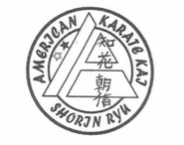
Traditional Okinawa Shorin Ruy Karate
Church of the Holy Nativity
5286 Kalanianaole Hwy
Honolulu, HI 96821
Mondays & Wednesdays 5:30PM to 7:00PM
Sensei Lee Donohue – 9th Degree Black Belt

Respect, Honor, Loyalty
Discipline/Character Development/Self Defense/Physical Fitness

$55.00 per month – 1st Month Free, Call (808)753-5617

