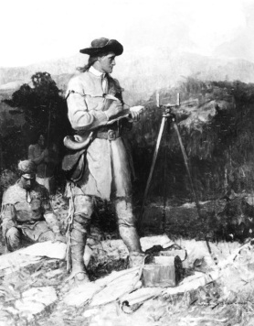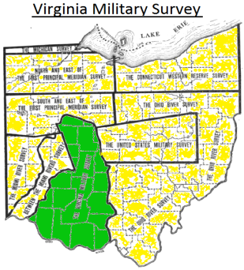
1784 Part of the southwest Ohio Territory was designated to be used for the Virginian Military District, which consisted of land between the Little Miami River and east to the Scioto River. This land was to be used as compensation to Virginia War Veterans of the Continental Army. The area near Foster (on the east side of the river) would become Hamilton Township.
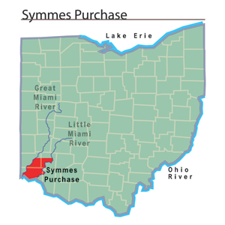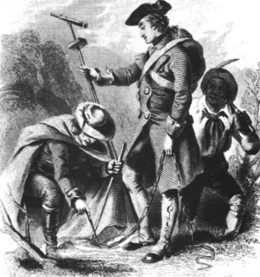
1788 Judge John Symmes of New Jersey, with a group of investors, formed the Miami Company. They petitioned the Continental Congress to purchase a track of land between the Great Miami and Little Miami rivers. In 1794 President George Washington approved the land patent for the Miami Company, which became known as the Symmes Purchase. The same year, President Washington appointed General Anthony Wayne to solve the hostile Indian problems in the area. By 1795 the Treaty of Greenville was signed with the Indians surrendering land in Ohio, Indiana and Illinois. This provided more safety for settlers in the territory and encouraged migration. The area near Foster (on the west side of the river) would become Deerfield Township.
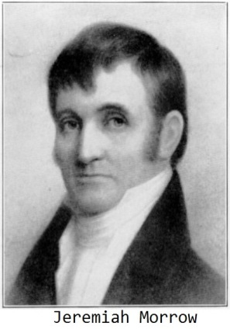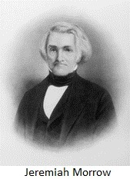
1796 Jeremiah Morrow, James Parkhill and Thomas Epsy traveled from the mouth of the Little Miami River (Columbia, Ohio) into the territory. Their first night was spent on an island in the Little Miami River, near the area that became Foster’s Crossing. The island would later be known as Creek Island. (A sizable natural island still exists in the river, at the southern end of the community.) Their land was part of the Symmes Purchase on the west side of the river. Later part of this area would be called Twenty Mile Stand. In 1799 Jeremiah Morrow returned home to the Gettysburg, Pennsylvania area and married James Parkhill’s sister Mary. A short time after returning, their house was consumed by fire and they lost the home and all their household goods. On a predetermined day, his neighbors from miles around built them a new home in one day. In 1802 Morrow was elected a Territorial Representative to Congress. When Ohio became a state in 1803, Jeremiah Morrow was elected as the first representative to the U.S. Congress from the state.
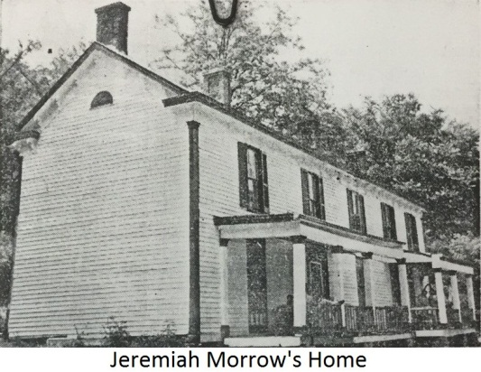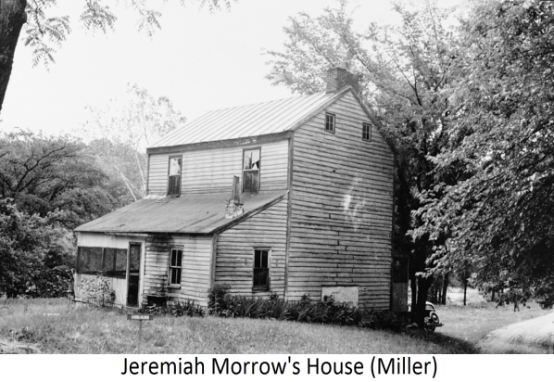
By 1813, Morrow had built a grist mill and saw mill located on what is today Davis Road. In 1822, after serving in the Washington Congress many years, he was elected governor of Ohio. As the state had no governor’s mansion, he worked out of his home by the river and often visited the Twenty Mile House at Twenty Mile Stand. There he established one of the first libraries (called a circulating library) in Warren County with his own books. At the age of 72, he retired from political life after 43 years of public service. He spent his last years of life at his home and mill. Jeremiah would pass away in 1852, at the age of 80.
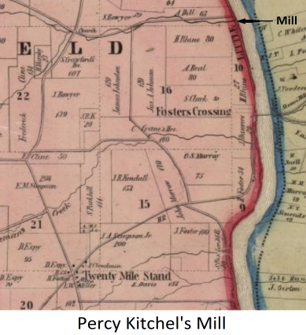
1806 Brazilla Clark (a cabinet maker) built the first grist mill in the area, later to be called Foster’s Crossing. Located on the west side of the river, it aided early settlers who were forced to travel long distances to mills. He sold the mill to co-owner Moses Kitchel (one of the earliest pioneers in the area), who later passed it to his son Percy Kitchel. In 1844 the mill burned and in 1890, Harvard University would research and explore a site at the dead end of today’s Kings Mills Road (the old mill race is still visible). Clark, the builder of this mill, later served in a voluntary Ohio Militia Unit in the War of 1812. He was taken as a prisoner of war near Detroit and remained a captive until its end. After the war, he relocated his residence to northern Ohio.
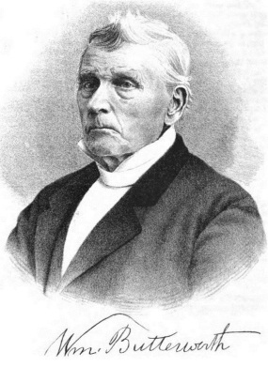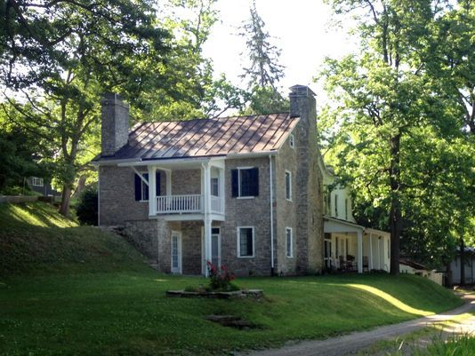
1814 Benjamin Butterworth, a Quaker from Virginia, moved his family to the area. He bought property in the Virginia Military District that would extend from Fosters Crossing to Loveland. Their home was located close to Jeremiah Morrow’s house and mill on the opposite side of the river. While the first residence was built of logs, a second was constructed of stone and still stands today. The Butterworth family played a major role in both the construction of the Little Miami Railroad and the Underground Railroad. His son William Butterworth was a farmer and teacher for 40 years. William’s son Benjamin (named after his grandfather) became an attorney and later served in the US Congress.
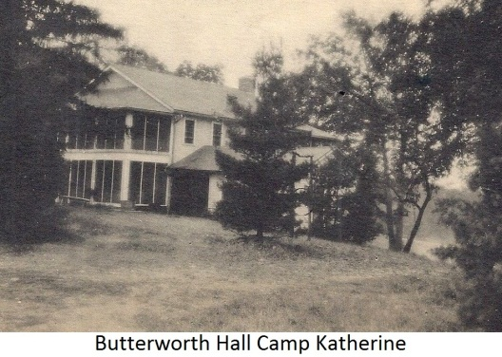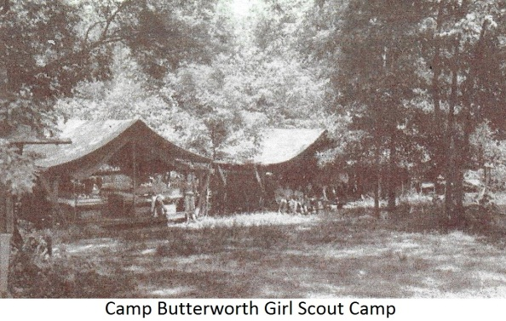
Congressman Benjamin’s son William (named after his grandfather William) married Katherine Deere of the John Deere Family and aided in the development of the tractor. In 1930 and childless, William and Katherine donated his inherited 150 acres for the establishment of Camp Katherine (it would later be known as Camp Butterworth), a Girl Scout Camp located on Butterworth Road. The Butterworth family made significant contributions to both the local community and the nation.
1834 Daniel Morgan purchased approximately 100 acres of land, in the Virginia Military Survey 1548 (east side of river), from the James Hamilton and James Stryker Families. The southern portion of the land ran beside today’s Bear Run Creek. Morgan would own a small mill next to this creek where a dam provided water power. (The creek served as the mill race.) In 1841, he sold the property to the Little Miami Railroad Company. By 1843, Morgan (now in Illinois) filed a claim in the Warren County Common Pleas Court against the Little Miami Railroad Company and Jeremiah Morrow for failure of payment. At a Sheriff’s Sale in 1844, Henry Foster purchased 86 acres and Levi Fulks purchased the remaining 14 acres.
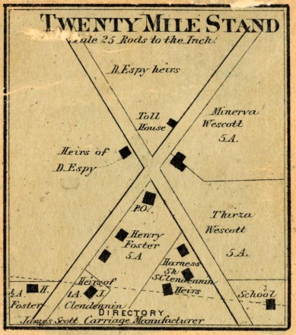
1840 A macadamized (packed broken stone) State Road was completed from Cincinnati through the Twenty Mile Stand settlement and to the Foster area. Laid out in 1804 to run from Cincinnati to Chillicothe and a chartered pike by the State of Ohio in 1834, it was called locally the Cincinnati Hopkinsville Turnpike. By 1836, authorization was given to construct a toll-bridge over the Little Miami River.
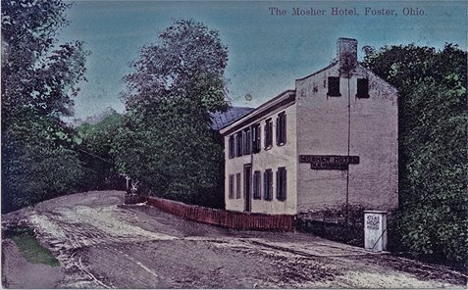
1842 At the age of 28, James Foster moved from the Twenty Mile Stand area where he had worked for his father, Henry Foster, as a store clerk. He purchased land from William Butterworth, on which (with his father’s assistance) a store and a tavern/inn were built. Located on the east side of the river close to the bridge, James’ business was called the Twenty Two Mile Stand, as it was located approximately 22 miles from Cincinnati. The Little Miami Railroad would name this stop (on their route) Fosters. However later (with the first Post Office), the name Foster’s Crossing would be adopted as the community’s name. (This was due to the main road crossing the river on the west side of his business and the new railroad tracks on the eastside of the business.) James would become one of the town’s leading merchants and a respected member of the community. In 1865 and after successful operation for many years, James sold the business to Adam Leever. He then spent his remaining years at his home which was located on a hill on the west side of the river (across the turnpike from the mill race inlet). James Foster’s daughter Hanna married Jeremiah Morrow’s son, who was also named James. His sons, William S. and Joseph G. would serve in Ohio Volunteer Infantry Regiments during the Civil War. Later, both would become owners of properties and businesses on the west side of the river.
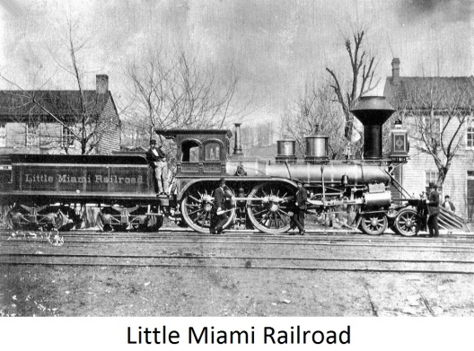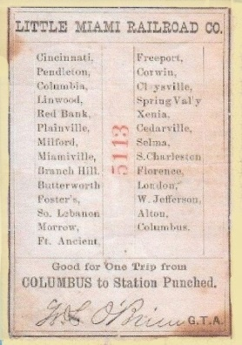
1843 The Little Miami Railroad was completed on the eastside of the river from Cincinnati to Foster’s Crossing. (The Train Station was named Fosters.) Jeremiah Morrow was instrumental in the planning, financing and president for 10 years. During construction, the Butterworth family not only donated land and provided for workers but also supply timber (cut into railroad ties at Morrow’s mill). In exchange they received both a life time passage and a train stop (Butterworth Station) at their home. The railroad would be instrumental to the development of Foster’s Crossing and other settlements in both the Symmes Purchase west of the river and the Virginia Military District on the east side of the river.
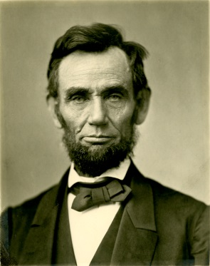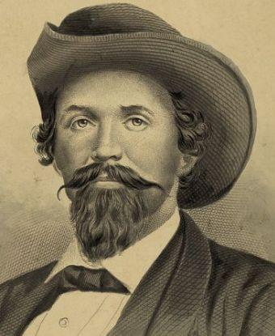
Among the many famous people to pass through Foster on the Little Miami Railroad was Abraham Lincoln in route to his Presidential Inauguration in 1861 and John Hunt Morgan (Morgan’s Raiders) in his escape from the Ohio State Penitentiary in 1863. It operated in the area until 1870 when most of its line was leased for 99 years by the Pennsylvania Railroad System.
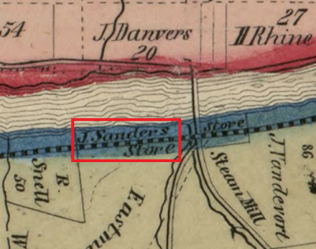
1843 John Sanders, who was born in Prussia in 1819 and learned the shoe trade (cobbler) in Pennsylvania, moved to the area. After working for James Foster as a clerk for 3 years, he married Margaret Gruber. In 1850 he purchase land on the east side of the river from William Butterworth. Located next to the river and across the turnpike (south) from James Foster’s store, he established a business keeping grocery and rail road boarders. Several years later, he moved to the west side of the river where he changed his business to a saloon and boarding house. His boarding house was located between the river and turnpike, south of the old Mason Road (Foster Socialville Road). The saloon was directly across the road from the boarding house. Today, the viaduct over the river is almost over the area where his property was located. (His boarding house still stands today.) Mr. Sanders served 10 years as toll-receiver on the Cincinnati Montgomery Hopkinsville Turnpike and was a member of the Catholic Church. He also served as a Director for the Separate School District of Fosters Crossing.
1844 Henry Foster purchased 86 acres on the east side of the 22 Mile Stand (James Foster’s building), at a Sheriff’s Sale. It included Daniel Morgan’s former mill tract with a dam. On the mill lot (next to Bear Run Creek), he built a new mill that would be known as the Foster Mill. (Percy Kitchel’s mill had burnt the same year.) Later, Henry would build a framed hotel on his property beside the turnpike next to the railroad crossing. After successfully operating these two businesses, Henry would sell the 86 acres and two businesses to James Vandervort in 1853. While he would own many properties and contribute to the growth of the community, Henry Foster was considered one of the Founding Fathers, if not the Founding Father of Foster.
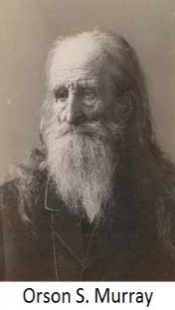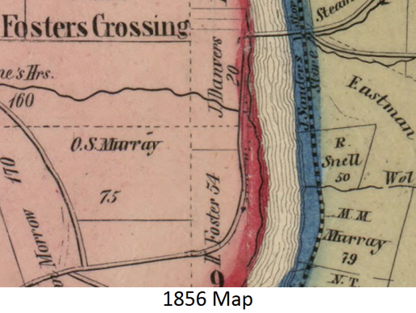
1844 Orson S. Murray moved from New York City to Ohio. Born in the free state of Vermont and a minister, his abolitionary views became so extreme he lost his ordainment. He then became an atheist and moved with his wife and children to New York City. There he came under more pressure for his views and was forced to leave. He and his family moved to the Butterworth farm where he purchased land with several log structures from the Butterworths. The property would be named Fruit Hill. He used one two story log structure for a residence and another for a print shop. Murray soon began publishing his previous abolitionist paper called the Regenerator. The paper was hand carried down the hill and across the river at Jeremiah Morrow’s mill dam. It was then taken to the Twenty Mile Stand Post Office (established in 1824) where it was mailed nationwide. After the death of his wife, he left Fruit Hill to his sons and bought property across the river. Orson later married into the Poor family and purchased a farm at Foster’s Crossing, next to the Little Miami Railroad. The new farm would later become the site of a corn drying facility and today, part of the Rivercrest community. Orson’s son Charles B. Murray would become a statistician, editor of The Cincinnati Price Current (market statistics on livestock and grains) for 41 years and Executive Secretary of the Cincinnati Chamber of Commerce for 20 years.
1848 The Maineville Academy (a private school) opened in Yankeetown (Maineville). It was the brain child of William Butterworth and provided college prep courses to all the surrounding area. A board walk was constructed from the Foster’s Crossing train station to the academy for attending students. The school was held in high esteem. Among its graduates were members of the Butterworth, Morrow and Murray families which distinguished themselves on local, state and national levels.
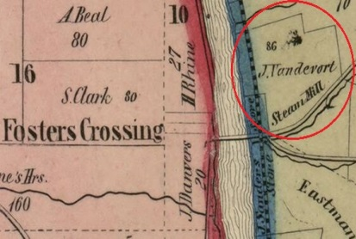
1853 James Vandervort purchased 86 acres on the east side of the river from Henry Foster. The property included both the Foster Mill and a hotel (close to the railroad crossing). Because the mill operation was dependent on water power and the flow of water in Bear Run Creek was much slower in the dry seasons, Vandervort purchased a boiler and steam engine to supply consistent power. (This type of power conversion was becoming popular, at the time.) By 1856, he sold the hotel and lot it was on, to Catherine Griffiths. In 1860, he sold 12 acres, including the mill operation, to Charles Merkle.
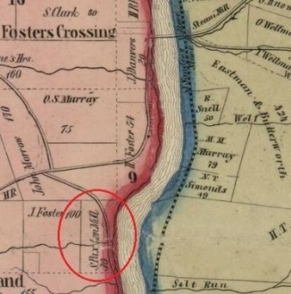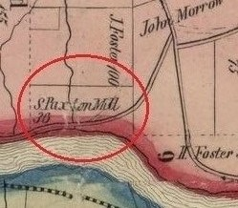
1854 Jeremiah Morrow’s family would sell their past residence and mills to Samuel Paxton. (Jeremiah died in 1852.) The mill operation became known as Paxton’s Mills.
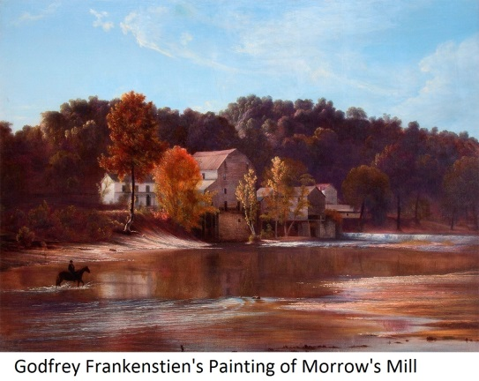
In 1869, a famous painter, Godfrey Frankenstein, would paint two paintings of the past governor’s mill. Paxton would continue the mill operation for many years before splitting the property and selling the mill. He retained the residence until 1883, when it was sold to August Hoppe. Paxton would die in 1888, at his residence in Loveland.
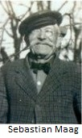
1854 Sebastian Maag, a blacksmith and a wagon maker, immigrated to the area with his wife Elizabeth (Fisk) Maag from Germany. First opening a business on the east side of the river, he later established a blacksmith and wagon shop on the west side of the river. It would be located to the north of John Sanders’ Boarding House, next to the mouth of a creek (today called Simpson Creek). Maag was not only a hard worker and business man, but also a respected and popular member of the community. He passed his work ethics and practices on to his descendants who would own many of the properties and business in the town.
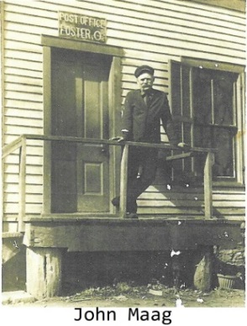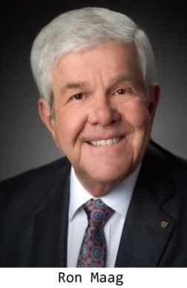
His son Louis became a miller and worked for Augustus Hoppe. Another son, Frank would continue the blacksmith business, after Sebastian’s death in 1909. Also, Frank was elected as Township Trustee in 1915. Still another son, John Maag, would become Post Master in 1915 and later, John’s descendent, Ron Maag, would become a Representative in the State Legislature where he would served until reaching his term limits.
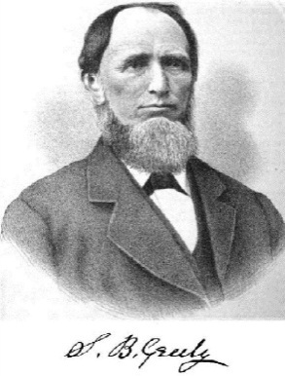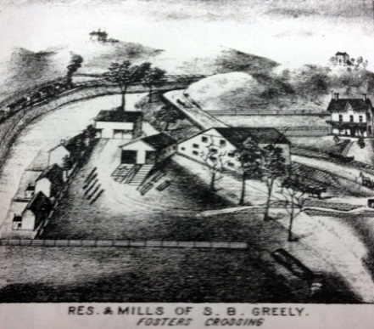
1857 Seth Greely bought a saw mill at Foster’s Crossing from Francis Phillips. In 1817 Greely’s parents had migrated from Maine to a farm in Hamilton Township near Yankeetown (Maineville). In 1858 and with his new partner James Atkinson, they built a grist mill. A few years later (1862), Greely bought Atkinson’s share in the venture.
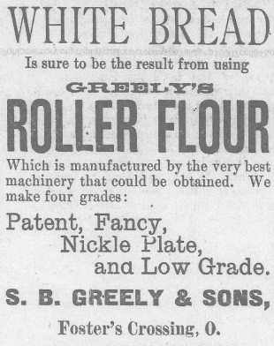
The mills were known as Little Miami Mills. His business of providing both ground grains and lumber prospered. He built a home on the upper hillside of his property which still stands today. The family was a strong supporter of the Maineville Academy and would also own many properties in the town. By 1887, the two mills and the residence would be sold to Augustus and Ernst Hoppe.
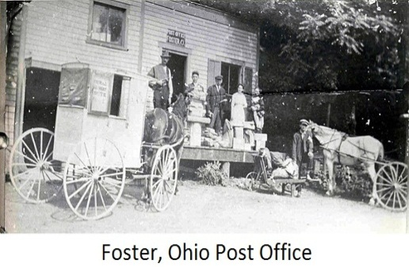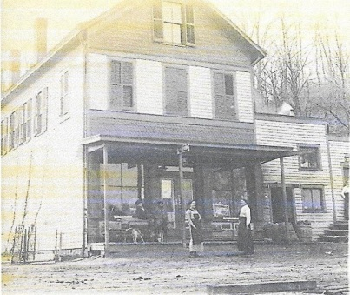
1859 The first Post Office was established in Foster’s Crossing and built on the east side of the river near the bridge. Joseph T. Mathews was the first Postmaster. Later, it would be moved to the west side of the river next to Joseph G. Foster’s Store. In 1883 the name was changed from Foster’s Crossing to Foster and then to Fosters in 1884. In 1893 the name was changed back again to Foster and retained until its closing. After the 1959 flood, the Post Office was moved to Postmaster Mrs. Leota Black’s property. Located close to the old entrance to Hoppe’s Island (Greely’s Mills), it remained at this location until it was closed in 1961.
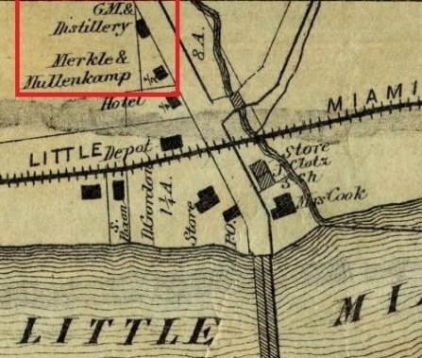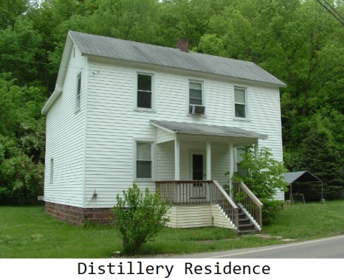
1860 Charles Merkle purchased 12 acres (along the turnpike, on the east side of the river) from James Vandervort. The property would include Vandervort’s Steam Mill. While Merkel would maintain ownership of the property, he would form a partnership with Conrad Mullenkamp. Together and with the technical assistance of Theophilus Simonton, they would convert the steam mill into a distillery. The (legal) distillery would be one of the first distilleries in Warren County. In 1867, they would purchase the wood framed hotel next to the rail road, making the two, owners of a hotel, distillery and grist mill. (This same year, Mullenkamp would buy Merkle’s share of the Hotel.)Together, they would operate the businesses until 1870, when Merkle was forced to sell the majority of his property in a Sheriff’s Sale. By 1871, Mullenkamp sold the hotel to Daniel Rost.
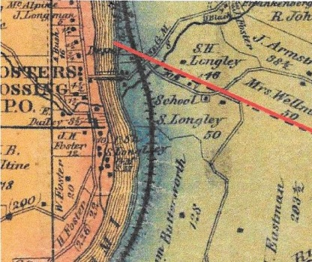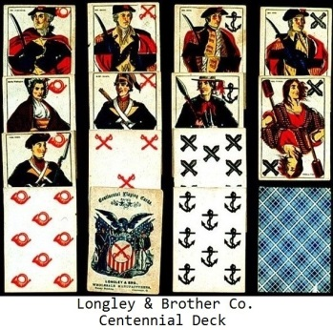
1860 Joanna (Hey) Longley, wife of Septimius H. Longley, purchased property on the east side of the river from the White Family of Cincinnati. It was located to the south of Bear Run Creek (the mill tract) and east of Foster Maineville Road. By 1861, Septimius and his brother Servetus (both printers by trade) manufactured the first playing cards in this part of the country, at Fosters Crossing. (Most playing cards were manufactured on the east coast.) They moved their business to 248 Walnut Street in Cincinnati. There they would manufacture the first playing cards in that city, under the name Longley & Brother Co.
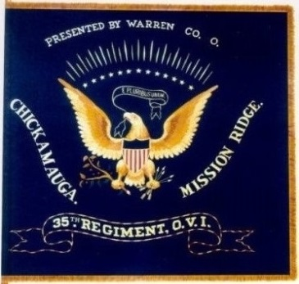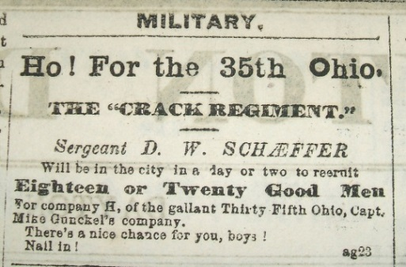
With the Start of the Civil War in 1861, there was a need for military flags. By 1862, the Longley Brothers were under contract to manufacture 120 infantry and artillery flags. The Longley & Brother Co. quickly converted to flag manufacturing. In 1863, they were contracted for 235 regimental flags and in 1864, for 600 cavalry standards. Brothers Elias, Sierenius and Alcander would also become involved in the company. The Longley & Brother Co. would produce the most flags in the Cincinnati Depot area with the John Shillito Co. being their closest competitor.
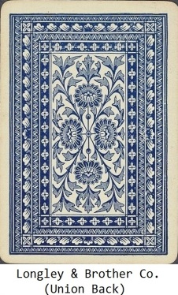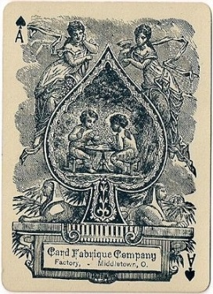
Also in 1864, Anna (Loftus) Longley, wife of Servetus Longley, purchased property at Fosters Crossing on the east side of the river, next to the Septimius H. and Joanna Longley residence. (Today, the east side of the viaduct passes both over and onto their property locations.) After the end of the war, the brothers would return to manufacturing playing cards. In 1867, they would sign a Land Contract with S. B. Greely to purchase property on the west side of the river, for the purpose of manufacturing playing cards. The property would be between the turnpike and Greely’s Mill Race (across the road from James Foster’s residence). In 1874, the name of the business in Cincinnati would be changed to Card Fabrique Co. and later be moved to Middletown, Ohio. By 1882, the family had sold all their properties in Fosters Crossing. Members of the Longley Family also distinguished themselves in phonography (shorthand) and more efficient use of the manual typewriter.
1861 On March 26, on the east side of the river, James Foster’s store was entered by robbers. The burglary resulted in the loss of goods valued at $200.00. At the time of the reporting (4-4-1861) by local papers, the thieves had not been arrested.
1861 On April 4, it was reported an elderly lady known as Bailey had died from injuries received in an accidental fire at her home, on March 27. It was stated she lived in a small cabin by herself and had the habit of drinking to excess and by some unknown means, her clothes caught fire.
1861 In May, Warren County Coroner White conducted an inquest on the body of an unknown man found in Atkinson and Greely’s mill dam. It was judged to have been in the water for three weeks and was in such condition that it was impossible to identify, except for a mark of a cross on the right arm. The jury concluded it was an accidental drowning.
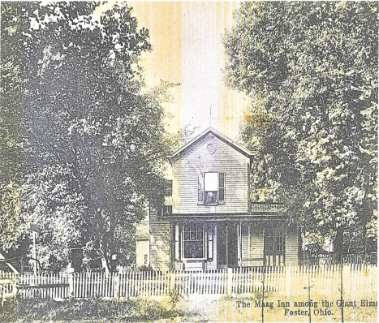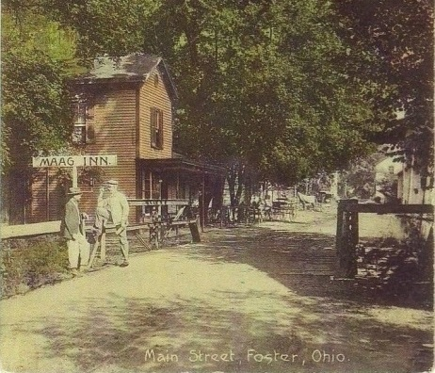
1864 Sebastian Maag purchased an inn from Levi & Mary Shoemaker. The establishment would be called the Maag Inn. The family would retain the business for close to 84 years, making many improvements to the property.
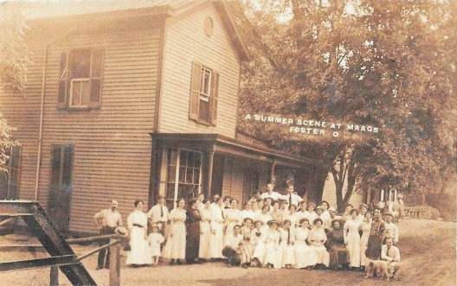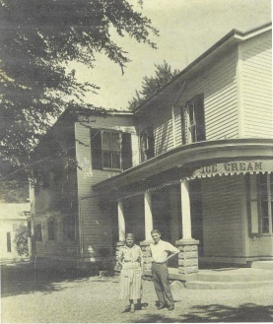
The business would prosper and even during the years of Prohibition, the tavern was converted into an ice cream parlor. In 1949, the Maag Family sold the property to Richard & Goldie Ashburn.
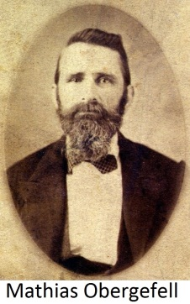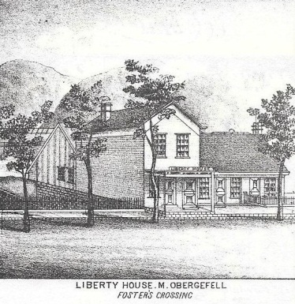
1865 At the age of 39, Mathias Obergefell moved to Foster’s Crossing with his wife and their children. Born in Germany in 1826, where he became a tailor, he married Francisca Slatter in 1851. They immigrated to America in 1854 and located in Cincinnati where he worked on military uniforms for the government. Obergefell purchased John Sanders’ Boarding House and converted it into a hotel he named the Liberty House. Next to his hotel, he would later build a restaurant and tailor shop. It was said he could provide either a square meal or a suite of clothes and he was well respected for his fair dealings. After his first wife’s death, he married Katherine Rieger in 1880. By 1897, his widow Katherine sold the Liberty House to John Scheer, who sold it to Sebastian Maag the same year.
1865 The Free Turnpike Act was passed in Ohio making the majority of turnpikes toll free. However, this did not apply to bridges and tolls continued to be collected. With the new law, the roads were primarily maintained through taxes. By this time, the turnpike through Foster’s Crossing was called the Cincinnati Montgomery Turnpike.
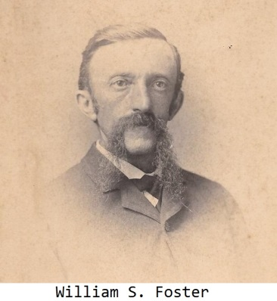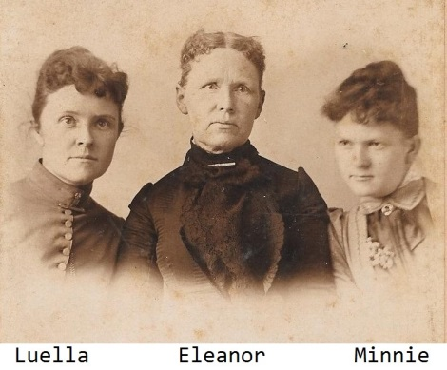
1865 William S. Foster (James Foster’s son) purchased property on the west side of the river, close to the end of the bridge. The property would later become the location of the Miami Inn and 2 ice houses. His wife Eleanor, immigrated with her parents in 1852, from England. William and Eleanor married in 1862, after which they had 2 daughters. The same year of this property purchase, William also purchased property from his grandfather, Henry Foster. This property would be located across the turnpike from the Greely Mill, next to his father, James’ residence and become his family’s residence. William would later sell a small portion of the property (next to the turnpike) to S. B. Greely who would also build his residence.
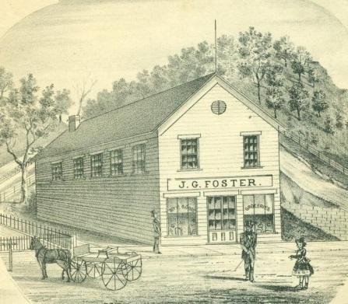
1867 Joseph G. Foster (William Foster’s brother) purchased a store on the west side of the river from Halton & Eliza Fitzgerald. A new Post Office would later be built onto the side of the store when the service was moved from the eastside of the river. Never recovering fully from his experiences in the Civil War, Joseph would tragically die from congestion of the brain at the age of 33, in 1877. His grandfather Henry had died in 1870 at age 90 and his father James H. had died in 1872 at age 57. One year after Joseph’s death, his wife would also die, leaving their 4 children to be raised by family members. Not only was the Foster Family the town’s namesake but also respected for their moral interests of the community. The family would maintain ownership of the store until 1884, when it would be sold to Benjamin True.

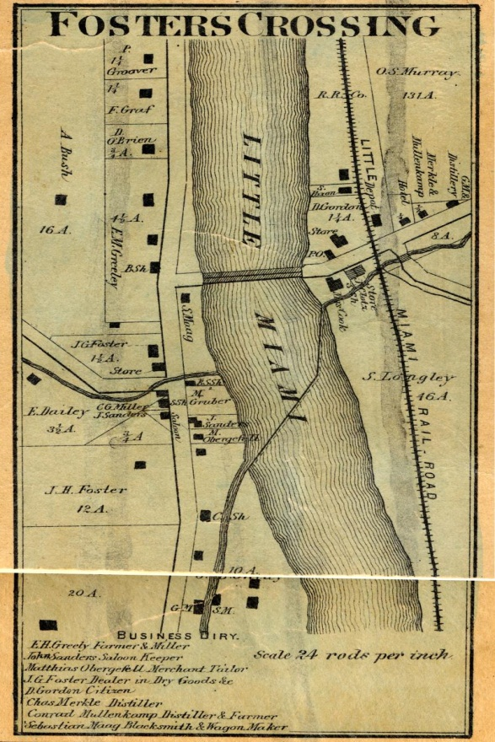
1867 This was an early map of Foster’s Crossing published in the 1867 Warren County Atlas. It shows the general layout of the community. The bridge over the river, railroad, mill race and roads are shown. Also shown are the locations of the post office, businesses, property owners and other structures. It further included a business diary of prominent citizens at that time.
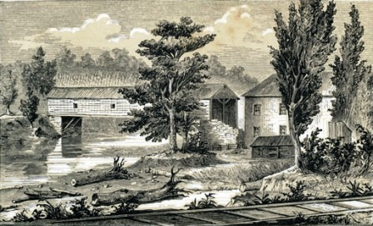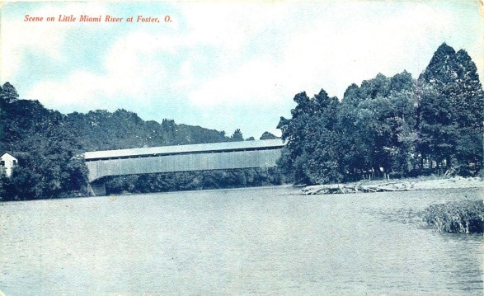
1867 Mr. Hebble built a new covered bridge across the river with timbers cut and framed at Greely’s saw mill. The State of Ohio had authorized the construction of the first toll bridge at Foster’s Crossing in 1836. Hebble’s bridge was 26 ft. above the water, 24 ft. wide and 200 ft. long. The new bridge was a toll bridge also and stood until the 1913 flood when it was destroyed.
1868 Foster’s Crossing was reported to have a population of 180. This included 105 German, 50 American and 25 Irish. The town was featured in a Western Star article describing the number of buildings (47), types of businesses, shops and residences. It was noted there were no school houses or churches in the little village. The end of the article also gave political views. The ballots were stated to be in the Democratic hands, while the brains were stated to be in the Republican cranium.
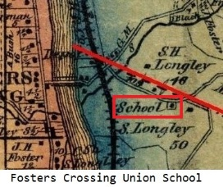
1868 Mr. Scott, Representative of Warren County, petitioned the Deerfield Township Board of Education to create a separate school district at Foster’s Crossing. In the same year, the petition was approved and the school district established. In 1870 an attempt was made to have the act repealed. However, with the support of attorney Benjamin Butterworth (William’s son) and 42 residents, it was defeated. Prior to this, the community had two schools, German and English. The English was called a Union School and was located on what is today Foster Maineville Road, near Butterworth Road.
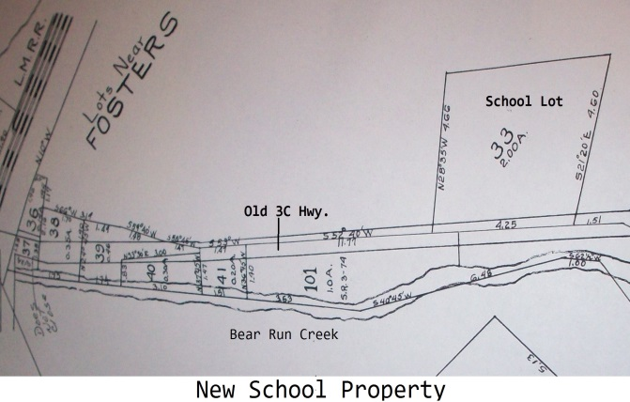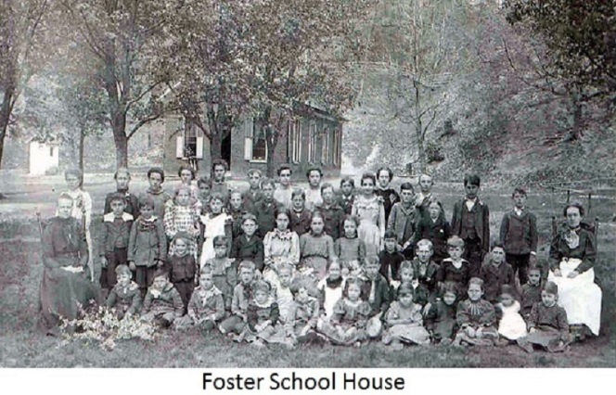
Ichabod and Lucy Murray (of Kansas) with William & Rachel Poor sold 2 acres to the Directors of the School District of Fosters Crossing in 1871. The property was located along the Cincinnati Montgomery Turnpike on the east side of the river (close to the entrance of Orson S. Murray’s property). The directors were John Sanders, William McCallister and Seth B. Greely. At this location, a one room structure of brick was constructed and later two additional rooms added on to the front of the original structure. Students attended nine months of the year as opposed to the original four months. Education was to the eighth grade level. The Foster Public School operated until 1942 when it was closed. Students were transferred to the Kings Mills School. Later, the building was occupied by the St. John Catholic Church and today, Ballet Tech of Ohio.
1870 John H. Delfendahl purchased 11+ acres on the east side of the river from Charles Merkle. By 1871, he purchased the distillery lot and equipment from Fredrick Klensch. He was then the owner of both the steam mill and distillery (which had belonged to Charles Merkle). In 1878, Delfendahl was convicted of selling untaxed liquor and the Federal Government would sell his distillery property, steam mill and all equipment. Henry Lachtrop would be the purchaser. In 1883, Delfendahl would purchase the mill tract with it’s ice house, back from Lachtrop . He would operate the ice house, plus a chicken business until 1926, when he would sell the property to his son (Harry).

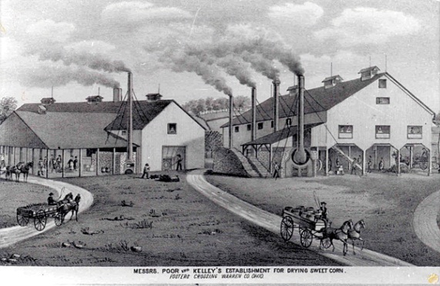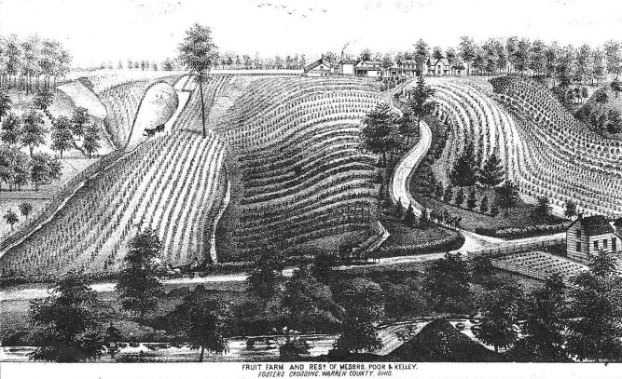
1871 Henry B. Kelley of New York (Orson S. Murray’s son-in-law) arrived in the Fosters Crossing area. The following year he became a partner of William H. Poor. While it was common to dry fruits or pickle vegetables, they discovered a new process for drying corn. (The Indians had been drying corn by fire for a number of years to prevent the growth of organisms which cause decay.) The men developed their new process and built a corn drying facility on Orson Murray’s farm (today called Rivercrest Community). Afterwards, they would join J. M. Hayner and start a second operation on his farm at South Lebanon, Ohio. (This location would later become the first corn canning firm west of the Alleghenies and evolve into The South Lebanon Packaging Company.)
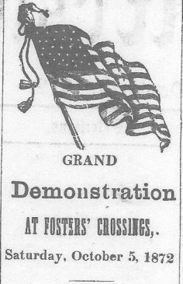
1872 On Saturday, October 5, a political meeting was held at Fosters Crossing to provide candidates an opportunity to campaign for office. Eminent speakers were Ben Butterworth, Job Stevenson, Warner Bateman and P. H. Clark. A German speech was also given by F. Vogeeler.
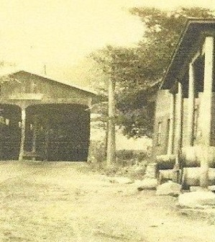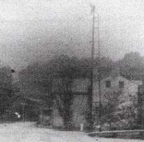
1873 Robert Cook, an Irishman and former railroad worker, purchased a store, on the east side of the Foster’s Crossing Bridge (next to the river), from George Cochran. Prior to the purchase, he had worked for Isaac Stubbs at his farm and mill for over 10 years. After 7 years of operating the store, he entered into a co-partnership with John Bernard Rolhing. Together, they built a large and lucrative retail business (Cook & Rolhing) that included dealers in coal. Robert Cook would continue to purchase additional property on the east side of the river. Included was a 16 ft. right-of-way (alley) at the rear of his store to the railroad (in 1882) and property from the Beech Creek Distilling Company (in 1889).
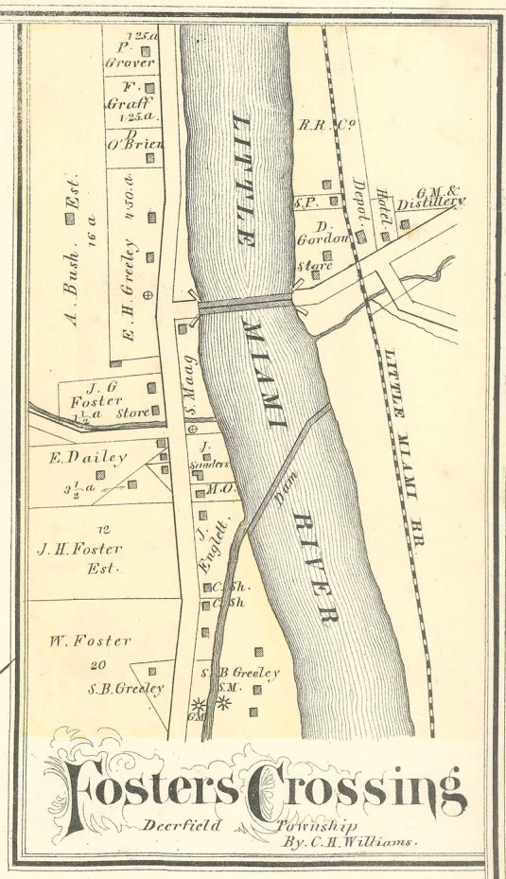
1875 This was a map published in the 1875 Warren County Atlas. One noticeable addition from the 1867 map is Greely’s new residence. Also, the first Post Office location, on the eastside of the river, is now a store.
1875 In June, Joseph Foster’s residence was visited by a tramp requesting something to eat. The manner in which he disposed of the meal, his politeness and intelligence attracted the family’s attention. While he never gave an account of himself, only the name of John, the family took him in. He proved to be trustworthy, honest and gentle with the children. On Monday, July 19, he was attending a small child when it pulled at his recently mended coat. He became violently angered and before he could injure the child, Foster shot him in the head. In a matter of minutes, John was dead.
1876 H. P. Dove, of Butler County, Ohio, became government store-keeper of the Foster’s Crossing Distillery. The distillery was a U.S. bonded warehouse by the Treasury Department, Office of Internal Revenue. He was employed in this position for over 12 years. Dove was also a civil war veteran.
1877 On July 12 it was reported, a marine monster had taken up residence in the Little Miami River, near Foster’s Crossing. It was stated the creature was most active around 10 o’clock at night, when a great deal of splashing would be heard in the river. Witnesses included several prominent citizens including Robert Cook (a store owner). Bathing and fishing in the river almost came to a stand-still, until it was discovered the monster was an alligator. Citizens then made arrangements to capture the reptile and possibly put it on display at the Cincinnati Zoo.
1878 On February 15, Federal Agents seized the Foster’s Crossing Distillery and arrested owner, John H. Delfendahl with several of his employees, on a charge of defrauding the US Government of lawful taxes on whiskey. Also arrested was Mathias Pieffer of Fillmore Street, Cincinnati, for concealing the untaxed liquors. (Only Delfendahl and Pieffer posted bail.) The illicit whiskey coming by wagon into Cincinnati had been known about for several weeks and the Internal Revenue Department had sent agents to investigate. After being caught in the act, Delfendahl and his employees made threats prior to and after their arraignment in Federal Court. The witnesses included the Foster’s Crossing Postmaster, George Fouche. An additional charge for intimidation of the witnesses was added. On May 10, 1878, Delfendahl was tried and convicted. He was incarcerated and the Internal Revenue Service sold the distillery in July of the same year to cover his penalties, taxes and costs.
1878 A. W. Pittinger of Cincinnati started Fishwick & Pittinger Merchants Merchandising Store. The property was located close to the west end of the bridge, between the former Joseph Foster Store and what would later become the Miami Inn. Pittinger was educated in Cincinnati and completed a full commercial course at Bartlett’s College. This level of education was rare in rural areas. (He had married Fishwick’s daughter Lucy in 1875. Thus, Fishwick was his father-in-law.)
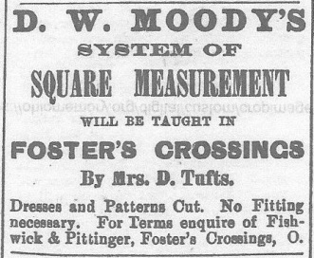
Their business had not only become competitive in Foster’s Crossing, but also in the surrounding communities. They carried a large variety of common merchandise and hard to locate items. The store would suffer a major fire in 1893, which resulted in the loss of the business. (The business was only insured for $3,500.00 and the loss was $10,000.00.)
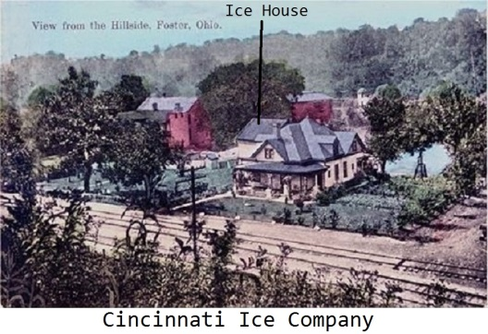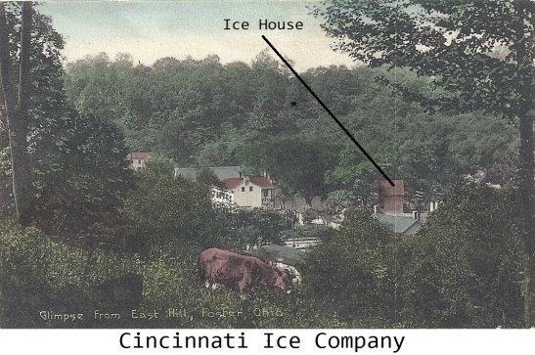
1878 The Cincinnati Ice Company purchased property on the east side of the river. The property was located between the river and the railroad tracks, behind Robert Cook’s store and the Mosher Hotel (once James Foster’s store). At this site, a stone building was used as a staging area for ice that would be shipped by railroad to their customers.
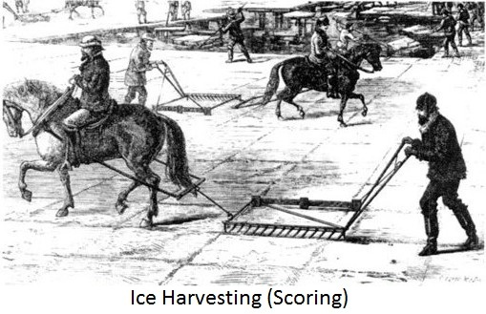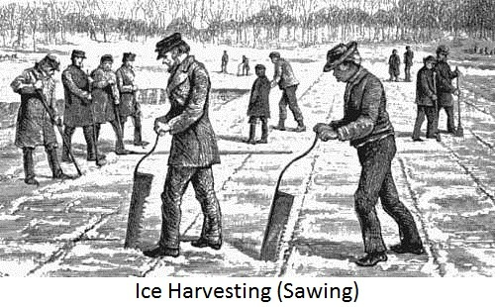
Foster had several ice houses. Ice boxes for both commercial and residential use had been introduced in the mid 1800’s and by the turn of the century, over half of the homes and nearly all the business (requiring product cooling) had ice boxes. The ice was harvested above the dam when at least 6” thick, it was scored into squares, cut by hand and stored in the ice houses. Saw dust insulation was used in the thick walls of the ice house and between layers of stored ice. The work would continue, until the ice houses were full. Ice was also sold to surrounding communities. Several ice houses were located in the community. One was behind the Miami Inn (Herb’s), which was at the west end of the bridge and next to what is today’s Kings Mills Road. While another, was on the mill tract next to Bear Run Creek (next to the old distillery stone warehouse). Some business in the community constructed storage facilities on their property for their own use.
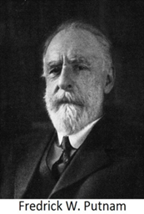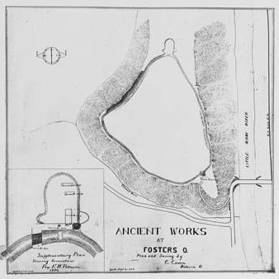
1879 Archaeologist Fredrick Putnam, professor and curator of the Peabody Museum of Archaeology and Ethnology at Harvard University, investigated the earth works discovered at Foster’s Crossing. Located above the river valley on the west side, it was known locally as The Fort.
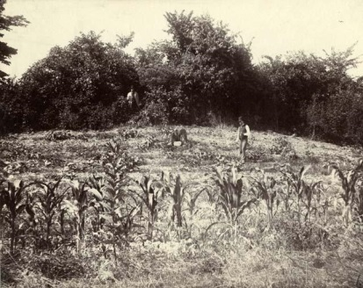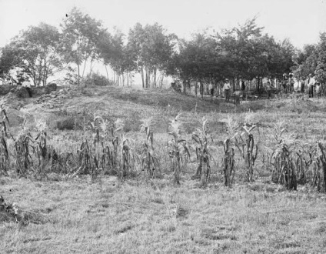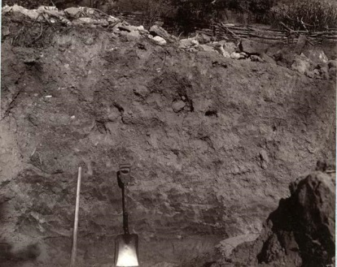
His research stated, the ridge of the earthworks was approximately 2,843 ft. in length and 50 ft. wide. Constructed of stone on the inside and burnt clay on the outside, the artificial ridge had significant amounts of cinders that was the result of wood being burnt to fuse the materials together. This created an orange colored hard surface, which made the site both unusual and unique. The north wall was 9-12 ft. high, south and east walls only 3-6 ft. high and west wall barely visible. He reported the structure was built by the Hopewell Culture after the Fort Ancient construction. While never stating what its use was, he never believed fully it was for defensive purposes. He referred to it as a Singular Prehistoric Structure at Foster’s Little Miami Valley, Ohio. Today, the site is not accessible as it is on private property. (Dr. Putnam also investigated the famous Serpent Mound in Ohio.)
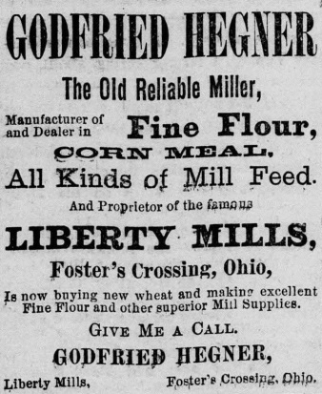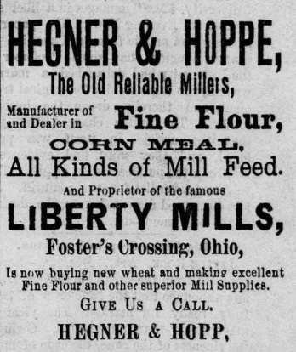
1881 Godfried Hegner purchased the grist mill and saw mill on Davis Road, from the Robinson family. The mills had been the Jerimiah Morrow Mills and later, the Paxton Mills. By 1882, Godfried was advertising in local papers and in 1883 he entered into a partnership with Frank Hegner (his brother) and August Hoppe. They then ran advertisements which included Hoppe as a miller. Godried would purchase his brother’s share and by 1884, August Hoppe would purchase his, becoming the sole owner of the mill. (Hoppe also was the owner of Morrow’s home place next to the mill property.) In 1887, August would sell the mill to Ernest Hoppe and together, August & Ernst would purchase Greely’s Mills, located up the river on the main turnpike.
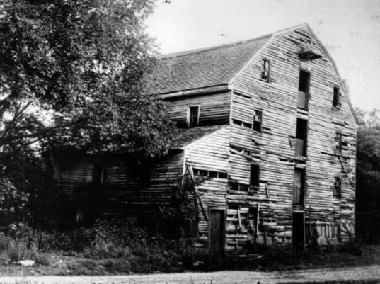
The Liberty Mills would be razed shortly after 1906. However, the property and Morrow’s old Home would remain in the Hoppe Family until 1926. It was then sold to Victor Wilson.

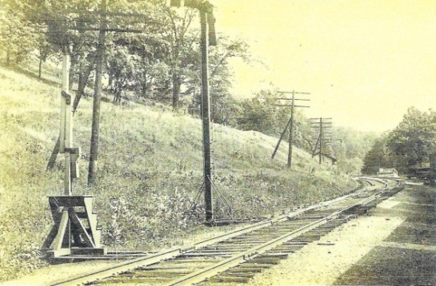
1882 On July 23, the east bound Freight Train, No. 15, failed to stop at the end of the side-track at Foster’s Crossing. With the engine and several cars extending on to the main track and before corrective action could be taken, the west bound Express Train, No. 6, collided with the front of the freight train. The passenger train (No. 6) experienced little damage to the train and minor injuries to the passengers. However, the freight train engine was extensively damaged and several freight cars rolled over the bank and into the river. The engineer of the freight train, Mr. Lyons, was severely injured. The No. 6 passengers were delayed about two hours and a wrecking car was sent to the site to clear the tracks and recover the damaged engine and freight cars.
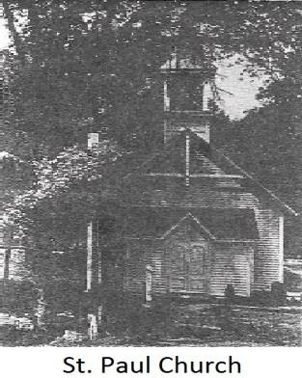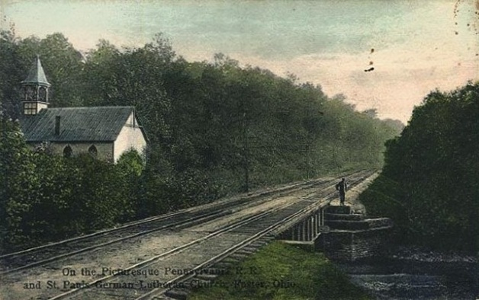
1883 St. Paul’s Church was built by Ben Kroener of Maineville, on land donated by the Butterworth Family. It was located facing Foster Maineville Road, with the Little Miami Railroad to its rear. The German congregation had been meeting for a number of years in the one room Foster School House. Their services were conducted in German, with English lessons taught on weekends. The 1913 flood severely damaged the structure and pushed it off its foundation. Members salvaged and repaired the building, to continue its use. In 1921 the services would be conducted entirely in English. It would later be called “The Church by the side of the road” and its picture displayed Sunday mornings by the local WLW Television Station. In 1957 the lower part of the church was added on to for the growing Sunday school. The congregation today is located at Lakeview United Church of Christ on Columbia Road.
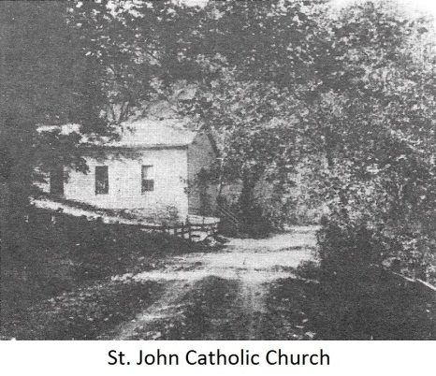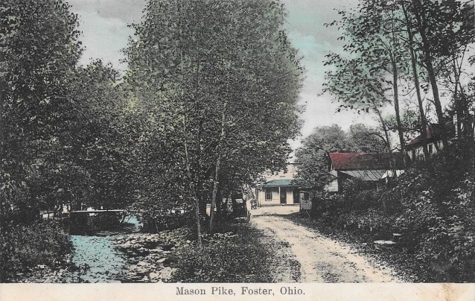
1883 St. John’s Catholic Church was built on Mason Pike (Foster Socialville Road). The land, donated by member Edward Daily, was at the foot of a hill overlooking a creek. The name was St. John Mission Church. That same year, it became a Parish. The Priest served both the St. John Church and the St. Malachy Church, located in Morrow. Built in 1854, St. Malachy was the first Catholic Church in Warren County. Prior to St. John’s construction, the congregation often traveled to Morrow by rail. Foster had visiting Priests who conducted weddings, death rites and even held a Mass in a private residence. (Masses were normally held once a month.) After construction, the church grew and was improved. (The old foundation is visible today on Foster Socialville Road.) In 1943 the Grail, a Catholic supported Monastery, was established at the top of the river valley (next to the viaduct’s northwest side). Supervised by Nuns, this was a farming commune and woman’s spirituality center.
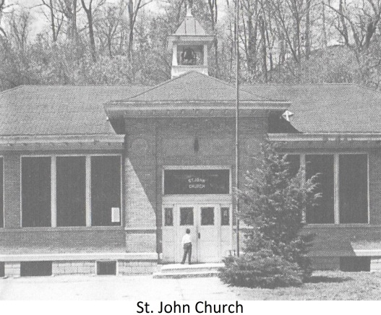
By 1944, the church was no longer able to accommodate the members and the Archdiocese of Cincinnati purchased the old Foster school building, which had been closed in 1942. The original old school house, located to the rear of the main building, was renovated into a chapel. (Windows from the old church were used.) In 1965 St. John and St. Malachy churches merged to form St. Philip the Apostle Catholic Church in Zoar, Ohio.

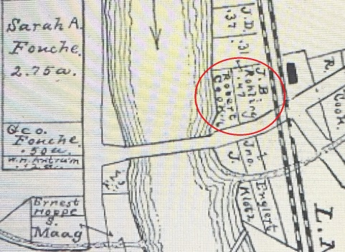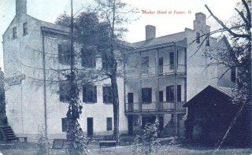
1886 John Bernard Rolhing (partner to store owner Robert Cook) would purchase the fashionable brick hotel and restaurant next to the store, from the Daniel Gordon Family. (This had been James Foster’s store.) The hotel would be operated by Theresa (Maag) Englert from 1892 to 1907. It would be named Mosher Hotel, Foster Hotel, and in 1934, Eugene Diss would name it the Blue Danube. Renamed the Train Stop in 1970’s, it is still in business today and is called the Monkey Bar & Grill. In 1911, Rolhing would purchase Robert Cook’s store (next to the river) from his family. Unfortunately, it would be washed away in the 1913 flood, smashing into the Loveland Bridge.
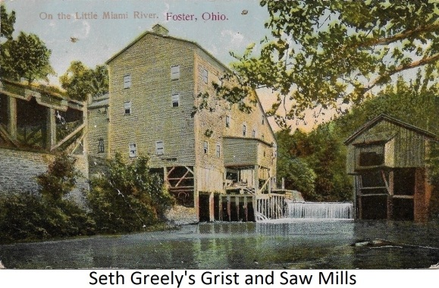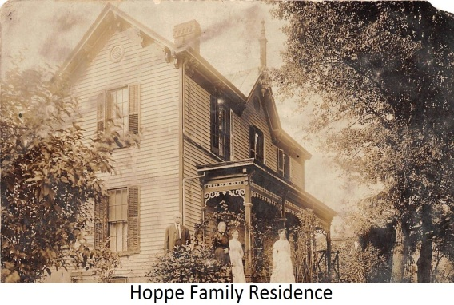
1887 Augustus Hoppe and his brother Ernest purchased Seth Greely’s Mills and property. August had previously owned and operated Liberty Mills on Davis Road. (This mill had been the Morrow Mill.) While Ernest purchased the Greely hillside residence, both brothers would together purchase the grist mill on the upper side of the mill race and the saw mill, with three residential homes on the lower side or island.
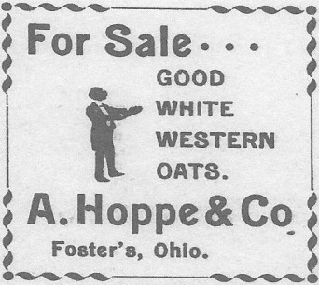
The business (Miami Mills) continued to prosper and provide the milling of corn, wheat, rye, barley and other grains for animal feed. In addition, cornmeal and pancake flour was produced. Their cake flour was of such a high quality, they became suppliers to bakeries in Lebanon and Cincinnati. Their top brand was called Pride of Miami. At some point, the saw mill became no longer profitable and its use was discontinued. In 1910, August and his wife Henrietta would deed their ½ share of the business to their son Edward A. Hoppe. August would die in 1912 and Edward would be elected Township Trustee in 1913. The Ernest Hoppe family would retain their ½ share until 1922 when it would be sold to George and Mayme Standley. By 1934, Edward and his wife Ada would purchase this ½ share from their daughter and son-in-law, Bernice and Robert Hallam (who had purchased the ½ share from the Standley Family). They then became the sole owners of the business. The Edward Hoppe Family continued to contribute to the growth of the community for many years.
1888 On April 12, it was reported a man believed to be Daniel Sweeny of Pittsburg Pennsylvania passed away. His death was stated to have been caused from injuries he received in a fall, while attempting to steal a ride on a train at Fosters, 2 days earlier. On Election Day the young man went to Loveland where he joined in the evening festivities. He then went to Foster where he fell between two railroad cars while attempting to board a train.
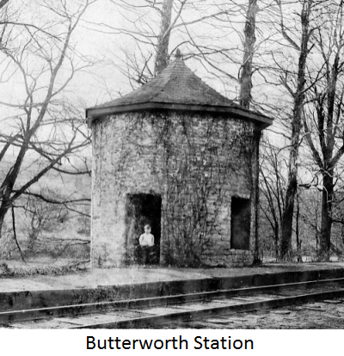
1888 On October 1, Passenger train, No. 9, was in route to Cincinnati when it struck a 15 inch diameter sycamore tree, which had been blown across the tracks in a recent storm, near the Butterworth Station. The train continued on for about a quarter mile, when it was stopped by the conductor putting on the air brakes. The Engineer, Patrick Golden, was found injured and unconscious. He was removed to Laurel, Ohio, for medical treatment. Fireman Mull was found along the tracks a distance back, where he had been thrown from the engine and soon recovered. The tree was cut in two by the engine, while the cow catcher, smoke stack and side of the cab were damaged. Also, the mail car had holes punched in it. Passengers were never aware of the accident, until the train stopped. An engine was sent from Cincinnati to pull the wrecked train in.
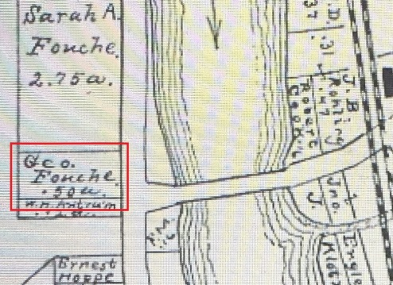
1889 George B. Fouche would purchase the once William S. Foster (later Miami Inn) property at the west end of the bridge. He also served the community as Postmaster. In 1878, as Postmaster, he became involved in a Federal Criminal Case. George was not only a whistle blower on illegal whiskey distribution, but also participated in the apprehension of the perpetrators. He testified for IRS Agents in Federal Court in Cincinnati. In 1925, the Fouche Family would sell the property to George Stuemer.
1892 On September 10, two railroad cars were destroyed by arsonists at Fosters. Investigation revealed, four cars containing rags shipped from the cholera-infested city of Hamburg, Germany had first been staged on a side track at Terrace Park and then moved when they became in danger. When the citizens of Foster became aware of the contents, railroad officials set a watch over the cars with employees. Around 10 o’clock at night, two of the cars were set on fire and destroyed. The remaining two cars were moved south and staged between Butterworth Station and Loveland. During the clean-up of one burnt car, the body of a child and a valise containing 3 suits of clothes were found. An investigation was initiated to determine the circumstances and cause of death.
1893 On September 21, it was reported the A. W. Pittinger store and contents had been consumed by fire. The heroic efforts of the Loveland Fire Brigade and the assistance of the Railroad Wrecking Crew (who happened to be in town at the time) prevented extensive damage to the surrounding buildings, plus the wooden wagon bridge that crossed the river. The fire was suspected to have been caused by a spark on dry shingles. Pittinger’s loss was stated to be $10,000.00. While sadly, he was only insured for the sum of $3,500.00.
1893 On November 5, Henry Thomas Butterworth passed away at the age of 85. Born in Virginia, he was among the children Benjamin Butterworth brought to Ohio, when he purchased property in the Virginia Military District. As an adult, he became known as “Uncle Tom” Butterworth in the community and lived on the family farm. He not only physically assisted with the construction of the Little Miami Railroad, but also served as a conductor on the Underground Railroad. Being a frugal man, he had built his own plain coffin 15 years prior to his death and stored it in a shed, telling no one but his wife Nancy. Per his requests, his grave was dug by employee Richard Tucker (an Afro-American) and his coffin lined simply by his daughters. He was buried next to 3 of his children, in the family cemetery on the farm.
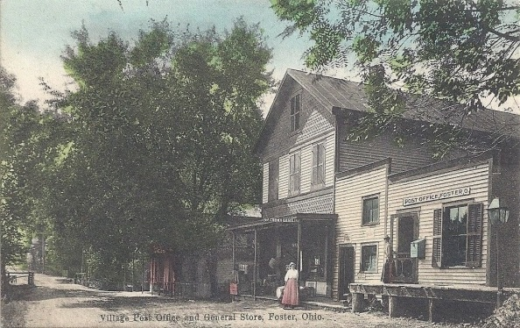
1895 Ernest Hoppe would purchase the one time Foster Family Store and Post Office building, from Benjamin True. He became Post Master from 1897 to 1910 when his son Ernest Louise Hoppe Jr., became Postmaster (1910 to 1915). In 1923, Herbert Hoppe purchased the business and eventually, established a partnership with family members. Herbert Hoppe and Company would now be the owners of the store. Members of the Hoppe family would successfully operate the business until 1948 when it would be sold to Dillard & Ethel Goose.
1897 On March 11, it was reported Foster experienced the worst recorded flood up to this date. On the east side of the river, Postmaster Jacob Englist and his family were trapped in a large brick building by the swift rising waters. With their cries for help, the townspeople became stressed as no means of rescue was available. The following day the river had fallen and the family was chilled and hungry, after being without food or heat for 24 hours. Across the turnpike, Robert Cook’s store (also next to the bridge) suffered significant damage to the building and many of his goods were washed away. His loss was estimated to reach $10,000.00. The train depot was reported to have had several feet of water inside, during the height of the flood. While the wagon bridge across the river and the railroad bridge remained intact, the bridge over Bear Run Creek (Foster Maineville Road) was completely washed away. Up the river, Kings Mills suffered an estimated $150,000.00 in damage.
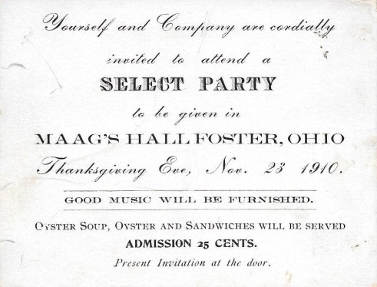
1897 Obergefell’s Liberty House and property was sold to Sebastian Maag. The name was changed to Maag’s Hall. The business would continue to provide dining and dancing. Music was played by German type bands and the dancing was mainly Quadrilles. After the passing of Sebastian Maag Sr., his family maintained ownership and continued to operate Maag’s Hall until after 1930. In 1942, Sebastian Maag Jr. sold the property to Hillard and Edna Profitt.
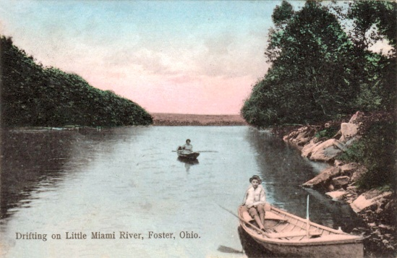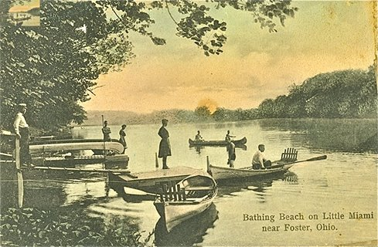
1900 Due to the economic and convenient train transportation from populated areas, the town had become a popular recreational area. While the majority of the surrounding communities were dry, Foster’s German/Irish culture had always maintained taverns. This was often over the objections of many of its citizens. Local large employers, such as Kings Great Western Powder Company and the Peters Cartridge Company often provided patrons to the businesses.
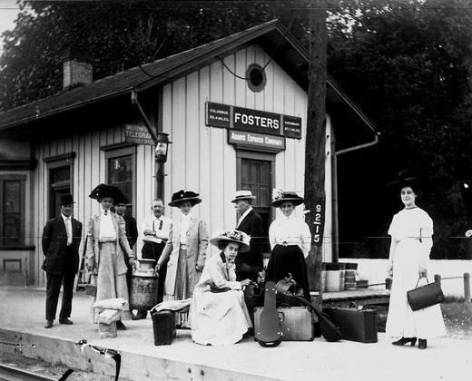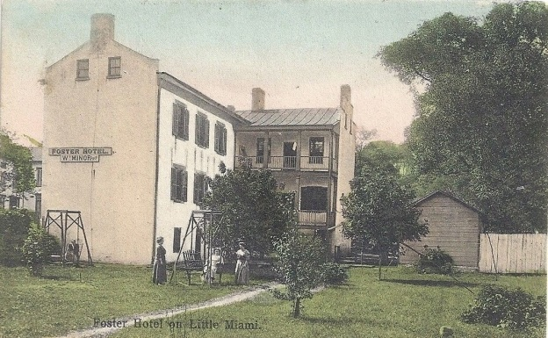
While the main road through the community was still un-surfaced and was used mainly by local travelers, inns and boarding houses found their clients to be more and more people on holiday or vacation from the urban areas who used the train for transportation.
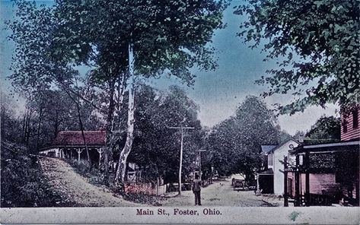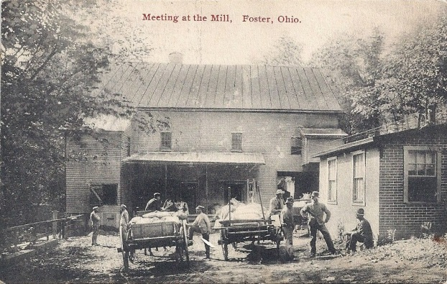
Many of the old established businesses had been passed on to family members while others had been sold to locals or interested parties. However, they still provided services to the local communities and farmers. Foster would continue to grow both economically and in popularity.
1900 A 16 year old Clara Landen wrote an essay on Foster titled “My Home Village”. In her description of Foster, she spoke of a boat that ran between Foster and Kings Mills. At that time, it had only been in operation one summer. It was named the “Queen of the Miami” and was gasoline powered. She stated it could comfortably hold almost 25 people with a fair of 5 cents each. Clara’s parents were Joseph and Mary Landen. (The Landen Family later owned and operated a large dairy farm with a dairy store which was located between Foster and Twenty Mile Stand, on Us 22 & St. Rt. 3 in the mid 1950’s.)
1901 On September 10 it was reported, Morris Osborne had made an attempt to fly at Foster. After observing guinea hens fly over a barn at his residence in South Lebanon, he constructed a set of wings similar to those of the fowl. His first attempt was stopped by the Village Marshall at the South Lebanon Bridge. Not discouraged, he selected the covered bridge at Foster for his experiment. He soon appeared on the roof of the bridge in pink tights, sleeveless undershirt and his wings. With an audience on both banks of the river, he was launched into the air. Instead of soaring, he turned a somersault and plunged into the river with a big splash. Only bubbles and a tip of one wing remained at the surface. A boat was launched from the bank of the river and he was rescued. The inventor then loaded his wings and family onto his wagon and returned to his home.
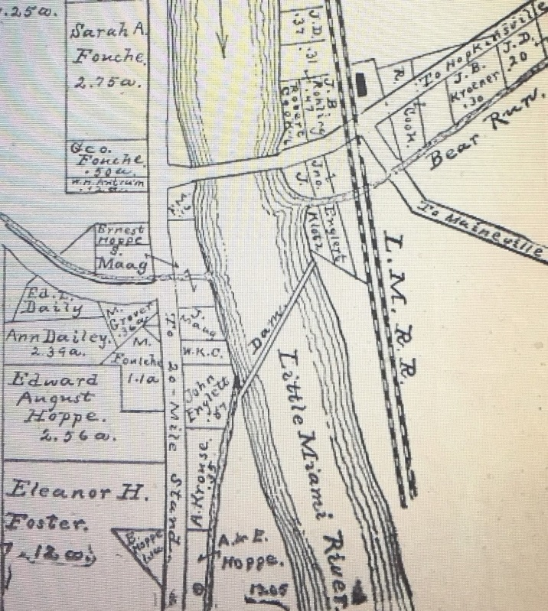
1903 This is a portion of the Foster Map published in the Warren County 1903 Atlas. As the town continued to evolve, changes in property ownership is apparent. Some of which are, the Robert Cook Store and (John) Ben Rohling Hotel are shown on the east side of the river next to the bridge. The Joseph Foster Store, is now shown as belonging to Ernst Hoppe and his inn to Sebastian Maag. Also, Augustus and Ernest Hoppe are now shown as the owners of the Seth Greely mill and residence.
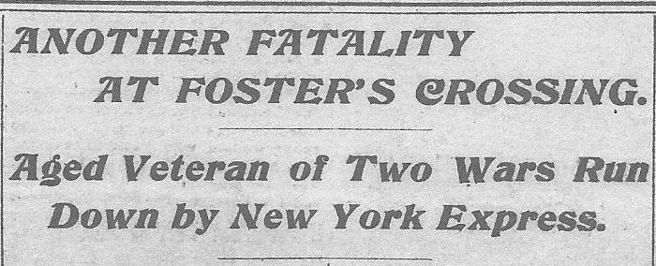
1903 On January 29, it was reported, an 82 year old veteran of two wars had been killed at the Foster’s Crossing. Living at the Gillis Farm, George Gibbs had been in route to the mill with a few sacks of corn. His one horse jolt wagon was startled by a freight train on the side track. Attempting to cross the tracks, with his attention on the freight train, his wagon was stuck by the fast moving No. 7 New York Express. The express continued another ½ mile before being able to stop. After backing back to the depot, Gibb’s body was discovered on the cowcatcher of the train with fatal injuries. While all proper signals had been given, there had been numerous complaints of trains stopping too close to the crossing. This had been the second fatality in 5 months. The crossing was stated to have always been a dangerous crossing.

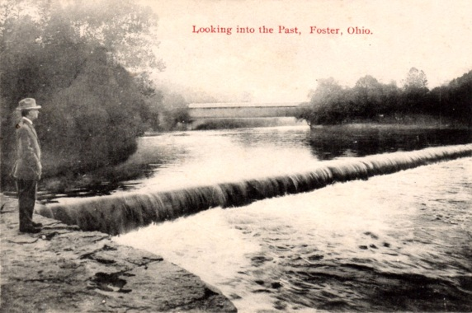
1909 On August 15, Miss Clara Friedhoff of Glendale and Louis Fox of Langland St., Cincinnati, drowned in the Little Miami River at Foster. Witnesses stated, the two were boating with friends when Fox rowed their boat too close to the dam. Ignoring warnings (the river was high that day), their boat became caught in the current and washed over the dam. Though the boat was still upright, Miss Friedhoff panicked, stood up losing her balance and upset the boat in the water. Fox’s body was recovered down river near Remington 2 days later, while Miss Friedhoff’s body was recovered at Branch Hill 3 days later.
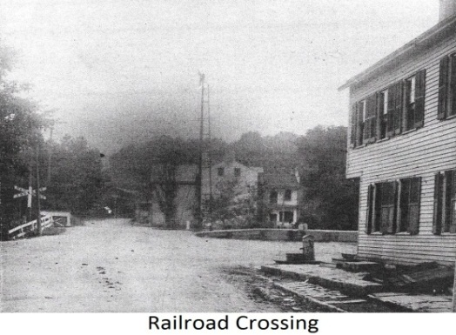
1910 On December 16, it was reported Andrew Rohmer, a local farmer, was awarded $4,000.00 in damages from a suit filed against the railroad. On October 10, 1905, he was at the Foster Crossing with his wagon and team. At that time, the train engineer caused the engine to blow steam off. This frightened the horses and caused them to bolt. Rohmer was thrown from the wagon and suffered a broken jaw. He sued the railway company for $8,500.00. The case finally came to trial before Judge Gorman and the jury returned a verdict in Rohmer’s favor.

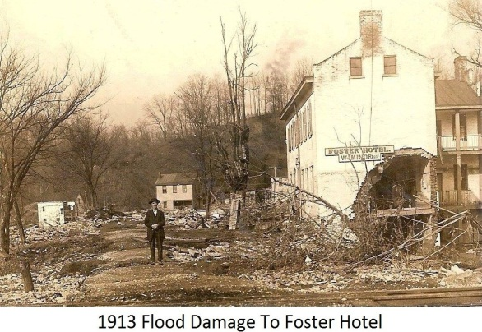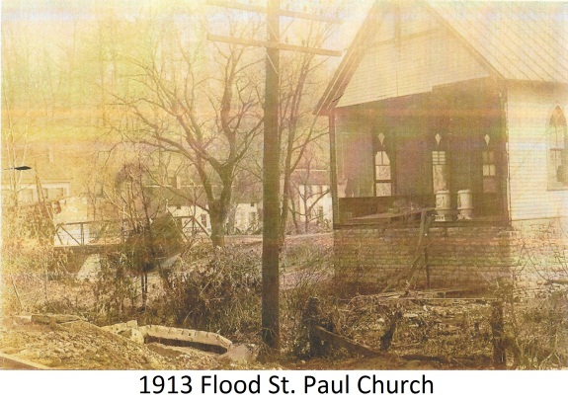
1913 In March the area would experience 8-11 inches of rain in 3 days. Called the 1913 Easter Flood, on March 26 the river would be observed to rise over the 33 foot mark at Kings Mills. The little community would suffer the worst disaster of its history. On the east side of the river, John Rohling would suffer the loss of his store (formerly Robert Cook’s) next to the bridge. It was reported to have remained intact until it was washed into the Loveland Bridge. His brick building to the east (Foster Hotel) was severely damaged after a barn was washed into it. Across the road from Rohling’s Store, John Maag’s brick building (almost identical to the Foster Hotel) was completely washed away and it was stated, not a brick could be found. The windows on the north side of the German St. Paul Church were broken out creating an inside pressure which pushed the entire west wall out. The church’s organ, pews and other contents were all washed away.
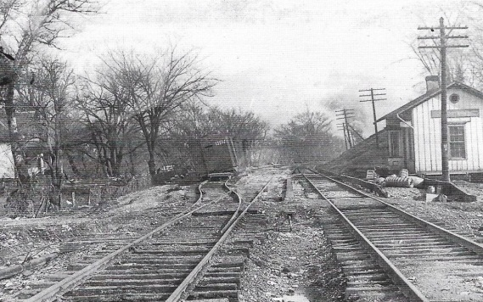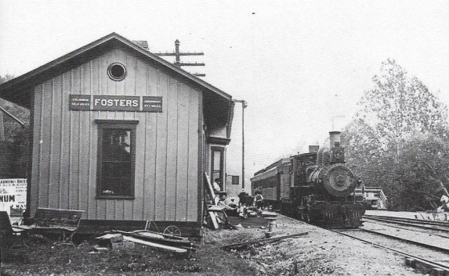
The rail road, station and many roads along the river were cut-off and damaged. Some roads reportedly had 4 foot deep pot holes from the flood’s currents. This effected travel and shipment of needed supplies both in and out of the community.
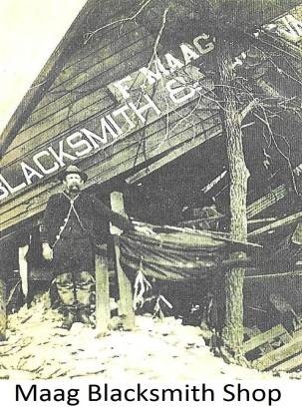
Foster would suffer the loss of its bridge across the river and extensive damage to many of its buildings (some would be razed). A temporary swinging cable bridge was constructed for pedestrian use, while horses and wagons transported at the old river crossing. Josiah Morrow (Jeremiah Morrow’s grandson) who was a Lebanon attorney and author of local history for The Western Star, wrote it was the most disastrous flood on record in the area.
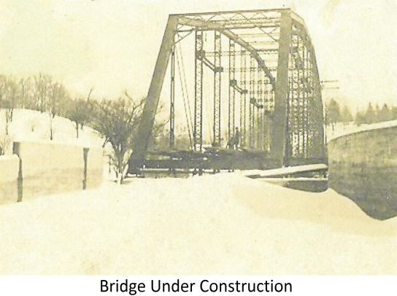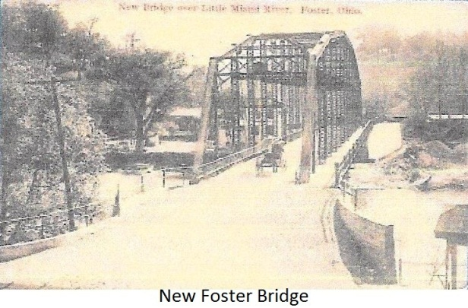
By June of the same year, the Warren County Commissioners were excepting bids on a single span, high truss, steel bridge, 100 ft. long and with a 5 ft. sidewalk. On July 10, the contract was given to the Toledo Bridge Company. The new steel bridge was completed on March 3, 1914 and the Hoppe Company’s Auto Truck made the initial public crossing.
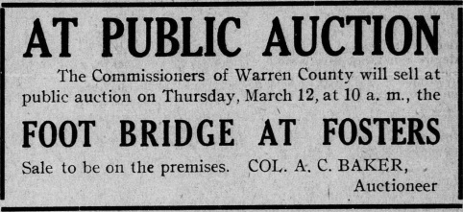
With the completion of the new bridge, the Warren County Commissioners would auction the cable supported pedestrian bridge. Though the face of the little town would be changed forever, the community would continue to prosper.
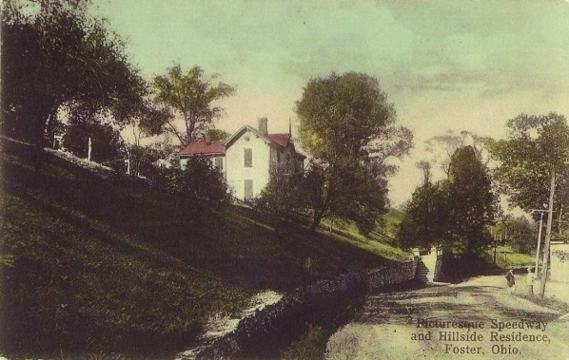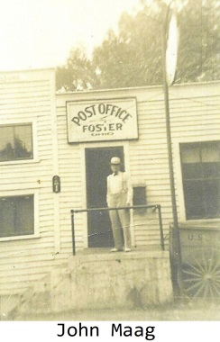
1915 John Maag purchased what was once Seth Greely’s home from Ernest & Minnie Hoppe. John would become the community’s Post Master the same year. He would hold this position for over 15 years. Later, other Maag family members would also serve in this position. In 1942, John would sell the property to Oscar and Alice Dunn, having owned it for 27 years.
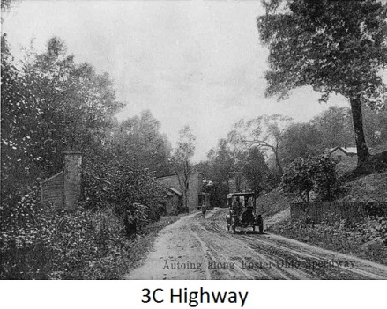
1923 With the introduction of the automobile and its increased use, the State of Ohio began designating route numbers to main roads. The 3C Highway (also called Montgomery Road) through Foster would be designated State Route 3. As it was the main road connecting Cincinnati, Columbus and Cleveland and traveled extensively, the town adapted to the new trade it brought.
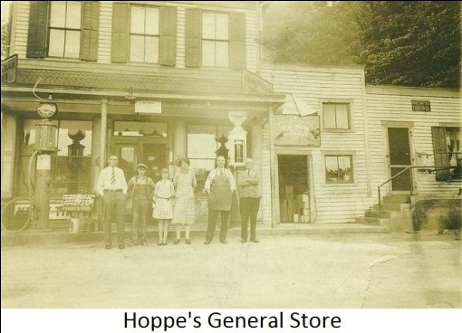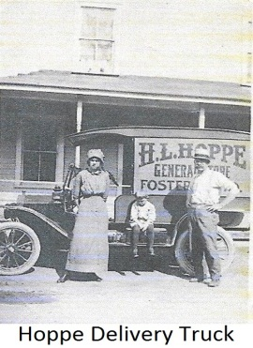
Augustus Hoppe’s son Herbert Hoppe, who now owned the old Joseph Foster store, began selling fuel, auto accessories and making deliveries with a motorized vehicle. At this time, it would be the only business selling gasoline in the town. Later, a bus stop would also be established at the business. In 1926 the road was designated to be US 22 by the Federal Highway Administration. Still a dirt and gravel surface (called a mud road in the wet seasons), the road would not be paved until 1930 and then maintained by state and local governments.
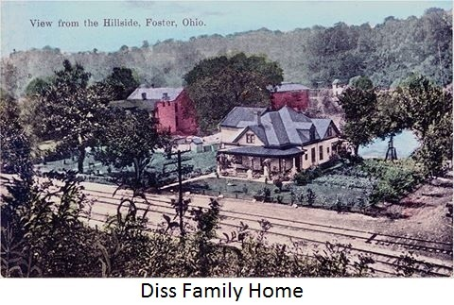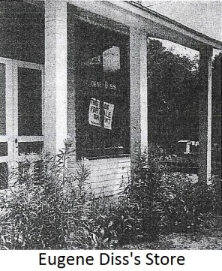
1923 Eugene Diss Sr. and his wife Luella purchased the former Foster Hotel and a store between the hotel and railroad tracks from W. Louise Braun. (Braun had purchased the property 2 years earlier from the Rohling Family.) In addition, they purchased a large frame home to the rear of the hotel and store, which was once used as a residence and boarding house. The store became a furniture store and later an antique store. The hotel continued operation and in 1934 the name was changed to The Blue Danube (a name it would retain until 1975). By 1945, Diss was a widower and sold the Blue Danube to Albert F. Fritts. However, he kept the store and home which were later passed to Eugene Diss Jr., his son.
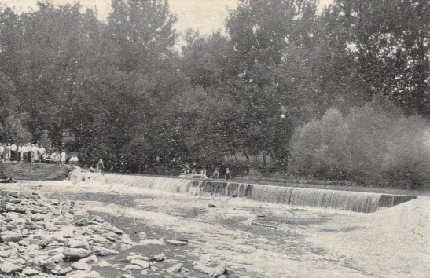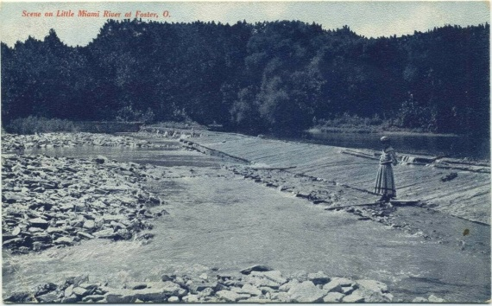
1925 Hoppe’s Island had evolved into a get-away paradise for relaxation. It had become a popular destination which provided the activities of swimming , canoeing, picnicking and dancing in a pavilion named Liberty Hall. (Part of the pavilion exists today in Carl Rahe Park.) The grist mill remained operational, but the island park became the growing business.
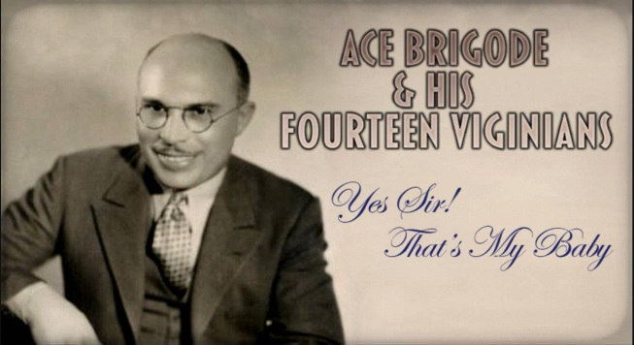
The Roaring Twenties and Jazz Age encouraged people to dance and have fun. Big Band Leader Ace Brigode managed the park for a period of time and many popular bands would be featured from around the country.
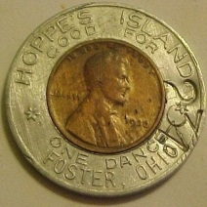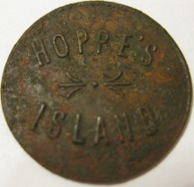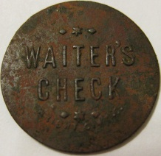
Edward Hoppe’s daughter Bernice Hallam stated, “on Sundays it was impossible for visitors to reserve a picnic table, unless at the premises as early as 5 am”.
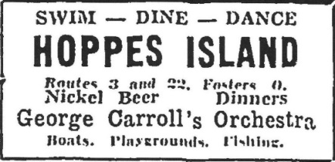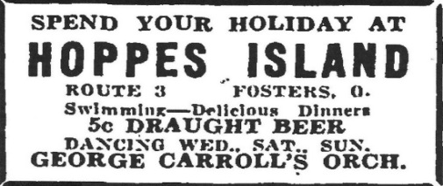
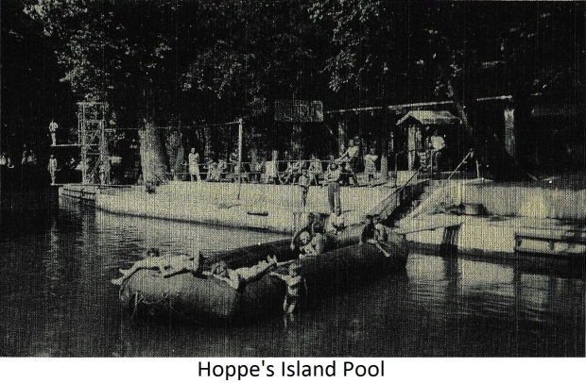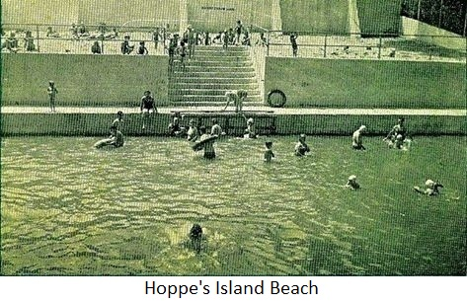
By the mid 1930’s, a swimming pool was constructed in the mill race next to the pavilion. (A swimming pool had been constructed in the river below the dam prior to this pool.) A beach area was also built (still visible in Carl Rahe Park) between the Old 3C Highway and the pool. The river supplied water not only for the mill, but also the pool. With two diving boards, steel rings suspended by chains from a steel cable extended across the pool and later two US military surplus inflatable rafts. The pool became a big attraction on the island. Tragically in 1944, Edward Hoppe lost his life in an accident at the mill. He had managed the business from 1910 (when his father August deeded it to him), a total of 34 years. The Hoppe Family continued to operate the business until 1950 when it was sold to Henry C. Caldwell.
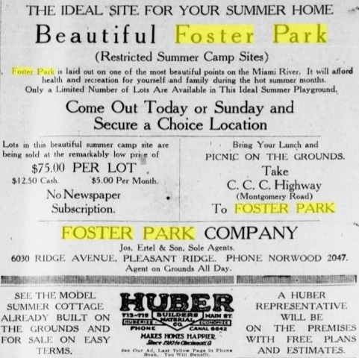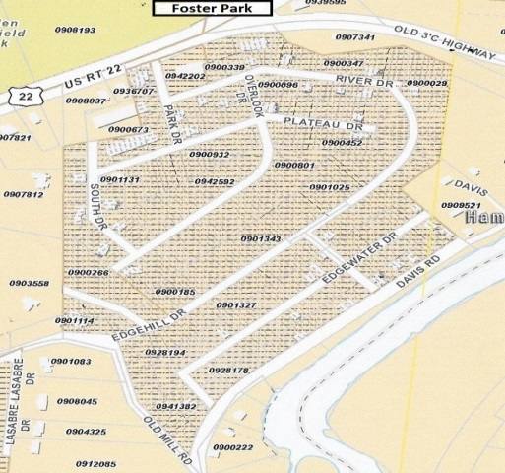
1925 The Foster Park Company advertised sites for summer homes. The main entrance began at the southwest end of the community from US 22 & 3 and portions of the development ran south to the Old Mill Road. It also, extended from the top of the hill over to Davis Road along the river. With Joseph Ertel and his son being the sole agents, the restricted summer camp sites were advertised to be the ideal sites for summer homes. Huber Builders Material Company provided a model summer home for sale on easy terms. Lots were advertised to be $75.00 with $12.50 cash down and payments of $5.00 per month.
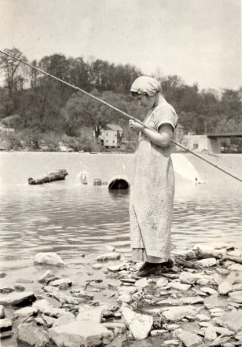
1930 On April 24 it was reported, a Closing Day Program for the Foster School Year would be held on May 17, at 1:30. The usual basket dinner would be one of the features of the program. Students who had not been tardy or absent for the year and students who made the honor roll for the past six weeks, were listed as:
ATTENDANCE HONOR ROLL
Rema Gose Rema Gose (8th grade) Elmo Testerman Elmo Testerman (7th grade) Eugene Maag Richard Juterbock (6th grade) Mildred Rhodes Mildred Rhodes & Edith Gose (5th grade) Vivian Rhodes Rachel Brenner (4th grade) Dortha Haney Adolph Leder (3rd grade) Mary E. Begley Walter Perry (2nd grade) Ruth Mastio Glen Reynolds (1st grade)
It was also announced, snake season had once again started. (An activity many students enjoyed.)

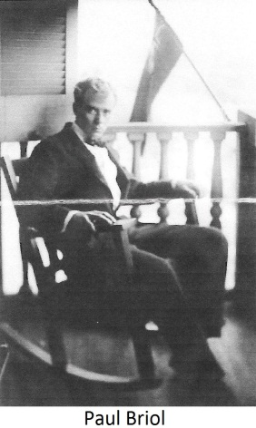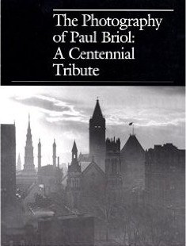
1935 Well known Cincinnati photographer, Paul Briol, purchased a cottage from Shiro Tashiro, a Japanese American UC Professor. The property was located close to the river in Foster Park, on the corner of Old Mill Road and Davis Road, near Jeremiah Morrow’s old home. Briol visited the cottage religiously on weekends from his home in College Hill and referred to it as Camp. It was decorated with a variety of national flags and lights both inside and outside the little cottage. Among his guest were people connected with the University of Cincinnati, musicians with the Cincinnati Symphony Orchestra and later immigrants and refugees from Europe (Briol spoke fluent French). By the 1940’s he was the most sought after photographer in Cincinnati. In 1950 he was seriously injured in a car accident, one mile south of Mason on US 42. Though attempting to continue his work and life style, he never fully recovered. By 1962 he moved to Katonah, New York. Today, his work is still valued and displayed.
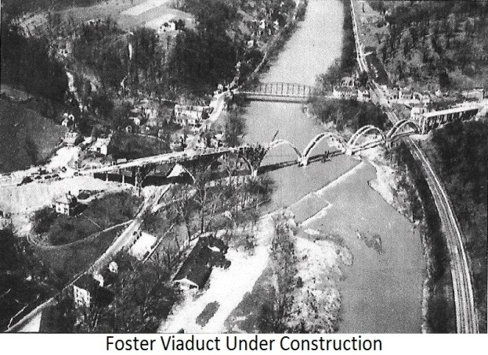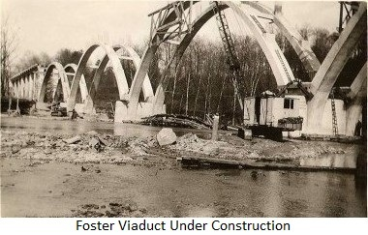
1936 Work began on the Foster Viaduct with an open-spandrel concrete rib-arch bridge design. A WPA Project, the goal was to not only facilitate the flow of traffic, but also to elevate U. S. 22 and State Route 3 out of the flood plain, thus preventing another tragedy similar to the 1913 flood.
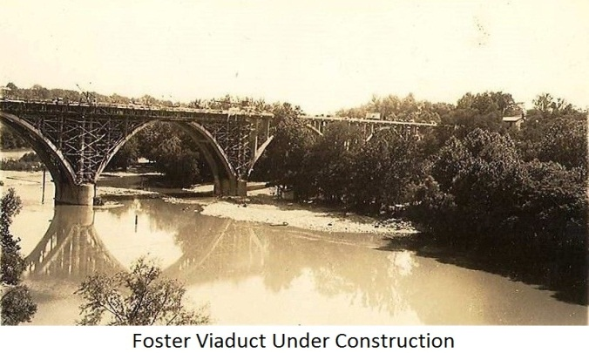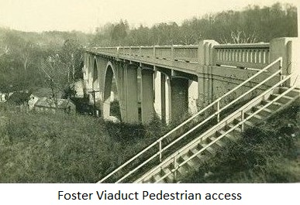
The design provided a pedestrian walkway across the bridge, with a stair access at the southwest from the Old 3C Highway and another stair access at the northeast from Foster Maineville Road. The bridge was dedicated in 1938 and the bus stop (Greyhound) was relocated from Hoppe’s store in town, to an unsheltered location at the southwest end of the viaduct. Later, a state roadside park with outdoor facilities and several picnic tables was built a short distance northeast of the Viaduct (the pull-off area is visible today). In 1991, the bridge deck was resurfaced and the walkway removed. Though the new bridge created a by-pass that would affect other businesses, Hoppe’s Island continued to enjoy its popularity.
1938 With the completion of the viaduct, resident Stella (Doan) York, a hobbyist who wrote lyrics and poetry (some of which were published), wrote a poem that reflected the feelings of most of the community.
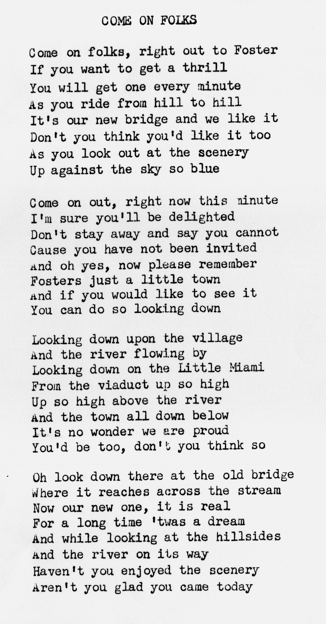
While the majority of the residents were elated and proud of the new structure, most would not realize the long term effect this bypass would have on the little community.
1944 Herbert Michael purchased the Miami Inn from Mary Elizabeth Stuemer. The property had once belonged to William S. Foster and later Postmaster George Fouche. Because of his honest dealings and compassionate nature, he was well respected in the community. His family attended the St. Paul Church in Foster where his wife, Doris, was a Sunday School Teacher. In 1971, Herbert would suffer a heart attack and die while attempting to settle a dispute between two patrons. The family sold the property to Dennis Plummer in 1973 and Plummer sold the property to Deerfield Township in 1977.
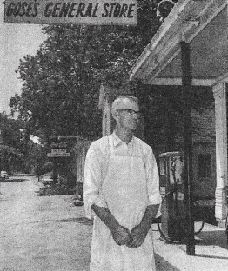
1948 Dillard and Ethel Gose would purchase what was once the Joseph G. Foster store from the Hoppe family. In 1977, Deerfield Township would purchase the property and later raze the store structure.
1949 Richard and Goldie Ashburn purchased the Maag Inn from the Maag family. The business name would be changed to Dick’s Inn.
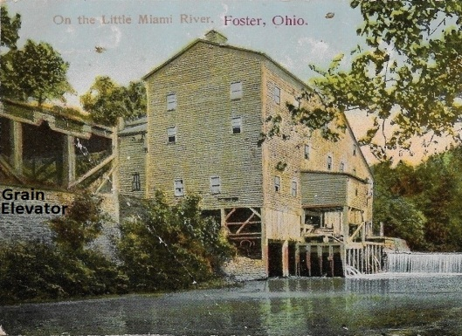
1950 Ada Hoppe, widow of Edward Hoppe, would sell Hoppe’s Island to Henry and Vivian Caldwell. The popular park continued to operate under the original name, Hoppe’s Island. Henry Caldwell converted the grain elevator (located south of the mill) into a very impressive residence with a view out over the millrace and island. While Edward was killed in an accident at the mill in 1944, tragedy would strike again in 1953, when Henry suffered a leg injury in a tree cutting accident on the island property. Shortly after, he passed away from a blood clot. The property was sold in 1953 to Glenn Irwin and Glenn Reynolds.

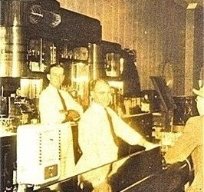
1950 Edward and Elsie Brewer purchased a business on the west side of the river that had once belonged to John Sanders. Located next to the old Obergefell’s Liberty House (later Maag Hall), they named the business, Brewer’s Fish Fry. Brewer’s fish sandwich became so popular, people often traveled from outside the little community to dine there. In 1977, Brewer would sell the property to Deerfield Township Trustee James Gould.
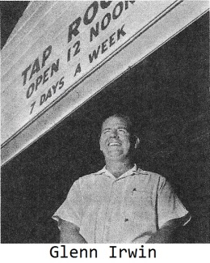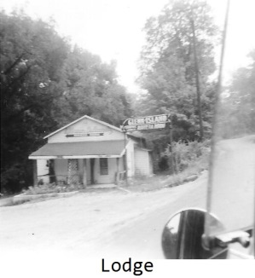
1953 Glenn Irwin and Glenn Reynolds would buy Hopppe’s Island. The name would be changed from Hoppe’s Island to Glenn Island. Glenn Irwin would later buy Glenn Reynolds’ share and become the sole owner. The Island would continue to be operated as in the past. However, the Lodge would evolve into permanent residences.
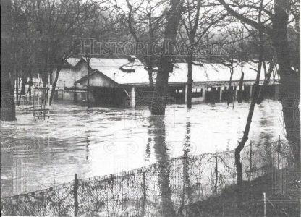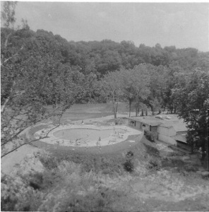
With the continued problem of spring flooding along the river, Irwin made the decision to fill the old pool (in the mill race) and construct an elevated keyhole shaped pool at the north end of the pavilion. The new pool would utilize well water and be equipped with a filtration system. As the old mill race pool was dependent on river water, the new pool had clear treated water with lighting below the water line. The main entrance would be move to the north, to accommodate his new outlay (this entrance is the same as used today at Carl Rahe Park). While the park and picnic areas remained virtually the same, the pavilion would be renovated and local popular bands would be hired to provide music for dancing.
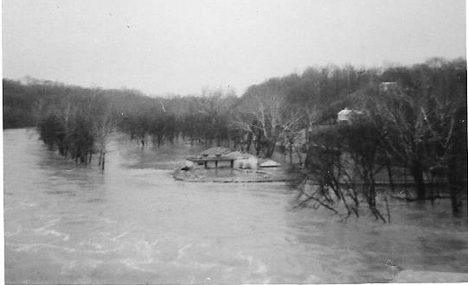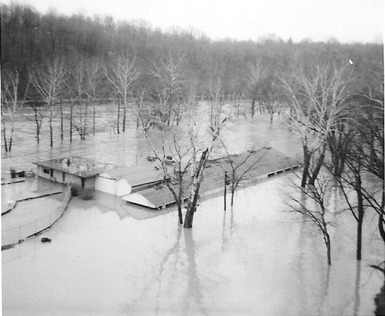
In spite of the new pool’s elevation, floods would continue to plague the property often causing extensive damage. The property would later be purchased by the State of Ohio and converted into Carl Rahe State Park.
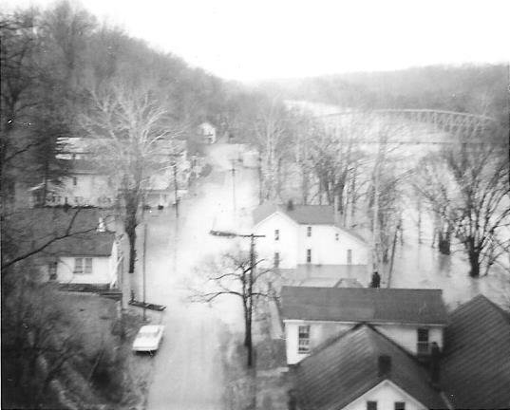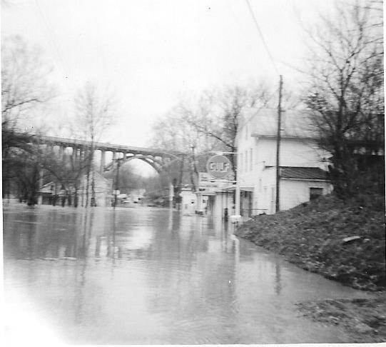
1964 The community would experience yet another flood. Though not as extensive as prior floods, it would always present businesses and residents with the same challenge of clean-up and putting their properties back in order. In addition there was a loss of trade and restricted travel during these times. Many structures would be razed and never replaced after the waters receded.
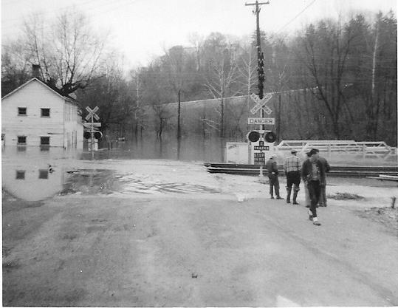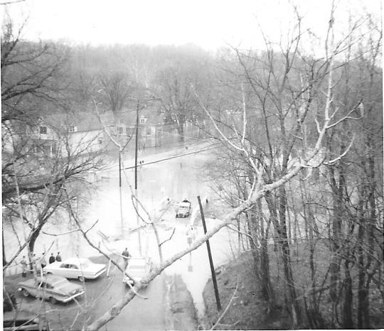
Also, on the eastside of the river, the railroad business would be interrupted when waters reached extreme levels. Ironically, the same river with its Indian paths that aided early settlement and provided water power for mills, would now become part of the community’s demise.

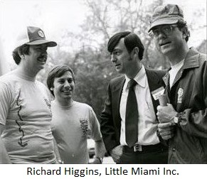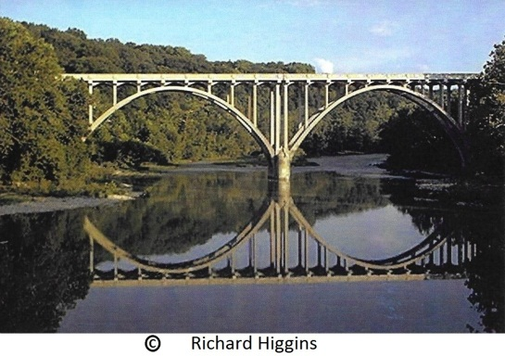
1967 Little Miami Inc. (a non- profit charitable organization) with volunteers and donations, was founded to preserve the Little Miami River. Among their goals was, not only to achieve a balance between environmental protection and economic development, but also to save the Foster river front. In 1968 the State of Ohio passed the Scenic River Act and one year later, the Ohio Department of Natural Resources designated the Little Miami River, in its entirety, to be the first State Scenic River. Also in 1968, the Federal Government passed the Federal Wild and Scenic Rivers Act. The Little Miami River through Foster was named as Ohio’s first National Scenic River in 1973.
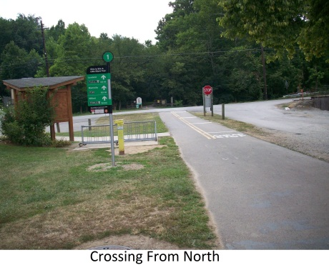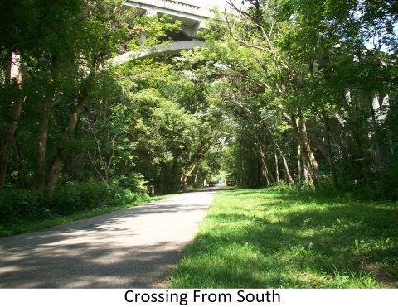
1974 Trains stopped running and in 1976 the tracks were removed. By 1979, with the efforts of Little Miami Inc., the abandoned railroad through Foster became part of the Little Miami State Park. In 1983 the Ohio Department of Natural Resources began work on a paved scenic trail. Among the Little Miami Inc. achievements were, facilitating the establishment of the Little Miami Bike Trail and Carl Rahe State Park (formerly Hoppe’s Island and later Glenn Island) in Foster. Today, known as the Little Miami Conservancy, they continue to improve and preserve the area through research and donations.
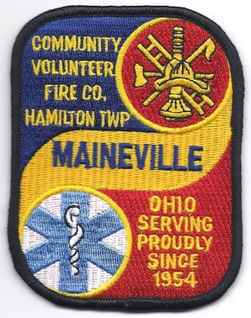
1974 On June 10 it was reported, the Maineville area Assistant Fire Chief, Wilmo (Bill) Testerman lost his life at Foster. The volunteer squad was leaving the scene of a fire at the Glenn Island Wharehouse when Testerman tripped and fell in front of one of the trucks he was directing back onto the roadway. He was a charter member of the Maineville Emergency Squad and owner of a grocery store in Maineville. He also was the Hamilton Township Clerk. (Later, Hamilton Township would name Testerman Park in his honor.)
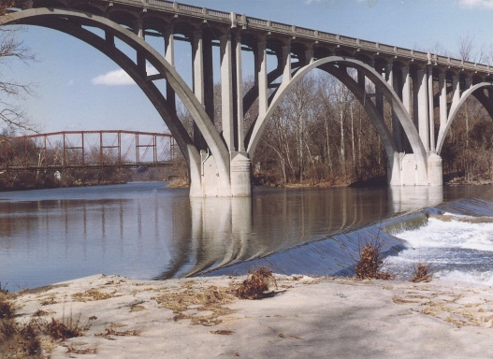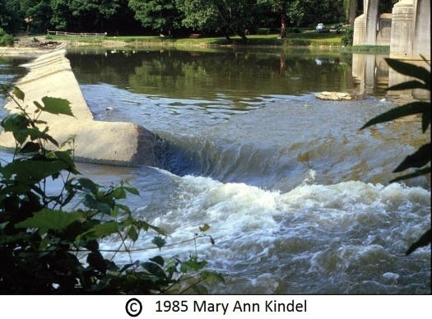
1984 The dam in the river at Foster was decommissioned by the Ohio Department of Natural Resources. It was felt that restoring the river to its natural free flowing state would augment the river’s ecology and improve recreational opportunities. However, the primary reason was safety, as low head dams were viewed as drowning machines. The river had increasingly become very popular for activities such as canoeing trips and the dam was not only partially breached, but also in poor condition. In 1985 the Army Corps of Engineers began to lower the river level by controlling the discharge of water from the Caesar Creek Reservoir (built in 1973 for flood control) and the dam was removed.

