**Today I worked on:**

**I made progress with:**

Today’s Date: Mon Tues Wed Thurs Fri / /

**Bathroom:**

* Used
* Changed
* Accident

**I ate:**

**Notes from Home:**

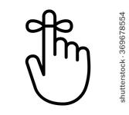 **Friendly Reminders:**

**I had trouble with:**