RAGU BOLOGNESE
FLIGHTS BY JIMMY

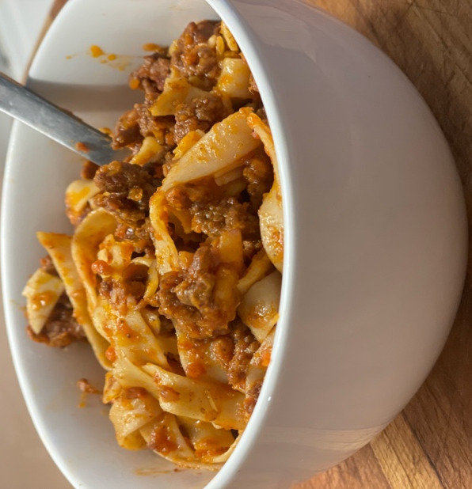
Bolognese with ½” egg noodles

Ragu bolognese is a dish that has a lot of memories for me. I first fell in love with ragu bolognese in Destin, Florida, where I was stationed at Hurlburt Field. I spent about 10 years there with Air Force Special Operations. There is a restaurant in Destin called La Famiglia which I would frequent quite often. I became good friends with the proprietors daughter, Michaela. On many evenings after flying, I would sit at the restaurant bar and eat a bowl of bolognese and chat with the family.
This is nearly an all-day dish and at a minimum, 4 hours are required. The long simmer of the beef with the white wine and milk is what gives bolognese its distinct flavor. There are a couple important tips to making a superb ragu bolognese.
- Use a high fat content ground beef of about 20%. This makes the richness of the dish.
- Cream or half and half will take this dish to the next level.
- Wider pasta will make the mouth-feel of this dish nice.

Ragu Bolognese
Serves 10
2 hrs of work concurrently with about 4 hrs of cooking (not going to sugar coat it, set aside at least half of a day)

Ingredients
¼ C EVOO
¼ C butter
2 C each finely chopped or coarsely grated
Onion
Celery
Carrot
7-8 cloves garlic, minced
3 lbs ground beef, 20% fat
½ lb pancetta diced
8 oz tomato paste
1 C whole milk
½ C half and half or cream
1 ½ C white wine
Salt for sprinkling on both sides of ground beef
1.5 Lbs wide pasta (weight before cooking)

Tools
Extra large, wide pan (I used a 14” frying pan)
Food processor (makes things easier, but not required)

- Slowly heat pan with 2 Tbsps EVOO.
- Dice or coarsely shred vegetables and saute’ until onions are translucent.
- Remove most of the vegetables then saute’ the pancetta. Salt the ground beef, add remainder of EVOO and brown with the pancetta on high heat for about 15-20 min. Be sure to dice up the ground beef in the pan.
- Return vegetables to the pan and combine with meat. Turn heat to med-low and continue to saute’ for about 30 min.
- Add tomato paste and sauté for about 20 min.
- Add milk products and sauté for about an hr.
- Add wine and continue to sauté for another 1 ½ hrs. Be sure to add a bit of water if sauce becomes too dry.
- Cook pasta.
- Combine completed pasta and sauce. Hold some of the sauce in reserve if you don’t want to overwhelm the pasta. Add a bit of pasta boiling water to loosen up the bolognese. SERVE!

Recipe by Jimmy, www.flightsbyjimmy.com
Adapted from Mario Batali.

