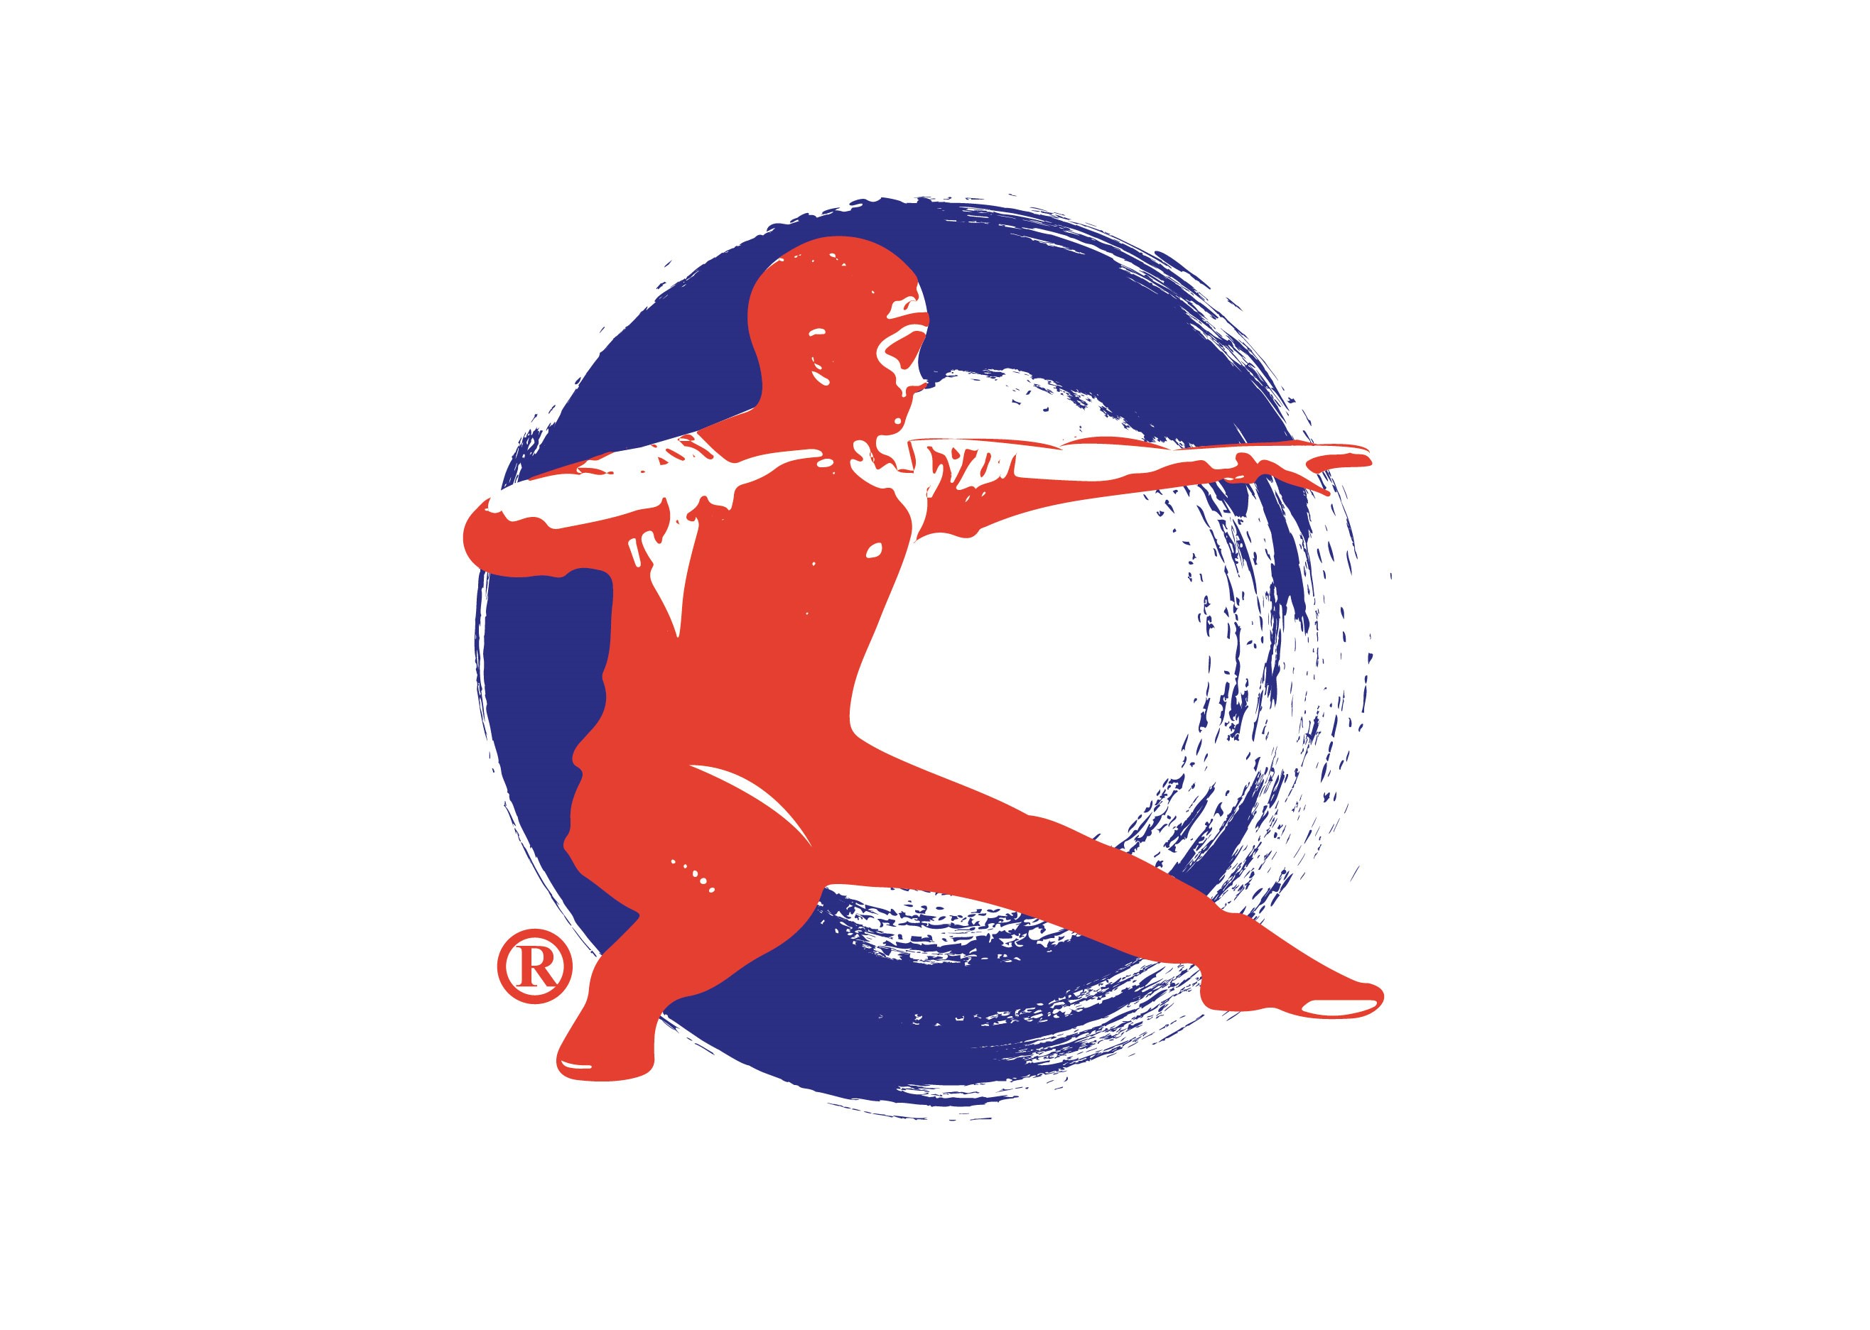

Old Frame Version-1
1. Commencing Form 2. King Kong Pounds Mortar
3. Grasp the Robe 4. Close & Seal
5. Single Whip 6. King Kong Pounds Mortar
7. The Crane Spreads Wings 8. Step Obliquely
9. Brush Knees 10. Wade Forward
11. Step Obliquely 12. Brush Knees
13. Wade Forward 14. Parry & Punch
15. King Kong Pounds Mortar 16. Flinging Fists
17. Dragon Bounce 18. Push Hands
19. View Fist from Elbow 20. Reverse Arms
21. Crane Spreads Wings 22. Step Obliquely
23. Shoulder Throw 24. Parry & Punch
25. Close & Seal 26. Single Whip
27. Cloud Hands 28. High Pat the Horse
29. Right Foot Kick 30. Left Foot Kick
31. Left Heel Kick 32. Wade Forward with Palm Strikes
33. Strike the Ground 34. Double Kicks
35. Heart Guarding Fist 36. Whirlwind Kick
37. Right Heel Kick 38. Parry & Punch
39. Capture Grip 40. Push The Mountain
41. Close & Seal 42. Single Whip
43. Front Hack 44. Rear Hack
45. Split the Horse Mane 46. Close & Seal
47. Single Whip 48. Fair lady works at the shuttle
49. Grasp The Robe 50. Close & Seal
51. Single Whip 52. Cloud Hands
53. Fall & Bounce 54. Rooster Stand
55. Reverse Arms 56. Crane Spreads Wings
57. Step Obliquely 58. Shoulder Throw
59. Parry & Punch 60. Close & Seal
61. Single Whip 62. Cloud Hands
63. High Pat The Horse 64. Cross Legs
65. Palm Against Fist 66. Monkey Picks Fruit
67. Single Whip 68. From Bird to Dragon
69. Step Up For Stars 70. Step Down To Ride a Tiger
71. Turn Round with Lotus Kick 72. Canon Fists
73. King Kong Pounds Mortar 74. Closing Form Published 201009

