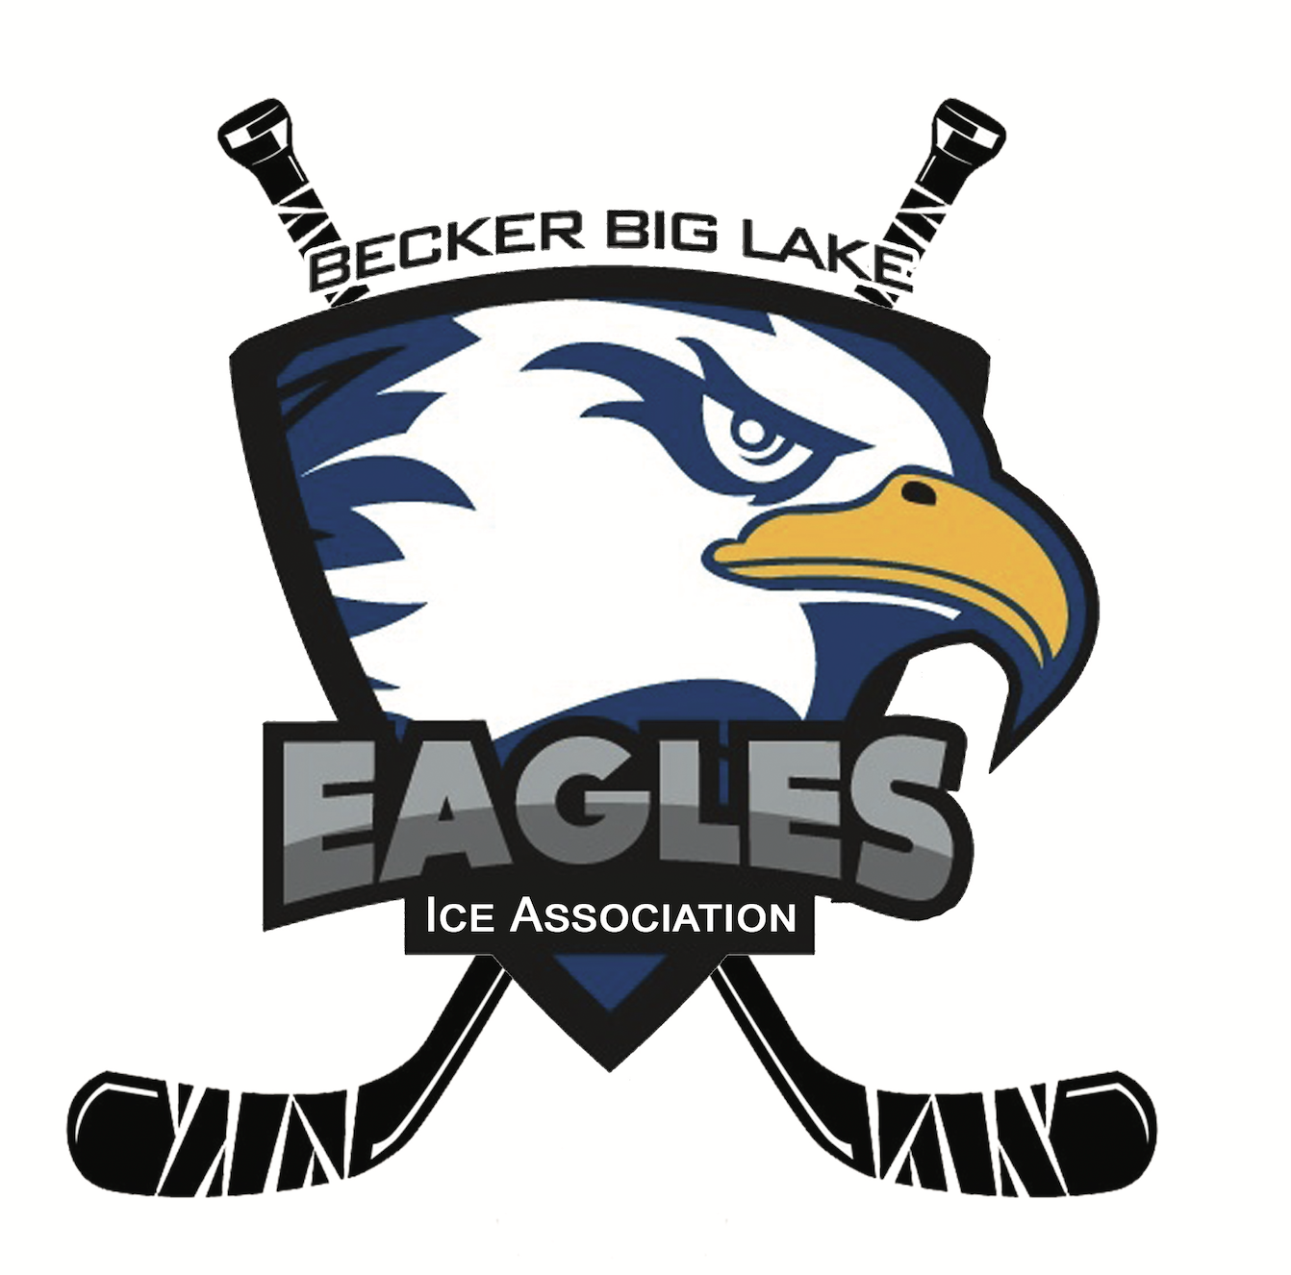
Becker Big Lake Ice Association
Meeting Minutes | November 2, 2025
6:30 p.m. - Monthly Meeting
Getaway Bar - Orrock, MN

Call to Order
Meeting was called to order at 6:34 pm by BBLIA Board President Dave Nelson.

Roll Call
Board Members Present: Rick Katka, Kris Knodle, Corey Nundahl, Dave Nelson, Melissa Clausen, Alan Heidemann, Sam Warren, Matt Brausen, Kasey Buck

Agenda Review
No changes made to the meeting agenda.

Meeting Minutes Approval
See October 5, 2025 meeting minutes for review and approval. Motion to approve made by Corey Nundahl. Seconded by Alan Heidemann. All in favor. Approved.

Member Applications
No applications.

Open Forum
BBLYHA Squirt Request
The Squirt C team is requesting approximately $500 for pins for their international tournament. Discussion about how players have pins and trade them during the tournament. Parents have paid for these in past years. BBLIA does not approve this request since we already donate to BBLYHA each year and we cannot take individual team requests.

Gambling Updates
Manager Report- Nicole Lane
- See 12-2025 Gambling Report and Manager Notes for info and expenses approval.
  - Specialty bingo at the Getaway on Nov. 1 went very well. Nicole is working with Dueling Brews for their next specialty bingo date.
  - September was our first monthly revenue of $1 million!
  - Nicole will be switching to give donations at the end of the month, instead of the beginning, to not overgive before all expenses.
  - The MN Department of Revenue audit is in progress and should be done by mid-November.
  - Discussion about wanting to see end of month actual spending from previous month vs. budgeted. The board is not aware how much gets spent on each line item vs. what is budgeted. BBLIA is not worried about the spending and would just like a better understanding.
  - Discussion about allowable expenses. Same as usual.
    - Motion to approve allowable expenses made by Matt Brausen. Seconded by Melissa Clausen. All in favor. Approved.

Treasurer Report
Balance: $538, 579.02
- Statement attached later
- Taxes are completed by Turning.
- We need to pay $25 to the state to renew our non-profit status.

Campaign Steering Committee
Communications Plan Updates
- Dave spoke with most bar owners, except Trails, and all seems to be well with potential land change to Becker
- Dave spoke with SpudFest and Raeanne seemed to understand the position. Follow up email was sent.
- Sam attended the BBLYHA meeting and everyone seemed receptive. No big questions were asked.
- Upcoming: Dave and Alan are meeting with the Big Lake city members and Corey is meeting with the Becker mayor.

Discussion about potentially doing more advertising for our gambling locations, especially if we move to Becker. Could we get their logos on the boards in Princeton? How much would this cost? Dave will get these exact costs. Future topic at next meeting.

Lawyers & Gift Agreement Updates
- Kristi received two quotes from lawyers that she trusts and got advice from with our situation. She recommends hiring Spencer Fane since their firm will have many employees with different specialties.
- All lawyers suggest that BBLIA creates an LLC holding company to accept the land as a gift. They will help us complete this.
- Motion to hire Spencer Fane as the BBLIA attorney, spending up to $8,000 to create our LLC and deal with all contracts and negotiations of the gift agreement, made by Dave Nelson. Seconded by Rick Katka. All in favor. Approved.

Facility & Construction Committee Updates
Building committee will schedule a meeting to review ISG contract and determine whether we should hire different architects. We will also request that Spencer Fane look over the ISG contract to confirm that we can switch.

Community Events Updates
Sportsmen’s Raffle
- Kris has all of the prizes confirmed from Scheels.
- All tickets were distributed. Each BBLYHA was given 1 book per player and 5 extra. Each family gets 2 hours of volunteer time per book sold and for every 3 books sold, player gets entered into a raffle for a pair of Wild tickets.
- Turn in by December 1.

Party Bus Event Recap
- Approximately 20 people attended and the feedback from the bars was positive.
- Final invoice needs to be paid for the bus
- This event lost money but helped us market our gambling locations and cause.

Future Topics
Gambling location advertising
Sportsmen's raffle

Next Meeting
Sunday, November 30 at 6:30pm at Getaway

Adjournment
Motion to adjourn meeting by Rick Katka. Seconded by Sam Warren. Meeting adjourned at 8:08pm.

