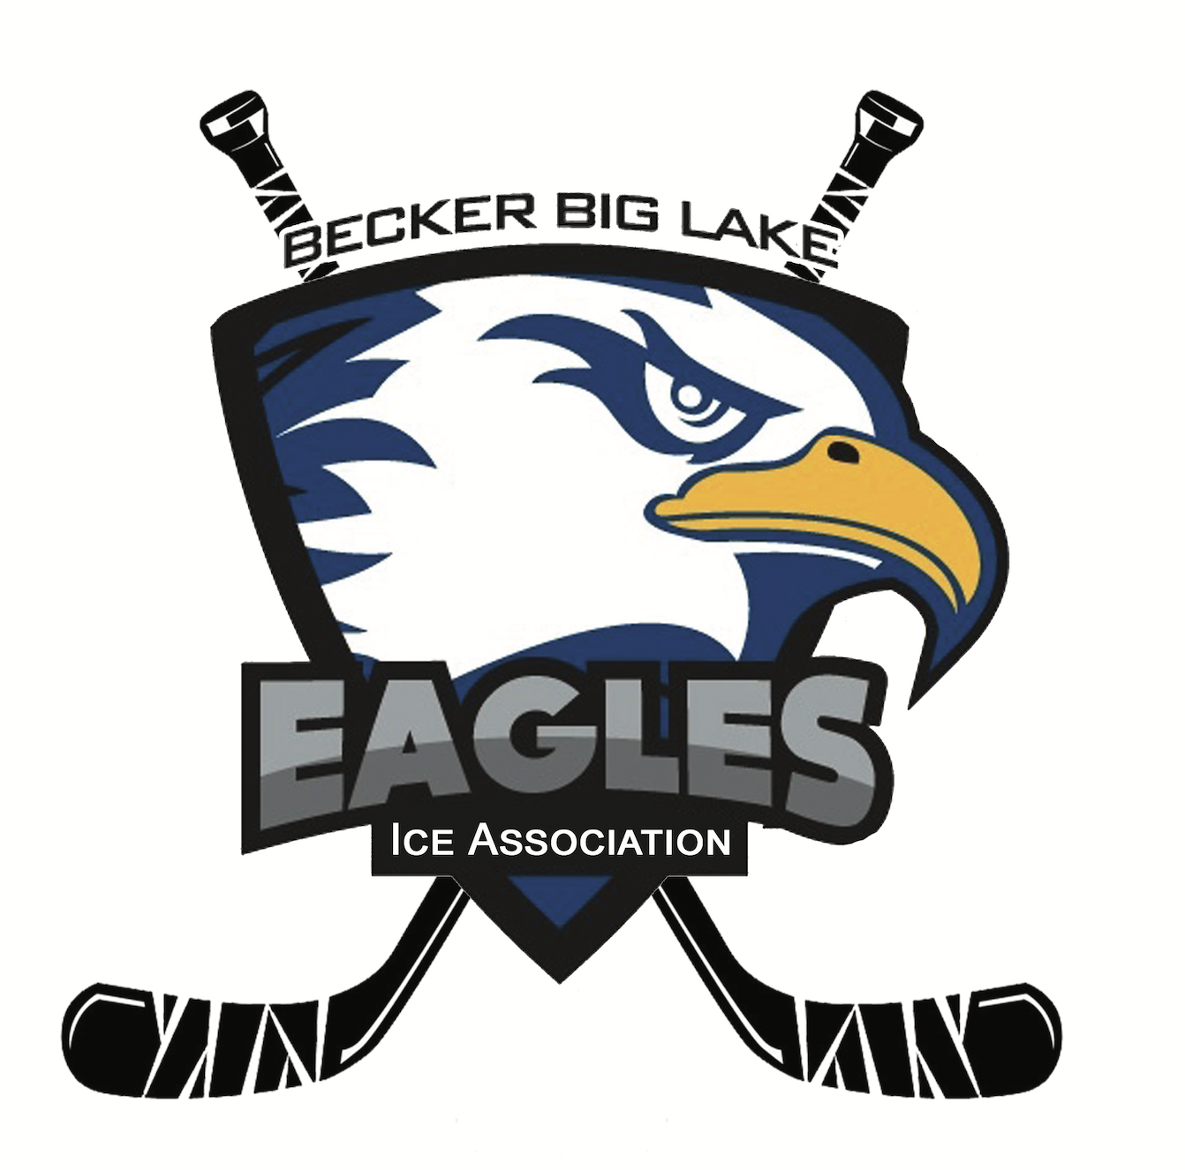 **Becker Big Lake Ice Association**

**Meeting Minutes | October 8, 2024**

6:00 p.m. - Monthly Meeting

McPete’s Bar & Lanes - Big Lake, MN

**Call to Order**

Meeting was called to order at 6:05 pm by BBLIA President Dave Nelson

**Roll Call**

Board Members Present: Dave Nelson, Melissa Clausen, Sam Warren, Alan Heidemann, Corey Nundahl, Matt Brausen, Rick Katka, Kris Knodle

Association Members Present: Nicole Lane, Kasey Buck, Karlee Buck, JJ Storland, Emily Korbel

**Agenda Review**

No changes made to the meeting agenda.

**Meeting Minutes Approval**

See [September 8, 2024 meeting minutes](https://docs.google.com/document/d/13HeDle4KNO8tDAZoUuwbnrs1T0JwGDeTQTAJglgH_8c/edit?usp=sharing) for review and approval. Motion to approve by Alan Heidemann. Seconded by Corey Nundahl. All in favor. Approved.

**Member Applications**

No new members.

**Open Forum**

Sno Cruisers Donation Request

Big Lake Sno Cruisers is requesting $350 for their youth safety day on December 14. They previously received funding from the Elk River Lions but are asking us since we are now at the Getaway.

* Motion to approve $350 donation from the general account to the Sno Cruisers made by Dave Nelson. Seconded by Kris Knodle. All in favor. Approved.

EIN Issue

Reinstatement date is not listed on our EIN number/document for some unknown reason. This means we do not qualify for some corporate giving programs, as it codes as an error. Dave will contact the state to get this problem resolved.

**Gambling Updates**

Manager Report- Nicole Lane

* See [10-2024 Gambling Report](https://drive.google.com/file/d/1j-Guza7yf0vYnVzPDytquRaFwyinNjwJ/view?usp=sharing) for info and expenses approval.
  + Overall, gambling going well and picking up as it gets colder
  + Discussion about allowable expenses. Nicole wants to donate $10,000 to the general fund and we also need more money for purse bingo, now that we are having two.
    - Motion to approve allowable expenses, with spending of up to $6,000 on bingo prizes, made by Rick Katka. Seconded by Corey Nundahl. All in favor. Approved.

Locations

* Dueling Brews
  + Purse Bingo on November 9 at 1pm.
* The Getaway Bar
  + Purse bingo on November 3. Nicole will get details and send to Sam for promotion.
  + Discussion about individuals not associated with BBLIA trying to do some side gambling operations. Nicole will address this with Jenni, as we cannot allow that to happen on our premise.
* Lupulin Brewing
  + Business as usual.
* Trails
  + Slightly down in income due to multiple large winners
* Damstrom’s Bar & Grill
  + Off to a good start.

Discussion about starting search for assistant gambling manager. Nicole and Dave will meet to discuss details and being working on an employee description.

**Treasurer Report**

Balance: $303,583.89

* [See September 30, 2024 statement](https://drive.google.com/file/d/1NxxsjPBCmlLzJ8EHppn7iTJbr0cpCOGR/view?usp=sharing)

Sherburne State Bank Meeting Update

They were excited to hear about BBLIA progress and inquired about our plans for a capital campaign. The next steps are to officially move over our bank account and set up a CD account. Options for this were presented and discussed.

* Motion to move both general and gambling accounts to Sherburne State Bank made by Matt Brausen. Seconded by Melissa Clausen. All in favor. Approved.
* Motion to make Dave Nelson, Rick Katka, and Melissa Clausen signers on the general bank account at Sherburne State Bank, made by Kris Knodle. Seconded by Sam Warren. All in favor. Approved.
* Motion to make Dave Nelson, Rick Katka, Nicole Lane, and Melissa Clausen signers on the gambling account at Sherburne State Bank, made by Sam Warren. Seconded by Corey Nundahl. All in favor. Approved.

**Secretary/Comms Update**

No updates.

**Building Update**

Big Lake City Meeting Update

Dave met with city officials and the mayor. They seem not interested in assisting with funding or backing of a loan. Discussion about how this impacts our plans and other possible routes of funding. We cannot get support from senators without city backing.

Capital Campaign Consultant Update

Michael Davy is not interested. Board met with Growth by Design (GBD) and was presented a proposal. GBD went over the proposal during this meeting and allowed for questions. Total cost will be $58,000 for Phase 1 (community re-engagement) and Phase 2 (feasibility study). Both of these will take approximately 9 months to complete collectively. Board met with GBD again with more questions and what Phase 3 (campaign) would look like. Discussion about overall feelings on GBD as a company, what our next steps need to be, and moving forward. Collective agreement that community re-engagement is our next best step and we need to begin this process.

* Motion to hire Growth By Design as consultants, with November 15 start date, for $58,000 to complete Phase 1 and 2 in their proposal made by Sam Warren. Seconded by Corey Nundahl. Rick Katka abstained from voting. All others in favor. Approved.

Discussion about potential land in Becker, as mentioned by a school board member. Next step would be to have a meeting with Beckery city and schools to see if this would even be a possibility.

Discussion about redoing our website. Corey will contact someone for a quote.

**Government Update**

No updates.

**Fundraising Update**

Gun Raffle

* Live drawing: December 14 at the Getaway
* 570/2000 tickets in circulation
* Tickets being sold at Dueling Brews, Getaway, and Damstroms

Pours for a Purpose

* November 14 at Lupulin
* Wear a hockey jersey to enter a raffle for a Ryan McDonaugh signed stick.

**Action Items**

Meet with city of Becker

Meet with Becker superintendent

Get quote for website redesign

Resolve EIN number issue

**Future Topics**

Capital Campaign

Gun Raffle

Website redesign

**Next Meeting**

Sunday, November 3 at 6:30pm at the Getaway Bar

**Adjournment**

Motion to adjourn meeting by Sam Warren. Seconded by Alan Heidemann. Meeting adjourned at 7:42pm.