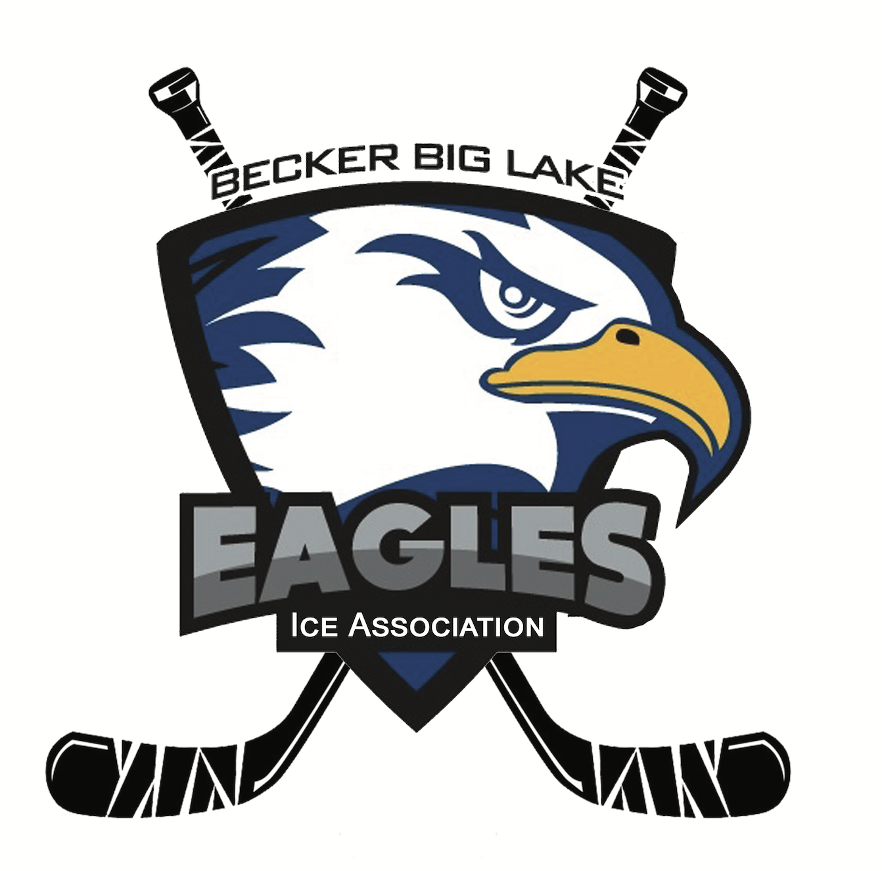 **Becker Big Lake Ice Association**

**Meeting Minutes | July 1, 2024**

6:30 p.m. - Monthly Meeting

McPete’s Bar & Lanes - Big Lake, MN

**Call to Order**

Meeting was called to order at 6:35 pm by BBLIA President Dave Nelson

**Roll Call**

Board Members Present: Dave Nelson, Melissa Clausen, Matt Brausen, Sam Warren, Alan Heidemann, Corey Nundahl

Board Members Absent: Kris Knodle, Rick Katka, Lindsay Wiborg

Association Members Present: Nicole Lane

**Agenda Review**

No changes made to the meeting agenda.

**Meeting Minutes Approval**

See [June 2, 2024 Meeting Minutes](https://docs.google.com/document/d/19KNla5sIWn8x9YdWjmslBHUskAYdF2ErzG8BDagKwGc/edit?usp=sharing) for review and approval. Motion to approve by Alan Heidemann. Seconded by Melissa Clausen. All in favor. Approved.

**Member Applications**

Mirella Dalla Venezia. Motion to approve as association member made by Dave Nelson. Seconded by Corey Nundahl. All in favor. Approved.

**Open Forum**

Property Sign

Alan spoke to Lucinda on the Big Lake council and the sign can be 4x8 ft. maximum. Dave will create a draft for the next meeting and Alan will look into the permit process. Discussion about design and potential solar powered lights.

**Gambling Updates**

Manager Report- Nicole Lane

* See [7-2024 Gambling Report](https://drive.google.com/file/d/17Vtw2nbjr8gogXsy51i4gdb8g4sGKhEM/view?usp=sharing) for info and expenses approval. Summer slowdown continues.
  + Discussion of allowable expenses.
  + Motion to approve allowable expenses made by Dave Nelson. Seconded by Sam Warren. All in favor. Approved.

Locations

* Dueling Brews
  + eTab winner of $4000 so we are negative this month. Discussion about how that process works and pay outs.
* The Getaway Bar
  + Bingo going well. Nicole will be purchasing a security camera for the booth. Approved at prior meeting.
  + Gun raffle will be here in December. Potential date of December 14.
* Lupulin Brewing
  + November 14: Pours for a Purpose event for BBLIA. Need beertenders.
* Trails
  + Going well. No ownership changes yet.
* McPete’s
  + Ownership change has occurred. Dave will reach back out and touch base with them soon.

**Treasurer Report**

Balance: $218, 446.67

* [See June 26, 2024 statement](https://drive.google.com/file/d/1RzAqkpqg5r0e6-lPoat6yD88sdLqTpJV/view?usp=sharing)

Discussion about opening some sort of money marketing account and/or higher interest yield account. Melissa will talk to Nate Martinson about this and board will pursue options.

**Secretary/Comms Update**

2024-2025 membership fees are due: $5 per person.

**Building Update**

ISG sent new building renderings but have not sent an updated budget yet. Waiting on this for further discussion.

**Government Update**

No updates. Planning to reconnect with Senator Mekeland soon.

**Fundraising Update**

Golf Tournament

First teams are signed up. Bison Custom Tile sponsored both beer carts. Discussion about securing more sponsors and getting donations for auction/raffle.

Discussion about printing sponsor signs and banners. Dave will order from RPM Graphics near him for $8 per yard sign and $80 per banner. Need high resolution logos for signs. Sam will create these, drop in a Drive folder, and send to Dave.

Fundraising meeting tentatively on July 22 at 6:30pm at Lupulin.

Reminder about Pours for a Purpose event on November 14. Discussion about making it another “hockey night” and reserving the event space. Sam will contact them and ask.

**Future Topics**

Golf Tournament Recap

Yard Sign Update

Gun Raffle Date

**Next Meeting**

Sunday, August 4 at 6:30pm at The Getaway.

**Adjournment**

Motion to adjourn meeting by Sam Warren. Seconded by Alan Heidemann. Meeting adjourned at 8:06pm.