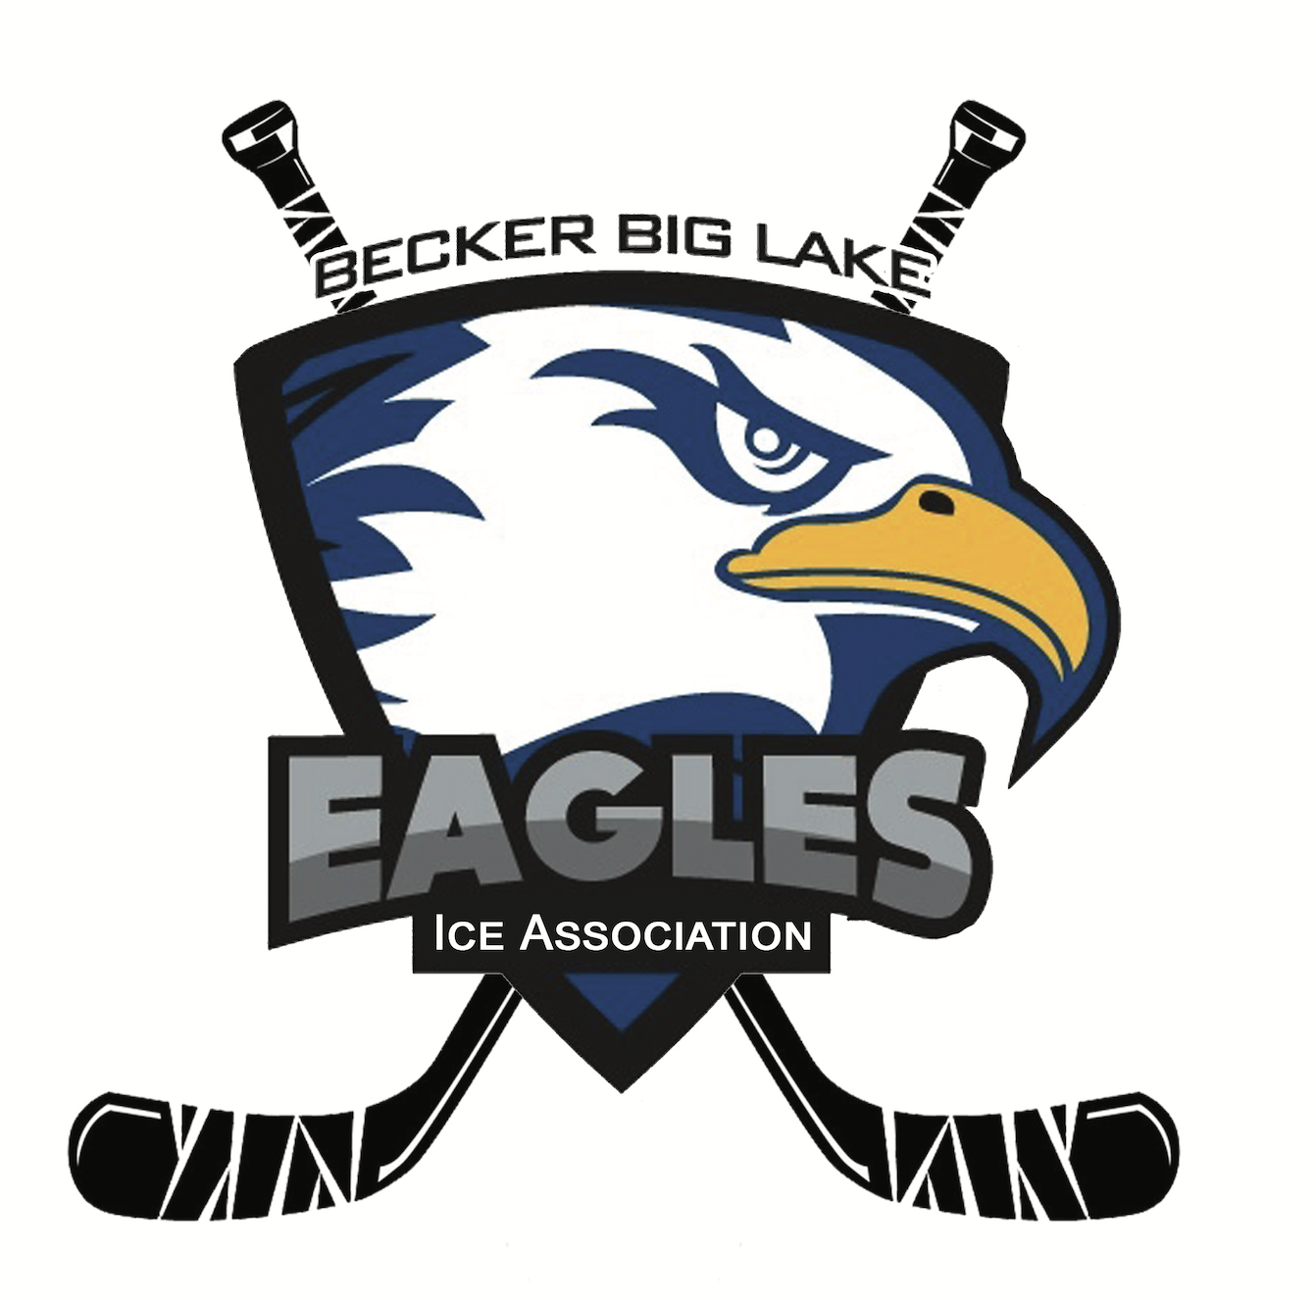 **Becker Big Lake Ice Association**

**Meeting Minutes | December 8, 2024**

6:30 p.m. - Monthly Meeting

Getaway Bar - Orrock, MN

**Call to Order**

Meeting was called to order at 6:33 pm by BBLIA Vice President Corey Nundahl

**Roll Call**

Board Members Present: Sam Warren, Corey Nundahl, Matt Brausen, Rick Katka, Kris Knodle, Kasey Buck

Board Members Absent: Dave Nelson, Melissa Clausen, Alan Heidemann

Association Members Present: Emily Korbel, Kara Knodle, Karlee Buck, Travis Korbel, Nicole Lane

**Agenda Review**

No changes made to the meeting agenda.

**Meeting Minutes Approval**

See [November 3, 2024 minute](https://docs.google.com/document/d/1EO7qBPTU09mp1iFdJ1D8mO5CFFp0wJ5IRuvax3_tE1I/edit?usp=share_link)s for review and approval. Motion to approve by Kris Knodle. Seconded by Sam Warren. All in favor. Approved.

**Member Applications**

None.

**Open Forum**

Hockey Fights Cancer fundraiser game is set for February 7 as a general notice.

**Gambling Updates**

Manager Report- Nicole Lane

* See [12-2024 Gambling Repor](https://drive.google.com/file/d/1LvahYY5Mgn34IiAfOFQbxz-OfPpwkoaC/view?usp=share_link)t and [Manager Notes](https://docs.google.com/document/d/1a-iF7IQ0yyqmfOpM7yFtYmjwe3Lz-8vF/edit?usp=share_link&ouid=112205853646934414828&rtpof=true&sd=true) for info and expenses approval.
  + Overall, gambling going well and picking up as it gets colder
  + Purse bingos went well at Damstroms, Lupulin had the highest eTab deposit yet, and new receivers were installed at the Getaway for better reception. Discussion about potential options after the New Year and working with bar owners.
  + Nicole attended the charity conference and learned about co-meat raffles. Discussion about reaching out to some smaller groups to help run our meat raffles and split profits. Kris will ask some Big Lake groups for interest.
  + Discussion about allowable expenses.
    - Motion to approve allowable expenses made by Matt Brausen. Seconded by Rick Katka. All in favor. Approved.

Nicole will be writing a draft assistant gambling manager position posting for review.

**Treasurer Report**

Balance: $315, 483.89

* [See November 29, 2024 statement](https://drive.google.com/file/d/1GNeU7pJawO96z3wiz5utaFAqS7PLzdHZ/view?usp=share_link)

**Secretary/Comms Update**

No updates.

**Building & Campaign Update**

Capital Campaign Consultant Update

Discussion and recap of meeting with Growth By Design. Sam will send out homework specifics to the board, due December 15. Do they have ideas on how to grow list of stakeholders via others involved in hockey?

Discussion about asking ISG to scale back plans again and reduce costs.

**Government Update**

Amateur Sports Commission

Kasey contacted them and she’s meeting with them on Thursday. Their primary goal is to expand sports in areas that need it.

Kris was selected to the Big Lake economic development committee. Hopefully, he can garner support from more city officials.

**Fundraising Update**

Gun Raffle

* Live drawing: December 14 at the Getaway
* 1200/2000 tickets are out, with only 200 turned in so far
  + Make sure to talk to players to return sold and unsold tickets
* $1,000 Scheels gift card raffle for those in attendance. Purchase for $10/ticket
* Discussion about event plan and arrival time. Board should arrive around 5pm, with drawing at 7pm.

**Action Items**

Complete GBD homework by December 15

Meet with Amateur Sports Commission

**Future Topics**

Capital Campaign

Gun Raffle Recap

Amateur Sports Commission

**Next Meeting**

Sunday, January 12 at 6:30pm at Getaway Bar

**Adjournment**

Motion to adjourn meeting by Rick Katka. Seconded by Sam Warren. Meeting adjourned at 7:27pm.