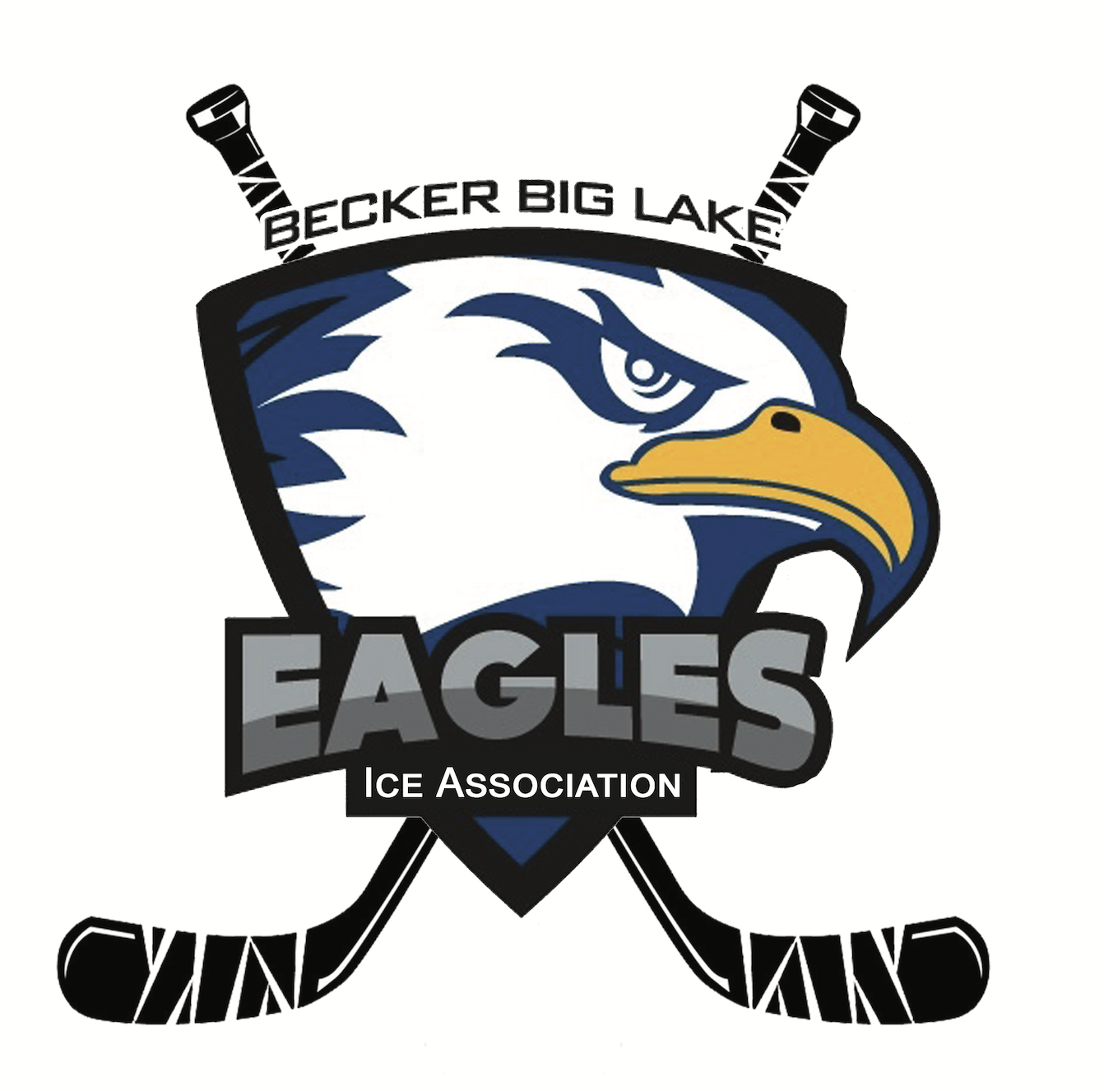 **Becker Big Lake Ice Association**

**Meeting Minutes | January 23, 2025**

6:30 p.m. - Monthly Meeting

Getaway Bar - Orrock, MN

**Call to Order**

Meeting was called to order at 6:34 pm by BBLIA President Dave Nelson

**Roll Call**

Board Members Present: Sam Warren, Corey Nundahl (phone), Matt Brausen, Rick Katka, Kris Knodle, Kasey Buck, Dave Nelson, Melissa Clausen, Alan Heidemann

Association Members Present: Kara Knodle, Nicole Lane

**Agenda Review**

No changes made to the meeting agenda.

**Meeting Minutes Approval**

See [December 8, 2024 meeting minutes](https://docs.google.com/document/d/1Pa7TvuYfb3KhdbBZw3PZtkhwrrOL3ijr0fAbmE904IE/edit?usp=sharing) for review and approval. Motion to approve by Kris Knodle. Seconded by Melissa Clausen. All in favor. Approved.

**Member Applications**

Sadie Bjork

Motion to approve Sadie Bjork as association member made by Alan Heidemann. Seconded by Dave Nelson. All in favor. Approved.

**Open Forum**

Assistant Gambling Manager Position

* Nicole and Dave drafted an application. Dave will post on indeed and send to Sam for promotional purposes
* This position will largely do the in-person, day to day tasks and Nicole will continue to do bookwork
* Tentatively paying $1050 per month. Tentative schedule to take applications and do interviews in February. Final interview with board in March, start as early as April 1.
* Motion to approve up to $200 on job marketing post made by Dave Nelson. Seconded by Matt Brausen. All in favor. Approved.

Elk River Youth Association

* Corey met with president of the ERYHA and they are very interested in helping back our rink financially.
* Amount is dependent on how much ice we can give them and the agreement. ER says they can easily take 10 hours of ice time per week.
* Discussion about potential amounts and what an agreement would look like. Corey is planning to meet with more people involved and talk with Anoka rink board on what they did, too.

Big Lake Community Fair- March 15

Sam asked GBD if we should attend. They said yes- good opportunity to invite folks to the town hall meetings.

* Motion to spend $150 on big lake community fair made by Rick Katka. Seconded by Sam Warren. All in favor. Approved.

**Gambling Updates**

Manager Report- Nicole Lane

* See [1-2025 Gambling Report](https://drive.google.com/file/d/1eUPuiHjAGgGZCjc8P3oZ1_t1kZr8ycie/view?usp=share_link) and [Manager Notes](https://docs.google.com/document/d/1WfBe2dG3rv_NXp01OPWveatRGoiRrk4p/edit?usp=share_link&ouid=112205853646934414828&rtpof=true&sd=true) for info and expenses approval.
  + Damstroms Update: We were missing $3,500 in cash. A police report has been filed, and the gambling control board has been notified. Nicole is proceeding with the proper paperwork. We removed all gambling operations immediately. Damstroms has since closed completely.
  + Everything else is running as normal and doing well.
  + Discussion about allowable expenses.
    - Motion to approve allowable expenses made by Alan Heidemann. Seconded by Sam Warren. All in favor. Approved.

**Treasurer Report**

Balance: $330, 370.44

* [See December 31, 2024 statement](https://drive.google.com/file/d/14qM6tNG6QgnYULD5VK2VpWS22H45-UT8/view?usp=share_link)
* Motion to pay 2025 property taxes in full, amount to $4540, made by Kris Knodle. Seconded by Melissa Clausen. All in favor. Approved.

**Secretary/Comms Update**

Elections are coming up in April. We start collecting board nominations in March. New year starts in May.

United We Shiver is cancelled this year. United Way is doing some other sort of fundraiser at the Buff. BBLIA will not participate.

**Campaign Update**

Sam & Corey GBD Meeting Recap

Discussed what exactly they were looking for in the stakeholder list. Essentially, we need to list everyone who is anyone in the community, regardless of whether we think they will donate or not. Board needs to fill out stakeholder spreadsheet by January 31 to keep timetable rolling.

Town hall meetings to be conducted in late March and early April. GBD working on our case study packet. Discussion about potential locations for these. Sam will ask GBD what size we need or some good examples of locations.

Discussion about working more with the chamber of commerce. Can we be one of their lunch speakers before town hall meetings? Sam will check into this.

**Government Update**

Dave is attending the Big Lake school board meeting on February 26 and will be on the agenda. They would like an update and are potentially interested in partnering opportunities.

Meeting to be scheduled with the amateur sports commission.

**Fundraising Update**

Gun Raffle

* Profited approximately $3,000.
* We cannot do a separate in-person raffle during the live drawing. All raffles/winners must be pulled from the originally sold tickets

Golf Tournament

* Down payment is due soon for August 1, 2025
  + Motion to approve up to $600 as a down payment at a golf course for a tournament made by Rick Katka. Seconded by Dave Nelson. All in favor. Approved.
* Discussion about whether or not we should do this event again.
* Board members will get quotes from other golf courses for pricing comparison.

**Action Items**

Complete stakeholder list by January 31

Get golf course quotes

Meet with Amateur Sports Commission

**Future Topics**

2025 Elections

Stakeholder List

Assistant Gambling manager search

Golf Tournament

**Next Meeting**

Sunday, February 2 at 6:30pm at Getaway Bar

**Adjournment**

Motion to adjourn meeting by Rick Katka. Seconded by Sam Warren. Meeting adjourned at 8:21pm.