**­­­­­**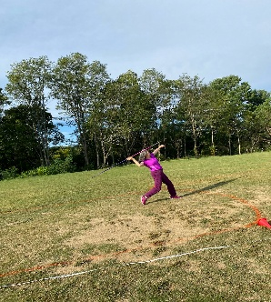 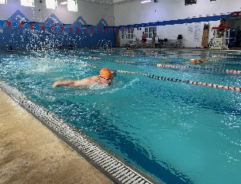 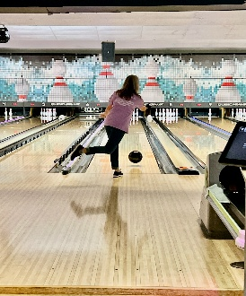 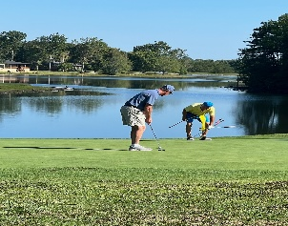 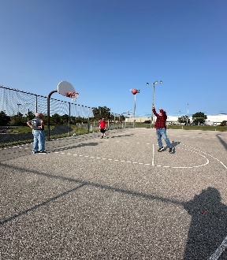





**Upper Cumberland Tennessee Senior Olympics**

**2025**

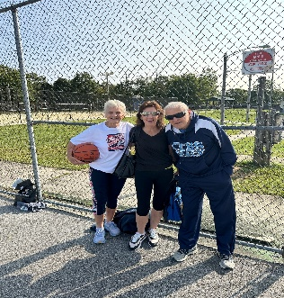 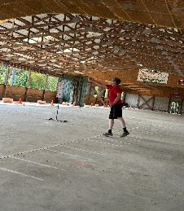 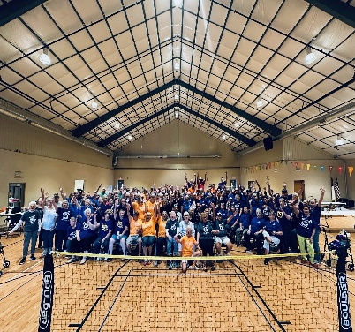 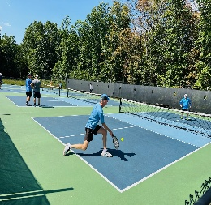 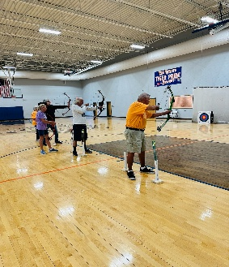

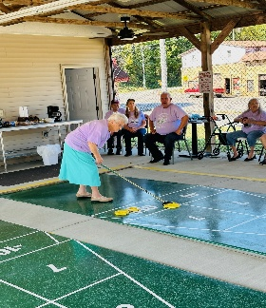 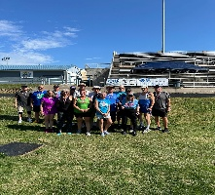 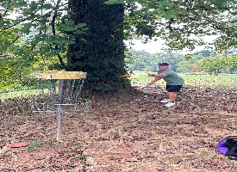

**Dates: September 2nd – September 30th Entry Deadline: August 3rd, 2025**

**Presented**

**By:**



**The Upper Cumberland District Tennessee Senior Olympics is a sports competition for athletes 50 and older that combines a wide range of competitive activities. The objective of this special event is to recognize people who have achieved and maintained good health throughout their lives, to promote physical fitness and the pursuit of lifetime leisure activities, and to provide opportunities for fun, recreation, and fellowship.**

**EVENT SITES**

**Registration Information**



**Cumberland County High School** 660 Stanley St, Crossville

**Centennial Park** 837 Industrial Blvd, Crossville

**Cane Creek Park** 201 CC Camp Rd, Cookeville

**Fentress County Senior Center** 308 South Main St, Jamestown

**Bowling World** 545 Neal St, Cookeville

**Putnam County Family YMCA** 235 Raider Dr, Cookeville

**Bear Trace Golf Course** 407 Wild Plum Ln, Crossville

**Fairfield Glade Library**  455 Lakeview Dr, Crossville

**Bethlehem Baptist Church** 626 Potato Farm Rd, Crossville

**Crab Orchard Elementary** 240 School Rd, Crab Orchard

**The Fort at Southwest Point** 1225 S Kentucky St, Kingston

**AGE CATEGORIES**

* The Tennessee Senior Olympics age categories are as follows:

50-54 55-59 60-64 65-69 70-74 75-79 80-84 85-89 90-94 95+

* Participants will qualify for age divisions according to their age as of December 31, 2025. In doubles events and in team competition, teams will compete in the division determined by the age of the youngest player.

**DISTRICT RULES AND FEES**

* Teams may be comprised of any player regardless of district.
* Participants may enter an unlimited number of events. However, they may not register for events that will overlap in time. If you are unable to participate in the Upper Cumberland District Tennessee Senior Olympics, please call (615) 200-8760 or visit our website, [www.tnseniorolympics.com](http://www.tnseniorolympics.com) to find information on other districts.
* All Participants are required to pay a one-time entry fee ($40.00) for up to two sports categories and $2.00 for each additional sports category.
* Below are additional event related fees and information. The $40 entry fee includes all events in each category-singles, doubles, and mixed doubles- and all the events in swimming and track. The fee also includes medals, one t-shirt, and admission to the awards luncheon. There is a $15.00 fee to the recognition luncheon for every guest that is a non-participant. To receive your t-shirt at your event, all registration is due by **August 3, 2025**. If turned in after this date, you will receive your t-shirt in late October, after all our events are over. If this is the case, you are responsible for picking up your t-shirt at Fair Park Activity Center in Crossville.

**Bowling - $2.90 per game at singles and doubles events (to be paid at bowling venue.)**

**Golf - $36 – includes cart fee, green fee, and range balls.**

* All participants must live within 30 miles of the Tennessee state line and be pre-registered to participate
* Team Captains are responsible for submitting team entry forms and team rosters by **August 3, 2025.**

The entry form and fees may be hand delivered or mailed to:

**Upper Cumberland District Senior Olympics 1433 Livingston Rd. Crossville, TN 38571.**

Please make checks payable to: “**Fair Park Activity Center”**

**STATE RULES & EQUIPMENT**

* All events will be conducted in accordance with the 2025 Tennessee Senior Olympics Official Rules Manual. A copy of the manual is provided to each District Coordinator. The complete rules manual is also available on our website, [www.tnseniorolympics.com](http://www.tnseniorolympics.com). A copy of the rules for each event will be available at each event site.
* Equipment for each event will be provided by the Tennessee Senior Olympics unless stated otherwise in the rules of each event. Participants are advised to consult the Official Rules Manual concerning equipment for their specific event(s). Please make special note that shuffleboard players may use their own cue and that tennis participants are required to provide their own racquet and balls. Equipment is provided for all field events.

**AWARDS**

* Medals will be presented for first, second, and third place finalists in each age/sex category. The awards will be presented at the conclusion of each event. All District participants are eligible for the State Finals.

**HEALTH**

* The Tennessee Senior Olympics strongly recommends that each participant consult his/her doctor regarding practicing, preparing, and competing in these sporting events or any similar physical activity.

**T-SHIRT SIZE CHECK APPROPRIATE BOX**

**BOTH SIDES** OF THIS ENTRY FORM MUST BE COMPLETED FULLY TO SUCCESSFULLY REGISTER.

**ENTRY FORM**

**General Information (please print) FIRST NAME LAST NAME**

 

**GENDER DATE OF BIRTH**

 **MALE** **FEMALE**   

MONTH DAY YEAR

**EMAIL ADDRESS PHONE NUMBER**  

**STREET ADDRESS** 

**CITY STATE ZIP CODE** 

**Health Information**

Do you have specific health conditions or contradictions that would need to be disclosed in the case of a medical emergency?

YES NO IF YES PLEASE EXPLAIN.

______________________________________ ______________________________________

**Recruitment**

Are you a first time Senior Olympics athlete?  YES- I was NOT recruited by a returning athlete  YES- I was recruited by a returning athlete. Name_____________________________  NO

**Volunteer**

Are you interested in volunteering for an event? YES NO IF YES WHICH EVENT?

__________________________________

__________________________________

**State & National Information**

**Important Information! Please Read!**

**L**

**M**

**S**

**TENNESSEE STATE SENIOR OLYMPICS**

**XXXL**

**XXL**

**XL**

* NEXT SUMMER’S STATE FINALS

**The t-shirt order will be placed on Thursday, August 4, 2025. In order to receive a t-shirt at your event, you must be registered by 08/03/2025! All late registrations will receive their t-shirts after all of our events have concluded.**

* IMPORTANT INFORMATION! PLEASE READ!
* Information and exact dates for the 2023 Tennessee Senior Olympics State Finals will be posted at [www.tnseniorolympics.com](http://www.tnseniorolympics.com) by the end of the year.
* To be eligible for the 2023 state finals, athletes must participate in a fall 2022 district event in most sports. District participants will participate and qualify in age divisions that match the state finals age determination. Age at the district will be determined by the athlete’s age as of December 31 of the next calendar year. Athletes must be 50 years old by December 31, 2023 to compete in the 2022 state finals. For example, for the 2022 districts, age will be determined as of December 31, 2023. For the 2023 state finals, age will be determined as of December 31, 2023. This is to ensure that athletes are practicing and playing in the age group that they will be placed in at the summer 2022 state finals. For example, an individual who turns 50 on April 1, 2023 will play in the 50-54 division in the fall 2022 districts although he or she is 49. Athletes must be 50 years old by December 31 of 2023 year to compete in the 2022 state finals. Open sports that do not require district qualification include archery, cornhole, cycling (5K and 20K), disc golf, the 5K and 10K road races, 5K Walk, racquetball, triple jump, pole vault, and the powerwalk. Sports not offered at your home district are also considered open. This list is subject to change by our board of directors. Notification of changes will be via e-mail.

**Entry & Event Fees**

 **Registration Fees ---------------------------- $40.00**

 **I am participating in more than 2 event categories ___- 2(free events) = ____ x $2.00(per event) = $________**

 **I am participating in Golf ----- +$36 ----- $________**

 **I am attending the luncheon --------------- $0.00**

 **I am bringing guest(s) --- ____ x $15 --- $________**

 **Donations -------------------------------------- $________**

**Check # _________ -or- Total Cash Enclosed $_______**

**Entry & Event Fees**

 **Registration Fees ---------------------------- $40.00**

**I am participating in more than 2 event categories ___- 2(free events) = ____ x $2.00(per event) = $________ NOTE: *Each Tennis Event is considered a separate category***



 **I am participating in Golf ----- +$32 ----- $________**

 **I am attending the luncheon --------------- $0.00**

 **I am bringing guest(s) --- ____ x $15 --- $________**

 **Donations -------------------------------------- $________**

**TOTAL AMOUNT ENCLOSED ----- $___________**

* Registration for the state finals will open in March 2023.
* Details will be e-mailed to all district participants.
* Visit www.tnseniorolympics.com for more information about the state finals.

**National Senior Olympics**

**2023 Nationals** We wish the best of luck to those of you who qualified and plan to attend the National Senior Games- the Senior Olympics for July 7-18, 2023 in Pittsburgh, PA. Qualifying for the 2023 Nationals was held during our 2022 State Finals in June (for most sports), August for pickleball, and September for cycling.

**In the addition to the above fees, if you are participating in bowling ($2.90 per game) those fees are to be paid at the event venue where you will be participating, on the day of the event.**

**MAKE CHECKS PAYABLE TO: Fair Park Activity Center**

**MAIL ALL FORMS AND FEES TO:**

**Upper Cumberland District Tennessee Senior Olympics 1433 Livingston Road Crossville, TN 38571**

**2025 Nationals** The next qualifying cycle will begin with the 2023 fall districts leading to the 2024 state finals. This offers an opportunity to advance to the 2025 Nationals. Location to be determined.

For more information about Nationals, please visit www.nsga.com­­­­­­­­­

**Health**

* **SHUFFLEBOARD**
  + **SINGLES**
  + **OPEN DOUBLES PARTNERS NAME: ____________________ PARTNERS YEAR OF BIRTH: ____________**
* **TABLE TENNIS**
  + **SINGLES**
  + **DOUBLES PARTNERS NAME: ____________________ PARTNERS YEAR OF BIRTH: ____________**
  + **MIXED DOUBLES PARTNERS NAME: ___________________­­_ PARTNERS YEAR OF BIRTH: ____________**
* **SWIMMING**
  + **BACKTROKE**  **50**  **100**  **200**
  + **BUTTERFLY**  **50**  **100**
  + **BREASTSTROKE**  **50**  **100**  **200**
  + **FREESTYLE**  **50**  **100**  **200**  **400**
  + **INDIVIDUAL MEDLEY (4 STROKES)**  **100**  **200**
* **TRACK EVENTS**
* **50**  **100**  **200**  **400**  **800**



 **1500 RUN**  **POWER WALK**

* **FIELD EVENTS**
  +  **DISCUS**  **JAVELIN**  **SHOT PUT**  **SB THROW**

 **HIGH JUMP**  **LONG JUMP**  **TRIPLE JUMP**

**EVENTS**

* **ARCHERY**
* **BASKETBALL**
  + **FREE THROW**
  + **THREE POINT SHOT**
* **BOWLING**
  + **SINGLES**
  + **DOUBLES PARTNERS NAME: _________________ PARTNERS YEAR OF BIRTH: __________**
  + **MIXED DOUBLES PARTNERS NAME: __________________ PARTNERS YEAR OF BIRTH: ___________**
* **CHAIR VOLLEYBALL**
* **CORNHOLE**
  + **SINGLES**
  + **DOUBLES PARTNERS NAME: _________________ PARTNERS YEAR OF BIRTH: __________**
  + **MIXED DOUBLES PARTNERS NAME: __________________ PARTNERS YEAR OF BIRTH: ___________**
* **DISC GOLF**
* **GOLF**
* **HORSESHOES**
* **PICKLEBALL – RATING: ___________**
  + **SINGLES**
  + **DOUBLES PARTNERS NAME: _________________ PARTNERS YEAR OF BIRTH: __________**
  + **MIXED DOUBLES PARTNERS NAME: __________________ PARTNERS YEAR OF BIRTH: ___________**

**Liability Waiver**

I, the undersigned, understand and expressly assume the dangers of the District Senior Olympic(s) competition(s) I have entered. I hereby agree to indemnify, save, and hold harmless [Tennessee Senior Olympics, Upper Cumberland District Tennessee Senior Olympics, BlueCross BlueShield of Tennessee, Fair Park Activity Center, Upper Cumberland Development District/ Area Agency on Aging and Disability, Bowling World, Fairfield Glade and facilities, Putnam County Family YMCA, Fentress County Senior Citizens Center, Bear Trace Golf Course, Crossville Centennial Park, Cumberland County High School, Crab Orchard Elementary School, and any other sponsoring agencies or their respective agents, representatives, successors, or assignees] for my health, safety, loss of property, or injury resulting from my participation in the Upper Cumberland District Tennessee Senior Olympics and planned special events. To the best of my knowledge, I have no physical restrictions or contradictions which would prohibit my competing in the event(s) I have selected. Senior Olympics has my permission to have emergency medical personnel attend to me during my participation in the Senior Olympics if it is deemed necessary.

I, the undersigned, grant Senior Olympics and its sponsors the right to use any still or motion pictures taken of me during the District Senior Olympics without remuneration.

**Signature ________________________________________Date ____________________**

**Monday, September 15 Disc Golf (The Fort at Southwest Point)** 10:00am EST

**Tuesday, September 16 Bowling (Bowling World)** 9:00am- Doubles 11:00am- Mixed Doubles

**Thursday, September 18 Chair Volleyball (Bethlehem Baptist)** 9:00am

**Saturday, September 20 Table Tennis (FFG Multipurpose Building)** 9:00am- Singles 10:30am- Doubles 12:00pm- Mixed Doubles

**Monday, September 22 Shuffleboard (Fentress County Senior Center)** 9:00am- Singles

**Tuesday, September 23**  **Shuffleboard (Fentress County Senior Center)** 9:00am- Singles

**Thursday, September 25 Corn Hole (Bethlehem Baptist Church)** 9:00am

**Monday, September 29 Shuffleboard (Fentress County Senior Center)** 9:00am- Doubles

**Tuesday, September 30**  **Shuffleboard (Fentress County Senior Center)** 9:00am- Doubles

**Monday, May 4, 2026. Luncheon (Fair Park Activity Center)** 11:00am **---** *DATE & TIME SUBJECT TO CHANGE*

**Tuesday, September 2 Bowling (Bowling World)** 9:00am- Singles

**Swimming (Putnam County YMCA)** 1:00pm

**Wednesday, September 3 Basketball (Centennial Park)** 12:30pm **Horseshoes (Centennial Park)** 1:00pm

**Thursday, September 4 Golf (Bear Trace Golf Course)** 9:00am- Start (Please arrive by 8:30am) Free Lunch to follow

**Saturday, September 6 Archery (Crab Orchard Elementary School)** 9:00am

**Monday, September 8 Pickle Ball (Cane Creek Park)** 9:00am- Singles (All ages / levels)

**Tuesday, September 9 Pickle Ball (Cane Creek Park)** 9:00am- Women’s Doubles (All ages / levels) 12:30pm- Men’s Doubles (All ages / levels)

**Wednesday, September 10 Pickle Ball (Cane Creek Park)** 9:00am- Mixed Doubles (50-64 / all levels) 12:30pm- Mixed Doubles (65-84 / all levels)

**Thursday, September 11 Pickle Ball – Rain Date**

**Friday, September 12 Pickle Ball – Rain Date #2**

**Saturday, September 13 Track and Field (Cumberland County High**) 8:00am- Field Events approx. 11:00am-Track Events

**Upper Cumberland District – 2025 - Event Schedule**

**State & National Information**

Important Information! Please Read!

**2026 STATE FINALS ELIGIBILITY NOTE**

* Per the TSO Board**, participation in a 2025 District Games will be required** to **qualify** for**the 2026 State Finals. The 2026 State Finals**is a qualifier for the**2027 Nationals.**
* Attending our 2025 Districts will be a vital step towards qualifying for the 2026 State Finals! This is not just a requirement; it’s an incredible opportunity for growth, competition, and connection. By participating in the district competitions, you’ll not only enhance your skills but also immerse yourself in the wonderful camaraderie that our community fosters. Together, we can embrace the joy of movement, fitness, and shared experiences.
* **Support your fall 2025 district** and make the most of this journey toward health and wellness.

**2026 STATE FINALS INFORMATION**

* Information and exact dates for the 2026 Tennessee Senior Olympics State Finals will be posted at www.tnseniorolympics.com by early 2025.
* District participants will participate and qualify in age divisions that match the state finals age determination. The age at the district will be determined by the athlete’s age as of December 31 of the **next** calendar year. Athletes must be 50 years old by December 31, 2026 to compete in the 2026 state finals.
* Open sports that do not require district qualification will be announced in the fall of 2025.
* Visit www.tnseniorolympics.com for more information about the state finals.

**2027 NATIONALS** - **New Qualifying Cycle!** - **THE ROAD TO TULSA, OK**

* The 2026 Tennessee Senior Olympics State Finals events will serve as qualifying opportunities for the 2027 Nationals.
* Top finalists at our state finals events will qualify for the 2027 National Senior Games scheduled for Tulsa, OK, with dates to be determined.
* Visit [www.nsga.com](http://www.nsga.com/) for further info including detailed qualifying information.

Algood Senior Center Brenda Dishman (931) 537-3447 [algoodseniorcenter@frontier.com](mailto:algoodseniorcenter@frontier.com) Baxter Senior Center Barbara Lee (931) 858-5657 [baxterscc@gmail.com](mailto:baxterscc@gmail.com) Monterey Senior Center Saundra Gilmore (931) 839-8053 **Smith County** Smith County Senior Citizens Center Jan Johnson (615) 735-0476 **Van Buren County** Stephanie Neely (931) 946-7151 **Warren County** McMinnville/ Warren County Senior Center Connie Smith (931) 473-6559 **White County**  Sparta Senior Center Brenda Roberts (931) 836-3663

**Jackson County** Fairview Senior Center Geraldine Rhoten (931) 268-0837 Granville Multipurpose Senior Center Lisa Braun (931) 653-4647 **Macon County** Lafayette/ Macon County Senior Center Brenda Fulson (615) 666-3780 [seniors@nctc.com](mailto:seniors@nctc.com) **Overton County** Betty Parrott (931) 823-1268 [ovcosrctr@twinlakes.net](mailto:ovcosrctr@twinlakes.net) **Pickett County** Senior Citizens of Pickett County Diana Dowdy (931) 864-7972 [byrdstownseniorcenter@yahoo.com](mailto:byrdstownseniorcenter@yahoo.com) **Putnam County** Putnam County Senior Citizens Maxine Frasier (931) 526-9318 [director@cookevilleseniorcenter.org](mailto:director@cookevilleseniorcenter.org)

**Cannon County**  Cannon County Senior Center Deborah Leach (615) 563-5304 [ccsc@dcpccom.net](mailto:ccsc@dcpccom.net) **Clay County** Clay County Multipurpose Senior Center Sandra Wix (931) 243-3467 [clayscc@twlakes.net](mailto:clayscc@twlakes.net) **Cumberland County** Fair Park Senior Center Alicia Arehart (931) 484-7416 fpscalicia@outlook.com **Dekalb County** Smithville Senior Center Pam Redmon (615) 597-7575 [dekalbseniordirector@gmail.com](mailto:dekalbseniordirector@gmail.com) Alexandria Senior Center Jennifer White (615) 529- 2928 [seniors@dtccom.net](mailto:seniors@dtccom.net) **Fentress County** Fentress County Senior Citizens CenterKelly Young (931) 879-7249 [kelly.young@fentresscountytn.gov](mailto:kelly.young@fentresscountytn.gov)

**Local Senior Centers: Contact Information**

|  |  |  |  |  |
| --- | --- | --- | --- | --- |
| **District** | **2025 Dates** | **Entry Deadline** | **Contact Information** | **Email Address** |
| **Chattanooga** | TBA | TBA | Kelly Price  (423) 240-1508 | kelly@tnseniorolympics.com |
| **East TN** | TBA | TBA | Melissa Ward  (865) 436-4990 | melissaw@gatlinburgtn.gov |
| **First TN** | TBA | TBA | Donna Campbell  (423) 434-6230 | donnacampbell@johnsoncitytn.org |
| **Greater Nashville** | September 22 – September 27 | TBA | Traci Meador  (615) 200-8760 | [info@tnseniorolympics.com](mailto:info@tnseniorolympics.com) |
| **Memphis** | September 19 – October 13 | TBA | TBA | TBA |
| **Northwest** | TBA | TBA | Elizabeth Whitmore  (731) 587-4213 | elizabeth.whitmore@nwtdd.org |
| **South Central** | TBA | TBA | Pam Hyde  (931) 762-4231 | phyde@lawrenceburgtn.gov |
| **Southeast** | TBA | TBA | TBA | TBA |
| **Southwest** | September 13 – September 23 | TBA | Marc Mingledorff  (731) 425-8376 | mmingledorff@jacksontn.gov |
| **Upper Cumberland** | **September 2 - September 30** | **August 3rd** | **Carlee Beaty**  **(931) 484-7416** | **ucseniorolympics@gmail.com** |

**FINAL CHECKLIST:**

COMPLETE BY: **August 3, 2025**

* **OFFICIAL ENTRY FORM AND EVENT REGISTRATION FORM**
* **HEALTH INFORMATION FORM AND LIABILITY WAIVER**
* **INCLUDE CHECK/MONEY ORDER FOR THE TOTAL AMOUNT PAYABLE TO: *Fair Park Activity Center***
* **I UNDERSTAND I MAY NOT ENTER ANY EVENT AFTER THE DEADLINE**
* **I UNDERSTAND ALL FORMS AND FEES MUST BE RECEIVED BY 08/03/2025 IN ORDER TO PARTICIPATE IN ANY SENIOR OLYMPICS EVENTS AND RECEIVE A T-SHIRT AT MY EVENT.**

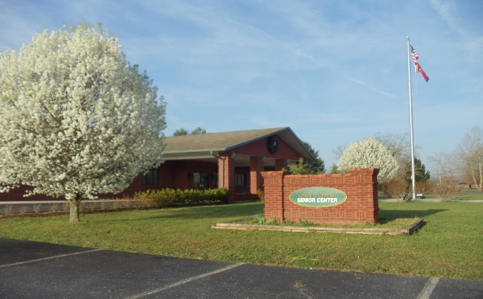Alicia Arehart, Coordinator.

Carlee Amonette, Assistant Coordinator.

Upper Cumberland District Tennessee Senior Olympics 1433 Livingston Road Crossville, TN 38571. Email: ucseniorolympics@gmail.com Phone: (931) 484-7416



**A special thank you to our 2025 Tennessee Senior Olympics Sponsors!**

