The 2019 Senior Chief Scott DeCoste Memorial Scholarship Inc.

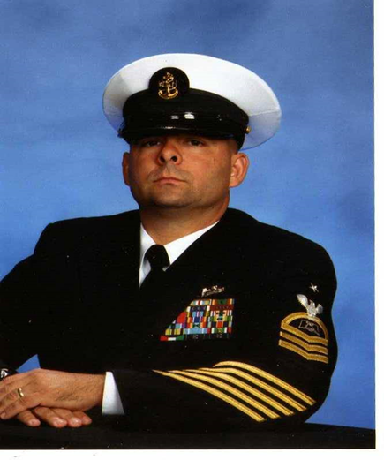
- Qualifications:

  - 2019 Woonsocket High School Graduating Senior
  - Accepted into College
  - Overcame a personal or educational obstacle

- Required Documents:

- Essay (500 words, type-written, double-spaced)
- Faculty letter of recommendation

Required Documents Can Be Either Mailed or Emailed to:

The Senior Chief Scott DeCoste Memorial Scholarship, Inc.
732 Woodcott Drive Chesapeake, VA 23322

lisa@sdecoste.org

- Due Date: April 30, 2019

- Personal Information:

  - Name of Applicant:

  - Home Address:

  - Date of Birth:

  - Phone:

- Academic Information:

  - Current GPA:

  - Extra-curricular activities:

  - Volunteer work:

Have you applied for admission to a college or university?

Have you been accepted?

List the names of the institutions where you have been accepted:

- Essay:

Scott struggled in high school with academics before turning it around and graduating in 1984. Please describe in the essay what you feel you struggled with, whether it be personal or educationally related, and how you overcame it to graduate.

Note: Please feel free to use additional paper if you need more space to provide the requested information.

The Scott DeCoste Memorial Scholarship Inc. is a non-profit 501c3 organization that was formed on June 13, 2016 in memory of Retired Senior Chief Scott DeCoste. Scott passed away on August 31, 2015 at the age of 49 years old after a brief 8-week battle with cancer. The purpose of the organization is to award scholarships to high school students who have overcome a personal or academic obstacle prior to graduation.

Tax Id: 81-2892439
www.sdecoste.org
FaceBook page: Senior Chief Scott DeCoste Memorial Scholarship

