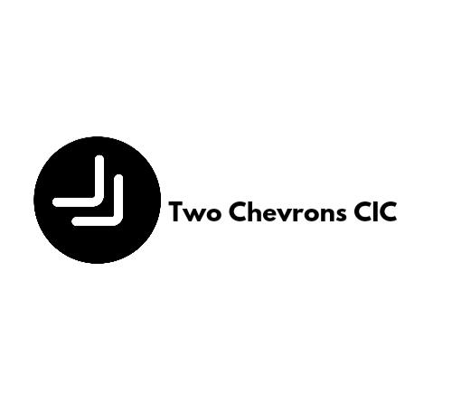

CV
- CV template is included in this pack or can be downloaded at Veterans and Blue Light | Two Chevrons.
- This CV is chronological and has nice clean layout, there are other types of CV such as:
  - Functional or Skills-Based CV.
  - Combination CV.
- Make sure you have some achievements on the CV not just a list of duties.
- Ideally it should contain specific numbers and should be translatable ; e.g.
“I conducted a reconnaissance of the area, formulated my battle plan, and issued orders to my troops. We successfully executed the plan and seized control of the enemy position. “ could be “I collated data and market research on competitors and developed a strategic plan that resulted in X, Y & Z”
- Power of 3….make sure that if you are applying for an Operations Director job (for example) then the words Operations Director appears on your CV 3 times. You can put it after your name, then at the top of professional profile and then maybe in the competencies bullet points…..your objective here is for the hiring manager to see Ops Director 3 times and that then makes them think “yep let’s get them in for interview”
- Linked to that last point – most people see a CV as a historical “what I’ve done in the past” document – what we actually need to make sure is that it is tailored/tweaked to “what’s next” or “what’s important to the hiring manager on that job you are applying for”. Bit difficult to explain on email but I can elaborate on the phone if you wish.

LinkedIn

- In terms of your LinkedIn profile. This is your first impression.
- It used to be that you made your first impression when you walked into the interview.
- Now companies/hiring managers/recruiters check you out on LinkedIn to see if you look professional enough to work at their business. This can be the difference between interview and no interview…..so it’s important.
- I think a black and white photo looks quite professional. Edward Smith | LinkedIn or Joshua Rio Leach-Aslam | LinkedIn
- Also, on LinkedIn you need to have a think about ‘search-ability’. So what job titles are you searching for in Google? If you are typing in “Manufacturing Manager”, would I find you if I searched LinkedIn (or your CV) for a manufacturing Manager (i.e. do you have that specific term on there?)

Interview Tips

- Here is a video link with some tips (quick caveat – they may be highly patronising!). Also this isn’t a fancy polished and edited performance; but hopefully still helps : https://vimeo.com/925745021
- I’ve got other bits to share at interview stage so as you move forward if you want a bit of coaching, I am always happy to help and indeed quite enjoy this part of the job

We trust you found these tips and tricks helpful. Should you need additional support or guidance, please don't hesitate to reach out to us at info@twochevrons.co.uk.

