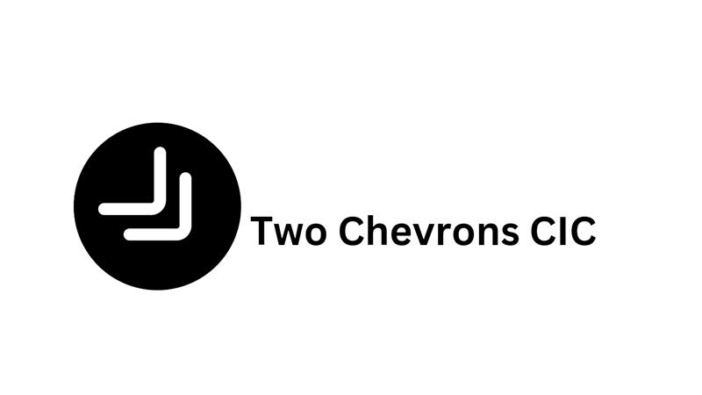

Two Chevrons Partnership Programme
Terms and Conditions
- Partnership Commitment:
  - By entering into a partnership with Two Chevrons, the partner agrees to actively support and contribute to the organisation's initiatives, aligned with its values and objectives.
- Financial Commitment:
  - Partners are obligated to fulfil the financial commitments associated with their chosen partnership tier, contributing to the sustainability and success of Two Chevrons' programs.
- Non-Partisan Position:
  - Partners are required to maintain a non-partisan position and refrain from engaging in any party political activities that may compromise the impartial nature of the partnership.
- Transparency and Accountability:
  - Partners commit to transparency in their operations and agree to be held accountable for the outcomes of collaborative initiatives. Regular reporting on contributions and impact is expected.
- Long-Term Partnership:
  - Partnerships are viewed as long-term commitments. Partners are encouraged to sustain their involvement to ensure continuity and lasting positive impact.
- Inclusivity and Diversity:
  - Partners must actively promote inclusivity and diversity within their initiatives, ensuring equal opportunities for all individuals within the armed forces and blue light communities.
- Legal and Ethical Standards:
  - Partners must adhere to all legal and ethical standards in their operations, conducting business with integrity and in accordance with relevant regulations.
- Oath of Allegiance:
  - Partners may be required to sign an Oath of Allegiance, pledging their dedication to the values, causes, and standards upheld by Two Chevrons.

- Termination of Partnership:
  - Two Chevrons reserves the right to terminate a partnership if the partner fails to adhere to the terms and conditions outlined herein or engages in activities contrary to the organisation's values.
- Amendments:
  - Two Chevrons reserves the right to amend these terms and conditions without prior notice, and partners are responsible for reviewing updates regularly.
By entering into a partnership with Two Chevrons, partners affirm their commitment to these terms and conditions, fostering a collaborative and impactful relationship.
