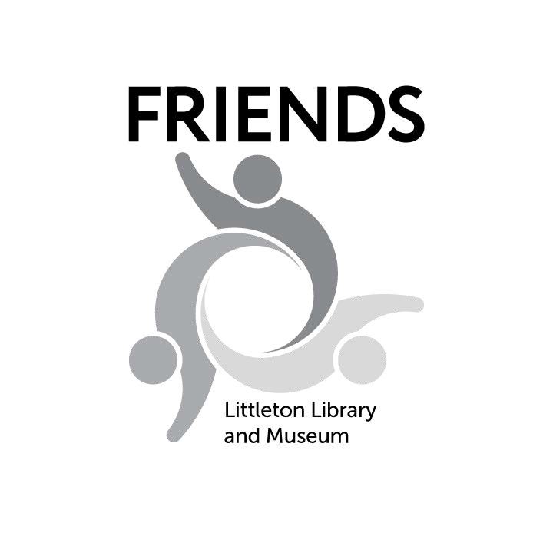
Creative Writing Contest 2023 Entry Form
Submission Deadline: Midnight Mon., April 3, 2023

This entry form is for entries that will be emailed or mailed to us. Email completed form with your submission to FriendsCreativeWritingContest@gmail.com. Or you can use the online
entry form on our website, FriendsLittleton.org, and link to your manuscript.

Fill out one entry form per submission. Please print and complete all information legibly. Name:
Street Address: ZIP Code:

Phone: Email:

School: Teacher’s Name:

Grade: (circle one) 1–2 3–5 6–8 9–10 11–12
Category: (circle one) Poetry Fiction Nonfiction Collaborate (List names):
Title of Entry:
I declare that the attached manuscript is my own work. (Plagiarism will be cause for dis- qualification.) I have read and complied with all of the contest rules.
Author Signature (Required) Parent Name (Please Print) (Required)
Parent Signature / Date (Required)
Safe2Tell: The Friends’ Creative Writing Contest adheres to the Safe2Tell principles. Safe2Tell is a Colorado program that allows the reporting of issues regarding the safety of students, parents or community members.
We understand that students may express anger, sadness or other strong emotions in their writings. While we
encourage uninhibited writing, we also take our responsibilities under Safe2Tell seriously.

