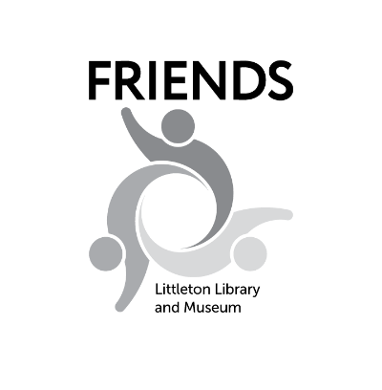
Creative Writing Contest
2023 Rules and Information
The Friends of the Littleton Library and Museum’s annual student Creative Writing Contest is designed to promote and encourage excellence in creative writing. It is not to be used as a classroom assignment. Entries are due by midnight,
Monday, April 3.
Categories
- Poetry — Writing in verse, 100 lines or fewer. Examples: rhymed, blank verse, song lyrics, free verse, epic, ode, spoken word.
- Fiction — Short story or one-act play, 2,500 words or fewer. Examples: mystery, science-fiction, historical, fantasy, humor, thriller, romance.
- Nonfiction — Short story or essay, 2,500 words or fewer. Examples: memoir, biography, historical, instructional, commentary.
- Collaborative — More than one person working together. Can be a mix of ages (1st through 12th grade). All entries will be judged as one category. Poetry 100 lines or fewer; fiction and nonfiction 2,500 words or fewer.

Judging Criteria
Judges receive all entries anonymously. Judging is based on originality, quality of expression and skill in handling specific forms of writing. Detailed, grade-specific judging rubrics are on the Creative Writing Contest section of our website at FriendsLittleton.org. Judges will notify the winners before school ends that year. All judging decisions are final.

Awards
In each category, judges will select a 1st, 2nd, and 3rd place winner. A prize will be awarded to each winner. Winning submissions will be compiled into a spiral-bound book, which will be available for purchase or can be referenced at Bemis Library.

Rules Carefully read and follow these rules
- Only students in the 1st-12th grades who live within theLittleton Public Schools District or attend a LPSmay enter the contest.
- Entries must be received by the deadline: Midnight, Monday, April 3, 2023.
- NO LATE ENTRIES WILL BE ACCEPTED.
- Incomplete entry forms will be subject to disqualification.
- Students may submit one entry in each category. Each entry must have a separate entry form.
- The author’s name should appear ONLY on the entry form, not on the manuscript.
- Label each page of the manuscript with the title of the work and the page number.
- Manuscripts must be typed or printed legibly on only one side of an 8 1⁄2” x 11” sheet. First grade authors may dictate their entries for another person to type.
- Do not use a folder or a cover.
- Original submissions will not be returned.
- Entries must be submitted in one of three ways:
  - Online FriendsLittleton.org, under the Programs and Events tab and click on Creative Writing Contest, follow prompts to submit Entry Form and submission by Google Docs.
  - Email completed entry form and submission to: FriendsCreativeWritingContest@gmail.com.
  - Mail or drop off completed entry form and submission to: Creative Writing Contest, c/o Bemis Public Library, 6014 S. Datura St., Littleton, CO, 80120. Mailed entries must be postmarked April 3, 2023, or earlier.

This contest is sponsored and managed solely by the Friends of the Littleton Library and Museum. Bemis Public Library staff is not involved with judging. The Contest adheres to the principles of Colorado’s Safe2Tell.
Questions? Email us at: FriendsCreativeWritingContest@gmail.com.

