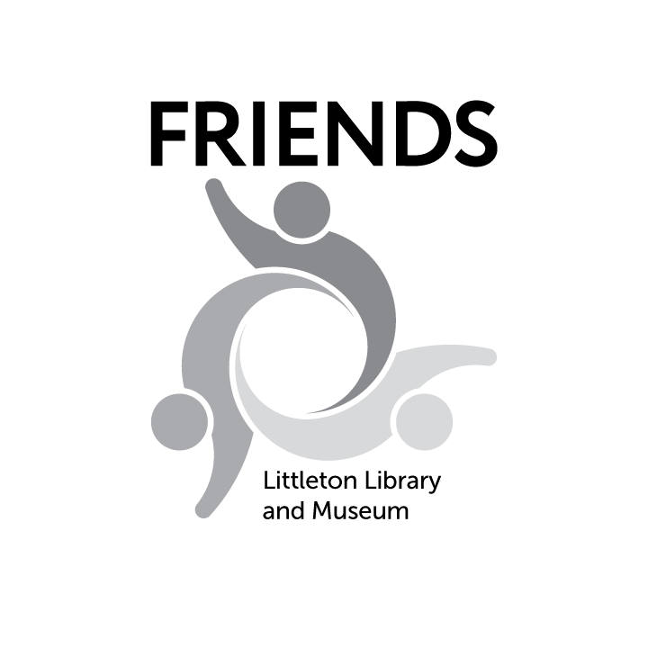

Date: March 1, 2023

To: Littleton Public Schools Office Managers and School Administrators

From: Friends of the Littleton Library and Museum

Subject: **56th Annual Creative Writing Contest for Students**

We are delighted to announce that our 56th annual student Creative Writing Contest is now open for submissions. Students in grades 1–12 who live within the Littleton Public Schools District are eligible.

We know how hard education professionals work to spark children’s imaginations. For more than 50 years, our local nonprofit — the Friends of the Littleton Library and Museum — has encouraged that effort with our spring Creative Writing Contest.

Entries will be judged by the Arapahoe Community College English Department.

Attached is an information flyer for teachers, librarians or other appropriate staff as well as the Rules/Entry Form and judging criteria. We would appreciate your assistance in distributing this information to parents and staff through all available communication channels at the earliest opportunity! Info is online at friendslittleton.org, too.

**Contest deadline is midnight, Monday, April 3, 2023**.

Questions? Contact FriendsCreativeWritingContest@gmail.com. Thank you!

***Imagination = Intelligence Having Fun!***