Morgan County Master Gardeners
“Helping Morgan County Grow”
www.mcmastergardeners.org

2026 GardenFest and Pansy Sale Vendor Application
Sponsored by Morgan County Master Gardener Association, Inc.
Saturday, March 14, 2025 9am-3pm Setup Friday, March 13 6-7:30 pm
Location: Mooresville Christian Academy, 4271 State Road 144, Mooresville,I N 46158. Easily accessible from I-69 or State Road 67.

Business name __________________________________________________

Your name _____________________________________________________

Business address_________________________________________________

Business phone_________________Cell phone________________________

Email__________________________________________________________

Website_______________________________________________________

Facebook page__________________________________________________

Merchandise or service description___________________________________

______________________________________________________________

Booth Rental Fees: First 8 ft. x 10 ft. booth $60___________
Two 8 ft. x 10 ft. booths for $100_______
Three 8 ft. x 10 ft. booths for $150_____
Outside 20 x 20 ft. space for $50________
I will need a booth with electricity_________
I will need an 8 ft. table__________
Early Bird Special: $45 for 8 ft. x 10 ft. booth if application is received with payment by December 1, 2025.

Note: We are unable to refund canceled reservations. No applications will be accepted without payment sent.
General release: The undersigned does hereby and forever discharge Morgan County Master Gardeners from all manner of actions, suits, damages, claims, and demands whatsoever in law or equality, from any loss or damage to the undersigned’s property while in possession, supervision, or auspices of the 2026 GardenFest and Pansy Sale.

Vendor Signature________________________________Date________

Scan the QR code for payment or send check, payable to Morgan County Master Gardeners, with application to: Jim Stupka, treasurer, Morgan County Master Gardeners, P.O.Box 148, Mooresville, IN 46158

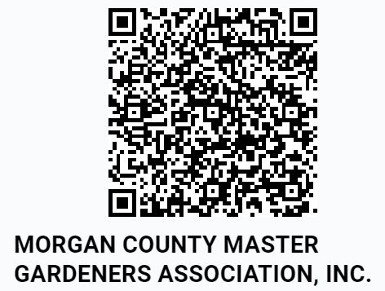

Take your cell phone. Use the QR code app which is easy to download for free, scan the code and it goes right to the payment for MCMG. You can pay with credit, debit, or bank account.

