Hallelujah – Finally A Cure for Canker

By Charity Harmon – drawing on personal experience and professional references namely, Dr. Frank Reilly Canker Powder Inventor, Karin Thompson Sales Rep at Monarch Labs, the faithful wrapping crew of NES Pony Club, and Raymond Lantz a professional farrier.

The Background:

October 5, 2024, I had to put my 14 year old swing mare to sleep. She couldn’t get up and the canker had invaded enough of her hooves that I believe it had become cancer. A few friends came to support and witness. It was a happy and sad day, she was finally out of pain, but I couldn’t help but think “what a waste!” When three of my other younger mares contracted canker, my search for the cure was becoming desperate.

The Problem:

November 12, 2024, Following the summer show season, three of my mares presented with canker indicated by painful swollen dermis, stinking necrotic flesh, and ulcerated horny growths compromising their hooves. Roxy (8) and Jynx (6), full sisters out of my swing mare, had canker in four hooves each. Bonnie (13) no relation to my mare line, had canker in three hooves. Facing 24/7 stalling of three horses and treatment of eleven hooves, I relied on advice from the American Farrier Journal “Dealing with Hoof Canker,” which highly recommended Maggot Debridement Therapy (MDT). Maggot debridement therapy is based on the fact that maggots secrete a relatively large group of digestive enzymes to remove devitalized necrotic tissues. I engaged the services of Monarch Labs in Irvine, CA for maggot debridement therapy (MDT). A couple of conversations with the Monarch Labs Sales Representative, Karin Thompson, and we were off to the races. Monarch Labs is the leading biotherapy company in the United States, having produced and distributed Medicinal Maggots™ (disinfected Phaenicia sericata larvae) since 2005. The female maggot, *lucilia sericata*, order *diptera*, is the larvae of the greenbottle fly. Nurtured on sterile beef liver, these little beauties are mostly carnivorous, consuming matter that is already in a state of decay. As we unpacked that canker is the decaying flesh of the equine hoof in the 2024 Fall ASHA Newsletter volume 48, Issue 2. Maggots have three core beneficial effects on wounds: debridement, disinfection, and enhancement of wound healing. Maggots have a conical body form (i.e. extending to a point). The anterior or head-end is pointed with the posterior end being more blunt. The posterior end of the maggot often has two dark areas that can be mistaken for eyes. These are actually the spiracles (breathing holes) for the maggot and enable the maggot to breathe whilst burrowing down into whatever it is feeding on. At the anterior end are the maggot's mouthparts and these are often hook-like. In many species the structure of the mouthparts is the best way to identify the species of fly from its maggot. I tell you all of that to tell you that no matter your thoughts on maggots 🡪The maggots of *lucilia sericata* do not digest healthy living tissue. I suggest an even bigger benefit the MDT provides. The owner can debride cankerous hooves without any cutting!!! Reduced trauma, no bleeding, and vast improvement of affected area for when the farrier does debride.

The Science:

Karin Thompson provided articles and advice on debriding the cankerous hooves with maggots, one of which was a professional article published by the Journal of Equine Science.

Treponemes-Infected Canker in a Japanese Racehorse: Efficacy of Maggot Debridement Therapy was very informative on types and causes of canker. Describing canker as atypical moist, pododermatitis, with loosened and ulcerative epidermis over the frog and its surrounding horny tissues. Chronic lesions form characteristic papilla-like horny structures, which make canker difficult to treat, especially in neglected cases. Although the etiology of canker has not been investigated extensively, because the condition is encountered infrequently (almost a direct quote from Dr. Frank Rielly). For example, irritant stimulation of the sensitive layer of the foot due to virus, bacteria involving preferential factors, especially in unsanitary or wet environments. Meanwhile, the pathological appearance to bovine digital dermatitis (DD), of which abnormal feet, especially in the interdigital region, could be diseased by treponemes. Bovine DD caused by treponemes is expected to be transmitted by contact with treponemes that contaminate the stall floors. In addition, polymerase chain reaction (PCR) techniques targeting the Treponema-specific 16S ribosomal RNA gene fragments (16S rDNAs) were recently used to prove that plural clones genes of noncultivatable treponemes infected lesions of the equine canker. The study went on to say, whether treponemes are infectious or opportunistic is a controversial question (meaning we do not know how or why canker is contracted). In usual practice, mild canker is treated by topical applications over affected tissues. Alternatively, in severe cases, a scalpel, hoof knife, or electrocautery under general anesthesia is used to remove proliferative and poorly cornified tissues until normal corium is revealed. A relatively new therapy, medical grade sterile maggot debridement therapy (MDT) can be used for treatment of canker. Maggots applied to cankerous lesions promote formation of healthy granulation tissue on which good healthy epidermis can grow. It is known that maggots remove damaged tissue as well as its associated bacteria by digestive secretions, called exudate. There was some concern in the article about maggots drowning in the exudate prior to completing their 50-60 hours of working, but I found healthy, thriving, maggots on each dressing change. There are four types of wound exudate: serous, sanguineous, serosanguinous, and purulent. Canker sloughy wounds and the proteolytic enzymatic extracorporeal digestion by the larvae, produces serous (not serious) drainage which is clear, thin, and watery. The production of serous drainage is a typical response from the body during the normal inflammatory healing stage, typically composed of water, proteins, and cells. The secreted enzymes produced by larvae digestion show antimicrobial activity. Indicating that MDT has potential in combating biofilm-associated infections.

The Protocol:

Based on these assurances, I confidently set up shipments with Monarch Labs. Karin and I decided to set up a shipment of MDT every Monday, affording two applications of maggots to every hoof. The number of maggots-impregnated gauze (two individually wrapped pads per vial) containing 250-500 larvae (~200 larvae per gauze pad). Normally priced around $300 per vial for FDA approved hospital application, I was charged considerable less for animal application (~$70 per vial before shipping). Even so, we estimated I could treat one hoof with 1 larvae impregnated pad (2 in each vial) for each application, or 1 vial per hoof per week. The Journal of Equine Science recommended daily dressing changes and replacing the maggots every 3 days. This is a good idea to keep the hoof dry (the exudate soaks the cotton pad and makes a moist, nasty environment). Next, Karin and I talked about how to contain the maggots in the wound. Eventually, I settled on wrapping the hooves with a thick pad of cotton, secured with vetwrap, elasticon, and duct tape. We would lovingly extract the first instar larvae from their vial with cotton swabs, a pointy pair of tweezers onto cotton and 4x4 sterile non-woven gauze. This takes a little bit of time so having a partner was very helpful. While my helper would extract maggots, I would cut old bandages and rinse the expired maggots from the hooves with hot water from a garden hose. While this will make Dr. Reilly squirm by adding water to the cankerous hoof, it was a calculated risk. I also followed the Journal of Equine Science article in the number of weeks to continue treatment, applying eight weeks of MDT, where the photos show that four weeks of treatment is the optimal length of time.

The Miracle:

As you can imagine, all this research and networking brought to my attention Dr. Frank Reilly’s Canker Powder, formulated and dispensed by Wickliffe Compounding Pharmacy in Lexington, KY. This miracle powder contains Doxycycline, Bismuth Subgallate, Ketoconazole, Metronidazole, Sulfamethoxazole, Trimethoprim, Aspirin, Dimethyl Sulfone (MSM), Zinc Sulfate Heptahydrate, Magnesium Oxide and feels like talcum powder with a yellow tint (unintentionally discovered it tastes like Aspirin). The protocol developed by Dr. Reilly calls for a thick application of powder to the affected hoof with a thick pad of cotton wrapped and secured (using the same supplies for used for MDT). Dr. Reilly’s protocol calls for a rigorous reapplication of powder and wraps every 1-2 days for 30 days. After a couple of days treatment the canker had retreated/desiccated enough for the farrier to debride the frog and surrounding hard surfaces of the hoof with minimal bleeding. The powder must be applied at least 3/4 of an inch thick, the horse must be kept inside a stall, in dry and clean bedding. The goal of Dr. Reilly’s protocol is dry, dry, dry. In addition, he recommends oral medicine of Doxycycline (2x per day for 30 days – NOT RECOMMENDED FOR PREGNANT MARES), Ivermectin oral deworming paste (1x per week for 5 weeks), Ration Balancer (high protein feed 2x daily for 30 days), and High dose Vitamin E (2x per day for 30 days), and NSAIDs as appropriate if the horse is too sore to put adequate pressure on the cankerous hoof to squish the powder into the wound.

The Bottom Line:

Two months. That is it, four weeks of MDT, and four weeks of Dr. Reilly’s Canker Powder. If you would like to discuss this protocol or would like to read any of the referenced articles, please give me a call 315-783-1759.

Call Out Box 1: Maggots are the larvae of a fly, soft-bodied grub. They are legless creatures that are no bigger than a grain of rice. Usually white, but can be red or brown hue. A group of maggots is a Grumble. Pictured here: Adult female common green bottle flies, *lucilia sericata* (Meigen), laying eggs.

.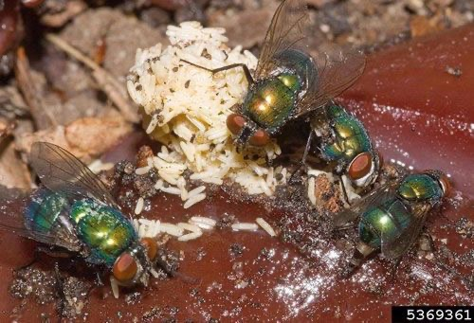

Call Out Box 2: Myiasis is the infestation of the skin by larvae (maggots) of a variety of fly species (order *diptera*) that for a certain period of time feed upon living, necrotic, or dead issue, liquid body substances, or ingested food of their host.

Call Out Box 3: Treponema is a genus of spiral-shaped bacteria.

|  |  |
| --- | --- |
| Domain: | [Bacteria](https://en.wikipedia.org/wiki/Bacteria) |
| Kingdom: | [Pseudomonadati](https://en.wikipedia.org/wiki/Pseudomonadati) |
| Phylum: | [Spirochaetota](https://en.wikipedia.org/wiki/Spirochaete) |
| Class: | [Spirochaetia](https://en.wikipedia.org/wiki/Spirochaete) |
| Order: | [Spirochaetales](https://en.wikipedia.org/wiki/Spirochaetales) |
| Family: | [Treponemataceae](https://en.wikipedia.org/wiki/Treponemataceae) |
| Genus: | Treponema |

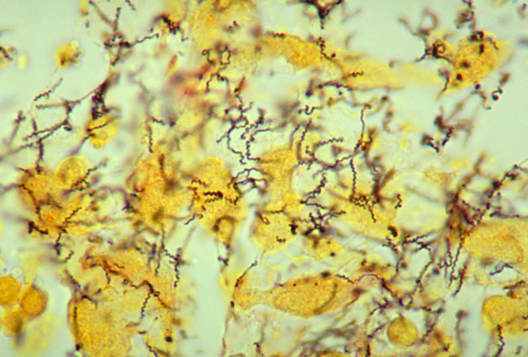

Call Out Box 4: Supply List

1. $37 per package - 36 Piece Self Adherent Bandage Wrap Breathable Cohesive Bandage Elastic Adhesive Tape for Stretch Athletic Sports Wrist Ankle, 4 Inch x 5 Yard (Black)
2. $59 per package - Nuanchu 16 Rolls Elastic Adhesive Bandage Tape Self Adherent Cohesive Flexible Stretch Elastic Athletic Tape for Sports Ankle Knee and Wrist, Vet Wrap for Horses Pets Cats Dogs(4 Inch x 5 Yard)
3. $21 per package - Black Heavy Duty Duct Tape, 2 inches x 30 Yards - 5 Pack, 8.27 mil Thickness, Strong, Flexible, No Residue, All-Weather and Tear by Hand - Bulk Value for Repairs
4. $89 per package - Dukal CR1-12 Cotton Roll, 1 lb., White, Pack of 12
5. $18 per package - Thick Non Woven Gauze Pads 4x4 Sterile Pack of 100 | 8-ply Non Woven Gauze | Individually Packed Non Woven Gauze Sponges 4x4 | Soft and lint-Free Medical Gauze Pads for Effective Wound Care
6. $70 per vial plus shipping – MDT from Monarch Labs (call Karin for current pricing: 949-679-3000; [sales@monarchlabs.com](mailto:sales@monarchlabs.com))
7. $405/bucket - Wickliffe Canker Powder (treats 2 hooves for 30 days)
8. $179/bucket – Health-E Maximum Strength Vitamin E Powder (14,000 IU/oz)
9. $200/bucket – Oral Doxycycline (treats 1 horse for 30 days)
10. $15/syringe – Oral Ivermectin (1.5 syringe for 5 treatments) = $113/horse

Call Out Box 5:

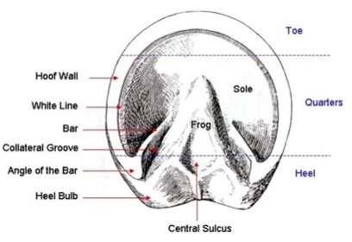

Call Out Box 6: Bonnie MDT Treatment (3 month progress photos of Right Rear Hoof of 13 year old Shire Mare), with Doxycycline.

Call Out Box 7: Jynx MDT Treatment (3 month progress photos of Right Front Hoof of 6 year old Shire Mare), without Doxycycline.