Messiah Lutheran Church

Valdosta, Georgia

500 Baytree Road – [messiahluth500@gmail.com](mailto:messiahluth500@gmail.com)

Office: 229-244-0143 Pastor’s Cell: 404-951-6336

|  |
| --- |
| Pastor Stephen Wareham |
|  |

# Sunday, July 27th, 2025

“We have found the Messiah” John 1: 41b

WELCOME VISITORS!

**We are pleased to meet you and have you visit us today!**

**Please sign our Guest Book located in the church entryway (Narthex) as well as the attendance sheet located in the red folder in each pew. Let us know how we may be of service to you in any way.**

* **RESTROOMS** *are located in the Narthex.*
* **QUIET BAGS** are available in the Narthex for older children. We also offer a children’s bulletin for ages 3-6 and ages 7-12.
* **QUIET/CALMING ROOM** *and a changing table are located near the Fellowship Hall (through the accordion doors behind the choir).*
* **INVITATION TO COMMUNION** *The Sacrament of Holy Communion is offered to all baptized and prepared Christians who believe Christ is truly present with us in this meal. Trusting in the promises of his Word, “—given and shed for you for the forgiveness of sins,” they intend to grow in faith by the power of the Holy Spirit working through this means of grace toward a more committed life with Jesus and His Church.*
* **RECEIVING COMMUNION** *Please extend your hand to receive the bread. Wine is offered from the Chalice or individual cups. Grape juice (center ring, lighter color) is offered for those who choose not to receive wine. After the Communion Assistant follows with the Chalice, place your empty cup on the communion rail rack. Children not yet prepared for the Sacrament may come forward for a blessing “that, living in the covenant of their Baptism and in communion with the Church, they may lead godly lives until the day of Jesus Christ.”*
* **OPPORTUNITIES FOR CHRISTIAN GROWTH**

Sundays at 9:00 am: Adult Bible Study in the **Pine Tree House**.

Sundays at 9:30 am: Sunday School: Grades 4th & 5th in the **Pine Tree House.**

Sundays at 9:15 am: Sunday School: Grades 6th – 12th in the **Pine Tree House**.

Tuesdays at 10:00 am: Pastor’s Bible Study in the **Pine Tree House.**

Tuesday 6:00 pm: Pastor’s Men’s Potluck Bible Study in the **Pine Tree House.**

# Free Welcome Black And White Clipart, Download Free Welcome Black And White Clipart png images, Free ClipArts on Clipart Library

Seventh Sunday After Pentecost

Divine Service Setting One

***The Mission of Messiah Lutheran is to grow in our relationship with God through worship, education, and service, while sharing Christ’s peace and fellowship with all.***

### AS WE GATHER

# Prayer is powerful. Our Father promises to hear and to answer every single one of our prayers, no matter how big or small. Jesus tells us that the one who asks will receive, the one who seeks will find, and the one who knocks will have the door opened for them. We are blessed to have a God who not only tells us to pray, but who WANTS us to pray to Him. Take everything to God in prayer, and you might find yourself surprised by the answers you receive, the blessings you find, and the doors that are opened.

# **PRELUDE & PERSONAL DEVOTION *(Quiet Please)***

# +Confession and Absolution+

Stand

All may make the sign of the cross in remembrance of their Baptism.

INVOCATION

P In the name of the Father and of the T Son and of the Holy Spirit.

C **Amen.**

EXHORTATION LSB 151

P If we say we have no sin, we deceive ourselves, and the truth is not in us.

C **But if we confess our sins, God, who is faithful and just, will forgive our sins and cleanse us from all unrighteousness.**

Silence for reflection on God’s Word and self-examination.

CONFESSION OF SINS LSB 151

P Let us then confess our sins to God our Father.

C **Most merciful God, we confess that we are by nature sinful and unclean. We have sinned against You in thought, word, and deed, by what we have done and by what we have left undone. We have not loved You with our whole heart; we have not loved our neighbors as ourselves. We justly deserve Your present and eternal punishment. For the sake of Your Son, Jesus Christ, have mercy on us. Forgive us, renew us, and lead us, so that we may delight in Your will and walk in Your ways to the glory of Your holy name. Amen.**

ABSOLUTION LSB 151

P Almighty God in His mercy has given His Son to die for you and for His sake forgives you all your sins. As a called and ordained servant of Christ, and by His authority, I therefore forgive you all your sins in the name of the Father and of the T Son and of the Holy Spirit.

C **Amen.**

SHARING OF THE PEACE

### P The peace of the Lord be with you.

### C And also with you.

### *Please extend the hand of fellowship to your neighbors with the words: “The peace of the Lord.”*

# +Service of the Word+

ENTRANCE HYMN

779 COME, MY SOUL, WITH EVERY CARE

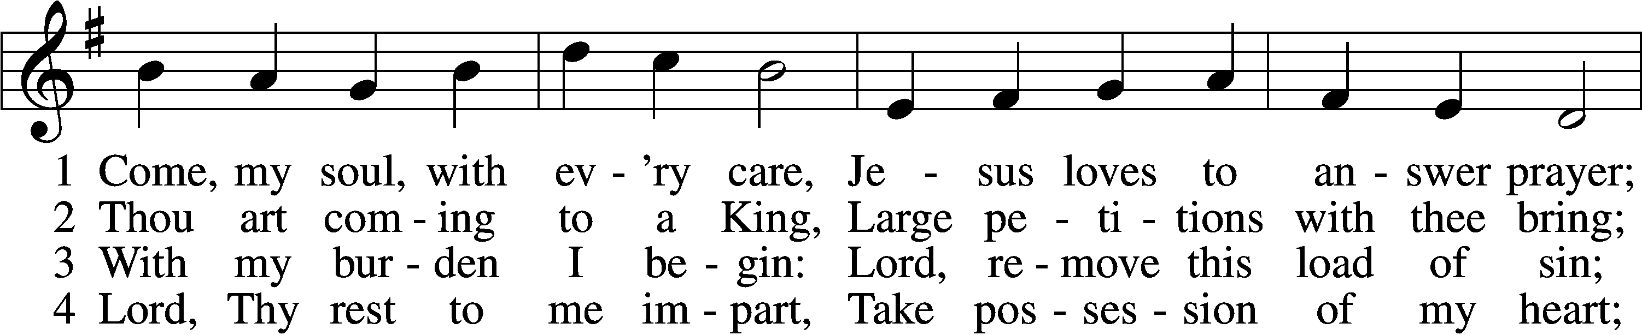

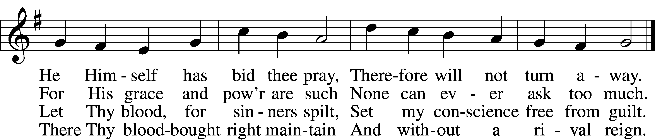

**VERSE 5**

While I am a pilgrim here,  
Let Thy love my spirit cheer;  
As my guide, my guard, my friend,  
Lead me to my journey’s end.

**VERSE 6**

Show me what is mine to do;  
Ev’ry hour my strength renew.  
Let me live a life of faith;  
Let me die Thy people’s death.

Text: John Newton, 1725–1807, alt.; Tune: Justin H. Knecht, 1752–1817; Text and tune: Public domain

Stand

Introit Psalm 119:145–149; antiphon: Psalm 50:15

Call upon me in the day of trouble; I will deliver you, and you shall glorify me.

With my whole heart I cry; answer me, O Lord! I will keep your statutes.

I call to you; save me, that I may observe your testimonies.

I rise before dawn and cry for help; I hope in your words.  
My eyes are awake before the watches of the night, that I may meditate on your promise.

Hear my voice according to your steadfast love;

O Lord, according to your justice give me life.

**Glory be to the Father and to the Son and to the Holy Spirit;**  
**as it was in the beginning, is now, and will be forever. Amen.**

Call upon me in the day of trouble; I will deliver you, and you shall glorify me.

KYRIE LSB 152

GLORIA IN EXCELSIS LSB 154

SALUTATION AND COLLECT OF THE DAY

P Let us pray.

O Lord, let Your merciful ears be attentive to the prayers of Your servants, and by Your Word and Spirit teach us how to pray that our petitions may be pleasing before You; through Jesus Christ, Your Son, our Lord, who lives and reigns with You and the Holy Spirit, one God, now and forever.

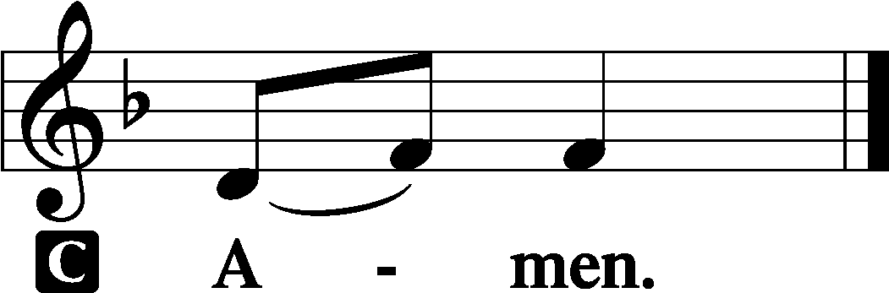

Sit

OLD TESTAMENT Genesis 18:20-33

20Then the Lord said, “Because the outcry against Sodom and Gomorrah is great and their sin is very grave, 21I will go down to see whether they have done altogether according to the outcry that has come to me. And if not, I will know.”

22So the men turned from there and went toward Sodom, but Abraham still stood before the Lord. 23Then Abraham drew near and said, “Will you indeed sweep away the righteous with the wicked? 24Suppose there are fifty righteous within the city. Will you then sweep away the place and not spare it for the fifty righteous who are in it? 25Far be it from you to do such a thing, to put the righteous to death with the wicked, so that the righteous fare as the wicked! Far be that from you! Shall not the Judge of all the earth do what is just?” 26And the Lord said, “If I find at Sodom fifty righteous in the city, I will spare the whole place for their sake.”

27Abraham answered and said, “Behold, I have undertaken to speak to the Lord, I who am but dust and ashes. 28Suppose five of the fifty righteous are lacking. Will you destroy the whole city for lack of five?” And he said, “I will not destroy it if I find forty-five there.” 29Again he spoke to him and said, “Suppose forty are found there.” He answered, “For the sake of forty I will not do it.” 30Then he said, “Oh let not the Lord be angry, and I will speak. Suppose thirty are found there.” He answered, “I will not do it, if I find thirty there.” 31He said, “Behold, I have undertaken to speak to the Lord. Suppose twenty are found there.” He answered, “For the sake of twenty I will not destroy it.” 32Then he said, “Oh let not the Lord be angry, and I will speak again but this once. Suppose ten are found there.” He answered, “For the sake of ten I will not destroy it.” 33And the Lord went his way, when he had finished speaking to Abraham, and Abraham returned to his place.

A This is the Word of the Lord.

C **Thanks be to God.**

EPISTLE Colossians 2:6–19

6Therefore, as you received Christ Jesus the Lord, so walk in him, 7rooted and built up in him and established in the faith, just as you were taught, abounding in thanksgiving.

8See to it that no one takes you captive by philosophy and empty deceit, according to human tradition, according to the elemental spirits of the world, and not according to Christ. 9For in him the whole fullness of deity dwells bodily, 10and you have been filled in him, who is the head of all rule and authority. 11In him also you were circumcised with a circumcision made without hands, by putting off the body of the flesh, by the circumcision of Christ, 12having been buried with him in baptism, in which you were also raised with him through faith in the powerful working of God, who raised him from the dead. 13And you, who were dead in your trespasses and the uncircumcision of your flesh, God made alive together with him, having forgiven us all our trespasses, 14by canceling the record of debt that stood against us with its legal demands. This he set aside, nailing it to the cross. 15He disarmed the rulers and authorities and put them to open shame, by triumphing over them in him.

16Therefore let no one pass judgment on you in questions of food and drink, or with regard to a festival or a new moon or a Sabbath. 17These are a shadow of the things to come, but the substance belongs to Christ. 18Let no one disqualify you, insisting on asceticism and worship of angels, going on in detail about visions, puffed up without reason by his sensuous mind, 19and not holding fast to the Head, from whom the whole body, nourished and knit together through its joints and ligaments, grows with a growth that is from God.

A This is the Word of the Lord.

C **Thanks be to God.**

Stand

ALLELUIA VERSE LSB 156

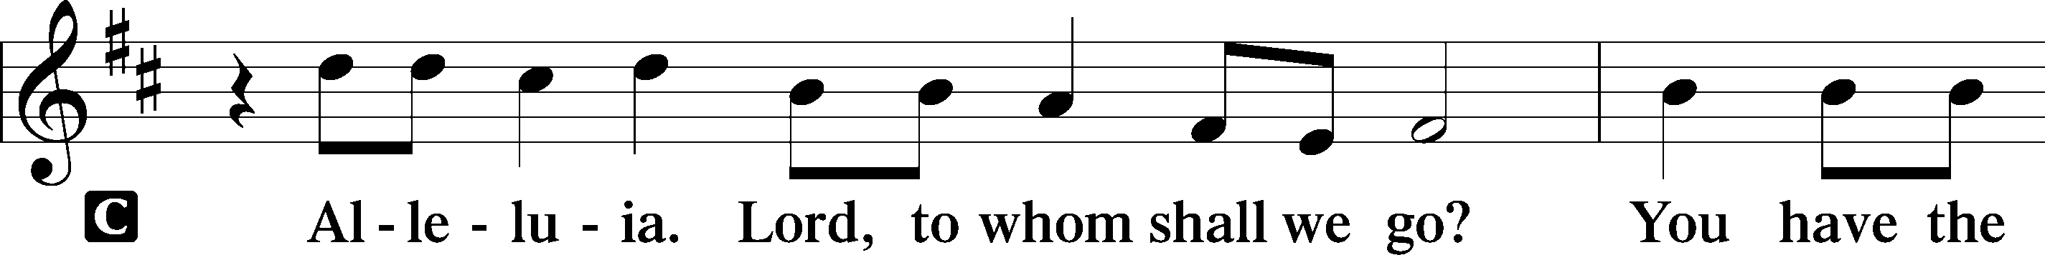

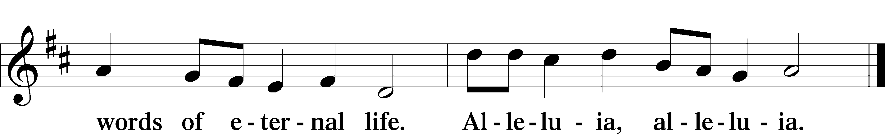

HOLY GOSPEL Luke 11:1–13

P The Holy Gospel according to St. Luke, the eleventh chapter.

C **Glory to You, O Lord.**

1Now Jesus was praying in a certain place, and when he finished, one of his disciples said to him, “Lord, teach us to pray, as John taught his disciples.” 2And he said to them, “When you pray, say:

**“Father, hallowed be your name. Your kingdom come.  
3Give us each day our daily bread, 4and forgive us our sins,  
for we ourselves forgive everyone who is indebted to us.   
And lead us not into temptation.”**

5And he said to them, “Which of you who has a friend will go to him at midnight and say to him, ‘Friend, lend me three loaves, 6for a friend of mine has arrived on a journey, and I have nothing to set before him’; 7and he will answer from within, ‘Do not bother me; the door is now shut, and my children are with me in bed. I cannot get up and give you anything’? 8I tell you, though he will not get up and give him anything because he is his friend, yet because of his impudence he will rise and give him whatever he needs. 9And I tell you, ask, and it will be given to you; seek, and you will find; knock, and it will be opened to you. 10For everyone who asks receives, and the one who seeks finds, and to the one who knocks it will be opened. 11What father among you, if his son asks for a fish, will instead of a fish give him a serpent; 12or if he asks for an egg, will give him a scorpion? 13If you then, who are evil, know how to give good gifts to your children, how much more will the heavenly Father give the Holy Spirit to those who ask him!”

P This is the Gospel of the Lord.

C **Praise to You, O Christ.**

Sit

770 WHAT A FRIEND WE HAVE IN JESUS

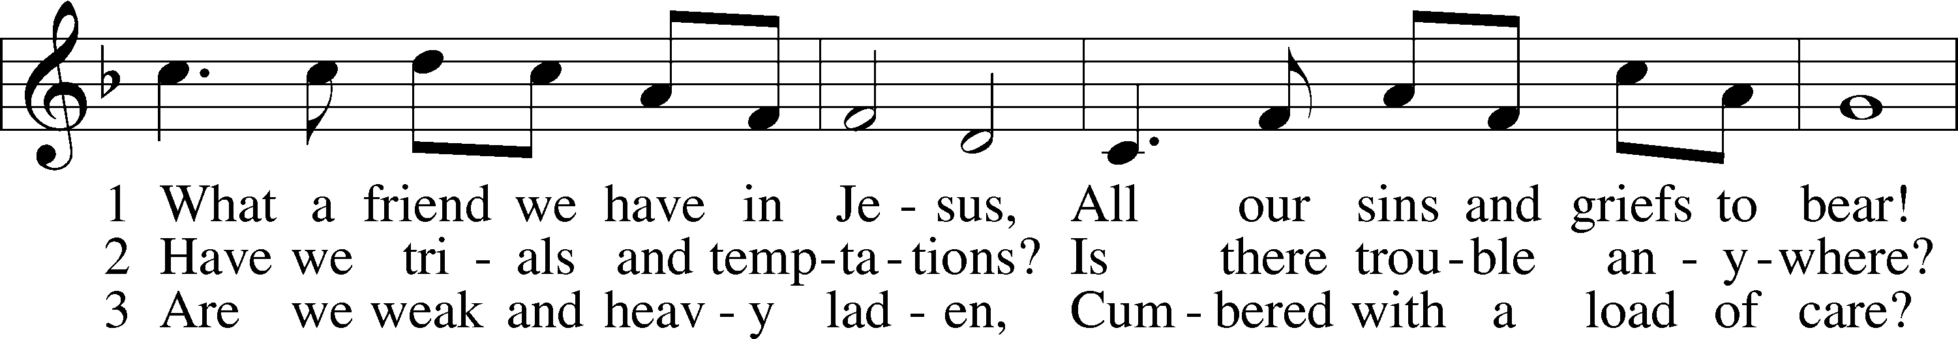

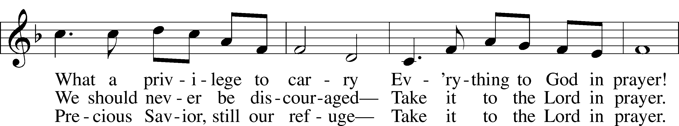

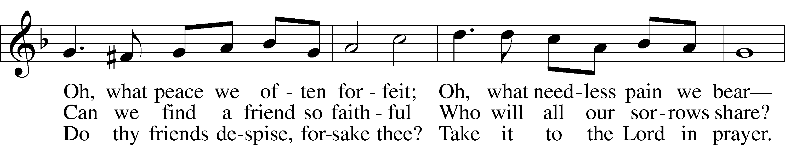

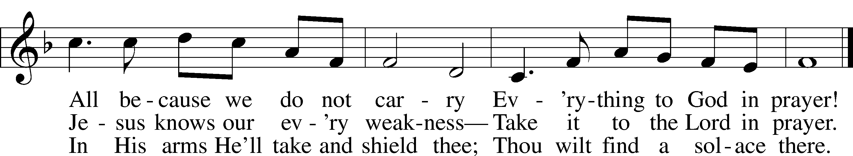

Text: Joseph M. Scriven, 1819–86; Tune: Charles C. Converse, 1832–1918; Text and tune: Public domain

**SERMON “Pray Big!”**

**Pastor Stephen Wareham**

Stand

**NICENE CREED**

C **I believe in one God, the Father, the Almighty, maker of heaven and earth, of all that is, seen and unseen.**

**I believe in one Lord, Jesus Christ, the only Son of God, eternally begotten of the Father, God from God, Light from Light, true God from true God, begotten, not made, of one Being with the Father; through him all things were made. For us and for our salvation he came down from heaven; by the power of the Holy Spirit he became incarnate from the virgin Mary, and was made man. For our sake he was crucified under Pontius Pilate; he suffered death and was buried. On the third day he rose again in accordance with the scriptures; he ascended into heaven and is seated at the right hand of the Father. He will come again in glory to judge the living and the dead, and his kingdom will have no end.**

**I believe in the Holy Spirit, the Lord, the giver of life, who proceeds from the Father and the Son, who with the Father and the Son is worshiped and glorified, who has spoken through the prophets. I believe in one holy catholic and apostolic church. I acknowledge one baptism for the forgiveness of sins. I look for the resurrection of the dead, and the life** T **of the world to come. Amen.**

PRAYER OF THE CHURCH

P In peace, let us pray to the Lord:

C **Lord, have mercy.**

P For faith to offer our petitions and unburden our hearts from the weight of sin and trouble, and that we would live in the light of God’s promises, let us pray to the Lord:

C **Lord, have mercy.**

P For pastors who embrace the honor and duty to lead the people of God in prayer as we all offer our petitions in the name of Jesus, let us pray to the Lord:

C **Lord, have mercy.**

P That all the families of the people of God would live in prayer, and thus come to know the full blessing of God’s fatherly care, let us pray to the Lord:

C **Lord, have mercy.**

P For our nation to be a repentant and faithful place where wickedness is curbed and God’s gracious presence is welcomed with thanksgiving, let us pray to the Lord:

C **Lord, have mercy.**

P For prayerful hearts that leave all vengeance in the hands of God and trust His justice to preserve the righteous and vanquish the wicked, let us pray to the Lord:

C **Lord, have mercy.**

P For all who suffer, *[*especially _____________*,]* that God, who heard and considered the prayers of Abraham, would spare them and draw them ever closer to Himself, let us pray to the Lord:

C **Lord, have mercy.**

P (Special Petitions)

C **Lord, have mercy.**

P For a child’s confidence as we come to the Lord’s table this day, that we might approach in sure and certain faith so that, in the gifts of Christ’s body and blood, the forgiveness we ask for will be given and the life we seek we will find, let us pray to the Lord:

C **Lord, have mercy.**

P Heavenly Father, we ask Your blessing and look to You as the Giver of all good gifts. Make us ever eager to come to You in prayer and thanksgiving, as Your Son has taught us. By Your Holy Spirit, bring us to behold in Christ the fulfillment of those things for which we pray — Your holy name, Your coming kingdom, daily bread, forgiveness, shelter in temptation and deliverance from every evil; through the same Jesus Christ, Your Son, our Lord, who lives and reigns with You and the Holy Spirit, one God, now and forever.

C **Amen.**

Sit

OFFERING

*If you’d like to give electronically with your offering, please see the back of the bulletin for details on donating through Zelle or Thrivent.*

Stand

OFFERTORY

# **955 LET THE VINEYARDS BE FRUITFUL**

**

**

**

**

**

**

# Text: John W. Arthur, 1922–80; Tune: Richard W. Hillert, 1923–2010 Text and tune: © 1978 Lutheran Book of Worship. Used by permission: LSB Hymn License no. 110000972

# +Service of the Sacrament+

PREFACE LSB 160

P It is truly good, right, and salutary that we should at all times and in all places give thanks to You, holy Lord, almighty Father, everlasting God, through Jesus Christ, our Lord, who, out of love for His fallen creation, humbled Himself by taking on the form of a servant, becoming obedient unto death, even death upon a cross. Risen from the dead, He has freed us from eternal death and given us life everlasting. Therefore with angels and archangels and with all the company of heaven we laud and magnify Your glorious name, evermore praising You and saying:

SANCTUS LSB 161

PRAYER OF THANKSGIVING LSB 161

P Blessed are You, Lord of heaven and earth, for You have had mercy on those whom You created and sent Your only-begotten Son into our flesh to bear our sin and be our Savior. With repentant joy we receive the salvation accomplished for us by the all-availing sacrifice of His body and His blood on the cross.

Gathered in the name and the remembrance of Jesus, we beg You, O Lord, to forgive, renew, and strengthen us with Your Word and Spirit. Grant us faithfully to eat His body and drink His blood as He bids us do in His own testament. Gather us together, we pray, from the ends of the earth to celebrate with all the faithful the marriage feast of the Lamb in His kingdom, which has no end. Graciously receive our prayers; deliver and preserve us. To You alone, O Father, be all glory, honor, and worship, with the Son and the Holy Spirit, one God, now and forever.

C **Amen.**

THE WORDS OF OUR LORD

P Our Lord Jesus Christ, on the night when He was betrayed, took bread, and when He had given thanks, He broke it and gave it to the disciples and said: “Take, eat; this is My T body, which is given for you. This do in remembrance of Me.”

In the same way also He took the cup after supper, and when He had given thanks, He gave it to them, saying: “Drink of it, all of you; this cup is the new testament in My T blood, which is shed for you for the forgiveness of sins. This do, as often as you drink it, in remembrance of Me.”

P As often as we eat this bread and drink this cup, we proclaim the Lord’s death until He comes.

C **Amen. Come, Lord Jesus.**

P O Lord Jesus Christ, only Son of the Father, in giving us Your body and blood to eat and to drink, You lead us to remember and confess Your holy cross and passion, Your blessed death, Your rest in the tomb, Your resurrection from the dead, Your ascension into heaven, and Your coming for the final judgment. So remember us in Your kingdom and teach us to pray:

LORD'S PRAYER

C ***Our Father who art in heaven, hallowed be Thy name, Thy kingdom come, Thy will be done on earth as it is in heaven; give us this day our daily bread; and forgive us our trespasses as we forgive those who trespass against us; and lead us not into temptation, but deliver us from evil. For Thine is the kingdom and the power and the glory forever and ever. Amen*.**

PAX DOMINI

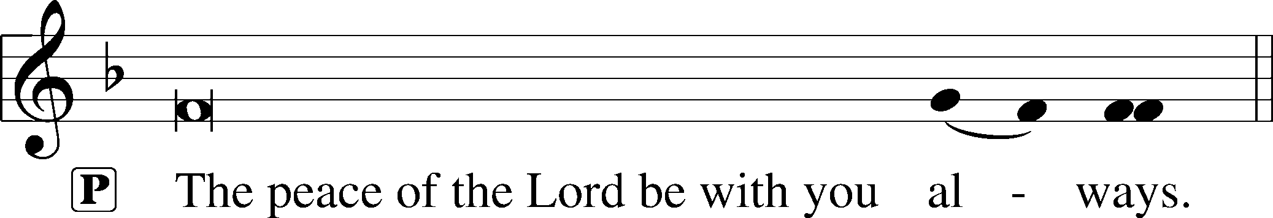



AGNUS DEI LSB 163

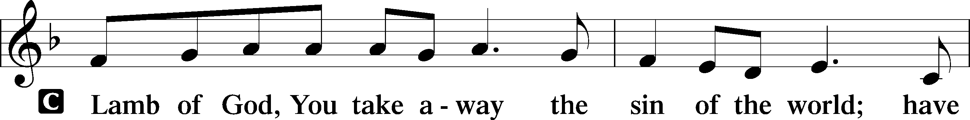

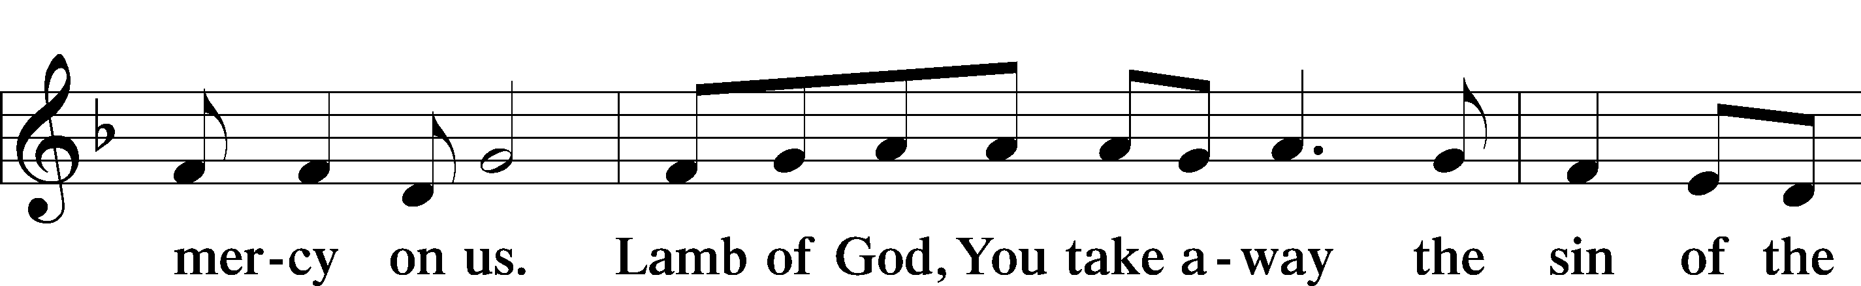

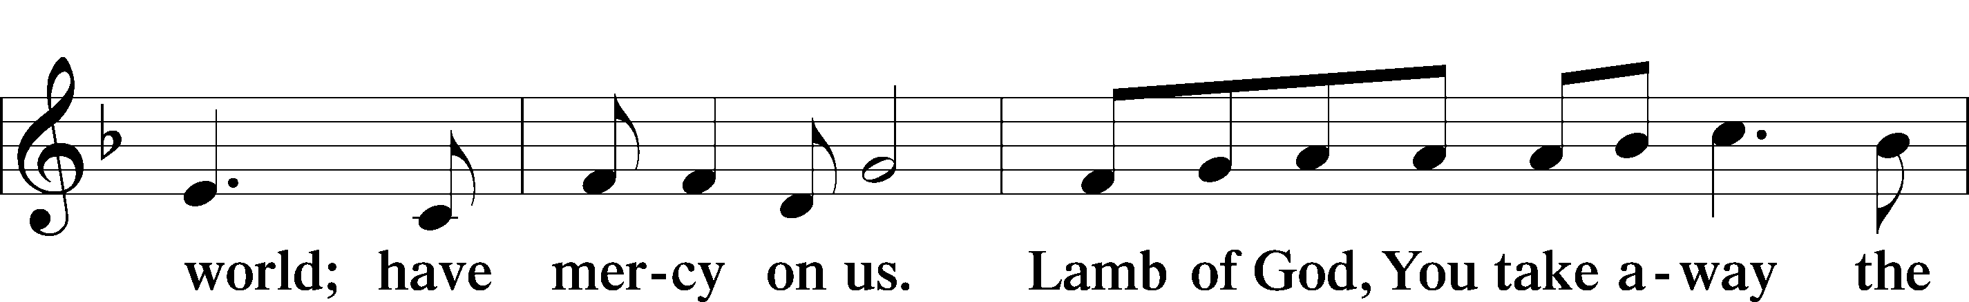

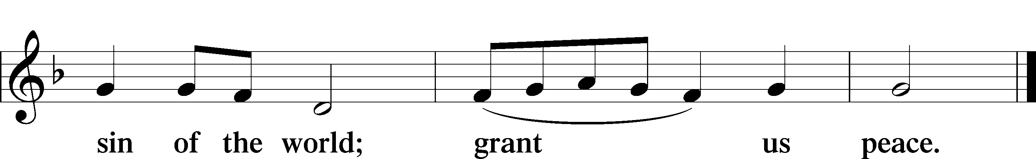

Sit

DISTRIBUTION

DISTRIBUTION HYMNS

725 Children of the Heavenly Father

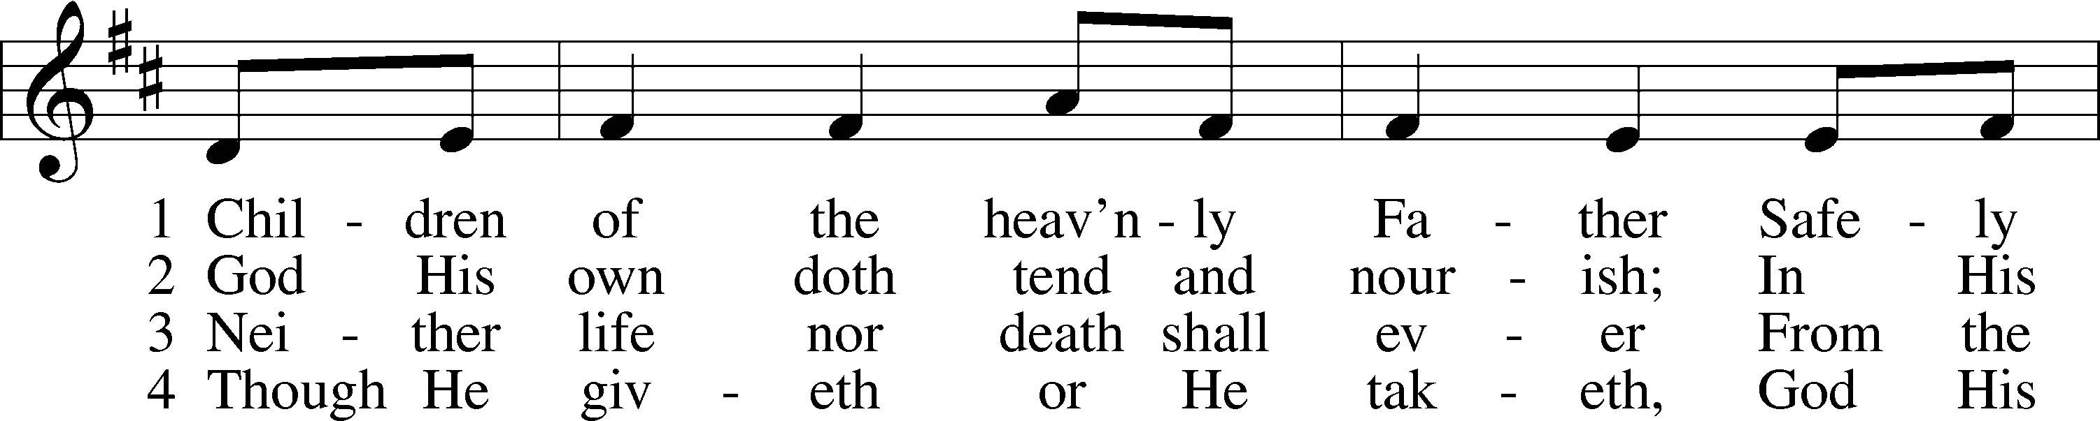

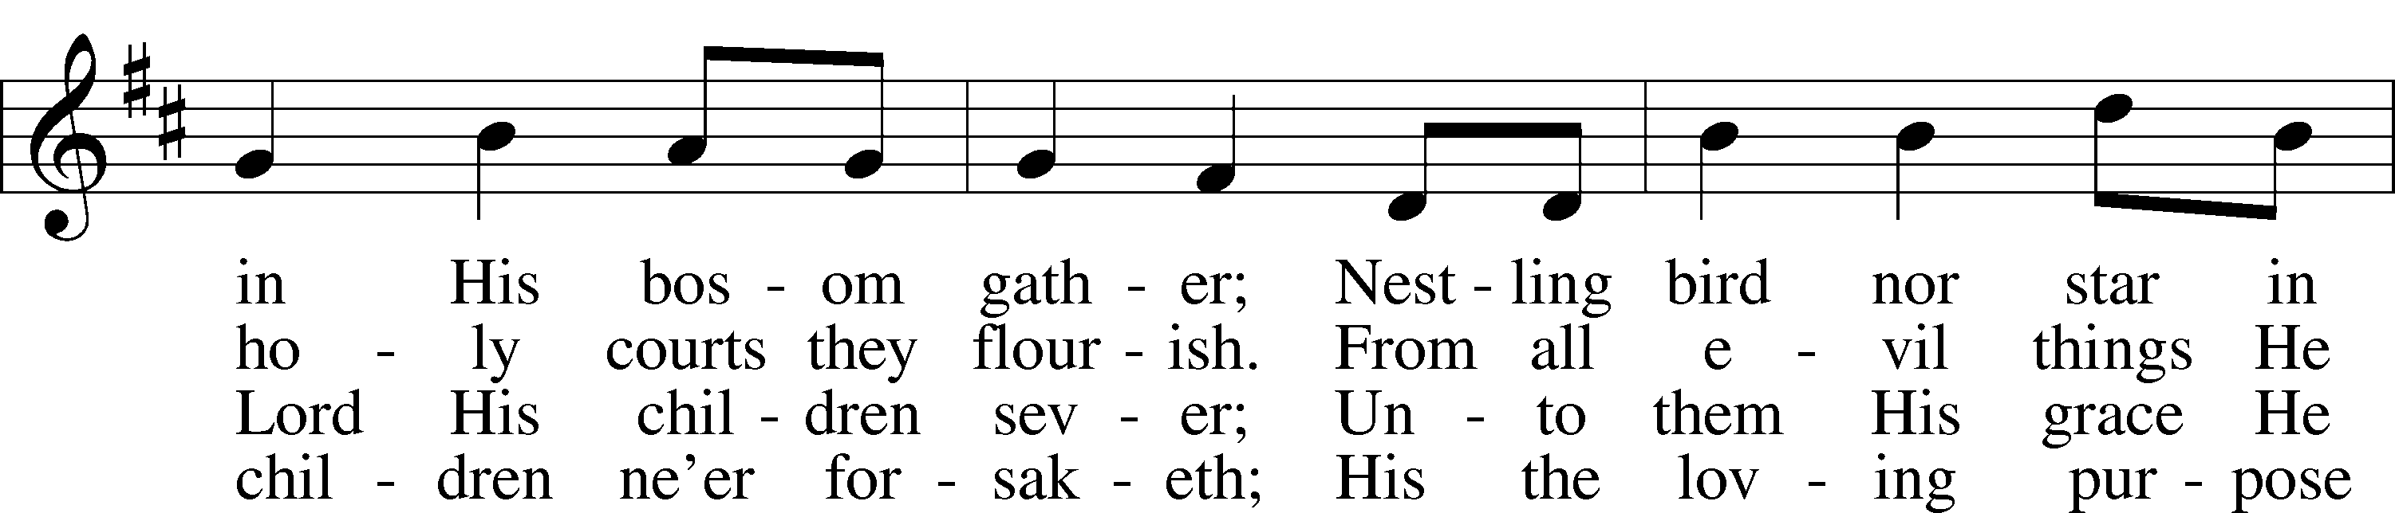

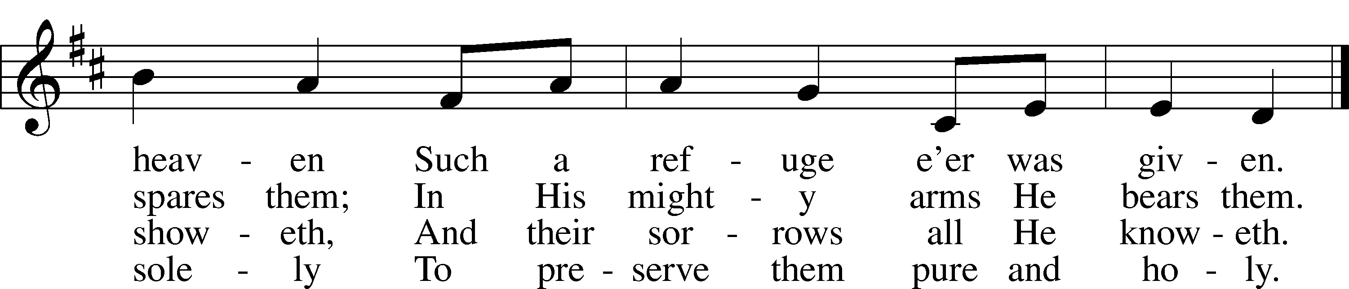

Text: Carolina Sandell Berg, 1832–1903; tr. Ernst W. Olson, 1870–1958; Tune: Lofsånger och andeliga wisor, 1873, Sweden;  
Text: Public domain; Tune: Public domain

550 LAMB OF GOD

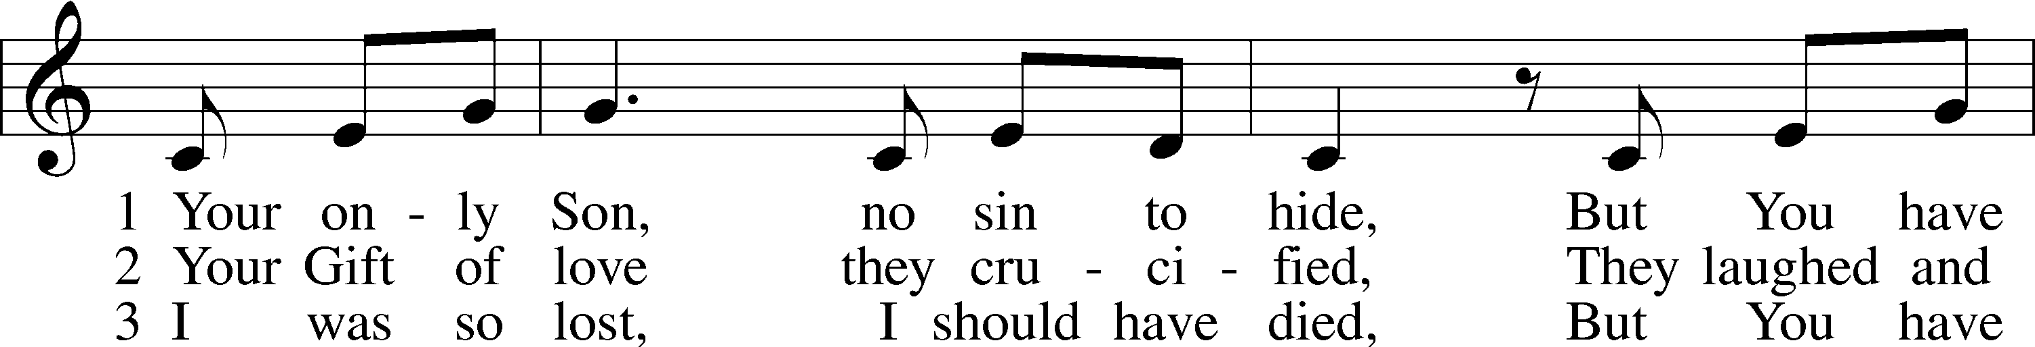

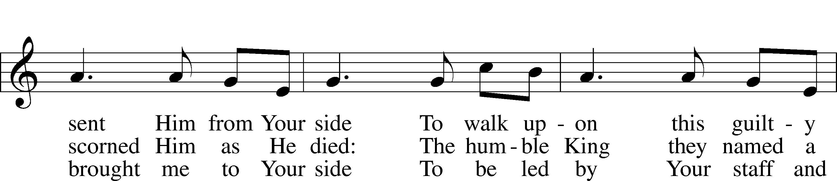

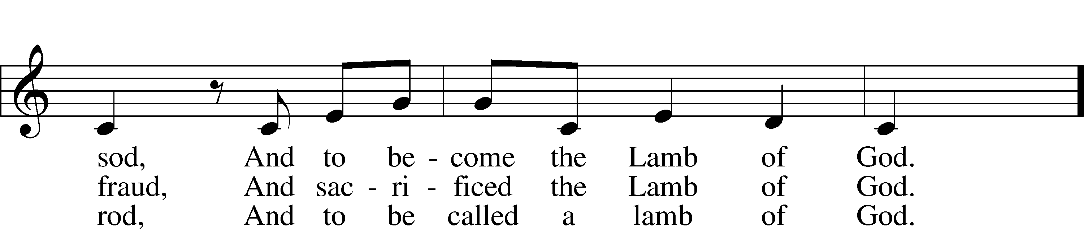

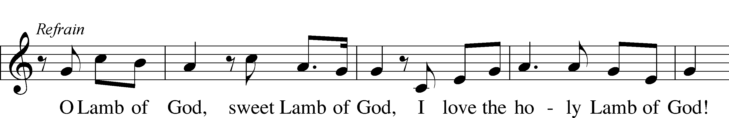

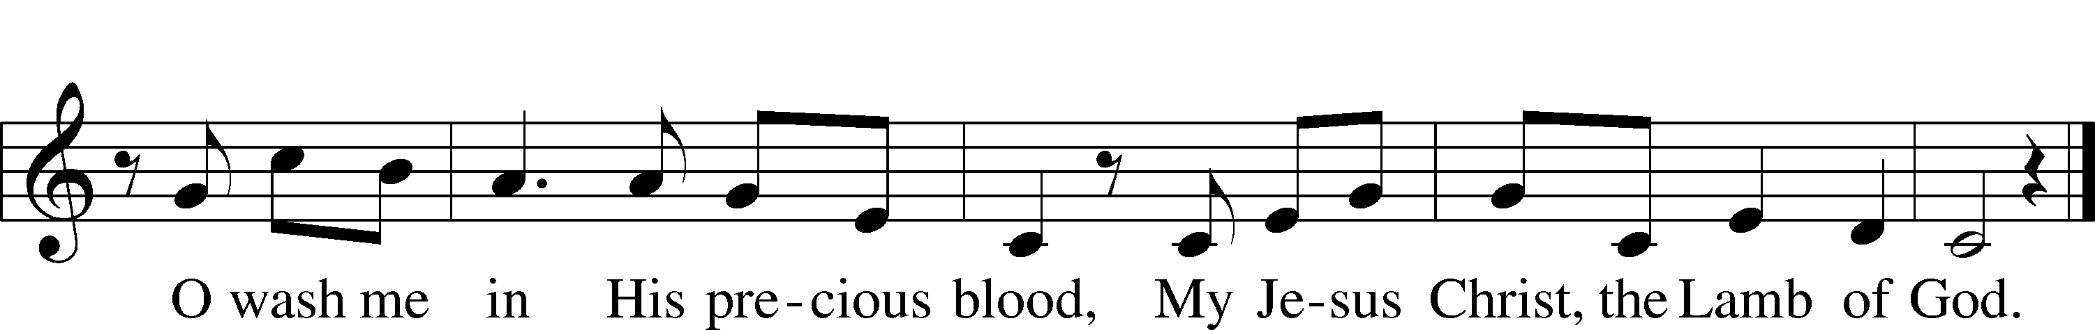

Text and tune: Twila Paris, 1958; Text and tune: © 1985 Straightway Music, admin. EMI. Used by permission: LSB Hymn License no. 110000972

588 JESUS LOVES ME sts. 1, ref, 2

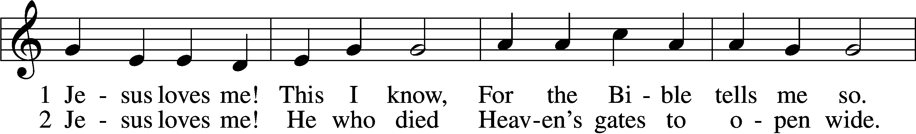

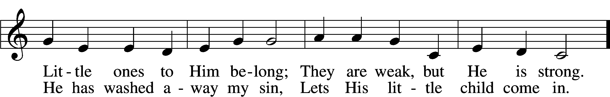

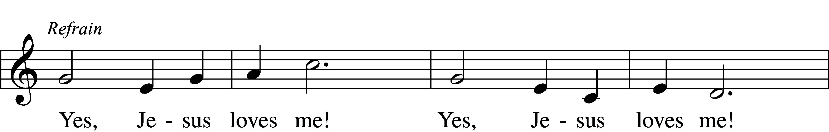

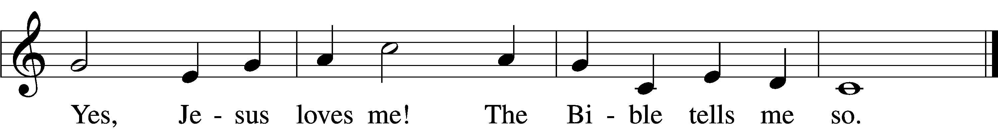

Text: Anna B. Warner, 1820–1915, alt.; Tune: William B. Bradbury, 1816–68; Text and tune: Public domain

Stand

**POST-COMMUNION CANTICLE**

THANK THE LORD LSB 164

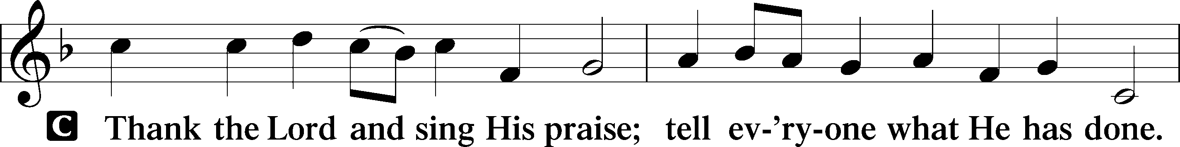

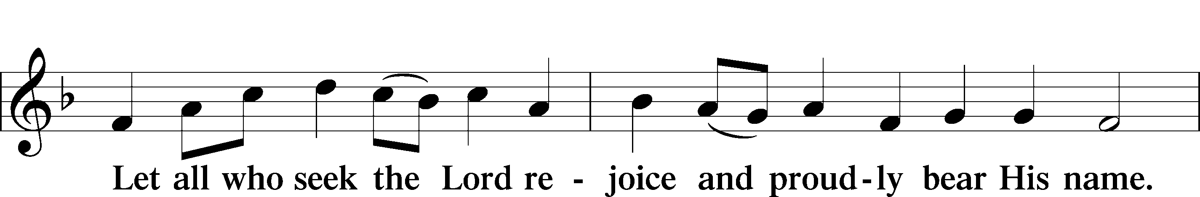

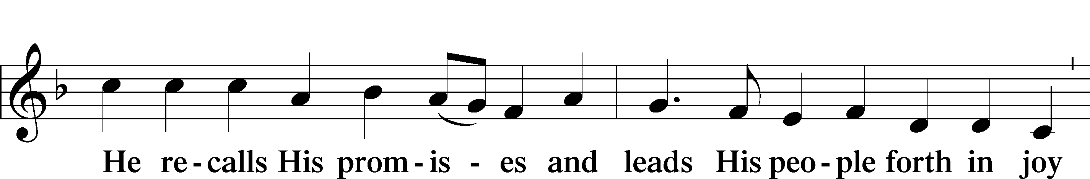

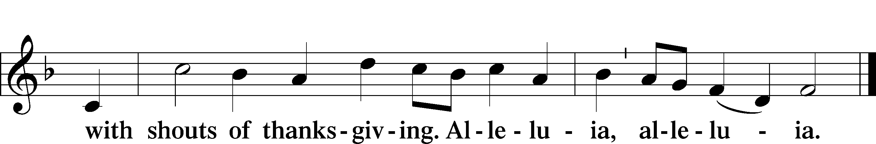

POST-COMMUNION COLLECT

A Let us pray.

Gracious God, our heavenly Father, You have given us a foretaste of the feast to come in the Holy Supper of Your Son’s body and blood. Keep us firm in the true faith throughout our days of pilgrimage that, on the day of His coming, we may, together with all Your saints, celebrate the marriage feast of the Lamb in His kingdom which has no end; through Jesus Christ, Your Son, our Lord, who lives and reigns with You and the Holy Spirit, one God, now and forever.

C **Amen.**

*Sit*

BENEDICTION LSB 166

**Benediction** *LSB 166*

P The Lord bless you and keep you.

The Lord make His face shine on you and be gracious to you.

The Lord look upon you with favor and T give you peace.

C **Amen.**

917 SAVIOR, AGAIN TO THY DEAR NAME WE RAISE

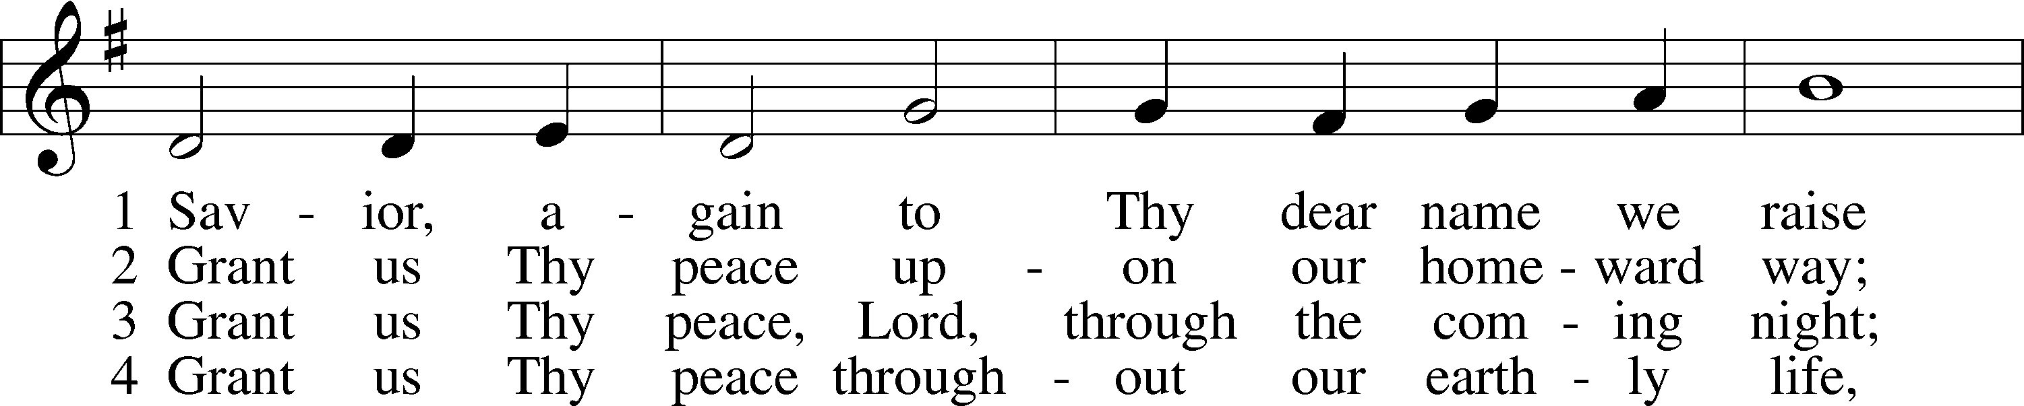

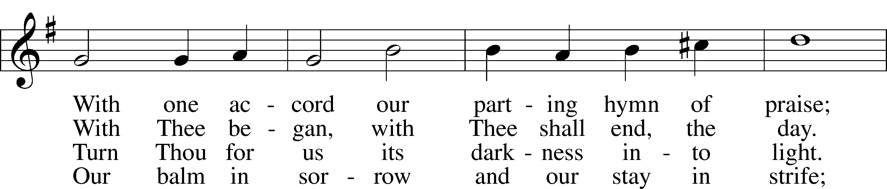

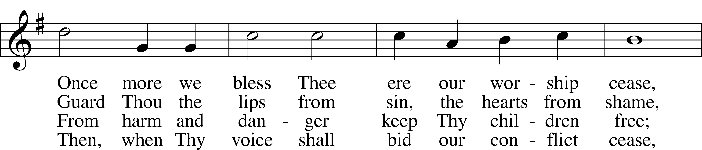

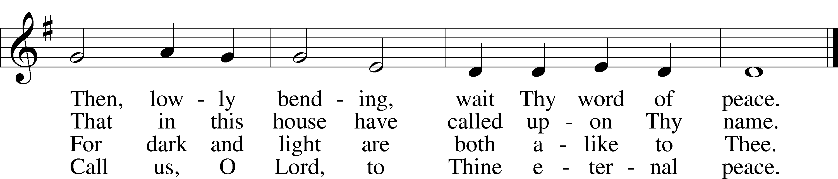

Text: John Ellerton, 1826–93; Tune: Edward J. Hopkins, 1818–1901; Text and tune: Public domain

DISMISSAL

P Go in peace, serve the Lord.

**C Thanks be to God.**

Acknowledgments: Divine Service, Setting One from the Lutheran Service Book. Unless otherwise indicated, Scripture quotations are from the ESV® Bible (The Holy Bible, English Standard Version®), copyright © 2001 by Crossway, a publishing ministry of Good News Publishers. Used by permission. All rights reserved.Created by Lutheran Service Builder © 2025 Concordia Publishing House.

**READINGS FOR NEXT SUNDAY: Eighth Sunday after Pentecost**

**Ecclesiastes 1:2, 12-14; 2:18-26; Colossians 3:1-11 Luke 12:13-21**

**SAINT DAYS, FEAST DAYS, & COMMEMORATIONS THIS WEEK**

**July 28th: Johann Sebastian Bach; Musician and Theologian**

**July 29th: Mary, Martha, and Lazarus of Bethany: Disciples of the Lord**

**July 30th: Robert Barnes: Confessor & Martyr**

**July 31st: Joseph of Arimathea: Witness of the Burial of Our Lord**

***“Therefore, since we are surrounded by so great a cloud of witnesses, let us also lay aside every weight and sin which clings so closely, and let us run with endurance the race that is set before us.” Hebrews 12:1***

**THIS WEEK AT MESSIAH LUTHERAN**

**TUES 10:00 Bible Study with Pastor**

**6:00 Men’s Potluck Bible Study**

**THURS 9:00 LWML Quilter’s Group with Devotional**

**SUN 9:00 Bible Study & Sunday School**

**10:30 Worship with Holy Communion**

**STEWARDSHIP THOUGHT** *Matthew 5:23 “So if you are offering your gift at the altar. . .” Jesus connects our generosity toward God’s Kingdom to our love and forgiveness toward our brethren in the Kingdom. Both grow out of God’s love toward us. We forgive as we have been forgiven, and we give as we have been given to. All our growth in sanctification is growing into our Heavenly Father’s own actions through thankful imitation.*

A simple scan can do so much,

Your gift brings hope, your kindness—touch.

Click the code, it’s quick and true,

Big or small, we thank you!

