Messiah Lutheran Church

Valdosta, Georgia

500 Baytree Road – [messiahluth500@gmail.com](mailto:messiahluth500@gmail.com)

Office: 229-244-0143 Pastor’s Cell: 404-951-6336

|  |
| --- |
| Pastor Stephen Wareham |
|  |

# Sunday, August 3rd, 2025

“We have found the Messiah” John 1: 41b

WELCOME VISITORS!

**We are pleased to meet you and have you visit us today!**

**Please sign our Guest Book located in the church entryway (Narthex) as well as the attendance sheet located in the red folder in each pew. Let us know how we may be of service to you in any way.**

* **RESTROOMS** *are located in the Narthex.*
* **QUIET BAGS** are available in the Narthex for older children. We also offer a children’s bulletin for ages 3-6 and ages 7-12.
* **QUIET/CALMING ROOM** *and a changing table are located near the Fellowship Hall (through the accordion doors behind the choir).*
* **INVITATION TO COMMUNION** *The Sacrament of Holy Communion is offered to all baptized and prepared Christians who believe Christ is truly present with us in this meal. Trusting in the promises of his Word, “—given and shed for you for the forgiveness of sins,” they intend to grow in faith by the power of the Holy Spirit working through this means of grace toward a more committed life with Jesus and His Church.*
* **RECEIVING COMMUNION** *Please extend your hand to receive the bread. Wine is offered from the Chalice or individual cups. Grape juice (center ring, lighter color) is offered for those who choose not to receive wine. After the Communion Assistant follows with the Chalice, place your empty cup on the communion rail rack. Children not yet prepared for the Sacrament may come forward for a blessing “that, living in the covenant of their Baptism and in communion with the Church, they may lead godly lives until the day of Jesus Christ.”*
* **OPPORTUNITIES FOR CHRISTIAN GROWTH**

Sundays at 9:00 am: Adult Bible Study in the **Pine Tree House**.

Sundays at 9:30 am: Sunday School: Grades 4th & 5th in the **Pine Tree House.**

Sundays at 9:15 am: Sunday School: Grades 6th – 12th in the **Pine Tree House**.

Tuesdays at 10:00 am: Pastor’s Bible Study in the **Pine Tree House.**

Tuesday 6:00 pm: Pastor’s Men’s Potluck Bible Study in the **Pine Tree House.**

# Free Welcome Black And White Clipart, Download Free Welcome Black And White Clipart png images, Free ClipArts on Clipart Library

Eighth Sunday After Pentecost

Divine Service Setting One

***The Mission of Messiah Lutheran is to grow in our relationship with God through worship, education, and service, while sharing Christ’s peace and fellowship with all.***

# **AS WE GATHER**

# “And he said to them, ‘Take care, and be on your guard against all covetousness, for one’s life does not consist in the abundance of his possessions.’” *Luke 12:15*

# Coveting is the opposite of being content with what God has given us. And the cure for coveting is twofold: thankfulness to God and generosity toward God’s purposes. So be on guard against all covetousness. Acknowledge that your Father has given you all that you need and therefore be free and confident in directing the wealth of this world toward godly purposes.

# **PRELUDE & PERSONAL DEVOTION *(Quiet Please)***

# +Confession and Absolution+

Stand

All may make the sign of the cross in remembrance of their Baptism.

INVOCATION

P In the name of the Father and of the T Son and of the Holy Spirit.

C **Amen.**

EXHORTATION LSB 151

P If we say we have no sin, we deceive ourselves, and the truth is not in us.

C **But if we confess our sins, God, who is faithful and just, will forgive our sins and cleanse us from all unrighteousness.**

Silence for reflection on God’s Word and self-examination.

CONFESSION OF SINS LSB 151

P Let us then confess our sins to God our Father.

C **Most merciful God, we confess that we are by nature sinful and unclean. We have sinned against You in thought, word, and deed, by what we have done and by what we have left undone. We have not loved You with our whole heart; we have not loved our neighbors as ourselves. We justly deserve Your present and eternal punishment. For the sake of Your Son, Jesus Christ, have mercy on us. Forgive us, renew us, and lead us, so that we may delight in Your will and walk in Your ways to the glory of Your holy name. Amen.**

ABSOLUTION LSB 151

P Almighty God in His mercy has given His Son to die for you and for His sake forgives you all your sins. As a called and ordained servant of Christ, and by His authority, I therefore forgive you all your sins in the name of the Father and of the T Son and of the Holy Spirit.

C **Amen.**

**SHARING OF THE PEACE:**

***Please extend the hand of fellowship to your neighbors with the words:***

***“The peace of the Lord.”***

# +Service of the Word+

ENTRANCE HYMN

850 GOD OF GRACE AND GOD OF GLORY

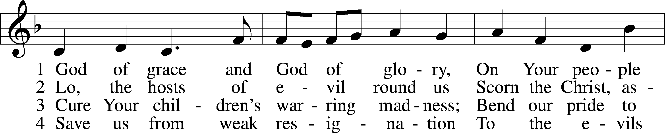

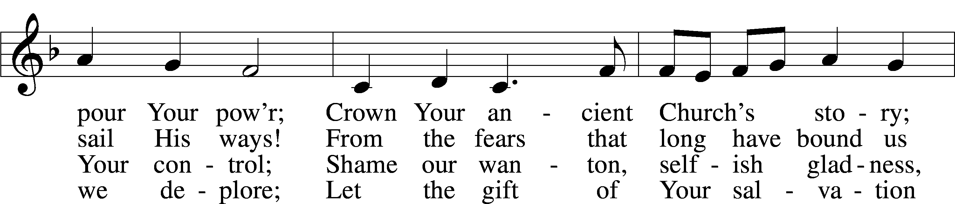

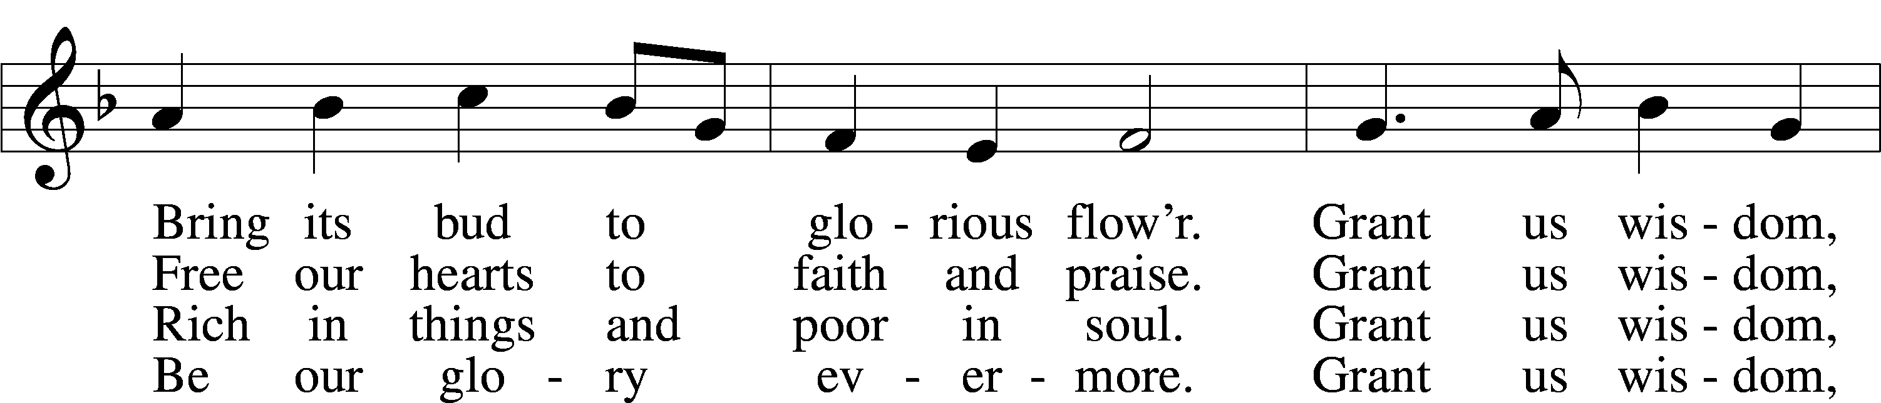

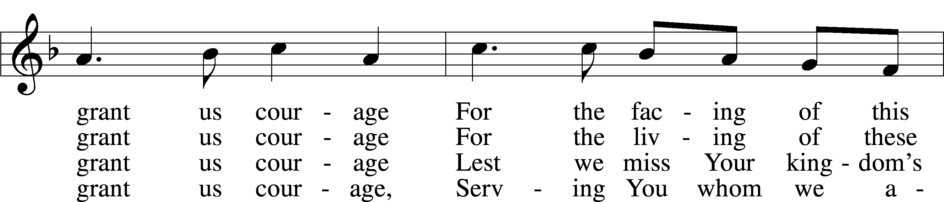

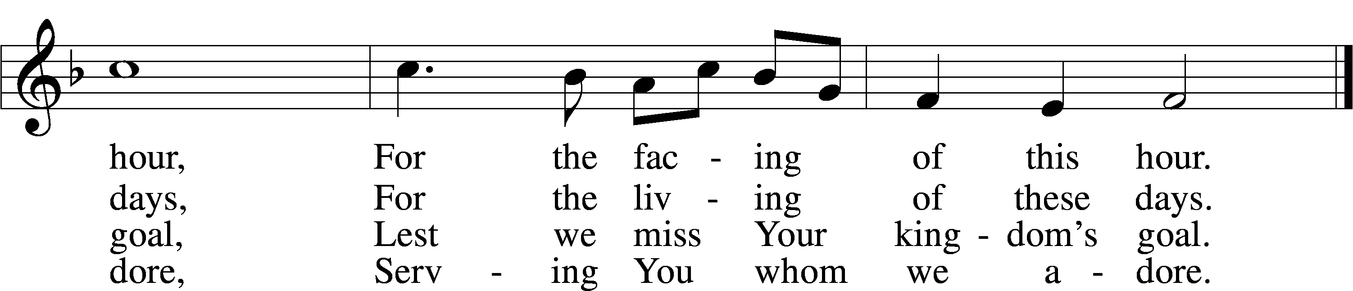

Text: Harry Emerson Fosdick, 1878–1969; Tune: John Hughes, 1873–1932l Text and tune: Public domain

KYRIE LSB 152

GLORIA IN EXCELSIS LSB 154

SALUTATION AND COLLECT OF THE DAY

P Let us pray.

O Lord, let Your merciful ears be attentive to the prayers of Your servants, and by Your Word and Spirit teach us how to pray that our petitions may be pleasing before You; through Jesus Christ, Your Son, our Lord, who lives and reigns with You and the Holy Spirit, one God, now and forever.

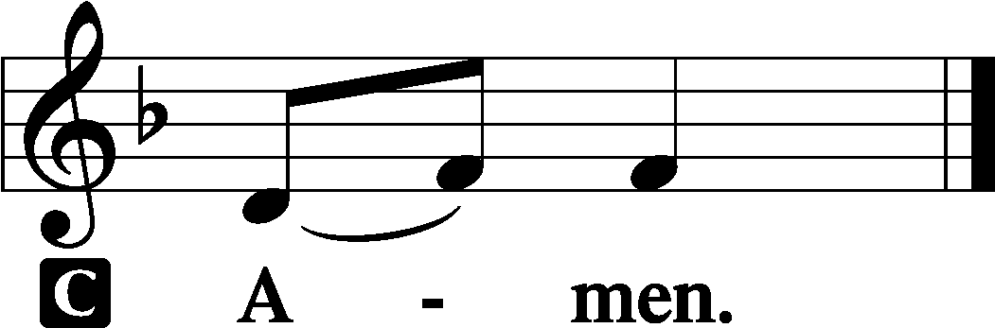

Sit

OLD TESTAMENT Ecclesiastes 1:2, 12–14; 2:18–26

2Vanity of vanities, says the Preacher, vanity of vanities! All is vanity. . . .

12I the Preacher have been king over Israel in Jerusalem. 13And I applied my heart to seek and to search out by wisdom all that is done under heaven. It is an unhappy business that God has given to the children of man to be busy with. 14I have seen everything that is done under the sun, and behold, all is vanity and a striving after wind. . . .

18I hated all my toil in which I toil under the sun, seeing that I must leave it to the man who will come after me, 19and who knows whether he will be wise or a fool? Yet he will be master of all for which I toiled and used my wisdom under the sun. This also is vanity. 20So I turned about and gave my heart up to despair over all the toil of my labors under the sun, 21because sometimes a person who has toiled with wisdom and knowledge and skill must leave everything to be enjoyed by someone who did not toil for it. This also is vanity and a great evil. 22What has a man from all the toil and striving of heart with which he toils beneath the sun? 23For all his days are full of sorrow, and his work is a vexation. Even in the night his heart does not rest. This also is vanity.

24There is nothing better for a person than that he should eat and drink and find enjoyment in his toil. This also, I saw, is from the hand of God, 25for apart from him who can eat or who can have enjoyment? 26For to the one who pleases him God has given wisdom and knowledge and joy, but to the sinner he has given the business of gathering and collecting, only to give to one who pleases God. This also is vanity and a striving after wind.

A This is the Word of the Lord.

C **Thanks be to God.**

PSALM Psalm 100; antiphon: v. 3

1Make a joyful noise to the Lord, all the earth!

2Serve the Lord with gladness!  
 Come into his presence with singing!

3Know that the Lord, he is God!  
 It is he who made us, and we are his;  
 we are his people, and the sheep of his pasture.

4Enter his gates with thanksgiving,  
 and his courts with praise!  
 Give thanks to him; bless his name!

5For the Lord is good;  
 his steadfast love endures forever,  
 and his faithfulness to all generations.

EPISTLE Colossians 3:1–11

1If then you have been raised with Christ, seek the things that are above, where Christ is, seated at the right hand of God. 2Set your minds on things that are above, not on things that are on earth. 3For you have died, and your life is hidden with Christ in God. 4When Christ who is your life appears, then you also will appear with him in glory.

5Put to death therefore what is earthly in you: sexual immorality, impurity, passion, evil desire, and covetousness, which is idolatry. 6On account of these the wrath of God is coming. 7In these you too once walked, when you were living in them. 8But now you must put them all away: anger, wrath, malice, slander, and obscene talk from your mouth. 9Do not lie to one another, seeing that you have put off the old self with its practices 10and have put on the new self, which is being renewed in knowledge after the image of its creator. 11Here there is not Greek and Jew, circumcised and uncircumcised, barbarian, Scythian, slave, free; but Christ is all, and in all.

A This is the Word of the Lord.

C **Thanks be to God.**

Stand

ALLELUIA VERSE LSB 156

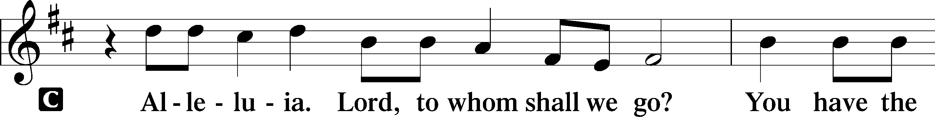

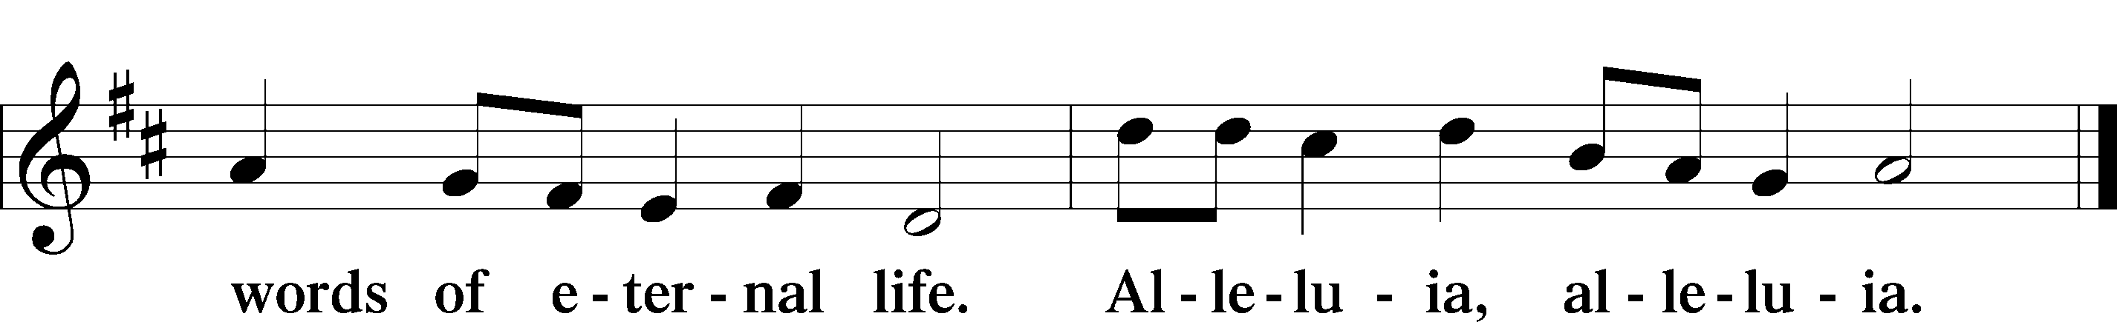

HOLY GOSPEL Luke 12:13–21

P The Holy Gospel according to St. Luke, the twelfth chapter.

C **Glory to You, O Lord.**

13Someone in the crowd said to [Jesus], “Teacher, tell my brother to divide the inheritance with me.” 14But he said to him, “Man, who made me a judge or arbitrator over you?” 15And he said to them, “Take care, and be on your guard against all covetousness, for one’s life does not consist in the abundance of his possessions.” 16And he told them a parable, saying, “The land of a rich man produced plentifully, 17and he thought to himself, ‘What shall I do, for I have nowhere to store my crops?’ 18And he said, ‘I will do this: I will tear down my barns and build larger ones, and there I will store all my grain and my goods. 19And I will say to my soul, Soul, you have ample goods laid up for many years; relax, eat, drink, be merry.’ 20But God said to him, ‘Fool! This night your soul is required of you, and the things you have prepared, whose will they be?’ 21So is the one who lays up treasure for himself and is not rich toward God.”

P This is the Gospel of the Lord.

C **Praise to You, O Christ.**

Sit

789 PRAISE AND THANKSGIVING

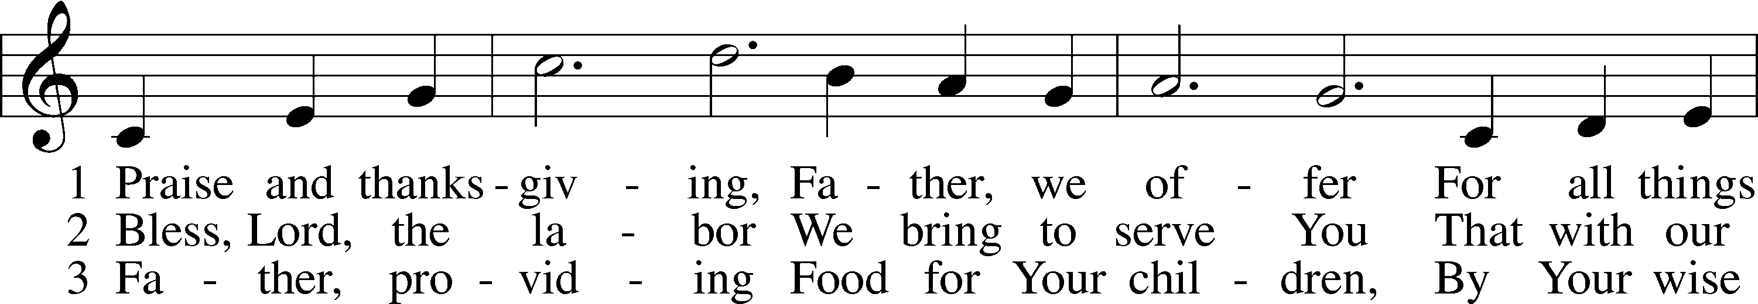

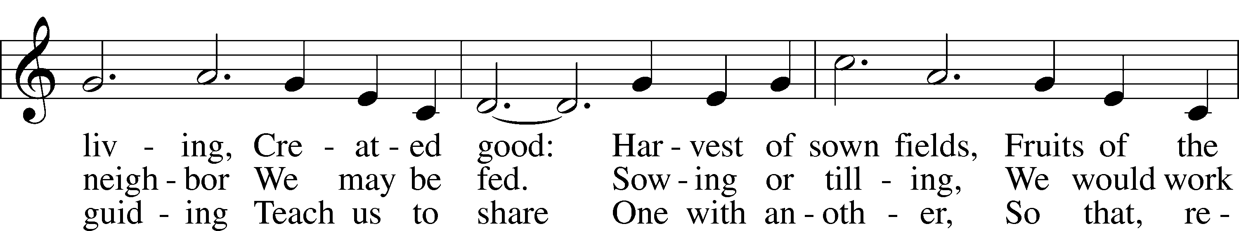

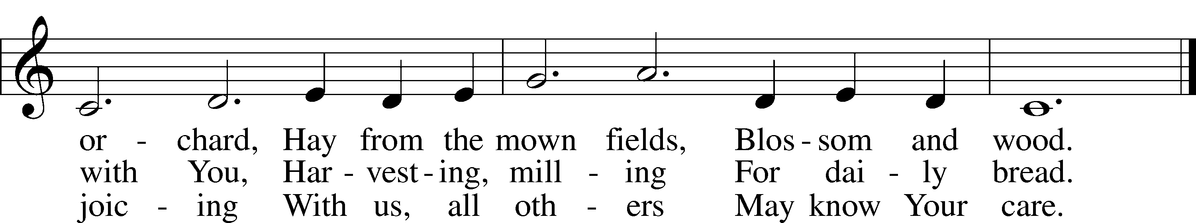

Text: Albert F. Bayly, 1901–84; Tune: Gaelic, 19th cent.;   
Text: © 1987 Oxford University Press. Used by permission: LSB Hymn License no. 110000972; Tune: Public domain

**SERMON “Striving after Wind!”**

**Pastor Stephen Wareham**

Stand

**NICENE CREED**

C **I believe in one God, the Father, the Almighty, maker of heaven and earth, of all that is, seen and unseen.**

**I believe in one Lord, Jesus Christ, the only Son of God, eternally begotten of the Father, God from God, Light from Light, true God from true God, begotten, not made, of one Being with the Father; through him all things were made. For us and for our salvation he came down from heaven; by the power of the Holy Spirit he became incarnate from the virgin Mary, and was made man. For our sake he was crucified under Pontius Pilate; he suffered death and was buried. On the third day he rose again in accordance with the scriptures; he ascended into heaven and is seated at the right hand of the Father. He will come again in glory to judge the living and the dead, and his kingdom will have no end.**

**I believe in the Holy Spirit, the Lord, the giver of life, who proceeds from the Father and the Son, who with the Father and the Son is worshiped and glorified, who has spoken through the prophets. I believe in one holy catholic and apostolic church. I acknowledge one baptism for the forgiveness of sins. I look for the resurrection of the dead, and the life** T **of the world to come. Amen.**

PRAYER OF THE CHURCH

P Let us pray for the whole Church of God in Christ Jesus and for all people according to their needs.  
God, our Creator and Redeemer, You wonderfully created our human nature and yet more wondrously restored it. By the power of Your Spirit, set our minds on things above, where Christ is seated, and renew us more and more in Your image. Lord, in Your mercy,

C **hear our prayer.**

P O Lord, guard Your Church, the people of Your own possession, and give to her honorable and noble men for the Office of the Holy Ministry. Likewise grant gracious and devoted men and women commissioned for the teaching arts and works of charity within Your Church. Make us rich in the treasure of Your grace that will never disappoint us, that we may give generously toward those in need. Lord, in Your mercy,

C **hear our prayer.**

P Heavenly Father, You promise to provide for all our needs of body and soul. Defend our hearts from focusing on worldly wealth and our families from the strife that flows from the love of money. Lead us to trust Your fatherly care in all things. Lord, in Your mercy,

C **hear our prayer.**

P Almighty God, protect us and our neighbors from those who seek to do us harm. Restrain those who senselessly commit acts of violence against others, and keep in peace and safety those who live and work in places of danger. Lord, in Your mercy,

C **hear our prayer.**

P Lord God, be near to the suffering, the dying and the grieving *[*especially Your servants _____________*]*. Sustain them in the truth that their lives are even now hidden with Christ in God, and that when He appears, they will also appear with Him in glory. Give them compassionate and skillful doctors and nurses, that their suffering may be alleviated and their minds and bodies returned to health. Lord, in Your mercy,

C **hear our prayer.**

P (Special Petitions)

C **hear our prayer.**

P Heavenly Father, You consecrate the gifts Your people bring and offer for us the very body and blood of Christ for our salvation. Give us hearts to treasure this everlasting gift, and so protect us from the love of fleeting riches. Lord, in Your mercy,

C **hear our prayer.**

P Almighty God, give holy wisdom to Your dear children, that they may see through the illusions of this world and, being tempted by no temporary pleasures, arrive at the salvation promised to those who trust in Christ. Lord, in Your mercy,

C **hear our prayer.**

P O Lord, our heavenly Father, because we do not know what we need or how to ask, lead us by Your Spirit to trust in Your wisdom and to have confidence in Your grace, for this life and even forevermore. Into Your hands, O Lord, we commend ourselves and all for whom we pray, trusting in Your promises; through Your Son, Jesus Christ, our Lord.

C **Amen.**

Sit

OFFERING

*If you’d like to give electronically with your offering, please see the back of the bulletin for details on donating through Zelle or Thrivent.*

Stand

OFFERTORY

# **955 LET THE VINEYARDS BE FRUITFUL**

**

**

**

**

**

**

# Text: John W. Arthur, 1922–80; Tune: Richard W. Hillert, 1923–2010 Text and tune: © 1978 Lutheran Book of Worship. Used by permission: LSB Hymn License no. 110000972

# 

# +Service of the Sacrament+

PREFACE LSB 160

P It is truly good, right, and salutary that we should at all times and in all places give thanks to You, holy Lord, almighty Father, everlasting God, through Jesus Christ, our Lord, who, having created all things, took on human flesh and was born of the virgin Mary. For our sake He died on the cross and rose from the dead to put an end to death, thus fulfilling Your will and gaining for You a holy people. Therefore with angels and archangels and with all the company of heaven we laud and magnify Your glorious name, evermore praising You and saying:

SANCTUS LSB 161

PRAYER OF THANKSGIVING LSB 161

P Blessed are You, Lord of heaven and earth, for You have had mercy on those whom You created and sent Your only-begotten Son into our flesh to bear our sin and be our Savior. With repentant joy we receive the salvation accomplished for us by the all-availing sacrifice of His body and His blood on the cross.

Gathered in the name and the remembrance of Jesus, we beg You, O Lord, to forgive, renew, and strengthen us with Your Word and Spirit. Grant us faithfully to eat His body and drink His blood as He bids us do in His own testament. Gather us together, we pray, from the ends of the earth to celebrate with all the faithful the marriage feast of the Lamb in His kingdom, which has no end. Graciously receive our prayers; deliver and preserve us. To You alone, O Father, be all glory, honor, and worship, with the Son and the Holy Spirit, one God, now and forever.

C **Amen.**

THE WORDS OF OUR LORD

P Our Lord Jesus Christ, on the night when He was betrayed, took bread, and when He had given thanks, He broke it and gave it to the disciples and said: “Take, eat; this is My T body, which is given for you. This do in remembrance of Me.”

In the same way also He took the cup after supper, and when He had given thanks, He gave it to them, saying: “Drink of it, all of you; this cup is the new testament in My T blood, which is shed for you for the forgiveness of sins. This do, as often as you drink it, in remembrance of Me.”

P As often as we eat this bread and drink this cup, we proclaim the Lord’s death until He comes.

C **Amen. Come, Lord Jesus.**

P O Lord Jesus Christ, only Son of the Father, in giving us Your body and blood to eat and to drink, You lead us to remember and confess Your holy cross and passion, Your blessed death, Your rest in the tomb, Your resurrection from the dead, Your ascension into heaven, and Your coming for the final judgment. So remember us in Your kingdom and teach us to pray:

LORD'S PRAYER

C ***Our Father who art in heaven, hallowed be Thy name, Thy kingdom come, Thy will be done on earth as it is in heaven; give us this day our daily bread; and forgive us our trespasses as we forgive those who trespass against us; and lead us not into temptation, but deliver us from evil. For Thine is the kingdom and the power and the glory forever and ever. Amen*.**

PAX DOMINI

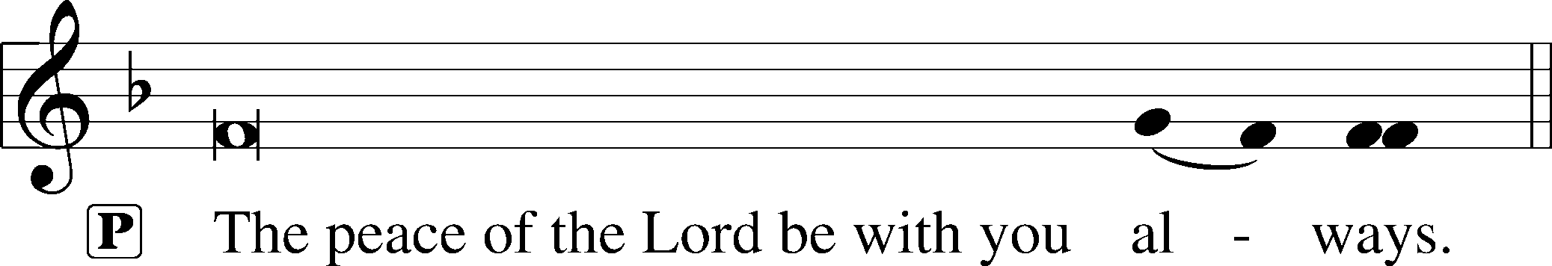



AGNUS DEI LSB 163

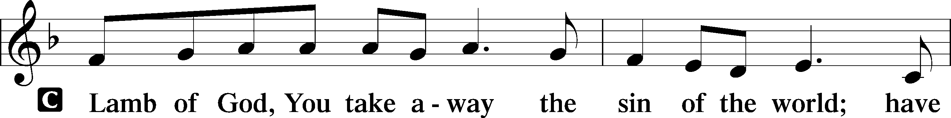

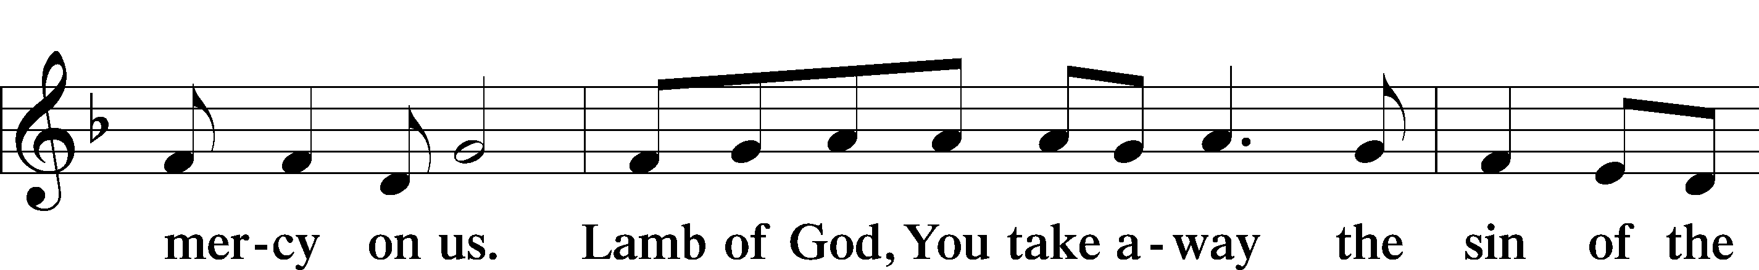

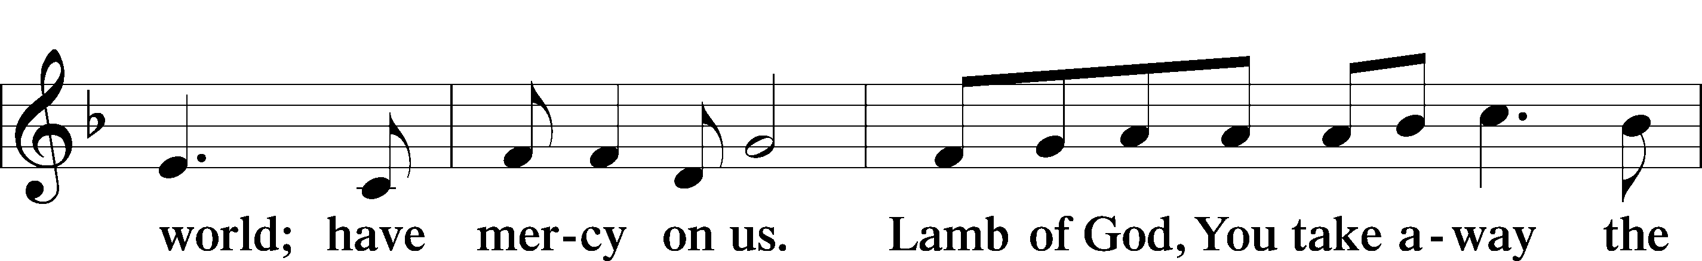

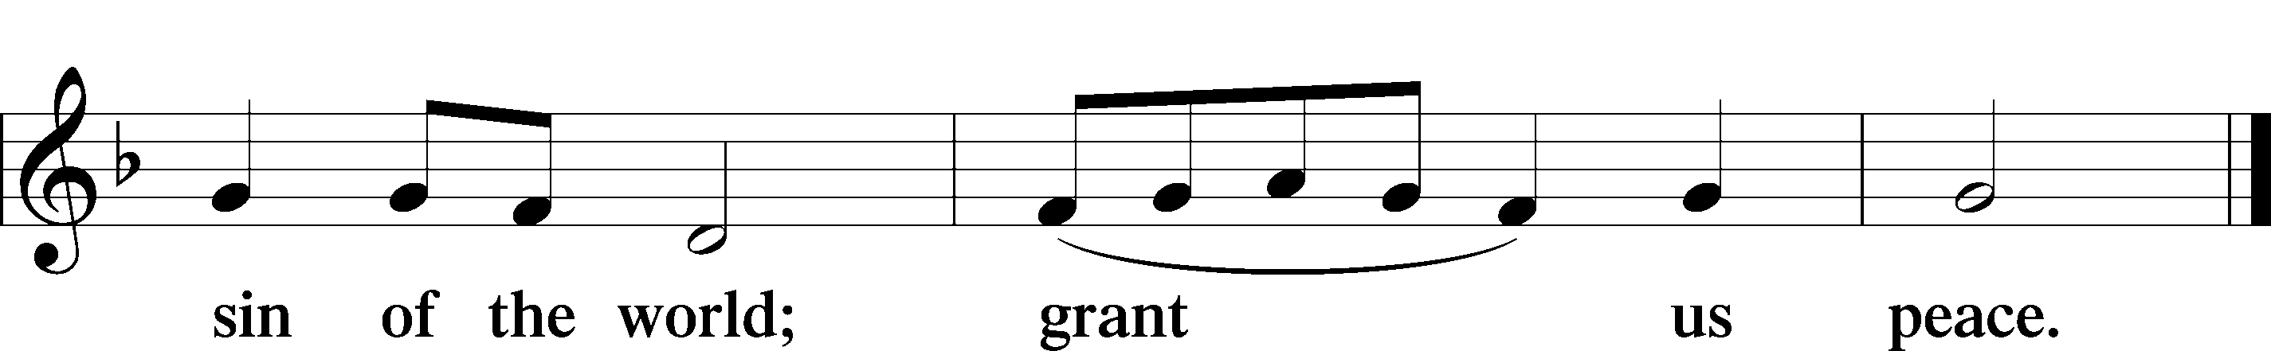

Sit

DISTRIBUTION

DISTRIBUTION HYMNS

618 I COME, O SAVIOR, TO THY TABLE

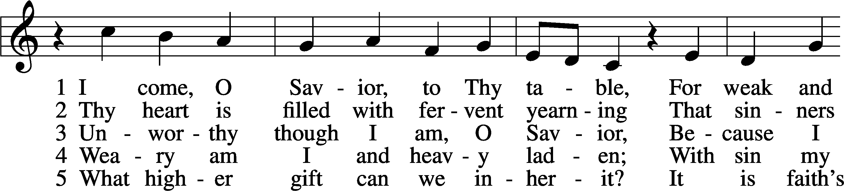

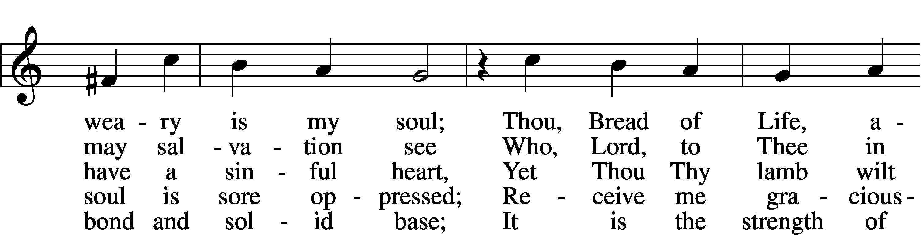

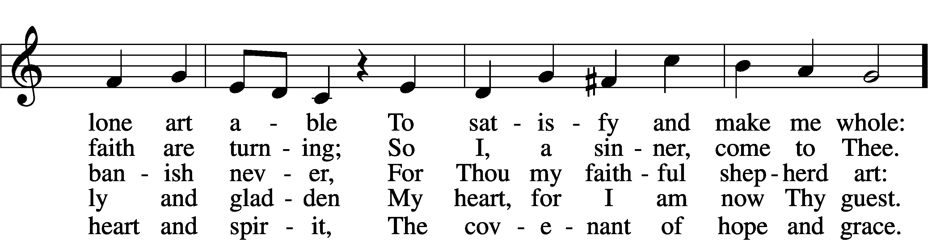

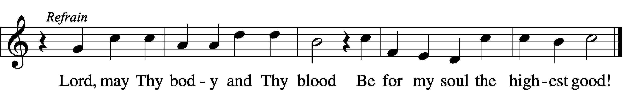

Text: Friedrich Christian Heyder, 1677–1754; tr. The Lutheran Hymnal, 1941, abr.; Tune: Emskirchner Choral-Buch, 1756, Leipzig  
Text: © 1941 Concordia Publishing House. Used by permission: LSB Hymn License no. 110000972; Tune: Public domain

761 ROCK OF AGES, CLEFT FOR ME

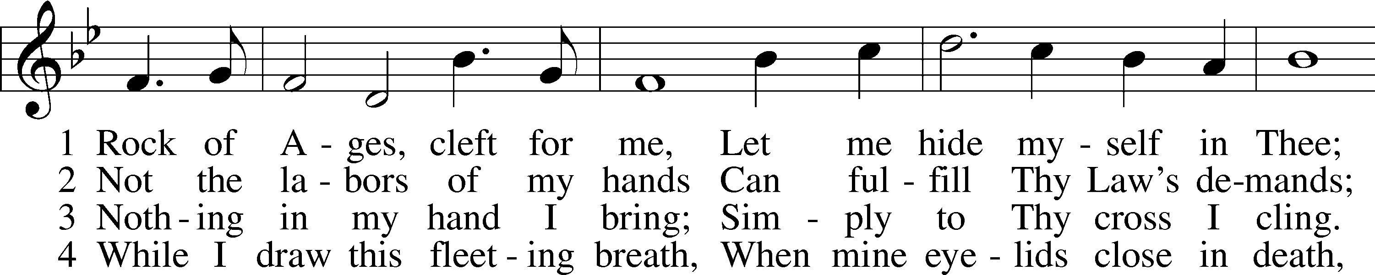

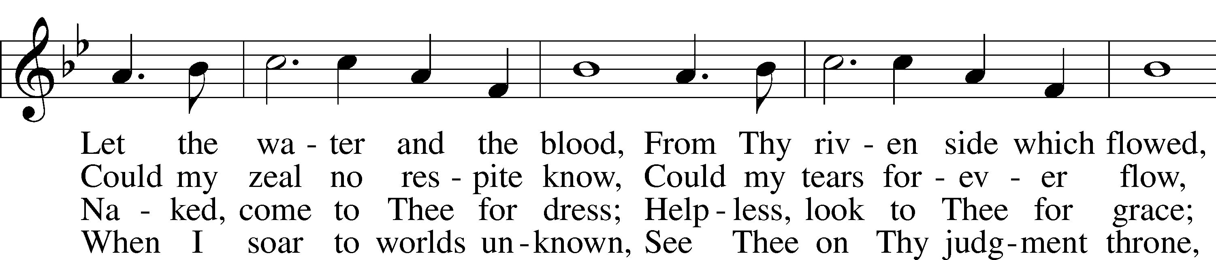

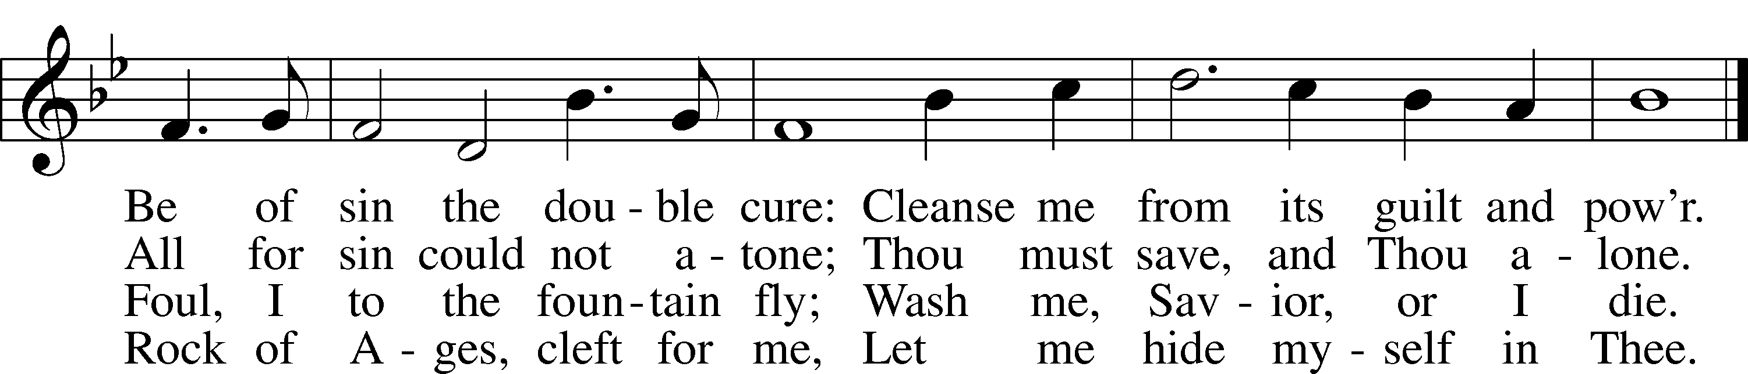

Text: Augustus M. Toplady, 1740–78; Tune: Thomas Hastings, 1784–1872; Text and tune: Public domain

626 COME, LET US EAT

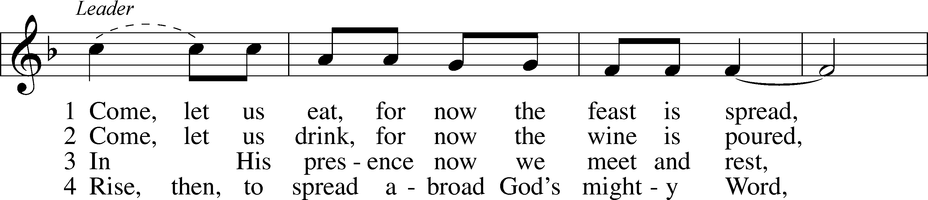

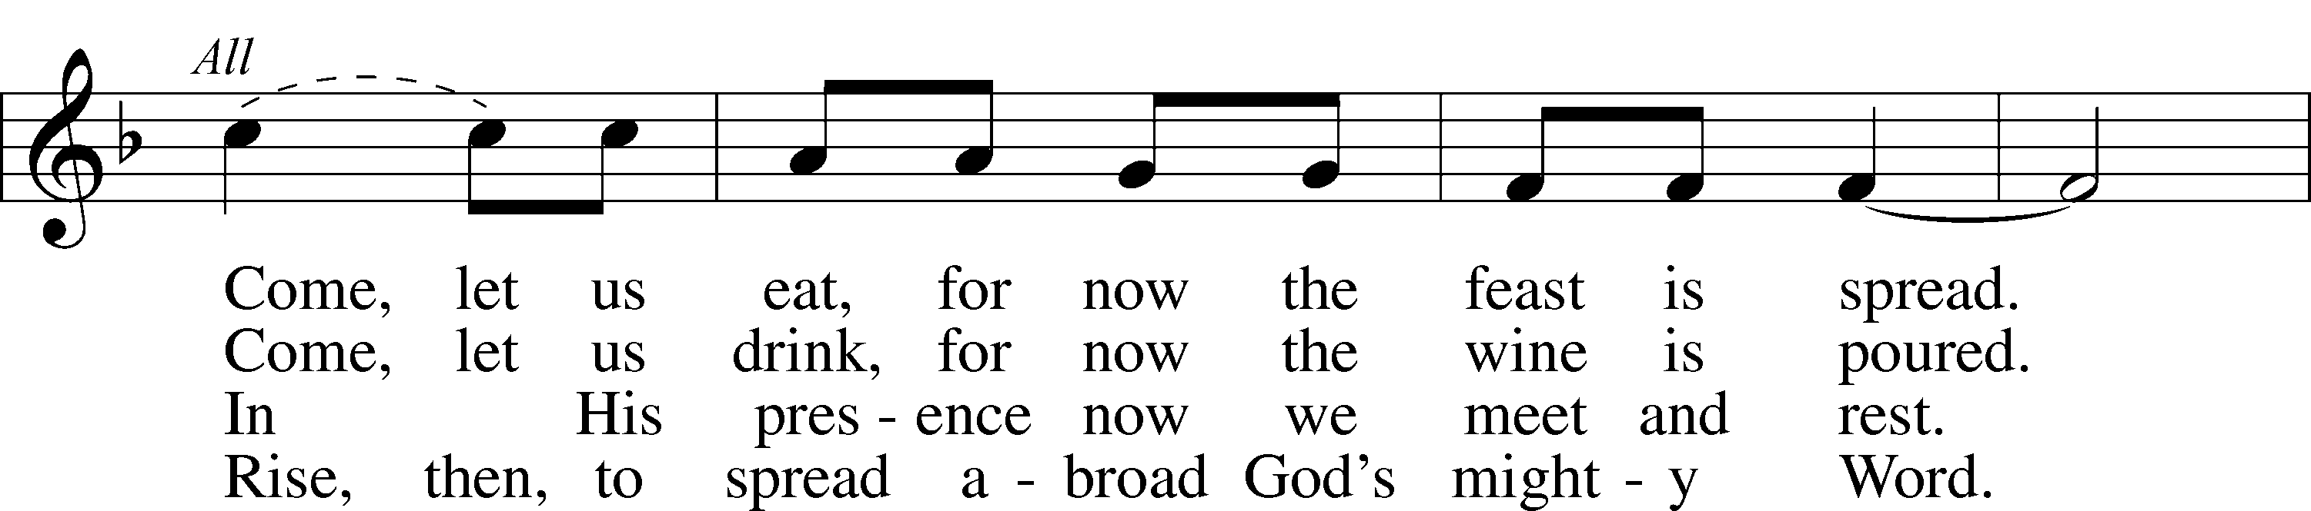

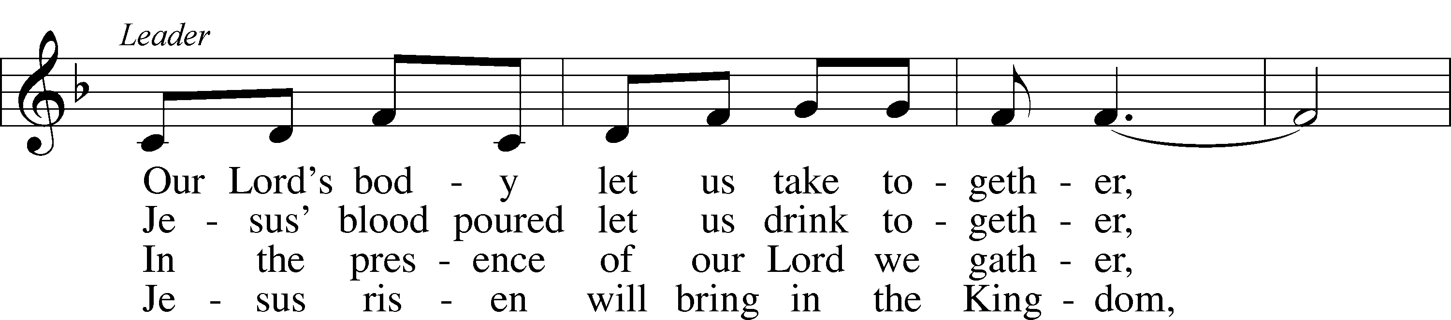

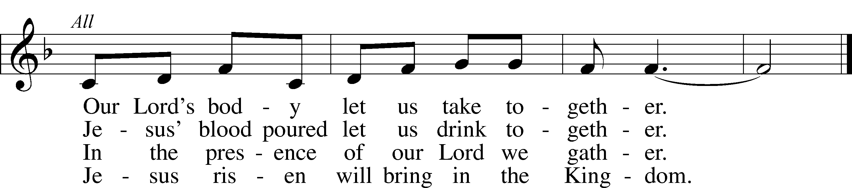

Text (sts. 1–3): tr. Margaret D. Miller, 1927, alt.; (st. 4): Gilbert E. Doan, 1930–2024, alt.; Text (sts. 1–3) and tune: Billema Kwillia, 1925  
Text (st. 4): © 1972 Augsburg Fortress. Used by permission: LSB Hymn License no. 110000972  
Text (sts. 1–3) and tune: © Lutheran World Federation. Used by permission: LSB Hymn License no. 110000972

Stand

**POST-COMMUNION CANTICLE**

THANK THE LORD LSB 164

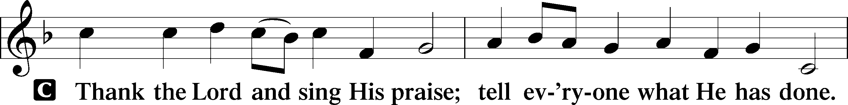

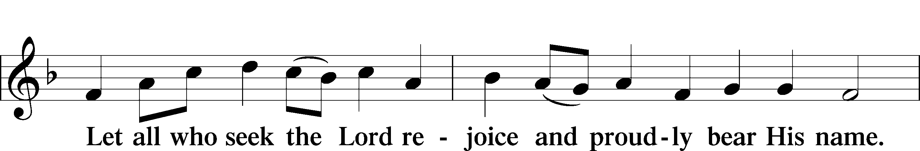

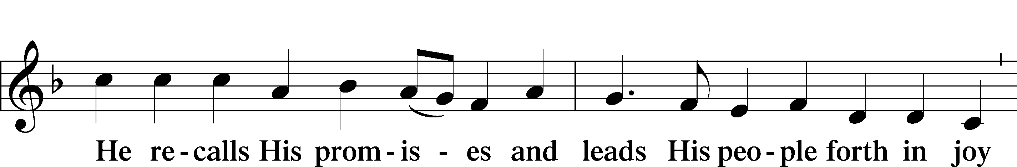

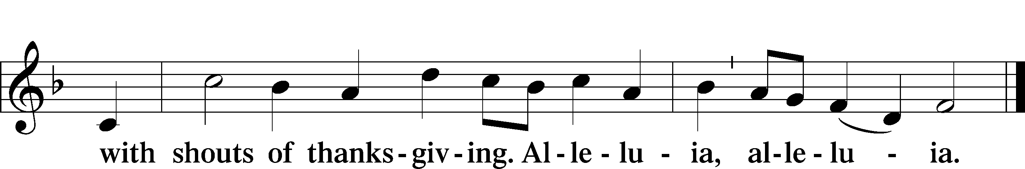

POST-COMMUNION COLLECT

A Let us pray.

We give thanks to You, almighty God, that You have refreshed us through this salutary gift, and we implore You that of Your mercy You would strengthen us through the same in faith toward You and in fervent love toward one another; through Jesus Christ, Your Son, our Lord, who lives and reigns with You and the Holy Spirit, one God, now and forever.

C **Amen.**

BENEDICTION LSB 166

P The Lord bless you and keep you.

The Lord make His face shine on you and be gracious to you.

The Lord look upon you with favor and T give you peace.

C **Amen.**

842 SON OF GOD, ETERNAL SAVIOR

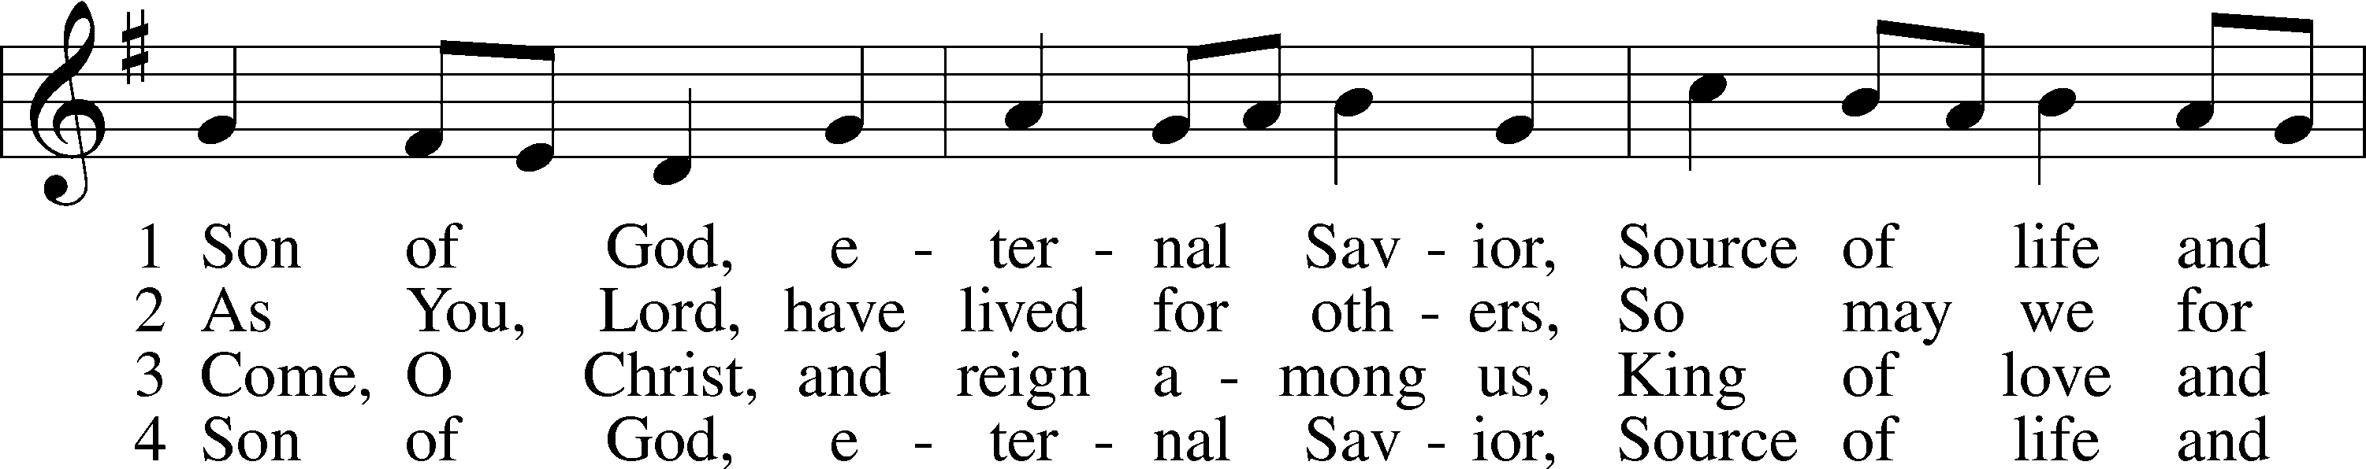

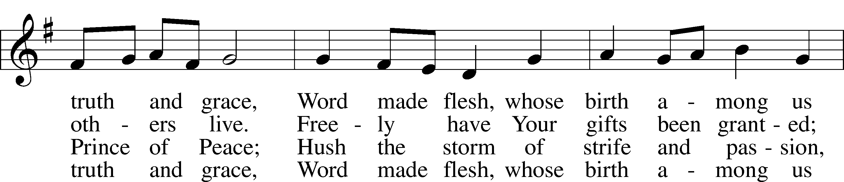

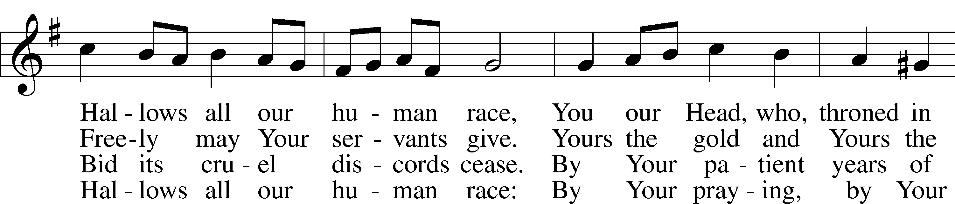

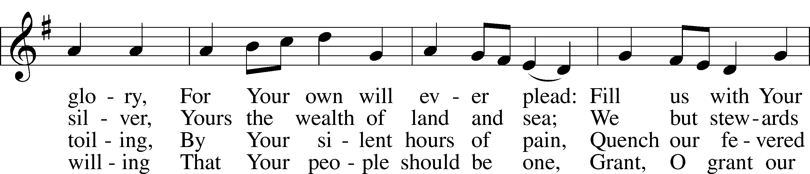

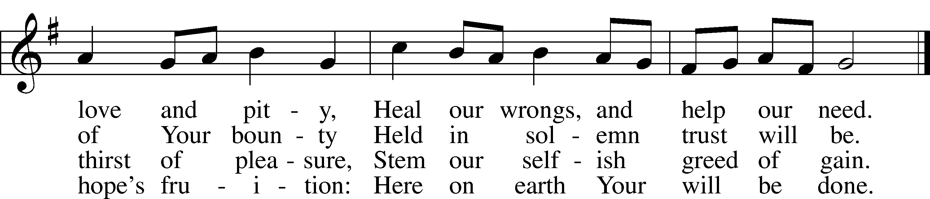

Text: Somerset T. C. Lowry, 1855–1932, alt.; Tune: Oude en Nieuwe Hollantse . . . Contredansen, c. 1710, Amsterdam; Text and tune: Public domain

DISMISSAL

P Go in peace, serve the Lord.

**C Thanks be to God.**

Acknowledgments: Divine Service, Setting One from the Lutheran Service Book. Unless otherwise indicated, Scripture quotations are from the ESV® Bible (The Holy Bible, English Standard Version®), copyright © 2001 by Crossway, a publishing ministry of Good News Publishers. Used by permission. All rights reserved.Created by Lutheran Service Builder © 2025 Concordia Publishing House.

**READINGS FOR NEXT SUNDAY: Eighth Sunday after Pentecost**

**Ecclesiastes 1:2, 12-14; 2:18-26; Colossians 3:1-11 Luke 12:13-21**

**SAINT DAYS, FEAST DAYS, & COMMEMORATIONS THIS WEEK**

**August 3rd: Joanna, Mary, and Salome – Myrrh bearers**

**THIS WEEK AT MESSIAH LUTHERAN**

**TUES 10:00 Bible Study with Pastor**

**3:00 LWML Meeting**

**6:00 Men’s Potluck Bible Study**

**THURS 9:00 LWML Quilter’s Group with Devotional**

**SUN 9:00 Bible Study & Sunday School**

**10:30 Worship with Holy Communion**

**STEWARDSHIP THOUGHT**

*“I have compassion on the crowd.” Still today, the Lord has compassion upon those who follow Him. He knows our needs, and He provides for us. Indeed, He does all this for us long before we think to pray for what we need, before we even know that we need it. Knowing the Lord’s provision frees us from worry about our bodily needs. The Lord really does provide for us out of His unending compassion.* ***Mark 8:2***

A little scan is all it takes,

To help us serve for goodness’ sake!

Click the code and lend a hand,

Together, we can make a stand!

