Messiah Lutheran Church
Valdosta, Georgia

500 Baytree Road – MessiahLuth500@gmail.com
Office: 229-244-0143 Pastor’s Cell: 404-951-6336

www.messiahlutheranvld.com

Pastor Stephen Wareham
MessiahVLDPastor@gmail.com

Sunday, March 15th, 2026
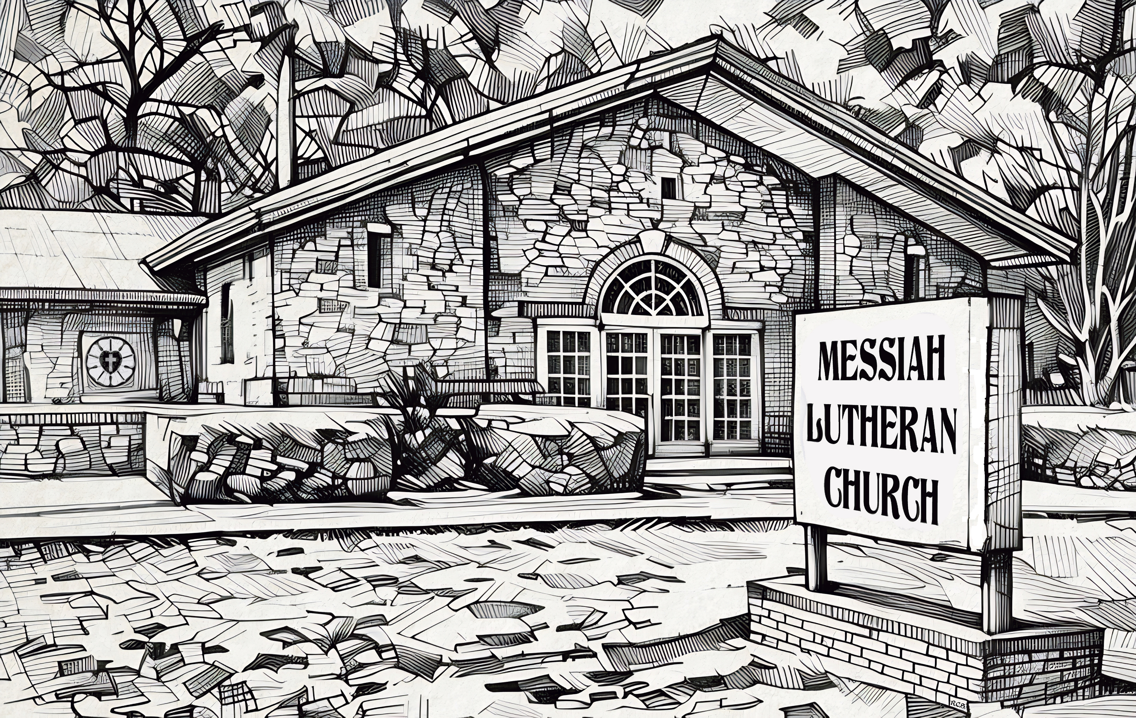
“We have found the Messiah” John 1: 41b

We are pleased to meet you and have you visit us today!
Please sign our Guest Book, located in the church entryway (Narthex), as well as the attendance sheet, which can be found in the red folder in each pew. Please let us know how we can assist you in any way.

- RESTROOMS are located in the Narthex.

- QUIET BAGS are available in the Narthex for older children. We also offer a children’s bulletin for ages 3-6 and ages 7-12.

- QUIET/CALMING ROOM and a changing table are located near the Fellowship Hall (through the accordion doors behind the choir).

- INVITATION TO COMMUNION The Sacrament of Holy Communion is offered to all baptized and prepared Christians who believe Christ is truly present with us in this meal. Trusting in the promises of his Word, “—given and shed for you for the forgiveness of sins,” they intend to grow in faith by the power of the Holy Spirit working through this means of grace toward a more committed life with Jesus and His Church.

- RECEIVING COMMUNION Please extend your hand to receive the bread. Wine is offered from the Chalice or individual cups. Grape juice (center ring, lighter color) is offered for those who choose not to receive wine. After the Communion Assistant follows with the Chalice, place your empty cup on the communion rail rack. Children not yet prepared for the Sacrament may come forward for a blessing “that, living in the covenant of their Baptism and in communion with the Church, they may lead godly lives until the day of Jesus Christ.”

- OPPORTUNITIES FOR CHRISTIAN GROWTH
Sundays at 9:00 am: Adult Bible Study in the Pine Tree House.
Sundays at 9:30 am: Sunday School: Grades 4th & 5th in the Pine Tree House.
Sundays at 9:15 am: Sunday School: Grades 6th – 12th in the Pine Tree House.
Tuesdays at 10:00 am: Tuesdays with the Pastor Bible Study in the Fellowship Hall.
Tuesday 6:00 pm: Pastor’s Men’s Potluck Bible Study in the Pine Tree House.
Tuesday 6:00 pm: Women’s Potluck Bible Study in the Fellowship Hall.

Fourth Sunday in Lent
Divine Service Setting Two

The Mission of Messiah Lutheran is to grow in our relationship with God through worship, education, and service, while sharing Christ’s peace and fellowship with all.

AS WE GATHER
“Jesus answered, “It was not that this man sinned, or his parents, but that the works of God might be displayed in him.” John 9:3
One of Jesus’ toughest lessons is that even suffering can become a stage for the works of God to be displayed. But because of Jesus, we can trust with complete confidence that God’s power and glory are revealed through every circumstance, offering our lives as testimonies of His transforming grace.
PRELUDE & PERSONAL DEVOTION (Quiet Please)

+Confession and Absolution+
Stand

All may make the sign of the cross in remembrance of their Baptism.

INVOCATION
P In the name of the Father and of the T Son and of the Holy Spirit.
C Amen.

EXHORTATION LSB 151
P If we say we have no sin, we deceive ourselves, and the truth is not in us.
C But if we confess our sins, God, who is faithful and just, will forgive our sins and cleanse us from all unrighteousness.

Silence for reflection on God’s Word and self-examination.

CONFESSION OF SINS LSB 151
P Let us then confess our sins to God our Father.
C Most merciful God, we confess that we are by nature sinful and unclean. We have sinned against You in thought, word, and deed, by what we have done and by what we have left undone. We have not loved You with our whole heart; we have not loved our neighbors as ourselves. We justly deserve Your present and eternal punishment. For the sake of Your Son, Jesus Christ, have mercy on us. Forgive us, renew us, and lead us, so that we may delight in Your will and walk in Your ways to the glory of Your holy name. Amen.

ABSOLUTION LSB 151
P Almighty God in His mercy has given His Son to die for you and for His sake forgives you all your sins. As a called and ordained servant of Christ, and by His authority, I therefore forgive you all your sins in the name of the Father and of the T Son and of the Holy Spirit.
C Amen.

SHARING PEACE:
Please extend the hand of fellowship to your neighbors with the words:
“The peace of the Lord.”

+Service of the Word+
ENTRANCE HYMN
411 I WANT TO WALK AS A CHILD OF THE LIGHT
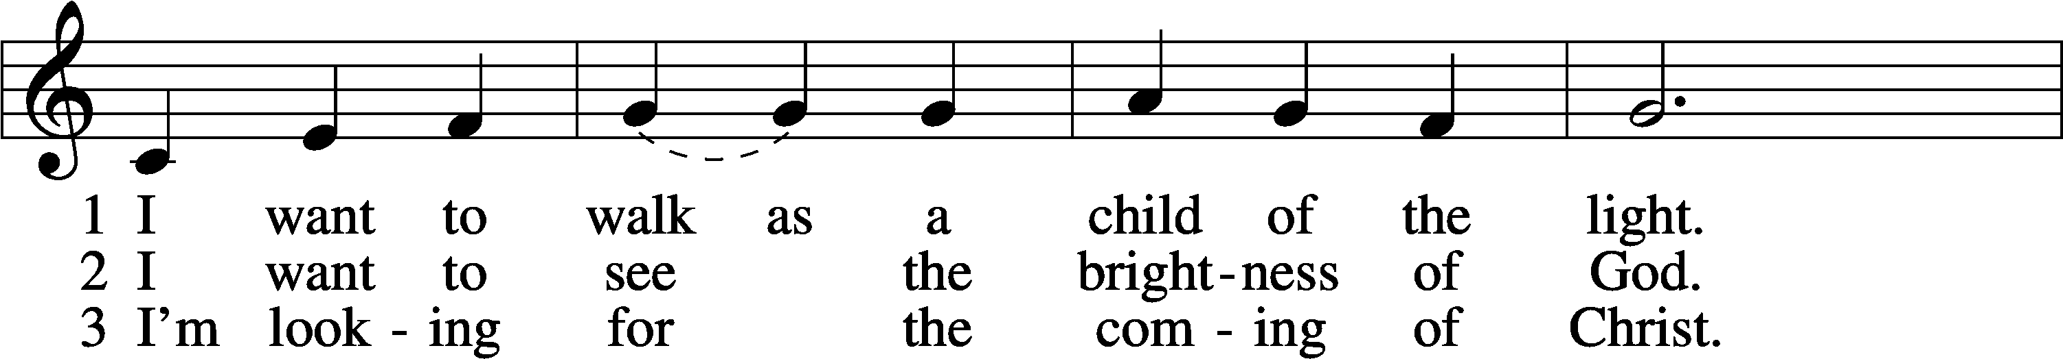
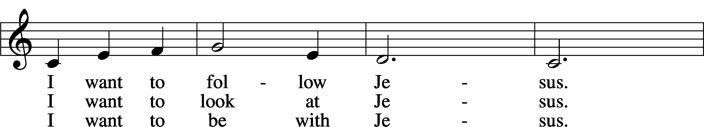
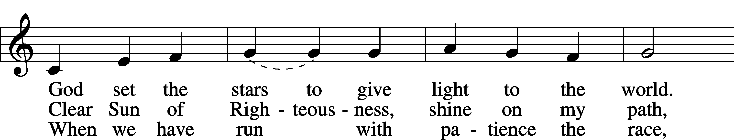
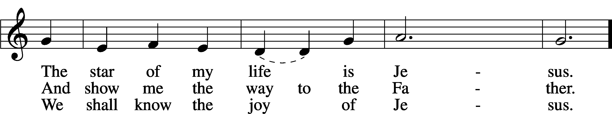
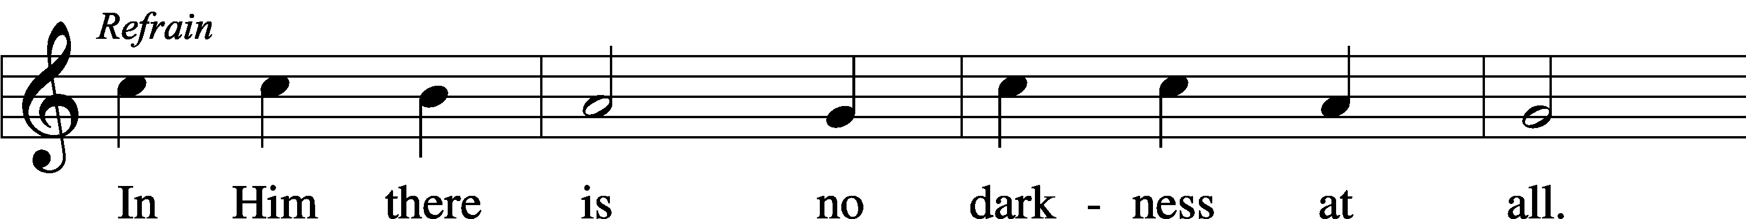
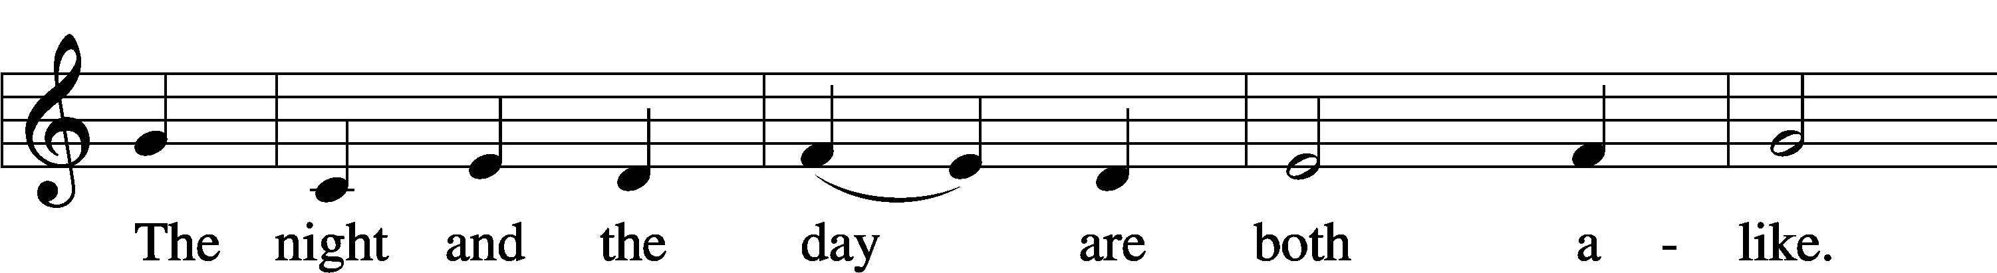
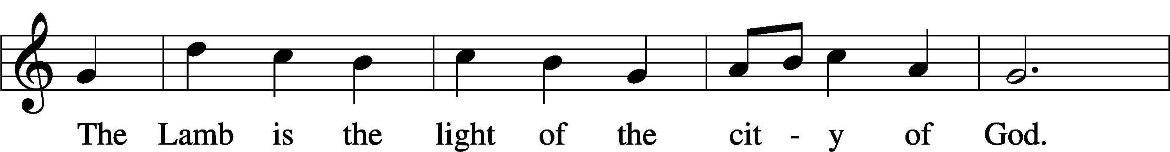
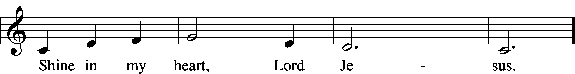
Text and tune: Kathleen Thomerson, 1934–2025; Text and tune: © 1970, 1975 Celebration. Used by permission: LSB Hymn License no. 110000972

KYRIE LSB 168
P In peace let us pray to the Lord.
C Lord, have mercy.
P For the peace from above and for our salvation let us pray to the Lord.
C Lord, have mercy.
P For the peace of the whole world, for the well-being of the Church of God, and for the unity of all let us pray to the Lord.
C Lord, have mercy.
P For this holy house and for all who offer here their worship and praise let us pray to the Lord.
C Lord, have mercy.
P Help, save, comfort, and defend us, gracious Lord.
C Amen.

SALUTATION AND COLLECT OF THE DAY
P The Lord be with you.
C And also with you.
P Let us pray.
Almighty God, our heavenly Father, Your mercies are new every morning; and though we deserve only punishment, You receive us as Your children and provide for all our needs of body and soul. Grant that we may heartily acknowledge Your merciful goodness, give thanks for all Your benefits, and serve You in willing obedience; through Jesus Christ, Your Son, our Lord, who lives and reigns with You and the Holy Spirit, one God, now and forever.
C Amen.

Sit

OLD TESTAMENT READING Isaiah 42:14–21
14For a long time I have held my peace; I have kept still and restrained myself; now I will cry out like a woman in labor; I will gasp and pant.
15I will lay waste mountains and hills, and dry up all their vegetation; I will turn the rivers into islands, and dry up the pools.
16And I will lead the blind in a way that they do not know, in paths that they have not known I will guide them. I will turn the darkness before them into light, the rough places into level ground. These are the things I do, and I do not forsake them.
17They are turned back and utterly put to shame, who trust in carved idols, who say to metal images,“You are our gods.”
18Hear, you deaf, and look, you blind, that you may see!
19Who is blind but my servant, or deaf as my messenger whom I send? Who is blind as my dedicated one,or blind as the servant of the Lord?
20He sees many things, but does not observe them; his ears are open, but he does not hear.
21The Lord was pleased, for his righteousness’ sake, to magnify his law and make it glorious.

A This is the Word of the Lord.
C Thanks be to God.

EPISTLE Ephesians 5:8–14
8For at one time you were darkness, but now you are light in the Lord. Walk as children of light 9(for the fruit of light is found in all that is good and right and true), 10and try to discern what is pleasing to the Lord. 11Take no part in the unfruitful works of darkness, but instead expose them. 12For it is shameful even to speak of the things that they do in secret. 13But when anything is exposed by the light, it becomes visible, 14for anything that becomes visible is light. Therefore, it says, “Awake, O sleeper, and arise from the dead, and Christ will shine on you.”
A This is the Word of the Lord.
C Thanks be to God.
Stand

VERSE LSB 173
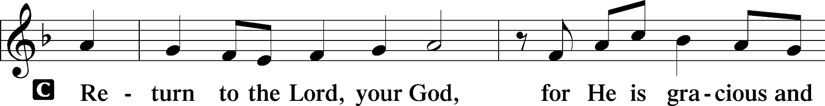
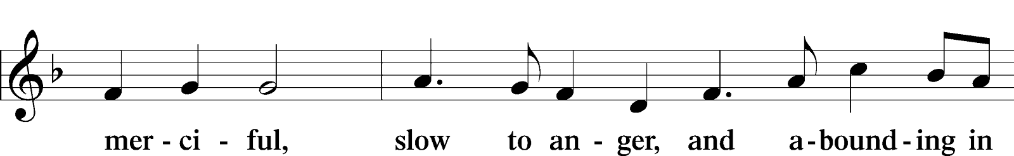
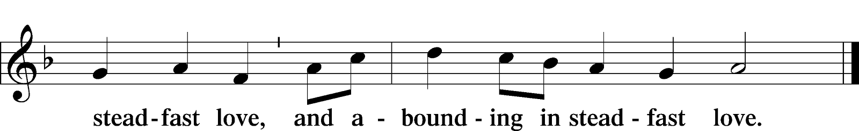

HOLY GOSPEL John 9:1–41
P The Holy Gospel according to St. John, the ninth chapter..
C Glory to You, O Lord.

1As [Jesus] passed by, he saw a man blind from birth. 2And his disciples asked him, “Rabbi, who sinned, this man or his parents, that he was born blind?” 3Jesus answered, “It was not that this man sinned, or his parents, but that the works of God might be displayed in him. 4We must work the works of him who sent me while it is day; night is coming, when no one can work. 5As long as I am in the world, I am the light of the world.” 6Having said these things, he spat on the ground and made mud with the saliva. Then he anointed the man’s eyes with the mud 7and said to him, “Go, wash in the pool of Siloam” (which means Sent). So he went and washed and came back seeing.
8The neighbors and those who had seen him before as a beggar were saying, “Is this not the man who used to sit and beg?” 9Some said, “It is he.” Others said, “No, but he is like him.” He kept saying, “I am the man.” 10So they said to him, “Then how were your eyes opened?” 11He answered, “The man called Jesus made mud and anointed my eyes and said to me, ‘Go to Siloam and wash.’ So I went and washed and received my sight.” 12They said to him, “Where is he?” He said, “I do not know.”
13They brought to the Pharisees the man who had formerly been blind. 14Now it was a Sabbath day when Jesus made the mud and opened his eyes. 15So the Pharisees again asked him how he had received his sight. And he said to them, “He put mud on my eyes, and I washed, and I see.” 16Some of the Pharisees said, “This man is not from God, for he does not keep the Sabbath.” But others said, “How can a man who is a sinner do such signs?” And there was a division among them. 17So they said again to the blind man, “What do you say about him, since he has opened your eyes?” He said, “He is a prophet.”
18The Jews did not believe that he had been blind and had received his sight, until they called the parents of the man who had received his sight 19and asked them, “Is this your son, who you say was born blind? How then does he now see?” 20His parents answered, “We know that this is our son and that he was born blind. 21But how he now sees we do not know, nor do we know who opened his eyes. Ask him; he is of age. He will speak for himself.” 22(His parents said these things because they feared the Jews, for the Jews had already agreed that if anyone should confess Jesus to be Christ, he was to be put out of the synagogue.) 23Therefore his parents said, “He is of age; ask him.”
24So for the second time they called the man who had been blind and said to him, “Give glory to God. We know that this man is a sinner.” 25He answered, “Whether he is a sinner I do not know. One thing I do know, that though I was blind, now I see.” 26They said to him, “What did he do to you? How did he open your eyes?” 27He answered them, “I have told you already, and you would not listen. Why do you want to hear it again? Do you also want to become his disciples?” 28And they reviled him, saying, “You are his disciple, but we are disciples of Moses. 29We know that God has spoken to Moses, but as for this man, we do not know where he comes from.” 30The man answered, “Why, this is an amazing thing! You do not know where he comes from, and yet he opened my eyes. 31We know that God does not listen to sinners, but if anyone is a worshiper of God and does his will, God listens to him. 32Never since the world began has it been heard that anyone opened the eyes of a man born blind. 33If this man were not from God, he could do nothing.” 34They answered him, “You were born in utter sin, and would you teach us?” And they cast him out.
35Jesus heard that they had cast him out, and having found him he said, “Do you believe in the Son of Man?” 36He answered, “And who is he, sir, that I may believe in him?” 37Jesus said to him, “You have seen him, and it is he who is speaking to you.” 38He said, “Lord, I believe,” and he worshiped him. 39Jesus said, “For judgment I came into this world, that those who do not see may see, and those who see may become blind.” 40Some of the Pharisees near him heard these things, and said to him, “Are we also blind?” 41Jesus said to them, “If you were blind, you would have no guilt; but now that you say, ‘We see,’ your guilt remains.”

P This is the Gospel of the Lord.
C Praise to You, O Christ.

Sit

CHILDREN'S MESSAGE

HYMN OF THE DAY
571 GOD LOVED THE WORLD SO THAT HE GAVE
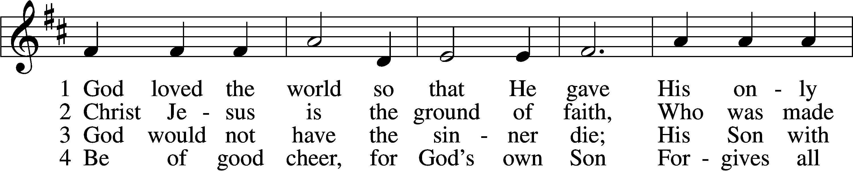
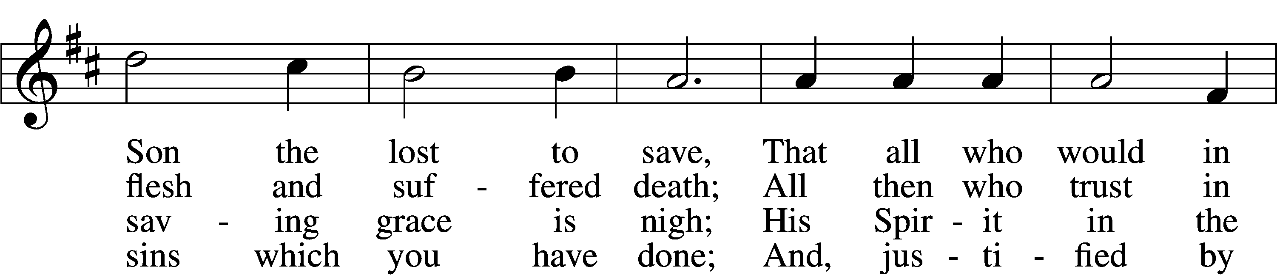
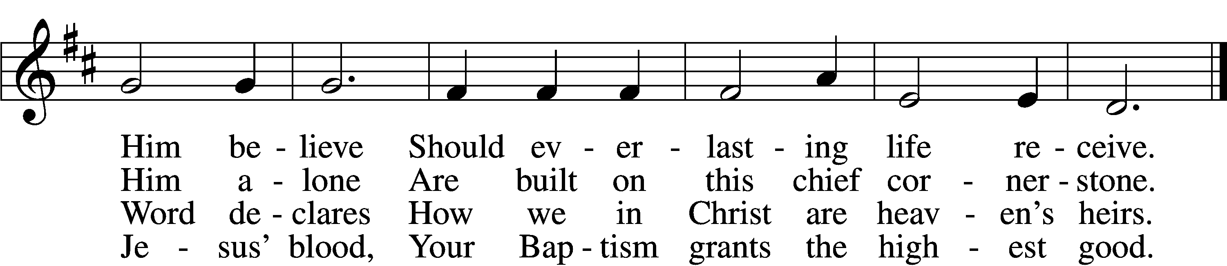
VERSE 5
If you are sick, if death is near,
This truth your troubled heart can cheer:
Christ Jesus saves your soul from death;
That is the firmest ground of faith.
VERSE 6
D Glory to God the Father, Son,
And Holy Spirit, Three in One!
To You, O blessèd Trinity,
Be praise now and eternally!
Text: Heiliges Lippen- und Hertzens-Opffer, c. 1778, Stettin; tr. August Crull, 1845–1923, alt.;
Tune: George J. Elvey, 1816–93; Text and tune: Public domain

SERMON PASTOR STEPHEN WAREHAM

Stand

NICENE CREED
C I believe in one God, the Father, the Almighty, maker of heaven and earth, of all that is, seen and unseen.
I believe in one Lord, Jesus Christ, the only Son of God, eternally begotten of the Father, God from God, Light from Light, true God from true God, begotten, not made, of one Being with the Father; through him all things were made. For us and for our salvation, he came down from heaven; by the power of the Holy Spirit, he became incarnate from the virgin Mary and was made man. For our sake, he was crucified under Pontius Pilate; he suffered death and was buried. On the third day he rose again in accordance with the scriptures; he ascended into heaven and is seated at the right hand of the Father. He will come again in glory to judge the living and the dead, and his kingdom will have no end.
I believe in the Holy Spirit, the Lord, the giver of life, who proceeds from the Father and the Son, who with the Father and the Son is worshiped and glorified, who has spoken through the prophets. I believe in one holy, catholic, and apostolic Church. I acknowledge one baptism for the forgiveness of sins. I look for the resurrection of the dead, and the life T of the world to come. Amen.

PRAYER OF THE CHURCH
P Let us pray for the whole Church of God in Christ Jesus and for all people according to their needs.
Great Physician, enlighten our eyes by Your blessed Gospel, and hide us in Your shelter in the day of trouble. Provide a home in Your Church for those cast out by this world, and unite them with us in the pure confession of Your name. Lord, in Your mercy,
C hear our prayer.
P Lord of glory, You have gathered Your Church and sanctified us in Your truth. Guide and direct Matthew, our Synod president; Rev. James Rockey, our district president; and Burt Matlock, our circuit visitor. Preserve all vacant congregations, send laborers into Your harvest and sustain those whom You have sent. Lord, in Your mercy,
C hear our prayer.
P Almighty Father, uphold in mercy all authorities, especially parents and the civil servants of our nation. Strengthen our homes, and keep families firm in the Christian faith. Preserve us from wickedness, and uphold order and justice for a peaceful life. Lord, in Your mercy,
C hear our prayer.
P Lord God, You have promised that what we suffer does not condemn us, but instead displays Your glory. Sustain the afflicted in body or soul, [especially _____________,] that they would take heart, trust You for healing and find You even in the midst of their trials. Lord, in Your mercy,
C hear our prayer.
P Blessed, O Lord, is everyone who is not offended by Your Christ. Give us faith to believe His blessed testament, seek His Holy Supper for the forgiveness of our sins, and confess Your truth with honest hearts in the communion of this altar. Lord, in Your mercy,
C hear our prayer.
P O Lord, those who wait for Your salvation have the promise that You will not forsake them. Lead those who wander in darkness through rough places, that they would find the way of righteousness and not be put to shame. Lord, in Your mercy,
C hear our prayer.
P All these things, O heavenly Father, we pray in the name of Jesus Christ, asking You to grant our prayers not for our sake but for His sake alone. Teach our hearts to be content with Your will and to trust that You will answer with what is best for us and at the right time for our need. Graciously receive our prayers, deliver and preserve us, for to You alone we give all glory, honor and worship, Father, Son and Holy Spirit, one God, now and forever.
C Amen.

Sit

OFFERING
If you’d like to give electronically with your offering, please see the back of the bulletin for details on donating through Zelle or Thrivent.

Stand

OFFERTORY
955 LET THE VINEYARDS BE FRUITFUL
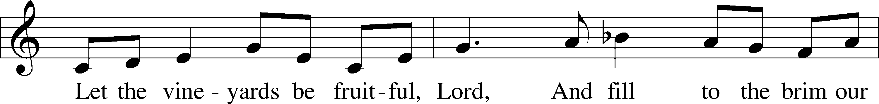
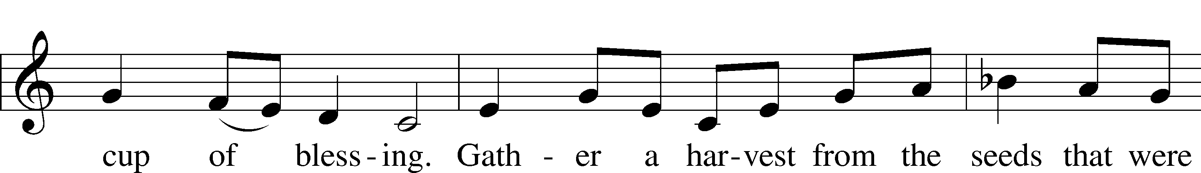
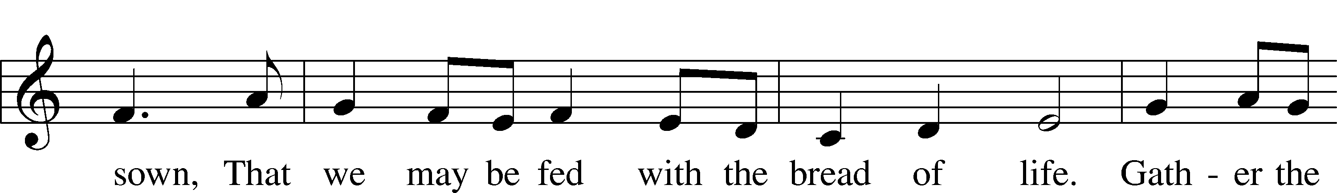
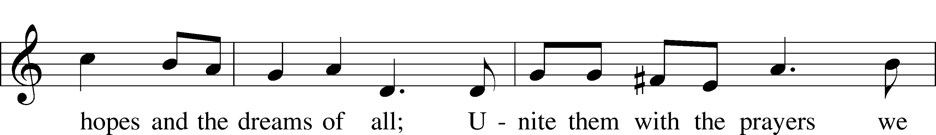
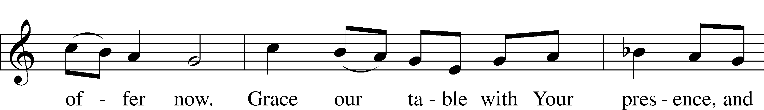
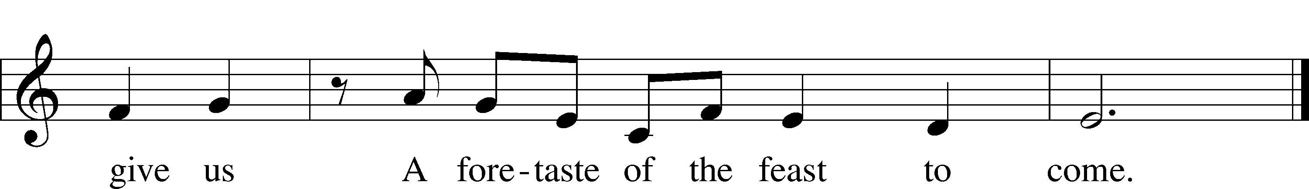
Text: John W. Arthur, 1922–80; Tune: Richard W. Hillert, 1923–2010
Text and tune: © 1978 Lutheran Book of Worship. Used by permission: LSB Hymn License no. 110000972

+Service of the Sacrament+
PREFACE LSB 177
P The Lord be with you.
C And also with you.
P Lift up your hearts.
C We lift them to the Lord.
P Let us give thanks to the Lord our God.
C It is right to give Him thanks and praise.

PROPER PREFACE
P It is truly good, right, and salutary that we should at all times and in all places give thanks to You, holy Lord, almighty Father, everlasting God, through Jesus Christ, our Lord, who overcame the assaults of the devil and gave His life as a ransom for many that with cleansed hearts we might be prepared joyfully to celebrate the paschal feast in sincerity and truth. Therefore with angels and archangels and with all the company of heaven we laud and magnify Your glorious name, evermore praising You and saying:

SANCTUS LSB 178
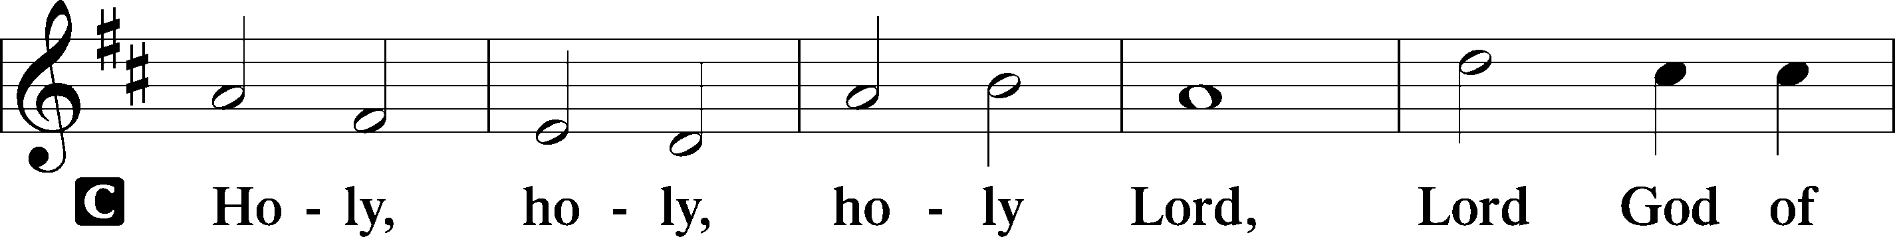
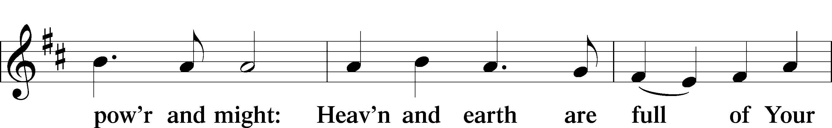
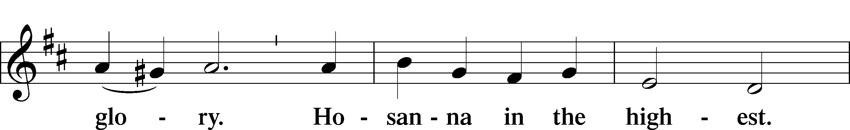
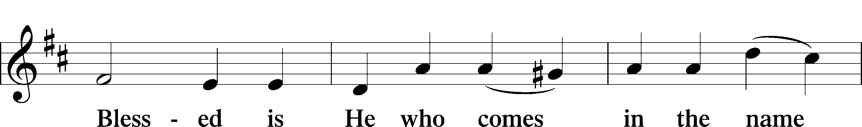
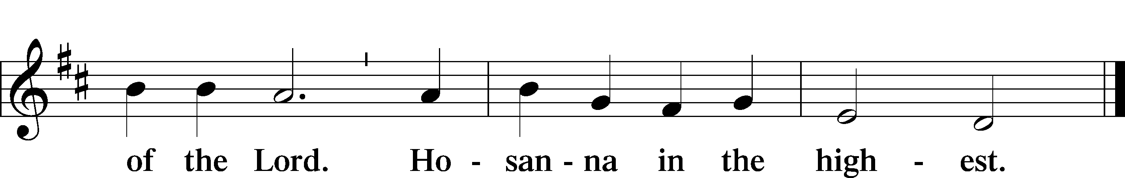

PRAYER OF THANKSGIVING LSB 178
P Blessed are You, Lord of heaven and earth, for You have had mercy on those whom You created and sent Your only-begotten Son into our flesh to bear our sin and be our Savior. With repentant joy we receive the salvation accomplished for us by the all-availing sacrifice of His body and His blood on the cross.
Gathered in the name and the remembrance of Jesus, we beg You, O Lord, to forgive, renew, and strengthen us with Your Word and Spirit. Grant us faithfully to eat His body and drink His blood as He bids us do in His own testament. Gather us together, we pray, from the ends of the earth to celebrate with all the faithful the marriage feast of the Lamb in His kingdom, which has no end. Graciously receive our prayers; deliver and preserve us. To You alone, O Father, be all glory, honor, and worship, with the Son and the Holy Spirit, one God, now and forever.
C Amen.

THE WORDS OF OUR LORD
P Our Lord Jesus Christ, on the night when He was betrayed, took bread, and when He had given thanks, He broke it and gave it to the disciples and said: “Take, eat; this is My T body, which is given for you. This do in remembrance of Me.”
In the same way also He took the cup after supper, and when He had given thanks, He gave it to them, saying: “Drink of it, all of you; this cup is the new testament in My T blood, which is shed for you for the forgiveness of sins. This do, as often as you drink it, in remembrance of Me.”
P As often as we eat this bread and drink this cup, we proclaim the Lord’s death until He comes.
C Amen. Come, Lord Jesus.
P O Lord Jesus Christ, only Son of the Father, in giving us Your body and blood to eat and to drink, You lead us to remember and confess Your holy cross and passion, Your blessed death, Your rest in the tomb, Your resurrection from the dead, Your ascension into heaven, and Your coming for the final judgment. So remember us in Your kingdom and teach us to pray:

LORD'S PRAYER
C Our Father who art in heaven, hallowed be Thy name, Thy kingdom come, Thy will be done on earth as it is in heaven; give us this day our daily bread; and forgive us our trespasses as we forgive those who trespass against us; and lead us not into temptation, but deliver us from evil. For Thine is the kingdom and the power and the glory forever and ever. Amen.

PAX DOMINI LSB 180
P The peace of the Lord be with you always.
C Amen.

AGNUS DEI LSB 180
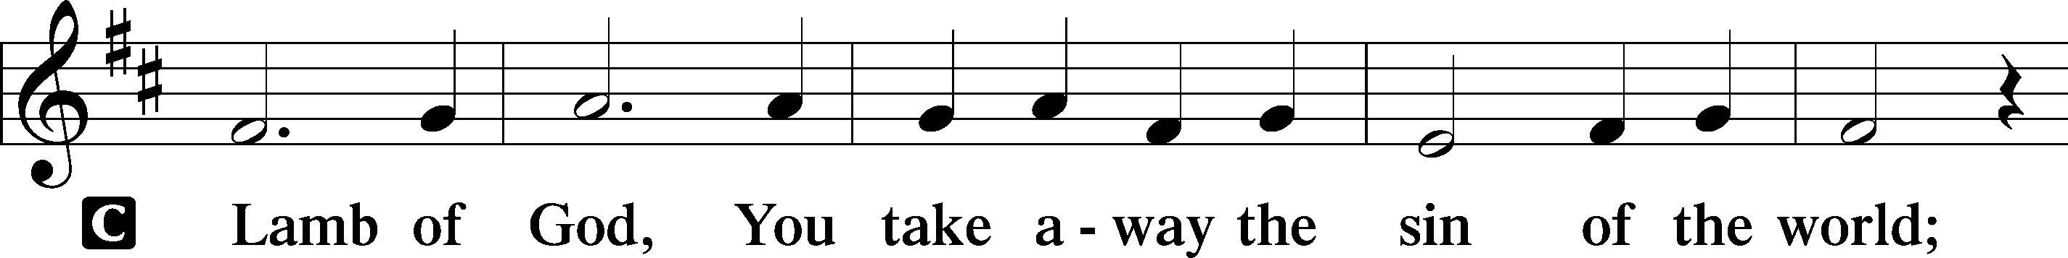
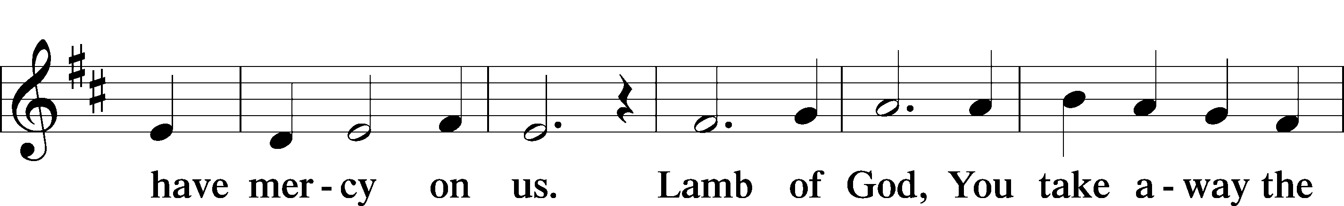
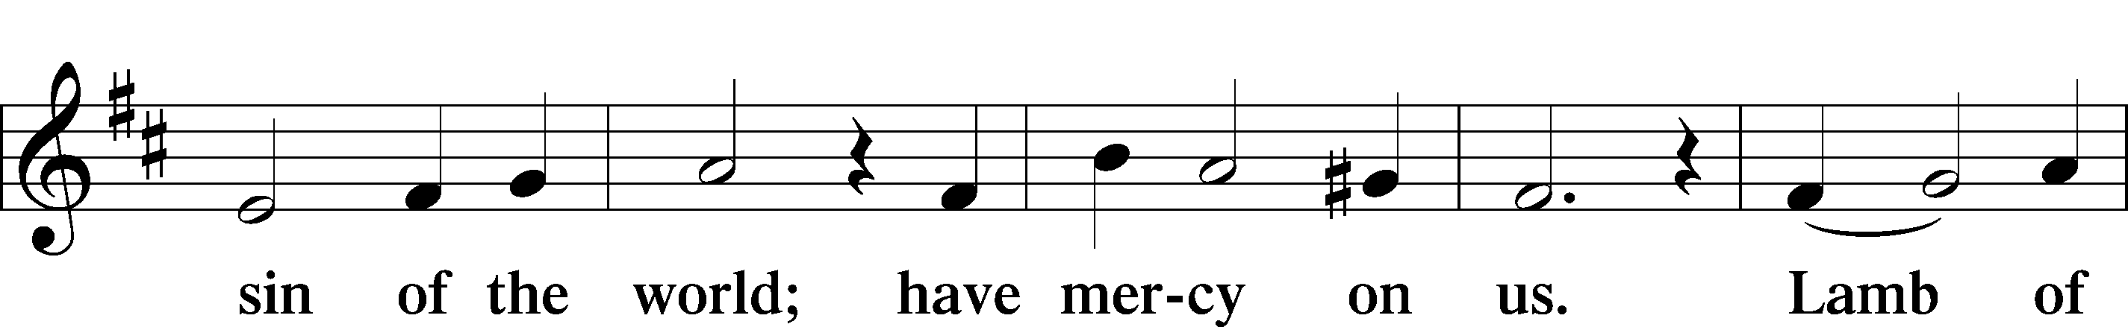
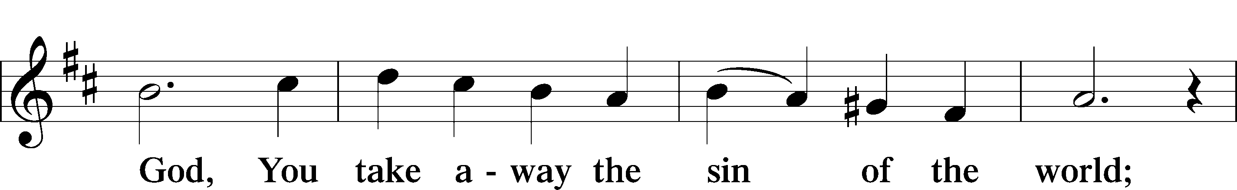
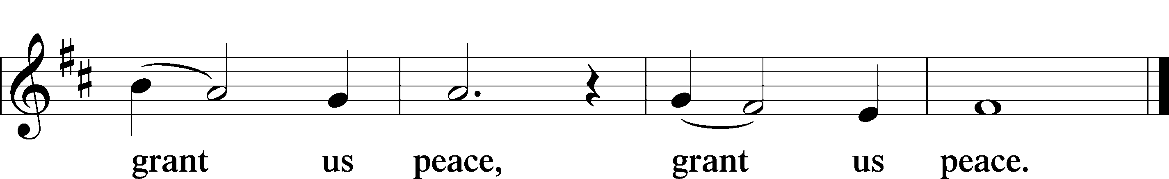

Sit
DISTRIBUTION
845 WHERE CHARITY AND LOVE PREVAIL
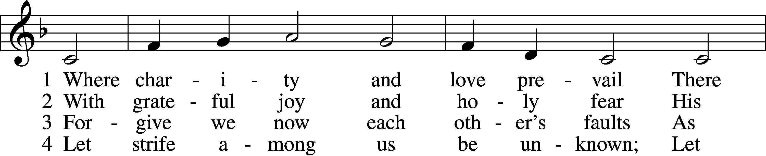
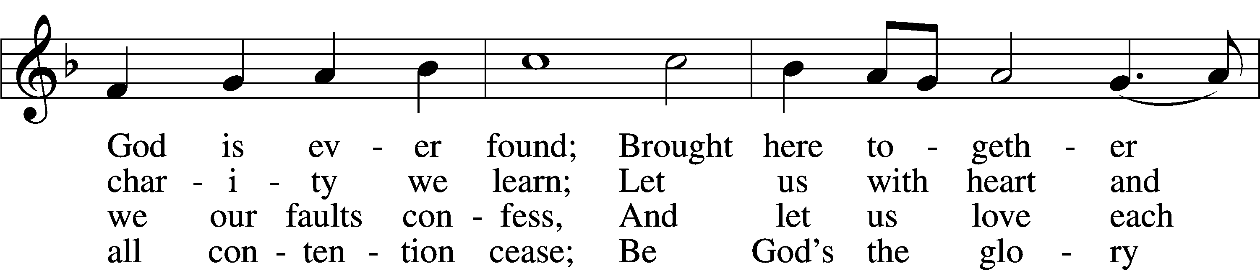
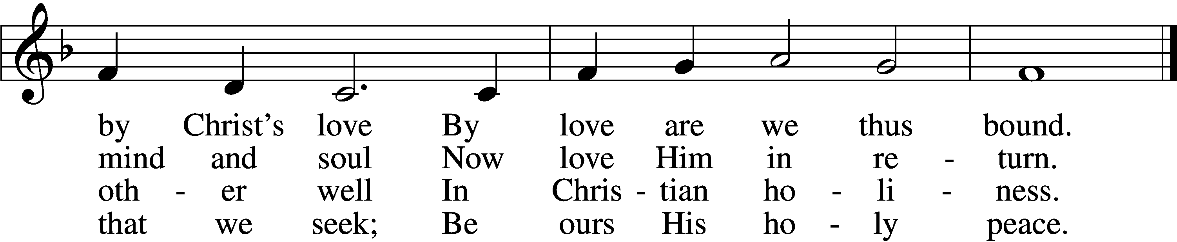
VERSE 5
Let us recall that in our midst
Dwells Christ, His only Son;
As members of His body joined
We are in Him made one.
VERSE 6
For love excludes no race or clan
That names the Savior’s name;
His family embraces all
Whose Father is the same.
Text: Latin, c. 9th cent.; tr. Omer E. Westendorf, 1916–97, alt.; Tune: Lucius Chapin, 1760–1842 Text: © 1960 World Library Publications. Used by permission: LSB Hymn License no. 110000972; Tune: Public domain

427 IN THE CROSS OF CHRIST I GLORY
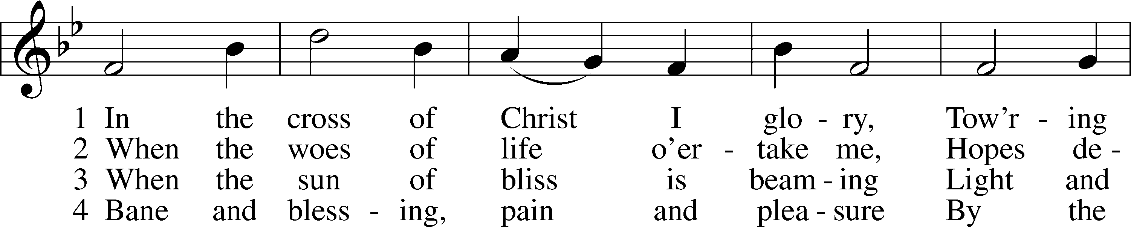
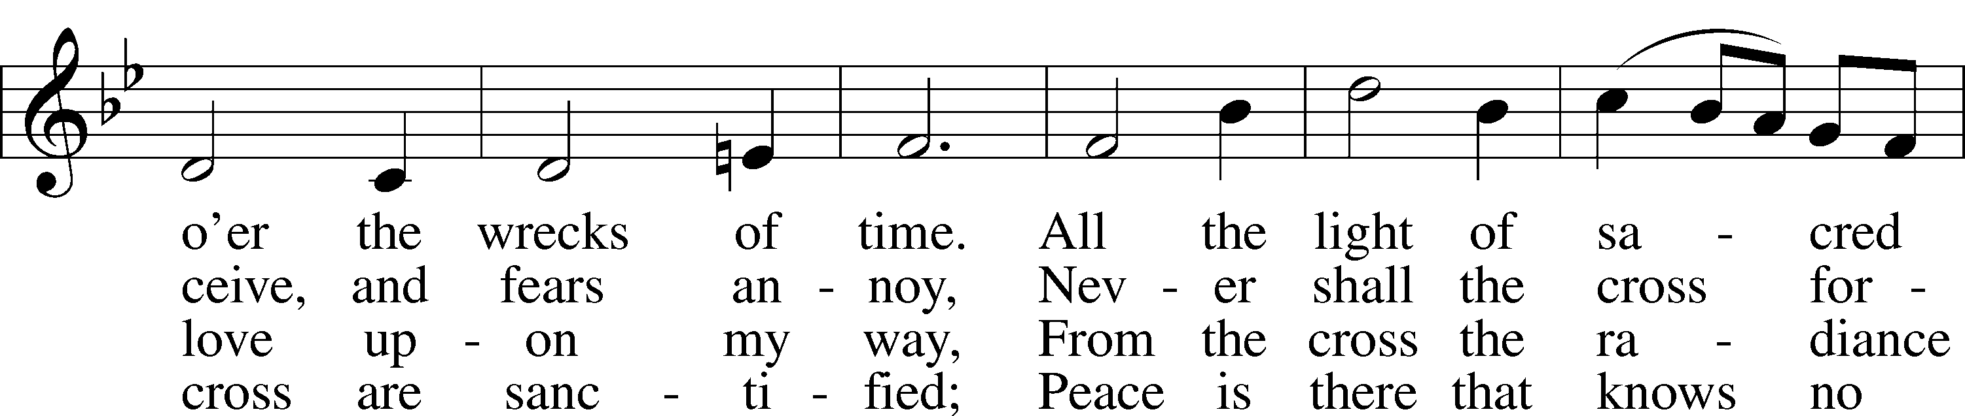
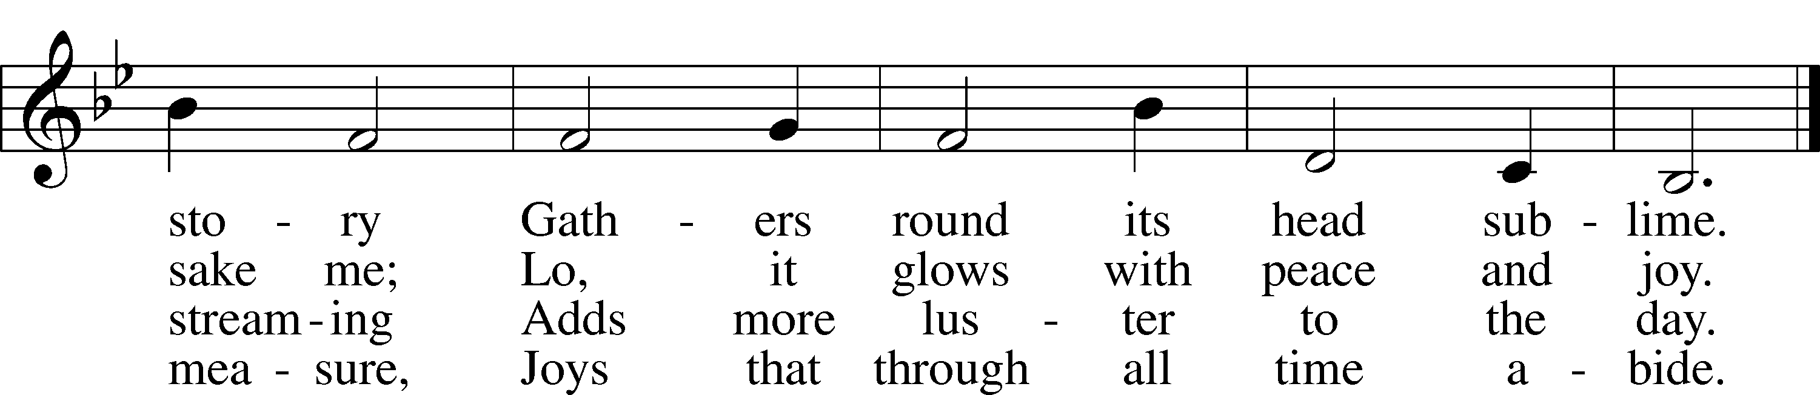
Text: John Bowring, 1792–1872; Tune: Ithamar Conkey, 1815–67; Text and tune: Public domain

588 JESUS LOVES ME sts. 1, ref, 2
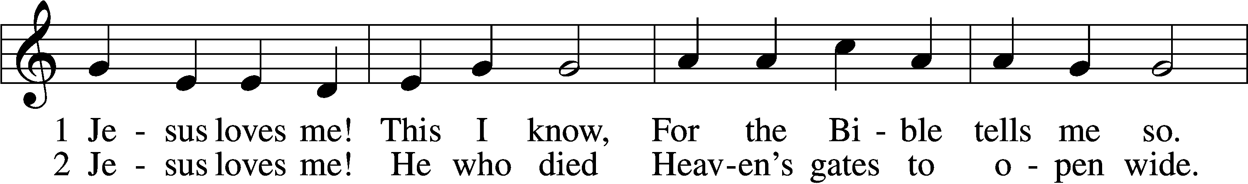
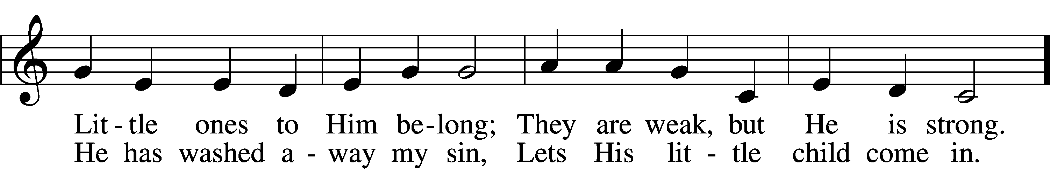
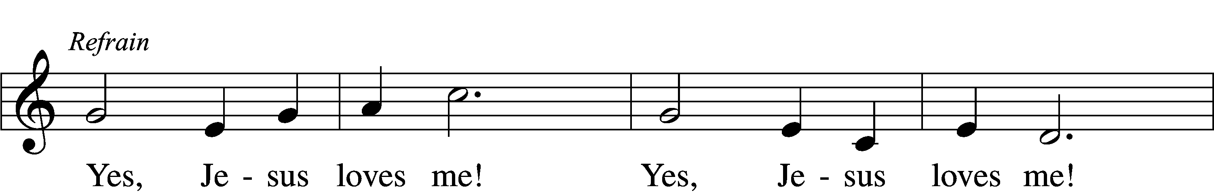

Text: Anna B. Warner, 1820–1915, alt.; Tune: William B. Bradbury, 1816–68; Text and tune: Public domain

Stand

POST COMMUNION CANTICLE
NUNC DIMITTIS LSB 199
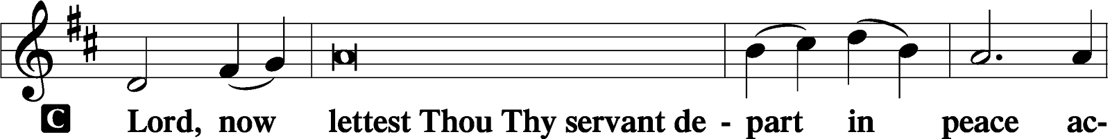
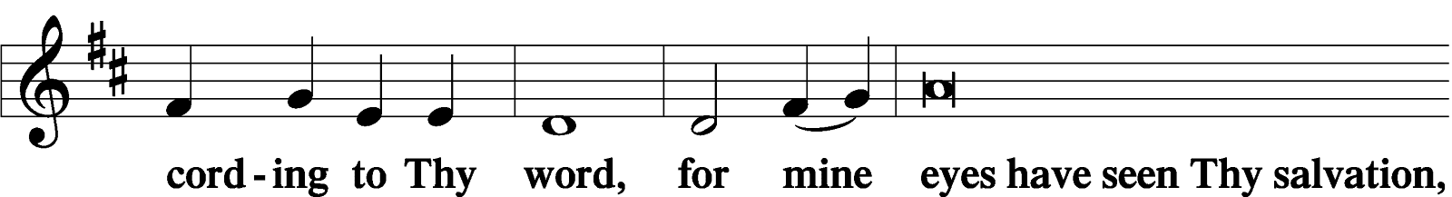
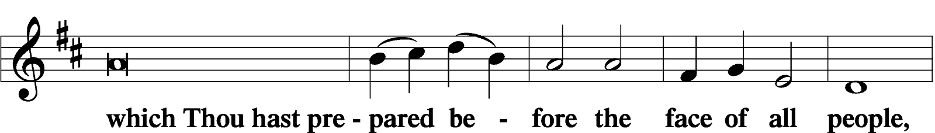
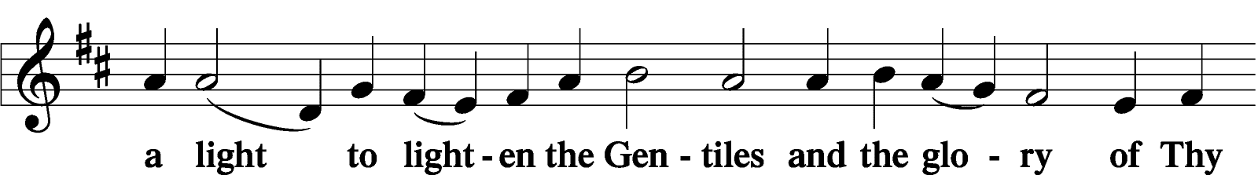
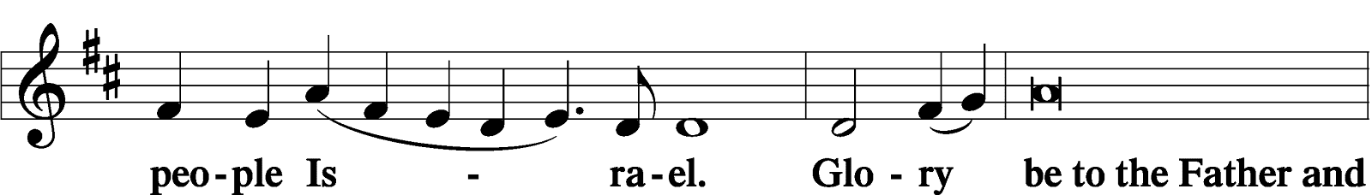
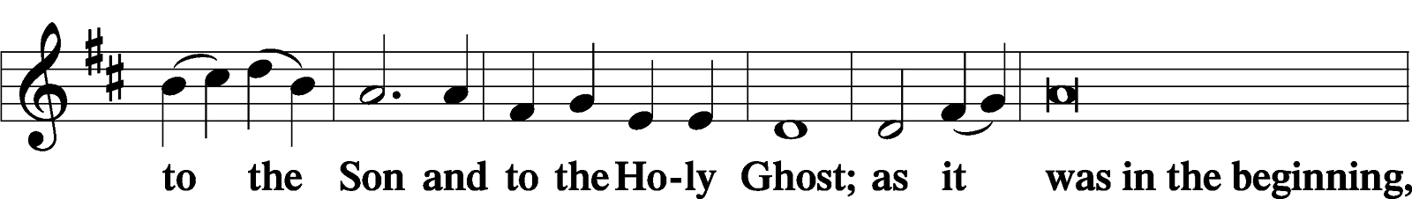
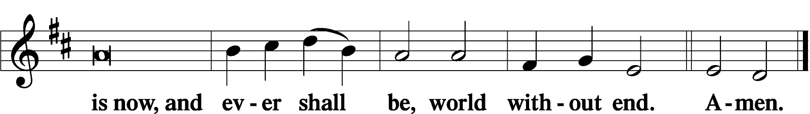

POST-COMMUNION COLLECT
P Let us pray.
We give thanks to You, almighty God, that You have refreshed us through this salutary gift, and we implore You that of Your mercy You would strengthen us through the same in faith toward You and in fervent love toward one another; through Jesus Christ, Your Son, our Lord, who lives and reigns with You and the Holy Spirit, one God, now and forever.
C Amen.

BENEDICTION LSB 183
P The Lord bless you and keep you.
The Lord make His face shine on you and be gracious to you.
The Lord look upon you with favor and T give you peace.
C Amen.

CLOSING HYMN
849 PRAISE THE ONE WHO BREAKS THE DARKNESS
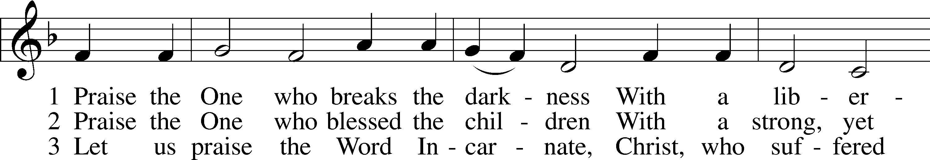
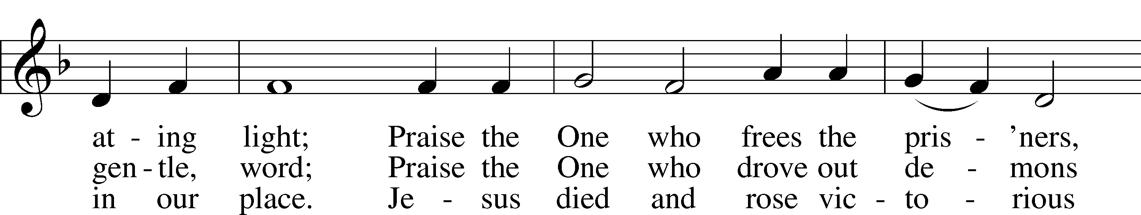
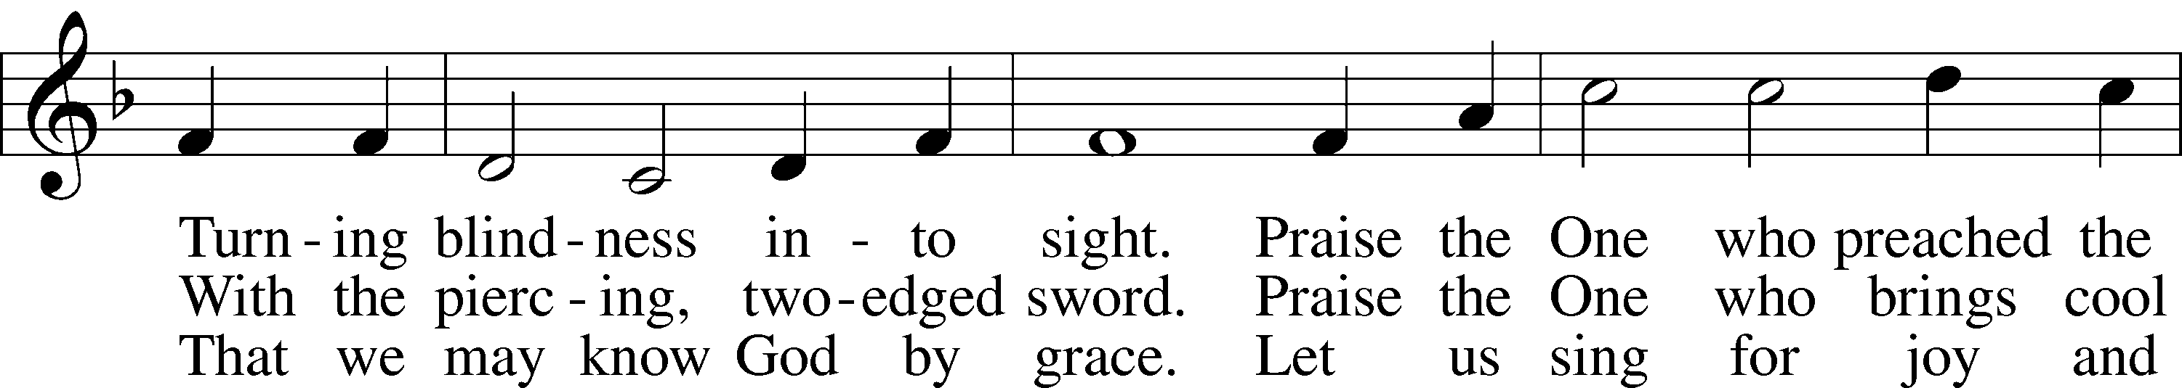
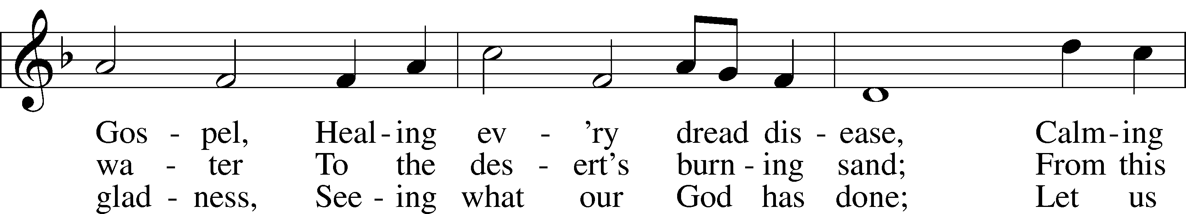
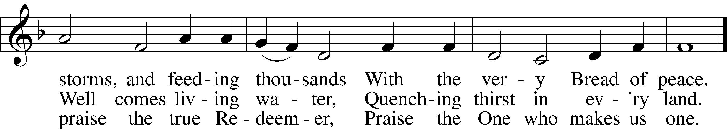
Text: Rusty Edwards, 1955; Tune: The Sacred Harp, 1844, Philadelphia
Text: © 1987 Hope Publishing Co. Used by permission: LSB Hymn License no. 110000972; Tune: Public domain

DISMISSAL
P Go in peace, serve the Lord.
C Thanks be to God.
Acknowledgments: Divine Service, Setting One from the Lutheran Service Book. Unless otherwise indicated, Scripture quotations are from the ESV® Bible (The Holy Bible, English Standard Version®), copyright © 2001 by Crossway, a publishing ministry of Good News Publishers. Used by permission. All rights reserved. Created by Lutheran Service Builder © 2025 Concordia Publishing House.

SAINT DAYS, FEAST DAYS, & COMMEMORATIONS THIS WEEK
Wednesday, March 17th: St. Patrick – Missionary to Ireland
Thursday, March 19th: St. Joseph – Guardian of Jesus

READINGS FOR NEXT SUNDAY: Fifth Sunday in Lent
Ezekiel 37:1 – 14; Romans 8:1 – 11; John 11:1 – 45

✝️ THIS WEEK AT MESSIAH LUTHERAN ✝️
TUES 10:00 Bible Study with Pastor
6:00 NO Potluck Bible Studies during Lent!
WED Noon Lenten Midweek Service
6:00 Lenten Meal
7:00 PM Lenten Midweek Service
THURS 9 – 12 Quilter’s Group with Devotional
5:30 Long-Range Planning Committee Meeting

STEWARDSHIP THOUGHT
“I cry to you, O LORD; I say, ‘You are my refuge, my portion in the land of the living.’” Psalm 142:5
The Lord is our portion, our refuge, our everything. His mercy preserves us through all our days in the land of the living. This confidence frees us from the fear that so often leads to sins of greed and coveting. We have the Lord, we have a Father, He is in control, so we can follow His Word in confidence.



This Lent we journey, slow and true,
With hearts made new in all we do.
No offering too small or slight—
God’s grace shines bright in darkest night.



🌟 LWML YARD & BAKE SALE 🌟
Saturday, March 21st | 8:00 AM – 1:00 PM

Find a treasure, grab a bite — supporting a Mite-y mission that’s shining bright!


BAKERS NEEDED! Please bring your treats, pretty and sweet, your homemade goodness can’t be beat.

Donations Accepted:
Thursday, March 19 | 9 AM – 1 PM &
Friday, March 20 | 9 AM – 6 PM

SEE FLYERS FOR GUIDELINES AND
RESTRICTIONS ON WHAT WE CAN TAKE.

❓QUESTIONS?❓ Please call Nan Boyd 📞 229-834-4881

All monies go to charity! Thank you for helping make this event a blessing!

✨💜 TIME & TALENT SURVEY 💜✨
Did you peek in your mailbox today?
Something is waiting — don’t tuck it away.

Take time in prayer to consider your part,
The gifts God has placed within your heart.

When you’re finished, drop it by the office door —
Each servant’s hand helps us do more.
Together in Christ, our church will thrive,
As God’s people serve with hearts alive.
✨✨✨✨✨💜💜💜💜💜💜💜💜💜💜💜💜✨✨✨✨✨

