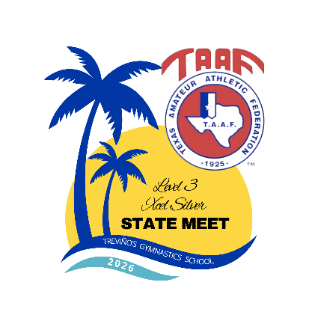

Level 3 and Xcel Silver

State Championship Meet

Hosted By: Trevino’s Gymnastics

1438 S. I-35E

LANCASTER, TEXAS 75146
972-223-0167

May 2-3, 2026

MEET FORMAT: CONTINUOUS CAPITAL CUP

Saturday, May 2, 2026 SESSION 1

Level 3 – Divisions 4, 5, 6 & 7

Gym Opens: 7:30am
Open Stretch: 8:00am
March In: 8:20am
Timed Warm Up: 8:30am Competition: 8:38am Awards to follow

Saturday, May 2, 2026
SESSION 2

Level 3 – Divisions 1, 2 & 3

Open Stretch: 11:30am
March In: 11:50am
Timed Warm Up: 12:00pm

Competition: 12:08pm
Awards to follow

Saturday, May 2, 2026

SESSION 3

Xcel Silver – Divisions 6 & 7

MEET FORMAT: Modified Traditional – This session only
Open Stretch: 3:00pm
March In: 3:20pm
Warm Up/Compete: 3:30pm
Awards to follow

Saturday, May 2, 2026

SESSION 4

Xcel Silver – Division 5

Open Stretch: 5:45pm
March In: 6:05pm
Timed Warm Up: 6:15pm
Competition: 6:23pm
Awards to follow
Sunday, May 3, 2026
SESSION 5

Xcel Silver – Divisions 3 & 4

Gym Opens: 7:30am
Open Stretch: 8:00am
March In: 8:20am
Timed Warm Up: 8:30am
Competition: 8:38am
Awards to follow

Sunday, May 3, 2026
SESSION 6

Xcel Silver – Divisions 1& 2

Open Stretch: 11:45am
March In: 12:05pm
Timed Warm Up: 12:15pm
Competition: 12:21pm
Awards to follow

