Stalker: Race to the Clouds

Rule Set (Version 1.1)

Objective
- Be the first player to reach the Giant King's Castle at the top of the Beanstalk.
- Retrieve the Golden Egg Fragment and survive the final challenge to win the game.

Players
- 2–6 players
- Recommended Ages: 10+
- Play Time: 20–40 minutes

Components (Prototype)
- 1 Game Board
- 5 Player Tokens
- 6 Movement Cards
- Item Cards
- Event Cards
- Trap Markers
- Golden Egg Fragment Token

Game Setup
- Each player chooses a character token.
- Shuffle the Item Deck and Event Deck separately.
- Place both decks next to the board.
- Place the Golden Egg Fragment on the Giant King's Castle space.
- Every player begins on the Start space at the bottom of the Beanstalk.

Turn Order
- Pick a movement card
- Move your character the number of spaces the card tells you.
- Resolve the space you land on.
- Draw cards if instructed.
- End your turn.

Board Spaces
- Safe Space – Nothing happens.
- Item Space – Draw one Item Card.
- Event Space – Draw one Event Card.
- Trap Space – Follow the trap instructions.
- Shortcut – Choose to take a faster but riskier path.
- Rest Area – Skip any negative effects until your next turn.

Item Cards
Item cards may:
- Move you forward.
- Protect you from traps.
- Block another player's movement.
- Steal an item from another player.
- Remove a negative effect.

Event Cards
Events may include:
- Giant patrols.
- Falling cloud bridges.
- Magical storms.
- Hidden treasure.
- Secret paths.
- Helpful travelers.

Movement Cards
Events may include:
- Drizzle's Detour? Draw it and you sneak onto a hidden path. Move two spaces forward and ignore the next trap space you hit. But if another player draws the same card, the detour collapses and both of you go back one.Falling cloud bridges.
- Gloomgill's Shortcut. Draw it and pick an opponent. You can leapfrog to their space and then move one extra step. But that opponent gets to draw a free item card. Hidden treasure.
- Cloud surge. Play it when you're about to move. Double your movement this turn, but skip your next turn while the winds settle.
- Vine snarl. Toss it during another player's move. They stop immediately, right where they are. Then on their next turn, they roll or draw as normal, but start from that spot.
- Giant's Toll. Place this card on the next bridge space ahead. The first player to reach it has to either pay one item card or move back two spaces. Once it's triggered, discard it.

Player Interaction
- Certain Item Cards may target other players.
- Players may block shortcuts or force opponents to take longer routes.
- Players may steal or discard certain items when instructed by a card.

Shortcuts
- Shortcuts allow players to move toward the castle faster.
- Some shortcuts require drawing an Event Card.
- Failed shortcut attempts may force players backward or make them lose a turn.

Winning the Game
- A player must reach the Giant King's Castle exactly.
- Upon reaching the castle, the player must complete the Final Challenge by drawing one Final Event Card.
- If successful, they claim the Golden Egg Fragment and immediately win.
- If unsuccessful, they remain at the castle and may try again on their next turn while other players continue racing.
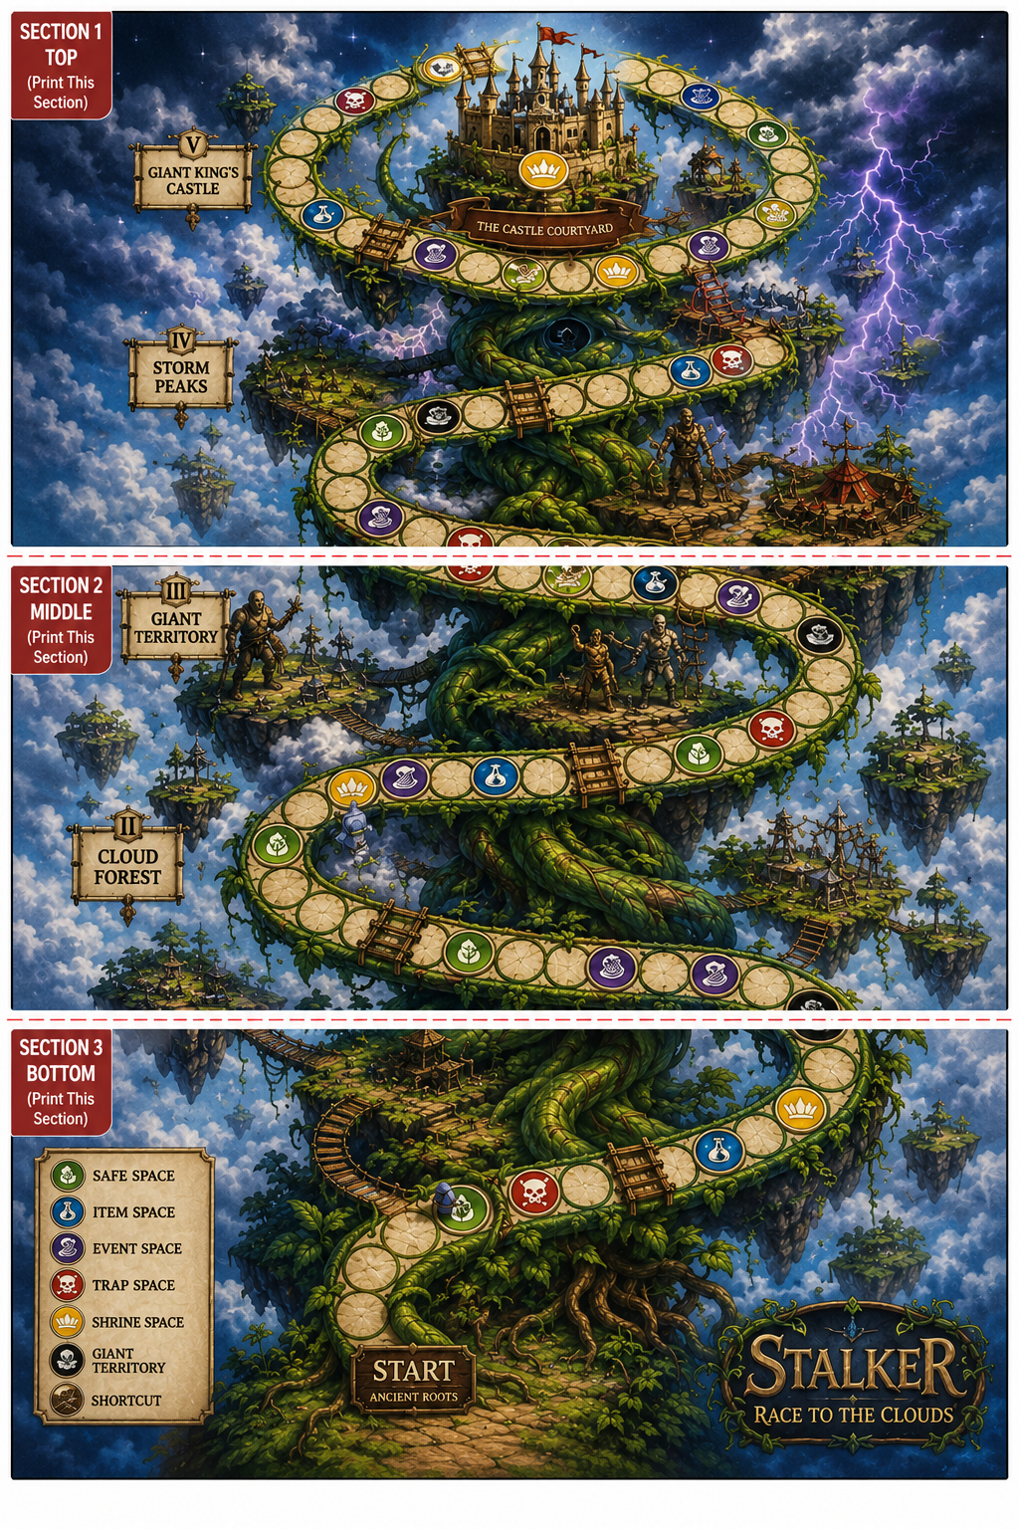
Player Tokens

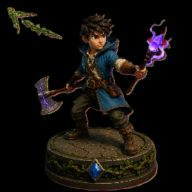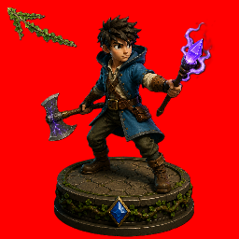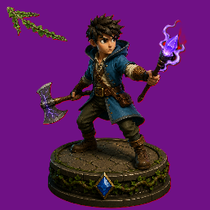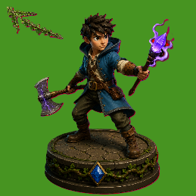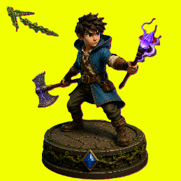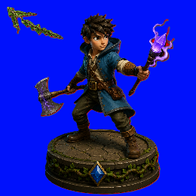

Other Tokens

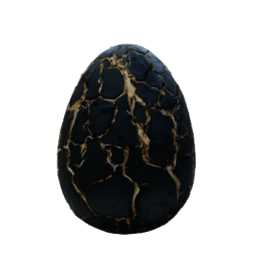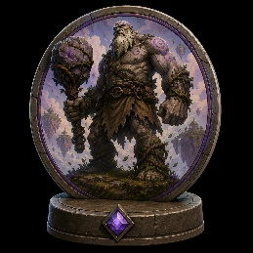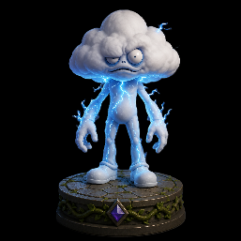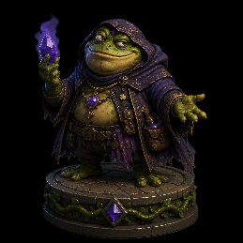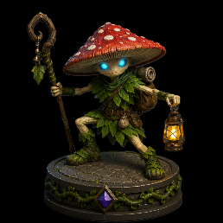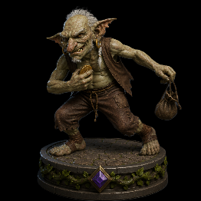

Event Cards and Item Cards (Print 2)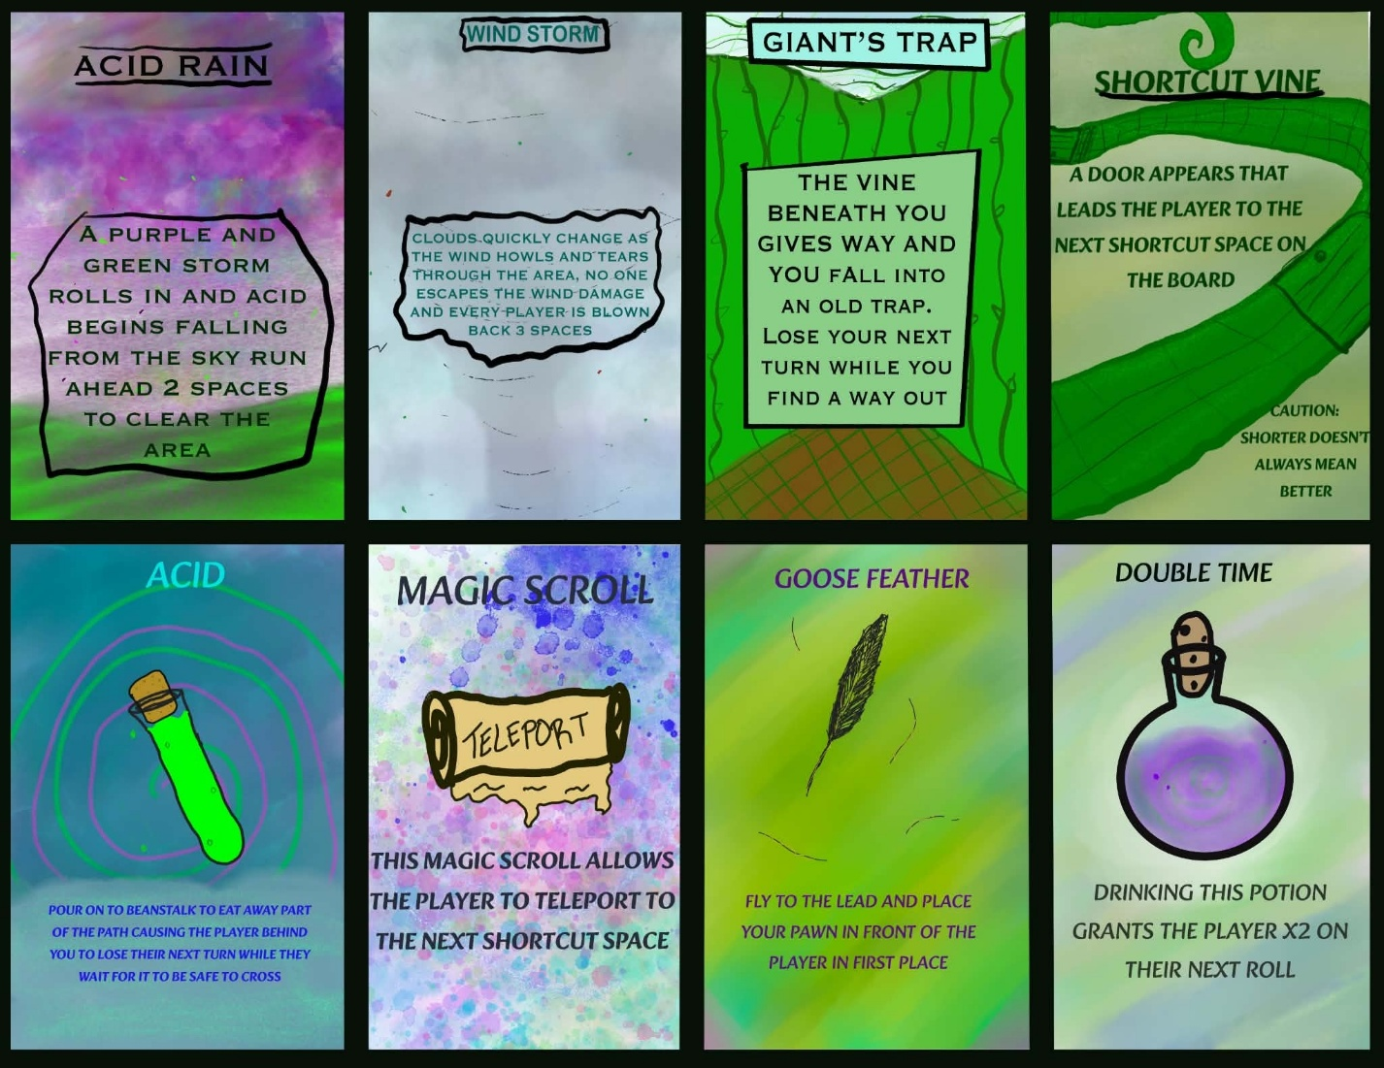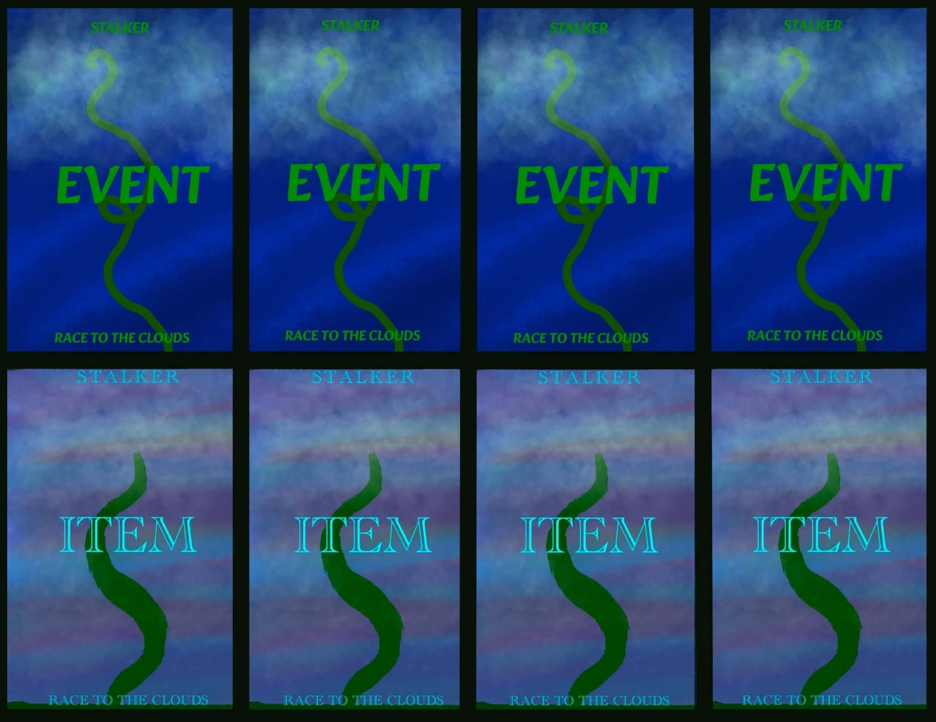

Item Cards (Print 2)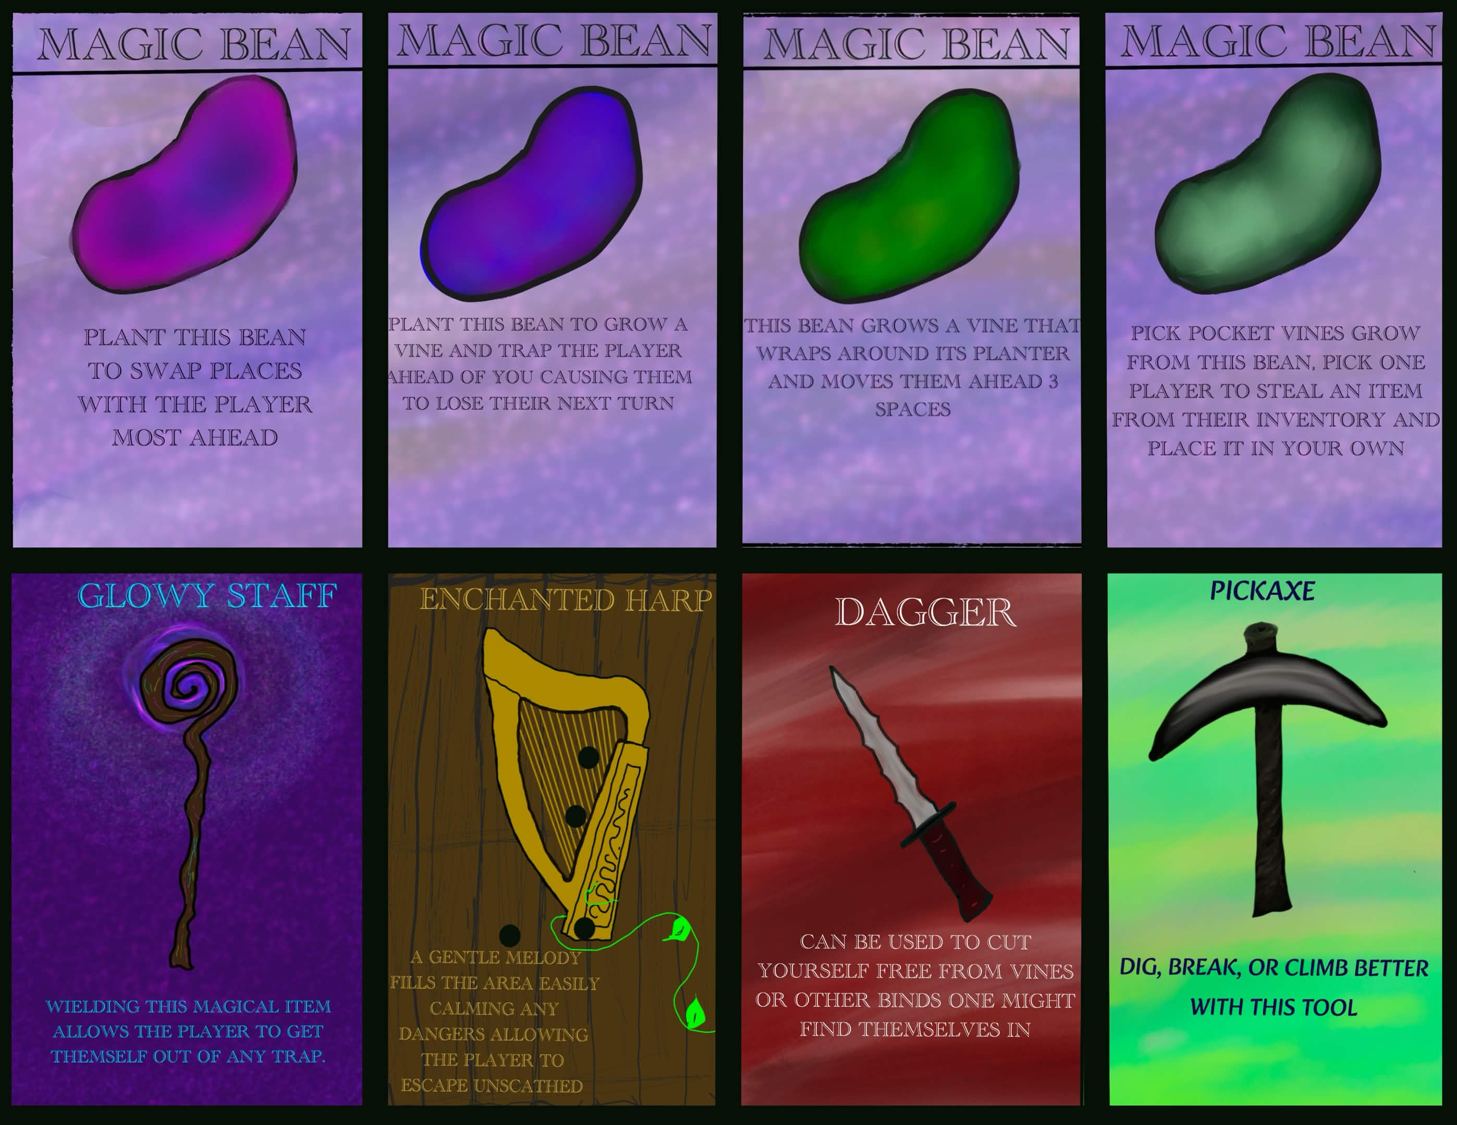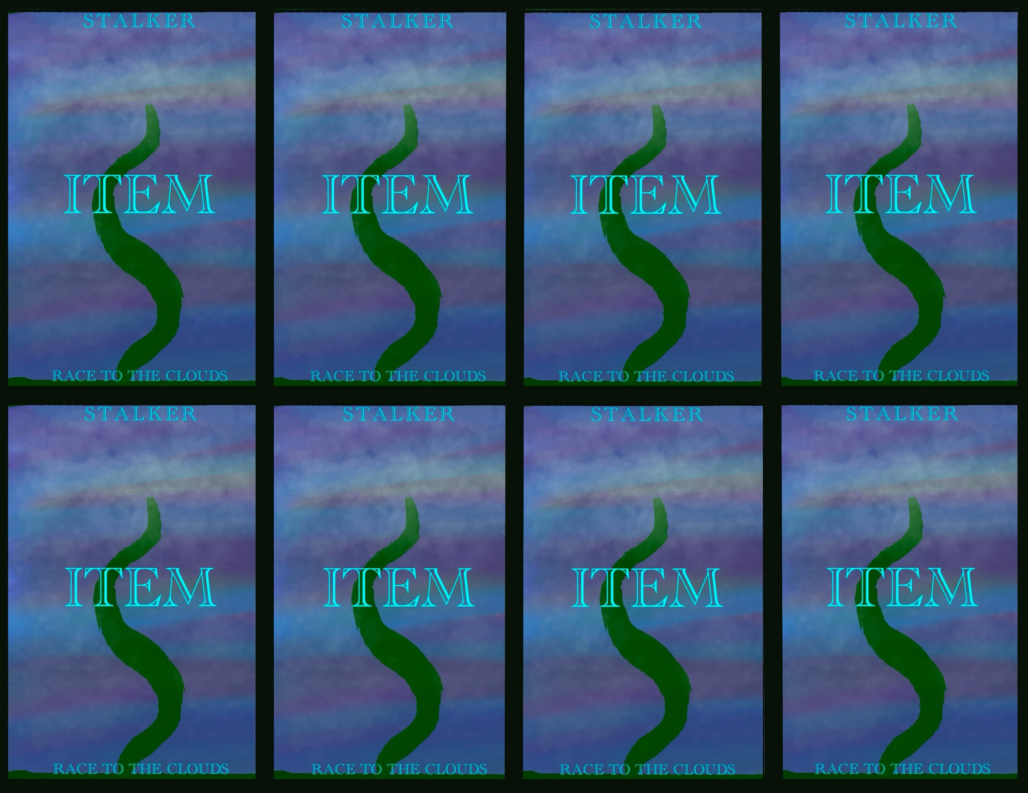

Movement Cards (Print 2)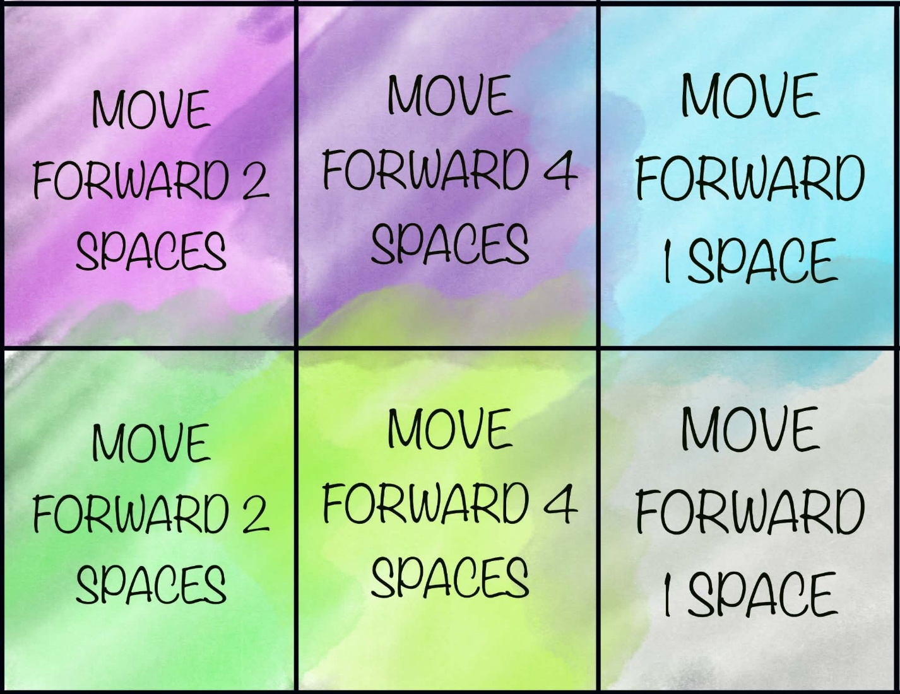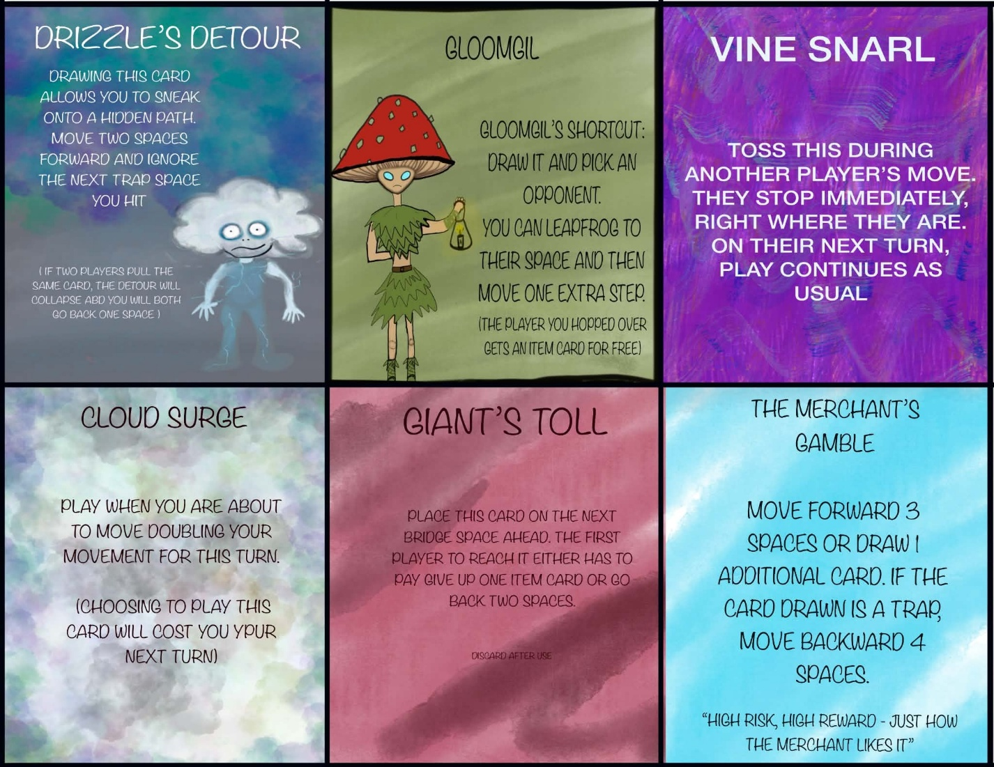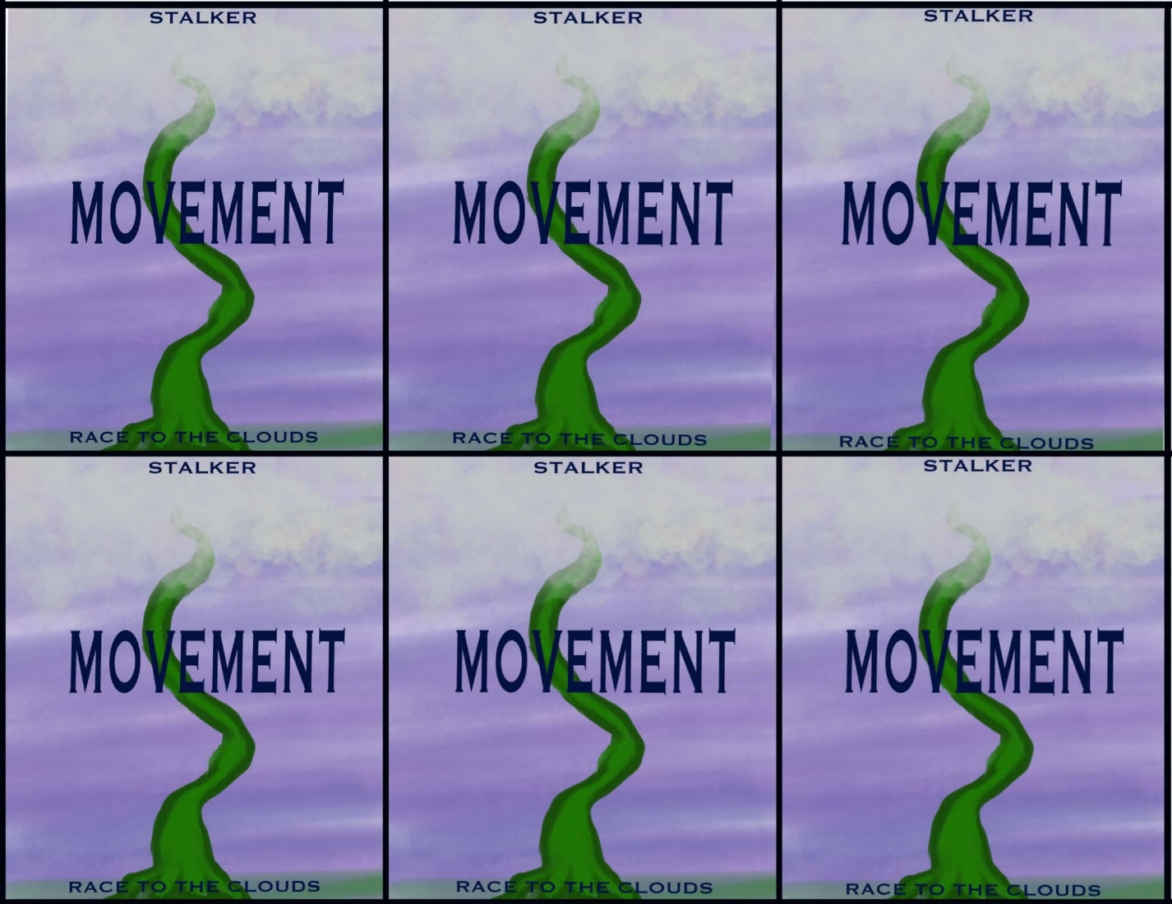

Trap Cards (Print 3)