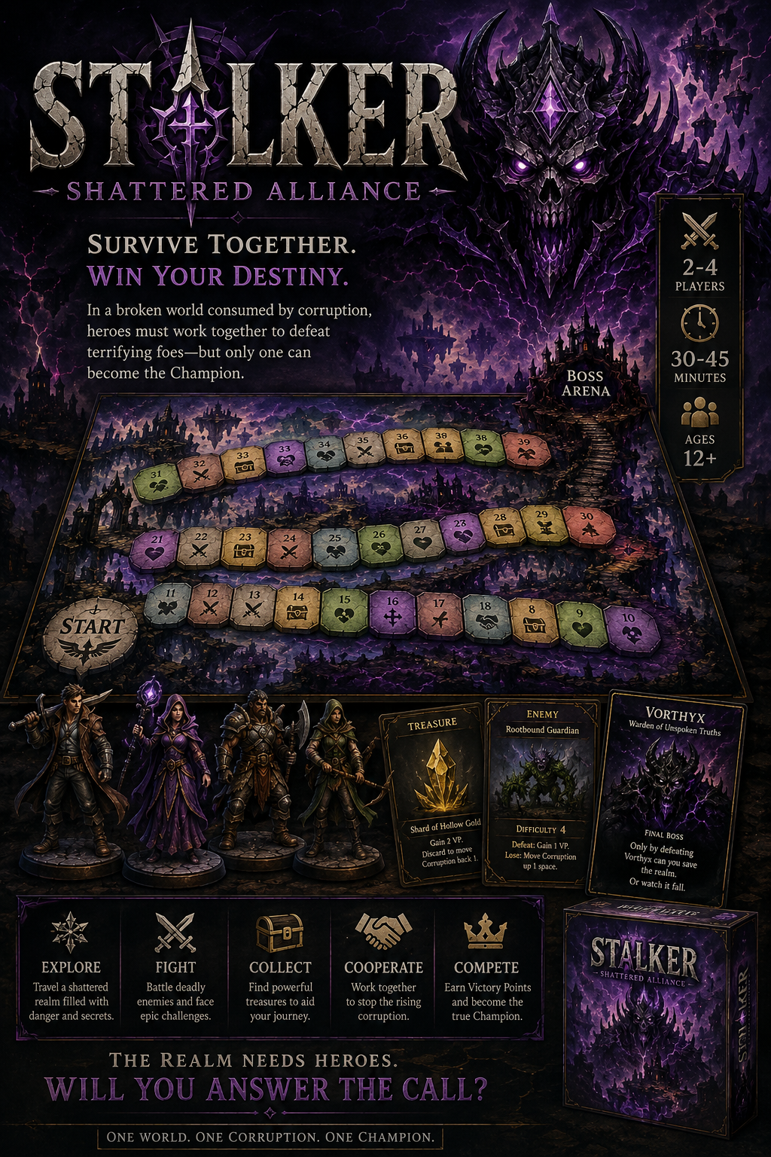STALKER: SHATTERED ALLIANCE

A 2–4 Player Cooperative Competitive Board Game
Players: 2–4
Play Time: 25–40 Minutes
Recommended Age: 12+
Objective: Work together to survive the corruption and defeat the final boss, but earn enough Victory Points to become the Champion of the Shattered Realm.

1. THE STORY
The realm above the clouds is dying.
Corruption has begun spreading across the shattered kingdom, twisting creatures and destroying what remains of the land. A group of unlikely heroes must travel through the corrupted realm and confront the creature responsible.
No hero can survive alone.
Players will need to fight enemies, collect treasure, help one another, and control the spreading corruption. If the corruption becomes too powerful, everyone loses.
But if the heroes save the realm, only one will be remembered as its greatest champion.

2. COMPONENTS
The game requires:
- 1 Game Board
- 4 Character Standees
- 4 Character Cards
- 1 Six-Sided Die
- 1 Corruption Board
- 1 Corruption Marker
- 1 Final Boss Card
- 12 Enemy Cards
- 12 Treasure Cards
- 4 Health Tokens
- Victory Point Tokens
- 1 Boss Health Marker

3. SETUP
- Place the main game board in the center of the table.
- Place the Corruption Board beside it.
- Put the Corruption Marker on 0.
- Shuffle the Enemy Cards and Treasure Cards into two separate decks.
- Each player chooses a character.
- Give each player their matching Character Card and standee.
- Every player begins with:
  - 6 Health
  - 0 Victory Points
  - 0 Treasure Cards
- Place all player standees on the START space.
- Place the Final Boss Card near the end of the board.
- Roll the die. The player with the highest number goes first.
Play continues clockwise.

4. YOUR TURN
Every turn has three steps.

Step 1 — Roll
Roll the six-sided die.

Step 2 — Move
Move your character up to the number of spaces rolled.
You may choose to move fewer spaces if you want.

Step 3 — Resolve Your Space
Perform the action shown on the space where you stop.
Once the action is completed, your turn ends.

5. BOARD SPACES

⚔ ENEMY
Draw the top Enemy Card.
You must fight the enemy.

💰 TREASURE
Draw one Treasure Card.
Treasure can contain weapons, healing items, magical objects, or other bonuses.
Unless the card says otherwise, you may keep it until you decide to use it.

♥ HEALING
Recover 2 Health.
You can never have more than 6 Health.

☠ CORRUPTION
Move the Corruption Marker forward 1 space.

🤝 ALLY
Choose another player.
Either:
- Give that player 1 Health, OR
- Give them one of your Treasure Cards.
Gain 1 Victory Point for helping.

✦ SAFE SPACE
Nothing happens.
Your journey continues.

6. COMBAT
When you encounter an enemy, draw an Enemy Card.
Each enemy has a Difficulty Number.
Roll the die.

If your roll equals or beats the Difficulty Number:
You defeat the enemy.
Gain the Victory Points shown on the card.

If your roll is lower:
Lose 1 Health.
Then roll again.
Combat continues until:
- The enemy is defeated, OR
- Your Health reaches 0.

7. HELPING IN COMBAT
Before another player rolls during combat, one player may offer to help.
The assisting player gives the fighter:
+1 to their next combat roll.
If the enemy is defeated using the bonus:
- The fighter receives the normal Victory Points.
- The assisting player receives 1 Victory Point.
Only one player may help per combat roll.
This creates an important decision:
Helping another player makes it easier for everyone to survive—but you're also giving another player a better chance to earn points.

8. HEALTH AND DEFEAT
Every character begins with 6 Health.
If your Health reaches 0, your character is knocked out.
Move your character backward to the nearest Healing or Safe Space.
Restore your Health to 3.
However, being defeated has consequences:
- Lose 2 Victory Points.
- Increase Corruption by 1.
Victory Points cannot fall below 0.

9. THE CORRUPTION TRACK
The Corruption Track represents the destruction spreading across the realm.
It begins at:
0
The maximum is:
10
Corruption increases through certain board spaces, enemy effects, Treasure Cards, and player defeats.

WARNING
If Corruption reaches 10 at any point:

EVERY PLAYER LOSES.
The realm has been completely consumed.
It does not matter how many Victory Points anyone has.

10. TREASURE
Treasure Cards provide special advantages.
Examples include:
Healing Potion
Restore 2 Health.
Rootsplitter
Gain +2 on one combat roll.
Gloomlight Lantern
Ignore one Corruption Space.
Golden Fragment
Gain 2 Victory Points.
Protective Charm
Prevent 1 Health loss.
Most Treasure Cards are discarded after use unless the card specifically says they remain active.
A player may hold a maximum of 3 Treasure Cards.

11. REACHING THE FINAL BOSS
When the first player reaches the Boss Space, the final battle begins.
Finish the current round so every player has had the same number of turns.
Then move every surviving player to the Boss Arena.
The normal board is no longer used.

12. FINAL BOSS BATTLE
The Final Boss begins with:
12 Health
Players attack clockwise.
On your turn, roll the die.

Roll 4–6
Deal 2 Damage to the boss.

Roll 1–3
Your attack fails and you lose 1 Health.
Treasure Cards and character abilities can still be used.
After every player has attacked once, the boss attacks.
Increase Corruption by 1.
Then begin another round.

13. DEFEATING THE BOSS
The players win together if the boss reaches 0 Health before Corruption reaches 10.
Each time a player successfully damages the boss, they gain:
1 Victory Point
The player who deals the final blow gains:
+2 Bonus Victory Points.

14. WINNING THE GAME
There are two possible endings.

CORRUPTION WINS
If the Corruption Track reaches 10:
Every player loses.
There is no champion.

THE HEROES WIN
If the final boss is defeated, everyone has successfully saved the realm.
Now count Victory Points.
Victory Points come from:
- Defeating enemies
- Helping other players
- Treasure
- Damaging the boss
- Landing the final blow
The player with the most Victory Points becomes:

CHAMPION OF THE SHATTERED REALM
In the event of a tie, the player with the most remaining Health wins.
If players are still tied, they share the victory.

THE GOLDEN RULE
You cannot win if everyone loses.
Sometimes helping another player is the best move.
Sometimes letting them handle their own problems might put you ahead.
Choose carefully.
The realm needs heroes—but it only remembers one Champion.
