1959-60 Coach Bob Morris (7-9 – Whitehall WMC champs)

The 1959-60 season was a transition year for NM athletics, and not just for basketball. The Norsemen were caught in a predicament where they kept their ties with their WMC opponents while also adding a few newcomers who would join them the following year in a brand-new conference that will be named The Seaway Conference. NM would start the basketball season minus four of their five starters from the NM champs from the previous season. Only 6’3 Tom Cousineau would return as a starter and many of those that would start in 1959-60 saw very little action from the previous season.
NM began the season on a winning note against a familiar foe in Scottville on the Northside court. Three players for NM reached double figures in the low scoring affair with Ira Bank leading the charge with 14 while three-year veteran Tom Cousineau controlled the boards and added 11 with Carl Rittman netting 10.
After being dominated by Hart for more than a decade with the Pirates winning 22 out of 24 games at one point, NM has reversed the rivalry as they made it nine straight vs. their WMC rivals with a 53-40 win over Hart.
In their third straight encounter against an WMC foe Montague rallied to defeat NM 46-42. The Norse took a big lead in the first quarter, but their star center Tom Cousineau picked up three quick first period fouls and sat much of the game as a spectator.
In the first meeting between two schools that until 1958 were one and the same, North Muskegon won the first matchup between the two neighboring schools.
The game wasn’t pretty, but it couldn’t have been closer as NM had to go into overtime to secure a 48-46 win over Reeths Puffer. Dave Johnson’s canned a 20-footer just before the final buzzer sounded in OT to give NM the first win in their series.
Dave Johnson again nearly was the hero in their next game that wasn’t decided until they reached another overtime session. With Whitehall leading 48-47 Johnson was fouled with one second remaining and stepped to the free throw. Johnson made the first to send the game into overtime but missed the second. The Vikings then handed NM a 54-50 loss in the extra session to end the 1959 calendar year.
A pair of long-time rivals, but never members of the same conference, NM and Fremont met again for the 45th meeting and it was NM who were the victors on the Packers home court 55-44. The following day after this game, principals of the new league, which would include both Fremont and NM, met to decide the name of the new conference.
NM then played the role of a spoiler as they handed Shelby their first defeat in the WMC with a 63-52 win over the visiting Tigers. A pair of underclassmen played big roles in the NM win. Sophomore Roger Shaffer had 13 points while freshman Steve Harpold had eight. Harpold, a polished freshman, unfortunately for NM followers transferred out of state with his family before he would begin his sophomore year. Balanced scoring was the key as Bank, Shaffer, Carl Rittman and Cousineau all scored 10 or more points in the victory.
Due to a quirk in the schedule the Norse were idle for the next two weeks. After composing a promising 5-2 record the Norse would only earn two more wins the remainder of the season. The Norse were rusty on their home court and lost to Hart on a buzzer beater by Dick Hasty. Just six seconds earlier Tom Cousineau’s tip in had tied the game and it looked like NM was headed to their third overtime game of the season before Hasty’s basket doomed the Norse. So frustrated was Norse scoring ace Ira Bank following the loss that he smashed his fist through a plate glass window in the locker room and had to go to the hospital for numerous stitches.
In the final game ever played up to this date between NM and Reed City (2025) NM went on the road to defeat Reed City 55-53. The series would conclude with NM holding a 3-1 edge in the very brief four-game series.
Muskegon Catholic then unleashed their frustration for having dropped five of their previous six games against NM with a dominating 52-24 victory over the Norse. Although he only scored three points, MCC ‘s Dennis Potuznik only had to walk one block to the Northside gym where he was squared off with his childhood buddy and NM neighbor Tom Cousineau. The Norse were stone cold during the game, and their low total of 24 points would be the fewest points scored by a NM team for nearly 40 years.
In what would prove to be their final win of the season, NM got 15 points from sophomore Roger Shaffer in a 46-40 road victory at Montague to split the season series with the Wildcats.
Talk about an even rivalry. Going into their next game with Whitehall each team had won 26 games in the 52 games played between the two rivals. Whitehall then took a one game lead in the tight series with a 61-55 win over the Norse. The victory also clinched the WMC title for the Vikings in their last year in the historic conference until their return from the Seaway in 1985. Carl Rittman had his best game in the losing cause before the sellout crowd at the Northside gym with 19 points.
Playing without their star center Tom Cousineau, who was out with the flu, NM battled but lost at the tiny confines of the Shelby gym 79-71.
NM then dropped their second game of the season to Fremont 47-42 as their shooting woes continued heading into the final game of the regular season against Reeths Puffer. The second game was a near carbon copy of the first meeting at Reeths Puffer that NM won in overtime. This game saw Reeths Puffer making a final last second bucket to nip NM 39-38. A long mid court heave by Ira Bank of NM swished through the nets but the shot was taken just a fraction after the final horn had sounded.
Once again it was Coopersville ending NM’s season with a 60-53 win over the Norse. The Broncos, with the districts once again held on the Norsemen’s home court, went on a 16-1 run to break up a close game.

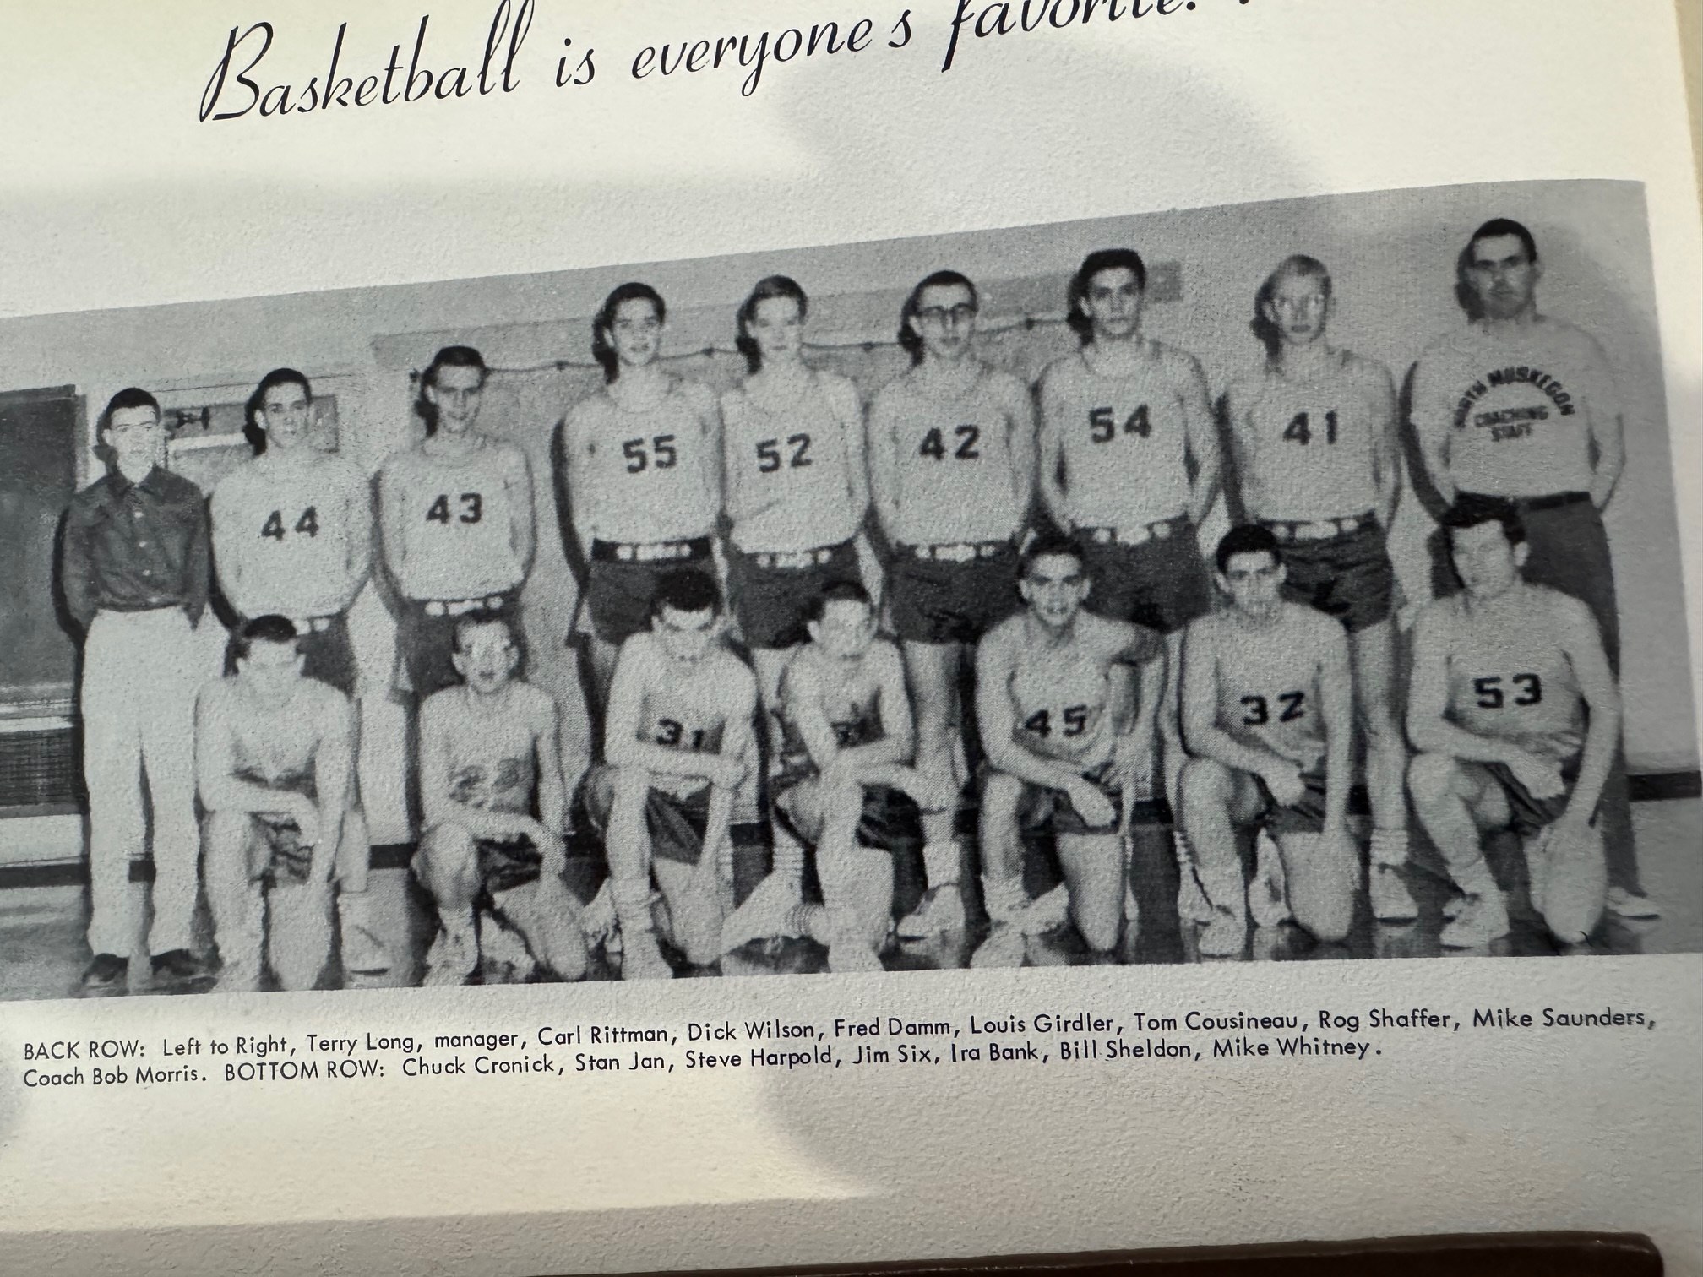

1959-60 NORSEMEN

N Muskegon 43 Scottville 33 Ira Bank 14, Tom Cousineau 11
N Muskegon 53 Hart 40 Bank 20, Mike Saunders 13, Cousineau 11
N Muskegon 42 Montague 46 Bank 13, Roger Shaffer 9, Dick Wilson 9
N Muskegon 48 Reeths Puffer (ot) 46 Bank 15, Cousineau 12, Shaffer 7
N Muskegon 50 Whitehall (ot) 54 Bank 15, Cousineau 13
N Muskegon 55 Fremont 44 Bank 19, Cousineau 11, Shaffer 8
N Muskegon 63 Shelby 52 Bank 14, Shaffer 12, Carl Rittman 12
N Muskegon 44 Hart 46 Bank 17, Cousineau 10
N Muskegon 55 Reed City 53 Bank 17, Cousineau & Rittman 12
N Muskegon 24 Musk Catholic 52 Cousineau 6
N Muskegon 46 Montague 40 Shaffer 15, Cousineau 10
N Muskegon 55 Whitehall 61 Rittman 19, Bank 9
N Muskegon 71 Shelby 79 Bank 22, Wilson 14, Steve Harpold 12
N Muskegon 42 Fremont 47 Shaffer 11, Bank 9
N Muskegon 38 Reeths Puffer 39 Bank 14, Cousineau 18
N Muskegon*53 Coopersville 60 Bank 15, Rittman 14, Shaffer 13

1960-61 Coach Bob Morris (9-9 – NM 4th -Coopersville Seaway champs)

Only junior Roger Shaffer returned as a starter from the 1959-60 team as NM ventured for the first time into the recently established Seaway Conference. Fielding a very young team NM made a surprising run in the district tournament, winning a pair of games before losing in the district finals to Big Rapids. Three juniors, Shaffer, Dan Cooper and Tom Moyes would move into the starting lineup while sophomore Bob Hasper would eventually crash into the starting five.
The opener vs. West Michigan Christian was billed as the first ever meeting between the two local squads but evidently lost through the archives was the ‘matinee’ contest played before the NM student body back in 1954 won by the Warriors. WMC turned back the host Norse before a turn away crowd at the Northside gym 61-52.
Still keeping ties with their long-time WMC conference foe Montague, NM easily defeated the host Wildcats 73-37 as Roger Shaffer netted 28 points, a total only surpassed previously in NM annals by Walt Busker in 1954, Gordy Odell in 1955 and Dick Maples and Ken Bolema in 1956. Although they had played against one another 46 games in the past, the first game between NM and Fremont in December of 1960 would be the first played as conference members, and the first official basketball contest for the Norse in the neophyte Seaway conference. My how the Muskegon area loved basketball during this era! On the same date that a capacity crowd watched Fremont defeat the Norsemen 51-38, 1400 fans were also on hand at Muskegon Catholic where the Crusaders defeated their rivals from Grand Rapids Catholic. However, the big crowd was at the recently completed LC Walker Arena where 4200 fans were on hands for the first of two games played between Muskegon and Muskegon Heights. The rematch between the two local rivals drew over 5100 fans.
A rivalry that began back in the 1930s, and one game played in 1945, was resumed when NM hosted Ravenna at the NM gym. 6’5 Sophomore Bob Hasper was inserted into the starting lineup for the first time and responded with a team high 14 points to lead NM to a resounding 62-27 romp over the visiting Bulldogs.
Although NM had moved into the Seaway, it would have been an injustice to not have Hart on their schedule. NM defeated the visiting Pirates 63-48 as four Norsemen scored in double figures. An undefeated Whitehall team pasted the Norse 74-65 in the first game played between two long-time WMC foes in the new Seaway Conference.
NM evened their Seaway record at 2-2 with a 64-47 win over Reeths Puffer as Roger Shaffer and Bob Hasper combined for 38 points to lead the victors.
Playing at a new gymnasium, a far cry from the old tile floor facility, did not help the Norse as they were overwhelmed by Coopersville 56-35.
Muskegon Catholic then closed the gap in the short series between MCC and NM by downing the Norsemen 65-49 in front of a large crowd on hand at MCC.
The Norse were no match for Fremont, co-leaders at the time in the Seaway, as they fell 56-36 to the Packers before NM would go on a modest winning streak.
NM, after relying mostly on offensive output from their front line of 6’5, Bob Hasper, 6’4 Roger Shaffer, and 6’3 Dan Cooper, received a big shot in the arm from their backcourt in their 73-38 blitz against Montague at the Northside gym. 5’4 Tommy Moyes, who sat out much of the first part of the season, led all NM scorers with 13 points while his backcourt mate Bill Shackelford added 11.
NM then traveled to Ravenna for the first time since the 1930s and came away with a 58-46 victory over a Ravenna team that was looking for their first victory of the entire season.
Trailing by 12 points heading into the final period NM put on a furious rally to upset Whitehall 51-49 in front of another packed house at the Northside gym. Steals by Tommy Moyes led to some easy layup baskets in the final period with a Roger Shaffer layup after a Moyes steal gave the Norsemen the game winning bucket.
The three-game winning streak came to a screeching halt when Reeths Puffer reversed the score from their earlier loss to NM with a 64-48 thrashing of the Norsemen on the Rockets home court.
NM nearly pulled off a stunner in their final game of the regular portion of the 1960-61 season but came up a couple points shy in a 48-47 loss to the Seaway champs from Coopersville. The Broncos John Johnson was a one-man wrecking crew for Coopersville as he scored 32 of his team’s 48 points. Although they lost, the junior dominated Norse showed they could stir up some trouble for their opponents in the upcoming district tournament.
The districts were held at the new Fremont gymnasium, and the Norse were looking to post an upset over a Fremont team that handled them easily in a pair of regular season contests. The Norse pulled off a shocker and nipped the Packers in overtime 65-64 as four NM players were in double figures, all underclassmen: Shaffer (18), Cooper (14), Hasper (13), and Moyes (11).
An even more daunting task then faced NM as they would next march up for the first time in NM history with Lakeview who had yet to taste defeat during the entire season. Boasting of a perfect 16-0 record Lakeview was stunned by the Norsemen 63-60. NM’s leading scorer for the entire season, Roger Shaffer, had but three points for the entire game. However, all three of his points game on free throws that tied up the game at 60-60. Tommy Moyes then hit a free throw with 38 seconds left that proved to be the winning point as Lakeview was unable to answer in the game’s dying moments. Sophomore Bob ‘Moose’ Hasper tallied a career high 33 points to lead the Norse. Earlier in the week it was announced that WOOD-TV in Grand Rapids would televise all state championship games, the first year for television of this traditional event in state history. After two emotional wins in the district tournament, the bubble burst for NM as they were soundly defeated by Big Rapids 65-39 to leave NM with an overall .500 record at 9-9. With their four top scorers returning the following season the Norsemen were very optimistic for the future.

N Muskegon 61 West MI Christ. 52 Dan Cooper 15, Roger Shaffer 8
N Muskegon 73 Montague 37 Shaffer 28, Bill Sheldon 11
N Muskegon 38 Fremont 51 Shaffer 18, Cooper 13
N Muskegon 62 Ravenna 27 Bob Hasper 14, Shaffer 12, Cooper 8
N Muskegon 63 Hart 48 Hasper 16, Shaffer 14, Mike Saunders 12
N Muskegon 65 Whitehall 74 Hasper 23, Shaffer 13, Cooper 11
N Muskegon 64 Reeths Puffer 47 Shaffer 20, Hasper 18, Cooper 13
N Muskegon 35 Coopersville 56 Hasper, Shaffer 7, Tom Moyes 5
N Muskegon 49 Musk Catholic 65 Shaffer 15, Cooper 10
N Muskegon 36 Fremont 56 Hasper 15, Shaffer 13 m
N Muskegon 73 Montague 38 Moyes 13, Shackelford 11, 4 with 8
N Muskegon 58 Ravenna 46 Hasper & Shaffer 17
N Muskegon 51 Whitehall 49 Shackelford 16, Shaffer 14
N Muskegon 48 Reeths Puffer 64 Dick Bultman 10, Shaffer & Cooper 8
N Muskegon 47 Coopersville 48 Shaffer 15, Hasper 10, Cooper 9
N Muskegon*65 Fremont (ot) 64 Shaffer18, Cooper 14, Hasper 13, Moyes 11
N Muskegon*63 Lakeview 60 Hasper 33, Cooper 14
N Muskegon*39 Big Rapids 65 Hasper 17, Cooper 8

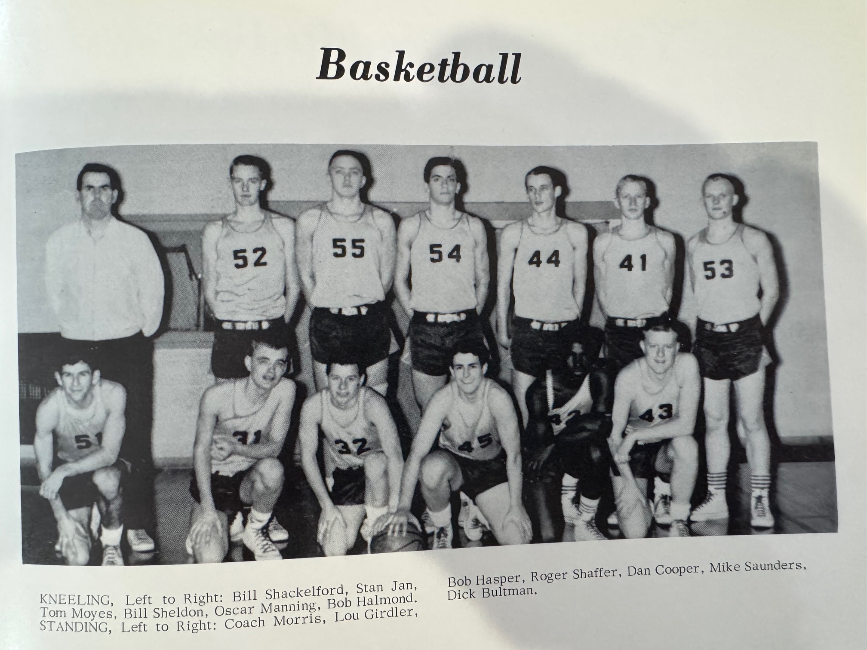

1960-61 NORSEMEN

Kneeling L-R: Bill Shackleford, Stan Jan, Tom Moyes, Bill Sheldon, Oscar Manning, Bob Halmond
Standing L-R: Coach Morris, Lou Girdler, Bob Hasper, Roger Shaffer, Dan Cooper, Mike Saunders, Dick Bultman

1961-62 Coach Bob Morris (14-5 – Seaway & District champs)

With four starters returning from the 1960-61 team that upset unbeaten Lakeview in the districts, expectations were high for veteran Coach Bob Morris and Norse followers. NM would field one of their tallest teams in school history with 6’6 junior Bob Hasper, 6’4 senior Roger Shaffer, and 6’3 Dan Cooper on the front line. The other returning starter was 5’4 Tom Moyes while 5’8 junior Rick Schanhals and 6’3 senior Harry Overhuel were slated to also see a lot of action.
Despite lofty expectations, the Norse didn’t look like a team that would have a good season as they were shelled by West Michigan Christian 73-50. With WMC not fielding a football team, Elmer Walcott’s Warriors had many more practice sessions to shake off any early season rust. A transfer student from Grand Rapids Christian, Rick Duistermars, led the way for a Warriors convincing 73-50 victory by pouring in 30 points. Bob Hasper had 15 for the Norse who played without starting forward Dan Cooper.
NM bounced back to defeat their longest rival Montague 57-52 with Roger Shaffer netting 18. Coach Morris was pleased to have Dan Cooper back in the lineup as the 6’3 junior was also in double figures with 11.
Cooper played even better in NM’s opening game in the Seaway Conference as the former well known used car dealer netted 22 points as NM snapped a five-game losing streak to Coopersville with a 49-40 victory.
Cooper, according to NM reporter for the game Roger Rappoport, currently a well-known author, hit a 30-footer with 20 seconds remaining to give the Norse the lead in the 43-29 NM victory over rival Fremont. Sophomore Mike Baldwin then calmly canned two free throws in the closing seconds to insure a NM victory.
It was then off for the holidays for the Norsemen as they would go three weeks before returning to the hardwoods to play a long time WMC foe in Hart. After losing nine of their last ten games to the Norse, Hart pulled off an upset over the rusty Norse with a 55-46 win at the Hart gymnasium. It would be the last game on the old Pirate floor as Hart would christen their new gymnasium in February. NM led 29-22 at halftime but a disastrous 3rd quarter doomed the Norse.
Ravenna was as cold as the January weather as the Muskegon area had undergone a 14-inch snowfall earlier in the week. The host Bulldogs scored only one field goal in the first half as NM routed Ravenna 53-26.
With the temperature outside the NM gymnasium hovering at -15 degrees, it was much warmer inside as the Norse nearly pulled off an upset over West Michigan Christian. Behind 27 game leading points by Shaffer, NM led 51-45 at the end of the 3rd period against a Warrior team that would go on to win the Class C state championship in March. The rematch with WMC was a far cry from the season opener when the Class C state champs blew out NM by 27. One of the starters for WMC who scored eight points against NM was Eddie Douma. A future inductee into the Muskegon Area Sports Hall of Fame, Douma would go on to have a great coaching career at Calvin College and Hillsdale.
NM then made it four wins in a row in Seaway Conference play with a narrow 57-53 victory over Whitehall before a packed house in NM. Future long time Muskegon County Sheriff Bob Carter had 14 points in a losing cause for the Vikings. NM scored the final four points of the game after the score was knotted at 55-55 on a field goal by Shaffer and a pair of free throws by Rick Schanhals.
In a game plagued with numerous fouls, the Norse dropped an ugly game at Reeths Puffer 45-39 to fall back into a tie at the top of the heap in the Seaway standings with Fremont, each with a 4-1 record. NM starters Shaffer, Cooper and Moyes all fouled out of the contest.
Roger Shaffer and Bob Hasper combined for 50 points as NM won their fifth game in nine starts against Muskegon Catholic. NM got off to a great start against MCC and were never threatened by the visiting Crusaders. NM led by as many as 17 points at 55-38 before the Crusaders made a late surge. Shaffer finished with a game 29 points with Hasper adding 19 and Tom Moyes 8.
NM kept pace with Fremont for the top spot in the Seaway as they snapped a five-game losing streak to Coopersville in their 57-71 road win over the Broncos. The Norse big front line of Shaffer (18), Cooper (13) and Hasper (12) took command with a big fourth quarter run after the teams were in a tight 36-34 battle entering the final quarter.
The Norse were than matched up for the second time of the season against their long-time rivals from Montague in a battle between the leaders of their respective conferences. NM had to rally from an eight-point deficit in the game’s final minutes to pull off a 61-57 victory. It wasn’t until Dan Cooper hit a field goal with two-minutes remaining did the Norse take the lead for good.
In a pivotal game matching the league co-leaders in the Seaway Conference, NM took over first place with a 58-50 win over the Packers on the Fremont home court. Shaffer and Hasper provided the 1-2 punch for the Norse as Shaffer had 19 and Hasper 16 points.
NM had little problems in disposing of Ravenna 78-44 in their second meeting of the season. Veteran coach Bob Morris was able to substitute freely throughout the contest with Shaffer scoring 24 points before heading to the bench in the second half.
NM then clinched the Seaway Conference title with a dramatic 63-62 win over Whitehall, coupled with a Fremont loss. With Whitehall trailing NM 59-58, Tommy Moyes hit a couple of clutch free throws followed by a Roger Shaffer basket that gave NM the points needed to hold off a late Whitehall rally. Harry Overhuel had a career high 18 points to lead the Norse attack.
NM then avenged their lone setback on the season with yet another one-point victory over Reeths Puffer. A full house was on hand for the final home game of the 1961-62 season as the Norse ended the season with a 9-1 record and their lone championship as a member of the Seaway Conference. John Siscoe gave RP a late lead, but NM’s Tommy Moyes knocked down the winning field goal, the only field goal made in the game by the NM playmaker to make the final score read NM 51 Reeths Puffer 50. Sophomore Mike Baldwin had a season high 11 points and chipped with several rebounds to give NM a boost.
NM began tournament play by playing the host Fremont Packers in a game that was predicted to be a close encounter. That was not the case as NM easily defeated the Packers 54-36 to advance to the district finals. NM led at the end of the first quarter by only 13-11 but that was as close as Fremont would get to the Norsemen as NM made it a perfect 3-0 on the season against their rivals from yesteryear. Coach Morris was able to empty his bench as eight Norsemen broke into the scoring column led by Roger Shaffer’s modest 13 points, followed by Dan Cooper with 12. The Norse victory set up a rematch of last season’s district finals between NM and Big Rapids.
The Norse would go into the game with Big Rapids as decided underdogs, with Big Rapids perhaps still gloating over a lopsided 26-point victory over NM to end the Norsemen’s 1960-61 season. However, NM pulled off the stunner as reserve Rick Schanhals had the game of his life to power the Norse to victory. Schanhals came off the bench and scored 16 points, with eight of his tallies coming in the early part of the final quarter to bring the Norse roaring back after trailing 43-34 entering the final eight minutes of action. With the game tied at 53-53 and the capacity crowd of 2,000 fans on their feet screaming, Shaffer, who led all scorers with 19 points, hit one free throw and Schanhals a pair to give NM the victory and the district championship. The joyous NM players hoisted Schanhals on their shoulder and carried Rick, and the district trophy back to the NM locker room. It also would be the last game played to date between North Muskegon and Big Rapids.
In the only game NM played in more than 90 years at Central Michigan University, the Norse saw their season come to an end in the most heartless of ways, losing to Alma in overtime 56-53. It appeared NM was headed to victory in overtime after Tom Moyes hit two clutch free throws with, but 12 seconds left to give NM a 51-50 lead. However, Alma’s Dave Johnson, who tormented the Norse all night with 30 points, took the inbounds pass after the Moyes made free throws and raced down the floor only to be fouled. Johnson made one of two free throws to send the game into overtime. NM lost Dan Cooper and Roger Shaffer to foul trouble and were only able to score but two points in the overtime session to end their season.
Coach Bob Morris made the comment to NM reporter Roger Rappoport that in his 13 years of coaching, this was his best team. NM closed out the season by winning nine games in a row before the overtime loss to Alma, the only meeting between the two schools in program history. The 1961-62 Norsemen finished with a 14-5 season and winners of the Class B Seaway Conference. So strong was this team that four players made the All-Conference Seaway first unit of the 10 players selected: Tom Moyes, Roger Shaffer, Dan Cooper, and Bob Hasper.
Sadly, many of these NM players would pass away way too soon. Co-Captains Roger Shaffer and Tom Moyes would not make it to 30 years, nor would reserve forward Mike Baldwin. Starters Bob Hasper and Dan Cooper are no longer with us. Reserves Jim Nielsen, Charley Yonkers, Jerry Arnouts and Bob Halmond also have passed on leaving only two players on this great NM team still with us as of this writing in 2026.
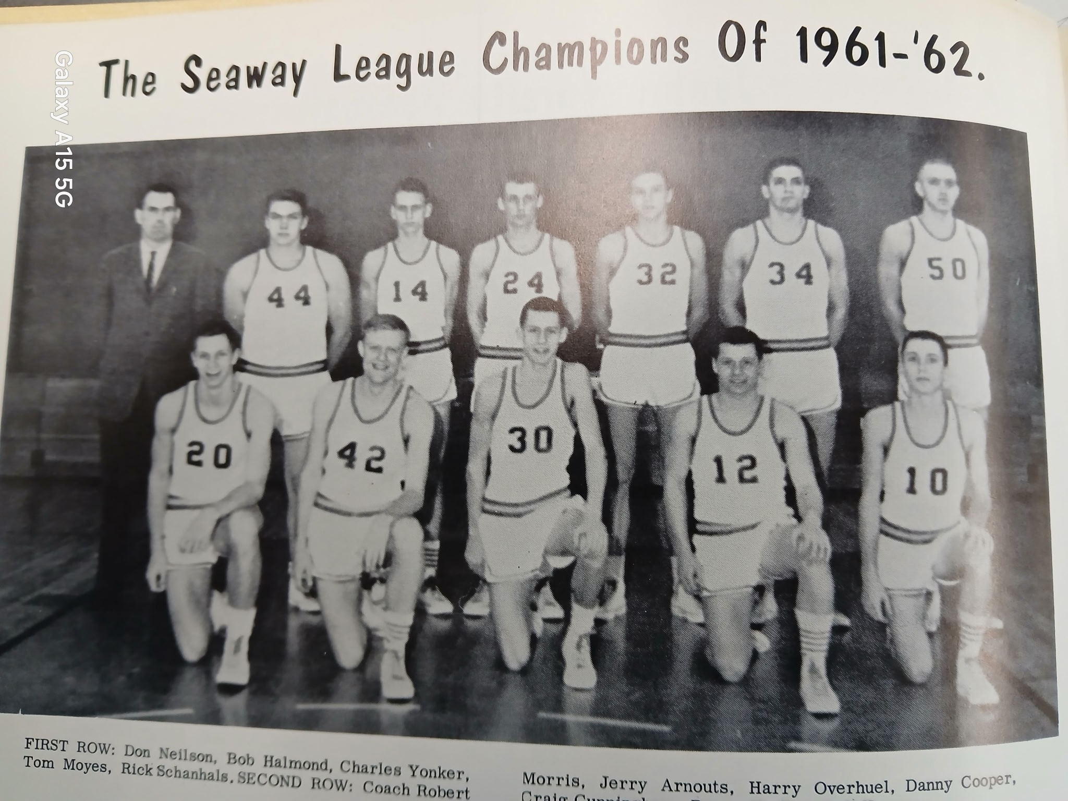

The NORSEMEN SEAWAY CHAMPS of 1961-62

First Row L-R: Don Neilson, Bob Halmond, Charles Yonkers, Tom Moyes, Rick Schanhals
Back Row L-R: Coach Bob Morris, Jerry Arnouts, Harry Overhuel, Dan Cooper, Craig Cunningham, Roger Shaffer, Bob Hasper

N Muskegon 50 West MI Christ. 73 Bob Hasper 15, Roger Schaffer 11,
N Muskegon 57 Montague 42 Shaffer 18, Dan Cooper 11, Hasper 9
N Muskegon 49 Coopersville 40 Cooper 22, Shafer 12, Hasper 7
N Muskegon 43 Fremont 39 Shaffer 15, Cooper 12
N Muskegon 46 Hart 55 Shafer 16, Tom Moyes 10
N Muskegon 53 Ravenna 26 Shaffer 12
N Muskegon 63 West MI Christ. 67 Shaffer 27, Cooper 13, Moyes 10
N Muskegon 57 Whitehall 53 Shaffer 18, Hasper, 16, Cooper 9, Moyes 8
N Muskegon 39 Reeths Puffer 45 Shaffer, 15, Hasper 9
N Muskegon 69 Musk Catholic 60 Shaffer 29, Hasper 21, Moyes 8
N Muskegon 57 Coopersville 41 Shaffer 18, Cooper 13, Hasper 12
N Muskegon 58 Fremont 50 Shaffer 19, Hasper 16
N Muskegon 61 Montague 57 Hasper 18, Cooper 14, Shaffer 10
N Muskegon 78 Ravenna 44 Shaffer 24, Hasper 12, Cooper 10
N Muskegon 63 Whitehall 62 Cooper 18, Harry Overhuel 14, Moyes & Shaffer 11
N Muskegon 51 Reeths Puffer 50 Shaffer 14, Mike Baldwin 11
N Muskegon* 54 Fremont 36 Shaffer 13, Cooper 12
N Muskegon* 56 Big Rapids 53 Shaffer 19, Rick Schanhals 16
N Muskegon* 53 Alma (ot) 56 Cooper 19, Baldwin 10. Hasper 10

1962-63 Coach Bob Morris (13-6 –District champs, Whitehall Seaway Champs)

With the loss of three of their starters from the previous season the prospects for another highly successful season for the Norsemen didn’t appear all that promising for the upcoming season. However, the Norsemen would once again be district champions with convincing victories over upstart Mona Shores and Reeths Puffer to bring home their second straight district championship trophy. Bob Hasper, a three-year starter as a center would be the leading scorer for the Norse while Harry Overhuel and Rick Schanhals, both of whom played huge roles in 1961-62 would return. Mike Baldwin, who had several good games for NM would earn a spot in the starting lineup with veteran coach Bob Morris welcoming Don Nielsen back as another senior who earned a lot of playing time in ’62.’ Adding considerable height to the NM lineup was 6’4 Craig ‘Stretch’ Cunningham, who showed considerable improvement during the offseason. With sophomores Dean Rosenberg and Tom Thiele added to the roster, the Norse would field a team with considerable depth.
If one could look back in hindsight, one could clearly see it was not a good idea to schedule West Michigan Christian for your home opener. Unfortunately, that was the case for NM for not only the 1962-63 season, but for five seasons in a row the Warrior would be NM’s opening opponent. Coming off a season where WMC would win the Class C state championship and have the luxury with not fielding a football team and having many more practice sessions than the Norsemen, WMC would hand NM a loss to begin the season 54-45. It was too much of the Duistermar brothers who combined to score 40 of the Warriors 54 points as many fans were turned away at the door at the sold-out NM gymnasium. The game was much closer than the 1961-62 opener as NM trailed 21-20 at the halftime break. WMC pulled away in the second for the win as NM was led by 6’6 senior center Bob Hasper with 19 points and Mike Baldwin with 14.
NM then made the short jaunt to Montague a successful journey as they rallied to edge the Wildcats 50-47. NM trailed early in the fourth quarter before Mike Baldwin scored seven straight points in the game’s final two minutes to turn the game in favor of the Norse.
It wasn’t pretty but NM prevailed 50-37 to earn their first, of what would prove to be a three-game sweep over Reeths Puffer.
NM, in a quest to defend their Seaway Conference Championship, made it two in a row against Seaway foes with a 55-35 win over Coopersville. Coach Bob Morris was able to empty his bench in NM’s 20-point victory over an outmanned Coopersville five. Bob Hasper and Mike Baldwin each scored a dozen points for NM while Rick Schanhals was in double figures with 10. Eight Norse players scored in the contest, including sophomore Dean Rosenberg who scored six.
After losing to NM in nine of their last ten games, Hart downed the Norse for the second year in a row with a 58-47 win over NM. Once again NM was rusty following a three-week holiday break without a game in falling to the Pirates.
The Norse incurred a bad break over the layoff as it was discovered Mike Baldwin had suffered a broken bone in his right arm that forced the Norse star to play with a cast that hampered his shooting. Baldwin did play against the Pirates but could only score two points. Bob Hasper again paced the losing Norse with 19 points, but no other Norseman was able to reach double figures. One positive sign for the Norse was the continued improved play from Craig Cunningham who helped NM on the boards and scored nine points in the losing cause.
There was a newcomer to NM schedule and a new four-year school when NM played Orchard View for the first time in school history. The Cardinals threw a scare into the Norse before big Bob Hasper took over in the tight final quarter as NM pulled away to a 51-46 victory. Hasper pumped in 22 game high points for the victors while Rick Schanhals added 11.
The one-two combo of Hasper and Schanhals kept NM undefeated in the Seaway following a low scoring 46-38 win over Fremont on the Northside court. The NM due accounted for 35 of NM’s 51 points as NM improved to 4-0 in Seaway Conference action.
NM then set up a battle of the unbeatens in the Seaway with a sloppy 57-49 win over Ravenna. With NM and Whitehall both boasting of perfect records in the conference, the winner of the big showdown battle would take a huge edge in taking the crown. Bob Hasper again paced NM in their win over the Bulldogs with 21 points while Harry Overhuel and Rick Schanhals had ten points and Dean Rosenberg eight.
Whitehall then showed NM why they are not only undefeated in the Seaway but overall as they made the Norse their ninth straight victim of the season with an easy 70-48 victory over NM. Only Bob Hasper was able to solve the Viking’s defense with 15 points. One piece of good news in the loss was the return of Mike Baldwin, out with an injury since December.
The Norse were still mired in a mild slump following their second loss in a row, a 62-45 loss to Muskegon Catholic.
NM found their winning edge with a 64-49 win over Reeths Puffer as the NM trio of Hasper, Schanhals and Overhuel scored 53 of NM’s points. The win over the Rockets would turn the tide on the season as NM would go on a nice run of winning seven of their next eight games.
Montague trailing 45-44 with less than a minute remaining, had a chance to take the lead but lost possession of the ball and NM held on to outlast Montague 45-44 to earn their second close win against their longest rival. The difference in the game was a pair of Rick Schanhals free throws to give NM their final score of 45. Hasper was once again the big gun for the Norse with 22 game leading points.
Hasper then converted on 12 of his 16 attempted shots good for 24 points as NM breezed to a 60-43 win over Coopersville.
NM then needed a 35-foot shot in the game’s final seconds to send the game into overtime before the Norse would survive a 63-57 win over Fremont in overtime. For the first-time all-season Bob Hasper was not the leading scorer for the Norse. Instead, it was Rick Schanhals who led NM in scoring with 24 points, with 10 of his points coming in overtime. Backup center Craig ‘Stretch’ Cunningham, a vastly improved big man had 16 points while Hasper was held to nine.
Craig Cunningham’s improved play of late had led him into a starting role for NM and the 6’4 senior had 15 points to help lead the Norse to a convincing 70-58 rout of Ravenna. Cunningham’s 15 points trailed Bob Hasper’s 20 markers and Mike Baldwin’s 17 as the win set up NM’s chance for a possible tie in the Seaway in their final game of the regular season with undefeated Whitehall. NM lost to Whitehall but the second matchup with the Vikings was a lot closer than their 22-point defeat from earlier in the season. NM lost 53-45 as Whitehall completed their regular season undefeated at a perfect 16-0. It was quite a season in Viking lore as their football team also posted an undefeated season. Bob Hasper was the only Norsemen in double figures with 12 points.
NM began their tournament play against a very young Mona Shores team that would be playing in their first post season MHSAA tournament game. Still two years away from a four-year school the Sailors oldest players were but sophomores and were no match against the experienced Norse, especially 6’6 senior center Bob Hasper as ‘Moose’ equaled his career high with 33 points in NM’s 68-47 rout of the Sailors. Playing their best basketball of the season and playing in their first pair of games at the LC Walker Arena, the Norse had four players in double figures as NM overwhelmed Reeths Puffer78-39 to claim their second straight district title in NM history. Bob Hasper with 19, Craig Cunningham 12, Dean Rosenberg 11, and Rick Schanhals with 10 led the balanced NM attack. The two schools would have to wait forty years before they would meet once again.
Last season the Norsemen played their only game in history at CMU’s fieldhouse. This 1962-63 season saw NM playing their only game in school history at Western Michigan’s fieldhouse. The Norse were heavy underdogs against the second rated team in the state, Hudsonville Unity Christian who entered the game with NM with a sparkling 20-1 record. The Norse came close to pulling off the huge upset but foul trouble in the game’s final quarter threw a roadblock into the Norse chances for the upset. NM and Hudsonville had seen the game tied 15 times before NM’s Mike Baldwin, who was a force on the backboards and Harry Overhuel fouled out. NM had stunned the large crowd on hand at WMU by taking a 34-33 lead at the half. For the game NM had more field goals than Hudsonville but the winners had a decided edge at the free throw line. Bob Hasper ended his outstanding NM career with 22 points, with Stretch Cunningham adding 16 and Rick Schanhals ending his career with 10. Hudsonville would go to finish in the game’s state final contest before losing to perennial Class B champions River Rouge.

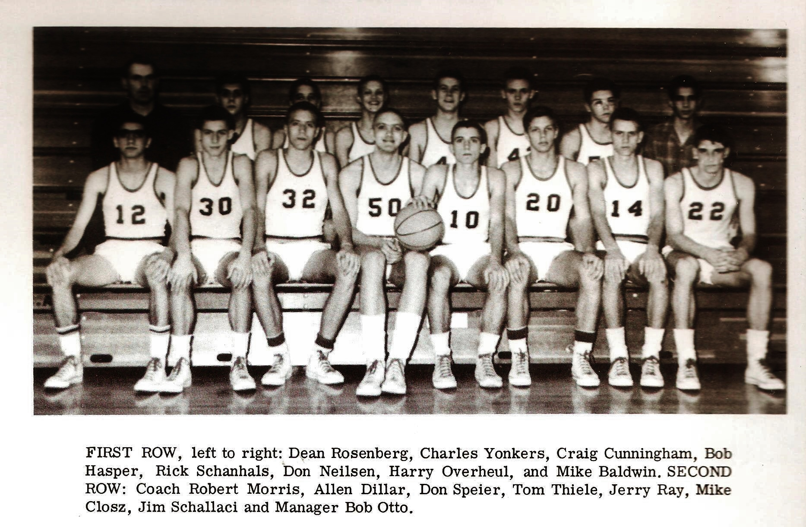
THE NORSEMEN of 1962-63

N Muskegon 45 West MI Chr. 54 Bob Hasper 19, Mike Baldwin 14
N Muskegon 50 Montague 47 Hasper 20, Baldwin 11
N Muskegon 50 Reeths Puffer 37 Hasper 10, Baldwin 11 rebounds.
N Muskegon 55 Coopersville 35 Hasper & Baldwin 12, Rick Schanhals 10
N Muskegon 47 Hart 58 Hasper 19,
N Muskegon 51 Orchard View 46 Hasper 22, Schanhals 11
N Muskegon 46 Fremont 38 Hasper 21, Schanhals 14
N Muskegon 57 Ravenna 49 Hasper 21, Harry Overhuel & Schanhals 10
N Muskegon 48 Whitehall 70 Hasper 15, Baldwin returns from injury
N Muskegon 45 Musk Catholic 62 Hasper 13, Schanhals 10
N Muskegon 64 Reeths Puffer 49 Hasper 20, Overhuel 17, Schanhals 16
N Muskegon 45 Montague 44 Hasper 22, Dean Rosenberg 7
N Muskegon 60 Coopersville 43 Hasper 24, Baldwin 10
N Muskegon 63 Fremont (ot) 57 Schanhals 24 points, C. Cunningham 16
N Muskegon 78 Ravenna 58 Hasper 20, Baldwin 17, Cunningham 15
N Muskegon 45 Whitehall 53 Hasper 12, Cunningham, & Overhuel 9
N Muskegon* 68 Mona Shores 47 Hasper 33, Cunningham 10
N Muskegon* 78 Reeths Puffer 39 Hasper 18, Cunningham 12, Rosenberg 11
N Muskegon * 63 Hudsonville Un. 73 Hasper 22, Cunningham 16, Schanhals 10

1963-64 Coach Bob Morris (12-5–Whitehall Seaway Champs)

The 1963-64 season would again see the Norsemen have a very good season, winning 12 games while dropping but five contests. It would be the 16th and final season for NM’s popular coach Bob Morris who would give up his successful coaching job to continue at NMHS as a teacher and athletic director. Not a great deal was expected for his final season with only Mike Baldwin returning as a starter. Baldwin, listed at ‘maybe’ 6’1 would be the tallest starter on an NM team that would field its smallest team in recent memory. Not only were the Norse short on height, but also short on experience as Baldwin would be the only senior. Somehow, the veteran Morris would squeeze every bit of talent out of this team to produce an outstanding record in his swan song at his beloved NMHS. Junior Dean Rosenberg, who saw plenty of playing time in his sophomore season would be a part of a NM team that would basically play with a four-guard offense. Tom Thiele saw action as a sophomore while Don Johnson, the leading scorer from the 1962-63 JV team would be a pleasant surprise for Norse fans.
Again, NM would open their season with a perennial powerhouse as their opponent, the Warriors of West Michigan Christian, a team that played for a state championship in three of their last six years, winning it all in 1958 and 1962. To compound the NM task the game was at WMC. However, Coach Morris’s scrappy Norsemen were up to the task and captured their first win over the Warriors in six meetings with a narrow 47-45 victory. With the score knotted at 45-45 Tom Thiele’s had a nifty block of a Warriors shot that gave the ball back to the Norse in the game’s final minute. Seconds later Dean Rosenberg was fouled and calmly made both free throws that proved to be the game winner. Rosenberg led Norse scorers with 15 points while Mike Baldwin added 12 and Don Johnson ten and for the first time in five seasons NM would open their schedule with a victory.
No longer a pushover in their brief tenure in the Seaway Conference, Ravenna threw a scare into the Norse in game number two on the season before falling to NM 57-54. So tight was this game that NM never took the lead for good until Don Johnson’s field goal with but 1:02 showing on the clock. Tom Thiele and Dean Rosenberg each had 15 points for NM with Johnson tossing in 10 markers and Mike Baldwin nine.
With a starting lineup without a player as tall as 6’2, it was imperative if this NM team was going to be a winner, then they would need some accurate shooters from out court. NM did indeed get that necessary out court shooting led by Don Johnson’s 23 points as NM defeated Montague 67-58. NM also was accurate from the free throw line by meshing 25 free throws in 31 attempts, nine of the charity tossed coming from Mike Baldwin. Baldwin would finish with 15 points and Dean Rosenberg added 14 as NM improved to a perfect 3-0.
Foul trouble and a pesky full court pressing Orchard View defense led to the Norse losing their first game of the season to the Cardinals 54-41. Tom Thiele and Dean Rosenberg were the only Norse in double figures as they each scored 14 points in the loss, the second ever meeting between the two local schools.
NM bounced back to win their seventh straight game against Fremont with a 57-47 victory. It was Tom Thiele who had the hot hand for the Norse by tallying 22 points to improve NM’s record to 4-1 on the young season. Don Johnson added 15 while Dean Rosenberg was also in double figures with 10.
Even playing without starting guard Don Johnson the Norse were able to put together one of their best showings of the season with a dominating 70-39 road win over Coopersville. With Johnson out with the flu bug coach Morris gave John Pattenger the start and the star on the NM baseball team delivered by pulling down several rebounds and chipping in with eight points. The 31-point margin would be the most lopsided victory in the 31 meetings between the two schools.
Instead of a three-week break over the Holidays, NM returned to the court in but two weeks as they would again face the Hart Pirates in the first game of the new 1964 year. NM held the cold shooting Pirates to one first half field goal enroute to a 68-24 thrashing of the Hart Pirates, ending a brief two-game losing streak to their long-time foe. Steve Peterson became the fifth player in NM’s first seven games as the team’s leading scorer as he pumped in a team high 19 points. Rosenberg had 11 while 11 Norsemen scored in the rout including seven points scored by future Navy Admiral John Hutson. It was not a good season for the Hart Pirates who had produced many outstanding teams in the past. That was not the case in 1963-64 as the Pirates failed to win a single game.
NM improved 4-1 in Seaway Conference play and 7-2 overall as they defeated Reeths Puffer and their head coach Bruce Benson 63-56. Benson had previously coached many of the NM players where he served as the NM JV basketball coach and head baseball coach before making the move to RP. Don Johnson led four Norsemen who scored in double figures with 19, with Tom Thiele, Dean Rosenberg and Mike Baldwin all scoring 13.
Once again, the gym at Whitehall proved to be a tough place to earn a Norsemen win over the years as Whitehall handed NM their second defeat in Seaway Conference play with a 75-62 victory. The NM cause wasn’t helped when three Norse players fouled out of the contest with Tom Theile exiting the contest before the end of three periods. NM had outshot the Vikings 27-22 from the field by it was at the free throw line where Whitehall prevailed, netting 31 free throws to the Norsemen’s slim total of eight. Don Johnson with his deadly out court shooting kept NM close with his game leading 25 points. Steve Peterson netted 16 but no other NM player scored more than six points as Whitehall took a firm grip of first place in the Seaway.
NM quickly righted the ship and would win their next five games to insure a successful season. After hanging on to just nip Ravenna in their first contest, the Norse found the Ravenna gym more friendly as they had little trouble in handing the Bulldogs a 62-47 loss in their second go around. Dean Rosenberg, recovering from an injured hand, regained his shooting eye and led NM with 19 points while his backcourt mate Don Johnson flipped in 14.
After losing earlier in the season to Orchard View by 13 points, coupled with OV pulling off a stunning upset over unbeaten Whitehall a week earlier, chances didn’t appear bright for a NM victory. However, the Norse pulled off the stunner over a cold shooting OV team that connected on only 21 of 80 attempts. Mike Baldwin had a monster game for the Norse, especially in rebounding as he was credited with 23 rebounds to go along with 14 points. Tom Theile had 16 points and Don Johnson 15, but it took a pair of free throws from Dean Rosenberg in the game’s final moments to ice the victory. With the win NM again had hopes for a tie for first in the Seaway as they were only one game behind league-leading Whitehall who stood in first place with a 7-1 record.
The Norse continued their domination in the 1960s with Montague as they defeated the Wildcats 64-41, a far cry from their first game in early December when NM won by only three points. Don Johnson garnered 19 points for NM while Dean Rosenberg pitched in with 13 and Mike Baldwin again controlled the boards as NM was never threatened after the first quarter.
NM would then win their fourth straight, and ninth in a row over Fremont. After the Fremont JVs destroyed the Little Norse 86-42 in the preliminary, it was clear that the nine-game winning streak was about to end. The game was close throughout the second half as the teams were deadlocked at 40-all heading into the final quarter before the NM trio of Johnson-Rosenberg-Baldwin took control. NM edged the Packers by one slim point 54-53.
It was parent’s night at NMHS as NM had to come from as many as 10 points behind before finally catching and then passing the Coopersville Broncos to earn their fifth straight victory 63-59. John Pattinger was inserted into the starting lineup, and he responded with 11 points, many of those coming in NM’s 3rd quarter rally. Dean Rosenberg led the NM scorers with 17 with Don Johnson adding 14.
The season didn’t end well as NM went from a 12-2 record to finish at 12-5.
NM enjoyed a five-point lead at 52-47 with four minutes left in the game but failed to score again as Reeths Puffer won 53-52. NM had a chance to tie and perhaps win the game but a free throw with just three seconds on the clock missed and NM’s chances to force a tie with a win in the final game of the regular season with Whitehall was now a moot point. Don Johnson with 19 points was the only NM player in double figures. Tom Theile with nine, while Steve Peterson and Mike Baldwin with eight were close.
Whitehall repeated as Seaway Conference champs and improved their regular season record to 14-1 after downing NM 75-60. The Norse once trailed by as many as 18 but got as close to six in the final stanza before the Vikings pulled away. Whitehall would lose but only one contest, an early season loss to Orchard View over the past two seasons. Don Johnson netted 15 points for NM with Tom Theile the other Norse to reach double figures with 10.
NM returned to the spacious LC Walker Arena once again for district play but their season came to a crushing end with a 60-52 loss to Reeths Puffer. The game was much closer than the final score as NM led late in the contest at 50-49 before the Rockets went on a 13-0 run to close out the game. Steve Peterson had a season high 20 points to lead NM. Don Johnson added 19 points with NM’s only senior Mike Baldwin capping his fine three-year career on the NM varsity with seven points.
Coach Bob Morris would retire as the Norsemen’s head coach after 16 seasons with a record of 143 wins as opposed to 117 defeats. If ever the term was applicable that “he was a player’s coach” that would be coach Morris. Morris started at NMHS for the 1948-49 season where he inherited no starters, and only one letterman and suffered through by far his worse season at 1-13. Coach Morris would mold that very young team where in but two years they would be co-champs of the WMC. Under his tutelage North Muskegon would win three conference championships, including one in the Seaway Conference. His Norsemen would often finish in second place during his tenure. In his final seven seasons as the head coach, he would post a record of 76 wins and only 46 losses, 2 conference championships and two district titles. No other NM coach ever posted a better record over seven seasons than Bob Morris. After Morris retired, Norse followers would have to wait 15 more years before NM would win another WMC title. How proud your author was to give the eulogy when his beloved coach, and very good friend passed away.

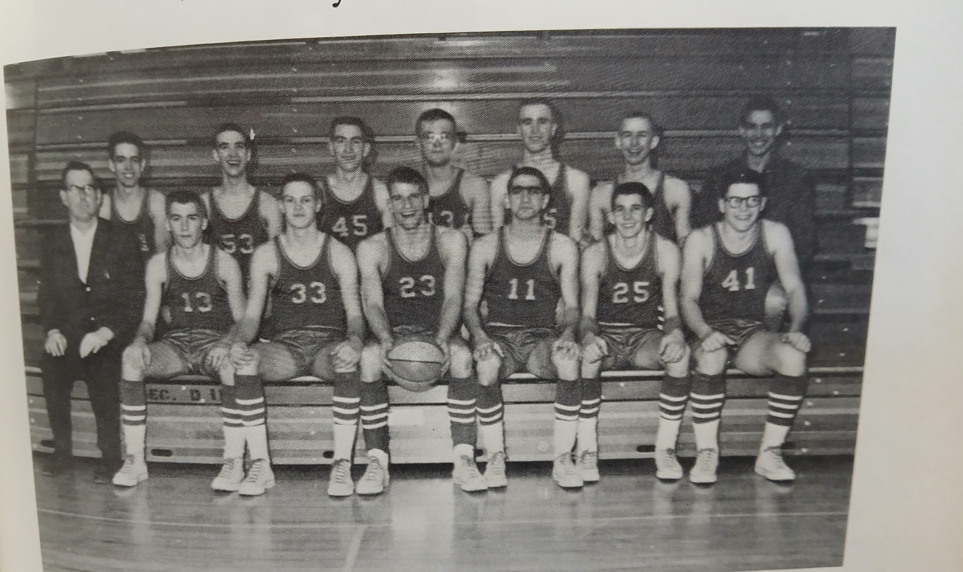

Front Row L-R: Coach Morris, Don Johnson, Tom Thiele, Mike Baldwin, Dean Rosenberg, Steve Peterson, Jim Shillaci
2nd Row L-R: Mike Senecal, John Pattenger, Dave Forner, John Hutson, Jeff Peterson, Kim Swanson, Mgr. Bob Otto
The NORSEMEN of 1963-64

N Muskegon 47 West MI Christ. 45 Dean Rosenberg 15, Mike Baldwin 12
N Muskegon 57 Ravenna 54 Rosenberg & Tom Thiele 15
N Muskegon 67 Montague 58 Don Johnson 23, Baldwin 15
N Muskegon 41 Orchard View 54 Thiele & Rosenberg 14.
N Muskegon 57 Fremont 47 Thiele 22, Johnson 15, Rosenberg 10
N Muskegon 70 Coopersville 39 Baldwin 17, Rosenberg 16, Thiele 10
N Muskegon 68 Hart 24 Steve Peterson 19, Rosenberg 11
N Muskegon 63 Reeths Puffer 56 Johnson 19, Baldwin, Thiele and Rosenberg 13
N Muskegon 62 Whitehall 75 Johnson 25, Peterson 14
N Muskegon 62 Ravenna 47 Rosenberg 19, Johnson 14
N Muskegon 61 Orchard View 57 Baldwin 14 & 23 rebounds. Thiele 16
N Muskegon 64 Montague 41 Johnson 19, Rosenberg 13
N Muskegon 54 Fremont 53 Baldwin 16, Johnson 15, Rosenberg 14
N Muskegon 63 Coopersville 59 Rosenberg 17, Johnson 14, Pattinger 11
N Muskegon 52 Reeths Puffer 53 Johnson 19, Theile 9
N Muskegon 60 Whitehall 75 Johnson 15, Theile 10
N Muskegon* 52 Reeths Puffer 60 Peterson 20, Johnson 19

1964-65 Coach Don Boyink (3-14–Whitehall Seaway Champs)

With only one starter lost to graduation, and coming off a very good 12-5 season, there surely had to be a great deal of optimism for the 1964-65 season. However, it didn’t happen. Not only did NM lose their only senior and inspirational leader in Mike Baldwin, but they also lost their coach with the retirement of Bob Morris.
It bears mentioning here the story of Mike Baldwin, a three-year regular for NM teams who produced a combined 39-16 record during Mike’s NM career. Baldwin was also a standout on the NM track team and one of the most well-liked boys at NMHS. Sadly, just a little more than a year after Baldwin played his last game for NMHS, he passed away from a brain hemorrhage in June of 1965 at the age of 20. Baldwin will always be remembered every year with the presentation at the final awards assembly with the Mike Baldwin award.
The new NM basketball coach was Don Boyink, who welcomed back a veteran team from the 12-5 team from the previous season that included four starters and a total of eight letterman. Yet, the Norse had their most dismal season since 1949. Coach Morris always emphasized defense during his 16 years at NM, and never did his Norsemen play anything but a man-to-man defense. Only two times in the previous season did an opponent score more than 61 points in a single game, both by a powerful Whitehall team that lost but one regular season game in two years. In ten of NM’s games in this 1964-65 season, NM’s opponents scored more than 70 points, and in six games the opponents scored more than 80, three more 80 points games allowed by a coach Morris team in his 16 years!
The Norse once again opened the season with a powerful West Michigan Christian team, a team so talented that they would win the state Class C Championship in March. NM scored 78 points against the Warriors, but the bad news was they gave up 85 points, the most points scored by a Norse opponent in school history. The Norse offense gave every indication that despite the loss, this could be a special season for NM. The lead see-sawed back and forth for much of the game but the big break for WMC came when NM’s Don Johnson incurred an elbow injury midway through the third quarter and never saw any further action. Johnson was a thorn in the side to veteran coach Elmer Walcott’s WMC team as Johnson had already scored 20 points, 14 of those coming from the free throw line. With Johnson on the sidelines WMC was able to pull away to earn the victory. Dean Rosenberg scored 25 points for NM while the other returning starters from the previous season, Tom Thiele and John Pattinger netted 14 and 10.
NM then encountered another tough foe in game number two as they traveled to Whitehall in hopes of pulling off the upset against the two-time defending Seaway champs. NM started off strong but faded in the second half as Whitehall won easily over NM 71-57. Don Johnson, with a week’s rest was able to return from his elbow injury suffered in their opener with WMC and led the Norse with 21 points. Steve Peterson added 11, Tom Thiele 10 and Dean Rosenberg 8 as NM fell to 0-2, with both losses coming against a pair of very good teams.
NM then showed all their potential in their next outing as they steamrolled Ravenna 87-36. So decisive was this trouncing that to this day (2026) this remains the most lopsided win against a Ravenna team in history. So dismal was the Ravenna shooting that the Bulldogs were only able to make but two of their first 13 free throws. Leading the Norse barrage was Don Johnson with 23 points. John Pattinger netted 16, Steve Peterson 15, and Tom Thiele 10, before NM reserves flooded the floor in the second half.
It appeared all was well for NM as they had a come-from-behind victory over Fremont to square their record at 2-2. At one point the Norse trailed 46-31 early into the third period before they ignited their rally. NM closed the gap to 63-52 at the end of the 3rd quarter as victory for NM still seemed dire. It didn’t take long for NM to tie the game at 65-all on a pair of free throws from John Pattinger. NM then pulled away in the final stretch to win 77-74. NM received balanced scoring in the win with five players reaching double figures with the leading scorer being Don Johnson with 16.
For the fourth time in five games the NM defense gave up more than 70 points as they were overwhelmed by Orchard View 84-59. Tom Thiele had 17 points for NM as the Norse would go on a long losing streak that would eventually reach nine games without tasting victory.
Playing before a standing room only crowd at NMHS, Reeth Puffer moved into first place in the Seaway with an 80-69 win over the Norse. Tom Thiele led NM scorers with 23 points followed by John Pattinger’s 13 but giving up 80 points to your rival was too much for the NM shooters to overcome.
It had been nearly 30 years since North Muskegon and Fruitport last met in basketball in 1936. And my how the game had changed over the three decades. NM defeated Fruitport 32-15 in their long-ago matchup from the 1930s. The two teams 30 years later would combine to score 157 points with Fruitport winning 80-77 over the Norse. It was the third straight game NM allowed an opponent to score 80 points, the same amount a coach Bob Morris team allowed in his 16 years as NM’s head coach. NM’s fortunes were now heading due south in the loss to a Fruitport five that came to the NM gymnasium looking for its first win of the season. NM saw a 69-64 lead disappear as Fruitport took the lead for good in the final 10 seconds on a free throw and a tip in on the missed free throw to shock the Norse 80-77.
Just three days after their loss to Fruitport it would go from bad to worse for the Norsemen as head coach Don Boyink dismissed six players from the NM team. Coach Boyink was forced to bring up the starting five from the JV team as only Dean Rosenberg would be the lone starter not dismissed from the team. With a depleted roster Coopersville than snapped their six-game losing streak against the Norse in recent years by nipping the Norse 58-54. Scoring 12 points in the game was Steve Peterson. NM had two Steve Peterson’s on the team, but it was the younger Steve Peterson who remained on the team.
NM was no match for Whitehall and their 6’10 center Maurice Kennebrew, who scored 24 points, as NM was handedly defeated by Whitehall 69-37. Only Dean Rosenberg, the one starter remaining from the Norse team that began the season was able to get in double digit numbers for NM with 11 points.
What a turnaround it was from the first game between NM and Ravenna when the Norse handed the Bulldogs a 51-point whipping, the most lopsided win against Ravenna in their long rivalry. Ravenna’s Dan Schut’s 10-foot jumper in the final 10 seconds gave Ravenna a 62-60 win over NM to end a nine-game losing streak to the Norsemen. Dave Marchido, who only a few days earlier was playing on the Norse JV team, led NM scorers with 19 points.
History repeated itself a week later when it was Fremont’s turn to make amends for an earlier loss to NM as the Packers thumped the Norse in their return engagement 69-42. Once again it was Marchido who would lead the Norse in scoring with 18 points. No other Norse player was able to score more than six points as NM’s once high scoring offense again sputtered.
The very young Norsemen were no match for Orchard View and their star player Jim McClain as they were scorched by the Cardinals 82-53. The Cardinals put this game away early as they raced out to a commanding 23-6 lead after the first eight minutes. Only Mike Senecal was able to get in double figures for the host Norsemen with 10 points.
NM then snapped an eight-game losing streak while extending their mastery over Montague to 10 straight wins with a 60-57 over the host Wildcats. It wasn’t until former JV player Randy Hutson tallied a closing basket did the Norse clinch the win. Dean Rosenberg led NM scorers with 23 points while Hutson finished with 13.
The Norse then went back to their losing ways as they fell 76-54 to a heavily favored Reeths Puffer team on the Rocket’s home floor. NM was within 11 points of RP 56-45 at the end of three quarters, but the Norse then went five minutes without scoring a point as RP pulled away. Dean Rosenberg, the defending state champion in the mile run, topped Norse scorers with 15 while Steve Peterson added 14.
The young Norse had improved immensely since the dismissal of six varsity performers in January as shown in their one-point 77-76 loss to Fruitport. Fruitport overcame a one-point Norse lead when Dick Doctor made both free throws in the game’s final seconds to give NM a tough defeat. NM wasn’t helped when Dean Rosenberg, who had scored 25 points, fouled out late in the game. In their highest scoring game since scoring 77 points in their first matchup with the Trojans, Steve Peterson with 19 and Mike Senecal with 14 also scored well in a valiant losing effort. Randy Hutson and Jeff Peterson just missed scoring in double digit numbers with nine each.
In a near repeat of their earlier clash at Coopersville, the Broncos again handed NM a 55-50 defeat to close out the regular season. Scoring in double figures for the young Norse were sophomore Randy Hutson with 12 and junior Jeff Peterson with 10. NM wouldn’t have to wait long to begin tournament play as they opened play the following Monday to face Orchard View at the LC Walker Arena. It was a quick exit for the Norse as they fell to OV for the third time during the season 88-70 as Bayou bound Jim McClain of the Cardinals poured in 35 points. The disappointing season for NM came to a quick close but not before Steve Peterson found the spacious LC Walker Arena to his liking with a career high 28 points. Dean Rosenberg ended his three-year varsity career with 14 and Jeff Peterson 13 as NM finished their season with a 3-14 record. First year head coach Don Boyink’s career at NM was short-lived as Boyink resigned as NM coach.

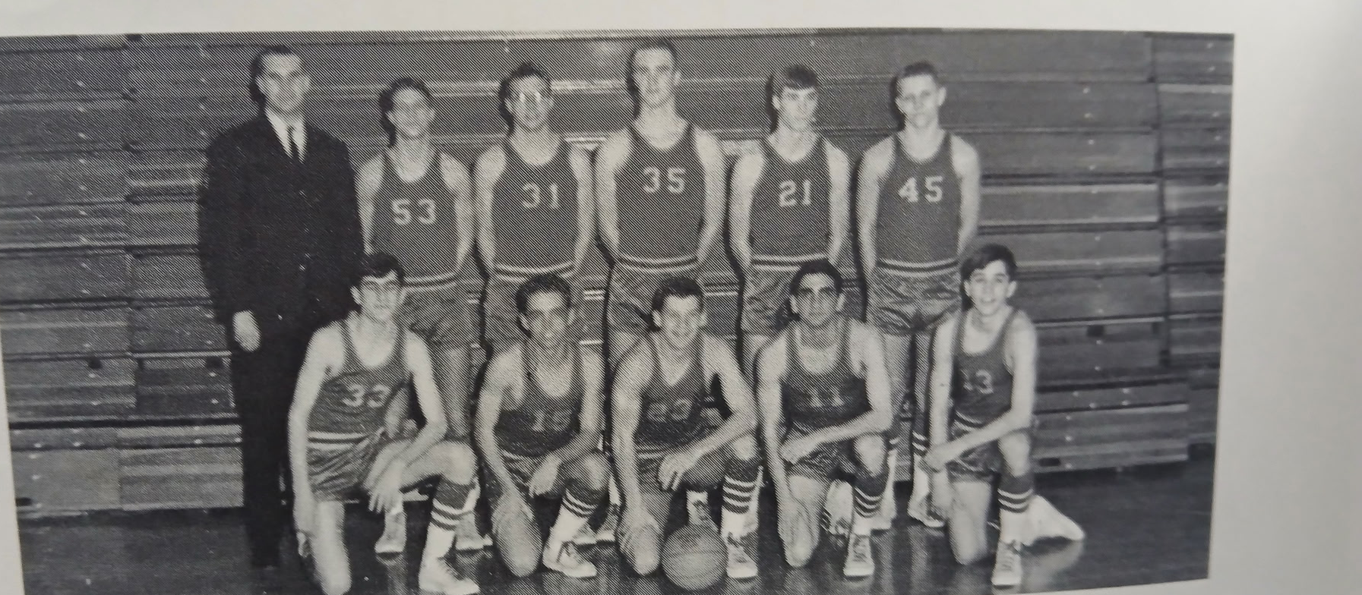

1st Row L-R: Bob Rosenberg, Mike Senecal, Ken Mack, Dean Rosenberg, Bob Swanson
2nd Row L-R: Coach Don Boyink, Randy Hutson, John Flarry, Jeff Peterson, Steve Peterson, Dave Marchido
The NORSEMEN of 1964-65

N Muskegon 78 West MI Christ. 85 Dean Rosenberg 25, Don Johnson 20
N Muskegon 57 Whitehall 71 Johnson 21, Steve Peterson 11, Thiele 10
N Muskegon 87 Ravenna 36 Johnson 23-, Pattinger 16, Peterson 15
N Muskegon 77 Fremont 74 Johnson 16, Thiele & Peterson 13.
N Muskegon 59 Orchard View 84 Thiele 17, Peterson 12
N Muskegon 69 Reeths Puffer 80 Thiele 23, Pattinger 13
N Muskegon 77 Fruitport 80 Thiele, Johnson & Pattinger 10
N Muskegon 54 Coopersville 58 Peterson 12, Rosenberg 11
N Muskegon 37 Whitehall 69 Rosenberg 11, Peterson 8
N Muskegon 60 Ravenna 62 Dave Marchido 19, Rosenberg 14
N Muskegon 42 Fremont 69 Marchido 18
N Muskegon 53 Orchard View 82 Mike Senecal 10, Jeff Peterson 9
N Muskegon 60 Montague 57 Rosenberg 23, Randy Huston 13
N Muskegon 54 Reeths Puffer 76 Roseneberg 15, Peterson 14
N Muskegon 76 Fruitport 77 Rosenberg 25, S Peterson 19
N Muskegon 50 Coopersville 55 Hutson 12, J Peterson 10
N Muskegon* 70 Orchard View 88 S Peterson 28, Rosenberg 14

1965-66 Coach Tom Seroczynski (6-11–Fremont Seaway Champs)

The Norse traveled to Coopersville for their opening game of the 1965-66 season and the first game under head coach Tom Seroczynski who also performed duties as NM’s head football coach. Coach ‘Sero’ would have to wait for his first victory as NM’s much smaller Norsemen were outsized by the taller Broncos and lost 50-46. After leading 29-26 at halftime the Norse managed to score but four points in a decisive third period as they were outscored by the hosts 14-4. Bob Rosenberg, younger brother of Dean, led NM scorers with 15 points, with Dave Marchido netting 12 to go along with 15 rebounds. Pat Kersh, in his first start in a Blue & Gold Norse uniform, chipped in with 11.
Coach Seroszynski had to wait until only his second game to earn his first win, a 78-55 defeat of Ravenna. The first-year coach received excellent balanced scoring by his Norsemen led by Randy Hutson’s 22 points. Dave Marchido had another good game on the boards with 17 rebounds while Hutson received scoring help from Bob Rosenberg with 15, as well as Pat Kersh and Steve Peterson with 12 points each.
The Norse were just simply outclassed by the defending Class C state Champs of Western Michigan Christian 74-45 to fall to 1-2 after three games played. Future Weber State Division 1 player Wes VanDyke had 17 points for the winning Warriors. Bob Rosenberg and Steve Peterson provided much of the NM punch with 16 and 12 points respectively.
NM toughened up their defense as they held the high scoring and undefeated Reeths Puffer Rockets to 57 points, nearly 25 points below RP’s average. The Norse, however, were only able to come up with 49 as they fell 57-49 to the host Rockets. A trio of Norse were able to reach double digits in points; Bob Swanson, back from a football injury had 13 while Dave Marchido had 12 and Steve Peterson 10.
NM evened their record at 2-2 with a 76-66 win over Fruitport on the Northside court. NM received balanced scoring from their cagers as Steve Peterson had 21, Bob Rosenberg 18, Randy Hutson 17, and Bob Swanson with 11 as NM survived the hot shooting of Fruitport’s Bob Sarachman who led all scorers with 27 points.
NM then ran into a red-hot Fremont Packer team who made the Norsemen its fifth straight victim with an easy 74-52 victory at the NM gym. Bob Rosenberg scored 13 of his 19 points in the first quarter to keep the Norse close but the Packers had too much firepower and blitzed the Norse in the final period to pull away. Pat Kersh followed Rosenberg in scoring honors for NM with 14 points.
The last time North Muskegon played Spring Lake before their encounter in late December of 1965 was back in 1934 when NM wasn’t even a four-year high school. In 1965 Spring Lake scored 94 points, 80 more than they scored in a 14-8 low scoring affair in the 1933-34 season. The 94 points scored by the Lakers was the most points ever given up by NM in school history, a mark since surpassed.
It was no contest after the Lakers had a comfortable 45-24 lead at halftime. Dave Marchido paced the Norse with 22 points and 13 rebounds while Randy Hutson added 17 for the visiting Norsemen.
NM and Whitehall went into overtime for the first of six times in their long rivalry. The Vikings, who won five of those six overtime games, edged the Norsemen 66-63. NM scoring was so balanced that five NM players scored in double figures: Dave Marchido and Steve Peterson netted 13, Bob Rosenberg and Pat Kersh scored 12 and Bob Swanson 11. The Norse took the lead in regulation at 63-61 only to see the Vikings tie the game on an Art Pumphrey bucket to send the game into the three-minute OT.
In what would prove to be the final game played between the two schools in a rivalry that began in the 1942-43 season, Coopersville handed the Norse a 74-64 beating. Despite the loss NM would win 17 of the 31 games played between the two schools over the years. One of those 14 NM defeats is one your author will never forget when Coopersville defeated my 1959 team 58-56 in the districts, the only game in NM history decided in ‘sudden death.’ Randy Hutson, who was not one of the five Norse players in double figures in the overtime loss to Whitehall (he had only 2 points), was the high scorer in the loss to the Broncos with 18 points.
The Norse snapped their four-game losing streak in a big way with a lopsided 83-68 win over Ravenna. It was only the third win on the season and second over the Bulldogs. Once again, several Norse shared in the scoring department with Bob Rosenberg’s 17 points leading the way, one point more than Steve Patterson’s total of 16.
Playing perhaps their best game of the season, NM defeated Reeths Puffer 69-63 as four starters reached double figures for the Norse. NM also did very well at the free throw line as they converted on 19 of 24 charity tosses. Steve Peterson led the balanced attack with 18 points. Also in double digits for NM were Randy Hutson (13), Bob Swanson and Dave Marchido with 11 while Bob Rosenberg came close to making it 5-for-5 with 9 tallies.
NM then completed their longest winning streak at three wins with a narrow 77-75 victory over Fruitport. Dave Marchido had a huge game for NM with 27 points and a massive rebound total of 26, unofficially a record that still stands today. (1926) Bob Swanson joined Marchido with his own season high total of 23 points as NM improved to 5-6 in Seaway Conference action.
NM enjoyed a 44-30 lead at halftime and then held off a late Fruitport rally after Randy Hutson and Steve Peterson had fouled out.
Fremont clinched the Seaway Conference Championship with an explosive 91-59 conquest of the outmanned Norse. The Packers won despite missing the services of their leading scorer Bill Bekkering, out with an ankle injury. It didn’t matter as his replacement Chris Nelson poured in 17 points as NM never threatened the powerful Packer quintet. Steve Peterson with 16 and Bob Rosenberg with 13 led the Norsemen.
NM then rattled the hoops for 89 points, second only to the 104 scored by the Gordy Odell led Norsemen against Whitehall in 1955, in their 89-53 defeat of Montague. In the 191 games played to date between the two long-time rivals, this was the most lopsided win by a Norsemen team vs. the Wildcats until the Norsemen of 2026 routed the Wildcats 72-30. It was now Steve Peterson’s turn to have his highest scoring output of the season with his 27 points. Randy Hutson with 14 and Bob Rosenberg with 13, and Dave Marchido’s 10 markers also contributed to the high Norse total.
In the last meeting between the two teams in their brief rivalry for the next 45 years, Spring Lake won their second game of the season over the Norse 76-67. Larry Aldridge, who would play baseball in the summertime for the North Muskegon Independent baseball team, scored 31 points to lead the Lakers. Dave Marchido championed the Norse losing cause with a 19-point effort with Bob Rosenberg adding 14.
In their final game in the Seaway Conference NM fell to Whitehall 90-62, a far cry from their opening battle in early January when the game wasn’t settled until overtime. Whitehall’s win over the Norse was their ninth straight leading into the MHSAA playoffs the following week. The future looked good for Viking followers as their JV team posted a perfect 17-0 season at the expense of the Little Norse. Randy Hutson topped NM scorers in the varsity contest with 17 points, with Bob Rosenberg netting 12 and Dave Marchido 10. Showing promise that he will be a big help for next season’s NM team was 6-3 Mark Erickson who scored nine points.
With declining enrollment NM had dropped to the Class C level and with Laketon Township students all now a part of the Reeths Puffer School system, the Norse would move back to the West Michigan Conference in time for the 1966-67 school year. After playing at the Class B level for the past three years, with all games played at the LC Walker Arena, NM would now begin tourney play at Whitehall where their opponent would be a Scottville team that had won 16 of their 18 games. NM led at the end of the first quarter but the Spartans, co-champs of the WMC, pulled away behind the play of big Mike Hankwitz, to end the Norse season with a 62-47 victory. Hankwitz, a charter member of the Mason County Hall of Fame, would go on to become one of the leading defensive coordinators in NCAA football. Mark Erickson again showed his rapid improvement during the season as he led NM with 11 points and 12 rebounds, giving the Norse faithful hope that good things would come soon. Scottville would go on to advance to the state semi-finals where they lost in overtime to L’Anse when they made but 10 of 19 free throw attempts. Scottville fans will always wonder “What If” as L’Anse would win the following day in the state finals by 19 points.

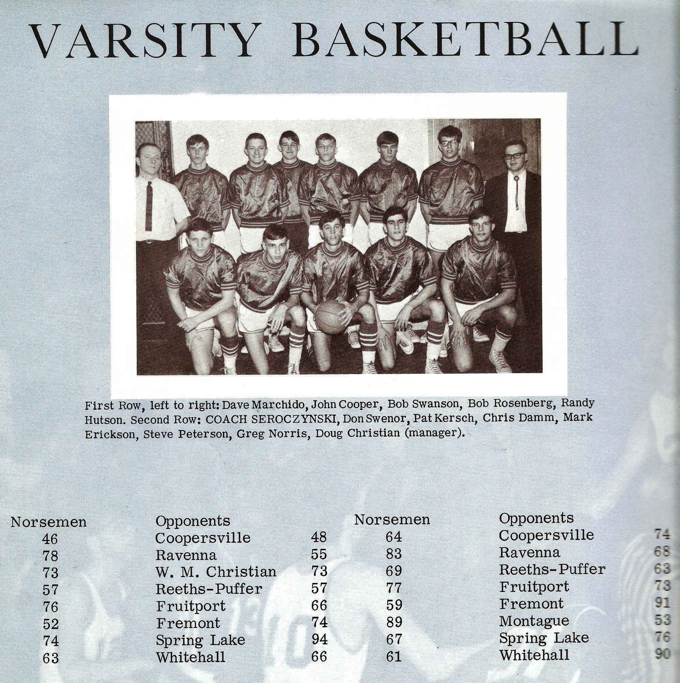

The NORSEMEN of 1965-66

Bottom Row L-R: Dave Marchido, John Cooper, Bob Swanson, Bob Rosenberg, Randy Hutson
Standing: Coach Tom Seroczynski, Don Swenor, Pat Kersh, Chris Damm, Mark Erickson, Steve Peterson, Greg Norris, Doug Christian (Manager)

N Muskegon 46 Coopersville 50 Bob Rosenberg 15, Dave Marchido 12
N Muskegon 78 Ravenna 55 Randy Hutson 22, Rosenberg 15
N Muskegon 45 West MI Christ. 74 Rosenberg 16, Steve Peterson 12
N Muskegon 49 Reeths Puffer 57 Bob Swanson 13, Marchido 12
N Muskegon 76 Fruitport 66 Peterson 21, Rosenberg 18, Hutson 17
N Muskegon 52 Fremont 74 Rosenberg 19, Pat Kersh 14
N Muskegon 74 Spring Lake 94 Marchido 22, Hutson 17
N Muskegon 63 Whitehall (ot) 66 Five NM players in double figures.
N Muskegon 64 Coopersville 74 Hutson 18, Rosenberg 14, Marchido 13
N Muskegon 83 Ravenna 68 Rosenberg 17, Peterson 16, Marchido 12
N Muskegon 69 Reeths Puffer 63 Petersson 18, Hutson 13, 2 more with 11
N Muskegon 77 Fruitport 75 Marchido 27 & 26 rebs, Swanson 23
N Muskegon 59 Fremont 91 Peterson 16, Rosenberg 13
N Muskegon 89 Montague 53 Peterson 27, Hutson 14, Rosenberg 13
N Muskegon 67 Spring Lake 76 Marchido 19, Rosenberg14
N Muskegon 62 Whitehall 90 Hutson 17, Rosenberg 12, Marchido 10
N Muskegon * 47 Scottville 62 Mark Erickson 11, Peterson 12

1966-67 Coach Tom Seroczynski (14-5–co-champs with Shelby WMC)

North Muskegon was back in its favorite element, the West Michigan Conference and NM’s most successful football coach in NM history, Tom Seroczynski, would see some of his football magic rub off on his Norsemen basketball team as NM turned things around with a superb 14-5 record. Coach ‘Sero’ welcomed back nearly his entire starting unit from the previous season as well as 6’3 center Mark Erickson.
NM’s first opponent would be West Michigan Christian, a team that throttled the Norsemen by nearly thirty points the previous season. NM took the Warriors to overtime only to lose in one of the most frustrating games in school history. Ten seconds remained in regulation with NM leading 54-52 when WMC’s Bob Devries stepped to the free throw line in a one-and-one situation. Devries missed the shot that was rebounded by NM’s Mark Erickson. But wait ---- An official ruled, however that a group of youngsters seated at the Warriors end of the court had unduly distracted Devries and he was awarded the shot over. He then made both free throws to send the game into overtime where the Warriors eventually won.
Still early as a four-year school NM had no trouble in defeating a green Oakridge team 72-49 in the first game of more than 100 games these two teams will play one another over the years. Oakridge stayed with the Norsemen for three quarters before NM blitzed the host Eagles with 26 fourth quarter points to win in a runaway 70-49. Dave Marchido collected 18 points and Mark Erickson 16 to lead the Norse. Also in double figures for the Norse were Rick Homan and Bob Rosenberg with 11 and 10 points respectively.
NM welcomed their neighbors from Reeths Puffer to the Northside gym in a non-conference clash with NM using a big fourth quarter to pull away from the Rockets 60-50. RP was playing their first season coached by former Muskegon Heights standout Dan Wright. After a tight game after three quarters of play with NM holding a four-point lead, NM outscored the Rockets 15-9 over the game’s final eight minutes. Mark Erickson led NM with 16 points with Bob Rosenberg close behind with 11 as NM improved to 2-1 on the season.
NM would travel to Manistee, who joined the West Michigan Conference for a brief three-years stretch beginning with the 1966-67 season. It would be the first meeting between the two schools since they met in a district game in 1949 when Manistee defeated the 1-13 Norsemen in overtime. It was a long journey home on a frigid December night after Manistee defeated the Norsemen 67-61, the first loss in their return to the WMC for NM. Mark Erickson did yeoman like work for NM, both on the boards and in scoring as he led NM in scoring with 18 points, the only Norse player to reach double figures.
For the second time in their last three games, the Norsemen lost a game to Whitehall that went into overtime, 66-62. It was a frustrating final two minutes in regulation for both teams as neither scored after the game was tied at 59-59. Whitehall sophomore Tim Bloomberg scored five points in overtime to lead the Vikings to the non-conference victory as Whitehall remained in the Seaway Conference. Rick Homan, after playing on the JV team the previous season, has crashed his way into the starting lineup for NM and led Norse scorers with 20 points before fouling out in the fourth quarter. Mark Erickson added 13 and Dave Marchido 12 for the losing Norsemen.
Following a two-year absence from their schedule, NM would resume once again playing one of their oldest rivals in the Hart Pirates. Unlike the 1940’s and into the mid-fifties when Hart went 22-2 vs. NM, the tide had turned to the Norse’s favor, as NM had won 13 of the last 17 games vs. the Pirates. Coach Seroczynski’s Norse had little trouble downing veteran Coach Harvey Weaver’s Pirates as the 0-4 Hart five fell to NM 84-64. Five NM players reached double figures in the onslaught led by Dave Marchido’s 20-point output coming on making nine of his 10 field goals attempts. Bob Rosenberg added 16 markers, while Rick Homan, Randy Hutson and Mark Erickson all had 11 points as the Norse were now 2-1 in WMC conference competition.
In a rivalry that is separated by only three games over nearly 200 games played between NM and Montague, the 1960’s were dominated by the Norse as they won their 12th straight victory over the Wildcats 59-52. NM took a big lead into the final quarter before Montague rallied to make the final score look a little more respectable. Dave Marchido paced the Norse with 18 points, closely followed by Rick Homan with 16 as NM improved to 3-1 in WMC conference play.
Scottville, NM’s next opponent lost virtually their entire starting five from their 1965-66 team that came close to winning a state championship and were not even a shell of that powerful squad that would rank as one of the tops in Spartan history. NM poured in a season high 85 points to move to 4-1 in conference play to set up their next game with undefeated Shelby. Mark Erickson led the high scoring Norsemen with 22 points, with Bob Rosenberg adding 14.
Coach Jimmy Darrow’s Shelby Tigers put the Norsemen in a big bind early as their hot shooting, led by Bill Beckman and Gene Gifford propelled Shelby into a huge 45-23 lead at halftime. The win gave the Tigers a commanding two game lead in the WMC with the Norsemen dropping back into a second-place tie with Manistee at 4-2. Only Randy Hutson with 15 and Dave Marchido with 10 would score in double figures for the Norse.
NM then found the competition much easier as they bounced back to tumble Oakridge 80-51 just three days after their big loss to Shelby. NM wasted little time in showing this was going to be a long night for the visiting Eagles as they raced out to an early 17-3 lead after the first eight minutes of play and would then go on to coast to an easy victory. Eleven of the 13 Norse players who played in the game got into the scoring column led by Randy Homan’s 16 points followed by Mark Erickson who had 15 points and 17 rebounds. The win would begin a nine-game winning streak for the Norsemen.
North Muskegon then handed Fruitport and their Muskegon Area Sports Hall of Fame coach Ken Vandyke a 66-54 defeat in a non-conference clash on the Northside court. Mark Erickson had a big game for NM with 23 points while Bob Rosenberg and Rick Homan added 13 and 12 respectively.
NM than showed they are a much-improved team from earlier in the season when they made amends for an earlier loss to Manistee with a 75-63 win on the Northside court. Manistee came out cold from the long bus ride and quickly dug themselves in a hole they could not get out of as NM bolted out to a 15-1 lead before Manistee could hit a field goal. Dave Marchido and Mark Erickson were a nice one-two punch for the Norse as they scored 20 and 17 points. All five starters were in double figures for NM; Rosenberg and Bob Swanson 11 apiece while Randy Hutson netted 10.
NM then set up a big battle the following night with the league leaders as the Norse used a 31-point barrage in the final quarter to roll past a determined Hart five 67-47. NM might have been looking ahead to their big rematch with Shelby as they led only 36-34 before heading into the deciding quarter. It was not a pretty game as five Norse players would eventually foul out of the contest while four Pirate players were also retired before the end of the contest on fouls. Bob Rosenberg with 16 and Mark Erickson with 14 led Norse scorers.
After being demolished by Shelby in January in a 32-point debacle, NM did the unthinkable and held the high scoring Shelby squad to just 47 points as NM moved into a first-place tie with the Tigers in the WMC following their 51-47 upset. NM tightened up their defense considerably since that first encounter and held future Bowling Green University cager Bill Beckman to a season low 11 points. Even Tiger sharpshooter Gene Gifford, who remains as of this writing in 2026 as the veteran head coach of the Muskegon Community College Jayhawks, was held in check with nine points. The game was tight all the way and was knotted up at 39 after three quarters had been played. NM took the lead for good on a Bob Rosenberg jump shot at the 1:13 mark to give NM the lead at 49-47. Rosenberg led the balanced Norse scoring with 14 points followed by Mark Erickson with 11. Randy Hutson netted eight points, but it was his solid defense on Beckman that contributed heavily to the win. In the spring Hutson showed his athletic ability as he became the first Norsemen to ever win the 100-yard dash at the Greater Muskegon Track Championship.
NM perhaps suffered a little letdown just three days after their thrilling Saturday night win over Shelby but still had enough firepower to edge Montague 58-55 to remain tied with Shelby at the top of the WMC. Bob Swanson, whose two free throws late in the game iced the win for NM, led NM scorers with 14 markers while Mark Erickson had 12 and Rick Homan 11.
There was no letdown in NM’s next contest as they kept their winning streak intact with a 65-40 win over Ravenna. Coach ‘Sero’ was able to empty his bench early in the rout as points were distributed among nine Norsemen. Chris Jacobi came off the bench to score eight points, just four less than starters Bob Swanson and Mark Erickson’s game high 12 points. NM was just one win away from sharing their first conference title since NM’s 1959 team won the title outright.
Mission accomplished! NM made the journey to Scottville on a night when four inches of snow fell accompanied by subzero temps. Fortunately for the Norsemen, NM didn’t have to play in Scottville’s legendary old bandbox gymnasium with the low ceiling and a backboard at one end of the gymnasium attached to the wall. NM clinched a tie with Shelby for the WMC title with a businesslike 74-66 win over a school that was amid changing its ‘official’ name to Mason County Central. Balanced scoring, the trademark for this 1966-67 team paved the way for their 8th straight victory with all five starters for NM in double figures.
NM would open tournament play with Kent City, the first meeting between these two teams in more than 30 years. The Eagles used stall tactics in their bid to upset the Norse, but after the stall temporarily worked, as Kent City led 7-4 at the end of the first quarter, NM regained the lead and then cruised to a 65-49 victory at the Class C districts held in Whitehall. Mark Erickson’s 14 points and 17 rebounds paced the NM victory as they posted their 9th straight and 14th victory on the season.
There was no controversial finish in the second matchup between West Michigan Christian and the Norsemen. The Warriors, who played a tough schedule against mostly Class B and A opponents pulled away after a tight first half to end NM’s season with a 66-47 victory.
The 14 wins for NM equaled their highest win total in school history in the second, and final season for head coach Tom Seroczynski. With a full-time job, as well as the time committed as the head football coach, ‘Sero’ would hand the coaching duties to Dave Cooke, who would spend decades at NM guiding Norse athletes in football and basketball. It’s doubtful if any Norse team in more than 90 years of basketball on the Northside could boast of a more balanced team than the 1966-67 Norsemen. NM primarily went with six players that took up most of the minutes during the season, and at one time or another all six were the high scorer in a Norse game. The six Norsemen were Bob Rosenberg, Rick Homan, Randy Hutson, Dave Marchido, Bob Swanson and Mark Erickson. Only Rick Homan would return for the next NM basketball season with his five teammates all having graduated.
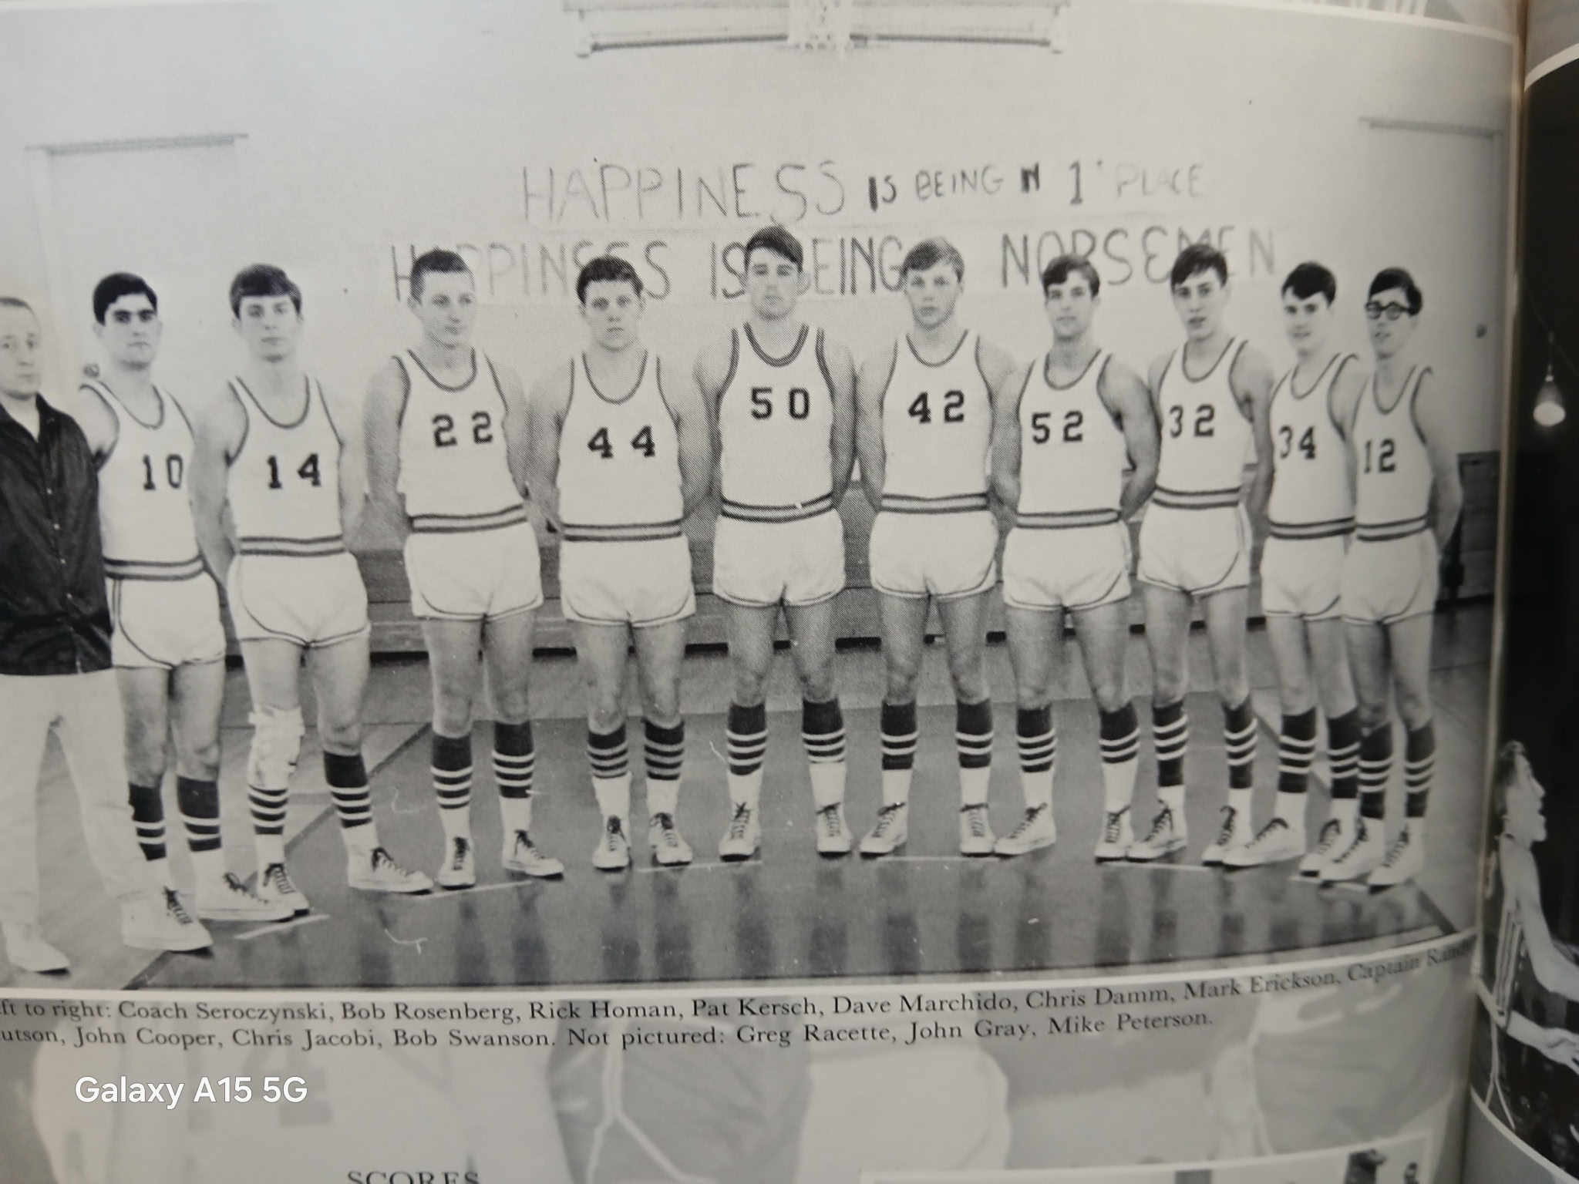

The NORSEMEN of 1966-67

L-R: Coach Tom Seroczynski, Bob Rosenberg, Rick Homan, Pat Kersh, Dave Marchido, Chris Damm, Mark Erickson, Chuck Cousineau, John Cooper, Chris Jacobi, Bob Swanson

N Muskegon 54 WMC (ot) 64 Bob Rosenberg 12, Rick Homan 10
N Muskegon 72 Oakridge 49 Dave Marchido 18, Mark Erickson 16
N Muskegon 60 Reeths Puffer 50 Erickson 16, Rosenberg 11
N Muskegon 61 Manistee 67 Erickson 18
N Muskegon 62 Whitehall (ot) 66 Homan 20, Erickson 13, Dave Marchido 12
N Muskegon 84 Hart 64 Five in double figures led by Marchido’s 20
N Muskegon 59 Montague 52 Marchido 18, Homan 16
N Muskegon 85 Scottville 58 Erickson 22, Rosenberg 14
N Muskegon 50 Shelby 82 Hutson 15, Marchido 10
N Muskegon 80 Oakridge 51 Homan 16, Erickson 15 & 17 rebounds WIN 300
N Muskegon 66 Fruitport 54 Errickson 23, Rosenberg 13, Homan 12
N Muskegon 75 Manistee 63 Marchido 20, Erickson 17
N Muskegon 67 Hart 47 Rosenberg 16, Erickson 14
N Muskegon 51 Shelby 47 Rosenberg 14, Erickson 11, Marchido 9
N Muskegon 58 Montague 55 Swanson 14, Erickson 12, Homan 11
N Muskegon 65 Ravenna 40 Swanson & Erickson 12, Chris Jacobi 8
N Muskegon 74 Scottville 66 Marchido 14, four other starters with 13.
N Muskegon* 65 Kent City 49 Erickson 14 points & 17 boards.
N Muskegon * 47 WMC 66 NM season 14-5 season ends to WMC.

1967-68 Coach Dave Cooke (7-10 Oakridge WMC Champs)

Dave Cooke would begin his first of many years associated with sports at NMHS when he succeeded Tom Seroczynski as the new basketball coach. Coach Cooke, a three-sport star in high school at Muskegon High, and a three-year regular for Western Michigan’s football team, was also a three-sport coach, after serving as first, the Whitehall JV football coach and then the varsity head football mentor, also was the Whitehall varsity track coach and guided the 1965-66 Whitehall JV team to a perfect 17-0 record. However, the cupboard was pretty much empty when Cooke took over at NMHS with only Rick Homan returning from the WMC co-champs from 1966-67. Despite the lack of experience, as well as height, Cooke was able to guide NM to seven victories in his rookie season at NM. 1967-68 would be a season of streaks, both winning and losing. A four-game losing streak would be followed by three straight wins. NM would then drop five in a row before bouncing back to win four. And for the second straight year NM had the misfortune of again playing a loaded WMC in the playoffs.
While the ‘ole announcer’ was making his debut as a broadcaster up north calling the Traverse City – Grand Rapids South basketball game, Coach Cooke was coaching the first of hundreds of NM games for both basketball and football at NMHS. However, the Norse opened the season on the road against a Shelby team anxious to atone for their surprising loss to NM last season that resulted in Shelby having to share the WMC title with NM. Coach Jimmy Darrow’s Tiger tripped up the Norse 63 to 54 as legendary long time area coach Gene Gifford scored 22 points for the winning Tigers. Rick Homan, the lone returning regular from last season’s co-champs led all scorers with 24 points in a losing cause as no other NM player was able to score more than seven points.
It’s not often when you lose all five starters due to foul trouble but that was the case when NM invaded the home of the West Michigan Christian Warriors. To no one’s surprise WMC won the foul plagued contest 62-50 before a full house at the WMC gym. The Warriors broke open a close game at halftime to pull ahead of the Norse in a second half that sent NM players regularly going to the bench due to foul problems. Football quarterback Pete Speier was the big gun for the Norsemen with 16 points while Tom Burmeister came off the bench to tally 11. Rick Homan, playing less than half the game due to foul problems, was held to eight points before eventually fouling out of the game.
NM dropped their third straight game to begin the season to a vastly improved Oakridge team 48-45. Only two Norsemen were in double figures for the game, Pete Speier with 12 and Rick Homan with 11. It was early in the season, but Oakridge would get even better under head coach Bob Goryl and would embark on a long winning streak.
NM was able to shake their offensive doldrums but again were plagued by foul troubles as NM dropped a high scoring 80-79 contest to Manistee. Five players didn’t foul out in this loss as opposed to their game with WMC, but three players did exit with foul problems as NM dropped its fourth game in a row to start the season. Rick Homan led the Norse with 18 with Rod Raymour adding 16 and Pete Speier 14.
North Muskegon’s cagers gave their new head Dave Cooke an early Christmas present just three days before Xmas with a 61-49 win over Montague, the first win for both the Norsemen and their head coach. The game was much tighter than the final score as NM didn’t take the lead for good until Rod Raymour hit a jump shot with about five minutes left in the game. NM then went on a 13-3 run to ice the game over the visiting Wildcats. Rick Homan hit a career high 27 points for the Norse with Rod Raymour netting 13.
NM then made Hart their second victim of the season with a 67-62 road win in Hart. NM gave themselves a nice cushion by taking a 44-31 lead at halftime that proved too much for a possible Hart rally. Sophomore Rod Raymour led the way for the Norse both in scoring and rebounding with 19 points and a massive 23 rebounds. Rick Homan added 15 and Pete Speier 12.
North Muskegon welcomed a newcomer to their schedule as they defeated Pentwater 61 to 57 in the first of more than 30 contests to be contested over the ensuing years. Rick Homan led NM scoring with 20 points with Pete Speier adding 12 and Rod Raymour 10.
NM gave the eventual Seaway league champion Whitehall a battle in a non-league Saturday clash at the Northside gym before losing to the Vikings 70-54. It was dead even between the two long-time rivals at halftime 27-27 before Whitehall opened some distance on the Norse in the second half. Rick Homan had 15 to pace the Norse scorers with Rod Raymour adding 12. Once again foul problems hurt NM chances to pull off the upset as three Norse players fouled out.
The Norse made the long trip to Scottville with high hopes of getting back into the win column prior to facing the Spartans of Mason County Central who were still looking for its first win in WMC action. However, it was Mason County Central who came out on top 78-74 in the see-saw battle with the visiting Norsemen. The Spartans saw a four-point lead at halftime expand slightly to six as they began action in the fourth quarter. NM rallied and even took a brief lead at 62-61. Three times the lead changed hands during the frenetic final period before Mason Co Central iced the contest late. Rick Homan had another big game for the Norse with 22 points with Pete Speier close behind with 18. Chris Jacobi netted 10 points while four other Norsemen who saw action all had six points.
North Muskegon threw a scare into Shelby in their second meeting as a couple of free throws from Chris Jacobi tied the score at 57-all with just 2:21 left to play in the game. Four North Muskegon fouls turned into eight clutch free throws made by Shelby as they made it two in a row over the Norse on the season with a 65-59 victory. Brad Griffin and Gene Gifford combined for 42 points for the winners while Chris Jacobi had his season high point total for the Norse with a team leading 16 markers. Sophomore Rod Raymour had nine points and 23 rebounds as the Norse came just short of pulling off the upset.
A standing room only crowd was on hand at Oakridge to watch the WMC’s most surprising team win their 10th straight game with an easy 61-39 win over NM. Coach Bob Goryl’s Eagles were the whipping boys of the conference a year ago but what a turnaround a year later. With the crowd in a frenzy, the host Eagles jump all over the jittery Norsemen to race off to a commanding early 16-2 lead. “This was our team’s best game all year,” said the proud coach following the easy victory. Only Rod Raymour and George Fisher with 10 points were in double figures for the Norse.
In perhaps the first game played on the Northside court on a Saturday afternoon in NM basketball history, Manistee made NM walk the plank for their fifth straight loss with a 68-61 win. Coach Cooke brought sophomore Jamie Woodruff up from the JV team and the future NM star football quarterback responded well with nine points in the losing cause. Rick Homan meshed 17, Tommy Burmeister 12 and Rod Raymour 10.
The losing streak had come to a merciful end, and the streaking Norse would now go on their own streak, a winning streak. It took a while but after the teams were knotted up at the end of three periods, the Norse scored 28 fourth quarter points while holding the Pirates to only six to turn a tight game into the proverbial ‘laugher’ with the final score NM 77, Hart 55. Rick Homan delivered 20 points to the Norse cause with help from George Fisher with 15 and recent callup Jamie Woodruff tossing in 10.
Call me a little ‘old fashioned’ but they just made them tougher back in the 1960s. Despite blizzard conditions and windchills in Michigan hovering around minus -40, the games went on back in February of 1968. It took three hours for a busload of Muskegon High students to just get from Traverse City to Baldwin after the big Reds game at Traverse City. Fortunately for this author who called that game for the local Traverse City station, I had just a short jaunt back to the comfort of my Traverse City home following the game – with a quick stop at Sleders Tavern. The Norse had the frigid Friday night off but returned to the hardwoods on Saturday to host Fruitport in the cozy warm Northside gym. After burning the nets for 26 points in the fourth quarter against Hart a week earlier, NM outdid themselves against Fruitport by scoring 30 points in the final stanza in an 83-65 win over Fruitport. Four Norsemen were in double digits in scoring: Rick Homan led with 24, followed by Pete Speier with 15, with Rod Raymour and Tommy Burmeister scoring 11 each.
For only the second time in NM’s basketball history NM scored more than 90 points in a game with a 92-78 win over Mason County Central. The highest scoring game by a NM team was 104 points in a 1955 NM win over Whitehall when the game was played at the old NM band-box gym. Rick Homan and Pete Speier each scored 24 points in the high scoring contest, while 16 and 15 points were posted by George Fisher and Tommy Burmeister as NM won their third straight game.
The Norse concluded their regular season by winning their fourth straight and their 15th win in a row over Montague 64-53. NM led after every stop to improve their regular season record to 7 and 9. Rick Homan again led NM in scoring with 23 points with Rod Raymour helping the Norse cause with 14.
NM’s first season on first year coach Dave Cooke came to a quick end as the Norse had the misfortune to draw West Michigan Christian in the first game of the MHSAA playoffs. The Warriors led by as many as 21 points before the never-say-die Norsemen made the final score read WMC 77 NM 63. Rick Homan ended his career with a career high 29 points with Pete Speier the only other Norse in double figures with 10.
The ’ole announcer’, who spent 10 years in Traverse City before returning to my hometown in 1976, journeyed three times to the Port City for the Class A districts, two to broadcast a pair of games and the other taking the 150-mile trek to watch Muskegon defeat Muskegon Heights in a game played between two teams both ranked in the top ten in the final Class A rankings. The game for the district championship between Traverse City and Muskegon (a double overtime win for TC) to this day was the most exciting high school game I had the pleasure of broadcasting over the more than 40 years of calling games on the airwaves. What was also special was my broadcast partner that night was Gene Young, my sidekick for many years.

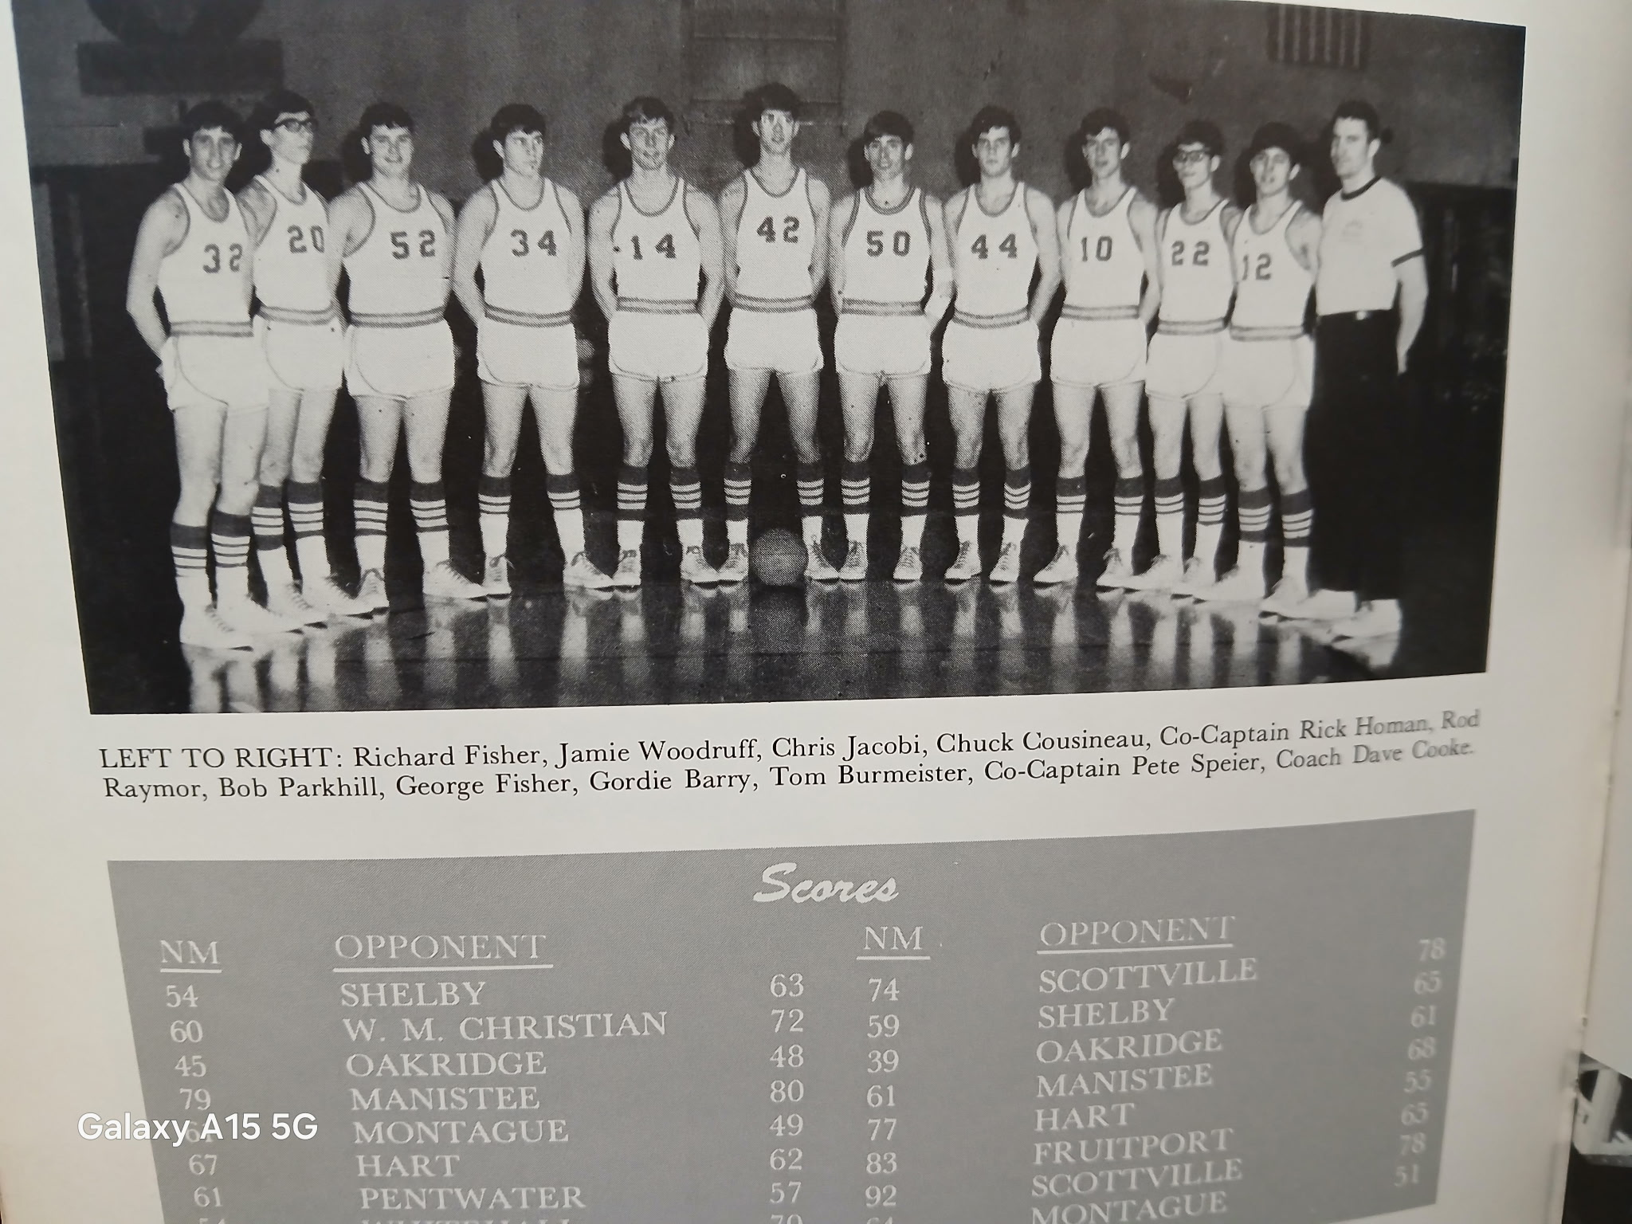

The 1967-68 NORSEMEN

N Muskegon 54 Shelby 63 Rick Homan 24
N Muskegon 60 WMC 72 Pete Speier 16, Tom Burmeister 11
N Muskegon 45 Oakridge 48 Speier 12, Homan 11
N Muskegon 79 Manistee 80 Homan 18, Rod Raymour 16, Speier 14
N Muskegon 61 Montague 49 Homan 27, Raymour 13
N Muskegon 67 Hart 62 Raymour 19 and 23 rebounds, Homan 15
N Muskegon 61 Pentwater 57 Homan 20, Speier 12, Raymour 10
N Muskegon 54 Whitehall 70 Homan 15, Raymour 12
N Muskegon 74 Mason Co 78 Homan 22, Speier 18, Chris Jacobi 10
N Muskegon 59 Shelby 65 Jacobi 16, Speier 14, Raymour 23 rebounds
N Muskegon 39 Oakridge 61 George Fisher & Raymour 10
N Muskegon 61 Manistee 68 Homan 17, Burmeister 12, Raymour 10
N Muskegon 77 Hart 55 Homan 20, Fisher 15, Jamie Woodruff 10
N Muskegon 83 Fruitport 65 Homan 24, Speier 15, Burmeister & Ramour 11
N Muskegon 92 Mason Co 78 Homan & Speier 24, Fisher 16, Burmeister 15
N Muskegon 64 Montague 53 Homan 23, Raymour 14
N Muskegon* 63 WMC 77 Homan career high 29, Speier 10

1968-69 Coach Dave Cooke (5-13 Shelby WMC Champs)

Dave Cooke would enter his second year as the NM coach and would return three players who saw considerable action from the previous season, 6’3 Rod Ramour, and a pair of six footers in George Fisher and Jamie Woodruff. Also returning from last year’s rotation was Tommy Burmeister. Departed via graduation was high scoring Rick Homan who averaged 20 points per game and was NM’s leading scorer in 12 of their 17 games. Pete Speier, the team’s second highest scorer left to become a future starting quarterback at Northern Michigan University. Playing once again a daunting schedule, the Norse would only win five games during the season but were competitive in nearly all their contests. Surprisingly, two of their wins game in their first three games against a pair of perennial powers of this era.
The Norsemen opened at home with Shelby and would also face in their first three games defending WMC champion Oakridge and a West Michigan Christian team that could boast of three state championship teams over the last decade. The Norse got off on the right foot with a surprising 63-53 victory over a Shelby team that was highly regarded and featured a high scoring center in 6’8 Art Huston. Tommy Burmeister scored 11 points in the pivotal second quarter as NM shocked the visitors by scoring 27 points in the quarter while limiting the Tigers to only 13 as the Norse enjoyed a 40-28 lead at halftime. Shelby did cut the NM lead to three points in the fourth quarter before NM iced the game late. Burmeister scored a career high 18 points to lead the Norse while George Fisher and Jamie Woodruff each had 12.
Interest in basketball was sky high at Oakridge following their WMC title the previous season at a jam-packed Oakridge gymnasium as the Eagles defeated NM 74-65. It was a scoring dual between the Eagles Kelly Johnson, who set an Oakridge single game scoring record with 31 points, and NM’s Rod Raymour. The 6’3 NM center scored 24 points but that wasn’t enough to overtake the Eagles. George Fisher had 14 and Tommy Burmiester 10 as the Norse evened their record at 1-1.
It's hard to believe when one look’s back to review NM’s overall 5-13 record from 1968-69 that one those five wins was at the expense of West Michigan Christian. The Norse had won but one game in the previous 12 meetings, but the Norsemen did indeed pull a surprise and upset the always strong Warriors 59-56. The Warriors were just coming off a 20-point win over Hudsonville Unity Christian and were positioned to add another win over NM into the victory column. It appeared WMC was indeed destined for another victory over NM when they had a 48-41 lead over the Norse. However, entering back into the game for NM were Jamie Woodruff and Rod Raymour, who had been sitting on the pines for some time with four personal fouls. A George Fisher free throw tied the game at-56-56 with 1:03 remaining. Raymour’s jumper then tallied the deciding points with about a half minute remaining, and Bob Steele’s free throw with three seconds remaining was the clincher for the Norse. Raymour, despite sitting several minutes with foul trouble, finished with 21 point and Woodruff added 14 more for the Norsemen. Unfortunately for Norse followers, they would not capitalize on the momentum and went into a tailspin.
Manistee let NM know early that it was going to be a long bus ride back to the Port City. Manistee led 42-23 early into the second half as NM was totally outgunned by the hosts. Rod Raymour with 12 points was the only NM player in double figures.
After losing five straight to the Norse, and opening the current season with five losses, the Hart Pirates broke both streaks with a 56-42 victory over NM. The poor shooting Norsemen only connected on one fourth of their field goal attempts with Rod Raymour once again the only Norsemen in double digits in scoring with 14 points.
An even longer streak was broken by Montague in the next game for NM early in January of 1969. Montague snapped a 15 games winless streak against NM by the narrowest of margins with a 74-73 victory on their home court. Sophomore Dave Erickson had a season best 17 points for the Norse, while Bob Steele had 16, Rod Raymour 14 and Jamie Woodruff 11 as NM fell to 2-4.
The Norse failed to take advantage of Whitehall having three starters not suited up for disciplinary reasons as the Vikings still had enough firepower to nip the Norse 72-67 in a non-league contest between the two long-time rivals. Rod Raymour topped Norse scorers with 21 points, but the Norse were unable to contain the Viking’s Tim Hatcher who ripped the nets for 31 points.
Trailing at halftime the Norse went on a 16-4 run in the third period and went on to win their first game in five weeks with a 67-64 victory over Mason County Central. Rod Raymour again led NM in scoring with 18 tallies with Jamie Woodruff and Bob Steele chipping in with 15 and 11. NM would have to savor this game for a while as they would again go on a long skid.
The Norse then traveled to take on the league leaders in the WMC, the Shelby Tigers who were sitting on top of the standings with a 6-1 league record, with their only loss coming to the Norsemen in game one. Rod Raymour had 18 for the Norse with George Fisher adding 13 as NM fell to 3-6 overall and 2-5 in the WMC in the 60-50 loss to the Tigers. Judging by the score of the JV game won by the Tigers convincingly 60-37, it appeared that Shelby would be well stocked in the future with a JV team that featured a promising looking freshman by the name of Paul Griffin, a future NBA star.
NM jumped out to a quick 10-0 lead to begin the contest but couldn’t hold on as Oakridge kept their second place standing in the WMC with a 77-72 overtime victory over the upset minded Norsemen. An old bad habit that had plagued the Norse in recent years reared its ugly head again – foul trouble. After the game was tied at 67-67 after regulation, Oakridge scored all 11 of their points in the three-minute extra session on free throws.
Fruitport then handed NM their third straight loss 76-63 in a Saturday night game played on the Fruitport home court. Jamie Woodruff had a season high 21 in a losing cause for NM, closely followed by Rod Raymour with 17.
It looked like the Norse were on track to snap their losing streak that had reached three as they held a 20-point lead over Hart at 29-9 early in the second quarter. Hart, however mounted a furious rally to trail by on only seven at the half 38-31. The Pirates went on a 14-0 run in the second half to doom the Norse and would eventually win 75-68. NM had four players in double figures: Rod Raymour (18), George Fisher (17), and Jamie Woodruff and Dave Erickson with 10.
For the fourth game in a row, and their second in as many nights, the Norse failed to hold on to a halftime lead as they fell to Ravenna 62-49. A career high 27 points by George Fisher went for naught as NM dropped to 3-10 on the season. One key to the Bulldog win was their tight defense that held NM’s leading scorer Rod Raymour to a season low of five points.
Sophomore Dave Erickson led NM to their first victory in nearly in nearly a month in a 58-50 over Montague on the Norse home court. Erickson pumped in 29 points on 14 field goals and a free throw to snap a five-game losing streak. Erickson also snatched 10 rebounds in one of the finest performances in NM’s long history by a sophomore.
NM acquired their fifth (and final) victory on the season and their lone road win with an 87-58 beating of Class D Pentwater. NM grabbed an early 40-21 lead at halftime and did not suffer their usual letdown in the second half. George Fisher led NM with 20 points with Rod Raymour close behind with 17. A harbinger of perhaps things to come in the following year was the NM Junior Varsity scoring 100 points in the preliminary. Could the varsity also top the century mark a year later?
A total of 45 fouls were called resulting in Manistee connecting on 27 of 33 free throws as NM fell 83-80 to Manistee. No one could call the two officials ‘homers’ as both referees, Harry Voss and Ralph Weiss, were one-time teachers at NMHS. NM also took many trips to the charity line and scored 20 of their 80 points on charity tosses. The three-point loss was a big improvement from their earlier meeting when NM lost to their northern visitors by 33 points back in December. The two teams would have to wait more than 40 years before they would meet once again on the hardwoods.
North Muskegon’s regular season ended as Mason County Central made amends for an earlier loss to NM and dropped the Norse into a tie in the cellar of the WMC with the Spartans. The 73-63 loss left the Norse with a regular season record of 5-12. Once again, the Norse penchant for fouling their opponents aided in their defeat as Scottville was able to attempt a whopping 42 gift shots, making 27 while the Norse were limited to 14 free throws. Rod Raymour finished with 20 points for NM with Bob Steele adding 16 and Tommy Burmiester 14.
To say that NM had a poor shooting performance in their district opener would be an understatement. NM cashed in on only 16 per cent of their field goal tries as their season ended with a 53-42 loss to Montague. NM’s poor shooting only went from bad to worse in the final quarter as they failed to connect on a single shot as their season ended with a 5-13 record. Rod Raymour ended his junior season with 15 points while Tom Burmiester cashed in 11.

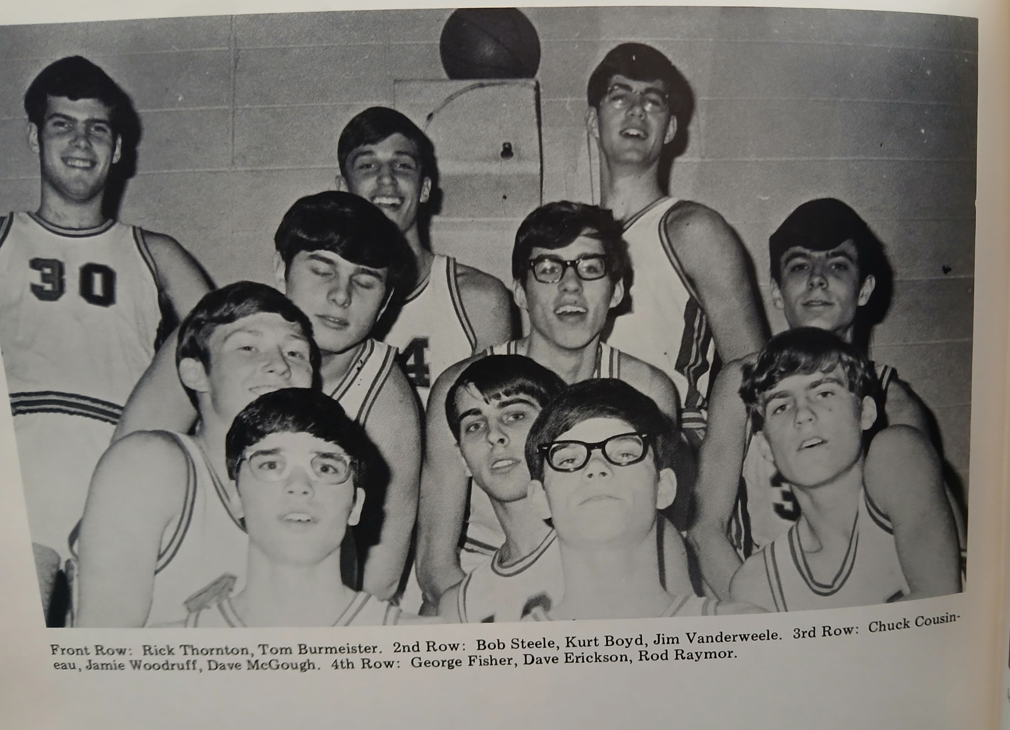

The 1968-69 NORSEMEN

N Muskegon 63 Shelby 53 Tom Burmeister 18, G. Fisher & Woodruff 12
N Muskegon 65 Oakridge 74 Rod Raymour 24, George Fisher 14.
N Muskegon 59 WMC 56 Raymour 21, Jamie Woodruff 14
N Muskegon 43 Manistee 76 Raymour 12, Chuck Cousineau 8
N Muskegon 42 Hart 56 Raymour 14
N Muskegon 73 Montague 74 Dave Erickson 17, Bob Steele 16, Raymour 14
N Muskegon 67 Whitehall 72 Raymour 23, Woodruff 14, Erickson 12
N Muskegon 67 Mason Co 64 Raymour 18, Woodruff 15, Steele 11
N Muskegon 50 Shelby 60 Raymour 18, Fisher 13
N Muskegon 72 Oakridge(ot) 77 Raymour 16, Fisher 14, Woodruff 13
N Muskegon 63 Fruitport 76 Woodruff 21, Raymour 17
N Muskegon 68 Hart 75 Raymour 18, Fisher 17
N Muskegon 49 Ravenna 62 Fisher 27
N Muskegon 58 Montague 50 Erickson 29, Woodruff 9
N Muskegon 87 Pentwater 58 Fisher 20, Raymour 17
N Muskegon 80 Manistee 83 Erickson 18 & Steele 18, Woodruff 13
N Muskegon 62 Mason Co 73 Raymour 20, Steele 16, Tom Burmeister 14
N Muskegon*42 Montague 53 Raymour 15, Burmeister 11

1969-70 Coach Dave Cooke (10-9 Shelby WMC Champs)

The 1969-70 school year would welcome Ravenna into the West Michigan Conference and the WMC would remain with the same eight teams for more than 50 years before six more teams would be added to the venerable conference in 2022.
The Norsemen would post a winning 10-9 record for coach Dave Cooke who was beginning his fourth season as the basketball coach. NM would return a solid front line that included third year starter Rod Raymour along with Dave Erickson and Jamie Woodruff. A junior and a sophomore appear to be the leading prospects to start in the backcourt. Steve Mooney appears locked in as one of the starters in the backcourt while sophomore Rick Jones would earn one of the guard sports. With Jones and Woodruff on the court at the same time NM could boast of having two of NM’s all-time best quarterbacks from their football team attempting to win a basketball game.
The Norse got off to a great start as they defeated a Montague team that was regarded as one of the front runners in the WMC 65-54. The backcourt of Steve Mooney and Rick Jones were instrumental in the NM victory with 16 and 10 points respectively. It was a pair of veteran returnees who led NM in scoring with Rod Raymour scoring 18 and Woodruff 17 in a very balanced NM offensive attack.
NM made the journey to Scottville to play a Mason County team that had generally been a tough team to beat on their home court. However, not the case this season as NM was in command all the way in a 71-60 win over the host Spartans. Rod Raymour was the top NM gunner with 23 points with Dave Erickson chipping in with 16 points. The backcourt combo of Steve Mooney (13) and Rick Jones (12) had another good night for NM while Jamie Woodruff added 9 markers before fouling out late in the game.
NM nearly made it three in a row to begin the season as they gave the always tough West Michigan Christian Warriors a battle before losing 90-80. With just five minutes left in the game it was anybody’s game to win as the score was knotted up at 74-74 before the host Warriors outscored NM by 10 points in the game’s final minutes. NM’s starting five scored 79 of their 80 points. Jamie Woodruff had 21, Rod Raymour 18, Rick Jones 17, Steve Mooney 14 and Dave Erickson added nine. The only other Norse point came on a free throw from future NM football great Jeff Chrystal.
After giving up 90 points in their previous game to WMC, the Norse tightened up their defense and limited Oakridge to 27 points, 63 fewer then allowed against Christian as NM won 45-27. The low scoring affair could also be attributed to a very patient Oakridge team who took only 16 shots through the first three quarters. Rod Raymour with 14 and Dave Erickson with 13 led NM as once again the starting five scored all the points for NM as the Norse stayed perfect in the WMC at 3-0.
NM moved to 4-1 on the season and in the process snapped an 11-game losing streak to Whitehall with a 79-61 victory. NM gained a 57-24 edge over the visiting Vikings on the boards. Once again NM had a very balanced scoring attack with Raymour collecting 24 markers, followed by Woodruff (21), Jones (13) and Mooney (12). The 4-1 start for the Norse was their best start to open the season in six years.
The Norse team bus traveled through 11 inches of snow to Ravenna as all games in the area went on as scheduled. Eleven inches of snow in today’s wimpy day and age would probably have caused a postponement, and that would have been a good thing for the Norse as they lost to Ravenna 52-38. The Norse were as cold as the January weather outside the Bulldog gymnasium as they shot 0-11 in the third period. Dave Erickson was the only Norsemen in double figures with 13 points as NM dropped their first game in the WMC to a Ravenna team playing in its first season in the West Michigan Conference.
NM scored 24 third quarters points, 24 more than they made in the same quarter in their previous game with Ravenna to improve their record to 5-2 on the season with a 79-61 win over Hart on the Northside court. Rod Raymour had another big scoring night for NM with 23 points with Dave Erickson adding 18. Jamie Woodruff, in addition to his 14 points, led all rebounders with 14.
NM then were trounced by a young Shelby team that was beginning a three-year run that would prove to be the best run by a team in WMC history. The Tigers unveiled the Griffin combo – sophomore Paul and his cousin, junior Kim Griffin and the pair would combine to score 41 points in the Tigers 74-50 win over the Norse. Jamie Woodruff, the all-state quarterback on NM’s football team, led NM with 22 points.
The Norse moved into second place, two games behind Shelby following a 61-56 win over Montague to complete a season sweep over the host Wildcats. Rod Raymour led NM once again in scoring with 21 points with Jamie Woodruff adding 10. Coach Cooke strengthened his team with the callup from the Junior Varsity of sophomore Mike Schalk who came off the bench to score seven points in his varsity debut.
In a non-league contest the next night Orchard View stunned the Norse 76-66. OV coach Gale Noel, whose wife was my speech teacher at NMHS, saw his Cardinals win their third straight game and fourth win in a row in the brief series between the two teams. Raymour and Woodruff each scored 17 for NM with Mooney (13) and Erickson (12) all in double figures in the Norse loss.
NM had to go into overtime to hang onto second place in the WMC as Jamie Woodruff scored a career high 28 points for the Norsemen. NM earned 24 of their points from the free throw line with Raymour notching nine of his 17 points from the charity stripe. Also scoring well for NM were Rick Jones with 17 and Dave Erickson with 14.
NM went into overtime in their second straight outing, but the results were not as good as they were nipped in the extra session by Oakridge 69-68. The game was a total contrast from the first game played between the two when the Eagles scored but 27 points in their loss to NM. John Scraver of the Eagles hit the basket to send Oakridge into overtime and then hit the winner in the extra session to give Oakridge the victory. Jamie Woodruff scored 18 points before fouling out in the fourth quarter, one point behind team leader Rod Raymour’s 19 tallies.
6’9 Ravenna center Dan Lawrence was too much for the Norse to handle as he scored 35 points to lead Ravenna to their second win on the season over the Norse 66-57. Dave Erickson led the Norse with 19 points with Rod Raymour adding 13 and Jamie Woodruff 10 for the Norse. The two teams would meet later in the opening round of the playoffs. Would the Bulldogs make it three in a row over NM?
In a game for the ages, NM shattered the single game scoring record by scoring 118 points in a 118-78 victory over outmanned Pentwater. NM scored 33 in the first quarter and 31 in the second stanza to take a 63-32 halftime lead over the Falcons. NM dominated in the rebounding department with 79 boards to but 17 for the much smaller Falcons. Eleven players scored for NM with six players reaching double figures for the Norse. Those in double digits included Rod Raymour (26), Jamie Woodruff (21), Steve Mooney (14), Rick Jones (12), Dave Erickson (11) and sophomore Mike Schalk (10). It was the second game NM would tally over 100 points and remains more than 50 years later still a single game scoring record.
Hart then stunned the Norse with an 83-77 win over NM to split the season series between the two rivals. The loss dropped the Norse into a second-place tie with Ravenna in the WMC. So evenly matched were WMC teams behind league leader Shelby that a 6-5 record was good for second place. Rick Jones tossed in 18 points to lead the Norse with Woodruff meshing 16 and Erickson 15. NM chances for victory were hampered when Rod Raymour left in the second half with an ankle injury.
While the Norsemen was losing to the Hart on February 20, 1970, the ‘ole announcer’ was still in Traverse City calling the play-by-play for Traverse City’s game with Muskegon. It was a night that Muskegon’s Larry Tatum will long remember as he set a still standing Muskegon scoring record with 50 points. The officials for the JV game never got the message that they were to work the JV game and never showed. I was then asked to fill in as the sole referee so the JV teams could at least play a game. After working up a sweat from this game I then had to bring my now smelly body up to the broadcast booth to call Tatum’s 50-point record. Muskegon was credited with a 2-0 JV forfeit victory.
Scoring points was seldom a big problem for the Norse as they went over the 90-point mark in a 91-76 victory over Fruitport. Jamie Woodruff became the fifth NM player in school history to score 30 or more points in a single game. Dave Erickson was a field goal shy of also scoring 30 as he finished with 28 points. Also scoring in double figures were sophomores Rick Jones (16) and Mike Schalk with 10 as Rod Raymour sat out the contest nursing an ankle injury.
Although they didn’t win, the Norsemen gave a good account of themselves in their 84-72 loss to WMC league champs Shelby. The Norse welcomed back Rod Raymour to their lineup, but NM had no answer for 6’5 junior Kim Griffin who scored 35 points. Raymour scored 16 points in his return to the lineup while Jamie Woodruff had his second consecutive high scoring game with 26 points and 16 rebounds.
There’s the often-used term that it’s tough to defeat a team three times in a season. Whether that is true or not it was applicable this season when NM stopped a Ravenna three-peat with a 65-58 victory over the Bulldogs in the playoff opener. NM took advantage of Ravenna’s 6’9 center Jim Lawrence getting into foul trouble and having to sit for major minutes of the second half. NM, with Lawrence sitting, led 46-42 heading into the final period. Jamie Woodruff was a steady performer for NM with 15 points and 14 rebounds. Rick Jones led Norse scorers with 16 and Rod Raymour 12 as NM earned a date in the district finals in Whitehall with West Michigan Christian.
The Warriors had a tough draw in the Class C district and were forced to play three games to advance to the district finals. WMC defeated the WMC champs Shelby in begin the playoffs and were heavy favorites to defeat NM. The Norse gave the Warriors a real scare and once enjoyed a 45-34 lead over the Warriors. WMC then showed their poise and bounced back to overtake NM and took the lead for good at the end of the third period at 53-51. Rod Raymour had a great game in his final appearance in a Norsemen uniform with 22 points. Rick Jones added 14 for NM while Jamie Woodruff was held to four points.
The Norse season came to an end with a winning record and a season that was most entertaining for Norse followers. NM would have a team comprised of several three-sport participant’s that would be back for the 1970 football season, a team that could arguably stake their claim as one of the best in NM history.

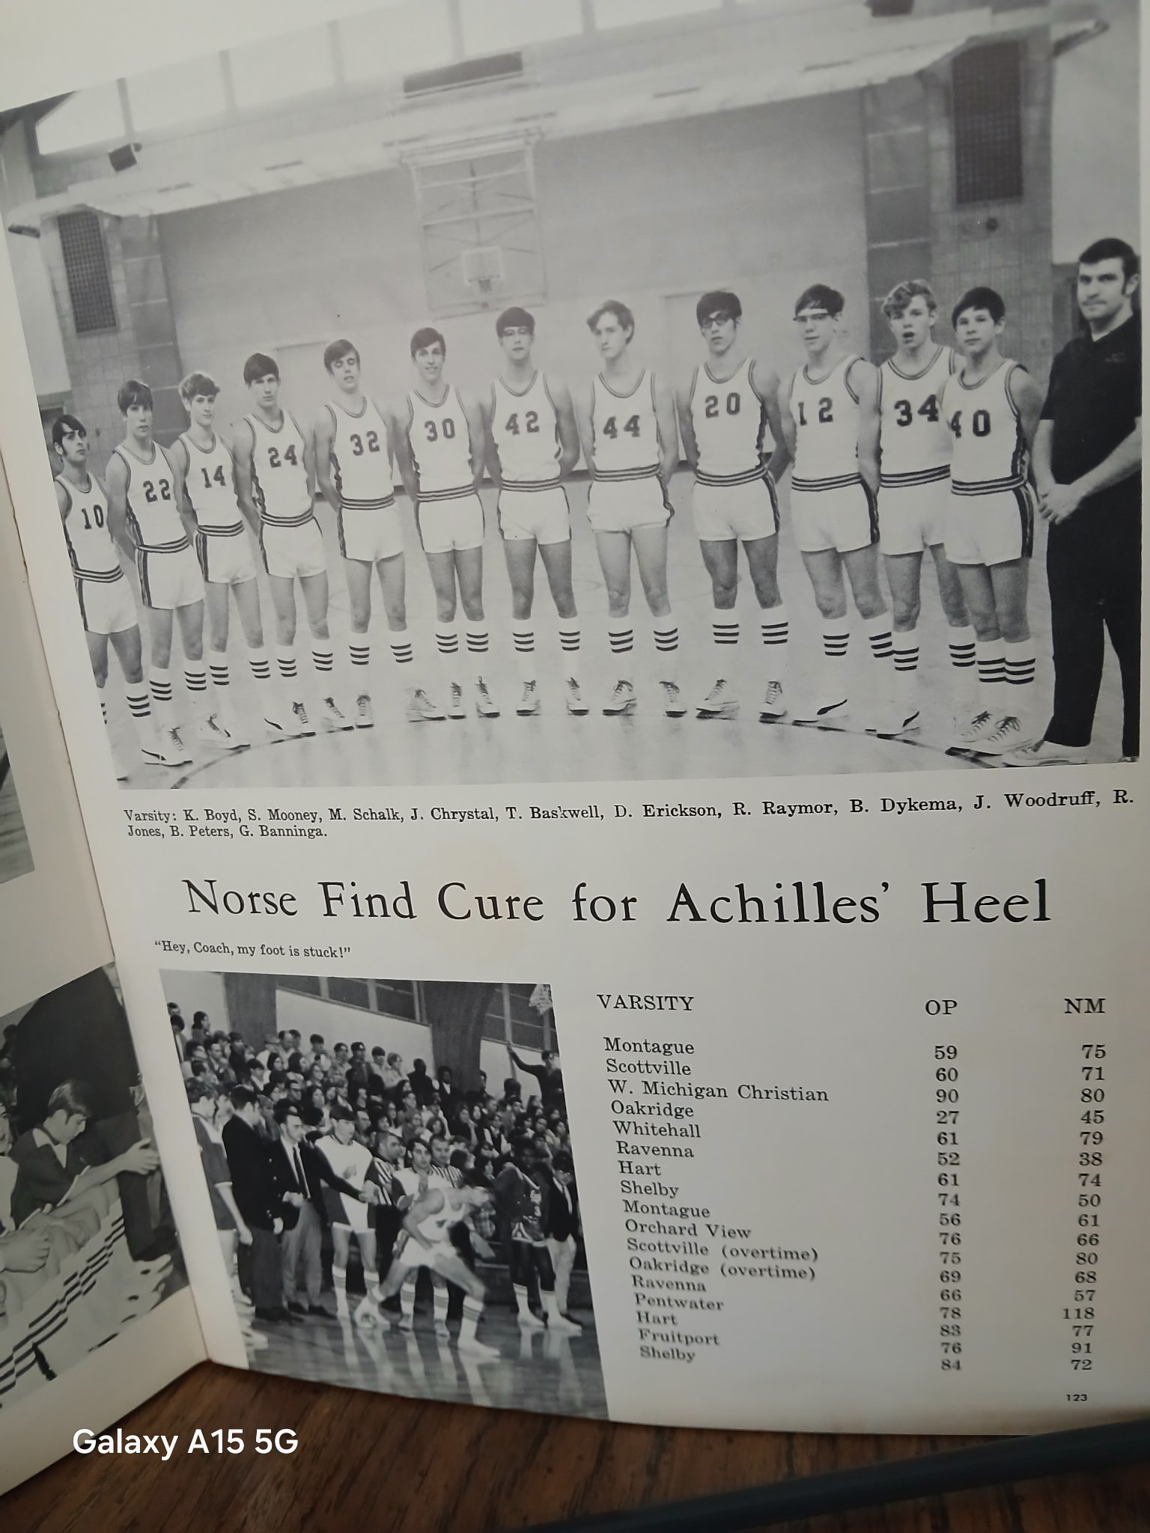

1969-70 NORSEMEN BASKETBALL

L-R: Kurt Boyd, Steve Mooney, Mike Schalk, Jeff Chrystal, T. Baskwell, Dave Erickson,
Rod Raymour, D. Dykema, Jamie Woodruff, Rick Jones, B. Peters, G. Banninga, Coach Dave Cooke

N Muskegon 65 Montague 54 Rod Raymour 18, Jamie Woodruff 17
N Muskegon 71 Mason Co 60 Raymour 23, Dave Erickson 16, S. Mooney 13
N Muskegon 80 WMC 90 Woodruff 21, Raymour 18, Rick Jones 17
N Muskegon 45 Oakridge 27 Raymour 14, Erickson 13, Woodruff 9
N Muskegon 79 Whitehall 61 Raymour 24, Woodruff 21, Jones 13
N Muskegon 38 Ravenna 52 Erickson 13
N Muskegon 74 Hart 61 Raymour 23, Erickson 18, Woodruff 14.
N Muskegon 50 Shelby 74 Woodruff 22
N Muskegon 61 Montague 56 Raymour 21, Woodruff 10, Mike Schalk 7
N Muskegon 66 Orchard View 76 Raymour & Woodruff 17, Mooney 13
N Muskegon 80 Mason Co (ot) 75 Woodruff 28, Raymour, 17, Jones 17
N Muskegon 68 Oakridge (ot) 69 Raymour 19, Woodruff 18, Jones 14
N Muskegon 57 Ravenna 66 Erickson 19,
N Muskegon 118 Pentwater 78 Six Norse in double figures: Raymour 26
N Muskegon 77 Hart 83 Woodruff 16, Erickson 15
N Muskegon 91 Fruitport 76 Woodruff 30, Erickson 28, Jones 16
N Muskegon 72 Shelby 84 Woodruff 26, Raymour 16, Schalk 14
N Muskegon*65 Ravenna 58 Jones 16, Raymour12
N Muskegon*62 WMC 70 Raymour 22, Jones 14

1970-71 Coach Dave Cooke (9-9, Shelby WMC Champs & State champs)

NM would begin the season with five lettermen returning from their winning season from the previous year but the loss of All-conference performers like Rod Raymour and Jamie Woodruff would create big holes for the upcoming season. Many of the NM players would be coming off from performing on one of the top football teams in NM annals where they posted a perfect 8-0 record and were never threatened in any game. Rick Jones is back as a returning starter along with Mike Schalk, a callup from the Junior Varsity team who moved into the rotation midway through the 1969-70 campaign. Jeff Chrystal, arguably the best wide receiver in NM’s football history also earned his letter from last season’s basketball team. All three of the above-mentioned players were juniors.
Although still rusty from their incredible football season the Norsemen had enough firepower to open their season with a 74-69 win against Montague. All five starters for NM were members of the undefeated football team with three-year starter Dave Erickson leading the way with 20 points. All-Conference quarterback Rick Jones followed with 17 while Mike Schalk added 15 and all-conference linebacker in football Jim Dagen had 10 in his first year on the NM varsity.
A cold shooting first quarter put the Norsemen into an early hole, and they couldn’t recover as Mason County tripped up the host Norse 81-73. Four Norsemen were in double figures in the loss with Dave Erickson and Steve Mooney each with 15 points followed by Rick Jones with 14 and Jim Dagen with 10.
For only the third time in 16 meetings were the Norse able to defeat a West Michigan Christian team. With former Warrior Eddie Heethuis taking over the coaching duties from Elmer Walcott, WMC had no answer for the NM trio of Rick Jones, Mike Schalk and Dave Erickson as the threesome scored 61 of NM’s 73 points. The Norse led at the end of every stop in a rare win over WMC. Taking some time off from coaching, Walcott in February was a hero when he noticed his next-door neighbor in February of 1971 had not been seen for a couple of days. Walcott broke into his neighbor’s home and found his 75-year-old neighbor on the basement floor suffering from a broken hip, saving the lady’s life.
The Hart Pirates turned a close game at halftime (31-29) into a runaway as the host Pirates scored 32 points in the third period in a 76-60 win over NMHS. Rick Jones led the losing Norsemen with 21 points while his favorite receiver in football Jeff Chrystal added 12 as the Norse evened their record at 2-2 but only 1-2 in conference play.
For the second season in a row, NM would surpass the century mark in points scored with a 101-54 rout of Kent City. The Norse might not have reached the 100-point mark if not for a ‘Jack Cooper’ moment by a Kent City player to begin the game. Much like Cooper did for NM in a game with Hart in 1953, a confused Kent City player scored a basket in the wrong bucket, giving NM an early 2-0 lead. From there NM would score 99 points from their own shooters in only the third game ever played between NM and Kent City, with the first meeting going back to 1935. Dave Erickson led the 11 Norse players who scored in the game with 22 points, followed by Jeff Chrystal with 18.
They didn’t score 100 points, but the Norsemen came close as their athletic team poured in 93 points, including 32 in the final period to hand Ravenna a 93-62 beating. Dave Erickson, Mike Schalk and Rick Jones combined to score 67 of NM’s 93 points as all eleven NM players suited up for the game in Ravenna scored.
The run and gun Norsemen scored 90 or more points for the third consecutive game as they poured in 91 points in a 91-62 win over Oakridge. It didn’t appear the long three-week layoff between games for the holidays affected the Norse shooters. The Norse put this game away by halftime with a commanding 50-21 lead as coach Dave Cooke used mainly subs in the second half. Mike Schalk led NM with 20 points as 10 Norsemen scored in the contest. Dave Erickson had 18 points in the NM balanced attack with Jim Dagen adding 15 and Jeff Chrystal 13 more as NM improved to 3-2 in the conference with a big contest with Shelby next on the schedule.
Shelby showed NM and the rest of the area basketball fans that this Tiger team was indeed special as they dominated the Norsemen 87-50. Kim Griffin and his cousin Paul combined to score 46 points to nearly match the entire NM team total as Shelby moved to 7-0. Only Dave Erickson with 17 and Rick Jones with 10 were able to score in double figures for the Norse. The Tigers would be the only team to hold NM under 60 points in the entire season, and the Tigers did it twice.
NM regained their shooting eye once again at the expense of Montague as NM once again surpassed 90 points in a 92-83 shootout with Montague. NM moved to 6-3 on the season and 4-3 in the WMC. Once again NM relied on several scorers in the shootout highlighted by Dave Erickson’s 30 points, the sixth Norseman to score 30 or more in a single game. NM unleashed 81 shots during the contest with 32 finding the range. Rick Jones added 21, Jim Dagen 18 and Mike Schalk 12.
NM scored 29 fewer points in their 1971 win over Pentwater as opposed to their record-breaking scoring barrage with the Falcons last season. Still, NM was able to post 89 on the scoreboard in an 89-73 win over Pentwater. In the back-to-back Friday-Saturday games with Montague and Pentwater NM scored 181 points.
NM then outdid themselves in their next game against a winless Orchard View team as NM came one point shy of the century mark with a 99-61 thumping of the Cardinals. Steve Mooney had his highest scoring output of the season with 25 points as five Norsemen reached double figures. Rick Jones (20), Mike Schalk (14), Jeff Chrystal (13, and Dave Erickson (11). Just when it seemed NM was playing its best basketball, the final one-third of the season would see NM’s fortunes going in the wrong direction.
For the first time in nearly 40 years an NM basketball game was postponed due to weather conditions as the NM away game with Mason County Central was postposed to February 9th due to blizzard conditions. However, most of the other games in the Muskegon area went on as scheduled. It was de ja vu just one week later as a Friday scheduled game with Hart was postponed for one day. Once again, the Norse were able to score at will, but so did their rivals from Hart who outscored the Norse 88-84. The Saturday night game at the Northside court saw NM’s Dave Erickson tally 24 points, followed by Mike Schalk with 18, Steve Mooney had 17 and Rick Jones netted 10 as NM dropped their second game of the season to the Pirates.
Once again 90 points were scored in a NM game but unfortunately for Norse followers, it was Mason County Central who had the high scoring honors with a 93-70 win over the Norse. NM was doomed at halftime as the host Spartans had a commanding 47-31 advantage as the Norse sputtered in the Tuesday make-up game played in Scottville. Mike Schalk led the Norse with 15, while Rick Jones had 13 and Tom Kesteloot a season high 12.
After beating Ravenna by nearly 30 points in December, the Bulldogs gave NM a real scare in the rematch as NM survived 63-61. A baseline jumper by Rick Jones broke a 61-61 deadlock late in the game to insure NM of their ninth win of the season. There was still nearly a minute to play after the Jones two-pointer, but Ravenna turned the ball over on a traveling call, NM missed two free throws, and Ravenna missed a possible tying basket at the end as coach Dave Cooke breathed a sigh of relief. Dave Erickson had 19, Rick Jones 17 and Mike Schalk 11 to lead the Norsemen.
NM then played back-to-back games on Friday and Saturday and lost on both nights, first to Whitehall and then it was Oakridge who handed the Norse a defeat 24 hours later. To lose at Whitehall was no surprise as the Vikings gym was always a tough place to come away with a win. Whitehall led all the way as the hosts connected on nearly fifty per cent of their shots. So balanced was the NM scoring that Dave Erickson, Jeff Chrystal and Rick Jones all scored 16 points, while Jim Dagen, Mike Schalk, and Steve Mooney all had eight.
After earlier losing to the Norse in front of their home fans, the Eagles found the Norsemen gym much better to their liking as they rebounded from an earlier 29-point defeat to stun the Norsemen 86-81. Dave Erickson had scoring honors for the Norse with 21 points while Mike Schalk collected 17.
A powerful Shelby team rolled to its first unbeaten season in school history as the Tigers methodically destroyed the Norse 89-56 to end the regular season at 17-0. It would only get better for the Tigers, and they would romp to the Class C state championship. So special was this Tiger team that they would be inducted into the Muskegon Area Sports Hall of Fame. Dave Erickson was the only Norsemen in double figures with 23 points. The 1970-71 state champs from Shelby defeated all their foes by an average of 30 points per game.
History didn’t repeat itself after NM had lost twice to Ravenna during the regular season last year before winning in a playoff game. There was no third game jinx for Hart as they rolled to their third straight win over the Norse 84-65 to end the Norsemen’s season at 9-9. Dave Erickson ended his splendid career for the Norse with 24 points and 15 rebounds as NM ended their season by dropping their final four games.
For those who like high scoring games then the 1970-71 would be your team.
Employing a helter-skelter offense and a full court pressing defense, this Dave Cooke coached team can boast that they were the highest scoring team in more than 90 years of NM basketball. The Norse averaged 77 points per game. However, that mark should be tempered by knowing that they gave up more than 75 points per game, also the most scored against an NM team.

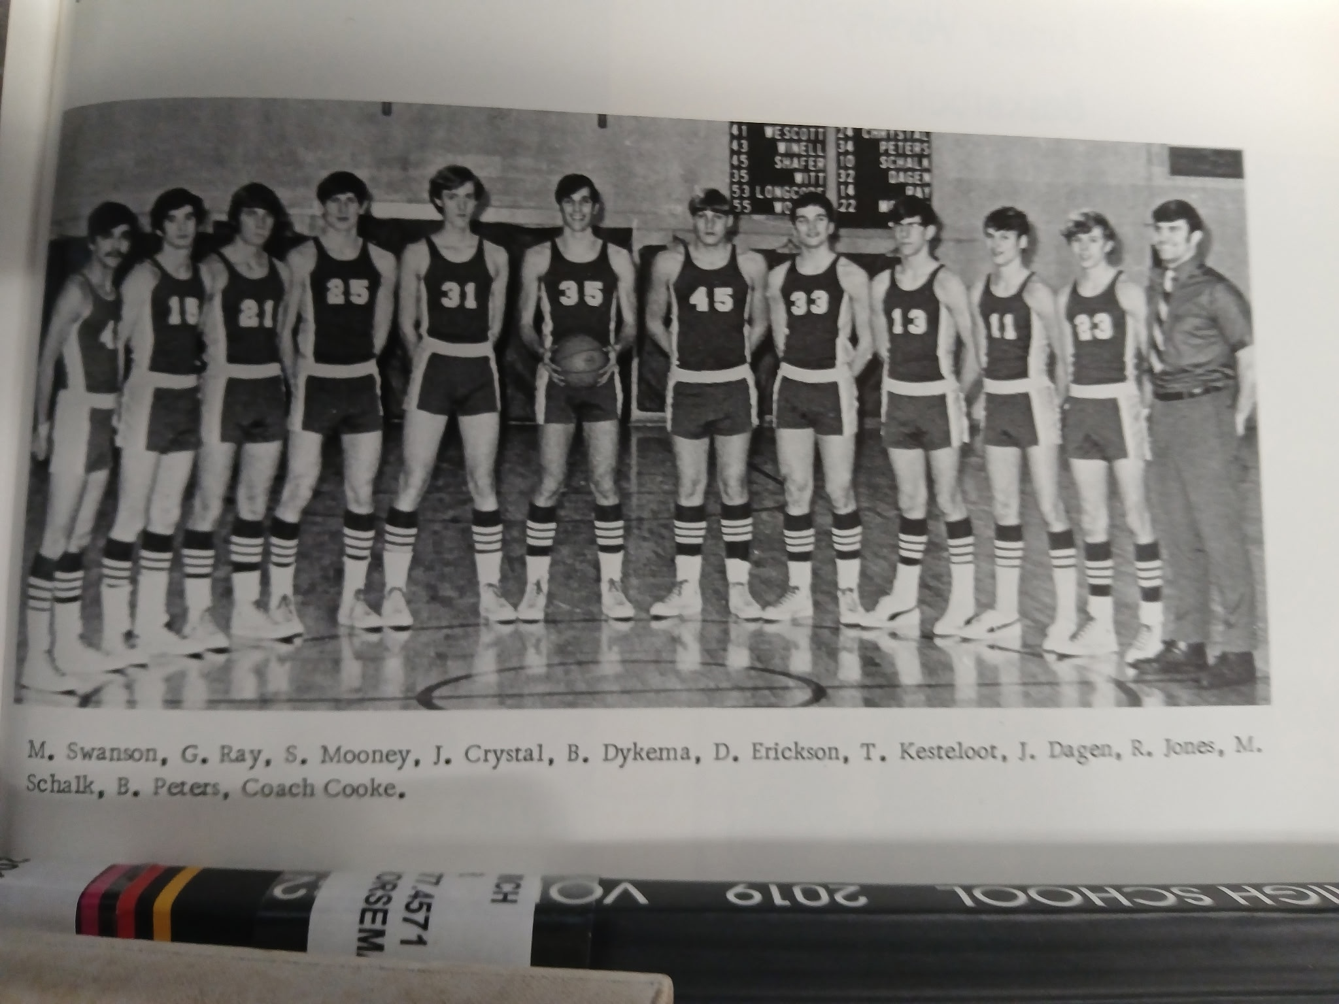

L-R: Merle Swanson, Gary Ray, Steve Mooney, B. Dykema, Dave Erickson, Tom Kesteloot, Jim Dagen, Rick Jones, Mike Schalk, Coach Dave Cooke

The 1970-71 NORSEMEN

N Muskegon 74 Montague 69 Dave Erickson 20, Rick Jones 17, M Schalk 15
N Muskegon 73 Mason Co 81 Erickson & Steve Mooney 15, Jones 14
N Muskegon 73 WMC 67 Jones 23, Erickson 21, Mike Schalk 17
N Muskegon 60 Hart 76 Jones 21, Jeff Chrystal 12
N Muskegon 101 Kent City 54 Erickson 22, Chrystal 18, Jones & Mooney 12
N Muskegon 93 Ravenna 62 Erickson 25, Schalk 23, Jones 19
N Muskegon 91 Oakridge 62 Schalk 20, Erickson 18, Dagen 15, Chrystal 13
N Muskegon 50 Shelby 87 Erickson 17, Jones 10
N Muskegon 92 Montague 83 Erickson 30, Jones 21, Dagen 18, Schalk 12
N Muskegon 89 Pentwater 73 No report in MC played Jan 23
N Muskegon 99 OV 61 Mooney, 25, Jones 20, Schalk 14, Chrystal 13
N Muskegon 84 Hart 88 Erickson 24, Schalk 18, Mooney 17, Jones 10
N Muskegon 70 Mason Co 93 Schalk 15, Jones 13, Tom Kesteloot 12
N Muskegon 63 Ravenna 61 Erickson 19, Jones 17, Schalk 11
N Muskegon 72 Whitehall 83 Erickson, Chrystal & Jones 16 points.
N Muskegon 81 Oakridge 86 Erickson 21, Schalk 17
N Muskegon 56 Shelby 89 Erickson 23
N Muskegon* 65 Hart 84 Erickson 24, Jones 10

1971-72 Coach Dave Cooke (9-9, Shelby- MCC co- Champs, Shelby State Champ)

There was euphoria heading into the 1971-72 basketball season as NM was still celebrating their 1971 mythical state championship football team. However, football did take its toll early into the season as football injuries would sideline a couple of returning starters to begin the season; all-state football player Jeff Chrystal and all-conference linebacker Jim Dagen. Chrystal’s injury appeared to be the most serious of the two and Jeff would miss the first six games of the season. NM would return four of their five starters from their 9-9 record from the previous season but would surely miss their leading scorer, all-conference front line performer Dave Erickson. The four starters returning, all football players along with Dagen and Chrystal, included Mike Schalk and all-state quarterback Rick Jones. Yet another football player who lettered and saw considerable action from last season was Tom Kesteloot, the tallest Norse player at a modest 6’2. Cooke would utilize these all-around athletes and once again employ a running game that would produce another high scoring team.
NM would have the disadvantage of opening the season with a Montague team that had already had the experience of playing a game while the Norse would play without their two starters injured in football. Mike Schalk with 24 and Rick Jones with 19 tried to take up the scoring slack as the two three-sport standouts scored 43 of their teams 55 points in an 81-55 loss to the visiting Wildcats.
NM welcomed Jim Dagen back to their lineup and Dagen responded with a team high 20 points, but it wasn’t enough as NM dropped a road win to Mason County Central 82-75. The game was tight all the way with the host Spartan leading the visiting Norsemen 58-54 heading into the final quarter. Mike Schalk had 17, Rick Jones 14 and Gary Ray 10 for the losing Norsemen.
North Muskegon had no answer to stop the towering West Michigan Warriors from controlling the backboards in a 77-54 loss to the Warriors. WMC outrebounded the smaller Norse by an astounding 77-31 margin. Jim Dagen again led NM in scoring with 18 markers with Gary Ray tossing in 13 and Rick Jones 12. The Warriors were fortunate that Mike Schalk had an off night as the senior guard was held to a season low of 3 points.
Mike Schalk bounced back from his season low to score 27 points but fouled out late in the game that led to a Hart Pirate run that culminated in a 59-53 victory over the Norse. The defeat was the fourth straight loss to begin the season and the eighth straight defeat over a two-year period for the Norsemen. Gary Ray chipped in with 13 points and Jim Dagen 10 and in this game, it was Rick Jones who had a season low with two points.
Both Rick Jones and Mike Schalk had big games as each scored 26 points to lead NM to their first victory of the season, 76-69 over Ravenna. Jones and Schalk had identical stat lines of 10 field goals and six free throws to give their team their first win after losing eight straight over a two-year period. “It was the first time this year we did a real good job on the boards,” said NM coach Dave Cooke.
Kent City gave up 101 points in their last meeting with the Norse losing by 47 points, but it was much closer a year later as NM escaped with an 84-82 victory over the host Eagle team. Rick Jones sank a pair of free throws with three-seconds left for the game winning points. Five Norse were in double figures in their second straight victory after starting the season with four losses. Mike Schalk pumped in 31 points to lead all Norse scorers and became the seventh player in Norse history to surpass the 30-point mark. Rick Jones and Dave Moore each scored 12 while Tom Kesteloot with 11 and Jim Dagen with 10 gave Schalk some much needed support in the two-point victory.
NM resumed action from the Holiday break by winning their third straight with an 82-51 rout of a winless Oakridge team. Jim Dagen notched 23 points with plenty of help from Mike Schalk with 19 and Tom Kesteloot with 12. Coach Cooke was happy to welcome back to the lineup Jeff Chrystal who came off the bench to score nine points.
Shelby had to have all the incentive when NM visited the home of the Tigers on Jan 14, 1972. Just a week earlier Shelby had their 39-game winning streak come to an end in a loss at Mason County Central. NM had to pay the price for the Shelby anger as the Paul Griffin led Tigers trounced the Norsemen 90-53. NM ‘held’ the future WMU Bronco and NBA star to 37 points and 26 rebounds. Mike Schalk continued his fine scoring with 21 points with Rick Jones chipping in with 12.
NM found Montague to be a much easier opponent. After losing to the Wildcats in the season opener NM won their second match 72-59. NM led at every stop as Mike Schalk poured in 22 points to lead Norse scorers while Jim Dagen netted 13.
Twenty-four hours after the win over Montague NM needed a career game from Tom Kesteloot to just edge Pentwater 73-72. The Norse trailed the Falcons by four points with two minutes to go before Kesteloot led NM to the narrow victory. Kesteloot popped in three quick field goals in the final two minutes to rally the Norse to their fifth win in their last six starts. Kesteloot was also a force on the boards with 15 rebounds to go along with his career high 21 points. Mike Schalk added 15, Rick Jones 14 and Jim Dagen 10.
For the second straight year the Norse scored more than 90 points against Orchard View with a 94-75 win on the Cardinals home court. For the second time this season Mike Schalk and Rick Jones scored 26 points in the same game. Jeff Chrystal had his best game since recovering from a football injury with 17 markers while Jim Dagen notched 10 as NM kept their winning effort going with their sixth win in their last seven meetings after a bad 0-4 start.
Coach Dave Cooke’s Norsemen had shown remarkable improvement since the 0-4 start to begin the season. NM led for most of the game against a Mason County team that only a few days earlier had handed Shelby their first WMC defeat in 39 games. The Spartans entered the Norse gym ranked as the number one team in Class C but never took the lead over a game NM team until the final minutes in a hard fought 76-72 win over the Norse. Five times the game was tied in the final period before the Spartan would pull away. In what must be a first, all five starters from North Muskegon would foul out of the game. with Mason County taking full advantage of the tightly called game by making 32 of 42 free throws. Mike Schalk was magnificent for the losers with 26 points while Jeff Chrystal had 17 and Jim Dagen 13.
It appeared the Norse were headed for an easy victory in their rematch with Hart as they took a 25-14 lead into the second quarter. Hart then switched into a zone press that bothered the Norse as Hart roared back to earn a 75-69 lead. Mike Schalk had yet another big night with 22 points to pace the Norse with Jeff Chrystal adding 10 and Tom Kesteloot 10.
Whitehall was still in the Seaway Conference throughout the 1970s but the two close rivals were always on each other’s schedule and would remain so for more than 50 years until the WMC expanded in the 2021-22 season. Bothered by a press in their loss to Hart the Norse had no trouble with a Whitehall press to post an 88-73 victory on the friendly Northside court. For the 10th time during the season Mike Schalk scored more than 20 points as he poured in 28 markers in the game labeled as an upset in the Muskegon Chronicle. Future Whitehall head coach Mark Will paced Whitehall with 22 points while NM’s Jim Dagen and Tom Kesteloot had 16 and 14 points while also collecting 15 rebounds each.
For a brief period, they played in the dark in Ravenna. Early into the junior varsity game an auto hit a power pole and knocked out the lights in much of Ravenna, including Ravenna high school. It would be two hours before the lights came back on and play resumed with NM winning 77-72. Rick Jones led NM with a career high 28 points while Mike Schalk again surpassed the 20-point barrier with 21 markers.
North Muskegon won their ninth game of the season as Tom Kesteloot scored a career high 33 points as NM defeated winless Oakridge 91-72. High scoring Mike Schalk was content to feed his teammates as he scored but seven points in the contest. Subs played much of the game as ten Norsemen entered the scoring column.
NM had no answer for Paul Griffin who had 37 points and 24 rebounds as Shelby defeated NM 110 -73, the most points ever allowed by a NM team. Mike Schalk played his final home game on the NM court and scored a career high 35 points. Only Gordy Odell had scored more points than Schalk’s 35 points up to this date in 1972.
There would be no March Madness for the Norse this year. Thanks to this being a leap year, the first round of the playoffs came on February 29th and perennial power West Michigan Christian ended NM’s season 91-76 in the Class C districts held in Hart. NM stayed with the 7th ranked Warriors as they trailed by only a single point, 38-37 at halftime. The Warrior then broke a 45-45 tie by going on a nine-point run to pull away from the Norse. Mike Schalk ended his career with 31 points, his third game scoring 30 or more points in a game. Earlier in the season the Warriors held Schalk to a season low three points. Rick Jones capped his career in splendid fashion with a career high 29 points.
When I look back at the 1971-72 season, I find the WMC conference, as well as NM’s schedule, as arguably the strongest in NM history. Shelby would advance to win the Class C state championship for the second year in a row. One of Shelby’s losses was to Mason County Central. Following MCC’s win over Shelby the Spartans moved to number one in the state rankings. Shelby also lost once to West Michigan Christian but then came back to beat WMC twice, with the big win coming in the district championship in a game that may have decided a state champion. Six of NM’s losses during the season came against these three powerhouse teams. Coach Dave Cooke, again utilizing the athleticism of his team, ran a run and gun offense that averaged 73 points per game, second only to the 1970-71 team that put up 77 points each game, far and away the top two offensive seasons in NM annals. Mike Schalk had one of the best seasons in NM history as he poured in 404 points, an average of more than 22 points each game. Three times Schalk scored more than 30 points in a game, a feat only accomplished up to this date by the great Gordy Odell in 1955. And Schalk didn’t score his points against mediocre competition. Schalk in his final six games of the season scored 26 against Mason County, 35 against the state championship Shelby team, and in his final appearance in a Norse uniform, scored 31 against 7th ranked WMC. Only in NM’s 30-point victory over a very poor Oakridge team did Schalk not score more than his 22-point average. Instead, he scored but seven points, as he was content to set up his teammates instead of padding his own stats. Mike Schalk left us all too soon in an automobile accident. How proud Mike would be to see what his son, who was too young at the time of Mike’s passing to remember what his father had accomplished. Ryan Schalk was named the coach of the year in the GLIAC conference as the head coach of the GLIAC championship Saginaw Valley University softball team

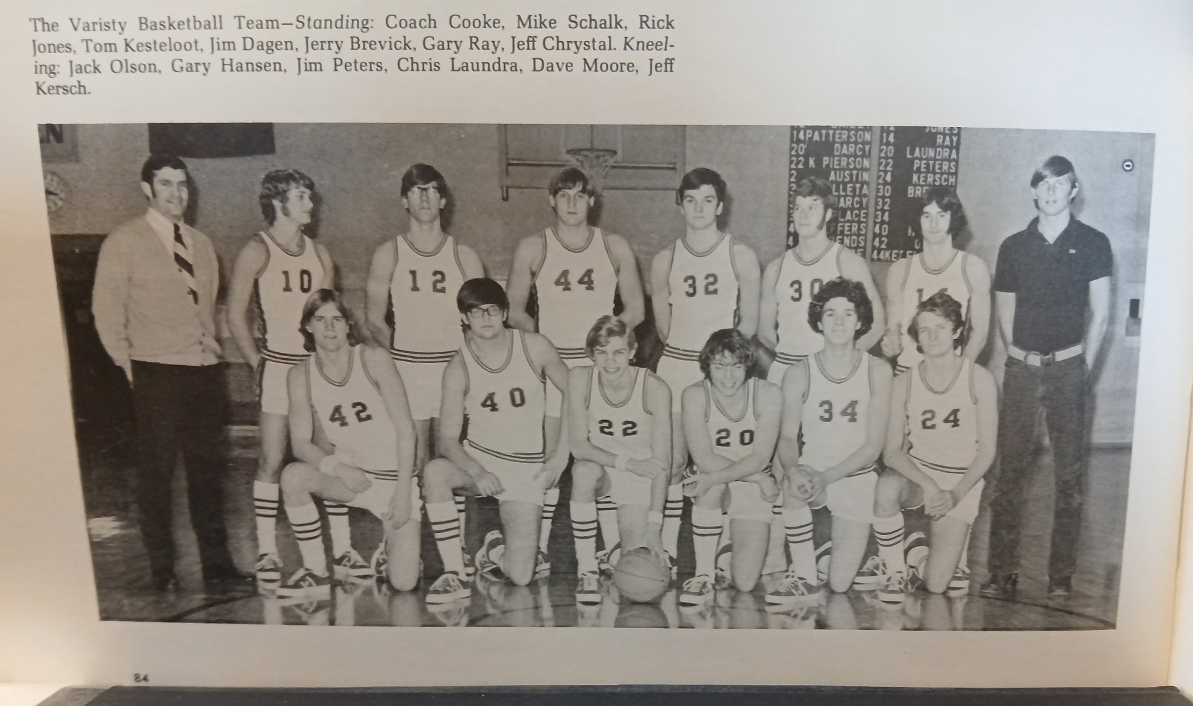

The 1971-72 NORSEMEN

N Muskegon 55 Montague 61 Mike Schalk 24, Rick Jones 19
N Muskegon 75 Mason Co 82 Jim Dagen 20, Schalk 17, Jones 14
N Muskegon 54 WMC 77 Dagen 18, Gary Ray 13, Jones 12
N Muskegon 53 Hart 59 Schalk 27, Ray 13, Dagen 10
N Muskegon 76 Ravenna 69 Schalk & Jones 26 points, Dagen 10
N Muskegon 84 Kent City 82 Schalk 31, Jones & Dave Moore 12
N Muskegon 82 Oakridge 51 Dagen 23, Schalk 19, Tom Kesteloot 12
N Muskegon 53 Shelby 90 Schalk 21, Jones 12
N Muskegon 72 Montague 59 Schalk 22, Dagen 13
N Muskegon 73 Pentwater 72 Kesteloot 21, Schalk 15, Jones 14, Dagen 10
N Muskegon 94 Orchard View 75 Schalk & Jones 26 points, Jeff Chrystal 17
N Muskegon 72 Mason Co 76 Schalk 26, Chrystal 17, Dagen 13
N Muskegon 69 Hart 75 Schalk 22, Chrystal 13, Kesteloot 10
N Muskegon 88 Whitehall 73 Schalk 28, Dagen 16, Kesteloot 14
N Muskegon 77 Ravenna 72 Jones 28, Schalk 21, Crystal & Kesteloot 10
N Muskegon 91 Oakridge 72 Kesteloot 33, Jones & Dagen 12
N Muskegon 73 Shelby 110 Schalk 35,
N Muskegon*76 WMC 91 Schalk 31, Jones 29

1972-73 Coach Dave Nelson (5-16 overall, Ravenna WMC champs)

Dave Cooke left North Muskegon (but he would return) to take over as the head football coach at Reeths Puffer. Replacing Cooke was former Muskegon High, Central Michigan star, and Muskegon Panther professional basketball player Dave Nelson. Nelson, who would come to North Muskegon after serving as the head coach at Holton, would inherit virtually an entirely new team as all five starters and a few reserves from the previous year had all departed via graduation. Only Dave Moore, Jerry Brevick and Chris Laundra saw spot action from the previous season. NM would take their lumps early into the season, but they did improve in the second half of the season and would get way better the following year. The new coach was candid about his upcoming season: “We don’t have any experience, height, or lettermen back,” said a forthright Nelson.
The same could be said for Shelby as they too lost almost their entire roster from the back-to-back Class C state champs. The Norse gave the host Tigers a real battle before coming out on the short end of a 70-69 score. Jim Duplissis scored 20 points with Tom Thornton netting 16 for NM. Jerry Brevick, who played sparingly in a reserve role last year added 17 points for his new coach Dave Nelson.
It took only the first few minutes of their second game of the season to see that the Norse were headed for a long season with their young club. WMC bolted out to a 25-7 lead at the end of the first quarter and by the time the final horn had sounded NM was staring at the scoreboard of a 96-37 defeat, the most lopsided loss up until that date in program history. Tom Thornton led the low NM output with 11 points.
It didn’t get any better in their next contest with Mason County Central as NM was walloped by the visiting Spartans 84 to 49. Once again, this game was over by the end of the first stanza as MCC led 17-5. Tom Thornton had 14 while Jerry Brevick netted 10 for the 0-3 Norseman.
New NM coach Dave Nelson recorded his first win as the NM cage coach, and he has Tom Thornton to thank. Thornton scored 32 points, the ninth Norsemen to score 30 or more points as the Norse defeated Montague 60-52. Thornton was uncanny from the free throw line as he buried 14 of his 15 attempts. Jerry Brevick also reached double figures for the first-time winners with 12 points.
One may find it hard to believe that a team that led 11-10 at the end of the first quarter would find themselves losing by 45 at game’s end but that was true in Hart’s 85-45 victory over NM. Hart led by 12 at halftime but then just blitzed the Norsemen on the Pirates home floor in the second half to keep the Pirates undefeated in the early part of the season while the Norsemen would fall to 1-4. Tom Thornton topped all scorers with 22 points as no other NM player scored more than six points.
It’s a good thing NM had Kent City on their schedule as two of their five wins on the season came against Kent City. Tom Thornton continued his fine scoring with 22 points with 10 of his points coming at the charity strip where he swished 10 of his 11 attempts. Jerry Brevick was second in scoring for the Norse with nine points.
The Norse were aided in their victory when Kent City shot a woeful 13 of 31 free throws.
In the final game of 1972 for the Norsemen the Norse hung with the much taller Ravenna Bulldogs for three quarters, but the Norse caved in to the Bulldogs when Tom Thornton fouled out early into the last quarter. Ravenna turned a close game into an 83-56 laugher after Tom Thornton fouled our early in the fourth quarter after scoring 23 points. The Bulldogs went on a 27-7 run in the game’s final eight minutes.
NM returned from the Holiday break looking to continue their unbeaten record against Pentwater. That did not happen as Pentwater handed NM an 80-42 trouncing. The Norse shot an abysmal 4 for 44 in the second half with only Jerry Brevick in double figures with 13 points.
A big time second half by their opponents sent the Norse to an 80-59 defeat by Oakridge. NM was in contention at the halftime break, trailing 40-36, but were soundly outgunned in the second half beginning with a 25-9 run against the Norsemen in the third period. Jerry Brevick with 13 and Jim Peters with 11 paced the Norse.
NM coach Dave Nelson couldn’t have asked for a better Christmas present. Tom Fillipow, arguably the most talented transfer student in NM history, moved with his family from Florida to North Muskegon and immediately made a huge impact for Norsemen basketball. The 6’4 Fillipow scored 20 points, picked off 16 rebounds and dished off seven assists to lead NM to a 65-55 victory against the 1971 & 72 Class C state champs, the Shelby Tigers. Fillipow wasn’t the only addition to the Norse lineup as football star Tom Achterhoff also made his debut and scored 16 points.
There was good news across the country on January 26, 1973, as the Vietnam War was ending, but not so good news for NM basketball as the Norsemen dropped their game 48-40 to Montague. NM was 0-1 at the free throw line while Montague made 13 charity throws for the difference in the victory. Tom Fillipow netted 14 and Jerry Brevick scored NM 10 as NM struggled to put points on the board.
Mason County continued their home court dominance over the years against the visiting Norsemen with a 79-54 triumph. Tom Thornton kept NM in the game early with 18 of his team high 24 points coming in the first half as NM fell to 3-9 on the season.
The Norse kept within range of Hart as NM trailed the Pirates 29-27 in a slow game that was in complete contrast from the Dave Cooke years at NMHS. Hart then outscored the host Norsemen 15-10 in the final period to earn a 44-37 victory. Tom Fillipow with 20 points, scored more than half of NM’s total points. Hart would have one of their best teams ever, even though they did not win the WMC. The Pirates did win the Class C regional before losing to Saginaw St. Stephens in the quarterfinals.
NM had the unenviable task of attempting to derail the Ravenna Express on the Bulldogs homecourt. Ravenna was boasting of perhaps their best team in Ravenna history as they improved their record to 17-1 with an easy 78-44 romp over NM. Tom Fillipow, hampered by early fouls, still led NM with 11 points. Tim Coletta led the balanced Ravenna machine with 22 points.
Orchard View was never in trouble in an 81-66 victory over North Muskegon on the Norsemen’s home court. First year head coach Mike Henry’s Cardinals improved their edge over NM in every quarter to even their record at 9-9 while the Norse were still looking for that elusive number four victory. Tom Thornton tossed in 21 points and Tom Fillipow 14 with Jerry Brevick also in double figures in the loss with 11.
Although they lost, it was apparent that NM was improving despite losing to Whitehall 81-68. The game was tied at one point at 51-all, and the Norse trailed by only four at 60-56 heading into the final quarter. Tom Thornton had his second 30-point game on the season to lead the Norse while Tom Fillipow had 14 points and 15 rebounds.
NM lost to Oakridge 86-75 in the final game of the regular season but served notice that with junior Tom Fillipow returning for the following season, NM fortunes would be on the rise. Fillipow poured in 35 points in the loss, but the Norsemen committed a whopping 32 turnovers. NM wouldn’t have to wait long to see if they would earn at least one win on the season with Oakridge as they drew the Eagles as their first-round opponent in the playoffs.
Once again NM showed that it’s tough to beat a team three times in a season, or twice in a week, as NM pulled a mild upset with an opening round 76-65 playoff victory over Oakridge, just five days following their previous meeting. Tom Fillipow scored 32 points, his second straight 30 plus output over Oakridge while also pulling down 15 rebounds. Jerry Brevick added some additional firepower for NM with a season high 20 points.
NM surely received a favorable draw in the Class C District tournament played at Spring Lake High School. NM made it two straight wins in the tournament as well as two wins on the season over Kent City with a commanding 88-49 win vs. the Eagles, easily their highest scoring output on the season. Four Norsemen were in double figures topped by Tom Thornton’s 23 points with Tom Fillipow close behind with 20. Jerry Brevick with 13 and Chris Laundra with 10 added to the Norse total as they advanced to the Class C district championship against 19-1 Ravenna.
NM gave the Bulldogs a much better game than in their first two blow-out losses to the Bulldogs before losing in the district title match 64-54. Ravenna was playing without their star point guard Tim Coletta who was injured in the final minutes of Ravenna’s win over West Michigan Christian in the district semi-finals. Juniors Tom Fillipow with 21 and Tom Thornton with 15 gave notice that NM will be a much tougher out when the following season begins.

N Muskegon 69 Shelby 70 Jim Duplissis 20, Tom Thornton 17
N Muskegon 37 WMC 96 Thornton 11
N Muskegon 49 Mason Co 84 Thornton 14, Jerry Brevick 10
N Muskegon 60 Montague 52 Thornton 32, Brevick 12
N Muskegon 45 Hart 85 Thornton 22, Brevick 6
N Muskegon63 Kent City 41 Thorton 22
N Muskegon 56 Ravenna 83 Thornton 23
N Muskegon 42 Pentwater 80 Brevick 13
N Muskegon 59 Oakridge 80 Brevick 13, Jim Peters 11
N Muskegon65 Shelby 55 Tom Fillipow 20, Tom Achterhoff 16
N Muskegon 40 Montague 48 Fillipow 14, Brevick 10
N Muskegon 54 Mason Co 79 Thornton 24
N Muskegon 37 Hart 44 Fillipow 20
N Muskegon 44 Ravenna 78 Fillipow 11
N Muskegon 66 Orchard View 81 Thornton 21, Fillipow 14, Brevick 11
N Muskegon 68 Whitehall 81 Thornton 30, Fillipow 14, 15 rebounds
N Muskegon 75 Oakridge 86 Fillipow 35
N Muskegon*76 Oakridge 65 Fillipow 32, Brevick 20
N Muskegon*88 Kent City 49 Thornton 23, Fillipow 30, Brevick 13
N Muskegon*54 Ravenna 64 Fillipow 21, Thornton 21, Brevick 10

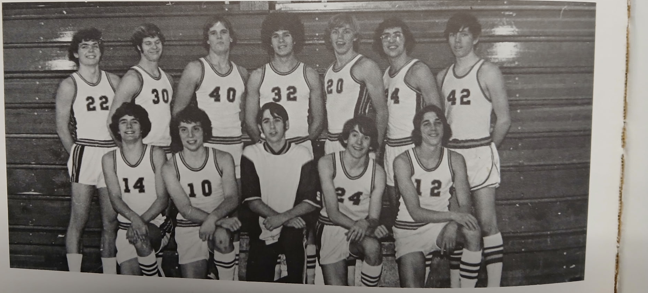
Note:
Not in photo
is Tom
Fillipow who
joined the
team in January

Kneeling L-R: Jim Duplissis, Chris Laundra, D. Singer, D. Fosler, Tom Thornton
Standing L-R: Tom Achterhoff, Jerry Brevick, Jack Olson, Dave Moore, Jim Peters, R. Jensen, B. Holcomb
THE NORSEMEN of 1972-73

1973-74 Coach Dave Nelson 14-8 overall, District & Regional Champs – Montague WMC Champs)

Three starters returned from last year’s team as for the first time in since 1935 NMHS would drop down in enrollment where they would compete in Class D. In 1935 the Norsemen advanced all the way to the quarterfinals. Would history repeat itself in 1973-74? One of the returnees would be 6’4 Tom Fillipow, one of the finest to ever don the Blue & Gold uniform for NM. He would be joined by Tom Thornton, a prolific scorer who twice as a junior scored 30 points in a single contest. Coach Dave Nelson would welcome back Tom Achterhoff, an outstanding football player who could also play roundball very well. 6’2 junior Larry Williams, arguably the best baseball player in Norse history would bring his wiry 6’2 frame to the Norse starting lineup. One who saw but limited time in his junior season, but who had improved immeasurably over the offseason was 5’7 Bob Cordo. 6’1 all-state football player Jerry Crocker would add some muscle to the lineup while 5’8 Nick Nedeau would provide Coach Nelson with some valuable minutes.
A name that is synonymous with Shelby basketball, Rock Zoulek connected on a 25-footer with two seconds remaining to defeat North Muskegon 64-62 to begin the 1973-74 season. More than fifty years later, Rick Zoulek continues to lead Shelby as their long-time (and I do mean long-time) head basketball coach. Zoulek’s game winning shot spoiled the opening game for NM’s Tom Fillipow who had 27 points and 18 rebounds. Coach Nelson following the game was not happy with how NM was not able to handle Shelby’s pressing defense.
Western Michigan Christian welcomed back their former coach who returned to guide the Warriors after taking a few years off. Elmer Walcott, who had already won four state championships was back in charge and WMC responded with an 88-72 win over the visiting Norsemen.
After Montague handed the Norsemen their third straight loss 63-50, it was imperative if NM was to turn their season in the right directions they needed to go on a streak. Lack of rebounding hurt NM with Tom Fillipow again leading the Norsemen with 18 points with Tom Thornton adding 10.
Overshadowing NM’s first win of the season, a 50-39 victory over Hart was the play of the first NM girls’ team in school history. The Lady Norse defeated Memphis High 47-43 to advance to the first ever state finals for the gals to be played in MHSAA history. Nancy Dean led the gals in scoring with 15. One oddity in the game was the gals from Memphis were wearing uniforms from Alma High, the site of the state finals in 1973, as there was a mix-up as both teams arrived with only uniforms in dark colors. NM would go on to play in the state championship game only to lose to Ewen-Trout-Creek. The Lady Norse played their quarterfinal game in Traverse City City against Hillman. What a surprise I got when three of my teachers, who I surely caused premature gray hairs as a student in the late 1950s, asked if I would join them to attend the game. How thrilled I was to go with Homer VanHoesen, John Joza, and my high school basketball coach Bob Morris as we enjoyed watching the gals win a one-point thriller over Hillman.
In the boys win over Hart NM tightened the screws on defense and received an all-around game from Tom Fillipow. The 6’4 junior scored a modest 10 points, well below his average, but had 24 rebounds and dished off for eight assists. Tom Thornton led NM in scoring with 15 while Larry Williams also had 10 points. History will show it would be the only Norse win over the Pirates covering a 13-game span.
In a game played at Sparta High School, Tom Thornton scored 36 points, second only to Gordy Odell in a single game as NM topped Kent City 71-57. Thornton was the recipient of several passes from versatile Tom Fillipow who added eight assists 19 rebounds and 14 points.
After dropping all three games to Ravenna the previous season, NM made up for those losses by treating the Bulldogs to an 89-54 beating. Tom Thornton and Tom Fillipow combined for 60 points (32 & 28) and Larry Williams added 17 as NM evened their record at 3-3 heading into the Holiday break.
A long three-week break for the Holidays didn’t affect NM’s dynamic duo of Tom Fillipow and Tom Thornton. Fillipow poured in 30 and Thornton 25 to account for all but 30 of NM’s points in a 75-66 victory over Oakridge. Fillipow was also a monster on the boards with 22 rebounds.
The Norse made sure there were no Rick Zoulek heroics in their rematch with Shelby as NM won by eight points in their 64-56 road win at Shelby. Fillipow and Thornton teamed for 45 points as the streaking Norsemen won their sixth straight game after starting the season 3-0.
Montague all but wrapped up the WMC title as they downed the Norse for the second time on the season and snapped NM’s winning streak at seven with a 52-48 win on the Wildcats home court. NM was held without a free throw attempt in the entire second half as all of Tom Fillipows 26 points came on field goals.
Larry Williams, a fire balling righthanded pitcher for the NM baseball team came out firing strikes at the basket as he scored a season high 20 points to lead NM to a rare victory over Mason County Central 67-57. Tom Thornton had a team high 26 points while Tom Fillipow chipped in with ‘only’11 but set up his teammates with 11 assists.
Hart made amends for an earlier loss to the Norsemen with a 63-52 win over NM on the Pirate’s home court. The Pirates held Tom Fillipow to nine points as the Norse dropped to 5-4 in WMC action. The red-hot Pirates won their 8th game out of their last nine. Larry Williams continued his improved play with 17 points to lead the Norse with Tom Thornton also in double figures with 13.
Tom Fillipow netted 31 points as NM won an easy 86-64 victory over Ravenna, a near identical score as their earlier win. Four Norsemen were in double figures, including Tom Thornton with 14, while Tom Achterhoff and Nick Nedeau each scored 10 points. After winning the West Michigan Conference the previous season, the Bulldogs regressed as they were still looking for their first win in the WMC.
The Norse again scored 86 points just days later with an 86-60 trouncing of Orchard View. Tom Thornton singed the nets for 34 points, with Fillipow adding 18 and Williams 15 as NM shot better than 50% from the field for the entire contest.
Whitehall employed a box and one defense to stop Tom Fillipow, leaving the door open for Tom Thornton, Larry Williams and point guard Bob Cordo. Fillipow garnered eight of his 14 points at the free throw line as NM received excellent balance. Tom Thornton scored 20 points, Larry Williams 17 while Cordo scored a season high 12 points in a game rated as an upset.
Mason County Central took advantage of a flu-stricken Tom Fillipow who was able to play in only brief stretches of the game but still managed to tally 16 points as the Spartans downed the Norsemen 79-70. Tom Thornton scored 18 to lead NM scorers with Bob Cordo and Larry Williams each adding 12.
Not playing until the second half Tom Fillipow, still ailing with the flu, the Norsemen would lose their final game of the regular season to Oakridge 70-64. Fillipow gamely came off the bench in the second half to score nine points. Larry Williams had a season high 25 points to lead the Norse with Tom Thornton netting 16 and Bob Cordo 10. Coach Nelson and Norse fans were hoping Fillipow will be at full strength for the upcoming tournament.
Playing in their first MHSAA Class D tournament game since 1935, NM had to withstand four of their starters fouling out of the contest to hang on to a 58-57 win over Pentwater. Before fouling out Tom Fillipow had 19 points, Tom Thornton 14, and Larry Williams 12. Tom Achterhoff also went to the sidelines after fouling out of a game that turned into a free throw contest. NM trailed at the end of the third quarter by one point before outpointing the upset minded Falcons by two in the final eight minutes to survive to advance to the finals.
The Norsemen won their first district championship in 11 years with a 60-44 win over Hesperia in a Class D tournament held at Holton High. In the first matchup between the two teams since 1938, the Norse trio of Fillipow, Thornton and Williams proved to be too much for the losing Panthers. Fillipow had 15 rebounds while Tom Achterhoff pulled down 12 caroms as NM advanced to the Class D regionals at Kenowa Hills High School.
It took a three-minute overtime period for NM to advance to the regional championship as they nipped Potterville 71-67 in the only meeting thus far in NM history between the two schools. Coach Dave Nelson needed help from other Norsemen not named Tom Fillipow as the 6’4 senior fouled out of the game with still four minutes to go in regulation. Tom Thornton had a big game for the Norsemen with 29 points while Fillipow grabbed 16 rebounds, had nine assists and 17 points before fouling out. Coming through big time late in the game for NM were Larry Williams, Nick Nedeau and little Bobby Cordo. In the overtime period Nedeau hit two big free throws to get the Norse started, Williams added a rebounding basket, and Cordo clinched the game for NM with two free throws with six seconds remaining.
The Norse would enter the regional championship clash with Allendale as underdogs to the 19-4 Falcons. NM would win their first regional championship in 39 years with a thrilling 62-61 victory. The two Toms, Fillipow and Thornton combined for 46 points with Larry Williams’ 11 points combining for all but three of NM’s total points. NM was helped in the victory by some poor free throw shooting by Allendale as they hit on 11 of 22 charity tosses, including a pathetic 1 for 8 in the first half. Williams scored four of his points in the game’s final moments on made free throws to ice the victory and send NM to the quarterfinals against highly ranked Traverse City St. Francis.
North Muskegon moved down from Class C to Class D to begin the current season. Unfortunately for NM, so did Traverse City St. Francis, a team who advanced to the state final four in Class C in 1973. This game caused mixed feelings for your author. At this time, I was residing in Traverse City and was part of a good independent team. During the practice time leading up to this game our team, which consisted of players that included Frank Majerle (father of Thunder Dan) and Joe LeMeiux, former Muskegon Catholic star and basketball coach at Traverse City Central, would scrimmage TCSF to get them prepared to play my alma mater. My role in these practice sessions was to simulate the play of NM point guard Bobby Cardo. I must confess that while watching the quarterfinal game between these two teams in Ludington, I was ‘silently’ pulling for my alma mater. However, TCSF was too strong for the Norse. NM was doomed as early as the first half when Tom Fillipow drew his fourth foul with the game still in doubt. Just two minutes into the second half Fillipow drew his fifth foul. “That was really too bad Fillipow had to foul out,” said St Francis coach and my good friend Jim Rossi. “It was the turning point of the game when we had them in foul trouble.” Fillipow fouled out in minimal playing time with a career low of four points. Stepping up big time for the Norse was their only junior player on the floor, Larry Williams. The 6’2 thin man with a blazing fast ball in the spring, kept NM in the game with a career high 32 points, the 11th NM player in program history to score 30 points in a game. St. Francis all state guard Ron Fewins had 26 points, but their best player was their 6’5 jumping jack Center Jim Swaney who would go on to college stardom at Toledo.

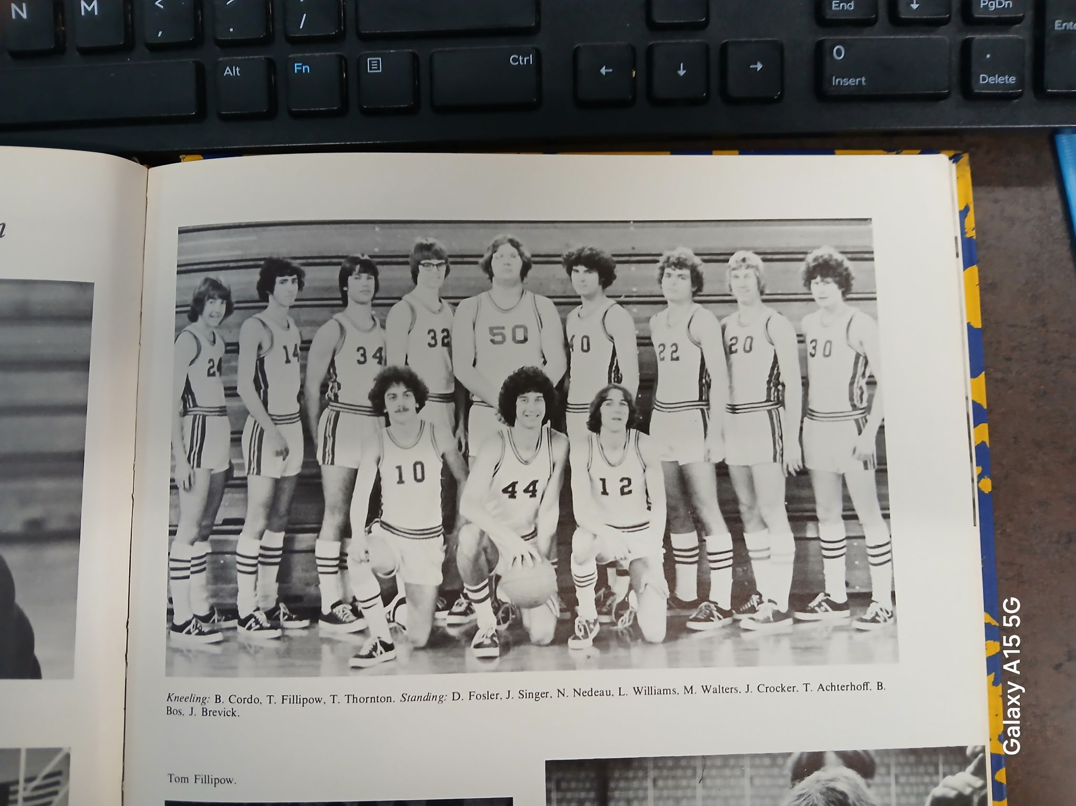
Kneeling L-R: Bob Cordo, Tom Fillipow, Tom Thornton
Standing L-R: D. Fosler, J. Singer, Nick Nedeau, Larry Williams, Mark Walters, Jerry Crocker, Tom Achterhoff, B. Boss, J Brevick

THE NORSEMEN REGIONAL CHAMPS of 1973-74

N Muskegon 62 Shelby 64 Tom Fillipow 27, Larry Williams 10
N Muskegon 72 WMC 88 Fillipow 33, Tom Thornton 15, Williams 10
N Muskegon 50 Montague 63 Fillipow 18, Thornton 10
N Muskegon 50 Hart 39 Thornton 15, Fillipow & Williams 10
N Muskegon 71 Kent City 57 Thornton 36, Fillipow 14 & 19 rebounds
N Muskegon 89 Ravenna 54 Thornton 32, Fillipow 28
N Muskegon 75 Oakridge 66 Fillipow 30 & 22 reb., Thornton 25
N Muskegon 65 Pentwater 41 Fillipow 12
N Muskegon 64 Shelby 56 Fillipow 25, Thornton 21
N Muskegon 48 Montague 52 Fillipow 26, Tom Achterhoff 8
N Muskegon 67Mason Co 57 Thornton 26, Williams 20, Fillipow 11
N Muskegon 52 Hart 63 Williams 17, Thornton 14, Fillipow 9
N Muskegon 86 Ravenna 54 Fillipow 31, Thornton 14, Nick Nedeau 11
N Muskegon 86 Orchard View 60 Thornton 34, Fillipow 18, Williams 15
N Muskegon 69 Whitehall 60 Thornton 20, Fillipow 14, Bob Cordo 12
N Muskegon 70 Mason Co 79 Thornton 18, Fillipow 16, Williams -Cordo 12
N Muskegon 64 Oakridge 70 Williams 15, Thornton 16, Cordo 10
N Muskegon*58 Pentwater 57 Fillipow 19, Thornton 14, Williams 12
N Muskegon*60 Hesperia 44 Fillipow 18, Thornton 12
N Muskegon*71 Potterville(ot) 67 Thornton 29, Fillipow 17, Williams 14
N Muskegon*62 Allendale 61 Thornton 24, Fillipow 22, Williams 11
N Muskegon* 62 TC St Fran. 84 Williams 32, Thornton 12

1974-75 Coach Rande Horn 6-14 overall, Shelby champs)

Dave Nelson would serve only two years as the Norsemen head coach, freeing Dave to pursue his favorite pastime---golf. His replacement would be Rande Horn who would only have one starter returning from the previous season’s regional champions --- Larry Williams. Horn was more than familiar with Larry as he was married to Larry Williams’ sister. It’s doubtful if the Norsemen would have won a single game in the upcoming season without the presence of Larry Williams in the Norse lineup.
First year coach Horn was awarded with a victory in his coaching debut as NM opened the season with a 72-64 win over Pentwater. John Duplissis scored 22 points in his first varsity appearance while the only Norse starter returning, Horn’s brother-in-law Larry Williams, showed he still has his shooting touch as he netted 20 points. Another newcomer to the Norsemen lineup, Rob Hansen, was in double figures with 13.
The Norse took to the road once again but in their second game they were on the losing end of a 54-36 loss to Oakridge. Just as NM was playing for their first-year coach Randy Horn, the Eagles were also playing their first game under their new coach, former WMC Warrior ace Denny Vanderstelt. Larry Williams scored 16 for NM, while Jerry Crocker, recently named to the all-state football team, chipped in with 10.
The Norse kept it close in their third game of the season but 32 points by NM sharpshooter Larry Williams wasn’t enough as the Norse fell to the Warriors 77-69. Williams repeatedly was fouled by Warrior players on drives to the basket and connected on 16 of 18 free throws. Jerry Crocker muscled his way to the hoop to score 16 points as the Norse fell to 1-2.
It looks like Shelby, after a sub-par season a year ago after posting back-to-back state titles, is a team to be respected once again as they pummeled the Norse 88-55 by scoring at least 20 or more points in all four quarters. Larry Williams scored 14 points before fouling out in the second half. Jeff Guy led the Norse with 15 points while Rob Hanson added 11. The 14 points scored by Williams would prove to be his lowest output of the season.
NM and Mason County went to overtime with the Spartans taking advantage of NM playing the overtime period without their leading scorer Larry Williams who had fouled out in the fourth quarter. With Williams taking his 18 points to the bench, the visiting Spartans outscored the Norsemen 10-0 in overtime to send the Norsemen to their fifth straight defeat. Jerry Crocker scored a season best 23 points while Jeff Guy added 14 for NM.
The losses continued to pile up for the Norse has they fell to 0-4 in the WMC following their 68-57 loss to Montague. NM held a 19-14 lead at the end of the first stop, but Montague then took over for the final three quarters. Larry Williams netted 20 points for the 1-5 Norsemen with Rob Hansen chipping in with 14 and Jeff Guy 12.
Its’s probably a good thing that Holton was added to the NM schedule beginning in the 1974-75 season as wins would be tough to come by over the next three seasons. NM snapped a five-game losing streak with a comfortable 69-49 win over the Red Devils as Larry Williams again led NM in scoring with 23 points.
The Norsemen dug themselves into a deep hole by being outscored 20-12 in the opening period in their 75-69 loss to Hart. The Pirates shot over 50% in the win while only Larry Williams with a game high 30 points was able to consistently find the range for NM. Williams also grabbed 19 rebounds in the loss while Jerry Crocker gobbled up 11 boards and added 13 points.
Down by 18 points at one stage, NM put on a desperate press in the fourth quarter to outscore Ravenna 24-7 to rally for a 63-61 victory over Ravenna. Larry Williams got the game winning field goal for the Norse when he rebounded his own missed shot and made the put back with just two seconds left on the clock. Williams would finish with 20 while Jerry Crocker had a season high 22 and Jeff Guy 10 points as the Norse would win their first game in the West Michigan Conference.
NM would win their third victory in their last four games with a low scoring 40-38 non-league victory at home over Kent City, their 8th straight victory to begin their series over the years with the Eagles. Larry Williams scored half of NM’s points with a game high 20 with half of his points coming at the free throw line.
NM allowed an opponent to score more than 100 points in a single season for the second time in school history (Shelby 110 in 1972) in a 104- 73 loss at Whitehall.
The Vikings sent a notice to NM fans early that this was not going to be the Norsemen’s night at they raced out to a 30-17 first quarter bulge. Larry Williams continued his hot scoring with 25 points, the only Norsemen in double figures.
Oakridge made it a clean sweep in the season series with an 82-60 conquest of the Norsemen. Larry Williams and Jeff Guy shared scoring honors for NM with 15 points with John Duplissis adding 12.
Shelby kept their record spotless in WMC play with an 82-67 win over NM while the Norsemen were still looking for that elusive 2nd conference victory. Shelby cruised to the win thanks to a 40-22 lead at halftime. Larry Williams scored 29 for the Norsemen, the only NM player in double figures as NM fell to 4-8 overall and only 1-7 in conference play.
NM wasn’t the only team still looking for that elusive second victory in WMC action. The other team was Montague, whose only conference win came against the Norse in their first meeting. It was NM who would win that 2nd WMC conference game in a narrow 63-61 win over the Wildcats. Bruce Bos broke the tie with a couple of free throws in the game’s final moments. Bos iced the victory when he came up with a vital steal and his mates were able to stall out the final seconds. Larry Williams scored 18 of his 20 points in the first half and then was doubled teamed in the second half. John Duplissis and Jeff Guy than took advantage of that strategy with 18 and 17 points respectively.
The winning edge went away quickly as NM loss decidedly at Mason County Central 74-46. Larry Williams was a one-man show for the Norsemen with 19 points and 18 rebounds.
After being eliminated by the Norsemen in the 1974 regional final in the first meeting between the two schools, Allendale was surely fired up to make NM pay for that loss as Allendale thumped the Norse 84-58. It didn’t hurt the host Falcons when NM ace Larry Williams had to sit the entire third period with four fouls. In three quarters of play Williams was still able to muster 25 points, the lone Norse player to hit double digits.
Hart continued their dominance over NM in the 1970s with a 66-61 win over the Norsemen. Only a late fourth quarter flurry of NM points when NM outscored Hart 26-13 did NM make the final score reasonably close. Larry Williams again surpassed the 20-point mark with 23, while Jeff Guy added 14 as they approached the final week of the 1974-75 season.
NM won their sixth, and final game of the season by defeating Holton for the second time 82-71. Larry Williams continued his hot shooting with 24 markers, just above his 22 point per game average for the campaign. Ron Hansen added 14 for the 6-12 Norsemen.
It appeared NM was headed for victory in the game’s final seconds when Bruce Bos hit one of two free throws to give NM a two-point lead. Ravenna’s Mark Stancliff was fouled after receiving a court length pass. Stancliff missed the shot but was fouled on the play with no time showing on the clock. Stancliff, who finished with 29 points calmly made two free throws to send the game into overtime. Stancliff and Brian Wright, the longtime baseball coach at Shelby, and still the head coach of the Tigers after more than 40 years at the helm, then combined to score nine points in overtime to send the Norseman to another defeat. Larry Williams did his part for the losers with 26 points and 13 rebounds.
After one year playing at the Class D level, the enrollment at NM went up slightly, just enough to move them into the Class C bracket where they would be pitted in the first round against perennial Class C power West Michigan Christian.
Larry Williams, arguably the finest baseball player in NM history, wasn’t too shabby in basketball. NM had their season end with a 78-59 defeat to the WMC Warriors despite yet another 30-point output by Williams, his fourth in his prep career. No other Norseman was in double figures as NM ended the season with a 6-14 record. Williams would score 450 points in the 20-game season, an average of 22.5 points per game, an average second only to Gordy Odell’s 30 ppg. average in 1954-55.
After the Norsemen posted a mediocre 6-14 record it would get worse for NM, much worse over the next two seasons.

N Muskegon72 Pentwater 64 John Duplissis Larry Williams 20
N Muskegon 36 Oakridge 54 Williams, 16, Jerry Crocker 10
N Muskegon 69 WMC 77 Williams 32, Crocker 16
N Muskegon 55 Shelby 88 Jeff Guy 15, Williams 14, Rob Hanson 11
N Muskegon 63 Mason Co(ot) 73 Crocker 23, Willians 18, Guy 14
N Muskegon 57 Montague 68 Williams 20, Hanson 14, Guy 12
N Muskegon69 Holton 49 Williams 23, Crocker 10
N Muskegon 69 Hart 75 Williams 30, Crocker 13, Hanson 10
N Muskegon63 Ravenna 61 Crocker 22, Williams 20, Guy 10
N Muskegon40 Kent City 38 Williams 20, Guy 8
N Muskegon 73 Whitehall 104 Williams 25
N Muskegon 60 Oakridge 82 Williams & Guy 16, John Duplissis 12
N Muskegon 67 Shelby 82 Williams 29, Guy 10
N Muskegon 63 Montague 61 Williams 20. Duplissis 18, Guy 17
N Muskegon 46 Mason Co 74 Williams 19
N Muskegon 58 Allendale 84 Williams 25
N Muskegon 61 Hart 66 Williams 23, Guy 14
N Muskegon 82 Holton 71 Williams 24, Hansen 14
N Muskegon 64 Ravenna (ot) 73 Williams 26
N Muskegon*59 WMC 78 Williams 30

1975-76 Coach Rande Horn 3-18 overall, Shelby champs)

The Norsemen would take their lumps in the forthcoming season, with virtually their entire starting five from the previous season lost to graduation. Expected as regulars to begin the season would be Scott Wickland, Randy Breen, and Parker Cooper up front with Mike Hekkema and Jeff Guy at the guards. Due to injuries and suspensions this lineup would often change throughout the season.
NM would open the season with Pentwater; a team NM had defeated in eight of their first nine meetings. The lone loss to Pentwater was a resounding 42-80 defeat in 1973. That score was nearly matched by the current Pentwater team who trounced the Norse 80 to 45. Pentwater was a much-improved team from earlier years bolstered with the addition of Pete Dumont, a transfer from Hart who was the leading scorer for the Pirates in the previous season. Lack of height was going to pose a big problem for NM throughout the season as Pentwater controlled the boards and were never challenged by the smaller Norsemen. Scott Wickland, who saw a lot of action last season for NM, but never scored in double figures in any game, did get into double figures in his first game as a senior with 10 points.
It was not much better in the second game for the Norse as they had a two-fold problem. They had trouble both scoring points and trouble with stopping their opponent as Oakridge rolled over the Norse 75-36. The Eagles busted out to a 27-8 lead after the game’s first eight minutes and never looked back. Wickland again led the Norse in scoring with a modest eight points.
One would think it couldn’t get any worse for the Norsemen, it not only got worse, but NM suffered their biggest loss in program history as they were embarrassed on their own court 113-41 by Shelby. Unfortunately for the Norsemen, there was no mercy ruling coupled with no running clock as there is in the current era as Shelby continued to pour in the points, the most allowed ever by a NM team. Joe Sheehan had 13 and Parker Cooper 14 for the winless Norsemen.
A pair of teams looking for their first win of the season saw Mason County win their first game of the season over the still winless Norsemen 80-51. Once again NM was never in the game as they trailed the Spartans 38-25 at halftime. A 24-11 Mason County run in the third quarter put the game out of reach.
The Norse had but two points after the first quarter had come to an end and only 39 as the final horn sounded as Montague defeated the Norsemen 53-39. If anybody was looking for a sign for a better future for NM basketball, then one would have to look at the junior high level as the NM junior varsity team was also winless. The good news, there were some promising players in middle school at NM as well as a couple of freshmen on the Jayvee team.
NM had high hopes for breaking their five-game losing streak as Hart was also looking for their first win. The Norse clawed their way back from a large deficit to close the gap to 44-42 in the final quarter only to see the Pirates break NM’s back by scoring the next five markers to put the game out of reach and hand the Norse another setback 59-47. Parker Cooper had 13 points and as many rebounds in a losing cause with Joe Sheehan and Jeff Guy tallying 12 for NM.
The new year began with NM losing their seventh straight game to Ravenna 85-55 but there was a ray of light for NM as Terry Lough joined the Norsemen and wasted no time in displaying his basketball skills as he scored 27 points, nearly double the previous high for a Norse player.
One of the last teams one would expect for NM to snap a season long losing streak would be a win over the Whitehall Vikings. However, it did happen much to the joy of the loyal Norse followers who saw NM edge the visiting Vikings on a Saturday night 62-56. It was Terry Lough who had his second straight 20 points plus game with 22 markers. Chris Morgan also had the hot hand as he scored 15 points as NM’s losing streak ends at seven.
NM lost to Oakridge by 39 points in their first outing, but the Norsemen didn’t have Terry Lough in game one. The transfer student scored 30 points as NM stunned Oakridge 64-60 in a game that wasn’t decided until the team had played two overtimes. The win was the first game NM played that went into the second OT since Coopersville defeated the WMC champs of NM in the 1959 playoffs. Neither team scored in the first overtime as Jeff Guy scored six of NM’s nine points in the second OT.
Holton held NM’s recent scoring ace Terry Lough to but four points as Holton just edged the Norse 47-46. NM had the ball with seconds left in the game but mishandled the ball and Holton prevented NM from securing their third straight win. Jeff Guy had a career high 18 for NM while Parker Cooper added 11.
Just days after losing a battled tested game to Muskegon Height, Shelby passed the century mark for the second time on the season against NM with a thorough 105-58 romp over the Norsemen. Parker Cooper in a losing cause had a season high 20 points for the Norse while Terry Lough finished with 17.
Trailing by four points with 16 seconds to go Chris Morgan stole the ball and went in for a layup to narrow the Montague margin to but two points. Just seconds later Jeff Guy stole another pass and went in to score to send the game into overtime, and the never-say-die Norsemen would go on to win 59-55. It would be the last time NM would taste victory in the season. Jeff Guy had 20 for NM, followed by Scott Wickland and Chris Morgan with 12.
“It just seemed the ball players had no hustle,” said a disconsolate NM coach Rande Horn following NM’s 63-43 loss to Mason County Central as NM now stood 2-8 in the WMC. NM had 23 turnovers in the loss to the Spartans. Randy Breen led the Norse in scoring for his first time with 12 points, all coming in the fourth quarter.
Allendale had three players score more than 20 points, including 22 by future NFL football star Robert Jackson as Allendale crushed the Norsemen 98-59. Chris Morgan and Parker Cooper each had 12 for the Norsemen.
The Pirates of Hart made the Norsemen Walk the Plank as they defeated NM 79-63 for their second win on the season over the Norsemen. Hart led 44-20 at the half as NM never threatened. Randy Breen had his highest scoring output of the season with 18 points.
It was apparent that all was not well with NM basketball as four of NM’s regulars didn’t make the game for disciplinary reasons. Holton took advantage and handed the Norsemen a 63-51 defeat. Mike Hekkema was not one of those suspended as he had a season high 15 points in the defeat while Parker Cooper led NM in the rebounding department with 10.
Most people remember Brian Wright as first and foremost a baseball guy. However, the veteran baseball coach for more than 40 years at Shelby was also a very good basketball player in his prep days at Ravenna. Wright scored 26 points to lead Ravenna to a resounding 91-47 victory over a thin NM team. Parker Cooper scored a career high 23 points for NM with Mike Hekkema adding 11.
North Muskegon met Newaygo in basketball for the first time in 24 years and it was the Lions who nipped the Norse 57-54 as the final week of the basketball season was coming to a merciful close for NM. Luck was not kind to the Norsemen as they had the ball with 14 seconds left and a tie score only to have the ball stolen by Newaygo’s Art Barton where he was fouled. Barton made both free throws to send the Norsemen to their 16th defeat on the season. Chris Morgan netted 19 points and Mike Hekkema 12 to lead the Norse.
Allendale defeated NM 59-39 to close out the regular season. Although NM lost by 20, it was still superior to their 39-point licking administered by Allendale earlier in the season. Called up from the junior varsity team was freshman Bruce Baty. Baty would score the first of his many points in his outstanding prep career with a modest 8 markers in the loss. Rob Hansen netted 15 and Parker Cooper 10 for NM.
After giving up more than 100 points in their two previous meetings, the Norse could take some consolation in holding Shelby to 68 points in their opening round loss in the district tournament. However, on the other side of the spectrum NM was able to only score 20 points in the 69-20 loss to the WMC champs. Nearly 50 years has come and gone in program history and never has a NM team in the ensuing years scored less than the 20 points in a game. It was no disgrace to lose to the Tigers, WMC, district as well as regional champs.
The Norse were plagued all season with injuries and suspensions and had to play a lot of jayvees and even freshmen at the season’s end. A big blow for NM was the loss of Terry Lough with an injury after he transferred to NM at the start of the new year in January. The three wins for NM in 1975-76 however, would be three more than they would win the following season.
The 1975-76 team had the dubious distinction of allowing the most points scored in a game (113 to Shelby) while the 20 points scored by NM in their district loss to Shelby was the lowest point total in NM history since 1948. Unfortunately, it would only get worse in the upcoming next season.

N Muskegon 45 Pentwater 80 Scott Wickland 10, Jeff Guy 8
N Muskegon 36 Oakridge 75 Wickland 8
N Muskegon 41 Shelby 113 Parker Cooper 14, Joe Sheehan 13
N Muskegon 51 Mason Co 80 Sheehan 14, Guy 11
N Muskegon 39 Montague 53 Wickland 10
N Muskegon 47 Hart 59 Cooper 13, Sheehan & Guy 12
N Muskegon 55 Ravenna 85 Terry Lough 27
N Muskegon 45 Kent City 62 No report in paper
N Muskegon 62 Whitehall 56 Lough 22, Chris Morgan
N Muskegon 64 Oakridge (2ot) 60 Lough 30
N Muskegon 46 Holton 47 Guy 18, Cooper 11, Mike Hekkema 5
N Muskegon 58 Shelby 105 Cooper 20, Lough 17
N Muskegon 59 Montague (ot) 55 Guy 20, Wickland & Morgan 12
N Muskegon 43 Mason Co 63 Randy Breen 14, Sheehan 8
N Muskegon 59 Allendale 98 Cooper & Morgan 12
N Muskegon 63 Hart 79 Breen 18
N Muskegon 51 Holton 63 Hekkema 15, Cooper 10 rebounds
N Muskegon 47 Ravenna 91 Cooper 23, Hekkema 11
N Muskegon 54 Newaygo 57 Morgan 19, Hekkema 12
N Muskegon 39 Allendale 59 Rob Hansen 15, Cooper 10, Bruce Baty 8
N Muskegon*20 Shelby 68 Hekkema & Baty 4 points.

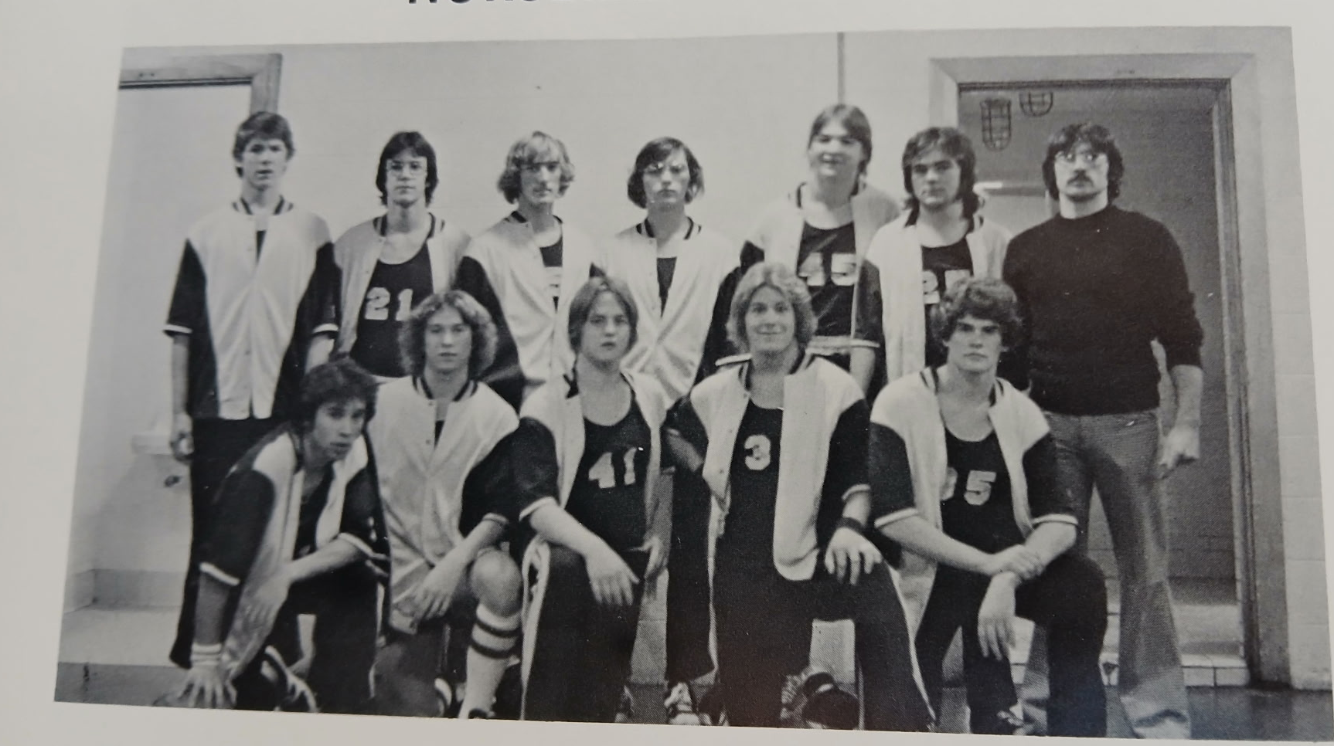

The NORSEMEN of 1975-76

Front row L-R: Jeff Guy, D. DeKuiper, Scott Garvey, Scott Wickland, Mike Hekkema.
Back Row L-R: Parker Cooper, Chris Morgan, Randy Breen, B. Boyd, Terry Lough, Joe Sheehan, Coach Rande Horn

1976-77 Coach Rande Horn 0-20 overall, Shelby champs)

NM would experience their only winless season in 90 years of Norse basketball. It was such a bad season for NM that in only three of their 20 games did the Norse come within ten points from an opponent. The young Norsemen took the road in an early start to the 1976-77 season and fell 11 points short in a 55-44 loss at Pentwater. Dan Dekker got 11 points while sophomore Bruce Baty tallied nine points and a game high 10 rebounds. Mike Hekkema and Mike Hogan added eight points and Mark Zettell six to complete NM’s scoring.
Shelby continued their dominance over the Norsemen as they won their sixth straight game over NM by a margin of 25 or more points with a resounding 72-29 win over NM. The Norse were outscored badly in every quarter with Dan Dekker, the high point man for NM with a modest 9 points.
It might have been a typo, but perhaps not, when NM head coach Rande Horn was quoted in the game report in NM’s 87-47 loss to Mason County Central that the Norsemen committed 57 turnovers. Mason County bombed NM with 34 first quarter points by using an early press. Dan Dekker scored 13 and Bruce Baty 11 for NM.
The 42-40 loss to Montague would prove to be the closest NM would come for a victory during the long season. The game was tied with one minute remaining before Montague put in a last second rebound off a missed shot to come away with the win in a low-scoring affair. Bruce Baty’s 13 points were high for the Norsemen with Dan Dekker adding 11 and Brad Coon nine.
Although they lost the game, NM’s sophomore Bruce Baty displayed his potential as he poured in 29 points in NM’s 84-68 loss to Hart. NM fell behind 40-25 at the half but did play the Pirates even in the second half to give NM at least a glimmer of hope. Dan Dekker had 12 and Brad Coon eight.
The score was dead even with about three minutes to play in NM’s next game with Ravenna. The Bulldogs, with some hot shooting from my future broadcast partner in later years, Joe Coletta, went on a 15-1 run to discard any Norsemen’s thoughts they were going to win a ball game. Bruce Baty was stellar in the loss with 19 points and 8 rebounds. Brad Coon followed up with a dozen points and Dan Dekker reached double figures with 10.
Victory again eluded NM although they did keep the score close in a non-league 69-60 loss to Newaygo. Playing mostly juniors and sophomores NM was only able to shoot a dismal 20 percent for the game. Bruce Baty once again handled the bulk of the scoring chores for the Norse with 19 points with junior Mike Hogan adding 10.
There would be no upset of Whitehall in 1977 after NM spun a surprise on the Vikings a year earlier. A pressing Whitehall press frustrated the Norse and turnovers led to easy baskets for the Vikings as they continued their home court dominance over the Norse with a 76-49 victory. Sophomore Bruce Baty was again the star of the show for the losing Norsemen with 22 points followed by Dan Dekker with 10.
Oakridge forced NM to once again commit too many turnovers as the Eagles cruised to a 69-51 victory. Only a NM 26-13 run mainly against Oakridge subs kept the game reasonable as NM continues to struggle. Bruce Baty, who has averaged more than 20 points per game over his last five games, led the Norse with 21.
After losing by more than 40 points in their first meeting, the Norse did show some improvement in their second meeting with Shelby as they lost by ‘only’ 20--- 77-57. Once again turnovers are a big problem for NM as they committed 25 miscues. Bruce Baty led NM with 17 markers, the only Norsemen in double figures. Shelby, for the second consecutive year, would not only win the WMC, but would again be district and regional champs.
Kent City used their fast break and pressing defense to rout the Norse 80-48 on the Norsemen’s home floor. No report was given on point getters for NM.
Expectations were high as NM eagerly anticipated their next game with Montague; a team NM lost to by a mere two points earlier in the season. Those hopes faded quickly when the Norse missed 12 of their first 13 shot attempts and were outscored in every quarter by a Montague team that had only won three games on the season, with two of those wins coming at the expense of the winless Norsemen. Bruce Baty and Dan Dekker shared scoring honors for NM with 11 points.
NM led at the end of the first quarter, but it was all Holton from that point on as Holton made it an unlucky 13 losses on the season following an 80-56 loss to the Red Devils. Bruce Baty had 15 and Mike Hekkema 11 for the 0-13 Norsemen.
‘Old Man Winter’ likely saved North Muskegon from another loss as their game at Scottville with Mason County Central was cancelled due to blizzard conditions. With wind chill temps at minus -41 degrees, and heavy snow, all sporting events for the entire weekend were cancelled in the Muskegon area that was experiencing one of its coldest winters in history.
Hart added to NM’s misery with a resounding 84-48 victory over the Norse as NM was only able to make 6 of 16 free throws. Mike Hogan was the only Norsemen in double figures with 10 with point guard Jim Kueny just behind Hogan with nine. Mike Hekkema had 8 points while Bruce Baty was held to 7.
Future NFL star defensive back Robert Jackson scored 28 points in Allendale’s 86-54 win over NM in a game that was rescheduled from Tuesday to Saturday due to the inclement weather conditions that created havoc in the winter of 1977. Dan Norris worked his way into the NM rotation and led Norse scorers with 15 points with Bruce Baty and Mike Hekkema adding 11 each.
The sophomore dominated Norsemen fell to Ravenna 78-57 as hopes for at least one win on the season became dimmer and dimmer. Bruce Baty led NM with 14 with Jim Kueny adding 11 in the NM lost cause.
The Norse just couldn’t stand prosperity as they saw a seven-point halftime lead quickly dissipate when they could only score five third period points and were then outscored by 11 in the final period in a 59-53 loss to Holton. Bruce Baty tallied 19 for NM with Jim Kueny netting 10.
NM scored a season high 80 points but also gave up a season high 102 as they dropped their 18th straight contest of the season to Oakridge 102-80. Bruce Baty scored 17 for NM while a sophomore teammate making his first appearance in an NM varsity uniform, John Nedeau, added 12.
NM’s hopes for at least winning one single game vanished as Allendale thumped the hapless Norsemen 78-46. Robert Jackson led the way for Allendale with 22 points, but no Norsemen scorers were mentioned in the report to the Muskegon Chronicle.
The 1976-77 season came to a merciful end for NM as there was no March Madness for the Norsemen. In fact, they never played in March as they lost their 71-50 playoff game to Grant on February 28. It would be the first game played between the two teams since the 1947-48 season and to this date they have never met since the 1977 playoff game. NM finished the season at 0-20 and it could have been worse. A game scheduled with Mason County during mid-season was cancelled due to bad weather and never made up. Probably a good thing as NM had lost earlier to the Spartans by 41 points.
Rande Horn would be replaced as NM’s head coach after posting a 9-51 record in his three seasons by John Wolfe. Bruce Baty was selected to the 10-member all-WMC team where it was reported the 6’4 sophomore averaged 16 points and 10 rebounds per game. The new NM coach was hopeful that the experience gained by the very young NM team that started three sophomores would pay off in a few victories for NM the following season. The Norsemen would win more than a ‘few’ games, much more!

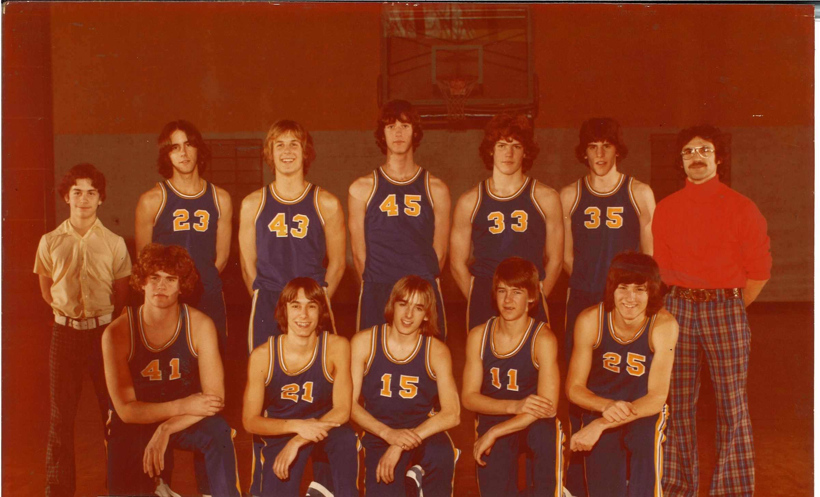

The NORSEMEN OF 1976-77

Front Row L-R: Mike Hekkema, Jim Kolbe, Jim Kueny, John Nedeau, Brad Coon
Standing L-R: Jeff Cordo, Mark Zettell, Dan Norris, Bruce Baty, Pat Bowen, Mike Hogan
Coach: Randy Horn

N Muskegon 44 Pentwater 55 Dan Dekker 11, Bruce Baty 9
N Muskegon 29 Shelby 72 Dekker 9
N Muskegon 46 Mason Co 87 Dekker 13, Baty 11
N Muskegon 40 Montague 42 Baty 13, Dekker 11, Brad Coon 9
N Muskegon 68 Hart 84 Baty 29, Dekker 12, Coon 8
N Muskegon 52 Ravenna 64 Baty 19, Coon 12, Dekker 10
N Muskegon 60 Newaygo 69 Baty 19, Mike Hogan 10
N Muskegon 49 Whitehall 76 Baty 22, Dekker 10
N Muskegon 51 Oakridge 69 Baty 21
N Muskegon 57 Shelby 77 Baty 17, Hekkema, Dekker & Mark Zettell 8
N Muskegon 48 Kent City 80 No scorers mentioned for NM
N Muskegon39 Montague 65 Baty & Dekker 11, Mike Hekkema 9
N Muskegon 56 Holton 80 Baty 15, Hekkema 11, Dekker 9, Coon 8
N Muskegon Mason Co Cancelled
N Muskegon 48 Hart 84 Hogan, 10, Jim Kueny 9
N Muskegon 65 Allendale 84 Dan Norris, 15, Baty & Hekkema 11
N Muskegon 57 Ravenna 78 Baty 14, Kueny 11, Hekkema 9
N Muskegon 53 Holton 59 Baty 19, Kueny 10, Hekkema 7
N Muskegon 80 Oakridge 102 Baty 17, John Nedeau 12
N Muskegon 46 Allendale 78 No NM scorers reported
N Muskegon*50 Grant 71 Baty 14, Hekkema 12, Pat Bowen 8

1977-78 (Coach John Wolfe, 13-7 overall, Shelby WMC Champs)

There was only one way to go for North Muskegon’s basketball team in 1977-78, and that was to go up. However, not many would realize how far up this still young NM team would go in the upcoming season. John Wolfe, an Indiana native with a keen basketball mind, took over the head coaching duties after NM had suffered through three bad seasons. Bruce Baty, a 6’4 sophomore, an all-conference performer would headline the returnees for coach Wolfe. One weakness for NM from their winless season was the lack of a skilled point guard. That weakness would turn into a strength with the play of 5’9 junior guard John Nedeau. Another big weapon at Wolfe’s disposal would come from a freshman, 6’3 Jeff Cooke. A valuable performer on the football team Cooke would not only be NM’s leading rebounder, but the leading rebounder in the entire West Michigan Conference --- As a freshman! Junior Pat Bowen and Brad Billinghurst returned as did a couple of guys who saw extensive action the previous season in Brad Coon and Dan Norris.
Before a large crowd at the northside gymnasium, the first few minutes of the opener had to give Norse fans thoughts that it would be more of the same as NM trailed Pentwater 12-4 early in the first game of the season. NM then picked up the pressure in the second quarter and took over the game with some outstanding play from point guard John Nedeau and Bruce Baty. With Baty (19) and Nedeau (14) and the young Jeff Cooke adding 10 points as well as controlling the rebounds, NM defeated Pentwater 60-52 to finally quell at 28 games the longest losing streak in NM history.
Even in a loss the Norse showed early on that this was not going to be an easy win for their opponent. NM trailed Shelby by only two points late in the game only to see Shelby pull away when NM intentionally fouled the Tigers late in the game. The 3-time WMC champions and 2-time regional champs had too much height for the Norse and came away with a 57-48 victory over NM. Bruce Baty had 14 and Dave Billinghurst had 10 points to lead the Norse.
A slow first half and the inability to shoot a high percentage from the field, a trait not uncommon over the years when NM traveled to Scottville, led to Mason County Central edging the Norse 41-39 in what would prove to be the lowest scoring output of the season for NM, and their opponent. Bruce Baty had 10 points while John Nedeau and Brad Coon had nine for the Norse with Jeff Cooke leading all NM rebounders with nine. The Norse would go to 0-2 in the WMC but that would quickly change.
Freshman Jeff Cooke had his first double-double of his career to lead NM to a 52-46 win over Montague. Cooke had 10 points and led all rebounders with 14. Bruce Baty had 14 before fouling out late in the game while Pat Bowen and Brad Coon each chipped in with nine points as NM wins their first WMC game since defeating Montague in the 1976-77 season.
NM then ran into a hot shooter from Kent City named Brian Summers who scored 31 points and was so sizzling hot he made his last 12 shots in a row as the Eagles downed the Norse 83-68 on the Kent City home court. Jeff Cooke had 19 points and eight rebounds to lead the Norse while Bruce Baty had 18 and Pat Bowen 10 for NM.
North Muskegon trailed by as many as 19 points in a road game at Ravenna before rallying to overhaul Ravenna and earn a 62-51 victory over veteran coach Gene Gifford’s Bulldogs. After trailing Ravenna 21-10 after the first quarter, NM would outscore the Bulldogs 52-30 the rest of the way. Bruce Baty had a season high 21 points, with Brad Coon adding 15 and John Nedeau 10 to even NM’s WMC record at 2-2.
NM would finally attain a winning record following a 71-63 win against Whitehall. NM connected on 25 -36 free throws in the foul marred battle with the Vikings. Jeff Cooke poured in 23 points; the most points ever tallied by a NM freshman in a single game to lead the Norse. Bruce Baty added 18 and John Nedeau 12 as the Norse moved above the .500 mark for the first time in four years.
NM would head into the Holiday break with a winning record after defeating Grand Rapids St. Joseph Seminary 66-54 in the only game played between the two teams in program history. Point guard John Nedeau continued his fine play with 18 points while his buddy Bruce Baty added 15. Jeff Cooke controlled the backboards with 16 caroms while Brad Coon added 13 points as the Norse would go into the 1978 new year with a 5-3 record.
NM received terrific games from their two big men, 6-3 freshman Jeff Cooke and 6’4 junior Bruce Baty in NM’s 77-67 victory over Oakridge. The duo combined for 46 points (Baty 26 and Cooke 20) and controlled the boards as Cooke pulled down 15 and Baty 12. John Nedeau directed the offense and contributed 10 points for NM as they won their sixth straight contest.
It was no disgrace for NM to lose a game by ten points to the 3-time defending WMC champion and the state’s top-rated team in Class C in the Shelby Tigers. Shelby’s 6-7 Dave Kuipers, 6’4 Paul Huffman and 6’3 Brian Beckman were too much for the visiting Norsemen. NM took a 17-14 lead at the end of the first quarter only to see the Tigers outscore NM 17-10 in the second quarter and never looked back as Jim Tate’s Tigers stayed undefeated on the season. The game was postponed from Tuesday to the next night due to heavy snow, just a prelude to what mother nature would have in store for the Muskegon area in just a few days. Bruce Baty topped NM scorers with 20 while Brad Coon with 12 and John Nedeau with 10 were also in double figures.
From the basement of the WMC to second place in one year could the Norsemen boast after their 70-61 victory at Montague. Freshman Jeff Cooke netted 23 points and a game high 11 rebounds, a mark nearly matched by his teammate Baty who banged in 19 points and grabbed 12 rebounds.
In the first of three games played between Hart and North Muskegon, the biggest margin of victory in the three games would be just a two-point difference. It was a one-point difference in their first matchup, a game originally scheduled in December but cancelled due to a snowstorm. That December snowstorm would seem like a day in the tropics with what would lay ahead for Muskegon and the entire state of Michigan the next week. NM needed a career high 31 points by Bruce Baty to defeat Hart 57-56 as the Norse improved to 8-4 overall on the season.
Brad Coon sank a 14-footer with just one second left to give NM a dramatic 56-55 win over Mason County Central. Earlier the Spartans had handed NM a 2-point loss. The win gave NM undisputed possession of second place in the WMC behind undefeated Shelby. NM received balanced scoring in the thriller played on the northside court with John Nedeau scoring 13, Bruce Baty and Pat Bowen, 12, Jeff Cooke 9 and Coon with a modest 6 but two of those points turned into the game winner.
The Norsemen were schedule to play Hart on Friday January 27, 1978. The mightiest blizzard in Greater Muskegon history had shut off everything; schools, sports, and even the Muskegon Chronicle did not publish as Code Red was applied to the area, meaning all automobiles were not permitted access to the roads. Every sporting event in the entire state of Michigan was cancelled. The only business open in North Muskegon was the World-Famous Bear Lake Tavern. The fabled BLT did a record business despite the fact there wasn’t one car in the lot. All the patrons came via snowmobiles or just walked to escape cabin fever.
Even though schools remained closed through the following Tuesday on January 31, NM made the journey to Newaygo to play a Newaygo team who would sport an impressive 11-3 record after edging the Norse 49-45. It was the 8th win in a row for Newaygo while NM would slip to a still impressive 9-5 record after the loss. Bruce Baty scored 20 of NM’s 45 points in the losing Norse with Brad Coon close behind with 16.
The Norsemen got back on the winning path as freshman Jeff Cooke had an 18 & 18; 18 points and 18 rebounds as NM defeated Ravenna 71-51. Bruce Baty was also a strength on the backboards as the junior pulled down 14 rebounds to go with his 16 points. Junior point guard John Nedeau had his usual steady game with 17 points and Brad Coon reached double figures with 12.
Bruce Baty drilled a mid-range jumper with five seconds showing on the clock as NM won their second game in six tries against Allendale 62-61. The game winner was good for two of his game high 21 points for Baty. Jeff Cooke and Brad Coon each had 11 and John Nedeau 10. Cooke again was a tower of strength on the backboards with 16 rebounds.
Bruce Baty’s 29 points with many of his points coming off Jeff Cooke rebounds and John Nedeau passes led to a 72-49 romp over Holton. Cooke had another big day on the boards with 16 rebounds and 12 points as NM improved to 12-5, making that 0-20 record from a year ago look like a distant past.
With Bruce Baty and Jeff Cooke sitting many minutes in the second half with foul troubles, point guard John Nedeau took up the slack and scored a season high 24 points as NM defeated Oakridge 66-58. The victory clinched second place in the WMC, a huge step up from their sitting all alone in the basement the previous season. Baty managed to supply 13 points in his limited minutes while Cooke had 12 and his usual bushel basket full of rebounds with 16.
Bruce Baty went out with a back injury early in the first half as Hart defeated NM 66-64 in overtime. Overtime games with Hart were not kind to Norse in their long history with the Pirates as NM lost all four games that went into the extra session with the Pirates. NM was just a second away from walking away with a big win over the Pirates, but Hart’s Mike Bursley was fouled snaring a rebound and made one of his two free throws that forced overtime. Jeff Cooke and John Nedeau each netted 20 points for NM.
NM traveled to White Cloud for their final game of the regular season, the first meeting between the two teams since 1935. Playing without their leading scorer Bruce Baty, NM gave a White Cloud team with a solid 15-4 record all they could handle before losing 57-51. Jeff Cooke had 18 points and 13 rebounds for the Norsemen while John Nedeau had 16 and Brad Coon 12.
Once again there would be no March Madness for the Norsemen. And more importantly there would be no Jeff Cooke, out with the first of his many future knee injuries, and a less than healthy Bruce Baty as Hart ended North Muskegon’s season with a 52-50 win. The district tournament was played on the Pirates home floor which didn’t help the visiting Norsemen.
Following the end of the 1977-78 season three Norsemen were selected to the WMC All-Conference team, with all three being underclassmen including one freshman. Juniors Bruce Baty and John Nedeau were joined on the select team along with freshman Jeff Cooke. Shelby, who reached the state quarterfinals for three straight years only to lose each year to the eventual 1978 state champs from Buchannan, also had three on the first 10 listed. Nedeau was the floor general for NM while Baty scored 349 points in 20 games and surely would have scored more if not for an injury early into the 19th game of the season with Hart. As for Cooke, he was second in scoring on the team to Baty and was the leading rebounder, not for just the Norse, but the entire conference with 233 rebounds in 20 games. Cooke has etched his name in NM history as one of their program’s finest as a coach and an AD but if not for several serious knee injuries one can only imagine on what his athletic career at NMHS would have been if he had been fully healthy as a student athlete.

N Muskegon 60 Pentwater 52 Bruce Baty 19, John Nedeau 14, Jeff Cooke 10
N Muskegon 48 Shelby 57 Baty 14, Brad Billinghurst 10
N Muskegon 39 Mason Co 41 Baty 10, Nedeau & Coon 9
N Muskegon 52 Montague 46 Baty 14, Cooke 10 points & 14 rebounds
N Muskegon 68 Kent City 83 Cooke 19, Baty 18, Pat Bowen 10
N Muskegon 62 Ravenna 51 Baty 21, Coon 15, Nedeau 10.
N Muskegon 71 Whitehall 63 Cooke 23, Baty 18, Nedeau 12
N Muskegon 66 St Joe Sem. 54 Nedeau 18, Baty 15, Coon 13, Cooke 16 reb.
N Muskegon 77 Oakridge 67 Baty 26, Cooke 20 & 16 reb, Nedeau 10
N Muskegon 55 Shelby 65 Baty 20, Coon 12, Nedeau 10
N Muskegon 70 Montague 61 Cooke 22, Baty 18, Coon 12
N Muskegon 57 Hart 56 Baty 31, Nedeau 12, Cooke 9
N Muskegon 56 Mason Co 55 Nedeau 13, Baty & Bowen 12
N Muskegon 45 Newaygo 49 Baty 20, Coon 16
N Muskegon 71 Ravenna 51 Cooke 18 & 18, Nedeau 17, Baty 16, Coon 12
N Muskegon 62 Allendale 61 Baty 21, Cooke & Coon 11, Nedeau 10
N Muskegon 72 Holton 49 Baty 29, Cooke 12 points & 16 rebounds
N Muskegon 66 Oakridge 58 Nedeau 24, Baty 13, Cooke 12
N Muskegon 62 Hart (ot) 64 Cooke & Nedeau 20, Billinghurst 8, Baty 6
N Muskegon 51 White Cloud 57 Cooke 18, Nedeau 16, Coon 12
N Muskegon*50 Hart 52 Nedeau 12, Coon 11, Baty 6

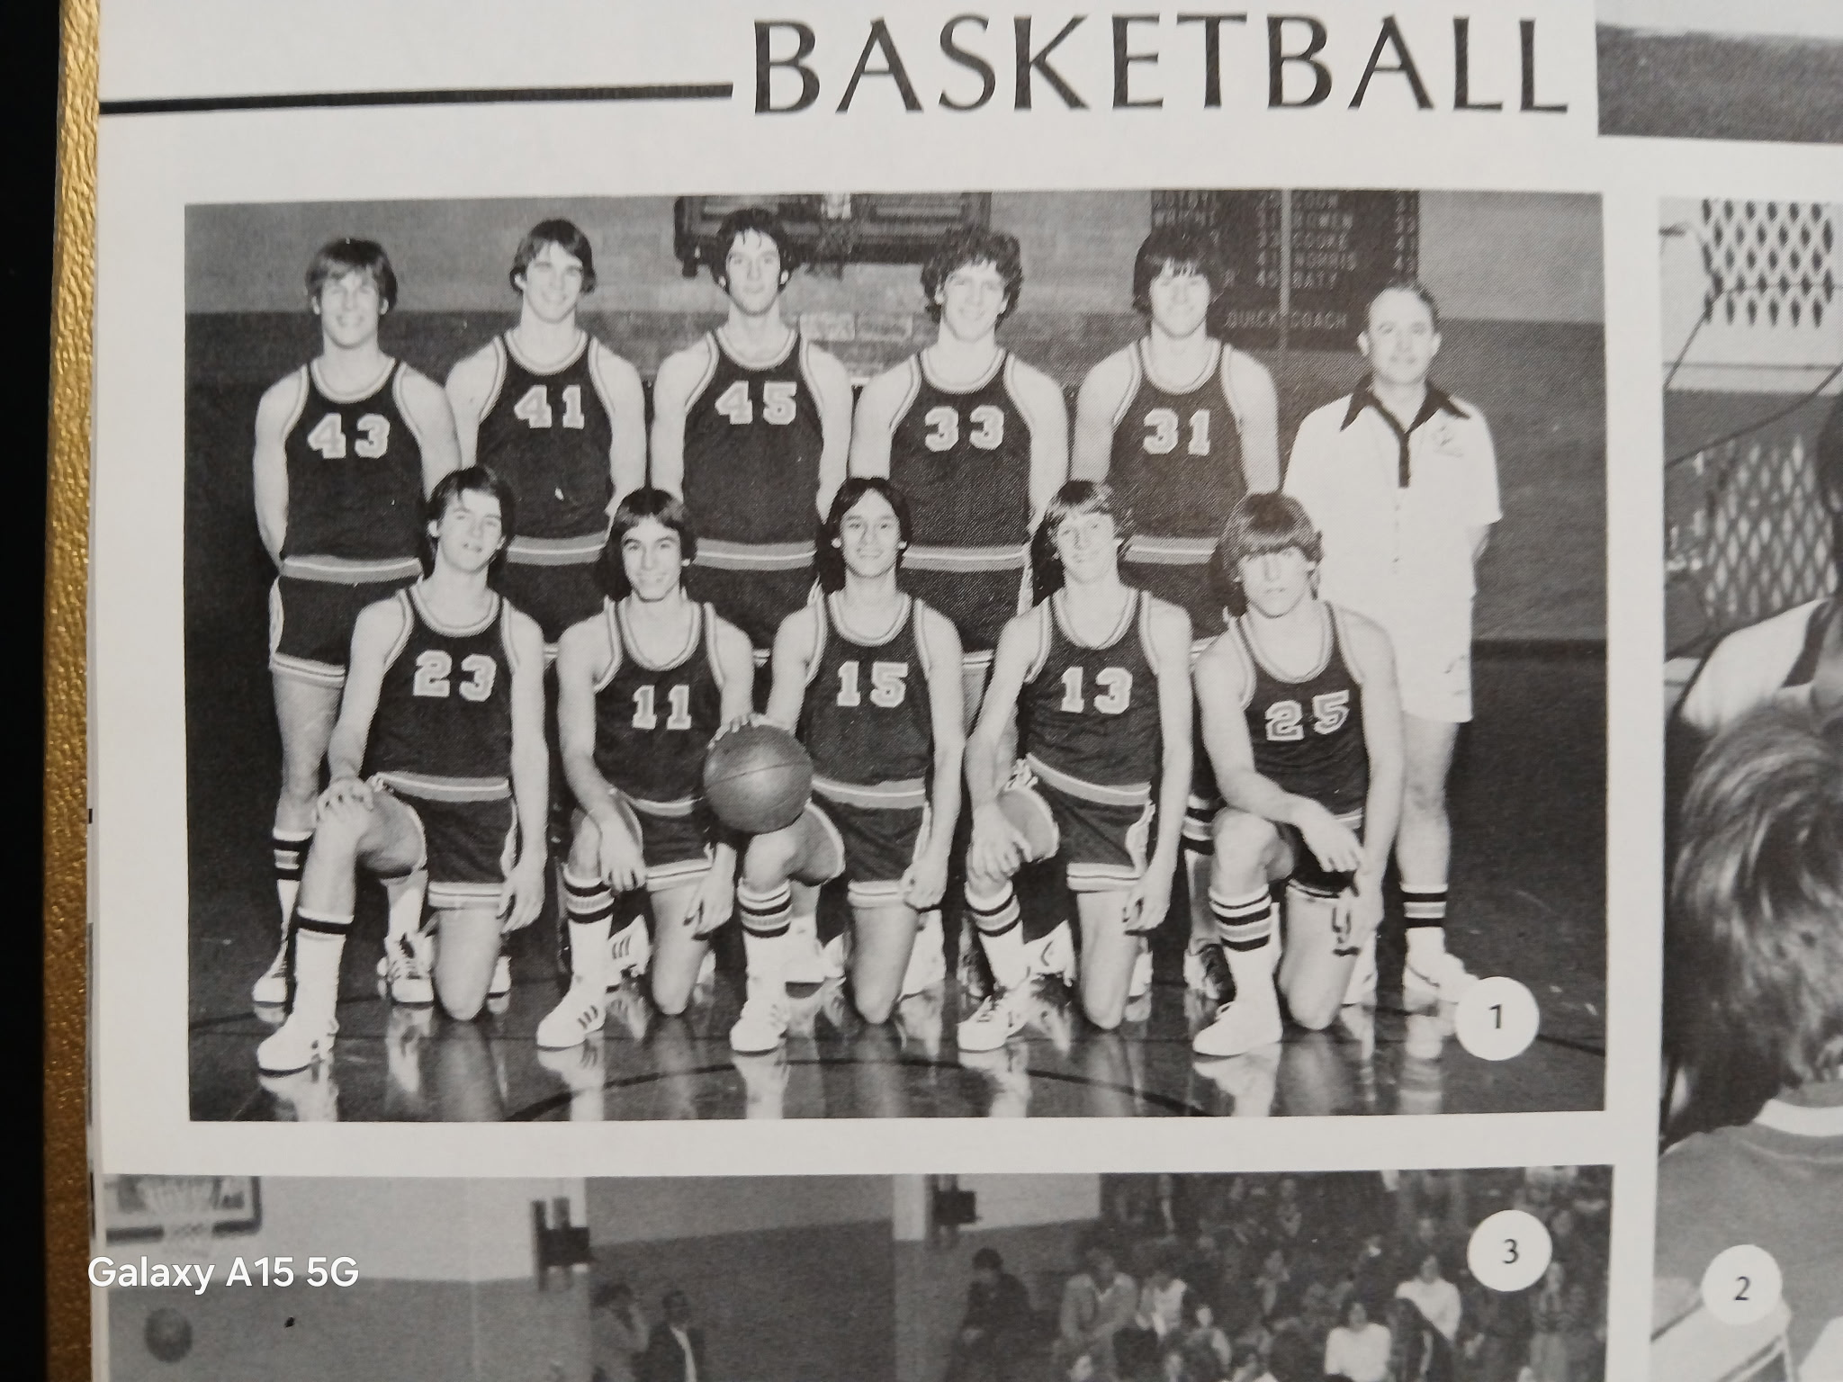

The 1977-78 NORSEMEN

Top Row L-R: Dan Norris Jeff Cooke, Bruce Baty, Pat Bowen, Brad Coon, Coach John Wolfe
Bottom Row: John Nedeau, Jim Kolbe, Jeff Kolbe, Brad Billinghurst, Phil Andrie

1978-79 (Coach John Wolfe, 16-6 overall, NM WMC Champs)

NM was picked as the pre-season favorite to dethrone four-time champion Shelby as the West Michigan Conference Champions, and for good reason. NM finished second to Shelby in last season’s WMC race and return virtually their entire team. Three of the returnees were first team All-WMC in Bruce Baty, point guard John Nedeau and 6’4 sophomore center Jeff Cooke. NM returns all five starters as Brad Coon and Pat Bowen all will be in the starting five for second year head coach John Wolfe. However, NM will have to start the season without Cooke, who suffered a freak knee injury at a summer football camp. Wolfe was hopeful of having Cooke, the leading rebounder as a freshman in the WMC and who averaged 11 points per game, would return by the Holiday break.
NM made those who predicted a WMC title for the Norse look good as NM opened their season with a 92-72 win over Mason County Central. The 92 points scored by the Norse still stands today as the most points ever scored by NM over the lads from Scottville. Bruce Baty led the Norse offensive onslaught with 25 points. John Nedeau had a double-double with 10 points and 10 assists. Brad Billinghurst and Bruce Jones were also in double figures with 10 and 12 points respectively.
NM in their second game scored less than half of the points they tallied in their first game as they lost to Montague 50-45. Perhaps the Montague boys were mad that their girls team lost to the NM gals in the district finals a week earlier. Only Bruce Baty of the Norse was able to get in double figures with his 15 game leading points.
John Nedeau scored a career high 31 points, had six assists and four steals to lead the Norse to a 72-60 win over Kent City. NM trailed by one at halftime before coming alive in the second half. Bruce Baty scored 16 points and had 12 rebounds and four steals for NM as the Norse moved to 2-1 early in the season.
It was now Bruce Baty’s turn to score 31 points as he led NM to a 73-58 victory over Hart. The game made amends for Baty who played hurt when Hart knocked NM out of the playoffs last year. John Nedeau played his usual fine floor game and chipped in with 15 points.
With Bruce Baty and Bruce Jones sitting on the bench for much of the game with foul troubles, guard John Nedeau and Brad Billinghurst took charge leading NM to a 75-54 road win at Ravenna. NM put the game away with a 27 -14 edge in the third quarter. NM’s pressing defense forced Gene Gifford’s Bulldogs into committing 38 turnovers in the game.
NM broke up the Holiday break by playing in a four-team tournament at Hesperia. While millions of people were at home watching Ohio State coach Woody Hayes throw a punch at a Clemson football player that would end the legendary Buckeye coaches’ career, NM was defeating Pentwater 52-42. Bruce Baty was back in form with 22 while no other Norse player had more than four points. However, ten NM players did score in the contest. NM returned to Hesperia the following night and defeated the hosts 56-50 as Baty had 17 points and 10 rebounds while Brad Coon added 14 as NM ended 1978 with a fine 6-1 record.
West Michigan Christian, a team that would advance to the Class D championship game in March in Ann Arbor, stopped the NM winning streak at five with a 77-65 victory over the Norsemen. WMC’s Dave Doorn scored 27 points, many on rim-rattling dunks to lead the Warriors who were playing their last season under legendary coach Elmer Walcott. The good news for the Norse was the first appearance of the season for 6’4 center Jeff Cooke. Cooke had his right leg bandaged from thigh to ankle to give support to his injured knee. John Nedeau paced NM in scoring with 19 points while Brad Coon and Bruce Jones had 12. In addition to his 27 points, the Warriors Doorn did an outstanding job in defending NM’s high scoring Bruce Baty. Baty was limited to six points for the game, far below his average.
NM displayed balanced scoring in their 86-62 win in WMC conference play against a winless Oakridge team. John Nedeau had 18, Bruce Baty 14, Brad Coon 11 and Tom Wright 10 while Jeff Cooke, playing with a heavy brace that surely slowed him down, added nine as NM resumed their winning ways and were now 4-1in the WMC.
How the mighty have fallen. After winning four consecutive WMC titles and three regional titles, Shelby was pummeled by NM 77-48 as the Norsemen broke a nine-game losing streak vs. Shelby. Bruce Baty had 18, Brad Coon 16, and John Nedeau 10 while Jeff Cooke gutted his way to score eight points and pull down 7 rebounds.
NM made the long trip to Scottville driving through the snow-covered roads worthwhile as the Norse nipped Mason County Central 69-65. With Jeff Cooke sitting out to rest his ailing knee, the Spartans controlled the backboards, but the Norse had just enough fire power to post a victory. Brad Coon had a career high 23 points to lead the Norse balanced attack. Bruce Baty had 15, Brad Billinghurst 11, Bruce Jones 10, and John Nedeau 8 as NM stayed on top of the WMC.
NM won their 13th straight game on their home court with a 62-54 victory over Orchard View. The Norse moved to 10-2 on the season with the win as Bruce Baty had 19 points and Brad Coon 14. John Nedeau had nine points and the leading assist man in the WMC had six assists. On an ominous note, Jeff Cooke was only able to play limited minutes on his ailing knee.
NM atoned for their only loss to Montague to pad their lead in the West Michigan Conference with a 77-58 victory over Montague. Bruce Baty poured in 26 points while pulling down 11 rebounds. A 25-point fourth quarter put NM in the win column. A hobbled Jeff Cooke helped Baty on the boards with 10 rebounds while Brad Coon and Brad Billinghurst added 10 points.
In a battle of league leaders NM snapped a long Newaygo winning streak with a 63-51 victory. NM won the battle of the boards with an ailing Jeff Cooke grabbing 13 boards. Bruce Baty, Bruce Jones and Brad Coon each grabbed eight rebounds as NM improved their record to 12-2. Playing virtually on one leg Cooke also had a season best 13 points, just behind Bruce Baty’s leading NM total of 17. Bruce Jones also tallied 13 for the Norse who won despite John Nedeau missing the game due to illness.
The Norse were stunned on their home court as Hart pulled off the 70-61 upset to hand NM their 3rd loss and 2nd in conference play. A big fourth quarter won for Hart as NM cooled off after a good start in the game’s opening quarter. Bruce Baty and Brad Coon each had 15 in a losing cause while Jeff Cooke had a dozen points as NM lead’s lead in the WMC was whittled down to a one game edge.
That edge almost dissipated as NM struggled to a 54-52 victory over a Ravenna team they had defeated earlier in the season by over 20 points. NM had to overcome a big deficit as they went on a 12-2 run to close out the game with a victory. NM played without Bruce Baty who was out with an illness. John Nedeau and Brad Billinghurst led NM scorers with 15 points while Jeff Cooke added 9 points and 16 rebounds to keep the Norsemen at the top of the standings in the WMC.
With Bruce Baty still suffering from the flu Jeff Cooke took up for the loss of Baty and scored a career high 27 points and pulled down 10 rebounds. However, that wasn’t enough as Whitehall continued their home court mastery over NM with a 68-65 victory of the Norsemen.
North Muskegon lost more than a game in their 73-57 defeat at the hands of neighboring Reeths Puffer. With 5:31 to go in the fourth quarter the once energetic crowd turned suddenly to stone silence as NM’s sophomore center Jeff Cooke laid in agonizing pain on the floor after reinjuring his knee. Situated high above the court broadcasting the game I could hear the break from our catbird seat at the old Rocket gymnasium. Reeths Puffer’s Sam Hughes, whose father with the same name was a state champion in track as well as an outstanding basketball player at North Muskegon in the late 1950’s, led RP with 22 points. John Nedeau had 14 and Bruce Baty 12 in the losing cause.
NM then used a big first quarter to earn a share of the WMC with an 85-63 win over an overmatched Oakridge team. NM put the game away early with a 31-8 lead after the games first quarter was in the books. John Nedeau and Bruce Baty each had 14 points for the victors with ten Norsemen getting into the scoring column.
Bruce Baty became the first NM player in program history to score 1000 points as NM clinched the outright WMC title with am 88-64 win over Shelby. Baty netted 23 points and picked off 13 rebounds. With Jeff Cooke out and Bruce Jones at home with an illness NM needed production from their reserves. All state football linebacker Scott Cooper responded with a career high 14 points and Tom Wright added 11 as NM finished the regular season 15-5 and regular season champs.
The injury and flu riddled Norsemen had enough horses to defeat Hart 82-64 in the first round of the Class C district tournament held in Shelby. Bruce Baty netted 22 while the Norseman received season highs from reserves Mark Boukamp and Bob Pickle who each came through with a dozen points. Point guard John Nedeau had several assists and chipped in with 12 points for the 16-5 Norsemen.
Injuries and illnesses finally caught up with the Norsemen as they were eliminated from the playoffs after a 56-53 loss to Montague. With Jeff Cooke out for the season, and Bruce Jones as well with mononucleosis, a third starter and orchestra conductor of NM’s offense, John Nedeau had been slowed by a virus in recent games. Nedeau didn’t even start but volunteered his services when NM fell behind the Wildcats, who split the season series with NM and were hammered 77-58 by NM in an earlier meeting. “We needed our experienced big guys to help on the boards. If we could have rested Bruce Baty it would have helped but we couldn’t do it,” said Norse coach John Wolfe after the game. A less than healthy Nedeau scored 16 points, just shy of Baty’s 18 with Bob Pickel coming off the bench to contribute 10 as NM’s season ended with a 16-6 record, the most wins in program history.
Head coach John Wolfe lamented late in the season that NM never once was at full strength for a single game. Although NM won a program record at the time 16 games, one must wonder how many games and how far could NM have advanced in the playoffs with five healthy starters. Baty and Nedeau once again were selected to the WMC All-Conference team. Baty would finish with 1042 career points, the first NM player to reach the 1000-point mark while Nedeau led the Norse and the entire WMC in assists with 102.

N Muskegon 92 Mason Co 72 Bruce Baty 25, Brad Billinghurst 12, John Nedeau 10
N Muskegon 45 Montague 50 Baty 15
N Muskegon 72 Kent City 60 Nedeau 31, Baty 16
N Muskegon 73 Hart 58 Baty 31, Nedeau 15
N Muskegon 75 Ravenna 54 Nedeau 22, Brad Billinghurst 18, Baty 4
N Muskegon 54 Pentwater 42 Baty 22
N Muskegon 56 Hesperia 50 Baty 17, Brad Coon 14
N Muskegon 65 WMC 77 Nedeau 19, Coon and Bruce Jones 12
N Muskegon 86 Oakridge 62 Nedeau 18, Baty 14, Coon 11, Tom Wright 10
N Muskegon 77 Shelby 48 Baty 18, Coon 16, Nedeau 10, Cooke 8
N Muskegon 69 Mason Co 65 Coon 23, Baty 15, Billinghurst 11, Jones 10
N Muskegon 62 Orchard View 54 Baty 19, Coon 14
N Muskegon 77 Montague 58 Baty 26, Coon & Billinghurst 10, Win 400
N Muskegon 63 Newaygo 51 Baty 17, Jones 13& Cooke 13, Coon 11
N Muskegon 61 Hart 70 Baty & Coon 15, Cooke 12
N Muskegon 54 Ravenna 52 Nedeau & Billinghurst 15, Cooke & Coon 9
N Muskegon 65 Whitehall 68 Cooke 27 points, Coon 18, Nedeau 8
N Muskegon 57 Reeths Puffer 73 Nedeau 14, Baty 12, Jeff Cooke injured
N Muskegon 85 Oakridge 63 Baty & Nedeau 14, Scott Cooper 12, Coon 11
N Muskegon 88 Shelby 64 Baty 23, Cooper 14, Wright 11
N Muskegon*82 Hart 64 Baty 21, Nedeau 14, Boukamp & Pickle 12
N Muskegon* 53 Montague 56 Baty 18, Nedeau 16, Bob Pickle 10

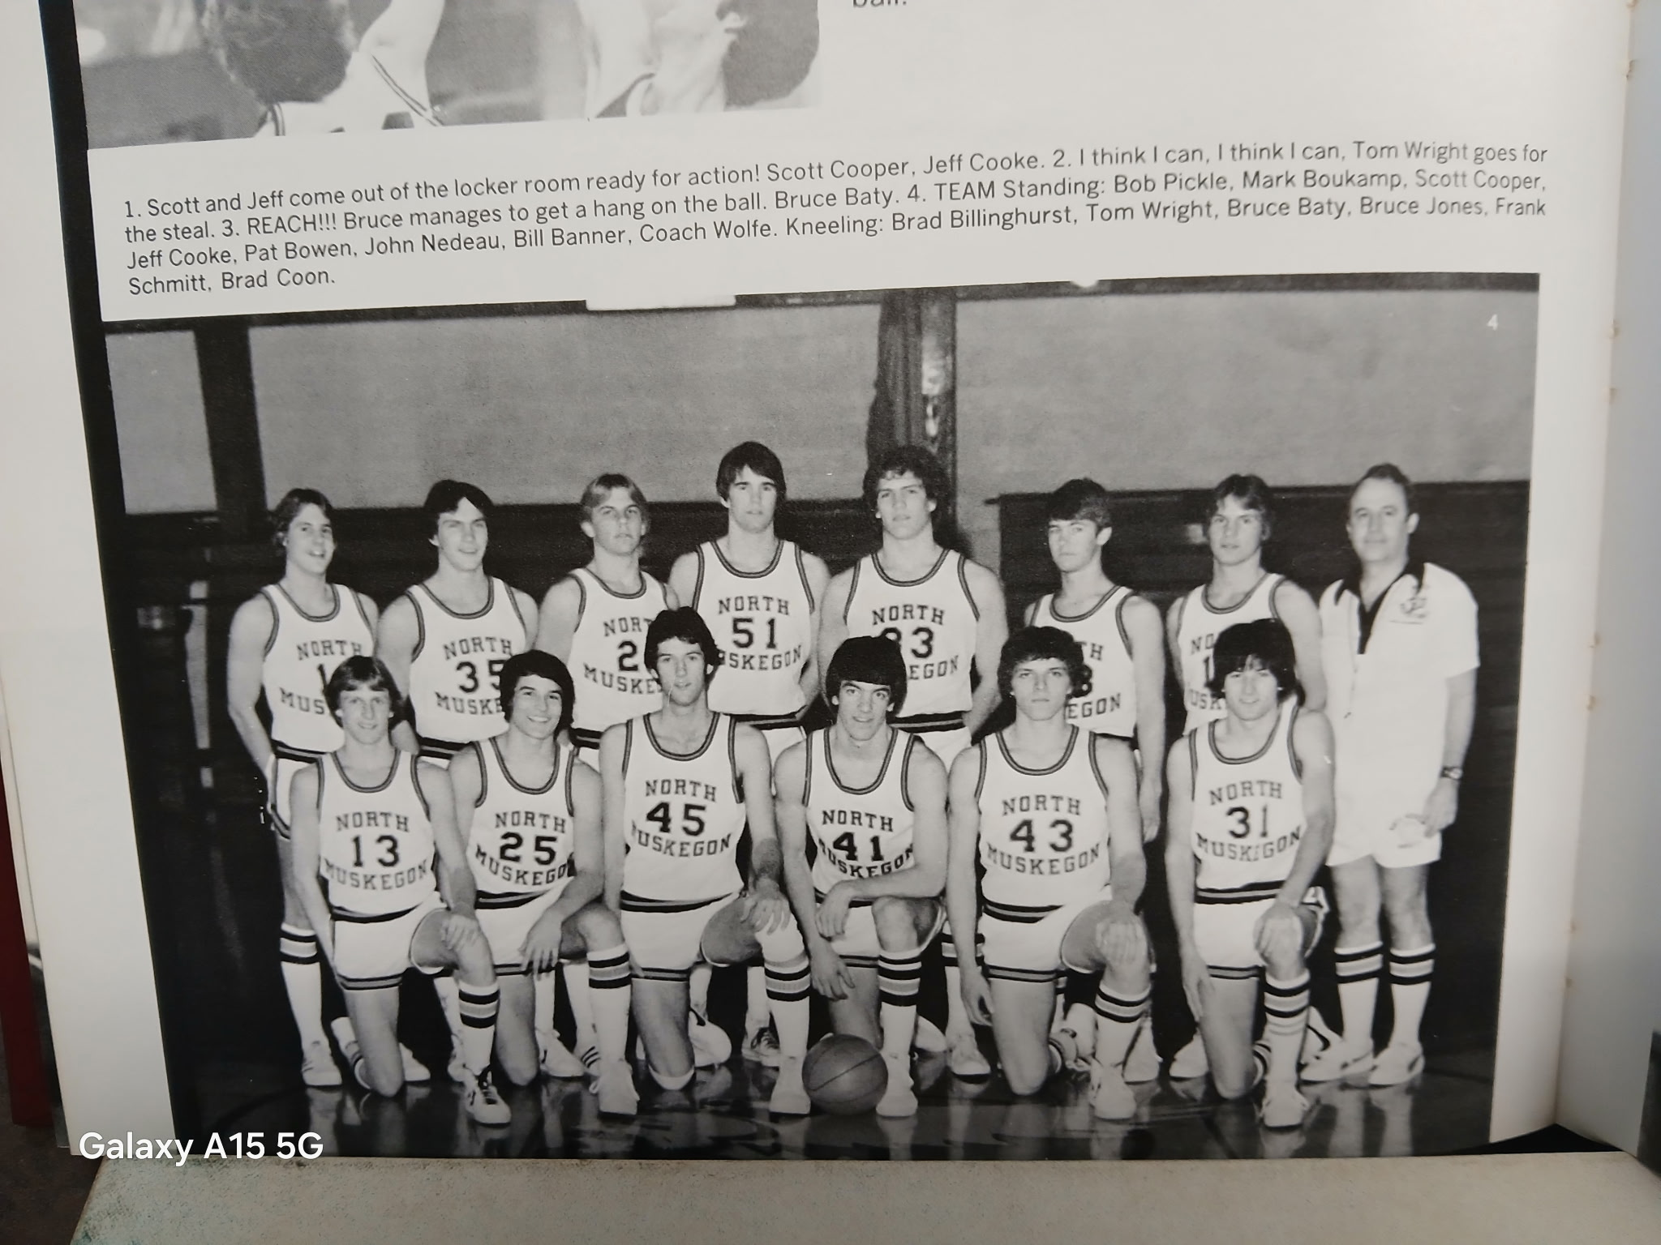

The 1978-79 NORSEMEN

Standing L-R: Bob Pickle, Mark Boukamp, Scott Cooper, Jeff Cooke, Pat Bowen, John Nedeau, Bill Banner, Coach John Wolfe
Kneeling L-R: Brad Billinghurst, Tom Wright, Bruce Baty, Bruce Jones, Frank Schmitt, Brad Coon
,
1979-80 (Coach John Wolfe, 13-8 overall, Montague-Ravenna co- WMC Champs)

The good news for third year head coach John Wolfe was that he returns six lettermen from his WMC Conference champs from last season. The bad news – none of the returning lettermen were starters. One of those starters would have been a junior this season but Jeff Cooke will have to sit out his entire junior season with a serious knee injury. Lettermen returning fighting for a starting sport are Bruce Jones, Scott Cooper, Mark Boukamp, Bill Banner, Tom Wright, and Bob Pickel. Gone via graduation included All-Conference performers Bruce Baty and John Nedeau, honorable mention all-WMC Brad Coon and Brad Billinghurst.
None of the above led the Norsemen in scoring in their first game. Instead, it was 5’6 guard Brad Pflaum who tallied 12 points in the Norse opener with Orchard View. Those 12 points weren’t enough as the Cardinals, behind the game leading 18 points and seven steals from future CMU and NFL star Curtis Adams, handed NM a 48-45 loss. Tom Wright added 10 points and 13 rebounds in the low scoring contest as the rebuilt Norse five started the season 0-1.
The Montague Wildcats would be a thorn in the side of NM throughout the season, beginning with their first of three wins over the Norsemen, a 50-48 win over the Norse in overtime. The Norse took the game into OT despite shooting an abysmal 0-18 from the field in the second quarter. Trailing by seven entering the final quarter the Norse applied full court pressure and a Brad Pflaum layup in the closing seconds of regulation sent the game into overtime. Montague’s Dave Tchozewski took charge in the 3-minute overtime session and scored four of Montague six points as the Wildcats nipped the Norse. Pflaum’s 12 points led the Norsemen as NM struggled to put points on the board for the second straight game.
Oakridge was a welcome opponent for the Norse as the Norse got out of their scoring slump at the expense of an Oakridge team still looking for its first win in two years. NM scored 77 points in their 77-55 win over the Eagles playing under first year coach Barry Peets, a former Shelby star. Mark Boukamp had 18 for the balanced Norse, with Brad Pflaum adding 15, Dave Billinghurst 12 and Tom Wright 11 as NM wins their first game of the season. For Oakridge it was their 27th loss in a row.
Mark Boukamp scored 10 of his game high 16 points in the fourth quarter as NM defeated Kent City 66-52. The Norse outscored the host Eagles 16-6 in the fourth quarter to ice the game and even their season’s record at 2-2. Tom Wright had 12 points for the Norse while Brad Pflaum and John Dykema were also in double figures with 10.
In a game played as part of a doubleheader at the LC Walker Arena, Reeths Puffer nipped the Norsemen 67-64 in a game that was tight for the entire final eight minutes. Twice NM closed to within one point of the Rockets in the game’s closing minutes but great free throw shooting in the late stages of the game led to a Rocket victory. Brad Pflaum with 17 and Mark Boukamp with 16 led the Norse.
Trailing by as many as nine points in the second half, NM rallied to earn a 61-53 non-conference win over Fruitport. NM outscored the host Trojans 17-6 in the fourth quarter to even their season’s record at 3-3 heading into the decade of the 80s. Tom Wright had 15 to lead the Norse while Brad Pflaum and Bill Banner added nine.
NM then captured by far their biggest and most surprising win of the year when they shocked West Michigan Christian 73-65 in overtime. WMC, under their first-year head coach Jim Goorman, was a heavy favorite, 5-0 on the season with one of their wins a one-sided victory at the LC Walker Arena over the 2-time state Class B Champs Muskegon Heights. WMC would advance all the way to the Class D state championship game at UM’s Chrisler Arena in March. The difference in the game was NM holding the visiting Warriors scoreless in the third period as NM outscored Christian 15-0 before a packed house in NM. It appeared the Warriors would have the momentum going into the overtime period after Brad Hoffman made a 25-footer with no time on the clock to force OT. NM outscored WMC 13-5 in OT with Mark Boukamp making six of seven frees throws. Brad Pflaum had a terrific game for NM with 20 points, six steals and five assists. Boukamp added 19 points for the Norse and Dave Billinghurst 11.
NM took that momentous win over WMC and carried it up to Hart as the Norsemen overwhelmed the Pirates 87-58. NM out pointed the host Pirates 44-17 in the second half as coach John Wolfe switched defenses in the second half to shut down Hart. Tom Wright had 19, John Dykema 16, Mark Boukamp 13, and Brad Pflaum 12 as NM improved to 5-3 on the season and 2-1 in the WMC.
NM had to go all out in post a narrow 58-55 victory over Ravenna. The Norse saw a 10-point lead in the fourth quarter whittled down to put two points before they cashed in their fourth quarter free throws to come out on top. Tom Wright had 19 points for the winners while Mark Boukamp added 14.
Newaygo made two free throws with nine seconds left to defeat NM 48-47. Bruce Jones had temporarily given NM the lead moments earlier when he made two free throws only to see the Lion’s Mike Wright connect on a couple of game winners. John Dykema’s 15 led NM scorers in the low scoring contest.
In a place not always conducive for a Norsemen victory, the Norse did come out on top as NM defeated Mason County Central 74-65. Brad Pflaum led NM to a rare victory in Scottville with 17 points, eight of his points coming in the pivotal final quarter. Dave Billinghurst connected for a season high 17 points while John Dykema netted 15 as NM stayed in the WMC title chase with a 4-1 conference record.
North Muskegon raced into a tie for first place with Shelby after a late basket by 5’5 guard Brad Pflaum gave NM a 54-52 victory over the Tigers. Shelby mounted a late comeback to stay within range of the Norse after trailing by as many as 14 points. Pflaum had 8 points and six assists to move NM into a tie with the Tigers in the WMC with a 5-1 record. John Dykema was also in double figures for the victors with 12 points. Rounding out all the scoring for the Norse were Bruce Jones, Dave Billinghurst and Mark Boukamp, each scoring eight points.
An improved Oakridge team made the Norse work hard for their 78-66 victory over the Eagles. John Dykema had a season high 21 points and 10 rebounds to lead the Norsemen. Bruce Jones also had a season high with 20 points and 13 rebounds as NM stayed even with Shelby in the WMC. Brad Pflaum had 10 points and four assists for the Norse.
Montague once again foiled NM with yet another tight victory, winning this time 51-48 to knock NM out of first place in the WMC. A poor shooting third quarter doomed the Norse as they were only able to notch 6 points in the eight-minute period. John Dykema with 12 and Mark Boukamp’s 10 points led NM in the low scoring matchup.
Bob Pickel only had six points, but he made four of those points when it counted most, as he scored the final four points on clutch free throws as NM survived 58-56 over Hart. Mark Boukamp and Dave Billinghurst each scored 14 points for the host Norsemen, who earlier in the season defeated Hart by 29 points. Brad Pflaum had 10 for the Norse as they kept their hopes alive for another WMC title.
NM’s chances for their second straight title suffered a big jolt as Ravenna turned back the Norse 68-62. The Bulldogs led throughout the contest although the visiting Norsemen sliced into Ravenna’s lead, pulling to within one point several times during the last eight minutes. Ravenna won this game at the free throw line in the final quarter my swishing nine of their last ten free throws. Mark Boukamp had 18 points to lead the Norse with Tom Wright adding 13.
Since 1970 the winner of the North Muskegon-Whitehall rivalry was the host school as North Muskegon defeated Whitehall on the northside court 72-54. North Muskegon outscored Whitehall in all but the opening quarter to improve their record to 11-6 overall. Brad Pflaum had 16 points for the Norsemen while Tom Wright notched 12.
In a home game that was dedicated to the memory of the late Wes Kaule, a long-time maintenance man at NMHS, the Norse made amends for an earlier loss in the season to Newaygo with a 74-65 victory over the visiting Lions. NM received outstanding balance in the win led by Dave Billinghurst’s 21 points. John Dykema had 13, Mark Boukamp 11 and Bruce Jones had a big game with 11 points to go along with his haul of 16 rebounds.
On the same night that USA hockey fans will remember the “Do you believe in Miracles?” win over the USSR, NM made sure there was no miracle for visiting Mason County Central as NM won easily 86-63. The win moved NM into a three-way tie for first place in the WMC with Ravenna and Shelby. NM moved in front 23-9 after the first quarter and were in control the rest of the way. All 12 Norsemen suited up for the game scored in the contest as coach John Wolfe was able to substitute often in the romp over the Spartans. Mark Boukamp with 18 and Dave Billinghurst with 12 were the only two of the dozen Norse who scored that placed in double figures.
NM’s chance to repeat as WMC went up in smoke as Shelby defeated the Norse in Shelby 71-61. Brad Pflaum scored 25 points, the highest total by a Norsemen player in the entire season but most of his teammates had an off night in the shooting department.
NM’s season ended as Montague swept the season series against the Norse with a 65-57 win at the Class C district in Whitehall. NM scored four more field goals than the Wildcats, but Montague shot 23 free throws, making most of those charity tosses while NM went to the free throw line but three times in the second half. NM played without Mark Boukamp who injured a knee in practice. Dave Billinghurst and John Dykema each had 13 points for NM with Tom Wright chipping in with 11.
Despite starting the 1979-80 with five new starters NM finished a very respectable, and to be honest, a surprisingly good record of 13-8. NM fans can only speculate what the record could have been if they had a healthy Jeff Cooke, who had to sit out the entire year with a serious knee injury. Only in the final game with Shelby when the Norse lost by ten, was there a game NM lost that they were not in contention in the final minute, a testament to the outstand job done by NM coach John Wolfe. The good news for Wolfe and the Norse faithful, bad leg and all, Jeff Cooke would be back in a NM uniform for the 1980-81 season.

N Muskegon 45 Orchard View 48 Brad Pflaum 12, Tom Wright 10
N Muskegon 48 Montague (ot) 50 Pflaum 12
N Muskegon 77 Oakridge 55 Mark Boukamp 18, Pflaum 15
N Muskegon 66 Kent City 52 Boukamp 16, Wright 12
N Muskegon 64 Reeths Puffer 67 Pflaum 17. Boukamp 16
N Muskegon 61 Fruitport 53 Wright 15, Pflaum & Bill Banner 9
N Muskegon 73 WMC (ot) 65 Pflaum 20, Boukamp 19, Billinghurst 11
N Muskegon 87 Hart 58 Wright 19, Dykema 16, Boukamp 13
N Muskegon 58 Ravenna 55 Wright 19, Boukamp 14, Dykema 10
N Muskegon 47 Newaygo 48 Dykema 15, Wright 8, Pflaum 7
N Muskegon 74 Mason Co 65 Pflaum & Billinghurts 17, Dykema 15
N Muskegon 54 Shelby 52 Pflaum 18, Dykema 12
N Muskegon 78 Oakridge 66 Dykema 21, Jones 20, Pflaum 10
N Muskegon 48 Montague 51 Dykema 12, Boukamp 10
N Muskegon 58 Hart 56 Boukamp & Billinghurst 14, Pflaum 10
N Muskegon 62 Ravenna 68 Boukamp 19, Wright 13, Billinghurst 11
N Muskegon 72 Whitehall 54 Pflaum 16, Wright 12
N Muskegon 74 Newaygo 65 Billinghurst 21, Dykema 13, Jones 16 rebounds
N Muskegon 84 Mason Co 63 Boukamp 18, Billinghurst 12
N Muskegon 61 Shelby 71 Pflaum 25, Dykema 12
N Muskegon*57 Montague 65 Billinghurst & Dykema 13, Wright 11

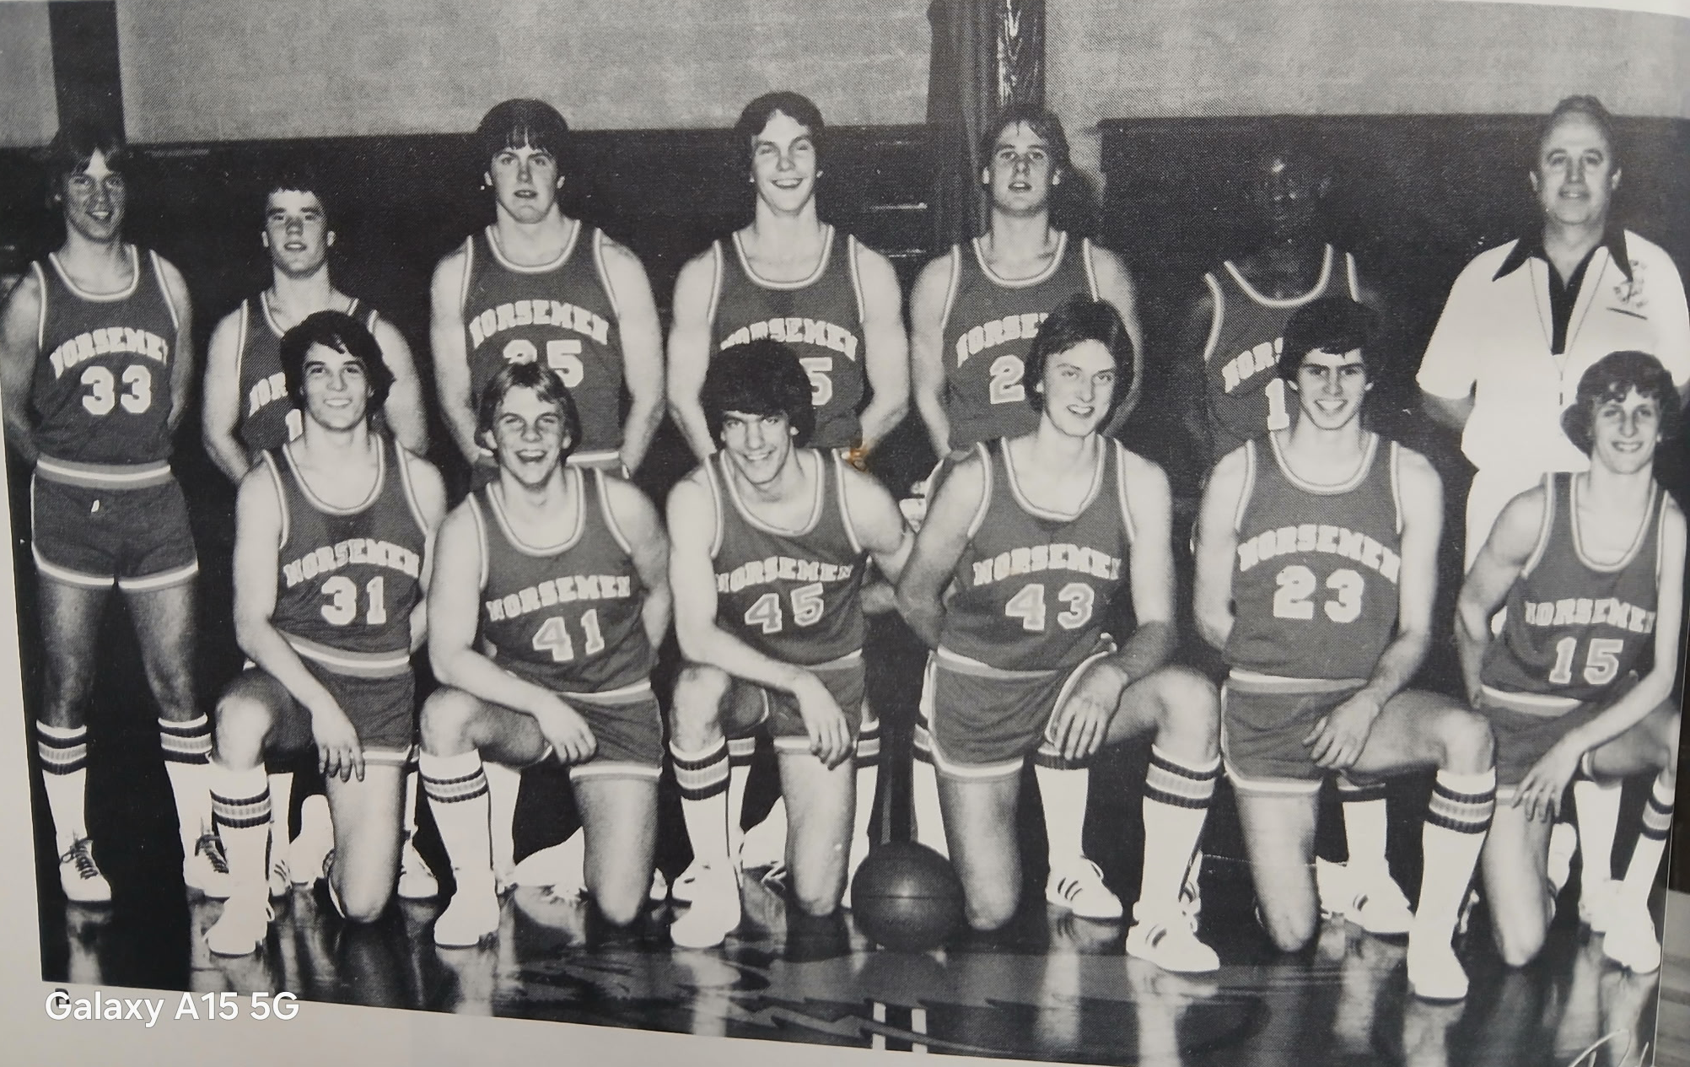

1979-80 NORSEMEN

Front Row L-R: Tom Wright, Scott Cooper, Bruce Jones, John Dykema, Ron Matthews, Dave Billinghurst
Top Row L-R: Bill Banner, Brad Pflaum, Mike Hansen, Mark Boukamp, Bob Pickle, Derrick Thomas, Coach John Wolfe

1980-81 (Coach John Wolfe, 14-8 overall, NM WMC Champs)

Expectations for the Norsemen were high, as well as tall as a few of the returning starters in the front-line range between 6’4 and 6’5. John Dykema, who averaged 11 points per game last season returns to the starting lineup. The big news is the return of 6’4 senior Jeff Cooke who in his freshman year led the entire WMC in rebounding. Cooke played a few games his sophomore year before reinjuring his tender knee in a game at Reeths Puffer. The injury was so severe that Cooke had to sit out all the games last season. 6’4 Steve Fretty, a callup from the junior varsity team will also give NM a boost in size. All-league pick Brad Pflaum returns as the point guard where he averaged nearly 12 points per game and over five assists. Dave Billinghurst, a returning starter at a forward last season will round out the starting five as a guard.
It was not the start that North Muskegon wanted, or expected, as they began the season losing 57-55 at Newaygo. NM played catchup all game long and nearly came all the way back as they outscored Newaygo 23-12 in the final quarter. NM played the game without the services of Jeff Cooke; the only game Cooke would miss the entire season.
Oakridge then stunned the Norse by winning for the first time in their last six meetings 72-63. NM welcomed back Jeff Cooke and the 6’4 senior responded with 18 points and 11 rebounds to lead the Norsemen. Steve Fretty added 17 and 5’6 guard Gene Esteban tallied 12 points as NM drops their second straight to open the season.
NM then lost their third game in a row, and their second loss by two points as Orchard View nipped NM 60-58. A shot by Greg Cooke was deemed to be attempted after the final horn had sounded as the Cardinals for the second year in a row won a tight contest with the Norsemen. NM can look no further than the turnover department to come up with a major reason for the defeat. NM turned the ball over 25 times to but 14 for the victorious Cardinals. Dave Billinghurst had 16, and Jeff Cooke and Steve Fretty each had 14 points for the Norse. OV would then go on to win the Seaway Conference title for their coach Mike Henry.
North Muskegon and Muskegon Heights met up for the first time in history at the LC Walker Arena and the Norse were no match for the undefeated and talented Tigers who romped over the Norse 81-49. NM was outscored in every quarter and could now look forward to a much easier schedule as they fell to 0-4 on the season. No Norsemen scored in double figures for NM with Jeff Cooke, Steve Esteban and Steve Fretty each scoring eight points.
NM took to the hardwoods just one day after Christmas with a game against Reeths Puffer as part of a Holiday tournament at Fremont. In what would prove to be the last game ever played between the two neighboring schools, NM defeated the Rockets 65-53 to even the series played from 1960 to 1980 at 10 wins for each team. Jeff Cooke had his best game since the return from his injury to lead the Norse with 22 points and 16 rebounds. Gene Esteban totaled 13 points while dishing off for seven assists. Brad Pflaum was a big help to his team with nine assists. The victory, the first of the season for NM put them into the finals the following day against Fremont, who defeated West Michigan Christian in the other game in the tournament.
In the first meeting between two old time rivals in 15 years, NM won the Fremont Classic with a 70-68 victory over the host Packers. Brad Pflaum was the man of the hour for NM as the 5’6 guard scored three baskets in the closing minutes to give NM a come from behind victory over Fremont. Pflaum’s final two points came with six seconds to go to break a tie at 68-all. Pflaum finished with 16 points, five assists and three steals. Steve Fretty notched 16 points while Jeff Cooke had 13 points and 11 rebounds. John Dykema was the fourth Norsemen to score in double figures with 10 points.
In a game moved from NM to Fruitport as the Norse school had no heat due to boiler problems, NM didn’t mind the move at all as they scored a season high 93 points in a rout of Fruitport. John Dykema had 22 points, Greg Cooke 14, Gene Esteban 13, Steve Fretty 12, while Brad Pflaum and Jeff Cooke each scored ten points. It was the second time in NM’s long history where six NM players scored in double figures. If not for one more basket, Ron Matthews would have made it seven as he ended up with eight points.
It was now back to the grind of playing your West Michigan Conference opponents after the Norse played six non-conference opponents in the month of December. First up in January of 1981 was Montague and as usual, it was another close game with NM coming out on top 57-54. After beginning the season at 0-4, the Norse had now evened their record at 4-4. John Dykema had his second straight 20-point game to lead the Norse while Jeff Cooke had 15 points and 12 rebounds for the Norsemen.
NM used a full-court zone press in the third quarter to come from behind to defeat the Hart Pirates 73-66 to earn their fifth straight win. Leading the pressure defense were guards Gene Esteban and Greg Cooke who forced several Hart turnovers to turn the game around for NM. Jeff Cooke led NM in scoring with 19 points while his brother Greg had 11. Also in double figures for the Norse were guards Gene Esteban and Brad Pflaum who netted 13 and 11 points respectively.
NM saw an eight-point lead entering the final quarter vanish as Ravenna outscored the Norsemen 18-8 in the final eight minutes to nip the Norse 59-57. Marty Grenell hit a 10-footer with three seconds showing on the clock for the game winner for the Bulldogs. Jeff Cooke was a tower of strength on the boards with 21 rebounds to go along with his 13 points. Brad Pflaum led Norse scorers with 15 points as the five-game winning streak ended.
It appeared NM chances for winning the conference title were doomed after dropping a 61-55 contest at Shelby. The loss dropped NM to 2-3 in the conference making all games in the WMC ‘must’ wins for the Norse. Stay tuned. Once again it was a bad fourth quarter that hurt the Norse as they led by five points heading into the final eight minutes only to be outscored 21-10. Jeff Cooke had 13 points and 13 rebounds for the Norse while his brother Greg was the other NM player in double figures with 10.
NM had little time to rest as they entertained current league leader Mason County Central the next night. NM got a career high 29 points from Dave Billinghurst who came off the bench to score 10 points in the second quarter to give NM a 34-32 lead. Billinghurst was near perfect on the night as he made 13 of his 15 field goal attempts. Jeff Cooke had a double-double with 15 points and 10 rebounds as NM, even with a 3-3 conference record, pulled to within one game of the lead in the conference standings.
The top of the leaderboard in the West Michigan Conference was now in chaos following NM’s 57-50 victory over Oakridge. Shelby remained at the top of the standings with two losses but there was a logjam at second place with four teams, including the Norsemen who following the win over the Eagles were tied in second place with a 4-3 record. With still five games remaining in the WMC still to be played, the Norse were now back in the hunt. Jeff Cooke had a monster game for the Norsemen with 22 points and 21 rebounds.
Close games have been the norm of late when NM and Montague meet on the court and that was the case once again as the Norsemen, trailing by as many as nine points early in the game, bounced back to defeat Montague by three points 54-51. Dave Billinghurst pumped in 20 of his 24 points in the second and third quarters to lead the Norse comeback. The win kept the Norse tied in second place with a 5-3 WMC record. Brad Pflaum finished with 12 points for NM.
NM posted their second victory in less than a week over an Oceana County foe as winless Hart fell to the Norsemen 72-52 in a game played on the Pirates home court. Brad Pflaum had a season high 18 to lead NM’s victory and Dave Billinghurst netted 16 as NM stayed in the WMC race with the win. Jeff Cooke had 10 rebounds for NM with some big games looming in the WMC.
NM rebounded from a two-point loss earlier in the season to Ravenna to bounce back in their second meeting with a 72-54 win over the Bulldogs. Dave Billinghurst continued his torrid scoring with 18 points to lead the Norse with Brad Pflaum close behind with 13. The Cooke brothers, Jeff and Greg each had 10 points as did John Dykema for the well-balanced NM offense.
Due to record snowfall during the month of February in 1981, NM and Whitehall had to wait a day to reschedule a game from Tuesday to a Wednesday date. The Norsemen were still looking for their first win at Whitehall since 1962 after losing once again on the Vikings home court 58-55. NM had four players reach double figures, but the highest points achieved was John Dykema’s 12 markers. Brad Pflaum added 11 while Jeff Cooke and David Billinghurst both tallied 10 as NM’s winning streak, all earned against WMC conference foes, ended at five.
Two conference games remained on NM’s schedule. If the Norse could come out on top in both games, then the WMC title would be theirs. Mission accomplished in game number one.
NM blitzed Mason County Central with 47 second half points to push their overall record at 8-3 while the Spartans fell to 8-4. The Norse were now tied for the lead with Shelby and those two would meet in a winner take all format on Tuesday February 24. NM had five players in double figures in the win over Mason County with Jeff Cooke’s 16 leading the list. Gene Esteban had 14, John Dykema 13, and Brad Pflaum and Dave Billinghurst each tallied 10.
NM trailed Shelby 16-9 at the end of the first quarter and trailed by two at the half in front of a sold-out crowd in the Northside gym. A third quarter uprising by the Norse turned the game in their favor as they outscored the Tiger 16-8. NM kept their momentum during the final eight minutes to end the game with a 62-54 victory and a WMC championship. Jeff Cooke was huge for NM with 26 points and 10 rebounds. John Dykema also had a big game for NM with 18 points and 12 rebounds. Coach John Wolfe following the game lauded the play of a player who only had two points in the game. Greg Cooke worked tirelessly in a box and one defense on Shelby’s star performer Dave Beckman. Beckman had 32 but Coach Wolfe had high praise of Cooke. “If Greg hadn’t shadowed Beckman, he might have scored 40 or 50 points. He’s that good,” said a jubilant Wolfe.
NM ended the season just the opposite in how they started – with a win over a Newaygo team that handed the Norse their opening loss. Behind the play of Jeff Cooke, the Norse led all the way to win 69-55. The 6’4 senior had 19 points and grabbed 15 rebounds. Dave Billinghurst also had a strong game with 16 points.
The Norse opened the Class C district tournament at Hart with a 65-50 victory over Hesperia with four Norsemen in double figures. It was the fifth win in as many meetings against Hesperia in a brief rivalry that began back in 1937. Once again it was a well-balanced NM attack with four Norsemen reaching double figures: Jeff Cooke with 14, Dave Billinghurst 13, John Dykema 12 and Brad Pflaum 10. The win moves NM into the district semifinals where they would face Whitehall.
NM found themselves trailing Whitehall 47-35 in the third quarter before NM went into a full court man-to-man pressure defense that almost paid off in a Norse victory, only to have their season come to an end with a 62-60 loss to Whitehall. Jeff Cooke finished his season – but certainly not his career at North Muskegon with 19 points. Dave Billinghurst and John Dykema each finished with 13 as North Muskegon finished their season at a very respectable 14-8.
Brad Pflaum repeated as a first team All-WMC performer with his playmaking skills while averaging 10 points per game. An easy choice for the All-conference team was 6’4 senior Jeff Cooke. Although he led the WMC conference in rebounding as a freshman it was a glaring oversite not to include Jeff on the 1978 team. No mistake was made in 1981 as Cooke, who was injured midway through his sophomore season and sat out his entire junior season, again led the WMC in rebounds while tossing in 15 points per game. Cooke was a driving force as to why North Muskegon won the conference championship in 1981. NM would not win another basketball conference championship until ---- Cooke would coach the Norse to a title years later.

N Muskegon 55 Newaygo 57 Dave Billinghurst 16, Brad Pflaum 13
N Muskegon 63 Oakridge 72 Jeff Cooke 18, Steve Fretty 17
N Muskegon 58 Orchard View 60 Billinghurst 15, Cooke & Fretty 14
N Muskegon 49 Musk Hts 81 Gene Esteban, J. Cooke, Fretty 8, Pflaum 7
N Muskegon 65 Reeths Puffer 53 J. Cooke 22, Esteban 13, John Dykema 10
N Muskegon 70 Fremont 68 Pflaum 16, Fretty 13, J. Cooke 11
N Muskegon 93 Fruitport 50 Six Norse in double figures, Dykema 22
N Muskegon 57 Montague 54 Dykema 20, J. Cooke 15
N Muskegon 73 Hart 66 J. Cooke 22, Esteban 13, G. Cooke 11
N Muskegon 57 Ravenna 59 Pflaum 15, J. Cooke 13 points & 21 reb.
N Muskegon 55 Shelby 61 J. Cooke 13, G. Cooke 10
N Muskegon 72 Mason Co 60 Billinghurst 29, J. Cooke 15
N Muskegon 57 Oakridge 50 J. Cooke 22 points & 21 rebounds
N Muskegon 54 Montague 51 Billinghurst 24, Pflaum 12
N Muskegon 72 Hart 52 Pflaum 18, Billinghurst 16, J Cooke 9
N Muskegon 72 Ravenna 54 Billinghurst 18, Pflaum 13
N Muskegon 55 Whitehall 58 Dykema 12, Pflaum 11
N Muskegon 78 Mason Co 58 J. Cooke 13, Esteban 14, Dykema 13
N Muskegon 62 Shelby 54 J Cooke 26, Dykema 18, Pflaum 10
N Muskegon 69 Newaygo 55 J Cooke 19 & 15 rebounds. Billinghurst 16
N Muskegon*65 Hesperia 50 J Cooke 14, Billinghurst 13, Dykema 12
N Muskegon* 60 Whitehall 62 J Cooke 19, Billinghurst & Dykema 13

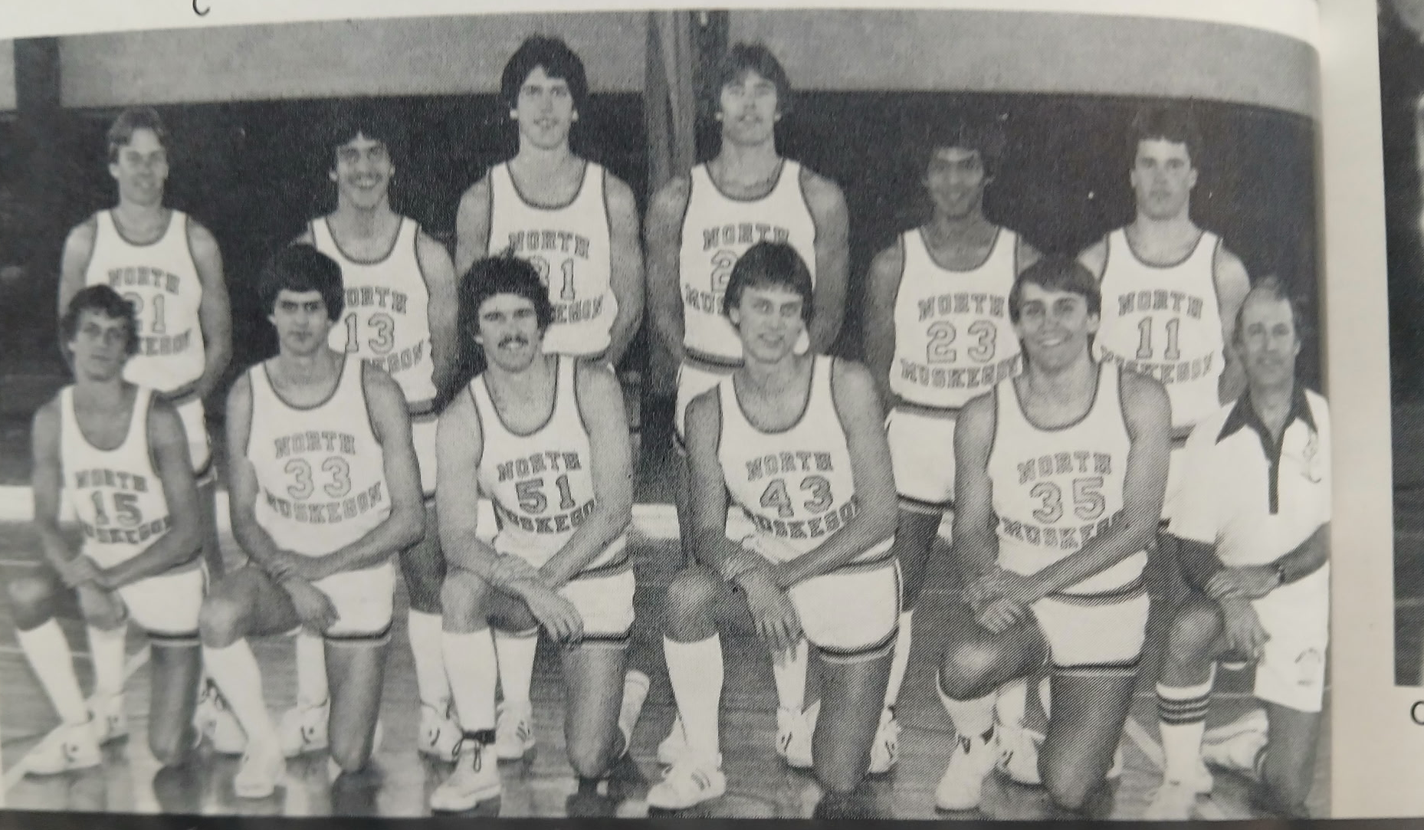

The 1980-81 NM Conference Champs

Front Row L-R: Dave Billinghurst, Ron Matthews, Jeff Cooke, John Dykema, Steve Fretty, Coach Wolfe
Top Row L-R: Bob Banner, Jeff Cordo, Ross McAllister, Greg Cooke, Gene Esteban, Brad Pflaum
Front Row L-R: Dave Billinghurst, Ron Matthews, Jeff Cooke, John Dykema, Steve Fretty, Coach John Wolfe

1981-82 (Coach John Wolfe, 7-15 overall, MCC- Montague tie in WMC)

The 1981-82 season would show the Norsemen winning only seven games. With a few breaks that record could have easily been reversed as the Norsemen lost all three games that went into overtime as well as a few other contests that went down to the wire with NM on the losing end. Two starters returned from the WMC championship team of 1981, Steve Fretty and Gene Esteban. Greg Cooke, who made the all-state team in football also saw extensive action during the previous season.
Less than a week after the NM football team played in the Class C state championship game, the Norse basketball team was hurried into action to face the Orchard View Cardinals, the defending Seaway Conference champs. OV thumped NM 67-57 with Mark Jalovek burning the Norsemen with 27 points. Returning starter Steve Fretty tallied a career high 21 points to lead NM with Gene Esteban adding 11.
The Norse got off to a good start in their quest to repeat as WMC conference champs with a 58-51 win over Shelby. Gene Esteban led NM with 16 points with 3-sport standout Greg Cooke netting 12. 6’4 Steve Fretty controlled the boards during the game with 14 rebounds to go along with his eight points.
NM made it 2-0 in WMC action following their 79-72 win over Oakridge. After trailing much of the game, the host Eagles pulled to within one point of the Norsemen with three minutes left in the game. Greg Cooke scored eight of his 15 points in the final quarter as NM pulled away in the closing minutes to secure the victory. Steve Fretty led Norse scorers with 19 points as NM showed exceptional balance. Gene Esteban added 14 points with Sam Nedeau and Dave Weller chipping in with a dozen points each. Weller pulled down 15 rebounds to lead all players in that department.
NM would then begin a five-game skid starting with a 65-54 loss to Montague in a game played on the Norsemen’s home court. The Wildcats were in control from the opening tip to improve their record to 3-2 while the Norsemen fell to 2-1 in the WMC. Greg Cooke, playing on an injured ankle was the only Norse player in double figures with 14. Sam Weller and Steve Fretty were close with nine points each.
Overtime games did not treat NM kindly during the 1981-82 season as they had three games go into the extra session and the Norse lost all three. Their first overtime loss came against West Michigan Christian in a Holiday Tournament played at Reeths Puffer. WMC edged NM 62-61 by outpointing the Norse 6-5 in the three-minute overtime. After WMC made a pair of free throws to take the lead at 62-61 the Norse failed to connect on their final shot. NM received great balance but their high point man, Steve Fretty scored but 14 points. Also in double figures for NM were Greg Cooke with 13 while Sam Weller, Gene Esteban and Sam Nedeau all had 10 markers.
With the loss to WMC the Norse then played a consolation game with Fremont. There was no overtime needed in this game as Fremont won handedly over the Norsemen 65-46. Gene Esteban carried most of the scoring load for NM with 18 points.
After being blown out by the Norsemen by 43 points in 1981, Fruitport flipped the script and handed NM their fourth straight defeat 69-55. A big third quarter when the host Trojans scored 25 points was the catalyst in Fruitport’s victory. It was only the third victory in 18 games for Fruitport over the years in the series with NM. Steve Fretty had 18 in a losing cause for the Norse while Gene Esteban was also in double figures with 10.
Hart’s Bob Cutter hit a 10-foot jumper as time ran out to lift the Hart Pirates to a hard-fought 56-55 win over the Norsemen. The winning basket came just seven seconds after NM had taken their own one-point lead before Cutter’s bucket. Dave Weller had 15 and Gene Esteban 13 and Sam Nedeau 12 points as NM dropped their fifth straight game.
Greg Cooke sparked the Norse with 17 points and numerous steals as NM snapped their five-game losing streak with a 63-53 win over Ravenna. Steve Fretty followed Cooke in scoring with 14 points with Sam Nedeau chipping in with 11.
In a non-league game Muskegon Height controlled the backboards in a convincing 73-46 win over the Norsemen on the Tiger’s home court. NM played the Tigers tough in the first quarter, trailing by only three points, but the Tigers pulled away and never looked back with a 24-13 advantage in the second quarter. Sam Nedeau had 13 to pace the Norse with Greg Cooke adding 11. The two teams would not meet again for another 30 years. The loss unfortunately for the Norse faithful, would begin another long losing streak for the Norse.
The journey on a Tuesday night to Scottville made for a long trip home as Mason County Central bombarded NM with 91 points in a 91-69 whipping of the Norsemen. The 91 points was by far the most points allowed by the NM defense all season with 34 of the Spartans points coming in the second quarter to put the game out of reach. Dave Weller’s 20 points was high for the Norse with Sam Nedeau’s 13, and Greg Cooke’s 11 points also making it into double figures.
On a night when many games were cancelled due to freezing rain, the Norsemen team bus made it to Shelby only to see NM drop their third straight game to the host Tigers 61-50. NM’s offense was as slippery as the highways around West Michigan as they committed 23 turnovers. NM led at the half, but Shelby outscored the Norsemen 20-8 in the third quarter and followed that up with a 20-13 advantage in the final eight minutes. Dave Weller had his second consecutive 20-point game and grabbed 12 rebounds to lead the Norse.
As if it wasn’t bad enough to lose three games that went into overtime during the season, but to lose a game that went two overtimes had to be gut-wrenching for the Norsemen. Rick Larabee’s jumper from the baseline with seconds left to go in the second overtime period spelled defeat for NM as Oakridge edged NM 65-63. Despite the loss, NM head coach John Wolfe was pleased with his team’s effort: “We had our best team play that we’ve had. I was pleased with the hustle of our players.” Said Wolfe. Dave Weller continued his fine play of late with 16 points and 10 rebounds while Greg Cooke added 15 points and nine boards while Sam Nedeau tossed in 14.
Whitehall pulled away in the fourth quarter to defeat the Norse 66-52 in a non-league game between the two long-time rivals. The Vikings, leading by five points entering the final quarter outscored NM 20-11 to hand the Norsemen their 5th straight defeat. Steve Fretty led NM with 16 points followed by Greg Cooke with 13. In December of 1982 Whitehall applied to rejoin the WMC, an application gladly accepted by the WMC, and the Vikings would become a member beginning with the 1984-85 season.
First place Montague stayed on top of the standings in the WMC by topping NM 68-57 as NM fell to 3-11 on the season and 2-6 in the WMC. Sam Nedeau led NM with 13 points followed by Steve Fretty with 11 points plus 11 rebounds.
NM snapped their six-game losing streak with a 63-43 breather over Hart as NM got a spark from Jeff Cordo who scored al 10 of his points in the second half. Sam Nedeau led the Norsemen in scoring with 16 points while Steve Fretty controlled the backboards with 13 rebounds. In addition to Cordo, Bob Banner also had his best game to date for NM with nine points.
The Norsemen took 40 foul shots and made 26 to defeat Ravenna 56-48, their second win on the season against the Bulldogs. Steve Fretty dominated the game according to Bulldog head coach Bob Sarachman with 12 points and 17 rebounds. Greg Cooke also had 12 markers for the Norsemen with Dave Weller adding 14 as NM improved to 5-12 on the season.
NM suffered yet another close defeat as Newaygo’s Dean duChemin’s jump shot with 16 seconds left was the game winner. NM missed a couple of shots to send the game into overtime to drop NM to a 5-13 overall record. Steve Fretty netted 14 for NM while Bob Banner reached double figures for the first time on the season with 10.
Mason County improved to 15-3 on the season and moved into first place in the WMC with an 8-1 record, one half game in front of Montague with one week to go in the race. The Spartans won 62-51 despite playing without their leading player Frank Tuka who was out with a concussion. NM played MCC close until the Spartans broke it open with a 21-13 advantage in the fourth quarter. Steve Fretty led the offensive effort for the Norse with 17 points and seven rebounds. Greg Cooke and Sam Nedeau both reached double figures with 10.
Greg Cooke and Dave Weller each had career highs in NM’s 86-78 victory over Kent City in the final game of the regular season. Cooke poured in 27 points and Weller 24 to give NM some badly needed momentum heading into next week’s MHSAA playoffs. Weller also grabbed 15 rebounds while Steve Fretty had 14 points and 15 rebounds as NM controlled the backboards. Kent City finished the regular season as conference champs of the NCAA league and a 15-5 record.
In a basketball oddity, Hart nipped North Muskegon 56-55 earlier in the season. When the final horn had sounded in the first game played in the Class C district held at Shelby, the score was the exact same, but this time it was NM on the front end of a 56-55 score. It was a game that NM easily could have lost. Hart seemingly had the game wrapped up holding a one-point lead, but a Hart player inexplicably took a shot with six seconds showing on the clock. The shot missed and was rebounded by the Norse. After a couple of time outs and one-second left on the clock, Sam Nedeau lobbed an inbounds pass to Steve Fretty, Fretty missed the shot but was fouled. Fretty than calmly hit both free throws with no time on the clock to give NM a 56-55 victory. Nedeau finished as high point man for the winners with 16 points, Dave Weller 13 and Fretty 12, including the two game-winning free throws.
For the second time in a row when the two teams met, Oakridge and North Muskegon would again play an overtime game. This time Oakridge needed just one overtime period to end the Norsemen’s season with a 65-61 victory. At one point late in regulation NM took a three-point lead only to see the Eagles claw back to force overtime. Greg Cooke and Steve Fretty each scored 13 points in their last game in a Norse uniform while Dave Weller, a junior, led NM with 21 points.
John Wolfe would retire from coaching NM basketball following the 1981-82 season but would remain at NM as the Athletic Director. Wolfe in five years won 63 games while losing 45 with two WMC championships and a second-place finish. NM would have to wait 20 years before they would win another WMC basketball championship.

N Muskegon 57 Orchard View 67 Steve Fretty 21, Gene Esteban 11
N Muskegon 58 Shelby 51 Esteban 16, Greg Cooke 12, Fretty 14 reb.
N Muskegon 79 Oakridge 72 Fretty 19, Cooke 15, Esteban 14
N Muskegon 54 Montague 65 Cooke 14, Fretty & Weller 9
N Muskegon 61 WMC (ot) 62 Fretty 14, Cooke 13, three with 10 points
N Muskegon 46 Fremont 65 Essteban 18
N Muskegon 55 Fruitport 69 Fretty 18, Esteban 10
N Muskegon 55 Hart 56 Weller, 15, Esteban 13, Sam Nedeau 12
N Muskegon 63 Ravenna 53 Cooke 17, Fretty 14, Nedeau 11
N Muskegon 46 Musk Hts 73 Nedeau 13, Cooke 11
N Muskegon 69 Mason Co 91 Weller 20, Nedeau 13, Cooke 11
N Muskegon 50 Shelby 61 Weller 20 points and 12 rebounds
N Muskegon 63 Oakridge (2ot) 65 Weller 16, Cooke 15, Nedeau 14
N Muskegon 52 Whitehall 66 Fretty 16, Cooke 13
N Muskegon 57 Montague 68 Nedeau 13, Fretty 11
N Muskegon 63 Hart 43 Nedeau 16, Jeff Cordo 10, Bob Banner 9
N Muskegon 56 Ravenna 48 Weller 14, Fretty & Cooke 12
N Muskegon 48 Newaygo 50 Fretty 14, Banner 10
N Muskegon 51 Mason Co 62 Fretty 17, Cooke & Nedeau 10
N Muskegon 86 Kent City 78 Cooke 27, Weller 24, Fretty 14
N Muskegon*56 Hart 55 Nedeau 16, Weller 13, Fretty 12
N Muskegon* 61 Oakridge (ot) 65 Weller 21, Cooke and Fretty 13

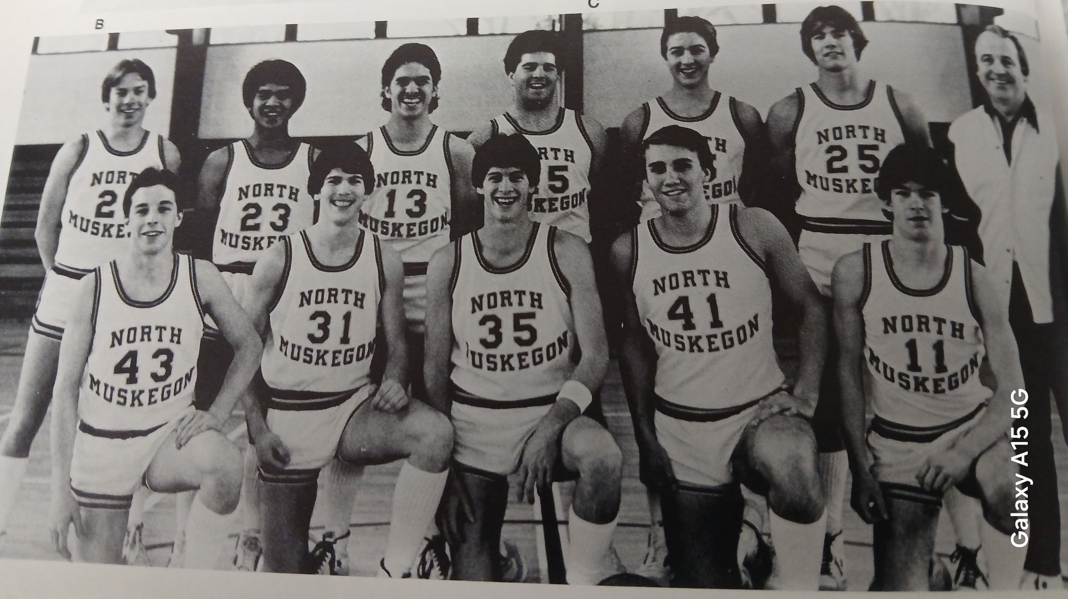

THE NORSEMEN of 1981-82

Front Row L-R: Brad Kinning, Ross McAllister, Dave Weller, Steve Fretty, Sam Nedeau
Back Row L-R: Bob Banner, Gene Esteban, Jeff Cordo, Tom Serocztnski, John Bowen, Greg Cooke, Coach John Wolfe

1982-83 (Coach Dave Cooke 7-15 overall, Mason County wins WMC)

A very familiar face would replace John Wolfe to begin the 1982-83 season. A man who would wear many hats over the years ---Dave Cooke. Cooke was the NM basketball coach from 1968 thru 1973, before taking over at Reeths Puffer as their football coach from 1972 – 1977. Showing his versatility and his love of working with today’s youths Cooke returned to NM, not only as a guidance counselor and science teacher but took over as the North Muskegon girls’ basketball coach where he won a couple of districts and a WMC championship with the gals. When John Wolfe resigned NM needed a new boys’ basketball coach. Already burdened down with the immense responsibilities as NM’s head football coach, where he would stay for decades, Cooke would now perform double duty as both NM’s football and basketball coach, a common feat in the 1930s and 40s but a rarity in the 1980s and beyond. Cooke would serve three years coaching both sports before Walt Gawkowski came to his rescue to free Cooke to concentrate on his football duties, a coaching job slowly but surely becoming work for 365 days a year.
NM returned a pair of starters from last year’s team, Dave Weller, an all-conference selectee and Sam Nedeau, but the rest of the starting five would have to come from reserves and members of last year’s junior varsity team. Brad Kinning had shown much improvement during the offseason and could crack the starting lineup while sophomore Mike Sekulich could also be a big factor for the upcoming season.
The Norsemen made Dave Cooke’s return as their basketball coach a successful one with a narrow 59-57 win over Orchard View. Free throw shooting was the difference in the opener as the Norse scored 21 from the free throw line while the Cardinals only had seven. Sam Nedeau scored 14 points to lead NM scorers. Brad Kinning added 11, sophomore Mike Sekulich and Jim Sheehan eight.
Newaygo had too much height for the Norse in a Saturday night contest as the Lions defeated NM 60-46. Dave Weller led NM with 11 while Mike Sekulich added nine.
NM bounced back to defeat Shelby 67-62. The game was tied at halftime before NM then outscored Shelby 18-12 in the third quarter to win their opening game in the WMC. Sam Nedeau had 18 points and six assists to lead NM. John Bowen added 13, Dave Weller 11 and Mike Sekulich 10 in the balanced NM offense.
It was a tale of two halves in NM’s next game with Oakridge with the Eagles winning the half that counted the most, the second half. NM led 26-17 at halftime only to be outplayed badly by Oakridge in the second half as the Eagles would go on to win 61-53. Brad Kinning came off the bench to score 18 points while Mike Sekulich added 12 for NM.
A cold spell in the fourth quarter meant big trouble for the Norse as they went five minutes without scoring giving West Michigan Christian a path to victory. The Warriors took advantage of the dry spell to edge NM 50-49 in a Holiday tournament held at Muskegon Community College. Mike Sekulich scored 17 points, 15 in the first half to lead the Norse with Jim Sheehan adding 10. The loss sent NM into the consolation game of the tournament to face Fremont.
Sam Nedeau had the game of his life as he poured in 28 points to lead the Norsemen to a 65-55 victory over Fremont in the consolation game of the MCC tournament on the Jayhawk campus. Nedeau had his points on nine field goals and a 10-16 showing at the free throw stripe. Mike Sekulich added 10, Brad Kinning 9, and Dave Weller 8 to round out the Norse scoring.
The Norse trailed Fruitport 40-27 at halftime but came roaring back behind the play of sophomore Mike Sekulich to trip Fruitport 66-63. With the score tied at 63-all Sekulich converted on a three-point play as the Norse came all the way back to defeat Fruitport 66-63. Sekulich scored 21 points and had 11 rebounds in the Norse non-league victory while Dave Weller and Sam Nedeau each contributed 14 points in the win.
Only a big fourth quarter when NM outscored Montague 24-12 did the Norse make the final score of 81-73 look respectable. Montague dominated in the first half as they outscored the Norse 50-32. Sam Nedeau was the high point man for NM with 19 points, followed by Mike Sekulich with 13 and John Bowen with 10.
Hart broke a five-game losing streak to NM 61-56 and they did most of their damage at the free throw line. The Pirates made 23 of 27 free throws including a stretch in the final quarter when they hit 12 straight. NM was hurt when sophomore Mike Sekulich twisted an ankle while driving the baseline and didn’t return until the final quarter. NM had closed to within two points at 51-49 with 3:40 left but the Pirates cashed in their free throws after being fouled by desperate NM players to pull ahead. Brad Kinning led a balanced NM attack with 13 points as points were spread almost equally among nine NM players. Jim Sheehan scored 10 with John Bowen and Sam Nedeau scoring nine.
The original report of Mike Sekulich leaving the game against Hart with a twisted ankle turned out to be more serious. X Rays taken had shown that Sekulich had suffered a fracture of his ankle and would be lost for the rest of the season. With one of their leading scorers on crutches Ravenna won their first game of the season with a 58-55 victory over NM. Sam Nedeau attempted to take up some of the scoring slack with the absence of Sekulich and poured in 21 points. Brad Kinning netted 11 and Dave Weller 10 as NM dropped to 4-6 on the season.
After NM took a 20-18 lead over Mason County Central after one quarter was played, the Spartans then went on a rampage beginning with a 26-12 advantage in the second quarter as they swamped NM 85-60. Only Sam Nedeau with 20 points was able to find the range consistently for NM as the Norse lost their fourth game in a row, all against WMC competitors.
Norse shooters were as cold as the January weather as NM lost their fifth straight WMC contest 58-45 to Shelby. Three NM players fouled out of the contest as Shelby put this game away early by racing out to a 15-6 lead at the end of the first quarter. Only Brad Kinning was in double figures for NM with 11 points.
A confident Oakridge team started four newcomers against NM and still came out on top with a 68-56 victory over the slumping Norsemen. Dave Weller had his best scoring game since his junior season with 17 points to lead the Norse with Sam Nedeau reaching double figures with 10. At this point in time NM had to have concerns that they may not win another game.
Those concerns would be put to rest as NM surprised Montague with an upset 70-60 win over the Wildcats. The defeat knocked Montague out of a first-place tie with Mason County Central and stopped NM’s season long losing streak at six. Sam Nedeau led NM with 21 points and was lauded by Coach Cooke for his defensive play as well. Dave Weller added 15 points and Brad Kinning 14 as the Norse won but their fifth game of the season and the second in the WMC.
Dave Weller had a career high 27 points, but it wasn’t enough as Hart held off the Norse to earn a 70-63 victory. Sam Nedeau had 13 but Norse fans had to be happy to know that the earlier report that Mike Sekulich was out for the season was erroneous as Sekulich returned to score eight points giving Norse fans hope that a couple more wins might be on the horizon.
A ten-day layoff didn’t help the Norse shooters as they made but four of their 25 shot attempts in the first half as they lost a tight contest to Ravenna 67-63. Mike Sekulich and Sam Nedeau each had 13 points for the Norsemen while Dave Weller added 11.
In the first of two meetings between the Norse and the West Shore Academy School, it was West Shore who won the first of the two contests 79-66. The
fledgling West Shore team had accrued many talented players from the area and with the win moved to an impressive 15-2 record. Sam Nedeau had 18 while Brad Kinning had 14 points for NM. Mike Sekulich did not see action.
To nobody’s surprise who have followed the Whitehall-North Muskegon rivalry over the years, the Vikings used the packed house on hand at Whitehall to send the visiting Norsemen back to the northside with a 78-66 loss. Whitehall shot a blazing 71% from the field in the first quarter and kept up their hot shooting to take a 44-33 over NM at halftime. Sam Nedeau had a near career high of 27 points while John Bowen with 11, was the only other NM player to score more than six points.
Mike Sekulich, with his injured ankle getting better every day, sparked the Norsemen to a 57-55 victory over Kent City. Sekulich scored all 18 of his points in the second half as NM mounted a big comeback victory after trailing by as many as 16 points in the first half. Sekulich also led in rebounding with 13 while Jim Sheehan and Dave Weller each added 11 points for the Norsemen.
Mason County insured themselves of the outright championship in the West Michigan Conference with an 89-70 win over NM in the final game of the regular season. MCC finished 17-3 overall and 10-2 in the WMC. Mike Sekulich led NM with 20 points while Dave Weller added 11.
The Norsemen couldn’t have been all that excited to have the 1983 Class C district tournament in a Whitehall gymnasium where NM hasn’t experienced a victory since 1962. Fortunately, they were not playing Whitehall, but Shelby in the opening round. NM came out the victors 66-62 over Shelby but it did not come easy. NM had to rally from 11 points behind to pull off the thriller in overtime. Brad Kinning only had two field goals for the entire game, but they were big ones. Kinning’s layup with 13 seconds left brought NM all the way back and forced overtime. Moments later Kinning gave the Norse a four-point lead in overtime that iced the game. Mike Sekulich again led the Norse offense with 17 points and 10 rebounds. John Weller had 14 points and 12 rebounds while John Bowen had his best scoring output of the season with 15 points. Now for the bad news --- less than 24 hours later NM would have to play the home team from Whitehall on their home court.
A tired Norsemen team then had their season end with yet another defeat at the hands of Whitehall on the Vikings home court. “I’m extremely proud of this group,” said Cooke whose team bows out at 7-15. “They made up for their deficiencies with plenty of hustle. We have some good young kids coming back to the program next season.” One of those kids coming back would be sophomore Mike Sekulich, who will also serve in the fall as quarterback of Cooke’s NM football team. Sekulich tallied 13 points in the loss while hauling in eight rebounds. Sam Nedeau led NM scoring with 17 while Dave Weller added 10 points.

N Muskegon 59 Orchard View 57 Sam Nedeau 14, Brad Kinning 11
N Muskegon 46 Newaygo 60 Dave Weller 11, Mike Sekulich 9
N Muskegon 67 Shelby 62 Nedeau 18, John Bowen 13, Weller 11
N Muskegon 53 Oakridge 61 Kinning 18, Sekulich 12
N Muskegon 49 WMC 50 Sekulich 17, Jim Sheehan 10
N Muskegon 65 Fremont 55 Nedeau 28, Sekulich 10
N Muskegon 66 Fruitport 63 Sekulich 21, Weller & Nedeau 14
N Muskegon 73 Montague 81 Nedeau 19, Sekulich 13, Bowen 10
N Muskegon 56 Hart 61 Kinning 13, Sheehan 10, Nedeau & Bowen 9
N Muskegon 55 Ravenna 58 Nedeaau 21, Kinning 11, Weller 10
N Muskegon 60 Mason Co 85 Nedeau 20
N Muskegon 45 Shelby 58 Kinning 11
N Muskegon 56 Oakridge 68 Weller 17, Nedeau 10
N Muskegon 70 Montague 60 Nedeau 21, Weller 15, Kinning 14
N Muskegon 63 Hart 70 Weller 27, Nedeau 13, Sekulich 8
N Muskegon 63 Ravenna 67 Sekulich and Nedeau 13, Weller 11
N Muskegon 66 W. Shore Ch. 79 Nedeau 18, Kinning 14
N Muskegon 66 Whitehall 78 Nedeau 27, Bowen 11
N Muskegon 57 Kent City 55 Sekulich 18, Sheehan & Weller 11
N Muskegon 70 Mason Co 89 Sekulich 20, Weller 11
N Muskegon* 66 Shelby (ot) 62 Sekulich 17, Bowen 15, Weller 14
N Muskegon*58 Whitehall 74 Nedeau 17, Sekulcih 13, Weller 10

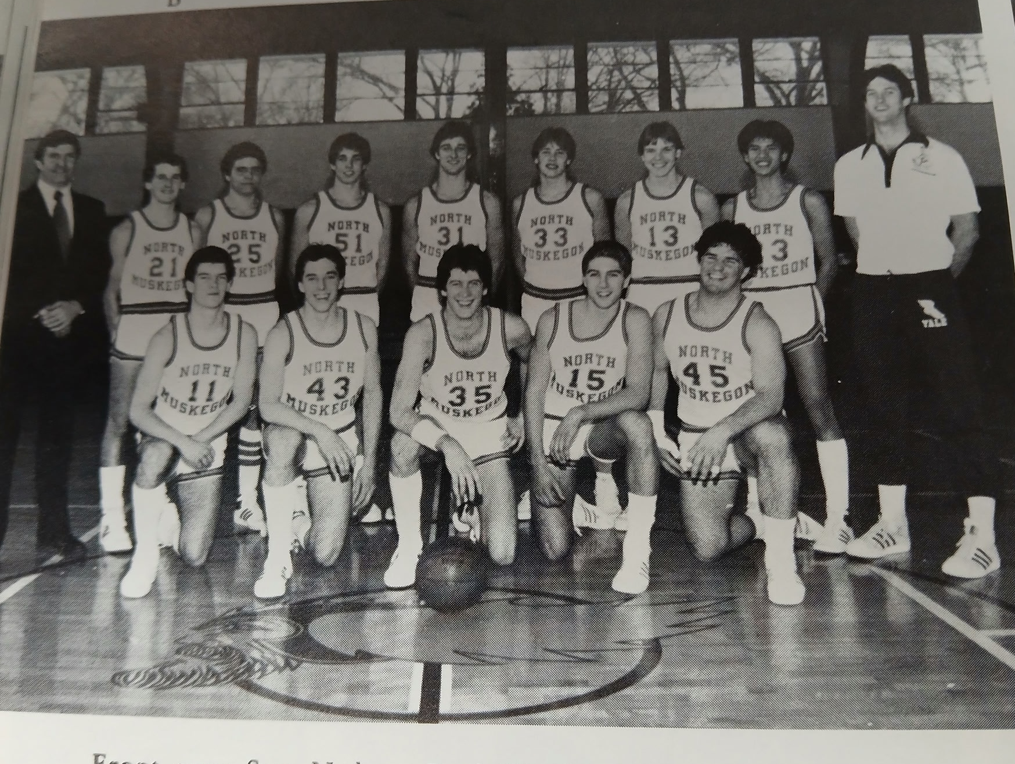

1982-83 NM BASKETBALL

Front Row L-R: Sam Nedeau, Brad Kinning, Dave Weller, John Bowen, Tom Seroczynski
Back Row L-R: Coach Dave Cooke, Todd DeMint, Jim Sheehan, Sean Duer, Craig Stevens, Mike Sekulich, Bill Reek, Ramon Esteban, Asst. Coach Bruce Baty

1983-84 (Coach Dave Cooke 6-15 overall, Oakridge wins WMC)

NM head coach Dave Cooke was hopeful that his current basketball team could match the outstanding record posted by his football team that just completed its season with a 9-1 record. Several players would make the quick transition from football to basketball, including his star quarterback and running back. However, the record will show that most of those players were far better in football than roundball. Only two starters returned from the previous season’s basketball team, 6’2 junior Mike Sekulich and 6’0 guard Jim Sheehan. The rest of the returnees saw little action from the previous season and the Norsemen would struggle as they would come out victorious in but 6 of their 21 games.
NM went on the road to play a talented and big Newaygo team and fell 62-45 to the Lions. Future Muskegon Community College standout 6’6 Dan Davis scored 23 points as Newaygo, who would go on to win their conference, outscored NM in every quarter to post an easy victory. Mike Sekulich led NM with 16 points while the other returning starter from the previous season, Jim Sheehan, netted eight markers.
NM would then entertain Shelby on the Northside court with coach Jim Tate’s Shelby’s Tigers rated as the team to beat in the WMC. It looked like Shelby was going to coast to an easy win over the Norse as NM missed their first 13 shots and fell behind at one point in the opening quarter 15-4. Somehow, the Norse regrouped and pulled off a shocking 50-47 win over Shelby. As bad as NM started off shooting, they quickly found their touch and proceeded to make 10 of their next 14 shot attempts to claw back into the game. Nursing a three-point lead with four minutes to go, Shelby went into a stall that backfired. After NM committed a foul, a Tiger player missed the front end of the one-and-one and NM’s Todd Demint cashed in a bucket to close the gap to a single point. Shelby continued their stall and with 1:50 remaining the Norse came up with a steal. The Norse worked the clock down to a half-minute remaining and took the lead for the first time in the game on a Bill Reek bucket. Mike Sekulich, who would lead the Norse in scoring with 16 points, came up with a steal, was fouled, and calmly hit both free throws to make the final score 50-47. Sekulich was also the game’s leading rebounder with 16, while Jim Sheehan and Sean Deur scored in double figures with 10 points each.
Whitehall wrapped up the next game early, and they didn’t need their friendly home court gym as they outscored NM 40-20 in the first half enroute to a 62-45 victory. Jim Sheehan had a career high 18 points for NM while Mike Sekulich had nine. Mark Cooke, the youngest of head coach Dave Cooke’s three boys, led all rebounders with 14.
Scoring points would be a huge problem for the Norsemen this season and the low scoring continued in a 68-41 loss to Oakridge. For the second straight game the Norse were only able to net 20 points in the first half, while the Eagle’s meshed 36. Jim Sheehan had 12 and Sean Deur 10 as NM dropped to 1-3 early in the season. Meanwhile, Oakridge was off to a great start on the season with a perfect 5-0 record.
The shooting woes continued as the Norse were overwhelmed by Fremont 22-4 in the third quarter in a 72-47 loss in the four-team holiday tournament played at Muskegon Community College. The Norse trio of Jim Sheehan (16), Sean Deur (12) and Mike Sekulich (11) accumulated all but eight of NM’s 47 points. The game was the 64th game between the onetime former rivals. The series could not have been any closer as each team won 32 games over the years. It would be nearly another 40 years before Fremont and North Muskegon would meet again in basketball.
Hall of fame coach Jim Goorman has had many outstanding teams during his legendary career as West Michigan Christian’s head coach. However, the 1983-84 WMC team was not one of those outstanding teams. After NM posted a rare win (53-44) over the Warriors, the WMC record stood at a woeful 0-6. It was a tight game with NM clinging to a one-point lead with five minutes to go before Mike Sekulich hit a couple of two pointers to give NM some breathing room.
The Norse finally found their shooting eye and topped the 50-point mark for the first time all season in defeating Fruitport 68-55. Jim Sheehan became the first Norsemen to score 20 points in a game during the season while Mike Sekulich came close with 18.
NM got off to a quick 6-2 start in their next game with Montague, but it quickly went downhill for the Norse as the Wildcats went on a 14-0 spurt and never looked back in a 67-52 win over the Norsemen. Mike Sekulich had a yeoman like effort in the loss with 16 points and 15 rebounds. Sean Deur was the only other Norse in double figures with 13.
NM then posted 81 points, by far their leading offensive total for the season. Unfortunately, they allowed 88 points as Hart defeated NM 88-81. NM received a big lift from Jeff Jordan who scored 17 points, easily his best offensive showing up to date. Shawn Deur and Mike Sekulich each netted 18. Deur was hot early and scored all 18 of his points before leaving the contest in the third quarter with an injury.
With the game tied at 36-all, the Norse scored 30 points in the second half, 16 of those points coming at the free throw line as NM defeated Ravenna 66-52. “It was tied going into the last quarter and we grabbed a six-point lead,” said NM coach Dave Cooke.” Ravenna was not patient and kept fouling us, and we were fortunate to make the free throws,” said Cooke following the game. Mike Sekulich poured in 26 points and grabbed 16 rebounds to lead the Norse to victory. Jim Sheehan added 11 and Bill Reek nine as NM won their second game in the WMC.
The Norse led by as many as nine points before dropping a 64-62 contest to West Shore Christian in the second and final game played between the two schools. Poor free throw shooting in the fourth quarter when NM three times missed the front end of one-and-one free throws cost the Norse. Mike Sekulich had 17 game leading points for NM while Mark Cooke had 12 points and 12 rebounds.
NM might find it hard to believe that Mason County Central had just loss four games in a row after being soundly whipped by the Spartans 75-41. “They shot well, and we didn’t.” said NM coach Dave Cooke. NM never scored more than 11 points in any quarter in being held to 41 points. Mike Sekulich was the only Norsemen in double figures with 13 points.
After losing very early in the season to NM by three points, Shelby completely flipped the script and downed NM by 24 in a 76-52 romp over the Norse. Shelby more than doubled the score (44-20) at halftime as they cruised to the victory on the Shelby court. Jim Sheehan (12), Sean Deur (11) and Mike Sekulich (10) led the NM offense.
North Muskegon gave a heavily favored Oakridge team a battle before losing 56-51 to an Eagle team who boasted of a 10-1 record after their win over the Norse. The Eagles would finish the regular season as WMC champs with a 19-1 record. NM trailed by only one point with just under a minute to play as Oakridge cashed in clutch free throws at the end to hold off the Norsemen.
NM gave second place Montague a test but fell eight points short in a 63-55 loss to the Wildcats. In a sloppily played game with each team committing 23 turnovers, Montague took over the game when they went up by 13 over NM in the third quarter. Mike Sekulich scored 14 points and grabbed 12 rebounds for NM. Jim Sheehan had 13 and Sean Deur and Craig Stevens added nine for the losing Norsemen.
NM shot a woeful 17 of 74 for the game and fell behind 24-7 as Hart cruised to an easy 66-45 win over NM. Jim Sheehan popped in 16 points for NM and Mike Sekulich added 12. The win kept Hart in the hunt in the WMC title chase while improving their overall record to 12-3. Meanwhile NM was 2-8 in conference play and 4-12 overall.
In a battle of the bottom feeders in the WMC, NM had just enough scoring power to defeat Ravenna 70-66. The win raised NM’s record in the WMC to a modest 3-8 while the Bulldogs fell to 1-9. Mike Sekulich was a driving force in NM’s win with 23 points with Jim Sheehan adding 12 and Sean Deur 11. Ravenna kept themselves in the game with some nifty shooting from the charity strip where they knocked down 18 of 22. After that kind of shooting, one finds it hard to believe that two weeks earlier in a loss to Montague the Bulldogs shot an unfathomable 2-19 at the free throw line.
North Muskegon won their sixth and final game of the season, three more wins than Orchard View was winning at the time, 70-57 over the Cardinals. Jim Sheehan netted 19 points, Mike Sekulich 14, and Sean Deur 12 as NM would take a 6-12 record into the final week of the regular season.
Kent City finished the regular season with an excellent record of 15-5 after their 74-61 victory over the Norse. The Eagles made 22 of their 25 free throws while the Norse made only nine of 20. NM got some offensive production from several players with four players in double figures: Mike Sekulich and Jim Sheehan with 12, Mark Cooke and James Bridgeford with 10.
NM ended their regular season with a 59-50 loss to Mason County, but it was a far cry from the 75-41 pounding the Norse received from the Spartans earlier in the season. NM trailed by only one point at halftime before Mason County gradually pulled away in the second half. Mike Sekulich was the only Norsemen in double figures with 16 points.
NM would go down in enrollment and would play as a Class D school in the 1984 MHSAA tournament. That would not prove to be a plus for the Norse as they would draw an excellent team with an 18-4 record. Pentwater broke open a close game in the second half and would go on to win 77-57. NM got a surprising boost from James Bridgeford who came off the bench to score a game high 16 points for the Norsemen. Bridgeford also grabbed eight rebounds. Mike Sekulich finished his fine junior year with 10 points and 13 rebounds.
The Norse would end their season with a 6-15 overall record but with several players returning for the following season, the Norse would get back to their winning ways.

N Muskegon 45 Newaygo 62 Mike Sekulich 16, Jim Sheehan 8
N Muskegon 50 Shelby 47 Sekulich 16, Sheehan and Sean Deur 10
N Muskegon 45 Whitehall 62 Sheehan 18, Sekulich 9, M. Cooke 14 reb.
N Muskegon 41 Oakridge 68 Sheehan 12, Deur 10
N Muskegon 47 Fremont 72 Sheehan 16, Deur 12, Sekulich 11
N Muskegon 53 WMC 44 Deur 15, Sekulich 14
N Muskegon 68 Fruitport 55 Sheehan 20, Sekulich 18, Deur 10
N Muskegon 52 Montague 67 Sekulich 16 & 15 reb. Deur 13
N Muskegon 81 Hart 88 Sekulich & Deur 18, Jeff Jordan 17
N Muskegon 66 Ravenna 52 Sekulich 26, Sheehan 11, Bill Reek 9
N Muskegon 62 W. Shore Ch. 64 Sekulich 17, Sheehan 15, Cooke 12
N Muskegon 41 Mason Co 75 Sekulich 13
N Muskegon 52 Shelby 76 Sheehan 12, Deur 11, Sekulich 10
N Muskegon 51 Oakridge 56 Sheehan 17, Sekulich 10
N Muskegon 55 Montague 63 Sekulich 14, Sheehan 13
N Muskegon 45 Hart 66 Sheehan 16, Sekulich 12
N Muskegon 70 Ravenna 66 Sekulich 23, Sheehan 12, Deur 11
N Muskegon 70 Orchard View 57 Sheehan 19, Sekulich 14, Deau 12
N Muskegon 61 Kent City 74 Sheehan & Sekulich 12
N Muskegon 50 Mason Co 59 Sekulich 16
N Muskegon* 57 Pentwater 77 James Bridgeford 16, Sekulich 10

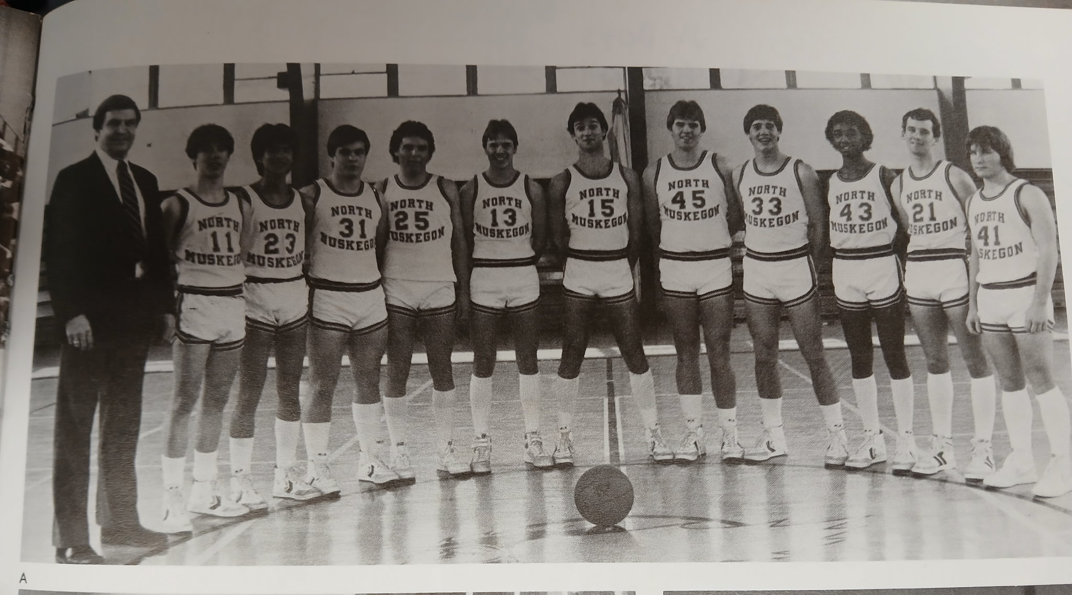

The 1983-84 NORSEMEN

L-R: Coach Dave Cooke, Brock Dana, Ramon Esteban, Jeff Jordan, Jim Sheehan, Bill Reek, Clark Stevens, Mark Cooke, Michael Sekulich, James Bridgeford, Todd DeMint, Trevor Leutscher

1985-85 (Coach Dave Cooke 12-10 overall, Mason Co Central wins WMC)

A very busy Dave Cooke who doubles as both the football and basketball coach at North Muskegon, was more optimistic about this year’s NM team than in the recent past. The Norse return all three of their front-line starters from the previous season, 6’3 Mark Cooke, 6’2 Sean Deur, and All-WMC returnee Mike Sekulich, who would begin his 3rd year in the starting lineup for NM. Cooke’s early concerns would be who would step up in the backcourt?
Whitehall would play their first game in the West Michigan Conference since 1960 and their first opponent would be North Muskegon, a team that hadn’t beaten Whitehall on the Vikings home court since 1962. That streak came to a merciful end as NM defeated the Vikings, surprisingly easy, 67-52. Mike Sekulich, a starting quarterback on the football team showed that he hadn’t lost his touch as he burned Whitehall for 25 points. Sean Deur added 13 points while a newcomer to the lineup, Jeff Diller chipped with 11 as the Norse got off to a rousing start to begin the season.
NM made in two in a row to begin the season, both wins coming against WMC opponents with a 58-56 squeaker over Montague. Only in the fourth quarter were the Norsemen outscored by the Wildcats. Montague tallied 17 to NM’s 13 but not enough to catch the Norse. Mike Sekulich led the balanced NM offense with 14, with Jeff Diller and Sean Diller both scoring 12 while football star Dante Hutcherson added nine.
The defending WMC Champs from Oakridge quickly turned a close game into a rout when they outscored the Norsemen 17-2 in the final minutes of the second quarter. The Eagles would make the final score 90-64 in a game played as part of the Muskegon Community College Holiday basketball tournament but would also count as a West Michigan Conference contest. Foul trouble plagued the Norse as Mike Sekulich was the only starter who didn’t foul out. Sekulich meshed 25 points for NM while Jeff Diller added 18.
The Norse duo of Sean Deur and Mike Sekulich combined to score 42 of NM’s 61 points to win the consolation game of the MCC tournament 61-51 against West Michigan Christian. Deur had a career high 22 while Sekulich also netted 22. NM would have to cherish this win for a long time as the next NM victory over a WMC team would be in the next century when they featured a big red head named Drew Naymick.
Big Tim Perry scored 36 points to lead Shelby to a 67-49 victory over NM on the Tiger’s court. Mike Sekulich again led the Norse with 17 points and nine rebounds. Sean Deur had 11 and Mark Cooke nine points as NM slipped back to 2-2 in the WMC.
NM improved to 4-2 with a non-league 54-46 win over Fruitport. Mike Sekulich again had a big scoring game with 24 with Sean Deur adding 10 and Jeff Diller eight. Mark Cooke did a good on the boards with nine rebounds. The two teams would have to wait another 30 years before they would meet again.
In a game where neither team was shooting the lights out at the charity stripe, NM managed to win a nail-biter over Hart 46-45. Hart converted on 11 of 23 attempts while NM was even worse, making but 8 out of their 24 free tosses. NM trailed by five with a minute and a half left and received some great play by football star Tom Dana. Inserted for his defensive quickness by coach Dave Cooke, Dana banked in a field goal shortly after a Mike Sekulich field goal to cut the lead to one. NM forced a turnover followed by another Sekulich field goal to give NM a 46-45 lead and the final score. Sean Deur had 16 points and six rebounds while Sekulich had eight rebounds in addition to 12 points.
NM rallied from a 13-point deficit in the third quarter to go on a second half roll to outscore the host Pentwater Falcons by 25 points to earn a 70-58 road win. Mike Sekulich paced the Norse once again with 21 points and 12 rebounds while Jeff Diller netted 17 as the Norse improved to 6-2.
NM built up a 25-point lead and then coasted to a 78-56 victory over Ravenna to improve their record to 7-2 on the season. The seven wins already was one more than the Norse won all last season. Sean Deur had a big day with 24 points, while Mike Sekulich and Tom Dana each had 10 for the streaking Norsemen.
That streak came to a sudden end when Whitehall, who lost at home earlier in a rare loss over the years to NM, repaid the favor and won on the Norsemen’s home court 60-58. Many games in the area were cancelled due to the horrendous weather, but NM and Whitehall chose to play. NM had their poorest shooting night from the floor, and it led to their four-game winning streak coming to a halt. NM trailed by 10 with four minutes remaining but a late comeback left them two points short. Mike Sekulich paced the Norse with 17 while Mark Cooke had his best scoring night on the season with 15.
Cold shooting from the floor for the Norse contrasted with hot shooting from the free throw line by Orchard View led to a 76-67 Cardinal victory in a non-league game. One Norse player who wasn’t plagued by poor shooting was Sean Deur. The 6’2 senior connected on 12 of his 18 field goal attempts and made five of his eight free throws for a career high 29 points. Orchard View potted 34 of their 42 free throws in a foul filled contest. Scoring 17 points for the winning Cardinals was John Jancek, currently the defensive coordinator for the LSU football Tigers after coaching at many major D1 schools, including stints at Tennessee and Georgia.
The Norse made a 12-point lead at halftime hold up as NM won their eighth game of the season and second over Montague with a 63-54 victory. The one-two punch of Sean Deur (17) and Mike Sekulich (15) led the Norse offensive attack with help from Mark Cooke who added nine.
NM ran into an Oakridge team that seems to play its best against the Norse. Although they didn’t singe the hoops for 90 points as they did in their earlier game with the Norse, they had enough firepower to tally 74 points to earn a 74-62 win; a final score that really wasn’t that close. The Eagles led by nearly 20 points before NM made a late run in the final quarter. Mike Sekulich had 16, Sean Deur 13, and Dante Hutcherson 10 for the Norse who dropped to 8-5 overall.
In their first game with Shelby when NM scored only 49 points, the Norse gave up 67 points and lost by 18. The Norse again scored 49 points in their rematch with the Tigers but in this game, they only allowed 45 points and came away with a victory. The game was tight most of the way and it took a couple of pressure free throws from Trevor Leutscher in the game’s final seconds to put the game on ice. Leutscher, an outstanding running back on the football team, had his highest point production of the season in the low scoring contest with 8 points. His running mate in the NM backfield, Dante Hutcherson, also had eight points and had six assists. Sean Deur led the scoring with a modest total of 12 while Mike Sekulich had a season low of four points.
The math is this game was simple. Hart hit for 58 percent from the floor while NM shot 32 percent as the Norse lost to the Pirates 70-61. NM received 16 points from Darren Smith and 15 from Mike Sekulich to drop to 6-5 in league games. With the win Hart kept their slim hopes alive with a share of the league crown, tied with Oakridge at 8-3 but trailing Mason County Central with only one league loss.
North Muskegon and Holton resumed their rivalry after a seven-year gap, and the Norse breezed to a 72-45 win over the Red Devils. Holton had an 8-8 record entering the game, but NM’s much tougher regular season schedule was a big help. Mike Sekulich had 16, while Mark Cooke had to make his father happy as he scored 15 points while pulling down 13 rebounds. Darren Smith has been a recent surprise for NM as he scored in double figures for the second straight game with 13 points.
The game was tied at halftime between Mason County Central and NMHS, but the league leading Spartans outscored NM by six points in each of the final two quarters to earn a 62-50 win. The win all but clinches the WMC title for the Spartans who are 10-1 in the WMC and an impressive 16-1 overall. Balanced scoring was the theme for the Norsemen as Mike Sekulich had 12, Darren Smith 10, Sean Deur 9 and Trevor Leutscher 7.
NM let a game get away from them as Kent City used the home court crowd to help rally the Eagles from a 10-point deficit in the final quarter to outscore NM 20-8 in the game’s final eight minutes in nipping the Norse 65-63. NM needed to look no further than the stat sheet to come up for a big clue for the loss to the Eagles. NM made only 13 of 29 free throws, many on the front end of a one-and one. NM did receive outstanding balance as Mark Cooke and Darren Smith had season highs of 16 points, with Mike Sekulich adding 15 and Sean Deur 10.
It took a couple of postponements due to inclement weather but on a Wednesday night Mason County Central was finally able to make the journey from Scottville to NMHS. The final score of 62-51 was nearly identical to their game from a few days back of 62 to 50. It was almost identical in the summary as MCC outscored NM by 10 points in the second half following a tight first half that saw the visitors leading by just one point. Darren Smith continued his fine play in the second half of the season with 17 points to lead the Norse followed by Mike Sekulich with 12 and Sean Deur 10. With the win Mason County wins the WMC title.
NM closed out the regular season with a convincing 69-50 victory over Ravenna. After missing a bundle of free throws that contributed to their defeat against Kent City, NM converted 13 of 16 free throws against Ravenna, many of those made free ones coming in the final quarter. Mark Cooke continued to get better as the season moved along and had his best scoring output of the season with 17 points while latching on to 14 rebounds. Mike Sekulich was also a force in the victory as he also netted 17 points while grabbing 15 rebounds.
Games in March during the MHSAA tournament often provide much different results than games played during the regular season. Case in point. NM scored 70 points in January in a 70-58 win over Pentwater. In the Class D district played at Holton between these same two teams, it was a much different game. Scoring was low and NM had to rally from a 3-point deficit with 2:14 left in the game to earn a 48-47 first-round victory. Mike Sekulich scored 14 and Sean Deur added 10 in the low scoring game.
For the second time in the last few games, poor free throw shooting cost NM. Making only 12 of 30 free throws hurt even more this time as it cost the Norse a chance to win a district tournament as they lost by only four points, 72-68 to Baldwin in the Class D district final played at Holton. Baldwin hit 20 of 28 from the charity stripe to earn the right to advance to the regional. Reggie Fox, future Muskegon Community College star who took his talents to the University of Wyoming led Baldwin to their victory with 28 points. Sean Deur ended his career at NMHS with 23 points with Mike Sekulich also playing his last game in a NM uniform tallied 14.

N Muskegon 67 Whitehall 52 Mike Sekulich 25, Sean Dear, Jeff Diller 11
N Muskegon 58 Montague 56 Sekulich 14, Diller & Deur 12
N Muskegon 64 Oakridge 90 Sekulich 25, Diller 18
N Muskegon 61 WMC 51 Deau 22, Sekulich 22
N Muskegon 49 Shelby 67 Sekulich 17, Duer 11, Mark Cooke 9
N Muskegon 54 Fruitport 46 Sekulich 24, Deur 10, Diller 8
N Muskegon 46 Hart 45 Deur 16, Sekulich 12, Diller 11
N Muskegon 70 Pentwater 58 Sekulich 21, Diller 17, Cooke 10
N Muskegon 78 Ravenna 56 Deur 24, Sekulich 10, Tom Dana 10
N Muskegon 58 Whitehall 60 Sekulich 17, Cooke 15, Deur 9
N Muskegon 67 Orchard View 76 Deur 29, Sekulich 10, Dante Hutcherson 8
N Muskegon 63 Montague 54 Deur 17, Sekulich 15, Cooke 8
N Muskegon 62 Oakridge 74 Sekulich 16, Deur 13, Hutcherson 10
N Muskegon 49 Shelby 45 Deur 12, Trevor Leitscher 8, Hutcherson 8
N Muskegon 61 Hart 70 Smith 16, Sekulich 15, Cooke 8,
N Muskegon 72 Holton 45 Sekulich 16, Cooke 15, Smith 13,
N Muskegon 50 Mason Co 62 Sekulich 12, Smith 10, Duer 9
N Muskegon 63 Kent City 65 Smith & Cooke 16, Sekulich 15, Deur 10
N Muskegon 51 Mason Co 62 Smith 17, Sekulich 12, Duer 10
N Muskegon 69 Ravenna 50 Cooke & Sekulich 17, Hutcherson 8
N Muskegon 48 Pentwater 47 Sekulich 14, Deur 10
N Muskegon 68 Baldwin 72 Deur 23, Sekulich 14, Leutscher 11

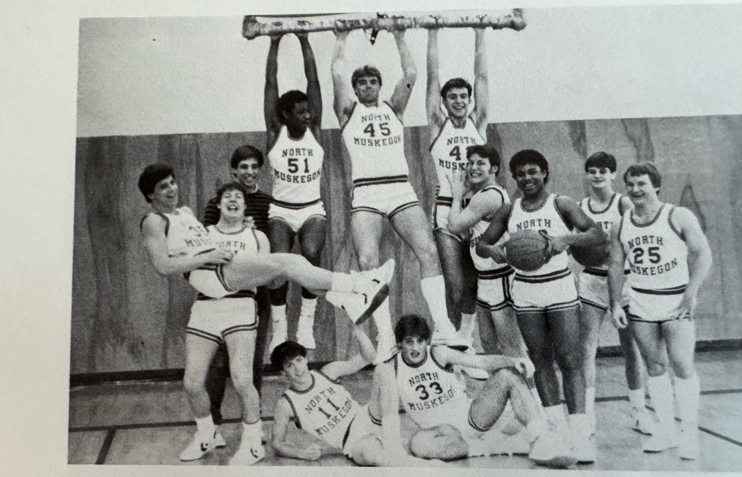

The 1984-85 NORSEMEN

Standing L-R: Tom Dana, Dennis Flynn, Sean Duer, Darren Smith, Mark Cooke, Jeff Diller, Mark Flynn, Donte Hutchinson, Tom Thiele, Trevor Leitscher
Sitting L-R: Brock Dana, Mike Sekulich

1985–86 (Coach Walt Gawkowski 3–18) Oakridge – MCC tie WMC)

Dave Cooke stepped aside as the NM basketball coach to concentrate more on his yeoman duties as NM’s football coach. Replacing Cooke would be Walt Gawkowski, coming over from Muskegon Catholic where he was the head basketball coach for the Crusaders. Gawkowski would serve three years as the basketball coach but would serve many years as the head baseball coach for NMHS where he was recognized as one of the best baseball mentors in the state of Michigan.
The cupboard was nearly bare of returnees that greeted Gawkowski for his first practice. Only football star Dante Hutcherson and Jeff Diller saw extensive action from last year’s NM’s fine season. NM would struggle mightily as they would only come out on top in three games, two of those coming at the expense of a normally dominant Shelby fivesome.
NM began the season with a conference clash with Ravenna, and it was clear that NM was going to have difficulty putting points on the board. A young Ravenna team broke open a close game in the fourth quarter by outscoring the Norse 22-6. Dante Hutcherson, who never reached double figures in a game last season, led the Norse with 17 points with Mark Flynn chipping in with 11.
Whitehall then handed the Norse their second defeat on the season 50-39. NM’s one-point lead after the opening period of play went away quickly as Whitehall’s quickness proved too much for NM to handle. Dante Hutcherson had 13 points and Mark Flynn 12 as the Norse could only muster 39 points in the contest.
The fans in Newaygo were still basking in the glory of celebrating the second consecutive state championship won by the Newaygo girls’ team over the weekend. That enthusiasm spilled over to the boys’ team as they defeated NM 65-53. Newaygo spotted the visiting Norsemen a seven-point lead after the first quarter, but the Norse were only able to score four points during the entire second period while Newaygo tallied 15. Dante Hutcherson led NM with 18 points followed by Jeff Diller with 13.
NM had by far their highest scoring night thus far in the 1985-86 season with 69 points against Montague. However, NM gave up 95, the most points a NM opponent would score all season. NM got good production from Jeff Diller and Dante Hutcherson as each surpassed the 20-point barrier. Mark Maynard had 11 as Montague scored 20 or more in each quarter to breeze past the Norse.
Oakridge riddled NM’s defense for 74 points to dampen the coming out party for NM freshman Matt Kolbe who scored 20 of NM’s 45 points in a 74-45 loss to the Eagles. Closest to Kolbe in scoring for NM was Wes Phillips who netted seven points as NM was still looking for their first victory of the season.
The Norse wouldn’t have to wait long for their first win, just four days, as the Norse surprised Shelby 65-50. A big 22-9 advantage in the second quarter helped NM acquire their first win. Dante Hutcherson was the catalyst for the spurt in the second quarter with four steals that he converted into buckets. For the second time in three games Jeff Diller had 21 and Hutcherson 20 in a game while Mark Kolbe netted 11. NM would have to savor the win over Shelby as it would be another nine games before NM would come out on the winning side of a score.
Free throw woes hurt NM badly in the previous season and was a factor in NM’s 59-48 loss to Hart, the sixth win in a row for the streaking Pirates. Hart netted 13 points at the charity stripe to the Norsemen’s two. The Pirates built a 31-25 lead at halftime and gradually pulled away from the Norse in the second half. Jeff Diller led NM with 17 points followed by Dante Hutcherson with 12.
A slow first quarter where NM was outscored 16-7 led to NM dropping a non-league game to Pentwater 67-60. NM shot a woeful 3 for 19 in that pivotal opening quarter. NM made a run in the fourth quarter to close the Pentwater advantage to four points before NM’s Dante Hutcherson, who scored 23 points, fouled out of the contest. Jeff Diller added 14 and Wes Phillips nine for the 1-7 Norsemen.
The Norsemen were completely overwhelmed by Mason County, losing 80-32, the second largest loss to the Spartans in the long rivalry over the years. The host Spartans held NM to 32 points, NM’s lowest scoring output of the season. Only in the fourth quarter when MCC had reserves playing in the game did NM manage to score more than 10 points in a quarter. No Norse player was even able to score in double figures in the lopsided loss.
The second meeting with Ravenna was a much closer game than the first contest between the two teams. After being blown out by nearly 20 points in a game that opened the season, the Norse lost by only 6 points. The six points difference was a 24-18 fourth quarter for Ravenna. Leading the Bulldogs was Donnie Tyndall who scored 16 points. Tyndall would become a major college coach reaching as high as the head coach of Tennessee. Tyndall currently coaches at Chipola junior college in Florida where one of his assistants is Mark Jacobs, who scored 11 points in the Bulldogs 65-59 win over NM. Donte Hutcherson tallied 22 points for the Norsemen before fouling out late in the game.
NM had a golden opportunity to pull off a rare road victory at Whitehall only to see the Vikings outscore the Norse 28-17 in the fourth quarter to edge NM 62-60. The Vikings connected on 11 of their 12 free throws in the final eight minutes to stun the Norse and send NM to their 10th loss in 11 games. NM had four players in double figures: Mark Kolbe and Jeff Diller 13, Dante Hutcherson 11, and David Rodgers 10.
NM couldn’t keep a taller Hesperia team off the boards as the Panthers had numerous second chance opportunities to hand NM a non-league 62-46 loss. It was a tale of two bad quarters that led to the Norse defeat. Hesperia outscored NM 17-6 in the first quarter and 22-14 in the third. Dante Hutcherson was the lone Norsemen in double figures with 12 points.
Although their record wouldn’t show it, the Norse did show much improvement during the season. After being blown out by Montague 95-69 in their first encounter, NM took the Wildcats to overtime before losing 61-55. Sophomore Wes Phillips had a season high 19 points for the Norsemen with Dante Hutcherson close behind with 17.
The improvement wasn’t quite as noticeable in NM’s next loss to Oakridge. After losing their opener to Oakridge 74-45, the Eagles scored the same number of points while NM improved just gradually by notching 48 points, a miniscule three more than they netted in their first contest with the Eagles. Oakridge was never threatened by the Norse as they outpointed NM in every quarters. Mark Kolbe and Wes Phillips shared high point earners for NM with each scoring 12 points.
NM took to the road in their second of two non-league games with Hesperia and came away with a much-needed one point 51-50 victory over the Panthers. Dante Hutcherson with 17 and Mark Kolbe with 16 led the Norse scorers but head coach Walk Gawkowski had special praise for Dave Rodgers. “Although Rodgers only scored two points, the job he did on defense was really great,’ said the Norse head coach.
NM then escaped with their second one-point victory in the week with a 53-52 win over a Shelby team coached by Rick Zoulek, who nearly 40 years later is still at the helm for the Tigers. Rick Zoulek has coached many great teams at Shelby in his four decades as the head coach. 1986 would not be one of those great teams as his Shelby Tigers finished the season winless at 0-21. At one point in the first half the Norse trailed by as many as 11 points before NM mounted their comeback. For once NM won the battle at the free throw line as NM was nine of 11 while Shelby was but two of six. Jeff Diller led NM with 16 points closely followed by Matt Kolbe with 14 and Dante Hutcherson with 12.
A quick 18-6 start propelled Holton to a 61-53 non-league win over the Norse. A late fourth quarter rally by NM came too late to overtake the Red Devils. Dante Hutcherson led NM with 16 with Jeff Diller with 12 and Wes Phillips with 10 also in double figures.
Hart outscored NM 18-8 in the second quarter, the difference in the game in Hart’s 57-47 win over the Norse. Jeff Diller had 17 points and 14 rebounds to lead the Norse, but NM was unable to overcome their 23 turnovers committed in the contest.
Kent City made quick work of NM as they jumped out to a 19-8 first quarter lead and continued to roll in a 72-44 pounding of the Norsemen in the final week of the regular season.
There was no 50-point blowout in the second meeting of the season between NM and Mason County Central, but it was still a MCC win as the regular season came to an end with NM losing to the Spartans 73-56. The Spartans would finish the regular season with another great record of 18 wins against but two defeats to earn a tie in the WMC with Oakridge. Dante Hutcherson and Jeff Diller were the one-two punch for NM with 19 and 16 points respectively.
North Muskegon would host their first district tournament since 1959 with the Class D district contested on the Northside court. And, just like 1959 when the Norse lost the first game of the Class B district to Coopersville in sudden death, the 1986 Norsemen went down to a 56-53 opening round loss to Pentwater. NM led for three and a half quarters before Pentwater rallied to eliminate the Norse. Dante Hutcherson ended his successful season with 19 points with Wes Phillips close behind with 14.

N Muskegon 43 Ravenna 62 Dante Hutcherson 17, Mark Flynn 11
N Muskegon 39 Whitehall 50 Hutcherson 13, Flynn 12, Jeff Diller 8
N Muskegon 53 Newaygo 65 Hutcherson 18, Diller 11
N Muskegon 69 Montague 95 Diller 21, Hutcherson 20, Mark Maynard 11
N Muskegon 45 Oakridge 74 Mark Kolbe 20, Wes Phillips 7
N Muskegon 65 Shelby 50 Diller 21, Hutcherson 20, Kolbe 11
N Muskegon 46 Hart 59 Diller 17, Hutcherson 12, Flynn 8
N Muskegon 60 Pentwater 67 Hutcherson 23, Diller 14, Phillips 9
N Muskegon 32 Mason Co 80 Kolbe & Diller 8, Hutcherson 7
N Muskegon 59 Ravenna 65 Hutcherson 22, Diller 13
N Muskegon 60 Whitehall 62 Kolbe & Diller 13, Hutcherson 11, Rodgers 10
N Muskegon 46 Hesperia 62 Hutcherson 12, Kolbe and Phillips 8
N Muskegon 56 Montague (ot) 61 Phillips 19, Hutcherson 17
N Muskegon 48 Oakridge 74 Kolbe & Phillips 12, Diller 9
N Muskegon 52 Hesperia 51 Hutcherson 17, Kolbe 16, Diller 9
N Muskegon 53 Shelby 52 Diller 16, Kolbe 14, Hutcherson 12
N Muskegon 53 Holton 61 Hutcherson 16, Diller 12, Phillips 10
N Muskegon 57 Hart 67 Diller 17, Hutcherson 10
N Muskegon 44 Kent City 72 Hutcherson 11, Diller 9, Kolbe 8
N Muskegon 56 Mason Co 73 Hutcherson 19, Diller 16
N Muskegon* 53 Pentwater 56 Hutcherson 19, Phillips 14, Flynn 10

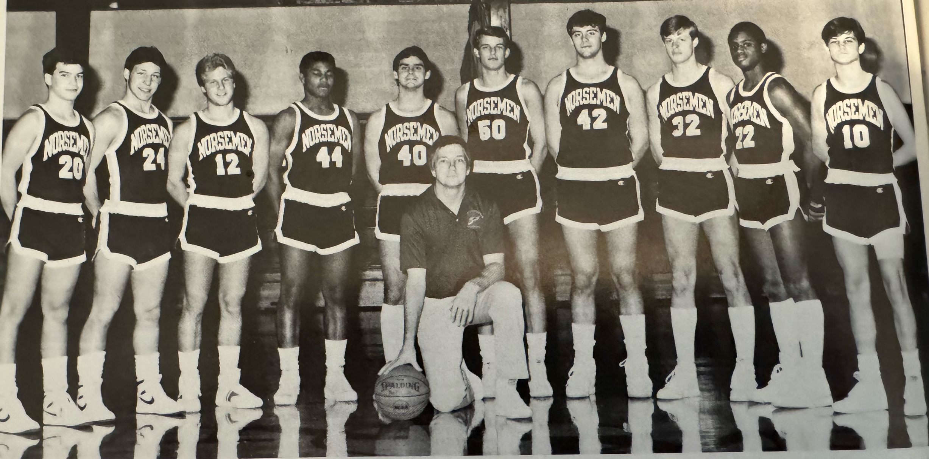

The 1985-86 NORSEMEN

L-R: Mark Maynard, Mark Flynn, Steve Amante, Dante Hutcherson, Steve Hoffman, Mike Austin, Jeff Diller, Dave Rodgers, Wes Phillips, Tom Theile, Coach Walt Gawkowski

1986-87 (Coach Walt Gawkowski 7-14, Mason County champs WMC)

2nd year coach Walt Gawkowski will welcome four regulars returning for the 1986-87 season: Dante Hutcherson, Mark Kolbe, Wes Phillips and David Rodgers. Also joining the Norsemen five would include Jerry Brichan, Bob Kersting, Matt Steketee and Jimmy Johnson. The Norsemen would only win seven games during the season but would prove to be very competitive. The season would end in a record setting scenario that was not kind to this team, losing a pair of games that would require six overtimes. The 1986-87 season would begin a huge change in basketball as it would mark the beginning of the three-point shot.
The Norsemen began the season by snapping a four-game losing streak to Newaygo with a 60-47 victory in a game that wasn’t nearly as close as the final score. The Norse enjoyed a commanding 51-30 lead entering the final quarter. Dante Hutcherson, an all-state running back in football, began his third year as a basketball starter and took up where he left off from his junior season by scoring 20 points to lead NM. Sophomore Mark Kolbe also was in double figures for the winning Norse with 13 markers. Second year coach Walk Gawkowski also had special praise for his role players who helped in the NM win, including Dave Rodgers, Bob Kersting and Jim Johnson.
The annual long road trip to Scottville saw NM get off to a rocky start and it never got much better as NM lost to Scottville 61-41. It was 33-14 at halftime with the hometown Spartans in control. Only a 14-8 fourth quarter run did NM outscore MCC in a period. No Norsemen were in double figures as their high point man Bob Kersting only had nine points.
NM got back in the winning column with a 53-43 home victory over Ravenna thanks to a big second quarter when NM outscored the Bulldogs 20-9. NM trailed 17-10 after the first quarter was completed and finally took the lead in the second quarter on a field goal by Jim Johnson. Wes Phillips had his best scoring output to begin the season with eighteen points while NM received a nice all-around game from Dante Hutcherson with 15 points, six steals and a pair of assists.
NM played a newcomer on their schedule, Fruitport Faith Christian, and the Norse came away with a 67-49 victory. The game was tight at halftime with NM leading by three points. NM pulled away in the second half as NM Coach Gawkowski attributed some of the second half spark to Jim Johnson, who came off the bench to score 10 points. Mark Kolbe had a game high 20 points while Donte Hutcherson filled up the stat sheet with 17 points, six rebounds, six steals and four assists. Wes Phillips chipped in with 14 points as NM had four players in double figures.
NM jumped out to an early 14-6 lead at Whitehall, but the host Vikings doubled the score over NM 16-8 in the second quarter to send both teams to their lockers rooms tied at 22-all. Whitehall outlasted NM in the second half to earn a low-scoring 47-44 win over NM. Matt Kolbe led NM in scoring as Donte Hutcherson, who had become a complete player, had 10 points along with seven steals and six assists.
Following a long holiday layoff NM final got back on the court but they didn’t bring with them from 1986 their shooting eye. The Norse were only able to score 42 points in a 65-42 loss at Montague. NM only had 18 points at halftime as Montague cruised to the victory. Mark Kolbe was the only Norseman in double figures with 14 points with Dante Hutcherson close with nine.
It took a pair of overtime periods before NM was able to put away a scrappy Pentwater team 72-70, partially making amends for the Falcons ending NM’s last season in the opening game of the layoffs. NM’s pesky defense created 27 turnovers with 11 of those coming on steals from Dante Hutcherson that was probably the top mark in steals in NM history. Dante also fired in 25 points with scoring help coming from Matt Kolbe (18) Wes Phillips (11) and Scott Brichan (10).
The Norsemen broke open a tight game by holding Oakridge to but six fourth quarter points while the Norse scored 14 to defeat the Eagles 60-49. Mark Kolbe pumped in 20 points for the victorious Norsemen with Wes Phillips (12) and Dante Hutcherson (10) also in double figures.
In a game moved due to inclement weather from a Friday to the following Wednesday North Muskegon traveled to Shelby and defeated the host Tigers 63-61. NM overcame a dreadful opening quarter when they scored but four points to rally for the win. Wes Phillips led NM with 16, Matt Kolbe netted 15, while NM’s ‘super sixth’ man Jim Johnson scored 13. Donte Hutcherson played his usual all around floor game and became the fourth Norsemen in double figures with 11. The win gave NM a solid 6-3 record. However, this would mark the highwater mark on the season for NM as they would only win one more game in the entire season, against these same Shelby Tigers.
After an even first half Hart came out sizzling in the third quarter to record a 32-18 edge over NM to break the game open as Hart would go on to win 88-68. Scott Brichan had a career high for NM with 18 points while Mark Kolbe and Wes Phillips each added 13 in what would prove to be the first of eight straight losses for the Norsemen.
NM’s next task was an attempt to break up Mason County Central’s 8-0 perfect record in the WMC. Early into the third period after three consecutive steals by Dante Hutcherson, the Norse cut MCC’s margin to 31-28. The visiting Spartans then went on an 18-5 run and were well on their way to compile a perfect 9-0 record in conference play. Scott Brichan continued his recent fine play for NM with 14 points and 10 rebounds. Jim Johnson finished with 10 points and five assists while the quick hands of Dante Hutcherson produced seven steals and six assists.
The Ravenna Bulldogs, losers to NM early in the season by 10 points, more than reversed that ending by thumping the Norse by 25 points, 65-40. Only Wes Phillips was in double figures for the cold shooting Norsemen with his modest 12-point effort.
NM then dropped a mid-week game to a Hesperia team who came into the game with a modest 3-10 record. The host Panthers edged the Norsemen 54-51. Mark Kolbe was the only Norsemen to reach double figures with 18 points with Jim Johnson close with nine.
Playing at home on a Thursday President’s Day weekend, poor shooting led to another Norse defeat in a 51-46 loss to Whitehall. NM shot a poor 31 per cent while the victorious Vikings shot 51% to send NM to their 5th straight defeat.
NM lost the rebounding battle in an 81-76 loss at Holton. The Red Devils more than doubled the number of rebounds (50-24) over the Norsemen that resulted in many easy put backs. NM, trailing 59-46 entering the final quarter, put up 30 points in the game’s final eight minutes but still fell five points short. The Norse had five players reach double figures led by Dante Hutcherson with 17 points, several steals and nine assists. Matt Kolbe 16, Wes Phillips 13, and Bob Kersting and Jim Johnson with 10 all scored in double figures but fell short of overtaking the Red Devils.
A poor first quarter whereby the Norse were down 16-4 after eight minutes of play led to NM losing once more to Montague 62-50. NM lost despite a possible record effort from the quick hands of Dante Hutcherson who was credited with a probable school record 12 steals. The all-state football player also led NM in points with 18 and assists with six. Matt Kolbe with 13 and Scott Brichan with 11 also were in double figures as NM fell to 6-10 on the season after a promising 6-3 start.
For the second straight game NM dug themselves into a first quarter hole in a 61-47 loss to Oakridge. NM trailed 17-8 heading into the second quarter and never threatened the Eagles. Oakridge held NM’s Dante Hutcherson to but four points as only Matt Kolbe (14) and Jerry Brichan (12) were able to score in double figures.
Finally, a good first quarter and more importantly, a win! NM scored 90 points, nearly 20 more than their previous best during the season as NM snapped their losing streak at eight with a 90-65 win over Shelby. The Norse had outstanding balance scoring with four players in double figures, and two other NM players close with eight. Matt Kolbe (18), Scott Brichan (15, Dante Hutcherson and Wes Phillips (14) were all in double figures with Jim Johnson and Bob Kersting adding eight points as NM finally secures their long sought-after seventh victory on the season.
Kent City improved their record to 17-2 in an easy 75-53 victory over the Norse that began the final week of the regular season. The Eagles shut down NM’s Dante Hutcherson who got into early foul trouble and would score a season low two points. Kent City outscored NM 21-9 in the third period to erase any thoughts of a Norse comeback. Bob Kersting led NM with 14 points and nine rebounds while Matt Kolbe and Wes Phillips each scored 11 for the Norsemen.
NM finished their 1986-87 in the cruelest of fashions, losing their final two games that were both decided in overtime. Not just one over time session – but six! In the longest game ever played by a NM team the Norse lost their final game of the regular season to Hart that took four overtimes to decide a winner. The host Pirates outpointed NM by four points in the final three-minute period to earn a 66-62 victory.
Too add more salt to the wounds for the 1987 Norsemen they would have their season come to a bitter end with another overtime loss 74-70 to West Michigan Christian. WMC would have the advantage of playing on their home floor in the first district tournament ever hosted by the Warriors. Sophomore Mark Kolbe led NM with 20 points while junior center Scott Brichan had 19. NM showed great balance in the loss as Dante Hutcherson (16) and Wes Phillips (10) were also in double figures for NM. The Norsemen and the Warriors would meet often in the ensuing years in the playoffs as all their next 11 games would take place in the playoffs and all 11 games were won by WMC.
Coach Walt Gawkowski’s Norsemen won only seven games during the season but were in contention in many of their games, including those two final heart-breaking games that went into overtime.

N Muskegon 60 Newaygo 47 Dante Hutcherson 20, Mark Kolbe 13
N Muskegon 41 Mason Co 61 Bob Kersting 9, 4 players with 6
N Muskegon 53 Ravenna 43 Wes Phillips 18, Hutcherson 15, Kolbe 8
N Muskegon 67 Fport Christ. 49 Kolbe 20, Hutcherson 17, Phillips 14
N Muskegon 44 Whitehall 47 Kolbe 12, Hutcherson 10
N Muskegon 42 Montague 64 Kolbe 14, Hutcherson 9
N Muskegon 72 Pentwater (2ot) 70 Hutcherson 25, Kolbe 18, Scott Brichan 10
N Muskegon 60 Oakridge 49 Kolbe 20, Phillips 12, Hutcherson 10
N Muskegon 63 Shelby 51 Phillips 16, Kolbe 15, Jim Johnson 13
N Muskegon 68 Hart 88 Brichan 18, Phillips & Kolbe 13
N Muskegon 46 Mason Co 70 Brichan 14, Johnson 10
N Muskegon 40 Ravenna 65 Phillips 12
N Muskegon 51 Hesperia 54 Kolbe 18, Johnson 9
N Muskegon 46 Whitehall 51 Kolbe 14, Phillips 10, Brichan 9
N Muskegon 76 Holton 81 Hutcherson 17, Kolbe 16, Phillips 12,
N Muskegon 50 Montague 62 Hutcherson 18, Kolbe 13, Brichan 11
N Muskegon 47 Oakridge 61 Kolbe 14, Brichan 12
N Muskegon 90 Shelby 65 Kolbe 18, Brichan 15, Hutcherson & Phillips 14
N Muskegon 53 Kent City 75 Kersting 14, Kolbe & Phillips 11
N Muskegon 62 Hart (4ot) 66 Kolbe and Brichan 17, Kersting & Phillips 10
N Muskegon* 70 WMC (2ot) 74 Kolbe 20, Brichan 19, Hutcherson 16

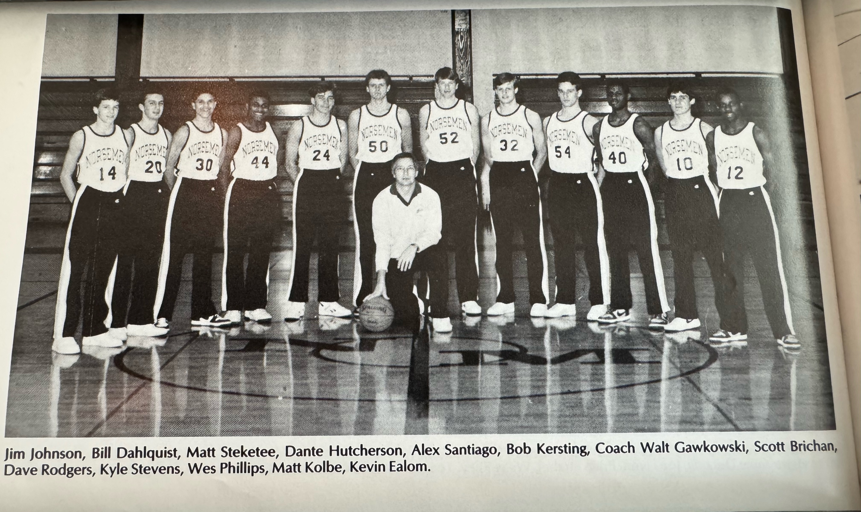

THE 1986-87 NORSEMEN

1987-88 (Coach Walt Gawkowski 4-17, Montague champs WMC)

NM would return five players, including four starters for the 1987-88 season. One starter not returning however was the leader of the previous season’s team: Dante Hutcherson. Mark Kolbe, still only a junior, would return as a third-year starter, while other regular returning included Wes Phillips, Bob Kersting and Jim Johnson. Again, despite the less than stellar record NM would be competitive in most of their regular season games. The 1987-88 high school season would begin the second season for the three-point shooters.
For the second straight season the Norse opened their schedule with Newaygo but a 35-point performance by Lion head coach Mike Pumford’s son Brian led to an opening loss for the Norsemen, 81-70. NM received balanced scoring from their returning veterans as Mark Kolbe netted 21, Bob Kersting and Wes Phillps 15, with Scott Brichan and Jim Johnson contributing eight and seven points respectively. NM would have to wait several games to earn their first victory.
The Norse had to feel good about their chances in their second game with Mason County Central when they went into the locker room at halftime trailing by only one point to the two-time defending WMC champs. However, the visiting Spartans came out on fire in the third quarter by outscoring the Norse 26-7 enroute to an 80-70 victory. Matt Kolbe led NM with 19 points followed by Wes Phillips with 18 as each of the NM leaders connected on three 3-pointers. Haley Potts and Scott Brichan each added eight to the Norse cause. Jim Johnson had six points with an equal number of assists as NM drops to 0-2.
Ravenna used a 22-9 impetus in the first quarter as the Norse fell victim in their third straight start losing 71-63 to the Bulldogs. Matt Kolbe again led NM scorers with 17 while Jerry Brichan added 14. Jim Johnson made 10 points and five assists while Wes Phillips had 10 rebounds for the visiting Norsemen.
The Norse probably will look back at their 92-54 loss to Whitehall as the low point of their season. The visiting Vikings scored 20 or more in every quarter during the rout of the winless Norsemen. Matt Kolbe’s 15 points led the Norse with Scott Brichan adding 10.
The New Year didn’t treat NM any better than the old as following a long layoff over the holidays, NM fell to Montague 80-62. The Wildcats led from the opening tipoff to the final horn. Matt Kolbe again was the leading scorer for the Norse with 18 points, followed by Wes Phillips with 14 and Bob Kersting with 10.
NM took the road to Pentwater with high hopes of attaining their first win against a fellow Class D school. That did not happen as Pentwater out tallied the Norsemen 32-9 in the final quarter to win by 23 points. Both teams were deadlocked at 38-all before the host Falcons went on their huge run. For the first-time all-season Matt Kolbe, held to six points, did not lead NM in scoring. Scott Brichan topped NM with 14 points with Bob Kersting adding 10. Three frustrated NM players fouled out in the deciding fourth quarter.
The Norse would finally get their first victory with a 62-44 win over Oakridge. One may find this hard to believe but it would be the last victory by NM over Oakridge in 22 games. NM would not get on the plus side of the scoring column with Oakridge until the Drew Naymick era at NMHS. So dominant was Oakridge over the Norse during the 1980s and 90s that Oakridge would compile a surreal 33-2 record during that span. Scoring was evenly distributed for the Norsemen. Matt Kolbe and Wes Phillips each tallied 14, Haley Potts netted 12 and Scott Brichan added 10 points with nine rebounds.
NM then made it two straight wins as they defeated Shelby for the sixth straight time in the long series that stood at 52-45 following this game in 1988. The Norse were down seven with 4:30 left in the contest when they ramped out their defense and rallied for the victory. Matt Steketee came off the bench to spark the Norse with 14 points, equaling teammate’s Scott Brichan’s 14 markers.
North Muskegon, who rarely plays a school with an enrollment less than the Norse, made Fruitport Faith Christian, a fledging school with only 53 students, their third straight victim with a tight 73-67 victory. NM needed to have a 30-21 fourth quarter run to secure the victory. The Conquerors were paced by last season’s leading scorer in the area Scott Bathrick who bucketed 29 points. Scott Brichan had 18 points for NM while Wes Phillips had a big game with 17 points and 20 rebounds.
The three-game winning streak ended abruptly and would be the start of another long losing skein for the Norse as they lost a decision to Hart 67-60. The loss spoiled a career high outing from junior Mark Kolbe who scored 27 points. Scott Brichan notched 16 for the Blue & Gold as their record now stood at 3-7. It would not get any better.
The script for game two with Mason County Central was very similar to their first meeting in early December. NM and MCC were tied at halftime when the host Spartans again used a big third quarter to pull in front of the Norse enroute to a 72-64 defeat of NM. Matt Kolbe led NM with 14 points while Scott Brichan chipped in with 12 points and eight rebounds. Wes Phillips netted 11 and Mike DeLong came off the bench to also tally 11 points. Tom Meyers, yet another reserve had a season high 10 while NM playmaker and defensive stopper Jim Johnson had six assists.
The first quarter appeared to be the Achilles Heel for NM in 1987-88. Ravenna busted out of the gates to lead NM 22-10 after the first eight minutes were complete, the difference in the game as Ravenna would win by nine, 66-57. Wes Phillips notched a season high 20 points for NM with Matt Kolbe the only other Norsemen in double figures with 12.
Hesperia than edged NM 55-50 in front of the home folks at the northside gymnasium. The Panthers were consistent as they outscored the Norse by the tiniest of incremental scores in each quarter. Mark Kolbe and Scott Brichan had 11 and Wes Phillips 10 for NM. The Norse were hurt when both Jim Johnson and Kolbe fouled out of the contest.
The doldrums continued for NM as they were trounced 67-42 by a much-improved Whitehall team. Again, NM got pummeled in the first quarter as Whitehall roared to a 20-6 first quarter lead. Wes Phillips scored 16 points for the losing Norsemen while Scott Brichan had 10 points and grabbed six rebounds.
NM then was handed their largest defeat by Holton in the two schools series history, 86-55. A sparse crowd at the NM gym saw Holton break away early with a 20-11 first quarter lead. Only in a 14-14 second quarter did NM present a challenge for the visiting Red Devils. Mark Kolbe was the only Norsemen in double figures with 12 points while Haley Potts (9) and Jim Johnson (8) were close.
After coaching and having great success for several years at Shelby, Jim Tate moved south a few miles to become the head coach at Montague. Tate quickly began working his magic at Montague. Tate has the Wildcats on top of the WMC, and they stayed there as all 12 players on Montague’s roster scored in a massive 105-67 whipping of the Norsemen. Scott Brichan (15), Wes Phillips (14) and Jim Johnson (10) managed to hit double figures for NM as NM’s losing streak had now reached nine.
In a clash between the bottom feeders of the WMC, Oakridge emerged the winner with a tight 67-63 win over the Norsemen. Oakridge’s victory sends NM to a 3-14 overall record and 2-10 in the conference. NM received good offensive production from Scott Brichan (20) Matt Kolbe (19) and Haley Potts (16).
Shelby held the Norse at bay to make amends for an earlier loss to NM as they posted a 65-63 victory in the game played at Shelby. The Tigers had made a vast improvement in two years under the tutelage of Rick Zoulek. Just two years earlier the Tigers failed to win a game but the win over NM pushed the Tigers to a winning record at 10-9. Haley Potts earned high scoring honors for NM with a modest 12 points, with Scott Buchan and Matt Kolbe trailing with 11 each.
Once leading by as many as 11 points, NM squandered the lead to spoil a herculean effort by the Norsemen’s Jim Johnson. An outstanding baseball player for coach Gawkowski’s baseball team in the spring, Johnson scored a career high 18 points in a moment that will long be remembered by the Johnson clan. Unfortunately for Norse followers, Johnson’s Norsemen lost a heartbreaker to Kent City 66-64 as the losing streak reached 10.
At long last North Muskegon would win a game after a long 10 game dry spell. NM held off Hart to win the final game of the regular season 68-64. Scott Brichan had 17 points while Wes Phillips and Mark Kolbe netted ten as NM would finish the regular season at 4-16, with three of those wins coming against West Michigan Conference opponents.
NM’s season would come to a merciful close when West Michigan Christian downed NM 75-48 in the first round of conference play. NM would have to get used to meeting the Warriors in the ensuing years, as they would face WMC 12 times from 1987 thru 2000 in the district playoffs, and --- they would lose them all.
After a close first half with the Warriors holding a slim 23-19 lead, WMC came alive in the second half to outscore NM 52-30 in winning 75-48.
Walt Gawkowski, who was a busy man at NMHS, would step down as the boys’ basketball coach but would continue for many years as the NM baseball coach. Widely known for his baseball knowledge as one of the top coaches in Michigan, Gawkowski also served as the athletic director and full-time teacher at North Muskegon.

N Muskegon 70 Newaygo 81 Mark Kolbe 21, Bob Kersting, Wes Phillips 15
N Muskegon 70 Mason Co 80 Kolbe 19, Phillips 18
N Muskegon 63 Ravenna 71 Kolbe 17, Brichan 14, Jim Johnson 10
N Muskegon 54 Whitehall 92 Kolbe 16, Brichan 10
N Muskegon 62 Montague 80 Kolbe 18, Phillips 14, Kersting 10
N Muskegon 47 Pentwater 70 Brichan 14, Kersting
N Muskegon 62 Oakridge 44 Kolbe 14 & Phillips 14, Haley Potts 12,
N Muskegon 52 Shelby 45 Brichan 14, Matt Steketee 14, Kolbe 8
N Muskegon 73 Fport Christ. 67 Brichan 18, Phillips 17, Potts 12, Kolbe 11
N Muskegon 60 Hart 67 Kolbe 27, Brichan 16
N Muskegon 64 Mason Co 72 Kolbe 14, Brichan 12, Mike Delong 11
N Muskegon 57 Ravenna 66 Phillips 20, Kolbe 12
N Muskegon 50 Hesperia 55 Kolbe & Brichan 11, Phillips 10
N Muskegon 42 Whitehall 67 Phillips 16, Brichan 10
N Muskegon 55 Holton 86 Kolbe 12, Potts 9, Johnson 8
N Muskegon 67 Montague 105 Brichan 15, Phillips 14, Johnson 10
N Muskegon 63 Oakridge 67 Brichan 20, Kolbe 19, Potts 16
N Muskegon 53 Shelby 65 Potts 12, Brichan & Kolbe 11,
N Muskegon 64 Kent City 66 Johnson 18, Brichan 18, Kolbe 9
N Muskegon 68 Hart 64 Brichan 17, Phillips and Kolbe 15
N Muskegon* 48 WMC 75 Phillips 15, Johnson 9

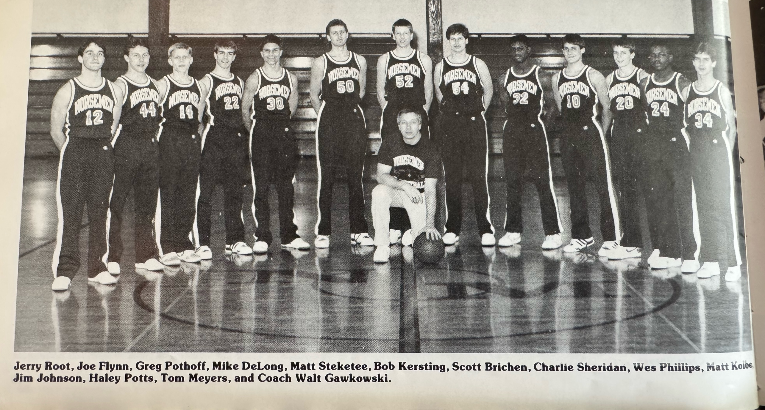

THE 1987-88 NORSEMEN

1988-89 (Coach Greg Wieman 10-10, Montague champs WMC)

Greg Wieman replaced Walt Gawkowski as the basketball coach at NMHS with Walt now free to concentrate on his favorite sport of baseball. Mark Kolbe returns as a four-year starter, and he’ll be joined by another regular from the previous season in Haley Potts. A big addition to the basketball program was Rondell Hutcherson, a transfer from Mona Shores and the younger brother of former NM star Dante Hutcherson.
The Norse kicked off the season with a 79-74 win over Newaygo as Haley Potts was on fire. Potts scored a career high 33 points with Rondell Hutcherson coming off the bench to score 23. Veteran Mark Kolbe continued his great play in his fourth year in a NM varsity uniform with 13 points. Hutcherson with four 3-pointers, and Potts with a trio of long bombs, were instrumental in NM winning their first game under their new coach Greg Wieman.
It was a brief winning streak for the Norsemen as they dropped their next game at Hart 64-54. Mark Kolbe had 17 and Rondell Hutcherson 13 as Hart overcame a 46-44 deficit going into the fourth quarter by outscoring NM 20-8 in the game’s final eight minutes. After scoring 33 points in the season opener, Haley Potts was a marked man by the Pirates and was held to nine points.
A rare win was earned by the Norsemen when they defeated Mason County Central in their next game. How rare? From 1981 until 2000-01 the two teams would play 39 games. NM’s 68-56 win in December of 1988 would be the only win for the Norse over MCC during the next two decades. The 24 consecutive wins covering that span would constitute as the most losses to one team in NM history. To add further intrigue, the win came on the road in Scottville, a venue that did not treat the Norse kindly over the years. Balance scoring was the key for NM, including 13 points from a newcomer to the roster, Scott Smith. Rondell Hutcherson fired in 20 points, Haley Potts 16 and Mark Kolbe 13. Charlie Sheridan played a big role for the winners with a game high 10 rebounds.
North Muskegon then made the journey to Walkerville for the first ever contest between the two schools. Fortunately for the Norsemen they were playing the boys team and not the girls. The little hamlet of Walkerville was still in a celebratory mood after their girls’ team four days earlier had just won their second straight Class D state championship. As it was, NM struggled against the Walkerville boys’ team but won thanks to the hot shooting of Haley Potts. With the score tied at 60-all inside the bandbox Walkerville gymnasium, Potts scored 12 of his game high 26 points in the fourth quarter as NM escaped with a 70-65 victory.
NM then fought off a late fourth quarter run by Ravenna to squeak out a 72-69 win over the Bulldogs. Haley Potts continued his torrid scoring with 28 points. Rondell Hutcherson added 18 points and Charlie Sheridan 12 as NM began the season with a winning 4-1 record. The Bulldogs star players had little time to practice before the basketball season arrived, and for a good reason. Ravenna made it all the way to the state championship game in football before losing to Detroit DePorres. Bulldog quarterback Mark Jacobs was not too shabby in basketball as he led Ravenna with 21 points and 13 rebounds. Jacob’s favorite receiver in football, Rod Place was close behind with 18 points.
It was probably a good thing that the Norsemen’s next game would be the final contest in the brief three game series with Fruitport Faith Christian. The Norse had little trouble in defeating the Fruitport private school as they jumped out to an early 19-4 lead and never took their foot off the gas in a 79-30 rout. Haley Potts in limited minutes scored 20, Tom Meyers 11 and Rondell Hutcherson 11. Matt Kolbe played an unselfish game by coming up with five rebounds four assists and three steals as 10 Norsemen scored in the game. The 6-1 record was NM’s best start since 1978-79. However, that would change quickly.
Whitehall used their home floor advantage to jump out to a 22-6 first quarter lead and NM never could catch the Vikings the rest of the way, losing their second game of the season 81-63. Haley Potts (20), Rondell Hutcherson (17) and Mark Kolbe 12) scored all but 16 of NM’s points.
It looks like defending WMC champion Montague will be a tough out during the season as they had no trouble in downing NM 66-44. Playing without Haley Potts and Rondell Hutcherson NM was no match for the Wildcats. Matt Kolbe was the only Norsemen in double figures with 16 points.
The Norsemen got back on the winning track with an easy 84-68 high scoring win over Pentwater. Rondell Hutcherson joined the 30-point club with an even 30 points to highlight the victory. Mark Kolbe netted 21 points in the rout while Karl Nicles, an all-state kicker on the football team, had a double-double with 10 points and 10 rebounds.
It had become clear as the season reached the midway point that the Norsemen were basically dependent on the trio of Rondell Hutcherson, Haley Potts and Mark Kolbe. The threesome accounted for all but 13 points in a 67-64 victory over Shelby led by Potts who hit three triples and 25 points. Hutcherson followed with 15 and Kolbe 10 as NM improved to 8-4 and 3-2 in the conference.
Holton came out sizzling hot in the opening quarter by opening a 14-point lead after the first quarter was in the books enroute to a 76-67 win over NM. Only a 24-10 NM third quarter kept the game within reach, but the Red Devils kept their composure and pulled away in the fourth quarter. Haley Potts kept NM within range of Holton by scoring 19 of his 29 points in the second half. Mark Kolbe filled up the stat sheet with 11 points, nine rebounds and four assists.
NM made amends for an earlier loss to Hart by earning an 82-72 victory when they returned to the NMHS court for their second contest of the season. With the Norse leading by only a point at halftime, NM outpointed Hart 23-10 in the third quarter, the difference in the final score. Rondell Hutcherson had a big night with 21 points, seven rebounds and six assists. Haley Potts scored 16 plus five assists while Mark Kolbe, who stands less than six feet tall, had 15 rebounds to go along with his 14 points.
After procuring a rare win at Scottville, NM stumbled at home in their second meeting and fell to Mason County by a slim one point 63-62 in a game decided in overtime. Rondell Hutcherson was a one-man wrecking crew for the Norse with 28 points, eight rebounds and seven steals. The key to victory for the visiting Spartans was stopping Haley Potts from making a single field goal. All of Potts five points came at the free throw line.
The NM trio scored 52 of NM’s 69 points but it wasn’t enough as Ravenna attained a split of the season series with a home court 74-69 win over the Norse. Haley Potts (21). Rondell Hutcherson (20) and Mark Kolbe (11) were all in double figures for the visitors. First quarter woes hurt NM as they trailed 18-7 after the first stop and could never catch the Bulldogs.
It was now the Norsemen’s turn to earn a season’s split as they atoned for an earlier loss at Whitehall to earn a 53-48 home win over the Vikings. NM got a huge boost from Scott Smith who gave the Norsemen’s vaunted trio much-needed scoring help with his 13 points. The threesome of Haley Potts (14), Mark Kolbe (12) and Rondell Hutcherson (10) joined Smith to give NM four players to reach double figures. For once, having an opponent bust out to an early first quarter lead didn’t kill NM chances for a win. Whitehall jumped out to a 16-4 lead after the game’s first eight minutes before NM steadily chipped back at the Viking’s lead.
NM then pulled off a stunner with a 67-65 win over eventual WMC champion Montague. Montague owned an impressive 16-1 record before running into the Norsemen. NM trailed by five points heading into the final quarter but got big plays from Rondell Hutcherson and Scott Smith down the stretch to pull off the upset. Hutcherson would finish with 20 points while Smith would hit the winning free throw and chip in with nine rebounds to give NM their 10th, and final win of the season.
The momentum of their upset victory over Montague did not carry over to NM’s final three games of the season, as they lost all three. NM seems to bring out the best in Oakridge during the 1980s and 90s. Oakridge dominated NM on the boards 48-28 as Oakridge throttled the Norse 77-52 to give the Eagles their first of many season series sweeps over the next decade with NMHS. Haley Potts was the only Norsemen to find the range consistently with a game high 26 points. NM fell below .500 in the WMC with a 6-7 conference record and 10-8 overall.
There was indeed a lot of parity in the West Michigan Conference for the 1988-89 season. NM split all their WMC games apart from the Oakridge sweep. Shelby earned a split with the Norse in the final game of the WMC season with a 74-57 win. Matt Kolbe finished with 18 points in his final game after four years playing in a Norsemen uniform to lead NM scorers. Haley Potts added 13 and Rondell Hutcherson was held to eight. Shelby trailed by seven at halftime but came back for the win helped by three NM players who fouled out in the second half.
For the second straight year, in what would look like an annual ritual, NM and West Michigan Christian would meet in the MHSAA playoffs. NM gave the Warriors a tussle but fell five points short as WMC would earn a 69-64 victory. The NM trio of Haley Potts (18), Matt Kolbe (16) and Rondell Hutcherson (15) again led the Norse bid to advance as NM ended the season at 10-10. NM would finish at .500 on the season and they would have to wait a full ten years before they would again post a winning record.

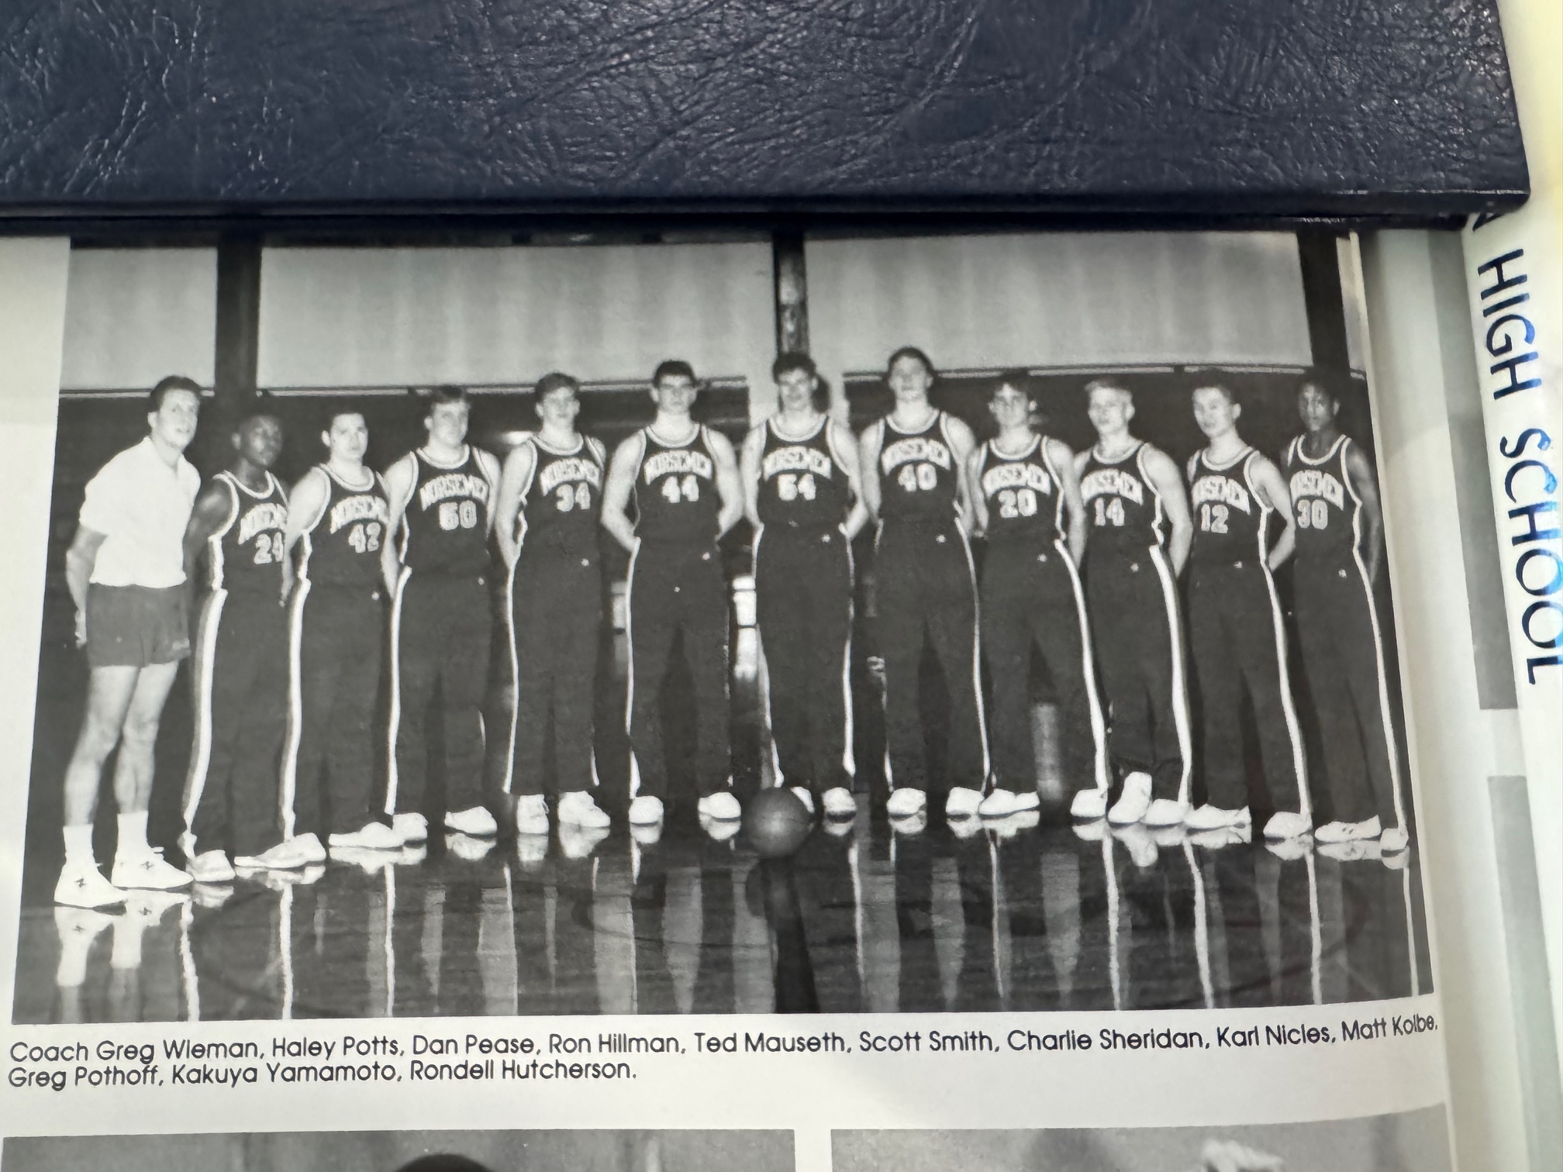

The 1988-89 NORSEMEN

N Muskegon 79 Newaygo 74 Haley Potts 33, Rondell Hutcherson 23
N Muskegon 54 Hart 64 Mark Kolbe 17, Hutcherson 13
N Muskegon 68 Mason Co 56 Hutcherson 20, Potts 16 S. Smith & Kolbe 13
N Muskegon 70 Walkersville 65 Potts 26, Kolbe 11, Hutcherson 10
N Muskegon 72 Ravenna 69 Potts 28, Hutcherson 18, Charlie Sheridan 12
N Muskegon 74 Fport Christ. 30 Potts 20, Tom Meyers 11, Hutcherson 11
N Muskegon 63 Whitehall 81 Potts 20, Hutcherson 17, Kolbe 12
N Muskegon 44 Montague 66 Kolbe 16
N Muskegon 84 Pentwater 58 Hutcherson 30, Kolbe 21 Karl Nicles 10
N Muskegon 63 Oakridge 88 Hutcherson 22, Kolbe 14, Potts 13
N Muskegon 67 Shelby 64 Potts 25, Hutcherson 15, Kolbe 10
N Muskegon 67 Holton 76 Potts 29, Kolbe 11, Hutcherson 9
N Muskegon 82 Hart 72 Hutcherson 21, Potts 16, Kolbe 14
N Muskegon 62 Mason Co) ot) 63 Hutcherson 28, Kolbe 11, Sheridan 8
N Muskegon 69 Ravenna 74 Potts 21, Hutcherson 20, Kolbe 11
N Muskegon 53 Whitehall 48 Potts 14, Smith 13, Kolbe 12, Hutcherson 10
N Muskegon 67 Montague 65 Hutcherson 20, Potts 15, Sheridan 12
N Muskegon 52 Oakridge 77 Potts 26, Kolbe and Hutcherson 8
N Muskegon 57 Shelby 74 Kolbe 18, Potts 13, Hutcherson 8
N Muskegon* 64 WMC 69 Potts 18, Kolbe 16, Hutchersson 15

1989-90 (Coach Greg Wieman 2-19, Montague -Whitehall co-champs WMC)

The decade of the 1990s would not treat the Norsemen kindly. Not until the 1998-99 season, with NM under the command of Jeff Cooke, would the Norse post a winning record. The poorest season record during the decade would be the first as NM in the second year under head coach Greg Wieman would win but two games, both wins coming against a pair of very small Class D schools. NM lost a pair of nail-biters by two points and were competitive in a few more – but 2-19 – is 2-19. Only Rondell Hutcherson returned from the previous season as a starter where he averaged a lofty 17 points per game. Hutcherson would have a good season for NM averaging more than 20 points per game. The 5’11 senior missed four games early in the season but still finished with 343 points. Scott Smith saw plenty of playing time in the previous season and he gave NM some much needed experience. Coach Wieman would have a freshman starting to begin the season in Cam Balash while sophomore Dan Delong would be called upon as a starter. Both Balash and DeLong would have a good season even if the 2-19 record wouldn’t portray a lot of success.
Rondell Hutcherson scored 24 points, half of NM’s total in a 51-48 opening game loss to Hart. Hart led 35-19 at the halftime, a lead good enough to hold off a late NM rally when they outscored Hart 19-4 in the fourth quarter. Scott Smith had 10 points while sophomore Nate Gates, who failed to score, did grab 8 rebounds for NM.
Mason County Central’s Craig Shriver, the son of Spartan head coach Jack Shriver broke a 64-all deadlock in the game’s final 10 seconds to defeat the Norse 66-64 and put a damper on a sensational night by NM’s Rondell Hutcherson. The 40 points scored by Hutcherson was second at the time only to Gordy Odell’s 53 points scored back in 1955. Hutcherson gunned in a trio of 3-pointers and grabbed 11 rebounds, but it was a woeful night at the free throw line that caused NM the game. After making 10 of 12 free throws three days earlier against Hart, the Norse only made 6 of 17 against MCC.
NM was leading at the end of three quarters 51-50 only to see Newaygo explode for 34 points in the fourth quarter to NM’s 19 to send NM to their third straight defeat. Rondell Hutcherson poured in 23 points to pace the Norse with Scott Smith netting 16 points and Dan DeLong 12. Rondell Hutcherson scored 18 of his 29 points in the fourth quarter to draw NM to within four points at game’s end. Freshman Cam Balash had 17 points for the Norse while Scott Smith grabbed a game high 13 rebounds.
In the first of a ten-game series, NM defeated Calvary Baptist 75-55. NM played without their ace scorer Rondell Hutcherson, but NM’s Dan DeLong took up the scoring slack with 25 points with Scott Smith (16) and Jeff Smith chipping with 15 points.
Freshman Cam Balash scored 23 points and sophomore Dan DeLong added 17 but it wasn’t enough as the young Norsemen fell to Whitehall 73-57.
NM had a seemingly comfortable 50-40 lead heading into the fourth quarter, but the Pentwater Falcons then went on a scoring rampage in the game’s final eight minutes, outscoring the Norsemen 28-6 to hand NM their 6th loss of the season 78-66. At one point in the third quarter the Norse lead was 14 points before NM fell apart in the final stanza. Dan DeLong led NM with 20 points and six steals, followed by Jeff Smith with 16 points and eight rebounds.
Oakridge used a big third quarter to turn a close game into a runaway as NM fell to Oakridge 89-56. Eagle football star David Nelson, who would become a well-respective police officer in North Muskegon, came off the bench to spark Oakridge with 18 points. Dan Delong played hard for NM scoring 12 points, while dishing off for 12 assists and six rebounds in a losing effort.
NM had the ball trailing by one point with 12 seconds left but never got a shot off and Shelby withstood an upset bid by the Norsemen to win 66-65. Scott Smith had 16 points and eight rebounds and Cam Balash 15 points. Shelby moved to 8-3 on the season while the Norsemen, still looking for a win in the WMC, were now 1-8. It would get worse. Although he scored only four points, NM fans had to be excited to see that Rondell Hutcherson was back in the lineup.
NM had a healthy Rondell Hutcherson and had a rare victory in their grasp but couldn’t hold off a fourth quarter Holton rally and lost 65-62 to the Red Devils in a non-league contest. Hutcherson finished with 19 points and five steals followed by Scott Smith with 12 and Cam Balash with 11.
The Norse took a 33-29 lead at halftime in a game at Hart, but the host Pirates came out smoking hot in the second half and doubled the score vs. NM 46-23 to win easily 75-56.
NM was not a match for a Montague team that improved to 10-1 on the season following a 72-56 win over the Norsemen. Montague enjoyed a 27-3 advantage at the free throw line as NM fell to 1-11 and 0-8 in the WMC. Rondell Hutcherson scored 18 for NM while Dan DeLong had 11 points, seven rebounds and five assists.
The young Norsemen gave Mason County Central a battle for the first half of the game, trailing by one at halftime, but the host Spartans pulled away from NM in the second half to post a 72-58 loss on the Norse. Rondell Hutcherson and Dan DeLong shared scoring honors for NM with 18 points.
It appeared NM was headed to a much-needed second victory of the season, but those hopes evaporated when Hesperia’s Bobby Rumsey drilled a baseline jumper with just one second remaining to defeat the luckless Norsemen 58-57. The Panthers did an outstanding job in holding NM’s high scoring Rondell Hutcherson to but seven points, far below his 20-point average.
The struggles continued for the Norse as Ravenna downed NM 65-46 in a game where the Bulldogs out rebounded the Norse 50-25. Only Rondell Hutcherson was in double figures with 16 points with the next highest scorer for NM, Cam Balash, limited to seven points.
NM final snapped their long losing streak at the expense of Class D Walkerville with a 90-63 rout. Rondell Hutcherson with 26 and Cam Balash with 21 led NM in scoring. Ty Zednik took full advantage in his first game in the starting lineup with 14 points and nine rebounds. Dan DeLong put his name in the NM record book with 15 assists.
The Norse were not embarrassed as they gave a good account of themselves in losing to the co-leaders of the WMC Whitehall Vikings 80-71. The one-two combo of senior Rondell Hutcherson (21) and freshman Cam Balash (19) accounted for 40 of NM’s 71 points in the loss.
NM then played a Montague team that needed a win to preserve their hold at the top of the WMC. The Cats did win over the very young Norsemen 79-64 despite 29 points by NM’s scoring machine Rondell Hutcherson.
NM found themselves trailing 42-25 at halftime and posed little threat to Oakridge who continued their mastery over the Norsemen with an easy 89-68 victory. Dan DeLong had a season high 28 points for NM as Oakridge concentrated on stopping Rondell Hutcherson who was held to 10 points.
Rondell Hutcherson had another huge game for the Norse, but NM just didn’t have enough help as Shelby handed NM their 14th defeat in the WMC without a win, 81-67. Hutcherson finished the regular season with 27 points, seven rebounds, six assists and eight steals. “He’s such a great athlete, it’s hard to shut him down, “Shelby coach Rick Zoulek said of Hutcherson. “We just wanted to keep him in the gym somewhere and keep him under 30 (points).”
For the fourth straight year West Michigan Christian ended NM’s season with a 53-38 victory in the MHSAA playoffs. One oddity in the game was that neither team was able to make a three-pointer in the entire game. NM shot a dismal 22 per cent from the field. Rondell Hutcherson was held to 10 points, far below his average as NM’s season ended with a woeful 2-19 record. Even the advantage of NM hosting the tournament on their home floor didn’t help the Norsemen. The Warriors would advance to the state semi-finals before losing to Detroit East Catholic.

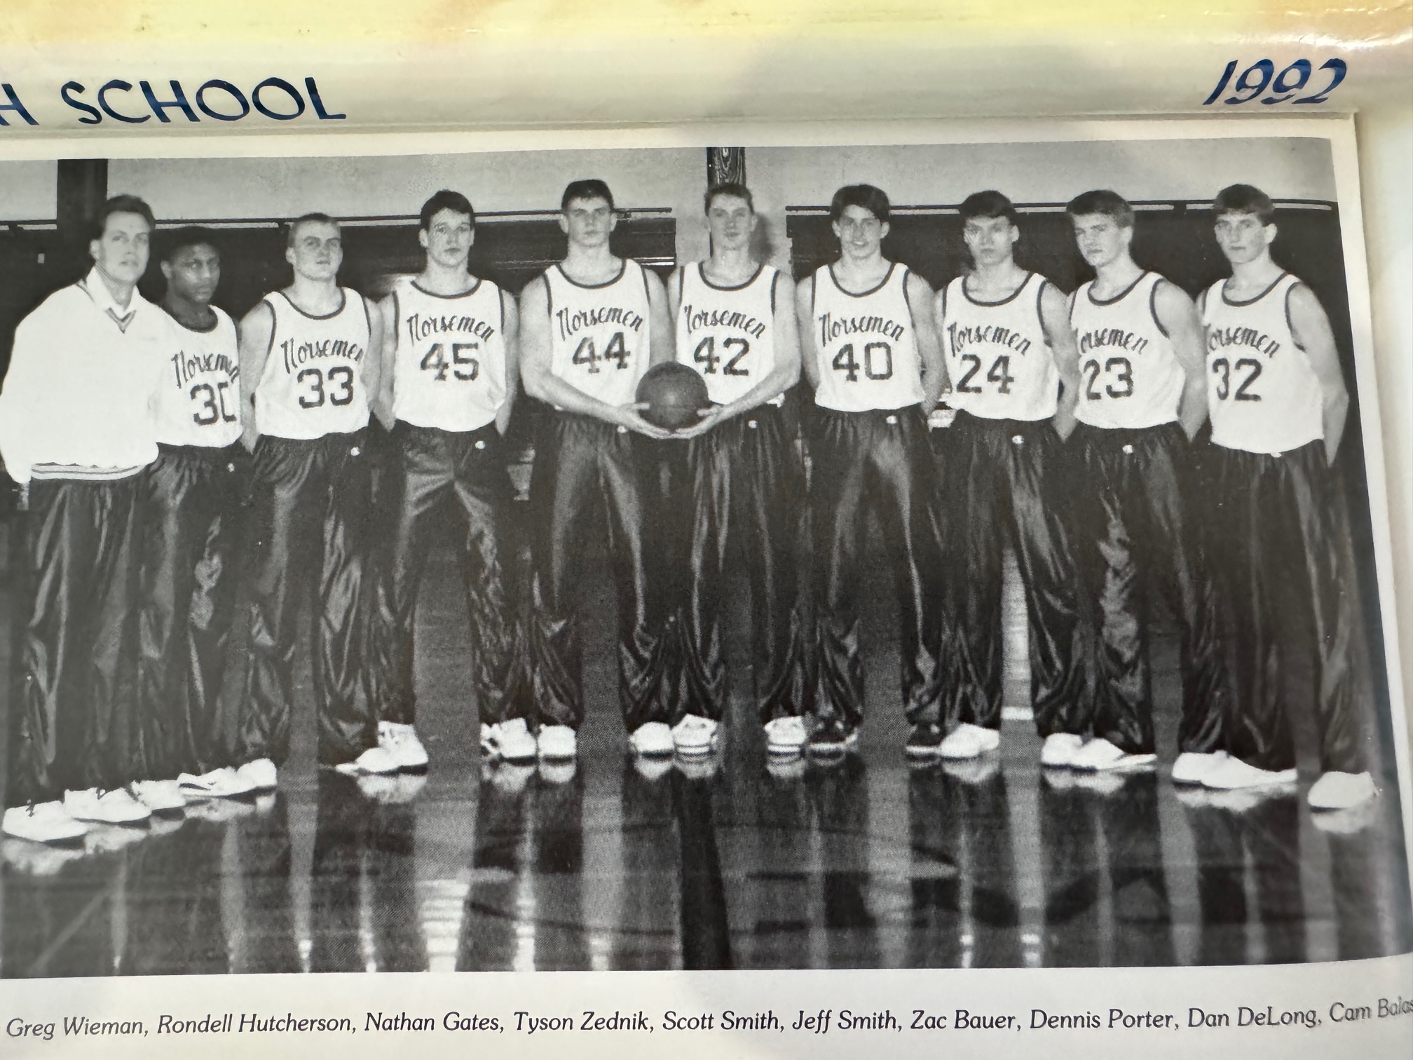

The 1989-90 NORSEMEN

N Muskegon 48 Hart 51 Rondell Hutcherson 24, Scott Smith 10,
N Muskegon 64 Mason Co 66 Hutcherson 40, Cam Balash 7
N Muskegon 69 Newaygo 85 Hutcherson 23, S Smith 16, Dan DeLong 12
N Muskegon 61 Ravenna 65 Hutcherson 29, Balash 17
N Muskegon 75 Calvary Baptist 55 Delong 25, S Smith 16, Jeff Smith 15
N Muskegon 57 Whitehall 73 Balash 23, DeLong 17
N Muskegon 66 Pentwater 78 DeLong 20, J Smith 16, Balash 10
N Muskegon 56 Oakridge 89 DeLong & S Smith 12, Ty Zednik 9
N Muskegon 65 Shelby 66 S Smith 16, Balash 15, DeLong 10
N Muskegon 62 Holton 65 Hutcherson 19, S Smith 12, Balash 11
N Muskegon 56 Hart 75 Hutcherson 21, DeLong & Balash 8
N Muskegon 56 Montague 72 Hutcherson 18, DeLong 11, Zack Bauer 9
N Muskegon 58 Mason Co 72 Hutcherson & DeLong 18
N Muskegon 57 Hesperia 58 S Smith 12, Nate Gates 11, Zednick 10,
N Muskegon 46 Ravenna 65 Hutcherson 16, Balash 7
N Muskegon 90 Walkerville 63 Hutcherson 26, Balash 21, Zednik
N Muskegon 71 Whitehall 80 Hutcherson 22, Balash 19, S Smith 9
N Muskegon 64 Montague 79 Hutcherson 29. Bauer 7, Balash 6
N Muskegon 68 Oakridge 89 DeLong 28, Hutcherson 10, Balash 8
N Muskegon 67 Shelby 81 Hutcherson 27, DeLong 11, Balash 8
N Muskegon* 38 WMC 53 Hutcherson 10

1990-91 (Coach Greg Wieman 4-19, Montague champs WMC)

Although the 1990-91 Norsemen would miss graduating senior Rondell Hutcherson, much more was expected for the 1990-91 Norsemen than a woeful 4-19 records. For the second consecutive year the Norse posted a winless record in the WMC and only in their final game in the regular season with Oakridge, did they come close to a victory. Four starters returned plus a promising sophomore from the junior varsity team that should have forbode a better record but that didn’t materialize. Unfortunately, one of the returnees, Dan DeLong severely cut his arm/wrist late in the football season and would sit out the entire year. Sophomore Cam Balash returns for his second season and brings with him a 10 point per game average while Jeff and Scott Smith (no relation) were also a part of last year’s rotation. Nate Gates, a star lineman on NM’s football team returns to give the Norse some muscle on the front line while that promising sophomore was Joel Johnson, still growing at 5’4 who would work his way into a starting point guard position. Zac Bauer, yet another football star, also gives NM some experience as a returnee for the Norsemen. NM boasted of several two- & three-star athletes, but that didn’t transcend into a successful basketball season.
NM got off to a less than stellar start to begin the season and the game. Newaygo jumped out to an early 10-0 lead, perhaps a foreboding sign of things to come as that was the point differential in the game with Newaygo on top 68-58. Jeff Smith with 14 and Nate Gates with 13 led the Norse.
In their second WMC game of the season NM was only able to put 41 points on the board as NM lost to Hart 50-41. The Norse had a short-lived lead of one-point with six minutes remaining in the contest before Hart pulled away. Zach Bauer with 13 and Jeff Smith with 12 were the only Norsemen in double figures.
The point production didn’t get much better in NM’s next game, a long road trip to Scottville to face Mason Country Central. For the first time in five years NM didn’t have one player in double figures. The Spartan roared out to a 42-23 lead at halftime and coasted to a 78-45 win over NM. Football lineman Matt Stegelman muscled his way to score nine points, NM’s high point total for the contest.
NM did manage to have three players in double figures in their next game, but NM was held to but 50 points in a 75-50 loss to Ravenna. Cam Balash had 13, Jeff Smith 11, and Zach Bauer 10 as NM falls to 0-5 to begin the season.
It’s probably a good thing that the Norsemen had Calvary Baptist on their schedule. After NM had defeated Calvary Baptist 61-49, the win would only be NM’s third win in two years, with two of those victories coming against Calvary Baptist. NM won by 12 points, with all 12 of those points coming in the overtime session with NM shutting out Calvary Baptist 12-0 in the extra session. Ten of those points in OT came on free throws. Zac Bauer scored 16 points and grabbed 14 rebounds for the Norse, while Joel Johnson and Nate Gates added 15 and 14 points respectively.
Whitehall used a 18-7 third quarter burst to pull away in the second half in beating the Norsemen 62-40. Joel Johnson was the only Norse player in double figures with 11.
Cam Balash, who averaged more than 10 points a game as a freshman, got off to a slow start in his sophomore season. Norse fans were looking for a breakout. That came in NM’s game with Ravenna shortly after the start of the New Year in 1991 when he scored 27 of NM’s 57 points in their 69-57 overtime loss to Pentwater. After both teams were tied at the end of regulation Pentwater outscored the Norse 16-4 in the three-minute overtime with 10 of those points coming on free throws.
It was back to the drawing board for the Norse as scoring points once again became a big problem. Scoring was not a problem for Montague as they scored 75 while NM was held to 48. For the second time during the season no Norsemen players were able to score in double figures. Cam Balash with nine, was close.
The Norsemen only hit on 3 of 15 field goals in the first quarter and that set the tone as Oakridge handed NM their ninth defeat of the season 63-51. Cam Balash was the only Norse player in double figures with 15.
Only in the third quarter did Holton have a big advantage over the Norse. The Red Devils tallied 21 points to NM’s 15 in the eight-minute quarter following halftime in defeating NM 63-55. Four Norsemen managed to score in double figures for NM: Matt Benedict (14), Cam Balash (12), Nate Gates and Zac Bauer (10).
Shelby served notice early that they were not going to be denied on their home court as they bolted out to an unsurmountable 20-point lead 27-7 over NM in the first quarter. Shelby would then blow out the Norse 80-43 as NM would leave Shelby with a 1-11 record. Matt Benedict’s 11 points was the best a Norse player could do as Shelby sweeps the season series.
The Norse came a split second away from posting their first victory in WMC competition in three years only to be denied by a made basket following a rebound by Hart’s Aaron Rooney as the buzzer sounded in the background. The buzzer-beater gave Hart a 71-70 victory over NM and moved the Norse to 0-9 in the WMC. Matt Steigelman had a season high 16 for the Norsemen, with Jeff Smith (15) and Joel Johnson (10) also in double figures.
NM suffered their second straight heartbreaker when Walkerville’s Jason Bond scored with five seconds on the clock to spoil a great game from NM’s point guard Joel Johnson. Connecting on four three-pointer among his game high 24 points, Johnson scored 15 of his 24 points in NMs final quarter as NM mounted a furious comeback after trailing 70-54 entering the final eight minutes. The win for Walkerville would be the only victory earned by the Wildcats in the 12 meetings with the Norse over the years. Nate Gates with 18 and Cam Balash with 16 also scored well for NM as their 87 points was by far their leading offensive output of the season.
The Norse did not have to worry about a buzzer beater sending the Norse to a crushing defeat in their next game against Mason County Central. The visiting Spartans more than doubled the score on the Norsemen in a 91-45 thrashing. Cam Balash was the only Norsemen in double figures with 14.
Finally --- at long last --- a win! And they did it with conviction as NM defeated Hesperia 73-54 to snap a 10-game losing streak. After a 15-all first quarter the Norse outscored Hesperia in the next three quarters as four Norsemen scored in double digit numbers. Cam Balash (22), Joel Johnson (17), Nate Gates (16) and Scott Smith (11) led the Norse to victory to send their suffering fans home happy.
The momentum of the Hesperia victory did not carry over into NM’s next game with Whitehall as the Norse were given a pasting by Whitehall 79-38. It would be more of the same in their next four games.
In back-to-back games NM would have their lowest scoring games of the season. All the incentive was with Montague as a win over NM would clinch the West Michigan Conference championship. Montague not only had the incentive, but they had the talent as they destroyed the Norsemen 70-33. So decisive was the victory that Montague led 39-13 at halftime. Cam Balash led NM with 14 of NM’s 33 points as no other Norse player scored more than four points.
The Norsemen then played a makeup game with Ravenna that was postponed due to weather to February 27. Ravenna was never threatened as NM fell to the Bulldogs 81-48. Cam Balash with 17, was the only Norsemen to score more than six points.
NM then ended their regular season with their fifth straight defeat by 30 or more points in a 74-42 loss to Oakridge. For the second consecutive season NM posted a 0-14 record in WMC play. Nate Gates led NM with 15 points.
After playing predominantly a schedule against Class C schools, it was a welcome relief for NM to open the playoffs against Class D opponents. NM’s first opponent would be Saugatuck in the first game played in history between the two schools. Finally, fate was on the side of the Norsemen as Saugatuck missed the front end of a one-and-one and came up blank on a couple of other shots in the closing seconds that would have met defeat for NM. Instead, the Norsemen win the first game of the playoffs 55-54. Much of the credit for the victory went to NM center Scott Smith. Smith had 11 points and 12 rebounds, but it was his defense on Saugatuck’s high scoring center Jerry Prys that was the difference in the game. “Prys is a prize. He’s a nice player but Scott Smith did a great job on him.” said NM coach Greg Wieman. Prys had scored 30 points in their last game.
NM would then play Calvary Baptist on the Northside court; one of the two teams NM had defeated during the regular season. Held to a season low of two points in their first matchup, Cam Balash scored a game high 17 in the playoff game to lead the Norse to a 52-45 victory and a berth in the district finals with Allendale.
NM would go into the finals as distinct underdogs to an Allendale team that was ranked number four in the state, boasting a 21-1 record and eliminated perennial power West Michigan Christian in an earlier game. To no one’s surprise Allendale advanced with a 77-50 victory. Allendale would advance all the way to the state finals before losing to Ann Arbor Gabriel Richard. The district final clash was the last time the two teams would meet in basketball. NM was led by junior guard Joel Johnson with 13 points as the season would come in an end with an overall record of 4-19. With most of the players returning, 1991-92 surely looked more promising.

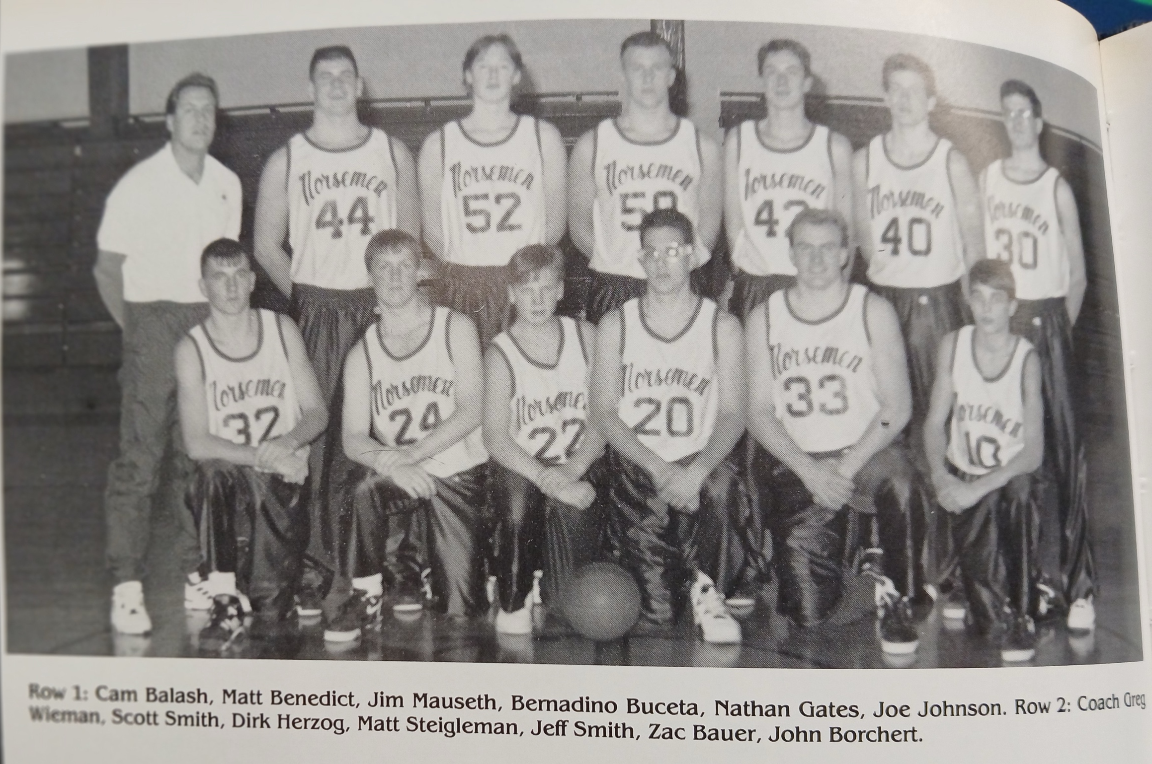

The 1990-91 NORSEMEN

N Muskegon 58 Newaygo 68 Jeff Smith 14, Nate Gates 13, Cam Balash 10
N Muskegon 54 Shelby 71 J Smith 15, Balash 12, Scott Smith 9
N Muskegon 41 Hart 50 Zach Bauer 13, J Smith 12
N Muskegon 45 Mason Co 78 Matt Steigelman 9, Balash 8
N Muskegon 50 Ravenna 75 Balash 13, J Smith 11, Bauer 10
N Muskegon 61 Calvary Bap. 49 Bauer 16, Joel Johnson 15, Gates 14
N Muskegon 40 Whitehall 62 Johnson 11, Bauer & J Smith 7
N Muskegon 57 Pentwater (ot) 69 Balash 27. Matt Benedict 11
N Muskegon 48 Montague 75 Balash 9
N Muskegon 51 Oakridge 63 Balash 15, J Smith 9, Johnson 8
N Muskegon 55 Holton 63 Benedict 14, Balash 12, Gates & Bauer 10
N Muskegon 43 Shelby 80 Benedict 11, Gates 9, S Smith 8
N Muskegon 70 Hart 71 Steigelman 16, J Smith 15, Johnson 10,
N Muskegon 87 Walkerville 89 Johnson 24, Gates 18, Balash 16
N Muskegon 45 Mason Co 91 Balash 14
N Muskegon 73 Hesperia 54 Balash 22, Johnson 17, Gates 16
N Muskegon 38 Whitehall 79 S Smith 8, Johnson and J Smith 7
N Muskegon 33 Montague 70 Balash 14,
N Muskegon 48 Ravenna 81 Balash 17
N Muskegon 42 Oakridge 74 Gates 15, Balash 9
N Muskegon*55 Saugatuck 54 Balash 17, S Smith 11, Johnson 7
N Muskegon*52 Calvary Baptist 45 Balash 17, Bauer 11
N Muskegon*50 Allendale 77 Johnson 13, Balash & S Smith 6

1991-92 (Coach Greg Wieman 10-12, Shelby champs WMC)

Greg Wieman would begin his third and final season as the Norsemen head coach. Wieman would welcome back nearly his entire team from the 1990-91 season plus one player who sat out the previous campaign with an injury. Three-sport standout Dan DeLong, one of the leading performers on the NM team during his sophomore year would be a most welcome addition to the current team. Others returning to the team would include point guard Joel Johnson, who would put up big numbers during the upcoming season. Cam Balash, who was a starter as a freshman, and the leading scorer from last year’s team, would begin his junior season. Others, who if not starters, but who were part of last year’s rotation, included Zach Bauer and Matt Steigelman. My longtime broadcasting partner, Gene Young and I made it a point to include a few NM games on our schedule, not only because the Norse had an excitable team, but they had a pep band called ‘Out of Bounds’ who made a Norsemen basketball game an entertaining experience.
After winning but two regular season games from the previous season it took only the first game for the Norsemen to reverse that trend by earning a hard fought 53-50 victory over Newaygo in a game that went into overtime. In the extra three-minute session NM scored all nine of their points on free throws. Dan DeLong and Cam Balash each had 10 points for NM with point guard Joel Johnson adding eight. High School basketball got off to a late start with no Michigan teams schedule to play a game until December 10.
Shelby seemingly couldn’t miss as they raced out to a 48-28 lead at halftime to hand the Norse their 17th, and final consecutive defeat in WMC competition 82-67. The Tigers shot better than 60 percent in the first half to hold off any thoughts of a NM comeback. Cam Balash led NM in scoring with 18 with Joel Johnson close behind with 17.
One would have to go back to late February of 1989 to see North Muskegon win a basketball game in the West Michigan Conference. The 17-game losing streak came to an end and in a big way as NM overwhelmed Hart 72-45 on the NM court, much to the delight of the NM pep band ‘Out of Bounds’, who entertained the fans throughout the contest. NM outscored Hart in every quarter to improve to 1-1 and escape the WMC cellar for the first time in three years. Cam Balash scored 18 and Zach Bauer 10 for the winners.
After playing but three games in the month of December, the Norsemen had a long three-week break between games. NM showed their rust following the holiday layoff by dropping a contest to Pentwater 54-50. The Norsemen scored but 16 points in the entire first half as they lost for a third consecutive season to Pentwater. NM mounted a second half comeback that had them take a brief lead in the second half only to see Pentwater close out the contest on a 12-2 run. Cam Balash led NM with 15 with Joel Johnson adding 12 points and six steals. Dan DeLong was held to two points before fouling out in the final quarter.
NM quickly shook off their rust in their next game as they scored 89 points in a win over Ravenna to improve their season record to 3-2. NM applied the pressure early on the Bulldogs and created 25 turnovers. Joel Johnson and Cam Balash each scored 20 points for the visiting Norsemen while Pat Kitchka added 17.
NM then continued their winning ways with a commanding 83-54 win over their favorite whipping boys over the years. The victory over Calvary Baptist would be one of the ten wins in the series without NM tasting defeat, their only opponent over the years in a 10 or more-game series where they never lost to an opponent. Joel Johnson led the Norsemen with 15 points with Matt Steigelman netting 13 and Nate Gates 10.
Whitehall broke open a one-point game at halftime by going on a 19-7 run in the third quarter to edge NM 59-53. Cam Balash led NM with 14 points while Matt Steilgelman took control of the rebounds with 16. Joel Johnson, Zack Bauer and Dan DeLong all had nine points for the Norsemen who were now even in the WMC at 2-2 while Whitehall now shares first place with Shelby at 4-1.
NM won a 60-58 thriller over Montague, one of only three wins for NM over Montague during the 1990s. The game was tight all the way as NM got a huge game from little Joel Johnson who pumped in 21 points with 12 of his markers coming on three-point shots. His running mate at guard Cam Balash, a model of consistency over the years, backed up Johnson with 15 points.
After a couple of very lean years, it was a rarity when the Norsemen could enjoy a blow-out victory over an opponent. Such was the case when NM throttled Holton 80-50. Joel Johnson and Dan DeLong each netted 17 for NM with Cam Balash scoring an even 10 as NM improved to 6-3 on the season. Eleven Norsemen scored in the contest.
It was back to earth for NM as their nemesis of the 1990s, Oakridge, lowered the boom on the Norse in their next outing with a 79-58 thumping of NM. It wasn’t that Oakridge was beating up on their other foes as the Eagles had a worse record than NM. Dirk Herzog came off the bench for NM and scored a season high12 points for the visiting Norsemen, equaling Cam Balash for game high honors.
The score was 36-17 at halftime as NM coasted to a commanding 76-40 win over an outmanned Walkerville team. After losing to Walkerville the previous season, NM would play the Wildcats nine more times in the 1990s, and they would win them all. Ten Norsemen entered the scoring column with Cam Balash leading the way with 14 while Joel Johnson and Dirk Hezog each had 12 points.
NM hung around for a while but a big third quarter by Shelby when they went 20 points up on the Norse was more than a NM comeback could handle as the 1992 WMC champs won for the second time on the season over NM 74-61. Joel Johnson led NM with 15 points to keep NM in the game. Cam Balash netted 10 and Zack Bauer followed with 9.
NM broke open a close game against Hesperia with a 20-8 run in the fourth quarter to win going away 65-55. Cam Balash led NM with 15, while Matt Steigelman, who terrorized Hesperia running backs in late November in the Fall, added 11 points and Joel Johnson 10.
North Muskegon’s 79-73 victory at Hart would be the highwater mark for Norsemen basketball for the 1991-92 season. The win gave NM a 9-5 record but unfortunately, there would be only one more win for NM, none in the final six games of the regular season. NM had balanced scoring in their second win on the season over Hart. Cam Balash had 18 with Joel Johnson and Matt Steigelman close behind with 17.
NM was amid losing 24 games in a row to Mason County, but they nearly stopped that streak early in the run as they lost by a single point 54-53 in a February game played in Scottville. NM went down to defeat in a cruel way. The Norse led by seven points entering the final quarter only to see the Spartan’s Dave Cronk sink two free throws with two seconds left to play to send the Norseman back to NM with a tough defeat. Joel Johnson continued his sparkling play for NM with 16 points, the only Norse player in double figures.
The Norsemen went stone cold in the final quarter, making only two field goals in the final quarter as NM only made 22 per cent of their shots in the second half to fall to Ravenna 69-50. Earlier in the season NM defeated Ravenna on the Bulldogs home court by 22 points. Cam Balash was the only NM player in double digits with 18 points as NM completed their second of a six-game slide.
The Norsemen only had one bad quarter in their 70-62 loss at Whitehall. It came in the opening quarter when the Vikings led by eight points at the end of the first quarter, the margin of victory in the game.
It was payback time for Montague. The Cats, evidently still steaming about their one-point loss to NM earlier in the season, caught fire in the second half to defeat the Norse 86-61. One player that wasn’t stopped by the Wildcats was NM’s scrappy point guard Joel Johnson. The 5’8 Johnson, who tallied 21 points against the ‘Cats’ in the first game scored 19 in the second. However, Montague’s second half run of 45-27 easily handed NM their fourth straight loss, all against WMC opponents. Nate Gates followed Johnson in scoring with 13 while Cam Balash netted 10 markers.
Four Norsemen reached double figures, but NM dropped their second game to Mason County Central 73-62. NM barely lost to the Spartans a couple of weeks earlier in Scottville so NM was disappointed that they might attain a split of the season series with a win on their home court. Leading the balanced NM offensive attack was junior Cam Balash with 16. Close behind Balash were a trio of seniors; Zach Bauer (15), Joel Johnson (13) and Nate Gates (10).
NM carried a six-point lead heading into the final quarter of their final game of the regular season with Oakridge but couldn’t withstand a fourth quarter Eagle resurrection and dropped a tight game 70-68. The loss spoiled a great game from NM’s Joel Johnson who set a school record with seven made three-pointers. Johnson’s 27 points were the most scored in a single game by a Norsemen for the season. NM finished the WMC season with a 4-10 record while Oakridge was an even 7-7. There will be a lot of pressure from Oakridge fans on the Eagle head coach next season as Oakridge JVs finished a perfect 20-0.
Class D district play was hosted by West Michigan Christian and both WMC and NM were heavily favored to win their opening games and that held true. NM easily defeated Calvary Baptist for the second time in the season 94-62 while the Warriors easily downed Saugatuck setting up a district final between the two longtime rivals. Cam Balash had 24 against Calvary Baptist as NM was able to play all their reserves.
In the district finals the Norsemen had the misfortune to play one of the best teams in West Michigan Christian history. NM lost to WMC 80-62 who would then breeze to the Class D state championship at MSU two weeks later. Cam Balash scored 20 for the Norse while Joel Johnson ended his fine senior season and career with 13 points.
Joel Johnson and Cam Balash ended the season with the exact number of points: 313 for an average of 14.2 per game. The West Michigan Conference announced its all-league basketball team, and Joel Johnson was the only Norsemen selected to the first team. Coach Wieman would step down as the Norse head coach and would be replaced by Mark DeLap.

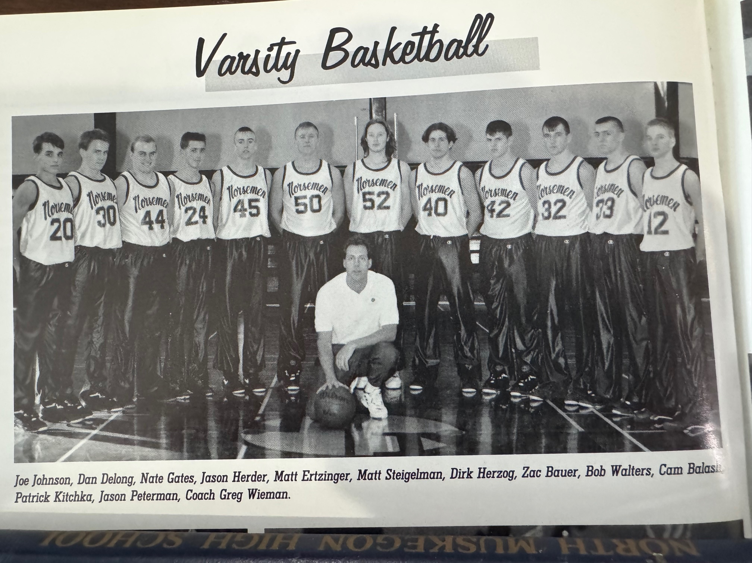

1991-92 NORSEMEN

N Muskegon 53 Newaygo (ot) 50 Dan DeLong 10, Cam Balash 10
N Muskegon 67 Shelby 82 Balash 18, Joel Johnson 17, DeLong 11
N Muskegon 71 Hart 45 Balash 18, Zak Bauer 10, Nates Gates 9
N Muskegon 50 Pentwater 54 Balash 15, Johnson 12
N Muskegon 89 Ravenna 67 Johnson 20, Balash 20, Pat Kitchka 17
N Muskegon 83 Calvary Baptist 54 Johnson 15, Matt Steigelman 13, Gates 10
N Muskegon 53 Whitehall 59 Balash 14, Johnson, Bauer & DeLong 9
N Muskegon 60 Montague 58 Johnson 21, Balash 15
N Muskegon 80 Holton 50 Johnson and DeLong 17, Balash 10, WIN 500
N Muskegon 58 Oakridge 79 Dirk Herzog 12, Balash 12, Johnson 10
N Muskegon 76 Walkerville 40 Balash 14, Johnson & Herzog 12
N Muskegon 61 Shelby 74 Johnson 15, Balash 10, Bauer 9
N Muskegon 65 Hesperia 55 Balash 15, Steigelman 11, Johnson 10
N Muskegon 79 Hart 73 Balash 18, Johnson & Steigelman 17
N Muskegon 53 Mason Co 54 Johnson 16, Balash 9
N Muskegon 50 Ravenna 69 Balash 18, Johnson 8, Matt Ertzinger 8
N Muskegon 62 Whitehall 70 Johnson 18, Gates 13, Balash 12
N Muskegon 61 Montague 86 Johnson 19, Gates 13, Balash 10
N Muskegon 62 Mason Co 73 Balash 16, Bauer 15, Johnson 13
N Muskegon 68 Oakridge 70 Johnson 27, Gates 9, Balash 8
N Muskegon*94 Calvary Baptist 62 Balash 24, Bauer 17, Johnson 8
N Muskegon*62 WMC 80 Balash 20, Johnson 13 Ertzinger 10

