History of North Muskegon Basketball
By Jim Moyes

NOTE: Playoff games marked with *

1932-33 – Coach: Lyle McNitt (6-6 overall; no conference)

Note: Games played against Second teams not included

The Norsemen experienced their first season in varsity competition in 1932-33 and posted an admirable 6-10 record, although four of their games were against junior varsity opponents. The team was comprised of 9th and 10th graders as the first graduating class would not be for another two years. There was a total of 82 students combined in the ninth and 10th grade that comprised the entire enrollment for the 1932-33 season. From kindergarten through 10th grades there were a total of 360 students. The nation was still enmeshed in a depression at this time in history. NM teachers volunteered to take a 10 per cent pay cut to keep the school operable.
The old rule of a jump at center court following a made basket was still in effect while the 10 second rule for teams advancing the ball past center court was adopted. The ‘original’ Norsemen Team was made up of Russell Adams, Marvin Andrea, Robert Bulklot, Ralph Cooper, Clordon Daugherty, Norman Ferrill, Junior Hook, James McNiff, Laverne Sittser, Joe Witham and Keith Miles. The first NM girls’ team was comprised of Anna May Noreen, Phoebe Ann Peterson, Maurine Erickson, Barbara Ladd, Marian Church, Donna Castenholz, Geneva Sweet, Phoebe Brown, Florence Kuharvicz, Marianna Sebolt, Mildred Klecka, Jean Goudzwaard, and Ethel Connor.
The first game in NM basketball history was played at Montague on December 2, 1932, with the Norse losing their first ever varsity game 15-23. The game was one of three games played with the Junior high and the girls’ team also playing on this date. Since this was the first game, here are the complete point totals with only four players scoring: Ralph Cooper 6, Russell Adams 5, Joe Witham 2, and Junior Hook 2. No mention for posterity as to who made the first points in that game.
NM then showed they were a much-improved team in the second game with the Wildcats played inside the cozy NM gymnasium. NM, after losing in the first game of the season, and the first game in school history 23-15, defeated the Cats 28-24 behind the fine shooting of Keith Miles who tossed in 14 points.
In a game played at NMHS between the NM girls and Ravenna girls Maurine Erickson scored 29 points in a 34-28 victory, more points than the boys scored in their 38-22 loss to the Bulldogs. The highlight of the season had to be the Norse winning as 10th graders, their first game ever played in the MHSAA playoffs when they defeated White Cloud 15-14 in a Class D playoff game in Fremont. Points were at a premium as the score was tied at 14-14 after regulation. Jim McNiff made a free throw in OT at that would be the only score made in the entire overtime period. Joe Witham had 6 points, Cooper and McNiff 3, Russ Adams had two and Junior Hooker one to comprise all the scoring in the upset victory. The season came to a crushing end as NM was downed by Muskegon St Joseph in the district final 25-12. Keith Miles, who was the leading scorer for the Norse in the first half of the season, did not play in the second half of the season for reasons unknown to your author. On January 6 Miles scored 14 points in NM’s 35-10 victory over Fruitport.

Score Interesting Fact
N Muskegon 15 Montague 23 Ralph Cooper 6, Russell Adams 5
N Muskegon 28 Ravenna (Sec) 14 Cooper 15 pts
N Muskegon 16 Muskegon (Sec) 31 Keith Miles 9 pts.
N Muskegon 14 Musk Hts (Sec) 25 Cooper 4, Witham 3
N Muskegon 35 Fruitport 10 Miles 14, Cooper 9
N Muskegon 28 Montague 24 Miles 14, , Cooper 6
N Muskegon 7 Whitehall 21
N Muskegon 38 Spring Lake 10
N Muskegon 23 Godwin Hts 33 Cooper 10
N Muskegon 14 Whitehall 24 Joe Witham & Junior Hook 4 points
N Muskegon 18 Spring Lake 16 Jim McNiff & Russ Admas lead win
N Muskegon 22 Ravenna 38 McNiff 11, Cooper 7
N Muskegon 15 Shelby (Sec) 20 McNiff & Adams 5 points, Cooper 4.
N Muskegon* 15 White Cloud 14 Witham 6. McNiff’s winning FT in ot
N Muskegon* 12 Musk. St Joseph 24 Cooper 5, McNiff, Witham, Adams 2,

1933-34 – Coach Lyle McNitt (9-6 overall; no conference)

Still a year away from a four-year school, the Norsemen from 1933-34 posted a winning record as the future looked bright for the NM basketeers. From the onset of the building of the NM High School in the early 1930’s the games were played in the compact gymnasium until the 1957-58 season. The actual playing surface was much smaller than today’s typical 94 feet distances from endline to endline. One only had to advance the ball but about a third of the way to enter the front court. In early December of 1933 in a NM 24-22 loss to Ravenna Jack Jiroch, in the game report from the Muskegon Chronicle, ‘threw’ in a basket from almost his own free throw line to tie the game at 20-20. In the early days of NM basketball, it was common for three games to be played in succession. The first game would feature the boy’s junior varsity game (often referred to as ‘seconds’) while a varsity game with the girls would then be contested. Joining holdovers from the 1932-33 team as a starter for the current Norsemen was Alexander Purdue. Making up the rotation of players primarily used during the season in addition to Purdue were Marvin Andrea, Joe Witham, Ralph Cooper, Jack Jiroch, Fred Schmidt and Russel Adams. In a record that perhaps will never be broken for futility, the Norse held Muskegon St. Joseph to but five points in a game held on January 19, 1934, at the Northside gymnasium. NM had a 10-player roster during the season and nine of the ten scored in NM’s 35-18 victory over Grant on Feb 23, 1934. The Only NM player who failed to score in the game was Alexander Purdue. Jack Jiroch scored 22 points, matching the entire output of their Fruitport opponent to set a NMHS scoring record. NM defeated Fruitport in early December in the first of the two meetings 35-10 as Ralph Cooper scored 13 points followed by Joe Witham with 8. It was the same exact score that NM earned as 10th graders a year earlier against Fruitport. The NM season came to an end by being upset in the first round of the Class D district tournament by White Cloud. The Norse had defeated White Cloud twice earlier in the season but were no match for White Cloud in the tournament. White Cloud won 30-17 with much of their damage occurring after Jack Jiroch, along with Ralph Cooper and Bob Emerson had fouled out in a rough contest played at the Grant Community Center.

Score Interesting Fact
N Muskegon 35 Fruitport 10 Ralph Cooper 13, Joe Witham 8
N Muskegon 30 Spring Lake 21
N Muskegon 22 Ravenna 24 Jack Jiroch 8, Cooper 5,
N Muskegon 21 Montague 27 Jiroch 8, Cooper, Witham 4
N Muskegon 32 White Cloud 27 Cooper 14, Witham 8, Russ Adams 6
N Muskegon 22 Musk St Joe 5 Cooper 11, Jiroch 8, Adams 2
N Muskegon 8 Spring Lake 14 Only the score reported in MC
N Muskegon 21 Grant 15 Jiroch 8, Adams 6
N Muskegon 13 Montague 32 Cooper, Norm Ferrill 4 points
N Muskegon 10 Ravenna 13 Jiroch 7
N Muskegon 24 White Cloud 23 Jiroch 12, Cooper 7
N Muskegon 35 Grant 18 Jiroch 10, Fred Schmidt 6, 9 NM player’s score
N Muskegon 37 Fruitport 22 Jiroch record 22.
N Muskegon 31 Musk St Jos 26 Jiroch 10, Witham 6
N Muskegon* 17 White Cloud 25 Three NM players foul out in district.

1934-35 – Coach Lyle McNitt (14-5 overall; no conference District & Regional Champs)

The 1934-35 season would go down in Norse history as unprecedented in Norse annals. In a season that was marked with joy from winning district and regional championships, it was also marked with tragedy with the death of a star player. The season began on a winning note as NM swept all three games played in December. However, the first of NM’s misfortunes occurred in the first game following the Holiday break when they lost on the road to White Cloud 27-21. Although no explanation was given NM played without star player Bob Raddatz, who was ordered ‘to rest’ by the team physician. Alexander Purdue and Joe Witham each had eight points to lead the losing Norse. On a more positive note, the NM junior varsity won their 18th straight game over a two- year period.
NM dropped their second contest at Montague, but it took overtime before the Norse fell to the Wildcats 23-21. There was no need for overtime in the JV game as the Norse reserves romped to their 22nd victory in a row by defeating the little Wildcats 25-1 --- yes One. It was not a great day for all three NM squads on the first day of February 1935. The three teams fell at the hands of the Shelby trio in the first basketball game played between the now long-time rivals. Of note was the JV team losing after winning 23 games in a row. Nearly 90 years has since passed and I’m curious if that streak has ever been broken over the many decades that has followed. The adage that it’s tough to win three games in a single season over another team certainly proved prophetic between White Cloud and North Muskegon. In the previous season the Norse won both regular season games against White Cloud but then dropped the district opener to WC.
The tables were turned in 1934-35. White Cloud won both regular season games, but it was the Norse then winning the district opener. After dropping the last game of the regular season 27-20 to White Cloud the Norse turned the tables and upset White Cloud 22-17 as Bob Raddatz and Alexander Purdue combined for 14 of NM’s 22 points.
The Norse then doubled up the score by defeating Fruitport for the third time on the season 26-13 but there was an ominous sign in this contest as Alexander Purdue was held scoreless. The euphoria from winning the district quickly dissipated as tragedy struck. Although he was playing with a pain in his side, the Junior forward insisted on playing during the Fruitport game. Purdue participated in a special assembly on Monday in which the team was honored and presented with the district trophy. On Tuesday evening the pain became so severe that Purdue was rushed to the hospital where an emergency appendectomy was performed. However, Peritonitis had set in, and Purdue passed away a week later, two days before NM would play in the quarterfinals. Coach Lyle McNitt inserted Bob Emerson into the lineup to replace Purdue while Norm Ferrill would also see action in NM’s 17-11 win over Custer. Emerson performed admirably in the 24-18 victory over Kent City with seven points. Bob Raddatz also tallied seven points and Howard Speed eight as the Norse would be regional champions. Norse followers would have to wait nearly 40 years before NM would again be crowned Regional Champions.
The Norse would play their quarterfinal game with Stevensville with a heavy heart. When the players received the sad news of Alexander’s death their first thought was to drop out of the tournament. “No, Alex wanted you to carry on for him. It was his wish,” the grief-stricken father W.J. Purdie told his son’s teammates as they gathered around him to express their sympathies. To add to their misery, the Norse would lose another regular in their game with Stevensville as Howard Speed came down with the three-day measles. The pair of losses would prove to be too much to overcome as the Norse fell to Stevensville 24-20. The Norse could always ask “What if” as Stevensville just two days later were crowned Class D champions. Following the season at the team’s banquet Joe Witham, the long-time proprietor of the Canary Inn, was awarded a trophy as the best all-around player on the 1934-35 Norsemen.

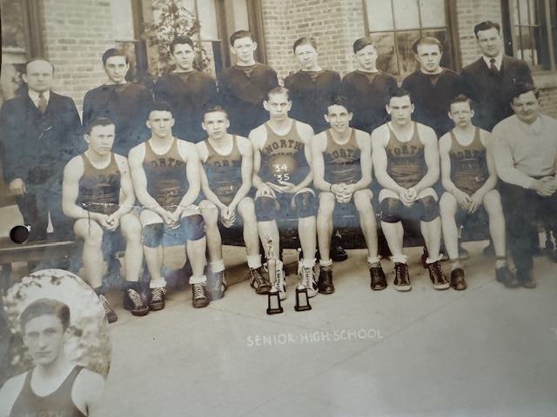

The REGIONAL CHAMPS of 1934-35
Top Row: L-R: Asst. Coach Gustafson, Walt Bergren, Clarence Rogers, Marv Andree, Bob Frost, Bill Sessions, Ray Woodhouse, Coach Lyle McNitt
Bottom Row: Al Schmidt, Joe Witham, Bob Emerson, Todd Speed, Bob Raddatz, Feggie Schmidt, Elmer Witham
In the Insert (Alexander Purdue)

N Muskegon 26 Fruitport 17 Joe Witham 11, Bob Raddatz 7, Alexander Purdue 6
N Muskegon 28 Ravenna 16 Howard Speed & Witham 7, Raddatz & Bob Emerson 4
N Muskegon 27 Montague 15 Raddatz 9, Fred Schmid 6
N Muskegon 21 White Cloud 27 Purdue and Witham 8 each
N Muskegon 23 Fruitport 13 Speed 8, Raddatz 7, Witham 6
N Muskegon 27 Grant 11 Speed 10, Witham 8
N Muskegon 28 Musk St Mary 14 Witham 9, Raddatz 8, Purdue & Speed 4
N Muskegon 34 Musk St Joe 17 Speed 12, Raddatz 8
N Muskegon 20 Shelby 23 Raddatz 7, Purdue and Schmid 5
N Muskegon 30 Grant 17 Witham and Speed 8 points, Purdue 6
N Muskegon 40 Ravenna 13 Witham 13, Raddatz 9, Schmid 8
N Muskegon 29 Musk St Joe 10 Purdue 12, Raddatz & Speed 4
N Muskegon 20 White Cloud 27 Speed 8 Raddatz and Purdue 4
N Muskegon 22* White Cloud 17 Raddatz 8, Purdue 6
N Muskegon 26* Fruitport 13 Schmid 9, Speed & Witham 6, Raddatz 4
N Muskegon 17* Custer 11 Raddatz 11, Speed & Witham 3
N Muskegon 24* Kent City 18 Raddatz and Emerson 8, Speed 7.
N Muskegon 20* Stevensville 24 Playing without two starters.

1935-36 – Coach Lyle McNitt (14-2 overall; no conference, District Champs)

With only Joe Witham lost to graduation, the Norse were poised to have another successful season in only their second year as a four-year school. NM would have had a fourth starter returning for the upcoming season but for the tragic passing the previous season of Alexander Purdue.
Prior to WWII there was a girls’ team at NMHS. The 1935-36 team was comprised of Joyce Bergren, Geneva Sweet, Catherine Bulkley, Jennie Hekkema, Eleanore Sweet, Barbara Gerling, Doris Speed, Sally Sessions, and Barbara Mavis. Sally Sessions would have a great career as a pro golfer and was inducted into the charter class of the Muskegon Area Sports Hall of Fame. Barbara Mavis would become Mrs. Bob Raddatz.
There were mixed emotions for the opening game of the 1935-36 season at the Northside gymnasium. At halftime of the varsity game there was the unveiling of the Alexander Purdue trophy, the oldest annual award given to a NM player who excels in both basketball and football. ‘Winning one for Alexander Purdue’ the Norse doubled the score on Fruitport 28-14 with Howard Speed and Bob Raddatz, returning regulars from the previous season, scoring 14 and 8 points respectively. Fred Schmid returned as a starter from last year’s regional championship team and was joined in the backcourt by his brother Albert. Called upon when the Norse played without both Purdue and Speed in their quarterfinal game with Stevensville, Al Schmid was a member of the Junior Varsity team that won 23 consecutive games without tasting defeat. Yet another regular from their final game of the preceding season, Bob Emerson was injured and would miss much of the season.
On December 12, NM traveled to Montague in hopes of atoning for one of their defeats incurred the previous season. Mission accomplished as Al Schmid scored 13 points in leading the Norse to victory.
NM would then have to wait nearly three weeks to play their next game and perhaps they were a little ‘rusty.’ In what would prove to be their only loss suffered in the entire regular season, the Norse led all the way up into the closing moments before dropping a low-scoring 15-13 defeat at Fremont.
The Norse then had yet another low-scoring contest with Whitehall but managed to escape with a 17-16 victory. Bud Wiley, who replaced the injured Bob Emerson in the starting lineup led NM scorers with 8 points.
In a game touted to be a revenge game, the Norse made amends for their only loss earlier in the season as they trounced Fremont 25-13. Al Schmid led the way with 8 points with Raddatz adding seven. Of special mention for the game was the play of Howard Speed as he added materially by controlling all the tip offs. It was not until the 1938 season when the jump ball after each made basket was eliminated.
The winter of 1936 will go done in local annals as one of the most brutal in Muskegon history. The game with Grant was cancelled as there was no way for Grant to reach NM as the roads were completely blocked. So deep were the drifts on US 31 that a special rotary plow had to be transported in to clear the highways. NM’s next contest scheduled for Ravenna was also cancelled as the road leading to Ravenna was impassable. The front page of the Muskegon Chronicle of February 22 showed a picture of US 31 North of Montague with the snowbanks well over ten feet high. The temperature at Muskegon on February 21, 1936, was 20 below zero. Although the games were called and the road going north and south on US 31 were blocked, schools remained opened. They brought them up tough in the 1930’s.
Despite the frigid conditions the entire NM contingent of three teams made the jaunt to Whitehall. NM made it 10 wins in 11 tries as they downed the Vikings 27-16. The girls team continued their winnings as they also won their game with Whitehall 17-12.
Following their final regular season game with Fruitport the Norse would enter the MHSAA playoffs hoping to make a long run. However, the student body enrollment had increased from the previous year, and the Norse would now find NM moving up to Class C. The Norse were able to go to their bench early as NM had little trouble to besting an outmanned Ravenna team 29-18. Of special note during the contest was the meeting of NM head coach Lyle McNitt who coached against his younger brother Merlin McNitt, one of Ravenna’s starting players. NM moved into the district finals with another convincing 26-14 win over Sparta. Meet officials at Grant were thrilled with the turnout as a ‘robust’ $130 was collected at the gate.
After defeating Grant handedly in their first encounter, that was not the case in the district championship as the Norse had their poorest shooting output on the season in losing to the host Tigers 19-15. However, with rules at that time, NM was allowed to move on to the regionals but fared no better against Zeeland. The Norse held a slim lead at halftime but were thoroughly outgunned in the second half by Zeeland and fell 31-21 to end their season at 13-3. Zeeland would end their season as Class C runner up. Losing in the championship game to Lansing St. Mary.

N Muskegon 28 Fruitport 14 Howard Speed 14, Bob Raddatz 8
N Muskegon 32 Montague 32 Al Schmid 13, Raddatz 7, Speed 6
N Muskegon 21 Grant 9 Speed 10, Raddatz 6
N Muskegon 13 Fremont 15 Speed 4
N Muskegon 17 Whitehall 16 Bud Wiley 8, Raddatz 5
N Muskegon 22 Ravenna 8
N Muskegon 23 Newaygo 9 Wiley 7, Raddatz 6, Speed 5
N Muskegon 28 Montague 21 Speed 9, Raddatz 8, Wiley 6, F Schmid 5
N Muskegon 28 Shelby 12 Al Schmid 8, Raddatz 6, F. Schmid 5
N Muskegon 25 Fremont 13 Al Schmid 8, Raddatz 7
N Muskegon 27 Whitehall 16 Al Schmid 7, Wiley, and F Schmid 5
N Muskegon 32 Fruitport 15 Wiley 8, Speed 7, Raddatz & F Schmid 6,
N Muskegon* 29 Ravenna 18 Ross Cooper 7, Fred Schmidt & Speed 7
N Muskegon* 26 Sparta 14 Speed 10, Raddatz and Fred Schmidt 6
N Muskegon* 15 Grant 19 Speed’s 4 points leads NM scoring
N Muskegon* 21 Zeeland 31 Raddatz 8, Fred Schmid 5

1936-37 – Coach Lyle McNitt (12-4 overall; 4th WMC, Scottville WMC Champs)

The Norsemen kicked off their 1936-37 with a starting five of Bob Raddatz, a three-year mainstay for NM, as well as returning starters Bud Wiley and Albert Schmid. Walt Bergren would also crack the starting lineup along with newcomer Bob Cooper. NM got off to a quick start as Coach Lyle McNitt’s squad defeated his alma mater and his young brother Merlin’s Ravenna team 29-16. North Muskegon had now joined the West Michigan Conference for the first time with long-time mainstays Hart, Montague, Shelby, and Scottville. Whitehall, who did not field a football team did have a basketball team and was another member of this long-time conference.
The Norse made their first ever WMC basketball contest a winning one as they had little trouble in disposing of a favored Shelby team 33-12. Three- year starter Bob Raddatz led NM with 12 points. In the first game of three played at the Shelby band-box gymnasium, the NM girls defeated Shelby 25-0, the first shutout in a basketball game in years. In a forgettable game that will go down in Norse annals as the second lowest scoring game for combined points saw NM fall to Montague 12-9. Montague used a collapsing zone defense to throttle Bob Raddatz, and it worked perfectly as the NM star failed to score a point. In the early years of basketball teams were often called ‘Tossers’ and for many years, including during today’s times known as ‘cagers.’ Early gymnasiums, mostly college teams had cages surrounding the playing courts.
In early January the headline for NM’s win over Fremont was: ‘Norsemen Defeat Fremont Tossers.’ The Norse lost to Whitehall 18-17 in a game that was highly disputed. Whitehall scored (or did they) a basket with about 40 seconds remaining that at first was not deemed a made basket by the referee. Fans, thinking the basket was good stormed the floor in exuberance and after much discussion, the referee reversed his decision and called the basket good. Coach McNitt later acknowledged the basket was indeed good and was only concerned that a technical foul wasn’t called on the Whitehall fans for storming the court.
Later in January NM turned the tables on Montague. After the Norse were limited to but nine points in their first meeting in December, NM returned the favor and held Montague to but six points in a revenge 19-6 Norse victory. Held scoreless in their first game with the Wildcats, Bob Raddatz had 11 of NM’s 19 points.
Prior to NM’s 35-22 victory at Ravenna, a car accident on the way to the game was a near disaster for three NM students. Injured in the crash was Emma Jean Gwatkin, older sister of NM football star John Gwatkin. Not injured in the roll-over was future Hall of Fame great Sally Sessions, a passenger in the car driven by her brother William Sessions.
During the season NM twice defeated Grant, winners of the Newaygo Conference. The second tilt between NM and Whitehall was again an exciting one that went into overtime with NM winning on a basket from Bob Raddatz. The victory atoned for the earlier controversial loss to the Vikings and eliminated Whitehall’s chances to win the WMC conference championship that was won by Scottville. After closing out their regular season with an impressive 28-18 victory at Hart it looked like it might be a promising run in the upcoming state tournament. After defeating Hesperia, the Norse were poised to win the district against a Newago team that scored but 10 points in the district semifinal 12-10 win over Grant. However, a long tournament run was not to be as the Norse had their lowest scoring game in the school’s more than 90-year history as they scored only five points as they were eliminated by Newaygo 15-5. It was the fewest points scored combined by two teams in NM history.

N Muskegon 29 Ravenna 16 Bob Raddatz 10
N Muskegon 33 Shelby 12 Raddatz 12, Bob Cooper 8, Bergren 7
N Muskegon 9 Montague 12 Raddatz held scoreless, Wiley 4
N Muskegon 16 Grant 14 Wiley’s free throw late the winner.
N Muskegon 16 Scottville 18 Raddatz 5 points
N Muskegon 22 Fremont 17 Cooper & Schmid 8 points
N Muskegon 17 Whitehall 18 Cooper 8 in controversial game.
N Muskegon 19 Montague 6 Raddatz 11
N Muskegon 35 Ravenna 22 Raddatz 10, Cooper 9.
N Muskegon 21 Fremont 17 Raddatz and Cooper 8 points
N Muskegon 32 Hart 18 Raddatz 15, Cooper 6, Wiley 5
N Muskegon 17 Grant 10 Raddatz 7, Wiley 6
N Muskegon 25 Whitehall 23 Raddatz 11 & game winner in OT.
N Muskegon 28 Hart 18 Cooper 14, Raddatz 8
N Muskegon* 24 Hesperia 14 Raddatz 7, Wiley & Cooper 5
N Muskegon* 5 Newaygo 5 Lowest NM point total in school history.

1937-38– Coach Lyle McNitt (12-4 overall - Whitehall WMC Champs)

Three regulars returned for the 1937-38 season, Walt Bergren, Harvey Speed, and Bob Cooper, as the Norse repeated their successful 12-4 record from their previous season. The 1937-38 season did not begin well for the Norsemen as the rule for having a center court jump ball after each made basket was thankfully ended. A powerful Whitehall team downed the Norse 26-21 with Harvey Speed leading NM scorers with eight points while Ellis‘Nip’ Pender added 5. The Norse bounced back to throttle Shelby 36-16 as Donald Andree and Thornton scored seven and six points respectively. In the first of the three games played at the Northside gymnasium the NM girls edged Shelby 25-24. Sally Sessions, a charter member of the Muskegon Area Sports Hall of Fame scored 11 points for NM while the older sister of Dave Whitsell, another future member of the MASHOF led all scorers with 18 points. There must have been a lid on the basket as NM was able to score a season low 11 points in a 23-11 defeat by Montague. However, the Norsemen would then go on a nine-game winning streak before again losing to Whitehall for the second time in the season. The second of their nine straight victories came at the expense of Hart. NM defeated the Pirates with Bob Cooper scoring 14 points. Also in double figures for the Norse was Oliver Eyestone, who had moved from Hart to North Muskegon to begin the season. The 1937-38 season was a difficult season for the Pirates as all their games were played on the road while their new gymnasium was under construction. Coach McNitt generally used a rotation of seven players during the season: Harvey Speed, Oliver Eyestone, Walt Bergren, Lawrence ‘Lunk’ Bergren, Bob Cooper, Edwin Cowles and Dick Hoeker. The schedule had to be altered somewhat as a scheduled January 25 game at Shelby was postponed to a later date as a blizzard that hit the entire state of Michigan made the road to Shelby on US 31 impassable. Perhaps making amends for the only loss incurred by the Norsemen during the football season, NM defeated Fremont twice in basketball, the latter contest a convincing 33-18 victory at the NM gymnasium. During the nine- game winning streak NM topped Scottville twice, including a 22-14 victory at the Scottville tiny court, always a tough win for any team venturing to the Mason County school. The 29-21 victory at Montague came on a furious NM second half comeback. Trailing 19-9 at the half the Norse outscored the host Wildcats 20-6 to secure the victory. The winnings streak, as well as a golden opportunity to win the WMC Championship both ended as Whitehall, after holding a three-point lead at halftime, routed the Norse in the second half to earn the win and their first WMC Championship. NM was only able to net but three field goals in the entire contest as ‘Dude’ Pelon, a longtime fixture as a pitcher in baseball, led the Vikings with 11 points. Whitehall would advance all the way to the final eight in the MHSAA playoffs before losing in overtime to Stevensville. The Norse bounced back to edge the Hart Road Warriors 40-38 to clinch second place in the WMC. NM had to rally from behind in the final two minutes to earn the victory. NM opened the MHSAA tournament with a ragged 34-28 victory over Hesperia. 38 fouls were called with numerous players from both teams having players fouled out of the contest. Rules at the time called for a player to be disqualified when he accumulated his fourth foul. NM then ran into a very good Ravenna team who had lost but one game in the regular season and fell to the Bulldogs 35-26. The leading scorer for Ravenna was Lyle McNttt’s youngest brother B. McNitt who led all scorers with 13 points. Ravenna made it to the finals of the regional tournament but lost in overtime. The Bulldogs can only blame their woeful shooting from the free throw line for their loss. Ravenna had nine free throw attempts in regulation --- and missed ALL nine!

N Muskegon 21 Whitehall 26 Harvey Speed 8, Ellis‘Nip’ Pender 5
N Muskegon 36 Shelby 16 Donald Andree 7, Thornton 6
N Muskegon 11 Montague 24 George McNeil & Bill Peterson 4 pts.
N Muskegon 33 Grant 18 Bob Cooper 13, Speed 7, McNeil 5
N Muskegon 40 Hart 28 Cooper 15, Oliver Eyestone 10, Speed 7
N Muskegon 20 Fremont 15 Walt Bergren 6, Speed 5,
N Muskegon 22 Scottville 14 Cooper 9, Ed Cowles 5, Speed 3
N Muskegon 33 Fremont 18 W. Bergren 11, Pender 8, Cooper 6
N Muskegon 30 Scottville 17 Cooper 13, Speed 8
N Muskegon 29 Montague 21 Bergren & Cooper 7, Speed 6, Pender 5
N Muskegon 27 Grant 21 Cooper 12, Speed 6, W. & L. Bergren 4
N Muskegon 29 Shelby 26 Speed 9, Cooper & W. Bergren 6
N Muskegon 14 Whitehall 32 NM only 3 Field goals
N Muskegon 40 Hart 38 Cooper 16, Pender 9
N Muskegon* 34 Hesperia 28 Coopers 11, Speed 8
N Muskegon* 28 Ravenna 35 Cooper 11, Speed 6, Pender 5

1938-39 Coach Lyle McNitt (14-4 overall NM WMC Champs)

The Norsemen had one of their better years in the school’s long history with a 14-4 record while winning the WMC Championship. It would be another 20 years before NM would be undisputed WMC champs. Fully half of their season’s defeats came at the hands of Manistee.
The Norse began their season on a winning note with a double-digit victory against a Whitehall team that was decimated by graduation losses from their championship team from the previous season.
In their second game of the season the Norse trailed Shelby by one with two minutes left but rallied behind baskets from Ellis Pender and Shed Thornton to eke out a 18-15 victory.
NM again had to rally to defeat Montague 23-22. Montague had a 22-19 lead at the end of the third quarter but failed to score a single point the rest of the contest.
NM and Manistee battled into overtime as the two squads were even at 23-23 at the end of regulation. Rules at the time specified that the team that scores the first two points in the three-minute overtime would be declared the winner. There was only one point made in the extra session, a free throw by Manistee’s Mikula (no first name provided). When the final buzzer had sounded that one point would prove to be the difference as NM lost their first game of the season to Manistee 24-23. Lunk Bergren’s six points was the best for NM followed by Nip Pender with four.
Playing on their new gymnasium floor in their first season, Hart handed NM a surprising 48-18 thumping in early January. Future WMU All-American baseball player Fred Stevens led the Pirates uprising with 15 points.
For those who like offensive basketball the January 13 contest with rival Fremont was not for you. The teams played more than seven minutes before a point was scored. The Norse eventually won the game that had to be hard to watch 13-11, with Lunk Bergren’s five points the leading scorer for the Norse. In the 30-18 victory over Shelby Elllis ‘Nip’ Pender poured in 19 points, the second highest total at the time in Norse history.
The Norse took a one game lead in the WMC on February 7th with a 23-17 victory over Montague. The Norse, trailing 10-5 at the ‘halftime rest’ rallied in the second half behind the play of Lawrence ‘Lunk’ Bergren to pull away from the visiting Wildcats.
The Norse kept up their winning ways with Fremont by pulling away in the final quarter to dump Fremont 21-11. In the second low-scoring affair on the season between the two squads, the Norse were leading by only 10-9 entering the final quarter.
In a ‘must win’ game near the close of the regular season the Norse defeated Whitehall in ‘sudden death’ 30-28. Rules at the time had the team that first scores two points in overtime would be declared the winner. Don Andree scored the overtime basket by converting on a rebound off a missed shot for the winning points. Don McNeil scored with just seconds to go in regulation to send the game into overtime and set up a regular season finale against Hart to decide the WMC championship.
Hart had to be tabbed as a prohibitive favor after trouncing the Norse by 23 points earlier in the season. In a roughly played game in front of an overflow crowd at the Norse gymnasium, the Norse pulled off a stunning 30-27 victory over the Pirates. Leading the way with a career game was NM’s portly Dick Hoeker. With both starting guards Don Andree and Lunk Bergren having earlier fouled out of the game, Hoeker poured in 14 career points to lead NM to the improbable upset victory. A huge factor in NM’s victory was holding Hart’s future Muskegon Area Sports Hall of Fame inductee Fred Stevens without a field goal in the game.
After playing all their previous MHSAA playoff games in Newaygo County, the Norse were assigned to travel North, and it all worked out very well for the Blue and Gold. The NM boys were not the only WMC basketball champs, as the NM girls team went undefeated in conference play and were WMC champs. The Norse opened their tournament played at Shelby with a convincing 44-32 victory over Muskegon St. Mary’s. The Norse received some major scoring from a couple of players who saw limited action during the regular season. Morris Engstrom came off the bench to lead all scorers with 14 points while Herb Cooper chipped in with 10 tallies.
NM then played Whitehall. Although the game was not decided in ‘sudden death,’ it was just as close as the earlier thriller. NM’s Lawrence Bergren was fouled with just four seconds to go in regulation and calmly swished both free throws through the net and NM won their second straight nail-biter over the Vikings and earned a berth in the district finals.
NM then captured the Class C district championship with a well-earned 32-30 victory over Ludington St. Simons. Don McNeil tipped in a missed NM shot with seconds remaining to give NM a 32-30 lead. A last second made bucket from the Ludington five came just after the buzzer sounded, sending the Norsemen to the Class C regional in Grand Rapids. The Norse had a sharp second half and won a trip to the regional finals with a 30-19 conquest of Grant. It was a tale of two halves at the regional championship game between NM and Holland Christian. One may find it hard to believe that when one looks at the final score of 35-15 that NM was even in the game. NM led at halftime 14-7 but the wheels came off the Norse in the second half as the Maroons, who would later advance to the state finals, blew out NM in the second half as the ice-cold NM five could only muster one point for the entire half.

N Muskegon 23 Whitehall 13 Lunk Bergren 7, Ed Cowles, and Dick Hoeker 4
N Muskegon 18 Shelby 15 NM come from behind win. No NM over 4 pts
N Muskegon 23 Montague 22 Don McNeil 6, Hoeker 4, Don Andree 3
N Muskegon 23 Manistee 24 Bergren 6 as 11 Norse players see action
N Muskegon 18 Hart 41 George McNeil 7
N Muskegon 13 Fremont 11 Bergren 5, George McNeil 4
N Muskegon 24 Scottville 20 G. McNeil 8, D. McNeil 6
N Muskegon 30 Shelby 18 Ellis Pender 19 of NM’s 30 points
N Muskegon 17 Manistee 24 NM loses for 2nd time vs. Manistee, Pender 5
N Muskegon 23 Montague 17 Bergren 10, Don McNeil 5 as NM now 1st
N Muskegon 21 Fremont 11 Pender 9, Don McNeil 6
N Muskegon 30 Whitehall 28 Andree the winner in OT. Bergren 10
N Muskegon 30 Hart 27 Hoeker 14, Don McNeil 9 for WMC champs.
N Muskegon* 44 Musk St Mary 33 Morris Engstrom 14, Herb Cooper 10.
N Muskegon* 26 Whitehall 24 Bergren GW free throws.
N Muskegon* 32 Lud St Simons 30 Don McNeil 9, Hoeker 8
N Muskegon* 30 Grant 19 Pender, Hoeker, Bergren 6 points
N Muskegon* 15 Holland Chr. 35 Pender 8, Don McNeil 6, Hoeker 1.

1939-40 Coach Lyle McNitt (8-6 overall 3rd in WMC – Hart Champs)

Returning as regulars from the WMC and Class C 1938-39 district champs were Ellis Pender and Lawrence Bergren. Pender, a co-captain on the 1939 NM football team, got the Norse off to a rousing start with 15 game high points in NM’s 33-21 opening win over Muskegon St. Mary’s. Morris Engstrom, who saw considerable action in the previous season captured a starting spot and chipped in 5 points. In a rivalry in the early days of NM basketball, the second game of the season proved to be another thriller. Hart broke a 22-22 tie with 20 seconds remaining to down the Norsemen 24-22 in front of a packed house at the Northside gymnasium. Adding to the drama was a made field goal made by a Norse player that was said to be made after time had expired in the contest. ‘Lunk’ Bergren paced all scorers with 10 points. Trailing 20-10 at the end of the third period, the Norse put on a furious rally but came up two points short in a 21-19 loss vs. Shelby.
Following a convincing win over Montague. The Norse continued their dominance of the 1930s against Fremont as they won their 10th game in 11 tries 34-21 over Fremont.
A capacity crowd packed the antiquated NM gymnasium to witness the Norsemen taking on the defending State Class D champs in Muskegon St. Joseph. The fast-breaking St. Joseph five downed the Norse 33-21 despite a game high 14 points scored by ‘Lunk’ Bergren. NM’s leading scorer, Ellis Pender, scored the games’ first points on a free throw but then was held scoreless the rest of the game by St. Joseph. The Muskegon parochial five would go undefeated throughout the season before tasting defeat in the regional championship game.
A second clash between NM and Hart wasn’t nearly as close as the first encounter back in December as Hart crushed NM 41-24 to earn their fourth straight WMC victory on the season. Bill Gates topped NM scorers with 8 points as Hart shut out NM for the entire third quarter.
Marsh Reeves made his first start as a Norsemen a productive start as he scored 12 points in a 41-24 victory over Whitehall. The Norse continued their dominance over Fremont as they made it 11 wins in a row after Fremont had won the first game in the rivalry back in 1935. NM rallied in the second half to edge the Packers 28-24 with Pender, now back in the lineup, scoring nine points to lead the Norsemen.
The Norse had two players in double figures, a rare event in the 1930’s and 40’s in a 38-27 win over Montague. Marsh Reeves tallied 13 points while Lunk Bergren added 12. The game was played in Whitehall at the Eagle/Ottawa gymnasium, later known as the Tannery. This gymnasium would serve as the home site for both Montague and Whitehall until well into the 1950s.
NM won their next two WMC Conference games against Shelby and Scottville to move into s second place tie in the WMC. Second place in the WMC behind undefeated Hart was at stake in the regular season finale at Whitehall. The Vikings edged the Norse 27-25 to take outright possession of second place as the Norse were unable to hang on to a first half lead.
A second half rally came up short as NM lost their opening game of the Class C state tournament 31-26 as the Norse were eliminated for the second straight year by Holland Christian. Lawrence Bergren scored 11 points in his final game in a NM uniform while Holland Christian was led by their future coach Art Tuls with 14 points.

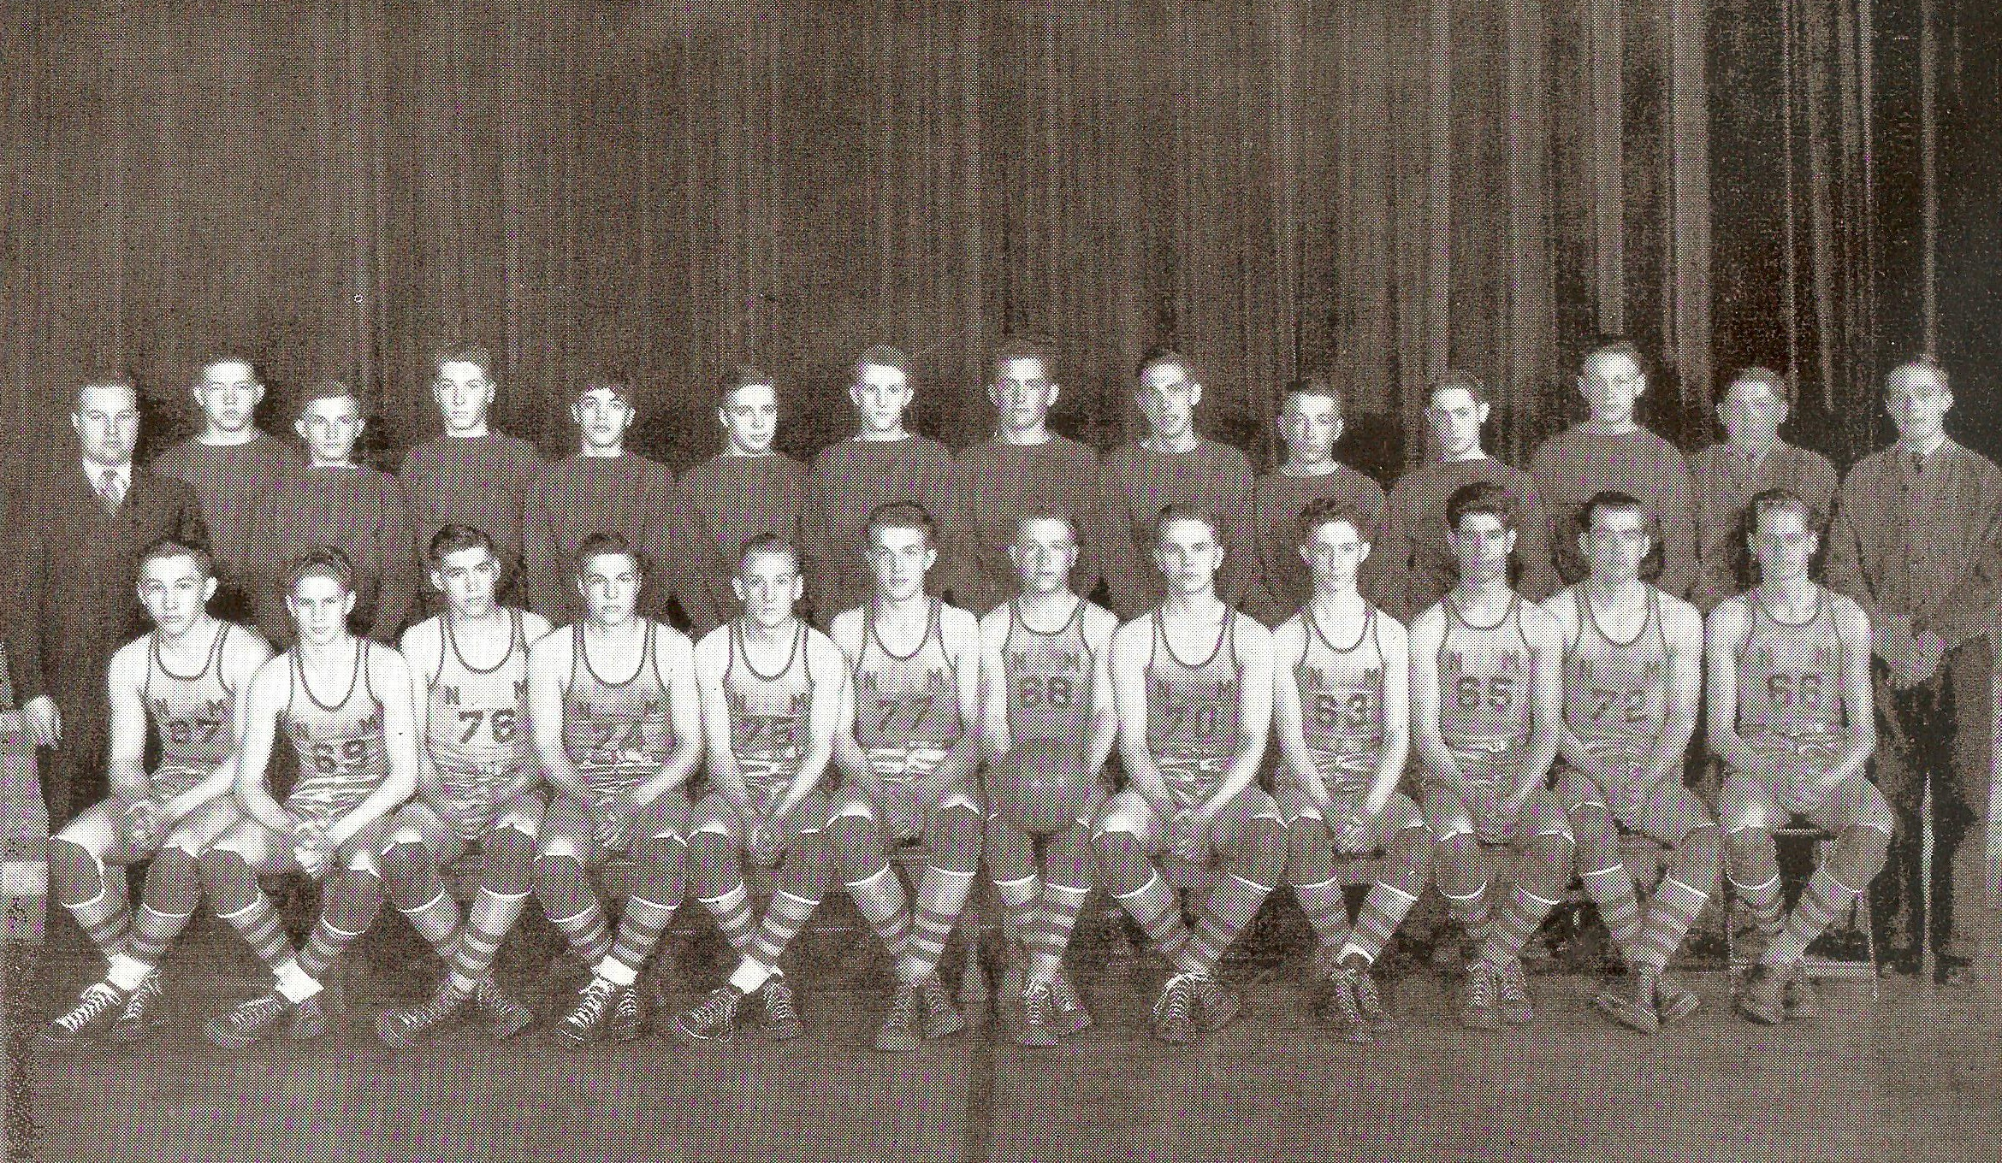

The 1939-40 NORSEMEN
Need help to identify players. I do recognize the following: Marsh Reeves #87, Lunk Bergren # 24, Nip
Pender # 75, Arnie Stafford # 72

N Muskegon 33 Musk St Mary’s 21 Ellis Pender 15, Morris Engstrom 5
N Muskegon 22 Hart 24 Lawrence Bergren 10 Points
N Muskegon 19 Shelby 21 Pender & Bergren 5, Engstrom 4
N Muskegon 34 Montague 22 Pender 10, Gregory Mahynski 5
N Muskegon 34 Fremont 21 Pender 15, Bergren 9
N Muskegon 22 Musk St Joe 33 Bergren 14 vs the defending state champs.
N Muskegon 24 Hart 41 Bill Gates 8, Pender 5
N Muskegon 42 Whitehall 28 Marsh Reeves 14. Bergren 8
N Muskegon 28 Fremont 24 Pender 9, Don McNeil 5
N Muskegon 38 Montague 27 Reeves 14, Bergren 13
N Muskegon 33 Shelby 19 Pender, 10, Bergren 8
N Muskegon 31 Scottville 10 Pender 10, McNeil 8, Bergren 6
N Muskegon 25 Whitehall 27 Bergren & McNeil 8, Reeves 5
N Muskegon* 26 Holland Christ. 31 Bergren 14 as NM season ends

1940-41 Coach Lyle McNitt (12-6, 2nd in WMC – Hart WMC champs – NM District Champs)

With but two veterans’ returning for the 1940-41 season, Joe Farrell and Marsh Reeves, with neither player a full-time starter, not much was expected for the upcoming season. However, the Norse surprised the pundits and posted a 12-6 record and a district championship. After a so-so start to the season NM improved considerably as the season wore on and won eight games in a row before losing a close playoff battle against Grant.
The Norse opened the season against a favored Muskegon St. Mary’s squad and displayed promise with a 32-24 victory. Joe Ferrell paced the Norse with 15 points while Marsh Reeves added eight in a game where NM never were threatened by the veteran St. Mary’s five.
The Norse then took down the defending WMC champs from Hart as Marsh Reeves tallied 19 points, second highest individual game total in NM annals. Many years after Reeves tallied his game high tally, March often boasted to your author about his great time wearing the Norsemen uniform.
After dropping a home tilt with Shelby, the Norse won three in a row, the first a 25-17 victory over Fremont, with Marsh Reeves leading the Norse with 13 points. One oddity occurred during the contest that would not have been possible under today’s rules. NM’s Jack Goudzwaard was fouled and was awarded one free throw (no one and one at this time). Jack made the free throw and was granted another attempt when a Fremont player stepped into the lane too soon. Goudzwaard made that attempt as well.
NM won their second of the first three games played with an overtime win over Muskegon St. Joseph. Ken Potter sank the winning basket in overtime after Marsh Reeves had sent the game into overtime with a late fourth quarter field goal. Seven Norsemen players scored in the contest, a rarity for the era.
After the Norse opened the 1941 year with a victory over Montague, NM then dropped three games in a row before going beginning a winning streak. Hart first made amends for an earlier loss to the Norse while Fremont, after dropping 11 in a row finally broke the hex with a slim 28-27 win over NM. The Norse had an option when fouled with less than a minute remaining and leading 26-25: take the foul shot or take the ball out of bounds. The Norse chose the latter, and it may have backfired ass Dave Jackson intercepted a Norse pass with the clock winding down, dribbled to midcourt and unleashed a desperation shot that swished through the net.
The NM Whitehall contest, played on January 28, was originally scheduled for January 17. However, the Flu had sent over 100 Whitehall students’ home as NM graciously let Whitehall reschedule the contest. Whitehall then gave the Norse a 31-22 pasting to hand the Norse their third straight defeat.
NM got back on the winning track with a 27-13 drubbing of a poor shooting Montague team 27-13. So sad was the Montague offense that the Wildcats had managed to score only two free throws in the first half as NM led 13-2 at the halftime ‘rest.’
Marsh Reeves continued his outstanding scoring as his 17 points led NM to a 29-17 victory in a road win at the tiny Scottville gymnasium, an always tough assignment for any Scottville foe.
NM then clinched second place in the WMC with a 43-32 home victory over Whitehall as Reeves and Ken Potter netted 10 points while Jack Goudzwaard chipped in with nine.
In the final game of the regular season Muskegon St. Joseph wiped out an earlier loss handed to them by the Norsemen with a 25-20 victory. St. Joseph’s Joe Beyrle, who would become one of America’s most decorated World War II heroes, had six points for St. Joseph. There was one bright spot for the Norse as the JV team went undefeated for the entire season with a winning streak that had reached 17 games.
NM entered the Class C district championships as decided underdogs to the WMC champs from Hart. The following day after defeating Scottville in the opening round the Norsemen stunned heavily favored Hart 39-30 as Marshal Reeves led the Norse with 18 points. NM bounced out to an early 8-0 lead and never looked back to earn the upset win.
Playing their third game in as many days, NM then defeated Montague for the third time during the season as Reeves again netted 18 points for the Norse. The district champs then had their season come to an end as Grant won their 16th straight contest of the season to nip the Norse 26-24. Leading the way for Grant was future Central Michigan long-time head coach Ted Kjoldede with 14 points. Kjolhede’s sister, Imogene, would serve as a schoolteacher at North Muskegon in the late 1950s where on her students was your author.

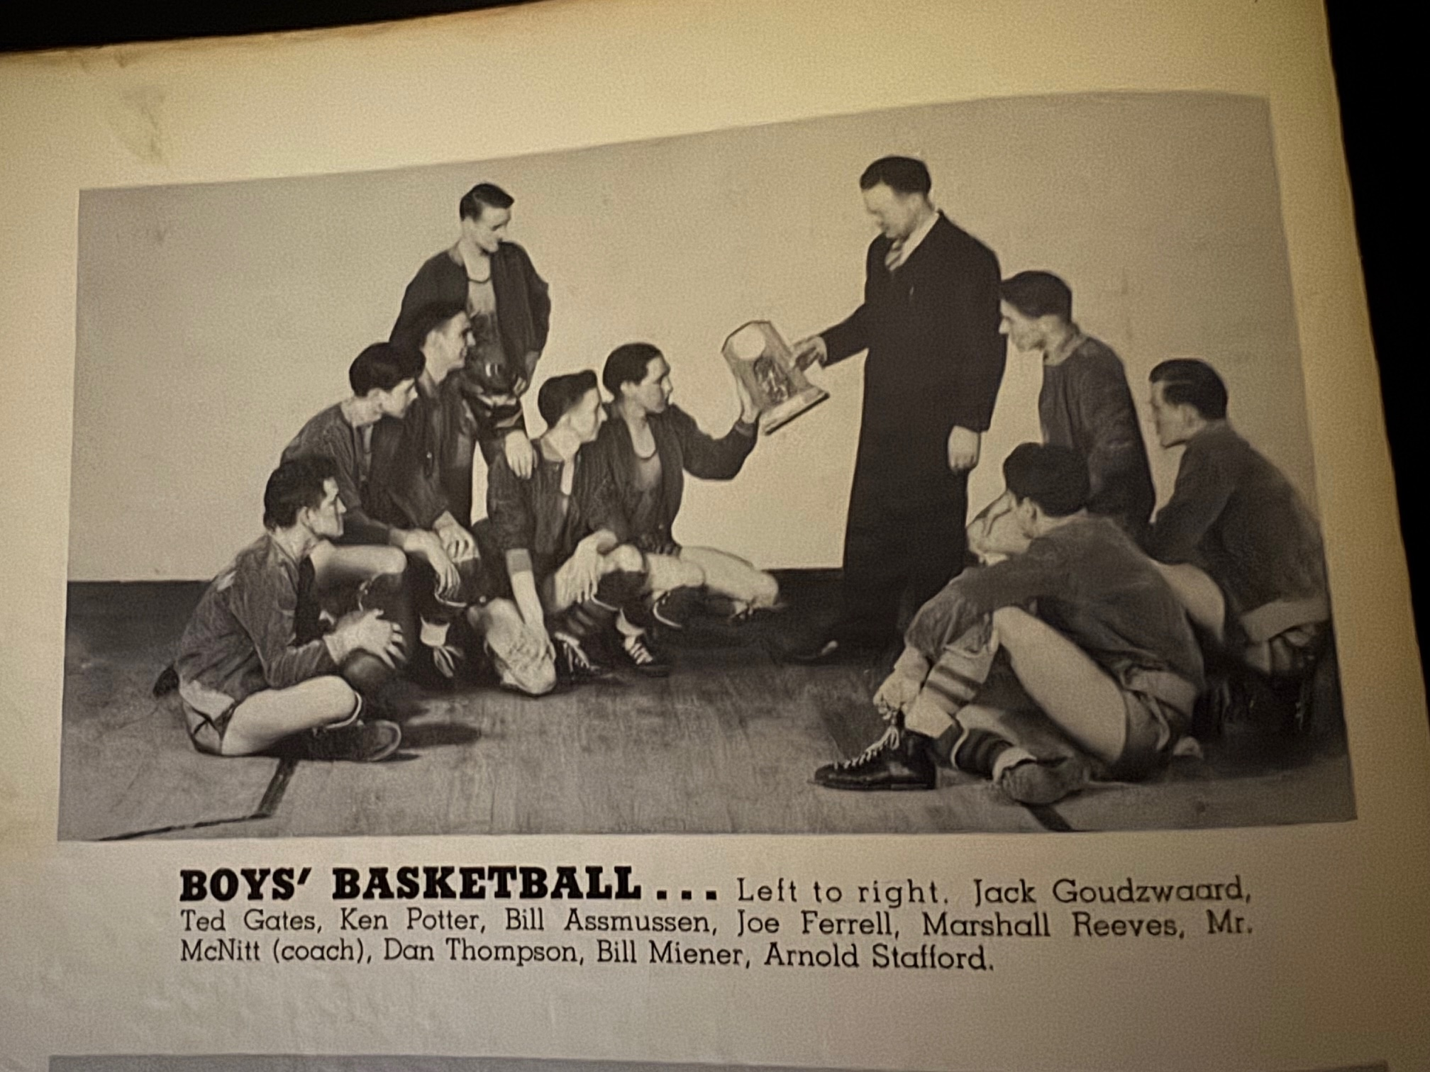

The 1940-41 NORSEMEN

N Muskegon 32 Musk St Mary’s 24 Joe Ferrell 15, Marsh Reeves 8
N Muskegon 34 Hart 21 Reeves 19, Jack Goudzwaard 6
N Muskegon 20 Shelby 29 Reeves 5, Ferrell 4
N Muskegon 25 Fremont 17 Reeves 13, Ken Potter 5
N Muskegon 41 Musk St Joe 39 Reeves 16, Potter 12
N Muskegon 25 Montague 19 Potter 8, Reeves 7, Bill Asmussen 4
N Muskegon 30 Hart 34 Dan Thompson and Goudzwaard 8,
N Muskegon 27 Fremont 28 Reeves 13 as Packers win at the buzzer.
N Muskegon 22 Whitehall 31 Asmussen, Reeves, Goudzwaard 5 points.
N Muskegon 27 Montague 13 NM holds Montague no FG in first half
N Muskegon 28 Shelby 22 Reeves 19, Potter 7
N Muskegon 28 Scottville 17 Reeves 17 points
N Muskegon 43 Whitehall 32 Reeves & Potter 10, Goudzwaard 9
N Muskegon 20 Musk St Joe 25 Potter 9, Reeves 6.
N Muskegon* 26 Scottville 20 Reeves 10
N Muskegon* 39 Hart 30 Reeves 18 as NM upsets WMC champs
N Muskegon* 35 Montague 14 Reeves again scores 18 – District champs
N Muskegon* 24 Grant 26 Potter 8, Reeves 6

1941-42 Coach Lyle McNitt (8-8, 4th in WMC – Hart WMC champs)

Four veterans who saw considerable action for North Muskegon’s district champs from 1940-41 returned to the Norse: starters Jack Goudzwaard, and Ken Potter along with Bill Asmussen and Bill Miner.
The Norse got off to a promising start to begin the season with a 44-22 stomping of Muskegon St. Mary’s, but visions of a perfect season went up in smoke the following week when they were defeated by the Hart ‘Skyscrapers’ 38-29. The Pirates featured a towering front line of 6’6 Walter ‘Stretch’ Hansen and 6’5 Joe Kapulac that proved too tall of a task as four NM starters fouled out of the contest. Joe Mack, father of future Mona Shores boys’ basketball coach Mike Mack, led all scorers with 13 points.
Two days later sports took a back seat to everything as Japan had bombed Pearl Harbor, and the US was now firmly involved in World War II. NM’s hopes of a WMC title were quickly extinguished by Shelby as NM was downed on the Shelby floor 31-25.
The Norse got back on the winning track against their favorite ‘whipping boy’ of the era with a 27-17 victory over Fremont. NM was no match for a powerful Muskegon St. Joseph juggernaut as they ended the war-torn year of 1941 with a home loss to the visitors 39-31.
Hazardous driving conditions postponed all games scheduled in the WMC conference on Friday Jan 9, 1942. The Norsemen were able to travel to Hart for their second meeting of the season the following Tuesday but fell to the Pirates in a hectic contest that saw many players fouling out of the contest. The two referees, one from Ludington and the second, an old-time friend of your author and Muskegon Sports Hall of Fame inductee Nelson Voltz, called 44 fouls in the contest. The Norse got off to a sensational start and held an amazing 16-1 lead over the Pirates at the end of the first quarter. However, playing before a capacity crowd the Pirates, behind the play of Joe Mack who scored 22 points clawed their way back to victory. NM was forced to play the last two minutes of the contest with but four players on the floor as Hart was victorious 40-37. One must remember that prior to a rule change in 1945, players were disqualified after four fouls instead of the current rule of five. Jack Goudzwaard had 11 for the Norse. Hart also had some key players foul out of the contest including Mack as well as 6’6 frontline players Stan Kapulac and ‘Stretch’ Hanson.
For their second consecutive game the Norsemen saw a lead collapse as Whitehall posted a 29-27 victory over NM. The Norse led 27-23 late in the game only to see the Vikings score six unanswered points to send NM to the basement of the WMC conference. It would prove to be a year to remember for Whitehall fans as they made it to the state championship game at MSU’s Jenison Fieldhouse before losing the final game to Leland.
Muskegon also made it to the state finals but, like Whitehall, had to accept the runner up trophy. Both Muskegon and Whitehall had the experience for the first time of playing in a game that used glass backboards.
NM broke their three-game losing streak at the expense once again of Fremont as coach Lyle McNitt started four players from NM’s undefeated, untied, and unscored upon football team from the fall. The dynamic NM backfield duo of Moe Sikkenga and Don Bowen were installed into the starting lineup with lineman Jack Goudzwaard and Bill Goldberg in NM’s 32-26 win over the Packers.
NM then finally broke into the winning column in the WMC with a 34-19 victory over Montague as Bill Asmussen scored a career high 16 points. After losing to Shelby 34-23 Ken Potter scored 20 points, second most at that time in NM history to lead NM to a 41-29 win over Scottville.
The Norse made a complete turnaround from scoring their lowest total points in a season in a 27-18 loss to Whitehall by becoming the first NM team in history to surpass 50 points in a single game in a regular season ending 51-15 rout of Montague.
NM opened the 1942 state playoffs with a district 33-22 win over Scottville with Goodzwaard scoring 8 points while Potter and Don Bowen added 7.
However, the Norse faced an ominous task in their next game as they would face Hart, a team that traversed through the season undefeated and sporting a perfect 15-0 record. In a game that still rankles my good friend Walter ‘Stretch’ Hansen, a stellar Hart performer 82 years later in 2024 at the age of 99, NM did the unfathomable and upset the Pirates 27 to 25. Stretch was held to six points as Ken Potter led all scorers with 15 points. My good friend Stretch made it to the century mark before passing away in 2025.
The game winning field goal was made by Potter’s nephew Don Bowen, who hooked in a side court shot in the final minute of play for the winning goal. In a district final game where the teams were only separated by no more than two points, Ludington St. Simons nipped the Norse 26-25. The Norse lost star guard Don Bowen in the first quarter when he fouled out. At the time it took but four fouls to disqualify a player.
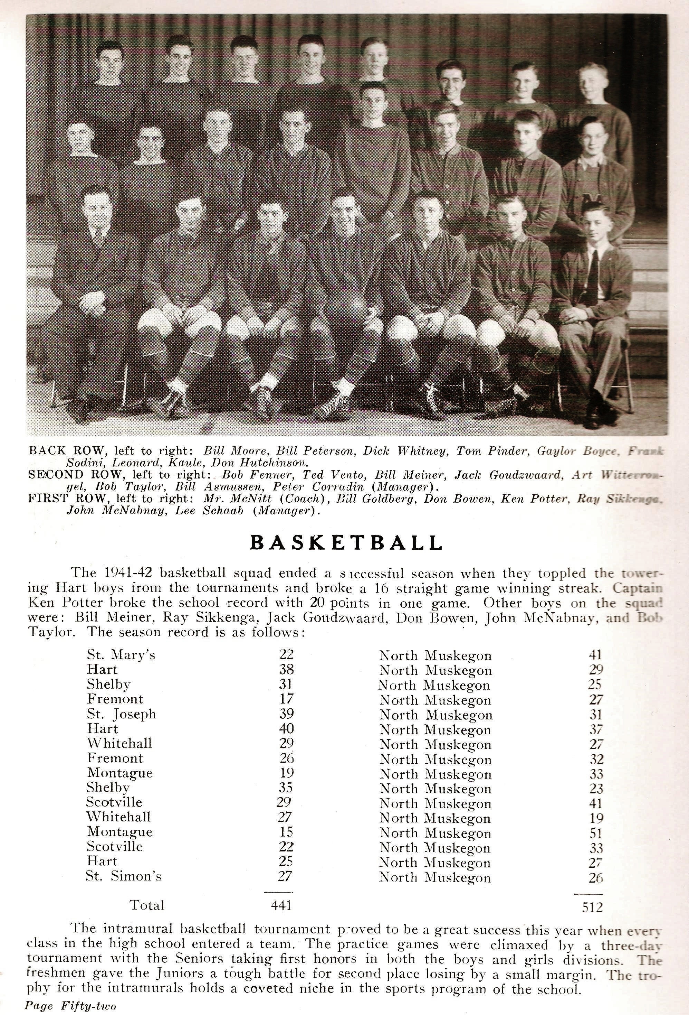

The 1941-42 NORSEMEN

N Muskegon 44 Musk St Mary’s 22 Ken Potter 12, Jack Goudzwaard 10
N Muskegon 29 Hart 6 Potter 10 as 4 NM players fouled out
N Muskegon 25 Shelby 31 Potter 9, Don Bowen 7
N Muskegon 27 Fremont 17 Bill Asmussen 8, Goudzwaard, Bowen 6
N Muskegon 31 Musk St Joseph 39 Asmussen 9, Potter & Bowen 6
N Muskegon 37 Hart 40 NM plays with only 4 due to foul trouble.
N Muskegon 27 Whitehall 29 Potter 12, Bill Goldberg 5
N Muskegon 32 Fremont 26 Potter 9, Goudzwaard 8
N Muskegon 34 Montague 19 Asmussen 16, Goudzwaard 10
N Muskegon 23 Shelby 34 Asmussen 8, Potter 6
N Muskegon 41 Scottville 29 Potter 20, Bill Meiner 12
N Muskegon 18 Whitehall 27 Goudzwaard leads low score NM with 5
N Muskegon 51 Montague 15 Potter 14 as NM scores 50 points.
N Muskegon* 33 Scottville 22 Goodzwarrd 8, Potter & Bowen 7.
N Muskegon* 27 Hart 25 NM beats 16-0 Hart, Potter 15, Bowen wins game.
N Muskegon* 26 Ludington St Simon 27 Goudzwaard 12, Asmussen 7

1942-43 Coach Paul Moyes (4-8, 3rd in WMC – Hart WMC champs)

Although NM completed arguably their finest season in football history, the same results did not happen in basketball. Paul Moyes had succeeded Lyle McNitt as the football, basketball, and baseball coach beginning with the fall of 1942. Moyes’ plate was full as he was also coach of the NM Junior Varsity team. 1943 proved to be a hardship year for sports, and for all Americans as our country was deadlocked during World War II. Rationing of several items were in existence, notably gas rationing which posed a deterrent for travel. Gas rationing took effect on Dec 1st, 1942, and NM, due to the distance that would require the burning of too much fuel, did not play Scottville in 1943. Whitehall too, cancelled both of their games with Scottville while as many as six Michigan Universities completely dropped basketball for the duration of the War. Even coffee lovers had to lower their penchant for an early morning brew due to tight rationing. The team that was perhaps hurt the most was Hart. The Pirates, boasting of a skyscraper lineup had the potential to win the state Class C championship, however, following the district tournaments, the rest of the season was cancelled for all MHSAA events. Only 11 regular season games were scheduled for the Norse, the lowest number of games in school history. Four letter winners returned from the previous season, Bill Goldberg, Moe Sikkenga and Don Bowen from the great football team, as well as Don McNabney. However, none of the lettermen returning were high scorers from the previous year’s 8-8 squad as the three leading scorers had graduated.
The Norse had an ominous assignment for their opening game of the 1942-43 season in the Hart Pirates. Still smarting from their huge upset the preceding year by NM, the Pirates pummeled the Norse 37-17. Walter “Stretch’ Hansen led the Pirates with 13 points while Bill McNabney scored eight of the NM’s slim totals of 15 points, their lowest offensive output of the entire season.
The Norse bounced back the following Friday to defeat Shelby handily 35-14 on the NM home court. Football star Don Bowen led NM in scoring with 10 points while sophomore newcomer Don Jacobson, also a regular on the NM football team, added seven.
Luck was finally on the side of Fremont who had been on the losing end of most of their battles over the years with the Norse. Fremont won in overtime 31-30 in what would prove to be the first of three one-point victories over NM during the season.
It was now time for the Norse to enjoy the fruits of a one-point win when they edged Muskegon St. Joseph a few days later 21-20. A late free throw made by Moe Sikkenga, one of just two points scored during the game by the husky NM guard, proved to be the game winner in the low-scoring affair held just before the Christmas Holiday break.
Hart’s imposing huge front line proved to be too much once again in their second encounter of the season with a 49-28 swamping of the Norse. Don Jacobson led NM with 10 points while Art Wittevrongle added five. Scoring six points for the winners from Hart was Lyle Burmiester, who years later would be one of this author’s working partners at Wagoner Transportation in Traverse City.
The Norse led heavily favored Whitehall by four points midway through the game’s final quarter before the Vikings rallied to earn a 28-22 victory. Scoring four field goals on hook shots, Don Bowen and NM won their third contest of the season with a 27-16 victory over Montague.
NM then made it two wins in a row, and their final victory of the season with a series sweep of Shelby. The modest 36 points scored by NM would be their biggest offensive output of the season and the only game whereby the Norse had two players score in double figures, Bowen with 11 and Jacobson with 10.
Coach Paul Moyes had to ‘raid’ his JV team for the Whitehall contest as four of his varsity players were suspended for cutting classes. Whitehall then dropped the Norse 42-29. Sikkenga had 8 for the Norse while a pair of JVs called up, Tom Jackson and freshman Dick Salmonson combined for 8 of NM’s points. Due to travel restrictions the Norse had to wait two weeks before entertaining the Vikings.
NM’s regular season ended when they dropped a contest at Montague 37-22, a game that was delayed nearly a week.
The entire season then ended when NM dropped a hard-fought game with Coopersville. The districts for Class C were held at the spacious Central Campus gym of Muskegon High School, and the Norse came up one point short in a 26-25 loss to Coopersville.

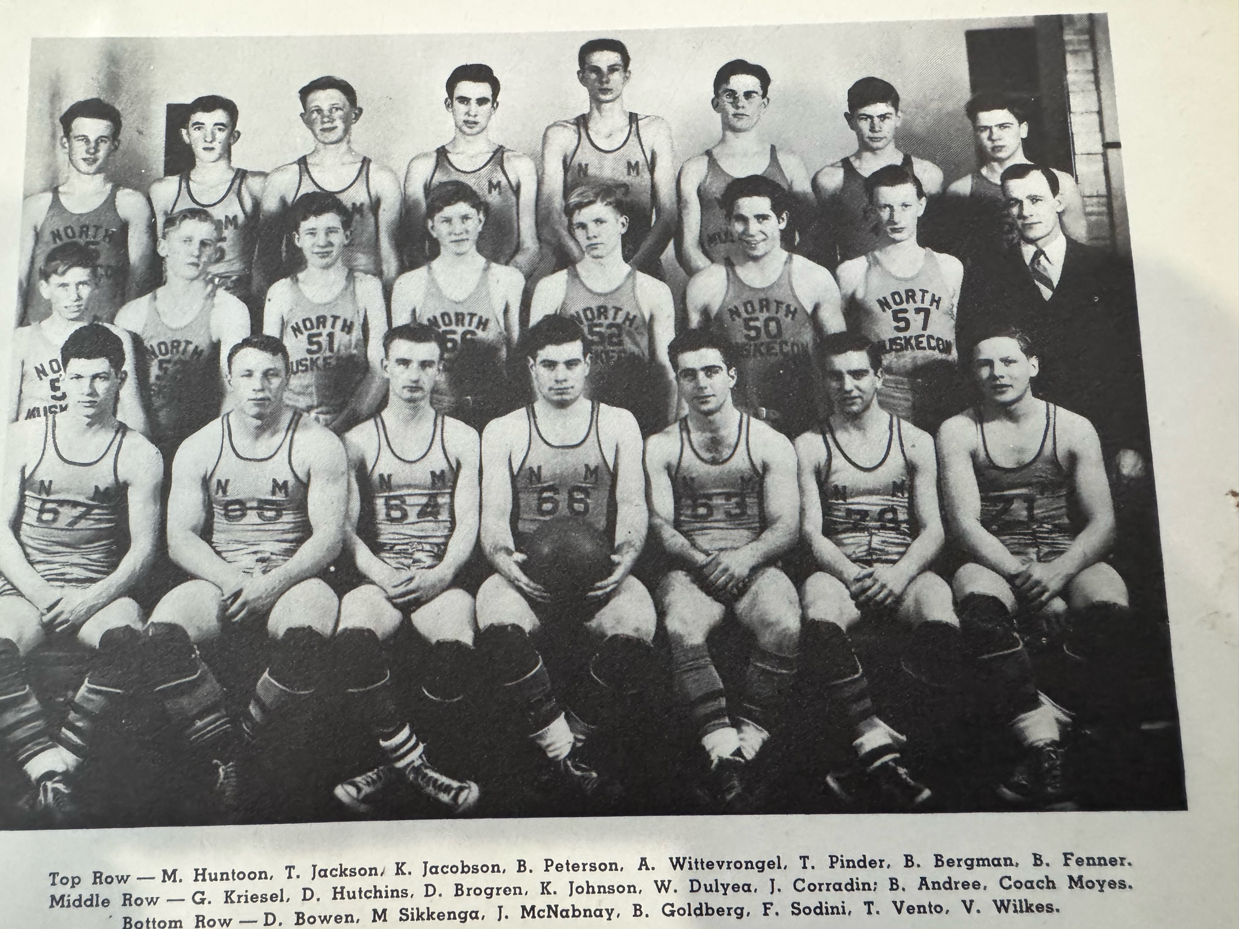

1942-43 NORSEMEN

N Muskegon 26 Hart 40 Bill McNabney 8, Bill Goldberg 5
N Muskegon 35 Shelby 15 Don Bowen 10, Don Jacobson 7
N Muskegon 30 Fremont 31 Moe Sikkenga and Goldberg 7, Bowen 6,
N Muskegon 21 Musk St Joseph 20 McNabney 7, NM wins on Sikkenga ft.
N Muskegon 28 Hart 48 Jacobson 10, Bill Peterson 5.
N Muskegon 22 Whitehall 28 Jacobson & Goldberg 7.
N Muskegon 17 Fremont 18 Jacobson & Goldberg 5.
N Muskegon 27 Montague 16 Bowen 10, Goldberg 6.
N Muskegon 36 Shelby 23 Bowen 11, Jacobson 10, Goldberg 8
N Muskegon 29 Whitehall 42 Sikkenga 8, Tom Jackson 6
N Muskegon 22 Montague 37 Bowen 7, Jacobson 5
N Muskegon* 25 Coopersville 26 Jacobson and Art Wittevrongle 8

`
1943-44 Coach Paul Moyes (3-10) 3rd in WMC – Montague WMC champs)

The Norsemen didn’t fare well in the War years of 1943-44. Once again, they played a limited schedule of 12 games as fuel rationing again raised havoc with scheduling opponents. Three lettermen returned for the start of the season, including junior center Don Jacobson, Tom Jackson and the Norsemen’s tallest cager in Art Wittevrongle. One player counted upon by coach Moyes was Bill Peterson. However, Peterson opted to join the service midway through the 1943 football season as did many other patriotic Americans during this tumultuous period.
There was good news for high school athletes just prior to NM’s opening game with Hart. The MHSAA executive board announced that basketball, as well as track & field championships will again resume after a one-year hiatus in 1943. It would be another 77 years before the Covid 19 pandemic reared its ugly head and forced cancellation of state championships.
Once again NM opened the season against the 4-time WMC champions from Hart and were no match for the Pirates in a 40-26 defeat.
The schedule got even tougher as NM played a mid-week game against the Muskegon Big Reds and were humbled by the Big Reds 53-14. Leading the way for Muskegon was Bill Bos, a future inductee into the Muskegon Area Sports Hall of Fame and the oldest of the four Bos brothers. The Bos residence in North Muskegon was just a few yards away from the NM school complex as the three younger Bos brothers would all play for North Muskegon.
NM then resumed playing their WMC competitors and nearly pulled off their first victory of the year against Shelby. The Norse saw a four-point lead in the final period evaporate as the host Tigers sent NM to their third consecutive defeat 29-25.
Fremont at one point had lost 10 straight games to NM but the Packers have reversed that trend as they won their third victory in a row by a score of 30-22 over their rivals.
After going more than three weeks without playing a game, the Norse displayed their rust from the long layoff as they scored only 11 points as they were routed by Hart 46-11.
After scoring but 11 points at Hart, the Norse touched the sixty points mark for the first time in school history in a 60-36 blitz over Whitehall. Art Wittrevongle netted a career high 20 points while freshman Bob Pyle added 12.
After losing at one time 12 of 13 games vs NM, Fremont won their fourth game in a row over the Norse 41-32 despite 12 points tallied by NM’s Don Jacobson.
Falling victim due to rationing and other factors caused by World War II was girls’ basketball at NM. It would be 30 years before girls’ basketball would be revised at NM and at most other schools throughout the USA with the advent of title IX.
Competing without center Wittrevrongle, who was out with the flu, NM was only able to muster 13 points in a 18-13 loss to league leading Montague. It was a virtual one-man show for NM as Don Jacobson scored 11 of NM’s 13 points.
The Norse finally annexed their second win of the season with a 25-20 win over Shelby, atoning somewhat from their early season loss to the Tigers. Missing in action in NM’s third and final victory of the season was their coach, Paul Moyes. Coach Moyes was in Detroit to take a physical examination for a commission in the US Navy. Superintendent Max Smith was the interim coach for the Norse as NM defeated Scottville 33-24 with Salmonson leading the way for the Norse with 13 points.
What a difference a few weeks make. After scoring a school record 60 points at the Northside gym in January, the Blue & Gold netted 41 fewer points in their rematch with Whitehall in a 33-19 loss.
In the final game of the regular season NM almost pulled off the upset against Montague. The Wildcats had to come from behind to edge the Norse as Montague went undefeated in WMC conference action for the season. In a near replay of their previous game Montague scored but one point in the entire second half but was able to hold on to end the Norse season in the first round of the playoffs 18-16.

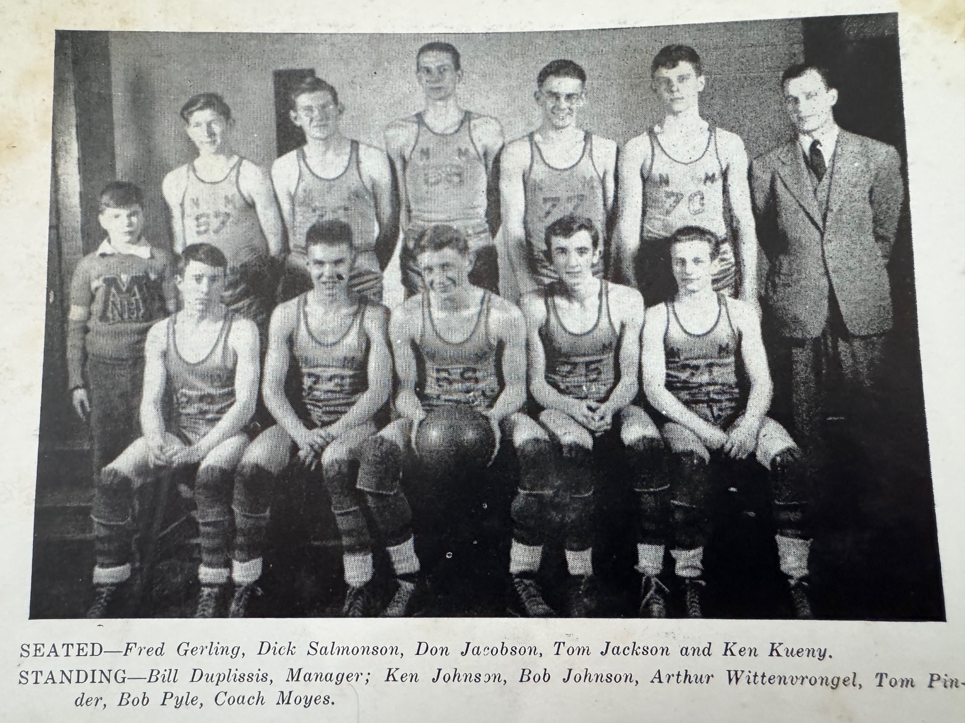

THE NORSEMEN OF 1943-44

N Muskegon 26 Hart 40 Tom Jackson 7, Tom Pinder 6
N Muskegon 14 Muskegon 53 Art Wittevrongle 10 of NM’s 14 points.
N Muskegon 26 Shelby 29 Don Jacobson 12 leads NM in loss
N Muskegon 22 Fremont 30 Jackson 12; 8 of his points on FTs
N Muskegon 11 Hart 46 Norse score only 3 points in second half.
N Muskegon 60 Whitehall 36 Wittrevongle 20, Bob Pyle 12, Ken Kueny 9
N Muskegon 31 Fremont 41 Jacobson 12
N Muskegon 13 Montague 18 Jacobson 11 of NM’s 13 points.
N Muskegon 25 Shelby 20 Jacobson, Pyle and Dick Salmonson 7
N Muskegon 33 Scottville 24 Salmonson 13, Jacobson 7, Ken Kueny 6
N Muskegon 19 Whitehall 31 NM scores 41 less points less than 1st game
N Muskegon 15 Montague 18 WMC champs Montague rallies in 2nd half
N Muskegon* 16 Montague 18 WMC Champs just barely defeat NM in playoffs

1944-45 Coach Earl Meyers (10-8) 2nd in WMC – Montague WMC champ, ‘C’ District champs)

Paul Moyes, coach for the last two years at NM, had entered the service in May of 1944 and was replaced by Earl Meyers. Three lettermen returned from the 1943-44 squad, including three-year starter Don Jacobson. Tom Jackson also returned for the Norse while 6’4 center Bob Pyle, still only a sophomore, also returned to the NM lineup. Although NM began the season by losing six of their first nine games, they did finish strong by going on a six-game winning streak to close out the season.
NM began the season with balanced scoring the key in a 34-18 victory over a newcomer to their schedule in Coopersville. Sophomore Bob Pyle had 9 points while back-up center Harry Waters netted 7.
The Norse then ventured across the causeway to take on Muskegon, for the second, and last, meeting ever between the two schools on the hardwoods. The second meeting resulted in nearly the same score as the first game played as Muskegon romped 53-16. NM kept in close early but the Big Reds, behind the play once again of future NM resident Bill Bos, went on a 16-0 run to squash any NM hopes for victory. No Norsemen were able to score more than four points in the contest.
NM opened their WMC schedule on the road in Hart but dropped a decision to the Pirates 28-24. The Norse after trailing for nearly the entire game, managed to tie the score at 20-all only to see the Pirates score the game’s final four points. Sophomore Bob Pyle. With a modest seven points topped NM in scoring.
The Norse jumped out to a commanding 17-4 lead enroute to their second win on the season, 43-23 over Shelby. Don Jacobson led the Norsemen with 12 points.
Fremont then spanked the Norse 49-31, the largest margin of victory over the Norse in the series history that was once dominated by NM. The Packers even received a fortuitous two points when a Norsemen player tipped the ball into the wrong basket.
The losing woes continued following a two-week layoff for the Holidays. Montague handed the Norse a 30-24 loss followed by their second loss on the season to Hart 41-35. The loss to the Pirates, despite a game leading 12 points by Tom Jackson, put the nail in the coffin for any Norse hoops of winning the WMC title.
Using a 16-7 first quarter advantage over Whitehall, NM snapped their three-game losing streak with a 31-28 win over the Vikings. Don Jacobson and Ken Kueny led the Norse, each with eights.
After dropping their second game of the season to a good Fremont team 46-35, NM, behind Don Jacobson 15 points, defeated Coopersville for the second time on the season 31-25.
Keeping their undefeated winning streak intact, Montague defeated the Norse for the second time on the season 34-23.
NM would begin a six-game winning streak as Don Jacobson tallied a career high 18 points in a NM 39-28 victory at Shelby.
NM compiled their largest scoring total on the season with a 47-31 win over Scottville in their annual one-game only series. Tom Jackson with 14 and Bob Pyle with 10 scored in double figures for the Norse.
The Norse closed out their regular season in winning fashion with convincing wins over Muskegon St. Joseph (36-18) and Whitehall to prepare them for the district tournament. So stingy was the Norse defense (or how bad was the St. Joseph offense, as the Norse held the visitors to no field goals for the entire first half.
The Norse clinched second place in their 42-29 conquest of Whitehall as most of the nation was riveted to the US Marines battle on Iwo Jima.
NM opened with Muskegon St. Mary’s in the Class C districts held at Fremont. For the first time in program history NM had three players reach double figures in a game. Jackson had 12 points, Ken Kueny 11 and Jacobson 10 as the Norse defeated St. Mary’s for their sixth straight win over the local Irish.
NM then defeated Newaygo to win the district title at Fremont. The Norse garnered more than half of their points in the 3rd period with 15 markers as they pulled away from Newaygo. Called up from the JV team, Bud Anderegg led Norse scorers with nine points.
North Muskegon’s season ended as they were outclassed by Grand Rapids Lee in the opening round of the regional. Although the two schools had faced each other many times in the 1940s in football, the playoff contest was the only game played in basketball between the two teams.

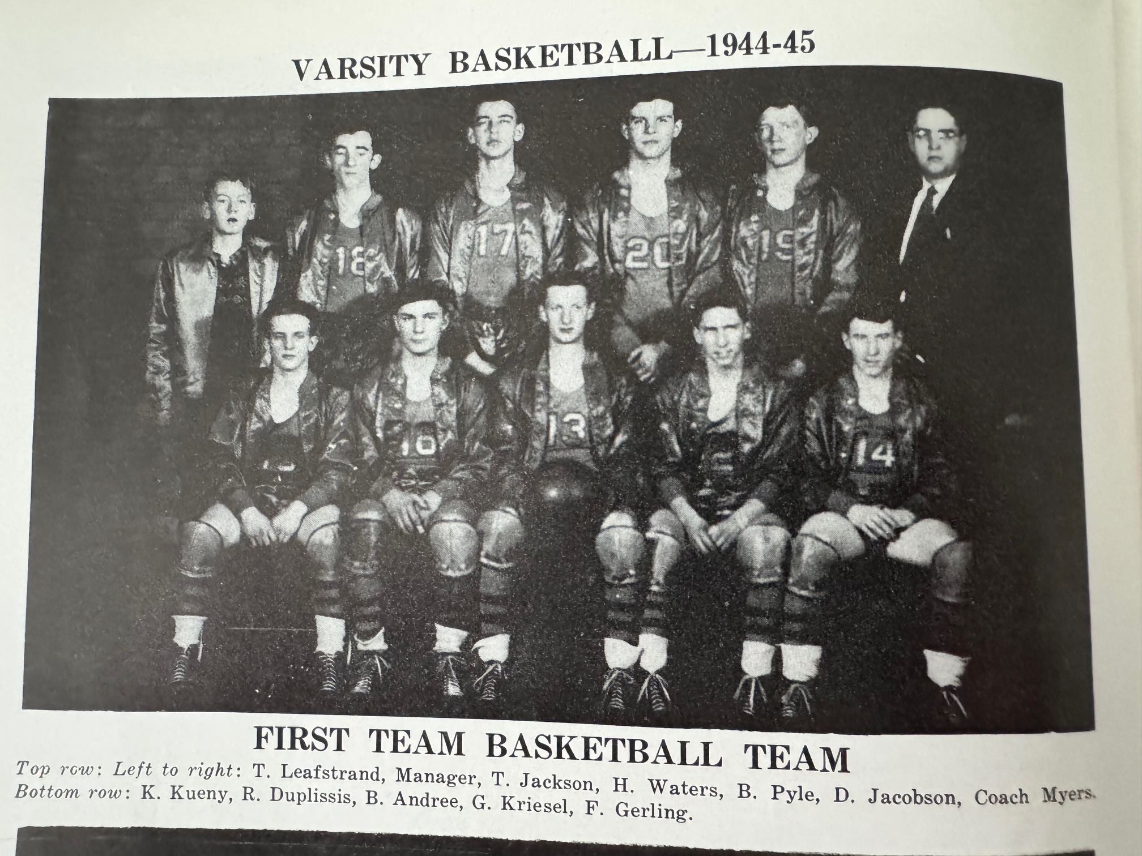

N Muskegon 34 Coopersville 18 Bob Pyle 9, Harry Waters 7
N Muskegon 16 Muskegon 53 Tom Jackson, Bill Andree, & Jacobson 4
N Muskegon 24 Hart 28 Pyle 7, Jackson 6, Ken Kueny 5
N Muskegon 43 Shelby 23 Don Jacobson 12, Jackson 9
N Muskegon 31 Fremont 49 Kueny and Pinky Gerling 7 points.
N Muskegon 24 Montague 30 Jacobson 8, Pyle 7, Bob Duplissis 5
N Muskegon 35 Hart 41 Jackson 12, Pyle 7
N Muskegon 31 Whitehall 28 Kueny and Jacobson 8.
N Muskegon 35 Fremont 46 Jacobson 11, Kueny 10
N Muskegon 31 Coopersville 25 Jacobson 15, Pyle 7
N Muskegon 23 Montague 34 Pyle and Jackson 7, Jacobson 5
N Muskegon 39 Shelby 28 Jacobson 18, Jackson 9, Pyle 6
N Muskegon 47 Scottville 31 Jackson 14, Pyle 10, Andree & Jacobson 8
N Muskegon 36 Musk St Joseph 18 Jackson 10, Kueny 7, Jacobson 6
N Muskegon 42 Whitehall 29 Jacobson 14, Pyle 8, Kueny 7
N Muskegon* 46 Musk St Mary’s 27 Jackson 12, Kueny 11, Jacobson 10
N Muskegon* 28 Newaygo 20 Bud Anderegg 9, Jacobson 8
N Muskegon* 14 Grand Rapids Lee 36 Lowest output of season for NM.

1945-46 Coach Earl Meyers (7-10) 4th in WMC – Hart WMC champ)

The state now permitted 15 games could be played beginning with the 1945-46 season and NM added a new opponent in Grand Haven. Three lettermen returned for second year head coach Earl ‘Bud’ Meyers: Ken Kueny, Bob Pyle and Bud Anderegg. 63 players tried out for the team resulting in multiple cuts before NM would open the season.
The Norse again opened their season with Coopersville and came away with the victory 43 to 36 as Bob Pyle led NM with 14 points while Bud Anderegg had 9 and Bob Duplissis 7.
The Norse then faced for the first time ever, the Grand Haven Buccaneers, who were playing for the first time with a coach other than Muskegon area Sports Hall of Fame charter inductee Gus Cohrs. Replacing Cohrs, recently released from his duties from the service was Steve Sluka, who would also be inducted into the MASHOF. The Norse were no match for the visiting Bucs as their tight zone defense on the small NM gymnasium floor limited NM to but six field goals for the entire game.
Hart then continued their mastery of the Norsemen by edging NM 36-33. It was a raggedy game as three Norse players would foul out of the contest.
NM went to overtime to defeat Shelby 31-27. Two free throws by Bob Duplissis and a field goal from Al Hekkema in overtime sealed the win for the visiting Norse. All 31 points tallied by the Norsemen came from underclassmen.
NM then snapped a six-game losing streak against Fremont with a 37-25 victory over the Packers. The fortunes of NM took a decided downturn following their victory over Fremont as they would embark on a three-game losing streak. Included among the losses was a narrow defeat at Hart in a game whereby the Norse led up until the final minute in regulation. After 5’4 (maybe) Ken Kueny gave NM the lead late in the contest. Hart’s McKinley Schrumpf tied the contest to send the game into a three-minute overtime period. NM was scoreless in the overtime frame while the Pirates one lone basket during the period was all that was needed in the 32-30 victory over the Norse.
The Norse were no match for Whitehall’s Jack Harper who notched 21 points in the Viking’s lopsided 42-18 win over the Norse. Ken Kueny, who had just returned from taking a physical for the draft, returned with an ailing stomach and could only play but a couple of minutes in the defeat.
Kueny was healthy and back in the lineup and scored 10 points as NM defeated Coopersville for the second time on the season 48-21.
After losing to both Fremont and Montague NM did find a win thanks to a 15-point burst from Bob Pyle in a 35-30 win over Shelby.
Following a loss to Scottville the Norse suddenly found their offense as they routed Muskegon St. Joseph 61-33, the most points scored to date for a NM team. The Mutt & Jeff of NM, 6’4 Bob Pyle and 5’4 (maybe) Ken Kueny each scored 20 points in the NM victory. A big Norse rally fell short in their next contest as they dropped a decision to Whitehall 36-32. The Vikings welcomed back three regulars who had been suspended.
NM defeated Grant in the first round of the playoffs 42-26 with the big news the 22 points scored by Bob Pyle that equaled a record set 12 years early by Jack Jiroch in 1934. The Norse season ended with a tight 31-30 loss to Ravenna, the first meeting between the two foes since the 1937-38 season.

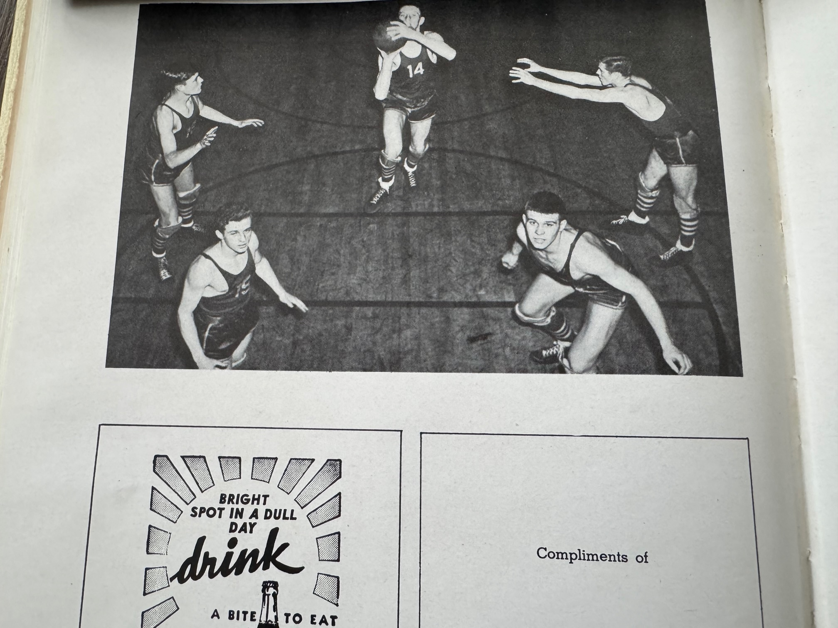

THE NORSEMEN STARTING FIVE of 1945-46

L-R: Ken Kueney, Bob Duplissis, Al Hekkema, Bud Anderegg, Bob Pyle

N Muskegon 43 Coopersville 36 Bob Pyle 14, Bud Anderegg 9, Bob Duplissis 7
N Muskegon 20 Grand Haven 34 Duplissis 6, Ken Kueny 5, Al Hekkema 4
N Muskegon 33 Hart 36 Duplissis 11 as 3 Norse out on fouls
N Muskegon 31 Shelby 27 Hekkema 14, Pyle 10, Duplissis 6.
N Muskegon 37 Fremont 25 Duplissis & Kueny 8, Hekkema 7
N Muskegon 32 Montague 37 Anderegg 10, Hekkema 9, Duplissis 7, Pyle 6
N Muskegon 30 Hart 32 Pyle 11, Hekkema 9, Kueny 6
N Muskegon 18 Whitehall 42 Kueny ill, Ken Barrs led NM with 4 points.
N Muskegon 48 Coopersville 21 Kueny and Anderegg 10 points, Pyle 9, Hekkema 7
N Muskegon 34 Fremont 39 Seven Norse score but the leader Kueny had but 4 points
N Muskegon 33 Montague 46 Kueny 10, Pyle 7, Hekkema & Duplissis 6
N Muskegon 35 Shelby 30 Pyle 15, Hekkea and Baars 6.
N Muskegon 25 Scottville 37 Hekkema & Duplissis 7
N Muskegon 61 Musk St Joe 33 Pyle & Keueny 20 each.
N Muskegon 32 Whitehall 36 Hekkema 8, Kueny 7
N Muskegon* 42 Grant 26 Pyle school record tying 22 points
N Muskegon* 30 Ravenna 31 Anderegg and Jack Ortquist 9 each.

1946-47 Coach Earl Meyers (8-8) NM third in WMC – Whitehall champs)

Four lettermen returned for coach Earl Meyers to begin the 1946-47 season. Big Bob Pyle (6-4, 220) returns to begin his fourth year as a Norse regular and co-holder of the NM school record for points in a game with 22. Included among the four letterwinners would be Dick Salmonson, who is returning from a stint in the service. Starters from last year returning include Bob Duplissis and Al Hekkema. Missing starter from the previous season was 5’4 (maybe) Ken Kueny who can boast of a career high of 20 points scored in a single game. Kueny and his longtime pal Al Hekkema would be fixtures as Norse fans at NM basketball game well into the next century before they each passed on. Superintendent Max Smith was adamant that they would limit the number of spectators allowed into the NM bandbox gymnasium to 510. In the past the tiny gymnasium was overcrowded with spectators who would sit in the aisle ways that overtaxed the facility.
NM opened the season by defeating Coopersville for the fifth consecutive time 43-22. Fresh off his tenure in the service Dick Salmonson led NM with 13 points as the Norse nearly doubled the score on the visiting Broncos.
The Norse were again outclassed by Grand Haven 27-20 in their second-ever meeting. The Norse made it close yet dropped their ninth straight contest to Hart 25-21.
A reported 75 people had to be turned away as a sellout crowd of 510 saw the Norsemen rout Shelby 48-20. Bob Pyle led a pair of Norsemen in double figures with 15 points while Bob Duplissis gunned in 11.
A long break over the Holidays was just what was needed for the Norse after ending 1946 losing handedly to Fremont. After dropping nine straight to their rivals from Hart, the Norse played their best ball to date on the season as they upset the Pirates on the Norse floor 41-29. Al Hekkema dropped in 14 points while Bob Duplissis added 12 as NM won their 2nd WMC game on the season.
It was a bazaar finish for NM in their 55-45 loss to Whitehall. NM had a 10-point lead heading into the final quarter and inexplicably failed to a score a single point in the final quarter while Whitehall meshed 20.
It was no disgrace to loss a pair of games to Fremont during the 1946-47 season. Fremont won their second game of the season 40-30 over NM in what would be Fremont’s furthest run in their school’s history. The Packers would advance to the state finals before losing the Class B championship game to Alma.
NM then made it six victories in a row with a 43-33 conquest of Coopersville to get back on the winning track. Al Hekkema had 13 points, Bob Pyle 11, while reserve Dale Bos, brother of former Muskegon basketball star and tennis ace Bill Bos, moved into the rotation and scored nine points. The immediate future didn’t look all that promising if free throw shooting from the JV players could be exploited. In the JV’s 22-21 loss to the Coopersville JV’s, the Norse cagers hit but one free throw in 21 attempts.
In additional to snapping a long losing streak to Hart, NM also stopped their suffering at the hands of Montague as they swamped Montague 56-35 for their first win over the Wildcats in eight games. Despite 19 points from my old friend Al Jancek, NM had much better balance as three Norse players were in double figures. Al Hekkema with 16, Ken Baars and Dick Salmonson had 12 each with Bob Duplissis just missing with 8.

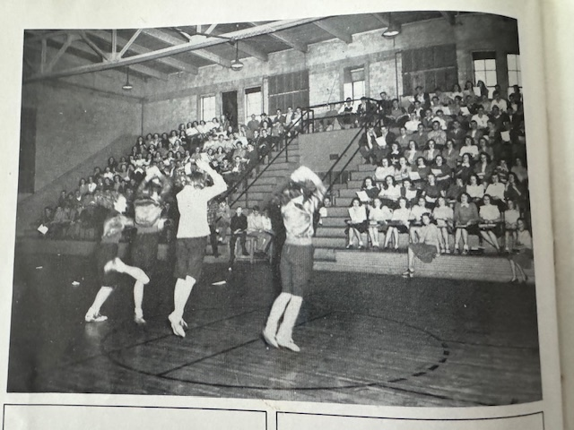

THE OLD NM GYMNASIUM AND A LOOK AT THE PERMANENT SEATS

No tickets were available at the door for the highly anticipated matchup on February 21 with Whitehall as all tickets were sold out and no one without a ticket was allowed into the bandbox NM gymnasium. The hometown fans came away disappointed as Whitehall downed the Norse 41-37 and clinched the WMC Championship, the first WMC title in Whitehall school history. Al Hekkema netted 14 points in the losing cause.
With their spirits crushed by the loss to Whitehall the Norse quickly got back into action the following Monday to play a game at Shelby that was postponed to Feb 24, 1947, due to an earlier snowstorm. NM saw the game get away from them in the fourth period as Shelby, beaten soundly by the Norsemen in December by 28 points upset the Norse 32-22. The Norse could only blame their shooting woes from the free throw line as they were only able to make six of their 15 attempts.
NM need a couple of very late baskets from Bob Pyle and Al Hekkema to earn a tight victory over Newaygo 31-30 to begin the 1947 tournament.
Sadly, for Norse followers, they would have to wait another 10 years to earn a victory in the playoffs.
After losing to the Norsemen in their previous five meetings, Muskegon St. Mary’s came from behind to eliminate NM from the tournament 35-29. For St Mary’s, it was their 17th consecutive win in a row and for three NM seniors it was their final game. The graduating seniors of Al Hekkema (12) Bob Pyle (8) Bob Duplissis (5) scored all but 4 points in the loss to the undefeated Irish. WMC champ Whitehall would end St. Mary’s season in the first game of the regional. Whitehall would make a great run in the 1946-47, advancing all the way to the semifinal four.

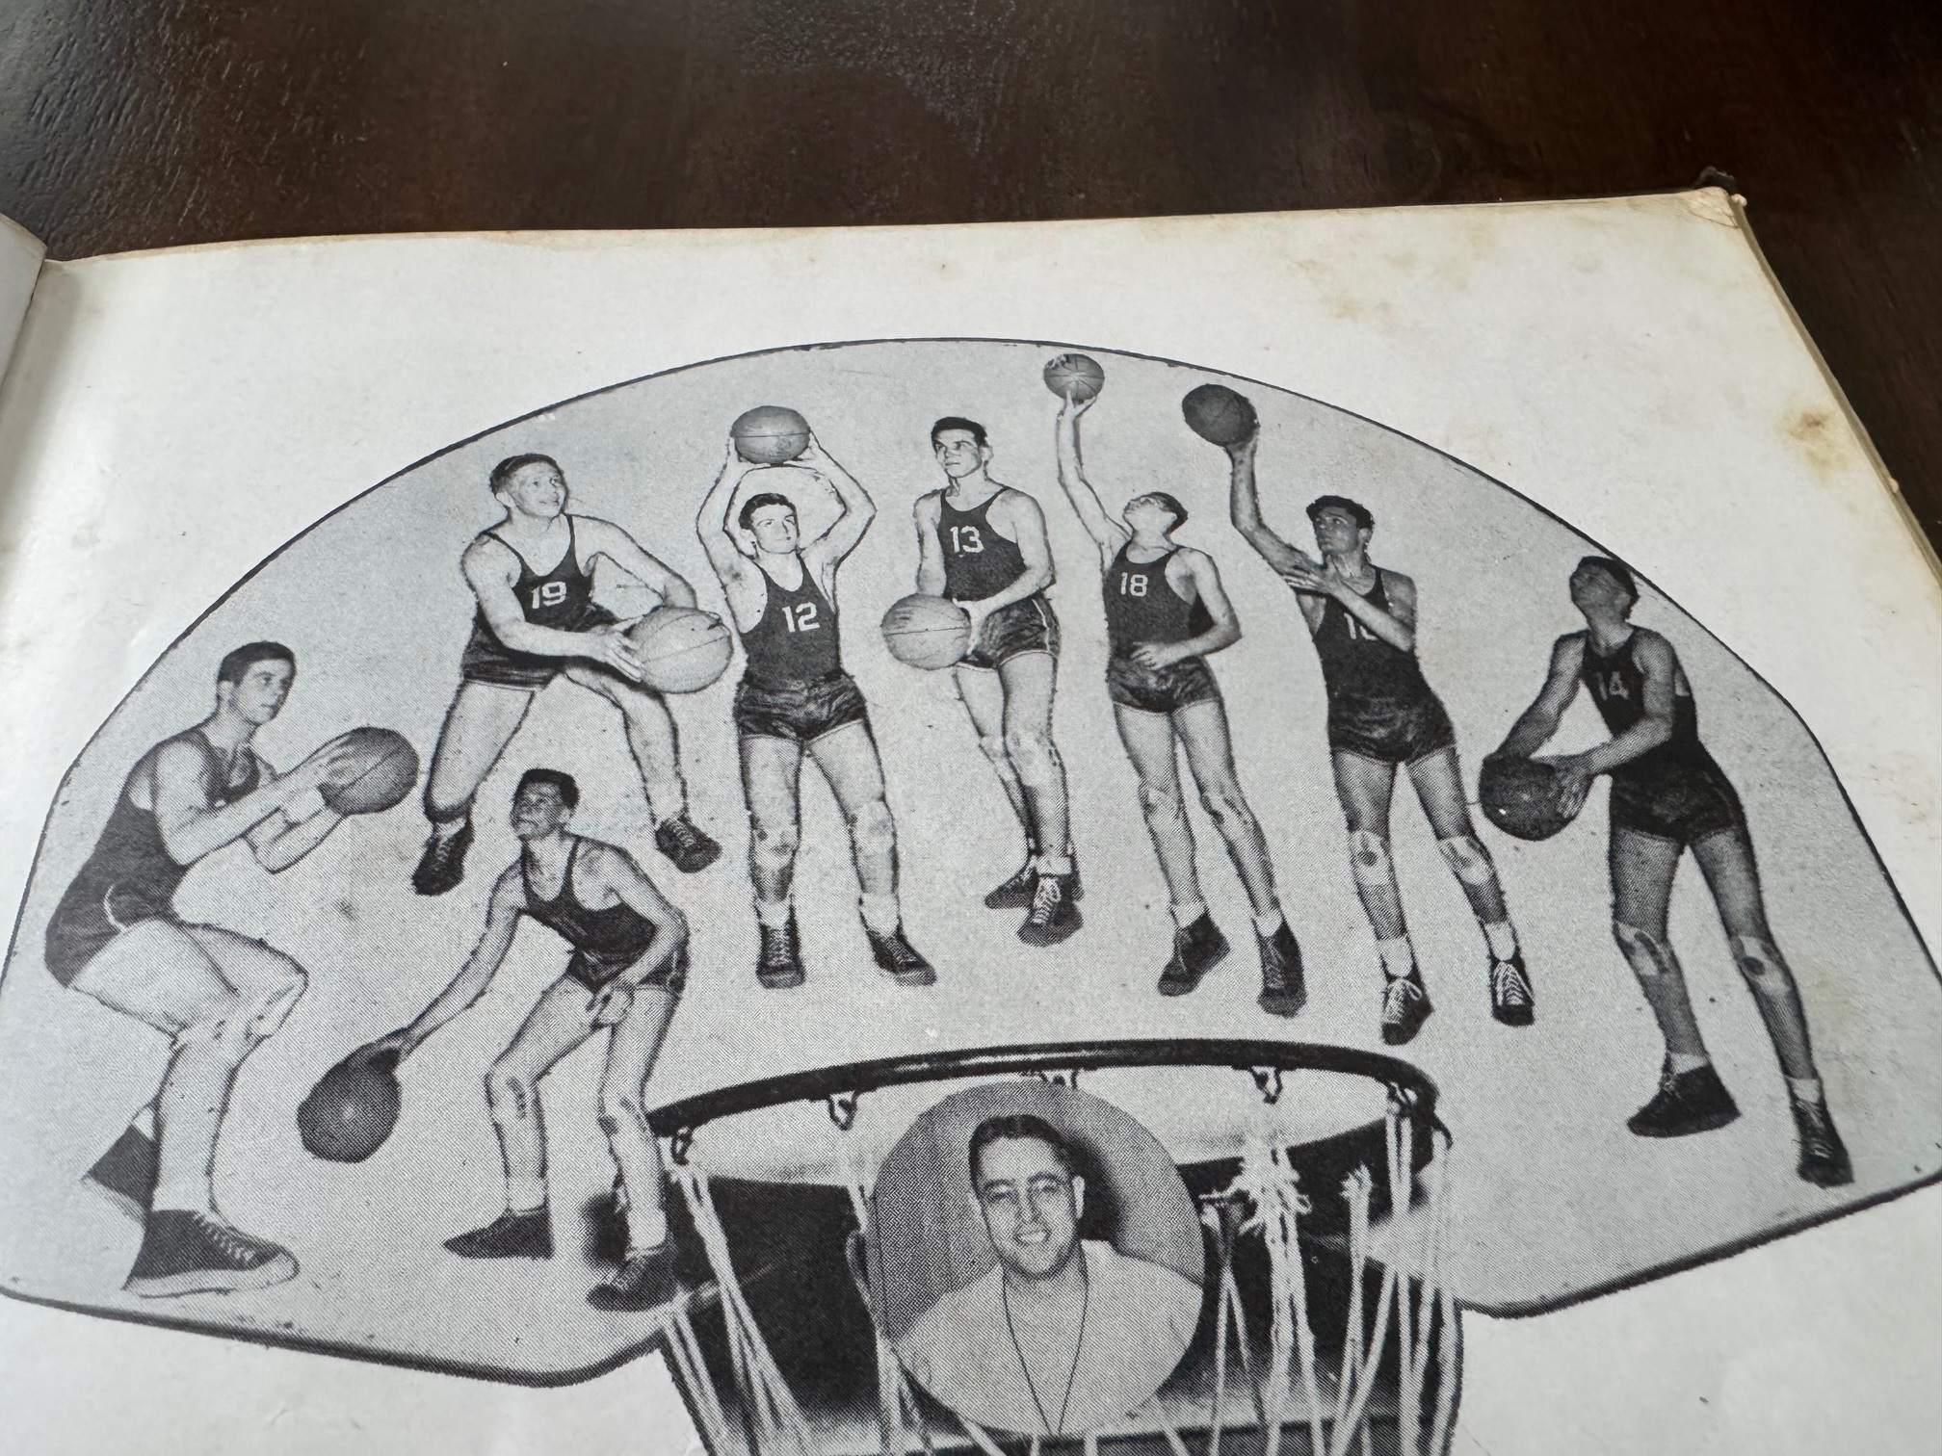

The 1946-47 NORSEMEN

L-R: Bob Pyle, Al Covell, Jim Scott, Ken Baars, Don Salmonson, Dale Bos, Bob Duplissis, Al Hekkema

N Muskegon 43 Coopersville 22 Dick Salmonson 13, All Hekkema and Ken Baars 8
N Muskegon 20 Grand Haven 27 Bob Pyle 8, Hekkema & Baars 6
N Muskegon 21 Hart 25 Pirates defeat NM for 9th straight time.
N Muskegon 48 Shelby 20 Pyle 15, Bob Duplissis 11, Baars 9
N Muskegon 27 Fremont 48 Pyle 7, Baars 6, Salmonson & Hekkema 5
N Muskegon 41 Hart 29 Hekkema 14, Duplissis 12, Pyle 8
N Muskegon 45 Whitehall 55 Salmonson 10, Hekkema, Duplissis & Baars 9, Pyle 8
N Muskegon 30 Fremont 40 Duplissis 9, Hekkema & Pyle 7, Salmonson 5
N Muskegon 43 Coopersville 33 Pyle 11, Dale Bos 9,
N Muskegon 56 Montague 35 Hekkema 16, Salmonson & Baars 12, Duplissis 8
N Muskegon 41 Scottville 37 Duplissis 14, Hekkema 8, Baars 7
N Muskegon 37 Whitehall 41 Hekkema 14, Duplissis 8, Pyle 7, Baars 6
N Muskegon 22 Shelby 32 Hekkema 9, Duplissis 8, Bos 7.
N Muskegon 46 Montague 26 Pyle 13, Hekkema 10, Duplissis 9, Bos 7, Baars 6
N Muskegon 31* Newaygo 30 Pyle 11, Bos 8, Hekkema 6
N Muskegon 29* Musk St Mary 35 Hekkema 12, Pyle 8, Duplissis 5, Bos 4

1947-48 Coach Earl Meyers (2-13) NM 5th in WMC – Hart champs)

With only Dale Bos and Ken Baars returning to the starting lineup from the previous season, prospects didn’t look all that rosy for the Norse. The Norse would only win two games on the season, both against Montague as NM experienced their worse season to date in program history.
The writing was on the wall in their first game on the season when they were pummeled by Muskegon St. Joseph 54-40 in a game that wasn’t even that close as NM outscored St. Joseph 16-4 in the final quarter. Leading the scoring for St. Joseph was future NM football coach Dick Doornbos with 22 points. The two returning starters for NM, Dale Bos and Ken Baars had 17 and 14 to pace the Norse.
It didn’t get any easier for NM in their second contest against Grand Haven as the host Buccaneers doubled the score on the Norse 49-24. Following a Ken Baars two-pointer early into the second half the score was tied at 16 all but the rest of the game belonged to Grand Haven.
Coach Earl Meyers’ five gave Norse fans hope that all was well in game number three as they defeated Montague 41-38 in overtime. Dale Bos was the big gun for NM by scoring the winning basket in overtime, two of his game high 18 points. Jim Scott had a key bucket in the overtime period for NM as three NM players fouled out of the game before the fourth quarter.
However, it was back to reality for NM beginning with a 42-24 loss to Shelby. Dale Bos had 13 points, but no other Norse player was able to score more than three points. The Norse then ran into a hot shooting cager from Muskegon St. Mary’s, Jack Martin, who surely must have set a school record with 30 points in the Irish 54-48 win over NM.
After a close first half that had Scottville leading by only two points at halftime, once again NM faltered in the second half at Scottville’s super-tiny gym and fell to the Spartans 43-36.
League leading and defending WMC champs Whitehall then derailed the Norse 51-33, but the worst was yet to come. To say that the Norsemen’s offense was colder than the previous night’s temperature of -13 below would be an understatement--- check out this stat of NM’s impotent offense. NM trailed Hart 33-0 and the half! A Dick Schalk field goal late in the third quarter averted NM going scoreless for three full quarters but the Norsemen still found themselves trailing 47-2. The 59-9 loss to Hart must perhaps take the dubious honor of the worst showing in NM history.
Thank goodness for the Norsemen that Montague was on the schedule. After their embarrassing loss to Hart, the Norsemen more than welcomed a trip to Montague where the Norse won their second, and last game of the season with a 41-30 victory over Montague. Ten Norsemen saw action in the game, including a few sophomores. However, it was a trio of seniors, Jim Scott (10) Ken Baars (8) and Dale Bos (8) who led NM scorers.
Still smarting from a defeat to Muskegon St. Joseph where future NM football coach (1958 & 59) Dick Doornbos poured in a school record 33 points, Shelby held off a NM rally to edge the Norse 42-40. NM coach Meyers started five reserve players to begin the game, and it backfired as Shelby led NM by 13 points at the end of the first quarter.
Newaygo had replaced Fremont on the NM schedule, and perhaps it was a wise move as Fremont would go all the way to the state semifinals in Class B. Although NM was on the losing end 45-41 to Newaygo, they were in contention throughout the contest.
The final four games on the season again were not pretty for the Blue & Gold. Following a home loss to Scottville 54-29 NM would give up the most points in program history (as of the 1948 date) as Whitehall poured in 73 points to the Norsemen’s 35. Leading NM in scoring was Jim Scott with 10. Scott, who lived directly across the street from my residence in NM, in later years would become a longtime teacher and head track coach for Whitehall.
Hart secured their WMC Championship with a commanding 54-39 victory over NM. Although NM scored but 39 points, it was 30 points more than they tallied in their initial game with Hart. NM than had the dubious task of attempting to win a playoff game against an undefeated Grant squad. NM fought gamely and trailed the heavy favorites by only a point at halftime. Grant pulled away in the second half and NM would end the season with but two wins. On a positive note, that would be double the wins NM would have the following season.

N Muskegon 40 Musk St Joseph 54 Dale Bos 17, Ken Baars 14
N Muskegon 24 Grand Haven 48 Baars 8, Jim Scott 4
N Muskegon 41 Montague (ot) 38 Bos 18, Scott 7
N Muskegon 24 Shelby 42 Bos 13
N Muskegon 48 Musk St Mary’s 54 St. Mary’s Jack Martin scores 30.
N Muskegon 26 Scottville 43 Scott 10, Baars 4
N Muskegon 33 Whitehall 51 Baars 15, Bos 13
N Muskegon 9 Hart 59 NM 0 pts in first half. Ken Douglas 7
N Muskegon 41 Montague 30 Scott 10, Baars 8, Bos 8
N Muskegon 40 Shelby 42 Scott 10, Douglas & Baars 8.
N Muskegon 41 Newaygo 45 Scott 14, Bos 13, Baars 9,
N Muskegon 29 Scottville 54 Scott 9, Baars 8
N Muskegon 35 Whitehall 73 Scott 10
N Muskegon 39 Hart 54 Bos & Douglas 10 points, Dick Schalk 6
N Muskegon*33 Grant 43 Scott 10, Baars 9, Schalk 8, Douglas 6

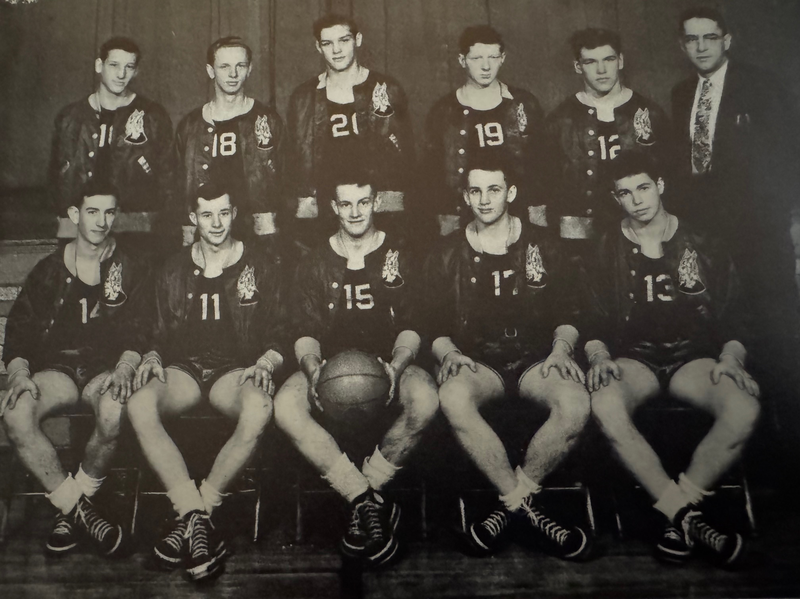
THE NORSEMEN of 1947-48
Seated: L-R: Monte Hand, Jim Scott, Ken Baars, Ken Douglas, Joel Wiener
Standing: L-R: Robert Boss, Cliff Dobben, Dale Boss, Charles Leafstrand, Don Fitt,
Coach Bud Meyers

1948-49 Coach Bob Morris (1-13) NM 6th in WMC – Hart champs)

North Muskegon had a new coach, and it would prove to be a very popular hire in Bob Morris. Unfortunately for Coach Morris he only had but one letterman to work with for the 1948-59 season and the one letterman, Monte Hand, saw limited action from the previous season. Although NM had a dismal 1-13 record, the experience gained by the many underclassmen on this team would lead to a co-WMC championship in but two years. Your author was in early grade school during the 1948-49 school year and being the son of a football and baseball coach, and living right across the street from the school, I spent many hours after school watching the Norsemen practice. In this youngster’s wide eye vision, I thought these players were superstars. Many years had passed by before I did research on NM basketball and I was shocked to finally realize that these players who I looked up to with envy, won only one game the entire season! Coach Morris would coach the Norse through the 1964 school year and would be the head mentor for more than 250 games. It was in his very first game with Grand Haven where his Norsemen would be on the losing end of the most lopsided score in his long coaching career as Grand Haven swamped the Norse 70-20.
Although they lost in their next outing, NM was not embarrassed in their 39-37 defeat at the hands of Montague. Scoring in double figures for the Norse, the first of many times during his career, was sophomore Bill Duplissis.
The next four games saw the Norse defeated in all games by more than double digit scores before they were finally able to post their first, and only victory on the season against Montague. The first of those lopsided defeats came at Muskegon’s Central Campus gym when NM was defeated by Muskegon St. Mary’s 45-27.
Looking for a spark, Coach Morris called up from the Junior Varsity team freshman John Dykhouse for NM’s away game with Whitehall. Dykhouse chipped in with seven points, but it was not nearly enough as NM dropped their sixth straight game of the season 51-32 to the Vikings.
Ben Leisburg broke the Hart High school scoring record at the expense of the Norse with his 30 points in a 75-42 rout of the Norse at the northside gym. As if there weren’t enough troubles with the basketball team. The long-standing old school that was just north of the current high school was condemned for safety reasons as NM administrators scrambled to find some temporary facilities for some of their classes. Shortly thereafter the old school built in the first part of the 20th century was demolished. For many of us youngsters from the 1940s, it meant that we would no longer be able to slide down the long fire escape that was attached to the east side of the building.
After suffering seven straight losses NM finally was on the winning side of the score with a 29-25 victory over Montague. Bill Duplissis fired in 11 points while Coach Morris got some fine play from Bill Woller. Then it was once again back to reality for the Norse as they lost to Shelby 49-31 in a battle for who would escape the cellar of the WMC.
NM nearly pulled off an upset over Newaygo, the leaders of the Newaygo County Athletic Conference but fell two points short in a 25-24 loss at the Norse gym. NM was no match in the bandbox Scottville gym as they were downed convincingly by the Spartans 50-26.
NM came close to pulling off the upset with Whitehall as they trailed by only a point going into the final quarter. NM gave powerful and league champion Hart a brief scare in the regular season finale as they enjoyed an all too brief lead in the second quarter before the Pirates pulled away to a 53-34 victory.
The Norse nearly pulled off a stunning upset in the MHSAA playoffs but fell to Manistee 47-46. It was the first year whereby North Muskegon was a Class B school. Fortunately for Norse fans, NM would show vast improvement over the next few seasons.

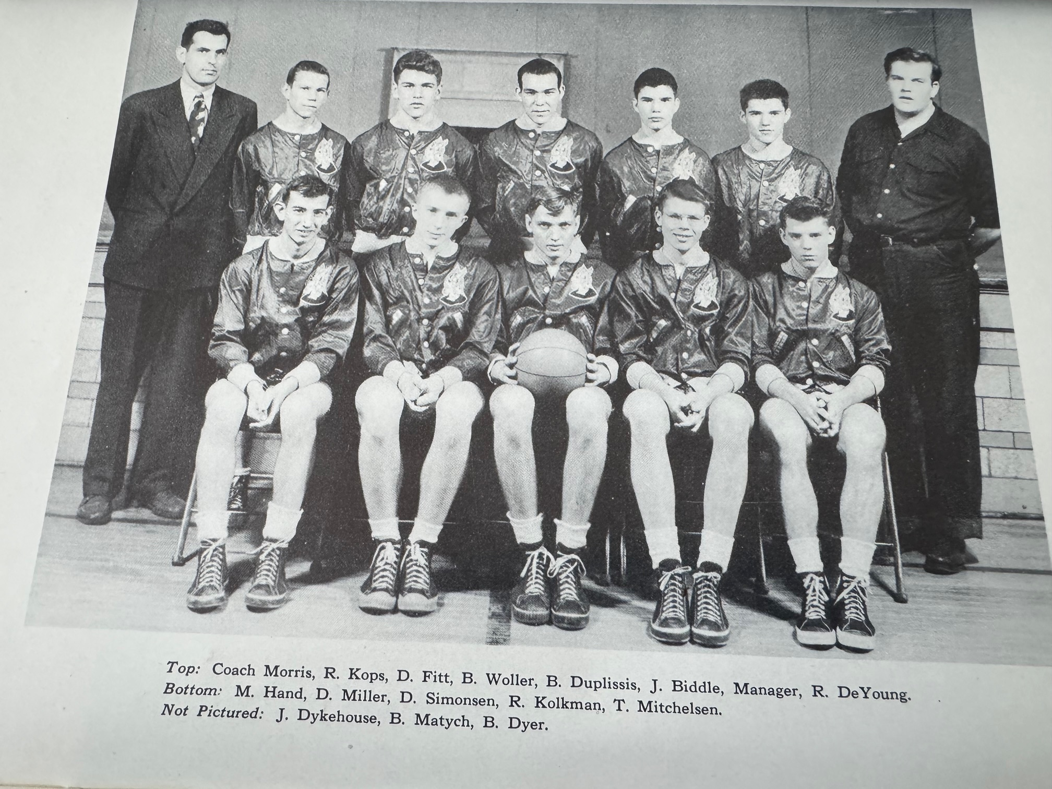

The 1948-49 NORSEMEN

Top Row L-R: Coach Morris, Roger Kops, Don Fitt, Bill Woller, Bill Duplissis, Mgr. Russ DeYoung
Bottom Row L-R: Monte Hand, Don Miller, Don Salmonson, Ron Kolkman, Tom Mitchelson
Not pictured: John Dykhouse, Bud Matych, Bill Dyer

N Muskegon 20 Grand Haven 70 Monty Hand 5 pts in worse loss for Coach Morris ever.
N Muskegon 37 Montague 39 Don Miller 16, Bill Duplissis 10, Bill Dyer 10
N Muskegon 28 Shelby 45 Don Simonson 15, Duplissis 5
N Muskegon 27 Musk St Mary’s 45 Miller 11
N Muskegon 33 Scottville 49 Miller 14, Dyer 9
N Muskegon 32 Whitehall 51 Miller 10, Hand, 8, John Dykhouse 7
N Muskegon 42 Hart 75 Dykhouse and Tom Mitchelson 9, Duplissis 8
N Muskegon 29 Montague 25 Duplissis 11, Bill Woller & Miller 6
N Muskegon 31 Shelby 49 Hand and Dyer 7
N Muskegon 24 Newaygo 26 Mitchelson and Miller 7
N Muskegon 26 Scottville 50 Duplissis 10, Miller 6
N Muskegon 28 Whitehall 39 Duplissis 9, Miller 7, Dykhouse 6
N Muskegon 34 Hart 53 Simonson 9, Duplissis 8
N Muskegon *46 Manistee 47 Miller 13, Mitchelson 11

1949-50 Coach Bob Morris (7-7 NM 2nd in WMC – Hart champs)

Five lettermen returned for 2nd year coach Bob Morris with two of his returnees still underclassmen in sophomore John Dykhouse and junior Bill Duplissis. Seniors returning included starters Bill Dyer, Monte Hand and Jerry Raymond.
NM began the season and dropped their opener in a bazaar way at Newaygo. The Norse called one too many timeouts late in the game that resulted in a technical foul. Newaygo made the foul shots, and NM went down in defeat 50-46. Newaygo, with one of their stars being future Montague head coach Bill Mattson, would go undefeated in conference play in the Newaygo County Athletic Association. Sophomore John Dykhouse led NM with 16 points while Bill Dyer added 14 and junior sharpshooter Bill Duplissis had 12 to account for all but three of NM’s total points.
Dykhouse was the man of the hour as NM began their West Michigan Conference schedule with a tight 24-23 win over Montague. Dykhouse’s last minute made free throw, one of his game high 14 points was the difference in the NM victory.
It took only until their third game of the season for the Norse to double their number of wins from the previous season when they downed Shelby 35-31. Duplissis led NM with 15 points, followed by Dykhouse with 10 and Claude Easterling netting 8.
NM ended 1949 with a loss at Fremont 51-35 in a game that the Packers had firm control the entire game.
It would be another three weeks before NM would return to action to begin the new decade of the 1950s. Unfortunately for the Norse, their first game after the long layoff would be a road contest at Scottville’s tiny ‘House of Horrors’ bandbox gymnasium, where the local team always held a decided advantage with their low ceiling gymnasium and a court where at one end the basket was attached to the wall. Although heavily favored the Norse dropped a 33-31 squeaker to the Spartans with Bill Duplissis the only Norseman in double figures with 10 points.
Despite converting on but four of 15 free throws the Norse emerged victorious 46-32 over Whitehall as Bill Dupliissis, who made NM’s only free throws, led all scorers with 16 points.
NM then ventured to Hart to take on their nemesis and again fell to the Pirates 49-35. Hart rebounded from a loss earlier in the week to Muskegon St. Joseph in a game that was held at the downtown Muskegon YMCA. The three Muskegon Parochial Schools during the length of their school’s history never had a gym they could call their own.
Leading at one time 20-5, NM blew a big lead and fell to Montague 37-35. It took an extra three minutes, but NM was content to walk off with a 33-30 win at the Northside gym over Shelby as Captain Bill Dyer scored a game high 14 points.
In a rare Thursday game, the Norse evened their record at 4-4 on the season with a convincing 41-24 win over a young Muskegon St. Mary’s team. Duplissis had 16 for the Norse while being guarded by young St. Mary’s freshman guard Jim Morse.

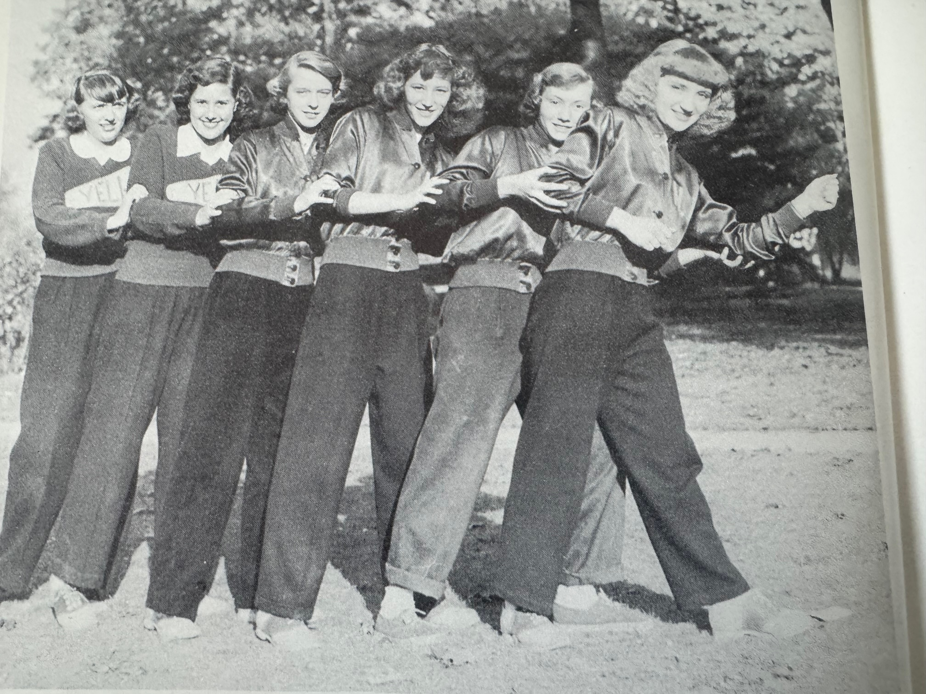

How well I remember these great cheerleaders from 1950:
L-R; Pearl Webster, Janice Eckwell, Margaret Deymond, Bev Baars, Mary Hughes & Barb Tarr.
And their favorite Cheer:

Gazella – Gazella – Gazella Gazay
Get out – Get out – get out of our way
Beebo – Byebow – Sis-coom-pah
North Muskegon High School Rah Rah Rah!

To clarify how much of an advantage over the years it was for Scottville to play on their bazaar home court, one needed to look no further than the 1949-50 season. After losing earlier in the season at Scottville’s bazaar gym in early January, NM won by a whopping 25 on their home court vs. the Spartans.
NM built up a modest four-game winning streak after defeating both Scottville and Whitehall. The Norsemen’s 39-31 victory over Whitehall, with Bill Duplissis scoring a season high 19 points, set up the regular season finale with Hart to determine the WMC conference championship. Needing a win to tie Hart for conference honors, once again the Norse fell prey to the Pirates 45-37. NM had a golden opportunity to earn a tie as the Norse held a huge 31-16 lead over the Pirates with only two minutes to go in the third period. However, the Hart ‘jinx’ prevailed as the Pirates won their 15th game in their last 16 meetings with the Norsemen.
Still smarting from their loss to Hart the Norse were no match for Fremont in the opening round of the playoffs in a 20-point loss to the Packers. However, with their top two scorers returning, the following season looked much more promising for the Norsemen.

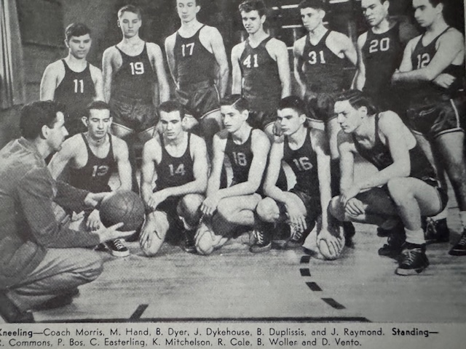

The 1949-50 NORSEMEN
Kneeling: Coach Bob Morris, Monte Hand, Bill Dyer, John Dykhoise, Bill Duplissis, Jerry Raymond
Standing L-R: Ron Commons, Clause Easterling, Kyran Mitchelson, Ray Cole, Bill Woller, Don Vento

N Muskegon 46 Newaygo 50 John Dykhouse 14, Bill Dyer 12
N Muskegon 24 Montague 23 Dykhouse 14, Duplissis 5
N Muskegon 35 Fremont 51 Dykhouse 13
N Muskegon 31 Scottville 33 Duplissis 10
N Muskegon 46 Whitehall 32 Duplissis 16, Monty Hand 10
N Muskegon 35 Hart 49 Dykhouse 14, Duplissis 12
N Muskegon 35 Montague 37 Dykhouse 10, Duplissis & Dyer 8
N Muskegon 33 Shelby (ot) 30 Dyer 14, Dupllissis & Dykhouse 6
N Muskegon 41 Musk St Mary’s 24 Duplissis 16, Dykhouse 11
N Muskegon 48 Scottville 23 Dykhouse 16, Duplissis 14, Hand 12
N Muskegon 39 Whitehall 31 Duplissis 19, Dykhouse 9
N Muskegon 37 Hart 45 Duplissis 19, Dykhouse 8
N Muskegon*36 Fremont 56 Duplissis 17

1950-51 Coach Bob Morris (10-5 NM co-champs in WMC with Shelby)

One of your author’s most fondly remembered teams would be the Norsemen of 1950-51. I believe I only missed watching one game played by the Norse this season that featured one of my early idols in sports, Bill Duplissis. “Duppy’ was a three-sport star and a class gentleman who always treated this youngster with the upmost respect. When I was a freshman at NMHS I was thrilled to wear his number #24 jersey even though it was perhaps two or three sizes too big for this tiny youngster. I was proud when I sadly gave one of the eulogies at his funeral when my idol and long-time friend passed away in March of 2009.
Just five years after our country left World War II, the USA was involved in yet another conflict as the Korean War had begun which impacted many of our young athletes. The captain of Army’s undefeated 1949 football team, Lt. John Trent was killed in action in Korea.
NM returned their two leading scorers from the 1949-50 season, and they quickly made their presence known in the opening game when they defeated the defending Newaygo County league champions from Newaygo 42-36 in overtime. Duplissis and John Dykhouse accounted for 32 of NM’s 42 points.
NM made it two straight wins to start the season as Paul Bos, a frequent starter from the previous season, was in doubles figures with 11 points as NM defeated Montague at the Whitehall Tannery 50-38. Dykhouse added a game high 16 points as the Wildcats made stopping Duplissis their number one priority. “Dupe’ had a modest six points but his teammates more than picked up the slack.
It was in early December of 1950 when a couple of additions at the school were now open at NMHS. The elementary school for those from kindergarten to fourth grade was opened as well as an addition to the current high school that included a couple of classrooms as well as a new facility for shop classes.
A brief December schedule saw a scheduled game with Shelby snowed out until a later date and Fremont edged NM 42-37 before games resumed in early January of 1951.
NM throttled Scottville 59-24 with Duplissis scoring 21 points, a single point away from the school record.
The Norsemen and Shelby made up a game earlier postponed due to a snowstorm on January 9 and it was a game that always was sadly remembered by Bill Duplissis. “Dupe’ did not play in the NM-Shelby clash with the Tigers as he was suspended one game for ‘sidestepping’ a class, something that gnawed Duplissis for many years. With their leading scorer not in uniform Shelby nipped the Norse by two points, a loss that would prove costly to NM as they would have to share the WMC championship. It appeared even with their best player not in the lineup that the Norse would win out as they held a 44-38 lead with but three minutes to play only to see Shelby score the games last eight points. One of the Shelby players on the floor would not only lay claim as the best football player in WMC history, but as a freshman Dave Whitsell would later deprive the Norsemen of an outright conference championship. In a improbable victory over Scottville, Whitsell won the game by hitting a shot from mid-court at the buzzer.
NM then survived a scare by winless Whitehall 39-33 to keep their title hopes alive.
For only the 2nd time in 18 meetings were the Norse able to beat their arch nemesis from Hart 35-32 before a sold-out crowd at the Norse gym. Bill Duplissis scored eight of his game high 20 points in the final quarter to lead NM to the all-important victory.
Following perhaps their worse showing of the season in losing to Coopersville on their unusual tile floor gymnasium, NM bounced back three days later to turn back Montague for the second time on the season. Bill Duplissis fired in a new school record of 23, points; last set in 1946 by his neighbor Bob Pyle, who lived right across the street from Duplissis.
The NM sharpshooter improved on his record by a point as he tallied 24 points in a 51-43 win at Shelby. Duplissis sat out the loss to Shelby earlier in the season and it probably cost NM the outright championship in that loss to the Tigers.
NM, who was beaten by Muskegon St. Mary’s in football, turned the tables on the Irish with a 47-39 victory on the hardwoods. Paul Bos had a career high 19 for the Norse while St. Mary’s was led by a pair of long-time friends of your author, Mike Kanitz with 13 and Jim Morse with 12. After trouncing Scottville earlier in the season by 35 points, NM struggled to come away with a victory on Scottville’s cracker box gymnasium but escaped with a 41-34 win. It is hard to pinpoint how much of a homecourt advantage Scottville had over the years, but by looking at home and away scores over the many years, it was huge.
NM then clinched at least a tie with Shelby in the WMC with a 57-20 win over Whitehall. NM received outstanding balance in the win as Duplissis netted 17, Paul Bos 11, John Dykhouse 10 and defensive guard specialist Don Vento added 9. Ten NM players scored at least a point in the victory.
Leading throughout much of the game, with at one time a 10-point lead over their longtime nemesis from Hart, NM had to settle for the co-championship of the WMC with Shelby as NM lost to Hart in another ‘heartbreaker’ 53-50. John Dykhouse was outstanding for the Norse with a school record 25 points, eclipsing the record held by his teammate Bill Duplissis less than a month earlier. NM led 41-34 heading into the final quarter before Hart rallied to throw a dagger once again into the Norse’s hopes for an outright title. The Hart gym has proven a jinx to Norse teams over the past 12 years, as only once back in 1940 have the Norse been able to win a decision at Hart.
The 1950-51 season ended in the last ever meeting between North Muskegon and Grand Haven in basketball. Bill Duplissis ended his stellar career in fine fashion as he scored 19 points in the first-round playoff game held at the Holland Armory.

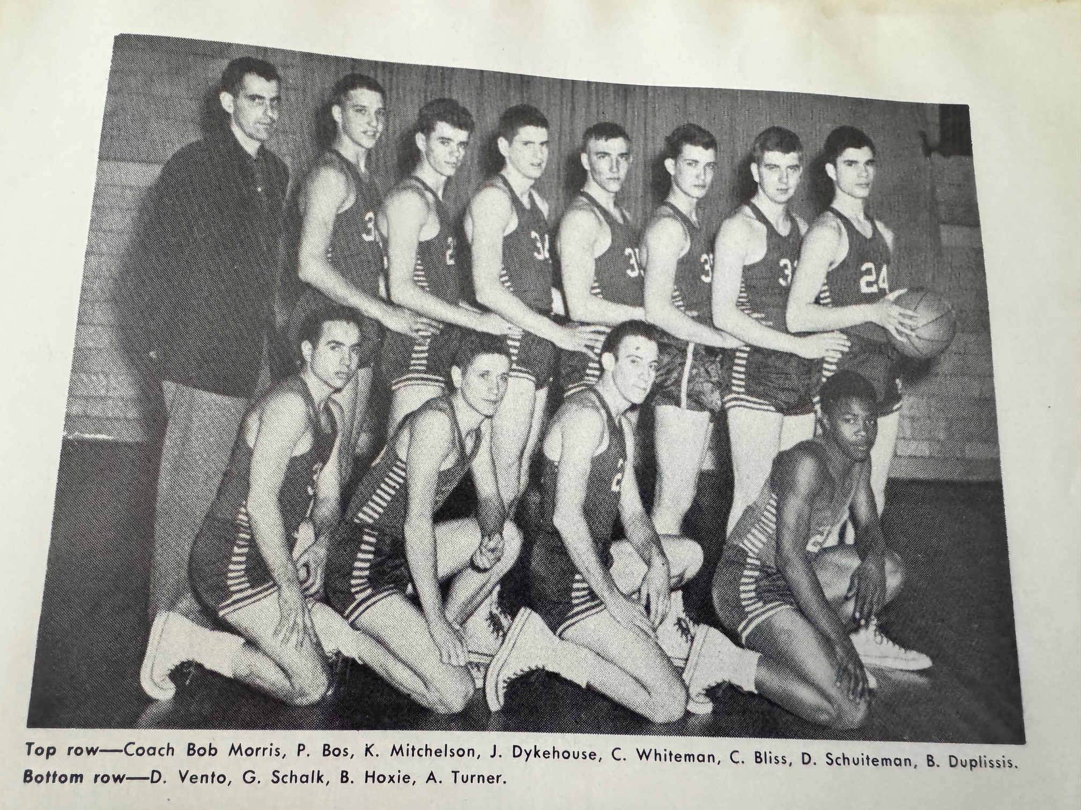

Top Row L-R: Coach Morris, Paul Bos, Kyran Mitchelson, John Dykhouse, Charley Whiteman, Chris Bliss, Don Schuitemn, Bill Duplissis
Bottom Row L-R: Don Vento, George Schalk, Bernie Hoxie, Art Turner

The NORSEMEN WMC Co-CHAMPS of 1950-51

N Muskegon 42 Newaygo (ot) 37 Bill Duplissis 19, John Dykhouse 13
N Muskegon 50 Montague 38 Dykhouse 16, Paul Bos 11,
N Muskegon 37 Fremont 42 Duplissis 15, Dykhouse 11, Bos 6
N Muskegon 59 Scottville 24 Duplissis 21, Dykhouse 11, Mitchelson 8
N Muskegon 44 Shelby 46 Dykhouse 17, Kyran Mitchelson 8
N Muskegon 39 Whitehall 33 Bos 12, Duplissis 11, Mitchelson 10
N Muskegon 35 Hart 32 Duplissis 20, Dykhouse 10
N Muskegon 22 Coopersville 37 Duplissis 7, Charley Whiteman & Bos 4
N Muskegon 56 Montague 49 Duplissis record 23, Dykouse 10, Bos 9
N Muskegon 51 Shelby 43 Duplissis 24 to improve on his record.
N Muskegon 47 Musk St Mary’s 39 Bos 19, Duplissis 12, Dykhouse 10
N Muskegon 41 Scottville 34 Dykhouse 14, Duplissis 13, Don Vento 6
N Muskegon 57 Whitehall 20 Duplissis, 17, Bos 11, Dykhouse 10
N Muskegon 50 Hart 53 Dykhouse NM record 25 points in loss
N Muskegon*45 Grand Haven 51 Duplissis 19, Dykhouse 10, Bos 9

1951-52 Coach Bob Morris (10-5 2nd in WMC – Hart Champs)

North Muskegon returned but one letterman from their 1950-51 season in John Dykhouse, a four-year starter for coach Bob Morris. No other returnee managed to even earn a major letter from the previous season as expectations were low for the current season. However, the Norsemen did have a successful campaign that equaled the previous season’s success in wins & losses. Sophomore Tom Arntz developed rapidly into a very good player for NM and the Norse got a boost in size from 6’5 senior Dan Olsen.
NM was a decided underdog for game number one on the season when they traveled to an always tough to play Newaygo gym to tangle with the defending NCAA champions. The veteran Dykhouse led NM to a triumph by pouring in more than half of his team points in a 34-27 win.
In their first WMC contest NM had little trouble with Montague as NM prevailed behind Dykhouse’s 17 points in a 42-29 victory on their home court.
Playing perhaps their poorest game of the season NM fell at Shelby 34-29.
It appeared NM had secured a rare victory over Fremont at the Packer gymnasium when Gordon Munn, who scored his only point in the game on a free throw with just seconds to go appeared to clinch a NM win. However, NM fouled on the inbounds pass and Fremont converted to send the game into overtime whereby Fremont won its seventh straight win in the series.
A raging blizzard forced the cancellation of the Scottville at NM game in mid-December. The game was later made up on the last day of February.
The cancelled game caused a layoff of nearly a month before NM resumed action on January 11, 1951, against Whitehall. John Dykhouse improved on his own NM scoring record with 26 points as NM nearly doubled the score on Whitehall 61-31.
Hart’s mastery over the Norsemen continued as Hart again won on their home court 51-44 over NM to virtually doom any hopes for NM to win the WMC title.
In the final game played between NM and Muskegon St. Mary’s NM defeated the Irish 53-50 on the Northside court as Dykhouse and Arntz combined to score 40 of NM’s 53 points. Art Turner only scored two points in the entire game, but it came at the right time for NM as his basket with the scored knotted up at 50-50 proved to be the game winner. The two teams did not meet again in 1952-53 and it was probably a good thing for NM as St. Mary’s would have an outstanding team that was rated number one in Class C much of the season before falling in the Class C Championship game.
NM hung on despite a rash of foul troubles to nip Montague 35-33 in a game annually contested at the Whitehall Tannery gym. What a difference a few weeks make! After scoring but 29 points in an earlier loss at Shelby, the Norse exploded for a school record 74 points in a 30-point win at the friendly Northside gym against the Tigers. Dykhouse netted a game high 22 markers while 6’5 center Dan Olsen added 15 before fouling out early in the fourth period.
NM kept their flickering hopes of earning a share of the WMC title alive when they handed Scottville a 46-31 loss at the Northside gym.
NM then clinched second place in the WMC with a 51-34 victory over a Whitehall team that was still seeking their first victory of the season.
It was yet another agonizing defeat handed to the Norsemen in their second game of the season with the Hart Pirates. NM looked like they had finally found the formula against their jinx with the Pirates as they held a commanding 18-5 lead after the first quarter. However, the Norsemen quickly developed foul trouble as Dan Olsen, Art Turner and high scoring John Dykhouse ended the half in foul trouble, each with four fouls. Sophomore Tom Arntz scored 24 points in the losing cause while 6’5 junior center Dan Olsen netted 15. Hart would end the regular season with a perfect 15-0 record.
The Norsemen then posted an easy 54-40 win over Coopersville. Three Norse were in double figures for NM; Art Turner with 12, Arntz and Dykhouse with 11. Making his varsity debut after being called up to the varsity was freshman Dave Bliss, who made his first appearance as a varsity performer a success with five points.
Three seniors, John Dykhouse, Art Turner, and Don Schuiteman led the Norsemen to a rare 56-44 away victory at Scottville to close out a very successful 1951-52 regular season. Dykhouse and Turner shared scoring honors with 13 points while Schuiteman was a stalwart on defense.
A tall task was at hand when NM entered the Class B district in Holland against the hometown Holland Christian team that was coming off a win over an undefeated St. Joseph team. It was a game effort by NM, but they fell short 45-35 to the Maroons. John Dykhouse capped his fine 4-year career with a team leading 17 points while Tom Arntz added 13 as the duo scored all but five of NM’s total points.

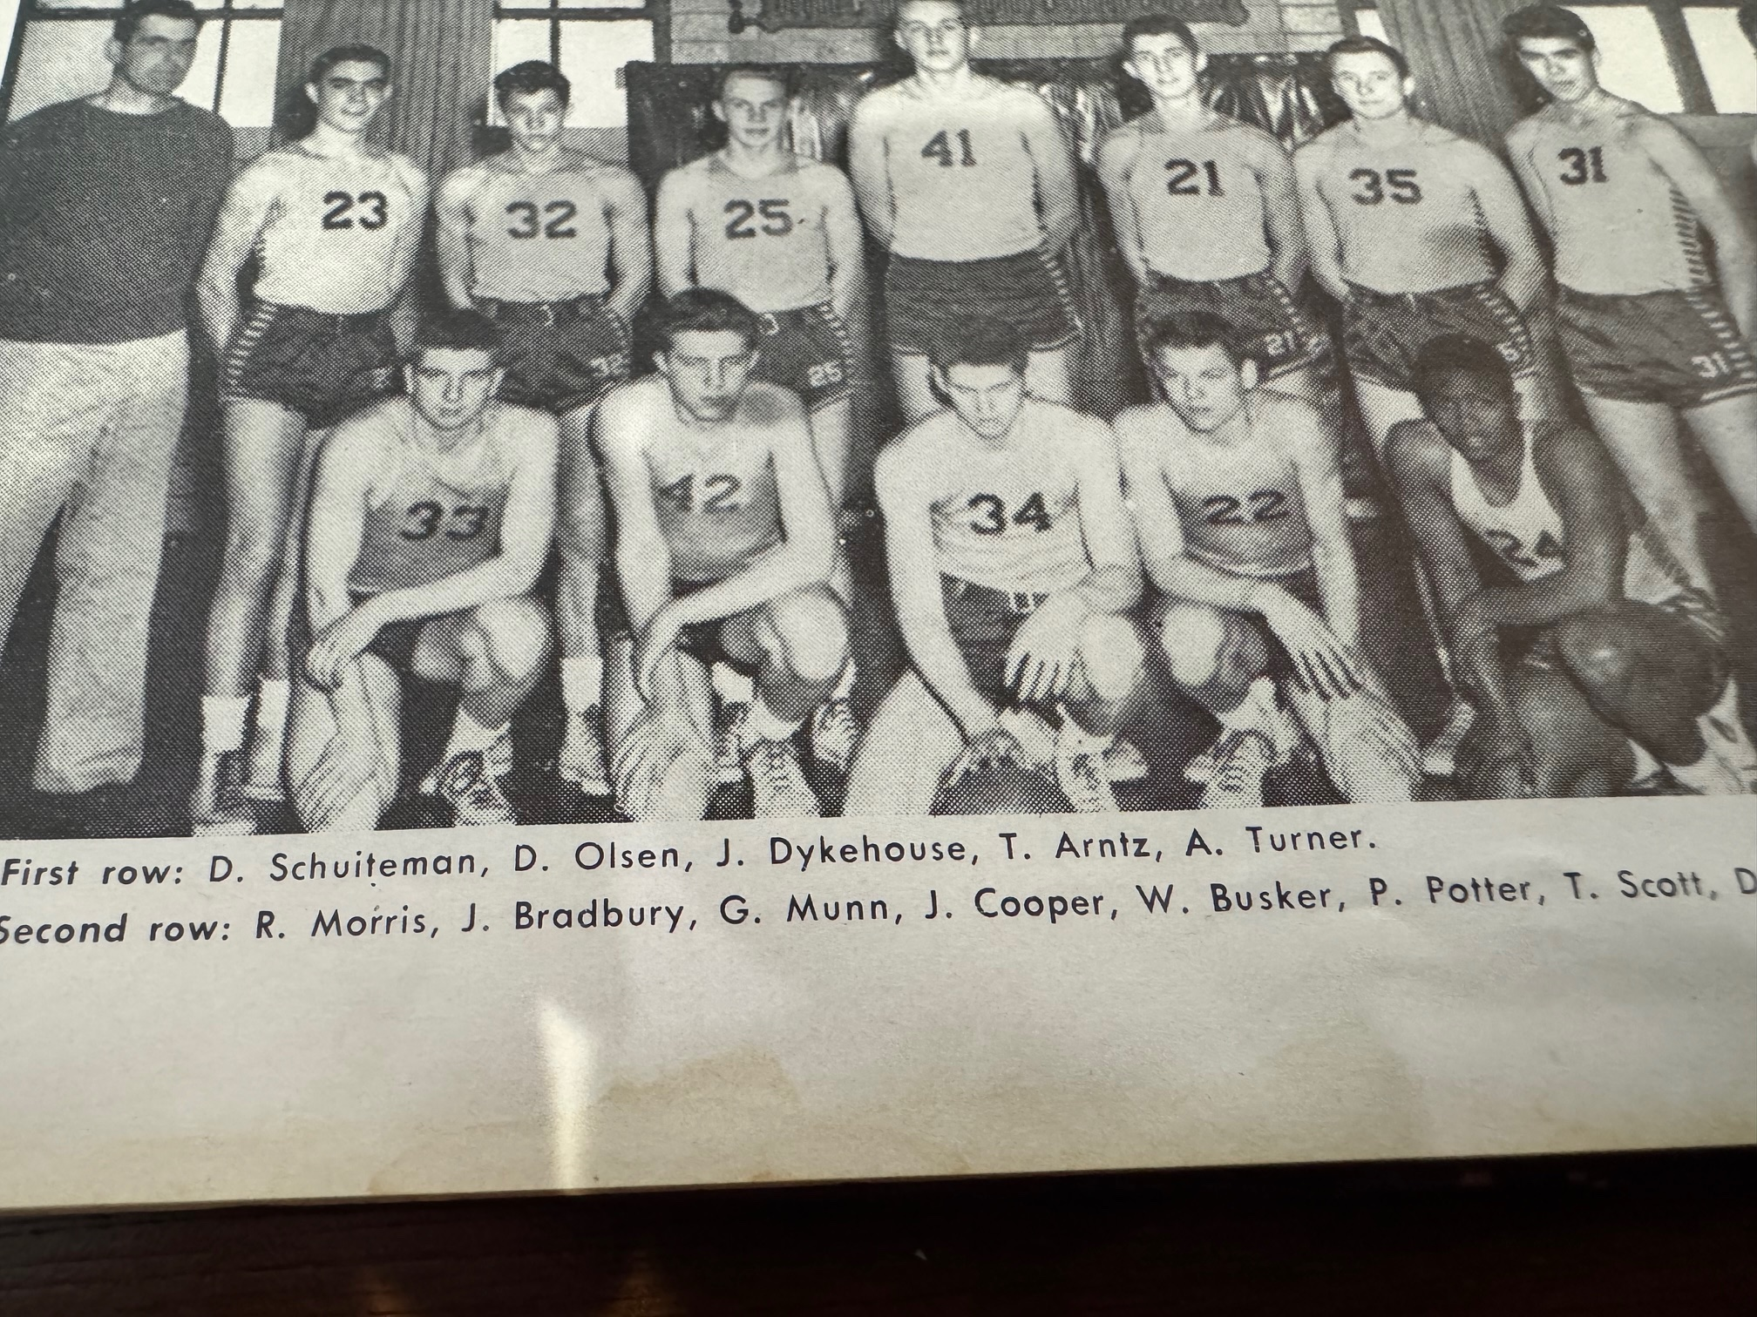

The 1951-52 NORSEMEN
Kneeling L-R: Don Schuiteman, Dan Olsen, John Dykhouse, Tom Arntz, Art Turner
Standing: Coach Bob Morris, John Bradbury, Gordy Munn, Jack Cooper, Walt Busker, Phil Potter, Tom Scott, Dave Bliss

N Muskegon 34 Newaygo 27 John Dykhouse 20, Tom Arntz 7
N Muskegon 42 Montague 29 Dykhouse 17, George Schalk 8, Arntz 7
N Muskegon 29 Shelby 34 Arntz 12, Dykhouse 10
N Muskegon 38 Fremont (to) 39 Arntz 15, Art Turner 9, Dykhouse 8
N Muskegon 61 Whitehall 31 Dykhouse record 26, Arntz 15
N Muskegon 44 Hart 51 Arntz 17, Don Schuiteman 10
N Muskegon 53 Musk St Mary’s 50 Dykhouse 22, Arntz 18, Olsen 9
N Muskegon 35 Montague 33 Arntz, Dykhouse, Olsen all 8 points.
N Muskegon 74 Shelby 44 Dykhouse 22 NM record, Arntz 10
N Muskegon 46 Scottville 31 Dykhouse 18, Arntz 11, Turner 9
N Muskegon 51 Whitehall 34 Dykhouse 16
N Muskegon 54 Hart 56 Arntz 24, Olsen 15
N Muskegon 54 Coopersville 40 Turner 12, Dykhouse & Arntz 11, Bliss 5
N Muskegon 56 Scottville 44 Dykhouse & Turner 13, Arntz 12
N Muskegon*35 Holland Christ. 45 Dykhouse 17, Arntz 13
No 31 is Dave Bliss

1952-53 Coach Bob Morris (7-8 Hart WMC Champs)

Two starters returned from last season’s 10-5 ball club as underclassmen would dominate the roster for the 1952-53 campaign. 6’4 Dan Olsen would be the lone senior in the starting lineup while 6’2 four-sport star Tom Arntz would begin his second year as a starter. As the season progressed coach Bob Morris would see three sophomores move into the starting lineup: 6’2 Gordy Odell, 6’2 Dave Bliss and 6’0 Avery Allen. The trio of sophs were no strangers to one another as they all lived in the same neighborhood, just a block from North Muskegon High School. Tom Arntz and the Norsemen got off to a roaring start, Arntz especially.
The leading letterwinner (13) in NM history, Arntz wasted little time in establishing a new one-game scoring record as he pumped in 28 points to erase the record set the previous season of 26 by John Dykhouse as NM bested Montague 56-50.
In a game in which more than 100 free throws were taken in a foul prone contest on the Coopersville tile floor, NM saw a fourth quarter lead vanish as the Broncos nipped the Norse 56-50. Jack Cooper, who lived but three blocks from NMHS, and Arntz led Norse scorers with 11 points. Odell had eight points, all from the free throw line as the Norse committed 28 fouls in the loss with both Dan Olsen and Dave Bliss fouling out while Cooper and Arntz nearly went out on fouls with four each.
Tom Arntz and Gordy Odell combined for 38 of NM’s 60 points as they defeated Shelby 60-52 to win their second straight WMC contest. Future NFL all-pro performer Dave Whitsell, although standing but six-feet tall and playing center for Shelby, scored 11 points for the losing Tigers.
NM traveled to Holland to take on an even taller Holland Christian five and were overwhelmed 57-30, perhaps a major reason why this was the only scheduled game between the two teams in regular season history.
On the same night when Rio Grande College cage star Bevo Francis scored a still-standing college record of 116 points, NM defeated Scottville 48-40 to go a perfect 3-0 in the WMC title chase.
The Norse held off a Fremont rally to escape with a 47-45 win over the Packers. A last second made basket by Fremont that would have sent the game into overtime was a split-second too late as the Norsemen prevailed.
NM then set up an upcoming clash with Hart for the league lead in the WMC following a 55-44 win over Whitehall that wasn’t nearly as close as the final score. NM held a commanding 50-30 lead over the Vikings before NM coach Morris emptied his bench. Tom Arntz and Dan Olsen each tallied 15 points as the Norsemen got a big lift from their steady sophomore playmaker Avery Allen. It was Allen who keyed a big third quarter run as he scored eight of his nine points to help NM to an insurmountable lead heading into the fourth quarter.
To say that Hart was a jinx foe for NM during the early years of NM basketball would be an understatement. In the first of three ‘heartbreaking’ losses to Hart during the season, the Norsemen held a 66-64 lead late in the game only to see Hart center Gary Tubbs tie the game with seconds left, was fouled, converted the free throw to give Hart a one-point victory and the outright lead in the WMC. Coach Morris played six players during the game, and they all played well. NM was hurt considerably late in the game when both Tom Arntz and Dan Olsen fouled out of the contest. Arntz left with a game high 18 points while Odell, who missed all the practices leading up to the game with the flu, tallied 15 and Jack Cooper was also in double figures with 10.
Still smarting from their crushing defeat the previous Friday by Hart, Montague helped destroy all hopes for a WMC title by thumping NM 60-37 on the Norsemen’s home court. The Norse were hampered with Dan Olsen sidelined for the game as 6’6 Montague center Jerry Brown and 6’5 Ron Erdman controlled the boards in Olsen’s absence.
NM doldrums continued as the Norse fell to Shelby 69-55 as future longtime schoolteacher and clock operator for football at Mona Shores, Jack Cooper scored 30 points.
NM finally broke out of their slump, and against a good opponent with a 37-28 win over Fremont. Either NM played great defense or Fremont shot poorly (probably both) as NM’s 37 points was good enough to defeat the Packers for the second time on the season.
On the same day that Hart clinched another WMC title, their second straight and fifth in the last six years, the Norse went down to a narrow defeat at Scottville 51-49. Leading the host Spartans to victory on their tight floor was Gale Noel with 20 points, a future partner of your author and NM star athlete Tom Stribley in later years in harness racing.
Another sellout crowd packed the quaint NM gym and NM didn’t let their followers down with a 53-44 triumph over Whitehall as Tom Arntz led the way with 21 points.
Hart made it a perfect 10 for 10 in WMC play as they kept up their home court dominance over the Norse. In a game where an astonishing total of 62 fouls were called, Hart edged the Norse 68 to 63. Starters Dan Olsen. Avery Allen and Dave Bliss fouled out of the contest. The Norse even saw reserve Walt Busker leave the Hart floor with five fouls.
As luck (or bad luck) would have it. NM would have to return in less than a week to the dreaded Hart court to again try to depose of the Pirates in the opening round of the MHSAA playoffs. Again, close but no cigar for NM as they were downed by the Pirates by a scant 3 points. After NM tied the game at 69-69 with just seconds remaining, NM fouled Hart’s Buzz Stevens who canned both free throws to give Hart the win. A late free throw by Hart made the final score 72-69.

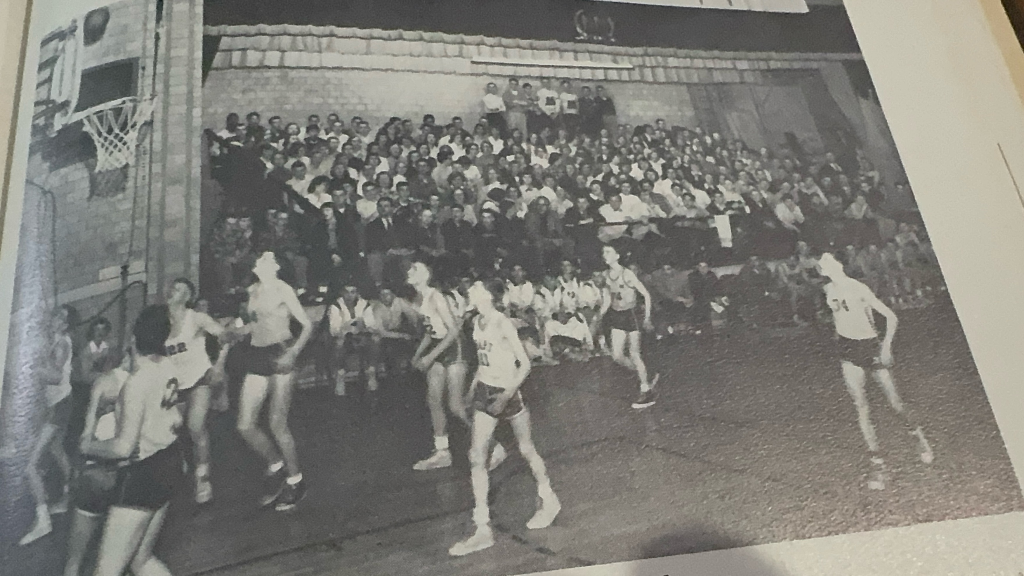
A look at the stage from a JV game between NM & Hart in 1954. You can bet the
‘ole’announcer was at this game.
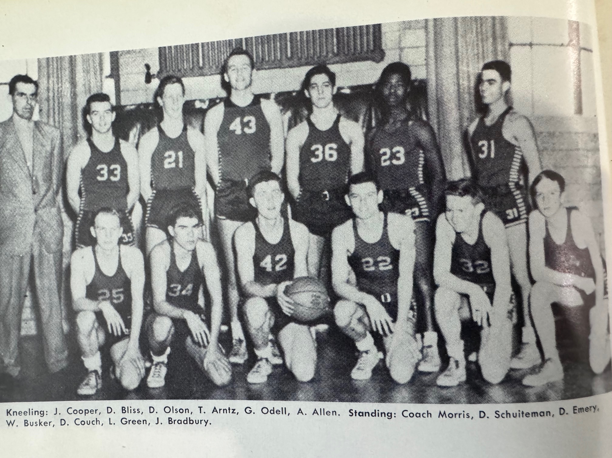

The 1952-53 NORSEMEN

Kneeling L-R: Jack Cooper, Dave Bliss, Tom Arntz, Gordy Odell, Avery Allen
Standing L-R: Coach Morris, Dick Schuiteman, Red Emory, Walt Busker, Dave Couch, Leonard Greem, John Bradbury

N Muskegon 56 Montague 48 Tom Arntz school record 28, O’Dell 12
N Muskegon 50 Coopersville 56 Jack Cooper 11, Arntz 11, NM 25 fouls
N Muskegon 60 Shelby 52 Arntz 20, Gordy Odell 18, Dan Olsen 12
N Muskegon 30 Holland Christ. 57 Arntz 12
N Muskegon 48 Scottville 40 Odell 15, Olsen 13, Arntz 12
N Muskegon 47 Fremont 45 Arntz 19, Odell 10, Olsen 8, Avery Allen 4
N Muskegon 55 Whitehall 44 Arntz & Olsen 15, Allen 9 Odell 7, Bliss 5
N Muskegon 66 Hart 67 Arntz 18, Cooper & Odell 15, Cooper 10
N Muskegon 37 Montague 60 Arntz 15 Cooper & Odell 8
N Muskegon 55 Shelby 69 Arntz 18, Olsen 14, Odell 8, Allen 4
N Muskegon 37 Fremont 28 Olsen 15, Cooper 14
N Muskegon 49 Scottville 51 Arntz 15, Odell & Olsen 11
N Muskegon 53 Whitehall 44 Arntz 21, Dave Bliss 13
N Muskegon 63 Hart 68 Arntz 18, Odell 16
N Muskegon* 69 Hart 72 Arntz 21, Odell 14, Cooper 8

1953-54 Coach Bob Morris (10-6 2nd WMC Hart WMC Champs)

With their two leading scorers returning for the 1953-54 season hopes were at a fever pitch from Norse followers when the new season began. In addition, three-sport star Dave Bliss would return for his junior year. However, coach Morris and NM fans were dealt a crushing blow with the news that one of their three sophomore regulars from 1952-53 would not be returning to the NM school. Instead, playmaker Avery Allen brought tears to his team and legion of fans who watched Allen run the Norse offense with his brilliant playmaking and ball-handling skills with news that Allen would be entering a prep school. Allen would leave NM and his saddened NM teammates to improve his academic standings in hopes that someday down the road he could find a prestigious job, not on the pristine shores of Lake Michigan, but in ‘beautiful’ Dayton, Ohio.
NM faced an ominous task in their season opener as they would face the Montague Wildcats and their huge 6’8 center Jerry Brown. Brown would score ten points in the first half before coach Morris doubled Brown in the second half with 6’4 Walt Busker and 6’3 Tom Arntz holding Brown scoreless in the final two periods. NM had a commanding 41-24 late in the game but held off a torrid Wildcat rally to earn the win. Arntz was held to nine points, but junior Gordy Odell took up the slack with 16 points.
For the second straight game NM had another big man to contain. NM was able to hold 6’7 Frank Scott to ten points, but Scott knocked in a pivotal basket with seconds remaining to stretch the Coopersville advantage to 51-48, the game’s final score. Arntz and Odell were again the big offensive guns for NM with 21 and 17 points.
A gym that has often posed problems for NM in the past posed no problems for Tom Arntz and his teammates as they won their second straight WMC contest 64-44 over the Shelby Tigers.
It was the first game ever contested between NM and the first year consolidated Muskegon Catholic School, but it might have been the best. With a sellout crowd packed into the cozy NM gym, the Norse won 62-61 with the winning point coming on a Walt Busker free throw.
In what might be the most bizarre of games scheduled by North Muskegon over the years, NM faced another opponent for the first time, West Michigan Christian. The game initially wasn’t even on either teams’ schedule. The game took place on a Wednesday afternoon at 2:30 PM at the NM gym with only the North Muskegon Student Body present. West Michigan Christian won the game 54-42 even though they didn’t have any fans in attendance.
Two days later the Norse made the long journey to Scottville and came away with a hard-fought win. Gordy Odell scored a career high 23, more than half of his team’s total.
The Norse ran into a buzzsaw as Fremont then overwhelmed the Norsemen 67-47 despite 20 points scored by NM’s Odell. Arntz added 16 but the other Norsemen were only able to tally but 11 points, seven of those scored by Walt Busker.
During the following week’s practices NM’s Tom Arntz slipped in the locker room and incurred a deep gash that required several stiches, resulting in Arntz watching from the NM stands in their Friday night game with Whitehall. Taking Arntz’s place was seldom used Leonard Green, better known for his ability on the football and baseball fields. Green scored 20 points, one of three Norse players to score more than 20 points as NM racked up a school record 81 points in the rout of Whitehall. 6’4 Walter Busker scored a season high 24 while steady Gordy Odell netted 23.
It was time for NM to again make their dreaded trip to Hart, where it had not been since the early 1940s when NM earned a victory on the Pirates home court, many of those losses coming from the slimmest of margins. It looked like the Norsemen would finally end their jinx with the Pirates as they once held a 15 point. But when big Walk Busker fouled out of the contest, Hart center Gary Tubbs went ballistic and led a furious Hart comeback to again send NM down to another ‘heartbreaking’ defeat. Tubbs scored a WMC record 37 points to lead the Pirates to their comeback win and set NM back with a 4-1 record in WMC action. Playing on a bad foot, Tom Arntz scored 20 points in the losing cause. Busker had 17, Green 11 while Odell was held under ten points for the first time all season with nine.
The Norse suffered a double whammy in WMC action as they were upset by Montague in a game held as usual in the Whitehall Tannery, 48-46. The Wildcats scored the winning two-pointer with but five seconds remaining to virtually eliminate the Norse from winning conference honors. Walt Busker, who has improved his offensive game immeasurably of late, led Norse scorers with 17 points followed by Odell with 13. Tom Arntz, still suffering from his injured foot had a season low five markers.
NM kept their faint hopes for a WMC title alive as the big three of Arntz, Odell and Busker combined for 68 of NM’s 77 points in a win over Shelby.
NM paid back Fremont, the co-leaders of the Ken-New-Wa conference from an earlier setback at Fremont by defeating the Packers 62-57 as Gordy Odell tied the school scoring record of 28 points held by his teammate Tom Arntz from the previous season. Arntz also had a great game for the winners with 19 tallies. It was also a good night for the Norse JVs as they handed the Packers their first loss in 26 games.
NM moved into a tie for second in the WMC with their second victory of the season over a good Scottville five 51-37.
NM outlasted Whitehall 51-47 to set up what promised to be yet another dandy of a game with Hart. And a dandy it was --- for the Norsemen! Before the usual sellout crowd at the NM gym the Norse put it all together as they routed the Pirates 84-69. The victory snapped the 29-game winning streak in WMC conference play over the past three years for Hart. Walt Busker became the first NM player in school history to score 30 or more points in a single game while the team total of 84 points was another school record. After seeing the Pirates star center score 37 points in their initial meeting, Busker and his Norse mates held Tubbs to but nine in their second matchup.
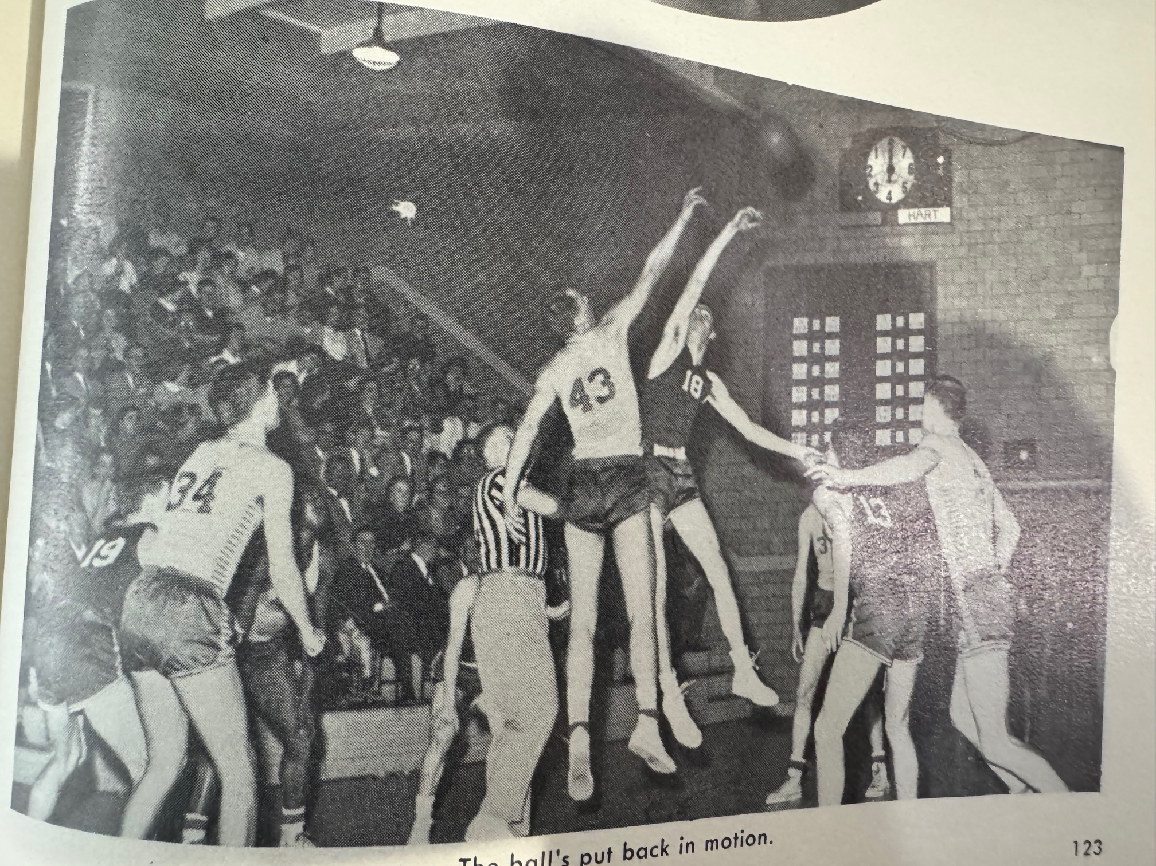

Walt Busker, jumping center to start the fourth quarter vs Hart’s Gary Tubbs, becomes 1st NM player
to score 30 points in a game. From L-R other NM players: Dave Bliss (#34), Leonard Green, Gordy
Odell and Tom Arntz.
Notice the ‘modern clock in the photo used in the 1940’s & 50s.

However, the Norse were faced with another jinx over the past eight years --- winning a playoff game. After scoring a school record 84 points a week earlier against Hart, NM scored just half that total in their opening playoff game with Fremont. NM shooters at one

time made but two shots in 19 attempts in the tournament game played at the new Grand Haven gym. Fremont, winners of the Ken-New-Wa Conference downed the poor shooting Norsemen 48-41.
NM finished the season against top notch competition at 10-6 with several highlights and school records. The game would mark the end of one of NM’s greatest all around athletes and an argument could be made that Tom Arntz was number one. Nobody in the more than 90 years of NM athletics won more letters than Tom Arntz (13). What was impressive was that Arntz was All-Conference in all four sports. Two times All-Conference in football and basketball, a three-time WMC champion in track in the high jump, and although there were no all-WMC teams selected in those years in baseball, the four-year starter at NM during his four years in baseball surely would have made the All-Conference team if one was selected. When his senior season had ended Arntz had scored a NM career best of 662 points, an average of more than 15 points per game. Walt Busker, who came on strong in the second half of the basketball season would leave NM for Dartmouth College, where he would be reunited as a student with NM’s 1952-53-star playmaker Avery Allen.

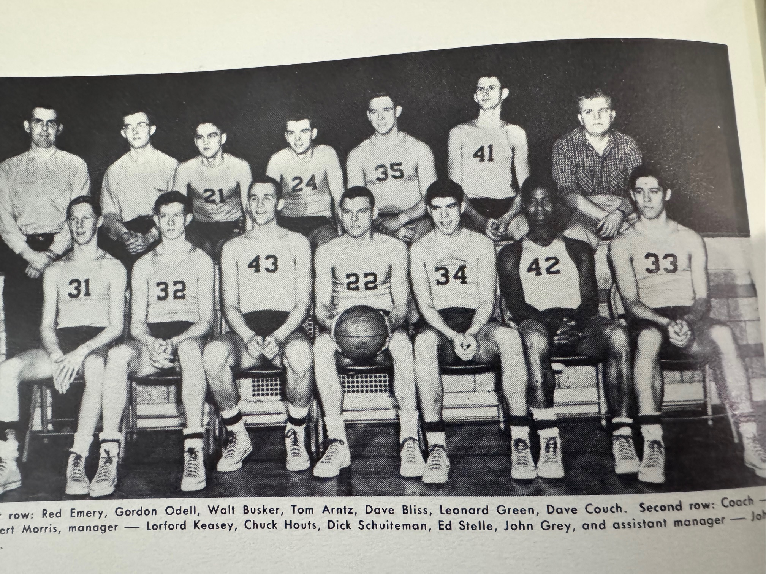

The 1953 -54 NORSEMEN
Front Row L-R: Red Emory, Gordy Odell, Walt Busker, Tom Arntz, Dave Bliss, Leonard Green, Dave Couch
Top Row L-R: Coach Morris, Lorford Keasey, (Mgr.) Chuck Houts, Dick Schuiteman, Ed Stelle, John Grey, John Vail (Mgr.)

N Muskegon 44 Montague 41 Gordy Odell 16, Dave Bliis 11, Tom Arntz 9
N Muskegon 48 Coopersville 51 Arntz 21, Odell 17
N Muskegon 64 Shelby 44 Arntz 25, Odell 13, Walt Busker 11
N Muskegon 62 Musk Catholic 61 Arntz 18, Odell 17, Busker 15, Bliss 9
N Muskegon 42 West Mich Chr. 54 Arntz 12, Odell 10, Busker 9, Bliss 7
N Muskegon 39 Scottville 34 Odell 23, Arntz 8, Busker 5.
N Muskegon 47 Fremont 67 Odell 20, Arntz 16
N Muskegon 81 Whitehall 44 Busker 24, Odell 23, Leonard Green 20
N Muskegon 65 Hart 68 Arntz 20, Busker 17, Green 11, Odell 9
N Muskegon 46 Montague 48 Busker 17, Odell 13, Arntz 5m Green 5
N Muskegon 77 Shelby 61 Odell 25, Busker 24, Arntz 19
N Muskegon 62 Fremont 57 Odell school record 28, Arntz 19
N Muskegon 51 Scottville 37 Busker 18, Arntz 16, Odell 13, Bliss 4
N Muskegon 51 Whitehall 47 Arntz, 17, Odell 16, Busker 14
N Muskegon 84 Hart 69 Busker record 30, Odell 16, Arntz 14
N Muskegon*42 Fremont 48 Busker 14, Odell 10, Arntz 8

1954-55 Coach Bob Morris (9-7, NM ties for 2nd: Scottville WMC champs)

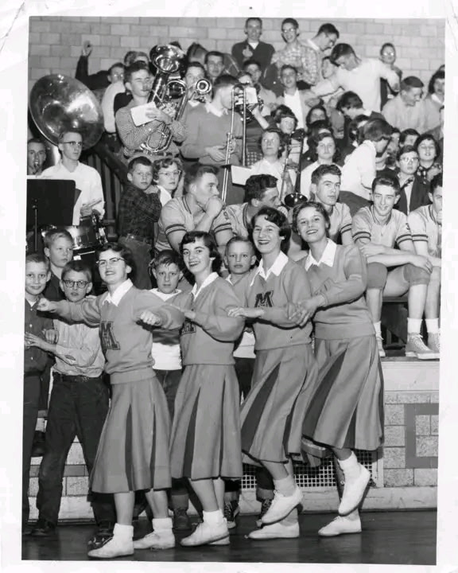
NM Cheerleaders at a NM basketball game in 1955

L-R Kay Moran, Margaret Ginn, Diane Wilkie &
Linea Swartz.

See any one you know in the background? My brother Tom is in this photo.

Two starters returned for the Norsemen to begin the 1954-55 season and one of those starters would go on to become the most prolific scorer in NM history. 6’3 Gordy Odell, who averaged a whopping 17 plus points per game as a junior, would headline the list of returnees and would shatter all scoring records in his senior season. Also returning as a starter was Dave Bliss, a three-sport star who was first string All WMC as an end on NM’s undefeated football team in the Fall. Joining Odell and Bliss in the rotation would be fellow seniors Tom Stribley and Jack Mavis while 6’4 junior Ken Bolema would be the lone underclassmen as a starter. All five starters were well acquainted with one another as they all lived just a little more than a stone’s throw from the high school.
NM, who already had a rough schedule made it even tougher as they would begin the season with their first ever meeting with the Ludington Orioles. Playing on the large Oriole gymnasium the smaller but quicker Orioles raced by the Norsemen to earn a 63-50 victory. Odell, who spent tireless hours honing up his game on an outdoor basketball court where the current tennis courts are now located, gave NM fans a quick preview of his basketball acumen when he poured in 29 points in a losing cause, just one point shy of the school record.
Odell then scored 30 points, all field goals, as NM suffered their second straight defeat on the young season as the Norse fell at the Whitehall Tannery to Montague 54-52. Odell’s 30 points equaled the school record of 30 by Walk Busker, currently a member of the Dartmouth freshmen football team. Dave Bliss and Ken Bolema each scored eight points but both players fouled out in the contest.
Odell than shattered the school record in their next game as he poured in 39 points as the Norse secured their first win of the season at the expense of Shelby 63-61. Odell tallied 17 field goals; one more than the entire Shelby team scored during the game.
NM received much better balance as they pummeled Muskegon Catholic 66-35 in a game played at Muskegon High’s Central Campus gym. Dave Bliss led the Norse attack with 21 points while Odell was ‘held’ to 19. Igniting the Norsemen attack from his guard position was Jack Mavis who netted 12 points.
Scottville, with one of its best teams in their school’s history made it six straight wins on the 1954-55 season with a 56-48 win over the Norse. Odell, despite double and triple teamed all night still managed to score 22 points in a losing cause.
NM evened their season record at 3-3 with a hectic 60-58 defeat over Fremont. Odell was again sensational as he blistered the nets for 35 points. Fremont nearly tied the game with just four second left but fell two-points shy as the final buzzer sounded to give NM the upset victory over a powerful Packer five.
Odell again surpassed the 30-point mark by canning 16 field goals and a pair of free throws good for 34 points as NM defeated Whitehall in the Vikings new gymnasium.
The duo of Odell and Bliss, who resided within a block from one another in NM, combined for 54 of NM’s 75 points as the Norsemen handed the once dominant Hart Pirates a 75-54 defeat. Odell rifled in 33 points while his neighbor Dave Bliss added 21 as NM moved into 2nd place in the WMC. The once proud Pirates dropped their fourth conference game in five starts.
NM atoned for an earlier loss to Montague with a convincing 66-47 victory in front of the usual sellout crowd at the tiny NM gymnasium. Once again Odell surpassed the 30-point mark with 34 markers while getting some great support from his teammates. Dave Bliss added 14 points while little Jack Mavis was in double figures for the first time in his career with 10.
The Norse won their fifth straight contest with a commanding 77-58 victory at Shelby as the Norse front line of Odell, Bliss and Bolema dominated the action. Odell scored a ‘ho-hum’ 30 points while Bliss added 21 and Bolema 14 on the Tiger home court.
Despite yet another school scoring record (40 points) by the amazing Gordy Odell, NM dropped a high scoring game at Fremont 85-79. The Packers got off to a red-hot start on their home court by blistering the nets for 33 points and the Norse were never able to recover from that scoring onslaught.
NM then had the misfortune of playing their next game against an undefeated Scottville team on their crackerbox gym and dropped the game to the host Spartans 60-52. Scottville would easily field their best team in history until their state finalist team in the next century as they advanced all the way to the quarterfinals in the MHSAA playoffs. Odell with 23 and Bliss with 19 combined for all but 10 of the total points scored by the Norsemen.
NM again hit the road for their fourth straight game yet came away with a tough victory at Coopersville 70-65. NM trailed the Broncos 64-61 with 1:23 left in the game. Dave Bliss nailed a 20-footer and then canned two free throws to give NM the lead. Odell then added a free toss, and Jack Mavis capped the rally with a clinching field goal to preserve the NM win. Odell again passed the 30-point barrier with 34 points, setting up a historical feat three days later.
Odell and the Norsemen would set records that would stand for years as NM scored 104 points in a 104-81 victory over Whitehall. Odell’s 53 points were the most points scored by any Greater Muskegon player in history. The bespectacled Odell misfired on only eight of his 31 shots attempts during his assault on the record. Odell was on fire right out of the gate as he rifled home 16 points in the first period, added nine more before half and used his uncanny eye and skill in posting six baskets and two gift shots in the third frame to set the stage for his final output. Also having a good night were Dave Bliss and Ken Bolema who added 17 and 14 points. Feeding Odell on the night were Norse guards Jack Mavis and Tom Stribley.
Just the thought of North Muskegon coming to Hart must have inspired Hart to play at their absolute best. Still looking for their first win on the Pirates home court since the Pirate gym was erected in 1939, Hart again defeated NM in the final game of the regular season 83-77. Gordy Odell had his poorest game of the season and finished with 14 points, by far his lowest total of the season. Far off form throughout the contest, Odell had a chance to win the game for the Norse with the score tied at 71-71 with 3-seconds to go but the Hart jinx continued as the normally sure shot missed both free throws. Hart then took control of the game in overtime as both Dave Bliss and Ken Bolema had fouled out late in the fourth quarter. Carrying the load for NM was pint-sized Jack Mavis who had a career high 25 points. Mavis was a late bloomer who would get much better in the years after graduation as he became one of the top scorers as a Muskegon City League player and would even become a star, as well as a player coach for Muskegon Business College. Tom Stribley, normally just content to feed his teammates from his guard position also had a season high of 16 points in the upset loss to Hart.

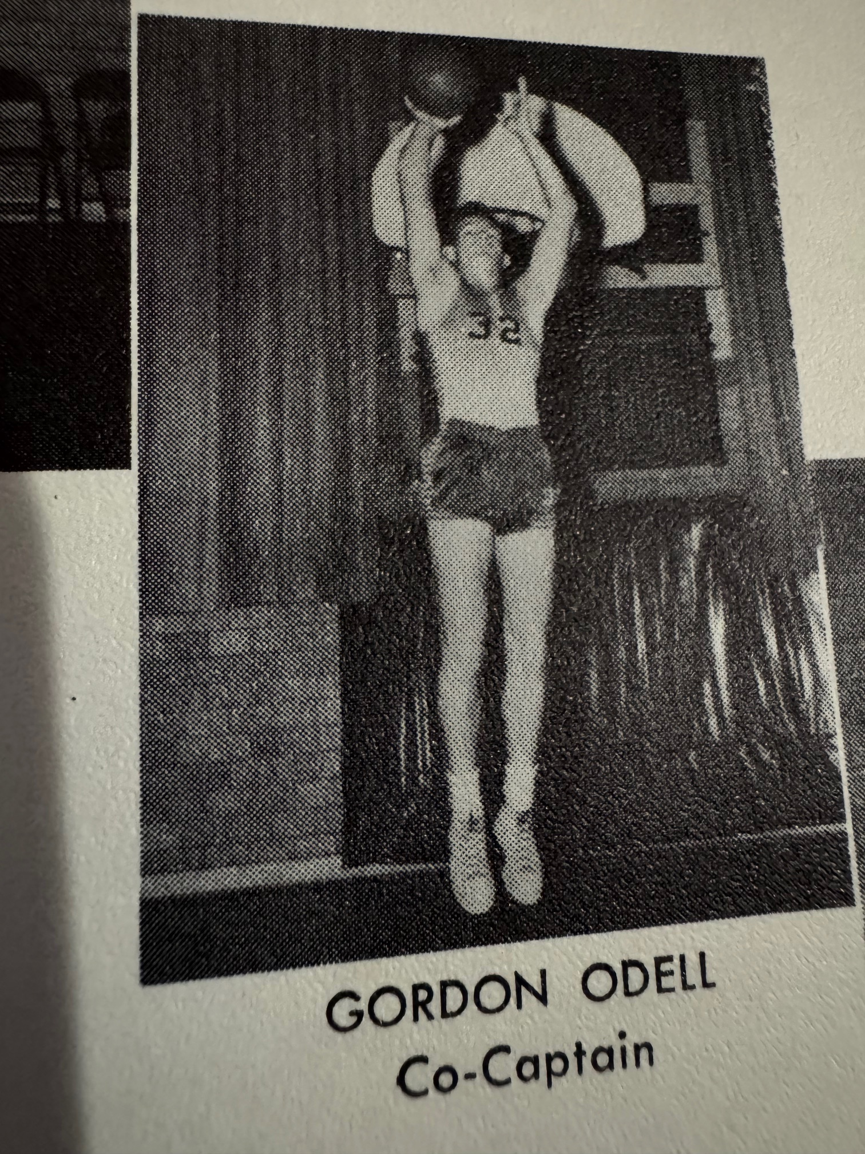
Gordy Odell: First Team Class B All State in
1955. The most prolific scorer in NM history
With a points per game average of more than
30 points per game.
There was one more hex the Norse had to face: winning a playoff game. And again, NM could not post a victory and for the second straight year dropped their playoff opener to rival Fremont 57-51. Concentrating in tying up Gordy Odell worked as for his second straight game Odell was held in check with 13 points. Ken Bolema, the lone underclassmen in the Norse starting lineup had a season best 18 points to lead NM scorers. Bliss ended his career as a 3-years starter with 11 points while also bowing out were guards Jack Mavin and Tom Stribley. Odell would finish his brilliant career with a career total of 898 points in 47 games that averaged out to 19 points per contest. His per game average 30.1 for his senior year when he banged in 898 in 16 games led Odell to being named to the first team Class B All State team. One must remember that during Odell’s career teams were only permitted to play but 15 regular season contests.

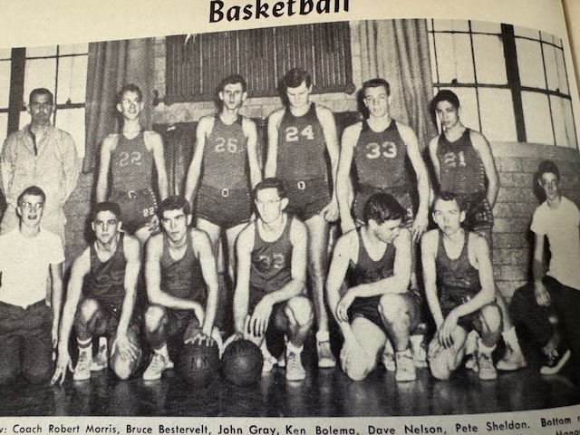

THE 1954-55 NORSEMEN

1st Row L-R: Scot Wagoner (Mgr.), Chuck Hourss, Dave Bliss, Gordy Odell, Tom Stribley, Jack Mavis, Frank Moran (Mgr.) Standing L-R: Coach Bob Morris, Bruce Bestervelt, John Gray, Ken Bolema, Dave Nelson. Pete Sheldon

N Muskegon 50 Ludington 63 Gordy Odell 29, Dave Bliss 12
N Muskegon 52 Montague 54 Odell 30, Bliss & Bolema 8
N Muskegon 63 Shelby 51 Odell record 39, Bliss 9, Ken Bolema 7
N Muskegon 66 Musk Catholic 35 Bliss 21, Odell 19, Jack Mavis 12
N Muskegon 48 Scottville 56 Odell 22, Bolema 12, Bliss 8
N Muskegon 60 Fremont 58 Odell 35, Bliss 12, Bolema 9.
N Muskegon 64 Whitehall 51 Odell 34, Bliss 9, Bolema 8
N Muskegon 75 Hart 54 Odell 33, Bliss 21, Bolema 8, Mavis 6
N Muskegon 66 Montague 47 Odell 34, Bliss 14, Mavis 10, Bolema 8
N Muskegon 77 Shelby 58 Odell 30, Bliss 21, Bolema 14. Mavis 7
N Muskegon 79 Fremont 85 Odell record 40, Bliss & Bolema 14
N Muskegon 52 Scottville 60 Odell 23, Bliss 19
N Muskegon 70 Coopersville 65 Odell 34, Mavis and Bliss 11
N Muskegon 104 Whitehall 81 Odell record 53, Bliss 17, Bolema 14
N Muskegon 77 Hart 83 Mavis 25, Tom Stribley 16, Odell 14
N Muskegon* 51 Fremont 57 Bolema 18, Odell 13, Bliss 11

1955-56 Coach Bob Morris (7-9, Reed City WMC Champs)

Only two lettermen returned for the 1955-56 season and only 6’4 senior Ken Bolema was a starter. Chuck Houts did see considerable action for Coach Bob Morris the previous season and will move into the starting rotation for this season’s squad.
NM again had a tough opener as they entertained an always strong Ludington team. The Orioles, led by future Ludington head coach and AD Wally Sadosty had little trouble with the inexperienced Norsemen as they won going away 65-46 on the Norsemen’s home court. The tiny Norse court, which had been the home for NM basketball since 1933, would be turned into a library following the close of the season as a new gymnasium was in its early stages of being constructed. Ken Bolema matched Sadosty’s 20 points with Dick Maples adding 10 for NM. Bruce Bestervelt earned a start for NM and added eight points with Houts adding six markers.
Dick Maples, who had to sit out last season because of a transfer ruling, became only the third NM player in history to score 30 or more points in leading NM to a narrow 63-62 win over Montague. Maples garnered his 31 points on nine field goals while also making 13 free throws, the most charity tosses ever made in one game by a Norse player. Arlan Cedarquist gave the visiting Wildcats a brief lead at 62-61 but Maples then made two of his 13 free throws with 20 seconds left for the game winner.
The small basketball court at Shelby often led to some nightmarish games over the years. This was again the case in December of 1955 as Shelby downed the Norse 57-47. After scoring 31 points a week earlier Shelby had all eyes on Dick Maples and held the Norse guard to but seven points. Bruce Bestervelt was the only NM player in double figures in the loss with 13 points.
Ken Bolema was the man of the hour for the Norse as the Norse defeated Muskegon Catholic Central for the third straight time 63-61. Bolema, who had a game high 22 points calmly meshed two free throws in the closing moments of the game for the margin of victory. The Norse got a big boost from reserve Jim Olding who scored eight of his ten points in the final period.
NM again failed to do any damage at the site of where Scottville plays their home games as NM lost 64-55 to the Spartans. NM pulled to within three points at 41-38 in the third period before the Spartans pulled away. Ken Bolema was the only Norsemen that solved the odd configuration of the Scottville facility with his game high 21 points.
A parade to the free throw line paved the way for a 66-52 win for Fremont in the first of their annual home and home rivalry over the years. The visiting Packers cashed in 28 free throws to the host Norse eight.
After losing to NM 12 straight games, Whitehall finally snapped their losing ways to the Norse with a close 69-66 win. Claude Caviness made his only basket the entire game late in the contest for the game winner for Whitehall who improved to 3-1 in the WMC while the Norse were just the opposite at 1-3. Ken Bolema fired in 27 points for NM with Dick Maples adding 15 and Chuck Houts 12.
Surely the last place one would expect the Norse to not only break their current three game losing skein but a streak that dates back 17 years would be at Hart High. The Norse did both as the one-two punch of Dick Maples and Ken Bolema combined for 49 of NM’s 69 points in NM’s 69-56 victory. I should have known it was going to be a good night for the Norse. This seldom used JV reservist scored his only point of the entire season when I ‘banked’ in a free throw against the Hart wooden backboard.
The second meeting of the season between Montague and NM was just as close as the first contest but in the second game there was a different winner: Montague. After losing at NM by one early in the season, it was Montague winning by two in their second encounter by an almost identical score 65-63. NM enjoyed an all too brief six-point lead heading into the final quarter before Montague rallied.
It was then time for NM to reverse the tables as they made amends for an earlier loss to Shelby with a 71-57 victory on their home court. Balance scoring paced the NM victory with four Norsemen in double figures. It was WIN number 200 in NM basketball history.
The Norsemen couldn’t use the excuse of playing poorly on the tiny Scottville floor as they were pummeled on their home site by the Spartans 69-41 to fall to 3-5 in the WMC and 4-7 overall.
NM did a complete 360 after suffering the embarrassing loss to Scottville by surprising Coopersville 61-41. Ken Bolema and Dick Maples had their shooting eyes working as Bolema tallied 15 and Maples 15 in NM’s surprising 20-point victory over the visiting Broncos.
Playing their best ball of the season, and after losing to Whitehall earlier on the NM court, NM pummeled the Vikings on their new gymnasium floor 78-51. Ken Bolema had a career high 35 points. Only Gordy Odell had tallied more points than Bolema’s output at Whitehall.
Even when they are having a down year, Hart always seems to play their best against the Norsemen. The glory years for Hart basketball were now in the past as the once dominant Pirates came to the NM gymnasium with only one win for the entire season. They came close to doubling their total at the expense of NM as they lost by only four points 66-62. Dick Maples gunned in 28 points for the victors. The game was the final game played over the years at the old gymnasium, one that brings back lots of fond memories for this old timer.
Fremont, boasting of one of their top teams in school history, made the Norsemen their 15th victim in the final game of the regular season. Just the Friday before the Packers won a thrilling victory over a Zeeland team where one of their star players was future baseball Hall of Fame pitcher Jim Kaat. The Packers would advance to the quarterfinals before losing to the eventual Class B state champs from Stephenson.
If NM was to ever break their playoff drought that goes back to 1947, then it would be a matchup with a Sparta team that won only three games in the entire season. However, the jinx held, and NM lost to the lowly Sparta team 62 to 54 to end their season at 7-9, their first losing season in the decade of the 50s. There surely was one oddity for the West Michigan Conference in the 1955-56 season. Reed City had a perfect 7-0 conference mark yet never played North Muskegon.

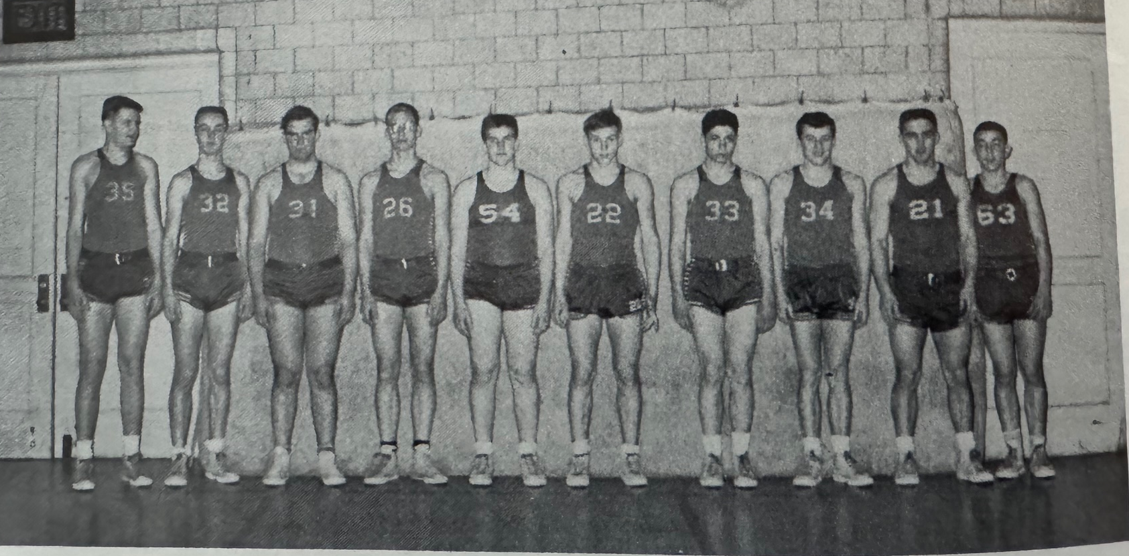

The NORSEMEN of 1955-56

L-R: Ken Bolema, Jim Damm, Sam Cline, Albert Port, Bob Prins, Jim Olding, Pete Sheldon, Dick Maples, Chuck Houts, Jim Sibson

N Muskegon 46 Ludington 65 Ken Bolema 20, Dick Maples 10
N Muskegon 63 Montague 62 Maples 31 points included 13 free throws
N Muskegon 47 Shelby 57 Bruce Bestervelt 13, Jim Damm 8
N Muskegon 63 Musk Catholic 61 Bolema 22, Jim Olding 10
N Muskegon 55 Scottville 64 Bolema 21, Bestervelt 8, Damm 8
N Muskegon 52 Fremont 66 Bolema 17. Damm 12, Maples 9
N Muskegon 66 Whitehall 69 Bolema 27, Maples 15, Chuck Houts 12
N Muskegon 69 Hart 56 Maples 26, Bolema 13
N Muskegon 63 Montague 65 Bolema 22. Houts 15, Damm 12
N Muskegon 71 Shelby 57 Maples 17, NM WIN 200
N Muskegon 41 Scottville 69 Bolema 17, Olding 7
N Muskegon 61 Coopersville 41 Bolema 15, Maples 15 Pete Sheldon 7
N Muskegon 78 Whitehall 51 Bolema 35, Maples & Damm 13
N Muskegon 66 Hart 62 Maples 28, Bolema 16, Damm 11
N Muskegon 55 Fremont 65 Bolema 25, Houts 6, Ron Farmer 5
N Muskegon*54 Sparta 62 Bolema 16 Maples 13, Sheldon 12

