History of North Muskegon Baseball
Compiled by Jim Moyes

NOTE: Conference games marked with *

1935 – coach Lyle McNitt (5-1 overall; no conference)

In its first year as a four-year high school, North Muskegon coach Lyle McNitt fielded the first-ever Norsemen baseball team comprised of 13 eager candidates. The first game ever played by the Norse would be one for the ages. The Norse scored 19 runs vs. Montague – yet lost 23 -19. The combined 42 runs scored between the two teams has only been equaled, but never broken, in school history. The Norse did regroup to win their next five games in an abbreviated six-game schedule. The winning pitcher in at least four of those wins was ace Norse hurler, freshman Walt Bergren. The 13 original Norsemen included Albert Schmidt 2B; Bob Raddatz 1B; Fred Schmid C; Lewis Frost 3B; Charles Buys RF; Clarence Rogers SS; John Eckman P; Herbert Munson P; Marvin Andree CF; Orlo Huntoon C; Bud Wiley 3B; and in center field was the long-time proprietor of the Canary Inn, Joe Witham. The school’s first baseball win came against New Era, 14-8.

Record Score Interesting Fact
0-1 Montague 23, NM 19 School’s 1st game
1-1 NM 14, New Era 8 School’s 1st win, Walt Bergren & Fred Schmid the winning battery
2-1 NM 13, Montague 4 Walt Bergren 5-hitter
3-1 NM 11, Holton 7 Bergren 6-hitter
4-1 NM 16, Whitehall 6 Bergren wins, Whitehall commits 10 errors.
5-1 NM 5, Holton 3 no report in MC

1936- No team

1937 – coach Lyle McNitt (6-4 overall; 3-1 in WMC; co-Champs w/ Hart)
The highlight of the season had to be their first victory of this campaign. The 8-0 victory over the Muskegon Big Reds was not only the first win of the season but was the first baseball game ever played by tradition rich Muskegon High School. The 1937 season marked the brother combo of Walt Bergren and his brother Lawrence, a duo that would raise havoc with NM opponents. Breaking out their new blue and gold uniforms, Walt Bergren tossed a two-hitter and received some lusty hitting support from first baseman Bob Raddatz. The future career Naval Officer knocked in four runs with a pair of doubles to spearhead the Norse offense. Walt Bergren would be the winning pitcher in five of the six Norse victories, including a one-hit shutout of Whitehall in the season ending 19-0 rout. In an earlier 18-3 romp over the Vikings, Oliver Eyestone rapped out a pair of triples as well as two doubles. The leading hitter on the 1937 Norsemen, Eyestone gave the supreme sacrifice in World War II as he will Killed in Action in the European Theatre in 1944. Only a tight 2-0 loss to eventual co-WMC champion Hart prevented the Norse from posting a perfect season in conference action.

Record Score Interesting Fact
0-1 Montague 2, NM 1 Walt Bergren 14 K’s; Bob Raddatz 2 hits
0-2 Grand Haven 15, NM 1 NM commits 7 errors; GH would finish with undefeated season
1-2 NM 8, Muskegon 0 Bergren 2-hitter; Raddatz 4 RBI, 2 doubles; MHS 1st game ever
1-3 *Hart 2, NM 0 Bergren 3-hitter; W. Bergren 2 hits, L Bergren, Shad Thornton & Howard Speed 1B
2-3 *NM 8, Scottville 7 Howard Speed wins
3-3 NM 7, Holton 5 Speed 2 doubles
4-3 NM 18, Whitehall 3 Oliver Eyestone 2 3Bs; NM 10 runs in 1st inning, Al Schmid & W. Bergren 3 hits, Speed winning pitcher
5-3 *NM 2, Montague 1 no report in MC Bergen had to be the winning pitcher
5-4 Holton 5, NM 2 no report in MC
6-4 *NM 19, Whitehall 0 Bergren 1-hitter to finish season with five wins, NM 14 hits

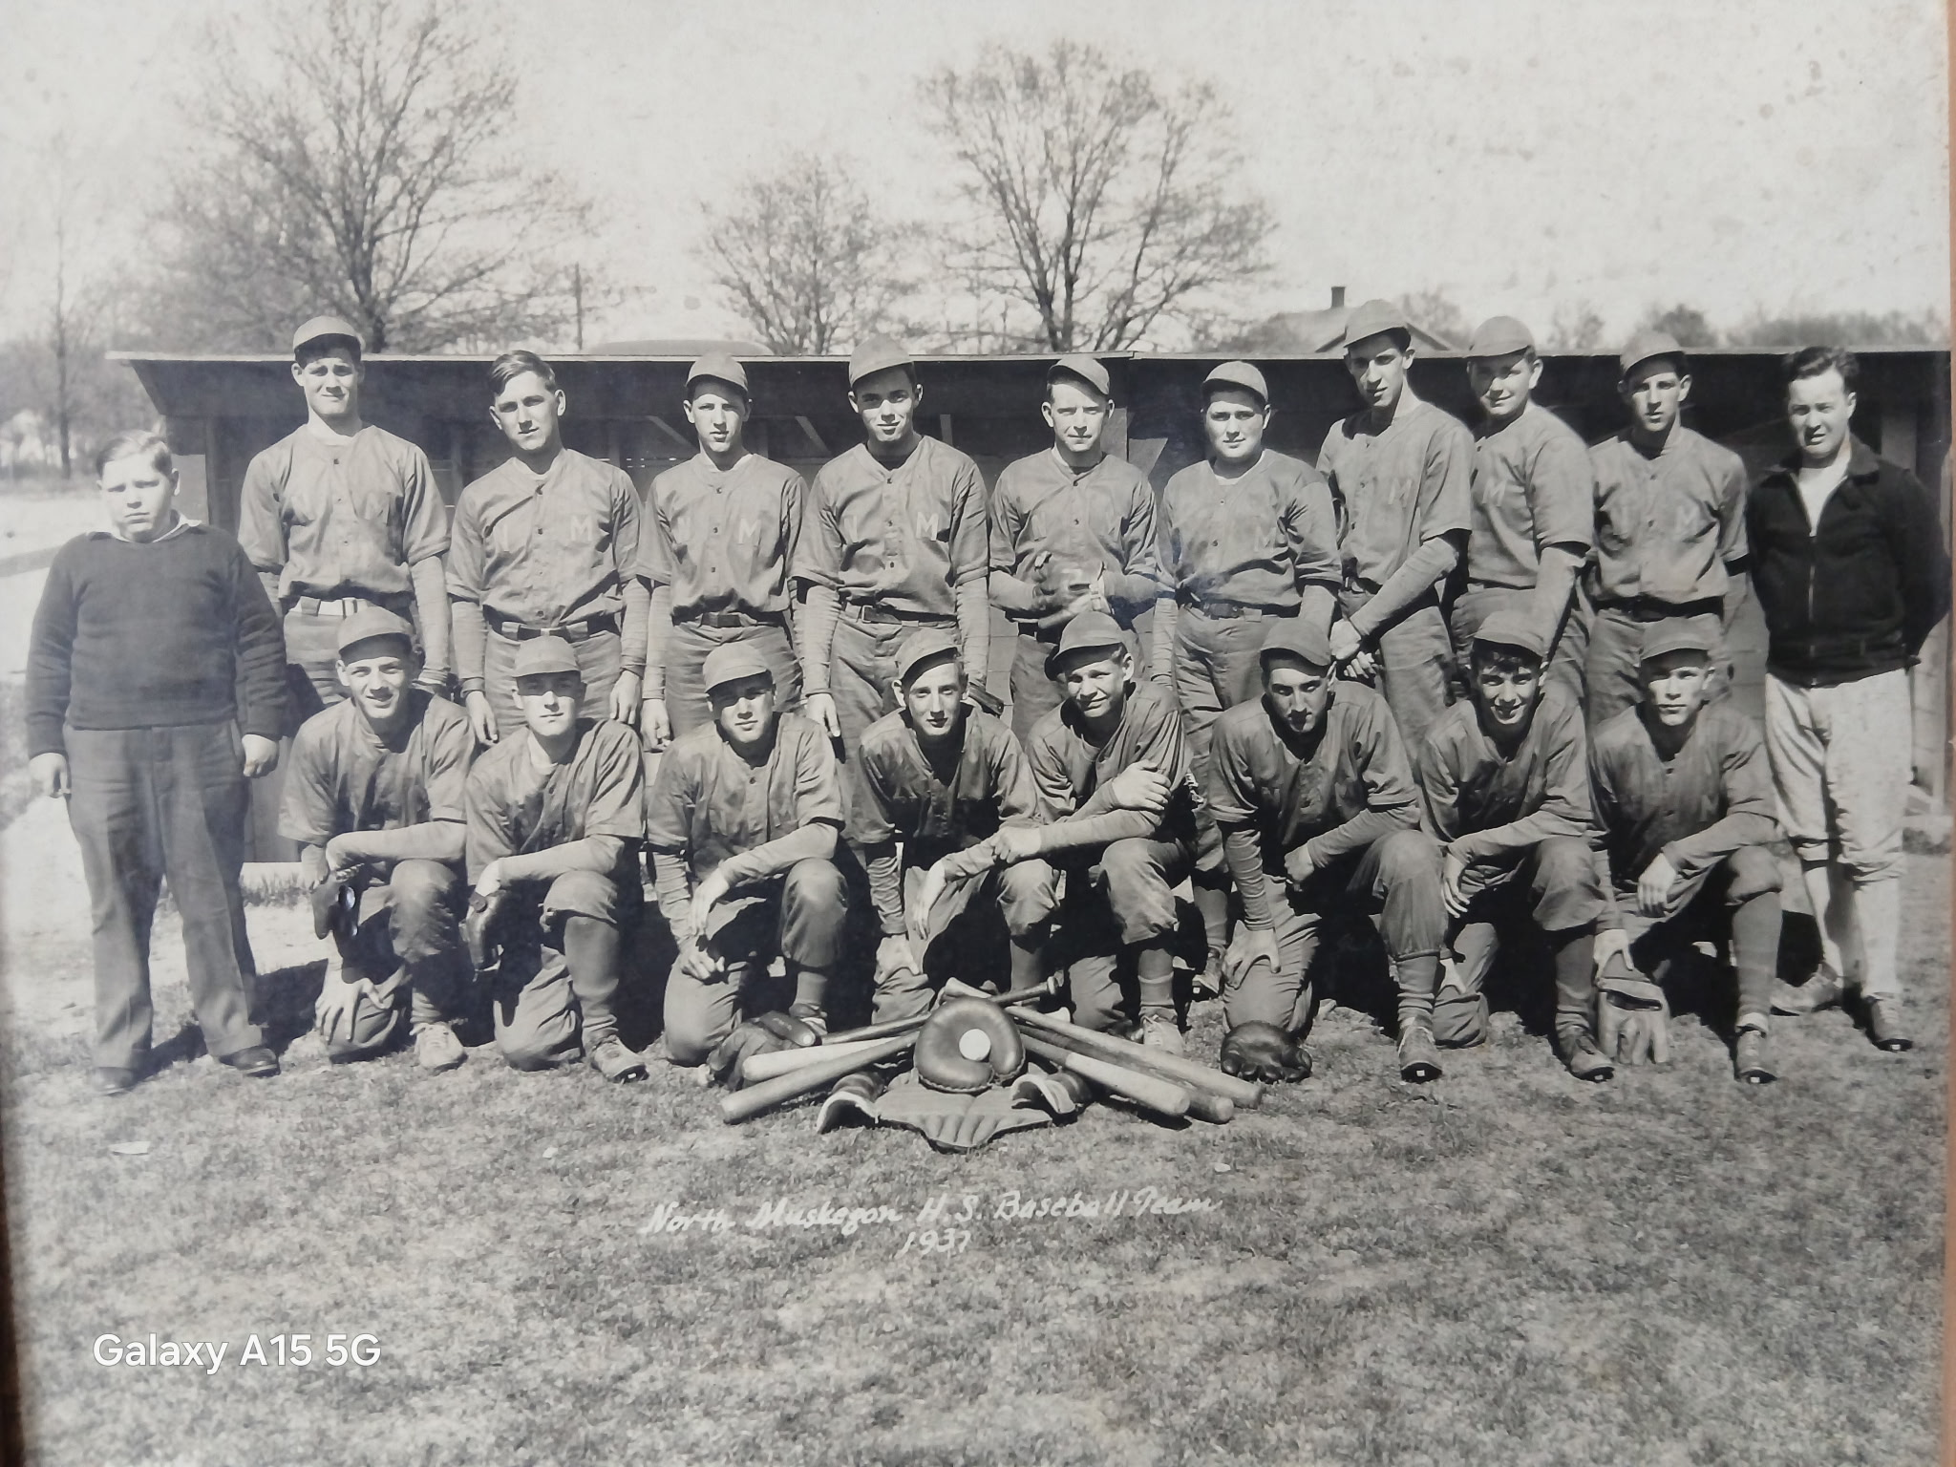

The 1937 NORSEMEN

Many missing names but those your author recognized include:
Front Row: Lawrence Bergen 3rd from left, followed by Nip Pender; next to Nip on the right is Harvey Speed, then Walt Bergen and on the far right is Al Schmit.
Top Row: Far right is coach Lyle McNitt: 2nd to his left is Dick Hoeker followed by Bob Raddatz and Shad Thornton.
At the far left in the top row is Oliver Eyestone who gave the supreme sacrifice in WWII.

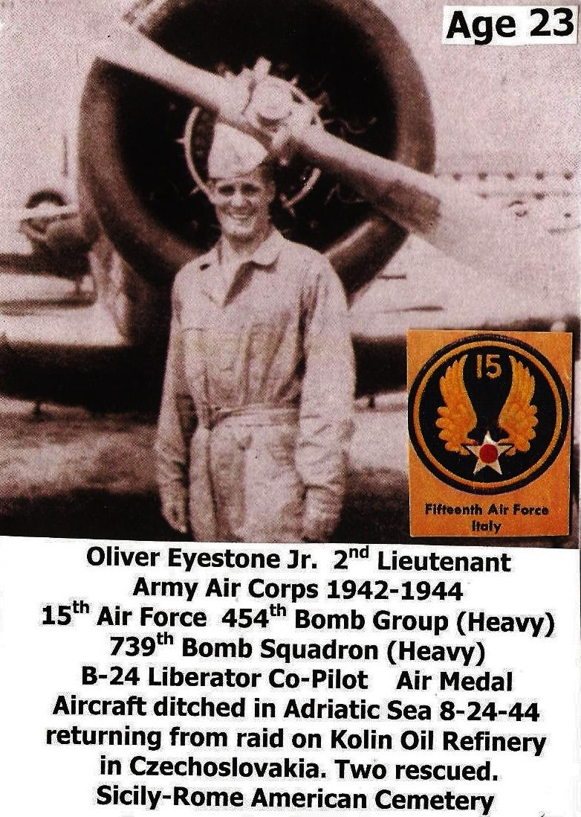

The photo is courtesy of former Norseman Richard Mullally

1938 – coach Lyle McNitt (10-2 overall; 4-0 in WMC; WMC Champs)

Surely the 1938 baseball season from long ago was one of the most successful in the annals of North Muskegon High history. The record shows a record of 10-2 but ‘officially’ it would be correct to say the record would be 9-1 as one win and won loss were actually ‘practice games’ against a newly formed Muskegon Junior College team. The Norse dropped the first game to MCC but won the second of the two-game series 8-1 with their ace hurler Walt Bergren spinning a two-hitter with 16 Ks. Walt Bergren and his sophomore brother Lawrence (Lunk) formed a very formidable battery that would rank among the best in NM history. Walt even received a tryout from the Chicago White Sox where for years the photo of Walt in a White Sox uniform at Comiskey Park was displayed on the walls at the Bear Lake Tavern. The Norse of 1938 in just their third year of active competition picked up their first Western Michigan Conference championship by posting a perfect 4-0 WMC record. After dropping consecutive games to Grand Haven and Muskegon Junior College, coach Lyle McNitt’s Norsemen would finish the season with nine straight wins to post a 10-2 record. The nine straight victories would stand nearly 70 years as the longest winning streak in Norse history, not broken until the 2007 squad put together a string of 15 consecutive wins.
Walt wasted no time in making his presence known by twirling a one-hit shutout over Holton and received a triple from brother Lunk in the Norse season opener. Walt Bergren’s 2-0 shut-out victory over Montague on May 20 was initially listed as a one hitter with 17 strikeouts. However, thanks to a story in the Muskegon Chronicle of May 26, 1938, Bergren pitched a no-hitter. Longtime Montague coach Eldred Townsend displayed his integrity by noting that Bergren should be credited with a no-hitter. During the contest a Montague batsman had a single and advanced to second on the play. However, the Montague hitter failed to touch first base on his way to second and was called out, nullifying his base hit. At one point in the contest Bergren fanned 13 consecutive batsmen and his 17 punchouts in the game is still a record that has not been surpassed in NM annals. The backup pitcher to Walt Bergren was Howard Speed, who defeated Montague in their first of two encounters 3-2 by pitching a three-hitter. The Norse also received some lusty hitting during the season from Lunk Bergren who had multiple extra base hits on the season, as well as from Al Johnson, Dick Hoeker and Oliver Eyestone.

Record Scor Interesting Fact
1-0 NM 7, Holton 0 Walt Bergren 1-hitter; Lunk Bergren triple, W. Bergren takes the loss.
1-1 Grand Haven 7, NM 5 L. Bergren 2 hits, including HR
1-2 Musk. Jr. College 9, NM 3 Played on April 28, it was noted as a practice game
2-2 NM 3, Montague 2 Howard Speed 3-hitter, with Walt Bergen the save, Lunk Bergren and Speed each a 2B
3-2 *NM 10, Hart 2 W. Bergen 3-hitter; Speed, Oliver Eyestone, Dick Hoeker, and W. Bergren all hit a 2B
4-2 NM 11, Holton 6 Oliver Eyestone, Al Johnson 3B, Speed 6-hitter to stop 6-game Holton winning streak.
6-2 *NM 2, Montague 0 W. Bergren no hitter, 17 K’s; Eyestone HR, L. Bergren a double and Speed 3B.
7-2 *NM 13, Whitehall 2 W. Bergen 2-hitter; W. Bergren 2 hits; L. Bergren 2B, Zahrt 2 hits.
8-2 NM 10, Musk. St. Joseph 1 Speed wins on a 4-hitter; Speed HR
9-2 NM 8, Musk. Jr. College 1 W. Bergren 2-hitter, 16 K’s; Speed 2B

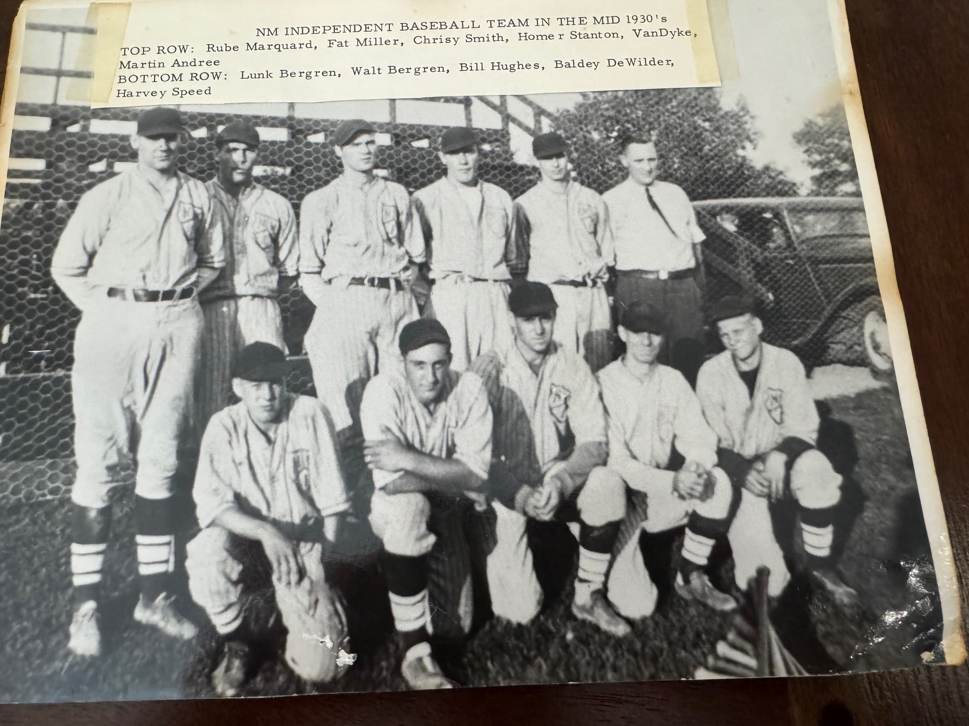

NM Baseball from the late 1930s. (Notice the old bleachers in the background)

Although not the high school team, this was an independent team managed by Francis ‘Rube’Marquard that included several NM players from the 1930’s including the Bergren brothers, Lawrence and Walt.
Standing L-R: ‘Rube’ Marquard, Fat Miller, Charley Smith, Homer Stanton, VanDyke, Martin Andree
Kneeling L-R: ‘Lunk’ Bergren, Walt Bergren, Bill Hughes, Baldey DeWilder, Harvey Speed

1939 – coach Lyle McNitt (4-6 overall; 2-2 in WMC; xx place in WMC; Montague Champs)
The Norsemen baseball team slipped below .500, a disappointment for many of the NM players who boasted of their first perfect 8-0 record earlier in the year in football. The Norse were hindered when catcher Lunk Bergren, a regular since his freshman season in 1937, was injured and missed the second half of the season. The departure via graduation of Walt Bergren left the Norse drastically short of an experienced mound staff. The highlight of the season perhaps was NM’s 15-10 win over Whitehall on May 2; a date best remembered in baseball history as the day Lou Gehrig ended his consecutive game-playing streak at Tiger Stadium. Poor hitting doomed the Norse from posting a better season as third baseman Al Johnson posted the lone home run garnered by an NM player during the season. It should be noted that there was a NM softball team, but results were rarely posted in the Muskegon Chronicle. The Chronicle did mention that the NM gals were a perfect 3-0 on the season and were led by Muskegon Area Sports Hall of Fame Charter member Sally Sessions who was batting a perfect 1.000 after three games. The NM boys golf team finished 5th at the state tournament with Morris Engstrom placing second. Engstrom was probably not the top NM student golfer as that would surely belong to Sessions who became one of the leading female golfers in the country. Not only was Sessions a top softball player and golfer, but she was also the top female tennis player in Muskegon.

Record Score Interesting Fact
0-1 Holton 4, NM 3 no report in MC
0-2 Grand Haven 10, NM 2 NM only 3 hits
1-2 NM 15, Whitehall 10 Lou Gehrig ends playing streak in Detroit. Al Johnson HR. NM scores 8 in 2nd inning.
1-3 *Hart 16, NM 2 NM scores 2 runs in first, NM 8 errors, Walt Bergren 2B.
3-4 Montague 11, NM 1 NM only 1 hit
3-5 *Montague 5, NM 3 NM 5 errors; NM strikes out 11 times. Al Johnson 6-hitter loss.
3-6 Grand Haven 6, NM 1 NM only 5 hits
4-6 *NM 7, Whitehall 6 Al Johnson triples as Johnson and McNeil combine for the win.

1940 – coach Lyle McNitt (5-4 overall; 1-3 in WMC; xx place in WMC; Hart Champs)
The Norsemen started strong and ended the season with a bang but could only muster two more wins between the bookend start and finish. Lunk Bergren blasted a game-winning home run in the eighth inning to give the Norse a dramatic 7-6 season opening win over Muskegon St. Joseph. Pitching was again a trouble spot for Coach Lyle McNitt’s team as Dan Thompson was the only hurler to give the Norse more than one quality start. The trio of Thompson, Bob Frost and Bergren was able to combine for a 15-0 pasting of Muskegon St. Jean’s in the season finale. Among the Norse regulars during the campaign was Pete Sodini, whose work over the years in promoting baseball at Reeths-Puffer, culminated with the R-P baseball field being named in Sodini’s honor. And, in case you’re interested, the population of North Muskegon in 1940 was 1665, a 30% improvement from 1930.
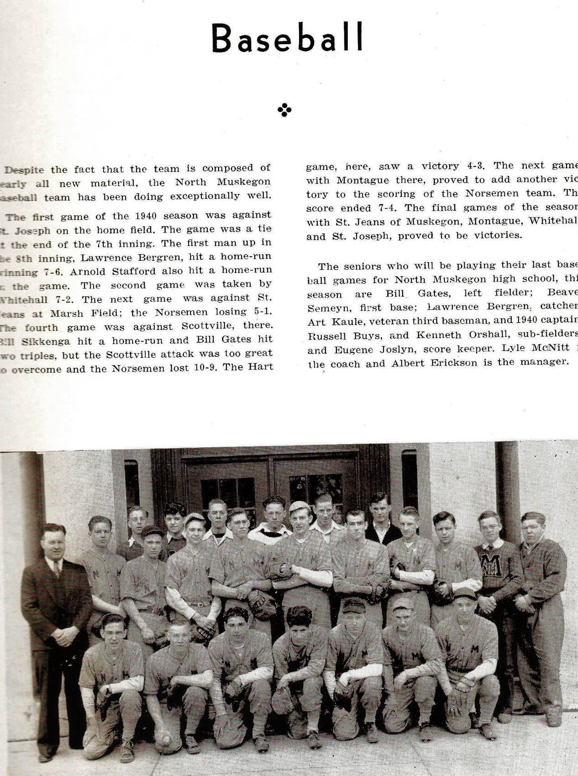

The 1940 NORSEMEN

Missing names – any help to identify please e-mail me. I do recognize my one time
teammate Lunk Bergren far left 1st row and Pete Sodini 3rd from left 1st row. Arnie Stafford
Is 4th from the right in the 2nd row.

Record Score Interesting Fact
1-0 NM 7, Musk. St. Joe 6 8 innings; Lunk Bergren game winning HR in 8th; Arnie Stafford also homers.
1-1 *Whitehall 7, NM 2 no report in MC
1-2 Musk. St. Jean’s 5, NM 1 Dan Thompson & Bob Frost combine for loss in game played at Marsh Field
1-3 *Scottville 10, NM 9 Bill Sikkenga HR, Bill Gates 2 triples
2-3 *NM 4, Hart 3 Dan Thompson 5-hitter as NM scores 2 in 7th for walk off win. Bob Frost 2B.
3-3 NM 7, Montague 4 Bob Frost comes in game in relief to pick up the win.
3-4 *Montague 6, NM 5 Arnie Stafford HR, bases loaded triple; Bill Sikkenga HR as Montague rallies for win
4-4 NM 15, Musk. St. Joe 6 NM 18 hits; St. Joe commits 10 errors. Frost & Thompson pitched for the Norsemen.
5-4 NM 15, Musk. St. Jean’s 0 Thompson wins; Art Kaule, Sikkenga triples

1941 – coach Lyle McNitt (8-1 overall; 3-1 in WMC; 2nd place in WMC; Hart Champs)
The Norse posted a dazzling 8-1 record but had to settle for second place behind an outstanding Hart team that was led by future Western Michigan University All-American Fred Stevens. Only a 10-0 pasting at the hands of the Pirates denied the Norsemen from posting a perfect season. Coach Lyle McNitt found some long sought-after live arms to send to the mound during the season in Don Gunn and Bob Frost. The campaign also marked the arrival of hard-hitting shortstop Bill Meiner, along with future NM gridiron greats Bill Goldberg, Don Bowen, Jim Corradin, Moe Sikkenga, Wayne Dulyea and Frank Sodini. Meiner came up just short in becoming the first Norse to hit for the cycle when he knocked out a home run, double and a single in NM’s 8-6 victory over Muskegon St. Joseph. One had to wonder as to the batting average of Meiner during the season as Bill had multiple hits in nearly all games reported in the Muskegon Chronicle. NM capped their season with an impressive two-game sweep of Muskegon St. Mary’s who were coached by one-time radio icon Jack Roach. Ted Gates and Meiner belted out triples in the DH on the same day that the baseball world mourned the passing of baseball great Lou Gehrig. Seven starters would return for the 1942 season with only first baseman Ted Gates and outfielder Russ Olson lost to graduation.

Record Score Interesting Fact
1-0 NM 12, Musk. St. Joe 1 Bob Frost winner. Don Gunn pitches final 2 ing. and goes 3-4; Bill Miner triple & 1B; Leonard Kaule 2 hits.
2-0 NM 9, Whitehall 8 NM scores 9 runs in first 3 ing; Bill Goldberg, Frank Sodini 2 hits
2-1 *Hart 10, NM 0 NM commits 5 errors; Frost takes the loss allows 8 runs before Frost in 4 ing.
3-1 *NM 15, Scottville 7 Bill Meiner, HR, 3B; Sodini 3B; Frost pitches all 7 innings for NM,
4-1 *NM 9, Montague 6 Meiner has three hits as NM scores 4 runs in top of 7th for win. Gunn winner.
5-1 *NM 8, Whitehall 6 no report in MC
6-1 NM 8, Musk. St. Joe 6 Bill Meiner HR, double, single as Frost & Gunn pitched for NM
7-1 NM 8, Musk. St. Mary’s 4 Ted Gates & Meiner triple, single; Don Gunn pitched a 4-hitter
8-1 NM 18, Musk. St. Mary’s 0 Bob Frost, Gunn combine on 1-hitter; MSM single with 2 outs in 7th; Miner, Sodini, Goldberg lead NM hitters

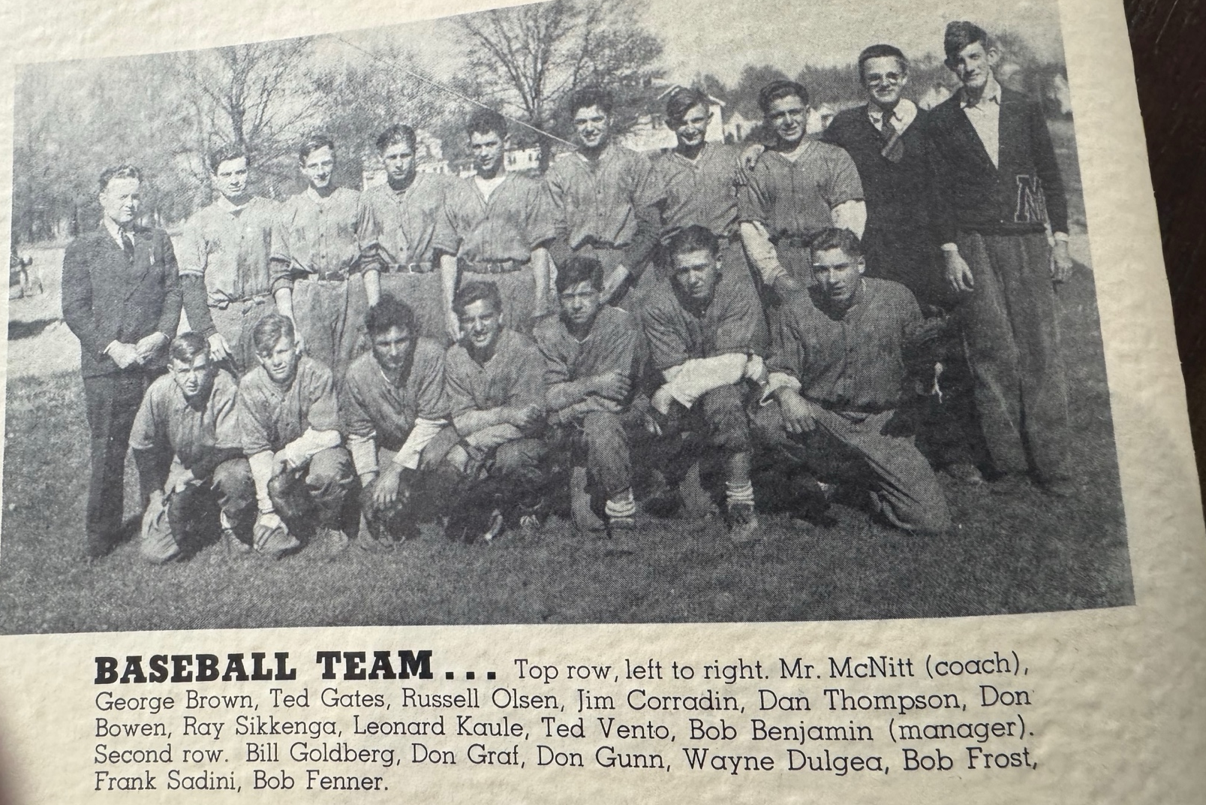

1941 NORSEMEN

Editor’s Note: This photo was copied from the Norse Annual from 1941. It is clear to me that this is not the correct order of the players shown in this photo. The leading hitter on this team Bill Meiner is not listed in this photo, but he is clearly the player in the first row to the far right. Standing directly behind Meiner is my long-time barber, Frank Sodini.

1942 – coach Lyle McNitt (5-4 overall; 2-1 in WMC; co-Champs w/ Hart & Whitehall)
Lyle McNitt completed his coaching career at North Muskegon by earning a share of the West Michigan Conference championship with the Hart Pirates. McNitt would leave NM to take over the football coaching reigns at Grand Rapids College, succeeding a man who, after just taking over the head coaching duties, was called to duty in World War II. The man McNitt replaced was former Detroit Lion great Potsy Clark while Clark’s assistant Gerald R. Ford, would depart coaching to take a fling at politics. Perhaps McNitt was too busy working out a contract for Grand Rapids JC as none of the NM home games throughout the season were reported to the Muskegon Chronicle. The high-water mark for the season was NM’s exciting 2-1 road triumph over Montague. Don Gunn hurled a two-hitter with Bill Meiner’s home run the difference in the outcome. Although there was no game story in the Muskegon Chronicle in NM’s 12-7 loss to Hart, the Pirates could boast of a pair of players who lived to be centurions. Walter ‘Stretch’ Hansen, who would become good friends with your author, lived to celebrate his 100th birthday in November of 2024. Also surpassing the 100th year on this planet was Stretch’s Hart teammate Harold Tate, who is still with us as of this writing in 2026.
It was a school year to be long remembered by Norse fans as the NM football team ran through the 1941 season undefeated, untied and unscored upon.

Record Score Interesting Fact
0-1 Musk. St. Joe 3, NM 0 Don Gunn loses 5-hitter as Bill Krozona allows NM only 2 hits
1-1 NM 14, Whitehall 2 no report in MC
1-2 *Hart 12, NM 7 no report in MC
1-3 Musk. St. Mary’s 4, NM 3 at Marsh Field, Don Gunn allows only 4 hits, Gunn, Jim Corridine singles in 3-run 5th inning for NM
2-3 NM 3, Montague 0 no report in MC
3-3 *NM 2, Montague 1 Don Gunn 2-hitter; Bill Meiner HR wins game, Wayne Dulyea 2 hits, Miner also a single
3-4 Musk. St. Mary’s 5, NM 4 no report in MC
4-4 *NM 7, Whitehall 6 no report in MC
5-4 NM 6, Musk. St. Joe 1 no report in MC

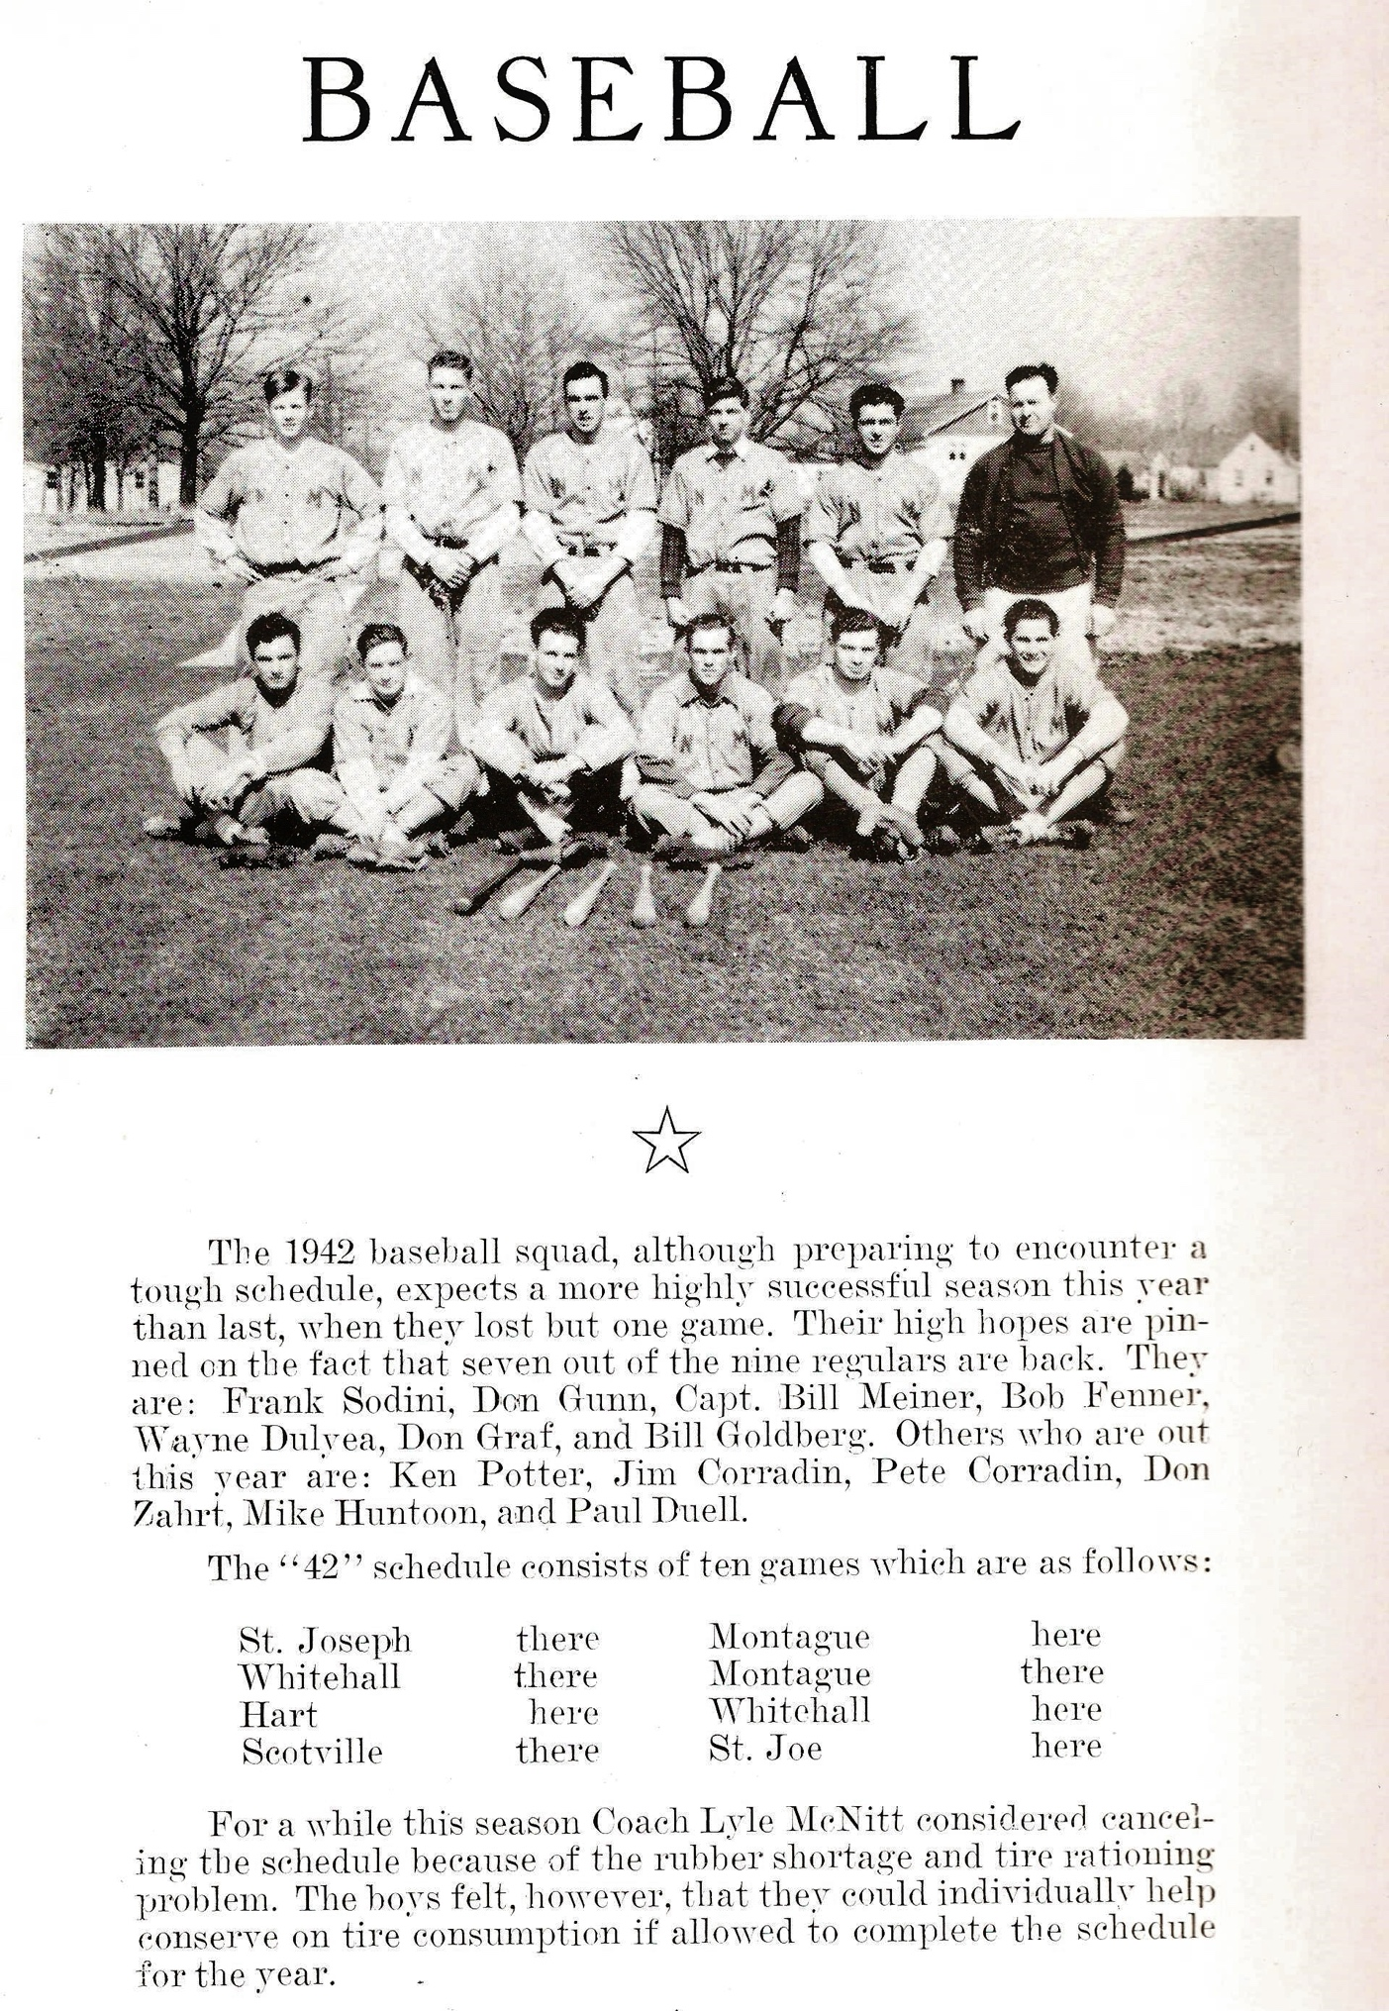
The 1942 NORSEMEN

Those I can identify: Top Row L-R: Bob Fenner, Bill Meiner, Ken Potter, ?, Frank Sodini, Coach Lyle McNitt
Bottom Row: ?, Pete Corridin, ?. ?, Bill Goldberg, Jim Corridin

1943 – coach Paul Moyes (5-2 overall; 3-0 in WMC; WMC Champs)
North Muskegon welcomed a new coach to the community when Paul Moyes took over the duties from Lyle McNitt. Moyes earlier coached the 1942 football team to another undefeated season as the Norse extended their still-standing state record of 15 games where they were undefeated, untied, and unscored upon. Many of those great gridiron icons, which became only the third team ever inducted into the Muskegon Area Sports Hall of Fame, continued their success in baseball and led the Norse to a perfect record in winning the West Michigan Conference. This team was also stingy with runs allowed – in nearly 90 years of Norsemen baseball, the 1943 team allowed the fewest runs per game (2.00). NM would begin the season with the following starting lineup: Bob Gunn pitcher; Frank Sodini catcher; Don Jacobson 1B; Bob Fenner 2B; Wayne Dulyea SS; Virgil Wilks 3B; Jim Corradin CF; Ken Tyler RF; Paul Duell RF. Due to stringent gas rationing in 1943 throughout the USA, NM was able to schedule but eight games, including three games against Class A foes Muskegon, Muskegon Heights and Grand Haven. However, their scheduled game with Grand Haven in late May was rained out and never rescheduled. The Norse got out of the blocks in a hurry when they blasted Whitehall 20-0 with Frank Sodini lashing out four hits. On May 12, Virgil Wilks posted not only the first reported no-hitter in NM history but also the first no-hitter in conference history with a 4-0 shutout over the defending WMC champs, the Hart Pirates. The Norse tallied all their runs in a four run third with Wayne Dulyea, Ken Tyler, Wilks, and Don Jacobson stroking base hits. Each team committed but one error as the game was completed in a very swift one hour and fifteen minutes. However, after some diligent research it has now been found that the first no-hitter thrown by a NM pitcher was accomplished in 1938 by Walt Bergren when a rule book error was found. Only losses to Class A powers Muskegon Heights and Muskegon put a blemish on a war-torn abbreviated 5-2 season. Future Rose Bowl hero Jack Weisenberger, the spinning fullback on the University of Michigan national championship football team of 1947, three-hit the Norse in Muskegon Heights’ 4-1 win. Weisenberger wasn’t too shabby of a baseball player either, as he made it all the way up to AAA level with the Boston Braves farm system.

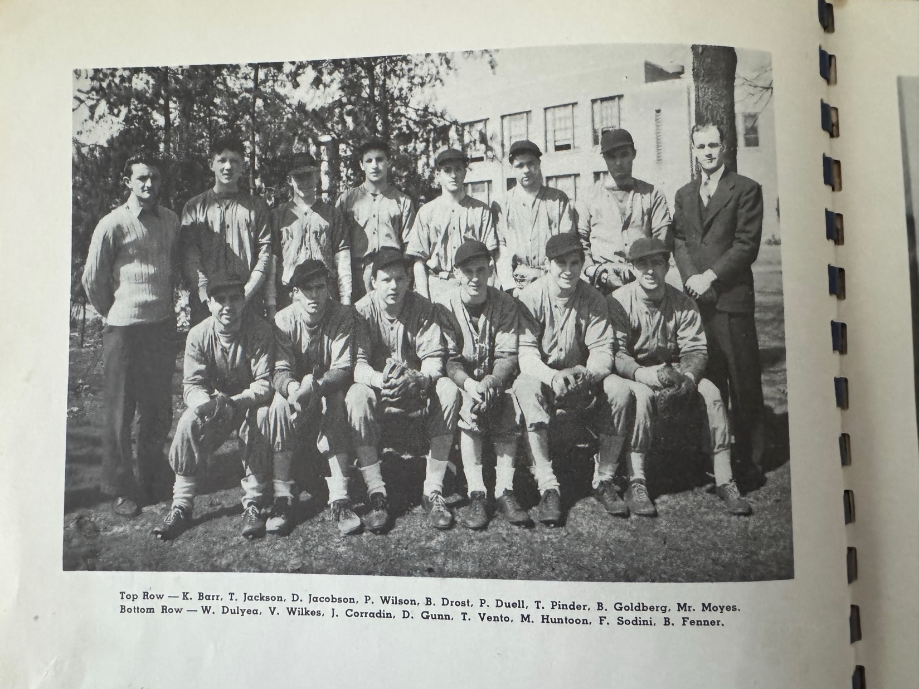

THE NORSEMEN OF 1943

Editor’s note: Just as in the 1941 team photo the players listed are not in the correct order. In the bottom row Ted Vento is to the far left and Frank Sodini to the far right. To the left from Sodini is Jim Corradin.

Record Score Interesting Fact
1-0 NM 20, Whitehall 0 Frank Sodini 4 hits, Don Gunn and Virgil Wilks split shut out. Ken Tyler, Wayne Dulyea and Wilks 2 hits/
1-1 Musk. Heights 4, NM 1 Sodini triple and scores only NM run
2-1 NM 8, Montague 0 no report in MC
3-1 *NM 13, Montague 1 Gunn wins, Paul Duell HR, Wilks 3 hits, Wayne Dulyea, Ken Tyler tripled as did Wilks
4-1 *NM 4, Hart 0 Virgil Wilks 2nd^{t} no-hitter in school & WMC history, 1 walk 6 K’s, NM scores all 4 on Hits by Dulyea, Tyler, Wilkes and Jacobson.
4-2 Muskegon 7, NM 1 31st straight win for Muskegon, Duell doubles; NM errors on a pair of dropped fly balls contributed to the loss. Lefty Bob Gunn pitched.
5-2 *NM 9, Whitehall 2 Don Gunn the winning pitcher as NM wins conference.

1944 – coach Paul Moyes (5-3 overall; 4-0 in WMC; WMC Champs)
The Norse made it back-to-back WMC championships while again sweeping through the WMC portion of their schedule. NM began the season with freshman Bob Pyle and Tom Pinder handling the pitching chores with Glen Buys the catcher. Rounding out the starting nine would be Don Jacobson at first base, Tom Jackson at 2B, Ken Kueney ss, and Marshall Strayer at 3B. Norm David, LaVerne Nicholson, Don Buerhle and Bill Zaagman would share the outfield duties.
NM had to wait nearly a week as rains forced the postponement of their first two of only eight games scheduled for the 1944 season. NM easily defeated Whitehall 12-3 in their opener as NM belted out 14 hits with George Felt leading the way with 3 hits. Marshall Strayer, who would hit an all-time best .614 for NM had two of NM’s hits.
Tom Pinder than hurled a gem in NM’s 5-3 victory over Shelby, giving up but three hits while walking only one. Heavy hitting Marshall Strayer led the Norse batsmen with a pair of hits including a triple.
Jack Weisenberger again was a thorn in the side of the Blue & Gold, as he one-hit the Northsiders for the second straight year. Only Marshall Strayer was able to get a hit from the future hero of the 1948 Rose Bowl as NM batters struck out 19 times.
Tom Pinder proved to be the ace of the Norse pitching staff. After posting an earlier 5-0 shutout over Shelby, Pinder struck out 15 Hart batsmen enroute to a 10-1 NM triumph. Following the May 5 encounter with the Pirates, Norse head coach Paul Moyes packed his bags and drove his 1936 Ford Model A car to Detroit where he enlisted in the Navy. The following day Moyes would return to Muskegon where he would be present for the birth of his second son, future four-year starting Norse shortstop Tommy Moyes.
Fortunately for the Norsemen their 7-2 loss to Monague did not count as an official West Michigan Conference game. After giving up all seven of Montague’s run in the first three innings, NM starter Bob Pyle pitched four perfect innings. The Norsemen then became the 44th straight victim during a Muskegon winning streak that began back in 1940. Future MSU pitching ace Bill Page earned the victory for the Big Reds with hitting help from Bob Ludwig with two hits. After a successful career in pro baseball where Ludwig advanced to the Triple A level, Ludwig would cap his baseball career as a member of North Muskegon’s summer baseball team in 1959 where Ludwig was a teammate of your author.
The Norse clinched at least a tie for the WMC title with a dramatic 8th inning walk off win over Montague as Marshall Strayer led the way with three hits, including a double. Salmonson homered for the Norse as NM backs up Tom Pinder’s pitching by committing no errors in the field. The Norse clinched the conference championship in a most exciting fashion on May 18 vs. Whitehall. Dick Salmonson slid home with the winning run late in the game after Marshall Strayer had earlier belted a pair of home runs, the first NM slugger to mash multi homers in a single game. Ten days after the Norse ended their season with a WMC-clinching victory over Whitehall, Moyes would join many of his former athletes in fighting the perilous battles of World War II. Moyes would present letters to the following before departing for the service: Tom Pinder, Bob Pyle, Ken Kueny, Dick Salmonson, Tom Jackson, Don Jacobson, Marshall Strayer, Leonard Buys, LaVerne Nicholson, Don Buehrle, Norm David, Bob Duplissis and George Felt.

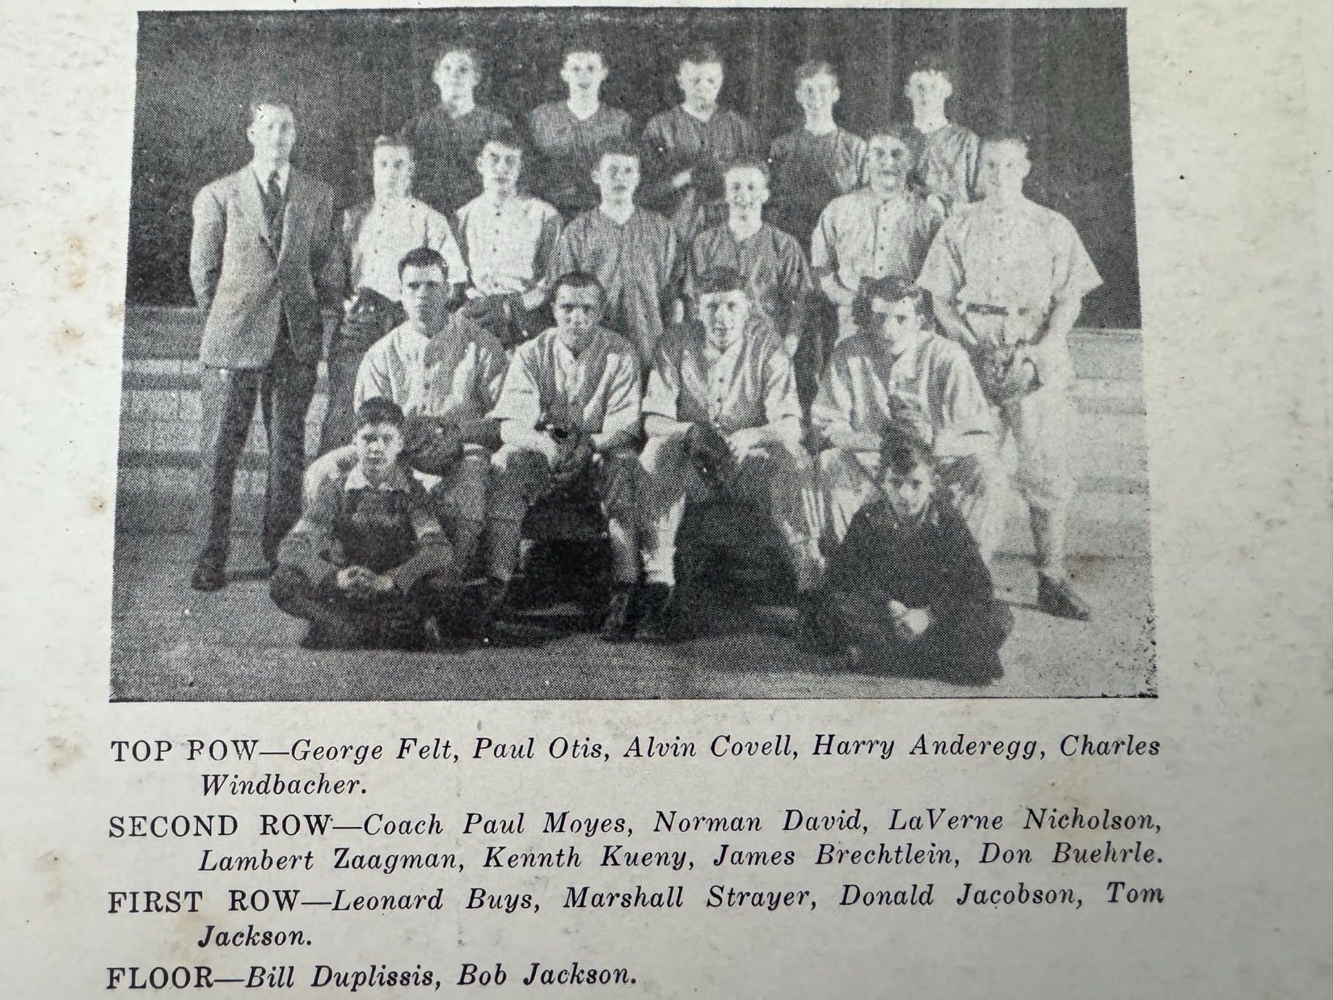
1944 NORSEMEN

Record Score Interesting Fact
1-0 NM 12, Whitehall 3 George Felt 3 hits, Bob Pyle, Strayer & Dick Salmonson 2 hits; Pyle with relief from Tom Pinder pitched for the Norse.
2-0 *NM 5, Shelby 0 Tom Pinder wins as he walked only one batter and 3 hits: Marshall Strayer triple, single,
2-1 Musk. Heights 9, NM 0 Jack Weisenburger 1 hitter and K’s 19 also hit 1B, 2B & 3B for Heights, Strayer has lone NM hit
3-1 *NM 10, Hart 1 Pinder 1-hitter, 15 K’s; Strayer GS, Coach Moyes departs for Navy on the day before his son Tom was born.
3-2 Montague 7, NM 2 Non-conference loss, Pyle pitches for NM
3-3 Muskegon 12, NM 0 Muskegon wins 44th straight game as Pinder pitches for NM. Bob Ludwig 2 hits for Muskegon.
4-3 *NM 6, Montague 5 Strayer 3 hits; Salmonson HR, NM 0 errors
5-3 *NM 5, Whitehall 4 Marshall Stayer 2 HRs as Pinder & Pyle lead Norse to WMC title.

1945 – coach Earl Meyers (6-4 overall; 3-1 in WMC; co-Champs in WMC w/ Whitehall& Montague)
While coach Paul Moyes was serving as a gunnery officer aboard a Naval ship in the Pacific Theater, Earl Meyers pinch hit for Moyes for the next two seasons. The Norse grabbed a share of the crown in the WMC. Only a tough, season-ending 4-3 defeat at the hands of Whitehall denied the Norse from grabbing the entire trophy. Junior right-hander Norm David became the top Norse pitcher during the season. Aided by the lusty slugging from Marshall Strayer, who tattooed the Shelby staff for a home run and pair of doubles, David whiffed a dozen Tiger batters in a 13-5 Norse blowout win. Although the Norse fared well against competition in the WMC, it was dealt a dose of reality when facing the big boys. Muskegon Heights’ pitcher Earl Beam threw a no-hitter at the Norse while Muskegon High showed the Northsiders why they could lay claim as one of the all-time best teams in Michigan prep history. Bob Ludwig, a future teammate of your author on the North Muskegon Independents, put a real hurt on the Norse with a 21-0 trouncing, Muskegon’s 52nd straight win in a row. Ironically, the game played on May 8 was only the third game played during the season for the Big Reds as numerous rainouts limited their schedule. The Norse clinched at least a tie in the WMC with a bazaar slugfest on the Northside vs. Montague. The Norse became winners when Bud Anderegg drove home Tom Jackson and Norm David with a 2 RBI single in the seventh inning as the Norse won 16-15. Marshall Strayer led the victors with a pair of doubles and a single. Stayer batted a lusty .614 for the season, more than .300 points higher than the number two hitter. In 90 years of NM baseball Strayer’s average remains at the top of the list in Norse history.

Record Score Interesting Fact
1-0 NM 7, Holton 2 Marshall Strayer wins.
2-0 NM 6, Holton 0 Bud Anderegg 2-hitter, Stayer catches the 2nd game of doubleheader, Strayer 2 hits, both doubles
2-1 Montague 5, NM 1 Anderegg takes the loss with Strayer a double & single for NM.
3-1 NM 4, Whitehall 3 NM wins on back-to-back 2B by Tom Jackson & Don Jacobson in 7th inning. Bob Pyle winning pitcher.
4-1 *NM 13, Shelby 5 Norm David 12 K’s; Strayer HR, 2 doubles, Al Meerzo double
4-2 Musk. Heights 6, NM 1 NM no-hit by Earl Beam. NM scores only run on a Jackson walk, an error, Strayer walk and a passed ball by Hts. Sonny Grandelius.
5-2 *NM 7, Hart 5 David wins; David 3 hits as NM scores 3 in top of the 7th to earn the victory.
5-3 Muskegon 21, NM 0 Muskegon’s 52nd straight win
6-3 *NM 16, Montague 15 Strayer 3 hits; Anderegg’s 2 RBI single in 7th brings in the winning runs.
6-4 *Whitehall 4, NM 3 no report in MC other than the score

1946 – coach Earl Meyers (6-5 overall; 6-4 in WMC; 2nd place in WMC, Montague Champs)
An extremely young team that used as many as five freshmen (Tom Mitchelson, Bob Chaffee, Bill Graham, Bill Jackson, Ken Douglas) in its lineup, the Norse continued their winning ways in coach Earl Meyers’ last season as the Norse baseball coach. Meyers would remain as the NM basketball coach through the 1947-48 school year. With the brutal War now thankfully over, the Norse were able once again to schedule Scottville as gas restrictions during the war kept any travel over a certain distance to a minimum. The renewed rivalry took place in the season opener, and it resulted in a Norse sweep of the visiting Spartans. Senior Norm David pitched a strong game in the opener as he fanned 12 Spartans and yielded only five hits. Bob Anderegg hurled the second game in the DH and was aided by three hits from Ken Kueny who also had three hits in the opener. A walk off grand slam in the bottom of the seventh inning by Hansen of Hart spelled defeat for NM in their third game of the season. NM then handed Shelby a resounding 16-0 defeat as Anderegg throws a 4-hit shutout and welcomed back heavy hitting catcher Marshall Strayer who banged out four hits. Four unearned runs in the fourth led to a 6-3 defeat to Whitehall despite David striking out 12 Viking batters. Montague rallied for five runs in the fifth inning to nip the Norse by a single run at 8-7 in their next outing. The Norse dropped their third straight game to a powerful Muskegon Heights team before they would get back on the winning track and win their next three games. Strayer broke up a 6-6 tied with a homerun to initiate a six-run NM uprising in the sixth inning to defeat Hart 12-6. Strayer and Al Meerzo had a pair of base knocks as NM won their second straight WMC game with an 8-5 victory over Shelby. NM capped their brief three-game winning streak with a narrow 5-4 victory over Whitehall. Marshall Strayer continued his onslaught of opposing pitchers as his base’s clearing triple was the big blow to give Norm David the victory. Norm David would have a busy spring for the Norsemen. Not only was David the ace of the pitching staff, but he was also a valuable member of the NM track squad. His best time of 2:04.0 in the 880-yard dash would serve as the school record for the next 15 years. David began and ended the season in stylish fashion, striking out 12 in the season-opening 8-5 win over Scottville and striking out 17, a school record, in a season-ending 8-7 loss to Montague. The Norse had a golden opportunity to garner a share of the WMC vs. the Wildcats but NM errors led to two unearned runs in the 7th while another Norse miscue led to the winning run for the conference champs in the 10th inning.

Record Score Interesting Fact
1-0 *NM 8, Scottville 5 Norm David 12 K’s, Ken Kueny 3-4
2-0 *NM 9, Scottville 7 Kueny 3-for-4 (6-8 in DH)
2-1 *Hart 14, NM 11 Kueny, David 2 hits. NM loses on GS in 7th
3-1 *NM 16, Shelby 0 Bob Anderegg WP, Marshall Strayer 4 hits (3B), David 2 hits (3B)
3-2 *Whitehall 6, NM 3 David 12 Ks. Strayer 2 hits, David 3B. Tom Jackson 2B.
3-3 *Montague 8, NM 7 David fans 8
3-4 Musk. Hts. 9, NM 2 NFL great Sonny Grandelius catcher for Heights
4-4 *NM 12, Hart 6 NM scores 6 in 7th inning, David 11 Ks. Al Meerzo 2 hits, Strayer breaks up tie with 7th ing. HR.
5-4 *NM 8, Shelby 5 Meerzo & Stayer 2 hits, Anderegg WP
6-4 *NM 5, Whitehall 4 Strayer bases loaded 3B, Ken Baars 3B, David WP
6-5 *Montague 8, NM 7 10 innings David 17 K’s, Al Meerzo 2 hits (double) 4 RBIs

1947 – coach Paul Moyes (3-7 overall; 3-7 in WMC; xx place in WMC; Shelby-Scottville Co-Champs)
Paul Moyes returned from the service to once again take over the reins for the Norsemen. The season was marred by an abnormal amount of inclement weather that resulted in numerous cancellations. This would be a rebuilding year for coach Moyes as 1947 would be the only year NM would not have a winning season under Moyes’ leadership. The tempo was set when the season opener with Hart was postponed due to snow. NM garnered their first win in the new Moyes era with a wild 13-10 road victory at Whitehall. NM hurlers James Brecklein and Milt Ortquist gave way to Ray Williams who finally stopped the Whitehall hitting attack by twirling two scoreless innings. The Norse then put together four runs in the top of the seventh to secure the win. Although NM fell to lanky Al Jancek and Montague in game three on the season, the Norse did pull off the first triple play recorded in school history. With runners on first and second and no outs in the first inning, Lewis of Montague lined sharply to shortstop Tom Mitchelson. Mitchelson then fired to first baseman LaVerne Nicholson to nip one runner and Nicholson’s throw to second baseman Al Meerzo completed the triple play. The Norse got some timely hitting from Ken Baars and Dick Salmonson as each belted a double with the bases loaded. Tom Mitchelson added a pair of hits for NM as Ray Williams went the distance in their 8-6 victory over Hart. The Norse had an early lead go by the wayside as Shelby completed a rare season sweep over NM with a 15-7 victory over the visiting Norsemen. After dropping a 13-10 slugfest to Hart in a makeup from an earlier game that was snowed out, the Norse staged a wild come-from-behind win over Whitehall. The Norse got a game-winning hit from Jack Krolczyk as NM rallied for five runs in the bottom of the seventh inning to defeat the Vikings, 10-9. Credit for the win went to freshman hurler John Biddle. Unfortunately for Norse followers, it would be the last victory of the 1947 season as the Norse dropped their final three games. Although Bob Chaffee banged out three hits, including a triple, the Norse lost to Montague 14-7 and then incurred a double header loss to WMC conference champs Scottville to complete their schedule, all games against WMC teams. A scheduled season finale with Muskegon Heights was cancelled due to inclement weather as subnormal low temperatures and rain raised havoc with all spring sports in 1947.

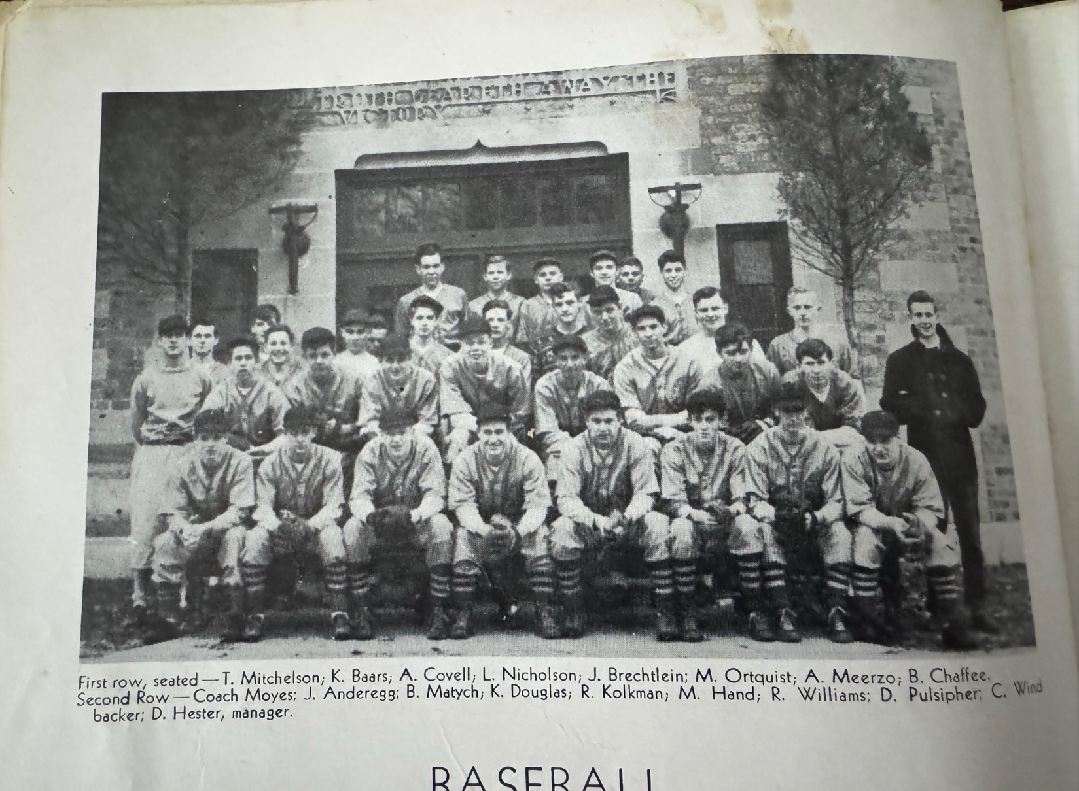

THE NORSEMEN OF 1947

Record Score Interesting Fact
0-1 *Shelby 10, NM 3 No report in MC
1-1 *NM 13, Whitehall 10 NM scores 4 in 7th for win
1-2 *Montague 11, NM 3 NM executes triple play, Tom Mitchelson-LaVern Nicholson-Al Meerzo
2-2 *NM 8, Hart 6 Ken Baars 2 hits, bases loaded double, Dick Salmonson, Mitchelson 2 hits
2-3 *Shelby 15, NM 7 Shelby has seven two out hits in 3rd inning
2-4 *Hart 13, NM 10 Hart scores 12 runs in first 3 innings; Salmonson leads Norse with 3 hits.
3-3 *NM 10, Whitehall 9 Jack Krolczyk GW hit: NM scores five runs in 7th
4-3 *Montague 14, NM 7 Bob Chaffee 3 hits (triple)
4-4 *Scottville 8, NM 1 NM only 3 hits as Chaffee losing pitcher
4-5 *Scottville 10, NM 0 Scottville’s sweep of Norse earns share of WMC title. NM only 7 hits in Double Header

1948 – coach Paul Moyes (5-3 overall; 5-2 in WMC; 2nd place in WMC; Scottville Champs)
The entire west side of the State of Michigan was inundated with heavy rains that raised havoc with the baseball season. There was a two-week period from April 28 until Mid-May when the entire slate of games for NM baseball was cancelled due to rain and unplayable ball fields. The season went down to the wire to determine the WMC conference champ. The Norse took the long jaunt up old highway US-31 in the final WMC game of the season to play Scottville in a winner-take-all battle. A young and jittery NM pitching staff walked an uncharacteristic 11 Spartan batters in losing the championship clash 12-7. It was the first outright WMC championship for Scottville in their school’s history. Earlier in the season, the Norse dropped a heartbreaker to Shelby, 10-9, despite a Tom Mitchelson home run. It was a chilly start, but a winning one for the Norse as NM played their opener at Hart in freezing conditions. It was so cold that by mutual consent the game was to be but a five-inning affair. However, the subpar weather conditions resulted in numerous errors committed by both teams, but the Norse prevailed 13-10. Coach Paul Moyes used three pitchers in the contest, starting with veteran Ramon Williams, followed by sophomore John Biddle with freshman John Arntz pitching` the final inning. The Norse dropped their second game of the season to Shelby in a 10-9 shootout on the Norse diamond. The Norse lost the game but found a pair of budding stars in freshmen John Arntz and Bill Duplissis. By the time Arntz entered the game the visiting Tigers had already put nine runs on the board, but Arntz stopped the bleeding by holding Shelby scoreless the rest of the way. The Norse battled back to make the final 10-9 but could not overcome a Shelby 10-3 lead. Mitchelson banged a two-run homerun for the Norse while Ken Douglas rapped out a double in the losing cause. It became apparent that Coach Moyes had settled on the young pitching duo on Biddle and Arntz for the rest of the campaign. Biddle gave up but three hits in a 9-2 victory over Whitehall. The Norsemen had to wait more than two weeks before their season resumed due to Mother Nature rearing its ugly head. It took NM extra innings before they were able to nip Montague 7-6. After Montague punched across a run in the top of the ninth inning, the Norse rallied with Mitchelson hitting a walk off double that knocked in Monty Hand for the win. Earlier Jack Anderegg hit a four-bagger in the seventh to tie up the game and send it into extra innings Freshman pitcher John Arntz paired up with freshman catcher Bill Duplissis to win the first of many games these two would win for the Norsemen over the next four years in the nine-inning thriller. Sophomore John Biddle would prove to be another mainstay on the mound for the next three years by hurling a three-hit 9-2 victory over Whitehall and later allowed the Vikings only a single base hit in an abbreviated 12-1 romp. The Norsemen completed their 1948 ‘sweep’ of their White Lake rivals by outslugging Montague 12-7 with Biddle notching the victory despite allowing 12 Wildcat base hits. The leading batsman for the victory was speedy shortstop Tom Mitchelson with three hits. A two-sport star during the spring, Mitchelson earlier in May led NM to the WMC track championship with his victory in the 100-yard dash. The Norse concluded their abbreviated season by squandering a 7-1lead to Muskegon Heights. The Tigers rallied to down the Norse 15-7 giving the Norse an overall 5-3 record on the season. The starters for NM for 1948 included Ken Douglas 1B; Monte Hand 2B, Jack Anderegg 3B, Tom Mitchelson SS, outfielders Bob Chaffee, Ken Baars and Jack Krolczyk, Bill Duplissis C, while the pitching chores primarily consisted of Ramon Williams, John Biddle and John Arntz.

Record Score Interesting Fact
1-0 *NM 13, Hart 10 Ken Douglas 3 hits
1-1 *Shelby 10, NM 9 Tom Mitchelson HR, Douglas triple, Jack Anderegg double
2-1 *NM 9, Whitehall 2 John Biddle 3-hitter, Bob Chaffee 2 hits 3 RBIs
3-1 *NM 7, Montague 6 John Arntz wins; 9 ing.; Anderegg HR, Monty Hand 2 hits, Mitchelson double
4-1 *NM 12, Whitehall 1 Biddle 1-hitter (4 ing.)
5-1 *NM 12, Montague 7 Mitchelson 3 hits, including double
5-2 *Scottville 12, NM 7 Norse pitchers walk 11
5-3 Musk. Heights 15, NM 8 NM loses 7-1 lead, Mitchelson 2 hits including double

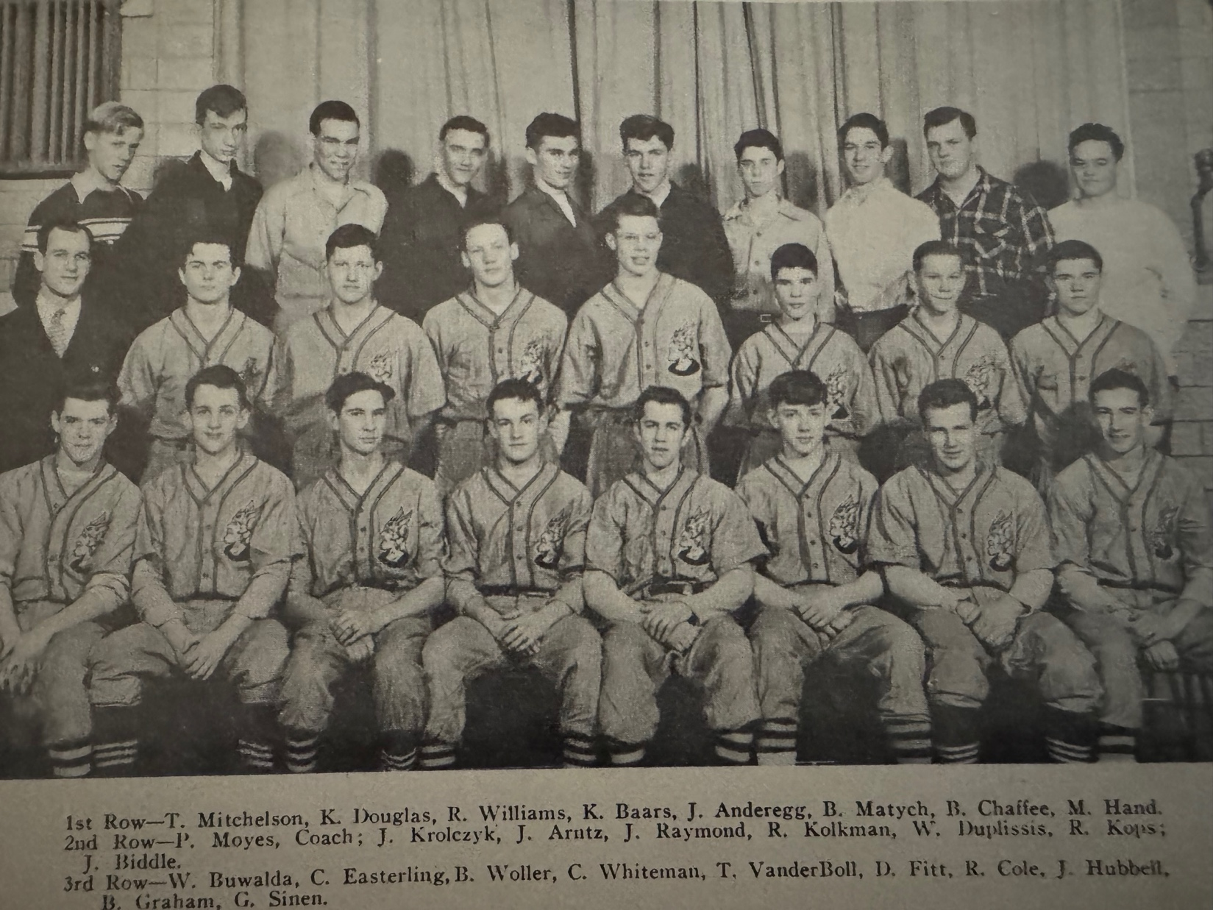
NM BASEBALL TEAM OF 1948

1949 – coach Paul Moyes (8-5 overall; 8-2 in WMC; Co-WMC Champs w Scottville)
The Norse would have one of their most successful WMC runs in the school’s history beginning with the 1949 season. NM would win the first of their five consecutive conference championships. The Norse pitching staff of sophomore John Arntz, junior John Biddle and senior Ron Kolkman would team up to shutout the opposition in five of the team’s 13 games. Three of those shutouts would be two-hit gems from the flame-throwing Arntz. Not even during the current era, when a 30-game schedule is the norm, would a Norse pitching staff match this extraordinary achievement – until 2007 when the pitching staff tossed six shutouts. However, three of those 2007 shutouts came in games of less than 5 innings against very weak opponents. Norse mounds men got plenty of hitting support during their 8-5 season from Ron Commons, Bill Woller, Monty Hand, Tom Mitchelson, Jack Krolczyk, Bill Duplissis and Don Schuiteman. Ron Kolkman, a future general manager in AAA baseball, tossed the first of the three consecutive shutouts to begin the 1949 season with a 3-hit 5-0 whitewash of Hart. NM continued their pitching prowess in the second game of the season when Arntz hurled the first of his two-hit shutouts against Shelby. Ron Commons was a perfect 4-4 at the plate while ‘Big John’ helped his own cause with an RBI double. John Biddle one-upped Arntz in the next NM game as he threw a one-hit shutout as Bill Woller delivered a pair of triples while Duplissis also had a 3-bagger and Mitchelson and Krolczyk each had two hits in NM’s 7-0 shutout of Montague. The shutout string of three games came to a resounding halt in the season’s fourth game as NM errors and nine walks led to a 13-2 thumping at the hands of a very good Muskegon Heights team. Each team had six hits with Woller getting half of NM’s hits that included a pair of doubles. The Norse recovered to edge Hart 8-6 with Biddle getting the win. Mitchelson and Bud Matych each had a pair of hits for NM. Arntz, with some lusty hitting from Don Schuiteman and Ron Commons, who both hit triples, had no trouble in their 9-2 WMC win over Shelby as a record-breaking heat wave was enjoyed in the Muskegon area. Errors played a role as the Norse gave up three unearned runs in the fifth inning in a 6-2 loss to Class A Muskegon. Arntz hurled the fourth shutout of the season in the 10-0 win over Whitehall by allowing but two singles. Bill Woller and Ron Commons had a pair of hits while Duplissis lashed a triple. Montague handed the Norse their first defeat in WMC action with a narrow 5-4 victory. The Wildcats scored two runs in their half of the sixth and then held off the Norse. The last defeat in an 8-2 conference record would be at the hands of Scottville in the second game of a doubleheader. It would be the last time the Norse would taste defeat in the conference over the next 21 games. NM won the first game of the doubleheader that clinched the WMC title as Arntz pitched a 2-hit gem. The big guns for the Norse offensively were Monty Hand, Tom Mitchelson and Bill Duplissis with two hits each. The Norse lost 7-2 in the nightcap. The game was called due to darkness with Scottville in the lead. In a near duplicate of their earlier 10-0 win over Whitehall, John Arntz again held Whitehall to 2-hits as the Norse posted their fifth shutout of the season with a 11-0 conquest of the Vikings. Monty Hand led the strong Norse offense with three hits, including a triple. With their 8-2 conference record, the Norse would share the WMC title with Scottville.

:

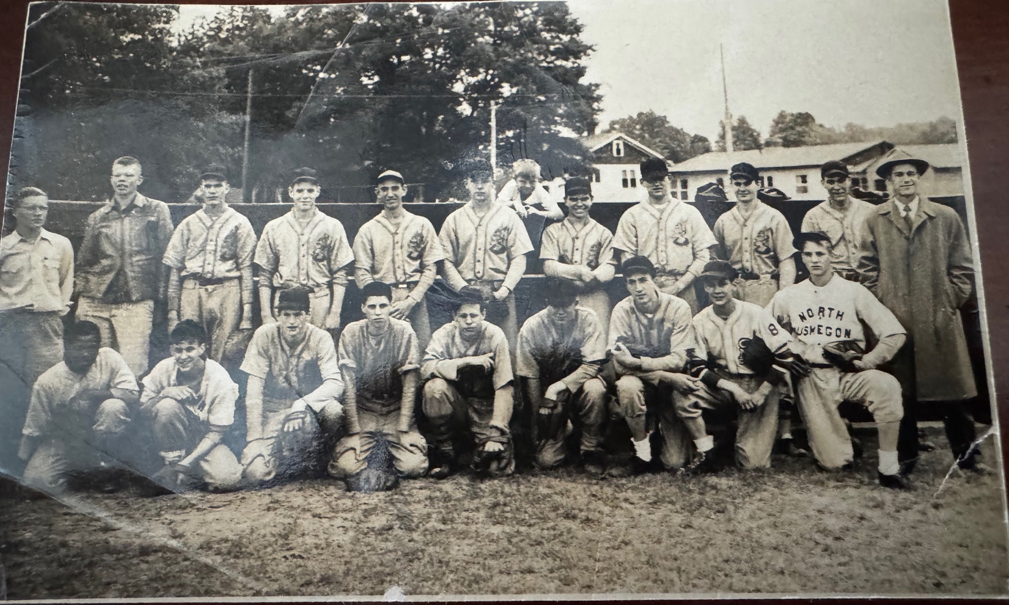

THE 1949 NORSEMEN

Top Row: L-R Sherman Cone, Ron Kolkman, Bill Duplissis, Tom Mitchelson, Monte Hand, Bud Matych, Ron Commons, John Arntz, Jack Krolczyk, Bill Woller, coach Paul Moyes
1st Row: Art Turner, Jack DeWald, John Dykhouse, Ray Cole, D. Guerne, Don Schuiteman, Claude Easterling, Wayne Sheffler, Paul Bos
On the dugout: Jim Moyes (Batboy)

Record Score Interesting Fact
1-0 *NM 5, Hart 0 Ron Kolkman 3-hitter, Bill Woller, Bud Matych 2 hits
2-0 *NM 5, Shelby 0 John Arntz 2-hitter, double, 12 K’s; Ron Commons 4 hits, HR
3-0 *NM 7, Montague 0 John Biddle 1-hitter; Woller 2 triples, Bill Duplissis triple
3-1 Musk. Hts. 13, NM 2 Woller 3 hits, including 2 doubles
4-1 *NM 8, Hart 6 Bud Matych, Tom Mitchelson 2 hits
5-1 *NM 9, Shelby 2 Arntz 9 K’s; Commons, Don Schuiteman triple, Ken Douglas double
5-2 Muskegon 6, NM 2 Biddle losing pitcher as NM commits 3 errors
6-2 *NM 10, Whitehall 0 Arntz 2-hitter; Duplissis triple, Hand 3 hits including a triple; Waller,Commons two hits
6-3 *Montague 5, NM 4 Jack Krolczyk double as Montague hands NM their first loss in WMC conference action.
7-3 *NM 8, Scottville 1 Arntz wins with a 2 hitter, Hand, Mitchelson & Duplissis 2 hits
7-4 *Scottville 7, NM 2 NM pitchers allow only 3 hits but pitchers wild. Game called after 5 (Darkness)
8-4 *NM 11, Whitehall 0 Arntz 2-hitter; Monty Hand 3 hits, including a triple
8-5 Musk.Hts. 8, NM 1 Heights only loses 2 games all season.

1950 – coach Paul Moyes (9-4 overall; 9-0 in WMC; WMC Champs)
Although a 9-4 season record may not look that impressive on paper, the 1950 Norsemen baseball team would rank with some of the best NM squads. Coach Paul Moyes’ nine dropped a pair of hard-fought games to Muskegon and Muskegon Heights after sweeping all comers in the WMC. John Arntz fanned 10 Heights hitters in a 3-1 loss and dropped a three-hitter in a 5-2 loss to Muskegon in the first game of the season between the two schools. In the first Muskegon contest both NM ace pitchers Biddle and Arntz worked for the Norse but faulty fielding by NM led to all five Muskegon runs being unearned. Game No. 2 vs. the Big Reds was lost by the narrowest of margins 8-7. The Norse could not protect a 7-6 lead going into the seventh as the Big Reds scored once to send the game into only the second extra inning affair in NM history. The Norse were unable to score off Big Red reliever Jim Mitchell during his four innings of work. The undefeated Big Reds won the game with one out in the ninth on a squeeze bunt by Big Red shortstop and Greater Muskegon legend Earl Morrall. Morrall would have an incredible NFL career, including an MVP season in 1969 while with the Baltimore Colts. Senior hurler John Biddle posted two shutouts while allowing opponents only two hits in three of his wins. Early in the season the Norse gave Muskegon Heights a real scare in their tight 3-1 loss to the Tigers. John Arntz fanned 10 Tiger batters, but his teammates were only able to garner two hits and scored their lone run on a bases loaded walk to Charlie Whiteman. Only the Heights was able to touch up an outstanding NM pitching staff for more than eight runs in a game. NM tore through their 1950 WMC schedule undefeated with the first of their nine straight wins coming in their season opener, a 10-1 thrashing of Shelby behind the pitching of senior John Biddle. John came right back later in the week to shutout Whitehall 7-0 on four hits, with Bob England pitching the final two frames for the victors. NM then made it three straight wins in the WMC with a 9-3 victory over Hart. John Arntz scattered four hits and received some lusty hitting support from Claude Easterling, Monte Hand, Bill Woller and Bill Duplissis. After cold weather had postponed three earlier scheduled games with Montague, the two teams finally met with temperatures in the balmy seventies. John Biddle was again stellar on the mound giving up but one run and four hits in the 5-1 Norse victory. Three of NM’s hits went for extra bases with the big blow being a 2 RBI triple by Duplissis. Ron Commons included a double among his two hits while Bill Woller also tagged Wildcat pitching for a two-bagger. The following day the Norse traveled to Shelby where Bob England got his first start of the season and was the winning pitcher in a game called after the fifth inning with NM the victor due to rain 7-4. Later that evening winds clocked as high as 80MPH were reported in the Muskegon area and temperatures that were in the high seventies took a sharp nosedive. The Norse bounced back following their heartbreaking defeat at the hands of a powerhouse Muskegon Big Red nine to defeat Hart 8-5. John Arntz was not at his sharpest but had enough backing from his Norse batsman to earn the win. Commons, Hand, and Easterling all had a pair of hits for the winners while Arntz helped his own cause with a double. Bill Duplissis, the big NM hitter throughout the season, banged out four hits that brought in three Norse runs as NM defeated Montague 6-1 behind the two-hit pitching by John Biddle to make it seven in a row in WMC action. Biddle then pitched a masterful two-hitter as NM clinched the WMC title with a 10-0 shutout over visiting Scottville. Biddle aided his own cause with a triple. Second baseman Gordy Munn added a pair of hits for NM while Woller slammed a home run and Duplissis drove in two runs as the Norse secured their 8th straight WMC victory. The Norse completed their sweep of WMC foes with a wild 13-7 victory over Whitehall. Each team’s pitching staff allowed 12 walks as NM overcame a six-run deficit to pull out the victory. Trailing 6-0 after two innings in the book, the Norse tallied eight runs in the third inning and never looked back. Biddle relieved John Arntz in the second frame as ‘Big John’ had a tough time finding the strike zone. With the game out of reach Ray Cole relieved Biddle to secure the victory. Duplissis was again the big gun for the Norse with a pair of hits including a home run. Muskegon Heights downed the Norse in the season’s finale 10-3 as a tired John Biddle went the entire distance for the depleted NM pitching staff. The Norse were limited to four hits with Duplissis getting two of the base knocks with Munn and John Dykhouse also getting a hit each.

Record Score Interesting Fact
1-0 *NM 10, Shelby 1 John Biddle 2-hitter, Ron Commons double
1-1 Musk. Hts. 3, NM 1 John Arntz 10 K’s, NM’s only score on a Charley Whiteman Walk
2-1 *NM 7, Whitehall 0 Biddle 4-hitter, 11 K’s, Claude Easterling 2 hits
2-2 Muskegon 5, NM 2 Arntz & Biddle combine on 4-hitter, 3 NM errors costly
3-2 *NM 9, Hart 3 Arntz 3-hitter; Bill Woller, Claude Easterling triple, Monty Hand 2 hits
4-2 *NM 5, Montague Bill Duplissis triple; Woller, Ron Commons 2 hits, Biddle 4 hitter
5-2 *NM 7, Shelby 4 Bob England winning pitcher, Duplissis key RBI
5-3 Muskegon 8, NM 7 Nine innings, Muskegon ties games in 7th, wins on squeeze by Earl Morrall
6-3 *NM 8, Hart 5 Commons, Hand & Easterling 2 hits, Arntz winning pitcher
7-3 *NM 6, Montague Biddle 2-hitter, double; Duplissis 4 hits, including triple
8-3 *NM 10, Scottville 0 Biddle 2-hitter; Woller HR, Gordy Munn 2 hits, Duplissis 2 RBI’s
9-3 *NM 13, Whitehall 7 Duplissis, 2 hits, HR, each team walks 12
9-4 Musk. Hts. 10, NM 3 Duplissis 2 of 4 NM hits, John Dykhouse, Munn each 1 hit

1951 – coach Paul Moyes (10-2 overall; 9-0 in WMC; WMC Champs)
Coach Paul Moyes, unable to continue his labor of love after the 1951 season due to a serious illness, would lead the Norse to another undefeated WMC season and an overall mark of 10-2. There were certainly no outcries of global warming in April of 1951 as NM’s first three games were postponed to later dates as the temperatures hovered near the freezing mark for much of the month. The temperatures had climbed into the mid 40s for the opening game blow out (15-2) of Whitehall that gave a quick glimpse of this team’s abilities. The Norse demonstrated power at the plate; (two triples and two doubles) strong pitching; (a one hitter by John Arntz) and flawless defense (no errors). Showing extra base power, the Norse received triples from Jerry Upman and Bill Duplissis, and doubles from Don Vento and freshman Tom Arntz. Both of NM’s losses were very competitive and came at the hands of a Muskegon powerhouse that would end the season undefeated and rated as the top team in the state. In the first encounter with Muskegon, the Norse gave freshman Tom Arntz, a future Norse multi-sport star, his first start behind the plate, as two NM regulars were unable to suit up. The Norse jumped to an early 3-0 lead with RBI base hits from Tom Arntz, Charlie Whiteman and John Dykhouse that accounted for the three NM tallies. However, the 1951 Big Red State champs took advantage of a brief wild streak from John Arntz who walked four batters and was not helped by a trio of critical errors that led to six Muskegon runs in the third inning. Muskegon would hand NM their first defeat 10-4 with the Arntz brothers contributing for five of the Norse nine hits. One of the leading hitters for the big Reds with a pair of hits was Lee David, who would coach NM in football and baseball in the 1960s. NM had very little time to lick their wounds as they would host a very good Montague team the very next day on the Northside diamond. Montague gave the Norse their closest scare in WMC conference action in 1951 as it took a Norse rally to pull out the win. The Arntz brothers contributed heavily to the win as John Arntz broke up a tie game in the sixth inning for the game winning RBI. Earlier John’s freshman brother Tom belted a first inning home run, the first of his two hits on the day. A record-breaking heat wave where the temps topped out at 85 degrees were welcomed by the fans and players as the Norse romped on the northside diamond 14-3 over Hart. Five NM players, Gordy Munn, Jerry Upman, Jack Dewald, Bill Duplissis and Arntz also helped his own cause as each had multiple hits for the Norse. With ideal temps still in the 80s NM continued their hitting onslaught the next day with a 13-2 rout of Shelby as Bill Duplissis cruised to the victory. Pint-size third sacker Don Vento showed he had plenty of pop in his bat as he drilled a home run for the winners as did Jack Dewald who also added a three-bagger and five RBI. Just two days later the Norse completed their sweep of Shelby with another double-digit victory. John Arntz pitched a complete game five-hitter and was backed up with hitting support from Dykhouse with three hits while Vento also rapped out a pair of safeties. NM took a short-lived lead in their second encounter with the 1951 eventual state champs from Muskegon but fell once again by the identical 10-4 loss they occurred in their first game earlier in the season to the powerful Big Reds. The Big Reds took the lead over the Norse with the big blow being a line drive double off the left field fence by Earl Morrall. Returning to action in WMC play, NM made short work of Whitehall as a big nine run outburst made it easy for John Arntz to record his fourth win in a 13-5 rout of the Vikings. NM made it two-straight over their closest competitor in conference play by posting a 7-1 victory over Montague with Duplissis tossing a slick two-hitter. WMC officials were so confident that NM would take care of the Scottville Spartans that they presented NM the WMC championship trophy at the official conference banquet, three days before the doubleheader. The Norse pummeled the host in the first game that proved the administrators’ prognostication were correct with a 22-3 whipping of Scottville. Duplissis had a day for the ages in the twin bill. In game one, Duplissis blasted five hits, including three doubles and a triple in a 22-3 rout of the Spartans. In the nightcap, Duplissis took to the mound and threw a one-hitter in shutting out the Spartans 8-0. A pair of NM’s all-time greats would end their four-year careers on a historical note. Bill Duplissis came on in relief of John Arntz to save the season-ending 8-6 victory over powerful Muskegon Heights, the first NM victory over Oakie Johnson’s Tigers in school history. Although he needed relief help from Duplissis to earn the win, it was John Arntz’s 3-run home run in the sixth inning that was the game winner for the Norse. This was no ordinary Muskegon Heights team that lost to NM. Earlier in the season the Tigers defeated Kalamazoo Central, who were rated the number one team in the state at the time. In their final game of the season the Heights tied Muskegon 5-5, the only blemish on the season for Muskegon who finished 13-0-and the unofficial state champs. With stalwarts such as Tom Arntz, John Dykhouse and Jack Dewall returning, 1952 looked promising as well.
According to Jim Moyes, North Muskegon baseball historian, the 1951 team would rank as the best in Norsemen history. No other team in NM history can boast of a wider margin of victory (10.7-4.25), an average of almost 6 ½ more runs than their opponents. The 10.7 run average is also the highest in school history (in a season with 10 or more games), and what is amazing about this number is that it came during the period of high-school baseball when wooden bats were used. In his all-too-short coaching career at North Muskegon, coach Moyes’ clubs would win the WMC crown five times in his seven-year stint, posting half of the conference titles earned in the 90 years of NM baseball. The Class of 1951 would go down in the long history of NM sports as one of the most talented in history. The Norse were conference champs in all four major sports (football, basketball, baseball and track) and if the conference would have had a full slate of schools participating in golf, the Norse golfers would have won that title as well.

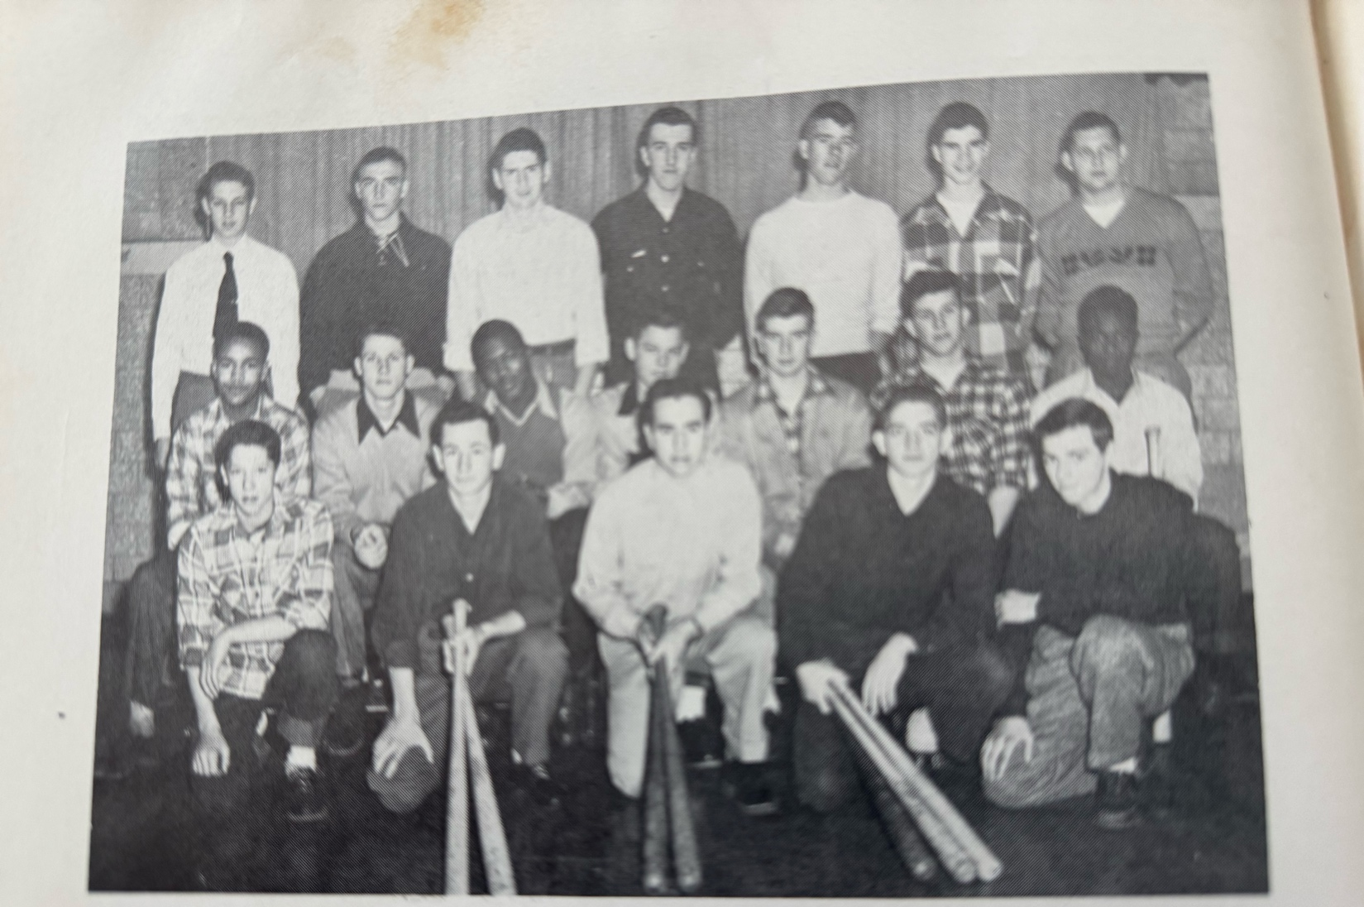

1951 NORSEMEN BASEBALL WMC CHAMPS

1st Row L-R: Gordy Munn, Jack Striegle, Don Vento, Ron Dykman, Emil Pinter
Middle Row L-R: Charles Jones, Harvey Fohlbrook, Earle Edwards, Tom Arntz, Don Schuiteman, Jack Dewald, Art Turner
Top Row L-R: Ron Stevens, Charlie Whiteman, John Dykhouse, Jerry Dekker, Jerry Upman, Bill Duplissis, John Arntz

Record Score Interesting Fact
1-0 *NM 15, Whitehall 2 John Arntz 1-hitter; Bill Duplissis, Jerry Upman triples, Don Vento & Tom Arntz doubles
1-1 Muskegon 10, NM 4 J. Arntz 3 hits; freshman Tom Arntz 2 hits), Harvey Fohlbrook 2 hits
2-1 *NM 8, Montague 7 T. Arntz 2 hits, HR, J. Arntz GW RBI, Upman 2 hits
3-1 *NM 14, Hart 3 J Arntz two hitter & 2 hits, Jack Dewald, Munn, Upman & Duplissis 2 hits
4-1 *NM 13, Shelby 2 Jack Dewall HR, triple, 5 RBI, Don Vento HR, Duplissis 5 hitter
5-1 *NM 12, Shelby 2 John Dykhouse 3 hits, including triple, J. Arntz 5 hitter
5-2 Muskegon 10, NM 4 Muskegon would be state champs, NFL MVP Earl Morrall 2 hits
6-2 *NM 13, Whitehall 5 NM scores 9 runs in fifth, Arntz winning pitcher
7-2 *NM 7, Montague 1 Duplissis 2-hitter, Arntz 2 hits (triple), Don Schuiteman, Munn, Upman 2 hits
8-2 *NM 22, Scottville 3 Duplissis 5 hits, including triple and 3 doubles
9-2 *NM 8, Scottville 0 Duplissis 1-hitter; NM WMC win streak at 18
10-2 NM 8, Musk. Hts. 6 J. Arntz 3-run HR in 6th inning; Duplissis save; 1st win vs. Heights

1952 – coach Arnold Wilson (10-2 overall; 9-1 in WMC; WMC Champs)
Arnold Wilson, in his only season as the North Muskegon baseball coach, inherited a veteran team as well as some talented freshmen. Seven lettermen from the 1951 powerhouse team would insure another very successful season. Three freshmen would also see considerable action for the 1952 Norsemen: first baseman Dave Bliss, outfielder/pitcher Gordy Odell and pitcher Dick Schuiteman. Outfielders John Dykhouse, Curtis Jones, and Harvey Fohlbrook, infielders Don Schuiteman, Art Turner and Gordy Munn, sophomore catcher Tom Arntz along with pitcher Scott Moore all saw action in 1951. On their way to a fourth consecutive WMC title, the Norse extended their undefeated streak in the conference to 23 straight wins before falling 4-3 to Montague in the fifth WMC game of the season. NM captured their 20th straight WMC contest with a solid 8-1 triumph over Shelby to open the 1952 season. Sophomore Scott Moore picked up the win and was aided with some robust hitting from Gordy Munn with three hits, Don Schuiteman whacked a homer and a single while John Dykhouse also aided in the victory with a pair of safeties. A pair of freshman hurlers, Dick Schuiteman and Gordy Odell gave up nine runs, but their teammates scored 12 runs as NM extended their winning streak to 20 games in conference play with a win over Whitehall. Curtis Jones had his biggest game as a Norsemen with a home run, triple and a single to pace the Norse offense. The Norse needed a run in the bottom of the seventh inning to procure a tough 6-5 victory over Hart. Gordy Odell came on in relief in the bottom of the seventh to stop Hart from scoring and received credit for the win. Tom Arntz led Norse batsmen with three hits, including a double and triple and scored the game winning run when John Dykhouse fielder’s choice was tossed over the first baseman’s head. NM’s incredible WMC winning streak finally came to an end but only by the narrowest of margins as Montague nipped the Norse 4-3. The one-run loss to the Wildcats would be the lone conference defeat tasted by the Norse over a three-year period. NM was so dominant from 1950 through 1953 that they would go on a streak during this era where they posted a record of 32-1 vs. their conference opponents. Montague, behind the pitching of future Montague head baseball coach Charlie Mikkelson, had a three run fourth inning and then held off a Norse rally to edge the Norse 4-3. Trailing by two runs entering the bottom of the seventh inning, the Norse received a pair of hits from Art Turner and Curtis Jones, but Mikkelson fanned the next two hitters to snap NM’s WMC game winning streak at 23, a record that still stands more than 70 years later. A new pitching star emerged for the Norse in their very next game following the heartbreaking loss to Montague in freshman Dick Schuiteman. In his first start as a Norsemen Schuiteman, whose son David possesses the NM school record in the two-mile run, spun a sparkling two-hitter in a 11-0 win over Shelby. Schuiteman got all the runs he would need as Norse leadoff hitter Gordy Munn opened the game with a home run. Muskegon then made the Norse their 21st straight victim as hard throwing Chuck Dobberstein limited the Norse to but three hits. It would be the second, and last loss the Norse would suffer during the 1952 campaign. Coach Wilson then sent Schuiteman back to the mound two days after the loss to the defending State Class A champs and the freshman came through by holding Hart to four hits in a 5-2 victory over Hart. NM broke up a 3-3 tie in the fourth inning with RBI singles by Art Turner and Curtis Jones. NM then defeated Whitehall 11-3 to set up a huge game the following week at Montague to decide the WMC championship. Scott Moore earned the victory for NM as Harvey Fohlbrook was the hitting star for the Norse with four hits in four at bats. The stage was now set for a West Michigan Conference showdown between Montague and NM. The day before the highly anticipated matchup the Montague squad was featured with a couple of photos in the May 12, 1952, edition of the Muskegon Chronicle. The Norsemen took little time in spoiling the Wildcat’s hopes of putting a halt to the current Norse dynasty when they quickly jumped out to an early lead by scoring five runs in their first at bats off Montague’s ace hurler Charlie Mikkelson. The fired-up Norsemen then bunched together a pair of runs in the third and fourth innings to post an insurmountable 9-0 lead over the host Wildcats. Gordy Munn, Art Turner and Tom Arntz all had big hits in NM’s big first inning and then it was freshman pitcher Dick Schuiteman who limited Montague to but five hits while his NM defense had but one error during the contest. Schuiteman allowed but one extra base hit in the contest, a double by Harold Flagstead as NM won 10-4. Although guaranteed at least a tie in the West Michigan Conference, the Norse still needed a victory in their final league game at Scottville to claim their fourth straight WMC title. No Problem. Again, the Norse struck early and Jones, Turner and Arntz contributed to three first inning runs as the Norse cruised to an 10-4 win behind the pitching of southpaw pitcher Scott Moore. The Norse had to wait nearly two weeks before they could conclude their highly successful season against a very good Muskegon Heights team. It was well worth the wait as NM for the second straight season concluded their year with a victory over the Heights. Shutting out a vaunted Heights team was Dick Schuiteman. By shutting out the Tigers on but two hits, the 15-year-old posted the finest season ever posted by a freshman pitcher by winning five of the Norsemen’s 10 wins and posting an ERA of but 1.51. Posting big hits in the Norse 3-0 victory were Harvey Fohlbrook, Tom Arntz, John Dykhouse, and Curtis Jones while Dick’s older brother Don Schuiteman scored two of NM’s three runs in the contest.

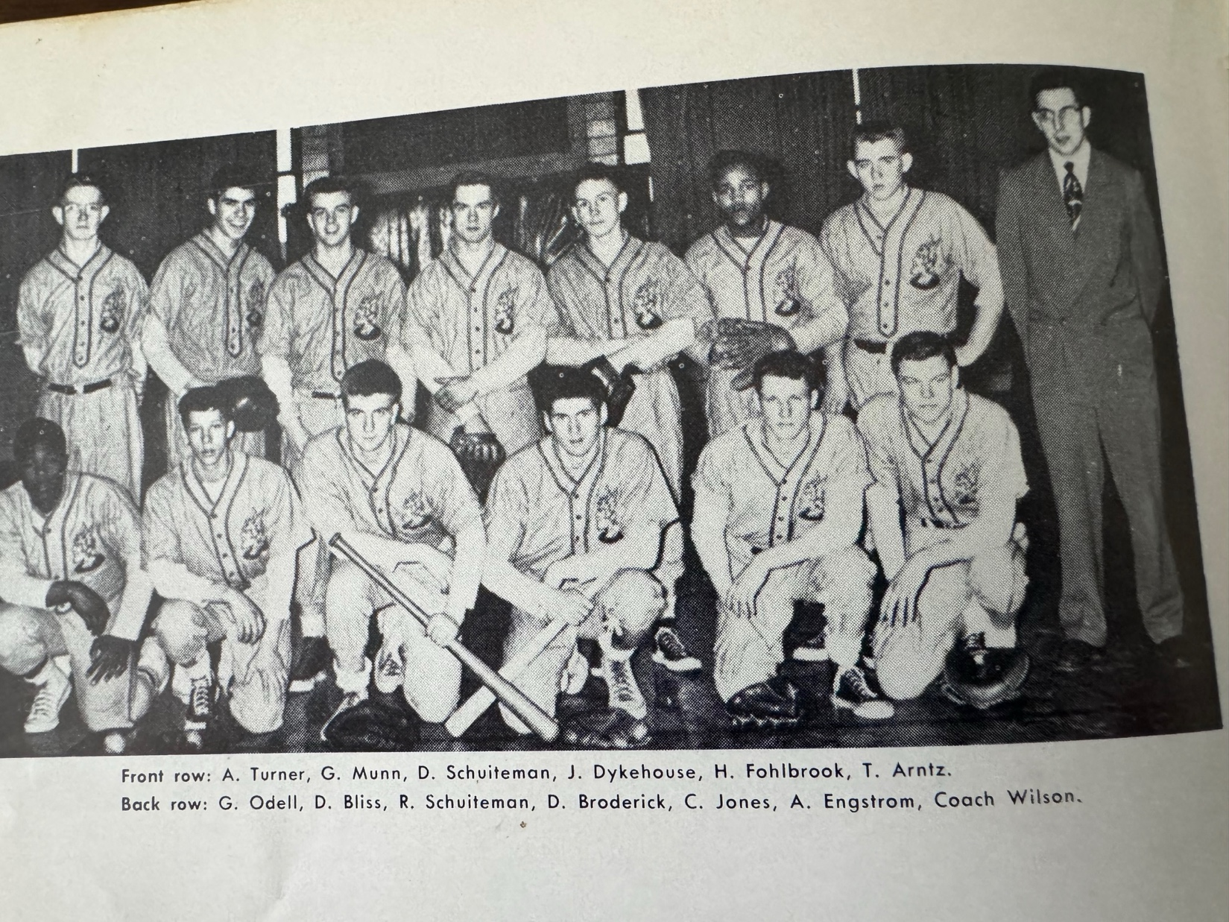

THE 1952 NORSEMEN – WMC CHAMPS

1st Row L-R: Art Turner, Gordon Munn, Don Schuiteman, John Dykhouse, Harvey Fohlbrook, Tom Arntz
Standing L-R: Gordy Odell, Dave Bliss, Dick Schuiteman, Scott Moore, Dale Broderick, Curtis Jones, Alan Engstrom, Coach Arnold Wilson

Record Score Interesting Fact
1-0 *NM 8, Shelby 1 Don Schuiteman 2 hits (HR) John Dykhouse 2 hits (double)
2-0 *NM 12, Whitehall 9 WMC win streak hits 20, Curtis Jones 3 hits (HR, 3B, 1B)
3-0 *NM 5, Scottville 2 No report in MC
4-0 *NM 6, Hart 5 Hart SS throws DP ball into Bear Lake, Arntz 3 hits (3B,2B,1B), Odell gets save in relief of Scott Moore
4-1 *Montague 4, NM Charlie Mikkelson, longtime Montague coach, beats NM
5-1 *NM 11, Shelby 0 Dick Schuiteman 2-hitter, Gordy Munn lead-off HR
5-2 Muskegon 16, NM 3 Future Minor Leaguer Chuck Dobberstein limits NM to 3 hits
6-2 *NM 5, Hart 2 Schuiteman 4 hitter, Art Turner & Jones RBI singles
7-2 *NM 11, Whitehall 3 Scott Moore 4 hitter, Harvey Fohlbrook 4 hits
8-2 *NM 10, Montague 4 Schuiteman 5 hitter, NM scores 5 in 1st, key singles by Munn, Turner & Arntz
9-2 *NM 10, Scottville 4 Clinch WMC title. Moore 3 hitter as NM scores first 9 runs
10-2 NM 3, Musk. Hts. 0 Schuiteman 2-hitter, Arntz key RBI double

1953 – coach Dunc Lectka (6-1 overall; 6-1 in WMC; WMC Champs)
Although North Muskegon administrators perhaps hired new head baseball coach Dunc Lectka as a football coach first and baseball second, it was the sport of baseball that Lectka clearly had his most passion. The former all-around star athlete from Cadillac High School spent one year in the Detroit Tigers minor league system with Fulton of the Kitty League in 1941. As with most athletes from this generation, World War II cut his dreams for a major-league career short. The 1953 baseball season easily qualifies has the most abysmal as far as weather conditions are concerned. The inclement weather saw the Muskegon area receive rain in 27 of 33 days and forced the Norsemen to cancel their entire slate of games scheduled for the month of April. It was not until the first week of May were the Norse able to begin play for the year. When they were able to finally begin their season Coach Lectka’s nine got off to a great start by winning their first four games, as the Norse would capture the WMC conference championship for the fifth straight year. The first two wins remain a mystery as there were no results filed in our local paper for wins early in the season vs. Hart and Scottville. The first result posted was NM’s 6-2 victory over Whitehall with sophomore ace Dick Schuiteman earning the win. Getting base hits for the Norse were freshman Ron Simonelli, juniors Leonard Green, Tom Arntz, and Walt Busker, senior Curtis Jones and Schuiteman. The Norse quickly proved that a season with a schedule of more than a measly seven games would have meant many more NM wins for this talented team in 1953 following a 17-0 stomping of Hart. Scott Moore allowed the host Pirates but one hit before giving way to Dave Bliss to finish off the Pirates in the final inning. Moore was also dangerous at the plate as he was a perfect 3-3 against the struggling Pirate pitching staff. Bliss, the smooth fielding NM first basemen, also had a fine day at the plate with a single and a triple while catcher Tom Arntz, just two days after he placed first in the WMC championship track meet in the high jump, also had a double and a single as the Norse pounded out 16 hits. The following day the Norse had a rare subpar day in an away game played under the lights at Whitehall as they suffered their only loss during the 1953 season. The usually sure handed Norsemen committed six errors as sophomore pitching ace Dick Schuiteman would lose his only game in his first two years on the hill. The Norse had twice as many hits as the Vikings, but errors played a major role in the defeat as Schuiteman allowed but three hits during the game, two of those being RBI hits by Whitehall’s Jim Lorenz. In one of the most improbable comebacks in NM history, the Norse rallied from being down 3-0 with two outs in their half of the seventh inning to score four runs to edge host Montague in a game that helped lift NM to another WMC title. With one out pinch hitter Chuck Houts doubled. After the next batter fanned and there was two outs Ron Simonelli lifted a short fly ball into short left field that was dropped by the shortstop. Dave Bliss and Curtis Jones then drew walks and Leonard Green, who came on in relief of starting pitcher Scott Moore in the sixth inning, helped his own cause with a clutch double that tied up the game. With Tom Arntz at the plate the Montague pitcher committed a balk and Jones trotted home for what proved to be the winning run. The Norse turned right around two days later and won another one run battle with Montague to clinch yet another WMC title. Leonard Green was the hitting star for the Norse and figured in both of NM’s runs in the 2-1 victory. Green tripled and scored on a fielder’s choice in the sixth inning for what would prove to be the winning run. Earlier Green doubled in the fourth inning and scored the first of but two NM’s runs on a fielding error. Dick Schuiteman went the distance to earn the win. NM would cap their great run from 1950 through 1953 with an enviable record in the WMC of 34-2 against conference opponents. The 1953 Norse featured the lively young arms of juniors Leonard Green, Scott Moore and Schuiteman on the hill. Junior catcher Tom Arntz was joined by a flock of five underclassmen who would provide the core for NM baseball over the next two seasons. Sophomores Gordy Odell, Dave Bliss, and Jack Mavis along with freshman Ron Simonelli would join Schuiteman in the starting lineup through 1955.

Record Score Interesting Fact
1-0 *NM 9, Hart 2 No report in MC
2-0 *NM win, Scottville loss No report in MC
3-0 *NM 6, Whitehall 2 Dick Schuiteman 5 hitter, Leonard Green 2 hits (triple)
4-0 *NM 17, Hart 0 Scott Moore & Dave Bliss combine for shutout-Bliss, Tom Arntz 2 hits
4-1 *Whitehall 7, NM 5 NM commits 6 errors in night game @ Whitehall, Schuiteman 5 hitter
5-1 *NM 4, Montague 3 NM scores 4 runs in top of 7th after 2 out for win. NM’s 4th run scores on a balk
6-1 *NM 2, Montague 1 Schuiteman gives up 1 un-earned run. Green 3b,2b.

1954 – coach Dunc Lectka (7-3 overall; 5-3 in WMC; 2nd place in WMC; Scottville Champs)
The Norse relinquished their stranglehold on taking the West Michigan Conference Championships as they placed second to WMC champ Scottville. Leonard Green (7-1) was the ace of the staff by winning all seven NM wins on the season. Two of Green’s victories were shutouts, including a 16-strikeout performance in an 8-0 Norse victory over Montague. Green finished the season with a stellar low ERA of 1.54. Pitching (that is Green) was a strongpoint for Dunc Lectka’s nine as no opponent was able to score in double digits. All three of NM’s losses came against WMC foes as the Norse struggled with their hitting. The non-conference victories in the season were against Lectka’s previous coaching post, Sparta, and a rare 10-9 decision over perennial power Grand Haven. The Norse kicked off their 1954 season with a 2-1 road win against Sparta as Leonard Green pitched a one hitter, a scratch infield single. Green also helped his own cause with an RBI single as well as scoring the game winning run in the sixth inning when, after he earned a walk, stole second and then scored on a Leonard Plank double. His RBI single in the opening inning drove home four-year starter Tom Arntz who had doubled. The two teams were fortunate to even play the game as the following day heavy rains caused a nearby creek to overflow and totally inundate Sparta’s baseball field. Whitehall pitching ace Ron White shut out NM in the first conference game on the season as White struck out 14 and walked only one Norseman in the Vikings 3-0 win. Green pitched well for the Norse as he gave up but 4 hits as all three Vikings runs were unearned.

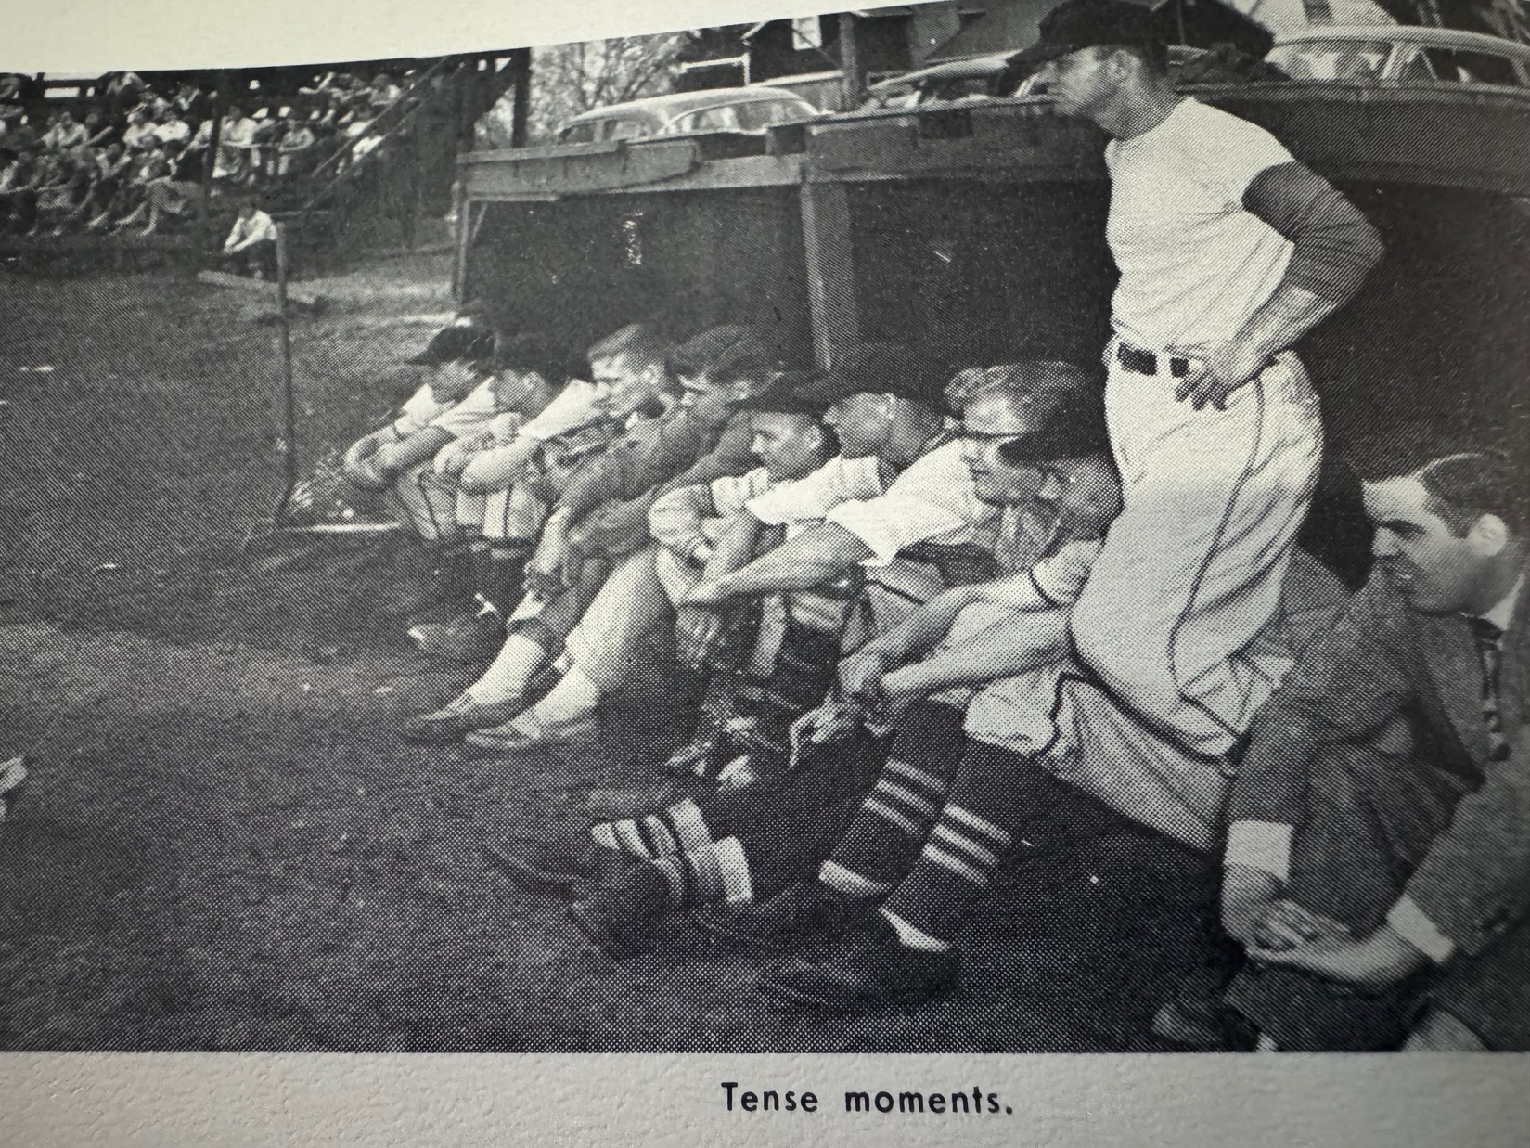
The Norse dugout during a game in 1954 with Coach Lectka standing with Bob Dorsh in the suit next to Lectka. Notice the old bleachers off to the left that were in use for many years.

Green pitched a gem as he shut out Montague 2-0 in the third game of the season. Dick Schuiteman’s single drove in Jack Mavis for the first NM run while Leonard Plank accounted for the other NM tally with a solo home run. The Norse then played a pivotal double header two days later, but after winning the opener 11-5, Scottville won the second game of the twin bill despite some NM heroics from Green and Gordy Odell. Green came on in relief in the third inning with but one day’s rest to earn the win and preserve the Norse victory. Odell had three hits in the opener while Green blasted a home run. Also getting clean shots for NM were Tracy Prins, Dick Schuiteman, Jack Mavis and Chuck Houts. Scottville took advantage of a Norse miscue in the fifth inning of the nightcap as the Spartans scored five runs in a 6-3 victory over the Norse. Although he was the losing pitcher in game two, Odell continued his hot hitting with two more hits to give him five hits in the DH good for five RBIs. NM bats fell silent in their next encounter as they were only able to get a double from Odell and a single from Plank as they fell to Hart 7-1 on a very cold afternoon on the Northside diamond. The Norse found their once lost hitting skills as they earned a wild 10-9 road victory over Grand Haven. Leonard Green came on in relief in the third inning and held off the Bucs for his 4th win of the season as well as the team’s fourth. Chuck Houts hit a pair of doubles for the Norse while Odell chipped in with a pair of hits as the Norse banged out 12 hits. NM won the second game of the two-game series 4-2 against Whitehall as Leonard Green went the distance to earn his fifth win of the season. NM scored all four of their runs in the fourth inning against Viking pitcher Jim Stone before Ron White came on to stop the bleeding. Getting base hits in the big inning for the Norse were singles by Ron Simonelli and Dave Bliss and doubles from Walt Busker and Tom Arntz. With Dick Schuiteman relegated to only outfield duties due to a sore arm, Leonard Green performed yeoman duty for the 1954 Norsemen and was spectacular once again as he struck out 16 hitters and granted but two hits in a 7-0 shutout over Montague. Green was so dominant that at one point he struck out eight batters in a row at one stretch. NM bunched six of their seven runs in the fourth inning with Schuiteman driving in two runs with a single and received RBI doubles from Tom Arntz and Tom Stribley. Although he seldom pitched during the season, Schuiteman showed all that he was no slouch at the plate as he also had a double and a triple to go along with his single. Ron Simonelli also added a pair of hits for the victorious Norse while Dave Bliss swatted a three-bagger. NM and Green finished the season strong by winning their final four games, including the last game of the season, a 6-2 triumph over Hart. NM took advantage of a generous Pirate pitcher as they received eleven walks during the game. The three top players on the NM team, seniors Green and Arntz and junior Gordy Odell had all three of the NM hits in the game. NM’s season ending victory over Hart marked the end of a great all-around career for catcher Tom Arntz. Arntz earned four letters in baseball and track three in football and basketball. Arntz won 14 letters over his career, the most letters earned by any single athlete in NM history. So versatile was the 6-3 Arntz that he captured the conference championship in the high jump in both his junior and senior years while also performing the catching duties for four years for NM baseball. Arntz wasn’t the only Norsemen to earn a letter in track as their ace pitcher Green also lettered.

Record Score Interesting Fact
1-0 NM 2, Sparta 1 Leonard Green one hitter; Tom Arntz RBI double
1-1 *Whitehall 3, NM 0 Green 4-hitter in loss
2-1 *NM 2, Montague 0 Green 3-hitter
3-1 *NM 11, Scottville 5 Green win in relief; Gordy Odell 3 hits
3-2 *Scottville 6, NM 3 Odell has 5 hits in DH and 5 RBIs.
3-3 *Hart 7, NM 2 NM has only 2 hits, Odell (2B), Leonard Plank (1B)
4-3 NM 10, Grand Haven 9 Chuck Houts 2 doubles, Odell 2 hits
5-3 *NM 4, Whitehall 2 Green 6-hitter; Tom Arntz and Walt Busker doubles
63 *NM 7, Montague 0 Green 2-hitter, 16 K’s; Dick Schuiteman, Dave Bliss, Arntz triples
7-3 *NM 6, Hart 2 Green 4-hitter, Arntz 2 RBI 1B, Odell and Green base hits

1955 – coach Dunc Lectka (8-2 overall; 7-1 in WMC; WMC Champs)
The Norse returned to the top of the ladder in the WMC for the sixth time in the past seven years by posting a 7-1 record in conference action. Only defending champion Scottville was able to move into the winner’s circle vs. the Norse, but the Norsemen redeemed themselves by taking the nightcap of a doubleheader with the Spartans. The Norse received some lusty hitting from all-time NM great Gordy Odell. Odell, who was an All-State selection in basketball, set the table for a great season for the Blue & Gold by belting a grand slam home run in the season opening 7-6 win over Whitehall. Dick Schuiteman picked up the win and was aided by three hits off the bat of sophomore third baseman Pete Sheldon. The Norse won a pair of close games with Montague, the first a 4-3 victory over the Wildcats with the winning blow a two-RBI triple off the bat of Dick Schuiteman. The two- run 7th inning rally began with the Norse trailing 2-1. Jack Mavis opened the home seventh with a single. Pete Sheldon flied out, but Dave Bliss came through with a single to set up winning pitcher Schuiteman’s game winning three-bagger. In the third and fourth games of the 1955 season NM made the long jaunt up old US 31 for their annual double header with Scottville. Dick Schuiteman was off form in the first game as the Norse were shutout 7-0 as the visitors were only able to get two hits, both from Schuiteman. The Norse rallied behind the pitching of Dave Bliss and the lusty hitting from Odell to garner a split in the DH. Odell blasted a school record three doubles in NM’s 6-4 victory as a durable Tom Stribley caught both ends of the double header. Odell again flexed his muscles in the next NM game with a home run and a triple in a 6-1 victory over Hart. Schuiteman regained his form and tossed a three-hitter while fanning 12 Pirate batters. The Norse won a pivotal game against Whitehall by scoring all three of their runs in the third inning against Viking ace pitcher Ron White. Dick Schuiteman pitched a three-hitter to earn the win. The Norse began their third inning rally with a single by Jerry Bayne. After a force out from Pete Sheldon retired Bayne, Dave Bliss drew a walk and both Bayne and Bliss scored on a two RBI single by Gordy Odell. Schuiteman helped his own cause with a single. Odell came through in the clutch with a 2 RBI single for what proved to be the game winner while Schuiteman scored the final run on a passed ball. The following day the Norse played a game that they would have liked to have forgotten. Muskegon Heights, who won twelve straight victories in the season and were Southwest Conference Champs, took advantage of what perhaps might still be a Norse record for futility as they committed 13 errors on the rocky Norse infield in a 21-8 loss. The horrendous second inning that saw the Heights score 13 runs came on six hits, six walk, and five errors. Oddly enough, the Norse out hit the Tigers 13-12 with Ron Simonelli leading the NM batsmen with a double and a triple while Jack Mavis and Tom Stribley each notched a pair of safeties. With their ace hurler Dick Schuiteman on the mound the Norse clinched at least a tie in the WMC with a 6-4 victory against Montague. NM broke open a 1-1 ball game with five-runs in the fifth inning. Mickey Hinkin opened the inning with a single. A double by Jerry Bayne moved Hinkin to third who scored on base hit by Dave Bliss. Gordy Odell drove in two runs with a two-run RBI single, one of his three hits on the day for Odell. Odell scored the final run on an RBI force out grounder from Tom Stribley. A future long-time Orchard View baseball coach, Stribley closed the door on the WMC championship by clubbing a game-winning double in the pennant clinching 2-0 victory over Hart. Odell showed why he has been selected to the All-Time NM team when he gave Schuiteman a rest and tossed a shutout in the Conference clincher. Odell, after hitting a single, also scored one of the NM’s two runs that crossed the plate on Stribley’s clutch double. Dick Schuiteman then capped his sterling career by notching a school record-equaling 17 strikeouts in the season ending 5-0 shutout of Grand Haven. Tom Stribley, who caught every inning of every game in 1955 led the Norse hitting attack with three hits. 1955 would mark the end of the Golden Era for NM baseball. The Norse won six WMC conference titles in seven years, with only a second-place finish in 1954 stopping total NM dominance during this period. For the next 53 years, NM would only win the WMC title one more time (1972). Playing his last game for the Blue & Gold was Gordy Odell, surely one of the top athletes in NM history. A unanimous choice as an All-State basketball player, there would be little doubt that if there was an All-State team in baseball in 1955, then Odell would have made that team as well. Oh, how I wish I had Gordy’s batting average for 1955 as it surely would rank up there at the top of the listing in NM baseball history.

Record Score Interesting Fact
1-0 *NM 7, Whitehall 6 Gordy Odell GS, Pete Sheldon 3 hits. Schuiteman winning pitcher.
2-0 *NM 4, Montague 3 Schuiteman GW 2 run triple, winner, Simonelli, Chuck Houts 2hits
2-1 *Scottville 7, NM 0 Schuiteman’s only loss on season but has only NM hits (2)
3-1 *NM 6, Scottville 4 Odell 3 doubles, Dave Bliss winning pitcher
4-1 *NM 6, Hart 1 Odell HR, triple, Schuiteman 3 hitter 12 K’s, Schuiteman 2 singles
5-1 *NM 3, Whitehall 1 Schuiteman, 3 hitter 9 Ks. NM scores all 3 in 3rd, Odell 2 RBI single
5-2 Musk. Heights 21, NM 8 Ron Simonelli 3B, 2B, Jack Mavis & Tom Stribley 2 hits
6-2 NM 6, Montague 4 Odell 3 hits, 2 RBIs. Schuiteman 4 hitter, Dave Bliss RBI
7-2 *NM 2, Hart 0 Odell wins Stribley GW double drives home Odell & Simonelli
8-2 NM 5, Grand Haven 0 Schuiteman 17 K’s, Stribley 3 hits, Mike Hinkin 2 RBI single

The NORSEMEN of 1955

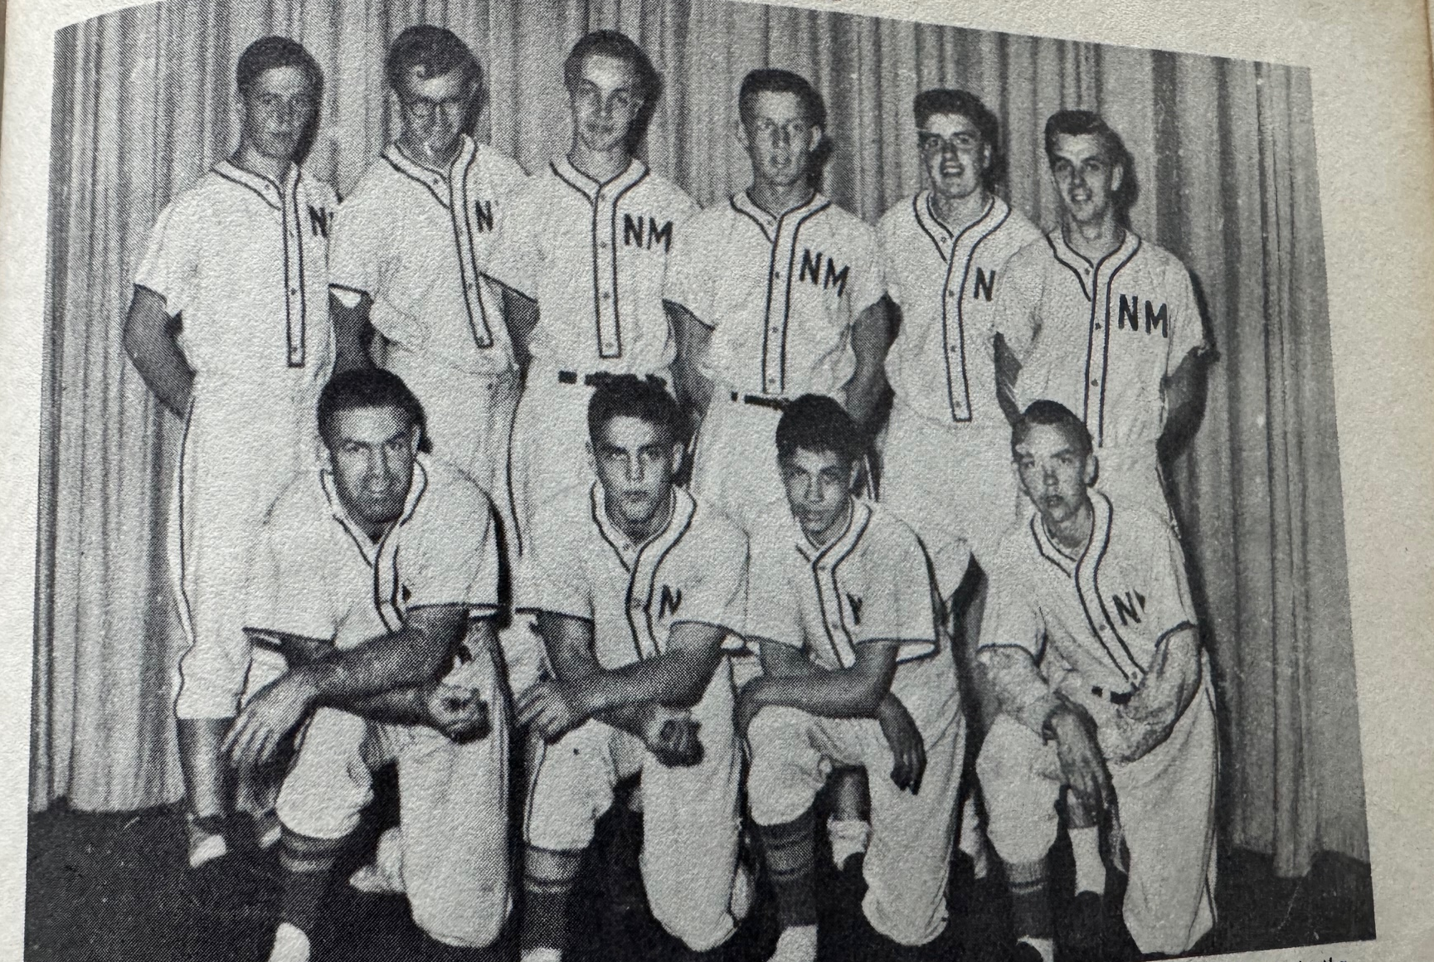

Back Row L-R: Tom Stribley, Gordon Odell, Jim Damm, Ron Simonelli, Tracy Prins, Dick Schuiteman
Front Row L-R: Coach Dunc Lectka, Chuck Houts, Pete Sheldon, Jack Mavis (Missing is 1B Dave Bliss)

1956 – coach Dunc Lectka (4-5 overall; 4-3 in WMC; xx place in WMC; Hart Champs)
The Norse failed to reach the .500 mark for only the second time in 20 years; however, the Norse were able to stay above the .500 mark in the WMC. It was a season that would have plenty of upsides for the Norse with a few truly unique performances. Shortstop Pete Sheldon pulled off a feat that will likely stand for the ages. On May 17, the future starting third sacker for the ‘Big Green’ of Dartmouth College of the Ivy League blasted two home runs against Scottville – in the same inning. One of Sheldon’s shots was a grand slam and the other a two-run dinger. The Norse got the 1956 season off on the wrong foot as they lost an error-filled game to Hart 12-8. NM committed three errors in the fifth inning leading to the Pirates scoring seven runs that led to the Norse loss. Jim Damm had a pair of hits for the losing Norsemen while the game marked the debut of freshman Jerry Johnson, who began his high school baseball career with a couple of RBIs. The Norse made it two losses in a row in WMC action as they dropped their next contest to Whitehall 6-3. The Norse averted a shutout as they scored three runs in their final at bat in the seventh inning that featured triples from Pete Sheldon and Joe Sienkiewicz. The Norse got back on the winning track when pitchers Ron Farmer and Ron Simonelli tossed consecutive shutouts. The 6’5 Farmer blanked Montague in the victory with hitting help from Jim Damm who collected three hits and Mike Hinkin added a double and a single as NM topped Montague 8-0. Simonelli later in the week tossed a three-hit shutout over Scottville 4-0 with Pete Sheldon bagging a pair of hits. The Norse dropped their second game of the season to Hart as a six run first inning uprising by the Pirates was too large for NM to overcome. Coach Lectka’s squad did rally to eventually tie the game at six runs apiece, but the Pirates took the lead in the seventh to edge the Norse 7-6. Pete Sheldon again led all Norse hitters with two hits, one of those hits a long triple. The Muskegon area had many of their games cancelled the following week. This author remembers taking refuge in our basement as heavy winds, tornado sightings, and hail, some as large as a baseball pummeled our area casing damage in the millions.
More than two weeks had elapsed between games before the Norse traveled to Scottville for a historic game on May 17, 1956, where Norse shortstop Pete Sheldon would accomplish a MHSAA first.
Here is Sheldon’s historic recap as posted in the May 18, 1956, edition of the Ludington Daily News: “Scottville and North Muskegon were locked in a close battle when Pete Sheldon hit a grand slam home run that paved the way for a 16-6 Norse victory here Thursday. Wayne Davidson had just come in to relieve Art Barton; the bases were loaded but Davidson fanned the first batter to face him. Then he tried to slip a fast ball past Sheldon who drilled it into right field for a home run. Before the inning was over Sheldon had hit two home runs, North Muskegon had batted around and scored 10 runs.”
Sheldon’s feat of two home runs in the same inning has been equaled many times over the years, but it was the only accomplishment during the wooden bat era. In fact, it would be 42 years before a Michigan high school prep would match Sheldon’s mark in 1998.
Ron Simonelli hurled 5 1/3 hitless ball before Whitehall was able to notch a hit off the veteran right hander. After losing an earlier game to the Vikings, the Norse routed Whitehall 15-1 in the second meeting between the two rivals. NM put up crooked numbers in the first and sixth innings with Mike Hinkin pacing the attack with two singles. Simonelli was helped by a sharp NM defense that turned 3 double plays in the game. Simonelli, on just one day’s rest, pitched a two-hitter against Grand Haven but an unearned run cost him and the Norse a 2-1 victory against Grand Haven. Simonelli did his best also in the hitting department with a double and a single in a losing cause.
In the next game, the Norse defense helped Norse pitching ace Ron Simonelli by turning three double plays in a 15-1 trouncing of Whitehall. The Norse pulled off a remarkable 11 double plays after just seven games were played. Simonelli pitched another gem, but in a Norse defeat suffered at the hands of Grand Haven. Simonelli, who would go on to play football at the University of Wyoming, gave up but two hits to the Bucs in a 2-1 losing cause. The Norse dropped their final game of the season to a very good Muskegon Heights team 6-1. Joe Sienkiewicz had a pair of hits for NM as they ended the season at 4-5. Muskegon Heights would finish the season with a 12-2 record and were led by a trio of players who also were standouts on the Heights 1956 state champion basketball team, Ron Robinson, Lloyd Swelnis and Osie McCarty.

Record Score Interesting Fact
0-1 *Hart 12, NM 8 Jim Damm 2 hits (triple) NM has 8 errors, Fr. Jerry Johnson 2 rbi
0-2 *Whitehall 6, NM 3 Pete Sheldon, Joe Sienkiewicz, triples
1-2 *NM 8, Montague 0 Ron Farmer 2 hitter, Damm 3 hits, Mike Hinkin 2 hits (2B)
2-2 *NM 4, Scottville 0 Ron Simonelli 3 hitter, Sheldon 2 hits
2-3 *Hart 7, NM 6 Sheldon 2 hits, triple
3-3 *NM 17, Scottville 6 Sheldon 2 HR in 1 inning (GS & 2-run)
4-3 *NM 15, Whitehall 1 NM turns 3 double plays, Simonelli 1 hitter, Hinkin 2 hits
4-4 Grand Haven 2, NM 1 Simonelli 2-hitter and has 2 hits including a double
4-5 Musk. Hts. 6, NM 1 Sienkiewicz 2 hits

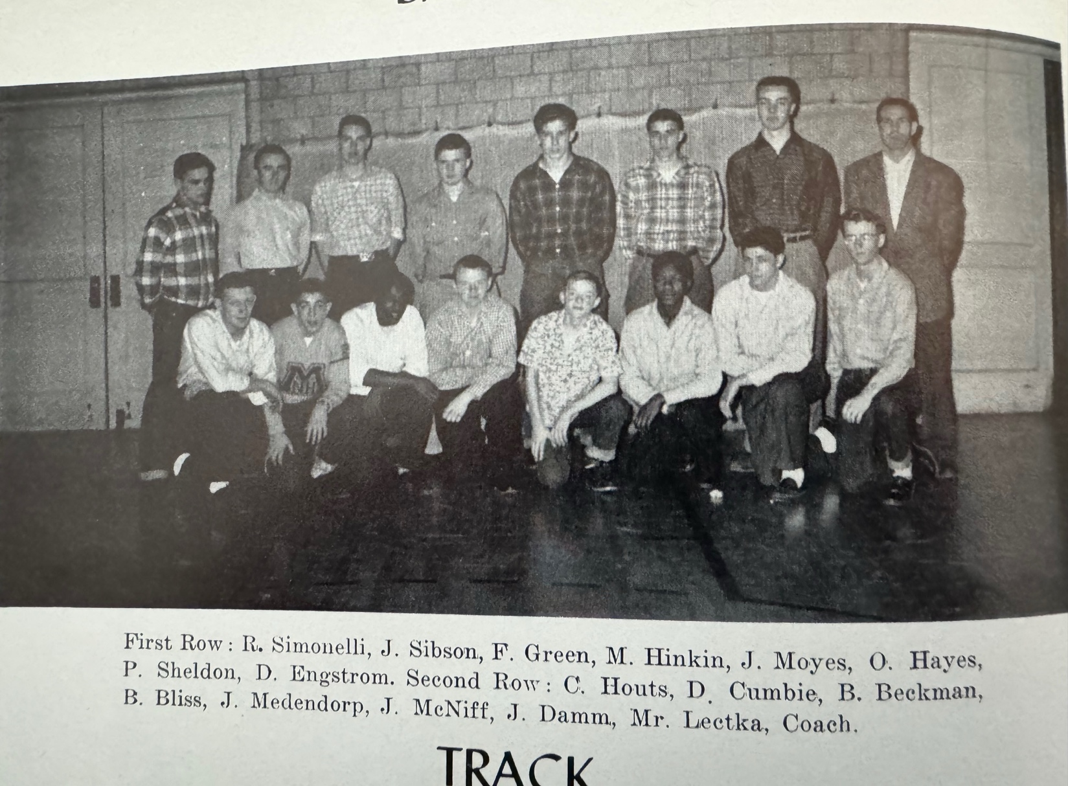

The 1956 NORSEMEN

1957 – coach Dunc Lectka (4-7 overall; 4-3 in WMC; xx place in WMC; Whitehall Champs)
The next two seasons would not be good ones for a Norse program that had experienced so much success in the first two decades at NMHS. NM would compile only a 4-7 record with two victories each over Montague and the Scottville Spartans. The 1957 Norsemen got off on the wrong foot in their season opener at Hart in a game played in sub-freezing temperatures. NM produced only three hits in the contest, including an RBI double from Mike Hinkin and an RBI single by Al Beauchamp as Hart defeated NM 5-2. In the first ever matchup between a pair of long-time rivals in both football and basketball Fremont managed but a pair of hits but thanks to some generous NM pitching Fremont was able to score ten runs in a 10-5 win over the Norse. Mike Hinkin started on the mound for NM but had to leave the game in the sixth inning after walking a batter to open the sixth inning due to an injured back. Hard throwing junior right hander Ron Farmer, who would eventually develop into a fine pitcher later in the season, was far off his game in relief and walked the first six batters he faced as the roof caved in on the Norse. The Packers would score six runs in the inning to pull away from a 4-4 tie. The 6-6 Farmer was certainly on his game in NM’s following contest as he one hit Scottville and struck out 15 in an 8-1 victory. Pete Sheldon again abused Scottville pitchers by crashing a homerun for the winners while Jim McNiff added a pair of singles. In a game filled with errors as NM and Hart combined for 17 errors, Hart defeated the Norse for the second time on the season with a 10-8 victory on the rocky Norse diamond. The lone extra base hit in the error filled contest was Sheldon’s double. Mike Hinkin was the tough luck loser as Whitehall edged the Norse 3-2. Hinkin went the distance in the loss and was the hitting leader for NM with a couple of hits including a double. The Vikings tallied twice in the bottom of the seventh for a walk off win. Fremont, behind the pitching by future Detroit Tiger farmhand Wayne Somers, shut out the Norse 5-0 in their second encounter of the season for the two teams. Somers outdueled Ron Farmer who gave up five runs and struck out seven in the loss. Farmer again had another fine outing with another 15-strikeout performance in a 4-2 victory over Montague. Farmer granted just two hits as the Norse made it a clean sweep on the season over Montague. Earlier NM won 6-4 but no story of that game was covered by the Muskegon Chronicle. Farmer developed a sore arm early in NM’s next contest with Grand Haven and had to give way to Hinkin in the first inning. The Buccaneers put the game away early with five first inning runs on their way to a 9-3 win over NM. The Norse capped their season with another contest against a Class A opponent and were soundly defeated by Muskegon Heights 14-4. The contest would mark the final appearance for one of NM’s top baseball players in school history in Pete Sheldon. A member of the All-Time NM team, Sheldon would then go on to become the third baseman for Dartmouth University before becoming a prominent attorney in later life. The overall 4-7 record would be the lowest number of wins for a Norse nine in 10 years. Unfortunately, it would only get worse in 1958.

Record Score Interesting Fact
0-1 *Hart 5, NM 2 NM only 3 hits off Jim Gwinnup & Turk Griffin
0-2 Fremont 10, NM 5 Packers break up 4-4 tie with a 4-run 6th as NM walks 6
1-2 *NM 8, Scottville 1 Ron Farmer 1-hitter, 15 K’s, Pete Sheldon HR
1-3 *Hart 10, NM 8 NM commits 10 errors: Sheldon double
2-3 *NM 6, Montague 4 (No report in MC)
1-4 *Whitehall 3, NM 2 NM loses 2-1 lead as Whitehall scores 2 in 7th. Mike Hinkin LP
1-5 Fremont 5, NM 0 Wayne Somers shuts out NM. Sheldon, Damm, Beauchamp, McNiff get only hits
2-5 *NM 4, Montague 2 Farmer 15 K’s, allows only 2 hits
3-5 *NM 10, Scottville 8 Damm 3 hits
3-6 Grand Haven 9, NM 3 Hinken relieves sore armed Farmer in 1^{st,} Hinkin Joe Sienkiewicz 2B
3-7 Musk. Hts. 14, NM 4 Heights legend Osie McCarty 2 hits including 3B

1958 – coach Dunc Lectka (1-7 overall; 1-3 in WMC; xx place in WMC; Whitehall Champs)

About the only bright note for North Muskegon during the spring of 1958 came on the track – not on the baseball diamond. Sam Hughes, whose son Mark would captain the University of Michigan basketball team to the 1989 NCAA championship, would win the Class B State Championship in the high jump. The Norse would win only one game vs. Hart during the entire season enroute to a mysteriously low record of 1-7. This author found it strange that NM played but 8 total games in 1958, with no games reported with a pair of WMC conference foes, Shelby or Montague. An ominous omen of things to come in 1958 was quickly set in the season opener vs. Fremont as future Detroit Tiger signee Wayne Somers threw a no-hitter while striking out 17 of the 21 outs recorded against the Norse. Somers had an additional no hitter against WMC champs Whitehall during the campaign and posted a shut out over powerful Muskegon. One bright note for Norse fans: Somers played for the North Muskegon entry in the summer city league before departing for his minor league assignment. Three sport star Carl Dekuiper led the Packer batsmen with 3 hits, including a home run. Ron Farmer came on in relief of freshman Bill Shackelford and picked up what would prove to be the only NM win on the season in a 11-8 victory over Hart. Dale Swanson, Larry Powell and Al Beauchamp all had a pair of hits for the Norse. Farmer gave up but one hit and struck out six in his four and a half innings of work. Beauchamp was the pitcher for NM in a WMC contest vs. Scottville with NM losing to the Spartans handily by the score of 11-2. Freshman Bill Bissen got his first start as a Norsemen as a catcher in the losing cause. Fremont won its 8th straight victory and second of the season over the Norse with a 15-2 beating of NM. Al Beauchamp, who went the distance in the losing cause had two of NM’s three hits, one of his hits a two-run home run that scored Dale Swanson. The Norsemen woes continued as they then suffered a 13-5 pounding at the hands of eventual 1958 WMC champ Whitehall with freshman pitcher Bill Shackelford taking the loss. Three days later history repeated itself as Whitehall clinched the WMC title with a convincing 17-4 drubbing of the Norse. NM baseball came to a merciful end when they lost their season finale to Muskegon Heights 10-6. The winning battery for the Heights is well known to NM fans. The winning pitcher was Gene Young, who for many years teamed up with former NM grad Jim Moyes as a long-time sports radio duo in the Muskegon area for more than 30 years. Coming on in relief of Young in the Heights win was Freddy (The fireman) Meyers. Meyers is the proud grandfather of record-setting NM player some seven decades later; Ben Meyers. Getting two of the three hits allowed by the Young-Meyers duo was Dale Swanson, lifetime friend of Moyes, Young and Meyers.

Record Score Interesting Fact
0-1 Fremont 16, NM 0 NM no-hit by Wayne Somers, 17 K’s
1-1 *NM 11, Hart 8 Dale Swanson, Al Beauchamp, Larry Powell 2 hits
1-2 *Scottville 11, NM 2 Beauchamp losing pitcher, freshman Bill Bissen catches.
1-3 Fremont 15, NM 2 Beauchamp 2 run HR for NM
1-5 *Hart 9, NM 7 no report in MC
1-6 *Whitehall 13, NM 5 Bill Shackelford complete game loss
1-7 *Whitehall 17, NM 4 Merv Mitchell has three hits for the Vikings
1-8 Musk. Hts. 10, NM 6 Swanson 2 of NM’s 3 hits.

1959 – coach Bruce Benson (7-10 overall; 1-3 in WMC; xx place in WMC; Whitehall Champs)
Bruce Benson, who played a couple years in the Baltimore Orioles minor league system, became the manager, and the Norse survived an opening-day shaky outing against Muskegon Catholic Central to post a respectable record. Tommy Moyes began his four-year career as a Norse mainstay by posting the only Norse hit against the Crusaders. Bo Levandowski, hard throwing MCC righthander gave up his lone hit in the 8-1 win over the Norse to Moyes, the first batter he faced. Sophomore Bill Shackelford pitched hitless ball for the Norse until the fifth inning before Catholic scored all 8 of their runs over the final two frames. After a 12-11 slugfest win over Fremont, the Norse dropped a pitcher’s duo when Scottville pushed two runs across the plate to edge the Norse 3-1. NM had only three hits against the Spartans, two of those from Tommy Moyes. In a game played in frigid weather, NM resumed a series with Holton whom they last played back in 1945 with a 13-7 win. Freshman Bill Cribbs earned the win for the Norse with Bill Shackelford and Dave Johnson each rapping out a pair of hits. Dave Johnson’s older brother Jerry, the NM shortstop came on in relief in a rare pitching appearance and got the win in a 5-2 victory over Whitehall. It was noted that the game was a non-conference contest and did not count in the WMC standings, won during the 1959 season by Whitehall. Bill Shackelford surrendered but four hits as NM won their next game 3-2 over West Michigan Christian. Jerry Johnson returned to the mound once again and led the Norse to their fifth win in seven starts in a 7-3 WMC conference victory over Shelby. Hart left-hander Turk Griffin pitched a no-hitter against the Norse in a 7-0 whitewash of NM in a WMC tilt. The game was played in record-breaking 88-degree temperatures. Whitehall, who had earlier lost to the Norse in a non-conference clash, made amends for that loss and stayed undefeated in WMC play with a 16-8 slugfest win over the Norse. NM catcher Bill Bissen had a pair of hits including a 3-run homer in the losing cause while Tommy Moyes and Jerry Johnson each had a pair of hits for the losing Norsemen. NM then had a game that they would surely like to forget and one for the record books – but not in a good way. NM was jolted 31-8 by Muskegon Catholic, the most runs ever scored against a NM team in school history. The lone consolation for NM was a home run by Jay Conover. The Norse than eked out a 5-4 victory over a winless West Michigan Christian team who suffered their 13th straight loss 5-4. After Christian put 4 runs on the board in the first inning Jerry Johnson saved the day for NM with a solid relief performance to earn the win. Johnson aided his own cause with a pair of hits. NM all-star selection Jerry Johnson had a day to remember in a 23-5 thrashing of Reeths Puffer. Johnson became the first Norseman to hit for the cycle and had five hits in all to become only one of two Norse (Justin Visconti is the other) to hit for the elusive cycle. Jerry teamed up with his brother Dave on May 6 for another NM first. Each of the Johnson brothers belted homeruns in a 7-5 loss to Holton, a feat matched in 2003 by the Dean brothers. Before NM entered the season ending White Lake Tournament NM fell to the Heights 7-2 with Bill Cribbs going all the way for NM on the mound. The Norse would end their season with an invite to the White Lake Invitational. The Norse gave undefeated Grand Rapids Lee a real scare behind the five-hit pitching of Bill Shackelford before falling 3-0. The Norse were only able to get a lone hit from Bill Garber in the loss to GR Lee who eliminated host and WMC champ Whitehall in an earlier game. The hitting woes continued the following day, as the Norse were again shutout 2-0 by Fremont in the consolation round. The highlight of Benson’s initial year at the helm had to be NM’s 23-5 romp over Reeths-Puffer. It would be the first-ever meeting between these two schools, as 1959 would produce the first graduating class for the Rockets. The lowlight on the campaign had to be the 31-8 thumping from Muskegon Catholic.

Record Score Interesting Fact
0-1 Musk. Catholic 8, NM 1 Freshman Tommy Moyes only NM hit
1-1 NM 12, Fremont 11 No report MC
1-2 *Scottville 3, NM 1 Moyes has 2 of NM’s 3 hits, Scottville scores 2 in 7th for win
2-2 NM 13, Holton 7 Bill Shackelford & Dave Johnson 2 hits; Bill Cribbs winning pitcher
3-2 NM 5, Whitehall 2 Jerry Johnson wins in relief, Jay Conover 2 hits
4-2 NM 3, WM Christian 2 1st meeting between two schools, Shackelford pitches 4 hitter
4-3 Musk Catholic 3 NM 8 Pat White hits 2 HR’s for MCC, Conover HR for NM
5-3 NM 7, Shelby 3 NM only 4 hits, NM 6 runs 6th inning; Shelby has 1st team in 5 years
5-4 *Hart 7, NM 0 Hart’s Turk Griffin no hits NM
5-5 Holton 7, NM 5 Brothers Dave & Jerry Johnson each hit HR
5-6 *Whitehall 16, NM 8 Moyes, Jerry Johnson 2 hits, Bill Bisson HR
5-7 Grand Haven 9, NM 2 No report MC
6-7 NM 5, WM Christian 4 Jerry Johnson gets win in relief, also has 2 hits (2b)
7-7 NM 23, Reeths-Puffer 5 Jerry Johnson cycle (5-for-6), 7 rbi’s
7-8 Musk. Hts. 7, NM 2 NM has 5 hits, Heights now 8-1
7-9 GR Lee 3, NM 0 GR Lee has undefeated season, Bill Shackelford gives up but 5 hits
7-10 Fremont 2, NM 0 Consolation game of White Lake tournament

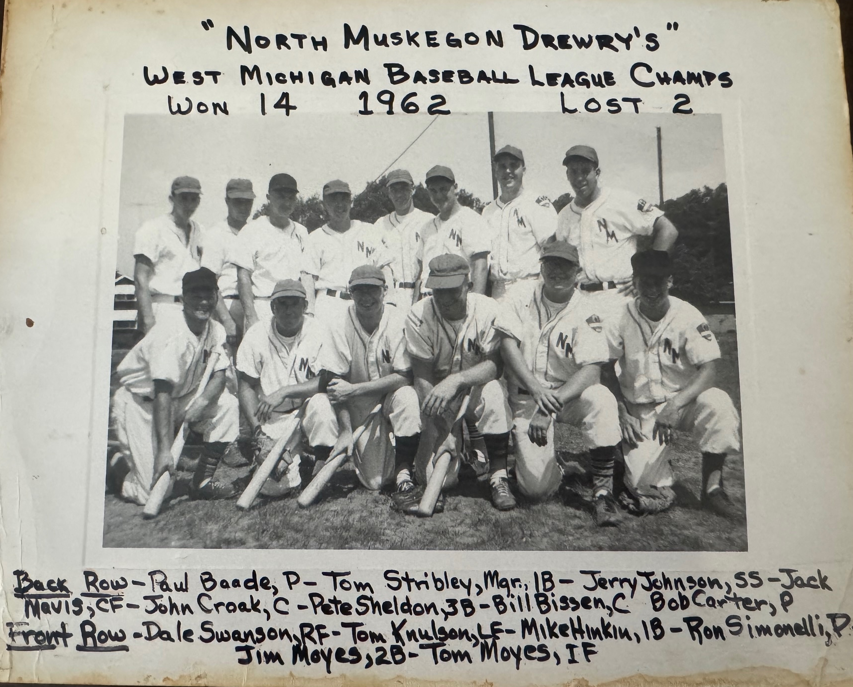

The ‘TOWN TEAM’ comprised of many former Norsemen from 1953-1962

1960 – coach Bruce Benson (7-8 overall; 2-3 in Seaway; xx place in Seaway; Whitehall Champs)
This would be the first of six years that the Norsemen would play in the Seaway Conference. The period from 1960 through 1966 would be the only years since the Norse became a complete high school in 1935 that NM wouldn’t compete in the West Michigan Conference. The Norse would play only a partial Seaway schedule in 1960 but would have a full load for the 1961 season. Oddly enough, reports from the Muskegon Chronicle list NM as being in both the WMC as well as the Seaway conference. Coach Bruce Benson’s nine would slip just below the .500 level. NM again opened their season against Muskegon Catholic, and although the Norse outhit MCC, they fell short in a 10-7 loss. Bill Cribbs banged out a 3-run home run for the Norse as MCC scored six runs in the third inning thanks in most part to five NM errors. Cribbs took to the mound in NM’s next encounter and tossed a two-hitter in a non-conference 4-1 victory over Montague. Junior Southpaw hurler Bill Shackelford pitched the first of his two-career no-hitters for the Norse. Shackelford’s no-no was not without its quirks. He would surrender eight walks to the Western Michigan Christian Warriors but would strike out 13 in a narrow 3-2 Norse victory. It was clear there were no pitch-count limitations in 1960. The Norsemen also had a remarkable turnaround vs. Reeths-Puffer. After being soundly thrashed 14-0 by their nearby rival early in the season, the improved Norse had a huge turnaround and defeated the Rockets in a late-season contest. Bill Cribbs went the distance and was aided by a pair of hits by Charley Langeland and a bases loaded triple by Shackleford as NM defeated Shelby 15-7. NM nearly squandered an eight-run lead in the second meeting of the season against West Michigan Christian but hung on the drop the Warriors 16-11. Oscar Manning clubbed a grand slam while Bill Porter added a solo shot for the winners. After the Norse dropped an 8-3 game with Hart, Muskegon Heights also was victorious against NM with a 7-2 victory to even the Norse record at 4-4 on the season. Langeland, Bill Bissen and Bill Porter all chipped in with two-baggers for the losers. NM handed eventual Seaway champions Whitehall a surprising 7-3 defeat behind the pitching of Bill Cribbs. Cribbs helped his own cause as he and Langeland each had a pair of safeties for the Norsemen. NM took the lead in the WMC with a conference mark of 3-1 following a 12-7 home victory over Montague. Shackelford, and Bill Porter each doubled twice in the contest while catcher Bill Bissen went two for three. The lead in the WMC lasted but one day as Scottville handed the Norse a sound beating of 13-3 as NM hurlers were pounded for 13 hits. Bill Cribbs did hit a solo homer for the Norse while Oscar Manning had a pair of singles. Whitehall in a game billed as non-conference (WMC or Seaway?) made amends for an earlier NM victory when the Norse defeated the Vikings 7-3 by turning the tables and defeating NM 12-6. Bill Cribbs, who won in the earlier game with Whitehall, was not as fortunate in the second affair in the series and suffered a 12-6 loss. While the Norse track team was winning the Seaway Conference Track & Field Championship, the Norse baseball team was not as fortunate on Tuesday, May 18. Grand Haven’s flame throwing pitcher Roger Wheeler threw a perfect game as the Norse were overwhelmed by the powerful Buccaneers 13-0. Grand Haven was early into their winning streak that would last into 1962 and set a state record. NM closed out their season by making the Seaway champs from Whitehall work hard as the Vikings needed two walks and two NM errors to push across a 9th inning run in the Seaway Conference baseball tourney. Jon Swenson was the hero for Whitehall as he came on in relief and allowed but one hit in four innings of relief work.

1960 NORSEMEN

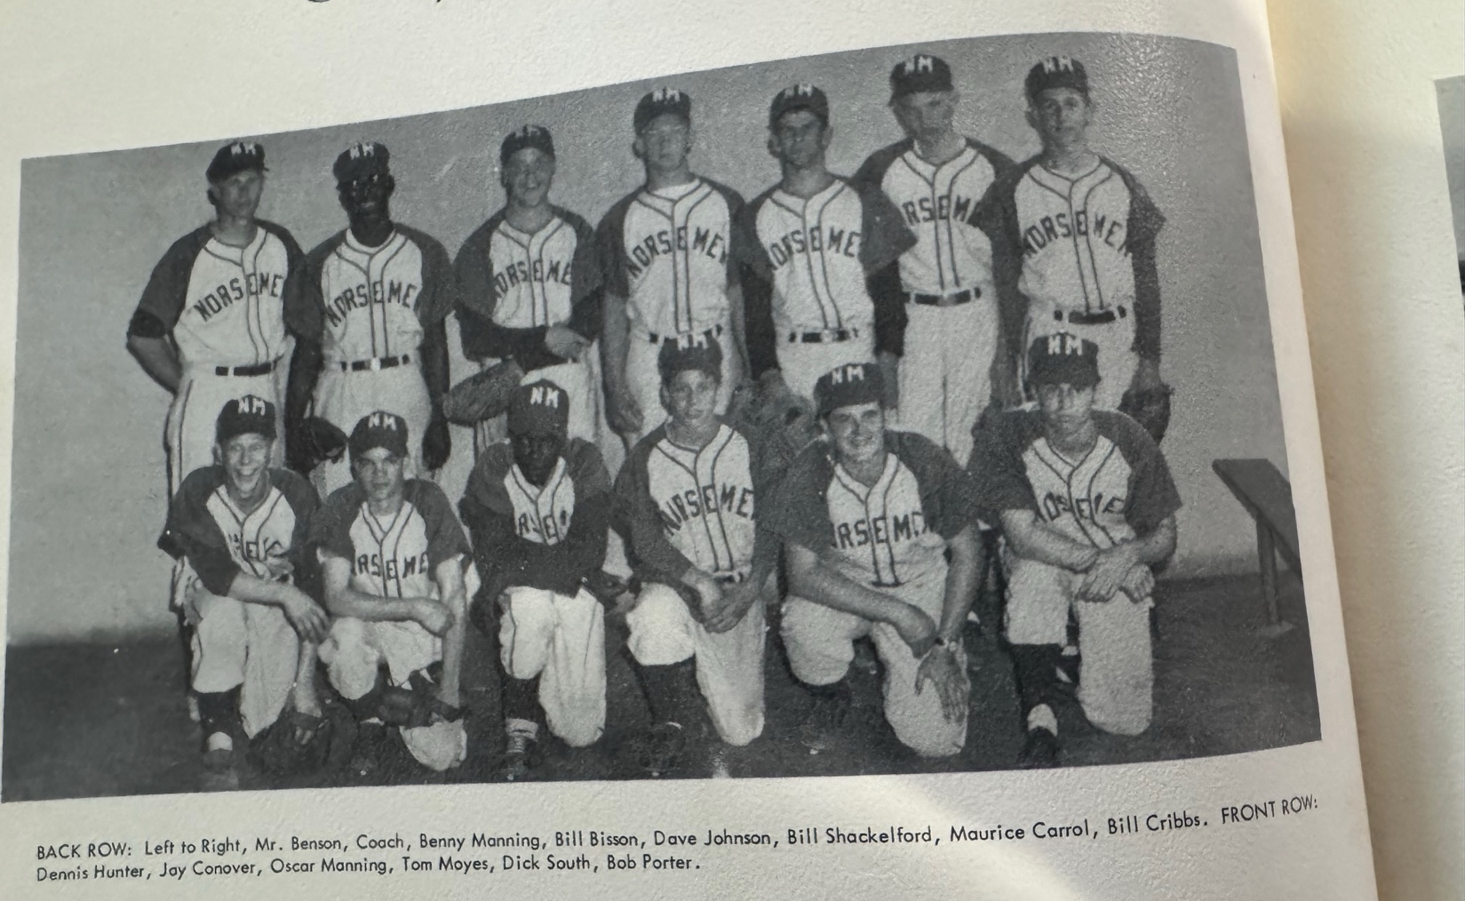

Record Score Interesting Fact
0-1 Musk. Catholic 10 NM 7 NM commits 5 errors in 6th run 3rd for MCC
1-1 NM 4, Montague 1 Bill Cribbs 2-hitter
2-1 NM 3, WM Christian 2 Bill Shackelford no-hitter, 8 BB, 13 K’s
2-2 *Reeths-Puffer 14, NM 0 Joe Fodrocy shuts out Norse
3-2 NM 15, Shelby 7 Shackelford bases loaded triple, Charlie Langeland 3 hits
4-2 NM 16, WM Christian 11 Oscar Manning GS, Jerry Porter HR
4-3 Hart 8, NM 3 no report in MC
4-4 Musk. Heights 7, NM 2 Bill Bissen, Langeland, Manning doubles
5-4 *NM 7, Whitehall 3 Cribbs winning pitcher, Cribbs & Langeland 2 hits
6-4 NM 12, Montague 7 Shackelford & Porter 2 doubles, Bissen 2 hits
6-5 Scottville 13, NM 3 Cribbs HR, Manning 2 hits
6-6 *Whitehall 12, NM 6 Bissen double
6-7 Grand Haven 13, NM 0 Roger Wheeler throws a perfect game for Grand Haven
7-7 *NM 8, Reeths-Puffer 7 no report in MC
7-8 *Whitehall 5, NM 4 Seaway tournament, Manning 2 hits

1961 – coach Bruce Benson (9-7 overall; 6-4 in Seaway; co-Champs in Seaway w/ Fremont & Ravenna)
The Norse were able to get a share of the Seaway conference title even with four losses. NM got its season off on the wrong foot as they dropped a 10-1 decision to Muskegon Catholic at Marsh Field. Future Weber State baseball star and St. Louis Cardinal farmhand Ron Jancek allowed the Norse just three hits, two of those from shortstop Tommy Moyes. Bill Shackelford, who would have a spectacular season as the ace of the staff, tossed a 6-hitter as NM topped Montague 3-2. Charley Langeland and Oscar Manning each hit doubles in the second inning as all the scoring took place in the first two innings. The two newest schools in the Seaway Conference, NM and Whitehall played the first of their two-game series in Whitehall and NM tallied 18 runs in a 18-6 rout of the host Vikings. Norse senior catcher Bill Bissen laced a pair of doubles for the winning Norsemen. Future Muskegon High Principle Arlyn Zach allowed only a pair of hits to NM as the Ravenna Bulldogs topped the Norse 5-3. Baseball during the week of April 24-28 had to be put on hold after a foot of snow fell over the weekend in the Muskegon area. A tough 6-5 loss to Fremont deprived NM of winning the Seaway Conference championship outright. Bill Cribbs went the distance for the Norse in the losing cause. Bill Bissen led a Norse offense that tallied 18 runs with three hits as NM defeated West Michigan Christian 18-7 with Bruce Kirk getting the win for the Norse. ‘Rubber arm’ Bill Shackelford blanked Coopersville 7-0 by hurling a three hitter while fanning 13 Bronco hitters. Shackelford also led NM at the plate with three hits and two RBI. NM again won a lopsided game against a good Whitehall team 11-2 as ace lefthander Shackelford allowed a paltry two-hits. The Norse used the home run ball as NM defeated Muskegon Heights 13-11 on the Norse diamond. The Norse had two men on base each time when Oscar Manning, Bill Cribbs and Shackleford delivered circuit blows. Shackleford had to come on in relief to stop a Heights rally and picked up a save. The next day Shackelford pitched a gem as he allowed but one Ravenna base hit in a 16-0 rout of the Bulldogs. What was ironic about the lopsided win was that earlier in the season Shackelford was tagged with his only loss of the season by these same Bulldogs. Oscar Manning had 4 hits, including a double and a triple while Tom Moyes notched a pair of base hits. In the first of back-to-back games played between NM and Reeths Puffer, the Rockets would nip the Norse 4-3 and hand Shackleford his second defeat on the season. Oscar Manning supplied all the runs scored for NM when he tripled with the bases loaded. The Rockets than made it a clean sweep over NM 5-1 despite being outhit by the Norse 7 to 4. Bill Cribbs was the hard luck loser while Charley Langeland paced the Norse with a pair of hits. Shackelford than tossed a no-hitter, becoming the only Norse pitcher in school history to have multiple no-hitters when he defeated Fremont despite giving up 3 runs in a 6-3 victory. Shackleford walked six batters while striking out a still standing record 17 Packer batsmen. Although they had dropped three conference games, the win pushed NM into a three-way tie for Seaway Conference honors. You talk about a tough two days! The Norse next two games were scheduled against two of the best teams in any class, Muskegon and Grand Haven. Pitching on but two day’s rest, ironman Bill Shackelford limited the potent Muskegon Big Reds to but five hits but fell to Muskegon and Big Red pitcher Larry Maxwell 5-3. With Shackelford mercifully getting a day off the Norse were no match for Grand Haven’s Buccaneers, arguable the best baseball team in our area’s history and the first baseball team inducted into the Muskegon Area Sports Hall of Fame. Grand Haven made NM their 42nd victim enroute to a state record with a 22-6 beating of the Norse. Taking no chances on being upset, Coach Steve Sluka of the Bucs threw his ace of the staff Doug Vanderwall against the Norse. NM was able to tag Grand Haven for six runs with Bill Bissen hitting a home run and Shackelford showing he was much more than a pitcher, accruing three hits in the loss. Spearheading the Norse co-champs was lefty Bill Shackelford. Shackelford equaled John Arntz’s 1949 all-time mark for shutouts in a single season with three goose eggs. Shackelford ended his career with a two-hit shutout over Coopersville, after but three day’s rest to give the Norse a share of the Seaway Title.

Record Score Interesting Fact
0-1 Musk. Catholic 10, NM 1 Tommy Moyes 2 of NM’s 3 hits
1-1 NM 3, Montague 2 Bill Shackelford 6 hitter, Chuck Langeland Oscar Manning 2Bs
2-1 *NM 18, Whitehall 6 Shackelford winner, 2 hits (3B), Bill Bissen 2 doubles
2-2 *Ravenna 5, NM 3 NM commits 5 errors as Arlyn Zach WP for Ravenna
2-3 *Fremont 6, NM 5 Bissen 2 hits
3-3 NM 18, WM Christian 7 Bissen 3 hits
4-3 *NM 7, Coopersville 0 Bill Shackelford 3-hitter, 13 K’s, also 3-4 2 RBIs
5-3 *NM 11, Whitehall 2 Shackelford allows 2 hits, Bob Porter 2 hits
6-3 NM 13, Musk. Hts. 11 Shackelford (5RBIs), Cribbs, Manning HRs, Bissen 3 hits
7-3 *NM 16, Ravenna 0 Shackelford 1-hitter, Manning 4 hits (2B, 3B) Moyes 2 hits
7-4 *Reeths-Puffer 4, NM 3 Manning 3 RBI triple, NM five errors
7-5 *Reeths-Puffer 5, NM 1 Porter, Langeland 2 hits
8-5 *NM 6, Fremont 3 Shackelford no-hitter, 17 K’s
8-6 Muskegon 5, NM 3 Larry Maxwell throws 5-hitter at Norse
8-7 Grand Haven 22, NM 6 GH’s 42nd straight win, Bissen HR, Shackelford 3 hits
9-7 *NM 9, Coopersville 0 Shackelford 2-hitter, Bissen 3 hits, Langeland 2 hits (double)

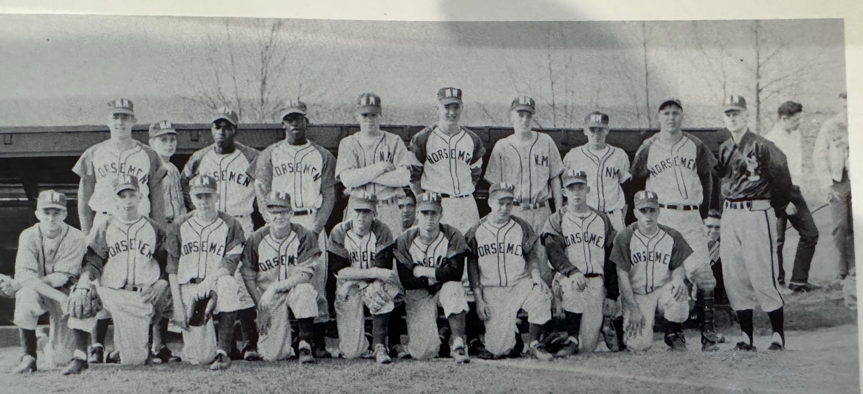

The 1961 NORSEMEN

Standing L-R: Bill Cribbs, Dave Hickman, Oscar Manning, Bennie Manning, Sam Langeland, Bob Hasper, Ray Schuiteman, Fred Stenberg, Bill Bissen, Coach Bruce Benson
Kneeling L-R: Paul Engstrom, Jim Six, Paul Baskwell, Jim Johnson, Bill Shackelford, Bob Porter, Tom Moyes, Dave Johnson, Charlie Langeland

1962 – coach Bruce Benson (13-5 overall; 11-2 in Seaway; 2nd place in Seaway; Whitehall Champs)
After earlier winning the Seaway conference in football and basketball, the Class of 1962 wanted to complete a clean sweep of championships as they hosted Whitehall on the last date of the regular season. The Norse and Vikings each had impressive 10-1 conference records leading up to the big game. Back on April 13, the Norse dealt Whitehall its only conference loss, 5-4. The Norse could have won the Seaway outright if they could somehow have mustered up one little run against Fremont. Gary Frens out-dueled Norse lefty Ron Matthews in 11 innings in a classic 1-0 pitchers’ duel. The winning run for the Packers was tallied on a bunt hit, an error on a pick-off attempt at first that sent the runner all the way to third, followed by a wild pitch that sent Dallen Gillen home with the winning run in a game that would doom NM to a second-place finish in the Seaway. In the season finale future Muskegon sheriff Bob Carter & Company were too much for the Norse and took the championship game with a convincing 8-2 victory. The Norse opened their season with a narrow 6-5 win over Montague with Bill Cribbs hitting a home run. In hindsight, the Norsemen could have done the Muskegon Big Reds of the 1940s a huge favor and saved their better pitchers for Grand Haven the next day. In the second game of the 1962 season, the Norse were on the wrong end of high-school history. Grand Haven took advantage of a charitable Norse pitching staff that gave up 20 walks in setting a state record of 56 wins in a row, a state record that would last for more than 40 years. The Norse even out-hit the Bucs, 13-6, in this memorable game. The 1962 Bucs were not even close in talent from the two previous seasons as their streak came to an end in their next contest. However, that one win against NM was the win that got their 1960-61 team into the Muskegon Area Sports Hall of Fame. The Norse in their very next game showed what they can do when their pitchers throw strikes. In the first of two pivotal matches between the two squads NM clipped a very good Whitehall team and handed the Vikings their lone loss of the season in the Seaway. Ron Matthews went the distance for the Norse as NM edged Whitehall 5-4. Matthews outdueled Vikings ace Bob Carter as Charley Langeland scored an unearned run in the bottom of the sevenths for the walk off win. NM used the one-hit pitching of Tracy Hickman to humble Muskegon Catholic 14-0, the first win ever against MCC and easily the most lopsided win against the Crusaders in program history. This was the same MCC team who ended Grand Haven’s state record winning streak at 56, just one game after the Norse fell to the Bucs in a game where they gave up 20 free passes. NM made it two-straight in Seaway competition as the Norse walloped Ravenna 11-3 as Ron Matthews went the distance. Benny Manning clubbed two triples in the NM victory. The two other defeats suffered by the Norse came against some of the best competition around. The Norse lost to Muskegon 6-3 and were able to muster six hits off future major-league hurler Ray Newman with Tommy Moyes and Charlie Langeland both chipping in doubles in a losing cause. The Big Reds overcame a 2-0 Norse lead by scoring six runs, most of those unearned as NM committed many costly errors. During the 1962 season Newman would team up with Jim Johnson as each pitcher would pitch 3 innings in a combined no-hitter over West Michigan Christian. Newman and Johnson would each pitch in the Major Leagues. 6’6 junior NM first baseman Bob Hasper, hit a two-run home run in the fourth inning in what would prove to be the game winner in a 7-5 victory over Fremont, certainly not the pitcher’s duel the two teams would play later on in the season. Ray Schuiteman earned the victory in a 12-3 romp over West Michigan Christian. His battery mate at catcher, Tom Johnson had a pair of hits for the Norse. Bill Cribbs then pitched NM to a 8-2 Seaway victory over Coopersville and helped his own cause with a pair of hits good for three RBI. Junior Ron Matthews with his third victory on the season in as many starts, served notice that he was going to be an ace pitcher for the Norse by allowing but one run in a 9-1 victory over Orchard View. Matthews, just as Cribbs did in the previous game, helped himself by going two for three with a double. Paul Engstrom keyed a big seven run Norse outburst in the fifth inning with a home run. The following week Matthews came on in relief in the fourth inning and picked up the win as NM defeated Ravenna 8-4 to remain undefeated in Seaway conference play. NM kept up their winning ways in the Seaway with Tracy Hickman picking up the win 6-4 over Orchard Views. Consecutive doubles by Moyes, Langeland and Cribbs helped the Norse tally five runs in the fifth inning, all they needed to secure the victory. The euphoria of winning was stopped short in the next game as it was the epic 1-0 loss in 11 innings to Fremont that deprived NM of a Seaway Conference championship. With their dobbers down NM then lost to a Muskegon Heights team that would have an undefeated season. They would bounce back that same week with a 6-4 win over Reeths Puffer. Bill Cribbs earned the win with 7th inning relief help from Tracy Hickman. Hickman then returned to the mound and hurled a masterful 3-0 shutout to complete the season sweep over Reeths Puffer, setting up the next day’s clash with Whitehall for the Seaway Conference Championship. As pointed out at the top of the 1962 recap above, Whitehall won the last and most important game of the year to snatch the Seaway winning trophy away from the Norse. After four scoreless innings the Vikings pushed five runs across the plate in their half of the fifth to dash any hopes for the Norsemen. Despite the loss the NM team of 1962 can reflect proudly on a very good overall record of 13-5. Would they match 13 wins again in 1963?

The 1962 NORSEMEN
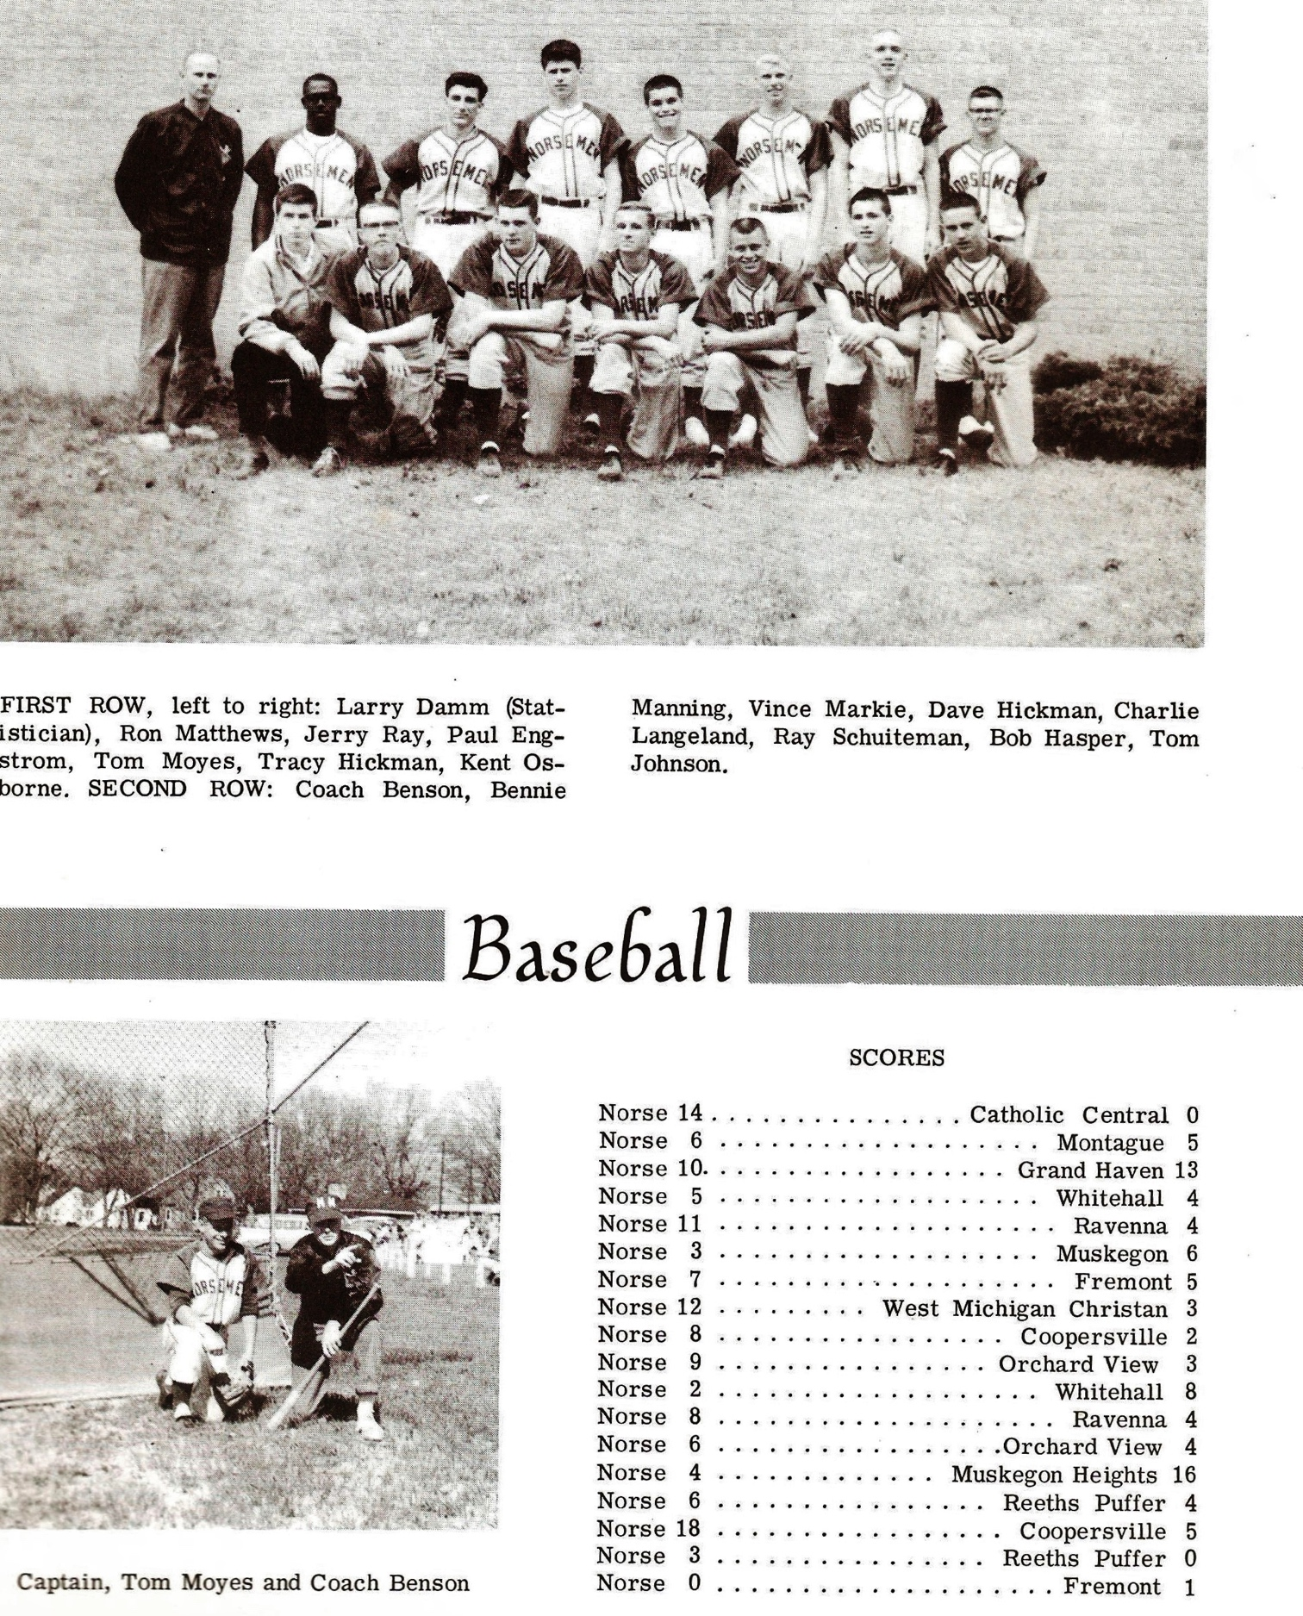

Record Score Interesting Fact
1-0 NM 6, Montague 5 Bill Cribbs 2 hits (HR), Bob Merkle & Charlie Langeland 2 hits
1-1 Grand Haven 13, NM 10 GH state record 56th straight win; NM walks 20
2-1 *NM 5, Whitehall 4 Langeland scores winning run in 7th
3-1 NM 14, Musk. Cath 0 Tracy Hickman hurls 1 hitter, Vince Markie 3B
4-1 *NM 11, Ravenna Bennie Manning 2 triples, Langeland triple
4-2 Muskegon 6, NM 3 Tommy Moyes, Langeland double
5-2 *NM 7, Fremont 5 Bob Hasper hits 2 run HR for win
6-2 NM 12, WM Christian 3 Tom Johnson 2 hits, Ray Schuiteman winning pitcher
7-2 *NM 8, Coopersville 2 Cribbs pitches a 2 hitter, also has 2 hits (2B)
8-2 *NM 9, Orchard View 1 NM scores 8 runs in 5th, Paul Engstrom HR, Hickman 2B, 3B
9-2 *NM 8, Ravenna 4 Cribbs, Langeland 2 rbi each, NM scores 5 in the 4th
10-2 *NM 6, Orchard View 4 NM scores 5 in the 5th on doubles by Moyes, & Langeland
10-3 *Fremont 1, NM 0 Ron Matthews pitches all 11 innings in loss. Fremont scores on a WP
10-4 Musk. Heights 16, NM 4 Heights undefeated season, Langeland 2 hits
11-4 *NM 6, Reeths-Puffer 4 Hasper 3B, Hickman, Cribbs & Markie 2B
12-4 *NM 18, Coopersville 5 Cribbs 2 triples, Hasper 3 hits
13-4 *NM 3, Reeths-Puffer 0 Hickman shutout win, Cribbs 2 hits
13-5 *Whitehall 8, NM 2 Whitehall wins Seaway as NM places 2nd.

1963 – coach Lee David (13-5 overall; 11-2 in Seaway; Seaway Champs)
The Norsemen posted another fine season as new head coach Lee David’s first baseball team won the Seaway conference championship. The pitching of Ron Matthews and the slugging of third baseman Charlie Langeland were pivotal to the success. It was surely not a positive start in 1963, especially if the Norse were to become conference champs, as they lost their opener 3-1 to Fremont. The Norse carried a slim 1-0 lead into the final inning only to see the Packers rally for three runs as Tracy Hickman was the tough luck NM losing pitcher. What a difference a year makes! After losing the final game of the 1962 season that determined the Seaway Conference championship, the Norse turned the tables on Whitehall and posted an 8-3 win behind the two-hit pitching of Ron Matthews. Catcher Tom Johnson led the Norse hitting attack with three singles. Hickman helped his own cause with a key double as NM scored six runs in the second inning. Grand Haven then threw a punch at NM and shut out the Norse 6-0 with Tracey Hickman getting a pair of hits as NM fell to 1-2 on the season. Playing in their third straight games in as many days, a rarity in the early years of NM baseball, the Norse broke a 4-4 tie in the sixth inning to pull away to earn a 9-5 win over Orchard View. Five NM players had multi-hit games: Langeland, Paul Engstrom, Johnson, Hickman and Ray Schuiteman. Langeland had four hits in a losing cause against the Muskegon Reds in an early season contest, two more than posted by Muskegon star and future major leaguer Jim Johnson. As any avid Norse fan can tell you, this is the same Jim Johnson who would become Superintendent of Schools at North Muskegon in the 1980s. It was no disgrace to lose to Muskegon as the Big Reds would post a 21-1 record, have two players who reached the major leagues, with their only loss coming in extra innings to Grand Haven. Shortly after Johnson passed away in 1987, the baseball field that dates to 1920 was named in Johnson’s honor. Ron Matthews came oh so close to a no-hitter when he gave up just one scratch hit single in a 5-0 shutout over Ravenna. Catcher Tom Johnson was a perfect 4-4 at the plate while Charley Langeland got the Norse off to a good start with a 2-run home run in the third inning. The big bats of Johnson and Langeland paced NM to a 6-3 victory over Muskegon Catholic. NM was baffled by the slants of the Tiger’s Jesse Banks as Muskegon Heights pasted the Norse 10-1. The Norse behind the pitching of Ron Matthews won a 3-2 extra inning contest with Orchard View. Langland’s 3-bagger in the 8th inning was the game winner for NM. Ray Schuiteman and Bob Hasper each had a double in the victory. The Norse moved into first place in the Seaway Conference with a 5-4 squeaker over Coopersville. Matthews came on in relief of Tracey Hickman after the Broncos had moved to within one run of the Norse to pick up the save. Langeland continued his heavy hitting with a two-run homer in the first and Paul Engstrom banged out a two-run triple in the third and then scored what proved to be the winning run on an error. The Norse then traveled to Ravenna and came away with a 7-3 win behind the pitching of Hickman. Leading by only one run Ron Coverley gave the Norse some breathing room when he belted a three-run homer in the 7th inning. Bobby Walters had a pair of hits for NM while Ray Schuiteman crashed a triple. Matthews then hurled his second one-hitter on the season when he shut out Reeths Puffer 4-0. Bob Hasper and Tracy Hickman led the Norse offensive attack with a pair of hits. Hickman’s first hit in the opening inning drove in two of NM’s four runs. NM had an improbable comeback victory over Montague to complete their sweep of the three contests during the week. Trailing 2-0 going into the bottom of the seventh NM ‘stole’ the victory from visiting Montague. NM tallied the winning runs when a double steal attempt by the Norse went awry for Montague as a wild throw brought in the winning runs that brought in Schuiteman and Johnson for the game winner. NM then clinched at least a tie in the Seaway with a 10-3 victory over Whitehall with Ron Mattews in relief of Hickman getting the victory. Hickman, however, did well as a hitter with three hits while Rick DeBruyn and Schuiteman each added a pair of safeties. NM and Ron Matthews closed out their 1963 campaign in brilliant fashion in a 10-0 victory over Reeths Puffer. Matthews capped his sterling career with a no-hitter. Catcher Tom Johnson slammed a three-run homer while Langeland closed his great NM career with a pair of doubles.

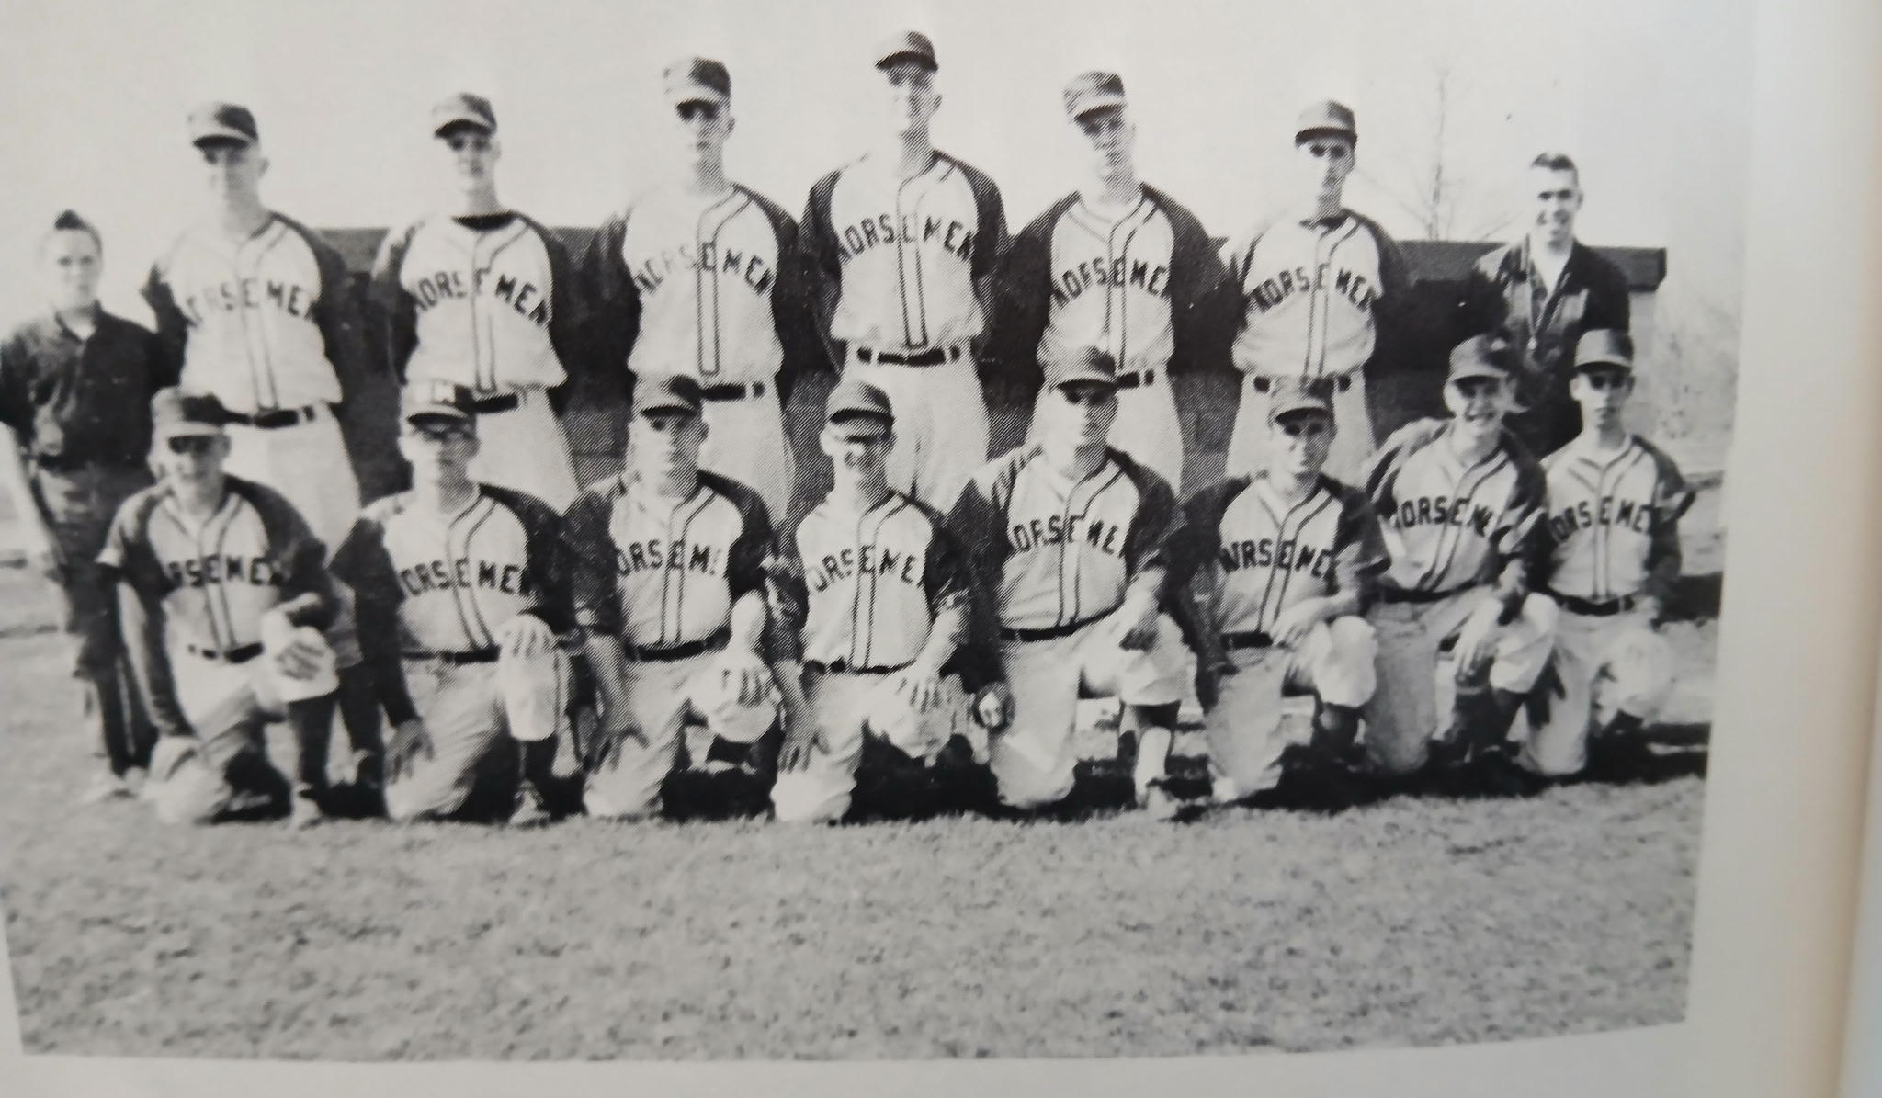

The SEAWAY CHAMPS of 1963
Kneeling L-R: Dan Foote, Ron Matthews, Ron Coverly, Tom Johnson, Charlie Langeland, Paul Engstrom, Bob Walters, Mike Senecal
Standing L-R: Mgr. Pat Kleveland, Rick DeBruyn, Tom Thiele, Jerry Ray, Bob Hasper, Ray Schuiteman, Tracy Hickman, Coach Leland David

Record Score Interesting Fact
0-1 *Fremont 3, NM 1 NM only 3 hits, including 2 by Tom Johnson
1-1 *NM 8, Whitehall 3 Ron Matthews 2-hitter, Johnson 3 hits, Bill Young 2 hits
1-2 Grand Haven 7, NM 0 Tracey Hickman 2 hits
2-2 *NM 9, Orchard View 5 Charlie Langeland triple, double
2-3 Muskegon 12, NM 4 Langeland 4 hits
3-3 NM 7, Montague 6 No report in MC
4-3 *NM 5, Ravenna 0 Ron Matthews 1-hitter; Johnson 4 hits; Langeland HR
5-3 NM 6, Musk. Catholic 3 Langleand and Johnson lead NM hitters
5-4 Musk. Heights 10, NM 1 NM only 4 hits off Jesse Banks
6-4 *NM 3, Orchard View 2 Matthews goes 8 ip. in win. Langleand 3B wins in 8th.
6-5 *Coopersville 8, NM 6 No report in MC
7-5 *NM 12, Fremont 2 No report in MC
8-5 *NM 5, Coopersville 4 Langeland HR
9-5 *NM 7, Ravenna 3 Ron Coverly 3-run HR; Bob Walters 2 hits
10-5 *NM 4, Reeths-Puffer 0 Matthews 1-hitter
11-5 NM 3, Montague 2 NM wins on double steal in 7th inning
12-5 *NM 10, Whitehall 3 Hickman 3 hits
13-5 *NM 10, Reeths-Puffer 0 Matthews no-hitter, Johnson HR, Langeland 2 2Bs.

1964 – coach Lee David (14-8 overall; 9-5 in Seaway; xx place in Seaway; Ravenna Champs)
The Norse added one more win in 1964 to set a new mark for most wins in a season. It should be pointed out, that in fairness to the outstanding teams before them, the 1964 schedule was made up of 22 games. The Norse had a talented three-man rotation throughout the season in Jerry Ray, John Pattenger and Rick DeBruyn. Ray posted two shutouts in his eight-victory season during the campaign while Pattenger chipped in with another whitewash. DeBruyn came on strong and posted an ERA of 2.63. The trio posted a collective ERA of 1.99 runs allowed per game with Ray the workhorse of the staff by allowing only 1.65 earned runs per contest. Ironically, Pattenger, as did Bill Shackelford in 1961, pitched a no-hitter, but did not get a shutout in an 11-1 pasting of Fruitport. Coach Lee David’s squad posted a 9-5 record in the Seaway but could not duplicate their championship effort from 1963. Hard throwing Jerry Ray jump started the 1964 season the right way with a 5-1 complete game victory over Reeths Puffer. Ray pitched hitless ball through six innings before tiring and allowing three hits in the seventh. The big blow for the Norsemen was a bases loaded triple from Bobby Walters. John Pattenger was a hard-luck loser as he allowed but three runs while striking out 12 only to lose 3-0 to Ravenna in the second game of the 1964 season. Ray came back later in the week to shut out Muskegon Catholic 6-0 while striking out 12 Crusaders. Mike Senecal crashed a solo homer in the first inning and that would be all that Ray would need. NM bats were as cold as the chilly April weather as they were no-hit by Coopersville’s Larry Troutwine 3-0 in a Seaway Conference clash. John Pattinger suffered the loss although he only granted three hits to the Broncos while fanning nine. After losing to NM in their first six meetings, West Michigan Christian finally earned a victory over the Norse 7-3. Trailing 3-0 after four innings of play, the Warriors rallied to score all seven runs in the final three innings. NM was only able to muster two hits in the loss, singles by Jerry Ray and Skippy Speier. For the third time early in the season the Norse were shut out, this time losing 3-0 to Whitehall. Jerry Ray allowed but three Viking hits, but his teammates were only able to notch two hits off Whitehall’s Bob Muttart. NM then pulled off a real stunner in their fourth game played during this week of Mid-April by upsetting Grand Haven 2-1. And although NM was only once again able to muster two hits, it was enough as Rick Debruyn limited the Bucs to only one hit. NM scored both of their runs in the first inning with only Mike Senecal earning a spot on the base paths with a base hit. Tom Thiele added the other NM hit later in the contest. In the first meeting between the two schools, Mona Shores scored an unearned run in the bottom of the seventh inning to defeat NM 5-4. Bob Walters had a couple of hits for the Norse, including a 2-run home run to lead all hitters. It would be nearly another 50 years before NM would win a game against the Sailors. Jerry Ray then got NM back on the winning track by hurling a 5-0 shutout over Fremont. Bob Rea belted a homer for NM while Mike Senecal added a triple. Both Senecal and DeBruyn had two hits. The following day John Pattinger inserted himself into the NM record book by pitching a no-hitter against Fruitport. Don (Skippy) Speier had a pair of hits for NM as Pattinger became the fourth pitcher in NM history to throw a no-hitter in the 11-1 win over the Trojans. Ravenna moved into the top spot in the Seaway with an 11-6 win over NM as the Norse helped the Bulldogs cause with seven errors. Senecal and Jim Schillaci each had a pair of hits for NM in a losing cause. Norse winning pitcher Jerry Ray helped his own cause in a 5-3 victory over Reeths Puffer by contributing a two RBI single in the fifth inning as the Norse scored all the runs’ they needed by putting up a four spot on the board. Don Johnson, DeBruyn and Walters each had a pair of hits for the Norse as they improved their season record to 6-6. John Pattinger nearly had his second no-hitter of the season when he allowed but one hit in a 4-2 Norse upset victory over Coopersville. That moved the Norse above the .500 mark. The lone hit was a double in the sixth inning that brought in both Coopersville runs. In their fourth game in as many days Jerry Ray concluded the week by allowing but two hits in a non-league 7-2 victory over perennial rival Montague. Ray got all the help he needed when Tom Cribbs belted a three-run home run in the third inning. Tom Thiele, as well as Cribbs each had a pair of hits for the Norse. The modest three-game winning streak game to an end in the next game with Orchard View as the Norse were edged 3-2. DeBruyn was the tough luck losing pitcher as the Cardinals winning run came following a triple and an errant throw that allowed the winning run to cross the plate in the sixth inning. The Norse got back on the winning track with a hard fought 4-3 win over Whitehall. Jerry Ray went all seven innings for the win and got some hitting help from Tom Thiele, Tom Cribbs and Don Speier. NM had their most explosive game of the season when they scored 14 runs in a 14-2 defeat of Fruitport. DeBruyn was the happy recipient of the rejuvenated offense to pick up the win. Cribbs and Walters each had a double and a single among the Norse hits. Muskegon continued their dominance over NM as they shut out the Norse 6-0. Only in Muskegon’s very first game back in 1937 were the Norse able to defeat the Big Reds. The Norse only had three hits in the contest while Jerry Ray took the loss despite only allowing six hits. NM would end their 1964 season on a hot streak as they would win all four of their remaining contests. John Pattinger got their final week off in grand style as he posted his second shutout of the season by blanking Montague 3-0. Rick DeBruyn paced the winners with two hits while Don Speier had a two-bagger. Jerry Ray won his seventh game of the season and in the process beat a long-time nemesis of NM in Packer’s pitcher Gary Frens. Frens fanned 13 NM batters but in the process gave up a home run to Speier and Bobby Walters added two hits for the victors. NM atoned for an earlier defeat by Orchard View by defeating the Cardinals 5-2 with DeBruyn allowing but four hits to earn the win. DeBruyn was also a force at the plate with a couple of hits that brought in a pair of runs. Tom Cribbs supplied some insurance runs with a two-RBI double.
The Norse made it 4 for 4 on the week and concluded the season with a 11-6 victory over Spring Lake. It was the first ever meeting between the two schools and the Norse would have to wait more than 30 years before they would again be victorious over the Lakers. Working his second game in three days, Jerry Ray picked up the win but need some relief help from Tom Cribbs to put away the Lakers. Speier, Walters, DeBruyn and Don Johnson all had a pair of hits as the once punchless Norse had a season high 11 hits in the win. The 1964 season would be the last season NM would have a winning record for the next eight seasons.

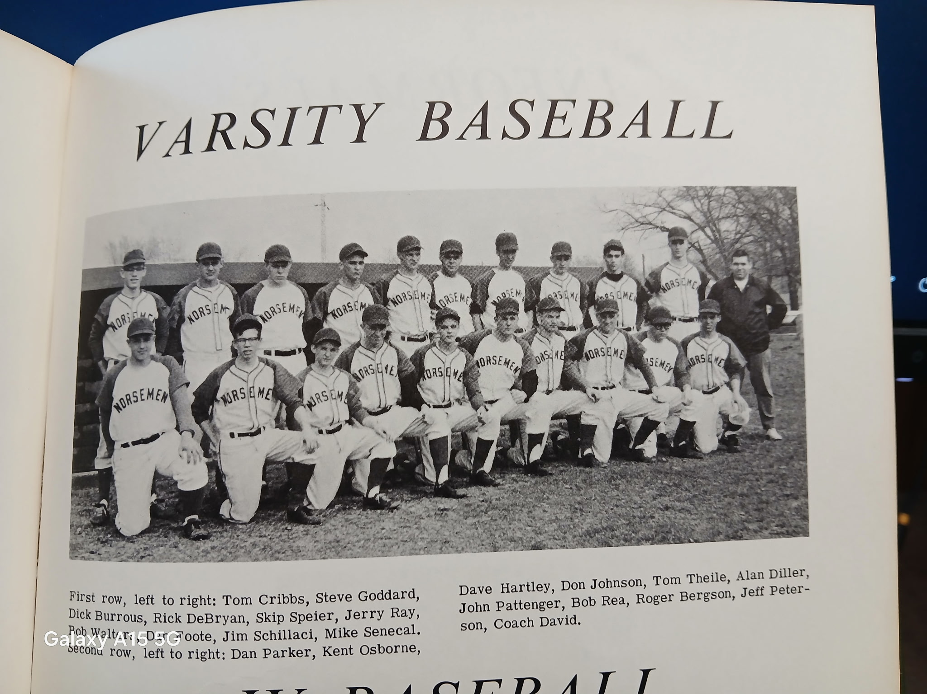

The 1964 NORSEMEN

Kneeling L-R: Tom Cribbs, Steve Goddard, Dick Burrows, Rick DeBruyn, Skip Speier, Jerry Ray, Bob Walters, Dan Foote, Jim Schillaci, Mike Senecal
Standing L-R: Dan Parker, Kent Osborne, Dave Hartley, Don Johnson, Tom Thiele, Alan Diller, John Pattenger, Bob Rea, Roger Bergson, Jeff Peterson, Coach Leland David

Record Score Interesting Fact
1-0 *NM 5, Reeths-Puffer 1 Jerry Ray 10 K’s, Bob Walters bases loaded triple
1–1 *Ravenna 3, NM 0 John Pattenger 12 K’s in 5 innings
2-1 NM 6, Musk. Catholic 0 Ray 11 K’s; Mike Senecal HR
2-2 *Coopersville 3, NM 0 NM no-hit by Larry Troutwine, Pattenger gives up 3 hits
2-3 WM Christian 7, NM 3 NM scores 2 runs on a double steal
2-4 *Whitehall 3, NM 0 Norse only have 2 hits as Ray gives up earned run & 3 hits
3-4 NM 2, Grand Haven 1 Rick DeBruyn 4-hitter-NM wins with only 2 hits (Senecal & Tom Thiele)
3-5 Mona Shores 5, NM 3 Bob Walters HR, Mona scores winning run in 7th on misjudged pop up
4-5 *NM 5, Fremont 0 Ray wins: Bob Rea double, HR, Senecal, DeBruyn 2 hits
5-5 *NM 11, Fruitport 1 John Pattenger no-hitter, Skippy Speier 2 hits
5-6 *Ravenna 11, NM 6 NM commits 7 errors, Senecal, Jim Schillaci 2 hits
6-6 *NM 5, Reeths-Puffer 3 Ray wins: Walters, Don Johnson, DeBruyn 2 hits
7-6 *NM 4, Coopersville 2 Pattenger 1-hitter, 12 K’s
8-6 NM 7, Montague 2 Ray 2-hitter, 10 K’s, Tom Cribbs 2 hits (HR), Thiele 2 hits
8-7 *Orchard View 3, NM 2 Thiele 2 hits
9-7 *NM 4, Whitehall 3 Ray 9 K’s, Cribbs double, Thiele 2 RBI single
10-7 *NM 14, Fruitport 2 Tom Cribbs, Walters 2 hits, DeBruyn winner
10-8 Muskegon 6, NM 0 Ray loses
11-8 NM 3, Montague 0 Pattenger wins, DeBruyn 2 hits
12-8 *NM 4, Fremont 1 Ray wins: Speier HR, Walters 2 hits
13-8 *NM 5, Orchard View 2 DeBruyn winning pitcher & 4 hits 4RBIs
14-8 NM 11, Spring Lake 6 Ray wins, finishes 8-1: DeBruyn HR, Speier, Walters, Don Johnson 2 hits

1965 – coach Lee David (3-8 overall; 3-7 in Seaway; xx place in Seaway; Orchard View Champs)
In coach Lee David’s final year as the NM skipper, this season would signal a temporary end of baseball prosperity on the Northside for the next few seasons. However, this final record is incomplete as some Seaway conference game reports are missing, including three of the last four scheduled games. It is likely that two of those missing games were Norse losses, according to Muskegon Chronicle reports for 1965. Only Bob Senecal, Bob Rea, and former Little-League home run-hitting phenom Tom Cribbs returned from the successful 1964 squad, and the Norse dropped the first seven games of the season. Perhaps the opening game 9-0 defeat at the hands of Fruitport was a harbinger of the rough times that would await the Norse throughout the season. NM was only able to muster three hits from the bats of Senecal, Rea, and Jim Middleton. The hitting picked up in their second contest, but not the pitching as the Norse fell decidedly to Fremont 17-8. Tom Cribbs had a solo home run for the Norse while Bob Rae added a pair of doubles among the 11 hits garnered by NM hitters. In what was perhaps the low point on the season for the Norse could well have been their failure to get any hits on April 27 vs. the offerings of Orchard View pitcher Tom Waggoner. A wild throw in the bottom of the seventh inning on a triple off the bat of Reeths Puffer’s Tom Bray was the difference in NM’s 7-6 loss. Earlier in the top of the final inning Roy Richardson, with the second of his two hits, tied up the game on a base hit. Once again, the Norse were on the short end of the same 7-6 score, this time to Ravenna in their next contest. The Norse quickly gave up five runs to the host Bulldogs in the first inning and had to play catchup the rest of the way only to again fall just one run short. Tom Cribbs was the only NM player with multi hits, including a double. The Norse had their hitting shoes on, but the pitching corps of the Norse did not as NM was outslugged 13-10 by Coopersville. While Dean Rosenberg was setting a mile record at the Greater Muskegon Track & Field Championships that still stands as of this writing 60 years later, the NM baseball team didn’t fare as well as they fell 9-2 to Whitehall. NM only had two hits (Mike Senecal and Roger Vanderlind) against Whitehall’s Bob Muttart. Among the eight hits for the Norse were a pair of safeties from Bob Rea, including a double, while Wes Wegner clubbed a triple in the losing cause. Tom Cribbs produced perhaps NM’s most shining memory from 1965 when the stocky right-hander hurled a four-hitter in a 7-2 Norse victory over Fruitport as NM finally earned their first win of the season after seven consecutive losses. Cribbs, who fanned 12 was also the hitting star for the Norse with three RBI, two of those runs coming in on a double off the bat of Cribbs. The Norse the following day played their only game of the season outside of the Seaway Conference against Muskegon. A single from Andy Dagen was the only hit the Norse would earn from Big Red pitcher Tom Klett as the Norse absorbed a 9-0 pounding from Muskegon. NM atoned for their most lopsided loss of the season in an earlier contest by upsetting Fremont 6-5. A two-run home run from Roy Richardson proved to be the difference as NM won their second game of the season. NM then pulled off another shocker when they upset Ravenna 5-2 behind the pitching of Pat Kersh and the hitting of Jim Osborn who batted a perfect 4-4. Mike Senecal and Bob Rea each belted a two-run home run to end the Norse season with a pair of wins. The loss was a blow to Ravenna’s hope of repeating as Seaway Champs. The Norse finished the season with their poorest record in several years, unfortunately for NM baseball fans, the immediate future wouldn’t get any better.

Record Score Interesting Fact
0-1 *Fruitport 9, NM 0 Mike Senecal, Bob Ray, Jim Middleton have only NM hits
0-2 *Fremont 17, NM 8 Rea 2 doubles, Andy Dagen, Jim Osborne 2 hits, Cribbs HR
0-3 *Orchard View 8, NM 0 NM no-hit by Tom Waggoner
0-4 *Reeths-Puffer 7, NM 6 Roy Richardson 2 hits, 3 RBI
0-5 *Ravenna 7, NM 6 Tom Cribbs 2 hits (double)
0-6 *Coopersville 13, NM 10 Bob Rea 2 hits (2), Wes Wegner 3b
0-7 *Whitehall 9, NM 2 Roger Vanderlaan and Senecal only 2 hits
1-7 *NM 7, Fruitport 2 Tom Cribbs 4-hitter. 12 Ks. also had 3 RBI (double)
1-8 Muskegon 8, NM 0 Dagen has NM’s only hit off Muskegon’s Tom Klett
2-8 *NM 6, Fremont 5 NM wins on Roy Richardson’s 2-run HR in 6th
3-8 *NM 5, Ravenna 2 Osborne 4-4, Pat Kersh winning pitcher

1966 – coach Fritz Wagner (3-11 overall; 3-11 in Seaway; xx place in Seaway; Fruitport Champs)
North Muskegon’s last year in their six-year stint in the Seaway would prove be less than memorable for long-time followers of Norsemen baseball. The Norse, under first-year coach Fritz Wagner, would post a 3-11 record against an all-Seaway Conference lineup. The only non-conference games on the schedule vs. Muskegon and Muskegon Catholic were rained out and never rescheduled. Big sticks were missing from the NM offense throughout the season as the Norsemen were shut out five times (including the final three games), one of the lowest offensive outputs in NM history (only 40 runs scored in 14 games). For the second straight season the Norsemen began the season by being more than humbled by Fruitport. After being shut out 9-0 in the opener in 1965, the Norsemen had no hits in 1966 against Fruitport’s Ron Stroup. Two days later the Norse had nine more hits than in their season opener as they defeated Fremont 9-7. One of those hits was a three-run homer by Dave Marchido. Catcher Andy Dagen had a solo shot for the Norse while Jim Osborne had three hits, and two runs batted in to aid winning pitcher Tom Cribbs who pitched all seven innings for the victors. The Spring Lake Lakers were not as kind to the Norse in the next contest as NM was crushed 12-4 on the Northside diamond. The only bright spots for the Norse were by Pat Kersch and Ray Richardson, each of whom collected a double in the defeat. It took eight innings for Ravenna to hand the Norse their third defeat of the young season as the Bulldogs scored three in the extra inning. NM outhit Ravenna 6-3 but made eight errors behind pitcher Pat Kersch. Pete Speier and Larry Carter each had a pair of hits for NM. Reeths-Puffer’s Glen Hartley fanned 14 Norse hitters as the Norse fell to the Rockets 5-0. The future looked dire for the Norse as the one-win NM team’s next foe was Fruitport, who already had claimed NM one of their victims to begin the season. NM caught the high-flying Trojans at the right time of the day before the Trojans had their nine-game winning streak to start the season snapped by Muskegon. In an improbable moment for NM, the Norse put together four straight singles after two were out to shock the eventual 1966 Seaway champs 5-4. Tom Cribbs went all seven innings to earn the victory while Jim Osborn and Dave Marchido each had two safeties for the surprising Norsemen. The euphoria from the startling win over Fruitport was short-lived as Fremont scored six runs in the second inning enroute to an 8-4 victory over NM. Tom Cribbs, who came on in relief in the big Packer uprising in the second inning, also hit a home run for the Norse while Wes Wegner chipped in with a double and a single. The Norse were no match for Spring Lake as the Lakers Larry Aldridge smashed two doubles and two singles in their 14-4 rout of the Norse. Coopersville then scored an unearned run in the top of the 8th inning as NM dropped their second extra inning game of the season 3-2. Pat Kersh was the hard luck loser for the locals while Tom Cribbs again paced the Norse offense in the loss with a pair of singles and both NM RBI in the contest. For the second time in the season Ravenna defeated the Norsemen by the identical score of 6-3. Tom Cribbs went the distance for NM while Pete Speier had a pair of hits as the Norse dropped their fourth straight contest. The Norse finally broke their losing streak by winning the first game of a double header with Whitehall 6-5. After being on the losing end twice before in games that went into the eighth inning, the Norse were able to come out on the winning side in the first game of the twin bill 6-5. Roy Richardson drive home Larry Carter with the winning run to hand pitcher Pat Kersh the victory. Roger Vanderlaan had three hits in the opener while Pete Speier and Tom Cribbs each added a pair of safeties. Dave Arneburg allowed but one hit, but it was enough as Whitehall won 1-0 in a game called after five innings due to darkness. The Norse did not finish the 1966 on an upbeat note. Quite the contrary. The Norse were shut out in their final two games, first by Reeths Puffer 13-0 and then were trounced by Coopersville 17-0. Coach Wagner used five pitchers against Reeths Puffer and three against the Broncos. The pitching staff received little help in the rout by Cooperville as the NM defense committed 10 errors. 1966 would be the last season NM would compete in the Seaway Conference as the following Fall NM would return to the West Michigan Conference. Unfortunately for Norse fans, it would get worse in 1967.

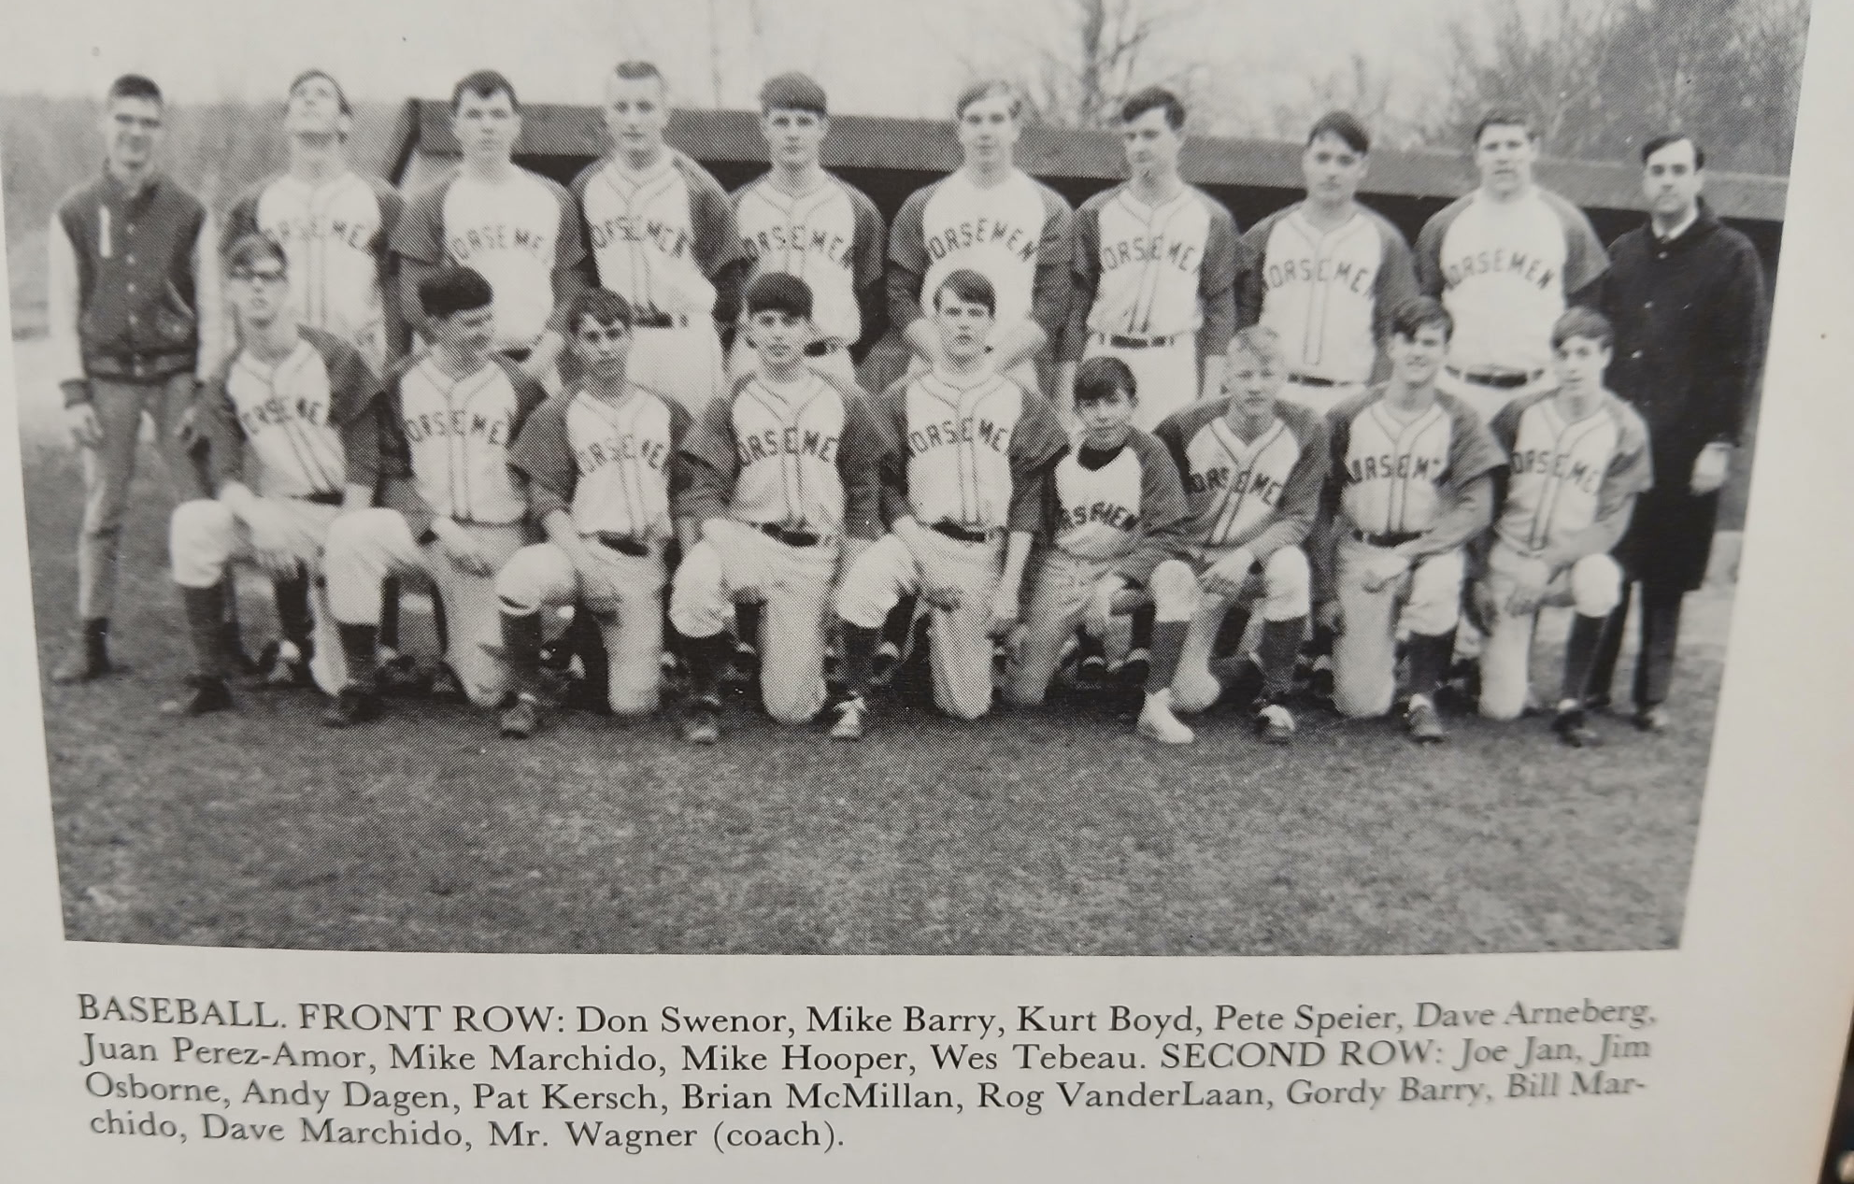

The 1966 NORSEMEN

Record Score Interesting Fact
0-1 *Fruitport 10, NM 0 NM no-hit by Fruitport’s Ron Stroup
1-1 *NM 9, Fremont 7 Dave Marchido 3runHR, Andy Dagen HR, Jim Osborne 3 hits
1-2 *Spring Lake 12, NM 4 Pat Kersh & Ray Richardson doubles
1-3 *Ravenna 6, NM 3 Ravenna scores 3 in the 8th. Pete Speier, Larry Carter 2 hits.
1-4 *Reeths-Puffer 5, NM 0 Glen Hartley fans 14 Norse.
2-4 *NM 5, Fruitport 4 Marchido, Osborne 2 hits, NM rallies with 4 hits after 2 outs in 7th
2-5 *Fremont 8, NM 4 Tom Cribbs HR, Wes Wegner 2 hits
2-6 *Spring Lake 14, NM 4 Larry Aldrige 4 hits for the Lakers
2-7 *Coopersville 3, NM 2 8 inn. Cribbs 2 hits. Coopersville scores unearned run in the 8th
2-8 *Ravenna 6, NM 3 Pete Speier 2 hits, Dagan double
3-8 *NM 6, Whitehall 5 8 inn. Richardson’s double scores Larry Carter with winning run
3-9 *Whitehall 1, NM 0 Dave Arneburg loses five inning one hitter
3-10 *Reeths-Puffer 13, NM 0 Marchido double
3-11 *Coopersville 17, NM 0 Osborne double

1967 – coach Fritz Wagner (1-13 overall; 1-9 in WMC; 6th place in WMC; Montague Champs)
The return to the familiar haunts of the West Michigan Conference didn’t meet with any more success for the baseballers, who were able to muster but one victory during the season, a 7-0 shut-out victory over Shelby. Pat Kersh picked up the victory with help from future Northern Michigan University quarterback Pete Speier, who chipped in with three hits to aid the winning cause. Again, it was a lack of hitting that doomed the Norse from posting a better season. Following a 1966 season that saw the Norse hit a career low with five scoreless games, the 1967 batsmen fared even worse, only scoring 37 runs in 14 games. An omen of things to come in 1966 came in their very first game with West Michigan Christian. Only a single off the bat of Dave Marchido prevented Warrior pitcher Steve DeWall of a no-hitter as the Norse were shutout 4-0. A two-hit pitching gem from Dave Arneberg went to waste as the Norse could only scratch out a pair of hits in a 1-0 loss to Fruitport. Pat Kersh also pitched very well but again the NM offense was almost punchless in a 4-1 loss to Scottville. Kersh fanned 10 Scottville batters but only Pete Speier, Andy Dagen and Kurt Boyd were able to collect hits. NM was no match for Montague as they dropped their fourth straight game on the Northside diamond to the Wildcats 14-1. The Norse were only able to garner three hits against Montague’s Jim Knale with Roger Vanderlaan getting a double for the only extra base hit. Whitehall then threw yet another shutout at the Norse with long-time restaurant entrepreneur Hobby Thrasher pitching the final two innings for the Vikings. NM wasted a superb pitching performance as the Norse fell to Hart 1-0. The opening stretch of six games where the Norse scored but 2 runs in six games is easily the most futile stretch in nearly 90 years of NM baseball. The Norse were able to put together five hits in the loss to the Pirates, after managing no more than two safeties in their previous five losses. NM finally put some wood on the ball in their seventh game of the season in a 7-6 loss to Oakridge. The Norse tallied 13 hits in this game, more than they totaled in their first six games. It looked like NM was on track to win their first game of the season as they led 6-0 heading into the bottom of the third inning in the game played at Reese Field in Muskegon. However, fame was fleeting as the Eagles quickly scored six runs in their half of the third inning to wipe out the NM lead and added the winning run in the fifth. Pete Speier and Kurt Boyd each had a pair of hits for the losing Norse. In the first meeting in seven years between of a pair of WMC rivals, NM shocked visiting Shelby 11-6 to win their first, and only game of the 1967 season. The Norse tallied nine unearned runs in the second inning off the generous Shelby defense that contributed heavily to the victory. Pete Speier, the most consistent NM hitter during the season, led NM hitters with three singles. Bill Marchido, Jim Osborne, Kurt Boyd, Andy Dagen and Pat Kersh all had big hits in the pivotal second inning. It was back to their losing ways following their lone victory of the season. First Montague, the eventual 1967 WMC Champs knocked off the Norsemen 6-3 as Pete Fernandez of the Wildcats struck out 11 NM batsmen. Dave Machido and Pat Kersh, each with a pair of hits had four of the five Norse hits as NM dropped to 1-8 on the season. NM was then no match at Scottville as the now newly named Mason Co Central Spartans routed the Norse 11-2. NM enjoyed an all too brief 2-0 lead before the Spartans took charge. Jim Osborne had half of NM six hits with two singles and a double. The Norse were oh so close to defeating Ravenna in a non-league clash, but the host Bulldogs dashed NM’s hopes when they pushed across the winning run in the bottom of the 7th inning to edge the hard-luck Norse 5-4. The winning run came home following a walk, a balk to move Ravenna hitter Tom Wright in scoring position, followed by a walk-off single from Keith Deglopper. Unlike the previous season when NM was routed in their final games of the season, the Norse lost three of their final four games by just a single run. For the second day in a row the Norse were again edged by a run, but this time their opponent, Hart, had to go nine innings to earn the win. To add salt to their wounds the Pirates’ winning run was unearned. Despite that ‘friendly’ left field fence on the Norse diamond, it took game number 12 before Jim Osborn hit the first home run of the season by a Norse hitter. The lone bright spot in the next to last game of the 1967 season was the second home run hit by a Norsemen hitter when Roger Vanderlaan blasted a three-run homerun to account for three of the four runs scored by NM in their 8-4 loss to Oakridge. Gene Gifford, the long-time basketball coach at Muskegon Community College won a tight pitching duel over Pat Kersh to make amends for NM’s only victory earlier in the season against Shelby. Gifford had to go eight innings while striking out nine as Kersh suffered another tough loss. Pat Kersh lost two 1-0 games during the campaign while compiling an era that was likely under 2 runs per game.

Record Score Interesting Fact
0-1 WM Christian 4, NM 0 Dave Marchido has only NM hit off Steve DeWall
0-2 Fruitport 1, NM 0 Dave Arneberg loses, Kersh & Pete Speier (2B) only NM hits
0-3 *Scottville 4, NM 1 Speier, Kurt Boyd, Andy Dagen only NM hits
0-4 *Montague 14, NM 1 Roger Vanderlaan, Boyd & Speier only NM hits
0-5 Whitehall 8, NM 0 NM only 2 hits in being shut out by Whitehall.
0-6 *Hart 1, NM 0 Hart scores winner on a throwing error off a bunt single,
0-7 *Oakridge 7, NM 6 NM has 13 hits, Speier and Boyd 2 hits
1-7 *NM 11, Shelby 6 Pat Kersh wins: Pete Speier 3 hits
1-8 *Montague 6, NM 3 Marchido, Kersh 2 hits for NM
1-9 *Scottville 11, NM 2 NM had 2-0 lead before giving up 11 unanswered. Jim Osborne 3 hits
1-10 Ravenna 5, NM 4 Ravenna scores run in 7th for win
1-11 *Hart 6, NM 5 Nine innings; Jim Osborne HR
1-12 *Oakridge 8, NM 4 Roger Vanderlaan 3 run HR
1-13 *Shelby 1, NM 0 Eight innings. Kersh loses to Shelby’s Gene Gifford

1968 – coach Fritz Wagner (3-10 overall; 2-8 in WMC; xx place in WMC; MONTAGUE Champs)
The struggles continued for the Norse, as coach Fritz Wagner’s crew was able to win just three games while suffering 10 defeats. It had become clearly apparent that many of the superior Norse athletes were running track for veteran track coach Wes Bunks. Bunks’ track teams were amid putting together a winning streak in dual track meets that would surpass more than 30 consecutive meets. NM opened their 1968 season once again with West Michigan Christian, and although the Norse were on the short end of a 7-3 score, they at least showed signs that they would have a more potent offensive attack. After being shut out in their opener last year with the Warriors, in the 1968 opener they at least scored three runs. Dave Arneberg then hurled a nifty three-hit 2-0 shutout over Scottville for one of the teams three wins. The Norse needed a little help from Scottville’s defense as both NM runs came without benefit of a hit. Ravenna pounded across seven runs in the seventh inning to stun the Norsemen 9-8. NM starter Curt Boyd was sailing along enjoying a commanding 7-2 lead before the wheels came off. Tommy Burmeister came on in relief to stop the bleeding, but the damage had been done. Pete Speier crashed a pair of extra base hits to lead NM in a losing cause. After dropping a game with Hart, Pete Speier homered and Tom Burmeister had three hits in the Norse’s best offensive production in 1968, a 13-11 slugfest win over Fruitport. What was shocking about this win was Fruitport would go on to a 14-3 record and win the Seaway Conference championship. Dick Stine, who would coach Oakridge basketball in the future, tossed a two-hitter at the Norse in a 5-1 Eagle victory. NM nearly upset the eventual 1968 WMC champs, but a late seventh inning rally fell a run short in a 3-2 loss to Montague. NM then notched their third, and final victory of the 1968 season with a 7-4 victory over Shelby. Tom Burmeister and Richard Bailey each had a pair of hits in the victory with the big blow for NM a bases loaded triple off the bat of Mike Barry. Bailey would lead the Norse in hitting for the season with a batting average of .389. Gordy Barry cracked a grand slam home run, but it wasn’t enough as NM dropped a 10-5 contest to Montague. It was not a pretty ending to the 1968 season for the Norsemen as they dropped all five of their remaining contests. The ‘killer’ was an embarrassing 24-0 trouncing by Oakridge. Evidently there was no ‘mercy’ ruling in this game has Oakridge had a 17-0 lead going into the top of the seventh on the Northside diamond. As bad as it was for NM baseballers in 1968, it would not get any better in 1969.

Record Score Interesting Fact
0-1 WM Christian 7, NM 3 Kurt Boyd 2 hits
1-1 *NM 2, Scottville 0 Dave Arneberg 3-hitter, NM scores on 3 walks & 2 errors
1-2 Ravenna 9, NM 8 Ravenna scores 7 runs in 7th inning; Speier 2B, 3B
1-2 *Hart win, NM loss No report in MC
2-3 NM 13, Fruitport 11 Speier HR; Tom Burmeister 3 hits, Boyd the winning pitcher.
2-4 *Oakridge 5, NM 1 Future Oakridge basketball coach Dick Stine 2 hits Norse
2-5 *Montague 3, NM 2 Pete Speier’s double in 6th first NM hit, Boyd LP
3-5 *NM 7, Shelby 4 Burmeister, Richard Bailey 2 hits
3-6 *Scottville 14, NM 2 No report in MC
3-7 *Montague 10, NM 5 Gordy Barry 2 hits (GS) for Norse
3-8 *Hart win, NM loss No report in MC
3-9 *Oakridge 24, NM 0 Stine shuts out Norse on 2 hits, Rick Bailey & Boyd
3-10 *Shelby win,NM loss No report in MC

1969 – coach Fritz Wagner (2-12-1 overall; 1-10-1 in WMC; 7th place in WMC; Hart Champs)

Coach Fritz Wagner was hopeful of an improved Norse team to man the diamond. Five regulars returned from the previous year, but unfortunately for Norse fans, it would be another dreadful season on the Northside. The Blue & Gold initially were able to win but one game, an early season 7-3 victory over Ravenna. However, a late season request by Montague to play a game after the regular season came to an end secured a second victory for the Norse. An omen for 1969 was given in the opening game of the season. Kurt Boyd pitched a no-hitter, but his teammates gave him little support, committing 10 errors as the Norse defense allowed five unearned runs to cross the plate in a 5-2 loss to Montague. It was the only no hitter in NM history where the Norse team was on the losing side. Norse pitcher Tommy Burmeister was the winning pitcher in the first NM win all year as the Norse defeated Ravenna 7-3. Burmeister gave up but four hits to Bulldog hitters while Mike Patton delivered the big blow for the winners with a big three-bagger as the Norse scored four runs in their half of the fourth inning to secure the victory. From there it was mostly downhill for the Norse. But not before the Norse forced Hart to have to break up a 10-10 tied in the seventh inning as the visiting Pirates tallied three runs to outlast NM 13-10. Jim Dagen, Bard Carlson, Rich Bailey and Mike Patton all had a pair of hits for NM while Greg Taylor blasted a homer. There was a familiar foe in NM’s next contest when NM made the short jaunt across the Causeway to face Orchard View. The third-year manager for Orchard View’s baseball team was former North Muskegon three sport star from the 1950s, Tom Stribley. And the success Stribley enjoyed during the middle 1950s at NMHS carried over to his reigns as the skipper of the Cardinals as OV defeated his old alma mater 8-4. OV could boast as the top team in 1969 in the Muskegon Area as they captured the City Championship with a 2-0 victory over Fruitport near the season’s close. Home plate was missing for NM hurlers in their next contest with Fremont, as NM pitchers gave up 15 walks in a none too surprising 14-1 loss to Fremont. The Norse then dropped their next three games to Shelby, Oakridge and Ravenna. After losing a no-hitter in their season opener, the Norse perhaps came away with a ‘moral victory’ as a game with Montague was called due to darkness as the teams played to a 3-3 tie in nine innings. Tom Burmeister went all nine innings for the Norse in the first tie game in NM history. Fortunately for the Norsemen, Montague challenged the Norse to play another game shortly after their regular season was completed. NM then fell to Mason Co. Central twice with only a Mike Barry homerun and a Jim Vanderweele double in the game two loss to the Spartans gave Norse fans something to cheer. Hart then pasted the Norse 10-0, but the Norse made it close in securing their second win of the season but dropped an extra inning affair to Shelby 3-2. Oakridge then supposedly ended NM’s long season with a 9-6 conquest of the Norse. Jim Vanderweele had three hits in the losing cause while Tommy Burmeister had a pair of hits as NM’s season of 1-12-1 appeared to come to a merciful close. However, Montague challenged the Norse to schedule a game as an earlier contest was called due to darkness with the score tied at 3-3 after nine innings of play. Jim Vanderweele sparked the Norse to an 8-7 triumph, with a two-run triple in the third and his single, along with three Montague errors in the seventh, proved to be the decisive runs. Although a tough season for the Norse ended, at least they had the consolation prize of going out on a winning note.

Record Score Interesting Fact
0-1 *Montague 5, NM 2 Kurt Boyd loses no-hitter; NM commits 10 errors, Jim Vanderweele 3B
1-1 *NM 7, Ravenna 3 Tom Burmeister four hitter, Mike Patton triple
1-2 *Hart 13, NM 10 NM pitchers walk 10, Greg Taylor HR
1-3 Orchard View 8, NM 4 NM only has 4 hits
1-4 Fremont 14, NM 1 Four NM pitchers walk 15
1-5 *Shelby 8, NM 2 No report in MC
1-6 *Oakridge 9, NM 1 Dick Stine has 1 hitter (Boyd triple)
1-7 *Ravenna 7, NM 1 NM only 3 hits; Vanderweele, Rich Bailey, Patton
1-7-1 *NM 3, Montague 3 9 innings, Burmeister 9IP, Mike Barry, Bailey, Vanderweele 2 hits
1-8-1 *Mason CC 7, NM 1 NM’s only run on a double by Barry, RBI single by Bailey
1-9-1 *Mason CC 9, NM 3 Barry HR, Vanderweele 2B
1-10-1 *Hart 10, NM 0 score from Hart yearbook
1-11-1 *Shelby 3, NM 2 Shelby wins on wp in 8th, Taylor 2 hits, Jim Dagen, Burmeister 3B
1-12-1 *Oakridge 9, NM 6 Vanderweele 3 hits (double), Burmeister 2 hits, Dagen 2 RBI
2-12-1 *NM 8, Montague 7 Makeup game give NM 2nd win. Vanderweele 2 hits including 3B.

1970 – coach Larry Blackmer (4-9 overall; 4-6 in WMC; xx place in WMC; Shelby-Montague co-Champs)
Departing coach Fritz Wagner was only too glad to hand over the coaching reins to new head coach Larry Blackmer. Wagner had suffered through a four-year period where his teams were only able to muster nine wins against a painful 46 defeats and one tie. Norse football coach Tom Seroczynski’s gridders were amid winning their third of five straight WMC conference championships while Wes Bunks boasted of a track team that took its dual meet consecutive winning streak of 33 in a row into the 1970 season. Coach Blackmer was enthused in early season tryouts when 28 players reported for early season workouts, including 15 freshmen and sophomores. The Norse got off to a woeful start, dropping their first six games of the season, which made it 18 of 19 games without a win (there was one tie in that stretch), before getting into the win column with a 14-3 pasting of Oakridge. Although the Norsemen were unable to mount a winning season, the future certainly looked more promising as they finished the season with three straight conference wins. NOTE: Potentially missing three games.

Record Score Interesting Fact
0-1 *Montague 13, NM 3 Jim Dagen 2 hits
0-2 *Ravenna 9, NM 1 Apollo 13 lands safely, Jim Ray lone NM RBI
0-3 *Mason CC win, NM loss No report in MC
0-4 WM Christian 18, NM 3 NM gets four scattered hits
0-5 *Hart 7, NM 3 Hart has 6 unearned runs, Mike Patton 2 hits for NM
0-6 Shelby, NM loss No report in MC (May not have played Fruitport – rain)
1-6 *NM 14, Oakridge 3 Greg Taylor HR, 2B, Tom Kesteloot HR
1-7 Orchard View 6, NM 4 OV scores 2 unearned in 7th, Patton 2 hits (triple)
1-8 *Montague 8, NM 4 Patton, Kurt Boyd 2 hits, Taylor triple
1-9 *Scottville 5, NM 4 NM loses when catchers drops’ ball on throw from outfield
2-9 *NM 13, Hart 8 Chris Hellman, Patton, Rick Anderegg 2 hits
3-9 *NM 5, Shelby 4 Anderegg GW RBI in 8th inning, Taylor 2 hits
4-9 *NM 10, Oakridge 9 NM wins in 7th, Brad Carlson GW single, Patton 3 hits, Mark Anderson HR

1971 – coach Larry Blackmer (6-10 overall; 5-6 in WMC; 3rd place in WMC; Ravenna Champs)
The Norse improved slightly during the 1971 season by moving into the winner’s circle six times. Again, the Norsemen got out of the blocks slowly by dropping their first four games before rebounding against newly renamed Mason County Central (formerly Scottville). Rick Anderegg mowed the Spartans down by fanning 15 batters in a 5-3 NM victory. Rick Jones, an all-state quarterback who directed NM to a perfect 8-0 record during the football season, had three hits in NM’s 9-6 triumph over Montague. In the final contest of the season, an 8-5 win over Hart, the Norse defense pulled off one of only three reported triple plays in school history (1947 and 2004 the others).

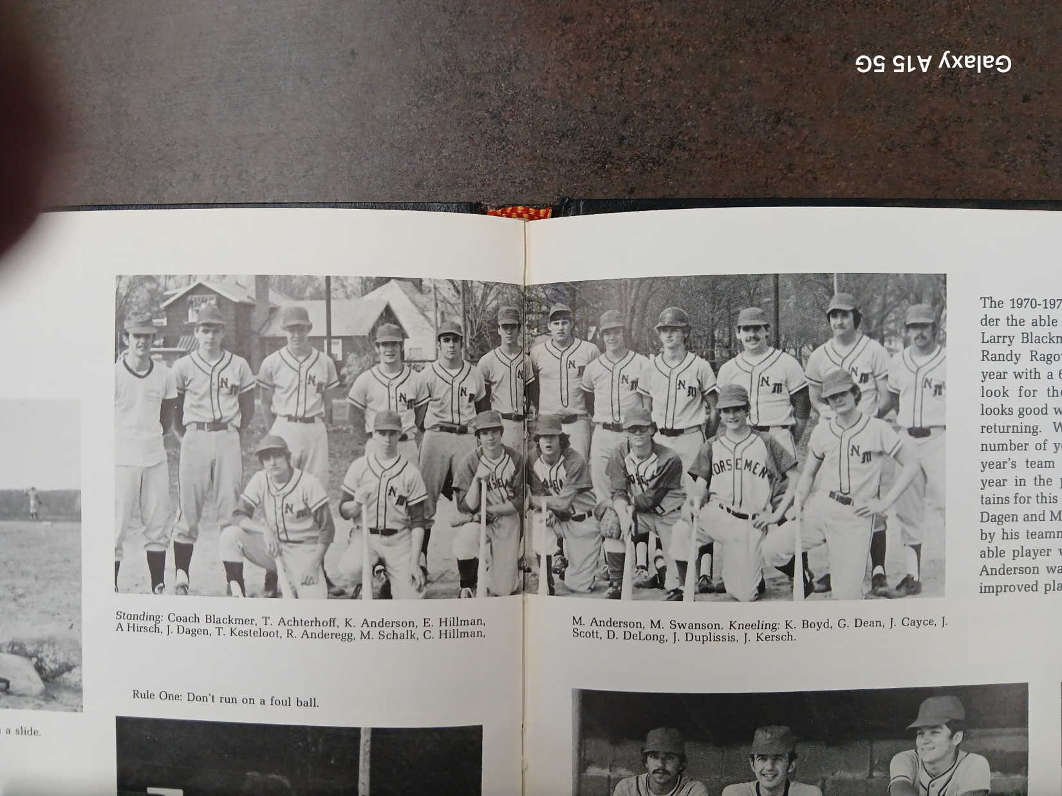

The 1971 NORSEMEN

Record Score Interesting Fact
0-1 Fruitport 12, NM 5 Chris Hillman 2 hits (double)
0-2 *Montague 4, NM 1 Rick Jones only NM hit
0-3 WM Christian 5, NM 1 Tom Kesteloot single to drive in only NM run
0-4 *Ravenna 6, NM 3 Art Hirsh home run
1-4 *NM 5, Mason CC 3 Rick Anderegg 2 hitter, 15 K’s, Jim Dagen 2 hits
1-5 *Hart 16, NM 12 Hart rallies for 6th runs in 6th inning, Anderegg HR
2-5 NM 12, Whitehall 11 NM rallies for 4 runs in 7th, Tim Anderson 2 hits
3-5 *NM win, Shelby loss No score in MC
3-6 *Oakridge 8, NM 3 Dagen 2 hits (HR)
3-7 Orchard View 7, NM 1 Merle Swanson 2 hits (double), Mike Schalk RBI single
4-7 *NM 9, Montague 6 Jones 3 hits, 5 rbi, Ken Anderson 2 hits (double)
4-8 *Ravenna 8, NM 3 Dagen accounts for all NM runs with a 3 run HR
5-8 *NM 7, Mason CC 1 Anderegg 3 hitter, 10 K’s, Mark Anderson 2 hits
6-8 *NM 8, Hart 5 NM turns triple play, Mark Anderson HR, Swanson 2 hits
6-9 *Shelby 6, NM 1 Mark Anderson’s Sac Fly only NM run
6-10 *Oakridge 4 NM 3 Score from Jack Schugars

1972 – coach Larry Blackmer (12-7 overall; 11-1 in WMC; WMC Champs)
After seven straight losing seasons, the Norse put it all together by capturing the West Michigan Conference championship. The season began with back-to-back losses, including a 12-9 loss to Whitehall when the Vikings scored seven runs in the bottom of the sixth inning to erase an 8-5 Norse lead. Six of those runs came after two were already out; however, the Norse would not let those early setbacks get in the way. Spearheading the 12-7 season were the Norse foursome of Rick Jones, Rick Anderegg, Greg Dean and Larry Williams. Jones, who quarterbacked the Norse football team to a No. 1 state ranking in the Class C football polls, was the leading home-run hitter for the Blue & Gold with five. Dean, who hit at a .481 clip, is the father of future Norse power hitters Geoff and Mike Dean in the 2000s. Greg would be the first Dean to clear the friendly left-field fence on the Northside during an 11-8 victory over Hart. Anderegg showed a lively arm once again in 1971 with a 12-strikeout performance against WMC while 1972 would mark the arrival of reed-thin freshman Larry Williams. Although Williams would be best remembered as one of NM’s all-time best pitchers, he hit a robust .400 in 1972. This season would mark several milestones in North Muskegon baseball history. It would signal the first appearance for the Norse in the Muskegon County tournament and their first in a recently created state play-off format. Sadly, for Norse fans, they would drop their first-ever appearances in both, dropping a county tourney game to Mona Shores (4-0) and losing their first pre-District game to Western Michigan Christian (11-4). The other milestone accomplished by the 1972 club is one that is hard to believe: it would be the final West Michigan Conference championship won by the Norse until the 2008 season.

Record Score Interesting Fact
0-1 Fruitport win, NM loss
0-2 Whitehall 12, NM 9 Rick Jones loses; Jones HR, 3 RBI; Tom Achterhof 2 hits
1-2 *NM 4, Montague 3 Rick Anderegg wins; Mike Schalk, Larry Williams 2 hits
1-3 WMC 11, NM 1 Jeff Kersch loses; NM pitchers allowed 14 hits
2-3 *NM 4, Ravenna 1 Jones wins; Jones 3-run HR; Schalk 3-for-3
3-3 *NM 2, Mason CC 1 Jones 7 K’s; 2 hits (Greg Dean, Ken Anderson)
4-3 *NM 11, Hart 8 M. Anderson wins; Dean 3-run HR; Schalk, Williams 2 hits
4-4 Orchard View 3, NM 1 Reid Raymor loses: Jones HR
5-4 *NM 10, Shelby 0 M. Anderson wins; Jones 3-run triple; Dean 1B, 2B, 3 RBI
6-4 *NM 4, Oakridge 2 Jones wins: Jerry Brevick 3 hits, including a double
7-4 *NM 12, Montague 4 Anderegg 8 Ks ; Jones 2 doubles
8-4 *NM 5, Ravenna 3 . Anderson wins; Jones, Anderegg 2 hits
9-4 *NM 9, Mason CC 1 Jones wins; M. Anderson HR ; Jones, Anderegg 1B, 2B
10-4 NM 6, WMC 4 Anderegg 12 K’s; Jones, M. Anderson 3 hits
11-4 *NM 5, Hart 3 Mark Anderson wins; Dean 3 hits ; Schalk, Jones 2 hits
11-5 *Shelby 6, NM 3 Kersch loses; Jones HR; K. Anderson 2 hits
12-5 *NM 11, Oakridge 10 10 innings; Jones wins; NM 5 runs in 7th; K. Anderson 5 1B
12-6 Mona Shores 4, NM 0 1st County tournament game for NM; M. Anderson loses
12-7 WMC 11, NM 6 1st pre-District game; Anderegg loses; Dean single, 2-run 3B

1973 – coach Larry Blackmer (10-6 overall; 7-3 in WMC; 2nd place in WMC; Hart Champs)
The Norse put together another successful season and moved into a tie for first with Hart following an extra-inning win over the Pirates on May 17. The Norse needed a WMC season-ending doubleheader sweep over Oakridge to earn a share of the crown but had to settle for a split against the Eagles. Former NM principal Jim VanBergen. a regular on the WMC Pirate nine can boast about his conference championship, but Norse fans will be quick to point out who handed the Pirates both of their defeats in 1973. A bit of history took place prior to the Norse nine-inning battle with the title-winning Pirates. On May 14, sophomore Larry Williams, who batted .360 for the season, knocked in two runs in the 15th inning to give the Norsemen a 7-6 win over Mason County Central, the longest game in NM history. Williams, who would be selected to the all-time NM team as a pitcher, displayed his baseball versatility by making the West Michigan All-Conference team as an infielder. Half of the Norse victories were decided by one run, including a pair of thrillers over Western Michigan Christian. The Norse took the first win vs. their cross-town rivals with the big blow being a three-run home run by Reid Raymour. The second win took place in the pre-districts with Mark Anderson hurling a one hitter over the Warriors. The game winning blow was William’s 2 RBI single in the seventh that sent Norse fans home happy. The successful season came to an end but not before the Norse put up a good fight against Kent City, the top ranked team in Class C according to the latest AP poll. If not for a wild streak where NM pitches allowed 14 walks, the Norse could very well have pulled off the upset. NOTE: North Muskegon did not play in the County tournament.

Record Score Interesting Fact
0-1 Ravenna won, NM lost
1-1 *NM 8, Mason CC 7 Larry Williams 2 hits (double)
2-1 *NM 6, Montague 3 Reid Raymour 2 hits and winning pitcher
3-1 *NM 10, Hart 4 Raymour 3 run HR, Jeff Kersh 2 doubles GW RBI
4-1 NM 7, WMC 6 Eight innings. Reid Raymor 3-run HR
5-1 *NM 4, Shelby 1 Raymour 4 hitter, has 2 hits
5-2 *Ravenna 4, NM 2 Brent Holcomb, Mark Anderson 2 hits, Williams double
6-2 *NM 7, Mason CC 6 15 innings; Williams hits 2-run double in 15th for win
7-2 *NM 2, Hart 1 Nine innings vs. WMC champs; Greg Dean GW double in 9th
7-3 WMC 10, NM 0 Mark Riekels no hits the Norse
8-3 *NM win, Shelby loss No report in MC
9-3 *NM 8, Oakridge 7 Williams bloop single wins, Anderson, Raymour H
9-4 *Oakridge 2, NM 1 Oakridge scores 2 unearned runs off Williams in 1st inning
10-5 NM 3, WMC 2 Williams hits 2 rbi base hit in 7th for win, Anderson 1 hitter,
10-6 Kent City 7, NM 4 NM loses to top ranked Class C ranked team Raymour 3 run HR

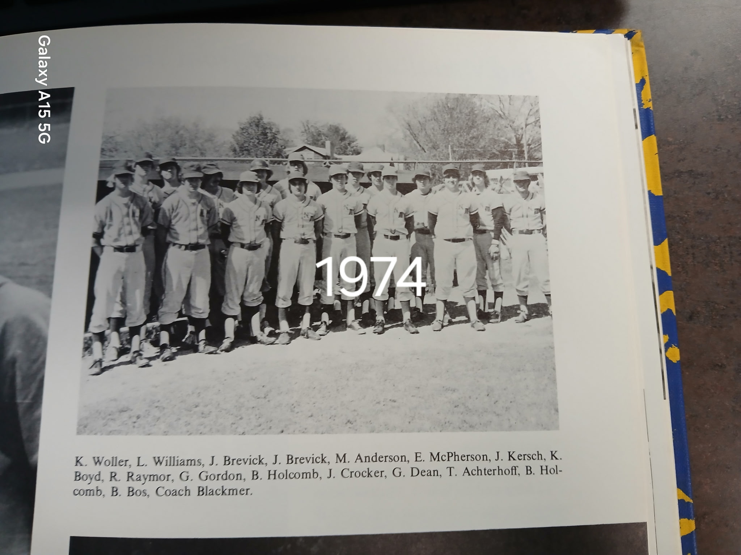
Although it says 1974, this
Is the 1973
Norsemen

The NORSEMEN of 1973

1974 – coach Larry Blackmer (5-10 overall; 4-8 in WMC; xx place in WMC; Hart Champs)
If only Larry Williams could have pitched every game for the Norsemen! Finals stats reported to the Muskegon Chronicle revealed an outstanding season for the junior right-hander. Williams fanned 92 batters while compiling an earned run average of less than one run a game (0.78), winning all five of NM’s wins picked up during the season, including a six-inning no-hitter in a pre-district win over Pentwater. Coach Blackmer’s decision to save Williams for the district championship game proved disastrous as Holton scored 6 early runs in an 8-3 district semi-final win. Speedy outfielder Jeff Guy, whose father Stan was a legendary football star and NM’s only All-Dream team honoree in 1954, swiped 22 bases during the 1974 season. NOTE: North Muskegon did not participate in County tournament

Record Score Interesting Fact
0-1 *Mason CC 11, NM 9 Game played in rain & snow
0-2 *Ravenna 1, NM 0 Reid Raymour loses a 2 hitter
1-2 *NM 4, Shelby 3 10 innings. Larry Williams winner, 11 K’s; Tom Achterhoff GW 1B
1-3 *Oakridge 3, NM 1 Williams 3 hitter – 10 K’s
1-4 *Montague 3, NM 2 NM loses on 2 errors in 6th. Raymour LP; Jeff Guy, Raymour 2 hits
1-5 Orchard View 10, NM 0 Don Beattie 5 inning no hitter
1-6 *Hart 4, NM 2 No report in MC – score from NM yearbook
1-7 *Hart 10, NM 6 Achterhoff 2 hits
2-7 *NM 2, Mason CC 1 Williams two hitter, NM win on walk-off balk call
2-8 *Oakridge 7, NM 2 No report in MC – score from NM yearbook
3-8 *NM 4, Montague 1 No report in MC – score from NM yearbook
4-8 *NM 5, Ravenna 2 No report in MC
4-9 *Shelby 2, NM 1 Shelby’s Rick Zoulek 1 hitter; Bruce Bos only NM hit
5-9 NM 10, Pentwater 0 Williams no-hitter, 15 K’s (6IP) Williams 2 hits, Guy 3 SB
5-10 Holton 8, NM 3 Districts

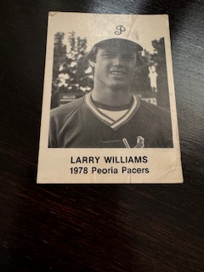

1975 – coach Dave Warmack (11-7 overall; 7-5 in WMC; xx place in WMC; Oakridge/Ravenna Champs)
Dave Warmack served as the head coach of the Norse for the 1975 season and piloted the Northsiders to a successful campaign. Larry Williams had a spectacular season for the Norsemen winning 10 of the 11 games where NM finished on top. With an ERA of .071, Williams still holds the top two seasons, ERA-wise, in NM history. Williams fanned 154 opponents in 1975, a mark that hurlers are still trying to match. Williams set the tempo for the season by tossing a four-hitter in a 3-1 early April victory over Fruitport. Williams pitched a pair of shutouts in 1975 and in five other outings gave up only a single tally. One of those one-run outings came against Ravenna when Williams lost a 1-0 pitchers’ duel to current Shelby head coach Brian Wright. The Bulldogs only run was unearned when Wright scored on a catcher’s overthrow of third base. The tall, slender and bespectacled hurler came back in the County tournament to fan 15 Bulldogs in a 4-0 whitewash of Ravenna. Williams was not just a one-sport wonder. During the winter Williams averaged more than 22 points per game for NM’s basketball team, at that time an average second only to Gordy Odell in NM history The win over the Bulldogs was the Norsemen’s first win in the four-year history of the County tournament. Supplying the big hit in the contest played at historic Marsh Field was a three-run home run by Terry Warmack, the younger brother of the Norse head coach. Williams, who would have a marvelous career at Central Michigan University, before embarking on a career in the Kansas City farm system where he would make it to the Double A level, was no slouch at the plate either. Williams lashed out five hits in NM’s 13-12 slugfest victory over Montague, a performance shared by only five others in NM history. It would be tough to argue against Larry Williams being the GOAT (greatest of all time) in the long and proud history of North Muskegon baseball.

Record Score Interesting Fact
1-0 NM 3, Fruitport 1 Larry Williams 4 hitter, also hit triple
1-1 *Ravenna 3, NM 2 Williams triple, Jeff Guy 2 hits
2-1 *NM 6, Mason CC 3 Williams winner, 2 hitter, 12 K’s, Ed McPherson, Guy doubles
3-1 *NM 1, Hart 0 Williams 1-hitter, 15 K’s, Guy 2 hits (triple)
4-1 *NM 8, Shelby 6 Williams 14 K’s, Shelby 6 unearned runs
4-2 *Oakridge 3, NM 0 Terry Warmack has only 2 NM hits
5-2 *NM 6, Montague 1 Williams 2-hitter, 14 K’s, Warmack 2 doubles
5-3 *Ravenna 1, NM 0 Williams loses; Williams has 2 hits (triple)
6-3 *NM 6, Mason CC 1 Reid Raymour winner, Bruce Bos 2 HR, Guy 2 hits
7-3 *NM 9, Hart 2 Williams winner, Terry Warmack 2 HR, double, 6 rbi
8-3 NM 10, Hesperia 1 Pre-District, Williams’ winner, 3 hitter, 15 k’s
8-4 *Shelby win, NM loss No report in MC
8-5 *Oakridge 9, NM 8 Oakridge scores 4 unearned runs in 7th, Williams HR, Randy Breen 2hits
9-5 *NM 13, Montague 1 Williams 5 hits
9-6 Ravenna 12, NM 1 District, Williams NM HR. Joe Coletta’s bases loaded 2b ends game
10-6 NM 4, Ravenna 0 County; Williams 15 K’s; Warmack 3-run HR
11-6 NM 6, Fruitport 5 Breen, Warmack 2 hits (game winning rbi) Williams 2 hits (2B)
11-7 Musk. Cath 7, NM 0 County finals; Williams 11 K’s, Guy 2 hits; MCC 6 unearned runs

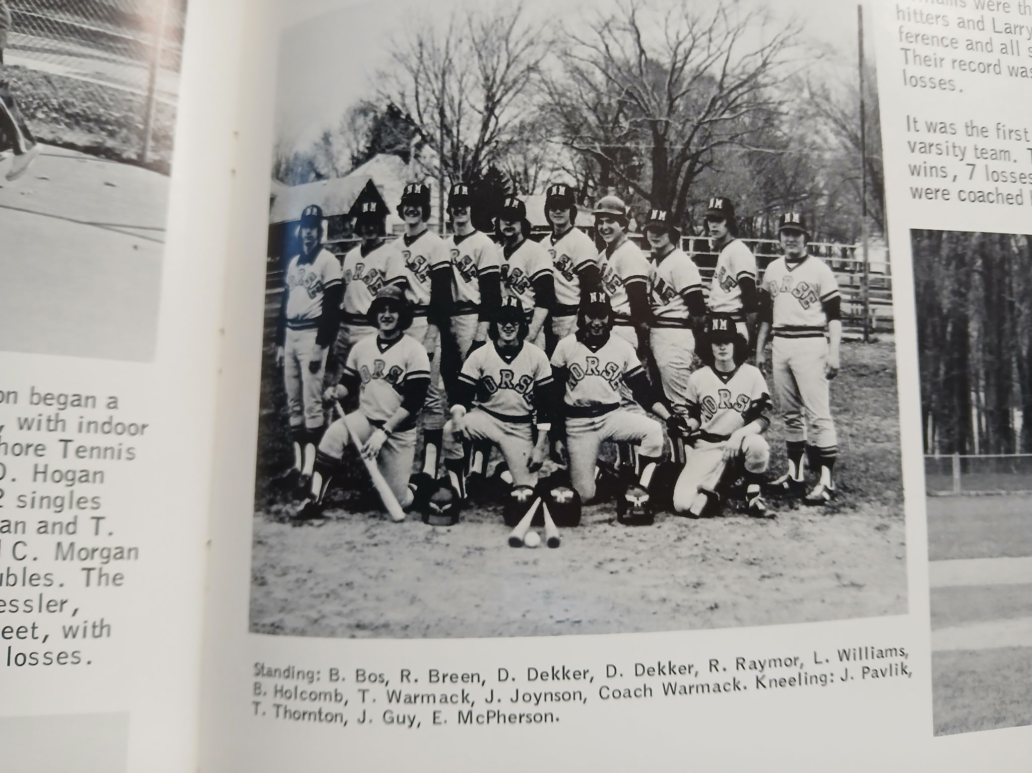

The NORSEMEN of 1975

Standing L-R: Bruce Bos, Randy Breen, Dan Dekker, Reid Raymour, Larry Williams, Bob Holcomb, Terry Warmack, J, Johnson, coach Dave Warmack
Bottom Row: John Pavlik, Tim Thornton, Jeff Guy, Ed McPherson

1976 – coach Ben Quick (3-12) overall; 2-9 in WMC; xx place in WMC; Ravenna Champs
The next four years would see the Norse suffer through some lean seasons. Former Mason County Central alumnus Ben Quick would take over the baseball program from his good friend Dave Warmack for the 1976 & ‘77’ seasons. Quick’s alma mater didn’t treat his Norsemen kindly in his first game as NM coach as the Spartan’s pummeled the Norsemen 13-2 in the season opener. In the Norse’s lone non-conference victory, Roger Crawford blasted four hits in a 9-8 NM victory over cross-town rival Western Michigan Christian. One of the Norsemen’s two WMC victories came over Shelby when the Norse came out on top in a 6-3 victory. The second match-up between The Norsemen and the Tigers would be decidedly different. The Tigers ‘dimed’ the Norsemen 11-0 with longtime Shelby basketball coach Rick Zoulek throwing a five-inning, no-hitter against the Norse. Coach Quick’s squad couldn’t have been too disappointed in their final loss of the 1976 season when they lost to Ravenna. The Bulldogs not only won the WMC but also made it all the way to the state championship game before losing in the state finals to perennial power Blissfield.

Record Score Interesting Fact
0-1 *Mason CC 13, NM 2 Terry Warmack HR
0-2 Fruitport 11, NM 1 NM has only 2 hits off Fruitport’s Ken Jett
0-3 WM Christian 11, NM 1 Warmack triple & double in five inning game
1-3 *NM 6, Shelby 3 Warmack 3 hitter, Warmack (triple) & Bert Jackson 2 hits
1-4 *Oakridge 6, NM 1 Harry Whiteman 1 hits the Norse (Kevin DeForest 1B)
1-5 *Montague 7, NM 3 NM has only 4 hits
1-6 Muskegon 13, NM 3 County tournament, Big Reds score 12 runs in 1st inng.
1-7 *Ravenna 6, NM 0 Joe Coletta 1 hitter for Ravenna; Jeff Stork only NM hit
2-7 *NM 4, Hart 2 NM wins with only 1 hit; Roger Crawford double
2-7 *NM, Hart Game rained out
3-7 NM 9, WM Christ. Crawford 4 hits including game winner, Dan Dekker 3 hits
3-8 *Shelby 11, NM 0 Five inn. Future Shelby basketball coach Rick Zoulek no-hitter
3-9 *Mason CC 10, NM 2 Jackson LP has NM commits 8 errors: Jackson triple
3-10 *Montague 10, NM 9 Pre-District & WMC game, Warmack 2 hits (3B); John Nedeau 2 hits
3-11 *Ravenna 12, NM 3 Brad Coon, Warmack rbi singles
3-12 *Oakridge 12, NM 5 NM commits 9 errors, Warmack triple

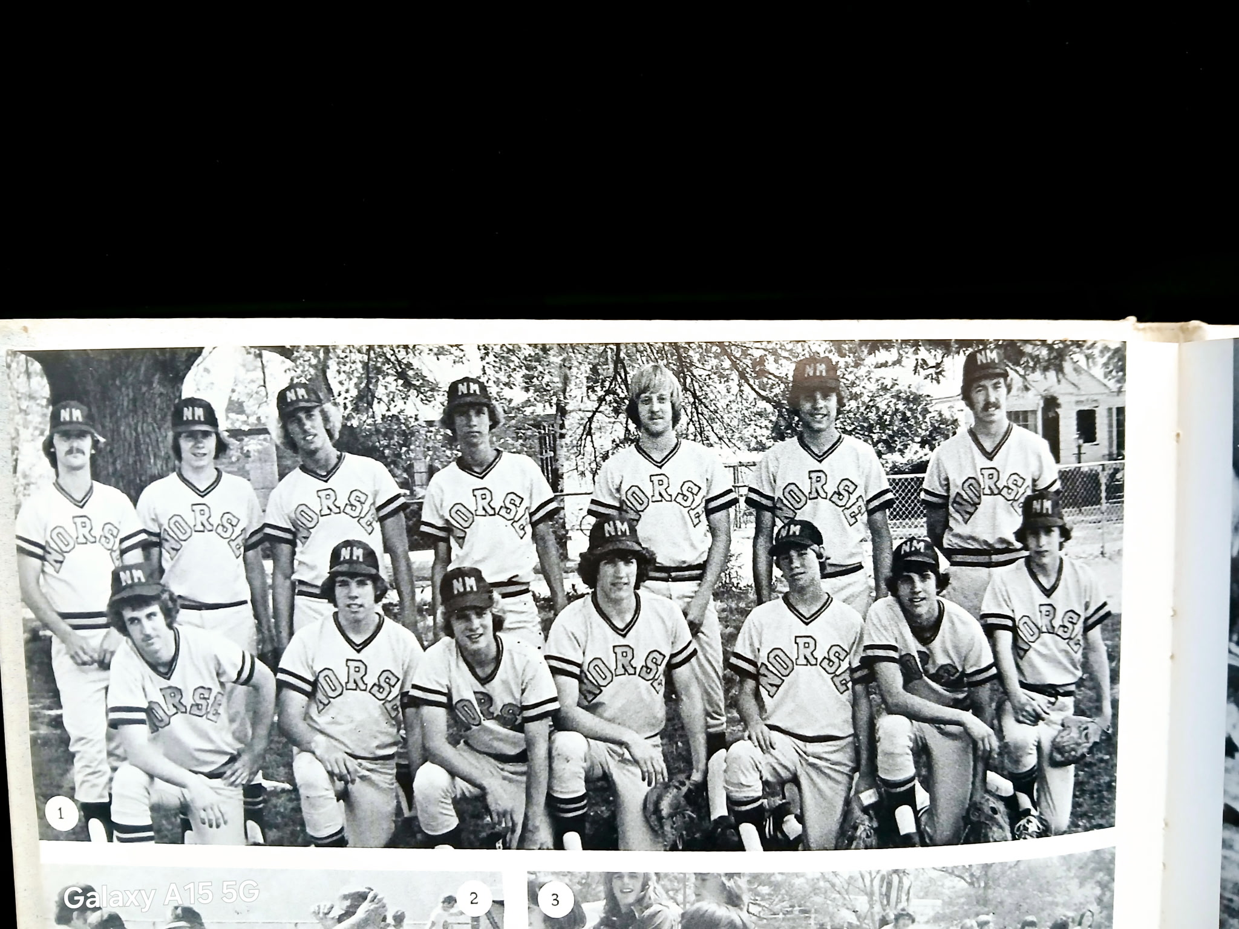

The 1976 NORSEMEN

1977 – coach Ben Quick (2-13 overall; 2-10 in WMC; 6th place in WMC; Mason County Central Champs)
The Blue and Gold were only able to win two games with both coming in West Michigan Conference competition, as Ben Quick’s final team was 2-10 in conference action. One of those wins came in exciting fashion as Roger Crawford belted a home run as NM edged Shelby 9-8 in early April. The other WMC victory was a most improbable victory for the Norse. Just two days after being shut out 10-0 by Oakridge, the Norse reversed the tables and defeated the Eagles 11-1. Crawford nearly helped NM win its third conference battle when he lashed a three-run round tripper against Hart, but the Norse fell one run shy of victory in an 8-7 loss to the Pirates. Mason County Central supplanted Ravenna as WMC champions, and the Spartans showed little mercy of a former Mason County Central alumnus when they pounded the Norse 15-0 in the final game of the 1977 season. Mason County posted a perfect 12-0 record in conference action but lost their important pre-district tournament game to conference rival Ravenna.

Record Score Interesting Fact
0-1 *Hart 5, NM 2 Tim Breen, Joel Stefanits 2 hits
0-2 *Montague 16, NM 5 John McNally HR
1-2 *NM 9, Shelby 8 Roger Crawford HR 2B; 9-inning game
1-3 *Ravenna 14, NM 0 Bill Motambo no hits Norse
1-4 *Mason CC 16, NM 4 NM only 3 hits (Bert Jackson, Randy Breen, Randy Swanson
1-5 *Hart 8, NM 7 Crawford 3-run HR
1-6 Fruitport 17, NM 3 County tournament
1–7 WMC 10, NM 6 Pat Bowen 3 hits
1-8 *Shelby 6, NM 3 Shelby wins their 1st game of season, Nedeau, Swanson rbi singles
1-9 *Oakridge 10, NM 0 Jackson fans 8 in losing cause
2-9 *NM 11, Oakridge 1 Tim Breen 2 hits (3B, 2B), Randy Breen & Bowen 2 RBI
2-10 *Montague 5, NM 2 R. Breen, Bowen 2 hits; Jackson double
2-11 Whitehall 15, NM 2 Pre-District, Swanson HR, Reeths Puffer principal Dan Beckman HR for Whitehall
2-12 *Ravenna 9, NM 0 NM loses to Joe Coletta (1-hitter), future Oakridge off. Coordinator and broadcasting partner on the radio with Jim Moyes & Gene Young
2-13 *Mason CC 15, NM 0

1978 – coach Randy Horn (2-13 overall; 2-10 in WMC; 7th place in WMC; Oakridge Champs
The season would be one of those years that new Norse baseball coach Randy Horn would just as soon forget. The baseball team finished with a disappointing 2-14 record, but those two wins were two more than Coach Horn’s basketball team was able to garner during the winter months. Baseball at North Muskegon did have its upside for coach Horn. Horn would marry the sister of NM baseball legend Larry Williams. If it was any consolation for NM baseball followers, it was that this team was competitive. Only in an 11-1 loss to Oakridge did the Norsemen suffer a double-digit defeat. The highlight of the season was the Norse’s 6-5 victory over Hart when sophomore Steve Preston knocked in the winning run. Roger Crawford was the overall hitting star for coach Horn’s team by blasting at least two home runs on the season. Crawford also picked up one of the two Norse wins by striking out 9 Shelby batsmen in an 8 inning win over Shelby. The Norse rallied to score two tallies in the seventh to send the game into extra innings and then Coach Horn’s future brother-in-law, Dave Williams, knocked in the winning run in the eight-inning with a double.

Record Score Interesting Fact
0-1 *Hart 3, NM 1 Bert Jackson 2 hitter, 14 Ks in loss, 3 errors in 7th doom NM, Scott Preston 2 hits
0-2 Musk. Heights 9, NM 3 Pat Bowen 2 hits (double), Greg Botbyl Roger Crawford 2 hits
1-2 *NM 5, Shelby 4 Eight innings, Botbyl 2 run single ties game, Dave Williams winning 2B
1-3 *Oakridge 7, NM NM only 3 hits (Jackson, Crawford and Ron Matthews)
1-4 *Montague 11, NM 7 Botbyl 2 run single only NM highlight
1-5 *Ravenna 12, NM 2 Ravenna scores 9 runs in 1st; Botbyl 2 hits
1-6 Oakridge 11, NM 1 County tournament; NM gets only 1 hit in 5-inning game
1-7 *Mason CC 11, NM 8 Crawford 2 hits (triple) Doug Laurin 2 hits
2-7 *NM 6, Hart 5 Steve Preston GW RBI, Botbyl 3 hits
2-8 *Shelby 8, NM 6 Matthews 2 RBI single, Andy Shirley RBI single
2-9 *Oakridge 10, NM 3 Oakridge wins 9th straight WMC game
2-10 *Montague 5, NM 4 Pre-district & WMC game; Montague scores on 3 passed balls and error, Steve Preston 2 hits
2-11 *Ravenna 12, NM Roger Crawford 3 run HR
2-12 WM Christian 9, NM 6 Bert Jackson 3 hits, including 2 triples, Crawford HR
2-13 *Mason CC 6, NM 5 Nine innings. Spartan’s Dale Swanson end game on walk-off HR

1979 – coach Randy Horn (1-14 overall; 1-11 in WMC; 7thplace in WMC; Mason Co. Central-Hart-Ravenna Co Champs)
The Norse battled hard again during the 1979 campaign but suffered through another dismal won-loss season. NM was able to win one game during a 15-game season, a 9-7 victory over Montague. Freshman Sam Parker hit a pair of home runs during the campaign, both against Montague. Parker’s home run in the second Montague game, to go along with a couple of other hits, was the difference in the lone Norse victory on the season. Submariner Kevin Ware picked up the only win garnered by a Norse pitcher in 1979. Symbolic of the Norse season was a 3-2 loss to Oakridge when the defense committed eight errors in a tight defeat. The loss to Oakridge was the 11th loss in a row for the Norsemen before they snapped their losing streak against Montague. Steve Preston, who would later lead Northern Michigan University to a Division 2 runner-up trophy in football as their starting quarterback, had a fine offensive season for the Norsemen with a .439 batting average.

Record Score Interesting Fact
0-1 *Hart 10, NM 0 NM only 3 hits (Sam Parker, Steve Preston, Ran Matthews)
0-2 Orchard View 8, NM 4 John Nedeau 2 run double
0-3 *Shelby 10, NM 8 Steve Preston 4 hits (HR, triple, 2 singles)
0-4 *Oakridge 3, NM 2 Brad Billinghurst loses 4 hitter, Steve Preston 2 rbi singles
0-5 *Montague 11, NM 4 Sam Parker 3 run HR
0-6 *Ravenna 4, NM 1 NM only 4 hits
0-7 *Mason CC 9, NM 1 John Arntz 2 hits (double) Dave Williams triple
0-8 Ravenna 7, NM 1 County tournament, Doug Laurin 2 hits
0-9 WM Christian 8, NM 6 Scott & Steve Preston, Matthews, Nedeau all have 2 hits
0-10 *Shelby 14, NM 3 Parker HR, Scott Preston 2 hits
0-11 *Oakridge 3, NM 2 NM commits 8 errors, Parker, Williams 2 hits
1-11 *NM 9, Montague 7 Parker 3 hits, including HR, Steve Preston 3 hits
1-12 *Ravenna 9, NM 4 Matthews triple
1-13 *Mason CC 13, NM 3 NM only 4 hits
1-14 *Hart 9, NM 7 WMC & District game; Mike Hanson 2 hits & 4 RBI

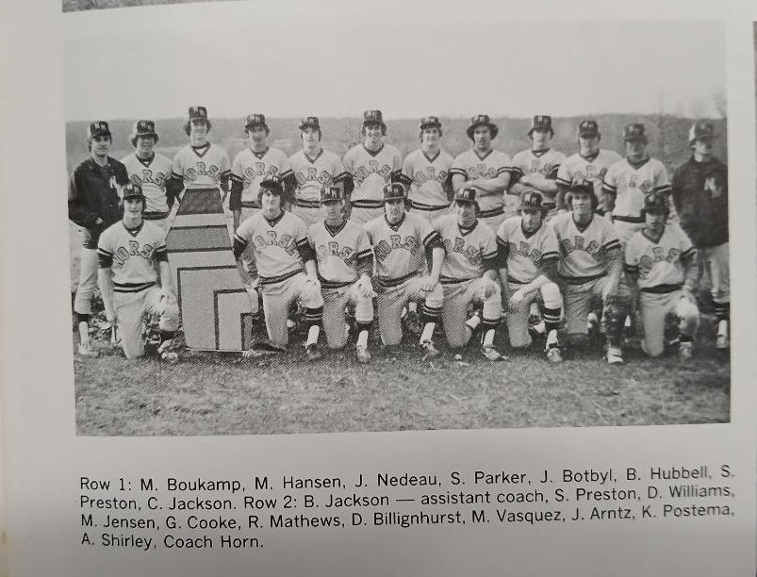

The 1979 NORSEMEN

1980 – coach John Gwatkin (10-8 overall; 8-4 in WMC; 4th place in WMC; MCC/Oakridge Champs)
The Norse made a monstrous turnaround from the 1979 debacle by compiling a winning record and came a single game from winning the West Michigan Conference championship. Mason County Central and Oakridge, who split their season series with the Norsemen, shared the WMC crown with 9-3 records. The Norse received a timely combination of good pitching from Brad Billinghurst (4-0, 1.57 ERA) Dave Williams (2-2, 1.77 ERA) and Ron Matthews (2-3, 3.42 ERA) along with some lusty hitting from sophomore Sam Parker (.447), Matthews (.394) and Greg Cooke (.377). John Gwatkin who volunteered for the job as a non-staff coach guided the Norsemen. Gwatkin’s one-year tenure was a memorable one as it would be another 15 frustrating years before a North Muskegon baseball team would post a winning record. A one for the books’ occurrence took place in the Norse’s 16-1 romp of Hart on May 6 when the Norsemen ran at will against the Hart Pirates in stealing 16 bases.

Record Score Interesting Fact
1-0 *NM 6, Oakridge 1 No game report in MC
1-1 *Montague 12, NM 6 Greg Cooke, Brad Billinghurst, Jeff Boybyl 2 hits
2-1 *NM 6, Ravenna 3 Ron Matthews winner; Brian Hubbell 2 hits
3-1 *NM 4, Mason CC 3 John Arntz drives in winning run-on base hit
3-2 Orchard View 15, NM 3 OV plays errorless ball vs. NM
4-2 *NM 5, Hart 1 Matthews, Bill Banner, Doug Laurin 2 hits; Botbyl 3 RBI
5-2 NM won, Holton loss County Tournament (no score reported in MC)
5-3 WMC 8, NM 7 County Tournament; Ron Rop drives in winning run for WMC
5-4 WMC 13, NM 9 Bill Banner 3 hits (triple) Matthews, Sam Parker, Laurin 2 hits
6-4 *NM 16, Hart 1 Greg Cooke HR; NM stole 16 bases; Billinghurst 2 H (3B)
6-5 *Shelby 3, NM 1 Dave Williams LP; 2-run throwing error dooms Norse
7-5 NM 13, Whitehall 6 Banner winner; Arntz 2 hits (triple) Laurin 2 hits
7-6 *Oakridge 8, NM 4 Eagles move into 1st place: Laurin 2 hits, Steve Preston 3B
8-6 *NM 10, Shelby 0 Billinghurst winner
9-6 *NM 6, Montague 5 Cooke 3 hits (HR, 2B); Parker 3 hits and throws runner out at plate
10-6 *NM 1, Ravenna 0 Kevin Ware wins
10-7 *Mason CC 11, NM 0 MCC scores 9 in the 1st; NM only 1 hit (Cooke, double)
10-8 Whitehall 13, NM 3 Pre-District; Parker triple, Cooke double

1981 – coach Terry Babbitt (7-11 overall; 5-7 in WMC; xx place in WMC; Ravenna Champs)
If the 1981 season were put on a graph, it would possibly resemble a seismograph chart from the San Francisco Earthquake of 1906. There were plenty of peaks and valleys throughout the season under coach Terry Babbitt. The Norse started off strong with early non-conference wins over Kent City and Western Michigan Christian, before dropping nine of their next 10 games. Ravenna, the West Michigan Conference Champion, may have had their way with other WMC foes, but certainly struggled against the Norse. Two of the Norsemen’s five conference wins came against the Bulldogs. Ravenna did have their day in the sun against the Norse by bouncing back to soundly defeat the Norse in the pre-District game. Longtime NM athletic director Jeff Cooke, who battled a rash of knee injuries during his high school career, can fondly look back and recall his pair of hits and three RBI performance in a 12-6 NM win over Hart. Ace Oakridge pitcher Bob Cavanaugh had a not to be forgotten moment in the county tournament. The future Central Michigan University ace was the winning pitcher in three games in one day. Cavanaugh went 4 innings in wins over Montague and North Muskegon and then went the route in the 1-0 championship game with rival Ravenna, tossing a no-hitter against the Bulldogs. Just two days before the County tournament Cavanaugh hurled a 5-inning no-hitter. In all Cavanaugh pitched 22 scoreless innings in three days. In more recent times pitchers cannot pitch more than ten innings without having at least a two-days’ rest. All conference games in 1981 were doubleheaders, much to the chagrin of many of the conference players and coaches. Due to a rainout the Norse were forced to play back-to-back doubleheaders against Mason County Central and Hart on May 13-14.

Record Score Interesting Fact
1-0 NM 9, Kent City 5 KC pitchers walk 15: Sam Parker, Kevin Ware 2 hits
2-0 NM 3, WM Christian 2 Parker drives in Brad Billinghurst for winning run
1-2 *Montague 7, NM 0 NM only 4 hits
2-2 *Montague 8, NM 5 Parker, Billinghurst, and Mario Ferratti 2 hits
2-3 *Shelby 8, NM 7 NM loses 7 run lead on 5 errors, 6 walks, 3 passed balls
3-3 *NM 14, Shelby 13 Greg Cooke, Ken Postema 3 hits; Billinghurst 2 hits
3-4 *Oakridge 3, NM 0 Bob Cavanaugh shuts out Norse
3-5 *Oakridge 2, NM 1 Cavanaugh winner in relief; Dan Brondyk has only NM RBI in DH
3-6 Orchard View 13, NM 3 Billinghurst 2 hits: Cooke double
3-7 Oakridge 4, NM 1 County Tournament, Cliff Jackson 2 hits
3-8 *Mason CC 7, NM 6 Cooke 2 hits; Ware HR
3-9 *Mason CC 11, NM 1 NM only 2 hits off MCC’s Rick Tyndall
4-9 *NM 17, Hart 1 NM scores 15 runs in 1st 2 innings; Parker 3 hits (3B) Cooke HR
5-9 *NM 12, Hart 6 Jeff Cooke 2 hits, 3 RBI
6-9 *NM 3, Ravenna 2 Parker HR; NM wins on Ken Postema’s Sac Fly
7-9 *NM 5, Ravenna 2 Ron Matthews 1 hitter
7-10 Reeths-Puffer 3, NM 0 Lance Lowder 3 hitter over NM
7-11 Ravenna 10, NM 0 Pre-District; Matthews has 2 of NM’s 3 hits (double)

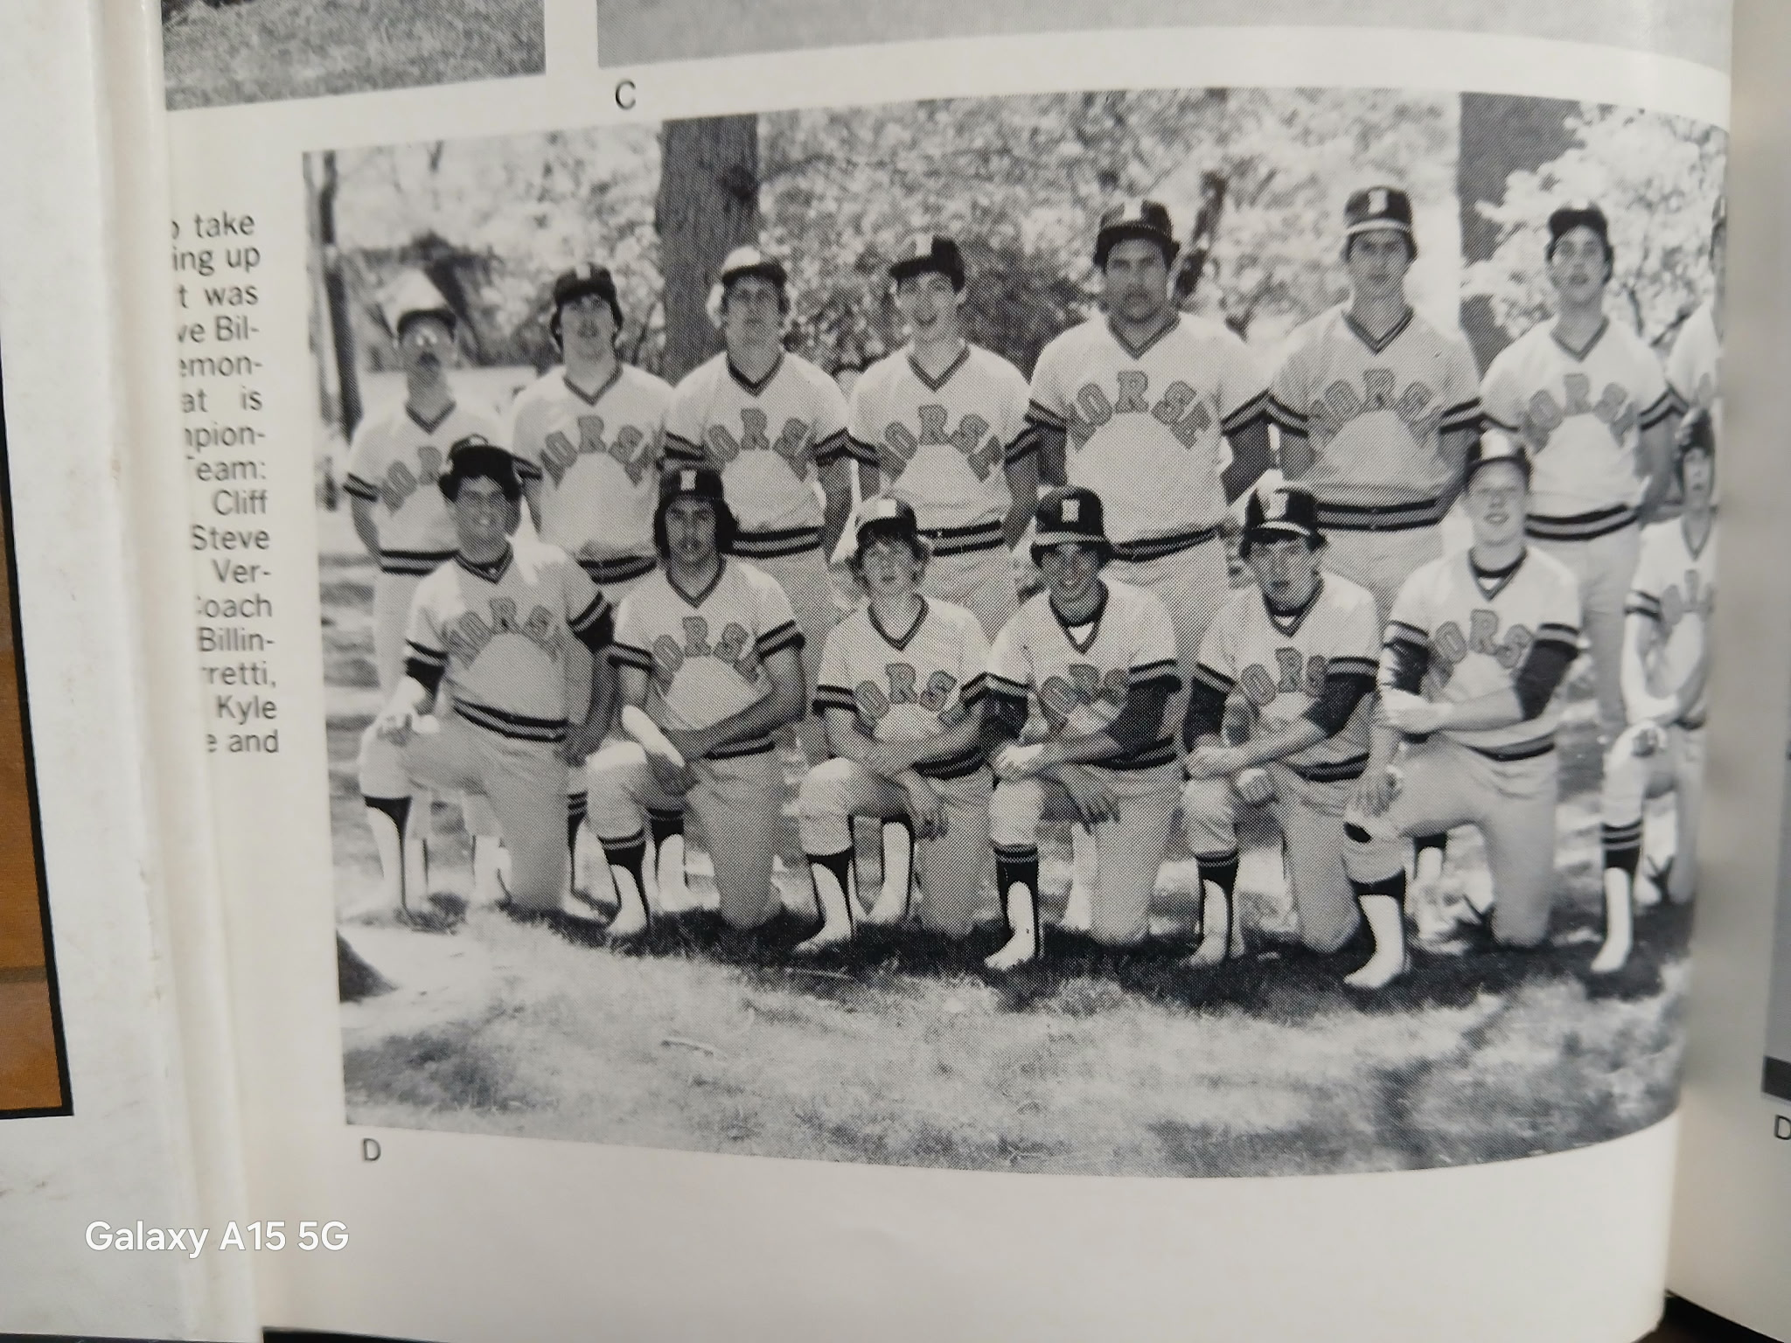

The 1981 NORSEMEN

Front Row: Tom Seroczynski, Cliff Jackson, Johnn Malloy, Steve Compeau, Scott Burns, Bob Versaw,
Tom Cooper
Top Row: Coach Terry Babbitt, Sam Parker, Dave Billinghurst, Mark Jensen, Mario Ferretti, Ron Matthews,
Kevin Ware, Kyle Segar: Not pictured – Jeff Cooke, Greg Cooke, Ken Postema, Dan Brondyk

1982 – coach Terry Babbitt (2-17-1 overall; 1-10-1 in WMC; 7th place in WMC; Montague-Ravenna Co- Champs)
The success the Norsemen enjoyed during the football season didn’t carry over into the baseball campaign as NM had a dreary 2-16-1 record. The tennis program at NM was rock solid as never before as the Norse netters won 84 matches before dropping a match in May to Grand Rapids Forest Hills Central. A pair of All-State football players, Greg Cooke and Sam Parker, who led the football team to the state finals in the fall, paired up to lead the Norse in their lone tie in the WMC. Cooke blasted a grand slam, and Parker notched a solo shot during an 11-11 slugfest that was called on account of darkness. The lone WMC win was a 9-8 trimming of Mason County Central with Cliff Johnson supplying much of the offense with four hits. After turning in their uniforms in late May the Norse were forced to make up an earlier game with Montague that was called due to darkness. The game was replayed on June 2^{nd,} as a win for Montague would give the Wildcats a share of the WMC championship with Ravenna. The Norse were more than cooperative as they were trounced 15-0 by the Cats. The Norse nearly salvaged the season by winning their pre-district game with Shelby, but the Tigers Dave Hoffman spoiled the fun by delivering a two out two-run triple in the bottom of the seventh inning. The poor showing for the Norse might have hastened head coach Terry Babbitt’s decision to give up coaching to become a school administrator. Certainly, the pay was much more lucrative for Babbitt, who would become the Superintendent of Schools at Mona Shores. '

Record Score Interesting Fact
0-1 Newaygo 14, NM 0 Greg Cooke 2 hits (double)
0-2 Montague 13, NM 1 Cliff Jackson 2 of 3 NM hits
0-3 Fruitport 12, NM 2 Jackson 3 hits (double); Cooke 2 hits
1-3 NM 10, WM Christian 4 Sam Parker, Rich South & Jackson all with single & double.
1-4 Shelby 15, NM 7 Jeff Cordo 2 hits
1-5 Shelby 8, NM 5 Jackson 2 hits
1-6 Oakridge 6, NM 2 Parker RBI single
1-7 Oakridge 14, NM 0 Bob Cavanaugh 16 K’s & wins both ends of DH over NM
1-8 Orchard View 14, NM 4 NM commits 8 errors; Parker 2 doubles; Cordo triple
1-9 Montague 18, NM 6 County Tournament; Tom Serocynski 2 hits
1-10 Whitehall 13, NM 1 Kyle Segar only NM RBI,
2-10 NM 9, Mason CC 8 Cliff Johnson 4 hits; Serocynski & Bob Versaw 2 hits
2-11 Mason CC 10, NM 9 Eight innings; NM loses on 2 wild pitches
2-11-1 NM 11, Hart 11 Greg Cooke GS; Sam Parker HR
2-12-1 Hart 8, NM 2 Cooke 2 hits (double)
2-13-1 Kent City 21, NM 1 NM only 2 hits
2-14-1 Ravenna 4, NM 2 Ravenna freshman Dennis Moeller 4 hits NM
2-15-1 Ravenna 7, NM 3 Jackson 2 hits; Parker triple
2-16-1 Shelby 8, NM 7 District; Cooke 2 hits (3 RBI); Versaw, Parker, Jackson 2 hits
2-17-1 Montague 15, NM 0 Make-up game gives Montague WMC tie with Ravenna

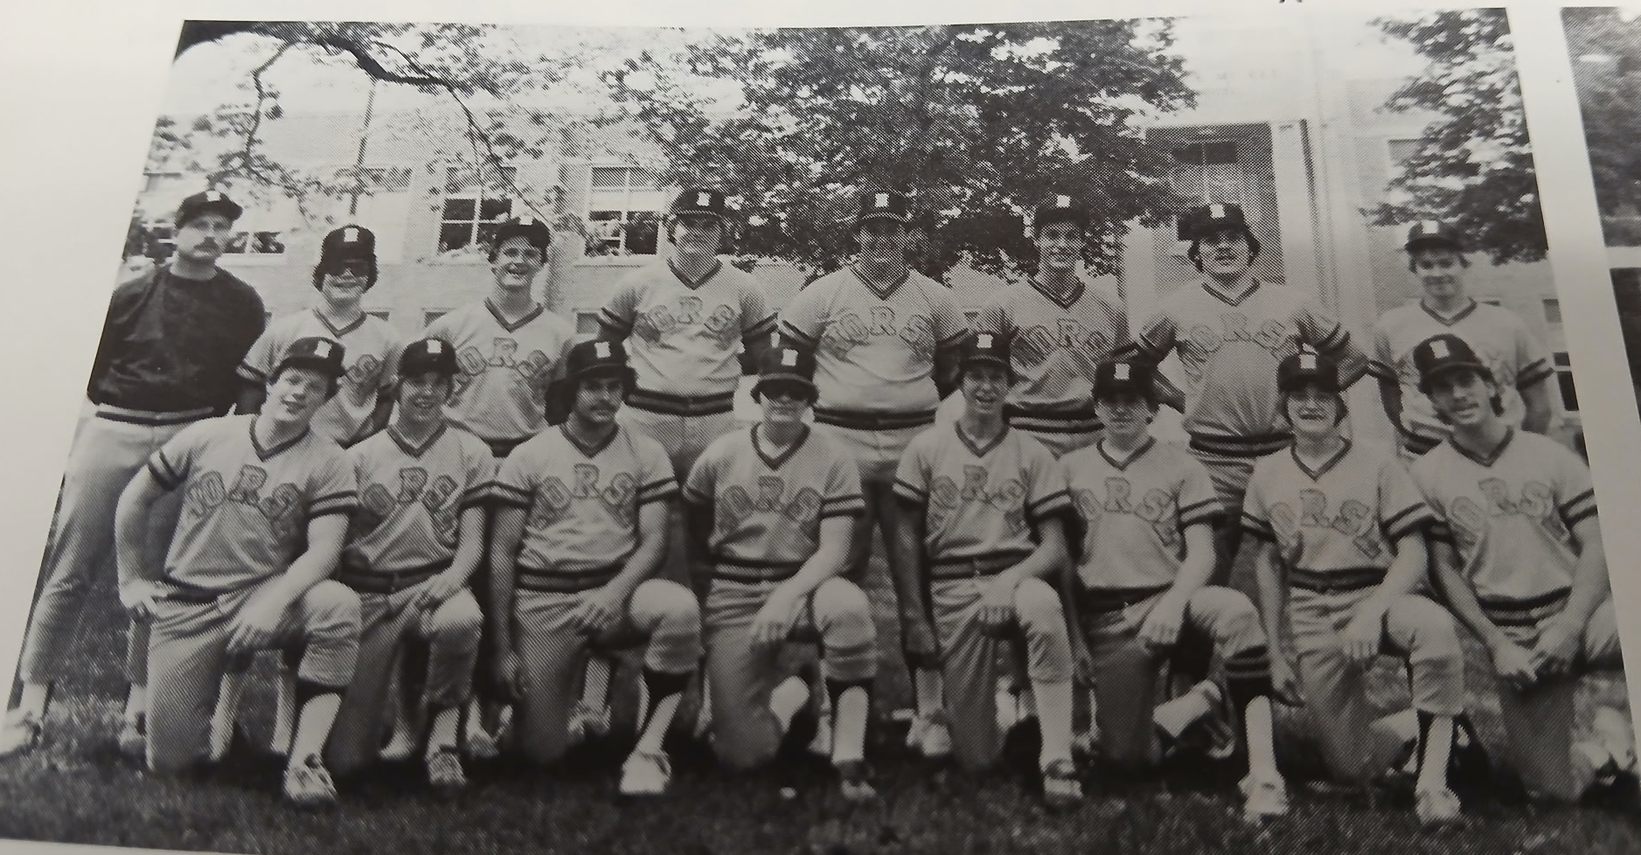

The 1982 NORSEMEN

Front Row L-R: Bob Versaw, Scott Smith, Cliff Jackson, Roger South, Tod Losee, Scott Burns, Rick South, Jeff Cordo
Back Row L-R: Coach Terry Babbit, Trip Curow, Kris Baker, Kyle Segar, John Tebeau, Greg Cooke, Sam Parker, Bob Banner

1983 – coach Denny Emmons (3-11 overall; 2-7 in WMC; 6th place in WMC; Montague Champs)
North Muskegon band director Denny Emmons added the baseball coaching position to his list of duties when the former Muskegon High School teammate of Jim Johnson took over for Terry Babbitt. However, the Norsemen struggles continued. Following the Norse season opener, a 23-0 whipping by Newaygo, Emmons might have had some second thoughts about leading the Norse. Many of the top athletes on the Northside campus for the past few years had begun trading in their Little League gloves for tennis racquets. After Emmons watched as his Norse were no-hit in their first two games, the Norsemen punched together eleven hits in an inconceivable 20-0 walloping of Kent City. Perhaps many of the Kent City players were on spring break as the Eagles in a May 11 rematch shutout the Norsemen 10-0. Greg Zack had a solid season at the plate by posting a batting average of .452. Roger South and Mark Cooke also had a few productive games for coach Emmons’ squad. Without question, the shining moment for NM was the season sweep of Shelby. Cooke had three hits in the first encounter with the Tigers in the 7-6 NM victory while South had four hits in the second meeting with Shelby, an 11-1 pounding of their WMC foe. The only other win for the Norsemen was a 20-0 shellacking of Kent City.

Record Score Interesting Fact
0-1 Newaygo 23, NM 0 Three pitchers (Rick Perkins, Scott Bonk, Troy Molton) no-hit NM
0-2 *Ravenna 12, NM 4 Dennis Moeller, relieved by Mike Gilliard, no hit NM
1-2 NM 20, Kent City 0 Roger South wins: South 2 2B, NM fire chief Steve Lague 2 hits
1-3 *Montague 21, NM 2 Montague scores 18 runs in 1st inn; Todd Losee. Tom Serocynski 2 hits
2-3 *NM 7, Shelby 6 Mark Cooke 3 hits, Serocynski, Greg Zack, Losee, John McCollough 2 hits
2-4 *Ravenna 8, NM 5 Zack 3 hits. Cooke 2 hits
3-4 *NM 11, Shelby 1 South 4 hits (triple, double & 2 singles)
3-5 *Oakridge 11, NM 1 NM commits 10 errors
3-6 Kent City 10, NM 0 NM only 2 hits
3-7 Whitehall 16, NM 3 County Tournament, Zack 2 hits (double)
3-8 *Mason CC 15, NM 2 MCC wins their first WMC game
3-9 *Hart 13, NM 2 NM commits 12 errors: Mark Flynn & Zack only NM hits
3-10 *Hart 5, NM 2 Greg Zack 3 hits (HR)
3-11 Hesperia 10, NM 0 Pre-District, NM only 2 hits

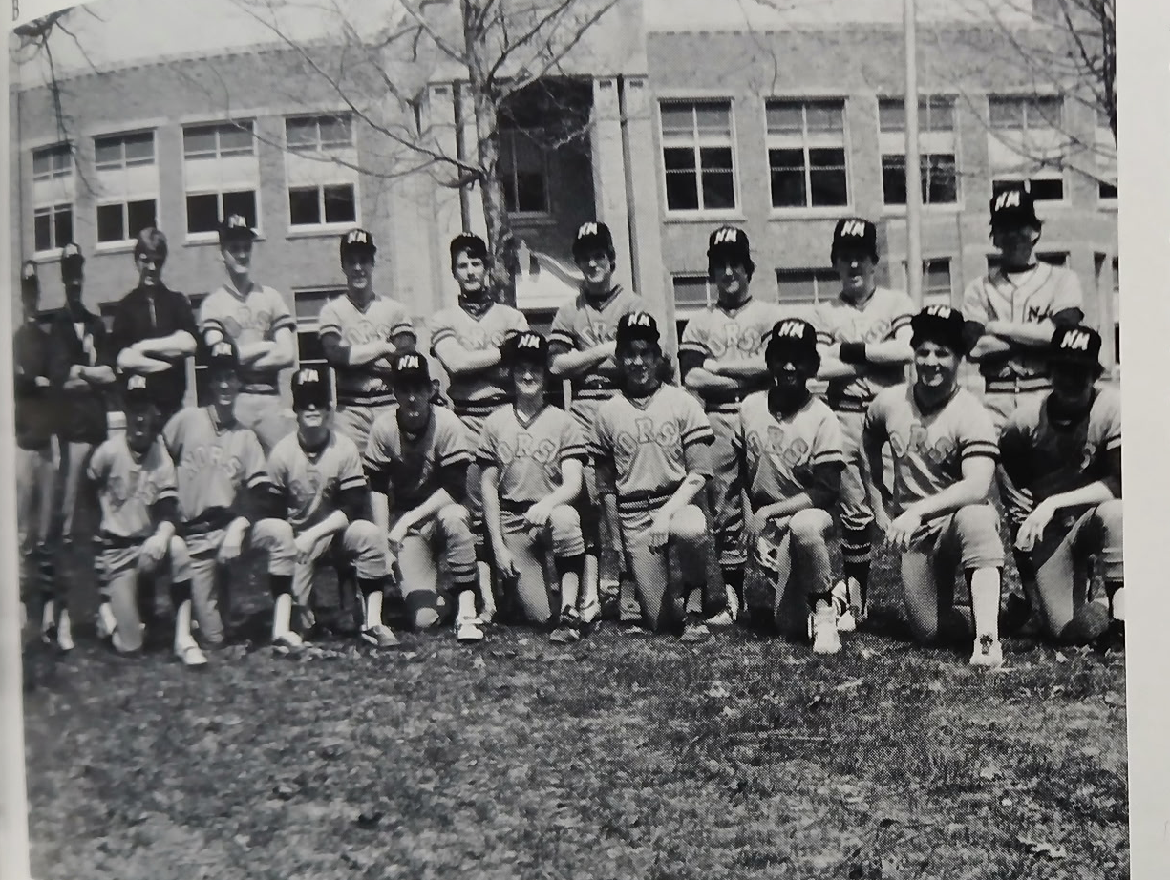

1983 NORSEMEN

Front Row: J. Morrall, T. Lossee, T. Curow, J McCullough, R. South, S. Smith, J. Bridgeford, T. Seroczynski, R. South
Back Row: Coach Emmons, V. Vasquez, M. Cooke, T. Weaver, B. Kinning, K. Baker, G. Zack, S. Burns, D. Andre

1984 – coach Denny Emmons (6-11 overall; 4-8 in WMC; xx place in WMC; Montague Champs)
The Norse doubled their win total over 1983 but still were a long way from getting back to the .500 plateau. The Norse continued their mastery over Shelby and their young head coach Brian Wright by again sweeping the Tigers in the season series. Wright would quickly resurrect the Shelby program and become one of the most respected baseball coaches in the area in the future. Veteran hurler Roger South posted the lone shutout for the Norse when he blanked the Pirates, 3-0, on May 11. The victory over the Pirates capped the Blue & Gold’s best streak of the season by notching their fourth victory in five games. The only loss during the span was a respectable 6-3 defeat at the hands of Montague. The Wildcats pitching ace Link Mikkelson, who would have a great minor league career over several years, struck out 15 NM batters for Montague on its way to an undefeated WMC season. Earlier in the season, Mikkelson posted back-to-back no-hitters vs. Ravenna and Whitehall.

Record Score Interesting Fact
0-1 Newaygo 10, NM 0 Scott Smith 9 strikeouts but loses
0-2 *Montague 15, NM 0 Bob Trevino 1 hits NM
0-3 *Oakridge 12, NM 6 Lousy report in MC – nothing on NM
0-4 *Ravenna 9, NM 8 Greg Zack HR, double; Jeff Diller double
0-5 *Mason CC 9, NM 2 NM has only 4 hits (another lousy report in MC)
1-5 *NM 14, Shelby 4 Mark Cooke triple, single; John McCollough triple
2-5 NM 5, Kent City 4 8 innings; Cooke triple; Zack 2 hits (2B); Todd Losee 2 hits
3-5 *NM 6, Oakridge 3 Cooke 2 hits (double); Zack, Diller 2 hits
3-6 *Montague 6, NM 3 NM batters strike out 15 times: Smith 2 RBI single
4-6 *NM 3, Hart 0 Roger South wins
4-7 *Hart 6, NM 5 Diller 2 hits; NM leaves runners on 2nd & 3rd in 7th inn.
4-8 Whitehall 24, NM 2 County Tournament
4-9 *Ravenna win, NM loss No report in MC
5-9 NM 7, WM Christian 6 Jeff Diller picks up win in relief
5-10 *Mason CC 11, NM 3 No report in MC
6-10 *NM 14, Shelby 1 Jeff Diller 3 hits; Cooke triple
6-11 WM Christian 15, NM 0 Pre-District; Todd Losee’s double only NM hit

1985 – coach Denny Emmons (10-11 overall; 6-8 in WMC; xx place in WMC; Whitehall Champs)
The Norse managed to reach the .500 record when the Norse had completed their regular season schedule. A first-round loss to West Michigan Christian once again left the Norsemen south of the break-even goal when the Warriors shut the Norse out 3-0. Whitehall made their reentry back into the West Michigan Conference a memorable one as they ran the table enroute to a perfect 14-0 league mark. Mark Flynn had a blowout year for the Norse by posting a .500 average and making the All-State team. Supplying some power for the Norsemen were Scott Smith, John Morrall and Jeff Diller. Smith had a career game in a May 14, an 8-3 win over Ravenna, chipping in with his arm and his bat. Smith was the winning pitcher and aided his own cause by blasting a home run and a triple. It appeared the Norsemen established some signs of having a better future when they won four straight games late in the season. They couldn’t have been too disappointed with their effort in their 3-0 defeat in the state playoffs to Western Michigan Christian. The Warriors would go on to capture the state Class D championship. The 1985 Norsemen can always boast they beat a state champ following an earlier 15-6 victory over the Warriors on May 16. By the way, the volunteer baseball coach for the Norse JVs in 1985 was your author, Jim Moyes. Please don’t ask me for our record.

Record Score Interesting Fact
1-0 NM 6, Kent City 3 Roger South winner; Scott Smith 2 hits (Double)
1-1 *Montague 9, NM 4 Todd Losee 3 hits
2-1 *NM 8, Hart 4 John McCollough 2 hits (2-2B’s), Steve Hoffman RBI double
2-2 *Oakridge 3, NM 1 NM only 2 hits; Jeff Diller & Smith
3-2 *NM 10, Ravenna 4 Losee 3hits; Mark Flynn, McCollough 2 hits
3-3 *Whitehall 8, NM 3 Losee 3 hits; Scott Smith HR
3-4 *Whitehall 8, NM 7 Jeff Diller 3 hits (HR); Losee 2 hits (HR)
4-4 *NM 16, Mason CC 11 John Morrall GS, double
4-5 Hesperia 11, NM 1 NM has 6 hits & 4 errors
5-5 *NM 5, Shelby 4 Hoffman’s 2 RBI single the big hit
5-6 *Oakridge 5, NM 3 Kyle Stevens, Diller, RBI singles
5-7 *Montague 10, NM 0 Tim Peterson strikes out 11 Norse in 5 inning game
5-8 *Hart 11, NM 5 NM loses 4 runs lead when Hart scores 8 in the 4th inning
6-8 NM 6, Oakridge 5 Co. Tourney; after Hoffman’s 3B, Stevens drives in winning run
6-9 Whitehall 22, NM 3 County Tournament; Whitehall 18 hits, Stevens rbi single
7-9 *NM 8, Ravenna 3 Smith HR, triple; Flynn 2 hits, Hoffman triple
8-9 NM 15, WMC 6 Diller, Mark Flynn 5 RBI, South 4 hits
9-9 NM 17, Musk. Hts. 4 Diller HR, 4 RBI, South 3 run triple
10-9 *NM 7, Shelby 5 Kyle Stevens HR
11-9 *Mason CC 19, NM 9 MCC scores 14 in 1st 2 innings
11-10 WMC 3, NM 0 Pre-District; Steve Dolislager 3 hits NM

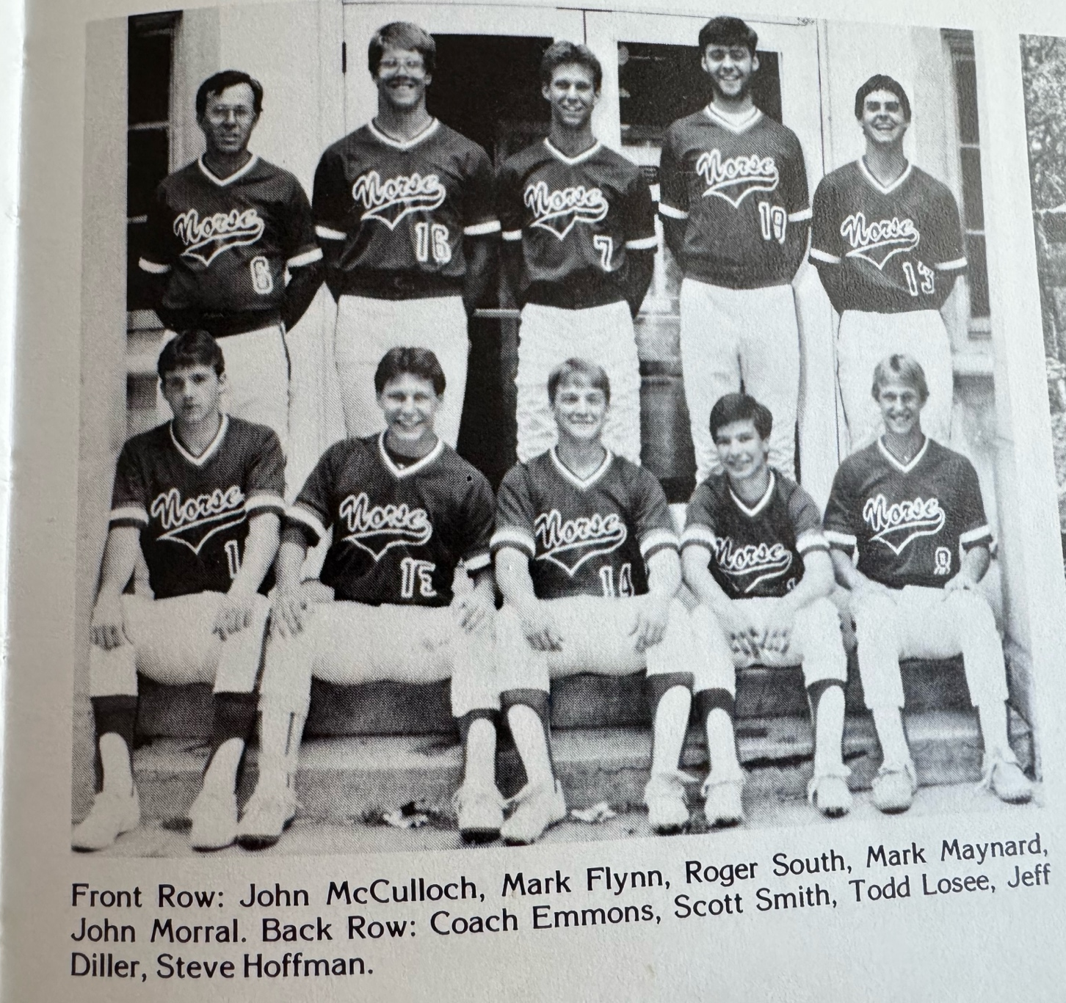
The 1985 NORSEMEN

1986 – coach Denny Emmons (5-15 overall; 5-9 in WMC; xx place in WMC; Montague-Whitehall Co- Champs)
One had to truly love baseball to play for the Norsemen in 1986. The Norse played the entire 20-game season on the road as major renovations were being implemented on North Muskegon’s baseball field. Underground sprinkling and a complete reseeding of the outfield were among the improvements made on the old diamond, first used by North Muskegon baseball in 1920. A very young team answered the early season call from head coach Denny Emmons and was able to come out on top in only five of the games. Practice sessions for the Norse were held on the rocky grounds at Pioneer Park, and coupled with the limited facilities, the Northsiders had to do without a JV team. The Norse had to wait until April 22nd before beginning the 1986 season. Despite an early morning record low temperature of 19 degrees Coach Emmons was able to begin their long road trip against the defending WMC champs from Whitehall. All five of NM’s wins came in WMC action, including a doubleheader sweep over the Shelby Tigers. In the first game against Shelby, sophomore Kyle Stevens tossed a two-hitter while fanning five. In the nightcap, John Morrall had three hits as the Norsemen again reached double figures in a 10-1 win. The season ended with North Muskegon still looking for that elusive first-ever District win. Again, NM took an early exit while dropping the tournament opener to Western Michigan Christian, 10-1. Notching a pair of hits for the victorious Warriors was hard-hitting Dan Bylsma, who would become the first Greater Muskegon hockey player to make it all the way to the National Hockley League.

Record Score Interesting Fact
0-1 *Whitehall 10, NM 2 NM pitchers walk 8: Mark Flynn RBI single
0-2 Orchard View 8, NM 2 Wes Phillips HR, single
1-2 *NM 13, Mason CC 4 Kyle Stevens HR, Matt Steketee, Steve Hoffman 2 hits
1-3 Reeths-Puffer 4, NM 2 Tim Rop double, Phillips, Hoffman 2 hits
1–4 *Oakridge 15, NM 8 Matt Kolbe 3 hits
2-4 *NM 9, Oakridge 5 Steve Hoffman, Mark Maynard 3 hits
2-5 *Montague 22, NM 4 Maynard 3-for-3, Kyle Stevens 2 hits
2-6 *Montague 12, NM 4 Maynard 3 hits (6-6 in DH)
2-7 Kent City 10, NM 7 NM commits 6 errors
2-8 *Hart 9, NM 3 Kyle Stevens losing pitcher (lousy report in MC)
3-8 *NM 9, Hart 4 John Morrall HR; Matt Kolbe, Phillips 2 hits
3-9 Montague 16, NM 6 County Tournament; Stevens 2 hits (double)
3-10 *Ravenna 15, NM 7 Phillips 2 hits (double)
3-11 *Ravenna 12, NM 6 NM uses four pitchers in loss (another lousy report)
3-12 *Whitehall 11, NM 1 Current umpire Chuck Hiltz winning pitcher for Vikings
3-13 *Mason CC 7, NM 3 Phillips HR
3-14 WM Christian 8, NM 7 WMC wins in bottom of the seventh (WMC 14-5 after win)
4-14 *NM 10, Shelby 2 Kyle Stevens 2-hitter, 9 K’s; Morrall 2 hits (triple)
5-14 *NM 10, Shelby 1 Morrall 3 hits (double); Stevens 2 hits
5-15 WMC 10, NM 1 District; future NHLer Dan Bylsma 2 hits for WMC

1987 – coach Walt Gawkowski (6-12-1 overall; 5-7-1 in WMC; xx place in WMC; Whitehall Champs)
Walt Gawkowski, a former standout outfielder for Central Michigan University, took over the head coaching duties, beginning a long tenure as the NM baseball coach. Following the first four games (all losses) of the season, Gawkowski may have had second thoughts. The first of more than 180 wins Gawkowski would gain in his 17-year reign came in the fifth game of the season on April 24. The Norsemen won 11-1 over rival Whitehall and its Hall of Fame coach John Huizenga. Although the Norsemen were outscored by an average of two runs per game, the Norse lineup had several batters who would be able to knock balls over the friendly North Muskegon left-field fence. Steve Hoffman, Mark Maynard, Tim Rop, Wes Phillips, Greg Stepke, and Matt Kolbe were the NM power hitters while freshman Joe Mylenek, Tom Meyers, and Jim Johnson all had multiple hit games. The Norse weakness was on the mound as the Blue & Gold hitters gave up nearly seven runs per outing.

Record Score Interesting Fact
0-1 *Hart 11, NM 1 Freshman Joe Mylenek 2 hits
0-2 *Oakridge 6, NM 5 Tom Meyers 2 hits (double); Matt Kolbe 2 hits
0-3 *Ravenna 6, NM 0 Jim Johnson, Mylenek 2 hits
0-4 OV 8, NM 4 Mark Maynard 2 hits (HR); Meyers 2 hits
1-4 *NM 11, Whitehall 1 Meyers 2 hits (double, triple); Wes Phillips, Jim Johnson 2 RBI
2-4 NM 13, Hesperia 3 Tim Rop, Matt Kolbe, Wes Phillips HR
2-5 *Mason CC 14, NM 1 NM pitchers walk 11
3-5 *NM 5, Shelby 4 Greg Stepke winner in relief; Matt Steketee scores winner on WP
3-5-1 *NM 3, Shelby 3 Called after 6th inning due to darkness, Stepke pitches 6 ing.
4-5-1 *NM 6, Oakridge 3 Meyers winner; Maynard 2 hits (double) Mylenek 2 hits
4-6-1 Kent City 7, NM 5 Kolbe 3 hits, Johnson 2 RBI
4-7-1 Montague 7, NM 4 County tournament; Greg Stepke HR
4-8-1 WMC 10, NM 5 Stepke HR; Future NHLer Dan Blysma of WMC HR
5-8-1 *NM 10, Hart 7 Steve Hoffman, Mark Maynard HR
5-9-1 *Montague 6, NM 3 Maynard’s double only NM extra base hit
6-9-1 *NM 4, Montague 1 Meyers 2 hits (triple); Mylenek 2 hits
6-10-1 *Ravenna 13, NM 3 Johnson 2 RBI double
6-11-1 *Mason CC 4, NM 1 Maynard 2 hits (double)
6-12-1 Allendale 9, NM 1 District: Maynard RBI single for only NM run

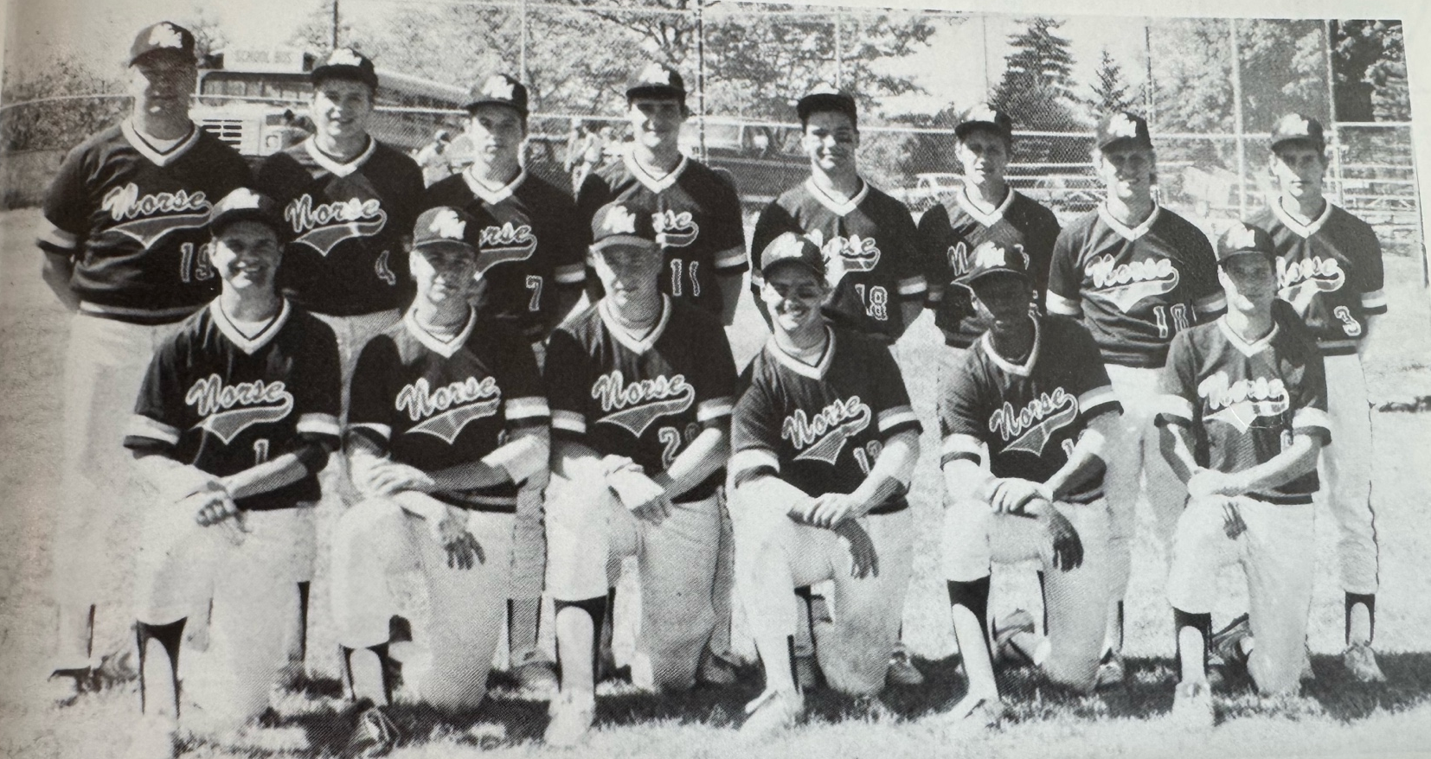

The 1987 NORSEMEN

Back Row L-R: Coach Walt Gawkowski, Jim Johnson, Joe Mylenek, Matt Kolbe, Mark Maynard, Tim Rop, Jeff Johnson, Tom Meyers
Front Row L-R: Matt Steketee, John Van Fossen, Greg Stepke, Steve Hoffman, Wes Phillips, Joe Ostrowski

1988 – coach Walt Gawkowski (8-13 overall; 7-7 in WMC; xx place in WMC; Whitehall-Montague Co-Champs)
A much-improved North Muskegon team took the field in 1988 on the newly named NM diamond. The long-time field, which was first used for baseball back in 1920, was named after North Muskegon Superintendent of Schools Jim Johnson. Johnson, who prepped at Muskegon High, became an All-American performer at Western Michigan University and made it to the major leagues as a pitcher for the San Francisco Giants. Johnson passed away from cancer in December of 1987. Appropriately, one of the main performers for the Norsemen was James C. Johnson, son of the late Superintendent. Johnson was the winning pitcher and chipped in with a home run in an early season 8-5 WMC victory over Mason County Central. In the second year of many matchups between Walt Gawkowski and his close friend, Brian Wright of Shelby, Gawkowski would claim the bragging rights for at least another year as the Norsemen swept a doubleheader from the Tigers. Joe Mylenek was the winning pitcher in each game. One of the infrequent happenstances in NM history came in the second game of the twin bill when Matt Kolbe and Johnson posted back-to-back home runs. It took 16 long years, but the Norsemen were able to finally break into the win column in the state playoffs. Kolbe blasted a grand slam in a 17-3 laugher over Grand Rapids Covenant Christian. The euphoria of winning didn’t last long, however, as tournament nemesis Wyoming Lee knocked the Norse out of the playoffs in the next game.

Record Score Interesting Fact
0-1 *Montague 12, NM 3 Tom Meyers triple
0-2 Kent City 7, NM 4 Matt Steketee, Meyers 2 hits
1-2 *NM 7, Oakridge 5 Meyers 2 hits, Jim Johnson RBI single
1-3 *Ravenna 11, NM 4 Only the score reported in MC
1-4 OV 8, NM 6 9 innings; Greg Stepke 2 hits HR, Current DeLaSalle football coach Dan Rohn scores winning run for OV
1-5 *Whitehall 10, NM 0 Chuck Hiltz 1 hits NM
2-5 *NM 8, Mason CC 5 Jim Johnson wins; Johnson HR
3-5 *NM 14, Shelby 3 Joe Mylenek wins, Meyers 4 hits (2B); Tim Rop 2 hits 4 RBI; Steketee 2 hits
4-5 *NM 8, Shelby 5 Mylenek wins; Johnson-Kolbe back-to-back HR
5-5 *NM 8, Oakridge 7 Ty McNabb GW RBI
6-5 *NM 3, Hart 1 Mylenek 10 K’s; Meyers HR
6-6 *Montague 7, NM 6 Montague scores 2 in 7th for win, Johnson 2 run triple
7-6 *NM 9, Hart 4 Johnson 9 K’s; Matt Steketee 3 hits; Meyers triple, double
7-7 WMC 18, NM 7 Mylenek HR; NM loses 7-0 lead, Tim Rop 3 RBI
7-8 *Ravenna 6, NM 5 9 innings; Johnson, Mylenek, Matt Kolbe, Dan Ostrowski 2Bs
7-9 WMC 5, NM 3 County Tournament
7-10 *Whitehall 13, NM 3 Mylenek double
7-11 Hesperia 11, NM 9 Steketee 4 hits, (2 doubles); Meyers, Kolbe 2 hits
7–12 *Mason CC 16, NM 4 Matt Kolbe HR
8–12 NM 17, Cov. Christ. Pre-District; Kolbe GS; Meyers 2 hits (3B); Rop, Stepke, Mylenek 2 hits
8-13 Wyoming Lee 11, NM 1 District; NM only 1 hit

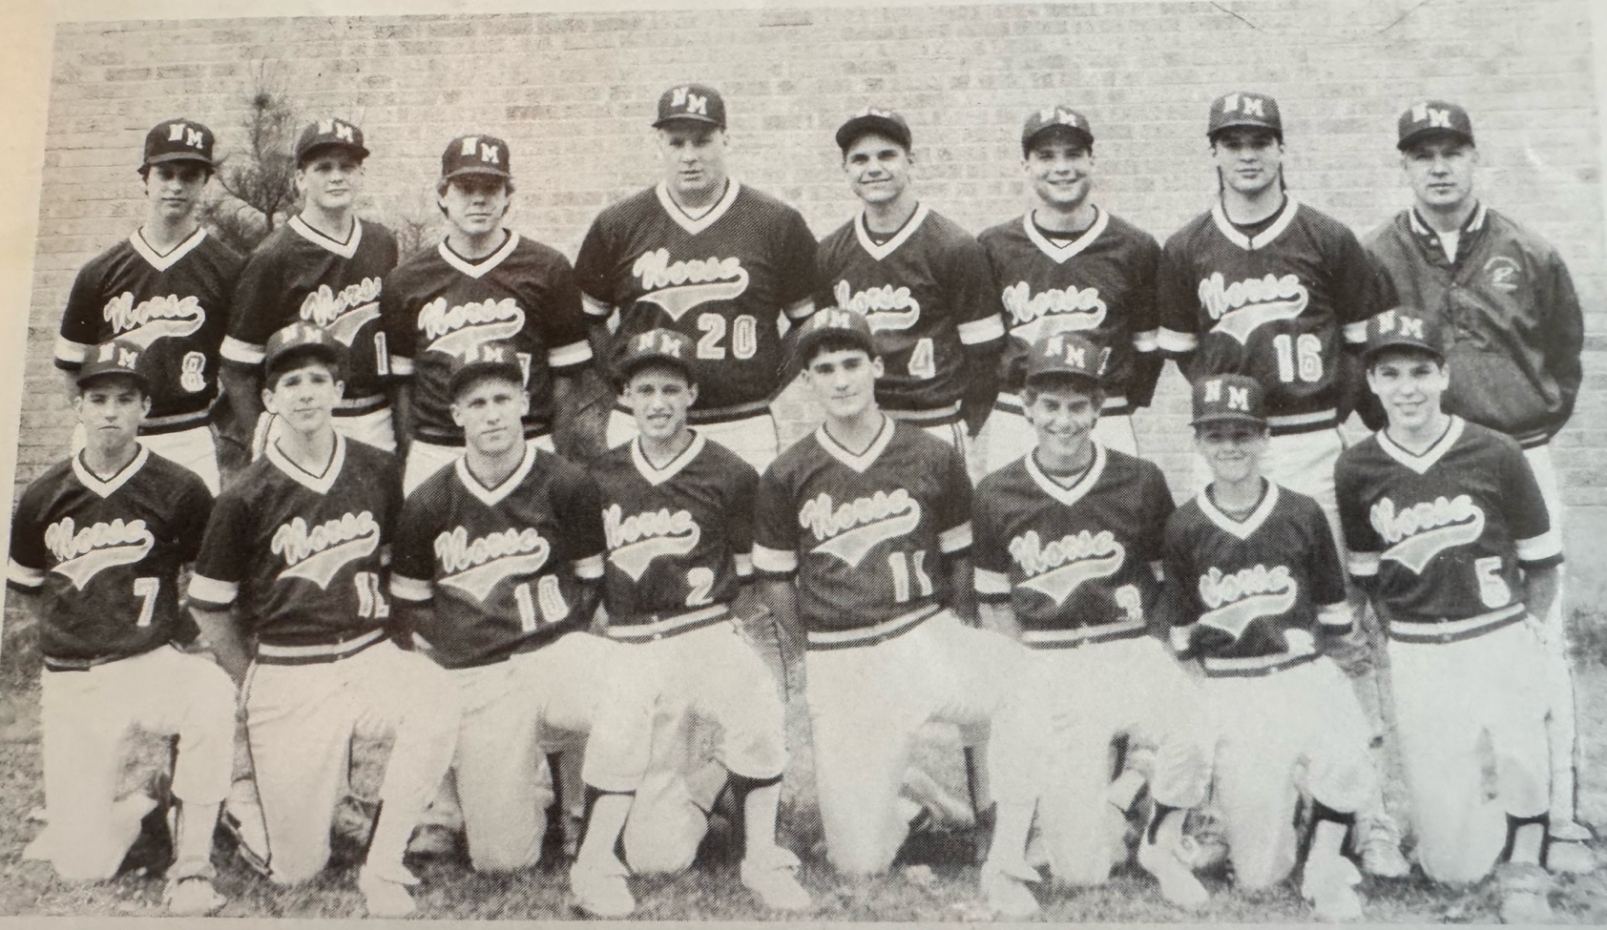

The 1988 NORSEMEN

Back Row L-R: Todd Ware, Ted Mauseth, Ron Hillman, Greg Stepke, Matt Steketee, Joe Ostrowski, Dan Ostrowski, Coach Walt Gawkowski
Front Row L-R: Joe Mylenek, Ty McNabb, Jeff Johnson, Tim Rop, Matt Kolbe, Tom Meyers, Eric Rop, Chris Anderson

1989 – coach Walt Gawkowski (10-8 overall; 6-7 in WMC; xx place in WMC; Whitehall Champs)

The Norsemen were finally able to climb over the elusive .500 mark. NM got off to a quick start by winning four of their first five games, including a pair of non-conference games against Western Michigan Christian and Orchard View. April 14 marked not only a Norsemen win against Montague but marked an historical first in NM sports history – the first varsity high school game played by the North Muskegon girls’ softball team. Junior Joe Mylenek was the MVP of this squad, playing a solid shortstop, giving coach Walt Gawkowski some solid innings on the mound, and was the most potent hitter (.407). Among Mylenek’s highest-producing games included a home run and two doubles in an NM 6-3 victory over Montague and a late season 10-6 victory over Mason County Central in which Mylenek had four hits.

Record Score Interesting Fact
0-1 *Oakridge 5, NM 1 Joe Mylenek goes distance in loss; also has double
1-1 NM 10, WMC 6 Matt Kolbe GS; Tom Meyers 3 hits (double)
2-1 *NM 7, Montague 3 Steve Huff HR
3-1 *NM 5, Hart 2 Freshman Matt Benedict 2 hits
4-1 NM 8, Orchard View 6 Mylenek triple, double
4-2 *Ravenna 3, NM 0 Meyers loser as NM only has 3 hits
4-3 *Whitehall 10, NM NM 1 hit by Tom Sheesley & Chris Andrews
5-3 NM 7, Holton 6 Ron Hillman’s 2 out 1B winner, Matt Benedict, Meyers, Mylenek 2 hits
5-4 *Shelby 9, NM 6 Meyers 2 hits (3B); Ty McNabb 2 hits (3B)
6-4 *NM 7, Shelby 1 Benedict 2 hits (double), Dan Ostrowski 2 hits
7-4 *NM 8, Mason CC 7 Ostrowski, 3 hits (double); McNabb 2 hts
7-5 *Oakridge 11, NM 2 Mylenek double
8-5 *NM 6, Montague 3 Mylenek HR, 2 doubles; Meyers 2 hits (triple)
9-5 *Hart 6, NM 4 Meyers HR, Matt Kolbe 2 run double
9-6 Whitehall 12, NM 1 County Tournament; NM only 3 hits
9-7 *Ravenna 13, NM 0 Erik Imbault & Scott DeCamp no hit NM
9-8 *Whitehall 12, NM 4 Mylenek, Benedict doubles
10-7 *NM 10, Mason CC 6 Mylenek, Meyers 3 hits, Matt Benedict 2 doubles & single
10-8 GR Baptist 4, NM 2 District; NM strands 13 runners

