History of NM football 2003-Current

2003 Coach Al Karaba (1-8 overall, Oakridge WMC Champs)

The Norse would not have a pretty season in 2003. Their 1-8 record would match the record for futility with the 1960 Norsemen. It’s tough to win with underclassmen comprising most of your roster, and it’s even tougher when your entire seven-man offensive line is void of seniors. The Norse would win their opener but then suffer through eight consecutive losses. However, NM was playing in arguably the toughest Class C league in the state as two of their West Michigan Conference rivals, would play at the Pontiac Silverdome in late November for state titles, with Ravenna winning it all in Class C.

Thank goodness for Holton being on the NM schedule. NM began the season with a 21-0 shutout of the Red Devils. NM would win nine of their next ten meetings with Holton, but no other team would fall to NM the rest of the 2003 season. Aaron Sanders rebounded from a dreadful first half where he fumbled twice inside the Holton five-yard line to bounce back to rush for 204 yards and a touchdown. After a scoreless first half NM scored on its first two possessions of the second half. Mike Dean capped an 11-play, 63-yard drive with an 8-yard run for the first NM score. NM then capitalized on a Holton fumble at their 30-yard line as Sanders rumbled 16-yards for a touchdown and a 14-0 NM lead. Playing with only 18 players, the young Holton coach Shane Fairfield had eight players going both ways in the August heat. “We learned we have some work to do. We’ll be all right, said Fairfield to Muskegon Chronicle reporter Tom Kendra following the game.” As history will show Fairfield did more than all right, leading Muskegon to many state championship games over the years after replacing Tony Annese as the Big Red head coach in 2009.

NM was limited to but 69 total yards as they lost the first of what would be eight consecutive losses the rest of the 2003 season 27 to 7 at Mason County Central. NM did tie the game in the second quarter on a one-yard quarterback sneak by Dave Treder before Mason Co dominated the test of the game.

Perhaps the only consolation prize in Whitehall’s 42-7 victory over NM was the fact that North Muskegon scored first. Mike Verschuren intercepted a Viking pass and returned it 60 yards for a Norsemen touchdown. That would be the only bad throw on the part of Whitehall QB Pat Welsch as he threw four touchdown passes in Whitehall’s rout of the Norse. Aaron Sanders led NM rushers with 93 rushing yards.

It wouldn’t get any better for the Norsemen in their fourth game of the season as they were shut out by Oakridge 48-0. The eventual 2003 WMC champs set the tempo early as they blocked two NM punts in the second quarter to set up touchdown runs.

In a game played with “buckets of rain’ falling in Shelby, NM fell to the cellar of the West Michigan Conference with a 13-12 loss to Shelby in overtime. It’s doubtful if NM ever had a game where they committed more turnovers than in this game with Shelby as they committed eight turnovers, four on fumbles and four on interceptions. NM’s only touchdown in regulation also came on a turnover, one of five turnovers in the game by the host Tigers. Ben McPherson intercepted a Tiger pass and returned it 20 yards for the score, but the PAT attempt failed. The game was tied at 6-6 after 48 minutes of play forcing overtime. Freshman Troy Forton, a future star on the NM baseball field, completed his only pass of the night through the raindrops with a 11-yard pass to Dave Treder. Over the years NM has traditionally boasted of a good kicking game, but the kicking game failed the Norse in this contest as they missed both PAT attempts. Shelby didn’t miss after they scored in overtime sending NM to their fourth straight loss in WMC action.

The Norse came close to their record of futility from the previous week’s loss to Shelby as they committed six more turnovers in a 20-7 loss to Hart. One could say they had seven turnovers as the Pirates blocked an NM punt in the fourth quarter to set up their final touchdown. NM scored their first offensive touchdown in regulation since their second game of the season when Aaron Sanders scored on a 2-yard run just before halftime. For Hart, they would only win one more game against the Norsemen in their next 18 contests.

Ravenna, in their 52-0 rout of the Norsemen, showed why they had the team that would go on to win the Class C state championship. Not only did the Ravenna display their might on offense, but their defense held the Norse to but 40 total yards for the entire game, and only four yards gained on the ground. Aaron Sanders had eight tackles for NM in the loss.

NM had to wait until the game’s final moments before they were able to get on the board in their 47-7 loss to Montague. It was victory number 100 for Montague head coach Ken Diamond as the second half was played with a running clock. NM’s offense, that created only six touchdowns in their eight consecutive defeats, scored late in the game on a pass from Troy Forton to Mike Dean, both outstanding baseball players during the spring baseball season.

North Muskegon’s final game, as well as their season, was as gloomy as the rainy weather as the NM season came to a merciful close in a season ending 21-0 loss to Suttons Bay. This was no ‘cupcake’ opponent for the Norse as Suttons Bay was a perfect 8-0 heading into their game with NM. In the battle of the ‘Norsemen’ NM twice got inside the heavily favored Suttons Bay 20-yard line in the first half but failed to score.

It was a frustrating season for the Norse as they would only score 61 points, the lowest points scored in 70 years, and the second lowest point total in 92 years of NM football. Once again, the Norse were limited in their post season individual honors. Aaron Sanders was picked for the second team all-area team as a running back while center Brian Corcoran was accorded honorable mention on an all-area team that was dominated by Ravenna and Oakridge, both reaching the state title game with Ravenna upsetting Saginaw Nouvel to win at all in Class C.

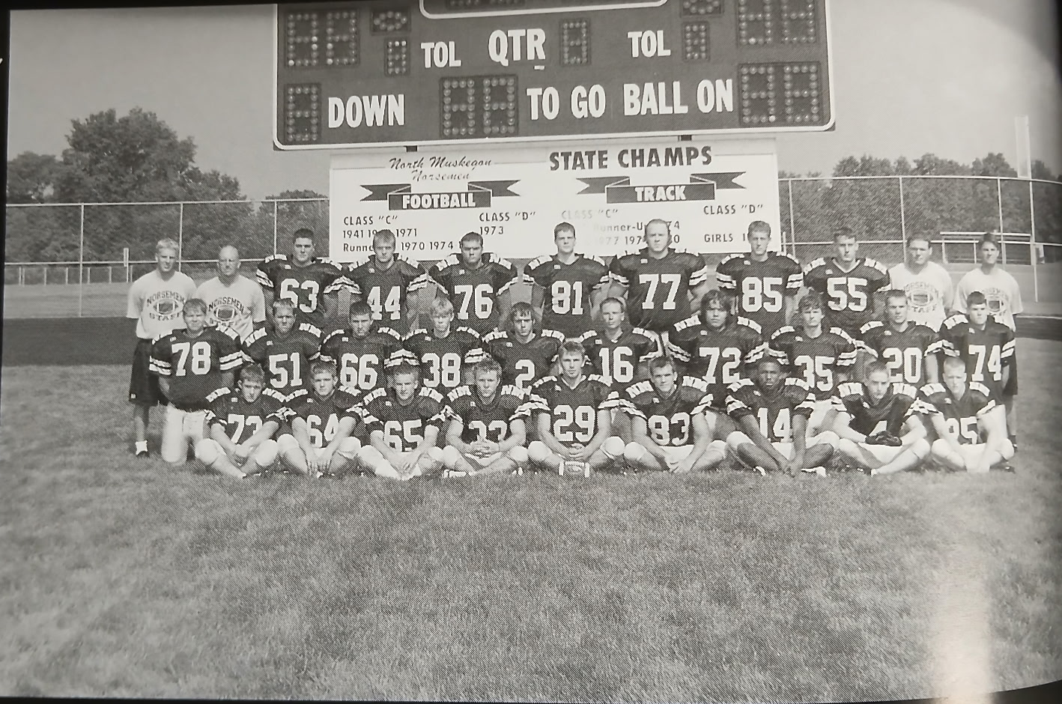

The 2003 NORSEMEN

Top Row L-R: Coach Jason Bogue, Head Coach Al Karaba, Brian Corcoran, Dan Bonner, Jared Derks, Greg Brooks, Christ Wendt, Andrew Westra, Ben McPherson, Coaches Dave Nelson, and Mike Belmonte
Middle Row L-R: Steve Curtis, Nate Derks, David Stitt, Greg Cooke, Dave Treder, Ryan Falkowski, Brett Campione, Jake Edick, Mike Dean, Brandon Willea
Bottom Row L-R: Brian O’Neil, Phil O’Neil, Chris Holloway, Aaron Saunders, Drew Barker, Mike Verschueren, Steve Stinson.

Record Score Interesting Fact

1-0 NM 21, Holton 0 Aaron Sanders TD & 204 yds. Mike Dean & Drew Barker TDs.
  - NM 7, Mason Co 27 Dave Treder one yard QB sneak. NM only 69 total yards.
  - NM 7 Whitehall 42 Mike Vershuren 6-yd interception return for TD. Sanders 93 yds.
  - NM 0, Oakridge 48 NM has 2 punts blocked to set up Oakridge TDs.
  - NM 12, Shelby 13 Ben McPherson 30-yd int. Ret. for TD. Troy 11 pass to Treder for TD.
  - NM 7, Hart 20 NM 6 turnovers & a blocked punt in loss. Sanders 2-yard TD.
  - NM 0, Ravenna 52 NM only 40 total yards & 4 yards rushing vs. the ‘C’ state champs.
  - NM 7, Montague 47 Troy Forton to Mike Dean TD pass NM’s only TD.
  - NM 0, Suttons Bay 21 Suttons Bay 1st undefeated season in school history defeats NM.

2004 Coach Al Karaba (3-6 overall, Montague WMC Champs)

The Norse would show some improvement by adding a couple of wins over their 2003 1-8 record. Most importantly, NM would be competitive in nearly all their games with only a 28-0 loss to the WMC champs from Montague the only exception. Over the years the schedule maker for NM football rarely added a ‘puppy’ for a season ending game. The final game of the 2004 campaign was with a Suttons Bay team who would advance to the state championship game at the Pontiac Silverdome. The Norse would add a little more ‘pop’ in their offense as they would return all seven of their offensive linemen from the previous year.

A Norsemen with a last name closely attached to NM history scored a pair of touchdowns to lead the Norsemen to a 28-14 victory over Holton. Nick Cooke, the son of Greg Cooke, an all-stater on the 1981 state finalist team, and the grandson of long time NM football coach Dave Cooke, scored a pair of TDs in their traditional season opener with the Red Devils. Cooke scored on a one-yard TD plunge and caught a pass from Troy Forton for 16 yards, one of three TDs scored by the Norse in the second quarter. John Fahnenstiel scored NM’s first of three second quarter tallies as NM took a 22-14 lead at halftime. Mike Dean wrapped up the scoring, and iced the game, when he raced 61 yards on a 3rd-and-18 with less than four minutes to go in the game. Unfortunately for NM, their penchant for fumbles and penalties from the previous season didn’t go away. The Norse overcame three fumbles, one of which was picked up and returned for a Holton touchdown and were penalized 18 times for 160 yards while somehow still picking up the victory.

Mason County won back-to-back games against NM for the only time in the 82 games played between the two schools with a 48-20 victory over the Norse. Once again Nick Cooke had a pair of touchdowns but that wasn’t nearly enough as Mason County overcame an early 14-12 Norse lead to swamp NM 48-20. The 48 points earned by MCC would prove to be the most points the Spartans ever scored against NM. Cooke had a pair of short TD runs of seven and four yards before MCC scored four unanswered touchdowns to pull away from the Norse. Troy Forton scored the final NM TD on a 2-yard run.

A loss is a loss is a loss but the final score of 13-4 is one for the books. In the entire modern world of football as there ever been a game that ended with a total of four points. North Muskegon had their four points tallied because of a pair of safeties, both on high snaps from the Whitehall center that sailed over the punters head and into the endzone. North Muskegon’s defense kept NM in the game as well as their ball control offense. NM had a drive that consumed the entire third quarter before stalling at the Whitehall 20-yard line. Whitehall’s James Cannon sealed the win for the Vikings with a long 85-TD run in the fourth quarter.

Oakridge was one year shy of winning a state championship but after losing their first three games of the season, the future didn’t look that bright for the Eagles. The Eagles won their first game of the season at the expense of the Norse with a hard fought 12-0 shutout. Oakridge had to go to the air against NM as their quarterback DJ Ritz was 7-of-10 for 207 yards. NM threatened to tie the game in the third quarter after trailing 6-0 at halftime when they drove inside the Oakridge 5-yard line. The Eagles stuffed three straight NM runs and a fourth downplay resulted in an Eagle sack. NM totaled 200 yards, including 165 on the ground with Nick Cooke picking up 77 of those yards.

The proud Norse finally won their first WMC victory in two years with a 21-7 win over Shelby that pulled NM out of the basement of the West Michigan Conference. Mike Dean helped set up his first of two touchdowns as he blocked a Shelby punt at the Tiger 25, and he would eventually score from the two-yard line to give NM a 14-0 halftime lead. NM’s Troy Forton passed to Greg Brooks in the first quarter from eight yards to give NM a 7-0 lead. Dean would score his second and NM’s third TD in the third period to give the Norse a commanding 21-0 lead before Shelby could crack the NM defense late in the game for their only score.

NM overcame four turnovers in the first half to edge Hart 7-6 on homecoming night at Fred Jacks field. Hart was only able to take advantage of one of the Norse miscues and scored with less than a minute remaining in the first half to take a 6-0 lead at halftime. Hart went for the two-point conversion following the TD but failed on a pass play. NM then put together their best drive of the game to start the second half. NM marched 75 yards in 12 plays before Mike Dean ran two yards up the middle for the TD. David Lenore then kicked what would prove to be the winning point to even the Norse record at 3-3. Seniors Ben McPherson and Greg Brooks led the stingy Norse defense with 13 and nine stops respectively.

Yet another oddity occurred in NM’s 27-2 loss to Ravenna. For the second time during the season the only Norse points came on a safety. The Norse averted a shutout to the Bulldogs when a Ravenna ball carrier fumbled the ball out of the end zone in the fourth quarter. The winners enjoyed great field position against NM. On their first eight possessions, four Bulldog drives started inside the NM 40.

Montague wrapped up the conference championship with a 28-0 victory over the Norsemen. First year coach Pat Collins, the quarterback on the 1992 state finalist Montague team, also took home the coach of the year honors on the post-season all-area team. Mason County Central, who has never won the WMC championships outright, had a chance to share the title with Montague but lost in overtime to Ravenna. Once again turnovers plagued the Norse as they lost the ball on five occasions to the Wildcats. Mike Dean had 70 of NM’s total of 160 yards while Nick Cooke had 12 tackles in a losing cause.

There was no way that the Norsemen were just going to ‘mail in’ the 2004 season despite having to end their season against a Suttons Bay team that would have their school’s best team in history. The ‘Norsemen’ to the North would give up 20 points to the Norsemen to the South in a 34-20 win, the most points Suttons Bay would have scored upon them until the state championship game. Suttons Bay finally took the lead on NM with just four minutes left in the game on a 34-yard screen pass. The winners sealed the win with a minute left in the game as they took advantage of a NM fumble to make the final score 34-20. Troy Forton and Mike Dean combined for two NM TDs on pass plays of 16 and nine yards. NM’s other touchdown came on a blocked punt that was run into the end zone from 23 yards by Nick Cooke.

Defensive lineman Jerad Derks was selected to both the C/D all area team and the WMC first unit for his play on defense. Derks led all Norse tacklers with 57 to go along with a fumble recovery. Lineman Chris Wendt was selected to the all-area offense second team while lineman Greg Brooks and Nick Cooke were on the all-area defense second team.

The 2004 season marked the end for state final games played at the Pontiac Silverdome. The 2004 finals were played inside but the heat had been turned off and the seats dusty as the demolition crew was ready to tear down the structure that had played host to the state finals for nearly 30 years. Muskegon teams played their final games on a successful note as Muskegon and Orchard View retuned back to the Port City bringing home the championship trophy.

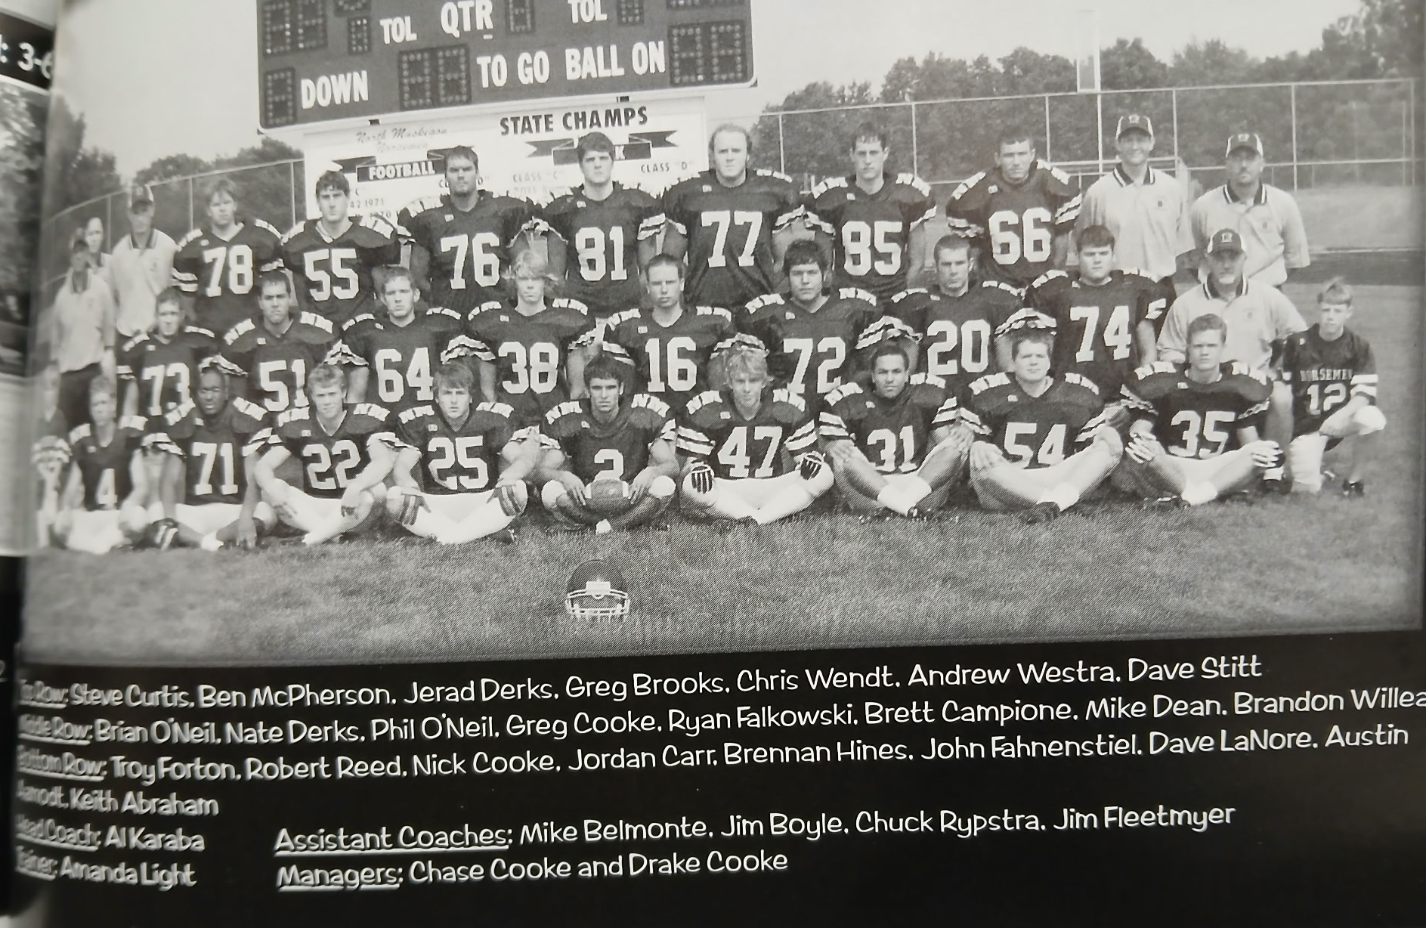

The 2004 NORSEMEN

Record Score Interesting Fact
1-0 NM 28, Holton 14 Nick Cooke 2 TDs, John Fahnenstiel TD, Mike Dean 61-yard TD run.
1-1 NM 20, Mason Co 48 Cooke 2 TDs, Troy Forton 1.
1-2 NM 4, Whitehall 13 NM’s only points coming on a pair of safeties.
1-3 NM 0, Oakridge 12 Cooke 77 of NM’s 165 rushing yards.
2-3 NM 21, Shelby 7 Dean 2 TDs, Trou Forton to Greg Brooks 8-yard TD pass.
3-3 NM 7, Hart 6 NM 75-yard scoring drive ends on Dean 2-yard TD.
3-4 NM 2, Ravenna 27 NM scores when Ravenna fumbles through the end z
3-5 NM 0, Montague 28 NM turns the ball over five times in loss to WMC champs.
3-6 NM 20, Suttons Bay 34 S.Bay scored 2 late TDs in NM loss. Dean 2 TD passes from Forton.

2005 Coach Al Karaba (5-4 overall, Oakridge WMC & State Champs)

Fourth year head coach Al Karaba was looking forward to having a winning record for the first time as head coach of the Norsemen and he would succeed. Although NM returned only four starters from the 2004 season, NM would return many of their backfield regulars from the previous season as the Norse would have several games where they put up mega points on the board. Nick Cooke returned as a two-way starter and Troy Forton, would begin his third year as the Norse signal caller at quarterback. Forton began his career as a co-op student from West Michigan Christian but began the 2005-06 school year as a full-time Norsemen student where he also excelled in baseball.

NM quickly showed that they would be able to put points on the board in their opening game, a 28-6 win over Holton. John Fahnensteil scored a pair of second half touchdown runs of 12 and 47 yards and Nick Cooke closed out the game with a 14-yard scamper. The only score in the first half came on a Troy Forton to Chris Scheldt pass good for 16 yards and a TD. Fahnenstiel would cap his evening with 140 rushing yards on 20 carries. Forton displayed his passing prowess by completing 8 of 13 passes for 148 yards. Sheldt, one of many Norsemen to go both ways, led NM in tackling with 11 tackles.

NM trailed by only 6 points heading into the final quarter before the Vikings added an insurance touchdown to defeat NM 12-7. In the scoreless first half NM had more scoring opportunities than Whitehall, advancing into Whitehall territory on four of five drives but coming up empty on the scoreboard. On one series of downs, NM was at the Vikings five-yard line with fourth and inches for a first down. The Norse tried to surprise the Vikings with a pass, but Whitehall’s defensive back Mark Boulet wasn’t fooled and batted down the intended pass in the end zone. Whitehall’s second touchdown, that iced the game for the Vikings, came with 3:38 left to play. NM did come fighting back by scoring a minute later on a 22-yard pass from Troy Forton to Nick Cooke to make the final score 12-7.

An Oakridge team that was destined to win the state championship later in November in the first year the finals were held at Ford Field in Detroit, proved too much of a foe in their 41-14 win over NM. The Norse did have 259 yards in the loss to the powerful Eagles and a pair of touchdowns. Matt Purtee cut a big Oakridge lead down to 28-14 in the third quarter while the first NM TD came in the first half on a pass from sophomore Kyle Cooke to Chris Scheldt. Kyle’s brother Nick Cooke was a force on defense with 15 tackles.

John Fahnenstiel had a night to remember in NM’s 56-21 victory over Shelby. And not far behind Fahnenstiel was Matt Partee. Each scored four touchdowns, the first time in NM history where two NM players each scored four TDs in a game. Fahnenstiel would finish with 242 yards rushing and returned a kick-off back 85 yards. Fahnenstiel’s TD runs would have brought a smile to the face of NM’s legendary Stan Guy as the TD runs were from 41, 64 & 68 yards. Partee also had three long TD runs of 33, 70, and 40 while adding his fourth TD on a 11-yard pass from Troy Forton. The 56 points scored by NM were the most tallied in a single game in 16 years.

The 16-year distance for the most points scored in a game would last but one week as NM scored 58 points in a 58-19 rampage vs. Hart. Once again John Fahnenstiel and Matt Purtee would have huge games. Fahnenstiel would score three TDs, two on long gallops from 40 and 54 yards as well as returning a kickoff back for the second straight week, a 74-yard dash for a touchdown. Purtee tallied twice, a run of 55-yards in the first quarter that began the barrage of Norse points, and the latter was one for the record books: a 75-yard return of a Pirate fumble. Three other Norsemen joined in on the parade of touchdowns. Nick Cooke traversed 21 yards for six points; Chris Scheldt received a pass good for 40 yards from Troy Forton while Forton made it a clean sweep for backfield starters by keeping the pigskin and dashing 15 yards for another Norse TD.

Ravenna stormed out to a commanding 26-0 lead at halftime over North Muskegon in their next game but there was no quit in the Norsemen. NM scored 21 unanswered points to throw a scare into first year Ravenna head coach Scott McFarrren, as Hall of Fame former Bulldog coach Dusty Fairfield took three years off from his coaching duties. John Fahnenstiel, playing at less than 100% physically due to a bruised lung sustained in last week’s game, ran for 122 second half yards and two TDs to give NM a chance for a comeback. Troy Forton put NM on the board first in the second half by connecting on a 10-yard TD pass to Nick Cooke. Fahnenstiel’s second TD came with less than two minutes remaining in the contest as Ravenna recovered the NM onside kick to run out the clock and preserve a 26-21 victory.

Perhaps the only bright spot in NM’s 45-6 loss to Montague was Matt Purtee returning a Montague kickoff back 95 yards for the only score for NM in the game. Purtee’s 95-yard return was the fourth longest return for six points in NM history. Montague took advantage of four Norse turnovers and scored 33 second quarter points. Unlike last week’s second half comeback, that wouldn’t happen against a stout Montague defense that limited NM to but 64 yards on the ground and 86 through the air. Nick Cooke was a force on defense for NM with 13 tackles.

Matt Purtee broke up a 6-6 tie with another one of his patented long TD runs, this from 55 yards to lead NM to a 13-6 win over Mason County Central. Purtee’s winning dash came with under three minutes left in the game to even NM’s record at 4-4 on the season. Purtee had 55 of his team leading 82 yards on the one TD carry. John Fahnenstiel had a second quarter TD run from six yards to tie the game at 6-6 before Purtee’s dash was the game winner.

NM insured that the second half was going to go quickly as the Norse jumped out to a 42-6 lead enroute to a 49-6 rout in the first game ever played between NM and Morley-Stanwood. Playing with a running clock the entire second half, NM was limited to but one second half TD on a John Fahnenstiel 14-yard run. Fahnenstiel helped push NM to their first winning record in four years with a pair of TDs and 135 rushing yards. Troy Forton had a pair of TD passes, one to Nick Cooke for eight yards and another to Chris Scheldt for 12. Mark Picard recorded his first ever NM TD when he returned an interception 22 yards. Cooke also had a rushing TD from 12 and Matt Purtee got the scoring started with a one-yard TD.

Nick Cooke was selected as the MVP for Norse football in 2005 and was a first team pick on the all-area team as a linebacker. Cooke was the area’s leading tackler with 101 tackles and had a pair of interceptions and a fumble recovery. Troy Forton was a do-everything performer for NM. Forton was selected as the first team area punter, was second team as a defensive end while performing duties all season as the NM quarterback. Matt Purtee did not go unnoticed by his West Michigan Conference foes as he was selected to the first team All-WMC team. It was a winning season for NM but 2006 would look even more promising with Forton, Fahnenstiel and Purtee returning in the backfield.

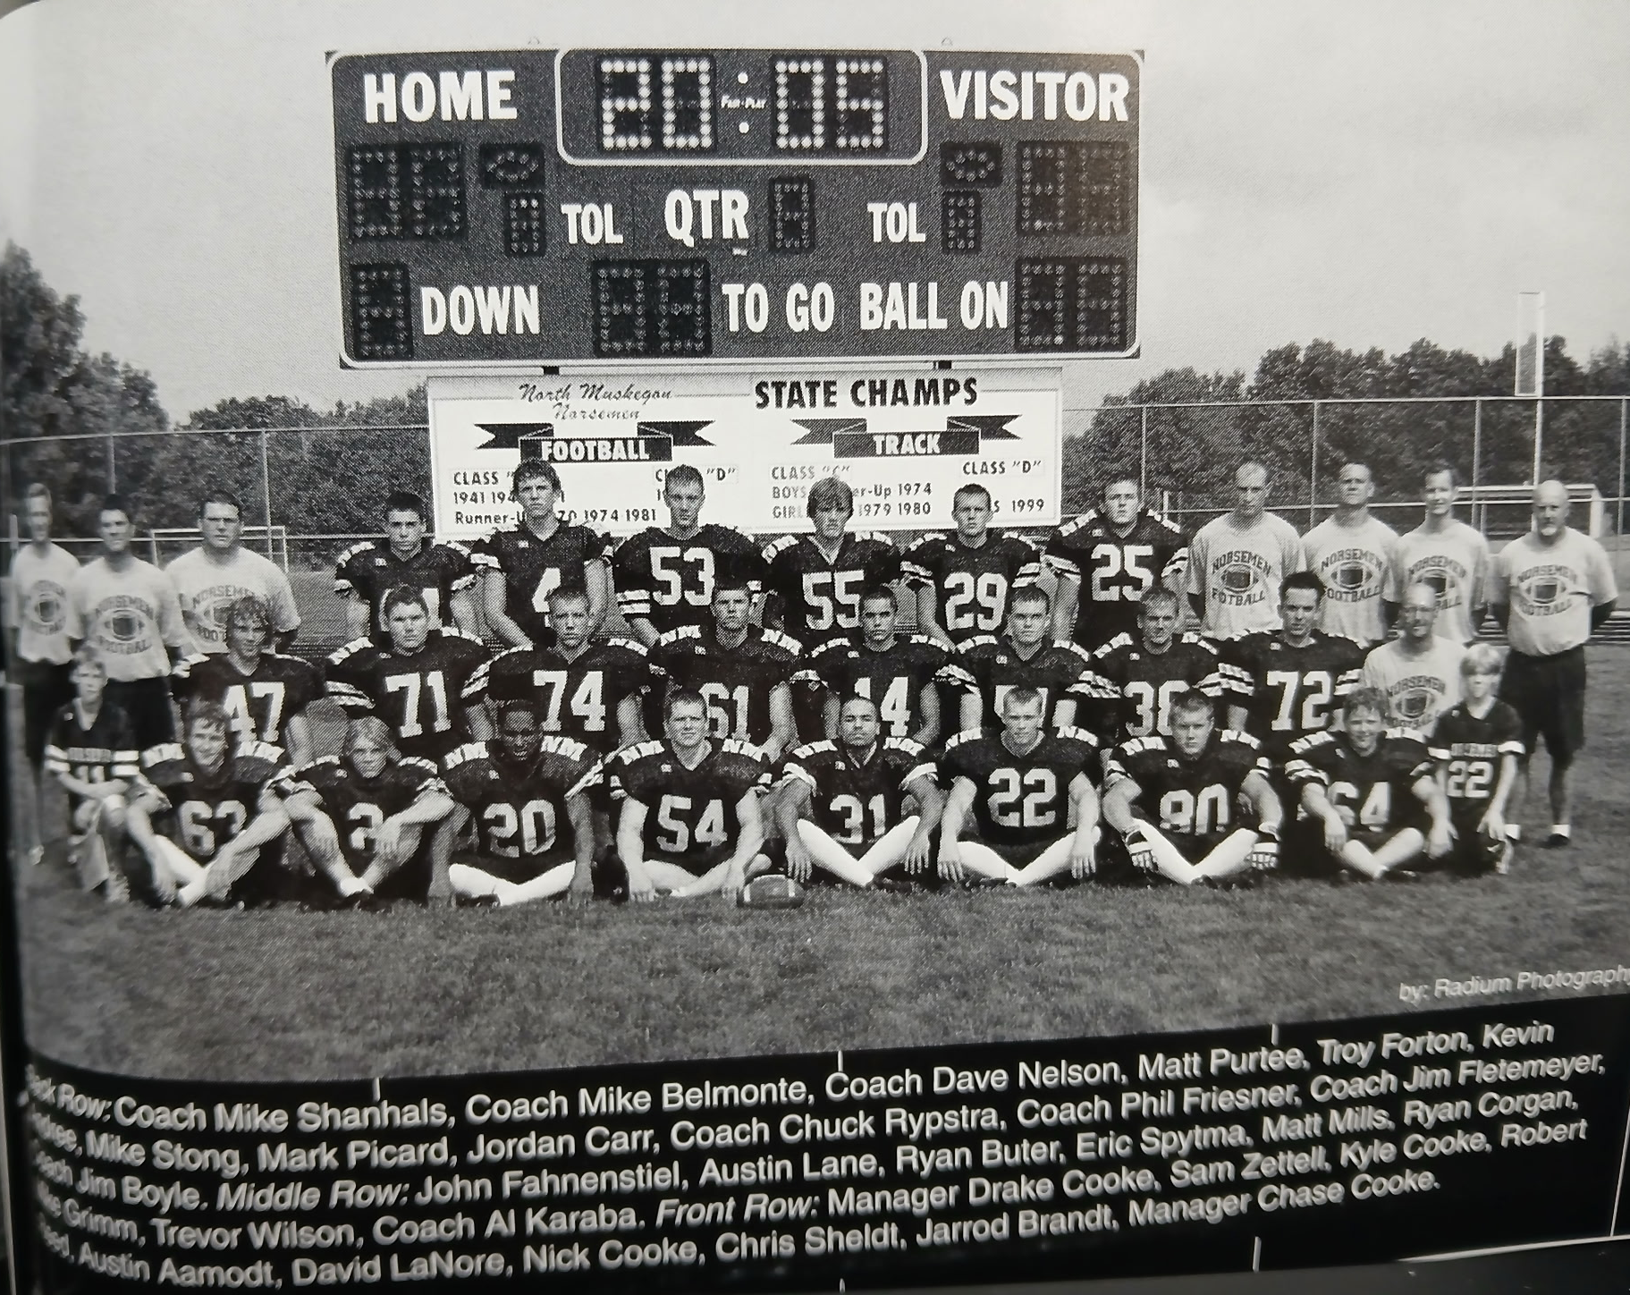

The 2005 NORSEMEN

Record Score Interesting Fact
1-0 NM 28, Holton 6 John Fahnenstiel 2 TDs (12 & 47), Troy Forton to Chris Sheldt TD.
1-1 NM 7, Whitehall 12 Forton to Nick Cooke 22-yard TD pass.
1-2 NM 14, Oakridge 41 Matt Purtee 80-yd TD run, Kyle Cooke to Scheldt TD pass.
  - NM 56, Shelby 21 Fahnenstiel 4 TDs, 242 yds + 85 kickoff TD. Purtee 4 TDs.
3-2 NM 58 Hart 19 Fahnenstiel 3 TDs, Purtee 2 TDs, a record 75-yard fumble return.
3-3 NM 21, Ravenna 26 Forton to Cooke 1-yd TD pass. Fahnenstiel 2 TDs.
3-4 NM 6, Montague 45 Purtee 95-yard kickoff return for TD. Cooke 13 tackles.
4-4 NM 13, Mason Co 6 Purtee 55-yard TD the winner. Fahnenstiel 6-yd tf
5-4 NM 49, Morley Stan. 6 Fahnensteil & Cooke 2 TDs, Forton 2 TD passes. Mark Piccard int TD.

2006 Coach Al Karaba (8-4 overall, regional finalist) Oakridge WMC Champs)

NM posted one of their biggest upsets in school history when they upset perennial power Oakridge to capture the district championship. The 2006 season would be the farthest NM would advance in the playoffs until 2023. NM had three talented backs returning for 2006. John Fahnenstiel, who rushed for more than 1000 yards in his junior season, and Matt Purtee, who gave NM a potent 1-2 rushing combo in 2005, as well as quarterback Troy Forton, the four-year starting quarterback for the Norsemen. Forton’s favorite receiver from 2005, Chris Scheldt also returns. Ball hawking defensive back Matt Mills, who intercepted seven passes in 2005 will lead the Norse secondary, while baseball standout Ryan Buter will lead the defensive lineman.

Holton would unveil the first field turf stadium in the Greater Muskegon Area when they hosted NM in their traditional season opener. The NM backs fell right at home with the pristine all-weather surface as they rolled up 43 first half points in a 50-26 romp over the Red Devils. Trivia fans should know that the first touchdown scored at the new field was scored by the Red Devils Chase Francis on a 55-yard run. NM, taking full advantage of Holton turnovers, then scored the next five touchdowns. Holton outgained NM in yardage 402-364. “Take the turnovers away and I thought we played very well,” said Holton coach and future Muskegon head coach Shane Fairfield. Matt Purtee got the Norse started with a 47-yard TD run and NM led 14-7 after the first quarter on Alex Jones’ 60-yard fumble recovery. NM then built a 43-14 lead at halftime with a John Fahnenstiel 75-yard TD, followed by a 63-yard scoring strike from Troy Forton to Jones. Matt Mills returned a Holton punt 67 yards, and Troy Forton connected with Chris Scheldt with an 8-yard scoring pass to give NM a 43-14 lead at halftime. Fahnenstiel ran a TD in from the 2-yard line to complete the NM scoring. Holton made the final score a little more respectable with a couple of late TDs.

NM then dropped their next game to Whitehall 21-13 as the Vikings prevented NM’s speedy running backs from any rushing touchdowns. NM’s only TDs came on a pair of TD passes from Troy Forton, both to Matt Purtee. After Whitehall took the opening kickoff and marched 80 yards for the first half’s only score, NM drove deep into Viking territory three times in the first half but never scored. Whitehall scored on the first drive of the second half to put the Norse behind the eight ball at 14-0. NM took advantage of a Whitehall fumble on the Vikings ten-yard line when a Troy Forton pass to Matt Purtee cut the score down to 14-7. However, Whitehall marched 73 yards on their next possession to ice the game. NM scored its second TD on a Forton 3-yard pass to Purtee to give NM some hope. After stopping the Vikings NM got the ball back with 1:51 left but failed to pick up a first down.

In a game delayed nearly two hours midway between the first and second quarter due to a thunderstorm Oakridge running back T.J. Patton rushed for 328 yards and a school record seven touchdown as Oakridge pounded the Norse 55-14. The Eagles ground out 575 yards, all on the ground as they were on their way to another WMC Championship and a playoff berth. NM scored first in the rout on a 69-yard pass play from Troy Forton to John Fahnenstiel. The other highlight for NM fans was a 92-yard kickoff return for a TD by Matt Purtee, just three yards shy of his 95-yard return from 2005. The two teams would meet again to play for a district championship. Based on the 55-14 whipping of the Norsemen, there could be little hope for a NM victory. Stay tuned.

John Fahnenstiel and Matt Purtee, running behind the blocking of transplanted from tight end to tackle Chris Scheldt, each ran for 135 yards in NM’s 34-7 win over Shelby. The Norse defensive line controlled the line of scrimmage by coming up with eight sacks as Sheldt moved from his former linebacker spot to a defensive tackle. Purtee scored on runs of 50 and 1 yards in the first half while Fahnenstiel got things started offensively for the Norse on a 2-yard TD run. Jordan Carr became the third Norsemen to kick two or more field goals in a game when he nailed a couple of kicks good from 30 yards. Troy Forton also tallied a TD with a quarterback sneak from the one-yard line as NM evened their season record at 2-2.

Matt Purtee had a spectacular game in three phases of the game to lead NM to a 41-6 thumping of Hart. Purtee had TD runs of 47 and 53 yards and two receptions for 165 yards, both scoring plays. The first pass from Troy Forton went 75 yards while his second went for 90 yards, equaling the 4th longest TD pass in Norse history. Purtee was also a force on defense with 12 tackles. The Norse totaled 539 yards on the evening with Forton 7-13 for 274 passing yards. John Fahnenstiel bagged a TD from 14 yards while Noah VanBergen completed the Norse barrage of points with a TD gallop of 40 yards.

After losing their last eight games to Ravenna, a win by any margin over the Bulldogs has been rare. To defeat Ravenna 49-0 was indeed a huge surprise to area football fans as NM improved to 4-2 on the season. The Norse shocked the home folks at Ravenna as they led by a lopsided score of 42-0 at halftime prompting a running clock for the entire second half. Matt Purtee amassed 203 rushing yards and scored on runs of 12 and 62. Troy Forton pitched a pair of TD passes, the first to John Fahnenstiel for 33 yards, the second to Noah VanBergen for 25. VanBergen also ran for a first half TD that totaled 23 yards while Forton and Fahensteil also had short TD runs to complete the Norse scoring.

It took the first play of the game to send a notice to the Norsemen that this was going to a long night in Montague. The Wildcats scored on a 75-yard run by Riley Hughes and the Cats never looked back in a surprisingly easy 45-22 victory over NM. Hughes would score five times for Montague to override the second consecutive 200-yard rushing game for NM’s Matt Purtee. It was 24-0 before NM was able to score on a 33-yard pass from Troy Forton to John Fahnenstiel. It didn’t take long for Montague to answer as Montague’s Shaun Hladki returned the ensuing NM kickoff 79 yards to set up a Hughes TD just before half. It was 45-7 before NM scored the game’s final two TDs, a 3-yard run by Fahnenstiel followed by a 62-yard dash by Purtee.

On a cold and blustery night at Fred Jacks Field, the Norsemen were one win away from clinching a playoff bid following a 23-0 victory over Mason County Central. John Fahnensteil scored all three Norsemen touchdowns as he rushed for 119 yards in 13 carries. Troy Forton, on a night where passing a football was treacherous, teamed up with Fahnenstiel for a 26-yard TD strike shortly before halftime. Despite the elements Forton completed 6 of 8 passes for 85 yards. Fahnenstiel, after Jordan Carr’s field goal gave NM a two-score lead, wrapped up the scoring in the fourth quarter with TDs from 43 and 16 yards.

While across town Muskegon was taking care of business in a 56-22 victory over Holland Christian and there soon to be famous (and very rich) quarterback Kirk Cousins, NM also took care of business and clinched a playoff berth with a solid 46-6 licking of Morley Stanwood. Matt Purtee and John Fahnenstiel made their usual yeoman like contributions each with a pair of TDs. NM quarterback Troy Forton threw a TD pass to Brett Westra and Forton was on the receiving end of a short TD pass thrown by Kyle Cooke. Cooke, with reserves playing much of the second half, tossed a strike to Alex Jones that totaled 70 yards and a TD.

The Norsemen made their first trip to the playoffs in five years a successful one as they defeated Newaygo 46-21. The Norse led 26-0 at halftime before Newaygo made a brief run by scoring the first two touchdowns of the second half. Matt Purtee scored from the one-yard line to give NM a three-touchdown advantage. The ensuing kickoff was returned 80 yards by Newaygo for a TD before NM once again gained control of the game on a pair of short TDs from John Fahnenstiel and Troy Forton. Fahnenstiel totaled three TDs for the game as he also scored a pair of NM tallies in the first half. Alex Jones intercepted a Newaygo pass and pranced 60 yards for a TD while Noah VanBergen also scored in the first half from 22 yards. NM received outstanding balance from its backfield. Purtee rushed for 120 yards, Fahnenstiel gained 87 while Noah VanBergen added 86. Troy Forton was near perfect in the passing department by completing 11-of-12 passes for 171 yards.

The win advanced NM to the district championship where they would travel to Oakridge, the WMC champs who pummeled the Norse 55-14 in their regular season matchup.

The Norse were looking at an ominous task when they made the short jaunt to Oakridge to vie for the district championship. Not only were the Eagles the WMC champs for the fifth straight season, but they were the defending State Champions! It had been 13 years since NM posted a victory over the Eagles and based on an earlier 55-14 pasting from Oakridge, a victory seemed dubious at best. However, the Norse shocked the Eagles early as they jumped out to an early 21-0 first half lead and held off an Oakridge charge in the second half to post a 21-14 upset victory. John Fahnenstiel had a monster first half for the inspired Norsemen. Fahnenstiel scored all three NM touchdowns in three different ways. Fahnensteil scored the game’s first TD on a brilliant 70-yard run.
With a little more than two minutes left in the first half Fahnenstiel leaped over an Oakridge defender at the goal line to haul in a 33-yard TD pass from Troy Forton. Moments later he stepped in front of an Eagle receiver and dashed 52 yards to paydirt as the hometown Oakridge faithful were stunned. Fahnensteil would win the Division 4 state title in the 100-meter dash before playing football at the next level at Harvard. After giving up nearly 600 yards on the ground in their first meeting, NM outgained the Eagles 200-79 in the first half. The Eagles fought back as the Norsemen gamely hung on as Oakridge narrowed the gap to 21-14 with still 11 minutes remaining in the contest. The NM defense stood tall, led by tackle Jordan Carr’s 10 stops to pull off perhaps the biggest upset in NM history. One of the members of NM’s coaching staff surely must have had mixed emotions. David Nelson, a former star at Oakridge was on the sidelines, this time as a NM assistant to Al Karaba. NM would have to wait 18 years before they would post another victory over Oakridge.

The improbable NM season came to a crushing end on an improbable play as NM lost to an undefeated Swan Valley team 9-7 in a game played in a torrential rainstorm. The play that ended the NM season as fate would have it was a 95-yard punt return by Brandon Hayes, the longest punt return for a touchdown by a NM opponent in more nearly 90 years of NM football. It was the only touchdown scored on the night by Swan Valley, but it would be the play that broke the back of the Norsemen. “I was hoping he would pick it up because it looked like we’d have them pinned deep,” said NM coach Al Karaba. “Then the kid made a whale of a play and just broke our backs,” lamented the Norse head coach. Trailing 9-0, after Swan Valley kicked a field goal in the opening half, NM broke through the stingy Swan Valley defense to score on a 26-yard pass play from Troy Forton to Kyle Cooke.

Post-Season honors were plentiful for the 2006 Norsemen. Running backs Matt Purtee and John Fahensteil, who both rushed for more than 1000 yards on the season, the only 1-2 combo in NM history to accomplish this fact, were honored on the first team all-area squad. (Although no stats were posted in 1942, it’s possible that Don Bowen and Moe Sikkenga also accomplished the same) Center Ryan Corgan also was tabbed for the first team while NM’s Troy Forton, a four-year starter at quarterback at NM, made the team as a defensive lineman. Coach of the Year honors went to long time NM coach Al Karaba. It was a fitting end for Karaba who chose to retire from his time-consuming job as head coach and gave way to John Slocum who took over the head coaching duties in 2007. Punching out holes for the all-area running backs, in addition to Corgan, was Chris Scheldt, the leading receiver as an end in 2005 who made the unselfish move to tackle in his senior year, was picked for the 2nd team all-area as a lineman.

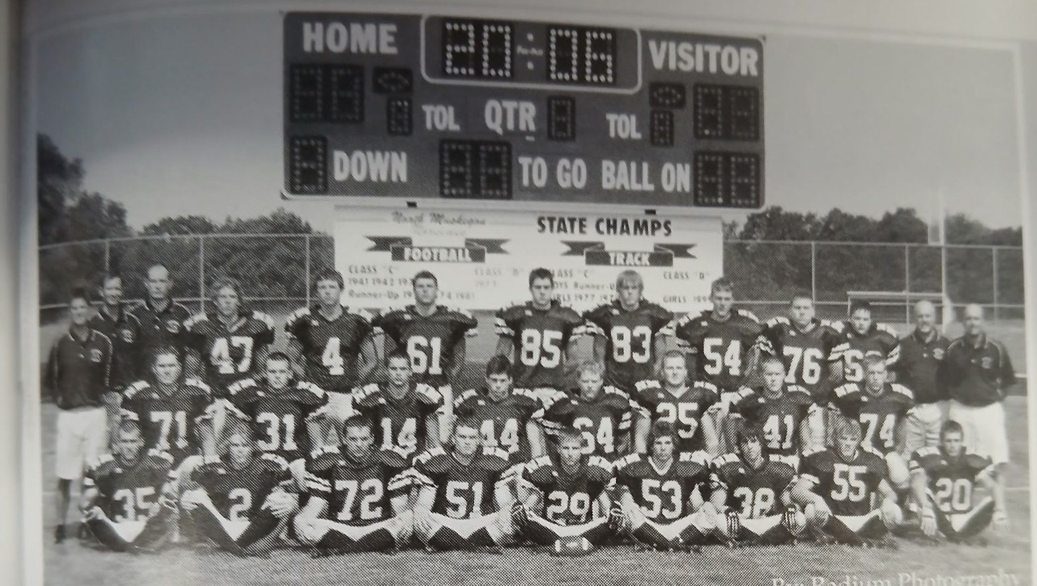

The 2006 NORSEMEN
Top Row L-R: Coach Mike Belmonte, Coach Jim Fleetmyer, Coach Chuck Rypstra, John Fahnensteil, Troy Forton, Eric Spytma, Brett Westra, Parker Zickel, Kevin Andree, Ryan Sexton, Eric Khan, Coach Jim Boyle, HC Al Karaba
Middle Row L-R: Austin Lane, Mark Pikard, Matt Mills, Matt Purtee, Jared Brandt, Jordan Carr, Chris Scheldt, Ryan Buter
Front Row L-R: Noah VanBergen, Kyle Cooke, Trevor Wilson, Ryan Corgan, Travis Falkowski, Steve Deur, Aaron Duplissis, Mike Strong, Alex Jones

Record Score Interesting Fact
1-0 NM 50, Holton 26 NM take 43-14 lead at half. 5 Norsemen score TDs.
1-1 NM 13, Whitehall 21 Troy Forton 2 TD passes to Matt Purtee.
1-2 NM 14, Oakridge 55 Purtee 92 yards kickoff return.
2-2 NM 34, Shelby 7 Purtee 2 TDs, Fahnenstiel & Forton 1 TD each. Jordan Carr 2 FG.
3-2 NM 41, Hart 6 Purtee 4 TDs, 47 & 53 run, 75 & 90 pass from Forton.
4-2 NM 49, Ravenna 0 Purtee 2 Tds, 208-yard rush., Forton TD passes to VanBergen & Fahnenstiel.
4-3 NM 22, Montague 45 Purtee 200 yds rush & TD. Forton to Fahensteil 33 TD pass.
5-3 NM 23, Mason Co 0 Fahnenstiel 3 TDs, 2 rushing (43 & 16) and 26-yd pass from Forton.
6-3 NM 48, Morley Stan. 6 Purtee and Fahnenstiel each a pair of TDs. Forton TS pass & TD reception. Kyle Cooke to Alex Jones for 70 yards and a TD.
7-3*NM 46, Newaygo 21 Fahnenstiel 3 TDs, Jones 60 yd. int ret., VanBergen & Purtee TD each.
8-3* NM 21, Oakridge 14 Fahnenstiel 3 TDs, 70 yd run, 33 yd. pass from Forton, 52 yd. int. TD.
8-4* NM 7, Swan Valley 9 Forton to Cooke 26-yard TD. Swan Valley 95 yd. punt return TD.

2007 Coach John Slocum (4-5 overall, Oakridge WMC Champs)

The 2007 season was filled with tight games decided by less than a touchdown. Unfortunately, the Norse were on the wrong side in five of those contests. First year head coach John Slocum must have felt snake bitten by the end of the 2007 season. Although NM had dropped their co-op program with West Michigan Christian, 26 players, including 15 seniors reported for early workouts, including five starters on both sides of the ball. NM would finish with a losing record, where just one more win would have qualified them for the playoffs due to their strength of schedule and dropping down in Class.

With prospects bright NM got a rude awakening with a rare 22-12 loss to Holton to begin the season. This would ultimately be the largest margin of defeat for the unlucky Norsemen the entire season. NM trailed by only a point late in the game and looking to take the lead. But an interception stopped the drive, and a long 47-yard TD run closed out the scoring. Holton scored first and converted on their 2-pointer to quickly take an 8-0 lead. NM countered with a 9-yard touchdown pass from new quarterback Kyle Cooke to Matt Mills, but the PAT failed. After Holton went up 15-6, NM countered on a 2-yard run by Noah Vanbergen and a safety to pull within one. The interception and long run late by Holton’s Esmond Castrejon ended any chance for a comeback victory.

The visiting Oakridge Eagles, still smarting from their playoff loss to NM in 2006, scored on their opening possession of the game and that would be all the scoring for the next 40 plus minutes as Oakridge would win 7-0. The big play in their drive was the opening kickoff return of 48-yards by Kyle Huck. Oakridge needed a pass play from the two-yard line to advance into Norse paydirt. Although the final score was close, the stats were one-sided in favor of Oakridge. The Eagles outgained the Norse 256-105 and had a 16-6 advantage in first downs. The Norse defense gave up yards, but no touchdowns, after the opening TD by Oakridge. Eric Fahnenstiel led the Norse defense with 16 tackles.

NM suffered what would prove to be the first of agonizing one-point losses in a 22-21 setback to Shelby. A couple of long touchdown passes from Tiger quarterback Kurt Burmeister to Lorenzo Rodriguez, the first good for 35 yards and the second for 69 yards were all the scoring attained by Shelby as both teams were tied 14-14 as regulation play ended. NM scored their first touchdown on a 1-yard run by quarterback Kyle Cooke, and the second TD was a Kyle Cooke pass to Matt Mills for 14 yards. Following the coin flip NM had first crack on offense and scored on a 12-yard pass from Cooke to Alex Jones. Fred Hill, who was perfect on all three PATs gave NM a 21-14 lead. After Jared Jenkins scored from 5-yards out to draw Shelby within one, Shelby head coach Lorenzo Rodriguez rolled the dice and went for the two-point conversion and the win. It looked like NM had stopped Tiger QB Burmeister on an option play but as he was going to the ground Burmeister pitched the ball to Omar Rodriquez who scampered into the endzone for the 2-pointer and the win.

Alec Jones scored four touchdowns, two on defense and two on offense, and Kyle Cooke threw three touchdown passes as NM finally moved into the victory column with a 44-13 win over Hart. Cooke connected with Jones with TD passes of 23 and 18. Playing on both sides of the ball Jones scored his first TD when he picked up a Pirate fumble and scooted 23 yards into the end zone. Early in the second half Jones picked up a blocked punt and returned it 19 yards for his fourth and final touchdown. NM scored in a variety of ways. Their first TD came on a 63-yard punt return by Matt Mills. Mills also scored on a TD on one of Cooke’s three TD passes, a 14-yard tally in the second half. The final Norse touchdown came the old-fashion way: a 23-yard run by running back Cole Orrison.

Dusty Fairfield returned as the Ravenna head coach after a brief hiatus. Perhaps one of his reasons to return as the Bulldogs head coach came after seeing Ravenna losing to NM 49-0 in 2006. Renowned in the past for producing outstanding kickers, a failed extra point after NM’s last touchdown prevented at least a tie as Ravenna hung on to edge NM 34-33. The Norse had opportunities late in the game, but the Bulldog’s defense stopped NM short of a first down at the Ravenna 21-yard on a 4th-and-1 play. Kyle Cooke filled the air with footballs with 10 of his 32 passes completed for a whopping 356 yards. NM scored the game’s first touchdown on a conventional 4-yard run by Noah VanBergen. Their final four TDs came on long pass plays, three caught by Alex Jones that went for 67, 42 and 80 yards. A Ravenna touchdown early in the fourth quarter gave Ravenna a 34-27 lead. On their next play from scrimmage, after taking over at the 16-yard line following a Bulldog kickoff, Cooke connected with Matt Mills for a pass play that went for 84 yards. However, the extra point attempt failed, and the Norsemen suffered their fourth defeat of the season, two of those losses by just one point.

Kyle Cooke had his second consecutive four TD pass night, but it wasn’t enough as Montague edged the Norse 35-38. Also, for the second straight week the Norse had a final scoring drive stopped deep in their opponent’s territory. NM had a first and goal at the Wildcat five-yard line with less than two minutes remaining in the game, but a run and three failed pass plays doomed the Norse to another aggravating defeat. NM won the battle of the stats but not the score. NM totaled 327 yards during the game, with Cooke’s passing counting for 222 of those yards by completing 13 of his 27 passes. Alex Jones was on the receiving end of two of Cooke’s TD strikes, the first for 7-yards and his second from 18 yards drew the Norsemen to the final 38-25 score.

The Norse would win their final three games of the season with the first of those three a convincing 45-14 drubbing of Mason County Central. Kyle Cooke completed only four passes on the night, but three of those completions went the distance with TD strikes of 50 and 66 yards to Alex Jones and the other a 35-yard aerial to Matt Mills. After spotting the hosts from Scottville a first quarter TD, NM put this game quickly away with 33 second quarter points. Noah VanBergen scored on runs of 51 & 45 yards; Cooke added another rushing TD from 11 while Cole Orrison capped the scoring with a 15-yard run. VanBergen joined the 200-yard rushing club with his 17 carries while Orrison chipped in with 87 yards as NM finished with 485 total yards.

NM snapped a six-game losing streak at the hands of Whitehall with their 25-13 victory over the Vikings. After throwing for 11 TD passes in his previous three games Cooke used his legs to top Whitehall. With the score tied in the second half Cooke capped a Norse 80-yard drive with a 3-yard run. NM then forced a Vikings punt with the big play being a 12-yard sack by Ryan Buter. A couple of plays after NM took possession Cooke ripped off a 51-yard TD up the middle to give NM a two-score lead and the final score of 25-13. Buter, the career home run hitter for North Muskegon Baseball, scored the second NM TD on the night when he picked up a fumble and rambled 40 yards for a TD. Earlier Noah VanBergen had scored for the Norsemen on a 32-yard run. Cooke finished with 110 rushing yards on the night while Erick Fahnenstiel was the mainstay of the NM defense with 13 tackles.

NM closed out their season thinking back to a bunch of ‘What Ifs.’ None of NM’s five losses on the season were double digit defeats, with 2 of those setbacks by only one point. NM made it three straight wins to close out the season on a winning note with a commanding 34-8 win at Morley Stanwood. Unfortunately, no mention of this game was in the Muskegon Chronicle.

The Norsemen could have used a bona fide public relations consultant as this team had scant representation for post-season honors. Alex Jones, who caught at least 10 TD passes (no stats for the final game) during the season wasn’t even tabbed for honorable mention on the C/D all area team. His co-receiver Matt Mills did make the second team while Ryan Buter was also picked for second team on the All-Area team. Kyle Cooke was the only Norsemen to even receive honorable mention honors. NM did finish the season with a losing record against a tough schedule, but they were only a play or two from advancing into the playoffs where they would have been a tough out for any opponent playing at the Class D level. Montague, a 35-28 winner over NM, came four points away from advancing to the state championship, a perfect example of what could have been for the Norsemen of 2007.

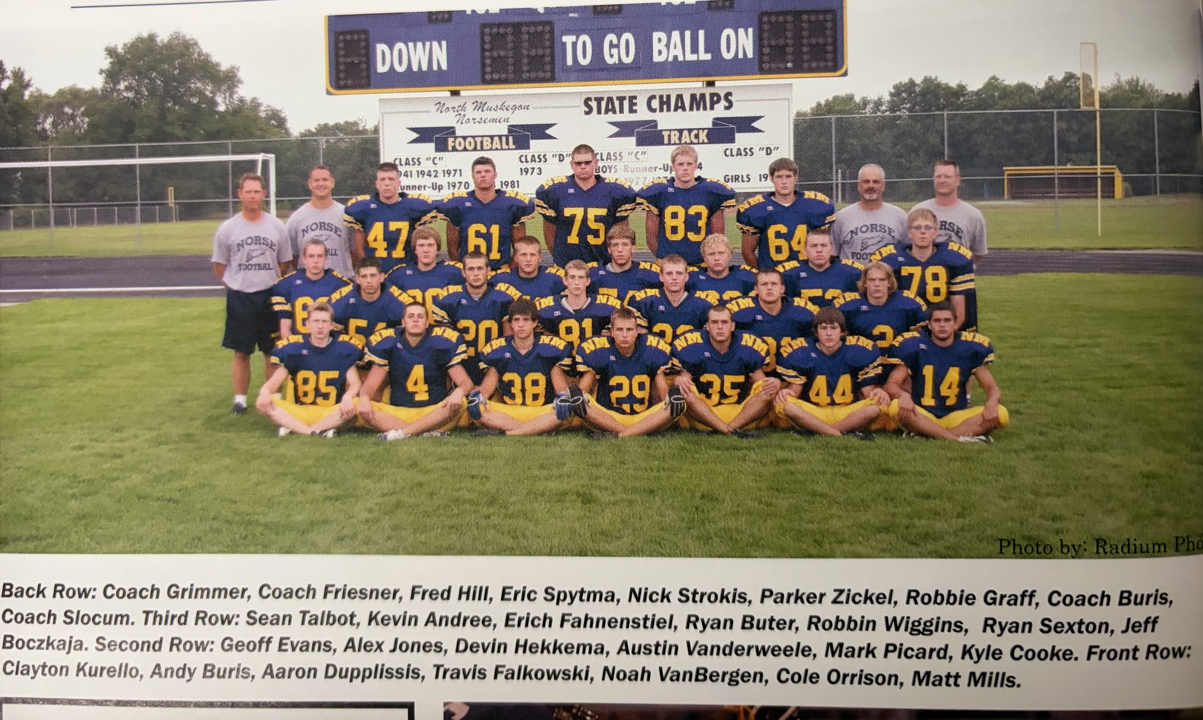

The 2007 NORSEMEN

Record Score Interesting Fact
0-1 NM 14, Holton 22 Kyle Cooke to Matt Mills 8 yd TD pass, Noah VanBergen 2-yard run.
0-2 NM 0, Oakridge 7 Eric Fahnenstiel 16 tackles, Kyle Cooke & Aaron Duplissis 8 apiece.
0-3 NM 21, Shelby 22 NM lost in OT. Cooke 1 yd TD and passes of 12 & 14 to Mills & Jones.
1-3 NM 44, Hart 13 Jones 4 TDs, Kyle Cooke 3 TD passes. Mills 2 TD, Cole Orrison TD run.
1-4 NM 33, Ravenna 34 Cooke 4 TD passes & 356 yds. Jones 3 TDs, Mills 84 yd pass for TD.
1-5 NM 28, Montague 35 Cooke 4 TD passes, Jones 2 Yds. VanBergen, Travis Falkowski TD.
2-5 NM 45, Mason Co 14 VanBergen 2 TDs & 200 yds. Cooke 3 TD passes, 2 to Jones, Mills
3-5 NM 25, Whitehall 13 Cooke 110 rushing yds, 2 TDS. Buter 40 yd fumble return.
4-5 NM 34, Morley Stan 8 No report in MC.

2008 Coach John Slocum (1-8 overall, Oakridge WMC Champs)

The 2008 football season would forever be known as the most successful season in Greater Muskegon History. Muskegon County teams would win four state championships, and the Norsemen would play three of the four champs. NM would only win one game as they were beginning a tough stretch in Norse football history before finally turning football fortunes around in 2012. Likeable Norse coach John Slocum would endure some tough sledding during his 5 years at NMHS as the head mentor, but he was not given a lot of top-notch horses to ride during his tenure. Only 20 players were on the 2008 roster with skill players such as Kyle Cooke, Alex Jones, Matt Mills, and Ryan Buter lost to graduation. It would be a long season.

The Norsemen would have a new opener for the first time in many years with Newaygo replacing Holton on its schedule. NM had played Holton for 20 consecutive years with NM dominating the series up to that point with 18 wins in 24 meetings. The rivalry with Newaygo went all the way back to their first matchup back in 1935. NM had won 14 of their previous 15 encounters with the Lions with Newaygo’s only win coming in 1984. Make that two wins for Newaygo as the Norse fans sensed this would be a tough year for the Blue & Gold after suffering a 45-3 pounding at the hands of the Lions. If the first game was any indication, it could be a long season for the NM running game as they finished with minus-36 yards rushing. There was yet another Cooke to surface at NM as Drake Cooke provided much of NM’s offense with a 15-22 passing night for 145 yards, seven of those completions going to Aaron Jones. NM led in this rout 3-0 on a 32-yard field goal by Dominick Nattle, but the Newaygo team dominated the rest of the game.

The Norse were no match for the 2008 Division 5 state champions. It’s doubtful if any team scored more points in the first half in the proud history of NM football than the 49 points scored by Oakridge in their 56-6 defeat of our Norsemen. In the blink of an eye Oakridge scored two touchdowns in the game’s first 20 seconds, a 59-yard run and then a 75-yard interception, both by Matt Eacher, two of his five touchdowns in the game. Devin Hekkema scored the only NM TD on a five-yard TD pass from Drake Cooke as the second half went by quickly with a running clock.

Perhaps the lone positive moment for NM fans in the 27-7 loss to Shelby came on the opening kickoff in the second half when Aaron Jones raced 85-yards for a TD, the only touchdown scored by the Norsemen in the loss. The TD momentarily gave NM some life as they trailed early in the third quarter by only six points at 13-7. Shelby’s defense created three turnovers, an interception, a fumble recovery, and a blocked punt. Levi Tull ran for 214 yards for the winning Tigers as the Norsemen fell to 0-3.

The Norsemen would win their only game of the season 48-12 against Hart, a program that was still looking for its first winning season in more than 20 years. NM took advantage of a jittery Hart team as they forced four first quarter turnovers. NM scored three touchdowns and kicked a field goal from those four turnovers to take a commanding 24-0 lead. Devin Hekkema and Cole Orrison each scored a pair of TDs, Hekkema a 12-yard fumble recovery and return, and a five-yard TD pass from Drake Cooke, while Orison had TD runs from 48 and five yards. Dominck Nettle kicked a pair of field goals while Drake Cooke ran for a TD and threw for 2 TDs. Aaron Jones was on the receiving end of one of Cooke’s TD passes. With the way that NM dominated the Pirates it looked like more wins were sure to come, but that did not happen.

A Drake Cooke 47-yard touchdown pass to A J Benedict in the second quarter drew North Muskegon within seven points at 14-7 before Ravenna displayed their superiority and scored three unanswered touchdowns to down the Norse 34-7. Drake Cooke was the top Norsemen as he rushed for 91 yards on 17 carries and threw for 148 yards in a losing effort. Aaron Jones was Cooke’s top target with three receptions for 46 yards.

Unlike 1992 when Montague rolled up the score in a 63-0 thumping of the Norsemen, the 2008 Montague coach Pat Collins, the quarterback of the 1992 Wildcats, was much kinder to NM as he did not pad the lead in the second half. Montague, with current Reeths Puffer head coach Cody Kater leading the way, led NM 42-0 at halftime forcing a running clock – mercifully – in the second half. Playing against Montague reserves NM back Cole Orrison broke loose on a 65-yard TD run for the only NM score of the game against the 2008 Division 6 state champs.

NM had their second highest point production of the season, but unfortunately, they gave up 49 points in a 49-30 loss to Mason County Central, exceeding by one point the most points ever compiled by MCC in the long series with the Norsemen. Drake Cooke passed for 293 yards and three touchdowns as NM, trailing 41-14 at halftime, scored the final two touchdowns of the game to make the score look a little more respectable. Aaron Jones had six receptions for 123 yards, including a long 83-yard TD pass from Cooke. Devin Hekkema added four catches for 48 yards and a TD while Cole Orbison ran for 55 yards that included a 25-yard TD.

When you’ve only won a single game all season, why not go for two late in the game when your trailing 21-20 against Whitehall? The Norse rolled the dice but came up empty after Cole Orrison scored late in the game to pull NM within one. The Norse attempted a running play to take the lead but failed as their record fell to 1-7 and they dropped to the cellar of the West Michigan Conference. Whitehall jumped in front early to take a 14-0 lead, but the Norsemen would rally. Drake Cooke, who connected on 14-of-25 passes for 146 yards closed out the first quarter on a 2-yard run to close the gap to 14-7. The first of Orrison’s two TDs tied the score at 14. A Viking TD in the fourth quarter, plus a successful conversion, provided what would prove to be the winning point before Orrison’s TD with one minute remaining gave NM faint hopes.

Nobody can accuse North Muskegon of scheduling a cupcake opponent to fill out their nine-game schedule from 1998-2008. Two of their opponents in game nine would advance to the state championship during this era, but none would come close to being as strong of a ninth date foe than the Muskegon Catholic team of 2008. Many would say the Crusader team of 2008, that buried all their opponents enroute to easily winning the Division 8 state title, might have been the best of all the many great Crusader teams since becoming a four-year school in the Fall of 1953. Players from former great MCC teams from 1959, 1974, and the 1980-82 trio may differ, but the 2008 team was indeed a powerhouse squad. So powerful was the 2008 MCC team that they had to scramble to find teams to fill out a schedule. Twice in 2008 MCC played teams in Wisconsin, including a Lacrosse, Wisconsin team located near the Minnesota border. MCC Hall of Fame coach Mike Holmes was merciful on the Norsemen. After taking a 31-0 lead at halftime, the Crusaders failed to score against an outmanned but determined NM team in the second half. NM was held to but 102 total against an impregnable Crusader defense. Devin Hekkema contributed 11 tackles to lead the Norse defense.

With three of the area teams winning state championship in Division 5-8, there was little room for post-season honors for an NM team with an 1-8 record. Eric Fahnenstiel was accorded 2nd team honors for his play as a linebacker while sophomore Aaron Jones was given honorable mention honors for his play as an offensive end.

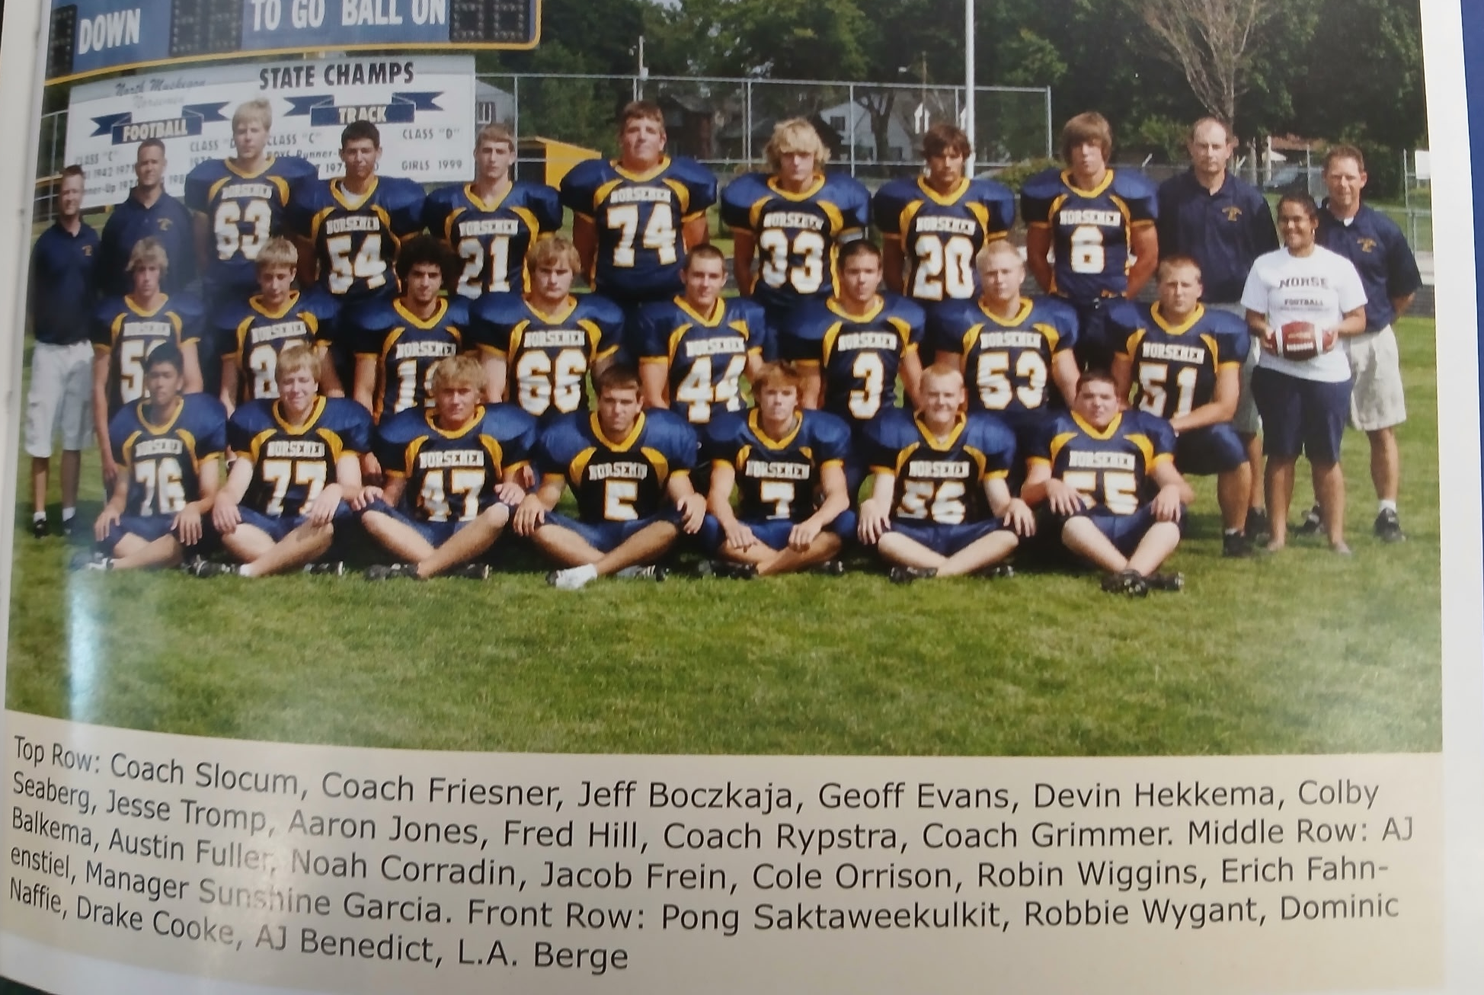

The 2008 NORSEMEN

Record Score Interesting Fact
0-1 NM 3, Newaygo 45 Dominick Nattle FG, Drake Cooke 15-22 145 yards passing.
0-2 NM 6, Oakridge 56 Cooke to Devin Heekkema 50-yard TD pass. Eric Fahnenstiel 10 tkls.
0-3 NM 7, Shelby 27 Aaron Jones 85-yard kickoff return for TD.
1-3 NM 48, Hart 12 Hekkema and Cole Orrison 2 TDS, Cooke 2 TD passes, and TD run.
1-4 NM 7, Ravenna 34 Drake Cooke to A J Benedict for 47 yards the only NM TD.
1-5 NM 7, Montague 42 Cole Orrison 65-yard TD run in second half only NM TD.
1-6 NM 30, Mason Co 49 Cooke 3 TD passes for 293 yds. Jones 123 yds receiving & TD.
1-7 NM 20, Whitehall 21 Orrison 2 TDs, Cooke a rushing TD and 146 passing yards.
1-8 NM 0, Musk CC 31 NM 102 total yards against the 2008 D8 undefeated state champs.

2009 Coach John Slocum (5-5 overall, playoff qualifier, Montague WMC Champs)

The on again – off again – co-op with West Michigan Christian was back on after a two-year hiatus. Seven WMC students would now suit up in a Norse uniform, and they made an immediate impact. NM got off to a great start to the 2009 season, winning five of their first six games before taking a turn in the opposite direction. The sophomores who comprised much of the lineup at the skill positions were now juniors, including quarterback Drake Cooke and his favorite receiver Aaron Jones.

NM did a complete 180 from their opening game with Newaygo the previous season. After getting drubbed by the Lions in 2008, NM won convincingly in the 2009 opener with Newaygo 34-6. A trio of WMC co-op students got off to a strong start for the Norsemen as Damario Harris, London Burris and Omari Lewis all scored a touchdown in the victory. Harris got the Norse started on the right foot with a 25-yard dash to give NM an early lead. Following a Newaygo touchdown NM then would score the next four TDs to pull away to an easy victory. Junior quarterback Drake Cooke connected with Lewis for a TD pass good for 34 yards to give NM a 12-6 halftime lead. After a Cooke one-yard TD QB sneak, Burris caught a seven-yard TD pass from Cooke to score the fourth NM TD of the game. Aaron Jones then completed the scoring for the host Norsemen with a six-yard run.

Even in a losing cause NM showed they were vastly improved from their previous season in their 57-28 loss to Montague. NM led late in the first half 28-27 in an explosive half that saw the two teams combine for 63 points in an entertaining first half. The fireworks started early as Montague’s Drew Pineda returned the opening kickoff 95 yards for a TD. The Wildcats added another TD before the Norsemen bounced back primarily on the arm of Drake Cooke and the receiving of London and Jeff Burris. Cooke would take part in all the Norsemen scoring with four TD passes, three to London Burris on TD catches of 37, 30, and eight yards and a fourth to Jeff Burris from three yards out. Montague would go on to not only win the competitive WMC conference but would win their second straight Division 6 state championship. Montague’s state championship victory over Monroe St. Mary Catholic in late November at Ford Field in Detroit was the final game your author would broadcast in Muskegon after 34 years behind the mic. It was time to follow the family to the Sunshine State.

NM’s 15-13 victory over Shelby surely was one of the most bizarre and improbable wins in NM’s long history. Trailing 13-9 with just 13 second left on the clock, NM forced a Shelby punt. Waiting on the Tiger punt and standing at his own 22-yard line was Jeff Burris. The fleet footed Burris then brought joy to NM followers while stunning the Shelby faithful who thought victory was theirs as Burris sped 78 yards for the winning touchdown as the clock ran out. It was the third longest punt return in NM history and the only punt return for a game winning touchdown. Earlier in the second half London Burris ran 66-yards for a NM TD to draw NM within 4 points of the Tigers at 13-9. Brian Kelly had kicked a 37-yard field goal in the first half that ultimately would be the difference in the scoring.

NM would use the momentum from their shocking victory over Shelby to score 67 points, the 4th highest point total in NM history with a 67-22 rout of Hart. For the second straight game Jeff Burris returned a punt for a TD. His 75-yard return nearly matched his game winning 78 game winner last week against Shelby. Burris added two more TDs, an 11-yard TD pass from Drake Cooke and a 6-yard run. Taylor Mills pitched in with a couple of long-distance tallies, a 74-yard run and a 30-yard interception brought back to paydirt. Demario Harris returned a kickoff back 90 long yards for six points while Drake Cooke, in addition to tossing a pair of TD strikes, with one of his aerials going to Omari Lewis for 16 yards, also ran 7 yards for a score. The other NM touchdown came from their defense when Aaron Jones intercepted a Pirate pass and raced 20-yards for a TD.

NM continued to rack up points, and they also gave up a bunch, but their 48 points was enough to hold off an onrushing Mason County Central team that scored 42, 21 of the Spartan points coming in a belated fourth quarter rally. Drake Cooke connected with Aaron Jones three times on TD passes of 4, 37, and 76 yards and rushed 27 for another NM tally. London Burris scored on rushes from 59 and seven yards to give NM a 48-21 lead before Mason County rallied for 21 fourth quarter points. The host Spartans recovered one onside kick and appeared to recover another late in the game only to have the second recovery nullified on a penalty. Cooke was 7-10 passing for 182 with Jones catching 4-of-the-10 for 76 yards and 3 TDs. Demario Harris led NM rushers with 147 yards with London Burris close behind with 136.

After averaging nearly 40 points per game in their first five games, the Norse needed a big effort from their defense in their 14-7 win over Whitehall. In a game played in wet and sloppy conditions the Norse ‘D’ stopped Whitehall drives four times inside its own 30-yard line. NM scored the game’s first TD on a Drake Cooke to Aaron Jones TD pass that connected for 29 yards. NM missed the extra point that led to Whitehall taking the lead after their only TD of the game and made PAT in the third quarter. NM marched 65 yards for the winning drive with the big play a 30-yard Cooke to London Burris pass play that moved the ball to the one. Taylor Mills then crashed over from the one and Cooke hit Jones for the two-point conversion to make the final score 14-7. With a 5-1 record it looked like NM was headed for a solid finish. However, their final three regular season opponents were blue bloods who had several state championship trophies in their trophy cases.

NM scored 27 points against the 2008 state champs from Oakridge, the most points the Norsemen would score against the Eagles through the 2021 season. However, the Eagles scored 38 to hand NM their second loss of the season. In a game played on a muddy Fred Jacks field, Oakridge used primarily their running attack in their 38-27 win over the Norsemen. Oakridge rushed for 417 yards while for NM most of their yards were gained through the air as Drake Cooke completed 8-of-15 passes for 225 yards and one touchdown. That touchdown was a 79-yard strike to Jeff Burris. The two teams were tied 21-21 at halftime, as London Burris and Taylor Mills matched the Eagle three touchdowns. Oakridge dominated the second half by outscoring NM 17-6 with the Norse TD coming on a fourth quarter touchdown from London Burris.

Just a little more than a year after Oakridge scored 49 points in a half, Ravenna also scored 49 points in a resounding 69-7 rout of the Norsemen. The 69 points scored by the unmerciful Bulldogs are the most points given up by a Norse team in program history. The Bulldogs put 21 points on the board before the Norsemen even ran an offensive play. Running back Jamohn Martin ran wild against NM with six touchdowns while NM’s only score came in the first half on a 9-yard touchdown pass from Drake Cooke to Jeff Burris.

A banged-up NM team was no match for Muskegon Catholic in dropping their regular season finale 47-0 to the Crusaders. The only good news for NM was after going 5-4 during the season against a flock of tough competitors, they would make the playoffs with a 5-4 record. The bad news, NM was hurting with injuries and would be sub-par for their playoff opener. MCC had a 391-129 advantage in offense as NM played their first game ever at MCC’s Kehren Stadium.

After defeating Morley Stanwood by a combined score of 133-20 in the three games played to close out the 2005-07 seasons, one would think it would be another walk in the park for NM. This, however, was not the Morley-Stanwood teams NM played in the past but a team that would be 10-0 after a 38-7 romp over the Norsemen in the opening round of the playoffs. The hosts from M-S didn’t have a Tyler Hanks in their initial three meetings. Hanks was too much for the NM defense as the 2009 Hanks ran for 270 yards and 3 touchdowns. Playing in the wind and the rain NM would end their season at 5-5. NM’s only points scored came on a 29-yard touchdown pass from Drake Cooke to London Burris.

London Burris was accorded honors as a 2nd team running back on the C-D all-area team. The only other Norsemen to get a sniff of attention was sophomore defensive lineman Jonathon Ackley. One stat the alumnae from the team of 2009 would not be proud of; the 335 points they gave up to their opponents was the most against NM in program history.

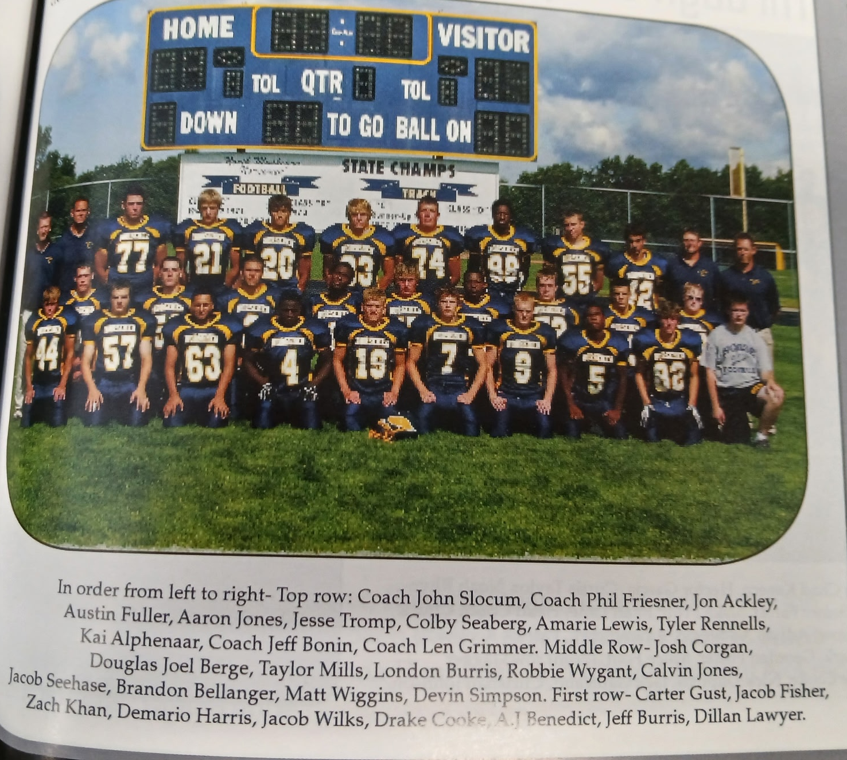

The 2009 NORSEMEN

Record Score Interesting Fact
1-0 NM 34, Newaygo 6 Drake Cooke 2 TD passes & run (L Burris, Demario Harris, Omario Lewis & Aaron Jones TDs.
1-1 NM 28, Montague 57 Cooke 4 TD passes, 3 to London Burris, one to Jeff Burris.
2-1 NM 15, Shelby 13 J. Burris 78 Yd Punt return wins. L Burris 66 TD run, Brian Kelly FG.
3-1 NM 67. Hart 22 J. Burris 3 TDs, Cooke 2 pass TD & run, Harris 90 yd Kick off TD.
4-1 NM 48, Mason Co 42 Cooke to Jones TD passes of 4, 37 & 76. Burris 59 & 7 yd TD.
5-1 NM 14, Whitehall 7 Cooke to Jones 29 yds TD, Taylor Mills 1 yd TD.
5-2 NM 27, Oakridge 38 L. Burris 2 TDs – R Burris 79 yd pass from Cooke, Mills TD.
5-3 NM 7, Ravenna 69 Most points scored against NM – Cooke to J Burris 9 YD TD pass.
5-4 NM 0, Musk CC 47 London Burris 62 rushing yards leads crippled Norse team.
5-5* NM 7, Morley Stan. 38 Cooke to L. Burris for 29 yards only NM TD.

2010 Coach John Slocum (4-5 overall, Oakridge & Shelby tie WMC Champs)

You talk about tough luck! NM began the 2010 season by losing their first three games, all by a single point! NM would finish with a losing record of 4-5, but that could easily have been a 7-2 record with a few breaks going their way. NM returned their three-year starter at quarterback in Drake Cooke and 2nd team all-area running back London Burris. NM would receive another boost in their offense with the addition of John Waller, a speedy co-op student from West Michigan Christian. Three-year starting receiver Aaron Jones would return to give Drake Cooke a nice option when he went to the air. The defense should show improvement as six starters from 2009 return including big tackle Jonathon Ackley and linebacker Jesse Tromp. Although their record may not show a winning season, the 2010 Norse were a much better team than their final 4-5 record.

NM would renew a series with Grandville Calvin Christian and would drop the first of their first three one-point defeats 21-20. It didn’t take but the opening quarter for John Waller to show his speed as he raced 56 yards for a touchdown. London Burris took up where he left off in 2009 as he blazed into the secondary and sped 69 yards for a second NM TD. NM led 14-0 as Burris ran in a two-point conversion after NM misfired on their first PAT from placement. Grandville CC did not go away and answered with three unanswered touchdowns and three made extra points. Drake Cooke then connected with Burris from 49 yards out to bring the Norse within a point of tying the game. However, the extra point attempt was blocked, a play that spelled doom for NM. Walker finished with 89 yards on nine carries and Burris had 64 yards in six rushes. Aaron Jones had four catches for 64 yards.

The defending two-time state champs from Montague, possessing a 23-game winning streak, needed a 16-yard TD pass from Travis Cockerill to Steve Murdoch with only 16 seconds left on the clock to hand NM their second straight one-point defeat 14-13. John Waller, for the second straight week, scored the game’s first touchdown on a 19-yard run but the extra point attempt failed. Montague took the lead in the third quarter on an 8-yard run and a successful extra point to take a 7-6 lead. NM regained the lead with 10:24 left in the game on a 40-yard TD pass from Drake Cooke to Carter Gust. It’s easy to second guess many years after the fact, but NM went for the one pointer on the extra point from placement to lead 13-7. After their last seconds TD, Montague then kicked the extra point to hand NM their second tough loss in a row.

They say bad things sometimes come in threes and that was the case again for the Norse in their 21-20 loss to Shelby. And just maybe it was Shelby’s turn to win a game in the game’s final moments as NM did a year ago when Jeff Burris returned a punt for a TD as the clock expired. This time it was Shelby who scored with less than 30 seconds to go in the game to send the game into overtime where they handed NM their third one-point defeat in a row. To make things even more miserable for the Norsemen, Shelby converted on their game tying march on a 4th and 18 play to keep the drive alive. Shelby scored first to take a 7-0 lead at halftime. John Waller than broke loose on NM’s first drive of the second half and bolted through the left side and raced 89 yards for a TD. Again, NM failed on their PAT attempt. Prior to Shelby’s game tying drive Jesse Tromp scored on a three-yard run and NM tied the score on Waller’s two-point conversion run. Shelby took over first in OT and scored and made their extra point. Drake Cooke dove in from one yard out to bring NM within a point of sending the game into a second overtime period. The snake-bitten Norse could not handle the snap from center, and they dropped to 0-3 on the season. Three losses by three lousy points.

With their extra point woes contributing to their three earlier defeats NM Coach John Slocum must have had kicking tryouts during the week. NM had prided themselves over the years with their kicking game. As the ball boy for NM in the late 1940s I well remember the Matych brothers, first Bud and later Jim winning games with their kicking. Many years later NM would boast of such great kickers as Mario Ferretti, Sam Parker, Dr. Carl Nicles and Jamie Keane. Coach Slocum chose Aaron Jones to handle the kicking chores and, although his kicking was in no means the difference in NM’s 55-0 drubbing of Hart, Jones was 7 of 8 in PAT attempts in the Norse romp of the lowly Pirates. Jones also caught a TD pass from Drake Cooke and returned a punt back for another tally. John Waller had a huge game for the winners as he scored on long TD runs of 51, 55, and 54. London Burris added to the Norse onslaught with scampers for six points from 54 and 34 and NM had a 48-0 lead at halftime.

NM again showed their potential as they again exploded in the first half by scoring 47 points to force a running clock in the second half for the second straight week in their 56-6 win over Mason County Central. John Waller, (3 & 11), London Burris (4, 15 & 30) and Aaron Jones (21 & 54 Yard TD passes from Drake Cooke), combined for 7 of the 8 NM touchdowns in their hammering of the Spartans. Carter Gust had the other touchdown on a 56-yard pass interception returned for six points.

The Norsemen would move to 3-3 on the season with another good offensive showing in their 46-10 stomping of Whitehall. London Burris only needed 7 rushes to total 172 yards and John Waller finished with 115 yards on 11 carries. Drake Cooke was efficient in the passing department by clicking on 10 of his 12 attempts for 210 yards and three touchdowns. Five of Cooke’s completions went to Aaron Jones who recorded five catches for 135 yards and a 55-yard TD gallop. Waller scored on a pair of long 70-yard runs in accumulating most of his 172 rushing yards. NM, after those three early one-point losses, would need to win at least two of their next three games to make the playoffs. However, looming ahead were Oakridge, Ravenna and Muskegon Catholic, winners of many state championships.

NM lost to Oakridge 31-14, putting NM’s chances in peril for qualifying for the playoffs. Oakridge jumped out to an early 14-0 lead before NM would counter on a 25-yard scoring pass from Drake Cooke to Aaron Jones. NM came close to sending the game into the second half tied at 14-14 but Oakridge’s 3-sport All-Star Jamie Potts knocked down a pass in the end zone to kill the Norse chances. The Eagles then scored the first 10 points of the second half to pull away from NM. John Waller provided the second NM TD on the game with a six-yard run in the second half. Oakridge did a good job of shutting down the NM running game as Drake Cooke was forced to go to the air. Cooke was an impressive 18-34 for 321 yards for NM. Jones hauled in eight catches for 139 yards while London Burris also had eight receptions for 145 yards.

Ravenna removed all doubts for a Norsemen playoff berth with a 35-14 victory over the Norse. It was Ravenna who earned their sixth win of the season who qualified for the post-season, while NM was eliminated with their fifth defeat. Ravenna turned a tight game into a 28-7 halftime lead after the Norse trailed 14-7 following a Drake Cooke one yard run in the opening half. The Bulldogs then pushed their lead to 35-7 before NM added the game’s last touchdown on a 9-yard pass play from Drake Cooke to London Burris. With their final hopes for a playoff berth dashed, would NM just mail it in against always powerful Muskegon Catholic in the regular season finale?

After losing their first three games of the season by failed extra points, NM got a well-deserved victory by finally winning a game with their own one-point 28-27 squeaker over Muskegon Catholic. The winning points came after Drake Cooke hit Aaron Jones with a six-yard scoring pass. Instead of going for the one-point conversion with the now reliable Jones, coach John Slocum went for two and were successful on a conversion pass from Cooke to Carter Gust. MCC tallied in the fourth quarter and went for the win with a two-pointer of their own but were stopped by the NM defense. Senior quarterback Drake Jones finished his NM career in style by throwing four touchdown passes, three to London Burris (61, 14 & 6) and the final one to Jones. NM and MCC would both end their 2010 season with identical 4-5 records.

Although it would be considered ‘faint praise,’ the 2010 Norsemen could boast of perhaps being the best 4-5 team in the more than 90 years of NM football. If NM could have just turned around one of those first three losses into the winning column they surely would have advanced to the playoffs with their strength of schedule. The only Norseman selected to the first team all-area squad was their outstanding three-year starter at receiver, Aaron Jones. Jones was not selected as a receiver however, but as the all-area punter with a 38.2 average per punt. Jones was selected as a 2nd team receiver as were John Waller and Drake Cooke. Despite a losing record of 4-5, that record would look very good after the 2011 season.

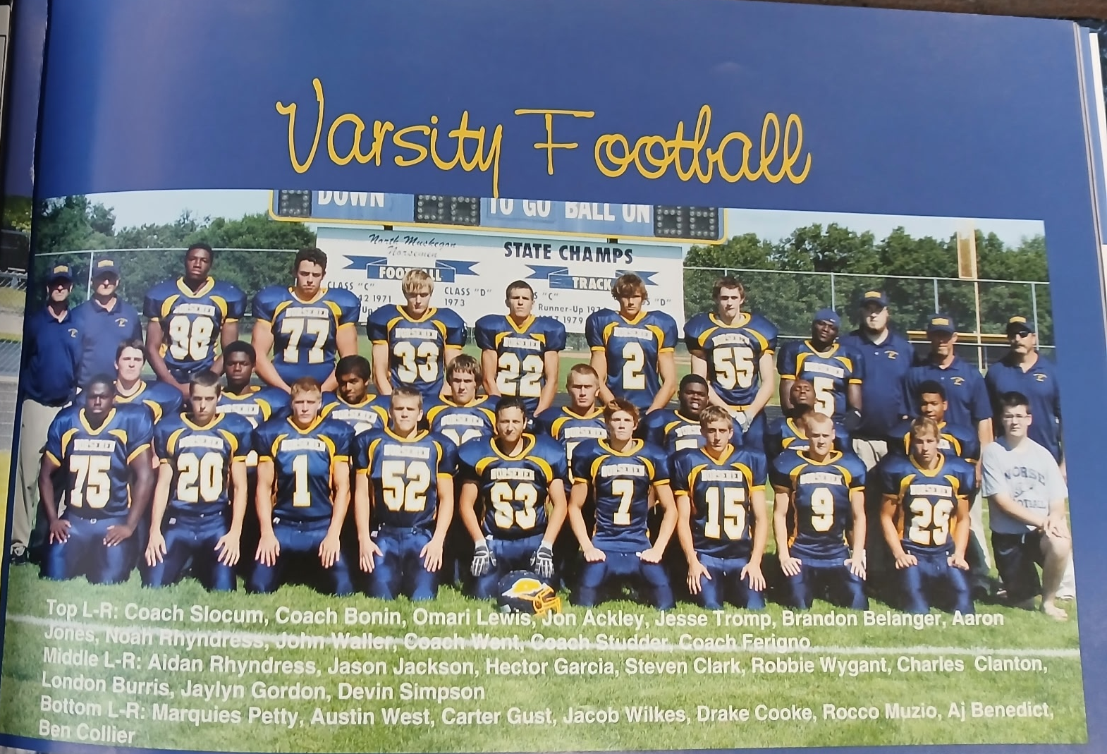

The 2010 NORSEMEN

Record Score Interesting Fact

0-1 NM 20, Cavin Christ. 21 London Burris 2 TDS, 69 run, 46 pass from Cooke, John Waller TD.
0-2 NM 13, Montague 14 Waller 19 TD run, Drake Cooke to Carter Gust 40-yd TD pass.
0-3 NM 20, Shelby 21 Waller 89 yd TD, Jesse Tromp 3-yd and Cooke 1 yd TD.
1-3 NM 55, Hart 0 Waller 3 TDS (51, 55 & 54) Burris 54 & 34, Aaron Jones 2 TD.
2-3 NM 54, Mason Co 6 Burris 3 TDs, Waller, and Jones 2. Gust 56 yd interception TD.
3-3 NM 46, Whitehall 10 Waller 2 long TDs & 172 yards. Cooke 210 yds pass. Jones TD.
3-4 NM 14, Oakridge 31 Cooke 321 yards passing. Jones 25 yd rec TD. Waller 6-yd TD.
3-5 NM 14, Ravenna 35 Cooke 1-yard TD run, Cooke to Burris 9 yard passing TD.
4-5 NM 28, Musk CC 27 Cooke 4 TD passes, 3 to Burris, 1 to Jones. Cooke-Gust 2 pt. wins.

2011 Coach John Slocum (0-9 overall, Oakridge & Shelby again tie WMC Champs)

The 2011 season would be one to forget, if possible. It was the only winless season in more than 90 years of NM football as they experienced an 0-9 record. In five of their losses NM failed to score. NM did return several linemen, but they were severely hurt with graduation at several key skilled offensive positions, notably quarterback Drake Cooke, running back London Burris and wide receiver Aaron Jones. With the loss of major 2010 offensive stalwarts to graduation, putting points on the board would pose a major problem for fifth year coach John Slocum.

The one running back returning who made major contributions in 2010 was John Waller, one of six West Michigan Christian students playing football for NM in their co-op program. Waller scored a touchdown in the 2011 opener but that was all the scoring as NM lost their opener once again to Grandville Calvin Christian 14-7. It became apparent as early as their first game that NM was going to have trouble scoring points. Waller was the leading rusher with a modest 65 yards on 19 carries while the Norsemen only completed 2-of-6 passes for 14 yards.

NM did better in yards gained in their second game of the season but still found points hard to come by as they were shutout by Shelby 12-0. Both Shelby touchdowns came in the opening quarter, the first coming following an 80-yard march, the second touchdown took place shortly thereafter when NM fumbled the ensuing kickoff. Shelby scored three plays later with 1:00 remaining in the opening quarter. The Norse garnered 267 yards of total offense, including 144 yards rushing, but couldn’t score. NM quarterback Rocco Muzio went 10-21 through the air for 112 yards while Jaylin Gordon led all rushers with 79 yards on 11 carries.

Following Harts 21-20 win over North Muskegon all signs pointed to a lean year for Norse football. It would be the only win Hart would post over NM in 21 of 22 seasons, and the last Hart victory over NM through the 2025 season. Through the rest of the 2011 campaign NM would not come closer than 14 points of their remaining opponents. The win was Hart’s first in 21 games against WMC competition. NM’s Chuck Clanton gave NM a 20-14 lead early in the final quarter, but the all-important extra point attempt failed. Hart’s Lucas Romback scored on a 53-yard run with 4:30 left, the PAT was good, and NM would incur their 3rd straight defeat. Adrian Anderson on a two-yard run and Rocco Muzio scored from 27 for the other NM TDs.

NM suffered their fourth straight defeat and the second of what would be five games they would be held scoreless in a 37-0 whipping by Whitehall. NM was never in the game as they trailed 24-0 at halftime. John Waller was a NM workhorse in the loss as he carried 19 times to earn his 74 yards.

NM would score 28 points in their 42-28 loss at Mason County Central. Unfortunately for the Norse faithful, NM would only score 14 points in their final four games of the season. It appears that the media had suddenly lost interest in Norse football as there was scant reporting of this game. The only writeup did mention that the Norsemen did lead at one point in the game 21-0 before Mason County stormed back but there was no mention on how either team scored their touchdowns. Perhaps one of the reasons for the lack of reporting on this game is that both teams entered the game with 0-4 records.

Oakridge, who would again share the West Michigan Conference title with Shelby for the second straight year, downed the Norsemen at Fred Jacks Field 39-0. So dominant was the Eagle defense that NM only picked up three first downs and totaled but 39 yards of total offense.

John Waller would score two touchdowns for the Norse, their last two TDs of the season as NM dropped their game to Ravenna 37-14. I am curious as what was the actual score in this game. One source has Ravenna winning 35-7 while the Muskegon Chronicle posts the final as 37-14. I had moved to the Sunshine State of Florida by 2011, and I am in the dark. The MC did mention in their very skimpy report of the game (one paragraph) that John Waller scored 2 TDs for the Norse. Let’s give Waller the benefit of the doubt and credit him with two tallies as the Norsemen were scoreless in their final two games.

Once again coverage was limited to but one paragraph in reports from Montague’s 19-0 win over NM, and perhaps that is best as NM is one week removed from their poorest season in their proud football history. NM showed fighting spirit in this game as they trailed the heavily favored Wildcats only 6-0 at halftime.

It would prove to be a daunting task in NM’s final game if they were going to evade their first, and only, winless season in their final game. Perennial power Muskegon Catholic, with a record of 7-1 would be their final hope for victory. The season would come to a merciful close as MCC shutout the Norsemen 35-0. MCC scored in every quarter as they rushed for 337 yards as NM’s season ended at 0-9.

John Slocum would be replaced as the Norse mentor for the 2012 season. Named to replace Slocum was longtime NM assistant Mike Belmonte. The 2011 season was not only one to forget for NM followers as, for the second straight season, the Muskegon area had no teams playing for a state championship, a rarity for a proud football area that had seen so much success over the years. Thankfully, not only Muskegon area teams, but in a lesser but positive way, NM would again produce winning teams. One Norse player did receive special attention. Jon Ackley, who would make the first team all-MIAA team while playing at Albion College, was picked as a first team all-area lineman.

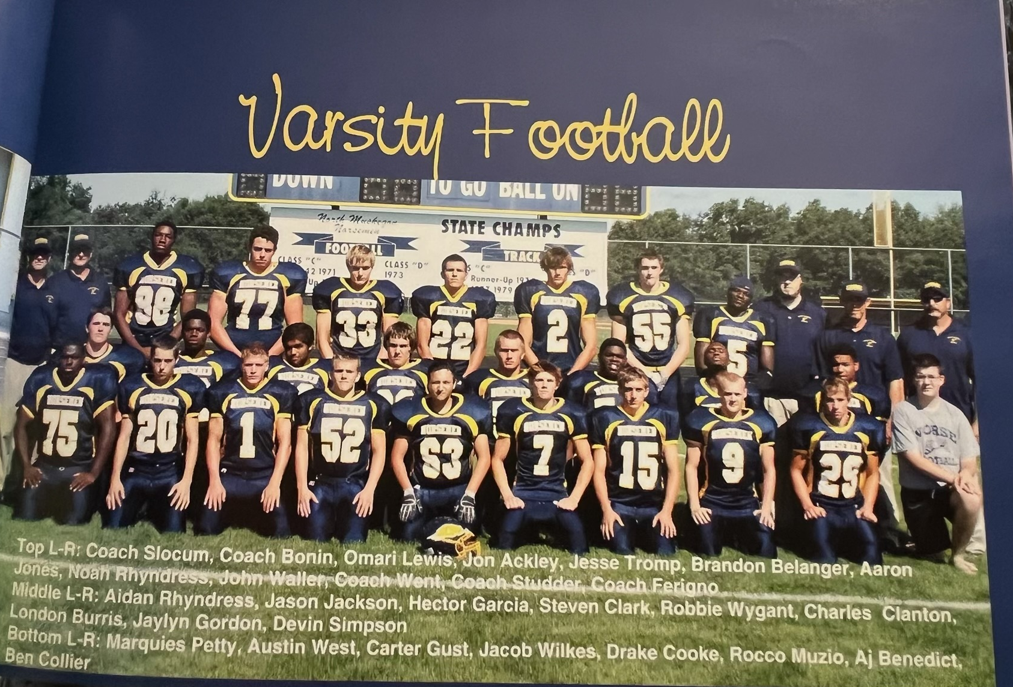

The 2011 NORSEMEN

Record Score Interesting Fact
0-1 NM7, Calvin Christ. 14 NM limited to less that 100 yards in offense. John Waller 1 yd TD.
0-2 NM 0, Shelby 12 Shelby posts 1st of five shutouts suffered by NM during season.
0-3 NM 20, Hart 21 Chuck Clanton 40-yd TD, Adrian Anderson, Rocco Muzio TD each.
0-4 NM 0, Whitehall 37 John Waller 74 yards in 19 carries.
0-5 NM 28, Mason Co 42 No writeup in Muskegon Chronicle.
0-6 NM 0, Oakridge 39 NM only 39 yards of total offense and 3 first downs.
0-7 NM 14, Ravenna 35 John Waller two touchdowns. (maybe)
0-8 NM 0, Montague 19 NM trailed 6-0 at halftime to stay close to the Wildcats.
0-9 NM 0, Musk CC 35 NM ends only winless season in more than 90 years of NM football.

2012 Coach Mike Belmonte (5-4 overall, Oakridge WMC Champs)

The 2012 season, although surely not the strongest team fielded in Norse history, was a vast improvement from the winless 0-9 team of 2011. So improved was the team that they managed to post a winning record with a mark of 5-4. There was not only a shakeup with NM playing under a new coach in Mike Belmonte but there was a marked turnover with the area media. No longer would the Muskegon Chronicle have multiple sports writers with talents the likes of Cindy Fairfield, Mike Mattson, and more recently Sports Editor Tom Kendra, retiring. The shakedown at the Chronicle left the newspaper with a skeleton crew where Mark Offerman had the ‘impossible task’ of being a one-man crew covering Muskegon Area Sports. Fortunately for local sports fans a new digital media publication was founded that did an outstanding job: The Local Sports Journal.

NM would again kick off their season against a very good Grandville Christian team, coming off an impressive 8-2 record from 2011. NM began their 2012 season much like they left off from 2011, with a 34-13 loss at Grandville. A pair of touchdowns three minutes apart in the third quarter was too much for the Norse to overcome. Making his debut at quarterback for NM was Adrian Anderson who struggled with 7-of-20 passing for just 27 yards and three interceptions. “You have to remember that it was Adrian’s first game ever playing quarterback,” said coach Belmonte following the game. Anderson did kick two short field goals to account for six of NM’s points with a 3-yard TD run from Holden Vanderweele completed the Norse scoring.

Shelby, the two-time WMC champion showed they have another good team as they handed NM their second loss of the season and school record 11th straight defeat with a 28-15 win over the Norsemen. NM was hurt in the first half with a pair of costly turnovers and two penalties. NM did cut the lead to 21-7 on Adrian Anderson’s 20-yard touchdown run and completed their scoring on an Anderson 25 scoring pass to Sam Powell.

It was back to normal in NM’s next game with Hart – A NM win. After losing their only game with Hart in twenty years, NM saw six players score rushing touchdowns in NM’s 52-0 thrashing of Hart. Logan Waller led the way for the Norse with a pair of touchdowns and 115 rushing yards. Nick Duplissis added 54 yards on nine carries while Christian Ramirez and Holden Vanderweele each scored rushing touchdowns. Quarterback Adrian Anderson rushed for a TD and was 2-3 passing for 59 yards. Ryan Gannon with six tackles helped NM hold Hart to but 100 yards of total offense.

The Norsemen used the arm of quarterback Adrian Anderson and the hands of his favorite receiver Sam Powell in their 25-21 win over Whitehall. Anderson was 8 of 17 passing for 126 yards and three touchdowns, all caught by Powell who finished with 76 receiving yards. The big TD was a 17-yard pass to Powell with but two seconds remaining in the first half. Nick Duplissis gave the Norsemen their first lead of the game with a 19-yard TD run in the third quarter. NM rallied from a 14-0 first quarter deficit to pull off the win. Ryan Gannon and Christian Brower finished with 10 and nine tackles respectively to lead the Norse defense.

NM’s 48-20 victory over Mason County made it three straight wins in a row, a modest achievement but a huge improvement from last year’s winless season. For the second straight week Sam Powell caught three touchdown passes with grabs of 27, 42 and 59 yards all thrown from Adrian Anderson. Holden Vanderweele carried 10 times for 64 yards with touchdown runs of 1 and 29 yards. Logan Waller chipped in for 69 yards and an 11-yard score while Logan Ramirez joined the scoring parade with a 11-yard TD.

Oakridge clinched a playoff berth and with their 27-6 win over the Norse and were on their way to an outright WMC championship. NM kept it close with the WMC champs trailing 13-0 at halftime. NM played the Eagles even in the second half but still came up short. Adrian Anderson scored the NM TD on a 1-yard QB carry and rushed for 60 yards. Nick Duplissis rushed for 63.

The Norse then snapped a five-game losing streak to Ravenna with a 27-8 victory to improve to a winning record of 4-3. Logan Waller ran for a 56-yard touchdown in the first quarter and finished with 89 rushing yards on 10 carries. Mitchell Edick ran for a 41-yard touchdown and finished with 73 yards while Christian Ramirez added a 35-yard TD run. Nick Duplissis tacked on a 5-yard TD run for the Norsemen while Jack Gautraud was a force on defense for the Norse with two interceptions and seven tackles.

Montague, leading 14-6 with just a little more than five minutes to play in the first half, exploded for 23 points to pull away to an 37-6 halftime lead. The Cats would end up winning 44-14 as the second half was played evenly. The Wildcats were honoring at halftime of this game their 1992 state runner-up players whose quarterback that season was the current Montague head coach, Pat Collins. Holden Vanderweele scored NM’s first touchdown from one yard out and the second came late in the game from the three-yard line. Adrian Anderson completed 7 of 17 passes for 94 yards.

With a 4-4 record going into their final game of the regular season, the Norsemen once again would be paired in their final game with a tough opponent. Maple City Glen Lake would face the Norse for the first time in school history and would travel to NM boasting of a perfect 8-0 record. The Norsemen shocked the undefeated Glen Lake team 22-14 with the big play a 64-yards touchdown pass from Adrian Anderson to Mitch Edick early in the fourth quarter to break a 14-14 tie. Earlier the NM touchdowns were scored by Nick Duplissis and Logan Waller.

NM head coach Mike Belmonte was hopeful that NM with their 5-4 record with all four losses coming against playoff teams would advance NM to the playoffs, but they just missed.

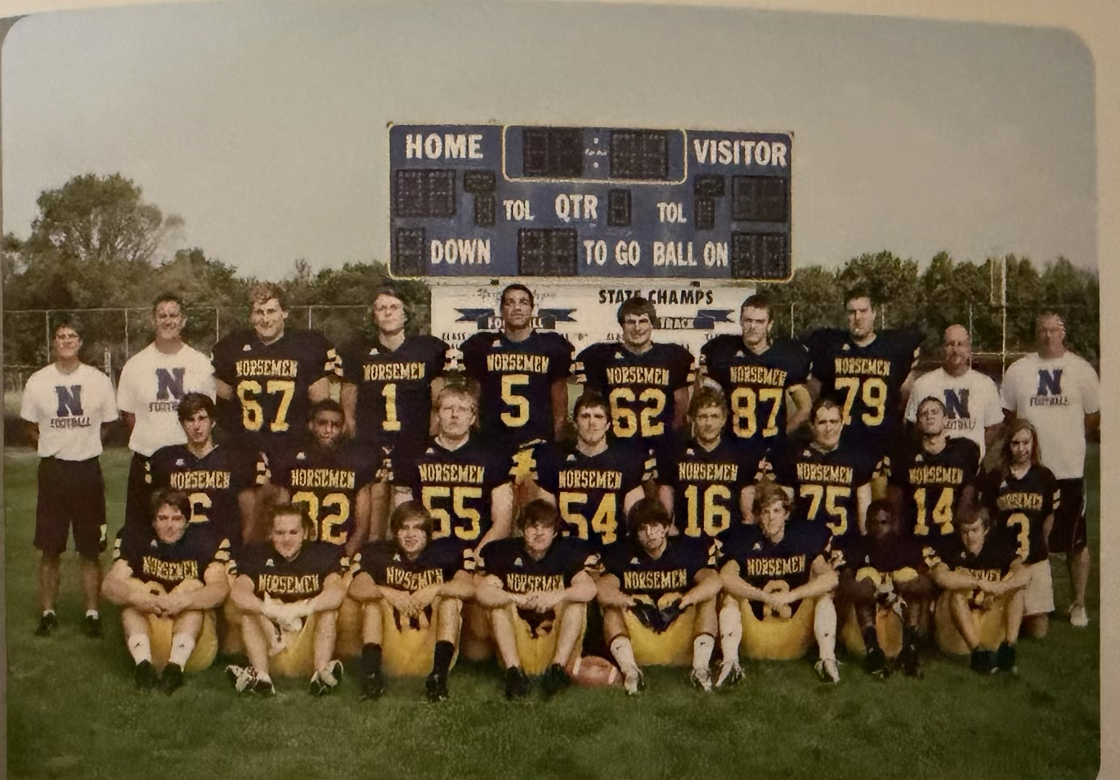

The 2012 NORSEMEN

1st Row L-R: Holden Vanderweele, Eric Vasquez, Christian Ramirez, Nick Duplissis, Antonio Gordon, Nicholas Souter
Middle Row L-R: Brody Scott, Dominique Conway, Justin Fairfield, Aidan Rhyndress, Adrian Anderson, Patrick Ronkema, Logan Waller, Megan Ronkema
Standing L-R: Coach Mike Belmonte, Coach Friesner, Ryan Gannon, Adam Edick, Sam Powell, Christian Brower, Justin Kollar, Evan Lane, Coach Al Karaba, Coach Scott Wynsma

Record Score Interesting Fact
0-1 NM 13, Calvin Christ. 34 Adrian Anderson 2 FG, Holden Vanderweele 3-yd TD.
0-2 NM 15, Shelby 28 Anderson 20-yard run and 25-TD pass to Sam Powell.
1-2 NM 52, Hart 0 Logan Waller 2 TDs & 114 yards. 5 NM backs score TD.
2-2 NM 25, Whitehall 21 Adrian Anderson 3 TD passes, all to Sam Powell for 17, 18 & 32)
3-2 NM 48, Mason Co 20 Sam Powell 3 TD receptions (27, 42 & 59) lead NM win.
3-3 NM 6 Oakridge 27 Anderson 1 yd TD and 60 yds rushing, Nick Duplissis 63 yds.
4-3 NM 27 Ravenna 8 Waller 56 yd TD, Mitchell Edick, Duplissis & Christian Ramirez TD.
4-4 NM 14, Montague 44 Montague scorers 23 points in 5 minutes to blow game open.
5-4 NM 22, Glen Lake 14 Anderson to Edick winning 63 yd TD pass. Walller, Dupllissis TD.

2013 Coach Mike Belmonte (5-4 overall, Shelby WMC Champs)

The Norse got off to a blazing start to begin the 2013 season in their second year under head coach Mike Belmonte. NM won their first three, and five of their first six, before dropping their last three and missing out on a playoff berth. It would be the last hurrah for Shelby as they would not only beat the Norsemen, but the Tigers would also win the WMC Championship. Not only have the Tigers not won a WMC title since 2013, but they have also likewise failed to beat a NM team over the next decade.

It looks like NM had found themselves another in their long time run of producing outstanding quarterbacks in Brody Scott. Scott rushed for 114 yards in but five attempts and 2 touchdowns that included a long 70-yard dash for six points, completed 5/6 passes and on the other side of the ball intercepted a pass and returned the pigskin 44 yards for another TD. The win ended a three-game losing streak to Grandville Calvin Christian as NM won handedly 39-21. NM led 28-0 before the Squires could counter. Logan Walled chipped in with a TD and Aaron Rahrig kicked a field goal as the Norse won their first opener in four years.

The Norsemen followed their 52-0 whipping of Hart in 2012 with a near identical trouncing in 2013 with a 49-0 shutout of the Pirates. NM totaled more than 400 total yards in their rout of Hart. Brody Scott had another big day for the winners as he threw a 21-yard TD pass to Andrew Shafer and ran 10 yards for another touchdown. Vernell Smith had 101 yards rushing including a long TD dash of 77 yards.

The Norse scored all their points in the first half in a 28-7 win over Whitehall. Brody Smith completed 7-of-11 passes for 111 yards and one touchdown and Holden Vanderweele rushed for 56 yards and one TD. Logan Waller had a pair of touchdowns and rushed for 106 yards for the victorious Norsemen. The first came from 10 yards out for a first quarter score and then a 19-yard pass from Scott in the second quarter. The final NM TD in the opening half was a halfback pass to Mitchel Edicks for 19 yards. It was a balanced attack for the Norse as they gained 146 yards running and 148 yards passing. NM was now a perfect 3-0 on the season but some tough opponents loom ahead.

NM has their three-game winning streak come to a crashing end as they fell 43-7 to the number one ranked Division 5 team in the state, the Oakridge Eagles. The Norse trailed only 7-0 in the first quarter before Oakridge pulled away with three touchdowns in the second quarter. Logan Waller kept NM from averting a shutout with a six-yard TD run in the second quarter. Waller led NM rushers with 92 yards. The loss was the first loss of the season for the Norsemen and their first loss in the WMC.

North Muskegon scored two second quarter touchdowns and they made it stand up as they defeated Mason County Central 14-0. Riley Fairfield opened the scoring with a 22-yard touchdown pass from Brody Scott. Later in the quarter Mitch Edick added a 5-yard touchdown run. “Brody Scott played a solid game for us at quarterback,’ said NM coach Mike Belmonte following the game. “He took care of the football, made some good reads and ran tough,” added Belmonte. The Norse improved to 3-1 in WMC conference action with a big game looming the following week with an always tough Ravenna team.

Aaron Rahrig kicked a 27-yard field goal with 1:55 remaining as NM edged the visiting Ravenna Bulldogs 29-27 in a thriller at Fred Jacks Field. Holden Vanderweele had earlier given the Norsemen a 27-21 lead earlier in the fourth quarter on a 68-yard run. Ravenna rallied to take a 28-27 lead to set up Rahrig’s heroics. Brody Scott completed 5 of 9 passes for 80 yards, including a 42-yd TD pass to Riley Fairfield. Logan Waller was a workhorse for NM as he rushed for 142 yards and two touchdowns with his longest TD a 61-yarder. The win moved the surprising Norsemen to 5-1 on the season, just one win away from an automatic playoff berth.

A Montague interception deep in their own territory stopped a potential tying or game winning drive for North Muskegon in Montague’s 35-38 win over NM. Montague’s sophomore quarterback Jacob Buchberger played a part in all five Wildcats touchdowns that left both teams with a 5-2 record. Buchberger did have one his passes intercepted by NM freshman Cameron Waller who returned it 35 yards for a Norse touchdown in the second quarter. Logan Waller was all over the field for the Norsemen as he rushed for 72 yards, scored on three short TD runs, caught six passes for 73 yards and had seven tackles on defense. The loss to Montague was their 13th straight defeat at the hands of the Wildcats.

NM was hoping not only to play the role of a spoiler to Shelby’s perfect 7-0 season but also qualify for the playoffs with a win. Neither happened as Shelby clinched what would prove to be their last, as of this writing, championship in the West Michigan Conference. Winning their first outright title since 1977, Shelby would experience their last hurrah in football for many more years. The Tigers led 28-14 at halftime, added ten more points in the second half to move to a perfect 8-0. NM, who got touchdowns from Andrew Shafer on a 24-yard run and on a Brody Scott to Riley Fairfield 16-yd pass, would now need to beat a once beaten Glen Lake team in next week’s long road up North to qualify for the playoffs.

Glen Lake was undefeated when NM upset the Lakers the previous season. Glen Lake had won seven straight games in this 2013 season before they were edged in their eighth game by perennial football power Traverse City St. Francis 28-21. The Norse needed to ‘upset’ Glen Lake once again to keep their season extended and qualify for the MHSAA playoffs. The Norsemen gave Glen Lake all they wanted and more. The big play that cost NM a 17-14 loss was an 88-yard TD run by Trevor Apsey in the fourth quarter that proved to be the game breaker and end NM’s 2013 season. Vernell Smith led North Muskegon with 60 yards and a 33-yard touchdown while Brody Scott had a 6-yard TD.

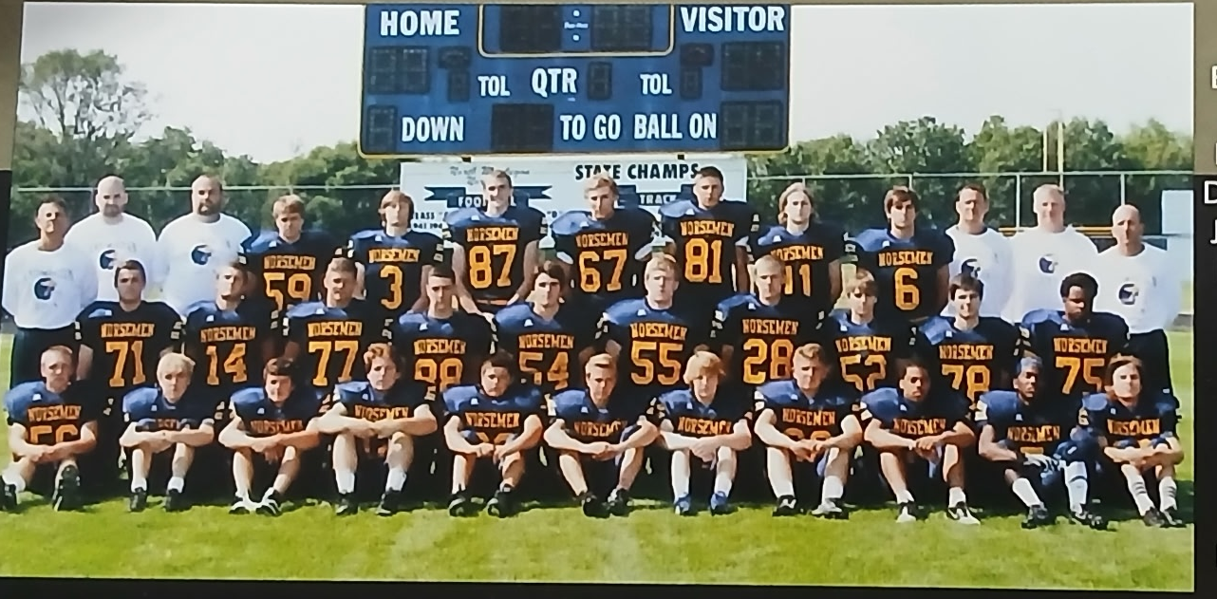

The 2013 NORSEMEN

Back Row L-R: Head Coach Mike Belmonte, Coach Tom Moore, Coach Chad Kevern, Nick Shafer, Mitch Edick, Jason Normadin, Ryan Gannon, Aaron Rahrig, Garrett Rebone, Brody Scott, Coach Phil Friesner, Coach Scott Wynsma, Coach Al Karaba
Middle Row L-R: Cam Waller, Logan Waller, Devin Eckhoff, Dylan Metzdorf, Aidan Rhyndress, Justin Fairfield, Riley Fairfield, Jacob Hogan, Matt Evans, Stephon Jackson
Front Row L-R: Braxton Gerdes, Allen Kinahan, Andrew Shafer, Holden Vanderweele, Thomas Montgomery, Erick Bleakley, Josh Johnson, Jake Bean, Vernonell Smith, Antonio Edwards, Christian Ramirez.

Record Score Interesting Fact
1-0 NM 39, Calvin Christ. 21 Brody Scott 114 yds rushing & 2 TDs. One of his TDS 70 yards
2-0 NM 49, Hart 0 Vernonell Smith 101 yds rushing, 77 yd TD. Scott TD pass & run.
3-0 NM 28, Whitehall 7 Waller 2 TDs, Scott 7-11 one TD passing, Holden Vanderweele TD.
3-1 NM 7, Oakridge 43 No. 1 Oakridge downs Norse. Waller 6-yd TD and 94 yds.
4-1 NM 14, Mason Co 0 Scott to Riley Fairfield 22-yd TD pass. Mitch Edick 5-yd TD run.
5-1 NM 29, Ravenna 27 Aaron Rahrig’s 27 yd FG the winner. Vanderweele 68 yd TD run.
5-2 NM 28, Montague 35 Logan Waller 3 TDs, Cameron Waller 35-yard interception TD.
5-3 NM 14, Shelby 38 Andrew Shafer 24-yd TD run, Scott to Fairfield 16 yd TD pass.
5-4 NM 14, Glen Lake 17 NM loses on 88 yd TD run. Smith 23 yd TD, Scott 6 yd TD.

2014 Coach Mike Belmonte (5-4 overall, Oakridge WMC Champs)

After a hiatus of seven years, Holton would once again be NM’s opening opponent to begin the 2014 season. Vernonell Smith had a huge game in NM’s 42-7 victory over the Red Devils as he scored three TDs on runs of 74, 48 and six yards. Logan Waller got NM started in the right directions with an interception early in the game at Holton’s 35-yard line. He then capped the drive by diving in from three yards out on a fourth downplay for the first of NM’s TDs. Waller later added a 65-yard TD run. Making his debut as the NM starting quarterback was Eric Bleakley. The future Navy Midshipman had a modest start, but he would take his place down the road as one of NM’s finest all-around athletes.

NM opened their conference season with a 49-22 win over Hart. The win would be the third in a row over the Pirates, who as of this writing are still looking for their first victory over NM since 2011. The game was well over by halftime as NM enjoyed a 49-8 lead at the break. Vernonell Smith started the rout with a 3-yard run followed by a 1-yard sneak by Erick Bleakley. Ben Gautraud returned an interception for a TD followed by a Logan Waller TD for 92 yards after catching a screen pass from Bleakley. That pass and run was a Norse record, breaking by a single yard a 91-yard pass and catch from Ron Simonelli to Stan Guy in 1954. (That record would be broken in 2018 on a 94-yard TD pass from Mack Young to TJ Mckenzie) Other NM TDs against the outmanned Pirates was a 58-yard Bleakley to Riley Fairfield TD pass and runs for six points by Anthony Oveido and Leguan Hooper.

Whitehall won their third straight game of their season with a 14-7 win over the Norse, the first 3-0 start for the Vikings in eight years. The game was tied at 7-7 before Whitehall scored with 2:58 left in the third quarter on a Zarren Aylor 10-yard run. That TD was set up by an interception by Whitehall’s Nolan Throne. That would prove to be the game winner as NM’s only score came on a 21-yard pass from Erick Bleakley to Riley Fairfield. The game was played in a steady rain that contributed to a sloppy contest.

Oakridge would number North Muskegon as one of their victims as they posted a 27-0 victory on their way to winning the West Michigan Conference Championship. There was no mention of this game in the Muskegon Chronicle, only the final score. However, a few days later there was an incident that took place in the game that influenced the balance of the season. NM quarterback Erick Bleakley was hit with a blindside hit that fractured his clavicle and ended the season for the promising junior QB. “The best you can say about it, it was uncalled for and overaggressive,” said NM head coach Mike Belmonte. Sophomore Riley Fairfield will move from end to quarterback for NM’s next game with Mason County Central.

It took overtime but NM was able to defeat Mason County Central 21-14 to move to 3-2 on the season. Mitchell Edick caught a 10-yard pass from Riley Fairfield in the OT period to score first. NM then recovered a Spartan fumble on the Spartan’s ensuing possession to escape with the win. Edict also led NM in rushing with 114 yards on 11 carries that included a 32-yard TD dash, The other NM score during regulation came on a 1-yard sneak by Riley Fairfield, now taking over the quarterback duties after the season ending injury to Erick Bleakley.

NM trailed Ravenna 35-0 at halftime forcing a running clock in the second half. The Bulldogs with a 5-1 record would be one win away from a playoff berth while NM needed to win all three of their remaining games. NM would come close. NM was held on the rainy night to but 56 rushing yards with their only touchdown a 1-yard plunge by Logan Waller just before halftime.

Montague made it 14 wins in a row over the Norsemen with a 34-17 victory. Andrew Shafer scored a couple of short yardage TDs for the Norse and Logan Waller, a running back who moved to quarterback to replace an injured Erick Bleakley, passed for 105 yards for NM as their hopes for a playoff berth were dashed.

Riley Fairfield had a big day in NM’s 41-7 win over Shelby. Fairfield caught a couple of TD passes from Logan Waller and ran a fumble recovery 64 yards for a score. NM would snap a four-game losing streak vs. Shelby as the Tigers are still looking for their next win against the Norse as of the 2026 season. Vernonell Smith ran for 125 yards on 13 carries and scored a pair of TDs, one on a 22-yard run and another on a 36-yard touchdown pass from Fairfield.

NM resumed a short rivalry in 2014 with Hesperia and responded with a season ending 42-25 win to finish for the third consecutive year with a 5-4 record. Logan Waller had a huge game in the win as he accounted for four touchdowns and added eight tackles on defense. Waller was six of eight passing and ran 21 times for 161 yards and three rushing touchdowns. Waller’s TD pass of 28 yards was hauled in by Mitchell Edick. Vernonell Smith rushed for 99 yards and on defense intercepted a pass that he returned 25 yards for a score. Riley Fairfield caught two passes for 54 yards as NM could only wait to see if their 5-4 record would make the playoffs. They didn’t and it was wait until next year.

NM fans can look back on the 2014 season and wonder how different this season might have been for the Norsemen if not for the controversial blind side hit that cost NM quarterback Erick Bleakley missing the final five games of the season.

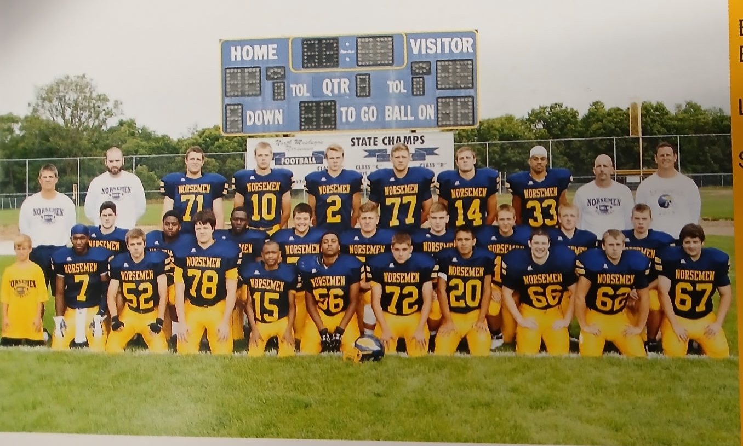

The 2014 NORSEMEN

1st Row L-R: Denny Belmonte, Antonio Edwards, Jacob Hogan, Jacob Achterhoff, Lequan Hooper, Kameron Torres, Logan Visscher, Anthony Oviedo, Roman Kuzio, Brian Dietrich, Jesse Ware
Middle Row L-R: Ben Gautraud, Justin Edwards, James Duncan, Thomas Montgomery, Jake Bean, Andrew Butzow, Brett Huff, Braxton Gerder, Caleb Hulka
Standing L-R: HC Mike Belmonte, Tommy Moore, Cameron Waller, Riley Fairfield, Erick Bleakley, Devon Eekhoff, Logan Waller, Vernonell Smith, Al Karaba, Phil Friesner

Record Score Interesting Fact
- NM 42, Holton 7 Vernell Smith 3 TDs (74, 48 & 6). Logan Waller int. & 2 TD.
- NM 49, Hart 22 Erick Bleakley to Logan Waller school record 92 yd TD pass.
2-1 NM 7, Whitehall 14 Bleakley to Riley Fairfield 21-yard pass only NM TD.
2-2 NM 0, Oakridge 27 Bleakely inj., out for the season. Thomas Montgomers 11 tackles.
3-2 NM 21, Mason Co 14 Fairfield TD pass to Mitch Edict wins in overtime.
3-3 NM 6, Ravenna 49 Ravenna bolts out to 35-0 lead. Waller 1-yd TD.
3-4 NM 17, Montague 34 Shafer 2 TDS, Waller 105 yards passing.
4-4 NM 41, Shelby 7 Fairfield 3 TDs including 74 yd fbl. return, Vernonell Smith 2 Yds.
5-4 NM 42, Hesperia 25 Waller 3 rush TDs, 1 passing. Edict 28-yard TD pass.

2015 Coach Mike Belmonte (3-6 overall, Montague WMC Champs)

The Norsemen would finish the season with their only sub .500 record under head Coach Mike Belmonte who would finish his final season as the Norse football mentor following a four-year stint. NM had a decent year scoring points, but their defense had too many holes. The 325 points allowed by the Norsemen were the second most points scored by their opponents in program history. Teams in the West Michigan Conference would have to scramble to find an opponent as Hart did not field a varsity football team. A familiar face in North Muskegon would make the daily journey to Hart to guide the Hart JV team in hopes that varsity football at Hart would resume in 2016. That coach was Larry Witham, who thankfully for NM fans would return to his hometown the following year to take over the head coach duties at North Muskegon.

The Norsemen welcomed back to the field a couple of players who missed much of the previous season with injuries, and both made a difference in NM’s season opening 35-14 win over Holton. Erick Bleakley had four touchdowns, three on the ground (2,14 & 17) and one in the air on a 54-yard pass to Ben Garcia. Vernonell Smith in his first game back since a season ending injury from 2014 broke loose for a 31-yard TD run.

Following the opening win over Holton, the Norsemen went into a tailspin and dropped their next five games. NM was no match for Whitehall as the Vikings pounded out a 54-13 victory over the Norsemen. NM’s two touchdowns came on pass plays (30 & 15 yards) from Erick Bleakley to Riley Fairfield. Fairfield finished with five receptions for 111 yards while Bleakley completed nine of 19 passes for 157 yards and added 54 yards on the ground.

My, how coverage of our local teams by our once great local newspaper spiraled downward since the advent of digital news. Where for many decades high school football coverage by our local teams was always front-page news in our sport sections, the September 13, edition of the Muskegon Chronicle relegated coverage to page 11 of the SUNDAY (not Saturday) sports section. There was zero coverage of the game with Oakridge which may not have been a bad thing. NM’s defense again surrendered more than 50 points in their 53-27 loss to Oakridge. With the sad status of the MC, thankfully coverage of local sports has been picked up by a couple of outstanding new digital publications, The Local Sports Journal and Catchmark Sports.

For the third straight game, all NM losses, the Norse defense gave up more than 50 points in a 63-40 loss to Ravenna. The combined 103 points was easily the most points scored in the long rivalry between the two teams that dates to 1932. Ravenna’s 21-0 start was too much for NM to overcome. Even though there was a running clock in the third quarter after Ravenna went up 56-20 over the Norsemen, the offenses were so primed that four more TDs were scored before the clock ran out to end the game. Vernonell Smith had 3 TDs for NM that included a long 93-yard kickoff return. Erick Bleakey and Riley Fairfield paired up for a couple of TD passes. Bleakley was 17-28 for 188 yards while Fairfield caught eight passes for 121 yards and his two TDs.

NM suffered their fourth straight defeat in WMC action with a 40-14 drubbing at the hands of Mason Co Central.

NM stayed winless as they lost a tight contest to Montague 27-26. It was a cruel way to lose as Montague’s Jacob Buchberger raced 85 yards for the game winning touchdown with 4:31 left in the game. Erick Bleakley completed 13 of 21 passes for 199 yards that included a touchdown pass of 43 yards to Ben Garcia. Vernonell Smith was a workhorse for the Norse with 138 yards on 27 carries and three NM TDs. Smith TDs were from I, 19 and 23 yards.

NM defeated Shelby in their next contest 32-30 to avoid going winless in the WMC. Your author is still looking for scoring plays from this game.

With Hart not fielding a varsity football team NM’s veteran Athletic Director Jeff Cooke was able to find an opponent in Manton. Better known for providing some outstanding basketball teams, the Rangers were no match for the Norse as NM would win their third, and final victory of the season 33-6 over Manton.

Normally a team can just check off a win when Hesperia is on your schedule. But that certainly wasn’t applicable with the 2015 Hesperia Panthers. After going 1-8 in 2014 Hesperia would experience their best season in program history by going a perfect 9-0, their only undefeated regular season record in their school’s history. The ninth victim was North Muskegon, and they pummeled the Norsemen 56-6. It was not the way that head coach Denny Belmonte wanted to go out as the NM head coach. NM had to play their last two games without quarterback Erick Bleakley who suffered a concussion in game 7. Belmonte had to use his third string quarterback, and his top rusher Vernonell Smith at QB. Smith did compete a 23-yard TD pass to Ben Garcia to pull the Norse with within 14-6, but the Panthers ran at will over the NM defense the rest of the game as NM finished with a disappointing 3-6 record.

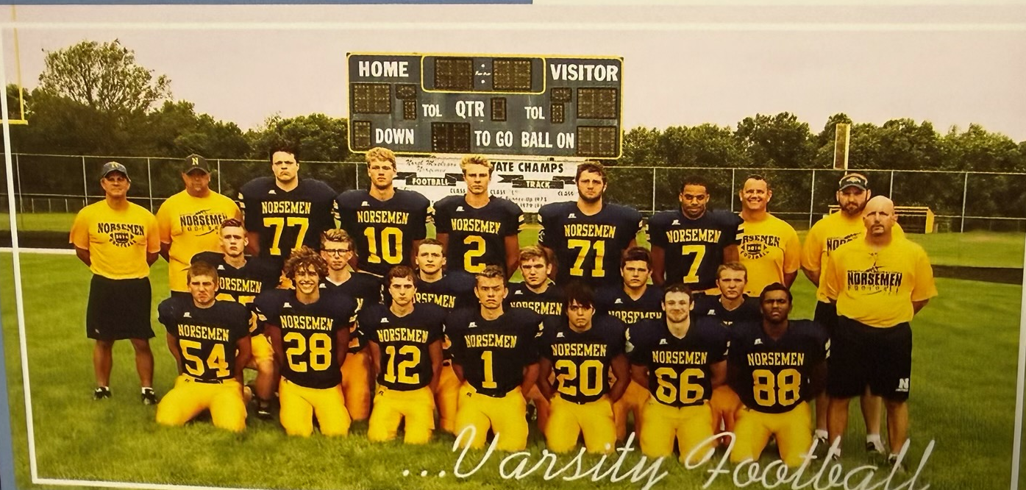

The 2015 NORSEMEN
Standing L-R: HC Mike Belmonte, Coach Houseman, Jacob Achterhoff, Riley Fairfield, Erick Bleakley, Cam Waller, Vernonell Smith, Coach Friesner, Coach Moore, Coach Karaba
Middle Row L-R: Hunter Schotts, Truls Krough, Dylan Larsen, Andrew Butzow, Thomas Montgomery, Brett Hiff
1st Row L-R: Jake Bean, Nick Bytwerk, Thomas Lane, Caleb Hulka, Marc Ramirez, Roman Kuzio, Ben Garcia

Record Score Interesting Fact
  - NM 35, Holton 14 Erick Bleakley 4 TDs, 3 on the ground, Vernonell Smith TD.
  - NM 13, Whitehall 54 Bleakley two TD passes to Riley Fairfield accounts for NM TDs.
  - NM 27, Oakridge 53 No coverage given of this game in MC.
  - NM 40, Ravenna 63 Smith 93 yd Koff TD & 3 TDs, Bleakley to Fairfield 2 TD passes.
  - NM 14, Mason Co 40 No report of this game.
  - NM 26, Montague 27 Smith 3 rushing TDs, Bleakley 199 passing yds & TD.
2-5 NM 32, Shelby 20 No coverage
3-5 NM 33, Manton 6 No coverage
3-6 NM 6, Hesperia 56 Smith 23 yd TD pass to Ben Garcia avoids a shutout.

2016 Coach Larry Witham (5-4 overall, Oakridge WMC Champs)

North Muskegon welcomed back with open arms a long time NM fixture in athletics, Larry Witham to take over as head coach to begin the 2016 season. A football ‘junkie’, Witham played his high school football at NMHS in the late 1970s and assisted the NM coaching staff for many years. Witham even coached the NM girls’ softball team and was instrumental in grooming the pristine home softball field on the shores of Muskegon Lake. Witham was generous with his time in 2015 by traveling daily to Hart to attempt to resurrect a football program at Hart by serving as the Junior varsity coach. Hart did not field a varsity team in 2015 but with Witham creating interest Hart would again resume varsity competition in 2016. It was a tale of two halves before the Norsemen would begin to jell under Witham’s guidance. NM dropped their first four games of the season but made a serious turnaround by winning their final five games to again post a winning record.

In a short-term rivalry that consisted of 10 games dating back to 1940, the Norsemen played Reed City for the first time since 1978 and came away with an opening game loss to Reed City 32-9. Justice Sikkenga booted a 31-yard field goal for NM’s first three points. NM later tallied on a 10-yard pass from Jesse Cooke to Lequan Cooper. Coach Larry Witham would use a pair of quarterbacks, much like his high school head coach Dave Warmack did in his prep days at NM when Witham would alternate at QB with Steve Preston. Cooke was 9-13 for 124 yards while Mack Young was 9-11 for 102 yards. Each of the young QBs would suffer an interception. It was the first win by Reed City over the Norse since 1943 as NM had won eight of the previous nine encounters.

NM led Whitehall 7-0 at halftime, but the Vikings regrouped at halftime and outpointed the Norse 35-7 in the second half to pull away to a 35-14 win. The turnaround for Whitehall began as early as the first play of the second half as Whitehall’s Joe Dowdell picked off a pass that was returned 42 yards for a touchdown. NM did counter by completing an 80-yard drive capped by a Thomas Montgomery TD catch from 11-yards, but it was all Whitehall the rest of the game. Vernonell Smith scored from two yards out to give NM the lead at halftime. Not to be deterred, first year head coach Larry Witham remained optimistic following the game. “We didn’t protect the ball very well and probably didn’t manage the clock as well as we should, but we’ll regroup,” said Witham. “We’ve got a pretty good football team we think and we’re pretty talented.” It would take a few more games, but the 2016 Norsemen would back up Witham’s optimism.

Oakridge held NM scoreless until the fourth quarter in a 29-14 victory over NM to send the Norsemen to their third straight loss on the season. NM had two long drives for their TDs, the first went 99 yards that culminated in a 19-yard TD pass from Jessee Cooke to Thomas Montgomery. The second NM TD came when they drove 63 yards in four plays with Cooke scoring on a 2-yard run.

NM continued to show improvement as they gave Ravenna a battle before losing 28-20. Vernonell Smith scored a pair of touchdowns for the Norse, the first a burst of 59 yards, the second a nine-yard dash. Sandwiched between Smith two tallies was a 16-yard TD pass from Jesse Cooke to TJ McKenzie. It was the fourth straight loss for NM against four proven football teams. The final five football games of the season would show a Norse resurgence.

Head coach Larry Witham acquired the first, of what would prove to be many wins as the Norse mentor, as NM put together a solid showing in a 28-6 win over Mason County Central. Vernonell Smith got the Norse on the board first with a 35-yard interception return for a touchdown, one of two TDs created by the Norse defense. Cameron Waller picked up a fumble and returned it 20 yards for six NM points. Smith, who finished with 89 yards, also scored on a 7-yard run in the second half. Chandler Edwards scored on a 12-yard carry while Witham gave credit following the game to his sophomore quarterback, Mack Young.

It had been 15 long years since NM had defeated Montague and with the Cats entering the game with the Norse sporting a perfect 5-0 record, including a 3-touchdown walloping of rival Whitehall the previous week, the Norsemen would go into the game as decided underdogs. The Norse pulled off a shocking 14-6 win over the state ranked Wildcats. “It was a great win for our kids,” said first year coach Larry Witham. “We were presented with a lot of adversity at 0-4, and it would have been easy to give up and stop playing,” added Witham. Montague scored first but NM took the lead in the first half on a two-yard run by Vernonell Smith and added an insurance touchdown in the second half on a 15-yard pass from sophomore quarterback Jesse Cooke, son of athletic director Jeff Cooke and grandson of longtime NM coach Dave Cooke, to senior tight end Cam Waller. Smith finished with 135 rushing yards on 25 carries. “We told them at the beginning of the game we were going to shock the world and the kids executed everything to perfection,” said an ebullient Witham.

The next three games would find the Norsemen outscoring their three opponent 170-7. The first of their runaway victories was a 49-7 shellacking of Shelby. Chandler Edwards scored three touchdowns (8, 9 & 1) and Vernonell Smith two tallies (4 & 2) as both backs rushed for more than 100 yards in the win. Mack Young tossed a pass to Riley Fairfield good for a 41-yard touchdown while Caleb Hulka closed out the Norse scoring with a nine-yard effort.

NM took advantage of a Hart team that was still a few years away from turning their program around as they downed the Pirates 49-0. The Norse forced a running clock in the second half with a 35-0 halftime lead. Mack Young and Jesse Cooke each threw for a Norse touchdown while Vernonell Smith needed only four carries to net 89 yards. Chandler Edwards needed but 4 carries to net 104 yards.

It was a record setting finish to the NM season as they scored the most points against an opponent in program history with a 73-0 whitewash of Holton. It was 52-0 at halftime and NM still was able to score three more TDs in the second half with a running clock in effect. Thomas Montgomery had a couple of touchdown runs while sophomore Chandler Edwards was NM’s leading rusher with a modest 68 yards in four carries as eight different Norsemen found the end zone. Scoring TDs for NM were Montgomery (2), Vernonell Smith, Cameron Waller, Riley Fairfield, Chase Edwards, Stephan Smith, John Hayhurst, and De’Shary Warren. One individual school record was set in the rout, a 48-yard field goal by Justice Sikkenga.

Head coach Larry Witham was hopeful that somehow his Norsemen could ‘sneak’ into the playoffs with a 5-4 record but that wasn’t in the cards as NM failed to have the number of playoff points to qualify. Fortunately for NM fans under Witham’s leadership, his first year as the NM coach would be as of this writing the last year NM would not qualify for the playoffs.

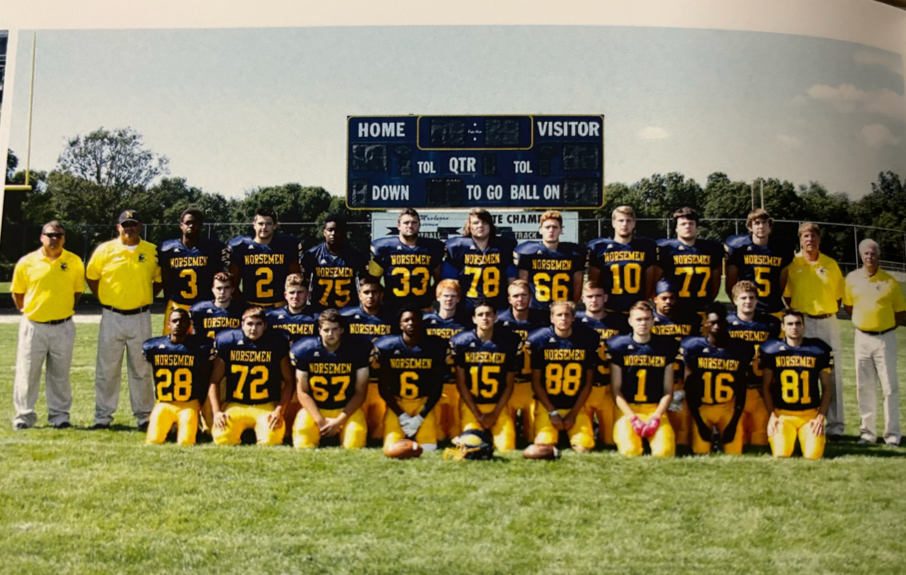

The 2016 NORSEMEN
1st Row L-R: Lequan Hooper, Logan Visscher, Jesse Ware, Chandler Edwards, Mack Young, Justice Sikkema, Caleb Hulka, De’Shary Warren, Nolan Fairfield
2nd Row L-R: Thomas Lane, Jake Bean, Anthony Oviedo, Brady Lindell, Brett Huff, Andrew Butzow, Vernonell Smith, Mitchell Wolters
Top Row L-R: Coach David Nelson, Coach Tim DeJonge, TJ McKenzie, Thomas Montgomery, Justin Edwards, Cameron Walker, Matt Kison, Hunter Schotts, Riley Fairfield, Jake Achterhoff, Jesse Cooke, Coach Jamie Woodruff, Head Coach Larry Witham

Record Score Interesting Fact
  - NM 9, Reed City 32 Jesse Cooke to Laquan Cooper 10-yd TD pass. Justice Sikkenga FG.
  - NM 14, Whitehall 35 Thomas Montgomery 11-yard TD catch. Vernonell Smith 2-yd TD.
  - NM 14, Oakridge 29 Cooke to Thomas Montgomery 19-yd TD pass. Cooke 2-yard TD run.
  - NM 20, Ravenna 28 Smith 59 & 9 yd TD runs, Cooke to TJ McKenzie 16 yd TD pass
1-4 NM 28, Mason Co 6 Smith 2 TDS, 7-yard runs and 35-yd interception, Cam Waller 20 yd fumble ret TD. Chandler Edwards 12-yd TD and 69 yards rushing.
2-4 NM 14, Montague 6 Smith 2 yd TD. Jesse Cooke 15-yard TD pass to Waller.
3-4 NM 49, Shelby 7 Edwards 106 yds, 3 TDS, Smith 122 yards 2 TDs.
4-4 NM 49, Hart 0 Edwards 104 yd, Smith 89, Cooke & Mack Young TD pass.
5-4 NM 73, Holton 0 Eight NM players score TDs, Sikkenga record 48-yard field goal.

2017 Coach Larry Witham (6-3 overall, Playoff qualifier, Montague WMC Champ)

After losing to Hesperia by 50 points in 2015, NM nipped the Panthers 28-27 in overtime to open the 2017 season. Hesperia bolted out to a 14-0 lead at halftime before the Norse could get on the board. It took an interception by Brennan Moat that he returned 80 yards for a touchdown to close the gap to 14-7. Head coach Larry Witham went with a two-quarterback system, and it worked to perfection. Mack Young and Jesse Cooke combined to pass for 262 of the 267 yards of total offense as Witham was employing his ‘Air Witham’ offense. Cooke completed a second half TD pass of 57-yards to Chandler Edwards for a TD. It was a Mack Young hookup with TJ McKenzie that went for 12 yards and a NM tally that forced overtime. Young then hit De’Shary Warren on a cross pattern to start the overtime period, and NM led 28-21 following Dylan Hoffman’s 4th straight made extra point. Hesperia scored on their first play and elected to go for two points and the win, but the run was stuffed by the NM defense.

Oakridge continued their dominance over the Norse as NM would incur their first of two defeats on the season vs. the Eagles in their 42-14 loss. NM did give the Eagles a brief scare as Christian Brooks scored a pair of third quarter touchdowns to give the Norse a brief 14-13 lead. Oakridge then used a punishing ground attack in their win over NM by rushing for 405 yards. Brooks also was a star for NM on defense as he was credited with 17 tackles. The Eagles big sophomore running back Leroy Quinn rushed for 229 yards on 27 carries and three touchdowns.

NM notched a big win over an always tough Ravenna team 28-7. With both teams scoreless just before the end of the first half Chandler Edwards slipped through the Bulldog line to block a punt. The ball was scooped up by Christian Brooks who jogged into the endzone to put the Norse ahead going into the half. Brooks used that momentum to bust free for a 55-yard run in NM’s first drive of the second half. Edwards then broke the game wide open with a couple of long TD runs in the second half, the first a 62-yard score, the second a 53-yard gallop that gave NM an insurmountable 28-0 lead before Raveena could score late. Edwards would finish with 164 total rushing yards and the 6’2 215 pounds Brooks 89.

In was almost a moral victory in NM’s 48-7 loss to a powerful Montague squad. In previous weeks the Wildcats totaled 76 and 65 points in back-to-back victories over Shelby and Mason County Central. Norse fans would have something to cheer for in the second half as Chandler Edwards returned a kickoff 75 yards for the only Norse score in the game.

Following their loss to Montague NM would go on a three-game winning streak, outscoring their three opponents 120-6. In their 45-0 win over Mason County Central Chandler Edwards had a big game, rushing for 179 yards and three touchdowns on runs of 46, 4 & 66). Christian Brooks added a pair of short TDs while Jesse Cooke had a hand in the final two Norse tallies, a 56-yard pass play to Brennan Moat and a 4-yard quarterback keeper. The Norsemen had their best offensive game to date as they rolled up nearly 500 yards in the shutout.

Christian Brooks was then the man of the hour for NM in their 49-6 whipping of Shelby. Brooks scored on runs of 5, 63, and 20 and finished with 217 yards on 16 carries. Brooks also excelled on defense with five tackles and an interception. Mack Young and TJ McKenzie paired up for a couple of TD passes, one covering six yards and the other a 30-yard connection. Chandler Evans chipped in with 111 yards and two touchdowns.

In their next game it was Chandler Edwards who returned to the starring role for NM in a 26-0 shutout of Hart. Edwards rushed for 211 yards and a rushing touchdown as NM moved one win away from clinching a playoff position. Edwards rushing TD was a 54-yard scamper while he also scored on a pass from Mack Young that totaled 32 yards. Alex Wolski tackled a Pirate in the end zone for a safety. Christian Brooks scored the first Norse TD on an eight-yard run while the only points for NM in the second half came on a 34-yard field goal by Dylan Hoffman.

The Norsemen would have to wait another week to claim a playoff berth as Whitehall downed the Norse 25-14. The tone was set on the game’s opening kickoff as Whitehall’s Terrell Harris returned the kick 95 yards. Whitehall was the better team on this October night as they had a dominating 265-21 edge in total offense over NM. Both NM touchdowns were on pass plays from Jesse Cooke to De’Shary Warren, one from 22 yards and the second from 20 yards.

It was a must win scenario for North Muskegon in the final game of the regular season. NM would resume a series against Orchard View that began in 1963, as the last game played between the two teams went back nearly 20 years. NM came through against an Orchard View program that was a much-feared team during the John Shillito era as NM won 36-12. The Norsemen got another big night from Chandler Edwards as he broke loose for five touchdowns, four in the second half as NM pulled away in the final two quarters after trailing 12-7. Edwards finished with 321 total yards, the most yards rushing in a game by a Norsemen in program history. His TD runs were from 33, 57, 45, 5 & 5 yards.

The Norsemen had the misfortune to play a very good Oakridge team as their first-round opponent. Just as in their first meeting Oakridge used their ground attack in defeating the Norse 38-7. Oakridge enjoyed a commanding 421-129 edge in total offense to eliminate the Norsemen. The Norse were limited to but 35 rushing yards and 94 through the air with Jesse Cooke and Mark Young each completing three passes. NM’s only TD came on a shovel pass from Jesse Cooke to De'shary Warren for 30 yards that gave NM a brief 7-0 lead. NM would end their season at 6-4 and would now enjoy a nice run of winning football during the Larry Witham era.

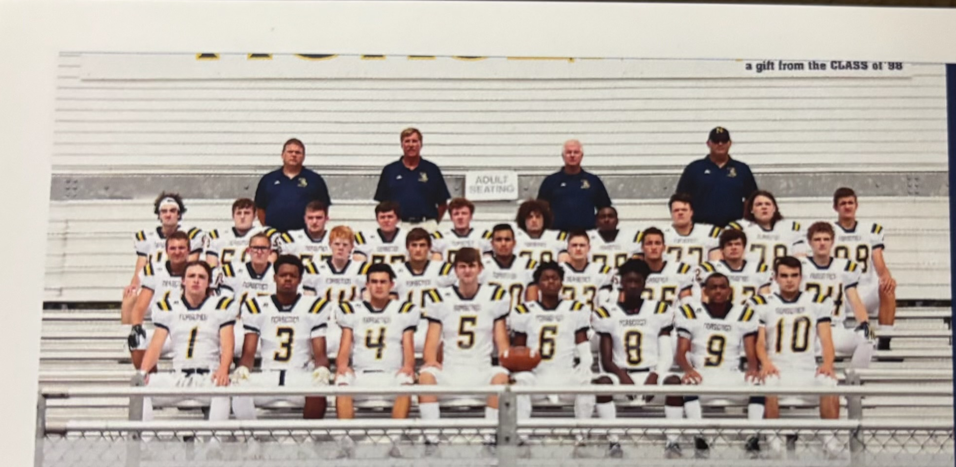

The 2017 NORSEMEN
1st Row L-R: Kyler Dana, TJ McKenzie, Mack Young, Jesse Cooke, Chandler Edwards, De’Shary Warren, Lequan Cooper, Nolan Fairfield
2nd Row L-R: Brett Huff, Dylan Hoffman, Brady Lindell, Jimmy Cobb, Anthony Oviedo, Brenden Moat, Christian Brooks, Harry Mierz, Mitchel Wolters
3rd Row L-R: Alex Wolski, Tylor Ramsey, Andrew Butzow, Asa Poulin, Joe Flynn, Jesse Ware, Justin Edwards, Jacob Achterhoff, Matt Kison, Noah Stewart,
4th Row L-R: Coach Dave Nelson, Coach Jamie Woodruff, HC Larry Witham, Coach Tim DeJonge

Record Score Interesting Fact
1-0 NM 28, Hesperia 27 Mack Young 2 TD passes, Jesse Cooke 1, Brenden Moat int. TD.
1-1 NM 14, Oakridge 42 Brooks TD runs of 64 & 4 yards and 17 tackles.
2-1 NM 28, Ravenna 7 Edwards blocked punt and 2 long TDs, Brooks 2 TDs.
2-2 NM 7, Montague 48 Edwards 75-yard kickoff return only NM score.
  - NM 45, Mason Co 0 Chandler Edwards 170 yards and 3 TDs. NM 500 yards offense.
4-2 NM 49, Shelby 6 Brooks TD runs of 5, 63 & 20 and a defensive interception.
5-2 NM 26, Hart 0 Edwards 211 rushing yards and 2 TDs. Brooks 8-yd TD run.
5-3 NM 14, Whitehall 25 Both NM TDs passes from Cooke to Warren.
6-3 NM 36, Orchard V 12 Edwards school record 321 yards & 5 TDs.
6-4* NM 7, Oakridge 38 Cooke and Mark Young 3 completions each.

2018 Coach Larry Witham (5-5 overall, Playoff qualifier, Montague WMC Champ)

Head coach Larry Witham abandoned his duo quarterback concept in 2018 but instead took advantage of their best talents. Mack Young would take over as the top signal caller and one of his favorite receivers was his co-partner at QB in 2015, Jesse Cooke. Cooke, with his 6’6 frame would receive plenty of aerials in 2018 from Young. Due to their strength of schedule NM would again qualify for the playoffs with a 5-4 record.

You want to talk about efficiency? Chandler Edwards carried the ball only four times in NM’s 41-6 opening game victory over Hesperia, but three of his carries went for six points and a TD! Edwards compiled 140 yards on those four rushes as the Norsemen opened their season 1-0. Edwards first of three TDs went for 13 yards and was set up on a nice punt return from TJ McKenzie. The next time Chandler touched the ball he traversed 65 yards for six points. In the only carry that didn’t go the distance he ripped off a 55-yard dash that was followed on the next play by a Stephen Smith 25-yard run for a score. Edwards would go into the locker room at halftime with three carries for 136 yards and two scores. Edwards didn’t waste any time in the second half as he returned the second half kickoff 70 yards for his third TD. Just a few moments later Edwards would score his fourth TD on a more modest four-yard run. NM tallied its final TD on a one-yard touchdown pass from Mack Young to Jesse Cooke.

Playing against the crème of the crop of the WMC in their next three games, the Norsemen were able to put points on the boards but were unable to slow down their opponents. NM gave up 175 points in their three losses to Oakridge, Ravenna, and Montague before doing a complete 180 on defense by posting three consecutive shutouts. It was de ja vu once again in Oakridge’s 61-27 romp over the Norsemen. The Eagles once again used a dominant running game that the Norsemen were nearly helpless in defending as Oakridge rushed for 492 yards while holding NM to a minus -38. The Norse did all their work in the passing game as Mack Young finished 17-24 for a school record 395 yards and three TDs in the losing cause. The bad news for Young, he was sacked eight times. TJ McKenzie hauled in eight of those completions for 211 yards and two scores. Jesse Cooke snatched three catches for 91 yards and a TD. The Eagles were keying on Norse running back Chandler Edwards and held the senior running back to 24 yards in 11 carries.

The Norse were able to score four touchdowns but were unable to slow down Ravenna in a 53-26 loss. All NM points came in the first half as the Bulldogs forced NM to go to the air. Mack Young had a huge night once again for the Norsemen as he completed 25 of 42 passes for 390 yards and four touchdowns. Jesse Cooke was on the receiving end of seven of Young’s passes with two TDs (6 & 13 yards). The other TD passes from Cook went to De’Shary Warren (36) and TJ Mckenzie for 26. For the second straight week NM was held to negative rushing yards as Ravenna totaled 239 yards while holding NM to minus -9.

The Norsemen next task was to try to stop a Montague juggernaut that would advance all the way to the state championship game. NM was no match with this Montague powerhouse team as they were walloped 62-20. It took little time for the Wildcats to jump out in front 19-0. NM’s TJ McKenzie then returned the kickoff following Montague’s 3rd TD 94 yards for a touchdown, the fourth longest return of a kickoff in NM annals and the 22nd all time since the 1932 season. NM’s other TDs came from the arm of Mack Young who connected with a 28-yarder with McKenzie and a 21 yarder to Chandler Edwards.

After giving up 175 points to their last three opponents, the inconceivable happened. NM than shut out their next three opponents! Was it NM making a drastic improvement on defense, or were their opponents less than stellar? Probably both.

The Norsemen began their three-game shutout streak with a 35-0 win over Mason County Central. John Hayhurst filled in for an injured Mack Young at quarterback and threw for four touchdowns and 161 yards. Ironically Hayhurst only completed 4-of his 6 pass attempts but all four of his completions went the distance. Three of Hayhurst TD passes went to De’Shary Warren. Chandler Edwards had another huge game as he rushed for 151 yards and a touchdown.

The Norsemen would continue to pad their stats with a 49-0 drubbing of Shelby. John Hayhurst continued his job as a suburb ‘relief pitcher’ passing for 244 yards on 8-of-15 attempts. Three of his tosses went for TDs, two to Jesse Cooke for 24 and 35, and one to TJ McKenzie for 71. The Norse had a couple more long six-pointers, a 66-yard punt return by McKenzie and a 92-yard TD run by Cooke late in the fourth quarter. Not to be left out of the fun, Chandler Edwards started the rout with a 35-yard touchdown in the game’s opening minutes. Hayhurst also crossed the Shelby goal line when he scrambled 22 yards for a second half TD.

NM completed their three-game sweep of the bottom feeders in the WMC with a 48-0 pasting of Hart. Mack Young returned to the lineup, and he had another productive passing night with 244 passing yards and three touchdowns to three different receivers. Young connected with TJ McKenzie for 23, Chandler Edwards for 44 and his understudy at QB, John Hayhurst for 16. De’Shary Warren returned an interception 41 yards for yet another NM TD, while John Smith closed out the shutout with a short one-yard run.

An opportunistic Whitehall team toppled the Norse 47-21. The Vikings stunned the Norse after a pair of TD passes from Mack Young to Jesse Cooke tied the game at 14-14. On the next kickoff Whitehall’s Terrell Harris returned the Norse kick 85 yards for a TD and then they really hurt the Norse with a TD just 16 seconds before halftime to go into the second half with all the momentum. TJ McKenzie then gave NM a brief hope when he returned his second TD of the season 90 yards for the final NM TD. Whitehall then scored a couple of quick TDs to salt the win away and make NM’s next game with Orchard View a must win game to have any hopes of advancing to the postseason MHSAA playoffs.

For the second straight year NM would close their regular season against Orchard View needing a victory to have any hopes of playing another week. Again, NM came through with a 47-22 victory and would find out on Sunday that with their strength of schedule they would advance to the playoffs. The Norse did their damage both passing and running the football. Chandler Evans ran for four touchdowns on long runs of 33 and 18, as well as a pair of shorter runs in leading Norse rushers with 161 yards. Mack Young connected with TJ Mckenzie on two long pass plays, one for 28 and another that went for 94 yards, the longest TD pass play in NM history. De’Shary Warren ended the Norse scoring with a pick six late in the game.

With a 5-4 record NM had to go on the road and their opponent was an undefeated Lake City team with a 9-0 record. The difference in the game happened to be the two point safety by Lake City early in the game. That safety was all important as the final score was 30-28. Lake City moved to a 16-0 lead before Norse speedster TJ McKenzie revved up his explosiveness. McKenzie took the kickoff after a Lake City score and raced 90 yards for a TD. Later in the game McKenzie would again follow a Lake City TD with an 85-yard kickoff return. It was the only time in NM history where a Norsemen returned two kickoffs for a TD in a game. McKenzie would total four kickoff return TDs on the season, another NM best. McKenzie would also be on the receiving end of a Mack Young TD pass good for 13 yards. Young earlier connected with De’Shary Warren for 23 yards and a TD. The 2-point conversion brought NM to within 1 point at 16-15.

The Norsemen had plenty of offensive firepower in 2018. Five players on the offensive side of the ball would be college bound the following Fall. Quarterback Mack Young, wide receiver TJ McKenzie and tight end Jesse Cooke would suit up for Hope. Chandler Edwards would don a Wayne State uniform while wide receiver De’Shary Warren was headed for Alma College.

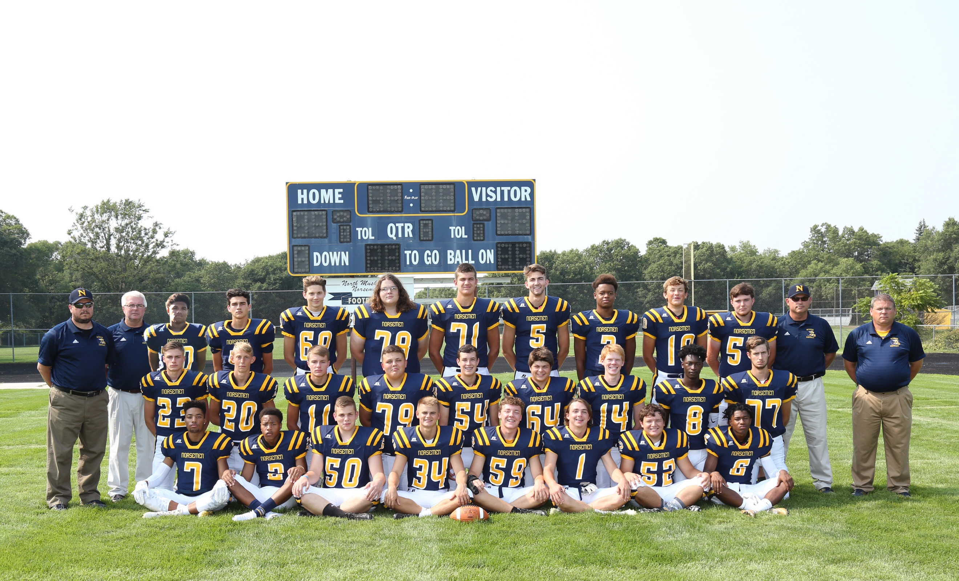

The 2018 NORSEMEN
1st Row L-R:Stephan Smith, Marcus Lane, Caleb Crawford, Joey Tarrant, Joe Flynn, Kyler Dana, Caleb Rypstra, Chandler Edwards
2nd Row L-R: Brenden Moat, David Towner, Eric Rypstra, Hunter Routley, Brett Galdeen, Logan Richards, Brady Lindell, De’Shary Warren, Jackson Davis
3rd Row L-R: Coach Mike Feltes, HC Larry Witham, Jon Adams, Mack Young, Noel Rahrig, Matt Kison, Noah Stewart, Jesse Cooke, TJ McKenzie, John Hayhurst, Asa Poulin, Coach Tim DeJonge, Coach Dave Nelson

Record Score Interesting Fact
- NM 41, Hesperia 6 Chandler Edwards 4 TDS & 140 yards.
1-1 NM 27, Oakridge 61 Mack Young school record 395 passing. TJ McKenzie 211 rec. yds.
1-2 NM 26, Ravenna 53 Young 4 TDs passes and 390 yards.
1-3 NM 20, Montague 62 McKenzie 94 yd Koff ret TD.
2-3 NM 35, Mason Co 0 John Hayhurst 4 TD passes, 3 to De’Shary Warren. Edwards TD.
2-4 NM 49, Shelby 0 Hayhurst 4 TD s, Cooke 2 TDs, one a 92-yd run. McKenzie 2 TDs.
3-4 NM 48, Hart 0 Young 3 TD passes, Warren 41 interception return for TD.
4-4 NM 21, Whitehall 47 Young 19-43 245 & 2 TDS.McKenszie 90 yd KOff YD.
5-4 NM 47, Orchard V 22 Young to Cooke record 94 yd TD pass. Edwards 4 TDs.
5-5* NM 28, Lake City 30 McKenzie two kickoff returns for TD, 90 & 85.

2019 Coach Larry Witham (5-5 overall, Playoff qualifier, Oakridge WMC Champ)

Always optimistic, head coach Larry Witham would have high hopes that his 2019 Norsemen would have a winning season and make the playoffs once again.
Senior John Hayhurst, who filled in more than admirably during a couple of games the previous season when Mack Young was injured, would now be the quarterback in 2019. Four of his five starters who created some big holes for NM backs would return, including 6’7 240 Noah Stewart who would eventually play for the University of Michigan’s 2023-24 National Champions. Witham was hoping with several players returning on defense that they would solve many of their defensive woes from the previous season when in their four conference losses they allowed 223 points. As always, NM would be the smallest school in enrollment in the WMC. NM will begin the season without any co-op players from West Michigan Christian which places them at a Class D level.

NM showed they could once again put points on the board as seven different players scored touchdowns, including two punt returns for TDs. Amongst those who scored in NM’s 56-12 thumping of Hesperia included Stephan Smith, who rushed for 93 yards. John Hayhurst threw for 60 yards and a touchdown and ran in for a score as well. Collins Schotts rushed for 56 yards and two touchdowns, including once on a punt return as NM had a most successful season opener.

Instead of an offensive show as anticipated when NM and Ravenna squared off in game two on the season, it was a defensive battle with Ravenna nipping the Norsemen 14-13. After a scoreless first period where NM controlled the ball for all but three offensive plays, NM scored on the 2nd play of the 2nd quarter with Collin Schotts scoring on a six-yard run to give NM a 7-0 lead. Ravenna battled back to score with 1:29 to play in the first half and then went for two points. The made two-pointer proved to be essential in the outcome of this game as it then forced NM to go for two points following Schotts short TD run early in the fourth quarter. A two-point conversion catch was ruled incomplete when the Norse receiver caught the ball out of bounds. Ravenna scored with 6:34 left to go up 14-13 and then held off the Norse for the victory. John Hayhurst was 8-for-16 passing for 126 yards.

NM dropped their 17th game in their last 18 clashes with Montague 28-24 when the Wildcats rallied in the final quarter to overtake the Norsemen. NM took an early 10-0 lead on a John Hayhurst run from two yards out and a 29-yard field goal by Gabe Rahrig. After Montague cut the lead to 10-7 Collin Schotts broke loose for a 55-yard TD with just 43 second left in the first half to give NM a 17-7 lead. However, on the ensuing kickoff Dylan Everett returned the kickoff 87 yards to the house to flip the momentum as Montague pulled within 17-14 at the half.
Both teams exchanged TDs in the second half with NM’s touchdown a 1-yard run by Hayhurst. Montague scored with five minutes left to end the scoring.

NM then whipped Shelby 56-0 to even their season record at 2-2. The Norse took full advantage of Shelby fumbles to take an overwhelming 49-0 lead at halftime. Running back Stephen Smith had a huge second quarter for NM by rushing for three touchdowns on runs of 55, 43 and two yards. John Hayhurst threw for a couple of TD passes in the first quarter, a 41-yard strike to Eric Rypstra and a nine-yard score to Joe Tarrant. Tarrant also had a short 1-yard TD and was a force on defense with two interceptions. Baseball star Alec Cutter added the other TD on a fumble return shortly before halftime.

NM again made short work of both of their Oceana County WMC foes with yet another shutout in a 49-0 thumping of Hart. It was their 7th straight conquest of the Pirates, and their 13th win in their last 15 meetings. Stephan Smith scored three of NM’s tallies on runs of 6, 27 and 2 yards. NM also got TD runs from Collins Shotts (33 and 38 yards) and Joe Tarrant raced 62 for yet another NM tally. The other NM score came on a John Hayhurst pass of 15-yards to Brian Pannucci as NM improved to 3-2 on the season.

After giving up a near record total points in 2018 NM received a monstrous game from their defense in a 17-7 win over Whitehall. The win snapped a five-game losing streak to the Vikings. John Hayhurst had a strong game for the victors throwing for 204 yards that included a three-yard TD pass to Eric Rypstra while also rushing for NM’s finals score. Gabe Rahrig kicked a 20-yard field goal to give NM some breathing room against the Vikings. Future U-M gridder Noah Stewart led the strong NM defense with seven tackles and a sack.

Division 7 NM was no match for the top Division 5 ranked team in the state in the Oakridge Eagles. Oakridge brought the Norse back to reality with a convincing 34-7 victory over NM, their 14th straight victory over the Norse since NM’s 21-14 upset playoff win over the Eagles in 2006. Oakridge outgained the Norse 248 to 17 in the first half and led 22-0 at the break. “We’ve got to bounce back, we’ve still got playoff aspirations ahead of us, that’s for sure,” said NM head coach Larry Witham following the game. “We know were a good football team.” NM’s only score against the WMC champs was a 2-yard run from Stephen Smith. Brenden Moat shined as both a receiver and a punter for NM. Moat caught 3 passes from quarterback John Hayhurst for 76 yards and punted four times for an average of 49 yards per punt.

NM was surely a good football team in their ‘must’ 54-16 win over Mason County to give them five wins and visions of a playoff berth. After a slow start NM poured on the gas pedal to score 51 points in the final three periods in an easy win over the Spartans. John Hayhurst led the Norse with 184 yards passing and two touchdowns, while adding two more touchdowns on the ground. Joe Tarrant rushed for 101 yards that included a 66-yard TD dash. Stephan Smith had a 41-yard scoring run and chipped in with 94 rushing yards. Hayhurst’s TD pass was to Smith for six yards. Dale Towner scampered in from 43 yards to cap the Norse scoring.

The Norse would again go into their final game with Orchard View needing a win to get an automatic berth in the playoffs. But this wasn’t the 3-6 or 2-7 OV team NM faced in the previous two years. This was an 8-0 Orchard View team playing their best brand of football in 14 years. OV would have a perfect 9-0 season following a 33-20 win over the Norsemen. NM was generous in the first half with three turnovers that resulted in Cardinal points put on the board. OV led 24-0 before NM could get it together and score on a QB sneak by John Hayhurst shortly before half. NM went to their passing game to move the ball against the Cardinals and narrowed the gap on the final play of the third quarter on a 4-yard keeper from Hayhurst. OV countered with a TD and a 2-point conversion to put the game out of reach. NM scored the game’s final touchdown on a 48-yard completion to Brenden Moat. Moat had a tremendous game in the losing cause as he caught 12 passes for 173 yards.

When the playoff field was announced on TV the following day, despite the loss to undefeated Orchard View, NM had qualified in Division 7. The bad news, for the second straight week they would be facing another undefeated team in Pewamo-Westphalia. This was a P-W team so loaded on defense that they had only given up three touchdowns the entire season. Not only was P-W’s defense sharp, but likewise for their offense as they put up 35 points in a 35-0 victory over NM.

One of the highlights of the past NM season was the kicking of Gabe Rahrig. The school record holder in made field goals in 2018 as a sophomore, Rahrig hit three of four field goals in 2019 and was a perfect 37-for-37 on extra point attempts.

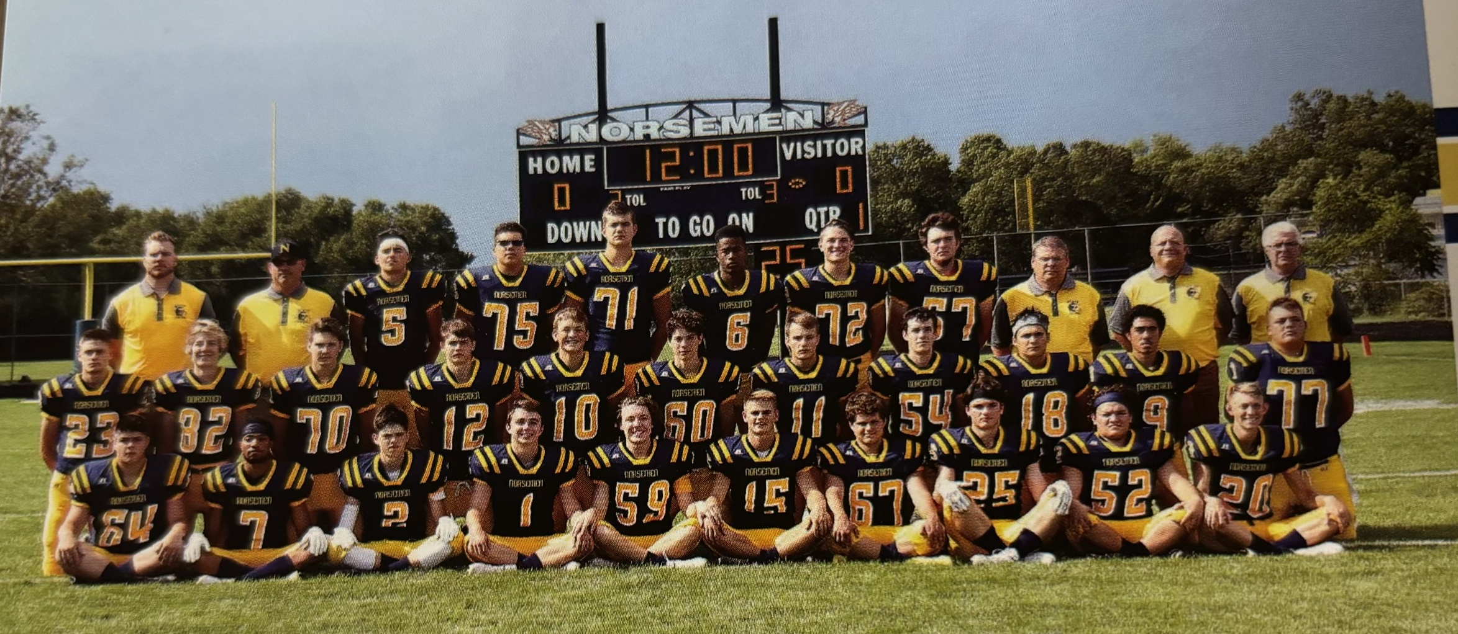

The 2019 NORSEMEN
1st Row L-R: Logan Richards, Stephen Smith, Joe Duplissis, Kyler Dana, Joe Flynn, Joe Tarrant, Ayden Persicke, Colin Schotts, Caleb Rypstra, David Towner
2nd Row L-R: Brenden Moat, Max Scheerer, Noel Rahrig, Braeden Fleming, John Hayhurst, Gabe Rahrig, Eric Rypstra, Brett Galdeen, Brennen Pannucci, Marcellus Rouse, Hunter Routley
3rd Row L-R: Coach Nick DeKraker, Coach Tim DeJonge, Alec Cutter, Le’Andre Brown, Noah Stewart, Amarion Dickerson, William Gallo, Asa Poulin, Coach David Nelson, Coach Bryan Rypstra, HC Larry Witham

Record Score Interesting Fact
1-0 NM 56, Hesperia 12 Seven players score TDs for NM.
1-1 NM 13, Ravenna 14 Collin Schotts 2 TDs, Ravenna wins on made 2-point conversion.
1-2 NM 24, Montague 28 John Hayhhurst 2 short TDs, Shott 6-yd TD.
2-2 NM 56, Shelby 0 Stephan Smith 3 TDs, Joe Tarrant 2, Hurst 2 YD passes for TDs.
3-2 NM 49, Hart 0 Smith 3 TDs, Schotts 2, and Tarrant 1. Pannucci 15 yd TD pass.
4-2 NM 17, Whitehall 7 Hayhurst 204 passing yards, 15 TD pass to Eric Rypstra.
4-3 NM 7, Oakridge 34 Smith 2-yd TD. Brenden Moat 3 receptions &49 avg. per reception
5-3 NM 54, Mason Co 16 Hayhurst 2 TDs, 1 passing, 2 rushing. Dale Towner 43 yd TD.
5-4 NM 20, Orchard V 32 Moat 12 catches for 173 yds & TD. Hayhurst 2 TDs.
5-5*NM 0, Pewamo-West.35 NM loses to state finalist Pewamo-Westphalia.

2020 Coach Larry Witham (4-4 overall, Playoff qualifier, Montague WMC Champ)

The 2020 football season was without question the most bizarre, not only for North Muskegon, but for the entire State of Michigan and much of the USA. Covid 19 had emerged in March and cancelled late winter and all spring sports for much of the nation. The state of Michigan was one of the last states to allow high schools sports to resume as Governor Gretchen Whitmer’s edict forced cancellation of the first three games of the football season. Whitmer initially struck a dagger in all Michigan High School players when she announced in August that there would be no football played in 2020. Fortunately, she changed her tune and permitted football to resume in Mid-September but playing a limited six game schedule. When play was resumed fan participation was limited as only a handful of fans, mostly parents were in attendance. It was so disconcerting in Michigan that the final games of the playoffs were played in January.

With all fans in the stands wearing masks and widely spaced apart, NM opened their season in mid-September with a 42-0 shutout of Shelby. Brennan Pannucci was the 2020 NM quarterback, and he connected early in the contest with Amarion Dickerson for a 25-yard TD. Following a Collin Schotts 2-yard TD, Pannucci connected again for six points, this time a 10-yard flip to Joe Dupplissis. NM took a 21-0 lead at halftime and didn’t waste any time to move out in front 28-0 as Dickerson returned the second half kickoff 88 yards. Schotts scored his second TD in the second half on a 15-yard run while Nick Dana capped the Norse romp with a 3-yard TD. Taking up right where left off last season, Gabe Rahrig, who was 37-for-37 last year, was 6 for 6 in the opener with Shelby.

NM continued their complete domination over Hart with a 41-16 victory to go 2-0 to start the season. The big news was that Gabe Rahrig finally missed an extra point after making well over 40 consecutive over the last two seasons. Collin Schotts scored a pair of 5-yard rushing TDs for NM. Pannucci connected with Amarion Dickerson with a 12-yard TD pass and Joe Duplissis and Denny Belmonte also scored on short TD runs. Pannucci finished with 111 yards passing and added a one-yard TD run.

A Whitehall team that returned nearly all their starters from 2019 were too much for NM as Whitehall moved to 3-0 with a 41-3 win. The only NM score was in the second period. Amarion Dickerson had a long kickoff return before he was finally stopped at the Whitehall 23-yard line. NM couldn’t move the chains and then had to settle for a 30-yard field goal by Gabe Rahrig. That made the score 14-3 and it was all Whitehall the rest of the contest. The Norse rushing offense was completely stymied by Whitehall as the final stats showed NM with negative 38 yards.

Oakridge came up with several long yardage TDs to humble the Norsemen 42-0. Collin Schotts led the Norse with 73 yards on 15 carries as NM dropped to 2-2 on the season. Fortunately for NM, Mason County Central is their next opponent, an opponent who has fared poorly over the years against the Blue & Gold.

NM had no trouble once again with Mason County Central as NM scored early and often to take a 28-0 lead at halftime in their 42-0 win over MCC. Brennen Pannucci had three short TD runs to lead the Norse. All six NM touchdowns were on the ground as Alec Cutter, Collin Schotts and Jackson Oliphant all crossed the Spartans goal line. Pannucci did his best Tim Tebow impersonation as the big Norse quarterback ran for 154 yards to improve NM’s record to 3-2 with one game remaining in the regular season against an undefeated Montague team.

And how good was Montague in 2020? The Wildcats were good enough to not only defeat NM 41-13, but they absolutely crushed all their opponents in the playoffs to win the state championship. After all playoff games were halted after November 13th, Montague had to wait until January 8th before playing a regional championship game against Montrose. Their final 3 wins in January were 41-16 against Montrose, 49-14 against Graying to reach the finals and then they were rewarded with a state finals game in the indoor comforts of Ford Field where they destroyed Clinton 40-14. When one looks back in retrospect NM had no reason to feel ashamed to lose 41-13 to a Montague team that would be playing its final season under their coach Pat Collins. Brennen Panucci took part in both of NM’s touchdowns, one on a 12-yard TD pass and the second on a one-yard run.

With a six-game regular season schedule the MHSAA in this extraordinary 2020 season did the same for football as they have done every year for basketball, let every team advance to the playoffs. NM’s first opponent was Grand Rapids North Pointe Christian. NM defeated the furniture city team 26-0. Gabe Rahrig gave NM all the points they would need when he started NM off on the right foot with a 31-yard field goal. Brennen Pannucci then tossed touchdown strikes to Amarion Dickerson, the first went for 35 yards and the second was good from 47 yards out to give NM a 17-0 lead at halftime. A blocked punt resulted in a safety while Collin Schotts dived in from one yard out to make the final score read NM 26, North Pointe Christian 0.

Next up in the playoffs NM had to travel to Pewamo-Westphalia to play the top ranked team in the state. After losing to the Pirates 35-0 the previous year, NM was given little chance of earning the W. Your author was taking full advantage of today’s magic world of technology as I was sitting on the edge of my chair in faraway, but sunny and warm Ponte Vedra, Florida watching this thriller. The underdog Norse jumped out to a 10-6 at half and enjoyed a 17-12 lead heading into the final quarter. Gabe Rahrig got NM started with a 34-yard field goal and Brennen Panucci followed with a 30-yard TD pass to give NM a quick 10-0 lead. After a P-W touchdown NM answered with a Pannucci TD pass of 14 yards to Collin Schotts. P-W rallied to take a 18-17 lead, but NM fought back. The Norsemen moved to the Pewamo-Westphalia 20-yard line late in the game and were faced with a 4th down with nine yards to go. Rather than go for the field goal to take the lead and perhaps the win, NM decided to attempt a pass rather than risk a kick into the teeth of a strong wind. As the home crowd, who were no longer obeying the unwritten rule of creating space between their seats, the pass for a first down, and perhaps a TD, fell incomplete in the end zone. NM’s Covid 19 season had come to an end. Ironically, despite winning the game, the season was also over for the Pirates. Covid had spiked in the rural area, and the Pirates had to forfeit their next game to Ithaca. Pewamo-Westphalia would bounce back however and win the Division 7 state title in 2021.

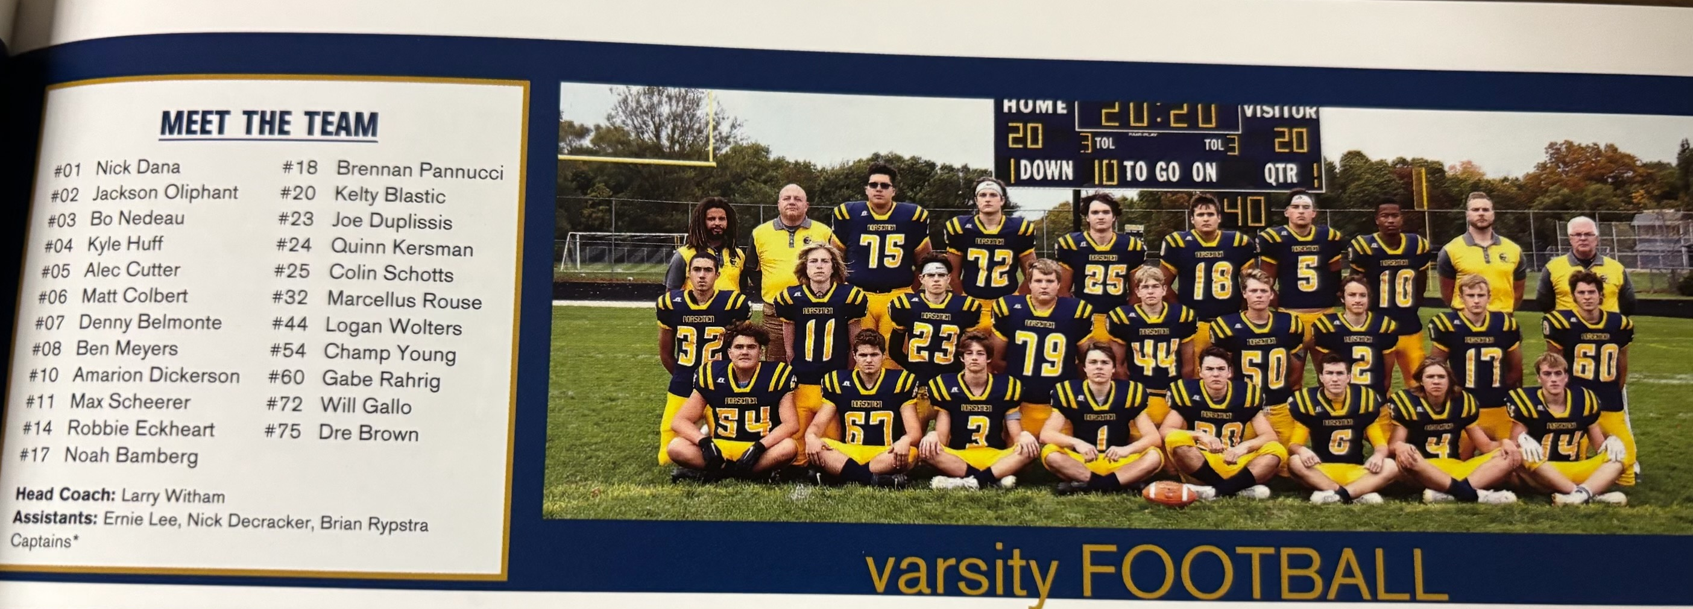

The 2020 NORSEMEN

Record Score Interesting Fact
1-0 NM 42, Shelby 0 Amarion Dickerson 88 yd. KO TD. Brennan Pannucci 2 TD passes.
2-0 NM 41, Hart 16 Colllin Schotts 2 TDs, Denny Belmonte, Joe Duplissis, Pannucci TD.
2-1 NM 3, Whitehall 41 Gabe Rahrig 30-yard field goal only NM score.
2-2 NM 0, Oakridge 42 Collin Schotts 73 rushing yards on 15 carries.
3-2 NM 42, Mason Co 0 Pannucci 3 TDs, Schotts, Alec Cutler & Jackson Oliphant TDs.
3-3 NM 13, Montague 41 Pannucci passing TD and rushing TD as NM loses to state champs.
4-3*NM 26, N.Pointe Ch. 0 Rahrig FG, Pannucci 2 TD passes to Dickerson, Schotts 1-yard run.
4-4*NM 17, P-W 18 Pannucci 2 TD passes, 35 & 47 to Dickerson. Rahrig 31 yd FG..

2021 Coach Larry Witham (4-6 overall, Playoff qual., Montague- Oakridge WMC Champ)

The Norse would begin the year with a promising freshman signal caller at quarterback in James Young. The first opponent for NM to begin the season was perennial power Muskegon Catholic Central, the first meeting between the two locals in football since the 2011 season. MCC would win the fifth game in the series 27-13 but Young would make his presence known early as he rifled a 31-yard TD pass to Bo Nedeau. With Gabe Rahrig no longer kicking for the Norse, the extra point failed. MCC would take the lead at 7-6 before NM would retake the lead on a 29-yard touchdown pass from Young to Landon Christensen. It would be the last time NM would cross the Crusader’s goal line against MCC in 2021 but the duo of Young to Christensen would have their day in the sun in 2023.

Montague then dropped NM to an 0-2 record to start the 2021 season. It would mark the 5th straight win for the Cats against the Norse and their 19th win in their last 20 meetings. Despite the recent surge by Montague NM still leads overall after 89 games had been played in this long series with 45 wins to Montague 41 victories. Three of the games from yesteryear ended in a tie game. Montague shut out the Norse 35-0 with freshman James Young only earning 75 yards on 28 of his pass attempts. Denny Belmonte was the leading rusher for the Norse in this game with 51 yards on 16 rushes.

After going 48 minutes scoreless the previous week against Montague, it took NM only 8 seconds to score their first of many touchdowns in their 67-0 rout of hapless Shelby. James Young on the first play from the line of scrimmage connected with Matt Colbert for 49 yards. By the time 12 minutes had gone by to signify the end of the first quarter the Norse had a 34-0 lead. Five different backs scored on the night against Shelby. Sophomore Ben Meyers tallied two TDs as did Nick Dana. James Young threw for 131 yards on six of seven passing with four of his six completions going for touchdowns. NM had more than 500 total yards on offense with 350 of those on the ground.

NM would then move to .500 on the season with a 37-0 victory over Hart. So dominant has NM been against Hart and Shelby that their overall record for the last six season shows NM outscoring the two Oceana County neighbors 562-13!
NM dominated the Pirates, but NM head coach Larry Witham said there is light at the end of the tunnel for the Pirates. “We knew they were a much-improved club, and we prepared as such,” added Witham following the game. NM began the game with three first quarter touchdowns and rolled into halftime with a 28-0 lead after a second quarter tally. James Young threw three TD passes, two to Matt Colbert and another to Nick Dana. Denny Belmonte had a rushing touchdown for the Norse. NM added another touchdown on a fumble recovery in the end zone.

Whitehall would post a 33-0 shutout over NM in what would prove to be the last game played between the two teams after the two schools had met in 59 previous meetings. With the WMC expanding to add six more schools beginning the next school year, the two long-time rivals would not be on each other’s schedule as of the 2024 season. Even though Whitehall shut out the Norse, NM still leads in the series that began back in 1945 with 31 wins to Whitehall’s 28. Whitehall posted their third straight shutout as they held NM to only 70 total yards and six first downs. With minus rushing yards for the game NM’s best offense was the 88 yards accrued by James Young on 13-of-23 passes.

After a poor performance against Whitehall, it looked like NM would have little chance against a once beaten Oakridge team. NM gave the Eagles a battle but fell just short in a 32-27 loss to the Eagles. NM almost pulled off the upset when late in the game and NM at the Eagle’s 15-yard line, a James Young pass in the end zone was intercepted by Corey Vanderputte to seal the deal for Oakridge. It was a back-and-forth game for much of the contest. NM took the lead at 7-6 on the first of 3 TD passes from James Young, a 37-yard toss to Brandon Rypstra. After Oakridge took the lead Denny Belmonte’s two-yard run switched the lead back to the Norse. Again, it was back and forth with Oakridge first scoring, but NM again answered on a Young to Carson Moat strike for 26 yards. In a game that resembled a tennis match NM again followed an Eagle score with Young’s third TD pass of 62 yards to Matt Colbert giving NM a 27-26 lead heading into the fourth quarter. A Vanderputte TD, his fourth of the game gave the lead to Oakridge at 11:43 of the fourth quarter, a lead that would stand until the clock ran out.

NM then lost more than just a game in their 17-6 loss to Ravenna; they also lost their quarterback. James Young was injured early in the contest with a broken clavicle that would sideline him for the rest of the season. Young was replaced by their ace running back Denny Belmonte at QB. Belmonte did run for a first half score but that would be all the scoring NM could muster against a strong Ravenna defense. Belmonte in a relief role would complete 12 of his 21 passes for 73 yards, with Matt Colbert catching eight of Belmonte’s passes for 57 yards.

Quarterback woes continued for NM as second-string quarterback, and first team running back Denny Belmonte separated his shoulder early in the game. NM was now needing another QB. In stepped sophomore Ben Meyers and he quickly showed his all-around athletic ability by leading NM to a 35-0 victory over Mason County Central. One of the best baseball players in NM history, Meyers would run for a TD and pass for three more in his reserve role. Two of his TD passes went to WMC first team All-Conference end Matt Colbert on 50- and 15-yard strikes, the third was a 22-yarder to Kyle Huff. Colbert caught another TD pass, but this was thrown by the Mason County quarterback that Colbert returned for a touchdown. Meyers would finish with 7-of-11 passing for 147 yards. Colbert had six receptions for 132 yards as NM improved to 3-5 with one regular season game remaining.

NM would win four games on the season, two against Oceana County Schools and two against Mason County squads after NM ended their regular season with a 25-0 victory over Ludington. It was the first meeting between the two schools in 17 years and with the win NM has now won 12 of the 20 games played between the two schools since their first meeting back in 1946. Third string quarterback Ben Meyers again put his athletic ability on display against the Orioles by rushing for three touchdowns on a pair of six-yard runs and a 45-yard burst. Meyers would rush for 110-yards from his quarterback position while Nick Dana added 57 yards to the Norse offensive total. Bo Nedeau added the fourth NM TD on a short two-yard run.

The rules for advancing to the playoffs received an additional tweak before the start of the 2021 season with the primary emphasis being on the strength of schedule for each team. With that edict in place NM was able to advance into the playoffs, but without two of their most important players, James Young and Denny Belmonte. NM was matched up for the second time of the season with the Ravenna Bulldogs and were nipped by Ravenna 7-6. It would seem inconceivable at the time, but this game was decided in the first minute of the 48 minutes played in the game. Ravenna’s Thomas McCullough ran 48 yards for a touchdown and Hunter Hogan’s made extra point gave Ravenna a 7-0 lead with just over a minute played. With 1:04 left in the game NM capped a long drive to score on a six-yard slant pass from Ben Meyers to Landon Christensen to make the score 7-6. It was then decision time for head coach Larry Witham who was coaching the game from the press box recuperating from recent heart surgery. After a timeout and a huddle NM decided to roll the dice and go for the win. The two-point conversion failed, and the Bulldogs hung on for the win.

With the 2021 NM team loaded with talented underclassmen, the future looked good for NM football, and the Norsemen of the next two seasons would more than equal those promising expectations.

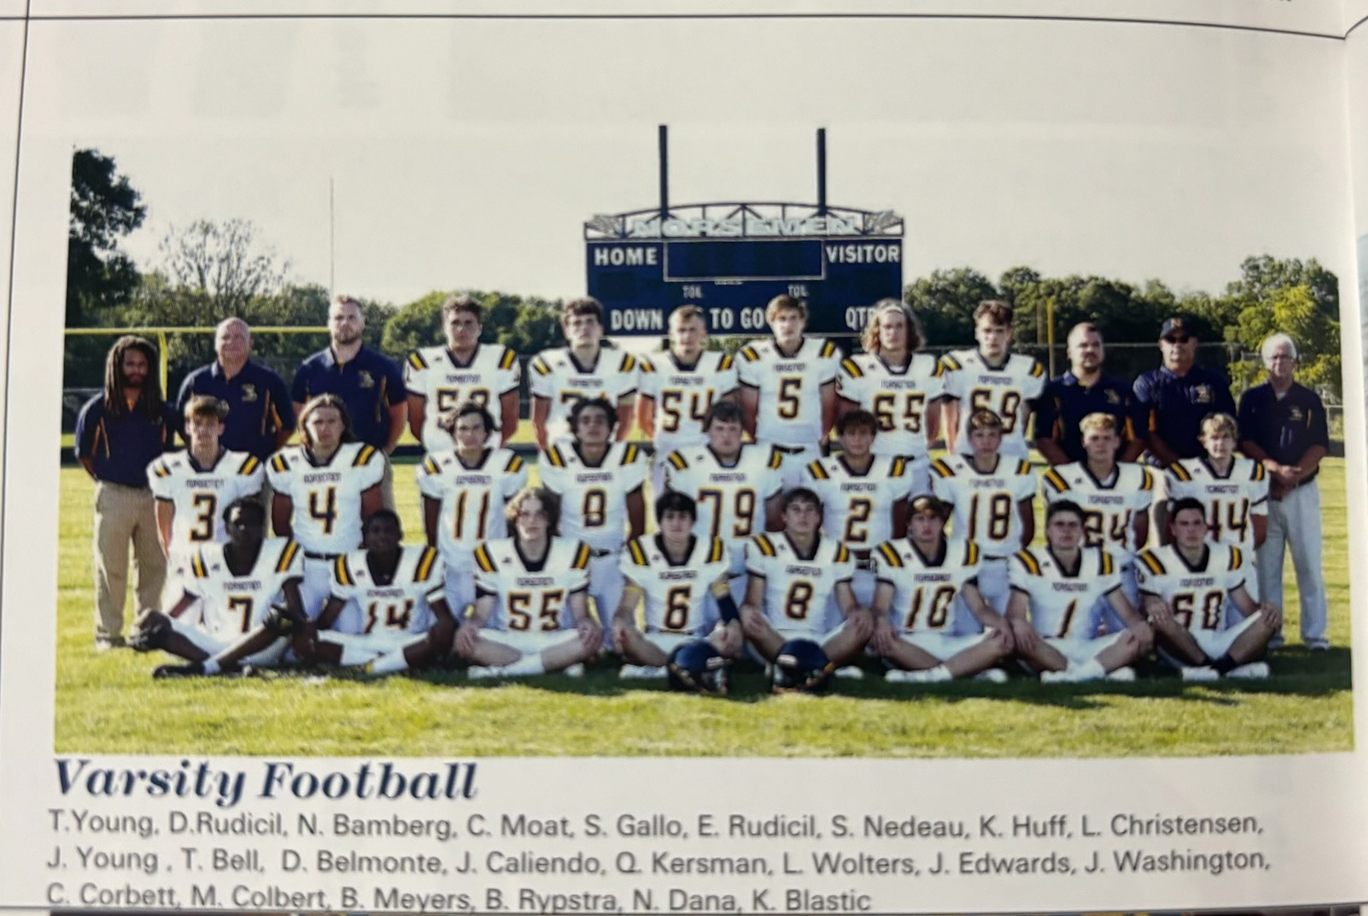

The NORSEMEN of 2021

Record Score Interesting Fact
0-1 NM 13, Musk CC 27 Young 2 TD passes,32 yd to Bo Nedeau & 29 to Landon Christensen.
0-2 NM 0, Montague 35 Montague wins their 19th of the last 20 games between the teams.
1-2 NM 67, Shelby 0 James Young 4 TD passes, Ben Meyers & Nick Dana 2 TDs.
2-2 NM 37, Hart 0 Young 3 TD passes, Matt Colbert 2 TDs, Belmonte & Dana 1.
2-3 NM 0, Whitehall 33 NM minus yards rushing, Young 88 yards passing.
2-4 NM 27, Oakridge 32 Young 3 TD passes, Belmonte 2-yd TD and 17 tackles.
  - NM 6, Ravenna 17 Young injured, Belmonte at QB 12-21 passing and rushing TD.
3-4 NM 35, Mason Co 0 Ben Meyers 4 TDs, 3 passing 1 rushing. Colbert 3 TDs.
4-5 NM 25, Ludington 0 Meyers 110 yd rushing & 3 TDs, Bo Nedeau TD.
4-6* NM 6, Ravenna 7 Meyers to Christensen 6 yd TD pass. 2-pointer for win fails.

2022 Coach Larry Witham 8-2 overall, Playoff qualifier, NM Rivers WMC Champs

After 90 years without any drastic changes, the administrators of the West Michigan Conference went overboard by admitting six new schools into perhaps the most stable conference in the State of Michigan. With the addition of Hesperia, Holton, Orchard View, Manistee, Ludington and Fremont, the league was divided into two separate divisions called the Rivers and the Lakes divisions. NM, with their small enrollment would be paired in the Rivers division composed of Hesperia, Holton, Shelby, Mason County Central, NM, and Ravenna. Only Ravenna had a proven football program which opened the door for NM to easily win their division. Not on the 2022 schedule were former rivals Oakridge and Whitehall. NM had played Oakridge for 55 consecutive years totaling 59 games. Likewise, NM had faced Whitehall 59 times in their program’s history, but neither would be on NM’s 2022 schedule. With those two schools off their schedule, it certainly improved NM chances to improve on their won-loss record and that would prove true in 2022.

NM would open their season at a neutral site against perennial power Muskegon Catholic. It would be NM’s first game played at historic Hackley Stadium in 73 years, a 13-7 victory over Muskegon St. Mary’s in 1949 with your author amongst those in attendance. MCC spoiled NM’s vision of a perfect regular season sweep with a come from behind 24-22 victory over the Norsemen. Sophomore slinger James Young started the scoring with a 57-yard bomb to Carson Moat. MCC battled back to score but missed the extra point to keep the score at 7--6 NM. Young, who was 25 of 35 on the afternoon (the game started at 4:00 PM) for 278 yards and two TDs, completed a second TD toss of 20-yards to Ben Meyers to make it 14-6. MCC scored later in the half to make the scoreboard at Hackley Stadium show NM 14-MCC 12. NM extended their lead to 22-12 on a Young 2-yard run but the rest of the game belonged to the Crusaders. MCC’s David Hill raced 68 yards for a TD, and the Crusaders made it all way back to stun the Norse on a short one-yard TD run.

A once proud Orchard View team who were dominant during the John Shillito era, were now just a shell of themselves in 2022 as NM crushed OV 54-0. Sophomore QB James Young was again on target as he completed 15 of 23 passes for five touchdowns, second only to Rick Jones’ six TD passes in 1970. Fellow sophomore TJ Byard caught four passes for 89 yards and two touchdowns. Ben Meyers (twice) and Carsen Moat also were on the receiving end of Young’s TD aerials. Meyers also ran for a TD while August Gerardi came off the bench to score twice to complete the scoring.

NM jumped out to a 34-0 halftime lead in a 41-6 win over Mason County Central at Fred Jacks Field. Denny Belmonte had a huge game for NM by rushing for 134 yards in but 10 carries with 2 TDs to lead the Norse attack. James Young connected with TJ Byard from 7-yards out to get the Norse offense rolling. The Young to Byard combo teamed up from 55-yards to give NM a 12-0 lead with two minutes left in the opening period. By the time the clock ran out at the end of the second quarter NM was in command 34-0. Belmonte caught a pass from Young from 13 yards for a TD, followed by a Belmonte 15-yard run and Young’s fourth TD pass of the opening half, a 54-yard catch and run to Alex Newville. Belmonte’s 65-yard TD run in the second half closed out the Norse scoring.

Once again NM scored 34 points in the opening half to earn a convincing 50-0 shutout of Hesperia. James Young had another monster game for the Norse, throwing for 311 yards and five touchdowns. TJ Byard was again Young’s favorite target as the sophomore wideout caught three passes for 136 yards and two TDs. Carson Moat hauled in a pair of TD passes with Talon Thompson grabbing two of Young’s pin-point passes, the longest 54 yards good for a TD. Sam Gallo forced a fumble that Drew Bartos returned for a TD while the lone rushing touchdown during the game was a dash of 24 yards by Denny Belmonte. Jake Erne got in on the fun with a 42-yard field goal, the second longest in NM history.

NM again made short work of an improving Hart team to post a 55-14 win over the Pirates. NM piled up a quick 21 first quarter points as NM had a nice passing and running balance. James Young was near perfect by completing 17-of-19 passes for 275 yards and two touchdowns. Young also rushed for a touchdown while Denny Belmonte ran for three TDs. On the receiving end of Youngs TD passes were TJ Byard and Carson Moat. Freshman Bryce Colbert saw action late and he tossed his first TD pass as a Norsemen. August Geradi also visited the Hart end zone with a TD. The Norse were now 4-1 on the season but just ahead was a Montague team NM hadn’t beaten in five years and only once in the last 20 years.

At long last NM was able to defeat their longest rival and recent nemesis Montague 27-7. James Young threw for 263 yards on 24-of-31 passing and one touchdown in the rare win in the 90th meeting between the two schools. NM had 379 total yards to the Wildcat’s 278 to improve their record to 5-1 on the season. Young got the scoring started with a 5-yard run that was followed by a Denny Belmonte dash from eight yards out as NM jumped out to a 14-0 first quarter lead. Montague narrowed the gap to 14-7 at halftime but NM countered with two third quarter touchdowns, the first on a 12-yard pass play to TJ Byard, the second on a 10-yard run by Ben Meyers. NM coach Witham lauded great praise on his defense following the victory. “Great team victory against a very formidable opponent in Montague,” said Witham, “Our defense really set the tone, though in the second half,” added Witham. Denny Belmonte and Sam Gallo led the stout NM defense with seven tackles each.

Fred Jacks Fields was near capacity when the Ravenna Bulldogs came to North Muskegon for game seven on the season. I was fortunate to watch the game with the GOAT in Norsemen football, Stan Guy and my classmate and dear friend for many years Dale Swanson, a former star NM player from the 1950s. I was honored to be a guest on my old radio station at halftime with my good friend Tom Kendra. It was a beautiful night for football and yours truly and the thousands gathered were treated to an entertaining game. NM won the game 28-7 but perhaps overlooked in the game was an injury to Denny Belmonte on just the second play of the game. Head coach Larry Witham was hopeful that Belmonte would be OK “because he is the heart and soul of this team,’ said the concerned coach following the game. Unfortunately, Belmonte was not OK and the two-way standout for the Norsemen had his season come to an end. The versatile Ben Meyers stepped up to become the primary running back for NM, and it was no surprise that Ben performed well. Early in the contest the NM defense came through as Kyle Huff forced a fumble that was scooped up by Brandon Rypstra who took the pigskin 70 yards for the game’s first score. There was no further scoring until just seconds before halftime when James Young connected with TJ Byard for a 34-yard TD pass. The combo of Young to Byard then teamed up for a 31-yard TD in the third quarter. A long 80-yard catch and run gave the Bulldogs some life as they cut the lead down to 21-7 but Young’s third TD pass of the game, a six-yard pass to tight end Kyle Huff put the game on ice for the Norse.

North Muskegon as of this writing (2024) has played 816 games, but only one time did NM get credited for a win due to a forfeit. NM was scheduled to play Holton in game eight of the 2023 season, but Holton had to forfeit because they couldn’t field enough healthy players to face the Norse. I’m curious if the administrators who allowed Holton to compete in the WMC were now having second thoughts.

Holton wasn’t the only team facing hard times in 2022. As recent as 2013 Shelby was the WMC champ but the talent has gone dry in recent seasons. NM cruised to an easy 42-6 win to give NM a WMC title in the newly created, but much weaker Rivers, division. It had been more than 20 years (1991) since NM could claim a WMC title in football. James Young compiled 197 passing yards that included three TD passes, one each to TJ Byard, Drew Bartos, and Landon Christensen. Young also ran for a 1-yard score while Ben Meyers ran for TDs from six and seven yards.

With the win over Shelby NM had won their first WMC title since they tied in 1991 and the first outright title since 1986. Ravenna was second in the Rivers Division with one loss in the division – to North Muskegon. Ravenna will make amends for that defeat with a stunning 10-7 upset victory in the first game of the MHSAA playoffs. After coughing up the football five times in their first meeting with NM, the Bulldogs had zero turnovers in the all-important playoff game. NM had no answer for Ravenna’s Hunter Hogan. In today’s day & age a three-sport star is rare, but Hogan played five sports in his high school career at Ravenna, winning an unheard of 15 varsity letters, two more than NM’s all time letter winner Tom Arntz from 1951-54. Hogan never left the field in this game as he rushed for 123 yards and a touchdown and completed 6-of-12 passes for 90 more yards while playing stellar defense and special team play. Hogan’s 23-yard field goal with 1:08 remaining in the first half proved to be the difference in the game. Ravenna’s secondary held NM’s James Young to his season low in passing with 9 of his caught 18 passes totaling but 101 yards. NM’s only score was on a 12-yard run by Ben Meyers in the second quarter.

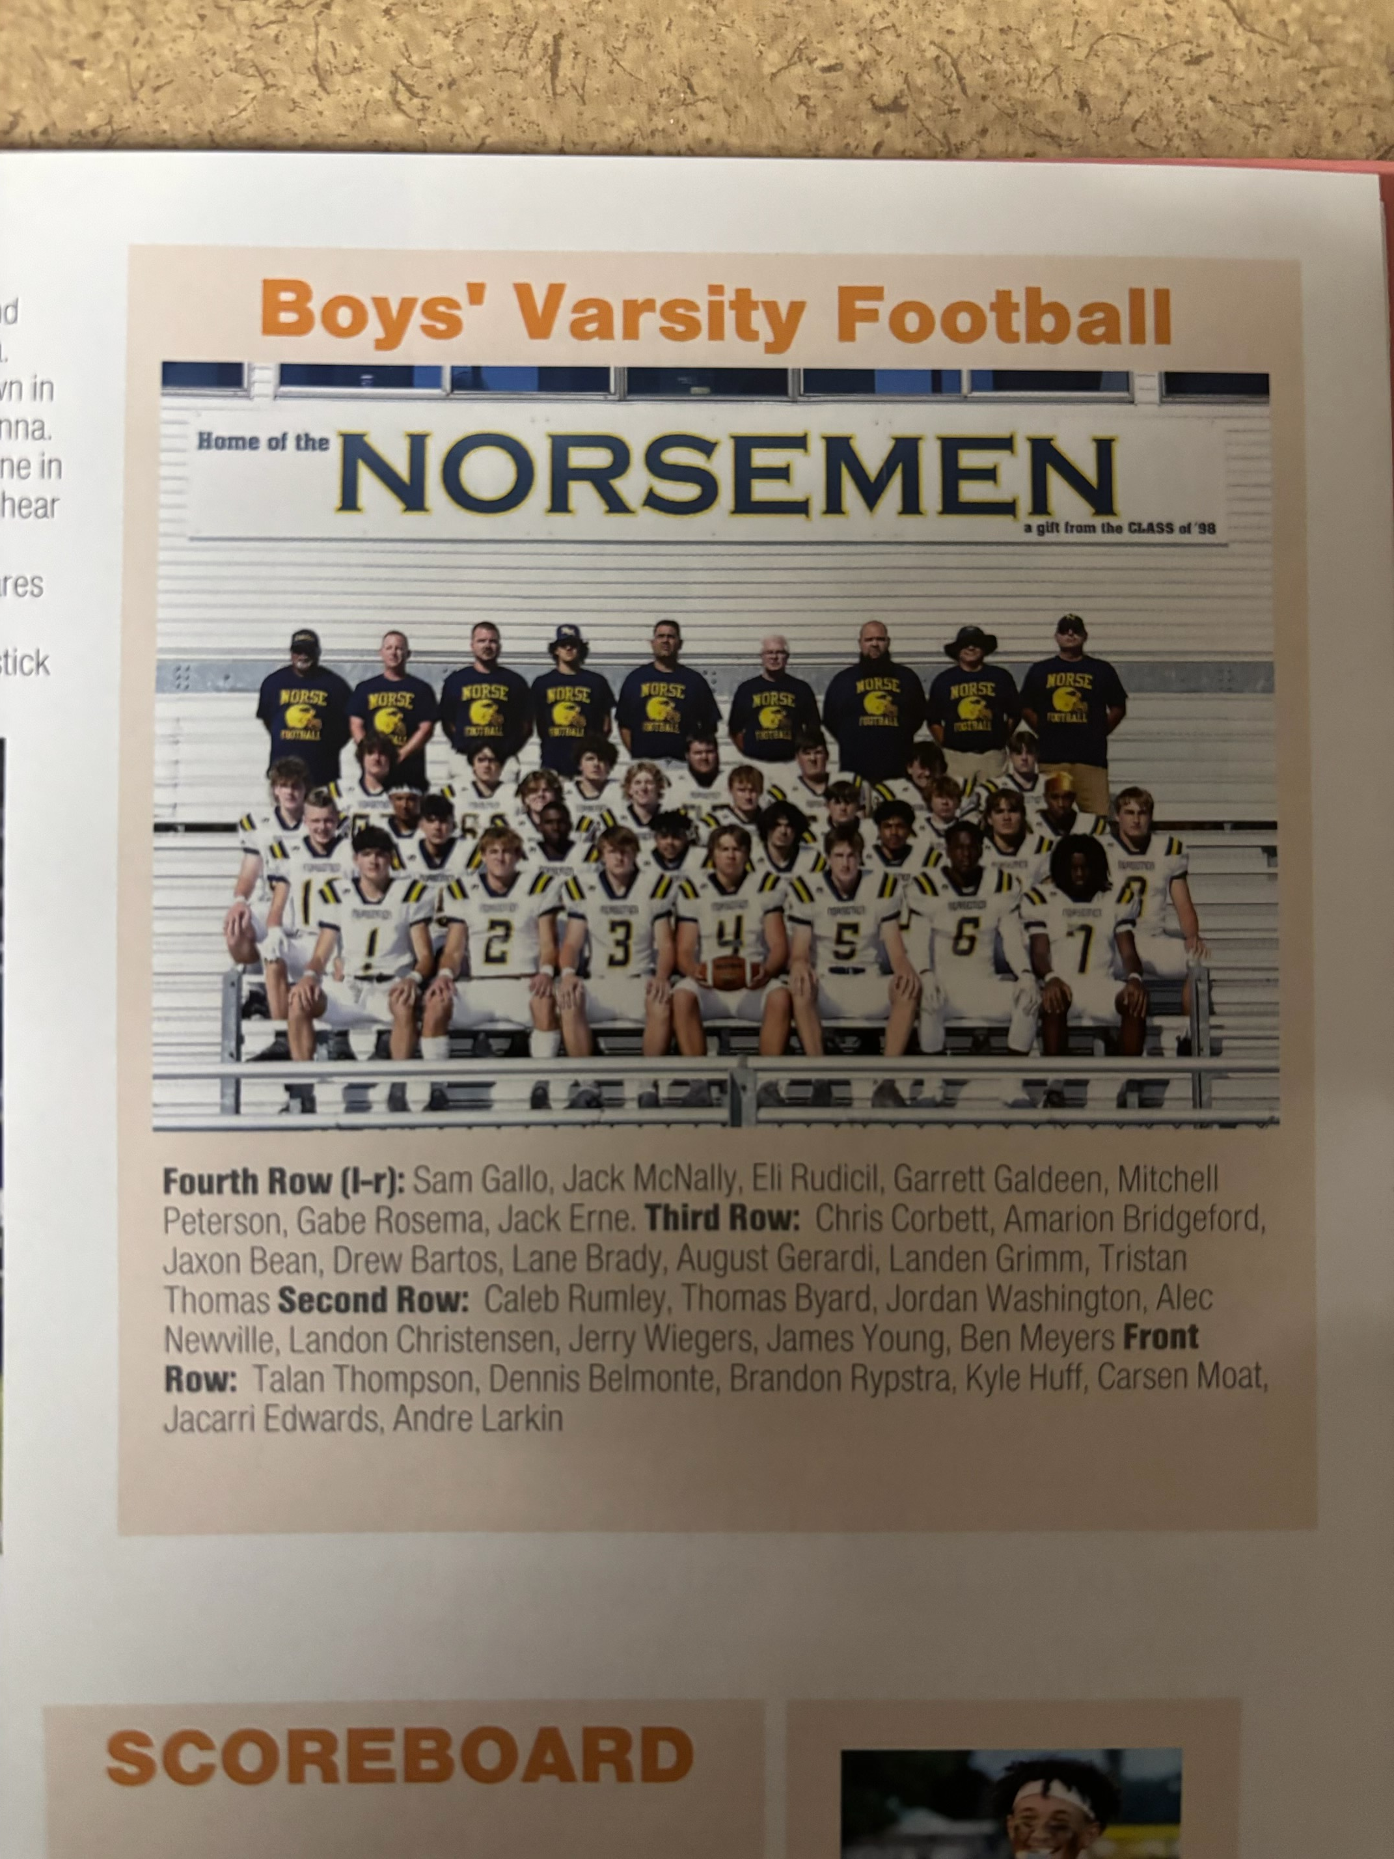

The NORSEMEN of 2022

Record Score Interesting Fact

0-1 NM 22, Musk CC 24 James Young 278 yds pass & 2 TDs, Young also a TD run.
1-1 NM 55, Orchard V 0 Young 5 TD pass, 2 each to TJ Byard & Ben Meyers, Carsen Moat 1.
2-1 NM 41, Mason Co 6 Young 4 TD pass, 2 to Byard, Belmonte 134 yds & 2 TDs.
3-1 NM 50, Hesperia 0 Young 5 TD passes and 311 yds, Byard & Moat 2 TDs, Thompson 1
4-1 NM 55, Hart 14 Belmonte 3 TDs, Young 3 TD, 2 passing &275 yards.
5-1 NM 27, Montague 7 Young 263 yards pass, rush TD, Young -Byard TD, Belmonte. Meyers TD.
6–1 NM 28, Ravenna 7 Brandon Rypstra 70 yd fum. Ret. For TD, Young 3 TD passes.
7-1 NM 2, Holton 0 F Holton forfeits, only forfeit win in NM history.
8-1 NM 42, Shelby 6 Young 3 TD passes & 1 rushing, Meyers TD runs of 6 & 7 yds.
8-2*NM 7, Ravenna 10 Meyers 12-yard TD only NM points in upset by Ravenna.

2023 Coach Larry Witham 12-1 overall, Playoff qualifier, NM Rivers WMC Champs

The Norse began their 2023 season against Pewamo Westphalia, a perennial power in football. The visiting Pirates invaded North Muskegon having won three Division 7 state championships since 2016. Two of their playoff victims during their run were playoff victories over the Norsemen. NM needed a 23-yard field goal from Junior Owen Booth with just five seconds left to earn their first victory over the Pirates. The Norse began the contest on a promising note with a methodical 15-play scoring drive that was culminated on a 3-yard TD pass from James Young to Ben Meyers. The visiting Pirates proved they would be no pushover as they scored with four minutes left in the second quarter, but their extra point try from placement was wide to make the score NM 7 PW 6 at the halftime break. The Norse then took the lead in the fourth quarter on a 37-yard TD pass from Young to Landon Christensen. Booth’s kick gave NM a 14-6 lead, but PW were not to be denied as they scored with less than two minutes remaining and then converted on a two-point conversion to knot the game at 14-14. Alec Newville returned the ensuing kickoff to the PW 45-yard line to give NM excellent field position. Young connected with TJ Byard on a 28-yard pass play to the 17. Young then scrambled for nine and five yards to set up Booth’s game-winner.

In game two the Norse atoned for a heartbreaking 24-22 loss to Muskegon Catholic the previous season by romping to a convincing 41-21 victory. The Norse were in command the entire game and at one point enjoyed a 35-7 lead over the host Crusaders in the second half. Ben Meyers began the Norse scoring parade with a one-yard TD score. From that point on James Young and Landon Christensen put on a record-breaking show. Young hit Christensen on four TD passes good for 260 yards, including a 78-yard TD strike for the Norsemen’s final score. Young also connected with TJ Byard for six receptions good for 64 yards. Young’s final passing yardage totaled 398 yards, an all-time NM record for a single game. A late MCC TD made the final score read NM 41-MCC 21, only the second victory over the Crusaders in their seven-game series.

NM had little trouble in their opening West Michigan Conference game by rolling to a decisive 49-12 victory over Mason County Central. The Norsemen won the game, but they lost a WARRIOR! In one of the game’s first plays three-year starter and two-way performer Ben Meyers went down with an injury, a small fracture in his tibia. Meyers gamely attempted to return to the lineup later in the playoff game with Pewamo-Westphalia, but he again was reinjured in the same area. Meyers, who surely would have been a leading candidate for the Greater Muskegon Athlete of the Year, also had to sit out the entire basketball season where he was a returning starter and a defensive lockdown specialist. James Young was 10 of 16 in the passing department with four TD passes split among four different receivers. With an abundance of talented receivers to choose from, Alec Newville was the primary recipient as he caught five passes good for 157 yards and one TD. Landon Christensen caught a pair of Young’s flings for 40 yards and a TD while TJ Byard and freshman Cullen Bartos also caught TD strikes from Young. Bartos and Newville each had a rushing touchdown as the Norse made it a perfect 3-0 on the season.

A downtrodden Hesperia team was no match for the Norsemen in game four of the 2023 season. So dominant was the Norsemen that they never even experienced a third down situation in the contest. Alec Newville returned the game’s opening kickoff to the Hesperia 26 and just two plays later junior Tristan Thomas scampered 28 yards for a TD and the rout was on. Three minutes later James Young threw a perfect strike to Landon Christensen who streaked 75 yards for a TD. A short field, thanks to a 40-yard punt return by Talan Thompson set up Thomas’s second TD run from 10 yards out. Before the first quarter had come to an end Young found TJ Byard for a 51-yard tally. Newville made it 35-0 with a 59-yard TD gallop, freshman Cullen Bartos scored from 17 yards out while Thomas made the scoreboard read 49-0 at halftime after a 9- yard TD. With a running clock in the entire second half the Norse still managed to add on three more tallies, the first a one- yard plunge by Chuck Meyers. A pair of players from the JV team culminated the rout with Hunter Wilder racing 49 yards for one score while Adam Dugener scored from 20 yards out to make the final score 69-7. Owen Booth was perfect on all his PAT attempts as the Norse made it a perfect 4-0 to begin the season.

For only the third time in 85 meetings have the Norsemen and Hart met with both team undefeated going into a game, the last dating back to 1967 when both teams started a modest 2-0. After many years posting losing seasons, Hart had finally reversed direction the past couple of seasons and entered the fray boasting of a perfect 4-0 season, their best start since the 1961 season. The Pirates started the game with a perfectly executed on side kick attempt, but the Norse defense stopped Hart on downs. NM then executed a perfect 90-yard drive with the final 24 yards coming on a pass from James Young to Alec Newville. Owen Booths PAT gave the Norse a 7-0 lead. NM then reciprocated and tried an on-side kick. The Norse recovered but were guilty of an illegal push and Hart retained possession on the Norsemen side of the midfield stripe. Running out of a version of the single wing formation that emphasized the running game, the Pirate offense received a break when facing a fourth & seven at the NM 30-yard line, a desperation pass from Hart quarterback/tailback Connor Edwards was caught on a jump ball situation near the NM goal line by Eman Hertzler who then backtracked into the endzone for the TD. The Pirate two-point conversion attempt was stuffed by the Norse and NM still enjoyed a 7-6 lead early into the second quarter. Hart failed to stop NM on the ensuing drive that was capped by a 6-yard TD run by junior running back Tristan Thomas. The Norse continued dominating the Pirates the rest of the game using a solid ball control offense where they mixed up the running and passing game while limiting Hart’s running game to limited yardage. A one-yard plunge by Young padded the NM lead to 21-7 lead at halftime. Hart tried to surprise the Norse on their opening possession of the 3rd quarter with a fake punt that was stopped by the Norse. Taking advantage of excellent field position the Norse marched a short 32 yards that was capped by a two-yard TD from freshman running back Cullen Bartos. Hart then attempted to make a comeback, scoring late in the third period to cut the NM lead to 27-14. The game breaker for the Norse came on the next possession. Faced with a fourth down and 12 yards to go at the Pirate 18-yard line, Young found a wide open Bartos at about the 10-yard line and the young freshman jogged untouched into the end zone to make the final score read NM 34-Hart 14.

The Norse made it six-straight wins on the season with a convincing 34-7 victory in the 91st meeting between Montague and North Muskegon on the gridiron. The Norse made an early statement by taking the opening kickoff and marching 59 yards in just five plays with Tristan Thomas covering the final 6 yards for the touchdown. The Norse added a pair of TDs in the second quarter, the first set up following an interception by AJ Larkin. Thomas scored his second tally from 11 yards out and a long bomb from James Young to TJ Byard made it NM 21 Montague 0 at halftime. Montague came out determined to begin the second half and used up nearly the entire third quarter before Ryver Jarka crashed over from the one-yard line with nearly ten minutes run off the clock. Montague threw a brief scare at the Norse by stopping NM deep in their own territory. Starting a drive that could turn the game into a one-score NM lead the drive fizzled when on a fourth & five play the Wildcat quarterback was sacked on a huge loss in Montague territory. Facing a daunting third and goal to go from the Cat’s 29-yard line Young scrambled for 23 yards down to the six. On fourth down Young connected on a six-yard strike to Landon Christensen that pretty much insured a Norse victory. Owen Booth missed his only extra point attempt in the game, but the Norse were firmly in command 27-7. Freshman Cullen Bartos made the final score read 34-7 with a 10-yard run late in the game.

In a game played during a monsoon, the Norse had to rely on their run game and a stout defense to earn a hard-fought 18-7 victory over Ravenna. The series between these two opponents that dates back into the 1930s finds each team with 33 wins in the 66-game series. The NM vaunted aerial game was nearly completely shut down as the Norse were only able to attempt six passes during the driving rain, completing three for just 22 yards and one interception. However, the defense stood out in the victory by blocking a punt, three interceptions, multiple sacks and put an exclamation point on the evening by forcing a Ravenna safety and holding the host Bulldogs to but one touchdown. The Ravenna TD came early in the contest that would prove to be a short-lived lead for the upset minded Bulldogs, the only time during the regular season when the Norse trailed in any game. A long run of 60 yards set up the lone scoring play for Ravenna, a 5-yard TD pass from Blake Homaly to Chase Thomas. The Norse quickly countered less than a minute later to take back the lead they would never relinquish on a 34-yard TD dash from James Young. Earlier in the game Owen Booth nailed a 24-yard field goal through the raindrops to give NM a 3-0 lead. The other Norse scores came on a safety when the Ravenna punter was tackled short of getting out of his own end zone with Young’s one-yard TD burst sealing the coffin for the Bulldogs. Freshman Cullen Bartos likely became the first freshman in 90-years of NM football to rush for more than 100 yards when he plowed through the rain 23 times for a total of 101 yards. Junior Chuck Meyers was a standout on defense with 12 tackles and two tackles for a loss while Layne Brady, Ace Anderson, Tristan Thomas, Jack McNally, Talan Thompson, AJ Larkin and Carter Muzzy all posted impressive defensive numbers as the Norse moved to a perfect 7-0.

With a berth in the playoffs locked up, as well as a possible home-field advantage, the Norse decided to protect the pristine NM playing field by moving their scheduled home game to Holton’s all turf field. Winless over the last two seasons, the Norse romped over perhaps the poorest Holton team in their school’s history 64-0 as the NM JVs played nearly all the second half. Alec Newville got the ball rolling with a 30-yard TD jaunt, the first of four first quarter NM tallies. Freshman Cullen Bartos breezed around left end from six yards out for the 2nd NM score. James Young connected with TJ Byard on a 52-yard TD toss and Newville completed the 1st quarter onslaught with his second TD of the quarter from 27 yards. With many of the starters already taking a seat on the bench, JV quarterback Bryce Colbert made it 35-0 on a quarterback keeper from nine yards out. Freshman JV Jourdon Ealom got into the scoring act with a nine-yard run and then Hunter Wilder, yet another Frosh performer, lived up his name by running ‘wild’ throughout the rest of the game. Wilder’s first TD gallop was a 70-yard streak to the end zone, followed by a 62-yard TD. On the final play of the game, he raced 47 yards for his third TD. Showing that the Norse are secure in the future with a bevy of young running backs, Ealom also added his second TD from 15 yards.

The Norse then capped their first undefeated regular season in 37 years with a convincing 52-14 rout of Shelby. To be candid, NM did compete in a very weak “Rivers” Division of the West Michigan Conference and did not have to face either Whitehall or Oakridge, a pair of teams that have dominated the Norse over the last decade. NM marched a very quick 90 yards for their first of eight touchdowns on the night, with Tristan Thomas only having to go from one yard for the first score. James Young than connected on the first of his five TD passes with a 32-yard strike to a wide-open Chuck Meyers. Young than teamed up with TJ Byard from seven yards out on the final play of the quarter to make the scoreboard read NM 18 Shelby 0. In the second quarter the Norse added a pair of tallies to improve their margin to 30-0. The first was a short 4-yard TD completion to Alec Newville, the second a 20-yard toss to Landon Christensen. The one drawback for the Norse in the first half was that they had failed to convert on any of their five first half touchdowns. The Norse were playing without their number one kicker Owen Booth who was nursing a hip pointer. Shelby gave their slim visiting crowd finally something to cheer as they executed a ‘Hail Mary’ pass for a TD on the last play of the half. Before NM would get their hands on the ball on offense to begin the second half Shelby then connected on yet another desperation long heave on a fourth and long play to narrow the gap to 30-14--- but the rest of the game was all Norsemen. Tristan Thomas burst through from 13 yards followed by NM’s only successful 2-point conversion, a pass from Young to Byard. Young’s day was then done after he threw his 5th TD pass to Byard from 14 yards out that was followed by a 2-point conversion run by Thomas. The final NM tally came on a 40-yard TD pass from back-up QB Bryce Colbert to Logan Dawson to make the final score of the 2023 regular season read: NM 52 Shelby 14.

NM moved to a perfect 10-0 with a 27-14 first round playoff victory over Union City. The Norse wasted no time as they scored on their first play from scrimmage on a 62 yards pass play from James Young to Alec Newville. Unfortunately, Newville was injured on the play and sat out the rest of the game. A powerful front line from Union City carved out a huge hole for Riley Leonard who raced virtually untouched on a 42-yard TD run. NM bounced back on their next offensive series as Young found freshman Cullen Bartos wide open on a wheel route for a 21-yard TD completion. NM was forced to go for two as their kicker Owen Booth reinjured his hip following his made extra point after the NM TD and the play failed. NM beat the clock at the end of the halftime and tallied a much-needed insurance touchdown on a 3-yard touchdown run from Tristan Thomas. The 2-point conversion again failed as the Norse took a 19-6 lead into the half. Neither team was able to put points on the board until NM scored with 5:12 left in the game on a 2-yard burst. The final NM points game on a 2-point conversion pass from Young to Chuck Meyers. Union City never gave up and was able to narrow the gap on a 9-yard TD run from Landyn Crance with 3:36 remaining.

With a record-breaking snowfall that raised havoc with not only the North Muskegon football field, but the entire town as trees and broken limbs littered the community. The second-round playoff game was moved to Oakridge high school where the district championship game was played on the immaculate Oakridge all turf complex. Facing a powerful squad from Lawton High the Norse staged a come from behind victory behind a stellar performance from their quarterback James Young. Young ran, passed, and even punted the Norse to their 11th straight victory with his 39-yard TD run late in the final period the clincher for NM. Young had a hand in all four scores, his first coming following a 91-yard drive that began when NM stopped Lawton an inch shy of a first down. Young completed the drive when the junior QB plowed over from the one. After Lawton tied the score at 7-7 Young tossed a perfect strike to Landon Christenson that was good for 57 yards and a TD. With their regular kicker on the sidelines with a hip injury, the extra point attempt failed. Lawton then scored the next two touchdowns to give the visiting Blue Devils a 21-13 lead at halftime. Lawton then made it a two-score advantage when they kicked a 41-yard field goal midway through the third quarter to improve their lead to 24-13. From that point on, Young and the Norse defense took command. A long NM 80-yard drive was capped with a 23-yard TD pass from Young to TJ Byard. A 2-point conversion pass from Young to Alex Newville narrowed the lead to 24-21. Lawton then drove all the way down inside the Norse 10, but the Norse stopped the Blue Devils one yard short of a first down at the NM seven. It took NM but sevens plays, with Young mixing up the running of freshman Cullen Bartos and his pinpoint passing to move into Lawton territory for the winning TD, a 39-yard quarterback keeper from Young that completed the 93-yard drive. After the Norse forced a four and out for Lawton the Norse were looking at fourth down inside three minutes to play and a punt was in order. Young could not have punted better. His 44-yard punt was downed at the Lawton 1-yard line with 2:28 remaining in the game. NM forced yet another four and out and the Norse had clinched their first district championship in twenty years.

One would be hard pressed to believe the second rematch between NM and Pewamo-Westphalia could be any tighter than the season opener between the squads. It took another fourth quarter rally for the Norse to edge PW 28-27 in a regional championship game held once again on the Oakridge All-Turf Field. The Norse started the contest with a scoring drive to take an early 7-0 lead. Young threw for 57 yards on the march, with all three completions going to the Bartos brothers, with the scoring play a 28-yard screen pass to freshman Cullen Bartos. The visiting Pirates, whose only defeats during the season were to NM, bounced back to tie the game at seven apiece early into the second quarter. NM quickly retook the lead on a short two-yard pass from Young to Drew Bartos. With the scoring drive aided by a couple of 20 yards pass plays to Chuck Meyers and TJ Byard, the last to Byard was good for 23 yards down to the two. Ben Meyers, seeing his first action since an injury very early into the 2023 season, recovered a PW fumble at the visitors 23-yard line. Two plays later Young found Alec Newville in the end zone for the TD and the Norse took a 21-7 lead at halftime. The Pirates took the opening kickoff in the second half and marched 58 yards to narrow the gap to 21-13. The two-point conversion attempt was stuffed by Chuck Meyers. Pewamo-Westphalia then capitalized on a rare James Young interception in NM territory to tie the contest at 21 all after they converted the two-point play. Early into the final stanza PW marched all on the ground to take their first lead of the game at 27-21. However, the point after from placement was wide right and the Norse still had life. NM marched all the way down the field to the Pewamo two-yard yard but were unable to score. With little time remaining the Norse needed a stop and indeed they did. On a third down-play Drew Bartos dropped the PW ball carrier for a loss at the two-yard line. The ensuing short punt saw the Norse take over at the Pirate 31-yard line. Young connected with Chuck Meyers to the 16. Three plays later the Norse were faced with a 4 & 5 at the Pirate eleven-yard line with the ball game squarely on the line. Young then did his best Fran Tarkenton impersonation (for our younger crowd – perhaps Patrick Mahones) when he scrambled for seemingly an eternity before he unleashed a clutch throw that was caught in the end zone by Landon Christenson. It was then left up to a player who was not even on the roster until the previous day when an emergency kicking audition was held by NM coach Larry Witham. The winner of that audition was Drew Gabriel who booted the extra point through the uprights for the winning point. With still about a minute and a half remaining in the game NM needed a pair of great defensive tackles from Henry Husman and Drew McNally, as well as a final Hail Mary pass deep in NM territory that was broken up by Talen Thompson, AJ Larkin and Chuck Meyers. The win moved the Norse to a perfect 12-0, the most wins in a single season for the Blue & Gold.

The magical season came to an end as the Norse fell to a perennially potent Menominee team 32-21 in the state semifinals. The Norse got off to an awful start as they were outscored 20-0 after the first two quarters of play. Poor field position played a huge part in their abnormal first half as the NM offense was only able to muster 20 first half yards, with only one short pass completion of but four yards all the Blue & Gold were able to muster after the first 24 minutes were in the books. However, the Norse showed their true colors in the second half as James Young passed for more than 160 yards and two TD’s while rushing for a third. NM took the opening kickoff in the second half and marched all the way to pay dirt to close the deficit to 20-7. Menominee’s first possession of the second half came to an abrupt halt as Alec Newville intercepted a Maroon pass and the Norse were back on the attack. Young finished the NM drive with a one-yard keeper and Drew Gabiel’s PAT gave NM life as they were down just 20-14. NM’s defense dug in and held Menominee to a three and out forcing a Menominee punt. NM brought their huge following who made the long jaunt to Gaylord to their feet when they executed a fake punt to give the Norse a first down. However, the drive stalled and forced a Norse punt. Perhaps the big play of the game occurred early into the fourth quarter. Menominee threw a long pass that somehow escaped the clutches of a pair of Norse defenders that moved the Maroons deep into NM territory. Menominee was able to complete the scoring drive to give the UP squad a two-score advantage. A bad break spelled doom for the Norse on their next possession as a James Young pass glanced off a Menominee helmet into the hands of one of his teammates who raced 40 yards into the end zone for the game breaking TD. Showing the mettle that they displayed throughout the 2023 season NM never gave up and, on their final offensive play of their historical season, scored their final of many touchdowns on the season on a 10 yards pass from Young to Drew Bartos.

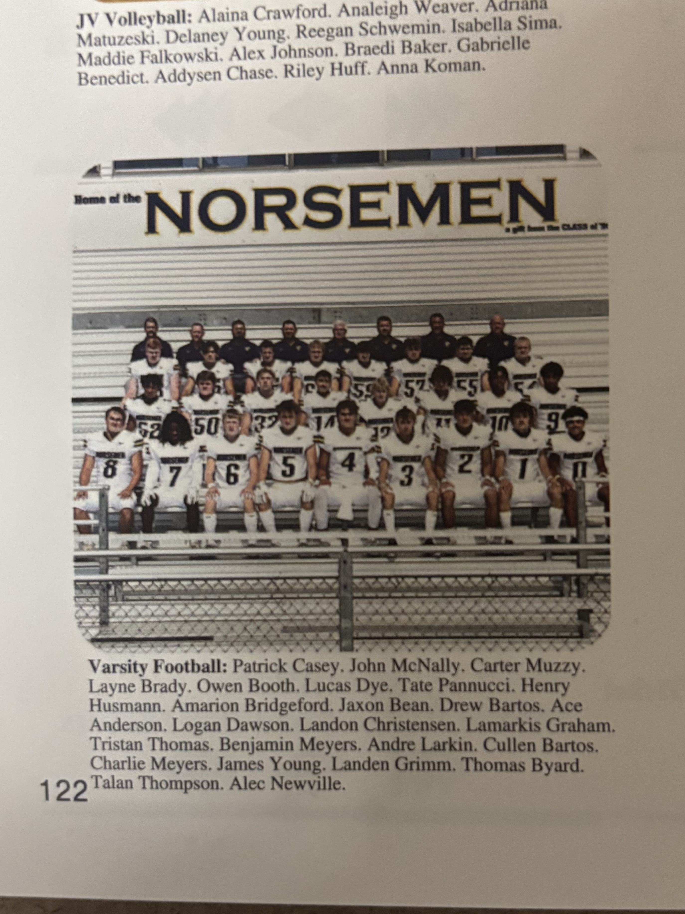

The NORSEMEN of 2023

Record Score Interesting Fact

1-0 NM 17, Pewamo-West. 14 Owen Booth kicks a 23-yard FG field goal with 5 seconds left for win. James Young TD passes to Ben Meyers and Landon Christensen.
2-0 NM 41- Musk. Cath 21 Young throws for school record 398 yards. Christen school record 4 TDs and 260 receiving yards. Meyers and Tristan Thomas rushing TDs.
3-0 *NM 49 Mason Co Cent 12 Young 4 TD passes. Alec Newville 175 receiving yds and 2 TD; Cullen Bartos, TJ Byard and Christensen TD receptions; Newville TD run.
4-0 *NM 69 Hesperia 7 Thomas 3 TDS, Young 2 TD pass (Christenen & Byard); Newville 59-yd TD; Bartos 17-yd TD, Hunter Wilder from 49 & Adam Dugener from 20, Chuck Meyers TD
5-0 *NM 34 Hart 14 Young to Newville 24 TD pass; Thomas 6-yard TD; Young 1-yard QB run; Bartos 2-yard TD run and 18 yd TD pass from Young.
6-0 NM 34, Montague 7 Thomas 2 TDs (6 & 11); Young TD passes to Byard and Christensen; Bartos 10-yard TD.
7-0 *NM18 Ravenna 7 Young only attempts 6 passes but scores both NM TDs from 34 & 1. Bartos field score and NM scores 2 points on a safety,
8-0 *NM 64 Holton 0 JV’s play much of the game; Wilder 2 TD (70,62 &47); Ealom 2 td (2 & 15) Colbert 9 yd TD; Newville 2 (30 & 27) Bartos 6 yd TD; Young to Byard 52 pass TD
9-0 *NM 52 Shelby 14 Young 5 TD passes (Byard 2, Christensen, Chuck Meyers, Newville 1 each), Thomas 2 rushing TD (1 & 9); Colbert to Logan Dawson 40 YD pass TD.
10-0 NM 27 Union City 14 NM scores on 1st play from scrimmage, Young 62 yd pass to Newville: Thomas 2 short rushing TDs and Cullen Bartos 21-yard TD pass from Young.
11-0 NM 27 Lawton 24 Young pass for 256 yards and accounts for all 4 NM TDs. Christenson and Byard TD receptions of 57 and 23. Young TD runs, including the winner from 39.
12-0 NM 28, Pewamo-West.27 NM rallies in final two minutes. Young 4 TD passes (C. Bartos, Newville, D. Bartos, Chistensen). 12 wins the most in NM history.
12-1 NM 21 Menominee 32 After shutout in the first half NM scores 3 TDs in the second half. Young TD passes to Byard and Drew Bartos and a one yard Young run.

2024 Coach Larry Witham 11-2 overall, Playoff qualifier, State semi-finalist, NM Rivers WMC Champs

With many regulars returning from the 2023 season, including a record setting quarterback who would be starting an unprecedented fourth year as the Norse signal caller, the ceiling was sky high for the upcoming NM season. However, shortly after NM’s basketball season came to an end James Young stunned his coaches and teammates by transferring to Muskegon High School. The QB chores then fell on a slight junior from the 2023 JV team by the name of Bryce Colbert. Surely no one could have expected what Colbert contributed to NM’s second consecutive run to the final four. The junior southpaw threw for 2216 yards good for 23 touchdowns with only two of his passes intercepted by his opponents. Colbert, who nearly matched the production of the departed Young spread the wealth as his four most targeted players were TJ Byard, Drew Bartos, Landen Grimm, and Chuck Meyers. Junior Hunter Wilder caught but two passes, but one of those receptions went for 69 yards and a TD against Millington. Wilder and sophomore Cullen Bartos each rushed for more than 500 yards on the season giving head coach Larry Witham hope for more success in 2025. Henry Hussman had 124 tackles to lead the NM defense, but three other Norse had more than 90 tackles as Chuck Meyers & safety Cullen Bartos had 95 and Drew Bartos 90. The Norse again reached the final four and were champs of the Rivers Division of the West Michigan Conference for the third straight season.
In what has recently could only be described as an intense rivalry, North Muskegon and Pewamo-Westphalia may be nearly 100 miles apart from one-another, but that hasn’t deterred these two schools from facing each other in the past few seasons in epic contests, both in football and basketball. Twice Pewamo has gotten the best of NMHS in basketball the last two seasons while NM returned the favor last year in football by defeating P-W twice, including a hard-fought battle to win a come-from-behind contest to cop the 2023 regional title 28-27. These two teams met in the 2023 opener with NM winning another thriller 17-14 on a game-winning field goal from Owen Booth. It was more of the same to begin the 2024 season with the host Pirates scoring a late TD and a successful 2-point conversion to nip the Norse 8-7. The Norse dominated the first half with the big scoring play a 35-yard end around from senior back Drew Bartos. Booth’s PAT gave NM a 7-0 lead that would stand until late in the game when Pewamo-Westphalia capped a long scoring drive with a touchdown to trail 7-6. While the Pirates were lining up to kick the extra point to tie up the game and send it into overtime, an over-eager Norseman jumped offside. The penalty changed the decision by the Pirates to go for two and the victory which they accomplished on a short plunge from inside the two-yard line for the 8-7 win. NM started a new quarterback to begin the season as their three-year starting quarterback James Young transferred to Muskegon High School. Junior Bryce Colbert took over the NM QB duties for NM and did a nice job as he completed 8 of his 21 attempts for 77 yards to five different receivers. Leading NM in rushing was Drew Bartos with 67 yards while his younger brother, sophomore Cullen Bartos rushed for 36 yards.

The Norsemen quickly got back on the winning track with a 43-7 conquest of Shelby. NM broke out of the gates quickly as they score 21 points in the opening quarter. NM wasted no time getting on the board as they marched 80 yards in six plays, all on the ground. The big play on the drive was a 39-yard run by sophomore Cullen Bartos that set up his own TD on a short one-yard plunge. NM then took it to the house, this time a 9-yard drive that was helped by a Shelby penalty for jumping offsides when NM was punting from their own 17-yard line That kept the drive alive and ended a few plays later when junior running back Hunter Wilder raced 57 yards for the second Norse TD. The Norse then made it 21-0 after a Jaxon Bean fumble recovery gave NM the ball at the Shelby 44. Junior quarterback Bryce Colbert then completed his first TD pass in a Norse uniform when he connected with Chuck Meyers from 40-yards out. With just seconds left in the first half Tristan Thomas galloped 32 yards for a tally to make it 27-0. On a broken play Cullen Bartos scrambled to get enough time to get off a pass that Landen Grimm caught in the end zone for a 2-point conversion to send NM into the halftime break with a commanding 29-0 lead. NM then extended their lead to 36-0 early into the third quarter on a 13-yard pass from Colbert to TJ Byard. The Tigers averted a shutout with a fourth quarter TD That NM quickly answered with a 50-yard dash to paydirt from Tristan Thomas. Owen Booth, who was perfect on all his PAT attempts, made the final score NM 43 Shelby 7. Colbert was 10 of 16 for 140 yards and two TDs while the rushing attack was evenly distributed between Tristan Thomas (92 yards and 2 TDS on but 5 carries), Hunter Wilder (79 yards on 3 carries, 1 TD) and Cullen Bartos (72 yards in 6 carries and a TD)

The Norsemen then won 36-20 over a much-improved Mason County Central squad that traveled to NM with a perfect 2-0 record. NM got on board first with a Bryce Colbert to TJ Byard TD connection good for 37 yards with less than five minutes having gone off the clock. A blocked punt by Brennen Allen in the closing moments of the first quarter set up NM’s second score. Taking over at the Spartan 21-yard line it took the Norsemen only three plays to add their second touchdown early into the second quarter on a short 1-yard run by Hunter Wilder to give the Norsemen 13-0 lead. NM then surprised the Spartans with a successful 2-point conversion on a toss from Colbert to Ace Anderson that gave NM a 15-0 lead. The Spartans then went on a time-consuming drive of nearly nine minutes for their first score of the game to close the gap to 15-6 at the halftime break. It took NM less than 15 seconds to score the first touchdown of the second half. A short Spartan kickoff gave NM excellent field position at their own 47 yard-line. On the first play Colbert connected on a short pass to wide receiver Drew Bartos who broke a couple of Spartan tackles to race 53 yards to paydirt. Owen Booth’s PAT from conversion gave NM a 22-6 lead. The Spartans gambled on fourth down in their own territory, but Drew Bartos brought down a Spartan runner well short of the first down marker that turned the ball over to the Norsemen at the MCC 39-yard line. Three plays later Colvert hit Byard on a post pattern from 24 yards out to give NM a commanding 29-6 lead. The Spartans battled back to score a pair of touchdowns to bring life back to the visitors from Scottville. A 12-yard TD pass on the final play of the third quarter made it 29-14 NM and the Spartans made it 29-20 after another time consuming 90-yard drive but their 2-point attempt to make it a one score lead failed with 2:01 left in the contest. An onside kick saw their kick somehow spin backward and NM took over at the Spartan 37-yard line. On the next play Landen Grimm raced 37 yards on an end-around play to make the finals score read NM 36, Mason County Central 20.

Hesperia was no match for the Norsemen as the Blue & Gold cruised to a 42-7 win over the host Panthers with big plays playing a major part in the victory. NM received huge plays from junior Hunter Wilder and Landen Grimm as NM improved to 3-1 on the season. Wilder touched the ball three times on offense and all three of his carries resulted in touchdowns, including a pair of long distance runs from 86 and 27. Wilder nearly added another as he was tackled at the one-yard line after returning a Panther punt 49 yards. Wilder’s 86-yard burst was the 14th longest TD run in NM history and was the 27th TD run by a Norsemen running back over 80 yards dating back to 1932. Grimm’s trio of TDs including a 90-yard return of a kickoff just moments after Hesperia scored their only touchdown of the game in the second quarter. It was the eighth longest kickoff return for six points in NM history and the 27th time in program annals when a Norsemen returned a kickoff for a TD. Grimm scored the first NM TD early in the game when he found himself wide open in the end zone and caught the TD pass from Bryce Colbert. NM mixed up the run with the pass as Colbert threw for 152 yards passing to six difference receivers while six NM running backs totaled 250 yards on the ground led by Wilders three rushes for 114 yards.

Two plays and two touchdowns. That’s how quick the potent NM offense operated in their 42-6 conquest of Hart to post their fourth straight victory, all against their Rivers opponents in the West Michigan Conference. On their first play from scrimmage junior quarterback Bryce Colbert connected with senior wide receiver Drew Bartos for a 57-yard TD strike. After NM forced a Pirate’s punt NM again needed but one play, this time a 52-yard TD toss from Colbert to senior end Chuck Meyers. Colbert was an efficient 15 of 18 passes on the night good for 305 yards and four touchdowns. Four receivers caught multiple passes from Colbert with TJ Byard grabbing seven of Colbert’s aerials good for 123 yards and two touchdowns. Hunter Wilder, who led the stout NM defense with seven solo tackles, scored a rushing TD as did Tristan Thomas as the Norse improve to 4-1 on the season. In addition to the 305 yards the Norse accumulated in the passing game, six NM rushers ran for 167 yards as NM totaled nearly 500 total yards in their conquest of Hart, their 12th straight victory over the Pirates, and their 19th victory in their last 20 meetings with their longtime rival. The win was the 499th in NM football history, one away from a milestone 500th triumph.

The 500 milestone was accomplished, and it was fitting that this historic win came against their oldest foe. The Norsemen defeated Montague 36-8 in the 92nd consecutive meeting between the long-time rivals who have met every year since 1933. NM used a ‘bend- but do not break’ defense, coupled with a big strike offense to move to 5-1 on the season. Twice the Norsemen stopped the Wildcats at the NM one-yard line in the first half and held the ‘Cats’ out of the endzone until the waning minutes of the contest when the winner had long been decided. NM took the opening kickoff and marched 61 yards in 11 plays, culminated with a 1-yard plunge by Hunter Wilder. The big play on the drive was a 30-yard pass from Bryce Colbert to TJ Byard that moved NM deep into Montague territory. The Cats got on the board with a safety two plays after NM stuffed a potential Montague scoring drive at the one-yard line. Midway through the second quarter NM scored on a perfectly executed screen pass from Colbert to sophomore running back Cullen Bartos that was good for 56 yards that gave the Norse a 14-2 lead at halftime. NM padded their lead on a perfectly thrown pass from Colbert to Byard good for 14 yards and a TD. Cullen Bartos then took the snap from center on the extra points and ran to the corner of the endzone to extend NM’s lead to 22-2. Wilder, who had been held in check to but nine yards in six carries, exploded on a sweep of 52 yards for a Norse TD that led to a 29-2 Norse advantage. On the first play from scrimmage following Wilder’s run, Ace Anderson’s interception set up NM’s final score, a 32-yard TD pass from Colbert to Drew Bartos. Owen Booth kicked the extra point, his 26th conversion on the season without a miss for NM’s final points, Montague scored late in the contest to make the final score read 36-8 as NM notched their fifth straight victory after their opening one-point defeat to begin the season.

NM spread the wealth around as six different Norsemen crossed the goal line as NM handed Ravenna a decisive 40-0 loss on the historic NM gridiron. Bryce Colbert tossed three touchdown passes to three receivers as the junior quarterback totaled 240 passing yards. The strong trio of NM backs, Hunter Wilder (1) Cullen Bartos (22) and Tristan Thomas (19) each tallied rushing TDs as NM posted their most lopsided win over a traditionally strong Ravenna team since 2006. Colberts scoring tosses went first to Drew Bartos for 19, followed by a pass, catch and nifty 60-yard connection with Landen Grimm, capped by a Colbert scramble and toss to Chuck Meyers for 12 yards. NM put this game away early as they raced to an early 33-0 halftime lead over a stunned Bulldog eleven. NM then took the opening kickoff to begin the second half and moved steadily downfield to set up a 19-yard TD run by Tristan Thomas to make the scoreboard read NM 40, Ravenna 0 and forced a running clock the rest of the game. Double-teamed all game long, TJ Byard was kept out of the end zone but his 34-yard reception amongst heavy traffic set up NM’s first TD on a one-yard plunge by Hunter Wilder. A blocked punt by Henry Hussman late in the first half set up a Colbert TD pass to Meyers.

You know it’s going to be a good season when the Norse can defeat Oakridge. NM’s 34-17 conquest of the visiting Eagles snapped a 16-game losing streak and was only the second Norse victory over the visitors in 30 games. NM won by 17 points, but that differential is deceiving as NM needed a second half rally to pull off the win. NM trailed Oakridge with only 1:40 left in the third quarter 17-14 before the Norse game up with the biggest play of the game. The Norse were a big strike team in 2024 and that was put on display on the very next play after the Eagles took the lead on a field goal. Senior defensive back Jaden Villapando fielded the Oakridge kickoff on his own six yard and sped through the entire Oakridge defense 94 yards to give NM the lead they would not relinquish. A fired-up Norse defense then forced a three and out for the Eagles that set up a 48-yard scoring drive. Lining up to kick a field goal NM either scored a TD on a broken play or on a well-conceived play as holder Cullen Bartos caught the errant (or planned) snap from center and hit a wide open Villapando in the endzone for six points instead of three to make it a two-score lead for the host Norsemen. NM then put the icing on the cake following an interception and 46-yard return by TJ Byard. Bryce Colbert set up his 1-yard quarterback keeper on a nifty 15 yards run that set up NM’s final TD to make the final score read 34-17. Oakridge got on the board first late in the first quarter, but NM responded quickly with a 71 TD pass from Colbert to Byard. A second hookup from Colbert to Byard for 14 yards gave NM a 14-7 that Oakridge equaled with a TD with two minutes remaining to send both teams into halftime tied at 14-14.

NM, with an 8-1 record, would enter the playoffs as the top seed in their district with their first-round opponent Evart. In the first meeting between the two schools in any sport NM had little trouble with the visitors as they romped over Evart 56-0. It could have been worse as the Norse forced a running clock for the entire second half after they exploded to a 49-0 halftime lead. The Norse excelled both with the pass and the run as they rushed for 271 yards and passed for 213 with junior quarterback Bryce Colbert a perfect 8-8 with three of his tosses going for touchdowns. Two of Colbert’s aerials TDs went to TJ Byard, one for 55 and another for 50. Colbert went to the air early and connected from 33 yards out with Drew Bartos to give NM an early 7-0 and the rout was on. Junior running back Hunter Wilder scored a pair of TDs, including an 88-yard gallop on the last play of the first half. Landen Grimm tallied on a 36-yard burst while sophomore Keefe Kersman scored his first TD in a Norse uniform with a 20-yard TD in the second half.

For the second straight week NM would face an opponent for the first time in program history and again came away with a victory as NM defeated McBain 27-7 to earn their second consecutive district title. The bend, but do not break defense held the Ramblers, who came into the game averaging a whopping 42 points per game, to but seven points with Cullen Bartos with 14 tackles and Henry Hussman with 11 stops leading the NM defense. Cullen Bartos also rushed for three touchdowns on runs of 12, 6, & 3 while his brother Drew Bartos tallied NM’s other six-pointer on a 23-yard scoring toss from Bryce Colbert. Colbert was again efficient with his passing as the junior quarterback connected on 10 of his 13 passes for 161 yards. Bartos led Norse rushers with 77 yards while Hunter Wilder notched 60 yards on nine carries. Drew Bartos was the favorite target for Colbert with a season high 122 yards on five receptions. The victory sets up a rematch with Menomonee in the regional final with the Norse traveling nearly 500 miles for their first ever journey to the UP, more than double their previous longest road trip from 1979 when they traveled to Detroit to play Detroit Lutheran West.

NM was now faced with an ominous task. Not only would they have to play a heavily favored Menominee team who ended the Norse run the previous season, but they would have to make a 450 mile, eight-hour trip to Menominee. It would be the first trip a NM team would make to the UP in any sport but my how the Norse responded! NM dominated the Maroons with a 23-0 shutout win using a trio of methods: a running attack where the duo of Hunter Wilder and Cullen Bartos would rush for 165 yards, a passing attack led by Bruce Colbert that added 125 yards, and a stonewall defense that forced several Menominee turnovers. NM took a 7-0 lead on a 21-yard run by Wilder and added there more points early in the second half on an Owen Booth field goal. TD runs by Bartos and Wilder capped the NM win to bring the regional trophy back to an already bulging NM trophy case. The long journey to the UP did not deter the Norsemen from enjoying a huge turnout from their loyal followers.: “When we came onto the field just before the start, I couldn’t believe the amount of people wearing the blue and gold and the noise they made. It sounded like it was a home game,” said NM coach Larry Witham.

It was on to Lansing as the Norsemen would make it all the way to the final four for the second straight year. Their opponent was a very strong Millington team that was also appearing in the state semis once again. The game perhaps was won by Millington on a trick hook & ladder play with just seconds left in the first half and Millington out of time outs. A pass from Truk Terburk to Bryce Martin was executed perfectly as Millington jumped ahead of NM 21-14 at the halftime break. Millington scored first but NM quickly followed up with a 69-yard pass play from Bryce Colbert to Hunter Wilder, only the second pass completed to Wilder during the 2024 season. A second Millington touchdown was matched with 5:33 left in the half as sophomore Cullen Bartos scored the first of his three one-yard touchdowns to knot the game at 14 all. There was 0:17 showing on the clock when Martin crossed the NM goal line to give Millington the momentum while sending a stunned NM team to the locker room down 21-14. Poor field position throughout the third quarter thwarted any attempts for NM to operate as Millington scored a pair of TDs and a safety to give the Cardinals from the thumb area of Michigan a seemingly safe 35-14 lead with only nine minutes to play. When NM fumbled the ensuing kickoff to give the ball back to Millington it appeared even more gloomy for the Norsemen. However, NM forced a quick three and out and quickly marched 78 yards for a TD capped by a Cullen Bartos 1-yard TD. NM then recovered a Millington fumble and suddenly there was life for the Norse. On a fourth downplay Bryce Colbert then connected on a 38-yard pass to Drew Bartos that took the ball to the Cardinal five-yard line. Two plays later Cullen Bartos was in the end zone and NM trailed 35-28. A perfectly executed on side kick was first believed to have been recovered by the Norse but when they finally untangled the pile it was a Millington player who was on the bottom with the football. Millington then ran out the clock with a pair of first downs to clinch the win and end NM’s improbable season at 11-2.

As fate would have it, it was likely the state championship was decided in Lansing between the Norse and Millington as the Cardinals of Millington breezed to the state D7 championship the following weekend with a 24-0 shutout of Monroe St Mary Catholic. Post season honors were plentiful for several of the Norsemen. On defense linebacker Henry Hussman was declared the defensive player of the year for the entire Muskegon area that included all schools. Also tabbed for first string defensive honors were Hussman’s co-linebackers Chuck Meyers and Drew Bartos while sophomore defensive back Cullen Bartos was also selected for first team honors. To have four players tabbed for first team honors is quite a feat for the area’s smallest school.

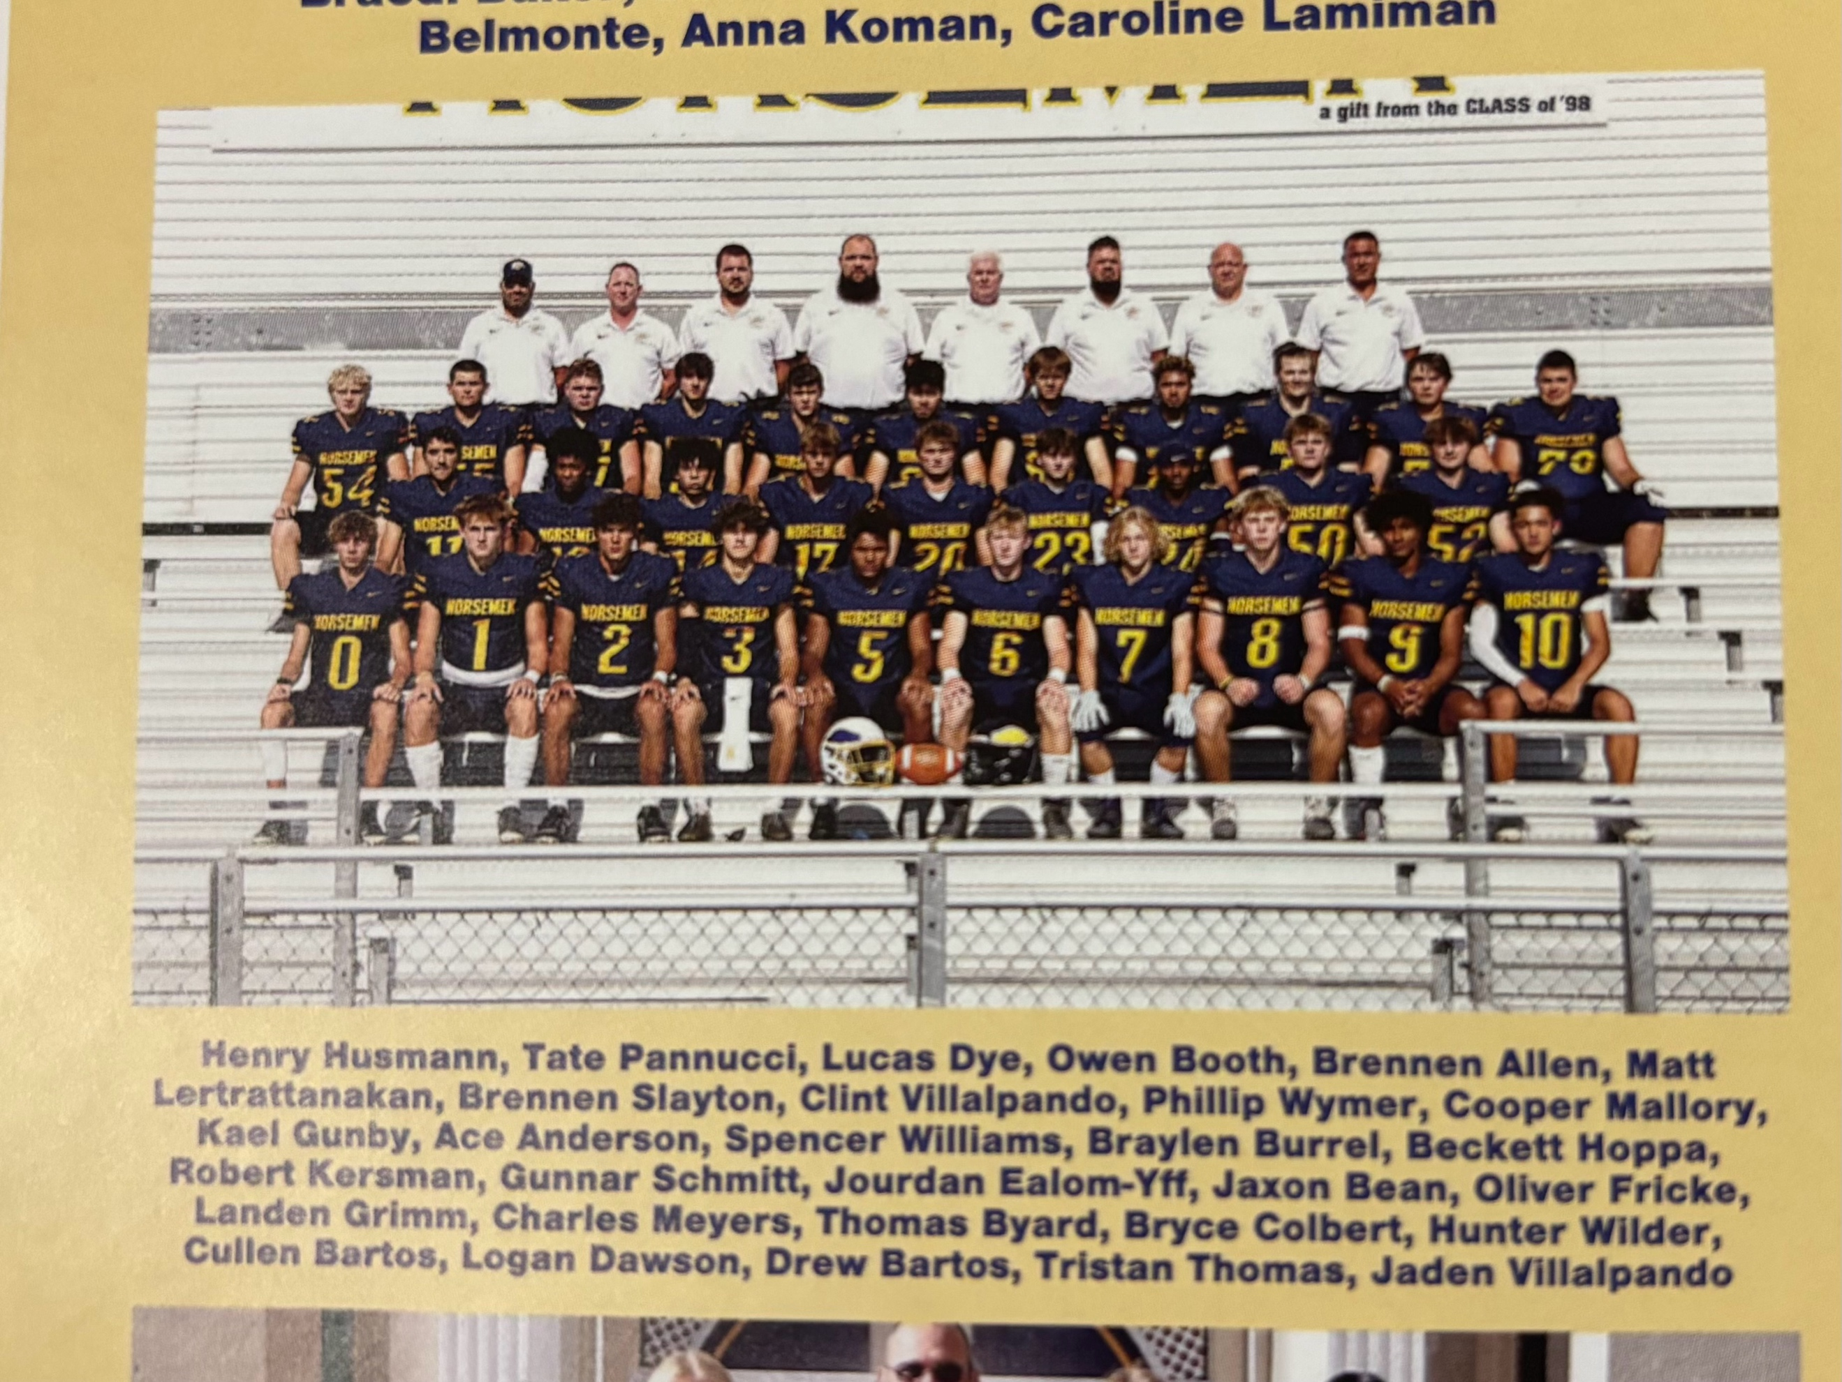

The NORSEMEN of 2024

3rd Row L-R: Henry Hausman, Tate Pannucci, Lucas Dye, Owen Booth, Brennen Allen, Matt Lertrattanakan, Brennen Slayton, Clint Villapando, Phillip Wymer, Cooper Mallory, Kael Gunby
2nd Row L-R: Ace Anderson, Spencer Williams, Braylen Burrel, Beckett Hoppa, Keefe Kersman, Gunnar Schmitt, Jourdon Ealom-Yff, Jaxon Bean, Oliver Fricke
1st Row: Landen Grimm, Charles Meyers, TJ Byard, Bryce Colbert, Hunter Wilder, Cullen Bartos, Logan Dawson, Drew Bartos, Tristan Thomas, Jaden Villapando
Coaches in the top row L-R: Ryan Rimedio, Andy Bartos, John Ribesky, Larry Witham (HC), Matt Dye, Bryan Rypstra, Ken Byard

Record Score Interesting Fact

0-1 NM 7, Pewamo-West. 8 Pewamo scores late and made 2 ptr. To nip NM. Drew Bartos NM TD on 35 yd end around.
1-1 NM 43- Shelby 7 NM 21 1st qtr. points. Bryce Colbert 2 TD passes; Tristan Thomas 2 TDs; TJ Byard & Cuck Meyers TD receptions, Hunter Wilder & Drew Bartos TD runs.
2-1 *NM 36 Mason Co Cent 20 Colbert 3 TDS passes (2 to Byard 1 to D Bartos), Landen Grimm 37-yard TD runs, Wilder 1 yard TD.
3-1 *NM 42 Hesperia 7 Wilder 3 TDS (86, 27 & 1); Landen Grimm 3 TDs (90 yards kickoff, 35 pass from Colbert. 24 yd run
4-1 *NM 42 Hart 6 Colbert 4 TDS passes good for 305 yards. Byard 2 TDs and 7 receptions for 123 yards. Meyers, D. Bartos, Thomas & Wilder TDs.
5-1 NM 36, Montague 8 Colbert 3 TD passes (Byard (14), C Bartos (56) D Bartos (32), Hunter 2 TD’s (1 & 52).
6-1 NM 40 Ravenna 0 Colbert 240 yards and 3 TD passes (D Bartos 19, Grimm 60, Meyers 12, C Bartos (22) Thomas 19 and Wilder 1 yd TDs.
7-1 NM 2 Holton 0 Once again NM earns a forfeit victory over Holton.
8-1 NM 34 Oakridge 17 Jaden Villpapando 94 Koff TD, 8 yd pass from Bartos, Byard 71 & 14 YD pass from Colbert, Colbert 1 yard run
9-1 NM 56, Evart 7 NM runs for 271 and passes for 213. Byard 2 TD pass, D Bartos 33 TD pass, Wilder 2 TDS (5 & 88) Keefe Kersman 20 yd TD
10-1 NM 27 McBain 7 Bartos brothers all 4 NM TDs, C. Bartos runs of 12,6 & 3) D Bartos 23 pass from Colbert.
11-1 NM 23 Menominee 0 NM avenges loss from previous season. Wilder & C Bartos rush for 165 yards. Colbert 125 yards passing.
11-2 NM 28 Millington 35 Cullen Bartos three 1-yd TDs, Colbert to Wilder 69 yards TD. D Bartos 11 tackles and 68 receiving yards.

2025 Coach Larry Witham (7-4 overall, Playoff qualifier, NM Rivers WMC Champs)
When a team loses several stalwarts from one of the most successful team in NM’s long history, it was inevitable that Norsemen fans could not expect the same in 2025. The graduation of such standouts such as Henry Houseman, Drew Bartos, Jaden Villapando, Chuck Meyers, all-WMC Conference performers, coupled with the loss of All-State end TJ Byard, Tristian Thomas and Landen Grimm would be a tall task to ask of a school with such a small enrollment as NMHS.
Somehow veteran head coach Larry Witham and his staff put up more than a respectable record in 2025, accumulating seven wins against four losses. Once again, the Norsemen swept all their opponents in the Rivers division of the West Michigan Conference to earn their fourth consecutive WMC championship.
Norse fans were treated once again to an entertaining brand of offensive fireworks on offense that saw senior quarterback Bryce Colbert throw for 2475 yards in 11 games. His 29 TD passes were just two off the school record of 31 set by his predecessor James Young in 13 games in 2023. Replacing all-state receiver TJ Byard would be a formidable task but more than rising to the occasion was junior Beckett Hoppa who spent his entire sophomore season on the JV team. Hoppa was a touchdown machine as he caught 37 passes for 826 yards, with 15 of those receptions counting for six points, easily a NM school record. So consistent was Hoppa that after not grabbing a TD pass in the NM opening game of the season, he would catch a TD pass in all the remaining 10 games, a record that could be tough to surpass in the future.
Although NM gave up nearly triple of the measly 122 points given up by the Norsemen ‘D” from 2024, it surely was no fault of NM’s one-man wrecking crew of junior Cullen Bartos. Defensive stats are without question the most suspect of those attained as a defensive performer. This author prides himself on not ‘padding’ tackles that is so commonplace with ‘generous’ statisticians of many prep teams. I credited Bartos for 116 SOLO tackles during the season, including what surely must be a school record of 19 solo tackles in NM’s game with Oakridge.
The Norse reached the playoffs once again before being ousted by one of Pewamo-Westphalia’s strongest teams in their school’s history.

Pewamo-Westphalia showed the Norsemen what a perennial power looks like in a convincing 35-6 victory in the Norse home opener. Winners of 4 four state championships and six state final appearances since 2013, the Pirates had too much firepower and too many Thelens for a NM team that is trying to fill the vacated holes from many of their star players who have moved on after getting their diplomas.
Although the margin of defeat appears lopsided, the young Norsemen did show some promise for the long season that looms ahead. It was a scoreless first quarter between the two recent rivals that features two former Norse football players in their administration, former NM quarterback and now P-W AD Troy Forton, and current principle for the Pirates, former NM wide received Ryan Portenga.
The biggest thorn in the side for the Norsemen was senior Pirate quarterback Ty Thelen, who rushed for 137 yards and three TDs while throwing for an addition tally. One of six Thelens on the Pirate roster, the two-way standout for P-W also had one of the three passes picked off by the Pirate’s defense and several times broke away for key first down pickups that kept the ball away from the NM offense.
Although the stats will show the NM quarterback had a mediocre day, his receivers didn’t do Colbert too many favors as many of his passes were dropped. A testament to Colbert’s scrambling abilities was Bryce was not sacked all night by P-W’s aggressive defense. Colbert did throw for 128 yards on the evening, including the lone NM score on the evening, a short TD toss to Cullen Bartos.
It was in the rushing department where the Norsemen fell short as they were only able to ground out 48 yards against a stout Pewamo defense. The Norse held off the Pirates until midway through the second quarter when it took nine plays for the Pirates would score the game’s first TD. A quick three and out forced a Norse punt that would lead to the second Pirate score shortly before halftime. The big play on the drive was a dazzling 21-yard run by Thelen on a third and long play where he eluded several Norse tacklers. On the next play Thelen hit Cody Pohl on a 20-yard pass play to give the Pirates a 14-0 lead at intermission. A last-ditch halftime drive by the Norse fell short with one of the three interceptions by P-W in the game.
A pass interception led to a 21-0 lead early into the third quarter that iced the contest for P-W. The Norse followed with their only TD drive of the game. Aided by a couple of long pass plays from Colbert to Beckett Hoppa and Bartos, the Norse got on the board when Bartos caught a Colbert aerial in heavy traffic from four-yard outs for the lone Norse tally in the game.

The Norse won their 12th consecutive game over the Shelby Tigers, but this was not your Shelby team that the Norsemen used as whipping boys during this stretch. The Norse had to go all out to nip the Tigers 33-30 as they evened their season record at 1-1.
The Tigers even had a chance to pull off a stunning upset late in the game. After Hunter Wilder broke through left tackle for a 24-yard TD to put the Norsemen up 27-16, the Tigers wasted little time to answer when they mounted a six-play drive that closed the Norse lead to 27-24.
The Tigers than executed what appeared to be a successful onside kick but an unfortunate penalty for being offsides negated the play and the very fortunate Norsemen, and their fans breathed a sigh of relief. After being bottled earlier up by a staunch Tiger defense where he was limited to but 44 rushing yards in 10 attempts, Wilder raced around left end to score from 46 yards out to make it a two score Norse lead at 33-24 following a Gunner Schmitt made extra point. Two plays earlier Wilder had a 48-yard dash to paydirt called back by a NM penalty on a very similar play but Wilder’s second back breaking play against the Tigers saw no flags.
‘Never to say die’ the Tigers did score a last second TD to make the final score 33-30.
Coach Phil Fortier’s Tigers, who have not experienced a winning season since 2013, showed early into the contest that Shelby was not going to be any pushover as they answered an early NM TD with a QB scamper by Isaac Garcia and a two-point conversion to take an 8-7 lead over the Norsemen. The Norse then took a lead they would never relinquish on a very fortuitous TD aerial that was deflected into the hands of Beckett Hoppa that resulted in a 39-yard TD pass from Bryce Colbert. NM then padded their lead to 19-8 shortly before halftime on a nine-yard run by Cullen Bartos. The score remained unchanged until Shelby took advantage early into the fourth quarter of a muffed NM punt they turned into eight points to set up the game’s final exciting moments. After a slow start Wilder would finish the game with 115 rushing yards, 71 of those yards coming on his final two carries of the game. Colbert would complete 12 of his 19 passes for 185 yards with Hoppa on the receiving end of three of those completions for 120 yards and a TD. Hoppa was also a force on defense with 10 tackles, that was also equaled by NM’s defensive all state candidate Cullen Bartos.

North Muskegon mixed in the run with the pass to overwhelm Mason County Central in a Rivers Conference game held in Scottville. Highlighting the Norse victory was a record setting touchdown run of 99 yards by junior Cullen Bartos, eclipsing the previous record set in 1961 of 97 yards by Bill Young. With Mason County on a drive deep in NM territory late in the third period, a defensive hit by Bartos created a fumble that was recovered by a Norseman at their own one yard-line. Running out of the Wildcat formation Bartos broke through a big hole created by the Norsemen offensive line and raced 99 yards for the record-breaking TD. The Bartos long scamper pushed the NM lead to 35-13. In the fourth quarter Norse quarterback Bryce Colbert, on his only carry of the game ran 26 yards on a designed quarterback keeper for the final NM touchdown to make the final score 42-13. Colbert had a big game on the day by throwing for 301 yards and four touchdowns. Catching TD passes for the Norsemen were Beckett Hoppa with two six-pointers, with Braylen Burrel and Cullen each grabbing a Colbert aerial for TDs. Gunner Schmitt was perfect on all seven of his extra point attempts. The Norse were also productive in the rushing department led by Bartos with 158 total yards with Hunter Wilder adding 82 as the Norse totaled 567 yards in the victory, the 10th straight conquest over the years against the Spartans.

On a picturesque early Fall evening with the Maple trees surrounding the outer perimeter of Fred Jacks Field displaying an early change of colors, the Norsemen rushed for a season high 421 yards to pound Hesperia 54-21 to move to 3-1 on the season. Cullen Bartos tallied 173 yards and three touchdowns in but six carries with Hunter Wilder racing 148 yards in seven attempts and two TDs to highlight NM’s rushing game. Senior quarterback Bruce Colbert only passed eight times in the contest, all in the first half for 106 yards and two TD strikes but ran for 69 yards in four carries as NM posted their third straight victory after their opening game loss to powerful Pewamo-Westphalia. Bartos wasted no time to make known this was going to be a productive night on the ground for the host Norsemen as he took the first offensive carry of the game on a direct snap from center and raced untouched 60 yards for the first of the eight NM TDs accrued on the evening. Hesperia quickly showed they were not going to be a pushover for NM as they took the ensuing kickoff and drove deep into NM territory before the drive was halted on a Carlton Williams interception in the end zone. NM then had an efficient 80-yard march capped by a short three-yard toss from Colbert to Drew Gabriel to improve their lead to 14-0. The score went to 21-0 early in the second quarter when Colbert teamed up with Beckett Hoppa from 19 yards out. The Panthers, aided by a key fourth down pickup crossed the NM goal line on a quarterback sneak to close the gap to 21-7. Bryce Colbert than showed he is more than just a passing quarterback as he keyed the next NM tally by rushing on two quarterback keeper plays that totaled 49 yards that set up a short Bartos score to make it 28-7. Hesperia then capitalized on a Colbert interception to set up a late second quarter TD that sent the two rivers conference teams into halftime with NM on top 28-14. The visitors then took the second half kickoff and drove deep into NM territory before Eli Gomez forced a Panther fumble recovered by the Norsemen’s Jace Thompson. That would be the last serious threat by Hesperia the rest of the game as the Norse rushing game dominated the game’s final minutes. It took NM just two plays to go 88 yards as Bartos dashed 52 yards to stretch the Norse lead to 34-14. A perfectly executed option play from Colbert to Hunter Wilder was good for 32 yards and another Norse TD.
NM closed out their scoring on a 25-yard burst by Wilder while sophomore Gavin Quarry got in on the act by carrying on eight straight rushes before scoring from four yards out for the final NM points. Hesperia scored on a late TD passing bomb to make the final score read 54-21.

The Norsemen defeated a well-drilled Hart eleven 29-18 in a game whereby the statistics of time of possession played fool’s gold on the Hart gridiron. The win was the 13th straight NM win over Hart and the 20th victory in the last 21 meetings between the two old-time rivals, but the win was not your traditional walk in the park conquest as in the past. Pirate head coach Joe Tanis has groomed a formidable team built around a unique offense that closely resembles the old single wing used during your ‘ole announcers’ childhood. Although I don’t have the actual time of possession stat at my disposal, it was clear after watching the film of this contest from my home far to the south in the Sunshine State, that it looked like Hart had the ball forever. But veteran Norse head coach Larry Witham, who once was the JV coach at Hart and helped turn the Hart football program into a competitive unit, used his ‘bend but do not break’ defense to pull off the victory. The Pirates wasted no time in showing the Norsemen that they came to play as they picked off a Bryce Colbert pass on NM’s first possession in NM territory. After several running plays, that churned up time as well as first downs, Pirate quarterback – err tailback – Kolt Rockwell surprised the Norse defense geared up to stop the run, with a pass in the endzone to a wide-open Logan Jorrisen. Surprisingly, in today’s era of a soccer style kickers Hart went for the two-point conversion that was stopped by the Norse. The Norse took the lead after the Pirate’s score on an 18-yard sweep of right end by Hunter Wilder. Drew Gabriel than kicked the extra point to give the Norse a slim 7-6 lead. The big play on the drive was a 42-yard pass play to Cullen Bartos. The Pirates than mounted a 90-yard drive that ate up the remaining minutes of the opening quarter and well into the second before Kyle Greener powered in from five yards out to give the lead back to the Pirates at 12-7. After it appeared that Hart had forced NM to punt on fourth and long, the Pirates were penalized on Bryce Colbert’s punt that kept the drive alive. Colbert than connected on a 45-yard bomb to Drew Gabriel that set up a Wilder run off tackle as the Norsemen regained the lead at 14-12. Hart drove deep into NM territory but with time running out in the first half, NM defensive back Beckett Hoppa came up with a key interception that preserved NM’s ever slight advantage at halftime. The Pirates received the second half kickoff and chewed up half of the clock in the third quarter before scoring on a well-designed pass play to regain the lead at 18-14. Fortunately, for the many Norse fans who journeyed to Hart, it would be the last points earned by the pesky Pirates. When times are at their toughest the Norse can always turn to their brilliant versatile all state candidate Cullen Bartos. The top NM defensive player, Bartos is no slouch on offense. A short pass in the flat to Bartos became a long 32-yard pickup setting up the touchdown that would give NM the lead they would not relinquish. The TD did not come easy for the visiting Norsemen as they scored on a fourth and 10 play on a well-executed pass from Colbert to Beckett Hoppa. On a busted play for the extra point Bartos took the mishandled snap from center and connected with Hoppa for the two-pointer to make the scoreboard in Hart read: NM 22-Hart 18. Until the Norse scored their final touchdown on a 37-yard burst up the middle by Bartos to give NM the lead at 29-18, the difference in the game was the difference in extra points.

Montague spoiled Homecoming for the Norsemen as they used a relentless ground attack to defeat the Norse 39-26. The loss by the Norse was their first in the West Michigan Conference in three years although their record in the newly formed Rivers Division remains spotless as the Wildcats are in the Lakes Division. Penalties and failure to slow up the double wing offense by the Wildcats contributed to the Norse defeat. The first penalty cost the Norsemen six points as a 45-yard TD run by NM quarterback Bryce Colbert was denied due to a penalty. After the Norsemen then had to punt the ball, it took Montague just one play to show it was going to be a long night for the NM defense. On their first play from the line of scrimmage Devlin Dean raced 91 yards for the score and gave Montague a lead they would never relinquish. Dean’s long gallop would be the first of nearly 500 yards the Wildcats would total during the game. The Montague trio of backs comprised of Dean, Cole Moss and Eli Peterson would each run for more than 100 yards in their balanced attack. Meanwhile, the Norse had to mostly go to their passing game to churn out yardage as the Montague defense limited Norse running backs to but 77 yards on the ground. Bryce Colbert tossed for 285 yards, but he needed what may have been a school record 44 attempts to post that yardage. Ironically, Colbert’s lone TD pass on the evening came on his 44th and last throw in the game, a 10-yard completion to Beckett Hoppa. After Montague pulled in front 12-0 NM capped a long drive with a Colbert keeper to narrow the gap to 12-6. However, Montague, who never had to punt the entire game, took the ensuing kickoff and drove relentlessly down the field with Dean scoring his second TD to give the visitors a 19-6 lead at halftime. The Cats then delivered the possible knockout blow to begin the second half when Cole Moss broke a pair of tackles and sprinted 54 yards to paydirt to extend their lead to 26-6. The Norse than showed some offensive spark as they scored just a little more than a minute later on a four-yard run from Hunter Wilder. NM fans suddenly had their hopes raised for a possible Norse comeback when Drew Gabriel scooped up a Wildcat fumble and raced 55 yards for a TD. For the third straight time, NM was unsuccessful with an extra point attempt but were down by only one score 26-18. But it was not to be as the NM defense was not able to contain Montague’s rushing attack, and the Wildcats tallied a pair of TDs to pull away from the host Norsemen. A Colbert TD pass to Hoppa followed by a two-point conversion pass to Cullen Bartos made the final score 39-26. NM did receive a consolation prize when word was received of a Hart win over Mason County Central that clinched the Rivers Division championship for the Norse, their fourth straight title in the newly formed West Michigan Conference.

The Norsemen removed all doubt as to who the top team in the River Division of the West Michigan Conference is in 2025 as the NM 36-29 victory over Ravenna completed a sweep of all their opponents in the recently formed division. The Norse used the heroics of two-way standout Cullen Bartos as the junior standout scored the winning touchdown in the fourth quarter on an electrifying 96-yard kickoff return just moments after the Bulldogs had tied the game at 29 all. It was the second time this season that a Bartos long scamper had etched his name in the NM record book. Just weeks after his 99-yard TD run from scrimmage in a win over Mason County Central put Bartos as the all-time leader in that department, his long kickoff return was the third longest return in Norse history. Veteran Norse head coach Larry Witham received a great game from senior running back Hunter Wilder who ran with reckless abandum in the win. Most of Wilder’s 89 rushing yards came at pivotal times in the hard-fought contest. However, his first big play in the game came in the opening quarter when he received a perfect pass on a wheel route from Bryce Colbert on a 4th and 14 yards to go play that was good for 20 yards and a Norse touchdown. A Colbert pass for two points to Drew Gabriel tied the game at 8-8 after the Bulldogs scored an earlier TD. NM than took the lead at 15-8 when Wilder ran through several Bulldog tacklers as he raced 30 yards for the second Norse score. Ravenna than used a crushing ground attack to knot the score at 15 all. A perfect Colbert aerial where he hit Beckett Hoppa in perfect stride gave the lead back to the visitors at 22-15. It looked like the Norse were going to take that lead into the halftime break, but the Bulldogs scored with no time on the clock to even the score at the half. Wilder than ran wild as his 13-yard TD run capped a 75-yard drive to begin the second half as NM retook the lead at 29-22. With 8:32 left in the game Ravenna again deadlocked the contest at 29-29 to set up Bartos game wining kickoff return. Colbert had an efficient passing game by completing 11 of his 14 passes good for 186 yards and two TDs. After being overwhelmed the previous week by a powerful Montague running attack, the Norse defense, although giving up 29 points, was much improved from the previous week. Drew Gabriel was in on 14 tackles for the Norse while Bartos added 11, including forcing a Ravenna fumble on a Bulldog drive that was recovered by Carlton Williams.

Playing for the first time in 16 years in a rivalry that dates to 1935, the Norsemen used the passing arm of Bryce Colbert to aid in their high scoring 56-34 win over Newaygo. The Lions didn’t play like a team that came into the contest seeking their first win of the season – not at all!
The Norse got off to an inauspicious start when on the opening kick of the game the NM receiver thought Newaygo’s opening kickoff was going out of bounds, only to see the pigskin take a right turn and was recovered by Newaygo. The stunned Norsemen then saw the visitors score on the next play to take a 7-0 lead. NM quickly bounced back to tally on the first of Colbert’s TD passes with a 25-yard strike to Beckett Hoopa. The two-point try to take the lead failed as the Lions led 7-6. It was clear as far back as the first game of the NM season that the Norsemen were no threat to have an unscored upon season as the Hall of Fame Norsemen accomplished more than 80 years ago. Once again it was a bend-but do not break defense whereby the Norsemen had to outscore their opponents and that was the case against the pesky Lions. Newaygo marched downfield to make the scoreboard at the Northend of Fred Jack’s field show the Lions with a 14-6 lead. NM would tie the game at 14-14 following a 30-yard TD pass from Colbert to Carlton Williams and a successful 2-yard PAT pass from Colbert to Cullen Bartos. Playing like a team that was not at all intimidated by the heavily favored Norsemen, Newaygo once again regained the lead only to see the Norsemen quickly answer with Colbert capping a long drive with a short 4-yard TD pass to Bartos. Drew Gabriel booted the extra point through the goalposts to give NM a slim 21-20 lead at halftime. The NM defense forced a rare three and out to open the second half that NM turned into seven points on a 19-yard pass from Colbert to Gabriel. Oliver Fricke than forced a Newaygo fumble at the Newaygo 15-yard line. On the first play Colbert found basketball star Braylen Burrell open in the end one and it appeared that Norse were going to break the game wide open as they led 35-20. The Lions, however, refused to fold and scored with just over three minutes left in the third quarter, but missed on the extra point as the Norse had a 2-score lead at 35-26. It was on the next possession when one play may have played a pivotal role in this contest. With the Norse facing a fourth and long and Colbert back to punt, the snap from center sailed well over Colbert’s head. Colbert scurried back to retrieve the ball near his own end zone. With no chance to punt the ball Colbert spotted Bartos open a short distance away and then Cullen Bartos did what Bartos does best---make a big play. The all-state candidate turned what appeared to be disaster into a 37-yard first down. On the first play of the final quarter Hunter Wilder raced 19 yards for a Norse TD to pull ahead 42-26. Newaygo kept up their intense play by scoring once again and a successful 2-pointer made it a one score game at 42-34.The Norse finally gave themselves some breathing room aided by a nice kickoff return by Wilder and a long Wilder 37-yard dash that set up a short 3-yard TD run by Bartos. Bartos then took a direct snap from center and hit Bryce Colbert in stride with a perfect pass that went for 48 yards and the game’s final score in the 56-34 shootout. Colbert’s five TD passes were just one shy of a 55-year-old record that was set by Rick Jones in a 1970 rout of Scottville.

In what has been a major shortcoming for the Norsemen in 2025 again reared its ugly head as the Norse suffered their third defeat of the season 41-27 to Oakridge. The host Eagles rushed for 407 yards to hold off the passing of NM’s Bryce Colbert who nearly matched the Oakridge rushing stats by throwing for 370 yards. There was only one punt in the ballgame, none by Oakridge who had their only drive not turned into six points on the evening stopped on a fumble caused by NM linebacker Hunter Wilder. If not for NM’s failure to score a pair of touchdowns in the first half when they were deep in Oakridge territory the outcome of this contest could have been far different. On their initial drive of the game NM was at the Eagles one yard line but two rushing plays were stopped by the hosts. An 80-yard kickoff return by Wilder set up another golden NM scoring opportunity but a botched handoff resulted in a NM fumble at the 11-yard line that put a crushing halt to the drive. The Eagles then marched 89 yards and scored on the final play of the first half to take an improbable 14-0 lead at halftime. The Eagles took the second half kickoff and chewed up seven minutes off the clock to score from shortrange and put a damper on Norse hopes for victory. The Norse didn’t fold, however and punched in a pair of touchdowns to make it a one score game. The first score occurred with NM looking at a difficult fourth and goal situation from the 22-yard line, but Colbert hit his junior tight end Drew Gabriel who somehow fought his way into the end zone. Veteran head coach Larry Witham, fully aware that his defense was struggling to stop the Eagles running attack, had his Norse attempt an onside kick that was executed perfectly that set up a short 4-yard TD pass to Beckett Hoppa. Although the extra point attempt was blocked it still became a one score game with NM trailing 28-20.
Oakridge did recover the second NM onside kick and made it a two-score contest at 34-20. Colbert again went to the air and following a long completion to Bartos that was stopped at the one-yard line Colbert scored on a keeper to once again make it a one score game at 34-37. The Norse couldn’t stop the Eagles who not only ran off most of the remaining time but also scored with a minute remaining to make the final score read 41-27. Oakridge limited NM to but 17 total yards rushing, with 25 of those yards coming on one burst by Wilder. Although through the years there is no leader as to the number of tackles recorded in a single game (sorry) it is probable that Colon Bartos would be near, or at the top of the list. The hard hitting junior defensive back recorded 19 solo tackles as well as a pair of assists to slow down the Eagle express. Bartos also placed a big role in the Norse offense as he was on the receiving end of 11 of Colbert’s completions totaling 130 yards.

North Muskegon roared into the second round of the MHSAA playoffs with a resounding 48-6 conquest of Saranac in the first ever meeting between the two schools. Only a third quarter touchdown by the visitors from Mid-Michigan prevented the Norsemen from posting their first shutout of the campaign. Bryce Colbert threw five touchdown passes to three different receivers and 254 total yards to pace the Norse offense while several players on defense helped post their finest defensive performance of the season. Despite ideal conditions at Fred Jacks field the Redhawks were nearly shutout in the passing game as they completed but three passes for only five total yards. When Saranac tried to throw deep it was usually Carlton Williams who was there to knock a pass down. Hunter Wilder made the most of his opportunities as he ran for 98 yards in a modest five carries. The senior running back jump started the Norse offense late in the first quarter when he raced 70 yards for the first of his two rushing touchdowns. He later added a 10-yard tally and was on the receiving end of a 40-yard TD strike from Colbert. Two other long touchdown runs by Wilder were denied due to a Norse penalty that negated a 66-yard pass play from Colbert and a long run to begin the fourth quarter was also whistled back. The Redhawks who came into the contest with a 7-2 record hung around for much of the first half before the Norsemen scored three touchdowns in the last five minutes of the second quarter to take a comfortable 28-0 lead at halftime. Two of those touchdowns came on pass plays from Colbert to Beckett Hoppa, the first from 13-yards out while the second was a 43-yard strike with just 0:34 left in the half. For Hoppa, it was the ninth straight game in which he caught a TD pass. Sandwiched between the two Hoppa scores was a Wilder 10-yard dash. Receiving to start the second half the Norse wasted little time in extending their lead. Hoppa returned the kickoff 50-yards and on the next play Colbert connected with Wilder with only 18 seconds played in the third quarter. Drew Gabriel’s only missed extra point in seven attempts prevented a running clock with the scoreboard showing the Norsemen on top 34-0. The visiting Redhawks did not throw in the towel as Saranac marched down field to score their lone touchdown with the big play being a 26-yard run by Sophomore Gabe Webb when he somehow escaped from a horde of would-be Norse tacklers to set up his one-yard run. The Norse then made short work in their quest to force a running clock on their next series of downs when a Colbert aerial to Cullen Bartos found paydirt from 15-yards out. The fifth TD pass thrown by Colbert was good for 39 yards to Bartos that completed the Norse scoring.

It was not the closure that the 2025 Norsemen had hoped for, but this team can certainly hold their heads high despite a lopsided 54-28 loss to top ranked Pewamo-Westphalia. Already heavy underdogs prior to the opening kickoff, the Norsemen hopes for an upset dwindled even more with the unexpected loss due to illness of their outstanding two-way performer Hunter Wilder on the eve of the district final. With their best team in many years, The Pirates, playoff nemesis vs. NMHS in football and basketball in recent years, had far too much firepower for the Norsemen who were never able to overcome the loss of several graduated players from their 2024 season. The loss was never more apparent than on defense as the Norse were victim of a massive 54 points scored by P-W who showed little mercy in the rout. The Norse can take some consolation in the 28 points scored during the game were far and away the most allowed by the P-W powerhouse during the season. With the Norse running attack limited with the loss of Wilder, the leading rusher on the season, the Norse were forced to go to the air. Senior quarterback Bryce Colbert did all he could as he threw for 270 yards and three TDs with Cullen Bartos adding to the passing total with a halfback pass good for 41 yards and a touchdown to senior end Beckett Hoppa, one of three touchdown passes caught by Hoppa. For Hoppa, it was the 10th consecutive game in which he was on the receiving end of a touchdown pass, easily an all-time NM record.
Colbert’s 270 yards in the game also put him in second place on the leaderboard board in the 92 years of NM football as his 2475 total passing yards was second only to the record of James Young in 2023. Among the many NM fans who made the trip to Mid-Michigan was one time NM three sport star Pate Sheldon, 86 years young who was the QB for NM during the fabled Stan Guy era at NMHS. A retired attorney in the Lansing era Sheldon became the first NM baseball player to play for a D1 school when he was the third baseman for Dartmouth in the early 1960s. Your author is going to skip any play-by-play descriptions for this game, but I would be remiss if I didn’t point out the robust work of Cullen Bartos. A one-man wrecking crew on defense, Bartos was all over the field as he had 14 solo tackles and concluded his brilliant junior season with 116 solo tackles.

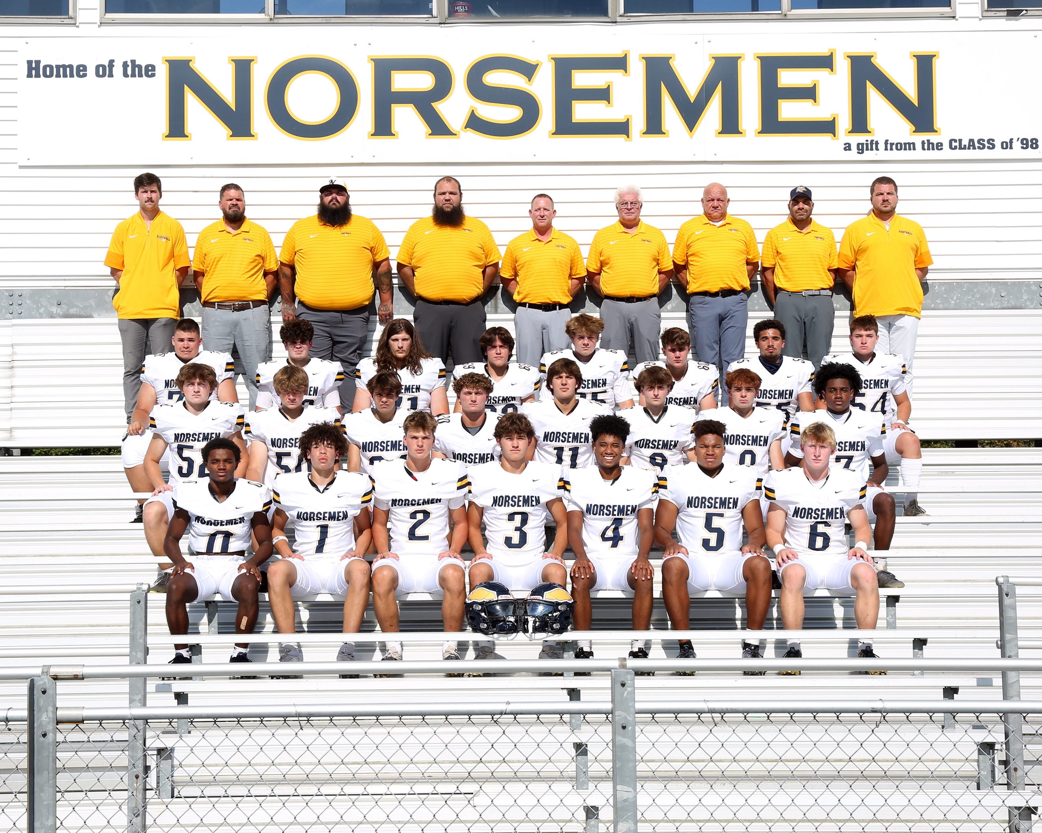

The 2025 NORSEMEN

1st Row L-R: Jourdan Ealom-Yff, Braylen Burrel, Beckett Hoppa, Bryce Colbert, Spencer Williams, Hunter Wilder, Cullen Bartos
2nd Row L-R: Oliver Fricke, Johnny English, Kyle Mack, Keefe Kersman, Drew Gabriel, Gunner Schmitt, Andrew Proksa, Carlton Williams
3rd Row L-R: Kael Gunby, Jackson Dye, PJ Wymer, Eli Gomez, Brennen Slayton, Clint Villapando, Jace Thompson
NM Coaches far top L-R: Trevor Poisson, Matt Dye, Daryl Schillaci, John Ribesky, Andy Bartos, Larry Witham (HC), Bryan Rypstra, Ryan Rimedio, Mike Jados

Record Score Interesting Fact

0-1 NM 6, Pewamo West 35 Veteran P-W team overwhelms NM. Bryce Colbert to Cullen Bartos 4 yd TD 1-1 NM 33, Shelby 30 Wilder 2 long TD runs, Colbert 12/19, Beckett Hoppa 120 yds rec. TD 2-1 NM 49, Mason Co. 21 Bartos record 99 yd TD run, Colbert 4 TD passes, Hoppa 2 TDs
3-1 NM 54, Hesperia 21 NM rushes for more than 400 yards; Bartos 3 TD 173 yds, Wilder 148 yds
4-1 NM 29, Hart 18 Wilder 2 TDs (18&8), Colberrt to Hoppa TD, Bartos 37 yd TD
4-2 NM 26, Montague 39 Colbert 285 passing yds, Hoppa 6/137 TD, Gabriel 55 Fumble for TD.
5-2 NM 36, Ravenna 29 Bartos 96 yd Kickoff return, Wilder 90 yards 3 TDs, Hoppa 45 yd TD.
6-2 NM 56, Newaygo 34 Colbert 5 TD passes, Wilder 96 rushing yards, Bartos 2 TDs & 14 tackles.
6-3 NM 27, Oakridge 41 Colbert 370 passing yds, Bartos record 19 tackles, 130 yds receiving.
7-3 NM48, Saranac 6 Colbert 254 yds, 5 TDs, Wilder 3 TD, Bartos & Hoppa 2
7-4 NM 28, Pewamo West 54 Colbert 270 yds, Hoppa 3 TD, Bartos TD pass to Hoppa

