1955 – coach Dunc Lectka (3-6 overall, 2-3 WMC, Montague Champs)

Faced with the daunting task of replacing some of the finest players to ever put on a North Muskegon football jersey, including arguably the finest to wear the colors of the Blue & Gold in Stan Guy, coach Dunc Lectka did have at his disposal a handful of starters from the 1954 squad. Ron Simonelli, a four-year starter would return in the backfield along with juniors Pete Sheldon and Aron Wortham. Although not a returning starter Wortham did see extensive action for the 1954 Norsemen. All-WMC conference tackle Tony Nord returned but a pair of other junior starters from last season would not. All WMC guard Dick Montgomery moved with his family to East Lansing and would have an outstanding year for the Trojans as he was selected as a first team All-State lineman. Tom Girocco, another starter from last year counted on as a lineman was out with an injury. End Chuck Houts also returned for the Norse, but the numbers once again were down.

The 18-game winning streak enjoyed by the Norse over the last two years was quickly stopped in their road opener at Coopersville as they were defeated 19-6 by the Broncos. NM did get off to a good start as they took an early lead 6-0 as they scored in eight plays on a 64-yard drive with Aron Wortham and Ron Simonelli doing most of the work. Simonelli would score from 15 but that would be all the scoring for the Norse as Coopersville scored three unanswered touchdowns to pull away for the win.

Game number two found North Muskegon taking a rare beating at the hands of Ludington. The visiting Orioles totaled 194 yards rushing to but 19 for NM while the Orioles rolled up 13 first downs to but two for the Norse. The Orioles were led by future Central Michigan quarterback Wally Sadosty who ran and passed Ludington to victory. The lone NM score came in the final quarter when Pete Sheldon rifled a pass to Aron Wortham good for 39 yards and a touchdown.

NM got back to their winning ways with a 31-6 pounding of Scottville. So dominant was the Norse that they out rushed Scottville on the ground 329 yards to seven. It was 31-0 before the visiting Spartans scored late in the game. Aron Wortham had a pair of tallies for the Norse, one from 23 yards out for the 1st NM score in the first quarter and it took Wortham only 1-yard to score his second, and the team’s 5th TD in the final period. Ron Simonelli had a big night for NM, scoring on a 65-yard punt return and 14-yard run, while junior quarterback Pere Sheldon added a three-yard TD in the 3rd quarter.

Hart handed NM its first loss in WMC competition in more than three years 12-6 in a game played at Hart on a soggy, rainswept field. Hart drew first blood when they scored midway in the opening period on a 74-yard drive with Lyle Gale going the final 36 for the TD. The Norse came right back with Ron Simonelli giving the Norse good field position on a long kickoff return where he was not stopped until he was downed in Pirate territory at the Hart 44. After a NM first down to the 34 Pete Sheldon on third down hurled a long forward pass intended for Simonelli. Interference was called on a Pirate defender to give the Norse a first down. From there Simonelli again did most of the work and would eventually score from two yards out to tie the score at 6-6. Sheldon’s extra point placement was blocked, and the score was all tied 6-6 at halftime. After a scoreless third period Hart scored what would prove to be the winning touchdown early into the final period when Jack Franklin scored on a 32-yard run.

According to sportswriter Tom Kampenga, who covered the Norsemen for the Muskegon Chronicle in 1955, Tom felt the Norsemen finally looked more like the Norse teams of the past few years following their 26-6 win over Whitehall. NM scored first when Fred Livingston, a sophomore newcomer bucked over from the five. That lead didn’t last long as Whitehall’s Kaj Sorenson galloped 66 yards for the tying marker. However, neither team was successful on their extra point attempts as the score remained 6-6 going into the second half. The second half belonged to four-year starter Ron Simonelli and the Norse. Simonelli returned a Whitehall punt 54 yards to pay dirt and then took things into his own hands by also running for the extra point. On their next possession the Norse moved 62 yards in seven plays with Simonelli going the final four yards on the first play of the fourth quarter. The Norse defense than produced the final points when lineman Ron Adema blocked a Viking punt. The ball rolled all the way back into the Whitehall end zone where it was recovered by Don Berry. Pete Sheldon’s extra point kick made the final score 26-6.

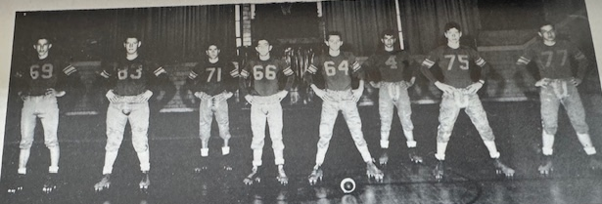

NM LINE OF 1955

L-R: Joe Mierendorp, Chet Broner, Bill McIntyre, Jim Sibson, John VanApple, Jim Zahrt, Joe Sienkiewicz, Dick Partrudge

Frustration had to have set in following the Wednesday evening home 7-6 loss to Shelby. The Norse had clobbered the Tigers by a margin of 176-33 over their last four games, all huge Norse victories. The Norse dominated in all the stats except the one that counts the most --- the one on the scoreboard. NM made 15 first downs to three and outgained the Tigers 190-132 on the ground. In addition, the Norse had two touchdowns called back due to penalties, with the last taking place on the final play of the game. The Norse scored their only touchdown to take the lead midway through the second quarter. Chuck Houts, who was converted from a starting end to fullback, climaxed a 56-yard drive by plunging over from the two-yard line. After NM was assessed a five-yard penalty for delaying the game the Norse attempted a pass for the extra point, but the all-important point failed. On the next possession Shelby fooled the Norse when Larry Pranger on a reverse play traversed 54 yards for the touchdown. The pivotal extra point kick from Larry Smith would prove to be the winning point in the contest. The first touchdown called back by the Norse came early in the game when Ron Simonelli’s long punt return for 82 yards was called back due to a penalty. Twice in the final quarter it looked like NM was going to find a way to pull off the victory. The first drive went awry when the Norse fumbled at the Shelby six-yard line. Shelby took over with little time left on the clock and tried to run out the clock on quarterback sneaks. The last sneak on fourth down was stopped leaving NM with time for one last play. Chuck Houts would score from the two-yard line, but the Norse were offsides on the play and the game ended due to the rules from that era denying NM another play.

What a difference a year makes! Last year’s controversial game with Manistee resulted in a 12-12 tie, preventing NM from posting a perfect season. In 1955 the Norse managed to score one more point and then held off Manistee to earn a 13-12 victory that snapped their three-game losing streak. It appeared that NM had the game wrapped up with little time remaining in the game and NM leading 13-0. Manistee blazed 70 yards to score but Ron Adema broke through the Chippewa’s offensive line to block the extra point. Manistee then worked an on-side kick to perfection and took over at the Norse 49. There was only five-seconds left in the game when Ed Hansen completed a pass to Ed Anderson for a touchdown. It looked like the teams were again headed for another tie but the Norse defense, led by lineman Tony Nord, stopped Manistee’s try for the extra point and the Norse held on for a 13-12 win. Aron Wortham was the offensive sparkplug for the Norse scoring a pair of first half touchdowns. His first tally came on a 13-yard run around end. Ron Simonelli added what would prove to be the game winning point when he crashed through the line for the extra point. Wortham’s second TD was a dandy. The senior back raced 82 yards for the touchdown in the second quarter behind some excellent blocking up front. 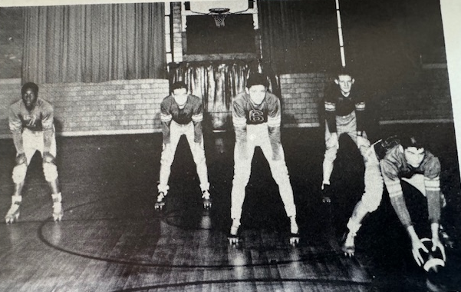

The NM BACKFIELD OF 1955

L-R: Aaron Wortham, Fred Livingston, Pete Sheldon, Ron Simmonelli & Bob Bond

For at least a half it looked like the Norse would be able to post an upset victory over Montague, but the eventual champs dominated the second half by scoring 26 unanswered points to win going away 28-6. The Norse led by a slim 6-0 margin at halftime on a Pete Sheldon 22-yard pass to Jim Olding. The big play in the long 94-yard drive was a 72-yard run by Aron Wortham. Montague scored four six-point TDs in the second half without having completed a pass in the entire game. The big gainer for the victors was an 82-yard punt return by Walter Anderson.

It was de ja vu for Norsemen football in their final game of the season as again they had a lead at halftime only to falter in the second half in their 33-21 loss to Greenville. It was the second, and last game of the two-game series between the two schools. Ron Simonelli had a fitting end to his brilliant career as a Norsemen. On the first play from the line of scrimmage Simonelli streaked 69 yards for a touchdown. Just moments later Aron Wortham took off on an even longer touchdown jaunt by going 76 yards for a score and the Norsemen were up 14-0 and it looked like it would be a good night for NM. Such was not to be, however. The Norse, already very thin in ranks, lost their star player Simonelli to an injury in the second quarter. NM was able to find a way to score on an 80-yard march with Simonelli on the bench with most of the yardage coming on pass completions from quarterback Pete Sheldon. Sheldon capped the drive with a 1-yard sneak and that would end all NM scoring. With Simonelli on the bench the Norse sputtered both on offense and defense as Greenville pulled away with Roger Knapp contributing to four of the winner’s TDs. The Norse would end their season with a 3-6 record, their first losing season under coach Dunc Lectka. After dominating the 11-man WMC all-Conference team in 1954, only Ron Simonelli was selected to the 1955 squad with lineman Tony Nord earning honors on the second team.

Record Score Interesting Fact
0-1 Coopersville 19, NM 6 Ron Simonelli 15-yard TD
0-2 Ludington 26. NM 7 Pete Sheldon to Aron Worthan 39-yard TD pass.
1-2 *NM 31, Scottville 6 Simonelli and Worthan 2 TDs, Sheldon 1.
1-3 *Hart 12, NM 6 Simonelli 2-yard TD only NM score
2-3 * NM 26, Whitehall 6 Simonelli 2 TDS, 54 yd Punt ret., Fred Livingston TD, Don Berry recovered fumble in end zone,
2-4 * Shelby 7, NM 6 2 NM TDs called back by penalty, Chuck Houts NM TD.
3-4 NM 13, Manistee 12 Wortham 2 TDs,13 & 82) Simonelli extra point run wins.
3-5 * Montague 26, NM 7 Sheldon to Jim Olding 32 yd TD pass only NM score
3-6 Greenville 33, NM 21 Simonelli (69) Wortham (76) TDS and Sheldon 1 yd sneak

1956 – coach Dunc Lectka (5-4 overall, 3-2 WMC, Montague Champs)

Things would look and even sound different in 1956 for Norsemen football. The new look would be a renovation of the football field with the home side now moving to the East side where new bleachers have been erected to replace the old rickety wood slats that have been the visitors’ seats for more than 20 years. The sound would be different as the Norse have a new fight sound, although the old school song played to the same tune as Notre Dame’s fight sound would still be a part of Norse athletics. Another new look would be the numbers out for football as 34 players were on hand to begin the Fall workouts. They even had a new ‘stringer’ to report games for the Muskegon Chronicle in 15-year-old Jim Moyes, who replaced his good friend Tom Kampenga who had graduated. The number one problem that 4th year coach Dunc Lectka felt was an issue for his 1956 team was a lack of speed. “We are so slow its, pitiful” said Lectka, “Pete Sheldon is our only really experienced back and we just don’t have a gamebreaker--- a Stan Guy type of fellow who can break up a game anytime he gets the ball.” When reminded that Stan Guys comes along about once in 25 years, Lectka said: “I know it, but we ought to have someone who can run the 100-yard dash in less than 15 or 20 seconds.”

Lectka’s fears proved prophetic as the Norsemen were shutout in their home opener by a very good Coopersville team 19-0. The Norse played the Broncos hard in the first half and even threatened to take the lead as they drove down to the Broncos nine-yard line before their drive was stopped. In the first half much of the yardage gained by the Norse was from sophomore running back Chuck Coverly. However, Coverly injured his ankle on their most serious drive and sat out the rest of the game with an injury. Fortunately, for Norse fans, Coverly would not miss another game in the 1956 season.

The Norse made the trip to Ludington and came home with a 12-7 win on a most memorable night for this very young cub reporter. Back in 1956 there were no press box for reporters to cover the game and in most instances, there were not even scoreboards. However, for me anyway--- Ludington was big time. They not only had a press box, but they had a veteran reporter who had been the Sports Editor for the Ludington Newspaper for years, Dick Derrick. I sat next to Mr. Derrick during the game, and he could not have been more courteous as well as giving me some helpful hints on reporting. It is now 2026 as I write this Norse history, and I wonder why those 70 years have passed by so fast. I will always remember how well I was received by Dick Derrick on September 21, 1956. Making it a perfect night for the young Norse reporter was a NM 12-7 victory on the Ludington gridiron. The Norse had to come from behind and then hold off a last-ditch rally by the Orioles to preserve the victory. Ludington scored their first, and only touchdown late in the first quarter. The Norse game back to close the gap to a single point when two-way back Pete Sheldon intercepted a Wally Sadosty pass and returned it to the Norse 36. A quick pass from quarterback Sheldon to end Don Berry moved the ball to the Ludington 48. Junior halfback Bill McIntyre then slipped through the line and dashed 48 yards for the score. A missed PAT attempt left the Norse trailing by one, 7-6 at halftime. The Norse had their game winning drive early in the final quarter with a now healthy Chuck Coverly doing much of the running on power plays. The stocky sophomore then scored from the six-yard line and the 12-7 score would hold up. Ludington did mount a late drive that was stopped deep in NM territory at the six and the Norsemen had their first victory of the season. Putting a damper on the NM victory was an injury to popular NM end Larry ‘Lunk’ Johnson, who suffered a fractured ankle and would be lost for the 1956 season.

A couple of days before the Norse would begin their conference schedule at Whitehall, the sports world was saddened with the passing of Babe Dickinson Zaharias, the world’s greatest female athlete who succumbed to cancer at age 42. Whitehall would win their first game over North Muskegon since 1947 as they upended the Norse 20-7 at Funnell field in Whitehall. The Norse won the battle of the statistics, but penalties and fumbles hurt the visitors. One bright spot-on defense was the play of junior Jack Musselman who recovered a fumble and stopped another potential Whitehall scoring drive with an interception. Whitehall tallied first and led 7-0 but NM countered with a long 80-yard drive with Chuck Coverly leading the attack. Bill McIntyre skirted around left end for the touchdown with Coverly’s successful extra point run knotting up the game at 7-7. Whitehall added a second period touchdown and took advantage of a NM fumble at their own 3-yard to ice the game and make the final score read 20-7. Coverly was a workhorse for the Norse as he picked up 133 yards in 17 carries. One of the game officials was a young Dick Dolack, who served as a head linesman for Nelson Volz’s crew. Dolack would go on to be an official for many years in the NFL. Both Dolack and Volz are in the Muskegon Area Sports Hall of Fame.

If one would inquire as to who North Muskegon would consider as their number one rival during the early years, my guess it would have been Fremont. These two opponents faced each other every year from 1934-1952 with many of the games played on the final game of the season. After a three-year absence the series was resumed for the 1956 season with the Norsemen winning 21-14 over the Packers. The Packers tallied first, but the Norse came back to knot up the game on a Bill McIntyre eight-yard TD run with Chuck Coverly running for the extra point as the teams left the field at halftime tied at 7-7. Early into the third quarter the Norse marched 74 yards to take the lead on a Coverly six-yard dash to pay dirt and again Coverly ran for the extra point. The third NM touchdown was set up by a Jim Sibson interception, one of the junior lineman’s two interceptions during the game. Coverly then completed the short 35-yard drive on a 10-yard gallop with Fred Livingston adding the extra point on a run. Fremont scored late to make the score a little more respectable. Coverly again passed the century mark in yardage with 106 yards rushing while also catching three passes from quarterback Pete Sheldon for another 30 yards.

The Norse would begin their road game at Scottville with the following starting lineup: Tom Cousineau and Jack Musselman at the ends; Bob Prins and Bob Bond at tackles; Jim Sibson and Joe Sienkiewicz at guards; Francis Launstein at center, and the backfield would consist of Pete Sheldon, a 3-year starter at quarterback, Bill McIntyre and Chuck Coverly at the halfback posts, and Fred Livingston at fullback. Cousineau would be the fourth freshman in NM history to ever start a game for the Norsemen; preceded by Bob Pyle, Dick Schuiteman and Ron Simonelli from earlier years. The Norse compiled all their yardage in the contest on the ground as they edged the host Scottville eleven 21-6. NM only attempted two passes during the game as Coverly again surpassed 100 yards rushing with 107. McIntyre, Coverly and Sheldon scored the NM TDs.

The Norse made amends for their 7-6 upset from the previous season by walloping host Shelby 51-0 on a Wednesday night game on the Tigers field. After attempting but two passes in their previous win at Scottville, Pete Sheldon displayed his talents by completing nine passes out of 10 attempts, three for touchdowns, rushed for 68 yards and a TD, and even caught a couple of passes good for 50-yards. Sheldon caught his pair of passes after sophomore Jerry Johnson entered the game and played quarterback with Sheldon now a running back. Oh, the future Dartmouth College third baseman also intercepted the only pass attempted by Shelby in the entire game to set up one of many Norse TDs. Chuck Coverly had another exceptional game for the Norse by scoring four times, two running and two on passes from Sheldon. Tom Cousineau became the third Norsemen gridder in program history (Dick Schuiteman and Ron Simonelli) to score a TD as a Frosh when he hauled in a 15-yard TD strike from Sheldon. Bill McIntyre got in on the scoring parade with a 17-yard scamper while reserve sophomore lineman Bill Ginman pounced on a loose ball in the endzone after his teammate Bob Bond had blocked a punt for the final Norse tally.

Playing without the services of star sophomore running back Chuck Coverly who was out with an ankle injury, Norse coach Lectka inserted sophomore Jerry Johnson at quarterback and moved the versatile Pete Sheldon to a halfback to replace Coverly. The transition worked to perfection as Sheldon rushed for over 100 yards, highlighted by a long touchdown gallop of 62 yards as the Norse edged the Hart Pirates 13-6. Johnson had a fine game at quarterback as he completed five of six passes with one completion good for another Norse touchdown to halfback Bill McIntyre. The road victory over Hart was their fifth win of the season and insured that the Norsemen would once again have a winning season.

It looked like the Norsemen were headed for their fourth WMC victory on the season and a possible share of the WMC title when they took a 14-0 lead at halftime in their game with Montague. The Wildcats spoiled any Norsemen hopes for a WMC title share by coming out on fire in the second half and scored 28 unanswered points to defeat NM on the Northside field 28-14. The Norse received a crushing blow when star back Chuck Coverly, who had rushed for 56 yards and a TD, and on the receiving end of three passes and the second Norse TD, reinjured his ankle in the second period and would not see any action in the second half. After going through the previous four seasons pretty much injury free, Lady Luck had run out on the Norse as numerous injuries had now forced the Norse to only suit up 18 able body men for the game with Montague.

The Norsemen had the misfortune in their final game to run into one of the best teams in Manistee history. The visitors arrived at the Norse field looking to move their record to 8-1, the best record since Manistee went 7-0 back in 1919. The Norsemen played hard and gave the visitors a tougher game then the final score of 20-0 might indicate. The final Manistee TD came when a Norse fumble was scooped up and run into the end zone for a touchdown. The Norse were victimized by perhaps the smallest player on the field in 143-pound quarterback Carl Raatz. Scoring both Manistee touchdowns Raatz continually hurt the Norse with quarterback keeper plays that totaled 137 yards rushing. A very young NM team would lose but three starters to graduation for the following season: quarterback Pete Sheldon and linemen Bob Prins and Bob Bond. Bond and Coverly were selected to the first team All WMC conference team with Sheldon and Francis Launstein picked for the 2nd team.

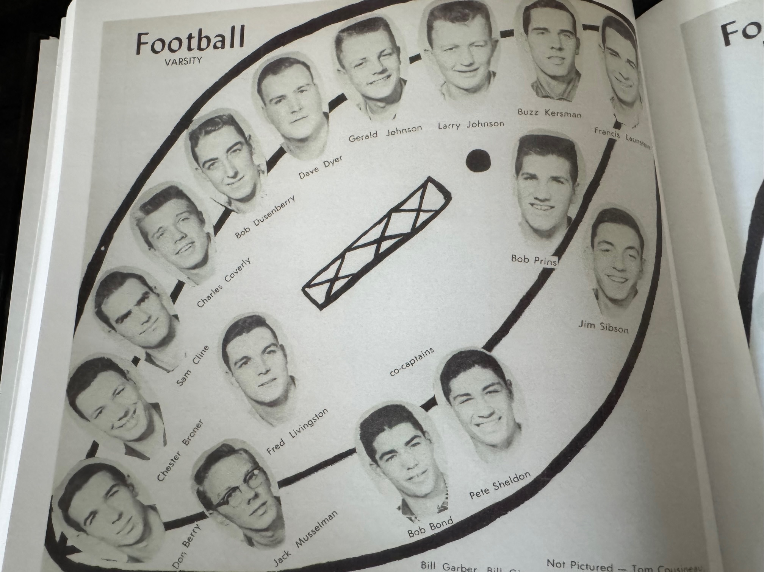

The 1956 NORSEMEN

Record Score Interesting Fact
0-1 Coopersville 19, NM 0 NM shutout in your authors 1st game as NM reporter
1-1 NM 12, Ludington 7 Bill McIntyre 48 yd TD, Chuck Coverly 6-yard TD run.
1-2 *Whitehall 20, NM & McIntyre TD, Coverly rushes for 133 yards in loss.
2-2 NM 21, Fremont 14 Coverly 2 TDs (6 & 10 yds) Mcintyre 8-yard TD.
3-2 * NM 21, Scottville 6 McIntyre, Sheldon and Coverly NM TDs.
4-2 * NM 51, Shelby 0 Sheldon 3 TD pass for TD, 1 rush, interception, Jerry Johnson TD pass, Fr. Tom Cousineau TD rec, Mcintyre TD rec. Bill Ginman fum. Rec. for TD, Coverly 4 YDS.
5-2 * NM 13, Hart 6 Sheldon 106 yd rushing, 6d yd TD, Johnson to McIntyre TD pass.
5-3 * Montague 28, NM 14 Coverly 2 TD’s before sitting out 2nd half with injury.
5-4 Manistee 20, NM 0 Carl Raatz runs wild in NM loss.

1957 – coach Dunc Lectka (3-6 overall, 3-2 WMC, Montague Champs)

Although expectations were somewhat higher in 1957, the Norse were on the losing end in too many close games and stumbled to an overall record of 3-6 with all their wins coming against WMC opponents. Perhaps an ominous warning was posted when in their pre-season scrimmage Friday before their regular season opener, a bank of lights went out, and the scrimmage had to be called nearly a full quarter before the scheduled ending. Thirteen lettermen returned from last years’ 5-4 record including the entire backfield except for Pete Sheldon. Jerry Johnson saw extensive duty last year as Sheldon’s backstop while all-conference running back Chuck Coverly was expected to do the same to opponent’s defenses. The first game of the 1956 season was on September 21. My how times have changed with the adding of playoff competition beginning in 1975. To put things in perspective, the 2023 Norsemen football team were scheduled to play their 5th game on September 22.

1957 would also be the first year that Reeths Puffer would field a true varsity football team. Many of the current seniors on the 1957 Norsemen football team resided in the Reeths Puffer School District. It would be the last year Reeths Puffer area students, except those currently residing in the Laketon Township district, would attend the North Muskegon school. The Rockets, who would field a squad composed entirely of 11th graders and younger and would use the North Muskegon field as their home field while waiting for Gale Bolthouse Stadium to be erected.

The opener at Coopersville would epitomize the entire 1957 season. Twice the Norse had potential scoring drives stopped that could have been game winners inside the Broncos 1-yard line. The host Broncos scored first early into the contest and that TD would ultimately hold up for the victory. The first serious frustrating Norse drive ended on a fourth and goal play at the Bronco two. Chuck Coverly, who earlier had done much of the ball carrying on the drive and caught a pass from Jerry Johnson that covered 27 yards, was called on to power his way in from the two but seemingly the entire Bronco defense expected a Coverly carry and he was stopped at the one. Early into the fourth quarter the Norse began a long march that began back at their own 12-yard line. The Norse would then drive 87 and 9/10th yards only to again suffer more agony. An apparent Coverly touchdown run from the 3-yard line was called back due to a NM penalty. Coverly powered his way down to the one, but a fourth down sneak failed just inches from the goal line, and a possible Norse victory went awry.

Injury woes were having a major impact as the Norse prepared for their home opener, a 20-14 loss to Ludington. Starting guard Jim Sibson incurred an elbow injury and was possibly ruled out for the season; Tom Cousineau, a sophomore who often started as a freshman, was out with a concussion; Fred Livingston would also miss the Oriole contest with a sprained ankle. The injury riddled Norse battled hard against the Orioles but again fell tantalizingly short of victory. Ludington scored late in the first period, but the Norse came back to even the game at 7-7 on a 17-yard TD pass from Jerry Johnson to Bill McIntyre and a successful Johnson PAT. Ludington would score late in the second period to lead 14-7 at halftime. Chuck Coverly started a NM tying drive by first intercepting an Oriole pass and then scored from five yards out to even the game at 14-14 after another perfect Johnson kick. The Orioles caught a big break on their winning TD. Ludington quarterback Gary Hackett hurled a pass downfield that bounced off Norse defender Dale Swanson into the hands of a surprised Oriole receiver who raced into the endzone. The Norse mounted a furious closing drive late in the contest down, but misfortune again hit the Norse as a penalty killed the drive after the Norse had reached the Orioles eight-yard line.

The injury and flu-ridden Norse team somehow found a way to defeat Whitehall 19-18 in a game that featured perhaps the most ‘bizarre’ play in NM’s long football history. The Norse spotted the Vikings an early first half lead at 12-0 with the second TD an exciting 58-yard dash by their outstanding running back Gordy McLouth. It looked like the Vikings were going to run away and hide from the Norse, but a Viking back was jarred loose of the football by NM’s defensive back Dale Swanson, and the Norse took over at their own 9-yard line. It was on the next play when the game turned on a play that will long be remembered by those in attendance at the Northside field. NM back Bill McIntye busted through the line and suddenly there were no Viking defenders between McIntyre and the goal line 91 yards away. However, as McIntyre raced down the west sidelines an overeager Viking reserve, watching McIntyre head for an apparent touchdown, jumped onto the playing field and tackled the surprised NM ball carrier. The play was eerily similar to an incident that occurred in the 1954 Cotton Bowl when Alabama’s Tommy Lewis came off the bench to tackle Rice’s Dicky Maegle. Just as Maegle was awarded a touchdown, so was McIntyre on his dash against Whitehall. After Jerry Johnson kicked what would eventually prove to be the deciding winning point, the play rejuvenated the Norse’s spirits. After a scoreless third quarter, Johnson returned a Viking punt 34 yards down to the Whitehall 16-yard line. NM drove down to the one where McIntyre this time only had to go one yard, 90 less than his previous extraordinary TD in the first half and the Norse led for the first time in the game 13-12. The Vikings didn’t fold and would eventually score from one-yard out with the big play on the drive a McLouth 65-yard run. With little time remaining the Norse began their winning drive. Running backs Frank Moran, Swanson and McIntyre moved the ball down to the Whitehall 38. From there Johnson went to the air and hit end Jack Musselman with a couple of crucial completions, the first for big yardage down to the eight, the second on third down and eight where he hit Musselman in the corner of the endzone to make NM 19-18 winners.

The injury report would only get worse as the Norse prepared for their game with Fremont. Not only would four regulars miss the game with the Packers, but the Norse would be without the services of their All-Conference running back Chuck Coverly. Although the muscular and popular Coverly was hampered with nagging ankle injuries for the past two seasons, the real reason for Coverly’s departure was not due to injuries. Coverly was a good friend and classmate of your author who often confided with me that he just did not love the game of football. Fremont had extra incentive with their game against the Norse on their home field as the Packers, who would win the Ken-Ne-Wa conference championship in 1956, had lost their game at NM 21-14. And what a year 1957 would be for Fremont. The Packers would run the table and go 8-0 on the season, the last perfect season for Fremont for the next 66 years. The Norse were no match for one of the best teams in Packer history. NM had no answer for Carl DeKuiper, a 3-sport standout and one of the best all-around athletes in Fremont history, who passed and ran the host Packers to a 21-7 win over the Norse. The Norse didn’t score until the fourth period when they were already trailing 21-0. Jerry Johnson completed an 84-yard drive, aided by some fine running by Frank Moran and Dale Swanson, by sneaking over from the one-yard line to make the final score read 21-7.

In their first meeting since 1944, the Norse defeated a new, but brief member of the WMC, Reed City, 26-14 for their second win of the season. Frank Moran, some 50 pounds lighter than the player he replaced in the NM backfield, Chuck Coverly, ran for 159 yards and scored three touchdowns to lead the Norse to their road victory. Moran had one 38-yard touchdown run called back, but he was credited with TD gallops of nine and 59 yards while catching a pass from Jerry Johnson for 14 yards and his third TD. The Norse were never threatened and wrapped up their scoring on a short one-yard plunge from Fred Livingston.

North Muskegon kept their hopes alive for a WMC title with a closer than expected 20-13 victory over Shelby. Those hopes would turn into wishful thinking as the Norse would go winless over the season’s final three games. The NM ‘pony backfield’ of lightweights, Frank Moran, Bill McIntyre and Dale Swanson, along with the accurate passing arm of Jerry Johnson led the Norse to victory. Moran scored a pair of TDs and rushed for 90 yards while McIntyre caught a six-yard TD pass from Johnson and ran for an even 100 yards. Swanson was on the receiving end of many of Johnson’s six completions to set up NM drives. Shelby gave the Norse a brief scare in the second half when they pulled to within one point at 14-13 midway through the third period before NM put the game away on Moran’s four-yard dash into the end zone.

The big news in the State of Michigan on Friday, November 1, 1957, was the opening to the public of the Mighty Mac bridge far to the north of the clash that same evening between NM and Hart. NM gave the Pirates a battle but fell 19-12, despite leading in most of the statistical departments. However, much of the Norse yardage was gained between the 30-yard stripes. The big play of the game occurred just after NM had tied up the game at 6-6 following a Frank Moran TD scamper of six yards. Hart’s Terry ‘Turk’ Griffin received the following Norse kickoff and ran through the center of the Norse without a hand touching him for a quick Pirate score. The Norse would narrow the gap late in the second period on a 21-yard dash to pay dirt by Dale Swanson. Both tries from placement failed the Norse and Hart had a 13-12 lead. The final touchdown in the half, and the game, was a Griffin short yardage run with but 28 seconds showing on the scoreboard. Neither team put points on the board in the second half as the Norse hopes for a conference crown were doomed.

Old Man winter roared its head as the NM-Montague game was played in arguably the worse weather conditions in NM football history. Heavy snow and winds gusting at 50 mph caused thousands of dollars in damage to area properties --- but they raised them tough in the 1950s and the game was played. In fact, there were no reported games in the entire state cancelled due to the weather. A depleted Norse lineup handicapped with numerous injuries fought hard in the miserable conditions as this reporter tried to scribble down notes while following the action on the sidelines. It was not until the second half that the eventual 1957 WMC champs from Montague would take control of the game as the first half found the teams deadlocked at 7-7. After Montague scored first in the opening quarter the Norse countered with reserve back Ed Beagle plunging over from the one-foot line for the score. The key play in the NM scoring drive was a 36-yard run by Dale Swanson that set up Beagles’ score. With kicking for extra points out of the questions with the blizzard conditions, both teams were successful on their extra points via the run game. Montague salted away the game by scoring the first two touchdowns in the second half before the Norse made it closer following a Frank Moran TD from the two with Montague earning a 20-14 victory. The Norse did throw a scare into Montague as time ran out with the Norse at the Montague 25-yard line. Playing a stellar game for the Norse was junior lineman Dave Taylor, opening holes on offense from his tackle position and making key tackles from his linebacking post on defense.

Too say that the Norse non-conference schedule was difficult would be an understatement as two of their opponents would finish the season with undefeated records, Fremont and their final game opponent Manistee.

Nine seniors would suit up for their last game against undefeated Manistee, including starting ends Jack Musselman and Jim Pyle, tackle Francis Launstein and guard Joe Sienkiewicz. Both Bill McIntyre and Jim Sibson were starters for the Norse before sidelined with injuries. Joe Mierendorf was a senior Norse starter when NM was on defense. Due to injuries only junior quarterback Jerry Johnson was a starter in the backfield when the season got underway against Coopersville. Juniors Frank Moran and Dale Swanson were the chief running backs for much of the season with senior Eddie Beagle called upon late in the season to take over the fullback duties. It didn’t take junior tackle Dave Taylor long to crack the starting lineup where he did double duty as a tackle and linebacker. Bill Ginman, at just 145 pounds was a starting guard who would return the following season, as would junior center Bill Garber. Lost for the entire season with a concussion injury was their promising sophomore End Tom Cousineau, a starter as a freshman the previous season. The Norse threw a scare into Manistee on the Northside gridiron and even took a brief lead in the second half. Once again, the Norse were victimized by little Carl Raatz, who burned the Norse the previous year but was even more dominant in this contest. Raatz, a stocky 5-foot, 4-inch pack of dynamite, carried the ball 18 times for 187 yards and three touchdowns. Showing his toughness Raatz was injured numerous times and once even had to be carried off the field on a stretcher. Both NM touchdowns gave NM brief leads. The first a 10-yard TD pass from Johnson to Musselman on a fourth and goal, the second on an eight-yard strike from Johnson to Musselman and again on a fourth and goal play. Trailing 14-12 Manistee then lived up to its billing and scored the games’ final three TDs to stay undefeated while the Norsemen finished 3-6.

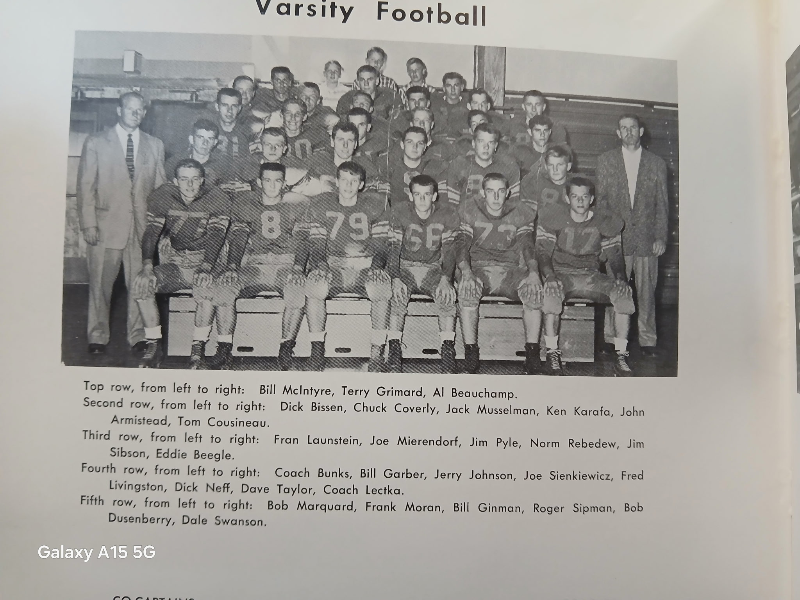

The 1957 NORSEMEN

Record Score Interesting Fact
0-1 Coopersville 6, NM 0 Twice NM was stopped inside the one-yard line.
0-2 Ludington 20, NM 14 Injuries hit NM. Ludington wins on a deflected pass for a late TD. Jerry Johnson passes tp McIntyre for TD, Chuck Coverly scores from 5
1-2 *NM 19, Whitehall 18 McIntyre bizarre 91 yd TD when tackled by player off bench. McIntyre 1-yard TD; Johnson passes to Jack Musselman 8 yards for winning TD.
1-3 Fremont 20, NM 7 Fremont with their only perfect season in the last 66 years defeats NM. Johnson’s 1-yard sneak only NM TD.
2-3 *NM 26, Reed City 14 Frank Moran 3 TDs on runs of 9 & 59 and a TD pass from Johnson for 14. Fred Livingston plunges over from the 1 for final NM tally.
3-3 *NM 20 Shelby 13 Moran 2 TDs, McIntyre TD pass from Johnson as NM goes to 3-0 in WMC.
3-4 *Hart 19, NM 12 Long kickoff return by Hart’s Turk Griffin key play in loss. Moran from six and Swanson from 21 Norse TDs.
3-5 *Montague 20, NM 14 Montague wins in blizzard conditions. Ed Beagle a one-foot plunge and Moran from two NM ---TDs.
3-6 Manistee 30, NM 14 NM gets a pair of TD passes from Johnson to Musselman but could not contain Manistee’s Carl Raatz.

1958 – Coach Dick Dornbos (5-4 overall, 3-2 WMC, Montague Champs)

The Norse would have a new coach for the 1958 season as Dunc Lectka, who posted a winning record of 33 wins and 18 losses, with three WMC titles, resigned from his teaching and coaching duties to move across the state to take over the football duties at Tecumseh. “Coach Lectka was the best coach I ever had,” said Norse football great Dave Taylor, one of but three NM male graduates enshrined in the Greater Muskegon Hall of Fame. After coaching at Tecumseh for three seasons Lectka joined the athletic department at Michigan State where he was the assistant ticket manager. Lectka then left MSU and became the head ticket manager for the Buffalo Bills. Dunc Lectka, who perfected the ‘belly plays’ out of the T-Formation that was a staple for Muskegon area teams for decades, passed away from a heart attack while exercising in Buffalo, NY in February of 1969 at just 47 years.

Replacing the highly popular Lectka was Dick Dornbos, a Muskegon native who prepped at Muskegon St. Joseph, a school that didn’t have a football team. Dornbos would be coming to NM after posting a perfect 8-0 record at St. Joseph Michigan Catholic. Interest was high at NM to begin the year as a total of 75 boys, including 11 lettermen reported for the opening practice session. However, 28 of those players were freshmen. Once again, a daunting opening schedule of four talented opponents would pose a difficult challenge to begin the 1958 season.

The Norse again would open with Coopersville, a team they hadn’t defeated in the last three meetings. Make that now four straight losses to the Broncos as the Norse couldn’t add to their 6-0 lead at halftime. It looked like it would be smooth sailing for NM as on their first possession they marched 65 yards for what would prove to be their only touchdown on the evening. Frank Moran ran 29 yards for the score but Jerry Johnson’s point after from placement hit the goal post. There were a couple of big plays in that scoring drive, both pass plays. One a pass from Johnson to Moran that picked up 18 yards and another completion for the same yardage was caught by Tom Cousineau. Coopersville completely controlled the game in the second half as the Norsemen had the ball for just 13 plays. The Broncos scored once in both quarters of the second half to again defeat the Norse by the same margin as last year – six points as the final scoreboard read Coopersville 12 and North Muskegon 6.

NM put together one of their best offensive showings on the season when they evened their record at 1-1 with a 32-14 road victory against Ludington. NM rolled up 278 yards rushing with Dale Swanson the leading ground gainer with 146 yards that included a long TD dash of 75 yards for NM’s second TD of the game. Earlier sophomore fullback Jeff Olds led off the NM touchdown parade with a 35-yard TD run in the first quarter. Swanson scored his second TD on a pass from Jerry Johnson good for a 25-yard tally. Ludington closed the gap to 19-14 in the third period but then the defense took charge for the Norse. Dick Hoover set up the next Norse TD with a fumble recovery that would lead to a Tom Cousineau end around TD. Linebacker Dave Taylor then intercepted an Oriole pass to set up Olds’ second 6-pointer from 24 yards that competed the Norse scoring.

Whitehall pounced on the Norse early as their 33-16 victory was settled in the first half when the Vikings took a commanding 26-0 halftime lead. The Norse were unable to stop Jim ‘Bull’ Jordan who time and time again ran like his nickname through frustrated Norse defenders. Jordan, who ran for 140 bruising yards, scored two first half TDs, one for 40 yards, and set up another short TD of teammate Spud Wolfe. The Norse did show some life early into the second half to cut the lead in half on a pair of TDs. The first, a Tom Cousineau end run from five yards out, the second, a 77-yard pass and run play from Jerry Johnson to Dale Swanson. One bright spot for the Norse was the all-around play of tackle and linebacker Dave Taylor, the only Norse player who could contain Bull Jordan. Taylor also averaged more than 40 yards per punt.

The Norse won a Dad’s Night thriller 20-19 against Fremont to even their record at 2-2. Jerry Johnson threw three TD passes with his third strike completed with just seconds remaining. One factor that has changed over the years has been the kicking game after extra points. Before soccer style kickers came on the scene to make a PAT almost a certainty, such was not the case in the pre-Pete Gogolak era. The difference in the NM-Fremont game was indeed the made, or not made, extra points. The Norse ran successfully on two of their attempts after TDs while Fremont made just one. In addition to the heroics of quarterback Johnson, Dave Taylor deserves equal billing as the future two-time Ferris State captain and team MVP blocked the first two extra points attempted by the Packers, the difference in winning or losing. Johnson’s first TD pass went to Dale Swanson from 15 yards out with just 16 seconds left in the opening quarter. Tom Cousineau on a reverse made the all-important extra point. Fremont would score to close the gap to 7-6 at halftime. The Norse scored first in the second half on Johnson’s second TD pass, this time to Frank Moran good for a 10-yard tally with Moran also scoring what would prove to be the huge extra point on a cross-buck. Fremont would then score twice but Taylor forced his way through the offensive line to again block the Packer’s extra point. Fremont appeared to score the game winner on a Bultman to Kingsford pass for 35 yards with four minutes remaining in the game. This time Bultman’s meaningless kick was good to give the Packer a 19-14 lead. The Norse then began a 64-yard drive with sophomore Jeff Olds doing much of the ball carrying. With just seconds remaining it was do or die time for Johnson and the Norse. Faced with a fourth and goal at the ten-yard line Johnson finished his heroics with a TD pass to a surprisingly wide-open Tom Cousineau in the endzone to pull off the thriller. Following the game co-captain Dave Taylor of the Norse was presented with the victory can award, a symbol of each Packer-Norse game that dated back to 1935.

The Norse made it two straight wins over Reed City by posting their only shutout of the season with their 13-0 victory on the Northside field. After a sluggish first half the Norse added a pair of second half TDs to move to 3-2 overall and 2-1 in the WMC. The first half presented the Norse with a sequence of plays that had frustration written all over the faces of Norse fans and players. Frank Moran took off on a 69-yard TD run only to have it called back on a penalty. Following the 5-yard walk off Dale Swanson electrified the crowd with a 74-yard scamper for a tally, only again to see the play called back due to a penalty. The Norse did score a couple of penalty free TDs in the second half, the first a six-yard TD run by Tom Cousineau, the second, an eight-yard TD run by Jeff Olds who led all Norse backs in rushing with 124 yards gained in 15 carries.

The Norse sputtered on occasion in their 20-12 homecoming victory over Shelby but still had enough fire power to pull off the victory. The only TD scored in the first half was set up by a Dave Taylor interception. Taylor ran 62 yards after his interception before he was gang tackled by three Shelby tacklers at the one-yard line. Jerry Johnson sneaked over from the one on the next play and passed to Dale Swanson for the extra point to give the Norse a 7-0 halftime lead. Early into the second half Swanson, who rushed for 124 yards in 13 carries, outraced the Tiger defenders to score the Norse second TD from 43 yards. Frank Moran added the clinching TD for the Norse from the one-yard line after Shelby had scored their first touchdown on the preceding series.

North Muskegon had little trouble at Hart as they moved to 3-1 in the WMC and their fourth straight victory with their 31-14 victory. The Norse led 31-0 before Hart tallied a couple of late TDs after the Norse brought in the reserves. Dale Swanson had another big game for NM by rushing for 150 yards in but 13 carries. With two of his carries going for five and 54-yard TDs. Dave Taylor’s interception set up a NM score with Jerry Johnson passing to Frank Moran for 17 yards, and the same duo later teamed up on a 59-yard scoring strike. Johnson sneaked over from the one shortly before halftime to give the Norse a commanding 25-0 lead at halftime.

A large crowd was on hand to witness Montague score the games’ final three touchdowns to pull away and defeat the Norse 33-13. The Norse could not contain the Montague duo of Glenn Anderson and Larry Jancek who scored all five Wildcats TDs. The win set up the Conference Championship game the following Friday between a pair of rivals undefeated in WMC play, Montague and Whitehall. A Frank Moran two-yard TD and a Moran extra point tied up the game in the third period, but it was all Montague the rest of the game. Earlier in the first half Jeff Olds scored the first NM TD with a 13-yard spurt over left tackle.

The Norse concluded their season at 5-4 with perhaps their poorest performance of the season as they were soundly defeated by Manistee 30-6 on a rain drenched field in Manistee. Jay Conover, subbing for an injured Dale Swanson, scored NM’s only touchdown on a one-yard plunge, but that was it for the NM offense. Earlier in the week Swanson was given an X-Ray on his injured shoulder that showed he had a small fracture that he had been playing with most of the season. Three times the Norse drove inside the Manistee 10-yard line only to come up empty on each occasion. One who didn’t play a poor game for the Norse was their one-man defensive gang in Dave Taylor. In addition to leading the Norse in tackles, Taylor also blocked a punt and extra point attempt. In addition to a pair of seniors, who sat out the game, Swanson and Roger Sipman, who had been out since suffering a fractured ankle earlier in the season, the Norse would lose eight senior starters to graduation: Linemen Tom Baker, John Armistead, Dick Neff, Bill Garber and Bill Ginman, and three starting backs in Jerry Johnson, Frank Moran and Swanson. Returning starters would include end Tom Cousineau, sophomore Jeff Olds and end Dick Overcamp. It should be noted that returning as a starter on defense would be freshman Benny Manning. For those who are keeping score, Manning would be the fifth freshman to start a game in NM history with Bob Pyle (1943), Dick Schuiteman (1951) Ron Simonelli (1952) and Cousineau (1956) the others. Post-season All-Conference honors would go to Swanson and Taylor, both named to the first team. Honorable Mentions picks went to Cousineau, Ginman, Garber and Johnson.

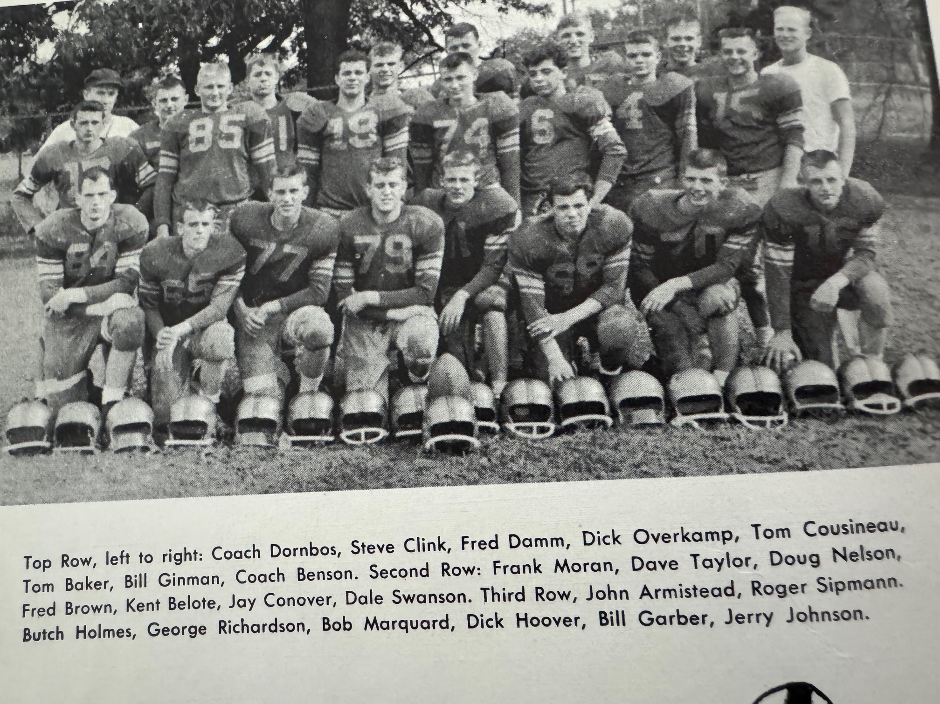

THE 1958 NORSEMEN

Record Score Interesting Fact
0-1 Coopersville 12, NM 6 NM loses 4th straight to Broncos: Frank Moran NM TD from 29
1-1 NM 32, Ludington 14 Swanson 146 yards rushing and 2 TDs; Jeff Olds 2 TD (35 &24), Tom Cousineau end around TD.
1-2 *Whitehall 33, NM 13 Whitehall busts out to 26-0 halftime lead. Jerry Johnson 77-yard TD pass to Swanson. Cousineau a 5-yard TD run.
2-2 NM 20, Fremont 19 Johnson hits Cousineau for winning TD with second left. Johnson 3 TD passes, other other to Swanson for 15 and Moran for 10.
3-2 *NM 13, Reed City 0 Norse post only shut out of season. Olds rushes for TD and 124 yards rushing. Cousineau a 6-yard TD run.
4-2 *NM 20, Shelby 12 Dave Taylor long interception return sets up Johnson’s 1-yard sneak. Swanson scores from 43 and Moran from one.
5-2 *NM 31, Hart 14 Swanson 2 TDs (5 & 54) Johnson to Moran 2 TD passing TDs (17 &59) Johnson 1-yard sneak TD.
5-3 *Montague 33, NM 13 Tied 13 all in the 3rd period, Montague scores final 3 TDs. Moran 2-yard TD, Olds from 13 for the other Norse score.
5-4 Manistee 30, NM 6 Dave Taylor shined in a losing cause on defense. Jay Conover scores NM only TD.

1959 – Coach Dick Dornbos (4-3-2 overall, 3-2 WMC, Montague Champs)

A sweet start to the 1959 season quickly turned sour as the Norse dropped their final three games of the season after going undefeated (tied twice) in their first six starts. It would be a short stay for head coach Dick Dornbos as he would leave the program at the end of the year. Only three starters returned for the Norse; ends Tom Cousineau and Dick Overkamp, and fullback Jeff Olds. Benny Manning surely could classify as a fourth starter as he started many games in 1958 on defense. NM was hoping to avert losing to the Coopersville Broncos for the fifth straight game. NM didn’t lose, but they also didn’t win as nothing was settled in a 7-7 tie. The Norse scored their only touchdown in the second quarter when Carl Rittman, a transfer from Traverse City, threw a 39-yard touchdown pass to Tom Cousineau. The pair also connected on the extra point. Coopersville blocked a NM punt in the same quarter and only had to travel 10-yards for their TD, and they too scored on a pass play for the extra point to knot the game up at 7-7. The Norse received a big blow earlier in the week when Jeff Johnson, who had prepped at Culver Academy before moving back to his hometown, was ruled ineligible by the MHSAA due to a transfer ruling.

NM continued their winning ways against Ludington as the Norse won for the 7th time in 11 meetings 28-6 in their 1959 home opener against the Orioles. For Ludington, better known for their outstanding basketball program during this era, it was their 11th straight loss and had now gone 20 games without a victory. Either the Norse put up a good defense or Ludington was woeful when they had the ball, but the Orioles didn’t pick up a first down until midway through the third period. Sophomore speedster Dave Rose gave the Norse offense a big boost as he rushed for a team leading 127 yards and scored the first NM TD on a nine-yard run early in the first period. Junior fullback Jeff Olds scored a pair of TDs, the first on a one-yard plunge in the first quarter and the second touchdown came in the second period from eight-yards out to give the Norse a 21-0 lead at halftime. Oscar Manning closed out the scoring with the games only score in the second half on a three-yard TD with freshman Steve Harpold running for the extra point. Ludington scored late in the game on a pass of four yards from Bink Wallace to 6’10” end Harry Volkers.

Prior to hosting Whitehall, the Norse received a big break. Bull Jordan, who terrorized the Norse in Whitehall’s win over the Norse last season would sit out with an injury, as would Whitehall’s quarterback Jon Swenson, one of the area’s finest baseball players in the Spring. NM scored first as Dave Rose scored from 12, one play after Jeff Olds ran 43 yards to the Vikings 12. A pair of punts led to a pair of Norse TDs. The first was set up when NM blocked a Viking punt that quarterback Carl Rittman turned into six points when he was successful on the first of his two sneaks on the evening. The second was a NM punt that was inadvertently touched by the Viking return man deep in his own territory. The Norse again capitalized on the Viking miscue when Rittman found a wide-open Jay Conover in the end zone for their third TD of the first half. The Norse weren’t finished as Rittman’s second QB sneak gave the Norse a surprising 25-0 lead at halftime. The Vikings dominated in the second half, but those four NM TDs were too much for the Vikings to overcome as NM prevailed 25-13.

In Fremont the following Friday it looked the Norse were doomed to defeat as they trailed 13-0 going into the final quarter. After having scored but 6 points in the second half over their last two games, it didn’t look good for the Blue & Gold. The tide changed for NM as they were able to score a pair of TDs over the game’s final 12 minutes and made one of two extra points to settle for a 13-13 tie with the Packers. Following a Packer TD at the end of the third period, NM began their comeback by marching 76 yards for their first touchdown with Dave Rose going the final five yards for the TD. Without a kicker a Norse pass in the end zone was incomplete and NM now trailed 13-6. Fremont then marched to the NM 30-yard before they were forced to turn the ball over to the Norse on downs. Utilizing the pass and a few timely runs, Jeff Olds scored on a six-yard run. This time a pass from Carl Rittman to his favorite target Tom Cousineau was good and the Norse escaped with a 13-13 tie to stay undefeated at 2-0-2.

The Norse moved to 3-0-2 on the season after defeating Scottville 20-7. NM wasted little time to get on the board as Jeff Olds scored from 34-yards out to make the score 6-0, and the lead upped to 7-0 when Dave Rose ran for the extra point. Scottville threatened to score on their next possession, but the Norse held the host Spartans at the NM 10- yard line. The Norse then marched 90 yards to pay dirt with the TD coming on a 17-yard pass from Carl Rittman to Jay Conover. A Jeff Olds 34-yard touchdown carry iced the game in the second half as NM stayed undefeated in WMC competition. NM won their third game of the season despite fumbling five times and was only able to cover but one of their miscues.

On a rain-soaked Northside field Shelby and North Muskegon played scoreless ball for 47 minutes and 56 seconds. The Norse barely escaped with a 7-0 victory when quarterback Carl Rittman scored on a 1-yard sneak with just four seconds remaining in the game. The Norse were more than fortunate to come away winners as Shelby practically gift-wrapped the Norse victory. For the first three periods both squads played even with neither team dominating in statistics on the muddy gridiron. The breaks went the Norse’s way in the final five minutes. NM recovered a fumble on the Tiger 28 but lost the ball on downs on the seven-yard line. Once again Shelby fumbled the wet pigskin and NM recovered at the Shelby five. Rittman held on to the ball for dear life as he sneaked in for the TD to give NM their fourth win of the season and third in the WMC.

It was Halloween night on the Northside field, and it was the Norsemen who got ‘tricked.’ Playing without their two-year starter and leading rusher Jeff Olds, the Norse just didn’t have the firepower in their 19-13 loss to Hart. The loss was the first of the season and first in the WMC for the Norse and was the beginning of a three-game slide. With the injured Olds watching from the bench the Norse went to the air to take an early lead in the game. Rittman’s first pass to Jay Conover was good for 11, and after a couple of running plays moved the ball to the 26, Rittman again connected to Conover for 26 yards and a TD. The point after attempt was a comedy of errors. Three plays were denied due to penalties; a pass play failed for NM and the 6-0 Norse lead would last until the second half. Dick Hasty scored three second half touchdowns to earn 18 unanswered points for the visiting Pirates. NM was able to close the gap to 19-13. With Dave Rose doing most of the work, the Norse marched 82 yards for the TD with Rose going the final three yards for the final Norse score.

Montague clinched their fifth straight WMC championship by edging the Norse 13-7 on the frozen turf at Montague’s Memorial field. Spotting the Wildcats two first half touchdowns proved too much for the Norse to overcome in a game played in frigid conditions. Injuries again plagued the Norse as two-year starter Benny Manning was lost for the second half due to a leg injury while end Bob Cihak was carted off the field on a stretcher. The Norse were once again without the services of top running back Jeff Olds. The Norse scored their only TD on a 20-yard run by quarterback Carl Rittman in the third period with Rittman passing to Jay Conover for the extra point. The Norse did threaten in the final quarter. A long pass from Rittman to Tom Cousineau was complete down to the Montague 20-yard line but was nullified due to offensive pass interference.

My how times have changed. There is little doubt if the weather would have been as bad in today’s era, as it was on the night of November 13, 1959, it is doubtful if any games would be played. Muskegon’s long time Sports editor James F Henderson the following day in his column: The Press Box ---recalled many other games played in similar conditions but the games always went on in football. All games were played on this date in 1959 despite freezing temps and heavy snow made for incredibly poor conditions. A bigger, deeper, and faster Manistee team survived the elements and shut out the Norsemen 12-0 as teams were limited to mainly just straight dive plays. There were 11 combined fumbles in the game and naturally they would play a huge part. Manistee recovered a fumble deep in NM territory and scored on a one-foot plunge. It would be all the scoring Manistee would need except Manistee halfback Terry Hansen suddenly found himself with clear sailing and raced to a 62-yard TD run in the second quarter. Those 62 yards were more yards than the entire NM team could muster the entire game. The loss was the third straight for the Norse after a great start and left them with a 4-3-2 record. It was also the last game for NM senior Tom Cousineau, one of the finest ends in Norse history. Also coming to an end was NM’s participation as a member of the West Michigan Conference as they would join the Seaway conference for the next six years. NM was not the only one leaving, as head coach Dick Dornbos would be leaving after just two years piloting the Norse. Also departing following graduation would be Carl Rittman and Dick Overkamp. Rittman was named first team all-conference as was Cousineau while Overkamp was honorable mention. In 1964 Tom Cousineau was named Hope College football player of the year. The former Norseman 3-sport star passed away in November of 2021.

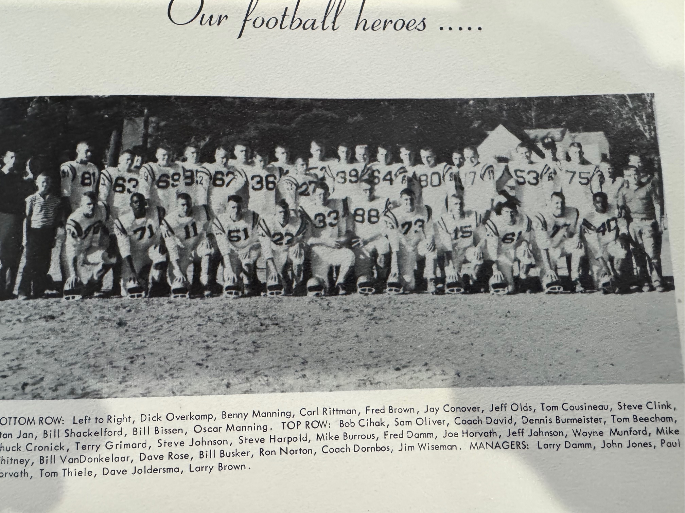

1959 NORSEMEN

Record Score Interesting Fact
0-0-1 NM 7, Coopersville 7 (tie) Only NM score comes on 49-yard TD pass from Carl Rittman to Tom Cousineau.
1-0-1 NM 28, Ludington 6 Jeff Olds scores a pair of TDs (1 & 8) while Dave Rose rushed for 127 yards and a 9-yard TD. Oscar Manning completes scoring with 3-yard TD.
2-0-1 *NM 25, Whitehall 13 A pair of punts, one blocked, the other touched led to two NM TDS. Rittman a pair of QB sneaks, Rittman passes to Jay Conover 7 yd TD. Rose 12 yd tally.
2-0-2 NM 13, Fremont 13 (tie) NM rallies from trailing 13-0 after 3 quarters to escape with a tie. Dave Rose and 5-yard TD and Jeff Ollds from 6 NM TDs. Rittman to Cousineau for the extra point.
3-0-2 *NM 20, Scottville 7 NM wins sloppy contest despite losing 4 fumbles. Jeff Olds two 34-yard TDs. Rittman to Conover for 17-yard passing TD.
4-0-2 *NM 7, Shelby 0 NM take advantage of late Shelby fumbles as Rittman sneaks from the one with four-seconds left in the game.
4-1-2 *Hart 19, NM 13 Hart scored 3 unanswered 2nd half TDs. Rittman to Conover for 26-yard TD. Rose scored from three.
4-2-2 *Montague 13, NM 7 Montague again WMC champs on frozen field. Rittman on NM TD on a 20-yard run.
4-3-2 Manistee 12, NM 0 Norse muster little yardage in game played in heavy snow.

1960 – coach Lee David (1-8 overall, 0-4 Seaway)

North Muskegon would have a new coach as well as a new conference, or do they? They know they have a new coach in former Muskegon Big Red star running back Lee David, who was on the state championship 1951 Muskegon team quarterbacked by Earl Morrall. The schedule was a mixture of West Michigan opponents as well as four members in the Seaway. The confusion was: what conference is NM officially affiliated with --- WMC or Seaway? It surely didn’t have an impact for NM winning a conference championship as the Norse would experience one of their worse seasons in history, winning but one of their nine games. Only the winless 2011 team would fare worse than the 1960 squad. Finally, just a couple of days before the season opener WMC Superintendents made it official that both Whitehall and North Muskegon, who bolted to join the Seaway would no longer be eligible to compete for trophies in thee WMC.
Only four lettermen returned from the previous year; Steve Johnson, who only played defense in 1959 would now be the NM quarterback, junior halfback Dave Rose, senior tackle Bill Bissen and lineman Bennie Manning, still only a junior but a two-year starter. Coach David summed it up perfectly even before the season got underway: “We are large but slow.”

Coopersville once again served as the Norse opener, and for the sixth straight year the Norse were winless against the Broncos, losing 21-0. The very green Norse offense just couldn’t get anything rolling and totaled just 44 yards rushing on a perfect night for football. Desperate to find a spark coach David inserted sophomore Charlie Langeland in at QB in the second half. The deepest NM was able to penetrate Coopersville territory the entire game was only to the Bronco 28. Getting praised for their defensive work were linemen Bill Busker, Troy Lalone and Bennie Manning. Perhaps a hint that better things might be happening in the future was the Norse junior varsity winning handily over the Broncos JVs earlier in the day. It was not the perfect start to their initial appearance in the newly formed Seaway Conference.

It would only get worse. Ludington handed NM their worse defeat in the 12-game series between the two schools when they pummeled the Norse 33-0. So futile was the NM offense that they only picked up 34 yards in total yardage in the entire game, and none of those yards came by passing the football. Veteran Chronicle reporter Mart Tardani made the long journey north to cover the game, and he did have some praise for a trio of Norsemen: Benny and Oscar Manning and sophomore Buddy Moran.

As the Norse approached their game with Whitehall, the first game played between the two long-time rivals as members of the Seaway Conference, the Norse were faced with the reality that they had but five first downs --- all season! Although they didn’t win, it was a complete reversal from their two earlier lopsided losses to begin the season. In fact, as heavy underdogs against Whitehall, the Norse were leading up until the games’ final stages 6-0. After being whitewashed in their first two games the Norse scored their first touchdown of the season on their first possession. Unfortunately, for Norse rooters, it would be their only score on the night. Short but stocky Bud Moran punched it over from the one to cap a 50-yard drive, but quarterback Charlie Langeland was stopped just inches shy on converting the all-important extra point. The 6-0 score stood up until the games’ final moments. The big play late was on a third and five play at midfield for the Vikings. Viking back Bill Darnell took a pass in the flat and out sped the Norse secondary until he was downed on the two-yard line. Future longtime Muskegon County Sheriff Bob Carter smashed through on the next play to make the score 6-6. Darnell than converted the game winning extra point on a dash around right end to make the final score read Whitehall 7, NM 6.

Fremont evened up the long time series between the two teams at 11 wins each (one tie) and they took home the ‘Victory Can’ with a 20-0 shutout of the Norse. Although the teams had played 23 games against one another in the past, it was the first game played as members of a conference. NM had their chances as they often drove into Packer territory only to have their drives stalled, but it still was unlikely they could overcome the stronger Packer team. For NM, it was the third time they failed to score over an opponents’ goal line in three games.

The only Norse win during the season came on Homecoming night on the Northside as the Norse scored in each quarter in defeating Scottville 25-0. The Norse were shorthanded as six players sat out the game for team rules infractions while end Don Nielsen was sidelined with a broken hand. NM without question had their best offensive showing of the season. Oscar Manning and Dave Rose were big ground gainers on the night while Charlie Langeland was effective in the passing game. NM tallied their first TD when Oscar Manning scored on a one-yard dive with Manning, Dave Rose and Langeland setting up Manning’s TD with gains of more than 15 yards during the drive. The Norse got some help on their second TD as Scottville butchered a punt attempt at their own 20 with less than a minute to go in the half. It took but two plays for Rose to go 20 yards into the end zone to give NM a cozy 12-0 lead at halftime. NM started the second half by marching 72 yards for their third TD with the big play a 37-yard pass to Joe Horvath. Rose than smashed over from the four and Dick Bultman’s kick for the extra point extended the lead to 19-0. Scottville had their most serious scoring opportunity in the fourth quarter when they advanced to the NM 5. Oscar Manning then intercepted a pass and galloped 96 yards for a TD. However, midway through his run clipping was detected and NM took over near midfield. Langeland then hit Joe Horvath on three completions, the latter good for eight yards and a TD to make the final score NM 25 Scottville 0. Prior to the opening kickoff there was a tribute to former head coach Paul Moyes who died the previous week after a long illness. A minute of silence was observed in memory of coach Moyes who fielded some of the finest grid teams in school history.

The Norsemen then had the misfortune of running into a Shelby team that was on its way to win their first WMC championship in 24 years. The Norse threw a scare into the host Tigers but fell to Art Willick and company 20-6. Shelby played like conference champs on their opening drive by marching 79 yards in 12 plays. Willick on this drive had runs of 15, 22 and 25 and capped the long march by catching a pass from Bill Knoth for a 20-yard TD. Dick Bultman blocked a Shelby punt at the Tiger 38-yard line midway into the second period to set up the only NM score. On the very next play Oscar Manning raced 38-yards for the TD but the extra point attempt failed. The visitors from NM nearly took the lead at halftime. After taking over at the Shelby 37 Charlie Langeland’s 28-yard pass to Dave Rose took it to the 13. Rose than got as far as the Tiger seven before time ran out with NM missing out on the chance to take the lead at halftime. Shelby iced the game with a couple of second half TDs to tag the very young Norse team with their fifth defeat of the year. Meanwhile history was begun at the LC Walker Arena when professional hockey returned to Muskegon with the Muskegon Zephyrs losing to Omaha 7-3.

What a week it was for the folks in the Greater Muskegon Area. On Thursday Vice-President Richard Nixon appeared in Muskegon just days before the 1960 Presidential election. If anybody ever asks what was the biggest crowd to ever appear at an event in the Walker Arena? It wasn’t for a hockey or basketball game, but it was when Richard Nixon spoke in front of 8,000 fans at the newly erected arena. The next day thousands of people lined up from Muskegon Heights all the way to Montague to welcome back to Muskegon the newly elected Miss America: Nancy Ann Fleming of Montague.

Later that day North Muskegon welcomed Hart for a game at the Northside field. Hart for the second straight year handed the Norse a defeat. These two teams have played 86 games going into the 2025 season. 1959 and 1960 would be the only period when Hart would win two straight games over the Norsemen. But the win surely didn’t come easy for the host Pirates. Trailing 18-0 late in the first half, Hart scored 19 unanswered in the second half to rally past the Norse 19-18. Oh, for a kicker! The Norsemen won in all the stat departments except for the final score. The first score for the fired-up Norse squad came from Oscar Manning when he scored from four-yards out in the opening period. The final two touchdowns occurred in the final four minutes of the half. Buddy Moran picked off a Pirate pass that the pint-sized back returned 55 yards for six points. Then Manning got into the interception act by picking off yet another poorly thrown Hart pass near midfield and sped all the way down to the six-yard line. Two plays later Charlie Langeland passed into the end zone to Bill Shackelford with little time left to push the lead to 18-0 --- but --- no extra point was successful on any of the three Norse TDs in the first half. Lady luck surely was not on the Norse side in this game. Hart returned the kickoff back to their own 43. Time for just one play before halftime. Dick Hasty tossed a screen pass to Walt Shogren who raced all the way into the endzone with no time left on the clock. Hasty then plunged over center for what would prove to be the winning point. An ill-timed penalty surely deprived the Norse of a golden opportunity to ice the game early into the third frame when Langeland teamed up with Shackelford on a long pass play that netted 80 yards down to the Pirate’s two-yard line, only to be called back. Hart would then score two TDs in the second half to send the Norse to their sixth defeat on the season.

Tough luck and missing a kicker rang true for the Norse in their second one-point loss, this time 7-6 at home to Montague. Montague was shooting for its sixth straight WMC Championship in 1960. That didn’t happen but the town of Montague got a huge ‘consolation’ prize with 1960 graduate Nancy Ann Fleming being crowned as Miss America in September. North Muskegon’s only score in the game came in the final period with only 45 seconds left on the clock. Quarterback Charlie Langeland scored on a sneak from the one, but to no one’s surprise who followed the Norse in 1960, a run for the extra point failed. Rain, buckets of it, played a factor in the low scoring game. NM had rushed for just 53 yards on the ground. Langeland and Joe Horvath did hook up on a key pass play good for 27 yards that set up the only NM score. Montague’s lone touchdown came in the third period on a pass from Bob Lloyd to end Dick Smith good for 13 yards and a TD. NM had a golden opportunity to score their second touchdown in the second half, but NM lost a fumble at the Wildcat 3-yard line.

Just days after John F Kennedy was elected President of the United States, two schools that until 1958, were one and the same before Reeths Puffer became a four-year school, met for the first time on the new Rocket football field. How well your author remembers a letter I received from President Kennedy in the summer of 1963: It began with “GREETINGS.” (One can guess the follow up story after the greetings.) The NM-RP rivalry would be a short one as the football teams would play one another only from 1960-65 when both schools were members of the Seaway Conference. The Rocket lineup would be filled with last names familiar to Norse fans, from the past as well as in the future. One the feature backs for the Gale Bolthouse Rockets team was Ron Guy, brother of former NM legend Stan Guy. Rocket linebacker Bob Buckmaster would be the father of Jeff Buckmaster, who years later would be a football star at North Muskegon. Rocket fullback Willie Bohach was the brother of former NM player John Bohach. John Bohach’s daughter, Annette Bohach, would be enshrined in the Muskegon Area Sports Hall of Fame after a great track career at NMHS and Indiana University. Even Rocket kicker Jim England had early connections with NMHS, as his sister Shirley was the Norse queen in 1953. The Norse scored their only touchdown midway through the third quarter on a pass play from Charlie Langeland to Bill Shackelford and, naturally, the Norse missed their extra point. Meanwhile the Rockets England, the only member of the England family of five who did not go to North Muskegon, kicked two straight extra points following the first two Rocket TDs. The Rockets would win 22-6 to complete their second season as a four-year school with a record of 6-1-1. The Norsemen season would mercifully come to an end with a record nearly the opposite of RP, at 1-8. Ten hardy seniors suited up for the final time for the Norse, including starters Bill Shackelford, Joe Horvath, Dick Bultman, Bill Busker, Oscar Manning and Bill Bissen, but plenty of talented underclassmen will return in hopes of flipping the coin in wins and losses the following year.

Record Score Interesting Fact
0-1 *Coopersville 21, NM 0 NM only musters 44-yards rushing entire game. First game for NM in the Seaway conference.
0-2 Ludington 33, NM 0 Ludington totally dominates as again NM shows little offense --- Only 34 yards in offense.
0-3 *Whitehall 7, NM 6 Whitehall scores late to ruin NM’s upset chances. Bud Moran scores first NM TD of season from the one.
0-4 *Fremont 20, NM 0 NM again scoreless as three deep drives stall in Packer territory.
1-4 NM 25, Scottville 0 Rose scores a pair of TDs, Manning a td and an interception. Langeland connected often to Joe Horvath, including a 8-yard TD pass.
1-5 Shelby 20, NM 6 Oscar Manning scores NM’s only TD against the WMC champs on a 38-yard run.
1-6 Hart 19, NM 18 Norse sees lead of 18-0 go up in smoke. Manning and Moran both pass interception returns for TDs. Manning 2nd TD from 1.
1-7 Montague 7, NM 6 Norse score with less than a minute left on Langeland sneak but miss extra point.
1-8 *Reeths Puffer 22, NM 6 Langeland to Shackelford for only Norse TD as season ends at 1-8

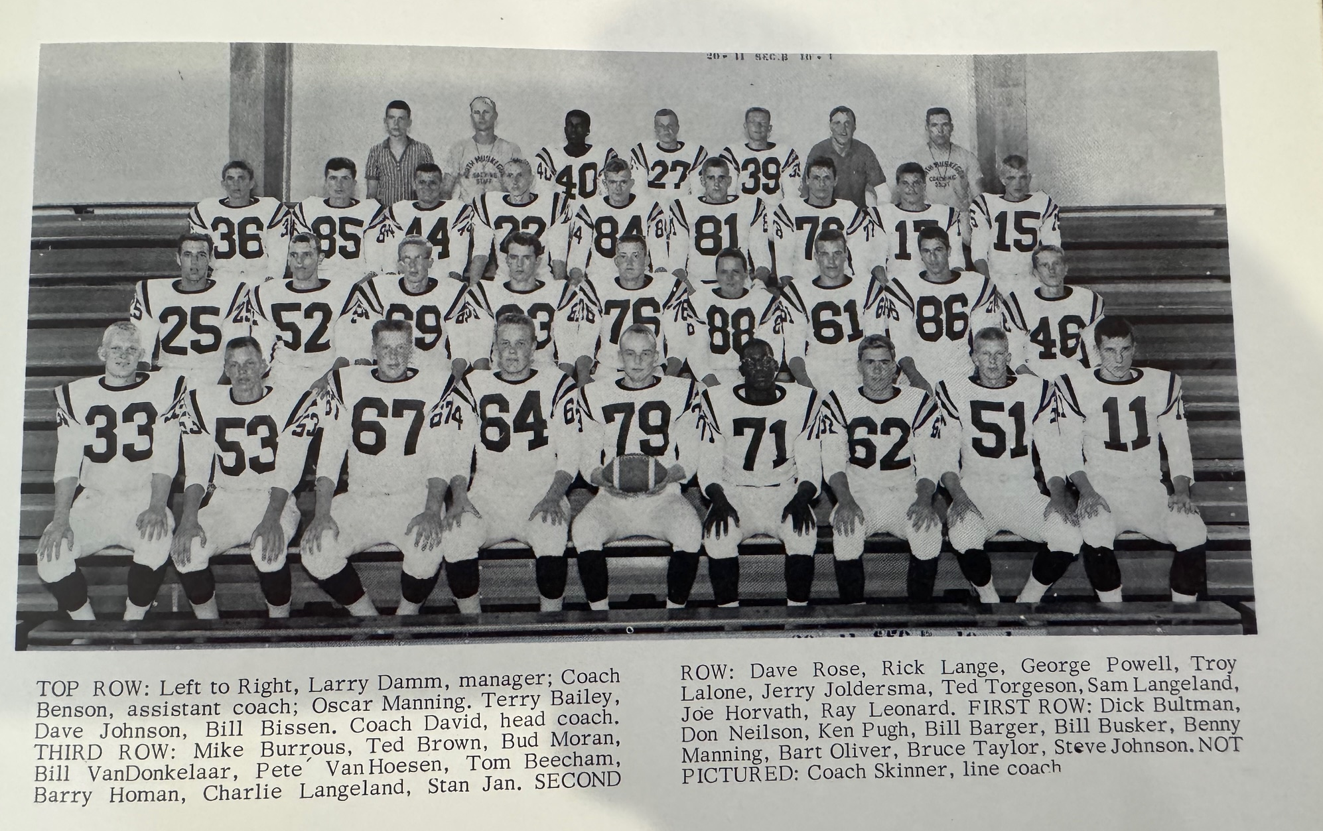

THE 1960 NORSEMEN

1961 – coach Lee David (7-1 overall 5-0 Seaway Champs)

What a difference a year makes! After winning but a single contest in 1960, the Norse completely turned the table around and went 7- and 1 in their second year in the Seaway Conference and were the Conference champions. A cast of veterans and a host of new faces gave hope to 2nd year coach Lee David that 1961 would be much different than 1960. After being soundly beaten by Ludington 33-0 in 1960 and held to but two first downs the entire game, the Norse battled hard in their home opener against Ludington only to fall 14-7. It would be the last time the Norse would be on the losing end the rest of the season. Ludington’s defense often bent but was rarely broken as four times the Norsemen advanced inside the 20-yard line before finally breaking the ice in the fourth period. Ludington struck first on a 43-yard pass from Manny Karosas to 6’6 end Van Tillotson, the first of two big pass receptions in the game for the rangy Tillotson. There was no further scoring until early in the fourth quarter when it would be the Norsemen who would finally find the end zone. The touchdown came on a 19-yard TD pass from returning starting quarter Charlie Langeland to first year newcomer Tom Moyes. A run for the extra point by Moyes tied the game at 7-7. However, Ludington came back to get the game winner. The big play was a pass to Tillotson that covered 45 yards before he was tackled at the NM four. From there Daryl Peterson scored, Mike Gebott was perfect on both of his extra points and Ludington had defeated a much-improved NM team 14-7.

In an old-time rivalry that goes back into the 1930s, the series with Fremont could not have been more even over the years as both teams had won 12 games out of 25 played with one game ending in a tie. NM had numerous injuries from their opener with Ludington with the most serious an ankle injury to returning starting halfback Bud Moran. Coach David unveiled a rising star in junior running back Bill Young who put up numbers in the Fremont contest not seen since the heyday of Stan Guy. Included in Young’s 265 total yard gains were a couple for the NM record books, a 97-yard TD run from scrimmage and an 85-yard kickoff return. Young’s first of three TDs gave the Norse an early 6-0 lead. The 97-yard TD gallop by Young served as a record for the next 64 years as the longest TD run in NM history. The lead went to 13-0 at the half thanks to an 18-yard TD pass from Charlie Langeland to Don Nielsen. And believe it or not, the Norse made an extra point via the old fashion way from a kick by Troy Lalone. Fremont, who shut out the Norse 20-0 in the previous season, took the lead into the fourth quarter on a pair of touchdowns by future Grand Haven head football coach Tom KeKuiper. That lead lasted only until the next kickoff was retuned 85 yards by Young. Young later than iced the game with his 97-yard TD run, breaking the record of 96 yards by Scott Moore in 1953. In 2025 Cullen Bartos raced 99 yards from scrimmage to eventually break the record.

Next up for the Norse would be the first meeting between NM and Ravenna since 1935, a series that would continue between the two schools every year apart from the 1967 & 1968 seasons. Bill Young had another sensational game, and for the second straight game had a run of 90 yards or more in a 26-6 victory. In all, Young ran for 158 yards in but 13 carries, an average of 12 yards per carry. The junior speedster once again scored three touchdowns with his first TD of 30 yards coming in the first quarter to begin the Norse scoring. Later in the opening quarter Young, on a simple dive play, shook loose from Ravenna defenders and raced 92 yards to pay dirt. Sophomore fullback Tom Holstrom capped a 46-yard drive in the second quarter with a three-yard plunge while the Bulldogs averted a shutout when they scored with 19 seconds left in the first half on an eight-yard run by Stan Jacobs. Young completed all the scoring in the contest with an eight-yard run and it appeared NM had finally found a kicker when Troy Lalone sent a couple of extra point kicks sailing through the uprights. Reserve quarterback Steve Crosby was pressed into service when starting quarterback Charlie Langeland missed the game due to a broken finger and did a fine job.

14 years had passed since North Muskegon had won a game by successfully kicking an extra point. After numerous games had passed when NM could have been on the winning side of games if only for a made extra point, NM finally emerged victorious when Troy Lalone kicked both of his extra point tries through the uprights in NM’s 14-13 victory over Montague. Not since Bud Matych made NM victors back in 1947 vs. Shelby would a made extra point from placement be the difference between winning or losing. Bill Young incurred a painful toe injury in practice and played only sparingly against Montague. Tom Holstrom filled in more than admirably for Young. The Norse had to make a second half comeback as they spotted Montague a pair of touchdowns in the first half to trail 13-0 at the break. With Holstrom carrying the ball on virtually every play NM drew within six points of the Wildcats in the third period after a Holmstrom one-yard plunge and a Lalone extra point. A Dave Hickman blocked punt then set up NM’s winning drive in the final period. A gimpy Bill Young then entered the game and combined with Holmstrom to move in for the score. However, the big play in the drive was a fourth down run by Ray Leonard that gave the Norse a much needed first down at the Wildcat 11. After three Holmstrom plunges up the middle, Young went over from the one. Lalone’s clutch extra point was good and the Norse came away with a 14-13 win over their rivals.

The Norse then made it two wins in a row over White Lake Area rivals when they spoiled Whitehall’s homecoming with a 20-6 win over the Vikings. It looked like it was going to be the Vikings night when they took the opening kickoff and drove 72 yards for the TD, the only points they would put on the board the rest of the way. In fact, the Norse defense would allow Whitehall a net gain of just one yard until the game’s end. Bill Young and the Norse wasted little time regaining a lead they would not relinquish when Young raced 46 yards for a Norse TD. In the second quarter Ken Pugh recovered a Whitehall fumble at the Vikings 23. On fourth down Steve Crosby chucked an 18-yard TD pass to Don Nielsen. The Norse in the third period went 75 yards for their final TD with Tom Moyes and Tom Holstrom doing much of the ball carrying. Holstrom plunged over for the score from the one, but the Norse missed all three of their extra points as the hero of last weeks’ game, Troy Lalone was on the sidelines with a twisted knee. The two points earned by the Norse came late on a safety when a bad snap from center went out of the end zone.

More than 3,000 fans were on hand on the Northside gridiron when Reeths Puffer visited North Muskegon for a game that would likely decide the Seaway Championship as both teams sported perfect 3-0 records in conference play. For more than three quarters nothing was decided as the game was deadlocked in a scoreless duel. Bennie Manning, a four-year starter for the Norse made a huge defensive play for the Norse when he broke through the Rocket’s offensive line and brought down RP’s punter before he had a chance to get the punt away. Three running plays and an illegal procedure penalty put the Norse in a precarious position. NM coach Lee David then called for a field goal. So rare was a field goal in NM history that one would have to go back in history to 1936 when NM not only made a field goal, but it had been 25 years since they even attempted a 3-pointer. Troy Lalone, whose kicks were the difference in the win earlier over Whitehall, became the first Norseman to kick a field goal since Walt Bergen in 1936 when he was perfect on his 30-yard field goal to give the Norse a 3-0 lead. The wind surely was knocked out of the sails of the Rockets. Shortly after Lalone’s 3-pointer the Norse took over at the RP 31-yard line after the Rockets gambled on a fourth down. Two plays later Tom Holstrom shook off several Rocket tacklers to go 35-yards for the game’s only touchdown. The Norse added another two points very late in the contest when Lalone added to his heroics by blocking a Rocket punt in the end zone. Lauded by Coach David for their defensive work in shutting out the Rockets were Bill Barger, Dave Hickman, Tom Moyes and Benny Manning. The Norse were now a perfect 4-0 and just one-win shy of a Seaway Conference Championship in their second year of the league.

The champs from the Seaway and the champs from the West Michigan Conference, Hart and North Muskegon, a pair of long-time rivals would face one another on the Northside field to settle bragging rights between the two conferences. It was the Norsemen who would come away with the win thanks to another super performance from halfback Bill Young. For the Pirates, although both North Muskegon and Whitehall were not a part of the WMC, 1961 would be their last outright conference title as of this writing in 2026. Racking up 4 touchdowns and running for 196 yards in 19 carries, Young scored on runs of 25, 52, 2 and 47 to lead NM to victory. The other NM TD in this game was a one-yard run by fullback Tom Holstrom. Scoring one of two Hart TDS on a 75-yard run was future Muskegon High School Varsity basketball coach Duane VandenHeuvel.

The Norse, although they hadn’t beaten Coopersville in seven-years, NM was still top-heavy favorites to defeat a winless Coopersville team and clinch the championship for the Seaway Conference in football for the 1961 Season. Fifteen seniors, many who contributed to the complete about face from the previous season’s one-win squad, would suit up for the Norse Road game at Coopersville. Among the starters were co-captains Benny Manning and Bill Barger, halfbacks Tom Moyes, Buddy Moran and Ray Leonard, quarterback Steve Crosby, linemen Dave Hickman, Jerry Joldersma, Bart Oliver, Sam Langeland, Ted Torgeson, Ken Pugh, George Powell and Jim Wheaton. Coach Lee David was wary of the Broncos: “We haven’t beaten them since 1954 and they could come up and beat us if we are not mentally prepared,” David said.

Not to worry. The Norse perhaps played their best game of the season in a 48-6 thrashing of the Broncos. Eight different players scored all NM touchdowns during the rout. Tom Moyes began the scoring with a 27-yard TD dash. Bennie Manning after four years as a starter, in his final game, intercepts a pass and returns it 72 yards for his only TD as a Norseman. Charlie Langeland hits his favorite receiver Don Nielsen for 36 and a third NM TD. Bill Young scored from 12, followed by a typical Tom Holstrom one-yard plunge. In the fourth quarter Ray Leonard, Bud Moran and Ray Schuiteman all scored, and the Norsemen were the Seaway champs. The Norsemen dominated the Seaway 11-man all-conference team with five players, Nielsen, Langeland, Manning, Holstrom and Young all being named to the first team while Bill Barger and Troy Lalone were tabbed for the second team.

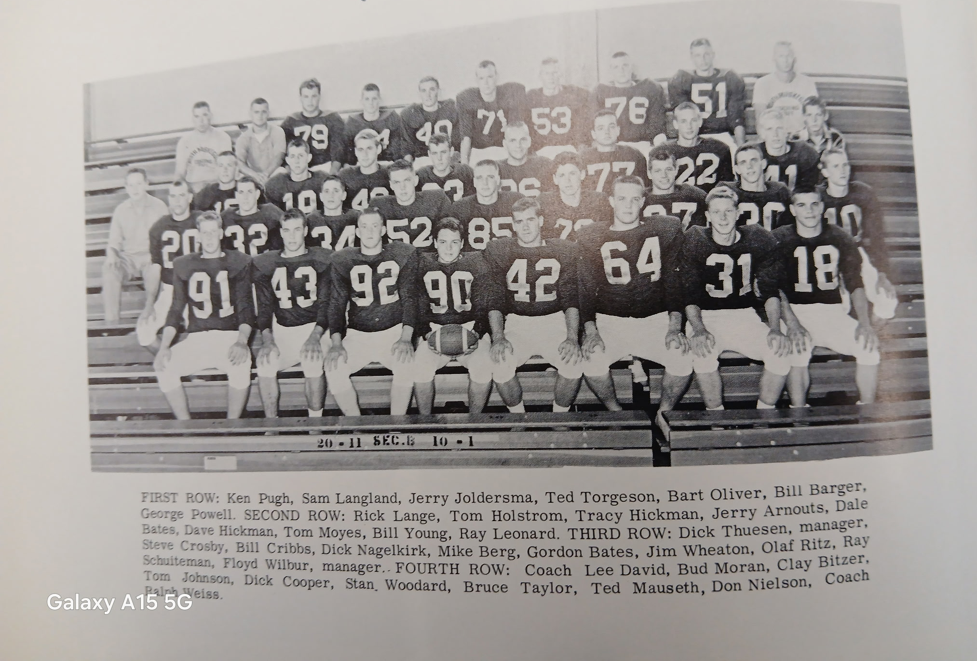

The SEAWAY CHAMPS of 1961
Note: # 18 (not listed above is Charlie Langeland) future team captain at Hope College

Record Score Interesting Fact
0-1 Ludington 14, NM 7 Two long passes contribute to opening game defeat. Tom Moyes scores NM TD on a pass from Charlie Langeland and runs for extra point for the Norse.
1-1 *NM 25, Fremont 14 Bill Young runs for school record 97-yard TD and equals record with 85-yard kickoff return. Young 3 TD, Langeland to Don Nielson 19 yards Passing TD.
2-1 *NM 25, Ravenna 6 Another monster game for Young. 3 Yds (92, 30 & 8). Sophomore Tom Holstrom a 3-yard TD.
3-1 NM 14, Montague 13 Holmstrom was the workhorse in the win. The difference in the win was 2 made extra points from Troy Lalone. A gimpy Young 1-yard TD. Holmstrom TD.
4-1 *NM 20, Whitehall 6 Young a 46-yard TD; Steve Crosby passes to Nielson for 18-yard TD. Holmstrom 1-yard TD.
5-1 *NM 11, Reeths Puffer 0 Lalone makes first NM field goal in 25 years in 4th qtr. Holmstrom 35-yard TD run late and Lalone blocks RP punt for a safety.
6-1 NM 34, Hart 20 Young 4 TDS on runs of 25, 52, 2 & 47. Holstrom 1-yd TD.
7-1 *NM 49, Coopersville 6 Eight players scored in the rout: Moyes, Nielsen, Manning, Young, Holstrom, Bud Moran, Ray Leonard, Bud Moran and Ray Schuiteman.

1962 – coach Lee David (6-1 -1 overall 4-1 Seaway, Whitehall Champs)

Just three points were the difference in 1962 from North Muskegon posting a perfect season. North Muskegon began the season by atoning for their only loss from 1961 in a big way as they blasted Ludington 30-0. Although the Norse lost 15 seniors thru graduation, a nice combination of returning starters and junior varsity performers showed early that this team was going to be no pushover. The Norse won handily despite the absence of their all-state running back Bill Young who was sidelined with a knee injury. A pair of returning all-conference members from 1962 got the ball rolling early against the host Orioles. Charlie Langeland set up the first TD with a long punt return and a 29-yard run to the three-yard line. From there bruising fullback Tom Holstrom then powered in for the first NM TD. The second touchdown was scored by Ray Schuiteman from 42 yards out to make it 12-0. With Young on the sidelines with an injury third year coach Lee David inserted Schuiteman at quarterback and moved the stocky Langeland to halfback. The moved worked smoothly as the duo were instrumental in the third NM TD when Schuiteman raced 38-yards on a bootleg play and Langeland went the final 20-yards to give the Norse a commanding 18-0 lead at halftime. Holstrom would run for 127 yards while Langeland also nearly hit the century mark for yardage with 88. The trio of Langeland, Schuiteman and Holstrom were well acquainted as they all resided within one block of one another. Next, it was All-Seaway end Don Nielson on the receiving end of a Schuiteman pass good for 18 yards that opened the second half. Holstrom added the final NM tally when he raced 57 yards. If not for a couple of long touchdowns called back by penalties, the score could have been much worse for the Orioles. Jim Schillaci had a 41-yard TD called back and reserve Tom Andrews also had a 50-yarder whistled back.

On a rain drenched field North Muskegon backs ran for nearly 400 yards in a 33-0 victory over arch-rival Fremont. Charlie Langeland had a huge game for the Norse with three touchdowns, including a long jaunt of 94 yards. Langeland ran for 187 yards while Tom Holstrom added 90. The Norse attempted only one pass, Ray Schuiteman to sophomore end John Hutson for 20 yards and a TD. Leading the defense were Dale Bates and Clay Bitzer as NM posted its second straight shutout.

North Muskegon would face Ravenna with the following starting lineup: Ends Don Nielsen and Dave Dewey; Tackles Clay Bitzer and Greg Young; Guards Rick DeBruyn and Dave Semelbauer; center Jerry Ray; Tom Andrews, Tom Holstrom, Ray Schuiteman and Charlie Langeland in the backfield. The Norse would earn their 3rd straight victory, all shutouts with a 20-0 win over the host Bulldogs. Charlie Langeland accounted for all three TD’s, his 6th in the last two games and 7th on the young season. Langeland scored his first TD on the team’s second possession to open the contest, capping a methodical 85-yard drive with a 14-yard end run. Ted Mauseth kicked the first of his two made extra point attempts and the Norse were off and running at 7-0. It took but four plays for the Norse to add their second TD in the second quarter with Langeland going the final 31 yards. The final Norse score was set up following an interception by lineman Clay Bitzer late in the contest with Langeland rushing for his final TD from eight yards out.

North Muskegon once again shut out their opponent for the fourth straight game but did not come up with a victory. The Norse and Montague played to a 0-0 tie in foggy conditions at the Northside Field that was filled to more than capacity. The Norse were even fortunate to come away with the deadlock as Montague moved deep into NM territory three times in the contest but came up empty on the scoreboard. The most serious threat came on the opening kickoff of the second half when the Cats Gary Quinn broke loose from his own ten yard for an apparent touchdown gallop. However, sophomore John Hutson caught Quinn with a desperation tackle at the NM ten-yard line. Marching three times inside of your opponent’s 20-yard line without putting points on the board would probably not have happened in today’s era of soccer style kickers. To add further woes to North Muskegon’s kicking game, Norse kicker Ted Mauseth fractured his knee in this game and would be lost for the season. The Norse had hopes going into the Montague game that their All-State running back Bill Young would be available but that was not the case as Young was still on the sidelines with a knee injury.

Whitehall had but one season in their school’s long history when they would go undefeated during a regular season. It was this season of 1962, but the Vikings had to rally for two touchdowns in the final ten minutes of the game to nip the Norse 21-19. The winning points can be attributed to the golden toe of Whitehall’s Bruce Finkbeiner, a top-flight baseball player in the spring who converted on all three of his extra point attempts. The Norse lost their kicker, Ted Mauseth, with an injury the previous week, and that proved costly to the Norse. The big play in the game, played before an overflow crowd on the Norse field, was an 80-yard punt return by Whitehall’s Jack Bellinger late in the game. The Norse trailed 7-6 at halftime with Tom Andrews capping a 74-yard drive with a touchdown from the three-yard line. The Norse scored a pair of TDs in the third quarter to apparently take command of the game. Both NM touchdowns were created from Viking fumbles. Tom Holstrom scored both NM TDs, the first from 26 yards out and the second from the two-yard line. The determined Vikings came charging back. After a pass play good for 33 yards, completed to another outstanding Whitehall baseball player, Jon Swenson, Bellinger scored the second of his three TDs on a short four-yard jaunt midway through the final period. After the Norse were forced to punt, Bellinger than fielded a NM punt at his own 20 and scored the game winner. The Norse hopes were buoyed with the return for the first time in the season with the return of Bill Young to the lineup. However, Young reinjured his knee early in the game and would be lost for the season.

After leading by two touchdowns the previous week at Whitehall and losing, the Norse did the opposite in their 25-19 win over Reeths Puffer. Spotting RP a couple of first quarter touchdowns to trail 13-0, it was the Norsemen’s turn to rally for a come from behind victory. For Reeths Puffer, it saw its unbeaten streak for the campaign come to an end. The game could easily have turned very ugly for the Norse after they fumbled the ensuing kickoff following the two Rocket TDS, but the Norse defense held. Al Dillar recovered a Rocket fumble on the Rocket 43 and the tide turned in favor of NM as they marched downfield to score in eight plays with Charlie Langeland going over from the 10-yard line. NM then took control in the second half with Langeland tossing a 28-yard TD pass to halfback Tom Andrews, but the Norse failed to tie the game as their kicking woes on extra points continued. Another Rocket fumble led to the Norse then taking a lead they would not relinquish. It took just six plays to cross the RP goal line with Ray Schuiteman hitting Rick Lange for 25 yards and a TD with 10:17 left. The Rockets gambled on a short yardage play at their own 33 but the Norse defense rose to the occasion. Langeland made the Rockets pay when he made a circus catch of a Ray Schuiteman pass to complete a seven-yard TD play. After missing three extra points on kicks, Langeland ran for the only extra point completed by the Norse in the game. The Rockets scored late to narrow the gap and the final score of 25-19. In addition to losing one All-Conference player in Bill Young, the Norse would also have to finish the season without yet another all-conference player from 1961 in end Don Nielsen. Langeland, Holstrom and Andrews, running behind a much-improved line, ran well for the winners. Holstrom’s’ total could have been more, but a 60-yard TD run in the first quarter was called back due to a penalty. In the absence of the injured Nielsen, NM got great end play from both Lange and sophomore John Hutson.

North Muskegon and Hart, a pair of long-time rivals met on a rare Saturday night game in Hart. Reports bemoaned the fact that this would be the last game played between the two schools as NM had joined the Seaway. However, history has shown that the separation would only be for three years before NM rejoined the WMC. Although this was a non-conference game there was much at stake. Hart needed a victory to stay undefeated. It was Hart who held Whitehall to a 6-6 tie, the only blemish on an otherwise perfect season for Whitehall. NM spoiled Hart’s hopes for a perfect season by edging the host Pirates 19-13. The Norse were the first to get on the board when Ray Schuiteman connected with halfback Tom Andrews for a 14-yard TD. Hart countered with a short drive following a Norse pass picked off and returned down to the NM 15. A screen pass from Jerry Brandel to Bud Tice went for 10 yards and a TD as Brandel kicked the extra point to give the Pirates a 7-6 lead. The defense midway through the third quarter gave the Norse the lead. Chased some 10 yards by a hoard of Norse defenders, the Pirate quarterback in his haste to get something on the play threw wildly. Tackle Greg Young gathered in the ball and raced untouched into the end zone. The Norse added an insurance touchdown when Ray Schuiteman connected with the second of two passes to his neighbor Charlie Langeland, good for a 45-yard TD pass. Hart closed the gap on a flea flicker play to make the final score NM 19, Hart 13. Much praise was bestowed on the Norse defense from veteran sportswriter Keith Dayharsh. He lauded the defensive work of Clay Bitzer, Tracy Hickman, Dave Semelbauer and Tom Johnson as the Norse won their 5th game on the 1962 season.

The Norse would make it six wins with a 52-12 blowout of winless Coopersville in the final game of the season. No longer would there be no name attached to the northside field. In a presentation prior to the game North Muskegon mayor, and long-time beloved teacher, John Hallmond, dedicated the field in memory of Dr. Fred H. Jacks, a former chiropractor who gave both physical and mental guidance to hundreds of youths of North Muskegon over the years --- all without a charge for his services. It was the Charlie Langeland show on Fred Jacks Field as the Norse earned a very respectable 2nd place finish in the Seaway. Langeland scored five touchdowns in a variety of ways. Two of his scores came on runs of 38 and 18 yards. He caught a pass from Schuiteman that was good for 26 yards and six points. He intercepted a pass and returned it 70 yards for another tally. And then he would score his 5th TD on a 65-yard return of a kickoff. Five TDs in four different ways. Langeland nearly had another TD when he was brought down on the Bronco five-yard line after he intercepted another pass. Langeland would finish the season with 15 touchdowns and 90 points, second only to the legendary Stan Guy from the 1950s. Also scoring touchdowns for the Norse were Tom Holstrom and Jim Shillaci, who tallied twice for the victors. Three Norsemen were accorded first team honors on the All-Seaway team. Langeland and Holstrom were the only two repeaters from the 1961 team while Clay Bitzer was the third Norse player on the first squad. Langeland would go on to have a stellar career at Hope College where he served as the Hope team captain in 1966. Second team honors went to Dale Bates and Jim Nielsen. Assisting coach David in his first year on the staff at North Muskegon was a man who would make a name for himself as a future Norse coach --- Tom Seroczynski.

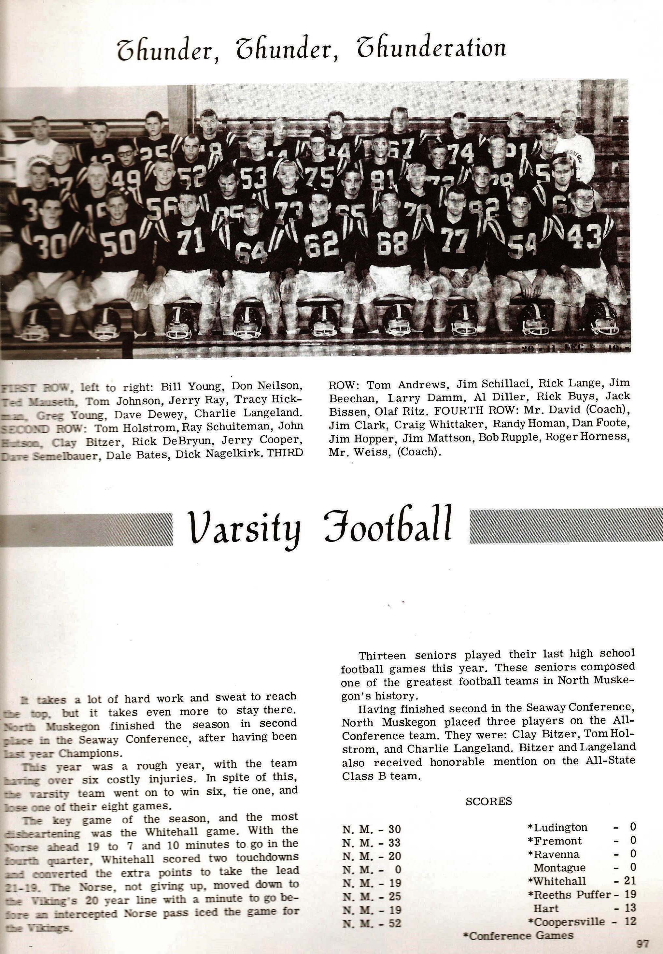
THE NORSEMEN of 1962

Record Score Interesting Fact
1-0 NM 30, Ludington 0 Tom Holstrom 127 yards and 2 TD; Charley Langeland 20-yard TD; Ray Schuiteman 38 yd TD and TD pass to Don Nielsen for 18.
2-0 *NM 33, Fremont 0 Langeland 187 yards & 3 TD, including one for 96. Schuiteman to John Hutson for 20-yard TD. Tom Andrews scores from seven.
3-0 *NM 20, Ravenna 0 Another 3 TD game from Langeland on carries of 14, 31 and 8).
3-0-1 NM 0, Montague 0 (Tie) John Hutson saves the Norse from defeat with an open field tackle at the 10-yard line.
3-1-1 Whitehall 21, NM 19 80-yard punt return defeats NM. Holstrom 2 TDs (26 & 2) Andrews a 3-yard TD as Whitehall would have their only undefeated season in history.
4-1-1 *NM 25, Reeths Puffer 19 NM spots Rockets 2 TDs but rallies. Langeland a running and receiving TD. Langeland TD pass to Andrews, Schuiteman to Rick Lange passing TD.
5-1-1 NM 19, Hart 13 Schuiteman 2 TD passes, one to Andrews for 14 and the other to Langeland for 45. Greg Young returns interception 25 yards.
6-1-1 *NM 52, Coopersville 12 Langeland becomes 2nd player in NM history to score 5 touchdowns in a game. Jim Shillaci scores twice and Holstrom once.

1963 – coach Lee David (4-2-2 overall 2-2-2 Seaway)

Twos were wild for the 1963 season as the Norse had equal numbers of wins, losses, and ties in the Seaway conference. Fortunately, the two ties would be the last season that the Norse would be involved in a tie game. NM was able to post wins against both of their non-conference opponents with wins over Ludington and Montague. NM brushed up for their upcoming season with a scrimmage against Mona Shores, a new school that would be a year away from having a senior class. Ten lettermen returned for the 1963 season for head coach Lee David. Leading the returnees was two-time all -conference back Tom Holstrom. Another starter returning in the backfield is Tom Andrews, while Jim Shillaci also saw much action as a running back in 1962. Coach David was enthused with his returnees on the forward wall with a host of starters giving NM a great deal of experience up front. Jerry Cooper was back at center, Jerry Ray and Dave Semelbauer the guards, Al Diller and Greg Young at tackles with junior John Hutson and Dave Dewey at the ends. The big question -- who would run the offense at quarterback?

Clint Oliver won the starting job at QB for the Norse and set up the first of two NM TDs in their opening 12-6 win over Ludington with a 65-yard run. Jim Schillaci’s 12-yard sprint following Oliver’s long run came in the closing minutes of the first half. Tom Andrew’s 14-yard TD run in the third quarter proved to be the game winner. The drive to pay dirt started when Jerry Ray intercepted an Oriole pass. Although he failed to score, much of the credit for the Norse offense went to their two-time all-conference running back Tom Holmstrom who was credited with picking up seven first downs on his own. The Norse defense, led by tackle Greg Young, had to really dig down in the closing minutes of the game. Trailing by just six points Ludington moved to within six yards of the Norse goal line before the Norse held and took over on downs.

The Norse won their second scheduled game of the season and their first in the Seaway with a 25-6 win at Ravenna. The Norse defense held Ravenna to but 54 yards rushing as the Bulldogs were only able to move the ball through the air against the northside eleven. NM scored on their second drive of the game on a 15-yard scoring pass from Clint Oliver to Tom Andrews. Andrews added his second TD in the fourth quarter on a six-yard run. Tom Holstrom, whose 22-yard run set up Andrews fourth quarter TD, set up his own TD from three-yards out with a 20-yard power run in the second quarter. Jim Procter tallied his first TD in a Norse uniform late in the game on a 22-yard jaunt. Once again it appears the Norsemen were without a proven kicker as their only extra point make was on a run.

Both Fremont and North Muskegon looked to go 3-0 on the season but it was the Packers who came away undefeated with a last minute 13-7 victory over the Norsemen. With the score tied at 7-7 midway through the fourth quarter it looked like the Norsemen would take the lead following a long pass from Clint Oliver to Tom Austin all the way to the Packer nine-yard line. The Packers defense then dug in, and without a kicker, the Norse turned the ball over on downs. Fremont then went on a long and methodical drive that culminated with just 0:56 second left on the clock when Packer quarterback Gary Frens sneaked over for the winning score. Earlier Frens, an outstanding baseball pitcher in his day, had given Fremont a halftime 7-0 lead on a 5-yard rollout in the second quarter. The only Norse score on the night came in the third period following a very short Fremont punt downed at the Packer 38. Jim Schillaci, Oliver, and Tom Holstrom advanced the ball to the 15. With third and seven Oliver hit Austin in the right flat who raced in for the score. Holstrom then powered over for the extra point to tie the game at 7-7 that was followed late in the game by Fremont’s winning score.

In addition to Mona Shores being a new kid on the block, another school appeared on the East Side of Muskegon in Orchard View. The Cardinals in their second year as a varsity football team, would join the Seaway Conference for the 1963 season. Orchard View would be no pushover in the first ever meeting between the two schools as the Norsemen just edged the Cardinals 12-9. Although it was early in their program the Cardinals had visions of winning the Conference as they made the short trip across the Causeway to the play the Norse undefeated early into the season. While Greater Muskegon mourned the passing of L. C. Walker on this day, a packed house was on hand at Fred Jacks field to watch North Muskegon mount a late goal line stand to preserve their narrow victory. The hero on the night for the Norse was Norse defensive lineman Dave Dewey. It was Dewey, with help from Jerry Ray who spilled the OV quarterback for a loss when the Cardinal needed but 2-yards to score and win the game with less than a minute left. Earlier Dewey was instrumental in stopping a Cardinal drive in the second quarter and recovered a fumble in the opening period that set up a NM touchdown by Clint Oliver. Dewey had help from the rest of his colleagues on defense as four times the Norse stopped OV drives deep in NM territory. Dewey recovered 2 fumbles and John ‘Admiral’ Hutson another to aid in the NM victory. The Norse scored what would prove to be the winning tally when they executed a 51-yard second quarter drive. The Norse traversed the distance in nine plays with Jim Proctor going nine yards for the TD. Orchard View’s points were scored on a 62-yard pass play from Curt Gardenour to Ron Verdermolen and they earned two-points on a safety when a Norse punt was blocked out of the end zone for the only points earned by either team in the second half.

In a final score only a soccer fan would love, Reeths Puffer and North Muskegon played to a 0-0 tie in front of a large crowd at the Rocket Stadium, which in the future would be named after their coach in 1963, Gale Bolthouse. The Norse had a decided statistical edge over RP as they had a big advantage in first downs at 16-7 and they ground out a total of 224 yards as opposed to the Rockets 144. It was the Rockets however, who had a golden chance to score in the waning seconds of the game as they advanced as far as the NM five-yard line. The Norse held and evidently the Rockets had no better luck in finding a kicker then NM as their field goal try was missed. The Norse did score a touchdown, on a 20-yard run by Tom Holstrom, but it was wiped out due to a penalty. Holstrom had several runs for decent yardage for NM, including one for 15 yards to begin the third quarter. Tempers flared after he was stopped that drew an ejection from a pair of players. Following the ejections Holstrom ran for 13 yards, and it was on the next play that Holstrom’s apparent TD run was brought back. Standing out for the Norse other than Holstrom was Jerry Ray while two new defensive players showed up well, Steve Nelson and future long-time NM fire chief Jay Kersman.

North Muskegon experienced a rare easy victory over Montague as the Norse shutout the host Wildcats 27-0. The Norse had their running game clicking all throughout the game, highlighted by an 81-yard jaunt by Jimmy Proctor. The Norse accumulated all but 14 of their 284 yards on the ground. Tom Andrews had a pair of short touchdown runs of four and three yards, but he had several long gainers that set up his TDs. Future NM pole vault record holder Dennis Wilder scored his first NM TD when he sped 61 yards to pay dirt. Jerry Ray came close to adding his name to the NM record book when he intercepted a Montague pass and raced 98 yards for the score, only to have the ball brought back when a Norseman was guilty of clipping on his long journey. It was Ray’s interception which set up Wilder’s 61-yard sprint.

A year after North Muskegon had scored 101 points in two blowout victories over Coopersville, the Broncos held a highly favored Norse team to a 7-7 tie. It would be the last tie game in NM history. It was a frustrating night for the Norse as they were denied several times from crossing the Coopersville goal line. In the fourth quarter NM came within one foot from pay dirt, only to be repelled by the Broncos. Just moments later Tom Andrews returned a punt down to the seven, but again, no TD and no field goal kicker. It got even more frustrating for the Norse in the same final period when they moved down to the 10-yard line only to see the clock run out of time. In total for the game, five times NM was inside the Bronco 25 with no points scored. Both touchdowns scored in the game came within moments of one another in the third period. After the Broncos scored a TD and ran for the extra point the Norse scored their only TD on their first play from scrimmage as Dennis Wilder, as he did last week in the game against Montague, came off the bench and ran for 51 yards to score. Clint Oliver ran for the all-important extra point as the score remained at 7-7 the rest of the way. It was homecoming for North Muskegon and at halftime they honored Charles Woodruff and Lyle Moran for their many years they have spent with the North Muskegon midget football teams.

In a hotly contested season finale that was marred by a wild melee in the final seconds of the game, Whitehall, now guided by first year head coach Dave Cooke, earned a share of the Seaway conference with a hard earned 20-12 victory over the Norse. Viking speedster Don Witt, a state Class B champion in the hurdles in 1964, scored a pair of touchdowns and set up a third to lead the co-champs to victory. All the scoring for Whitehall came in the first half on a soggy NM gridiron. Whitehall took an early lead with a pair of TDs before the Norse could counter with a 29-yard TD run by Tom Andrews. Early in the third quarter Andrews, who in the not-too-distant future would become a successful lawyer, busted another long run of 41 yards to narrow the deficit down to 20-12. However, as often was the case in 1963, lack of a kicking game and failure to score deep in opponent’s territory were shortcomings all season for NM. Shortly after Andrews second TD run Kent Osborme picked off a Vikings pass but the Norse ran out of steam at the Vikings six. NM could not take advantage of yet another potential scoring threat following a fumble recovery by sophomore Randy Homan.
No one could fault NM’s defensive effort in 1963 as they were tops in the Seaway by holding their opponents to but 61 points for the entire season, an average of just over seven points per game. Following the completion of the season linemen Greg Young and Dave Dewey along with running back Tom Andrews earned first place honors on the Seaway All-Conference team

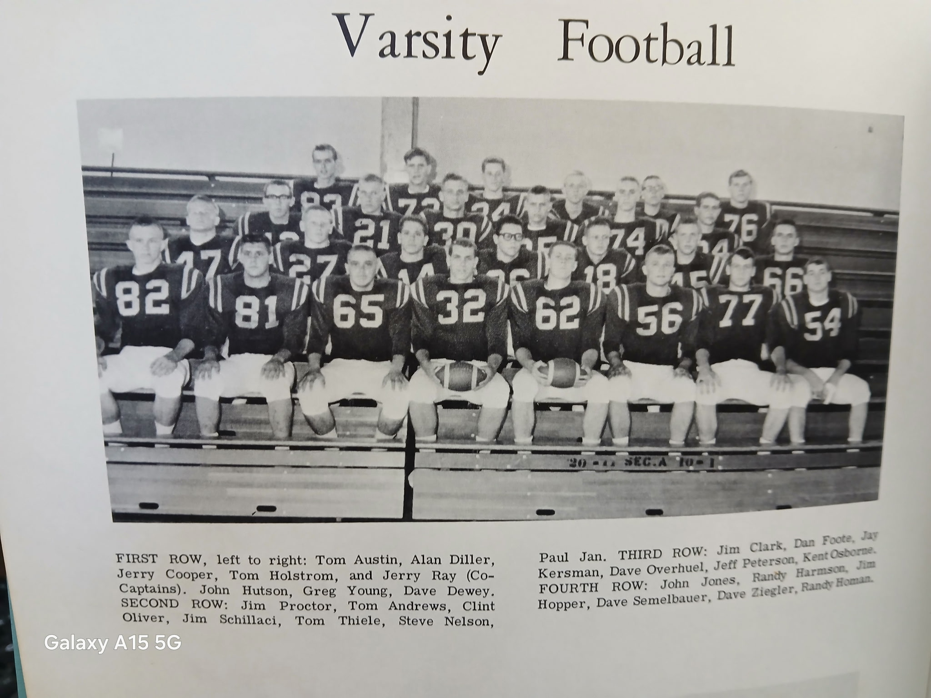

The 1963 NORSEMEN

Record Score Interesting Fact
1-0 NM 12, Ludington 6 Norsemen hold Ludington late in the game to earn win. Jim Schillaci and Tom Andrews TDs for the Norse.
2-0 *NM 25, Ravenna 6 Andrews 2 TDs, one rushing, one on a pass from Clint Oliver; Holstrom a 3-yard TD and Jim Proctor scores from 22 yards.
2-1 *Fremont 13, NM 7 Fremont scores winning TD with less than a minute in game. Oliver to Tom Austin 15-yard pass only NM TD.
3-1 *NM 12, Orchard View 9 Dave Dewey recovers 2 fumbles and makes a key 4th quarter stop. Oliver scores on a sneak and Proctor a nine-yard TD.
3-1-1 *NM 0, Reeths Puffer 0 (tie) RP misses a field goal with second remaining to keep the game scoreless. Holstrom several good gains with a 20-yard TD nullified due to a penalty.
4-1-1 NM 27, Montague 0 Proctor races 81 yards for TD. Andrews a pair of TDs; Dennis Wilder sprints 61-yard for a score. Jerry Ray’s 98 interception return wiped out by penalty.
4-1-2 *NM 7, Coopersville 7 (tie) NM fails to score five times while inside the Coopersville 25. Wilder NM TD on 51-yard gallop.
4-2-2 *Whitehall 20, NM 12 Andrews, 39 and 41-yard TD runs as NM loses to Seaway co-champs.

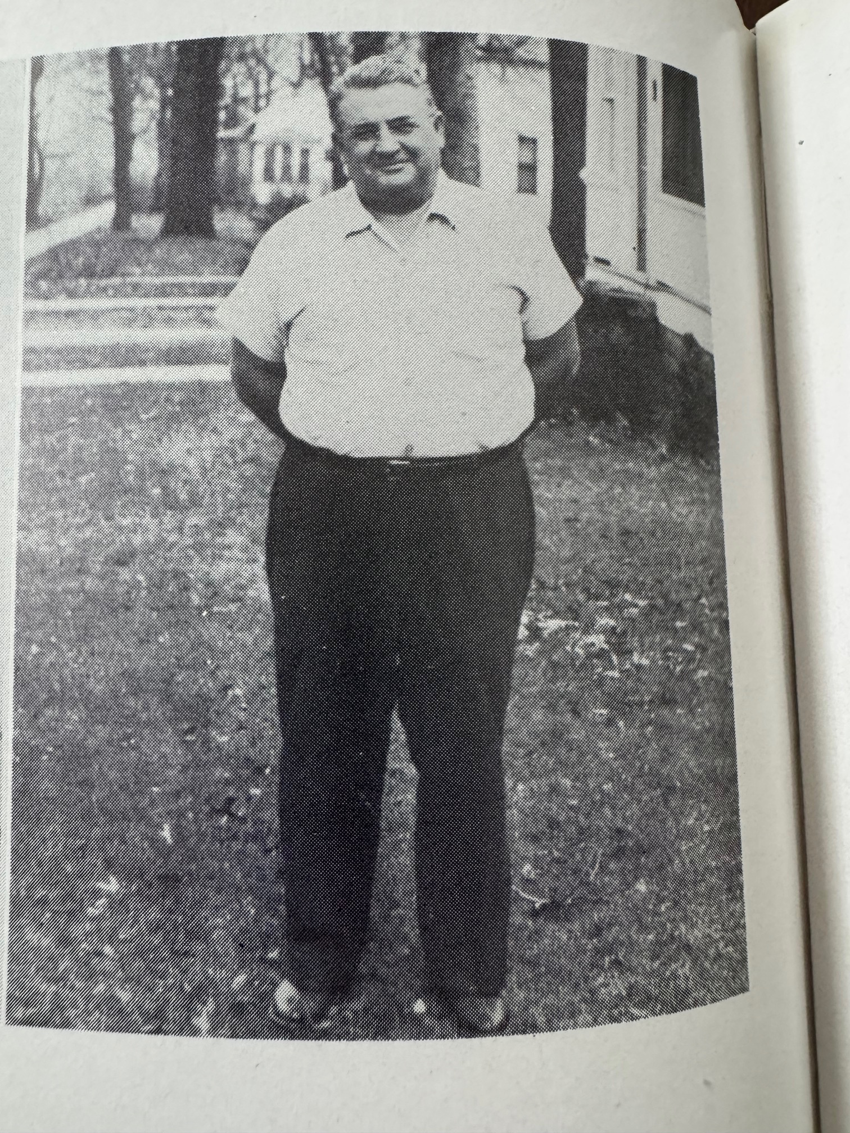
Fred Jacks:
A NM
Chiropractor
Who assisted
Without pay
Many NM
Athletes over
The years before passing away
In 1962. The
Football field is named
After Fred Jacks.

FRED JACKS

1964– coach Lee David (4-5 4-2 Seaway, Reeths Puffer Seaway Champs)

Prospects for the 1964 season didn’t appear too promising after losing several starters and a 1963 winless junior varsity team. Ten lettermen return: including Tom Austin, Steve Peterson, Randy Homan, Jeff Peterson, Charlie Selander, Dennis Wilder, and Steve Nelson. Clint Oliver returns at quarterback while head coach Lee David, and assistants Tom Seroczynski and Ken Barnhill are pleased to have all-conference running back Jimmy Proctor returning for his senior season. David made a switch by moving two-year starting lineman John Hutson to fullback. Hutson, a future Admiral, who climbed all the way up to be adjutant general for our country, was just a ‘few’ paygrades ahead of your author, an E-4 in the Army in 1964-65.

1964 included teams that were in their infancy. Oakridge would have grades up to tenth grade while Mona Shores and the Norsemen’s final regular season opponent, Spring Lake, would each have teams competing with a senior class for the first time.

The Norse had an ominous opener for the 1964 season as they traveled to Ludington to take on an Orioles team loaded with 26 seniors, 18 of those seniors’ returning lettermen. Meanwhile, coach David had but 25 players on his entire roster. The Norse started strong but ran out of gas in the second half as Ludington rallied for a 20-6 victory. Dennis Wilder gave NM the early lead with a break away 48-yard TD scamper. That would be the only score until late in the third period when the bigger and deeper Orioles began to roll over the tiring Norse. Ludington scored three late TDs; one set up when the host Orioles got great field position after blocking a punt deep in NM territory. Much credit was given to a trio of Norse stalwarts following the game. Big Jim Mattson, 300-pound middle guard, was a force on defense while John Hutson was a Norse workhorse in short yardage situations. Wilder would race for a total of 68 yards in six carries.

NM spotted Ravenna an early TD but came back to earn a 19-12 victory over the visiting Ravenna Bulldogs in game number 2. Dennis Wilder scored a pair of TDs while Jim Proctor, who scored the first NM TD with a 31-yard run, adding the other. Wilder had runs of 30 and 18 yards go the distance with Wilder making a kick from placement following the first NM score.

NM made it 2-0 in Seaway competition with a 13-6 victory over last year’s co-champs from Fremont. Nothing was decided in the first half although NM had a 54-yard TD run by Dennis Wilder called back because of an inadvertent whistle. The second half was the Jim Proctor show, both on offense and defense. Proctor picked off a Packer pass on the 43-yard line, and with the aid of a great block from Tom Austin, raced 57 yards for the games first score. Fremont on their next possession lost the ball on a fumble. With the Norse facing third down and 17 yards to go for a first down quarterback Clint Oliver connected on a long pass to Proctor who traveled 44 yards for what would prove to be the deciding score. Wilder’s extra point made it 13-0. Game stats posted following the game showed that it was the only pass attempted by NM the entire game. Fremont closed the gap to score with seven minutes left. After turning the ball over on downs, the Packers had a pass intercepted by NM defensive back Ken Mack with just two minutes left and the Norse then ran out the clock to make their overall record 2-0 in the Seaway. Going both ways, Proctor was credited with 11 unassisted tackles while another 2-way performer, Clint Oliver had eight unassisted tackles.

Coach Jack VanSchelven’s Orchard View Cardinals snapped NM’s modest two-game win streak in the conference with a narrow 13-7 win over the Norse. For the second straight week the two teams failed to score in a very conservative first half dominated by the defenses. There were a combined ten punts from both teams until the third period, when instead of punts, each team turned the ball over on fumbles. The Cardinals recovered a NM bobble at the Norse 40 and ultimately cashed it in for six points on a 10-yard pass completion from Dave Workman to Ron Marek. The Norse scored following a Cardinal fumble and only had to move 30 yards for a TD. Jim Proctor powered over from inside the one and NM took a brief lead when Dennis Wilder’s PAT was perfect. The lead didn’t last long as the Cardinal started a game winning 70-yard drive that culminated with an eight-yard touchdown run from Mickey Six. The Norse, already with limited depth, were weakened with an injury to fullback and linebacker John Hutson, who has been out with injured ribs.

The Norsemen had no answer for Reeths Puffer and Rocket fullback Dick Barnhart as the Norse fell 33-13 in front of a standing room only crowd at Fred Jacks Field. Barnhart scored all five touchdowns for the winners while racking up 163 rushing yards. The Norse were never in contention in the game and didn’t score until the fourth quarter when already trailing 26-0, sophomore Bob Swanson threw a touchdown pass good for seven yards to Tom Austin. Later in the final quarter Jim Proctor made the scoreboard read 33-13 when he scored from six yards out. The Rockets would go on to post their first undefeated season in school history.

Even though North Muskegon has been a member of the Seaway Conference beginning with the 1960 football season, North Muskegon has continued to schedule Montague. The 1964 meeting with the Wildcats would be the 33rd straight year these two rivals have met on the gridiron. These two teams have now met every year since NM started football with their first team in 1933 and the 2025 meeting marked the 93rd consecutive game. After being shut out by the Norse in 1963, Montague made amends in 1964 with a 26-14 victory over the men in Blue & Gold. The win spoiled a Norse homecoming as the Wildcats used a mixture of running and passing in the contest. Montague quarterback Bill Barber completed 7 of his 14 passes for 146 yards, a lofty stat in an era where the running game was emphasized more than the pass. NM did tie up the game early in the second quarter when Jim Proctor scored from the six-yard line and Dennis Wilder completed the extra point. Montague then pulled away by scoring the next two TDs to pull ahead 20-7. Bob Swanson had now taken over duties as the NM quarterback and the sophomore led the Norse on a 70-yard drive in but four plays with Proctor racing the final 17 yards into the end zone. Montague went to the airways and increased their lead by going 62 yards in two pass plays, the latter a 31-yard completion from Barber to Michael Stebens for the game’s final TD.

A record-setting 97-yard return of an intercepted pass by Dennis Wilder highlighted NM’s 18-6 victory at Coopersville. The Norsemen scored twice inside the last two minutes of the first half to stun the Broncos. The Norse executed a 70-yard drive that was set up on the first of a pair of interceptions by Wilder. Behind the strong running of backs John Hutson and Steve Nelson it was Wilder who scored the first of his three TDs. With only 10 seconds left in the half and Coopersville desperate to get on the scoreboard, Wilder intercepted a pass at his own three-yard line and then broke the backs of Coopersville with his record-setting 97-yard run to pay dirt. Coopersville showed some life early into the final period when they took advantage of a Norse fumble at the NM eight-yard line and scored with 10:35 left in the game. The Norse then executed a time consuming seven-minute drive to ice the contest. Nelson carried the ball on 10 of the 13 NM plays with Wilder going the final four yards to earn the Norse the victory and end their two-game losing streak. Neither team was able to convert on an extra point on their four touchdowns, not at all unusual in the pre-soccer style kicker era.

The Norse would then nip Whitehall the following week 13-8 to begin a ten-game winning streak against the Vikings. Six of those ten wins were decided by less than a touchdown. Three days after Lyndon Johnson retained his office as President of the United States the Norse again used the tail end of the second half to score a couple of quick touchdowns. Trailing 6-0 the Norse took the lead by going 61 yards in nine plays with Bob Swanson tossing a short four-yard TD pass to Jim Proctor. Dennis Wilder gave the Norse a 7-6 lead when his placement was good. Whitehall then quickly turned the ball over to the Norsemen as they fumbled the ensuing kickoff at their own 21-yard line. With 0:26 seconds left in the half Swanson connected on his second TD pass to Ken Mack good for 15 yards and six points. The Vikings blew a golden opportunity in the third period when they fumbled the ball inside the NM one-yard line. Whitehall was able to salvage two points as NM’s Steve Nelson was tackled in the end zone to narrow the lead to 13-8. The Norse then just hung on for the victory as the Vikings late in the game frittered away another scoring opportunity when the Norse recovered another Whitehall fumble at the NM 28-yard line.

In its first year as a four-year football program, Spring Lake defeated NM 19-0, a loss that denied NM of a winning record. The Lakers used a pounding ground game as all their 252 yards came via the rush. The Norse rushed for only 83 yards on the night and never seriously threatened to score. A brief fracas erupted with about five minutes to play but cooler heads prevailed, and the game was able to run to its conclusion after it was originally called by the game officials. The game would be the first of back-to-back games between the Lakers and the Norsemen, the only two games played between the teams in 93 years of NM football. Although there were no Norsemen selected to the All-Seaway conference offensive team, three were selected to the first team defensive team: Defensive tackle Tom Cribbs, linebacker Clint Oliver and defensive back Dennis Wilder.

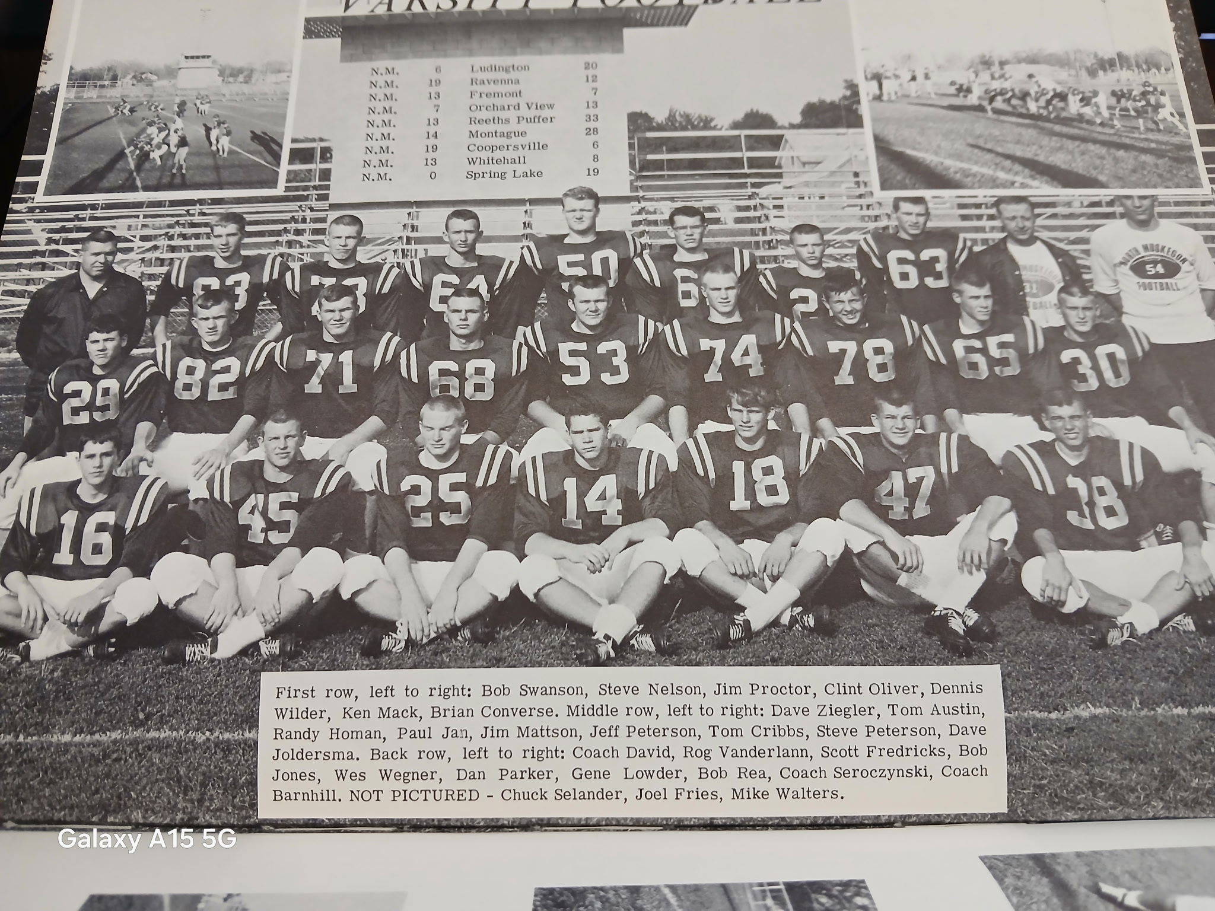

The 1964 NORSEMEN

Record Score Interesting Fact
0-1 Ludington 20, NM 6 Dennis Wilder has lone NM TD on 48-yard dash to pay dirt.
1-1 *NM 19, Ravenna 12 Wilder a pair of TDs, 30 & 18 yards, Jim Proctor raced 31 yards for TD.
2-1 *NM 13, Fremont 6 Proctor scores a TD on offense & defense. Returns interception 57 and a TD pass from Clint Oliver goes for 44.
2-2 *Orchard View 13, NM 7 OV comes from behind in 4th quarter after trailing 7-6. Proctor scores only NM TD from inside the one.
2-3 *Reeths Puffer 33, NM 13 Dick Barnhart scores all 5 RP Yds as Norse trailed at one point 26-0. Bob Swanson 7-yard pass to Tom Austin and Proctor from six NM TDs.
2-4 Montague 26, NM 14 Proctor tallies both NM TDs, 6 & 17 as NM drops homecoming game to Montague in the 33rd straight meeting between the two teams.
3-4 *NM 18, Coopersville 6 Wilder’s record 97 yd pass interception the first of his 3 TDs. Also scored on 2 short runs
4-4 *NM 13, Whitehall 8 NM scores TDS in less than two minutes late in first half. Bob Swanson TD passes of 4 Yds to Proctor, 15 to Ken Mack.
4-5 Spring Lake 19, NM 0 NM limited to but 83 yards rushing as NM shut out for the only time in 1964 season.

1965– coach Tom Seroczynski (6-3 overall 4-3 Seaway)

Well before NM began their final season in the Seaway Conference, NM administrators had already asked Superintendents in the West Michigan Conference for readmission to the West Michigan Conference. The 1965-66 school year would be the last year for the students residing in the fast-growing Laketon Township area who would attend North Muskegon Schools. Most of those Laketon Township students would be attending Reeths Puffer. Fruitport and Spring Lake were new additions to the Seaway Conference. After an absence of six years, the Norse would renew a contract with Manistee that would continue for another five seasons. The war in Vietnam had escalated in 1965 and would not come to a merciful end until 1973. Not even your ‘heroic’ author, who was sent with his Army unit to Vietnam in the summer of 1965 was able to win the war for the USA.

Taking over the head coaching duty for the Norse would be Tom Seroczynski, a former trainer with the Chicago Bears who had been assisting Lee David for the past three seasons. Coach ‘Sero’, with Don Walters as his assistant, would post an envious record during his tenure as the NM coach. Only seven lettermen returned from the previous 4-5 season, but one of those would include All Seaway Conference lineman Tom Cribbs. Randy Homan, a 215- pound converted fullback from a starting center returns as a three-year starter. Still only a junior, Bob Swanson moved into the starting quarterback position shortly after the start of last season and he’ll be joined in the backfield by speedster Ken Mack.

North Muskegon would begin the 1965 season with Manistee, who would briefly begin a short stint in the WMC. To show it’s sometimes called a small world, Manistee would be coached by Art Haage. A few years down the road Haage would replace former Muskegon St. Mary star Mike Kanitz as the football coach at Traverse City St. Francis. Moving into a new home from a rental in Traverse City, it was the Haage family who would move into the former rental home of the Moyes family. To add even more spice to the Haage story, it was Mike Kanitz who Haage replaced as coach at TCSF that was the number one reason why this author got back working in the media. Kanitz, a teammate of mine in a winter basketball league knew that I had once worked as a reporter for the Muskegon Chronicle. Big Mike recommended me to cover his Traverse City St. Francis team, and the rest is history --- from journalism to radio.

Ken Mack had an amazing day in NM’s 19-12 victory over Manistee as he returned a pair of punts for long distance TDs. One for 70 yards and the second a record 93 yards, 2-yards father than the legendary Stan Guy returned a punt against Scottville in 1953. Both of Mack’s exciting punt returns were needed as the only other NM touchdown came the conventional way late in the first period on a five-yard TD by Tim Thill. Mack’s first return of 70-yards gave the Norse a 13-0 lead with just under three-minutes to play in the first half. Manistee came right back before halftime to cut the NM lead to 13-6 on a 53-yard pass play. The winning TD run by Mack came midway through the third quarter to give the Norse a 19-6 lead. Dave Marchido made several big defensive plays on deep drives into NM territory throughout the fourth quarter. Manistee drove down to the four-yard before a Manistee fumble was recovered by Marchido. On the very next play the Norse fumbled the ball right back. Incredibly Manistee fumbled what must have been a very slippery pigskin and again it was Marchido on the recovery. The host Chippewas did manage to score with 5:48 left in the game to trail 19-12. With 55-seconds remaining Manistee was down to the Norse four-yard line and again they fumbled and again it was Marchido who recovered his third fumble of the game to preserve the 19-12 victory.

The Norse spotted Whitehall a 12-0 lead but came back to score three touchdowns in the second half to edge future long time NM coach Dave Cooke’s Whitehall squad 20-13. The Norse scored all their touchdowns in the final quarter with much of the credit going to the defense, particularly Steve Peterson. The son of Bill Peterson, a member of the 1942 NM Hall of Fame Team, had a school record three interception in the game, two in the final quarter. Trailing 13-0, Peterson picked off a Whitehall pass early into the fourth quarter to set up NM’s first TD. Starting at the Vikings 29 Ken Mack scored the first NM TD at 9:28 of the final quarter. Mack also ran for the extra point to cut the Whitehall lead to 13-7. After NM stopped Whitehall on downs the Norse marched 65 yards in 12 plays with Mack again running in for the TD from seven yards out and converting what would prove to be the winning points on another successful run for the extra point. Peterson set up the final Norse score to ice the game when he returned his interception 21 yards before he was downed on the four-yard line. From there Ted Slater took it in for the score to make the final score read NM 20, Whitehall 13.

An undefeated North Muskegon team traveled to Ravenna to play a winless Bulldog squad. Playing inspired football Ravenna upset the Norse to send NM from the ranks of the undefeated. After a scoreless first half the Bulldogs put together a pair of winning drives in the second half to take a 13-0 lead before the Norse could make a belated move. With Ravenna’s defense holding NM to under 95 yards rushing for the game, the Norse went to the airwaves in the final period. Bob Swanson completed a pass on a 67-yard drive to Ken Mack good for 29 yards and six points. Swanson’s sneak gave the Norsemen renewed life as they trailed only by six points, 13-7 with still four-minutes left. A fumble recovery by Roger Vanderlaan gave the Norse life with two minutes remaining but the Norse chances were dead after Ravenna intercepted a NM pass to kill the drive. The Norse were hurt with injuries to three of their regulars. All-Conference tackle Tom Cribbs and guard Cubby Closz were out with ankle injuries while three-year starter Randy Homan missed the second half.

Your author finds it hard to believe that NM’s 18-6 victory over Fremont would be the last game played between these two long-time rivals. Fremont and NM had played 29 games over the years, and the series would end with NM holding a 16-12-1 record in the competitive series. With Fremont now a member of the WMC, it’s probably safe to say these two teams will meet once again on the gridiron. When it happens, it will be the first matchup in close to 60 years. Fremont would not be the only team on the 1965 schedule which would prove to be the last scheduled game between two schools. 1965 would also be the last time NM would play Reeth Puffer, Spring Lake, Coopersville and Fruitport.
With NM quarterback Bob Swanson handicapped with a dislocated finger the Norse and their innovated coach Tom Seroczynski did a little improvising and used a shotgun formation. After spotting the host Packers an early touchdown the Norse came back with a ‘razzle-dazzle’ pass from Ken Mack to Randy Homan that went the distance of 65 yards to tie the game at 6-6. The 6’2 200 lb. Homan was a workhorse on what would prove to be the winning drive early in the fourth quarter, an eight-yard march with Homan scoring his 2nd TD from 3 yards out. The final Norse tally came when Fremont was unsuccessful on a fake punt that gave NM excellent field position. Swanson went the last three yards on a keeper play with just two minutes left. With neither team able to add an extra point the entire game the final score in the final game between these two old rivals was NM 18, Fremont 6.

NM pulled a mild upset with a 7-0 victory in the second and final game of the brief two-game series between the Norsemen and Spring Lake. The only score was set up by an interception by Randy Homan at the Lakers 35-yard line just before halftime. Gutsy NM quarterback Bob Swanson, broken finger and all, scored from 11 yards out with under a minute to go in the half. Homan’s kick was true and although still an entire half to play, the 7-0 score would stand until the game’s end. The Lakers did mount one serious threat late in the contest but a fumble, recovered by future Orchard View head football coach Dave Janusiewicz, halted the march. Neither team was able to accumulate much offense in front of the standing room only crowd on the Northside. NM rushed for only 115 yards the entire game, all on the ground and the Norse were able to pull off the improbable victory without picking up a first down in the second half. The loss was the first setback of the season for Spring Lake and left the Norse just a half game out of first place behind league leader Reeths Puffer.

The Norse would make the short journey to Reeths Puffer with first place at stake in the Seaway Conference. With NM’s enrollment due to shrink with students from Laketon Township attending Reeths Puffer the following season, and the expected growth of RP, the battle with the Rockets would be the last football game between the two neighboring schools. The Norse battled hard against the Rockets but were unable to muster little offense against a stout Rocket defense. The Norse were limited to 70 total yards for the contest. With Bob Swanson limited with his broken finger NM was able to complete but one pass for nine yards. Top NM running back Randy Homan was playing injured as the Norse never seriously threatened all night. Running their streak to 15 games without losing a game, the Rockets had to work hard against a tough and determined NM Defense. It wasn’t until there was only 16 seconds left in the first half that RP was able to take the lead. The Rockets managed a second score in the second half and left it up to their defense to shut off the NM defense. NM only crossed the midfield stripe once in the final two quarters and totaled, but 17 yards gained in the second half as RP won 14-0.

In the only meeting between the Norsemen and Fruitport in the 93 years of NM football, a fumble and a missed extra point were the difference in Fruitport’s 7-6 victory. The Norse also were helped with a fumble that led to their only score in the game. Roger Vanderlaan’s fumble recovery at the Trojan 44 set up the NM six-pointer. The Norse were aided by a pass interference call against Fruitport with Randy Homan eventually pounding over from the two-yard for the only score by either team in the first half. Homan’s extra point try was wide as the Norse clung to a narrow 6-0 lead at halftime. A NM fumble was recovered by Fruitport at the NM six-yard line midway through the final quarter with NM desperately hanging on to a slim 6-0 lead. Fruitport took advantage and would knot the game at 6-6 with a 10-yard pass completion from quarterback Hank Christiansen to Roger Cox. The game winning extra point by Cox sailed through the uprights and Fruitport had won the only game played to date between the two schools.

The Norse will end their time in the Seaway and their 14-game rivalry over the years with Coopersville on a winning note with an 16-6 victory over the Broncos. NM, who never scored more than three touchdowns in a game in 1965, scored on their opening drive. Randy Homan’s one-yard plunge was set up on a 35-yard pass completion from Bob Swanson to Ken Mack. NM’s next scoring play was a rarity in early Norse annals. Randy Homan kicked a 28-yard field goal, only the third made field goal in the previous 33 years of NM football to make the score 10-0 NM. The Norse made it 16-0 in the final quarter. Following a fumble recovery by Andy Dagen. Swanson, with his broken finger hopefully fully mended, hit Steve Peterson on a 6-yard scoring play to make it 16-0. However, following the contest Swanson did require medical attention for his left thumb following the game at Hackley Hospital. The Broncos averted a shutout midway through the final quarter to make the final score 16-6.

North Muskegon would complete their 1965 season against their oldest rival, Montague. The game would be the only battle between the two teams in the 93-year rivalry that would conclude the final game of a regular season. The highlight in NM’s victory was a record-breaking 92-yard kickoff return by Gary Mumford. The only score in the first half was set up by a blocked punt by Harold ‘Cubby’ Closz, future Greater Muskegon prosecutor. Ken Mack powered in from the one and NM led at halftime 6-0. It was the opening kickoff of the second half when Mumford raced 92 yards for his record run. Evidently, there was no such thing as a ‘Victory Formation’ back in 1965 as Randy Holman scored the final Norse TD from 5-yards out with only 0:16 second showing on the clock. The margin could have been much wider, but two td runs by Ken Mack were called back due to Norse penalties. NM’s season had ended, but for me the following Friday was a most memorable day for the ‘Ole Announcer’, as I was aboard a plane heading home from a tour of duty in Vietnam.

Tom Cribbs repeated his position once again on the All-Seaway team while Randy Homan was also accorded All-Conference first team honors.
1965 would be the year of The Lasts. It would be the last year in a brief tenure in the Seaway Conference, and it would be the last games to date ever played between NM and Fremont, Spring Lake, Reeths Puffer, Fruitport and Coopersville. Head coach Tom Seroczyski’s coaching during the 1965-66 school year didn’t come to an end. Coach ‘Sero’ was asked to coach the NM basketball team due to the sudden resignation of Don Boyink and he quickly complied to help NM athletics as the basketball coach for two years.

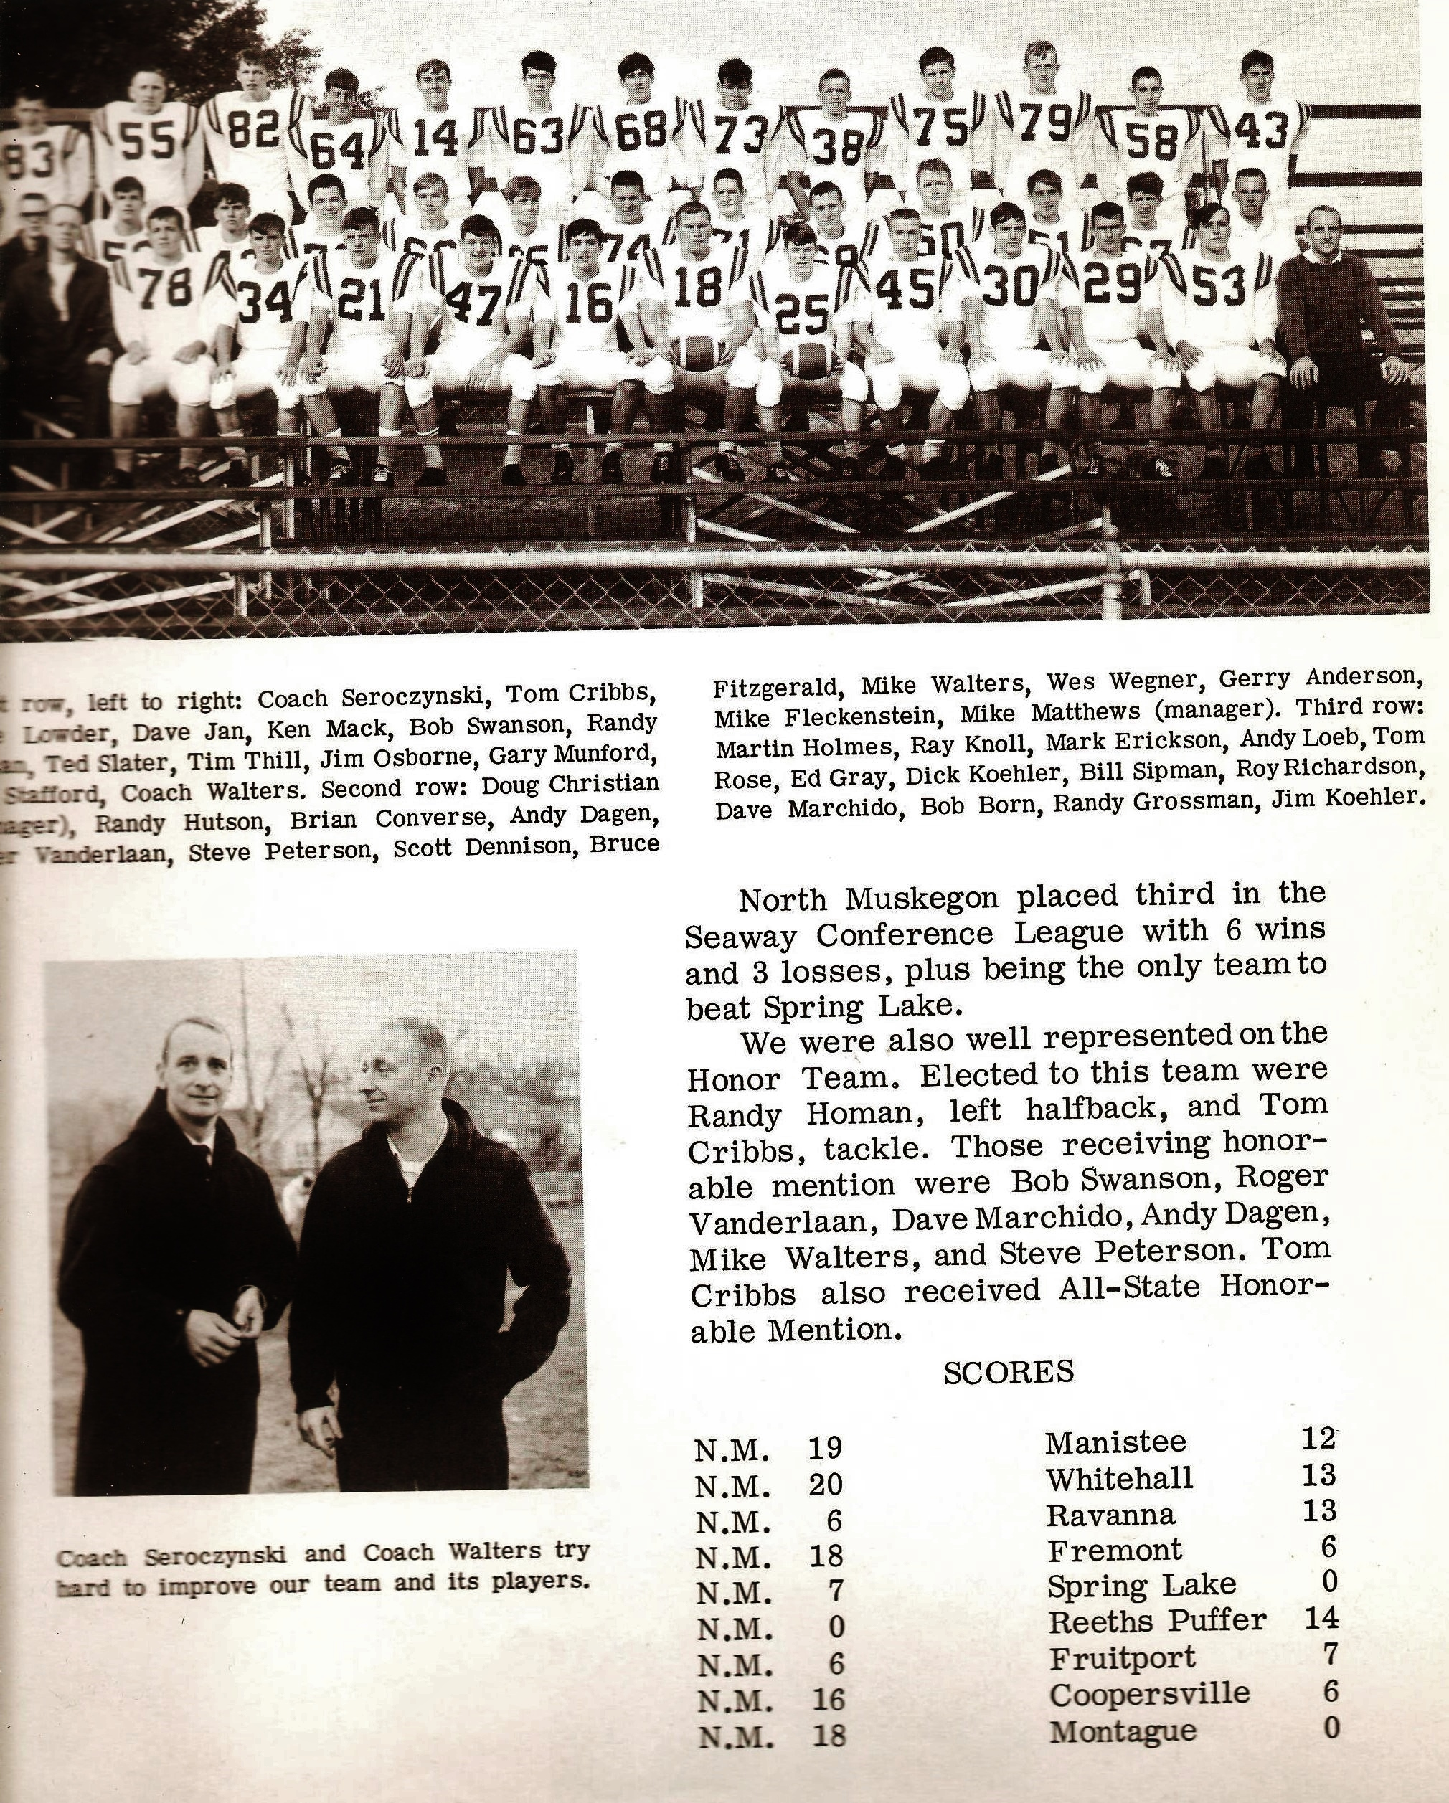

The 1965 NORSEMEN

Record Score Interesting Fact
1-0 NM 19, Manistee 12 Ken Mack returns 2 punts for TDs (93 & 70) Tim Thill scored from 4 yards. Dave Marchido 3 fumble recoveries.
2-0 *NM 20, Whitehall 13 Steve Peterson school record 3 interceptions. Mack two TDs and Ted Slater one. NM intercepts 4 Whitehall passes.
2-1 *Ravenna 13, NM 7 NM’s late rally falls short. Only NM TD a 29 -yard pass from Bob Swanson to Mack.
3-1 *NM 18, Fremont 6 Mack to Homan on a 65-yard TD. Homan and Swanson both scores 3-yard TDS.
4-1 *NM 7, Spring Lake 0 Swanson on a keeper play scores games only TD. Homan’s punts pinned the Lakers deep numerous times.
4-2 *Reeths Puffer 14, NM 0 NM held to only 70 total yards in the game as Rockets win 15th game in a row without a loss.
4-3 *Fruitport 7, NM 6 Fruitport recovers fumble deep in NM territory to rally for win. Homan only NM TD in first half from 3-yards out.
5-3 *NM 16, Coopersville 6 Homan a TD and 28-yard field goal lead NM. Swanson to Peterson 6-yard TD pass.
6-3 NM 18, Montague 0 Gary Munford returns kick off a record 92 yards for TD. å

1966– coach Tom Seroczynski (6-2 overall 4-2 WMC, Hart & Scottville tie WMC)

North Muskegon was back in their comfort zone after a brief stint in the Seaway conference with their return to the West Michigan Conference. Expectations were high that the Norse could challenge for the WMC title as 13 lettermen return for 2nd year head coach Tom Seroczynski. Among the starters returning were tackles Andy Dagen and Roger Vanderlaan. Mark Erickson and defensive stalwart Dave Marchido will again man the end posts while Mike Walters will go at center.
Dave Jan (officially Janusiewicz) and Cubby Closz will also bring experience along the front lines. The quarterback duties will be in good hands as Bob Swanson returns as a three-year starter. Others to earn the NM monogram from 1965 in the backfield would be Randy Hutson, Ted Slater and Tim Thill while Ron Stafford earned a letter last year as a linebacker.

Defense took center stage in the Norse home opener in NM’s 12-0 victory over Manistee. NM defensive back Phil Mason was especially a thorn in the side of the Chips with a pair of interceptions, a fumble recovery and several fine tackles. The first defensive highlight for the Norse took place midway in the first period. Mark Erickson charging hard from his defensive end position deflected a Manistee pass that was snagged by his teammate Dave Marchido who carried the pigskin 30 yards for the game’s first score. Mason, with one of his two picks on the night, set up the other NM TD that ended with Bob Swanson sneaking over from the one for the second NM TD. That would be all the points needed as NM’s defense held the visiting Chippewas to less than 100 yards in total offense.

NM won their second game in a row in their return to the WMC as Shelby fell victim to the Norse 12-0. It was the second shutout by the same score as the NM defense was again up to the task. The only serious drive by Shelby on the Norse gridiron was advancing to the Norse 23 before a Dave Jan interception ended the Tiger’s best threat. Early in the game NM had their most impressive drive of the game with a 65-yard march to pay dirt. The touchdown coming on a 15-yard pass from Bob Swanson to Jim Osborne. Dave Marchido, who seems to make a habit of coming up with a big defensive play was chiefly responsible for NM’s 2nd and final touchdown when he recovered a Shelby fumble at the Tiger 5-yard line. Randy Hutson, who led the Norse in rushing in the contest with 94 yards in 23 carries, scored from the 4-yard line. The good news for the game was the Norse ‘D’ which held Shelby to a total of 44 yards. The bad news, once again NM failed to convert an extra point for the second straight week and were penalized a whopping 95 yards.

North Muskegon’s brief winning streak came to a crashing halt when they fell to the Hart Pirates in their first road game 25-0. In the 87-game series between the long- time rivals, it was the second most lopsided defeat Hart ever inflicted on the Norse (1993 – Hart 47, NM 13). Fielding one of their strongest teams in their program’s history, Hart was in total control the entire game. For the first time in NM annals the Norse were held to minus rushing yards (-23) and but three first downs. Perhaps the only time the Norse fans had a chance to cheer was an 85-yard kickoff return by Dave Marchido after the third TD of the Pirates. However, it was deemed by an eagle-eye official that Marchido had stepped out of bounds during his return. Other than Marchido’s near TD their best opportunity to get on the board was after Rick Homan blocked a Pirate punt at the Hart nine-yard line. The stingy Hart defense held, and the Norsemen would take the bus ride back to NM without putting any points on the board.

It would be another three years before Ravenna would bolt the Seaway to join the WMC. In a rare off date as the Norse could not find an opponent in week four, the well-rested Norse had a most-welcome bounce back 30-0 victory over Ravenna to jump back into the win column. Before an entertained Homecoming crowd the Norse wasted little time in getting on the board. Dave Marchido sprinted 52 yards for the first TD and would then set up the second NM tally with a 36-yard punt return. Two plays later Randy Hutson dashed 18 yards, and the Norse were now in firm control. Hutson would have a monster game with his second TD run of the opening quarter on a 48-yard dash. Hutson then scored on a defensive play by picking off a Ravenna pass and returning it 45 yards for his third TD of the game. Jim Osborne scored the final NM TD on a much more modest run, a one-yard plunge to make the final score 30-0. It bears mention that the Norse didn’t set the world on fire with their kicking game. After four games played and nine TDs, the Norse had not converted even one extra point.

The Norse spotted Montague a 7-0 lead early into the first quarter before taking control in their 25-7 WMC victory. It took a while for the Norse to show their might, however. The Norse mounted a 73-yard drive, but the drive ended at the Wildcat one-yard line. Undeterred, the Norse then finally scored with little time left in the half with Bobby Swanson sneaking over from the one. Ted Slater can now boast of being The First in a couple of departments. Slater would become the first ever to win the ‘National Championship’ in snurfing – later to be renamed snowboarding, but he would score the first extra point for the Norse in ten attempts. With the score all knotted up at 7-7, the second half was all North Muskegon. Once again Dave Marchido went into his fumble recovering mode and recovered a Montague fumble deep in Wildcat territory. Two plays later, Dave’s cousin, sophomore Bill Marchido ran the last three yards to make it 13-7. Dave Marchido, a converted end from the 1965 season, fielded a punt and raced 73 yards to extend the lead to 19-7. Swanson completed the scoring when he connected on a 27- yard TD pass to Randy Hutson. Naturally, the extra point attempt was no good, and the Norse were now 1-13 in extra point attempts.

The Norse would make the trek up US 31 to Scottville for their first game against a school that had changed their official name to Mason County Central. The 1966 Mason County Team might very well have been the best team in their school’s history. When the 1966 season had ended, there would be a tie as WMC champs: Mason County Central and Hart. Nearly 60 years have elapsed and 1966 would be the last year Mason County even held a share of the WMC Championship. It was the key game in the WMC. Although the name change had become official, it was difficult not to refer to the Spartans as Scottville. The contest was the key game in the WMC on this date as the winner would at least claim a tie at the top of the leaderboard. A win for the Spartans and they would hold first place all to their own. Scottville (Mason County Central) scored first in the first half as they took over at the NM 42-yard line after a short Norse punt. The host Scottville team would take a 7-0 lead at halftime following a Dan Kliese 11-yard run. It was the only bad punt on the evening for Norse punter Rick Homan who had a couple of his booming punts travel over 60 yards. NM was able to tie the game early into the third quarter with Bob Swanson capping a 70-yard drive with a nine-yard run. Surprisingly, the Norse converted the extra point, only their second made conversion of the season. Fumbles and injuries hurt the Norsemen. Halfback Randy Hutson was lost early in the game with a knee injury while his partner at halfback, Dave Marchido, was severely hampered with a back injury. The Norse fumbled four times in the game and lost all four. It wasn’t a fumble that contributed to what would prove to be the deciding score, however. It was a 51-yard TD pass from quarterback Tim Stephens to Dick Swinehart that capped their 87 yards drive. The final TD was set up by a Norse fumble at the NM 33 as Scottville, for one of their rare times in program history, were undefeated at 7-0 with the final score MCC 20 and NM 7. Only a loss in their final game of the season the following week to Hart would stop the Spartans from having their only perfect season.

In the very early years as a four-year school Oakridge was but a shell of itself from their dominating teams in years to come. NM won the first nine of 61 games between the two schools but just the opposite has occurred in the current era. The Eagles threw a brief scare into the Norse by scoring the games’ first TD. Dave Marchido then scored the first of his three TDs when he plunged over from the one-yard line on the very first play of the second quarter. A fumble recovery by Mike Walter set up Marchido’s second TD, again a short plunge from the one to give the Norse a 14-6 lead at the break. NM broke open the game in the second half, first when Marchido ran for a seven-yard tally and the next, a TD pass from Bob Swanson to Jim Osborne good for 46 yards. Oakridge connected on a 70-yard TD aerial from Tom Kurtz to Ross Griswold before the Norse 27-12 lead increased to 33-12 after Swanson hit Mark Erickson with a 15-yard pass to complete NM’s scoring on the night. Oakridge scored on the final play of the game to make the final score read 33-19.

White Cloud was added to the NM schedule for the first of a two-year series with the Norse winning both meetings. 18 seniors wound up their prep careers, and they went out in winning fashion with a 20-6 victory over White Cloud contested on a chilly Fred Jacks Field. Both teams exchanged TDs early in the contest with the first NM score an eight-yard pass from Bob Swanson to Rick Homan. After the visitors tied up the game on the first play of the second quarter, NM broke the tie when Jim Osborne capped a 60-yard drive on a short TD from the one. Dave Marchido’s run for the extra point sent the Norse into the second half leading 13-6. The final NM score on the game, and the season, was on a short run by Marchido that was set up on a 35-yard pass play from Swanson to Mark Erickson. Earlier a 57-yard TD pass from Swanson to Ted Slater was denied due to a penalty.
Honored as members of the WMC first team following the season were center Mike Walter and Dave Marchido on the offensive first 11, while Mark Erickson, Andy Dagen, Dave Janusiewicz and Randy Hutson were selected for their defensive work.

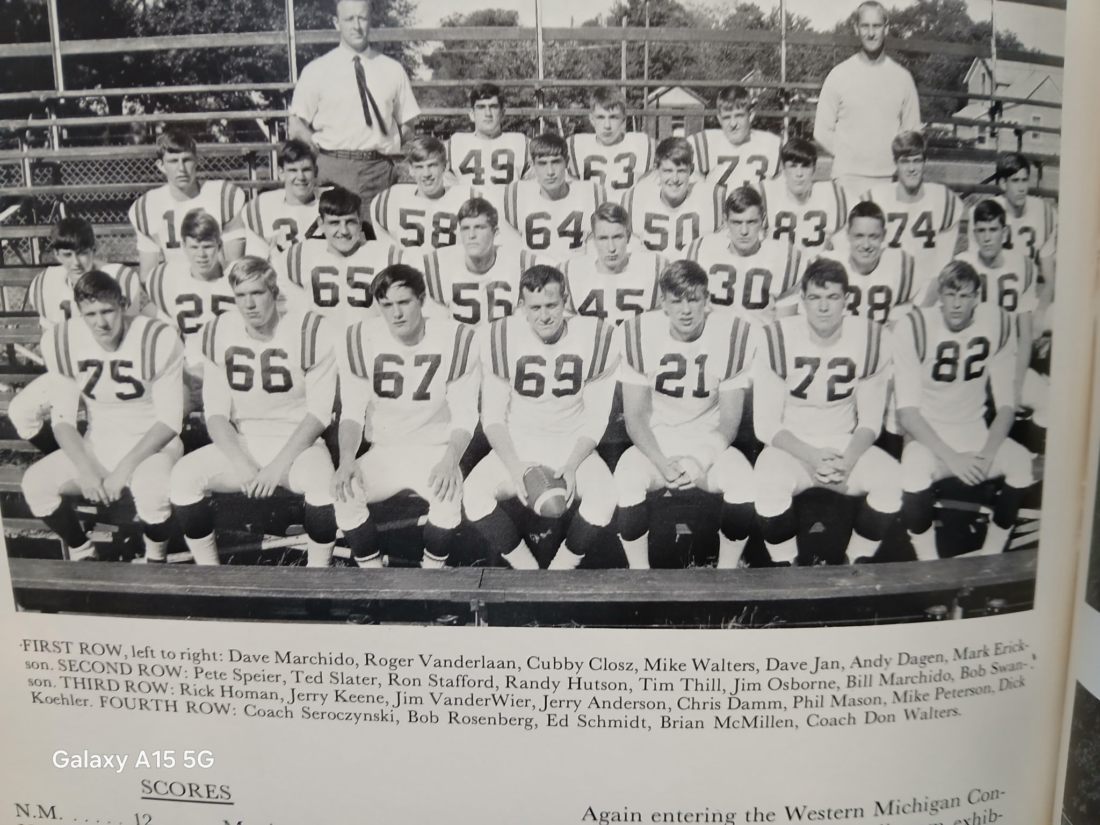

The 1966 NORSEMEN

Record Score Interesting Fact
1-0 *NM 12, Manistee 0 Phil Mason with 2 interceptions and a fumble recovery. Dave Marchido 30-yard pass interception returned for TD. Bob Swanson sneaks for 2nd NM TD.
2-0 *NM 12, Shelby 0 Defense holds Shelby to 44 yards. Marchido fumble recovery sets up Randy Hutson’s 4-yd TD. Swanson 15 yd TD pass to Jim Osborne.
2-1 *Hart 25, NM 0 NM held to minus rushing yardage by a strong Hart squad. Marchido’s 85-yard kickoff returned called back to the spot where he stepped out of bounds.
3-1 NM 30, Ravenna 0 Hutson 3 TDs, 2 on runs of 52 & 48, the other a 45-yard pass interception: Marchido scores from 45 and Osborne plunges from the one.
4-1 *NM 25, Montague 7 Swanson sneaks for a TD, connects with Hutson for 27 passing TD. Marchido punt return of 73 yards. Bill Marchido 3 yd TD. Ted Slater makes first extra point.
4-2 *Mason Co Cent.20, NM 7 Scottville would have their best record in history (7-1) after win. NM only score on 11-yard run by Swanson.
5-2 *NM 33, Oakridge 19 Marchido 3 short TD runs. Swanson 2 TD passes, one to Osborne for 46, the second 15 yards to Mark Erickson.
6-2 NM 20, White Cloud 6 Swanson 8-yard TD pass to Rick Homan for 1st TD, Marchido and Osborne each a 1-yard TD.

1967– coach Tom Seroczynski (8-1 overall 5-1 WMC tied for 1st with Manistee)

Most football geeks had little confidence that NM would experience a breakout season in 1967, after losing 18 seniors and but eight lettermen returning with many of the returning lettermen being non-starters. But my how those Norsemen would surprise those soothsayers. The Norse would begin the 1967 season with a newcomer on the schedule in Kent City. The Norse would find Kent City easy pickings over the years as their opening 42-12 win over Kent City would begin the first of eight consecutive victories over the years without tasting defeat. Offensively the Norse would open the season with Jim VanderWier at center; Larry Young and Jerry Keene at the tackles; Junior Bill Marchido and Mike Peterson at guards; junior Chuck Woodruff and Rick Homan at the ends; Peter Spier will take over the signal calling duties at quarterback; Phil Mason and Mark Johnson at the halves with Ed Schmid at fullback.

The Norse showed Kent City early that it was going to be a long night for the visitors. It took NM but 21 seconds to score first. On the first play after Phil Mason returned the kickoff 68 yards to the KC 10, Kurt Boyd scored on the very next play. The Norse then scored the second of their three first quarter TDs with quarterback Pete Speier hitting Mason with an 11-yard scoring toss. Two plays later, Speier, going both ways intercepted an Eagle pass that he returned for a TD. It appears that NM also found a kicker as Speier converted two of his three PATs after TDs. Make that three out of four as Speier connected following a fourth TD in the first half as Mark Johnson raced 31 yards to give NM an insurmountable 27-0 lead at halftime. Each team would score a pair of second half touchdowns. After Kent City got on the board with a TD on their first possession of the second half, the Norse answered right back by marching 58 yards with Speier going the final 10. Speier then added his third TD and the team’s sixth with a 25-yard tally. Speier’s five extra points nearly matched NM’s total production on conversion attempts from the previous season.

The Norse were upended in their second game of the season, and first in WMC play, when they fell to Shelby 13-6. The Norse were ahead on statistics but not on the scoreboard as NM churned up much of their stats between the 30s. It looked like NM was going to cash in first when Ed Schmid sped 50 yards for an apparent TD in the second period only to have his effort go for naught due to an untimely penalty. The Tigers scored what would prove to be all the points they needed with only 39 seconds left in the first half. Quarterback Gene Gifford, the long-time and still current basketball coach at Muskegon Community College, connected on a 34-yard screen pass to fullback Brad Griffin for the games’ first score. Jim Tenbrink’s kick put the host Tigers up 7-0. Shelby put the game away early into the final period by driving 71-yards to pay dirt with Griffin rambling from 38 yards to give Shelby a 13-0 lead. It was too little and too late for the Norse on their best drive of the night, a 77-yard march that ended on an 18-yard TD run by quarterback Pete Speier. Only 2:37 was left in the game and the Tigers ran out the clock to hand the Norse their first loss. Only wishful thinking would it be for one to expect the Norse would go undefeated the rest of the way.

NM got back to their winning ways with a 13-2 hard fought victory over Hart on a wet North Muskegon field. A couple of Hart fumbles that turned into touchdown drives were instrumental in the Norse victory. A Norse fumble of a Hart punt provided the only two points earned by the visitors. The safety gave Hart two points and the early lead late in the opening quarter. The first of the vital fumbles was recovered by NM’s Conrad Swanson on the NM 48. Two long passes from Pete Speier moved the ball deep into Pirate territory where Mark Johnson darted over from the two-yard line. Speier’s extra point kick was perfect, and the Norse had moved in front for good as NM’s defense held the Pirates under 100 total yards for the game. The second pivotal fumble came later in the second period when Bill Marchido fell on a fumble near midfield. Four plays later Speier hit a short pass to Phil Mason good for 3-yards and the final NM TD as both teams failed to score in the second half.

In the first ever meeting between NM and Hamilton the Norse posted a commanding 25-6 road victory. Once again NM’s defense created havoc with an opponent’s offense. Hard hitting by Norse defenders Jerry Keene, Tom True, and Ed Schmid forced three Hamilton fumbles alone in the first half. It was a Schmid fumble recovery that led to the first scoring drive for the victors, a 60-yard march that ended with six points when Mark Johnson ran the final four yards. Later in the same second period the Norse took advantage of a short Hamilton punt to push across their second score, a 31-yard pass play from Pete Speier to Rick Homan. A fumble and an interception set up the final two NM scores. Schmid broke through to jar the ball loose from the Hamilton quarterback that the Norse recovered at the Hawkeye 26. It took but four plays to score with Speier running the final seven yards. Speier’s talents worked both ways in the passing game. He not only does a nice job of completing throws to a teammate but also has a knack for intercepting passes from his opposing counterpart at quarterback. Speier’s pick late in the third period set up a successful Norse drive that ended with a Johnson six-yard TD. Hamilton averted a shutout in front of their home fans by scoring their TD with less than two minutes to be played to make the final score 26-6.

The Norse made the long journey to Manistee a productive jaunt as they upset the unbeaten Chippewas 27-6. NM’s Pete Speier led the Norsemen to victory in the bitterly fought contest that saw officials levy a whopping 215 yards in penalties that were equally distributed between the two teams. It was the Norse defense that made the first NM score possible when a bevy of Norse attackers blasted through to block a punt with the Norse taking over at the one-yard line. Sophomore back Kurt Boyd on the next play ripped across for the score. Speiers’ extra point put NM on top 7-0, and they were on their way to victory. Manistee did score on their drive following the NM score but missed the extra point with just six seconds left in the opening period. Manistee was assessed 40 yards in penalties on the next NM scoring drive with a Speier pass to Boyd for eight yards extending the NM lead to 14-6 after another good PAT from Speier. A 73-yard drive ended with another NM six points with Speier going over on a keeper midway through the third period. Speier completed the Norse victory with his second short rushing TD and added the extra point to make the final score NM 27, Manistee 6.

Talk about a log jam! NM’s win over Montague left the West Michigan Conference in a four-way tie for first. Fortunately, there were a few games left to straighten things out. The Norse moved into the battle for first with a 27-6 victory over the Cats in front of a homecoming crowd at Fred Jacks Field. Once again it was the fortuitous Norsemen taking advantage of opponents’ fumbles that contributed to their 4th straight victory. The first fumble recovery for the Norse took place on the very first play of the game when Montague coughed up the football on the opening kickoff at their own 24-yard line. Five plays later Ed Schmid powered over from the two, and after another perfect kick from Pete Speier, the Norse enjoyed a quick 7-0 lead. Opponents fumbling away the football seemingly has become habit forming as Montague only ran five plays before Larry Young recovered the second costly Montague fumble. It took eight plays for NM to score again with Kurt Boyd scurrying 17 yards as the Norse made it 14-0 in a hurry. The first quarter hadn’t even come to an end before NM took over at the Wildcat 44 after a fourth down gamble failed. Rick Homan made the big defensive play, and Pete Speier made the gamble hurt even more by running 30-yards for a TD and the Norse had pulled away to a 21-0 lead. Montague scored their only TD with about ten minutes left in the half, but NM wasn’t done scoring. Speier, who nearly averages a pick every game, set up the final Norse score with an interception on an Ed Schmid TD with just 11 seconds showing on the clock. A tired Speier missed his first extra point after three makes but the damage, and all the games scoring, was done in the first half.

To say that is a rare occasion when North Muskegon and Scottville would play for a WMC conference championship would be prophetic. Only the season before (1966) has Mason Co. Central (Scottville) even had a share of first place in the WMC when NM has been a member. Friday’s game at Fred Jacks field would be the first time in 90 years in WMC conference play when the two would meet in first place. And it was a dandy with NM prevailing 7-2. With more mud on the field than grass one knew this game was going to be a low-scoring affair. The only points in the first half came on a safety. Early in the second quarter a Scottville punt was downed deep in NM territory at the five-yard line. Norse fullback Ed Schmid was tackled in the end zone and that 2-0 Scottville lead just might hold up for the entire game. As usual, it was a fumble that led to the eventual winning, and only touchdown of the game. Tom True was the Norsemen who recovered a Scottville (I just can’t get used to calling the school Mason Co. Central) fumble at the visitors 4- yard line. Three plays later NM had moved to the 19 and on the first play of the fourth quarter Mark Johnson ran 19 yards for the TD. Pete Speier, playing despite a broken hand, kicked the extra point. The Spartans were not done yet. Late in the fourth quarter Scottville had started a drive after a Norse fumble on a punt near midfield. The Spartans pushed downfield as the time ticked away, and in eight plays they have moved to the NM 11-yard line. One fourth down on the three-yard line, Norse defensive lineman Larry Young stopped the Spartan back for no gain, and with 41 seconds left the Norse crowd went wild. Norse coach Seroczynski after the game gave much praise to his defense, headed by Bill Marchido, Jim VanderWier, Jerry Keene, Young and True. The Norse now needed a win next week against Oakridge to at least get a tie for the title in their second year back in the WMC.

NM got their much-needed win (20-0) over Oakridge as once again the Norse relied on turnovers by their opposition. The Norse wasted little time in getting on the board first as Phil Mason took the opening kickoff and raced all the way to the Oakridge 11. On the next play Mark Johnson found a huge hole through the middle to score. Pete Speier kicked the PAT, and the Norse had scored after only 25 seconds had elapsed in the contest. Each team traded pass interceptions in the second quarter, one by Jerry Keene of the Norse and one by Ron Ruel of Oakridge but that was about it for action as the score remained 7-0 at the half. The Norse once again used their outstanding defense to garner their next score when Conrad Swanson picked off an Oakridge pass around midfield and dashed 50-yards for the touchdown. Oakridge mounted their best scoring threat of the game on their next possession, but the drive was halted by another Conrad Swanson interception. Kevin McCrosky recovered an Oakridge fumble, one of six turnovers lost by the Eagles to set up the final NM score. On the first play after the fumble recovery Speier hit Mason with a 33-yard toss. Three plays later Speier completed the drive with a three-yard run to make the final score 20-0.

The Norse concluded their season, and their brief two-game series with White Cloud with their 2nd shutout of the season and the fourth game where their opponents did not cross their goal line with a 13-0 win at White Cloud. None of their opponents during the season scored more than two touchdowns on the NM defense, and none after the first two games of the season. NM would end their unexpectedly surprising successful season as co-champs with Manistee in the WMC, a team they soundly defeated earlier 27-6.

The win at White Cloud was played in a quagmire but the Norse clearly dominated play on the slippery field. And as been their custom all year, their defense clearly stifled White Cloud as the hosts only gained a total of 19 yards the entire game. Meanwhile, the Norse totaled more than 300 yards in offense but only were able to cross the goal line twice. As it’s been the norm all year the first NM drive was set up by a fumble recovery at the White Cloud 39. Eight plays later Pete Speier scored from the six-yard line and converted the extra point. NM had a couple of scoring chances go by the wayside before the first half ended. Ed Schmid had a 33-yard TD called back due to a holding penalty. Just before the first half ended Speier had a short two-yard TD run nullified by yet another penalty and the clock ran out with the Norse on the White Cloud two. The Norse added their final score on a five-yard tally by Phil Mason in the third period. Schmid would rush for 122 yards on the sloppy field while Speier added 77.
Four Norsemen were accorded first-team All-Conference honors. Quarterback Pete Speier, offensive guard Larry Young, defensive back Phil Mason while Rick Homan was selected to as an All-Conference offensive and defensive end. Speier would make a name for himself following his NM prep days as the starting quarterback for Northern Michigan University. There was much controversy at the superintendents meeting a few days following the end of the season as they voted 4-3 to award the championship trophy to North Muskegon. Manistee was to forfeit an earlier victory over Hart due to the use of an ineligible player, but who did win the outright championship? Reports the following season still listed Manistee as co-champs. Manistee was none too happy with the edict and left the WMC after the 1968 season which opened the door for Ravenna to become a member. Bygones will be bygones has Manistee was invited back into the WMC 55 years later in time for the 2022-23 season.

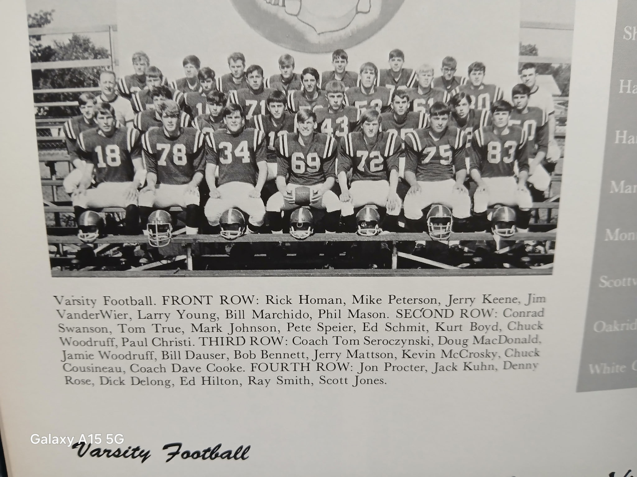

The 1967 NORSEMEN

Record Score Interesting Fact
1-0 NM 41, Kent City 12 Pete Speier scorer 23 points on 3 TDs and 5 extra points. Kurt Boyd a 10-yard TD and Mark Johnson scorer from 31. Phil Mason TD pass from Speier.
1-1 *Shelby 13, NM 7 Shelby hands NM their only loss of season. Speier scores late from 18 yards for only NM score.
2-1 *NM 13, Hart 2 Fumbles by Hart lead to NM touchdowns; Mark Johnson a 2-yard TD. Speier to Mason connect on 3-yard scoring pass play.
3-1 NM 26, Hamilton 6 Norse defense again strong in win. Johnson two TDs, Speier passes to Rick Homan for 31-yard tally: Speier 7 yd rushing TD.
4-1 *NM 27, Manistee 6 Speier runs for two short TDs, passes to Boyd for another. Boyd powers over from the one for NM TD.
5-1 *NM 26, Montague 6 Fumbles and an interception key NM win. Ed Schmid 2 TDs, Speier a 30-yd TD’ Boyd 17 yd tally.
6-1 *NM 7, Mason Co. 2 Trailing 2-0 at the half, NM scores in a Mark Johnson 19-yard TD. NM makes goal line stand in final seconds for the win.
7-1 *NM 20, Oakridge 0 NM earns tie in the WMC. Conrad Swanson 50-yard interception return for TD. Mark Johnson and Speier rushing TDs.
8-1 NM 13, White Cloud 0 NM limits White Cloud to 19 yards in offense. Speier 6-yard TD; Mason scores from five.

1968– coach Tom Seroczynski (7-1 overall 5-1 WMC tied for 1st with Manistee)

With NM enrollment the smallest in the WMC it was clear to NM head coach Tom Seroczynski and his assistant Dave Cooke, that many, if not most of their players are going to have to go both ways to avoid key injuries if the Norse had any hopes of repeating as conference champions in 1968. A huge void was at quarterback with the loss of Pete Speier, who would be the starting quarterback down the road at Northern Michigan University. Returning starters included All-Conference guard Larry Young and Bill Marchido up front and starting backs Mark Johnson and Kurt Boyd. NM received a huge boost from Bob Steele, a 185-pound backfield transfer to NM from Grand Rapids West Catholic. But who would play quarterback?

After their season opening 33-0 stomping of Kent City, it was quickly apparent that the Norse had found their quarterback and more. The Norse established that this team also had some speedy running backs as well as a solid quarterback in junior Jamie Woodruff. NM backs Kurt Boyd, Mark Johnson, Tim Johnson and Bob Steele, all had excellent games while Woodruff showed that he was going to be more than an adequate replacement for Speier at quarterback. Woodruff possessed the same traits as Speier did on defense as he intercepted a pair of Kent City passes, both picks setting up NM TDs. Steele, who rushed for 86 yards on the night in his Norse debut, got the Norse off to a good start with a TD run from nine yards out. Bill Marchido had replaced Speier as a kicker and his first PAT on the season was good to give NM an early 7-0 lead. With Woodruff directing the offense the Norse marched 92 yards in 14 plays with Mark Johnson racing 40 yards for the TD. With just seconds left in the half Woodruff intercepted the first of his two picks on the night. On the last play of the half Woodruff then hit Johnson with a perfect 42-yard strike to extend their lead to 19-0 at halftime. After a scoreless third quarter Woodruff picked off his second Kent City aerial and returned it to the KC 20. Then it was another Johnson, sophomore running back, Tim Johnson, who scored from eight yards out to pad the NM lead. Just moments later Kurt Boyd thrilled the Norse rooters when he fielded a punt at his own 38 and raced 62 yards to make the final score read NM 33, Kent City 0.

The Norsemen made amends for their only loss in 1967, but it wasn’t easy. NM was able to squeeze out a 13-7 victory over Shelby to extend their winning streak at Fred Jacks Field on the Northside to 15 straight victories. Both teams settled nothing in the first half although the host Norsemen came close. Early into the opening quarter Mark Johnson raced from his own 48 to the Shelby five where a touchdown saving tackle was made by the Tigers John Wyn. NM fumbled the ball away on their next snap from center to deny them a golden scoring opportunity. NM scored first in the second half when they came up with a big play as quarterback Jamie Woodruff hit Mark Johnson on a fourth and seven play to pick up a big first down at the Shelby 12. Two plays later Bob Steele powered his way into the end zone. The Tigers then fumbled the ensuing kickoff which Larry Young recovered at the Shelby 25. Woodruff then connected with Steele for a 15-yard TD pass to extend the lead to 13-0. Shelby did find the end zone to make the final score 13-7 but it was too little too late as the Norse were able to run out the clock.

It took a second half rally for NM to defeat Hart 19-6 after the Norse trailed 6-0 at halftime. Both teams had opportunities to score in the third period, NM advanced to the Pirate eight and Hart picked up a bobbled screen pass and drove to the NM 10 before Larry Young intercepted a pass to halt Hart’s drive. Jamie Woodruff came up with a huge play to get the Norse on the board, and in the lead. With the ball at the Hart 20 and NM facing fourth down, Woodruff scrambled on an attempted pass play and scooted down the sidelines to score. Bill Marchido’s extra point was good, and NM had a 7-6 lead. The opportunistic NM defense set up the second Norse TD just moments later. Marchido intercepted a Pirate pass at the Hart 22. Woodruff raced for his second TD on a keeper to give the Norse a little breathing room. NM put the game on ice late in the contest when Hart gambled on fourth down but failed to pick up the necessary yardage at their own 22. Bob Steele then put the game away with a three-yard rushing TD and the Norse had earned their third straight victory in the 1968 season.

In the second and last meeting in history between the two squads, North Muskegon defeated Hamilton 14-6 for their fourth straight victory to open the season and their 16th straight home victory. NM got on the board first and then had to hold on to take a lead at halftime. The NM score was set up by an interception by Mark Johnson who returned his pick down to the Hamilton six. Bob Steele put six points on the board with a one-yard plunge and Bill Marchido made it seven points with his PAT conversion. Hamilton came back to score on a pass play and then threw a scare into the Norse as they advanced inside the Norse five-yard line before time ran out in the half. The Norse had their best drive at the start of the third period. Topping the 71-yard drive was a 20-yard pass from Jamie Woodruff to his brother Chuck followed by another short one-yard plunge by the Norse fullback Steele. All of Steele’s yardage on the night weren’t just short dives plays as the fullback accrued 93 rushing yards for the game.

Manistee handed the Norse, not only their first loss of the season, but their first loss in front of the home folks in 16 games, as the visitors edged a banged-up Norse team 18-14. Playing with six of their regulars nursing injuries, the Norse battled the Chippewas on even terms throughout the contest. The Norse held a slight edge at halftime 14-12 but even though the Norse ran 45 plays in the second half to Manistee’s 21, it was the visitors who scored the only touchdown in the final 24 minutes. Manistee, who hadn’t penetrated past their own 45 in the half began their winning drive after a fourth down attempt by the Norse fell a foot short of a first down. Starting at their own 22 the visitors, aided by a 15-yard NM penalty, moved to their own 49 when Manistee quarterback Tom Walsh uncorked a 51-yard TD pass to his end for the winning touchdown with 6:05 remaining. Hindering their ability to score in the second half were the 80 yards in penalties that stopped Norse drives in the second half. Most of the game’s scoring took place in the first half with each team crossing their opponents goal line twice. The first NM score was on a 43 pass from Jamie Woodruff to Kurt Boyd. The second was a pass from Mark Johnson, who had received the handoff from his quarterback Jamie Woodruff---suddenly stopped and caught everybody by surprise by passing 13-yards into the end zone to Chuck Woodruff. The difference in the Norse leading at halftime were the two made conversion placekicks by Bill Marchido.

North Muskegon made the short jaunt up to Montague and with their 26-6 win over the Wildcats, thanks to a Hart upset over Manistee, the Norse moved into a three-way tie at the top of the heap with Manistee and Hart. NM scored first on a 20-yard pass from Jamie Woodruff to Kurt Boyd midway through the second quarter. Woodruff, who can catch an opponent’s pass as well as throw a completion on his own, intercepted a Montague pass two minutes later to set up his own TD on a quarterback sneak to give his team a 14-0 lead. Montague scored their only TD late in the second period, but the Norse put the game away in the second half. Mark Johnson ran the pigskin in from the 10 for the first NM TD in the second half and scored the final NM TD on a 14-yard screen pass from Woodruff. At the end of the season Montague head coach Jack Bendelow who won five WMC title in his 16 years at Montague, announced his retirement.

After Mark Johnson left the game with a leg injury just four plays into the game in Scottville, Coach Seroczynski put in another Johnson, Mark’s sophomore brother Tim Johnson, who did better than better and showed that he was going to be a thorn in NM opponent’s side for the next couple of years. Johnson scored on a pair of long runs to lead NM to a 19-7 victory over a stubborn Mason County Central team. All the scoring in the game was in the second half. Johnson scored his first TD in the final half when he outsprinted the Spartan defenders and raced 38 yards for a Norse TD. Just ten plays later Johnson showed his speed again and raced 33 yards for the second TD that proved to be the game winner. After Scottville scored quickly to get close to the Norse, Bob Steele than iced the game when he dashed 59 yards for the game’s final score.

Needing a win in their final game of the season to earn another co-championship in the WMC, thanks to the running of Bob Steele, the Norse accomplished their goal with a 20-7 win over Oakridge. Steele scored all three NM touchdowns with his first coming in the second quarter when he raced 67 yards to pay dirt with 7:46 left in the first half. After Oakridge was unable to move the ball in their possession, Steele struck again, this time from 37 yards, stiff arming his last tackler on his way to the goal line. Steele scored his final TD in the second half at a much shorter distance of 11 yards. Jamie Woodruff kept the Oakridge defense loose with a couple of key pass plays on the drive, including one to his favorite receiver on the season, Kurt Boyd. Norse coach Tom Seroczynski had special praise for his seniors, most of whom have helped NM win 14 of their last 15 games: Steele, Bill Marchido, Kevin McCroskey, Larry Young, Chuck Cousineau, and Chuck Woodruff following the win.

The Norse would share the title with Hart and Manistee, all with 5-1 conference records. For Hart, it’s been a long dry spell in winning WMC football championships. As of this writing in 2026, 58years have passed, and Hart is still looking to win another WMC title. Manistee would leave the WMC after the 1968 season but are now back on board in the newly expanded West Michigan Conference beginning in 2022. The Norsemen dominated the All-Conference team with five players earning first team honors, with three selected on both offense and defense. Junior Jamie Woodruff was picked as the top quarterback and as a defensive back. Bill Marchido earned honors as a tackle on both sides of the ball, while Bob Steele also was selected as a two-way performer. Steele, who rushed for 780 yards in eight games was also the league’s leading scorer with 72 points. Larry Young was one of only two repeaters from the 1967 All-Conference team when he was once again selected as an offensive guard. And how proud could the Woodruff family have been in 1968? Joining Jamie on the All-Conference team was his older brother Chuck, who was picked as a defensive end.

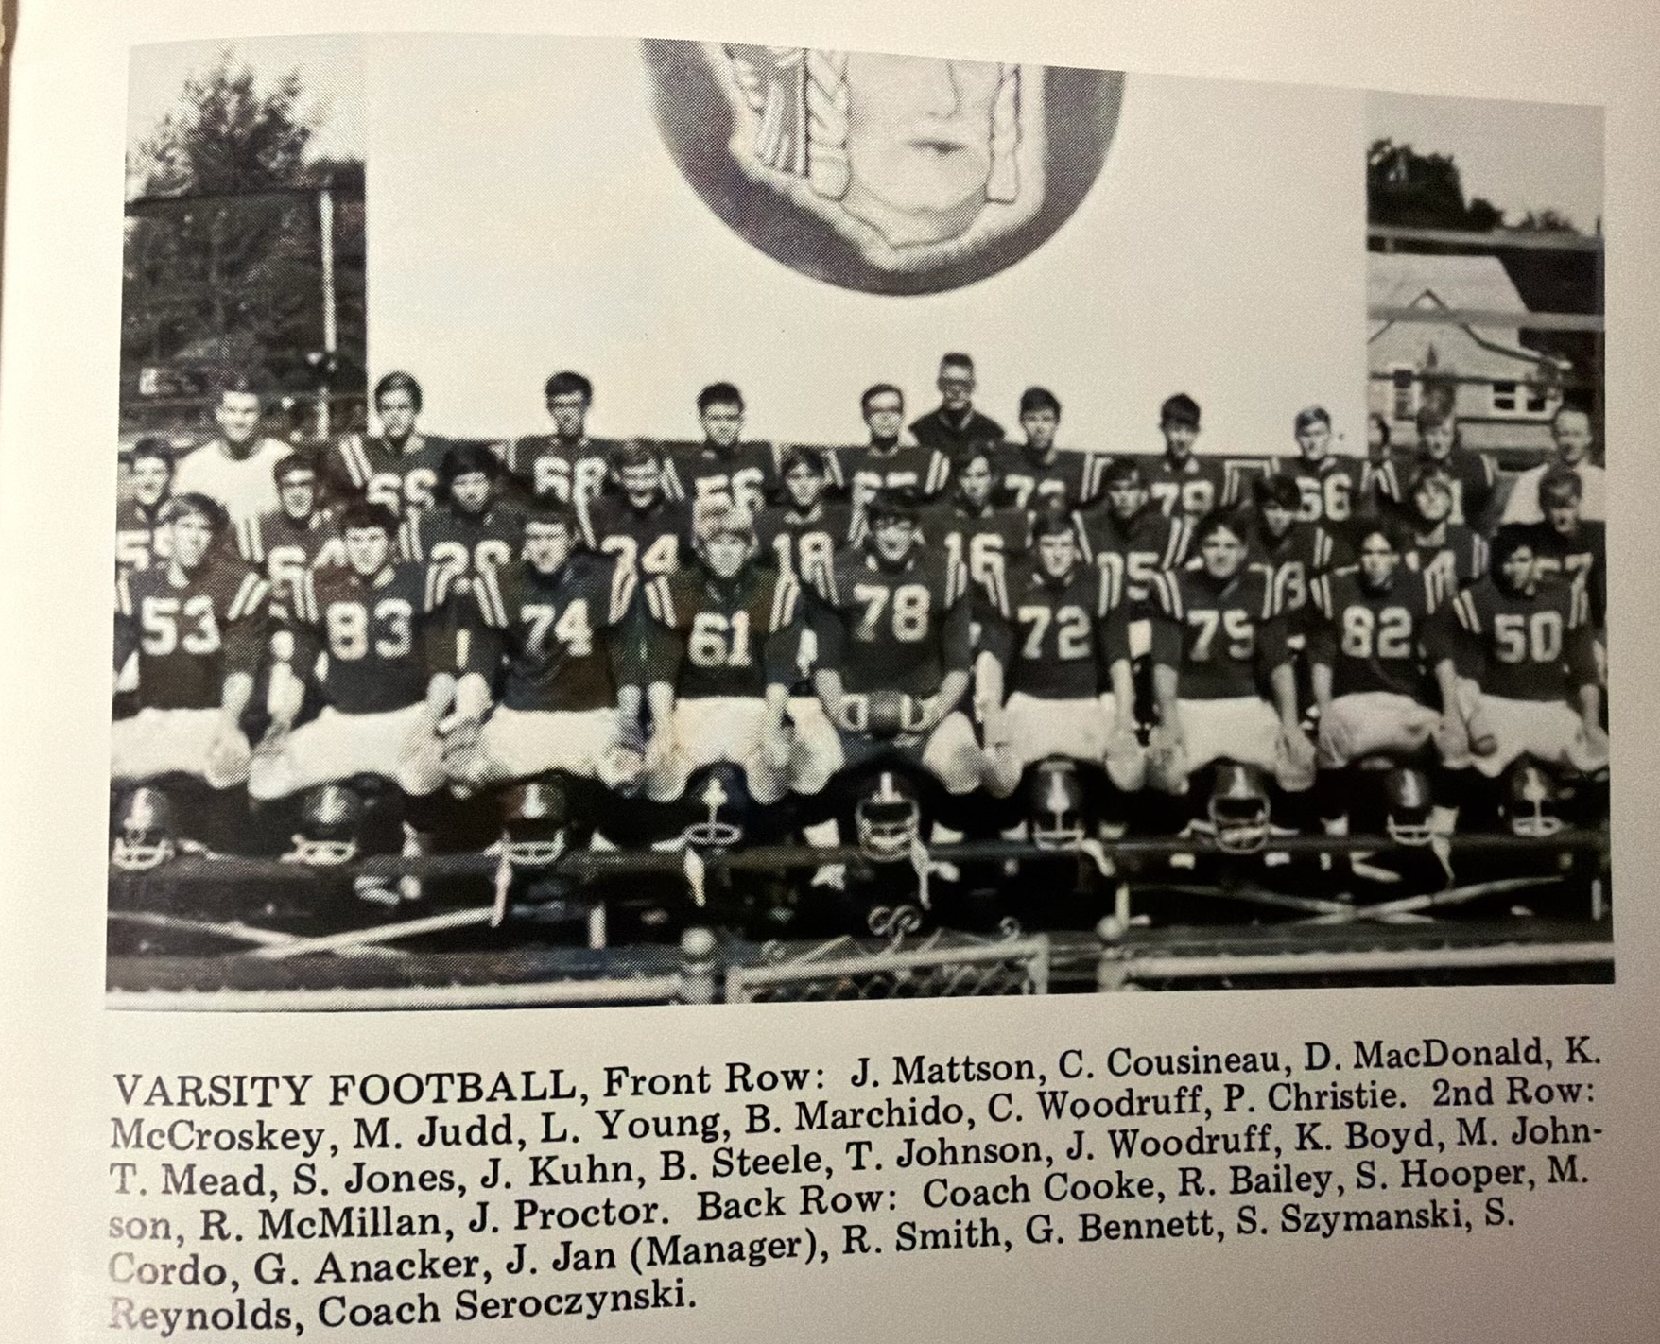

The 1968 NORSEMEN

Record Score Interesting Fact
1-0 NM 34, Kent City 0 Bob Steele makes his NM debut with 86 rushing yards and a TD. Mark Johnson a 40-yard rushing TD and 42 yd pass from Jamie Woodruff. Tim Johnson 8 yd tally.
2-0 *NM 13, Shelby 7 Steele with a pair of TDs, one a short rushing tally, the second on a 15-yard pass from Woodruff.
3-0 *NM 19, Hart 6 NM rallies for 3 TDs in the second half. Woodruff sprints for a pair of touchdown and Steele from 3-yards for final tally.
4-0 NM 14, Hamilton 6 Steele a pair of short 1-yard plunges for both NM TDs. Mark Johnson with an interception and return to set up first TD of Steele.
4-1 *Manistee 18, NM 14 Manistee scores winning TD on long pass in 4th qtr.; Jamie Woodruff to Boyd 43 yd TD, and a halfback pass from Mark Johnson to Chuck Woodruff for 13-yd TD.
5-1 *NM 26, Montague 6 NM moved into 1st place tie in WMC. Woodruff a pair of TD passes, one of 20 to Boyd, the other 14 to Johnson. Woodruff a QB sneak and Johnson 10-yard TD.
6-1 *NM 19, Mason Co Cent 7 Sophomore Tim Johnson in for injured Mark Johnson 2 long TDs (38 & 33) Bob Steele 59 yd TD.
7-1 *NM 20, Oakridge 7 Steele scores three TDS on runs of 67, 37, and 11 yards as NM ends as co-champs of WMC.

1969– coach Tom Seroczynski (7-1 overall 6-0 WMC champs)

The West Michigan Conference would add Ravenna as Manistee, still fuming over a possible forfeiture loss to Hart in 1967, dropped out. When Whitehall returned to the WMC in 1985 the venerable conference would remain intact until a monster change in 2022. The 1969 season would begin one of the best eras in NM football. NM, from the end of the 1968 season until early in 1972, would win 22 straight WMC Conference games. And--- mythical Class C State Champs in 1971!
A constant for NM football over the years has been their small number of varsity players once Reeths Puffer became a four-year school. Coach Tom Seroczynski may have bemoaned his lack of manpower to begin the 1969 season, but what he lacked in quantity the team was loaded with quality---and speed! Two-way All-Conference performer Jamie Woodruff headlined the returnees from their fine 7-1 1968 team. The backfield would also return a pair of ‘burners’ in Kurt Boyd and Tim Johnson, North Muskegon’s only track athlete to win the 100-yard dash at the Greater Muskegon Track & Field Meet. Waiting in the wings were a couple of juniors who can also fly, Dennis Witham and Merle Swanson. Only one starter returned to the line, senior Doug MacDonald, but waiting in the wings were several promising underclassmen who would help NM become the dominant team the next three years in the WMC. Seroczynski will also have back as his assistant, future NM long time successful coach Dave Cooke.

Jamie Woodruff demonstrated in the season opener that he would be ranked with many great NM quarterbacks to call the signals for the Blue and Gold. The returning two-way All-Conference quarterback had a hand-in-all six North Muskegon tallies in a 40-20 opening game victory over Kent City. So dominant have the Norse been in their eight-game series over the years with Kent City that the final totals show NM scoring 305 points to Kent City’s 35. Woodruff drilled TD aerials of nine, 35, and 21 yards and in between he also had TD jaunts of seven, 17, and two yards. Dave Erickson was on the receiving end of Woodruff’s first TD strike of nine yards. The second TD pass went to his favorite receiver from the previous season Kurt Boyd good for 35 yards. It was on the next play that North Muskegon, with woeful kicking woes over the years, surely welcomed in the two-point conversion rule by run or pass instituted in time for the 1969 season. Woodruff connected with Boyd for the first two-pointer in NM history. In the meantime, Kent City had also scored a pair of touchdowns but thanks to the Boyd two-pointer the Norse led 14-12. Woodruff then hit junior speedster Merle Swanson with his 3rd TD pass good for 21-yards with just 30 seconds left in the half. Woodruff ran for the first of his three rushing touchdowns to up the Norse advantage to 26-12 but Kent City wouldn’t fold as they closed the gap to 26-20. Woodruff then tallied on TD runs of 17 and two to make the final score read 40-20.

After giving up an uncustomary three touchdowns the previous week, the emphasis was on defense on the week of the Hart game. The work on improving the defense paid off as the Norse would not allow more than a touchdown in a single game the rest of the season until their final contest in 1969. The Norse scored in every quarter to earn a 27-6 road win in their conference opener with Hart. NM scored the game’s first three TDs before Hart could get on the board in the third period. Kurt Boyd plunged over from the one to score the first NM touchdown. Jamie Woodruff, an all- conference defensive back, set up his own eight-yard keeper sweep for the NM tally in the second quarter. Tim Johnson, who had dashed 47 yards on a running play in the first half, dashed 70-yards for the third quarter NM TD. After Merle Swanson intercepted a Hart pass in the fourth quarter Woodruff hit Boyd on an 18-yard aerial to complete the Norse scoring. NM rolled up 318 rushing yards in their 27-6 victory.

While your author was calling the Traverse City-Muskegon game at Hackley stadium, my alma mater was pasting Montague at Fred Jacks Field 39-0. The Norse again rushed for more than 300 yards in their shutout victory with little need to go to the air. One of the few aerials that NM quarterback Jamie Woodruff threw was an 18-yard TD pass to Kurt Boyd to begin the scoring. Woodruff tallied the next TD on a short three-yard scamper with Boyd adding the next six points on another three-yard trek into the end zone. Denny Witham scored his first touchdown in a Norse uniform with an 11-yard tally with junior Merle Swanson adding the final two TDs with runs of 11 and three yards.

With some sterner opposition from a Mason Co Central team the Norse mixed in the run with the pass in their hard-fought 20-6 victory in Scottville. Mason County out rushed NM slightly, 225-205, but the difference was the versatility of NM quarterback Jamie Woodruff. The senior signal caller threw for 158 yards that included a 51-yard scoring strike to Kurt Boyd for the first NM TD late in the first quarter. The Spartans were saved by the clock late in the first half as Woodruff, with 20 and 15 yards passes to Rod Raymour and Mike Patton, moved the ball to the Spartan four before time ran out in the half. Speedster Tim Johnson set up a pair of second half touchdown runs by Woodruff with near identical rushes of 44 and 45 yards. Woodruff followed each of Johnson’s runs with quarterback keeper runs from nine and 11 yards out to make it 4 and 0 to begin the 1969 season.

The Norse had their four-game winning streak come to a halt when Manistee shut out the Norse 15-0 in a game played on a muddy Fred Jacks Field on the Northside. The much larger Chippewa team dominated in all the stats. Fortunately, for the Norse rooters, Manistee was no longer a member of the West Michigan Conference, and the Norse would remain 3-0 in WMC action. The game marked the end of a hard-fought 16 game series between the two teams that first began back in the 1930s. NM would hold a slight 9 to 7 advantages in the series, with one very controversial tie in 1954 that kept NM from posting a perfect season. With Manistee back in the expanded WMC, but in a division opposite the Norse, it’s likely the two will meet again in the not-too-distant future.

In a series that was first dominated by the Norse but has clearly shifted the last few years to Oakridge, the Norse defeated Oakridge 47-8, the most points NM has ever tallied against the Eagles as well as their largest margin of victory over the years. NM’s seven TDs were distributed between five players. Jamie Woodruff and Kurt Boyd each scored a pair of touchdowns, Woodruff on two of his trademark QB sweeps from 7 and 41 yards with Kurt Boyd scoring on runs of 12 and two yards. Woodruff passed to Rod Raymour for a 57-yard TD strike while Tim Johnson showed his speed on a 41-yard dash to pay dirt. Denny Witham closed out the NM scoring with the day’s longest TD run of 78 yards.

The WMC title was on the line when NM traveled to Shelby for a game between the two unbeaten teams in conference play, both boasting perfect 4-0 records. The Norse would be playing without their junior speedster running back Tim Johnson, out for the season following a knee injury. The Norse had more than a capable replacement in another junior swifty in Merle Swanson. The Norse had to rally to earn the 12-8 victory and at least clinch a tie in the WMC. Merle Swanson chipped in with a pair of key long runs to set up both NM TDs. Trailing 8-0 following a second period TD by Shelby, the Norse drove 57 yards with Swanson eating up 43 of those yards on one run, setting up Jamie Woodruff’s 2-yard run with just 1:19 left in the first half. Still trailing by two points after Shelby basketball star Kim Griffin ran for the two-point conversion after their first half TD, the Norse were still on the short end of the score with less than two-minutes remaining in the game. Starting at the Shelby 49 with but 1:49 left in the game NM began a final desperation drive to pull off the win. Swanson nearly scored on a 20-yard run but was stopped at the one-yard line. Woodruff then plunged over the goal line to give the Norse the win and clinched a tie for the conference championship.

Only a loss to Ravenna would deny NM the 1969 WMC championship. With NM boasting a perfect WMC 5-0 record, and the Bulldogs winless in conference play, it looked the Norsemen would be a shoo-in to come away with an easy victory. Ravenna, however had other ideas by unleashing a passing combination featuring quarterback Tony Krepps and wide receiver Paul Herremans. Krepps first found Stan Jansen on a 53-yard bomb to put the Bulldogs on the board with just five minutes gone in the opening quarter. Jamie Woodruff, who had an awesome final game for the Norse, put a stop to another Ravenna threat by intercepting a Krepps pass at the Ravenna 33. On the next play Woodruff went for the jugular and hit Merle Swanson good for a 33-yard TD. Tim Meade kicked the extra point to give NM their first lead at 7-6. Ravenna came right back with Krepps connecting with Herremans, a long-time baseball and football coach at Ravenna for a 26-yard TD. The Bulldogs made the two-point conversion to take a 14-7 lead. Woodruff dashed 51-yards for a NM TD but the point after missed and Ravenna, still smelling an upset, led 14-13. To add further laurels to Woodruff’s final game in a NM uniform, he also set a school record with four interceptions in the contest, giving him 22 ‘picks’ in his career. The Norse then took a lead they would not relinquish when Kurt Boyd, after Jim Dagen recovered a fumble, sped 25 yards for the TD and the Norse were now on top 21-14. Ravenna kept the pressure on when Krepps went to the air again, this time connecting with Dennis Patterson on a 35-yard scoring play. The point after missed and the Norse kept their narrow lead at 21-20. The thrills continued for the chilled fans at Fred Jacks Field on the northside when Woodruff again ran for a long TD, this from 53-yards out early into the fourth quarter. The Norse went for two points, and a two-possession lead and Merle Swanson came through for the hosts by doing just that by racing into the endzone to stretch the lead to 29-20. The Norse enjoyed even more breathing room when Boyd added another six points on a run to go up 37-20. The Bulldogs would not roll over as Krepps threw his fourth TD pass of the game, this time a 73-yard bomb to Herremans to make the final score NM 37, Ravenna 28. The Norse were now on top of the WMC standings all alone with a perfect 6-0 record.

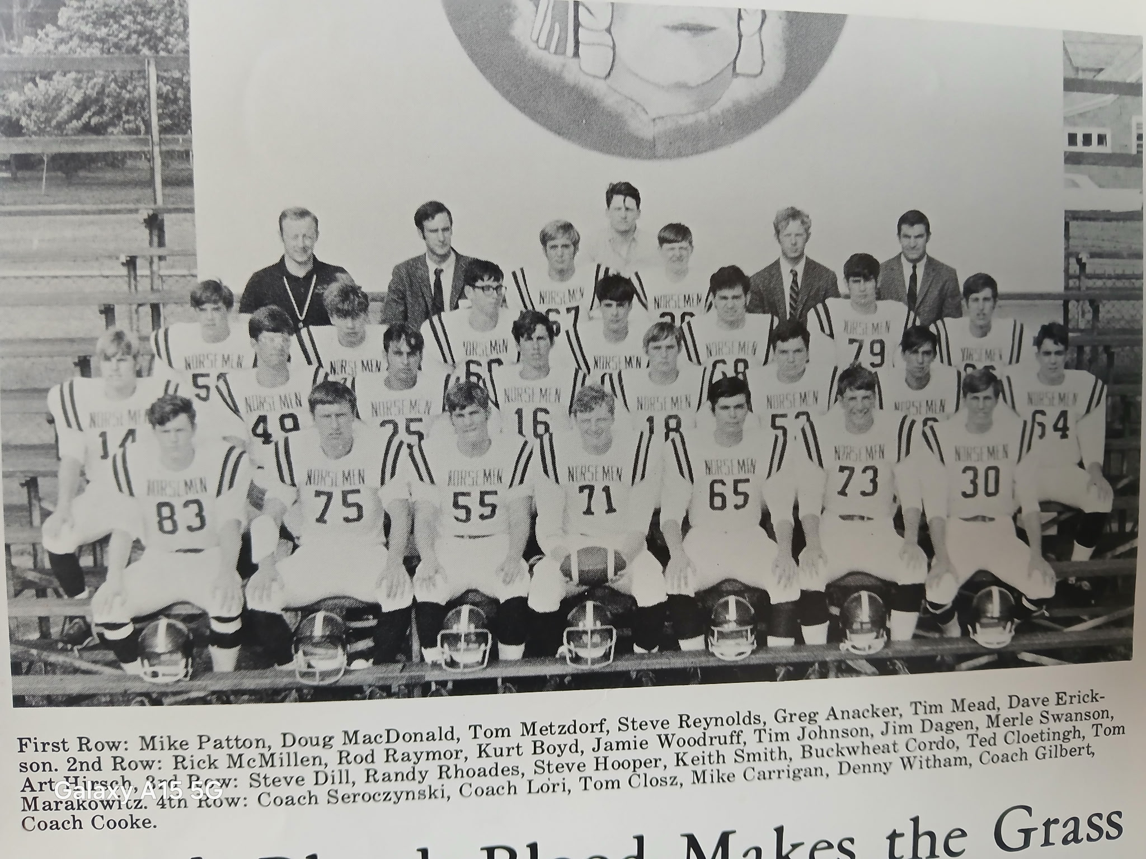

The 1969 NORSEMEN

The Norsemen would finish in the top ten in the final Class C AP poll (9th) and once again dominated the All-Conference team. Jamie Woodruff once again was selected on both first teams, as quarterback and a defensive back. The senior finished his career at NMHS with 26 touchdowns, 14 rushing, 12 passing and 2193 yards in total offense. His 22 interceptions during his three-year career still stands as an all-time NM best. Woodruff would take his talents to Northern Colorado where he was a three-year starter for UNC. Junior Tim Johnson and Kurt Boyd both made the team as running backs while upfront linemen Doug McDonald and junior Tom Metzdorf made 1st team honors. Along with Woodruff on the defensive team were Linebacker Mike Patton and sophomore middle guard Jim Dagen. As good as NM was in 1969, it would only get better --- much better in 1970 & 71.

Record Score Interesting Fact
1-0 NM 40, Kent City 20 Jamie Woodruff take part in all six NM TDs --- 3 passing and 3 rushing.
2-0 *NM 27, Hart 6 NM scores in every quarter. Woodruff a rushing TD and TD pass to Kurt Boyd. Boyd also a rushing TD and Tim Johnson 70 yards for TD.
3-0 *NM 39, Montague 0 Merle Swanson a pair of TD runs (11 &3), Boyd a 18-yd pass & 3-yard run. Woodruff sweeps in from 3 and Denny Witham scorers from 11.
4-0 *NM 20 Mason Co Cent 6 Woodruff to Boyd for 51-yards. Woodruff score from Nine & 11 after Tim Johnson sets up both tallies with runs of 44 & 45 yards.
4-1 Manistee 15, NM 0 Manistee dominates Norse on a muddy Fred Jacks Field in the last game played in the 16-game series.
5-1 *NM 47, Oakridge 8 Wood rushed for 2 TDs and a 57-yard TD aerial to Rod Raymour. Boyd scores from 12 and 2 yards. Johnson 41-yard TD.
6-1 *NM 12, Shelby 8 Swanson two long runs to set up a pair of Woodruff Tds; the winning TD coming with one-minute left in the game.
7-1 *NM 37, Ravenna 28 Winless Ravenna throws scare into NM. Woodruff 2 long TD runs (51 & 53) also TD pass to Swanson & intercepted school record 4 passes, Boyd 2 TD runs.

1970– coach Tom Seroczynski (8-0 overall 6-0 WMC champs, 2nd ranked in state)

Three all-conference players were included among the nine lettermen returning for the 1970 season, while 13 members of the undefeated JV team would make this 1970 team one of the most powerful Norse teams in school history. Halfback Tim Johnson, tackle Tom Metzdorf and middle guard Jim Dagen all returned for the Norse with quarterback Rick Jones and end Jeff Chrystal set to give NM one of the most dynamic 1-2 punches in Norse history. It looked like NM was set to have a good season, but ‘good’ would be an understatement.

NM began their onslaught of their 1970 foes with a 43-0 shutout over Kent City.
The Norse wasted little time getting things started in the season opener when Art Hirsh recovered a Kent City fumble in Eagle territory. Tim Johnson then tallied from three yards in what would prove to be the winning touchdown. Kent City played NM tough in the first half as only a short 22-yard field goal by Jeff Chrystal and the first of three TD runs by Merle Swanson gave NM a 16-0 halftime lead. Following a scoreless third quarter the NM offense showed its might in the game’s final period. In what would prove to be the first of many, Rick Jones connected with Chrystal with a 10-yard TD pass. Jones then paired up with Swanson for a 25-yard strike to set up a Swanson seven-yard TD run. Jones later hit Mike Schalk from 15 yards out before Swanson completed the Norse scoring with a 33-yard sprint to paydirt.

It took NM’s imposing offense a little time to get in sync after a scoreless first quarter in game number two vs. Hart, a 40-0 NM shutout. A Tim Johnson 14-yard TD run early in the second quarter got the Norsemen rolling. Merle Swanson’s 3-yard TD moved the lead to 13-0 and then a 25-yard TD strike from Rick Jones to Dave Erickson gave the host Norse a 20-0 halftime lead. A Jones aerial to Tim Johnson good for 49 yards boosted the lead to 27-0. The defense got in on the act with John Closz returning an interception 67 yards before Swanson closed the scoring out with a 30-yard burst.

NM made their first road trip a success as they posted their third straight shut out to begin the season with a 41-0 whitewash at Montague. Highlighting the game was a 96-yard TD dash by speedy back Tim Johnson. Merle Swanson kept scoring TDs, one on a 38-yard TD pass from Jones and another on a six-yard run. Dennis Witham brought the Norse rooters to their feet with a 67-yard punt return for six points. The Norse did most of their work on the ground as they rushed for 260 yards. Jones, a prolific passer had but one TD pass, but he scored a couple of rushing TDs from short yardage.

The AP polls had the mighty Norsemen listed at number three in the Class C polls and that ranking surely was not going to tumble following a 69-0 pasting of Scottville, the most points scored in NM history vs. the Spartans. Rick Jones threw for a program record six touchdown passes. Jones connected on TD strikes to Dave Erickson twice (24 & 44), a 36-yard TD pass to Tim Johnson, a 29 yarder to Merle Swanson, Jones to Mike Schalk for 18 and his final TD toss went to Jeff Chrystal for 16. I’m not sure how well received that last TD was viewed by the Scottville fans with the Norse leading 62-0 at the time. Dennis Witham fielded the second half kickoff and raced 83 yards for a TD. Tim Johnson had a pair of TD runs to begin the rout (5 & 15) with Merle Swanson igniting the NM scoring parade with a 63-yard burst.

A new opponent appeared on the NM schedule in Grand Rapids East Christian, and they performed no better than NM’s WMC rivals as they became the Norsemen’s fifth straight shutout victim 34-0. NM’s defense held the visitors from the Furniture City to only 25 yards net gained on the night compared to NM’s total of 314. Jones again had a productive game passing for a pair of TD strikes, one of 25 yards to Dave Erickson, the other for 35 to Denny Witham. Merle Swanson continued his exceptional running with a pair of TDs (51 & 4). Noted for securing yet another shutout victory were Jeff Chrystal and John Closz. Chrystal was not only a sensational end on offense and a great defensive player, but the junior whiz also did the placekicking chores for his team.

With Norse fans possibly envisioning a possible perfect season of eight shutouts, Oakridge put a halt to that kind of wishful thinking as they scored 13 points, the only points allowed by the NM defense all season! However, NM countered with 43 to extend their record to a perfect 6-0. NM’s Tim Johnson, on the very first play from scrimmage sprinted 60 yards for a TD and it looked like NM was going to be in for another easy victory. However, Oakridge came back on their first possession and scored the first TD against the NM defense on the year on a John Scraver pass of seven yards to John Thompson. NM quickly regained the lead on the first of three TD passes on the evening from Rick Jones. Jones connected with running back Denny Witham for 67 yards, but Oakridge scored before half to cut the lead to 14-13. The second half was all NM as Jones threw TD strikes of 64 yards to Mike Schalk and 18 to Jeff Chrystal. Completing the NM scoring were TD runs of 38 by Johnson and 11 by Merle Swanson.

The WMC title was squarely on the lines as Shelby came to Fred Jacks field boasting of a perfect record. However, only NM would stay undefeated on the season with a convincing 42-0 pasting of the visiting Tigers. Rick Jones not only threw a pair of TD passes, both to Dave Erickson good for 14- & 26-yards strikes but also intercepted two passes from his defensive backfield perch. Jones also tallied on a quarterback sneak for another tally while Johnson and Swanson also scored on a short one-yard plunges. One of the three NM interceptions on the evening was from Mike Schalk, who returned his pick into a 36-yard TD.

After getting a strong effort from Ravenna to close out the previous season, NM was looking for much of the same in the final game of the 1970 regular season. NM was up to the task and completed their first undefeated and untied season in 28 years with a 39-0 victory over Ravenna, their sevenths shutout in eight games. Rick Jones concluded his outstanding junior season with three TD passes, two of those to his favorite target for the upcoming 1971 season, junior end Jeff Chrystal. Dave Erickson also caught a TD strike from Jones, his seventh of the season as NM ended the eight-game schedule 8-0. Perhaps sometimes lost in the shuffle was NM’s defense who limited the host Bulldogs to 102 yards net gained for the entire contest. Denny Witham added a TD burst from 27 yards while Tim Johnson and Merle Swanson ended the season with a remarkable achievement: having scored a TD in every game on the eight-game schedule.
Playing their final game in a Norsemen uniform were such stalwarts as Dave Erickson, John Closz, Art Hirsh, Randy Rhoades as well the 1-2 backfield punch of Swanson and Johnson.

NM would conclude the season rated number 2 in the state in the AP polls, trailing only undefeated Galesburg-Augusta in the final Class C poll. NM obviously dominated the All WMC team with Juniors Jeff Chrystal, Rick Jones, Jim Dagen, and Mike Schalk all first team honorees. They were joined on the All-Star squad by senior running backs Merle Swanson and Tim Johnson and lineman Tom Metzdorp. Metzdorp and Johnson were returning all-conference selectees as was Dagen, who made the squad as a sophomore. With such domination of their WMC opponents it is likely there were other Norse deserving of All-conference honors, especially senior end Dave Erickson who caught seven TD passes on the season. Erickson did make honorable mention in the Free Press All State team with the Lansing State Journal honoring Dave with first team honors. The junior combo of Rick Jones and Jeff Chrystal were accorded honors on the prestigious first team Class C All-State team and virtually every poll. To finish number two in the state was most impressive, but could NM fare even better in 1971?

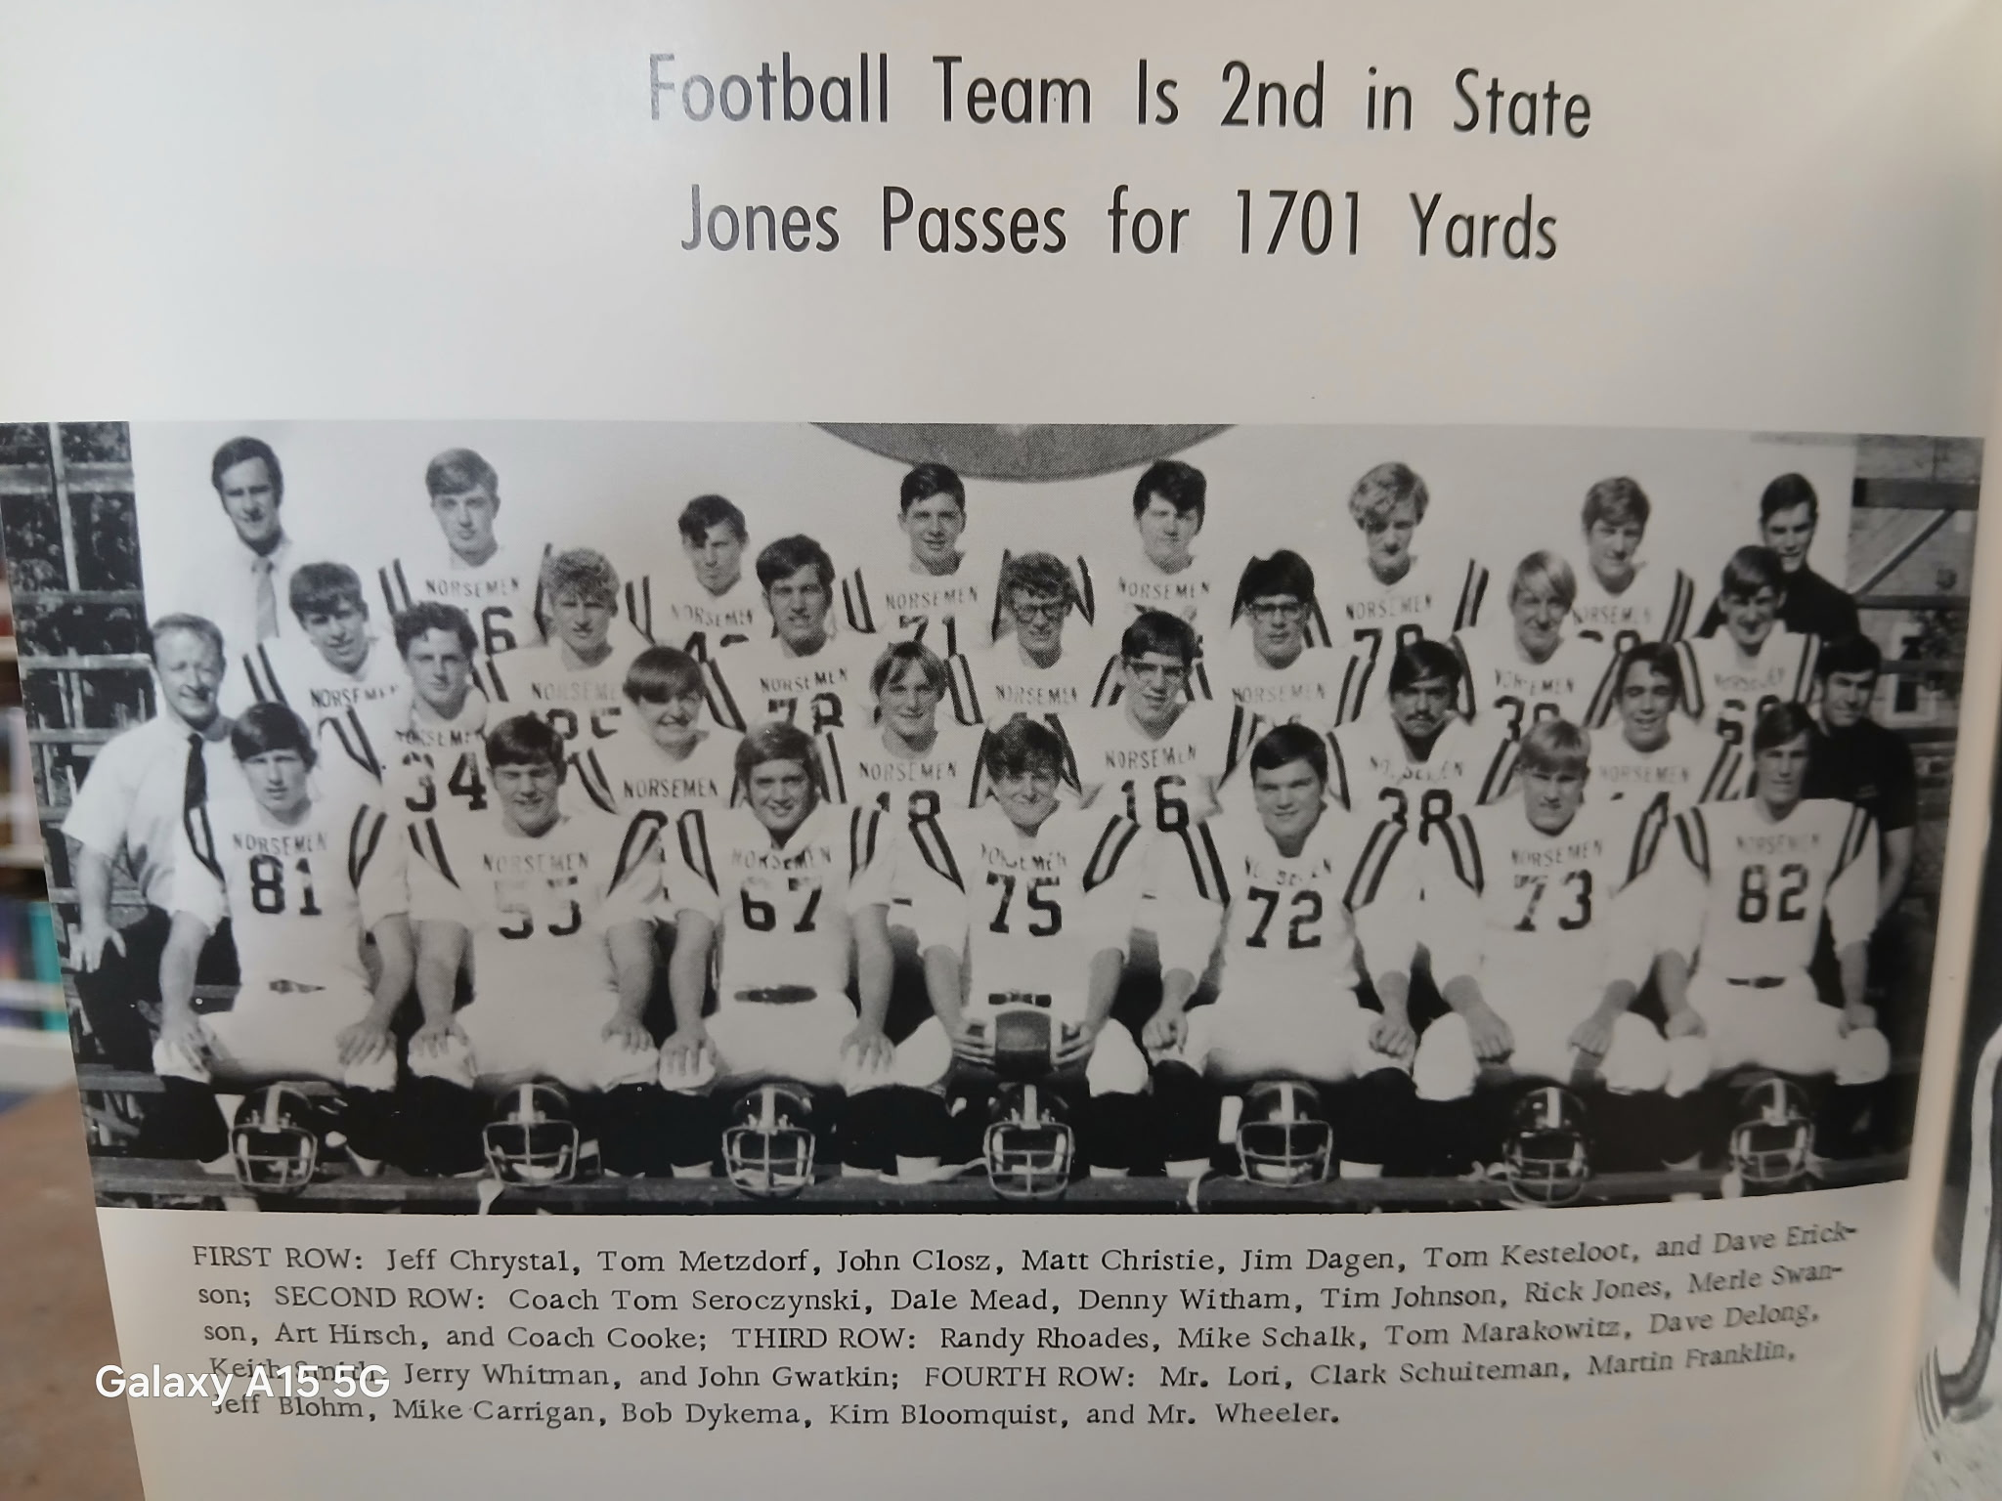

The 1970 UNDEFEATED NORSEMEN

Record Score Interesting Fact
1-0 NM 43, Kent City 0 Merle Swanson 3 TDs, Jeff Chrystal TD and a field goal, Tim Johnson and Mike Schalk TD. Jones 2 TD passes
2-0 NM 40, Hart 0 Swanson 2 TD (3 & 30) Jones 2 TD passes, 25 pass to Erickson and 49 to Tim Johnson, Johnson 14-yard TD run, John Closz 67 int return for TD.
3-0 NM 41, Montague 0 Tim Johnson 96-yard TD, Swanson 2 TDs – 1 rushing ,1 receiving, Denny Witham 67-yard punt return for TD, Jones 2 rushing TDs.
4-0 NM 69, Mason Co 0 Jones a school record 6 TD Passes. Johnson 3 TDs, Swanson and Erickson 2, Witham 83-yard kickoff return.
5-0 NM 34, Grand Rapids E. C. 0 Swanson 2 TD (51 & 4), Jones 2 TD passes (Erickson 25 & Witham 35, Johnson 2-yard TD run
(60 & 38) Swanson 11-yard TD run
6-0 NM 43, Oakridge 13 Jones 3 TD passes (Witham 67, Schalk 64, Chrystal 18) Johnson 2 TD runs of 60 and 38, Swanson 11-yard TD.
7-0 NM 42, Shelby 0 Jones 2 TD passes to Erickson 14 & 26) Schalk 35 yd int return for TD, Jones, Johnson, & Swanson 1-yard TDs.
8-0 NM 39, Ravenna 0 Jones 3 TD passes (Chrystal 2, 12 & 25 – Erickson 27), Witham 27-yard TD, Johnson 1 yd TD and Swanson 4 yd TD.

1971– coach Tom Seroczynski (8-0 overall 6-0 WMC champs, 1st ranked in state)

NM would lose the best running back combo since Don Bowen & Moe Sikkenga from the early 1940s in Tim Johnson and Merle Swanson, but NM returned a lot of talent to begin the 1971 season, including the passing duo of Rick Jones and Jeff Chrystal, both returning 1st string all-state performers. Jim Dagen, a two-time all-conference selectee would anchor the defensive line and would get plenty of help from the likes of players that included Tom Kesteloot and Jerry Whitman.
NM left little doubt that they would once again be a formidable opponent for all with an opening day 57-0 romp over an outmatched in all departments Kent City team. In the eight games played over the years between NM and Kent City this would be the most lopsided of all the games played, all won by North Muskegon.
Rick Jones began the season right where he left off from 1970 by throwing four TD passes before giving way early in the second half to reserve players. Jones found senior Mike Schalk twice for TD passes of 35 and 15 and the Kent City game began with Jeff Chrystal showing NM fans why he would go down in Norse lore as one of the best to suit up in a Blue & Gold uniform. Chrystal did it all in this game; catching a 23-yard aerial for a TD, intercepting a Kent City pass from his defensive position and returned it 35 yards for a TD and demonstrated his versatility by ending the first half with a 24-yard field goal. Jones accounted for five TD’s as he also scored on a 3-yard QB keeper. One of the recipients of a Jones TD pass was a pass to Jim Dagen good for 21 yards. Completing the scoring for the Norse were TD runs from Dale Mead (4 yards) and Bob Gilman.

NM began conference play with a road trip to Hart where the Pirates didn’t roll over and play dead against the heavily favored Norsemen. NM was ‘held’ to 26 points in the 26-14 victory over the Pirates, their lowest total points scored in two years. Rick Jones ran for one TD and threw a 31-yard pass to Jim Dagen to account for two of NM’s four TDs. Dale Mead crashed over from the one early in the game to give NM the early lead. Hart came back to tie the score, but NM responded with two TDs before halftime, the first, a TD pass to Dagen and the second was on a 34-yard TD run by Denny Witham. Jones 6-yard QB keeper in the third period ended all scoring in the game.

In a game marred by penalties, NM overcame more that 100 yards in penalties to post a 32-0 shutout over Montague. Jeff Chrystal had a pair of TDs, one a pass from Jones for 25 and the second on his second pick six on the season with a 40-yard return of a Montague pass. Dennis Witham a pair of short TDs and Dale Mead a one-yard plunge completed NM’s scoring. NM had a fine balance with the run and the pass as Jones passed for 191 yards while the NM running backs rolled up 183 yards.

When the polls came out in the following week’s newspapers, NM had moved into the top spot in the Class C polls, with perennial power Hudson High close behind in second place. The Norse did not roll up the score against Scottville as they did in their 69-0 victory from the previous season, but once again shut out the Spartans 34-0. Denny Witham rushed for 3 TDs as NM posted their third shutout in four games. Although he only threw for one TD, despite the rainy weather, Jones set up many of the NM TDs with his passing as he threw for 220 yards with his only TD strike a short five-yard toss to his favorite receiver Jeff Chrystal. Leading the defense in earning the shutout were Tom Kesteloot, Jerry Whitman and Jack Olson.

NM scored often and early in a 51-12 romp over Grand Rapids East Christian. It wasn’t until Norse coach Tom Seroczynski substituted freely in the second half before EGR Christian could find the end zone against the NM defense. East Christian would be in its last year as a school before being renamed Grand Rapids Christian. Rick Jones had another monster day passing as he threw for 190 yards with seven of his completions good for 100 yards and two touchdowns to Jeff Chrystal. Jim Dagen had one of the longest interception returns in NM history when he raced 86 yards after his interception in the second half.

Normally when a team loses five fumbles, three inside their opponent’s five-yard line and another from inside the 20, one shouldn’t expect to come out on top. However, the Norse overcame those miscues with a potent defense that only allowed Oakridge never to get closer than 48 yards from the Norse goal line as NM held off the Eagles 12 -0. It was the 6th consecutive win for the Norse over a school that was only in its seventh year as a 4-year school. The stout NM defense allowed the Eagles only 111 net yards in the contest. A Rick Jones to Mike Schalk pass for 37 yards would prove to be all the points needed but Dale Mead added an insurance touchdown run from four yards out to insure NM their 6th straight victory. The victory proved costly however, as two-time All-WMC performer Jim Dagen broke his collarbone and would be out for the rest of the season.

While much of the attention was riveted across the lake at Hackley Stadium where the top two rated teams in the state in Class A, Muskegon and Traverse City would decide the state title, WMC conference fans would be treated to another battle of the unbeatens when Shelby hosted NM. Shelby was the last WMC conference team to defeat NM back in 1967 and would be out to snap NM’s 17 game winning streak. Your author was back in his old hometown on this Friday night as I was at a packed Hackley Stadium doing the play-by-play as a radio announcer for Traverse City football. Although there were not the 11,000 fans at Shelby as there was at Hackley Stadium, those who were in Shelby saw NM survive their toughest test in two years. This was a banner era for Shelby Sports as the Tiger basketball team would win back-to-back state championships in basketball while their wrestling team would also capture a state title in the 1971-72 school year. NM prevailed 20-13 over a fine Shelby team with Dale Mead having a big day for NM with 120 rushing yards and two touchdowns. Shortly after Mead’s TD carry Dennis Witham returned a Shelby punt 70 yards for a TD. Mead’s second TD in the second period gave NM a 20-6 lead at halftime and then they had their defense go to work in the second half. Penalties were a hindrance to NM’s offense the entire game as they were assessed 120 yards in penalties. Jeff Chrystal, despite being doubled teamed the entire game caught passes for 55-yards, many on crucial third downplays. Credit surely should go to an inspired Shelby team as they stopped Rick Jones from throwing a TD pass for the first time in his career.

NM then closed out their historical season and two-year run with a 54-0 defeat over Ravenna, the most lopsided win over Ravenna in NM history. The potent 1-2 combination of Rick Jones to Jeff Chrystal ended in a blaze of glory. Chrystal, in addition to catching 6 passes for 108 yards, also intercepted a pass and returned it to paydirt from 20 yards out. Mike Schalk closed out his fine career with a pair of tallies, the first on a 45-yard pass interception to score NM’s first TD, the other a TD pass reception good for 30 yards. Limited to just kicking chores due to a broken collarbone Jim Dagen got in on the scoring act by converting six extra points from placement. One oddity in the game was that NM scored 54 points while also being assessed a whopping 139 yards in penalties. The final high school state poll saw both North Muskegon in Class C and Muskegon in Class A named state champs in their respective classes. Many NM fans could argue that the 1970 team, which put up even more impressive numbers than the 1971 Norse squad, also could have been voted as tops in their class. As one might expect NM again dominated the WMC All-Conference teams with nine making first team honors. Earning first team honors on offense were repeat winners Rick Jones and Jeff Chrystal with Denny Witham also on the first team. Jim Dagen, despite missing the last couple of games with an injury made the WMC first team for the third straight year on defense. Jeff Chrystal also made the first unit on defense while Mike Schalk was a repeat first team honoree on defense. Rounding out the NM All-Conference team was defensive lineman Tom Kesteloot. Jeff Chrystal, who would go on to have a great career as a starting end in the Big Ten for Illinois, was a no-brainer choice as a repeat first team All-State end.

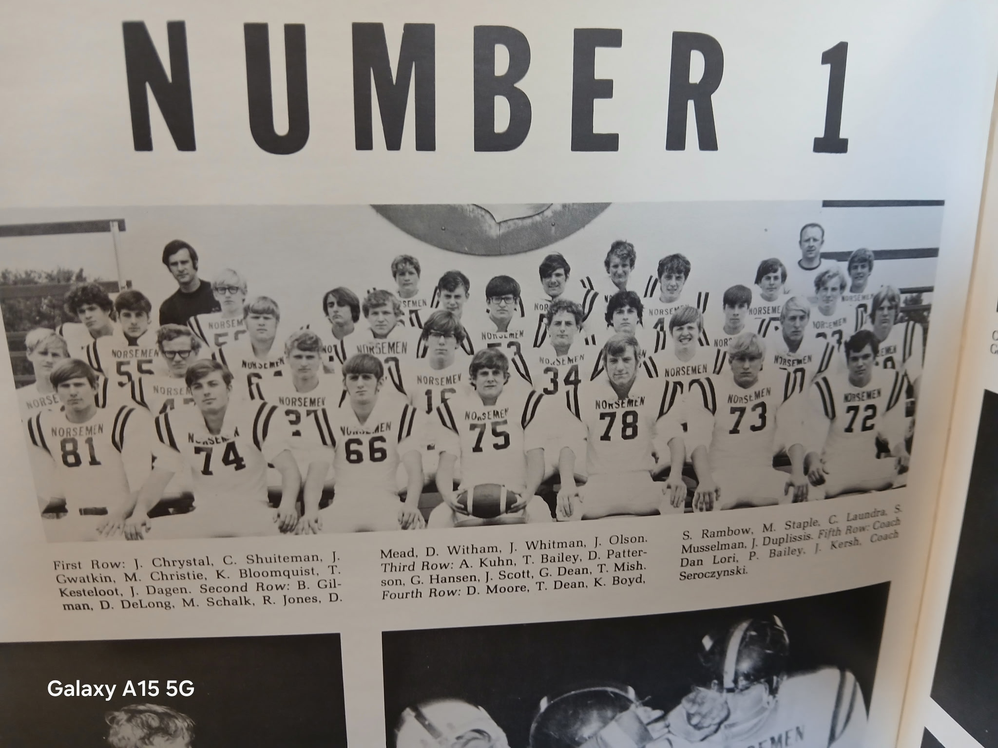

THE STATE CHAMPS OF 1971

Record Score Interesting Fact
1-0 NM 57, Kent City 0 Rick Jones 4 td passes (Mike Schalk 2, 35 & 15, Jeff Chrystal 15, Jim Dagen 21), Crystal int. return 36 for TD & 24 yd FG, Dale Mead 4 yd TD run, Bob Gillman 17 yd TD,
2-0 NM 26, Hart 14 Jones TD pass of 31 to Dagen and a 6-yard QB keeper, Dale Mean and Denny Witham 34 yd TD.
3-0 NM 32, Montague 0 Chrystal 2 TDs, one a 25 yd pass from Jones, a second on a 40 yd int. returned for TD. Mead 1 yd TD, Witham 2 TDs (8 & 1)
4-0 NM 34, Scottville 0. Witham 3 TDs from 5, 9 & 4. Mead 6 yd TD run. Jones - Chrystal 5 yds
5-0 NM 51, GR East Ch. 12 Jones 4 TD passes (Chrystal 29 & 49, Dagen 12, Schalk 11) Dagen 86-yard int return for TD, Schalk 11-yard TD, Witham 5 yd TD.
6-0 NM 12, Oakridge 0 Jones to Schalk 37-yard TD, Mead 4 yd TD. NM five fumbles.
7-0 NM 20, Shelby 13 Mead 120 yards rushing & two TDs. Withham 70-yard punt return
8-0 NM 54, Ravenna 0 Chrystal 105 receiving 1 TD plus 20 yd int TD. Shalk 2 TDs, 45 yards int & pass from Jones for 30. Jones 2 TD passes plus 60-yard punt return for TD. Mead 2 TD (1 & 4)

1972– coach Tom Seroczynski (5-3 overall Montague WMC champs)

Coach Tom Seroczynski returns for his sixth year as the NM head coach with an incredible won loss record of 38-3. Unlike today’s era where there seemingly appears there are more coaches on the sidelines than players, Coach ‘Sero’ had but one assistant, Bruce Ford. NM was hurt heavily with graduation losses. NM returned 20 lettermen for the opening of the 1972 season, but only four were starters: tackle Jeff Olson, guard Jeff Scott, defensive end Bob Gilman and tight end David Moore. Seroczynski would have to replace his entire backfield, an ominous chore indeed.

NM opened against a Kent City team that they had pounded over the last two years an even 100 to 0. Kent City proved right away that this was not going to be another Norsemen trouncing as Kent City scored first and even led at halftime 6-0. NM regrouped at halftime and scored three unanswered TDs in the final half to win their 20th straight game 21-6. NM took the lead for the first time when Chris Laundra ran for a touchdown from six yards out and Jeff Kersh converted the first of his three made extra points. A Tom Achterhoff TD from five yards out gave NM some much needed breathing room while Laundra completed all the scoring in the final period with his second TD run from the one-yard line.

Tom Achterhoff scored a pair of short yardage TD runs and Chris Laundra’s interception and return of 30 yards provided all the points needed for NM to win their 21st straight game in a 19-6 victory over Hart. Setting up two of those touchdowns scored by NM were some long-range passing plays from NM quarterback Tom Thornton. Thornton hit on five of nine passes for 123 yards, including long yardage completions of 41 and 48 yards to set up both NM TDs. Jack Olson stopped one potential Hart scoring threat with a fumble recovery. Unlike the previous two season whereby NM had only a few minor injuries, early in this season NM had already lost the services of three starters.

As the story goes, all good things must come to an end. Dan Wackernagle returned a Norse punt 90 yard before five minutes had gone by in the game to give Montague a 6-0 lead. When the final horn sounded ending the contest that was all the scoring for the entire game on a rainy night in Montague. NM had a 137-96 edge in offense, but Montague defenders dumped NM running backs for a loss 11 times during the game. Two fumbles lost during the game and 80 yards in penalties did not help the Norse as Montague handed the Norse their first loss in WMC play since 1967 while also stopping NM’s winning streak at 21 games. When the 1972 season had ended it was no disgrace to lose to Montague by a single score as the Wildcats would post a perfect 9-0 season and would be ranked fourth in the final AP Class C poll.

Perhaps still smarting from a humiliating 69-0 loss to the Norse two years ago, Scottville pulled a stunner and edged NM 14-13. The Spartans scored with just 38 seconds left in the game, went for the two-pointer, and cashed it in for a stunning victory over the Norse. Scottville, now officially named Mason County Central, took a 6-0 lead at halftime. NM took the lead on a Chris Laundra short burst from the two to tie the game at 6-6. Jeff Kersh than gave NM the lead with his successful boot from placement. It appeared NM had clinched the game as they scored on a Tom Achterhoff 15-yard run with just 3:38 left to play. However, the Spartans got great field position on the following kickoff starting near mid-field. Quarterback John Urka connected with Terry Hankwitz for six points to draw MCC within two points. The same twosome teamed up with a pass play for the two-point conversion and the victory.

The first ever game played between NM and Manistee Catholic saw the Norse snap their rare two-game losing streak by defeating the visitors 20-6. The homecoming crowd at NM’s Fred Jack’s Field saw NM score two first half TDs, both scored by Tom Achterhoff. Manistee made it close as they scored on their opening drive of the second half. Deep in their own territory with just 3-minutes left in the game, NM’s Mike Staple caused a fumble that he recovered in the Manistee end zone for the game’s final TD.

It what would prove to be the first of many wins over the Norse over the years, it took Oakridge six years to earn their first win as they downed the Norsemen 20-12. Oakridge scored two touchdowns in the first half to take a 13-0 lead before the Norse could answer before halftime. NM rallied to score first on a fourth and 14 play when Tom Thornton connected on a screen pass to Tom Achterhoff that was good for 31 yards and a TD. NM then received the kickoff to begin the second half and marched 60 yards for the score with Achterhoff running the final 20 yards for the tally. Both extra point attempts failed, and Oakridge tacked on the winning drive in the second half to make the final score read 20-12 and sent NM to their third loss of the season.

NM played Shelby in their final home game of the 1972 season, and it was the passing of Tom Thornton that keyed the 21-0 shutout. Thornton hit Jim Duplissis for a pair of TDs, the first from 10 yards out and the second covered 30 yards midway through the third period. Tom Achterhoff was on the receiving end of the third TD pass with just two minutes left in the game. Contributing to the shutout was the fine defensive play from Dave Moore, Tom Closz and Jack Olsen.

NM again closed their regular season with Ravenna with Tom Thornton beating Ravenna not with his arm, but his legs. Thornton rushed for his only two TDs on the entire season, both long jaunts from 40 and 55 yards as NM rushed for 322 yards on the night. Kevin Boyd had a huge game for the Norse as he rushed for 144 yards in 22 tries as NM closed out the season with their second straight shutout.

Selected to the WMC All-Conference team following the season were three offensive players: Seniors Jim Duplissis and Tom Achterhoff while junior Jeff Scott was accorded first team honors for his play as an offensive lineman. Scott also made the first unit as a defensive linebacker while senior Mike Staple made the team as a defensive lineman. With only one underclassman selected to the WMC honor squad there certainly couldn’t have been a huge ray of optimism for the 1973 season. But the Norsemen would surprise!

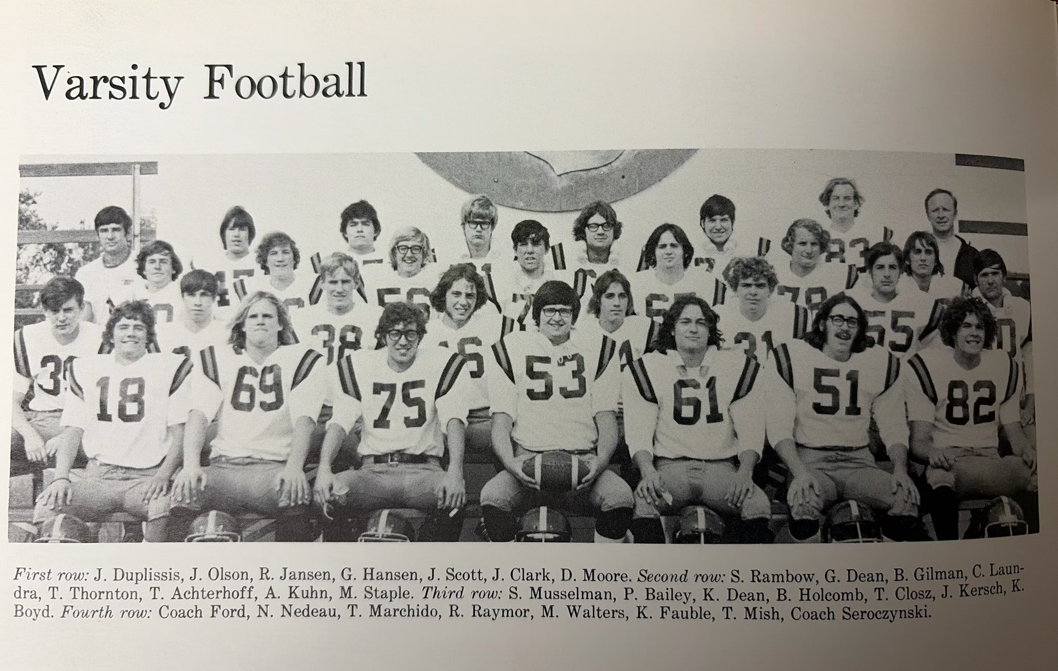

The 1972 NORSEMEN

Record Score Interesting Fact
- NM 21, Kent City 6 Chris Laundra 2 TDS (6 & 1), Tom Achterhoff 6-yard TD
- NM 19, Hart 6 Achterhoff 2 TDs (1 & 3) Laundraa 30 yd int. For TD.
2-1 NM 0, Montague 6 First loss in 21 games. 90 yd punt return winner for Cats.
2-2 NM 13, Scottville 14 Spartans score with 0:38 left. Laundra and Achterhoff NM TDs.
3-2 NM 20, Manistee CC 6 Achterhoff 2 TDS (7 & 15) Mike Staple recover fumble for TD.
3-3 NM 12, Oakridge 20 Thornton to Achterhoff 31 yd TD, Achterhoff 20 yd TD.
4-3 NM 21, Shelby 0 Thornton 3 TD passes: 2 to Jim Duplissis, & one to Achterhoff for 45 yards.
5-3 NM 14, Ravenna 0 Thornton 2 TD runs (55 & 40) Kevin Boyd 144 yards rushing.

1973– coach Tom Seroczynski (9-0 overall NM WMC champs 2nd State Class D Polls)

There could not have been a great amount of optimism for NM football fortunes in 1973 after NM posted a 5-3 record in 1972. In addition, enrollment at NMHS had dropped to where the Norsemen were now a Class D school playing a Class C & B schedule. However, the Norse would surprise perhaps even their closest followers as they posted an undefeated record. NM would strengthen their schedule by adding defending NCAA champ Newaygo to their schedule while adding, after an eight-year absence, Whitehall to their slate to give NM a ninth game. That game would prove to be a dandy. The Norse would return several key components from their previous season, including quarterback Tom Thornton and ace running back Tom Achterhoff, a first team running back on the WMC All-Conference team from 1972. Also returning as starters from 1972 were middle guard Tom Closz, Offensive guard, and defensive end Brent Holcomb, tackle Keith Fauble and tight end-defensive back Nick Nedeau. Several juniors would join those veterans in the starting lineup, and many would make huge contributions to the team’s success. Head coach Tom Seroczynski would also welcome a pair of newcomers to his coaching staff, Dave Warmack and Ed Zednick.

NM would kick off their 1973 schedule with Newaygo; a team NM hadn’t played since WWII ended in 1945. The Norsemen had little trouble defeating the defending NCAA champs with a decisive 41-6 victory. The Norsemen had a slim 13-6 lead at halftime before breaking the game wide-open in the second half.

NM then traveled to Hart for their first WMC Conference game and came away with a surprisingly easy 32-0 shutout victory over the Pirates. It was clear that the Norsemen had found an outstanding running back in Jim Pancy. Pancy had a pair of long TD runs, one of 80 and the other of 61. Tom Thornton connected with Tom Achterhoff from 35 yards out for a TD while Achterhoff also had a TD run of 20 yards. Reserve quarterback Bruce Bos finished NM’s scoring on the night with a 10-yard completion to Bruce Lindstrom. NM totaled more than 400 yards in total offense while the defense that shut out Hart was led by Don Stafford, Nick Nedeau and Brent Holcomb.

If NM’s 32-0 shutout of Hart the previous week wasn’t an eye-opener, then surely the Norsemen’s 33-12 conquest of defending WMC champ Montague served notice that NM was again a force to be reckoned with. The loss for Montague also snapped the Wildcat’s impressive 13 game winning streak. Special team play played a huge role in the Norse triumph. The defense sparkled as well as NM intercepted five Montague passes and swooped up two Wildcat fumbles. Tom Achterhoff’s 62 yards punt return before he was tackled at the Montague one-yard line set up NM’s first TD on a Tom Thornton QB sneak. Shortly after Montague had scored their second TD to take a 12-7 lead, Jim Pancy hauled in the very short kickoff and 12 seconds later was in the end zone on a 65-yard TD effort. Interceptions and fumble recoveries aided in NM’s other TDs, one a 20-yard pass from Thornton to Achterhoff and another setting up Thornton’s second QB sneak in the game. A Bob Thornton fumble recovery led to NM’s final TD, a 15-yard run from reserve back Lyle Atwood.

A NM road trip to Scottville ended up with NM stifling the host Spartans 20-0 as the NM defense completely shut down the hosts. Mason County Central was able to net but 61 yards against a Norse defense led by Don Stafford, Brent Holcomb and Bruce Bos. NM got all the scoring they needed in the first period with two TDs, the first a Tom Achterhoff 45-yard run, the second a Jim Pancy five-yard TD that was first initiated by a Pancy interception. The final NM tally came in the fourth period on a Jerry Crocker run from eight yards.

NM then made the long road trip to Manistee where NM played Manistee Catholic at one of my all-time favorite venues: Sabre Stadium in Manistee. As a young broadcaster in Traverse City, it was always a pleasure to call a game from the cozy confines of the Manistee CC facility; in an enclosed heated press box on a chilly fall evening, a rarity in comfort during the 1960s and 70s. The Sabres played many of their games on a Saturday night which allowed me to perform double duty as the play-by-play announcer for Traverse City High football on a Friday night and for Traverse City St. Francis as they played many games on Saturday while sharing the same football field with the Trojans. The Norse trailed the host Sabres at halftime 7-6 as their try for the extra point following a two-yard plunge by Jim Pancy failed. NM then took the lead for good in the second half. Again, it was a specialty team play by the Norse that gave NM the lead. Brent Holcomb broke through to block a Manistee CC punt that was recovered in the end zone by Don Stafford. This time NM went for the 2-point conversion and were successful as Tom Achterhoff ran it in for two points to give NM a 14-7 lead. NM then scored with less than a minute to play on a nine-yard TD scamper by Jim Pancy, his second TD of the game to make the final score NM 21-Manistee CC 7.

The opportunistic Norsemen won their sixth straight game on the season with a 26-15 win at home over Oakridge. Tom Achterhoff had three interceptions and scored the final NM touchdown with his six-yard run. Jim Pancy had a spectacular 91-yard TD run called back on a Norse penalty, but NM was able to score on the drive to take a 14-7 lead. The drive ended in impressive fashion with Tom Thornton connecting on four pass plays to Achterhoff, the final completion good for 20-yards as the clock ran out to end the first half. Thornton added a 2-yard run for the third NM tally with Jim Pancy adding the final touches on NM’s night with a 6-yard TD. Nick Nedeau had a pair of interceptions to go along with Achterhoff’s three picks to put a stop to several potential Oakridge scoring drives.

The vaunted NM offensive trio of Tom Thornton, Tom Achterhoff, and Jim Pancy each scored a pair of touchdowns as NM kept their undefeated season intact with a 42-6 pasting of Shelby. In addition to scoring a pair of TDs, Acherhoff again was a force from his defensive backfield spot as he intercepted two passes, giving him a school record 11 picks during the season. Achterhoff also scored a pair of TDs running with the football, one from 20 and the second from two. Pancy had one long TD run of 60 and the speedster had a second from a more modest run of nine. Thornton scored twice on a pair of short runs.

With their 21-12 win over Ravenna, NM had now won the WMC football title in six of the last seven years. Highlighting NM scoring was a school record 99-yard kickoff return by speedster Jim Pancy. Pancy’s burst with 8:45 left in the game was the clincher as NM posted a perfect 7-0 record in the WMC and moved to 8-0 overall. Pancy earlier had a 15-yard TD that broke the scoring ice in the first quarter. Tom Thornton, who rushed for 106 yards from his quarterback post, scored a third NM TD on a 12-yard sprint. Two-way standout Tom Marchido was a force on defense as he was in on 18 tackles.

In what would prove to be the only game between two long-time rivals between 1965 and 1985 before Whitehall rejoined the WMC, NM capped their undefeated season in dramatic fashion as they scored with less than a minute left to edge the Vikings 22-20. Tom Thornton’s heroics led NM to victory using both his legs and arm. NM trailed 12-0 after the first half before rallying in the game’s final two periods. Running the option to perfection, Thornton picked up 50 of his 147 yards rushing on their first drive with his TD run of eight yards pulling the Norse within four points of the Vikings after a successful conversion run by Jim Pancy. Thornton then scored again from 15 yards to give NM a 16-12 lead after another two-point conversion run from Jerry Crocker. Whitehall took the lead with 4:23 left in the game before NM put on a game winning 60-yard drive. Thornton completed passes to Gary Heilman and Crocker deep into Whitehall territory with Jim Pancy running into the end zone from two yards out to cap NM’s perfect 9-0 season.

Despite Traverse City St. Francis losing their final regular season game to St. Ignace, NM with their perfect 9-0 record placed second in the polls to St Francis. NM trailed by just a single point in the polls to a TCSF team guided by former Muskegon Catholic Head Coach Waldo Keating. For the Norse, the future surely looked bright as several veterans would return and would receive help from a Junior Varsity team that also swept its nine-game schedule.
Seven of its regulars were picked for the All-Conference team with both Tom Marchido and Tom Achterhoff selected on both offense and defense. Jim Pancy and quarterback Tom Thornton also was selected giving NM three of the four backfield performers picked. Tackle Brent Holcomb made the top offensive eleven selected while junior Jerry Crocker and senior Nick Nedeau joined Marchido and Achterhoff on the defensive team. Pancy rushed for 950 yards on the season while Achterhoff netted 708 yards on the ground while catching 44 passes for 600 yards. Thornton scored 62 points and completed 51 of 94 passes for 999 yards. So deep were the Norsemen that nine other players were given honorable mention honors. With many lettermen returning and an undefeated junior varsity team all signs pointed for another great year for NM in 1974. Also returning was their head coach, Tom Sereczynski, who was named coach of the year by the Detroit Free Press.

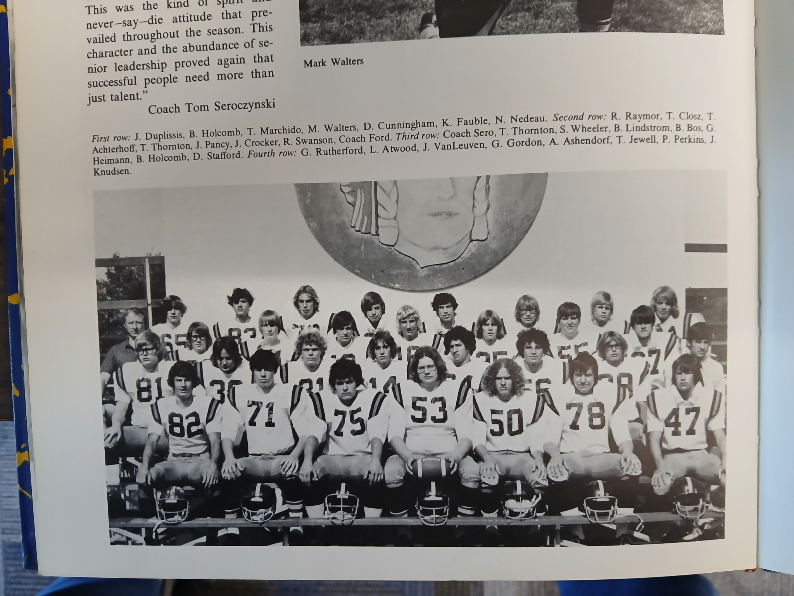

The UNDEFEATED NORSEMEN of 1973

Record Score Interesting Fact
1-0 NM 41, Newaygo 6 Jim Pancy 2 TDs, Tom Thornton to Tom Achterhoff TD.
2-0 NM 32, Hart 0 Pancy 2 TDs (80 & 61), Tom Thornton – Tom Achterhoff 20 yd pass, Achterhoff 20 yd run, Bruce Bos – Bruce Lindstrom 10 yd TS pass.
3-0 NM 33, Montague 12 NM 5 Int & 2 fumble rec. Thornton 2 QB sneaks, Pancy 65 yd kickoff return, Thornton – Achterhoff 5 yd TD pass.
4-0 NM 20, Mason Co. 0 NM defense allows but 61 yards. Achterhoff (45) Pancy (5) and Jerry Crocker (8) the Norse TDs.
5-0 NM 21, Manistee CC 7 Pancy 2 TDS (2 & 9) Don Stafford recovers fumble in end zone.
6-0 NM 26, Oakridge 15 Achterhoff 3 int. Thornton 2-yard TD and 20 yd TD pass to Acheterhooff. Pancy 6-yard TD.
7-0 NM 42, Shelby 6 Achterhoff,Pancy & Thornton 2 TDs each. Acheterhoff 2 int.
8-0 NM 21, Ravenna 12 Pancy a record 99-yard kickoff return, and 15-yard TD run. Thornton rushes for 106 yards and 12-yard TD.
9-0 NM 22, Whitehall 20 Thornton 2 TDs and 147 yds rushing. Pancy 2 yd TD with 0:30 left.

1974– coach Tom Seroczynski (8-0 overall NM WMC champs 2nd State Class D)

Although head coach Tom Sereoczynski had to replace several key players lost to graduation, the cupboard was hardly bare for the 1974 Norsemen. Speedy running back Jim Pancy, who rushed for nearly 1000 yards, returned along with several other lettermen, including all-conference performer Jerry Crocker. A promising group of newcomers elevated from the undefeated 1973 junior varsity team would prove to be an enormous help for the 1974 season. It was back to an eight-game schedule for NM as their ninth game opponent from 1973, Whitehall, was locked into the ninth date with another Seaway Conference team. With prospects of another banner season, it was difficult to find an opponent willing to schedule NM. Coach ‘Sero’ would have but one assistant, but it was more than just a good one in Dave Warmack.

NM got off to a productive start with an opening 24-0 victory over Newaygo for their 12th straight victory. NM totaled 400 yards in offense while the defense led by Lyle Atwood, Jerry Crocker, Mark Wolters, and Dan Hoople held Newaygo to but 13 yards rushing for the entire evening. The Norse scored in every period beginning with Jim Pancy’s 24-yard burst in the opening period. Jeff Guy, the son of Stan Guy, the GOAT (Greatest of All Time) in NM football lore set up his own touchdown with an interception. Bruce Bos, who succeeded Tom Thornton as the current NM quarterback, connected with Guy for a 27-yard scoring pass with just three seconds left in the first half. Reid Raymour added a 31-yard FG in the third while Bos ripped off a 40-yard TD in the final period to complete the scoring.

It was the Jim Pancy show in NM’s 31-13 victory over Hart. The senior running back rushed for a school record 307 yards while equaling another school record with five touchdowns in a game as he accounted for all the touchdowns scored by NM. Pancy’s TD runs were from 45, 35, 5, 70 and 25, as he put on a performance that was reminiscent of the great Stan Guy’s feats from the middle 1950s. And speaking of Guy, Stan’s son Jeff led the NM defense in their WMC conference victory over the Pirates with a team leading 14 tackles.

Jim Pancy came close to duplicating his five TD performance from the previous week as he scored four touchdowns in NM’s 54-0 trouncing of Montague. Pancy needed but nine carries to score his four TDs as he had plenty of help from his teammates. The Norse compiled 465 yards in total offense in the rout at Montague while the defense held the hosts to less than 100 yards total offense. Pancy’s TD runs were from 35, seven, eight, and 46 yards. NM’s defense also played a huge role in the victory by intercepting five Wildcats passes as well as a fumble recovery in front of a very quiet home crowd in Montague. Jeff Guy also had a big night for the Norse, on offense, defense and on the specialty team. Guy had a 59-yard punt return to set up his own 1-yd TD on the ensuing drive, had an interception that set up a Bruce Bos scoring toss of 35 yards to Scott Wickland, and had a second TD run of five-yards in the rout of the Wildcats. One of the five NM picks on the night was by Stan Andrie, who returned his interception 50 yards for the score.

A trio of Norse running backs each ran for over 100 yards as NM stomped Mason County Central 55-7 on the Norse gridiron. Jeff Guy had three TDs for the victors, two running (44 & 7) and his final TD was on a 52-yard interception return. Fullback Scott Wickland scored his first TD as a Norsemen from 17 yards out while Jim Pancy ‘only’ scored one TD, that a 23-yard scamper. NM signal caller Bruce Bos had a pair of short quarterback sneaks for TDs and rifled a 65-yard TD pass to John Duplissis. Praised by their defensive effort by coach Seroczynski was the play of linebacker Jerry Crocker and middle guard John Pavlik.

After a couple of routs of a pair of WMC opponents NM had a much tougher opponent in their next contest with Manistee Catholic. NM scored both of their touchdowns in the first half, both on passes from quarterback Bruce Bos, and then held on in the second half to keep their unbeaten streak alive with a 14-7 win over the host Sabres. NM’s offense sputtered most of the night as 100 yards in penalties stalled many of their drives. Bos’ first TD pass was a 30-yarder to Jeff Guy in the opening period while his second TD aerial was a 46-yard toss to John Duplissis. NM also coughed up two fumbles deep in NM territory in the second half, but NM’s stout defense held the host team to but one touchdown as NM improved to a perfect 5-0.

For the second straight year NM was chasing Traverse City St Francis for top honors in the Class D polls. The Norse kept their hopes alive to move to number one in the polls with a 34-12 victory over Oakridge. Once again, the NM defense rose to the occasion by creating five turnovers against the Eagles, four interceptions and a fumble recovery. Their fourth Int. of the game led to a 30-yard pick and TD by Dick Cunningham to sew up the 17th straight win for the Norse. Jim Pancy had a pair of touchdown runs for the Norse, the first a short run from the three, the second, a 30-yarder that gave NM a 21-6 lead at halftime. Jeff Guy’s lone TD on the night from the 12-yard line gave NM a 14-0 lead in the second quarter while Scott Wickland tallied a TD from 10-yards out in the second half. In addition to the Cunningham pick six, Guy, Wickland, and John Duplissis also had solo interceptions while NM defensive stalwart Jerry Crocker recovered a fumble.

NM had to rally to beat a fired-up Shelby Tiger team at Fred Jack’s field 21-15. Bruce Bos connected on a 10-yard TD pass to Scott Wickland with just 53 seconds left in the game to clinch the WMC title. Shelby had tied up the game at 15-15 with 5:31 left in the game before NM started their game winning drive. Jim Pancy’s kick-off return to near mid-field set up the winning TD, while a 19-yard aerial from Bos to Wickland was a key play in the winning drive. NM scored their first TD when they got a big break. Wickland, who also does the punting chores for the Norsemen, bobbled a snap from center and was forced to run and run he did. Wickland ran all the way to the Shelby 30-yard line where a few plays later Jim Pancy scored from the three. NM then scored midway through the second quarter with Jeff Guy scoring from the one. The big play in that drive was a 56-yard pass from Bos to Guy. Reid Raymour, the NM place-kicker received a high pass from center and ran in for a two pointer to give NM a 15-0 lead, later matched by Shelby in the second half.

Jim Pancy ended his brilliant NM career in a blaze of glory as he rushed for 161 yards and two TDs as NM completed their second consecutive year unbeaten with a hard-earned 12-3 win at Ravenna. Pancy’s touchdowns, both in the first half wiped out an early Ravenna 3-0 lead on a Brian Patterson field goal. Pancy nearly broke away for a 77-yard run only to fumble the ball with an open field ahead of him at the 50 as he eventually stepped out of bounds while bobbling the elusive pigskin. Jeff Guy joins his iconic father in the Norse record books when he intercepted one pass in the contest, giving him 11 interceptions on the season in just eight games, equaling the record set a year earlier by Tom Achterhoff. John Pavlik, who has the current multi-purpose locker room located outside the NM football field named after him following his death, led NM in tackles in the win over the Bulldogs with 19.

Once again NM was the bridesmaid in the final AP polls as for the second straight season, NM placed second in the Class D polls to Traverse City St. Francis. It would be the last year where polls would determine a state champion.
Ironically, if the parameters to determine winners in each playoff region were in effect for 1974, as they were in 1975, it would have been the Norsemen who would tally more playoff points then TCSF and would be one of four teams to qualify for the playoffs. NM once again dominated the WMC All-Conference team with nine players selected for first team honors. Jerry Crocker, who would go on to have a stellar college career at Northern Michigan University, was a repeat winner as he was selected at both offensive and defensive linebacker. Jeff Guy was also selected on both the offense and defensive first eleven while big Mark Wolters and Lyle Altwood joined Guy and Crocker on the defensive team. Reid Raymour was selected as the first team kicker while Bruce Bos the WMC punter. Bos was a more than competent quarterback as he passed for 52 of 78 passes for 883 yards and five TDS. Jim Pancy was a no-brainer choice as a running back on the all-conference team, but he also was honored as a first team All Stater in Class D. Pancy would rush for 956 yards in 115 carries, an astounding average of 8.3 yards per carry.

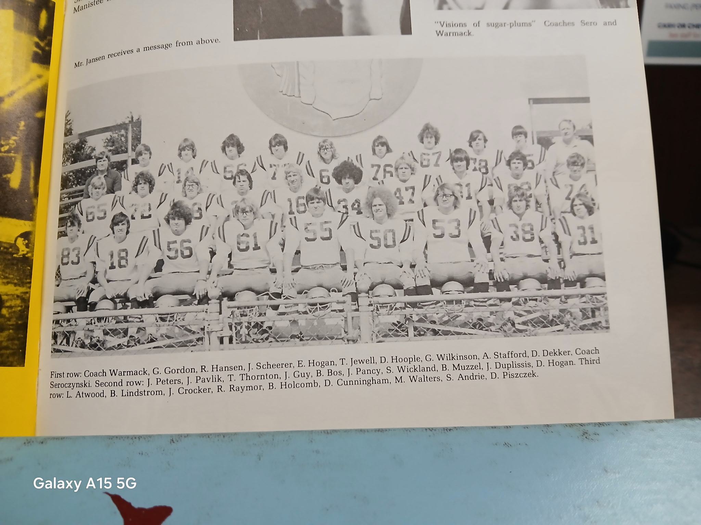

THE UNDEFEATED NORSEMEN of 1974

Record Score Interesting Fact
1-0 NM 24, Newaygo 0 Pancy 24 yd TD, Bruce Bos to Jeff Guy 27 yd TD, Bos 40 yd TD run.
2-0 NM 31, Hart 13 Pancy NM record 307 yds rushing, 5 TDs, (45,35,5,70,25)
3-0 NM 54, Montague 0 Pancy 4 TDs, Guys 2 TD, Stan Andrie 50 yd int. for TD.
4-0 NM 55, Mason Co. 7 Guy 3 TDs (2 rushing and 52-yd int), Bos 2 TD, Pancy 1, Scott Wickland 17-yd TD, Bos to John Duplissis 65-yard passing TD.
5-0 NM 14, Manistee CC 7 Bos 2 TD passes: 30-yards to Guy and 46 yards to Duplissis.
6-0 NM 34, Oakridge 12 Pancy two TDs (3 & 30), Guys 12 yd-TD, Wickland 10, Cunnigham a pick 6 from 30.
7-0NM 21 Shelby 15 Bos 10 yd TD pass to Wickland the winner. Guy & Pancy TD each.
8-0 NM 12, Ravenna 3 Pancy 2 TDS (22 &5) and rushed for 161 yards.

1975– coach Dave Warmack (4-5 overall, NM tie for 3rd, Shelby WMC Champs)

Norse followers were stunned with the resignation of Tom Seroczynski following the 1974 season. Coach ‘Sero’ during his 10 years guiding the Norsemen compiled an outstanding record of 72 wins, against only 11 losses, a winning percentage of 87 per cent that stands clearly at the top of the 14 head coaches who have guided the Norsemen as of this writing in 2025. During his tenure NM won four outright WMC championships, tied in two others, and were the mythical Class C state champs in 1971. Three other seasons NM would place second in the polls, 1970 in Class C and 1973 & 74 in Class D. Seroczynski would be replaced by a young Dave Warmack, who would also have outstanding success in his brief five years guiding the Norsemen.
1975 would begin a new and highly popular era for high school football in the state of Michigan as it marked the beginning of a state playoff to determine a true state champion. Unlike today when more than 100 teams qualified for the state playoffs, the first year of 1975 allowed but four teams in each class to qualify, one for each designated region. Several teams that posted unbeaten records were left out as one needed to complete a schedule filled with tough opponents with winning records to qualify as one of the four.

Two new opponents would appear on the NM schedule to fill out a nine-game schedule in Warmack’s opening year as the Norse head coach. Following a good start NM would not finish strong as they would post a losing record of 4-5, their first losing record in a decade. However, coach Warmack would leave NM in good stead following the 1979 season. Despite being the school in the WMC with the lowest enrollment, interest was high as 32 players were suited up on the varsity while another 40 youths were on the Junior Varsity team. A pair of returning all-conference players highlighted the returning Norsemen in two-way all-conference running back Jeff Guy, and defensive middle guard John Pavlik. Other starters from last year’s undefeated WMC champs included fullback-linebacker Scott Wickland, tackle Dan Hoople and two-way end Bill Muzzall.

The Norse opening opponent Watervliet was coming off a banner 1974 season where they won eight of nine games while returning several starters. In a game billed as a battle of two Class C football giants (NM had moved up in enrollment from D to C) the Norsemen won the battle before a capacity throng of 2500 fans on hand in Watervliet. Both NM TDs game on long plays, the first a 74-yard sprint by junior speedster Ron Steele. Watervliet tallied a TD next but their attempt for the two-point conversion was stopped by Jeff Guy. NM then took a 13-6 lead on a 42-yard run by Scott Wickland. The second half was a defensive struggle led by captains Jeff Guy, John Pavlik, and Dan Hoople. Also praised for his defensive work was Terry Warmack, the younger brother of the head coach.

NM did all their scoring in the first half but that would be enough as the Norse won at Hart 19-0. The Norse trio of running backs, Jeff Guy, Scott Wickland and Ron Steele each scored a touchdown as NM won their second straight game for their new head coach Dave Warmack. Steele scored the first TD from 3-yards out with the big play on the drive a 32-yard pass from quarterback Rob Hansen to Guy. Guy then scored on a 35-yard burst with still 3:45 left in the opening quarter. Wickland then powered over from the four early into the second quarter and the defense then did the rest for NM. The balanced running attack for the Blue & Gold showed Guy lugging the ball 10 times for 119 yards, Steele 17 carries for 83 while Wickland garnered 78 yards in 18 attempts.

Perhaps losing by an embarrassing 54-0 score was all the incentive needed for Montague to pay back that defeat to the Norse the previous year as Montague edged the Norse 18-14. It would be the second time in recent years whereby the Wildcats would snap a Norse winning streak. The current streak ended at 21 games while head coach Chuck Hulce’s 1972 team ended NM’s 25 game winning streak. The game started out as if it was going to be yet another easy NM victory as the Norse scored the first two times they had the ball, the only scores for NM the rest of the game. Jeff Guy scored from the 3-yard line after just four minutes were gone in the opening quarter. Junior tackle Dave Bowen, who years later would be your author’s attorney, recovered a fumble to set up a 24-yard TD run by Scott Wickland. The rest of the game belonged to Montague and their defense as they limited the NM rushing game and shut down the NM passing game by allowing but 14 total yards.

NM then got back on the winning track with a win against their perennial patsy, Mason County Central. NM won for their 26th time over the years while losing but two following their 26-12 win over the Spartans from Scottville. Jeff Guy performed a feat that even his legendary father never accomplished at NMHS, returning two punts for a TD in a single game. Guy had returns of 59 and 64 to key the NM victory, all in the space of two minutes in the opening period. NM’s only offensive TD on the night was a short 3-yard TD run from Scott Wickland that capped a NM 91-yard drive. The other touchdown was created by the defense as Dave Piszcek intercepted a Spartan pass and returned it 34 yards for a TD.

A very good Manistee Catholic team then stunned the Norsemen, snapping a two-game losing streak to NM with a convincing 30-12 win. NM received one TD on a 90-yard kickoff return from Ron Steele that brought the Norse within a TD of the Sabers. However, the rest of the game was dominated by the visitors from the North with the only other NM score coming on a 14-yard pass from Rob Hansen to Jeff Guy.

NM rebounded nicely following their lost to Manistee CC with a surprisingly easy 34-0 victory over Oakridge. Jeff Guy had a huge night on both sides of the ball in spearheading the Norse victory. Guy tallied the first of his three TDs the traditional way on a 17-yard run. Guy then had the first of his two interceptions on the night that set up a 44-yard TD run on the option play by QB Rob Hansen. Then another Guy pick set up his own touchdown, a 58-yard pass from Hansen. Not done yet, reserve quarterback Dennis DeKuiper, a transfer from Fremont that produced several great athletes with the last name of DeKuiper over the years, hit Guy for the final NM TD on a pass play that covered 31 yards. Earlier in the game Dave Pisczek ran a punt back 46 for six more Norse points.
Unfortunately for the Norsemen it was all downhill from there as they would drop their last three games.

NM was virtually punchless in the first of their three season ending losses at Shelby. A combination of a driving rain and a tenacious Shelby defense held NM to minus yards rushing in the game. Meanwhile the Tigers punched out over 200 yards on the ground with long time Shelby basketball coach Rick Zoulek scoring his team’s first touchdown as the Tigers rolled over the Norse 21-6. It was a banner year for Shelby as the Tigers posted their first unbeaten season since 1936. NM averted a shutout with Dave Pisczek passing six yards to Doug Dekuiper for the only NM TD late in the game.

Ravenna then snapped a seven-game losing streak to the Norse with a 24-18 victory. The first points of the game came from the toe of Ravenna’s Joe Coletta who booted a 25-yard field goal. Many years down the road Colleta would join my long-time partner Gene Young and your author in the radio booth calling many local football games. Scott Wickland ran for 121 yards and scored all three NM touchdowns in a losing effort. Wickland’s third touchdown run of 45 yards early in the fourth quarter gave NM the lead only to have the Bulldogs score late in the game after recovering a NM fumble at the Norse seven-yard line.

Battling numerous injuries as the season game to a close, the Norse capped their season with a rare Saturday afternoon contest in a first ever meeting with Allendale. Future NFL star Robert Jackson, only a junior ran for 190 yards – in the first half – as the Norse were over matched against Allendale and fell 60-13. The 60 points given up by the Norsemen were easily the most points allowed to an opponent up to that date. Jeff Guy scored both NM touchdowns. His first was a 12-yard run in the second quarter, the second came on a 49-yard pass play from sophomore quarterback Roger Crawford in the third period.

The WMC All Conference team was selected on an infamous night in Michigan History, the sinking of the Edmund Fitzgerald in Lake Superior. Jeff Guy repeated as a two-way player on both offense and defense. Also picked to the offensive first team was fullback Scott Wickland, guard John Peters and center Terry Warmack. Lineman John Pavlik was the only NM player selected to the All-Conference defensive team with his teammate Guy. It would get much better for Norse fans as Coach Warmack and the Norse would right the ship beginning with the 1976 season.
Record Score Interesting Fact
1-0 NM 13, Watervliet 6 Ron Steele 74-yard TD, Scott Wickland 42 yd TD.
2-0 NM 19, Hart 0 Steele, Wickland and Jeff Guy each a TD.
2-1 NM 14, Montague 18 Guy 3 yd TD, Wickland scored from 24. NM only 14 yds passing.
3-1 NM 26, Mason Co. 12 Guy 2 punt return TDs (59 & 64) Dave Pisczek 34 yd TD on Int. Wickland 3-yard TD.
3-2 NM 12, Manistee CC 30 Steele 90-yard kickoff return. Hansen to Guy 14-yard TD.
4-2 NM 34, Oakridge 0 Guy 3 TDs, Pisczek 56-yard punt return TD, Hansen 44 yd run TD.
4-3 NM 6, Shelby 21 NM minus yards rushing. Pisczek TD pass to Doug DeKuiper.
4-4 NM 18, Ravenna 24 Wickland 121 yards rushing and all 3 NM TDS (9, 5, & 45)
4-5 NM 13, Allendale 60 Guy 2 Tds, 12-yard run and 49-pass from Roger Crawford.

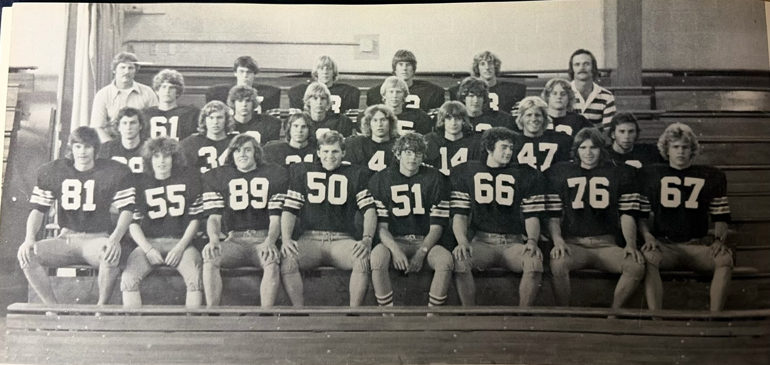

The 1975 NORSEMEN

1st Row L-R: W. Muzzall, E. McPherson, A. Stafford, C. Oliver, D. Hogan, J. Scheerer, D. Hoople, J.Peters
2nd Row L-R: J. Assmussen, D. DeKuiper, D. Pisczczek, D. DeKuiper, R. Hansen, S. Wickland, J Guy
3rd Row L-R: M. Hekkema, J. Atwood, R. Swanson, R. Steele, D. Bowen, S. Garvey
4th Row L-R: Coach Dave Warmack, J. Bettens, K. DeForrest, D. Dekker, R. Breen, Coach Ed Zednik

1976– coach Dave Warmack (5-4 overall,2nd in WMC, Oakridge Champs)

NM lost 18 seniors from the previous season as there would be a lot of new faces for 1976. Perhaps the most noted of the returnees from 1975 would be a player who was counted on to fill the important role of NM’s quarterback, but an injury in the opening game of the season ended 1975 all too soon for Randy Breen. Regulars returning for NM included speedster Ron Steele, a 9.9 sprinter who arguably was the fastest to don an NM uniform in school history. Starting tackles Dan Dekker, whose father Jerry Dekker was a fixture for many years working the chain gang crew for NMHS returned, as did Mike Hekkema and fullback Jeff Atwood.

It took only the opening game with Watervliet to show the importance of Breen as he led NM to their 12th consecutive opening game victory in a 26-22 victory over Watervliet. Breen tossed four touchdown passes with his last, a 31 yarder to Bill Sangster coming with just 38 seconds on the clock at Fred Jacks Field to give NM a come from behind 28-22 victory over the visitors from Watervliet. Breen hit Randy Swanson for a pair of TDs, one for 35 and an even longer connection of 60 yards with his first scoring toss a 9-yard pass to Jeff Atwood. In addition to the 169 yards passing in the game, NM rushed for 117 yards with Ron Steele lugging the pigskin for 60 of those yards.

Steele came back the following Friday to have a huge game in NM’s 20-7 victory over Hart by scoring all three Norse TD’s and rushing for 154 total yards. NM used the rushing game to earn the win as Breen only had to attempt three passes, but one of his two completions was a screen pass to Steele that went for 59 yards and a NM touchdown. NM’s defense, led by Jeff Storck, Mike Hekkema, Dave Bowen, and Dan Dekker limited Hart to 115 total yards for the game. Although Steele had several big gains over the course of the contest, both of his rushing TD’s game from short one and three yards away.

North Muskegon fleet running back Ron Steele sprinted 90 yards late in the game as NM rallied to upset Montague 14-12. Montague had taken the lead at 12-6 with just a little over three minutes to play in the game before Steele’s heroics. Following the Montague TD NM mishandled the kickoff and only advanced the ball to the 10-yard line. Expecting a pass late in the game, instead NM ran a sweep, and the speedy Steels outran Montague to tie the game at 12-12. Without a kicker, NM was forced to go for two. It was Breen to Breen, quarterback Randy Breen to his brother Tim Breen for the two-pointer and game winner as NM would win 14-12. Steele ran for 145 total yards on the night with most of those yards coming on his long TD run.

Ron Steele had another big night in NM’s fourth win to start the 1976 season, a 46-14 win over Mason County Central, but he had plenty of help from Tim Breen. Steele picked up 173 yards on 20 carries that included a short TD from two yards out and a 46-yard run. Breen caught a pair of TD passes from his brother Randy Breen and punctuated his night with an 86-yard kickoff return for six points. Randy Breen’s third TD pass on the evening was completed to Randy Swanson and went for 13 yards. The final two-points of the evening came on a pass from young freshman quarterback Larry Witham to Tim Breen.

The 1976 football season was the first year for this author as a play-by-play broadcaster in Muskegon. I had first begun as a broadcaster for high school football for Traverse City beginning with the 1968 season before moving back to my hometown of North Muskegon in 1976 when I purchased the Bear Lake Tavern. Although my main duty was to call the game of the week in the Muskegon Area, I must confess that I always made a point to include at least one game a year I would broadcast of my beloved alma mater. I well remember my first North Muskegon game broadcast. It was a Saturday night game NM played on October 16, 1976, at one of my favorite places to call a game, Sabre Stadium in Manistee. How well I remember the carpet covered floors and the heated private booth that I shared that evening with my broadcasting partner in 1976, longtime sportscaster Bill Trapp. I had little trouble convincing my boss at WTRU, Fred Tascone to put this game on our 1976 schedule as the Norsemen were a perfect 4-0 heading into the game with Manistee Catholic Central. Since it was a Saturday night game there was only a very small write-up for the game coverage in the following day’s Sunday morning edition of the Muskegon Chronicle. The bottom line – NM lost to Manistee in to be honest, a ho-hum game 13-6. NM’s only TD came in the third quarter on a 1-yard run by Jeff Atwood. Manistee CC had scored both of their TDs in the first half and NM was not able to catch up in the second half and had now lost their first game of the season. Manistee would reach the state playoffs in November before losing to the eventual state champs from Chrystal Falls Forest Park.

The loss to Manistee CC signaled a downturn the rest of the season for the Norsemen. NM took an early lead of 6-0 in their next game with Oakridge but, apart from a NM safety when Jim Wigren tackled the Eagles’ Calvin Johnson in the end zone late in the game for a safety, that would be all the scoring the rest of the evening for the Norse. The early NM TD came on a pass play from Randy Breen to wingback Tim Breen that covered 34 yards. Oakridge was led by Calvin Johnson, a recent inductee into the Muskegon Area Sports Hall of Fame who led the Eagles in rushing and scored a TD. The 20-8 win moved Oakridge into first place for their first time since joining the WMC. As history would dictate, it surely wouldn’t be their last.

It was a bitter pill to swallow in the next NM game as they lost a game to Shelby 14-8 that NM dominated for much of the game. NM had an 8-6 lead late in the game and were driving deep into Shelby territory. However, a fumble gave the ball to the Tigers who up until their final drive had only picked up two first downs the entire game. Aided by a costly personal foul call against NM Shelby trekked 83 yards in seven plays for the winning TD to hand NM their third straight loss. Playing without running back Ron Steele sidelined with a knee injury, the Norse were still able to rack up 183 total yards to Shelby’s 94. Bill Sangster took over much of the running duties with the absence of Steele and ran just short of 100 yards on 29 carries. Sangster added the two-point conversion following NM’s only TD of the game on a QB sneak from Randy Breen. Shelby got a fortuitous break late in the first half when they scored their first touchdown in the waning seconds of the first half after a mishandled snap on a punt.

NM scored on a 15-yard TD pass from Randy Breen to Randy Swanson in the first period, the first of two TD passes on the night between this combo. The two-point conversion gave NM an 8-6 lead they would not relinquish as NM prevailed 32-21 over Ravenna to clinch a winning season for the Norse with their fifth victory of the season. Although they lost two games in conference competition, the win clinched second place in the WMC for the Norsemen. Tim Breen intercepted a pass from my future colleague in the broadcasting booth Joe Coletta and returned it into a 28 yard-TD for NM.

Once again NM finished their season against Allendale and again, they were tortured with another great effort from Robert Jackson in a 42-18 loss to the visitors from Allendale. The future NFL star rolled up 207 yards rushing and four TDs to end the NM season with a 5-4 record. NM, trailing at the time 22-0, got on the board with a 31-yard TD pass from Randy Breen to his brother Tim. Breen later connected with Randy Swanson for a pair of TDs, one from 30 and the other good for 30 yards. The Norse landed six players on the WMC All-Conference team, end Randy Swanson, center Scott Garvey and back Ron Steele on offense. Lineman Jeff Storck, linebacker Mike Hekkema and defensive back Randy Breen were tabbed for the defensive eleven.

Record Score Interesting Fact
1-0 NM 26, Watervliet 22 Randy Breen 4 TD passes, 2 to Randy Swanson, & 1 to Jeff Atwood and Bill Sangster, the last to Sangster the game winner with 38 seconds left in the game.
2-0 NM 20, Hart 7 Ron Steele rushed for 154, 3 TDs, One a 59 pass from Breen.
3-0 NM 14, Montague 12 Steele 90-yard TD. QB Breen to Tim Breen 2-pointer the winner.
4-0 NM 46, Mason Co. 14 Steels 2 TDs (2 & 46) R. Breen to T. Breen 2 TDs. T Breen 86 yd Kickoff returns. R Breen to Ron Swanson for 13-yard TD.
4-1 NM 6, Manistee CC 13 NM losses 1st game of season. Jeff Atwood 1 -yd TD.
4-2 NM 8, Oakridge 20 R. Breen to T. Breen 34-yard TD. Jim Wigren safety.
4-3 NM 8, Shelby 14 R. Breen QB sneak, Bill Sangster rushed for 96 yards.
5-3 NM 32, Ravenna 21 R. Breen 2 TD passes to R Swanson (15 & 35). T Breen 28 yd int TD.
5-4 NM 18, Allendale 42 R. Breen 3 TD passes (T Breen 31, R Swanson (2) 30 & 11)

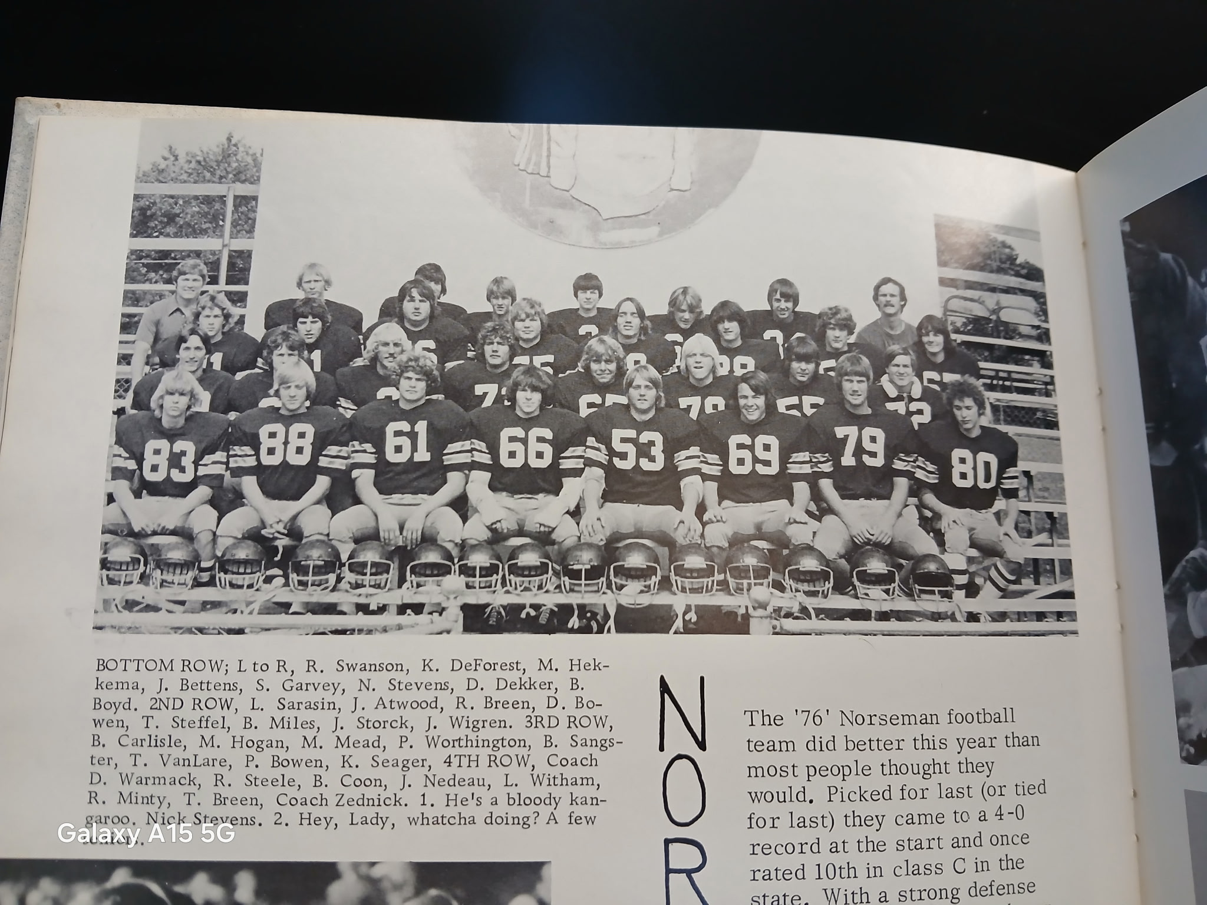

The 1976 NORSEMEN
Bottom Row L-R: Randy Swanson, K. DeForest, Mike Hekkema, J. Bettens, Scott Garvey, N. Stevens, Dan Dekker, B. Boyd, 2nd Row: L-R: l. Sarasin, Jeff Atwood, Randy Breen, David Bowen, T. Steffel, B. Miles. Jeff Storck, J. Wigren, 3rd Row L-R: B Carlisle, M. Hogan, M. Mead, P. Worthington, Bill Sangster, T. VanLare, Pat Bowen, K. Seager, 4th Row: Coach Dave Warmack, Ron Steele, Brad Coon, John Nedeau, Larry Witham, R. Minty, Tim Breen, Coach Ed Zednick

1977– Coach Dave Warmack (7-2 overall,2nd in WMC, Shelby Champs)

The fortunes for NM football continued heading in a positive direction for 3rd year head coach Dave Warmack. Grandville Calvin Christian would replace Manistee Catholic midway through the season while Reed City, an old foe of NM dating back to the 1940s would replace Allendale on the ninth date as once again NM was able to fill out a nine-game schedule. A few starters returned for the start of the 1977 season, and they were buoyed with six seniors who came out for football after choosing not to participate the previous season. Returning starters included an All WMC performer from his junior season in linebacker/lineman Jeff Storck. Others who started in ‘76’ were lineman Reed Minty, tackle/guard Jim Wigren as well as backfield starters Tim Breen and Jeff Sangster. Warmack went into the season by expanding his coaching staff with assistance from Ed Zednik, Bob Gibbs and John Campione.

NM began the season with a road trip to Watervliet where a multitude of turnovers led to a 18-12 loss to Watervliet. NM outgained the hosts during the contests but could not overcome five turnovers committed in the second quarter. All three turnovers led to Watervliet touchdowns as NM trailed 18-6 at halftime. NM’s first half TD came on a four-yard run by Roger Crawford. Needing a spark in the second half coach Warmack inserted sophomore Larry Witham into the game at quarterback. The sophomore delivered three passes good for 76 yards and a 39-yard TD pass to Phil Andrie. The 18 points tallied by Watervliet would prove to be the most points scored all season against a much-improved NM defense.

NM then bounced back with a surprisingly easy 34-0 victory over Ravenna. A couple of ‘youngsters’ who in the future would have a huge impact on North Muskegon sports helped in the Norsemen victory. That combination now so familiar to current NM followers teamed up for one of the Norsemen touchdowns. Current NM head football coach (sophomore) Larry Witham connected on a 19-yard touchdown pass to long time NM basketball coach and AD (freshman) Jeff Cooke. The Norsemen dedicated the team to starting tackle Jim Wigren who suffered a season ending knee injury in the first game at Watervliet. Following a safety caused by defensive back Tim Breen, Bill Sangster’s one-yard run pushed the lead to 8-0. Phil Andrie then scored the first of his three touchdown on the night with a four-yard pass from Roger Crawford. Andrie also caught a seven-yard TD strike from Witham and then added the game’s final TD on a three-yard run.

Thinking that he might have to throw the ball to have a chance in defeating an unbeaten Montague team, Coach Warmack went with sophomore Larry Witham at quarterback. However, NM was having such surprising success running the ball he settled on Witham just handing the ball to Bill Sangster. Sangster rushed for 113 of the 114 yards gained by NM in the first half. Sangster scored a touchdown in each half, and the defense did the rest as NM edged Montague 12-6. Freshman Jeff Cooke, playing safety for only his second time, equaled a NM record with three pass interceptions in the contest. Also, coming up with an interception apiece were Don Nelson and Mike Hogan.

Bill Sangster again rushed for more than 100 yards and tallied NM’s only TD as the Norsemen edged Mason County Central 7-0 to stay undefeated in the WMC with a perfect 3-0 record. Sangster’s touchdown came in the third quarter climaxing a 58-yard drive when he ran in from the eight-yard line to produce the game’s only score. Sangster finished the night with 140 yards in 22 carries while his running partner Phil Andrie added 40 yards on eight rushes. Jeff Storck led NM’s defense in posting the shutout while praise was also given by coach Warmack for the play of linebackers Don Nelson, John Nedeau and Andrie. The game was played in the rain in Scottville causing the Norsemen to fumble six times, losing the ball twice with Mason County losing the ball via three fumbles.

The Norse then traveled on a Saturday to Grandville to play for the first time in their program’s history, Calvin Christian. Once again NM was able to tally a single touchdown, but just like last week, that was enough as NM posted their second straight shutout with a 6-0 victory. Warmack had special praise for his offensive lineman Brad Miles, Pat Bowen, Reed Minty, and Jerry Wigren for opening holes in the second half for Bill Sangster who rushed 40 times in the game and gained 185 of the Norse’s 235 yards on offense. Sangster’s four-yard run in the second half was all the points needed as the defense did the rest for NM, holding Calvin Christian to but 10 yards in the second half.

Although each team scored a pair of touchdowns, that was misleading as NM’s 13-12 victory over Oakridge was a defensive battle for sure. For the most part it was special teams play and defensive highlights that dominated this WMC battle. Jeff Storck, with the Norse trailing 6-0, caught a short Oakridge punt and rambled 15 yards to the Eagle 12-yard line. Five plays later Don Nelson smashed over from the one-yard line to tie the game at 6-6 as both teams misfired on their extra point tries. NM then capitalized on another Eagle punting situation when a high snap from center to the Eagle punter sailed over his head and NM recovered at the Oakridge 14. Three plays later Bill Sangster scored on a five-yard sweep. Phil Andrie’s all-important extra point attempt was true as NM moved in front 13-6. It was following an Oakridge TD late in the game that set up a game saving play by NM’s Storck. Needing a victory to stay in contention for the WMC title, Oakridge head coach Calvin Fox went for the win. The Eagles went for a pass play that failed but a pass interference penalty against NM placed the ball at the one. A line plunge by Oakridge running back Andy Fairfield was met at the line of scrimmage by Storck who made the game saving tackle to earn NM their fifth straight victory on the season. NM’s defense held Oakridge to minus yards rushing for the game.

The NM victory over Oakridge set up a game with Shelby that would determine the WMC championship. Both teams possessed strong defenses and promised to be a defensive battle. A defensive battle might be an understatement. The hard-hitting Tiger defense caused eight NM fumbles, intercepted a Norse pass, and even blocked one NM punt as they defeated the Norse 10-0. Shelby took advantage of a Norse fumble on a punt to come away with a 21-yard field goal.
The blocked punt less than two minutes later turned into a Tiger TD as Marv DeWitt grabbed the loose ball at the six and waltzed into the end zone. The victory would lead to an undefeated season for Shelby and a berth into the MHSAA playoffs now in their third year. The Tigers can always boast that they were the first Greater Muskegon team to qualify for the playoffs. The playoffs became a little more liberal in 1977 when eight teams in each class, instead of just four in the two earlier seasons, qualified for a chance to win a state title.

North Muskegon then scored three touchdowns before Hart could get on the board as NM clinched second place in the WMC with a 21-6 victory at Hart. After NM scored a pair of first half TDs, the first on a Roger Crawford short run from the one, and the second a 16-yard scamper from Bill Sangster with just 20 seconds left in the half, Don Nelson put the game away for NM. Nelson gathered in the second half kickoff and rambled 70 yards for the score.

NM then closed out the season in style with a 20-14 win over Reed City in the first game played between the two squads in nearly 20 years. It was the seventh NM win in the eight games played in the series that was first contested back in 1940. “It was our best game of the season,’ said coach Warmack following the NM triumph over a Reed City team that finished their season at 6-3, with five of their opponents in Class B. NM was led by Bill Sangster and Roger Crawford. Sangster rushed for 134 yards and all three Norse touchdowns while Crawford picked up 65. Most of NM yardage came on the ground as they ran the ball 55 times for 272 yards. NM’s aroused defense, led by Don Nelson (11 tackles), Jeff Storck (10) while Crawford, Pat Bowen and Sangster also had several tackles. For the season NM only allowed 74 points for the entire season that computed to only eight points allowed per contest.

Jeff Storck won All-Conference honors both on offense and defense when the WMC announced the honorees from the 1977 season. Bill Sangster was picked as a first team running back while Roger Crawford and defensive back Brad Coon joined Storck on the defensive eleven. Storck was also honored on the Class C All State team by the Detroit Free Press.

Record Score Interesting Fact
0-1 NM 12, Watervliet 18 NM five turnovers costly. Roger Crawford 4 yd TD, Larry Witham 39 yd TD pass to Phil Andrie.
1-1 NM 34, Ravenna 0 Phil Andrie 3 TDs, Witham to Jeff Cooke 19-yard TD. Sangster 1 -yd TD.
2-1 NM 12, Montague 6 Sangster 2 TDs. Jeff Cooke ties single game record with 3 Int.
3-1 NM 7, Mason Co 0 Sangster 140 yards and 1 TD.
4-1 NM 6, Calvin Christ. 0 Sangster 185 rushing yards and 4-yard TD.
5-1 NM 13, Oakridge 12 Jeff Storck game saving tackle on extra point. Sangster 5-yard TD.
5-2 NM 0, Shelby 10 NM has 10 turnovers in loss to playoff bound Shelby.
6-2 NM 21, Hart 6 Don Nelson 70yd kickoff return, Crawford 1 yd & Sangster 16 yd TD.
7-2 NM 20, Reed City 14 Sangster all 3 NM TDs. Cooke 3 punts for an avg. of 43 per punt.

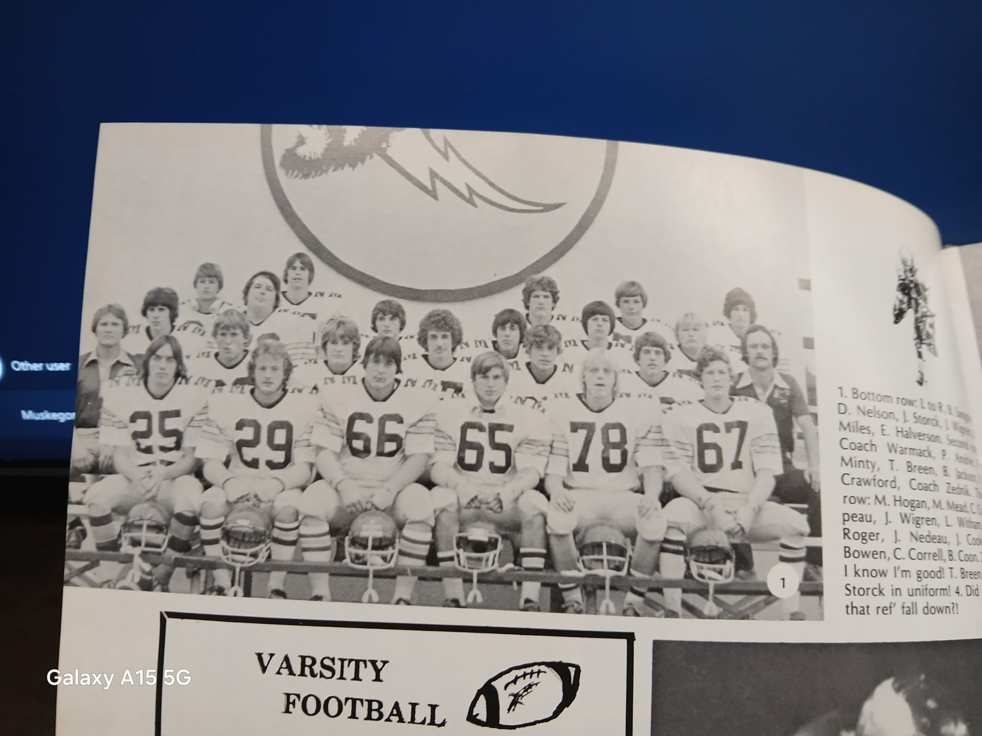

The 1977 NORSEMEN
Bottom Row L-R: Bill Sangster, Don Nelson, Jeff Storck, Jim Wigren, Brad Miles, Eric Halverson
2nd Row: L-R: Coach Dave Warmack, Phil Andrie, Reed Minty, Tim Breen, Bert Jackson, Roger Crawford, coach Ed Zednik
3rd: Row L-R: Mike Hogan, Marty Mead, Craig Compeau, Jerry Wigren, Larry Witham, Mark Rager,
4th Row L-R: John Nedeau, Jeff Cooke, Pat Bowem, Chuck Corrall, Brad Coon

1978– Coach Dave Warmack (8-1 overall, champs in WMC with Shelby)

Coach Dave Warmack, back for his fourth season as the head mentor for the Norsemen was hopeful before the season began that his current group of gridders could match last season’s 7-2 record. However, his Norsemen did even better as they compiled an 8-1 record, with their only loss coming against another very good Shelby team. Although only seven seniors returned from the 7-2 team in ‘77’, Warmack would be thrilled with the help he received from last year’s junior varsity team that posted an undefeated record and would produce several star players for the next couple of seasons. In the ‘what if’ scenario, this author would always speculate as to how good NM football fortunes would have been if they had a healthy Jeff Cooke. A starter as a freshman, and one who showed his talents in basketball as the leading rebounder in the entire conference, Cooke incurred the first of his nasty knee injuries during the off-season that prevented him from playing football again at NMHS and was lost, for not only the entire season, but much of his prep career.

Although NM would lose one potential star, it quickly became evident in their opener that they had found another, junior running back Paul Andrie. In the Norsemen’s opening game 13-8 win over Watervliet, the Norsemen rushed for 159 yards with Andrie compiling 150 of those yards, including a 68-yard TD run in the opening quarter. The big play of the game, and what would prove to be the winning points came in the third period. A Watervliet running back was hit hard by a Norse tackler, fumbled the ball and it was scooped by an alert Bill Banner who raced 44 yards for the TD. Coach Warmack was especially pleased with the play of his juniors during the win. Andrie was not only the game’s leading rusher, but he also tied for game honors with Jerry Wigren for the most tackles with 12.

NM dominated in the statistical department, but they needed a ‘shaky’ 21-yard field goal from Scott Preston to earn a 3-0 victory over Ravenna. It was the first game in NM history where the Norse won a game 3-0 and would be the first of three games in more than 90 years of NM football with a 3-0 win for the Norsemen. (Holton 1987 & Oakridge 1989 the others) NM’s defense kept the Bulldogs in check the entire game as the host Bulldogs were never able to get any deeper than the Norse 25-yard line. Paul Andrie again was the workhorse for NM as he totaled 97 yards in 25 carries while NM’s defense held Ravenna to only 74 total yards the entire game. Warmack singled out Pat Bowen for coming up with numerous big plays on defense as NM made it a perfect 2-0 to start the 1978 season.

NM scored with 1:01 left in the game on a three-yard TD by Bob Pickel to nip Montague 12-6 to move to 3-0 on the season. It appeared that both teams were headed for an overtime with the score tied at 6-6 late in the game before the Norse mounted their only scoring drive of the game. NM’s earlier TD, and the game’s first score came on an interception and 30-yard return for a TD by Brock Berson. Paul Andrie was held in check by a tough Montague defense as he was limited to 32 yards on the ground. Brad Billinghurst led the Norse ground game with 50 yards in but five carries.

NM then combined a crushing defense with a newfound passing attack in a 34-0 victory over Mason County Central. NM combined for 300 total yards while Scottville had a minus 67 rushing yards and a mere seven yards passing. After a scoreless opening period, NM went to the air waves as Junior quarterback Steve Preston connected with Brad Billinghurst good for 36 yards. With pass plays giving NM excellent field position NM scored a 4-yard rushing touchdown from short range. Paul Andrie scored a pair from one and seven yards out, Preston sneaked one over the goal line from the one while Bob Pickle capped NM’s scoring on the evening from 11 yards out to keep the perfect season intact at 4-0.

NM posted their third shutout of the season with a dominating 35-0 victory in the second ever meeting with Grandville Calvin Christian. Paul Andrie rushed for 161 yards and totaled four touchdowns, three rushing, and ran an interception back from 45 yards for another. The junior tailback’s rushing TDs were from 49, and two more from six yards out. Steve Preston continued his fine passing as he connected with Bob Pickle for a 52-yard strike. Mike Hansen tallied his first TD in a Norse uniform from one yard out to complete the romp.

NM got a big boost in a 14-0 win over Oakridge from Craig Hairston, a transfer from Muskegon who was playing in his first game. Taking some of the pressure off Paul Andrie, Hairston carried the ball 16 times for 72 yards and scored the second NM touchdown in NM’s win over the Eagles. Andrie had his usual productive game as he finished the game with 122 yards on 23 rushes as NM controlled the ball most of the evening. The win, coupled with a Shelby loss left NM alone at the top of the WMC conference with a perfect 4-0 record in the WMC. Oakridge, who came into the game winless, gave NM all they wanted. Perhaps NM might have been caught looking ahead to their big clash with Shelby the following Friday. For NM, who had allowed but 14 points through their first fix games, it was their fourth shut out on the season and third straight whitewash over an opponent.

After posting four shutouts on the season, the tables were turned on NM by Shelby as the Tigers shut out the Norse for the second straight year. The Tigers ended the NM streak to start the season at six wins and moved into a tie for the WMC lead with NM. The Norsemen dominated the game early, but the NM inexperience showed according to coach Warmack. Shelby’s only touchdown came on an eighty-yard drive that chewed up eight minutes on the clock with their touchdown coming on a 2-yard run with a minute left in the half to give Shelby a 6-0 lead. NM had a good drive going to start the second half. Paul Andrie ripped off three first downs to move NM deep into Shelby territory. However, the Norse fumbled, and Shelby recovered to end NM’s best scoring opportunity. NM later fumbled a punt deep in their own territory that doomed any Norse chance to pull off the victory as the Tigers kicked a short field goal to give the Tigers the final score of 9-0.

It surely wasn’t easy for the Norsemen in their battle with Hart as NM needed a successful two-point conversion run by Paul Andrie to earn a narrow 14-13 victory over Hart and secure a share of the WMC title with Shelby. Andrie and Craig Hairston controlled the running game throughout the contest despite not scoring in the second half. Andrie totaled 143 yards on 26 rushes while Hairston netted 133 in 22 carries. Andrie carried the ball eight times in NM’s first scoring drive in the opening period with Larry Witham scoring the TD from the two. A key play in the scoring drive was a fourth down and ten play when Brad Coon kept the chains moving with a 16-yard reception. Hairston then scored from four-yards away followed by Andrie’s two-point conversion. Hart, trailing 14-7, had three attempts to tie the game and send it into overtime. Their first kick attempt was good but, the Pirates were called for illegal procedure. The next attempt was wide, but the Norsemen were offsides giving Hart a third opportunity. That kick too, was wide, and NM escaped with the victory. Penalties hurt many Norse drives in the game as they were assessed a whopping 143 yards in penalties.

Junior running back Paul Andrie rushed for 170 yards and four TDs as NM defeated Reed City 40-8 to complete their season with an impressive 8-1 record. It was the eighth win in nine games vs. Reed City, and it would be another 38 years before they would again face each other. Andrie’s yardage pushed him over the 1000-yard mark on the season, the third back in NM history to rush for more than a thousand yards in a season. Andrie sat out the third quarter as his replacement Bob Pickle carried the pigskin 11 time for 82 yards and two TDs. All eyes were on the final playoff points totals to be announced early the following week.

NM finished just one spot from qualifying, but it was probably not a bad thing. Two Class C powerhouses in their region played the first game of the playoffs at Housemen field. Grand Rapids Forest Hills Northern defeated an injury riddled Muskegon Catholic team and would go on to win the Class C state championship. MCC was rated number one in ‘C’ all year with one of their wins during their 9-0 regular season run, a victory over Traverse City, the state champs later in the playoffs in Class A!

Five NM players made the WMC All-conference team with senior Pat Bowen selected to both the offensive and defensive team. Brad Coon was selected as a defensive back for the second straight year while three juniors from NM made the team. Paul Andrie and end Bob Pickel were selected for offense while John Arntz joined Coon and Bowen on the top defensive eleven. Bowen was picked as a first-string defensive player on the Free Press Class C All-State team. It was a great year for NM football in 1978. The 44 points allowed for the entire season has not been equaled by any future NM team through the 2025 season.

Record Score Interesting Facts
1-0 NM 13, Watervliet 8 Paul Andrie 68 yd TD, Bill Banner returns fumbler 44 yds for TD.
2-0 NM 3, Ravenna 0 Scott Preston a 21 yd FG for only score. Andrie 97 yards rushing.
3-0 NM 12, Montague 6 Bob Pickle 3-yard TD. Brock Berson 30 yd int for TD.
4-0 NM 34, Mason Co 0 Steve Preston to Brad Billinghurst 36 yd TD. Andrie 2 TD, Preston, and Bob Pickle a TD each.
5-0 NM 35 Calvin Christian 0 Andrie 4 TDs, 3 rushing 45 yd Int for TD, Pickle 11 yd TD, Preston to Pickle 52 yd TD.
6-0 NM 14, Oakridge 0 Craig Hairston 3 yd TD, Preston 1 yard sneak. Andrie 122 yds.
6-1 NM 0, Shelby 9 Loss moves Shelby into WMC tie with NM.
7-1 NM 14, Hart 13 Hairston & Larry Witham short TDs, Andrie 143 yds rush.
8-1 NM 40, Reed City 8 Andrie 170 yds & 4 TDs (2, 3,7 & 7) Pickle 2 TDs (11 & 4)

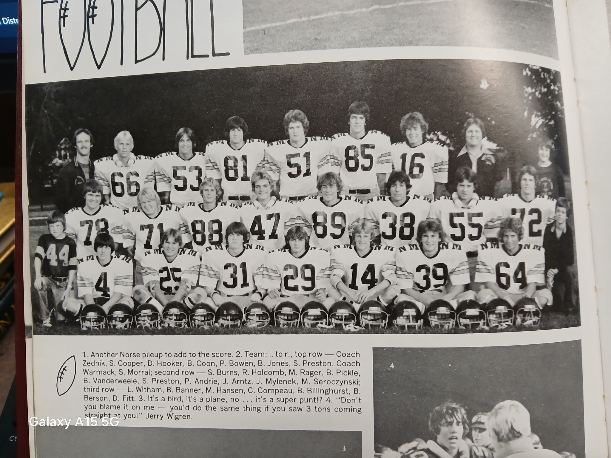

The 1978 NORSEMEN

1st Row L-R: Larry Witham, Bill Banner, Mike Hansen, Craig Compeau, Brad Billinghurst, Brock Berson, Dan Fitt
Middle Row: Scott Burns, Rich Holcomb, Mark Rager, Bob Pickle, Bill Vanderweele, Scott Preston, Paul Andrie, John Arntz, Jim Mylenek, Mike Seroczynski
Top Row: Asst. Coach Ed Zednik, Scott Cooper, Dan Hooker, Brad Coon, Pat Bowen, Bruce Jones, Steve Preston, Coach Dave Warmack

1979– Coach Dave Warmack (10-1 overall, WMC champs, state semi-finalist)

It promised to be an exciting season for North Muskegon football for 1979, and it was all that and more! Thirteen experienced lettermen returned from last season’s 8-1 team with a few other seniors who did not play football in 1978 adding to the mix. Best of all, Paul Andrie returned and added 20 muscular pounds to his frame. NM again boasted of a strong defense, but it was their offense that showed the greatest improvement from the previous season. NM scored only 143 points in winning eight games in 1978. They would nearly triple that amount with 398 points in 11 games in the 1979 season, a total that would not be surpassed until the 2023 squad scored 481 points in 13 games against much softer competition.

NM opened the season against a Class B Orchard View team that featured Curtis Adams, a future NFL running back. Adams had a fine game against the Norse rushing for 117 yards and his team’s only TD on a 45-yard run. Andrie however, ran for 204 yards behind some good blocking from his mates up front and tallied four TDs as NM won impressively 32-6 in the first game ever played between the two schools in 15 years. Yet another Norse headed for future stardom for NM, sophomore Sam Parker, stripped the ball from an OV ball carrier leading to one of the four Andrie TD runs. Earlier in the game NM’s Tom Wright did the same, his fumble recovery setting up an Andrie TD from the three. The final NM tally on the night came from senior quarterback Larry Witham’s 20-yard pass to Brock Berson.

Ravenna did a good job of containing Paul Andrie as he was held to 70 yards on the night, but it was the Norse passing game that highlighted its 27-12 victory over Ravenna. It might have been hard to believe at the time, but NM’s 15-point margin of victory would be the closest one would come versus the Norse until the November playoffs. Using a two QB system, Steve Preston threw a pair of TD passes, the first to Brock Berson for 22 yards, his second, a screen pass to Andrie that went for 35 yards. Larry Witham added the third NM TD via the passing route when he connected with Dave Billinghurst for 19 yards. Although checked to 70 yards rushing, Andrie was able to bust one open for a 24-yard TD, the first tally of the evening for NM.

Playing a near perfect ball game, the Norsemen netted 407 yards rushing, 270 accumulated by the legs of Paul Andrie that led NM to a 48-6 rout of Montague. Warmack gave special praise to the blocking of his fullbacks, Mike Hansen and Bill Banner and linemen Clark Stevens and John Arntz to free Andrie for a pair of long TD runs of 70 and 65 yards. The other two Andrie tallies were from a more modest effort from five and one yards out. The two NM QBs each contributed a tally, Preston on a one-yard sneak and Witham a five-yard TD toss to Tom Wright.

NM again had little trouble in defeating Mason Co Central as Paul Andrie kept up his amazing season with his 3rd four TD game of the season while rolling up 170 yards in NM’s 41-0 shutout of the host Spartans. Once again Andrie was aided by some great blocking up front. Split end Dave Billinghurst sprung Andrie free twice on pitchout runs of 15 & 42 yards. Billinghurst also caught a 16-yard TD toss from Larry Witham. When the Norse wanted to power the ball inside, they ran behind the blocking of John Arntz and Scott Cooper. Warmack lauded the defensive play of linebacker Mike Hansen. “He must have had about 18 tackles,” said Warmack of Hansen. The final NM TD came on a 3-yard run by Steve Preston.

The victory over Mason County Central set up a huge clash with Detroit Lutheran West with the Norsemen traveling for the first time to the Motor City. Lutheran West was ranked fourth in the latest AP poll with the Norsemen right behind in fifth. If North Muskegon was to attain the needed points to get into the playoffs, then this was a must win for the Norse. And win they did! 37-20 as Paul Andrie did it again with four touchdowns, three rushing on 233 yards, and for good measure intercepted a pass and returned it 35 yards for another tally. NM scored first on a field goal from a transfer from the Dominican Republic, Mario Feretti, good from 26-yards. Bob Pickle then stunned the home folks in Detroit with a 40-yard punt return. Lutheran West knew they were in for a long night when Andrie scored the first of his four touchdowns from 4 yards out to give NM a 17-0 lead before the hosts could counter. Lutheran West was hopeful of a comeback when they closed the gap to 30-20 but were punched in the gut when Andrie spoiled those hopes with a 55-yard TD to seal the win for the Norse. When I looked at the defensive stats it became clear to me that NM had a ‘generous’ stat person who counted the defensive tackles. Scott Coopers was credited with 25 tackles, Bruce Jones 20, John Arntz 17 and Sam Parker 16, more tackles than carries by the Detroit team for the entire game.

The WMC Conference title was at stake when North Muskegon and Oakridge, both sporting a perfect 4-0 record in conference play, met the following Friday. Oakridge was playing its first season under a new coach, a young man by the name of Jack Schugars, a 1964 graduate from Muskegon High School. Schugars and his Eagles did a nice job of containing Paul Andrie as NM blanked the Eagles 22-0. For Andrie, who ran for him a modest 107 yards in 27 carries, the yardage attained pushed him over the 1000-yard mark after, but six games played. The future Yale running back scored two touchdowns giving him 20 on the young season as he closed in on Stan Guy’s school record of 25 attained in 1954. Although the calendar showed it was October the 12th, the game was played with snow in the air possibly limiting a lot of offensive fireworks. NM limited the Eagles to but three first downs in the entire game in posting their second shutout of the season.

Paul Andie then equaled a school record for five touchdowns in a single game, a record he shares with Charlie Langeland, Jim Pancy and Stan Guy as NM overwhelmed Shelby 42-11. He also equaled the school record for TDs in a single season with 25 held by Guy. The lone TD scored by a Norsemen not named Paul Andrie was an interception by Steve Preston he returned 29 yards. One of Andries TD was one of the longest in NM history, a 90-yard TD pass from Larry Witham.

Stan Guy was on the sidelines in Hart and handed the game ball to Paul Andrie after Paul scored an early touchdown to break Guy’s record of 25 TDs set in 1954. Andrie added yet another TD to make his record for TDs in a season move up to 27 as NM smashed Hart 53-0. Bob Pickle scored three TDs and Bill Banner two as NM improved to 8-0 and an unblemished record in the WMC. Pickle’s three TDs came from three different ways: A punt return, a run for a TD --on his only carry in the game-- and scored on a pass play. The defense was also stellar in posting their third shutout. NM’s ‘generous’ stat man had Scott Cooper and John Arntz with 19 tackles apiece. When the polls came out the following Tuesday NM was 3rd in the AP polls, trailing Grand Rapids Forest Hills Northern and Middleville. More importantly, NM was also third in their region to the above two teams in the computer playoff rankings with only the top two in each regional qualifying for the playoffs.

Prior to the final game of the regular season with Newaygo, much of the attention was focused on those computer rankings but after NM’s 48-0 thumping of Newaygo they received the good news that Forest Hills Northern had lost to Lowell to set up a playoff matchup with Middleville. Bob Pickle scored the first TD for NM, but it didn’t come until the second quarter before NM’s offense began rolling. Paul Andrie scored four touchdowns, three rushing and an 18-yard pass from Steve Preston to move his total for the season to 31 TDs, a Greater Muskegon Record at that time. Brock Berson also scored twice as NM limited a Newago team, who finished the season at 6-3, to only 66 rushing yards for the game.

In 70 years of covering high school football, apart from the Muskegon-Traverse City game of 1971 when it featured No.1 vs. No 2, have I seen a bigger buildup for a high school game than the North Muskegon-Middleville game of November 9, 1979. Other than their 1981 state championship game at the Pontiac Silverdome, this game drew 8,000 fans to Grand Rapids’ Houseman Field on a night when the game was played in near sub-freezing temperatures, the most fans to attend a Norse football game. There were five radio stations tightly packed in our one radio booth covering this game, unheard of in the 1970s. Fortunately, my partner George Seymour and I were granted excellent seats in the front row of the two-tiered press box. Middleville had finished the season a perfect 9-0, just one poll point above the Norse as the top-rated team in the state. It was one vs two.

Crusty Middleville coach Bob White was bound and determined that he was going to stop NM’s one-man gang of Paul Andrie. However, NM had much more than Paul Andrie --- much more. NM quarterback Steve Preston had the game of his life, and so did many of his receivers as NM used their vastly underrated passing game to destroy top ranked Middleville 31-13. Preston, who became the starting quarterback in college for Northern Michigan University, passed for 218 yards and three touchdowns to shock coach White and the Middleville fans.
It didn’t look like at the game’s start it was going to be a walk in the park night for the Norse. A high snap on the light covering of snow on the artificial turf went over the NM punter’s head giving Middleville great field position on the Norse seven. Not letting adversity affect them, NM took the ensuing kickoff and tied up the game on a Paul Andrie 11-yard TD, his 32nd of the season and a successful PAT from Mario Ferretti. Middleville scored on a second quarter 66-yard run to extend their lead to 13-6 before NM then took control of the game. Steve Preston then connected for the first time all season to his brother Scott for 29 yards and a TD. Andrie who went both ways like many of the Norsemen, then intercepted a Middleville pass that set up a 15-yard pass from Steve Preston to Dave Billinghurst. Ferretti, who would take his kicking skills to Eastern Michigan University gave NM their first score of the second half with a 23-yard field goal, giving NM a two-score advantage at 24-13. The Preston-to-Preston combo then clicked for the game’s final score on a 33-yard pass play to make the final score read NM 31 and Middleville 13. NM not only dominated on the scoreboard but in the game stats as well. NM had 363 yards in total offense to Middleville’s 141 total yards. Defensively, veteran linebackers Scott Cooper and John Arntz stood out while sophomore middle linebacker Sam Parker was outstanding.
NM was now one win away from a visit to the Pontiac Silverdome to play for a Class C State championship. In the early days of the playoffs, you not only needed to win your games, but you needed to play a tough schedule to just qualify. NM’s opponent was battled tested Ishpeming from the state’s Upper Peninsula. It was Ishpeming in 1975 who defeated Hudson in the state final game played at Central Michigan University that snapped Hudson’s USA record winning streak.

Saturday, November 17th, 1979, was a beautiful day for a football game. The skies were blue and the temperature for the mid November day was an unseasonably toasty 50 plus degrees. However, both my partner for the broadcast that day, George Seymour, and I were shocked when we entered the stadium at Alma. The field was an ugly mess; mud completely covered the gridiron from the 40 to the 40. NM lost that day to Ishpeming, but NM’s classy coach Dave Warmack never once complained about the ugly playing surface. North Muskegon was held to 45 yards rushing on the day, with their terrific running back Paul Andrie limited to 25 yards on the slippery surface and no touchdowns, the only game all season that the Yale bound tailback failed to score a touchdown. Time and time again NM would drive deep into Ishpeming territory only to have potential scoring drives stalled on mistakes and turnovers. NM turned the ball over on turnovers an uncomprehensible seven times. The Norsemen with future NMU quarterback Steve Preston at the helm passed for 278 yards via the airwaves, but five passes were intercepted as NM receivers and running backs were slipping and sliding. Ishpeming got off to a startling beginning to the game by scoring the game’s first two TD’s, one of those TD’s set up on a Norse fumble at their 24-tard line. NM battled back and scored their only touchdown in the frustrating game on a 33-yard pass from Preston to Dave Billinghurst that capped an 85-yard NM drive. Billinghurst would have an exceptional receiving game on the afternoon by hauling in five passes good for 150 yards. NM had two promising drives die on interceptions at the Ishpeming nine and 19 late in the second quarter. NM’s frustrations would only get worse in the third period when NM had numerous chances to score and take command of the game. Paul Andrie was stopped just one yard short of the Ishpeming goal line that would have perhaps tied up the game. NM did get a pair of safeties to narrow the lead of the Hematites to 14-11. NM then mounted yet another drive that ended deep into Ishpeming territory at the 18-yard line. With their dobbers down, Ishpeming sewed up the game with a late TD to end NM’s magical season at 11-1. Ishpeming would advance to the state championship game where they would defeat Watervliet for the state Class C title, a team NM had defeated three of the last four years

Head coach Dave Warmack would be sought by many schools and he left NMHS to become a head coach first in Colorado. Warmack did get a state championship in 1988 while guiding Grand Junction Colorado to the 1988 state championship. Warmack returned to the state of Michigan where he became the head coach at Kalamazoo College. While battling cancer Warmack took a less stressful job as the head coach at Paw Paw High School. He mentored many players who would go on to play in college and even the NFL. Perhaps his most well-known player was Jason Babin who would go on to have an All-Pro career in the NFL as a defensive end. Babin currently lives in my hometown of Ponte Vedra, Florida where his two sons last year starred for the local football team. Dave Warmack passed away following his second bout with cancer in July of 2017 at 69 years of age.

As one might expect, NM dominated the 1979 WMC-All Conference team. Paul Andrie was an easy choice for the offensive eleven, but he was also tabbed as a defensive back as well. Bob Pickle made first team honors as an end, John Arntz at tackle while junior Mario Ferretti was the All-WMC kicker. Rich Holcomb made the defensive eleven with Andrie as a defensive back. Surprisingly, Andrie was not tabbed for first string honors on the Detroit Free Press All State team but linebacker Scott Cooper, who was just honorable mention in the WMC, was first string all-state in the Free Press.

Record Score Interesting Fact
1-0 NM 32, Orchard View 6 Paul Andrie 204 yd rushing & 4 TDs. Larry Witham to Brock Berson 20-yard passing TD
2-0 NM 27, Ravenna 12 Steve Preston 2 TD passes (Berson 20 & Andrie 35) Witham to Dave Billinghurst 19-yard TD.
3-0 NM 48, Montague 6 Andrie 270 yards and 4 TDs (70, 65, 5 & 1)
4-0 NM 41, Mason Co 0 Andrie 4 TDs, 170 yards, Witham – Billinghurst 16 YD pass.
5-0 NM 37, Detroit LW 20 Andrie 4 TDs (55, 4 & 1 rushing, 35-yard INT), Bob Pickle 40-yard punt return, Mario Feretti 26-yard FG)
6-0 NM 22, Oakridge 0 Two more TDs for Andrie (1& 10)), Preston 1 yd sneak.
7-0 NM 42, Shelby 11 Andrie’s 5 TD ties Stan Guys record of 25.
8-0 NM 53, Hart 0 Bob Pickle 3 TDs, Bill Banner and Andrie 2 each.
9-0 NM 48, Newaygo 0 Andrie 3 rush TDs (39, 44 & 2) pass TD 18,
10-0* NM 37, Middleville 13 Steve Preston 3 TDs (2 to brother Scott 29 & 33, one to Billinghurst for 15, Andrie 11-yard TD run, Ferretti 23 yd FG.
10-1*NM 20, Ishpeming 11 Preston to Billinghurst 33 yd TD. NM 2 safeties in the mud.

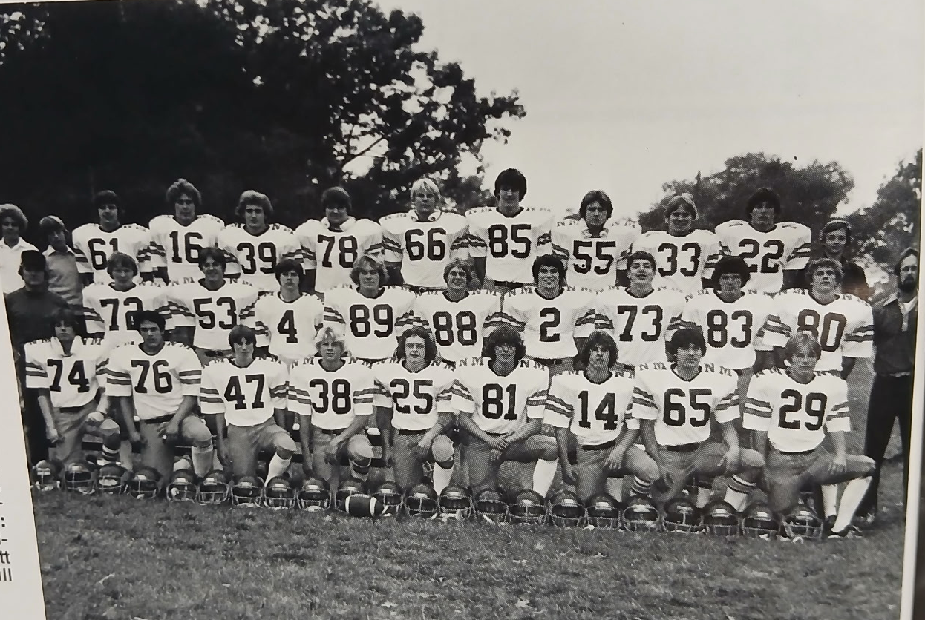

THE 1979 NORSEMEN STATE SEMI-FINALISTS

Front Row: L-R: Clarke Stevens, Mario Ferretti, Paul Panzel, Tom Monroe, Jeff Morrall, Kevin Ware, Mark Vento, Sam Parker, Dan Brondyk
Middle Row: Coach Dave Warmack, Ken Postema, Dan Hooker, Larry Witham, Scott Preston, Bob Pickle, Tom Wright, Charlie Fenwick, Brian Shirley, Dave Billinghurst Coach Ed Zednick
Top Row L-R: Jim Sheehan, John Andire, Tom Whittaker, Steve Preston, Rich Holcomb, Scott Cooper, Bruce Jones, John Arntz, Bill Banner, Paul Andrie, Mike Seroczynski

1980– Coach Dave Cooke (9-1 overall, WMC champs, state qualifier)

Dave Cooke would begin a long and successful tenure as NM’s football coach when he took over the duties from Dave Warmack. Football during this era at NM was King with 43 players suiting up as varsity players on Friday nights. Another good turnout for the JV team had 30 underclassmen on their roster. With only an average of perhaps 40 boys per class, that computes to more than half of their male athletes playing football at NM. NM lost several quality players from their exceptional 1979 team, but the current team shows potential with some outstanding returnees as well as a 1979 undefeated JV class. The biggest challenge will be finding players to replace the explosive NM backfield from the previous season. Dave Billinghurst, who capped his junior season by catching five passes for 150 yards in NM’s semifinal loss to Ishpeming returns while plenty of firepower returns to the offensive line. Clark Stevens returns on the line along with two-way standout Sam Parker. A pair of newcomers who did not play for the Norse in 1979 will be sure to supply much needed help. Jim Mylenek, a starting tackle in his sophomore season will boost the NM line while Brad Pflaum, a star on the basketball court will also take his talents to the gridiron.

Pflaum quickly made his presence known in the season opener vs. Orchard View, a 23-19 NM victory. After future CMU and NFL star Curtis Adams burned the Norse with a 96-yard kickoff return to begin the game, Pflaum tallied a TD from 10-yards out for the Norsemen’s first score. NM would score 20 unanswered points; short TD runs from Jerome Eck and Dan Brondyk to give NM a 20-7 lead at halftime. NM then exposed a weapon that would surely help keep their winning mode intact for the season, the kicking of Mario Ferretti. The future Eastern Michigan University kicker accounted for NM’s only points in the second half when he booted a 42-yard field goal, easily the longest field goal in Norse history at the time. OV scored a couple of TDs in the second half to close the gap, with the Cardinal’s final TD coming with only 1:19 to play.

NM didn’t have to wait long to realize the importance of Mario Ferretti’s kicking abilities as it was his soccer style kicking that was the difference in the outcome in NM’s 17-12 victory over Ravenna. Ferretti was successful on a pair of extra points after each NM touchdown and booted a 37-yard field goal. Both NM touchdowns came on big plays; the first a 48-yd scamper by Brad Pflaum, the second an 86-yard kickoff return by Jerome Eck.

NM showed that they would again be a force to be reckoned with in the WMC following their 27-7 win over Montague. For the second straight week NM received some big plays in their win, including their second TD return on a kickoff in two weeks, a 90-yard return from Dave Billinghurst. Junior running back Greg Cooke helped his father win his third game as the Norse head coach with TD bursts from 54 & 84 yards.

NM won their ninth straight game with Mason County and improved to 4-0 with yet another 62-14 romp over the Spartans. The Norse were expecting a close game after Mason Co upset Ravenna the previous week but that surely was not the case. Eight different Norsemen scored TDs on the night with Brad Pflaum the only multi-TD player with two. For the third consecutive game, NM returned a kickoff for a TD with Dave Billinghurst bringing one back for the second straight week from 80 yards. Also scoring for NM were Greg Cooke (5), a Chip Jordan to Mike Tjarksen pass (13), Jerome Eck (42), Dan Brondk 2, and Dave Maier (36).

In the only game played between the two schools, the Norsemen made it five in a row on the season with a 33-0 win over Sanford-Meridian. The Norse entered the game rated number three in the polls and looked every bit the part in the shutout over the Mustangs. The Norse defense held future CMU starting quarterback Ron Filmore to only 82 yards passing with one of Filmore’s passes intercepted and returned 35 yards for a TD by Jerome Eck. All the Norse yardage during the game came on runs, with 130 yards of their 252 rushing yards coming on two touchdown runs. Brad Pflaum dashed for a TD from 70 yards while Dave Maier scampered 60 for another six points. Eck tallied another TD and accounted for the game’s first on a short one-yard plunge, while Mike Tjarkesen also ran for a TD from 3-yards away.

The WMC Conference title was on the line in game six as both NM and Oakridge came into the game with a conference and season perfect record. Just as Norse head coach Dave Cooke projected prior to the beginning of the season: ‘that a big part of their team’s success would come from the foot of Mario Ferretti;’ Cooke’s words rang true as Ferretti booted a 26-yard field goal with: 0:06 on the clock to give NM a thrilling 10-7 win over Oakridge. The winning drive began back at the NM 20 as it appeared this game was headed for overtime in a battle dominated by both team’s defense. Using sweeps from backs Greg Cooke and Brad Pflaum, and excellent blocking up from Ken Stevens, Ken Postema and Greg Gust, NM chewed up the clock and marched deep into Eagle territory to set up Ferretti’s game winning boot. The stats were virtually even between the two evenly matched teams. NM rushed for 207 yards, just three more than Oakridge. NM passed for only 30 yards on the night but 20 of those yards was a completion from Chip Jordan to Dave Billinghurst that set up NM’s only TD, a 3-yard TD from Brad Pflaum shortly before halftime.

With six games completed it was time to look at those computer rankings to see where each team fit in their quest to make the playoffs. Could NM and Middleville be headed for a repeat matchup in Class C? NM and Middleville were ranked 1 & 2 prior to week seven.

NM kept their playoff hopes alive with a 27-14 win over an always tough Shelby team. The game was played on the muddy NM gridiron with conditions making the passing game virtually non-existent for both teams. NM rushed for 329 yards during the game, Greg Cooke rushing for 132 with Brad Pflaum nearly the same total with 125. Pflaum had 55 of those yards on one TD romp and scored his second TD from the one. Cooke scored on a one-yard plunge while future Yale football star Mike Tjarksen scored from 22 on a wingback reverse.

Needing a win over Hart to give the Norse their second straight WMC title, NM was up to the task as they shutout the Pirates 34-0. It was another game contested on a sloppy surface as the homecoming crowd at NM watched the game in a pouring rain. The Norse scored 20 first half points as they dominated action throughout the contest on both offense and defense. Jerome Eck had a standout game for the victors. Eck recovered a fumble, blocked a punt, and caught a 12-yard pass from Chip Jordan. Dave Billinghurst scored twice for NM, the first on an 18-yard pass from Jordan and the second a 20-yard run. Sam Parker, a two-way starter as a lineman and linebacker, got in on the fun with a 38-yard TD run as a running back. Greg Cooke scored NM’s first TD on a 36-yard run while Mike Tjarksen caught one of the two passes completed all night for the Norse on a 12-yard completion from Chip Jordan.

For the second straight year the Norse needed a win and some help to qualify for the playoffs. Entering their final regular season contest vs. a 5-2 Newaygo team, the Norse were in third place, behind Middleville and Saginaw Carrollton in the computer rankings, with only the top two in each regional qualifying. NM took care of business with a 42-8 spanking of Newaygo. Again, NM got a boost when Carrollton was defeated setting up a rematch with Middleville. After depending on their running game for most of their wins, NM went to the air waves as Newaygo tried to prevent the NM running game with seven down linemen. That set up the passing game for NM as Chip Jordan found Dave Billinghurst early for a pair of long TD passes while Billlinghurst also had a punt returned for six points. Tom Monroe ran a pass interception back 50 yards for another Norse tally while Chip Jordan ran the option 35 yards for a TD. Mario Ferretti was perfect on all six of his extra points.

A fourth quarter TD by Middleville broke a defensive standoff as NM bowed out of the playoffs with a 6-0 loss to Middleville. 6,000 fans were at Housemen Field in Grand Rapids to witness the first-round action between the same two teams from the 1979 season. Unlike 1979 when the two teams combined for 50 points, that was not the case in 1980. Middleville’s Brian Oosterhouse scored on a reverse from 34-yards for the games only score midway through the final period. Stats were about even for the night with Middleville having 194 yards in total offense with the Norsemen right behind with 183. Turnovers by both teams hurt numerous drives. NM had three turnovers in the game and had a field goal blocked.

Six Norsemen were placed on the WMC All-Conference team. Sam Parker, who will go down in Norse annals as one of the best to ever suit up for the Blue & Gold, was picked for both the offense and defensive elevens. Still only a junior, Parker would be joined on the offensive team by running back Brad Pflaum and senior tackle Ken Postema. Mario Ferretti was an easy choice as the kicker for the WMC team while Brian Shirley and another junior, Greg Cooke, would be tabbed for spots on the defensive team with Parker.

With NM fielding several juniors could they possibly make the playoffs for the third consecutive year in 1981?

Record Score Interesting Fact
1-0 NM 23, Orchard View 19 Brad Pflaum, Jerome Eck, Dan Brondyk TDs,
2-0 NM 17, Ravenna 12 Pflaum 48 yd TD, Eck 86 yd kickoff return. Ferretti FG.
3-0 NM 27, Montague 7 Dave Billighurst 90 yd Koff ret, Greg Cooke 54 & 84 yd TDs.
4-0 NM 62, Mason Co 14 Eight NM players score TDs, Pflaum 2 (15 & 21)
5-0 NM 33, Sanford Meridian 0 Jerome Eck 2 TDs (1 & 36 yd int) Pflaum 70 & Dave Meier 60.
6-0 NM 10, Oakridge 7 Mario Ferretti GW FG with :06 left. Pflaum 3 yd TD.
7-0 NM 27, Shelby 14 Pflaum 2 TDs (55 & 1) Mike Tjarksen (22) Cooke 1-yd TD.
8-0 NM 34, Hart 0 Billinghurst 2 TDs (18 pass, 20 yd run) Sam Parker 38 Yd TD.
9-0 NM 42, Newaygo 8 Billinghurst 3 TDs, Tom Monroe 50 yd int YD. Jordan 35 TD.
9-1*NM 0, Middleville 6 Turnovers plague NM. Pflaum 50 yds rushing, Cooke 41.

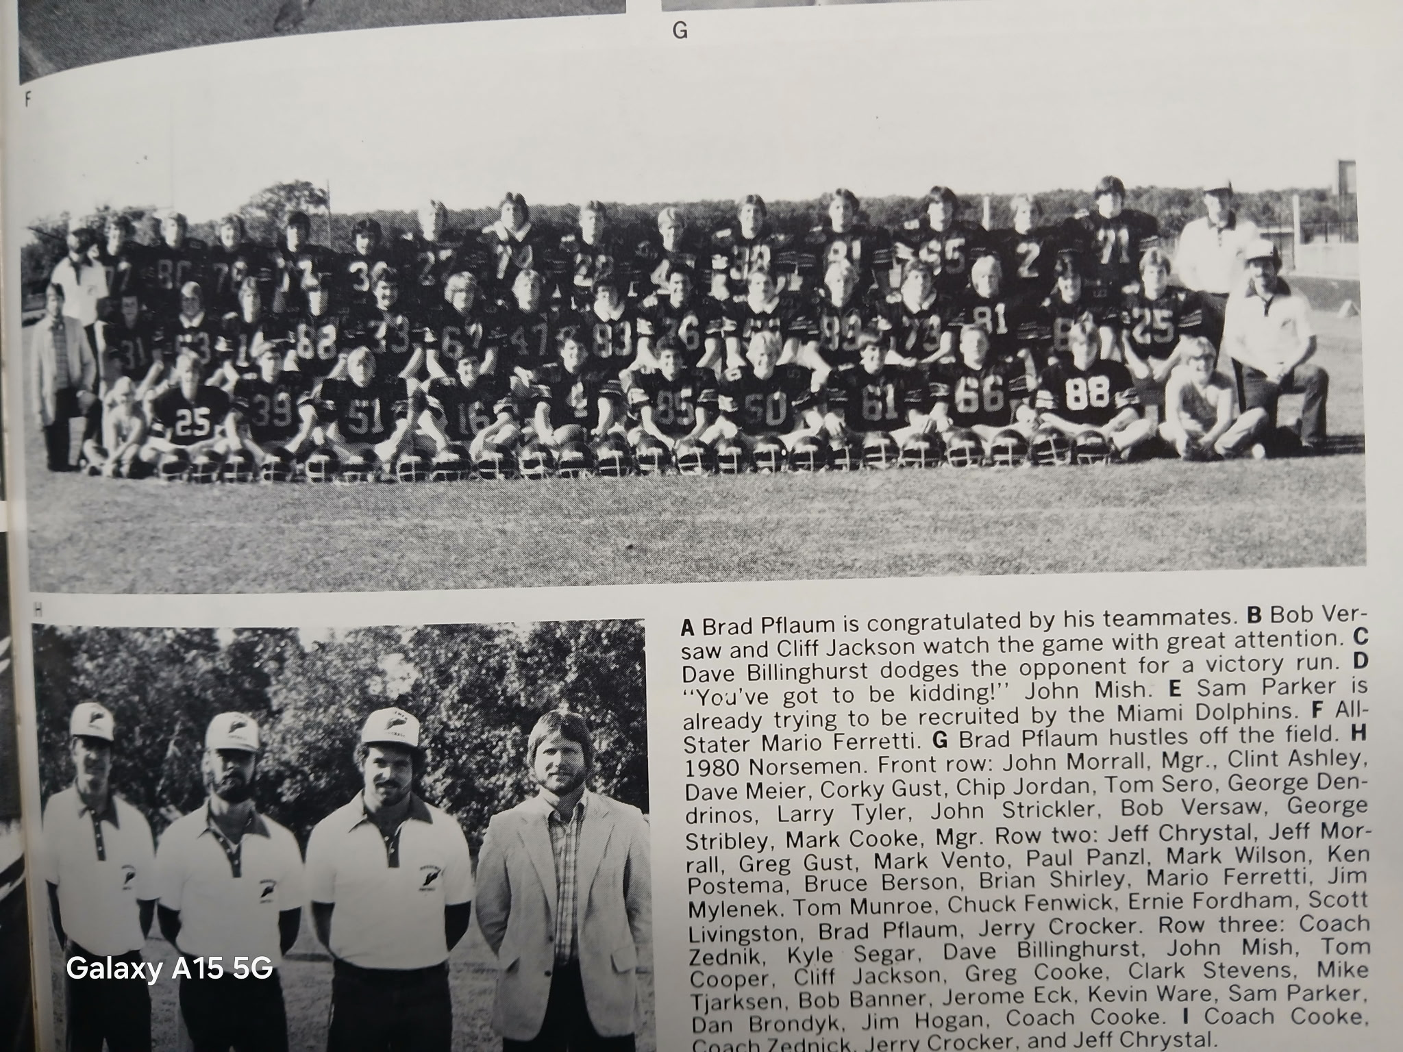

NM Football 1980

Front Row L-R: John Morrall mgr., Clint Ashley, Dave Meier, Corky Gust, Chip Jordan, Tome Seroczynski, George Dendrinos, Larry Tyler, John Strickler, Bob Versaw, George Stribley, Mark Cooke
Middle Row: Jeff Chrystal, Jeff Morrall, Greg Gust, Mark Vento, Paul Panzi, Mark Wilson, Ken Postema, Bruce Berson, Brian Shirley, Mario Ferretti, Jim Mylenek, Tom Monroe, Chuck Fenwick, Ernie Fordham, Scott Livingston, Brad Pflaum, Jerry Crocker
Top Row: Coach Ed Zednik, Kyle Segar, Dave Billinghurst, John Mish, Tom Cooper, Cliff Jackson, Greg Cooke, Clark Stevens, Mike Tjarksen, Bob Banner, Jerome Eck, Kevin Ware, Coach Dave Cooke,

1981– Coach Dave Cooke (11-1 overall, WMC champs, state finalist)

With six returning starters on offense and five on defense, expectations were high at the start of the 1981 season. The Norsemen were on an amazing run; 20 regular season wins in a row and back-to-back WMC titles. Headlining the list of returnees would be three-year starter Sam Parker. An all-conference performer for the past two years, Parker would do everything for NM in 1981 except drive the team bus to their away games. With a year at quarterback, Chip Jordan will have plenty of choices for receivers, including Yale bound Mike Tjarksen and Greg Cooke. Joining Parker as returnees on the line included tight end Tom Seroczynski and Bob Vershaw while many who saw action in 1980 will also help upfront. Returning on defense were All-WMC picks Cooke as a defensive back and Parker at linebacker. Among the number of Norse who went both ways for the Norse were defensive backs Tjarksen and Jerome Eck. John Stricker also returns from his linebacker spot as once again NM will play a schedule against formidable opponents, a must back in the early days of MHSAA football when only two teams from each regional qualified for the playoffs.

Once again NM would start their season against a very good Class B opponent, Orchard View. When the final horn had sounded at the end of this game, Orchard View would have given the Norse their narrowest win for the entire season. The Cardinals held the Norse scoreless for 48 minutes. Fortunately for the Norse followers, NM defense likewise held the Cardinals off the scoreboard setting up an overtime, the first in NM history. OV had the ball first, but the Norse defense once again was solid in OT. If Mario Ferretti still had another year of eligibility than NM Head Coach Dave Cooke would perhaps have just sent in his kicker to win the game. Instead with the ball at the six-yard line and OV again expecting NM to attempt to power their running backs into the line, Chip Jordan threw a quick out pass to Tom Serocynski who pranced into the end zone for the game winning score. Until the playoffs got underway no other team on NM’s regular season schedule would come less than 20 points from defeating NM.

An opponent surely had trouble trying to figure out where Sam Parker might play. Would Sam play on the line, linebacker, or would he also play in the backfield? In the second game on the 1981 season Sam played everywhere but it was his 53-yard touchdown run in the first quarter that got the Norse started in the right direction in this 34-7 victory over Ravenna. That TD led to three more NM TDs in the second quarter as the Norse took a commanding 28-0 lead at halftime. NM led 34-0 before the Bulldogs would score late in the final period for their only score on the night. Chip Jordan threw a pair of TD passes, a six-yarder to Mike Tkarksen and 12-yard pass to Brad Kinning and Jordan had a short two-yard TD run to account for three of NM’s tallies. Greg Cooke’s plunge from the one in the second quarter completed the NM scoring.

Greg Cooke surely made his father proud as the NM senior running back scored three touchdowns, including a TD on a 75-yard punt return to lead his father’s Norsemen team in a 35-0 shutout victory over Montague. Cooke also rushed for a game leading 129 yards and a pair of rushing touchdowns from eight and 10 yards. Mike Tjarksen ran for a 3-yard TD, Sam Parker bulled over from the four and added a game high 13 tackles.

NM took over undisputed possession of first place with a commanding 49-6 victory over Mason County Central. NM rolled up 334 rushing yards and 120 more real estate in passing as NM won for the eight straight time over the Spartans. Greg Cooke and Mike Tjarksen each scored on a pair of TD passes while Chip Jordan hurled a pair of aerials for six points. And, it looks like NM has found a replacement for Mario Ferretti in the kicking game as Sam Parker was a perfect 7-7 on his extra points.

For the only time in 90 years of NM football, NM traveled to Phillips Field to play Muskegon Heights in football. This was an era when the Tigers were a Class B force in football and were expected to give NM all they wanted and more. However, NM played a flawless game and won the contest by a surprising 32-6 margin over the Tigers for their 25th straight regular season win in a row. Greg Cooke, Chip Jordan, and Mike Tjarksen all had big offensive games for NM. Cooke tallied one short TD but set up others by rushing for 132 yards in 22 carries. Jordan passed for three TDs, two of those going to Tjarksen on tosses of 10 and 15 yards. Jordan’s other TD strike went to his tight end Tom Seroczynski from seven. Jerome Eck set up the first NM TD with an interception in the opening period and then was rewarded by getting the call from the one-yard line to score the first NM TD.

Oakridge’s Hall of Fame coach Jack Schugars, now in his third year as head coach of the Eagles was still looking for his first ever win over NM following his 21-0 loss to NM. However, as history will show, that percentage would change big-time. Greg Cooke scored two TDs, Chip Jordan completed a 65-yard TD pass to Jerome Eck, all coming in the second quarter as NM’s defense led by Sam Parker held Oakridge to only 39 yards of total offense in the entire game. NM got off to a rocky start. On the first play of the game Chip Jordan on a plain old quarterback sneak raced 68 yards for a TD only to have the play nullified by a NM penalty. Parker, a two-way starter had a monster game on defense with 18 tackles.

Greg Cooke ran for 309 yards and two TDs as NM improved to a perfect 7-0 on the season with a 33-6 victory at Shelby. Cooke had TD runs of one and 35 yards while Mike Tjarksen broke loose for long TD runs of 51 and 24. Sam Parker completed NM scoring on the night with a 28-yard tally. On the NM kickoff following the Parker TD, Shelby’s Rick Gowell ran the kickoff back 85 yards to account for Shelby’s lone score. NM rushed for more than 400 yards to clinch yet another WMC title.

NM certainly made a believer out of Hart coach John Shepich. “We didn’t give it away at all. It’s just that they’re the best (NM) team I’ve seen in the eight years I’ve been at Hart,” said Shepich following NMs 26-6 victory over his Pirates. The win marked the 15th straight NM win over the Pirates. Greg Cooke ran for 147 yards and a TD; Chip Jordan had a pair of TD passes to Jerome Eck (27) and David Fenwick (16) and Mike Tjarksen got things started for NM with a 13-yard TD on NM’s first offensive series of the game. The win made it three straight years in the WMC without a loss.

Mike Tjarksen had a night to remember in NM’s 29th regular season victory in a row, a 41-6 pasting of Newaygo. Tjarksen scored four touchdowns, two on runs of 15 and eight yards and caught a pair of TD passes from Chip Jordan that went for 23 and 16 yards. For the season Tjarksen had totaled 14 touchdowns. “Fourteen touchdowns aren’t bad for a guy that doesn’t carry the ball that much,” said Coach Cooke after the game. Greg Cooke, before he and the rest of the regulars headed to the bench for much of the second half, ran for 90 yards. Jerome Eck added a TD from 13 yards out and it appeared that Coach Cooke had an Ace in the Hole with Sam Parker. Parker, who on defense helped NM hold Newaygo to rush for minus 47 yards, carried the ball five times as a fullback and rushed for 53 yards.

NM, for the third straight season qualified for the playoffs, a testament to not only their abilities, but also to their strength of schedule as it was not unusual before the playoffs expanded to eight classes/divisions beginning in 1990 that a perfect 9-0 season did not guarantee one getting into the hunt.

Montrose was NM’s first round opponent and again the Norse were headed to Grand Rapids’ Houseman Field while the ‘ole announcer’ once again took his spot up in the comfy press box to call the action for my alma mater. And what a night it was for Sam Parker! On his 18th birthday Parker had one of the best games any NM player has accomplished on the gridiron as we near the 100th year of NM football. Parker was devastating from the opening minute of the game when he made the game’s first four tackles. On defense he would finish the game with 23 stops, including two sacks of the quarterback as Montrose was only able to gain 35 yards on the ground for the entire game. On offense he kicked two field goals and concluded his incredible night with a 50-yard TD run. “That was a pretty good birthday present, wasn’t it,” said his coach Dave Cooke to my good friend and Muskegon Chronicle Sportswriter Mart Tardani following the game. “Sam has been our team leader all season and has done so many things for us. He’s all over the field defensively, and we run his hole on offense.” NM shut out a good Montrose team 25-0 to set up a semifinal clash with the state’s top-rated team in the Class C polls, Iron Mountain. NM’s starting backfield of Chip Jordan, Greg Cooke, Mike Tjarksen, and Jerome Eck accomplished a feat that had to be a rarity for any team. They each had an interception on defense! The win didn’t come without one casualty however as Jerome Eck suffered an injury late in the victory and was lost for the rest of the playoffs.

The state semi-final game with Iron Mountain was played on the artificial surface at Flint’s historic Atwood Stadium that might have been better suited for ice skating then a football game. As good a game as Sam Parker had in NM’s win over Montrose, his performance the following week in NM’s 9-7 victory over Iron Mountain might have been even better. In more than 90 years of NM football this was the school’s biggest victory all time. Iron Mountain’s main strength was in their defense, featuring a couple of D1 tackles who would start in college at a pair of Power Five universities. The Mountaineers for the entire regular season had given up but two touchdowns. It took but one quarter for NM to score a touchdown against the Iron Mountain vaunted defense, a 62-yard run by Parker on the last play of the first quarter. With players slipping and sliding all afternoon on the slippery sleet covered turf, NM turned to their power back Parker most of the afternoon where he churned out 109 rushing yards. However, the big play in the game, other than Parker’s closing kick, came on a long pass play, not a run. Iron Mountain had taken a 7-6 lead with eight minutes to play and with the Mountaineer defense, it appeared NM was headed for their second semi-final defeat in three years to an UP squad. After the Norse were unable to sustain a drive Iron Mountain took over and were marching deep into NM territory. A fourth down pass was batted down at the NM two-yard line by, who else, Parker, to give NM life with 3:45 to go in the game. Faced with fourth down still deep in their own territory a Chip Jordan scramble left him about a yard short of the first down marker. However, Jordan fumbled the ball forward and with the rule at the time, his fumble went forward and out of bounds giving NM a new set of downs and new life. Jordan then completed, and Tjarksen caught, the biggest pass of their NM careers, a 42-yard completion to the Iron Mountain 30. Jordan then rolled out around left end for nine yards and an Iron Mountain penalty on the play advanced it to the seven. There were only 20 seconds left to play, and it was decision time for the NM coach. Dave Cooke mentioned in the post-game that he would have preferred to run a play to improve their field position as the ball was spotted at the far hash mark on the left side of the field. However, NM was out of time outs and Cooke had Parker try a field goal for the game winner. If I live to be a hundred (and as of this writing that’s not too far away) I’ll never forget Parker’s kick. From my broadcasting perch I had a perfect view of the kick. All I could think (to myself) was how are we going to mess up this play --- bad snap – bad kick --- anything. But the snap was perfect, the hold was perfect, and so was Parker’s kick. I believe for a moment I was speechless (honest), and all I could think to myself was that my beloved North Muskegon High School was going to play for a State Championship. Many WMC teams in the ensuing years would play in the state finals, and many would win, but it was North Muskegon High of 1981 who would be the first from their venerable conference to ever play for a state title.

As my good friend and longtime NM baseball coach Walt Gawkowski would often say: “You never know,” certainly could be applicable to the Norsemen winning a State Class C Championship before more than 20,000 fans at the Pontiac Silverdome. ‘You never know’ but it’s quite possible the NM game was lost at a stop on the long bus ride from Muskegon to Pontiac. Shortly after consuming a meal Sam Parker was stricken with a case of food poisoning which left him sick and weakened as the kickoff arrived in Pontiac. NM fell to Elkton-Pigeon-Bayport 15-6, but the game was much closer than the final score. NM had their chances but fell just short to bring the state title back to NMHS. Trailing 8-0 midway through the fourth quarter NM scored on an electrifying 48-yard punt return from Mr. TD for NM, Mike Tjarksen. However, the point after to tie the game on the two-point attempt failed as they fumbled the pitchout, and the ball sailed out of bounds. Earlier in the quarter on a fourth down and goal play Chip Jordan completed a pass to Corky Gust, but Gust was stopped at the one-yard line of Elkton-Pigeon-Bayport. Following Tjarksen’s TD run NM attempted an onside kick, but the ball didn’t go the necessary 10 yards and E-P-B took over in great field position. The Lakers drove deep into NM territory, and the Norse appeared to get a break when they recovered a fumble at the two-yard line. However, on the first play after the turnover the ball was jarred loose from the Norse running back and was recovered in the end zone to put all hopes for a late comeback to bed. And how much was Parker missed in this game? He carried the ball only 5 times for a net of 17 yards. Parker due to his illness played little in the game. “When you take him out of the middle, that really opens things up for them,” said Dave Cooke following the game. “On their touchdown drive, he wasn’t in there at all. My 1981 North Muskegon team will always be special in my heart,” said Cooke to Mart Tardani in a special profile on Cooke in the Muskegon Chronicle on September 4, 1986.

Greg Cooke’s 1439 yards rushing during the season made Greg the fourth Norse running back to surpass the 1,000-yard mark, and his total ranks third for a single season. NM has made several playoffs runs over the next five decades, but only the 1981 team played for a state title. Post season honors saw several NM players earn honors. Mike Tjarksen, Chip Jordan, Greg Cooke John Stricker and, of course, Sam Parker made the WMC first team All-Conference Team. Those four, as well as Larry Tyler all made the All-Area team, while Parker and Greg Cooke made the prestigious first team All-State team.

Record Score Interesting Fact
1-0 NM 6, Orchard View 0 (ot) Chip Jordan 6 yd pass to Tom Seroczynski in OT wins.
2-0 NM 34, Ravenna 7 Jordan 2 TD passes & a run, Sam Parker 56-yard TD
3-0 NM 35, Montague 0 Cooke 3 TDs, 75 yd punt ret., Parker & Tjarksen TDs.
4-0 NM 49, Mason Co 6 Cooke & Tkarksen 2 TDs, Jordan 2 TD passes
5-0 NM 32, Muskegon Hts 6 Jordan 3 TD passes, 2 to Tjarksen, Cooke 139 yds & TD.
6-0 NM 21, Oakridge 0 Cooke 2 TDs, Eck 65 yards TD pass from Jordan.
7-0 NM 33, Shelby 6 Coole 309 rushing yds, 2 TDs. Tjarksen 51 & 24, Parker 28.
8-0 NM 26, Hart 6 Jordan 2 TD passes (Eck 27 & David Fenwick 16)
9-0 NM 41, Newaygo 8 Tjarksen 4 TDs (runs of 15 & 6, 2 passes 23 & 16)
10-0* NM 25, Montrose 0 Parker 2 FG, 50-yd TD run, 23 Tkls, Cooke, Tjarksen TDs
11-0*NM 9, Iron Mountain 7 Parker winning FG, also 60-yd TD 109 rushing yds.
11-1* NM 6, Elkton-Pigeon 15 Tjarksen 48 yd Punt return for TD.

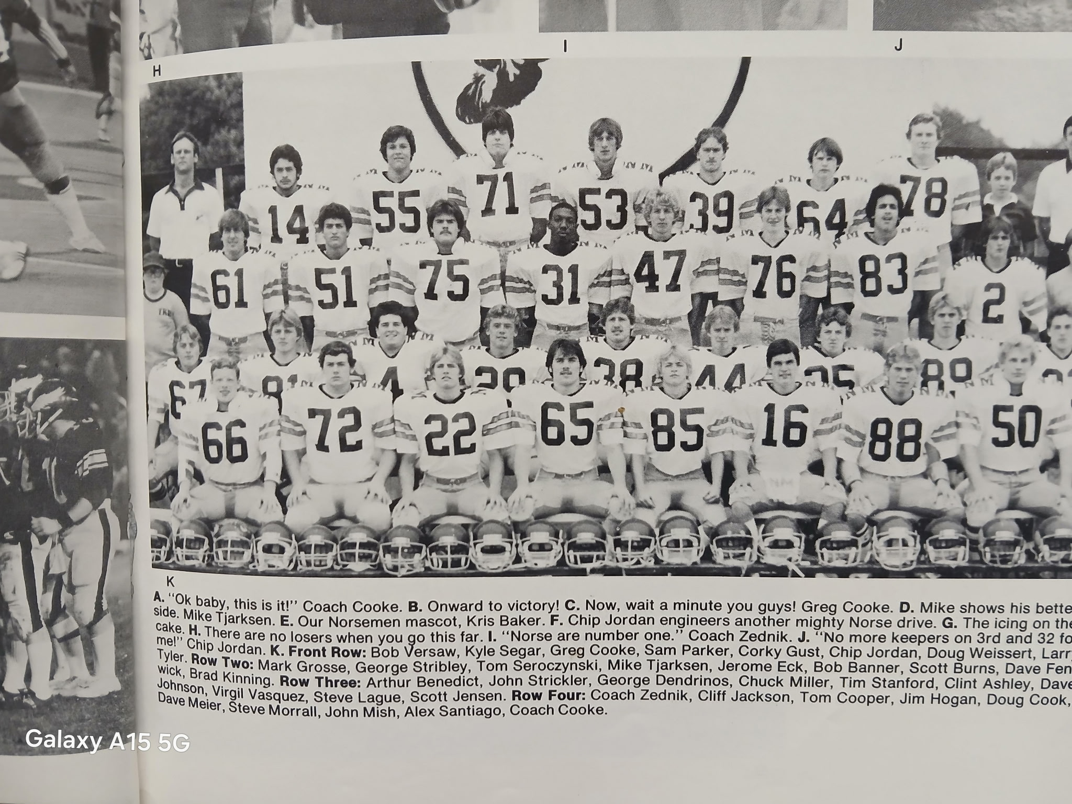

THE STATE RUNNERUPS of 1981
Front Row L-R: Bob Versaw, Kyle Segar, Greg Cooke, Sam Parker, Corky Gust, Chip Jordan, Doug Weissert, Larry Tyler,
Row Two L-R: Mark Grosse, George Stribley, Tom Seroczynski, Mike Tjarksen, Jerome Eck, Bob Banner, Scott Burns, Dave Fenwick, Brad Kinning
Row three L-R: Art Benedict, John Strickler, George Dendrinos, Chuck Miller, Tim Stanford, Clint Ashley, Dave Johnson, Virgil Vasquez, Steve Lague, Scott Jensen
Row four L-R:Coach Ed Zednik, Cliff Jackson, Tom Cooper, Jim Hogan, Doug Cook, Dave Meier, Steve Morrall, John Mish, Alex Santiago, Coach Dave Cooke

1982– Coach Dave Cooke (2-7 overall, Oakridge WMC Champs)

It would be almost a complete about face for the 1982 Norsemen as they would fall to 2-7 on the season. However, this would be a short blip for the Blue & Gold as they more than righted the ship the following year. You talk about a rebuild ----The Norse would return just one starter from their 1981 state finalist, tight end Tom Seroczynski. And he would be first moved to quarterback to take advantage of his talent and experience. Eight others who saw at least partial action in the 1981 state championship game would return. Although the Norse would post a somewhat dismal record, NM was close to turning several of those losses into victories. The young 1982 team would adsorb this experience and turn it around in just one short season.

A record that still stands today, 29 straight regular season wins without a loss came to an end in the very first contest as Orchard View edged the Norse 8-3. One certainly cannot fault the defense for the loss. NM took the lead with but 10 second left in the half on a 26-yard field from the last of the four Andrie brothers to play for NM, John Andrie. The game deciding score came from the OV defense when Steve Wilkinson intercepted a Norse pass and returned it 55 yards for the score. Wilkinson also ran in for the extra point; all the points Orchard View needed in this defensive standoff. Tom Seroczynski not only played quarterback, but he also played linebacker and led the Norse defense with 12 tackles while Chuck Miller had eight. Andrie rushed for half of NM’s total 120 yards gained on the ground.

It took not only 48 minutes to decide the winner in NM’s next game at Ravenna, but it also took three overtime periods before either team was able to score. The game was played in a continuous downpour the whole night as fumbles and miscues on the rain drenched field led to the scoreless duel. It was such a defensive struggle that there were only a handful of scoring chances during regulation. Ravenna’s only threat in regulation came after the Bulldogs intercepted a pass deep in in NM territory at the 11. That was quickly repulsed by the stout NM defense. Ravenna advanced the ball to the one in the first overtime but NM’s alert Gregg Zack, whose father Denny was a star for Ravenna in the late 1950s, recovered a fumble. NM had their chances in the overtime periods but came up empty both times. NM lost the ball on a fumble in the first OT and in the second had a 27-yard field goal blocked. Ravenna had the first possession in the third OT and connected on a TD pass and kicked the extra point. NM finally was able to cross the Ravenna goal line, and it came on a pass from Tom Seroczynski to Dave Fenwick, the only pass completed all night for NM. The placement failed and NM went down to their first defeat in a WMC conference game since 1978, 7-6.

Coach Dave Cooke shuffled his offense for NM’s next game at Montague. He moved Tom Seroczynski from quarterback to fullback so the Norse could capitalize on Seroczynski’s blocking abilities. The move paid off as his blocking created room for John Andrie to gain 149 yards in 28 carries in NM’s narrow 10-7 victory over Montague. Jeff Jordan, the younger brother of NM’s Chip Jordan, the Norse QB the previous two years, took over the quarterback duties and hit Virgil Vasquez with a 52-yard pass play for NM’s only TD in the game. In what proved to be the winning points, Andrie connected on a 35-yard field goal in the second quarter and then the Norse defense did the rest. Montague’s only TD came on a freak play. NM intercepted a pass in the third period, but the ball was knocked loose, and Mike Horn recovered in the end zone to earn Montague’s only points on the evening.

Mason County won their first game over the Norse in the last 10 years 22-6 as turnovers and penalties hurt the young Norsemen. The game was tied at halftime 6-6 thanks to a Jeff Jordan 15-yard pass to Greg Zack. Earlier in the second quarter NM was on a drive down to the Spartan 10-yard line only to lose the ball on a fumble. Mason County then took advantage of a fumble in the third quarter to score the winning touchdown. John Andrie picked up 92 yards in 25 tries for NM.

In their first meeting in 18 years the Norsemen and Ludington met in a football game. The Norsemen suffered their third agonizing loss on the season 12-7 at Ludington as penalties and fumbles led to yet another tough loss. Ludington scored their first touchdown on a Norse miscue in the first period when NM fumbled, and the Orioles Chris Castellani picked up the loose pigskin and traveled 60-yards for a TD. NM took a 7-6 lead on Jeff Jordan’s 16-yard scoring strike to Greg Zack, but Ludington scored from 10 yards out late in the game to hand NM their third close defeat of the season. Future NM fire Chief Steve Lague led the Norsemen in rushing with 65 yards. NM totaled 100 more total yards than Ludington, but mistakes doomed the Norse.

After losing three consecutive years to the Norsemen Jack Schugars finally attained a victory over NM but they had to come from behind to down the Norsemen 27-14. NM led at halftime 8-7 as they turned a bad snap from center into a two-point conversion pass from Jeff Jordan to Virgil Vasquez. This followed their only TD drive of the first half that culminated in a John Andrie dive from the one. NM received a bad break as a roughing the punter call against NM kept an Oakridge drive alive in the second half that ended with an Eagle touchdown that gave Oakridge the lead. An interception of a Norse pass set up another TD as NM fell to a very uncharacteristic 1-4 in the WMC and 1-5 overall.

Shelby’s 28-0 victory over North Muskegon the following week would be the only game in NM’s losing season where NM was badly outplayed. “They just beat us in all phases of the game” said NM coach Dave Cooke following the game. John Andrie carried 18 times for 69 yards while Tom Seroczynski led the Norse defense with 12 tackles.

It was the ‘Same O – Same O - for the Norse as fumbles and penalties contributed to their 7th loss of the season in the 9-6 loss to Hart. NM fumbled 6 times in the contest while losing the ball on three of those occasions. NM won the battle of the stats as they outrushed Hart by more than 100 yards. A 31-yard field goal in the third quarter proved to be the winning points for the Pirates. A fourth quarter 16-yard pass play from Jeff Jordan to John Andrie drew the Norse within three points of the Pirates but a 15-yard penalty late in the game stopped a potential game winning NM drive.

It could have been easy for the Norsemen to just throw in the towel and wait for the 1983 season to begin, but that was not the case as NM’s defense played hard to lead NM to their second win of the season 14-6 over Newaygo. Tom Seroczynski’s 21 tackles and the punting of Troy Scott gave NM excellent field position as John Andrie scored both NM TDs and once again led the Norse in rushing with 89 yards on 25 carries. While his brother Paul was tearing up the Ivy League as the league’s leading rusher while playing for Yale, his younger brother John was the only Norsemen to receive all WMC honors on the All-Conference Offensive team. Tom Seroczynski was the only NM player selected to the WMC All Defensive team. That would certainly change in 1983.

Record Score Interesting Fact
0-1 NM 3- Orchard View 8 John Andrie 26-yard field goal.
0-2 NM 6, Ravenna 7 NM losses in 3 OT game. Seroczynski to Dave Fenwick TD pass
1-2 NM 10, Montague 7 Jeff Jordan to Virgil Vasquez 52-yd TD pass. Andrie 35 yd FG.
1-3 NM 6, Mason Co 22 Jordan to Greg Zack 15-yd TD pass. Andrie 92 yds rushing.
1-4 NM 7, Ludington 12 Jordan to Zack 16-yd TD. Steve Lague 65 yards rushing.
1-5 NM 14, Oakridge 27 Andrie 2 short 1-yd TDs and 149 yards rushing.
1-6 NM 0, Shelby 28 Andrie 69 yards rishing, Tom Seroczynski 12 tackles.
1-7 NM 6, Hart 9 Jordan to Andrie 26-yard TD pass all the Norse scoring.
2–7 NM 14, Newaygo 6 Andrie 2 TD: s (6 & 2), Seroczynski 21 tackles.

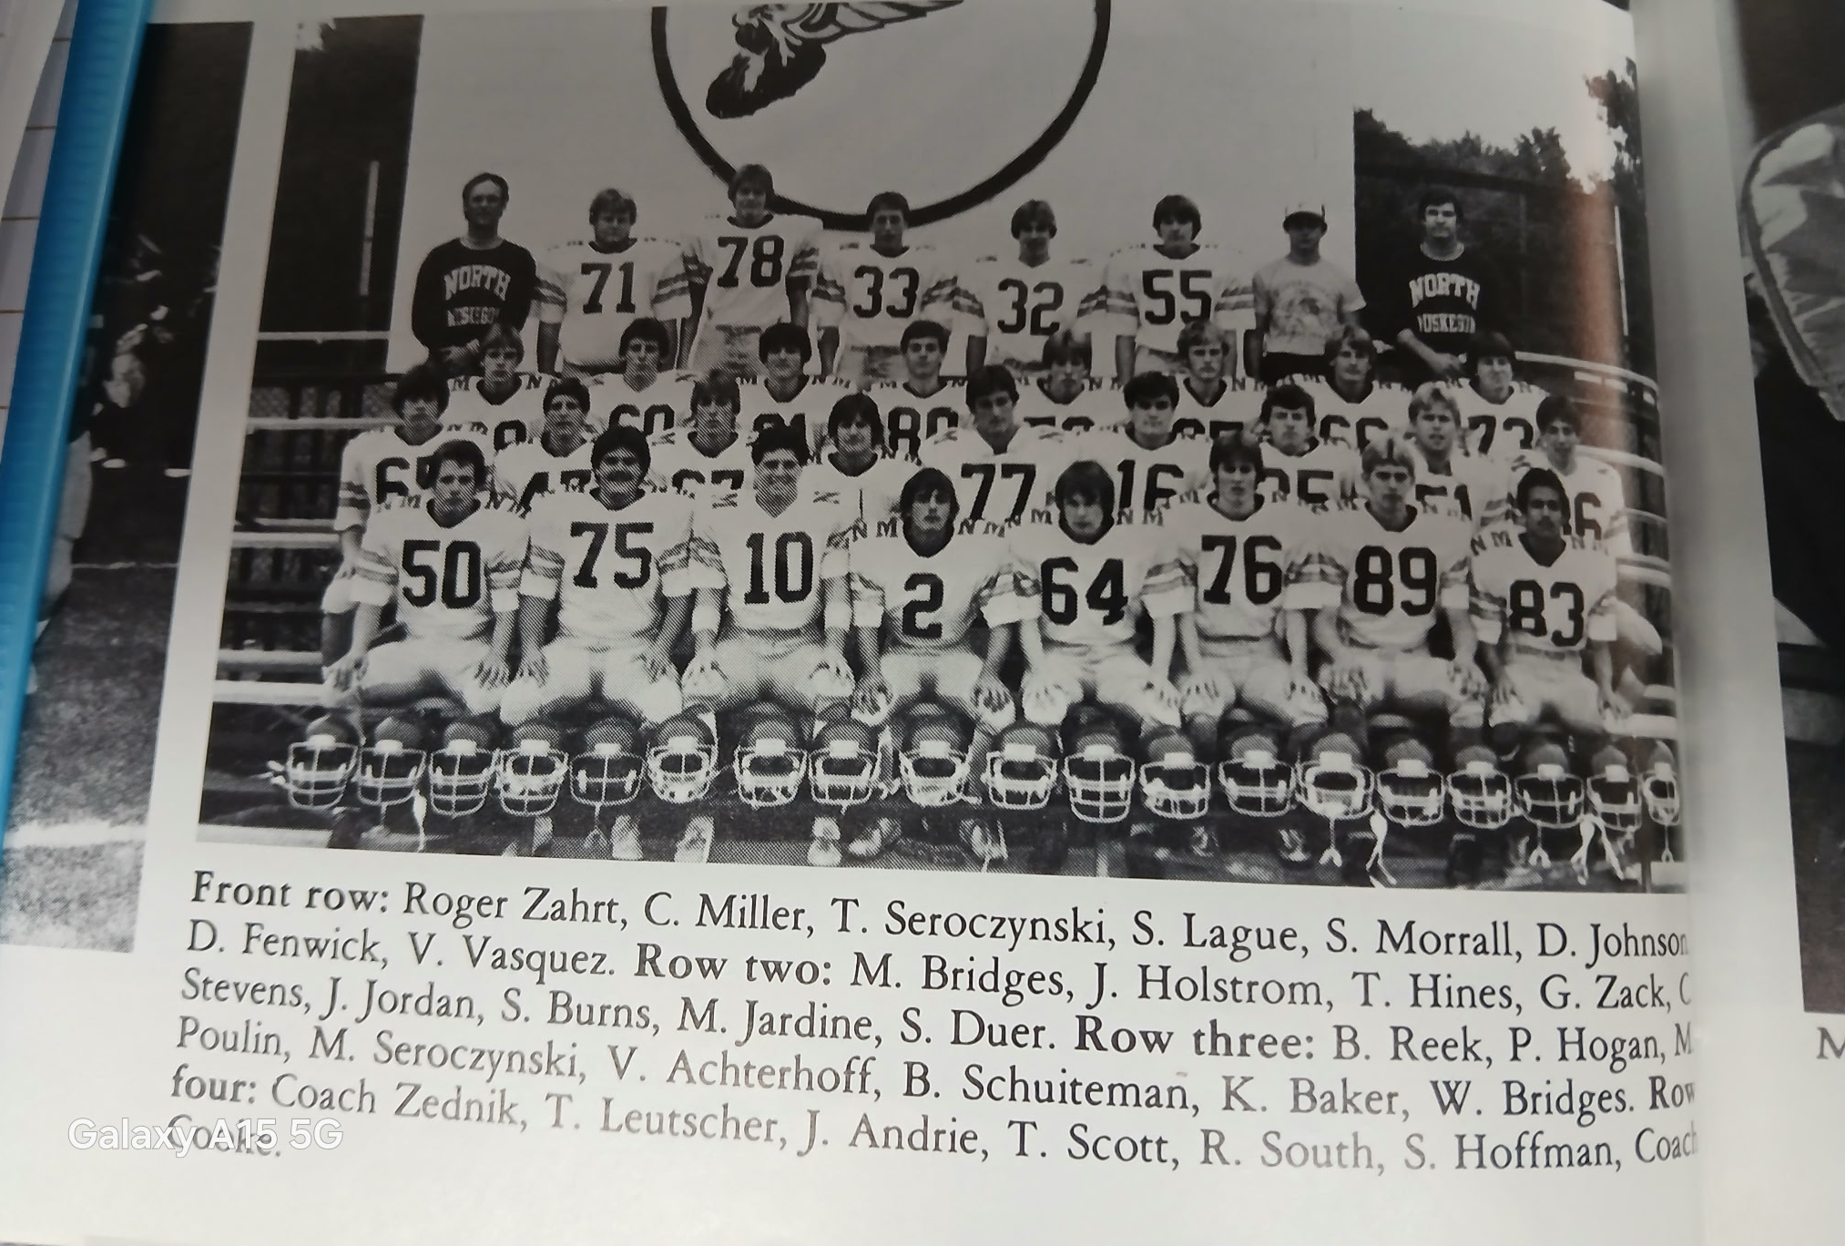

THE 1982 NORSEMEN

1983– Coach Dave Cooke (9-1 overall, WMC champs, state qualifier)

NM Head Coach Dave Cooke was cautiously optimistic for his 1983 team that was coming off a losing 2-7 record from 1982. “I look for us to come back. We’re shooting for .500 or better.” Well, they did better than .500, how about 1.000 for the regular season! NM took those close games they lost with their young team a year ago and completely turned their season around. So dominant was the Norse during the regular season that nobody came within 14 points of the 1983 Norsemen. Seven starters returned on offense including John Andrie who rushed for more than 800 yards in his junior year. Even more starters returned on defense, eight in all with several other lettermen as well as several juniors from the JV team who would contribute heavily to NM’s success. Last year’s starting quarterback Jeff Jordan would be moved to fullback to make room for promising junior quarterback Mike Sekulich.

Unlike the previous season, when fumbles and penalties hurt the inexperienced Norsemen, that was not the case in the opening 17-0 win over Orchard View. NM only fumbled once, but recovered, and had only a handful of penalties in a surprisingly convincing win over the host Cardinals. John Andrie scored two short TDs on runs of 3 & 4 yards while his 20-yard field goal was the only scoring in the first half. So dominant was NM’s defense that OV was limited to but 80 total yards for the entire game.

The Norse had their best offensive output in two years as they totaled nearly 400 yards in offense in a 35-7 rout of Ravenna. NM dominated on both sides of the ball as the defense held Ravenna to just 20 yards in the first half. Mike Sekulich showed he was going to be another good find in the line of NM quarterback as he played a part in three of NM five touchdowns. The junior southpaw throwing QB threw for a pair of TDs, the first to Mark Cooke, the second to Greg Zack and ran for a short TD himself. John Andrie scored the first NM TD from 5 yards out while the final NM tally came when reserve quarterback Sean Duer hit Mike Poulin with a TD strike.

It was another good night for Mike Sekulich, backup tailback Trevor Leutscher, and the North Muskegon defense as NM shut out Montague 30-0. Filling in for the injured John Andrie, Leutscher ran for 143 yards rushing and scored NM’s final touchdown with a 25-yard run. Sekulich tossed for three TD passes, both to brothers of former NM standouts. Sekulich connected with Mike Seroczynski on TD passes from 18 & 24 while the left-handed throwing Sekulich also threw a TD strike to Mark Cooke, the fourth of coach Cooke’s sons to play for NM. Andrie did play some on defense and chipped in with a 30-yard field goal.

Mike Sekulich and Trevor Leutscher again had big games as NM breezed past Mason County Central 35-7. Sekulich had TD passes of five yards to future Muskegon County Sheriff Mike Poulin and a 44-yard completion to Mark Cooke. Leutscher rushed for TDs from 11 and 15 yards as NM rushed for 326 yards. Last year’s quarterback Jeff Jordan, who had muscled up to 200 pounds, accounted for the other NM tally on a 4-yard run from his fullback position.

A healthy John Andrie paced the Norse in a 31-14 victory over Ludington with his play both on offense and defense. Andrie again returned as the NM workhorse of a running back as he carried 20 times for 127 yards and four touchdowns. He also added a pair of interceptions on defense and caused a fumble on a pitchout as the Norsemen improved their record to a surprising 5-0. Trevor Leutscher scored the other NM TD on a short 2-yard run. NM’s pass defense was so solid that they only allowed eight passing yards for the entire game.

Oakridge Hall of Fame Coach Jack Schugars absorbed his largest margin of defeat to NM when his Eagles were shut out 35-0 by the Norsemen. However, over his long and prosperous career, Schugars would accumulate an impressive 19 WMC titles and 262 wins. Special mention should go to NM’s defense that has limited their opponents to only 4 touchdowns all year, with two of those TD’s coming late in the game against the NM reserves. Among those who handled the bulwark of the defensive work were linebackers Craig Stevens and Jeff Jordan, and the front defensive core of Dennis Flynn, Tim Strait, Ben Scheerer and ends Vance Achterhoff and Mike Poulin. And let’s not forget the defensive secondary that was led by John Andrie. The youngest of the four Andrie brothers to play for the Norsemen, John followed his brother Paul to Yale where he became a regular in the Yale secondary. Andrie was a thorn in the side to Oakridge from his defensive back position all night as he intercepted a pair of passes, his fourth interception in the past two games. This marked the first time all season that coach Cooke employed both Trevor Leutscher and Andrie in the backfield at the same time. Leutscher scored a pair of TDs and carried the ball on eight carries for 93 yards against a good Oakridge defense. Although he didn’t catch a TD pass from Mike Sekulich, Mike Seroczynski hauled in three passes for 121 yards with the longest netting 52 yards. Sekulich connected with Mark Cooke for a 9-yard TD pass and sneaked over from the one for the final Norse score. The win over Oakridge put NM in the driver’s seat to return to the top of the pedestal in the WMC as Oakridge fell a game back of the Norse at 4-1 in the league.

The Norse had moved up to sixth in the latest poll prior to a trip to Shelby. NM used the running of John Andrie and a tight defense to shut out Shelby 14-0 to improve to a perfect, and unexpected, 7-0 on the season. Andrie scored one TD, ran for a two-point conversion, and kept the ball away from Shelby through most of the night with a game high 151 yards rushing. Scoring the other NM TD was his running mate in the Norse backfield, Trevor Leutscher, who bulled over from the one in the second half to secure the victory.

NM clinched the WMC title with their second straight 14-0 win in two weeks in Oceana County with their third straight shutout in defeating Hart. The host Pirates outgained NM as the host Pirates ran for 199 yards to NM’s 107. The difference, however, was the Norse passing game as Mike Sekulich threw for 107 yards while Hart only netted a slim five yards. With the Norse leading 7-0 Sekulich connected on a couple of long passes to Greg Zack for 90 yards, the second good for 25 yards and a TD. John Andrie was held below his season average for yardage, but he did manage to gain 82 yards on 18 carries.

North Muskegon then completed their regular season with their fourth straight shutout, and their 11th straight win in 11 games in a 34-0 win over Newaygo. Newaygo didn’t do themselves any favors in their quest to upset the Norse as they lost the ball on fumbles and interceptions seven times. Mike Serocznski had two interceptions and caught one of the three touchdown passes thrown during the game from Mike Sekulich. Greg Zack scored the first two touchdowns on passes from Sekulich. The second of those TDs came in the final minute of the first half on a flea-flicker play. Sekulich hit tight end Mike Poulin on a pass in the flat who in turn lateraled to Zack who sprinted into the end zone from 14-yards out. Tim Straight and reserve Tim Curow scored their only touchdowns of the year late to end the Norse scoring. Again, as they had to wait in the three earlier seasons beginning in 1979, NM had to sweat out the computer rankings to see if they had qualified for the playoffs for the fourth time in five years.

It would be another two years before Whitehall would return to the WMC after more than 20 years being a member of the Seaway. Who knows who would have won if the two long-time rivals would have played one another in 1983? If the two teams had met and Whitehall would have won, then it would have been Whitehall that would qualify for the playoffs, and not NM. However, due to their strength of schedule NM squeaked into the playoffs and they would once again head to Houseman Field to play an undefeated Comstock Park team coached by a young John Shillito.

After giving up but 28 points during the regular season, Comstock Park nearly matched the Norse season total for points allowed as they shut out the Norse 26-0. One of the spectators at Housemen Field was former North Muskegon three-sport star Tom Stribley, the athletic director at the time at Orchard View. So impressed was Stribley with Comstock Park and their coach John Shillito, that Stribley coaxed Shillito to come to Orchard View a couple of years later to guide the Cardinals. Comstock Park’s quarterback Jack Houghton was the star of the evening with two TD runs and two TD passes as Comstock Park ended NM’s season at nine wins against the single loss. It also was the first time in 54 games dating back to 1978 when NM was shut out in a game. The Norsemen can take pride that in a county where football reigns supreme, they were the only football team from the area that qualified for the 1983 playoffs.

NM dominated the WMC All-Conference team like never before as they landed eight starters on the All-Area team with seven on the offensive unit. Making the grade were center Frank Cobb, end Mark Cooke, tackle Theron Hines, Guard Craig Stevens, quarterback Mike Sekulich, back Trevor Leutscher and kicker John Andrie. Surprisingly, the Norse only had one tabbed to the defensive team despite shutting out four of their conference opponents and allowing but 14 points, defensive end Mike Poulin. What’s further puzzling is that although he didn’t make the first team all WMC-defensive team, John Andrie made first team All-State as a defensive back. Craig Stevens, rated tops in his class academically, also made first team All-State as an offensive lineman.

Record Score Interesting Fact
- NM 17, Orchard View 0 John Andrie 2 TDs (3 & 4 yds) 20-yard field goal. OV only 80 yds.
- NM 35, Ravenna 7 Mike Sekulish 2 TD passes (Mark Cooke & Greg Zack) 2 yd run.
- NM 30, Montague 0 Sekulich 3 TD passes (2 to Mike Sereczynski, 1 to Mark Cooke) Trevor Leutscher 25 yd TD and 143 rushing yards.
- NM 35, Mason Co 7 Leutscher 2 TDs (11 & 14) Sekulich TD passes to Cooke and Poulin.
- NM 31, Ludington 14 Andrie 4 TDs, 127 yds rushing & 2 int, Leutscher 2-yd TD
- NM 35, Oakridge 0 Leutscher 2 TDs (11 & 15), Andrie TD & 2 Int. Cooke 9 yd. TD rec.
- NM 14, Shelby 0 Andrie TD and 151 yds rushing. Leutscher one-yard TD.
- NM 14, Hart 0 Sekulich to Zack 25-yard TD, Sekulich 1-yard sneak for TC.
- NM 34, Newaygo 0 Sekluch 3 TD passes, 2 to Zack, 1 to Serocynski.
9-1 NM 0, Comstock Park 26 NM shut out by Comstock Park and coach John Shillito.

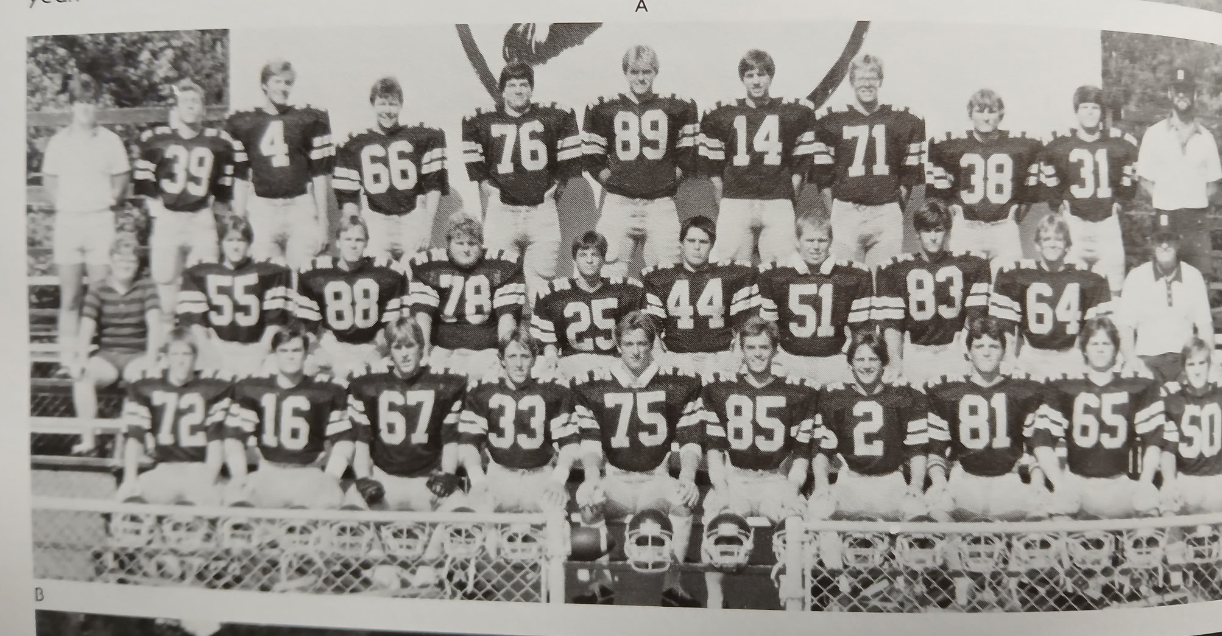

The 1983 NORSEMEN
1st Row L-R: Vance Achterhoff, Joff Jordan, Therron Hines, John Andrie, Clark Stevens, Mike Seroczynski, Greg Zack, Mike Poulin, Frank Cobb
Middle Row L-R: Art Benedict (Mgr.) Rick South, Bill Reek, Todd Leutscher, Scott Belote, Tim Strait, Mike Jardine, Steve Fowler, Jerry Johnson, head coach Dave Cooke
Top Row L-R: Asst coach Larry Witham, Bill Schornagel, Michael Sekulich, Dennis Flynn, Ben Scheerer, Mark Cooke, Sean Deur, Scott Smith, Trevor Leutscher, Trip Curow, coach Ed Zednik

1984– Coach Dave Cooke (5-4 overall, 3rd IN WMC - Montague champs)

Although expectations to have another perfect season were not met, NM posted a winning record for the 1984 season as they once again played a tough schedule. NM’s enrollment had now dipped where they moved down from Class C to D with two of their non-conference opponents on their schedule competing in Class B. Ed Zednick once again joined Dave Cooke as his varsity assistant with veteran John Campione returning as the head JV coach. Campione would have as his assistant a youngster just five years removed from graduating from NM, Larry Witham. Leading the Norse returnees were All-WMC honorees from the previous season, quarterback Mike Sekulich, running back Trevor Leutscher and end Mark Cooke. The big problem Cooke would face to begin the season was who would be a part of his offensive line as only Mark Cooke returns from his front seven from 1983. One of the players counted on to ignite the Norse offense would be junior Tom Dana, who rushed for over 1500 yards on the junior varsity team.

The traditional opener with Orchard View appeared to be heading for their second overtime game in the past three years but the Cardinals had better ideas. With the clock winding down late in the contest OV’s Bob Larabee galloped 53 yards down to the NM 12. Three plays later Larabee was in the end zone, and the Cardinals were 6-0 winners over the Norse, reversing the 0-6 loss to the Norse in 1981. Stats were nearly even for this defensive battle. Catching a pair of passes for OV for 30 yards was John Jancek. Jancek would later have a stellar career as a defensive coordinator for such college powerhouses as Tennessee, Georgia and currently as of this writing, LSU. Junior Tom Dana had a modest 62 yards on 14 carries for the Norse.

The Norse finally, for one game at least, had their offense clicking in a 41-13 victory over Ravenna. Tom Dana had a pair of touchdowns and 10 tackles on defense to lead the Norsemen. NM tallied three TDs in the second quarter to pull away from the Bulldogs. NM’s early lead following a Dana one yard TD was short-lived as the Bulldogs Bill White returned the NM kickoff back for a TD. Touchdown runs in the second period by Tom Dana (30), Mike Sekulich (6) and Trevor Leutscher turned the game in NM’s favor at halftime. Dana rushed for 120 yards on 11 carries while Sekulich ran for an additional 64 for the victors as NM evened their season record at 1-1.

Montague won their third game vs North Muskegon in a 20-year span, and they did it in convincing fashion with a 22-0 whitewash of the Norse. Montague, who would be the WMC champs in 1984, had all three of their touchdowns scored by Steve Jancek. The Norse rushing attack was led by Tom Dana with 60 yards as Montague limited NM’s passing game to but five yards. The final Montague touchdown came following a quarterback sack and subsequent fumble returned to the NM 3-yard line with Jancek running for the score on the next play.

NM’s first four games were like a roller coaster ride with their ups and downs. Shut out in the first game, scoring 41 in the second, back to zero points in the third and then another 40-point game in the fourth contest following a 43-7 win over Mason County Central. It didn’t at first appear that it was going to a Norse runaway at the onset of the game as Mason County scored first just before the end of the first period. NM then scored 43 unanswered points to pull away from the Spartans to even their record at 2-2. The Norse went ahead on a pass from end Mark Cooke to Sean Deur (that’s what the Chronicle wrote). Deur scored the first NM TD on a 14- yard run. Deur was very active for the Norse as he scored the first of three NM TDs in the third period on a 42-yard pass from Mike Sekulich. Tom Dana scored a pair of TDs for NM and led the Norse rushing attack with 117 yards and ran for a two-pointer. NM tackled a Mason Co runner in their end zone for a safety and on the following Spartan kick off Dana scored his second and the game’s final TD on a 55-yard kickoff return.

The Norsemen made the long trek up US 31 to play Ludington for the second straight year. They were victorious again, but it was not as easy as the previous season. Trailing 7-0 in the fourth quarter NM scored on a 59-yard run by Tom Dana. Coach Dave Cooke rolled the dice and decided to go for two and the win. Good decision. Mike Sekulich ran the option and escaped several Oriole tacklers to cross the goal line for the game winning two-pointer as NM win’s 8-7.

It took two overtimes for the Norse to earn a hard-earned 16-13 victory over Oakridge. NM seemingly had the game wrapped up leading 10-0 in the final period. But Oakridge fought back with a TD to bring the Eagles within two. With three minutes left in regulation Bill Riegler broke through the NM line and blocked a Tom Dana punt deep in Norse territory. The Eagles couldn’t score the go-ahead TD but called on Mike Latsch for a field goal to tie the game. The field goal just made it over the cross bar, and the two evenly matched teams were headed for overtime tied at 10-10. NM scored first on a 26-yard field goal by Mark Flynn to give NM a 3-0 lead at halftime. NM took advantage of an Oakridge fumble in the second half and scored their only TD in regulation on a 28-yard pass from Mike Sekulich to Orin Bush. Neither team was able to score in the first overtime. Oakridge settled for a second field goal by Latsch to give the Eagles a 13-10 lead. The Norse then scored when Mike Sekulich squeezed into the end zone from one yard out to give NM the win.

NM scored a touchdown in every quarter as they shut out Shelby 28-0 to improve to 5-2 on the season. Tom Dana scored on short TD runs of 7,11 and 2 while the other NM TD came on a 10-yard pass from Mike Sekulich to Scott Robarge. Sekulich was an accurate 8 of 10 in passes for 104 yards while the Norse rushed for 247 yards, with Dana topping the century mark with 114 yards.

NM would drop their final two games of the 1984 season as their offense failed to find the end zone in either contest. NM was first shut out by Hart 7-0 as they failed on a couple of scoring opportunities. A 23-yard attempted field goal was blocked in the second quarter, and a second golden opportunity went awry as the Norse fumbled at the Pirate 5-yard line with less than six minutes remaining in the game. Tom Dana failed to score after his 3-TD performance in last week’s win over Shelby but did lead NM with 76 yards in 19 carries.

After dropping their first 11 games to the Norsemen in a series that dated all the way back to 1935, Newaygo finally got on the winning side with a 22-0 shutout of the Norsemen. It was too much Dan Webber as the Lion running back gained 171 yards while scoring all three TDs to end the Norse season with a 5-4 record. Newaygo would end their season with an 8-1 season but would not qualify for the playoffs. The same was true for the undefeated Montague Wildcats who ended their season with a perfect 9-0 record which exemplifies how difficult it was before the playoffs expanded to even make the post season.

Pickings were slim for NM as far as All-WMC-Conference honors were concerned. For the first time in memory, NM failed to place a single player on the All-Defensive team but did manage to have three offensive players tabbed to the All- Offensive team: Quarterback Mike Sekulich, running back Tom Dana, and center Dennis Flynn. After qualifying for the Playoffs in four of the last four years, there would be no playoff games for the Norse following the 1984 season.

Record Score Interesting Fact
0-1 NM 0, Orchard View 6 OV scores in 4th quarter for the win. Tom Dana 62 rushing yds.
1-1 NM 41, Ravenna 13 Dana 2 TDs and 120 yds rush. Sekulich TD run and TD pass to Cooke.
1-2 NM 0, Montague 22 WMC champs Montague shuts out Norse. Dana 60 yds rushing.
2-2 NM 43, Mason Co 7 Deur passes and receives TD pass. Dana two TDs, 8 yd run, 55-KO ret.
3-2 NM 8, Ludington 7 Dana 59 yd run for only NM TD. Sekulich runs for GW 2-points.
4-2 NM 16, Oakridge 13 Sekulich 1 yd TD in 2nd ot for win. Sekulich to Orin Bush 26 TD pass.
5-2 NM 28, Shelby 0 Dana 3 TDs (7, 11 & 2) Sekulich to Scott Robarge 10 yd TD pass.
5-3 NM 0, Hart 7 NM had FG blocked and fumbled deep in Hart territory.
5-4 NM 0, Newaygo 22 8-1 Newago limits NM to under 100 yards in total offense.

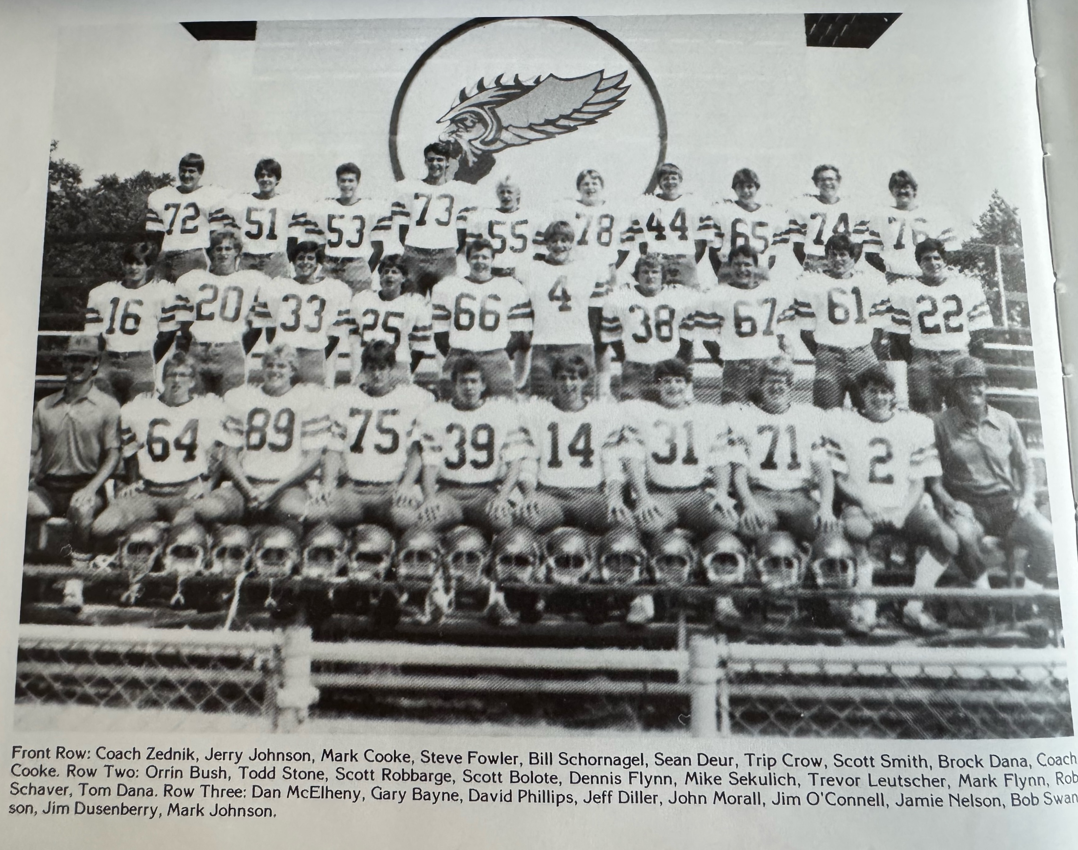

THE 1984 NORSEMEN

1985– Coach Dave Cooke (5-4 overall, Oakridge Champs)

Now a Class D school with the loss the previous year of a few Duck Creek students who previously elected to attend NMHS as their school of choice, the 1985 Norsemen will have a few proven players, but with diminishing numbers, depth will pose a problem, especially in case of injuries. Added to the NMHS coaching staff was former Reeths Puffer Head Coach Ed Shroeder, who also was Cooke’s trusted assistant when Cooke was the head coach at Reeths Puffer. Ready to start again for the Norse are tailback-cornerback Tom Dana, an All-Conference first team selectee from 1984, two-way end Jeff Diller, fullback linebacker Mark Flynn and split end-safety Scott Robarge. Cooke’s biggest need would be to find offensive lineman to block for Dana and his mates. Cooke would inherit a group of talented juniors and sophomores who would play significant roles in any Norse success. The Norse would repeat their 5-4 season, but the experience gained from their underclassmen would lead to a huge run in 1986.

The season didn’t begin well for the Norsemen as they were defeated by Orchard View 19-3. NM did get on board first with a 19-yard field goal but the rest of the game it was all Orchard View. One of three Orchard View touchdowns was scored by quarterback Rob Wortelboer on a 17-yard run. Wortelboer and your author would become acquainted when we both were residents in Ponte Beach Florida. Rob’s son was an outstanding lineman for a Ponte Vedra team that played in the state championship game in 2016 at the Citrus Bowl in Orlando.

The Norsemen found a running back to complement Tom Dana in junior Donte Hutcherson in NM’s last minute come from behind 20-16 victory over Ravenna. Trailing 16-14 the Norse mounted a 70-yard drive with little time remaining. A successful 26-yard pass play moved NM to the Bulldog four whereby Hutchinson scored his second TD of the game from 4-yards out to give the Norsemen a 20-16 win. Earlier in the game Hutchinson scored the first of his two TDs by gathering in a screen pass and racing 33 yards for a tally. Each team received fortuitous TDs at the expense of one another. First, NM’s Brian Diller scooped up a Ravenna fumble and rushed 16 yards into the end zone. The Norse then reciprocated as Ravenna’s Dave Wilburn then scooped up a NM fumble and breezed into the end zone for the Bulldogs first score. With less than two minutes to go in the game Tim Hahn scored on a four-yard sweep. A two-point conversion gave Ravenna a two-point lead at 16-14 before NM mounted their comeback. Tom Dana and Hutcherson gave NM a nice 1-2 combo as Dana rushed for 97 yards while Hutcherson gained 68 yards in the Norse win.

How do you lose a game 31-0 while compiling more total yards and holding your opponent to minus 19 yards offense and no first downs in the first half? Yet, that was the fate of North Muskegon in their game with Montague. There was no scoring in the first half as the Norse were inside Montague’s 15-yard line three times but failed to score. However, sometimes stats do lie as Montague scored 31 unanswered points in the second half to stun the Norsemen. NM even had more first downs then the winners, but three fumbles contributed to the defeat.

Dante Hutcherson and Tim Dana accounted for all the scoring in NM’s 27-6 victory over Mason County. Hutcherson capped a long NM drive with a four-yard burst for the first Norse score with Tom Dana following that TD with a seven-yard scamper. Hutcherson then salted this game away with a 52-yard punt return. After the host Spartans scored their only TD in the second half, Dana then broke through a big hole in the line of scrimmage and raced 79 long yards for the final Norse score to even their season’s record at 2-2.

NM and Whitehall then met for only the second time in 20 years as Whitehall had returned to the WMC after a long stint in the Seaway Conference. NM Coach Dave Cooke best summed up what had transpired in NM’s 31-26 win over the Vikings: “It was a see-saw battle,’ said the Norse mentor. And that it was. The first three NM touchdowns would be followed by a Viking TD before NM broke the skein with two consecutive tallies late. NM quarterback Orin Bush only threw for 89 yards on the night but three of his completions went for six points. Bush’s first TD toss went for 33-yards to Jeff Diller, but Whitehall quickly responded with a TD of their own. A second Bush 14-yard TD pass to Mark Flynn was answered with a long 57-yard pass by Whitehall from Randy Lorenz to speedy Jeff Cox. NM rushed for 289 yards on the night with 60 of those yards coming on the third NM TD by Tom Dana. Again, Whitehall scored to take a 20-19 lead over NM. The Norse then finally broke ‘we-score-you score’ trend by scoring the next two TDs, the first on a Dante Hutcherson 33-yard scamper, the second on Bush’s 10-yard pass to Dana. Whitehall closed out the scoring in exciting fashion as Lorenz teamed up with Cox on a long 96-yd TD reception to make the final score 31-26.

North Muskegon’s Fred Jacks field hadn’t been kind to Jack Shugars and his Oakridge Eagles. The Norse had outscored Schugars on the Northside field in their three home wins 73-0. Oakridge didn’t score much in their fourth trip to NM under Schugar’s leadership. However, the one TD on a 45-run run by tailback Fred Stewart was all the points needed in Oakridge’s 8-0 win over NM. It was the 6th straight win for the Eagles who would run the table and qualify for the first of many trips to the playoffs under the long and successful leadership from Schugars. It was a night where defenses ruled on a sloppy NM field. The stats slightly favored the Norse, and they had a couple of golden opportunities, but the Eagle defense led by Chad Brandow stymied Norsemen drives deep in Eagle territory. The NM duo of Dante Hutcherson and Tom Dana combined for 140 yards, but neither was able to cross the Oakridge goal line.

It was total domination by the NM defense and the running of Dante Hutcherson that propelled NM to a 34-0 shutout over Shelby. Hutcherson ran for three TDs on runs of 4, 1, and 33 and totaled 123 rushing yards for the game. Tom Dana contributed 70 yards rushing and a nine-yard TD as NM amassed 334 yards for the game while the defense limited the Tigers to only 30 yards. Reserve running back Ted Jahanshahi got in on the scoring with a late eight-yard TD.

The stats were even but the final score showed Hart edging the Norse 12-7 as the Norse were now at .500 on the season at 4-4. Hart scored the first two TDs before Dante Hutcherson scored a late TD from four yards out in the final quarter for the only NM score on the night. NM would need a final game victory over Newaygo to have a winning season and get some much-needed momentum heading into 1986.

It wasn’t easy but the Norse did just that. In fact, NM had to use an overtime session to earn the 20-19 victory and even that was done in dramatic fashion. Both teams were tied at 13 all at the end of regulation. Newaygo got the ball first and scored on one of Dan Webbers three TDs on the night. Newaygo faked the extra point kick to surprise the Norse, but NM intercepted the ball in the end zone to keep the Newaygo lead at 19-13. After three plays and a fumble recovery the Norse were faced with 4th & goal at the eight. Orin Bush hit Dante Hutcherson with a screen pass, and the junior speedster did the rest as he sped into the end zone. Mark Flynn then booted the game winning extra point, and the Norse had a winning season at 5-4. Hutcherson rushed for 165 yards on the night that included a long 69 yd TD gallop.

Hutcherson would make the UPI first team All-State team following the season. Dante was a multi-purpose performer for the Norsemen; running for 857 yards, catching 23 passes for 290 yards and made a couple of key interceptions. Best of all for Norse fans, he would return in 1986. His running mate Tom Dana would be accorded honorable mention all-state honors as well as Jeff Diller while Mark Flynn, Diller, Tom Dana, and Hutchinson would make the WMC honor squad along with tackle Mark Johnson.

Record Score Interesting Fact
0-1 NM 3, Orchard View 19 NM only a 19-yd FG.
1-1 NM 20, Ravenna 16 Donte Hutcherson 2 TDs, 33 Pass rec, & 4 yd run. Diller 16 yds on a fumble recovery and run.
1-2 NM 0, Montague 31 NM holds Montague to minus yardage in first half but loses.
2-2 NM 27, Mason Co 6 Hutcherson 2 TDs (4 and 52 punt ret, Dana 7- & 79-yard runs.
3-2 NM 31, Whitehall 26 Bush 3 TD passes, Dana & Hutcherson 2 TDs.
3-3 NM 0, Oakridge 8 2nd qtr. 45-yd run dooms NM. Hutcherson & Dane 140 yds.
4-3 NM 34, Shelby 0 Hutcherson 3 TDS (4, 1 & 33) Dana 9 yd TD. Ted Jahanshihi TD.
4-4 NM 7, Hart 12 Hutcherson only NM
5-4 NM 20, Newaygo 19 Mark Flynn’s Extra point in OT the winner. Hutcherson 2 TDs.

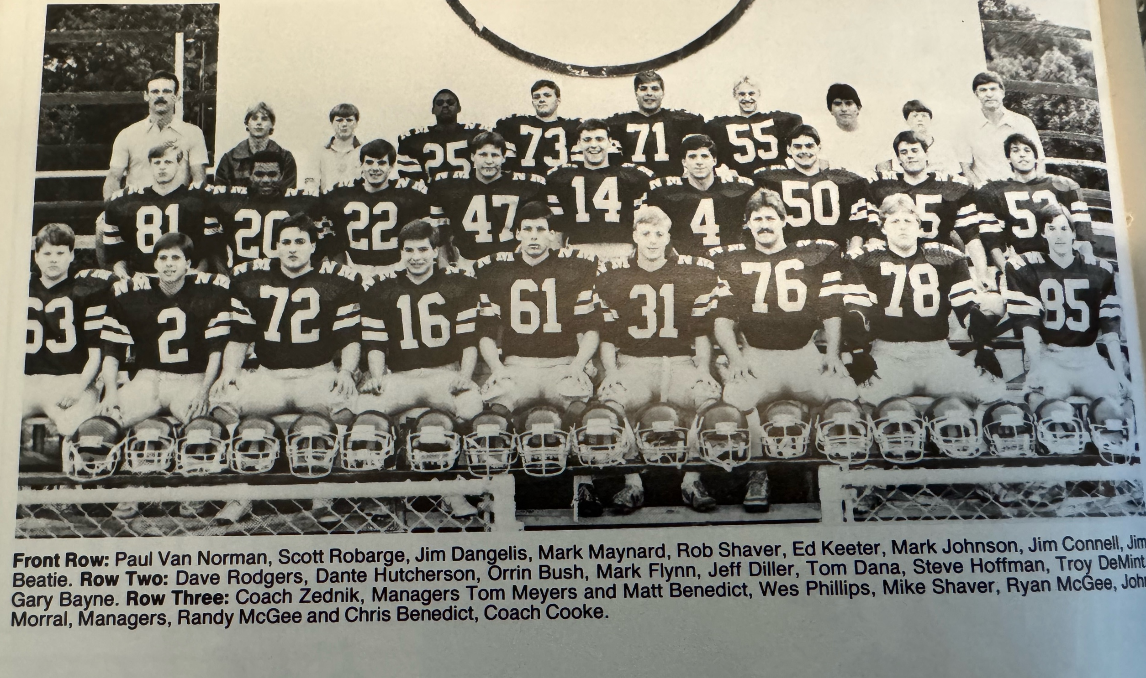

The 1985 NORSEMEN

1986– Coach Dave Cooke (11-1 overall, State semi-finalist, WMC Champs)

What a year it was for North Muskegon and for Greater Muskegon football! The Norsemen came one TD away from going to the state finals to join Muskegon and Muskegon Catholic at the Pontiac Silverdome. One must remember it was twice as difficult to make the playoffs through 1989 as there were only four divisions/classes who would qualify. Muskegon would lay claim as the state’s number one team as they won the Class A state title in front of the largest single day attendance crowd in state finals history. And who was the head coach for Muskegon? None other than former North Muskegon standout and three-sport athlete Dave Taylor, NM Class of 1959.

NM, a Class D school, once again opened their 1986 schedule against Class B opponent Orchard View. This was the first game that OV would play under their young 29-year-old coach John Shillito. Fast forward to 2024 and Shillito would win 340 games and five state titles before announcing his retirement. However, Shillito would have to wait to earn his first win as the mentor of OV as the Norsemen won 22-12. The final score might lead one to believe it was an easy win for NM but that surely was not the case. NM trailed 12-9 heading into the final quarter and did not take the lead until Mark Maynard hurled a 30-yard TD pass to Brian Diller. With time running out Dante Hutcherson iced the game with a 34-yard TD run. Diller was on the receiving end of a pair of TD passes, the first a 39-yard toss from Hutcherson and caught six passes on the night for 158 yards. Kyle Stevens, who led Norse tacklers with 11, scored the first three points for the Norse with a 25-yard field goal. Hutcherson, an all-state running back last season for NM showed he hasn’t lost his touch as he rushed for 169 yards and completed six passes for 119 more yards.

In a game where it appeared --whoever has the ball last would be the winner-- was certainly the case in NM’s wild 27-20 victory over Ravenna. Before the game winning touchdown on a pass from Mark Maynard to Joe Flynn, each of NM’s three touchdowns would be followed by a Bulldog TD. Dante Hutcherson was again the ‘Man of the Hour’ as he scored three of the four NM TDs and rushed for 145 yards. Ted Johanshahi added 70 yards as NM totaled 286 rushing yards in the victory.

With Montague limiting Dante Hutcherson’s ability to run from his quarterback position, coach Dave Cooke inserted Mark Maynard in at QB and moved Hutcherson to tailback. The move paid off as Hutcherson then rolled for 175 yards and two TDs as NM defeated Montague 28-6. Cooke made his switch late in the second quarter and it paid quick dividends as Hutcherson ripped off runs of 19 and 43 yards to set up a two-yard TD by Wes Phillips. The NM defense, led by linebackers Kyle Stevens and Scott Mahoney limited Montague to only 32 rushing yards during the game while NM totaled 278.

The Muskegon area in September of 1986 was attempting to dry out after torrential rains brought as much as 12 inches of rain over a two-day period. Fortunately for area football fans Friday night was dry and perfect for football. Mason County gave NM a brief scare as NM had to mount a rally and survive a controversial non-touchdown in the first half by MCC. At first a Mason Co TD on a fourth downplay was called a TD but an alert Coach Dave Cooke protested that the receiver was an ineligible receiver. Cooke’s protest was correct, and the teams remained scoreless at halftime. MCC scored first before NM rallied to score two second half TDs for the win. On NM’s drive following the MCC TD the Norse, with the big play a 43-yard dash by Dante Hutcherson, scored on Dante’s one-yard run. Ted Jahanshahi applied a big hit on a Spartan runner to cause a fumble on a loose ball at the Spartan 17 to set up the game winner. Hutcherson then scored once again from the one to give NM a perfect 4-0 record.

NM won a thriller when Kyle Stevens, who missed an earlier extra point, didn’t miss when it counted the most as his 18-yard field goal with only nine seconds left in the game gave NM a 22-20 win over host Whitehall. Trailing 20-13 Whitehall scored early in the fourth quarter to move within one of the Norse. Rather than a potential game tying extra point head coach John Huizenga gambled and went for two. The conversion pass from Joe Burmeister to end Scott Lamiman was good and the Vikings had a one-point lead. NM began their winning drive on its own 47-yard line with time running out. The big play in the drive was a screen pass on third and four from Dante Hutcherson to Scott Mahoney that went for 16 yards and a first down at the Whitehall two-yard line. NM was out of timeouts and rather than risk a run that might come up short, Coach Dave Cooke sent in Kyle Stevens who drilled the chip shot field goal through the uprights to give the Norse a 22-20 victory. Dante Hutcherson once again did the bulk of the running for NM with 173 yards rushing and one TD. Brian Diller accounted for the first NM tally on an 8-yard pass from Mark Maynard, Ted Jahanshahi the other on a one-yard plunge.

For the second straight week the Norse ‘cardiac kids’ pulled another victory out of their hat with a 16-14 victory over Oakridge. It wasn’t a game winning kick as it was last week in the final seconds against Whitehall, but when the final horn had sounded a Kyle Stevens 27-yard field goal was the difference in the game. Oakridge got on the board first on the first of Mike Postema’s long TDs, the first from 656 yards, the second a 57-yard dash to the end zone. Sandwiched in between Postema’s TD gallops was the Stevens field goal that had Oakridge leading 14-3 at halftime. The Norse received the second half kickoff but quickly fumbled the ball away. Not to be deterred NM mounted a long 87-yard drive with fullback Scott Mahoney plowing in from the seven. NM failed on their two-point attempt as the score stood at 14-9. With 4:48 left in the game NM’s Ted Jahanshahi recovered an Oakridge fumble on the Norse 35. Two runs of 22 and 28 by Mahoney gave the Norse first and goal from the 10. Two plays later Dante Hutcherson scored from eight yards out to give the Norse their first lead of the night. Stevens extra point kick gave NM the lead and the win at 16-14 to send 3,000 Oakridge homecoming fans home disappointed. Hutcherson had another good game on the ground with 133 yards while Mahoney bulldozed his way for 95.

Dante Hutcherson gained 200 yards on the ground while scoring all four NM touchdowns as NM improved to a perfect 7-0 on the season and 6-0 in the WMC following their 27-6 victory over Shelby. Hutcherson’s last TD was one for the books. Faced with a near hopeless third and 37 from their own 19-yard line, Hutcherson broke loose and galloped 81 yards to paydirt. Hutcherson scored a touchdown in each quarter from 1, 33, and 20 before his longest TD run of the night and of his career. The Norse garnered all 287 of their total yards for the game on the ground as NM’s front line was creating holes for the NM backs. Coach Cooke gave special praise for the win to his front five of center Steve Hoffman, guards Kyle Stevens and Troy DeMint, and tackles Mike Shaver and Chip Vanderwier. Ryan McGee had a special night on defense for the Norse as he was credited with 19 tackles.

NM then made it a clean sweep of the WMC with a 28-8 victory over Hart. The NM ground game was again working to perfection as they pounded out 322 rushing yards with 158 of those credited to Dante Hutcherson. Scott Mahoney rolled up 87 while Ted Johanshasi added 42 more yards to the Norse total. Hutchinson added three more TDs to his already impressive season total while NM even found their passing game. Mark Maynard connected on a 9-yard TD pass to Brian Diller for one of four NM tallies on the night.

With only one regular season game remaining it was time to check the computer playoff rankings to see where the Norse stood in their quest to return once again to post-season action. Playing virtually and All Class C schedule, with Orchard View a Class B opponent, the Norse were assured of advancing with a win or a loss to Newaygo. Playoff restrictions had eased the last couple of years as now four teams from each region would advance, instead of two in the early years of the playoffs.

NM ended an eight-year series with Newaygo that began in 1979 with a 25-0 shutout over the Lions. Since the rivalry began back in 1935 it was a series dominated by NM as they had won 15 of the 16 games. It would be another 30 years before the two teams would again collide in a playoff game. The Norse struggled with the Lions at the onset of the regular season finale, so much so that Coach Cooke, needing a spark, moved Dante Hutcherson to quarterback. On its third possession Dante guided the Norse on a 12-play 81-yard drive that was culminated by sophomore Scott Mahoney’s 5-yard run. Then it was TD time for Hutcherson as he scored the final three TDs for the Norsemen to bring his season total up to 20 as NM completed their fourth undefeated regular season schedule in just the seventh year for Dave Cooke as the NM coach.

No longer would first round playoff games be played at a neutral site as the MHSAA allowed all opening round games to be played at the home of the team with the higher computer points. Thus, Norse fans enjoyed the home opener as NM hosted Reading High who had to make the 175-mile journey to North Muskegon. NM was one of three Muskegon teams to qualify for the playoffs in 1986 as Muskegon and Muskegon Catholic also qualified. With the NM-Reading game played on a Friday night, and with the Big Reds and Crusaders playing their openers the following afternoon, I was excited to work NM’s game for WKBZ on the radio. With a night off, my halftime guest was Muskegon coach and former Norseman Dave Taylor, who was able to watch his alma mater defeat Reading 19-0. NM scored a pair of fourth quarter touchdowns to give the Norse some breathing room as Reading was only one score away from pulling off an upset before Dante Hutcherson raced 59 yards to give NM a two-score lead. Two-way starter sophomore Scott Mahoney then sealed the victory with a 20-yard interception of a Reading pass. NM scored the only touchdown in the first half when the do-it-all Hutcherson returned a Reading punt 48 yards for six points.

NM would head to Battle Creek to battle a Schoolcraft team coached by Larry Ledlow. If you investigate the MHSAA record book, you will find Ledlow with the highest winning percentage all time for all who coached in the many years of high school football in the State of Michigan. However, NM didn’t contribute to Ledlow’s winning percentage as NM pulled off a dramatic 10-7 overtime victory over Schoolcraft. Kyle Stevens 28-yard field goal in OT would prove to be the difference but the kick was not a walk-off winner. No, NM fans would have to sweat out four downs of a Schoolcraft possession as the Eagles won the toss and elected to go on defense in the overtime. After gaining no yards on their first two possessions starting at the NM ten-yard line, coach Ledlow elected to attempt a pair of passes to earn the win. Dante Hutcherson has been the catalyst for numerous Norse victories on the season for his outstanding offensive work, but it was his defense that saved the day for his Norsemen. Dante broke up both pass plays to send NM into the semifinals a week later against Fowler. Schoolcraft, who had just a short journey to nearby CW Post stadium in Battle Creek, took a halftime lead over the Norse by rushing for a TD on their first possession of the game. Hutcherson, now playing quarterback for NM, ran the option play 34 yards in the third period for NM’s only TD of the game and Hutcherson’s 23rd TD of the season. Stevens kick was good that set up the game’s histrionics in overtime.

NM had won six games during the season by coming from behind in the second half but that was not the case in their 6-0 loss to Fowler in the state semi-final game played again at CW Post stadium in Battle Creek. However, it was in the first half when NM failed to score deep in Fowler territory that contributed to their only defeat in 1986. NM on their very first possession had first and goal at the Fowler nine but failed to score. On their very next possession NM marched to the Fowler 24 before being stopped on downs. On the next possession Fowler scored the only touchdown in the entire game, a 61-yard option run in the second quarter. As of this date (2025) it was the only game played between the two schools. A win would have given the Muskegon area three teams in the state championship game as eventual state Class A champ Muskegon and Muskegon Catholic won.

Nineteen Eighty-Six was the beginning of a long run where the Muskegon Area could boast of being King football in the state of Michigan. As one might expect following the great season of 1986 many of the Norsemen were accorded post-season honors. None more so than Dante Hutcherson. An easy choice for all-area, all-conference, and

Dante set a NM season rushing record with 1759 rushing yards. In his two years as a Norsemen gridder his 2616 career rushing yards were third behind two NM legends, Stan Guy, and Paul Andrie. Also picked for post-season honors were end Byron Diller, tackle Chip Vanderwier, guard Troy DeMint and kicker Kyle Stevens on offense. Stevens and Hutcherson were also picked on defense, along with lineman Ryan McGee.

Record Score Interesting Fact

- NM 22, Orchard View 12 Brian Diller 2 TD rec, Dante Hutcherson 39 yd TD
- NM 27, Ravenna 20 Hutcherson 145 yds & 3 TDs. .
3-0 NM 28, Montague 6 Hutcherson 2 TDs & 175 rushing yds. Wes Phillips & Johanshihi TDs.
- NM 13, Mason Co 7 Hutcherson 2 TDs as NM rallies for win.
- NM 23, Whitehall 21 Kyle Stevens FG the winner. Hutcherson TD & 173 yds. Diller TD.
- NM 16, Oakridge 14 Hutcherson’s 8-yard TD late the winner. Mahoney 7 yd TD.
- NM 27, Shelby 6 Hutcherson 4 YTDs, (1,33,20 & 81) and 200 yds rushing.
- NM 28, Hart 8 Hutcherson 3 TDs 158 rush yd. Maynard to Dillard 9 yd TD pass.
- NM 25, Newaygo 0 Hutcherson 3 TDs 149 rush yd. Scott Mahoney 5-yd TD.
10-0* NM 19, Reading 0 Hutcherson 2 TDs, 59 yd run 48 punt ret. Mahoney 20 yd int TD.
11-0* NM 10, Schoolcraft 7 Stevens FG in OT wins, Hutcherson 34 yd TD & 2 pass breakups.
11-1* NM 0, Fowler 6 NM ends magical season.

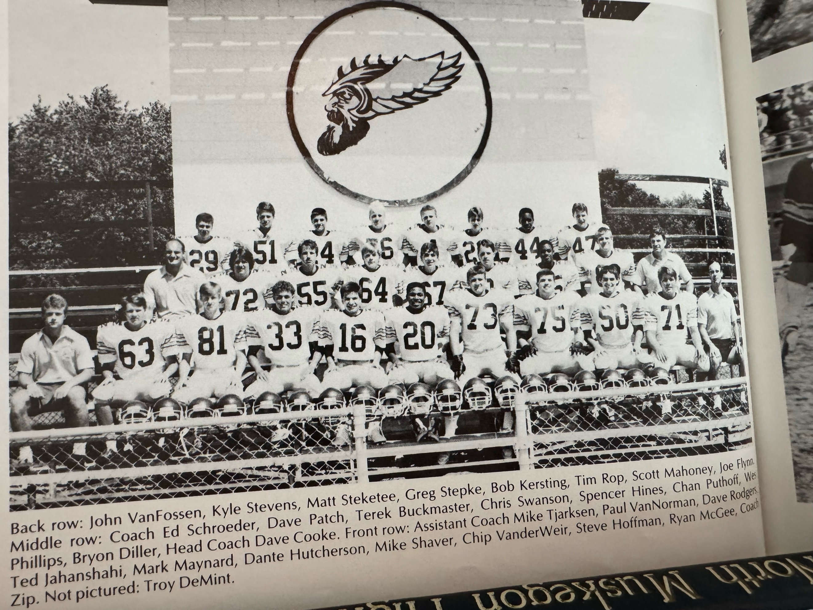

The 1986 NM STATE SEMIFINALIST

Front Row L-R: Coach Mike Tjarksen, Paul VanNorman, Dave Rodgers, Ted Jahanshahi, Mark Maynard, Dane Hutcherson, Mike Shaver, Chip Vanderwier, Steve Hoffman, Ryan McGee, Coach Ed Zednik
Middle Row: Coach Ed Schroeder, Dave Oatch, Terek Buckmaster, Chris Swanson, Spencer Hines, Chan Puthoff, Wes Phillips, Byron Diller, Head coach Dave Cooke
Top Row: John Van Fossen, Kyle Stevens, Matt Steketee, Greg Stepke, Bob Kersting, Tim Rop, Scott Mahoney, Joe Flynn

