1990 – coach Walt Gawkowski (6-16 overall; 2-12 in WMC; xx place in WMC; Ravenna Champs)
Coach Walt Gawkowski fielded a young team during the 1990 season with as many as four freshmen listed in a typical NM starting lineup. One of those yearlings, catcher Chris Benedict, led the Norse in hitting. His brother Matt, a sophomore pitcher, delivered one of the best outings by a Norse hurler in several years by working 10 innings in a 3-2, 11-inning defeat of Hart. The Norsemen closed strong late in the season by punching out a pre-District and a District win, including making amends for the 1989 first round defeat at the hands of Grand Rapids Baptist by trouncing the furniture city crew, 15-4. Joe Mylenek was a steady veteran among a bunch of youthful rookies. Mylenek won his first tournament appearance against Grand Rapids Covenant Christian but got little hitting support from his mates in a season-ending 2-0 loss to Wyoming Lee in the District championship game.

Record Score Interesting Fact
0-1 WMC 7, NM 6 Matt Benedict 4 RBI
0-2 *Montague 7, NM 3 Ron Hillman 3 RBI triple; Fr. Chris Benedict 2 hits
0-3 *Hart 17, NM 7 Benedict GS
0-4 OV 4, NM 1 3 NM errors lead to OV win: Hillman 2 hits
0-5 *Whitehall 5, NM 2 NM gives up 3 unearned runs in 6th: Hillman double
0-6 *Mason CC 5, NM 1 NM 3 hits (C & M Bendict, Steve Huff)
1-6 *NM 6, Mason CC 3 Huff HR; Joe Mylenek 2 hits (2b); C. Bendict 2 hits
1-7 *Shelby 12, NM 1 Huff HR
1-8 *Shelby 11, NM 4 NM has 6 hits and 5 errors
1-9 *Montague 12, NM 1 NM 1 hit by Doug Schlaff & Rob Smith
2-9 *NM 3, Hart 2 11 innings; Benedict 10 innings, 8 K’s; Eric Rop GW RBI
3-9 NM 9, Holton 0 County Tournament (No line score or report in MC)
3-10 *Ravenna 10, NM 2 County Tournament & WMC game; Huff triple
3-11 *Ravenna 10, NM 0 NM only 3 hits
3-12 Pentwater 10, NM 4 Joe Mylenek HR
3-13 *Whitehall 4, NM 0 NM only 2 hits off Chris Andrews
3-14 *Oakridge 6, NM 4 Matt Benedict 3 hits
3-15 *Oakridge 12, NM Scott Wall 2 hits NM
4-15 NM 9, Holton 5 8 Innings; Freshman Bob Walters 3 hits; NM scores 4 in 8th
5-15 NM 3, Cov. Christ. 2 Pre-District; Mylenek 9 K’s, Huff HR
6-15 NM 15, GR Baptist 4 District; Hillman 2 hits (2B); Rop & Bendict brothers 2 hits
6-16 Wyoming Lee 2, NM 0 District finals; NM only 1 hit (C. Benedict)

1991 – coach Walt Gawkowski (7-18 overall; 1-13 in WMC; xx place in WMC; Ravenna Champs)
The 1991 Norsemen nine certainly tested the patience of fifth-year head coach Walt Gawkowski. After splitting their first four games, including an upset 4-3 victory over Orchard View, the Norse went into a tailspin. With five sophomores in the starting lineup (Chris Benedict, Pat Kitchka, Paul Moyes, Bob Walters, and Cam Balash), the Norse would drop their next 15 straight games, the second longest losing streak in NM history. The never-give-up Norsemen finally put it all together late in the season by winning five straight games, providing some momentum for the immediate future. Highlighting the modest win streak was a come-from-behind District victory over rival Western Michigan Christian. Matt Benedict fanned 12 batters as the Norse came from five runs down to eliminate the Warriors, 7-6. An 8-4 win over Grand Rapids Baptist put the Norsemen into the district finals for the second straight year. However, the wheels fell off against powerful Allendale in the championship game as the defense committed 10 errors, and a depleted NM pitching staff gave up 14 walks.

Record Score Interesting Fact
0-1 *Oakridge 17, NM Oakridge scores 9 runs in 1st inning
1-1 NM 18, WMC 5 Matt Benedict winner; M. Benedict, Pat Kitchka 2 hits
1-2 *Hart 12, NM 2 Hart pitchers with 11 Ks in 5 inning game
2-2 NM 4, OV 3 NM wins with bases loaded Hit by Pitch in 7th
2-3 *Mason CC 7, NM 3 Eric Rop 2 hits
2-4 *Mason CC 6, NM 3 Cam Balash goes the distance in loss
2-5 *Montague 9, NM 6 Each team has 7 hits in NM loss
2-6 *Whitehall 16, NM 7 Toby Schuler 3 hits
2-7 *Whitehall 11, NM 1 NM only 2 hits
2-8 White Cloud 14, NM 12 Shelby Invitational; NM has 11 hits in loss
2-9 Shelby 7, NM 1 Shelby Invitational; NM gets only 3 hits
2-10 *Ravenna 8, NM 1 Ravenna scores 6 runs in 6th to pull away from NM
2-11 *Ravenna 13, NM 5 Chris Benedict 2 hits, Bob Walters double
2-12 Hesperia 10, NM 7 Walters HR
2-13 *Oakridge 7, NM 2 NM only 2 hits off Scott Wall
2-14 *Shelby 12, NM 2 NM again only has 2 hits
2-15 *Shelby 12, NM 2 M. Benedict RBI single
2-16 *Hart 10, NM 9 Benedict 4 hits; Hart scores 5 unearned runs in 7th for win
2-17 Ravenna 10, NM 0 County Tournament; Ravenna’s Jeff Porter 2 hits NM
3-17 NM 8, Pentwater 1 M. Benedict 14 K’s; M. Benedict 3 hits
4-17 *NM 7, Montague 6 C. Benedict 3-run HR
5-17 NM 12, Holton 1 Cam Balash 1-hitter
6-17 NM 7, WMC 6 M. Benedict 12 K’s; NM rallies from 5 down
7-17 NM 8, GR Baptist 4 District; M. Benedict 2 doubles
7-18 Allendale 20, NM 1 District finals; NM commits 10 errors; pitchers walk 14

1992 – coach Walt Gawkowksi (10-15 overall; 5-9 in WMC; xx place in WMC; Oakridhe-Ravenna Champs)
The Norsemen showed marginal improvement from the previous season by adding a couple more victories to the win column. The Benedict brothers, Matt and Chris, had a day to remember in an NM victory over Western Michigan Christian, delivering seven hits between them in an 11-7 NM win at Marsh Field. Joining the junior-dominated team was promising freshman pitcher/outfielder Justin Visconti. The hard-throwing lefthander, who would end his brilliant career ranked near the top of the leader board in many batting and pitching categories, completed his first season in a forgettable manner. The young Visconti was at the plate in the bottom of the seventh inning in the district championship game vs. Wyoming Lee. The count moved to 3-0 with the bases loaded in a 3-3 tie. The Norse were one ball away from winning their first-ever District title. It was not to be as the Wyoming Lee pitcher battled back and delivered three straight strikes on the future NM All-Star. Wyoming Lee then plated three runs in the eighth to eliminate the Norse from tournament competition. When your author originally wrote this story, I had shown the early season game with Oakridge had ended in a 9-9 tie. The game was later finished on May 27 as the game had a direct bearing on the WMC championship. Matt Benedict delivered a two-out single to score the winning that gave NM a 10-9 win and not a tie. The win prevented Oakridge from the outright championship in the WMC as they would now share the league title with Ravenna.

Record Score Interesting Fact
0-1 Musk. Catholic 10, NM 3 Cam Balash 2 RBI (double)
0-2 *Oakridge 9, NM 0 Brian O’Neal has 4-hitter for Oakridge
1-2 *NM 10, Oakridge 9 Bob Walters, Paul Moyes 2 hits; NM scores 4 runs in 7th inning. Game called due to darkness, NM wins on May 27 on Matt Benedict RBI single.
1-3 *Hart 11, NM 10 Freshman Mike Boyle 2 hits
1-4 Orchard View 11, NM 1 Pat Kitchka double, scores only NM run on wild pitch
2-4 *NM 11, Mason CC 10 Boyle HR; freshman Justin Visconti RBI double
3-4 *NM 10, Mason CC 5 Chris Benedict 2 hits; Matt Benedict complete game
3-5 *Montague 10, NM 5 C. Benedict 2 run RBI; NM commits 7 errors
4-5 NM 11, WM Christian 7 M Benedict 4 hits, including HR; C Benedict 3 hits (2B)
4-6 *Whitehall 5, NM 3 Kitchka complete game loss
5-6 *NM 9, Whitehall 1 M. Benedict 7 K’s; Walters HR
5-7 White Cloud 11, NM 2 No info from MC at all, just the score
5-8 *Ravenna 7, NM 1 Moyes singled in only NM run
5-9 *Ravenna 3, NM 1 M. Benedict complete game loss, Walter’s double
6-9 NM 7, Holton 5 County Tournament, Visconti wins first game
6-10 Oakridge 6, NM 5 County Tournament (M Bendict Losing pitcher)
6-11 *Shelby 14, NM 4 Walters HR; Kitchka 2 hits
6-12 *Shelby 11, NM 1 Visconti RBI double
6-13 Hesperia 9, NM 3 NM commits 8 errors: C. Benedict 2 hits
7-13 *NM win, Hart loss Hart coach didn’t call into MC – Girl’s coach did
8-13 NM 16, Holton 3 Visconti wins his 2nd game of season, Boyle, Pat Kitchka 3 hits, Visconti allows 3 hits.
9-13 NM 7, GR Baptist 2 Pre-District; M. Benedict 3-hitter, 11 K’s; Chris Roberts 2 hits
9-14 *Montague 6, NM 3 Kitchka 2 hits
10-14 NM 8, Pentwater 2 District; C. Benedict 2 hits
10-15 Wyoming Lee 6, NM 3 District finals; 8 innings; Matt Bendict forced extra innings with 2-run bases loaded 1B

1993 – coach Walt Gawkowski (12-14 overall; 6-8 in WMC; xx place in WMC; Shelby Champs)
Expectations were high for the 1993 Norsemen with seven returning starters back in the fold. Unfortunately, the team didn’t live up to those high expectations. Sophomore southpaw Justin Visconti became the ace of the staff and tossed a one-hitter with 12 strikeouts in a 2-0 late May victory over Oakridge. It would be the first shutout thrown in conference competition by a Norse hurler since 1984. The Norsemen ended the season in a disappointing fashion. After posting a regular season 11-1 victory over rival Western Michigan Christian, the Warriors turned the tables on the Norse in the District championship game. The Blue & Gold left the bases loaded in the bottom of the seventh inning while trailing 6-4, ending their quest to finally win a District championship.

Record Score Interesting Fact
0-1 *Hart 12, NM 2 Justin Visconti has only NM hit, Cam Balash Sac Fly
0-2 *Mason CC 7, NM 6 Chris Benedict 2 Hits (3B), Bob Walters 2 hits
1-2 *NM 6, Mason CC 3 Visconti 3 hits (2b), Mike Boyle, Paul Moyes 2 hits
1-3 Orchard View 14, NM 2 Visconti 2 hits, HR
2-3 NM 16, White Cloud 7 Benedict 3 hits, HR, Dan Meyers 3 hits, 4 rbi
2-4 Shelby 14, NM 12 Walters, Benedict HR, Moyes, Meyers 2 hits
3-4 *NM 7, Ravenna 4 Walters HR, Visconti 10 K’s
3-5 *Oakridge 4, NM 2 Visconti 8 K’s, Visconti & Nick Bolema 2 hits
3-6 Musk. Catholic 9, NM 1 County Tournament, NM only 2 hits (Chris Roberts & Balash)
3-7 *Shelby 5, NM 4 Pat Kitchka 2 hits, Moyes 3 walks 2 runs
3-8 *Shelby 9, NM 7 8 innings, Moyes & Bolema 2 hits
4-8 *NM 6, Hart 4 Moyes & Balash 2 hits
5-8 NM 11, WMC 1 Visconti 3 hits (2b) NM scores 7 in 5th inning
5-9 Musk. Catholic 3, NM 2 Benedict, Balash & Kitchka 2 hits, Visconti triple
5-10 Musk. Catholic 9, NM 1 Moyes & Balash 2 hits
6-10 *NM 5, Montague 3 Benedict, Balash, Moyes 2 hits
6-11 *Montague 7, NM 3 NM commits 5 errors
7-11 NM 12, Hesperia 6 Visconti, Balash HR, Kitchka 2 hits
7-12 *Ravenna 9, NM 5 Benedict HR, Moyes 2 RBI single
8-12 *NM 2, Oakridge 0 Visconti 1-hitter, 12 K’s
9-12 NM 18, Holton 4 Mike Farmer HR, Kitchka 3 hits
10-12 NM Win, Pentwater loss
10-13 *Whitehall 6, NM 0 Mike Boyle 3 hits, Kitchka 2 hits
11-13 *NM 13, Whitehall 7 Kitchka HR, Walters 2 hits (triple), Farmer, Chris Roberts 3 hits
12-13 NM 11, Walkerville 0 District, Balash 5 inn. shutout, Moyes, Kitchka, Roberts, Walters 2 hits
12-14 WMC 6, NM 4 District finals

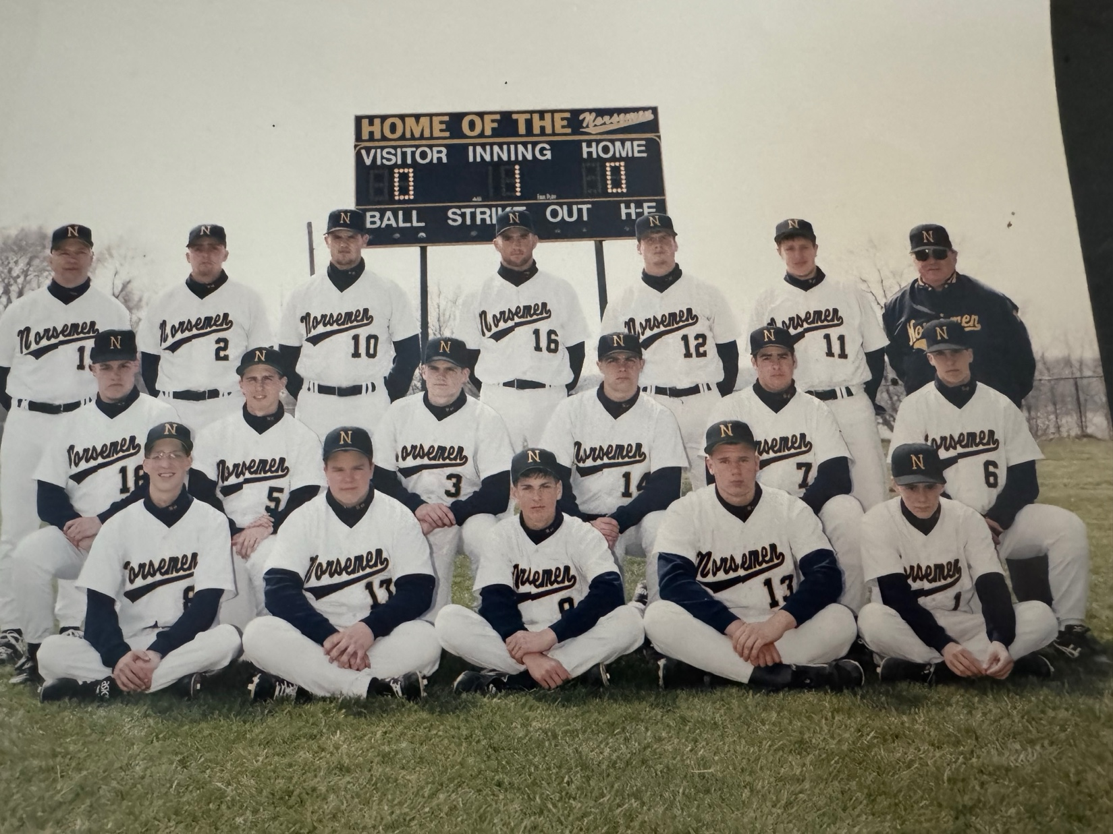

The 1993 NORSEMEN
Bottom Row: L-R: Kyle Tierney, Teddy Cooper, Kevin Robertson Dan Wegner, Mike Kirlis
Middle Row: Chris Roberts, Dan Meyers, Nick Bolema, Justin Visconti, Mike Farmer, Michael Boyle
Top Row: Head Coach Walt Gawkowski, Pat Kitchka, Bobby Walters, Cam Balash, Chris Bendict, Paul Moyes, Asst. Coach Jim Moyes

1994 – coach Walt Gawkowski (12-16 overall; 5-9 in WMC; xx place in WMC; Ravenna Champs)
A long dry spell finally came to an end for the Norse in 1994 when the North Muskegon baseball team ended 22 years of frustration by winning its first District championship. The 5-4 win over Western Michigan Christian helped soothe the wounds from the disheartening loss to the Warriors in 1993. With only three starters returning from the previous year’s club, it was an uphill climb for the young Norsemen. The Norsemen received a good boost from transfer student Mike Schreiber. Schreiber gave the Norsemen some solid play from his middle infield position as well has adding some timely hitting to the offense. Justin Visconti proved that his 1993 one-hitter against Oakridge was no fluke. Visconti again tossed another one-hitter at the Eagles as the Norse shutout Oakridge 6-0. When Visconti was not on the mound, the Norse pitching staff gave up a ton of runs. The Norse hurlers gave up 18 runs to Mason County Central in the first game of a doubleheader in Scottville. The good news for Norse fans was the Blue & Gold tallied 19 as Norse hitters found the short leftfield fence at the Scottville diamond enticing. Mike Boyle and Dan Wegner blasted a pair of home runs while Nick Bolema added another. The five home runs in that contest stand as the most home runs in a game in NM history.

Record Score Interesting Fact
1-0 NM 13, WMC 2 Justin Visconti HR
1-1 Hesperia 9, NM 7 Visconti 2 RBI
1-2 *Montague 7, NM 5 Mike Schrieber 4 hits; Shelby 12 runs in 1st inning
1-3 OV 18, NM 11 Visconti 3 hits
1-4 *Ravenna 7, NM 4 Visconti HR, double; Schrieber 3 hits
1-5 Shelby 24, NM 15 Mike Boyle GS; Schrieber 4 hits
1-6 Grant 16, NM 6 no report in MC, just the score
2-6 *NM 6, Oakridge 0 Visconti 1-hitter, 12 K’s, 6 1/3 innings of no-hit ball
3-6 *NM 12, Shelby 7 Visconti winner
3-7 *Shelby 11, NM 10 Dan Wegner; Visconti HR
4-7 NM 14, Holton 4 County Tournament; Schrieber 1 hitter; Visconti HR
4-8 Kent City 9, NM 7 County Tournament; NM commits 7 errors
5-8 *NM 11, Hart 3 Visconti 3 hitter, 14 K’s; Nick Bolema 3 hits, Wegner, Boyle
6-8 *NM 19, Mason CC 18 NM 5 HR (Boyle – 2; Wegner – 2; Nick Bolema – 1)
6-9 *Mason CC 17, NM 1 MCC scores 11 runs in 3rd; NM only 3 hits
6-10 *Montague 11, NM 6 Mike Kirlis 2 hits
6-11 *Whitehall 12, NM 0 NM pitchers walk 11
6-12 *Whitehall 18, NM 2 Kirlis has only NM hit
6-13 *Ravenna 10, NM 3 Nothing on NM in writeup
6-14 *Oakridge 14, NM 10 Visconti HR
7-14 NM 7, Holton 6 Visconti 13 K’s
8-14 NM 15, Pentwater 5 Boyle HR; Visconti 2 hits, including triple
9–14 NM 9, Pentwater 3 Boyle 3 hitter; Bolema 2 hits
10–14 *NM 5, Hart 3 Visconti 14 K’s
10–15 Musk. Catholic 11, NM 2 Visconti HR
11-15 NM 15, Walkerville 4 District; Boyle HR
12-15 NM 5, WMC 4 District Championship
12-16 Manton 4, NM 0 Regional; Visconti 3-hitter

1995 – coach Walt Gawkowski (19-7 overall; 11-3 in WMC; 2nd place in WMC; Ravenna Champs)
The 1995 season would be one of the most successful seasons the Norse would experience in several years, yet it left the Norsemen feeling a little empty. The team finished with the first winning season since a 11-10 record in 1985. Two of the Norse defeats suffered during the season bordered on the surreal. In the first game of the County tournament the confident Norse took a 6-0 record into their first -round matchup against a Holton team looking for its first win. The Red Devils shocked the Norse 12-7 as the Blue & Gold offense had numerous rallies cut short with lazy fly ball outs. When one looks at the final score in NM’s 29-13 defeat handed them by Reeths Puffer, no one could scarcely believe that NM led by one run going into the last inning. Before a shell-shocked NM pitching staff recorded the final out in the seventh and final inning, the Rockets had 17 runners cross the plate. Muskegon area Class C/D coach-of-the-year Walt Gawkowski’s nine seemingly were headed toward the school’s first West Michigan Conference championship in 22 years, boasting a WMC mark of 11-1 with two conference games remaining. Needing only one victory in the final two games, the Norse came up on the short end in both games. In the final contest, Oakridge finally got the better of Justin Visconti. After being one-hit twice in the past two years by the Norsemen ace, the Eagles dealt Visconti a 2-1 heartbreaking defeat. The hard-hitting Norse star also had a NM career-high 18-game consecutive hitting streak game halted by the Eagles. The Norse did bounce back to easily capture their second District championship in as many years, and they did it in convincing style. Visconti struck out 12 batters and belted his eighth home run of the season as NM trounced Western Michigan Christian. Teddy “Ballgame” Cooper joined in the fun by also blasting a home run for the winners. A bleary-eyed group of seniors struggled in the following weekend’s regional battle at James B. Johnson Field. Celebrating late into the night following the previous evening’s graduation ceremonies, the Norse struggled but did manage to pull out a 14-13 first-round regional win over Baldwin, the first regional win in school history. The Norse had little left in their tank and lost the regional final to powerful Mount Pleasant Sacred Heart. Visconti concluded his career with his name at the top of the record books in several categories, both with his bat and his arm. The only NM selection to the East-West All-Star game ended his career as a Norsemen in a most memorable fashion. At historic Tiger Stadium, Visconti lashed a double off the left-centerfield wall against future major league All-Star J.J. Putz.

Record Score Interesting Fact
1-0 NM 19, WMC 10 Justin Visconti the cycle (2nd cycle in school history), 6 RBI
2-0 *NM 4, Hart 2 Matt Wikandeer, Kevin Robertson 2 hits, Visconti 1 hitter
3-0 NM 11, OV 4 Mike Schrieber 3 hits & winning pitcher, Visconti 2 hits 4 RBIs
4-0 *NM 6, Whitehall 4 Visconti 15 K’s, Mike Kirlis, Visconti, Schreiber 2 hits
5-0 *NM 8, Oakridge 4 Visconti HR, Dan Wegner HR
6-0 *NM 11, Shelby 2 Visconti HR, 2 triples, 6 RBI
6-1 Holton 12, NM 7 County, Visconti 3 hits, Wikander 2 hits (double)
7-1 *NM 6, Ravenna 1 Mike Farmer 2 hits (HR), Visconti, Robertson 2 hits
7-2 Reeths-Puffer 29, NM 13 RP scores 17 runs in 7th inn to overcome a 1-run NM lead Schreiber 4 hits
8-2 *NM 8, Hart 5 Visconti, Ted Cooper HR
9-2 *NM 10, Mason CC 4 Visconti 12 K’s, Boyle & Visconti 2 hits D Wegner triple
10-2 *NM 4, Mason CC 3 Eight innings, Visconti 2 hits including GW double,
10-3 Fremont 16, NM 13 Visconti 4 hits, Wegner, Kirlis 3 hits
11-3 NM 5, Hesperia 4 Schrieber 2 hits, comes on in 7th to earn save
12-3 *NM 14, Whitehall 4 Wegner 3 hits, including HR, Visconti 3 run HR
12-4 *Shelby 10, NM 3 Visconti 2 hits
13-4 NM 12, Holton 1 Kirlis, Visconti, Schreiber, & D Wegner 2 hits
14-4 *NM 5, Montague 4 Visconti, Wikander doubles
15-4 *NM 11, Montague 4 Visconti HR, 2 triples, School record 7 RBIs, Kirlis triple
15-5 *Ravenna 6, NM 1 Visconti HR, Visconti gives up 6 unearned runs
15-6 *Oakridge 2, NM 1 Visconti’s 18-game hit streak snapped, NM only 2 hits
16-6 NM 5, Musk. Cath. Schrieber winning pitchet, Visconti 2 hits (2b) Cooper 2 RBIs
17-6 NM 15, Walkerville 5 District, Kirlis, Schrieber, Visconti, Robertson 3 hits
18-6 NM 16, WMV 4 District Championship; Visconti 12 K’s; Ted Cooper, Visconti HR, Farmer 3 hits
19-6 NM 14, Baldwin 13 Regional Mike Schrieber 4 hits; Wegner 2 hits 4 RBIs
19-7 MP Sacred Heart 9, NM 1 Regional finals, Wegner RBI double

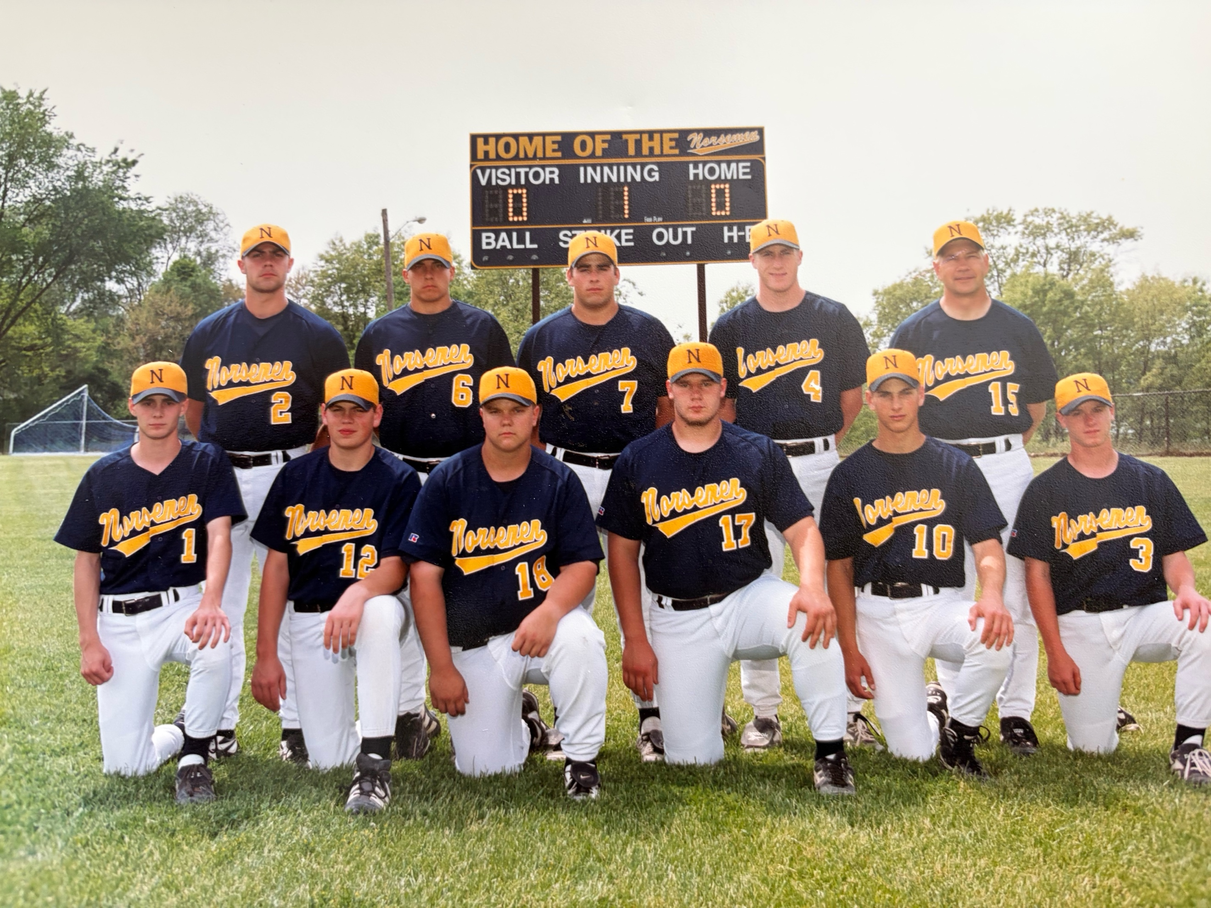

The 1995 NORSEMEN

Front Row: L-R: Mike Kirlis, Matt Wikander, Teddy Cooper, Dan Wegner, Kevin Robertson, Jeremu Wegner
Standing L-R: Justin Visconti, Matt Boyle, Mike Farmer, Mike Schreiber, Head Coach Walt Gawkowski

1996 – coach Walt Gawkowski (3-19 overall; 1-13 in WMC; xx place in WMC; Shelby-Ravenna Co- Champs)
From the Penthouse to the Outhouse – that was the direction the Norsemen took in 1996. After winning a school record 19 games in 1995, the Norsemen then turned around and lost 19, the most losses in school history. Ironically enough, NM’s only WMC conference win on the season came against perennial power Whitehall by the narrowest of margins, 10-9. Matt Wikander got the win and aided his own cause by capping a five-run rally in the bottom of the seventh inning as the Norse rallied for five runs. The Norse struggled in the pitching department as NM hurlers gave up an unhealthy 11.3 runs per game, the highest permitted per game in Norsemen history. Only tiny Pentwater High School would fall twice to the Norse. One of Pentwater’s losses came in the first round of Districts when the Norse won a 15-14 slugfest. Kevin Robertson delivered the highlight blow of the season when he delivered a two-run home run to send the game into extra innings. The Norse won in eight innings, but no such magic worked in the district championship game. Ending their season at an unceremonious 3-19, the Norse were nipped by perennial final foe Western Michigan Christian, 7-6, in another eight-inning battle.

Record Score Interesting Fact
0-1 WMC 14, NM 11 Matt Wikander 3 hits, Ted Cooper & Kevin Robertson 3 RBIs
0-2 *Whitehall 19, NM 2 Jeremy Wegner 2 hits
0-3 *Shelby 13, NM 12 no comments about NM in MC
0-4 Buchanan 7, NM 6 J. Wegner, Dan Wegner (cousins) HR
0-5 Buchanan 15, NM 1 D. Wegner’s HR accounts for only NM run
0-6 *Oakridge 15, NM 4 J. Wegner HR; Brian Ware triple
0-7 Oakridge 9, NM 8 County Tournament; Oakridge overcomes 6-1 deficit
0-8 *Ravenna 13, NM 3 Jason Bogue, D. Wegner doubles
0-9 *Hart 10, NM 8 Ted Cooper 3-run HR
0-10 *Montague 10, NM 2 Bogue 2 hits
0-11 *Montague 22, NM 2 Cats 12 hits, 17 runs in 1st inning, NM no hits in 3 ing. game
1-11 *NM 10, Whitehall 9 Wikander’s 2-run dbl. caps 5 run rally in 7th, Brian Ware 3 hits
1-12 *Mason CC 12, NM 0 Wikander 2 hits
1-13 *Mason CC 4, NM 2 Mike Kirlis 2 hits (HR)
1-14 *Shelby 7, NM 6 NM loses 5-0 lead
1-15 Musk. Cath. 16, NM 4 D. Wegner 2 doubles
1-16 *Oakridge 10, NM 0 NM only 3 hits; Wikander double
1-17 *Ravenna 10, NM 3 D. Wegner 3 hits
1-18 *Hart 16, NM 11 D. Wegner HR
2-18 NM 14, Pentwater 4 Marcus Norman winning pitcher; NM scores 7 in 1st inning
3-18 NM 15, Pentwater 14 Eight innings; Kevin Robertson 2-run HR to send game into 8th
3-19 WM Christian 7, NM 6 District: WMC scores 2 runs after 2 out for win; D Wegmer 2 hits

1997 – coach Walt Gawkowski (11-19 overall; 4-10 in WMC; xx place in WMC; Oakridge Champs)
One of the signature trademarks of a Walt Gawkowski coached team was improvement as the season progressed. That trait certainly applied once again in 1997 as the Norse captured yet another District title before succumbing to the defending Class D state champs, Mount Pleasant Sacred Heart in the Regional finals. The Norse received some timely pitching from Charlie Cihak as well as leadership and hitting from Matt Wikander Jason Bogue, Jeff Gowell and Jeremy Wegner throughout the season. Wegner finished the season right at the .400 mark to lead all hitters. Cihak’s best efforts were a 3-1, three-hitter vs. Mason County Central and a 4-0, 11-strikeout outing in the regional opener against Mason County Eastern. Coming off a dismal 1996 season, the Norse pulled a major early season surprise by edging Whitehall, 6-5, and their sophomore shortstop Nate McLouth, the only game Whitehall would lose to the Norsemen during the future Pittsburgh Pirate’s stellar career with the Vikings. McLouth is one of four big leaguers to play vs. NM. (Jim Johnson, Ray Newman and Blake Dunn are the others.) However, early in the 1920’s, prior to North Muskegon becoming a high school, Montague’s Ira Flagstead would play on the current northside diamond against the town team.

Record Score Interesting Fact
0-1 Reeths-Puffer 12, NM 2 Jeremy Wegner, Matt Wickander only 2 NM hits
1-1 *NM 6, Whitehall 5 Wegner 2 hits (HR), Wickander 2 hits (double) 4 RBIs
1-2 *Shelby 7, NM 3 Brian Ware HR, Adam Derrickson 2 hits
1-3 Mona Shores 8, NM 5 Eight innings, Eric Klopp, Wegner, Derrickson, Ware 2 hits (2b&3B)
1-4 *Oakridge 7, NM 2 Wegner 3 hits, Wikander double
2-4 NM 13, Pentwater 3 Jeff Gowell, Ware, Adam Vanberkum 2 hits
2-5 *Ravenna 7, NM 0 Wegner, Wickander only 2 NM hits
2-6 *Montague 8, NM 1 NM Gets all 3 of their hits in 7th
2-7 *Hart 11, NM 7 Wegner, Charlie Cihak 3 hits, Derrickson, Wikander 2 hits
2-8 Kent City 12, NM 1 County Tournament; Adam Derrickson HR, Wegner 3 hits
3-8 *NM 7, Mason CC 1 Cihak 3-hitter, Gowell 3 hits (double) 3 RBIs
3-9 *Mason CC 11, NM 1 Gowell 2 hits (double), Pleiness (Toronto Blue Jays) wins
3-10 Spring Lake 7, NM 6 Gowell 2 hits (double) Tying run thrown out at the plate in 7th
3-11 *Whitehall 4, NM 2 Future MLB All Star Nate McLouth 2-for-2 for Whitehall
4-11 NM 15, Hesperia 5 Cihak HR, Wegner only Norse with 2 hits
5-11 *NM 9, Shelby 3 Jason Bogue & Cihak HR
5-12 WM Christian 9, NM 8 Wegner HR, NM trailing 9-1 score 7 in 7th, Bogue 3 hits
5-13 *Oakridge 7, NM 4 Bogue, Wegner HR, Wegner 3 hits, Gowell 2 hits
6-13 NM 11, Holton 4 Wegner 4 hits, Wikander 3 hits, Derrickson 2 hits
7-13 *NM 9, Hart 6 Bogue 3 hits, Wikander 2 hits, Ware HR
8-13 NM 10, Orchard View 9 Cihak, Wegner 3 hits, Ware 2 hits (triple) Gowell 2 hits
8-14 Fremont 6, NM 3 Wegner double
8-15 *Montague 13, NM 3 Wegner 2 hits-double
8-16 *Ravenna 11, NM 9 Bogue & Cihak 2 hits, Wegner HR
8-17 Shelby 3, NM 2 @ Old Kent Park in GR, Wegner double
8-18 Shelby 7, NM 0 @ Old Kent Park in GR, Ware triple
9-18 NM 11, Pentwater 0 District, Ware 3-3 HR, Bogue 2 hits, Gowell 5 inning shut out
10-18 NM 11, WMC 8 District Championship, Ware hits HR, Matt Campbell 2 doubles
11-18 NM 4, Mason CE 0 Regional, Cihak 4 hitter. 11 K’s, Derrickson 2 hits. Triple 3 RBIs
11-19 MP Sacred Heart 12, NM 4 Regional finals, Bogue 3 hits, 2 doubles, Ware2B & 3B

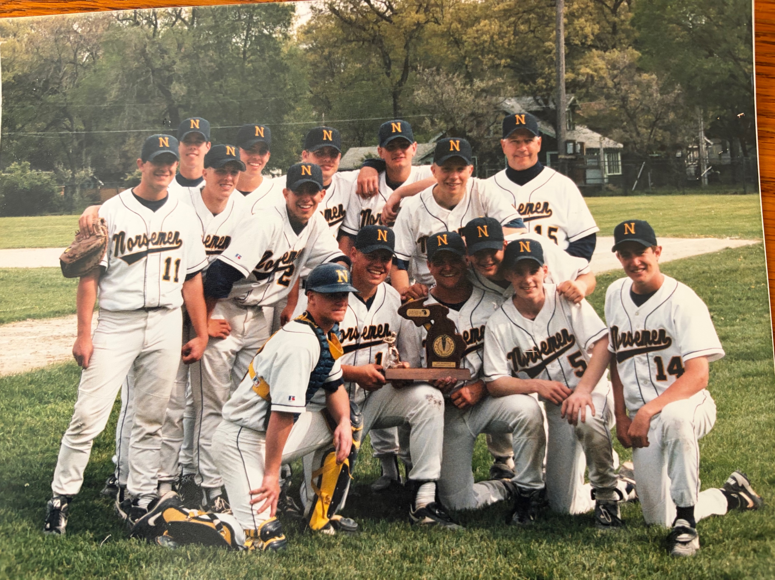

The District Champs of 1997
Kneeling L-R: Jeremy Wegner, Matt Wikander, Brian Ware, Joe Wingett, Charley Cihak, Ryan Campbell
Standing L-R: Matt Campbell, Nick Abel, Jason Bogue, Matt Boyle, Adam VanBerkum, Jeff Gowell, Adam Derrickson, Coach Walt Gawkowski

1998 – coach Walt Gawkowski (14-19 overall; 5-9 in WMC; xx place in WMC; Mason Co. Central Champs)
Although the weatherman cooperated in 1998 as the Norse were able to play a school record 33 games, it was an up-and-down season for the NM baseball team. In a rare display of good fortune, the Norse were able to get off to a good start in 1998, compiling a six-game winning streak before falling on some hard times. Much of this credit, however, should go to some strong opposition as NM dropped six of its next seven games to Mason County Central, Spring Lake and Whitehall before splitting a doubleheader with another tough opponent, the Montague Wildcats. The Norse again finished strong, and many of the Norsemen were able to pad their batting averages by piling up a combined 40 runs in a doubleheader blitz of Holton. Jeff Gowell batted a robust .423 for the season while Jeremy Wegner supplied much of the power by blasting five home runs. The Norsemen would face for the first time in the state playoffs a team they would now see a lot of over the next few years, the Crusaders of Muskegon Catholic. After competing in a higher classification for many years, declining enrollment moved Muskegon Catholic into Class D with the Norse. After defeating MCC 9-6 during the regular season, NM dropped the Class D District finals, 6-2. The Norse had earlier won the first game of the Saturday district twin bill in dramatic fashion. NM, undeterred after WM Christian took a three-run lead by scoring six runs in the sixth inning, rallied with four runs in the bottom of the seventh to earn a berth in the finals. Cihak laced a single for the game winning rbi.

Record Score Interesting Fact
0-1 Reeths-Puffer 9, NM 3 Future CMU ace Dave LeMieux winner; Joe Wingett 2 run single
1-1 *NM 11, Shelby 10 Jeremy Wegner 4 hits, including HR, 5 RBI
1-2 Mona Shores 10, NM 4 Charlie Cihak double
1-3 Mona Shores 16, NM 5 Anthony Visconti 2 hits, Jason Bogue, Ryan Campbell, Cihak 2Bs
2-3 *NM 6, Oakridge 5 Wegner 3 hits, including HR; Adam Derrickson HR
3-3 NM 23, Pentwater 8 Joe Wingett 3 hits, including HR
4-3 *NM 8, Ravenna 2 Cihak double 3 RBIs, Gowell winning pitcher
5-3 *NM 7, Hart 4 Cihak wins; Cihak 3 hits
6-3 NM 5, WMC 3 County; Bogue, Campbell 2 hits
7-3 NM 7, Holton 6 County; Campbell 2 hits, Nick Abel double
7-4 Musk. Cath. 9, NM 1 County championship; Bogue’s SF only RBI; Derrickson 3-3
7-5 *Mason CC 1, NM Cihak 3-hitter in losing cause
7-6 *Mason CC 13, NM 3 Jason Bogue HR
7-7 Spring Lake 11, NM 4 Wegner 2 HR; Bogue HR
8-7 *NM 11, Montague 8 Derrickson 3 hits, including HR
8-8 *Montague 8, NM 6 Cihak, Derrickson, Wegner 2 hits
8-9 *Whitehall 14, NM 4 Wingett 2 hits, Cihak double
8-10 *Whitehall 13, NM 3 Bogue triple
9-10 NM 8, Hesperia 7 Wegner 3 hits, Bogue 2 doubles
9-11 OV 11, NM 10 Anthony Visconti triple, 2 doubles ; Bogue 2 doubles
9-12 *Shelby 3, NM 2 Derrickson 2 hits, 2 RBIs
9-13 *Oakridge 6, NM 1 Catcher Nick Abel throws out 4 base runners
10-13 NM 9, Musk. Cath. 6 Nick Abel HR, Gowell & Derrickson 2hits (2B)
10-14 Shelby 10, NM 8 Campbell 2 hits
10-15 Shelby 15, NM 4 Bogue 2 hits, 3 RBIs
10-16 *Ravenna 7, NM 3 Abel, Campbell, Wegner 2 hits
11-16 NM 23, Holton 8 Gowell 4 hits (Sac Fly & double 6 RBI’s) Wegner, Visconti 3 hits
12-16 NM 17, Holton 5 Abel 6 hits in DH, Jason Bogues 3 hits (2 doubles) Cihak 3 hits
12-17 *Hart 15, NM 3 NM only 3 hits (Derrickson, Wegner, Wingett)
13-17 NM 2, GR-Baptist 1 Pre-District, Charlie Cihak 1 hitter, Visconti 2 hits GW double
13-18 Fremont 12, NM 1 Wegner HR, Gowell & Derrickson 2 hits
14-18 NM 9, WMC 8 District; Bogue 3 hits, Cihak 2 hits GW RBI in 7th
14-19 Musk. Cath. 6, NM 2 District finals, NM only 3 hits

The 1998 NORSEMEN

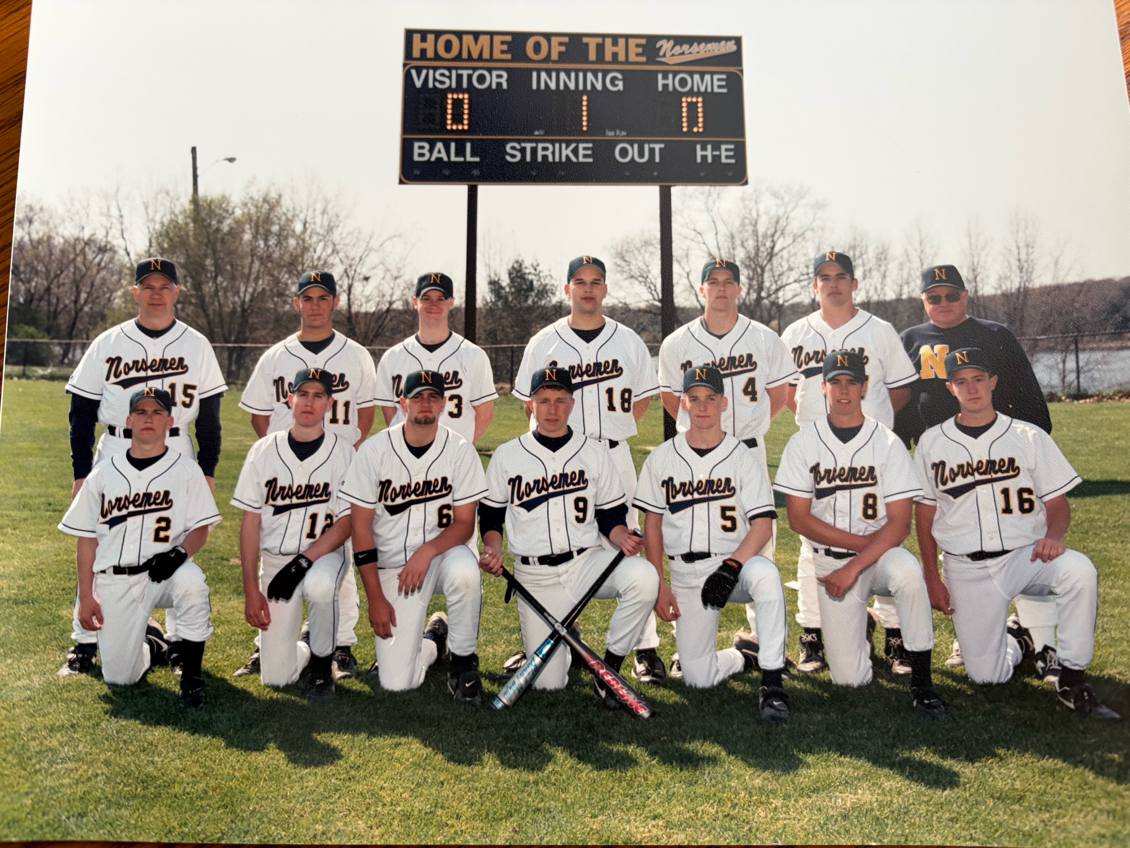

Front Row L-R: Jon Grimm, Rob Poubelle, Jeff Gowell, Adam Derrickson, Charlie Cihak, Nick Able, Ryan Campbell
Standing L-R: Coach Walk Gawkowski, Anthony Visconti, Jeremy Wegner, Joe Wingett, Jason Bogue, Matt Boyle, asst. coach Jim Moyes

1999 – coach Walt Gawkowski (11-16 overall; 7-7 in WMC; xx place in WMC; Whitehall Champs)
After getting off to a atypical slow start, the Norsemen bounced back to win 11 games. The battered Norse pitching staff gave up double-digit runs in five of their first six games before getting well in a doubleheader victory over Hart. The Norse needed only three innings to mercy the Pirates, 16-0, as Jason Bogue hit two of his team-high five home runs in the abbreviated contest. Other season highlights included Ryan Campbell’s six hits in a doubleheader victory over WMC rival Montague while J.J. Beckstrom traded his golf clubs for a baseball bat in 1999. The future golfing pro chipped in with three hits in a Norsemen 12-6 victory over Ravenna. The Norse were not so fortunate in a couple of other notable contests. After Jeff Gowell shut out the Shelby Tigers on a three-hitter, the very next outing was one for the books. The Norse scored 20 runs against Fremont ---yet lost! The Packers scored 21 in one of the wildest games in NM history. The Whitehall Vikings, in a visit to James B. Johnson Field, showed NM baseball followers why they would set a state record for the most home runs in a season. Rarely would a player ever blast a ball over the old fence in right field, but Whitehall did it twice in one game. The first rocket off the bat of David Miller was perhaps the longest ever hit at the venerable site that dates to 1920. The future Michigan State University slugger hit a Ruthian clout that finally came down after landing atop a tree in a yard on the other side of Fowler Street. Not to be denied, Nate McLouth, who would sign a hefty signing bonus with the Pittsburgh Pirates during the summer, also deposited a Diamond Baseball outside the spacious right field fence.

Record Score Interesting Fact
0-1 Muskegon 25, NM 13 First match-up since 1976, Justin Wikander bases loaded triple
0-2 Mona Shores 13, NM 8 J.J. Beckstron, Wikander, 2 hits
0-3 Mona Shores 10, NM 7 Jason Bogue double 4RBIs
1-3 *NM 12, Ravenna 10 Bogue HR, Eric Richardson 3 hits, Ryan Campbell 2 hits
2-3 NM 9, Pentwater 3 Beckstrom 2 hits, HR, Gowell 2 hits
2-4 Reeths-Puffer 17, NM 6 Jeff Gowell 2 doubles, Abel 2 hits
3-4 *NM 16, Hart 0 Jason Bogue 2 HR, 3 inning mercy game
4-4 *NM 6, Hart 5 Campbell GW RBI in 7th, Gowell 2 hits
4-5 *Whitehall 11, NM 0 Five innings as Whitehall’s David Miller throws shut out &hits HR
4-6 Musk. Cath. 9, NM 7 County, Bogue (2 doubles) & Gowell 2 hits, Wikander HR
5-6 NM 7, Hesperia 2 Campbell winning pitcher & 2 hits, Erik Richardson 2 hits
5-7 *Mason CC 6, NM 1 NM only 3 hits (Campbell, Nick Abel & Anthony Visconti)
5-8 *Mason CC 16, NM 2 NM only 2 hits in 5 inning game
5-9 Spring Lake 7, NM 6 Bogue 2 hits, Nick Marietti,
6-9 *NM 12, Ravenna 8 Beckstrom 3 hits 3 RBI, Richardson 2 hits (double)
7-9 *NM 14, Montague 4 Gowell, Bogue & Campbell 3 hits, Bogue winning pitcher
8-9 *NM 4, Montague 3 Ryan Campbell 3 hits, GW RBI, Gowell winner & 2 hits
8-10 Musk. Cath. 9, NM 4 Gowell 3 hits (2 doubles), Catcher Nick Abel throws out 3
8-11 *Oakridge 8, NM 0 Nick Heethuis no hits NM
8-12 *Whitehall 15, NM 3 Visconti HR
8-13 *Shelby 9, NM 3 Nick Marietti 2 doubles
9-13 *NM 5, Shelby 0 Jeff Gowell 3-hitter, Campbell 3 hits, Bogue & Richardson 2 hits
9-14 Fremont 21, NM 20 Nick Abel 2 HR’s 6 RBIs, Gowell 2 hits, Visconti HR
10-14 NM 14, Holton 6 Bogue HR, Campbell, Gowell, Visconti, Marietti 2 hits
11-14 NM 8, Holton 6 Beckstrom, Bogue HR’s
11-15 WMC 9, NM 8 District, Gowell & Campbell 2 hits
11-16 Oakridge Won; NM Loss (No score no report) Not sure if game was played

2000 – coach Walt Gawkowski (8-17 overall; 4-10 in WMC; xx place in WMC; Whitehall Champs)
A very young North Muskegon squad took their lumps in 2000. As many as four freshmen would see significant time for the Norse while the two leading pitchers on the staff were juniors. Sophomore Eric Richardson, grandson of former New York Yankee star Bobby Richardson, MVP of the 1960 World Series, would bring a big bat to the lineup. Infielders would see the inviting target of soon-to-be 6-foot-10 Drew Naymick, a future Michigan State University basketball player, as a first baseman for the next four years. The Norsemen pitching staff would be knocked around on occasion, but the experience garnered in 2000 would pay huge dividends the following year. Junior right-hander Mike Waisura turned in the best pitching performance when he limited Western Michigan Christian to four hits while leading NM to a first-round District win over their perennial rival. The lone senior on the team, Justin Wikander, led the team in hitting with a .347 average with junior shortstop Nick Marietti not far behind at .343.

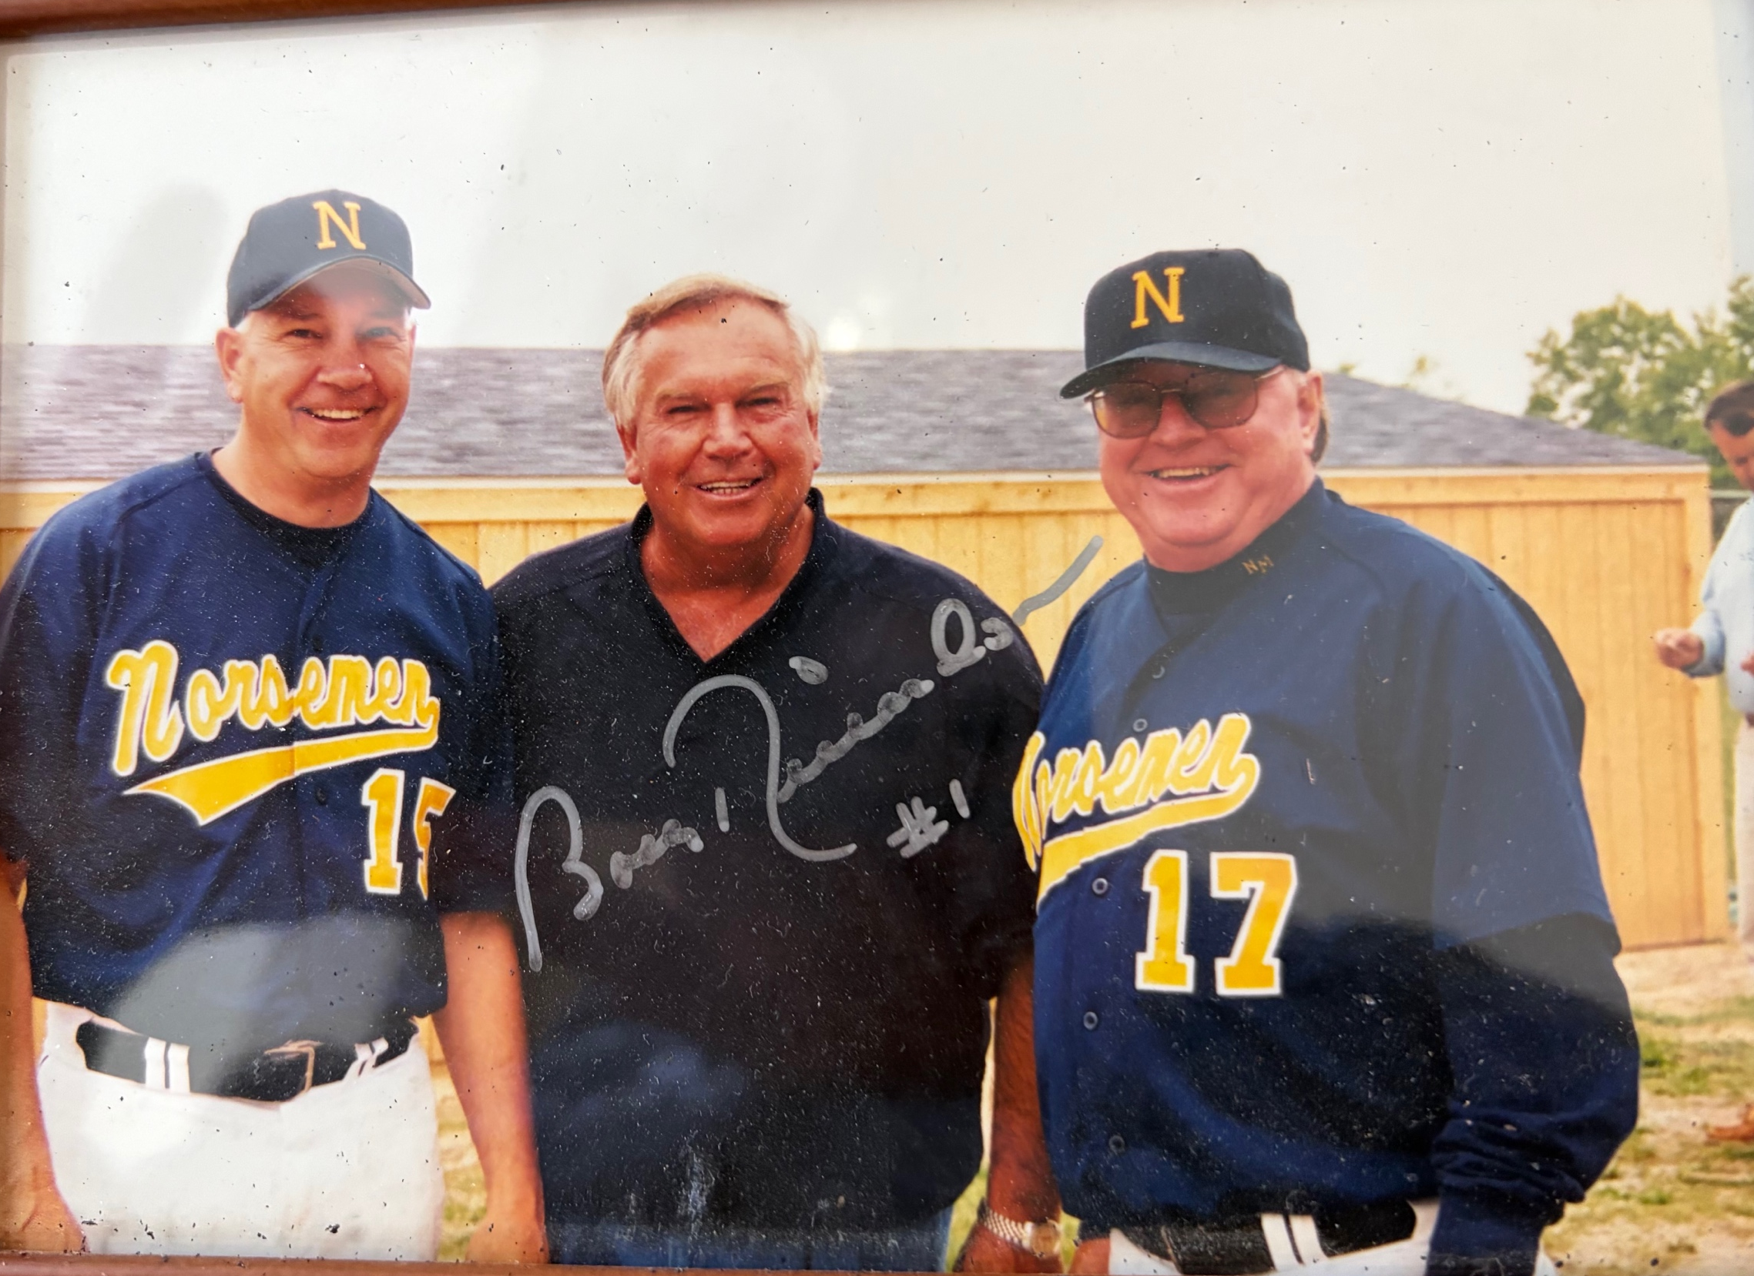
Head coach
Gawkowski& coach Moyes
With former World Series MVP Bobby Richardson, grandfather of NM Eric
Richardson prior to a game at NM.

Record Score Interesting Fact
0-1 Muskegon 20, NM 10 Justin Wikander HR
0-2 Muskegon 11, NM 1
0-3 WMC 9, NM 8 Nick Marietti 2 doubles, 3 RBI
0-4 Reeths-Puffer 16, NM 2
1-4 *NM 5, Ravenna 4 Mike Waisura 1B drives in winning run with 2 out in 7th, Drew Naymick 2 hits
1-5 *Montague 9, NM 1 Mark Bilek 3-for-3, including 2 doubles
2-5 *NM 14, Hart 3 Mike Waisura wins, no earned runs: Matt Geyer HR 5 RBI
3-5 *NM 11, Hart 5 Nick Haines double, triple; Drew Naymick triple, Marietti 2 hits
3-6 *Oakridge 8, NM 4 Erik Richardson 3 hits, Waisura 2 hits
3-7 *Whitehall 24, NM 0 Equals worse defeat in NM history
3-8 *Mason CC 13, NM 9 Richardson 3 hits HR & double, Waisura 2 hits (double)
3-9 *Mason CC 12, NM 1 Haines triple, Richardson single only NM hits
4-9 *NM 10, Ravenna 4 Future NFL Todd Herremans 2-for-3 for Ravenna, Bilek 2 hits
4-10 *Montague 16, NM 6 Richardson double
4-11 Montague 7, NM 1 County, NM walks nine, Richardson & Haines 2 hits
5-11 NM 13, Musk. Cath. 8 Bilek 4 walks, Waisura 2 hits (double)
5-12 *Oakridge 13, NM 1 NM only 2 hits (Geyer triple)
5-13 *Shelby 11, NM 2 Bilek HR (Only NM hit)
5-14 *Shelby 11, NM 1 Five innings; Wikander RBI single
5-15 *Whitehall 12, NM 2 Waisura 2 hits
6-15 NM 10, Holland Cal. 0 Sean Scott 5 inning shutout, Marietti & Wikander 3 hits
7-15 NM 19, Holland Cal. 4 Bilek, Haines HR
7-16 Hesperia 6, NM 2 Naymick 2 hits (double)
8-16 NM 3, WMC 2 district; Waisura 4-hitter
8-17 Musk. Cath. 9, NM 1 District finals

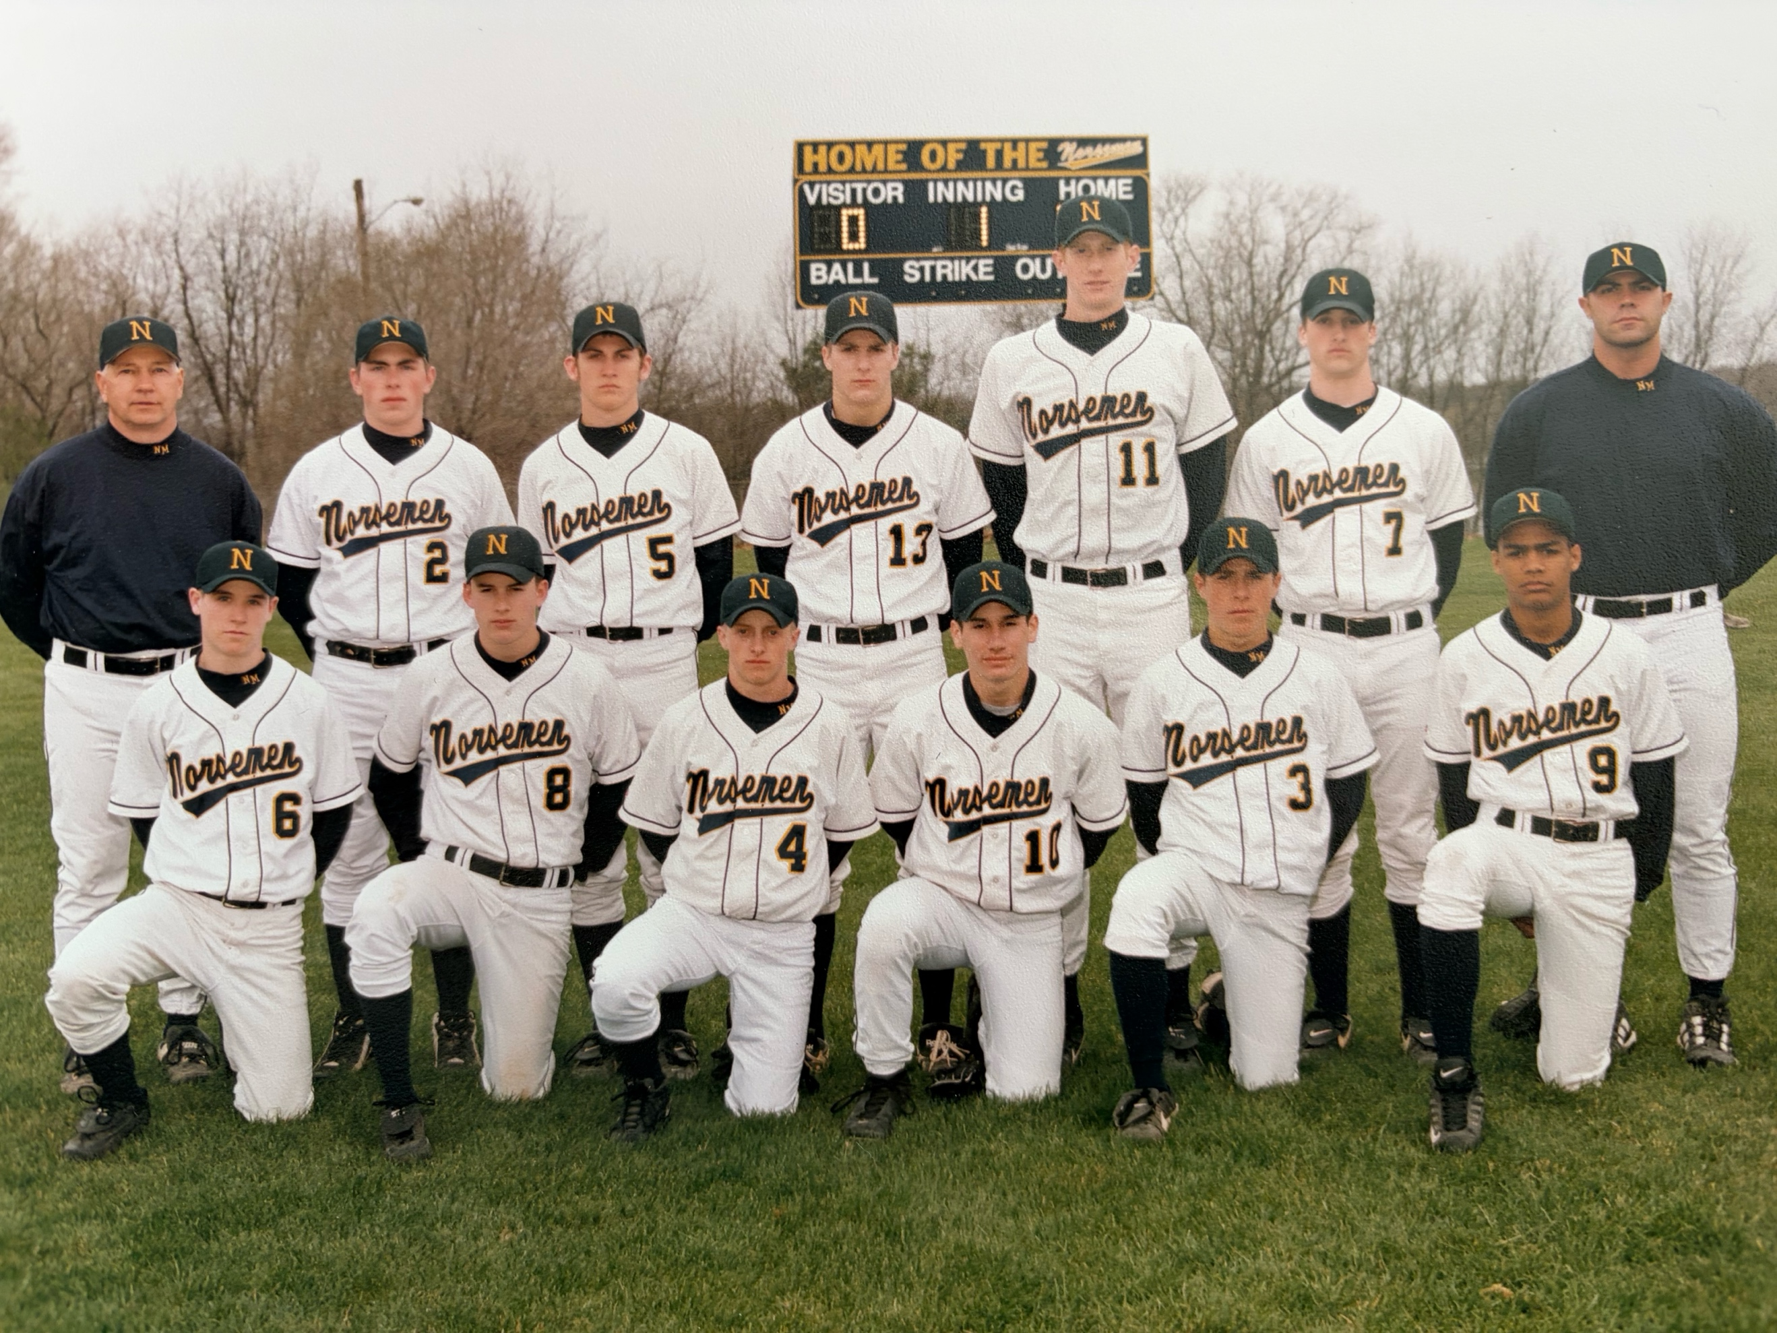

The 2000 NORSEMEN

Front Row L-R: Geoff Dean, Maatt Geyer, Nick Haines, Mark Bilek, Justin Wikander, Sean Scott
Back Row: Coach Walkt Gawkowski, Justin Wikander, Eric Wikander, Eric Richardson, Nick Marietti, Drew Naymick, Mike Wasiura, Asst Coach Justin Visconti

2001 – coach Walt Gawkowski (20-7 overall; 10-4 in WMC; xx place in WMC; Montague Champs)
The Norsemen team of 2001 became the first baseball club in NM history to win 20 games in a single season. Only in a doubleheader defeat at the hands of Montague would the Norse have a losing streak of more than one game. Certainly, one of many highlights for this team was capturing the school’s first County C/D title since entering the tournament back in the mid 1970s. After trailing Ravenna in the County semifinals by 10 runs, Sean Scott took the mound and stopped the bleeding. NM hitters did the rest with Eric Richardson blasting a long home run over the distant left field fence at MCC’s Sikorski Field to pace the comeback. The 22-20 NM victory equaled the most runs scored by two teams in NM history, first set in 1936 and matched in 1995. A rested Mike Waisura, penciled in to start Monday’s first game of a doubleheader with Montague, took the mound and guided the Norse to a well-played 6-1 victory over Holton in the County title game. As if losing a 10-run lead wasn’t enough anguish suffered by Ravenna coach Paul Herremans in 2001, the next game between the Norse and the Bulldogs bordered on the implausible. The Norse trailed by 4 runs with two out and nobody on base with a two-strike count on the Norse hitter. Future NFL star Todd Herremans then struck out the Norse hitter but, in a scene, reminiscent of Mickey Owens passed ball in the 1941 World Series, the Norse runner reached base safely and the never say die Norse rallied to take a 5-4 lead and hung on for the win. Coach Walt Gawkowski’s team again ended the season with a flourish by winning eight games in a row. Drew Naymick blasted a pair of tape measure home runs in the district championship win over Western Michigan Christian. After taking a week off, a rusty Norse pitching staff had difficulty adjusting to the pitching mound at the all-skin infield surface in Pentwater. The heavily favored Norsemen fell in the first round of the Regional to Grand Rapids Tri-Unity Christian, walking an uncharacteristic 11 hitters while dropping the high scoring affair, 12-11.

Record Score Interesting Fact
1-0 NM 6, Holland Cal 5
2-0 *NM 9, Whitehall 5 Matt Geyer 4-for-4, including 2 HR, Drew Naymick, Nick Marietti 2 hits
3-0 NM 9, Spring Lake 8 Eight innings, NM rallies from 8 down, Mark Bilek GW double
4-0 *NM 7, Oakridge 6 Mike Waisura 2 doubles, Erik Richards 2 hits
5-0 *NM 9, Shelby 4 Nick Haines, Geyer HR
6-0 *NM 6, Shelby 5 Nine innings, Naymick 2 hits GW rbi single in 9th, Richardson & Geyer 3 hits
6-1 Reeths-Puffer 12, NM 0 Marietti 2 hits, Richardson double
7-1 *NM 13, Ravenna 6 Richardson 2 hits, 5 RBIs, Marietti 4 walks, NM has 11 walks
7-2 *Mason CC 8, NM 6 Marietti 1-1 (3 walks)
8-2 *NM 10, Mason CC 3 Naymick & Marietti 3 hits, Marietti complete game win
8-3 *Whitehall 8, NM 5 Richardson & Sean Scott 2 hits
9-3 NM 11, Musk. Cath. 7 County tourney, Waisura, Geyer 3 hits, Marietti 3 more walks
10-3 NM 22, Ravenna 20 Co. Tourney; Richardson 3 hits HR, 5 RBIs; NM rallies from 10 down
11-3 NM 6, Holton 1 County Championship, Haines 2 hits, Waisura complete game
11-4 *Montague 6, NM 3 Bilek 2 hits
11-5 *Montague 10, NM 4 Haines 2 hits (double)
12-5 *NM 10, Oakridge 7
12-6 Holton 8, NM 7 Haines HR, Naymick 2 hits, Marietti 3 walks
13-6 *NM 6, Hart 4
14-6 *NM 10, Hart 9
15-6 *NM 5, Ravenna 4 Future NFL Todd Herremans of Ravenna takes the loss, Marrietti, Geyers 2 hits
16-6 NM 13, WMC 7 Naymick 3 hits 5 RBIs, Marietti 3 hits
17-6 NM 4, Shelby 3 Nick Marietti 15 K’s (4 in 1st inning), Geyer & Naymick 2 hits
18-6 NM 15, Pentwater 0 Pre-District; Richardson 3-for-3, Naymick, Waisura, & G Dean 2 hits
19-6 NM 7, Musk. Cath. 6 District; Waisura HR, Bilek, Naymick & Haines 2 hits
20-6 NM 10, WMC 0 District Championship; Naymick 2 HR
20-7 Tri-Unity 12, NM 11 Regional; NM pitchers walk 11 (7 scored), Marietti 3 hits
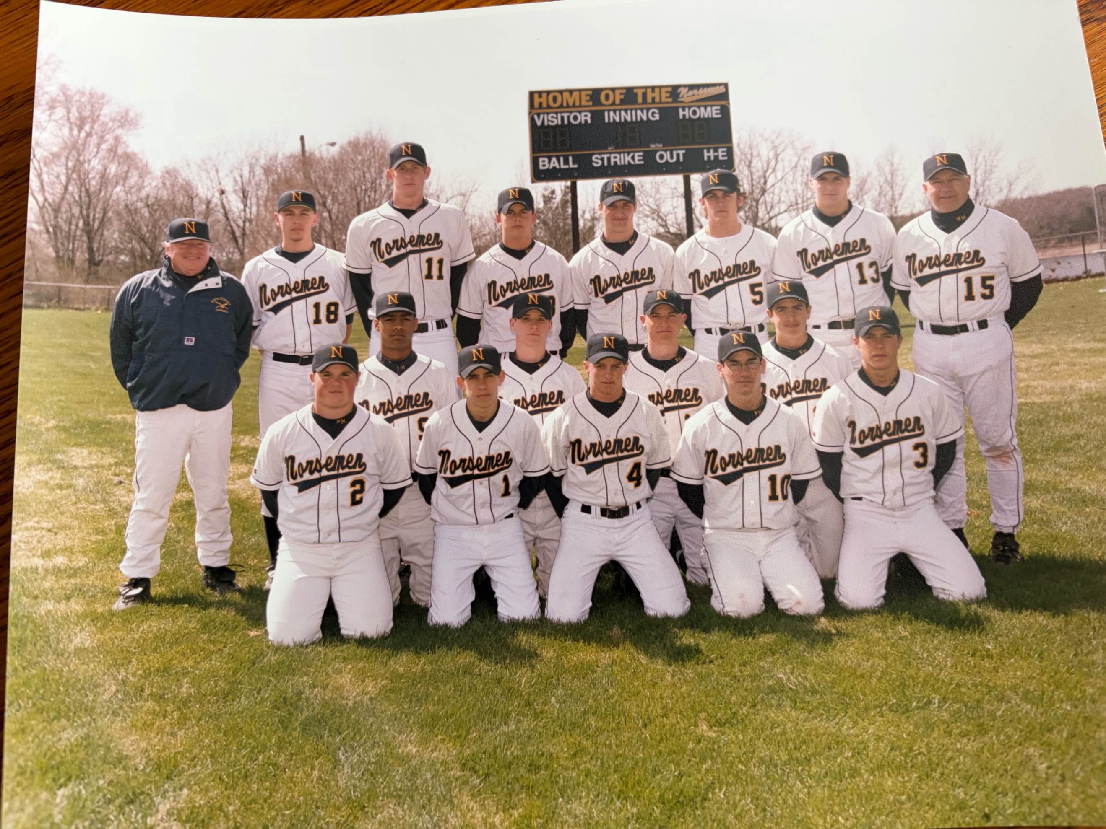

The 2001 NORSEMEN

Front Row L-R: Casey Closz, Brandon Hillman, Nick Haines, Mark Bilek, Cody West
Middle Row L-R: Sean Scott, Geoff Dean, Justin Derks, Grant Wieman
Standing L-R: Coach Jim Moyes, Drew Barker, Drew Naymick, Matt Geyer, Mike Wasiura, Eric Richardson, Nick Marietti, Head Coach Walt Gawkowski

2002 – coach Walt Gawkowski (9-17 overall; 3-11 in WMC; xx place in WMC; Montague Champs)
A young North Muskegon team struggled during the season, but a few Norsemen had some interesting highlights. Freshman Mike Dean may not have ever envisioned how his pitching career would turn out after a less than successful debut on the mound in early 2002. Dean gave up 15 runs, although only seven would be earned in a Norse 15-9 defeat at the hands of Spring Lake. Dean would bounce back from this setback to post four of the Norse nine victories on the season. Among the spectators taking in the NM-Laker game was MSU head basketball coach Tom Izzo. Having not yet signed future Spartan Drew Naymick, Izzo may have feared Naymick might want to opt to play baseball for the Spartans instead of basketball. Naymick, perhaps wanting to make a lasting impression on his future basketball coach, went a perfect 4-for-4 with a double in a losing cause. Although Drew Naymick has been in the limelight many times as basketball’s all-time shot blocker in MHSAA and now MSU history, Naymick had a day he will never forget against perennial power Holland Calvary. Naymick would get credit for his only pitching victory in his four years as a Norsemen. The modest Naymick went through most of his varsity and MSU career with an ailing shoulder, a fact he never once pointed out to his high school baseball coaches, just another testimony to his team play. Sean Scott had a day to remember in a NM twin bill sweep of Hart on May 7. Scott banged out a school-record eight hits on the afternoon, including three doubles in NM’s 17-10 win in game No. 1. Mike Dean would later join Scott as one of only a handful of ex-Norsemen to have three doubles in one game. Oddly enough, the trio of two baggers Dean banged out in a pre-District win over Walkerville would be his only doubles for the entire year.

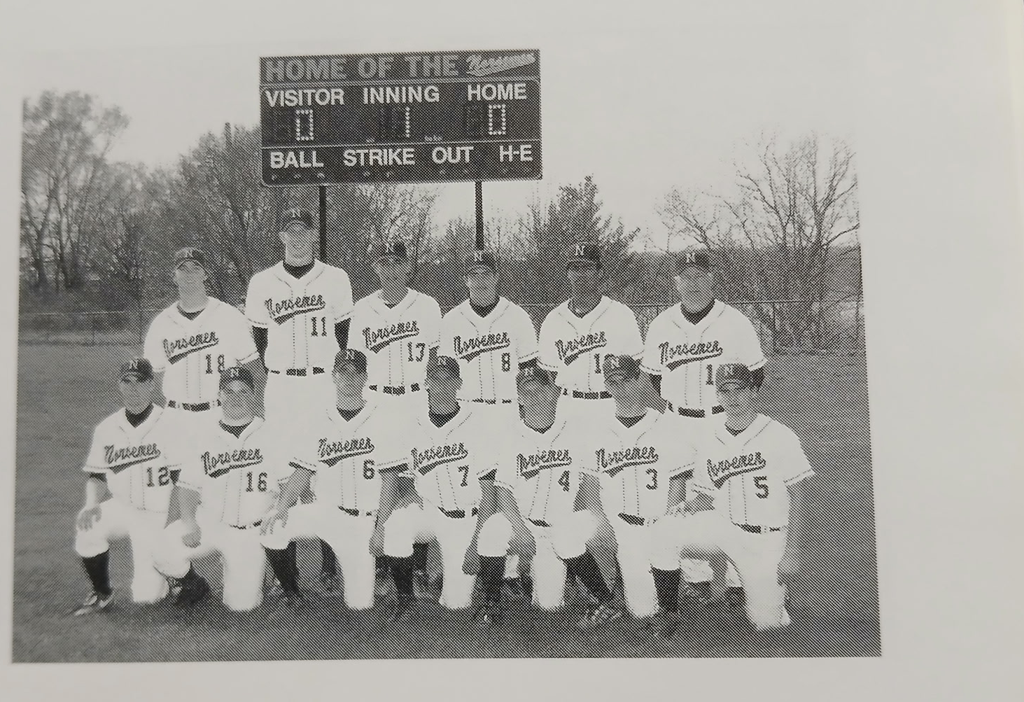

The 2002 NORSEMEN

Kneeling L-R: Mike Dean, Casey Closz, Geoff Dean, Justin Derks, Nick Haines, Brandon Hillman, Tom Hanis
Standing L-R: Asst Coach Pete Gawkowski, Drew Naymick, Eric Kravako, Grant Wieman, Sean Scott, Head Coach Walt Gawkowski.

Record Score Interesting Fact
0-1 Muskegon 14, NM 2 Nick Haines 2 hits
0-2 Reeths-Puffer 16, NM 2 Geoff Dean 2 RBI single, Haines double
0-3 *Whitehall 8, NM 2 Tom Hanis HR; Justin Derks double
0-4 *Shelby 9, NM 1 NM only 4 hits
0-5 *Shelby 8, NM 5 G. Dean 3 hits, Nick Haines 2 hits
0-6 Spring Lake 15, NM 9 Drew Naymick 4-for-4 as MSU coach Tom Izzo watches game
1-6 *NM 7, Oakridge 5 Naymick & Hanis 2 hits (double_, Tom Hanis 2 hits
1-7 *Mason CC 4, NM 3 Brandon Hillman double
1-8 *Mason CC 15, NM 3 5 innings G. Dean double
1-9 *Ravenna 5, NM 3 Haines 2 run triple
2-9 NM 15, Holland Cal. 2 Naymick winner; Nick Haines 3-4, including HR, 5 RBI
2-10 *Montague 15, NM 0 3 innings, Hanis double
2-11 *Montague 15, NM 0 4 innings, Nick Haines has only NM hit
2-12 *Whitehall 15, NM 8 Mike Dean, Eric Kravako 2 hits, Casey Closz HR
3-12 *NM 17, Hart 10 Sean Scott 4 hits, including 3 doubles, Mike Dean HR
4-12 *NM 16, Hart 2 Scott 4 hits, Naymick, Grant Wieman 2 hits
4-13 *Oakridge 16, NM 4 Mike Dean HR; Naymick 2-2; Scott 2 hits
4-14 WM Christian 15, NM 8 County, Kravako 2 hits
5-14 NM 7, Holton 5 Geoff Dean 2 hits (HR), Haines 2 hits
5-15 *Ravenna 9, NM 5 Mike Dean, Haines 2 hits
6-15 NM 9, Musk. Cath. 3 Hillman 2 hits, 4 RBI, Naymick & Hillman 2 hits
7-15 NM 16, WMC 13 Hillman, Naymick 2 hits (including double) G Dean 2 hits
8-15 NM 13, Walkerville 3 Pre-District; Naymick 4-for-4; Mike Dean 3 doubles, Hanis HR 4RBI
8-16 Shelby 9, NM 5 @ Old Kent Park in GR: Haines, Hillman 3 hits; Scott 2 hits
9-16 NM 5, WMC 3 District; Scott win in relief; 9 innings, Naymick GW RBI
9-17 Musk. Cath. 7, NM 0 District finals, Hillman has 2 of NM 4 hits

2003 – coach Walt Gawkowski (18-11 overall; 7-7 in WMC; xx place in WMC; Shelby Champs)
Walt Gawkowski concluded his outstanding coaching career in his 17th season by going out in style. The 2003 Norsemen won another District title and nearly added yet another County Championship to Gawkowski’s resume, dropping a tough 12-10 decision to Holton in the finals. The district championship game was certainly anti climatic from the first game of the day’s doubleheader. Trailing archrival Muskegon Catholic Central, 3-0, going into the bottom of the sixth inning, the outcome did indeed look dark for the Norsemen. However, with the bases loaded and two out, Sean Scott belted a long home run over the left-field fence to send the Norse fans gathered at James B. Johnson stadium into delirium. The 4-3 win over MCC was followed by a quick three-inning, 15-0 whitewashing of Grand Rapids Tri-Unity Christian in the championship game. First baseman Drew Naymick concluded his four-year career at or near the top of the leader board in several career statistics. What his teammates and coaches will most remember is Naymick withdrawing from the prestigious Michael Jordan Classic basketball all-star game. To have played in that game, televised on ESPN, would have meant he would have to forego his senior season of baseball per MHSAA rules. Naymick was the leading hitter on a team that collectively hit better than .300 for the season. The Norse batters swatted a school record 26 home runs with Geoff Dean hitting 10. On April 30, Geoff and Mike Dean had a moment that will long be remembered in the Dean family, becoming the first set of brothers to hit back-to-back home runs in a game. A welcome addition to the team was Japanese foreign exchange student Tomoki Hiramatsu. Hiramatsu was a splendid fielder for the Norse and chipped in with many timely hits throughout the campaign. Coach Gawkowski would end his coaching career with more than 180 victories before working his same kind of baseball magic at Mona Shores and later with the Muskegon Clippers.

Record Score Interesting Fact
1-0 NM 14, Muskegon 9 Mike Dean, Eric Kravako, Brandon Hillman HR
2-0 *NM 14, Ravenna 7 Hillman 2 HR; Geoff Dean HR; Drew Naymick 3 hits
3-0 *NM 4, Hart 2 Sean Scott 4-hitter, 8 K’s
4-0 *NM 11, Hart 4 NM scores 9 runs in an inning
5-0 NM 19, Holton 6 Scott HR
5-1 *Whitehall 14, NM 6 G. Dean HR, Tomoki Hiramatsu 3 hits
5-2 *Shelby 9, NM 3 Dean brothers hit back-to-back HR
5-3 *Shelby 14, NM 3 Hiramatsu 2 hits
5-4 *Oakridge 6, NM 1 NM averts shutout with 2 out single in 7th by Andy Grosse
6-4 NM 7, Fremont 6 G. Dean walk-off HR, Naymick 3 run HR & Mike Dean HR
6-5 Fremont 16, NM 12 Naymick, Hillman, Grosse 2 hits
7-5 *NM 4, Mason CC 0 Scott 3 hit shutout; G. Dean, Naymick HR, Hiramatsu 2 hits
8-5 *NM 9, Mason CC 4 G. Dean 2 HR, Scott 3 hits, Hillman 2 hits & 3 RBIs
9-5 NM 6, Musk. Cath 0 County tour. Scott 2nd straight shutout, Naymick, Justin Derks 2 hits
10-5 NM 8, Oakridge 6 County Tournament, Hillman 2 hits, Naymick 2 RBI double
10-6 Holton 12, NM 10 County Champs, NM spots Holton 7 runs in 1st, Hillman, Naymick 3 hits
11-6 *NM 12, Ravenna 1 Scott 3 run HR, Grosse 3 hits, Dean gets the win
11-7 *Montague 8, NM 7 G. Dean HR, Naymick 3 hits
11-8 *Montague 8, NM 7 Scott & Mike Dean 2 hits
11-9 Holton 2, NM 1 Hiramatsu, Hillman & M Dean have only NM hits
11-10 *Whitehall 3, NM 1 NM has but 3 hits (Hiramatsu, Geoff & Mike Dean)
12-10 NM 3, Musk. Cath 0 Andy Grosse wins, Mike Dean 2 hits (HR)
13-10 NM 5, Spring Lake 3 Kravako, Scott 3 hits in Tom Hickman’s (SL coach) last season
14-10 NM 13, WMC 3 Naymick, 3 hits, HR & double, M. Dean 3 hits, HR, Scott HR 3 RBIs
15-10 *NM 6, Oakridge 5 Naymick, G, & M. Dean, Grosse 2 hits
16-10 NM 7, WMC 6 Pre-District, Grosse 4-4, Naymick 3-4, G. Dean HR, Hiramatsu 2 hits
17-10 NM 4, Musk. Cath 3 District; Scott 6th-inning GS
18-10 NM 15, Tri-Unity 0 District Championship; 3 innings, Hiramatsu, Hillman, Wieman 2 hit
18-11 Wyoming Lee 10, NM 7 Regional, Scott, Kravako 2 hits

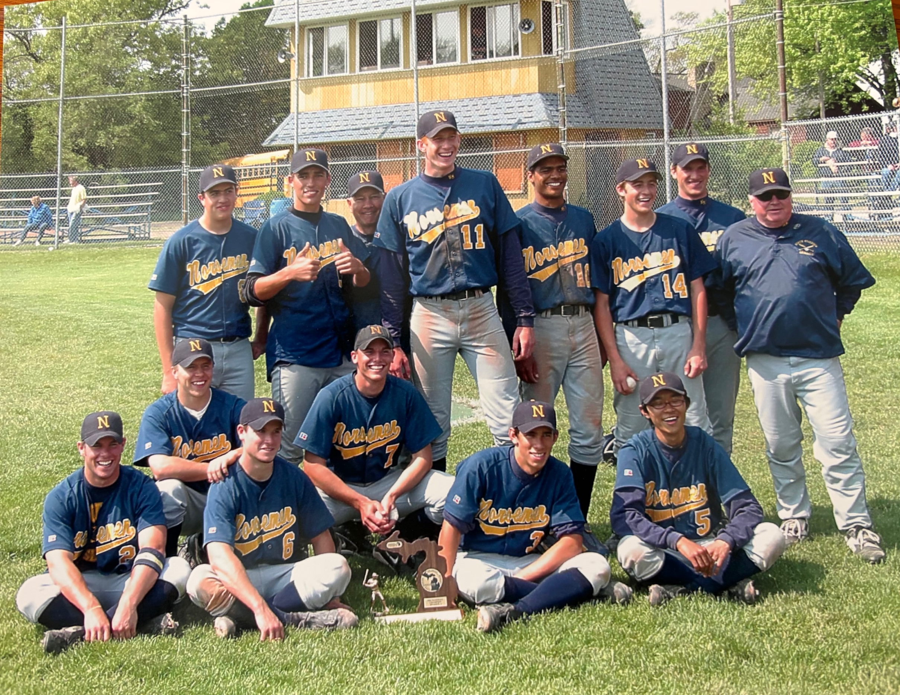

The NORSEMEN of 2003 with their District Championship Trophy

Front Row L-R: Mike Dean, Geoff Dean, Brandon Hillman Tomoki Hiramatsu,
Middle Row L-R: Aron Saunders, Justin Derks, Brandon Hillman, Head coach Walt Gawkoski. Camera Shy: Asst Standing L-R: Grant Wieman, Eric Kravako, Head Coach Walk Gawkowski, Drew Naymick, Sean Scott, Andy Grosse, Drew Barker, Asst. Coach Jim Moyes

EDITOR’s NOTE:

From 2004 through 2017 the stories were mostly written by NM Head Coach Warren Kent III.

2004 – Warren Kent III (9-16 overall; 3-11 in WMC; xx place in WMC; Oakridge Champs)
With only two seniors and three players with varsity experience, the No. 1 goal of the Norsemen was to improve as the season progressed. Mission Accomplished. In coach Warren Kent’s first year as a varsity baseball coach, North Muskegon struggled at the beginning of the season as both players and coaches searched for the right chemistry. But with the players focusing on “every pitch, every inning,” the Norsemen won seven of their final nine games. While the 9-16 record looks bad, it is deceiving. Statistically, the Norsemen were much better. The team was outscored 183-142 in the 25 games, but take away four losses (Muskegon, 11-1; Shelby, 16-0; Mason County Central, 17-1; Oakridge, 13-1) and North Muskegon outscored its opponents 139-126. In those 16 losses, 11 were by fewer than six runs, including five by two runs and one by one run. Therefore, North Muskegon was 11 runs away from a 15-10 record. The punch in the lineup was provided consistently throughout the season by three juniors (Mike Dean, Andy Grosse and Ben McPherson), which led the team in 12 of the 14 offensive categories. Dean led the team with a .377 average on a team-best 26 hits in 69 at bats. Grosse, who only struck out twice in 68 at bats, paced the team with a .482 on-base percentage and had team highs in doubles (10), walks (15) and stolen bases (12). He tied McPherson with a team-leading 15 RBI. McPherson led the team in home runs (3) and hit by pitch (3). He tied for the team lead with 17 runs scored. Grosse (.368) and McPherson (.305) were also two of five batters to post a batting average over .300. Dean and Grosse also handled a brunt of the pitching duties. Dean, who tossed 50.3 innings, led the team with three wins. Grosse led the team with 51.6 innings and 45 strikeouts while posting a 2.58 ERA. Grosse also posted two saves. Jordan Fairbanks (.323), a freshman who DH’d throughout the year, and junior Jake Edick (.316) were the remaining players to post a .300 batting average or better. Two seniors just missed the .300 mark. Grant Wieman, who was injured through the first half of the season, finished strong, posting a .278 average. He was 8-for-17 (.471) in the final eight games. Aaron Saunders, the predominant lead-off hitter throughout the year, led the team with two sacrifices and batted .269. Wieman and Saunders each went 1-0 on the mound. Four other players posted an average greater than .200. A.J. Dieters batted .250 in limited playing time. Freshman Chris Scheldt was consistent throughout the season, batting .246. Steve Dunn, who tied for the team lead with 17 runs and two sacrifices, posted a .245 average. First baseman Jerad Derks started strong but tapered off down the stretch and finished at .239. Junior Nick Carley contributed at both second and third, batting .180. Freshman Jordan Carr, who batted .176, made the most of his three hits as two of them left the park. While he put the ball in play (only five strikeouts in 45 at bats), junior Ryan Falkowski struggled at the plate all year, posting a .111 average. Falkowski was the No. 3 pitcher, posting a 2-5 record. Rounding out the team were four players, who will be counted on in the future: juniors Christian Helle, Andrew Westra and Mike Graff, and freshman Ron Balaskovitz. Balaskovitz also was 1-0 on the mound. NOTE: There was no County Tournament due to rain.

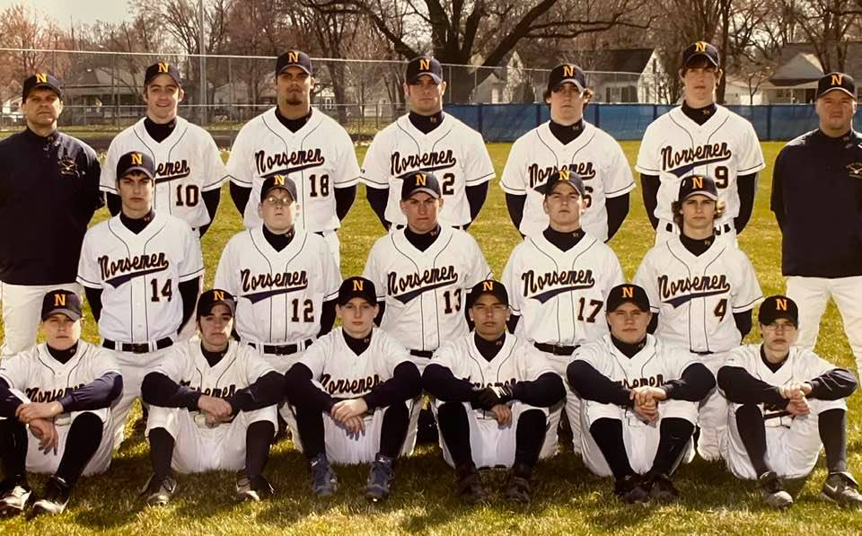

The 2004 NORSEMEN
Front Row L-R: Chris Scheldt Jr., Steve Dunn, Nick Carley, Ryan Felkowski, Aaron Saunders, Ron Balaskovitz,
2nd Row: Mike Graf, Andrew Deilers, Jordan Fairbanks, Jordan Carr, Jake Edick
Top Row: Asst Coach Mike Belmonte, Andy Grosse, Jerad Derks, Mike Dean, Ben McPherson, Coach Warren Kent

Record Score Interesting Fact
0-1 Muskegon 11, NM 1 One hit (Ben McPherson) for NM
0-2 Holton 17, NM 11 NM strands 13 runners; NM pitchers walk 15
0-3 Spring Lake 13, NM 10 NM commits 9 errors: freshman Chris Scheldt 2 hits, (2B)
0-4 *Ravenna 6, NM 4 McPherson 2 doubles; Andy Grosse HR; Jerad Derks double
0-5 *Whitehall 7, NM 4 NM only 3 hits (Derks 2 singles; Grosse double)
1-5 NM 7, Hesperia 6 Grosse 3 hits, including 2 doubles, 2 runs and 2 RBI
2-5 NM 8, Hesperia 4 8 innings; freshman Jordan Fairbanks 4-for-5, including a double
2-6 *Oakridge 8, NM 1 NM outhit Oakridge, 7-6; Grosse, Mike Dean 2 hits (2b)
2-7 *Hart 3, NM 1 NM hitters strike out 11 times, leave 7 runners on base
2-8 *Hart 2, NM 0 Combined one-hitter from Dean, Grosse; NM only 5 hits
2-9 *Ravenna 6, NM 4 Dean 2 HR; Grosse, McPherson, Aaron Saunders 2 hits
2-10 *Shelby 3, NM 1 Dean led offense with 2 singles
2-11 *Shelby 16, NM 0 Tigers 10 runs in 4th inning; Steve Dunn 2 1Bs (only NM hits)
2-12 Holton 12, NM 7 Holton scores 11 runs with 2 outs; Derks 2 doubles
2-13 *Mason CC 17, NM 1 NM held to just three hits while MCC smacked 15 hits
2-14 *Mason CC 4, NM 3 MCC scored unearned run-in top of 7th; McPherson, Grosse 2Bs
3-14 *NM 7, Whitehall 6 NM uses 5-run 5th ing. to erase 5-2 deficit: Dean, McPherson 2H
4-14 *NM 10, Montague Dunn scored winning run-on ground-out in bottom of 7th
5-14 *NM 12, Montague 2 Grant Wieman, Dunn, freshman Jordan Carr 2-run HR
6-14 NM 12, WMC 8 McPherson HR; Dean single, double, triple; Wieman, Dunn 2 hits
6-15 *Oakridge 13, NM 1 NM held to just two hits (singles by Dean, Grosse).
7-15 NM 10, Musk. Hts 2 Carr 2-run HR; Grosse double, HR, 2 RBI; Dean double
8-15 NM 15, Musk. Hts 0 NM triple play; NM scored 11 runs in 1st; Derks HR
9-15 NM 7, WMC 3 McPherson 3-run HR; NM only 4 hits but was helped by 8 errors
9-16 Allendale 8, NM 5 District; McPerson 2-run HR; Saunders single, double, 2 runs

2005 – Warren Kent III (20-8 overall; 9-5 in WMC; 3rd place in WMC; Whitehall Champs)
With a team dominated by seniors, the Norsemen built off the final nine games of 2004, when NM went 7-2, and had one of the more successful seasons in school history. North Muskegon captured the County Tournament title and the district championship enroute to a 20-win season. The team also finished third in the WMC, losing three games in the opposing team’s final at bat. This group of 12 seniors set the foundation for the future of Norsemen baseball under coach Warren Kent, who completed his second season. Coach Kent brought his father Warren Jr. on board as his assistant coach, as last year’s assistant coach Mike Belmonte took the reins of the JV program, which did not exist in 2004. The Tuesday morning of the pre-district game against Freedom Baptist, Warren Jr. suffered a heart attack and was rushed to Spectrum in Grand Rapids. By mid-afternoon, he was stable with stents put into his arteries, and he told Warren III to go coach. In one of the oddest wins in NM history, the Norse struck out 18 times (no, that’s not a typo) and had just one hit but scored three runs on wild pitches for a 3-2 win over Freedom Baptist, which helped catapult the Norse to the school’s sixth District title. While 12 of the 13 players were seniors, it was junior Austin Aamodt who won the batting title with a .438 average (39-for-89). His 39 hits also led the team. Aamodt also pitched well, compiling a 2-1 record while striking out 22 in 20 innings. He finished with a 2.45 ERA with opponents hitting just .238 against him. Two other players posted a batting average greater than .400. Mike Dean, who won the batting title in 2004, was 36-for-87 (.414), and Andy Grosse was 36-for-90 (.400). Dean led the team with 12 doubles, four home runs and 33 RBI. He also tied for the team lead with five triples. Grosse tied for the team lead with 90 at bats and 35 runs. Dean and Grosse were also the go-to guys on the mound, combining for 13 of the team’s wins. Dean finished with a 6-3 record while leading the team in most categories. He tossed 76 innings, finishing with 68 strikeouts and a 1.75 ERA. Opponents batted just .175 (50-for-287) against him. Grosse was 7-4 on the mound, striking out 46 in 54.3 innings. Ben McPherson was the only other batter to post a batting average greater than .300. McPherson went 26-for-71 (.366) and led the team with three sacrifices. Jerad Derks (.267) and Steve Dunn (.256) were two of five players to play all 28 games, joining Aamodt, Dean and Grosse. Derks and Dunn both tied for the team lead with 90 at bats while Dunn tied for the team high with 35 runs. Dunn, the lead-off hitter, also led the team in walks (18), hit by pitches (5) and stolen bases (16). Christian Helle (.232) and Nick Carley (.211) round out the players with an average greater than .200. Both became full-time starters in the outfield. Helle tied for the team lead with five triples. The final full-time starter, Ryan Falkowski, struggled at the plate (.149), but excelled on the mound, posting a 5-0 record with a 2.39 ERA in 29.3 innings. Jake Edick (.179) and Andrew Westra (.115) each gained significant playing time in the outfield and as courtesy runners. Rounding out the squad were A.J. Deiters and Mike Graff, who picked up his first varsity hit.

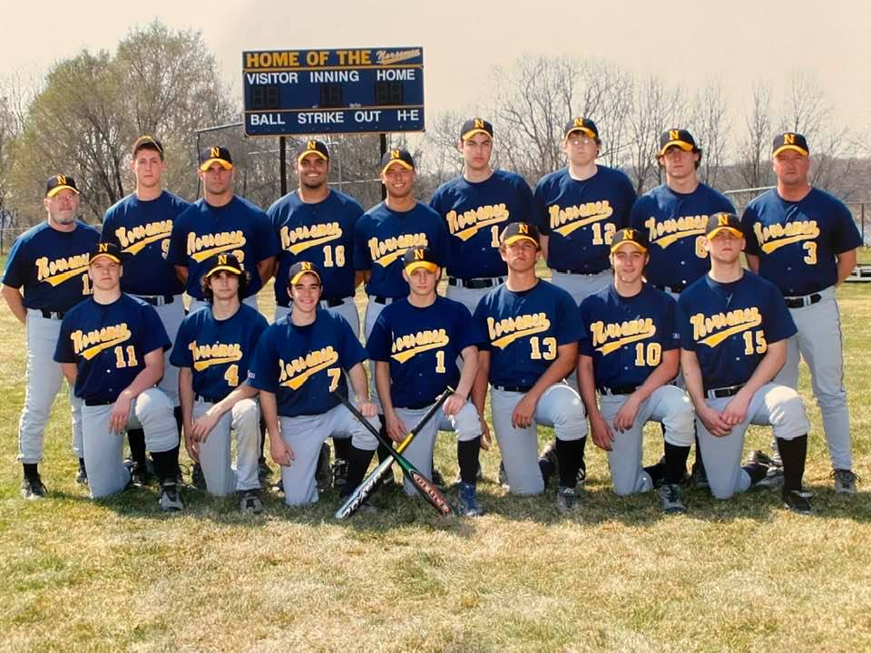

The 2005 NORSEMEN
Front Row: Austin Aamondt, Jake Edick, Steve Dunn, Nick Carley, Troy Forton, Andy Grosse, Christian Helle
Back Row: Coach Warrant Kent Jr., Andrew Westra, Mike Dean, Jerad Derks, Ryan Felkowski, Mike Graf,
AJ Dieters, Ben McPherson, Head coach Warren Kent III

Record Score Interesting Fact
0-1 Muskegon 16, NM 5 Andy Grosse 2 hits, including double; Jerad Derks 2 hits
0-2 Musk. Cath 8, NM 4 Austin Aamodt 2 hits, 2 RBI; Crusaders 7-run 2nd inning
1-2 NM 10, WMC 1 Mike Dean 2B, triple, 3 RBI, 2 runs; Ben McPherson, 3 RBI
2-2 NM 10, WMC 4 Grosse 3-run HR, 2 doubles, 5 RBI: Dean 1B, 2B, HR, 3 RBI.
3-2 *NM 4, Oakridge 2 NM only 2 hits (Aamodt, McPherson single)
3-3 *Hart 2, NM 1 Dean 2-hitter; Steve Dunn 2 hits; Hart scored once in bottom of 7th
4-3 *NM 11, Hart 9 Aamodt GS, triple; Derks 2-run HR; Grosse 2 hits, 2 RBI
5-3 NM 5, Holton 4 Dean HR, 2 runs; Aamodt single, double
6-3 NM 7, Holton 4 Dean single, 3-run HR, 4 RBI, 3 runs
6-4 *Whitehall 12, NM 5 Dean, Aamodt 2-run HR: McPherson 2 singles, 2 runs
7-4 *NM 2, Shelby 1 Dean complete game 4-hitter, 8 K’s; Falkowski 2 singles
7-5 *Shelby 12, NM 11 NM loses 7-run lead; Shelby scored once in bottom of 7th
8-5 *NM 9, Oakridge 4 Grosse 3 hits, 2 RBI, 4 runs, Dean 3-for-3; Christian Helle HR
9-5 NM 5, Musk. Cath 4 County Tournament; Derks single, double; Helle 2 hits; Dean 2B
10-5 NM 12, Ravenna 10 County Title; McPherson 2 singles, double, 4 RBI; Grosse 4-for-5
10-6 *Mason CC 8, NM 6 Eight innings; Dunn 2 singles, double, 2 RBI, 2 runs; Aamodt single HR
11-6 *NM 13, Mason CC 0 Grosse 3-hitter; Grosse 2 singles, 2 runs; Aamodt triple, 2 RBI
12-6 *NM 10, Montague 2 Helle 2 triples, 2 RBI, 2 runs; McPherson 2 singles, 3 RBI
13-6 *NM 16, Montague 6 Dean single, double, triple, 3 RBI, 3 runs; 9-run 4th inning
13-7 *Whitehall 11, NM 1 Dean single, double, run; 4th 3-game win streak of season snapped
14-7 NM 7, Hesperia 1 Aamodt 2-hitter, 11 K’s; NM 7 extra-base hits, including 4 triples
15-7 NM 16, Hesperia 4 Combined 1-hitter for Falkowski, Dean; Derks 3 singles, 3 RBI
16-7 *NM 3, Ravenna 0 Dean 1-hitter, 11 K’s; Aamodt 3 singles
17-7 *NM 12, Ravenna 2 Grosse 3-hitter; McPherson 2 doubles, 2 RBI, 3 runs; Helle 2-run
18-7 NM 3, Freedom Bap 2 Pre-District; NM batters struck out 18 times; NM only 1 hit
19-7 NM 5, Musk. Cath 0 District; Dean 1-hitter; Dunn single, double, 2 runs; Helle 2 singles
20-7 NM 23, Tri-Unity 7 District Championship; Dean single, triple, 2 RBI, 2 runs
20-8 Lawton 3, NM 2 Regional; Dunn double, run; NM only 3 hits

2006 – Warren Kent III (19-14 overall; 8-6 in WMC; xx place in WMC; Whitehall/MCC Champs)
With only one returner from 2005, the Norsemen entered the season with one senior, four juniors and seven sophomores. The biggest problem for the young team was the beginning of games, where the Norsemen posted a 5-9 record when they were losing after the first inning; with the lead or a tie game after one inning, NM had a 14-5 record. The first inning was the only inning in which opponents (43 runs) scored more than the Norse (32 runs). Despite these first-inning woes, the Norse came thisclose to accomplishing its three goals: winning the County tournament (lost in championship game), winning districts (lost in championship game), winning 20 games (missed by one win). Two of the team’s 19 wins came against Holton, which lost in the Div. 4 State championship game. The big nemesis for the Norse was Muskegon Catholic, which beat NM three times, including the season opener, the County championship game and the district championship game. The go-to player both offensively and on the mound was junior Troy Forton, a Div. 4 All-State infielder. Offensively, Forton led the way with a .565 average while posting team highs with 48 hits, 43 RBI, 41 runs and seven triples. He tied for the team lead with six home runs. He also led the team with a .645 on-base percentage. On the mound, Forton was a dominant force, posting a 10-3 record with a 1.06 ERA with only 12 earned runs in 79 innings. Opponents batted just .178 (53-for-297) against him. He also had 126 strikeouts. The only senior, Austin Aamodt, was the team’s second-leading hitter with a .391 average (43-for-110). Aamodt, one of three players to play all 33 games, led the team with 110 at bats and nine doubles. He tied for the team lead with six home runs. Aamodt was second on the team with 35 RBI. He struggled on the mound, posting a 1-5 record. Sophomore catcher Ryan Buter, who played every game, was the team’s third-leading hitter with a .372 average (35-for-94). He led the team with 22 walks while posting 29 RBI, eight doubles and four home runs. Buter also posted a 0-2 record on the mound. Junior infielders Jordan Fairbanks at third base, Reid Arends at second base and Ron Balaskovitz at first base had steady seasons. Fairbanks, who played all 33 games, batted .298, Arends had a .277 average, and Balaskovitz posted a .284 average. Fairbanks was third on the team with 31 RBI; Balaskovitz was second with 19 stolen bases. Balaskovitz and Arends were both 0-1 on the mound. The quintuplet of sophomore outfielders struggled all season, posting a collective .244 average (78-for-320) and striking out 93 times. Matt Dunn, who led the team with four sacrifices, posted a .313 average (15-for-48) in limited playing time. Noah VanBergen (.250) led the team with nine hit by pitches, Mark Picard (.238) led the team with 22 stolen bases, Austin Vanderweele batted .228, and Alex Jones (.216) had a team-high 24 strikeouts. Picard did have success on the mound, posting an 8-2 record with a 4.17 ERA. He did, however, walk 51 batters while striking out only 34. Sophomore Ryan Sexton and junior Chris Scheldt also gained a varsity letter with limited playing time. Sexton finished with a .333 average (7-for-21), and Scheldt, who joined the team midway through the season, finished with a .125 average (3-for-24). Four other sophomores got a taste of the varsity game. Arion Carley was 3-for-6 (.500), and Travis Falkowski went 7-for-15 (.467). Alex Wierda and Chris Gedman also played.

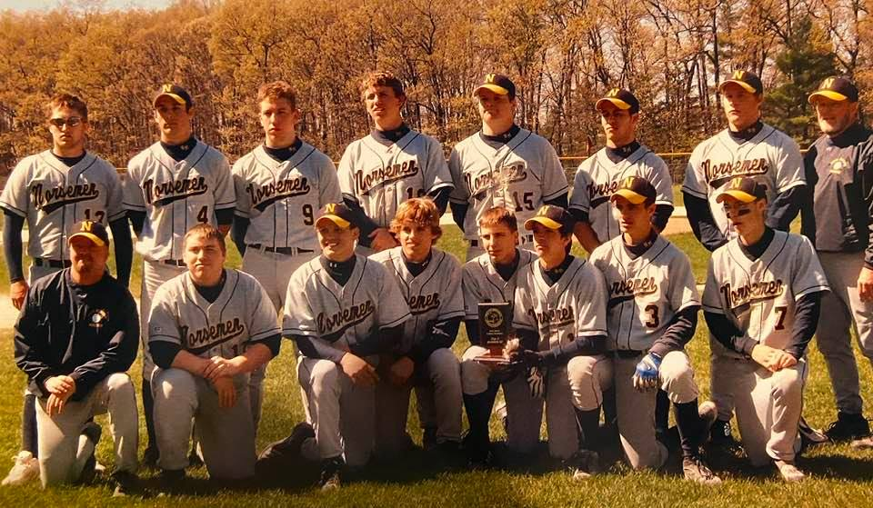

The 2006 NORSEMEN
Front Row L-R: Head coach Warren Kent III, Ryan Sexton, Mark Picard, Austin Vanderweele, Travis Felkowski, Matt
Dunn, Reid Arends, Ron Balaskovitz
Back Row L-R: Jordan Fairbanks, Alex Jones, Ryan Buter, Troy Forton, Austin Aamondt, Noah VanBergen, Chris Scheldt, Assistant Coach Warren Kent Jr.

Record Score Interesting Fact
0-1 Musk. Cath 7, NM 5 Lost in 7th inning; Ryan Buter double, HR; Austin Aamodt HR
0-2 *Montague 8, NM 7 Austin Vanderweele single, double, RBI; Troy Forton 2 hits
1-2 *NM 7, Montague 2 Forton 13 K’s; Alex Jones single, double; Ron Balaskovitz 2 hits
1-3 *Whitehall 11, NM 6 Balaskovitz, Buter, Matt Dunn 2 singles
1-4 *Whitehall 4, NM 1 Forton 13 K’s; NM only 3hits; Buter RBI single
2-4 NM 7, Holton 6 NM scored 6 in bottom of 6th: Buter double, 3 RBI, 2 runs
2-5 Fremont 6, NM 5 Lost in bottom of 7th on squeeze bunt; Aamodt single, 2-run HR
3-5 NM 10, Fremont 4 Forton 10 K’s; Aamodt 4-for-5 with double, 4 RBI
3-6 Hesperia 11, NM 6 NM commits 8 errors; Buter HR; Forton, Vanderweele 2 hits
4-6 NM 16, Hesperia 6 Jordan Fairbanks 2 doubles, 3 RBI; Forton, Balaskovitz single, 2B
5-6 *NM 16, Shelby 1 Forton 1-hitter, 9 K’s; Buter single, 3-run HR, 4 RBI, 3 runs
6-6 *NM 22, Shelby 8 Shelby had 8-1 lead; Forton, Buter 5 hits, HR; Aamodt HR
7-6 NM 8, Reeths-Puf 6 1st win over R-P since 1963; NM scored 6 runs in 5th inning
8-6 *NM 8, Oakridge 7 NM scored 4 runs in bottom of 7th: Reid Arends 2 singles, 2 RBI
8-7 Oakridge 5, NM 1 NM held to 3 hits: Arends triple, RBI
8-8 Spring Lake 8, NM 6 NM batters strike out 10 times: Vanderweele 2 singles, 2 RBI
9-8 NM 14, WMC 4 County Tournament; Mark Picard 3-hitter; Arends 2 singles, 3 RBI
10-8 NM 6, Holton 2 County Tournament; Forton 10 K’s; Forton 2 singles, 2 RBI
10-9 Musk. Cath 15, NM 1 County finals; Forton single, double, run
11-9 *NM 11, Ravenna 1 Forton 3-hitter; Forton single, triple, HR, 3 RBI; Aamodt 2B, HR
12-9 *NM 14, Ravenna 0 Picard 3-hitter; Forton 2 singles, triple, 5 RBI, 3 runs
12-10 *Hart 3, NM 2 8 innings; Forton 3-hitter, 13 K’s, no-hitter through 6 2/3
13-10 *NM 6, Hart 5 NM scored 1 run in top of 7th: Picard 2 singles, 3 RBI
13-11 Fruitport 11, NM 6 Forton 2 HR, 3 RBI, 2 runs; Alex Jones HR, Balaskovitz 2-run 3B
13-12 Fruitport 12, NM 2 Forton, Dunn 2 singles, RBI
14-12 NM 6, Mason CE 0 Forton 2-run HR, 2 runs: Vanderweele, Balaskovitz single, double
15-12 NM 13, Mason CE 3 NM started 9 sophomores: Ryan Sexton 3 singles, 4 RBI, 2 runs
16-12 NM 7, WMC 1 Aamodt single, 2-run HR, 4 RBI; Buter single, double; Arends 2B
17-12 *NM 7, Mason CC 3 NM 11 Ks, only 3 hits; Forton 10 K’s; Fairbanks 2 hits, 4 RBI
17-13 *Mason CC 12, NM 3 NM commits 8 errors; Fairbanks 2 hits, 3 RBI; Aamodt 2B, 2B
18-13 NM 21, Potter's H 0 Pre-District; Forton 2 singles, 2B, 2 RBI, 3 runs; Aamodt 2-run HR
19-13 NM 5, GR Cov. C 4 District; Buter single, double, RBI; Forton HR
19-14 Musk. Cath 10, NM 5 District finals; Forton, Fairbanks 2 singles; Aamodt double

2007 – Warren Kent III (24-4-1 overall; 11-2-1 in WMC; 2nd place in WMC; Whitehall Champs)
With 11 returners from a team that went 19-14, the 2007 Norse season began with high expectations. And these lofty expectations were valid, as the team, which finished the regular season ranked No. 2 in the state in Div. 4, accomplished all three of its goals – winning 20 games, capturing the County title and winning Districts. In fact, the Norse set 16 team records, including wins. The team also won a school-best 15 games in a row. A key to the season was the first inning. A year ago, the Norse were outscored 43-32 in the first inning and posted a 5-9 record when they were losing after the first inning. This year, NM outscored their opponents 62-20 in the first inning; in fact, the Norse outscored their opponents in every inning, including the second inning when only three teams scored runs for a total of seven and the sixth inning when only six runs were scored. All 15 players contributed throughout the season; the only negative in an otherwise positive season was production out of the No. 7 spot in the batting order. Every position in the batting order posted at least a .287 average, except No. 7, which posted a .173 average (14-for-81). Troy Forton, who was a repeat performer on the Div. 4 All-State team, wrapped up his career as the top hitter, average-wise (.515), and the 2nd top pitcher, ERA-wise (1.10), in Norse history. While his senior year was cut short due to a rib injury, Forton, who played shortstop, led the team in hitting with a .462 average (36-for-78). He led the team in hits (36), doubles (13) and triples (3). On the mound, Forton posted an 8-1 record while allowing opponents to bat just .134 (26-for-194). He also had a 1.16 ERA while striking out 89 in 54.3 innings. He also led the team with 12 hit batters. Forton threw first pitch strikes to 65 percent of the batters he faced (146-for-225). Catcher Ryan Buter’s junior season was one of the best power-hitting seasons in Norse history. Buter, who was selected as a Div. 4 All-State catcher, set a school record with 13 home runs and fell one RBI short of the school record with 50. He tied for the team lead in hits (36) and led the team with 37 runs, 24 walks and a .566 on-base percentage. He also posted a .450 average (36-for-80). Six players batted better than .300 led by junior Alex Wierda, a second baseman. In limited playing time, Wierda posted a .391 average (9-for-23). He struck out just twice in 29 plate appearances. Junior Ryan Sexton had a break-out season after bouncing between JV and varsity a year ago. Sexton, who played third base, batted .379 (25-for-66). Sexton also saw 13.3 innings on the mound, posting a 2-0 record while striking out 18 and only walking six. Senior Jordan Carr, who was playing for the first time since his freshman year, was 12-for-34 (.353). Junior Noah VanBergen, who played both outfield and catcher, posted a .333 average (23-for-69). VanBergen, who was one of two players to play all 29 games, paced the team with a school-record at that time of 23 stolen bases. He also led the team with six-hit by pitches. Senior Jordan Fairbanks, who finished with a three-year career batting average of .305 (57-for-187), posted a .310 average (22-for-71). Senior Ron Balaskovitz, who played all 29 games, led the team with 89 at bats and six sacrifices. He batted .303 (27-for-89). Three outfielders – Chris Scheldt (.280), Alex Jones (.270) and Matt Dunn (.262) posted a batting average of .262 or greater. Dunn also pitched two innings while posting a 1-0 record. Senior second baseman Reid Arends batted .242. Juniors Mark Picard (.222) and Travis Falkowski (.217) both struggled at the plate, but they flourished on the mound. Picard posted a 9-2 record while tossing a team-high 70.6 innings. He had a 2.08 ERA while opponents batted just .212 against him. His first-pitch strike percentage was 54 percent (166-for-310). Falkowski went 4-1 while throwing 39.6 innings. He had a 1.41 ERA while opponents batted .213. Falkowski threw 65 percent first-pitch strikes (116-for-178). Junior Austin Vanderweele, who struggled with injuries, only batted 16 times for a .125 average. Sophomores Ryan Hillman, Jacob Frein and Robin Wiggins joined the team for the post-season. Hillman had a hit in the regional loss while Frein scored a run in the districts.

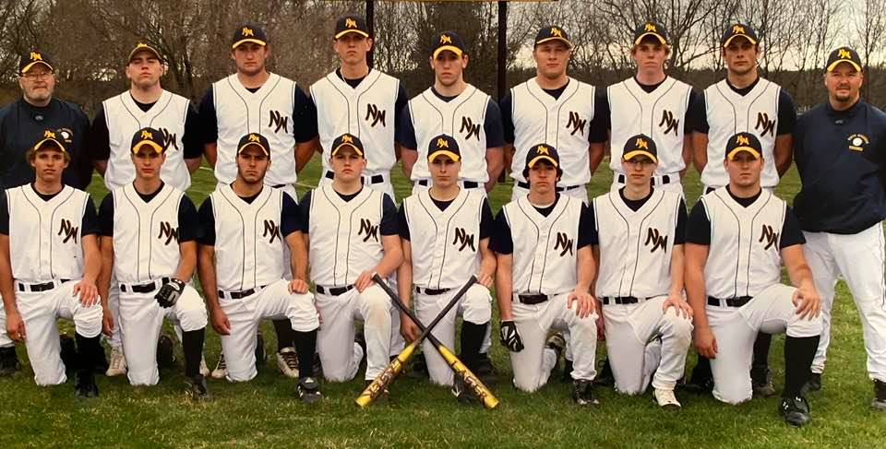

The 2007 NORSEMEN
Front Row L-R: Austin VanderWeele, Reid Arends, Noah VanBergen, Mark Picard, Travis Felkowski, Matt Dunn, Ron Balaskocitz, Jordan Carr
Back Row L-R: Asst Coach Warren Kent Jr., Ryan Sexton, Jordan Fairbanks, Troy Forton, Ryan Buter, Chris Scheldt, Alex Wierda, Alex Jones, head coach Warren Kent III

Record Score Interesting Fact
1-0 NM 5, Spring Lake 1 Noah VanBergen single, 4 stolen bases; NM steals 13 bases
2-0 NM 10, OV 9 NM erases 8-1 deficit to win in bottom of 7th; VanBergen 2 hits, 3 RBI
2-1 *Whitehall 6, NM 3 Troy Forton 12 K’s; Ryan Buter double, RBI
2-1-1 *NM 7, Whitehall 7 Jordan Carr 2-run double; Buter 2 hits
3-1-1 NM 13, GR Cov. 0 Forton no-hitter (5 innings); Forton 2 singles, 5 RBI; Buter HR
4-1-1 NM 12, GR Cov. 0 Three pitchers toss 1-hitter: Chris Scheldt 3-for-3, 2 runs
5-1-1 *NM 4, Shelby 0 Forton 2-hitter; Ryan Sexton 4 singles, 2 RBI
6-1-1 *NM 4, Shelby 1 Sexton single, double; Buter 2-run HR
7-1-1 *NM 13, Montague 3 Forton 11 K’s; Buter single, double, 3-run HR, 5 RBI, 3 runs
8-1-1 *NM 14, Montague 6 Forton 3 singles, 2 RBI, 2 runs; Buter single, triple, 2 RBI, 3 runs
9-1-1 *NM 13, Ravenna 7 County Tournament; Buter 3-run HR; Alex Wierda 3 singles, 2 RBI
10-1-1 NM 16, Musk. Cath 6 County Championship; Forton 14 K’s; Buter 2 HR, 5 RBI
11-1-1 *NM 8, Ravenna 0 Forton 1-hitter; Buter 2 doubles, 2 RBI; Forton double, 2 RBI
12-1-1 *NM 10, Ravenna 1 Mark Picard 2-hitter; Sexton HR; Buter single, double, 3 RBI
13-1-1 NM 4, Musk. Cath 3 NM only 4 hits; Jordan Fairbanks single, RBI, run
14-1-1 NM 16, Musk. Hts 0 Forton double, triple, 2 RBI, 2 runs; Carr double, 3 RBI
15-1-1 NM 15, Musk. Hts 1 Carr, VanBergen GS
16-1-1 *NM 12, Hart 1 Forton 12 K’s; Buter 3 HR, 7 RBI, 3 runs
17-1-1 *NM 13, Hart 3 Buter, Forton, Alex Jones single, double; Picard double, 3 RBI
17-2-1 Reeths-Puff 6, NM 0 Ron Balaskovitz 2 hits; ends school’s longest win streak (15)
18-2-1 *NM 25, Oakridge 1 Sexton single, double, 4 RBI, run: NM scores 21 runs in 4th inning
19-2-1 *NM 6, Oakridge 1 Picard 3-hitter; Sexton single, 3-run HR; Forton triple
20-2-1 NM 9, WMC 5 Buter 2 HR, 3 RBI, 3 runs; Forton single, 2 doubles, 2 RBI
21-2-1 *NM 10, Mason CC 2 VanBergen 2 singles, double, 4 RBI, run: Sexton 2 doubles
21-3-1 *Mason CC 7, NM 6 Buter 2 HR, 4 RBI, 3 runs; Sexton single, HR
22-3-1 NM 8, Muskegon 5 Wierda 4 singles, 3 runs; Jordan Fairbanks single, HR
23-3-1 NM 6, GR Cov. 0 District; Sexton single, double, 3 RBI; Ron Balaskovitz 3-for-4
24-3-1 NM 7, WMC 5 District Championship; Picard 3-hitter; Fairbanks 2 singles, RBI,
24-4-1 Lawrence 3, NM 1 Regional; NM only 2 hits (Buter, Ryan Hillman single), 12 Ks

2008 – Warren Kent III (34-4 overall; 12-2 in WMC; WMC Champs)
Wow! What a journey. The 2008 team will go down as arguably one of the best in school history. The Norsemen, which boasted a team of 10 seniors and six juniors, brought home five trophies during the 2008 campaign. First, the Norse captured the Reeths-Puffer Invitational title, convincingly defeating the host Rockets, 11-5, in the championship game. Secondly, NM had to wait almost a month to finish a suspended game with Oakridge to win the school’s first WMC title since 1972. With the Eagles leading 7-4, the Norse scored the game’s final 11 runs to capture the championship. Thirdly, the Norse had to again wait almost a month to win the County title, defeating Ravenna, 12-0, in the title game. Fourthly, NM brought home the district crown with a 7-2 win over Muskegon Catholic Central in the championship game. Finally, NM won the school’s first-ever regional crown with a 11-0 win over Coleman in the title game. After that, the team won its quarterfinal game (11-1 over Lake Michigan Catholic) before ending its season in Battle Creek in the state’s semifinals. The stats that this team compiled are astounding. This offensive juggernaut, which set 12 season team records, scored 10 runs or more in 27 of the season’s 38 games, setting a school record by scoring 10.71 runs per game. Half of the team’s 34 wins did NOT make it to the mandatory seven innings (two 3-inning games, two 4-inning games, eight 5-inning games, five 6-inning games). The key to this season, as it was in 2007, was the first inning, where the Norse outscored its opponents, 99-25. As a matter of fact, the Norse outscored its opponents in every inning by almost a 3-to-1 margin except for the fifth inning. For some reason, that inning saw NM score 21 runs, and opponents score 21 runs. Altogether, however, the Norse played 230 innings and only trailed in 33 of those innings. All season the Norse had solid hitting from all nine spots in the batting order. The best spot in the order was No. 3 (.547; 65-for-119) while No. 7 was the lowest (.291; 32-for-110). Senior Ryan Buter, a two-time All-State catcher, will go down in history as one of the school’s most prolific offensive players. This season, he led the Norse with a .565 average (61-for-108). Buter also posted team-highs with 65 runs, 22 doubles, 28 walks and a .647 on-base percentage. Buter owned or shared seven season records (runs – 65; hits – 61; doubles – 22; home runs – 13; walks – 28; batting average – .565; hitting streak – 34 games) and six career records (runs – 134; hits – 132; doubles – 36; home runs – 22; RBI – 126; walks – 74). Senior lefty Mark Picard excelled both on the mound and at the plate. On the mound, Picard, who was named to the All-State team, set three season records with 16 wins, 97.6 innings and four shutouts. He is also the school career record-holder with 33 wins and five shutouts. Opponents batted just .169 against him, and he posted a 1.36 ERA. At the plate, Picard finally reached his potential. After struggling offensively during his sophomore and junior years, Picard batted .376 (35-for-93) and tied for the team lead with three triples. Senior Ryan Sexton, who was named All-State as a first baseman, flexed his muscles in leading the Norse with 10 home runs and a school record 62 RBI while batting .375 (36-for-96). He also scored 41 runs and led the team with seven sacrifices. Sexton also fared well on the mound with a 0.53 ERA, allowing just two earned runs in 26.6 innings. He posted a 3-0 record with two saves. The outfield triumvirate of Matt Dunn, Noah VanBergen and Alex Jones combined for a .395 average (102-for-258), 110 runs and 81 stolen bases. Dunn, the left fielder, had the highest average with .476 (40-for-84) while scoring 35 runs, knocking in 28, walking 25 times and stealing 24 bases. Dunn also picked up a win on the mound with a three-inning no-hitter against Muskegon Heights. VanBergen, who played right field and batted lead-off, posted a .389 average (37-for-95) with 43 runs, 27 RBI, 22 walks and 26 stolen bases. VanBergen held the career stolen base record with 61, now good for fourth all-time. VanBergen set a school record with 14 hit by pitches and tied for the team lead with three triples. He once held the career record for most times hit by a pitch with 29. Jones, the center fielder, batted .316 (25-for-79), scored 32 runs and stole a school-record 31 bases that has since been surpassed three times. Senior Travis Falkowski, who played a solid defense at shortstop, excelled as the team’s No. 2 pitcher. Falkowski posted an 8-1 record with two saves while holding opponents to a .202 batting average. His ERA was a stellar 1.94, and his strikeout-to-walk ratio was nearly 3-to-1 as he struck out 60 and walked 21. Falkowski also tossed a five-inning no-hitter against Hart. Senior Alex Wierda made the most of his playing time, usually manning the second base spot when Travis pitched. Alex batted .339 (19-for-56). Senior Arion Carley, who was playing his first varsity season, batted .375 (9-for-24) in limited playing time. His main role was as courtesy runner, where he stole 23 bases. The final senior was Korean exchange student Kyung-Min Lee, who batted .250 (3-for-12). Leading the underclassmen were three junior infielders. Ryan Hillman, who played both second and shortstop, filled the clean-up spot in the batting order. He posted a .370 average (34-for-92) while scoring 43 runs and knocking in 30. Hillman, a contact hitter, struck out just seven times in 121 plate appearances. Splitting playing time at third base were Robin Wiggins and Patrick Rapson. Wiggins finished with a .385 average (30-for-78) while Rapson was 14-for-43 (.326). Hilllman and Wiggins also saw time on the mound. Hillman had a 2-0 record, including a three-inning no-hitter against Hesperia. Wiggins went 3-1. The final three players saw limited playing time due to seniors at their positions. Andy Buris, Nick Strockis and Jake Frein rounded out the team. Frein went 1-0 on the mound.

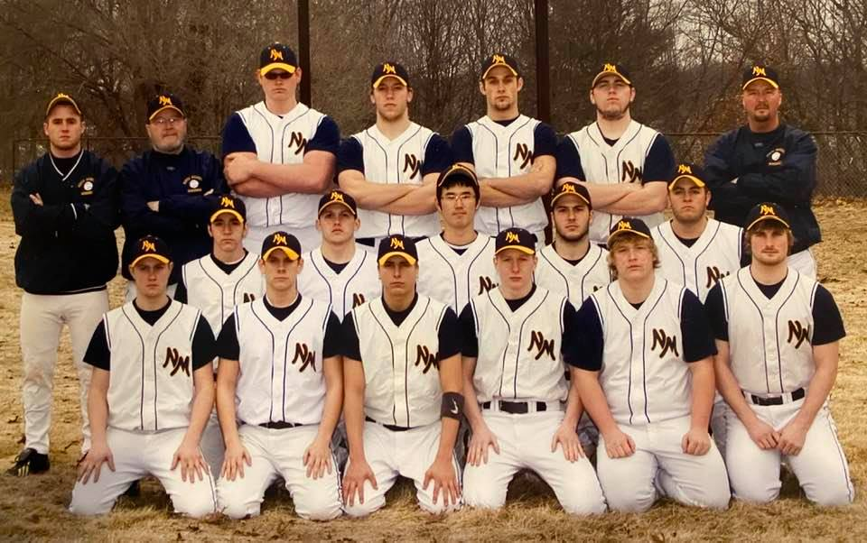
The 2008 NORSEMEN
Front Row L-R: Patrick Rapson, Ryan Hillman, Travis Felkowski, Matt Dunn, Arion Carley, Robin Wiggins, Jake Frein
2nd Row: Matt Dunn, Mark Picard, Kyung-Min Lee, Noah VanBergen, Andy Buris,
Back Row L-R: coach Kollin Borgeson, coach Warren Kent Jr., Nick Strockis, Ryan Buter, Alex Jones, Ryan Sexton, head coach Warren Kent III
Record Score Interesting Fact
1-0 NM 8, Muskegon 6 Mark Picard picks up win; Picard 3-for-3; Ryan Buter 2 singles, HR, 3 RBI
2-0 NM 12, Fruitport 5 NM scores 10 in final 3 innings; Ryan Sexton & Patrick Rapson 2 hits
2-1 *Whitehall 5, NM 3 NM pitchers walk 10; Vikings score 3 unearned runs in 6th inning for win
2-2 *Whitehall 13, NM 4 NM pitchers walk 9; batters strike out 8 times
3-2 *NM 8, Shelby 2 Picard 1-hitter; NM scores 7 in 6th inning to erase 2-1 deficit
4-2 *NM 11, Shelby 1 NM scores 6 runs in 1st inning: Buter & Matt Dunn 2 hits
5-2 *NM 6, Oakridge 4 NM wins despite being no-hit; benefited from 9 walks
6-2 NM 13, GR Cov 5 NM uses 12 hits, 12 walks & 11 stolen bases: Buter 4 singles
7-2 *NM 13, Ravenna 2 Picard 3 hits, 2 RBI, 2 runs; Alex Jones 2 doubles, 2 RBI, 2 runs
8-2 *NM 10, Ravenna 4 NM uses 8-run 4th to erase 4-1 deficit; Sexton 3-run HR
9-2 NM 14, Hesperia 4 NM scores 8 runs in 1st inning: Robin Wiggins 3 singles, double, 3 RBI
10-2 NM 16, Hesperia 1 Ryan Hillman 3-inning no-hitter; Buter 2 doubles, 2 RBI, 2 runs
11-2 NM 14, Montague 2 County; Sexton K's 8; Sexton 2 doubles, 2 RBI, 2 runs; NM 16 SB
12-2 NM 11, Holton 0 County; Picard 2-hitter; Buter 2 doubles, triple, 3 RBI; Sexton HR, 6 RBI
13-2 *NM 15, Hart 0 Picard 1-hitter, 12 K's; Picard double, HR, 3 RBI, 3 runs
14-2 *NM 15, Hart 1 Travis Falkowksi 5-inn. no-hitter, 9 K's; Buter HR, 2 RBI; Dunn 3b
15-2 NM 15, Musk. Hts 0 Dunn 3-inning no-hitter; Alex Wierda 2 doubles, 2 RBI, 2 runs
16-2 NM 15, Musk. Hts 0 NM hits 5 HR's (Sexton 2, Noah VanBergen, Picard, Hillman)
17-2 NM 11, Holton 0 Picard 2-hitter; NM scores 8 runs in 1st inning; VanBergen triple, HR
18-2 NM 11, Holton 5 Falkowski 3-hitter, 9 K's; VanBergen single, double, 4 RBI
19-2 *NM 9, Mason CC 4 Picard 9 K's; Jones 2 hits; Picard double, 3 RBI; Buter 2 2B
20-2 *NM 11, Mason CC 1 Falkowski 2-hitter; Buter 3 hits, 2 RBI, 2 runs; Sexton 3-run HR
21-2 NM 11, OV 4 Buter 2 doubles, 3 RBI, 2 runs; Sexton double, 2 RBI
22-2 NM 10, Oakridge 3 R-P Invitational; Buter single, HR, 2 RBI; Hillman single, 2B, 3 RBI
23-2 NM 11, Reeths-Puffer 5 R-P Invitational Championship; Sexton 3 singles, HR, 4 RBI
23-3 White Cloud 6, NM 4 Loss ends 21-game win streak: Buter HR, 2 RBI
24-3 NM 6, White Cloud 4 NM only 3 hits; Robin Wiggins 2 hits, 2 RBI; Buter double
25-3 *NM 12, Montague 0 Picard 2-hitter; Falkowski double, HR, 5 RBI
26-3 *NM 12, Montague 1 Falkowski 2-hitter; Hillman single, double, 3 RBI, 2 runs
27-3 *NM 15, Oakridge 7 Clinched WMC title; postponed since April 25; finished May 23
28-3 NM 16, Oakridge 6 Non-conference; Arion Carley 3 singles, double
29-3 NM 12, Ravenna 0 County Championship; postponed since May 3; finished May 28
30-3 NM 10, WMC 1 District; Picard/Falkowski 3-hitter, 9 K's; Buter, Hillman, Sexton 2B
31-3 NM 7, Musk. Cath 2 District Championship; Picard/Falkowski 3-hitter; VanBergen 2b, triple
32-3 NM 9, Saugatuck 4 Regional; Picard 13 K's; Buter & Sexton single, HR, 2 RBI
33-3 NM 11, Coleman 0 Regional Championship; Hillman single, 3-run HR, 4 RBI
34-3 NM 11, LMC 1 Quarterfinals; Picard 6-inning shutout, 15th straight win; Picard HR
34-4 BC All-Saints 8, NM 5 Semifinals; VanBergen 3 singles; Dunn 2 hits; Picard double, 2 RBI

2009 -- Warren Kent III (17-15 overall; 6-8 in WMC, Whitehall Champs)
Two words can sum up the 2009 season: pitching and defense. While the offensive statistics would suggest a better than 17-15 record, it was pitching and defense that tell the true story. Offensively, the Norse scored 65 more runs and had 80 more hits (including 29 doubles) than their opponents. They also out-hit opponents .327 to .270. However, NM pitchers allowed 161 walks and 32 hit batters for a total of 193 extra base runners (opponents had 197 hits). Of those 193 runners, 73 scored. Defensively, NM committed 84 errors (.908 average), which led to 83 unearned runs. However, with that said, the Norse did capture their fourth district title in the past five seasons and their sixth since 2001, which means every two-year player since 2001 has won a district title. For most of the season, the top five spots and the No. 9 position carried the offense, batting .363 (209-for-576). The Nos. 6-7-8 spots in the batting order struggled for a combined .259 average (70-for-270). NM outscored opponents in every inning. The best inning was the fourth with 46-26 edge. However, it was proven that the first inning was the key. The Norse had the lead at the end of the first inning 18 times and posted a 15-3 record in those games. When NM was losing or tied at the end of one inning, its record was 2-12. The Norse won five games in the sixth inning or later but also lost five games in the sixth inning or later. The senior triumvirate of shortstop Ryan Hillman, catcher Robin Wiggins and second baseman Patrick Rapson, who were the only returners from the 2008 team with significant varsity playing experience, made the offense go. Ryan, batting in the No. 3 spot, was the go-to guy offensively for most of the season. Ryan led the team with a .510 average (49-for-96). His 49 hits were a team high as were his 33 RBI. He tied for the team lead with 34 runs. Known for his plate discipline, Ryan struck out just four times in 116 plate appearances. On the mound, Ryan had the best strikeout-to-walk ratio (17:7) in 22.33 innings. He tossed a three-inning no-hitter against Muskegon Heights for his lone win. Robin, the No. 1 catcher and pitcher, was the hottest hitter down the stretch. Robin, the No. 4 hitter, finished with a team-high 13 doubles and 98 at bats. He was second on the team with a .367 average (36-for-98) and second with 29 RBI. On the mound, Robin posted a team-high six wins. He also led the team with 78 strikeouts and 66 walks. Opponents batted just .227 against him. From the No. 2 spot in the order, Patrick batted .360 (31-for-86) and led the team with 10 hit-by pitches. He also tied for the team lead with 34 runs. Senior outfielders Jake Frein and Geoff Evans also supplied some offensive firepower. Jake, who batted mainly in the No. 9 spot, was 24-for-73 (.329). He also saw 13.33 innings on the mound while picking up two wins. Geoff, a first-time varsity player, saw time in right field and as designated hitter. Geoff batted .333 (20-for-60) and led the team with three triples. The junior trio of Simon VanBergen, Erik Boczkaja and Brian Kelly picked up significant playing time. Simon, the team’s fastest player and center fielder, batted lead-off most of the year and led the team with 15 stolen bases. Unfortunately, he also led the team with 19 strikeouts. He did bat .303 (27-for-89). He also picked up two wins on the mound in just 11.33 innings. Erik, the regular first baseman, led the team with 17 walks while batting .260 (19-for-73). He also saw 7.33 innings on the mound and picked up a save. Brian, the every-day third baseman, struggled with a .231 average (15-for-65). The other regular every-day player was sophomore Drake Cooke, who played catcher, outfield and pitcher. Drake, who posted a .313 average (25-for-80), led the team with two home runs and six sacrifices. On the mound, Drake was 1-0 with one save in 6.66 innings. Sophomore Jory Meagher, the No. 2 pitcher, posted a 5-3 record in 62 innings. He led the team with a 2.94 ERA. Opponents batted .283 against him. Senior Andy Buris and junior Sam Gautraud were the final two players to remain with the varsity all year. Andy scored the winning run in the district championship game. Sam was the back-up second baseman and the top courtesy runner. The two managers, junior Tyler Rennells and Korean exchange student Chang-Seok Ryu (Foxy), each saw some playing time. Rennells had one hit and pitched one inning. Foxy batted .500 (2-for-4). The rest of the roster was made up of underclassmen, who saw time with both the JV and varsity teams. Sophomores John Hardy and Jake Veltman began and ended the season with the varsity as did freshman Curtis Taylor. Two other sophomores, Zac McCamant (1 games) and Trae Pitts (2 games), each played during the season.

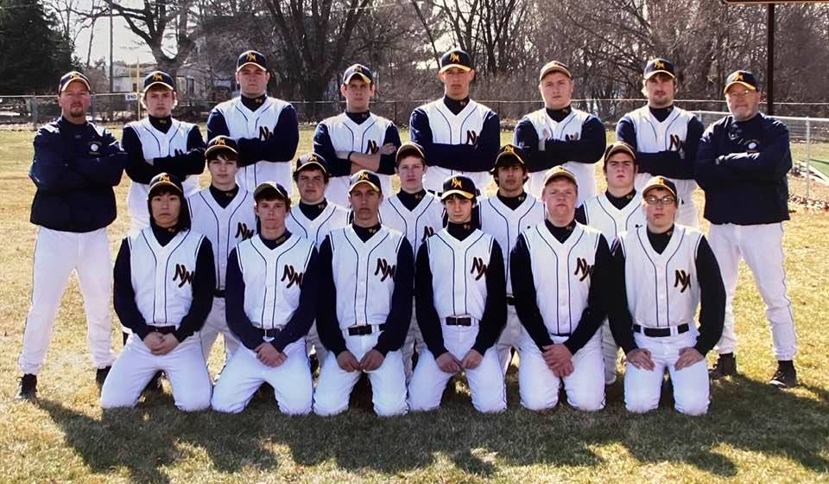

The 2009 NORSEMEN
Front Row L-R: Chang-Seok Ryu, Drake Cooke, Jake Veltman, Jory Meagher, Curtis Taylor, Tyler Runnells
2nd Row: Erik Boczkaja, Sam Gautraud, John Hardy, Simon VanBergen, Brian Kelly
Back Row L-R: Head coach Warren Kent III, Patrick Rapson, Andy Buris, Ryan Hillman, Geoff Evans, Robin Wiggins, Jake Frein, Coach Warren Kent Jr.
Record Score Interesting Fact
0-1 Reeths-Puffer 10, NM 0 Only 3 hits, including 2 singles by Patrick Rapson
1-1 NM 20, WMC Robin Wiggins, Jory Meagher 5-inning no-hitter; Ryan Hillman 4-for-4
2-1 NM 7, Fruitport 6 NM scores 2 runs in bottom of 7th without hit: Rapson solo HR
2-2 Spring Lake 17, NM 1 Worst loss since 2004; one hit (single by Hillman)
2-3*Whitehall 1, NM 0 Vikings score on bases-loaded walk-in 6th; NM 3 hits; Wiggins 11 K's
2-4 *Whitehall 12, NM 6 Wiggins 2 singles, double; bottom five in order go 0-for-15
2-5 *Oakridge 13, NM 6 NM strikes out 10 times: Hillman 3-for-3 w/ double, 2 RBI
3-5 *NM 9, Oakridge 6 NM scores 8 runs in 6th to erase 6-1 deficit vs. state quarterfinalists
4-5 NM 6, GR Covenant 5 Geoff Evans' RBI double in bottom of 8th wins game: Hillman 2B, HR
4-6 *Ravenna 10, NM 0 NM only 4 hits, including Simon VanBergen double
5-6*NM 10, Ravenna 7 Brian Kelly double, HR, 4 RBI; Erik Boczkaja single, HR
5-7 Musk. Catholic 8, NM 7 County; NM loses 7-2 lead; Rapson, Hillman, Wiggins, Drake Cooke 2 hits
6-7 NM 16, Musk. Heights 1 County; Evans 2 singles, double; Cooke 2 singles
7-7 *NM 14, Hart 2 Meagher 2-hitter; Wiggins double, HR; Cooke HR; Hillman, VanBergen 3 hits
7-8 *Hart 8, NM 6 Only allow 4 hits and K 12, but walk 10: Evans, Frein HR
7-9 White Cloud 10, NM 8 9 innings; 1NM 9 hits; Hillman 3 singles, double; Wiggins 2 doubles
8-9 NM 9, White Cloud 1 VanBergen 3-hitter; Rapson, Boczkaja 2 singles
9-9 NM 7, Holton 3 Wiggins, Rapson, VanBergen single, double; Hillman 2 singles
10-9 NM 21, Holton 0 17-run 4th inning: Hillman 4-for-4, 5 RBI, VanBergen 2 1bs, 3 RBI
11-9 NM 15, Musk. Heights 0 Hillman 3-inning no-hitter; Frein double; Evans, VanBergen triple
12-9 NM 18, Musk. Heights 1 Evans single, double, 5 RBI; John Hardy single, 2 doubles, 3RBI
13-9 *NM 8, Mason CC 7 Wiggins' 2-run double in bottom of 7th; Wiggins single, 2 doubles, 3 RBI
14-9 *NM 8, Mason CC 3 Hillman 2 singles, 2 runs; Boczkaja double
14-10 *Shelby 4, NM 2 Shelby 4 unearned runs in 6th; Hillman 3-for-3
14-11 Shelby 9, NM 8 Shelby breaks tie with 1 run in top of 7th: 6 players with 2 singles
14-12 Fremont 10, NM 2 Leading 2-0, NM allows 9-run 6th; only 1 hit (single by VanBergen)
14-13 *Montague 11, NM 9 Wildcats score 7 in 1st; Rapson 2 doubles, 2 RBI; Hillman 3 hits
15-13 *NM 15, Montague 5 Boczkaja, Frein single, double; VanBergen 2 singles
16-13 NM 7, Musk. Catholic 2 District; Wiggins 2-hitter; Frein single, 2 2bs, 3 RBI; Cooke 2B, HR
17-13 NM 4, WM Christian 3 District Championship; 8 innings; Andy Buris scores winning run on error
17-14 Spring Lake 6, NM 3 Six players with one single
17-15 Beal City 11, NM 5 Regional; Aggies use 7-run 6th to break open 2-1 game; Wiggins 2 2B

2010 – Warren Kent III (20-15 overall; 9-5 in WMC; 4th in WMC; Shelby Champs)
The best phrase to sum up the 2010 season would be “Consistently Inconsistent.” For some reason, the Norse could not hit on all cylinders. Case in point #1: The No. 3-4-5 hitters only had hits in the same game seven time during the season. Case in point #2: The Norse failed to score a run in the first inning 17 times. However, when they did have the lead in the first inning, NM was 9-3. Case in point #3: The Norse outscored its opponents in the third (48-28) and fifth innings (37-19) only to see opponents outscore them 48-34 in the fourth and 42-26 in the fifth. Case in point #4: The longest hit streak of any player was eight games, and only two players had hits in more than 60 percent (21 games) of the games played. Case in point #5: Look at these differences between the first 17 games and the final 18 games of certain batting averages – the No. 3 hitter dropped 57 points, the No. 4 hitter went up 62 points; the No. 5 hitter dropped 123 points, the No. 6 hitter went up 119 points; and the No. 2 hitter dropped 130 points, the No. 7 hitter went up 276 points. Beyond these negative stats, the Norse did win 20 games for the fifth time in school history and the fourth time on the past six seasons. Also, the lineup saw every position finish above a .276 average except the No. 9 spot. The four seniors (Erik Boczkaja, Simon VanBergen, Sam Gautraud and Brian Kelly) each finished with batting averages above .300. Erik, who batted in the No. 3 spot and manned the first-base position, was the go-to power guy (10 home runs) while leading the team with a .365 batting average (38-for-104). Erik, who played all 35 games, led the team with 38 hits and 35 RBI. Unfortunately, he also led the team with 23 strikeouts. Erik was also formidable on the mound, tossing 23 innings of relief and posting a 5-2 record. Simon, who batted in both the No. 1 and No. 6 spots in the order, provided the speed by leading the team with 18 stolen bases. Simon also paced the team with 31 runs and 108 at bats while holding a .324 average (35-for-108). Simon, who made the transition from center field as a junior to shortstop, led the team with 21 errors. Sam made the most of his starting assignment at second base, posting a .342 average (26-for-76) from the No. 7 spot in the order. Brian, who moved from third base to left field, had an up-and-down season. He finished with a .317 average (32-for-101) and led the team with four triples. Juniors Drake Cooke and Graham Preston, who both played all 35 games, were the only other regulars to bat above .300. Drake, the every-day catcher and No. 4 batter, hit .359 (37-for-107) and led the team with 11 doubles and a .455 on-base percentage. Graham, who played a solid right field, started the season at the No. 6 spot and finished at the No. 1 spot. He posted a .305 average (29-for-95), and his good eye at the plate helped him lead the team with 23 walks. Two other regulars finished with an average greater than .288. D.J. Berge, who was the regular designated hitter went 20-for-68 for a .294 average. He only struck out five times. D.J. also saw 16 innings on the mound. Trae Pitts, the lone All-Conference player and the regular center fielder, posted a .288 average (15-for-52). The final full-time player, Zac McCamant, had a tale of two seasons. Through the first 17 games, Zac, the regular third baseman and No. 2 hitter, had a .292 average (14-for-48). However, in the season’s final 18 games, Zac struggled to a .162 average (6-for-37). However, Zac did step up as a pitcher in the final 15 games of the season. He posted a 3-1 average, leading the team with a 2.01 ERA over 24.33 innings. Opponents only batted .237 against him. The top two pitchers – Jory Meagher and John Hardy – combined for 11 of the team’s 20 wins. Jory led the team in most categories, including innings pitched (65.33) and strikeouts (48). While posting a 5-3 record. At the plate, Jory finished with a .316 average (6-for-19). John tossed 64.66 innings and had a 6-5 record while posting a 2.38 ERA. Offensively, John had just 13 at bats. The final four juniors had varying degrees of success. James Kraemer, who was making his high school baseball debut, was 6-for-18 for a .333 average. Jake Veltman posted a .222 average (6-for-27 and saw 20.66 innings on the mound while picking up one win. Cody Liverance tied a school record with seven sacrifices in a season while batting .188 (6-for-32). Carter Gust (.188; 3-for-16) did not finish the season. Five sophomores played sparingly. Austin West made the biggest impact with a .400 average (2-for-5) with a double, a home run and four RBI. On the mound, he tossed 5.66 innings of shutout ball. Hector Garcia had a .333 average (3-for-9), Curtis Taylor (8 at bats) and Noah Rhyndress (4 at bats) each had a .250 average while Ben Ocharzak only had one at bat. Ben also saw 2.33 innings on the mound.

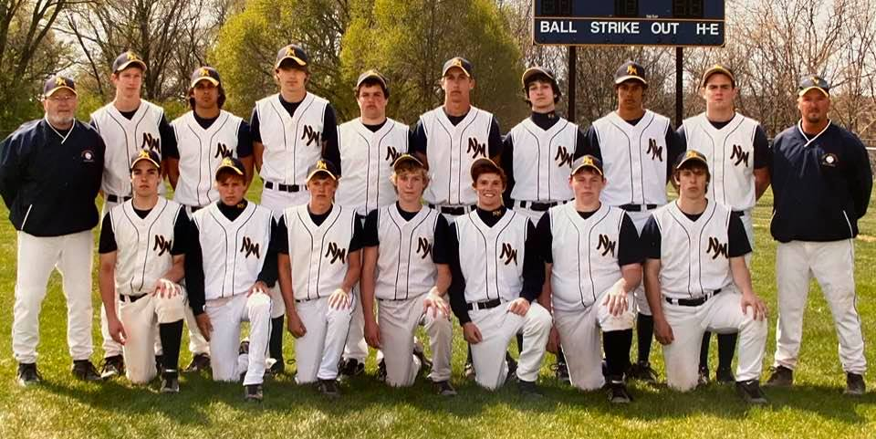

The 2010 NORSEMEN
Front Row L-R: DJ Berge, Carter Gust, Zac McCarmant, Graham Preston, Drake Cooke, Cody Liverance, James Kraemer
Back Row L-R: coach Warren Kent Jr., John Hardy, Simon VanBergen, Erik Boczkaja, Sam Gautraud, Jake Veltman, Jory Meagher, Trae Pitts, Brian Kelly, head coach Warren Kent III

Record Score Interesting Fact
0-1 Musk. Cath 10, NM 0 Graham Preston 2 singles
1-1 NM 6, Spring Lake 5 Scored winning run-in bottom of 7th: Erik Boczkaja, Zac McCamant 2 hits
2-1 NM 11, WMC 8 Down 8-2 in 3rd inning; 16th straight win over Warriors; Boczkaja HR, 3 RB
2-2 Fruitport 10, NM 8 Trojans scored 2 runs in top of 7th
3-2 *NM 13, Shelby 8 Beat Div. III quarterfinalists; down 6-0 in 1st; Boczkaja GS
3-3 *Shelby 13, NM 3 Pitchers walked 10, allowed 10 hits: Trae Pitts 2 singles
3-4 Mona Shores 13, NM 3 Sailors scored 11 runs in 4th inning: Cooke HR
3-5 *Oakridge 9, NM 1 One-hit by All-State pitcher Jamie Potts, Brian Kelly single
3-6 *Oakridge 6, NM 0 Kelly 2 singles
4-6 NM 9, Muskegon 8 Eight innings.; Sam Gautraud walk-off bases-loaded walk; Boczkaja 2-run HR
5-6 NM 8, Muskegon 1 1st lead after 1st inning of season; Jory Meagher, Cooke, Gautraud double
5-7 GR Covenant 7, NM 6 GRCC scores 2 runs in bottom of 7th: Kelly double, 2 singles
5-8 GR Covenant 10, NM 3 Five errors; Preston 2 singles; D.J. Berge double
6-8 *NM 8, Ravenna 7 Scored winning run-in top of 6th; Kelly 3 singles, 2 RBI, 2 runs
7-8 *NM 10, Ravenna 9 Scored 3 runs in bottom of 7th on Boczkaja's bases-clearing double
8-8 NM 6, Holton 4 County; Meagher complete-game win; Cook, Preston 2 singles
8-9 Oakridge 10, NM 3 County; Eagles scored 10 runs in 6th to erase 3-1 deficit; Boczkaja HR
9-9 *NM 9, Hart 5 Meagher career-high 13 K's; Cooke double, single, 5 RBI
10-9 *NM 11, Hart 0 John Hardy career-high 10 K's; Simon VanBergen double, 2 singles, 2 RBI
11-9 NM 12, Black River 2 Jake Veltman 2-hitter; Gautraud 2 singles
12-9 NM 11, Black River 1 1st 2 games between schools; team 3 triples (VanBergen, Kelly, Cooke)
12-10 *Mason CC 5, NM 0 Two-hit by league leaders; VanBergen, Pitts single
13-10 *NM 3, Mason CC 1 Hardy complete-game win; Boczkaja double
13-11 Reeths-Puffer 11, NM 4 Boczkaja, Preston single, double
13-12 Reeths-Puffer 2, NM 1 12 flyouts in loss; Boczkaja solo HR, single
14-12 *NM 8, Montague 0 Team 4 triples (Preston 2, VanBergen, Pitts)
15-12 *NM 18, Montague 11 19 hits; VanBergen 4-for-4, double, school-record 5 runs, 5 stolen bases
15-13 Holton 5, NM 3 Snapped Norse 10-game win streak vs. Devils; Boczkaja HR, double
16-13 NM 7, Holton 2 Boczkaja 2-run HR, single
17-13 NM 9, White Cloud 1 Zac McCamant, Boczkaja combined 1-hitter: Cooke HR, double, 2 singles
18-13 NM 4, White Cloud 3 Scored go-ahead run on wild pitch in top of 7th: Vanbergen double, single
18-14 *Whitehall 5, NM 4 Vikings scored 2 runs in bottom of 6th; stranded 12 runners
19-14 *NM 12, Whitehall 4 VanBergen GS, single, 5 RBI
20-14 NM 10, Tri-Unity 6 Pre-District; down 6-0 in 2nd inning; 3-4-5 hitters 7-for-12, 4 doubles, 2 3B
20-15 Musk. Catholic 11, NM 2 District; led 2-0 in 1st inning; Kelly 3 singles

2011 – Warren Kent III (24-15 overall; 9-5 in WMC; 3rd tie in WMC; Oakridge Champs)
At the end of the 2010 season, which saw the Norsemen finish 20-15 but no County title or District title, NM had some “Unfinished Business” as it headed into the 2011 season. With a District title in 2011, which included the ousting of rival Muskegon Catholic Central, call it “Transaction Complete.” For the fifth time in the past seven years and the sixth overall, the Norse won 20 games and won their 10th district title before losing in the regional finals to the two-time defending champion Aggies of Beal City, which lost in the state semifinals. Along the way, the Norse set three school records: at bats (1,006), games played (39) and walks allowed per game (2.20). As usual, a quick start proved important as the Norse had first inning leads in 23 games and had a 17-6 record in those games. NM outscored its opponents 83-28 in the first inning. Every spot on the batting order finished with an average of .267 except the No. 8 spot, which posted a .216 average. With nine seniors on the roster, it was not surprising that seniors would dominate the overall statistics. Zac McCamant, who was the team’s Most Improved Player, won the batting title with a .362 average (34-for-94) while manning the third-base position. Zac also led the team with 39 runs and a .512 on-base percentage. Drake Cooke, a three-year varsity player, was the team’s No. 2 hitter with a .354 average (35-for-99). His 35 hits led the team, as did his nine doubles. Drake, the every-day catcher, won the team’s Gold Glove Award for the second straight year. Graham Preston, who played both center and right field, also posted a better-than .300 average with a .323 (32-for-99). Graham, who took home the Coach’s Award, paced the team with four triples, 30 RBI and a school-record 30 walks. Unfortunately, he also led the team with 18 strikeouts. Jake Veltman, normally the regular right fielder, just missed the .300 mark with a .292 average. Left fielder DJ Berge led the tea m with 103 at bats while posting a .272 average. Trae Pitts and Cody Liverance played important roles. Trae was counted on for his base-running expertise as he stole a team-high 19 bases, and Cody was the defensive specialist at first base. The final two seniors were counted on mainly as pitchers. John Hardy, who led the team with nine hit by pitches and posted a .429 average (21-for-49) – he did not have enough plate appearances to qualify for the batting title – posted a 9-3 record while leading the team with 55 strikeouts against just 14 walks. John, who was the team’s MVP, also tossed a team-high 71.66 innings while posting a 2.54 ERA. Jory Meagher, a three-year starter, finished his career with a 6-4 record while leading the team with a 2.37 ERA. Opponents batted .261 against him. Two juniors saw significant playing time. Ben Ocharzak, the everyday second baseman, posted a .342 average (25-for-73) while leading the team with a school record-tying seven sacrifices. Curtis Taylor, who played both first and third base and was a designated hitter, just missed batting .300. He finished at .299 (29-for-97). Five other juniors – Jon Ackley, Hector Garcia, Austin West, Noah Rhyndress and Mike Berge – all played sparingly. West was the biggest contributor, mainly on the mound, where he posted a 3-4 record while striking out 37 and only walking eight in 37.66 innings. Sophomore Adrian Anderson, who made his varsity debut at the County tournament, led the team with five home runs while batting .353 (24-for-68).

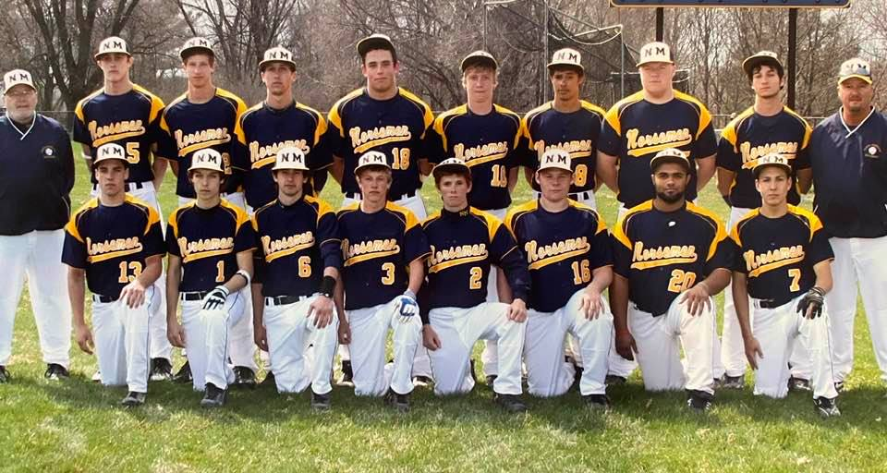

The 2011 NORSEMEN
Front Row L-R: DJ Berge, Austin West, Ben Ocharzak, Zac McCarmant, Drake Cooke, Cody Liverance, James Kramer
Back Row L-R: Coach Warren Kent Jr., Noah Rhyndress, John Hardy, Jake Veltman, Jon Ackley, Graham Preston, Trae Pitts, Curtis Taylor, Jory Meagher, head coach Warren Kent III

Record Score Interesting Fact
0-1 Fruitport 3, NM 1 Only 3 singles (Austin West, DJ Berge, Trae Pitts)
0-2 Reeths-Puffer 6, NM 2 Only 3 hits; Curtis Taylor double
0-3 Reeths-Puffer 7, NM 2 Only 2 singles (Jory Meagher, Drake Cooke)
1-3 *NM 7, Shelby 5 Only 3 hits; Cooke double; Meagher strikes out final batter with bases loaded
2-3 NM 13, WMC3 13 hits; Berge single, double, 3 runs, 3 RBI
3-3 NM 15, Musk. Hts 0 Graham Preston 3-run home run, 4 RBI, 2 runs
4-3 NM 18, Musk. Hts 0 Noah Rhyndress 3-inn. no-hitter; Ben Ocharzak double, 2 runs
5-3 *NM 9, Shelby 6 Berge 3-run home run; Preston single, triple, 2 runs
5-4 Shelby 10, NM 3 Non-conference; Meagher single, double; defense 6 errors
5-5 *Oakridge 9, NM 0 Only 3 singles (Preston, Cooke, Cody Liverance); defense 6 errors
5-6 *Oakridge 3, NM 2 Swept by state semi-finalists; Oakridge scores 3 runs in 7th; only 3 singles
6-6 *NM 17, Hart 1 1st 14 batters in 4th inning scored: Berge 2 doubles, 3 RBI
7-6 *NM 11, Hart 1 Taylor single, home run, 3 RBI, 3 runs
8-6 NM 6, Mason CC 4 Non-conference; Meagher & Liverance single, double
9-6 NM 8, Mason CC 3 Non-conference; Hector Garcia solo homer breaks 3-3 tie
10-6 NM 6, Ravenna 5 County; Ravenna bases loaded no outs in bottom of 7th; do not score
10-7 Musk. Catholic 8, NM 1 County; Ocharzak single, double
11-7 NM 7, Black River 1 John Hardy 3-run, inside-the-park HR
11-8 *Mason CC 4, NM 1 Taylor single, double, RBI
12-8 *NM 13, Mason CC 9 Three home runs in 3rd inning (Adrian Anderson, Jake Veltman, Ocharzak)
13-8 *NM 10, Ravenna 0 Anderson 2 singles, home run, 3 RBI, 3 runs
13-9 *Ravenna 9, NM 2 Defense 7 errors; Hardy 2 doubles
13-10 White Cloud 12, NM 9 Defense 5 errors; Indians score 9 in 3rd; Preston grand slam, triple, 2 runs
13-11 White Cloud 8, NM 3 Defense 5 errors; Anderson 2-run HR
14-11 *NM 7, Montague 3 Anderson 2-run triple; Cooke 2 singles; Meagher complete-game win
15-11 *NM 3, Montague 0 Hardy complete-game win; Zac McCamant 2-run single
16-11 NM 8, Mona Shores 2 Cooke grand slam in 1st inning; 1st win over Shores in 9 chances
16-12 Holland Christian 4, NM 3 HC Tournament; HC scored winning run with 2 outs in bottom of 7th
17-12 NM 12, Whitehall 5 HC Tournament; Rhyndress 5 innings of shutout relief
17-13 Zeeland East 11, NM 5 HC Tournament; Prom, so JV players played; winning 5-2 in 5th
17-14 *Whitehall 5, NM 2 Hardy & Cooke 2 singles
18-14 *NM 12, Whitehall 1 Seven runs in 1st inning; Hardy 2-hitter; Hardy 3 singles, 2 runs
19-14 NM 10, Fremont 3 Six runs in 1st inning: Anderson double, 2 runs, 2 RBI
20-14 NM 6, Fremont 5 Austin West 6 innings of shutout relief; Ocharzak home run
21-14 NM 14, Musk. Cath 5 District; trailed 4-1 in 1st; Hardy CG win; Hardy 2 singles, double, 2 runs
22-14 NM 17, WMC 0 District Championship; 10th district title; Hardy 2 hits, 2, 2 RBI
23-14 NM 6, Grand Haven 2 1st meeting since 1964; Anderson, Taylor, Berge each double
24-14 NM 12, Mason CE 1 Regional; Cooke 2-run HR, 2-run single, 3 runs; Ocharzak 2-run double
24-15 Beal City 5, NM 3 Regional Championship; 7 errors; 10 LOB; McCamant 2 hits

2012 -- Warren Kent III (26-13 overall, 8-6 in WMC; 4th place in WMC; Oakridge champs)
In a season that saw the Norse win 26 games, the second-most in school history, it was the games that got away that hurt the most. Of the team’s 13 losses, seven were by one run. Those one-run losses included five in the opposing team’s last at bat and four in the bottom of the seventh. For some reason, the Norse could not win the close games at the end. In those 13 losses, opponents outscored the Norse by 31 runs (85-54) for an average of 2.4 runs per game. On the positive side, the Norse outscored its opponents 257-56 in their 26 wins. This truly was a team: each of the 12 regular players played in at least 30 games, had at least 55 at bats and had at least 15 hits, and no player posted a batting average of less than .273. Overall, the team, batted .331 (341-for-1,029), the second-best in the coach Kent era. NM also set two records: team at bats (1,029) and innings pitched (245). The Norse also tied last year’s team with 39 games played. No surprise in the batting order, as the No. 3 and No. 4 spots posted the highest averages, .381 and .413, respectively. As usual the first inning proved its importance: the Norse were 11-3 when leading, 9-6 when tied and 6-4 when losing. In 20 games, NM did NOT score a run in the first inning and had seven other games where it scored just one run; that means the Norse scored two or more runs in the first inning just 12 times. Although there were seven seniors on the roster, it was junior Adrian Anderson who led the team in most offensive statistics. Adrian, the team’s Most Valuable Player, led the team with a school-record 122 at bats, 47 runs, 46 hits, 20 doubles, four home runs and 42 RBI. He tied for the team lead with 39 games played, which is also a school record. His .377 batting average was second-best. Adrian was also the team’s No. 2 pitcher, posting a 6-4 record while striking out 56 and walking 24. After Adrian, it was mainly seniors who led the way. Chase Raymond won the batting title with a .418 average (38-for-91) while playing a solid right field. Chase also led the team with a .545 on-base percentage and seven hit by pitches. Austin West, the team’s No. 1 pitcher, had the team’s third-best batting average with a.363 (33-for-91) and tied a school record with his 39 games played. On the mound, Austin posted an 8-5 record while striking out 57 and walking just 13 in 76.66 innings. Hector Garcia, the No. 1 catcher, tied for the team lead with six sacrifices while posting a solid .330 batting average (34-for-103). Noah Rhyndress, easily the team’s Most Improved Player, posted a .328 batting average (21-for-64), and on the mound, had a 5-1 record while striking out 40 and walking 13 in 40.66 innings. He had a 1.55 ERA while opponents batted just .220 against him. Curtis Taylor, the starting first baseman and Gold Glove winner, just missed the .300 mark for the second straight year. This year, Curtis batted .298 (28-for-94). Ben Ocharzak, the starting second baseman, played in a school record-tying 39 games. He also tied for the team lead with six sacrifices and led the team with a 16 stolen bases. On the mound, Ben set a school record with three saves. Jon Ackley, the back-up first baseman, played solid defensively (only one error) while batting .273. In addition to Adrian, four other juniors contributed to the team. Rogan McEvoy, who manned the third-base position, batted .330 (31-for-94). He also posted a 3-2 record on the mound while leading the team with a 1.38 ERA in 30.33 innings. Opponents batted just .191 against him. Jack Gautraud, who played center field, led the team with 24 walks while batting .286. Unfortunately, he also led the team with 26 strikeouts. Chase Cooke, the back-up catcher, posted a .281 batting average. The only other junior to lead an offensive category was Adam Edick, who had one of the team’s two triples for the season. Four sophomores saw limited time on varsity, but the foursome (Travis Webster, Jesse Dunn, Reese McCamant and Ryan Compeau) collectively batted .560 (14-for-25) while scoring 18 runs. Compeau had one of the team’s two triples.

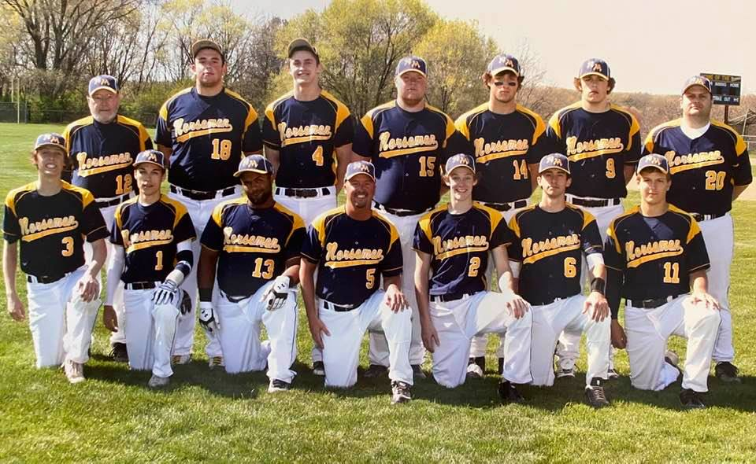

The 2012 NORSEMEN
Front Row L-R: Adam Edick, Austin West, Hector Garcia, head coach Warren Kent III, Chase Cooke, Ben Ocharzak, Adrian Anderson
Back Row: coach Warren Kent Jr., Jon Ackley, Noah Ryndress, Curtis Taylor, Chase Raymond, Rogan McEvoy, Coach Mike Moncel

Record Score Interesting Fact
0-1 Fruitport 2, NM 1 Six players with a single in Bud Giddings' debut as Trojan coach
0-2 *Oakridge 6, NM 3 Eagles score three w/ 2 outs in top of 7th: Adam Edick 3 runs
0-3 *Oakrdige 7, NM 2 Only 2 hits; Adrian Anderson double, Rogan McEvoy single
1-3 NM 6, WMC 2 Noah Rhyndress CG, 9 K's; Anderson single, double, RBI, run
1-4 *Ravenna 7, NM 6 Down 6-4, Bulldogs hit bases-clearing double in bottom of 7th
2-4 *NM 2, Ravenna 0 Anderson CG, 8 K's; Anderson & Ben Ocharzak double
3-4 *NM 10, Hart 0 Edick 2 singles, double, 2 RBI, 2 R; Curtis Taylor 2 singles, 2 RBI
4-4 *NM 14, Hart 2 17 hits; Hector Garcia 4 singles, 3 RBI, 2 runs
5-4 NM 11, Hesperia 1 McEvoy 5-inn. 1-Hitter; Anderson single, double, home run, 3 RBI,
6-4 NM 6, Hesperia 3 Anderson double, home run, 3 RBI, 2 runs
7-4 NM 9, Mona Shores 4 Marsh; Chase Raymond single, double, 3 RBI, run; McEvoy HR
8-4 NM 6, Muskegon 2 Rhyndress CG, 4-hitter; Jon Ackley 2 doubles, 2 RBI
9-4 NM 11, Muskegon 1 Raymond 2 singles; Anderson & Jesse Dunn double
10-4 NM 8, Mason CC 0 Austin West CG, 6-hitter; Ocharzak 2 singles, double, 2 RBI
10-5 Mason CC 10, NM 9 Spartans break 9-9 tie in top of 7th: Curtis Taylor, Garcia 2 singles
11-5 NM 4, Holton 1 County; 3-hour rain delay; McEvoy 2 doubles, run
11-6 Musk. Catholic 5, NM 3 County; Taylor single, 2 RBI
12-6 *NM 11, Montague 3 Nine-run first inning; Anderson 2 singles, 2 RBI, 2 runs
13-6 *NM 6, Montague 5 Noah Rhyndress single, home run, 2 RBI, run
14-6 NM 7, Holton 3 Edick 4 singles, RBI, run
14-7 Holton 3, NM 2 Devils break 2-2 tie in bottom of 7th: Anderson double, RBI
14-8 Reeths-Puffer 5, NM 2 Raymond 2 singles
15-8 NM 7, Reeths-Puffer 6 Winning run scored on double steal: Garcia single, HR, 3 RBI, 2 runs
15-9 White Cloud 4, NM 3 Indians break 3-3 tie in bottom of 7th: Garcia single, 2 RBI
16-9 NM 14, White Cloud 9 Anderson single, home run, 3 RBI, 3 runs
16-10 *Whitehall 11, NM 7 Garcia 2 doubles, 4 RBI
17-10 *NM 3, Whitehall 1 McEvoy 2 singles, run
18-10 NM 22, Musk. Hts 0 Chase Cooke 9 Ks in 3-inn. win; Ocharzak 2 doubles, 2 RBI, 2 runs
19-10 NM 18, Musk. Hts 4 Cooke 3 singles, 4 RBI, run
20-10 NM 7, Fremont 1 Rhyndress single, double, RBI, 2 runs
21-10 NM 15, Fremont 0 Ryan Compeau & Travis Webster single, double, 2 runs
22-10 NM 10, Holland Chr. 0 HC Tournament; McEvoy 3 doubles, 3 RBI, run
23-10 NM 10, Holland 3 HC Tournament; 15 hits; Raymond single, 2 doubles, 3 RBI, 2 runs
23-11 Zeeland East 12, NM 5 HC Championship; 11th game in 6 days; Rhyndress 2 doubles
24-11 *NM 7, Shelby 4 Anderson double, home run, 3 RBI, 2 runs
24-12 *Shelby 6, NM 5 Tigers break 5-5 tie in bottom of 7th; Raymond 2 singles, 2 RBI, run
25-12 NM 11, Freedom Chr. 1 Pre-District; Taylor 2 doubles, 2 runs
26-12 NM 22, Holland Cal 0 District; all 15 players scored; McEvoy single, double, 4 RBI, 3 runs
26-13 Musk. Cath 7, NM 6 District Championship; Raymond 2 singles, run

2013 -- Warren Kent III (16-14 overall, 10-4 in WMC; 2nd place in WMC; Montague champs)
While the Norse had a winning record for the ninth consecutive season, it was a quirky season. The Norse played 11 one-run games, going 4-7, and played a school record four extra-inning games, going 1-3. The Norse lost to both Muskegon and Western Michigan Christian while winning three games from Oakridge and sweeping a doubleheader from Whitehall. The Muskegon loss was the Big Reds only win of the season, and the WMC loss was the first to the Warriors since 2002 and snapped an 18-game win streak. The three wins over the Eagles was the first season sweep since 2008, and the sweep of Whitehall was the first since 1995. The Norse won the school’s 700th game with a 5-2 victory over Hesperia. NM now has a 705-727-5 record in 78 seasons. NM helped coach Kent win his 200th game, a 3-1 victory over Mason County Central. The offense only had two spots in the batting order post an average better than .300. The No. 3 spot was 47-for-99 (.475) while the lead-off spot was 38-for-110 (.345). The No. 4 (.232), No. 7 (.227) and No. 9 (.205) all struggled to find consistency. As usual, the Norsemen posted a big run advantage in the first inning, outscoring their opponents 46-15 in the first frame. NM had the first inning lead in 13 games but only posted a 7-6 record in those games. The Norse were 7-3 when tied after the first inning and 0-5 when losing in first inning. The Norse outscored their opponents in every inning except the sixth (21 to 12) and seventh (4 to 2) innings. The team set two school records while tying two others. The offense struck out just 132 times to break the school record by 11, and the pitching staff walked just 76 batters, breaking the school record by nine. The six doubles in the 11-1 win over Shelby tied a school record for two-baggers in a game, and the four doubles in the third inning of the same game also tied the school record for doubles in an inning. • Senior Adrian Anderson was by far the overall leader for the Norse. Adrian, the team’s MVP, led the team in most offensive categories. He led the team with an even .500 average (48-for-96), which tied him for No. 6 on the all-time season list. Adrian also paced the team with 96 at bats, 48 hits, 14 doubles, three triples, one home run, and a .569 on-base percentage, and he tied for the team lead with 27 runs and four hit by pitches. Adrian was also the team’s No. 1 pitcher, finishing with a 5-4 record with a 1.63 ERA. He led the team with 55 strikeouts in 60 innings. Juniors Ryan Compeau, Reese McCamant and Jesse Dunn were the only other players with a better than .300 average. Compeau, who manned first base, posted a .360 average (27-for-75) while batting in 22 runs. McCamant played both third and shortstop and finished with a .355 average (27-for-76) and tied for the team lead with four hit by pitches while stealing 14 bases. Dunn batted .319 (29-for-91) while tying for the team lead with 27 runs and four sacrifices and leading the team with 16 stolen bases. All three also saw time on the mound with McCamant tossing 32 innings with a 1.53 ERA and a 2-4 record. Neither Compeau nor Dunn recorded a decision in a combined 22 innings of work. Juniors Travis Webster (.298) and Brody Scott (.292) both came within one hit of hitting the .300 mark. Webster played outfield while Scott shared time as catcher and shared the Gold Glove Award. Senior Rogan McEvoy, while struggling offensively, posted the team’s best record on the mound with a 7-2 record. Rogan had a 1.53 ERA in 59 innings while striking out 52 and walking just 13. Offensively, Rogan led the team with 19 walks. Three other seniors – Adam Edick, Chase Cooke and Jack Gautraud – all played significant innings with Edick tying for the team lead with four sacrifices while Jack led the team with 20 strikeouts. Chase shared the Gold Glove Award. Juniors Stephen Pallante, Chris Hillman and Bailey Cooper each gained valuable playing time. One sophomore, Riley Draper, played 17 games and posted a 2-2 record on the mound while also playing second base. Two sophomores (Ben Gautraud and Connor Gannon) and a freshman (Connor McEvoy) all played at least one game.

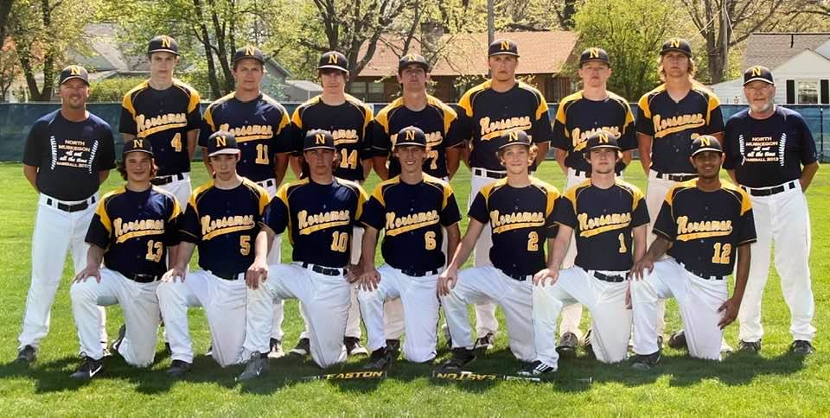

The 2013 NORSEMEN
Front Row L-R: Riley Draper, Chris Hillman, Travis Webster, Reese McCamant, Chase Cooke, Jack Gautraud, Dec Jani
Back Row L-R: Head coach Warren Kent III, Bailey Cooper, Adrian Anderson, Stephen Pallante, Brody Scott, Rogan McEvoy, Ryan Compeau, Adam Edick, coach Warren Kent III

Record Score Interesting Fact
0-1 *Ravenna 3, NM 1 Lost opener for 5th straight year; Ryan Compeau double
1-1 *NM 15, Ravenna 0 Nine-run third inning; Adrian Anderson 2 singles, triple, 2 runs
2-1 *NM 17, Hart 1 Nine-run first inning; Anderson/Reese McCamant combined no-hitter
3-1 *NM 15, Hart 0 Stephen Pallante 2 singles, double, 4 runs, 2 RBI
3-2 Musk. Cath 10, NM 9 Crusaders break 9-9 tie in 7th; Jesse Dunn single, double, run
3-3 GR Covenant 8, NM 7 10 innings; McCamant 3 singles, 2 runs
4-3 *NM 3, Oakridge 1 Anderson CG, 8 K's; offense no-hit through five innings; 4 singles in final 2 inn.
5-3 *NM 4, Oakridge 3 Eight innings; Rogan McEvoy CG; Anderson walk-off single
6-3 NM 8, Muskegon 1 McCamant CG, 6 K's; Travis Webster single, double, run
7-3 *NM 3, Mason CC 1 Anderson CG, no-hitter through 6 1/3
8-3 *NM 3, Mason CC 2 McEvoy CG; Dunn scored all 3 runs, also had 3 singles
8-4 Fremont 9, NM 1 Only 4 hits; Anderson double, RBI
8-5 Fremont 16, NM 15 NM had 11-2 first-ing. lead; Dunn 1B, 2B, 3B, 3 runs, 3 RBI
9-5 NM 6, Montague 0 County; Anderson CG, 7 K's; Brody Scott 2 doubles, 2 runs, 2 RBI
10-5 NM 4, Oakridge 3 County; McEvoy CG; McCamant 3 singles, run, RBI
11-5 WIN NM 5, Hesperia 2 Anderson, single, HR, run, RBI
12-5 NM 6, Hesperia 5 Riley Draper 1st varsity win, 6 1/3, 6 K's; Anderson 1B, 2B, 2 runs
12-6 *Montague 5, NM 4 Anderson 3 singles
12-7 *Montague 8, NM 0 Draper 2 singles
12-8 Holton 6, NM 5 County championship; 12 innings; Anderson 4 hits, 2 runs
12-9 WMC 6, NM Four First Warrior win since 2002; snaps 18-game win streak
13-9 *NM 6, Whitehall 2 Broke 2-2 tie with 4 in sixth inn.; Edick single, double, run, 2 RBI
14-9 *NM 9, Whitehall 3 Edick 3 singles, 2 runs, 2 RBI
14-10 Reeths-Puffer 4, NM 2 Anderson 2 doubles
14-11 Muskegon 8, NM 7 Took 7-4 lead in top of 8th; Webster 3 singles, run, RBI
14-12 Mona Shores 5, NM 2 Anderson 3 singles, RBI
14-13 *Shelby 5, NM 3 Compeau 2 singles, 2 RBI
15-13 *NM 11, Shelby 1 Compeau single, double, 2 runs, 2 RBI
16-13 NM 8, WM Lutheran 0 District; Anderson 3 singles, 2 runs, 2 RBI
16-14 Musk. Cath 7, NM 0 District Finals; MCC's sophomore lefty Nick Holt no-hit Norse

2014 -- Warren Kent III (14-13 overall, 8-6 in WMC; 3rd place in WMC; Oakridge champs)
While the Norse had a winning record for the 10th consecutive season, it was the games that were not played that made a difference in the season. Due to poor weather, NM had 10 games cancelled, which caused the team to struggle to find consistency. For example, the Norse had 29 practices, including Spring Break, before they even played a game. From April 21 to May 17, the Norse played 15 games, but in the final two weeks of the season, NM played 12 games over six dates. The Norse played three one-run games, going 0-3. The Norse played two extra-inning games, going 0-2. The longest winning streak was four while the longest losing streak was three. The Norse only had four spots in the batting order post an average better than .300 with the No. 4 spot leading the way with .412 (35-for-85). The No. 1 spot was .356 (32-for-90), the No. 3 spot was .333 (29-for-87) and the No. 9 spot was .319 (22-for-69). The No. 7 (.243) and the No. 2 spot (.244) struggled for consistency. NM had the first inning lead in 10 games, posting a 7-3 record in those games. The Norse were 6-4 when tied after the first inning and 1-6 when losing in first inning. The Norse outscored their opponents in every inning except the first (32-23) and sixth (20-6) innings. Because weather knocked 10 games from the schedule, the Norse only set two school records as a team. The offense struck out just 79 times to shatter the school record by 53, and the defense committed just 61 errors, breaking the school record by two. Brody Scott and Stephen Pallante were the defensive and offensive engines for the Norse. Brody, the every-day catcher, capped his varsity career in grand fashion. For the second consecutive year, he was selected the Gold Glove Award winner as he committed just two errors in 158 chances. Stephen, who played every inning of every game in left field, did not make an error in 31 chances. Offensively, Brody became the 29th member of the school’s .400 club by batting .443 (35-for-79). He led the team with 20 RBI and five sacrifices with his five sacrifices tying him for ninth on the all-time season list. Brody also tied for the team lead with 35 hits and six doubles. He tied school record with six at bats in the 12-inning loss to Ravenna. In the conference, Brody posted a .404 average (19-for-47) and led the team with three doubles and 13 RBI while tying for the team lead with three sacrifices. A year ago, Stephen batted .265; this year; he posted a .398 average, missing the .400 club by one hit. He led the team in five categories, including games played (27), at bats (88), runs (33), stolen bases (15) and on-base percentage (.476) and tied for team lead with 11 walks and 35 hits. Stephen also had the team’s longest hit streak (9 games). For these improvements from last year, he is the Most Improved Player. Additionally, Stephen was the team’s leading hitter in conference action with a .417 average (20-for-48). He also led the team with 22 runs, 20 hits, 48 at bats, nine stolen bases and a .509 on-base percentage in conference. He also tied school record with six at bats in the 12-inning loss to Ravenna. For his classroom work, Stephen was Academic All-State for the second consecutive year and was Academic All-Region and Academic All-District. Both players were named All-District, All-Area Second Team and All-Conference First Team and shared the team’s MVP award. Reese McCamant, who manned the shortstop position and was one of the team’s top pitchers, was one of three players to bat above .300 and tied for the team lead in triples (1) and home runs (1). He was selected to the All-District team and All-Area Honorable Mention as an infielder. Reese, who posted a conference batting average of .340 (16-for-47), was named to the All-Conference First Team as an infielder. On the mound, Reese paced the team with five wins overall and four wins in the conference. He made the all-time season shutout list by posting two, which put him at a tie at No. 5. Reese tossed shutout No. 1 against Mason CC, a 7-0 win, when he allowed just an infield single. Shutout No. 2 was against Ravenna in a 2-0 win when he allowed three hits. He struck out a season-high 10 batters in the district semifinal win over Potter’s House. Ryan Compeau, the regular first baseman, just missed the .300 mark, batting .291. He tied for the team lead with one triple and was selected All-Area Honorable Mention. In the conference, Ryan posted a .348 average (16-for-46) and was named All-Conference First Team as an infielder. Bailey Cooper was the team’s top defensive outfielder. His key defensive play came in the top of the eighth in a 4-4 tie with Ravenna when Bailey threw out a runner at the plate to preserve the tie. Bailey was the team’s No. 3 starter and had his best performance against Orchard View when he tossed a complete game, striking out five and scattering eight hits. He was the recipient of the Coach’s Award for his unselfish attitude. The final three seniors – Jesse Dunn, Travis Webster and Chris Hillman – all saw significant playing time. Jesse, who is the final of three brothers to play for Coach Kent, played mostly second base and right field when he was not pitching. He tied for team lead with 11 walks and posted a .324 conference average (12-for-37) but only batted .133 (4-for-30) in non-conference games. Jesse, the team’s No. 4 starter and the go-to relief pitcher, had the team’s lowest ERA at 1.88 but did not qualify for the ERA title because he fell 2.66 innings short of 25 innings. Travis, who was the starting center fielder, tied for the team lead with one triple and four hit by pitches. Chris, who played third base when he wasn’t sick, is the final of three Hillman brothers to play for the Norse. Riley Draper, who played second base, third base, shortstop and was one of the top pitchers, batted .372 (16-for-43) in the conference but only .161 (5-for-31) in non-conference games. He tied a school record with six at bats in the 12-inning loss to Ravenna. On the mound, Riley led the team in innings pitched (54.33), opponent’s batting average (.204), ERA (2.32), strikeouts (60) and saves (2). In the conference, he led team in innings pitched (35.33), opponent’s batting average (.188), ERA (1.59) and strikeouts (44). He tossed a no-hitter against Shelby, when the Norse rallied for five runs in the seventh inning to win 5-2. Riley struck out a season-high 10 batters in 6-5 loss to Mason CC. In the classroom, Riley was awarded Academic All-District and Academic All-Region honors. Ben Gautraud played third base, catcher and designated hitter. Ben, who hit his first varsity home run in the 16-1 victory over Hart, tied for the team lead in four categories: doubles (6), triples (1), home runs (1) and hit by pitches (4). Two other juniors – Connor Gannon and Joel Hardy – saw minimal playing time. Connor, who played shortstop and third base, tied for the team lead with three sacrifices in conference play. Joel, who played sparingly, was counted on as one of the team’s courtesy runners. Both are pitchers but saw few innings on the mound. Junior Marco Visconti and sophomores Erick Bleakley and Joe Osborn played fewer than five games. Bleakley did get one start on the mound, losing to Reeths-Puffer.

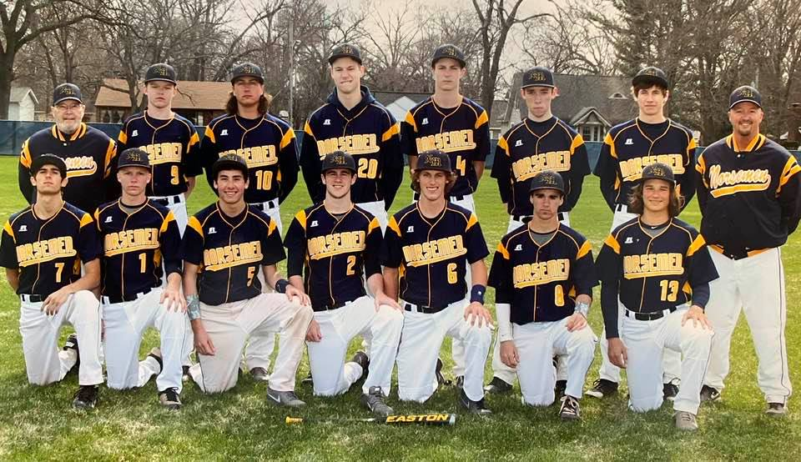

The 2014 NORSEMEN
Front Row L-R: Brody Scott, Joel Hardy, Connor Gannon, Ben Gautraud, Reese McCamant, Jesse Dunn,
Riley Draper
Back Row L-R: Warren Kent Jr., Ryan Compeau, Travis Webster, Marco Visconti, Bailey Cooper, Chris Hillman, Stephen Pallante, head coach Warren Kent III

Record Score Interesting Fact
0-1 Fruitport 6, NM 5 Eight innings; lost opener for 6th straight year; Brody Scott 2 Hits, RBI
1-1 *NM 16, Hart 1 10-run second inning; Ryan Compeau single, double, 2 runs, 2 RBI
2-1 *NM 22, Hart 0 13-run fourth inning; 19 hits; Stephen Pallante 3 singles, 4 runs, 4 RBI
3-1 NM 5, OV 3 Broke 3-3 tie in 7th; Bailey Cooper CG; Travis Webster 2H, 2B, 3 RBI
3-2 *Oakridge 12, NM 6 McCamant single, HR, 2 runs, 2 RBI
3-3 *Oakridge 5, NM 2 Pallante double, run
3-4 *Mason CC 6, NM 5 Six errors; Riley Draper 10 K's; Compeau 3 singles, RBI
4-4 *NM 7, Mason CC 0 Reese McCamant CG, 1-hit shutout; Jesse Dunn 3 singles, 2 RBI
4-5 Holton 7, NM 0 County; Pallante & Scott 2 singles
5-5 *NM 13, Montague 5 Seven-run second inning; McCamant CG; Draper 2 singles, 2 runs, 3 RBI
6-5 *NM 12, Montague 0 Draper 5-inning shutout; Compeau 2 singles, 2 runs, 3 RBI
7-5 NM 12, WMC 0 Cooper & Connor Gannon combined 1-hitter: Cooper single, 2B, 3 RBI
8-5 NM 10, WMC 3 Ben Gautraud double, run, 4 RBI
8-6 Musk. Cath 10, NM 0 One hit (Gannon infield single); 6 errors; MCC ranked No. 1 in state
8-7 Musk. Cath 10 NM1 All 10 Crusader runs unearned; only 3 hits; Pallante single, run
8-8 Montague 6, NM 5 Outhit Wildcats 11-3; Dunn 2 singles, 2 RBI
9-8 NM 6, Montague 2 Dunn CG, 5-inning win; Scott & McCamant 2 singles, run, RBI
10-8 *NM 9, Shelby 5 Pallante 2 singles, 2 runs
11-8 *NM 5, Shelby 2 Draper CG no-hitter; scored 5 runs in top of 7th; Scott single, 2B, RBI
11-9 *Whitehall 15, NM 2 Pallante 2 singles, run
11-10 *Whitehall 12, NM 5 4th-inning triple play; Pallante single, double, 2 runs, RBI
12-10 NM 7, Reeths-P 4 Webster 2 singles, run, RBI
12-11 Reeths-P 14, NM 1 Rockets scored 13 runs in 1st inning: Pallante & Compeau single
13-11 *NM 5, Ravenna 0 McCamant CG shutout; 3rd error-free game of season; Compeau 2 RBI
13–12 *Ravenna 6, NM 4 12 innings; Pallante 2 singles, run, RBI
14-12 NM 6, Potter's H1 District; McCamant 10 K's; Scott single, 2 doubles, 2 RBI
14-13 Musk. Cath 10, NM 0 District Finals; only one hit (Webster single)

2015 -- Warren Kent III (13-17 overall, 3-11 in WMC; 7th place in WMC; Whitehall/Montague Champs)
If the 2015 version of the North Muskegon varsity baseball team were a novel it would be the sequel to Great Expectations, titled Unfulfilled. It was the best of times; it was the worst of times. While the 2015 squad finished 13-17, this team had the potential to be one of the better teams, record-wise, in Norse history, but too many plays, too many innings, too many games that were not completed caused the season to take a downward turn rather than an upward turn. The Norsemen outhit nine opponents in games that they lost. The Norsemen lost five games in the other team’s final at bat. The Norsemen lost nine games by two or fewer runs. First innings, which usually set the tone, were not favorable for the Norse. While they jumped out to leads in 15 games, NM only went 8-7 in those games. When NM was trailing after the first inning, the Norse was 2-8, and when the score was tied, NM was 3-2. This year’s team batted .335, which was the second-best of any coach Kent team next to the 2008 state semi-finalist team (.372). The Norse outhit their opponents 270-171. Additionally, this team struck out just 118 times, the second fewest of any coach Kent-led team. Last year’s team struck out just 79 times. Conversely, opponents only batted .239 against Norse pitching and struck out 182 times. While the 78 errors were the seventh most in coach Kent’s 12 years, the 86 unearned runs were the third most. NM outscored its opponents in every inning, 1 through 5, but were outscored in every inning thereafter. Spots 1-7 in the batting order all posted a batting average greater than .319 with 1 through 4 all batting better than .379. NM struggled at both the No 8 (.183) and No. 9 (.256) spots. Three seniors (Connor Gannon, Riley Draper and Ben Gautraud), who batted 1-2-3, led the team throughout the season. Connor, who made the transition from infield in 2014 to outfield in 2015 flawlessly, won the Gold Glove Award. Connor was All-District, First Team All-Conference and Second Team All-Area as an outfielder. From the lead-off spot, Connor led the team with 24 stolen bases, which puts him in a tie at No. 3 on the all-time season list. He also led the team with 35 runs. Additionally, he posted a .379 average (36-for-95). In the conference, Connor paced the team with 47 at bats, 16 runs and 11 stolen bases while batting .340. Riley, who batted in the No. 2 spot and was one of the team’s top pitchers, was an All-District performer (utility), an Honorable Mention All-Conference selection (infield) and an Honorable Mention All-Area pick (infield). Overall, Riley led the team in hits (37) and at bats (97) while posting a .381 average. In the conference, Riley paced the team in at bats (47) while batting .383. His five runs scored against Hart tied a school record. On the mound, Riley was the staff workhorse, tossing a team-high 57innings, striking out 46, while finishing with a 4-7 record. Opponents batted just .202 against him, and he had a 2.43 ERA. Riley tossed three shutouts, which puts him in a second-place tie on the all-time season list. His four career shutouts rank him in a tie for second also. Academically, Riley was an Academic All-District and an Academic All-Region recipient. Ben, the team’s MVP, was the most consistent hitter throughout the season, mainly from the No. 3 spot in the order. Ben, who was All-District (infield), Honorable Mention All-Conference (infield), and Second Team All-Area (infield) was the team’s batting champ with a .439 average (36-for-82). He led the team with a .510 on-base percentage, 10 doubles and seven hit by pitches. His seven HBP’s put him in a tie at No. 7 on the all-time season list. His 11 career HBP’s put him in a tie for fifth on career list. Ben also hit one of the team’s two home runs and tied for the team lead with five sacrifices, which puts him in a tie for ninth on the all-time season list. His eight career sacrifices tie him for fourth on the career list. Ben also tied two school records for a game with five runs against Hart and two HBP’s versus Coopersville. In the conference, Ben batted .476 (20-for-42). Ben also had the team’s longest hit streak at 10 games, which ties him for 10th on the all-time season list. The leading junior on the team was Erick Bleakley, a First Team All-Conference and Honorable Mention All-Area performer (infield), while posting a West Michigan Conference batting average of .512 (22-for-43). Overall, Erick batted .402 (33-for-82), making he and Ben Gautraud just the fifth duo to bat over .400 in the same season (1980, 1994, 1995, 2007, 2008) in the 80-year history of NM baseball. NOTE: The 2005 team had three players bat over .400. In the conference, Erick led the team with 22 hits, eight doubles, two triples and 17 RBI. Overall, Erick paced the team with two triples and 24 RBI. His seven RBI vs. Hart tied a school record. On the mound, Erick was 2-5 with a 2.18 ERA in 45 innings and 45 strikeouts. For his work in the classroom, Erick made the Academic All-District and the Academic All-region teams. The final two players to post a batting average better than .300 were sophomores Brighton Schofield and Dalton Fuller, the corner outfielders. Brighton, the left fielder, posted a .362 batting average (25-for-69) and led the team with 17 walks. Dalton, the right fielder, batted .339 (21-for-62). Both Brighton and Dalton also pitched. Brighton struck out 17 in 19 innings but is still looking for his first varsity win (0-3). Dalton went 1-0 in eight innings. Two juniors just missed the .300 mark. Joe Osborn, who played second base, missed the .300 mark by two hits, posting a .279 average (17-for-61), while Ben Garcia, the first baseman, missed the .300 mark by three hits, posting a .275 average (25-for-91). On the mound, Joe was 0-1 in 7 innings, but he did combine with Joel Hardy for a five-inning perfect game at Pentwater. Ben posted a 4-1 record, striking out 36 in 24 innings. He posted a 1.42 ERA while opponents batted .212 against him. Sophomore Jake Bean, the every-day catcher, rounds out the normal starting lineup. While Jake, who was the team’s Most Improved Player, struggled offensively (.209), he was stellar behind the plate, fielding 141 chances and having only two errors. Jake tied for the team lead with five sacrifices, which put him in a tie for ninth on the all-time season list. Two seniors, Joel Hardy and Marco Visconti, saw varying degrees of playing time. Joel, who split time in left field and courtesy ran, had one of the team’s two homers and had the dubious distinction of leading the team with 18 strikeouts. On the mound, Joel posted a 2-0 record in 12 innings of work and combined with Joe Osborn for a five-inning perfect game at Pentwater. Joel was awarded the Coaches’ Award. Marco, who played third base, batted 26 times while posting a .231 average. Junior Kade Bickford posted a .200 average (5-for-20) in limited playing time. The final six players, one sophomore (Alex Slocum) and five freshmen (Tommy Gautraud, Brett Huff, Jimmy Cobb, Cayden Villescas and Matt Kraley), combined to post a .425 average (10-for-24) and score eight runs.

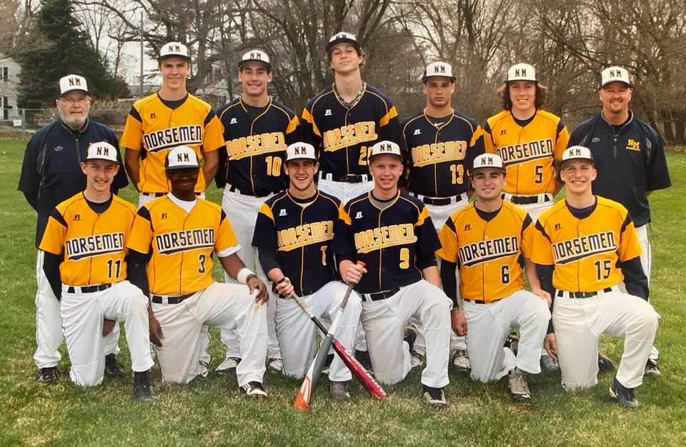

The 2015 NORSEMEN
Front Row L-R: Brighton Schofield, Ben Garcia, Ben Gautraud, Joel Hardy, Joe Osborn Dalton Fuller
Back Row L-R: Warren Kent Jr., Erick Bleakley, Connor Gannon, Marco Visconti, Riley Draper, Kade Bickford, Head Coach Warren Kent III – Not pictured Jake Bean

Record Score Interesting Fact
0-1 *Oakridge 15, NM 8 Lost opener for 7th straight year; Connor Gannon 2 singles, run
0-2 *Oakridge 10, NM 6 Erick Bleakley single, 2 doubles, 2 runs, 2 RBI
0-3 *Shelby 3, NM 2 Eight innings; Brighton Schofield double, run
0-4 *Shelby 8, NM 5 Bleakley double, 2 runs, RBI
1-4 NM 1, Coopersville 0 Only 2nd 1-0 win in 80-year NM history; Riley Draper cg. 2-hitter
1-5 Coopersville 4, NM 3 DH was first meeting between schools since 1966: Schofield 2B, RBI
2–5 NM 18, Pentwater 3 18 hits; Dalton Fuller 3 singles, 3 runs, RBI
3–5 NM 11, Pentwater 0 Joel Hardy, Joe Osborn 5-inn. perfect game, Draper & Schofield 3 hits
3–6 Mona Shores 12 NM 0 Only 2 hits; Schofield & Gautraud single
4-6 NM 9, Saugatuck 3 1st regular season meeting between schools; Gannon 3 hits, 2 RBI
4-7 Saugatuck 11, NM 5 7 errors; Bleakley & Alex Slocum 2 singles
5-7 *NM 32, Hart 0 School record 32 runs in 3 innings. Bleakley 2 singles, 2B, 3B, 7 RBI
6-7 *NM 10, Hart 0 Draper 9 K's; Joel Hardy single, triple, 2 runs
7-7 NM 3, Montague 0 County; Draper 3rd shutout of season, 1 hit, 9 K's; Schofield 2 hits
7-8 Oakridge 5, NM 3 County; only 4 singles; Draper single, run, RBI
8-8 NM 10, Orchard View 0 6th shutout of season; Garcia 4-hitter; Hardy 3-run HR
8-9 Orchard View 11 NM 2 Only 4 hits: Gautraud double
8-10 *Mason CC 12, NM 7 Gannon single, double, 3 runs, RBI
9-10 *NM 9, Mason CC 1 Gautraud single, double, HR, 4 runs, RBI
9-11 *Montague 3, NM 1 Draper 1-hitter; 5 singles from 5 different players
9-12 *Montague 8, NM 6 Nine innings; Draper 2 singles, triple, run, RBI
10-12 NM 5, WMC 4 Brothers Ben (p) and Tommy (c) Gautraud started game; Gannon 3H
11-12 NM 12, WMC 1 No seniors (senior awards assembly); Bleakley 3 hits, 2 runs, 2 RBI
12-12 NM 13, Hesperia 3 Fuller picks up win on his birthday; Gautraud 1B, 2B, 2 runs, 4 RBI
13-12 NM 4, Hesperia 2 Garcia 12 K's; Jake Bean 2 singles, 2 RBI
13-13 *Ravenna 2, NM 0 Draper 3-hitter; 6 singles from 6 different players
13-14 *Ravenna 9, NM 8 Bulldogs score twice in bottom of 7th; Draper 2 hits, double, run, RBI
13-15 *Whitehall 6, NM 5 Garcia 2 singles, run, RBI
13-16 *Whitehall 14, NM 4 Bleakley single, 2 doubles, run
13-17 WMC 5, NM 4 District; 8 innings; winning run scored on wild pitch; 8 errors; 4 players with 2 singles

2016 – Warren Kent (17-20) 4-10 in West Michigan Conference, Oakridge champs)

After a streak where the Norsemen posted winning records for 10 consecutive years, 2016 would be the second of 4 consecutive seasons where NM would post a losing record.
One of NM’s most versatile athletic performers of all-time, Erick Bleakley, did his best to stop the slide. The future Naval Academy grad posted sensational numbers, both on the mound and as a batsman for the Norse. Erick pitched a pair of gems to begin the 2016 regular season as well as the end but, received little hitting support from his teammates. Bleakley pitched a 1-hitter against Whitehall to begin the season, going the full 7-inning route only to lose 1-0. His final game at James B. Johnson field to cap the regular season was even more frustrating. In a game that was to be a ‘tune-up’ for the upcoming playoffs, Blakely pitched 7 shutout innings against Cedar Springs, only to lose the game in the 8th inning 1-0 when one of his infielders dropped a pop fly that brought in the only run in the 1-0 loss. The Norse were able to tally 4 runs in the second game of the DH to defeat Cedar Springs, coached by NM resident Mike Schaub, the son of 1953 NM graduate Donna Kenny, 4-3. The Norse season came to a quick ending just 4 days later when Bleakley, after throwing 110 pitches on Friday, threw 112 the following Tuesday but again, NM failed to score and were shut out by Ravenna. Earlier in the season Erick defeated Ravenna 2-1 allowing but 6 hits and one unearned run. Bleakley would finish with an earned run average of a scant .086 while striking out 86 batters. At the plate Bleakley hit a robust .431, with 7 HR, 4 3B, and 11 2B. What was even more impressive with Bleakley’s stats, he had ALL the NM home runs and triples for 2016. Ben Garcia was the only other Norse to hit over .300 with a .359 average. The 3rd senior on the 2016 team, Joe Osborn, was 4th in team batting average at .271. Sophomore Jimmy Cobb showed promise at the plate with a ,272 mark. After a slow start the Norse did finish strong as they won 8 straight games before losing the above mentioned 1-0 game to Cedar Springs. Among those 8 victories were a pair of wins over Zeeland West, including a 1-0 shutout 3-hit performance from Bleakley.
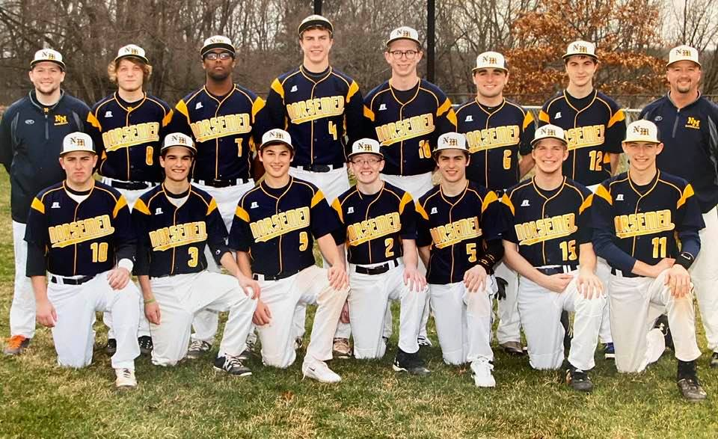

The 2016 NORSEMEN

Front Row L-R: Jake Bean, Tommy Gautraud, Jimmy Cobb, Sean Bickford, Alex Slocum, Dalton Fuller,
Brighton Schofield
Back Row L-R: coach Brett Cavanaugh, Josh Johnson, Ben Garcia, Erick Bleakley, Truls Krogh, Joe Osborn, Thomas Lane, head coach Warren Kent III

Record Score Interesting Fact
0-1 *Whitehall 1, NM 0 Eight IP Erick Bleakley 1 hitter, 7k in 7 IP, also 3b, Alex Slocum 2 hits (2b)
0-2 *Whitehall 3, NM2 Ben Garcia loss, NM only 2 hits, Whitehall wins in 7th
0-3 Saugatuck 6, NM 3 Blake Dunn (MLB) 2 hits for Saugatuck, NM only 5 hits, Slocum LP
0-4 Saugatuck 7, NM 3 NM only 2 hits (Garcia, Jimmy Cobb), Cobb LP in 5 inning game
0-5 Coopersville 11, NM 1 Bleakley 2 of NM 4 hits, Brighton Schofield takes the loss
1-5 NM 7, Coopersville 6 Garcia winning pitcher; Slocum 3 hits, Dalton Fuller, Garcia 2 hits
2-5 *NM 10, Shelby 9 Slocum gets win; Fuller (3 hits) SF wins in 7th
2-6 *Shelby 4, NM 3 Only five innings (Darkness); Fuller 2 hits, Garcia 2b
2-7 *Oakridge 2, NM 1 NM only 3 hits, Fuller, RBI 1B, Garcia and Bean singles; Bleakley loss
2-8 *Oakridge 8, NM NM uses 4 pitchers, Bleakley 3 hits (HR); Schofield 2 hits
3-8 NM 10, Muskegon 4 Slocum winner; Gautrad 2 hits, Fuller 2B, 2 RBI; Joe Osborne 2 RBI
3-9 * Ravenna 7, NM 1 NM only 5 hits (Schofield 2b, Gautraud, Bleaakley, Bean, Osborn
3-10 * Ravenna 14, NM 2 NM just 4 hits, Fuller RBI double, Bleakley, Osborn singles
4-10 NM 5, Alpena 4 Bleakley win also 2 hits & GW RBI. Gautraud, Garcia 2 hits.
5-10 NM 8, Kingsley 2 Slocum winning P, Slocum, Osborn 2 hits, Bean, Cobb, Gautraud 2b
5-11 Gaylord 17, NM 2 NM loses in Boyne Championship final, NM gives up 17 in 2 ing. Bleakley 2 RBI 3b
6-11 *NM 8 Hart 1 Slocum 2 hitter for win, Gautraud, Bleakley, Garcia (2b) 2 hits, Bean 3 hits
7-11 *NM 9, Hart 2 Cobb 7 ing for win; Osborn 3 hits, Fuller, Bean, Bleakley, Cobb (2b)
7-12 WMC 11, NM 6 Bleakley HR, 2b, 4 RBI, Fuller, Gautraud (2b),2 hits, Bean 2b
8-12 NM 5, WMC 1 NM splits DH, Scholfield, Ryan Kenny combined 1-hitter: Bleakley 3b
9-12 NM 2, Ravenna 1 Bleakley 6 hitter, 1 unearned run, Bean 2 hits, Garcia GW RBI single
9-13 Musk Cath 10, NM 1 Four MCC pitchers hold NM to 1 hit ((Scholfield) in Co. tournament
9-14 Mason CC 4, NM 2 Osborn LP, Mason CC score all4 runs in 4th: Blakely 2 hits (HR)
9-15 Mason CC 8, NM 1 MCC 7 runs in 5th for win; Bleakley 3 hits (HR)
9-16 Musk Cath 6, NM 3 MCC win in 8th inning. Slocum 1st 6 ing. 1 run; Bleakley 3rd HR in 3 games (3 hits)
9-17 *Montague 3, NM 2 Bleakley all 7 innings. Pitched. 0 earned runs; winning run on a bunt
10-17 *NM 8, Montague 7 NM earns split of DH, Garcia, Bleakley 3 hits with each a 2b,
11-17 NM 5, Pentwater 1 Jesse Cooke winner; Kenny saves: Garcia 3 hits, 2 RBI, Bleakley HR
12-17 NM 1, Zeeland West 0 Bleakley 3 hit shutout, 8 K, 1 BB, Bean GW single in 5th
13-17 NM 9, Zeeland West 5 NM scored 6 in 2nd, Garcia 3 hits, Bleakley 2 2Bs Cobb 2hits
14-17 NM 8 Kent City 6 Slocum winner, Cobb save: Garcia & Gautraud 2 hits
15-17 NM 12, Kent City 2 Osborne winner & gets 3 hits’ Bleakley 2 hits (HR), Garcia 2 hits
15-18 Holton 11, NM 6 Bleakley & Fuller 2 hits (both 1 2b); Fuller 3 RBI
16-18 NM 4, Holton 1 Bleakley 4 inning. winner: Schofield 3 ing save; Bleakley 2 hits (3b, 2b
16-19 NM 0, Cedar Spr.1 Bleakley pitches a 4-hit, 12 K gem only to lose in the 8th on a missed pop fly in 8th
17-19 NM 4, Cedar Spr. 3 NM rallies to earn DH split; Gautraud scores WR on passed ball in
17-20 Ravenna 6, NM 0 After throwing 110 pitches, Bleakley throws 112 on 3 days’ rest, but NM loses districts

2017 – Warren Kent (14-19 overall,) 6-8 in West Michigan Conference, Oakridge champ)
For the third consecutive season, the Norse finished with a less-than-.500 record, but the season did not start out that way. Through the first 20 games, NM had a 12-8 record with a team batting average of .303 while averaging seven runs per game. At that point in the season, eight players had a better than .300 batting average. However, over the final 13 games, the team went 2-11 with a team batting average of .210 while scoring just 29 runs (2.2 runs per game). Only one player batted better than .293 over that span. The Norse did add a trophy to the school’s collection, taking second place at the Boyne City Invitational. NOTE: All three of NM’s opponents at the invitational (Rudyard, Boyne City and Alpena) won a district title as did three other opponents (Whitehall, Montague and Muskegon Catholic Central). The Norse recorded a school-record seven shutouts; unfortunately, that is the number of times NM was shut out. NM also played 14 games where the game was decided by three or fewer runs; NM went 7-7 in those contests. Finally, the Norsemen were outscored by their opponents by 37 runs (209-172) for the second straight year. And the 209 runs surrendered were second most in the Coach Kent era.
The team was led by senior MVP Brighton Schofield, who paced the team in most offensive categories as well as most pitching categories. Offensively, Brighton, who played shortstop and left field mostly, batted a team-high .451 (41-for-91). Brighton also led the team with two triples, 20 RBI and 25 runs. Additionally, he tied for the team lead with 16 stolen bases. Those statistics helped him become an All-District outfielder. He did, also, have the honor of leading the team with 21 errors. In the conference, Brighton, who was a First Team All-Conference outfielder, batted an even .500 (17-for-34) to lead all WMC outfielders. His eight WMC doubles also led conference outfielders. On the mound, Brighton paced the team with 74 strikeouts in 55 innings while posting a 2.80 ERA. He finished with a 4-5 record.
Three other seniors (Jake Bean, Alex Slocum and Dalton Fuller) saw significant playing time. While Jake, a three-year starter at catcher, struggled to get untracked offensively, he did add his name to the NM record books when he hit two home runs in the 18-8 victory at Hesperia. This was the 19th time in Norse history that a player had hit at least two home runs in a game. Also, Jake had five sacrifices (tied for the team lead) this year, putting him at 11 for his career, which is tied for third on the all-time NM list. Jake’s strength was his defense where he committed just two errors (both in the loss to Muskegon Catholic Central) in 191 chances. For his work behind the plate, Jake was selected as the Gold Glove Award winner. Additionally, Jake became the first winner of the K2 Coach’s Award, which is dedicated to the memory of former assistant coach Warren Kent Jr., who passed away in February. Coaches are not supposed to play favorites, but Jake was always one of K2’s favorite players, and it is only appropriate that Jake was the inaugural winner of the award, which also comes with a $100 scholarship. Alex, the everyday center fielder and part-time pitcher, was an atypical lead-off hitter, drawing just two walks in 114 plate appearances. However, he did post the team’s third-best batting average (.312). On the mound, Alex became the first pitcher to start and win both games of a doubleheader under coach Kent when he defeated Hart twice. He was the only pitcher to finish with a winning record (3-2). Alex led the pitching staff with eight HBP. For his classroom work, Alex was Academic All-District. Dalton, who saw playing time in right field, first base and designated hitter, just missed the .300 mark, finishing with a .293 batting average. Dalton’s 10 career sacrifices put him in a tie for fifth on the all-time NM list.
Freshman Brenden Moat, who joined the varsity at the midway point and became the first freshman to gain a varsity letter under coach Kent, was the team’s second-leading hitter (.325). Brenden made a big splash over his first 18 games, posting a .412 average; however, down the stretch, he hit a slump, batting .154 over the final eight games. In the conference, Brenden was named Honorable Mention as an outfielder while batting .480 (12-for-25).
Junior Brett Huff, the back-up catcher, saw most of his playing time at the designated hitter position. He finished with a .281 average. Brett, who went from a .200 batting average prior to Boyne and batted at a .324 clip after Boyne, was selected as the team’s Most Improved Player. Additionally, Brett was honored with Academic All-District for his classroom work.
Sophomores Jesse Cooke and Mack Young should man the middle infield spots for the next two years. Jesse, who played shortstop and pitched, had the dubious distinction of leading the team with 22 strikeouts. However, Jesse’s conference body of work was good enough to be named to the All-Conference team as an infielder. In the WMC, Jesse batted .345 (10-for-29) with 10 RBI and nine runs. On the mound, Jesse, who sustained a hip flexor injury at the Boyne Invitational, had a Dr. Jekyll-Mr. Hyde type of season. Through his first 22 innings, Jesse struck out 31 and walked just one while over his final 30 innings, Jesse struck out 22 and walked 20. Overall, Jesse finished with 53 Ks in 52 innings while posting a 3-4 record. Mack was a mid-season call-up and was plugged into the second-base position. He just missed the .300 mark by one hit, posting a .298 batting average.
Four juniors (Tommy Gautraud, Jimmy Cobb, Ryan Kenny and Matt Kraley) had varying degrees of success. Tommy, who played both second and third base while batting in the No. 2 spot, tied for the team lead with 16 stolen bases and tied for the team lead with five sacrifices. Jimmy, who played left field, shortstop and pitcher, was the only player to play all 33 games. He also led the team with 116 plate appearances, which can be attributed to his improved plate discipline as he cut his strikeouts down from 23 to 13 and increased his walks from seven to a team-high 20. Jimmy also led the team with four hit by pitches and tied for the team in sacrifices with five. On the mound, Jimmy experienced some arm trouble, limiting him to 15 innings. Ryan, a lefty, saw most of his playing time on the mound while also seeing some playing time in left field. On the mound, Ryan tossed 47 innings while striking out 34; however, he led the team with 31 walks. He did lead the team with two saves. Now, has three saves, which ties the school record held by Jimmy Cobb. Matt’s role was defensive first baseman, where he succeeded with a fielding percentage of .965 with four errors in 113 chances.
The final four players (senior Sean Bickford, junior Mitchel Wolters, junior Jared DeMint and sophomore Brendan Gannon) saw minimal playing time. Both Sean and Mitchel were named Academic All-District for their classroom work.

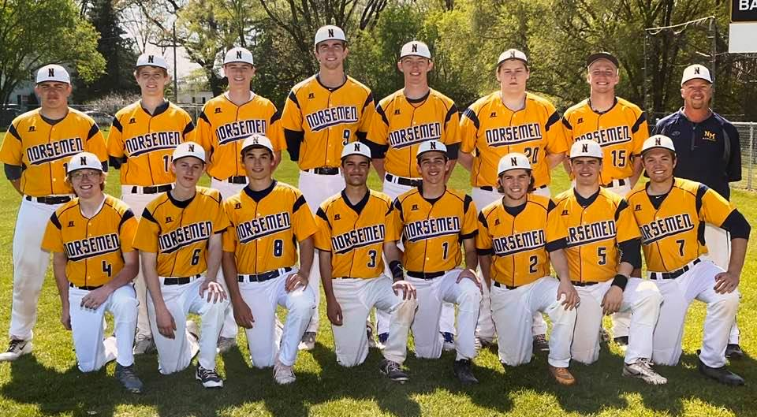

The 2017 NORSEMEN
Front Row L-R: Sean Bickford, Ryan Kenny, Jimmy Cobb, Tommy Gautraud, Mack Young, Matt Kraley, Alex Slocum, Brett Huff
Back Row L-R: Jake Bean, Mitchell Wolters, Brendan Gannon, Jesse Cooke, Brighton Schofield, Jared DeMint, Dalton Fuller, head coach Warren Kent III Not pictured Brenden Moat coach Joel Hardy

Record Score Interesting Fact
0-1* Whitehall 8, NM 0 Casey Huizenga no hits NM, Brighton Schofield LP 5, Alex Slocum 2 IP
0-2* Whitehall 5, NM 2 NM out hits Whitehall 8-5: Slocum, Schofield, Jesse Cooke 2 hits (2b)
1-2 NM 13, Cedar Spr. 4 NM wins against former NM coach Paul Moyes alma mater.
2-2 *NM 3, Shelby 0 Schofield winner, Ryan Kenny save; Schofield (2b) & Slocum 2 hits.
2-3 * Shelby 14, NM 2 Shelby scores 8 in 1st; NM 6 errors; Jimmy Cobb 3 hits (2 2b)
3-3 NM 9, WMC 6 Kenny winner; Cobb 3 hits (HR, 2 2b), Fuller, Schofield 2 hits (3b)
3-4 WMC 6, NM 4 Slocum complete game loss; Cobb 3 hits as NM splits DH
3-5 * Ravenna 7, NM 1 Schofield the loss: NM only 2 hits off Brian Thompson (Schofield (HR)
4-5 *NM 9, Ravenna 4 Cooke winner; 0 ER, 2 hits, 3 RBI (2 2b), Schofield 3-3 (2 2b)
5-5 NM 18, Hesperia 8 Slocum winner also 4 hits; Jake Bean 2 HR (only HR hit all year) 3 RBI
6-5 NM 5, Rudyard 1 Schofield 7 IP 2 hitter, 13 K, Bean, Fuller, Mack Young 2 hits
6-6 Boyne City 5, NM 3 Cooke 6 IP, loss; Cooke, Fuller 2 hits
6-7 Alpena 14, NM 4 Alpena scores 8 in 1st 2 ing; NM 5 errors, Schofield 2 hits (3b)
7-7 *NM 19, Hart 6 NM scores 12 in 3rd; Brett Huff 3 hits, Slocum, Cooke, Brenden Moat, Jared Demint 2 hits
8-7 *NM 9, Hart 0 Four IP Game; Slocum winner, Slocun, Tommy Gautraud 2 hits, Fuller 4 RBI
9-7 NM 7, OV 3 Kenny 6.2 IP winner, Slocum Moat (2b) Schofield (2b), 2 hits
9-8 Ravenna 10, NM 4 County tournament; Gauntraud, Fuller 2 hits. Cooke (LP)
10-8 NM 13, Muskegon 1 NM used 3 pitchers in 5 ing (Kenny, Cobb, Young), Young 3 RBI.
11-8 *NM 8 Mason CC 5 Cooke 7 IP winner, Also HR, Moat 3 hits, Slocum (2b) & Young 2 hits
12-8 *NM 10 Mason CC 8 NM scores 2 in 7th for win; Kenny winner & GW RBI; Schofield 3 hits
12-9 Musk Cath 11, NM 5 Kenny losing P, Gautraud & Schofield 2 hits, Cobb 2b
12-10 Reeths P 3, NM 2 RP wins on steal of home in 6th: Slocum 6 IP loss, NM 5 singles
12-11 Reeths P 13, NM 1 Cole Aerts 3 hits Norse in 5 ing game; Schofield 2 hits, Huff 1
12-12* Montague 3, NM 0 Schofield loser in 5 IP, Schofield 2 hits (2b), Young 2 hits
12-13 *Montague 9, NM 6 Cats’ score 9 in 7th for win; Slocun (2b), Moat 2 RBI, Schofield (2b)
12-14 Holton 11, NM 0 NM 6 hits by 6 different hitters in loss.
13-14 NM 9, Kent City 8 NM wins in 11th on an error; teams combined for 16 errors, Schofield winner& 3 hits
13-15* Oakridge 3, NM 2 Schofield 5 IP, loss; Cooke RBI single as pinch hitter in 7th as NM scores 2
13-16* Oakridge 12, NM 0 TJ Ruel shutout win for Oakridge; Moat with 2 of NM 6 hits
13-17 Zeeland W4, NM 0 NM only 3 hits, 2 by Slocum & 1 by Schofield. Schofield only 1 run in 4 IP but LP
13-18 Zeeland W 13, NM 0 NM only 2 hits by Young and Schofield (2b)
14-18 NM 3, WMC 2 NM scores 3 in 1st and hangs on for win: Schofield 7 IP for win.
14-19 NM 0 Montague 2 District game; Cooke goes all 7 and only allows 3 hits in loss.

2018 – Warren Kent (10-15 overall, 7-7 in West Michigan Conference, Oakridge champ)
The Norse would finish with less than a .500 record for the 4th straight year in what would prove to be the final year Warren Kent III would serve as the NM mentor. The Norse did finish .500 in the always tough West Michigan Conference but would see their season come to a quick close with an opening game 5-1 district playoff loss to perennial rival Montague. The Norse got off to a promising start by defeating an always strong Whitehall team twice in the doubleheader. After working 6 1/3 innings in a 5-1 victory in game number one, Jessee Cooke came on in game two and again was the winning pitcher in the nightcap as NM nipped the Vikings 3-2. Cooke was granted the win after Jimmy Cobb stole home in the 9th inning. Evidently there were no pitch count rules in effect for 2018 as Jesse threw 132 pitched in the double dip. The best Norse player on the 2018 squad was renowned artist Jimmy Cobb. The senior posted an impressive .493 batting average and led the team in virtually all the hitting categories, including in home runs, where Cobb hit the only homerun on the entire season for the Norse. The two mainstays on the Norse pitching staff were juniors Jesse Cooke and sophomore Brenden Moat, who combined to win 6 of the 10 Norse wins on the season. Giving a much-needed boost to the NM program was freshman Charlie Branch. Called up midway through the season from the JV team, Branch hit an amazing .512 by garnering 22 hits in just 43 at bats, by far his best average in his three years on the Norse varsity. Branch gave a quick preview on what he would soon accomplish as one of NM’s all-time best pitchers when he did pick up his first victory on the mound in but nine innings of work. Called up late in the season was yet another frosh who would etch his name in many offensive record categories, Alec Cutter. Alec would pick up his first of many hits in a Norse uniform, going 1-3 in his only game he suited up in the 2018 campaign. Unlike the 2016 season when the Norse finished strong, this was not the case for the 2018 nine as the Norse dropped seven of their last eight games. The one victory late in the season was a 13-11 win over Shelby when the young freshman Branch tied an all-time NM best by going a perfect 5-5 in the win. Sophomore Logan Richards with a .312 batting average was one of 3 Norse hitters to hit over .300.

Record Score Interesting Fact
1-0 *NM 5, Whitehall 1 Jesse Cooke 6.1 IP for win, Jimmy Cobb & Cooke 2 hits, Brett Huff 2b
2-0 *NM 3, Whitehall 2 Cobb steals home in 9th; Cooke wins both game (132 pitches) Tommy Gautraud 3 hits
2-1* Ravenna 4, NM 0 Brenden Redding shuts out N: Cooke loser (5 IP); Cobb 2H
2-2* Ravenna 11, NM 6 NM 6 errors; Cobb 2b,
2-3 Boyne City 10, NM 5 BC scored 7 in 7th to rally from 3-5 deficit: Moat LP, Cooke 2 hits (2b),
2-4 Boyne City 20, NM 3 BC scored 15 in 3rd; NM 10 errors; Logan Richards 2 hits, Cobb HR
3-4 *NM 12, Hart 0 Cooke winner in 5 IP game; Cooke 2 hits 3 RBI, Cobb 2 hits
4-4 *NM 17, Hart 1 Kenny winner (4 IP); NM 18 hits, Cobb 3, Gautraud, Charlie Branch, Mack Young 2 hits
5-4 NM 9, Montague 7 County tourney; Cooke winner, Cobb 2 hits 3 RBI, Moat 3 RBI
5-5 Musk Cath 10, NM 4 County tourney; Kenny LP, Moat, Cobb 2 hits, Logan Richards 2b
6-5 *NM 13, Mason CC 7 NM breaks up close game with 7 in 7th: Cooke 4 hits 2 doubles
7-5 *NM 12, Mason CC 1 Moat winner in 5IP game; Branch 3 hits (2b), Cobb 2 hits (2b) 3 RBI
8-5 NM 3, WMC 2 NM scores 2 in 7th for win; Branch 1st NM career win.
8-6 WMC 5, NM 3 Young takes loss 4.1 IP: NM only 3 hits, Branch (2b), Cooke (2b),
8-7 * Montague 13, NM 2 NM 7 errors; Cobb 2 hits, Cooke 5 IP loss (0 earned runs)
8-8* Montague 5, NM 2 Moat 6 IP, 1 ER, NM only 5 hits, Cobb 2b
9-8 NM 10, Cedar Springs 9 NM scores 4 in 7th with 2 outs for win; Lowe winner; Matt Kraley 3hits
9-9 Zeeland West 7, NM 4 Jimmy Cobb 3 hits 2b, Huff 2 RBI, Cooke, Kenny, Young all 2 IP
9-10 Zeeland West 12, NM 1 NM loses DH at Hope College in 5 inn, NM 4 hits
9-11 * Shelby 8, NM 1 Cooke 5 IP in loss; Cobb gets 3 of NM 6 hits (3b), Branch, Kinney 2b
9-12* Oakridge 7, NM 6 Oakridge rallies to win in 7th; Kenny 6.1 IP loser; Branch (2b), Gautraud, DeMint 2 hits
9-13 * Shelby 4, NM 3 Shelby scores winning run in 7th; Moat 6.2 IP loss; Cooke 2 of NM 4 hits, Cobb 2b
10-13 *NM 13, Shelby 11 Branch 5-5 (2 2b), Cobb 2 hits 4 RBI, Brendan Gannon 2 hits, Lowe W
10-14 Whitehall 6, NM 0 Four Viking hurlers shutout NM; 6 Norse hitters get 1 hit, Moat 2b
10-15 Montague 5, NM 1 District loss; Cooke takes the loss: Freshman Branch 2 of 3 NM hits,

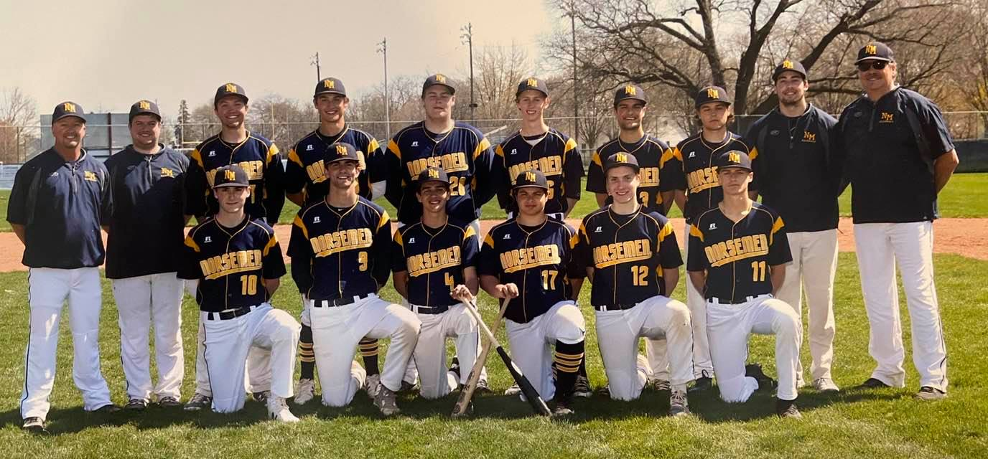

The 2018 NORSEMEN
Front Row L-R: Brendan Gannon, Jesse Cooke, Mack Young, Logan Richards, Billy Lowe, Brenden Moat
Back Row L-R: Head coach Warren Kent III, coach Sam Gautraud, Brett Huff, Jimmy Cobb, Jared DeMint, Ryan Kenny, Tommy Gautraud, coach Connor Gannon, coach Charles Rix – not pictured Charlie Branch

2019 – Steve Cutter (18-10; 11-3 in West Michigan Conference)

Former Hart Pirate ace Steve Cutter took over for Warren Kent as the head coach for the Norse and led NM to a much improved 18-10 record, a sure signal that NM baseball was on the rise. It didn’t take NM fans long to see that 2019 would not be their 5th straight losing season as the Norse won six of their first seven games. Although none of the Norse would crack the .400 barrier in 2019, seven of their regulars would hit over .300 over the 28-game schedule. Seven pitchers did most of the work in the pitching department with sophomore Charlie Brandt winning five games while losing two. Mack Young had a 4-1 winning record as the NM pitching staff compiled an impressive overall ERA mark of 2.27, a testament to the coaching expertise of Steve Cutter, who was also the pitching coach during the summer months for the Muskegon Clippers. The Norse had four complete game shutouts with Brenden Moat shutting out Fruitport 6-0 and Mason County 3-0 while losing a tough 1-0 contest to Fremont. Mack Young shut out Holton 10-0 while Branch hurled a 1-0 gem against a very good Montague team, who in turn, shutout NM 5-0 in the second game of the DH to hand NM one of their three conference setbacks. The 11 wins for the Norse in the WMC was their best conference mark since 2008. A double header defeat late in the season to conference champs Oakridge denied NM a WMC title. In addition to his pitching feats, Moat also excelled at the plate and on the base paths. The Junior hit .341 and swiped 20 bases on the season, including a school single game equaling record six in NM’s 13-3 defeat of Grant. The Norse came up big in 1-run contests, especially in WMC games. NM recorded one run victories over Shelby, Ravenna, Montague, and Whitehall while both of their wins over Hart were by a single tally. The widest margin of victory in the well-balanced WMC was but four runs in a 11-7 win over Mason County Central. Coach Cutter’s son Alec had a great sophomore campaign for the Norse by hitting for a .338 average that included five home runs, the only 4-baggers hit by the Norse in the entire season. Jesse Cooke and John Hayhurst both hit .333 on the season while Branch (.315) and Brendan Gannon (.308) were also above the .300 mark. After twice nipping Ravenna during the regular season the Norse saw the Bulldogs end the Norse season with a 4-2 win in the district playoff opener. Although Branch was credited for the loss, the young sophomore was able to go 3-3 at the plate. With many players returning, the 2020 season looked like it would be another prosperous season for the Norse ---- But--- fate was unkind to not only NM athletes but those around the globe as the planet earth suffered from a pandemic.

Record Score Interesting Fact
0-1 Holland Ch. 10, NM 4 Alec Cutter, Mack Young, John Hayhurst 2B
1-1 NM 6 Fruitport 0 Moat shutout; Shamus Corbett 3 hits, Brandon Moat, Charlie Branch & Cutter 3 hits (HR)
2-1 *NM 4, Shelby 3 Lowe winner, Marcus Lane 2 hits, Jesse Cooke 2 hits (2 2B)
3-1 *NM 6, Shelby 4 Moat winner, Cooke save: Cooke, Cutter, Branch 2 hits
4-1 NM 6, Saugatuck 4 Branch gets win in relief 5/1 scoreless innings; Cooke save
5-1 *NM 10, Ravenna 8 Cooke winner in relief; Cutter 3-4 HR, 2Bm 5 RBI, Hayhurst 2
6-1 *NM 12, Ravenna 11 Hayhurst 4-4, Cooke 2 hits, Cutter HR, Ravenna scores 5 in 7th
6-2 RP 15 NM 4 Moat & Logan Richards 2 hits in 5 ing. game. Mitchelson winner for RP
6-3 Fremont 1, NM 0 Moat loses on a 4-hitter, NM limited to 3 hits
6-4 Fremont 10, NM 1 Fremont scores 9 in 6th. NM only 4 hits
7-4 *NM 3, Hart 2 Branch winner, Branch steals home for deciding run
8-4 *NM 4, Hart 3 Young winner, NM scores all 4 in 5th. Cutter 2B and 2 RBI
9-4 NM 10, Holton 0 Young complete game shutout; Brendan Gannon 3 hits, Branch 2 2B
9-5 Musk. Cath 13, NM 3 Cutter 2 hits (2B), Young RBI 2B, Herniman 2B
10-5 *NM 1, Montague 0 Branch shutout, 1 hit, 12 K, Moat RBI double, Young 2B
10-6* Montague 5, NM 0 Nick Stever shuts out NM, Ramirez only NM hit,
11-6 *NM 3. Mason CC 0 Moat 3 hit shutout: Richard 2 RBI
12-6 *NM 11, Mason CC 7 Galdeen win: NM 15 hits; Cutter 3 hits (HR), Hayhurst 3 hits,
12-7 Hesperia 7, NM 1 NM only 3 hits; Cutter, Cooke 2B, Billie Lowe LP 4 hitter
13-7 NM 13, Grant 3 NM 12 SB; Young 6 hitter, Moat 3 hits 4 RBI 6 SB, Ramirez 2 hits
14-7 NM 5, Shelby 1 Ramirez 4 hitter, Moat, Hayhurst, Cooke 2 hits
14-8* Oakridge 7, NM 0 Corbett only 2 NM hits, Branch LP, 3 hits 7 K, 7 BB
14-9* Oakridge 12, NM 2 Moat losing pitcher, Moat 2-3, Branch 2 RBI double
15-9 NM 15, White Cloud 0 Cutter HR, Cooke 2 (2B), Brancj 2 hits, Avery Ramirez 1 hitter 3 ing.
16-9 NM 15. Holland Cal 0 Matt Herniman, Moat, Branch 2 hits; Cutter 3B, B. Galdeen win
17-9 *NM 10, Whitehall 9 Branch win; Branch 2B, Jesse Cooke 2 hits (2B);
18-9 *NM 4, Whitehall 2 Mack Young 6 hitter; John Hayhurst 2 hits, 2B; Cutter 2 hits
18-10 Ravenna 4, NM 2 Charlie Branch Losing pitcher but goes 3-3 as a hitter: Alec Cutter 2B

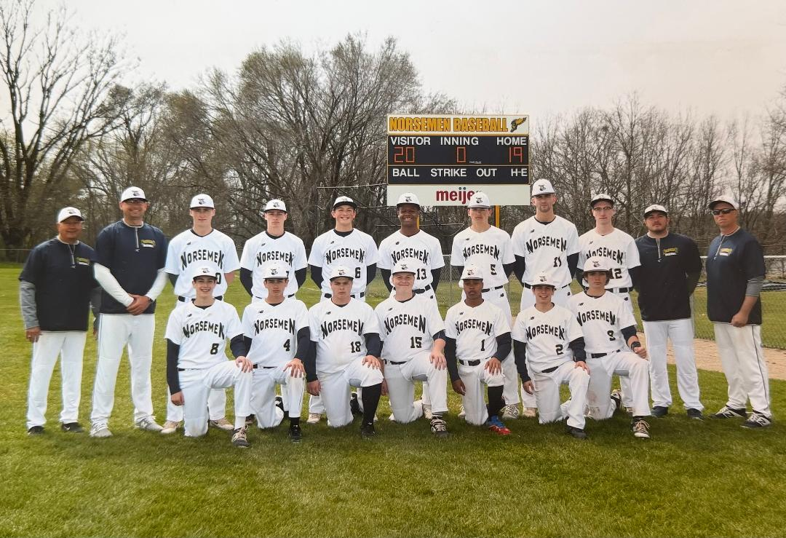

The 2019 Norsemen

Front Row L-R: Brett Galdeen, Mack Young, Logan Richards, Charlie Branch, Marcus Lane, Avert Ramirez, Shamus Corbett
Back Row: L-R Coach Walt Gawkowski, Head Coach Steve Cutter, Brendan Gannon, Brenden Moat, John Hayhurst, TJ McKenzie, Alec Cutter, Jesse Cooke, Billy Lowe, Coach Hayden Modaff, Coach Joe Branch

2020 – Cancelled due to Pandemic

2021 – Steve Cutter- (30-10 12-2 West Michigan Conference – NM co-champs with Montague, District champs)

To say that the NM baseball was eager to go in 2021 would be a vast understatement. The same was surely true of all baseball players across the USA who saw their 2020 season cancelled due to the Covid 19 pandemic. There could be little doubt that NM would have experienced a successful 2020 season if not for the loss of their entire season. Senior stalwarts such as Charlie Branch and Alec Cutter were denied their junior year which surely prevented those 2 NM stars of adding to their already impressive career stats. The Norse posted 30 victories on the season despite a vast change in their scheduling which saw NM face a more demanding schedule against top-flight competition. Included among newcomers on the 2021 schedule were top-flight opponents as Holland West Ottawa, Grand Rapids Forest Hills Eastern, Midland, Lincoln Park, Tecumseh, and a trip up north to play Traverse City St. Francis a doubleheader. The Norse swept St. Francis in a twin bill, 11-6 and 9-6. St. Francis would make it all the way to the state championship game in June in Division 3. The Norse would go 12-2 in West Michigan Conference and earn a share of the title with Montague. Both losses in the WMC were heartbreaking defeats. After pummeling Oakridge 12-2 in the first game of their doubleheader, the bats were silenced in the nightcap as the Norse were shutout 1-0 by the Eagles, despite Troy McManus allowing but a single run in 6 innings pitched. The second WMC loss was one for the ages. It came in the first game of a doubleheader at historic Marsh Field in front of a huge throng of spectators. Montague would score 4 runs in the 14th inning to edge the Norse 10-6. The marathon affair would be the 2nd longest game in NM’s 88 years of baseball. Undeterred by the crushing loss, the Norse showed their mettle and won the night-cap of the twin bill at Marsh field behind the pitching of freshman Ryan Delora and the hitting of freshman Ben Meyers who had three hits, including a double. The Norse crushed the ball as a team. The Blue and Gold collected 414 hits in 1077 at bats, a .381 average that is tops all time in Norse history. The Norse hurlers also fared very well during the 40-game season. As a team they posted an enviable ERA of 2.61 against stiff competition. Senior Charlie Branch was the workhouse of the staff and finished with a record of 9-2, and ERA of 1.89, struck out 107, and permitted less than one runner to reach base per inning. One could only lament what Charlie’s career mark would have been if not for missing the 2020 season. Sophomore Troy McManus began his stellar NM career with a bang by compiling a 4-2 record and an ERA of 1.75, Troy also made huge contributions at the plate with a .361 average. Young freshman Ryan Delora would begin an outstanding career on the mound for the Norse by recording a 5-2 won-loss mark. The Norse did win the season series against their rivals from Montague when they routed the ‘Cats’ 13-2 at James B Johnson field to earn their way to the district championship game vs. Ravenna. The Norse won 13-8 against Ravenna to earn a trip to the D3 Regionals. NM ran into a buzzsaw against a very strong Buchannan team where their successful season ended. Buchannan would finish as state runner-up in 2021 and would win it all the following year. The Norse had 4 players named to the WMC All-Conference team: Seniors Branch and Cutter, sophomore Troy McManus and freshman Ben Meyers. Cutter would finish his career by hitting at a .508 clip with Meyers not far back at .455. Branch, in addition to his above-mentioned pitching heroics, batted .435. The Norse also received help at the plate from a pair of seniors; Shamus Corbett hit .381 while Joe Duplissis, grandson of one of NM’s greatest all-time players, Bill Dupliissis, hit an impressive .365. Yet another Duplissis relative, sophomore Denny Belmonte, Bill’s great nephew, showed his athletic prowess by hitting .346 and stealing 27 bases.

Record Score Interesting Fact
1-0 NM 18, Hesperia 0 Matt Colbert 3 hits (2B); 3H Alec Cutter 3H (2 2b); Charlie Branch 2H Winner (3B);
2-0 *NM 15. Shelby 0 Troy McManus win,3 hit (2B); Colbert 3 hits, Cutter, Matt Herninen & Ben Meyers 2 hits
3-0 *NM 14, Shelby Cutter & Colbert 2 hitter, McManus (2B), Meyers, Champ Young, Nathan Sroka 2 hits
4-0 NM 2, Musk. Cath 0 Branch 1 hit shutout, 16 K, 0 BB; Joe Duplissis 2 hits, NM 0 errors
4-1 Holl. W. Ottawa 8, NM 4 W. Ottawa scores 4 in 7th; Belmonte, Cutter, Sam Gallo all 1 2B
4-2 Holl. W. Ottawa 14, NM 9 Duplissis 3 hits, Cuter 2 Hits (2 2b) Denny Belmonte 2 hits (2B), Cutter 2 hits
5-2 *NM 14, Hart 1 NM 10 runs in 4th, Herniman winner, Duplissis 3 hits (4 SB), Branch (2B), Corbett 2 hits
6-2 *NM 16, Hart 1 Corbett winner; Brady Babcock, Cutter (2B & HR) 3 hits:
7-2 NM 4, GRFE. 1 Branch & McManus combine for win; McManus & Meyers 2 hits;
7-3 Midland 12, NM 7 Cutter 3 hits (3B); Colbert 2 hits, Cutter & McManus 2 RBI
8-3 NM 4, GR Cov. 3 Moat winner 5 hitter, Cutter, Babcock, Corbett (2B, 2 RBI) 2 hits,
9-3 NM 13, GR Cov 3 Fr. Ryan DeLora 1st win, 9 SB (Belmonte 4); Belmonte, Duplissis 3 hits,
10-3 *NM 6, Ravenna 4 Branch winner; McManus Hold; Corbett save & 3 hits 2 RBI, Cutter HR
11-3 *NM 12, Ravenna 2 Duplissis winner, Corbett, Herniman 2 hits, (2B) Belmonte 3B,
11-4 Reeths P 13, NM 3 Branch 2 hits(2B), 3 RBI; Colbert 2 hits
12-4 NM 11, TCSF 6 Branch winner also 2 hits; Dupllissis Meyers & Belmonte 2 hits (2B), NM 16 Ste
13-4 NM 9, TCFS 6 NM scored 3 in the 8th, Herniman winner, Duplissis 3 hit (2B) McManus & Cutter 2 hits
14-4 NM 8, Reeths Puffer 3 Corbett winner, Branch 2 hits 2 RBI, Cutter 2B; Duplissis 2 RBI
15-4 *NM 12, Oakridge 2 Branch winner; Meyers 3 hits (2 2b)3 RBI; Corbett, Moat each 2B
15-5* Oakridge 1, NM 0 McManus loses on 6-hitter; Plumhoff 1-hitter (Meyers)
16-5 *NM 11 Mason CC 5 Gallo winner; McManus, Duplissis 3 hits (2b); Belmonte, Cutter 2H
17-5 *NM 13 Mason CC 3 Moat winner; Duplissis, Herniman, Cutter (3B), Meyers (2b) all 2H
17-6 Lincoln Park 4, NM 3 Delora pitches 8 1/3 ing. Meyers 3 hits 3 SB, Cutter 2 hits (HR), LPark 2 runs in 9th for win
17-7 Tecumseh 8, NM 1 Branch only allows 2 runs in 4 ing: McManus 3 hits (2 2b),
18-7 NM 10, WMC 0 Herniman 1 hit shutout: NM 10 SB, Duplissis, Rop, McManus 2 hits (3b), Meyers 3b
19-7 *NM 12, Whitehall 0 Branch 5 IP. No-hitter, Corbett, Cutter 2 hits (both 2 2b) Branch 3 RBI
20-7 *NM 5, Whitehall 2 McManus complete game win NM 11 SB; McManus (2b), Meyers 2 hits, Branch, Moat (2b)
21-7 NM 5, Berrien Springs 2 Delora winner, 0 ER, Meyers 3 hits (2b), Cutter 2 hits, NM 9 SB
22-7 NM 10, Coloma 0 Branch winner, 3 NM pitchers, NM 13 SB, Branch 3 hits, Cutter, Meyers, McManus 2 hits
22-8 Fremont 5, NM 3 NM held to 5 hits (Belmonte, (HR) Corbert, McManus, Meyers (2b), Cutter (2b)
23-8 NM 5, Fremont 3 McManus winner, 5 shutout ing; Duplissis, Meyers Cutter (2b) 2 H
24-8 NM 12, Manistee 2 Corbett winner, Cutter 2 hits (2b), Herniman, Corbett 2 hits 3 RBI, Meyers 2 hits
25-8 NM 11. Manistee 0 DeLora win in 4 ing; Cutter the cycle, Branch 2 hits (2b) Belmonte & Colbert (3b)
25-9* Montague 10, NM 6 Montague scores 4 in 14th after 2 outs, 2nd longest NM game ever; Meyers 3 hits, Moat 2 hits
26-9 *NM 12, Montague 3 Delora winner, Cutter 2 hits (2b, 3b), Branch 2 hits (2b) 3 RBI, Belmonte 2 hits (2b)
27-9 NM 12, Shelby 2 Corbert winner, Meyers 4 hits (2 2b), Corbett 2 hits 4 RBI
28-9 NM 5, WMC 2 District win; DeLora winner, Herniman save, Cutter 3 hits, Branch 3 hits (2 2b)
29-9 NM 13, Montague 2 District win at NM, Branch winner in 5 ing; Cutter, Belmonte 3 hits (4 RBI)
30-9 NM 13, Ravenna 8 McManus winner; Cutter 3 his, McManus 2 hits (4 RBI) Myers, Herniman, Duplissis HR
30-10 Buchanan 9, NM 0 NM only 2 hits, Branch (2b), Duplissis

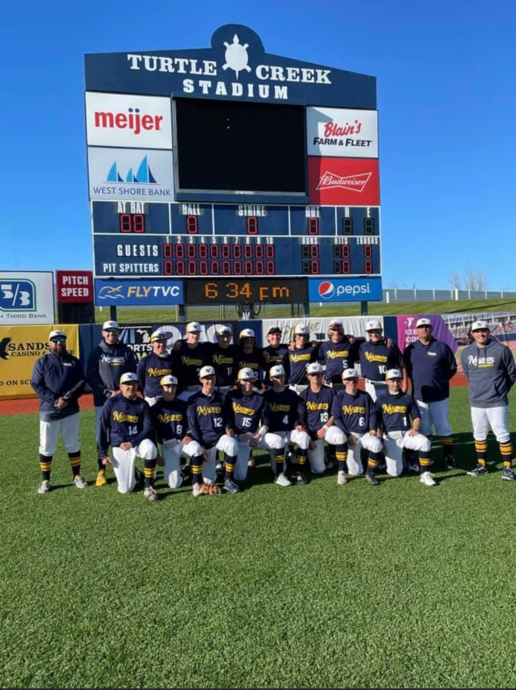
The 2021 NORSEMEN

Front Row: L-R: Champ Young, Ben Meyers, Troy McManus, Matt Herniman, Nathan Sroka, Denny Belmonte, Matt Colbert, Luke Rop
Back Row L-R: Coach Brian Moat, Head Coach Steven Cutter, Brady Babcock, Carsen Moat, Noah Bamberg, Shamus Corbett, Charlie Branch, Joe Duplissis, Alec Cutter, Will Gallo, Coach Paul Young, Coach Hayden Modaff

2022 – Garrett Moyer (24-12-1 Overall- 11-3 2nd West Michigan Conference – Montague champs)

The Norse not only lost Alec Cutter, one of their leading performers from 2021, but they also lost Alec’s father Steve Cutter. After a couple of remarkable years piloting the Norse to fantastic seasons, Cutter was appointed the head coach of Lansing Community College. Cutter wove his success from his tenure at NMHS to Lansing where he produced a pair of Lansing Star teams that would play in the Junior College World Series. The Norse were fortunate to appoint former Reeths Puffer Rocket star Garrett Moyer to fill the shoes of Cutter, and the Norse good fortunes continued. Cutter didn’t leave the cuphoard bare for his successor as 5 returning starters returned from the 2021 season (Troy McManus, Denny Belmonte, Ben Meyers, Matt Colbert, and Carson Moat while Ryan Delora would return as a part of the Norse pitching rotation.) The Norse would win 24 games with a schedule that nobody would classify as a ‘cupcake’ schedule. The Norse would play the likes of Holland West Ottawa, East Kentwood, North Farmington, Holland Christian, Mona Shores, Zeeland West, Reeths Puffer and would add the always powerful Grand Haven Buccaneers to their schedule. All 12 games against the much bigger schools were competitive, as their largest margin in defeats was an 11-5 loss to Mona Shores. The Norse were able to defeat West Ottawa early in the season 4-0 with McManus hurling a shutout and tied West Ottawa in the nightcap of the twin bill 5-5 before darkness prevailed. The Norse split their doubleheaders with both Zeeland West and Grand Haven. Another newcomer to their schedule was Sparta who fell to the Norse 7-5. An old rival dating back to the 1940s returned to the NM schedule and the Norse took the twin bill over Fremont 13-5 and 5-0 when McManus delivered yet another shutout gem over the Packers, one of his 3 shutouts earned on the season (8-0 win over GR Covenant Christian the other). The Norse posted a 11-3 record in the WMC but couldn’t earn a victory against their long-time rival Montague. The Norse lost their opening match in a pitcher’s duel 1-0 with the ‘Cats’ Kade Johnson outdueling McManus. Montague won the second game of the double header and then ended the Norse season in the district 4-1 with Johnson again besting the young Norse sophomore pitcher McManus. Delora led the Norse in victories with a pitching record of 7 wins against one loss. McManus would toe the rubber in the biggest matchups for the Norse, and he not only delivered with a 6-3 mark against the toughest of competition, but he also excelled at the plate. The junior southpaw led the Norse batsman with a .480 average while also leading them on the base paths with 28 steals in 29 attempts. Sophomore catcher Meyers was close behind at .442 while Junior Sam Gallo finished at a .432 clip. Belmonte also joined the .400 club, but it was his ability to get on base that really stood out. The junior was issued a school record of 33 base on balls. Add his walks to his 40 hits and being hit by a pitch 13 times, Belmonte had a team leading on base percentage of .581! With all their regulars returning apart from Senior Matt Colbert (.330 btg. avg.) it was apparent that 2023 was going to get even better for the Norse.
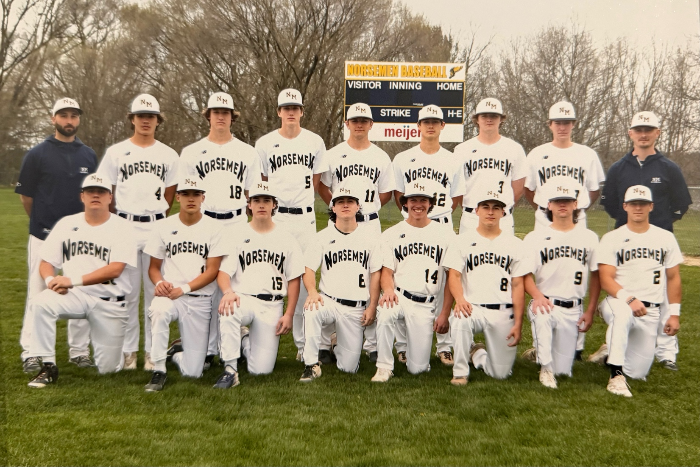

Top Row: L-R: coach Garret Moyer, James Young, Sam Gallo, Carson Moat, Noah Bamberg, Troy McManus, Ryan Delora, John Galliendo, coach Collin Houseman
Bottom Row: Champ Young, TJ Byard, Chris Corbett, Matt Colbert, Brady Babcock, Ben Meyers, Nathan Sroka, Denny Belmonte

The 2022 NORSEMEN

Record Score Interesting Fact
1-0 *NM 14, Shelby 2 Carsen Moat winner; Noah Bamberg 3H, Sam Gall0 2 hits, Ben Meyers & Moat 3b
2-0 *NM 10, Shelby 0 Ryan DeLora 6 IP shutout; 9 K; Meyers 3H (2b), Troy McManus (3b), Gallo 2H (2b)
3-0 NM 4 Holl. West Ott. 0 McManus 7IP 2H, 4K, 1BB; Delora 3 BI double; Meyers, Gallo, McManus 1b
3-0-1NM 5 Holl. West Ott. 5 Seven innings – Darkness; WO 2 in 7th to force tie; Gallo & Matt Colbert P; Meyers 3h
4-0-1NM 8 GR Calvin Ch. 2 Fr. James young 5IP win; Meyers 3 hits 4 RBI; Gallo, Colbert, Moat (2b), 2H
4-1-1NM 5 East Kentwood 7 EK rallies to score 3 in 6th; McManus 2H (2b); Young & Gallo RBI
5-1-1*NM 13, Ravenna 3 McManus 6 IP winner; Meyers 4-5, HR 3 RBI, McManus 3 hits, Delora, Colbert, Gallo 2H
6-1-1*NM 22, Ravenna 0 Delora 5 IP 1-hit shutout; Meyers 4-4 (2b); Delora 4-4 3 RBI, Gallo 3-4 (HR), NM 18H
6-2-1 North Farmington 8, NM 4 McManus and Gallo 2H, Delora 2.1 IP, Moat 3 IP
7-2-1 NM 6 Holland Christian 3 NM scores 3 in 7th for win; John Calliendo 2H 2 RBI; Gallo 2H
8-2-1*NM 12, Mason CC 1 McManus win 5 IP; DeLora (2b), Moat(2b), 2 hits,
9-2-1*NM 18 Mason CC 3 Denny Belmonte, Delora (5RBI), Moat, Meyers (4RBI), & McManus 2H; Delora winner
10-21*NM 28, Hart 3 Moat winner in 4 IP rout; Belmonte (2 2b), Meyers 3 hits 4 RBI, McManus 2H 4 RBI
11-2-1*NM 15, Hart 0 NM scores 10 runs in 4th; Young 4 IP shut out; McManus 3-3
12-2-1 NM 7, Sparta 5 Gallo 4 IP; winner; DeLora save; McManus & Meyers (2b) 2H
12-3-1 Fruitport 5, NM 4 Fruitport 3 run rally ion 7th for win; McManus 3-3
12-4-1 Mona Shores 11, NM 5 McManus, Colbert, Belmonte (2b) 2H, 4 NM pitcher used
13-4-1*NM 13, Oakridge Young winner; Belmonte 3-4 (2b), McManus 4-5; Colbert 2H
14-4-1*NM 9, Oakridge 1 DeLora 6 IP winner; 7 Norse with 2 hit each; Colbert, Gallo 2 RBI,
15-4-1 NM 6, Ludington 5 NM rallies in 7th for win; Belmonte & DeLora (2b), Meyers HR
15-5-1* Montague 1, NM 0 Kade Johnson out duals McManus; NM 2 hits
15-6-1* Montague 16, NM 4 NM 6 errors in 5 IP mercy rule game, Montague WMC champs
16-6-1*NM 9, Whitehall 5 NM pulls away with 5 run 5th; Young 6.2IP for win; NM 13H
16-7-1 *Whitehall 4, NM 2 Gallo 4 IP, loss; NM 5H, 4 of the NM hits doubles
16-8-1 Reeths P 11, NM 6 Colbert loss; Belmonte & McManus 3 hits (2b), Gallo 2H, 3 RBI
16-9-1 Reeths P 12, NM 8 Meyers 3-4 (2b), McManus & Gallo 3-4; Colbert 2H
17-9-1 NM 5, Fremont 0 McManus 6.2 IP; Meyers 2H (2b), Gallo 2H, Colbert 1-2
18-9-1 NM 13, Fremont 5 NM 8 runs in 5th; 13 hits; Gallo winner, Moat 3H, NM 3 3b
19-9-1 NM 9, Saugatuck 1 Champ Young 7 IP win, Belmonte 3-4 (HR, 2b) J. Young, C Young, & Meyers 2H
20-9-1 NM 15 Saugatuck 2 Noah Mamberg 6 IP win; Belmonte 3-3, Meyers 2H (HR) 5 RBI,
20-10-1 Zeeland West 7, NM 6 Zeeland wins in 9th; Caliendo 2H (2b) 2 RBI; McManus 2b,
21-10-1 NM 9, Zeeland West 2 Delora 7 IP win, McManus 3-5, 4 RBI (2b); J Young, Moat, Meyers, 2H
22-10-1 NM 8, GR Cov 0 McManus 7 IP shutout; Delora, Moat, Colbert, 2H; McManus 3-5
23-10-1 NM 5, Grand Haven 3 Three NM pitchers used (Delora, J Young, McManus (W), Meyers 2 hits, McManus 2b
23-11-1 Grand Haven 6, NM 1 Moat 3 of NM 6 hits; 3 pitchers used in tune up for districts
24-11-1 NM 6, Ravenna 1 District win; Delora 7 IP win, 3H, 7 K 1; Belmonte HR, Delora, Moat & Meyers 2 H
24-12-1 Montague 4 NM 1 District finals; Kade Johnson 2 hitter for ‘Cats’; McManus loss, McManus, J Young H

2023- Garrett Moyer (35-6-1, West Michigan Conference Champs, County Champs, District Champs)
With 8 regulars returning for the 2023 season there was much optimism for the upcoming campaign. Second year coach Garret Moyer was given a piece of bad news early when rising sophomore phenom James Young, a regular from 2022 and set to be a part of the pitching rotation, was out for the season recovering from an injury incurred during the football season. Although sidelined for the season, the record-setting NM quarterback still played a huge role with his support during the games by encouraging his teammates from the bench.
Despite the loss of Young, the Norse arguably experienced the best season in the 88 years of NM baseball. The NM record books took a smashing hit, both in team and individual records. But what junior catcher Ben Meyers accomplished during the season was ‘off the charts.’ The hard-working catcher led the team in virtually every offensive category, setting numerous records, both season and career marks with still a year to go wearing the uniform of the Blue & Gold. Meyers hit a robust .510 on the season while his OBS (on-base plus slugging percentage) was an ‘insane’ 1.535. Among his record setting 69 hits and 65 runs scored were 6 home runs, and yet another season record of 10 triples. As one NM fan said to me earlier in the season: “If Ben hadn’t stopped at second on many of his triples, he would have also led the team in doubles.” And where has anyone heard of a catcher leading a team in stolen bases? His team leading 34 stolen bases were second in NM team history only to Alec Cutter’s 38 thefts in 2021. Myers had a day he will long remember in the district championship game against Montague. Ben had a single, 2 triples and fittingly capped his day off with a grand slam to lead the Norse to the district championship. Meyer’s 8 RBI were the most by a NM batter in the 88-year history of NM baseball. One may find this hard to believe but Meyers, with still a year remaining, has the Norse career record in hits with 177. Meyers wasn’t the only Norse to have a great year in a Norse uniform in 2023. Seniors Troy McManus, Denny Belmonte and Sam Gallo concluded their NM careers at or near the top in numerous categories. McManus, an All-Conference basketball performer, delivered both at the plate and on the mound for the Norse. The southpaw won 11 games on the season, striking out 78 batters with an ERA of 1.46. Troy was no slouch at the plate or on the base paths either. Troy swiped 30 bases on the season and his total career steals of 85 was an all-time NM career best. McManus hit .436 on the season and would end his career as one of NM’s all-time best with a cumulative .425 mark from 2021-23. Troy’s 169 career hits is second only to Ben Meyers total of 229, while his total career total doubles of 41 stands at the top of the list. Hard-nose NM shortstop Denny Belmonte also etched his name into the record books in numerous categories. Denny has one record that could last for many generations that surely showed his toughness ---standing in the batter’s box and bravely getting hit by a pitch. Denny was plunked by opposing pitchers a record 16 times, an amount he was also hit in his sophomore season and was hit an amazing 45 times in his career, 16 more than Noah VanBergen was hit back in 2006-08. Belmonte hit .377 on the 2023 season but his penchant for getting hit by a pitch and drawing walks (25) gave him an on base percentage of .528. His 71 career walks are just 3 walks shy of the NM career best of 74 set by Ryan Buter (2005-08). In the all-important category of runs scored Belmonte would finish 2nd in NM annals with 142, behind (yet again) Ben Meyers total of 207. Although he missed a few games with an ankle injury, NM football star Sam Gallo had a fine senior season with a .340 average while chipping in with 35 RBI. Individual achievements are nice, but team accomplishments are even better, and this NM team can boast of being one of, if not, the best team in NM history. The team won a record 35 games but what stands out was their strength of schedule. Admittedly, there were a few ‘cupcakes’ that the Norse had to play as they were in a very weak WMC conference division, but their non-conference schedule was loaded with top-flight opposition. Although they dropped their first 2 games of the season to a division 1 Zeeland West team in tough affairs, 3-1 and 3-2, it was clear that this team was going to be special in 2023. Among those much bigger schools that fell to the Norse included: East Kentwood, GR Forest Hills Central and Eastern (a team that won the D2 title in 2022 and returned to the final 4 in 2023), Reeths Puffer, and Fruitport. Their biggest win on the season and the most impactful victory won by a NM team since the Norse defeated, at the time, a very powerful Class A Muskegon Heights team in the final game of the 1951 season, was a 12-2 victory over Mona Shores that earned the Norsemen the County Championship. NM had won a pair of County tournaments in previous years in the smaller division based on school enrollment, but this title was earned against all-comers in Muskegon County! The Norse ran the table in their division with a perfect 11-0 season, the first team to go undefeated in the WMC since coach Paul Moyes’ 1950 and 1951 teams both were a perfect 9-0 enroute to winning a record 21 straight wins without tasting defeat. Against all WMC opponents in both divisions NM was 21-1, their only loss coming against Montague, a team the Norse would own a 2-1 record for the season, including the big win for the district title. The Norse will lose several talented seniors from the 2023 team, including Carson Moat and John Caliendo, who both had terrific seasons for NM, but several talented underclassmen will return for 2023. In addition to Meyers, the Norse will welcome back Ryan Delora, a hard throwing right-hander who has already won 19 games in his career. Ryan was 7-1 on the season with 3 big saves and had a team-leading 84 strikeouts. One will not soon forget the ‘gem’ he tossed in the opening game of the playoffs when he threw a 1-0 shutout against Kent City. Delora was also a strong fixture at the plate and third base where he hit .331 with 13 of his 42 hits going for extra bases. Coach Moyer will also welcome back in 2024 a pair of sophomores who started for NM this past season. Carter Meiler showed a steady glove at second base while hitting an impressive .349 for the season while TJ Byard, a great receiver on the NM football returns to garner one of the outfield spots for the Norse. Meiler & Byard were both huge in NM’s opening round playoff victory over Grandville Calvin Christian. Fireballing freshman pitcher Logan Slimko will give NM what should be an outstanding pitching staff in 2024. Slimko showed his potential when he struck out 16 batters, second in NM history for a single game, in an earlier NM him over GR Covenant Christian.

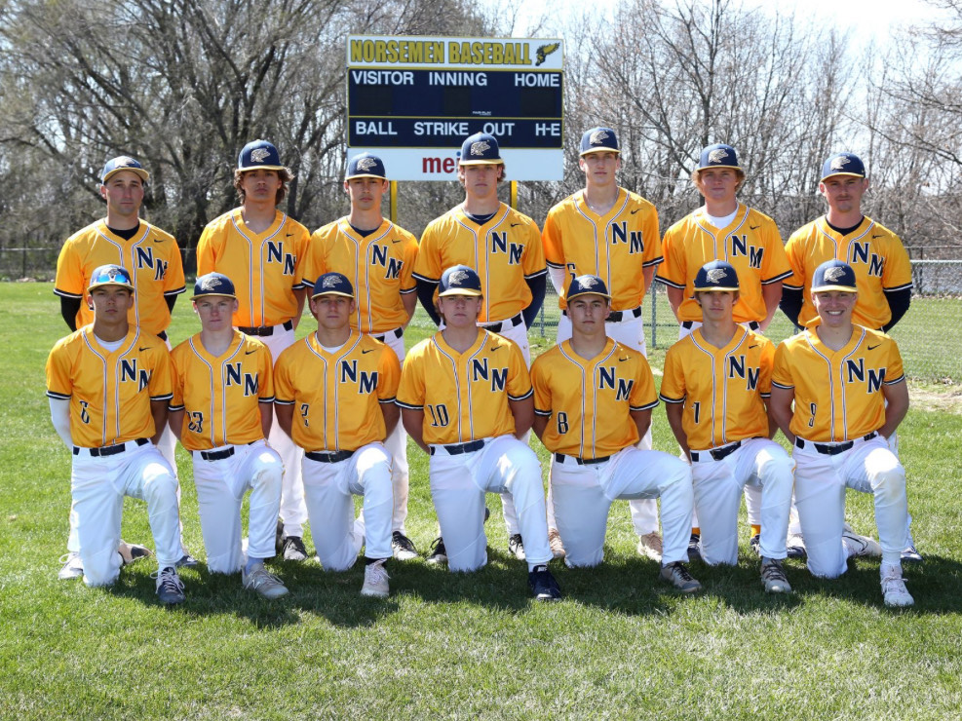

The 2023 NORSEMEN

Top Row L-R: Coach Garret Moyer, James Young, Troy McManus, Sam Gallo, Carson Moat, Ryan Delora, coach Collin Houseman
Bottom Row L-R: TJ Byard, Carter Mieler, Denny Belmonte, Jaxon Bean, Ben Meyers, Logan Slimko, John Caliendo

Record Score Interesting Fact
0-1 Zeeland West 3, NM 1 Four NM pitchers used: NM only 4H (Ryan Delora, Carson Moat, Ben Meyers, Troy McManus)
0-2 Zeeland West 3, NM 2 Moat & McManus pitched 5 ing. (darkness); Meyers, Moat, Logan Slimko, McManus (2b) H
1-2 NM 15 Hesperia 0 Mercy rule; McManus 3 IP, 1H; Moat, McManus 2 hits; Meyers 3 RBI
2-2 NM 18 Hesperia 0 NM 11 runs in 4th; Delora 1h, also 3 H, 5 RBI, Meyers, Denny Belmonte, McManus, 2H
3-2 NM 6, Calvin Christ 4 Moat 4 IP win; Meyers 2H, TJ Byard 3b, Gallo 2b. Meyers 3 SB
4-2 NM 15, East Kent. 10 NM wins tourney; Slimko winner; Meyers, Delora, McManus 2H
5-2*NM 4, Mason CC 2 WIN No. 850 McManus 7IP 2 hitters; Meyers 3-3, McManus 2H,
6-2*NM 9, Mason CC 1 Delora 7 IP 1 hitter 11K; Meyers 3-4 (4 SB); Gallo (2b), Delora (2b) Moat, & Byard 2H
6-3 WMC 6, NM 5 Wagenmaker 7IP win for WMC: NM only 6 hits (All singles)
6-3-1NM 5, WMC 5 Called after 5 darkness; Ace Anderson 4 IP; Moat HR 3 RBI, McManus, Delora 2H
7-3-1 NM 13, Fremont 7 Fr. Oliver Frick winner in relief, Belmonte save: McManus 5 RBI.
8-3-1 NM 2, Fremont 1 Jaxon Bean 6IP winner, NM scores 2 in 6th after 2 outs; NM 4 hits
9-3-1 NM 3, GRFHC. 1 NM scores 2 in 7th for win; McManus 1 hitter; Meyers 3 of NM 5H (2 2b, 3B)
10-3-1 NM 7, GRFHE 2 Delora 7 IP for win; Carter Mieler 2H, Belmonte 2b, Meyers H, Defeat D2 2022 champs
11-3-1 *NM 17, Ravenna 7 Four NM pitchers, Kaxon Bean W; Belmonte 4-4 HR, 2B, Meyers, Gallo HR, NM 12H
12-3-1 *NM 14, Ravenna 2 Slimko 6IP win; John Caliendo 3H (2 2b), Gallo HR, McManus, Delora 2H
12-4-1 Montague 19, NM 7 Mont. 14 runs in 4th; Gallo 2h (2b), Belmonte 2B.
13-4-1 NM 4, Montague 2 Gallo 5 IP winner; McManus & Delora (save) 1 IP, McManus 2H
14-4-1 NM 16, Whitehall 1 McManus win; Meyers 3-3 (HR, 2b) Belmonte 3H (2B) Delora 3b
14-5-1 BC Glenn 5, NM 3 Delora 5.2 IP loss, Belmonte, Mieler, Gallo (2B) all 2 hits.
15-5-1 *NM 16, Hart 4 Slimko 3.2 IP winner; Meyers 2H (HR), NM 5 2b
16-5-1 *NM 10, Hart 0 McManus wins Meyers 3H, Belmonte, McManus, Gallo, Delora 2H
17-5-1 NM 4, Whitehall 3 Game 1 of Co. tourney; Moat WP, McManus Save; NM scores 2 in 5th for win. Meyers 2b
18-5-1 NM 6, Reeths Puffer 0 Delora 7IP shutout, 3H 11K; McManus 3H (2b) Meyers 2H (3B)
19-5-1 NM 12, Mona Shores 2 County Champs! McManus 3 hitter; Meyers 2H (3B) 4 RBI, Moat 3H
20-5-1*NM 17, Holton 0 Jaxon Bean 5IP win; Meyers 4-4 (HR, 3B) 6 RBI, Caliendo 3H, McManus 2H 4 RBI
21-5-1*NM 14, Holton 4 Caliendo Moat pitched; McManus, Moat, Delora 2H (2b, 3B) Meyers 3B, Belmonte 2B
22-5-1 NM 11, Fruitport 2 Delora 7IP, 13 K, win; Meyers 3H, McManus (3b), Delora (2b), Caliendo(2b) 2 hits each
23-5-1 NM 8, Otsego 2 McManus 5.2 IP 0 runs, win; Belmonte, Gallo, 2 hits, Meyers 3b
24-5-1 NM 9, Hamilton 4 Gallo wins; Meyers, Meiler 2 hits; Caliendo, Delora, McManus
25-5-1 NM 9, GR Cov 1 Bean 7IP, 7K; Belmonte 3H (2 2b), Meyers 2h (HR), Moat 3H
26-5-1 NM 16, GR Cov. 1 Slimko 2 hiitter, 16K win; McManus 4H (2 2b), Meyers, Belmonte, Meiler 3H, Byard 2H
27-5-1*NM 14, Shelby 4 Fr Bronson Hurst win; Caliendo 2H (4 RBI), Meyers 2H (2b, 3b), Gallo 2 2b, Belmonte 3b
28-5-1*NM 11, Shelby 1 Fr Kayden Nielsen 1 hitter win: Belmonte 2H; Meyers 2b 2 RBI
29-5-1 NM 5, Oakridge 4 McManus win 6IP, Delora saves; Gallo 2H 2 RBI, Meyers 2H (2b)
30-5-1 NM 2, Oakridge 1 NM scores 2 in 6th for win, Moat GWI 2 run 2b; Delora in relief winner; Meyers 2h (3b)
31-5-1 NM 12 Musk Cath 3 McManus winner 4IP 3-3 at the plate (2 2b); Delora 3-4 (HR)
32-5-1 NM 8, Ludington 6 Only 9th & 10th graders play; Ace Anderson winner, Slimko save; Bean & Bryce Colvert 3H
33-5-1 NM 1, Kent City 0 Delora 7IP gem, 4H 10K, Meyers 19 game hitting streak ends; McManus RBI, Caliendo 2B
34-5-1 NM 17, Montague 5 McManus WP, Meyers 4-5, HR, 2 3b, and school record 8 RBI, Moat 3H, District Champs!
35-5-1 NM 5, Calvin Christ. 1 McManus winner, Delora saves; McManus, Moat, Meiler 2 hits, Byard 2 RBI
35-6-1 Lansing CC 7, NM 0 Lansing CC ends NM great season.

2024- Garrett Moyer (32-8), West Michigan Conference Champs

What a school year for North Muskegon Boys Sports! It all began in the Fall when NM’s football team raced to s perfect regular 9-0 season and advanced to the state semi-finals before losing to Menominee. The basketball team also produced an undefeated season record of 22-0, that extended to 24-0 before losing in the regionals. The NM track team won their first regional championship in 64 years and placed 5th in the state finals in division 3. And then there was the 2024 Norsemen baseball team! In a story made for a Hollywood epic, the Norsemen won 32 games --- all those games coming on the road as the North Muskegon City Council made the outlandish decision to destroy NM’s historic and pristine baseball field for a ‘practice soccer’ field.!
Coach Garret Moyer once again did a masterful job in directing the ‘homeless’ Norse to their second straight 30-win season. The Norse accomplished this feat despite losing several talented players from the 2023 team. Among those moving on were regulars Denny Belmonte, Carson Moat, John Caliendo, Sam Gallo and Troy McManus. Two others that coach Moyer was counting on for his 2024 team were juniors James Young and Charlie Meyers. Young transferred to Muskegon High shortly after the basketball season concluded, while Charlie Meyers had wrist surgery and missed the entire season. Both were counted on to break into the starting lineup, Young as a front of the line pitcher and outfielder while Meyers as an infielder.
To believe the 2024 Norsemen, who would start seven underclassmen, would surpass the 30-win plateau once again was extremely unlikely. In addition, the Norsemen would play a total of 40 games which surely had to tax a pitching staff. Somehow and someway, coach Moyer was able to work his magic on the Norse arms whereby not a single Norsemen threw more than 61 innings throughout the grueling schedule. NM would often play as many as six games in a week as nine different Norsemen saw mound duty, with a collected team ERA under two runs per game.
The roster included but four seniors on the 2024 roster, but two of those 2024 graduates would make historical contribution throughout their careers wearing the uniform of the Blue & Gold. Four-year starter Ben Meyers would end his incredible career at the top of the leaderboard in several offensive categories while Ryan Delora would save his best for last, both as a hitter and a pitcher.
Football star Alex Newville, although not a starter, made notable contributions to NM’s success on the diamond in many ways, as a hitter, pitcher, outfielder, and even did a nice job eating up innings as a part time relief pitcher. Ethan Bates, the other senior, saw little action in the field but was always supportive of his teammates and gave NM some much needed depth.
To say that NM got off to a terrific start to the 2024 season would be an understatement to be sure. The tone was set in their very first game, a 7-4 win over Mona Shores, a perennial baseball power whose enrollment of 1225 students was about four times the 317 enrolled at NMHS. Coach Moyer quickly showed his pitching depth as four NM pitchers (Jaxon Bean, Logan Slimko, Ace Anderson, and Ryan Delora) allowed the Sailors but one hit. The Norse put this game away early when they exploded for six runs in the 3rd inning, with the big blow a double off the bat of junior Jaxon Bean.
NM would win 11 games in a row to begin the season before finally losing 8-3 to D1 opponent Byron Center. So dominant was the Norse during this streak that they outscored their opponents 111-15. Opponents who fell during this streak included Montague and Oakridge twice, while NM defeated D1 Caledonia 11-1 and D2 Holland Christian 7-1.
NM would improve to 18-2 before dropping the championship game in the Muskegon County tournament to Reeths Puffer by one run 8-7. The Rockets had to make a shoestring catch (that a few NM ‘umpires’ believed was trapped) to hold off a late NM rally in the final inning.
A very good Spring Lake team handed NM their fourth defeat of the season, but the Norse bounced back to post what would prove to be their biggest win of the entire season, a 3-0 victory over the top ranked team in D3 in the state, Algonac, 3-0. Sophomore Logan Slimko pitched masterfully against Algonac, leaving the game after one out in the seventh inning after allowing but two hits while striking out 12. After Slimko had reached a mandatory limit of 105 pitches, coach Moyer reached deep into his nine man pitching staff and inserted another sophomore, Bronson Hurst to attempt to get the final two outs. Hurst had only pitched one inning prior to his appearance vs. Algonac, but as usual, coach Moyer had pushed the right button, and Hurst retired the next two hitters to secure the shutout victory. So important was this win that the Baseball Coaches of Michigan had moved North Muskegon to the number one ranking in the state in D3, a position they would hold throughout the rest of the regular season.
NM would then rip off another nine game winning streak before it fell in a pitcher’s duel to Reeths Puffer 3-1. Ryan Delora pitched a gem for NM in the loss as he allowed the Rockets but one run before exiting due to the pitch count ruling. RP won the game, but they needed a walk off two out home run in the eighth to nip the Norse.
Perhaps the strain of having to play all their games on the road, as well as transporting bulky equipment - and players - just to find a field to practice, finally took a toll on the Norse as the bats pretty much fell silent during the final stretch. Just two days before the all-important district finals, NM traveled to Zeeland East to play a double header against a Zeeland team that were champions of the D1 Ottawa-Kent Green division with a near perfect 20-1 record. The Norse lost to Zeeland, with an enrollment of just shy of 1000 students by a combined three runs in the DH, dropping the first 7-5 and the second 2-1.
Baseball can often play cruel tricks on a team. Unlike team sports such as football and basketball, where a team with vastly superior talent would rarely fall to an outmanned opponent, doesn’t always apply to baseball. Case in point: even the lowly St. Louis Browns defeated the mighty 1927 Yankees in a game. After defeating Montague three times during the regular season, the Norse dropped their district final game 4-1, ending their season with a spectacular, yet unfathomable 32-8 record despite having to overcome the callous decision of the North Muskegon city council members to destroy their field.
The loss to Montague snapped a streak whereby NM had a mind-boggling 35 game winning streak against West Michigan Conference opponents. Included in the streak were three wins during the 1924 season against Oakridge, the winners of the Lakes Division of the WMC.
Several Norsemen had spectacular seasons for NM led by the senior duo of Ben Meyers and Ryan Delora. Meyers would end his career at the top of the NM record boards in several categories. Ben would knock out 229 hits in his NM career, a mark that not only is the NM record, but is the fifth most hits by any Michigan High School player in state history. In the all-important category of runs scored, Meyers had crossed home plate 207 times in his four years as a NM starter, good for sixth place all time in state annals. Meyers also tops the NM record board in triples with 16, RBIs with 154, and in stolen bases with 112. All his NM records are also among the state leaders. Meyers will now take his talents next year to Lake Michigan College. (Where he hit .400)
Delora will leave NM by making a lasting impression, not only as a pitcher but as a hitter. Ryan led all NM hitters in 2024 with a .417 batting average and was an extra base and RBI machine. He led NM in doubles with 18 and RBI with 53, number three all time in both of those hitting departments. Delora was the ace of a very good NM pitching staff this past season. Delora had an overall record of 7 wins against 3 losses, but it was Delora who Coach Moyer would send to the mound against the toughest of NM opponents during the season. The 6’2 senior completed his career in a surreal fashion. In the annual All-Star game for graduating seniors from the Muskegon Area Ryan was named the game’s MVP as he belted a mammoth three-run homer. He took it one step further in his next All-Star game, played at Comerica Park in Detroit when he won his second MVP award against the state of Michigan’s top seniors. Ryan went a perfect 2-2 at the plate and pitched a scoreless inning to bring home his second coveted honor. Delora, who will now play for former NM coach Steve Cutter next year at Lansing Community College, posted an ERA of 1.51 while striking out 86 against the toughest of competition.
NM would never have had their amazing season without the help of some very talented underclassmen. Junior Jaxon Bean, a smooth hard throwing right-handed pitcher, led NM in victories with nine, sixth all time in NMs near 90 years of baseball. Bean also played a lot of first base for NM while hitting .287. Junior Carter Meiler started every game for NM at second base and became a fixture batting leadoff for NM. Carter had 46 hits on the season while hitting for an average of .351 while his total of 51 runs scored was second only to Ben Meyers in that department.
Sophomore Bryce Colbert also started every game for NM, primarily in left field and was an on base machine. With his 46 hits and team leading 27 walks it will undoubtably be surprising for many to know that next year’s probable starting quarterback on the football team led the Norsemen with an on base percentage (obp)of .576.
Surely one of most pleasant surprises for NM baseball was the play of sophomore Kylan Nielsen. The versatile Nielsen played multiple infield positions and batted a lofty .398 on the season after beginning the season as a reserve. Nielsen also was a valuable member of NMs deep pitching staff as he posted a perfect 5-0 record.
Another versatile performer was another one of those talented NM sophomores, Bronson Hurst. In addition to his above noted save in procuring NM’s biggest win of the season in their victory over Algonac, Hurst played several positions. Bronson would start several NM games as a catcher, giving Ben Meyers a much-needed breather. When Hurst wasn’t catching, he would start at either shortstop or third base. Hurst batted .276 on the season and showed some ‘pop’ with his bat with seven doubles. Hurst got better as a hitter as the season progressed as he finished the season by hitting safely in seven of his last eight games.
Logan Slimko, rated as one of the top sophomore pitchers in the entire state, had a spectacular season on the mound for the Norse. Slimko appeared in 16 games as a pitcher but only in the big win over Algonac, when he pitched 6.1 innings, did coach Moyer use the young Slimko in more than five innings of work. The hard throwing sophomore fanned 83 opposing hitters in only 44 innings pitched. The ceiling is high for Slimko who will surely draw the attention of many college coaches in the next two years. When not on the mound Slimko was the starting right fielder for NM. Slimko showed some power at the plate with eight doubles, two triples and a home run among his 29 hits accrued. On the negative side, as with most power hitters, Slimko also struck out 28 times in his 104 plate appearances, a stat he hopes to improve on in the coming years. Yet another sophomore who saw limited action but was productive when he was called upon was Oliver Fricke. Fricke could help the 2025 Norse considerable as he had five hits in only 12 at bats as well as appearing in three games as a pitcher, allowing no runs in his five innings of work
In addition to Jaxon Bean there were two other juniors who were regulars on this Norsemen nine. Three-sport star TJ Byard, an all-state receiver in football and a starter on NM’s 24-1 basketball team was one of the few returning starters from the 2023 NM powerhouse. Byard patrolled center field for NM and hit a solid .364 on the season as well as doing an exceptional job in the field. A middle of the season injury deprived Byard of many more at bats but TJ was able to return for the final two games of the season. Byard, who will be highly recruited in the upcoming football season, will be a mainstay in the outfield for the 2025 Norsemen.
One other junior who made major contributions this season was Ace Anderson. Anderson was another one of those players who could play several positions on the diamond, including the all-important role as a pitcher. Anderson was a perfect 4-0 on the season as he gave coach Moyer 31 innings pitched and allowed but 7 runs for an ERA of 1.13. Perhaps many assumed freshman Cameron Hurst was the NM batboy due to his small stature, but Cameron Hurst could turn into one of NM’s finest pitchers before he graduates. As the season developed Coach Moyer did not hesitate to throw the young Hurst into the line of fire and he displayed a live arm that will see his already impressive stuff get only better when he continues to grow.
Although the sting of losing their district final to Montague will surely linger for a while, when the dust settles and time moves on, this North Muskegon baseball team and their outstanding head coach and his staff, can look back upon one of the best years in our school history. The 2024 Norsemen can always say they were rated number one!

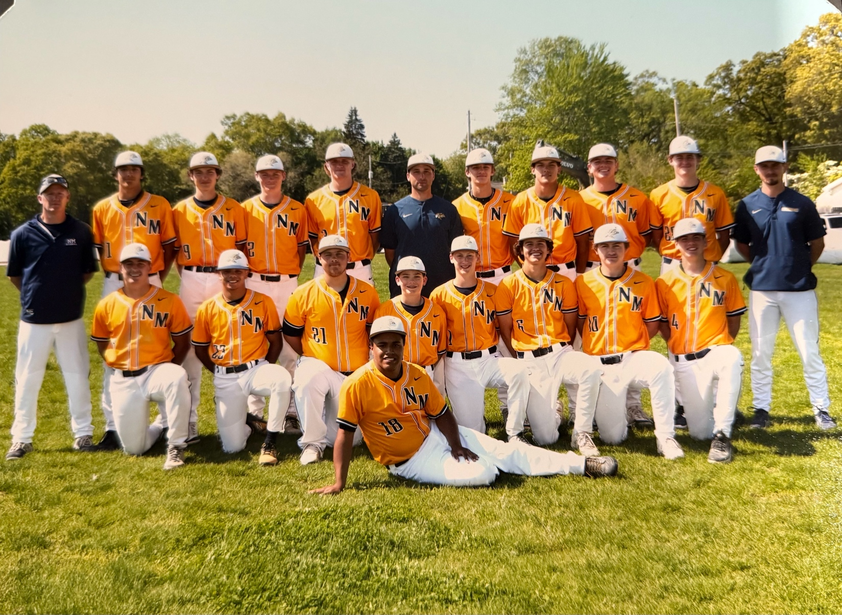

Top Row L-R: Coach Ryan Mieler, Ace Anderson, Dallyn Ellis, Carter Mieler, Ryan Delora, coach Garret Moyer, Logan Slimko, TJ Byard, Jaxon Bean, Charlie Meyers, Coach Collin Houseman
Bottom Row: Ben Meyers, Alec Newville, Ethan Bates, Cameron Hurst, Kylan Nielsen, Bryce Colbert, Oliver Fricke, Bronson Hurst
Front Row: Team Manager Chuck Wiegers

The 2024 ‘HOMELESS’ NORSEMEN

Record Score Interesting Fact
- NM 7 Mona Shores 4 Four pitchers allow MS only 1 hit with 12 Ks DeLora save
- *NM 15 Hesperia 0 Ben Meyers 4–4, Ryan DeLora 3–3 (3 2b)
3–0 *NM 16 Hesperia 1 DeLora 3–3 (2 2B), Meyers, O. Fricke, Alex Newville 2 hits
4-0 NM 15 Montague 0 Logan Slimko wins, Meyers 2 hits in 4 ing. run rule win.
5-0 NM 10, Montague 2 Kylan Nielsen 6 ing win, 5 NM players with 2 hits/
6-0 NM 11 Caledonia 1 NM scores 6 in 1st ing. Delora, Jaxon Bean, Slimko 2 hits.
7-0 *NM 7, Mason Co 0 Meyers 2 hits 3RBI, Bryce Colbert 2 Hits, Jaxon Bean wins
8-0 *NM 14, Mason Co 0 Carter Meiler 3 hits, NM 11 runs in 2nd. Delora 1 hitter, 5IP
9-0 NM 9, Oakridge 6 Delora 2 hits, 3 RBI, Nielsen wins, Bean, Meyers 2H
10-0 NM 7, Oakridge 4 Nielsen winner, Meyers & Delora 2 RBI, Colbert 3 hits
11-0 NM 7, Holland Christ. 1 Bean winner, 10 Ks, Meiler 2 RBI, Slimko, Byard 2 hits.
11-1 NM 3, Byron Center 8 NM loses when BC Scores 7 in ing., Delora, Slimko 2 hits.
12-1 *NM 14, Ravenna 2 Nielsen winner & 3 hits,Colbert 3 hits, Meyers 2 hits
12-2 NM 2, BC Lakeview 15 Lakeview 15 runs in 3rd ing., Meyers HR
13-2 NM 8, Steve-Lake 1 Meyers 4-4, Slimko 2 hits 3 RBI, Nielsen 2 hits.
14-2 *NM 14, Hart 0 Ace Anderson winner, Meyers, Colbert, Byard 2 hits
15–2 *NM 10, Hart 0 Slimko winner 11 ks, Delora 2 hits, 2 RBI (2B)
16–2 NM 11, Ravenna 0 Delora wiinner, 0 hits 10 Ks, also 2 hits 3 RBI
17-2 *NM 2, Montague 1 County: Slimko winner in relief, Meyers scores on pass ball.
18-2 NM 3, Oakridge 2 County): Delora winner, Meyers Walk off hit, Delora 2 hits, RBI
18-3 Reeths Puffer 8, NM County champs) Shoestring catch defeats NM, Meyers, Delora, Hurst, Slimko 2 hits, Meyers HR & 3 RBI.
19-3 * NM 16, Holton 0 Meyers 3 hits (3B0 2 RBI, Byard 2 hits, Anderson winner
20-3 *NM 6, Holton 0 WIN No. 900 Cameron Hurst winner, Myers, Colbert, B Hurst 2 hits
20-4 Spring Lake 9, NM 5 Four errors hurt NM, Meiler 2 hits, Slimko 2 RBI, Bean loss
21-4 NM 3, Algonac 0 NM win over #1 rated team. Slimlo 6.1 IP wins, 12 Ks, B. Hurst save. Meyers 2 hits, steals home, Meiler 2 hits.
22-4 NM 6, Whitehall 0 DeLora complete game shutout, 10 Ks, 4 hits, Meiler, Meyers 2H
23-4 *NM 15, Shelby 5 Bean winner, Meyers 3 Hits, Delora 2 hits 3 RBI, Slimko, Meiler 2H
24-4 * NM 8, Shelby 1 Ace Anderson 7IP win, Meiler, Colbert 2 hits, Meyers, Delora 2 RBI
25-4 NM 11, Oakridge 3 Anderson 3H, B Hurst, DeLora 2 H (HR), Nielsen 2H 3RBI
26-4 NM 11, OV 3 Meyers 3-4 (HR), Slimko, Nielsen 3H, Mieler 2 H
27-4 NM 15, OV 5 Meiler 2H 4 4RBI, Colbert, Anderson, B Hurst, Nielsen 2 hits, Nielsen 6IP winner.
28-4 NM 10, Oakland Christ. 0 Delora wins, Colbert 3 Hits, Nielsen & Anderson 2 hits
29-4 NM 12, Hamilton 7 NM scores 8 in 7th, 5 Norse with 3 hits, Bean the winning pitcher
30-4 NM 9, GR Cov 1 Delora 3 hits (HR, 2B), Meyers HR, Bean winner
30-5 Reeths Puffer 3, NM 1 RP wins in 8th, Delora 1 run in 7.1 IP & RBI, Meilers 2 hits
31-5 NM 11, White Cloud 3 Delora 3 hits, 3 RBI, Meyers 2 hits walk off HR, Newville wins
31-6 Zeeland East 7, NM 5 Colbert, Bean 2 hits, Zeeland 32 win on season
31-7 Zeeland East 2, NM 1 Zeeland wins on walk off hit, Meyers, Frick 2 hits.
32-7 NM 5, Kent City 1 Bean complete game win, Byard 3-3, Delora, B Hurst doubles
32-8 Montague 4, NM 1 Montague snaps NM’s 35game winning streak in WMC.

2025- Garrett Moyer (24-5) West Michigan Conference Champs

A roster depleted from graduation and transfer losses, as well as a decision from a 3-year starter to switch sports at NM could have signaled a bad omen for NM baseball. However, the holdovers from the 2024 season were all very good players but depth could be a factor if NM was again to have another great season. To make it even more difficult the Norsemen would play nearly their entire season on the road as their new baseball field was slow in developing. NM’s outstanding young coach Garrit Moyer had to improvise to even find a field --- or any lot or surface to just have a practice session.
As a further indignity to their woes, the Norse would often practice using their former beloved and historic baseball field that had been tragically turned into a soccer complex. I was shocked when your author visited my hometown in late May to find the baseball team practicing on the site of the small practice football field. The Norse were forced to hit wiffle balls as the field was far too short to use regular baseballs. Another shortcoming the Norse would have to endure was the loss of a batting cage as their former batting cage in the haste to build the soccer complex was tossed into the trash (somewhere).
Somehow and some way this gallant band of Norsemen was able to win 24 games while losing only five. A big factor in their outstanding season was a small, but very talented pitching staff. It’s doubtful in 90 years of NM baseball if NM had a staff that controlled the strike zone as the 2025 NM pitching crew. With a roster composed of mainly about a dozen players, six saw action on the mound with five of the six being underclassmen. In 177 innings worked during the season NM hurlers gave up only 54 walks while striking out 252, an inconceivable achievement. Despite a limited pitching staff coach Moyer was able to protect his young arms as no pitcher threw as many as even 50 innings in the season. Leading the staff was junior Logan Slimko. The hard throwing right hander who throws effortlessly won seven games for the Norse with an ERA of 0.99 pitching against the better opponents NM would face during the season. The Division 1 commit to Dartmouth struck out 103 batters in 49 2/3 innings of work that equates to fanning better than two batters an inning! With still a year to go Slimko already ranks near the top of the leader boards in strikeouts. With 245 career strikeouts Slimko is only one K away from second place in NM history to perhaps the GOAT of all-time in NM annals, Larry Williams, a former Norsemen who made it all the way to AA baseball after a stellar career at Central Michigan. Slimko, along with the trio of Senior Jaxon Bean, Junior Kylan Nielsen and Sophomore Cameron Hurst did the brunt of NM pitching during the year. The only senior on the staff, Bean would win five games for NM with one save while Nielsen and Hurst were control artists to say the least. In 37 innings of work the young Hurst, who was pitching to his older brother Bronson, the Norse catcher, walked but six batters all year. In 36 2/3 inning Nielsen was even better, allowing but four walks all season while posting an ERA of 0.57. And how impressive is that ERA?
That low mark serves as the top effort in 90 years of NM baseball.
The Norse were not too shabby at the plate. Seven NM regulars ended the season with a batting average better than .300 with junior Bronson Hurst’s .398 topping the lists. Only an 0-4 final game kept Hurst below that coveted .400 mark. Nielsen, Bean, and Slimko were more than just outstanding pitchers, but delivered at the plate as well. Nielsen would finish with a mark of .373 while Slimko made his hits count as he knocked in a team leading 30 RBI while hitting .329. Bean finished strong by connecting for 8 hits in his last 14 at bats to close at .320. Chuck Meyers, who had to sit out the entire 2024 season with an injury also came on strong as the 3-sport standout finished with a .319 average. Only a late season slump prevented 3-year senior starter Carter Meiler from posting a batting average well over .400. Meiler had some tough luck at the plate over his last six games as he was able to only have one base hit in his last 17 at bats, despite striking out only once. Bryce Colbert was steady all season and topped the .300 mark by posting a .313 average.
NM opened the season against a division 1 opponent as coach Garrett Moyer was not afraid of playing teams with many times the enrollment of NMHS. For the third consecutive season NM slayed the much bigger Sailors 6-2. Kylan Nielsen threw strikes as he only allowed four hits, struck out 8 and walked nobody as NM shocked the host Sailors with five runs in the first inning.
The well-traveled Norse took the road (again) to compete against their second straight D1 opponent and came away with a sweep of the twin bill with Zeeland West. The NM veteran pitching duo of Jaxon Bean and Logan Slimko hurled a 3-0 shutout to earn the win in game one. The second contest did not come as easily for the Norse as they scored perhaps their most improbable victory since they
posted a miraculous come from behind win over Ravenna in 2001. Trailing 3-1 in the top of the fifth as darkness creeped over the Zeeland West complex, the Norse were staring at a near certain loss with two outs and nobody on base. The Norse then got singles from Bryce Colbert and Carter Meiler and a walk to Kylan Nielsen to load the bases. Bronson Hurst then unloaded the bases with a clutch triple to give NM the lead. Slimko then came on in the bottom of the fifth to strike out all three Zeeland batters to earn his second save on the day as NM won 5-3.
North Muskegon won a twin bill at Shelby to improve to a perfect 5-0 to begin the 2025 WMC conference season. Sophomore Cameron Hurst was a workhorse in the double header as the crafty southpaw came on in relief in each game and picked up two wins. The diminutive Hurst, who will never break a radar gun with a blazing fast ball, mixed up his pitches well and allowed but one hit in 10 innings of work while walking no one as NM took the first game 11-4 and the nightcap 5-1. Hurst received plenty of hitting support in game number one as the Norse hitters piled up 17 hits led by Carter Meiler’s four base knocks. Logan Slimko went 3-4 good for 4 RBI while Cameron’s brother Bronson Hurst provided some extra base power with a pair of doubles. Chuck Meyers, Bryce Colbert and Owen Silvis all added a pair of hits in the Norse victory.
Bronson Hurst got the start in game number two and worked two innings before giving way to his brother Cameron who hurled no-hit ball in the final five innings. With the first game being played with snow flurries falling on the Shelby diamond, clear skies prevailed in the nightcap. The Tigers scored their only run in the top of the first inning, but the lead was short-lived as NM scored two runs in the bottom of the inning to take a lead they would not relinquish. Cameron Hurst struck out six Shelby hitters and received some solid defensive work from his teammates who played errorless ball. So efficient have been the Norse pitching staff in the early part of the season that they have only walked 4 batters in 33 innings.
North Muskegon took a twin bill over Oakridge, winning the opener 4-0 and then took the nightcap 16-5 to improve to a perfect 7-0 on the season. Logan Slimko celebrated his recent commitment to Dartmouth by hurling a shutout while striking out 10 Eagle hitters to earn the victory. NM tallied what would prove to be their only run needed in the top of the fourth on an error, a sacrifice bunt, and when Bronson Hurst hit a fly ball to the outfield, Carter Meiler tagged up at second and would advance home after the throw to third got away permitting Meiler to score. Hurst would later give NM a pair of insurance runs with a 2 RBI single.
NM put the second game away early as they opened the game with a nine run first inning, thanks in large part to wildness from a pair of Eagle pitchers. NM did notch out nine hits in the nightcap with Chuck Meyers and Bryce Colbert belting a pair of hits. Jaxon Bean went the distance for the Norse to pick up the win.
The highly rated Slimko who couples his 90-mph fastball with a nasty slider will follow former Norsemen 3-sport star Pete Sheldon to Dartmouth. Sheldon, who became the first MHSAA high school player to hit two runs in the same inning nearly 70 years ago, as a Norsemen, played third base for the Big Green after graduating from NMHS in 1957.
Garrit Moyer has only been the head coach for North Muskegon Baseball for less than four years. Moyer has certainly made the most of his brief tenure as following his double header victory over Holton Moyer as now won 100 games as opposed to but 26 losses. The Norsemen moved to a perfect 9-0 on the season with a pair of shutout victories on the Holton diamond, winning the first 12-0 and the second 5-0. Jaxon Bean and Kylan Nielsen permitted but a solo single to Gabe Colon in the opener in a game that went but five innings. Bronson Hurst went a perfect 3-3 to lead a NM attack that banged out 12 hits.
Fire balling Logan Slimko took the hill to begin the second game and needed to work only three innings to fan seven Red Devil hitters. Sophomore Cameron Hurst game on in relief and permitted but one hit and no runs in his four innings of work as NM shut out the Red Devils for the seventh time in their last eight meetings. Nielsen and Bean each had multi-hit games in the nightcap with one of Nielsen’s hits a two-bagger.
The Norse got an early wakeup call as they traveled south for a doubleheader against a top ranked Division 2 team in Stevensville-Lakeshore. Although they dropped both ends of the twin bill to the 9-2 host Lancers, the Norse came oh so close to at least garnering a split. NM took a 5-1 lead into the fifth inning of the nightcap of the DH but suffered a narrow 6-5 defeat as Lakeshore scored four runs in the sixth inning to pull out the victory. The Norse committed an uncharacteristic six errors in the contest. Chuck Meyers and Kyle Nielsen had a pair of hits for NM while Bryce Colbert added two RBI. Jaxon Bean was the tough luck loser for the Norse. NM took a short-lived lead in the opener, but Lakeshore took advantage of some wildness from NM pitcher Logan Slimko to earn the victory. The hard throwing Slimko surrendered but two hits and struck out 10 but surely set a NM record as he hit six opposing batsmen. Carter Meiler had both NM hits in the loss.
The Norse made a quick turnaround from their weekend twin bill loss by soundly trouncing the Hart Pirates in a double header, winning the first game 14-5 and making short work of the outmanned Pirates in game two 18-1 in a mercy rule game that lasted but three short innings. The win over the woeful Pirates was the 30th straight conquest of the Pirates and was the 100th victory over Hart in a long-time series that dates to 1937. NM’s regular starting catcher Bronson Hurst did his Bill Duplissis impersonation from 1951 by traversing 60’ 6” to the mound and worked 5 1/3 innings to pick up the win. Hurst was backed by some lusty Norse hitting led by Logan Slimko who had a pair of hits that included the Norsemen’s first homerun of the season and contributed 4 RBI.
With the Norsemen deemed the ‘home team’ in the nightcap Hart can take some solace by taking a 1-0 lead over the Norse in the opening inning. The wheels quickly fell off for the Pirates as some hefty Norse hitting aided by a bevy of Hart errors saw the Norsemen score nine runs in each of their first (and only) at bats to secure the easy victory. Chuck Meyers got three at bats in the two innings and made the most of his appearances by notching three hits and scoring three runs. Carter Mieler, Kylan Nielsen, and Jaxon Bean all had a pair of hits while Nielsen got the easy victory in but three innings of work.
The Norsemen advanced to the finals of the Greater Muskegon Championships for the third straight year before the short-handed NM squad lost to Fruitport in the championship game. A --good and bad ----sixth inning when the gritty blue and gold rallied to score four runs to defeat Reeths Puffer in the tournament semis, had a direct effect on the day’s final game played at historic Marsh Field. After freshman Hunter Darga walked to begin the rally, NM’s senior shortstop Chuck Meyers hit into a force play for the first NM out. However, Meyers injured his hamstring running to first base and was now out for the rest of the day and possibly the next couple of weeks. A walk to Bryce Colbert brought NM’s leading hitter Carter Meiler to the plate. Meiler laid down a perfect bunt down the third base line for a base hit. On the play the Rocket third basemen, in his haste to retire Meiler, threw the ball down the right field line and both runners scored. An (overly exuberant) Meiler raced all the way to third and in his exhilaration inadvertently spewed off a couple of choice words that would have made his grandmother cringe. Unfortunately, for NM fans, the umpire situated nearby did not have on earplugs and tossed Meiler from the game. Per MHSAA rules Meiler would also have to miss the championship game as well as both games of Tuesday’s double header with Ravenna.
Logan Slimko was outstanding in the 5-3 victory over the Rockets as he allowed but two hits while striking out 13 Rocket hitters. Until the leadoff runner walked to open the seventh inning, Slimko had not allowed a baserunner except during Reeths Puffer’s second inning when they scored three runs, all unearned. After Slimko reached the mandatory pitch count of 105, left-handed control specialist Cameron Hurst came in to retire the final two Rocket batters and the victory over their division 2 neighbors. Slimko and Reeths Puffers Brayden Mitchelson, who I suspect is related to Tom Mitchelson, an outstanding shortstop for North Muskegon in the late 1940s, were linked in a classic pitcher’s duel before the sixth inning Norse rally.
The Norse began their day’s triple header with a ‘home game’ that ironically was played on the Reeths Puffer Junior High baseball field. The Norse needed only five innings to run rule Ravenna 11-1 behind the pitching of Kylan Nielsen and the hitting of Carter Meiler. Nielsen breezed through four shutout innings before giving way to Bryce Colbert who made his season pitching debut by allowing but one run in the fifth inning. Meiler, who has a hefty batting average of .500 was a perfect 3-3 and three RBI during the victory. Nielsen helped his own cause with a pair of RBI singles.
The depleted Norse lineup was no match in the final against a much deeper Fruitport team. With the Norse without their leading hitter in Meiler; also, a stellar defensive second baseman, the Norse would open the game with Fruitport minus Meiler and their shortstop Chuck Meyers. NM stayed close as they trailed 3-1 but a big five run fifth inning was the downfall for the Norsemen. Bronson Hurst will someday have a story to tell his grandchildren as he blasted a homerun over the center field fence at Marsh Field to account for NM’s only run.
What Garret Moyer has accomplished in his fourth year as the head coach of North Muskegon is astonishing. This past weekend’s games marked the 56th consecutive game NM has played on the road. Perhaps only the Washington Generals, common opponents of the Harlem Globetrotters from yesteryear had to play more games on the road. than the Norse. Not only do the Norsemen lack a home field, but they must beg to find a field for a practice session. Somehow, coach Moyer, who draws a salary just ‘slightly’ south of an AJ Hinch paycheck, has somehow worked his magic for this remarkable team.
Using a patched-up lineup that was depleted over the weekend due to an injury and a surprisingly harsh suspension, the Norse were able to salvage a double header with a split with the Ravenna Bulldogs. The Norse were nipped in the first game 2-1 as NM head coach Garrit Moyer used a makeshift lineup as his Norsemen were without their starting shortstop and second baseman. An early error proved costly giving the Bulldogs an early run. The Bulldogs later added what proved to be the winning run in the bottom of the fifth inning. The Norse narrowed the gap to one in the sixth inning on an RBI single by Jaxon Bean, driving in Bryce Colbert who reached based on his third hit of the game. However, twice the Norse batsmen were caught looking at a called third strike with runners in scoring position.
The contests with Ravenna were scheduled as a home game with expectations that their new baseball field would be ready for use, but the Norse hopes of playing a home game once again were dashed as the Norse again had to hit the road for the twin bill with Ravenna. Somehow coach Moyer, with but 10 players at his disposal and coming off a rare triple header after but two days off, somehow was able to get the maximum out of his very thin pitching staff. With his top two pitchers, Jaxon Bean and Logan Slimko sidelined due to pitch count rulings, Sophomore Cameron Hurst and Junior Kylan Nielsen teamed up to earn a 7-4 victory in the second game of the double header. Cameron, who went 2 1/3 innings in the opener, battled through five innings in the nightcap and got some big hitting support from his brother Bronson as well as another good second game at the plate from Colbert. Nielsen, the hard luck loser in the first game, relieved Cameron Hurst in the nightcap with runners at second and third and no outs. Nielsen retired the next three batters to give NM their 14th win of the season against but four setbacks. Ironically, the final out recorded was a dazzling catch in center field from the player he just relieved, Cameron Hurst. Bronson Hurst and Colbert each added a pair of hits for the Norse while Nielsen, in addition to picking up the save in relief, added a base hit and two RBI for the victors.
The Norse then made the short journey to Marsh Field to play a Friday night double header with Montague. In a remarkably tight series, dating back 90 years when the Norsemen began their baseball program by playing Montague in their first ever game (won by Montague 23-1), each team has now won 90 games after the Norse swept the twin bill with the Wildcats. It appeared Montague was headed for the win after they jumped on NM starter Logan Slimko with three first inning runs. To say that Slimko then found his ‘groove’ after walking three Cat’s hitters and allowing 2 hits would be a vast understatement. Slimko would not permit a Montague baserunner the rest of the game as he struck out 16 batters before giving way in the seventh inning to Jaxon Bean due to a pitch count ruling. After an error and a pair of walks loaded the bases, Bean found his niche and struck out the last two batters to preserve the win. The big hit of the game came from an unlikely source as Oliver Fricke, hitting but .138 coming into the game, delivered a game winning 2 RBI single in the fifth inning to give the Norse a 4-3 lead. Cameron Hurst then added the final Norse run on a base hit. Bronson Hurst and Fricke each had a pair of hits for the winning Norsemen. Junior Bryce Colbert, NM’s all-state football quarterback, got his first start of the season in the nightcap and allowed but one run as NM run routed Montague 13-1 in a run ruled five inning game. NM had but seven hits in the contest but were aided by a leaky Montague defense that committed seven errors. Colbert helped his own cause with two hits while freshman Hunter Darga, filling in for an injured Chuck Meyers, also had a pair of hits as NM improves to 16-4 on the season.

North Muskegon traveled to Scottville for a scheduled 'home game' and won a double header over the Spartans of Mason County. The Norse breezed to a 10-0 win in the opener that went but five innings due to the mercy rule, but it was no walk in the park in the nightcap. The Norse tallied the winning run on a sacrifice fly from Logan Slimko that brought in Kylan Nielsen who singled to begin the inning. Nielsen hit and pitched the Norsemen to the 3-2 victory, allowing but two unearned runs, striking out 10 with no walks. Jaxon Bean pitched five scoreless innings to record the win in the first game and helped his own cause with a pair of base hits. Bruce Colbert led the Norsemen in hits in the victory with three.
NM defeated Caledonia with a dramatic 3-2 victory to win their third game in two days. Is there any more drama in sports than a bases loaded situation, two outs, your team leading by one run and to top it off, a 3-2 count on the batter? Hard-throwing Logan Slimko went from goat to hero to goat to hero, all in the space of two innings to give the Norse their 19th victory on the season against but four defeats.
Slimko came on in relief of sophomore Cameron Hurst after the crafty lefthander allowed but one run in four innings of work. NM took a 2-1 lead in the fourth inning, but the Scots tied it up in the sixth inning, aided by a pickoff throw by Slimko that went awry. The Norse then took the lead in the top of the seventh on a clutch single by Slimko that brought in Carter Meiler.
A pair of walks then loaded the bases, but Slimko again wore the hero’s cap when he struck out the Scots number three hitter to earn a hard-fought win. Special kudos in the final inning should go to NM junior catcher Bronson Hurst. Twice with a runner on third base he made a couple of spectacular catches of possible wild pitches to save the day.
After an exceedingly long wait of two years and 65 road games, the Norsemen finally enjoyed the experience of playing on their own field. Playing before a large and surely curious crowd the Norse opener on their news digs at James B Johnson field was a success as NM shut out Grant 7-0. In only the third game played between the two schools, NM used three pitchers in posting the shutout over a Grant team that was fresh from winning a Newaygo County invitational over the weekend. Jaxon Bean, Cameron Hurst, and Logan Slimko all saw action on the mound to post the whitewash. Bronson Hurst and Chuck Meyers led Norse hitters with two hits apiece while Hunter Darga made a sensational catch in left field to highlight defensive play for NM as they improve to 20-4 on the season.
The ‘ole announcer’ was somehow able to make it back up the steep hill at the new complex following the twin-bill sweep of Hesperia after NM’s 7-0 and 10-0 whipping of Hesperia on Friday, May 23. Jaxon Bean allowed but one baserunner (on an error) as NM defeated Hesperia 7-0 in the opener. Logan Slimko was the big batsman in the game by going a perfect 3-3 and a pair of RBIs.
Slimko then took the mound to begin the second game, and it wasn’t fair for Hesperia to even think about getting a hit off the hard throwing junior. Head coach Garrit Moyer then brought in his reliable crafty left-hander Cameron Hurst and he completed the 5-inning run rule no-hitter by allowing but one hitter to reach on a rare walk issued by the sophomore hurler. The Norse bats were booming in the nightcap by notching out 13 hits, five of those base knocks being doubles, two each by Slimko and Bronson Hurst.
The first round of the playoffs saw NM traveling to Ravenna to play a Bulldog team that finished but one game behind the Rivers Division champion Norse team and had handed NM their only conference loss all season in a 2-1 victory.
The Norse made amends for that defeat with a 5-1 victory over the host Bulldogs. Slimko was unhittable with 13 strike outs in his no-hitter and contributed the big hit in the game with a bases loaded double that cleared the bases in the first inning giving the Norse a 3-0 lead. The no-hitter was the 8th seven inning no-hitter in Norse history, but it ended with a little drama. With two runners aboard (on walks) and Slimko’s pitch count at 104, one from the maximum allowed in today’s rules, Slimko was facing his last batter. Slimko fanned the final batter he would see to secure the no-hitter. Only an unearned run on an error, and a couple of wild pitches prevented Slimko from a no-hit shut out, a feat that hadn’t been accomplished since Virgil Wilks pitched a 4-0 shut out in 1943 against Hart during the Paul Moyes coached era.
Slimko’s no-hit gem was an unprecedented third straight no-hit game tossed by the NM pitching staff, although this feat should be tempered that both wins with Hesperia were five inning contests.
Although the West Michigan Conference is now divided into two separate divisions, the Lakes and the Rivers, the Norse left no doubts as to who was the overall champion of the league that now goes back nearly a full century. Montague was the winner of the Lakes division but fell to the Norsemen during the season, not once, but three times, capped by NM’s convincing 11-2 win in the semifinals of the D3 District playoffs held in Ravenna. After three days of rest Logan Slimko returned to the bump and was dominant as usual. The junior righthander surrendered but two hits in the contest while striking out 14 Wildcat batsmen. Until the ‘Cats’ Kellan Francis hit a bloop single in the third inning, Slimko had gone 13 innings without giving up a hit. The very first inning was surely a preview of Slimko’s dominance as he had what is now known in baseball parlance as an “Immaculate Inning.” Nine pitches and nine strikes in what is likely an all-time first in 90 years on NM baseball. The game was knotted at two runs apiece after four innings of play after Slimko gave up two of his three walks in the game, followed by an error and a base hit by Jack Deegan. The Norse then pulled away with a pair of runs in the next inning and put the game out of reach in the sixth inning when they tallied five runs with the big blow being a two run double from senior Chuck Meyers. Two insurance runs in the seventh with one of the runs coming home on a long triple off the bat of Bronson Hurst made the final score stand at 11-2.
In football, as well as in basketball, the season ending playoffs are determined by seeding. Unfortunately for NM baseball, that inexplicably was not the case. If seedings were in effect for baseball the Norsemen would have experienced a much more favorable draw in a district loaded with good teams. The tournament schedule was determined by a random draw, and the Norsemen were faced with the daunting task of facing a pre-district playoff game on Tuesday with Ravenna, a team that earlier handed NM their only conference defeat of the season. The win by NM then set the Norse up with a very good Montague team who ended NM’s season with an upset victory the previous year. Waiting in the wings with the perfect draw was West Michigan Christian, whose only roadblock to making it into the district finals was a clash with Kent City, a team that had won but nine of their 30 regular season games.
The Warriors, a team loaded with seniors would face a NM team that had to use their ace pitcher Logan Slimko to reach the finals. In fairness to WMC, the way the Christian hitters were mashing the baseball its problematical if NM would have won the championship game even with a well-rested Slimko on the mound. The Warriors banged out 13 hits against three NM pitchers to defeat the Norsemen 7-3 and end another very successful year for the Blue & Gold at an impressive 24 wins against but five defeats. The first couple of innings was a harbinger of a tough afternoon for the Norse as both Warrior runs were unearned as three rare errors were committed by the normally tight NM defense. A two RBI single by Chuck Meyers in the bottom of the third gave NM a glimmer of hope but the Norse were unable to silence the Warrior bats the rest of the contest. Jaxon Bean, who had two hits in the opener against Montague, ended his NM career by adding another of pair of hits in the loss to WMC.
The loss to WMC ended the sterling careers of Carter Meiler, Jaxon Bean and Chuck Meyers. The threesome, comprised of all but one of the starting infielders for NMHS, will leave a big hole for coach Moyer to find replacements for the 2026 season. However, with five solid pitchers returning NM is poised again to have another fine season. A pleasant surprise for NM midway during the season was the fine play of Freshman Hunter Darga who earned himself a starting position. After a slow start at the plate Darga ended up with a bang by hitting a robust .348 over the last eight games of the season. Junior Oliver Fricke saw considerable action during the campaign and will surely challenge for a starting role in 2026.
One would be remiss without pointing out the job Coach Garrit Moyer has done in his four years as the NM head coach. Moyer’s Norsemen won 115 games while losing only 31, an astounding average of 29 wins per season. All this accomplished having to endure 65 consecutive road games without a home to call his own.
NM will have the luxury of having a field to call their own next year, although it will be a challenge to travel to the field using anything but a car as the field is not accessible by walking or even riding a bike. And wouldn’t it be nice if the baseball team could have a batting cage to call their own?

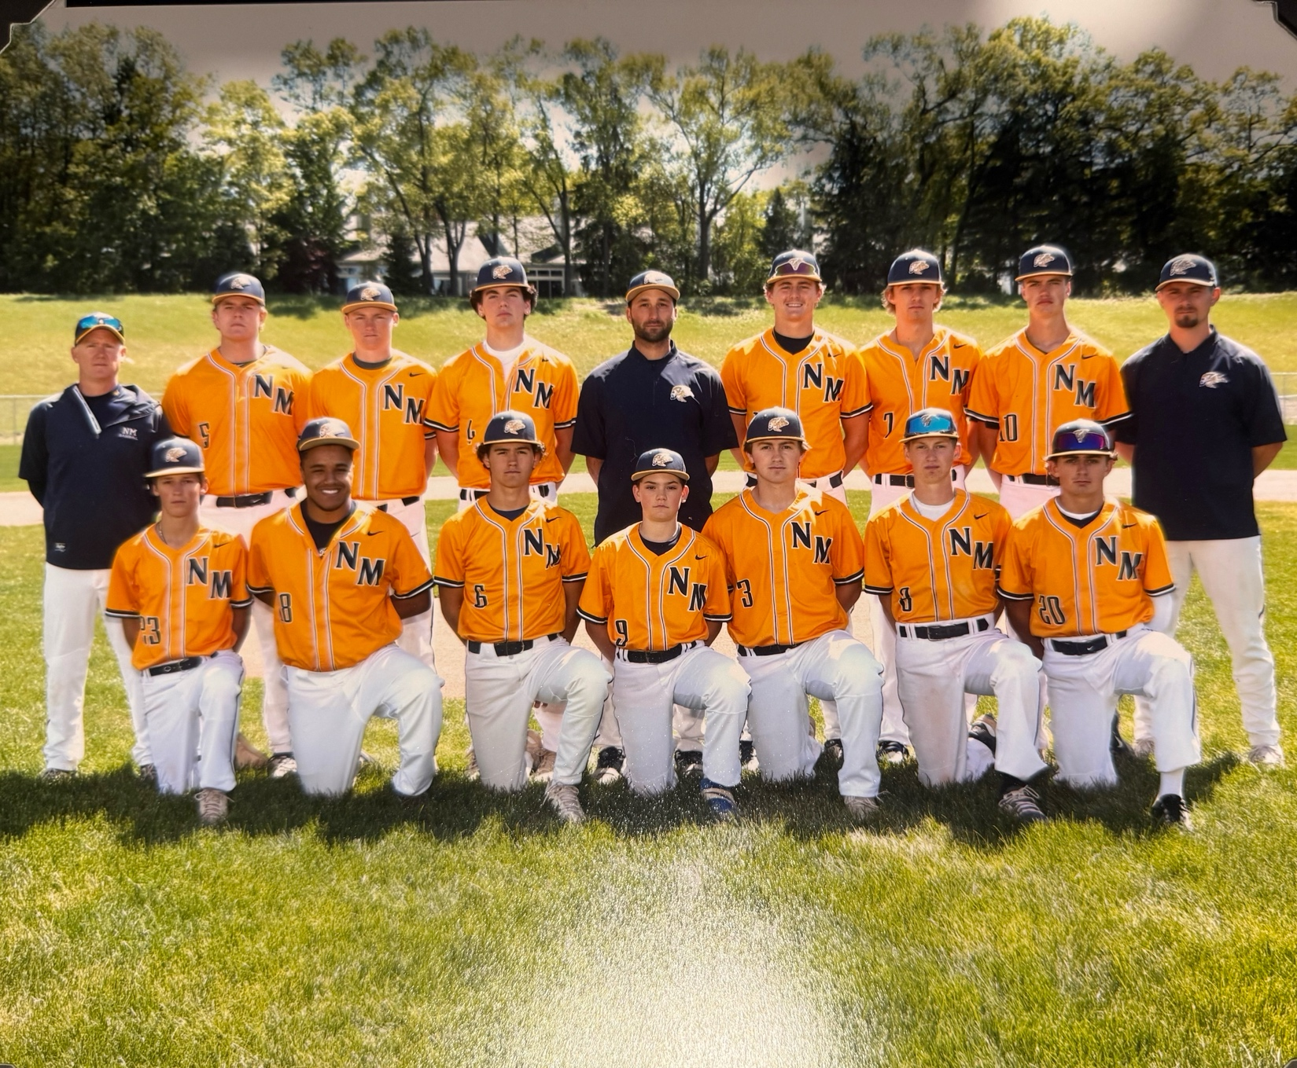

Top Row L-R: Coach Ryan Mieler, Jaxon Bean, Carter Mieler, Bronson Hurst, coach Garret Moyer, Logan Slimko, Owen Silvis, coach Collin Hourseman
Bottom Row: Hunter Darga, Chuck Wiegers, Bryce Colbert, Cameron Hurst, Oliver Fricke, Tommy Dahlquist
The 2025 NORSEMEN
1–0 NM 6, Mona Shores 2 Kylan Nielsen goes all 7 innings. Logan Slimko 2 hits & 2 RBI.
2-0 NM 3, Zeeland West 0 Bean the winner, Slimko save, Bronso Hurst 2 hits
3-0 NM 5, Zeeland West 3 B Hurst bases clearing 3B and gets win in relief. Slimko the save.
4-0 *NM 11, Shelby 4 Carter Meiler 4 hits, Cameron Hurst 5IP wins, 1 hit, no walks
5-0* NM 5, Shelby 1 C. Hurst 5IP of no-hit ball with 0 walks.
6-0 NM 4, Oakridge 0 Slimko shutout, 10 Ks, B. Hurst 2 RBI single
7-0 NM 16, Oakridge 5 Chuck Meyers, Bryce Colbert 2 hits, Bean winning pitcher
8-0 *NM 12, Holton 0 Bean & Nielsen combine for shutout. B. Hurst 3 hits
9-0 *NM 5, Holton 0 Slimko & C Hurst 1-hit shutout. Nielsen & Bean 2 hits.
9-1 Stevensville-Lake. 5, NM 1 Slimko LP, 2 H, 10 K’s but 6 HP, Meiler NM 2 hits.
9-2 Stevensville-Lake. 6, NM 5 NM loses a 5-1 lead. Meyers & Nielsen 2 hits.
10-2 *NM 14, Hart 5 Bronson Hurst the winner, Slimko 2 hits, HR & 4 RBI
11-2 *NM 18, Hart 1 NM defeats Hart for the 100th time. Meyers 3-3.
12-2 NM 11, Ravenna 1 Nielsen winner in 1st game of Co tourney, Meiler 3 hits
13-2 NM 5, Reeths Puffer 3 Slimko 13 K, Nielsen 2 hits & 2 RBI
13-3 Fruitport 9, NM 1 Big 5th inning dooms NM against once beaten Fruitport team
13-4 Ravenna 2, NM 1 Colbert 3 hits as NM loses pitchers dual.
14-4 NM 7, Ravenna 4 C. Hurst wins, Nielsen save: B. Hurst & Colbert 2 hits.
15-4 NM 5, Montague 3 Slimko 16 Ks, Oliver Fricke game winning hit
16-4 NM 13, Montague 1 Colbert the winner, Hunter Darga & Colbert 2 hits.
17-4 NM 10, Mason Co 0 Bean 5 inning shutout, Meiler 3 hits, Meyers & Bean 2 hits
18-4 NM 3, Mason Co 2 Nielsen complete game win, Nielsen & Colbert 2 hits
19-4 NM 3, Caledonia 2 C. Hearst & Slimko pitch. Slimko game winning hit
20-4 NM 7, Grant 0 NM wins 1st game at new field. C Hurst, Slimko, Bean no runs.
21–4 NM 7, Hesperia 0 Bean 5 ing. no-hitter. Slimko 3–3 and 2 RBI
22–4 NM 10, Hesperia 0 Slimko & C Hurst combine for no-hitter. NM 13 hits
23-4 NM 5, Ravenna 1 Slimko no-hitter and had a bases clearing double.
24-4 NM 11, Montague 2 Slimko 2-hitter, Meyers 2 runs 2B.
24-5 West Mich Christ. 7, NM 3 NM’s season ends as Warriors defeat the Norse.

