History of NM football 1987-2002

1987– Coach Dave Cooke (7-3 overall playoff qualifier Oakridge/Shelby,
co-WMC Champs)

NM had their work cut out for them if they were to again make the playoffs in 1987. If they were going to accomplish that goal, then they would need help from a group of returning regulars from 1986. Coach Dave Cooke would be counting heavily on end Brian Diller, bruising fullback/linebacker Scott Mahoney, wingback/cornerback Joe Flynn, two-way tackle Mike Shaver, and two-way back Wes Phillips. The bad news: They’re all area kicker Kyle Stevens moved to Manistee with his family creating a big hole. However, the Norse would find that they had a very good replacement as one would see very early into the season.

North Muskegon’s 1987 opener with Holton would be the first of 29 games to date played between the two local schools. Although NM has dominated the series over the years, winning 23 of the 29 games played, it took a field goal by the new NM kicker Karl Nicles to not only win the game, but his short 21-yard field goal would be the only points put on the scoreboard. NM had scoring chances throughout the game, but they were wasted.” It was simply a case where we got something going and ended taking a penalty or fumbling,” offered Coach Dave Cooke following the tight victory. The winning drive coming late in the fourth quarter consumed 74 yards before Nicles converted on his field goal to earn NM a narrow 3-0 win over the upstart Holton team.

NM posted their second straight shutout and put three touchdowns from three different ball carriers on the board in a 21-0 win over Montague. Jerry Root scored in the first quarter from 8-yards out while Wes Phillips scored from the nine in the second quarter to give NM a 14-0 lead at halftime. Fullback Scott Mahoney, who led all rushers with 91 yards and all tacklers with nine, bulled over from the 2 in the final quarter to end the scoring. NM hindered the Wildcat quarterback all night with Joey Bush credited for two QB sacks and defensive back Tim Dana with two interceptions. Mahoney had 91 yards rushing with Phillips close behind with 84.

The NM defense and their special teams scored all the points the Norse needed in a tight 10-8 victory over Mason County Central. For the second time in three games, it was a Karl Nicles field goal from 37-yards out that proved to be the game winner for the Norse. Trailing 8-7 in the third period Nicles nailed his field goal to overcome a Spartan lead in the second quarter on a Mike Lynn 32-yard scoring strike to Dave Cox. Lynn then tossed for the two-pointer to give the Spartans a brief lead heading into the second half. NM’s defense shut down Mason County’s running game to less than ten yards on the night. NM’s only TD came in the first quarter when NM’s Brian Diller picked up a Spartan fumble and raced 15 yards into the end zone.

Once again NM left it up to Karl Nicles to put NM into the victory column as he kicked the winning field goal with just 0:28 left in the game as NM eked out at 24-21 victory over Whitehall. NM squandered a 21-7 lead in the second half as two fumbles were turned into Viking TDs to tie up the game at 21-21 before Nicles stopped the bleeding with his third game winning field goal in the four Norse victories. NM got TDs from three different backs. Jerry Root scored the first on a 13-yard run. Joe Flynn added a second on a 23-yard score while Wes Phillips added the third on a 10-yard run to give NM their 21-7 lead.

Oakridge then snapped NM’s winning streak at four to begin the season with a 14-0 shutout of NM. This game was decided early, very early. Oakridge struck quickly on a long 74-yard TD gallop by the previous week’s Oakridge Homecoming King Mike Postema. “That first touchdown happened so fast that we didn’t know what the breakdown was,” Norsemen defensive coach Ed Schroeder said following the game. The second Oakridge TD came in a bizarre way. NM’s quarterback Mike Delong was hit hard, and the ball popped straight up in the air and landed in the hands of the Eagles TJ Reterstoff. Fifty-two yards later Reterstoff was celebrating in the end zone with the 2nd Oakridge TD of the quarter and the last score of the game.

Shelby played their best defensive game of the year with a complete domination of the running game. In the 12-0 blanking by Shelby the Norse were held to a season low 59 rushing yards while Shelby, led by the Muskegon Area’s all-time leader in the shot put, Aaron Gowell, rushed for 108 of the Shelby yardages. It was the second straight game in which the Norse failed to score a point, and they now were in a perilous position if they were again to qualify for the playoffs.

Winless Hart was a welcome opponent from their tough schedule in the 1987 season. NM scored all their touchdowns in the first half in their 19-0 victory to improve to 5-2 and keep up their slim hopes for a playoff run. Just as they have all season NM used a trio of players to score a TD in a game. Jerry Root scored first on a 13-yard run followed by a Joe Flynn dash for 23 yards. Mike Delong then tossed his first TD pass of the season when he teamed up with Brian Diller from 25 yards. Root had 84 rushing yards for the Norsemen on offense while junior linebacker Scott Mahoney had eight tackles as NM posted their third shutout of the season.

As if Karl Nicles hadn’t already done enough for NM’s quest to again make the playoffs, he came through again as his kicking was the difference in NM’s 10-6 victory over an up-and-coming Ravenna team that’s just beginning to jell under the leadership of their new head coach, Dusty Fairfield. Ravenna, with a team that’s loaded with several promising underclassmen, scored first when their junior tailback Jeff Heiss scored on a 17-yard run in the third quarter. The Bulldogs mishandled the snap on their extra point try that left the door open for a NM rally. NM began their drive on the next series of downs with runs by Wes Phillips (13 yards) and Chad Puthoff (11 yards) picking up valuable yardage on the ground. Another key play in their scoring drive was a 16-yard pass from Mike DeLong to Scott Mahoney. It was Mahoney who traversed the final 3 yards to tie the game at 6-6. In stepped Nicles, who became the Norse kicker at the beginning of the season when last year’s kicker, junior Kyle Stevens, moved with his family to Manistee. His extra point was perfect and so was a 24-yard field goal late in the game that gave NM three more insurance points.

Although they had two losses on the season, NM, a Class D school playing a Class C schedule was in the fourth and final position in the computer rankings. NM’s final opponent was a newcomer to their schedule replacing Newaygo, Kent City. NM had it their own way against Kent City in a dominating 36-0 rout of the winless Eagles. Scott Mahoney rushed for a pair of short TD runs while Mike DeLong had a big day for the Norsemen. The NM quarterback tossed a 12-yard TD pass to Brian Diller in the second quarter and shortly after halftime broke through on a 46-yard gallop for six points. Wes Phillips dashed for 33 yards for a first quarter touchdown while steady Karl Nicles kicked four extra points and, for good measure, booted yet another field goal. Matt Steketee led the NM defense in posting their fourth shut out on the season with two interceptions while Tim Dana had eight tackles.

North Muskegon would make the playoffs for the sixth time, five under the coaching of Dave Cooke. That number equals the mark of perennial power Muskegon Catholic who joined NM as the only playoff qualifiers in 1987. It would be a daunting task for the Norsemen as they would have to go on the road and play, not only the top-rated team in the computer rankings, but an undefeated Schoolcraft team that was ranked number one in the state in the final AP poll. Thirsting for revenge after being ousted by NM in the second round of the playoffs the previous season, Schoolcraft had to sweat out a last-minute drive from NM to defeat NM 7-2. Trailing 7-0 NM started an 80-yard drive that was stopped by an interception on a 3rd and goal play at the five. Schoolcraft then took an intentional safety to give them better field position on a fourth downplay. NM had time for one Hail Mary, but a penalty stopped the play, and NM ended their season at 7-3.

NM built their season not with a bunch of superstars but just gritty players as post season honors went to just a handful of Norsemen. Junior Karl Nicles was an easy choice as the All-Area kicker while tackle Mike Shaver made the first team all-area as a lineman. The lone Norsemen on the All-Area defensive team was linebacker Tim Dana. Nicles also made first team All-State honors as a kicker.

Record Score Interesting Fact
- NM 3, Holton 0 NM wins on 21-FG by Karl Nicles. Scott Mahoney 59 yds rushing.
- NM 21, Montague 0 Mahoney, Jerry Root and Wes Phillips NM TDs. Tim Dana 2 int.
- NM 10, Mason Co 8 Brian Diller picks up fumble for 15-yd. TD. Nicles winning 37-yd FG.
- NM 24, Whitehall 21 Nicles 38-yd FG wins another. Root, Phillips & Joe Flynn NM TDs.
4-1 NM 0, Oakridge 14 NM gives up two big plays to the Eagles.
  - NM 0, Shelby 12 NM held to season low 59 yards rushing.
5-2 NM 19, Hart 0 Root, Flynn TDS, Mike Delong to Diller 25 yd TD pass
6-2 NM 10, Ravenna 6 Mahoney only NM TD. Nicles extra point and field goal the winner.
7-2 NM 36, Kent City 0 Delong TD pass to Diller & 46 yd td. Mahoney 2 TDs, Phillips 1
7-3* NM 2, Schoolcraft 7 NM at Schoolcraft 5 yd line before interception stops drive.

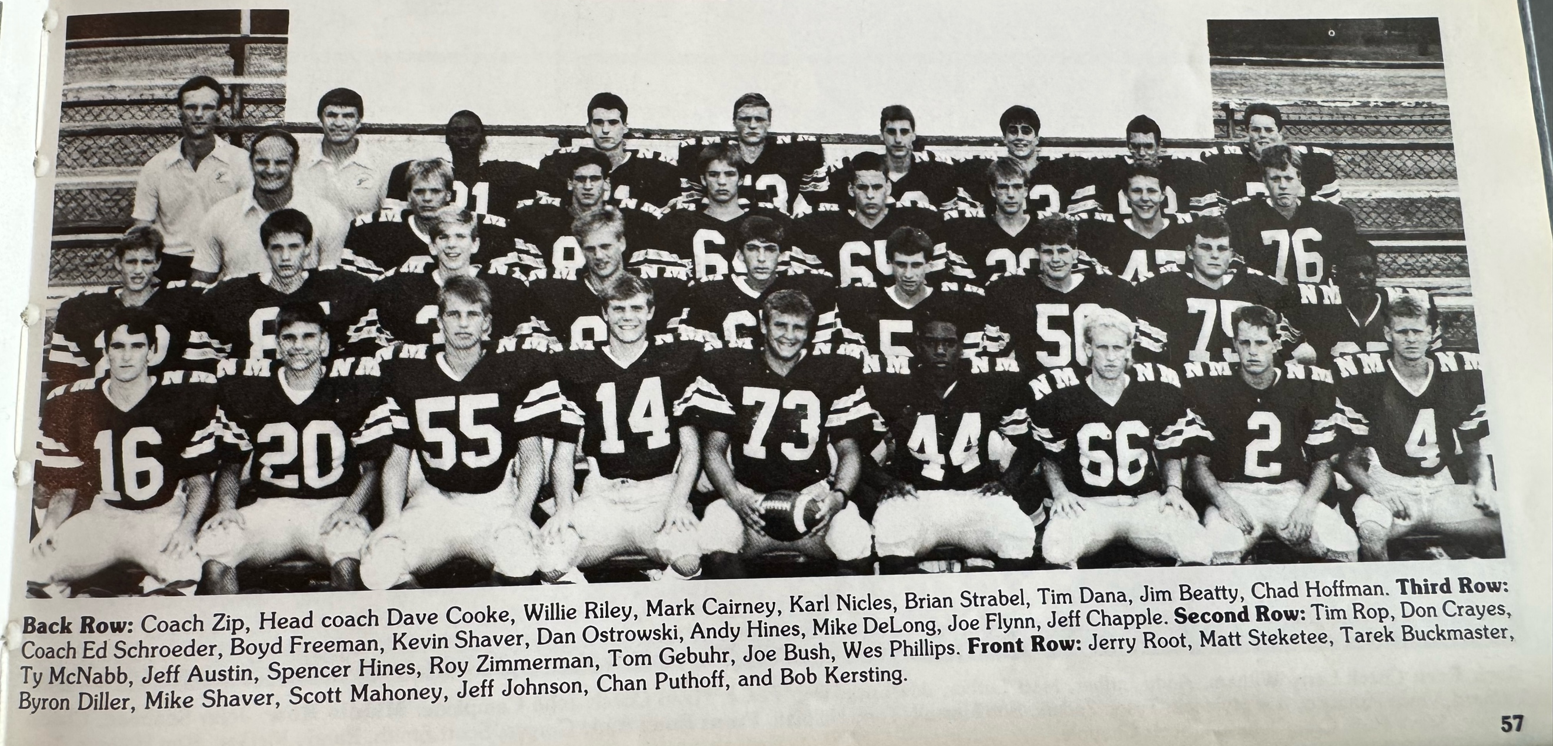

The 1987 NORSEMEN
1988– Coach Dave Cooke (8-2 overall, playoff qualifier, Ravenna WMC champ)

NM began the season as if they would challenge the 1941 team for an unbeaten, untied, and unscored upon season as they posted five straight shutout wins. NM would carry a 7-0 record into their 9th game of the season before tasting their first defeat at the hands of a great Ravenna team. NM would again make the playoffs, for the seventh time. Many would find it hard to believe but by qualifying for number seven, the Norse through the 1988 season had made the playoffs more than any other team in the Greater Muskegon area. Much of the optimism for NM football in 1988 was centered on their defense with a pair of stalwart linebackers in three-year starter Scott Mahoney and Tim Dana. Five other defensive starters also returned including Joey Bush, Joe Flynn, Boyd Freeman, Brian Strabel and Roy Zimmerman.

The Norse needed a good defense against a strong Holton team as the Norse had trouble moving the ball against the pesky Red Devils in their 14-0 victory. This was a Holton team that would win the rest of their regular season games and qualify for the playoffs. The defense scored a touchdown for NM when Roy Zimmerman recovered a blocked punt in the end zone for one of the two NM tallies. Veteran Scott Mahoney scored the first NM score and was the leading rusher on the night for the Norse with 64 tough yards. Joe Bush had 10 tackles for the Norse while the two veteran linebackers, Tim Dana, and Mahoney each contributed nine.

There were no long TD runs that harkened back to the days of Stan Guy as all five NM touchdown came inside the five-yard line as NM shut out Montague 34-0. Scott Mahoney rushed for a pair of short yardages touchdowns and had his best day as a running back with 149 total yards in 23 carries. Joe Mylenik is giving NM a nice 1-2 combo as he ran for 97 yards on but 10 attempts as NM had their offense in gear after a sputtering start in week one. Just as they did in their week one victory over Holton, the Norse defense was stellar as they held the host Wildcats to but 18 rushing yards for the entire game.

North Muskegon combined the run with the pass as the Norse used a balanced attack to subdue Mason County Central 46-0. Returning starting quarterback from 1987, Mike Delong threw a pair of touchdown passes, one to Haley Potts for 40 and his other TD aerial was to Brian Strabel good for 17 yards. Scott Mahoney scored three touchdowns in the rout, (10,9 & 5) while Potts also had an 11-yard scamper for his second TD. Joe Mylenek scored the first NM TD from 10 yards out in a commanding performance by both the offense and defense.

NM posted their fourth consecutive victory and fourth straight shutout with a 34-0 victory over a Whitehall team that is still looking for its first victory. Scott Mahoney rumbled for three short yardage touchdowns (2,3 & 4 yds) with Haley Potts having the night’s longest run, a 60-yard sprint to the goal line. Potts also had a two-yard tally as the Norse rushed for an even 300 yards for the game. Mahoney had 97 of the 300 yards while Potts was close behind with 87 yards on only 6 carries. Once again, the NM defense was dominant as they allowed Whitehall but 83 total yards for the entire game.

Returning for his second season was NM’s all-state kicker, Karl Nicles. However, due to field position and NM’s abilities to score touchdowns his kicking hadn’t been needed – until now. For the second time in eight years, Hall of Fame coach Jack Schugars lost to NM by a field goal as Nicles winning field goal in overtime was the only score in the 3-0 defensive slugfest at Oakridge. Currently a noted pediatrician in the Muskegon area, Dr. Karl Nicles was called upon in overtime after Oakridge denied the Norsemen an opportunity to score the traditional way with a TD. His 19-yarder was perfect, and NM had their fifth win in a row and an amazing five consecutive shutouts. The team’s played 48 minutes with nothing decided in regulation. Neither team had a serious scoring opportunity during regulation as the deepest penetration either team got to the opponent’s goal was a Norse drive to the Eagles 27. However, a Nicles field goal was blocked by the Eagles’ Larry Pierce. Oakridge featured a sophomore running back who dashed 47 yards to the NM 33 in the third quarter before NM’s defense held. The sophomore, Dave Nelson, was the leading rusher at the time in the WMC and would go on to have a stellar high school and college career. Oddly enough, Nelson in later life would move to North Muskegon where he became a valued police officer serving NM. Losing by a field goal would be doubly painful for Coach Schugars as his Eagles would lose to Ravenna by a field goal the following Friday.

Unrealistic thoughts of going the entire season without an opponent crossing their goal line ended, but the winning streak continued in NM’s 24-15 victory over a Shelby team that shut NM out the previous season. NM bolted out to an early 14-0 lead on short TD runs from Joe Mylenek (5) and Haley Potts (1). The shutout streak came to an end when Shelby scored with just eight seconds left in the half and with a successful two-pointer, closed the gap to 14-8. NM scored on their first possession of the second half on a Mylenek 4-yard run. Shelby responded to move to within one score of NM but NM’s ‘ole reliable’ kicker, Karl Nicles, put the game away with a 38-yard field goal to put the game on ice.

North Muskegon and Hart have faced one another 86 times as of this date. NM’s 61-0 rout of Hart in 1988 would be the widest margin of victory in a rivalry that’s been dominated by NM. It was 40-0 at the half as Scott Mahoney scored four TDs in three difference ways. Two TDs came on short runs; one came when he recovered a fumble in Hart’s end zone, while another came on a 48-yd pass from Mike DeLong. Haley Potts had a pair of TDs (21 & 9), with the other NM tallies coming from runs from Joe Flynn (29) Tim Dana (1) and Scott Chappel (14).

The stage was now set for the biggest game of the year and to make it even more dramatic it would be coach vs. pupil. Second year coach Dusty Fairfield was the Reeths Puffer quarterback for the Seaway co-champs in 1976. And who was his coach? Yup --- Dave Cooke. It would be No. 1 in the AP polls in Class D North Muskegon against No. 6 in Class C Ravenna. Fairfield had already performed miracles at Ravenna. So dismal was Ravenna football in the past that already the 7-0 record for Ravenna going into the NM game were the most wins in the school’s history! Cars were parked down the road seemingly forever as it was easily the biggest game to date to be played at Ravenna’s Citizen’s field. My partner Gene Young and I were as excited as well to call the game on WKBZ. After a scoreless first quarter Ravenna then did the unthinkable against a NM defense that had given up but 15 points the entire season. Ravenna scored four touchdowns – in the second quarter - all the points scored in the Bulldogs 26-0 victory to clinch their first ever WMC championship. Fairfield showed his masterful coaching genius that would lead him to four state championships during his brilliant coaching career. He surprised the Norse by flipping his all-everything quarterback Mark Jacobs to a wideout receiver and inserted his normal wideout Rod Place at quarterback. Place threw a pair of touchdown passes to Jacobs while tailback Jeff Heiss did the rest to nail down the biggest victory in Ravenna history as of that date. The Bulldogs would advance to the state finals at the Pontiac Silverdome where they gave Detroit DePorres a battle before losing a tight ball game.

Although they had suffered a crushing defeat the previous Friday at Ravenna and were already virtually assured of a playoff berth due to their strength of schedule, the Norse bounced back with an easy 33-0 conquest of Kent City in the final game of the 1988 regular season to clinch yet another playoff berth. NM got off to a sluggish start before finding their rhythm in the second quarter to post their 8th victory and seventh shutout of the season. Highlighting the victory was a long 82-yard sprint for a TD by Joe Mylenek. Scott Mahoney added a pair of TDs, one on a 5-yard run, the other on a 33-yard pass from Mike DeLong. Joe Flynn added to the total with a 23-yard run while Karl Nicles would cap his outstanding high school career with his final field goal in a Norse uniform.

From 1986 through the 1989 season, when there were only four Classes/Divisions, NM had the misfortune to always be placed in what would prove to be the roughest regional in the state. The Norse were in the same region with both Schoolcraft and Mendon who would go on to win two state titles during that period. NM’s first round opponent would be Mendon, whose only loss in the season was a one-point loss to Schoolcraft, who would go on to be the eventual state champs.

The playoff game against a strong Mendon team was played in the rain at Fred Jack Fields. Mendon scored both of their touchdowns on long plays. On their second possession of the opening quarter Clint Wagner sprinted 71 yards for a touchdown. Lightning struck twice for Mendon as their second tally in the third quarterback was an even longer 80-yard run by Joe White. “We didn’t play well at all, Said NM Coach Dave Cooke, “We made mistakes, particularly in the first half. Every team in the playoffs is good, and you just can’t make the kind of mistakes that we made. This was like out game against Ravenna, which was also played in a downpour. I guess we just don’t play well in the rain.” Added the coach following the 13-0 loss to Mendon.

Post season honors mainly focused on the NM defense, and why not since they posted seven shutouts in the nine games played. Tim Dana was selected to the all-area defensive team along with Joey Bush. Oddly enough, although Scott Mahoney was selected all-area first string on offense, he made 1st string defense on the All-State team pegged by the Detroit Free Press. Although not needed as much as he was in his junior year Kyle Nicles was honored as the top all-area kicker for the second straight year.

Record Score Interesting Fact

1-0 NM 14, Holton 0 Scott Mahoney TD from the 1. Roy Zimmerman block punt for TD.
2-0 NM 34, Montague 0 Mahoney 2 TDs, Joe Mylenic, Joe Flynn, Tim Dana each a TD.
3-0 NM 47, Mason Co 0 Mahoney 3 TDs, Mike DeLong TD passes to Potts and Stabel.
4-0 NM 34, Whitehall 0 Mahoney 3 TDs, Potts a 60-yard TD and another from 2 yards.
5-0 NM 3, Oakridge 0 Nicles 19-yd FG the winner.
6-0 NM 24, Shelby 15 Mylenek 2 TDs (5 & 4) Potts 1-yd TD, Nicles 38 yd field goal.
7-0 NM 61, Hart 0 Mahoney 4 TDs, Potts 2, Joe Flynn, Tim Dana and Scott Chappel TD.
7-1 NM 0, Ravenna 26 Record Ravenna crowd as Bulldogs score 4 TDs in second quarter.
8-1 NM 33, Kent City 0 Mylenek 82-yard TD, Mahoney 2 TDs, Flynn 23-yard TD run.
8-2 NM 0, Mendon 13 Mendon uses two long TD runs to end Norse season.

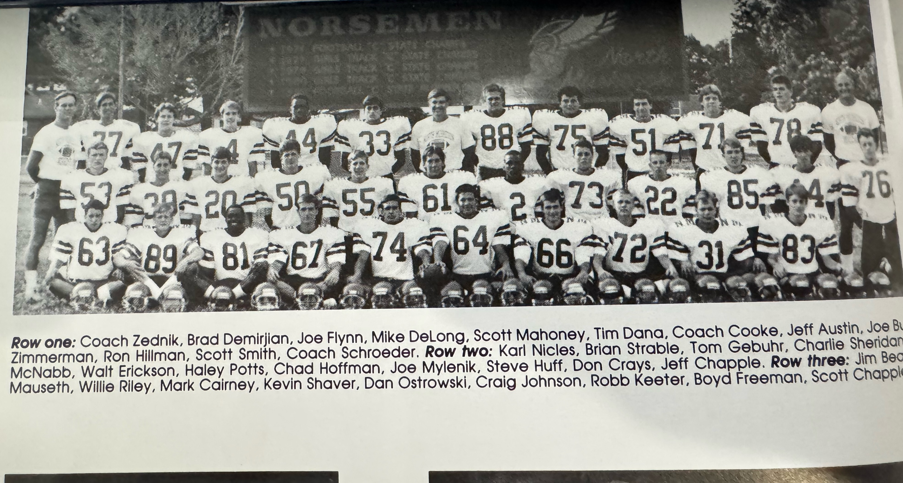

The 1988 NORSEMEN

1989– Coach Dave Cooke (8-2 overall, playoff qualifier, Oakridge WMC champ)

Nineteen Eighty-Nine would be the last year whereby only four teams would play for a state title. Expectations could not have been high at NMHS as the total enrollment at the school was less than 200 students. There was only a total of 35 boys in the junior and senior classes and as the practices began at the outset there were only 17 players on Coach Dave Cooke’s varsity. However, Cooke did return a handful of quality players from the 1988 team. Starters back included defensive backs Tom Gebuhr and two-way starter Joe Mylenek. Two-way performer Scott Smith and Defensive tackle Ron Hillman also retuned but it was unrealistic to believe NM could possibly match last year’s outstanding record. Somehow, again, NM would qualify for the playoffs for the eighth year and ninth overall, the most of any team in the Greater Muskegon Area.

NM did come up with a hidden gem with a transfer from Mona Shores, Rondell Hutcherson, the younger brother of Dante Hutcherson. And what an addition Rondell was to the NM team! In his first game in a Norse uniform ‘all’ Rondell did was score the first three Norse touchdowns on runs of 65, 23 & 3 to help NM defeat Holton 39-6 in their season opener. All three Hutcherson TDs came in the opening quarter! In the second half it was veteran Joe Mylenek who also scored a trio of touchdowns, two short plunges from the one and his final TD from 6-yards.

Rondell Hutcherson then scored five touchdowns, to share the record with five other Norsemen (Stan Guy, Charley Langeland, Jim Pancy, Paul Andrie, Chandler Edwards) in a 47-0 pounding of Mason County Central. Hutcherson had runs of 40, 12, 2, 3, and 4 yards as NM put this game away early with 27 first quarter points. Joe Melenek gave NM a nice 1-2 punch with Hutcherson as he scored two TDs. The Norse rushers accounted for 394 yards in the game with Hutcherson grinding out 189 yards and Mylenek 125.

For the eighth straight encounter between rivals North Muskegon and Whitehall it was the Norsemen who would again come out on top with a 21-6 victory. Rondell Hutcherson ran for 146 yards on 18 carries and received some great blocking from his running mate Joe Mylenek. It was a Mylenek interception who set up the first of Hutcherson’s two TDs. NM built up their lead over the Vikings to 21-0 before Whitehall could score late.

A powerful Oakridge team would hand NM what would prove to be their only regular season loss in 1989, 33-14. Oakridge used the big play to bolt out to a 19-0 lead with the first of their long TD’s a 35-yard run by future North Muskegon police officer David Nelson. There was no quit in the Norsemen as they closed the gap to 19-14. Their first TD came with coach Cooke making a gamble that paid off. With no time outs and time for only one play, Tom Gebuhr teamed up on an eight-yard TD pass to Scott Chappell to cut the lead to 19-7 at halftime. The Norse later marched 67 yards on 11 plays with Rondell Hutcherson churning up 25 yards on the drive. Hutcherson than scored the TD on a fourth and goal from the one to leave the Norse just five points shy at 19-14. However, the stronger Oakridge team powered their way to a couple of second half touchdowns to pull away for the win.

The Norse defense, especially the secondary paved the way for NM’s 16-8 win over Shelby. Both of NM’s TDs came on interceptions as the Norse offense failed to record a first down in the second half against a stout Tiger defense. Ty Zednik picked off a Shelby pass and returned it 32 yards for a TD. Brad Demirjian then gave the Norse some breathing room with a 25-yard field goal with 12 seconds left in the first half. Shelby’s Troy Gowell scored in the fourth quarter to narrow the NM lead to 10-8. With time running out and Shelby in desperation mode, Joe Mylenek intercepted a pass deep in Shelby territory and returned it 15 yards for the insurance touchdown with just 16 seconds left.

NM didn’t wait long to score their first touchdown in a 46-0 rout of Hart. Rondell Hutcherson took the opening kickoff and sped 98 yards for the first of seven Norse TDs on the night. Hutcherson later added TDs from 48 and 28 as NM had now outscored Hart 126-0 over their last three games. Sophomore Dan DeLong hurled a pair of TD passes, the first for 28 yards to Joe Mylenek, the second to Tom Gebuhr for 17. In addition to his two TD strikes, DeLong also ran 14 yards for six-points. Reserve Steve Huff scored the final touchdown on a 3-yard run late in the contest as NM improved to 5-1 on the season.

For the fourth straight season North Muskegon would win a game with a field goal in their 10-7 win over last year’s WMC Champs from Ravenna. Tom Gebuhr set up the game winner with an interception, the second of Bulldogs turnovers that aided in the Norse win. It was then up to Brad Demirjian to attempt the game winner from 39. The kick crept over the crossbar with perhaps an inch to spare to give NM a come from behind victory. Following a scoreless first half Ravenna scored first on a pass from Steve Crowley to Jerry Young from 8-yards out. A Randy McGee fumble recovery at the Ravenna 9-yard line led to an NM touchdown from Gebuhr on a quarterback carry.

No such game winning field goal was needed in the next Norse contest. NM handed Montague their worse beating ever in over 90 contests between the two rivals, 56-0. Rondell Hutcherson ran for 4 touchdowns with 261 yards rushing and even threw a TD pass to Joe Mylenek that went for 31 yards. Hutcherson’s TD sprints were from 49, 22, 14, & 35. Vince Panucci recovered a fumble in the end zone for his lone career TD while Scott Smith added a tally on a 4-yard pass from Tom Gebuhr.

In the only game ever played between the two schools, and the only Class D school on their schedule, NM overwhelmed Baldwin 47-0 in the final game of the regular season. The Norse scored four touchdowns in the first quarter to remove any doubts that NM was again headed into the playoffs. The game was played at Baldwin as NM had to scramble to even find an opponent willing to play the Norse in the final game of the season. Reports on this game from the Muskegon Chronicle were skimpy at best as the only Norse scores reported were Rondell Hutcherson scoring on a long run on the first possession and on a punt return of 60 yards.

The Norsemen had the misfortune of going on the road for their playoff game. To compound their ill-fated luck of the draw their opponent would be not only the number one team in the computer rankings, but the number one team in the polls, the Mendon Hornets. I think there is little doubt that the state champion for the 1989 season in Class D was decided in Mendon. History would show that Mendon, after their 7-0 defeat in overtime would demolish the rest of their opponents on their way to the state championship. Mendon was so dominate during the season that they outscored their opponents 443-31 and only North Muskegon came within 20 points of the Hornets during the season. NM had utilized their kicking game to pull out several wins over the past few years but a 33-yard field goal attempt that perhaps would have won the game fell agonizingly inches short of a NM victory. NM’s defense was never threatened during the first 48 minutes of the contest as the host Hornet’s never got inside the NM 25. Twice NM came up with key interceptions to thwart Mendon drives. Misfortune for NM took place on the very first play in overtime when a mix-up in coverage on a first downplay left a Mendon receiver wide open in the end zone. The pass on first down caught NM by surprise and the 10-yard TD pass would end the Norse season at 8-2.

The 1989 NM season was a masterful coaching job by coach Cooke and his staff. NM opened the season with only 17 players due to their school’s tiny enrollment. Many players were lost from the previous year’s team and the JV team from 1988 was a woeful 1-8. How Cooke and his Norsemen compiled an 8-2 record and lost in the playoffs in overtime to the eventual state champs was amazing! NM had their share of players selected for the All-Area C/D team but in this authors opinion, there was one glaring oversite. I love Jack Schugars and all that he has done for high school football. Schugars is a Hall of Fame coach and would go one to win many ‘coach of the year’ honors but with what Dave Cooke had to work with, Dave would have been my choice as coach of the year.

Rondell Hutcherson was a no-brainer pick for all-area. Hutcherson was also tabbed as a first team running back on the ‘D’ All-State team. His 1189 rushing yards made him the sixth back in Norse history to rush for more than 1000 yards in a season. Doing the blocking up front to create the holes for Hutcherson were lineman Tyson Zednek and Vince Pannuci who were picked for the all-area first team. Once again NM had the all-area kicker in Brad Demerjian. Two-way NM stalwart Joe Mylenek, whose 115 tackles in the season were second in the WMC. To have the remarkable season NM achieved with but 17 ‘ironmen’ players was remarkable.

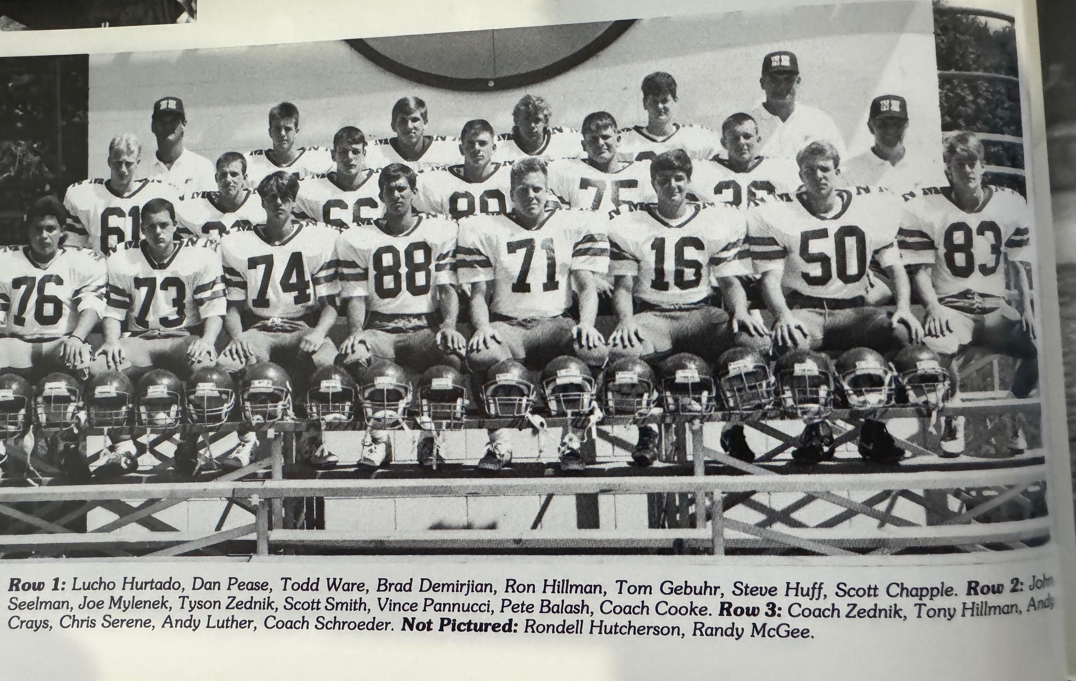

1989 Norsemen

Record Score Interesting Fact

1-0 NM 39, Holton 6 Rondell Hutcherson 3 TDs (65,23 & 3) Joe Mylenek 3 Tds (1,1, & 6)
2-0 NM 47, Mason Co 0 Hutcherson 5 TDs (40, 12, 2,3, & 4), Mylenek 2 (32 pass, 1 yd run
3-0 NM 21- Whitehall 6 Hutcherson TD runs from 2 & 3. Gebuhr WB sneak from 1.
3-1 NM 14, Oakridge 33 Gebuhr pass to Scott Chappell 8-yd TD. Hutcherson 1 yard TD.
4-1 NM 16, Shelby 8 Ty Zednik 32-yard int. Ret, TD,Mylenek 15-yd int. ret for TD.
5-1 NM 46, Hart 0 Hutcherson 3 TDs, 98 yrd. koff ret. Dan Delong 2 TD passes, TD-run.
6–1 NM 10, Ravenna 7 Brad Demirjians 39 yd. FG wins. Gebuhr 1 yd. Run.
7-1 NM 56, Montague 0 Hutcherson 4 TDs, pass to Mylenek for TD, Smith & Pannuci TDs.
8-1 NM 47, Baldwin 0 Hutcherson 60-yard punt return and long TD run.
8-1 NM 0, Mendon 7 NM loses in overtime to state champs

1990– Coach Dave Cooke (3-6 overall, 4th in WMC, Oakridge WMC champ)

Low numbers and a young and inexperienced team will finally catch up to the Norsemen after a run that had them in the playoffs seven years during the 1980s, the most of any Greater Muskegon team. A couple of all-area performers returned from the outstanding 1989 squad, lineman Ty Zednek and Vince Pannucci, but the entire backfield would have a new look. One addition to the team was a welcome back from big offensive lineman Matt Steigelman, who left with his family for Georgia following his freshman season but returned to North Muskegon for the start of his junior year. The 1990 team would have several juniors spliced in with a smattering of sophomores that would be comprised of but 21 players. Somehow Coach Cooke and his trusted assistants, Ed Zednik and Ed Schroeder would again keep the Norse more than competitive, but 1990 would be a learning curve for all.

It took but the first game for Norse followers to suspect that this was not going to be a typical NM playoff team as Holton surprised the Norse 22-6. After being shutout in their two previous meetings with NM, the Red Devils spotted the Norse a 6-0 lead but then scored the last three TDS of the game. Carl Murat rushed for 186 yards for the winners while Chris Serene, who led Norse runners with 98 yards, scored the first and only TD for NM.

At first glance when one looks at the final score of North Muskegon 2 and Mason County Central 0, a possible forfeit might have been the reason for the final score. That was not the case as junior Nate Gates sacked the Mason County quarterback in the end zone for what would prove to be the only score in the game. Tyson Zednek, who was switched from a lineman to a fullback from the previous season, led the Norse both on offense and defense as he led all rushers with 125 yards and 11 tackles on defense.

Whitehall played their first game on their renovated field, but all did not go well for the Vikings. It might have been a bad omen when a malfunction with the scoreboard left the fans in the dark as to the time and score, reminiscent of the 1940s for games played in the WMC. NM would win for the ninth consecutive time against the Vikings 14-6. After scoring but eight points combined in their first two games, the Norse got a boost when sophomore Randy Lindstrom got his first start on the varsity and responded with 68 yards and the second Norse TD in the fourth quarter on a 13-yard run. NM scored the only TD in the second quarter on Tysen Zednik’s 2-yard run after the drive was set up on a Scott Smith fumble recovery at the Whitehall 20. Zednik again led NM rushers with 98 yards and had 14 tackles, the same number as did another two-way performer, Scott Smith.

In the first of the many great teams produced over the years by Oakridge coach Jack Schugars, the 1990 squad was his first team to make it to the state championship game. The Eagles showed their might as they downed the Norse 41-13. Leading the way for Oakridge was a player who would make North Muskegon his home as a well-respected officer on the North Muskegon Police Force, David Nelson. On the Norsemen’s first possession Nelson picked off a tipped pass thrown by NM’s sophomore quarterback Cam Balash and returned it 58 yards for the touchdown. Nelson would score two more TDs and led all rushers with 176 yards. Dave Cooke gave all the credit to Oakridge. “We never recovered from the first score. They beat us in every phase of the game. It was just a good ole’ thumping,” said the obliging Norse head coach. Junior Dan Delong connected with Zac Bauer for a 14-yard NM TD just before half while Andy Crays closed out the scoring as he carried the ball from three yards out to make the final score 41-13.

The Norse had won many games in recent years with their kicking game, but that didn’t happen in Shelby’s 7-6 win over NM. Shelby scored first on a Troy Gowell 3-yard run in the second quarter and the Tigers made the kick to go up 7-0. NM also scored in the second quarter on a 17-yard TD pass from Dan Delong to Zac Bauer. However, Shelby’s Gowell broke through the line and blocked the NM extra point attempt, and that 7-6 score would hold up as neither team scored in the second half. NM’s defense held Shelby to only one first down in the second half, but NM likewise had trouble moving the ball. Sophomore Randy Lindstrom rushed 19 times for 101 tough yards while Tysen Zednick had 18 tackles.

What a turnaround for Hart! After being clobbered their last three games by a combined 126-0 to the Norsemen, Hart flipped the switch and downed the Norse 30-7. Statistics sometimes lie as turnovers can easily override stats. Such was the case in Hart’s case as Hart gave up 245 yards to the Norse to but 145 for the victorious Pirates. A blocked punt led to a 35- return for one Hart score while another Pirate TD came on a fumble recovery and run for 58 yards. NM trailed only 10-7 at the half with Tysen Zednick scoring the Norse TD before Hart pulled away in the second half thanks in part to Norse miscues.

Ravenna’s 34-7 victory over NM was a tale of two halves. Ravenna moved to 6-1 on the season enroute to a playoff berth but needed a good second half as NM led 7-6 at the half. They got more than a good second half. They had a great final two periods as they scored all 28 points to turn a close game into a runaway. NM tallied on a 13-yard pass from Dan Delong to Chris Serene to take a 7-6 lead on the made extra points but missed on two other attempts. Two Norsemen turnovers in the fourth quarter made the final score more lopsided.

It would be another two years before Montague would make it all the way to the state championship game, but that was probably wishful thinking for Montague fans in 1990 as the Wildcats would fall to 1-7 after a NM 34-9 victory. NM rolled over the Wildcats 34-7 as they racked up 333 yards on total offense while allowing the host Wildcats but 109. Den Delong threw for a pair of TD passes and 130 yards while Andy Crays and Chris Serene each scored on runs as NM ended their four-game skid.

In recent years NM would totally dominate Hesperia in football but that didn’t happen in their first ever meeting in 1990. The Norse now know how it feels to get burned on a last second’s field goal. Hesperia kicks a field goal with just four ticks left on the clock to edge the Norse 9-7. The Norse twice moved inside the Hesperia 10-yard line only to come up empty, including a missed short field goal. NM took an early 7-0 lead on a Randy Lindstrom run and made the extra point to give the Norse a 7-6 lead. Hesperia scored on a 17-yard TD pass but missed the extra point. As fate would have it Hesperia missed their first attempt on the last moment field goal but got a reprieve when a roughing-the-kicker penalty gave Hesperia kicker Steve Thomas another chance.

Only Tysen Zednick was selected to the All-Area team as the Norse failed to make the playoffs for the first time in four years. Zednick did even one better as he was selected to the Detroit Free Press first team. With several juniors and sophomores returning for the 1991 season the Norsemen would change that scenario.

Record Score Interesting Fact

0-1 NM 6, Holton 22 Chris Serene YD run while Tyson Zednik had 11 tackles
1-1 NM 2 Mason Co 0 Nate Gates sacks MCC QB for safety. Zednik 125 yards.
2-1 NM 14, Whitehall 6 Zednik 95 yds & 2-yd TD, Randy Lindstrom 68 yds 13 yd TD.
2-2 NM 13, Oakridge 41 Dan Delong to Zac Bauer 14, Andy Crays 3-yard TD.
2-3 NM 6, Shelby 7 Delong to Bauer 17 yd TD pass. Zednik 18 tackles.
2-4 NM 7, Hart 30 NM total 245 yards to 145 but fall short. Zednik NM TD.
2-5 NM 7, Ravenna 34 Delong to Serene 13-yard TD pass. NM led 7-6 at halftime.
3-5 NM 34, Montague 9 Delong 2 TD passes, Serene and Crays TD runs.
3-6 NM 7, Hesperia 9 Hesperia FG with no time left the winner. Lindstrom 6-yd TD.

The 1990 NORSEMEN

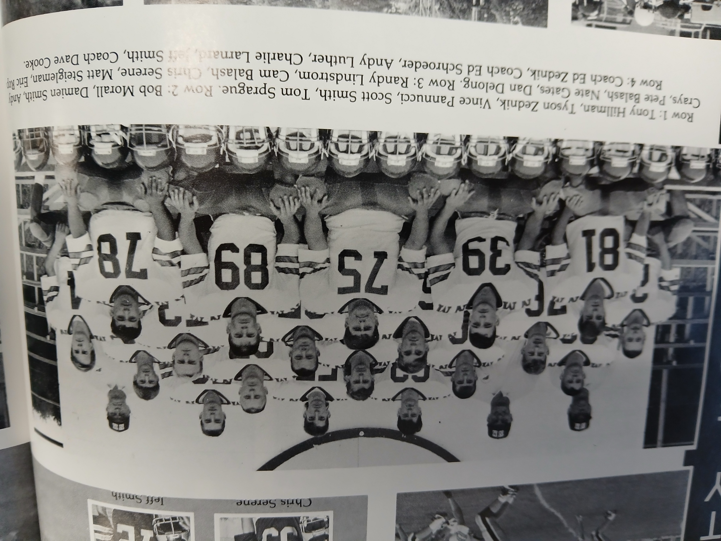

1991– Coach Dave Cooke (9-2 overall, Tied for 1st WMC – playoff qualifier)

NM would return once again to the promise land as they would end up in a three-way tie with Whitehall and Oakridge, all with identical 6-1 WMC records. Oddly enough, it would be the first share of the crown for Whitehall while for NM it would be their last under the old format before the conference was ‘watered’ down with several team schools joining the WMC beginning in 2022. From 1992 forward the WMC could proudly boast as being one of the strongest Class C/B conferences in the state as the trio of Oakridge, Ravenna and Montague would earn many state championships over the next 30 years.

It took but the first game to determine thar the strength of the 1991 Norsemen would be their defense. The first of their seven shutouts on the season was their opening 10-0 victory over Holton. So dominant was the NM defense that they limited Holton to 19 rushing yards in 32 attempts. The Red Devils didn’t even fare that well in the passing game as they finished with only one completion good for eight yards. Leading the defense were returning linebackers Nate Gates and Randy Lindstrom while up from forming the impenetrable line of defense were Bob Walters, Damien Smith, and Matt Steigelman. Dan Delong, the NM returning starter at quarterback, would have a great year also as a defender. On his way to becoming a first team all-state defender Delong was credited with eight tackles. Holton was likewise stingy on defense as the Norse were only able to put three points on the board in the opening half on a 21-yard field goal from Chris Roberts. Chris Benedict ran for the game’s only touchdown in the second half, running for 43 of his game leading 123 yards.

Who knew at the early stage of the season that NM’s 23-14 win over Whitehall would go a long way in determining the 1991 WMC championship. NM scored all 23 of their points in one quarter and then held off Whitehall to make it 10 straight triumphs over the Vikings. Although there was a total of 37 points scored, defenses nevertheless ruled in this contest. In fact, NM had only three first downs in the entire game while Whitehall had but four. Big plays in the second quarter led to the Norse victory. Junior linebacker Randy Lindstrom scored the first touchdown on a 15-yard interception. The second TD was a bit of a razzle-dazzle play with NM completing a double pass from Dan Delong to Cam Balash who in turn passed to a wide-open Joe Grimm in the end zone to complete the 24-yard play. Chris Benedict who totaled 98 rushing yards for the game, garnered 60 of those yards on a second quarter touchdown run. A bad snap that sailed over the Whitehall punter’s head resulted in a safety and NM’s final points in the quarter and the game.

NM would drop their only game of the regular season 12-0 to Oakridge as Oakridge limited the Norse to less than 100 total offensive yards for the game. The Norse were hurt with several dropped passes and their two lost fumbles in the contest surely didn’t help their chances. The Norse were playing without starting linebacker and fullback Randy Lindstrom as the normally stingy NM defense could not contain Oakridge running back Tom Carpenter who rushed for one TD and 142 yards. When one looks at the disparity in student enrollment with Oakridge having more than twice the students as NM, the Norse accounted for themselves very well.

After playing a pair of heavyweights for the past two games, NM got well with a 40-0 rout of winless Shelby. After totaling just 78 yards in their loss to Oakridge, the Norse rolled up 415 total yards while shutting out the Tigers. Dan Delong had a good game for NM with a rushing touchdown as well as a passing TD.

The following week was when Mother Nature raised havoc with Friday night football. Nearly all the games scheduled for Friday night experienced heavy rains coupled with lightning that forced the postponements of nearly all area games. The one exception was the game I was working between Muskegon and Saginaw Arthur Hill. In a game that lasted well past midnight with officials ignoring lightning clearly visible in the sky, Muskegon won 12-0. It would be the last loss for Arthur Hill as they would go on to win the state AA championship. Like most of the games, North Muskegon and Hart would play their game the following Saturday afternoon. The Pirates would score first in NM’s 35-6 conquest of Hart. Following that score, the Norse defense would not allow another score until the second round of the playoffs, a span of five games. Following the Pirate TD, Dan Delong sparked the NM offense with a pair of TD passes to Pat Kitchka for 18-yards and another to Zack Bauer for 31. DeLong scored the first NM TD on a quarterback keeper while Joe Grimm and Randy Lindstrom closed out the Norse scoring with a TD each.

NM’s 27-0 victory over Ravenna would have to be savored for several years. After NM dominated the rivalry by winning 26 of their previous 33 games vs. the Bulldogs, Ravenna would win 13 of the next 14 games. Dan Delong led the win over Ravenna by playing a part in three of NM’s 4 touchdowns. Delong ran for a pair of TDs (4 & 28) and teamed up with Pat Kitchka for a TD strike good for 39 yards. The first Norse TD proved to be one for the record books. NM partially blocked a Ravenna field goal attempt. Chris Benedict scooped up the pigskin at his own five-yard line and dashed 95 yards to give the Norse their first score.

Going into their next game with Montague, there was a 4-way long jam at first place in the WMC with Oakridge, Whitehall, Montague, and NM all sporting a 4-1 record. Make that a 3-way tie after the Norse shut out Montague 29-0. Recent rains had inundated area fields and Fred Jacks Field was no exception as again games in the area were played in the rain. North Muskegon used a ground attack against the Wildcats as they rushed for 300 yards with Chris Benedict and Randy Lindstrom each rushing for more than 100 yards. Lindstrom earned 52 of his 127 yards on a 52-yard TD burst. Benedict added a pair of tallies from seven and 10 yards with Lindstrom completing NM’s scoring with a one-yard plunge.

NM’s third consecutive shutout, a 42-0 win at Mason County Central, clinched a 3-way tie in the WMC with Oakridge and Whitehall. The Norse churned out 453 yards in offense while holding the host Spartans to only 41-rushing yards. For the second straight week Chris Bendict and Randy Lindstrom each scored a pair of TDs in the Norse romp. Benedict scored the first two Norse tallies on runs of 12 and one, with Lindstrom the next two TDs on runs of seven and 47. Dan Delong contributed for the 5th NM TD as he connected with Cam Balash from 29 yards out with Joe Grimm rushing from 4-yards out to complete the Norse scoring.

For a brief period, the WMC and the NCAA teams would complete their regular season with crossover games. Although there was a 3-way tie for first place in the WMC, the Norse were tabbed to play their crossover game against the NCAA champs from Hesperia in the first year of this endeavor. The game was played on a very cold and blustery Saturday afternoon in Hesperia. It was so blustery that prior to the game the wind blew out the window in our radio booth sending glass flying. Fortunately, my partner Gene Young and I were in another section of the press box at the time. NM’s defense, led by bruising tackle Matt Steigelman, was so effective that Hesperia managed just three yards in offense for the first half as NM jumped out to a commanding first half lead. The Norse utilized all three of their running backs in the victory. Tailback Chris Benedict rushed for 83 yards, fullback Randy Lindstrom 68 and wingback Joe Grimm 58. Grimm rambled 37 yards on a counter play for NM’s first score. Chris Roberts booted a field goal with the 35-mph wind at his back to give the Norse a 10-0 lead. That would prove to be more than the Norse would need, but the Norse added two insurance TDs from Lindstrom on fullback dives to make the final score 24-0.

With an enrollment of less than 200 student the Norse were listed in the bottom rung of high school teams. The number of classes invited to vie for a state title had now doubled from four to eight classes. The good news, NM was a clear number one in their computer region with a schedule competing against all Class C & B opponents. The bad news, also in their region were the defending state champions from Frankfort.

The Norse had little trouble in disposing of an outmanned Atlanta team as NM raced to their 9th win and fifth consecutive shutout with a 27-0 win over Atlanta in their only meeting in NM football history. Coming into the game Atlanta was aware of NM’s defense against the run. Atlanta coach Rod Marlatt’s game plan was to attempt to win the game with their passing game. That didn’t work as the Norse intercepted a whopping eight passes, three each from Norse defensive backs Chris Benedict and Pat Kitchka. Chris Benedict accounted for three of the Norse scores, two on runs of 12 and one, the other on a 22-yard pass from Dan Delong. Joe Grimm capped the Norse victory with a four-yard TD.

Just as North Muskegon had to be placed in the same regional in recent years with a powerful Mendon squad, it had to face another powerhouse in their same region in 1991 in Frankfort. Frankfort was in the middle of six incredible seasons as they made it to the championship game at the Pontiac Silverdome in five of six years beginning in 1988. Frankfort was at their best in 1990 and 1991, and they would go undefeated in both years. NM would face a Frankfort team that outscored their opponents 385 to 14 with only one of their opponents able to cross their goal line before traveling to NM to take on the Norsemen. Frankfort was ranked No. 1 all season while the Norsemen sat at number 2. It was likely the state champion for 1991 would be decided at NM’s Fred Jack Field on a sunny November afternoon. Although the final score looked like a lopsided victory, this game turned on Norsemen mistakes in the first half. NM in their opening series marched to the Frankfort 22-yard line before fate befell the Norse. A NM fumbled was scooped up by the Panther’s Derek Klein who raced 70 yards down to the NM 11 to set up Frankfort’s first score. NM then had a golden opportunity to tie the score or take the lead before the turning point of the game. NM had first and goal at the five but on the next play NM fumbled at the one-yard line. “Had we punched it in on the first drive it would have set the tone for the ball game, and it would have been different,” NM coach Dave Cooke said. “You get down there and have another score taken away with a fumble in the end zone --- that takes the wind out your sails. Momentum turned for them and we never got it back,” added Cooke. All momentum then went totally away for the Norsemen on the opening kickoff in the second half when Klein returned the second half kickoff 87 yards before tackled at the 8-yard line. Another promising season ended with a loss to Frankfort.

Until NM received more students through the school of choice edict, tiny numbers would contribute to some lean years for NM football as Montague, Ravenna, and Oakridge would begin a long domination of WMC football.

Dan Delong and Matt Steigelman made the Free Press All State team for their defensive work while DeLong also was accorded all Area honors as the top C-D quarterback. Zac Bauer was named to the all-area first team with 17 catches for 353 yards. Once again, overlooked was NM Coach Cooke who had to settle for second place as the top area coach. Pegged for second team honors on the all-area team were Chris Benedick. Damien Smith and kicker Chris Roberts on offense while Tom Sprague and Randy Lindstrom were picked for defense.

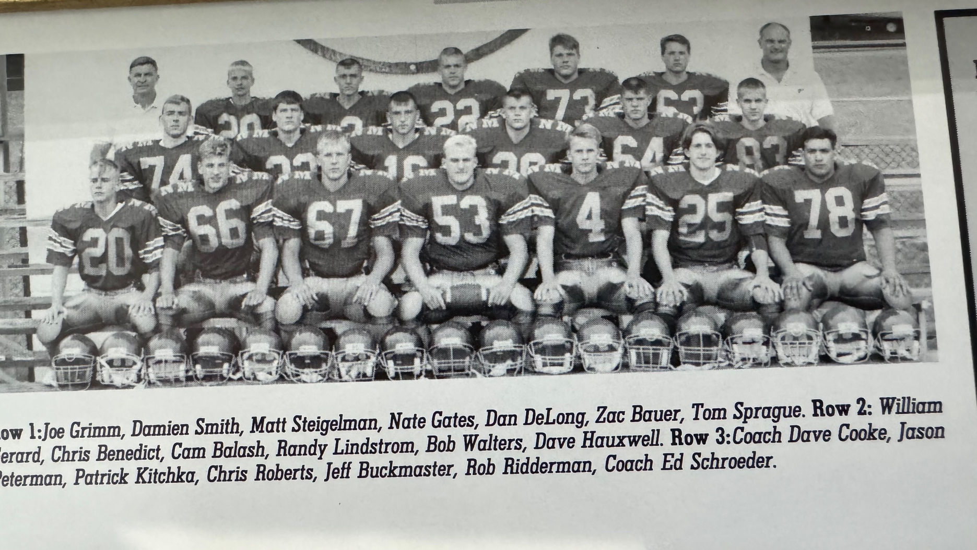

1991 NORSEMEN

Record Score Interesting Fact

- NM 10, Holton 0 Christ Benedict 43 yd YTD. NM defense limits Holton to 27 total yds.
- NM 23, Whitehall 14 Randy Lindstrom 15-yd int, Benedict 60 YD TD. Pass -Grimm 24 ydTD.
2-1 NM 0, Oakridge 12 NM only 78 total yards. Nate Gates 13 tackles, Matt Steigelman 9.
3-1 NM 40, Shelby 0 Benedict 3 TDs (34, 20 & 5) Delong ran & passed for TD.
4-1 NM 35, Hart 6 DeLong 2 TD passes & run. Grimm 13 yd TD & Lindstrom 1 yd TD.
5-1 NM 27, Ravenna 0 Delong 2 TD runs (4 & 28) TD 39 yds to Kitchka. Benedict 95 yd ret.
6-1 NM 29, Montague 0 Benedict (7 & 10) and Lindstrom (52 & 1) NM TDs. Chris Roberts FG
7-1 NM 42-, Mason Co 0 Benedict (12 & 1) & Lindstrom (7 & 46) TDs. Cam Balash 29 pass TD.
8-1 NM 24, Hesperia 0 Grimm 37 YD td. Lindstrom 2 TDs from the 1. Roberts field goal.
9-1 NM 27, Atlanta 0 Benedict TD runs of 12 & 1, pass for 22. Grimm 4-yard TD run.
9-2 NM 0, Frankfort 25 Turnovers plague Norse as NM loses to 2-time state champs.

1992– Coach Dave Cooke (4-5 overall, Montague WMC Champs)

Never since enrollment numbers from the 1930s to the present day have student numbers been lower that the 160 students enrolled from grades 9-12 at NMHS in 1992. That equates to an average class size of only 40 pupils. Somehow NM has stayed competitive over the years in football, with much of the success credited to head coach Dave Cooke, beginning his 31st year in coaching in 1992. The Norse dropped below .500, but barely, with a 4-5 record, and only in their losses to eventual state finalist Montague and a defeat by Whitehall were they soundly defeated. The pre-season team photo showed only 17 players dressed for the varsity but three of those 17 were starters in the backfield. Cooke returns Chris Benedict who ran for over 1000 yards (exact number not known), fullback Randy Lindstrom and wingback Joe Grimm. The bad news: who was going to block for those returning vets as graduation took a big toll? One of the two starters returning on the line would be sophomore Jeff Buckmaster, a starter as a freshman. Scott Wynsma was projected to start at tackle with Buckmaster while the guards were projected to be manned by David Hauxwell and future TV celebrity with CNN, Dan Cevallos. Bob Walters was the other starter back from 1991 and he would move from guard to center. With 17 players, many would be expected to go both ways with any Norse lost to an injury would be a bad sign for the success of this team. As it was true for many of his years as the head coach at NMHS, Cooke would have Ed Schroeder as his trusted assistant.

The Norse got off to a promising start to the season with a 29-8 victory over Holton. NM found a replacement for all-area quarterback Dan Delong as Cam Balash passed for two touchdowns and ran for another. Balash first connected on a six-yard TD pass to Pat Kitchka, and next teamed up on a 42-yard toss that accounted for six points. Balash scrambled for six more points from four yards away while a halfback passes from Pat Kitchka to John McLaughlin caught Holton off guard and went for 44 yards and a TD. NM appears to have found yet another solid kicker as sophomore Mike Boyle nailed a 29-yard field goal.

Whitehall ended their ten-game losing streak to NM in a big way as they crushed the Norse 41-13. The offensive line of the Vikings overpowered the Norsemen creating huge holes for their all-area back Jeff Stark to run for 221 yards and 3 touchdowns. It was 41-0 before the Norse were able to put points on the board in the final quarter. Cam Balash connected with Joe Grimm on a long 75-yard pass and run while Grimm rushed from 3 yards out for NM’s and the game’s final TD. NM played their 2nd straight game without their 1000-yard rusher Chris Benedict, out with a knee injury, but even with Benedict in the lineup Whitehall was the superior team.

NM received a most welcome return to the lineup in Chris Benedict as the Norse enjoyed a 10-7 short-lived lead over host Oakridge at halftime. But the Eagles would wear down the Norse in the second half to defeat NM 19-10. NM took the early lead 3-0 on a 35-yard field goal from Mike Boyle and had an upset in the making when Christ Benedict capped a 59-yard drive with a 3-yard TD. Oakridge scored with one minute left in the first half on a 23-yard TD run from Charlie Randall. The second half all belonged to the Eagles as the Norse fell to 1-2 on the season.

NM evened their record at 2-2 with a 34-6 conquest of Shelby. It was the first time all season that a pair of healthy veteran backs scored for the Norse. Randy Lindstrom tallied his first TDs of the season on runs of 37 and one while Chris Benedict added a short TD to his credit. The Norse spotted Shelby an early touchdown but scored the last five TDs to pull away from the Tigers. Joe Grimm gave NM the lead after scoring from 12 yards out in the opening quarter. The final tally for the victors came on a Cam Balash pass to Pat Kitchka for 31 yards. NM’s defense, led by Bryan Taylor and Grimm with nine tackles, did not allow Shelby a first down for the entire second half.

The Norse let a 9-0 lead get away from them as Hart rallied to nip the Norse 20-17. Jason Gale broke away on a 75-yard TD gallop in the final quarter to hand the Norse their third defeat of the season and remove any chances for a repeat of their WMC championship. NM took the early lead, first on a Cam Balash two-yard QB keeper, and then a 28-yard field goal by Mike Boyle. After Hart took the lead in the third quarter 14-9, NM scored on a Randy Lindstrom 10-yard run and a made two-pointer to retake the lead before Gale’s long TD run dropped the Norse to 2-3 on the season.

NM and Ravenna battled for more than three quarters with nothing to show for it on the scoreboard. The Bulldogs then scored 14 unanswered points against the thin Norsemen team to earn a 14-0 victory. The Bulldogs returned just one starter from their 1991 team and were two years away from putting on the field (in this author’s opinion) the top team in WMC history in 1994. The backbreaker for NM came when sophomore QB Matt Crowley sprinted 59 yards for a TD with nine minutes left in the game. NM was plagued with dropped passes according to head coach Dave Cooke as NM fell to 2-4 on the season. It wouldn’t get any better in their next game.

Perhaps still smarting from losing to the Norse 56-0 and being shut out in their last five games to NM, Montague showed no mercy for the Norsemen as they handed NM their worse defeat in school history, 63-0. Montague would advance for the first time in their school’s history to the state finals before losing to perennial power Detroit DePorres in the championship game. The Wildcats rolled up 581 yards in total offense while the Norsemen felt hopeless to slow down the Montague express. Leading the Wildcats to victory was their quarterback Pat Collins, who returned to his alma mater to lead them to three state championships as their head coach.

NM didn’t hang their heads followed their defeat at Montague as they bounced back to win their first game in four starts with a 28-6 victory over Mason County Central. Three-sport NM standout Cam Balash ran for one TD and intercepted a pass that he returned 52 yards for another score. Chris Benedict propelled the Norse to a good start with a pair of short TD runs from one and four yards out. The Norse scored all 28 of their points in the 28-6 victory over the visiting Spartans in the first half.

The WMC and NCAA continued their brief cross-over series and as luck would have it, NM was paired up with Holton, a team they opened with to start the season. The results were nearly the same as NM overwhelmed the Red Devils 34-6. Chris Benedict capped his fine NM career in style by rushing for 222 yards and three TDs. Benedict began the scoring with a 26-yard TD run in the first quarter and then capped all scoring with an 85-yard kickoff return following Holton’s only TD in the second half. Randy Lindstrom scored a TD on both offense and defense. Lindstrom ran for one TD, and he not only led all tacklers on defense with 14 tackles, but the senior linebacker also recovered a Holton fumble in the end zone for a TD. Cam Balash tossed to Pat Kitchka for 9-yards and a TD as NM completed the season at 4-5.

Despite their 4-5 losing record, the Norse, due to their strength of schedule as a ‘D’ team playing a ‘C’ schedule, came one spot away from again qualifying for the playoffs. Three-year starter Randy Lindstrom topped post season honors for NM. Lindstrom was selected to the first team All-State team as a linebacker and was the only Norsemen selected to the all-area first team. Sophomore Jeff Buckmaster was selected to the second squad all area team as was Chris Benedict as a defensive back.

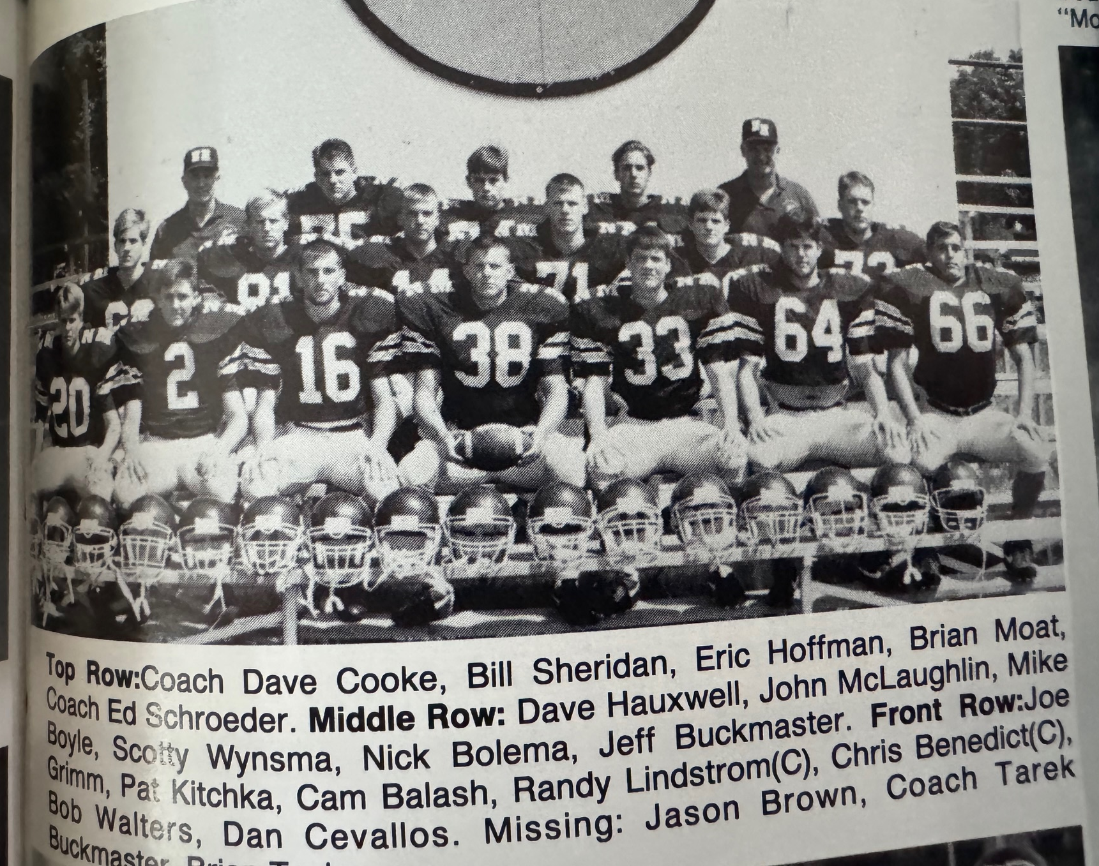

1992 NORSEMEN

Record Score Interesting Fact
1-0 NM 29, Holton 8 Cam Balash 2 TD passes, 1 run. Pat Kitchka -John McLaughlin 42 TD.
1-1 NM 13, Whitehall 41 Balash to Grimm 75 yards TD pass. Grimm 3-yard TD.
1-2 NM 10, Oakridge 19 Chris Benedict returns to lineup. Scored 3 Yd TD. Mike Boyle FG.
2-2 NM 34. Shelby 6 Randy Lindstrom 2 TDs (37 & 1), Grimm 12 yd TD, Kitchka 32 pass.
2-3 NM 17, Hart 20 Balash 2 yd and Lindstrom 10-yd TD, Boyle 28-yd FG.
2-4 NM 0, Ravenna 14 Benedict 72 yds on 9 carries. NM only 3/16 in passing.
2-5 NM 0, Montague 63 Montague hands NM worse loss ever.
3-5 NM 28, Mason Co 6 Balash 52 yd int. return for TD & 1 yd run. Benedict 2 short TDs.
4-5 NM 34, Holton 6 Benedict 222 yd rushing including 85 yd Koff ret. Lindstrom 2 TDs.

1993– Coach Dave Cooke (2-7 overall, Montague, Oakridge, Whitehall co-champs)

Small numbers would handicap the Norse throughout the 1993 season. The young Norsemen would take their lumps as they would only win two games, but the experience gained would pay dividends the following year. Only four starters would return for 1993, with only five seniors on the 1993 roster as juniors would comprise 11 of their team’s small squad of 18 players. Starters returning included running back Joe Grimm, end Nick Bolema, and linemen Jeff Buckmaster and Scott Wynsma. Mike Boyle, who saw action in 1992 mainly as the kicker would now take charge of the quarterback position.

NM would again get off to a nice start as they breezed to a 48-0 win over Holton. Joe Grimm had a career day for himself for the Norsemen with four touchdowns while running for 167 yards. Sophomore Bo Thrasher, future owner of Hobo’s Tavern in NM, added a ten-yard TD run and added 115 of NM’s total 414 rushing yards. Grimms TD came on runs from 28, 3, 2, and 24. Junior quarterback Mike Boyle tossed his first TD pass of his career with a 30-yard toss to Leigh Kakaty, currently the lead senior of a hard rock band called the Pop Evils. Fullback Erick Peterson finished the Norse rout with a six-yard TD.

It would now be back to the grind against teams in the tough WMC conference. As usual, Oakridge would have another potent team as they handed the Norse their first loss of the season. 33-17. NM made Oakridge fret somewhat as a two-yard run by Joe Grimm closed the gap at halftime to 12-7. Grimm was injured on the play and was feared lost for the season, dropping their numbers down from 18 to 17 players. Cooke then moved Mike Boyle from quarterback to Grimm’s spot as a tailback and inserted sophomore Justin Visconti at quarterback. Visconti, who would become one of NM’s top baseball players of all time, connected with Leigh Kakaty on a 30-yard scoring pass. Visconti then set up a Boyle field goal with 6:41 remaining before Oakridge scored an insurance touchdown to insure an Oakridge victory.

The Norse then saw a 20-6 first half lead quickly dissipates as Shelby came from behind to hand NM their second loss on the season 28 to 23. Mike Mumper’s 45-yard TD in the fourth quarter was the winner for the Tigers. Offense was not a problem for the Norse as Justin Visconti completed 11 of 19 passes for 259 yards, three of those completions went to Bo Thrasher for 199 yards. After Shelby scored first, NM came back to take the lead following a Mike Boyle field goal on a two-yard plunge from Jeff Buckmaster. Visconti’s then tossed a 25-yard TD pass to Leigh Kakaty followed by a 1-yard run by Boyle to make the score 23-6 before Shelby’s Mumper scored a pair of TDs to nip the Norse.

NM’s second straight journey to Oceana County didn’t fare any better than their first trip to Shelby. Hart scored 47 points in their 47-13 win over the Norse, the only time in the NM-Hart rivalry where the Pirates scored more than 30 points against the Blue & Gold. Jon Gale scored five touchdowns, including an 82-yard kickoff return to lead the Pirates to victory. Justin Visconti tossed a 19-yard TD pass to Nick Bolema while Erik Peterson, who led the Norse defense with 16 tackles, scored the only rushing TD for the Norsemen on a one-yard plunge.

One year away from their dominating 1994 team, the young Bulldogs had more than enough firepower to defeat NM 32-13 as NM was still looking for their first WMC victory on the season. Back at quarterback where he started the season, Mike Boyle threw a pair of 13-yard TD passes, one to Leigh Kakaty and the other to Nick Bolema to account for the NM touchdowns. Bulldog coach Dusty Fairfield unveiled a young freshman into the Bulldog lineup. Benny Clark, who would become this area’s all-time rushing leader, added a pair of long scoring runs from his wingback position for Ravenna.

The woes continued in the WMC as NM dropped their 5th WMC contest to Montague 28-16. The Norse were on the losing side of the ledger, but it was a far cry from the previous year’s 63-0 wallop by Montague. The visiting Wildcats jumped out to a 14-0 lead before the Norse battled back to play even with Montague the rest of the game. NM scored two touchdowns and a field goal in the final quarter to throw a brief scare at the Wildcats. A freshman callup from the JV team, Andrew Hager, scored two short TDs as the Norse battled injuries. The other points earned by NM came on a 35- yard field goal from Mike Boyle.

Although they came away with a 10-7 victory over Mason County Central, NM still took an uncharacteristic trip to the WMC cellar with their win over Mason County Central. Shelby, NM, and Mason County all would tie for the bottom spot in the WMC with 1-6 records. The Norse ‘safety’ won the hard-fought game against the host Spartans. The Spartans scored early to take a 7-0 lead. The all-important safety resulted following a NM punt that was downed on the one-foot line. On the next play the Spartan back was tackled in the end zone as the lead for Scottville was 7-2 at halftime. A fumble recovery by NM at midfield set up the winning touchdown in the second quarter on a 4-yard run by Mike Boyle. The Norse then hung on for their first WMC victory on the season.

Whitehall clinched a tie with Oakridge and Montague with their 20-0 shutout over the Norse in the final conference game of the season. The Vikings shut down the NM running game to a measly four yards rushing for the entire game. Mike Boyle at quarterback provided some offense for the Norse by completing four passes for 74 yards.

The final game for NM probably couldn’t have come too soon for NM as a multitude of turnovers led to a season ending 16-14 loss to Hesperia in a WMC-NCAA crossover game. NM lost three fumbles and had two interceptions in an error plagued game. Junior quarterback Mike Boyle was 6 of 17 passing and scored a TD for a NM team was that had become decimated with injuries in their backfield. Erik Peterson also scored a touchdown for NM as the 1994 season couldn’t come soon enough for the Norsemen.

The 1993 season wasn’t just a bad year for North Muskegon, but it was a rare year when the Muskegon Area didn’t have at least one representative playing for a state title at the Pontiac Silverdome. The Muskegon area had been represented in a state championship game every year since 1988. King Football would return to normal in 1994. One NM player from 1993 was lauded for his play. Junior Jeff Buckmaster not only made the all-area team but was also made the 1st team all-state team as a lineman.

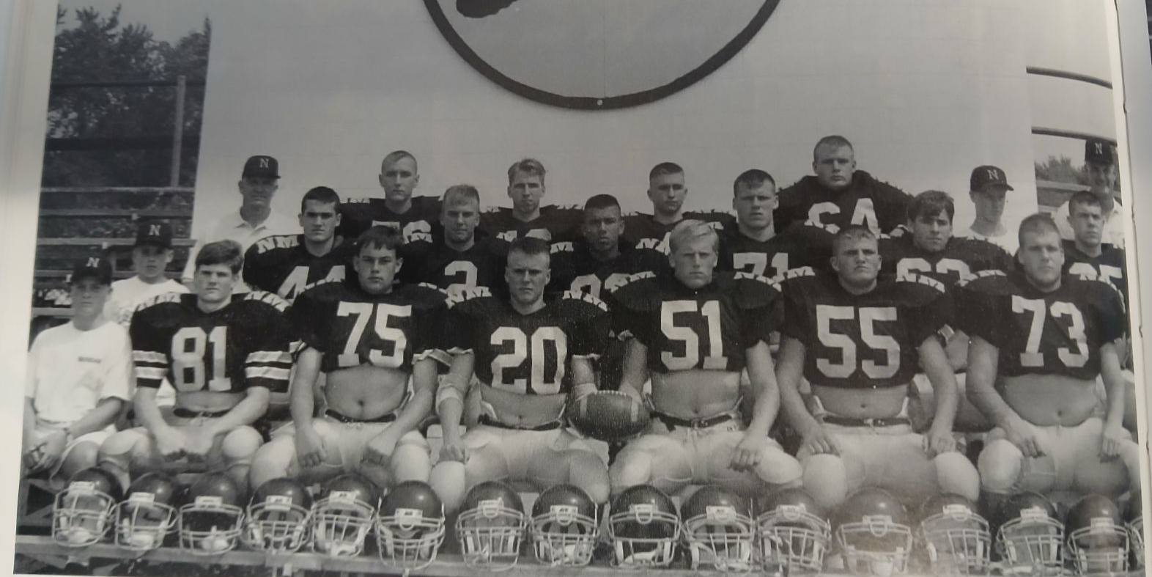

The 1993 NORSEMEN

Front Row L-R: Adam Peterson, Nick Bolema, Eric Hoffman, John McLaughlin, Jaime Peterson, Jeff Buckmaster
Middle Row L-R: Matt Boyle, Eric Peterson, Leigh Kakaty, Scott Wynsma, Mike Farmer, Justin Visconti
Top Row L-R: Coach Dave Cooke, Jim Frybarger, Matt Gueidenzoph, Bo Thrasher, Dan Wegner, Jeremy Wegner, coach Ed Schroeder. Not pictured: Mike Schrieber and Chris Lear

Record Score Interesting Fact
- NM 48, Holton 0 Joe Grimm 4 TDs (26, 3,2, 24), Mike Boyle – Leigh Kakaty TD.
1-1 NM 17, Oakridge 33 Justin Visconti – Kakaty 30 TD TD. Grimm 2-yd TD.
1-2 NM 23, Shelby 28 Visconti 259 pass yds & TD to Kakaty, Jeff Buckmaster 2-yd TD.
  - NM 13, Hart 47 Visconti to Nick Bolema 19-yard TD, Erik Peterson 1 yard TD run.
  - NM 13, Ravenna 32 Boyle 13-yard TD passes to Kakaty and Bolema.
  - NM 16, Montague 28 Andy Hager two one-yard TDs. Boyle 35 yd FG.
2-5 NM 10, Mason Co 7 NM safety the difference. Boyle 40-yard rushing TD.
2-6 NM 0, Whitehall 20 Whitehall holds NM to only 4 rushing yards.
2-7 NM 14, Hesperia 16 Boyle TD run, Erik Peterson 2-yard TD

1994– Coach Dave Cooke (7-4 overall, Playoff qualifier- Ravenna WMC Champs)

The Norse bounced back to qualify for the playoffs once again. NM seems to have a penchant for drawing teams early in the playoffs that advance to win the state championship and that held true to form once again. Numbers were again low for the football team as Coach Dave Cooke, now in his 33rd year of coaching had but 18 players to work with and any injury would be a huge detriment such as it was in 1993. Although the Norsemen were short on quantity, they did possess some quality. Returning for his fourth season as a starter was Jeff Buckmaster, a 6-3 260 two-way starter who made the all-state team in his junior season. The future Hillsdale College football star would be joined by returning regulars in linemen Mike Farmer, Scott Wynsma and tackle Dan Wegner. Mike Boyle returns as the starting quarterback and will once again handle the kicking duties. Many of the players will go both ways and the defense will be aided by Scott Dubrish, a transfer student who was a two-way starter for Reeths Puffer. Cooke had a few returning players to pick from to round out his backfield, including 1993 starting fullback Erik Peterson.

For the seventh straight year the Norse would open their season with Holton, a tradition that would continue for twenty years. It was sevens across the board as the Norse scored a TD in each quarter and Mike Boyle would kick each point after in NM’s 28-0 shutout victory over Holton. NM set the tone early as all-state lineman Jeff Buckmaster scooped up a Red Devil fumble and rambled into the end zone from 15 yards out to begin the Norse scoring. Mike Boyle then connected with future restaurant entrepreneur Bo Thrasher for a scoring strike of 53 yards in the second quarter. Andrew Hager had TD runs in each quarter of the second half, the first from 13 yards and the final tally in the fourth quarter from three yards.

NM snapped a five-game losing streak to Oakridge with a 22-12 victory. Three big plays, two of those coming on long touchdown passes from Mike Boyle to Leigh Kakaty paved the way for the Norse. NM got on the board first as sophomore Matt Gongalski, behind key blocks from Dan Wegner and Jeff Buckmaster, sprinted 55-yards for the TD. NM made it 14-0 at halftime when the first of the two TD passes to Kakaty went for 34 yards. “It’s important for us not to have to come from behind, with only 18 players” said North Muskegon assistant coach Ed Schroeder. “We kind of must score points and then hold on. We were really tired in the fourth quarter”. Oakridge did score both their TDs in the fourth quarter as the Norse held on. It was a victory NM would savor as it would be a dozen years before NM would again defeat Oakridge.

NM used a powerful running game to post a 35-0 victory over Shelby. Erick Peterson and Bo Thrasher each contributed a pair of rushing touchdowns as NM totaled 275 yards in rushing. Matt Gongalski, who led all Norse rushers with 110 yards, scored the final TD as NM won their third straight victory on the season. Although he didn’t tally a TD, Andrew Hager added 84 yards on 14 carries.

For the second straight week NM scored an identical 35-0 win over an Oceana County foe, this week it was Hart falling to the Norsemen. A combination of a solid running game coupled with a defense that held Hart to only 43 yards in total offense and forced three turnovers gave NM their fourth straight victory and third shutout in four games. Andrew Hager got the ball rolling for NM with the first of four first half touchdowns on a 23-yard run. Matt Gongalski scored a pair of rushing TDs, the first from nine while he raced 51 yards for the second. Bo Thrasher then made it 28-0 at halftime with an 8-yard rush. NM scored their final TD in the second half when reserve quarterback George Keefe combined with Thrasher on a 33-yard pass play. NM was now sitting pretty with a 4-0 record, but the competition would now get much stronger.

When one can look back well after the season played out, North Muskegon’s 18-7 loss to Ravenna could be construed as a ‘moral victory.’ Your author has maintained over the years that the 1994 Ravenna Bulldog team was the best WMC team I’ve seen since watching WMC football since the 1940s. The Bulldogs had it all: A great quarterback in Ken Nichols; a division 1 running back in Benny Clark; a bruising fullback/tight end in Brandon Kantola and an offensive line that was big and strong. 6’6 300-pound Charley Knapp would excel at WMU; Mike Anthony at 6’4 and 270 was a monster on both sides of the ball. Only an injury in his senior year denied him a chance to play at the D1 level. In addition, in Gary Johnson, the Bulldogs had a nose guard on defense who couldn’t be blocked. When all was said and done this Bulldog team captured the state championship with a rout of Schoolcraft. In my only trip ever to Marquette to broadcast a game, I was led to believe by my colleagues in the media (UP media) that Iron Mountain was unbeatable. After I listened to their gloating the praises of their Iron Mountain team I only replied: “They had better be good as I know Ravenna can play.” When the final horn sounded the Bulldogs had handed Iron Mountain a 34-12 beating, and it really wasn’t even that close.

The Norsemen’s 1984 game was played in the rain in Ravenna, and the Norsemen gave the Bulldogs one of their toughest of very few challenges in the entire season. The Norse were trailing only 12-7 with less than a minute remaining. However, the Norsemen were pinned back deep in their own territory. A screen pass was intercepted by Brandon Kantola and returned 15 yards to clinch the victory for the Bulldogs. Kantola’s mother was a North Muskegon grad whose brother Dick Schuiteman was a 4-year starter for NM back in the glory years of the 1950s. The Norse certainly had their chances to pull off the stunner, but a wet ball and dropped passes contributed to their defeat. Following a long punt return by Leigh Kakata deep into Bulldog territory in the final quarter, a field goal try was blocked. On their next possession NM was able to sustain a drive and with five minutes left trailed 12-7 after Matt Gongalski scored from the two-yard line. The Bulldogs Kantola then ended any NM hopes for victory with his interception and TD.

Perhaps still smarting from their effort the previous week against Ravenna, the Norse were stunned by Montague 43-20. Brian Swisher rushed for 197 yards and four touchdowns for the Wildcats. NM was far off its game as they were only able to complete 3 of 16 passes. One of those passes went for six points as Mike Boyle and Bo Thrasher combined for a 51-yard effort just before the first half ended with NM trailing Montague 22-14. The Wildcats dominated the second half with NM’s Andrew Hager scoring late in the game to make the final score 43-20.

Matt Gongalski rambled for 183 yards and scored four touchdowns to help power the Norse to a 49-0 romp over Mason County Central. Gogalski scored on runs of 1, 22, and 45 yards and caught a 7-yard TD strike from George Keefe. Andrew Hager scored a pair of TDs from nine and three-yard runs while Bo Thrasher scored from the 11. NM finished with 350 yards in total offense while defensively NM held the Spartans to only 75 total yards with Scott Dubrish leading the way with 12 tackles.

NM let a game get away from them in their 36-26 loss at Whitehall. NM enjoyed a 21-8 lead after scoring three touchdowns in the space of three minutes in the second period. Aided by a disputed roughing the kicker penalty and an ensuing unsportsmanlike penalty, Whitehall was able to complete a long 80-yard drive before halftime to move within one score of the Norse. Neither team scored in the third quarter, but the final 12 minutes produced plenty of action. NM had a chance to go up two scores, but Whitehall intercepted a NM pass at the Whitehall three-yard line that was returned to the 20. On the next play Cliff Foster broke through the line and raced 80-yards for the TD. A made two-point conversion gave Whitehall the lead at 22-21. NM regained the lead with a 69-yard drive and scored on a three-yard run by Andy Hager to move in front 30-27. That lead lasted for all but a few seconds as Nate Baker returned the kickoff 88 yards. Whitehall then put the nail in NM’s coffin with a late touchdown.

For the second time in three years NM was paired up in the WMC/NCAA crossover with Holton, necessitating their second game on the season with the Red Devils. The second meeting was nearly the same as the first contest between the two as the Norsemen won 31-0. The win propelled NM back into the playoffs after a two-year hiatus and set up a first-round matchup with Mount Pleasant Sacred Heart. The Norse settled their win over Holton early by racing out to a 28-0 halftime lead. Matt Gongalski scored two TDs in the first 24 minutes on runs from 8 and 3 yards. Mike Boyle had a hand in the other three NM scores. The senior quarterback scored the game’s first TD on a QB sneak. He then teamed up with his favorite receiver Leigh Kakaty for a 25-yard TD pass. The only scoring in the second half was a 36-yard field goal by Boyle.

Mount Pleasant Sacred Heart was no match for the Norse in the opening playoff game as NM rolled to an easy 59-6 victory. Mike Boyle got the Norse a jump start with a 19-yard TD sprint. Matt Gongalski then scored the first of his three touchdowns on a 60-yard run. He later added touchdown runs from three and 12 yards. Lineman Mike Farmer scooped up a MPSH fumble and rambled 35 yards for a NM TD as the rout was on. It was 35-0 at halftime and a running clock made for a quick second half. NM was able to score twice in the second half. The first was a run of three yards by Andrew Hager, the second was a two-yard scamper by freshman Jamie Keene. Sacred Heart finished with minus -5 yards rushing compared to the Norse total of 338 yards.

NM, as well as this broadcaster, drove to the quaint little town of Beal City to play the undefeated Aggies. It looked like the entire town, plus more, packed the home stands and they were not disappointed. The Aggies ‘politely’ stunned the bigger Norsemen as they scored on their first four possessions enroute to a 34-0 shutout of the Norsemen. Initially, things started out OK for the Norse as they took the opening kickoff and marched all the way to the Beal City one. However the Norse running back fumbled into the end zone, Beal City recovered, and it was all Beal City after that turnover. NM’s sophomore running back Matt Gongalski, who rushed for over 1000 yards during the season finished with 68 hard-earned yards in 21 carries. Scott Dubrish led NM’s defense with 14 tackles as the Norse season ended while Beal City would go on to capture the state Class D championship.

Jeff Buckmaster was a repeat first team member of the all-state team and was joined by his teammate Mike Boyle who was bestowed first team all-state, not only for his kicking, but also his punting. In 1998 Buckmaster would be selected by Hillsdale College as their most outstanding offensive lineman. Scott Dubrish would join Buckmaster and Boyle on the prestigious Class C/D all area team. Second team all-area honors went to Boyle at quarterback, and end Leigh Kakaty. Making second team all-area on defense were lineman Scott Wynsma and defensive back George Keefe.

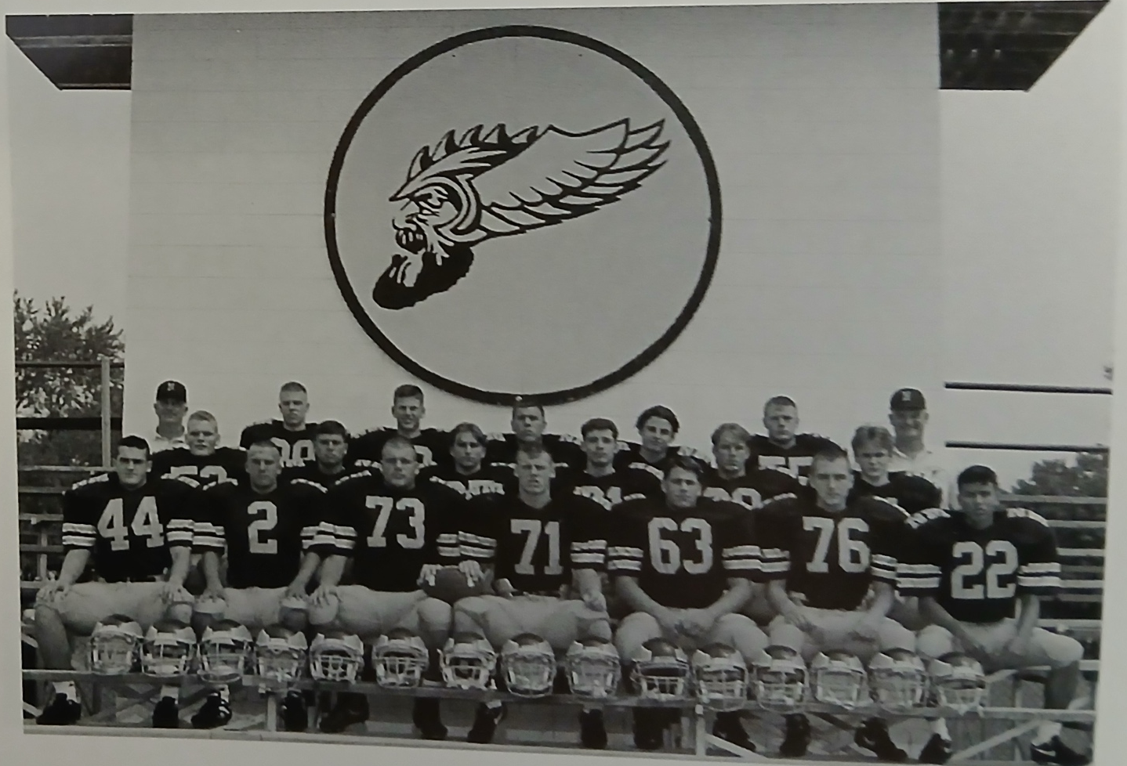

The 1994 NORSEMEN

First Row L-R: Erick Peterson, Mike Boyle, Jeff Buckmaster, Scott Wynsma, Mike Farmer, Jim Frybarger, Leigh Kakaty
2nd Row L-R: Todd Riegler, George Keefe, Bo Thrasher, Andrew Haak, Scott Dubrish, Mike Kirlis
Top Row L-R: Head coach Dave Cooke, Ernie Brezina, Kevin Robertson, Bill Franks, Andrew Hager, Dan Wegner, coach Ed Schroeder

Record Score Interesting Fact
- NM 28. Holton 0 Jeff Buckmaster 15 yd fumble rec. TD. Andrew Hager 2 TDs, Mike Boyle to Bo Thrasher 53-yard TD pass.
2-0 NM 22, Oakridge 12 Boyle 2 TD passes to Leigh Kakaty (34 & 48) Matt Gongalski 55 yd TD and 90 rushing yards.
- NM 35, Shelby 0 Erick Peterson, Thrasher each 2 TDs, Gongalwski TD & 110 yards.
4-0 NM 35, Hart Gongalski 2 TDs, Hager 23 yd TD. Thraser 9 yd run & 33 pass from George Keefe.
4-1 NM 7, Ravenna 18 NM gives state champs a scare. Gongalski 2 yd TD.
  - NM 20, Montague 43 Hager 1 & 15 yd TD, Boyle to Thraser for 51 yds.
5-2 NM 49, Mason Co 0 Gongalski 4 TDs, Hager 2 and Thasher 1.
5-3 NM 26, Whitehall 36 Gongalski, Hager, Boyle rushing TDs. Kevin Robertson 24 fumble ret.
6-3 NM 31, Holton 0 Gongalski 2 TDs, Boyle TD run, Pass to Kakaty 25 yds, 36 yd FG
7-3* NM 49, MP Sacred H 6 Gongalski 3 TDs, Mike Farmer 35 yd fumb. TD, Jamie Keene TD
7-4* NM 0, Beal City 34 Beal City shuts out NM and wins Class D title.

1995 Coach Dave Cooke (5-5 overall, Playoff qualifier- Ravenna WMC Champs)

The deeper I dig into research to cover the history of football at NMHS the more I am awed by the success NM had under the mentorship of Dave Cooke. By far the smallest school in the WMC conference, how NM stayed competitive during his tenure is a mystery to me. Cooke was handed an assignment for the 1995 season whereby he would only have but 17 players. Cooke lost several players from last year’s 7-4 team that lost in the playoffs to the state champions from Beal City. Only Dan Wegner would return as the lone returning starter as a lineman. The backfield, however, will have several returning players who played prominent roles in last year’s successful season. Matt Gongalski and Andrew Hager, still only juniors return. George Keefe, an all-area second team performer in the defensive backfield will take over at quarterback. Bo Thrasher, a three -year starter also is back while Jay Kakaty will replace his brother Leigh at wingback.

North Muskegon would open their 1995 season again with Holton, a team NM had beaten in nine of their ten meetings. However, Holton threw the Norse a surprise and surprised them early --- like on the first play. Four-year Holton running back Mike Nichols shocked the Norse by running 87 yards to give Holton a 7-0 lead. North Muskegon answered with a long drive in the second quarter with Matt Gongalski going over from the one. George Keefe then passed to Bo Thrasher for the extra points as NM took an 8-7 lead. Holton would capitalize on a NM fumble at the Norse 35 later in the second quarter and scored their second, and the games last touchdown on a Nichols four-yard run. NM controlled the ball for much of the second half but couldn’t score as Holton held off the Norse to earn a 13-8 victory.

North Muskegon got back on track by defeating Shelby 29-6. Bo Thrasher ran for a couple of early touchdowns to lead the Norsemen to victory. Thrasher scored on runs of two and a 69-yard burst. NM added a pair of TDs in the second half on a 12-yard run by Matt Gongalski and a near school record 95-yard interception return for a touchdown by Todd Riegler.

Matt Gongalski ran wild at Hart as the junior running back scored four touchdowns and piled up 179 yards as NM defeated the Pirates 35-12. Gongalski TD runs were from 9, 3, 79 and 23. Bo Thrasher also ran well as he accounted for 114 of the 430 yards that included a 49-yard touchdown scamper.

The Norsemen gave the defending state champs from Ravenna a battle but fell short 18-6. The Norse trailed 12-6 at the half as NM scored their game’s only TD on a 22-yard scoring strike from George Keefe to Marcus Norman. The one-two punch of Kevin Wilburn and Benny Clark proved too much for NM as Wilburn scored two TDs, and Clark, who ran for 200 yards added the insurance touchdown in the second half for Ravenna. For Ravenna, it was their 17th straight victory over two seasons.

The Norsemen rallied to edge Montague 21-20 in a critical game for Norsemen hopes of again making the playoffs. Bo Thrasher scored the game’s first touchdown but the Wildcats, using the wing T offense scored the next three touchdowns to lead 20-7. NM then used the running of Matt Gongalski and nine men on the line of scrimmage on defense to stop the Wildcats. Gongalski had touchdown runs of 11 and nine yards to tie the game at 20-20. Just as they have accomplished often in the past, the difference in the game was in their kicking game as sophomore Jamie Keene’s successful extra point made the difference in a win or a loss. Montague attempted a late field goal that could have been the winner. Attempting a 25-yard field goal the Cats were guilty of illegal motion and penalized five yards. That penalty cost the Cats dearly as the try from 30-yards fell just short.

NM then improved to 4-2 on the season with a 28-6 victory over Mason County Central. Bo Thrasher got the Norsemen off to a nice start with a 20-yard scamper for a TD, but the ensuing kickoff was returned 90-yards for a Spartan touchdown. NM retained the lead as the extra point failed. From that point on it was all North Muskegon. Dan Wegner made a big play for the Norse as he blocked a Spartan punt that was picked up by Brian Ware who waltzed into the end zone to give the Norse a 14-6 lead. Matt Gongalski then did the rest of the damage with a pair of long TD runs of 54 & 52 yards to secure the win. Gongalski would finish with 158 yards rushing while Andrew Hager led the defense with 13 tackles.

For the second straight game NM rallied from behind to take down a White Lake area team with a come-from-behind 21-14 victory over Whitehall. The victory probably clinched another date in the playoffs for the Class D Norsemen. Trailing 14-7 at halftime, the Norsemen got a third quarter boost when junior Brandon Byers blocked a Whitehall punt. Teammate Kevin Robertson picked up the football and raced 10 yards for the tying touchdown. Matt Gongalski, who rushed 14 times for 172 yards, busted loose in the third quarter with a 61-yard TD to give NM a lead they would not relinquish. Earlier Gongalski scored the first NM TD on a 54-yard scamper.

After winning two of their last three wins in comeback fashion, the trend was reversed with Oakridge coming from behind to score all 16 of their points in a 16-6 win over the Norsemen. Although NM dominated the first half, they had to settle for a pair of field goals from Jamie Keene. The score remained 6-0 NM until midway in the final quarter. The Big play for Oakridge came on a 9-yard swing pass on fourth and eight. As fate would have it for the Norse it was the only pass completed on the rainy night by Oakridge, but it kept the drive going and ended on a six-tard TD run by Jason Korson. Korson ran for the two-point conversion to make it 8-6 Oakridge. NM was on a drive when misfortune struck for the Norse. A George Keefe passed was intercepted by David Randall who returned it 60 yards for the touchdown that clinched the win for the Eagles.

NM once again would begin and end their regular season with Holton. However, unlike last year when NM won both games it was Holton who flipped the script and won the pair in 1995. The Holton win would be the only game won by an NCAA school in their annual crossover contests to close out the regular season. After NM scored following an early Holton TD, Holton took a lead they would not give up shortly before halftime on a 48-yard touchdown pass. George Keefe kept NM close with a pair of identical 65-yard touchdown passes, one to Bo Thrasher and the second to Matt Gongalski. The loss to Holton was not the momentum the Norse were seeking heading into the playoffs.

NM lost a heart-wrenching 15-12 thriller to Portland St. Patrick, coming perhaps less than a foot away from victory. The big play of the game took place when NM was facing a fourth and goal from the Portland one-yard line with 4:11 remaining in the game. Fullback Andy Hager took the handoff after a quick count and tried to burrow in between guard and tackle. Hager was met almost immediately by linebacker Brian Kriger and was ruled downed at the one-foot line. NM quarterback George Keefe finished his day, and career, by completing nine of 12 passes for 251 yards, 143 of those yards completed to Bo Thrasher. Two of the completions to Thrasher resulted in the NM touchdowns, the first from 60-yards and the second that gave NM a 12-7 lead was good for 39 yards. Portland took the lead for good on a 14-yard scamper by Mark Meyers before NM mounted their ill-fated 54 yards and two-third foot drive. NM could once again look back at what if --- if they would have scored at the goal line. The following week Portland St. Patrick did lose a tight game to Fowler 6-0. Fowler would then breeze to the state championship.

The most decorated Norseman during the postseason was lineman Dan Wegner, selected not only to the All-Area Class C/D team but won honors on the Class D all-state team. George Keefe repeated on the all-area defensive first unit while running back Matt Gongalski and kicker Jamie Keene made second team all- area. Linebacker Andrew Hager also was honored with 2nd team all-area.

Record Score Interesting Fact
0-1 NM 8, Holton 13 Matt Gongalski 1-yd TD and 67 yards rushing.
1-1 NM 29, Shelby 6 Todd Riegler 95 yd int TD. Bo Thrasher 2 TDs, Gongalski one TD.
2-1 NM 35, Hart 12 Gongalski 4 TDs, 179 yds. Thrasher 49 yd TD run.
2-2 NM 6, Ravenna 18 NM scores on 22-yd pass George Keefe to Marcus Norman.
3-2 NM 21, Montague 20 Thrasher TD, Gongalski 2TDs, Jamie Keene’s extra point wins.
4-2 NM 28, Mason Co 6 Gongalski 2 TDs, Thrasher 1, Dan Wegner blk punt. leads to TD.
5-2 NM 21, Whitehall 14 Byers blocked punt keys win. Gongalski 54 & 61 yd TD runs.
5-3 NM 6, Oakridge 16 Keene’s 2 field goals only NM points.
5-4 NM 20, Holton 32 Keefe 65 yd TD passes to Thrasher & Gongalski.
5-5*NM 12, Portland SP 15 Keefe 2 long TD passes to Thrasher (60 & 39)

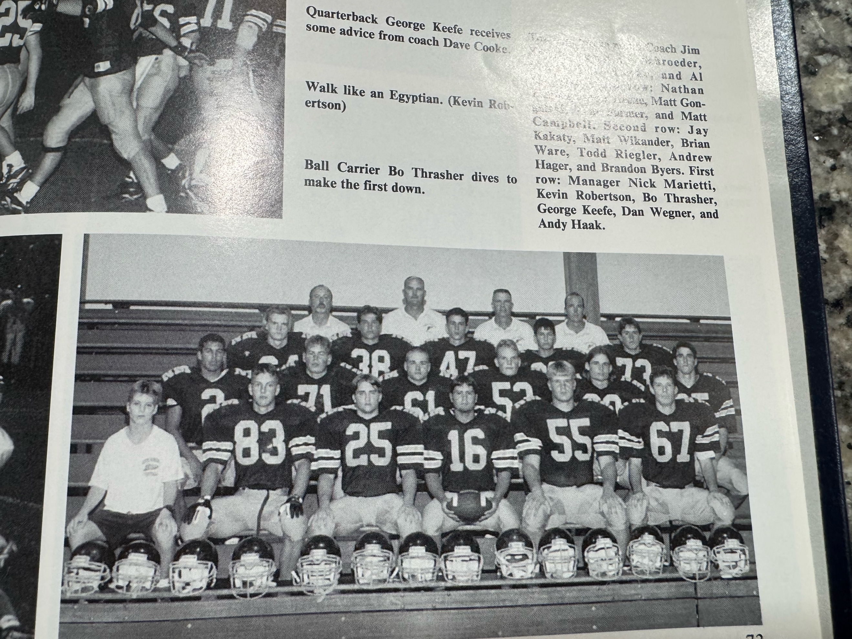

The 1995 NORSEMEN

1st Row L-R: Nick Marietti (mgr), Kevin Robertson, Bo Thrasher, George Keefe, Dan Wegner, Andy Haak
2nd Row L-R: Jay Kakaty, Matt Wikender, Brian Ware, Todd Riegler, Andrew Hager, Brandon Byers
3rd Row L-R: Nathan Bolema, Jamie Keene, Matt Gongalski, Tom Farmer, Matt Campbell
Top Row: Coach Jim Boyle, Coach Ed Schroeder, Head Coach Dave Cooke, Coach Al Karaba

1996 Coach Dave Cooke (4-5 overall, - Oakridge WMC Champs)

Before the 1996-97 school year even got underway Coach Dave Cooke and the Norsemen received some disturbing news. Their two-year returning running back who rushed for more than 1,000 yards in 1995 would not be returning to North Muskegon High. Instead, Matt Gongalski had transferred to nearby Whitehall leaving a huge hole in the NM offense. “It hurts us a lot, said coach Cooke about the loss of Gongalski. “We planned to build a lot of our offense around him. Matt was a legitimate breakaway threat. I’m not sure we’ll have that now,” lamented Cooke. NM would return three-year player Andrew Hager while Cooke is hopeful that junior Jamie Keene would fill the open space created with the loss of Gongalski. Only center Matt Wikander returns as a starter on the offensive line while four starters from 1995 return on the defensive side of the ball. Linebacker Brandon Byers and tackle Brian Ware would join Wikander and Hager as starters. There was a bit of good news when fall practice opened for the Norse, Cooke now had 21 players to work with instead of the norm of 17 the past five years.

For roughly 2/3 of the opener against Holton, it appeared that the Red Devils would win their third straight game over the Norse after winning both encounters in 1995. However, the Norse came from behind and scored the game’s final 19 unanswered points to win the season opener 25-12. With Andy Hager churning out most of the yardage, Jason Bogue capped a 78-yard drive with a four-yard plunge to tie the game at 12-12. Although the Norse scored their first six points on a pair of Jamie Keene field goals, the extra point was missed creating the tie. Jamie Keene scored the go-ahead touchdown on a 30-yard run. Jeremy Wegner then iced the game with an 8-yard scamper for the final score. Keene was a workhorse back for NM as he carried the ball 26 times for 167 yards.

NM made it two for two to begin the season with a 24-6 conquest of Shelby. Jamie Keene opened the NM scoring with his third field goal in two games. Keene later added a short one-yard TD for a score as he would total 161 more rushing yards in a busy 29 carries. Jeremy Wegner returned a Tiger punt 47 yards for a score while the defense created six points when Tommy Farmer recovered a Shelby fumble in the end zone. Shelby averted a shutout when they scored late in the contest.

NM made it 3-0 to begin the season by defeating Hart 27-12. Quarterback Jay Kakaty threw a pair of touchdown passes that complemented their grinding rushing attack against the Pirates. Kakaty threw his first touchdown pass of his career to Jeremy Wegner in the first half (47 yards) and came back later in the half to team up with Andrew Hager for 11 yards and a TD. NM then turned to their durable tailback Jamie Keene in the second half. Keene, who carried 29 times for 177 yards, scored a pair of short TD plunges from one and two yards to turn a 13-12 NM halftime edge into a final victory of 27-12.

NM then gave the soon to be 1996 State Class C champs from Ravenna a real scare in their 7-6 loss to the Bulldogs. Nary a point was scored by either team in the first three quarters although the Norse had their chances. NM missed on a 36-yard field goal in the first half that sailed just wide left that perhaps could have met a Norse victory. The Bulldogs Benny Clark scored from 17 yards out in the final quarter to give the host Bulldogs a 7-0 lead. NM then scored on its last possession of the game on an 11-play, 57-yard drive that was culminated with Jay Kakaty diving over from the one. NM’s kick for the extra point to tie the game was blocked by Danny Marshall.

Although they came close in many of their final five games of the season, the Norse would only win one of their remaining games against tough competition. Montague turned three NM turnovers into points as the host Wildcats downed the Norse 30-20. NM took a 14-12 lead late in the second quarter before Montague came up with the game’s biggest play. Brian Balon broke loose for a 91-yard TD that sapped NM’s spirit as the Norse would go into halftime not with a lead, but a deficit from which they would never recover. Jamie Keene and Jay Kakaty each had TD runs in the first half from inside the ten. NM scored their only touchdown in the second half on a fourth quarter 8-yard TD pass from Kakaty to Jeremy Wegner.

Jamie Keene rushed for 261 yards and four touchdowns as NM defeated Mason County 27-6. The rushing yardage by Keene put the junior running backs season’s total to 1061 yards. Keene accounted for all 27 NM points as he also handles all the kicking duties. The Spartan’s lone score came on a 73-yard fumble return on the first play of the second half.

A win over Class B Whitehall would insure the Class D NM team of a berth once again into the playoffs. It was not to be however, as the Norse fell just short in a 20-17 loss to Whitehall. Once again NM failed to capitalize on some ideal scoring chances. A first quarter field goal attempt hit the cross bar and bounced back, and a first and goal at the Viking eight went for naught with an interception in the end zone. NM failed to stop Whitehall on their opening drive as the Vikings twice picked up first downs on a fourth downplay in their own end of the field. After Whitehall scored on their opening drive NM answered when Jamie Keene capped a 68-yard drive with a score from the two-yard line. Whitehall then scored the next two touchdowns; the latter scored on a 31-yard pass play to former NM player Matt Gongalski. Trailing 20-7 at the half NM closed the gap to 20-14 on a 25-yard pass from Jay Kakaty to Tommy Farmer. With 6:49 remaining, and trailing by six points, NM’s Keene kicked a 25-yard field goal to move the Norse within three. NM got the ball back with a little more than three minutes remaining but turned the ball over on downs. Jamie Keene was again the tireless running back for NM as he gained 141 rushing yards on 30 carries.

The Norsemen’s next game with Oakridge was over in a matter of a couple of minutes. Looking to go a perfect 8-0 Oakridge stunned the Norse on the very first play from scrimmage when David Randall sprinted 65 yards for a TD. After NM went three and out, a high snap over Norsemen punter Jeremy Wegner was recovered at the NM 18-yard line. Three plays later Oakridge scored again, and the Norsemen were reeling the rest of the night. The 45-0 loss meant their next game with Grant would be a must win for NM if they were to have any chance at the playoffs.

It was not to be as NM gave up too many big plays in the first meeting between the two teams in 61 years. Just as they gave up a big play on the first play from scrimmage last week against Oakridge, Grant scored even quicker as John Swanson took the opening kickoff and sped 96 yards for the touchdown. NM answered with an Andrew Hager 4-yard run for six points. Grant then reciprocated with their ‘shortest’ TD of their 5 touchdowns, a 47-yard run. A Jamie Keene one yard run, a Jay Kakaty pass to Andrew Hager for 35, and a Keene 25-yard field goal tied the game at 22-22 at halftime. Grant then ripped off touchdown gallops of 70 and 74 yards to end the Norsemen’s season at 4-5.

Junior Jamie Keene joined the 1,000-yard club for NM runners with 1275 yards rushing on the season. Keene was also tabbed for first team all-state in Class D as the kicker. Competition was so fierce with talented running backs that despite 1275 yards gained, Keene had to settle for second team all-area honors. Jamie was the only Norse represented on a first team, either offense or defense. Defensive back Tommy Farmer and linebacker Brandon Byers were named to the second team Class C/D all area team.

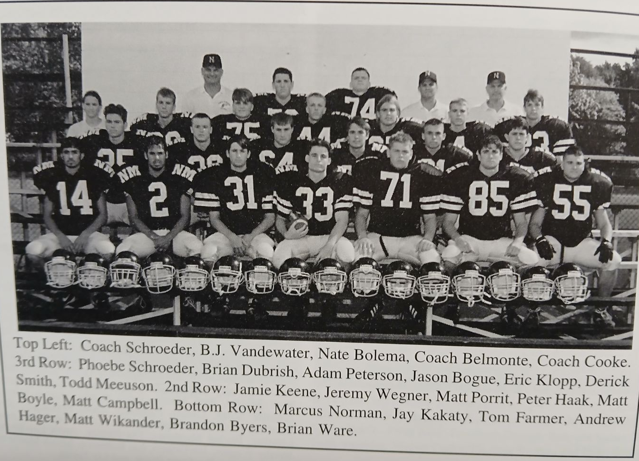

The 1996 NORSEMEN

Record Score Interesting Fact
- NM 25, Holton 12 Jamie Keene 2 FG & TD, Jason Bogue & Jeremy Wagner each a TD.
- NM 24, Shelby 6 Wegner 47 yd punt return, Tommy Farmer rec. fumble for TD.
- NM 27, Hart 12 Jay Kakaty 2 TD passes (47 to Wegner, 11 to Hager) Keene 2 TDs.
3-1 NM 6, Ravenna 7 Kakaty one yard TD, Extra point block vs. 1996 Class S state champs.
  - NM 20, Montague 30 Keene 9 yd TD, Kakaty 7 yd run TD, pass of 8 to Wegner for TD.
4-2 NM 27, Mason Co 6 Keene 4 TDs (10, 3, 10 and 3) and 261 yards.
4-3 NM 17, Whitehall 20 Keene 2 yd TD, 25- yd FG, Kakaty to Farmer 25-yd pass TD.
4-4 NM 0, Oakridge 45 NM gives up two quick scores as Oakridge clinches WMC.
4-5 NM 22, Grant 34 NM gives up 5 lg. TD runs. Keene TD & FG. Kakaty – Hager TD pass.

1997 Coach Dave Cooke (8-3 overall, - Playoff qualifier, Oakridge WMC Champs)

What a strange year it would prove to be for the Norsemen in 1997. In a conference that produced two state champions in Oakridge in CC and Ravenna in C, NM would defeat state Class C champ Ravenna and lose to state CC Oakridge by a 6-0 score. NM would win eight games on the season yet none of their wins, or losses were lopsided. Expectations were higher for 1997 with a solid group of returnees, most notably on offense. The most notable returning starter would be senior Jamie Keene, who rushed for more than 1200 yards last season and was honored as the Class D first team all-state kicker. Jeremy Wegner also returns as a regular while much of the offensive line is welcomed back by coach Dave Cooke, ready to begin his 27th year as a head coach.

NM used primarily their rushing game to defeat Holton 13-6 to begin the 1997 season. Jeremy Wegner and Jason Bogue did much of the work for the Norsemen. Wegner led the Norse with 109 yards rushing while Bogue, who chipped in with 41 yards rushing, was also a force on defense with 10 tackles. Holton took advantage of a Norse miscue when the snap from center went over punter Jeremy Wegner’s head and was recovered at the NM 4-yard line. That led to an opening touchdown for the visiting Red Devils, but that would be all the scoring the rest of the way for Holton. It was NM who then took advantage of a Holton fumble at Holton’s 22-yard line to produce their first score, a one-yard quarterback sneak by their new quarterback T.J Schumacher. Schumacher then added the second, and last score of the game with a seven-yard quarterback keeper. NM received a jolt early into the fourth quarter when Jason Bogue went down with a possible season ending knee injury.

NM was without the services of Jason Bogue but did welcome the return to action of Jamie Keene, who sat out the Norse opener. Keene was at his 1996 self as he rushed for 168 yards in 22 carries and two rushing Touchdowns. Keene also added a TD from his defensive post as he intercepted a Pirate pass and returned it 33 yards. TJ Schumacher was getting better and better in his first year as the NM quarterback as he rushed for a couple of TDs for their second straight victory to start the 1997 season.

The Norse showed they were for real in 1997 as they played an inspired defensive game to edge Ravenna 10-6. Jamie Keene rushed for 171 against a tough Bulldog defense and accounted for nine of the 10 NM points. Keene gave the Norse an early lead, and the first half’s only scoring when he booted a short 20-yard field goal. Keene then added the clincher when on a third and three he broke free and raced 45 yards for a touchdown. Ravenna than mounted their only scoring drive on the game with Neil Sladick scoring to close the gap to 10-6. Ravenna then was successful on the onside kick, but NM forced a four and out to run out the clock and take what would prove to be their biggest win of 1997. Feared lost for the season following an injury in the NM opener, the Norse were more than happy to see the return of Jason Bogue who had eight tackles for the winners.

The Norsemen then pulled off one of their biggest comeback victories in more than 90 years of NM football as they scored 17 unanswered points in the game’s final ten minutes to stun Montague 17-14. Trailing 14-0 with less than ten minutes remaining in the game, NM’s Nick Mosher picked up a fumble in Montague’s backfield and raced 20 yards for a touchdown with 9:23 showing on the clock. Fueled by a now energized offensive line --- Eric Klopp, B.J. Vanderwater, Adam Petersen, Nate Bolema, Matt Porritt, Peter Haak, and Mosher at tight end --- the Norsemen then put together a 10-play 74-yard scoring drive. Jamie Keene covered the final 18 yards for the TD and kicked the extra point to knot the game up at 14-14. Montague then got the ball back, but disaster struck once again for the stunned Wildcats. Jeremy Wegner recovered a fumble on Montague’s 29-yard line. Six plays later Keene, the all-state kicker from 1996, calmly kicked a 23-yard field goal for the game winner against the undefeated Wildcats. Sophomore Rick Martin was all over the field on defense with his 15 tackles.

Surely a letdown would be understandable following two very emotional victories over two of the top competitors in the WMC. But what a letdown! The Norse had defeated Mason County Central 24 out of their last 25 games, including the last 14 in a row. The Spartans pulled off the stunning upset on their homecoming night in Scottville with a 16-12 win over the punch less Norsemen. NM was held to just over 100 yards rushing the entire night, including holding NM’s Jamie Keene to his lowest rushing yardage in two years as he netted but 23 yards running the football. The difference in the game was in the extra points. After MCC scored first they completed a pass for two points. After TJ Schumacher teamed up with Nick Mosher for a 33-yard scoring strike the Norsemen were forced to go for two and failed. NM led 12-8 going into the fourth quarter following an eight run TD by Jason Bogue but again failed on the two-pointer. Mason County scored the winning touchdown in the fourth quarter on a one-yard run by quarterback Jason Bacon.

What a difference a week makes! After struggling against a Mason County team that would win only two games all year, the Norsemen showed their might with a convincing 49-20 victory over Class B Whitehall. Jamie Keene scored 37 of NM’s 49 points with five touchdowns, 3 extra points and a 31- yard field goal. Keene scored four rushing TDs on runs of 10, 10, 1 & 2 and caught a TD pass from TJ Schumacher from nine yards out for his fifth TD. At one point in the third quarter NM had built up a surprising 36-6 lead over the Vikings. Whitehall tallied the final touchdown on a 42-yard run by sophomore quarterback Nate McLouth, an athlete renowned for being a ‘fairly good’ baseball player. Also getting into the scoring column were Jon Grimm and Nick Thrasher. Grimm on a 14-yard pass from Schumacher while Thrasher tallied on a nine-yard run.

Facing the top ranked team, and the eventual state champ in Class CC would present an ominous task for any team, certainly a public-school Class D team such as North Muskegon. Oakridge with an enrollment more than twice the size of NMHS (482-201) just nipped the Norsemen 6-0. The win clinched the WMC title for Oakridge who would go on to post an 11-1 record with their only defeat coming the following week in a two-point loss to the Class C state champs from Ravenna. NM stood toe-to-toe with the Eagles, but a pair of lost fumbles and an interception stopped potential NM scoring drives. NM drove deep into Oakridge territory in the fourth quarter before turning over the ball on an interception by the Eagles Jeff Bowen. Oakridge took advantage of a short NM punt in the third quarter to score the game’s only touchdown.

Jamie Keene booted a school record three field goals in a game in North Muskegon’s 22-13 win over Shelby. Keene also scored a pair of rushing touchdowns to account for all of NM’s 22 points as NM improved to 6-2 on the season. Keene had another 100-yard rushing game, the 12th time surpassing the century mark in two years, with 134 yards. Jason Bogue was a force on defense in the Norse win with a game high 12 tackles.

Although they had already clinched a berth in the playoffs with a 6-2 record against Class B & C competition, the Norse wanted to make amends for being knocked out of the playoffs the previous year by Grant. This year it was NM who knocked Grant out of the playoffs as they were battling Orchard View for a spot in the playoffs. It took an overtime period for NM to pull out the victory, and it was Jamie Keene who rose to the occasion as NM edged Grant 27-24. After Grant failed to score in their possession in the overtime, NM head coach Dave Cooke called on his reliable kicker to bring home the victory. A perfect seven of seven in field goal tries during the season, Keene made it eight for eight to give NM the victory that insured them of homefield advantage in the upcoming playoffs. Keene rushed for 121 yards and one touchdown and kicked a pair of field goals to lead the Norse. Derrick Smith scored NM’s first TD in the second quarter when he returned an interception 56 yards to give the Norse a 10-6 lead. For the second straight year Grant returned a kickoff back for a touchdown to give Grant the lead at halftime. Grant went up 18-10 on a Scott VanSingel 39-yard TD run. The Norse then tied up the score on a Keene 21-yard dash and an all-important two-pointer on a TJ Schumacher run. With just 1:18 remaining in the game Grant tied the game at 24-24 on a TD pass. It was then that Grant head coach Dave Eichberg made a decision that he will rue forever. Instead of kicking the extra point, Eichberg due to his long snapper being injured, went for the two-pointer that was stopped by NM and forced overtime.

The Norse almost let one get away as a pass happy Mount Pleasant Sacred Heart team scored two fourth quarter touchdowns but failed on two-pointers following each of their touchdowns as NM prevailed 21-19. Jamie Keene again had a monster game for the Norse. Keene ran for 221 yards on a school record (perhaps) 39 carries and scored two touchdowns. While NM garnered most of their yards on the ground (279 of 300 total yards), Mount Pleasant Sacred Heart took to the air to move the ball against the Norse as they attempted a whopping 36 passes while completing 17 for 160 yards. Keene’s perfect 3-3 on extra-point kicks would prove to be the difference. Jeremy Wegner may have saved the day for the Norse as he batted a pass away in the end zone as MPSH attempted a two-pointer that would have tied in the game late in the fourth quarter.

NM’s season game to an agonizing close as a Bay City All Saints touchdown in the fourth quarter ended the NM season with an 8-3 record. The Norse were leading 7-6 before the visitors from Bay City scored the winning touchdown in the final quarter. However, it was perhaps in the first half when NM lost this game. With just 20 seconds left in the first half All Saints quarterback Nick Grange hooked up on a 41-yard pass play to his favorite received Craig Francis. With NM’s top defender Derrick Smith on the sidelines with an early injury, Grange completed two more passes to Francis, the final pass was good for a nine-yard completion and with just nine seconds left in the half All-Saints trailed by only a point after their extra point attempt was blocked by Jon Grimm. But instead of the shutout, All Saints turned NM’s game back around in a matter of seconds. “We should have gone in at halftime up 10-0, or maybe 17-0.” Said NM coach Cooke. “In a close ball game against a good club, you can’t make those kinds of mistakes.” All Saints began their winning drive after intercepting a Norse pass with 6:18 to go in the game. A 14-yard pass play, and a 30-yard run set up the All Saints 3-yard TD run that finished off the Norse season.

Finally--- Dave Cooke was selected as the Area Coach of the Year by leading his 19 player NM team to an 8-3 record. Cooke was given the honor even though two other schools, Oakridge and Ravenna won state titles. Cooke was joined on all area team by Jamie Keene and tackle Nate Bolema on offense while Eric Klop and Derrick Smith were accorded honors on the first team all-area defensive team. Keene was also chosen again as the all-area kicker. Keene and Smith were also picked as first team all staters by both the Detroit Free Press as well as the AP vote selected by the state media.

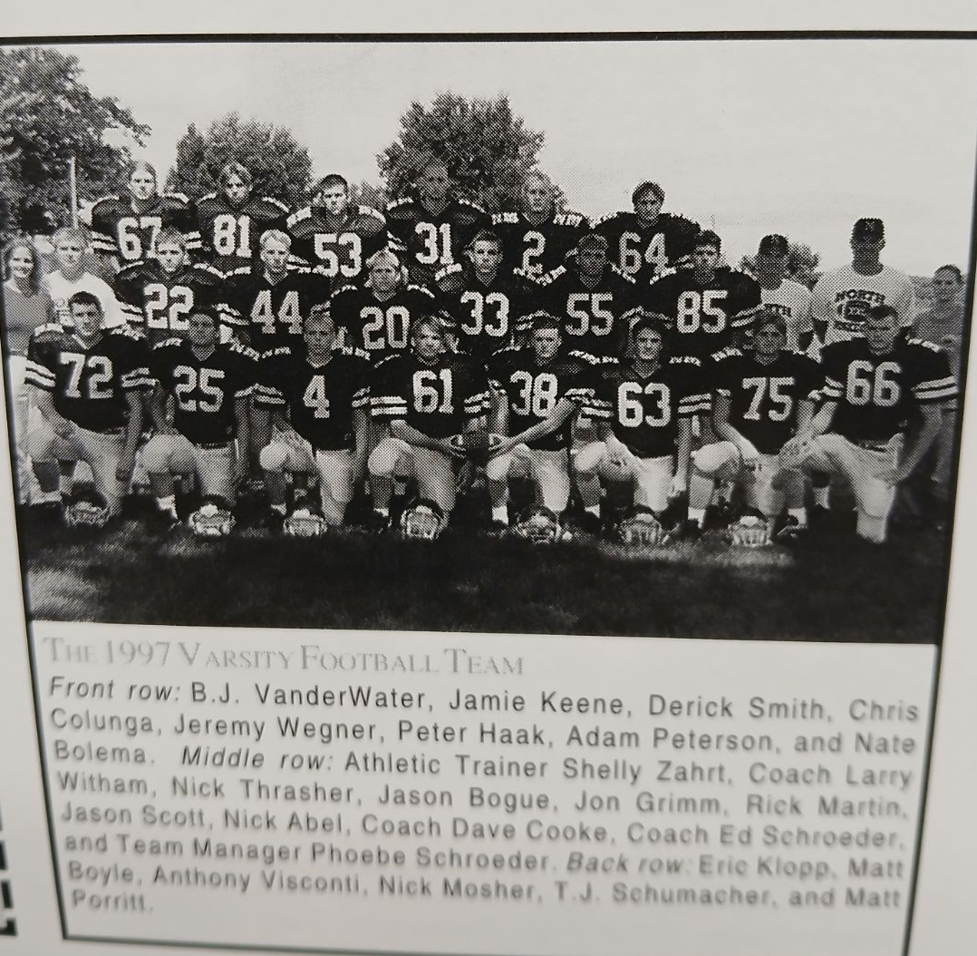

The 1997 NORSEMEN

Record Score Interesting Fact

1-0 NM 13, Holton 6 TJ Schumacher 2 TDs (1 & 7) Jeremy Wegner 109 yards rushing.
2-0 NM 35, Hart 12 Jamie Keene 168 yds, 3 TDS, Schumacher 2 TDs.
- NM 10, Ravenna 6 Keene 171 yds, 45-yard TD and 20-yard field goal.
4-0 NM 17, Montague 14 NM scores last 17 points. Nick Moser 20 yd fumble recovery, Keene 18 yd TD, winning 23- yard field goal.
4-1 NM 12, Mason Co 16 Schumacher to Moser 33 yd TD pass. Bogue 8-yard TD.
5-1 NM 49, Whitehall 20 Keene 5 TDs, 4 rush and pass from Schmacher.
5-2 NM 0, Oakridge6 Keene 72 yards as NM holds state champs to 6-0 margin.

6-2 NM 22, Shelby 13 Keene 3 field goals and 2 TDs.
7-2 NM 27, Grant 24 Keene’s FG in OT the winner. Keene 2 FG & TD. Derrick Smith 56 yd interception return for TD. Schumacher one-yard TD and big two-point run.
8-2* NM 21, MPSH 19 Keene 2 TDs, Schumacher 1 Wegner batted away 2-pointer for tie.
7-3* NM 7, Bay City AS 14 Keene TD. All Saints scores with :08 before half and late TD.

1998 Coach Dave Cooke (3-6 overall, Whitehall WMC Champs)

It would be a couple of lean years for NM football as the Norsemen would only win four games until they entered the next century. There would also be a new look for NM football beginning with the 1998 season, a co-op partner with West Michigan Christian. The good news for this new idea, NM would get additional players, the bad news the Norse would move up to Class CC as they had to use the combined enrollment of the two schools. Over the years that this co-op took place, WMC generally supplied 2-4 four players a year with only a handful making notable contributions. Even with the addition of the WMC players, none of whom had any playing experience, the Norse numbers would still be small as head coach Dave Cooke’s NM team would only field 20 players, four of whom would be sophomores. NM would field four starters back on offense and only three on defense, not a recipe for success.

It didn’t take but their season opener to note that this might be a tough year for Norsemen football. Holton would hand NM their most decisive defeat in a series that has been dominated by the Norse, 33-6 in the season opener. NM could never find any kind of rhythm in the game as they fumbled three times in the first half. NM’s only score came in the third quarter when returning starting quarterback TJ Schumacher scored on a 12-yard keeper. One bright spot for the Norsemen was the play of linebacker Rick Martin who made 11 tackles.

NM then recorded one of their two wins on the season with a 13-6 victory over Hart. It was the 61st meeting between the two rivals with Hart winning only five of the past meetings between the two long-time foes. Just as they have often done in the past NM used their kicking game to procure the victory. Replacing two-time all-state kicker Jamie Keene in 1998 would be Karl DePoy. It was two made field goals by DePoy from 25- and 26-yards yards that would prove to be the difference in the 13-6 Norse victory. Returning three-year starter Jason Bogue was the top performer on defense as Bogue had nine tackles, a blocked punt, and an interception. The only touchdown scored by the Norse was a one-yard plunge by Rick Martin in the second half. TJ Schumaker had a productive passing game by connecting on 10 of 14 for 110 yards.

The Norse were no match in their next contest with the defending Class C state champs as Ravenna used several big plays to stampede the Norsemen 38-7. Ravenna scored on long runs from 49, 84, 46, 75, and a more modest scamper from 10 to bury the Norse and partially make amends for NM’s 10-6 upset of the Bulldogs last season. Ravenna junior Kent Keresbury kept up the tradition of yardage chomping Bulldogs tailbacks of late as he rushed for 317 yards against the NM defense. NM’s lone score came in the third period as quarterback T J Schumacher found junior Justin Wikander all alone to complete a 46-yard TD pass. A bright spot for NM on defense was the recorded 16 tackles by Anthony Visconti.

NM’s offensive woes continued as Montague shutout the Norse 26 to 0 as the Wildcat defense held NM to minus -7 yards rushing and under 100 yards in total offense. All of Montague’s offense came on 289 rushing yards as Montague never was forced to pass. All NM’s yardage came via the airwaves as TJ Schumacher was 7-of-12 passing for 99 yards. Anthony Visconti with 14 and Jason Bogue with 12 tackles were the stalwarts on defense for the Norsemen.

The offense remained stagnant, but the defense came up with some big plays to lead the Norse to their second, and last victory on the season with a 21-14 win over Mason County Central. Justin Visconti’s fumble recovery on the Spartan’s one and Ricky Martin’s blocked punt contributed to the NM win. TJ Schumacher scored one play after Visconti’s recovery while Nick Thasher followed Martin’s block with a nine-yard touchdown to give NM a 14-6 lead. The Spartans rallied to tie the game at the halftime break at 14-14. NM scored on the game winning, and only TD in the second half as they took the opening kickoff to begin the third quarter and marched 65 yards in 15 plays with the winning play a 7-yard pass from Shumacher to Justin Visconti.

Whitehall’s first game in the WMC was back in 1932. They would have to wait 66 years before the Vikings would win an outright WMC championship. Whitehall made sure that North Muskegon was not going to be an obstacle to obtain their goal as they rolled over the Norse 50-7, Whitehall’s widest margin of victory all time over NM. Whitehall totaled 515 total yards with Jason Johnson rushing for 245 yards and four touchdowns as the Vikings posted their first undefeated and untied regular season in their school’s history. A 22-7 halftime lead turned into a blowout as Whitehall scored 28 unanswered points after halftime. NM’s only score game on a 74-yard scamper by Nick Thrasher.

Two early fumbles that led to Oakridge fumbles took the energy out of the
Norsemen as they fell to Oakridge 32-0. NM couldn’t get anything mounted on offense as Oakridge stuffed the Norsemen, allowing just 68 total yards for the entire game.

NM unveiled a sophomore quarterback in their game against Shelby and Nick Marietti didn’t waste any time to show what he could do with the pigskin. Marietti connected on TD strikes of 35 yards to Jon Grimm and 4-yards to Rick Martin in the first quarter enroute to a 17-6 win. Martin set up his touchdown reception by blocking a punt. Shelby closed the gap to 14-6 but Kyle DePoy sewed the game up in the fourth quarter by knocking through the uprights a 28-yard field goal. Marietti completed 6 of 12 passes for 81 yards ensuring that the Norsemen would be in good hands at quarterback for the next couple of seasons. Nick Thasher topped the century mark in rushing with 114 yards in 30 carries.

North Muskegon didn’t go out and schedule a ‘puppy’ to play in their last game of the 1998 season. The Norse added Fulton-Middleton to their schedule and were soundly beaten by the Lansing Area School 42-14. ‘All’ Fulton-Middleton would do was go on and win the Class DD state championship. F-M had the total offensive package against the Norsemen as they rushed for 349 yards and passed for 167. Nick Thrasher scored both of NM’s TDs against the state champs of ‘98’ on runs of three and 28. Jason Bogue left everything he had out on the field as he had 21 tackles.

For the first time in several years the Norsemen were left without an all-state player. Anthony Visconti was tabbed for first team honors on the all-area team while Jason Bogue, and lineman Jason Scott were picked for the second team on defense. Kyle DePoy was picked for the second team all-area C/D kicker.

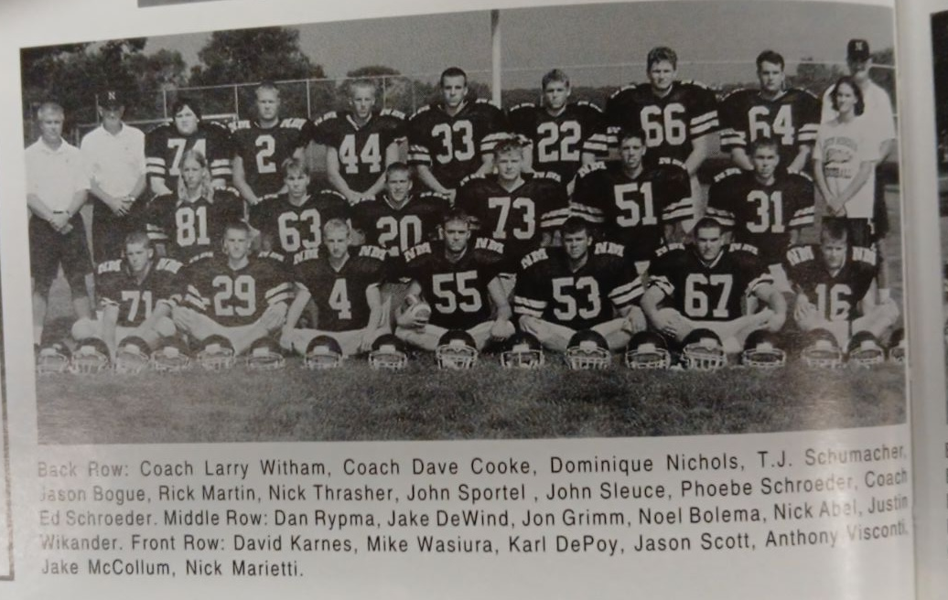

The 1998 NORSEMEN

Record Score Interesting Fact
0-1 NM 6, Holton 33 TJ Schumacher scores on NM TD on a 12-yard keeper.
1-1 NM 13, Hart 6 Karl DePoy 2 field goals, Rick Martin 1 yd TD run.
1-2 NM 7, Ravenna 38 Schumacher 46-yard TD pass to Justin Wikander only NM score.
1-3 NM 0, Montague 26 Schumacker 7 of 12 passing for 99 yards. NM -7 yards rushing.
2-3 NM 21, Mason Co 14 2 MCC TO’s’s lead to NM scores. Schumacher – Wikander 7 yds TD.
2-4 NM 7, Whitehall 50 Nick Thrasher 74-yard TD. Anthony Visconti 12 tackles.
2-5 NM 0, Oakridge 32 NM only 68 total yards as turnovers lead to 2 quick Oakridge
3-5 NM 17, Shelby 6 NickMarietti TD passes of 35 & 4 to Jon Grimm and Martin.
3-6 NM 14, Middleton-F 42 Thrasher 3 and 28 yd TDs. Jason Bogue 21 tackles.

1999 Coach Dave Cooke (1-8 overall, Whitehall WMC Champs)

The playoffs have changed immeasurably over the years since they began in 1975. For the first few years there were teams with perfect 9-0 records who wouldn’t qualify for the playoffs. Until 1989 there were only four state champs, and it was still not a walk-in-the-park to qualify when state champs were doubled beginning in 1990. However, beginning with the 1999 season another week was added to the schedule that now doubled the number of teams that could qualify for the playoffs. One simply had to win six, games, or five if one played an eight-game schedule and you are in. 1999 would be a down year for the Norsemen and they wouldn’t come close to qualifying as they were only able to procure but one win. Fortunately, it would only be a blip for one year. There was good news and bad news for the 1999 Norsemen. The first good news is the return for his 29th year of coaching Dave Cooke. The bad news for Cooke: he will be coaching from a cart or on crutches after a hip replacement during the summer. The other good news: there were 26 players suited up for the varsity, a boost from prior years when as few as 17 would be suited up in their blue and gold uniforms. The bad news: Only one starter on offense and three on defense return from 1998. Only six seniors would be on the NM roster with the remaining consisting of underclassmen. The co-op with WMC would bring a pair of underclassmen who would help the Norse in running back Marlin James and linebacker Michael Klobucher.

With the necessity of an extra game to accommodate all the teams who would qualify during the regular season to enter the playoffs, the Norsemen would play their first game in history during the month of August. It was not a pretty opener for the Norse at Fred Jacks Field as they lost to Holton 27-19 in the first game ever played in August by a NM team. It took only the first play from scrimmage that signs pointed to a possible bad omen for NM as they fumbled on their very first play. Holton turned the miscue into a touchdown, and it wouldn’t be the last NM turnover. After NM took the lead on a pair of TDs, the first a one-yard run by fullback Rick Martin, and the second a 60-yard sprint by freshman Jeremy Scott, disaster again fell upon the Norse. Holton fell upon another Norse fumble with two minutes left in the half and they scored the go-ahead touchdown and held on to defeat NM 27-19. Junior quarterback Nick Marietti teamed up with Justin Wickander from 29 yards out to close the gap to less than one score. NM was doomed when yet another fumble late in the game was recovered by Holton in the end zone for the game’s final score. It was no disgrace to lose to Holton as this was one of the strongest teams in Holton history as the Red Devils went 7-1 in the regular season, won a playoff game before losing to eventual state finalist in Hopkins.

Ravenna pushed across two third quarter touchdowns to hand the Norse their second defeat to start the 1999 season. Using their traditional power I offense with their tailback getting most the carries, Ravenna tailback Kenny Cook rushed for 267 yards on 42 carries and scored both Bulldog TDs. The Norse were only 5-19 in the passing department for 38 yards while freshman running back Jeremy Scott was limited to 58 rushing yards as Ravenna’s defense dominated the game.

North Muskegon would win their only game of the season as they defeated their oldest rival, the Montague Wildcats 32-8 to complete their first three home games of the season. Rod Melton returned Montague’s very short kick off to begin the game 55 yards to give the Norse a 6-0 lead. Montague then regained the lead at 8-6 in the second quarter before NM regained the lead for keeps as Melton scored his second TD, a 21-yard pass from Nick Marietti. NM then improved on their 12-8 halftime lead with three short TD runs in the second half: Jeremy Scott and Mike Wasiura from one and Marlin James from two yards out.

For the first time in the 56 years since NM played Scottville, the Spartans shut out the Norsemen 21-0. NM didn’t help their cause as they committed four turnovers while also having a pair of miscues from their punting team. NM was held to only 70 yards of total offense, 42 of those yards picked up on the ground by running back Marlin James.

For the second straight week NM failed to score a point as the WMC 1999 champs from Whitehall shutout the Norse 25-0. Whitehall back Jason Johnson again had a field day against the Norse with 244 of Whitehall’s 274 rushing yards earned during the game. Johnson even hurt the NM bid to score a touchdown in the first half. With the Norse trailing 6-0, Spencer Suchy intercepted a Nate McLouth pass and was headed for the goal before he was caught from behind by Bryce Smith. Suchy fumbled and the ball was recovered at the NM ten by Johnson. Future MLB all-star outfielder Nate McLouth was 9-17 passing for Whitehall while his counterpart Nick Marietti finished at 6-18. Both McLouth and Marietti were shortstops on their school’s baseball teams in the spring. Nick Martin was a force for NM on defense as the Norse linebacker had 16 tackles in the loss.

NM led heavily favored Oakridge through three quarters of play before the Eagles scored a pair of fourth quarter TDs to edge the Norse 22-15. NM enjoyed a halftime lead over the Eagles when Rick Martin punched it in from seven yards out and Karl DePoy converted on the extra point. Oakridge took the lead on the first of Mike Rhanor’s two TDS in the fourth quarter. A bad snap from center set up Rhanor’s second score. NM scored late on a Nick Marietti 20-yard TD pass to Spencer Suchy and a two-point conversion made it 22-15. The Eagles were then able to run out the clock to deprive NM of a possible upset. Marietti was 9-14 for 147 yards in the loss.

After playing an always tough Oakridge team close the previous week, NM suffered a letdown and were soundly defeated by Shelby 34-8. Shelby used a potent passing attack in their convincing win as the combo of QB Jim Gice and Josh Ford teamed up for three TD passes. Shelby was never threatened as they took a 34-0 halftime lead over the Norsemen. NM earned their only touchdown in the game on a fourth quarter 39-yard run by West Michigan Christian student Marlin James.

NM edged Hart in total yards 240-203 but three interceptions aided Hart to a 28-15 victory over the Norse. One of the interception’s took place in the Hart end zone to thwart a possible NM score while another led to a Pirate TD as the Norse fell to 1-7 on the season. Mike Wasiura caught a 20-yd TD pass from Nick Marietti for the first of two NM TDs on the night. Rick Martin added the second in the third period on a short 3-yard run.

NM ended their season with the long road trip to Fulton (or was the game in Middleton?) as they lost their final game to the defending Class DD state champs 34-14. Rick Martin was able to rush for 135 yards, including a 48-yard run to lead the Norse. Nick Marietti ran for the other NM score as the young Norse ended a rare losing season at 1-8. The experience gained in 1999 would pay off better dividends the following season.

As one might expect when a team finished 1-8 on the season that there would not be a slew of NM players selected for post-season honors. However, junior tackle Kirk Long was picked for the first team all-area defensive squad while linebacker Rick Martin made 2nd team as a linebacker. There was quality on the 1999-all area team as two of the all-area picks, Muskegon Catholic’s Ruvell Martin and Ravenna’s Todd Herremans would have productive careers in the NFL, and both would be selected to the Muskegon Area Sports Hall of Fame. Yet another first team pick in Class A & B was Whitehall’s Nate McLouth, a future MLB all-star who joins both Martin and Herremans in the MASHOF.

The 1999 NORSEMEN

Record Score Interesting Fact
0-1 NM 19, Holton 27 Jeremy Scott 60-yd TD, Rick Martin TD, Nick Marietti – Justin Visconti 39-yard TD pass.
0-2 NM 0, Ravenna 12 NM only 5-19 passing, Scott 58-yard rushing.
1-2 NM 32, Montague 8 Rod Melton 2 TDs, Scott, Marlin James, Mike Wasirua TDs.
1-3 NM 0, Mason Co 21 Four turnovers mar Norse cause. James 42 rushing yds.
1-4 NM 0, Whitehall 25 Future MLB all-star Nate McLouth leads Vikings to win.
1-5 NM 15, Oakridge 22 Martin 7 Yd. TD. Marietti to Spencer Suchy 20-yd TD pass.
1-6 NM 8, Shelby 34 James 39-yd TD & late safety all points earned by NM.
1-7 NM 15, Hart 28 Marietti to Wasiura 20-yd TD. Martin 3-yard TD.
1-8 NM 14, Mid-Fult 34 Martin 48-yard TD run, Marietti TD.

2000 Coach Dave Cooke (7-3 overall, Playoff qualifier, Oakridge WMC Champs)

NM rebounded from their 1-8 season to nearly flip the script as they begin the 21st century. John Slucum and Larry Witham would be head coach Dave Cooke’s assistants as Cooke would be without, for the first time in many years, his loyal assistant Ed Schroeder. Thanks to the co-op program with West Michigan Christian, 28 gridders would be on the 2000 roster, with 10 of those players coming from WMC. The co-op program, beginning its second season did come with a big change if they were to qualify for the playoffs. For playoff purposes, NM would have to use the combined enrollment of the two schools, pushing NM up to the CC level. Six starters from the previous season would return from 1999, including quarterback Nick Marietti and their lone all-area first team selectee lineman Kirk Long. Seven players would return on defense, but the return of numerous starters would have its drawbacks as a possible nine players would go both ways, leaving late game fatigue perhaps an issue. A new football building named after the late John Pavlich would be completed during the season, a welcome addition for Norse football.

Once again Holton, a team coming off their best season in their school’s history would be NM’s opponent to begin the season. The Norse broke the Red Devil’s modest two-game winning streak over the Norse, but not my much, as NM edged Holton 8-7. It didn’t take long for NM to utilize one of those ten players from West Michigan Christian that led the Norse to their victory. Holton jumped out in front with an early first quarter touchdown and kicked the extra point to lead NM 7-0. Norse quarterback Nick Marietti threw a swing pass to Rod Melton in the second quarter that Melton took 44 yards for a touchdown to cut the lead to 7-6. Coach Cooke made the decision to go for two points and Marietti connected with WMC student Ryan Portenga for a two-pointer for what would prove to be the winning point as neither team scored in the second half.

Ravenna tailback Kenny Cook burned the Norse for the second straight year as he again grounded out more than 200 yards as Ravenna scored three unanswered touchdowns to defeat NM 28-6. Running behind the blocking of future NFL lineman Todd Herremans, Cook scored a pair of TDs, including a 29-yard tally. NM had tied the game at 6-6 late in the first quarter with what would prove to be their only score in the game, a 58-yard run by Rod Melton. The Bulldogs defense then allowed NM only 71 rushing yards for the rest of the game. The Bulldogs secondary rose to the occasion as well, as they intercepted three NM passes. “I don’t think we showed what we are capable of as a team tonight,” said NM coach Cooke, “Ravenna is a very sound team fundamentally and you can’t make mistakes like we made tonight and expect to win.” Cooke’s prophecy was right as NM would win six of their next seven contests.

North Muskegon rallied from a 15-6 deficit to score two touchdowns in the game’s final five minutes to escape with a 22-15 victory over Montague. Nick Marietti tossed a six-yard touchdown pass to Rod Melton with 4:56 left in the game to cut the deficit to one point after their successful two-point conversion. The Norse recovered the onside kick to get the ball back and mounted their game winning drive that was capped by a Jeremy Scott 3-yard TD run with 2:09 left. Montague advanced to the NM 20-yard line before Melton picked off a Montague pass to stop the drive and give the Norse the win. NM had to savor the victory over the Wildcats as Montague would win an unprecedented 15 straight victories over the ensuing years over the Norse.

NM again pulled out a late come from behind victory as they scored the winning points with only 1:32 left to play after trailing by four to lift the Norse to a 19-16 victory over Mason County Central. Nick Marietti and Rod Melton, who also served as the backcourt pair on NM’s basketball team, teamed up on a 16-yard TD pass for the win. Melton, for the second straight week, intercepted a pass from Mason County on their last possession to halt a last-minute Spartan drive. Mason County led 10-6 at halftime before NM regained the lead on a short 3-yard run by Mike Waisura. MCC then countered with a fourth quarter tally to set up NM’s final heroics. Marlin James scored the initial NM TD from three yards for the only Norse score in the first half. James would rush for 74 yards while Marietti was 8-13 passing with Melton catching five of those passes for 79 yards, including the game winner.

There was no need for any last-minute comeback’s needed as NM scored all 21 points in the first three quarters to shut out Whitehall 21-0. The game was played in the rain as NM used their ground game to down the Vikings as three different Norse backs scored. Jeremy Scott scored the first touchdown on a short two-yard run and Rod Melton added the second on a 41-yard dash. NM took advantage of one of Whitehall’s four turnovers in the third quarter to notch their final TD. A Whitehall fumble at the Viking 15-yard line led to a 1-yard dive into the end zone from Marlin James to complete the scoring. After having their first two extra points from placement blocked in games one and two, the Norse shored up their blocking giving kicker Nick Marietti time to get away his kicks where he was a perfect 3-3.

North Muskegon threw a real scare into Oakridge as the Eagles needed a late touchdown to hold off the resurging Norsemen 22-14. With the aid of costly major penalties that totaled 45 yards, Oakridge was able to go 59 yards, with the winning tally a 11-yard TD by Jeff Williamson. Oakridge started the game as if they were going to breeze to an easy victory over the Norse as they took a 14-0 lead on two short TD runs by Ray Stover. The tide turned in the second half as NM scored a pair of TDs to tie the game at 14-14. The first NM TD came on a whacky play. Nick Marietti tossed a short pass to tight end Kirk Long who after making the catch fumbled the ball. Rod Melton picked up the loose ball and ran 20 yards before fumbling near the goal line only to have Melton jump on his own fumble in the end zone for a crazy NM TD. NM then tied the game on a 70-yard drive that culminated when Marietti connected with Marlin James on a screen pass that went 13 yards and a TD. NM had a chance to perhaps tie the game as a pass to a wide-open Norse receiver that had touchdown written all over it was dropped.

NM scored the first 31 points and received a great boost from a pair of West Michigan Christian student athletes in their 31-7 win over Shelby. Marlin James had a career best 199 rushing yards and a pair of TDs while Ryan Portenga scored on a TD on a pass from Nick Marietti as the Norse improved to 5-2, just one win shy of qualifying for the playoffs. Mike Wasiura finished with 80 rushing yards that included NM’s final TD on his 37-yard run. NM got on the scoreboard first with the team’s first field goal of the season, a 28-yard boot by Marietti.

The Norse were back again in the playoffs after soundly defeating Hart 33-6. The combo of Nick Marietti to Rod Melton worked their magic seven times good for 117 yard and three touchdowns as NM mixed the run game with their passing to subdue the Pirates. The Norse had long scoring drives of 80, 92, 61 and 56 to the delight of the home fans in attendance at Fred Jack Field. Marlin James scored two touchdowns and rushed for 90 of their 174 yards on the ground. Marietti was 12 of 17 passing for 192 yards with passing TDs to Melton from 6, 12, and 37 yards. Junior Mike Klobucher led the NM defense with 17 tackles.

On a perfect Indian Summer Saturday afternoon at Fred Jacks Field North Muskegon closed their regular season with a 38-17 victory over Fulton-Middleton. Nick Marietti threw four touchdown passes and kicked a field goal to lead NM to victory. Marietti first found his favorite receiver Rod Melton for a 35-yard hookup. The Norse QB’s other scoring tosses went to West Michigan Christian students Marlin James and Ryan Portenga. With the score knotted up at 17-17 in the third quarter the Norse exploded for 21 unanswered points. Marietti connected with Portenga twice for touchdowns. The first good for 34 and the second for 18. Jeremy Scott closed out the scoring with a short TD run as NM won their first game against Fulton Middleton in the third of four contests between the two schools in a four-game series that would end in 2001.

NM would qualify for the playoffs, and they would again travel to Oakridge to play the Eagles for the second time in the season. NM lost by a touchdown in their first meeting, it would come even closer in the second matchup. NM got off to a great start against the Eagles as they jumped out to a 13-0 halftime lead. NM totally outplayed Oakridge in the first half as they had a 156-47 total yardage advantage. It could have--and should have been --an even bigger Norse lead at the conclusion of the first two quarters. “We had them on the run in the first half,” said NM coach Dave Cooke. But so many times we were our worse enemy. We had two interceptions, two fumbles and penalties in key situations. We haven’t had those in the last three, four weeks. You can’t make those turnovers against a good ball club.” NM regrouped after all those early miscues and scored first on a 24-yard scoring pass from Nick Marietti to Rod Melton. NM did get a break on the last play before halftime as the Norse were attempting a field goal. The kicker Marietti picked up the ball after a bad snap from center and lofted a 14-yard TD pass to Matt Geyer. Coming off the bench and setting up their second TD was a sophomore from the JV team, 6’10 basketball star Drew Naymick. The future Michigan State starting center set up the TD with a huge 20-yard competition on a fourth downplay. For the third time this season Marietti had what would prove to be critical extra point attempt blocked. The Eagles scored a TD in the third and fourth quarter and made both extra points to take a 14-13 lead. With still half of the fourth quarter remaining the Norse had their chances. The first drive to retake the lead ended after a costly fourth-and-one penalty forced NM to punt. Oakridge then punted and the ball was downed at the one-yard line. Faced with a dilemma of traversing 99 yards with no time outs, NM picked up two first downs but ran out of time in a valiant effort against the 2000 West Michigan Conference champs, ending their season with a very good 7-3 record.

The Norsemen fared very well as far as post season accolades on the C/D All-Area team. Nick Marietti was the C/D quarterback picked. The No. 1 ranked student academically in his class completed 82-of 169 passes for 1169 yards and 16 touchdowns. Also picked on the first team was his favorite receiver, Rod Melton who caught 37 of Marietti’s passes for 599 yards and 10 TDs. Kirk Long, not only made the all-area team as a tight end, tackle fullback, or wherever needed, Long also made the prestigious Detroit Free Press All-State team. Running back Marlon James made the second team all-area team while Josh Dagen, Mike Wasiura, and a pair of Western Michigan students playing for the Norsemen, Mike Klobucher and future Mona Shores Athletic Director Ryan Portenga were honored on the second team all-area defensive team. It would be 23 years before NM would have another first team pick on the Detroit Free Press All State team: TJ Byard in 2023.

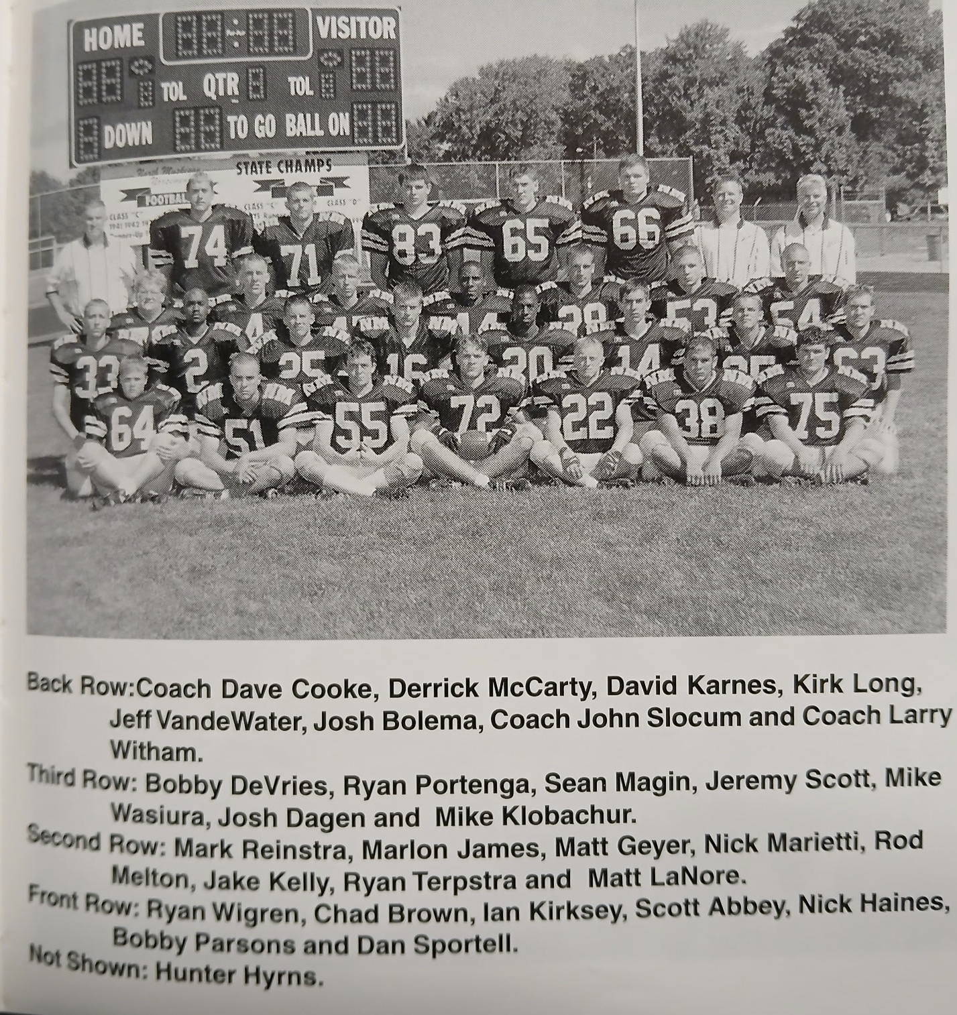

The 2000 NORSEMEN

Record Score Interesting Fact

1-0 NM 8, Holton 7 Nick Marietti to Rod Melton 44 yd TD. NM pass to Ryan Portenga PAT for the game winning TD. Jeremy Scott 81 rushing yards, Marietti 8-17, 87 passing yds.
1-1 NM 6, Ravenna 28 Melton 55-yard TD run for NM’s only score.
2-1 NM 22, Montague 15 Marietti to Melton 2 TDs, Scott the game winning TD.
3-1 NM 19, Mason Co 16 Marietti – Melton TD for win, Marlin James, Mike Wasiura TDs.
4-1 NM 21, Whitehall 0 Scott (2 yds), Melton (41) and James (1) score NM TDs.
4-2 NM 14, Oakridge 22 Melton TD on a fumble. Marietti to James 13 yd TD pass.
5-2 NM 31, Shelby 7 James 2 Yds, 199 yds rushing. Portenga & Wasiura TDs.
6-2 NM 33, Hart 6 Marietti to Melton 3 TDs (6, 12 & 17) James 2 TDs.
7-2 NM 38. Mid-Fult. 17 Marietti 4 TD passes (2 to Portenga, 1 to James & Melton)
7-3* NM 13, Oakridge 14 Marietti to Melton 24 pass TD, Marietti to Matt Geyer 14 yds.

2001 Coach Dave Cooke (2-7 overall, Oakridge-Montague-Ravenna WMC Champs)

An era would come to an end as the 2001 season would be the 22nd and final season for Dave Cooke as the head coach. Cooke would win 130 games during his tenure, easily the most wins by a NM coach over the 91 years of Norse football that won 495 games as of the beginning of the 2024 season. NM made the playoffs 13 times under Cooke’s leadership, second in Greater Muskegon to only Muskegon Catholic. What makes his record so notable was that North Muskegon was always the smallest school in enrollment in the WMC, and the area, throughout his 22 years. Most of his playoff teams came well before the MHSAA added an extra week that doubled teams eligible to qualify for the playoffs. Cooke’s 1981 team was the first team from the powerful West Michigan Conference to play for a state championship. Following his retirement from NM Cooke for many years would serve as a TV commentator with his friend John Arter, following his high school alma mater at Muskegon High. A very young Norse team would take their lumps in 2001 and although their 2-7 record was not up to their usual standards under Cooke’s 22 years at the helm, NM was competitive in each game.

The 2001 season got off to a promising start with a 35-12 victory over Holton. Tony Shyne accounted for 239 all-purpose yards, including second half TDs on a 42-yard run and a 72-yard kickoff return. West Michigan Christian student Jake Kelly would take over the signal calling duties at quarterback in 2001 and threw for two scores, a 31-yard pass to Sean Scott and a 22-yarder to Geoff Dean. Sean’s brother Jeremy Scott rushed for 91 yards and added a 2-yard TD for the Norse. Mike Klobucher, a two-year starter for NM, who would go down in Norse annals that would compare with the likes of Dave Taylor and Sam Parker as a top linebacker, had 15 tackles to lead the Norse.

NM came within one point of tying Montague early into the second half before Montague scored three unanswered touchdowns to pull away from the Norse in their 43-21 victory. A new precedent had been set in 2021 with teams now beginning play before Labor Day. Many schools had now opted to play games on Thursday of the Holiday weekend and 2021 would be the first game NM would play on a Thursday night. NM scored first against Montague on a 57-yard TD pass from Jake Kelly to Nick Haines. Kelly kept the Norsemen close with a second quarter pass good for six points to Jeremy Scott. Fullback Mike Klobucher drew NM within one at 22-21 when he muscled over from the nine-yard line, but Norse miscues led to Montague touchdowns as four turnovers doomed any Norse chances of pulling off the win.

Scottville (Mason County Central) and North Muskegon have played 81 games over the years. Scottville has posted just one lone shutout against the Norse, the 2001 9-0 victory at Scottville. As it turned out all the scoring the Spartans needed came on a field goal in the first half. They then clinched the contest as they returned the opening kickoff of the second half 94 yards. Mike Klobucher was the story for the Norse on defense as the NM linebacker had 12 tackles. NM’s offense was virtually non-existent as they totaled only 18 yards for the game.

Whitehall began a six-game winning streak against the Norse with a 24-14 victory. The game was played just days after the infamous attack of September 11, 2001, and was a welcome diversion for high school football fans across the nation. The game with Whitehall was a tale of two halves. NM scored two second quarter touchdowns to take a 14-7 lead at halftime. Nick Haines completed a NM drive with a 4-yard run and shortly before half, Tony Shyne electrified the Norse crowd with a 58-yard TD run. However, the second half all belonged to Whitehall, especially the third period. The Vikings amassed 127 yards while the Norse were in the negative column with a minus -8 total yards. Mike Klobuchar had another monster game defensively for the Norse with 21 tackles.

Oakridge totaled 500 yards opposed to NM’s 90 as the Eagles downed the Norsemen 38-6. North Muskegon’s only touchdown came on defense on a 60-yard interception return from Geoff Dean. The less said about this game, the better.

NM scored first, gave up 15 unanswered points to Shelby, and nearly scored a TD at the end but it wasn’t to be for the Norse who lost 15-7 to the Tigers. Mike Klobuchor’s nine-yard YD run gave NM a 7-0 lead at the end of the first quarter but that was it for the Norse. Shelby tallied touchdowns in the second and third quarter before the Norse made a last-ditch rally. With just five second left in the game and NM at the Shelby 7-yard line, the West Michigan Christian Co-op of Jake Kelly and Klobuchor tried to connect on a pass in the end zone, but the pass fell incomplete as time expired.

Tony Shyne and Mike Klobuchor had huge games as NM finally put their offense together in a 48-7 rout of Hart. Klobuchor scored 4 touchdowns, three coming on short runs of 9, 8 & 2 and added a fourth TD when he caught a pass from Jake Kelly that totaled 24 yards. Shyne had a career day in rushing as he ran for 215 yards in but 10 carries. His two TD runs were long distance journeys: the first a sprint from 72 yards and the second a 95-yard scamper, the fourth longest TD run in Norse history. Klobucher also led NM with a game high 14 tackles.

The Norsemen had no answer for Ravenna’s Roger Plont as the Bulldogs clinched a three-way tie in the WMC with Montague and Oakridge. Plont had a hand in all Ravenna’s points as he threw for three touchdowns and ran for another as well as completing two 2-point conversions. Ravenna led 28-0 before NM was able to score with three minutes remaining on a 2-yard TD run by Mike Klobucher. The future star player for Ferris State, as usual, led all tacklers with 16.

NM closed out their season on Saturday afternoon, October 20, 2001, the earliest date to close a season in their history. One surely couldn’t blame Mike Klobuchar for their season ending 33-6 loss to Fulton-Middleton. The two-way tireless Klobuchar finished the day, and his prep career, with 109 yards rushing and a 3-yard TD. The never say quit Klobucher was a one-man wrecking crew on defense with 18 tackles.

NM had only one player named to the all-area team and that was a no-brainer. Mike Klobucher was an easy choice as a first team linebacker, but no other NM player was even picked as an honorable mention selectee, demonstrating that NM was lacking quality football players in Dave Cooke’s last season at NM, ending 40 memorable years as a high school coach. Klobucher was easily the best player that NM received during the years they had a Co-op with West Michigan Christian. It did mention that Klobucher set a school record with 182 tackles, a possible record to be sure, but it should be mentioned that tackles were rarely, if ever, tabulated in previous seasons. Klobucher was not only an outstanding football player but one who excelled in academics. He finished with the top-grade point average at WMC while maintaining a perfect 4.0 grade point average as well as performing yeoman like duties for the Ferris State football team.

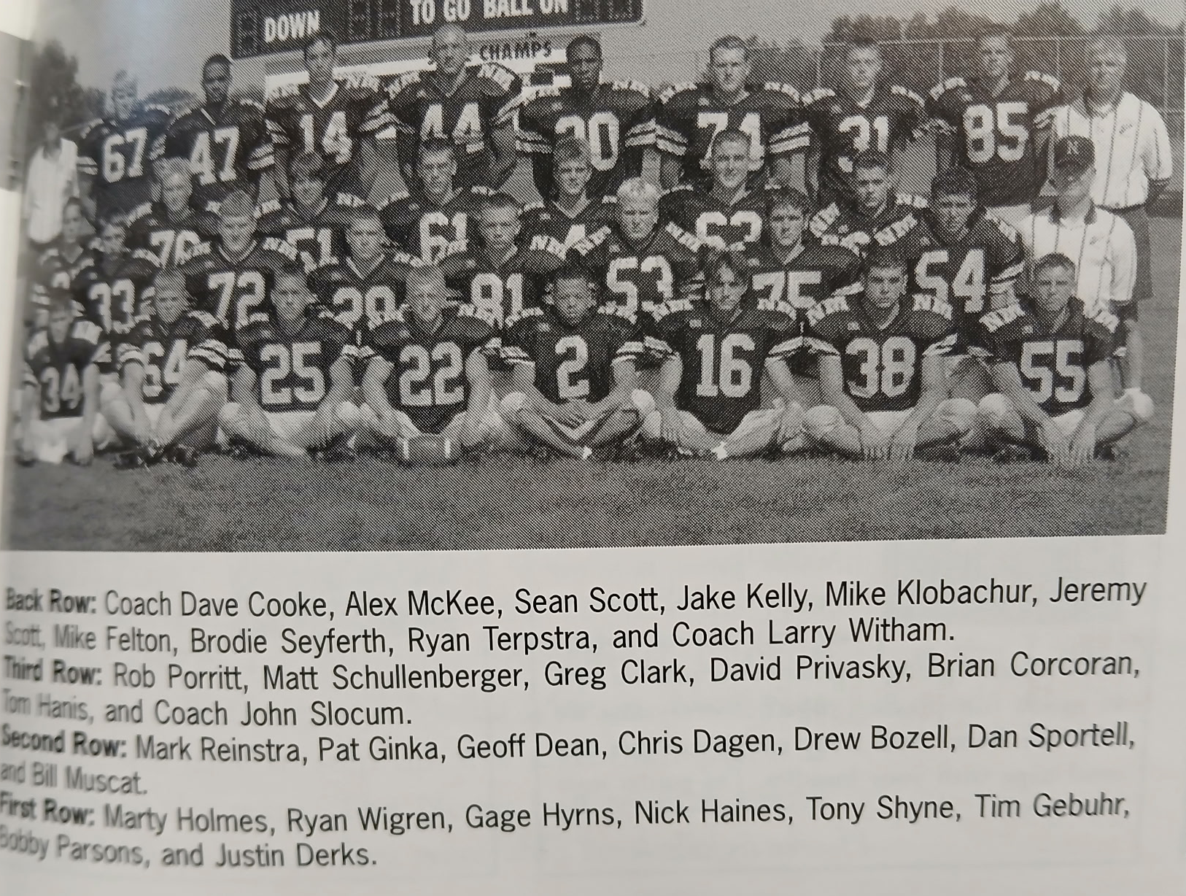

The 2001 NORSEMEN

Record Score Interesting Fact
1-0 NM 35, Holton 12 Tony Shyne 239 yds, 2 TDs, Jake Kelly 2 TD passes, J. Scott 91 yds.
  - NM 21, Montague 43 Kelly TD passes to Nick Haines & Scott. Mike Klobucher 9-yd TD run.
  - NM 0, Mason Co 9 Only shutout by Scottville in 80-year series. Klobucher 12 tkl.
  - NM 14, Whitehall 24 Haines 4 yd run, Shyne 58 yd TD. Klobucher 21 tackles.
  - NM 6, Oakridge 38 Goeff Dean;s 60-yd interception return the only NM score.
  - NM 7, Shelby 15 Klobucher 9-yard run for only NM TD.
  - NM 48, Hart 7 Shyne 72- & 95-yard YD runs, Klobucher 4 TDs and 14 tackles.
2-6 NM 6, Ravenna 28 Klobucher 2-yard TD and 16 tackles.
2-7 NM 6, Mid-Fult.33 Klobucher 109 rishing yards, 3-yard TD and 18 tackles.

2002 Coach Al Karaba (4-5 overall, Oakridge WMC Champs)

There would be a new look for North Muskegon football as Al Karaba, a former Muskegon Catholic football star and track standout would replace Dave Cooke as the head coach of the Norsemen, the 11th head coach in NM history. Cooke served 22 years as the Norse mentor and coached for forty years, including stays at Whitehall and Reeths Puffer. Karaba also served as the head track coach at NMHS with Doug Clark. Karaba was no stranger to NMHS football as he served as the Norse JV coach for the past 11 years and would only make modest adjustments to Cooke’s I-formation attack. NM would continue working in students from West Michigan Christian into the Norse football program. However, of the 10 players with WMC ties, only one would play on the Norse varsity.

In addition to a new coach there were a few new faces for the young Norsemen in 2002. NM made their new head coach Al Karaba’s debut as the new mentor for the Norsemen a success as they had little trouble in defeating Holton 34 to 8. The Norse jumped off to an early 21-0 halftime lead over the Red Devils on a pair of touchdown runs from Gage Hyrns (14 & 2) and another by Marty Holmes. Geoff Dean had a 38-yard scoring run in the second half while Aaron Sanders crashed over from the one. Holmes led NM rushers with 106 yards while Bill Muscat led the NM defense with 11 tackles.

The jittery Norsemen fumbled four times in the first half at Montague as the Wildcats took advantage of the Norse miscues to post an insurmountable 33-0 halftime lead. Tony Shyne was one bright spot for the Norse as he broke loose for several long runs in the second half to lead NM rushers with 129 yards. Sophomore Mike Dean saved NM from being shutout with a late 3-yard TD run to make the final score 39-6. Justin Derks made 10 tackles, while Geoff Dean and Marty Holmes had seven stops of the Norse.

Tony Shyne scored on a pair of long TD runs to lead NM to a 21-13 victory over Mason County Central. Shyne’s first TD traversed 28 yards while his second TD in the second quarter was a longer dash of 65 yards. NM secured the victory in the second half as quarterback Tom Gebuhr completed his first career TD pass with a 15-yard hookup with Gage Hyrns. Shyne would finish with 110 yards on 18 carries as NM totaled 273 yards to the Spartans 151.

NM was charged with nine penalties, many of those in the second half as Whitehall came from behind to edge the Norse 19-14. NM and Whitehall each traded TDs in the first half to make it 7-7 at halftime. NM took the lead after Tony Shynes second TD of the game tied the contest at 13-13. Brody Seyferth’s PAT gave NM a 14-13 lead heading into the final period. There were a couple of fourth and one plays that changed the complexion of this game. The first occurred with less than 10 minutes to play in the game. On a fourth and one Whitehall’s Julius Foreman, not only picked up the first down, but went all 40 yards for the winning TD. NM shortly thereafter had a fourth and one to pick up a first down in Whitehall territory but were stopped short of moving the chains as Whitehall then ran out the clock.

The Norse were no match for an Oakridge team that would race through the 2002 season with a spotless record before losing in the regional finals. Oakridge handed NM their worse defeat of the 2002 season with a 52-7 thumping over the outmanned Norse. NM was limited to 125 yards, 56 of those earned by Norse running back Tony Shyne. NM was able to avert the shutout on a late 14-yard scamper by Shyne in the fourth quarter.

NM enjoyed a 14-17 lead on Tony Shyne TD runs of 55 and 30 yards only to see Shelby rally in the second half to hand the Norse their fourth loss on the season 28 to 14. Shyne finished with 161 yards on a workmanlike 24 carries while Tim Gebuhr completed 8-of-14 passes for 73 yards. Four of his completed passes went to Sean Scott. Justin Derks had 10 tackles to pace the Norse defense.

NM got back into the victory column with a 29-14 win over winless Hart as the Dean brothers led the way for the Norse. Sophomore Mike Dean scored both NM touchdowns in the second half on runs of 12 and 15 yards. Senior Geoff Dean didn’t score but netted 94 rushing yards on 18 carries. Mike Dean led Norse ball carriers with 132 yards on eight carries. In the first half NM had tallies from Marty Holmes, who scored the first NM TD on a six-yard run, while Gage Hyrns scored from 14 yards out as NM’s record stood at 3-4 on the season.

NM held the highly favored Ravenna Bulldogs to zero points in the first half, but that scenario changed quickly in the second half. On the first play from scrimmage in the third quarter Ravenna’s Roman Starr raced 65-yards to paydirt, the first of three third quarter touchdowns by Ravenna in their 18-7 win over the Norse. NM’s only touchdown came on a 14-yard pass from Tim Gebuhr to Brody Seyferth.

NM concluded their 2002 season on a winning note with a 20-8 victory over Covert in the only meeting between the two schools in NM football history. NM took advantage of four Covert turnovers to complete their season with a 4-5 record. NM received a pair of short one-yard TDs from Marty Holmes and Geoff Dean while they added their third on a 14-yard halfback pass from Gage Hyrns to Sean Scott. NM finished with 163 of their 216 yards on the ground with Geoff Dean rushing for 85 yards. Hyrns also had an interception on defense while Drew Barker recovered a pair of fumbles for the victors.

2002 was the leanest season in memory as far as post season honors were concerned. No Norsemen were selected to the first team all-area team although Brodie Seyferth was picked as the second team kicker. Only senior linebacker Justin Derks received even an honorable mention for the all-area squads. All was not lost for NM athletics, as the Norsemen 2002-03 basketball team, arguably the best team in school history, led by future MSU star Drew Naymick, would be regional champions and would suffer but two defeats for the entire season.

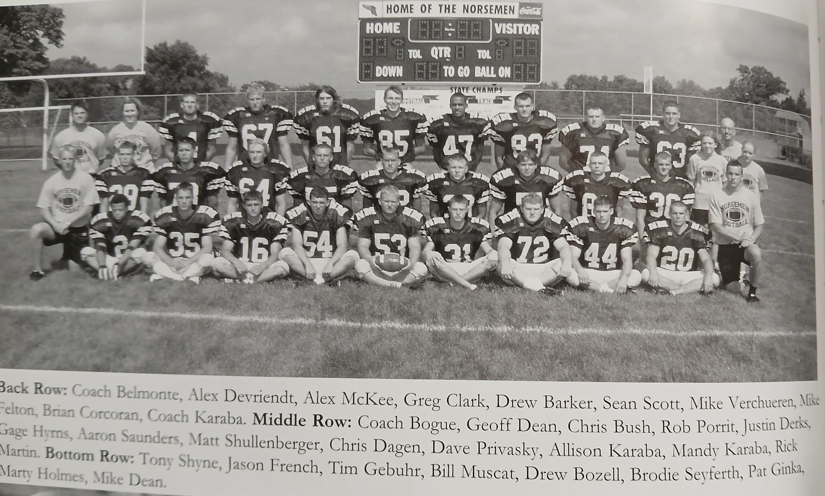

The 2002 NORSEMEN

Record Score Interesting Fact

1-0 NM 34, Holton 8 Gage Hyrns 2 TD, 1 TD Marty Holmes, Geoff Dean & Aaron Saunders.
1-1 NM 6, Montague 39 Tony Shyne 129 yards rushing. Mike Dean 3-yard TD run.
2-1 NM 21, Mason Co 13 Shyne YD runs of 28 & 65. Tim Gebuhr to Holmes 15-yard TD pass.
2-2 NM 14, Whitehall 19 Shyne 9 and 3-yard TDs. NM assessed 9 penalties for 100 yards.
2-3 NM 7, Oakridge 52 Shyne 14 yd TD and 56 rushing yards.
2-4 NM 14, Shelby 28 Shyne 2 TDs of 55 & 30 yards. Shyne 161 rushing yards.
3-4 NM 29, Hart 14 Mike Dean 2 TDS (12 & 15) Holes 6 yd TD, Hyrns 14-yard TD.
3-5 NM 7, Ravenna 18 Gebuhr to Brody Seyferth 14-yard TD pass.
4-5 NM 20, Covert 8 Holmes, Geoff Dean 1 -yd TDs, Hyrns to Sean Scott 14-yd TD pass.

