History of North Muskegon Football
By Jim Moyes
NOTE: Conference games marked with *

1932– coach Lyle McNitt (0-1 overall; no conference)

NM played but one game in 1932 as it was the first year that NM was officially a high school. The oldest players for the Norse in 1932 were only 10th graders as the first graduating class at NM was in 1935 (1934 for the football season in the Fall.) All four of Ravenna’s TDs were set up by costly NM interceptions, perhaps a harbinger of things to come under Lyle McNitt as his teams seldom passed in the years to follow. The first TD scored in NM history was by Joe Witham who scored from two yards out after McNiff recovered a fumble at the Ravenna two-yard line. Joe Witham would eventually be the proprietor of the Canary Inn, while his nephew Larry Witham would become the head coach for NM football in 2016. The following day after the varsity game with Ravenna, the NM Junior High team defeated Bunker Hr. High 7-0. Fred Schmid, with just 20 seconds remaining in the game, on a broken play, raced 80 yards for the winning TD. Lyle McNitt and Joe Witham have one thing in common, they each scored the first touchdowns in their school’s history. Lyle McNitt scored Ravenna’s first ever TD when he recovered a fumble in the end zone in a 1924 game vs. Coopersville.

Record Score Interesting Fact
0-1 Ravenna 26, NM 6 School’s 1st game, Joe Witham scored NM’s only TD after McNiff recovered fumble. NM 4 interceptions costly.

1933- coach Lyle McNitt (1-4 overall; no conference)

Starters in the first game for NM: LE E Cooper, LT Bill Hekkema, LG Charles Buys, C Adams, RG Norm Ferrill, RT Howard Speed, RE Ross Cooper, QB Jack Riordian, LH Joe Witham, RH Jack Jiroch, FB Fred Schmidt. The Norse dropped their opening game of the season at Montague with very little mentioned in the game story. It did point out in the 14-0 loss to Montague that the play of E. Cooper, Charles Buys, C. Adams and Fred Schmidt stood out.
NM just might have been looking at some ‘home cooking’ in their 7-6 loss to Ravenna. Rules of the time ruled pass interference to be ruled a completion as a long desperation pass gave Ravenna the ball at the NM two-yard line where they scored and then completed the extra point. The lone NM score was tallied by Fred Schmidt who climaxed a 60-yard NM TD march by scoring from the one-yard line. However, the attempt to complete the extra point failed when Jack Jiroch was stopped inches short of the goal line.

The Norse then won their first game in more than 90 years of NM football with a 19-7 ‘upset’ victory over Muskegon St. Joseph. Ironically, it would be the only game played between the two schools. Fred Schmidt scored the first NM TD that was set up by a Norse fumble recovery at the St. Joseph 35-yard line. Jack Jiroch played a major role in the final two NM tallies, rushing for one and throwing a 30-yard TD strike to Schmidt for the clinching touchdown.

The Norse scored first to take an early 6-0 lead on a pass from Jack Jiroch to Fred Schmidt, but it was all Shelby from that point on until the final scored saw Shelby come out on top 27-6 over the Norse.

The Norse then completed their schedule with a 7-0 loss to Grant. The Norse marched all the way to the Grant 3-yard line but couldn’t cross the Grant goal line. Grant then marched 97 yards for the game’s only touchdown to end the first season in NM history with one win against four defeats.

NM finished their first abbreviated five-game season with underclassmen only on their roster. With NM still a year away from having a senior on the team, your author is puzzled as to why Jack Riordan and Jack Jiroch didn’t play the following year. Unfortunately, my old NM friends who were in the know, have long since passed away

Record Score Interesting Fact
0-1 Montague 14, NM 0 Game played at Montague
0-2 Ravenna 7, NM 6 At Ravenna, a long pass resulted in NM interference with 5 seconds left. Ravenna then scored on next play. Fred Schmidt NM TD
1-2 NM 19, St. Joseph 7 Jack Jiroch scores a TD and throws TD pass of 30 yards to Schmidt, Schmidt scores first TD as NM wins its first ever game.
1-3 Shelby 27. NM 6 NM’s only TD on a 4th down pass from Jiroch to Schmidt.
1-4 Grant 7, NM 0 Grant marches 97 yards in the second quarter for game’s only score.

1934 – coach Lyle McNitt (2-3-1 overall; no conference)

Seven letter winners returned from the 1934 season which is confusing as everybody was back from the 1933 year as nobody was a senior. It must have been tough to earn a letter nearly 90 years ago. The letter winners were Joe Witham, Bill Sessions, Ross Cooper, Fred Schmid, Bill Hekkema, Raymond Woodhouse, and Charles Buys. Playing key roles for NM in addition to the returning letterman would be Fred’s brother Al Schmid, and Bob Raddatz. Norm Ferrill, Woodhouse, Witham and Andre, members of NM’s first graduating class played their final game for the Norse. Now an established 4-year school NM would no longer have to play a bigger school’s reserve team.

The Norse began the 1934 season, and the first as a 4-year school, by losing to Montague 13-0 on the NM gridiron. The only real highlight for the Norse was a booming 65-yard punt by Fred Schmidt. Long time Muskegon Chronicle Sports editor James F Henderson covered the game and gave high praise to NM’s end Bob Raddatz, 14-year-old guard Bill Sessions, The Schmidt brothers, Fred and Albert Schmidt, and tackle Bill Hekkema.

NM’s first win of the season, and their 2nd in school history completely reversed their 6-26 loss to Ravenna from the first ever varsity game played two years earlier. Fred Schmidt keyed the Norse win with his punting, running and pass defense. Schmidt scored the first NM tally from three yards out following one of his long punts that gave the Norsemen a short field. Joe Witham’s 6-yard TD gave the Norsemen a 13-0 lead at the halftime break. A third quarter Ravenna pass was intercepted by Schmid who returned the pigskin 78 yards for the third NM tally. Ross Cooper also picked off an errant Bulldog pass and returned it 38 yards for the final NM score. Although NM was credited with two wins for the year, only the Ravenna victory was against a varsity opponent.

Even though they were playing the Muskegon Heights 2nd team, the Heights were amid a winning streak that would consist of 31 consecutive wins without tasting defeat. Coach Oakie Johnson’s Tigers had so much firepower that even their second team would over-power the NM varsity 39-6. After a scoreless opening quarter, the Tigers scored four second quarter TDs to pull away from NM. Fred Schmidt was the lone bright spot for the home team as he scored the only NM TD from 17 yards out, also in the second quarter.

NM lost their first road contest of the season when they were shut out by Shelby 13-0. The Norse played the host Tigers even for the first half as neither team was able to punch across their opponent’s goal line. The Tigers had to go deep into their play book to earn their first touchdown. A play that included a pair of laterals worked for 18 yards and a TD. The second touchdown was set up on a bizarre play where a fumble recovery by a Shelby player at the NM 4-yard line saw the Tiger headed towards the wrong goal line before he was spun around by one of his teammates. The confused Tiger was able to reverse direction and was not brought down until he reached the NM four-yard line. The Tigers were able to score from there, converted the extra point to make the final score read Shelby 13, NM 0.

NM traveled to Grant and settled for a 13-13 tie. Only a pair of short paragraphs covered the game in the Muskegon paper. Fred Schmidt accounted for all the NM scoring with a pair of TDs and running for an extra point.

Although it goes down in the record books as a win, NM’s 69-0 rout of Fremont was accomplished against the Packer’s JV team. The game would be the first of 17 consecutive games played on the final day of each season during the rivalry. Fred Schmidt capped an outstanding season with four TDs. Joe Witham and Ross Cooper each added a pair of touchdowns in the rout. A highlight was Arlo Huntoon drop kicking for one of the extra points earned by NM. The 69 points would be the most points scored by a NM team until the undefeated 1970 powerhouse NM team also scored 69 in a romp over Mason County Central.

Record Score Interesting Fact
0-1 Montague 13, NM 0 The highlight for the Norse was a quick punt by Fred Schmid that was good for 65 yards. Game played at NM.
1-1 NM 26, Ravenna 6 Schmid returns interception 78 for one of his 2 TDs, Ross Cooper returns interception for 38-yard TD. Joe Witham from 6 yards for TD.
1-2 Muskegon Hts (2nds) 39, NM 6 Schmid’s 17 yards TD only NM score.
1-3 Shelby 12, NM 0 Shelby scored on a couple of bazaar plays, one when Shelby intercepted a pass and started running the wrong way before stopped.
1-3-1 NM 13, Grant 13 (tie) Played in Grant on a Wednesday afternoon, Fred Schmid scored both NM TDS and ran for one extra point.
2-3-1 NM 69, Fremont (2nds) 0 NM should have played the Fremont varsity. Fred Schmid 4, Witham 2, Cooper 2 TD and Arlo Huntoon drop-kicked for an extra point.

1935 – coach Lyle McNitt (4-1-2 Overall, no conference)

The Norse had only three scoreless ties in more than 90 years of football, and two of those came in the 1935 season, with scoreless ties against Montague and Grant. Although NM would not join the West Michigan Conference until 1936, the Norse can boast that they surely would have been the WMC Champs in ‘35’. Although they did not play Scottville, the Norse tied Montague in the season opener, defeated Hart 20-0 and shutout the 1935 WMC camps Shelby Tigers 14-0. Only a season ending 6-0 loss at Fremont on a ‘fluke’ cost NM an undefeated season. However, with several great athletes now enrolled at NMHS, it was clear NM was on the road to gridiron success. The 1935 season marked the great play of Bob Radatz, a sure handed end who would later have an illustrious career in the military. The Schmid brothers Fred ‘Feggy’ Schmid and his brother Al were the leading point producers. Fred Schmid, as the strategy as the game dictated during the pre-WWII days, often saw teams punting well before fourth down while Schmid often delivered some long punts. As well as leading the Norse in tackles from his linebacking position. Bill Hekkema, whose younger brother Al Hekkema (Class of 1947) would star on the hardwoods for the Norse and a fixture at many NM athletic events until his recent passing, did yeoman like work as a halfback and defensive stalwart. Walt Bergren, one of the top baseball players in NM annals, played well both as a runner and a passer out of the ‘Single Wing’ NM offense. NM had plenty of depth in the backfield as Ross Cooper played well. Phil Grimard was the defensive leader, and the Norse got fine line play from Bill Sessions and acting captain Charles Buys.

Record Score Interesting Fact
    - NM 0, Montague 0 (tie) At Montague the tackling and punting of Fred Schmid kept Montague from crossing the NM goal line.
    - NM 32, Ravenna 6 Only Ravenna score came on an interception and 70-yard return for TD by Merlin McNitt, Coach McNitt’s younger brother. Bob Emerson scores after recovering a blocked punt. Fred Schmid injured. Emerson 2 TD. Al Schmidt a 70-yard TD run and Bill Hekkema from 7. Walt Bergen passed and ran for a TD
2-0-1 NM 20, Newaygo 0 Al Schmid 2 TDS and Bill Hekkema a TD. Bob Radatz, Phil Grimard, Bill Sessions and Walt Bergren open big holes with their blocking.
3-0-1 NM 14, Shelby 0 Ross Cooper to Radatz for the first NM TD. Walt Bergen to Fred Schmid for a 45-yard TD. Phil Grimard starred on defense.
3-0-2 NM 0, Grant 0 Nothing decided in this contest as Grimard, Sessions, Charles Buys, Radatz and Bill Hekkema stood out for the NM defense.
4-0-2 NM 20, Hart 0 NM wins the first of many games between these 2 schools. Bob Radatz made some sensational catches including a TD reception. Al Schmid a TD
4-1-2 NM 0, Fremont 6 The first of 8 consecutive games contested on Armistice Day was played on a muddy Packer field. The game was decided with Fremont scoring with 2 minutes left in the game. The Packers scored when a pass batted away by a Norse defender went into the arms of Stroven who dashed 15 yards for the TD.

1935 – coach Lyle McNitt (4-1-2 Overall, no conference)

The Norse had only three scoreless ties in more than 90 years of football, and two of those came in the 1935 season, with scoreless ties against Montague and Grant. Although NM would not join the West Michigan Conference until 1936, the Norse can boast that they surely would have been the WMC Champs in ‘35’. Although they did not play Scottville, the Norse tied Montague in the season opener, defeated Hart 20-0 and shutout the 1935 WMC camps Shelby Tigers 14-0. Only a season ending 6-0 loss at Fremont on a ‘fluke’ cost NM an undefeated season. However, with several great athletes now enrolled at NMHS, it was clear NM was on the road to gridiron success. The 1935 season marked the great play of Bob Radatz, a sure handed end who would later have an illustrious career in the military. The Schmid brothers Fred ‘Feggy’ Schmid and his brother Al were the leading point producers. Fred Schmid, as the strategy as the game dictated during the pre-WWII days, often saw teams punting well before fourth down while Schmid often delivered some long punts. As well as leading the Norse in tackles from his linebacking position. Bill Hekkema, whose younger brother Al Hekkema (Class of 1947) would star on the hardwoods for the Norse and a fixture at many NM athletic events until his recent passing, did yeoman like work as a halfback and defensive stalwart. Walt Bergren, one of the top baseball players in NM annals, played well both as a runner and a passer out of the ‘Single Wing’ NM offense. NM had plenty of depth in the backfield as Ross Cooper played well. Phil Grimard was the defensive leader, and the Norse got fine line play from Bill Sessions and acting captain Charles Buys.

Record Score Interesting Fact
    - NM 0, Montague 0 (tie) At Montague the tackling and punting of Fred Schmid kept Montague from crossing the NM goal line.
    - NM 32, Ravenna 6 Only Ravenna score came on an interception and 70-yard return for TD by Merlin McNitt, Coach McNitt’s younger brother. Bob Emerson scores after recovering a blocked punt. Fred Schmid injured. Emerson 2 TD. Al Schmidt a 70-yard TD run and Bill Hekkema from 7. Walt Bergen passed and ran for a TD
2-0-1 NM 20, Newaygo 0 Al Schmid 2 TDS and Bill Hekkema a TD. Bob Radatz, Phil Grimard, Bill Sessions and Walt Bergren open big holes with their blocking.
3-0-1 NM 14, Shelby 0 Ross Cooper to Radatz for the first NM TD. Walt Bergen to Fred Schmid for a 45-yard TD. Phil Grimard starred on defense.
3-0-2 NM 0, Grant 0 Nothing decided in this contest as Grimard, Sessions, Charles Buys, Radatz and Bill Hekkema stood out for the NM defense.
4-0-2 NM 20, Hart 0 NM wins the first of many games between these 2 schools. Bob Radatz made some sensational catches including a TD reception. Al Schmid a TD
4-1-2 NM 0, Fremont 6 The first of 8 consecutive games contested on Armistice Day was played on a muddy Packer field. The game was decided with Fremont scoring with 2 minutes left in the game. The Packers scored when a pass batted away by a Norse defender went into the arms of Stroven who dashed 15 yards for the TD.

1936 – coach Lyle McNitt (4-3, 2-2 in WMC- Shelby champs)

NM begins a long journey as a member of the West Michigan Conference. Despite NM entering only its 3rd year as a full-time high school, only four lettermen returned from the previous season, Al Schmid and Bud Wiley in the backfield, lineman Bill Hoxie and end Bob Radatz. Bill Hoxie’s younger brother Bernie, more than a decade later, would be a star halfback for Paul Moyes’ Norsemen in the late 1940s and 1950. With no lights on the Norse field, as well at all the teams in the WMC, games on the Northside would start at 3:45 in the afternoon.

The opening game with Montague was the first game played at the current site that was installed as part of a WPA project during the summer. After Bob Radatz, who caught 5 passes, including a pair for TDs in the opening game played on the newly constructed NM field, the Norse lost to Scottville when a bad snap from center sailed over Walt Bergren’s head and was recovered in the endzone for a Scottville TD. The Norse would lose only once to Scottville over the next 20 games.
NM won 13-6 against Newaygo in a tale of two halves. With rain pounding down on the gridiron and a sea of mud, coach McNitt decided to punt early and often to force Newaygo errors. NM just played it straight in the second half and scored on a couple of 30-yard TD runs from Schmid and Bergren.

The Norse scored first but dropped a 14-7 game to 1936 WMC champ Shelby. NM then defeated an unbeaten Grant team and would win their final game of the season 11-6 over Hart. In more than 800 games of NM football, it was one of but 4 games when NM scored exactly 11 points. Walt Bergren kicked a 36-yard field goal, the first field goal in NM history. Harts only score was a TD pass caught by Hart and WMU legend Fred Stevens.

NM outplayed Fremont for three quarters but the Packers rallied to defeat the Norse as a crowd estimated at 3,000 were treated to a parade prior to the NM field dedication.

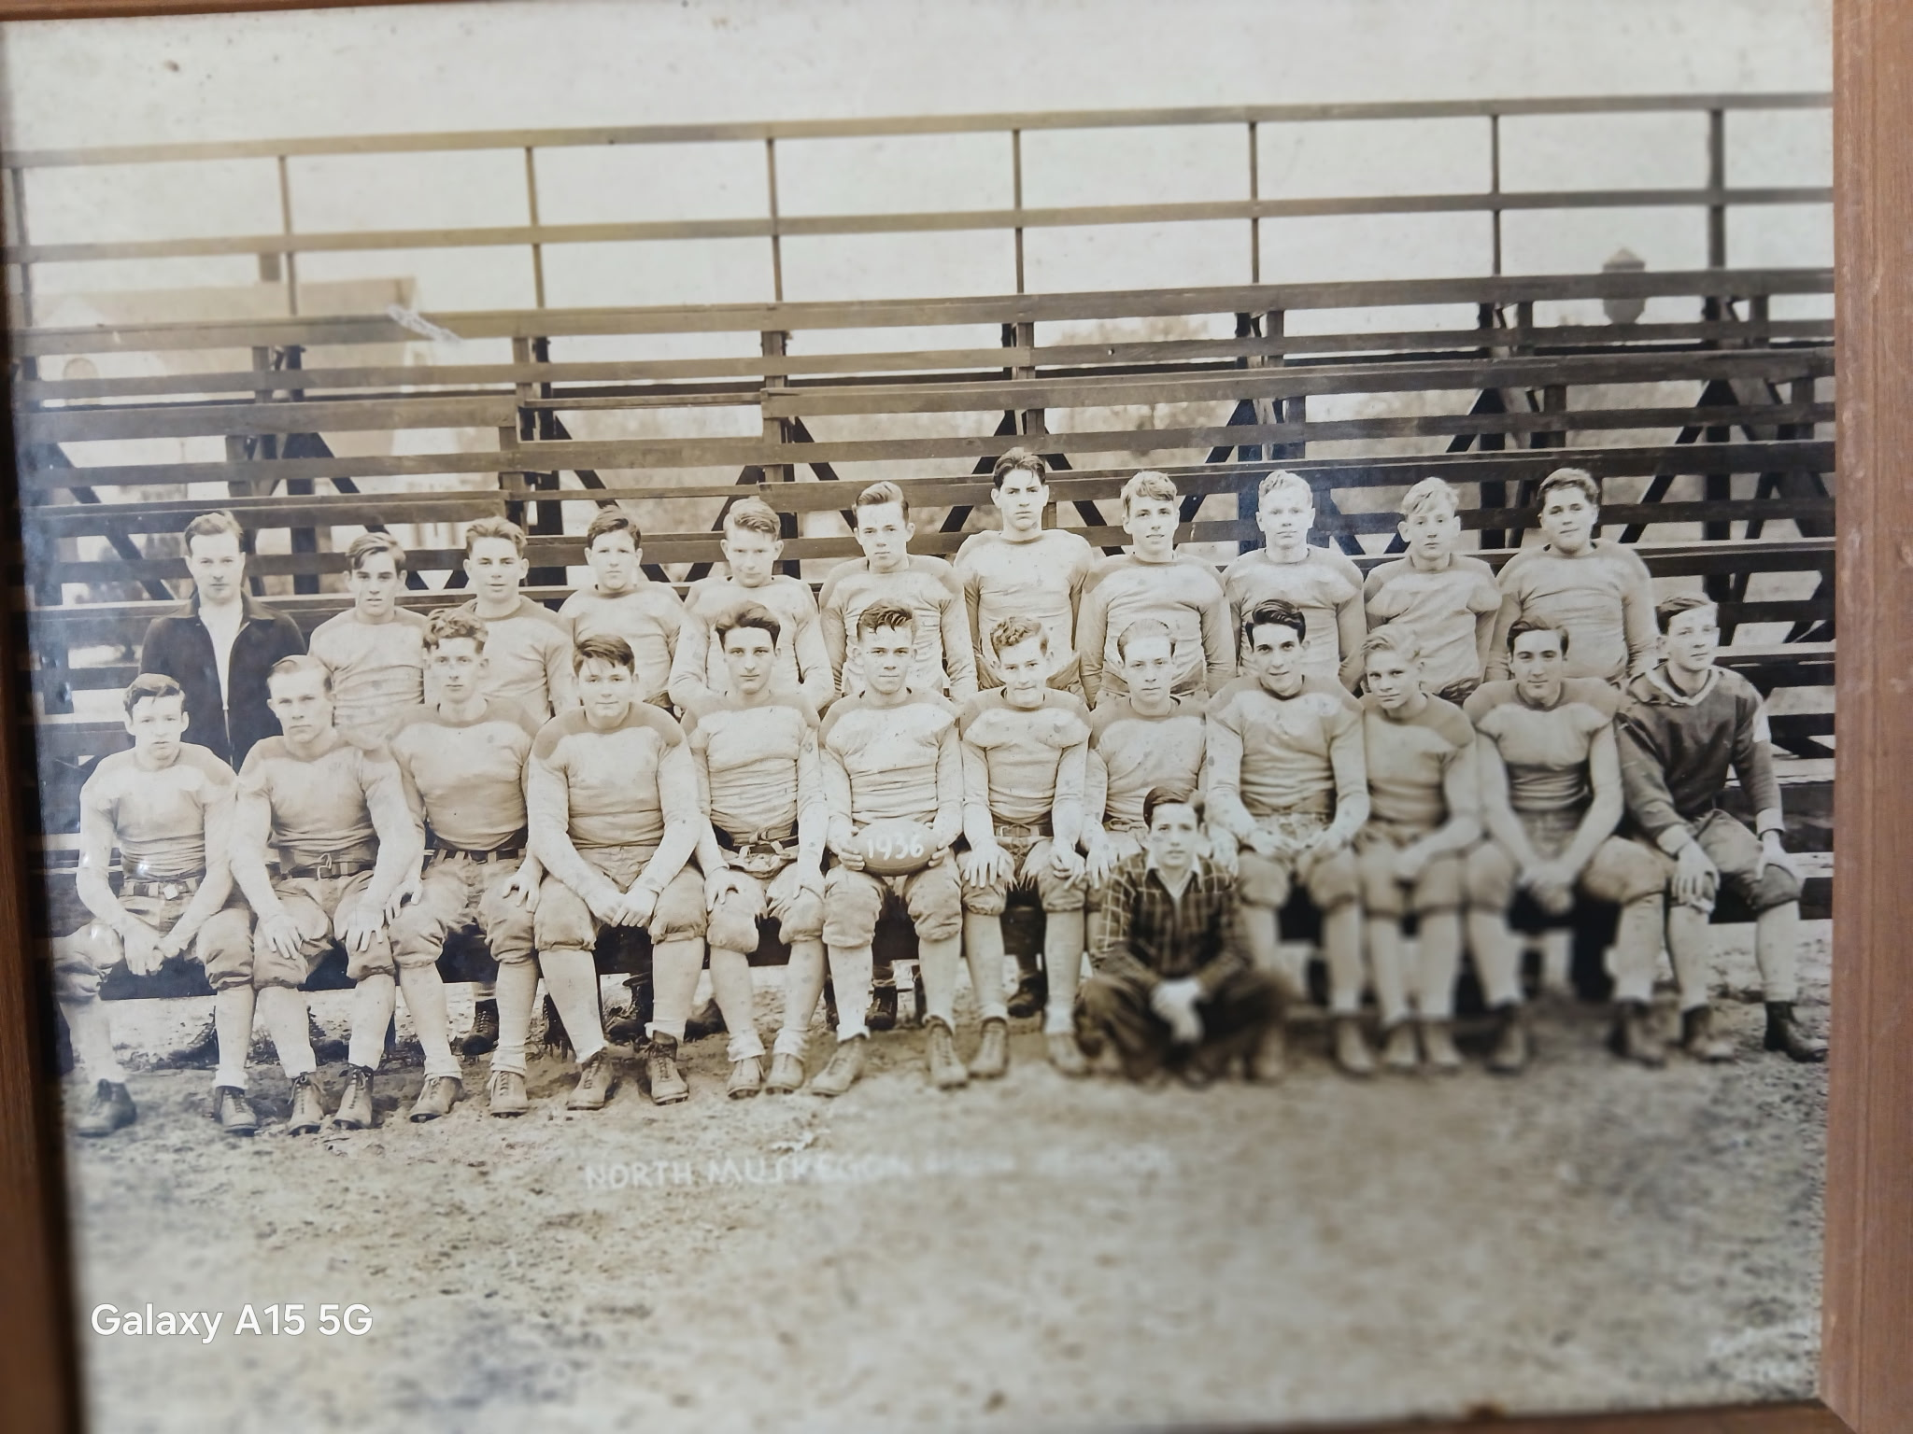

Players that your author can identify from memory. If you know the names of those marked with a?, please email me at jimmoyes@aol.com

1st Row: L-R:?, Al Schmid, ?, Dick Hoeker? Bill Hoxie, ?, ?, Bob Raddatz, Harvey Speed, Walt Bergren, ?
Top Row: Coach Lyle McNitt, ?, Bill McNabney,?,?, Bill Peterson, George Seabolt,?, Bob Delong, Nip Pender, Shad Thornton

The 1936 NORSEMEN

Record Score Interesting Fact
1-0 *NM 18, Montague 0 Bob Radatz catches a pass from Walt Bergren for the first TD ever scored on the new NM field. Radatz 2 TDs, Harvey Speed 1 TD.
1-1 *Scottville 7, NM 6 NM loses when snap from center goes over the head of punter Bergren & recovered by Scottville for the winning TD. Bergen pass to Bud Wiley for NM TD.
2-1 NM 13, Newaygo 6 Bergren and Schmid each tally 30-yard TDs in a game at Newaygo played in rain and mud. Newaygo’s only TD on the ‘sleeper’ play.
2-2 *Shelby 14, NM 7 NM scores first against the 1936 WMC Champs on a Schmidt short TD but Shelby scores on a 25-yard 4th qtr. pass for win.
3-2 NM 20, Grant 13 NM defeats previously unbeaten Grant. Bergren to Radatz 25 yd TD, Schmid 17 yd TD, and 1-yard TD. Bergren kicked 2 extra points.
4-2 *NM 11, Hart 6 A safety and field goal in the first quarter gives NM a 5-0 lead. Schmid’s 1-yard TD accounted for the rest of NM’s points.
4-3 Fremont 19, NM 8 NM leads 8-0 entering 4th quarter before Packer’s rally. Schmid TD and safety only NM scores.

1937 – coach Lyle McNitt (6-1-1, 4-0-1 WMC Champs)

11 lettermen returned for the Norse and their experience showed as they began a six-year run as WMC champs. Only a 6-6 tie with Hart denied the Norse a perfect WMC season. Along the front lines NM started Captain Bill Hoxie, along with Watson Buwalda, Wilson Grimard, Dick Hoeker, `Bill Peterson, Charles Moehlman and George Dillinger. Walt Bergen returned as a regular in the backfield and coach McNitt welcomed a young John Gwatkin to the squad. Edwin Cowles and Harvey Speed also produced some impressive stats.

NM got off to an explosive start by thrashing Scottville 41-7 in the season opener on the Northside. John Gwatkin gave a quick preview on what to expect from him as a Norsemen by scoring the first of his many touchdowns during his career.

The game at Newaygo depicted some of the farcical elements small town schools would often experience during the 1930s. The game with Newaygo was played on the same field used by the baseball team. The skin part of the infield bore no grass but when the action was on the outfield, the grass had not been mowed, and it was higher than the players shoe tops according to the game story written by legendary Muskegon Chronicle Sports Editor James F Henderson. And ---- the game was played with only one official who according to Henderson did a very good job under the circumstances.

It should be noted for local historians that the Muskegon at Benton Harbor game was the first game played under the lights for an area football team. It was also the first game broadcast locally with Hall of Fame announcer Hilliard Gudelsky (shortened to Gates of Hoosiers fame) doing the play-by-play on WKBZ, Muskegon’s first radio station.

In front of a ‘homecoming’ crowd NM shut out Shelby 38-0 with Walt Bergren scoring a school record four touchdowns.

NM posted their third straight whitewash the following week with a 26-0 win over Grant as W. Bergren had an 85-yard TD run.

Only a 6-6 tie the following Wednesday afternoon at Hart denied NM of a perfect season. A late NM drive stalled at the Pirates 2-yard line, but NM did clinch their first of many WMC titles.

In the 40-0 shutout victory over St. Mary’s, there was one play that was indeed strange under today’s rules. John Gwatkin had his extra point attempt blocked. Nip Pender recovered the blocked kick and ran into the end zone for the extra point.

In a matchup of unbeaten teams, Fremont, who gave up but six points all season, downed the Norse 20-0 in the season finale. Following the completion of the 1937 season four Norsemen were voted to the first team all WMC-Conference team: Charles Moehlman was selected for the second straight year while Bill Hoxie, Harvey Speed and Walt Bergren were also picked. Second team All-WMC honors were bestowed on Wilson Grimard and Watson Bulwalda.

Record Score Interesting Fact
1-0 *NM 41, Scottville 7 John Gwatkin scores 2 TD, one from 70. Walt Bergen 2 TD and 5 extra points, Harvey Speed passes to Bill Peterson for a TD. ‘Lunk’ Bergren a 16-yard TD.
2-0 *NM 20, Montague 7 W. Bergren 2 TD and Speed one as NM wins their 2nd straight WMC contest in Montague,
3-0 NM 28, Newaygo 0 ‘Nip’ Pender, Speed, Gwatkin and Oliver Eyestone each score a TD in the non-conference clash at Newaygo.
4-0 *NM 38, Shelby 0 NM clinches at least a tie in the WMC. W Bergren scores 4 TDs, Speed 2 on homecoming on the Northside field.
5-0 NM 26, Grant 0 W. Bergren 2 TDs with the longest from 85 yards, Edwin Cowles and Gwatkin each with a TD as NM post 4th straight shutout.
5-0-1 *NM 6, Hart 6 NM stopped late in the game at Hart’s 2-yard line. Eyestone the NM TD as Bergren’s extra point attempt went wide.
6- 0-1 NM 40, St Marys 0 W Bergren, Speed and Eyestone each score 2 TDs in first ever meeting between the 2 locals.
6-1-1 Fremont 20, NM 0 In a battle of unbeatens host Fremont shut out the Norse 20-0

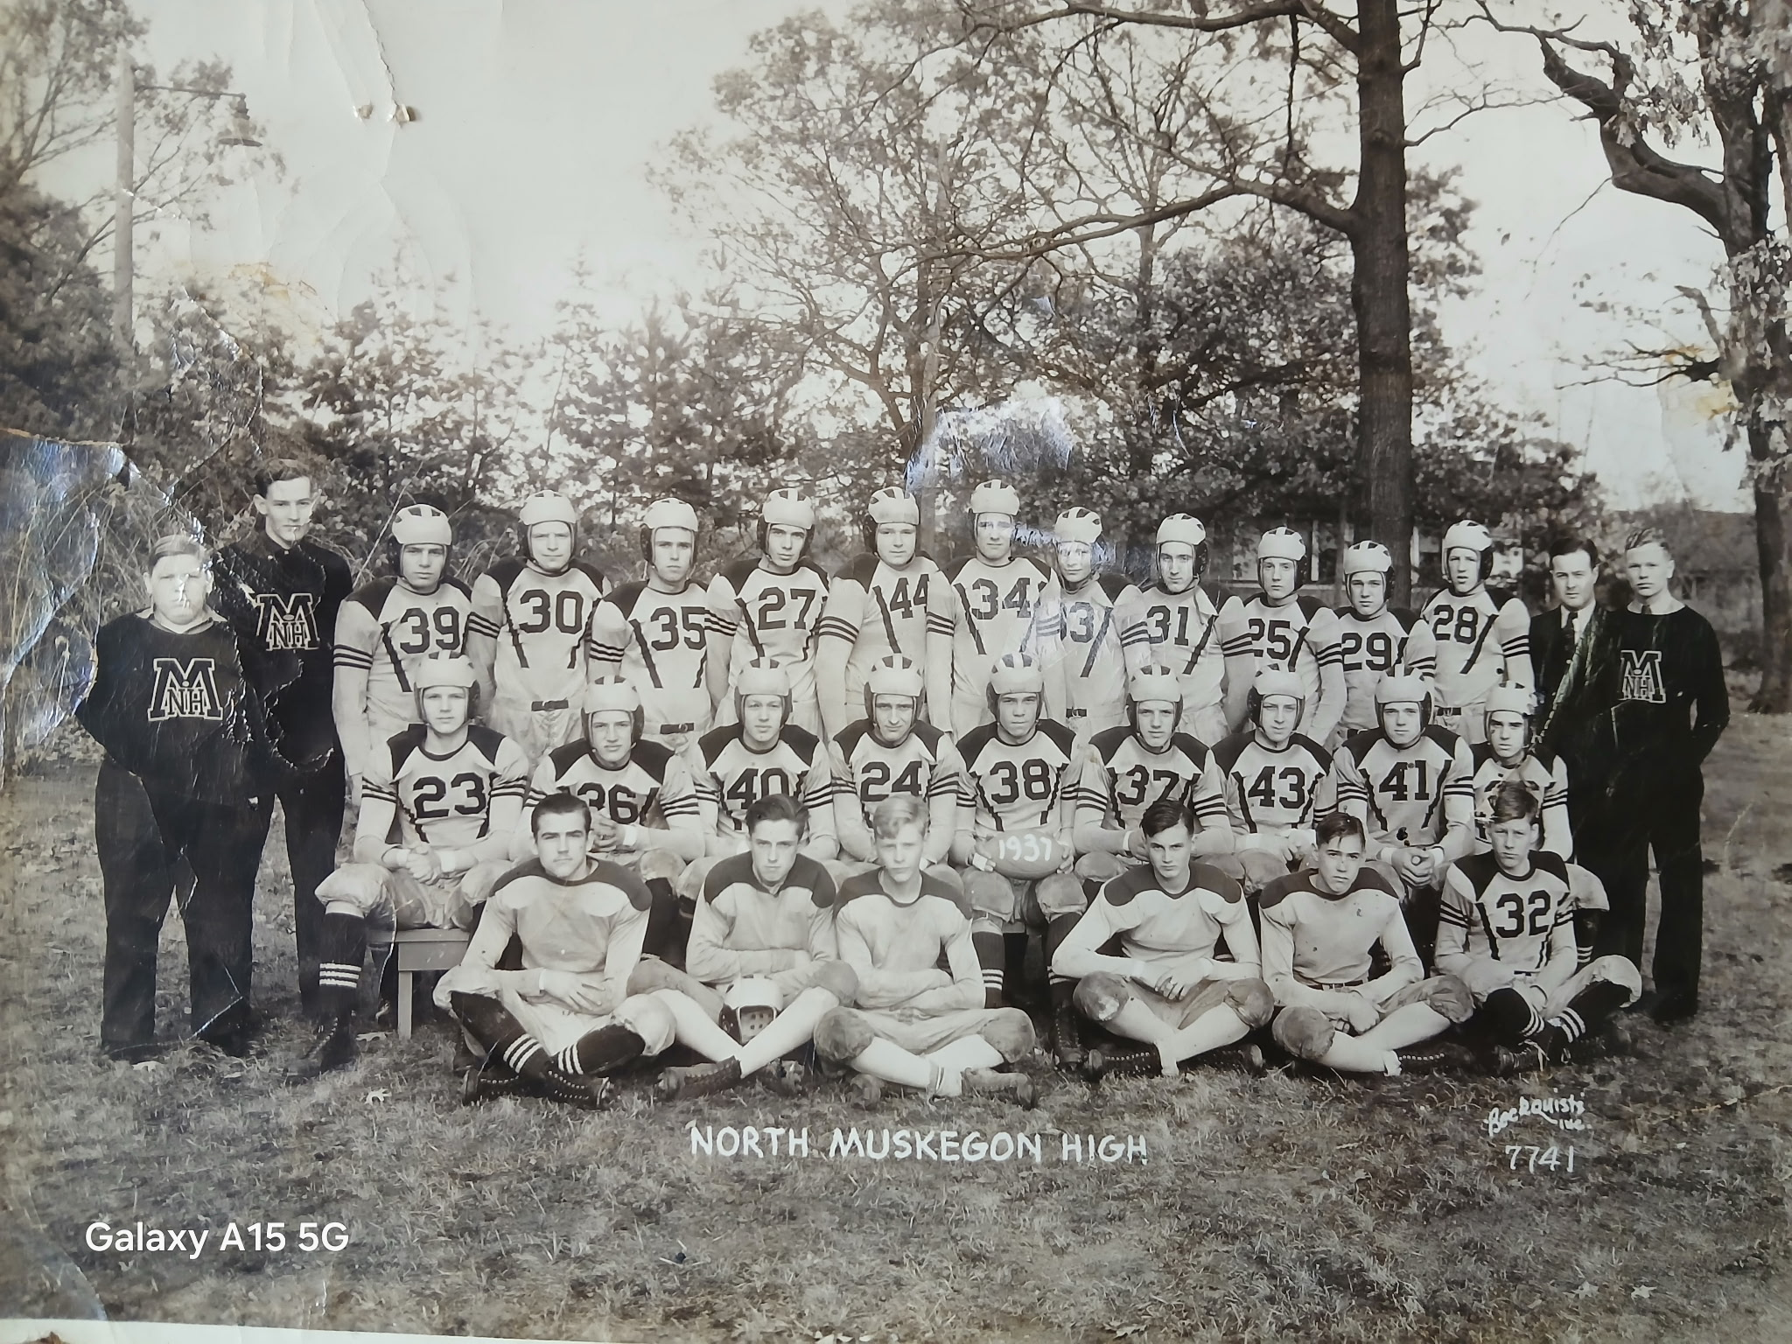

The NORSEMEN OF 1937

1938 – coach Lyle McNitt (8-0, 4-0, WMC champs)

The Norse entered the 1938 with high hopes as 13 lettermen returned. Pre-season optimism was tempered with a difficult schedule as the Class C Norse had five Class B teams on their schedule. The Norse featured a line that averaged a ‘hefty’ 171 pounds with tackle Dick Hoeker tipping the scales at 243 pounds. Seeing action in 1938 along the front lines included Melvin Berry, Bill Peterson, Watson Buwalda, Wilson Grimard, Herbert Cooper and Sheldon Thornton. Returning in the NM backfield included regulars from the previous season, Edwin Cowles, and Oliver Eyestone but the bread and butter back for 1938 would be John Gwatkin who would post numbers that are envied even today. George McNeil was slated to see a lot of action at quarterback with Elllis ‘Nip’ Pender also sure to see plenty of playing time.

It didn’t take long for Gwatkin to display his running abilities as he ran for more than 100 yards and scored 2 TDs in NM’s first two non-conference games against Class B foes Otsego and Manistee. NM combined the running ability of Gwatkin with a defense that only allowed 12 points all season.

NM played their first game under the lights at historic Houseman Field in Grand Rapids against Class B GR Lee. Gwatkin ran for 2 TDs as the Norse shutout Lee halfback and future Detroit Tiger pitching ace ‘Stubby’ Overmire.

The Norse were challenged by Shelby in their 2nd WMC contest of the season. After Shelby scored a TD in the second quarter and took the lead at 7-6, it was the only time the Norse trailed all season. NM quickly rebounded behind the great running once again of Gwatkin who rushed for 165 yards and a TD as NM pulled way in the second half. NM took the lead as Cowles scored on a short line plunge after Gwatkin brought the ball deep into Shelby territory on a long run. Stafford scored a couple of short-range TDs in the second half while Oliver Eyestone completed the scoring with a late TD.

Coach McNitt played his entire roster in NM’s easy 34-0 win over Scottville in a Wednesday afternoon game on the Northside. McNitt gave Gwatkin a breather and Arnie Stafford scored a couple of early TDs before giving way to Gwatkin as the featured running back.

Gwatkin, dubbed perhaps the most outstanding running back in Greater Muskegon according to Muskegon Chronicle Sports editor James Henderson, scored 2 quick TDs as NM clinched their 2nd straight WMC title with a 21-0 win over Hart.

An overflow crowd estimated at more than 3,000, some standing in place five and six deep saw John Gwatkin, Oliver Eyestone and Arnold Stafford lead NM to a 24-0 victory over Fremont, atoning for the Packers ending NM’s hopes for an undefeated season in 1937. The defense, that allowed but 12 points all season was led by Sheldon (Shad) Thornton, Herbert Cooper, Bill Peterson and Dick Hoeker. Watson Bulwalda and Wilson Grimard also opened holes for the NM running backs. Gwatkin and Eyestone each scored a TD while Stafford added 2, the latter TD going 80 yards. According to statistics supplied by Fred ‘Doc’ Jacks Gwatkin ran for 1358 yards in the season, averaging a whopping 11 yards per carry while scoring 11 touchdowns.

Although Gwatkin was their featured running back, no Norse fan should ever forget Oliver Eyestone. The leading hitter on the Norse baseball team in the Spring, Eyestone gave the supreme sacrifice in World War II. Eyestone gave his life for our country flying a B-24 mission over the Adriatic Sea on August 24, 1944.

The Norsemen dominated the WMC All-Conference team with five players accorded first team honors: William Peterson, Watson Buwalda, Dick Hoeker, John Gwatkin, and Ed Cowles. So deep were the Norse that another five were picked for the second team: Herbert Cooper, Wilson Grimard, Melvin Berry, Oliver Eyestone and Arnie Stafford.

Record Score Interesting Fact
1-0 NM 32 Otsego 6 In the only meeting of these 2 schools, NM held Otsego without a rushing first down. John Gwatkin 130 yds rushing & 2 TD, Olliver Eyestone 2 TD, Edwin Cowles 1 TD. Arnie Stafford made his first appearance as a Norseman and intercepted a pass and returned 55 yards for a TD.
2-0 NM 14 Manistee 0 Gwatkin starred by rushing for 125 yards and 2 TDS. Dick Hoeker a force on defense. NM forced a safety in front of the home folks on the Northside.
3-0 *NM 20 Montague 0 Nip Pinder throws 2 TD passes and Arnie Staffford gets a crushing block from Wilson Grimard and runs 80 yards for TD.
4-0 NM 26 GR Lee 0 NM plays 1st night game in history at Housemen Field in GR. Gwatkin 2 TD, rushed for more than 200 yards. Stafford TD and Don McNeil TD pass reception.
5-0 *NM 32, Shelby 6 NM trails for only time of the season but pulls away in the second half. Stafford 2 TD, Gwatkin, Eyestone & Cowles a TD each.
6-0 *NM 34, Scottville 0 Stafford stars in convincing win. Scores 2 TD as did Gwatkin who came in as a sub as NM played mainly reserves. Eyestone also a TD.
7-0 *NM 21 Hart 0 Gwatkin leads NM to victory by scoring all 3 NM TDs, his first 2 coming in the games’ first 5 minutes. (2, 45 & 15-yard TD dashes)
8-0 NM 24, Fremont 0 NM completes their first perfect season as Stafford scores 2 TD, Gwatkin and Cowles 1 each. NM only allows 12 points all season.

1939 – coach Lyle McNitt (7-1 overall, 4-0 WMC champs)

Three weeks after all hell broke out in Europe as WWII begins with the invasion of Poland by Germany, the Norse hosted Grand Rapids Lee in the 1939 season opener. Many lettermen returned from last year’s undefeated team. However, many were not starters but did garner much experience. Starters returning included Don McNeil, Herbert Cooper, and Wilson Grimard on the line while Arnie Stafford highlighted the returnees in the backfield. Ellis Pender saw considerable action in this his third season on the NM varsity. Russell Buys will add depth to the backfield while Lawrence ‘Lunk’ Bergren, a future baseball teammate of your author in baseball, will take over duties at center. Also projected to help on the line are tackles Beaver Semeyn and Bill Gates while Albert Mattison will fill in at one of the ends.
Stafford showed on the first NM drive of the season in their 27-6 victory over GR Lee that he was a more than capable replacement for Gwatkin. Stafford accounted for 76 rushing yards in the Norse first drive that ended with Arnie going over from the four-yard line.

The Norse spoiled Manistee’s first game on their new lighted field by crushing the hosts 38-6.

Game time strategy was much different decades ago as illustrated in NM’s 21-6 win over Montague. After NM marched down the field, with Arnold Stafford running on all the plays and scoring a TD, Montague received the Norse kickoff and elected to punt on ‘First Down,’ a common practice at football games of this era.
Coach McNitt used his reserves in many of the NM contests as Stafford wasn’t even mentioned in NM’s easy victory over a ‘thin’ Scottville team. “Pin ball” entrepreneur Marsh Gerling had a huge game for the Norse and scored 2 TDs.

The Norse shutout Shelby 21-0 even with star back Arnie Stafford sidelined with a leg injury. There was one TD pass from Ellis Pinder to Wilson Grimard that would be illegal today. Taking the direct snap from his ‘Single Wing’ position, Pinder ran to his right and then tossed left to Grimard, playing a guard for NM. Grimard then raced 32 yards for NM’s second touchdown in yet another shutout victory over a WMC opponent.

Long before soccer style kickers would dominate the kicking game, extra points from placement were never a sure thing. A sure thing did occur in the Shelby game as future career military man Pender was successful on all his 3 attempts from placement against Shelby.

In one of but two meetings in NM history, the Norse pummeled one of the most storied athletic programs in MHSAA history when they defeated East Grand Rapids 47-0 on the Norse gridiron.

The Norse made it 15 straight victories and 3rd straight WMC title with a 18-7 victory at Hart, setting up a big season ending battle at Fremont.

The Norsemen have played more than 800 games in more than 90 years of football. If one had to pick one of the top 10 games played in NM history than one surely couldn’t overlook the 1939 November 10 game on a very cold afternoon in Fremont. The game was billed as a battle between a pair of senior running backs, the Norsemen’s Arnold Stafford and Fremont’s Walter Derby. And the two stars didn’t disappoint. Ironically, neither Stafford nor Derby would score a touchdown in the 14-12 Fremont victory. The difference in winning and losing came off the toe of Derby, who was successful on both his extra point attempts. The Fremont contest would be the first game Stafford would see action since the Scottville game midway through the season where he had been sidelined with a leg infection. Interest was high for the contest as it drew front page coverage that included the first action shot pictures of NM football featured in the Muskegon Chronicle. Although neither Stafford nor Derby scored, it was their running that set up their team’s touchdowns. Derby not only used his legs and accurate toe, but he also used his arm as he passed for both Fremont TDs. The first was a 29-yard completion to Bob Burlin followed by a perfect kick from placement by Derby. The Norse countered with a couple of TDs to take a 12-7 lead at halftime. Following the Packer TD Stafford ran the ball on several carries from his own 32 down to the Packer 16-yard line. On fourth down Pinder fired a perfect pass to Don McNeil in the end zone. However, Pender’s attempt at placement was blocked leaving the Packers in front at 7-6. After a short punt NM had the ball at the Packer 41-yard line. Stafford was stopped after a couple of short gains before the Norse struck pay dirt. Dan Timmer galloped 38 yards while shaking off several tacklers to score to give the Norse a 12-7 lead. After a scoreless third period the Packers took over at their own 20-yard line. Derby raced 50 yards to the Norse 35 where the 1940 100 and 220-yard Class B state track champion was caught from behind by Stafford. Although NM did not field a track team at the time, Stafford surely passed his speed down to his son Don, who set a 220-yard dash record at NMHS that would last for more than three decades. Fremont than ran the ball down inside the Norse one-yard line where the Norse put on an epic stand. After the Packers lost yardage with a couple of running plays, Derby hit a wide-open Max Rose for what would prove to be the winning TD. Moments later a penalty perhaps cost the Norse a victory and a second perfect season. With the ball at the Packer 25-yard line, Wilson Grimard came out of the line on a guard around play. Grimard raced into the endzone, but the Norse were guilty of a motion penalty.

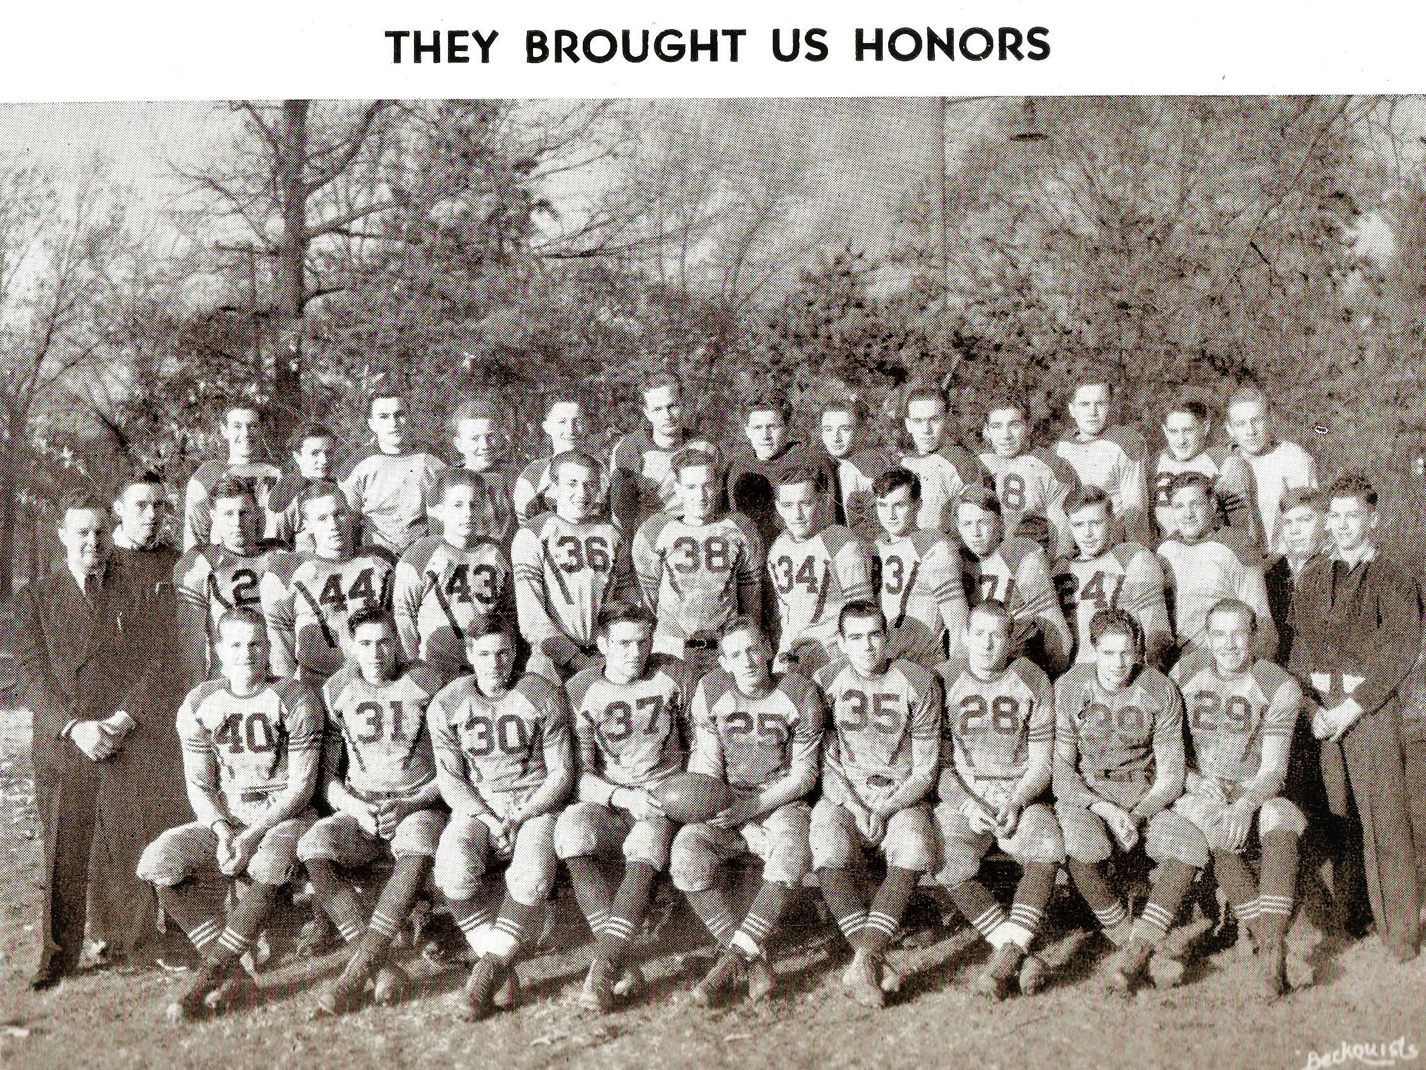

The 1939 NORSEMEN

Record Score Interesting Fact
1-0 NM 27, GR Lee 6 Stafford runs wild in opener, 2 TDs and well over 100 tards rushing. Dan Timmer TD and Nip Pender catches a long TD pass from Gosselin.
2-0 NM 38, Manistee 6 The Norse put this game away early leading 25-0 at halftime. Stafford all 11 carries for 1st TD. Timmer 2 TD, Albert Mattison recovers punt in end zone. Pender 56 yd TD
3-0 *NM 21, Montague 6 Stafford again had a monster game as he scorers 2 early TDs. Arnie then scored his 3rd TD by returning an interception 57 yds to paydirt.
4-0 *NM 25, Scottville 0 Reserves played much of the game. ‘Goose’ Gosselin scores 1st TD, Pender the 2nd on a 52 yd run, Marshall Gerling the final 2 TDs.
5-0 *NM 21, Shelby 0 Pender 2 TD passes, one to Don McNeil, the second to ‘guard’ Wilson Grimard. Bill Sikkenga races 76 yards for final Norse TD.
6-0 NM 47, East GR 0 Sikkenga 3 TDs (45, 51 & 2), Timmer 2 short TDs, Pender reverses field a number of times in exciting 78-yard TD gallop.
7-0 *NM 18, Hart 7 NM wins WMC and posts 15 straight victory. Sikkenga the workhorse with 2 TDs, the latter from 73 yards. Dan Timmer 25-yard TD,
7-1 Fremont 14, NM 12 Fremont ends NM 15 game winning streak as Stafford and Fremont’s Walter Derby wage dual.

1940 – coach Lyle McNitt (6-2 Overall 3-0 WMC champs)

September of 1940 would see London battered daily by the German Luftwaffe as thousands of youngsters registered for the draft. The war had already begun to have an effect even for Norse football as Dan Timmer had joined the National Guard and his status was always questionable for games as well as practices. The Norse also received an early blow when Arnold Stafford suffered a cracked shoulder bone before the season even started and he was out indefinitely.

Stafford’s absence was missed immediately as the Norse were held scoreless by Grand Rapids Lee in their season opener. Bill Overmire, brother of future Detroit Tiger ace Frank ‘Stubby’ Overmire, led Lee to victory.

The Norse then played three straight games on the Norse home field, all Norse victories. After methodical wins over Manistee (14-0) and Montague (21-6), the Norse faced an undefeated Reed City team on Oct 11. Bill Sikkenga ran wild for the Norse with 3 TDs, and the game featured the first appearance of one of the finest players to ever grace the Northside gridiron in Don Bowen. Replacing Sikkenga late in the game Bowen completed a TD pass to Art Gosselin.

There were plenty of mixed emotions following NM’s 40-0 victory over Shelby the following week. It would be the last game for 3-year regular running back Dan Timmer. No, Timmer wasn’t sidelined with an injury. Instead Timmer was leaving the Norse as a private in the Michigan National Guard. It was only fitting that Timmer would go out in a blaze of glory. Dan scored three touchdowns and kicked three extra points in the win over Shelby. Bill Sikkenga added 2 TDs for the Norse while sophomore Don Bowen entered late in the game to throw a TD pass to another sophomore, Frank Sodini. Earlier at a North Muskegon pep rally Timmer was honored by the student body and was presented a parting gift from his teammates.

The following Friday, Timmer and 100 members of Company G departed for a years’ training in Louisiana. A solemn crowd of 20,000 lined the streets of Muskegon to say goodbye.

While Timmer was on a train headed to Louisiana, the Norsemen were in East Grand Rapids to take on the Pioneers. This was a much stronger EGR team than the 1939 squad that was routed by the Norse 47-0. The good news for Norse fans was that Arnie Stafford, their ace running back from 1939 saw his first action following a pre-season injury. The loss to EGR would be the last time the Norse would taste defeat until 1943 and would be the last time the Norse would be scored upon for nearly the next two seasons.

Who could ever have envisioned that following NM’s 25-0 shutout of Hart that the Norsemen would post 15 consecutive games undefeated, untied and unscored upon? Hart would be the first to fall to the Norse during the streak that would firmly establish the Norse teams the next couple of years as the most decorated in school history. The victory over the Pirates on a sloppy NM field on 11/1 of 1940 would feature the young and the old. The old would be the pair of TDs scored by Bill Sikkenga, the young would see a pair of sophomores Don Postema and Don Bowen show their current and future talents. Postema scored on a short line plunge, but Bowen’s TD was anything but short; it was an 80 yards sprint to pay dirt!

The Norse defeated arch-rival Fremont 21-0 in their traditional season ending game played on Armistice Day. The game was played on a Monday afternoon with gale force winds that saw numerous ships sink in Lake Michigan at a cost of many lives. 2,000 brave fans saw a pair of NM seniors lead their team to victory as the Norse completed their season at 6-2, but undefeated in the WMC as they won their 4th straight conference title. Arnold Stafford, who suffered a broken shoulder before the season began, was only able to suit up for the final two games of the season. Inserted into the game in the third quarter, Stafford showed what Norse fans could only lament (what if) Stafford would have been healthy for the entire season? Arnie scored the final TD of the season for the Norse subbing for Bill Sikkenga, who closed out his outstanding NM career with 3 touchdowns. However, there was a younger Sikkenga on the sidelines who would more than capably fill his brother’s shoes over the next two seasons. The lone score in the game followed a blocked punt by Jack Goodzwaard at the Shelby 15-yard line. Phil Buys dashed for the game’s lone TD on the next play.

:

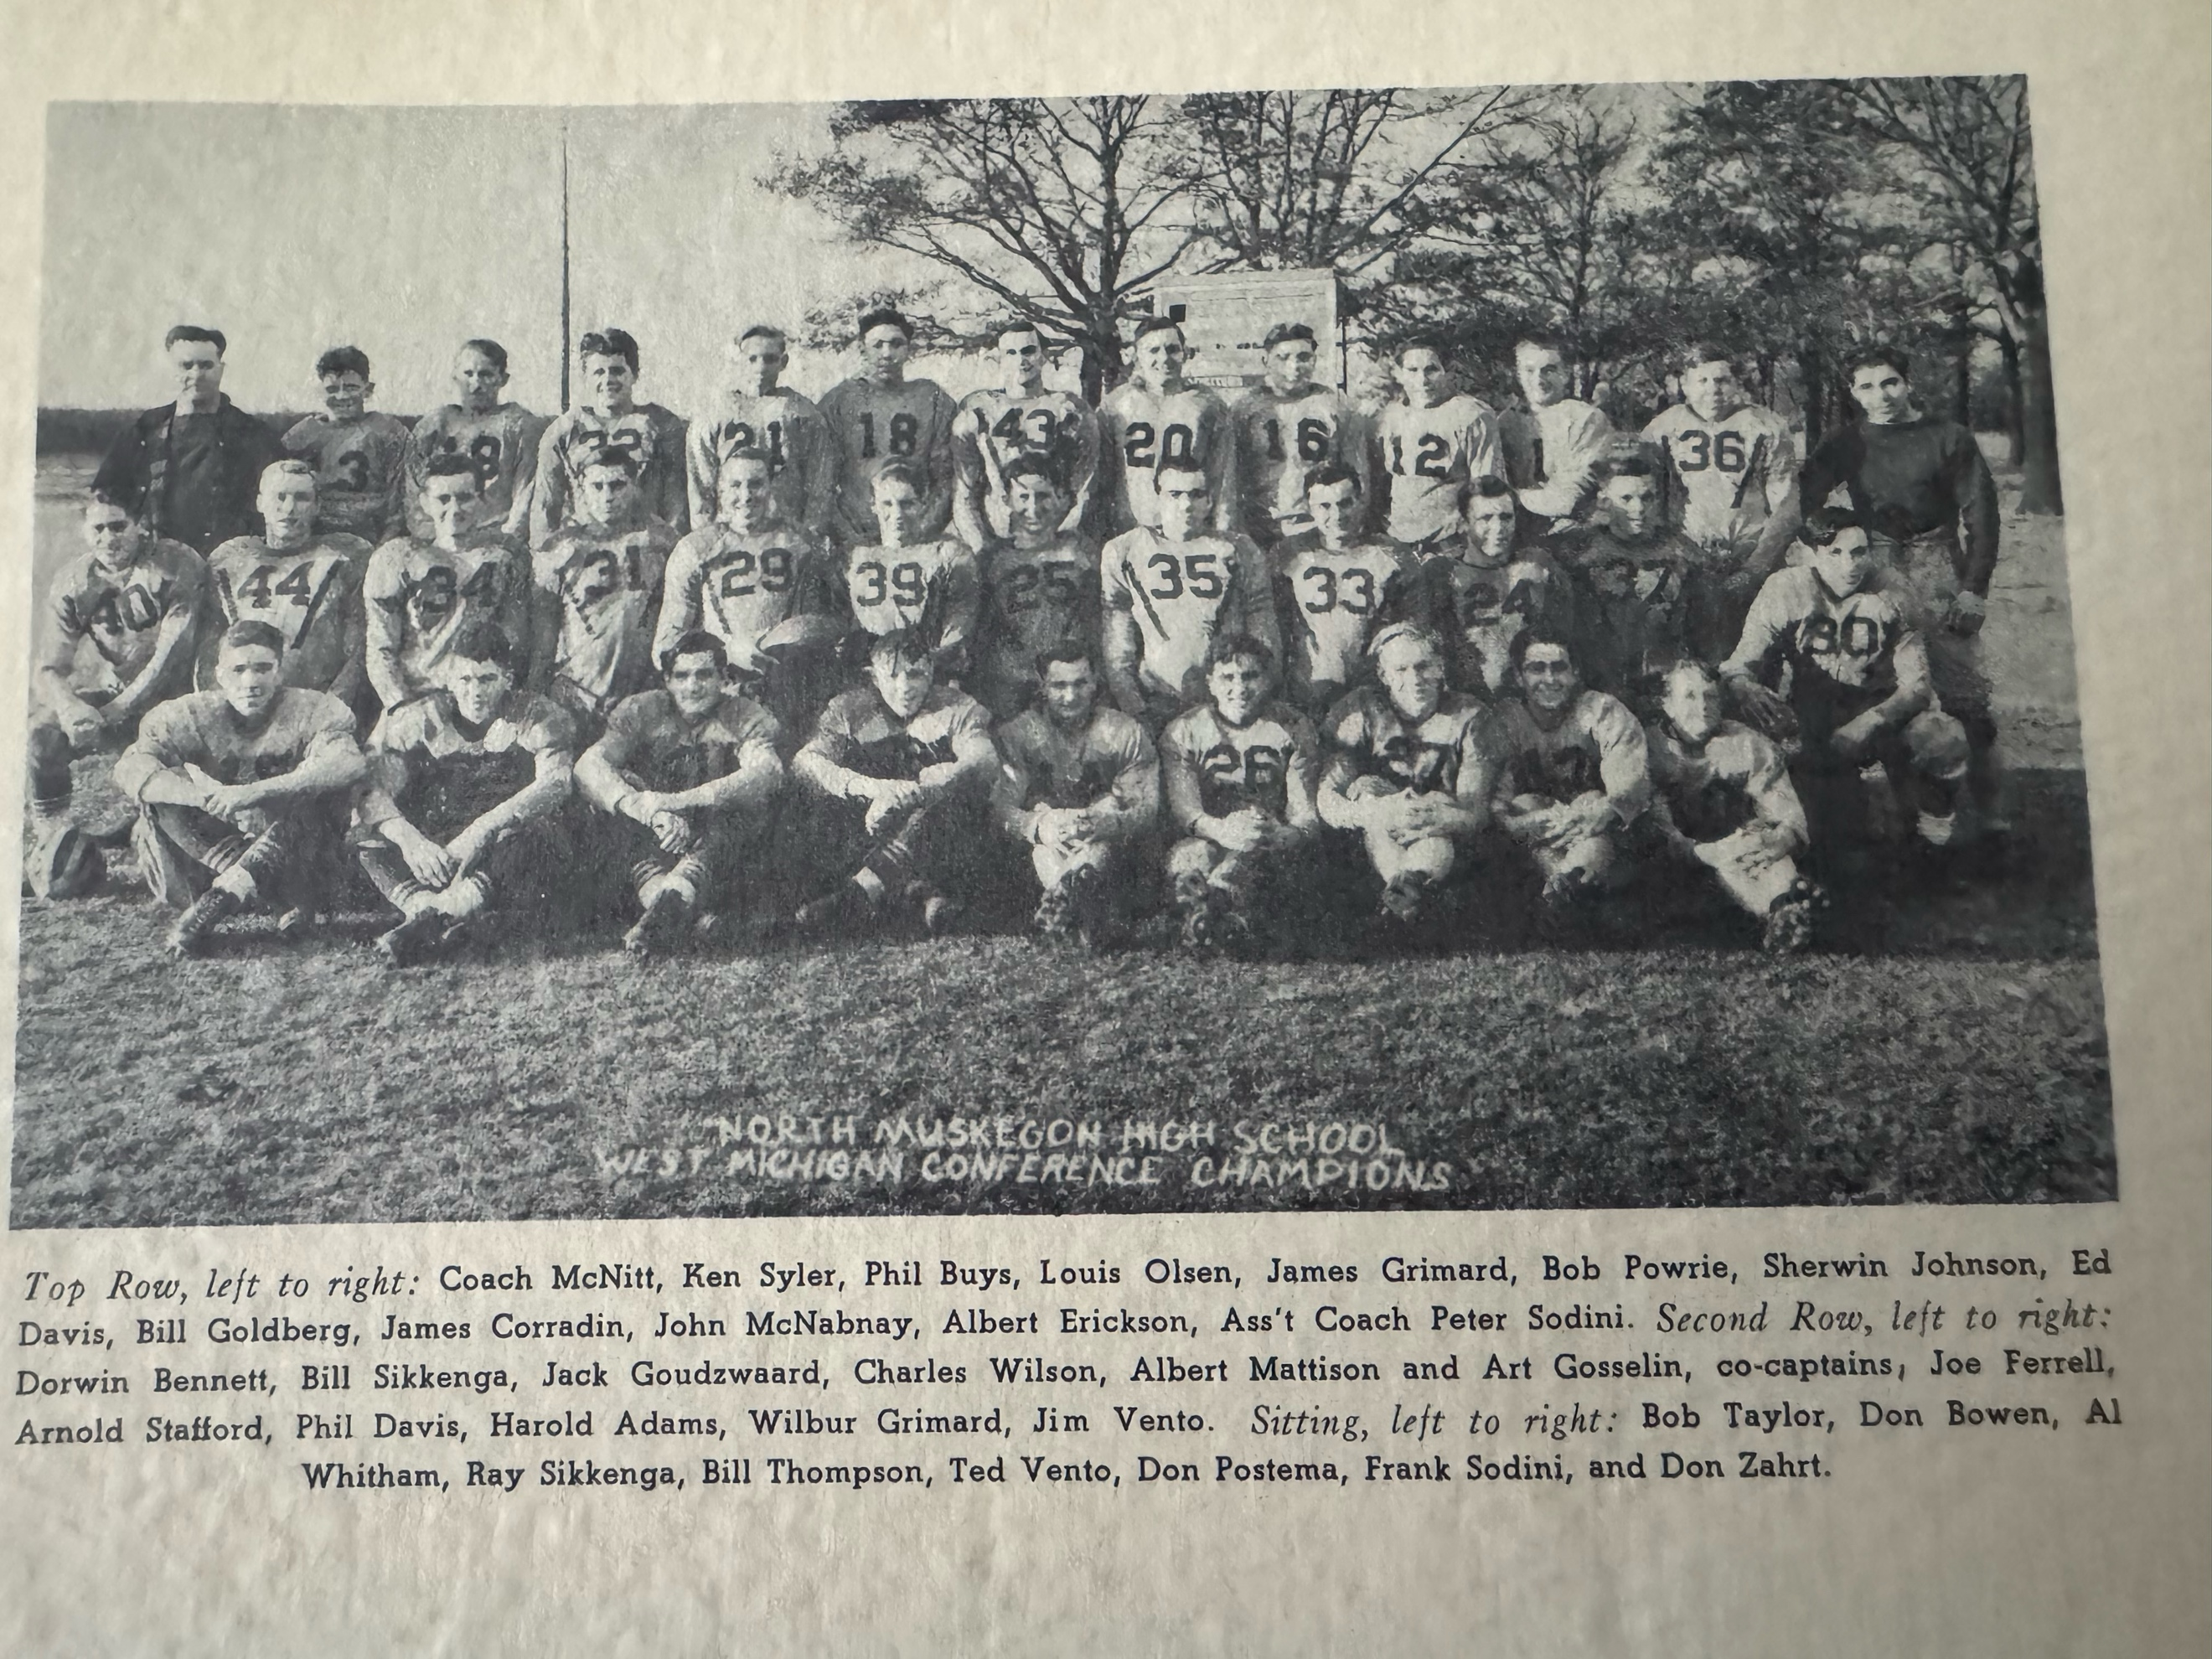

The 1040 NORSEMEN
Note: Al (Shake) Witham (Bottom row 3rd from left) the father of NM coach Larry Witham

Record Score Interesting Fact
0-1 GR Lee 7, NM 0 Playing under the lights in Grand Rapids, NM twice moved inside the Lee 15-yard line but were unable to score.
1-1 NM 14, Manistee 0 After a scoreless first half NM scores on a safety. Dan Timmer rushes for 2 TDs, his 2nd coming following an interception. Bill Sikkenga the leading rusher for NM.
2-1 *NM 20, Montague 6 Sikkenga, and Timmer with rushing touchdowns with Albert Mattison catching a TD pass from Sikkenga.
3-1 NM 27, Reed City 6 3 TDs by Sikkenga lead the Norse to victory. Sikkenga had TD runs of 35, 4, and 48. Soph Don Bowen passed to Art Gosselin for final TD.
4-1 *NM 40, Shelby 0 Timmer scores 3 TD before leaving to serve in the military. Sikkenga also scores a pair of TDs in the Norse rout of the Tigers.
4-2 NM 0, East GR 12 Playing without Timmer, NM shut out by a powerful East GR team. One of EGR TD came when NM fumbled while punting and recovered for a EGR TD.
5-2 *NM 25, Hart 0 Sikkenga scores a pair, Postema a short TD and Don Bowen sprints 80 yards for a TD as NM begins an unprecedented streak that has now survived more than 85 years.
6-2 NM 21, Fremont 0 NM scores 3 quick TDs in 1st quarter with Bill Sikkenga closing his career with 3 TDs. An injured Arnie Stafford also scores.

1941 – coach Lyle McNitt (8-0 Overall 4-0 WMC champs)

With Captain Jack Goudzwaard the only major letter winner returning, expectations were not that high on the Northside for the 1941 season. However, no one could possibly have forecast the success NM would have in football for the next two seasons. Coach McNitt would begin the 1941 season fielding a team that saw only a handful of players who had started a game. Most of the 1941 season would be composed of untested Juniors where only Don Bowen had seen major playing time in 1940. However, those untested but incredibly talented juniors, would soon be a part of MHSAA football program history.

High school football in 1941 was a welcome distraction as news reports were inundated with disturbing news of conflicts in Europe with the war having extended into Russia. As history has shown, it would only get worse.

The Norse began their 1941 schedule with a rare Saturday afternoon game on their home field and it didn’t take long for the Junior trio of Don Bowen, Moe Sikkenga and Don Postema to shine. Following a scoreless first half the Norse took advantage of a pair of Grand Rapids Lee turnovers to aid in their opening 12-0 victory. A Bowen pass to Ken Potter moved the ball to the seven with Bowen scoring on the very next play. Later in the third period Sikkenga intercepted a Lee pass and ran all the way down inside the one-yard line to set up Postema’s line plunge. The game ended with Lee advancing all the way to the six-yard line, insignificant at the time, but a Lee TD could have dampened what would turn into a historical season.

The Norse hit the road for the next three games and the NM ‘Road Warriors’ against pitched a trio of shutouts. The first was a 6-0 whitewash under the arcs at Manistee. The lone score of the game was a 57-yard tally by Don Postema. NM held the hosts to but three first downs the entire game as it quickly became apparent that defense was the number one strength of the Norsemen of 1941.

NM began defending their WMC Championship with a 18-0 shutout of Montague. Bowen scored 2 TDs for the Norse while reserve running back Phil Buys the other Norse TD. Two days later Norse fans and players would watch a rare Sunday afternoon game played on the Norse field between Muskegon St. Mary & Muskegon St. Joseph.

The Norse completed their three-game road trip with a 19-0 victory at Reed City. The ‘highlight’ for the Norse came after Don Bowen’s 83-yard TD run in the second quarter when Bowen’s extra point attempt from placement was good. So futile was the Norse kicking game, as they had not completed an extra point in their first three games, that Bowen’s first extra point attempt after his 12-yard TD pass to his uncle (yes, his uncle) Ken Potter was an attempted drop kick that fluttered off to the side.

The Norsemen survived their biggest scare from Shelby midway through the 1941 season. With less than two minutes to go in the game, and the Norse clinging to a 6-0 lead, Shelby back Joe Morse got behind the Norse defender after catching a pass. It appeared that Morse had clear sailing for a touchdown, but a streak of speed named Moe Sikkenga saved the day, the win, and the scoreless streak when he caught Morse from behind just 15 yards from the Norse goal line. Some 60 years later while serving a customer at the bar at the Bear Lake Tavern, it was Joe Morse who was telling me the story about his near TD back in 1941 when I said: “You have to meet Moe.” I called Moe Sikkenga, and he quickly came to the BLT and the two old foes became close friends recalling ‘the good old days.’

Most of the games during the season were surely not run-a-way victories for the Norse. Their widest margin of victory was their 27-0 conquest of Scottville, hardly a blow-out win. However, any NM score would prove to be enough for a win. Bowen tallied a pair of TDs; Sikkenga had a 10-yard gallop while a pair of sophomores turned in the final tally when Phil Buys threw a TD strike to Ken Tyler. The Norse may have finally found somebody who could kick extra points. After converting but one extra point in their first 5 games, Ken Tyler kicked 3 through the uprights against Scottville.

The Norse then added their seventh victim of the season as well as clinching their 5th straight WMC championship with a hard fought 13-0 victory over Hart. Jack Goodzwaard recovered a Hart fumble at the Pirate 26-yard line. Don Bowen, a few plays later, scored the only points needed on a run from seven yards out. Yet another NM TD in the fourth quarter was set up when a bad pass from center saw NM take over at the Pirate 28. Frank Sodini ran 19 yards to the nine-yard line. Three plays later Sikkenga crashed over from the one and the Norse were one victory away from a perfect season.

A sign of the times for this embattled era saw Ravenna’s season end abruptly. Ravenna’s head coach Roy Weaver was drafted into the army and the Bulldogs were left without a coach. When no replacement could be found the season was over for Ravenna.

Undefeated and unscored upon history was not on the side of the Norsemen as they prepared for their annual Armistice football game with Fremont. The Norse had met defeat at all previous 4 games played in Fremont, twice when they entered the season finale with a perfect record. Businesses in both towns were closed, a parade was held down the main street of Fremont with both high school bands leading the parade. As usual, an overflow crowd surrounded the muddy gridiron at Fremont. Although the final score showed the Norsemen on top 7-0, coach McNitt’s young squad totally dominated the game. The NM forward wall of Harold Adams Ken Potter, Jack Goodzwaard, Ted Vento, Jim Corradin, Bill Goldberg, and Bill Thompson dominated at the line of scrimmage. After a scoreless first half that saw NM stopped twice on downs deep in Packer territory, the big play of the game was an interception by Vento near midfield. Vento returned the ‘pick’ all the way to the Fremont 18-yard line. It was then time for one of NM’s all-time greats to take charge. Don Bowen carried the ball for the next seven carries before crossing the goal from one yard out.

With 8 starters returning, 1942 promised to be another great season for the Norse. Less than a month later the Japanese bombed Pearl Harbor and now it truly was a World War.

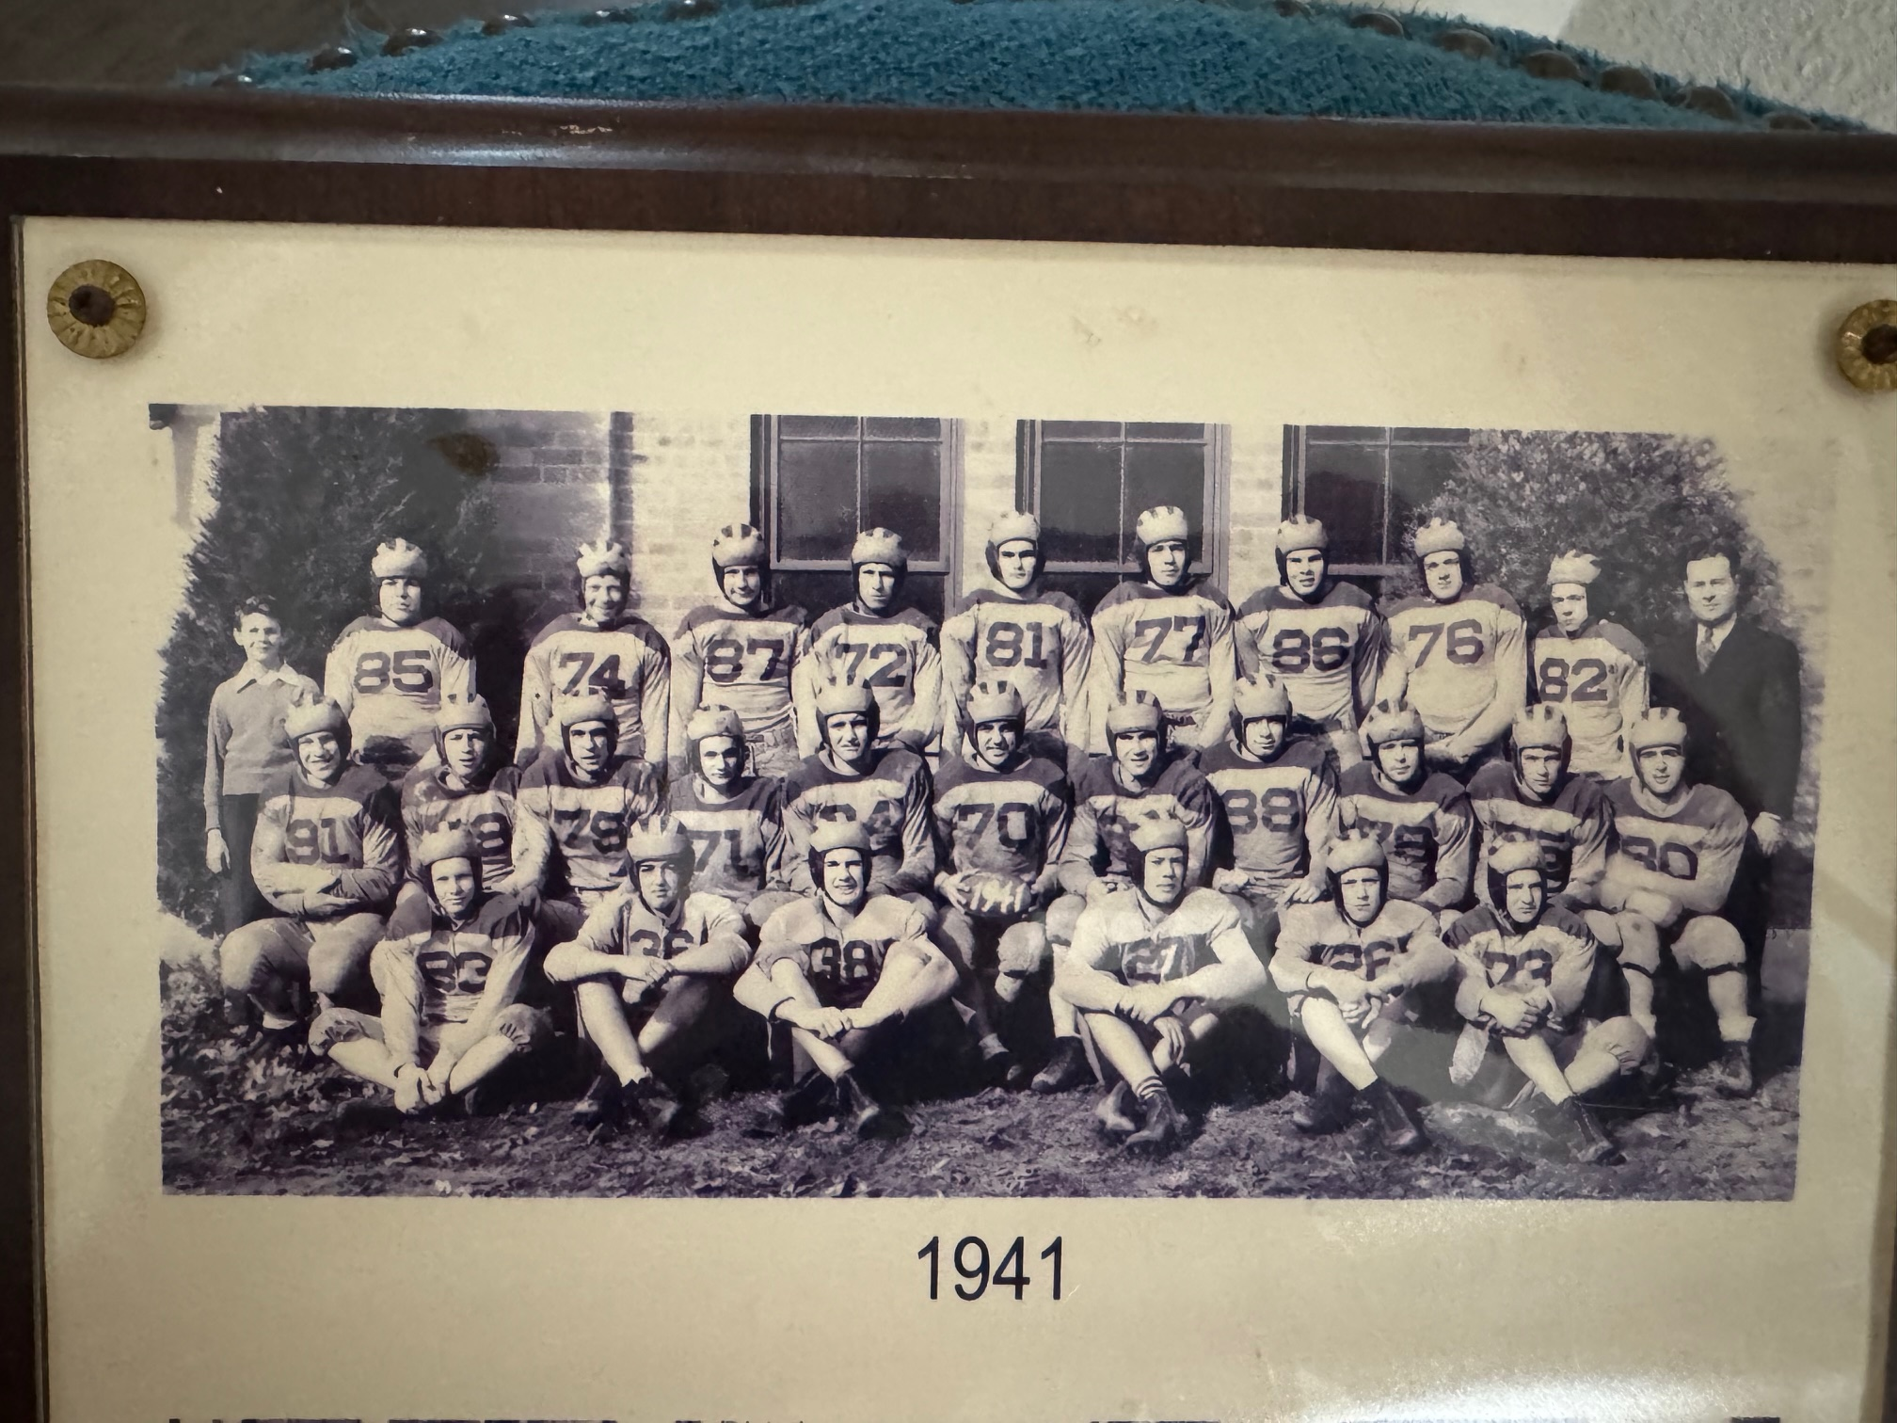

The UNDEFEATED, UNTIED & UNSCORED UPON NORSEMEN of 1941

Top Row L-R: Allan Sowles (manager) LeRoy Barnhart, Ken Tyler, Pete Corridin, Phil Buys, Sherwin Johnson, Bill (Tex) Moore, Jim Peterson, Calvin Peterson, Bob Fenner, Coach Lyle McNitt
Second Row L-R: Don Postema, Moe Sikkenga, Ken Potter, Bill Thompson, Jack Goudzwaard, Ted Vento, Jim Corridin, Bill Goldberg, Harold Adams, Don Bowen, Frank Sodini
Front Row L-R: Wayne Dulyea, Ed Brearly, Tom Pinder, Dick Whitney, Vern Parker, Bill Drost

Record Score Interesting Fact
1-0 NM 12, GR Lee 0 Bowen scores from seven for first NM TD. Don Postema scores from inside the one after a Moe Sikkenga interception and return.
2-0 NM 6, Manistee 0 Don Postema runs 57-yards for the game’s only score. NM defense limits Manistee to only three first downs,
3-0 *NM 18, Montague 0 Bowen 2 TDs, and Phil Buys the other TD, Montague drive in first half stopped at 3-yard line.
4-0 NM 19, Reed City 0 Bowen passes to his uncle Ken Potter for 12-yard TD. Bowen an 83-yard TD and then kicks Extra point – first of the season. Postema 4-yard TD.
5-0 *NM 6, Shelby 0 Moe Sikkenga saves the game for the Norse catching a Shelby runner from behind deep in NM territory. Phil Buys 15 yard run the only TD in the game.
6-0 *NM 27, Scottville 0 Bowen 2 TDs, Sikkenga a 10-Yard TD with Phil Buys tossing a TD pass to Ken Tyler for the final tally. Ken Tyler kicks 3 extra points.
7-0 *NM 13, Hart 0 Bowen scores first NM TD after a Goodzwaard fumble recovery. Sikkenga rams over from the 1 after Sodini’s 19-yard run sets up the score.
8-0 NM 7, Fremont 0 Ted Vento intercepts a pass at midfield and runs it back to the 18 to set up Bowen’s line plunge from the 1.

1942 – coach Paul Moyes (8-0 Overall 4-0 WMC champs)

The 1941 season was so successful that Lyle McNitt was enticed by Grand Rapids Junior College to replace George (Potsy) Clark as their head coach. Replacing McNitt was a 27-year-old former Michigan State grad who was the head coach at Haslett High near Lansing. Paul Moyes inherited a veteran team so talented that Coach Moyes would often modestly say to me: “My grandmother could coach that team.” What Moyes did was take a team that was dominant on defense and do some tweaking with an offense that scored but 108 points the previous season and turn them into an offensive juggernaut. The Norse would more than double their point production from 1941 and were never challenged. With their entire backfield returning from the previous season, the only gaps to fill were in the line. Don Jacobson and Don Gunn, a pair of junior newcomers won the start at the ends, Jim Corradin, and Ken Tyler returned as starters on the line and Ted Vento returned as the starting center. The other line spot was won by Virgil Wilkes.

A little ‘razzle dazzle’ was uncorked with the Norse offense in their 33-0 opening win at Grand Rapids Lee. The Norse unleashed some double reverses and other unique plays that gave the Norse their most lopsided win ever against Lee. Don Bowen scored twice, including a 93 yarder, while Moe Sikkenga added a pair of tallies, including one from 56 yards. Sikkenga even blocked a punt that rolled out of the end zone that resulted in a safety. Frank Sodini added the final Norse 6-pointer on a 20-yard off tackle smash. The score could even have been more lopsided, but a couple of Norse TD’s were called back due to penalties.

With war now raging all over the world, even high school football teams were now affected by the war. Transportation was becoming a real problem. Gas rationing was in effect where rationing coupons were good for a maximum of four gallons per week. Ravenna failed to field a football team in 1942 while many other schools were playing a shorter schedule. Even a major college such as Michigan State did not even field a football team in 1943.

No such problem arose at home for the Norse first home game for the 1942 season with Manistee. A bigger, but much slower Manistee eleven fell to the Norse as NM scored in three different ways. The first was scored by lineman Bill Goldberg, who blocked a punt and recovered it in the endzone for the first NM score to give the Norse a lead at halftime. NM scored the next TD on a pass from Bowen to his lifelong buddy Moe Sikkenga good for 27 yards. As usual during this historic NM run over the past couple of years, they failed to make the extra point. Displaying great depth in the backfield, reserve Phil Buys gave Bowen a rest and entered the game after NM intercepted a pass at the Manistee 30-yard line. Buys carried on all the next carries, with the final being from 6-yards out for the TD. Desperate to find somebody who could kick an extra point, Virgil Wilkes, the last surviving member of this amazing team, shocked the home folks when his extra point attempt was good.

While many of Greater Muskegon citizens were rounding up metal for a scrap drive, where even the school bell signaling the start of the school day at NM High was scrapped for the war effort, the Norse were preparing for their next game with Montague. The Norse were never challenged by the Wildcats as the wealth was spread among 4 different players, including the first TD as a Norseman by sophomore end Don Jacobson in a 26-0 Norse victory.

With so much attention on North Muskegon’s unscored upon streak, the most drama from the Norsemen’s 27-0 win over Reed City occurred in the games’ final moments when Reed City had a first down at NM’s 5-yard line. The hometown fans in attendance on the northside breathed a huge sigh of relief as the defense led by Corradin, Vento, and Goldberg dug in and pushed the Coyotes back to the 8-yard line where the Norse took over to preserve their unscored upon streak that now stood at 14. It was that tenacious defense that scored the first TD for the Norse. NM blocked a Reed City punt where it was scooped up by Ken Tyler who raced into the end zone. Tyler, who had won the job as the extra point kicker made it 7-0 with a rare made extra point. Bowen made it 13-0 when he had one of his patented Bowen runs for a touchdown followed by yet another perfect point after from Tyler. Bowen added a third tally while a pass from Phil Buys to Moe Sikkenga capped the scoring on a 15- yard pass play.

There were not any fourth quarter worries in NM’s next contest at Shelby as the host Tigers never got into Norse territory during the entire game as the Norse powerhouse breezed to an easy 32-0 win. After Don Bowen scored the first TD Norse fans had a brief scare as Bowen twisted an ankle and was sidelined for the rest of the half. Phil Buys, as he did throughout his career, was a pillar of strength in his reserve role and sparked the Norse to their second TD. A Buys pass to Don Postema was good for 25 yards and a NM TD. Captain Bowen did return for the start of the second half, and he quickly showed all was well as he raced 50 yards for the third NM TD. With a commanding lead Buys returned to the field and rushed for a fourth TD for the victors, Moe Sikkenga completed the scoring on what today would be known as ‘the hook and ladder’ play with Bowen firing a pass to Don Jacobson, who in turn lateraled to Sikkenga who raced 40 yards to pay dirt.

If ever there was a win that felt like a loss, the 6th game of the 1942 season with Scottville tops the list. The main storyline of this game surely wasn’t the Norsemen’s commanding victory and their 16th straight victory. Not at all. The main storyline was the fact that Scottville had scored! A third quarter run by Scottville’s Herb Spencer became the first score of any kind against NM in 16 games. The NM streak of 15 games undefeated, untied and unscored upon was over. And how significant is this achievement? As I write this story 83 years later, this record still stands in MHSAA history! The game was an away game for the Norse, but the game wasn’t played in Scottville, but in Ludington and under the lights on Wednesday Oct 21, 1942. The Norsemen had become a drawing card and one of the reasons for the change of venues from Scottville to Ludington was to give the people in Ludington a chance to see this great NM team in action. The headlines that graced the sports section in the Ludington Daily News spelled out in big bold letters: SPARTAN AERIALS CRACK NORTH MUSKEGON’s 15-GAME UNSCORED UPON RECORD. A lesser headline did type in: Norse Power paves way for 16th straight win. The beginning of the story written by long time Ludington Sports Editor Dick Derrick was all about Scottville’s drive to score the only touchdown given up by the Norse in 16 games, a streak that would shortly be expanded to 18. In a nutshell, Scottville mounted a 60-yard drive in the third quarter where they completed 4 of 5 passes with the big play a 15-yard pass from Herb Spencer to Ralph Backwick down to the 2-yard line. Two plays later Spencer scored from inside the two and although they lost the game 25-6, Derrick noted it was a ‘moral victory’ for Scottville. Far down into his story Derrick was very complimentary of this NM powerhouse. “Winners of the West Michigan Conference for five years and holding a victory string that stretches to 16 games, the Norsemen exhibited to football fans Wednesday night what blocking means to football with a crushing attack, completely land-locked that rumbled through Spartan defenses.” NM showed their superiority on their initial drive of the night. Taking over at their own 27-yard line all four NM backs took turns moving the ball downfield behind some great blocking up front to traverse 73 yards for a TD with Don Bowen on a short run going the final distance. The Norse completed the scoring in the first half with Moe Sikkenga racing 46 yards for a TD. NM then added a TD in their opening drive of the second half to take a commanding lead over the Spartans with Don Postema plunging over for the TD. It was on this drive where fate stepped in according to my conversation with an NM player years later that contributed to Scottville scoring against the Norse. Don Bowen, after picking up a first down following a 13-yard run, sustained an ankle injury and limped off the field. “With Don not in the secondary Scottville threw a number of passes where Don would have been defending,” said his buddy Moe Sikkenga. The Norse did tack on a final TD when Bowen’s replacement Phil Buys scored from inside the 10-yard line. The Norse had indeed won their 16th straight game but there was no celebration from the Norse players as they trudged off the Ludington field. “You would have thought we lost the game, if you watched our team walk off the field,” said revered NM teacher Homer VanHoesen to me many years later.

The Norse then headed to Hart to face a Pirate team that had this game on radar the entire season. The Norse scored TDs in the first and last quarter and had a couple of other drives stall out deep in Pirate territory. Although far less than 100 percent with an ankle injury, Don Bowen led the Norse to a TD on their first drive of the game. The Norse nearly added a second first half tally as they reached the Hart 3-yard line before time had expired. The Norse nearly added another 6 points to their total in the third quarter, but a clipping penalty halted a Norse drive that had reached the Pirate 10-yard line. NM did score the clinching TD with Don Postema scoring from 3-yards out. The Pirates did threaten late in the game as a pass from the twin towers of Walter ‘Stretch’ Hansen (who passed away in 2025 at 100 years young) to Stan Kapulak advanced the ball to the NM six-yard line as the game ended.

The Norse were top-heavy favorites to defeat a winless Fremont team in their annual Armistice game. Ten seniors who have played huge roles in the current NM streak would suit up for the last time in the blue & gold colors of the Norsemen. Only starting guard Ken Tyler and end Don Jacobson would return for the Norse. The Norsemen went out in a blaze of glory, and it was only fitting that the touchdown twins of Bowen & Sikkenga would each score 3 TDs in the 49-0 rout of the Packers. Bowen also threw a pair of TD passes to end Wayne Dulyea and Don Gunn. Only the Class A teams during this era were rated in the state high school polls. However, if a poll would have been in existence in 1942, there would be little doubt that this NM team would have topped all Class C lists.

Nearly 60 years after this historic run the Norsemen of 1941 & 1942 were inducted into the Greater Muskegon Hall of Fame, only the third team in Greater Muskegon history to be so honored. Twenty-five of the living Norsemen from those teams were in attendance while widows of five of the deceased members also were on hand for this moving induction. What a thrill it was for your author to serve as the emcee for this occasion. Sadly, as time moves on, none of those incredible men of ‘The Greatest Generation’ are with us as of this writing.

Record Score Interesting Fact
1-0 NM 33, GR Lee 0 Don Bowen 2 TDs, including a 93-yard run, Moe Sikkenga 2 TD’s and a blocked punt for a safety, Frank Sodini a 20-yard TD.
2-0 NM 19, Manistee 0 NM scores in 3-different ways. Bill Goldberg blocks a punt in the endzone, Bowen to Sikkenga a pass for 27 and Phil Buys 6-yard TD.
3-0 *NM 26, Montague 0 4 different Norse score in win. Bowen from short yardage, Buys passes to Postema for 25, Bowen TD toss to Don Jacobson, Sodini scores from 25.
4-0 NM 27, Reed City 0 Tyler starts the NM scoring with a 15-yard TD from a blocked punt. Bowen has another 2 TD game with Sikkenga the final TD on a pass from Phil Buys.
5-0 *NM 32, Shelby 0 Bowen 2 more TDs, Buys 1 TD pass to Postema and a rushing TD, Sikkenga scores on a trick play from 40.
6-0 *NM 25, Scottville 6 Scottville scores to end streak, Bowen, Postema, Sikkenga and Buys each score TD. Bowen’s injury in third quarter costly.
7-0 *NM 14, Hart 0 Hart gives NM stiffest test of the season. Bowen limps for one TD, Postema the other.
8-0 NM 49, Fremont 0 Bowen and Sikkenga end careers with 3 TDs each. Bowen also a pair of TD passes to Wayne Dulyea and Don Gunn.

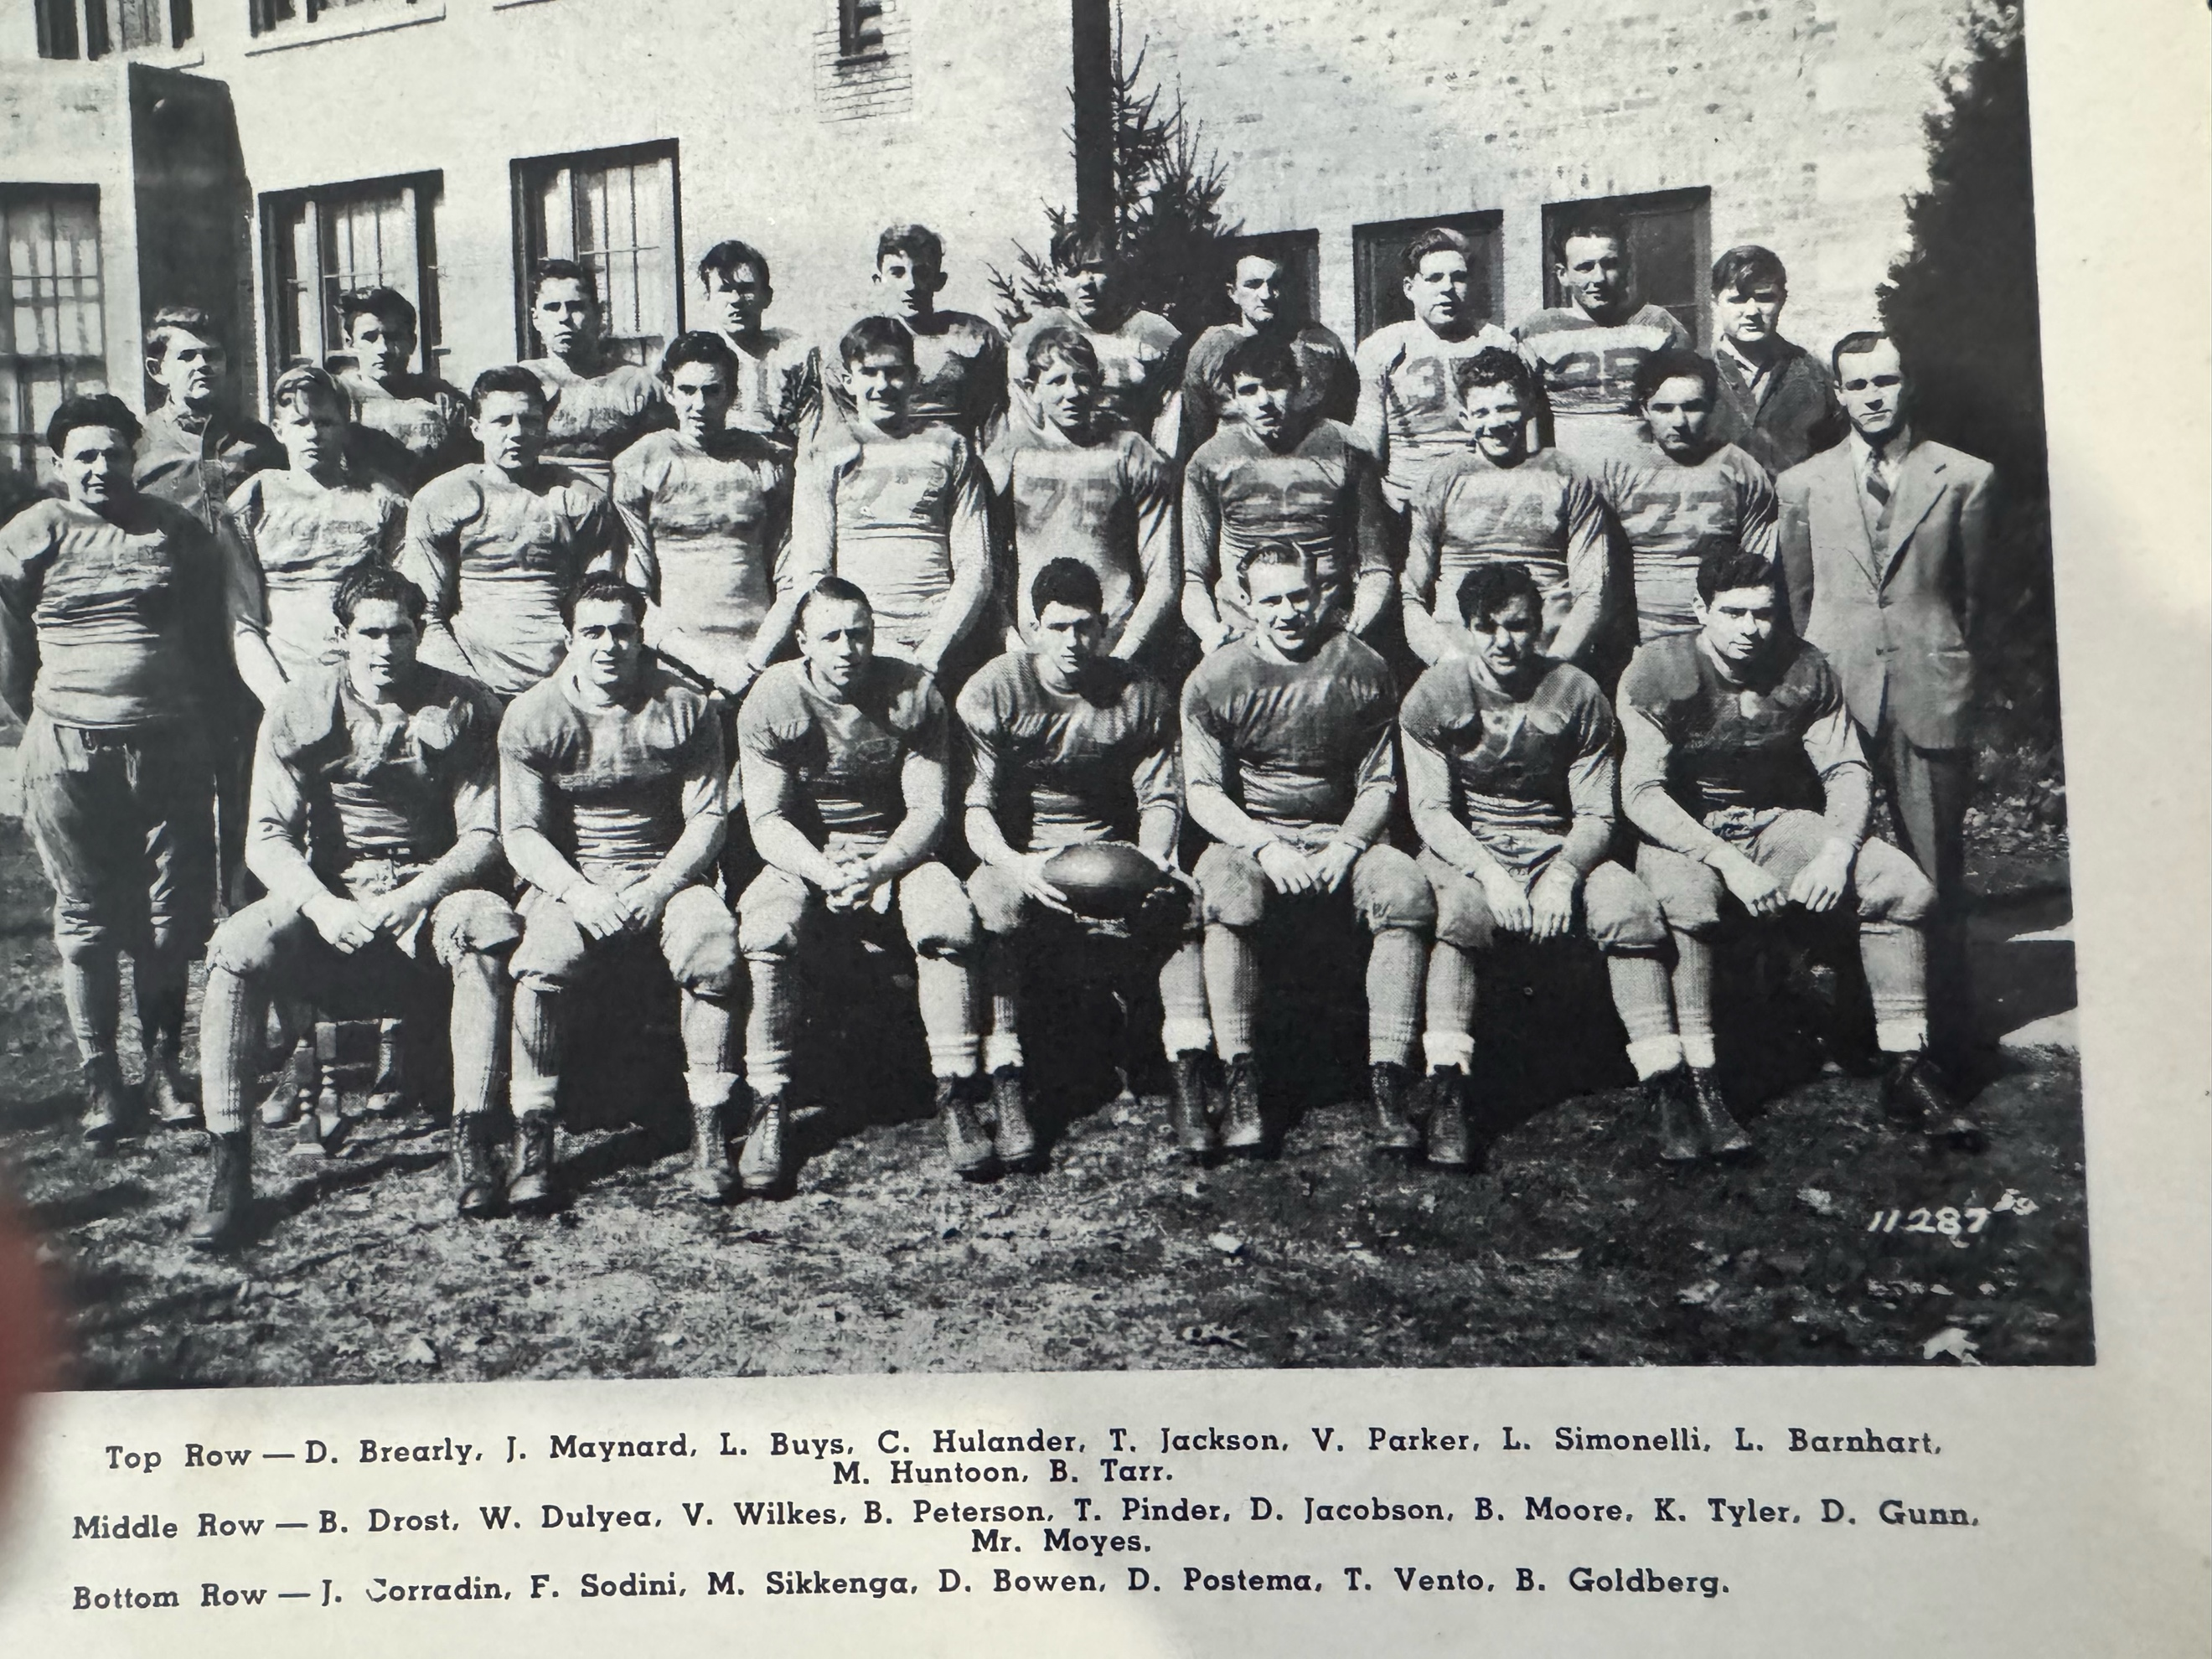

The 1942 HALL of FAME NORSEMEN:

1943 – coach Paul Moyes (3-4-1 overall 2-1-1 in WMC, Montague champs)

Injuries have always played a part in the game of football; but losing players to the draft or armed forces is unheard of in today’s era. Second year coach Paul Moyes was counting on Ken Tyler as one of his two regulars returning from last years’ powerhouse squad; however, 1943 captain elect Tyler had entered the service prior to the season opener. Two other starters were on the cusp of leaving for the service as running back Bob Fenner and lineman Bill Peterson had spent most of the week prior to the Norse opener with Grand Rapids Lee with draft duties in Detroit. All three would eventually miss all or most of the upcoming season and would leave for the service without earning their high school diploma. It would be many decades later during the Obama Administration when all three would deservedly receive their long overdue diplomas from NMHS. In a moving ceremony at a NM seniors award assembly in 2004, Ken Tyler received not only his long overdue diploma but was one of the recipients winning the Paul & Tom Moyes Sportsman Ship award.

The Norse fielded an injury riddled and inexperienced team in their home opener against Grand Rapids Lee. After a scoreless first half the Norse mounted a serious scoring drive but a fumble at The GR Lee 10-yard line halted their best scoring opportunity. The games only score came in the fourth quarter as Lee ended the Norse winning streak at 18 games with a 6-0 victory.

It was a long journey to Manistee for the second game of the 1943 season. There were no expressways in 1943, and the speed limit to save on gas as well as preserve tires for the war effort was set at a maximum of 35 mph. The return home was even longer as the Norse could not create any kind of offensive momentum against the heavier Manistee team and for the second straight week suffered a 6-0 loss. The injury problem for the Norse became even worse as starting halfback Dick Salmonson fractured a couple of ribs in the losing contest with Manistee.

After recently completing their still standing feat of holding their opponents scoreless through 15 straight games, the Norse began 1943 getting a dose of their own medicine. Montague, the 1943 WMC champs, scored in every quarter while holding NM scoreless. It was in this game that the Norse began playing perhaps the smallest and lightest gridder to ever don a Norseman uniform, 5’2, 105-pound sophomore Ken Kueny.

Although the Norse suffered their 4th straight defeat after another long journey to Reed City, the Norse made the game close and finally were able to produce their first TD of the season when reserve back Fred ‘Pinky’ Gerling completed a TD pass to the only returning regular from the 1942 season, Don Jacobson. The rest of the season appeared gloomy for NM but this plucky group of gridders would not taste defeat in the second half of the 1943 campaign.

The Norse were decided underdogs against Shelby but reports coming out of the northside were that the Norsemen would be at near full strength for the first time all season. Leonard Buys, the only returning backfield man with any experience from 1941, would be in the NM starting lineup. The Norse were finally able to have enough players to just have a scrimmage during the midweek practices and work on plays and defensive strategy for the game with Shelby. The Norse used an aerial attack to stun the favored and undefeated Shelby team 19-0 with Fred Gerling tossing three TD passes, two of those six-point strikes were caught by Don Jacobson. The Norse unleashed a ‘new’ formation for this game --- The T formation with Gerling the QB under center Tom Pinder.

It appeared the Norse were in for a long afternoon in their next game with Scottville. Utilizing the power of a pair of big 200-pound backs in Herb Spencer and Fred McGee, the visiting Spartans took the opening drive and scored an early TD against the much smaller band of NM defenders. They would never again cross the Norse goal line. NM nearly tied the game in the first half but a couple of passes at the Scottville goal line were dropped by Norse receivers. Using their newly formed T formation the Norse did mount a long drive in the third quarter led by the running of Tom Jackson and Lynn Felt with little Fred Gerling also contributing from his QB position. Felt plunged through for the TD but the extra point attempt by Marshall Strayer was just wide of the uprights. Playing his final game for the Norse was lineman Bill Peterson, who following the Wednesday afternoon 6-6 tie game with Scottville, would leave two days later for the armed services.

The Norse continued their climb down the comeback trail with a surprising 19-0 victory over a Hart team that was picked to give the Norse a tough game. The big play in the game was by the smallest player on the field. Ken Kueny, who tipped the scales at 105 pounds, intercepted a Pirate pass and scooted 46 yards for a TD. Lynn Felt would follow up later in the second half with a pair of TDs as the Norse secured their second victory of the season. If anybody is curious as to who was the first freshman to start a game for the Norse, the answer is Bob Pyle, who started the game at end for the Norse.

While the Norsemen had a few days off in preparation of their final regular season annual Armistice Day clash with Fremont it is noteworthy to point out the WMC conference championship game between Montague and Scottville. Montague was undefeated and unscored upon when they made the trip to Ludington to take on a Scottville team whose only blip of the season was a 6-6 tie with North Muskegon. Montague had little trouble in winning the game, but their season was very similar to North Muskegon’s undefeated feat of 1942. Montague had not given up a point up to their clash with Scottville but again it was the Spartans who would play the spoiler role in a defeat to thwart Montague’s quest for perfection. Ironically, it was Herb Spencer, who scored the only TD given up by the Norse in 16 games, who scored the lone TD for Scottville in a 26-7 final score, nearly identical. to NM’s 26-6 victory a year earlier.

The final game of the season was headlined by the work of little Ken Kueny. Playing on a field that had more mud than grass, Kueny led the Norse on an uninterrupted 74-yard TD drive. Kueny on the first play picked up 12 yards, a few plays later he picked up 18. The diminutive Kueny then picked up a first down to the Packer 28. On a key fourth down and five Kueny passed to freshman Bob Pyle to pick up the first down. After losing four yards, Kueny rushed for 12 yards. Covered in mud from head to toe, coach Moyes inserted Fred Gerling in to replace an exhausted Kueny. Gerling did the rest and scored from three yards’ out for the games only score. After a terrible start to the season the Norse rallied to save their season by going undefeated in their final four games. As 1943 came do a close, WWII was continuing to rage, many had given the supreme sacrifice, including 53 from the Muskegon area with another 21 missing in action. The good news --- The USA and their allies were winning the War.
Shortly after the conclusion of the 1943 season James F Henderson, veteran sports editor of the Muskegon Chronicle and my future boss picked his WMC All-Conference team. Henderson listed on his first team end Don Jacobson, tackle Bill ‘Tex’ Moore and guard Bill Drost while Center Tom Pinder and halfbacks Tom Jackson and Lynn Felt were listed on Henderson’s second team.

THE NORSEMEN OF 1943
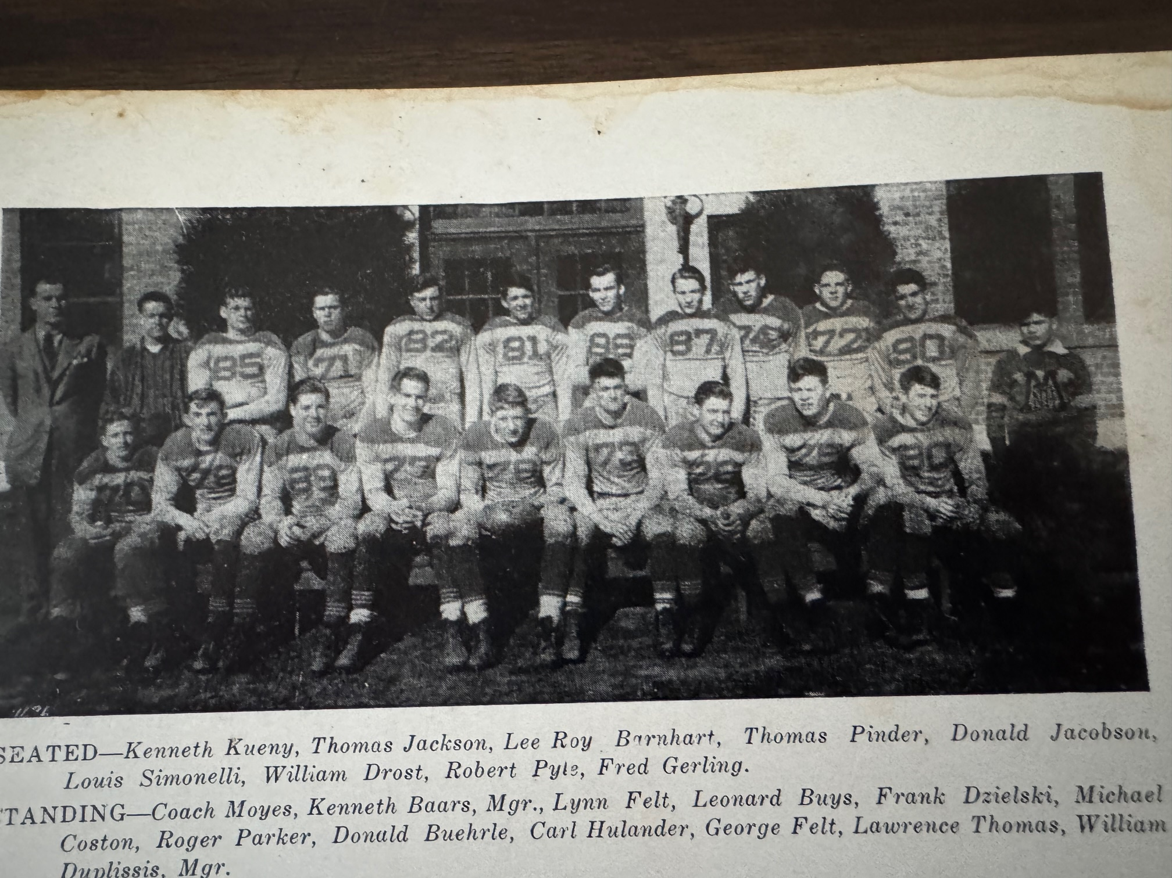

Record Score Interesting Fact
0-1 GR Lee 6, NM 0 NM winning streak ends at 18. NM fumbles at Lee 10 yard in their closest scoring threat.
0-2 Manistee 6, NM 0 NM offense struggles against Manistee. Fails to cross their own 40-yard line in the game.
0-3 *Montague 25, NM 0 Montague scored in each period as the Norse are shutout for the 3rd straight game.
0-4 Reed City 13, NM 6 NM loses by a TD but score their 1st TD of the season on a pass from Fred Gerling to Don Jacobson.
1-4 *NM 19, Shelby 0 NM unveils the ‘T’ formation with Gerling throwing 2 TD passes to Jacobson and one to Lynn Felt.
1-4-1 *NM 6, Scottville 6 Scottville scores first but NM dominates the rest of the game. Lynn Felt the lone NM TD. Bill Peterson leaves for the service 2 days later.
2-4-1 *NM 13, Hart 0 Lynn Felt 2 TDs, Ken Kueny returns intercepted pass 46 yards for TD
3-4-1 NM 6 Fremont 0 Armistice Game played in the mud. Kueny leads opening drive capped by a Fred Gerling TD.

1944 – coach Earl Meyers (3-4-1 overall 2-1-1 in WMC, Montague champs)

Seven NM players and one coach all had left their team before their senior year heading into the 1944 season. Lynn Felt, starting back on the 1943 team reported for induction just a few days before the Norse opener, and captain elect Louis Simonelli joined the Navy earlier in the summer. While virtually all the players were inducted into the armed forces, even their 30-year-old head coach joined his players in fighting the War against aggression. Although married, the father of two boys, and a schoolteacher/coach Paul Moyes enlisted as a Lieutenant in the US Navy in May of 1944. The new duties as the head coach for the Norsemen were entrusted to Earl S. Meyers.

The Norse made the jaunt to Grand Rapids for their traditional opener with Lee high and were no match for a Lee team that pre-season reports as being perhaps their best team in years. NM was only able to muster a pair of first downs while Lee was able to just pound the ball up the middle relentlessly against the smaller and young Norse defenders as NM fell 13-0.

The Norse bounced back nicely the following Friday with a convincing 25-0 victory over Reed City. The Norse scored first on a pass from a pair of returnees from the previous season, Ken Kueny to Don Jacobson to take a 6-0 lead at halftime. Early in the second half Tom Jackson broke loose on an 80-yard TD jaunt. Kueny then electrified the home crowd by fielding a punt at his own 34-‘s yard line and, with a lot of twisting and turning, ran 66 yards for a 3rd NM TD. Keuny then completed the scoring with a TD pass for 30 yards to Marshall Strayer.

Nothing was decided on the Northside gridiron as the Norse and Montague battled to a scoreless tie. The best chance for a score by either team came when Montague’s Wackernagle picked up a bad pass from center and
advanced the ball to the NM 2-yard line before swarmed under by the Norse. NM receivers dropped a pair of passes that could have resulted in TDs.

In the only game ever played between the two schools, Zeeland defeated the Norse 20-7. The Norse were only able to score late in the fourth quarter on a two-yard dive by Tom Jackson. Putting a huge damper on the contest was an accident that took the life of Don Brearley the day before the Zeeland contest. Brearley, a popular NM student who once served as a manager for NM football, was killed in a car accident just a block from the high school on his way to a pep rally on the eve of the game with Zeeland.

In a Wednesday afternoon game played on the Hart High School field, North Muskegon had their best offensive showing on the season with a 31-0 rout of Shelby. It was feared that Shelby wouldn’t even have a football team in 1944 as their football field was used as a camp for German Prisoners of War. All Shelby ‘home’ games during the season were played at nearby Hart. The Norse were only able to get a 4-yard TD run from Kueny in the first half, but they were working on all cylinders in the second half. A trio of Norsemen scored their first touchdowns wearing a Norse uniform: Frank Dzielski scored from 4-yards out on NM’s first possession of the second half, Bud Anderegg intercepted a pass and returned it for a TD while Sophomore Bob Pyle caught a TD pass from Tom Jackson. Marshall Stayer had the other TD on a short dive as NM won their 10th straight game over Shelby.

The Norse had visions of perhaps winning the WMC conference title heading into their game with Scottville as only a scoreless tie with Montague was a non-winning game in conference play. It was not to be although the Norse completely dominated play in their 7-6 loss on the Scottville gridiron. A Norse miscue created the only score for Scottville when a Norse pass was intercepted by Johnson of Scottville who returned it 50-yards for a TD. The all-important placekick was good, and the Norse trailed 7-0 at halftime. NM mounted their scoring drive midway into the third period and marched 60 yards to score on a Len Buys TD. However, a Norse weakness for several years again plagued NM as the extra point was wide. NM made a serious drive late in the game, but the final whistle blew with the Norse at the Scottville 5-yard line. NM had 13 first downs to Scottville’s four but 75 yards in penalties perhaps deprived NM of a win and at least a share of the WMC title.

NM kept their mastery of never having lost to Hart intact as they scored a couple of 2nd half touchdowns in a 13-0 win under the lights in Hart. On the last play of the third quarter Ken Kueny passed to Don Jacobson who quickly lateraled to Tom Jackson and the play was good for 68 yards and a Norse TD. Marshall Stayer completed a late march for NM with a short TD run.

Fremont scored their first touchdown against the Norse since 1939 and added two more to even the 10-game series between the two rivals at five games won by each team. The Norse had two scoring drives inside the Packer 20 but failed to score. For the second straight season NM would post an identical record of 3-4-1.

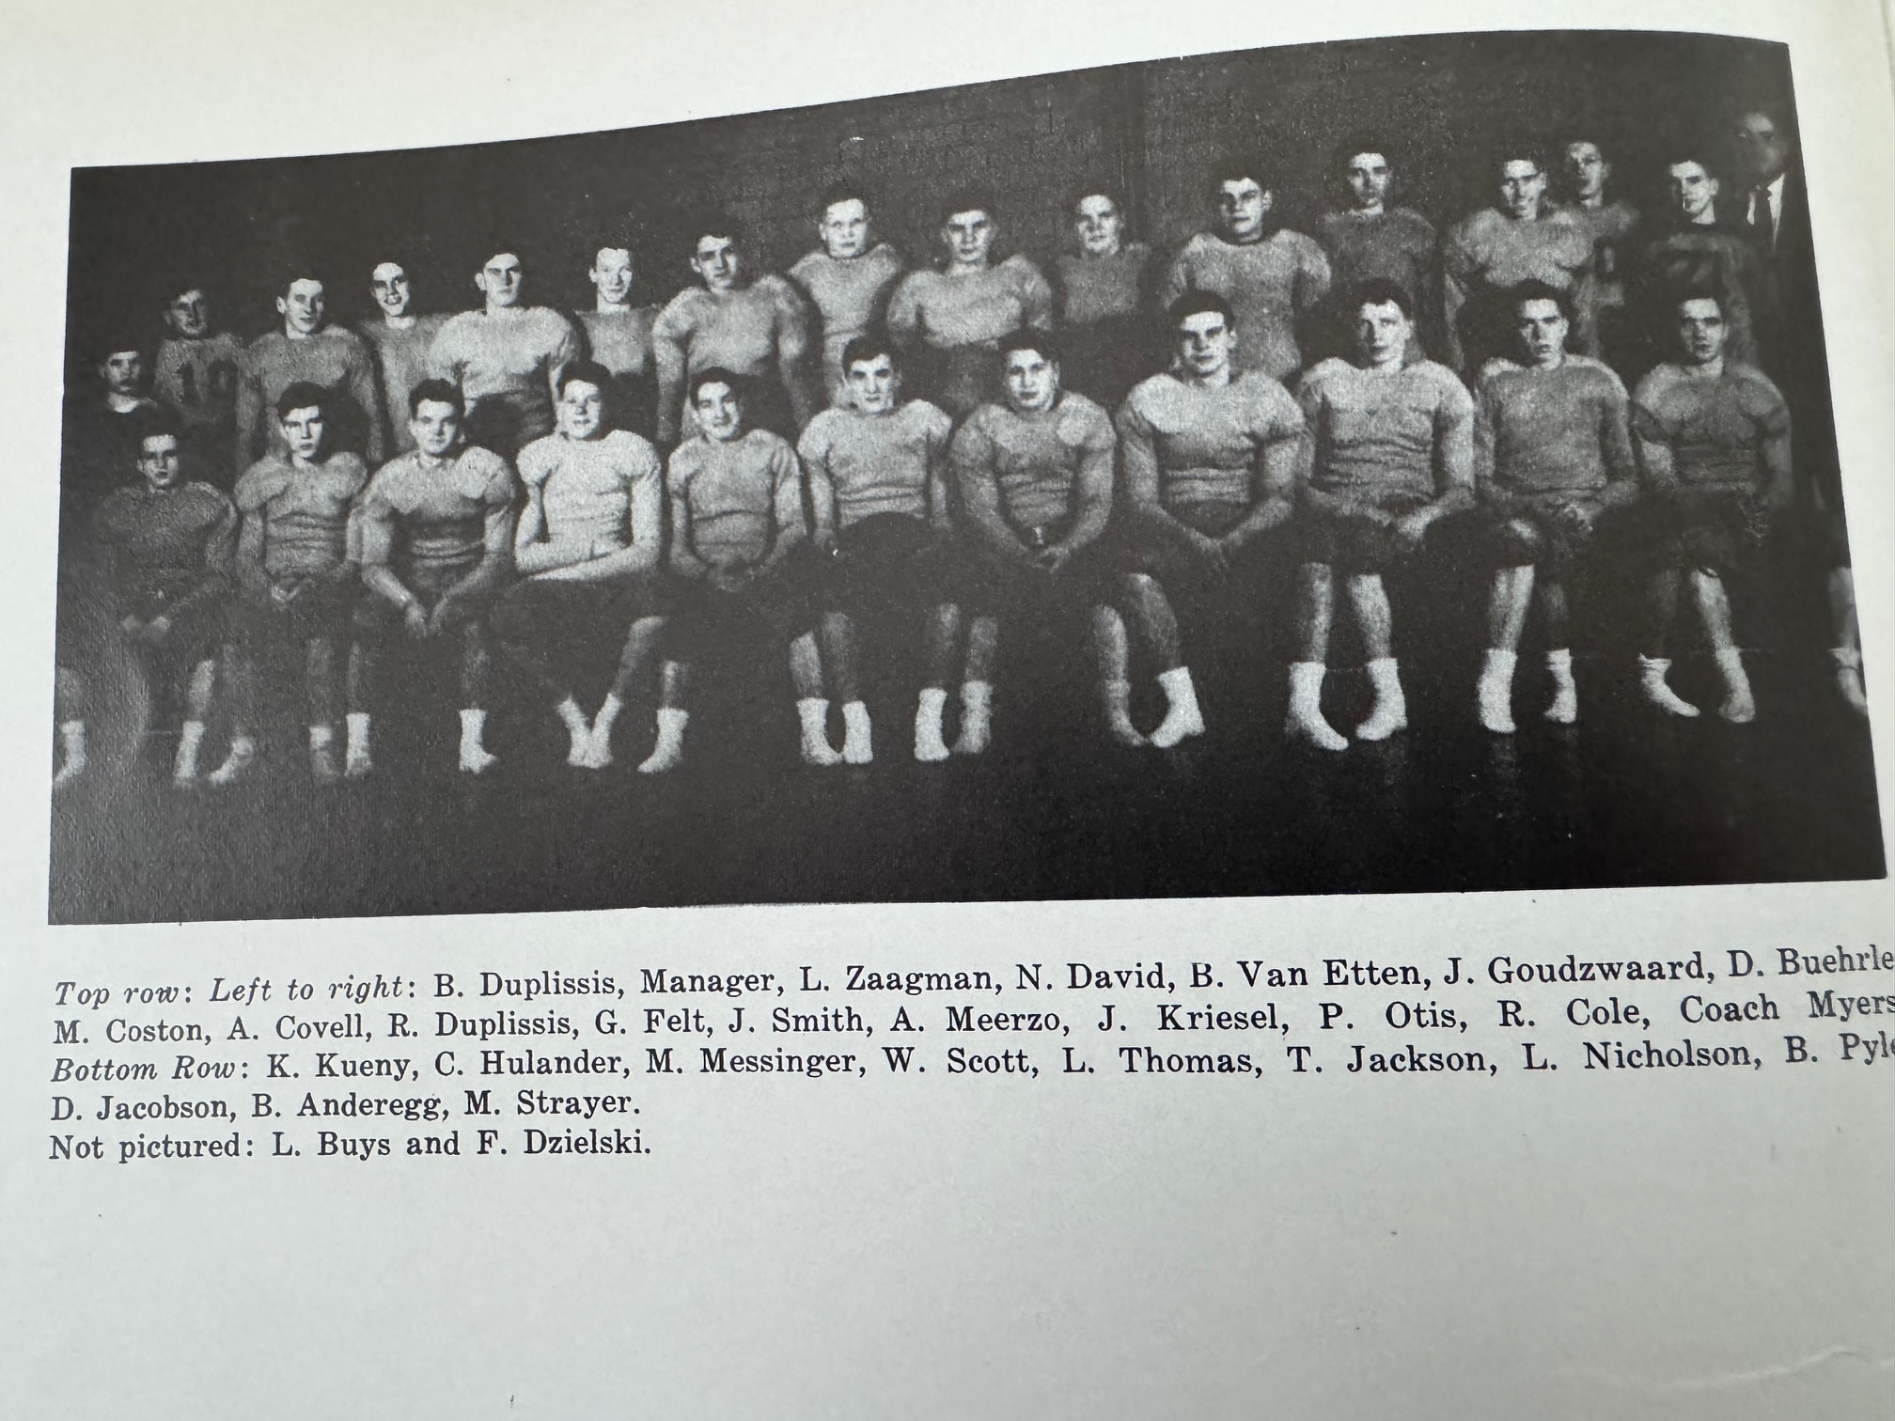

The NORSEMEN of 1944

Record Score Interesting Fact
0-1 GR Lee 13, NM 0 Lee scores a TD in 2nd and 3rd quarters and lets their defense do the rest as Lee shuts out the Norse for the second straight year.
1-1 NM 25, Reed City 0 Kueny throws 2 TD passes, one each to Don Jacobson and Marshall Strayer and returns punt 66 yards. Tom Jackson 80-yard TD.
1-1-1 *NM 0, Montague 0 NM and Montague play to scoreless tie. NM dominated game mostly played in Montague territory.
1-2-1 Zeeland 20, NM 7 NM held scoreless until Jackson scores on a short dive play with 4 minutes left.
2-2-1 *NM 31, Shelby 0 5 Norse tally TD’s: Kueny, Dzielski, Anderegg, Pyle and Strayer as NM wins 10th straight over Shelby.
2-3-1 *Scottville 7, NM 6 A pass intercepted and returned for a TD and made extra point the difference in tight loss. Buys scored NM TD, but extra point fails.
3-3-1 *NM 13, Hart 0 A 68 yards pass, catch and lateral from Kueny to Jacobson to Jackson good for TD. Strayer scores final TD.
3-4-1 Fremont 19, NM 0 Fremont evens 10-games series at 5 games each.

1945 – coach Earl Meyers (6-2 overall, 5-0 WMC Champs)

The bitter war had mercifully come to an end right at the start of the 1945-46 school year. The USA suffered more than one million casualties with more than 260,00 paying the supreme sacrifice. Virtually all the former NM players from previous years entered the service, with two Norsemen football players lost during the War:

Oliver Eyestone lost his life on August 24, 1944, and less than three weeks later Wayne Stenberg was killed in action on September 12, 1944.

The Norse lost two games total in the 1945 season, their first and their last games played. In between those bookend defeats the Norse not only won six straight games in convincing fashion, but they did it without allowing a single point during the streak.

The first encounter was an historic one for Norse followers, as it was the first game played under the lights on the home field. Although it would still be several years before the field would see an electronic scoreboard, a PA system was installed with NM Superintendent of Schools Max Smith behind the microphone. The Norse ran into one of Grand Rapids Lee’s best teams in their school’s history and nipped the Norse 14-0. The defense, which was outstanding the entire season gave up but one touchdown as the other Lee score came on an interception returned 65 yards.

In the first game ever played between these pair of long-time rivals, the Norse shutout Whitehall 31-0. NM scores the first TD on a fake punt as Marshall Strayer goes 61 yards for the TD. Stayer tallies 3 TDs for the game, Ken Kueny scored one and George Felt the other TD for the victors.

Pint size Ken Kueny led the Norse to a Thursday evening game played under the NM lights to their second straight 31-0 victory, a non-conference game with Newaygo. The two teams would not meet again for the next 28 years. Kueny scored three TDs and set up one of his scores with a long punt return. Strayer had a 58-yard pass interception return for a TD while George Felt the final TD after the short drive was set up on a blocked punt by Bob Duplissis.

The Norse added their 3rd straight convincing victory with a 32-0 shutout of Scottville on dedication night for the newly lighted Norse field. Strayer raced for three TDs for NM while Kueny, who over the off-season had ‘bulked’ up from 105 pounds to 123, and George Felt punched in the other NM TDs.

The Norse went to the air to score three of their four TDs in their 4th straight victory, a 27-0 shutout at Montague. Norm David, the ace of the NM pitching staff in the spring, pitched a pair of TD strikes to Marshall Strayer, while Ken Kueny used the ‘jump pass’ to connect with Bob Pyle for the 3rd TD pass reception. George Felt had the only rushing TD on a short plunge shortly before half for the first NM score.

Shelby then gave the Norse a good battle for half the game but the Norse behinds the legs of Kueny and another long interception return by Strayer led to a 26-0 victory over Shelby. Kueny scored on 13 and 28-yard runs in the second half while Strayer’s pick was good for a 62-yard TD. NM scored late in the first half on a one-yard plunge by sophomore back Ken Baars.

Hart, boasting of an undefeated team, and the Norse would decide the WMC championship on November 2nd on the Norse field. Neither team had given up a point to another conference opponent and there could be little doubt that points would come at a premium. When the 1945 WMC conference season ended, both teams would give up but 6 points. Fortunately for Norse followers it would be the Norsemen who would score the six points and capture another WMC championship. It was only fitting that it was the defense that made the big play for the Norsemen. With Hart punter Mid Littlebrandt back to punt deep in his own territory, the Pirate punter bobbled the snap from center and a wave of NM jerseys led by Don Buehle brought him down on the Hart two-yard line. Bud Anderegg, making the switch from center to running back squeezed through the Hart line for the game’s only score.

Roles were reversed in the final game of the season as it was Fremont who scored the games’ only six points to defeat the Norse and end their season at 6-2. In a somewhat similar happenstance in the Norse win over Hart, it was a Norse mistake that brought victory for the Packers. Kueny was first tackled for a loss behind the line of scrimmage and when he attempted to toss a lateral to a teammate it was picked off by Roger Thayer who raced untouched into the end zone.

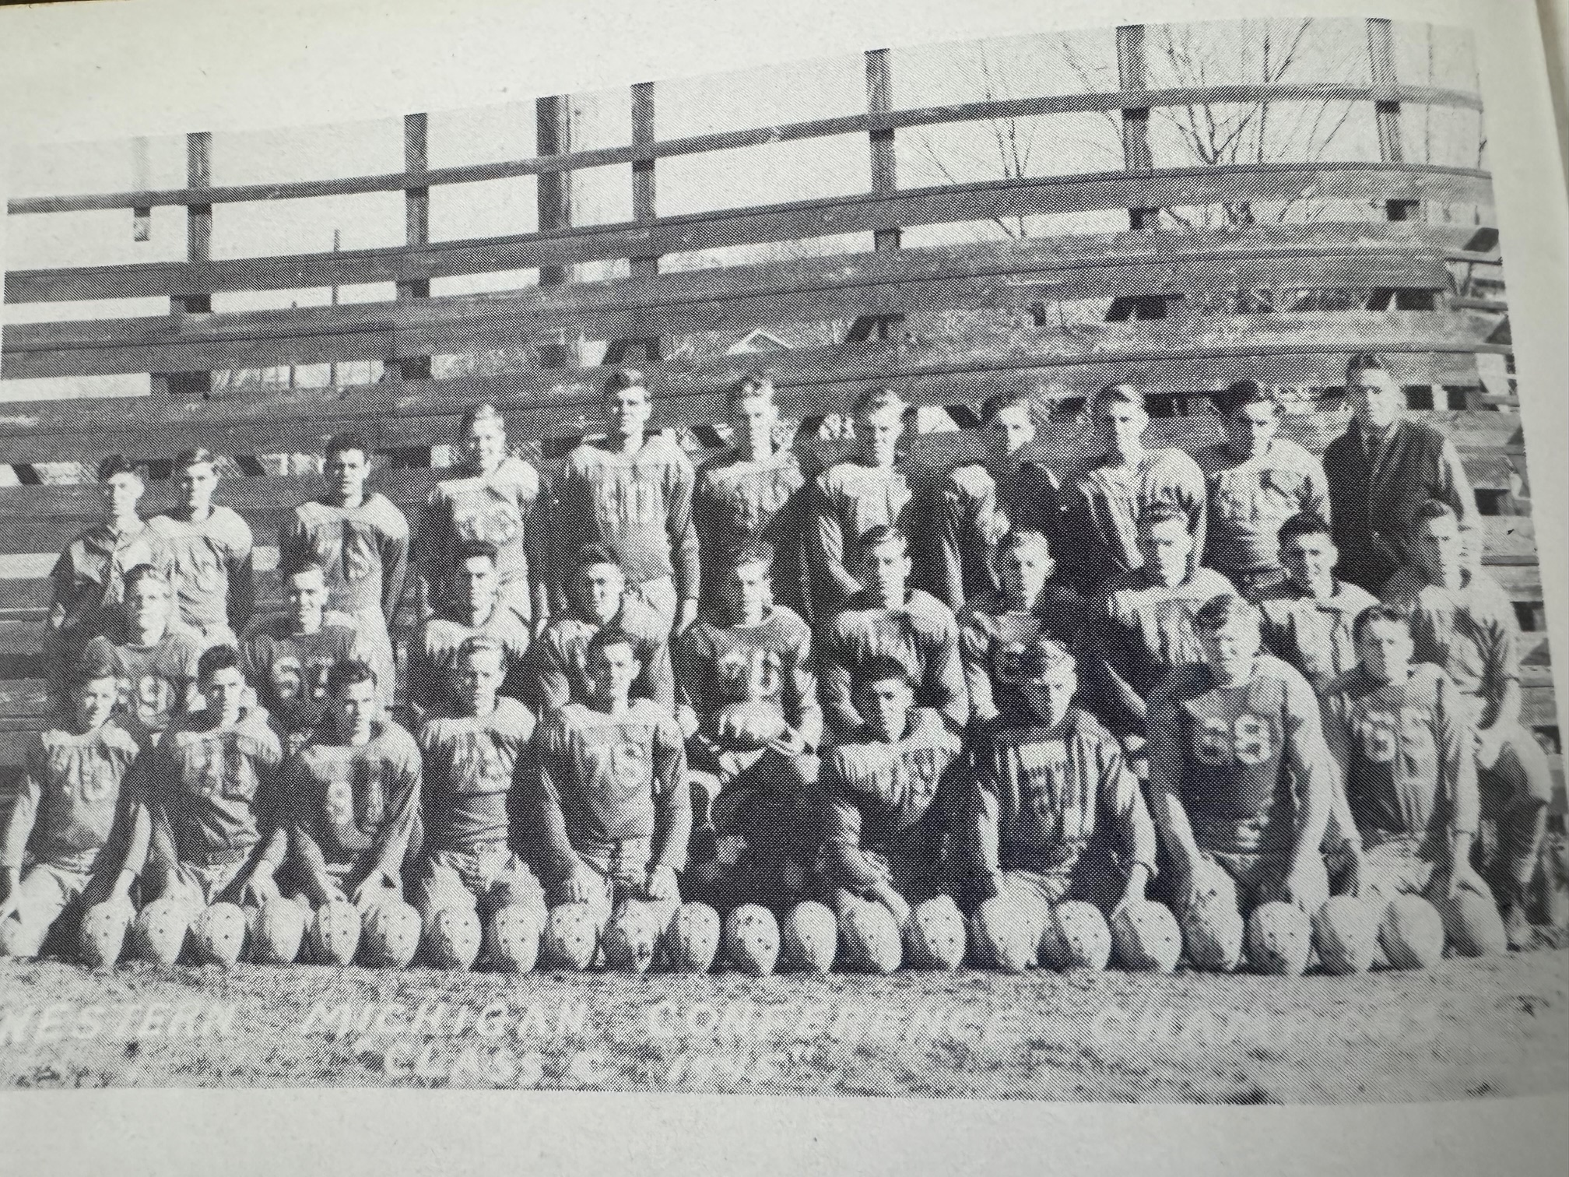

1945 NORSEMEN FOOTBALL WMC CHAMPS

Record Score Interesting Fact
0-1 GR Lee 14, NM 0 Lee scores on a 65-yard interception return for TD. NM defense only allows 1 TD.
1-1 *NM 31, Whitehall 0 Stayer scores 3 TDs, one TD on a fake punt good for 61 yards. Ken Kueny and George Felt TD each in first game ever with Whitehall.
2-1 NM 31, Newaygo 0 Kueny 3 TDs, including a long punt return, Strayer a long interception returned for six-points and Felt also scores.
3-1 *NM 32, Scottville 0 Strayer leads the Norse with 3 TDs, Kueny and Felt also score in rout of Scottville on dedication night on the newly lighted Norse field.
4-1 *NM 27, Montague 0 NM passes for 3 TDs, 2 from Norm David to Strayer, the other Kueny to Bob Pyle. Felt a rushing TD.
5-1 *NM 26, Shelby 0 Kueny a pair of TDs (13 &28) Strayer another interception returned for a TD. Ken Baars scores his first TD as a Norsemen.
6-1 *NM 6, Hart 0 NM edges undefeated Hart. Bud Anderegg scores after Hart punter dropped at the two-yard line. NM WMC champs!
6-2 Fremont 6, NM 0 Fremont intercepts NM lateral and scores games only TD to end the NM season at 6-2.

1946 – coach Paul Moyes (4-3-1 overall, 3-1-1 in WMC, Hart Champs)

Paul Moyes returned from serving in WWII to resume his coaching duties for the Norse. The Norse faced a tough task in their season opener against a veteran Grand Rapids Lee team that had 73 players on its roster. The Norse would open their reason with Dale Bos and Ken Cooper at the ends, Jack Mitchelson and Dale Pulsipher at the tackle spots, Roger Felt and Don Hulander were the starting guards while Al Covell occupied the center spot. Tom Jackson returned as the quarterback, Clifford Olsen and Dick Salmonson the halfbacks with stocky Lavern Nicholson the fullback. Lee defeated the Norse 6-0 in a defensive battle with the game’s only TD coming after an NM fumble at their own 15-yard line late in the opening quarter. It appeared the Norse had Lee stopped after three-line plunges produced little yardage. A fourth down pass was allowed for interference and Lee capitalized moments later for the game’s only touchdown, spoiling the return of Coach Moyes.

Whitehall scored two TDs in the final quarter to rally to a 12-6 victory over the Norse in game two of the 1946 campaign. A pass from Randy Lorenz to Viking end Lyle Peterson with 30 seconds remaining spelled defeat for the Norse. The Norse had a 6-0 lead until the game’s final stanza after Lavern Nicholson, on a fourth down-play, raced 23 yards for a NM TD midway through the second period.

The Norse welcomed back to their lineup from an ankle injury 6’5 220-pound senior tackle Bob Pyle for their next game against a Ludington eleven that were favored to hand NM their 3rd consecutive defeat. However, with Pyle providing big holes from his tackle spot, and plugging the line on defense, NM used three short TD bursts from Lavern Nicholson in the games’ first half in their 20-0 shutout of the Orioles. The loss would be one of but two-defeats on the season for Ludington, their other loss a tight 19-13 contest to Class A Grand Haven.

A new field equipped with lights was dedicated at Scottville, a field much needed according to Rex Funnell, a member of Whitehall’s football team of 1932. Funnell didn’t mince any words in an interview with this author in 2014. When asked the quality of the field Rex quickly replied: “Scottville just had a bad field.” Scottville proved to be the perfect host for the Norse as NM breezed to an easy 27-7 win in front of what was reported to be the largest crowd to see a Scottville football game. Four different NM backs scored with Bob Duplissis, Dick Salmonson, Jim Hubbell and Don ‘Doc’ Meisch all crossing the Spartan goal line. Meisch was a savior for the Norse in a most unusual way. Dale Pulsipher intercepted a Scottville pass on his own 40-yard line but started racing down the field… the wrong way. Meisch took off, and with a flying tackle, brought down his teammate just 10 yards shy of his own goal.

Newspaper headlines two days before NM’s next contest with Montague announced the hanging of 11 Nazi henchmen tried and convicted at the famed Nuremberg Trials. It was also a time when this country was going through a severe meat shortage. After weeks of empty shelves in local grocery stores, meat had finally become plentiful with prices for your favorite steak going for one dollar a pound.

The Norse captured their 3rd straight victory with a 20-0 victory over Montague as Nicholson again had a three TD performance. Two of those came on receiving end of passes, the first a 14-yard aerial from junior running back Ken Baars, the second receiving TD came with just 30 seconds left in the half on a 42 yarder from Clifford Olson. Sandwiched in between those receiving scores Nicholson added a rushing TD good for 49 yards.

The Norse then set up a possible chance for a WMC title game the following week with Hart by edging Shelby 13-7 on a Wednesday night. Nicholson churned up most of the yardage on NM’s initial scoring drive that was capped by his smash from inside the five-yard line. Ken Baars then provided the impetus for the final NM score by rushing for 50 yards to set up a Salmonson TD run from the four-yard line.

There was much hype for the NM contest with Hart that could have earned the Norsemen at least a tie for a conference championship. The game was one of futility on a wet Hart field as neither team was able to muster any offense with the game ending in a 0-0 tie. The one bright light for the Norse, other than their stingy defense, was the punting of Nicholson. Although Hart was still looking for their first win over the Norse, the Pirates were able to win the conference championship with their only conference blemish the scoreless tie with NM.

The Norse were decided underdogs to the once beaten Fremont team in the season’s finale. Among the Packers victims was WMC champion Hart, who fell to the Packers 51-0. No such rout occurred in this game as the Packers mounted but one scoring drive in the third period that stood as the only scoring for the contest as a valiant Norse team fell 6-0. Much credit for the outstanding defensive showing by the Norse was praise for the line play of Don Hulander, Don Miller, Bob Duplissis, Jim Brechlien and Bob Pyle.

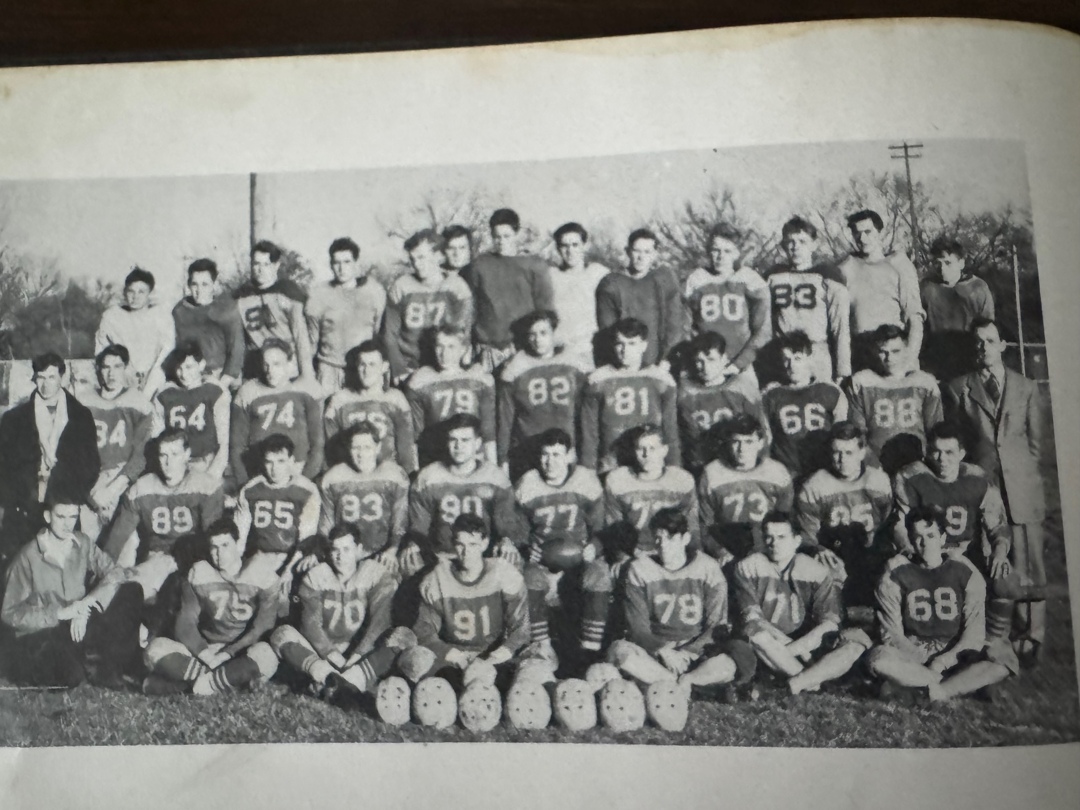

THE 1946 NORSEMEN

Bottom Row: L-R: William White Mgr., Joe Wiener, Jim Scott, Charles Oakes, Tom Mitchelson, Jack Krolczyk, # 68?
2nd Row: Don Hulander, Ray Cole, Al Covell, Bob Pyle, Laverne Nicholson, Cliff Olson, Bob Duplissis, Jim Brechtlein, Dick Salmonson
3rd Row: L-R, Charles Windbacker Mgr, Jim Hubbell, #64? Roger Felt, # 76? Don Miller, Dale Bos, Bill Putnam, Dale Pulsipher, Ken Baars, Ted Vanderboll Coach Paul Moyes
4th Row: ?, ?, Doyle Hamelink, Jack Mitchelson? Phil Bulwalda,?, Dick Sorenson, Bud Matych,?, Graham Rankin

Missing a few names as I just went from my memory of the players.
Please e-mail me at jimmoyes@aol.com if you can help with the missing names.

Record Score Interesting Fact
0-1 GR Lee 6, NM 0 NM fumble and pass interference leads to games only score.
0-2 *Whitehall 12, NM 6 White throws a pair of fourth quarter TD passes to rally and upset the Norse.
1-2 NM 20, Ludington 0 NM scores 3 first half TDs, all by Lavern Nicholson.
2-2 *NM 27, Scottville 7 NM spoils new Scottville field dedication as 4 NM backs score a rushing TD.
3-2 *NM 20, Montague 0 Nicholson 3 TDs, 2 on pass receptions and rushed 49 yards for a 3rd TD.
4-2 *NM 13, Shelby 7 Nicholson and Baars pick up most of the night’s yardage in Wednesday night win at Shelby.
4-2-1 *NM 0, Hart 0 (tie) Fumbles and a wet field prevented either team from a serious scoring chance.
4-3-2 Fremont 6, NM 0 Norse permits but one score to once beaten Fremont.

1947 – coach Paul Moyes (6-2 overall, 5-0 WMC Champs)

The 1947 season was a mirror of the 1945 campaign as the Norse went 6-2 while losing to the same two teams who defeated them in 1945, Grand Rapids Lee and Fremont. Sandwiched between those pair of bookend opponents the Norse went a perfect 6-0 to win another WMC championship while also disposing of Ludington.

The Norse did take the early lead in their traditional opener with Grand Rapids Lee with Bob Chaffee capping a long scoring drive by crashing over from the 2-yard line. After a Lee touchdown and a failed extra point, the Norse had a golden opportunity to take the lead in the third period but were stopped at the Lee one-foot line. Lee halfback Rolly Molenkamp would later race 50 yards for the game winning touchdown to give Lee their 5th straight opening game victory 13-6 over the Norse.

In nearly 60 games played between NM and Whitehall over the years, the Norse 50-0 romp over the Vikings would be their biggest margin of victory ever over their long-time rivals. The halfback duo of Ken Baars and Tom Mitchelson led the Norse rout by combining for 5 touchdowns. Baars totaled 170 yards on his TDs, one from 90 yards and the other from 80. The remaining NM tallies were from John Biddle, Bob Gundy and Jerry Raymond. Following the game, the entire Norse team of 45 gridders were treated to hamburgers and ice cream at Dyers Hillcrest Dairy, the current site of Ace Hardware at the corner of Ruddiman and Whitehall Road.

The Norse used a pair of defensive gems in their 13-7 victory in Ludington. With Ludington driving deep into NM territory, junior Tom Mitchelson intercepted a pass at his own 15-yard line and then raced untouched 85 yards for the score. With NM continuing their search for a competent place kicker, Ken Baars passed to Dale Bos for the extra point. Following a blocked punt at the Oriole 20-yard line, Mitchelson scored a few plays later from 6-yards out for the game’s final TD. The win was their second straight shutout over Ludington and was accomplished despite the Norse losing four fumbles on the night.

NM then made it a perfect two for two over a Mason County team when they defeated a previously undefeated Scottville eleven 18-6 on the Norse gridiron. After trailing 12-0 at halftime, the visitors moved to within six points of the Norse following a 55-yard TD pass, but the Norse put the game away when Dale Bos scored from 35 yards out on an end around reverse play late in the third period. Earlier the Norse scored a pair of first half TDs, both from Bob Chaffee, the first on a six-yard scamper and the second on a 70-yard dash following a Tom Mitchelson interception.

NM took over undisputed possession of first place following a 13-2 victory over Montague. Ken Baars and Tom Mitchelson each tallied TDs for the Norse while only giving up 2 points to the Wildcats. It appears that rules for a safety were different back in 1947. Bob Chaffee intercepted a Montague pass in his own end zone in the final period and was tackled in the end zone for a safety. Under today’s rules Chaffee’s pick would have been ruled a touchback and brought out to the 20-yard line.

The Norse then clinched the WMC title with a hard-earned 7-6 victory over Shelby the following Wednesday. NM had finally found their long sought-after kicker in junior Harry ‘Bud’ Matych whose successful point after from placement would prove to be the difference in the game. Matych made his game winning kick following a TD from fullback Jim Hubbell in front of 3000 fans at the Northside field. The Tigers threw a scare into the Norse when they capitalized on a Norse fumble in the final quarter and cashed in for a TD on a fourth down line plunge. The Norse stopped the Tigers extra point run to tie the game to move to a perfect 4-0 in WMC play. Ken Baars suffered a knee injury in this game, ending the co-captain’s season.

The Norse then scored almost at will in their final conference clash of the season in a 40-0 rout of the 1946 conference champs from Hart. ‘Doc’ Meisch and Bob Chaffee each scored a pair of TDs for the victors while Tom Mitchelson’s tally was a long distance 70 yards dash. Jim Scott, who would later become the long-time track coach at Whitehall, also joined the TD parade on a 10-yard run.

Once beaten Fremont ended the Norse season with a 14-0 shutout, the fourth straight year the Packers have won and held the Norse scoreless during the streak. The game was played in wretched conditions as rain and snow coupled with gusty winds contributed to a mistake plagued contest. The one shining moment for the Norse was a 70-yard run by Bob Chaffee but NM failed to score as their season ended at 6-2. At the season-ending football banquet the Norse players were awarded their letters and the WMC trophy presented. The guest speaker was future Detroit Lions head coach George Wilson, who spent his childhood years as a student and resident of North Muskegon.

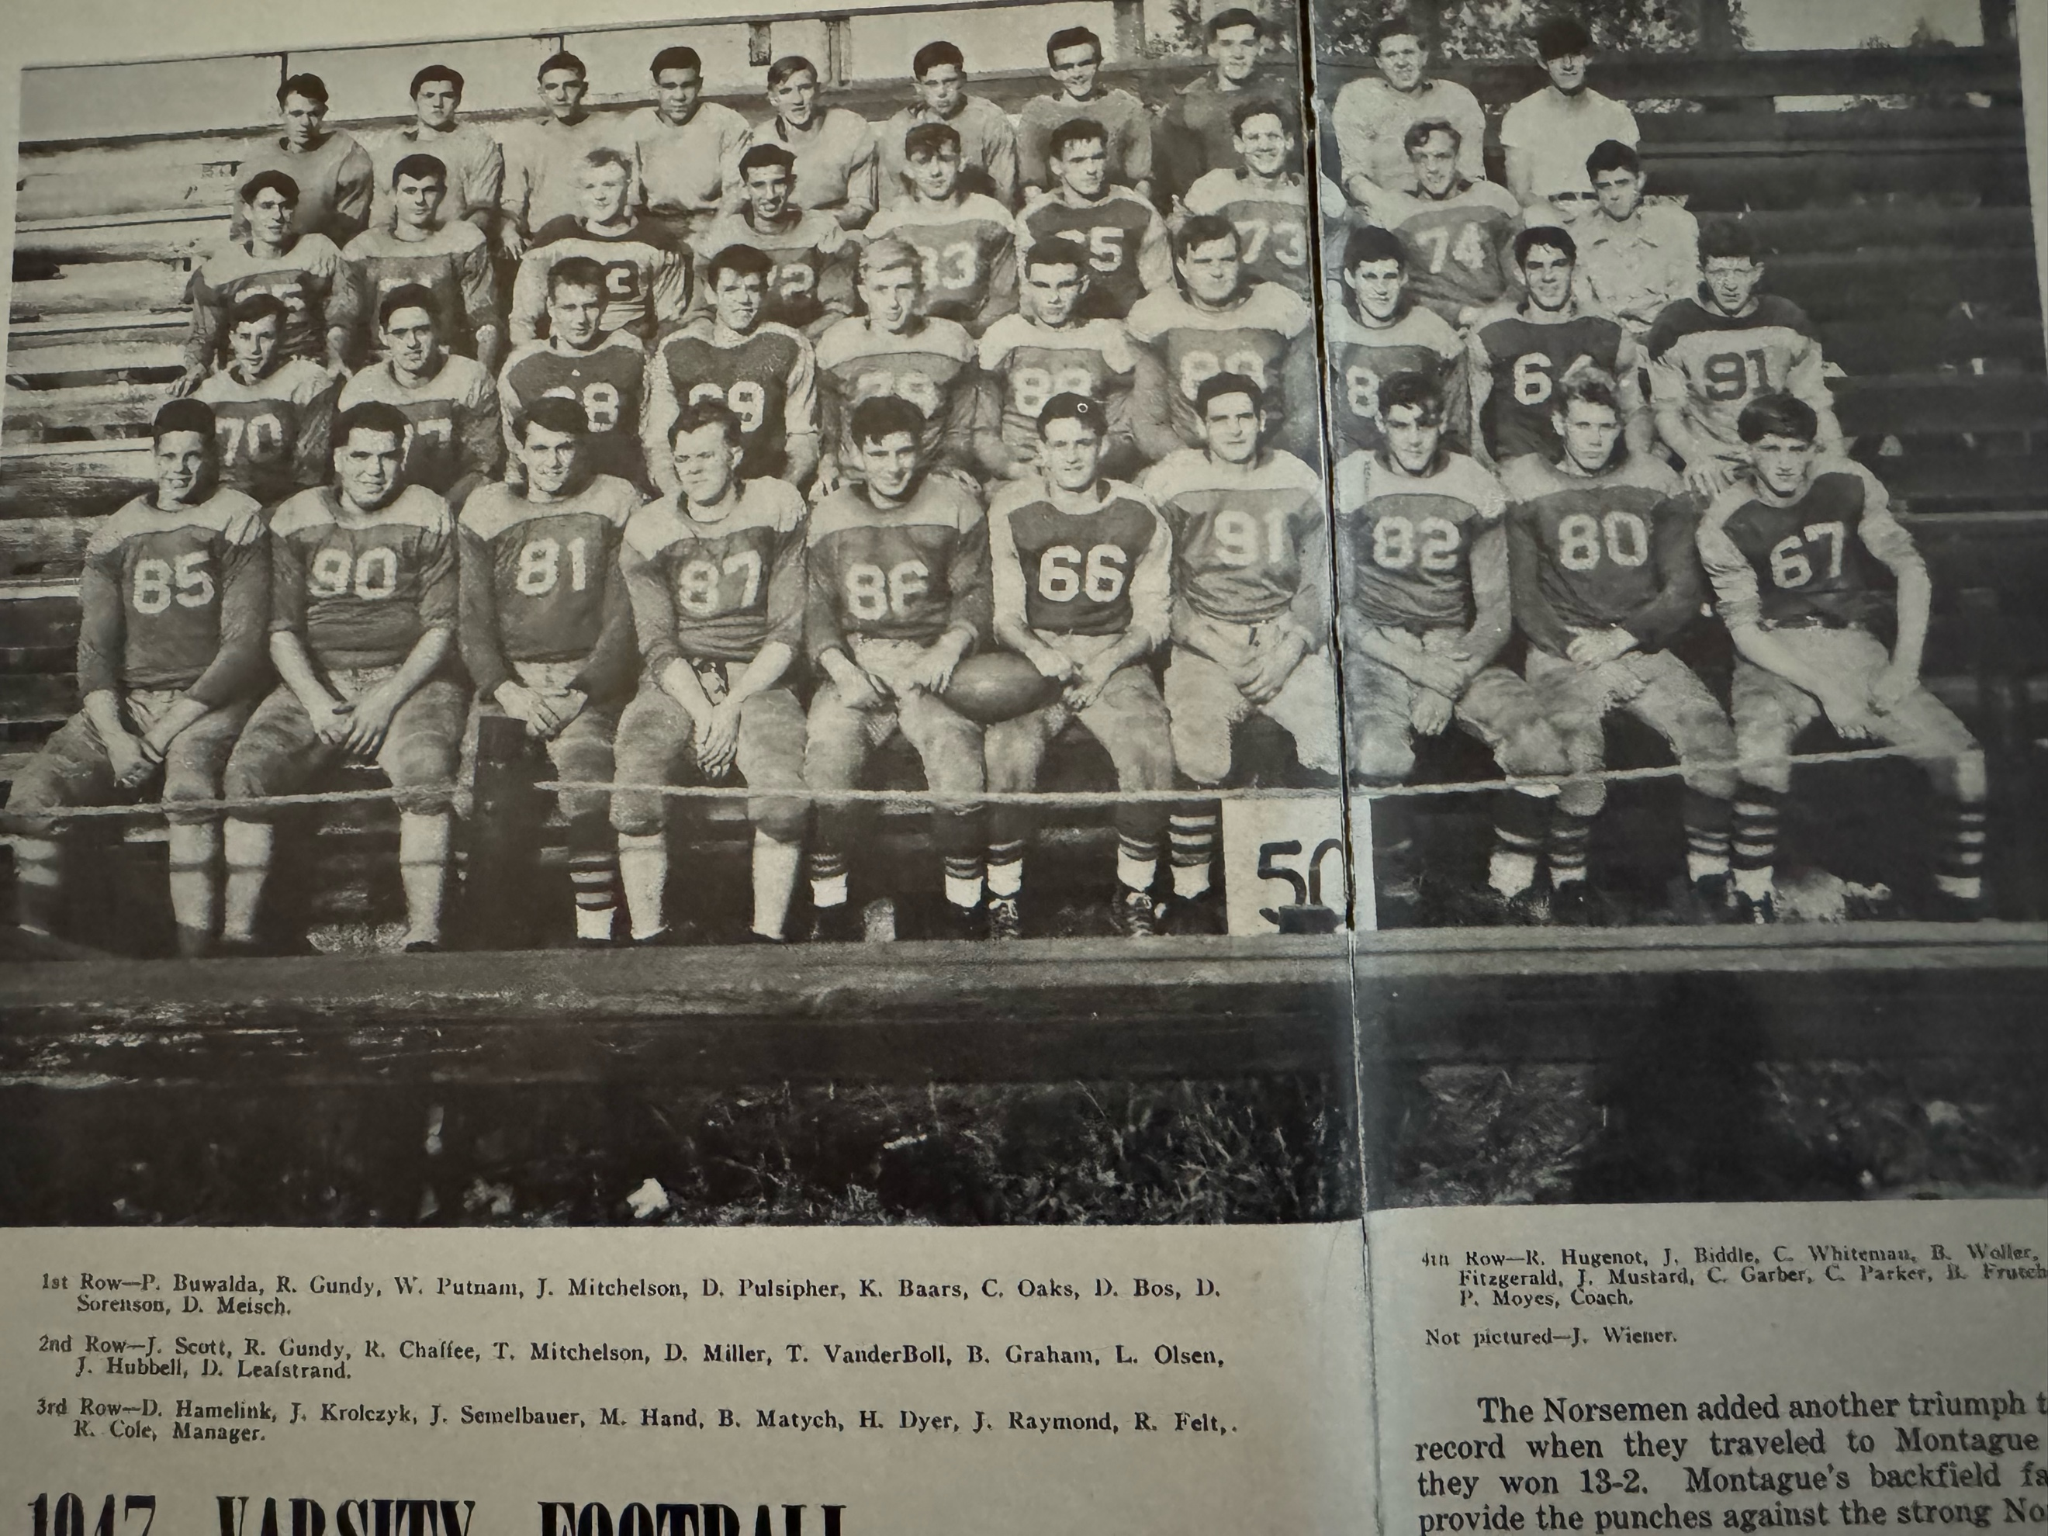

THE 1947 NORSEMEN

Record Score Interesting Fact
0-1 GR Lee 13, NM 6 NM takes early lead on a Bob Chaffee TD, but Lee wins on a 50-yard TD run in second half.
1-1 *NM 50, Whitehall 0 Tom Mitchelson 3 TDs, Ken Barrs runs for 90 & 80-yard TDs in largest win ever over Whitehall.
2-1 NM 13, Ludington 0 Mitchelson a 85-yard interception return for a TD and a 6-yard rushing TD.
3-1 *NM 18, Scottville 6 Chaffee a pair of first half TDs, Dale Bos clinches game with 35-yard reverse play in third quarter.
4-1 *NM 13, Montague 2 NM moves into first place in WMC. Mitchelson and Baars TD each for the Norse.
5-1 *NM 7, Shelby 6 Bud Matych boots extra point following a Jim Hubbell TD as NM clinches conference championship.
6-1 *NM 40, Hart 0 ‘Doc’ Meisch and Bob Chaffee a pair of TDs, Mitchelson runs from 70 yards for TD and Jim Scott 10.
6-2 Fremont 14, NM 0 Bob Chaffee 70-yard run but no TD.

1948 – coach Paul Moyes (4-2-2 overall, 2-1-2 WMC, Hart WMC Champs)

Other than their opening game thrashing at the hands of Grand Rapids Lee, the Norse came oh-so-close to running the table over their final seven games. However, a pair of tie games, along with a close loss to Montague left the Norse with a rare record of four wins and a pair of losses and ties. The opener at Lee in front of 2500 spectators went from bad to worse for the visiting Norsemen. Fumbles and interceptions plagued the Norse all night as a 18-0 deficit going into the final period turned worse as Lee scored three touchdowns, two of which were interceptions returned for TDs.

The Norse bounced back nicely in their home opener by shutting out Whitehall 14-0. Tom Mitchelson had a huge game for the winners with a pair of TDs from 30 yards and 12, with the latter TD set up on his own 55-yard scamper earlier in the drive. Bud Matych, with his younger brother Jim the holder, was perfect on both of his kicks from placement, a rarity up to this date in NM history.

The Norse 6-6 tie at Scottville in game 3 was about as painful as they come. It first appeared as the Norse would have an easy time with the host Spartans as they marched downfield for an early first quarter score with Tom Mitchelson scoring from 12 yards out. Earlier Mitchelson set up his TD run with a 31-yard run down to the 12. However, misfortune stepped in for the Norse. Bud Matych kicked the extra point, but the Norse were guilty of 12 men on the field when a replaced NM player was late getting off the field. Rules at the time met the point was nullified and no yardage was enforced leaving the score 6-0 with the Norse on top. It would only get worse. With little time left in the game (remember – no digital scoreboards at Scottville) Scottville went to the airways. A key pass completion from Slug Mavis to Lowell Hankwitz moved the ball down to the 6-yard line. Mavis then completed a TD pass to Bob Stakenes with just 5 seconds left in the game. The Norse did escape with a tie when a pass attempt to add the winning extra point failed.

Although it had promised to be a short series as plans had already been formulated for a new Catholic School to be erected at the Muskegon corner of Laketon & Barclay, interest was high for the first ever game played between the Norsemen and Muskegon St. Mary’s. Landscaping had begun for the new football field at what is now known as Kehren Stadium, and it would still be five years before students would enter Muskegon Catholic Central High School. The Norse would start the following players against St. Mary’s: Jerry Raymond and Don Miller at the ends; Roger Felt and Ted Vanderboll at tackles; Don Fitt and Bud Frutchey at guards; Bud Matych at center while the backfield would consist of Harold Dyer at QB, Tom Mitchelson and Bob Chaffee at halfbacks with Jack Krolczyk at fullback. And let us not forget the Norse ball boy--- your author, 7-year-old 2nd grader Jimmy Moyes. The game was as tense and close as advertised. Jack Krolczyk played a role in both of NM’s scores, one on offense, the other defense. Krolczyk completed a short 45-yard scoring drive in the second quarter by crashing over from the 4-yard line. Krolczyk then came up with what would prove to be the deciding play of the game early into the fourth quarter. Jack blocked an Irish punt that was recovered in the endzone by a St. Mary’s player for a safety. St. Mary’s would make it close with a late TD, but the extra point was blocked by Bud Matych as NM won 8-6. Oddly enough, Matych would have his own extra point attempt blocked after the Norse scored the games’ only TD in the first half. There was a sad moment during the contest when spectator Alexander Marema was stricken during the contest and later died that night at Hackley hospital.

Possibly suffering a mental letdown after their spirited victory over St. Mary’s, the Norse saw their chances as repeat champions in the WMC go down the drain as they were upset on their home field 13-6 by Montague. The Norse spotted the Wildcats 13 points before they were finally able to score in the final period on a 10-yard run by Tom Mitchelson. Coach Moyes played 26 players in the contest attempting to find a winning combination but to no avail.

NM journeyed to Shelby in hopes of keeping their very faint WMC title hopes alive and returned home with a resounding 35-14 victory. NM took little time to score as Tom Mitchelson took a double reverse and galloped 66 yards for a TD on their first play from scrimmage. Norse tackle Bud Frutchey grabbed a Shelby fumble out of the air and ran 35 yards for the second Norse score. Mitchelson bucked over for his second TD on the Wednesday evening contest while Bob Gundy from 4-yards out and Don Miller from 14, also scored for NM. Bud Matych was a perfect five for five on his extra points, easily the best performance up to that time in Norse history.

The Norse next traveled to Hart to face perhaps the best team in Hart history. The Pirates breezed through their first six games of the season not only undefeated, but unscored upon. The inspired Norse, having never lost to the Pirates in their previous meetings, became the only team to score on the Pirates in a game that ended in a 7-7 tie. The Norse dominated the first half and didn’t allow a Pirate first down for the entire first half. Jack Krolczyk capped a 50-yard Norse drive in the second quarter with a short TD plunge with Bud Matych kicking the all-important extra point. The Norse had threatened to score a couple of other times in the first half with the half ending with NM at the Hart eight-yard line. The half ended before NM could have possibly attempted a field goal as time was kept on the field by an official. The Pirates scored their only TD in the third quarter to pull within a point of the Norse. Once again, cloudy rules at the time hurt the Norsemen. A Hart pass to tie the game was incomplete but pass interference was called against NM and the extra point was allowed even though another play was not needed, and Hart had clinched the WMC title.

After losing four straight games to Fremont, all without the Norse scoring a single point, the shoe was on the other foot in the final game of the 1948 season as NM reversed the tables and shut out the Packers 21-0. After suffering through four long years without crossing the Fremont goal line, it took only 90 seconds to score in the 1948 contest with Tom Mitchelson going six yards to score. The Norse would have to wait until the second half to score their final pair of TDs with Bill Dyer scoring the first and Bob Chaffee the next on a drive that began from their two 2-yard line. Lauded for his outstanding line play was sophomore John Arntz who helped NM bring back the ‘tin cup’ symbol of the 13-year rivalry between the two schools. It would be the last game for 13 seniors, including lineman Ted Vanderboll who suffered a fractured left hip in the second half and was taken to a local hospital. Bud Matych can boast as the all-time best kicker in Norse annals for their first two decades of NM football as he was perfect on his last nine extra-point kicks.

Record Score Interesting Fact
0-1 GR Lee 37, NM 0 NM once again falls in opener with GR Lee as turnovers doom the Norse.
1-1 *NM 14, Whitehall 0 Tom Mitchelson TD runs of 30 & 12 lead the Norse.
1-1-1 *NM 6 Scottville 6 (tie) NM made extra point nullified by a penalty after Mitchelson 12-yard TD. Scottville scores TD with 5 seconds left for the tie.
2-1-1 NM 8, Musk. St. Mary’s 6 Jack Krolczyk scores TD and block a punt for a safety that leads to NM victory in first game between the two locals.
2-1-1 *Montague 13, NM 6 Mitchelson the only NM TD as NM loses their only WMC contest
3-2-1 *NM 35, Shelby 14 Mitchelson scores twice, with the longest from 6 yards,
3-2-2 *NM 7, Hart 7 (tie) Underdog Norse score only TD (Krolczyk) given up by WMC champs Hart. Hart ties on pass interference call on their extra point.
4-2-2 NM 21, Fremont 0 Mitchelson caps stellar career with 2 TDs, the longest 66 yards. Bill Dyer and Bob Chaffee also run for a TD.

THE 1948 NORSEMEN

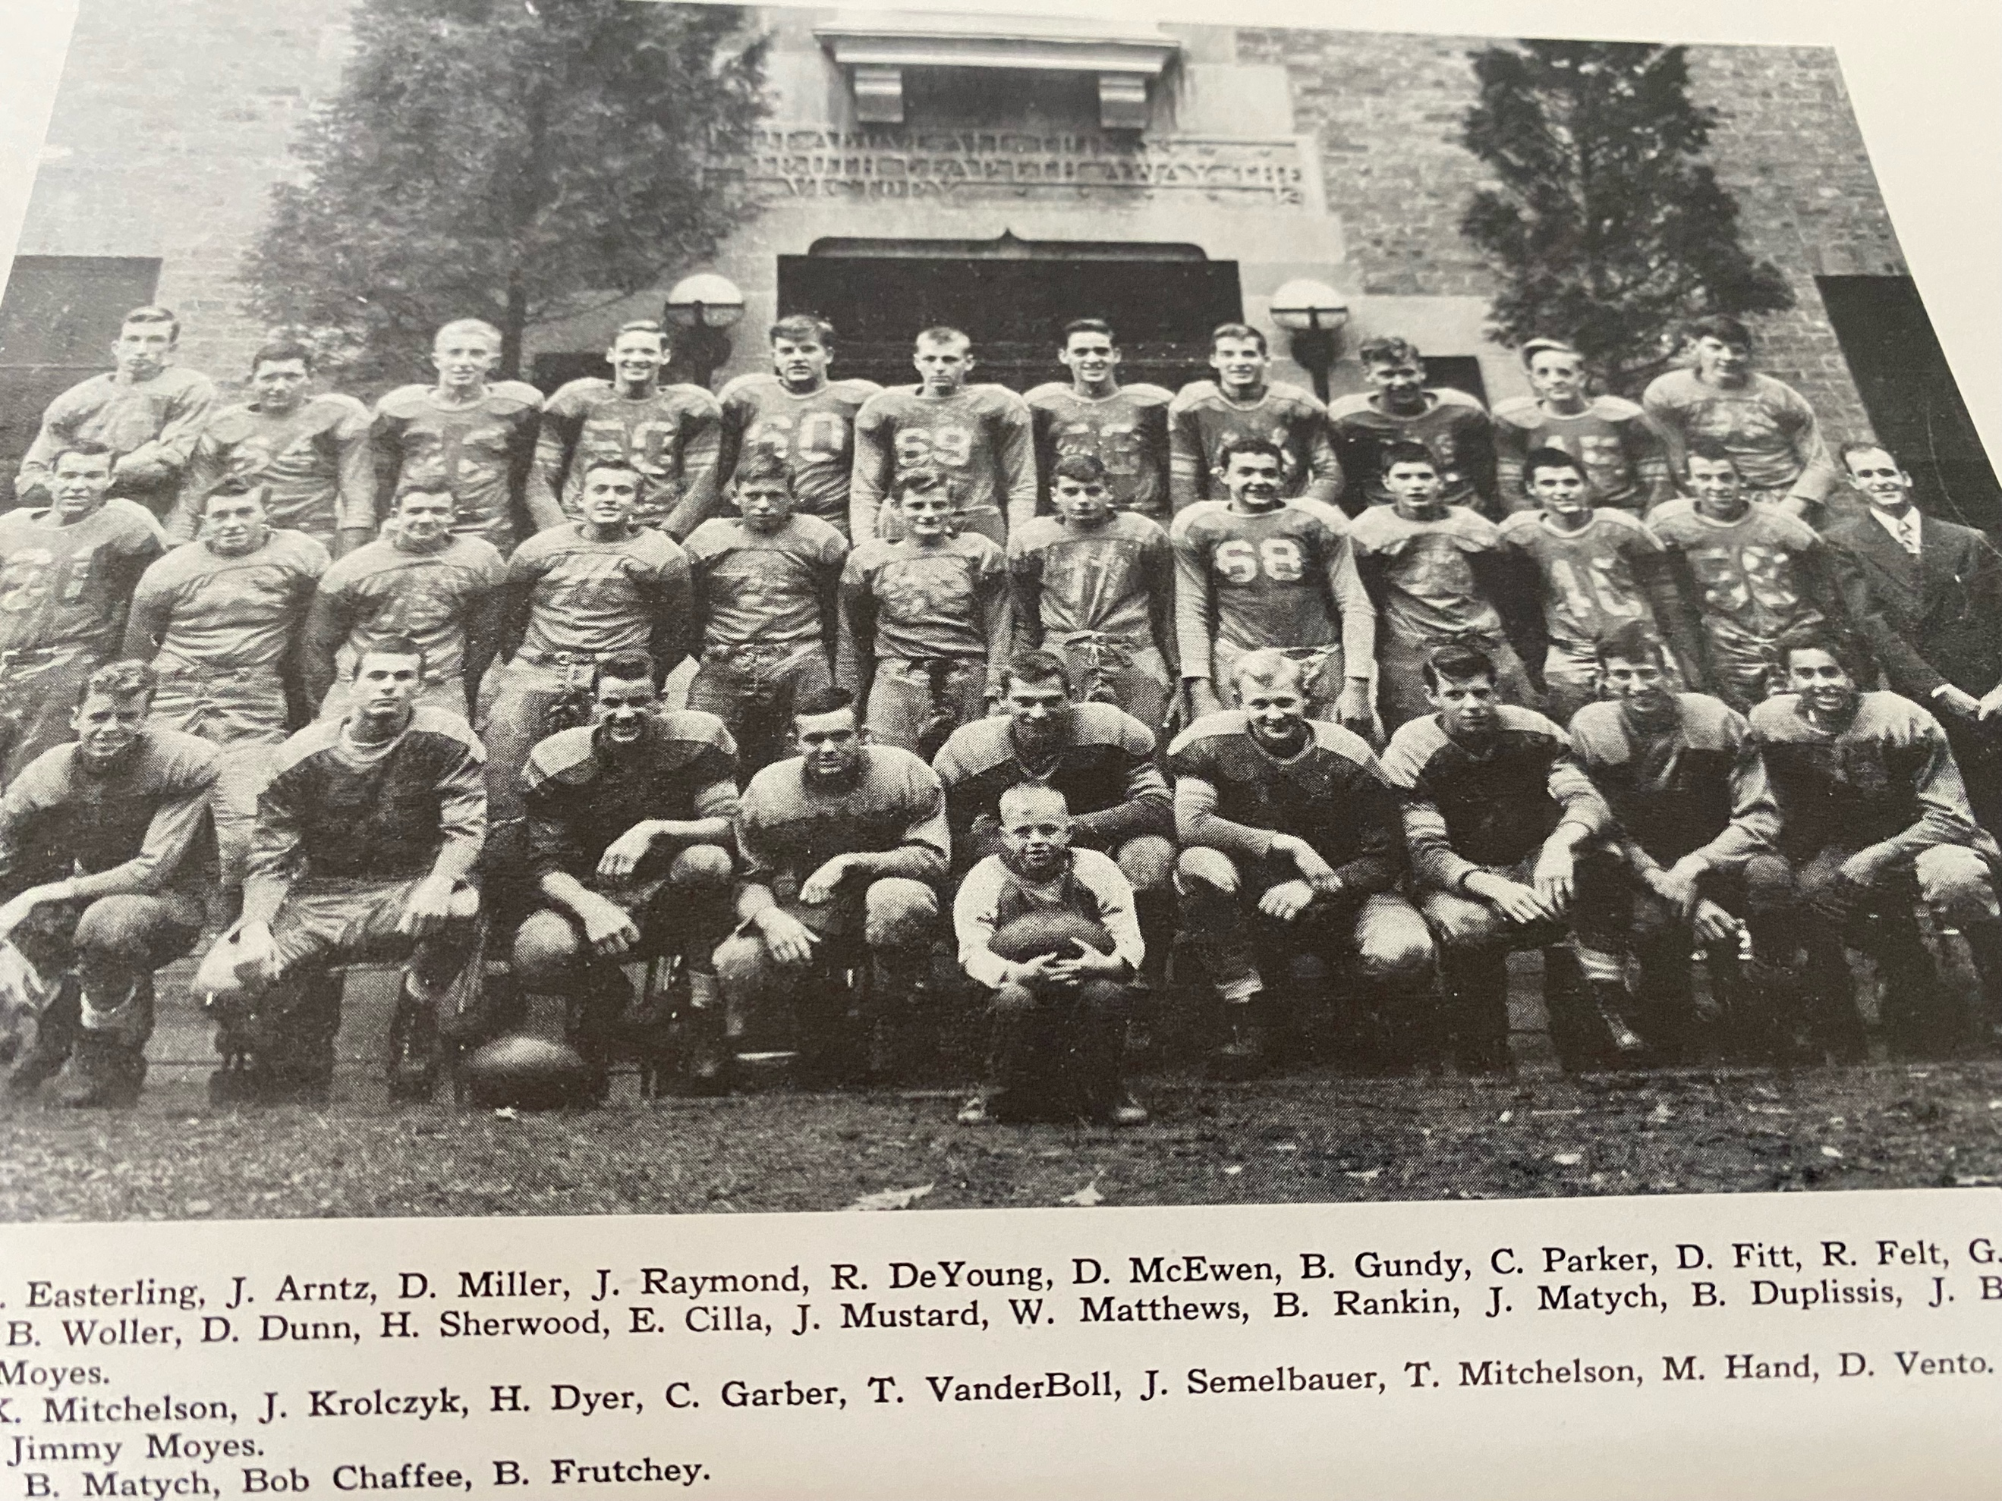

1949 – coach Paul Moyes (3-4-1 overall, 2-3 WMC, Montague Champs)
The Norse returned 14 lettermen from the 1948 season to begin the 1949 season. The bad news --- only co-captain Harold ‘Bill’ Dyer was a returning starter. The other lettermen included ends Jerry Raymond and Monte Hand, backs Jack Mustard, Don Fitt, Carlos Garber, Bernie Hoxie, tackles Russ DeYoung and John Arntz. Co-captain Jack Semelbauer would man one of the guard sports while all-around athlete Blll Duplissis would see action at quarterback and return as the Norse punter.

After losing six openers in a row to Grand Rapids Lee, the Norse did escape defeat but had to settle for a 14-14 tie in a game the Norse dominated statistically. The Norse had numerous chances to get on the board in the first half, but fumbles and penalties killed their drives including one that ended at the Lee two-yard line. Trailing 14-0 entering the final period, the Norse rallied for a pair of touchdowns. Just minutes into the final quarter NM, after fumbling away the ball deep in Lee territory, Lee returned the favor and fumbled twice, the second fumble recovery by Jerry Raymond would lead to the first NM score. Converted from a tackle to a fullback from 1948, Don Fitt scored the first NM tally on a 1-yard plunge. Shortly thereafter Jack Mustard set up the final NM score with an interception at the Norse 45. The Norse marched down to the Lee Rebel 5-yard line where Fitt scored to move the Norse within a point. Keeping the kicking game in the same family, Jim Matych replaced his brother Bud as the new NM kicking specialist and his two perfect placekicks gave the Norse the 14-14 tie.

Football was at a fever pitch locally in the late 1940s. Crowds of 12,000 or more were commonplace when Muskegon hosted games at Hackley stadium. Phillips Field was taxed to capacity as a record crowd of 9400 fans watched Muskegon Heights lose to Grand Rapids Catholic. Certainly, far less fans were on hand at old Funnell Field in Whitehall to watch the Vikings upset the Norsemen 6-0. The fans on hand saw Whitehall score with just two minutes gone in the game on a TD run by Ronnie Hoff. Few could have envisioned at that time that would be all the scoring in the game. The Vikings outplayed the favored Norse in all departments as the Norse never had any serious scoring opportunities deep in Viking territory.

After being shutout at Whitehall, the Norse returned home and revamped their offense and found a new offensive sparkplug. Junior Bernie Hoxie scored three touchdowns, including a 58-yard run and threw a touchdown pass to Jack Mustard to account for a fourth tally. John Biddle added a pair of rushing TDs while Mustard produced the last six-pointer with an interception and run for 50 yards. Limited to only kicking duties due to an ankle injury incurred against Whitehall, Jim Matych was able to convert on six of his seven extra-point kicks.

There was more than football to occupy NM student’s interest in the month of October. The old school that had served NM students from the beginning of the 19th century was demolished due to unsafe conditions. How well your author remembers as a kid sliding down the fire escape tube that gave many of us youngsters thrills during the early years.

NM scored early and late in front of 1500 spectators at historic Hackley Stadium as the Norse edged Muskegon St. Mary’s 13-7 to earn their second straight victory over the Irish. The early TD came in the first Norse possession as a 55-yard run by Jack Mustard set up Bernie Hoxie’s short run from inside the five-yard line for the games first score. The late score was the difference maker in the game with Hoxie passing from his halfback position to single wing quarterback Bill Dyer for a game-winning 15-yard pass completion. For the Norse to even get into position to score was due to the deadly right arm of Bill Duplissis. With the St. Mary’s defense shutting down the NM running game, coach Moyes inserted Duplissis into the game in hopes of igniting the passing game. And Duplissis delivered. Beginning their winning drive from their own 42-yard line, Duplissis went to the air and completed a pair of passes to Dyer down to the Irish 20-yard line. Two plays later a Hoxie to Dyer TD pass gave the Norse the victory. Perhaps an explanation should be given as to why Duplissis was even on the team. During the off-season Coach Moyes had to perform a selling job on Duplissis’s parents to even have Bill on the roster. Bill’s brother Bob was injured severely in the 1946 season giving great concerns to ‘Doc’ and Libby Duplissis to allow their youngest son Bill to even play the sport. Coach Moyes did a lot of pleading with the Duplissis parents and finally won out when he promised that he would only use their son as a passer and punter. Norse fans would have to wait 72 years before NM would play another football game at Hackley Stadium. By the time the 1949 season would end, St. Mary’s would move into their new digs off Laketon & Barclay for the final three games of the season.

Duplissis came off the bench late in the next NM game with Montague and nearly once again led NM to victory. After Montague scored with about a minute and a half left in the game Duplissis faded back to his own 40-yard line and shot a beautiful 50-yard heave down the middle to Monte Hand, who made a circus catch at the Montague four-yard line. Unfortunately, according to the official keeping the time on the field, he blew his whistle saying time had run out before the Norse could mount another play. Montague would win the game 6-0 and end the 1949 season as WMC champs.

The Norse took advantage of six Shelby fumbles in shutting out the Tigers 28-0 on one of those annual Wednesday night games from the 1940s and 50s. The Norse struck early when following s fumble recovery Kyran Mitchelson passed to Monte Hand in the end zone with sure-footed Jim Matych booting the first of his four extra points. Duplissis went to the airwaves in the second period with Hand catching his second TD pass. The busy Hand then recovered a fumble from his defensive end position to ignite another Norse TD drive. Duplissis once again showed his arm strength with a 40-yard aerial caught by Dyer. Bernard Hoxie then capped the drive by pitching a short pass to Mitchelson who in turn lateraled to Jack Dewald for six-points. Enjoying a comfortable 21-0 lead at half, the games only TD in the second half was a short run by Dyer following a Don Fitt recovering of a fumble deep in Shelby territory.

It took 15 long years before the Hart Pirates were able to earn a victory over the Norse with their 13-7 win on the Northside gridiron. All the scoring for the game was done in the first quarter. Speedy Gene Robinson raced 41 yards for a TD on the Pirates initial drive of the game. The Pirates than capitalized on a NM fumble to set up their second score just moments later with a Robinson TD pass completion to Jerry Schaner. The Norse roared back with Duplissis passing to Dyer for 13 yards and a Norse TD late in the quarter, but despite NM dominating offensively in the second half Hart was able to hold off the Norse for a rare series victory over NM.

It was a very cold evening for the final game of the 1949 season. Despite the cold that hovered near the freezing mark 2700 bundled up rabid football fans stood in line to gobble up the remaining tickets on sale for the annual season ending Muskegon-Muskegon Heights game. Many fans left empty handed after all 12,000 tickets were sold. Earlier that afternoon the Norse football field was in use as the Muskegon Little Reds defeated Kalamazoo Central’s 2nds 18-0 with Bob Fairfield, father of future Ravenna Hall of Fame coach Dusty Fairfield, running for a pair of long touchdowns.

Fremont denied the Norse a chance to finish with a winning season as the Packers edged the Norse 14-7. Freezing temps played a role in the game and contributed to the only NM score. The Norse drove deep into Packer territory on the opening drive of the game only to cough up the ball on a fumble at the Fremont four-yard line. However, the Packers in turn fumbled in their own end zone and the ball was recovered by Charlie Whiteman for a TD. The Packers then pulled within one on a long 72-yard run to cut the gap to one with the difference being a made Jim Matych extra point. A safety and an early touchdown made the score 14-7 before the Norse again had a late drive stopped deep into enemy territory as time ran out. The freezing weather did not stop the NM marching band from providing another impressive show at halftime. Dick Hester, arguably North Muskegon’s all-time greatest drum major, suffered a painful knee injury when he stepped in a gopher hole during the halftime show. Proving that the show must go on, the courageous Hester ignored the pain and continued his masterful performance while leading the Norse band.

Days following the end of the 1949 season MSC assistant coach Duffy Daugherty with his star player, former Muskegon Heights ace Sonny Grandelius, were the guest speakers at the season ending football banquet. Daugherty and Coach Moyes remained very close friends until Paul Moyes passed away in 1960.

THE 1949 NORSEMEN

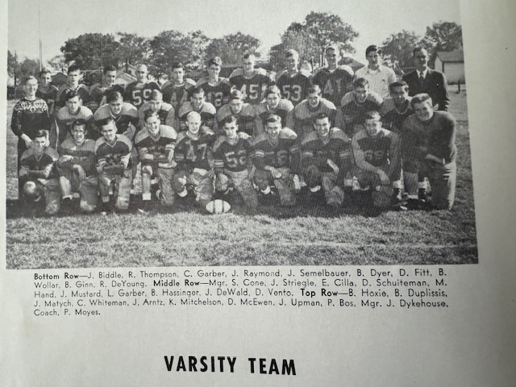

Record Score Interesting Fact
0-0-1 NM 14, GR Lee 14 tie Norse rally in second half to tie Lee. Don Fitt scores both NM TDs.
0-1-1 *Whitehall 6, NM 0 Norse upset by Whitehall as NM offense never threatens. Numerous injuries plague Norse.
1-1-1 *NM 48, Scottville 14 Bernie Hoxie runs for 3 TDS and passes for another. Jack Mustard 50-yard interception return for TD, Biddle 2 TD rushes.
2-1-1 NM 12, Musk. St Mary’s 7 Game played at Hackley Stadium. Hoxie TD run and TD pass to Bill Dyer
2-2-1 *Montague 6, NM 0 WMC champs Montague edges Norse. Final NM drive stopped at the 4-yard line as time runs out.
3-2-1 *NM 28, Shelby 0 Monte Hand with a pair of TD receptions, Jack Dewald and Dyer also score. Matych perfect on 4 extra points.
3-3-1 *Hart 13, NM 0 All scoring completed in first quarter as Hart wins first game over NM in 15 attempts. Duplissis passes to Dyer for only Norse TD.
3-4-1 Fremont 14, NM 7 NM’s only score was a fumble recovered in the end zone by Charlie Whiteman.

1950 – coach Paul Moyes (5-3 overall, 4-1 WMC champs)

Nineteen Hundred and Fifty would be the final season for Paul Moyes as the popular NM head coach. The players would reward coach Moyes with another WMC championship with only a controversial loss to Shelby the only blemish during the conference season. Unfortunately, the USA was embroiled in yet another war in Korea that kept our nation on pins and needles. The Norse were pre-season favorites to win the WMC championship, and they would not disappoint. However, the Norse again began the season against an old nemesis who had dominated the series since the Hall of Fame Norsemen team of 1942 toppled Lee 33-0. The Norse did escape defeat in 1949 when the two teams tied 14-14. The Norse got off to an explosive start in the game played in the furniture city when Bernie Hoxie electrified the crowd with a dazzling 73 TD run down the sidelines. After Jim Matych missed a rare extra point, the lead was short-lived. The Rebels grabbed a lead they would not relinquish on a 57-yard pass play and a made extra point. Lee then iced the game on yet another long pass completion, good for 68 yards to make the final score read 14-6.

The 1950-51 school year was one of numerous changes to NM’s school properties. The old school building that was used since near the turn of the new century had been demolished and two new buildings were in the process of being built. School space had become extremely tight as the enrollment had expanded where NM was now a Class B school and would remain Class B into the middle 1960s. So desperate were the administration to find necessary space for all their students that the North Muskegon Community Church housed classes for elementary students as did the recently erected City Hall. It would not be until the second semester of 1951 that the students from K-4th grade would move into the new elementary school.

The Norse made amends for a previous year upset by Whitehall with a convincing 13-0 shutout of the Vikings. NM’s answer to Elroy ‘Crazy Legs’ Hirsh was their own version of Hirsh in Bernie Hoxie who scored both NM touchdowns on gallops of 17 and 25 yards.

Hoxie may have been even better on a sloppy field in Scottville the following Friday. After a listless first half where nothing was decided, NM came alive in the second half with Hoxie doing much of the damage with some help from running back Jack DeWald. Taking the kickoff at their own 35, DeWald and ‘swivel hips’ Hoxie turned on the power and marched 65 yards to score with Hoxie plowing over the one for the score. Early in the final period the Norse went on another 65-yard scoring drive with Hoxie scoring this time from the nine on a play in which he carried three Scottville tacklers with him into the end zone. It was the 5th touchdown of the season in the 14-0 victory for the Norse, all scored by Hoxie.

The Norse were no match for Muskegon St. Mary’s in the third meeting between the two local squads as the Irish were always in firm control in their 31-6 victory. A young sophomore back by the name of Jim Morse, ran wild on numerous occasions. Although the future Notre Dame captain scored but one of St. Mary’s touchdowns, he set up others with several long runs including dashes of 36, 18, 19 and other bursts that spelled trouble for NM. The Norse were only able to escape defeat when Hoxie tallied a TD late for the Norse. The game featured a pair of quarterbacks who lived just a few blocks from each other in North Muskegon. John Fredericks got the better of Bill Duplissis on this matchup as the duo would remain lifelong friends. For many years Muskegon Catholic fans would see Fredericks and Duplissis pair up as members of the Crusader chain gang on the sidelines at Kehren Stadium. The following morning the entire Norse football team boarded a NM school bus and traveled to East Lansing to watch the MSC-Maryland football game thanks to tickets supplied by Coach Moyes’ good friend Duffy Daugherty. The Spartans, like the Norse on the previous evening, fared poorly against the Terps as they were drubbed 34-7. It would be the last game MSC would taste defeat for the next 28 games.

NM bounced back nicely in their next encounter with Montague as Bernie Hoxie was again the game’s big story. Ole ‘swivel hips’ scored all 4 NM touchdowns, including a 20-yard pass reception that went from Bill Duplissis to Paul Bos who lateraled to Hoxie for the TD. Bernie scored on runs of 16, 5 & 35 and even had a 47-yard TD scamper called back due to a penalty in NM’s 28-7 home victory over Montague.

In one of the more frustrating defeats in NM annals, the Norse were upset by the Shelby Tigers 18-13 on Wednesday evening at Shelby’s Getty field that served as both a football and baseball field. Bernie Hoxie scored his 11th and 12th touchdowns of the season to account for 12 of NM’s 13 points. However, the Norse star was stopped just one-yard short of the goal line by a freshman defensive back named Dave Whitsell (future NFL all-Pro). The final Norse drive began, and the Norse trailing by five-points, with four-minutes left on the clock, according to the official keeping time on the field. Following Hoxie’s near TD run the timekeeper said time had expired much to the surprise of Norse coach Paul Moyes. As his son, and the ball-boy for the 1950 Norseman, I had never seen my father argue with an official –-- until that moment. His argument that there should be time left on the clock naturally fell on ‘deaf ears’, and Shelby’s unexpected victory was official. It was now certain that NM had no wiggle room if they were to win the WMC Conference title and a win over Hart in their final WMC contest was essential. Mission accomplished!

It wasn’t easy as the Norse needed somebody not named Bernie Hoxie to defeat Hart. After scoring all of NM’s touchdowns after six games were completed, it was Jerry Upman, Norse fullback who became the first Norse other than Hoxie to cross the goal line in the second quarter to give his team a 6-0 lead at halftime. The popular Upman would pass away just six years later in April of 1956. Trailing 7-6 in the fourth quarter, John Arntz blocked a Pirate punt, and the Norse took over at the Pirate 34-yard line. A pair of runs by Carl Thompson and Hoxie brought the ball down to the Hart six-yard line but a pair of 15 yard holding penalties moved the ball back to the 20. After three plays failed to produce the Norse were in a desperate hole with fourth down and goal at the 36-yard line. Bill Duplissis then hurled a perfect strike to Kyran Mitchelson who raced down the sidelines for the winning score and a WMC championship.

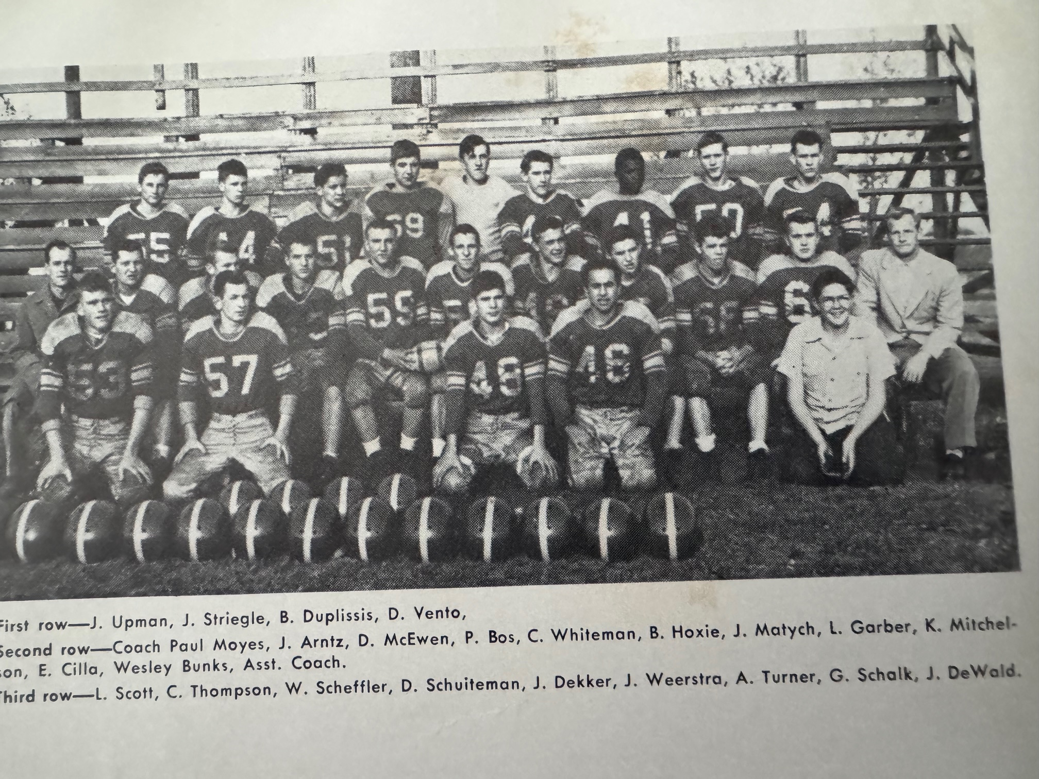

THE NORSEMEN OF 1950 WMC CHAMPS

The final game against Fremont would mark the end of the line for 13 seniors: Kyran Mitchelson and Paul Bos, ends; John Arntz, Dick McEwen, Larry Garber and Everett Cilla tackles; Charlie Whiteman and Don Vento guards; Jim Matych center; and backs Bill Duplissis, Jerry Upman, Jack Striegle and Bernie Hoxie. Hoxie would complete his brilliant senior season with a pair of long touchdown gallops of 57 and 69 yards, giving him 14 touchdowns on the season good for 84 of NM’s season total of 131 scored over the eight-game season. Duplissis, who would set school scoring records in basketball and was one of the best baseball players in school history, tossed a pair of TD passes to Carl Thompson for 21 yards and Paul Bos for 15. Wayne Sheffler returned a punt all the way from 65 yards out for the final Norse score.

At the football banquet on December 13th, 1950, coach Moyes stunned many, especially this author and my brother Tom, when he announced his resignation as football coach at North Muskegon because of illness (multiple sclerosis) contacted during his services with the armed forced in WWII. “Coaching here at North Muskegon has been the happiest time of my life,” the retiring coach said. “I regret leaving but believe it to be my duty to the team and the school.” Paul Moyes would remain as a teacher until 1953 and in the spring of 1951 would coach NM to the WMC baseball championship. Paul Moyes passed away on Oct 1, 1960, at the age of 45.

Record Score Interesting Fact
0-1 GR Lee 14, NM 6 Hoxie scores only NM TD on a sensational 73-yard run. Lee used 2 long pass plays for the win.
1-1 *NM 13, Whitehall 0 Hoxie again leads Norse with a pair of TDs, one from 17 & the other from 25. Bill Duplissis a pair of 45-yard punts.
2-1 *NM 14, Scottville 0 After a scoreless first half the Norse come alive in the second half to score 2 TDs, both from Hoxie.
2-2 Musk. St Mary’s 31, NM 6 Norse outgunned by Jim Morse led St. Mary’s team. Hoxie scored lone NM TD.
3-2 *NM 28, Montague 7 Hoxie runs wild, scores all 4 NM TD, 3 rushing, 1 receiving.
3-3 *Shelby 18, NM 13 Clock runs out on NM at the Shelby 1-yard line. Hoxie with 2 TDs.
4-3 *NM 13, Hart 7 Duplissis connects with TD pass to Kyran Mitchelson for winning TD to clinch WMC title.
5-3 NM 34, Fremont 0 Hoxie scores from 57 & 69 yards. Dupllissis 2 TD passes, one to Carl Thompson, the other to Paul Bos. Wayne Sheffler 65 yd TD punt return.

1951 – coach Bob Bushong (5-3 overall, 4-1 WMC, Hart WMC Champs)

Replacing Paul Moyes as the coach at North Muskegon was Bob Bushong. He would be assisted by Wes Bunks. It would be the second year on the staff for Bunks who assisted coach Moyes in 1950. Bunks would serve NM as a teacher, track coach and following retirement, would pull duty as a clock operator at NMHS for more than 40 years. Only five lettermen would return for the 1951 season (Norman Ferris, Jack Weerstra, Don Schuitema, Art Turner, and Jack DeWald) but only Schuiteman and DeWald saw extensive duty last season. Much of the roster would be filled with underclassmen with several talented sophomores joining the team. A slow start was expected and a slow start it was --- but the Norse would finish with a bang!

To no one’s surprised the Norse dropped their traditional season opener with Grand Rapids Lee 32-0 as coach Bushong’s inexperienced Norse had no answers for GR Lee’s veteran team. Don Schuiteman had numerous tackles for a Norse defense that was on the field for much of the game while sophomore end Tom Arntz looked sharp on pass receiving.

NM played host to Ludington in their first meeting since the Norse won over Ludington in 1947. For the second straight game the Norse were shut out as Ludington downed the Norse 19-0. The Norse did show much improvement from week one as they trailed only 7-0 after three quarters of play before Ludington put the game away with a pair of fourth period scores. Reports from this game had sophomore Jerry Westerfelder and Tom Arntz playing solid games for NM, while the Schuiteman brothers, senior Don and freshman Dick all performed well. Bands from each school performed at halftime for the 1,000 or so spectators on hand. It is rare in the current modern era when bands from both schools would follow their teams’ home and away, but it was a common occurrence during the 1940s and early 1950s.

Although it was just the 3rd game of the season and the first in WMC action, it was Hart’s 21-14 win over North Muskegon that would be the one game in conference play that would ultimately lead to the winner bringing home the trophy. It was loss number three on the season --- and their final loss in 1951 as it was clear that despite the loss there were signs that this very young and experienced team was about to turn their season around. Scoreless in their first two games, the Norse wasted no time in breaking that streak as Scott Moore, one of many sophomores playing for the Norse, raced 55 yards for a TD on their second play from scrimmage. Hart, who would finish the season a perfect 5-0 in winning the WMC title then scored 21 unanswered points. All three of Hart’s touchdowns came via the passing game, two from the arm of quarterback Bill Grady. The other TD was painful for the Norse as with just a mere five seconds left in the half Rich Eisenlohr connected on a short pass to Cart Robinson who then ran through the entire NM secondary to score. Moore scored his second touchdown after quarterback Art Turner shot a pass in the flat to sophomore Tom Arntz who lateraled to Moore who carried the ball the rest of the way for a 71-yard TD. When the season had ended the loss to the Pirates would to be the only defeat for NM in conference competition.

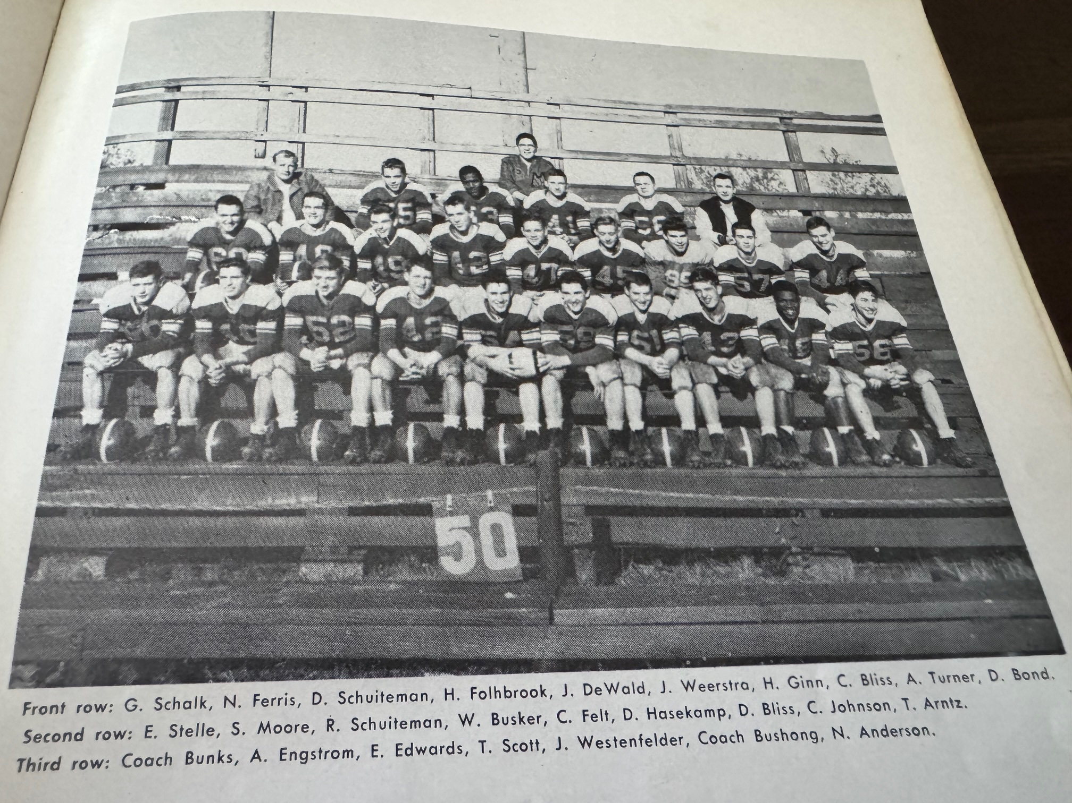

THE 1951 NORSEMEN

NM finally entered the victory column by posting a 20-0 victory at Whitehall. Scott Moore scored twice and Jack Dewald once to account for the NM touchdowns. The first Norse score was set up on a fumble recovery by sophomore Jerry Westerfelder in Viking territory. Runs by Earl Edwards and DeWald set up the first of Moore’s tallies. Norm Ferris broke through and blocked a Whitehall punt on the Whitehall 25. Two plays later Moore raced in from the 18 for his second TD to send the Norsemen into the halftime break with a 13-0 lead. Two sophomores and a freshman set up DeWald’s TD early into the third period. Freshman Dick Schuiteman hit Tom Arntz with a pass who lateraled to Moore who took it deep down inside Viking territory. Moore, who was now also handling the kicking duties, was two for three on extra point attempts. Lauded for their fine blocking up front were seniors Jack Weerstra and George Schalk, and sophomores Westernfelder and Walt Busker.

The first testing for RCA’s color TV sets were initiated just before NM took on Shelby at home on October 11th. The Norse routed an injury riddled Shelby team 53-6 to win the first of their four conference games. Although the score was decidedly lopsided in favor of the Norse it was Shelby who scored first. Don Schuiteman intercepted a Tiger pass but had the ball picked from his hand by Shelby’s Jimmy Alexander who raced untouched 78 yards for the TD. Two milestones, and to this day a school records was set. Freshman quarterback Dick Schuiteman became the first frosh in NM history to score a touchdown when he went off tackle to score NM’s second TD in the second quarter. The second half was when NM pulled away for the convincing win with three of those touchdowns coming from the defense. Tom Arntz intercepted two passes and returned both for touchdowns (a school record) while the final Norse score also came from an interception, this time from Harvey Fohlbrook, who returned his pick 75 yards. Earl Edwards got in on the scoring rampage by rushing for three touchdowns, the longest from 40 yards out as NM won their second straight WMC contest.

A sloppy field inundated with about two inches of rain could not stop Earl Edwards and the Norsemen in their 27-0 spanking of Fremont. On the first play from scrimmage Edwards raced 65 yards through the center of the Packer defense to score. After Dick Schuiteman tallied the second NM TD on a quarterback sneak, Edwards raced 66 more yards for his second-long TD of the game. Jack DeWald bucked over from the four-yard line to give the Norse their final TD just before the first half game to an end. With near impossible conditions on the rain drenched field in the second half, neither team was able to muster any serious scoring threats.
NM kept alive their very slim chances to at least garner a tie in the WMC when they hosted Montague in game number seven. The Norse scored on their opening drive when Earl Edwards broke away for a 40-yard TD gallop. Montague then took advantage by intercepting a Norse pass and took the lead when Sam Townsend connected on a 26-yard scoring strike to Tom Hissong. With NM missing on their first extra point try the same duo connected on a broken play on Montague’s extra point to give the Wildcats a 7-6 lead at halftime. Starting at their own 40 in the third period, the Norse marched 60 yards for what would prove to be the winning score when Tom Arntz, on an end-around play went nine yards for the TD. The Norse clinched the win when they went on a 78-yard drive with Edwards scoring from 15 yards out for the score. Scott Moore’s successful extra point made the final score read NM 20 Montague 7.

The beginning of November began a stretch of some of the coldest weather ever experienced for the month in Muskegon. By the time the Norse hosted Scottville on November 2nd, a couple inches of snow had fallen on the Norse gridiron as temperatures in some sectors of Michigan fell below zero. With one highly anticipated game remaining on the Norse schedule with Muskegon St. Mary’s, it would only get worse. Weather was a factor early into their home game as Scottville fumbled on their very first play near midfield. The Norse powered downfield with Jack DeWald piling over center for the games’ first score. With the weather hampering any kind of effective kicking game, Edwards went over tackle for the extra point. Scottville quieted the slim crowd who braved the elements as Dave Johnson returned Don Schuiteman’s short kickoff 75 yards for a TD. Scott Moore capped a 50-yard drive by scoring the first TD of the second half as he scored from the eight to extend the Norse lead to 12-6. Both teams combined for 14 fumbles during the game with the Norse taking advantage of those miscues in the final period. Edwards scored on an end sweep early into the period and Dick Schuiteman scored on a rare pass attempt when he was unable to find an open receiver. Instead, the freshman QB raced through the center of the line for a 15-yard TD run.

By the middle of the week of the NM-St. Mary’s season ending clash, a foot of snow had blanketed the Muskegon area and the Norse gridiron. Temperatures remained well below freezing for the entire week leaving the final game in jeopardy of being cancelled. As late as Thursday the game was still ‘on’ as the Muskegon Chronicle posted pictures and pre-game stories on the highly anticipated game. However, conditions had worsened. Two Shelby youths were killed in a car crash on icy roads near Shelby. Included in the tragic crash was Douglas Bearrs, president of his Senior Class at Shelby. With nearly 15 inches of snow having fallen in the Muskegon area, and still a half foot on the Norse field, the game was cancelled, much to the disappointment of many including this NM schoolboy. Many volunteers and the use of snowplows and even a huge road grader did clear the field at Hackley Stadium for the annual Muskegon-Muskegon Heights game scheduled for Saturday afternoon. Fortunately, skies had cleared, and temps ‘soared’ into the 40s at kickoff as Earl Morrall and the Muskegon Big Reds defeated the Heights and were deemed mythical state champions. The final score game was a Morrall pass to reserve back Harry Voss, who would become a teacher at North Muskegon beginning with the 1958-59 school year.

Record Score Interesting Fact
0-1 GR Lee 32, NM 0 A young NM team no match for GR Lee. NM starts many sophomores led by Tom Arntz.
0-2 Ludington 19, NM 0 NM absorbs second shutout but shows improvement.
0-3 *Hart 21, NM 14 Hart throws 3 TD passes in game that decides WMC title. Soph Scott Moore 2 TDs, a run of 55, pass completion for 71.
1-3 *NM 20, Whitehall 0 Moore 2 TDs, Jack DeWald one as NM wins first of 5 straight.
2-3 *NM 53, Shelby 6 Records set with NM 3 interceptions for TD, 2 by Arntz. Dick Schuiteman becomes first freshman to score a TD in NM history.
3-3 NM 27, Fremont 0 Earl Edwards runs to a pair of long first half touchdowns (66 & 65) as NM shuts out Fremont in the rain.
4-3 +NM 20, Montague 7 A pair of touchdowns by Edwards and an end-around play by Arntz leads NM over Montague.
5-3 *NM 26, Scottville 6 Cold & snow saw both teams combine for 14 fumbles. 4 Norse score TDs. DeWald, Moore, Edwards & Schuiteman.
NM – Musk. St Mary’s - cancelled Snow

1952 – coach Dunc Lectka (7-2 overall, 5-0 WMC champs)

A couple of major changes took place before the 1952 season would get underway. Bob Bushong, a member of the Naval Reserves was called to active duty, and the Norse had hired Duncan Lectka to take over as the NM football and baseball coach. The USA was still involved in the Korean conflict and as the 1952 football season was soon to start, nearly 19,000 Americans had already lost their lives in the Korean War. The Norse would play a nine-game schedule for the first time in school history. NM was slated to play nine games a year ago but their final game with Muskegon St. Mary’s was cancelled due to snow. Lectka would bring a combination offense of the traditional single Wing while also employing a t-formation that featured the belly play, an offense that would be a staple for many teams in Greater Muskegon into the next millennium. Lectka had been a head coach at Sparta but worked in 1951 as an assistant at East Lansing High while working on his Masters’ degree at Michigan State.

The Norsemen of 1951 went from being a very young team to an even younger team in 1952. In his first year as the Norse mentor coach Lectka’s Norsemen would be comprised almost entirely of juniors and some very talented sophomores. One of those sophomores would etch his name as arguably the greatest to ever don a NM uniform, 5’7 150-pound dynamo Stan Guy.

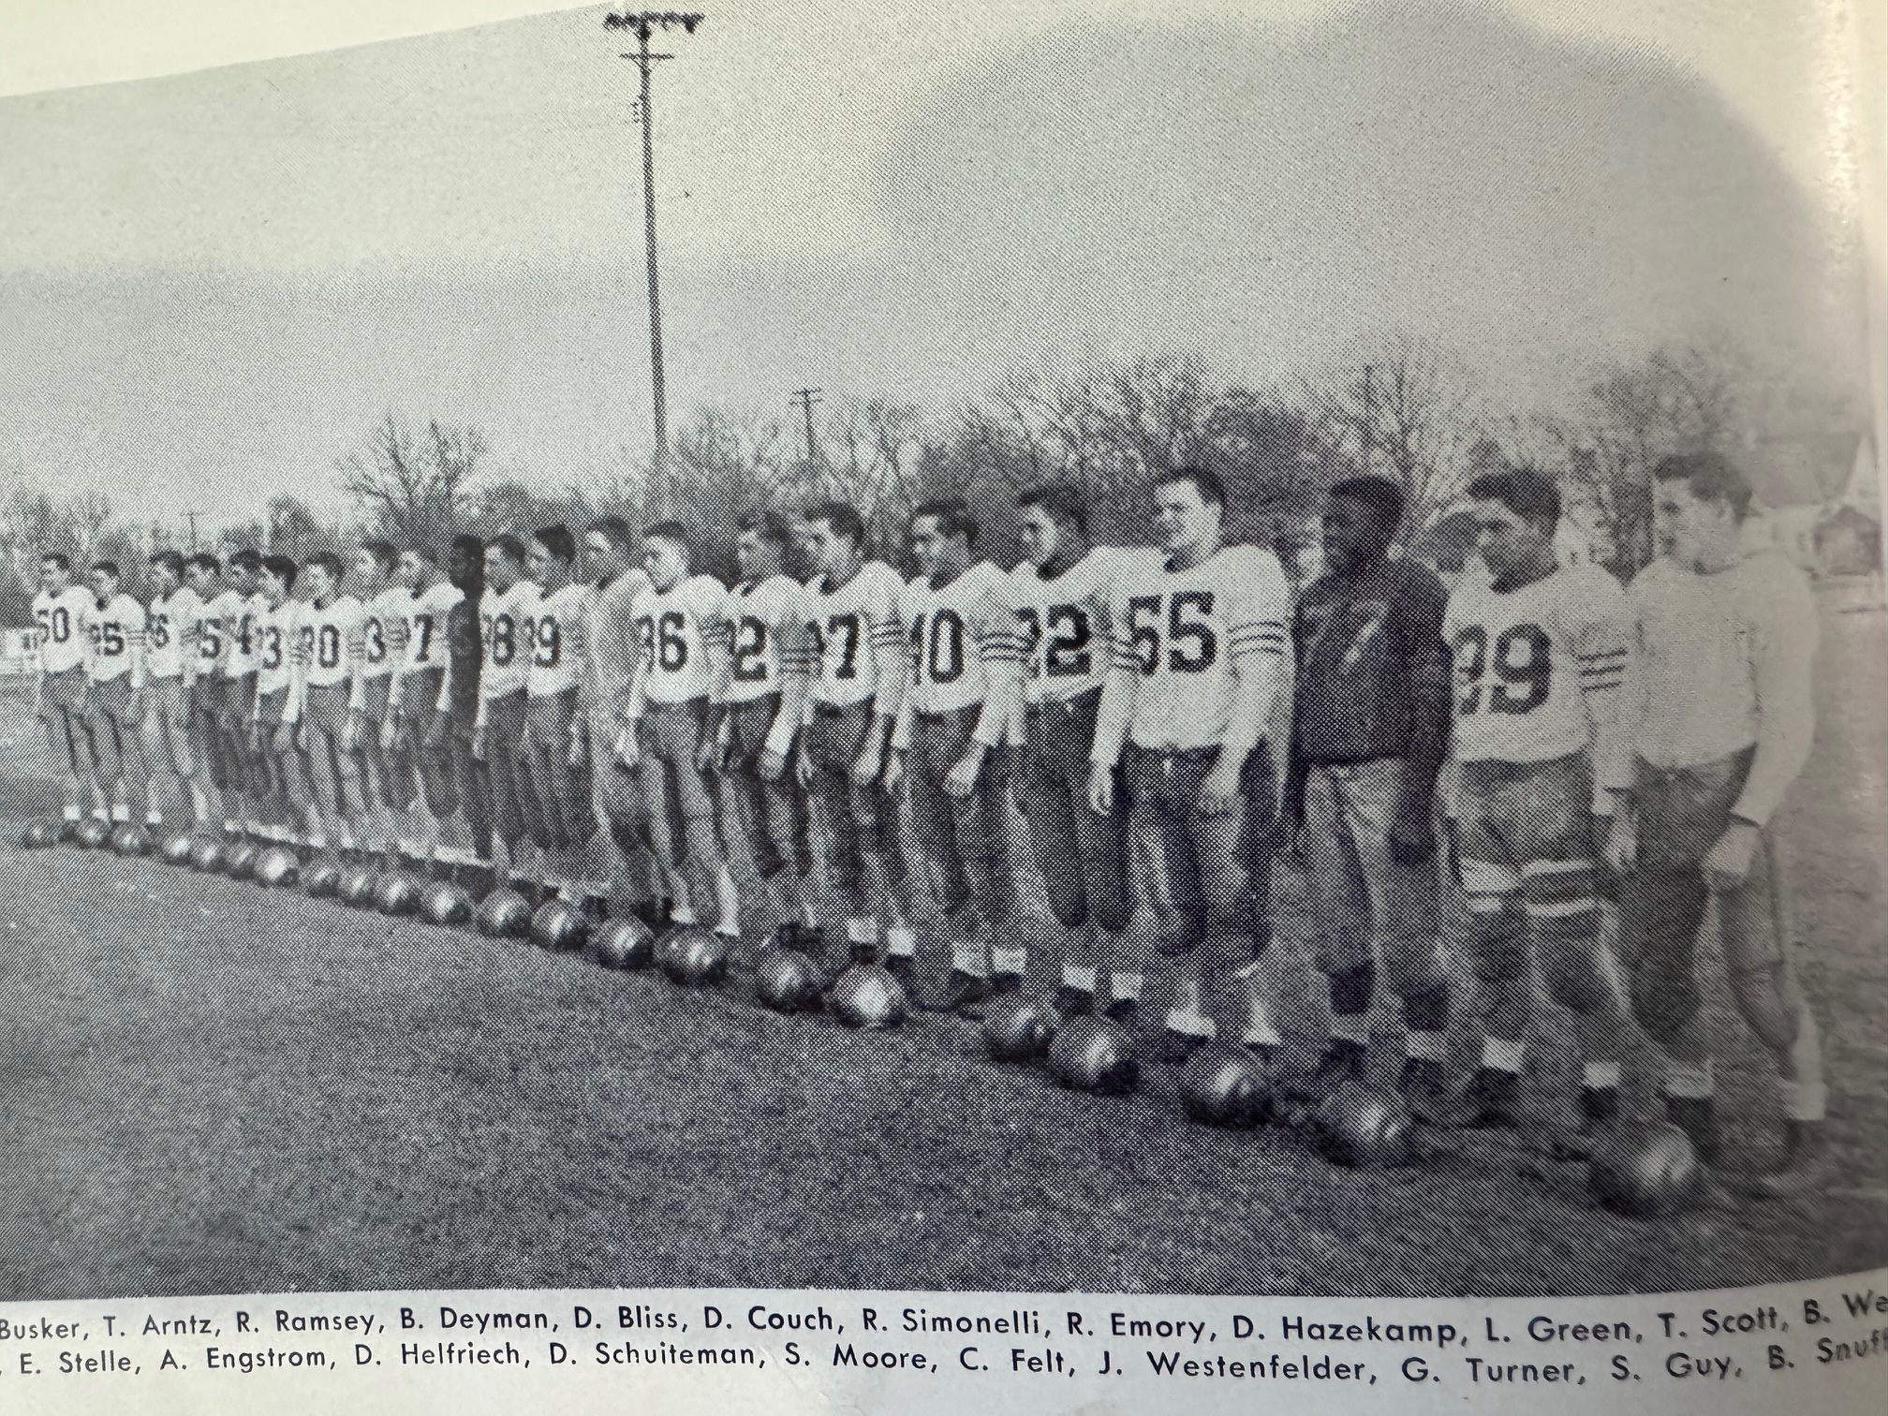

THE 1952 NORSEMEN

The Norse were more than eager to welcome Coopersville as their new opening game opponent. After all, NM had dropped 8 of the last nine game to Grand Rapids Lee with only a 14-14 tie back in 1949 preventing a complete sweep from Lee. The Norse would begin a series with Coopersville that would extend through the 1965 season where NM would win 7 of the 14 games played with 2 games resulting in a tie. It didn’t take Norse fans long to realize that they had something special to watch over the next three football seasons. Stan Guy, listed at 140 pounds scored twice on exciting 27-yard runs, while Scott Moore, who excelled from his linebacking post on defense added the third TD as the Norse won their first opening game since 1942, 21 -8 over the Broncos.

Still learning a new system implemented by coach Leckta the Norse were shutout for the second straight year by Ludington 32-0. It would be the largest margin of defeat during the Lectka era. The Norse were unable to get any running game established against the Oriole defense and were forced to go to the air to pick up most of their yardage. Leonard Green completed 7 of his 13 pass attempts with most of those going to Stan Guy. The loss to Ludington evened up the series over the years at 2 wins for each team. The coin would flip to the Norse’s favor the following season.

The Norse then handed coach Lectka his second win as the new NM head coach as they upset the defending WMC champs from Hart 20-13. Leonard Green and Tom Arntz connected on a pass covering 72 yards to set up the first Norse score, a one-yard sneak by Green. NM then took a 13-0 lead at halftime when Stan Guy raced 55 yards for the touchdown. The Pirates roared back in the second half for a pair of TDs, one an 85-kickoff return by Dale Kaufman. Scott Moore then iced the game for the Norse in the final quarter when the junior halfback sped 80-yards for the winning score.

Stan Guy led the Norse to their second consecutive win, and 2nd in the WMC, perhaps as much with his defensive play as his role on offense in a 27-12 win over Whitehall in front of 3,000 fans at Funnell Field. Guy did contribute to NM’s first score when he set up fellow sophomore Dick’s Schuiteman’s 36-yard TD with a long 49-yard run. Whitehall countered with their talented running back Osie Rostic, the Class C state champ in the 100-yard dash in 1952, who sped 57 yards for a TD. However, unlike the Norse’s Scott Moore, who was perfect on his extra point placement on the NM TD, Whitehall failed on their try and the Norse led 7-6 at halftime. Guy then made the first of his two big defensive plays when he recovered a Viking fumble to stop a Whitehall drive at the NM 34-yard line. The Norse would then mount a touchdown drive that culminated on a George Turner TD from four yards out. Guy then broke the Vikings’s hope for victory when he intercepted a Ron White pass and raced 52-yards for a clinching touchdown. Dick Schuiteman, who had had been converted by Lectka from a starting freshman quarterback in 1951 to a running back in 1952, then scored his second TD from 15 yards out for the final Norse points.

The Norse traveled up old highway 31 to Shelby and, although they spotted Shelby an early touchdown, had little trouble in stomping the hosts 41-13 with Stan Guy scoring three touchdowns on runs of 15, 26 & 39 yards. Guy also had another 39-yard dash that set up his first tally from the 15. Dick Schuiteman got into the scoring act with a long TD burst of his own, a 55-yard scamper for the Norse 2nd TD on the evening. Scott Moore had a 6-yard TD while Ron Simonelli became the second freshman in NM history (Dick Schuiteman the first in 1951) to score a TD when he bucked over from short yardage for the final NM score. The Norse defense did a good job of limiting Shelby’s future NFL star back Dave Whitsell to minimum yardage and one TD.

The Norse then won their third straight shutout victory over Fremont 38-0. During this streak the Norse outscored Fremont 99-0. Long-time Chronicle sports reporter Mart Tardani heaped great praise on the work of Stan Guy, not only for his running talents, but pointed out that time and again he broke though the Packer line to smear runners before they started to roll. Guy scored the first of NM’s six-touchdowns early into the contest when he scored from the 20-yard line. He added his second tally when he intercepted a Fremont pass in the 3rd quarter and returned it 25-yards for a touchdown. The Norse second touchdown during the romp was set up when the sophomore speedster returned a punt to the Packer 32. After a 15-yard gallop by Scott Moore moved the ball down to the three, Dennis ‘Red’ Emery, who shared the quarterback duties with Leonard Green, scored NM’s 2nd TD. Moore, on the first play from scrimmage to begin the second half broke through on a 68-yard TD jaunt. Just moments later Guy would tally on his TD interception. Dick Schuiteman would complete the Norse scoring with his seven-yard TD in the final period.

Two days after President Harry Truman arrived in Muskegon to speak in front of over 15,000 Muskegon residents at the C&O railroad station, The Norse handed visiting Montague a 26-9 defeat to clinch no worse than a tie for the WMC Championship. The Norse started slowly but needing a ‘spark’ they handed the ball off to Stan Guy who raced on one of his typical sprints for a 47-yard touchdown. Montague would take a short-lived lead when they caught the Norse off guard and scored on a ‘sleeper play’ which left Ron Erdman alone on the sideline. Before the Norse had spotted Erdman, he had caught the pass from Mel Weideman and left Norse pursuers behind on a play that went for a 70-yard TD. With the made extra point the Norse trailed 7-6 but they wouldn’t be on the short end of the score for long. Junior Jerry Westenfelder and freshman Ron Simonelli, only the third freshman to start a game for the Norsemen (Bob Pyle 1943, and Dick Schuiteman 1951 the others) both recovered Montague fumbles to set up NM scoring drives. Leonard Green’s pass to Scott Moore good for 45 yards set up one of the rare short TD runs of Stan Guy’s incredible career, from four yards out. The second fumble recovery by the Norse was tallied by Scott Moore from the 2-yard line after Guy had totaled 26 yards on a pair of runs. Schuiteman than completed the Norse scoring set up on a brilliant 49-yard run by Guy, with a short blast from the two.

It didn’t appear that Harry Truman’s speech three days earlier in Muskegon in support of Adlai Stevenson swayed enough votes as Dwight Eisenhower was easily elected to be our country’s next President.

North Muskegon needed a victory over second place Scottville to win the WMC title outright. That proved to be no problem as the Norse pummeled the host Spartans 34-0. The Norse took away any suspense in this game as they took a 27-0 lead at halftime as four Norse players scored touchdowns. Guy tallied the first on a 31-yard dash, Schuiteman added the second from four-yards out; Green’s pass to Tom Arntz added six more points for the Norsemen. Moore also joined the TD parade from four yards out. Guy added the final TD in the second half but his yardage on his TD was not reported in the game reports from Scottville. Next up was the BIG GAME!

Interest in the 1952 season finale was perhaps the most hyped contest in the 20 years of NM football dating back to 1932. Pre-crowd estimates had attendance to reach as many as 3500 to 4000 fans to watch a duo between two players who would go down in history as the two best to ever don their respective uniforms: Jim Morse for Muskegon St. Mary’s and sophomore Stan Guy. 70 years down the road in 2022 both Morse and Guy would be named 2 of the top 25 players in Greater Muskegon History.

St. Mary’s had played am extremely tough schedule with only a pair of tough losses putting a dent on the season. NM had an enviable 7-1 record against many Classes B & C opponents and would square off against a veteran St. Mary’s team that returned 13 lettermen from their 1951 season. The Norse had an enviable record despite the fact the 1952 team was the youngest in school history. Only lineman Jack Weerstra was a senior starter for the Norse. The
ends were junior Tom Arntz and sophomore Dave Bliss, each an outstanding athlete, who were also starters on the basketball and baseball teams. So talented was Arntz that going into his senior season he held the single game school record in basketball. A four-year starter in baseball, Arntz lettered in 4 sports his final two years as a Norsemen and was the WMC high jump winner in track. The tackles were juniors Walt Busker and Ed Stelle. Busker would play college football at Dartmouth while Steele took his talents to Albion where he was voted the most valuable freshman in his first year. Weerstra was teamed at one of the guard positions with junior Chuck Felt while junior Allan Engstrom performed the chores at center. Junior Scott Moore would team up with Guy during the 1952 and 1953 seasons to give the Norse their best backfield duo since Don Bowen and Moe Sikkenga led the Norsemen of the early 1940’s to 15-straight undefeated, as well as scoreless, games in a row. Sophomore Dick Schuiteman would be a Norse stalwart for four straight years while freshman Ron Simonelli would shore up the defense.

This game was a feature story in a 2-part series in the Muskegon Chronicle in the Fall of 2009. Here is part two penned by your author that describes in detail much of the story from this epic contest:

Part 2: Jim Morse & Stan Guy
By Jim Moyes (jimmoyes@aol.com)

Part one of our latest installment of Moyes’ memories set the stage for the only game played featuring two of this area’s finest all-time football players, Jim Morse and Stan Guy. To add additional appeal for our story, it would not only be the last game for Jim Morse, but also the last football game played by St. Mary’s High.
Although this match up would be the final game for Stan Guy and the North Muskegon Norsemen in 1952, the next two years would prove to be a very exciting era in northside football history.
And just how skillful were these two all-time greats? Jim Morse and Stan Guy put up numbers that today’s statisticians would fawn over. Let’s begin with Morse.
A letter winner for St. Mary’s High in his freshmen year back in 1949, Morse established records that have withstood the test of time at what is now Muskegon Catholic Central High School.
Morse would follow a sophomore season, where he tallied twelve touchdowns, by notching nineteen more TDs in each of his next two seasons for the Irish of St. Mary’s. Toss on an additional 43 points for his extra points kicked from placement and Morse would end his career with 343 points, tops in local parochial school history.
This feat was accomplished over a span of but 26 games, long before additional games were added during our current playoff era. And did Morse pad his touchdown totals with those short goal line plunges into the end zone? Check out these stats:
For his career Morse ‘averaged’ nearly 27 yards on each of his touchdown romps. In his junior year of 1951 Jim darted and weaved his way over 666 yards in scoring his 19 touchdowns, averaging an astounding 35 yards for each TD recorded. Included among his long touchdown jaunts was a 104-yard return of a pass interception vs. Bay City St. Joseph. Some 73 years later this remains today as the longest touchdown in Greater Muskegon football history.
Stan Guy’s totals for his career were nearly a carbon copy of the talented Morse. Guy too, found the opponent’s end zone a dozen times during his sophomore year, just a sample of the many exciting times that awaited Norsemen rooters.
After dashing through enemy defenses for 17 touchdowns in his junior year of 1953, Guy streaked for 25 more in his senior season. Stan’s 1954 totals were good for 150 points, tops in the entire state of Michigan. Even today’s computer equipped statisticians would be amazed at little Stan’s numbers.
The muscular built NM dynamo totaled nearly 1800 yards on his 54 career touchdowns, an amazing 33 yards average for each touchdown! Only three of his scores came from inside the fifteen-yard line!
Indian Summer gripped the Muskegon area on November 14, 1952, a stark contrast from the deplorable conditions from a year earlier. A brutal early winter snowstorm had forced the cancellation of the previous year’s season ending game.
Temperatures hovered in the middle fifties as St. Mary’s and North Muskegon awaited the eight o’clock kick off before the largest crowd in Norse history. Among the thousands of football fans in attendance, in addition to this old timer, was a young sixth grader at NMHS.
Nearly sixty years later Dave Taylor still remembers, not only the game, but also—THE SIGN. “I can still remember where I was when I first spotted the sign,” recalls the future Norsemen football star and Hall of Fame football coach for the Muskegon Big Reds. “I was sitting in the bleachers at the northwest end of the field when two guys approached my area holding up a sign. I couldn’t believe what that sign read: GUY WILL DIE!”
And did Stan Guy see that sign? When I asked Stan this question a few short days ago he replied in a very solemn tone: “I will never forget it.”
How fortunate I was to experience a recent afternoon lunch with Jim Morse and Stan Guy. It was amazing as we rehashed the game that took place nearly 57 years ago how clear they remembered that night, and how much praise and respect they had for one another.
Stan Guy was a nervous young sophomore, made decidedly more edgy after seeing the sign. “It wasn’t the wording of the sign that bothered me so much, but the picture of the coffin shook me up,” reminisced the former Norseman star.
“I was just a young sophomore, and I had never played against a team as big as St. Mary’s,” recalled Guy before placing his order for a perch sandwich. Although, thankfully, Guy didn’t die, that sign was somewhat prophetic as an injury did send the Norse superstar to the sidelines to stay early in the second half.
The game itself lived up to the hype and St. Mary’s superstar Jim Morse saved his best performance for his final act as a high school gridder. Morse did everything for the Irish on this perfect autumnal night for football except drive the team bus across the Causeway.
Morse had a hand in all the scoring for the Irish and they needed Jim at his best to defeat the pesky Norsemen. The talented NM defense keyed on containing Morse’s running game, but the future Notre Dame captain utilized all his assets to pin defeat on the hometown squad.
After three quarters had been played the Irish held a slim 14-13 lead over the hosts, the difference being a pair of made Jim Morse extra points coupled with a missed point after try by the Norse. The NM attempt was blocked by a young St. Mary’s freshman, Dick Seymour. Less than two years after this game Dick Seymour would see his sister, Leah Rae Seymour, exchange marital vows with his teammate Jim Morse.
For the record Morse passed to big Mike Kanitz for a pair of TD passes, ran for another score and put the final nail in that Norsemen coffin with a 55-yard punt return for the winning TD. According to my late colleague, Mart Tardani, who reported on this game for the Muskegon Chronicle, it was on this play that Guy, suffered his game, and season ending injury.
Just as North Muskegon was intent on stopping the running game of Jim Morse, St. Mary’s had a similar game plan to stop the diminutive Norsemen star Stan Guy. While Morse was more than a one-dimensional player, the same title could be applied to Guy. Stan set up the second Norse score with a long return of a Jim Morse punt.
With the locals leading 13 to 7 Guy intercepted a Morse pass and returned it deep into St. Mary’s territory. However, a Norse penalty on the play kept the ball in the possession of the Irish where, a few moments later, Morse delivered a TD pass to Kanitz to give St. Mary’s a lead they would never relinquish.
Morse ran, kicked, punted, passed (10-14 for 124 yards and 2 touchdowns) and delivered a big hit on Guy that was instrumental in making the final game in St. Mary’s history a 27-19 Irish victory. It would be the last high school game where Stan Guy would be on the losing end of a score, as the Norsemen would go undefeated over the next two years.
For second year head coach Harold Popp the victory was certainly bittersweet for the one-time graduate of Boys Town. Just a few days after coaching his Irish to perhaps their biggest win in school history, Popp was relieved of his duties as a St. Mary’s coach.
‘Rough Coaching’ was the reason given for Popp’s hasty dismissal, much to the surprise and disappointment of his star fullback Jim Morse. Morse strongly defended the coach at the team’s banquet. “Sure, Harold has been a rough coach, but football is a rough game. We wouldn’t have won half our games this season without him.”
Morse would go on to Notre Dame where he would have a fabulous career as a football star. Just days after Stan Guy capped his brilliant high school career (1954) with a win over Greenville; Morse took center stage on a much bigger platform as Notre Dame defeated USC 23-17. Morse ran for 179 yards, caught a pair of passes and scored 2 TDs.
In a 1955 game against the powerful USC Trojans Morse caught five passes from 1956 Heisman trophy winner Paul Hornung good for 208 yards. Morse’s per catch average of better than 41 yards per reception is still, to this day, an NCAA record.
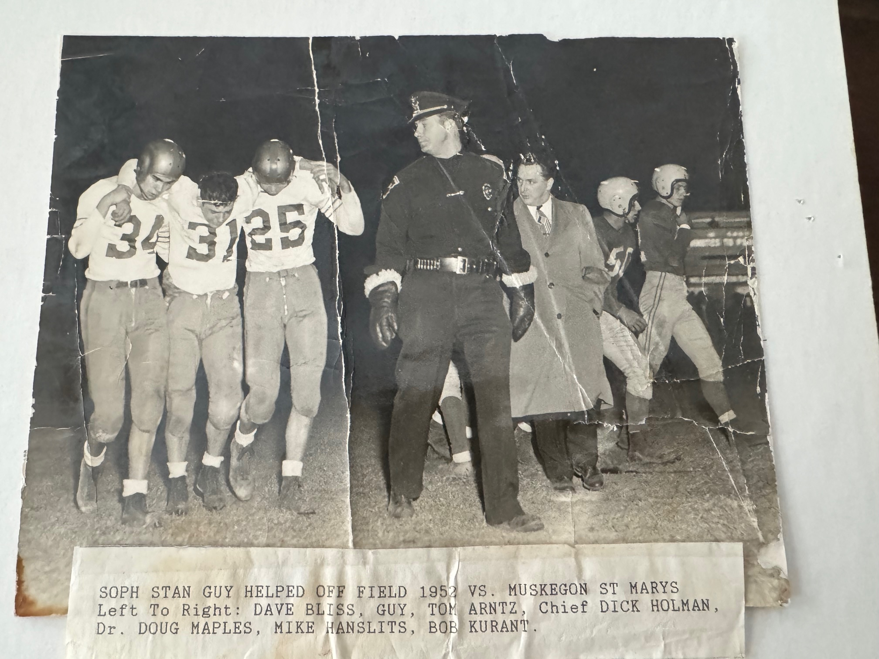
While Morse was a standout athlete, excelling not only in football, but also basketball and baseball, Stan Guy was a one-man record board in track and field at North Muskegon,
In the spring of 1955 Guy broke a Greater Muskegon standard in the pole vault that lasted twenty-five years. Stan sailed over a cross bar set at twelve feet above ground, using a cumbersome steel pole, streaking down a cinder runway, before landing in a pit with only a pile of saw dust to cushion his fall.
Guy had a combination of speed and power in a body that would make an Olympic gymnast envious. At one time he was possessor of six school records in track and field at North Muskegon. For many years his name took up most of the space on NM’s record board. At one time he was the all-time Norse record holder in the pole vault, long jump, 100-yard dash, the low hurdles, a member of the 880-relay team and the shot put.
And who should one day break Guy’s shot-put record. None other than the youngster who first spotted the ‘Guy Will Die’ sign, future Muskegon head football coach Dave Taylor.
Football scouts from major colleges did make the trip to North Muskegon to lure Guy to their university. I asked Stan a question that I assumed I had the answer as to why Guy didn’t pursue his football career to the next level.
I awkwardly asked Guy if it was due to his dislike for the textbooks as well as the thought that he couldn’t bear being without his high school sweetheart, Janet Woodhouse.
A very humble Guy surprised this reporter, and his friend Jim Morse, with his response. “Yes, you’re right about the first two, but really, I was just too damm small to play big time football.”
Jim Morse and Stan Guy have enjoyed watching their children, and now their grandchildren, have much athletic success over the years. It is well known that Jim’s son, Bobby Morse, following a fantastic football career, joins his dad to make up the only father-son duo in the Muskegon Area Sports Hall of Fame. Stan’s daughters, Shelly & Cindy Guy, led North Muskegon’s girls track team to three state championships from 1977 thru 1980. Unlike their proud Papa, the gals can still see their records still unsurpassed at NMHS.
There are some obvious major disadvantages as us old-timers head into the ‘golden years.’ However, I am so grateful that I was able to watch such former great athletes such as Jim Morse and Stan Guy display their athletic brilliance while in their prime. But more importantly, I am even more proud of having them as dear friends.

The Norse had completed their season as WMC champs and an overall record of 7-2. It would only get better for the next two years.

Record Score Interesting Fact
1-0 NM 21, Coopersville 8 Stan Guy a pair of 27-yard TDs in his NM debut. Scott Moore stars in defense and scores a short TD.
1-1 Ludington 32. NM 0 Ludington stops NM running game. Leonard Green 7 of 13 pass completions.
2-1 *NM 20, Hart 13 72-yard pass Leonard Green to Tom Arntz sets up Green 1-yard sneak. Guy 55, Moore 80-yard TDs.
3-1 *NM 27, Whitehall 12 Dick Schuiteman 2 TDs (26 & 15, George Turner 4-yard TD, Guy 52-yd interception return for TD.
4-1 *NM 41, Shelby 13 Guy 3 TDs on runs of 15, 26 & 39; Schuiteman 55 yd TD; Moore TD and freshman Ron Simonelli TD
5-1 NM 38, Fremont 0 2 more TDs for Guy, run of 20 & interception returned 25 for another, Red Emery TD, Moore 68, Schuiteman 7
6-1 *NM 27, Montague 9 47-yard TD from Guy starts things off for NM; Guy from 4, Moore from 3 & Schuitemam from 2 cap NM scoring.
7-1 *NM 34, Scottville 0 Guy a pair of TDs, Green pass to Arntz, Moore and Schuiteman each a TD.
7—2 Musk St Mary’s 27, NM 19 Future Notre Dame star Jim Morse figures in all the scoring for the winners. Guy injured in second half.

1953 – coach Dunc Lectka (7-0-1 overall, 5-0 WMC champs)

With just about the entire team returning from a successful 1952 season, expectations were high for the 1953 season. The players came back a year older, a little stronger, and more in tune with third year head coach Dunc Lectka’s offense and defense. Lectka kept himself busy playing baseball in the Greater Muskegon City League during the summer and the 31-year-old slugger led the entire league in hitting with a .431 average. Incidentally, one of his teammates on his Home Furnace team was the young football star from St. Mary’s who contributed to the Norse defeat in last year’s closing game of the season, Jim Morse. Morse, in addition to starring on the gridiron and leading St. Mary’s to a state runner up in basketball his senior year, hit over .300 for Home Furnace.
15 Lettermen return with the only position where a returning starter is missing is at one of the guard spots. Coach Lectka is grooming sophomore Ron Simonelli, who was a starter on defense last year to move from his fullback position to handle the guard duties. The only worry for Lectka heading into the season opener was he felt he was lacking depth as at least eight of the starting 11 are slated for two-way duty.

After a scoreless first half in their opener at Coopersville, the Norse used the big play to defeat the Broncos for the second straight year 26-0. Stan Guy returned the 2nd half kickoff 85 yards to get the Norse off and running. Pinned back at their own four-yard line and looking at a 3rd and long for a first down, Scott Moore got the handoff from quarterback Leonard Green and raced 96 yards for the TD, the second longest TD run in Norse history. Moore scampered on another long TD gallop of 55 yards early into the fourth quarter to crush whatever hopes the Broncos may have had in pulling off the victory. Dick Schuiteman added the final Norse tally later in the period. Worried in the pre-season by a possible lack of depth the Norse used 20 players, and they all performed well, including a smooth transition from fullback to guard by Ron Simonelli.

Stunned last year by Ludington who put a 32-0 whipping on the Norse for one of their two defeats, the Norse got three touchdown runs from Stan Guy (31, 11 and 56) and another 29-yard touchdown run by Scott Moore as the Norse defeated Ludington 25-7. Leonard Green threw for 99 yards passing with 66 of those coming on a pair of completions to Tom Arntz. Ludington’s lone score came a long punt return by Lee Snyder late in the game.

The Norse used good defense, exceptional special team play, and a finely tuned offense in routing Scottville 41-0. With Scott Moore on the sidelines for much of the game with a groin injury, Dick Schuiteman took on an added role as a running back and came through with touchdown runs of 3, 4, and 24 yards. Stan Guy, as usual, was terrific as he also tallied three TDs, with one going into the record books. The junior dynamo fielded a punt at his own nine-yard line early in the second period and raced through almost the entire team of Scottville for a 91-yard punt return TD, the longest punt return in Norse history. (Now 2nd to Ken Mack’s 93-yard return in 1965 vs. Manistee) Guy also raced for second half TDs of 11 and 30 yards as the Norse won their third straight game, outscoring their opponents 92 to 6. Praised for their line play that only allowed three Scottville first downs for the entire contest were Tom Arntz, Ed Stelle, Dick Montgomery, Ron Simonelli and Jerry Westerfelder. One of the three officials working the game was former UM great Jack Weisenburger, who also broadcast many games on local radio station WKBZ.

The Norse made Hart victim number four on the season with a 28-7 victory on the road. The Norse struck early as they marched 65 yards on only six plays with Stan Guy, Scott Moore, and Dick Schuiteman alternating on runs with Schuiteman going the final five yards for the score. Scott Moore was successful on the first of his four made extra points boots from placement. Hart mounted a long drive of their own but fumbled the ball deep in NM territory at the five. Guy then swept around end and sped away from the Hart secondary. No less than five Pirate defenders had Stan all but bottled up, but Guy kept his feet and pulled away for the long-distance TD. Guy would add another 35-yard TD to his credit while the passing combo of Leonard Green to Tom Arntz set up the final Norse TD with several long pass completions. Schuiteman would traverse the final three yards for the final Norse tally.

The Norse all but sewed up their second straight conference title following their 27-7 victory over Whitehall in front of a standing room only crowd on the Northside. Stan Guy again scored a couple of touchdowns from far out as the Norse made it a perfect 5-0 on the season. The Norse scored early after Scott Moore, one of many NM players who goes two-ways, recovered a fumble on Whitehall’s first play from scrimmage at the Viking four-yard line. Dick Schuiteman took it home from there and after Moore’s PAT the Norse led 7-0 before many of the fans found their seats --- or a place to stand. Whitehall quickly answered moments later and went on a 73-yard TD run to tie the game and give Whitehall hope. Whitehall smelled blood and was successful on an onside kick. However, that drive was thwarted when big Walt Busker intercepted a pass at the Norse 28. Two plays later Red Emery rifled a pass to Guy who outraced the secondary to complete a 67- yard TD pass play. A heavy fog enveloped the NM field as the second half began but Stan Guy sliced through the fog and scampered 45 yards to pay dirt. The last touchdown was scored by a now healthy Scott Moore who completed a 60-yard drive with a touchdown run from six-yards.

If one could go back in time and replay one game, surely the game with Kellogsville would be on this list. Easily playing their poorest game of the season in a game played in the rain, the road game with Kellogsville was the only time in NM’s long history of football these two schools would play one another. The visiting Norse did get off to a good start and it appeared the Norse would again be headed to an easy victory when they drove 80 yards in the opening quarter with Scott Moore and Stan Guy picking up most of the yardage with Guy romping 32 yards for the first score. A fortuitous block of a Dave Bliss punt late in the first half gave Kellogsville possession deep in NM territory that the hosts turned into a TD to tie the game at 6-6 at the break. NM took yet another lead in the second half with Dick Schuiteman traversing the final few yards but, again, on the sloppy field, NM missed the all -important extra point. The blockbuster moment came early into the fourth quarter when Jim Stewart dashed 68 yards against the normally solid NM defense to tie the game at 12-12 as Kellogsville also was unable to convert the extra point. The tie prevented the Norse from having their first perfect season since 1942. Their final two opponents would pay the price for an angry Norse team. It was not only a bad week for the Norse as the following day Purdue handed MSU their first loss after 28 consecutive games. The Spartans surely missed the presence of former Big Red Earl Morrall who did not make the trip due to an illness.

The Norse responded in a big way by clinching at least a tie in the WMC with a 47-7 thrashing of Shelby and their one-man gang of future NFL star Dave Whitsell. The Tigers just couldn’t find enough help (talent) for Whitsell as Stan Guy and company scored nearly at will against the visiting Tigers. Whitsell certainly did not have the line blocking the Norse backs received although Whitsell did pick up amazing yardage and was called ‘by far the best player we faced all year” by Norsemen coach Dunc Lectka. Stan Guy produced his ‘usual’ stellar game by scoring a pair of long-distance touchdowns and had one long 65-yard burst called back due to a Norse penalty. Reserve back Dave Couch had his best game as a Norsemen as he scored a pair of short-range TDs while Scott Moore, and Dick Schuiteman also scored with All WMC conference end Tom Arntz getting in on the act with a seven-yard end around TD to cap the scoring. Stats in the Muskegon Chronicle, (individual rushing stats were rarely published in the early years) did show Guy rushing for 167 yards from scrimmage to bring his total to 967 for the season, not counting his punt, pass receiving, and kickoff returns which were major.

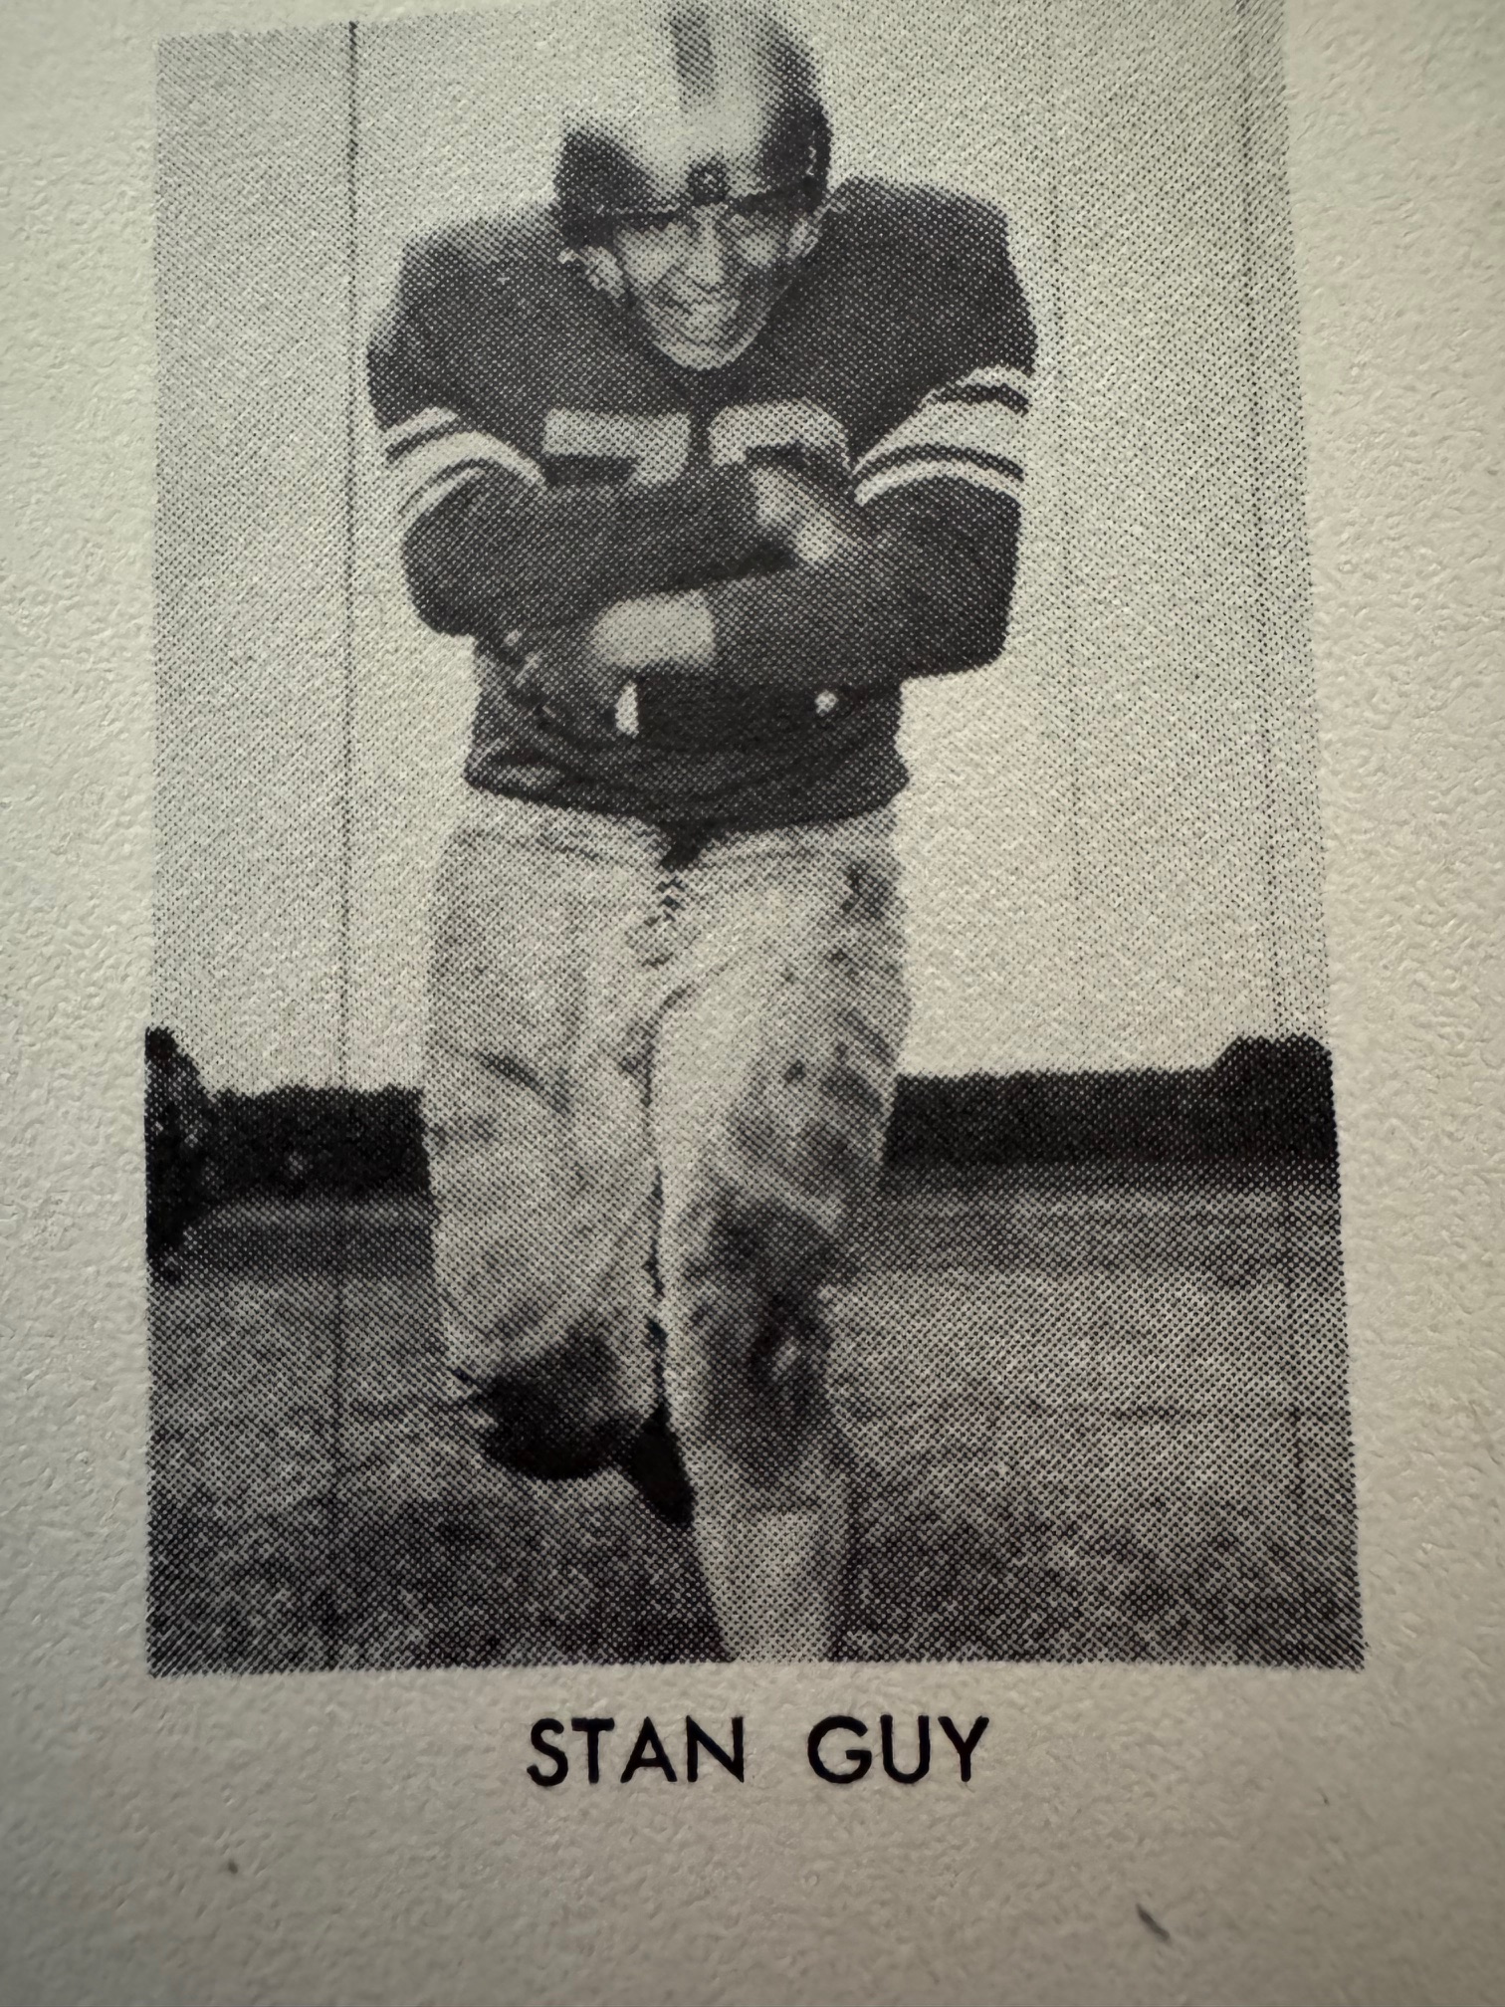

The Norse for the most part had an injury free season and would go into their season finale with Montague needing a victory to win the WMC championship outright. The Norse would start their usual starting lineup for Montague with a pair of outstanding ends in Tom Arntz and Dave Bliss, Walt Busker and Ed Stelle at tackles, Ron Simonelli and either Tom Girocco or Tom Stribley at the guards and Al Engstrom at center. The same starting backfield from the previous season remained intact with Leonard Green, Stan Guy, Dick Schuiteman and Scott Moore. The Norse were top-heavy favorites for the game at Memorial Field in Montague and that was certainly the case as NM had little trouble with the Wildcats. Although NM tallied seven touchdowns, led by Stan Guy’s three tallies, the defense was just as impressive as they limited Montague to but two first downs and a minus 37 yards rushing. The one pass completion to big Jerry Brown of 44 yards to the NM 28 was the only pass completion on the evening for the ‘Cats’ and would be the deepest penetration into NM territory for the entire game. Guy’s three Touchdowns came from 25, 2, and a 35-yard punt return for another six-pointer. Scott Moore capped his outstanding NM career with a 34-yard TD and a short one-yard plunge. Dick Schuiteman plunged over for another tally while Tom Arntz capped his career with a 15-yard TD pass thrown by Red Emery.

Record Score Interesting Fact
1-0 NM 26, Coopersville 0 Scott Moore runs 96 and 55 yards for TDs. Stan Guy returns 2nd half Kickoff 85 yds for TD. Dick Schuiteman 4 yd TD.
2-0 NM 25, Ludington 7 Guy 3 TDs on runs of 31, 11, & 56. Moore29 td. Tom Arntz caught a pair of passes good for 30 & 36 yards to set up scores.
3-0 *NM 41, Scottville 0 Schuiteman and Guy 3 TDs each with Guy returning a punt for 91 yards.
4-0 *NM 28, Hart 7 Guy 95 and 35 TD runs. Schuiteman 2 (5 & 3 yards). Leonard Green several pass completions to Arntz
5-0 *NM 27, Whitehall 7 Schuiteman and Moore 1 TD each; Guy 67 yd TD pass from Red Emery, 45 yd TD run.
5-0-1 NM 12, Kellogsville 12 (tie) Kellosgville spoils NM hopes for a perfect season on a final quarter long TD run. Guys scores from 32 and Schuiteman from short range for NM TDs.
6-0-1 *NM 41, Shelby 7 Guy 2 more long run TDs (60,65) Dave Couch 2 TD, Schuiteman 1 and Arntz a 7-yard TD run
7-0-1 *NM 47, Montague 0 Guy 3 more TD including his 2nd punt return for TD on the year. Moore 2 TD, Schuiteman 1 and Red Emery pass to Arntz for 15-yard TD.

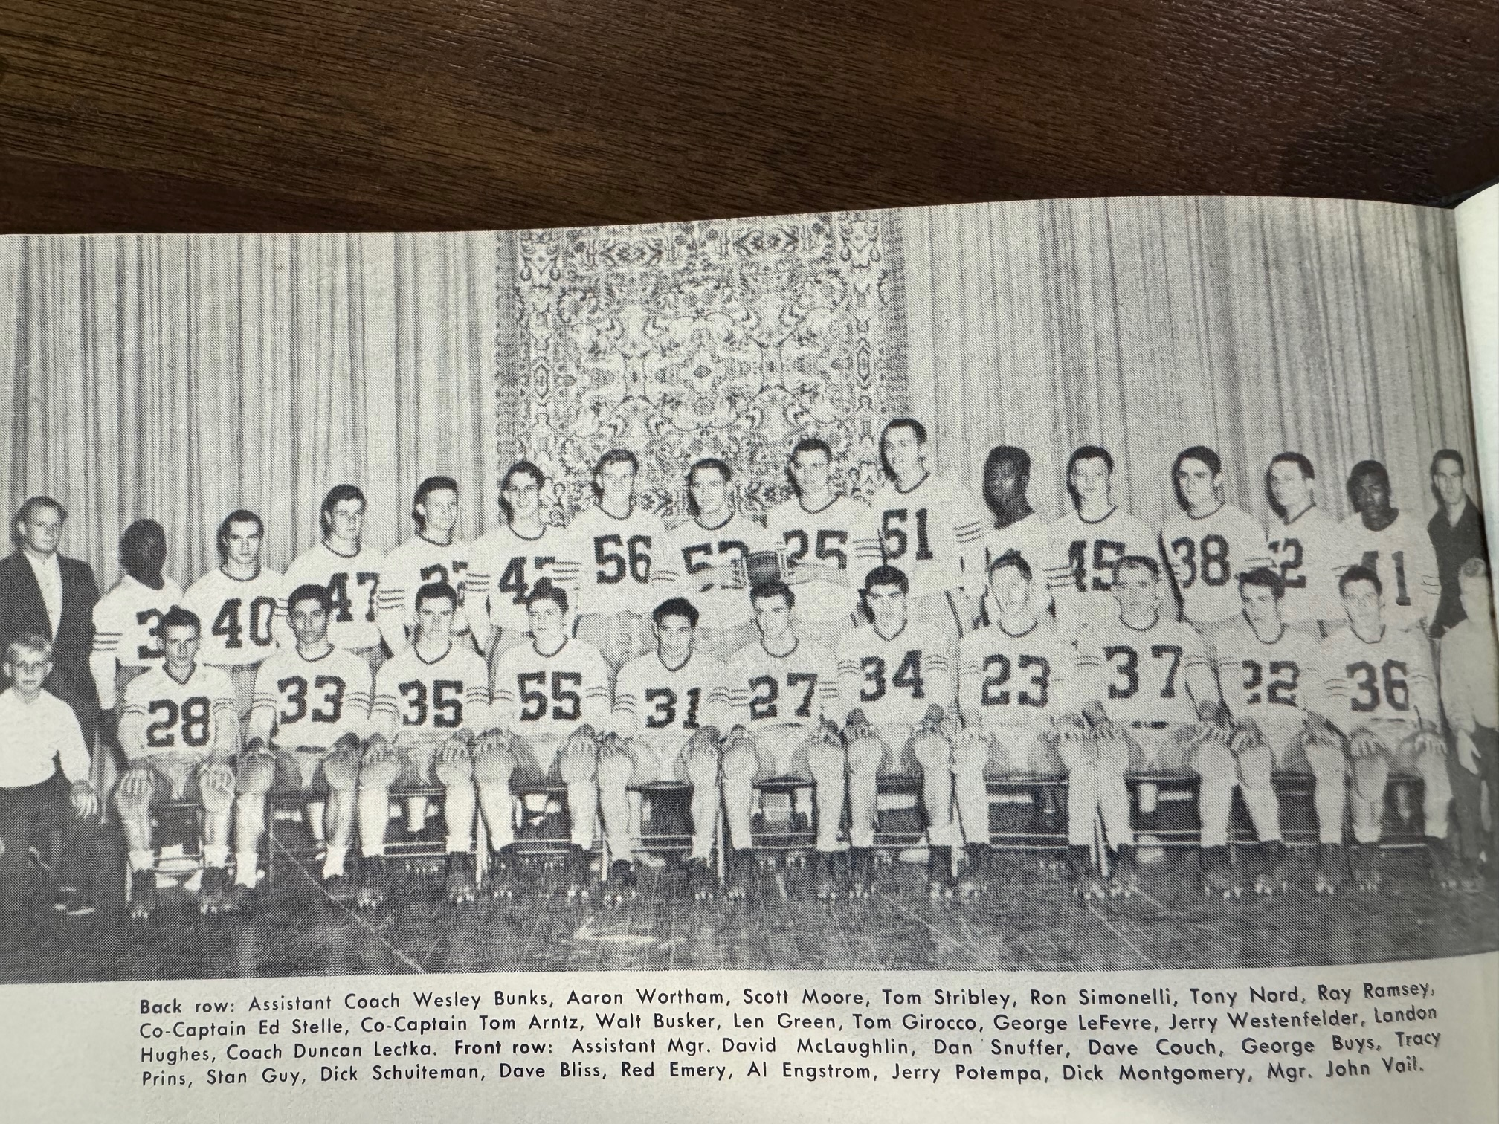

1953 UNDEFEATED NORSEMEN

1954 – coach Dunc Lectka (8-0-1 overall, 5-0 WMC champs)

Despite fielding one of the best teams in NM history in 1953, and a bevy of talented returnees, only 21 players showed up for opening practices on the northside. Those lettermen, who all saw extensive action a year ago, included all conference backfield performers Stan Guy and Dick Schuiteman and another all-conference returnee on the line in junior Ron Simonelli. Other lettermen returning, with all expected to join the starting lineup were Tracy Prins, Tony Nord, Tom Girroco, Dick Montgomery, Tom Stribley, Chuck Houts, and Dave Bliss. The biggest task for 3rd year coach Dunc Lectka was to find a quarterback as well as replace last years’ all-conference tackles Walt Busker and Ed Stelle.

The Norse lost the battle of the statistics but won their opening game 13-6 against a vastly improved Coopersville eleven. The visiting Broncos scored their first and only touchdown in the opening period, but the Norse rallied. Stan Guy showed early that he was in good form as he rattled off a typical Stan Guy long run good for 72 yards. Unfortunately, Norse fans groaned as the play was called back due to a NM penalty. After an exchange of punts, the Norse took over in excellent position at the Coopersville 38. In two plays Guy picked up all the yardage with his touchdown coming as he skirted around left end 10 yards for the score. Dick Schuiteman booted the extra point, and the Norse had a slim 7-6 lead at halftime. Ron Simonelli, who played on the line in the previous two years, made the transition from lineman to the backfield a smooth one as he led a third quarter Norse drive with several hard runs, culminating with the junior halfback scoring from the one for the game’s final score. The defense saved the day for the Norse in the games’ final minutes when the Broncos moved deep into NM territory. A fourth down pass near the Norse goal line was batted away by Dave Bliss and Guy to secure win number one for the Norse.

The Norsemen next journeyed to Ludington and although the final score was tight at 27-25, the Norse never trailed in the contest. The Norse took a lead that they never lost when Stan Guy raced 76 yards on the first play from scrimmage. After Ludington scored, but failed to convert the extra point, the Norse got a boost from reserve back Aron Wortham. Wortham electrified the crowd with an 81-yard touchdown gallop only to have it called back because of a holding penalty. Undaunted, Worthan later had a pair of 32 and 35-yard runs, the latter good for the second Norse TD and a 14-6 halftime lead after a successful PAT from Dick Schuiteman. The Norse then handed the Orioles a cheap touchdown when NM fumbled at their own 8-yard line and Ludington scored to close the gap to 14-13. It was Guy making a defensive play with a pass interception that set up a 79-yard scoring drive that only took five plays. The TD pass was tossed by fullback Schuiteman to Guy that went for 60-yards and a TD. Schuiteman then added his 3rd consecutive extra point from placement and the Norse led 21-13. Ludington took advantage of yet another costly Norse miscue and scored with 3:00 minutes left in the third period. Ron Simonelli then took on the bulk of the ball carrying chores on the final Norse drive on runs of 25, and 22 yards with Schuiteman scoring from the three-yard line for the final Norse score.

The Norse for the second straight week made the long jaunt to Mason County to battle Scottville in their first WMC game of the season. Stan Guy scored five touchdowns for the Norse, three coming in the first quarter as the Norse rolled over the host Spartans 48-6. So dominant was the 160-pound ball of fire that he had his first carry of 44 yards called back because of a clipping penalty. No problem. On the next play the tireless Guy raced 61 yards to pay dirt. Guy then capped the first period with touchdown runs of 15 and 28. The second half he scored on a pass from Schuiteman to Aron Wortham who lateraled to Guy who went the final 41 yards. Guy rushed for 181 yards on the night, that included his fifth touchdown from 38 yards. Schuiteman passed to Dave Bliss for a 15-yard touchdown and Ron Simonelli ran 50 yards, and just before crossing the goal line, lateraled to his teammate Schuiteman, trailing on the play, who took only a step to cross over the goal line.
The Norse unveiled a new starting quarterback in their 39-6 romp over Hart for game four of the 1954 season. Sophomore Pete Sheldon, a brilliant three-sport star during his career at NMHS, was moved into the QB position and made an already very good team even better. Sheldon made an immediate impact as his 33-yard pass play to Stan Guy set up Ron Simonelli’s first of his four TD runs from the three-yard line. Guy then broke the backs of the Pirates with a couple of second quarter TDs just moments apart. Guy broke away for a 48-yard TD burst and then on the next possession streaked in front of a Pirate receiver, intercepted a pass and dashed 57 yards for another Norse score that put them in a commanding 20-0 lead at halftime. Except for a Hart score in the second half that was started with a Norse fumble and aided by a couple of NM 15-yard penalties, the second half featured the running of Dick Schuiteman and Simonelli. With Sheldon at QB, Schuiteman would now take advantage of his skills and be used as a fullback out of the T-formation and a tailback out of the single wing. Schuiteman and Simonelli did much of the ball carrying to give Guy a much-needed breather with Simonelli scoring three second half TDS from 21, 16, and his final tally was a long 52-yard dash to pay dirt.

Whitehall was expected to give NM its toughest test if the Norse were going to win their third straight WMC title. The Vikings did indeed give the Norse a battle with Ron Simonelli’s TD capping a 69-yard drive that gave the Norse a narrow 7-0 lead at halftime. The Norse were denied a second score early into the second half when a Norse 60-yard drive, led by a 30-yard run by Stan Guy, was halted when the Norse failed to score on fourth down just inches from the Viking goal line. The Vikings fumbled at their own 13-yard line on the next series of downs setting up a second Simonelli plunge from the three. Guy had a 35-yard touchdown jaunt called back due to a penalty. Guy would later score when he caught a screen pass from Schuiteman and raced 70-yards for the TD as the Norse were now in firm control of another WMC title following their 20-0 victory over the Vikings.

There was no stopping Stan Guy in a mid-week Wednesday night WMC contest at Shelby as little Stan galloped for five of the six Norse touchdowns in their 40-7 win. Guys had TD runs of 30, 75, 52, 17, and 20 with the 52-yard TD coming on a completed pass from Pete Sheldon. The other Norse TD came when lineman Don Harris intercepted an intended pitch out, caught it in mid-stride and charged down the field 22 yards for the touchdown.

The following game would include a play that will long be remembered by Norse fans in attendance on the Norse gridiron in their Friday night battle with a very good Manistee team. It was the first meeting between the two teams since the 1943 season and would leave a lasting impression on your author as one of the most memorable in the many hundreds of games played in more than 90-years of NM football. It was a miserable night for football as the game was played in chilly temps in the 30s with rain mixed with snow that turned the NM gridiron into a mud bowl. Rain & snow didn’t stop Guy in the first half as he tallied on spectacular runs of 65 & 83 yards, but it was a 67-yard dash that didn’t count that will remain with this author forever. The Norse led at halftime on those two long Guy TDs only to have the bigger but slower Manistee team come back to tie the game in the second half. NM gambled on fourth down deep in their own territory, but it backfired as Manistee took over at the NM 28. The Chips barged over from the one, but the all-important extra point was stopped by Norse linemen Tom Stribley, Dave Bliss and Tom Girocco. NM was wide on the first of their two extra points while the second never got underway as the wet ball was fumbled while being placed down on the Tee. Manistee received their second fortuitous break when they blocked a Norse punt, and the ball rolled all the way to the Norse six which eventually turned into a Chippewa touchdown. This time the point from placement was blocked. With just two minutes’ remaining in the game the Norse had moved the ball to their own 32-yard line. There was time for only one play. Here is the incomparable wordage from Chronicle sportswriter, and later the editor of the Bay City Times, Tom Fallon who covered this game:

“It was a spectacular thing as it unfolded… that final reverse, which saw Guy, the Norsemen’s pint-sized galloping ghost, wing over left tackle behind some sharp blocking by his teammates and streak down the west sidelines, dancing by the lone safetyman to score. Jubilant Norse cheers (and I was one) quieted seconds later however, as officials signaled no score and pointed up the field to a penalty flag on the ground. The final horn had sounded as Guy broke into the clear and there was no chance for another North Muskegon play. Paul Boyink, referee, said a Norse player had clipped in clearing the way for the payoff run. The officials immediately were surrounded by angry Norse fans, but left the field without a riot, despite the fever pitch of the excitement.”

The game ended in a 12-12 tie and left many Norse fans and players who probably never accepted the final score, even though it remains official.
The next game was for all the marbles as far as the WMC was concerned. Both Montague and the Norse would go into the game undefeated in WMC competition. With this being the final WMC contest with only a road game against non-league Greenville left on the schedule, a win would ensure the Norse of winning their third straight league title while going undefeated in conference play during that period. It would also set the Norsemen undefeated streak over four years at 19 straight conquests of WMC foes. (Note: The Chronicle said 15 games, but they overlooked the four wins at the end of the 1951 season by the Norse).

The night would prove to be a memorable one for many, not only for the seniors playing their last game on the Northside field, but for me it was special as they honored the former Norse coaches over the years, including my father, Paul Moyes. The game was covered by two of my favorite reporters, both in the Muskegon Area Sports Hall of Fame: Mart Tardani who reported on the actual game coverage, while James F. Henderson wrote a column depicting many colorful little ‘nuggets’ on the game and other interesting tidbits. How memorable it was for yours truly when Diane Wilkie, Norse cheerleader who emceed the halftimes ceremonies, presented blankets to Lyle McNitt and my father Paul Moyes. How moved I was when Diane said: “To Paul Moyes, the most beloved of them all.” That blanket from many decades ago, is still used by his granddaughter to this day. Limited to a wheelchair in 1954, sadly, it was the last game due to illness Paul Moyes would see his beloved Norsemen play a game in person.

To say Stan Guy, playing his final game in front of the home folks, went out in a blaze of glory would be an understatement. Used as a ‘decoy’ in the first half Guy still raced for 258 yards rushing, scored four rushing touchdowns and added a fifth by intercepting a pass and returning it 30 yards for a TD. His first TD was that interception TD following a short NM drive of 36 yards with Dick Schuiteman scoring from the two-yard line. Schuiteman would then show the home folks that he had some speed and moves of his own as he had his longest TD of his career --- 86 yards, getting a key block from Dick Montgomery near midfield to shake him loose.

Always one who provided theatrics during his amazing NM career, on only his second carry of the half with just seconds remaining, Guy raced 85 yards for a TD that destroyed any hopes Montague had of upsetting the Norse. Guy put it into another gear in the second half. He set up his third TD by setting up his 4-yard tally by running 36 yards on the previous play down to the four. Guy on a later drive would dash 56 yards to the Wildcat 14. Again, on the very next play the amazing Guy found the endzone.

And then, again, it was time for more Guy theatrics. From a part of Mart Tardani’s game-coverage story: “Time for one play, and fans screaming for one last chance for their idol. They watched Guy running as a man in motion to the left, snare a lateral pass from Ron Simonelli and thunder towards midfield before cutting to the west sidelines to outdistance the stunned Wildcat secondary for the 54-yard scoring play.

James Henderson also showered praise on Guy in his story. “We wanted to see Guy run. We watched Schuiteman turn in a great dash and Guy score from 30 yards out on an intercepted pass. But the half neared its end before we were satisfied. Then Guy broke loose for 85 yards. He made a believer of this writer. The youngster can ‘change horses in midstream,’ dodging and ducking without altering his stride, and it takes a real tackle to stop him. For our money the little fellow, 5-7 and 158 pounds, rates with the best backs in this or any state.”

Time for one last game on the season and it would indeed be a stern task. The Norse would travel to Greenville to take on the champions of the Central Michigan Class B conference. The Norse were looking for their 17th game without a loss, with only ties with Kellogsville in 1953 and the controversial tie with Manistee earlier in this season preventing the Norse from outright victories. The Norse spotted the host Greenville squad a 6-0 lead early into the game and were threatening once again to score only to be stopped at the NM 9-yard line. Expecting a run, instead, halfback Ron Simonelli threw a long pass to Stan Guy near midfield and Guy did the rest and sped 91 yards for a TD, the longest TD pass at that time in Norse history. Gordon Obenauf’s blocked punt led to NM’s and Guy’s final career touchdown in the third quarter. NM took over at the five and it took Guy just one play for the score. Dick Schuiteman’s second perfect place kick gave the Norse a 14-6 lead. A punt return by the spectacular Stan Guy sets up NM’s final tally from the Greenville 20 to give the Norse a commanding 20-6 lead. Greenville scores with seconds left to make the score a little more respectable. Stan Guy would be selected to the All-State Dream Team – comprised of the top 11 players from all combined classes, the only North Muskegon player to be so honored. He would end the season with 25 touchdowns, good for 150 points which led all players in the State of Michigan in 1954. One of many remarkable achievements for Guy: In his three-year career he only failed to a score at least one touchdown in two games, both in his sophomore season.

Here are the 3-year career stats for arguably NM’s greatest player of all time--- Stan Guy.

What is remarkable about these totals is that North Muskegon didn’t run a formation where one back had most of the carries. NM used three running backs, and they all carried the ball evenly. For example, in the final game against Greenville. Ron Simonelli rushed for 60, Dick Schuiteman 46, and Guy 58. The difference was Guy’s long runs for TDs.

Career touchdowns: 55
Rushing touchdowns: 42
Pass receiving TDs: 7
Pass interception TDs: 3
Punt return TDs 2
Kickoff return TD 1

Average yardage on each TD Rushing: 36 yards
Average other: (int, punt, KOff): 57 yards
Average yardage for each TD: 42 yards

Notable records for Guy:
Longest punt return: (2nd) 91 yards (vs. Scottville 1953) – Record Ken Mack 1965
Longest pass reception (3rd) 91 yards (vs. Greenville 1954)
Longest rushing touchdown: 4th: 95 (vs Hart 1953) No. 1 Bill Young 1961

Career rushing totals: 2447 for two seasons.
Career passing yardage on just his touchdowns: 355 yards
Note: No stats compiled in 1952. On reported runs from TD and other in 1952 Guy had 414 yards.
Unofficially: Guy surely ran for 3000 or more yards rushing for his career.

Touchdowns called back due to penalties: 4 (218 yards total) 55-yard average.

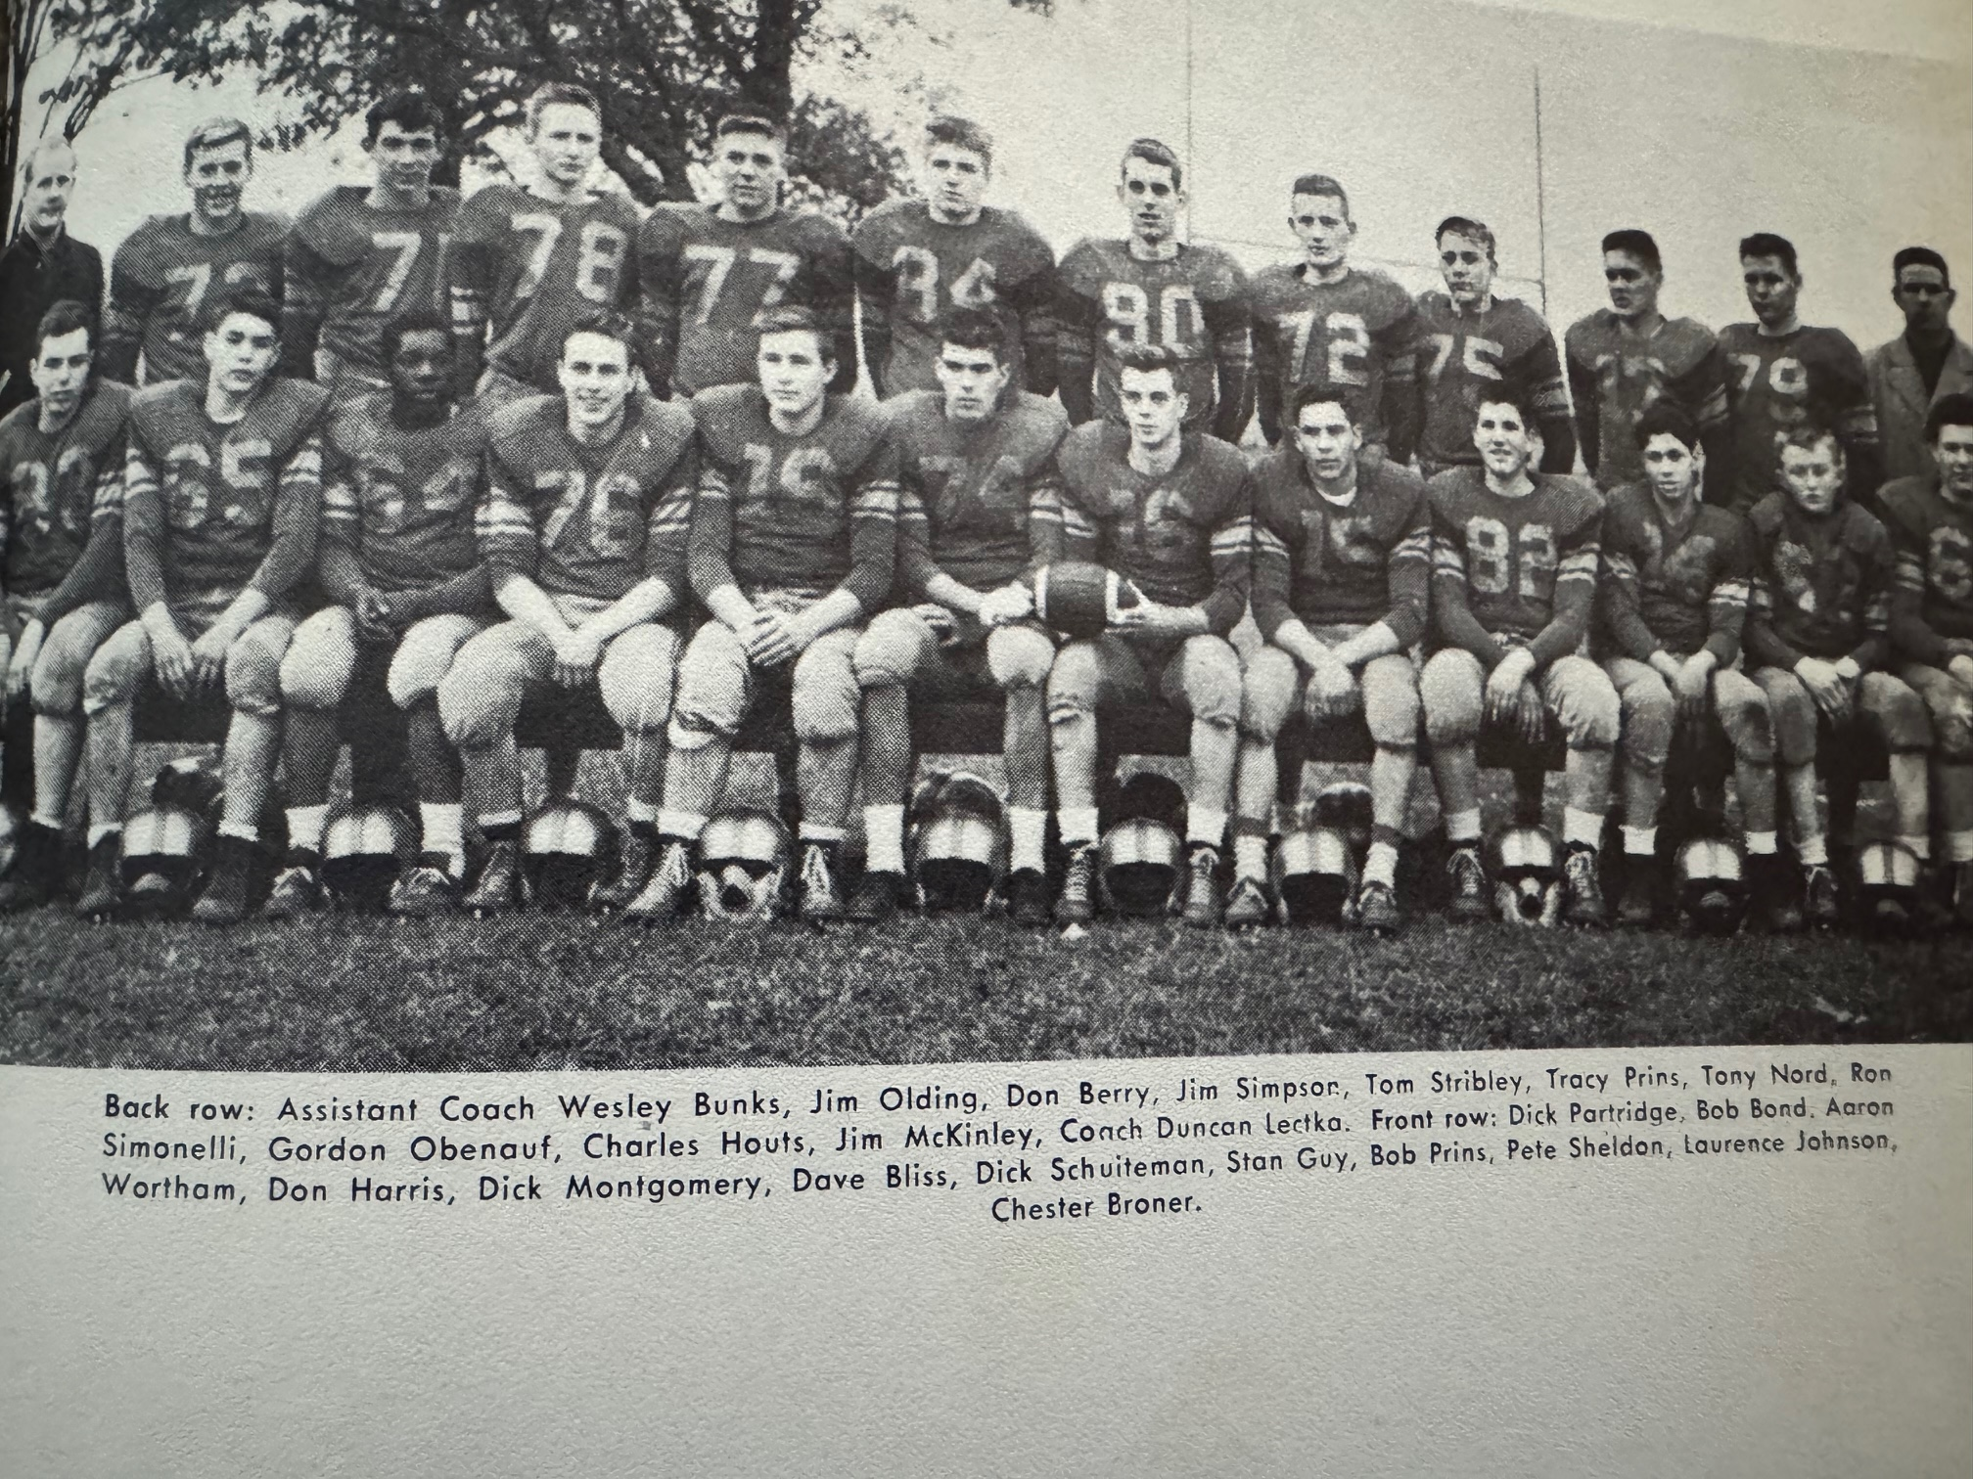

THE 1954 UNDEFEATED NORSEMEN

Record Score Interesting Fact
1-0 NM 13, Coopersville 6 Norse lose battle of the stats but come away with victory. Stan Guy and Ron Simonelli with a TD each for NM.
2-0 NM 27, Ludington 25 Norse never trailed the Orioles. Guy 76 YD TD on fist play and later 60-yard pass from Schuiteman. Aron Wortham 35 and Dick Schuiteman each a TD.
3-0 *NM 48 Scottville 6 Guy runs wild and scores 5 TDs, 4 rushing. Schuiteman passes to Bliss for 15 yd. TD, Schuiteman takes lateral from Simonelli and scores.
4-0 *NM 39, Hart 6 Pete Sheldon starts at QB. Simonelli 4 TDs and Guy 2.
5-0 *NM 20, Whitehall 0 Simonelli 2 TDs with Guy a pass reception from Schuiteman from 70 yards out.
6-0 *NM 40, Shelby 7 Five TDs for Guy; 4 on rushes of 30,75,17, & 20 with the other a 52-yard pass from Sheldon. Don Harris returns a lateral pass 22 for a TD.
6-0-1 NM 12, Manistee 12 (tie) Guy TD runs of 65& 83. Winning TD of 68 called back due to a penalty.
7-0-1 *NM 52, Montague 7 Guy rushed for 258 yards and five TDs, including an interception return for TD as NM clinches third WMC title.
8-0-1 NM 20, Greenville 13 NM defeats Central B conference champ Greenville. Simonelli to Guy for record 91-yard TD pass. Guy 2 TDs and Simonelli 1.

1955 – coach Dunc Lectka (3-6 overall, 2-3 WMC, Montague Champs)

Faced with the daunting task of replacing some of the finest players to ever put on a North Muskegon football jersey, including arguably the finest to wear the colors of the Blue & Gold in Stan Guy, coach Dunc Lectka did have at his disposal a handful of starters from the 1954 squad. Ron Simonelli, a four-year starter would return in the backfield along with juniors Pete Sheldon and Aron Wortham. Although not a returning starter Wortham did see extensive action for the 1954 Norsemen. All-WMC conference tackle Tony Nord returned but a pair of other junior starters from last season would not. All WMC guard Dick Montgomery moved with his family to East Lansing and would have an outstanding year for the Trojans as he was selected as a first team All-State lineman. Tom Girocco, another starter from last year counted on as a lineman was out with an injury. End Chuck Houts also returned for the Norse, but the numbers once again were down.

The 18-game winning streak enjoyed by the Norse over the last two years was quickly stopped in their road opener at Coopersville as they were defeated 19-6 by the Broncos. NM did get off to a good start as they took an early lead 6-0 as they scored in eight plays on a 64-yard drive with Aron Wortham and Ron Simonelli doing most of the work. Simonelli would score from 15 but that would be all the scoring for the Norse as Coopersville scored three unanswered touchdowns to pull away for the win.

Game number two found North Muskegon taking a rare beating at the hands of Ludington. The visiting Orioles totaled 194 yards rushing to but 19 for NM while the Orioles rolled up 13 first downs to but 2 for the Norse. The Orioles were led by future Central Michigan quarterback Wally Sadosty who ran and passed Ludington to victory. The lone NM score came in the final quarter when Pete Sheldon rifled a pass to Aron Wortham good for 39 yards and a touchdown.

NM got back to their winning ways with a 31-6 pounding of Scottville. So dominant was the Norse that they out rushed Scottville on the ground 329 yards to but 7. It was 31-0 before the visiting Spartans scored late in the game. Aron Wortham had a pair of tallies for the Norse, one from 23 yards out for the 1st NM score in the first quarter and it took Wortham only 1-yard to score his second, and the team’s 5th TD in the final period. Ron Simonelli had a big night for NM, scoring on a 65-yard punt return and 14-yard run, while junior quarterback Pere Sheldon added a three-yard TD in the 3rd quarter.

Hart handed NM its first loss in WMC competition in more than three years 12-6 in a game played at Hart on a soggy, rainswept field. Hart drew first blood when they scored midway in the opening period on a 74-yard drive with Lyle Gale going the final 36 for the TD. The Norse came right back with Ron Simonelli giving the Norse good field position on a long kickoff return where he was not stopped until he was downed in Pirate territory at the Hart 44. After a NM first down to the 34 Pete Sheldon on third down hurled a long forward pass intended for Simonelli. Interference was called on a Pirate defender to give the Norse a first down. From there Simonelli again did most of the work and would eventually score from two yards out to tie the score at 6-6. Sheldon’s extra point placement was blocked, and the score was all tied 6-6 at halftime. After a scoreless third period Hart scored what would prove to be the winning touchdown early into the final period when Jack Franklin scored on a 32-yard run.

According to sportswriter Tom Kampenga, who covered the Norsemen for the Muskegon Chronicle in 1955, Tom felt the Norsemen finally looked more like the Norse teams of the past few years following their 26-6 win over Whitehall. NM scored first when Fred Livingston, a sophomore newcomer bucked over from the five. That lead didn’t last long as Whitehall’s Kaj Sorenson galloped 66 yards for the tying marker. However, neither team was successful on their extra point attempts as the score remained 6-6 going into the second half. The second half belonged to four-year starter Ron Simonelli and the Norse. Simonelli returned a Whitehall punt 54 yards to pay dirt and then took things into his own hands by also running for the extra point. On their next possession the Norse moved 62 yards in seven plays with Simonelli going the final four yards on the first play of the fourth quarter. The Norse defense than produced the final points when lineman Ron Adema blocked a Viking punt. The ball rolled all the way back into the Whitehall end zone where it was recovered by Don Berry. Pete Sheldon’s extra point kick made the final score 26-6.

Frustration had to have set in following the Wednesday evening home 7-6 loss to Shelby. The Norse had clobbered the Tigers by a margin of 176-33 over their last four games, all huge Norse victories. The Norse dominated in all the stats except the one that counts the most --- the one on the scoreboard. NM made 15 first downs to three and outgained the Tigers 190-132 on the ground. In addition, the Norse had two touchdowns called back due to penalties, with the last taking place on the final play of the game. The Norse scored their only touchdown to take the lead midway through the second quarter. Chuck Houts, who was converted from a starting end to fullback, climaxed a 56-yard drive by plunging over from the two-yard line. After NM was assessed a five-yard penalty for delaying the game the Norse attempted a pass for the extra point, but the all-important point failed. On the next possession Shelby fooled the Norse when Larry Pranger on a reverse play traversed 54 yards for the touchdown. The pivotal extra point kick from Larry Smith would prove to be the winning point in the contest. The first touchdown called back by the Norse came early in the game when Ron Simonelli’s long punt return for 82 yards was called back due to a penalty. Twice in the final quarter it looked like NM was going to find a way to pull off the victory. The first drive went awry when the Norse fumbled at the Shelby six-yard line. Shelby took over with little time left on the clock and tried to run out the clock on quarterback sneaks. The last sneak on fourth down was stopped leaving NM with time for one last play. Chuck Houts would score from the two-yard line, but the Norse were offsides on the play and the game ended due to the rules from that era denying NM another play.

What a difference a year makes! Last year’s controversial game with Manistee resulted in a 12-12 tie, preventing NM from posting a perfect season. In 1955 the Norse managed to score one more point and then held off Manistee to earn a 13-12 victory that snapped their three-game losing streak. It appeared that NM had the game wrapped up with little time remaining in the game and NM leading 13-0. Manistee blazed 70 yards to score but Ron Adema broke through the Chippewa’s offensive line to block the extra point. Manistee then worked an on-side kick to perfection and took over at the Norse 49. There was only five-seconds left in the game when Ed Hansen completed a pass to Ed Anderson for a touchdown. It looked like the teams were again headed for another tie but the Norse defense, led by lineman Tony Nord, stopped Manistee’s try for the extra point and the Norse held on for a 13-12 win. Aron Wortham was the offensive sparkplug for the Norse scoring a pair of first half touchdowns. His first tally came on a 13-yard run around end. Ron Simonelli added what would prove to be the game winning point when he crashed through the line for the extra point. Wortham’s second TD was a dandy. The senior back raced 82 yards for the touchdown in the second quarter behind some excellent blocking up front.

For at least a half it looked like the Norse would be able to post an upset victory over Montague, but the eventual champs dominated the second half by scoring 26 unanswered points to win going away 28-6. The Norse led by a slim 6-0 margin at halftime on a Pete Sheldon 22-yard pass to Jim Olding. The big play in the long 94-yard drive was a 72-yard run by Aron Wortham. Montague scored four six-point TDs in the second half without having completed a pass in the entire game. The big gainer for the victors was an 82-yard punt return by Walter Anderson.

It was de ja vu for Norsemen football in their final game of the season as again they had a lead at halftime only to falter in the second half in their 33-21 loss to Greenville. It was the second, and last game of the two-game series between the two schools. Ron Simonelli had a fitting end to his brilliant career as a Norsemen. On the first play from the line of scrimmage Simonelli streaked 69 yards for a touchdown. Just moments later Aron Wortham took off on an even longer touchdown jaunt by going 76 yards for a score and the Norsemen were up 14-0 and it looked like it would be a good night for NM. Such was not to be, however. The Norse, already very thin in ranks, lost their star player Simonelli to an injury in the second quarter. NM was able to find a way to score on an 80-yard march with Simonelli on the bench with most of the yardage coming on pass completions from quarterback Pete Sheldon. Sheldon capped the drive with a 1-yard sneak and that would end all NM scoring. With Simonelli on the bench the Norse sputtered both on offense and defense as Greenville pulled away with Roger Knapp contributing to four of the winner’s TDs. The Norse would end their season with a 3-6 record, their first losing season under coach Dunc Lectka. After dominating the 11-man WMC all-Conference team in 1954, only Ron Simonelli was selected to the 1955 squad with lineman Tony Nord earning honors on the second team.

Record Score Interesting Fact
0-1 Coopersville 19, NM 6 Ron Simonelli 15-yard TD
0-2 Ludington 26. NM 7 Pete Sheldon to Aron Worthan 39-yard TD pass.
1-2 *NM 31, Scpttville 6 Simonelli and Worthan 2 TDs, Sheldon 1.
1-3 *Hart 12, NM 6 Simonelli 2-yard TD only NM score
2-3 * NM 26, Whitehall 6 Simonelli 2 TDS, 54 yd Punt ret., Fred Livingston TD,Don Berry recovered fumble in end zone,
2-4 * Shelby 7, NM 6 2 NM TDs called back by penalty, Chuck Houts NM TD.
3-4 NM 13, Manistee 12 Wortham 2 TDs,13 & 82) Simonelli extra point run wins.
3-5 * Montague 26, NM 7 Sheldon to Jim Olding 32 yd TD pass only NM score
3-6 Greenville 33, NM 21 Simonelli (69) Wortham (76) TDS and Sheldon 1 yd sneak

1956 – coach Dunc Lectka (5-4 overall, 3-2 WMC, Montague Champs)

Things would look and even sound different in 1956 for Norsemen football. The new look would be a renovation of the football field with the home side now moving to the East side where new bleachers have been erected to replace the old rickety wood slats that have been the visitors’ seats for more than 20 years. The sound would be different as the Norse have a new fight sound, although the old school song played to the same tune as Notre Dame’s fight sound would still be a part of Norse athletics. Another new look would be the numbers out for football as 34 players were on hand to begin the Fall workouts. They even had a new ‘stringer’ to report games for the Muskegon Chronicle in 15-year-old Jim Moyes, who replaced his good friend Tom Kampenga who had graduated. The number one problem that 4th year coach Dunc Lectka felt was an issue for his 1956 team was a lack of speed. “We are so slow its, pitiful” said Lectka, “Pete Sheldon is our only really experienced back and we just don’t have a gamebreaker--- a Stan Guy type of fellow who can break up a game anytime he gets the ball.” When reminded that Stan Guys comes along about once in 25 years, Lectka said: “I know it, but we ought to have someone who can run the 100-yard dash in less than 15 or 20 seconds.”

Lectka’s fears proved prophetic as the Norsemen were shutout in their home opener by a very good Coopersville team 19-0. The Norse played the Broncos hard in the first half and even threatened to take the lead as they drove down to the Broncos nine-yard line before their drive was stopped. In the first half much of the yardage gained by the Norse was from sophomore running back Chuck Coverly. However, Coverly injured his ankle on their most serious drive and sat out the rest of the game with an injury. Fortunately, for Norse fans, Coverly would not miss another game in the 1956 season.

The Norse made the trip to Ludington and came home with a 12-7 win on a most memorable night for this very young cub reporter. Back in 1956 there were no press box for reporters to cover the game and in most instances, there were not even scoreboards. However, for me anyway--- Ludington was big time. They not only had a press box, but they had a veteran reporter who had been the Sports Editor for the Ludington Newspaper for years, Dick Derrick. I sat next to Mr. Derrick during the game, and he could not have been more courteous as well as giving me some helpful hints on reporting. It is now 2024 as I write this Norse history, and I wonder why those 68 years have passed by so fast. I will always remember how well I was received by Dick Derrick on September 21, 1956. Making it a perfect night for the young Norse reporter was a Norse 12-7 victory on the Ludington gridiron. The Norse had to come from behind and then hold off a last-ditch rally by the Orioles to preserve the victory. Ludington scored their first, and only touchdown late in the first quarter. The Norse game back to close the gap to a single point when two-way back Pete Sheldon intercepted a Wally Sadosty pass and returned it to the Norse 36. A quick pass from quarterback Sheldon to end Don Berry moved the ball to the Ludington 48. Junior halfback Bill McIntyre then slipped through the line and dashed 48 yards for the score. A missed PAT attempt left the Norse trailing by one, 7-6 at halftime. The Norse had their game winning drive early in the final quarter with a now healthy Chuck Coverly doing much of the running on power plays. The stocky sophomore then scored from the six-yard line and the 12-7 score would hold up. Ludington did mount a late drive that was stopped deep in NM territory at the six and the Norsemen had their first victory of the season. Putting a damper on the NM victory was an injury to popular NM end Larry ‘Lunk’ Johnson, who suffered a fractured ankle and would be lost for the 1956 season.

A couple of days before the Norse would begin their conference schedule at Whitehall, the sports world was saddened with the passing of Babe Dickinson Zaharias, the world’s greatest female athlete who succumbed to cancer at age 42. Whitehall would win their first game over North Muskegon since 1947 as they upended the Norse 20-7 at Funnell field in Whitehall. The Norse won the battle of the statistics, but penalties and fumbles hurt the visitors. One bright spot-on defense was the play of junior Jack Musselman who recovered a fumble and stopped another potential Whitehall scoring drive with an interception. Whitehall tallied first and led 7-0 but NM countered with a long 80-yard drive with Chuck Coverly leading the attack. Bill McIntyre skirted around left end for the touchdown with Coverly’s successful extra point run knotting up the game at 7-7. Whitehall added a second period touchdown and took advantage of a NM fumble at their own 3-yard to ice the game and make the final score read 20-7. Coverly was a workhorse for the Norse as he picked up 133 yards in 17 carries. One of the game officials was a young Dick Dolack, who served as a head linesman for Nelson Volz’s crew. Dolack would go on to be an official for many years in the NFL. Both Dolack and Volz are in the Muskegon Area Sports Hall of Fame.

If one would inquire as to who North Muskegon would consider as their number one rival during the early years, my guess it would have been Fremont. These two opponents faced each other every year from 1934-1952 with many of the games played on the final game of the season. After a three-year absence the series was resumed for the 1956 season with the Norsemen winning 21-14 over the Packers. The Packers tallied first, but the Norse came back to knot up the game on a Bill McIntyre eight-yard TD run with Chuck Coverly running for the extra point as the teams left the field at halftime tied at 7-7. Early into the third quarter the Norse marched 74 yards to take the lead on a Coverly six-yard dash to pay dirt and again Coverly ran for the extra point. The third NM touchdown was set up by a Jim Sibson interception, one of the junior lineman’s two interceptions during the game. Coverly then completed the short 35-yard drive on a 10-yard gallop with Fred Livingston adding the extra point on a run. Fremont scored late to make the score a little more respectable. Coverly again passed the century mark in yardage with 106 yards rushing while also catching three passes from quarterback Pete Sheldon for another 30 yards.

The Norse would begin their road game at Scottville with the following starting lineup: Tom Cousineau and Jack Musselman at the ends; Bob Prins and Bob Bond at tackles; Jim Sibson and Joe Sienkiewicz at guards; Francis Launstein at center, and the backfield would consist of Pete Sheldon, a 3-year starter at quarterback, Bill McIntyre and Chuck Coverly at the halfback posts, and Fred Livingston at fullback. Cousineau would be the fourth freshman in NM history to ever start a game for the Norsemen; preceded by Bob Pyle, Dick Schuiteman and Ron Simonelli from earlier years. The Norse compiled all their yardage in the contest on the ground as they edged the host Scottville eleven 21-6. NM only attempted two passes during the game as Coverly again surpassed 100 yards rushing with 107. McIntyre, Coverly and Sheldon scored the NM TDs.

The Norse made amends for their 7-6 upset from the previous season by walloping host Shelby 51-0 on a Wednesday night game on the Tigers field. After attempting but two passes in their previous win at Scottville, Pete Sheldon displayed his talents by completing nine passes out of 10 attempts, three for touchdowns, rushed for 68 yards and a TD, and even caught a couple of passes good for 50-yards. Sheldon caught his pair of passes after sophomore Jerry Johnson entered the game and played quarterback with Sheldon now a running back. Oh, the future Dartmouth College third baseman also intercepted the only pass attempted by Shelby in the entire game to set up one of many Norse TDs. Chuck Coverly had another exceptional game for the Norse by scoring four times, two running and two on passes from Sheldon. Tom Cousineau became the third Norsemen gridder in program history (Dick Schuiteman and Ron Simonelli) to score a TD as a Frosh when he hauled in a 15-yard TD strike from Sheldon. Bill McIntyre got in on the scoring parade with a 17-yard scamper while reserve sophomore lineman Bill Ginman pounced on a loose ball in the endzone after his teammate Bob Bond had blocked a punt for the final Norse tally.

Playing without the services of star sophomore running back Chuck Coverly who was out with an ankle injury, Norse coach Lectka inserted sophomore Jerry Johnson at quarterback and moved the versatile Pete Sheldon to a halfback to replace Coverly. The transition worked to perfection as Sheldon rushed for over 100 yards, highlighted by a long touchdown gallop of 62 yards as the Norse edged the Hart Pirates 13-6. Johnson had a fine game at quarterback as he completed five of six passes with one completion good for another Norse touchdown to halfback Bill McIntyre. The road victory over Hart was their fifth win of the season and insured that the Norsemen would once again have a winning season.

It looked like the Norsemen were headed for their fourth WMC victory on the season and a possible share of the WMC title when they took a 14-0 lead at halftime in their game with Montague. The Wildcats spoiled any Norsemen hopes for a WMC title share by coming out on fire in the second half and scored 28 unanswered points to defeat NM on the Northside field 28-14. The Norse received a crushing blow when star back Chuck Coverly, who had rushed for 56 yards and a TD, and on the receiving end of three passes and the second Norse TD, reinjured his ankle in the second period and would not see any action in the second half. After going through the previous four seasons pretty much injury free, Lady Luck had run out on the Norse as numerous injuries had now forced the Norse to only suit up 18 able body men for the game with Montague.

The Norsemen had the misfortune in their final game to run into one of the best teams in Manistee history. The visitors arrived at the Norse field looking to move their record to 8-1, the best record since Manistee went 7-0 back in 1919. The Norsemen played hard and gave the visitors a tougher game then the final score of 20-0 might indicate. The final Manistee TD game when a Norse fumble was scooped up and run into the end zone for a touchdown. The Norse were victimized by perhaps the smallest player on the field in 143-pound quarterback Carl Raatz. Scoring both Manistee touchdowns Raatz continually hurt the Norse with quarterback keeper plays that totaled 137 yards rushing. A very young NM team would lose but three starters to graduation for the following season: quarterback Pete Sheldon and linemen Bob Prins and Bob Bond. Bond and Coverly were selected to the first team All WMC conference team with Sheldon and Francis Launstein picked for the 2nd team.

Record Score Interesting Fact
0-1 Coopersville 19, NM 0 NM shutout in your authors 1st game as NM reporter
1-1 NM 12, Ludington 7 Bill McIntyre 48 yd TD, Chuck Coverly 6-yard TD run.
1-2 *Whitehall 20, NM & McIntyre TD, Coverly rushes for 133 yards in loss.
2-2 NM 21, Fremont 14 Coverly 2 TDs (6 & 10 yds) Mcintyre 8-yard TD.
3-2 * NM 21, Scottville 6 McIntyre, Sheldon and Coverly NM TDs.
4-2 * NM 51, Shelby 0 Sheldon 3 TD pass for TD, 1 rush, interception, Jerry Johnson TD pass, Fr. Tom Cousineau TD rec, Mcintyre TD rec. Bill Ginman fum. Rec. for TD, Coverly 4 YDS.
5-2 * NM 13, Hart 6 Sheldon 106 yd rushing, 6d yd TD, Johnson to McIntyre TD pass.
5-3 * Montague 28, NM 14 Coverly 2 TD’s before sitting out 2nd half with injury.
5-4 Manistee 20, NM 0 Carl Raatz runs wild in NM loss.

1957 – coach Dunc Lectka (3-6 overall, 3-2 WMC, Montague Champs)

Although expectations were somewhat higher in 1957, the Norse were on the losing edge in too many close games and stumbled to an overall record of 3-6 with all their wins coming against WMC opponents. Perhaps an ominous warning was posted when in their pre-season scrimmage Friday before their regular season opener. A bank of lights went out and the scrimmage had to be called nearly a full quarter before the scheduled ending. Thirteen lettermen returned from last years’ 5-4 record including the entire backfield except for Pete Sheldon. Jerry Johnson saw extensive duty last year as Sheldon’s backstop while all-conference running back Chuck Coverly was expected to do the same to opponent’s defenses. The first game of the 1956 season was on September 21. My how times have changed with the adding of playoff competition beginning in 1975. To put things in perspective, the 2023 Norsemen football team are scheduled to play their 5th game on September 22.

1957 would also be the first year that Reeths Puffer would field a true varsity football team. Many of the current seniors on the 1957 Norsemen football team resided in the Reeths Puffer School District. It would be the last year Reeths Puffer area students, except those currently residing in the Laketon Township district, would attend the North Muskegon school. The Rockets, who would field a squad composed entirely of 11th graders and younger would use the North Muskegon field as their home field while waiting for Gale Bolthouse Stadium to be erected.

The opener at Coopersville would epitomize the entire 1957 season. Twice the Norse had potential scoring drives stopped that could have been game winners inside the Broncos 1-yard line. The host Broncos scored first early into the contest and that TD would ultimately hold up for the victory. The first serious frustrating Norse drive ended on a fourth and goal play at the Bronco two. Chuck Coverly, who earlier had done much of the ball carrying on the drive and caught a pass from Jerry Johnson that covered 27 yards, was called on to power his way in from the two but seemingly the entire Bronco defense expected a Coverly carry and he was stopped at the one. Early into the fourth quarter the Norse began a long march that began back at their own 12-yard line. The Norse would then drive 87 and 9/10th yards only to again suffer more agony. An apparent Coverly touchdown run from the 3-yard line was called back due to a NM penalty. Coverly powered his way down to the one, but a fourth down sneak failed just inches from the goal line, and a possible Norse victory went awry.

Injury woes were having a major impact as the Norse prepared for their home opener, a 20-14 loss to Ludington. Starting guard Jim Sibson incurred an elbow injury and was possibly ruled out for the season; Tom Cousineau, a sophomore who often started as a freshman, was out with a concussion; Fred Livingston would also miss the Oriole contest with a sprained ankle. The injury riddled Norse battled hard against the Orioles but again fell tantalizingly short of victory. Ludington scored late in the first period, but the Norse came back to even the game at 7-7 on a 17-yard TD pass from Jerry Johnson to Bill McIntyre and a successful Johnson PAT. Ludington would score late in the second period to lead 14-7 at halftime. Chuck Coverly started a NM tying drive by first intercepting an Oriole pass and then scored from five yards out to even the game at 14-14 after another perfect Johnson kick. The Orioles caught a big break on their winning TD. Ludington quarterback Gary Hackett hurled a pass downfield that bounced off Norse defender Dale Swanson into the hands of a surprised Oriole receiver who raced into the endzone. The Norse mounted a furious closing drive late in the contest down, but misfortune again hit the Norse as a penalty killed the drive after the Norse had reached the Orioles eight-yard line.

The injury and flu-ridden Norse team somehow found a way to defeat Whitehall 19-18 in a game that featured perhaps the most ‘bizarre’ play in NM’s long football history. The Norse spotted the Vikings an early first half lead at 12-0 with the second TD an exciting 58-yard dash by their outstanding running back Gordy McLouth. It looked like the Vikings were going to run away and hide from the Norse, but a Viking back was jarred loose of the football by NM’s defensive back Dale Swanson, and the Norse took over at their own 9-yard line. It was on the next play when the game turned on a play that will long be remembered by those in attendance at the Northside field. NM back Bill McIntye busted through the line and suddenly there were no Viking defenders between McIntyre and the goal line 91 yards away. However, as McIntyre raced down the west sidelines an overeager Viking reserve, watching McIntyre head for an apparent touchdown, jumped onto the playing field and tackled the surprised NM ball carrier. The play was eerily like an incident that occurred in the 1954 Cotton Bowl when Alabama’s Tommy Lewis came off the bench to tackle Rice’s Dicky Maegle. Just as Maegle was awarded a touchdown, so was McIntyre on his dash against Whitehall. After Jerry Johnson kicked what would eventually prove to be the deciding winning point, the play rejuvenated the Norse’s spirits. After a scoreless third quarter, Johnson returned a Viking punt 34 yards down to the Whitehall 16-yard line. NM drove down to the one where McIntyre this time only had to go one yard, 90 less than his previous extraordinary TD in the first half and the Norse led for the first time in the game 13-12. The Vikings didn’t fold and would eventually score from one-yard out with the big play on the drive a McLouth 65-yard run. With little time remaining the Norse began their winning drive. Running backs Frank Moran, Swanson and McIntyre moved the ball down to the Whitehall 38. From there Johnson went to the air and hit end Jack Musselman with a couple of crucial completions, the first for big yardage down to the eight, the second on third down and eight where he hit Musselman in the corner of the endzone to make NM 19-18 winners.

The injury report would only get worse as the Norse prepared for their game with Fremont. Not only would four regulars miss the game with the Packers, but the Norse would be without the services of their All-Conference running back Chuck Coverly. Although the muscular and popular Coverly was hampered with nagging ankle injuries for the past two seasons, the real reason for Coverly’s departure was not due to injuries. Coverly was a good friend and classmate of your author who often confided with me that he just did not love the game of football. Fremont had extra incentive with their game against the Norse on their home field as the Packers, who would win the Ken-Ne-Wa conference championship in 1956, had lost their game at NM 21-14. And what a year 1957 would be for Fremont. The Packers would run the table and go 8-0 on the season, the last perfect season for Fremont for the next 66 years. The Norse were no match for one of the best teams in Packer history. NM had no answer for Carl DeKuiper, a 3-sport standout and one of the best all-around athletes in Fremont history, who passed and ran the host Packers to a 21-7 win over the Norse. The Norse didn’t score until the fourth period when they were already trailing 21-0. Jerry Johnson completed an 84-yard drive, aided by some fine running by Frank Moran and Dale Swanson, by sneaking over from the one-yard line to make the final score read 21-7.

In their first meeting since 1944, the Norse defeated a new, but brief member of the WMC, Reed City, 26-14 for their second win of the season. Frank Moran, some 50 pounds lighter than the player he replaced in the NM backfield, Chuck Coverly, ran for 159 yards and scored three touchdowns to lead the Norse to their road victory. Moran had one 38-yard touchdown run called back, but he was credited with TD gallops of nine and 59 yards while catching a pass from Jerry Johnson for 14 yards and his third TD. The Norse were never threatened and wrapped up their scoring on a short one-yard plunge from Fred Livingston.

North Muskegon kept their hopes alive for a WMC title with a closer than expected 20-13 victory over Shelby. Those hopes would turn into wishful thinking as the Norse would go winless over the season’s final three games. The NM ‘pony backfield’ of lightweights, Frank Moran, Bill McIntyre and Dale Swanson, along with the accurate passing arm of Jerry Johnson led the Norse to victory. Moran scored a pair of TDs and rushed for 90 yards while McIntyre caught a six-yard TD pass from Johnson and ran for an even 100 yards. Swanson was on the receiving end of many of Johnson’s six completions to set up NM drives. Shelby gave the Norse a brief scare in the second half when they pulled to within one point at 14-13 midway through the third period before NM put the game away on Moran’s four-yard dash into the end zone.

The big news in the State of Michigan on Friday, November 1, 1957, was the opening to the public of the Mighty Mac bridge far to the north of the clash that same evening between NM and Hart. NM gave the Pirates a battle but fell 19-12, despite leading in most of the statistical departments. However, much of the Norse yardage was gained between the 30-yard stripes. The big play of the game occurred just after NM had tied up the game at 6-6 following a Frank Moran TD scamper of six yards. Hart’s Terry ‘Turk’ Griffin received the following Norse kickoff and ran through the center of the Norse without a hand touching him for a quick Pirate score. The Norse would narrow the gap late in the second period on a 21-yard dash to pay dirt by Dale Swanson. Both tries from placement failed the Norse and Hart had a 13-12 lead. The final touchdown in the half, and the game, was a Griffin short yardage run with but 28 seconds showing on the scoreboard. Neither team put points on the board in the second half as the Norse hopes for a conference crown were doomed.

Old Man winter roared its head as the NM-Montague game was played in arguably the worse weather conditions in NM football history. Heavy snow and winds gusting at 50 mph caused thousands of dollars in damage to area properties --- but they raised them tough in the 1950s and the game was played. In fact, there were no reported games in the entire state cancelled due to the weather. A depleted Norse lineup handicapped with numerous injuries fought hard in the miserable conditions as this reporter tried to scribble down notes while following the action on the sidelines. It was not until the second half that the eventual 1957 WMC champs from Montague would take control of the game as the first half found the teams deadlocked at 7-7. After Montague scored first in the opening quarter the Norse countered with reserve back Ed Beagle plunging over from the one-foot line for the score. The key play in the NM scoring drive was a 36-yard run by Dale Swanson that set up Beagles’ score. With kicking for extra points out of the questions with the blizzard conditions, both teams were successful on their extra points via the run game. Montague salted away the game by scoring the first two touchdowns in the second half before the Norse made it closer following a Frank Moran TD from the two with Montague earning a 20-14 victory. The Norse did throw a scare into Montague as time ran out with the Norse at the Montague 25-yard line. Playing a stellar game for the Norse was junior lineman Dave Taylor, opening holes on offense from his tackle position and making key tackles from his linebacking post on defense.

Too say that the Norse non-conference schedule was difficult would be an understatement as two of their opponents would finish the season with undefeated records, Fremont and their final game opponent Manistee.

Nine seniors would suit up for their last game against undefeated Manistee, including starting ends Jack Musselman and Jim Pyle, tackle Francis Launstein and guard Joe Sienkiewicz. Both Bill McIntyre and Jim Sibson were starters for the Norse before sidelined with injuries. Joe Mierendorf was a senior Norse starter when NM was on defense. Due to injuries only junior quarterback Jerry Johnson was a starter in the backfield when the season got underway against Coopersville. Juniors Frank Moran and Dale Swanson were the chief running backs for much of the season with senior Eddie Beagle called upon late in the season to take over the fullback duties. It didn’t take junior tackle Dave Taylor long to crack the starting lineup where he did double duty as a tackle and linebacker. Bill Ginman, at just 145 pounds was a starting guard who would return the following season, as would junior center Bill Garber. Lost for the entire season with a concussion injury was their promising sophomore End Tom Cousineau, a starter as a freshman the previous season. The Norse threw a scare into Manistee on the Northside gridiron and even took a brief lead in the second half. Once again, the Norse were victimized by little Carl Raatz, who burned the Norse the previous year but was even more dominant in this contest. Raatz, a stocky 5-foot, 4-inch pack of dynamite, carried the ball 18 times for 187 yards and three touchdowns. Showing his toughness Raatz was injured numerous times and once even had to be carried off the field on a stretcher. Both NM touchdowns gave NM brief leads. The first a 10-yard TD pass from Johnson to Musselman on a fourth and goal, the second on an eight-yard strike from Johnson to Musselman and again on a fourth and goal play. Trailing 14-12 Manistee then lived up to its billing and scored the games’ final three TDs to stay undefeated while the Norsemen finished 3-6.

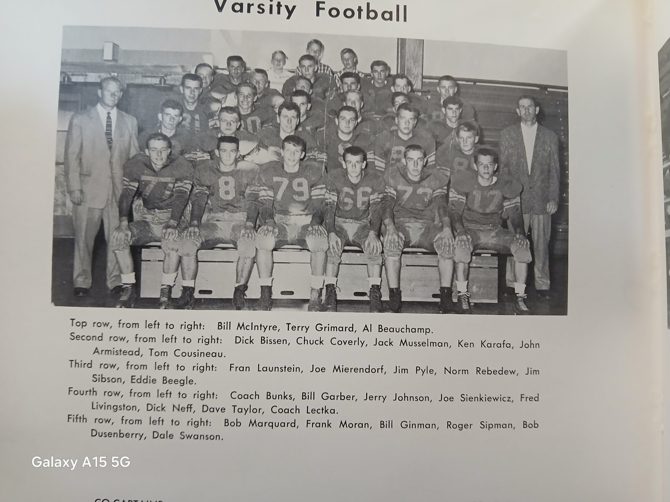

The 1957 NORSEMEN

Record Score Interesting Fact
0-1 Coopersville 6, NM 0 Twice NM was stopped inside the one-yard line.
0-2 Ludington 20, NM 14 Injuries hit NM. Ludington wins on a deflected pass for a late TD. Jerry Johnson passes tp McIntyre for TD, Chuck Coverly scores from 5
1-2 *NM 19, Whitehall 18 McIntyre bizarre 91 yd TD when tackled by player off bench. McIntyre 1-yard TD; Johnson passes to Jack Musselman 8 yards for winning TD.
1-3 Fremont 20, NM 7 Fremont with their only perfect season in the last 66 years defeats NM. Johnson’s 1-yard sneak only NM TD.
2-3 *NM 26, Reed City 14 Frank Moran 3 TDs on runs of 9 & 59 and a TD pass from Johnson for 14. Fred Livingston plunges over from the 1 for final NM tally.
3-3 *NM 20 Shelby 13 Moran 2 TDs, McIntyre TD pass from Johnson as NM goes to 3-0 in WMC.
3-4 *Hart 19, NM 12 Long kickoff return by Hart’s Turk Griffin key play in loss. Moran from six and Swanson from 21 Norse TDs.
3-5 *Montague 20, NM 14 Montague wins in blizzard conditions. Ed Beagle a one-foot plunge and Moran from two NM ---TDs.
3-6 Manistee 30, NM 14 NM gets a pair of TD passes from Johnson to Musselman but could not contain Manistee’s Carl Raatz.

1958 – Coach Dick Dornbos (5-4 overall, 3-2 WMC, Montague Champs)

The Norse would have a new coach for the 1958 season as Dunc Lectka, who posted a winning record of 33 wins and 18 losses, with three WMC titles, resigned from his teaching and coaching duties to move across the state to take over the football duties at Tecumseh. “Coach Lectka was the best coach I ever had,” said Norse football great Dave Taylor, one of but two NM male graduates enshrined in the Greater Muskegon Hall of Fame. After coaching at Tecumseh for three seasons Lectka joined the athletic department at Michigan State where he was the assistant ticket manager. Lectka then left MSU and became the head ticket manager for the Buffalo Bills. Dunc Lectka, who perfected the ‘belly plays’ out of the T-Formation that was a staple for Muskegon area teams for decades, passed away from a heart attack while exercising in Buffalo, NY in February of 1969 at just 47 years.

Replacing the highly popular Lectka was Dick Dornbos, a Muskegon native who prepped at Muskegon St. Joseph, a school that didn’t have a football team. Dornbos would be coming to NM after posting a perfect 8-0 record at St. Joseph Michigan Catholic. Interest was high at NM to begin the year as a total of 75 boys, including 11 lettermen reported for the opening practice session. However, 28 of those players were freshmen. Once again, a daunting opening schedule of four talented opponents would pose a difficult challenge to begin the 1958 season.

The Norse again would open with Coopersville, a team they hadn’t defeated in the last three meetings. Make that now four straight losses to the Broncos as the Norse couldn’t add to their 6-0 lead at halftime. It looked like it would be smooth sailing for NM as on their first possession they marched 65 yards for what would prove to be their only touchdown on the evening. Frank Moran ran 29 yards for the score but Jerry Johnson’s point after from placement hit the goal post. There were a couple of big plays in that scoring drive, both pass plays. One a pass from Johnson to Moran that picked up 18 yards and another completion for the same yardage was caught by Tom Cousineau. Coopersville completely controlled the game in the second half as the Norsemen had the ball for just 13 plays. The Broncos scored once in both quarters of the second half to again defeat the Norse by the same margin as last year – six points as the final scoreboard read Coopersville 12 and North Muskegon 6.

NM put together one of their best offensive showings on the season when they evened their record at 1-1 with a 32-14 road victory against Ludington. NM rolled up 278 yards rushing with Dale Swanson the leading ground gainer with 146 yards that included a long TD dash of 75 yards for NM’s second TD of the game. Earlier sophomore fullback Jeff Olds led off the NM touchdown parade with a 35-yard TD run in the first quarter. Swanson scored his second TD on a pass from Jerry Johnson good for a 25-yard tally. Ludington closed the gap to 19-14 in the third period but then the defense took charge for the Norse. Dick Hoover set up the next Norse TD with a fumble recovery that would lead to a Tom Cousineau end around TD. Linebacker Dave Taylor then intercepted an Oriole pass to set up Olds’ second 6-pointer from 24 yards that competed the Norse scoring.

Whitehall pounced on the Norse early as their 33-16 victory was settled in the first half when the Vikings took a commanding 26-0 halftime lead. The Norse were unable to stop Jim ‘Bull’ Jordan who time and time again ran like his nickname through frustrated Norse defenders. Jordan, who ran for 140 bruising yards, scored two first half TDs, one for 40 yards, and set up another short TD of teammate Spud Wolfe. The Norse did show some life early into the second half to cut the lead in half on a pair of TDs. The first, a Tom Cousineau end run from five yards out, the second, a 77-yard pass and run play from Jerry Johnson to Dale Swanson. One bright spot for the Norse was the all-around play of tackle and linebacker Dave Taylor, the only Norse player who could contain Bull Jordan. Taylor also averaged more than 40 yards per punt.

The Norse won a Dad’s Night thriller 20-19 against Fremont to even their record at 2-2. Jerry Johnson threw three TD passes with his third strike completed with just seconds remaining. One factor that has changed over the years has been the kicking game after extra points. Before soccer style kickers came on the scene to make a PAT almost a certainty, such was not the case in the pre-Pete Gogolak era. The difference in the NM-Fremont game was indeed the made, or not made, extra points. The Norse ran successfully on two of their attempts after TDs while Fremont made just one. In addition to the heroics of quarterback Johnson, Dave Taylor deserves equal billing as the future two-time Ferris State captain and team MVP blocked the first two extra points attempted by the Packers, the difference in winning or losing. Johnson’s first TD pass went to Dale Swanson from 15 yards out with just 16 seconds left in the opening quarter. Tom Cousineau on a reverse made the all-important extra point. Fremont would score to close the gap to 7-6 at halftime. The Norse scored first in the second half on Johnson’s second TD pass, this time to Frank Moran good for a 10-yard tally with Moran also scoring what would prove to be the huge extra point on a cross-buck. Fremont would then score twice but Taylor forced his way through the offensive line to again block the Packer’s extra point. Fremont appeared to score the game winner on a Bultman to Kingsford pass for 35 yards with four minutes remaining in the game. This time Bultman’s meaningless kick was good to give the Packer a 19-14 lead. The Norse then began a 64-yard drive with sophomore Jeff Olds doing much of the ball carrying. With just seconds remaining it was do or die time for Johnson and the Norse. Faced with a fourth and goal at the ten-yard line Johnson finished his heroics with a TD pass to a surprisingly wide-open Tom Cousineau in the endzone to pull off the thriller. Following the game co-captain Dave Taylor of the Norse was presented with the victory can award, a symbol of each Packer-Norse game that dated back to 1935.

The Norse made it two straight wins over Reed City by posting their only shutout of the season with their 13-0 victory on the Northside field. After a sluggish first half the Norse added a pair of second half TDs to move to 3-2 overall and 2-1 in the WMC. The first half presented the Norse with a sequence of plays that had frustration written all over the faces of Norse fans and players. Frank Moran took off on a 69-yard TD run only to have it called back on a penalty. Following the 5-yard walk off Dale Swanson electrified the crowd with a 74-yard scamper for a tally, only again to see the play called back due to a penalty. The Norse did score a couple of penalty free TDs in the second half, the first a six-yard TD run by Tom Cousineau, the second, an eight-yard TD run by Jeff Olds who led all Norse backs in rushing with 124 yards gained in 15 carries.

The Norse sputtered on occasion in their 20-12 homecoming victory over Shelby but still had enough fire power to pull off the victory. The only TD scored in the first half was set up by a Dave Taylor interception. Taylor ran 62 yards after his interception before he was gang tackled by three Shelby tacklers at the one-yard line. Jerry Johnson sneaked over from the one on the next play and passed to Dale Swanson for the extra point to give the Norse a 7-0 halftime lead. Early into the second half Swanson, who rushed for 124 yards in 13 carries, outraced the Tiger defenders to score the Norse second TD from 43 yards. Frank Moran added the clinching TD for the Norse from the one-yard line after Shelby had scored their first touchdown on the preceding series.

North Muskegon had little trouble at Hart as they moved to 3-1 in the WMC and their fourth straight victory with their 31-14 victory. The Norse led 31-0 before Hart tallied a couple of late TDs after the Norse brought in the reserves. Dale Swanson had another big game for NM by rushing for 150 yards in but 13 carries. With two of his carries going for five and 54-yard TDs. Dave Taylor’s interception set up a NM score with Jerry Johnson passing to Frank Moran for 17 yards, and the same duo later teamed up on a 59-yard scoring strike. Johnson sneaked over from the one shortly before halftime to give the Norse a commanding 25-0 lead at halftime.

A large crowd was on hand to witness Montague score the games’ final three touchdowns to pull away and defeat the Norse 33-13. The Norse could not contain the Montague duo of Glenn Anderson and Larry Jancek who scored all five Wildcats TDs. The win set up the Conference Championship game the following Friday between a pair of rivals undefeated in WMC play, Montague and Whitehall. A Frank Moran two-yard TD and a Moran extra point tied up the game in the third period, but it was all Montague the rest of the game. Earlier in the first half Jeff Olds scored the first NM TD with a 13-yard spurt over left tackle.

The Norse concluded their season at 5-4 with perhaps their poorest performance of the season as they were soundly defeated by Manistee 30-6 on a rain drenched field in Manistee. Jay Conover, subbing for an injured Dale Swanson, scored NM’s only touchdown on a one-yard plunge, but that was it for the NM offense. Earlier in the week Swanson was given an X-Ray on his injured shoulder that showed he had a small fracture that he had been playing with most of the season. Three times the Norse drove inside the Manistee 10-yard line only to come up empty on each occasion. One who didn’t play a poor game for the Norse was their one-man defensive gang in Dave Taylor. In addition to leading the Norse in tackles, Taylor also blocked a punt and extra point attempt. In addition to a pair of seniors, who sat out the game, Swanson and Roger Sipman, who had been out since suffering a fractured ankle earlier in the season, the Norse would lose eight senior starters to graduation: Linemen Tom Baker, John Armistead, Dick Neff, Bill Garber and Bill Ginman, and three starting backs in Jerry Johnson, Frank Moran and Swanson. Returning starters would include end Tom Cousineau, sophomore Jeff Olds and end Dick Overcamp. It should be noted that returning as a starter on defense would be freshman Benny Manning. For those who are keeping score, Manning would be the fifth freshman to start a game in NM history with Bob Pyle (1943), Dick Schuiteman (1951) Ron Simonelli (1952) and Cousineau (1956) the others. Post-season All-Conference honors would go to Swanson and Taylor, both named to the first team. Honorable Mentions picks went to Cousineau, Ginman, Garber and Johnson.

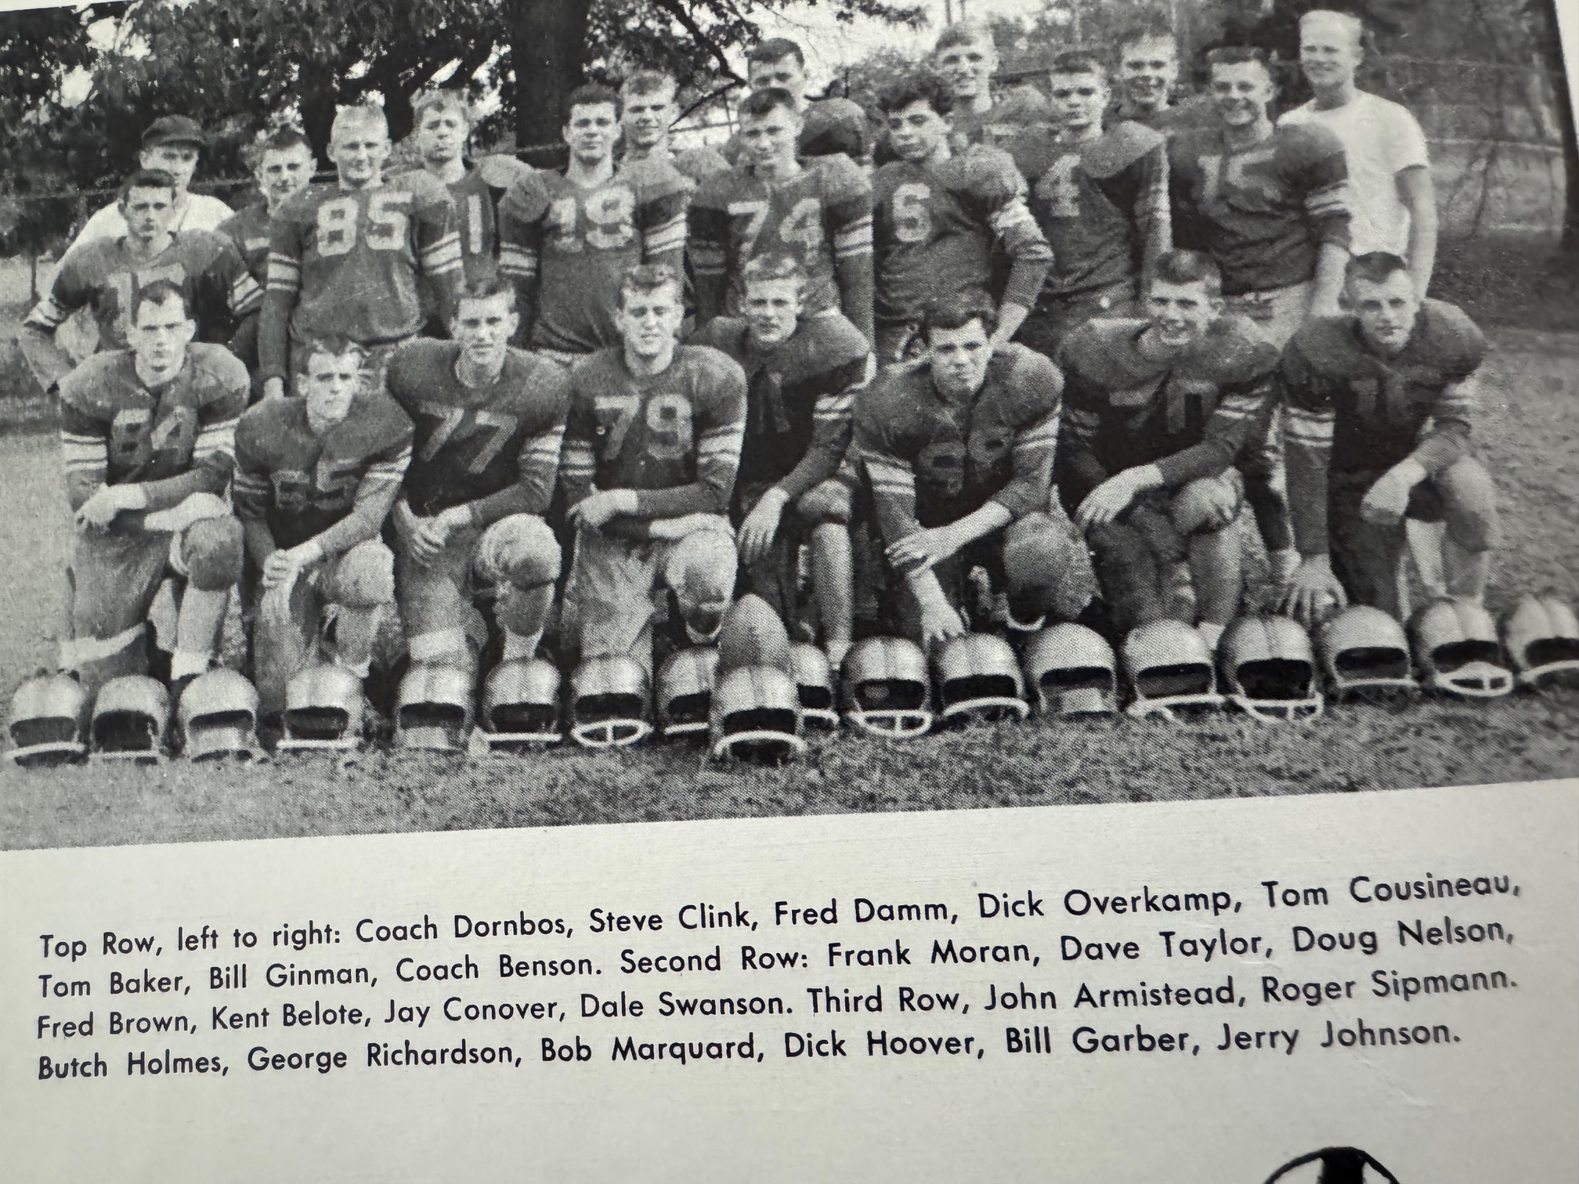

THE 1958 NORSEMEN

Record Score Interesting Fact
0-1 Coopersville 12, NM 6 NM loses 4th straight to Broncos: Frank Moran NM TD from 29
1-1 NM 32, Ludington 14 Swanson 146 yards rushing and 2 TDs; Jeff Olds 2 TD (35 &24), Tom Cousineau end around TD.
1-2 *Whitehall 33, NM 13 Whitehall busts out to 26-0 halftime lead. Jerry Johnson 77-yard TD pass to Swanson. Cousineau a 5-yard TD run.
2-2 NM 20, Fremont 19 Johnson hits Cousineau for winning TD with second left. Johnson 3 TD passes, other other to Swanson for 15 and Moran for 10.
3-2 *NM 13, Reed City 0 Norse post only shut out of season. Olds rushes for TD and 124 yards rushing. Cousineau a 6-yard TD run.
4-2 *NM 20, Shelby 12 Dave Taylor long interception return sets up Johnson’s 1-yard sneak. Swanson scores from 43 and Moran from one.
5-2 *NM 31, Hart 14 Swanson 2 TDs (5 & 54) Johnson to Moran 2 TD passing TDs (17 &59) Johnson 1-yard sneak TD.
5-3 *Montague 33, NM 13 Tied 13 all in the 3rd period, Montague scores final 3 TDs. Moran 2-yard TD, Olds from 13 for the other Norse score.
5-4 Manistee 30, NM 6 Dave Taylor shined in a losing cause on defense. Jay Conover scores NM only TD.

1959 – Coach Dick Dornbos (4-3-2 overall, 3-2 WMC, Montague Champs)

A sweet start to the 1959 season quickly turned sour as the Norse dropped their final three games of the season after going undefeated (tied twice) in their first six starts. It would be a short stay for head coach Dick Dornbos as he would leave the program at the end of the year. Only three starters returned for the Norse; ends Tom Cousineau and Dick Overkamp, and fullback Jeff Olds. Benny Manning surely could classify as a fourth starter as he started many games in 1958 on defense. NM was hoping to avert losing to the Coopersville Broncos for the fifth straight game. NM didn’t lose, but they also didn’t win as nothing was settled in a 7-7 tie. The Norse scored their only touchdown in the second quarter when Carl Rittman, a transfer from Traverse City, threw a 39-yard touchdown pass to Tom Cousineau. The pair also connected on the extra point. Coopersville blocked a NM punt in the same quarter and only had to travel 10-yards for their TD and they too scored on a pass play for the extra point to knot the game up at 7-7. The Norse received a big blow earlier in the week when Jeff Johnson, who had prepped at Culver Academy before moving back to his hometown, was ruled ineligible by the MHSAA due to a transfer ruling.

NM continued their winning ways against Ludington as the Norse won for the 7th time in 11 meetings 28-6 in their 1959 home opener against the Orioles. For Ludington, better known for their outstanding basketball program during this era, it was their 11th straight loss and had now gone 20 games without a victory. Either the Norse put up a good defense or Ludington was woeful when they had the ball, but the Orioles didn’t pick up a first down until midway through the third period. Sophomore speedster Dave Rose gave the Norse offense a big boost as he rushed for a team leading 127 yards and scored the first NM TD on a nine-yard run early in the first period. Junior fullback Jeff Olds scored a pair of TDs, the first on a one-yard plunge in the first quarter and the second touchdown came in the second period from eight-yards out to give the Norse a 21-0 lead at halftime. Oscar Manning closed out the scoring with the games only score in the second half on a three-yard TD with freshman Steve Harpold running for the extra point. Ludington scored late in the game on a pass of four yards from Bink Wallace to 6’10” end Harry Volkers.

Prior to hosting Whitehall, the Norse received a big break. Bull Jordan, who terrorized the Norse in Whitehall’s win over the Norse last season would sit out with an injury, as would Whitehall’s quarterback Jon Swenson, one of the area’s finest baseball players in the Spring. NM scored first as Dave Rose scored from 12, one play after Jeff Olds ran 43 yards to the Vikings 12. A pair of punts led to a pair of Norse TDs. The first was set up when NM blocked a Viking punt that quarterback Carl Rittman turned into six points when he was successful on the first of his two sneaks on the evening. The second was a NM punt that was inadvertently touched by the Viking return man deep in his own territory. The Norse again capitalized on the Viking miscue when Rittman found a wide-open Jay Conover in the end zone for their third TD of the first half. The Norse weren’t finished as Rittman’s second QB sneak gave the Norse a surprising 25-0 lead at halftime. The Vikings dominated in the second half, but those four NM TDs were too much for the Vikings to overcome.

In Fremont the following Friday it looked the Norse were doomed to defeat as they trailed 13-0 going into the final quarter. After having scored but 6 points in the second half over their last two games, it didn’t look good for the Blue & Gold. The tide changed for NM as they were able to score a pair of TDs over the game’s final 12 minutes and made one of two extra points to settle for a 13-13 tie with the Packers. Following a Packer TD at the end of the third period, NM began their comeback by first marching 76 yards for their first touchdown with Dave Rose going the final five yards for the TD. Without a kicker a Norse pass in the end zone was incomplete and NM now trailed 13-6. Fremont then marched to the NM 30-yard before they were forced to turn the ball over to the Norse on downs. Utilizing the pass and a few timely runs, Jeff Olds scored on a six-yard run. This time a pass from Carl Rittman to his favorite target Tom Cousineau was good and the Norse escaped with a 13-13 tie to stay undefeated at 2-0-2.

The Norse moved to 3-0-2 on the season after defeating Scottville 20-7. NM wasted little time to get on the board as Jeff Olds scored from 34-yards out to make the score 6-0, and the lead upped to 7-0 when Dave Rose ran for the extra point. Scottville threatened to score on their next possession, but the Norse held the host Spartans at the NM 10- yard line. The Norse then marched 90 yards to pay dirt with the TD coming on a 17-yard pass from Carl Rittman to Jay Conover. A Jeff Olds 34-yard touchdown carry iced the game in the second half as NM stayed undefeated in WMC competition. NM won their third game of the season despite fumbling five times and was only able to cover but one of their miscues.

On a rain-soaked Northside field Shelby and North Muskegon played scoreless ball for 47 minutes and 56 seconds. The Norse barely escaped with a 7-0 victory when quarterback Carl Rittman scored on a 1-yard sneak with just four seconds remaining in the game. The Norse were more than fortunate to come away winners as Shelby practically gift-wrapped the Norse victory. For the first three periods both squads played even with neither team dominating in statistics on the muddy gridiron. The breaks went the Norse’s way in the final five minutes. NM recovered a fumble on the Tiger 28 but lost the ball on downs on the seven-yard line. Once again Shelby fumbled the wet pigskin and NM recovered at the Shelby five. Rittman held on to the ball for dear life as he sneaked in for the TD to give NM their fourth win of the season and third in the WMC.

It was Halloween night on the Northside field, and it was the Norsemen who got ‘tricked.’ Playing without their two-year starter and leading rusher Jeff Olds, the Norse just didn’t have the firepower in their 19-13 loss to Hart. The loss was the first of the season and first in the WMC for the Norse and was the beginning of a three-game slide. With the injured Olds watching from the bench the Norse went to the air to take an early lead in the game. Rittman’s first pass to Conover was good for 11, and after a couple of running plays moved the ball to the 26, Rittman again connected to Conover for 26 yards and a TD. The point after attempt was a comedy of errors. Three plays were denied due to penalties; a pass play failed for NM and the 6-0 Norse lead would last until the second half. Dick Hasty scored three second half touchdowns to earn 18 unanswered points for the visiting Pirates. NM was able to close the gap to 19-13. With Dave Rose doing most of the work, the Norse marched 82 yards for the TD with Rose going the final three yards for the final Norse score.

Montague clinched their fifth straight WMC championship by edging the Norse 13-7 on the frozen turf at Montague’s Memorial field. Spotting the Wildcats two first half touchdowns proved too much for the Norse to overcome in a game played in frigid conditions. Injuries again plagued the Norse as two-year starter Benny Manning was lost for the second half due to a leg injury while end Bob Cihak was carted off the field on a stretcher. The Norse were once again without the services of top running back Jeff Olds. The Norse scored their only TD on a 20-yard run by quarterback Carl Rittman in the third period with Rittman passing to Jay Conover for the extra point. The Norse did threaten in the final quarter. A long pass from Rittman to Tom Cousineau was complete down to the Montague 20-yard line but was nullified due to offensive pass interference.

My how times have changed. There is little doubt if the weather would have been as bad in today’s era, as it was on the night of November 13, 1959, it is doubtful if any games would be played. Muskegon’s long time Sports editor James F Henderson the following day in his column: The Press Box ---recalled many other games played in similar conditions but the games always went on in football. All games were played on this date in 1959 despite freezing temps and heavy snow made for incredibly poor conditions. A bigger, deeper, and faster Manistee team survived the elements and shut out the Norsemen 12-0 as teams were limited to mainly just straight dive plays. There were 11 combined fumbles in the game and naturally they would play a huge part. Manistee recovered a fumble deep in NM territory and scored on a one-foot plunge. It would be all the scoring Manistee would need except Manistee halfback Terry Hansen suddenly found himself with clear sailing and raced to a 62-yard TD run in the second quarter. Those 62 yards were more yards than the entire NM team could muster the entire game. The loss was the third straight for the Norse after a great start and left them with a 4-3-2 record. It was also the last game for NM senior Tom Cousineau, one of the finest ends in Norse history. Also coming to an end was NM’s participation as a member of the West Michigan Conference as they would join the Seaway conference for the next six years. NM was not the only one leaving, as head coach Dick Dornbos would be leaving after just two years piloting the Norse. Also departing following graduation would be Carl Rittman and Dick Overkamp. Rittman was named first team all-conference as was Cousineau while Overkamp was honorable mention. In 1964 Tom Cousineau was named Hope College football player of the year. The former Norseman 3-sport star passed away in November of 2021.

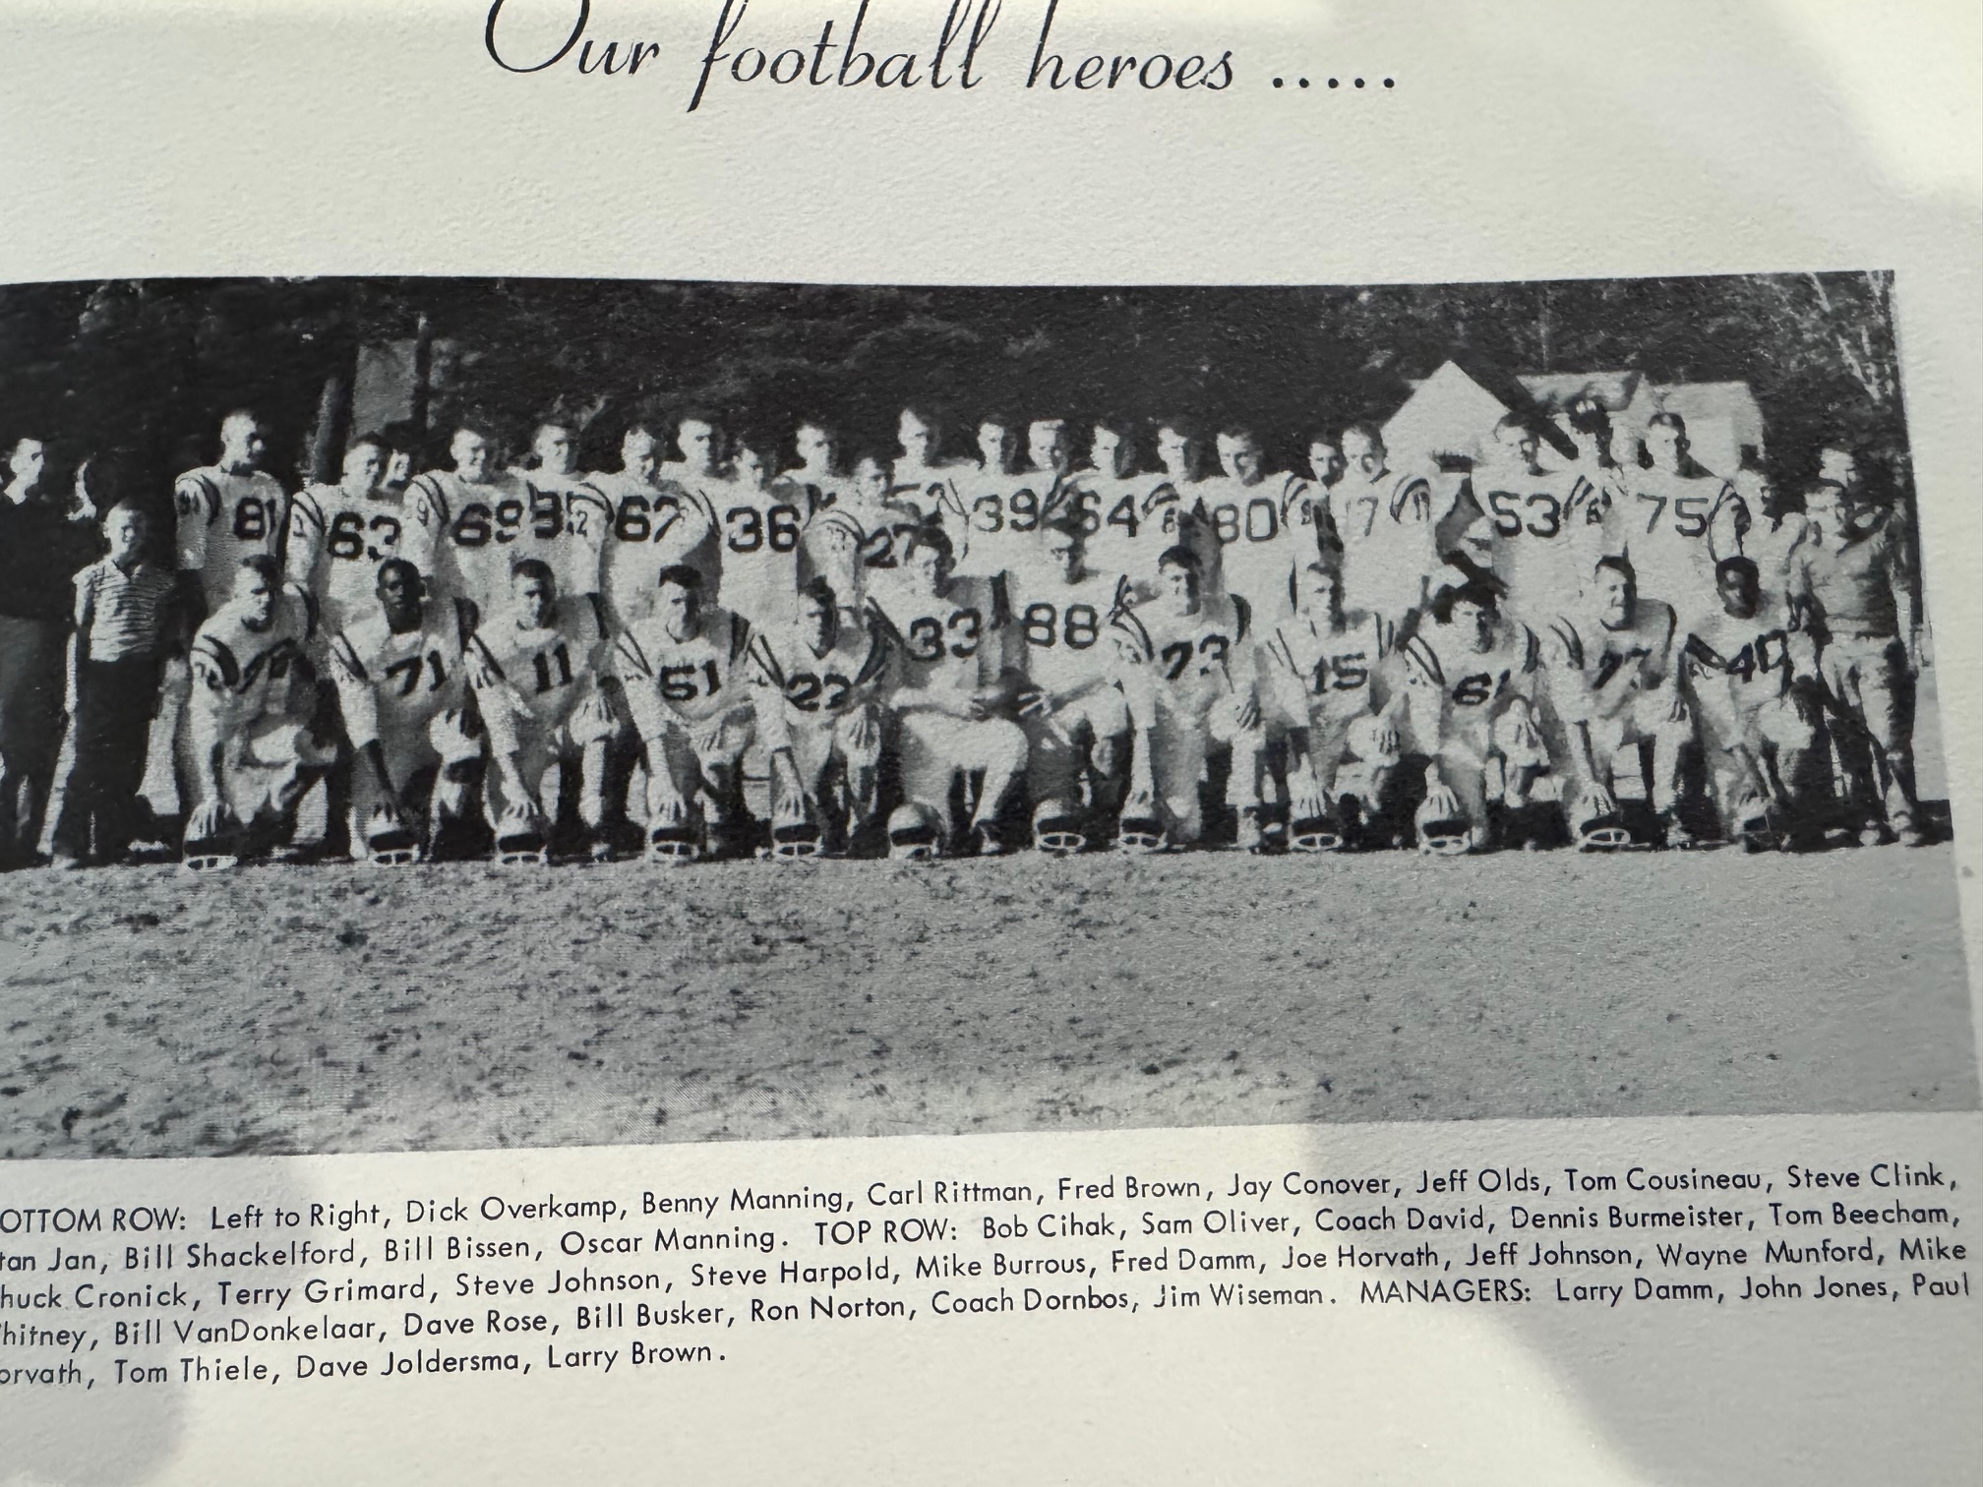

1959 NORSEMEN

Record Score Interesting Fact
0-0-1 NM 7, Coopersville 7 (tie) Only NM score comes on 49-yard TD pass from Carl Rittman to Tom Cousineau.
1-0-1 NM 28, Ludington 6 Jeff Olds scores a pair of TDs (1 & 8) while Dave Rose rushed for 127 yards and a 9-yard TD. Oscar Manning completes scoring with 3-yard TD.
2-0-1 *NM 25, Whitehall 13 A pair of punts, one blocked, the other touched led to two NM TDS. Rittman a pair of QB sneaks, Rittman passes to Jay Conover 7 yd TD. Rose 12 yd tally.
2-0-2 NM 13, Fremont 13 (tie) NM rallies from trailing 13-0 after 3 quarters to escape with a tie. Dave Rose and 5-yard TD and Jeff Ollds from 6 NM TDs. Rittman to Cousineau for the extra point.
3-0-2 *NM 20, Scottville 7 NM wins sloppy contest despite losing 4 fumbles. Jeff Olds two 34-yard TDs. Rittman to Conover for 17-yard passing TD.
4-0-2 *NM 7, Shelby 0 NM take advantage of late Shelby fumbles as Rittman sneak from the one with four-seconds left in the game.
4-1-2 *Hart 19, NM 13 Hart scored 3 unanswered 2nd half TDs. Rittman to Conover for 26-yard TD. Rose scored from three.
4-2-2 *Montague 13, NM 7 Montague again WMC champs on frozen field. Rittman on NM TD on a 20-yard run.
4-3-2 Manistee 12, NM 0 Norse muster little yardage in game played in heavy snow.

