1992-93 (Coach Mark DeLap 10-12, Whitehall WMC champs)

Mark DeLap, a basketball ‘junkie,’ if there is such a person, would describe NM’s new head coach. DeLaps’ resume for a basketball coach would have him coaching teams, players, and camps from California to New York. A Wisconsin native, DeLap came to NM after a two-year stint at tiny Bellevue, Michigan High School, one of his many stops during a long coaching career in basketball. DeLap also was an author and his book, A Warriors Heart, would, of course, be about basketball. There would be no need for a shot clock during the DeLap era at NMHS as NM for the most part would be a ‘run-and-gun’ team. The Norse team, however, was a model of inconsistency. Often during the 1992-93 season and beyond in the DeLap regime, NM would put up huge numbers in one game and small numbers in the next contest, one of the reasons for NM’s 10-12 record. The Norsemen would put up some big numbers on many of their lesser and smaller opponents but would struggle against their rivals in the WMC.
The 1992-93 season featured the young and the old. The old would-be four-year starter Cam Balash and the young would-be sophomore Leigh Kakaty who would quickly make his presence known in NM’s opening game 69-62 victory over Newaygo. Kakaty hit a 3-pointer with 1:30 remaining to break a 60-60 tie and sealed the deal by hitting four free throws in the final 20 seconds. The veteran Balash led NM in scoring with 17 points, followed by Kakaty with 15, and Bobby Walters with 11.
Game number two would begin a roller coaster sort of ride for the Norse as they would get thumped by Oakridge 81-48. The Norse, after leading the Eagles 20-15 would then get scorched in the next two quarters by a margin of 46-13 to make the final score show a commanding 81-48 Oakridge win. Cam Balash was easily the leading scorer for NM with 19 with Bobby Walters next in line with eight.
In a report posted in NM’s 58-34 victory over an outmanned Calvary Baptist team, the story said NM amassed 43 steals on the night. If true (and most likely a typo) that just might have been a world record. Chris Benedict led the host Norsemen with 17 points and nine rebounds and seven steals. Steals given to NM players included nine by David Cleveland, and eight by Jason Peterman and Nick Bolema. Your author has always been skeptical of some of the statistics credited to NM players during the DeLap era, but it would be hard to dismiss the scoring totals. Joe Grimm scored 16 points as coach DeLap showed mercy with Calvary Baptist as he played neither of his two big guns Cam Balash or Leigh Kakaty in the game.
During much of the Mark DeLap era NM was a run and gun team with a high tempo offense. However, NM slowed the tempo down to a crawl in their game with Shelby and it paid off in a 44-31 win over the Tigers. It was a victory that NM would have to savor as it was the only win from 1989 to 2000 over the Tigers during a stretch of 21 games. Cam Balash had 14 points to lead the Norse followed by Bobby Walters with nine.
The Norse only scored 41 points, but it was enough to defeat Pentwater 41-37 in the first game back from the Holidays. The Norse survived a poor third quarter when they were outscored 13-3 by the host Falcons. Cam Balash had 14 points to pace the Norse offense with Bobby Walters adding 11.
The Norse then had their lowest scoring output of the season as they resumed competition in the WMC. NM tallied a low total of 39 in losing to Hart 52-39. NM trailed by only two at halftime but had a miserable third quarter when they scored but two points. Pat Kitchka had a season high 15 for the Norse.
There are four high schools in Oceana County and NM played all four in succession, winning against the Class D schools (Pentwater & Walkerville) and losing to the Class C teams (Shelby & Hart). NM abandoned their slow tempo offense against lowly Walkerville as they outscored the Wildcats in a high scoring contest 86-80. Two Norsemen joined the 30-point club in the same game with Walkerville as Leigh Kakaty finished with 35 points and Matt Ertzinger, whose previous career high was 10 points, had a night to remember with 31.
In a season of high and lows, it was low for NM in their next outing as they were ambushed by Mason County Central by 52 points in a 98-46 beating in Scottville. This game was over quickly as the 7-1 Spartans raced to a 25-4 first quarter lead and never looked back. Cam Balash tallied 12 points for the losing Norsemen.
It was then back to the high in this topsy-turvy season. NM scored 103 points, their highest point total in 22 years in a 103-73 rout of Ravenna. It was Cam Balash’s turn to join the 30-point club except he settled for a much higher level as he scored 44 points, a NM total second only to Gordy Odell’s school record of 53 points 38 years earlier. Three other Norsemen were in double figures for the Norse against the winless Bulldogs: Leigh Kakaty with 16, Pat Kitchka 14 and sophomore Mike Boyle with 11.
NM would then continue their struggle against teams with a winning record as they scored less than half their total points against a weak Ravenna team in a 58-46 loss to Whitehall. Cam Balash totaled 24 points in a losing cause with Mike Boyle chipping in 12 for NM.
Mike Boyle had a nice all-around game for NM in a 70-51 loss to Montague. The 3-sport standout tallied 15 points, four assists and four steals but it was not enough to derail the Wildcats. After a close first quarter, Montague blew the game open with a 22-6 run over NM in the second quarter. Boyle’s 15 points led the Norse followed by Cam Balash with 10.
The Norse had one bad quarter, and it was a dandy as Oakridge overcame a second quarter deficit of 15 points by piling up 28 points to NM’s eight in the third quarter to earn a 59-53 win over NM. Cam Balash led NM with 12 points followed by 10 points by Bob Walters.
NM’s struggles against competition in the WMC continued as Shelby defeated NM 58-46 to complete a season sweep over the Norsemen. The Tigers outscored NM by 11 points in the third period to pull away. With the win Shelby atoned for an earlier loss to NM when they were held to 31 points in a 44-31 loss to the Norse.
The Norsemen had two players score more than 20 points, but it wasn’t enough as Hart defeated NM 65-61. Sophomore Leigh Kakaty tallied 24 points and senior Cam Balash scored 20 but NM still fell to Hart 65-61. Matt Ertzinger grabbed 16 rebounds in the loss as NM fell to 2-8 in the WMC. It would prove to be a good year for Hart as they would go on to win their first district championship in 20 years.
The highlight in NM’s loss at home to Mason County Central was a milestone moment for Cam Balash. The four-year starter for NM scored 11 points to become the second Norsemen in school history to join the 1000-point club. On the negative side the Norsemen lost the game to the visiting Spartans 66-45 to lose their 7th game in a row, all against WMC opponents.
NM broke their losing streak with a non-league victory over Hesperia 65-60. The one-two combo of Cam Balash (25) & Leigh Kakaty (18) provided the firepower in the Norse victory, their 7th of the season.
NM needed a 17-9 edge in the fourth quarter to avert losing to a Ravenna team that was still seeking its first win of the season. NM prevailed 47-45 to earn their 3rd and final win of the season in the WMC while Ravenna fell to 0-15 and 0-11 in the conference. The game was quite a contrast to their first meeting when NM scored more than 100 points, more than double of their winning total in the second game of the series. Leigh Kakaty scored 16 points for the winning Norsemen.
The Norsemen had a favorable schedule in 1992-93 as for the second straight week they would be playing a team still seeking their first win of the season. NM had no trouble in disposing of Holton (0-15) with an 80-51 romp over the Red Devils. Leigh Kakaty and Cam Balash had 14 points and Pat Kitchka netted 11 for the Norsemen.
The Norse made Whitehall work hard for their 51-39 victory over the Norsemen as the regular season neared its end. NM led 24-22 at halftime and trailed by only two at 32-30 heading into the final quarter. Whitehall wins the game by hitting on eight straight free throws in the closing seconds to close out the win. Leigh Kakaty and Cam Balash shared scoring honors for the Norse, each with a dozen points.
Montague never took the lead over NM until 2:30 remained in the game as NM played Montague to the final buzzer before losing to the ‘Cats’ 65-61. Both Cam Balash and Bobby Walters scored 15 for NM as the regular season came to an end with NM standing with a 9-11 record with only three of those wins in the WMC.
In the only meeting ever between the two schools NM advanced to the Class D district final following a dominating 85-32 victory over White Lake Christian. The score at halftime saw NM in command at 45-15 as coach DeLap was able to use his entire bench in the second half. Leigh Kakaty had 20, Pat Kitchka 17 and Cam Balash 12 as NM was headed to the district finals to play the defending state champs of West Michigan Christian.
The Class D district was held in Saugatuck in 1993 with the Norsemen surprising the defending state champs by leading at halftime 27-24. NM slowed the tempo down in the first half as veteran Hall of Fame coach Jim Goorman slapped on a full court defensive pressure defense to begin the second half on NM that not only speeded up the tempo but moved the game in the Warriors favor. WMC pulled ahead of the Norse in the third period and went on to a final 71-55 victory. WMC would advance all the way to the state championship held at the Palace in Auburn Hills before losing. Bobby Walters would lead the Norse in scoring with 17 as WMC held NM’s top scoring duo of Cam Balash (12) and Leigh Kakaty (7) well below their average.
Cam Balash would be the second Norsemen to surpass 1000 points for his career with 1101 points. Balash tallied 309 points for the season followed by Leigh Kakata with 240. Kakaty would shortly join Baty and Balash in the exclusive club.
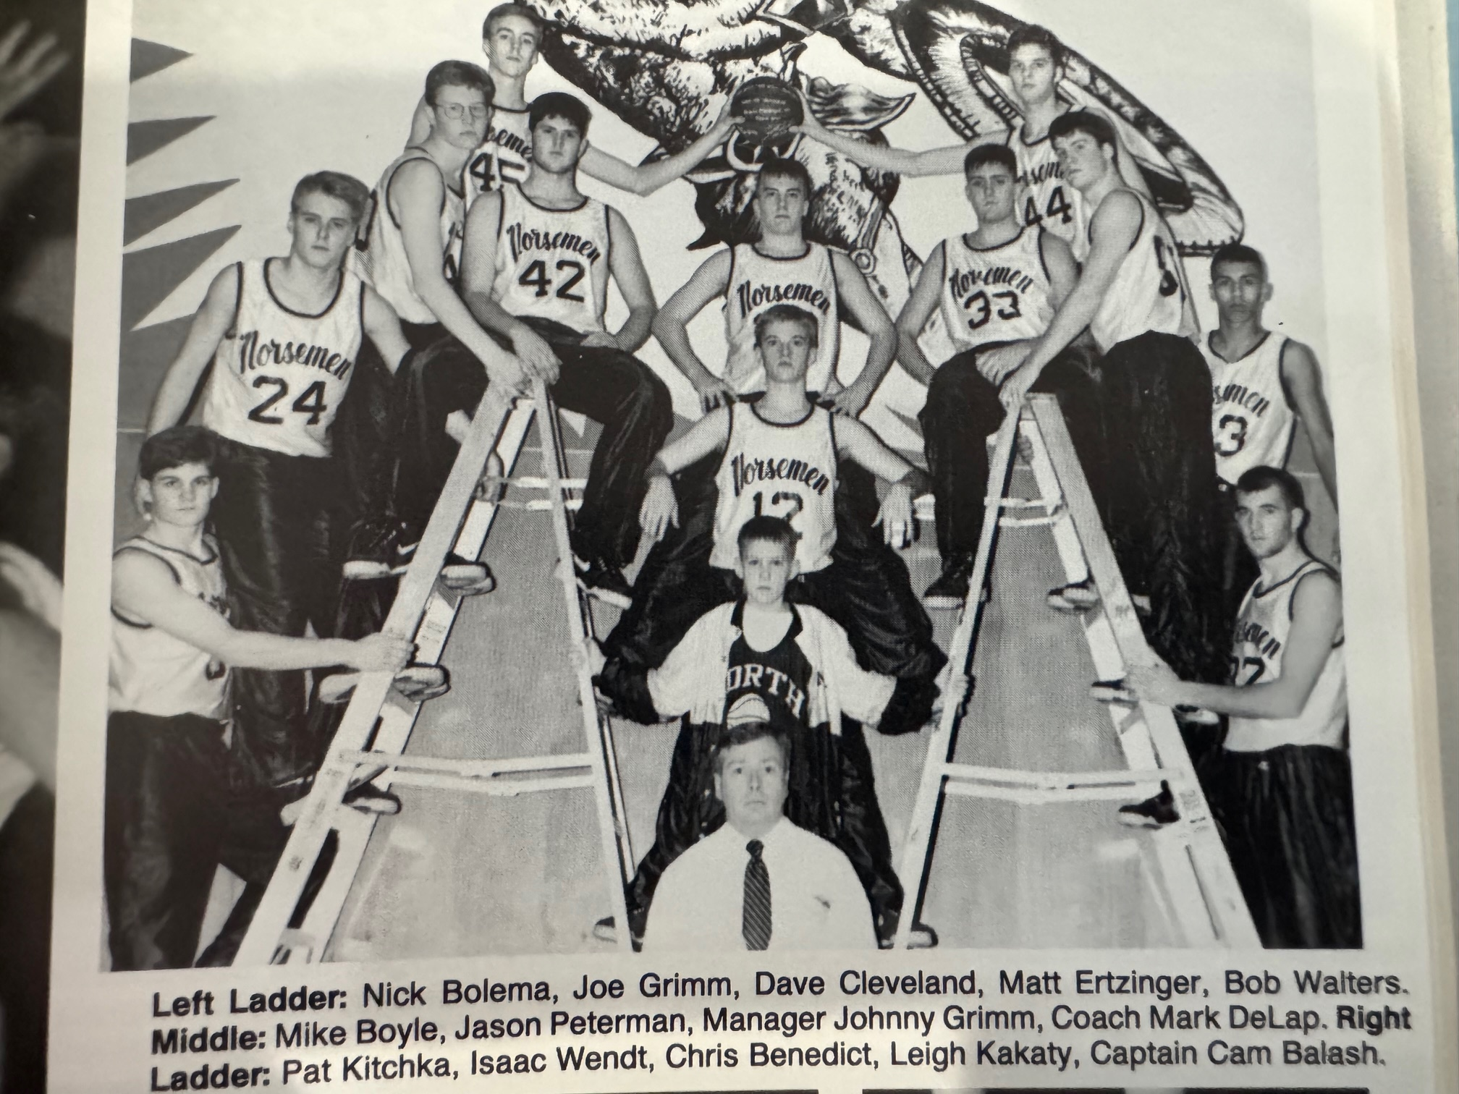

The 1992-93 NORSEMEN

N Muskegon 69 Newaygo 62 Cam Balash 17, Leigh Kakaty 15
N Muskegon 48 Oakridge 81 Balash 19, Bobby Walter 8,
N Muskegon 58 Calvary Baptist 34 Chris Benedict 17, Joe Grimm 16
N Muskegon 44 Shelby 31 Balash 14, Walters 9, Kakaty 8
N Muskegon 41 Pentwater 37 Balash 14, Walters 11, Kakaty 8
N Muskegon 39 Hart 52 Pat Kitchka 15, Walterss 9
N Muskegon 86 Walkerville 80 Kakaty 35, Matt Erzinger 31
N Muskegon 46 Mason Co 98 Balash 12. Walters 10
N Muskegon 103 Ravenna 73 Balash 44, Kakaty 16, Kitchka 14
N Muskegon 46 Whitehall 58 Balash 24, Mike Boyle 12, Kakaty 6
N Muskegon 51 Montague 70 Mike Boyle 15, Balash 10
N Muskegon 53 Oakridge 59 Balash 12, Walter 10
N Muskegon 46 Shelby 58 Balash 11, Kirchka 10
N Muskegon 61 Hart 65 Kakaty 24, Balash 20
N Muskegon 45 Mason Co 66 Balash 11, Kakaty & Kitchka 10
N Muskegon 65 Hesperia 60 Balash 25, Kakaty 18
N Muskegon 47 Ravenna 45 Kakaty 16, Nick Bolema 9, Balash 4
N Muskegon 80 Holton 51 Balash 14, Kakaty 14, Kitchka 11
N Muskegon 39 Whitehall 51 Balash & Kakaty 12
N Muskegon 61 Montague 65 Balash & Walters 15
N Muskegon*85 White Lake C. 32 Kakaty 20, Kitchka 17, Balash 12
N Muskegon*55 WMC 71 Walters 17, Balash 12

1993-94 (Coach Mark DeLap 10-12, Oakridge WMC champs)

The Norsemen would compile for the third straight season a 10-12 record with six of their wins coming against non-conference opponents. Leigh Kakaty would be the only starter returning from the previous season although Mike Boyle did see a lot of action.
Both Newaygo and North Muskegon only returned one starter from the previous year in the opening game of the season. Newaygo returned sophomore Mike Burde, a future Muskegon Area Hall of Fame top athlete award winner, and the Norsemen returned junior Leigh Kakaty. The opening game could not have gone better for the host Lions, nor could it have gone worse for the Norse has they experienced their most lop-sided defeat of the entire season with Newaygo blowing out NM 93-35. Burde scored 20 points for Newaygo while Kakaty led NM with 11 points.
Oakridge won their 12th straight game over the Norse as scoring points continued to be a big problem for NM. The Eagles outscored the Norse in every quarter in posting an easy 59-40 win. First year starter Isaac Wendt led NM with 11 points and 11 rebounds. Leigh Kakaty finished with 10 points, his lowest scoring total in a single game all season.
NM recorded their first win with a 57-30 victory over Calvary Baptist. Leigh Kakaty led the rout with 19 points with Mike Boyle tossing in nine to lead NM. The victory would be the seventh of 10 straight wins in the series with Calvary Baptist without NM tasting a defeat. So futile was Calvary’s offense that they had only scored 16 points heading into the final quarter.
Leigh Kakaty was a one-man gang for NM in their 60-42 loss to Shelby. The 5’10 junior guard scored 31 of NM’s 43 points as only three other Norse players were able to score. The Norsemen were able to only score 13 points in the first half.
NM scored their second victory of the season following the Holiday break, with both wins coming at the expense of Class D opponents with the first victory a 66-45 win over Pentwater. Kakaty had 26 points followed by Mike Boyle with 11 as eight Norsemen scored in the game, four more than scored in their last outing with Shelby. The Norsemen put away Pentwater early by taking a commanding 39-16 lead at halftime.
Hart overcame a two-point deficit going into the fourth quarter as they rallied to defeat NM 52-46 on the Northside court. Leigh Kakaty with 26 scored more than half of NM’s points as NM fell to 0-2 in the WMC.
Leigh Kakaty again had a big scoring night in their win over Walkerville. In the 71-63-win Kakaty got some scoring help from his teammates. Kakaty poured in 35 points and was helped in the scoring department from Isaac Wendt with 17 and Mike Boyle added 13 points as NM accrued their third victory of the season, all against Class D opponents. The Norse trio tallied all but six of NM’s 71 points.
Head coach Tim Genson of Mason County Central was coaching in his first year for the Spartans and his team came away with a 72-61 road victory over the Norse. The game featured a shootout between MCC’s all state forward Jeremy Holmes and NM’s Leigh Kakaty. Holmes scored 35 points in leading the Spartans back from a one-point halftime deficit to a victory while Kakaty scored 24 for the Norsemen. Mike Boyle trailed Kakaty in scoring with 13 points while Kirk Jensen had his season high of nine points.
It was 57-18 in favor of Whitehall before NM scored 22 points in the final quarter to make the score look a little more representable in a 77-50 loss at home to Whitehall. Leigh Kakaty (25) and Mike Boyle (10) scored all but 15 points for NM as the Norsemen were still searching for their first West Michigan Conference victory.
The Norse kept it close in their loss to Montague in losing 71-63 at home to Montague. The difference in the game was at the free throw stripe as Montague netted 17 free throws to NM’s 10. Leigh Kakaty continued his torrid shooting with 25 points with Nick Bolema and Mike Boyle netting 8. Isaac Wendt was productive for the Norse with 12 rebounds.
North Muskegon led at halftime and was all knotted up with Shelby at 40-all heading into the final quarter only to see Shelby run away in the fourth quarter by out pointing NM 24-9 to win 64-49. For only the second time all season Leigh Kakaty wasn’t the leading scorer for the Norse as Isaac Wendt took high points honors with 15 points to Kakaty’s 13. Wendt also was a tower of strength on the boards with 14 rebounds.
NM won their first game in the West Michigan Conference as they defeated Hart 56-51. NM pulled off the victory despite Leigh Kakaty being held to well below his average of points scored in a game. It was Kakaty’s backcourt teammate Mike Boyle who scored a season high 18 points that paced NM scorers while Kakaty was content with the win and 11 points. After both teams were tied at halftime, NM outscored the host Pirates in the third quarter to take a 43-35 lead into the final quarter. Hart took a brief lead with two minutes left in the contest only to see NM make six straight free throws to upset the Pirates. Isaac Wendt was again a force on the boards with 13 rebounds while chipping in eight much-needed points. The win over Hart was the only victory on the season over a team with a winning record.
North Muskegon won their second straight game in Conference action with a 74-52 win over a Ravenna team that was still looking for its first win in the WMC in two seasons. Leigh Kakaty led NM with 27 points but got plenty of help from his teammates. Isaac Wendt had 16 points while Mike Boyle tallied 10 and Nick Bolema 8 as NM improved to 5-8 overall and 2-7 in the WMC.
NM took a brief lead in the second quarter only to see the host Spartans of Mason County go on a 14-3 run to take a 38-26 lead at halftime. That momentum carried MCC to a 73-50 victory over NM despite a season high for Norse center Isaac Wendt who scored 19 points while pulling down nine rebounds in a losing cause.
NM got back on the winning track with a 77-70 victory over Hesperia with four players in double figures for NM, a first during the season. NM led at the end of every stop as they recorded their highest scoring output of the season. Leigh Kakaty paced the Norse balanced attack with 19 points, with Nick Bolema and Isaac Wendt each tossing in 12 markers and Mike Boyle 10. Dan Wegner and Kirk Jensen each came a field goal away from also getting into double figures with eight points.
After one quarter was in the books and with NM holding an 18-4 lead, there remained little doubt who was going to win the game as NM pummeled Ravenna 79-44. Kakaty led the onslaught with 27 points with Isaac Wendt adding 18. NM baseball ace Justin Visconti added eight as Ravenna remained buried deep in the WMC cellar.
Oakridge showed why they were the WMC champions in 1994 with an 83-54 thumping of the Norse. Isaac Wendt had 14 Leigh Kakaty 12 and Matt Boyle 10. Not to be discouraged NM would recover to start a mini winning streak.
The Norse won a non-league contest with Holton 52-45 as Issac Wendt had a big day for the winners. Wendt scored 11 of his 16 points in the third quarter as NM came from behind to roll past Holton. Wendt also gobbled up 15 rebounds. Leigh Kakaty connected for 21 points to lead NM scorers.
It was then that NM pulled off a stunner. After losing earlier in the season to Whitehall by 27 points – on their home court – NM pulled off a 69-63 win over the Vikings at the Whitehall gym that yielded rare victories to the Norsemen over the years. It’s doubtful if a NM team in the many games played over the years shot better than NM did in their win over Whitehall. The Norse shot 77 per cent from the field in the opening quarter and stayed hot for most of the game. Especially on fire was junior guard Leigh Kakaty who tossed in 39 points that included six three-pointers. Isaac Wendt scored 10 points for the winners while Nick Bolema added seven points as well as six assists. The win would prove to be the only win by the Norse over Whitehall during the entire 1990s with Whitehall winning 20 of 21 games.
NM came close to pulling off their second upset in as many games but a furious fourth quarter rally fell just short as Montague held on to nip the Norse 60-58 in the final game of the regular season. Nick Bolema, and Mike Boyle keyed the fourth quarter NM rally. Bolema scored six of his seasons high 12 points and Boyle nine of his 11 points in the fourth quarter. It forced Montague’s Lief Ortquist to hit two free throws in the game’s final seconds to win the game for Montague. Kakaty had a game high 17 points as NM finished the regular season with a 9-11 overall record for the third year in a row.
NM drew a winless Saugatuck team in the opening round of the Class D playoffs and had little trouble in breezing to a 69-50 victory. Leigh Kakaty scored 26 points as the Norse had their eyes set on finally getting a tournament win over a West Michigan Christian team that had a rare losing season. However, WMC is WMC and played a much tougher regular season schedule than the Norse. NM won 5 games against teams who had a combined record of 8-96. And that doesn’t include the record of Calvary Baptist who had an unknown record but lost by more than 50 points to WMC in the first game of the playoffs. NM had high hopes of defeating the Warriors and winning their first district title in 20 years. Both teams came into the contest on the Warriors home court with identical 10-11 records. A full house was on hand at the home of the Warriors, and it turned out it was no contest as WMC stunned the Norse 95-63. So balanced was this Warriors team that their high point man only scored 14 of his teams 95 points. Meanwhile NM only had four players score, with three of those Norsemen; Lee Kakaty (27), Mike Boyle (16) and Isaac Wendt (14) scoring all but six of NM’s total of 63 points. NM’s season would end at 10-12.

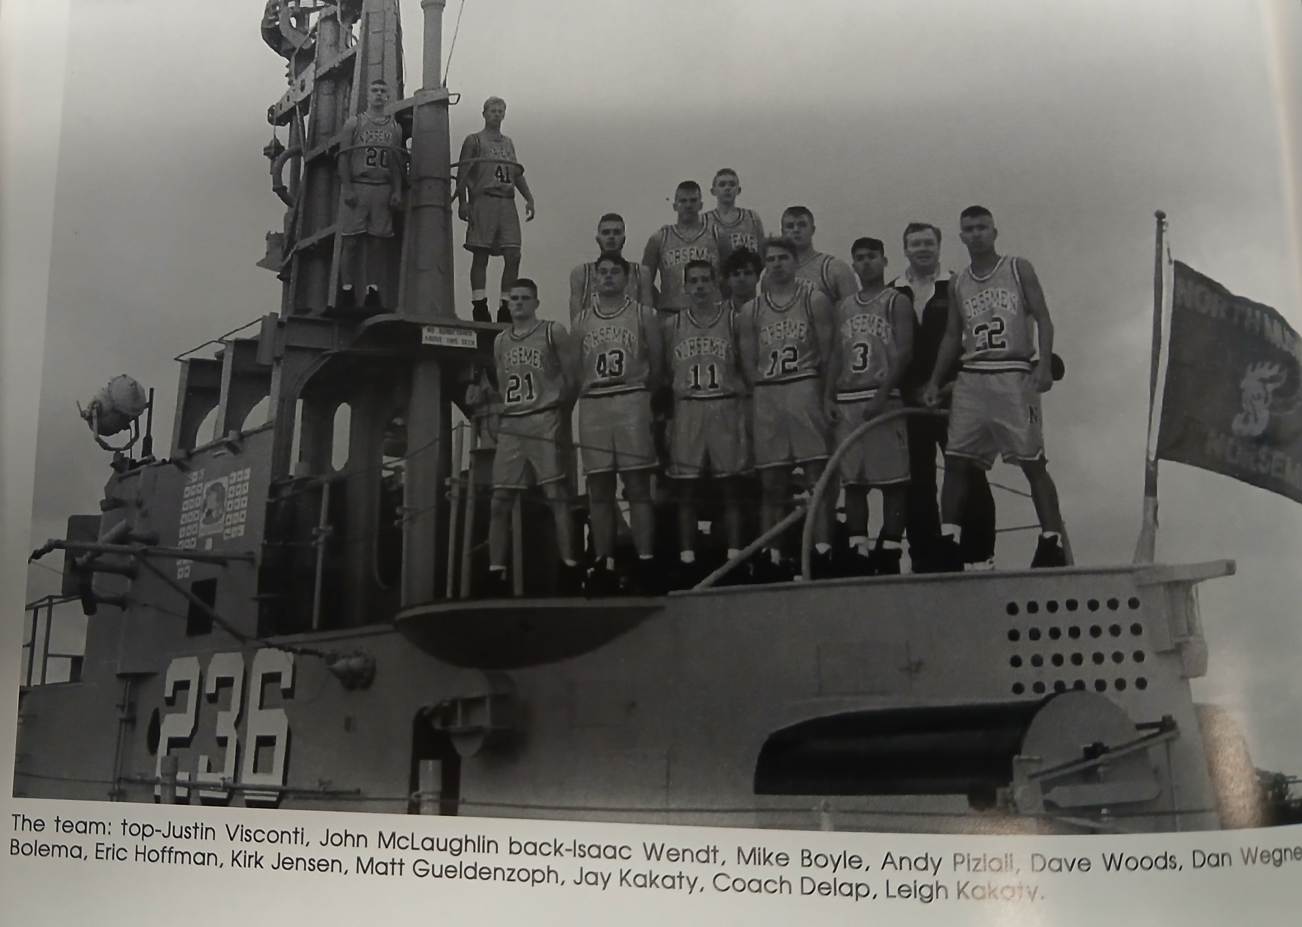

The 1993-94 NORSEMEN

N Muskegon 35 Newaygo 93 Kakata 11
N Muskegon 40 Oakridge 59 Isaac Wendt 11, Kakaty 10
N Muskegon 57 Calvary Baptist 30 Kakaty 19, Mike Boyle 9
N Muskegon 43 Shelby 60 Kakaty 31, Boyle 5, Wendt 5
N Muskegon 66 Pentwater 45 Kakaty 26, Boyle 11
N Muskegon 46 Hart 52 Kakaty 28, Boyle 8
N Muskegon 71 Walkerville 63 Kakaty 35, Wendt 17, Boyle 13
N Muskegon 61 Mason Co 72 Kakaty 24, Boyle 13, Kirk Jensen 9
N Muskegon 50 Whitehall 77 Kakaty 25, Boyle 10
N Muskegon 63 Montague 71 Kataty 25, Nick Bolema 8, Boyle 8
N Muskegon 49 Shelby 64 Wendt 15, Kakaty 12, Boyle 9
N Muskegon 56 Hart 51 Boyle 18, Kakaty 11, Bolema 9
N Muskegon 74 Ravenna 52 Kakaty 27, Wendt 16, Boyle 10
N Muskegon 50 Mason Co 73 Wendt 19, Kakaty 13
N Muskegon 77 Hesperia 70 Kakaty 19, Wendt & Bolema 12
N Muskegon 79 Ravenna 44 Kakaty 27, Wendt 18, Justin Visconti 8
N Muskegon 54 Oakridge 83 Wendt 14, Kakaty 12, Boyle 10
N Muskegon 52 Holton 45 Kakaty 21, Wendt 16
N Muskegon 68 Whitehall 63 Kakaty 39, Wendt 10
N Muskegon 58 Montague 60 Kakaty 17, Bolema 12, Boyle 11
N Muskegon*69 Saugatuck 50 Kakaty 26, Wendt 18
N Muskegon*63 WMC 95 Kakaty 27, Boyle 16, Wendt 14

1994-95 (Coach Mark DeLap 6-15, Whitehall WMC champs)

The Norsemen would have quite an entertaining year in the 1995-95 season that included some historical scoring feats by 5’10 senior guard Leigh Kakaty. Also returning for NM would be point guard Michael Boyle, a three-sport standout who was third in scoring and the assist leader from the previous 10-12 season. However, the return of those two standouts didn’t transcend into a winning record as NM would win only six games while dropping 15. Four of those wins came against Class D opponents with only one win coming in the West Michigan Conference as NM finished in the cellar. One positive among the negative was NM was much more competitive in their losses as compared to the previous season as there were only a handful of games where NM was badly outplayed. NM was basically a two-man show during the season as no Norse player outside of Kakaty and Boyle would average more than six points per game.
To validate NM’s competitiveness, even in a loss one could look as early as their opening game with Newaygo. The Lions embarrassed the Norsemen in December of 1993 by whipping NM by 58 points. That didn’t happen 12 months later as NM lost by only five points, 85-80 to Newaygo. Leigh Kakaty scored 34 points, one of 13 games during the season in which he would surpass the 30-point barrier in the loss. The Norse carried a five-point lead entering the final quarter, but the Lions roared back in the final eight minutes with a 28-18 edge over NM to earn the victory. Mike Burde led the Lions with 26 while future star bartender at the world-famous Bear Lake Tavern, Matt Shephard netted 20 points. With the score tied at 78-78 Shephard scored six of his 20 points in the game’s final two minutes. Shephard would have the rare feat of playing college basketball at all four levels: JUCO at MCC, D3 at Hope and D2 at IU at Fort Wayne and D1 at Fort Wayne when they advanced to the D 1 level. Shephard, however, had to take a back seat in the Shephard family in the most famous department as his current spouse Stacy Essenbarger, was a former Miss Michigan. Justin Visconti had a season and career high 14 points for NM while Michael Boyle added 12.
Montague made 15-of-17 free throws in the final half to preserve their 44-31 halftime lead as NM loses 83-71 to the Wildcats. Kakaty had 31 points and Boyle 21 to lead NM. Matt Gueldenzoph had 11 points for the Norsemen, his career and season best output for the Norse.
NM’s Leigh Kakaty set a new NM single game scoring record with 54 points as NM nipped Baldwin 85-82 on the northside court. The record eclipsed by one point the former record held by my next-door neighbor Gordy Odell back in 1955. However, should there be an asterisk to this record? Six of Kakaty’s points came on six made three-point field goals. The three-point shot wasn’t in existence in 1955. If not for the new rule, Kakaty would have finished with 48 under the rules from 1955. NM trailed 56-45 to Baldwin in a high scoring first half but went on a key 13-2 run in the third quarter to get back into the contest. Baldwin grabbed an 82-80 lead before Mike Boyle, who finished with 13 points and a reported 15 assists, answered with a driving layup. Kakaty and his mates then added the game’s final three points to preserve the Norse victory. It wasn’t all Kakaty and Boyle in the fourth quarter as Bill Franks added three big points in the final period and Dan Wegner added four of his eight points in the final quarter. To say that NM had a generous statistician in the 1994-95 season might be an understatement. The 6’2 Wegner was reported to have grabbed a game high 20-rebounds in the victory.
Leigh Kakaty was ‘held’ to 25 points as NM was sent back to reality as NM lost to Oakridge 80-48. The NM scoring machine got off to a good start by scoring 12 of his 25 points but then suffered a cold spell. Kakaty made but three of a whopping 27 shots the rest of the way. The Norsemen committed 35 fouls in the contest that resulted in the Eagles making 37 free throws. Mike Boyle added 10 points for NM as the Norse would go into 1995 with a 1-3 record.
NM got a jump start in their road game at Pentwater by gaining a 29-14 advantage over Pentwater enroute to a 87-66 victory. Leigh Kakaty regained his shooting eye by scoring 33 points to lead the Norse while Michael Boyle scored 15 and Justin Visconti 12 for NM.
The NM duo of Kakaty and Boyle scored all but 11 of NM’s total of 64 points in a 76-64 loss to Shelby. Kakaty scored 18 of his 41 points in the fourth as NM tried to come back from a 13-point hole accrued in the opening quarter.
NM continued to dominate Class D opponents as they hammered Walkerville 104-91 in a high scoring run-and-gun shootout. Leigh Kakaty led five Norsemen that reached double figures with 35 points. Michael Boyle scored a season high 25, Dan Wegner added 11 while both Justin Visconti and Billy Frank chipped in with 10 as NM improved to 3-4 on the season. Unfortunately for NM fans, that would be the highwater mark of the entire campaign.
Hart’s Chris Terryn was fouled with under a half-second to play in overtime and sank the front end of a one-and-one free throw to defeat NM 71-70. The loss put a damper on Leigh Kakaty joining the 1000-point club as his 32 points improved his career total to 1014 points. Mike Boyle added 16 for the Norse. Scoring 16 points for the victorious Pirates was Steve Cutter who was best noted for his baseball skills. Cutter, the current head coach of Lansing Community College coached the Norsemen in baseball beginning in 2019 where he would have incredible success with the Norse before moving on to the collegiate ranks.
The Norsemen were still looking for their first win in WMC action after dropping an 81-70 contest at Scottville to Mason County Central. Kakaty scored 24 while Justin Visconti scored 15 of his 16 points on five made three-pointers.
The Norsemen had one bad quarter, and that proved to be fatal as Ravenna’s 25-11 second quarter proved to be the difference in NM’s 75-63 loss to the visiting Bulldogs. It was a battle to see who could escape the cellar and for Ravenna, they not only escaped last place in the standings, but it was Ravenna’s first win in the WMC in four years. Leigh Kakaty’s 25 points led NM while Billy Franks had a season high 16 for NM as their record fell to 3-7.
NM tallied only 36 points in a 59-34 loss at Whitehall. Kakaty had 20 points to lead the Norsemen, but no other NM player scored more than three points. The Vikings settled this contest early when they outscored the Norsemen 18-4 in the second quarter. Whitehall stayed perfect on the season with the victory, one game ahead of Shelby in the WMC.
In a game labeled as being ‘sluggish,’ Montague posted a 47-36 win over the Norsemen. Leigh Kakaty scored a season low 16 points, but it was enough to lead NM in scoring, the only Norse player in double figures.
Oakridge continued their magic spell on the Norsemen with a businesslike 72-48 win to complete another series sweep of the Norsemen. Leigh Kakaty had a 31-point game for NM, the only Norsemen in double figures.
Shelby improved to 13-1 on the season with an 83-63 win over NM. It’s not often during the year that Leigh Kakaty wasn’t the game’s leading scorer but that was the case as Shelby’s 6’7 Chris Vanderslice scored 37 points while Kakaty totaled 33. Michael Boyle finished with 16 as NM remained winless in the WMC at 0-10.
The Norse trailed Hesperia 51- 46 at halftime in a shooting match on the Northside court before they turned on the defense in the second half to zoom by the Panthers 90-75. The 1-2 combo of Kakaty and Boyle were clicking as they combined to score 52 points between them while also getting help from Justin Visconti who chipped in with 13 markers. The win snapped a six-game losing streak for NM. All four NM wins came against non-conference foes.
A second quarter spurt by Mason County Central led to another WMC defeat as the Spartans topped the Norsemen 72-65. The visitors from Scottville poured in 23 points to NM’s nine in the pivotal second quarter. Leigh Kakaty again hit the 30-point mark with Michael Boyle supplying the assists to his running mate while also tossing in 15 points.
NM continued their dominance against Class D opponents (WMC excepted) as they used another sizzling scoring night by Leigh Kakaty to defeat Holton 69-58. Kakaty scored more than half of NM’s points with 38 markers to lead NM to their fifth win of the season, all against Class D foes.
It was victory at last in the West Michigan Conference as NM earned a 10-point 66-56 win over the Ravenna Bulldogs. NM used a big 22-9 fourth quarter to make amends for an earlier defeat to the Bulldogs. Leigh Kakaty led NM with 26 while Michael Boyle added 18 for the Norse who would earn their sixth and final win on the season.
Steve Cutter made NM fans proud during his terrific tenure as the Norse baseball coach from 2019-21. He did not make Norse fans happy in the second matchup of the 1994-95 basketball season when Cutter scored 30 points, 14 in the third period as Hart defeated the Norse 75-53. Cutter further added to the Norse troubles when he grabbed 20 rebounds. Cutter nearly doubled the total of NM’s scoring machine Leigh Kakaty who led NM with 17 points.
Whitehall won their last regular season game on the season 75-60 over the Norsemen to clinch the West Michigan Conference Championship. Future Division 1 head basketball coach Tony Jasick led the Vikings with 28 points. Leigh Kakaty led all scorers with 36 of NM’s 60 points.
NM and West Michigan Christian would meet in the playoffs for the fourth consecutive year and the second straight season that they would both have identical records (6-14). Five of NM’s six win came against Class D opponents while WMC faced mostly Class C & B teams. That tournament experience and depth played a factor as WMC wore down the Norse to come away with another tournament victory over NM, 73-66 in a game that was much closer than the final score. NM, behind Leigh Kakaty’s 20 first half points on 8 of 11 shooting sent the Norse into their own locker room at intermission leading 41-32. The Warriors took little time in bouncing back with a 25-14 run in the third quarter to take a two-point lead into the final quarter. Leading by two and with the ball, NM had a pass intended for Kakaty intercepted by the Warriors JJ Luchies that extended the lead to four and iced the game.
Leigh Kakaty, in addition to setting a single game scoring record set nearly 40 years earlier by Gordy Odell, joined Odell as one of only two Norsemen to average more than 30 points per game in a season. Kakaty was a top 10 candidate for Mr. Basketball honors in 1995. Incredulously, NM’s scoring whiz did not earn the respect of the coaches in the West Michigan Conference and was not selected to the WMC all-conference team. When no offers came for a possible career as a college basketball player Kakaty instead turned to pop-rock where he excelled in the music industry.

N Muskegon 80 Newaygo 85 Leigh Kakaty 34, Justin Visonti 14
N Muskegon 71 Montague 83 Kakaty 31, Boye 21 Matt Gueldenzoph 11
N Muskegon 85 Baldwin 82 Kakaty 54, Boyle 13, Dan Wegner 8
N Muskegon 48 Oakridge 80 Kakaty 25, Boyle 10
N Muskegon 87 Pentwater 66 Kakaty 33, Boyle 15, Visconti 12
N Muskegon 64 Shelby 76 Kakaty 41, Boyle 12
N Muskegon 104 Walkerville 91 Kakaty 35, Boyle 25, Wegner 11
N Muskegon 70 Hart (ot) 71 Kakaty 32, Boyle 16, Bill Franks 9
N Muskegon 70 Mason Co 81 Kakaty 24, Visconti 16, Boyle 14
N Muskegon 63 Ravenna 75 Kakaty 25, Franks 14, Boyle 12
N Muskegon 34 Whitehall 59 Kakaty 20
N Muskegon 36 Montague 47 Kakaty 16, Wegner 8
N Muskegon 48 Oakridge 72 Kakaty 31
N Muskegon 63 Shelby 83 Kakaty 33, Boyle 15
N Muskegon 90 Hesperia 75 Kakaty 27, Boyle 25
N Muskegon 62 Mason Co 75 Kakaty 30, Boyle 15
N Muskegon 69 Holton 58 Kakaty 38, Visconti 12
N Muskegon 66 Ravenna 56 Kakaty 26, Boyle 18
N Muskegon 53 Hart 75 Kakaty 17, Visconti 11, Boyle 10
N Muskegon 60 Whitehall 75 Kakaty 36, Wegner 10
N Muskegon*66 WMC 73 Kakaty 31, Wegner 10

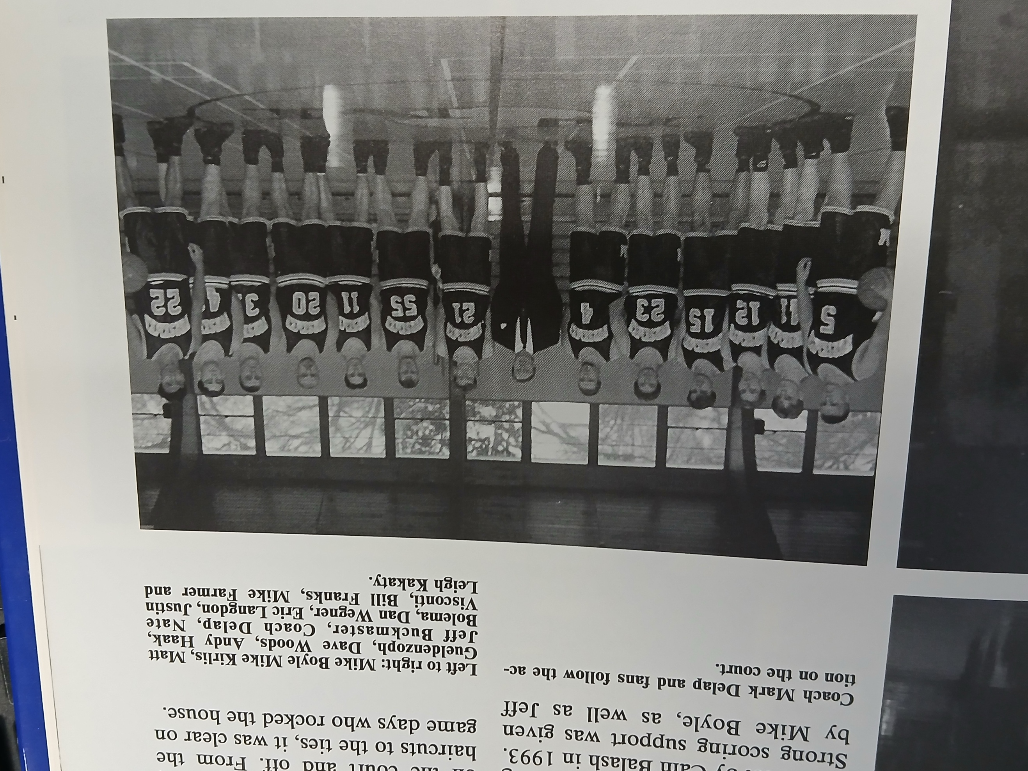

The 1994-95 NORSEMEN

L-R: Mike Boyle, Mike Kirlis, Matt Gueldenzoph, Dave Woods, Andy Haak, Jeff Buckmaster, Coach DeLap. Nate Bolema, Dan Wegner, Eric Langdon, Justin Visconti, Bill Franks, Mile Farmer, Leigh Kakaty

1995-96 (Coach Mark DeLap 9-14, Shelby WMC champs)

What a difference a year makes! In the 1994-95 season Leigh Kakaty had 13 games scoring more than 30 points and several more over 20 as North Muskegon won only six games. In this, the 1995-96 season, NM never had one player score 20 points in any game, yet NM won nine games, three more than the previous season. It would be almost a complete retooling of personnel for the upcoming season as only Bill Franks and Dan Wegner saw quality playing time. It would also mark the final season for Mark DeLap as the Norsemen head coach. Waiting in the wings would be a Norse icon who would lead NM back to basketball prominence with a familiar last name known to all in North Muskegon athletic lore. The Norse earned their nine wins despite averaging a mere 47 points per game.
NM’s final total of 30 points resembled a score out of the 1930s as NM was beaten soundly by Newaygo 73-30 in the season opener. NM had scoring balance in this game as nine players would score at least one point, but the high point man had only six points. One would have to go back to Coach Bob Morris’ first game as a NM coach in 1948 to find NM’s leading scorer (Monte Hand) to have less than six points in a game. John Westbrook was NM’s high point producer in the 1995-96 season opener with six points.
After absorbing a solid beating at the hands of a very good Newaygo team, NM was headed for an upset victory over Montague as they led 41-37 heading into the final quarter. That was not to be, however, as Montague stormed past NM to the tune of 28-14 to win going away 63-55. Jay Kakaty, young brother of Leigh, led a balanced NM offense with 12 points, with Park Kersman and Dan Wegner each adding 10 markers.
Oakridge continued to have NM in their hip pocket during the 1990s. Both teams were looking for their initial win of the season and the Eagles had no trouble in making the Norsemen their first victim, winning 64-42. Adams Sellinger pumped in 18 of his game high 31 points in the second half to lead the Eagle attack while Erik Langdon’s modest nine points led the Norse.
The Norse had a long three-week layoff for the Holidays to solve their shooting woes, but it would take NM more than one game for that to happen. Shelby held NM to 43 points, 17 of those points coming from Matt Wikander, while the Tigers scored 72 to hand the Norse their fourth straight setback 72-43.
It was the perfect time to have Walkerville to appear on the NM schedule, a team that would win only one time against North Muskegon in 12 games played over the years. NM scored 78 points, 15 more than they would score in any other game during the season as they had little trouble in their 78-52 win over the Wildcats. Jay Kakaty and Billy Franks each scored 19 points, equaling the high single game point total by a Norse player all season. Erik Langdon chipped in with 12 as the Norse win their first game of the season.
In a battle to see who would leave the cellar in the WMC, it was the Norsemen who would move up following a 58-40 win at home over the winless Hart Pirates. Jay Kakaty and Erik Langdon each had a dozen points while the Norse defense held the Pirates to only 40 points. NM led at the halftime break 34-18 and were never challenged the rest of the game.
Ravenna shot the lights out in the first half, hitting 17 of their first 28 shots to take a 20-point lead on the Norse at halftime. NM mounted a comeback but fell short as the Bulldogs held on to defeat NM 53-48. Matt Wikander had a big night for the Norse with 18 points and nine rebounds while Jay Kakaty finished with 15 and Bill Franks with 10.
Less than 24 hours after a tough loss to Ravenna NM simply ran out of gas in the final quarter in a 66-49 loss to Mason County. The Norse led 43-38 heading into the final quarter only to be blasted 26-6 in the fatal fourth quarter. Bill Franks and Jay Kakaty shared scoring honors for the Norse with 13 points while Dan Wegner pulled down 12 rebounds.
NM and Whitehall were engaged in a defensive struggle with the Vikings outlasting the Norse 39-35. Shooting woes were the rule for both teams as NM’s Erik Langdon was the only player for either team to make a 3-pointer. As opposed to their run & gun teams from his last two teams, Norse head coach Mark DeLap slowed the tempo down and it nearly resulted in a NM upset victory. Bill Franks had 11 points and nine rebounds while Matt Wikander tallied 10 points.
That slow it down tempo did work in NM’s next contest resulting in a tight 45-44 squeaker over Montague. It appeared after three quarters were in the books and NM leading 40-24, that this would be an easy victory. However, Montague threw a scare into the Norse by going on a 19-5 run as NM just hung on to earn the tough win. Matt Wikander led the winners with 13, closely followed by Jay Kakaty and Billy Franks with 11 as NM wins their second victory in the WMC.
The Norsemen again fell to Oakridge as NM went into another fourth quarter swoon, being outscored by the Eagles 23-7 leading to a 53-40 loss. Not a single NM player reached double figures with Matt Wikander’s nine points the closest. Dan Wegner was held scoreless but did grab 10 rebounds for the Norse.
Shelby ran their record to a perfect 15-0, 10-0 in the WMC, holding NM to their lowest offensive output since the first game of the season with a 53-31 victory on the Northside court. NM’s attempt to slow the game down did keep NM in the game, but only briefly as Shelby outscored NM in every quarter. Dan Wegner led NM with 10 points while Billy Franks grabbed 11 rebounds. Shelby impressed the pollsters as the Detroit Free Press ranked Shelby No. 1 in its class in the state.
A vastly improved Pentwater team invaded the home of the Norsemen and came away with a 41-38 win to improve the Falcons record to 9-4 while the Norse dropped to 3-10. A Bill Franks layup tied the score at 37-all with 5:31 still to be played in the game but the Norse were only able to record one point on a Matt Wikander free throw the rest of the game. Billy Franks had 13 points and Eric Langdon 9 to lead NM in another low scoring contest.
NM edged Hart by a single point, 54-53 to ensure that the Norsemen would not finish in the cellar of the WMC. After losing a couple of games in the fourth quarter earlier in the season it was NM’s turn for a last period comeback as they rallied to score 24 points to the Pirates 17 in the game’s final eight minutes to win their 3rd WMC victory and second win in the season over Hart 54-53. NM trailed by nine points with just under four minutes before their rally, led by Billy Franks who scored 10 of his game high 19 points in the final quarter, as rallied NM for the win.
NM again worked their fourth quarter magic to earn their second consecutive one point victory in less than a week with a 45-44 win over Hesperia. Jay Kakaty scored eight of his game high 18 points down the stretch to lead the Norse.
NM slowed the tempo down but Mason County Central, on the cusp of soon becoming a basketball power, had too much firepower in a 49-38 win over NMHS. The Spartans of Scottville improved to 13-3 on the season while NM fell to 5-11. Jay Kakaty led NM with 17 points while Matt Wikander had a dozen.
NM equaled last season’s total victories with a 53-46 triumph over Holton in a non-league contest. Bill Franks led the Norse with 17 while Eric Langdon netted 15 for the victorious Norsemen.
The Norse used another big fourth quarter to make amends for an earlier loss to Ravenna by using a 19-8 fourth quarter splurge to defeat the Bulldogs 48-38. The Norse had three in doubles figures: Bill Franks (12) Matt Wikander (11) and Dan Wegner (10) as NM topped last year’s team for wins in a season with their 7th win of the season. Meanwhile Ravenna was still stuck with only three wins.
In the first matchup between the two local teams in 33 years, back when North Muskegon was a Class B school and Muskegon Catholic Class A, The Crusaders defeated NM 68-45. It would mark the beginning of a series that would be played every year except one (2021) to the present day. The Crusaders cruised to a 20-point lead at halftime as NM had but one player in double figures, and barely, as Jay Kakaty tallied 10 points.
Whitehall finished their regular season in 3rd place in the WMC while NM settled for a 5th place tie with Montague following the Vikings 79-43 trouncing of the Norsemen. Whitehall’s defense forced 23 NM turnovers with Dan Wegner’s season high 16 points leading the Norsemen.
NM had a very favorable draw for the Class D tournament, opening with Saugatuck, a team winless two years earlier, and tiny Calvary Baptist, who was still looking for their first-ever win over the Norse. If there was any apprehension about playing their game with Saugatuck in Saugatuck that went away quickly as NM forged out to a big lead that at one point increased to 19 points late in the third quarter. The host Saugatuck squad then put on a rally that cut NM’s lead to five with two minutes to go before NM pulled away to earn a 63-56 first round victory. All five NM players who scored in the game reached double figures: Dan Wegner (14), Matt Wikander and Jay Kakaty (13), Erick Langdon (12) and Billy Franks (11).
Calvary Baptist threw a scare into the Norsemen as NM had to scratch and claw their way to a three-point victory 59-56, the closest Calvary would come to ever defeating NM in their 10-game series. For the second straight game in the tournament NM took a commanding lead into the final quarter only to see their opponent make a serious charge. NM led Calvary Baptist by 15 at the end of three quarters but had to withstand a 22-10 rally by the upstarts to earn a berth into the final against West Michigan Christian. NM need a career high 19 points from Eric Langdon to advance.
For the fifth straight year NM saw their season end with a 55-42 loss to West Michigan Christian. For the second straight season it was the third quarter that was the deciding quarter in the loss. NM trailed the Warriors by only two points at halftime. Just as he did a year ago, WMC’s hall of fame coach Jim Goorman put on a full court press to begin the second half, and it completely befuddled NM as they scored but two points in the entire third quarter. Matt WIkander with 12 and Billy Franks with 11 led NM as they ended the season at 9-14.
Mark DeLap would leave after four years and would be replaced by a former North Muskegon grad who would in a short period of time develop some outstanding teams and players during his long career. Jeff Cooke would be one of 15 coaches to guide North Muskegon basketball over the many years, but he would be the only coach who was also a North Muskegon grad.

N Muskegon 30 Newaygo 73 John Westbrook 6
N Muskegon 55 Montague 63 Jay Kakaty 12
N Muskegon 42 Oakridge 64 Erik Langson 9, Bill Franks 7
N Muskegon 43 Shelby 72 Matt Wikander 17, Franks 9
N Muskegon 78 Walkerville 52 Kakaty & Franks 19, Langdon 12
N Muskegon 58 Hart 40 Kakaty & Langdon 12
N Muskegon 48 Ravenna 53 Wikander 18, Kakaty 15, Franks 10
N Muskegon 49 Mason Co 66 Kakaty & Franks 13
N Muskegon 35 Whitehall 39 Franks 11, Wikander 10
N Muskegon 45 Montague 44 Wikander, 13, Kakaty & Franks 11
N Muskegon 40 Oakridge 53 Wikander 9, Kakaty & Westbrook 8
N Muskegon 31 Shelby 53 Wegner 10, Franks 11 rebounds
N Muskegon 38 Pentwater 41 Franks 13, Lamgdon 9
N Muskegon 54 Hart 53 Franks 19, Langdon 11
N Muskegon 45 Hesperia 44 Kakaty 18, Wikander 10
N Muskegon 38 Mason Co 49 Kakaty 17, Wikander 12
N Muskegon 53 Holton 46 Franks 17, Langdon 15, Kakaty 11
N Muskegon 48 Ravenna 38 Franks 12, Wikander 11, Wegner 10
N Muskegon 45 Musk Catholic 68 Kakaty 10, Langdon 9
N Muskegon 43 Whitehall 78 Wegner 16, Langdon 9
N Muskegon*63 Saugatuck 56 Five Norse in double figures
N Muskegon*59 Calvary Baptist 56 Langdon 19, Wegner 10
N Muskegon*42 WMC 55 Wikander 12, Franks 11

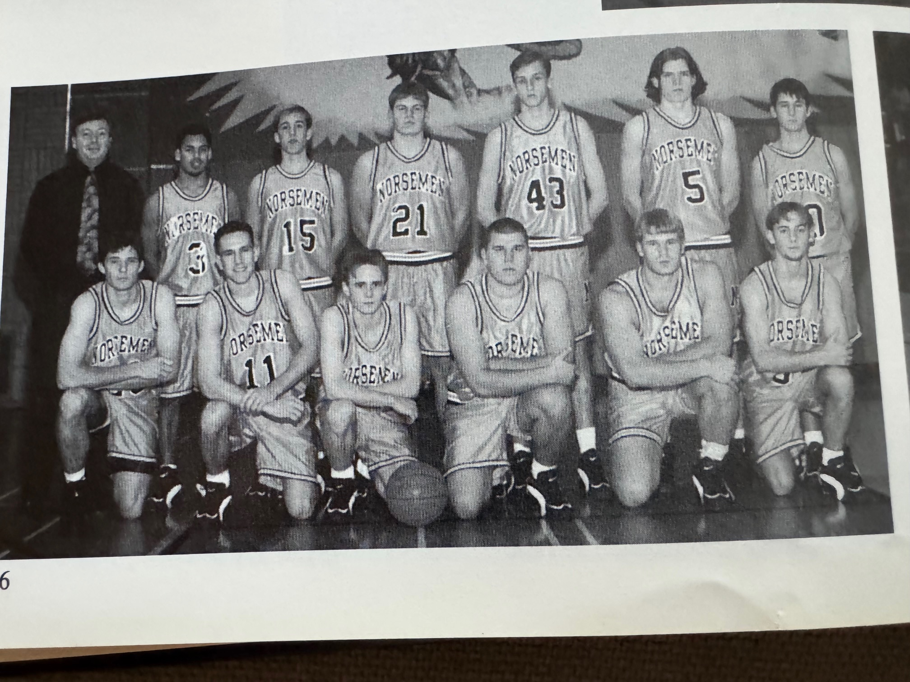
The 1995-96 NORSEMEN
Front Row L-R: Andy Haak, Eric Langdon, Mike Kurlis, Bill Franks, Dan Wegner, Noah Gerard
Top Row: Coach Mark DeLap, Jay Kakaty, Chad Kersman, Matt Wikander, John Westbrook, Nate Bolema, Tom Farmer

1996-97 (Coach Jeff Cooke 2-19, Mason Co WMC champs)
Former Norsemen Jeff Cooke would begin a lifelong commitment to his beloved alma mater as a coach and athletic director at the start of the 1996-97 season. It would take Cooke only a couple of years to bring NM basketball back to prominence, but the first two seasons would be rough. Cooke inherited a team that scored less than 50 points per game and a junior varsity team that also struggled to win a handful of games. Jay Kakaty and NM baseball star Matt Wikander were two regulars who returned for the upcoming season. Cooke began developing players at the elementary and junior high level with a keen eye directed at a very tall red head who was entering sixth grade. In the meantime, NM would have to suffer some growing pains as they would win but two games the entire 1996-97 season.
In the Norse opener with non-league foe Newaygo, the Lions blew open a close game at halftime by outscoring the Norse 25-6 in the third quarter as senior Matt Shephard with 22 points led the Lions to a convincing 76-43 win over NM. Nate Mogren was the only Norsemen in double figures with 16 points.
Whitehall then perhaps gave NM’s young coach some second guesses as to why he took over the coaching duties at his alma mater as Whitehall handed the Norse its worse beating in program history between the two teams with a 102-39 spanking. So dominant were the Vikings in this contest that they had a 45-16 rebound advantage against the much smaller Norsemen. Nate Mogren had 16 points for NM while another newcomer to the NM lineup Caesar Douglas scored 10.
North Muskegon than began a brief four-game series with Freesoil, a tiny school located between Scottville and Manistee that once was a powerhouse Class D team back in the early 1960s led by their legendary coach Max Carey. Freesoil would win one game in these four games series: the first, 57-53. The Pirates overcame a four-point NM lead at halftime to earn their third straight victory while the Norsemen would fall to 0-3. Nate Mogren (12), Jay Kakaty (11) and Nate Bolema (10) all scored in double figures in the loss.
NM would experience a winless season in the West Michigan Conference with the second of their losses a 78-46 loss to Montague. Every Wildcat who suited up for the Wildcats scored while Jay Kakaty was the lone Norseman in double figures with a modest 10 points.
Thanks goodness NM had tiny Walkerville on their schedule. NM defeated Walkerville, but just barely 68-65. NM needed a career high 24 points from Caesar Douglas and some woeful 1-for-7 free throw shooting from Walkerville to earn one of the two-wins NM would earn on the season. Jay Kakaty pitched in with 12 to help the Norse cause.
NM took a 11-10 lead after the opening quarter and kept it close for much of the game in their 65-50 loss to Oakridge, a game that would be considered a nail-biter when one looks ahead to the second game played between the two teams. Nate Morgren led NM with 15 while Matt Wikander chipped in with 11.
Shelby, the defending WMC champs, who went 20-0 during the regular season a year ago, more than doubled the score on NM at halftime and cruised to an 83-49 win on the Shelby home court. All 12 Tigers who suited up in the contest scored as veteran Shelby coach Rick Zoulek was kind to the Norsemen. Nate Mogren led the Norse with 11 points.
A slim crowd was on hand to see Mason County Central derail the Norsemen 86-41. The Spartans were in the first of two great years for the boys from Scottville. Led by the 1998 Muskegon Area Sports Hall of Fame high school sports boy student athlete of the year winner Chad Pleiness, the Spartans would reach the state final four two years in succession. Pleiness, in limited minutes, fired in 22 points to aid the Spartans handing the Norse their seventh defeat. Jay Kakaty had 10 to lead the outmanned Norsemen.
An overtime 63-58 overtime loss to Ravenna would be the closest NM would come to a win in the WMC. After both teams were tied at 52-all after regulation, the Bulldogs outscored the Norsemen 11-6 in the three-minute extra session to push NM deeper into the WMC cellar. It was a three-pointer from NM’s Nate Bolema that sent the game into overtime. Jay Kakaty had 19 points, including four 3-pointers to lead NM, while Matt Wikander with 13 and Nate Mogren had 12.
The Norse let another possible win in the WMC slip away as they led Hart late into the third period only to see the Pirates rally in the fourth to set NM back once more 49-42. Jay Kakaty cashed in 13 points with Nate Mogren also in double digits with 10 as NM falls to 1-9.
The Norse were no problem for Whitehall as the Vikings forged to an 18-point lead at halftime and increased that lead even more in the second half to walk away with an 80-47 victory over the Norsemen. Nate Bolema with 11 and Jay Kakaty and Nate Mogren with 10 led the losing Norse.
Montague stayed one game behind Mason County in the race for the WMC title with their 67-53 conquest of NM. NM stayed close at halftime, but Montague created space by outscoring NM 16-8 to begin the third quarter. Nate Morgren with 13, Jay Kakaty with 12 points and seven assists, and Matt Wickander with 10 points led the Norsemen.
NM won their second, and final game of the long season by defeating Pentwater in a non-conference contest. NM connected on 22 of 29 free throws to aid in their win over the Falcons. Nate Morgren paced the Norse with 19 points and Matt Wikander added 16. Jay Kakaty tallied 15 points and five assists for the Norse and Nate Bolema had 10 rebounds.
NM could not celebrate for long as their next game with Oakridge was not pretty. There was no ‘mercy’ rule in 1997 as there is today, and Oakridge surely showed no mercy. Oakridge opened the game by going on a 20-2 run to begin the first quarter and they added insult to injury with a 31-2 romp in the fourth quarter. The 93-23 final was the second largest margin of defeat in NM program history. One would also have to go all the way back to 1948 when NM scored less than 23 points in a game. Jay Kakaty with seven points was the only NM player who scored more than three points in the debacle. The immediate future didn’t bode well for NM as the JVs lost to Oakridge by 40.
After losing their previous game by 70, to lose by only five points, 53-48 to Shelby had to feel like a moral victory for the Norse. The game was even at halftime and NM trailed by only two heading into the fourth quarter. Nate Wikander and Nate Bolema had big games for NM in the loss. Wikander had 18 points while Bolema had a season high 12 points and 12 rebounds.
The Norsemen again flirted with victory in their next contest at Hart. NM led by three points at halftime but a bad third period led to a Hart rally and a 59-50 loss for the Norsemen. Hart doubled the score on NM in the third 18-9 to dispel any NM hopes for their third victory of the season. Matt Wikander had his season high of 19 points in the loss with Nate Mogren chipping in with 15.
NM was headed for another bad defeat in their non-conference clash at Holton as they were trailing 37-20 at halftime. The Norse then had their best third quarter in recent memory as they outscored Holton 28-8 to lead going into the final quarter. NM couldn’t maintain that momentum in the final quarter as Holton regained their poise and held off the Norsemen 69-64. Nate Mogren had a season high 24 points for the Norse, Jay Kakaty added 15, Matt Wikander 11 and Nate Bolema 10.
The final four games of the season would not bode well for the Norsemen. The first of those final four games was at Scottville to play the WMC champs. Mason County Central head coach Tim Genson was kind to the Norsemen. The Spartans had a commanding 40-19 lead at halftime, but Genson didn’t have his Spartans pour it on the outmanned Norse as they won ‘only’ 71-42, and it could have been worse. NM was deprived of a double-digit scorer, but Jay Kakaty came close with nine points.
NM equaled their lowest scoring mark since 1948 for the second time during the season with a 67-23 loss to Muskegon Catholic. NM never scored more than seven points in any quarter as MCC had their way with the Norsemen. For the second game in a row NM had no player score in double figures. Known more for his low scoring on the golf course, Casey Farwig had six points for the low-scoring Norsemen.
Any hopes for NM winning a game in the West Michigan Conference were dashed by Ravenna as the Bulldogs bolted out to a 31-20 lead at halftime and kept the same pace in the second half to ensure that the Norse would finish the season winless in the WMC. Jay Kakaty and Nate Mogren each had a modest 10 points to lead the Norsemen.
The season came to a merciful end and who else would make the Norsemen turn in their uniforms then West Michigan Christian. Again, as in the recent meetings in the playoffs the Norsemen couldn’t handle the Warriors pressure defense. NM had more turnovers (23) in the first half than points (19) as the Warriors manhandled the Norsemen 85-47. “We just couldn’t handle their pressure and committed too many turnovers”, said NM coach Cooke after the game. “It’s been a disappointing season, but I’m proud of the way the kids have kept after it and the effort they have put forth every game.”

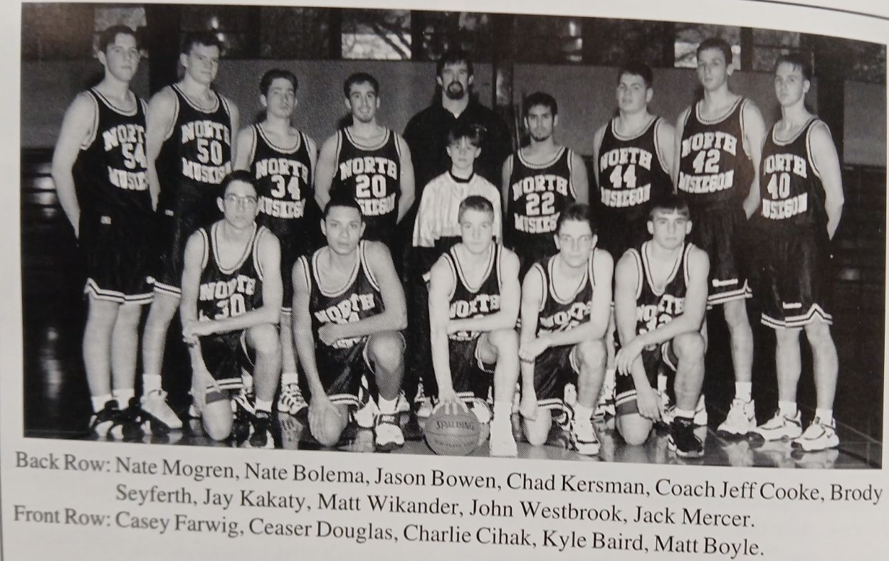

The 1996-97 NORSEMEN

N Muskegon 43 Newaygo 76 Nate Mogren 16
N Muskegon 39 Whitehall 102 Mogren 14, Caesar Douglas 10
N Muskegon 53 Freesoil 57 Mogren 12, Jay Kakaty 11
N Muskegon 46 Montague 78 Kakaty 10
N Muskegon 68 Walkerville 65 Douglas 24, Kakaty 12, Mogren 9
N Muskegon 50 Oakridge 65 Mogren 15, Matt Wikander 11
N Muskegon 49 Shelby 83 Mogren 11
N Muskegon 41 Mason Co 86 Kakaty 10
N Muskegon 58 Ravenna (ot) 63 Kakaty 19, Wikander 13, Mogren 12
N Muskegon 42 Hart 49 Kakatty13, Mogren 10
N Muskegon 47 Whitehall 80 Nate Bolema 11, Kakaty & Mogren 10
N Muskegon 53 Montague 67 Mogren 13, Kakaty 12, Wickander 10
N Muskegon 65 Pentwater 50 Mogren 19, Wikander16, Kakaty 15
N Muskegon 23 Oakridge 93 Kakaty 7.
N Muskegon 48 Shelby 53 Wikander 18, Bolema 12
N Muskegon 50 Hart 59 Wikander 19, Mogren 15
N Muskegon 64 Holton 68 Mogren 24, Kakaty 15, Wikander 11
N Muskegon 42 Mason Co 71 Kakaty 9
N Muskegon 23 Musk Catholic 67 Casey Farwig 6
N Muskegon 39 Ravenna 58 Kakaty & Mogren 10
N Muskegon*47 WMC 85 Kakaty 12, Wikander 11

1997-98 (Coach Jeff Cooke 6-16, Mason Co WMC champs)

NM would struggle in Jeff Cooke’s second year as the NM head coach, but help was on the way. Cooke welcomed the return of 6’4 Nate Morgren, NM’s leading scorer from the previous season and Nate Bolema, another 6’4 performer who reminded your author of his father Ken Bolema, NM’s star player from the mid 1950s. Caesar Douglas, who showed glimpses of potential in his junior year would be a much-improved player from the 1996-97 season. NM would win six games during the current season, a season that would be a building block for some of the best teams in NM history in the not-too-distant future. As far as the West Michigan Conference was concerned, the league was still basking in the glory of both Oakridge and Ravenna winning state championships in football.
NM would open with Newaygo for the 8th straight season. Not only would 1997-98 be the last time the Norsemen had Newaygo as their opening opponent, but it would also be the last time as of this writing in 2024 that they would play Newaygo in a game. Newaygo would win their fifth straight game against NM to conclude the series, but the final score was much closer than the last two games between NM and the Lions. The Norse dropped a tight game to Newaygo 64-60, a vast improvement over their last two games with Newaygo that resulted in blow-out victories for the Lions. NM connected on nine 3-pointers, five from Caesar Douglas while Nate Mogren dumped in 22 points for NM.
NM fans were hopeful that Whitehall’s resounding 82-38 blasting of NM wouldn’t signify another disastrous season for the Norse. The Vikings shot the lights out in the first half as they jumped out to a 41-18 lead at halftime. It wouldn’t be the last time NM took their lumps during the season, but there would be some brighter days ahead. Nate Mogren led NM with a modest 10 points.
NM needed all of Nate Mogren’s career high 29 points in their 83-81 overtime win over Freesoil. NM outscored the Pirates 9-6 in the overtime session to squeeze out a tight win, the first of the young season. Jeff Gowell had 18 points and Nate Bolema 13 in what would prove to be NM’s highest point total for the 1997-98 season.
NM trailed Montague by only four points heading into the final quarter. The visiting Wildcats then had their best quarter, outpointing the Norse 26-21 in the game’s final eight minutes to down the Norsemen 66-57. Nate Mogren continued his torrid scoring with 26 points with his front-line running mate Nate Bolema adding 16 points.
NM welcomed in the New Year with a resounding 72-48 victory over tiny Walkerville. A big second quarter where the Norse outpointed Walkerville 24-13 gave NM a comfortable 19-point halftime lead in their 72-48 victory. Nate Mogren again surpassed the 20-point mark with 21 with Caesar Douglas adding 15. Jeff Gowell had a double-double for the winners with 10 points and 10 rebounds.
Hard to believe that a team can lead at the end of the first quarter 19-17 yet lose by 34 points 80-46, but that’s what happened in yet another NM loss to Oakridge. The Eagles outscored NM 43-10 in the second and third quarters to turn the game into a rout. Nate Mogren finished with 14 points and Nate Bolema had 10 as NM was still searching for its first win in the WMC since 1996.
NM played Shelby much closer, but the Blue & Gold was still struggling to put points on the board. NM trailed by two at halftime before the Tigers pulled away in the second half to down NM 57-43. Nate Mogren led the Norse in scoring for the seventh straight game with 13 points, two more than Caesar Douglas.
A 10-0 run by Hart at the start of the final quarter turned a close game into a big 75-57 victory over NM. Turnovers (19) hurt the Norse chances for a WMC victory. Caesar Douglas took scoring honors away from Nate Mogren with a game high 16 points and 11 rebounds. Mogren did tally 14 points and Nate Bolema 11 for the Norse as they were still searching for that elusive first conference victory.
The chances for NM getting that first conference victory were nil as the Norse next faced arguably the best team in Mason County Central history. The Spartans jumped out to a 21-8 lead after the first quarter and by the time the final buzzer sounded MCC had doubled the score on NM 86-43. The good news for NM, coach Cooke was able to use 12 of his players and 11 scored. The bad news --- nobody for NM scored more than 7 points.
Charlie Cihak, an ace pitcher on the NM baseball team, only had four points but two of his points proved to be the game winner as he drilled a baseline jumper in the game’s final moments to give head coach Jeff Cooke his first ever victory in the West Michigan Conference, a 58-57 win over Ravenna. Caesar Douglas took scoring honors with 20 points with Nate Mogren adding 16 as the monkey was now off the back for a conference win.
Whitehall jumped out to a 29-6 first quarter lead and never looked back as Whitehall made it a clean sweep over the Norsemen with a solid 85-52 blitz of the Norsemen. A young sophomore for the Vikings who had a ‘pretty’ good baseball career, Nate McLouth, was one of five Vikings in double figures for Whitehall. Nate Mogren and Jeff Gowell scored 12 points apiece for the Norse.
In a near carbon copy of their previous game with Whitehall the results were nearly identical with the Norse giving up 85 points while scoring 55 in a loss to Montague. The game did not get out of hand until the final quarter when Montague expanded an 11-point third period lead into 30 following a 29-10 run in the fourth quarter. Again, it was Nate Mogren who led NM in scoring with 19 points.
NM feasted on their fellow Class D opponents during the season as five of their six wins came against teams in their own class. Both teams had huge quarters in this contest, but NM’s 25-12 run in the second was slightly larger than Pentwater’s 15-4 advantage in the third quarter as NM edged the host Falcons 64-59. The Norse fared well at the free throw line as junior Jason McCollum went 7-7 from the line in the final eight minutes and Nate Bolema made 6 of 8 in the fourth quarter to ice NM’s fourth win of the season. Caesar Douglas led NM with 20 points, Bolema finished with 17 and McCollum’s 12 markers would be a season high.
NM showed vast improvement in their second game on the season with Oakridge. After being blown out by nearly forty points in their first meeting the Norsemen were on the cusp of a possible upset as they led 28-21 at halftime. However, the Eagles outscored the Norsemen 54-33 in the second half to earn a 74-61 win over NM. Nate Mogren was the big scorer for the Norse with 18 points.
Shelby once again emptied their bench, and every Tiger suited up for coach Rick Zoulek scored in the Tigers 69-47 win over the Norsemen. Only Nate Bolema was in double figures for the Norse with 10 points.
Playing without an ailing Nate Mogren, the Norse were no match for a hot shooting Hart team as NM was drubbed 90-67. Caesar Douglas helped take up some of the lost production with Mogren sidelined as he tallied a season high 23 points followed by Jeff Gowell with 14 and Nate Bolema with 10.
North Muskegon put up four solid quarters to defeat Holton 82-55 to earn win number five on the season. The Norse got a season high 18 points from Charlie Cihak and help from several Norsemen to aid in the non-conference victory. Caesar Douglas helped with 17 points and 12 rebounds, Jeff Gowell scored 14 and dished off five assists while Nate Mogren was back in the lineup and scored 11 points,
It surely was no disgrace to lose to Mason County Central in 1998. This was arguably the best team in Scottville/Mason County Central’s history --- never mind --- it was the best team ever fielded by MCC. The Spartans would go undefeated until they lost in front of 12,000 fans in the state Class C finals to Detroit DePorress. The leader for the Spartans was Chad Pleiness, a 6’6 post player who was not only all-state in basketball, but also football where he was headed to Central Michigan on a football scholarship. However, his best sport was probably baseball where he surely would have made all-state in if they had all state teams for baseball in 1998. Pleiness would eventually sign a professional contract to play baseball where he played in the minor league for a few seasons. The catalyst for the Spartans was a foreign exchange student who traveled all the way from Western Australia, Adrian Whitten. Whitten was the final piece of the puzzle that propelled MCC to an unbeaten season until they lost to Deporres, a school West Michigan teams could never beat at the state finals in any sport. Whitten was your quintessential point guard with great hands, and a good shooter who could handle the ball like a seasoned pro. Pleiness had 19 points and 10 rebounds in limited minutes against the Norse while Whitten recorded 18 points, five steals and five assists. Jesse Deering was another top-notch player for the Spartans with 14 points and seven assists. For the outmanned Norsemen, Nate Bolema and Caesar Douglas had nine points.
After finally winning a game in the West Michigan Conference earlier to Ravenna, the Norse had high hopes of repeating in their second match. A win would tie Ravenna for 7th in the WMC, no mean feat but better than being alone in the cellar. However, the cellar it would be for the Norsemen as Ravenna played inspired ball on parents’ night in Ravenna to defeat NM 71-59. Nat Mogren gave it his all and scored 23 points to lead the Norse that left them with a 1-13 record in the WMC and 5-14 overall.
NM would play Muskegon Catholic in the final game of the regular season. In 1998 MCC was a member of the River Valley Conference that was stacked with seasoned basketball teams, including Tri-Unity Christian, Covenant Christian and West Michigan Christian, a trio that has won numerous state championships over the years. MCC won the season finale 68-54, turning a two-point lead at the end of the third quarter into a 14-point lead after outpointing the Norse 22-10 in the final quarter. Caesar Douglas (17) Nate Bolema (13) and Nate Mogren (12) provided all but 12 of NM’s points.
North Muskegon would open with Saugatuck for the 5th time in the 1990s and all five games were won by the Norse. The Norse earned a berth in the finals with a tight 66-61 win over Saugatuck thanks to a great night from Jeff Gowell. The starting shortstop in the spring for coach Walt Gawkowski’s baseball team, had a season high 21 points that included hitting 8 of his 9 free throws. Nate Mogren continued his steady play for the season with 15 points.
With their tournament nemesis West Michigan Christian now playing in Class C, the door was open for the Norsemen to win their first district championship since 1974. It was not to be as Holland Calvary Baptist, a fledgling new school who had never won a district took home the trophy with a 59-55 victory over the Norsemen. An 18-5 run by Holland in the second quarter put NM in a big hole. The Norse came back and tied the score twice late in the game on a pair of 3-pointers from Charlie Cihak, but Calvary Baptist answered each time. Nate Mogren ended his senior season with a game high 20 points with Cihak adding 11.

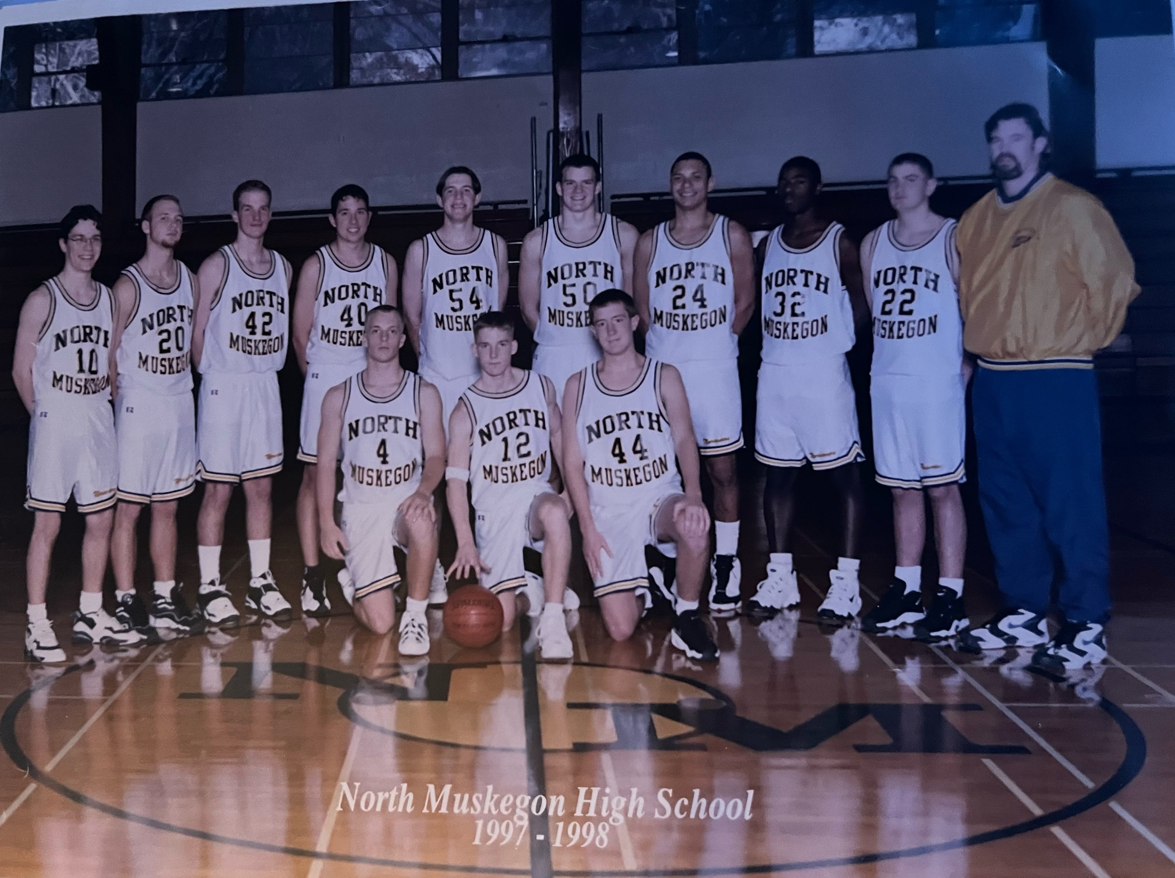

The 1997-98 NORSEMEN

Kneeling front L-R: Jason Bogue, Charlie Cihak, Ryan Campbell
Standing L-R: Kyle Baird, Jack Mercer, Steve Moore, Casey Farwig, Nate Mogren, Nate Bolema, Ceasar Douglas, Ben Lewis, Jeff Gowell, Coach Jeff Cooke

N Muskegon 60 Newaygo 64 Nate Mogren 22, Caesar Douglas 19
N Muskegon 38 Whitehall 82 Mogren 10
N Muskegon 83 Freesoil (ot) 80 Mogren 29, Jeff Gowell 18, Nate Bolema 13
N Muskegon 57 Montague 66 Mogren 26, Bolema 16
N Muskegon 72 Walkerville 48 Mogren 21, Douglas 15, Gowell 10
N Muskegon 46 Oakridge 80 Mogren 14, Bolema 10
N Muskegon 43 Shelby 57 Mogren 13, Dousglas 11
N Muskegon 57 Hart 75 Douglas 16, Mogren 14, Bolema 11
N Muskegon 43 Mason Co 86 State finalist Spartans double the score
N Muskegon 58 Ravenna 57 Douglas 20, Mogran 16
N Muskegon 52 Whitehall 85 Gowell & Mogren 12
N Muskegon 55 Montague 85 Mogren 19
N Muskegon 64 Pentwater 59 Douglas 20, Bolema 17, J. McCollum 12
N Muskegon 61 Oakridge 74 Mogren 18
N Muskegon 47 Shelby 69 Bolema 10. Mogren 9
N Muskegon 67 Hart 90 Douglas 23, Gowell 14, Bolema 10
N Muskegon 82 Holton 55 Charlie Cihak 18, Douglas 17, Gowell 14
N Muskegon 41 Mason Co 77 Bolema and Douglas 9
N Muskegon 59 Ravenna 71 Mogren 23, Gowell 13
N Muskegon 54 Musk Catholic 68 Douglas 17, Bolema 13, Mogren 12
N Muskegon*66 Saugatuck 61 Gowell 21, Mogren 15
N Muskegon*55 Holl. Cal Bap. 59 Mogren 20, Cihak 11

1998–99 (Coach Jeff Cooke 12–10, Shelby WMC champs)

Three players who saw plenty of playing time for NM the previous year return for the 1998-99 season and all would show much improvement over the previous season. Jeff Gowell, Jason McCollum and Jason Bogue would be joined by sophomores Nick Marietti and 6’4 Steve Privasky as the Norse will experience their first winning season since 1985, back when the Norsemen were coached by Dave Cooke, current coach Jeff Cooke’s father.
It didn’t look like NM was headed for a winning season if one was to look at NM’s season opener with Muskegon Catholic. The Norse were outscored in every quarter by MCC in a 62-43 loss. Jason McCullom had 14 to lead the Norsemen with sophomore Steve Provasky adding 10. However, the Norsemen would improve quickly.
NM bounced back just a day later to defeat Ravenna 63-49, only the second win in conference play in the past three seasons, with both wins coming against the Bulldogs. NM never trailed in the game and enjoyed slight advantages in every quarter to even their season record at 1-1. Jeff Gowell led Norse scorers with 15 points with Jason Bogue (14) and Steve Privasky (10) also in double figures.
Freesoil may have a tiny enrollment, but history has shown this little school near Manistee can play basketball. The Norsemen needed a 3-pointer from Jason McCullom with just under a minute to go in the game to finally take the lead from the Pirates. Jeff Gowell then added a pair of free throws to give NM a tight 61-59 win over Freesoil. McCullom led the Norse with 19 points and five steals. Gowell connected for 17 points and Steve Privasky for the third straight game added 10 points.
Whitehall jumped out to an early 15-6 lead at the end of the first quarter and NM couldn’t quite recover in losing to Whitehall 75-68. NM would not go away and outscored the Vikings over the final three quarters only to come up short of a victory. Jason Bogue had a great game for NM with 21 points while Jeff Gowell contributed 15 points and five assists. Jason McCollum netted 11 while steady Steve Privasky again scored 10 points. Sophomore Nick Marietti keeps improving with every game as he had a team high six assists while also adding eight points.
NM began the New Year with a resounding 79-41 rout of an outmanned Walkerville team. NM led at halftime 47-16 as Norse head coach Jeff Cooke used plenty of his reserves in the second half. Jason Bogue in limited minutes had 14 and Jason McCullum 11 as the starters sat for much of the second half. Ben Lewis had his season high of 11 as 10 Norsemen scored in the game.
Once trailing by as many as 14 points NM battled back to close to within four points with less than two minutes to play only to fall short to Montague 74-67. Jason Bogue had 19 points and five assists for NM while Jeff Gowell added 15 points and 10 rebounds as NM fell to 3-3 on the season.
Norse fans had to believe that they may never beat Oakridge again as the Eagles won their 22nd straight victory over the Norsemen 85-72. The 13-point deficit was a far cry from recent blowouts suffered against the Eagles. Perhaps when the two teams meet in the rematch later in February the Norse could stop the skid. NM garnered a lot of momentum for the rematch as they once trailed Oakridge by 18 at one point early in the fourth quarter, trimming the lead to four points before the Eagles pulled away on made free throws to make the score look worse than it could have been. Jeff Gowell led four Norsemen in double figures with 16 points. Jason McCullum (15), Steve Privasky (12) and Jason Bogue (10) all reached double digits.
The Norsemen led at halftime, but NM let one get away from them in losing to Shelby 64-56. Shelby erased a four-point halftime deficit and took the lead for good with an 18-13 third-quarter run. The Tigers than proceeded to ice the game by hitting 9-of-9 free throws in the fourth quarter to seal the win. Jason McCullum with 15 and Steve Privasky with 14 led the Norse.
NM finally beat someone other than Ravenna in the WMC with a 56-49 win over Hart. The Norse connected on 22 of 24 free throws but it took a couple of Jeff Gowell made 3-pointers late in the game to put away Hart 56-49. Jason McCullum had a season high 20 points, including 12-13 made free throws while Jeff Gowell was 6-6 at the line and 14 points for the Norse.
Mason County Central, with only one starter returning from their state runner-up team from last season pulled away from the Norsemen in the final quarter to defeat NM 64-54. It wasn’t until there was only four minutes left in the game that Mason County took the lead for good over the Norsemen. Sophomore Nick Marietti hit three 3-pointers and scored a season high 15 points to lead the Norse. Jason McCullum followed with 14 and Steve Privasky had 11.
It was now time for the Norse to begin their best run of the season as they would embark on a five-game winning streak. NM began with a 53-43 win at Ravenna. The Norse, trailing 28-22 at halftime, went on a 19-6 run in the third quarter to pull away from the host Bulldogs. Sophomore Steve Privasky took scoring honors with 16, points followed by Jason McCullum with 13 and Jeff Gowell with 12.
You may have to go back into the 1940s or maybe the 1930s to find when an opponent was shutout for an entire quarter. Such was Calvary Baptist’s fate when they were outscored 17-0 in the third quarter in NM’s 64-27 rout of winless (0-10) Calvary Baptist, who also went winless the previous season. NM substituted freely the entire game and only Steve Privasky played long enough to get into double figures as the sophomore center had 13 points and eight rebounds.
The next game with Pentwater was equally lopsided as NM had their highest point total of the season in their 86-50 whipping of the Falcons. Jeff Gowell had the game of his life as he became the 18th member of the NM 30-point club with 32 points as NM climbed above the .500 mark for the first time in years at this stage of the season with a 7-6 record. Steve Privasky had 16 as did Jason Bogue.
After losing 13 of their previous 14 games against Montague, the Norse would begin a streak (winning) of their own against the Wildcats. NM would split the season series with the ‘Cats’ with a 75-59 win. The Norse, after leading by one at the halftime break 32-31, went on a 21-8 run in the third quarter and continued with a 25-20 finish in the fourth to win going away. The Norse were led by a couple of baseball stars in the spring, Jason Bogue with 23 and Jeff Gowell with 18. Steve Privasky had a big game with 17 points and nine rebounds. The game was well covered by Muskegon Chronicle’s brilliant sports editor and writer Cindy Fairfield. Montague head coach Troy Love had special praise for NM’s coach Cooke in a feature story of the contest. “He’s done a great job,” said Lowe of Cooke. “The kids he has now have come up through his program. You can see he teaches the kids to play unselfishly. He’s the kind of guy who emphasizes the right things like sportsmanship and attitude. Give a ton of credit to coach Cooke. His team just plain outworked us on defense,” complimented coach Love. Perhaps the games leading scorer Jason Bogue summed it up for Norsemen basketball: “Basketball here used to be a sport we played before baseball or track.”
Losing 13 of 14 to Montague paled in comparison of the domination Oakridge had over the Norsemen during the 1990s as NM failed to win a single game in the 90s as the losing streak had reached 22. That streak also came to an end as NM defeated Oakridge 62-49. And the Norse got the victory because they got help from players other than the four leading scorers going into the game: Jeff Gowell, Jason Bogue, Jason McCallum and Steve Privasky. Nathan Crosswait had a season high 16 and Nick Marietti, who missed the win over Montague as he was on an academic trip to our nation’s capital had 10.
NM’s winning streak came to an end at five as the Norse lost to a 14-1 Shelby team yet to be defeated in the WMC 76-59. Shelby let it be known to the Norse early that this game belonged to the Tigers as they cruised to a commanding 42-18 lead at halftime before taking the foot off the gas. NM outscored Shelby’s reserves in the final quarter 23-13, Jason McCullum’s 18 points led NM with Jeff Gowell trailing with 11.
Sophomore Nick Marietti was the hero of the hour for NM when he drilled a shot off an inbounds pass with four seconds left in the game to deliver a 59-58 win for the Norsemen against Hart. It was a see-saw battle in the fourth quarter in the tight game as each team scored 20 points, before Marietti had the clinching two-pointer. Jason Bogue scored only four points but that didn’t define his value in this game. Bogue hounded Hart’s Scott Helms, a 23 plus per game scorer and held him to 17 points. Jeff Gowell had 17, Jason McCullum 13 and Nathan Crosswaite 11 as NM improves to 10-7 overall and 6-6 in the WMC.
The Norse made their annual long jaunt to Scottville, and the results were the same as most of those trips, a Mason County Central win and a NM loss. NM kept the game from being a runaway as Jeff Gowell’s five 3-pointers kept the game within reach in the 55-46 loss to the Spartans. Gowell, with 17 points was the only Norsemen in double figures.
In the first regularly schedule game between the two teams in program history, the Norsemen raced out to an 18-4 lead after the first quarter and then played steady ball the rest of the game to defeat Holland Calvary Baptist, a team that deprived NM of a district title a year ago, 59-48. Steve Privasky pumped in 17 points and grabbed 12 rebounds; Jeff Gowell totaled 11 points with 10 boards while Jason Bogue added a dozen points for NM.
The Norse loss their second game to Whitehall by seven points, the same margin of defeat in the first meeting, but this game was much tighter. NM took a 46-45 lead on a bucket by Nathan Crosswait before Whitehall hit some big shots down the stretch to end NM’s regular season at 11-9. Steve Privasky led a balanced NM offense with 13, while Crosswait had 12 and Jeff Gowell 11.
There was good news and bad news for the upcoming Class D tournament. The good news was their first opponent would be Calvary Baptist, a team that hadn’t won a game in two seasons. The bad news, waiting in the finals was West Michigan Christian who was back in Class D after one year in Class C. The Norse took care of business as expected with a 59-48 victory over Calvary Baptist, but the Norse looked far from sharp in a game that should have been a runaway win.
In a streak that defies common logic, West Michigan Christian made it 11 straight games in a row when WMC would eliminate NM in the playoffs. The game was never in doubt as the Warriors pummeled the Norsemen 86-46 on their way to eventually winning the Class D state championship. Nate Bultema, who sank the winning free throw with no time on the clock to defeat Detroit City at the Breslin Center at MSU, had 26 points in the rout of the Norse.
Despite the loss to a superior opponent in WMC, the Norsemen had turned their program around with their first winning season in 14 years. It would get even better as the next century would see the debut of a very tall red head who would attract big crowds to the Northside, not just fans but big-time college coaches.

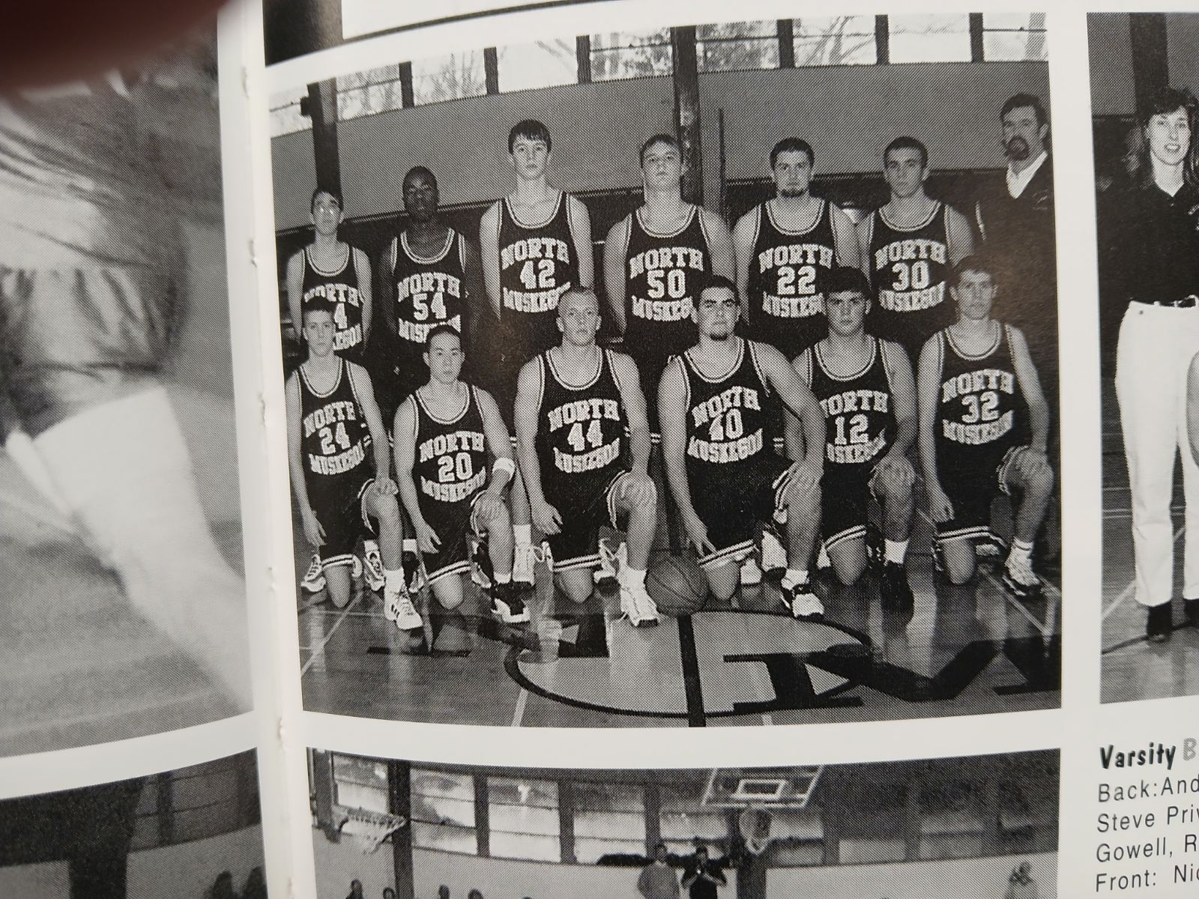
The 1998-99 NORSEMEN

Front Row L-R: Nick Marietti, Jeff Lee, Jason Bogue, Jake McCullum, Anthony Visconti, Rob Poubelle
Back Row L-R: Andrew Peterman, Ben Lewis, Steve Privasky, Nathan Crosswait, Jeff Gowell, Rick Martin, Head Coach Jeff Cooke

N Muskegon 43 Musk Catholic 62 Jason McCullom 14, Steve Privasky 10
N Muskegon 63 Ravenna 49 Jeff Gowell 15, Jason Bogue 14
N Muskegon 61 Freesoil 59 McCullum 19, Gowell 17, Privasky 10
N Muskegon 68 Whitehall 75 Bogue 21, Gowell 15, McCullum 11
N Muskegon 79 Walkerville 41 Bogue 14, McCullum 11, Ben Lewis 11
N Muskegon 67 Montague 74 Bogue 19, Gowell 15, McCullum 11
N Muskegon 72 Oakridge 85 Gowell 16, McCullum 15, Privasky 12
N Muskegon 56 Shelby 64 McCullum 15, Privasky 14, Bogue 10
N Muskegon 56 Hart 49 McCullum 20, Gowell 14, Privasky 13
N Muskegon 54 Mason Co 64 Nick Marietti 15, McCullom 14
N Muskegon 53 Ravenna 43 Privasky 16, McCullum 13, Gowell 12
N Muskegon 64 Calvary Baptist 27 Privasky 13
N Muskegon 86 Pentwater 50 Gowell 32, Privasky & Bogue 16
N Muskegon 75 Montague 59 Bogue 23, Gowell 18, Privasky 17
N Muskegon 62 Oakridge 49 Nathan Crosswait 16, Marietti 10
N Muskegon 59 Shelby 76 McCullum 18, Gowell 11
N Muskegon 59 Hart 58 Gowell 17, McCullum 13, Crosswait 11
N Muskegon 46 Mason Co 55 Gowell 17
N Muskegon 59 Holland Cal Bap 48 Privasky 17, Bogue 12, Gowell 11
N Muskegon 53 Whitehall 60 Privasky 13, Crosswait 12, Gowell 11
N Muskegon*59 Calvary Baptist 48 Marietti & McCullum 12.
N Muskegon* 46 WMC 86 McCullum 14

1999-2000 (Coach Jeff Cooke 14-8, Mason Co WMC champs)

After their first winning season in more than a decade, the Norse were looking for even better things in the 1999-2000 season. Two starters returned from the previous season in 6’7 junior center Steve Privasky and junior guard Nick Marietti. Also returning was a much-improved Nathan Crosswait. NM would get a special boost from Spencer Suchy, a senior transfer from Reeths Puffer. The big news, however, was the arrival of a 6’8 freshman that heralded the beginning of the Drew Naymick era. With a 6’8 Naymick paired with the 6’7 Privasky things were looking up for the Norsemen. Also earning a berth in the starting lineup was junior guard Rod Melton who would put up some big number in the upcoming season.
Muskegon Catholic defeated the Norsemen for the fifth straight time since the series resumed after the 1962-63 season 52-45. The NM-MCC game, except for a couple of years during the Covid 19 era, has always been the first game on NM’s schedule. All the signs were there that the losing streak to MCC was coming to an end as the Norsemen enjoyed a five-point lead heading into the final quarter. However, the Crusaders caught fire in the game’s final eight minutes outscoring the Norse 21-9 to down the Norse 52-45. Football star Jim Casselman sparked the Crusader’s rally with a couple of steals and scoring 13 of his 15 points in the final quarter. Future NFL star Ruvel Martin scored 10 points and grabbed 10 rebounds for MCC. The Crusaders would have their best start in school history winning their first eight games before losing in game number nine to Tri Unity Christian and their future NBA center Chris Kaman.
There would be a new stat for NM players – blocked shots! Freshman Drew Naymick blocked seven shots in the game with the Crusaders, the first of his many blocked shots that would put him at the top of the list in blocked shots in MHSAA history before his career would come to an end at NMHS. Offensively, Naymick would get off to a modest start for his first few games as he scored only four points in his first game in a Norsemen uniform. 6’7 junior Steve Privasky led NM with 14 points while another junior, Nick Marietti added 10.
NM, trailing by two-points after the opening quarter, decided this game in the second quarter when they outscored Ravenna 21-4 enroute to a 56-45 win. Spencer Suchy led NM with 14 points and Nathan Crosswait had 14 for NM.
6’8 freshman Drew Naymick gave NM fans a glimpse at what he could do with the basketball when he gets it down in the low post as he rifled in 18 points, blocked five shots and grabbed seven rebounds in NM’s 79-48 rout of Freesoil. The game would be the fourth and final game in a series with tiny Freesoil. So outmanned was Freesoil that NM had a 54-17 lead at halftime as coach Jeff Cooke used his entire bench throughout the game. Junior guard Rod Melton had 20 points to lead in the scoring department.
Whitehall did a good job of preventing the Norsemen from getting the ball down in the low post to their two big men, 6-8 Drew Naymick and 6’7 Steve Privasky in a 63-45 win over NM. Instead, the Norsemen settled for outside shots that consistently missed its mark as not one Norsemen scored in double figures. Despite a size disadvantage, Whitehall outrebounded NM 36-14, with 15 of those rebounds coming on the offensive end.
NM would begin the new century with a 63-45 win over Walkerville in the final game of their series that saw NM win 11 of the 12 games played. Nick Marietti had 17 points with 15 of those markers coming on five made 3-pointers while Steve Provasky grabbed 10 rebounds.
NM won their second game in West Michigan Conference play with a 71-62 win over a Montague team still looking for its first win on the season. NM jumped out to an early 20-8 lead and were never threatened as the Norse had balanced scoring in the victory. Steve Privasky had 17, Spencer Suchy and Nick Marietti each had 14 as NM was now 2-1 in WMC play.
Although NM & West Michigan Christian would face each other almost annually in the MHSAA playoffs, the two would face each other in a regular scheduled game for the first time in 15 years with the Warriors winning their 12th straight game over the Norsemen 69-58. A poor second quarter where WMC owned a 23-13 advantage was the difference in the game. NM shot poorly from the free throw line as they connected on only 8 of 20 free throws. Steve Privasky, who would transfer to WMC for his senior year, led NM with 20 points while Rod Melton had 17.
After being on the losing end on many lopsided victories during the 1990s, it was NM’s time for a blowout victory as NM throttled Oakridge 66-30. NM took a commanding 60-22 lead into the fourth quarter that forced a running clock, a new rule NM would have welcomed in many earlier losses to the Eagles. Nick Marietti had a season high 24 points and Drew Naymick added 11 for the Norsemen. The Oakridge game would mark the beginning of a streak whereby Naymick would score in double figures in 14 of his next 15 games.
Shelby was another team that dominated NM during the 1990s, winning 20 of 21 games and the last 12 in a row. The Norsemen’s 76-68 win over the Tigers was another bad streak that came to an end. Drew Naymick had a breakout game as the young freshman scored 11 of his 17 points in the pivotal second quarter when NM outscored Shelby 23-9. Naymick, who had an uncanny knack of not only blocking an opponent’s shots but keeping them in play in the style of the great Bill Russell, had eight blocked shots. Spencer Suchy had a career high 25 points, 11 of his points coming in the final quarter to squelch any thoughts of a Shelby comeback.
NM was all alone in second place, one game behind Mason County Central following their 71-60 victory over Hart. Nathan Crosswait had a career high 25 points, many of his points coming on putback rebounds. Steve Privasky and Rod Melton each had 13 points as NM improved to 5-1 in the WMC.
Any thoughts NM might have had about defeating Mason County went out the window in the third quarter as the Spartans took a two-game lead in the WMC with a 66-40 thumping of the upstart Norsemen. MCC went on a 13-1 run and scored 24 points to start the second half and shut down all the Norse players except Drew Naymick who had 20 points.
The Norse had little trouble in disposing of a 1-11 Ravenna team in a 69-45 romp over the Bulldogs. Steve Privasky had a huge game for NM with 15 points and 17 rebounds to lead the Norsemen who made their first 10 free throw attempts in the first half. Four Norsemen were in double figures with Spencer Suchy (14), Drew Naymick (12) and Rod Melton (11) joining Privasky.
How likely would it be in a game between two Class D schools where two of the players in a game would be future teammates at a basketball blue blood school like Michigan State? Both Drew Naymick and Pentwater’s Jason Aerts would be teammates and lifelong friends for Tom Izzo’s Spartans. Although Naymick had 20 points and Aerts but seven points, it was Pentwater who improved to 10-1 on the season with a 59-54 win over the Norsemen on the Falcons home court. The Falcons Joel Closs was the spark that propelled Pentwater as he scored 24 points, including his 1000th point to lead Pentwater to what would prove to be the final victory over the Norse in the two school’s history. Naymick had 12 blocks in the game, many of those blocks coming from shots attempted by his buddy Aerts. However, it was Aerts and his Falcons that would leave the court as the winners.
In what likely will go down as their biggest win of the season, the Norsemen stopped another losing streak, this time a 72-67 victory over Whitehall. The Norse stopped a Whitehall winning streak that had reached 10 games and broke a tie for second place in the West Michigan Conference. 6’7 Steve Privasky had perhaps his finest game in a Norse uniform with 19 points and six rebounds. The other half of NM’s twin towers, 6’8 Drew Naymick followed with 15 points, seven rebounds and three blocked shots. Four Norsemen reached double figures in the big win; in addition to Privasky and Naymick, Spencer Suchy had 14 and Rod Melton 12 points.
After the big win over Whitehall NM struggled somewhat to earn a 58-51 road victory against a struggling Montague team with a 1-12 record. NM led 27-13 at the halftime break as they were outscored by Montague in the second half to make the final score much closer. Drew Naymick had 14 points and blocked seven shots while Spencer Suchy also netted 14 for the Norsemen. The loss by Whitehall paled when tragedy occurred just days later with of the death of their coach.
There was no 36-point blowout in the second meeting of the season between NM and Oakridge. In fact, the Norsemen 66-30 winners in the first meeting at Oakridge, had to make a furious fourth quarter comeback to send the game into overtime. Spencer Suchy’s 3-pointer with less than a minute to go tied the game. After an Oakridge basket Drew Naymick scored on a putback with three seconds remaining to send the game into overtime. NM then outscored the visiting Eagles by four in the extra session to win 67-63. NM got help from several players in this game. Nick Marietti had 15 points, Rod Melton 14, Spencer Suchy 12, while Drew Naymick filled up the stat sheet with 10 points, 10 rebounds and six blocked shots.
Three days prior to NM’s Tuesday night game with Holton, there was very sad news from Whitehall as the Vikings popular head coach Mike Rohen had died of a brain aneurysm. Many years later, while interviewing at that time the head coach of Jacksonville University, Tony Jasick, I knew that Tony had a young daughter by the name of Rohen. Jasick, who played for Rohen while playing for Whitehall high school, thought so highly of his former coach that he named his daughter after his beloved former coach.
The Holton-NM game was a high scoring affair that was won by the Norse 83-71 as five Norsemen reached double figures led by Drew Naymick’s 19. Steve Privasky added 18, Rod Melton 15, Nick Marietti 14, and Spencer Suchy 10 as NM matched last season’s wins at 12.
NM took an early 20-12 lead after the first quarter and kept up the steady pressure the rest of the way to defeat Hart 65-52. Balanced scoring again was the rule for the victors with four in double figures led by Spencer Suchy’s 18 points, seven assists and five steals. Drew Naymick had 16 points while both Naymick and Steve Privasky each had 10 rebounds. Privasky and Nick Marietti each chipped in with 10 points as NM wins their 13th game on the season, the most wins since their head coach Jeff Cooke was in his senior year back in 1981.
NM’s next game was played on a Monday and there could not have been a bigger contrast in games than the second game of the season between NM and Shelby. After scoring 76 points in a 76-68 win earlier in the season, the Norsemen scored a meager 29 in the second contest in a 37-29 loss to the Tigers. However, a Rick Zoulek coached team had a knack for giving Norse misery over the years. Only Drew Naymick was in double figures for NM with 11 points.
The Spartans of Mason County left little doubt as to who was best in the West Michigan Conference in 2000. The Spartans ran the table in the WMC with a perfect 14-0 record after a convincing 67-44 win over the Norsemen. NM would have to settle for a second-place tie with both Shelby and Whitehall with identical 10-4 WMC records. There was a good post matchup between the Spartan’s 6’8 senior Dan Aultmaan and NM’s 6’8 freshman Drew Naymick. Aultman scored 25 and Naymick 18 with Naymick drawing high praise from the senior Aultman. “He’s going to be a real good player,” said Aultman. “He’s just a freshman, but he was moving me around down there. A couple of times I had to think twice about putting up a shot.”
Playing the Class D district on their home floor NM had no trouble in defeating Holland Calvary Baptist 70-47. Rod Melton scored a career high 28 points that included knocking down six 3-pointers, one away from the record of seven set by Joel Johnson in 1992. There would be no time to rest for the Norsemen because waiting in the wings less than 24 hours later would be their arch nemesis, West Michigan Christian, the defending state Class D champions.
The Norse had the misfortune to run into a buzz-saw as the Warriors connected on nine three pointers to once again eliminate the Norse from the playoffs for the 11th consecutive time. NM got 48 points from Drew Naymick (26) and Rod Melton (22) but received little else from the rest of the team as NM’s season ends at 14-8, their best record since the WMC championship team of 1981. Christian would once again make it to the Class D state finals only to lose to Detroit City. With only one senior graduating, the Norse were hopeful of even better things in 2001.

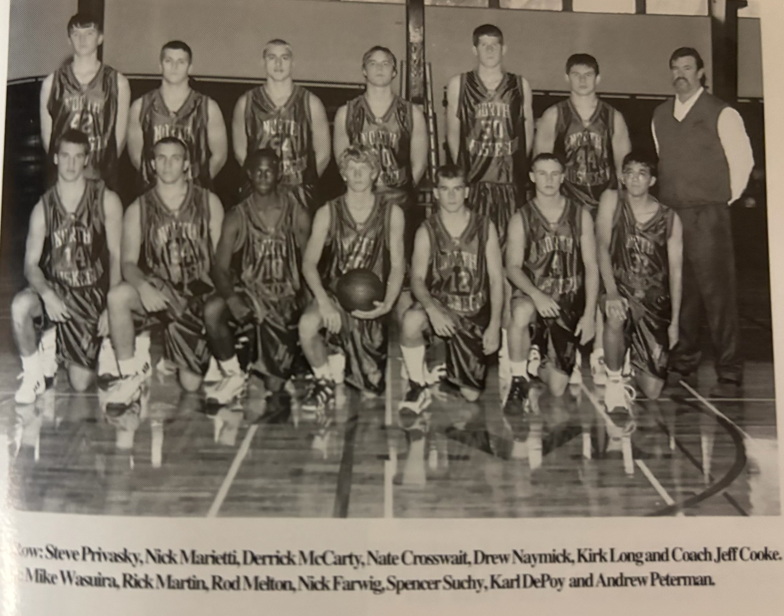
The 1999-2000 NORSEMEN

N Muskegon 45 Musk Catholic 52 Steve Privasky 14, Nick Marietti 12
N Muskegon 56 Ravenna 45 Spencer Suchy 14, Nathan Crosswait 13
N Muskegon 79 Freesoil 48 Rod Melton 20, Drew Naymick 18
N Muskegon 47 Whitehall 63 Crosswait 9, Suchy 8
N Muskegon 63 Walkerville 45 Marietti 17
N Muskegon 71 Montague 62 Privasky 17, Marietti & Suchy 14
N Muskegon 58 WMC 69 Privasky 20, Melton 17
N Muskegon 66 Oakridge 30 Marietti 24, Naymick 11
N Muskegon 76 Shelby 68 Suchy 25, Naymick 17, Privasky 10
N Muskegon 71 Hart 60 Crosswait 15, Privasky & Melton 13
N Muskegon 40 Mason Co 66 Naymick 20
N Muskegon 69 Ravenna 45 Privasky 15, Suchy 14, Naymick 12
N Muskegon 54 Pentwater 59 Naymick 20
N Muskegon 72 Whitehall 67 Privasky 19, Naymick 15, Suchey 14
N Muskegon 58 Montague 51 Naymick & Suchy 14, Marietti 12
N Muskegon 67 Oakridge (ot) 63 Marietti 15, Melton 14, Suchy 12
N Muskegon 83 Holton 71 Naymick 19, Privasky 18, Melton 15
N Muskegon 65 Hart 54 Suchy 18, Naymick 16, Privasky 11
N Muskegon 29 Shelby 37 Naymick 11
N Muskegon 44 Mason Co 67 Naymick 18, Privasky 10
N Muskegon*70 Holland Cal.Bap 47 Melton 28, Naymick 12, Privasky 10
N Muskegon* 68 WMC 83 Naymick 26, Melton 22

2000-2001 (Coach Jeff Cooke 15-6, Mason Co WMC champs)

Expectations were through the roof for the 2000-01 season and why not. NM was returning four starters from their young, but winning team from the previous year.
Both starting guards returned for head coach Jeff Cooke. Now seasoned seniors, with both averaging about 10 points a game in their junior season, Rod Melton and Nick Marietti would bring valuable experience to the backcourt. And NM fans had to be drooling over the thought of seeing 6’9 sophomore Drew Naymick in the front court with 6’7 Steve Privasky. But wait --- During the off season Privasky had made the decision to transfer to West Michigan Christian, even though due to MHSAA rules he would not be able to play for the Warriors until the second half of the season. Derrick McCarty developed into a very good fourth piece of the puzzle, but with the loss of Privasky, NM could never find that fifth man.
NM began the season on a promising note by snapping a six-game losing streak, and fifth in the last five seasons by edging Muskegon Catholic 46-43. Drew Naymick showed his skills early by scoring 19 points, 13 rebounds and six blocked shots. Derrick McCarty helped Naymick on the boards with 12 rebounds while Rod Melton chipped in with six assists and five steals.
In a game tabbed as The Game of the Week in West Michigan, it was the upstart Norsemen hosting Mason County Central, winners of three of the last four West Michigan Conference titles. It appeared as Mason County was going to blow NM out of their own gym as the visitors from Scottville had a stunning 34-14 lead at halftime. The Norse regrouped at halftime and outscored MCC 23-5 in the third quarter and even took a lead on a Nick Mariettu 3-pointer with five minutes left in the game. The Spartans didn’t fold and kept their poise and applied the relenting full court pressure that created 25 NM turnovers to win going away 58-49. The Norse didn’t help themselves down the stretch as they made only 1 of 9 field goals. Rod Melton topped NM scorers with 16 with Drew Naymick adding 14.
Your author, as well as hundreds of his former players and students, were saddened with the passing of long-time NM coach, teacher and athletic director, Bob Morris, who passed away on December 14, 2000. Morris not only was my coach at NMHS during my prep days but became a close friend. I was humbled to give the eulogy for this great man at his funeral.
The Norsemen built a 38-27 lead after three quarters and kept a steady pace in the final quarter to subdue winless Ravenna 53-40. The three returning starters from the previous season paced NM with Drew Naymick (15), Rod Melton (14), and Nick Marietti (13) scoring all but 11 points for NM.
The Norsemen then participated in a holiday tournament hosted by Spring Lake. No longer would NM play a pair of Class D schools, Walkerville and Freesoil who combined won only two games against NM. The Norsemen’s opening round opponent was Godwin Heights, a team North Muskegon hadn’t played since they were only a 10th grade school in 1933. Sixty-Seven years later they would meet in Spring Lake, and the results were the same as their first meeting, a Godwin Heights victory, 61-45. Drew Naymick with 18 points was the only Norse player who scored more than six points against the Furniture City five. NM was unable to handle the pressure defense from Godwin Heights as they committed 23 turnovers. Naymick accounted very well of himself with 11 rebounds and six blocked shots.
The Norse would then play Whitehall in a consolation game with the Vikings edging the Norse 67-65. The Viking’s Brent Smith’s 3-point play with 15 seconds left was the clincher for Whitehall in a game that was tight all the way. Drew Naymick again was the only NM player to reach double figures with a season high 26 points while grabbing 13 rebounds.
Oddly enough, Whitehall and NM would meet once again in a rare back-to-back matchup to begin 2001. NM would win the second of three games played in the season between the two rivals as Rod Melton led the way with 16 points, seven assists and five steals. Drew Naymick finished with 14 points and 14 rebounds while Derrick McCarty also had 14 for the Norsemen.
NM would then face their arch nemesis West Michigan Christian for the second year in a row as the two schools would continue a regular season schedule that is still in effect as of this writing in 2024. The Norse finally snapped a 13-game losing streak to the Warriors with a 53-46 victory. Drew Naymick nearly became the first NM player in program history to record a triple double as he finished with 19 points, 10 blocked shots and nine rebounds. Rod Melton also had a fine game for NM with 14 points, eight rebounds and six assists. The senior guard also came through in the stretch coming up with two steals which he converted into layups in the game’s final two minutes to seal the deal for NM. Derrick McCarty also was in double figures for the Norse with 10 points. The Warriors were playing without 6’7 senior Steve Privasky who stunned Norse followers when he decided to transfer to WMC after his junior year at NMHS. Due to MHSAA rules Privasky would have to sit out the first half of the season until after the semester break, a surprising decision to say the least.
Drew Naymick had another stat killing night in NM’s 64-57 win over Montague. Naymick scored 23 points, grabbed 11 rebounds, blocked eight shots and had four steals. NM led the Wildcats 34-14 at halftime and then held on to collect their 5th victory of the season. Also in double figures for NM were Rod Melton with 14, Nick Marietti with 11 and Mike Wiasura with 10.
Balanced scoring keyed NM’s 65-45 win over Oakridge led By Rob Melton’s 19 points and eight assists. Nick Marietti had 11 points as did Drew Naymick who also grabbed 10 rebounds and blocked six shots. Mike Waisura was in double figures for the second straight game with 10 points.
NM hit their free throws at the right time and moved into sole possession of first place in the West Michigan Conference with a 76-53 victory over Shelby in a game much closer than the final score. Leading by just two points at 52-50 at the 5:25 mark of the fourth quarter, NM went on a 9-0 run to pad their lead. NM went to the line 22 times in the fourth quarter and converted 18 of those free throws to earn the victory. Drew Naymick nearly had another triple double as he scored 16 points 12 rebounds and blocked eight shots. Nick Marietti led Norse scorers with 17 points, including a 9-for-10 showing at the free throw line in the fourth quarter. Again, NM had balanced scoring as three other Norsemen scored in double figures: Rob Melton with 16, Derrick McCarty 12 and Rob Wood, with 10 points, had his season high.
NM had two, and perhaps three games during the season where they played far below their potential. One of those sub-par games was their first game of the season against Hart. In NM’s poorest showing at Hart since they scored only nine points in a game on the old Hart gymnasium floor in 1948, NM tallied only 31 points in a 36-31 loss to the Pirates. The loss was even more painful as it cost NM the outright lead in the WMC that they would now share with three other teams. Drew Naymick’s 10 points was the only Norse player in double figures.
The Norsemen then went from rags to riches just days later against Mason County Central. After losing 24 consecutive games against MCC, and a hard-to-believe 38 of their last 39 games with the Spartans, NM finally broke their longest losing streak against an opponent in school history, and they did it convincingly with a 66-37 victory over the MCC five. NM showed early that this losing streak was about to come to an end as they enjoyed a 41-16 lead at halftime in front of a shocked home crowd in Scottville. Rod Melton matched his season high with 19 points while Derrick McCarty also had one of his highest scoring outputs on the season with 17 points. Nick Marietti chipped in with 13 while Drew Naymick settled for 12 points.
There was little doubt who was going to end the game the winner in NM’s 68-30 win over Pentwater. And although they lost the game Pentwater’s Jason Aert’s can always boast to his buddy Drew Naymick that ‘even though we lost I held you to eight points while I scored 18.’ Naymick and Aerts would two years later become teammates and lifelong buddies while playing basketball for Tom Izzo’s MSU Spartans. Aerts, who for years has a been a resident of North Muskegon, married NM grad and terrific volleyball and track star Anne Shroeder, daughter of longtime NM assistant football coach Ed Schroeder. In the rout of Pentwater Naymick was content to watch his teammates score the points against Pentwaters’ one-man team in Jason Aerts. Eleven Norsemen scored in the game with Nick Marietti’s 16 points the top point producer.
NM raced out to a big 17-3 lead after the first quarter and finished with a 25-14 run to defeat Ravenna 77-54 on the NM court. Derrick McCarty had a career high with 22 points as Ravenna’s emphasis was on stopping NM’s Drew Naymick who had a season low six points. There was good news and bad news for NM senior guard Nick Marietti. The good news – Marietti scored 17 points – the bad news – Marietti was ejected along with a Bulldog for a little extracurricular activity that not only resulted with the ejection of this game, but he would have to sit out the next game as well, an important WMC matchup with Whitehall. Future NFL lineman with the Philadelphia Eagles Todd Herremans had 12 rebounds for Ravenna.
Whether NM would have won if not for Nick Marietti missing the game due to an ejection from his last game, we’ll never know in NM’s loss to Whitehall 49-45. Drew Naymick did his part. The 6’9 sophomore center scored 20 points on 9-of-10 shooting which leaves a question as to why the big guy didn’t get the ball more? Derrick McCarty added nine as the loss slipped the Norse back in second place, one game behind league leading Shelby. Naymick also recorded seven rebounds and blocked nine shots. As one who has watched hundreds of NM basketball games since the 1940s, I’m not sure NM ever as a team block nine shots over an entire season!
NM got off to a blistering start as they welcomed Nick Marietti back into the lineup. The senior guard did not play in the NM loss to Whitehall and to show how much he was missed in the NM loss Marietti blitzed Montague for 21 points in leading the Norse to a 73-60 victory.
NM was next squared up with an Oakridge team that had been struggling to score points as well as wins as they were 0-12 in conference play. The Eagles scored but 20 points in their recent loss to Shelby and didn’t fare much better against NM in a 56-27 loss to the Norsemen. Nick Marietti continued his hot shooting with 20 points as the remaining Norse points were stretched out evenly among eight players.
Marietti scored 15 of his 20 points in the third quarter. Rod Melton had eight assists while Drew Naymick blocked 10 shots.
NM’s big four were all in double figures as NM warmed up for their upcoming big showdown with Shelby with a 69-53 victory over a stubborn Holton team. NM outscored the Red Devils in every quarter and put the game away with a 22-12 run in the fourth quarter. Drew Naymick (18), Rod Melton (16) and 14 assists, Nick Marietti (15), and Derrick McCarty 12 paced the NM attack.
In a game with a share of first place at stake NM hit its first seven shots to stun Shelby 15-1 enroute to a commanding 68-49 win at Shelby. NM pasted together their best game of the season, but could they do the same when the two teams meet again in the first game of the playoffs? Derrick McCarty tallied 18 points and pulled down 10 rebounds. Rod Melton had 16 points and eight assists; Nick Marietti had 11 points while Drew Naymick again made his presence felt with 12 points, 11 rebounds, six blocked shots and two dunks.
It was now up to the Norsemen to clinch at least a tie in the WMC and defeat a Hart team that defeated NM in a low scoring 37-31 tilt a month earlier. The Norsemen took care of business and had no problem in defeating the Pirates 69-46. For the third straight game NM’s foursome of Naymick (20) Melton (18) McCarty (13) and Marietti (10) were in double figures. NM was all prepped and appeared peaking for their first-round game against Shelby, a team they had whipped twice during the regular season and shared the WMC title with the Tigers. Or were they?
Shelby and North Muskegon shared WMC honors with identical 11-3 conference records. NM finished the regular season at 15-5, their most wins in more than 20 years while Shelby completed their season at 16-4, with two of those defeats being dealt by the Norsemen. With NM having defeated Shelby less than two weeks ago by 19 points – at Shelby – NM had to be considered a favorite.
Among those who left the Shelby gym stunned after the Tigers had defeated the Norsemen 50-42 was your author and my broadcast partner Gene Young who traveled to Shelby to bring the folks back in Muskegon the Game of the Week. The Tiger bench outscored the Norse reserves 24-9 and got a huge lift from sophomore center Marty Clevenger who came off the bench to score 13 points. Meanwhile the Norsemen, after having four players score in double figures in three straight games only had one player, Drew Naymick in double figures with 18. “They did a good job double and triple teaming Naymick. When they do that, we’ve got to hope somebody else starts hitting,” said NM coach Cooke following the game. Naymick still managed to score 18 points, but the Tigers held NM’s other scoring threats, Rod Melton, Nick Marietti and Derrick McCarty for only 14 combined points.

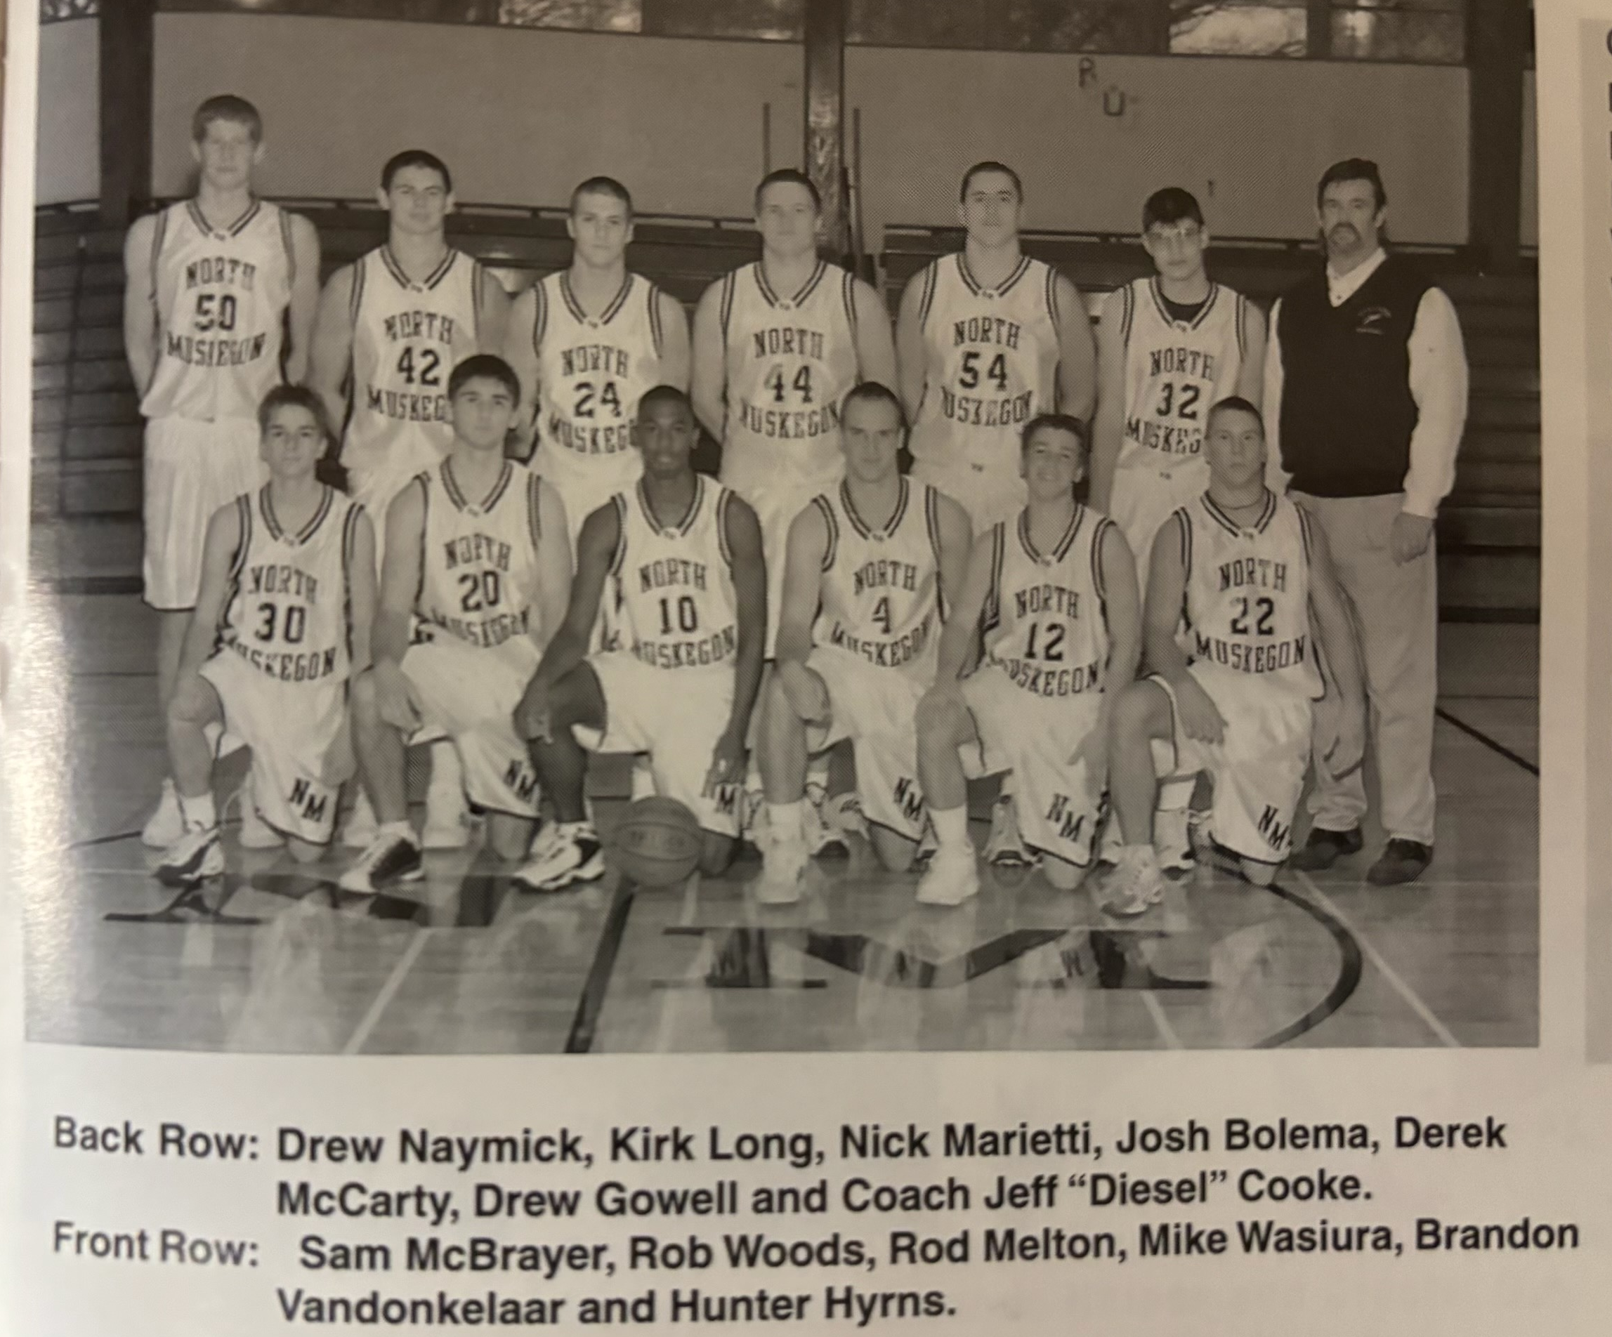
The 2001-02 NORSEMEN

N Muskegon 46 Musk Catholic 43 Drew Naymick 19, Derrick McCarty 8
N Muskegon 49 Mason Co 58 Rod Melton 16m Naymick 14
N Muskegon 53 Ravenna 40 Naymick 15, Melton 14, Nick Marietti 13
N Muskegon 45 Godwin Heights 61 Naymick 18
N Muskegon 65 Whitehall 67 Naymick 26, Melton & Marietti 9
N Muskegon 68 Whitehall 55 Melton 16, Naymick & McCarty 14
N Muskegon 53 WMC 46 Naymick 10 points, Melton 14
N Muskegon 64 Montague 57 Naymick 26, Melton 14, Marietti 11
N Muskegon 65 Oakridge 45 Melton 19, Marietti & Naymick 11
N Muskegon 76 Shelby 63 Marietti 17, Naymick & Melton 16
N Muskegon 31 Hart 36 Naymick 10
N Muskegon 66 Mason Co 37 Melton 19, McCarty 17, Marietti 13
N Muskegon 68 Pentwater 30 Marietti 16, Kirk Long 10, Melton 10
N Muskegon 77 Ravenna 54 McCarty 22, Marietti 17, Long 10
N Muskegon 45 Whitehall 49 Naymick 20, McCarty 9
N Muskegon 73 Montague 60 Marietti 21, McCarty 17, Naymick 13
N Muskegon 56 Oakridge 27 Marietti 20, Mike Waisura 9
N Muskegon 69 Holton 53 Naymick 18, Melton 16, Marietti 15
N Muskegon 68 Shelby 49 McCarty 18, Melton18, Naymick 12
N Muskegon 69 Hart 46 Naymick 20, Melton 16, McCarty 13,
N Muskegon* 42 Shelby 50 Naymick 18

2001-2002 (Coach Jeff Cooke 16-7, NM, Whitehall, Shelby co- champs)

Only Drew Naymick returned from the co-champs from 2001-01 but the allure of playing with a player with the talent of Naymick lured a couple of his buddies to transfer to NMHS, Matt Borushko, and midway through the season, Erik Kravako. Never in the more than 90 years of NMHS basketball has NM fielded a more talented trio. The best news --- they were all juniors and would only get better.
It wasn’t until Kravako became eligible in mid-January did the Norse add the key piece to their puzzle. With Kravako added to the lineup North Muskegon would go on an 11-game winning streak, their best winning streak since NM basketball began in 1932. However, until Kravako’s arrival NM struggled with a 5-6 record. To begin the season Naymick would be joined by three newcomers to the lineup. Gage Hyrnes, Brodie Seyferth, and Andy Gowell would join Borushko and Naymick to comprise the starting five. Until Kravako arrived this five would score virtually all of NM’s points, clearly showing one deficiency with NM basketball: a lack of depth.
North Muskegon got off to a 22-12 first quarter lead over Muskegon Catholic and as it turned out it was much needed as MCC made a fourth quarter comeback after NM’s 6’10 junior center Drew Naymick had fouled out with still six minutes remaining in the contest. NM hung on to win 84-81 as Matt Borushko quickly made his presence known. The junior transfer from Reeths Puffer scored 31 points, which oddly enough would be his career high at NMHS although he would have numerous 20 plus point games in his two-year career at NMHS. It is interesting to note but not only did Borushko have a season high in this game but so would guard Gage Hynes with his 12 points. Andy Gowell had 13 in the win over the Crusaders, just two points short of his career high. Naymick scored 22 points and blocked seven shots before his premature exit with foul trouble.
It looked like NM was about to blow Mason County Central out of their own gym when the two teams left the Scottville court at halftime with NM enjoying a comfortable 35-25 lead. However, the host Spartans came out a different team in the second half as they outscored NM 45-22 in posting a 70-57 win over the Norse. Drew Naymick and Matt Borushko were the big guns for NM with 24 and 17 points respectively. Gage Hyrnes added nine, but the rest of the Norsemen could score only seven points.
NM then evened their record in the WMC with an easy 65-49 win over a Ravenna team that was still looking for its first win. The big duo of Naymick (23) and Burushko (18) accounted for 41 of NM’s 65 points. Gage Hyrnes was in double figures with 11, the last time all season Hyrnes would hit double digits in scoring.
NM would then participate for the second year in a row in the Spring Lake Holiday classic. And NM would also for the second straight year go winless in the tourney.
NM played the host Spring Lake Lakers in the first game of the tournament and exploded to jump out to a 20-3 lead to begin the game with Matt Burushko hitting his first five shots. A very young Bill Core Spring Lake team then went into a full court press and that worked to perfection as Spring Lake took off to the tune of 50 points over the middle two quarters to take a 60-54 lead and then put the Norse away with a 9-0 run to start the fourth quarter. NM’s lack of depth was magnified in this game as Burushko and Drew Naymick accounted for 34 of NM’s first half 35 points. Naymick scored a game high 30 points to become the 20th member of the NM 30-point club while Burushko scored 24. Only 13 points were scored by the rest of the NM players. The game was only the seventh game played over the years with Spring Lake, and although 23 years has passed and Bill Core remains as the Spring Lake coach, the two teams have not meant since this game in December of 2001.
NM would again face Whitehall in the consolation game with Whitehall again coming out on top 75-61. Whitehall broke open a close game with a 20-8 run in the second quarter. Whitehall had five players score in double figures while NM had but two, a problem that would persist for NM until Erick Kravako, a transfer from Reeths Puffer becomes eligible in mid-January.
Just as they did a year earlier NM and Whitehall would again play back-to-back games after meeting a week prior in the Spring Lake Classic. The story was much the same except the results showed Whitehall winning more handedly in the second game 89-65. Again, Whitehall’s superior depth was evident with five players in double figures with Matt Burshko (26) and Drew Naymick (24) combining for 50 of NM’s 65 points.
The Norsemen got healthy in a hurry as they took a jaunt to Pentwater and came away with an easy 75-35 victory over an outmanned Pentwater five. Norse coach Jeff Cooke was able to substitute liberally throughout the contest. Matt Burushko played long enough to score 23 points and Drew Naymick got plenty of rest after tallying 15 points. Nine Norsemen scored in the game with Tony Shyne scoring a season high seven and Brodie Seyferth likewise had seven for a season high.
For the second time during the early part of the season NM jumped out to a big first half lead (24-4) only to see the lead slip away during a 58-54 loss to West Michigan Christian. The Warriors wily ‘ole’ veteran coach Jim Goorman, just as he has done often in the past against the Norse, changed his defenses and it worked once again. Matt Burushko, who scored 19 points in the first half was held scoreless in the second half while Drew Naymick scored only seven of his 17 points in the final two quarters. However, his final two points, which was not recognized at the time, was the 1001 points in Naymick’s career.
Following a tight first half the Norsemen pulled away with a 23-14 third quarter run in defeating Montague 67-55 on the Wildcats home court. Although it’s beginning to sound like a broken record the duo of Naymick (26) and Bursuhko (17) carried NM to victory. Naymick came one block away from a triple double with 12 rebounds and nine blocks complementing his 26 game high points.
The NM duo of Burushko and Naymick then outdid themselves as they combined for a ridiculous 60 points in a 72-58 victory over Oakridge. College coaches are now taking a close look at Drew Naymick as he came up with a monster game against the Eagles. Drew scored a career high at the time 35 points, grabbed 14 rebounds and for the second time on the season, and third time in his career, came one blocked shot away from a triple double, a rarity in prep ball with the games contested for 32 minutes.
Shelby applied the clamps defensively as they allowed NM a season low 40 points in a 57-40 home court win against NM. Drew Naymick was held to 17 and Matt Burushko only six, well below both player’s averages. The win boosted Shelby’s record in the WMC to a perfect 6-0 while the Norsemen’s record in the WMC fell to 3-3, leaving them three games behind the league leaders, and their chances to repeat as co-champs looked bleak. However – hold everything – help was on the way.
Not only did the Norsemen welcome with open arms 6’3 junior Erick Kravako but nine out of NM’s next 11 games would be at home. With Kravako netting 13 points in his debut as a Norsemen the Norse wouldn’t let a big 22-4 first quarter run get away from them as it did in two earlier losses during the season. For only the second time all season NM had three players in double figures in their 66-42 win over Hart. Matt Borushko netted 18, Kravako 13 and Naymick 11. Kravako didn’t just score 13 points. He increased his value to the Norsemen by collecting 10 rebounds and dishing off eight assists. Naymick with 11 blocks, amazingly had as many blocks as points as things were now looking very favorable for NM basketball.
NM nearly let one get away from them again as NM, once leading 24-7, needed a put back rebound basket from Drew Naymick with two seconds remaining in the game to give NM a thrilling 48-47 win over Mason County Central. Naymick’s game winner trumped a Scottville three-pointer that gave the visiting Spartans the lead at 47-46 with nine seconds left. Naymick finished with 15 points, seven assists and seven blocked shots. Erick Kravako finished with 10 while Gage Hyrns chipped in with nine points on three made 3-pointers.
NM had to wait a day as their Friday night scheduled WMC game with Ravenna was postponed a day due to bad weather. For the second straight game the Norse needed a rebound basket off a missed Norse shot by Drew Naymick to secure a 56-54 victory over a stubborn Ravenna team. The win drew NM within a game of first place as parity was the norm in the WMC in the 2001-02 season. Naymick paced NM with 23 points with Eric Kravako adding 11 and Andy Gowell 9. Surprisingly, high scoring Matt Borushko was held to but three points, well below his average.
Perhaps energized with the appearance of MSU coach Tom Izzo, who was interested in a 6’10 redhead in a NM uniform, NM atoned for two earlier losses to Whitehall by stomping the Vikings 74-59 and thrust themselves right back into the hunt in the West Michigan Conference race. The chase was on for luring Naymick as UM coach Tommy Amaker was at an earlier NM game. Many big-time college coaches would visit NM during the next few months. Izzo surely didn’t lose interest in Naymick as the big redhead scored 28 points, had 14 rebounds six blocks and three crowd appealing slam dunks. The big three put their talents on display as Matt Borushko scored 22 points and Erik Kravako 15, scoring all but 9 of NM total of 74 points.
After an emotional win over Whitehall NM lost their mojo somewhat as they had to hold off a determined Montague team to earn a 65-63 win. NM, leading by three points and with Montague with the ball with seconds left in the game, intentionally fouled a Wildcat to prevent a possible game-tying 3-pointer. The strategy worked, the Wildcat made the first, missed the second but NM grabbed the rebound to preserve the win and keep their WMC title hopes alive. The trio of Borushko (24), Naymick (23) and Kravako (11), scored all but seven of NM’s 65 points.
With Oakridge coach Brandon Barry focused on stopping Drew Naymick down low, NM took advantage of some free space to connect on nine 3-pointers in downing Oakridge 72-51. The unselfish Naymick was content to let his teammates fire away from out court and finished with a season low six points. Matt Borushko made four 3-pointers and scored 25 to lead the Norse. Andy Gowell scored a career high 15 and Eric Krvako 12.
NM had a midweek tune-up game with a 2-14 Holton team and cruised to a 59-36 win over the Red Devils. A 14-3 opening quarter set the tone for the Norse as the Holton shooters had a tough time as they were rejected an astounding 16 times by Drew Naymick. Matt Borushko fired in 21 points and Naymick 13 as the stage was set for a big clash three days later with Shelby.
Shelby had played a near perfect game in their earlier 17-point victory over NM, but that was before Erik Kravako donned a Norse uniform at the semester break. Tom Izzo and his assistant Brian Gregory were again at courtside in a game that was far from perfect. Only the final score was perfect for NM coach Jeff Cooke as his Norsemen had outlasted Shelby 45-40 to move from three games back to earn a tie in a logjam at the top of the West Michigan Conference. NM trailed 28-27 before a key 3-pointer from Kravako and a layup from Andy Gowell built the Norse lead to 34-28. Drew Naymick’s third dunk of the game bumped the lead to 38-31. NM held on from there for the victory as Naymick was again a one-man wrecking crew. The 6’10 redhead produced 18 points, 14 rebounds, six blocked shots, five steals and three assists.
One game remained in the WMC as well as the regular season and NM was almost assured of at least a tie as their final round opponent was a winless Hart team with an 0-18 record, a far cry from the glory days of the Stretch Hansen led Pirates from 1943 and other Pirate powerhouse teams until the middle 1950s. Still looking for their first victory as a huge underdog the Pirates led NM at halftime 34-26. It was then that Drew Naymick took charge as he led NM to a 26-9 advantage in the third quarter as the Norse eventually pulled away to secure a 75-62 victory. Naymick notched his career high in this game with 39 points while grabbing 15 rebounds. The win moved NM into a 3-way tie at the top of the WMC with Shelby and Whitehall, all sporting a 11-3 record in conference play.
NM would finish their 2001-02 season by playing their final four games at Hart, with three of those games in Class C tournament play.
Although NM had beaten Montague twice during the regular season the Cats played NM close in both of those games giving the Wildcats confidence, they could pull off a first-round tournament upset. And they nearly did. A possible game winning 15-footer at the buzzer by Montague missed its mark and NM was fortunate to come away with the win. Montague led NM most of the game It was not until early in the final quarter when NM took its first lead at 51-50 on an Erik Kravako layup. Down the stretch the lead changed four times as both teams squandered numerous opportunities to take control. Drew Naymick finished with a game high 17 points and eight blocks. Matt Borushko had 16 and Kravako finished with 14, setting up another date with Shelby in the district semi-finals.
In a game that was nearly a complete opposite of their last meeting in a low-scoring 40-35 NM victory, the district battle saw plenty of offensive fireworks as NM edged the Tigers 70-69. The Norse made a huge comeback to earn the win as they trailed Shelby by 11 points late in the third quarter. NM that went on a serious 20-4 run over a six-minute span to seal the win. The NM big trio again dominated the scoring for NM with Naymick leading the way with 24, closely followed by Borushko with 21 and Kravako with 18.
NM led Muskegon Heights for much of the game but ran out of gas in the late stages of the third quarter as the Heights depth, pressing defense, and team speed proved too much for the Norse as the junior dominate Norsemen fell 90-71. With University of Michigan coach Tommy Amaker looking on, as well as Stanford head coach Mark Montgomery who traveled all the way from California and traveled the snow- and ice-covered Michigan highways to Hart, Drew Naymick didn’t disappoint in the district championship game. Drew finished with 27 points, but it was when Naymick went to the bench in the second quarter with two personal fouls was when the Heights got back in the ball game by going on a 13-2 run. Matt Borushko finished with 23 points while the lone senior on the team, Andy Gowell had 12 points. NM’s season ended with a 16-7 record with 11 of those wins coming in the final 12 games of the season before losing to a Muskegon Heights team that advanced all the way to the final four at MSU.
The following year Muskegon Heights was a Class B school. One can only speculate as to how far the Norsemen would have advanced into the playoffs in 2002 if Muskegon Heights was Class B. The Heights had 503 students enrolled in 2002, (NM had 287). In 2003 Heights gained five students to go from a high-end Class C to a low-end Class B. The Heights missed advancing into Class B by a handful of students in 2002, a move up in class NM would have more than welcomed.

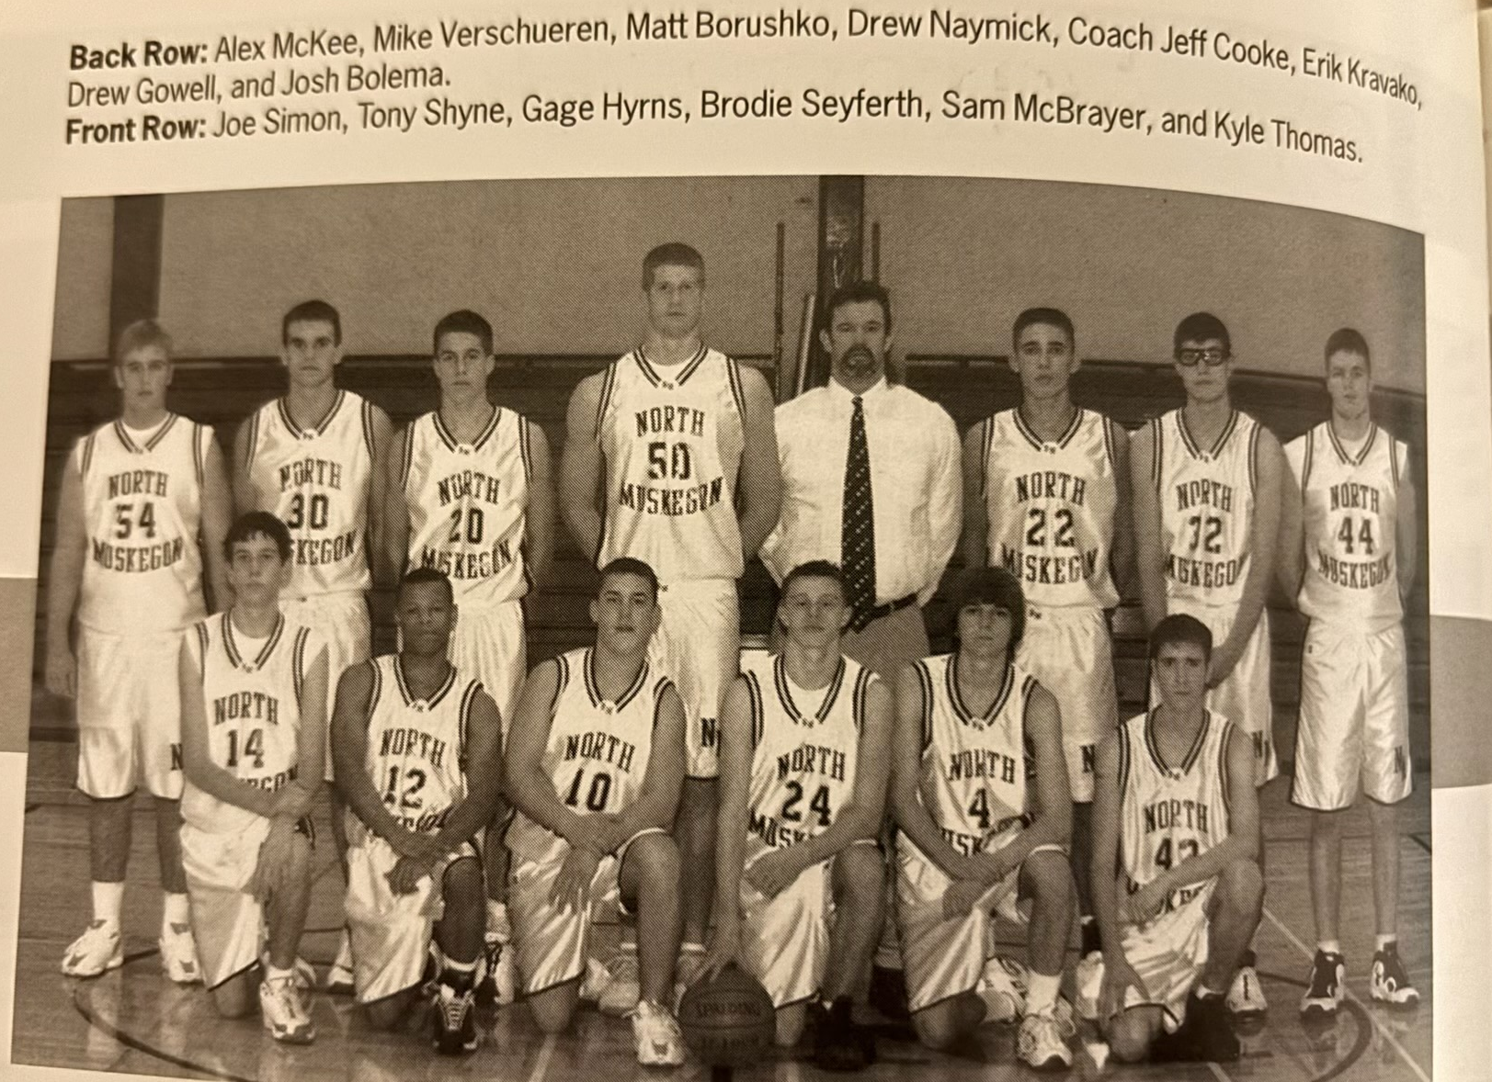

The 2001-02 NORSEMEN

N Muskegon 84 Musk Catholic 81 Matt Burushko 31, Drew Naymick 22
N Muskegon 57 Mason Co 70 Naymick 24, Burushko 17, Gage Hyrnes 9
N Muskegon 65 Ravenna 49 Naymick 23, Borushko 18, Hyrnes 11
N Muskegon 67 Spring Lake 79 Naymick 30, Burushko 24
N Muskegon 61 Whitehall 75 Naymick 24, Burushko 16 A. Gowell 9
N Muskegon 65 Whitehall 89 Burushko 26, Naymick 24
N Muskegon 75 Pentwater 35 Burushko 23, Naymick 15
N Muskegon 54 WMC 58 Burishko 19, Naymick 17
N Muskegon 67 Montague 55 Naymick 26, Burushko 17
N Muskegon 72 Oakridge 58 Naymick 35, Burushko 25
N Muskegon 40 Shelby 57 Naymick 17
N Muskegon 66 Hart 42 Borushko 18, Erik Kravako, Naymick 11
N Muskegon 48 Mason Co 47 Naymick 15, Kravako 10, Hyrnes 9
N Muskegon 56 Ravenna 54 Naymick 23, Kravako 11, Gowell 9
N Muskegon 74 Whitehall 59 Naymick 28, Borishko 22, Kravako 15
N Muskegon 65 Montague 63 Borushko 24, Naymick 23, Kravako 11
N Muskegon 73 Oakridge 51 Borishko 25, Gowell 15, Kravako 12
N Muskegon 59 Holton 36 Borushko 21, Naymick 13 & 16 blocks, WIN 600
N Muskegon 40 Shelby 35 Naymick 18, Kravako 8
N Muskegon 75 Hart 62 Naymick 39, Kravako 12, Burishko 11
N Muskegon*57 Montague 56 Naymick 17, Borushko 16, Kravako 14
N Muskegon*70 Shelby 69 Naymick 24, Borushko 21, Kravako 18
N Muskegon*71 Musk Heights 90 Naymick 27, Burushko 23, Gowell 12

2002-2003 (Coach Jeff Cooke 24-2, NM, WMC district & regional champs)

The 2002-03 North Muskegon team posted an amazing 24-2 record and came oh so close to being the first NM team to advance to the final four in basketball. Never has NM put on the floor at the same time three players with the abilities of Drew Naymick, Matt Borushko and Erik Kravako. The Norse were led by the 6’10 Naymick, who by his senior year had committed to play for Michigan State. The big Red Head was selected to play in the prestigious Michael Jordan all-star post season classic featuring the top 25 players in the entire country. However, due to his loyalty to his high school and NM baseball team, Naymick declined the invitation as MHSAA high school rules would have made Naymick ineligible for baseball where he was an outstanding first basemen. It’s a no-brainer as of this writing to say the 2002-03 team was the greatest team ever fielded in more than 90 years of NM basketball.
NM began the season with a 58-38 win over their traditional opening game rivals from Muskegon Catholic. If NM had one major issue in 2002-03 it was their lack of depth. The heralded trio of Matt Burushko (22) Erik Kravako (20) and Drew Naymick (10) scored all but six of NM’s total, a trademark for Norse basketball during the season. There would be only one game in the entire season when a Norsemen, other than the big three would score in double figures in a game. NM had no trouble in defeating the Crusaders as the game was never in doubt with the Norse taking a commanding 43-24 lead entering the final quarter. Naymick was playing somewhat tentatively as he was recovering from a broken foot but managed to block five shots.
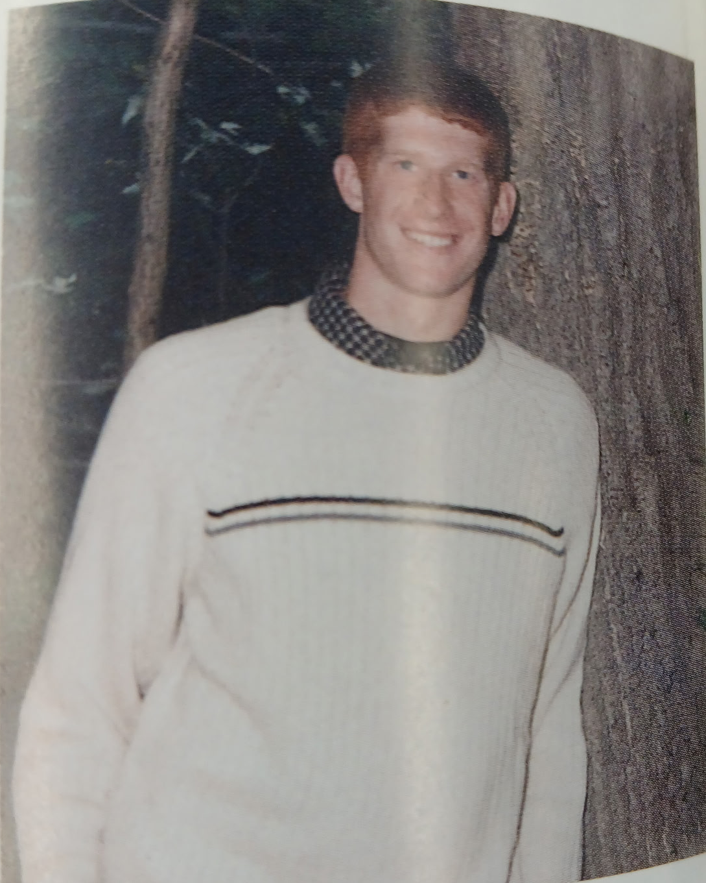

DREW NAYMICK

NM led Hart 54-15 forcing a running clock in the final period as NM overwhelmed the Pirates 69-42. Erik Kravako led the Norse with 24 points, Matt Borushko added 11 points and five steals. Still resting his ailing foot Drew Naymick scored but five points but made his presence known with nine rebounds and nine blocked shots. Ten different Norsemen got into the scoring column for NM as Norse head coach Jeff Cooke was able to empty his bench early.
Always a tough opponent over the years NM would win the first of a season sweep with a 62-40 victory over Mason County, the first season sweep over the Spartans since 1981. Drew Naymick, slowly recovering from foot surgery showed that he is starting to get back into peak condition as he scored 24 points, 12 rebounds and eight blocks. Erik Kravako, who’s early fourth quarter breakaway slam dunk sent the Norse fans into a frenzy had 26 points to send the Norsemen into the first ever Greater Muskegon Sports Hall of Fame Classic against Class A Mona Shores with terrific momentum.
In front of a sold-out crowd at Mona Shores High School the Norse ended the game on a 22-5 run to overcome a 50-39 deficit to pull out a thrilling 61-55 win over the host Sailors. Drew Naymick scored eight of his game-high 22 points in the fourth quarter to lead the comeback victory. Erik Kravako came up big for NM with 18 points while Matt Borusko pumped in 13 points and added four assists. NM had a 37-24 rebounding edge over the Sailors with Drew Naymick pulling down 23 missed shots. NM would not receive another invite to the Hall of Fame Classic for the next 19 years.
NM would then face a very talented and undefeated Muskegon Heights team in the finals of the two-day classic. (Now a one-day affair). Drew Naymick put on a show where he had the first triple-double in NM history and it came against the toughest of opponents in the Heights Tigers. NM had one Division 1 player while the Tigers had two in Eddie Spencer (22) and Jesse York (21) as well as a bench far superior to NM. The Norse had only four players score in the 72-58 loss to the Heights led by Naymick’s 23 points. Erik Kravako with 15 and Matt Borusko with 14 were in double figures while Gage Hynes with 6 points were the only NM players with points. Heights went on a 13-2 run late in the second period to break open a tight game as the teams played even the rest of the way in front of another sellout crowd. “Playing a Class A and Class B opponent on consecutive nights will make this team better,” said coach Cooke following the game. “We’re not going to face anyone more athletic or better than the Heights this year,” added Cooke. It would be two months before NM would taste another defeat. Cooke’s words proved prophetic as the Tigers would make it all the way to the Class B championship game in March.
After the Hall of Fame classic NM would face much easier competition and they would rarely be challenged until the playoffs. NM traveled to Ravenna and outscored the Bulldogs in every quarter to earn a 77-55 victory. Erik Kravako joined the now crowded NM 30-point club with a 32-point night against Ravenna. Kravako had a complete game with 11 rebounds. Drew Naymick had 21 points, 10 rebounds and five blocks. “He (Naymick) makes a lot of people around him better,” said Ravenna head coach Mike Dunnock.
A win over a Jim Goorman coached West Michigan Christian team is never easy. NM needed a 22-point fourth quarter in a game where the tempo was slowed down by WMC coach Gorman to finally pull away from the Warriors to earn a 51-41 victory. Eric Kravako and Drew Naymick each scored 16 points while Kravako also contributed 10 rebounds and five steals and Naymick blocked six Warrior shots.
It’s also rare when North Muskegon totally dominates Whitehall in a basketball season. It happened in 2003 and gives further verification of why this NM team was tops in Norse history. NM hit three of their first four 3-point attempts in the first quarter as the Norse enjoyed a commanding 21-4 lead over the Vikings after the game’s first eight minutes. It appears that Drew Naymick flirts with a triple-double in nearly every outing. Against the Vikings Drew had 18 points, 19 rebounds and seven blocked shots in NM’s 76-47 thrashing of Whitehall. Erick Kravako continued his torrid shooting with a game high 23 points with Matt Borushko adding 12 points and six assists.
Montague gave NM a couple of close call games in 2002 but there were few dramatics in 2003. NM again got out of the blocks quickly by jumping out to an 24-7 lead as Drew Naymick scored 10 of his 23 points as NM continued to roll in the WMC with a 74-46 win over the Wildcats. Naymick also added 12 rebounds and seven blocks. Naymick’s buddies Erik Kravako and Matt Borushko each scored 18 points.
Brodie Seyferth had the game of his life as he scored 17 points, 15 of those coming on made 3-pointers as NM took firm control of first place in the WMC with an 81-55 win over Oakridge. Seyferth, an underrated point guard who played in the shadow of Naymick, Kravako and Borushko had his only game on the season where he reached double figures. Naymick had 20 points, 10 rebounds and blocked six shots with Matt Borushko adding 20 points and five assists.
MSU coach Tom Izzo was again back in town to check on his NM recruit Drew Naymick. The 6’10 senior didn’t have one of his signature games, but he did chip in with 11 points, 11 rebounds and 8 blocks in NM’s 53-43 win over Shelby. Erick Kravako continued his outstanding play with 22 points and nine rebounds. Matt Borushko totaled 11 points while NM got some fine play from their role players Gage Hyrnes (six points and assists while Brodie Seyferth had three assists as NM had their lowest number of turnovers on the season with 10.
As the second half of the West Michigan Conference season began, it had now become crystal clear that all the teams would be chasing the Norsemen, but to no avail. The Norse started the second half like it began with a win over Hart 56-49. Erick Kravako scored 29 and a team high 12 rebounds with Drew Naymick adding 18 as NM kept their record perfect in the WMC.
Playing on back-to-back nights NM added two more victims to their list with WMC victories over Ravenna (58-43) and Mason County Central (58-47). In their first game against Ravenna the Norse needed a big second half as Ravenna led the heavily favored Norsemen 22-15 at the half. NM then woke up in the second half after a ‘few words of advice’ from coach Cooke to outscore the Bulldogs 43-21 in the second half. Kravako again led NM scorers with 19 with Naymick close behind with 17. Both players pulled down nine rebounds while Matt Borushko added 11 points and five assists.
In a makeup of an earlier games that was scheduled during the week but moved to Saturday due to bad weather, NM made their long trip to Scottville a successful one with an 11-point win over the Spartans to improve to a perfect 10-0 in conference play. The host Spartans had no answer for NM’s Drew Naymick as the big redhead pumped in 19 points to lead the Norse. Matt Borushko added 16, Erik Kravako 9 and Gage Hyrnes 4, the only Norsemen to score in the game.
One would have to go back more than 50 years, to the Bill Duplissis led Norsemen of 1951 to find a game when Whitehall scored less than the 22 points they scored against NM in a 44-22 Norse victory. The Vikings never scored more than seven points in any quarter. After giving up 76 points in their earlier loss to NM, the Vikings went to a stall offense to begin the game but after NM outscored the Vikings 16-6 in the second quarter that strategy clearly failed. The NM trio of Naymick, Kravako and Borushko all scored 13 points, all but five of the Norsemen’s total of 44.
The highlight of NM’s 68-40 victory over Holton came in the opening quarter when Drew Naymick took an alley-oop pass from Gage Hyrns and dunked to eclipse the NM all-time scoring record of 1366 points set by Lee Kakaty. Naymick scored 17 points as did Erik Kravako while the third part of the NM terrific trio, Matt Borushko added 16.
Borushko hoisted up nine 3-point shots and made six for his 18 points, just one made three away from the school record of seven by Joel Johnson in 1992 as NM defeated Pentwater 58-39 on a Wednesday night in February. Drew Naymick, just named as one of the 10 finalists for Mr. Basketball, was content to watch his teammates score as he settled for eight points.
Drew Naymick didn’t take a shot in the first quarter and made but one free throw in the first half as NM’s Matt Borushko was nailing 3-pointers to give NM a 27-22 lead at halftime. Then Naymick took over. Somehow the big redhead who makes his teammates better with his unselfish play had another triple double as he finished with 13 points, 10 rebounds and 10 blocked shots in a 58-39 win over Montague. Borushko finished with 19 points and Erik Kravako netted 12 as NM padded their first-place lead in the WMC.
NM’s next game with Oakridge would be the final game on the Northside court for Drew Naymick and his two pals, Eric Kravako and Matt Borushko. And the terrific trio capped their home court career in style as NM defeated Oakridge 77-51 and in the process clinched the WMC championship with a perfect 13-0 record and an overall record of 18-1, the best in school history. Naymick went out in style with 29 points, 12 rebounds and five blocked shots. Kravako netted 22 points while Borushko finished with 14. Only the final game of the regular season at Shelby awaited the Norsemen and their chance to complete a perfect season in the WMC.
Playing before a sold-out crowd of 2400 rebid fans on the Shelby home court (about 2000 more fans than the Shelby gym your author played in back in the late 1950s) the Norsemen jumped out to a 7-0 lead and never looked back to defeat Shelby 53-43. Naymick had a typical Drew Naymick game with 20 points and 18 rebounds as several of his teammates pitched in. The backcourt duo of Gage Hyrnes and Brodie Seyferth played an excellent floor game, handling Shelby’s full court pressure and working the ball up court and into the capable hands of the big three scorers. NM only had eight turnovers on the evening with Kravako (15) and Borushko (13) complementing Naymick. With both teams pitted in separate districts there was a great chance these two rivals would meet once again in the regional tournament.
The Norsemen moved south for the Class C district in 2003. South to Muskegon Catholic Central’s Ray Cioe gymnasium where NM’s first opponent was fellow WMC foe Ravenna, a team NM handled easily during the regular season. The tournament game was no different as NM used 32 points and 13 rebounds from Erik Kravako, his second 32-point game vs. the Bulldogs to easily defeat Ravenna for the third time on the season. Drew Naymick added 12 points and 11 boards while Brodie Seyferth had five steals and five assists.
The Norse than faced Kent City in the second round in the first meeting between the two schools in 15 years. Drew Naymick and the Norse were too tough for Kent City as the Norse advanced to the district finals with a 68-50 win. Naymick scored 30 points while grabbing 10 rebounds and blocking four shots. Naymick’s buddies also fared well. Erik Kravako added 16 points and seven assists while Matt Borushko had 15 points and nine rebounds.
Waiting to play the Norsemen in the district finals was the team NM probably wanted to see the least, the Warriors of West Michigan Christian. The two teams since 1987 had played one another in the district tournaments 12 times, and Christian had won all 12. The MHSAA playoffs had not been kind to Norsemen basketball over the years. It had been 30 years since the Norsemen won a district tournament with WMC being the biggest culprit. It was not a pretty game as the Norse shot only 27 percent from the floor. Anybody who followed NM during the regular season knew that NM got most of their offense from the trio of Naymick, Kravako and Borushko. But that didn’t happen as the big three combined for only 24 points, 14 of those from Naymick. Instead, a pair of role players stepped up big time for the Norsemen. Guards Gage Hyrns and Brodie Seyferth each hit three 3-pointers for nine points each to lead NM to a low scoring 42-34 win and their first district title, many years before the players on the floor were even born.
In what surely was a puzzling site for a regional site, three of the four teams in the regional, were located on the shores of Lake Michigan: NM, Shelby and Fennville. All three teams had to travel more than two hours east to Sanford-Meridian High School. The Norsemen and Shelby, a couple schools about a half hour from each other on the US 31 Expressway met in the first round on a Wednesday school night in Sanford-Meridian. If that contest would have been played at a neutral site closer to home like Reeths Puffer, as many as 3000 fans would have attended this rivalry game. However, the MHSAA evidently was subservient to Sanford-Meridian, ignoring the travel involved by NM and Shelby and the loss of major dollars that could have enriched the pockets of the MHSAA had the two teams meet somewhere in the middle of Mid-Michigan. My sidekick Gene Young and I broadcast this game as we knew that there were many fans who were reluctant to make the long trip. The game was as exciting as one would expect when Shelby and North Muskegon met in a big game. NM won a thriller 61-58 as Drew Naymick sank 6-of-6 free throws in the game’s final moments to ice the game. Trailing by three points with 12 seconds left in the game after Naymick, in a one-and one situation, hit two clutch free throws, Shelby hoisted a 3-pointer in hopes of sending the game into overtime. However, Naymick was clutch again and not only blocked the shot but caught the ball to end the game. Naymick finished with 21 points with Matt Borushko netting 14 and Erik Kravako 13 to send the Norsemen into the regional finals and another two-hour trip back to Sanford-Meridian.
Followers of North Muskegon sports had a big decision to make: Travel to Kalamazoo to watch the NM volleyball team play in the state semi-finals or drive 150 miles down turning, twisting roads for Friday’s regional championship basketball game against a Sanford-Meridian team playing on its home floor. No problem. Both teams won. In fact, the girls’ volleyball game was over by about 3:00 PM with the gals winning which gave hundreds of NM’s volleyball fans time to make the long trek to watch the boys game. NM disappointed the mostly favorable crowd of 2000 fans with a near perfect game to triumph 53-40 and win their first regional crown since 1974. The game was not as close as the final score as Sanford-Meridian scored the game’s final 11 points against NM’s reserves. Matt Borushko set the tone early with a couple of 3-pointers. NM then silenced the home rooters with a 14-0 run and with 2:44 remaining in the first half NM enjoyed a commanding 26-9 lead. Borushko finished as NM’s high scorer with 18 points with Naymick filling up the stat sheet with 13 points, eight rebounds and four blocks. Erik Kravako was far below his average with nine points, but he contributed to the win in multiple ways. Kravako played a key part with his ball handling in breaking the press, had seven rebounds, four assists and three blocked shots. And how did NM celebrate their victory the next day? They drove to Kalamazoo to cheer on the girls playing for a state volleyball championship.
Norse fans couldn’t have asked for more. NM, playing perennial state powerhouse Flint Beecher, probably played their best game of the season but fell just short of their first trip to the final four with a 60-54 loss to Flint Beecher. NM led at all the stops only to be outpointed 17-9 in the deciding final quarter. The Norse out rebounded Beecher 20-16 and shot 52 percent from the floor and hit 9-of-10 free throws. Drew Naymick capped his brilliant career with yet another big-time effort in the loss. Drew scored 23 points, grabbed seven rebounds and blocked eight shots. Naymick clearly outplayed his future teammate at MSU Marquis Gray, who finished with 14 points and seven rebounds. Twenty-two years has now gone by, and still no NM team has matched the exploits of the team of 2002-03. Drew Naymick set an all-time state record for blocked shots in a career with 527. He would also do the same at the highest level in college basketball while starring at Michigan State. Matt Borushko and Erik Kravako would also play college ball at Muskegon Community College. To have three players from one team play at the next level was unprecedented in NM basketball annals.

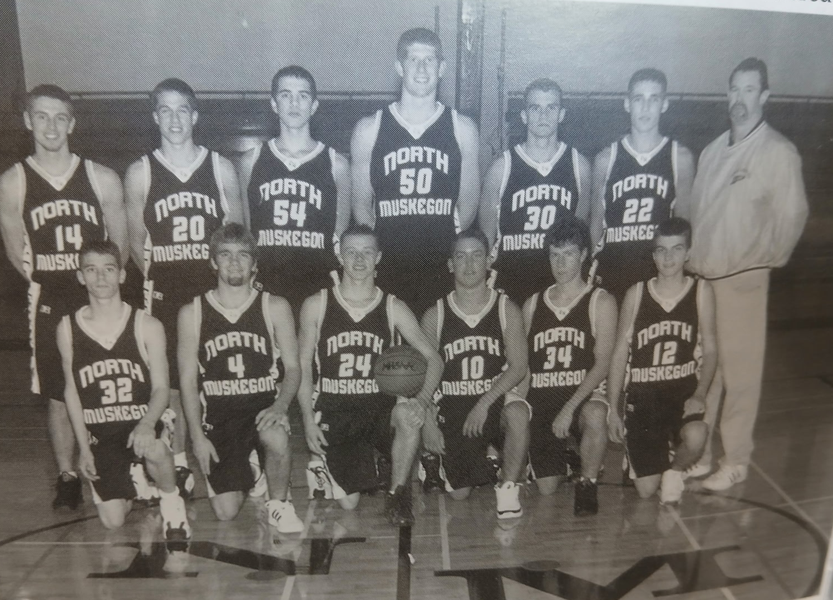

The NORSEMEN OF 2002-03

Front Row L-R: Adam Quail, Andrew Connor, Brodie Seyferth, Gage Hyrns, Drew Kleveland, Brandon Stickel
Back Row L-R: Drew Barker, Matt Borushko, Kyle Long, Drew Naymick, Mike Verschueren, Eric Kravako,
Coach Jeff Cooke

N Muskegon 58 Musk Cath. 38 Matt Borushko 22, Erik Kravko 22
N Muskegon 69 Hart 42 Kravako 23, Borushko 11
N Muskegon 62 Mason Co 40 Kravako 26, Drew Naymick 24
N Muskegon 61 Mona Shores 55 Naymich 22, Kravako 18, Borushko 13
N Muskegon 58 Musk Heights 72 Naymick 23, Kravako 15, Borushko 14
N Muskegon 77 Ravenna 55 Kravako 32, Naymick 21
N Muskegon 51 WMC 41 Naymick & Kravako 10, Borishko 9
N Muskegon 76 Whitehall 47 Kravako 23, Naymick18, Borushko 12
N Muskegon 74 Montague 46 Naymick 23, Borushko & Kravako 18
N Muskegon 81 Oakridge 55 Naymick & Borushko 20 Brode Seyferth 17
N Muskegon 53 Shelby 43 Karvako 22, Naymick & Borushko 11
N Muskegon 56 Hart 39 Kravako 29, Naymick 18
N Muskegon 58 Ravenna 43 Kravako 19, Naymick 17, Borushko 11
N Muskegon 58 Mason Co 47 Naymick 29, Borushko 16, Kravako 9
N Muskegon 44 Whitehall 22 Naymick, Borushko & Kravako 13
N Muskegon 68 Holton 40 Naymick & Kravako 17, Borushko 16
N Muskegon 58 Pentwater 39 Borushko 18, Kravako 10, Naymick 8
N Muskegon 58 Montague 39 Borushko 19, Naymick 13, Kravako 12
N Muskegon 77 Oakridge 51 Naymick 29, Kravako 22, Barushko 14
N Muskegon 65 Shelby 54 Naymick 20, Kravako 15, Borushko 13
N Muskegon* 66 Ravenna 41 Kravako 32, Naymick 12, Borushko 8
N Muskegon* 68 Kent City 50 Naymick 30, Kravako 16, Borushko 15
N Muskegon* 42 WMC 34 Naymick 14, Seyferth 9, Gage Hyrnes 9
N Muskegon* 61 Shelby 58 Naymick 21, Borushko 14, Kravako 13
N Muskegon* 53 Sanford Mer. 40 Borushko 18, Naymicj 13, Kravako 9
N Muskegon* 54 Flint Beecher 60 Naymick 23, Kravako 12, Borushko 11

2003-2004 (Coach Jeff Cooke 1-20, Shelby WMC champs)

From first to possibly worse. That sums up the 2003-04 season as head coach Jeff Cooke lost virtually his entire team from 2003 through graduation. Only Mike Verscheuren and Drew Barker saw any quality time during NM’s great 2003 season. The Norsemen scored 1606 points last season, but only 83 of those points were tallied by a returning Norsemen. After averaging more than 61 points in 2003, the Norsemen of 2004 managed to tally but 43 points per game. Only in one game during the season did a NM player score 20 or more points in a single game. The 43 points per game was the lowest offensive output for a NM team since 1950. NM would incur some growing pains over the next two seasons, but the Jeff Cooke led Norsemen would bounce back shortly.
Muskegon Catholic stopped a modest three game losing streak to the Norsemen with a 64-49 victory to begin the season. Drew Barker and Mike Verschueren, the only two returning Norsemen with any quality time from 2003, led NM with 11 and 10 points respectively.
In just the second game of the season NM would match their total losses from the previous season following a 63-51 loss to Hart. NM had won nine of the previous matchups between the two long-time rivals. It looked like NM was headed for victory as they led 27-21, but a fateful third quarter when the host Pirates outscored the Norse 25-10 did in the Norsemen. Adam Dunn, who connected on four 3-pointers led NM with 15 points followed by Drew Barker with 10. For Dunn it would be a season high.
The Norse pulled to within one point in the third quarter to Mason County Central before the Spartans erupted for 21 points in the final quarter to win going away 53-40. The officials were kind in this game at Scottville, especially towards the host Spartans. MCC was whistled for only four fouls in the entire game and none in the first half. No Norse players reached double figures in the loss, but Drew Barker and Brandon Stickle came close with nine points.
Ravenna was another team that ended a Norsemen winning streak during the season. The Bulldogs had lost 11 games in a row before defeating NM soundly 73-45. Ravenna ended this game early by jumping out to a 42-20 halftime lead. Again, NM didn’t have a player score in double figures as Drew Barker and Brandon Stickel each finished for the second straight game with nine points.
Perhaps the Warriors of West Michigan Christian were still smarting from losing a pair of games to the Norsemen last season. After NM went on a 10-0 run to tie the game at 14 to end the first quarter, the rest of the game belonged to Christian as they went on a 60-26 advantage to make the final score WMC 74 and NM 40. Junior Drew Arends paced NM with 14 points with Mike Verschueren adding 10.
The inexperienced Norsemen tied their game with Whitehall at 34-34 midway through the third quarter but were outscored 27-13 the remainder of the game as Whitehall handed NM their sixth straight defeat 61-47. Drew Barker hit three 3-pointers for NM and had 16 points to lead Norse scorers. With no 6’10 center to grab rebounds for NM in 2004, Whitehall outrebounded the Norse 39-23. There was a piece of good news for Norse fans. The game marked the last in the middle school gym of Whitehall as the Vikings would move into their new digs to start the 2004-05 season.
Points were hard to come by for the 2004 Norsemen. The 2003 Norsemen averaged more than 60 points per game. This year’s team never once scored 60 points in a contest. NM only put 28 points on the board in losing to Montague 58-28. Not only scoring points were a concern for the Norse but so was rebounding. For the second game in a row the smaller Norse were outrebounded by Montague 36-22. NM lost by 30, even though the score was tied at 8-all after the first quarter. No Norseman reached double figures, but Adam Quail just missed with 9 points.
The Norsemen for the first time during the season scored more than 50 points in a game but Oakridge scored more than 70 as NM loses to the Eagles 78-58. The Norse hung around as they trailed Oakridge 39-31 at halftime, but the second half belonged to the Eagles. For the first-time all-season NM had three players in double figures led by Drew Arends 19 points. Adams Quail had 11 and Drew Barker 10 as the defending WMC champs were still looking for their first win in conference play. In perhaps the biggest disparity in NM hoops history, Oakridge hit 22-of-25 free throws while the Norsemen made none (0-6).
NM held Shelby to a 12-10 lead before the Tigers went on a 24-7 second quarter run. But then it got worse. Shelby pummeled the Norse 29-8 in the third quarter to force a running clock the rest of the way as Shelby spanked the Norse 72-32. It was quite a turnaround for the first place Tigers after losing all three games to NM the previous season, including a game in the regional. All 13 players who dressed for Shelby scored while NM’s Drew Arends and Mike Verscheuren led NM with 10 points.
NM had a fragile one-point lead over Hart going into the final quarter, giving the sparse Norse crowd of rooters hopes that their Norsemen just might end their losing streak. However, it was not to be as Hart took the lead for good with two minutes left in the game to keep NM winless 46-43. Drew Barker had 13 points and 12 rebounds while Mike Verscheuren finished with 10 points.
An old problem reared its head again as the Norse let a first half lead turn ugly quickly in a 74-52 loss to Mason County Central. The Norse led at halftime 30-24 only to see another opponent come roaring back in the second half. The visiting Spartans from Scottville outpointed the Norse an overwhelming 50-22 in the second half to win going away. It didn’t take long for the Spartans to take the lead as they began the third quarter on a 17-1 run. Mike Verscheuren led NM with a season high 15 points with Drew Barker adding 13.
There was no need to worry about a team making a second half rally in their next game with Ravenna. Not with the Bulldogs already comfortably in front 33-17 at the half. Ravenna kept up the pressure in the second half enroute to a 63-34 win to drop the Norse to 0-12.
The Norse were on the verge of getting that long sought after win as they trailed by only one point at 42-41 early in the final quarter. However, the Norse couldn’t buy a basket in the final minutes of the game as they only managed a basket from Steve Dunn as the visiting Hesperia Panthers pulled away to earn a 54-43 victory over the struggling Norsemen. Dunn finished with 12 points to lead the Norse with Drew Arends adding 11.
Again, it was the third quarter blues for NM as Whitehall, with Pat Welsh scoring 14 of his 36 points in the third quarter, broke a halftime tie and Whitehall rolled on to a 54-45 win over the Norsemen. Drew Arends connected on four 3-pointers to lead the Norsemen with 17 points. Mike Verschueren had 12 points while Drew Barker pulled down 15 rebounds for the Norse.
After playing Mona Shores in the inaugural Muskegon Area Sports Hall of Fame Classic, NM and the Sailors began a series scheduled over the next three years. What a difference a year makes. There was a swing of 41 points from NM’s six-point victory last year to losing by 35 in 2004. The Sailors led by 20 points at halftime and cruised to a 64-29 victory on the Northside home court. Drew Barker’s nine points was best for NM.
If not for a bad start –and it was indeed a bad start – NM could have very well earned their first win of the season as they lost by only three points, 53-50 to Montague. NM started off the game shooting nothing but blanks as they made but one of their first 21 shots. NM didn’t quit and game back to send the game into the fourth quarter tied with the Wildcats, only to see a possible victory slide away. Drew Barker had a double-double for the Norse, 17 points and 10 rebounds. Mike Verscheuren also had a modest double-double with 10 points and 11 boards.
There was no one in North Muskegon happier than NM’s popular head coach Jeff Cooke after NM’s first (and only) win of the season 59-43 over Holton. “The kids were definitely fired up,” said Cooke. “They’ve worked hard all year and competed in games where we had a chance to win but fell apart in a quarter. Tonight, we were able to keep up the intensity, and we didn’t have any letdowns.” NM jumped out to a 19-9 lead and then proceeded to play four solid quarters of basketball to earn the win. Drew Barker finished with 14 points and 10 rebounds. Brandon Stikel had his best scoring output of the season with 10 points. Four Norsemen were in double figures in NM’s highest scoring game of the season. Also reaching double digits were Mike Verschueren with 13 and Drew Arends with 10.
Coach Cooke’s quote above where he lamented on how NM would play well but have one quarter proved prophetic once again as Oakridge. leading by a slim one point near the end of the third quarter, the Eagles blitzed NM 19-4 in the final quarter to win going away 62-46. Drew Arends with his 21 points in the loss had the highest single game point outing of the season for NM.
NM and Mason County Eastern began a four-game series beginning in 2004 and the boys from Custer, the season champs in the West Michigan D league, defeated NM 51-38. Mike Dean hit a trio of 3-pointers and accumulated a season high 11 points to lead the Norse.
It was wishful thinking if NM was going to earn at least one win in the WMC as their final hope for victory was a Shelby team that had already clinched the West Michigan Conference championship. Shelby showed why they were worthy champs as they hammered the Norse 82-48. Ironically, the Norseman led in this game 17-9 at the end of the first quarter and trailed by only a point at the half. Shelby then scored 58 points in the second half as the regular season came to an end.
NM had the misfortune of drawing the host school Kent City in the first game of the MHSAA playoffs. Kent City finished the regular season at 18-2 and were coming off a Friday night victory over Wyoming Rogers, rated number six in the state in Class B. NM accepted their fate and fell handedly to the host Eagles 70-29 as the season came to a merciful end.

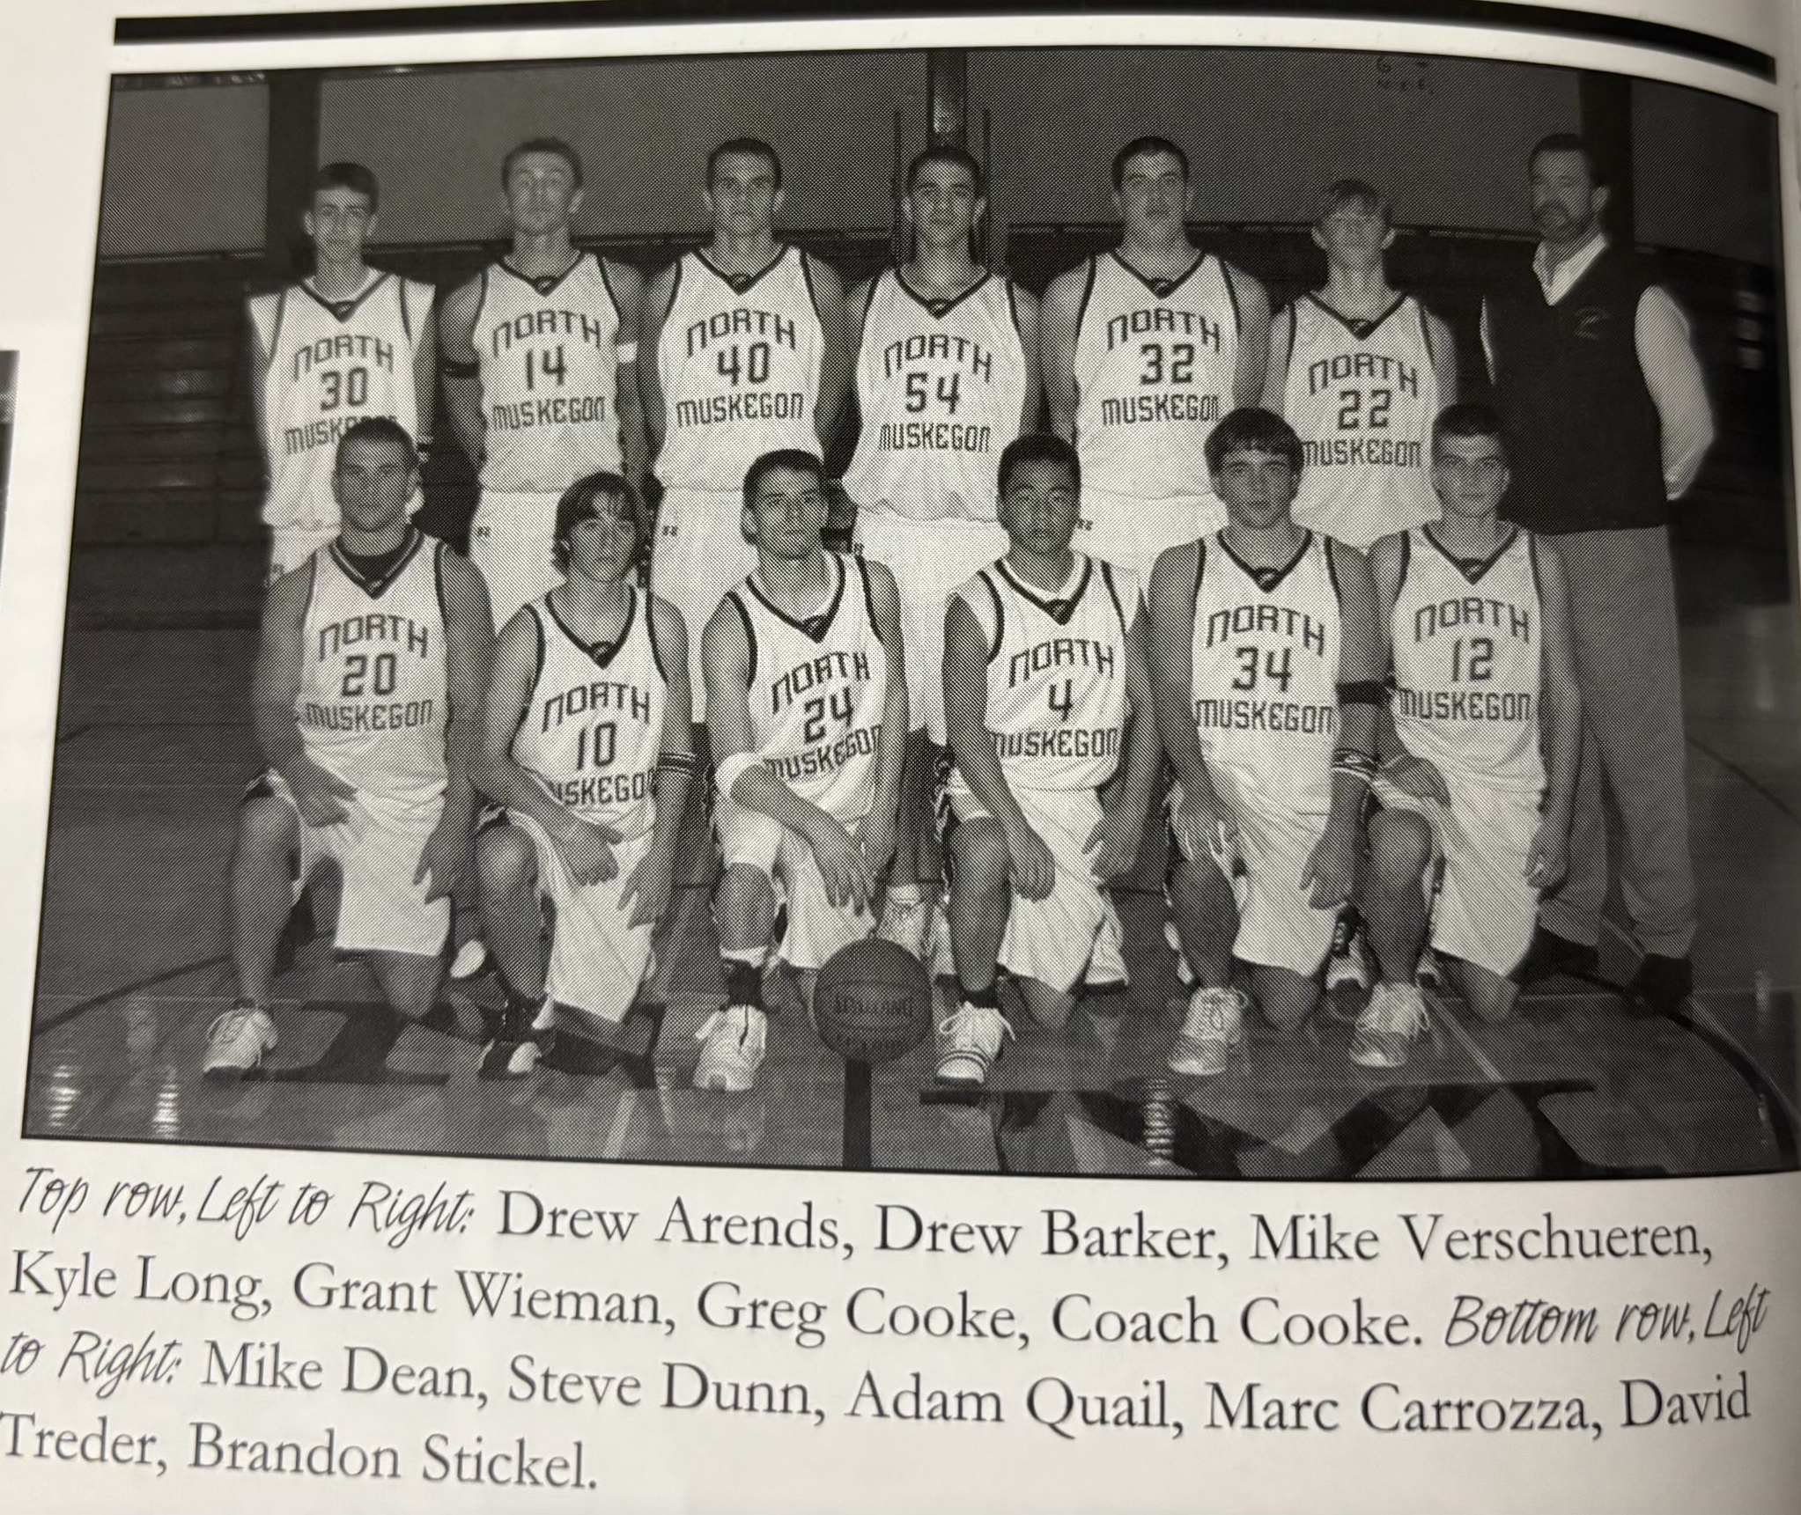
The 2003-04 NORSEMEN

N Muskegon 49 Musk Cath. 64 Drew Barker 11, Mike Verschueren 10
N Muskegon 51 Hart 63 Adam Dunn 15, Barker 10
N Muskegon 40 Mason Co 53 Brandon Stickel 9, Barker 9
N Muskegon 45 Ravenna 73 Stickel & Barker 9, Adam Qual 8
N Muskegon 40 WMC 74 Drew Arends 14, Verscheuren 10
N Muskegon 47 Whitehall 61 Barker 16, Arends 8
N Muskegon 28 Montague 58 Adam Quail 9
N Muskegon 58 Oakridge 78 Arends 19, Quail, 11, Barker 10
N Muskegon 32 Shelby 72 Arends 10, Verschueren 10
N Muskegon 43 Hart 46 Barker 13, Verscheuren 10
N Muskegon 52 Mason Co 74 Verscheuren 15, Barker 12
N Muskegon 34 Ravenna 63 Barker & Arends 7
N Muskegon 43 Hesperia 54 Dunn 12, Arends 11
N Muskegon 45 Whitehall 54 Arends 17, Verscheuren 12
N Muskegon 29 Mona Shores 64 Barker 9, Arends 8
N Muskegon 50 Montague 53 Barker 17, Arends 12, Verscheuren 10
N Muskegon 59 Holton 43 Barker 14, Verscheuren 13, Stickel 10
N Muskegon 46 Oakridge 62 Arends 21 Verscheuren & Quail 8
N Muskegon 38 Mason Co East. 51 Mike Dean 11
N Muskegon 48 Shelby 82 Barker 17, Stickel 8
N Muskegon* 29 Kent City 70 Arends 6

2004-05 (Coach Jeff Cooke 5-16, Shelby WMC champs)

It would be another tough year for the Norsemen who would finish with a 5-16 record. The 2003-04 Norsemen can now rest in peace as their infamous record of scoring the least number of points per game was ‘beaten’ by the 2004-05 squad that was only able to post an average of 39 points on the board per game. The current team was able to win five games, including a sweep of Oakridge. NM returned three regulars from the previous season: Adam Dunn, Mike Dean and Drew Arends with the lack of size a big problem for the Norse.
With the lack of a big man or two, NM started off the season with hopes that they could stay competitive with outside shooting. However, that was not the case in their opener with Muskegon Catholic as NM made only 4 of-27 3-pointers in a 64-53 loss to the Crusaders. Drew Arends, a returning regular from 2004 led the Norsemen with 19 points. Ironically, with 20 games still to be played during the season, Arends 19-point outing would be the highest single game mark for a NM player for their entire schedule of games.
Points were hard to come by for NM during the season. NM was only able to score 25 points in their 66-25 loss to Shelby. The Tigers blew the game open early by jumping out to a 21-2 first quarter lead and led by 34 entering the final quarter. The 25 points scored by the Norse was their lowest total team score in 54 years. The 25 points wasn’t even the low point of the season as NM would twice score only 24 points in a game. Mike Dean hit two 3-pointers for six points, NM’s high scorer in the contest.
The Norse then fell to Hart 53-36 in a game where the Norse stayed close until the final quarter. Trailing by five points after three quarters, the Pirates pulled away from the Norsemen with a 21-9 run in the fourth quarter. Hart was playing its first year with a new coach with an abundance of coaching experience. For seven years Terry Smith was the head coach at Division II Grand Valley State University, retiring to take a teaching and coaching position much less stressful at Hart High. No Norsemen reached double figures for the Norse with Drew Arends and Mike Dean sharing high point honors with eight.
After making but 4-of-27 3-pointers in their opener with Muskegon Catholic Central, the Norse did an about face with another MCC, Mason County Central and connected on 8-of-12 from behind the arc to pull off an upset over the visiting Spartans 62-59. NM almost gave a six-point lead away in the game’s final minutes when MCC converted a couple of steals into two-pointers. Drew Arends made 1-of-2 free throws to extend the NM advantage to three and the Norse intercepted a full-court pass to seal the win. It was the first game in two years where NM scored 60 points in a game. Leading the way for the Norsemen’s first victory was Drew Arends who had 17 points. Nick Cooke, NM head coach Jeff Cooke’s nephew, drained three treys and finished with 13 points while Austin Aamondt had 11.
In a non-conference game played in very late December the Norse were no match for Mona Shores. The Sailors blitzed the Norse 27-2 in the third quarter that forced a running clock for the rest of the game in a 79-31 defeat. NM scored only eight points in the entire second half with Zack Kidder’s seven points the high for NM.
After being overwhelmed by Mona Shores to end 2004, NM pulled off a shocker to begin 2005 with a 60-58 upset victory over West Michigan Christian. Trailing 50-44 entering the final quarter the Norse rallied to outscore the visiting Warriors 16-8 to earn their second and most improbable victory of the season 60-58. NM made eight treys in the game, but it was a 4-pointer that was the key play in the victory. Drew Arends tied the game at 50-all when he was fouled while making a 3-pointer and converted the free throw. Mike Dean hit a 3-pointer on the next possession that put NM ahead for good. Nick Cooke with 17 points led the balanced NM offense while Arends and Dean followed with 15 and 14 points.
Ravenna broke open a tight game at halftime to break away to outscore the Norse 37-19 in the second half to earn a comfortable 61-37 victory over the visiting Norsemen. Austin Aamodt led NM with 11 while Nick Cooke scored 10 for the Norse.
Yet another poor second half spelled defeat for the Norsemen as Whitehall posted a dominate 37-21 advantage over the final two quarters to send NM to a 62-41 loss. Ten Norsemen shared in the scoring, but none hit double figures with Drew Arends nine points being the top scorer.
Poor shooting paved the way for a 68-27 loss to Montague as the Norsemen only shot 18 per cent from the field. The Norsemen only scored 8 points in the entire first half while the Wildcats poured in 39 and just coasted to a win over NM in the second half. Nick Cooke’s nine points was best for the Norse.
The Norse enjoyed a short-lived 49-46 lead with two minutes remaining in the game before Mason County Eastern unleashed a final 12-3 run to send NM to their eighth loss of the season as opposed to but two wins. Nick Cooke scored 15 for the Norsemen while Steve Dunn dished out nine assists.
After holding a 26-18 lead at halftime, the Norsemen survived a near-even second half to win their third victory of the season and second in the WMC with a 47-41 win over Oakridge. Nick Cooke made his Uncle Jeff Cooke, the NM head coach happy as he scored 16 points to lead the Norsemen. Drew Arends added 14 while Steve Dunn added five assists and three steals for the Norse.
The Norse had victory in their grasp as they trailed Whitehall 38-37 with five minutes left in the game. The Vikings then dashed the Norsemen’s hopes with a 15-3 run as NM is defeated 55-40. Zack Kidder had a season high 11 points with Adams Dunn pitching in with 10.
Shelby again showed supremacy over the Norsemen as they doubled up the Norse 62-31 to stay perfect in the West Michigan Conference. NM was held below 10 points in each quarter with their high point producer Zack Kidder tallying only six points.
It’s tough to win when the object of the game is to score points. NM scored only 12 points in the first half but trailed by only seven, 19-12. Hart then scored 36 points in the second half, NM’s total for the entire game as Hart improved to 7-2 in the WMC with a 55-36 victory. Nick Cooke did manage to hit double figures for the Norsemen, barely, with 10 points.
Mason County Central, a team that lost to NM back in December, showed vast improvement in their second meeting with the Norse by whipping the Norsemen by 30 points 54-24. NM was only able to score but seven points in the second half, two in the third quarter, as the NM low total of 24 points now becomes the lowest points scored by NM in a game since the Norse scored only 22 points vs. Coopersville in 1950.
Normally when you hold your opponent to 42 one can expect a victory. Not the case however with the Norsemen of 2005. Hesperia defeated NM 42-40 as the Norse played the Panthers tough but fell short. NM led in the game at one point 27-24 and was tied at 31-all before Hesperia pulled away for the narrow two-point win. Nick Cooke led the Norse with 14 points followed by Drew Arends with 10.
On their home court the Norsemen and Ravenna were tied at 36-all heading into the fourth quarter giving the Norse rooters some hope. Those hopes were dashed when the Bulldogs outscored NM 14-6 in the game’s final eight minutes to defeat the Norse 49-40. The Norse were only able to make one field goal in the pivotal final quarter and were back in the cellar of the WMC with a conference record of 2-10. Nick Cooke was the shining light for North Muskegon with a season high 18 points.
NM made only 9-of-21 free throws in a 57-35 loss to Montague as their losing streak had reached eight games without tasting victory. NM did win the first quarter 12-10 but unlike the Continental Basketball League where the Muskegon Mayhem had a brief two year run before folding following the 2006 season, points aren’t awarded in high school basketball for winning a quarter. Nick Cooke led NM with 14 points.
For the second year in a row NM was grateful that Holton was on their schedule. With their lone win last year coming in a game with Holton, NM won again in 2005 to snap a eight game skid 49-39. What was ironic about this was that all 11 players suited up for the game scored for the Norsemen despite scoring only 49 points. Josh Chovaz, who has been working his way into the rotation of late scored six of his game high 14 points in the third quarter to key NM’s 20-11 run.
NM scored only 42 points in their final game of the regular season, but it was enough to defeat Oakridge and escape out of the West Michigan Conference cellar with a 42-39 victory. Nick Cooke nailed two free throws to give NM a 42-39 lead with seven seconds left to seal the victory. Austin Aamondt had 11 to lead NM in the low-scoring affair. Scoring in double figures for Oakridge with 10 points was Ryan Schalk, the current head softball coach at Saginaw Valley State and the son of the late Mike Schalk, an outstanding player for NM in the early 1970s who averaged more than 22 points per game in 1972.
West Michigan Christian more than avenged their earlier two-point loss to the Norsemen as they forced a running clock in a 63-24 rout of NM to end NM’s season at 5-16. At one point in the first half in the district contest hosted by Ravenna High School, the Warrior went on a 21-2 run. It was the fourth time during the season when NM scored less than 28 points in a game. One would have to go all the way back to 1949, Bob Morris first year as the head coach, when NM suffered through a 1-13 season, to find a NM team that scored less than 30 points more than four times.

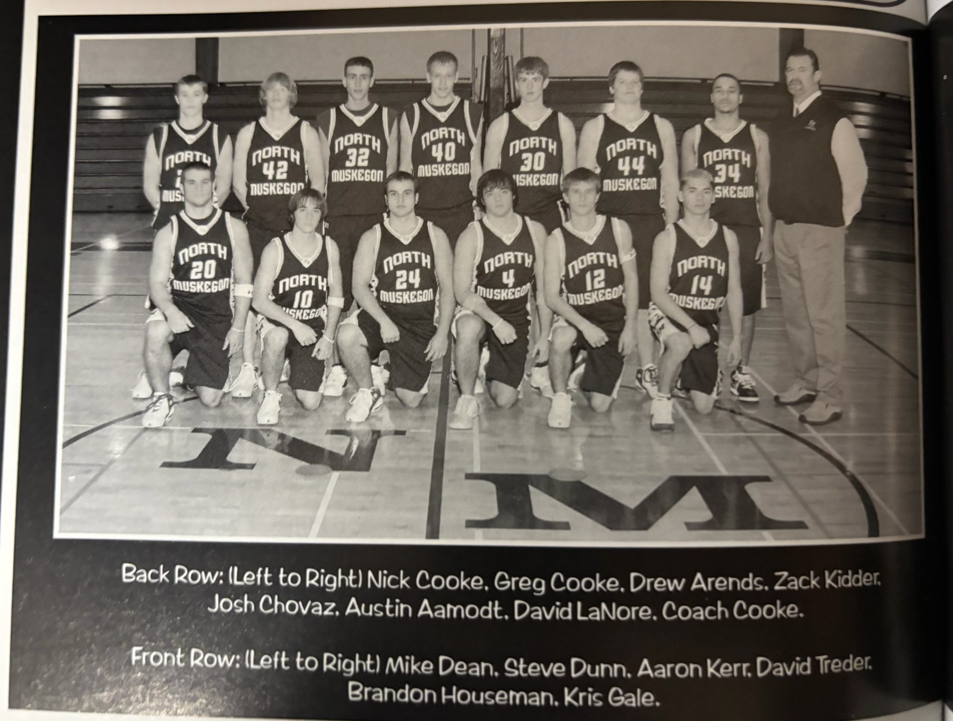

THE 2004-05 NORSEMEN

N Muskegon 53 Musk Catholic 64 Drew Arends 19, Mike Dean 9
N Muskegon 25 Shelby 66 Dean 6
N Muskegon 36 Hart 53 Arends & Dean 8
N Muskegon 62 Mason Co 59 Arends 17, N. Cooke 12, A. Aamondt 11
N Muskegon 31 Mona Shores 79 Zack Kidder 7, Nick Cooke 6
N Muskegon 60 WMC 58 Cooke 17, Arends 15, Dean 14
N Muskegon 37 Ravenna 61 Aamondt 11, N. Cooke 10
N Muskegon 41 Whitehall 62 Arends 9
N Muskegon 27 Montague 68 N Cooke 9, Adam Dunn 7
N Muskegon 52 Mason Co East. 58 N Cooke 15, Dean 9
N Muskegon 47 Oakridge 41 N Cooke 16, Arends 14
N Muskegon 40 Whitehall 55 Kidder 11, Dunn 10, Arends 9
N Muskegon 31 Shelby 62 Kidder 6
N Muskegon 36 Hart 55 N Cooke 10, Dunn 9
N Muskegon 24 Mason Co 54 Arends 8, Dunn 7
N Muskegon 40 Hesperia 42 N Cooke 14, Arends 10
N Muskegon 40 Ravenna 49 N Cooke 18
N Muskegon 35 Montague 57 N Cooke 14, Aamondt 8
N Muskegon 49 Holton 39 Josh Chovaz 14, N Cooke 11
N Muskegon 42 Oakridge 39 Aamondt 11, Cooke 9, Chovaz 8
N Muskegon* 24 WMC 63 Chovaz 6

2005-06 (Coach Jeff Cooke 4-17, Mason County WMC champs)

Although their record won’t show it, the 2005-06 Norsemen were an improved team from the previous season. The team was much better offensively as they scored nearly 10 points more per game than the 2004-05 Norsemen. Two of their 17 losses were in over time while five more losses were decided by less than five points. Only in a handful of games were the Norse badly beaten. The Norsemen returned their leading scorer back for the 05-06 campaign in Nick Cooke, a multi-sport standout who also excelled on the NM football team, and the nephew of Norse head coach Jeff Cooke who began his 10th season guiding Norsemen roundball. A sprinkling of others also returned aided by a few newcomers to the program led by a transfer from West Michigan Christian, Troy Forton, an all-state baseball player for NM in the Spring.
If the opening game of the season was supposed to signify an improvement in the Norse offense, that didn’t happen as the Norse only made one 3-pointer in a 52-38 loss to Muskegon Catholic. The Crusaders were on target with seven made long toms with Nick Cooke, NM’s leading scorer with 14 points, making NM’s only long-distance shot.
NM won the first of their four victories with a 51-44 decision over an Oakridge team who lost twice to NM in the previous season. The Norse led 11-4 at the end of the first quarter and held on for the win. NM did have one advantage over Oakridge -- practice time. Many of the Eagle players had little time to practice but for a very good reason. Oakridge just a few days earlier had won the state championship in football. Nick Cooke scored 14 points for NM while newcomer Troy Forton was in double figures with 11. NM did much of their damage at the free throw line making 18-of-26.
To confirm that NM had improved from the previous season one could look at NM’s next contest with Shelby, the defending WMC champs. NM lost to the Tigers twice in 04-05 by more than 30 points but lost by only five 59-54 when they first clashed in 05-06. The two teams were deadlocked at 51-all midway through the final quarter before Shelby’s Nate Plummer, who led all scorers with 32 points, hit three triples down the stretch to down the Norse. Turnovers were costly for the Norse as they committed 25 to the Tigers 13. Troy Forton led NM with 13 points and 10 rebounds while Chris Scheldt had a season high 12 and Mike Hermanson 10.
NM lost a tight one 51-48 to Hart but there were signs that the future was looking better as the NM JV team won 73-28. NM led 21-18 at the half but Hart’s 14-8 advantage in the third quarter would prove to be too much for NM to overcome as both teams tallied 19 points in the final period. Only four players scored for NM. Troy Forton became the first Norsemen to score 20 points in a game in two seasons with 20 markers while Mike Hermanson followed with 11.
NM trailed by one point heading into the final quarter before making a slight rally in the final quarter to defeat Mason County Eastern for the first time in three meetings 53-48. Nick Cooke had the hot hand for NM with 20 points, including four made 3-pointers. It was Cooke’s final 3-pointer with time running out that was the game-winner for the Norsemen.
The Norsemen and the West Michigan Christian Warriors were all tied at halftime, but the Warriors came alive in the second half to outpoint NM by 15 to win 67-52. Troy Forton, a transfer from WMC had his highest scoring game of the season against his former schoolmates with 24 points, the only NM player to reach double figures. WMC dominated in the free throw department making 19 free throws to NM’s poor 5-of-13.
NM gave another good account of themselves before losing in Scottville 48-43 to Mason County Central. The Norse took a slim one-point lead into the final quarter before the Spartans finished on a 21-15 run. Again, NM hurt themselves at the free throw line as NM attempted but four free throws while the Spartans netted 10. Troy Forton with 15 and Nick Cooke with 13 led NM. Mason County Central would go on to win the WMC with a 13-1 conference mark.
In the last game ever played between the two local schools in a brief five game series that began in 1963, Mona Shores needed overtime to pin a 58-54 defeat on the Norsemen. NM once again had the fourth quarter blues as the visiting Sailors outscored NM by three points in the final period to force overtime. The Sailors made six of their eight points in the extra session on free throws, but it was not free throws that cost NM the game. NM was a perfect 12-for-12 at the charity stripe, all made by Nick Cooke (20 points) and Troy Forton (19) as the duo combined to score 39 of NM’s total of 54 points.
Ravenna came out smoking hot in the first quarter as the Bulldogs opened with a 16-2 start to take a lead that NM could not recover in the Bulldogs 57-50 win over the Norse. The Norse battled back and came within three points of Ravenna midway through the final period but then the Bulldogs made enough free throws down the stretch to down the Norse. Ravenna completely dominated at the free throw line making 16 charity tosses to NM’s 4. Nick Cooke had 18 and Mike Hermanson finished with 14 to lead the Norsemen.
For the second straight outing NM fell behind early to their opponent as Whitehall
jumped out to a 16-6 first quarter lead enroute to a 63-46 win over the Norse. With the win the Vikings stayed unbeaten in the WMC. Nick Cooke had a career high 21 points and 10 rebounds in a losing cause for NM.
For the first time this season NM was never in the game as Montague won 61-44. The Cats used a big second quarter to pull ahead and were never again challenged. Nick Cooke was the only Norseman in double figures with 16 points as no other NM player tallied more than six markers.
With three minutes left in the game and the Norse leading 41-36, it looked like NM was headed for a win over Oakridge. However, NM never scored another point, and Oakridge hit a game winning three-pointer with 19 seconds left to send NM to their 10th defeat on the season 43-41. NM turned the ball over 23 times; a trait not lost on NM coach Jeff Cooke. “It seems like in the last 3 minutes every time we touched the ball, we turned it over,” said the disappointed coach. “Oakridge played well but turnovers killed us.” Mike Hermanson with 10 points led NM in the low-scoring affair.
In the first ever meeting between the two schools, NM must have thought they ran into a buzz saw as they absorbed their biggest loss of the season 91 to 49 to Grand Rapids Covenant Christian. The host team from GR lit up the scoreboard in the first half scoring 55 points and, even with a running clock for part of the final quarter, still rang up 28 points. Troy Forton had 18 points to lead NM.
Trailing by as many as 21 points in the fourth quarter NM mounted their best rally in ages only to come up two points short in a 64-63 loss to Shelby. The loss spoiled the game of his life for NM’s Austin Aamondt. Having scored no more than six points in a game, and playing in five games where he was scoreless, Aamondt had a career high 21 points and seven rebounds. The 63 points were the most points scored by NM during the season. Nick Cooke and Mike Hermanson each had 10 points for NM.
NM held a poor shooting Hart team to only 17 points through the first three quarters of play while the Norse had doubled that total with 34 as NM snapped a nine-game losing streak with a 53-34 win over the Pirates. NM in the past often had some poor shooting woes from the free throw line but not in this game as they hit 11-of-12. Nick Cooke’s 15 points led the Norse with three of his teammates each scoring seven points.
An old proneness came back to haunt the Norse once again -- scoring points. NM would score no more than 35 points in each of their next two games, both losses: the first to Mason County Central 59-35 and the second to Holton 42-33. Mason County jumped out to a 32-14 lead and added to their total in the final two quarters as NM never threatened the Spartans. NM was beaten in all phases of the game: outrebounded 43-28 while committing 23 turnovers. Nick Cook’s 12 led NM scorers.
The Norse let a possible win get away from the as they held a slim 24-23 lead entering the final quarter only to see Holton outgun NM 18-8 in the final quarter to win 42-33. Mike Hermanson’s 12 points was best for the Norse.
NM then played Ravenna on a Wednesday night game, and the Norse came through with their fourth, and final win of the season with a 46-35 win over the host Bulldogs. A big 20-10 third quarter was key for the Norse as Chris Scheldt led NM in scoring for the first time during the season with 11 points.
The Norsemen made a nice rally in the fourth quarter to send the game into overtime only to lose in the extra session by three points to Whitehall 58-55. The game earlier in the season when NM went 12-for-12 at the free throw line was now a distant memory as the Norse missed three attempts late in the fourth quarter and three in the overtime session. Nick Cooke and Chris Scheldt each had 12 while Mike Hermanson tallied 10 to lead the frustrated Norsemen.
NM seemed to make it a habit of turning the ball over 23 times as they did in their final game loss in the regular season 67-44 to Montague. Montague outscored NM in every quarter as NM ends the regular season with a 4-16 record but did escape the cellar in the WMC with a 3-11 record, one game better than Oakridge. Mike Hermanson’s 13 was best for NM.
The season ended as the host school Kent City squad, with a 40-21 lead at halftime, went on to trim the Norsemen 71-58. Nick Cooke finished his career with 13 points, the only Norsemen in double figures.
One normally cannot always rely on a junior varsity team that had a great record to have the same impact at the varsity level. However, NM’s JV team was outstanding during the season as varsity head coach Jeff Cooke let most of those good JV players stay together for the season in hopes they would have the same chemistry when they move up to the varsity. As one will soon see, Cooke did it right.

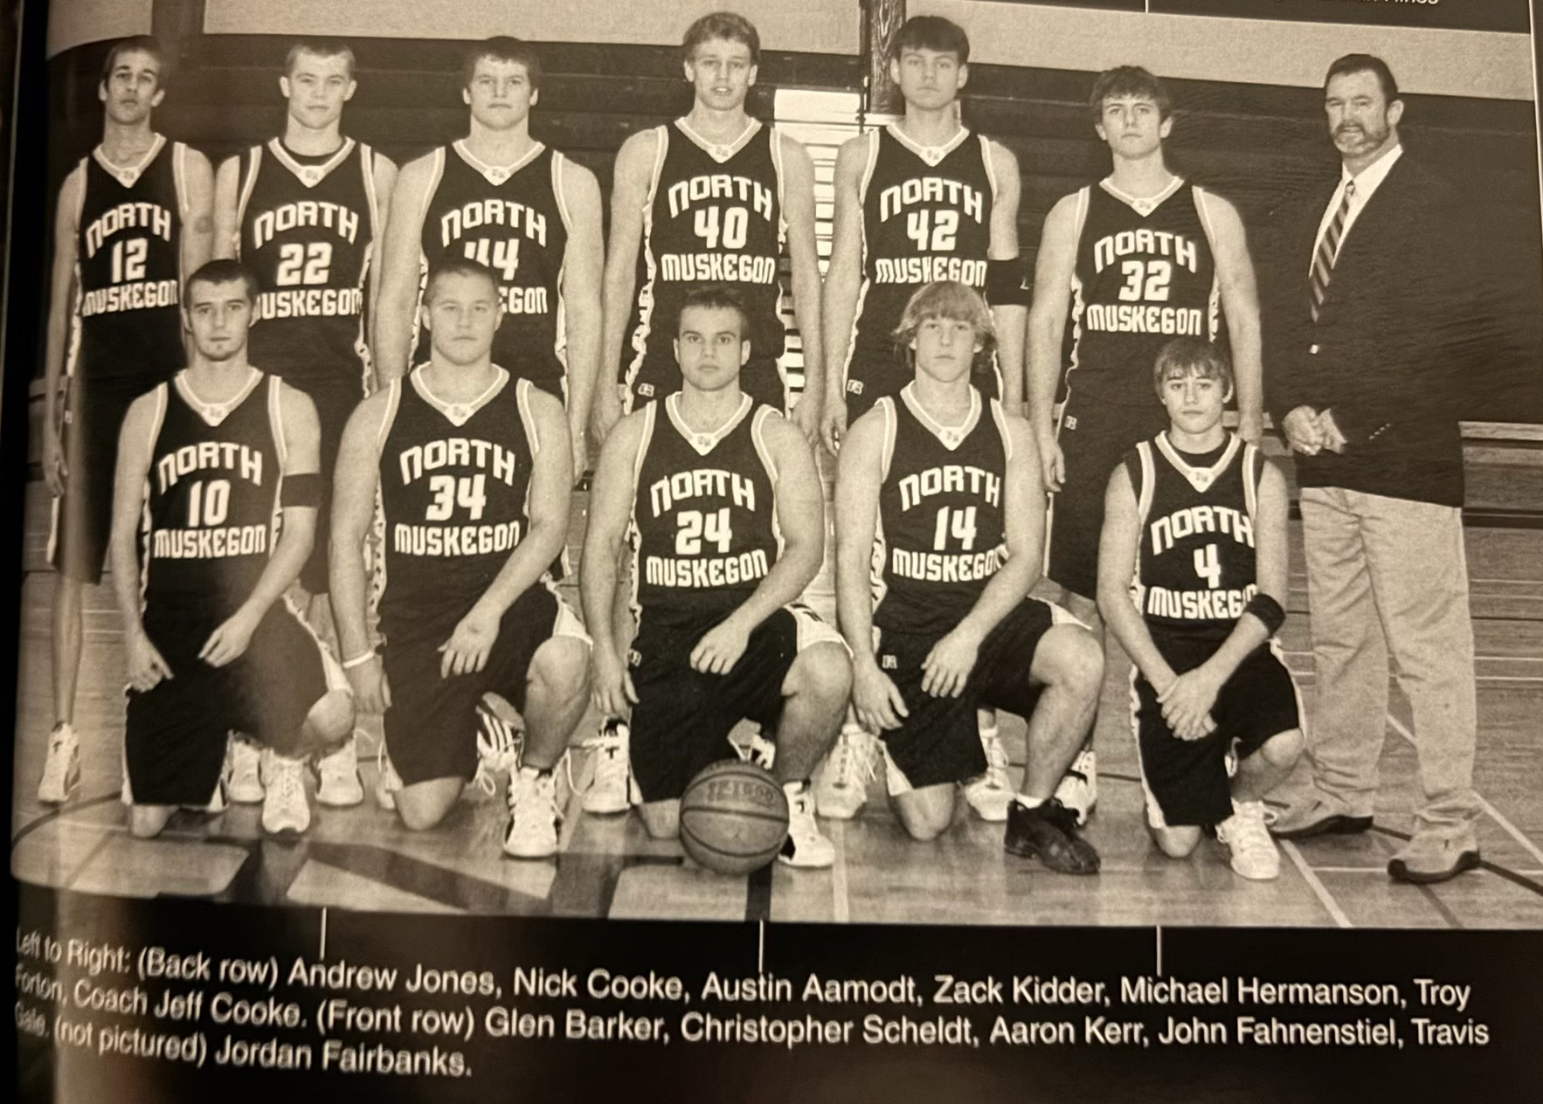

The 2005-06 NORSEMEN

N Muskegon 38 Musk Catholic 52 Nick Cooke 14
N Muskegon 51 Oakridge 44 Cooke 14, Troy Forton 11
N Muskegon 54 Shelby 59 Forton 13, Chris Scheldt 12
N Muskegon 48 Hart 51 Forton 20, Mike Hermanson 11
N Muskegon 53 Mason Co East. 50 Cooke 20 Forton 12
N Muskegon 52 WMC 67 Forton 24, Sheldt & Cooke 8
N Muskegon 43 Mason Co 48 Forton 15, Cooke 13
N Muskegon 54 Mona Shores (ot) 58 Cooke 20, Forton 19
N Muskegon 50 Ravenna 57 Cooke 18, Hermanson 14
N Muskegon 46 Whitehall 63 Cooke 21
N Muskegon 44 Montague 61 Cooke 16
N Muskegon 41 Oakridge 43 Hermanson 10, Cooke 9
N Muskegon 49 GR Cov. Christ. 91 Forton 16
N Muskegon 63 Shelby 64 Austin Aamondt 21
N Muskegon 53 Hart 34 Cooke 15
N Muskegon 35 Mason Co 59 Cooke 12
N Muskegon 33 Holton 42 Hermanson 12
N Muskegon 46 Ravenna 35 Scheldt 11
N Muskegon 55 Whitehall (ot) 58 Cooke & Scheldt 12, Hermanson 10
N Muskegon 44 Montague 67 Hermanson 13, Aamondt 8
N Muskegon*58 Kent City 71 Cooke 13

2006-07 (Coach Jeff Cooke 15-6, Mason County WMC champs)

The Norsemen made a huge turnaround after three losing seasons by posting a 15-6 overall record and placed second behind Mason County Central in the race for the conference title. NM received a big boost from 6’4 junior Harry Barendsen who would lead NM in scoring with nearly 14 points per game. Mike Hermanson, also at 6’4 returned as did Kyle Cooke. Ben Reider moved up from the JVs as NM could field a front line of three players at 6’4. Ian Schutek joined NM at the semester break as NM showed great balance throughout the season.
NM broke up a close game by going on a 21-11 run in the fourth quarter to snap a three-game losing streak to Muskegon Catholic in a low-scoring 42-35 victory. One newcomer and one returning veteran paced NM with Harry Barendsen scoring a game high 15 points and pulling down nine rebounds while Mike Hermanson totaled eight points and four steals. Returning playmaker Chris Scheldt added six assists as for the first time in four years NM starts off the season with a victory. NM caught the Crusaders at the right time as many of the Crusaders had but two weeks of practice as they were busy earlier helping MCC win a state championship in football.
NM went on the road for their second game of the season and played Shelby almost dead-even, except for one disastrous quarter. With the game tied at 20-all at halftime, the Tigers put together a 15-3 run against the cold shooting Norsemen in defeating NM 50-36. Turnovers, a trait that plagued the Norse a year ago, again posed a problem has NM committed 22 miscues, as opposed to only 12 in the opener with Muskegon Catholic. NM didn’t have a player reach double figures in NM’s lowest offensive output of the season with guards Travis Gale and Glen Barker leading NM, each with eight points.
To say that Hart got off to a woeful start would be an understatement as the Pirates never scored a point in the first quarter while NM scored 11 as NM had an easy time defeating the visiting Pirates 60-34. NM, with a height advantage over the Pirates enjoyed a big rebounding edge as 6’4 Harry Barendsen with 14 and 6’4 Mike Hermanson with 12 led the Norse scorers.
The Norse gave the defending WMC champions from Mason County Central, who returned most of their regulars, a battle before falling 64-62 in a thriller held at the Northside gymnasium. NM can look no further than free throws on the stat sheet for a telling explanation for their close defeat. The Spartans connected on 15 free throws to NM’s mediocre 4-of-12. The free throw stat is surprising as NM made eight 3-pointers in the loss, normally a sign that a team would have good free throw shooters. NM trailed 52-43 in the final quarter, but the pesky Norse wouldn’t go away as NM made three 3-pointers late to put a scare into the undefeated Spartans. Travis Gale led NM with 17 points with 15 of those markers coming on five made 3-pointers. Kyle Cooke, nephew of NM head coach Jeff Cooke connected on three 3-pointers and scored 12 for the Norse.
Scoring 75 points in their 75-64 win over Ravenna, NM had their best offensive output in four years. Harry Barendsen joined the 30-point club with 33 points, 21 tallied in the first half to lead the Norsemen. Ben Reider had his best game thus far on the season with 16 points while Mike Hermanson finished with 12 as NM improved to 3-2 on the season.
NM made the long journey to downtown Custer, Michigan a success as they used a strong second half, where they outscored Mason County Eastern 29-9 to earn a 56-31 win. The four wins before reaching the New Year of 2007 already equals the total number of wins from last season. Chris Scheldt led NM with 13 points followed by Glen Barker with nine.
One of the busiest coaches in the area, who in the late Fall had coached Muskegon High to a state championship in football, uses his ‘spare’ time to coach the Whitehall Varsity basketball team. Unlike in football where Muskegon’s iconic Ronald Johnson saved the day with a hit and a fumble recovery in the end zone that preserved Muskegon’s state final victory over Warren DeLaSalle, there was no magic for Tony Annese and his Whitehall Vikings in their game with North Muskegon. 6’4 Ben Reider tipped in a missed shot shortly before the buzzer sounded to give NM a 65-64 win over Whitehall as the NM students rushed onto the floor to celebrate the victory. The thrilling win snapped a six-game losing streak to the Vikings and moved NM into contention in the WMC with a 3-2 record. Ryan VanBergen, who Annese would have loved playing football for him at Muskegon High and who later starred for the UM Wolverines, scored 17 for Whitehall. NM had balanced scoring with Reider and Mike Hermanson each scoring 12 while Kyle Cooke and Harry Barendsen added 11 points.
Another six-game losing streak went by the wayside as the Norse defeated Montague 62-49. NM trailed at halftime, but NM then held Montague to four points in the third quarter to pull away behind the second half scoring of Harry Barendsen who scored 18 of his game high 24 points in the second half. NM had 15 steals in the win while Ben Reider with 11 and Chris Scheldt with 10 also reached double figures in scoring for the streaking Norsemen.
NM busted their next game with Oakridge wide open early with a commanding 49-22 lead at halftime. Harry Barendsen scored 12 of his team-leading 16 points in the second quarter. Mike Hermanson added 14, Travis Gale 15 and Parker Zikcl 10 as NM made it six wins in a row, their longest winning streak since the Drew Naymick era Norsemen of 2003.
West Michigan Christian’s defense, always troublesome in the Jim Goorman WMC era to solve, caused 24 Norsemen turnovers in Christian’s 67-61 win over NM. WMC also caused NM troubles at the free throw line as the Warriors made 10-of- 10 free throws in the final quarter to hold off the Norse. WMC outscored NM at the line 18 to 6 to overcome a NM 27-22 advantage in field goals. Mike Hermanson had a game high 19 points to lead NM while Ben Reider chipped in with 11 and Kyle Cooke 9.
NM atoned for an earlier loss to Shelby by nipping the visiting Tigers 58-55. Kyle Cooke also made up for two missed free throws with NM holding a slim one-point lead but quickly redeemed himself with a steal and a layup to seal the deal for NM. The game was tight all the way with Shelby holding a 52-49 lead with two minutes remaining. Harry Berendsen, one of four NM players at 6’4, scored six points in the final two minutes to recapture the lead for NM who are now 8-3 overall, and tied for 2nd place in the WMC with Shelby at 6-2. Berendsen’s 15 points led NM with Ben Reider close behind with 14.
NM caught Hart on a down year as the Pirates, now 1-9 on the season were again soundly defeated by NM 68-38. Ten Norsemen scored in the rout led by Harry Barendsen’s 17 tallies while Kyle Cooke added 11 and seven steals.
The following day on a snowy Saturday, NM traveled to White Cloud to play the first game between the two schools in 30 years. NM outscored the host Indians in every quarter to post an easy 75-51 victory. Harry Barendsen led NM’s balanced attack with 14 points as 10 Norsemen scored in the contest.
One only must compare this year’s results to last year’s game with Covenant Christian to appreciate the marked improvement in one year. The Norse lost to the Chargers by more than 40 points last season but won 56-51 a year later. NM held off a late Charger rally as the Chargers hit four 3-pointers to throw a scare into the Norsemen. With NM leading by only three with inside a minute to play, Travis Gale hit a pair of free throws to seal the win. Ben Reider led the Norse with 14 points with Gale finishing with 10.
Even though it was very early in February Mason County Central clinched at least a tie to earn their second straight WMC championship with a not-so-easy 49-43 win over the visiting Norsemen. NM held a two-point lead over the Spartans before the hosts limited NM to but five points through the first seven minutes of the final quarter to secure the victory. Harry Barendsen was the only Norsemen in double figures with 13 points.
After leading by five points at halftime The Norse pulled away from Ravenna by beginning the second half with a 15-6 run enroute to a 62-43 win to complete a season sweep of the Bulldogs. NM’s 62 points were spread among 11 players who scored as coach Cooke used his bench throughout the contest. Travis Gale’s 12 points led NM scorers.
Holton gave NM a good run in the first half as they trailed the Norsemen 30-29, but NM then used some solid defense in the final two quarters to outscore the visiting Red Devils by 16 points to win going away 70-53. Harry Barendsen led NM with 18 while Ian Shutek had a season high 14 points.
Future UM football standout Ryan VanBergen used his 6’5 250 body to overpower the Norsemen by scoring 25 points to lead Whitehall to a 65-59 win in a game that was decided in two overtimes. VanBergen’s three-point play to start the second overtime began a 10-0 Whitehall spurt to send NM to a defeat and dropped the Norse out of a tie for second place in the WMC with the Vikings. Ben Reider had a career high 22 points to lead the Norse while Kyle Cooke had an excellent game for NM with 15 points, five assists and three steals. Harry Barendsen, averaging about 15 points per game got into early foul trouble and was held scoreless by the Vikings.
Ben Reider scored eight of his ten points in the final quarter as NM made a huge comeback in the final quarter to defeat Montague 57-52. NM trailed 38-30 entering the final quarter before Reider and his teammates began their rally. Harry Berendsen led NM with 15 points.
The Norse had their best defensive performance of the year as they held Oakridge to but 28 points in NM’s 59-28 win. Eleven NM players got in on the scoring act led by Harry Barendsen’s 14 points. NM held Oakridge to less than 10 points in every quarter to finish the regular season at 15-5, a massive improvement over the last three years.
NM played at Kent City in the Class C district tournament and for the second consecutive season were eliminated by the host school 67-56. NM would have liked to have played the third quarter over again as they were outscored 24-11 after having taken a brief one-point lead at halftime. Free throws surely played a part in the exit from the tournament as Kent City made 20 from the charity stripe to NM’s four. Harry Barendsen ended his junior season with 18 points to pace the Norsemen.

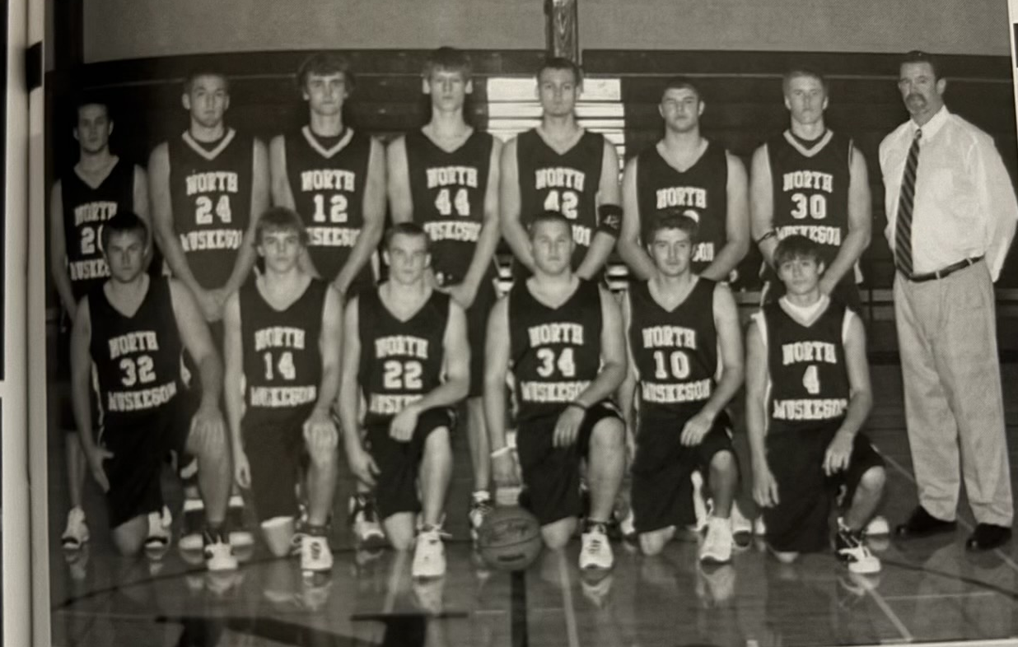

The 2006-07 NORSEMEN

Back Row L-R: Andrew Jones, Ian Shutek, Ben Reider, Harry Berendsen, Mike Hermanson, Eric Spytma,
Parker Zikel, Coach Jeff Cooke
Front Row L-R: Jordan Fairbanks, Alex Wierda, Kyle Cooke, Chris Scheldt, Glen Barker, Travis Gale

N Muskegon 42 Musk Catholic 35 Harry Barendsen 15, M. Hermanson 8
N Muskegon 36 Shelby 50 Travis Gale 8, Glen Barker 8
N Muskegon 60 Hart 34 Barendsen 15, Hermanson 12
N Muskegon 62 Mason Co 64 Barendsen 17, Kyle Cooke 12
N Muskegon 75 Ravenna 64 Barendsen 33, Ben Reider 16
N Muskegon 56 Mason Co East. 31 Chris Scheldt 13, Barker 9
N Muskegon 65 Whitehall 64 Reider and Hermanson 12
N Muskegon 62 Montague 49 Barendesen 24, Rider 10, Scheldt 11
N Muskegon 71 Oakridge 46 Barendsen 16, Gale 15, Hermanson 14
N Muskegon 61 WMC 67 Hermandson 19, Reider 11
N Muskegon 58 Shelby 55 Barendsen 15, Reider 14, Hermanson 10
N Muskegon 68 Hart 38 Barendsen 17, Cooke 11
N Muskegon 75 White Cloud 51 Barendsen 14, Ian Shutek 11, Gale 10
N Muskegon 56 GR Cov Christ. 51 Reider 14, Gale 10
N Muskegon 43 Mason Co 49 Barendsen 13
N Muskegon 62 Ravenna 43 Gale 12
N Muskegon 70 Holton 53 Barendsen 18, Shutek 14, Reider 10
N Muskegon 59 Whitehall (ot) 65 Reider 22, Cooke 15
N Muskegon 57 Montague 52 Berendsen 15, Reider 10
N Muskegon 59 Oakridge 28 Berendsen 14, Cooke & Reider 8
N Muskegon*56 Kent City 67 Barendsen 18, Hermanson 8

2007-08 (Coach Jeff Cooke 16-5, Montague WMC champs)

North Muskegon began the season starting five seniors. Unfortunately for Jeff Cooke and the Norsemen one of his projected starters and leading scorer from last year’s outstanding team, Harry Berendesen, had moved with his family to Oregon that created a major hole in the 2007-08 NM lineup. Despite Berendsen’s untimely departure, the Norsemen would have another successful season posting an outstanding 16-5 record.
With an all-senior lineup as opposed to Muskegon Catholic starting all underclassmen, experience won out as the Norsemen defeated a talented MCC team 57-51 as Ian Shutek scored 23 points, 11 more than his best effort from the previous season. Shutek was at its best when it counted most, in the fourth quarter as he scored 14 of his 23 points in the game’s final eight minutes, including 8-of-9 free throws. NM was helped by MCC’s poor free throw shooting as the Crusaders only made 8-of-20.
For the first time since 2003 the Norsemen had two players score 20 or more points in a game as Ben Reider and Ian Shutek each hit right on the 20-point mark in a 73-50 romp over Oakridge. Kyle Cook and Parker Zickel each hit the 10-point mark right on the button while Shutek also dished off six assists.
NM then handed Shelby a 56-34 loss to start their season perfect at 3-0 overall and 2-0 in the WMC. NM needed a big fourth quarter to pull away from the Tigers. With NM clinging to a 41-38 lead early in the fourth quarter Ian Shutek took over, scoring seven straight points that increased the lead to 52-38 and it was all over but the shouting. Ben Reider continued his fine play with 15 points with Shutek adding 13 and Alex Wierda chipping in with nine.
Playing their third game in a week, with none of the games played on the old traditional Tuesday and Fridays due to girls’ basketball in Michigan moved from the Fall to Winter, NM played their third game of the week on a Saturday afternoon in a non-conference clash with White Cloud. And, for the third time in a week the Norse emerged victorious with a 66-44 win over the visiting Indians. NM outscored White Cloud in every quarter as coach Jeff Cooke was able to go to his bench early with eight Norsemen figuring in the scoring led by Ben Reider’s 15 points and Karl Kettelhut’s 13.
Only in one game during the regular season did NM score less than 50 points in any one game. Perhaps the NM players were still thinking about Christmas shopping as their attention must have been diverted elsewhere as NM was only able to score 31 points in an improbable loss to Hart 32-31. To illustrate how improbable, in their next meeting later in the season the Norse would score 77 points. So --- in the two meetings with Hart-- the Norse would score their fewest (31) and their highest (77) points vs. Hart. Ben Reider with 15 points had nearly half of NM’s 31 points in the loss to Hart.
Mason County Central now must know how NM coach Jeff Cooke felt after his NM team went from 24-2 in 2003 to 1-20 the following year. The Spartans, after back-to-back West Michigan Conference Championships lost their fourth game in a row without a victory in a 50-40 loss to North Muskegon. The Spartans regressed so far in one year that they had two quarters where they scored four and five points as they combined to score only 40 points in losing to NM 51-40. Ben Reider scored 12 and Ian Shutek 11 as NM improved to 5-1.
The Norsemen started off 2008 with a convincing 72-58 over Ravenna. NM put together two good opening quarters to lead 40-30 at the halftime break and then coasted to the victory. Parker Zickel scored a career high 16 points, equaling Ben Reider as high point man for the Norse with Ian Shutek adding 15 points and 12 assists. Kyle Cooke dished off six assists while scoring 10 points as NM spread out the scoring.
Once a cellar dweller in the West Michigan Conference, NM moved into first place in the WMC after a thrilling 54-51 overtime victory over Whitehall. Ian Shutek drilled a 3-pointer with 90 seconds remaining in the overtime to give NM the lead for good. Ben Reider led the Norse with 19 points while Shutek finished with 14
NM stayed in first place in the WMC after a narrow 57-55 win over Montague but as Jeff Cooke said it best: “We’re fortunate to be in first. Several of our games could have gone either way.” Montague battled back after trailing by eight points at one time in the fourth quarter and had a chance to tie the game with two seconds left. Montague’s Mike Mack made the front end of a one-and-one but missed the second. Parker Zickel grabbed the rebound, was fouled and made one free throw with one-second left to ice the game for the Norsemen. The trio of Ben Reider (23), Ian Shutek (16), and Parker Zickel (16) scored all but five of NM’s 57 points.
Unlike last season when multiple players were needed to put points on the board for NM, that was not often the case in 2008. In NM’s 62-53 win over Oakridge four players scored all 62 points led by Ian Shutek’s 23 markers. Ben Reider, with 18 has now scored in double figures in all of NM’s first 10 games. Alex Wierda scored a season high 14 while Kyle Cooke’s seven markers comprised all 62 points. NM helped their own cause by connecting on 21-of-25 free throws.
There must be a story unbeknownst by your author as North Muskegon played for the only time in program history Bear Lake – not the famous NM Tavern – but a little community located on US 31 north of Manistee. The visitors, sporting an impressive 8-1 record, made the long journey to NM on snow covered roads only to lose to the Norsemen 70-58. Ben Reider scored a season high 26 points while a season best also was attained by a rapidly improving Alex Wierda who tallied 19.
It was NM’s turns to make a trip north on snow covered roads, but they only had to travel to Shelby where the Tigers began the game cold. NM started off with a 13-4 run and doubled the score at halftime 32-16 on their way to a rare season sweep over Shelby with a 61-41 victory. Steady Ben Reider’s 15 was tops for the Norse. Ian Shutek netted 14 and Kyle Cooke added 12 as NM stayed on top of the WMC standings.
After NM blasted Hart 77-40 one had to wonder how in the world did NM score only 31 points in their only loss thus far in the WMC to Hart back in December? The Norsemen after busting out to a 21-7 lead after the first quarter surpassed the entire previous point total of 31 points early into the second quarter in the rematch. The win was the eighth straight for the Norsemen and improved their record to 12-1. Ben Reider again led the Norse with 26 points with Ian Shutek netting 20. Many of those points by the NM duo came from passes from Kyle Cooke who had 11 assists.
NM again got off to a great start in a 73-48 win over Mason County Central to earn their 9th straight victory. Only a puzzling 32-31 loss early in the season to Hart kept NM from a perfect 14-0 start. NM had four players in double figures, and they almost had five as Karl Kettelhut missed by one point with nine. Reider (17) Wierda (14) Shutek (12) and Zickel (10) led the balanced attack.
North Muskegon had their bubble burst as they ran into a talented West Michigan Christian team that dominated the entire game with a 76-50 thumping of the Norsemen. Only in the first quarter was the game close as WMC led NM by only two points 17-15. The Warriors then outscored NM 47 to 21 over the next two quarters to hand NM only their second loss on the season. WMC’s heralded trap defense forced NM into 24 turnovers while limiting NM’s high scoring Ben Reider to 11 points. Ian Shutek led NM with 11 points and nine rebounds. The Warriors would go on to win the Class D state championship in March.
NM jumped on the back of Ian Shutek to rally from being down 33-24 in the third quarter to tie up the game with Ravenna and send the game into overtime with NM eventually winning 57-53. Shutek scored 10 of his game high 26 points in the fourth quarter to keep NM at the top of standings in the WMC. Alex Wierda finished with seven points, all seven in the overtime period. NM played the game without the services of their leading scorer Ben Reider.
For the third time in their last four meetings, North Muskegon and Whitehall had to go into overtime to decide a winner. NM won the earlier meeting in OT, but Whitehall turned the trick in the second meeting 66-65. Whitehall jumped ahead in the overtime mainly on free throws to deny NM a chance to clinch at least a tie for the WMC championship. Alex Wierda, who had a key 3-pointer to send the game into overtime, had a big game for the Norse with 16 points and nine rebounds. Ian Shutek collected 14 points, and eight rebounds and Ben Reider chipped in with 12 points and five assists.
North Muskegon needed a basket off a rebound from Ben Reider to nip Holton 57-55 in a non-league game. Reider finished with 19 points while Ian Shutek added 13 points and 10 rebounds. The two teams wouldn’t have to wait long for the rematch as they would meet again in the semifinals of the Class C district tournament in Montague.
It was winner take all when Montague and North Muskegon played in the final game of the regular season. It was the first time the two teams met to decide the WMC championship since 1959 when your (now very old) author was playing hoops for the Blue & Gold. Unlike the game from 49 years earlier when NM walked away with the win and the championship, it was Montague’s turn to earn the title on the very same floor the two teams played on in 1959. The 2008 year would be a memorable year for Wildcat fans as the fall of 2008 would see Montague win the state title in football. Three members of that championship football team helped defeat NM in the basketball game, including Cody Kater, who drilled a couple of three pointers to start the third quarter that gave Montague its biggest lead at 39-22, an advantage too much for NM to overcome. The Cats drilled 7-of-14 three pointers, with 5-of-7 made in the first half when Montague took control of the game. Ian Shutek drained three from long range in leading NM in scoring with 18 points, Parker Zickel scored 11, Alex Wierda 10 with Ben Reider adding nine points while leading Norse rebounders with 11.
NM defeated Holton for the second time in a week to advance to the finals in the Class C district tournament in Montague. In a physical battle NM prevailed 56-48 as the Norsemen made 10-of-13 free throws in the final quarter to aid in the win. NM took the lead for good in the final quarter on a pair of free throws by Ben Reider at 50-48 as NM scored the final eight points of the contest. Reider finished with 23 points while Ian Shutek added 12.
North Muskegon began and ended the season against Muskegon Catholic, winning the opener but losing in the district finals to the young Crusaders 51-45. NM trailed throughout most of the game and did make a furious fourth quarter rally outscoring MCC 11-4 only to fall short. MCC won despite shooting a dismal 8-of-26 from the free throw line. A gracious NM coach Cooke gave praise where praise was earned: “They are much better tonight than they were in the first game.” Ian Shutek closed his NM career with 15 points. Ben Reider, averaging near 17 points per game was held to four points but did grab 12 rebounds.
NM ended the season with an excellent overall record of 16-5, just missing out on a WMC title. If NM could play one game over again, it would be their surprising one-point loss early in the season with Hart that cost NM at least a share of the MWC title.

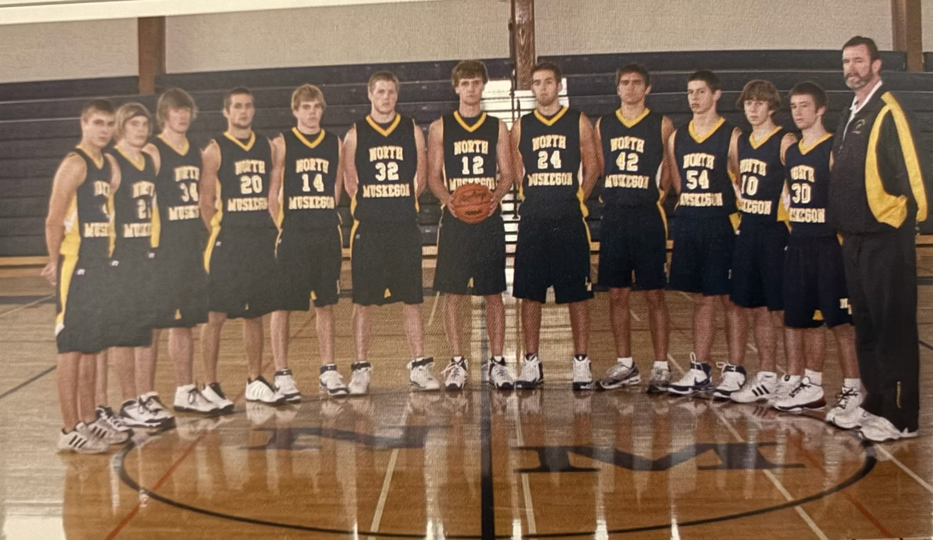

The 2007-08 NORSEMEN

L-R: Travis Falkowski, Kyle Cooke, AJ Balkema, Alex Jones, Alex Wierda, Parker Zickel, Ben Reider, Ian Shutek,
Adam Husingh, Geoff Evans, Nate Lynch, Kark Kettelhut, Coach Jeff Cooke

N Muskegon 57 Musk Catholic 51 Ian Shutek 23, Ben Reider 11
N Muskegon 73 Oakridge 50 Shutek & Reider 20, Cooke, Zickel 10
N Muskegon 56 Shelby 34 Reider 15, Shutek 13, Alex Wierda 9
N Muskegon 66 White Cloud 44 Reider 16, Karl Ketterhut 13
N Muskegon 31 Hart 32 Reider 15
N Muskegon 51 Mason Co 40 Reider 12, Shutek 11
N Muskegon 72 Ravenna 58 Parker Zickel & Reider 16, k15
N Muskegon 54 Whitehall (ot) 51 Reider 19, Shutek 14
N Muskegon 57 Montague 55 Reider 23, Shutek 16, Parker Zickel 13
N Muskegon 62 Oakridge 53 Shutek 23, Reider 18, Wierda 14
N Muskegon 70 Bear Lake 58 Reider 26, Wierda 19, Shutek 10
N Muskegon 61 Shelby 41 Reider 15, Shutek 14, Cooke 12
N Muskegon 77 Hart 40 Reider 26, Shutek 20, Kettelhut 9
N Muskegon 73 Mason Co 48 Reider 17, Wierda 14, Shutek12
N Muskegon 50 WMC 76 Shutek 16, Reider 11, Cooke 9
N Muskegon 57 Ravenna (ot) 53 Shutek 26, Alex Jones 10
N Muskegon 65 Whitehall (ot) 66 Wierda 16, Shutek 14, Reider 12
N Muskegon 57 Holton 55 Reider 19, Shutek 13, Cooke 9
N Muskegon 54 Montague 61 Shutek 18, Zickel 11, Wierda 10
N Muskegon*56 Holton 48 Reider 23, Shutek 12
N Muskegon*45 Musk Catholic 51 Shutek 15, Wierda 8, Reider 12 reb.

2008-09 (Coach Jeff Cooke 6-15, Montague WMC champs)

NM with virtually a new team would take a big step back in the 2008-09 season as coach Jeff Cooke patiently waits for his young team to develop. One of his youngsters was a freshman who would take his game to an unprecedented level before his four years are up at NMHS. Karl Kettelhut would certainly qualify as a candidate for the most improved player in NM’s long history. After averaging less than five points per game in his junior season Kettelhut scored 456 points in his senior season for an average close to 22 points per contest. During the season Ketterhut would top the 30-point mark three times while also setting the record for the most 3-pointers in a game with eight in a February game vs. West Michigan Christian.
However, the first game, and much of the year were a struggle for the Norse, but it was encouraging to see the improvement the team made in the closing stages of the season. The first game was a matchup between a very experienced Muskegon Catholic team and a very raw NM team that returned only one player, Kyle Ketterhut who saw any quality playing time from the 16-5 NM team of 2008. NM briefly surprised the Crusaders, who featured several players who were two weeks removed from a 14-0 state championship football team by taking an 18-12 lead after the first quarter. But then it was all MCC as the Crusaders outscored NM 49-14 in the second and third quarters in a 75-43 romp over NM. NM was led by a young freshman, Spencer Krannitz who scored the first of his over 2000 points he would score in his high school career. Krannitz finished with 16 points with Karl Kettelhut scoring 13. The duo scored 39 of NM’s 43 points.
NM then played Montague, yet another team that two weeks prior were crowned Division 6 state champs in football. Many of those football players were also very good in roundball as witness the 80-50 triumph for the Wildcats over the Norsemen.
The Wildcats unleashed 34 points on the Norsemen in the second quarter compared to NM’s 15 and the rout was on. Krannitz again had 16 points, Kettelhut 15 and Chase Raymond 12 to account for most of NM’s points.
Kark Kettelhut became the 23rd Norsemen in program history to top the 30-point mark with 31 points in NM’s 73-62 victory over Hart. NM led at all the stops to earn their first win of the season. Spencer Krannitz tallied 18 points despite making only 4 of 17 free throws, a department where he will surely show vast improvement as the freshman develops.
Ravenna stayed unbeaten as they snapped a five-game losing streak to NM with a 57-41 victory on the Bulldogs home court. Ravenna ran off to a 19-9 first quarter lead and stretched the lead to win going away. Karl Kettelhut had 12 and Spencer Krannitz 11 for NM.
Take away a bad second quarter when Whitehall blitzed the Norse 20-5, NM played the Vikings even in the other three quarters as no overtime was needed as Whitehall defeated the Norsemen 55-40. Krannitz with 11 and Kettelhut with 10 were the only Norse players in double figures as the young Norsemen continued to struggle.
Holton nipped the Norsemen 61-59, a win they would have to savor as it would be the last time Holton would win over NM over the next 14 games. It was a game the Norse would like to play back as they had a 55-43 lead with three minutes remaining before Holton rallied to go on an 18-4 run to pull out the victory. With the game tied the young Norsemen team put up an ill-advised shot with still 13 seconds remaining. The shot missed, Holton secured the rebound and a long pass led to Brett Bearup resulted in a Holton layup and a Norse loss. Again, it was the NM duo of Krannitz (19) and Kettelhut (16) who led the Norse point scorers.
NM lost their second straight nail-biter as Mason County Central rallied to edge the Norse 75-73 at the Northside gymnasium. The Norse became foul prone in the final quarter as the Spartans capitalized on the over aggressive Norse and made 15-of-21 free throws. The scoring twosome of Karl Kettelhut with 22 and Spencer Krannitz had 21 to lead the Norse.
Once again NM allowed a lead to get away in a 71-66 loss to Shelby. NM enjoyed a 34-30 lead at halftime, but the host Tigers regained the lead in the third quarter and held off the Norse the rest of the way. Karl Kettelhut made six 3-pointers, one off the school record of seven held by Joel Johnson in 1992 and tallied 29 points to lead NM. Spencer Krannitz added 14 as coach Cooke was still waiting for another NM player to step up and score in double figures.
NM wins their second game of the season, both wins coming in the WMC with a 62-48 victory over Oakridge. The Norse for perhaps the first time all season put together four consistent quarters in securing the win. The double K boys for NM, Krannitz and Kettelhut each poured in 20 points for NM.
Grand Rapids Covenant Christian had more firepower than the Norsemen as the visiting Chargers tallied 88 points to NM’s 64. Spencer Krannitz scored a season high 24 to lead the Norse while Karl Kettelhut netted 16 as NM falls to 2-8 on the season.
Montague stayed perfect at 8-0 in the WMC with a 96-63 win over the young Norsemen. NM trailed by only four points at the break at 43-39 but the second half was all Montague. The K boys did their best to keep NM in the game as Kettelhut netted 25 points while Krannitz continued his amazing play for a freshman with 19.
NM outscored Hart 23-4 in the fourth quarter to bus out of Hart with their second victory of the season over the Pirates 61-40. The Double K boys scored 50 of NM’s 61 points with Kettelhut scoring 28 and Krannitz 22. One other Norseman did reach double figures, not in points, but in rebounds as Ben Sheler grabbed 10 caroms for NM.
NM lost to Ravenna by 22 point 70-48 as NM led at half 27-25 only to see the visiting Bulldogs dominate second half action. Karl Kettelhut had 19 points, right on his average while Spencer Krannitz had 11 for NM.
Karl Kettelhut made a school record eight 3-pointer while scoring 32 points, but it wasn’t enough as NM lost 74-68 to West Michigan Christian. NM led the talented Warriors 40-35 at the break as they again came up short in the second half. With his proud grandfather watching in the stands, Spencer Krannitz again was in double figures with 11 points. Spencer’s granddaddy, Ken Krannitz, was an outstanding player for West Michigan Christian in the early 1950s. It surely was no disgrace to lose to the Warriors as Jim Goorman’s Warriors would go on to win another Class D state championship in March.
The Norse had one good quarter, the first, taking a 15-8 lead over the host Vikings before Whitehall caught fire and had a 41-24 run in the middle two quarters in defeating NM 64-57. Karl Kettelhut continued his torrid scoring with 30 points for the losing NM team, 15 of his tallies came on five 3-pointers, with Spencer Krannitz adding 12.
The Norse traveled to the Furniture City to play Grand Rapids North Point Christian in the first ever meeting between the two schools. It was once again the second half blues that bit the Norsemen as they were soundly beaten in the second half in a 77-54 loss. It was a tale of two halves as NM ‘won’ the first half 41-32 but North Pointe was a different team in the second half as they overwhelmed NM 45-23. Karl Kettelhut popped in 23 for the Norse while Chase Raymond became the first NM player in 16 games, other than the two Ks to score in double figures with 12.
A trademark (IMOP) of a well-coached team is one that shows improvement as the year progresses. NM was a much better team in the closing stretches of the season beginning with a 60-45 victory over a Mason County Central team NM lost to earlier in the season. The Big K duo of Kettelhut (26) and Krannitz (23) scored all but 11 of NM’s points in a 60-45 win over the Spartans. The Norse solved their second half blues by outpointing MCC 21-11 in the third quarter. Adam Hulsingh grabbed 12 rebounds for the Norsemen as all four of their wins have come in the WMC.
NM posted one of their highest scoring quarters in years, and it came at the right time in NM’s 71-64 win over Shelby, the second straight WMC team NM defeated to makes amends for an earlier season loss. NM popped in 32 fourth quarter points to rally back from a 46-39 deficit after three quarters for the comeback victory. Karl Kettelhut and Spencer Krannitz combined for 21 points in their fourth quarter run with NM getting some timely production from Adam Hulsingh who scored a season high 10 to become only the 2nd NM player other than the double Ks to score in double figures. Kettelhut scored 21 of his points on seven made 3-pointers with Krannitz finishing his night with 22 points.
NM went on the road and made a fourth quarter comeback to send the game into overtime only to lose in the extra session 58-56 to Oakridge. The Norsemen trailed 49-42 after three quarters and held the Eagles to only three points in the final quarter while scoring 11. Oakridge was the third team NM played during the season that also were state champs in football in the Fall. Two of the stars on the Eagles football state champs, Jamie Potts (19) and Mike Shoop (12) were the big scorers for the Eagles. Spencer Krannitz had 17 for NM with Adam Hulsingh scoring a season high 14. Karl Kettelhut was held to a season low of 12 points as NM concluded the regular season at 5-14.
Holton became the third team who defeated NM in the first game of the season only to lose in the rematch when NM defeated the Red Devils 70-63 in the first round of the Class C districts. Kettelhut with 26 and Krannitz with 23 was a big one-two punch Holton couldn’t contain.
Montague demonstrated why they were the WMC champs and boasting of a 21-2 record following a 91-54 victory over NM to win the district title on their home court. It was the second time during the season when Montague rang up 90 or more points on the scoreboard vs. the Norsemen. Kark Kettelhut concluded his outstanding senior season with 22 points. After scoring in double figures in 20 consecutive games, freshman Spencer Krannitz was held to three points, Aaron Jones, a late callup from the junior varsity team scored nine points as did Chase Raymond.

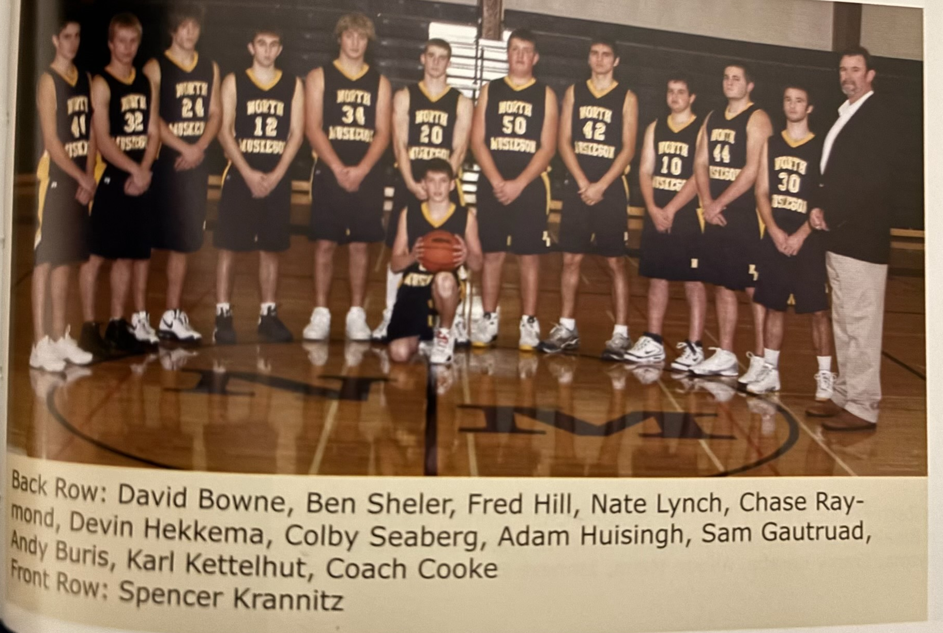

The 2008-09 NORSEMEN

N Muskegon 43 Musk Catholic 75 Spencer Krannitz 16, Karl Kettelhut 13
N Muskegon 50 Montague 80 Krannitz, 16, Kettelhut 15, Raymond 12
N Muskegon 73 Hart 62 Kettelhut 31, Krannitz 18
N Muskegon 41 Ravenna 57 Kettelhut 12, Krannitz 11
N Muskegon 40 Whitehall 55 Krannitz 11, Kettelhut 10
N Muskegon 59 Holton 61 Krannitz 19, Kettelhut 16
N Muskegon 73 Mason Co 75 Kettelhut 22, Krannitz 21, Ben Sheler 9
N Muskegon 66 Shelby 71 Kettelhut 29, Krannitz 14
N Muskegon 62 Oakridge 48 Krannitz & Kettelhut 20
N Muskegon 64 GR Cov. Christ. 88 Krannitz 24, Kettelhut 16
N Muskegon 63 Montague 94 Kettelhut 25, Krannitz 19
N Muskegon 61 Hart 40 Kettelhut 28, Krannitz 22, Sheler 10 reb.
N Muskegon 48 Ravenna 70 Kettelhut 19, Krannitz 11
N Muskegon 68 WMC 74 Kettelhut 32, Krannitz 11
N Muskegon 57 Whitehall 64 Kettelhut 30, Krannitz 12
N Muskegon 64 GR NP Christ 77 Kettelhut 23, Chase Raymond 12
N Muskegon 60 Mason Co 45 Ketterhut 26, Krannitz 23
N Muskegon 71 Shelby 64 Ketterhut 22, Krannitz 22, Hulsing 10
N Muskegon 56 Oakridge (ot) 58 Krannitz 17, Adam Hulsingh 14
N Muskegon* 70 Holton 63 Kettelhut 26, Krannitz 23
N Muskegon* 54 Montague 91 Ketterhut 22, Chase Raymond 9, Jones 9

2009-10 (Coach Jeff Cooke 11-12, Shelby WMC champs)

North Muskegon would start an all-underclassmen lineup for 2009-10, a season that would have their ups and downs but several highlights. NM almost doubled their win total from the previous season with 11 wins against 12 defeats.
The Norse opened the 2009-10 season with their annual opponent, the Crusaders of Muskegon Catholic. The Norse snapped a brief two-game losing streak with a 56-42 victory. Junior Aaron Jones led North Muskegon with 20 points with sophomore Spencer Krannitz adding 15 points, eight rebounds and four assists. MCC pulled within five points midway through the third period, but NM finished strong to go up 40-31 at quarter’s end. Eight NM players joined the scoring column with only Jones and Krannitz having played in the previous season.
A talented Oakridge team featuring Jamie Potts defeated NM in a game that was close all the way until Oakridge sealed the deal with free throws in the closing moments to defeat NM 53-45. Nick Huisingh had 15 points to pace the Norse while Spencer Krannitz totaled 10 points. John Hardy snagged 11 rebounds for NM.
Just a few days after leading Montague to back-to-back state championships in football, Cody Kater (25) and Matt DeJong with 19 points combined to lead the defending WMC basketball champs to a 66-52 victory over the Norsemen. The Norse trailed at every stop, but the loss was much closer than the three lopsided defeats Montague pinned on the Norse in 2008-09. Spencer Krannitz began to heat up with 19 points, with Aaron Jones (12) and Nick Huisingh (11) also in double figures.
It appears that some hard times are coming for the Hart basketball program that once was the scourge of WMC basketball in the 1940s and early 1950s. NM handed the Pirates a 66-52 defeat to hand the Pirates their fourth straight setback without a victory. To make matters worse for the upcoming seasons, the NM JVs handed the Pirates a 54-9 whipping in the JV game, a score very similar to a 59-9 beating the once potent Pirates handed NM’s varsity in 1948. Spencer Krannitz poured in 26 points to lead the Norse with Aaron Jones adding 17 while Drake Cooke had five steals as the Norse earn their first victory in conference play.
Ravenna outscored NM in all but the fourth quarter but by then the damage was done as Ravenna defeated NM 63-47. Spencer Krannitz had a big night with 25 with Aaron Jones adding 10 as NM fell to 2-3 in the early season.
Whitehall led all the way as the young Norsemen fell to the Vikings 74-53. The Vikings came out firing as they netted eight 3-pointers in the first half to build up a big early lead. NM did have three players in double figures: Krannitz (13), Jones 12 and John Hardy 10.
NM finally came out a winner, and it came against a team on the Scottville home court where the Spartans often had an edge over the years, Mason County Central. NM took a 49-41 lead into the final quarter and just hung on to earn a 59-58 win over the Spartans. Spencer Krannitz had 23 points, Nick Hulsing 18 and Aaron Jones 14 as the trio combined for all but four of NM’s total points.
Veteran head coach Jeff Cooke was a happy camper following NM’s convincing 70-48 victory over Shelby, their second win in the same week over an WMC opponent. “We seem to be coming together as a team,” said Cooke. “The win on Tuesday gave us some confidence and tonight I was really proud of how we played.” The win threw the WMC title chase into a log jam with three teams tied at the top and now NM lurking in the background at 3-4. Spencer Krannitz scored a career high 28 points for NM and got scoring help from Aaron Jones with 13 with Drake Cooke and Nick Huisingh both netting eight markers.
Spencer Krannitz joined the 30-point club with 35 points against a very talented Grand Rapids Covenant Christian team although in a losing cause as the Chargers won 76-62. For those keeping score that was a sophomore record for points scored by a Norseman.
Graham Preston made only four points, but it was his 10-foot jumper with two second left that won the ball game in NM’s thrilling 58-57 win over Oakridge. “It felt good to make the shot after some of the misses earlier in the game,” said Preston. “It felt true when I shot it. It’s definitely the biggest shot I have ever made,” ‘said the jubilant junior guard. The win knocked Oakridge out of a first-place tie in the WMC. Spencer Krannitz led the Norse with 20 points with Drake Cooke and Aaron Jones each adding 10.
A weary NM team traveled to Hudsonville the next day to play the only game in program history against Hudsonville Freedom Baptist and came back to NM on the short end of a 64-42 loss. Hudsonville steadily pulled away by outscoring NM in each quarter as the Norse were held to one of their lowest scoring games on the season. Spencer Krannitz led NM with 14 as Drake Cooke had a season high 12.
North Muskegon had a 10-point lead with less than six minutes to go but then Montague went on a 20-7 run to rally and defeat the Norse 67-64. The loss nullified a great effort from junior Aaron Jones who scored a career high 29 points with help from Spencer Krannitz who had 14 markers.
The Norse bolted out to a huge first quarter lead at 18-4 in a 57-47 victory over a Hart team was still looking for its first victory in the WMC. Aaron Jones and Spencer Krannitz shared high point honors with 15 with Nick Huisingh close behind with 14. The Norse enjoyed a 16-2 advantage in free throws made.
NM avenged an early season loss, a clear sign of an improved Norsemen team, with a 57-47 victory over Ravenna. Spencer Krannitz led NM with 23 points with Aaron Jones chipping in with 12. After a tight first half NM held the Bulldogs to seven third quarter points. The win over Ravenna would begin a streak whereby NM would win the next 25 games in a row against the Bulldogs without tasting defeat.
NM didn’t avenge an earlier 21-point loss to Whitehall but showed vast improvement over their earlier licking by taking Whitehall into overtime before losing 48-46. The Norsemen had the ball with a chance to take a final shot in overtime only for Whitehall to come up with a steal that set up Tyler Vanbergen’s last second field goal that spelled defeat for the young Norsemen. Spencer Krannitz had 15 in the low scoring contest with Drake Cooke, who hit three 3-pointers, equaling his season high with 12.
The Norsemen than had a rare lopsided 65-33 win over Mason County Central to improve their record to 8-7 on the season. NM put together four solid quarters in the romp with Krannitz again pacing Norse scorers with 20 points, right on his average up to this point in the season while getting offensive help from Nick Huisingh with 13 and Aaron Jones with 12 points.
West Michigan Christian showed the Norsemen on why they won 26 of 28 games and yet another Class D state championship in 2010 with a 79-54 victory over NM. The Warriors Evan Bruinsma, who would later star for the University of Detroit scored 40 points, against the Norsemen, the only opponent to score 40 or more points vs. a NM team. Bruinsma was also a force on the boards with 20 rebounds. NM hung around through three quarters before the talented Warrior team outpointed NM 21-10 in the fourth quarter. Spencer Krannitz with 15 and Nick Huisingh with 12 were in double figures for NM.
NM took a momentary step backwards in losing to Shelby 60-41. The Tigers had all the incentive working for them on their home court as the win clinched the West Michigan Conference championship for the Tigers. The middle two quarters were the difference makers in the contest as Shelby outscored NM 34-14. NM was held to their lowest offensive total of the season by the Tigers with Spencer Krannitz the only Norsemen in double figures with 16 points.
The Norsemen closed to within a point of Grand Rapids North Pointe Christian before the visitors pulled away in the closing moments to hand NM their third straight defeat 70-63.
NM closed out the regular season with a win over Holton 51 -45 as Spencer Krannitz scored 23 points, had eight rebounds, three steals and three assists. Nick Huisingh pulled down 12 rebounds for a NM team heading into next week’s MHSAA playoffs.
NM got a favorable draw in the MHSAA playoffs as they easily thumped a 2-19 Hesperia team 73-60. Coach Cooke was able to substitute freely as NM led 65-41 after three quarters. Ten players scored for NM led as usual by sophomore wonderkid Spencer Krannitz who netted 25 points. Nick Huisingh added 13.
NM made Hart a loser once again as the Pirates experienced one of their worse teams in history as they finished with a woeful 1-20 record on the season following NM’s 67-49 victory, Aaron Jones scored 14, Nick Huisingh 14, John Hardy had a season high 13 while Spencer Krannitz settled for 11 points as NM wins their 11th game of the season.
Montague then made it a three-peat for the second straight season as they eliminated the Norsemen 67-51. Montague again wins the district tournament and carries an impressive 19-4 record into the regional tournament. Spencer Krannitz, who finished the season with 441 points that averaged out to better than 19 points per game had 14 to lead the Norse with Nick Huisingh adding 14

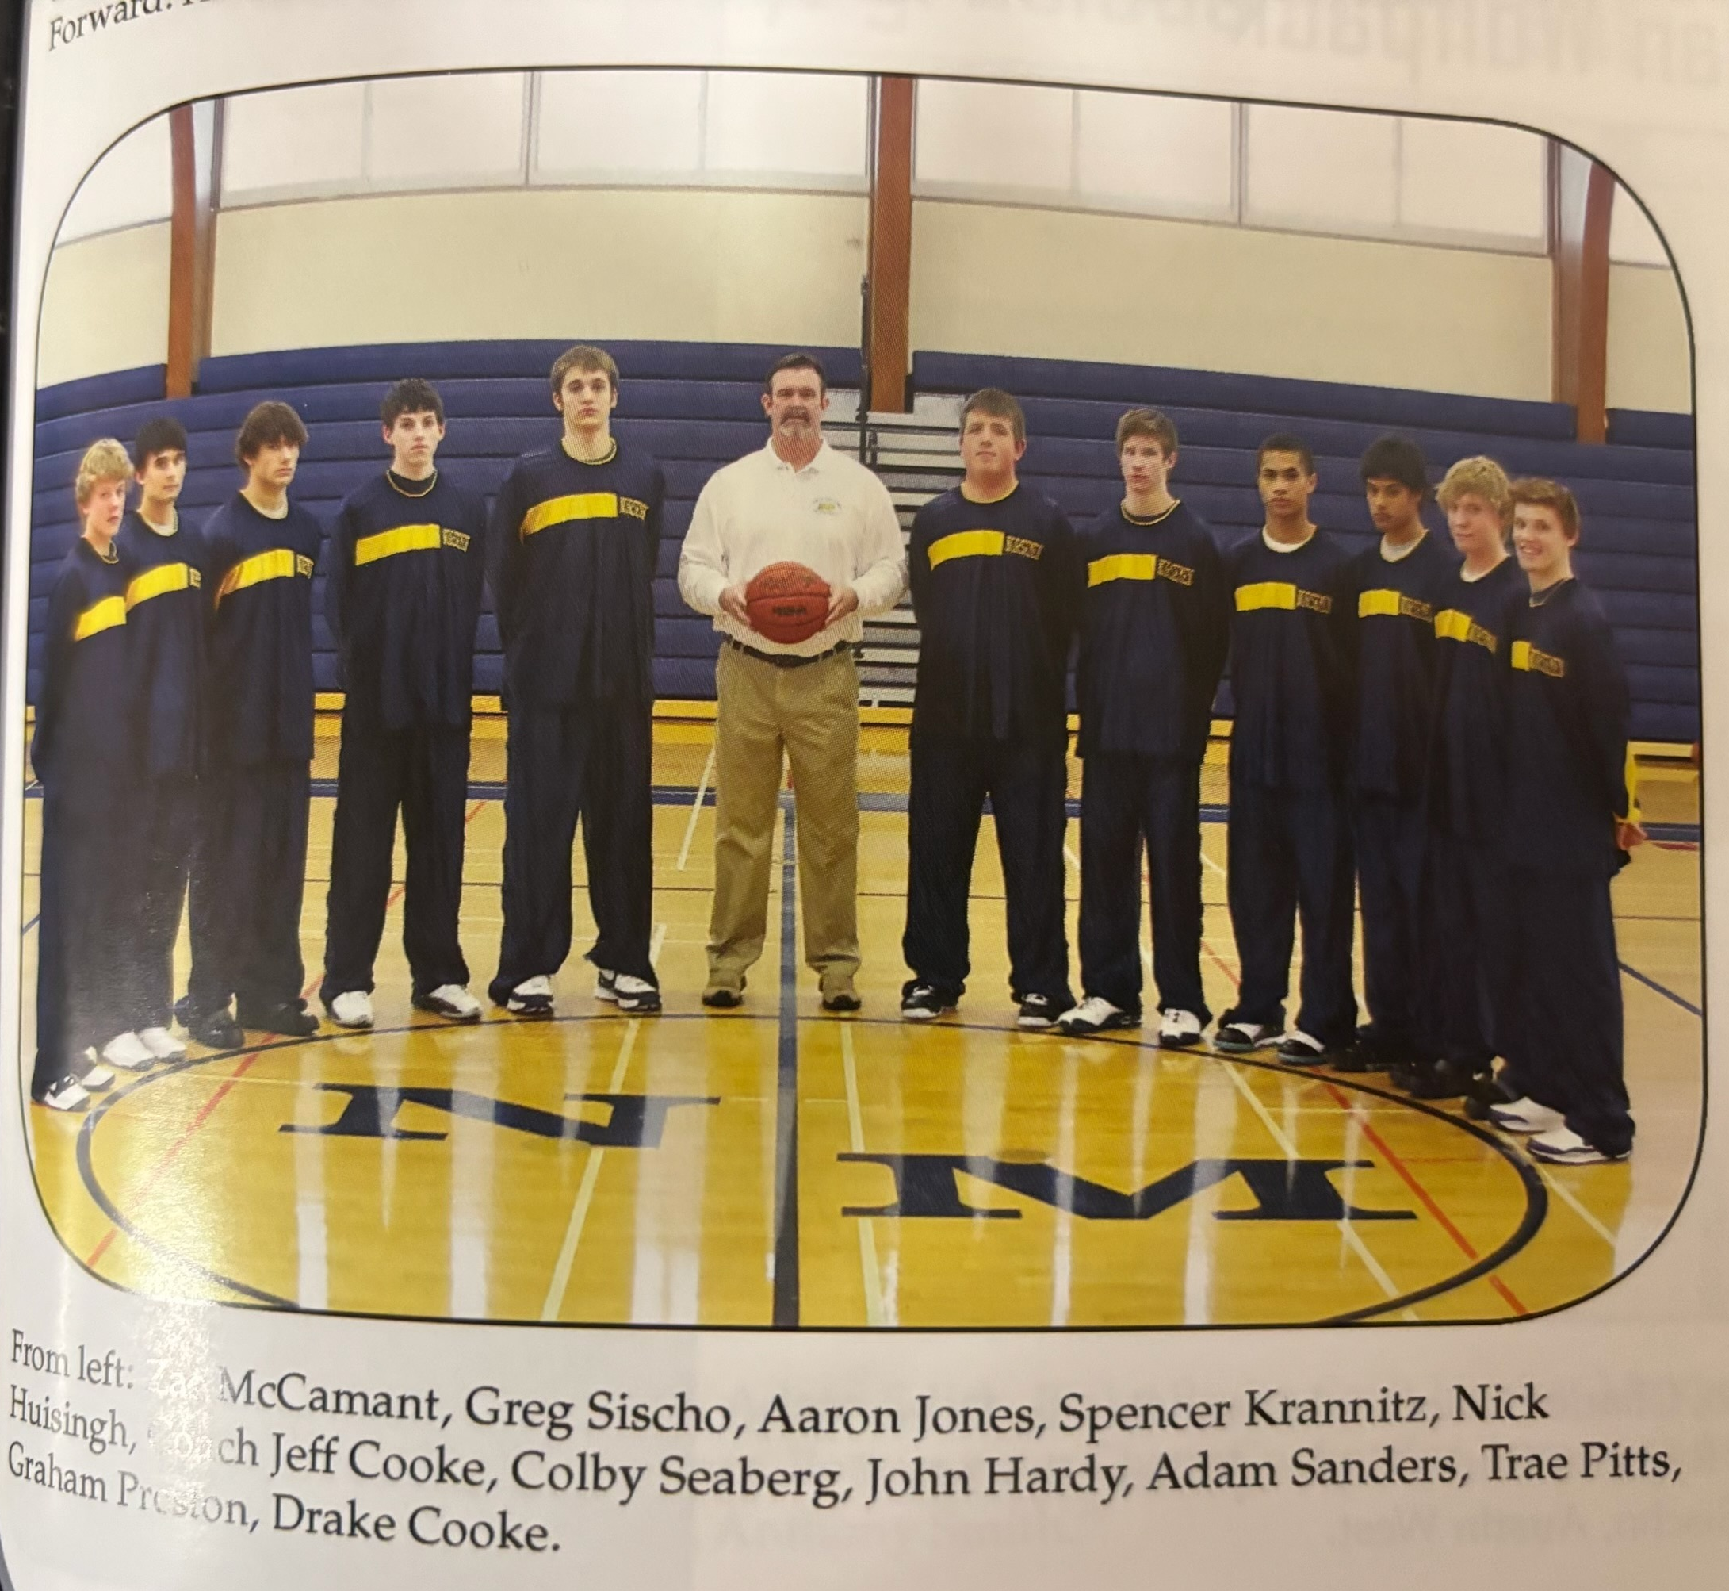
The 2009-10 NORSEMEN

N Muskegon 56 Musk Catholic 42 Aaron Jones 20, Spencer Krannitz 15
N Muskegon 45 Oakridge 53 Nick Huisingh 15, Krannitz 10
N Muskegon 52 Montague 66 Krannitz 19, Jones 12m Huisingh 11
N Muskegon 69 Hart 47 Krannitz 26, Jones 17
N Muskegon 47 Ravenna 63 Krannitz 25, Jones 10
N Muskegon 53 Whitehall 74 Krannitz 13, Jones 12, John Hardy 10
N Muskegon 59 Mason Co 58 Krannitz 23, Huisingh 18, Jones 14
N Muskegon 70 Shelby 48 Krannitz 28, Jones 23
N Muskegon 62 GR Cov. Christ 76 Krannitz 35
N Muskegon 58 Oakridge 57 Krannitz 20, Drake Cooke 10, Jones 10
N Muskegon 42 Hudsonville FBapt. 64 Krannitz 14, Cooke 14
N Muskegon 64 Montague 67 Jones 29, Krannitz 14
N Muskegon 57 Hart 47 Krannitz & Jones 15, Huisingh 14
N Muskegon 54 Ravenna 46 Krannitz 23, Jones 12
N Muskegon 46 Whitehall (ot) 48 Krannitz 15, Cooke 12
N Muskegon 65 Mason Co 33 Krannitz 20, Huisingh 13, Jones 10
N Muskegon 54 WMC 79 Krannitz 15, Huisingh 12
N Muskegon 41 Shelby 60 Krannitz 16, Huisingh 8
N Muskegon 63 GR North Point Ch. 70 Krannitz 22, Huisingh 13, Jones 11
N Muskegon51 Holton 45 Krannitz 23
N Muskegon*73 Hesperia 60 Krannitz 25, Huisingh 13
N Muskegon 67 Hart 49 Jones 24, Huisingh 14, Hardy 13, Krannitz 11
N Muskegon 51 Montague 67 Kannitz 13, Huisingh 13

2010-11 (Coach Jeff Cooke 13-10, Montague WMC champs)

With virtually their entire team returning from the previous season the Norsemen would have a much more experienced team to work with in the 2010-11 season. All three of their leading scorers return including a pair of Juniors, Spencer Krannitz (19.2 ppg) and Nick Huisingh (9.4 ppg) and senior Aaron Jones (11.3 ppg). Drake Cooke, Graham Preston, John Hardy and Greg Sicho also saw extended action in the 2009-10 season that will provide head coach Jeff Cooke much-needed depth.
North Muskegon as usual opened their season against Muskegon Catholic and recorded a surprisingly easy 63-31 win over the Crusaders. Spencer Krannitz took up right where he left off as a sophomore by leading the Norse with 23 points. Nine players scored for the Norsemen but only Krannitz was in double figures although Graham Preston was close with nine.
NM then defeated Ravenna 68-22; the fewest points scored by the Bulldogs since NM defeated Ravenna 35-22 back in 1937. So decisive was this game that nearly the entire second half was played with a running clock due to the mercy rule. Eleven Norsemen scored in the contest with Junior Nick Huisingh and John Hardy in double figures with 14 and 13 points respectively. Spencer Krannitz was content to let his teammates have fun in the rout as he scored nine points.
NM then routed Hart 78-30 as once again 11 Norse joined in on the scoring parade. Even with a running clock in effect for much of the fourth quarter the NM reserves were still able to outscore Hart 18-2 in the final eight minutes. In limited minutes Spencer Krannitz scored 18 points with Zac McCamant and Nick Huisingh each adding 11 for the 3-0 Norsemen.
North Muskegon and Saugatuck renewed their rivalry with NM breaking the game wide open with a 23-5 run in the second quarter to win easily for the fourth straight time to begin the season 71-42. Spencer Krannitz poured in 27 points for the Norsemen with Graham Preston adding 12 and Nick Huisingh 10.
NM began the new year by losing to their nemesis from the past three season, the Montague Wildcats. The Wildcats broke open a 39-32 halftime lead with a 17-7 run in the third quarter to slide past the Norse and win going away 71-56. It was the eighth straight win by Montague over the Norsemen. The game was a battle of the unbeatens with Montague the team now sporting the perfect record with NM dropping to 4-1. Spencer Krannitz led NM with 21 points with John Hardy adding seven for the Norsemen.
A big fourth quarter with the Norsemen netting 23 to the Eagles 8 put the game way for the Norsemen as they defeated Oakridge 71-48. At one point beginning late in the third period, NM went on a 17-0 run. Drake Cooke netted a career high 16 points for NM with Krannitz (15) and Preston 13) close behind as 10 Norsemen entered the scorebook.
NM played four solid quarters in NM’s 66-52 win over Mason County Central. Spencer Krannitz scoring eight of his game high 25 points in the final quarter. Nick Huisingh had a season high 18 points as the duo scored 43 of NM’s 66 points. NM was now an impressive 6-1 on the season but they would encounter a little bump in the road ahead.
Shelby used some sharp free throw shooting to hand NM a 74-69 defeat in a game played on the Northside court. The Tigers sank 15-of-21 free throws with 13 of those coming in the final quarter to send the Norsemen to their second defeat in the WMC. NM had four players in double figures led by Spencer Krannitz with 24. Graham Preston had a season high 16 with 12 of his points coming on four made 3-pointers. Aaron Jones added 11 and Nick Huisingh 10.
NM played a steady game as they defeated Whitehall 57-49. NM’s best quarter was the first as they outscored Whitehall 16-10 and then held their own the rest of the game. Nick Huisingh made a huge 3-point play with less than three minutes to play to give NM enough cushion to hang on. The Norse won despite only converting on 18-of-34 free throws. Scoring in double figures for the Norsemen were Krannitz (10), Huisingh (13) and Preston (10).
The Norse fell behind early and could never catch up as GR Covenant Christian edged the Norse 70-55. Spencer Krannitz’s 18 led the Norse while Graham Preston equaled his season high with 16.
It appears it went unnoticed by the media as Spencer Krannitz became the fourth Norsemen in school history to score 1000 points in NM’s 84-48 romp over Ravenna. Krannitz’s game high 28 points gave the Junior 1011 career points with still a season and a half remaining. Krannitz also grabbed 12 rebounds before taking a seat to make way for the reserves in the final quarter. John Hardy notched 12 points and Drew Chandonnet 10.
NM again had an easy time in the second matchup with Hart as NM again forced a running clock in a 74-31 pasting of Hart. Ten Norsemen scored in the thrashing with Krannitz (19), Preston (13) and Huisingh all in double figures.
In a near complete reversal of their first meeting, it was Oakridge who defeated the Norse after absorbing an earlier 71-48 loss to NM. Oakridge led 32-30 at the break but then NM went stone cold in the third quarter as they scored only six points while the Eagles countered with 17. Oakridge’s three sport star Jamie Potts did the most damage as he scored 21 of his 27 points in the second half. Spencer Krannitz had 20 and John Hardy 12 for NM.
North Muskegon only trailed twice but the second time counted the most as Mason County Central’s David Soraci connected on a 3-pointer late in the game that was the game winner in the Spartan’s 72-70 win over the Norsemen. NM had a pair of 3-point shots in the game’s final seconds but missed both potential game winners. Spencer Krannitz had a big game for NM with 26 points with John Hardy adding 12.
It was the Spencer Krannitz show in Shelby as the junior scoring machine poured in a career high 37 points as Krannitz’s big night led to a 63-55 victory over Shelby as NM got back into a winning mode. No other Norsemen came close to double figures as Krannitz scored more than half of NM’s points.
North Muskegon often had many bad shooting nights at the old Whitehall gymnasium (your author would be a prime example), but the Norse didn’t shoot much better on February 17, 2011, at the new Whitehall complex as they failed to make a 3-pointer in a 49-48 loss to the Vikings. Not only were the Norsemen shooting blanks from behind the 3-poinrt arc, but they didn’t fare much better at the free throw line as they shot an abysmal 7-of-18. Double teamed by the Vikings, NM’s Spencer Krannitz still scored 12 points, the same as his teammate Drake Cooke.
It was a strange four quarters in NM’s 83-67 loss to West Michigan Christian. In the first quarter WMC outscored the Norsemen 31-13. NM then scored 30 points in the second stanza to 19 for the Warriors. After NM won the third quarter battle 21-17, NM suddenly went stone cold in the final period as the Warriors outpointed NM 16-3. With Grandpa Ken Krannitz, a former cage great nearly a half-century earlier at WMC watching from the stands, his grandson Spencer Krannitz scored 16 of his 28 points in the first half to keep NM close before the Blue & Gold ran out of gas in the fourth quarter.
North Muskegon, er--- Spencer Krannitz gave undefeated Montague a battle before falling to a Montague team that would boast of an 18-0 record after their narrow 61-58 victory over the Norse. Krannitz scored 34 of NM’s 58 points as he kept NM in the game. Kranitz was a perfect 18 of 18 at the free throw line, a performance that still stands today as a NM record for one game marksmanship at the charity stripe. Montague needed a pair of timely 3-pointers from Chade Casebolt to earn the victory. His first 3-pointer with 30 seconds left tied the game and another 3-pointer at the buzzer was the winner.
NM traveled to Grandville for their first ever meeting with Grandville Calvin Christian but came back to NM the losers 71-60. The hosts from Grandville used a couple of bookend quarters, the first and fourth to thump the Norse. Spencer Krannitz had yet another scoring flurry as he pumped in 32 points to lead the Norse with Graham Preston reaching double digits with 10.
NM ended their four-game skid and tuned up for next week’s playoffs with a 77-57 victory over Holton. The Norse took a big 41-19 lead at halftime and coasted to victory. Spencer Krannitz scored 29 points while Graham Preston had a career high 21 for the Norse as they ended the regular season with a winning record of 11-9.
Ravenna’s season came to a merciful end as the Bulldogs 78-36 loss to NM left them winless for the year at 0-21. Even with a running clock NM outscored the hapless Bulldogs 36-7 in the second half. Playing limited minutes Spencer Krannitz still had enough time to drill 26 points, Preston Graham had 14 and football star Jonathan Ackley scored in double figures with 10.
North Muskegon and Holton met for the second time within a week, and the results were much the same with NM topping Holton 80-67. NM opened the game with a 21-9 run in the second quarter. Spencer Krannitz, who is averaging 30 points over his last six games scored right at 30 to lead NM into the final against West Michigan Christian. Preston Graham added 14 and Drake Cooke 11 as NM earned the right to play West Michigan Christian in the district finals.
West Michigan Christian, winners of three state Class D state championships came into Friday’s finals after ending host school Montague’s 20 game unbeaten streak. Already holding a 16-point win over NM earlier in the season it would indeed be a tough task to upset the powerful Warriors. The second game was much tougher than the first matchup as NM had the lead at 46-45 heading into the final eight minutes. It’s a huge understatement to say that the Warrior were tournament tested as they have now won 27 straight games – IN THE TOURNAMENT. WMC showed their composure and hit some big free throws down the stretch to end NM’s season at 13-10.



The Norsemen of 2010-11
(Drake Cooke far right)

N Muskegon 63 Musk Cath 31 Spencer Krannitz 23, Graham Preston 9
N Muskegon 68 Ravenna 22 Nick Huisingh 14, John Hardy 13, Krannitz 9
N Muskegon 78 Hart 30 Krannitz 18, ZacMcCamant & Hulsign 11
N Muskegon 71 Saugatuck 42 Krannitz 27, Preston 12, Huisingh 10
N Muskegon 56 Montague 71 Kraanitz 21, Hardy 11
N Muskegon 71 Oakridge 48 Drake Cooke 16, Krannitz 15, Preston 13
N Muskegon 66 Mason Co 52 Krannitz 25, Huisingh 18
N Muskegon 69 Shelby 74 Krannitz 24, Preston 12, Jones 11
N Muskegon 57 Whitehall 49 Krannitz 18, Huisingh 13, Preston 10
N Muskegon 55 GR Cov. Chris. 70 Krannitz 18, Preston `14
N Muskegon 84 Ravenna 48 Krannitz 28 (1011 career), Hardy 12
N Muskegon 74 Hart 31 Krannitz 19, Preston 13, Huisingh 11
N Muskegon 51 Oakridge 62 Krannitz 20, Hardy 12
N Muskegon 70 Mason Co 72 Krannitz 26, Hardy 12
N Muskegon 63 Shelby 55 Krannitz 37
N Muskegon 48 Whitehall 49 Krannitz & Cooke 12, Aaron Jones 10
N Muskegon 67 WMC 83 Krannitz 28, Preston 10
N Muskegon 58 Montague 61 Krannitz 34, Hardy 8
N Muskegon 60 Calvin Christ. 78 Krannitz 32, Preston 10
N Muskegon 77 Holton 57 Krannitz 29, Preston 21, Hardy 11
N Muskegon*78 Ravenna 36 Krannitz 26, Preston 14, Jon Ackley 10
N Muskegon*80 Holton 67 Krannitz 30, Preston 14, Cooke 11
N Muskegon*63 WMC 68 Krannitz 29, Ackley & Jones 8

2011-12 (Coach Jeff Cooke 15-8, Shelby WMC champs)

The Norse would play in front of packed gyms throughout the season with the number one drawing card being Spencer Krannitz, who was on pace to become the area’s all-time leading scorer. NM would incur a couple of double overtime defeats that if the scores were reversed it would have made an already good season even better.
NM had a 28-20 lead at the half before Muskegon Catholic came roaring back in the second half to hand the Norsemen a 57-52 loss in their season opener. In the opener of what would be a historic season for NM four-year starter Spencer Krannitz,scored 27 points in his 2011-12 debut. No other Norsemen scored more than seven points as Spencer was the only returning regular back from last year’s team.
NM traveled to Ravenna and cruised to an easy 69-37 victory behind 26 points from Spencer Krannitz. The senior sharpshooter also led NM in rebounds with 12. Football star Jonathon Ackley had 10 points and seven rebounds as nine Norsemen scored. The win marked the 700th win in program history.
Spencer Krannitz scored 38 of NM’s 61 points as NM ended a Montague nine game winning streak against the Norsemen. NM only made 1-of-15 3-pointers but did well at the free throw line with Krannitz making 9-of-10. Chase Raymond had 10 rebounds for NM as well as eight points.
NM jumped out to an early 21-3 lead after the first quarter and then went on to down Hart 68-42 in a road win at Hart. Spencer Krannitz made a 30-point game look routine as he poured in 33 points as 10 Norsemen scored in the rout over the Pirates. Junior Zach Rummery and senior Jonathon Ackley each had seven points while junior Adam Edict led Norse rebounders with nine. To say Hart had a bad day at the free throw line would be an understatement as the Pirates made only 7-of-26 free throws.
Holton was no match for NM in the first game of the New Year of 2012. The Norse led 51-16 forcing a running clock in the fourth quarter. Every Norsemen who suited up in the contest scored with Spencer Krannitz leading the way with 20 points in limited minutes. Chase Raymond had 9 points and 12 rebounds with junior Chase Cooke and Jonathon Ackley each adding eight for the 4-1 Norsemen.
NM nearly let a 33-21 halftime lead get away from them as Oakridge started the second half with a 18-7 run to close within one heading into the final quarter. NM regained their momentum and went on a 9-0 run and then held on to edge the Eagles 54-50 to stay undefeated in the WMC at 4-0. Spencer Krannitz scored 22 to go along with seven rebounds and six steals. Chase Raymond had 12 points on four 3-pointers and 11 rebounds. Patrick Giddings of Oakridge, who made eight 3-pointers, led all scorers with 26 points. Scoring eight points for Oakridge was senior Nick Huisingh, a transfer from North Muskegon. After playing their first five games on the road, it was the first home game for the Norsemen.
After their one home game to start the season NM again hit the road for their annual journey to Scottville to face the Mason County Central Spartans. NM fell into an early hole, trailing 22-10 after the first quarter. NM then chipped away at that lead and sent the game into overtime at 50-all. Each team scored eight points in the first overtime session forcing a second overtime. The Spartans sent the Norse packing with a loss outscoring NM 12-10 in the second overtime to capture a 70-68 heartbreaking loss to the Norse 70-68. The Norse had the misfortune to run into a player who had a hot hand. Sophomore guard Kody Ambrose, who went scoreless in the first half scored all his 26 points in the second half to lead MCC to victory. Spencer Krannitz did all he could for the Norse, scoring 36 of NM’s 68 points. Chase Raymond chipped in with 10 points and 12 rebounds.
It hardly caused a blip in the rapidly failing coverage of the Muskegon Chronicle that was amid some major downsizing as Spencer Krannitz put on an amazing show in the Norsemen’s 69-68 victory over Whitehall. Krannitz scored 48 points, the third highest point total in a single game by a Norsemen. Only Gordy Odell’s 53 scored against Whitehall and Leigh Kakaty’s 54 against a Class D Baldwin team ranked higher in NM annals. Krannitz’s performance wasn’t against any old foe, but a proven rival like Whitehall. Krannitz hit a pair of free throws with three seconds on the clock for the victory. Spencer also surpassed the all-time NM career scoring record od 1559 of Drew Naymick with his block buster of a night. Krannitz following this game now has a career total of 1579 points, just two points shy of Grant’s Joe Schuitema’s 1581 set in 1988. Krannitz connected on 7-of-9 three pointers, 10-of-14 two pointers and was 7-of-8 from the free throw line. With the season not even half completed, could Krannitz possibly become the area’s all-time career leader in points scored? Next on the list is the leader, Todd Bayle of Walkerville with 1911. The following Tuesday the Chronicle’s brilliant sports editor Tom Kendra, working with a staff that had faced some major downsizing wrote a great feature on Krannitz’s huge night.
Spencer Krannitz did surpass Joe Schuiteman with a 33-point effort, but it came in a losing cause as NM was defeated by Shelby 69-59. The Tigers stayed perfect on the season with a 9-0 record as they connected on 11 3-pointers in their home win over the Norsemen. So dependent are the Norse with Krannitz carrying the load that no other NM player had more than four points.
NM again hit the road for their 10th time in 11 games the following night after their game at Shelby. NM led 44-34 at the half, 55-52 after the third quarter before running out of gas in their second game in two nights as a very strong Grand Rapids Covenant Christian team defeated NM 82-76. Spencer Krannitz showed the home folks in the Furniture City of his talents as he rifled in 36 points. Spencer got some scoring help in this game from Sam Powell, who scored a career high 14, Zach Rummery with 11 and Chase Raymond with 10.
For only the second time all season NM played a game on their home court. NM Head Coach cannot fault the NM athletic director for the quirky schedule as Jeff Cooke wears both hats as the head basketball coach and athletic director. The Norsemen quickly showed the hometown fans that they like playing at home as they pounded out to a big 29-11 lead over Ravenna and coasted to an 86-46 rout of the Bulldogs. Spencer Krannitz played long enough to score 28 points. Chase Raymond added 11 points and 10 rebounds while Zach Rummery scored a career high 16 for the Norsemen.
Krannitz again did his thing with 34 points and eight steals in NM’s 68-55 win over Montague but got plenty of help from his teammates. Drew Chandonnet had a season high 13 points while Chase Raymond did a good job on the boards by grabbing 11 rebounds.
February 1st was a dark day for high school sports coverage as our beloved Muskegon Chronicle was taken over by a conglomerate known as Mlive.com. Box scores that had been posted for North Muskegon and all local team for 80 years was now a distant memory. An impossible job was given to the lone remaining sports reporter in our area, Marc Opferman who was given the ridiculous task of covering all sports. Instead, out sports pages were inundated with national and major college coverage of which none were located near Greater Muskegon.
Coverage of NM’s first game in February was limited to one paragraph, two days after the game was completed, with a NM rout of Hart 82-38. NM led at halftime 48-15 as head coach Jeff Cooke was able to substitute freely. “We came out strong and had a lot of people score,” was a quote from Cooke who phoned in the score. Spencer Krannitz led the Norsemen with 22 points as his pursuit of the area’s all-time career scoring record was getting closer. Will Byl, with the shortest name in NM history, came off the bench to score 13 points for NM with Jonathon Ackley in double figures with 11.
Oakridge made amends for an earlier loss to NM with a 62-57 victory over NM. There was zero coverage in the Muskegon coverage for this game but somehow your author discovered that Spencer Krannitz had another big game with 31 points with Chase Raymond adding 10 in a losing cause.
What a difference from game one to game two between NM and Mason County Central. After NM lost in a game that took two overtime sessions, there was no need for overtime in the rematch as NM bombed the Spartans 70-46. Krannitz stayed on pace to set an all-time area career scoring record with 33 points. No other Norsemen was in double figures, but eight other players did score for NM with Drew Chandonnet leading the second tier with eight points. Chase Raymond grabbed 11 rebounds as NM improved to 10-5. NM broke the game open in the third quarter outscoring the Spartans 24-13 as Krannitz scored 10 of his 33 points.
NM then posted the biggest upset to date in the West Michigan Conference as they handed Shelby their first loss of the season 62-59. This game wasn’t decided until after the final buzzer had sounded. With NM up by three with 4.9 seconds left Spencer Krannitz missed a game clinching free throw. The Tigers got the rebounds and an off-balanced desperation 3-pointer heave near midcourt banked in off the glass. However, both officials immediately waved off the basket as it occurred after the final buzzer had sounded. Despite Krannitz’s miss of the free throw it was probable that coach Cooke just ‘might’ keep Spencer in the starting lineup for the next game. Krannitz, despite being hounded all night by the Tiger defense, still scored a game high 24 points.
North Muskegon then swept a season series with Whitehall for the first time in 50 years (1962) with a 63-47 victory over the Vikings. Spencer Krannitz scored half the number of points as he scored in an earlier victory over Whitehall but still managed to score 24. Zach Rummery scored 16 much-needed points for the Norse while Chase Raymond filled up the stat sheet with six points, 11 rebounds, and four assists.
You know NM has had a good season anytime they can defeat West Michigan Christian. The Norse broke an eight game Warrior winning streak with a 43-37 win over WMC. NM held WMC to 37 points, the second lowest point total scored by WMC against the Norse in the 71 games played over the years between the two local rivals. Even more remarkable, the win was on the Warriors home court. Spencer Krannitz, although ‘held’ to 21 points heated up when it counted most in the low-scoring contest. WMC entered the final quarter leading NM 28-27 as Krannitz scored five points in the final quarter as NM outscored the hosts 15-10 to build their record to 13-5
NM can only have some wishful thinking on how much better their overall record would be this season if they would have won both of their games that went into double overtime. Except, they lost both including their second, and final game played against Grandville Calvin Christian. Spencer Krannitz scored 42 points to bring his career total to 1907, just five points away from the areas all-time record of 1911 of Walkersville’s Todd Bayle. Krannitz was a perfect 11-of-11 from the free throw line while Drew Chandonnet had a double-double, 12 points and 10 rebounds.
It was a historic night when North Muskegon hosted Saugatuck on March 1, 2012. Everything went right except for the final score as Saugatuck, who came to the Northside gym having never defeated NM in five previous games, defeated NM 65-60 in the last game of the regular season. It was also the last appearance on the NM court for Spencer Krannitz. With a packed crowd in attendance, that included the Area’s All-Time leading scorer going into the game Walkerville’s Todd Bayle, with 2:09 left to play in the first quarter Krannitz score a layup that broke the record. The game was stopped and with a touch of class, Todd Bayle stepped out on the court and handed the game ball to Krannitz. Ironically it was at the NM gymnasium where Bayle scored his last points as a player, in a district loss to West Michigan Christian. Krannitz would finish the game with 28 points to bring his career total to 1935. NM never led in the game, but the Norse did tie the game at 60-60 on Chase Raymond’s rebound putback with 37 seconds left. Saugatuck then made 5-of-6 free throws to make the final score 65-60.
North Muskegon defeated Ravenna 69-56 in the first game of the MHSAA playoffs 69-56 as Spencer Krannitz tallied 24 points.
NM struggled at times but had enough firepower and height to defeat Kent City 57-54. NM outrebounded Kent City, who didn’t have a player taller than 6’1, 43-30. Spencer Krannitz scored 20 points, but NM had enough balance to advance. Drew Chandonnet had 14 points and 11 rebounds while Chase Raymond added nine points and 14 rebounds to assist Krannitz. Kent City aspired of an upset as they jumped out to a 18-11 first quarter lead before NM bounced back to take the lead for good with a 16-2 run in the second quarter.
NM’s season came to a crushing end as Montague, who had lost in their two meetings during the regular season, defeated NM for the second time in three years 53-48. NM had a late chance to send the game into overtime. Trailing by five points with little time remaining, Spencer Krannitz cut the lead to two with a 3-pointer with 19 second remaining. After Montague made one of two free throws Krannitz was fouled on a last second shot. A very tired Krannitz missed his first two shots, intentionally missed the third but his free throw didn’t touch the rim and Montague held on for the victory. Krannitz ended his career with 29 points and became the first Greater Muskegon area player to score 2000 points with a final career total of 2008.

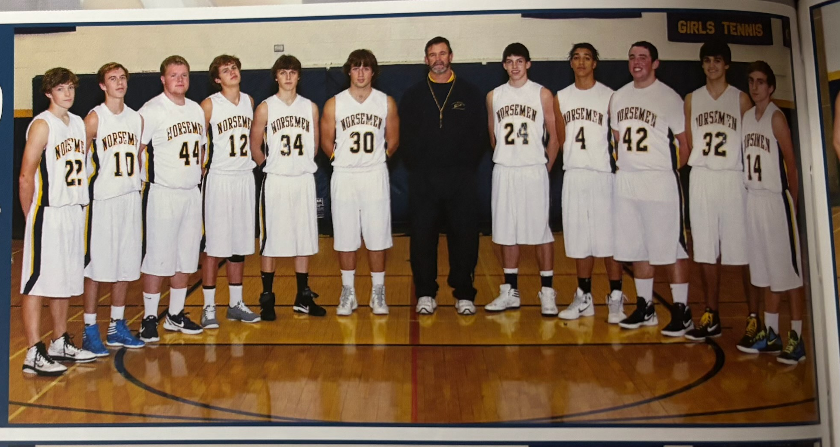

The 2011-12 NORSEMEN

L-R: Chase Cooke, Zack Rummery, Curtis Taylor, Will Byl, Adam Edick, Chase Raymond, Heada Coach Jeff Cooke, Spencer Krannitz, Sam Powell, Jon Ackley, Drew Chandonnet, Rocco Muzio, Austin West, Chuck Clanton

N Muskegon 52 Musk Catholic 57 Spencer Krannitz 27, Zach Rummery 7
N Muskegon 69 Ravenna 37 Krannitz 26, Jomathon Ackley 10, WIN 700
N Muskegon 61 Montague 53 Krannitz 38, Chase Raymond 8
N Muskegon 68 Hart 42 Krannitz 33, Adam Edict 9 rebounds
N Muskegon 71 Holton 31 Krannitz 20, Raymond 9 & 12 rebounds
N Muskegon 54 Oakridge 50 Krannitz 22, Raymond 12
N Muskegon 68 Mason Co 70 Krannitz 36, Raymond 10
N Muskegon 69 Whitehall 68 Krannitz 48
N Muskegon 59 Shelby 69 Krannitz 33,
N Muskegon 76 GR Cov. Christ. 82 Krannitz 36, Sam Powell 14
N Muskegon 86 Ravenna 46 Krannitz 28, Rummery 16
N Muskegon 68 Montague 55 Krannitz 34, Drew Chandonnet 13
N Muskegon 82 Hart 38 Krannitz 22. Will Byl 13, Ackley 11
N Muskegon 57 Oakridge 62 Krannitz 31, Raymond 10
N Muskegon 70 Mason Co 46 Krannitz 33, Chandonnet 8
N Muskegon 62 Shelby 59 Krannitz 24
N Muskegon 63 Whitehall 47 Krannitz 24, Rummery 16
N Muskegon 43 WMC 37 Krannitz 21
N Muskegon 74 Calvin Christian 82 Krannitz 42, Chandonnet 12
N Muskegon 60 Saugatuck 65 Krannitz 28.
N Muskegon* 69 Ravenna 56 Krannitz 24
N Muskegon* 57 Kent City 54 Krannitz 20, Chandonnet 14
N Muskegon* 48 Montague 53 Krannitz 29

2012–13 (Coach Jeff Cooke 6-15, Montague WMC champs)

The Spencer Krannitz era is over, and the Norse would take a step backward in the 2012-13 season. Only Sam Powell and Zach Rummery returned from the regular rotation from the previous season as the Norsemen would win 6 games while losing 15.
Sam Powell, one of only a handful of returnees from last year’s outstanding team recorded a double-double with 15 points and 12 rebounds as NM won their traditional opener with Muskegon Catholic 60-51. A 17-9 first quarter got NM off to a good start as NM was helped with the Crusaders shooting only 3-21 from the 3-point line. Zach Rummery also added 15 points for the Norsemen.
Montague had too much size for the smaller Norsemen as Montague used a big second half to win over the Norse 59-39. NM trailed the Wildcats by one at the halftime break before the Wildcats controlled the second half. Sam Powell again had 15 points for NM followed by junior Reese McCamant with nine and junior Tony Gordon with 7.
NM continued their complete dominance over Hart as NM raced to a double-digit lead in the first half and went on to defeat Hart 55-40. Junior Ryan Gannon, playing on the NM varsity for the first time, led NM in scoring with a modest 11 points followed by Sam Powell with 10.
Oakridge, with a much-improved team from last season, remained perfect in the early season with a 55-47 victory over the Norsemen. Sam Powell, whose previous career high from last season was 14 points, scored 22 to lead the Norsemen with Tony Gordon chipping in with 11 as NM is currently 2-2 on the season.
NM briefly held the lead at 42-40 in the third quarter, but West Michigan Christian rallied to earn a 65-54 victory over the Norsemen. Junior post player Bernard Smith had a huge game for the winning Warriors with 27 points and 16 rebounds. NM didn’t help themselves in this contest as they were guilty of four technical fouls that resulted in eight uncontested free throws for WMC. The Norse had balanced scoring with Sam Powell netting 13, with Reese McCamant and Tony Gordon each adding 10 points.
NM again saw a third quarter lead go away two days later as they lost to Mason County Central 64-54. Reese McCamant scored a season high 21 points with Sam Powe11 adding 11 as NM concluded the year of 2012 with a 2-4 record.
No longer called Muskegon Heights High School but now known as Muskegon Heights Academy, one thing remained constant: the Tigers still know how to play basketball whatever the name for the school. Now a Class D school with many of their students having transferred to other schools, including their veteran coach Keith Guy who joined the staff at Muskegon High, the Tigers still overwhelmed the Norse 85-38. Heights led 52-13 enroute to a running clock in the second half as the young Norse absorbed by far their most lopsided defeat of the year. Sam Powell drilled three 3-pointers for all nine of his team leading points.
Shelby pulled away in the fourth quarter after leading NM by only four points after three quarters of play to hand NM their fifth straight defeat 63-52. NM can look no further than the disparity in free throws as Shelby was 28-of-36 from the foul line while the Norsemen made 6-of-8. Three NM players were in double figures: Reese McCamant (14), Sam Powell (12) and Zach Rummary 11.
NM again kept in close, but those fourth quarter blahs kept NM from a win as Whitehall held off the Norse 49-47. Trailing 47-44 with less than a minute left, Reese McCamant drilled a 3-pointer to tie the game. Whitehall was fouled, made one-of two free throws only to see Viking center Matt Russell grab the rebound and make one-of-two free throws to clinch the game for Whitehall. NM had one last chance but a long 3-pointer by McCamant hit the back of the rim, and the final score remained at 49-47. Sam Powell finished with 15 points with Zach Rummery adding 13. NM again had troubles at the free throw line: connecting on 8-of-14 while Whitehall went 13-of-17.
After losing several of their games with late rallies by their opponents it was NM’s time to have a big second half. NM overcame a double-digit deficit at halftime to rally for a 67-64 victory over Ravenna to end their six-game losing streak. Will Byl came to the rescue of NM with a career high 17 points, Tony Gordon added 11 while Ryan Gannon was a force on the boards with 11 rebounds.
NM needed a 19-11 scoring run in the fourth quarter to hold off Hart 66-56 for their second straight win in the WMC. After leading 34-21 at halftime, Hart cut the lead to 47-45 heading into the fourth quarter leading up to NM’s deciding late run. Sam Powell led NM with 18 points with Will Byl adding 12.
Saugatuck outscored NM 6-3 in overtime to defeat the Norsemen for the second year in a row with a 59-56 non-conference win. NM led 43-39 after three quarters only to see Saugatuck rally to force overtime. Will Byl led the Norsemen with 12 points, Zach Rummery added 11 and Reese McCamant scored 10 points.
Points were hard to come by in an Oakridge victory over North Muskegon. The first quarter saw each team score but five points as Oakridge edged NM 47-40. The Eagles led 23-20 at half time, 37-30 at the end of the third with both teams scoring 10 points in the game’s final eight minutes. Will Byl with 15 points was the only Norseman in double figures in the low-scoring contest.
It was now the Norsemen’s turn to make a fourth quarter rally only to fall just short in a 58-55 loss to Mason County Central. The Norsemen trailed 28-18 at halftime and cut the Spartan’s lead to two points entering the final quarter. A 3-pointer by Tony Gordon gave the Norse its first lead early into the final quarter. MCC drained a big three with less than two minutes to play and then held off the Norse to earn the victory. NM almost forced a miraculous overtime but a halfcourt shot at the buzzer rolled around the cylinder and dropped off. Sam Powell and Will Byl each scored 15 points for NM.
There was no drama in the second meeting between Shelby and the Norsemen as the Tigers scored early and often in a 71-41 romp over the Norsemen. Shelby led 19-9 after the 1st quarter, 49-35 at the half and then really put a hurt on the Norse in the final quarter with a 22-6 run. Sam Powell’s 11 points was the best a Norsemen could do in the contest.
The Norse for the second time this season were no match for Montague as the Wildcats sweep the season series with a 66-48 win. “Just had too much balanced scoring, rebounding and free-throw shooting by Montague for North Muskegon to come back,” said NM coach Cooke. “I was very happy we were able to cut it to nine points in the fourth,’ added the NM coach who had nothing but praise for the victors. Sam Powell had 20 points to lead the Norse offense while Ryan Gannon had eight rebounds. Montague would end the season as West Michigan Conference champs.
The losing streak reached six as Whitehall dominated the Norsemen 66-47. Sam Powell once again led the Norse with 15 points followed by Tony Gordon with nine and Reese McCamant eight.
NM got back on the winning track as they defeated Ravenna 69-55 as the Norsemen were early into a winning streak against Ravenna that would eventually reach 25 games. The Norse were in control all the way as they enjoyed a 28-22 lead at halftime that NM increased by game’s end. Zach Rummery scored a season high 22 points for NM while Sam Powell added 13 and Reese McCamant 11.
In the last game of a seven-game series Grand Rapids Covenant won six of those games, including a 53-36 win over NM that ended the regular season. The Chargers made short work of the Norsemen early as they had a double-digit lead after one quarter. NM didn’t have any players reach double figures as Zach Rummery and Ryan Gannon were close with nine points. NM ended the regular season with a 5-14 record with four of those wins coming in the WMC.
North Muskegon, for many years after NM no longer had students from Laketon Township, always hovered on the border of being a small Class C school or a large Class D. In 2013 NM had dropped down to Class D and were placed in a district tournament hosted by Fennville High School. NM would play Holland Black River and would win easily 65-43 in the only game ever played between the two schools. NM went on a 21-7 run in the second quarter to pull away from the fledgling Holland area school. Sam Powell led the Norse with 14 points while Adam Edict had a season high 11. Will Byl and Tony Gordon both reached double figures with 10 points.
NM then played Muskegon Heights Academy in the district semi-finals, a Tiger team that destroyed NM in January by 47 points. The winner was the same, but the results were much different as the Norsemen played the Heights much tougher in the second meeting. Height led NM 52-13 at halftime in January. It was only a three-point halftime lead for the Tigers at 32-29 in Fennville. The Tigers would outscore the Norse 34-24 in the second half to end NM’s season at 6-15. Sam Powell ended his NM career with 15 points to pace the Norse.

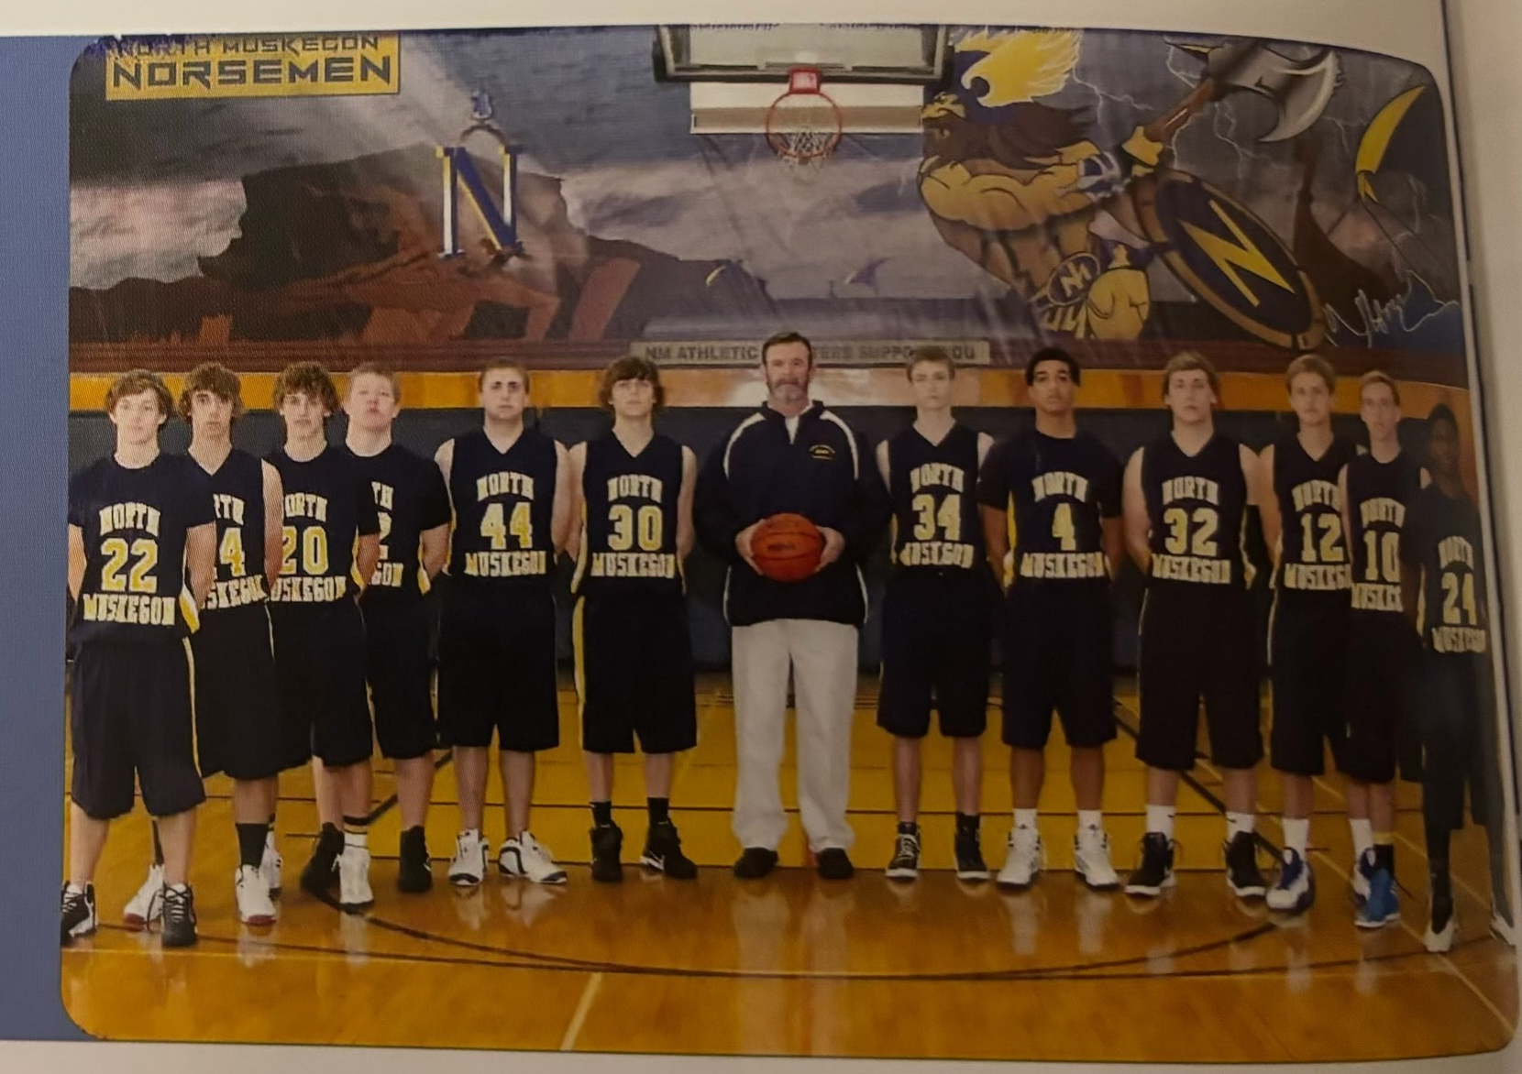

The NORSEMEN of 2012-13

L-R: Chase Cooke, Corey Hogan, Reese McCamant, Justin Fairfield, Scott Henley, Adam Edick, Bailey Cooper, Sam Powell, Ryan Gannon, Will Byl, Zach Rummary, Antonio Gordon (Head Coach Jeff Cooke centered)

N Muskegon 60 Musk Catholic 51 Sam Powell 15, Zach Rummery 15
N Muskegon 39 Montague 59 Powell 15, Reese McCamant 9
N Muskegon 55 Hart 40 Ryan Gannon 11, Powell 10
N Muskegon 47 Oakridge 55 Powell 22, Tony Gordon 11
N Muskegon 54 WMC 64 Powell 13, McCamant & Gordon 10
N Muskegon 56 Mason Co 63 McCamant 21, Powell 11
N Muskegon 38 Musk Heights 85 Powell 9
N Muskegon 52 Shelby 63 McCamant 14, Powell 12
N Muskegon 47 Whitehall 49 Powell 15, Rummery 13
N Muskegon 67 Ravenna 64 Will Byl, 17, Gordon 11
N Muskegon 66 Hart 56 Powell 18, Byl 12
N Muskegon 56 Saugatuck 59 Byl 12, Rummery 11, McCamant 10
N Muskegon 40 Oakridge 47 Byl 15, Powell 9
N Muskegon 55 Mason Co 58 Powell & Byl 15, Gordon 6
N Muskegon 41 Shelby 71 Powell 11
N Muskegon 48 Montague 66 Powell 20
N Muskegon 47 Whitehall 66 Powell 15, Gordon 9, McCamant 8
N Muskegon 69 Ravenna 55 Rummery 22, Powell 13
N Muskegon 36 GR Cov. Christ. 53 Rummer and Gannon 9
N Muskegon*65 Holland Black River 43 Powell 14, Adam Edick 11.
N Muskegon*53 Musk Heights 66 Powell 15

2013-14 (Coach Jeff Cooke 8-12, Shelby WMC champs)

Although they lost the game 71 to 63 to Muskegon Catholic, the Norsemen showed their grit in the opening game loss. The Norse got off to an awful start as MCC bolted out to an electric 29-13 lead after one quarter of play. And then it got worse for the Norsemen. The Crusader’s led 47-26 by halftime and the lead ballooned to 25 after three quarters. NM began the final quarter with a 12-1 run followed by another 9-0 run midway through the quarter. Junior guard Mitch Edick scored 13 of his team high 18 points in the final quarter as NM outscored the Crusaders 26-10 and tightened the gap to as little as six points before they ran out of time. Antonio Gordon followed Edict in the scoring department with 16 points.
After a poor start in their opener against Muskegon Catholic, NM made sure that wouldn’t happen in their second game of the season against Hart. NM led 30-14 at halftime against Hart and then went on to an easy 54-30 verdict over the Pirates to even their season record at 1-1. Marco Visconti led NM with 12 points with Ben Gautraud adding 10.
NM and Ludington got together for a basketball game for the first time in 55 years. Your author remembers that last meeting in December of 1959 very well as we lost to the Orioles in overtime. In a low scoring game Ludington did not need overtime to defeat NM as the Orioles held NM to their lowest output of the season in a 46-31 win. NM led at the end of the first quarter 12-11 but the rest of the game belonged to Ludington. Antonio Gordon and Mitch Edick each had seven points for NM.
NM and Oakridge went into overtime with the Norse rallying from a 41-34 deficit at the end of the third quarter for a comeback 60-57 win over Oakridge. NM somehow pulled off the victory despite a woeful 9-of-25 from the free throw line. NM’s comeback was precipitated with three made 3-pointers in the final quarter. With the score tied at 50-all after regulation the Norse outscored the Eagles 10-7 in the overtime session to secure the win. Antonio Gordon’s 16 points led the Norsemen while Ryan Gannon and Ben Gautraud grabbed nine and eight rebounds respectively. The Norse ended 2013 at 2-2 heading into January of 2014.
It was not a good start to 2014 as NM lost their first game in January 57-36 to Mason County Central. Kody Ambrose topped the 1000-point mark for his career to make the home folks on hand in Scottville happy. Mason County led the entire game, leading 28-19 at the half and 40-27 in the third quarter. Antonio Gordon’s 16 points was best for NM.
North Muskegon threw a genuine scare into a Shelby team that entered the contest with NM with a perfect 6-0 record. For more than three quarters it looked like NM was going to pull off the upset as they carried a 35-27 edge over Shelby at halftime. The Tigers came to play in the second half as they outscored the visiting Norsemen 36-23 to earn a come from behind 63-58 win over the upset minded Norsemen team. Ben Gautraud had a game high 20 points while Antonio Gordon finished with 12 points and Mitch Edict added 10 in the loss.
Muskegon Heights had it all their own way with a 62-39 victory over the Norsemen in a non-league matchup between the two local teams. Now known as Muskegon Heights Academy the Tigers made a repeat of their regular season romp over the Norsemen the previous season by going up on the Norse 28-8 after the first quarter was in the books. A jittery NM team suffered through nine turnovers in the first quarter before regaining their composure and playing the Heights even the rest of the game. Antonio Gordon had 11 and Reese McCamant 9 to lead NM.
In a game with a final score out of the 1940s Whitehall edged the Norsemen 38-32. The combined 70 points scored by the two teams was the lowest point total in a NM-Whitehall game since 1949 when Whitehall won over the Norsemen 39-28.
Whitehall was led by Matt Rohen who scored 17 of Whitehall’s 17 points. Matt was three years old when his father, former Whitehall head coach Mike Rohen passed away unexpectedly in 2000. Reese McCamant had 10 points, with nine of those markers coming on three made triples. Ben Gautraud had nine rebounds for the Norsemen.
The Norsemen then welcomed to NM Manistee; a team NM hadn’t played since Manistee was briefly in the West Michigan Conference in the late 1960s. Manistee could only manage but 27 points as the Norsemen were winners 65-27, their most lopsided victory of the season. So inept was Manistee that they only managed eight points in the first half as they trailed NM 36-8 at the break. Mitch Edick led NM with 14 points and Antonio Gordon added nine points and five steals.
Four Norsemen reached double figures as NM raced to an easy 77-53 victory over Ravenna. NM scored 49 points by halftime as they coasted to their fourth victory of the season. Antonio Gordon had 21 points and five assists to lead the Norse. Mitch Edick and Reese McCamant each scored 12 while Brody Scott added 10 as NM’s 77 points would prove to be their high-water mark on the season.
Montague’s Luke VanBoxel scored 33 of Montague’s 60 points in Montague’s 60-53 win over the Norsemen. After a very slow first quarter (7-3 Montague) NM trailed by only three at the half, 26-23 with Montague sneaking ahead in the second half by making 22 free throws on the night. Antonio Gordon’s 15 points topped all Norse scorers. Mitch Edick had 12 and Marco Visconti with 10 also were in double figures for NM.
NM then defeated Hart 41-27 in a game whereby Ryan Gannon scored 10 of his 12 points by making 10 of 12 free throw, Gannon’s high for the season. Reese McCamant chipped in with 11 as the Norsemen won a low scoring contest with Hart 41-27.
Oakridge took NM twice into overtime during the 2013-14 season and lost both games to the Norsemen, the second game a 53-49 Norse victory. NM led 30-25 entering the final quarter only to see the Eagles send the game into overtime when Oakridge made three free throws late in the game. The overtime session belonged to NM 8-4 as NM concluded the series sweep with the Eagles. Mitch Edick led NM with 14 points and Marcos Visconti adding 10. Ryan Gannon continued his fine rebounding work with 11 rebounds.
Mason County handed NM their second loss suffered during the season by the Spartans 56-34. The second contest was very similar to the first encounter with NM scoring 36 points in both losses. Antonio Gordon finished with 10 of NM’s low total of 36 points.
Trailing West Michigan Christian 43-34 heading into the final quarter NM exploded to tally 26 points. Unfortunately for NM rooters, Christian scored 22 to hold off the Norse 65-60. For the second straight year NM could not contain the Warrior’s Bernard Smith who scored 31 points including his 1000th point as a WMC Warrior. Antonio Gordon had a career high 24 to lead the Norse while Marco Visconti finished with nine points. Coach Jeff Cooke got some good production off the bench from Bailey Cooper who scored eight points.
North Muskegon put the clamps on Montague in the fourth quarter as they held the Wildcats to only three points while the Norse netted 17 to earn their first win over Montague in five tries 53-40. Antonio Gordon had 11 points while Marcos Visconti had 10 points and eight rebounds.
For the sixth time during the season NM failed to score 40 points in a game as they lost to Shelby 46-36. The Tigers improved to 14-1 on the season and 10-1 on their way to winning the conference championship. The underdog Norsemen closed to within three points of Shelby in the second half but could not overtake the Tigers. Antonio Gordon led all scorers with 17 points with Reese McCamant netting eight for the Norsemen.
The Norse got off to a great start, but it ended badly for the Norse as Whitehall rallied to defeat the Norse 58-52. NM got off to an unexpected 14-4 lead after the opening quarter only to see the Vikings chip away. NM led 27-20 at the halftime break but it was the third quarter that was the downfall of the Norse as Whitehall went on a 19-6 run. Whitehall then never made a field goal in the final quarter but after being fouled often by the Norsemen, the Vikings were deadly at the free throw line by making 20-of-21 free throws. Antonio Gordon again led the Norse in scoring with 18 points while teammate Mitch Edick added 12.
North Muskegon bounced back to win the final home game of the season and the final home game for veteran head coach Jeff Cooke who would step aside to become a full-time athletic director for his alma mater. The Norse defeated Ravenna 69-47 to earn coach Cooke his 189th victory as the NM head coach, the most wins by a NM coach in program history. Coach Cooke received a great game from Holden Vanderweele who scored nine of his 11 points in the first quarter to give NM a great start. Mitch Edick led the Norse in scoring with 12 points while Reese McCamant had seven steals.
NM had the misfortune to open their district tournament against Fennville, in Fennville. Just as it has been much of their downfall all year NM struggled to score points as their season ended in a low-scoring 48-43 loss to Fennville. The game is the only time the two teams have met in more than 90 years of NM basketball. Antonio Gordon led NM with 18 points and Mitch Edict added nine as the Norsemen season closed with a 7-12 record.

s

N Muskegon 63 Musk Catholic 71 Mitch Edick 18, Antonio Gordon 16
N Muskegon 54 Hart 30 Marcos Visconti 12, Ben Gautraud 10
N Muskegon 31 Ludington 46 Gordon & Edick 7
N Muskegon 60 Oakridge (ot) 57 Gordon 16
N Muskegon 36 Mason Co 57 Gordon 16
N Muskegon 58 Shelby 63 Gautraud 20, Gordon 12 Edick 10
N Muskegon 39 Musk Heights 62 Gordon 11, McCmant 9
N Muskegon 32 Whitehall 38 McCammant 10
N Muskegon 65 Manistee 27 Edick 14, Gordon 9
N Muskegon 77 Ravenna 53 Gordon 21, Edick & McCamant 12
N Muskegon 41 Hart 27 Ryan Gannon12, McCamant 11
N Muskegon 53 Montague 60 Gordon 15, Edick 12, Visconti 10
N Muskegon 53 Oakridge 49 Edick 14, Visconti 11
N Muskegon 34 Mason Co 56 Gordon 10
N Muskegon 60 WMC 65 Gordon 24, Visconti 9
N Muskegon 53 Montague 40 Gordon 11, Visconti 10
N Muskegon 36 Shelby 46 Gordon 17, McCamant8
N Muskegon 52 Whitehall 58 Gordon 18, Edick 12
N Muskegon 69 Ravenna 47 Edick 14, Holden Vanderweele 11
N Muskegon* 43 Fennville 48 Gordon 18, Edick 9

2014-15 (Coach Chuck Rypstra, 16-8 District Champs Shelby WMC champs)

There would be a changing of the guard with a new head coach for the 2014-15 season. Jeff Cooke, who brought NM back to respectability after resurrecting a Norsemen program that hadn’t had a winning season in a dozen season from 1985 until 1997 was replaced. Ironically, the last winning season the Norse experienced before Jeff Cooke’s tenure was in 1985 when the Norse were 12-9 and the head coach was Dave Cooke, Jeff’s legendary father.
Taking over the head coaching duties was no stranger to NM basketball. Chuck Rypstra had coached the Norsemen junior varsity basketball teams for 15 years and was all too familiar with the NM system. It was Rypstra who would have at his disposal in his first year many players coming up from the JV team that posted records of 19-0 and 18-2 over the last two years. Among those players included Erick Bleakley, one of the most versatile athletes in NM history who would star in all three varsity sports at NMHS: football, basketball, and baseball. Bleakley was even a terrific swimmer, but that sport was not offered at NMHS. Erick would later make his niche as an All-American rugby player at the Naval Academy. Other underclassmen who would make an impact are 6’4 Riley Fairfield, as well as incoming junior Joe Osborne and sophomore Vernonell Smith. Complementing these newcomers would be seniors Ben Gautraud, Marco Visconti and Mitch Edick. NM would get off to a rocky start but steadily improved as the season wore on. NM would shock even their most loyal of fans when they won the district tournament at the end of the season, defeating a pair of perennial area powerhouses, Muskegon Heights and West Michigan Christian.
A Muskegon Catholic team, with many of their players having partaken in just three practices after winning days earlier another state football championship, got a winning layup from their star running back Tommy Scott in the game’s final seconds to defeat NM in a thriller 47-46. The game was a see-saw affair as both teams exchanged leads often in the tightly contested contest. Junior Erick Bleakley and returning senior starter Marco Visconti each netted 10 points for the Norsemen.
North Muskegon traveled to Hart for their second game of the season and defeated the poor shooting Pirates 42-28. It was the first win in what would prove be a very successful career for new head coach Chuck Rypstra. Vernonell Smith netted 12 points and Mitch Edict eight thanks to some stellar keeping of the books over the years from coach Rypstra. There was zero coverage of this game in the Muskegon Chronicle. Local sports coverage had fallen by the wayside. In the Sunday sports section of the Muskegon Chronicle there were seven pages of sports coverage, but not one word for our local high schools.
Oakridge used their accuracy at the free throw line to defeat the Norse 68-54. Marco Visconti led NM with 13 points with sophomore Riley Fairfield adding 11.
West Michigan Christian then defeated a young North Muskegon team 53-39. WMC bolted out to an early 18-4 lead that proved to be too insurmountable for the Norse to overcome. None of the NM players reached double figures in scoring but Venonell Smith and Mitch Edick came close with eight points apiece. NM would use the long holiday layoff to garner some more experience from their young sophomores and juniors, and it would pay off as the Norsemen would quickly turn their 1-3 record into a winning record beginning in January of 2015.
Mason County defeated the Norsemen 57-41 in the first gamed played in January of 2015. The Spartans dominance over NM would quickly come to an end as the Norsemen would win 17 of the next 19 contests played between the long-time WMC rivals. Erick Bleakley led NM with 11 points and six rebounds with Mitch Edick in double figures with 10. points.
NM began to turn things positive beginning with a 61-42 win over Holton. The two teams briefly resumed an old rivalry after missing a couple of seasons. The win by the Norsemen would be the sixth win in a row over the Red Devils. Erick Bleakley tossed in 13 points and Riley Fairfield 11.
There was no rivalry in the early portion of the new century tighter than that of North Muskegon and Whitehall. Six games played between the two teams were decided in overtime with Whitehall winning four of those nail-biters. One of two of those overtime wins that went the Norsemen’s way came in 2015 thanks to the heroics of Eric Bleakley. It would be an improbable win for the Blue & Gold. The Vikings led by three points with 13 seconds left in overtime but were called for an intentional foul. Bleakley hit two free throws, and the Norse were allowed to inbound the ball because of the intentional foul. Bleakley took a shot, missed, but then got his own rebound and hit the winning bucket with three seconds left to give NM a 60-59 victory. NM saw a 12-point lead going into the final period dissipate as the Vikings rallied to send the game into the extra session. Ben Gautraud joined a list of several Norsemen who made seven 3-pointers in a single game with all 21 of his game leading points coming on the long bombs. Bleakley, a multi-sport athlete had 14 points, seven rebounds and five assists. Sophomore Riley Fairfield led NM in rebounding with 11 while also chipping in with nine points.
NM, with a 70-61 verdict over Ravenna were amid a 25-game winning streak over the Bulldogs. Erick Bleakley continued his improved play with 18 points and eight rebounds while Riley Fairfield and Joe Osborn added 10 each. NM’s 22-8 second quarter run proved to be the difference in the game.
The Norse continued their winning ways with a 57-42 victory over Montague. Scoring was spread around for the victorious Norsemen with Riley Fairfield 13 leading the way followed by Mitch Edick with 12 and Vernonell Smith with 11.
Following the victory over Montague the Norsemen played a Shelby team that came into the game undefeated. The Tigers stayed undefeated but not before NM gave the Tiger a real run. Trailing for most of the game the Norse clawed back to within one point with 30 seconds to go. Forced to foul, Shelby iced the game with a pair of free throws. Marco Visconti paced NM with 13 points with Bleakley adding eight points and seven rebounds.
NM’s 61-34 win over Hart was the first of a nice five game run that would ensure the Norsemen of a winning record in 2015. Riley Fairfield had a big game with 12 points, eight rebounds and four assists with Joe Osborn’s 14 points leading a balanced NM attack. Marco Visconti added 11 points as NM would improve to 6-5 overall. The record would improve quickly.
In the second of a home and home series with Manistee the Norsemen would go to 2-0 with the Mariners with an easy 56-41 win. Ben Gauraud had a big game for NM with 20 points while Marco Visconti chipped in with 12.
NM’s 70-53 victory in their next contest with Oakridge was a complete reversal of their first game with the Eagles when Oakridge tripped up NM by 14. The young Norsemen team was getting better as the season progressed as the returning regulars from 2014 coupled with new additions to the varsity were beginning to jell. Returning starter from 2014 Ben Gautraud led the way as he scored eight of his team high 15 points when the Norsemen shocked the visiting Eagles by racing out to 29-5 lead after the first quarter. That huge first quarter run gave NM the cushion needed in the victory as Oakridge outscored NM in the final three quarters but not nearly enough to overcome that NM first quarter run. Marco Visconti had 12 points, seven rebounds and four assists as NM would now turn their attention to play another team that defeated NM in their first contest.
The Norsemen trailed Mason County Central 21-15 at halftime and 30-27 after three quarters but then the Norse finished the game with a 20-11 burst in the final quarter to defeat the Spartans 47-41 to avenge an earlier season loss in Scottville. Riley Fairfield’s 14 points led NM as the Norse improved their overall record to 9-5 and 7-3 in the West Michigan Conference.
It had been 30 years since NM and Fruitport had met on the court and NM won much like they did in their last meeting in 1985 with a 58-42 win over the Trojans. NM used a strong first half to lead 29-18 at halftime as the Norsemen scored 24 of their first half points on eight made 3-pointers. Ben Gautraud led NM with 17 points while Riley Fairfield added 15.
Shelby, however, then demonstrated why they were the crème of the crop in the West Michigan Conference as NM was humbled by the Tigers 72-48. The win clinched the WMC title for the Tigers, their third championship in the last four years. Marco Visconti’s 12 points led the Norse.
Although the game didn’t go into overtime like their first encounter, NM’s 55-53 win in the second game was another of many tight contests between North Muskegon and Whitehall in recent years. NM missed free throws down the stretch, but Whitehall couldn’t take advantage of the Norse miscues. Riley Fairfield led NM with 15 points as NM continues their improved play to move to an 11-5 record.
The Norse then won their second in what would prove to be a three-game series with Ravenna 51-23. One would have to go all the way back to 1937, when Ravenna High graduate Lyle McNitt was the NM coach, to see Ravenna score less than 23 points in a game against the Norsemen. There was very little media coverage of this game, but it was reported that Marco Visconti led NM in scoring with 11 points.
The Norse then dropped a heartbreaker to Montague 58-55 when the Wildcats hit a 3-pointer at the buzzer. Riley Fairfield dropped in 20 points and Erick Bleakley 15 to lead the Norse.
NM closed out their regular season with a 56-42 win over Saugatuck with Erick Bleakley scoring 12 points and James Duncan 10.
It was then on to the districts where NM pulled off a couple of surprises.
NM began their district playoffs in a field of teams that included proven powerhouses of the past, West Michigan Christian and Muskegon Heights, teams that combined to win many state titles over the years. NM easily defeated Ravenna 63-39 in their opener, the third time since 2011 that the Norse won the trifecta against the Bulldogs. NM sealed the victory with a commanding 24-10 fourth quarter run led by Erick Bleakley’s 23 points and Marco Visconti’s 16 to earn a chance to play their tournament antagonist over the years; West Michigan Christian. These two combatants had met 19 times in the playoffs with the Warriors winning a stupefying 18 of those contests. Only the Drew Naymick Norsemen of 2003 won a tournament against the Warriors. However, the 20th tournament matchup was different as the Norse upset the Warriors 54-52, making up (partially) all those agonizing defeats of the past and even made amends for an earlier 14-point loss to WMC. However, this young NM team had improved immeasurable over the course of the season, and they were able to pull off the tournament victory due in large part to the hot hand of sophomore Riley Fairifield. The 6’4 Fairfield scored 12 of his 19 points in the fourth quarter, including meshing three of his four attempted 3-pointers. WMC led by one point with five minutes left in the game when Fairfield took over. After a scoring drought when neither team scored for nearly three minutes, Fairfield drained a triple, then added another a minutes later, and then sank three free throws down the stretch to secure the victory and a spot in the district finals against Muskegon Heights.
The Norsemen were given little chance of beating the Heights. The Tigers had won seven consecutive games over the Norse with most of those games not even close. Heights earned a trip to the finals after beating West Michigan Christian and Holland Black River. The Tigers showed no mercy against Black River as they won the game 115-21, the most lopsided victory of many in Muskegon Heights history. But miracles happen. Trailing at all the stops NM moved within striking distance of the Tigers as they trailed 48-45 heading into the final quarter. It was a hectic final quarter as Riley Fairfield scored five quick points with about a minute left to give NM the lead and then Erick Bleakley calmly sank two free throws with nine seconds remaining to make the final score NM 67, Muskegon Heights 63. The future looks good for NM as their two leading scorers in the game were sophomores, Fairfield with 18 and Vernonell Smith with 12.
Unfortunately, with girls’ basketball recently moved to the winter, NM had little time to celebrate or practice for their opponent in the first round of the regional tournament that was played in Beal City.on a Monday. The Norsemen ran into a red-hot Laingsburg team and lost 60-38. NM went stone cold in the third period as they only managed to connect on one field goal as Laingsburg pulled away from NM with a 15-6 run. No Norsemen were in double figures with a pair of underclassmen leading NM as Riley Fairfield and Erick Bleakley each scored nine points.

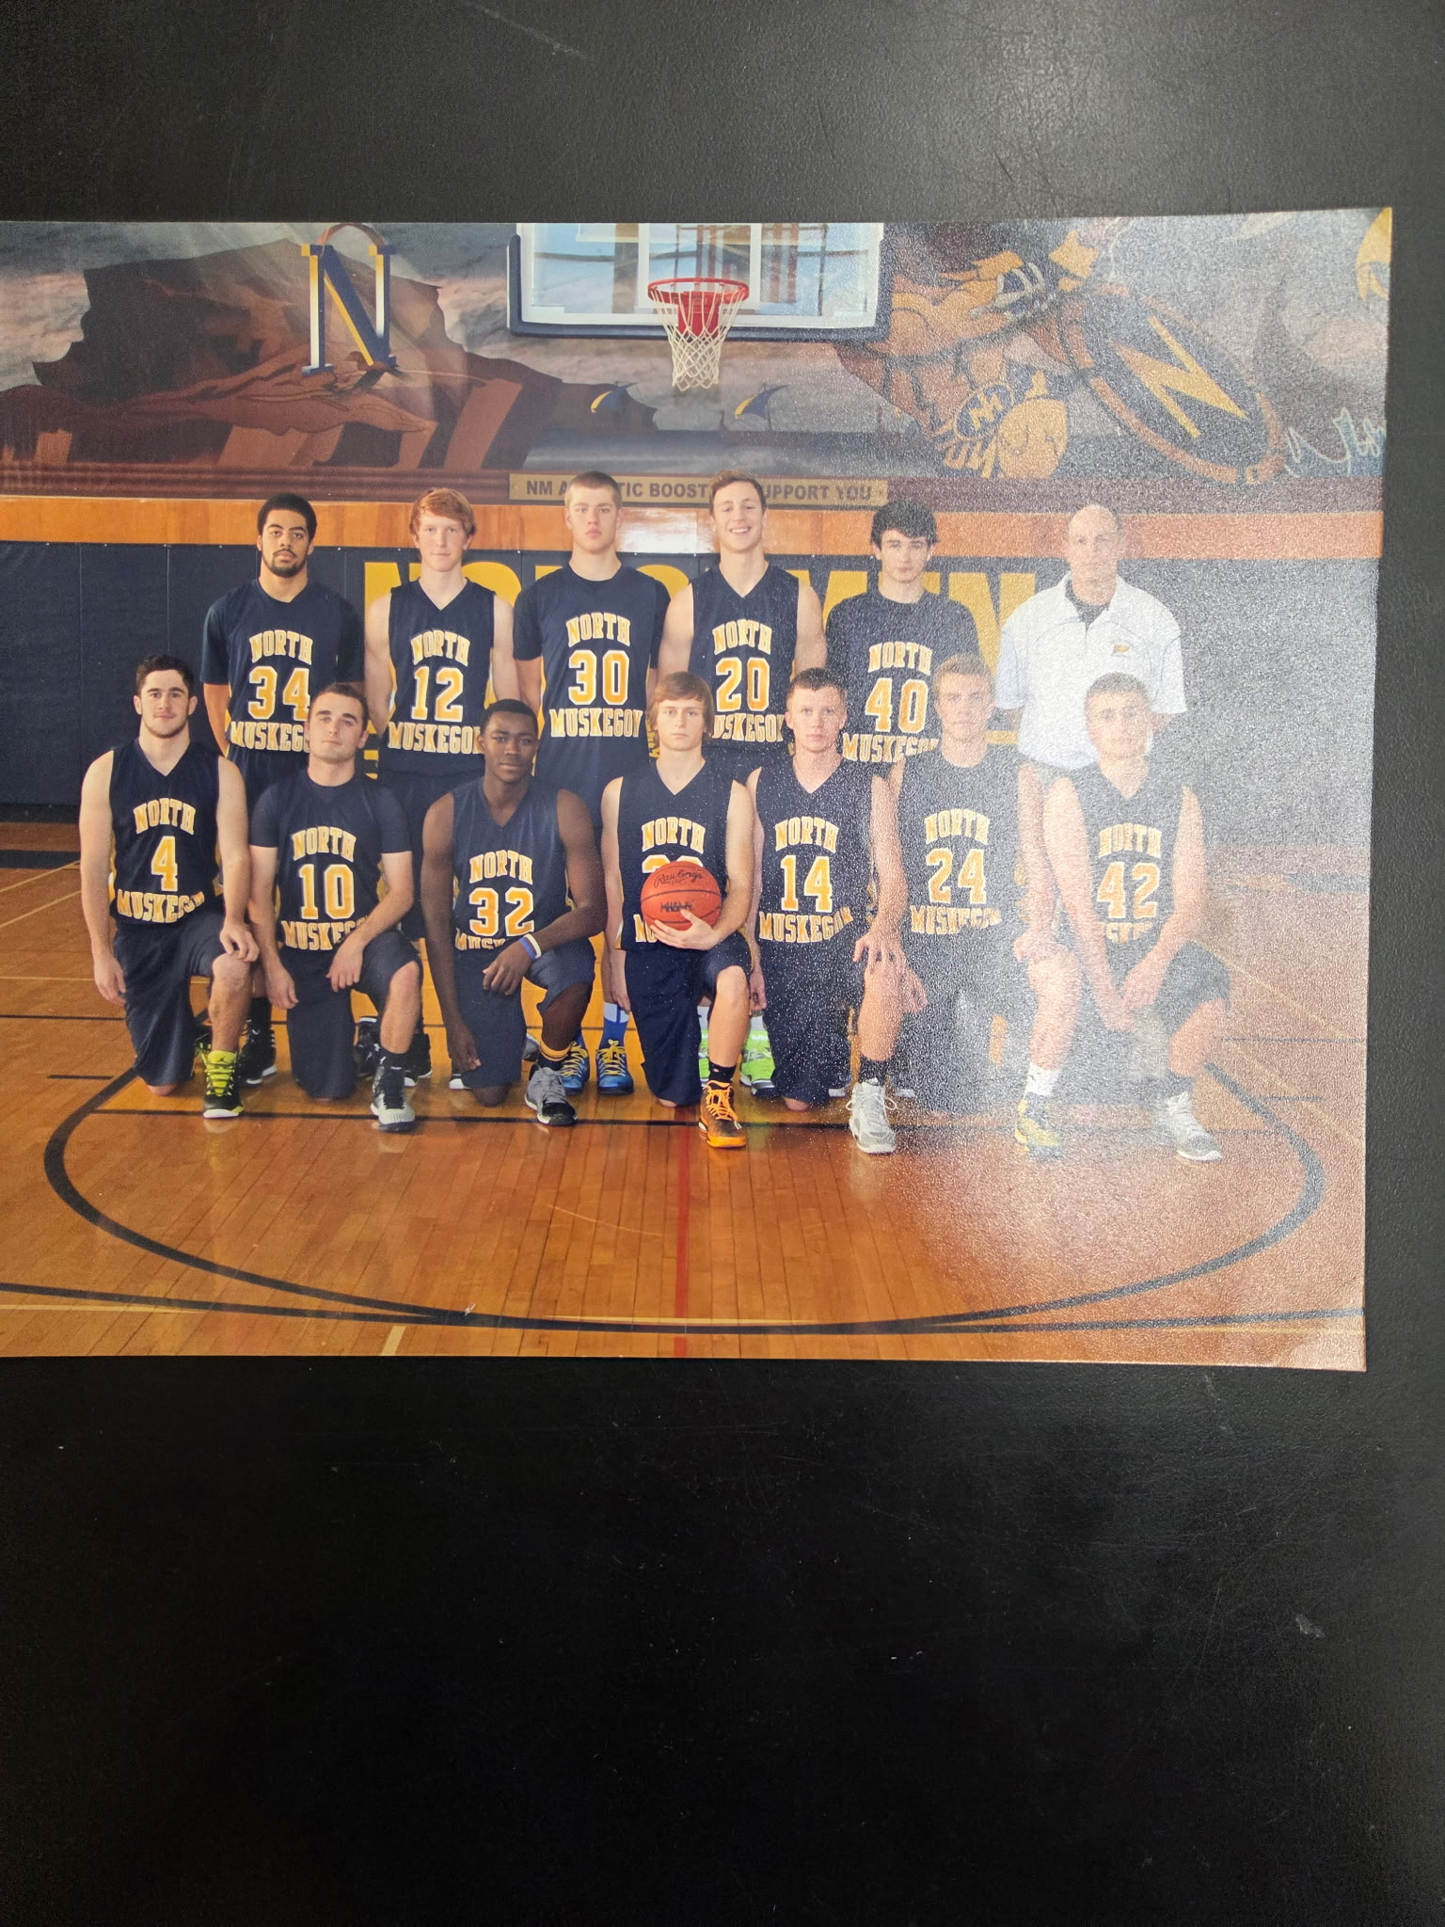

The 2014-15 NORSEMEN

Back Row L-R: Vermonell Smith, Cal Preston, Riley Fairfield, Marco Visconti, Gavin Poulin, Coach Rypstra
Front Row L-R: Ben Gauntraud, Joe Osborn, James Duncan, Mitch Edick, Joel Hardy, Erick Bleakley, Nick Schanhals

N Muskegon 46 Musk Catholic 47 Erick Bleakley & Marco Visconti 10
N Muskegon 42 Hart 28 Vernonell Smith 12, Mitch Edick 8
N Muskegon 54 Oakridge 68 Visconti 13, Riley Fairfield 11
N Muskegon 39 WMC 53 Smith 8, Edick 8
N Muskegon 41 Mason Co 57 Bleakley 11, Mitch Edict 10
N Muskegon 61 Holton 42 Bleakley 13, Fairfield 11
N Muskegon 60 Whitehall (ot) 59 Ben Gautraud 21, Bleakley 14
N Muskegon 70 Ravenna 61 Bleakely 18, Fairfield & Joe Osborn 10
N Muskegon 57 Montague 42 Fairfield 13, Edick 12, Smith 12
N Muskegon 45 Shelby 48 Visconti 13, Bleakley 8
N Muskegon 61 Hart 34 Osborn 14, Fairfield 12, Visconti 11
N Muskegon 56 Manistee 41 Gautraud 20, Visconti 12
N Muskegon 70 Oakridge 53 Gaurtraud 15, Visconti 12
N Muskegon 47 Mason Co 41 Fairfield 14
N Muskegon 58 Fruitport 42 Gautraud 17, Fairfield 15
N Muskegon 48 Shelby 72 Visconti 12
N Muskegon 55 Whitehall 53 Fairfield 15
N Muskegon 51 Ravenna 23 Visconti 11
N Muskegon 55 Montague 58 Fairfield 20, Bleakley 14
N Muskegon 56 Saugatuck 42 Bleakley 12, Duncaan 10
N Muskegon*63 Ravenna 39 Bleakley 23, Visconti 16
N Muskegon*54 WMC 52 Fairfield 19, Bleakley 13
N Muskegon* 67 Musk Heights 63 Fairfield 18, Vernonell Smith 12
N Muskegon*38 Laingsburg 60 Fairfield & Bleakley 9

2015-16 (Coach Chuck Rypstra, 14-7 Shelby – Whitehall Co- WMC champs)

NM couldn’t have asked for aa better start to open their 2015-16 season with a 72-50 victory over a Muskegon Catholic team who, just like the Norsemen, returned many regulars from their district champions from the previous year. Both teams also featured players who played on their respective school’s football team. NM Juniors Riley Fairifield and Vernonell Smith showed they could play both sports very well as Fairfield had 22 points and Smith 19 to lead the Norsemen to victory. NM’s quarterback Erick Bleakley was also in double figures with 12 points. NM put this game away midway through the second quarter when they went on a 16-2 run at Ray Cioe Gymnasium, the home court of the Crusaders. The Norse footballers had plenty of more time to practice as the Crusader gridders were just days away from celebrating another state championship.
After the Norse improved their record to a perfect 2-0 following an easy 63-46 victory over Hart with Riley Fairfield gunning in 13 points, NM stepped back a step as they lost to a very good Oakridge team 63-46. The Eagles led by 15 points at halftime as the Norse were only to be able to play the Eagles even the rest of the contest. Erick Bleakley led NM with 13 points, followed by Riley Fairfield with 12 and Dalton Fuller added 11.
It did not look good for the Norsemen in their next contest as they trailed their arch nemesis over the years, West Michigan Christian by double digits in the final quarter on the Warriors home court. NM then went to work, and it all began with a steal and a dunk from Vernonell Smith. That ignited a Norse run where they exploded for 12 points over a three-minute span with Riley Fairfield scoring five points and Eric Bleakely the other five markers. Fairfield scored nine of his 16 points in the fourth frame including a layup with 2:04 left to play that gave NM their first lead at 45-44. Bleakley, who scored 14 points in the game, added three free throws down the stretch to seal the win for NMHS 48-47.
Junior Riley Fairfield joined the 30-point club with 33 of NM’s 54 points in a 59-50 come-from-behind win over Mason County Central. Fairfield scored 14 of his points in the fourth quarter as NM overcame the Spartans third quarter lead by outscoring MCC by 11 points in the fourth to ice the win.
NM defeated Shelby for the first time in seven outings but the win didn’t come easily. Riley Fairfield scored the game-winning basket with just three seconds left in the game to give NM a 54-53 victory over Shelby. Fairfield had another huge game for the Norsemen with 24 points with Erick Bleakley adding 16.
As if the recent games fought between NM and Whitehall couldn’t get any tighter the two teams went into overtime for the seventh time since 2006 with Whitehall edging NM 73-71. It appeared the Norsemen were headed for victory at the new Whitehall gymnasium as they took an 11-point lead into the fourth quarter. Whitehall then outscored NM 22-11 in the fourth quarter as they received a lot of help from NM as the Norse were only able to make but 1-of-6 free throws in the final eight minutes. The Viking’s Lucas Schumm hit a layup with 4.8 seconds left to give the Vikings a perfect 5-0 record early into the West Michigan Conference schedule. NM had four players in double figures led by Riley Fairfield who had 15 points, five rebounds, five steals and four blocked shots. Erick Bleakley finished with 14, Vernonell Smith 13 and Dalton Fuller 11 points.
Muskegon Heights, perhaps still smarting after NM ended the Tigers season a year earlier in the playoffs, held the Norse to a season low with a 51-33 win. NM suffered a big blow in the game when Erick Bleakley, averaging 14 points per game, suffered from back spasms in the pregame warmups and was able to play very little in the game. Heights got off to a big start and had a commanding 39-20 advantage at the end of the third quarter. NM showed life as they went on a 11-1 run early into the fourth quarter to trim the Tigers lead to 40-32. Riley Fairfield had 10 of NM’s 31 points.
The Norsemen couldn’t sulk long about their loss to the Tigers as they were back in action the next night. NM rebounded nicely to dispose of Ravenna 71-39. Riley Fairfield scored 21 and Vernonell Smith 19 as NM improves to 6-3 overall and 4-2 in WMC action.
Montague scored 31 points with a furious comeback in the final period but in the end the Norsemen prevailed 66-54. Joe Osborn led the Norse with 15 points while freshman TJ McKenzie and Riley Fairfield both scored 14.
The Norsemen defeated Hart in another lopsided victory over the Pirates 70-31. The win improved their record to 8-3 on the season and 6-2 in WMC play. The Norse jumped out to a 13-5 lead after the first quarter and by the time the third quarter buzzer had sounded the Norse were in firm control at 49-25 as Coach Chuck Rypstra could now go to his bench. Before the reserves flooded the floor Erick Bleakley played long enough to score a season high 23 points, while Riley Fairfield added 17 points. Vernonell Smith reached double figures with 10 points to go along with seven rebounds and seven steals in a good all-around effort. To say that Hart was in a slump would be an understatement. Hart has now gone nearly four years without a win in the WMC.
A poor shooting night doomed the Norsemen in a 61-44 loss to Oakridge. “You’re not going to win against Oakridge scoring 44” said Norse coach Rypstra following the game. “That’s a low output for us, credit them for their defense.” NM shot only 25 per cent from the field in the loss to the Eagles. NM hung around throughout the first half as both teams struggled from the field as the host Eagles only led NM 23-21. Oakridge then started the second half on fire as they hit 4-of-5 from beyond the arc to expand their lead to 50-35 entering the fourth quarter. Erick Bleakley was the only Norsemen in double figures with 15.
The Norsemen had to go two overtimes to defeat Mason County Central 74-66. Erick Bleakley hit a clutch 3-pointer in the closing seconds of regulation to force overtime. Each team scored but two points in the first overtime, but NM opened it up in the second overtime to win by eight points. This game was a reversal of a game four years earlier that went into double overtime in a game that was won by the Spartans. Venonell Smith had a monster game for the Norse with a season high in points (23) and rebounds (16). Erick Bleakley had another strong game with 21 points.
The Norse then won a non-league game 69-64 over Saugatuck as Riley Fairfield scored 25 points and grabbed eight rebounds for NM. Saugatuck entered the game with an excellent record of 10-2 and were led by four-sport star Blake Dunn. A football, basketball, and still to this day a state record holder in track for both hurdles’ events, Dunn was also a ‘pretty fair’ baseball player. After starring in baseball and track for Saugatuck High Dunn would play for Western Michigan University in the spring and the Muskegon Clippers in the summer where he was coached by former NM basketball and baseball coach Walt Gawkowski. In 2024 Blake Dunn became a major leaguer when he was called up to play for the Cincinnati Reds. Dunn equaled Fairfield for high point honors with 25 points in the game, while Vernonell Smith added 12 points and Erick Bleakley chipped in with 11.
Riley Fairfield outdid himself the very next night as he scored a career high 36 points to lead NM to a 67-52 victory over Fruitport. NM jumped out to a 36-35 halftime lead and never looked back. This was the 24th, and as of this date the last game between Fruitport and NM in a series that dates to NM’s first season of basketball in 1932-33. NM dominated the rivalry winning 20 of the 24 games.
Shelby came from being six points down at the half by rallying in the third quarter outscoring NM 13-5 over the last six minutes to give Shelby a 38-33 lead going into the fourth quarter. Forced to foul late in the game Shelby came through at the free throw line by making 13-of-15 free throws in the final quarter to make the final score look much more lopsided at 59-45. Shelby improved to 12-2 on the season with one of those defeats to the Norsemen earlier in the season. Riley Fairfield led NM in scoring with 19 points followed by Erick Bleakley with 10.
NM helped Rick Zoulek’s Shelby Tigers in their next game by defeating first-place Whitehall 66-61. The loss by Whitehall to the Norsemen dropped Whitehall into a first-place tie with Shelby, both with 10-2 records while NM is 8-4 in league play. Riley Fairfield led NM with 19 while Vernonell Smith added 15 and Erick Beakley 10.
NM continued their winning streak against Ravenna with a convincing 56-43 victory over the Bulldogs. Erick Bleakley matched his career high with 23 points and 13 rebounds to pace the Norsemen. Riley Fairfield added 14 points and grabbed seven rebounds.
It appeared NM and Montague were headed into overtime after NM tied the game at 55-55 on a made basket by Riley Fairfield with nine seconds left in the game. However, Abraham Erickson nailed a long 3-pointer at the buzzer to give Montague a 58-55 victory over NM. Fairfield led NM with 20 points with Erick Bleakley netting 14.
Hesperia would prove to be no match for the Norsemen as NM nearly broke the scoreboard with a 93-59 trouncing of the Panthers. These two teams would meet seven times from 2016 to 2025, and NM would outscore Hesperia 663-265. The scoring was spread out evenly for the Norse led by Vernonell Smith with 17, Riley Fairfield 16, Erick Bleakley 15, and Thomas Montgomery came off the bench to score in double figures with 12 points.
Muskegon Heights, a proven perennial power, and North Muskegon, a team that has never advanced to the final four met in the district opener with the Tigers edging the Norsemen 60-56. The Heights improved their record to 17-4 while NM’s season came to an end at 14-7. It looked after the first half as this game was going like their first meeting in January when the Heights defeated NM by 18 as the Tigers led 32-23 at the halftime break. NM came out firing in the third quarter to tie up the game at 40-40 entering the final stanza as Riley Fairfield scored eight of his game high 25 points in the quarter. A 3-pointer by Dalton Fuller with 2:50 left gave NM a 50-47 lead but the Tigers answered just seconds later with a 3-poiinter of their own. Down the stretch the Norse shot themselves in the foot with their free throws, missing seven free throws in the fourth quarter alone. The Tigers hit a big triple with 1:30 left to give Heights a 55-52 lead. A layup and then made free throws by the Tigers was enough to end NM season but not before the Blue & Gold gave it a great effort. Fairfield had 12 rebounds to go with his 25 points while Bleakley ended his fine career with 12 points and four assists.

N Muskegon 72 Musk Catholic 50 Riley Fairfield 22, V. Smith 19
N Muskegon 63 Hart 46 Fairfield 23, Dalton Fuller 11
N Muskegon 60 Oakridge 74 Erick Bleakley 13, Fairfield 12, Dalton Fuller 11
N Muskegon 48 WMC 47 Fairfield 16, Bleakley 14
N Muskegon 59 Mason Co 50 Fairfield 33
N Muskegon 54 Shelby 53 Fairfield 24
N Muskegon 71 Whitehall (ot) 73 Fairfield 15, Bleakley 14, Smith 13,
N Muskegon 33 Musk Heights 51 Fairfield 10
N Muskegon 71 Ravenna 39 Fairfield 21, Smith 19
N Muskegon 66 Montague 54 Joe Osborn 15, TJ McKenzie, Fairfield 14
N Muskegon 70 Hart 31 Bleakley 23, Fairfield 17, Smith 10
N Muskegon 44 Oakridge 61 Bleakley 15
N Muskegon 74 Mason Co (2 ot) 66 Smith 23, Bleakley 21
N Muskegon 69 Saugatuck 64 Fairfield 25, Smith 12, Bleakley 11
N Muskegon 67 Fruitport 52 Fairfield 36
N Muskegon 45 Shelby 59 Fairfield 19, Bleakley 10
N Muskegon 66 Whitehall 61 Fairfield 19, Smith 15, Bleakley 10
N Muskegon 56 Ravenna 43 Bleakley 23, Fairfield 14
N Muskegon 55 Montague 58 Fairfield 20, Bleakley 14
N Muskegon 93 Hesperia 59 Smith 17, Fairfield 16, Bleakley 15
N Muskegon*56 Musk Heights 60 Fairfield 25

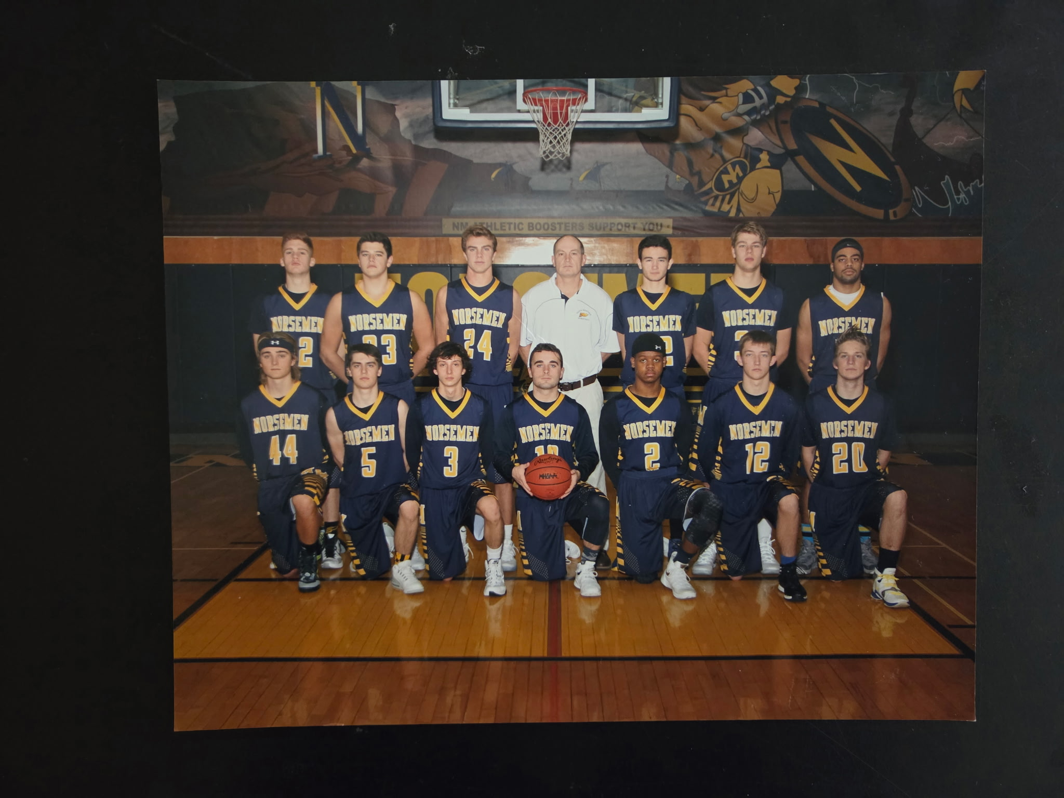
THE NORSEMEN of 2015-16
Back Row L-R: Hunter Schotts, Thomas Montgomery, Erick Bleakley, Coach Rypstra, Gavin Poulin, Riley Fairfield, Vermonell Smith
Front Row L-R: Nick Schanhals, Alex Slocum, Zach Burdon, Joe Osborn, TH McKenzie, Brighton Scholfield, Dalton Fuller

2016-17 (Coach Chuck Rypstra, 15-8 Whitehall WMC champs)

The Norsemen were coming of a successful 14-7 season with high expectation for the coming season. The Norse returned three regulars from the preceding season including Riley Fairfield, a two-time All WMC pick who averaged better than 18 points per game. Also returning for the Norse was Vernonell Smith, who was one of the top three scorers from the previous season. TJ McKenzie saw plenty of action as a freshman and would only continue to get better as a sophomore while Dalton Fuller was a part of the rotation. Thomas Montgomery played in spurts during the 2015-16 season and would give the Norsemen help with scoring and in particular rebounding. However, it took NM time to jell, and it wouldn’t be until near mid-season when the Norse would live up to their expectations.
Riley Fairfield took up where he left off from last season as the senior scored 27 points to lead the Norse to a 60-45 opening game victory over Muskegon Catholic. Once again MCC had several (five) of their 11 players dress that played on their state championship football team (again). MCC kept the game close at halftime as they trailed NM 23-17 at halftime. But then, Fairfield scored 11 of his 27 points in the third quarter as NM outscored the Crusaders 23-8 in the third quarter to pull away. Thomas Montgomery had a nice opener for NM with 14 points while grabbing eight rebounds. The win proved painful for the Norse and a possible explanation for their slow start of the season as TJ McKenzie suffered a broken wrist in the game and would miss the next six weeks. The Crusaders were led by freshman Cameron Martinez who would later transfer to Muskegon where he would set rushing records in football that may last for many years.
NM in their next game got a start for the ages as they scored the game’s first 18 points before Oakridge could score a point in NM’s 44-29 victory over the Eagles. Oakridge outscored the Norsemen the rest of the contest but not nearly enough to threaten the big Norse lead. Riley Fairfield had 16 points to lead NM in the low-scoring contest. Oakridge 29 points was the Eagles lowest total scored against NM in 47 years back when NM defeated Oakridge 45-27 in 1970.
NM then played perhaps their poorest game of the 2016-17 season when they lost in their next game to Mason County Central 53-35. This is one game whereby NM coach Chuck Rypstra probably burned the game tape the next day. None of the Norsemen were in double figures with Riley Fairfield and Vernonell Smith sharing scoring honors with a modest eight points apiece.
NM couldn’t wait fast enough to see 2016 come to an end and look forward to better things in a couple weeks following the holiday layoff. NM lost 53-48 to West Michigan Christian after leading WMC 38-36 after the third quarter. The Warriors were hot from out court as they tallied 10 3-pointers in the game. Riley Fairfield led all scorers in the contest with 20 points and Vernonell Smith finished with 16. Later in the season NM would make amends and defeat both Mason County Central and WMC in the rematches.
NM started the 2017 year with a solid 52-38 victory over Shelby. The Norse held Shelby to six points in the fourth quarter as three Norsemen scored in double figures led by two-time (and soon to make it three) all WMC performer Riley Fairfield with 16 points. Vernonell Smith had 16 and Thomas Montgomery 10 as NM is now on the winning side of the ledger with a 3-2 overall record. Following the win NM Coach Rypstra had plenty of praise for Fairfield: “He (Riley Fairfield) does everything for us. Plays solid defense, good 3-point shooter, and an all-around team leader for us,” said Rypstra.
The euphoria of the big win over Shelby was short-lived as NM just three days later lost to Whitehall 50-44. NM saw a fourth quarter lead go up in smoke as the Vikings used a 10-0 run to pull ahead of the Norsemen. Dalton Fuller led the Norse with 15 points and grabbed five rebounds.
NM rebounded from their loss to Whitehall by pounding Saugatuck 65-47 as Riley Fairfield dropped 30 points on the hosts. Vernonell Smith added 12 points while Thomas Montgomery controlled the boards for NM with 11 rebounds.
If an earlier loss to Mason County Central was NM’s poorest performance of the year than NM’s 67-44 loss to Montague would rate a close second. NM hung around throughout the first half as they trailed the Wildcats 32-26 at the halftime break, but Montague controlled the second half to drop NM to an even .500 record on the season at 4-4. Riley Fairfield again led Norse scorers with 16 points.
The Norsemen had no trouble in an easy 61-36 victory over Hart. The once proud Pirates had fallen on hard times in recent years. Earlier in the season Hart won their first victory in five years in the WMC with a win over Ravenna. Riley Fairfield had a double-double for NM with 21 points and 10 rebounds. Vernonell Smith chipped in with 18 points with Thomas Montgomery again strong on the board with 10 rebounds.
The Norse lost to an always talented Muskegon Heights team 62-47 with Venonell Smith with 12 and Riley Fairfield with 10 the only NM players in double figures.
Following the non-league loss to Muskegon Heights NM would turn the corner and have a very good second half of the season, beginning with a 46-34 win over Oakridge. The Eagles had high hopes for a good season but were hurt with injuries, including an injury to last year’s leading score Brady Lutrell. Held to only 29 points in their first meeting the Norsemen held Oakridge to 34 in the rematch as several players contributed to the Norse win. Football star TK McKenzie finished the night with 10 points, five assists and four steals.
NM’s 71-64 win vindicated their improvement from earlier in the season as they made amends for an earlier poor performance against Mason County Central to post a 71-64 win over the Spartans in the rematch. Riley Fairfield notched 27 points and got help from Thomas Montgomery and Vernonell Smith who added 14 points apiece. Dalton Fuller added eight as NM improved to 7-5 on the season.
NM made it a clean season sweep with Shelby with a 55-41victory over a once proud Shelby team that had begun a precipice decline from their many previous years of winning basketball. The win dropped the once proud Tigers to 2-11 on the season while NM jumps up to 8-5. NM had balanced scoring with TJ McKenzie and Dalton Fuller scoring 11 points apiece while Riley Fairfield added nine.
The Norse defeated Ravenna 50-33 with some solid defense, especially in the fourth quarter as the Bulldogs scored only one point to NM’s 15. Riley Fairfield’s 15 points was tops in the game.
Whitehall would go undefeated in West Michigan Conference play, but they received their biggest challenge during the season against NM. In the eighth game between the two rivals that would not be decided until they played in overtime, Whitehall needed a last second basket from Brandon Rake in overtime to nip an upset minded NM team 45-43. Whitehall led by 14 points at halftime, but the Norsemen would not fold. NM began the third quarter by going on an 11-0 run to trim the deficit to one point. Riley Fairfield drilled a 3-pointer with six seconds left in regulation to force the overtime.
It was de ja vu when NM faced Ravenna in their second contest against one another just days apart. In a statistical oddity the score in the second game was the same score as the first with NM winning 50-33. Riley Fairfield led NM with 17 points with Thomas Montgomery adding 10 as Thomas filled up the stat sheet with six rebounds, five steals, and four assists.
A poor third quarter by NM wiped out a 33-23 halftime lead as NM fell to Montague 52-49. Montague outscored the Norse 16-5 in the third quarter to earn the win. NM earlier lost to Montague by 23 points, a clear sign that NM had shown remarkable improvement as the season progressed. Dalton Fuller, Bret Huff and Thomas Montgomery scored 10 points.
In the second lowest scoring game between the two teams since 1951, NM defeated Hart 43-32 in the final West Michigan Conference game of the season. NM would finish their WMC campaign with a 9-5 record with Hart posting a 4-10 record, four more wins then they totaled in the previous four seasons. Vernonell Smith paced NM with 16 points with Riley Fairfield chipping in with 11.
In the only meeting between the two schools in program history, North Muskegon defeated Kalamazoo Phoenix 77-57 as Riley Fairfield scored 22 points. TJ McKenzie scored 15 and Vernonell Smith 10.
North Muskegon’s 49-46 win over Ludington must rank as one of the most improbable of the more than 900 victories earned in Norse history. Ludington traveled to NM with an imposing record of 18 wins against one defeat. Ludington would advance all the way to the Class B state championship game before losing to New Haven for the title. Ludington did erase a 10-point halftime deficit to tie the game as the fourth quarter began. TJ McKenzie hit a free throw with 10 seconds left to give the Norse a three-point lead. Ludington had several chances to score in the final moments, but their normal sharp shooters drew blanks and NM won for the first time in seven tries against the Orioles. Nine different Norsemen made a 3-pointer in the upset with Riley Fairfield’s 14 points leading the Norsemen followed by TJ McKenzie with 11.
NM, who lost to West Michigan Christian earlier in the season atoned for that loss in a big way as they swamped the Warriors 66-42 in the opening game of the MHSAA playoffs. Riley Fairfield had a game-high 21 points for NM with Dalton Fuller adding 10 points as NM earned a trip to the district semi-finals to play Ravenna for the third time in less than a month.
NM made it a clean sweep on the season with Ravenna with a 63-49 win over the Bulldogs. Ravenna made a game out of it as they were tied at 22-22 at halftime before NM outscored the Bulldogs 18-8 to take a 40-30 lead heading into the final quarter. NM sealed the deal with a 23-19 fourth quarter to win 63-49. TJ McKenzie led NM with 14 points, Vernonell Smith 12 and Dalton Fuller 10 to set up a district title match with powerful Muskegon Height.
Muskegon Heights, who along with the Norsemen handed Ludington one of their two regular season losses, used a big second quarter to win the district and end the Norsemen season 64-47 in the district final at Kent City. The Tigers 19-5 second quarter run was too much for the Norse to overcome as their season ends at 15-8. The big run gave the Tigers a 30-18 halftime lead, overcoming a slim NM 13-11 lead at the end of the first stanza. Vernonell Smith had 17 points that included a crowd-pleasing dunk while sophomore TJ McKenzie scored 11. The Tigers held NM’s leading scorer Riley Fairfield to eight points. The Heights season would come to an end with a one-point loss in the regional final to Grand Rapids Covenant Christian, a team who made it to the state championship game.

N Muskegon 60 Musk Catholic 45 Riley Fairfield 17, Thomas Montgomery 14
N Muskegon 44 Oakridge 29 Fairfield 16
N Muskegon 35 Mason Co 53 Fairfield & Vernonell Smith 8
N Muskegon 48 WMC 53 Fairfield 20, Smith 16
N Muskegon 52 Shelby 38 Fairfield 16, Smith 13, Montgomery 10
N Muskegon 44 Whitehall 50 Dalton Fuller 15
N Muskegon 65 Saugatuck 47 Fairfield 30, Smith 12
N Muskegon 44 Montague 67 Fairfield 16
N Muskegon 61 Hart 36 Fairfield 21, Smith 18
N Muskegon 47 Musk Heights 62 Fairfield 10, Smith 12
N Muskegon 46 Oakridge 34 Fairfield 10, TJ McKenzie 10
N Muskegon 71 Mason Co 64 Fairfield 27, Smith & Montgomery 14
N Muskegon 55 Shelby 41 McKenzie & Fuller 11, Fairfield 9
N Muskegon 50 Ravenna 33 Fairfield 15
N Muskegon 43 Whitehall (ot) 45 Fairfield 14
N Muskegon 50 Ravenna 33 Fairfield 17, Montgomery 10
N Muskegon 49 Montague 52 Brett Huff, Montgomery & Fuller 10
N Muskegon 43 Hart 32 Smith 16, Fairfield 11
N Muskegon 77 Kazoo Phoenix 58 Fairfield 22, McKenzie 15, Smith 10
N Muskegon 49 Ludington 46 Fairfield 14, McKenzie 11
N Muskegon*66 WMC 42 Fairfield 21, Fuller 10
N Muskegon*63 Ravenna 49 McKenzie 14, Smith 12, Fuller 10
N Muskegon*47 Musk Heights 64 Smith 17, McKenzie 11, Fairfield 8



The NORSEMEN of 2016-17

Back Row L-R: Coach Rypstra, Vernonell Smith jr., Jesse Cooke, Riley Fsirfield, Thomas Montgomery, Coach Tunney
Middle Row: Andrew Butzow, Brett Huff, Hunter Schotts, Brighton Scholfield
Front Row L-R: Dalton Fuller, Alex Slocum, TJ McKenzie, Zach Burdon, Lequan Hooper

2017-18 (Coach Chuck Rypstra, 20-4 NM WMC champs, District Champs)

NM finished 2017-18 with an outstanding record of 20-4, their best record in 15 years. Junior TJ McKenzie would return for the 2017-18 season as Coach Chuck Rypstra would welcome several promising underclassmen to the roster who would contribute heavily to their success. Joining McKenzie in the rotation would be 6’6 Jesse Cooke, the son of long time NM coach Jeff Cooke. De’Shary Warren would prove to be an adept point guard and others, including John Hayhurst and Eric Rypstra, the son of the current coach would give NM much-needed depth that was lacking over the years. This would be a banner year for the Norsemen, winning their first WMC title since 2003 and their first district tournament since 2015.

The Norse would hand Muskegon Catholic a decisive 63-33 defeat to begin the season. It would be the third of eight straight wins over the Crusaders with NM outscoring MCC-507-255 during the run which is current through the 2024 season. TJ McKenzie hit a 3-pointer two minutes into the game and added 14 points in the second half as NM rolled to an easy victory. McKenzie finished with 27 points while Jesse Cooke netted 14 and De’Shary Warren 10.
TJ McKenzie had another big performance as he scored 21 points in NM’s 63-43 win over Oakridge. The well-balanced Norsemen received 14 points from John Hayhurst and 10 from sophomore Eric Rypstra as NM begins the season at 2-0.
NM then won a resounding victory over Mason County Central 78-44, the widest margin of victory for NM over the Spartans in program history. For the first time in seven years NM had two players score more than 20 points in a game with TJ McKenzie netting 27 and Jesse Cooke 21.
NM stayed perfect on the season with a 59-51 win over Shelby This was a tightly contested game as the score was tied at halftime and at the end of the third period before the Norse pulled away in the final quarter. Jesse Cooke led NM with 15 points and nine rebounds. TJ McKenzie added 12 points and used his quick hands to pilfer eight steals. Eric Rypstra was also in double figures with 10 points.
NM played their annual game with West Michigan Christian to end 2017 and lost their first game of the season 46-40 in a low scoring game to the Warriors. The game was tight until the final quarter as the two teams were tied 19-19 at halftime with the Warriors holding a slim three-point lead going into the final quarter. TJ McKenzie led NM with 10 points.
For only the first time in eight games between NM and Whitehall was there a game decided by more than six points with three of the games decided in overtime. It was the Norsemen who posted the lopsided victory 53-31 over Whitehall. NM used a big second half to down the Vikings as the Norse led 18-17 at halftime. TJ McKenzie tallied 20 points and Jesse Cooke 12 to lead the Norsemen to their fourth victory in the WMC without a loss.
NM had lost 11 of the 12 games played between the Norsemen and Muskegon Heights, many of those losses lopsided wins for the Tigers. There was no massive win for the Tigers in this game as the Heights just squeaked by the Norse 58-56. NM had a a chance to send the game into overtime as a Norse player was fouled with six seconds left shooting a 3-pointer. The Norseman was only able to hit one of his three free throws; the Tigers grabbed the intentionally missed third attempt and held on for the victory. TJ McKenzie led the Norse with 17 points, eight rebounds, five steals, three assists and three blocked shots to fill out the stat sheet. John Hayhurst added 15 points and Eric Rypstra 12 in a game played in front of a packed house at the NM gym.
Although NM had lost a couple of non-conference games, NM stayed perfect at 5-0 on the WMC with a 54-36 win over Ravenna. TJ McKenzie had another big night for the winners with a game-high 18 points with point guard De’Shary Warren adding 10 points. Jesse Cooke contributed eight points and seven rebounds for the Norse.
NM led Montague by nine points at halftime but had to hang onto beat the Wildcats 58-52 as Montague cut the lead down to one point heading into the fourth quarter. NM sealed the win by making some clutch free throws down the stretch. TJ McKenzie led the Norse once again with 18 points, followed by De’Shary Warren with 12 and Eric Rypstra 11 as NM stays perfect at 6-0 in league play.
Hart briefly surprised the Norse by jumping out to an early 9-2 lead and led 11-8 at the end of the first quarter. The Norse then got their act together and went on a 21-2 run in the second quarter to take control of the game as they went on to win handedly 67-29. TJ McKenzie led NM in scoring with 17 while De’Shaary Warren had a nice all-around game with 15 points, seven assists and six steals. John Hayhurst chipped in with 10 points and eight rebounds.
After a convincing 58-39 win over Oakridge that kept the Norse perfect in the WMC at 8-0, NM can set their eyes on winning their first conference championship since 2003.The Norse got out of the gates fast at Oakridge as they outscored the Eagles by 14 points in the opening quarter that set the tone for the entire game. Oakridge made a brief run at the Norse in the third quarter but a 3-pointer by the Norsemen’s Eric Ryspstra sent NM into the fourth quarter with a comfortable 45-32 lead. TJ McKenzie kept up his consistent play with 17 points to lead the Norsemen. De’Shary Warren had eight points and four assists while the bulk of the rebounding work came from Jesse Cooke (9) and John Hayhurst with six boards.
TJ McKenzie equaled a school record by making eight 3-pointers in NM’s comeback 69-58 win over Mason County Central. McKenzie also became the 27th NM player to surpass 30 points in a game with his 32 total points. All of McKenzie’s points were needed as NM trailed 37-30 in the third quarter before the Norse erupted to go on a 19-2 run. John Hayhurst chipped in with 10 points for NM as they stay perfect at 9-0 in conference play.
It's never a given that one can beat a Rick Zoulek coached Shelby team, so the Norse are only too happy to complete their season sweep of Shelby with a 56-44 win. TJ McKenzie once again led NM with 21 points while John Hayhurst added 14 points and seven rebounds. The win sets up a huge next game with Whitehall with the winner likely to win the WMC championship.
For the first time in 15 years, the Norsemen has clinched at least a share of the West Michigan Conference championship with a come from behind 48-41 victory over Whitehall. NM is now 11-0 in conference play while Whitehall falls to 8-3. Going into the final quarter the Norsemen trailed the Vikings 38-33, and it was time to go to work. The determined Norsemen then went on to outscore Whitehall 15-3 in the final eight minutes to complete the comeback victory. TJ McKenzie who missed practice with a foot injury struggled with his shooting in the first half but came through big time as he scored the first six points of the final quarter. After McKenzie had tied the score sophomore Erik Rypstra put the Norse ahead for good with a long 3-pointer with 1:54 left to play. McKenzie would go on to score five more points in the quarter to ice the game. After a slow start TJ finished with 20 points with Jesse Cooke adding 13 and Rypstra eight.
After several tension filled games in conference play NM played a non-conference game against Saugatuck and came away a winner 61-49. The Norse got off to a good start and kept their lead all the way. Junior TJ McKenzie’s 19 points paced the Norse while sophomore Erik Rypstra added 10 points. The well-balanced NM team also got nine points and eight rebounds from John Hayhurst and seven points and a team leading nine rebounds from Jesse Cooke.
NM clinched the conference championship with a 53-23 thumping of Ravenna to send the large NM crowd home happy. NM had a commanding 25-11 lead at halftime that ballooned to 43-14 following a 18-3 third quarter. TK McKenzie, except for his 32-point outburst against Mason County Central has displayed amazing consistency by scoring between 17 and 21 points in 10 straight games, scored an even 20 in this game. Jesse Cooke tallied 15 for the WMC champs.
The goal of going undefeated the entire season was spoiled by Montague in the next to the last conference game of the season. Montague barely edged the Norse 49-48 as Montague used some sharp 3-point shooting to attain the victory. NM had a chance to salvage the victory, but a 30-foot shot at the buzzer failed to connect. TJ McKenzie with 23 points nearly scored half of NM’s points.
Hesperia was no match for NM as the Norse won easily 52-35 over the Panthers. NM jumped out to an early 18-5 lead and were never threatened. TJ McKenzie again scored in the twenties with a game leading 21 points with Eric Ryspstra and John Hayhiurst each contributing eight points.
The Norsemen closed out their conference play with a 59-45 victory over Hart to finish 13-1 and on top of the standings in the West Michigan Conference. Hart gave NM a battle for the first half as they trailed only 28-26 at the break before NM took control in the second half. TJ McKenzie’s 24 points again topped all scorers with De’Shary Warren adding nine points. Jesse Cooke pulled down 10 rebounds in the contest.
The regular season ended in a perfect matchup of conference champions, Ludington winners of the Lakes 8, and NM the winner of the West Michigan Conference. NM made the WMC proud as they defeated the 2017 Class B runner-up’s 55-43, the first win ever for a North Muskegon team at Ludington. It was the second victory in a row for the Norsemen over Ludington. NM was led, naturally, by TJ McKenzie with 24 points. John Hayhurst had a perfect night for the game as he never missed a shot in garnering his 14 points. Hayhurst was 5-for5 shooting from the field and a perfect 4-for-4 at the free throw line. NM heads into the MHSAA playoffs with a marvelous 17-3 record.
The Norsemen finished strong in their playoff opener to win their opening round Class C district game 62-45 over Holton. The Red Devils made the Norsemen work for the victory as the Norse needed a 14-point advantage in the final quarter to ice the game. For the first time in 16 games TJ McKenzie didn’t have to carry the brunt of the scoring load as it was Jesse Cooke topping Norse scorers with 15 points while grabbing 10 rebounds. TJ and De’Shary Warren each tallied 12 for NM.
For the fifth time in their rivalry NM has defeated Ravenna three times in a single season. NM now advances to the Class C district final thanks to a 63-55 win over the Bulldogs. NM won their first two games handedly but the Bulldogs, spurred on by their home crowd, made NM work hard for the victory. It was pretty much the TJ McKenzie show as the junior scored a career high 39 points, 22 in the second half, including 15 of NM’s 16 fourth quarter points. “He played pretty well, didn’t he,” joshed NM coach Chuck Rypstra following the game. “He just decided to take over.” McKenzie also had six steals and seven rebounds.
With still no shot clock in effect in Michigan High School basketball Kent City, who began the game with a perfect 21-0 record, played patient basketball but it was the Norsemen who came out on top in the low-scoring contest 37-33. The victory gave NM their first district title since 2015 and now moves to the regionals in Beal City. Junior De’Sahry Warren said after the game that the Norsemen weren’t fazed by the Kent City slow-it-down offense. “Coach told us before the game that the first team to score 40 points was going to win.” As it turned out 37 points was all that was needed for the victory, two points less than TJ McKenzie scored in NM’s win over Kent City. McKenzie was limited to 12 points, but he got plenty of help from his teammates to claim the district title. Jesse Cooke had 10 points, and five blocked shots and Cooke broke a 32-32 tie when he skied for a putback score with three minutes to play. Warren hit one of two free throws to give NM a 35-32 lead. Kent City then connected on one 1-of-2 free throws to cut the lead to 35-33 with 16 seconds left. Kent City than fouled Warren and the junior point guard calmly drilled both free throws for the final four-point edge.
The long road trip on a Monday night to Beal City saw NM’s season end with a 59-43 loss to Sanford Meridian, a team NM defeated to win the regional title in 2003. NM had their poorest shooting performance of the season as they hit on only 3 of 24 from 3-point range. It was even worse at the free throw line as Sanford-Meridian outscored the Norsemen from the charity stripe 23-5. TJ McKenzie, who averaged more than 20 points per game on the season scored 22 of NM’s 43 points with John Hayhurst adding 12 points.
With 11 players being underclassmen, NM would be heard from again in 2019.

N Muskegon 63 Musk Catholic 33 TJ McKenzie 27, Jesse Cooke 14
N Muskegon 63 Oakridge 43 McKenzie 21, John Hayhurst 14
N Muskegon 78 Mason Co 44 McKenzie 27, Cooke 21
N Muskegon 58 Shelby 51 Cooke 15, McKenzie 12, Eric Rypstra 10
N Muskegon 40 WMC 46 McKenzie 10
N Muskegon 52 Whitehall 31 McKenzie 20, Cooke 12
N Muskegon 56 Musk Heights 58 McKenzie 17, Hayhurst 15, Rypstra 12
N Muskegon 54 Ravenna 36 McKenzie 18, De’Shary Warren 10
N Muskegon 58 Montague 52 McKenzie 18, Warren 12, Rypstra 11
N Muskegon 67 Hart 29 McKenzie 17, Warren 15, Hayhurst 10
N Muskegon 58 Oakridge 39 McKenzie 17, Warren 8
N Muskegon 69 Mason Co 58 McKenzie 32, Hayhurst 10
N Muskegon 56 Shelby 44 McKenzie 21, Hayhurst 14
N Muskegon 48 Whitehall 41 McKenzie 20, Cooke 13, Rypstra 8
N Muskegon 61 Saugatuck 49 McKenzie 19, Rypstra 10
N Muskegon 52 Ravenna 23 McKenzie 20, Cooke 15
N Muskegon 48 Montague 49 McKenzie 23
N Muskegon 50 Hesperia 20 McKenzie 21, Rypstra & Hayhurst 8
N Muskegon 59 Hart 45 McKenzie 24, Warren 9
N Muskegon 55 Ludington 43 McKenzie 24, Hayhurst 14
N Muskegon*62 Holton 45 Cooke 15, McKenzie & Warren 12
N Muskegon* 63 Ravenna 55 McKenzie 39
N Muskegon* 37 Kent City 33 McKenzie 12, Cooke 10, Warren 9
N Muskegon* 43 Saford-Meridian 59 McKenzie 22, Hayhurst 12

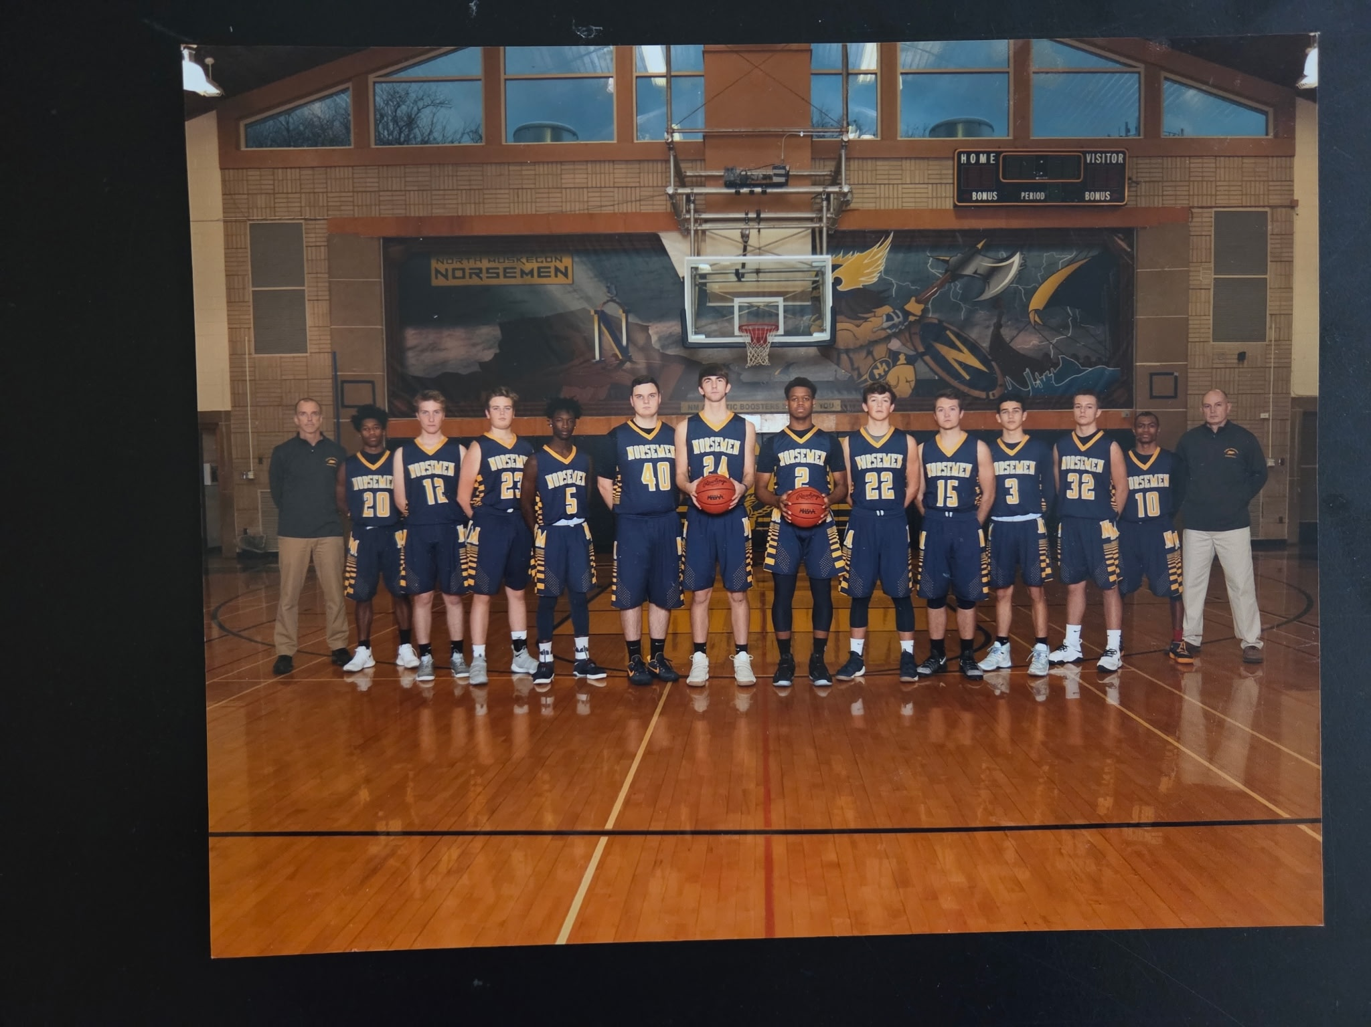

The 2017-18 NORSEMEN

L-R: Coach Tunney, Chandler Edwards, Billy Lowe, Max Tyson, DeShary Warren, Matt Olson
Jesse Cooke, TJ McKenzie, John Hayhurst, Brett Huff, Mack Young, Eric Rypstra, Lequan Hooper

2018-19 (Coach Chuck Rypstra, 20-2 NM WMC champs)

The 2018-19 season promised to be very good year for the Norsemen as they returned 7-of-8 of their top players from their WMC championship team from the previous season. NM was not only a good offensive team, but their defense was the best in recent history. The Norsemen allowed their opponents an average of only 40 points per game. One would have to go back to the very early 1950s to find a team that allowed fewer points per game than the 2019 Norsemen. However, under coach Chuck Rypstra that would be surpassed in the not-too-distant future. Offensively, the Norse returned high scoring TJ McKenzie who would surpass the 1000-point barrier midway through the season. A big front line of 6’6 Jesse Cooke and 6’4 John Hayhurst would make their presence known down low while returning backcourt starters included De’Shary Warren and junior Eric Rypstra.
The Norse showed in their first game that this NM team was going to be tough to score on with a 70-21 romp over Hesperia. By the time the first half had ended there would be a running clock due to the mercy rule as NM led by 35 points 45-10. With NM returning 11 players it would not be a problem for NM’s deep bench to keep scoring points. TJ McKenzie led NM with 18 points followed by Eric Rypstra with 11 and John Hayhurst with nine.
NM made quick work of Oakridge in their second game of the season. NM used an overwhelming second quarter to lead by 28 points at halftime and would go on to win 65-34 over the Eagles. Coach Chuck Rypstra was pleased with NM’s performance. “We played pretty well together, shooting it pretty well. I mean, making threes, just playing really well at the beginning.”
The Norsemen continued to roll as they overwhelmed Muskegon Catholic 59-35. NM again jumped out early against their opponent with a 36-16 halftime lead. Returning point guard De’Shary Warren led NM with 22 points followed by TJ McKenzie with 16. John Hayhurst was a force on the backboards as he grabbed 13 rebounds. Although the outcome probably wouldn’t have changed, the game was the opener for Muskegon Catholic.
Last season’s 78-44 win over Mason County Central was the most lopsided victory in the rivalry for the two schools that dated back to the 1930s only to be topped a year later when NM romped over the Spartans 75-31. This game was over early forcing a running clock for much of the second half as NM led 45-16 at halftime and 66-26 at the end of the third quarter. Several Norse got into the scorebook with TJ McKenzie’s modest 13 points the leader for the Norsemen as points were spread among many NM players. Jesse Cooke was in double figures with 12 points and six rebounds as the starters played limited minutes.
Once again, the Norsemen put their opponent away early in NM’s 68-31win over Shelby. The Norsemen busted out to a 27-8 lead after one quarter and led 45-16 at halftime with NM once again forcing a running clock for much of the second half. TJ McKenzie with 34 points, surpassed the 30-point mark for the third time in his career. John Hayhurst had 12 points and 13 rebounds in another strong outing.
Although the Norse didn’t receive their usual strong start to a game, NM had a strong second half to defeat Whitehall 53-35, the sixth game in a row to start the season where NM held their opponent under 40 points. One would have to go back 72 years to 1946 when NM held their first six opponents to less that 40 points in each game. NM led 26-22 at halftime but then pulled away in the second half as TJ McKenzie led the Norse with 24 points.
NM and Ravenna would meet in the next game with both teams boasting of perfect 6-0 records. Ravenna had lost 22 straight games to the Norsemen and were primed to end the streak. For only the briefest of time did it appear the Bulldogs might end the streak as they opened the first quarter by hitting 4-of-6 3-pointers to take a 19-17 lead after the first quarter had ended. The Norsemen then clamped down on defense and outscored Ravenna 15-5 in the second quarter to take the lead for good at halftime 32-24. NM then went on a 7-0 run to open the third quarter and then held off the Bulldogs the rest of the way. “Coming into this game we talked about handling the pressure and playing defense.” NM coach Chuck Rypstra commented after the game. “They’re a real good team and we gave up the most points (of the season) tonight, but I think we really made them work for the 51 they did get.” added Rypstra. Playing in front of a packed house in the NM gymnasium TJ McKenzie led NM with 20 points as several Norsemen contributed throughout the game. De’Shary Warren tallied 14 points and Eric Rypstra eight. John Hayhurst grabbed 12 rebounds; Jesse Cooke had four blocked shots while Mack Young served his role well with his solid defensive play.
If there were any doubts if the Norse were not going to have one of their best seasons in program history, those doubts were put to rest following NM’s stunning 71-43 victory over Muskegon Heights. The Tigers had won 12 of the 13 previous meetings against the Norse. NM made it clear in the first half that the Tigers would not go 13-of-14 as NM jumped out to a 45-22 halftime lead that they stretched to 53-38 heading into the final stanza. TJ McKenzie and Eric Rypstra paced the balanced NM attack with 17 points apiece. De’Shary Warren chipped in with 13 points while John Hayhurst grabbed 13 rebounds.
For the second year in a row Montague played the role of a spoiler as they handed what would prove to be the only loss incurred by the Norsemen during the regular season. Montague would use a 16-7 fourth quarter run to defeat NM 47-42, holding the Norsemen to their lowest scoring production of the season. NM led at the end of the third quarter 35-31 before Montague put the clamps on the Norse in the final period. TJ McKenzie’s 22 points led NM with John Hayhurst adding nine points and six rebounds.
NM shrugged off their only loss of the season with a dominating 68-25 win over Hart. This wasn’t a Hart team that went nearly five years to earn their first win in the WMC as they began the contest with NM with a fine 7-3 record. NM let it be known to Hart early that this wasn’t going to be their night as the Norse took a commanding 37-12 lead at the halftime break. The 25 points scored by the Pirates was their lowest offensive output vs. NM in 55 years when they lost to NM 68-24 in 1964. Five years earlier in 1959 NM held the Pirates to but 21 points in a 53-21 NM victory. (Your author had to sneak that in as that was my senior year) TJ McKenzie’s 16 points led NM while Eric Rypstra and Jesse Cook each finished with nine.
Oakridge played NM much tougher in their second meeting as the Norsemen needed a 14-7 fourth quarter advantage to ensure a 58-48 victory over the Eagles. The Norse took a comfortable 36-28 lead at halftime only to see the Eagles cut the deficit to 44-41 entering the final period. TJ McKenzie, closing in on 1000 career points, netted 20 for the Norse while John Hayhurst added 14 points and 10 rebounds for the 10-1 Norsemen.
TJ McKenzie became the sixth Norsemen in program history to score more than 1000 career points in NM’s 69-42 win over West Michigan Christian. McKenzie’s 23 points led NM to their widest margin of victory over WMC in their long rivalry. Eric Rypstra added 15 points and De’Shary Warren 11 points as NM continued to roll.
Over the long rivalry between Mason County Central the series had been dominated by Scottville/Mason County Central as they had won 84 times to NM’s 49 up to the 2016-17 season. Since then, the Norsemen have dominated the Spartans to close the overall series gap to 86-67 as NM would win 16 of the next 17 games. NM won their second game of the season 58-38 over MCC behind 21 points by TJ McKenzie. Eric Rypstra continued his steady play with 13 points as NM improved to 11-1 on the year and 8-1 in the WMC.
Weather wreaked havoc for nearly a full week in late January and early February postponing many games, including NM’s game with Shelby that was moved to the final game of the season.
NM’s next game would be a non-league contest with Ludington. After Ludington won the first six games in a brief series that was spread out over the years dating back to the mid 1950s, NM would win the final three games that concluded with a 54-47 win over the Orioles. TJ McKenzie and Eric Rypstra would again score 12 and 13 points respectively.
North Muskegon than put a stranglehold on winning their second straight WMC championship with a 57-45 victory over a good Ravenna squad. NM led 25-17 at the halftime break but Ravenna came roaring back in the third period to tie the game at 38-38 heading into the final quarter. NM did not get rattled and outscored the Bulldogs by 12 points in the quarter to virtually sew up the conference title. TJ McKenzie’s 25 points and 10 rebounds led the Norse with Jesse Cooke contributing eight points and eight rebounds.
Cooke then had a career high 18 points while grabbing nine rebounds as NM atoned for their only loss of the season with a 58-44 win over Montague. NM took control right away with a 13-6 first quarter advantage to take a lead they would not surrender the rest of the game. TJ McKenzie followed Cooke with 15 points.
It took only one game for Jesse Cooke to extend his career high as he shared high scoring honors with TJ McKenzie with 19 points in NM’s 77-42 win over Hart. NM racked up 50 points in the first half to remove any doubt who was going to come out on top in this game.
The Norsemen then handed Whitehall their biggest loss to the Norse since 1954 as NM overwhelmed the Vikings 81-53. The hot-shooting Norsemen made 14 3-pointers in the win led by Eric Rypstra’s 22 points. TJ McKenzie had 14 points and De’Shary Warren 14 to go along with eight assists while Jesse Cooke controlled the backboards with 19 rebounds.
It was another game with a running clock as NM routed Saugatuck 68-33. NM led 38-10 at halftime and cruised to an easy victory. TJ McKenzie had 17 while defensive stopper Mack Young had a season high of nine points for the Norse.
A win over Shelby has seldom been easy for NM. The Tigers came into their game with the Norse with a woeful 2-17 record and winless at 0-13 in the WMC. The Tigers kept the game close as NM led by only 25-24 at the halftime break before going on a 12-3 run in the third quarter to give NM some breathing room. De’Shary Warren paced NM with 13 points six steals and five assists. Jesse Cooked added 12 points while Shelby held NM’s TJ McKenzie to under double digit figures for the first time all season with nine points.
For the second year in a row, and the sixth time in recent history, NM defeated Ravenna three times in a single season with a 67-49 victory in the opening game of the MHSAA playoffs. NM turned a close game at halftime where they led 29-25 into a runaway in the second half with a 38-point explosion in the final two quarters. The outburst was sparked by TJ McKenzie who scored nine of his game-high 26 points in the third quarter. Jesse Cooke scored 16 points with his final two points coming in the game’s final minute of action when he received an alley-oop pass from Eric Rypstra and finished with a thundering dunk.
NM picked a bad time to have their poorest shooting night of the season in their season ending 60-49 loss to Grand Rapids North Pointe Christina. NM ‘settled’ for three pointers but made only 3-of- 27 from behind the arc giving credence to the long-time axiom that one ‘lives and dies with the 3-point shot’. NM stayed within range of North Pointe as they trailed 40-36 entering the fourth quarter. However, NM continued their shooting woes in the final quarter and were forced to foul that extended the North Pointe lead to a game ending 11-point advantage. JT McKenzie would end his brilliant career at NMHS with 17 points. Junior guard Eric Rypstra finished with 11 and John Hayhurst 10.

N Muskegon 70 Hesperia 21 TJ McKenzie 18, Eric Rypstra 11
N Muskegon 65 Oakridge 34 McKenzie 21
N Muskegon 59 Musk Catholic 35 De’Shary Warren 22, McKenzie 16
N Muskegon 75 Mason Co 31 McKenzie 13, Jesse Cooke 12
N Muskegon 68 Shelby 31 McKenzie 34, John Hayhurst 12
N Muskegon 53 Whitehall 35 McKenzie 24
N Muskegon 61 Ravenna 51 McKenzie 20, Warren 14, Rypstra 8, Win 800
N Muskegon 71 Musk Heights 43 McKenzie & Rypstra 17, Warren 13
N Muskegon 42 Montague 47 McKenzie 22, Cooke 9
N Muskegon 68 Hart 25 McKenzie 16, Rypstra & Cooke 9
N Muskegon 58 Oakridge 48 McKenzie 20, Hayhurst 14
N Muskegon 69 WMC 42 McKenzie 23, Rypstra 15, Warren 11
N Muskegon 58 Mason Co 38 McKenzie 21, Rypstra 13
N Muskegon 54 Ludington 47 McKenzie 21, Rypstra 13
N Muskegon 57 Ravenna 45 McKenzie 25, Cooke 8
N Muskegon 58 Montague 44 Cooke 18, McKenzie 15
N Muskegon 77 Hart 42 Cooke & McKenzie 19
N Muskegon 81 Whitehall 53 Rypstra 22, McKenzie 14, Warren 11
N Muskegon 68 Saugatuck 33 McKenzie 17, Mack Young 9
N Muskegon 46 Shelby 36 Warren 13, Cooke 12, McKenzie 9
N Muskegon*67 Ravenna 49 McKenzie 26, Cooke 16
N Muskegon* 49 North Pointe Christ. 60 McKenzie 17, Rypstra 11, Hayhurst 10

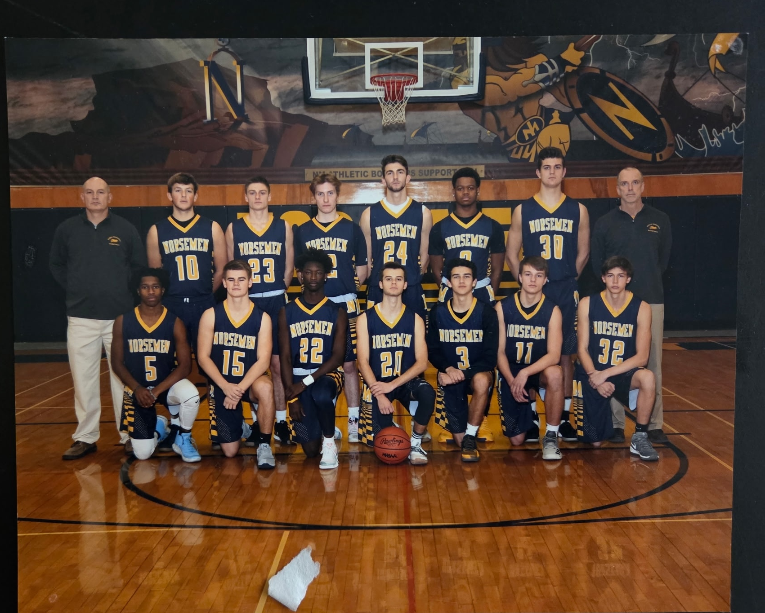

The 2018-19 NORSEMEN

Front Row L-R: Chandler Edwards, Joey Tarrant, Deshary Warren, Jack Dobb, Mack Young, Eric Rypstra, Braden Fleming
Back Row L-r: Coach Rypstra, John Hayhurst, Brendon Moat, Billy Lowe, Jesse Cooke, T.J. McKenzie, Noah Stewart, Coach Tunney

2019-20 (Coach Chuck Rypstra, 14-6 Ravenna WMC champs)

Surely great expectations couldn’t be expected of the Norsemen after losing many of the players through graduation who made two consecutive WMC championships possible. John Hayhurst would be one of two regulars from the previous season’s 20-2 squad returning. The other regular, Eric Rypstra fractured his ankle during the football season and would miss several games before he would return. Several newcomers would now join the Norse, nearly always a recipe for failure. However, NM was a pleasant surprise in the 2019-20 season as they would post a sparkling 14-6 record.

NM began the season with their usual opening game opponent in Muskegon Catholic and NM crushed the host Crusaders 64-28. NM got off to a great start as first year senior Trevor Schulz, who didn’t play basketball in his junior season, came off the bench to score all 15 points of his points in the first half to help give NM a 39-16 lead at the halftime break. “With Trevor, it’s really a unique story,” said NM coach Chuck Rypstra. “He actually didn’t play last year, but we’ve been playing with him forever, so we know what he can do. He can shoot the ball and he’s really long and lanky, so he sticks with defenders. It looked natural to him out there. He was shooting the lights out,” said Rypstra. With plenty of new faces in the lineup NM also got some good play from newcomers like point guard Jack Dobb with nine points and three assists. With the absence of Eric Rypstra, who will miss several games in the season due to a football injury, John Hayhurst would be the only returning regular. Hayhurst took charge and led NM with 21 points and 13 rebounds.
The Norse next defeated Mason County Central 63-51 after trailing the Spartans at halftime and 38-36 heading into the fourth quarter. The final quarter belonged to the Norsemen as they made a big fourth quarter run and iced the game with some good free throw shooting. Three-year starter John Hayhurst led NM with 17 points and 11 rebounds while Jack Dobb and Trevor Schulz both added 14 points. Yet another fresh face to the NM lineup this season, Joe Tarrant, scored all his nine points in the deciding fourth quarter.
Yet another newcomer to NM basketball, Braeden Fleming with 12 points led NM to a 46-25 victory over a once proud Shelby team who went winless the previous year in the WMC. Jack Dobb added seven points, five assists and three steals as NM would end the 2019 year with a perfect 3-0 record.
After a long layoff for the holidays that lasted nearly three-weeks, NM returned to action with a clash with Whitehall. NM spotted the Vikings a 16-7 lead after the first quarter and then began chipping away at the Vikings’ lead but would fall one-point short in a low-scoring 42-41 loss to Whitehall. The game was tied at 39-39 with 1:39 remaining. The Vikings hit a late bucket and a free throw to extend their lead to three. The Norse scored a two-pointer, when they needed a three, with three second left in the game for their first loss of the season and first in conference play. John Hayhurst scored well more than half of NM’s points with 24 points while also grabbing 13 rebounds.
After losing 25 games in a row to the Norsemen and returning many of their starters from their previous season, Ravenna broke the long losing streak to NM with a 50-42 victory. The Norse dug themselves into a big hole early trailing 29-11 at the half. The Norsemen came alive in the third quarter to outpoint the host Bulldogs 18-9, but the damage had already been completed much earlier. Trevor Schulz scored 12, while John Hayhurst and Jack Dobb scored in double figures with 10 points apiece. The Bulldogs had their best start in years as they began the season with a 7-0 record after their win over the Norsemen.
Just one year removed from suffering their worse defeat to NM in the long rivalry between the two local schools, West Michigan Christian bounced back to throttle the Norse 55-38. Sophomore sensation Kellen Mitchell totaled 36, just two points less than the Norsemen’s entire total to lead the Warriors win. Just as they did last week, NM let their opponent jump out to a big lead as NM found themselves looking at a 26-9 deficit at the end of the first quarter. That was the difference in the game as both teams played even the final three quarters. Trevor Schulz led NM with 10 points while John Hayhurst had eight points and 12 rebounds.
NM and Montague have played nearly 200 games as of this writing (2024) with many of the games going right down to the wire. That was not the case this year as NM handed Montague their worse loss since the two rivals first met in 1932, 76-37. Perhaps the Norse were fired up knowing that it was Montague who handed NM their only losses in winning the last two WMC championships. NM welcomed back to the lineup veteran guard Eric Rypstra, a three-year starter who missed the first few NM games with a foot injury. Eric scored 12 points in his return with Trevor Schulz leading the Norse scorers with 16 points. Brennan McManus also made his presence felt in the game with eight points, four steals and four assists.
Hart was again no match for the Norsemen as NM won easily 65-28. The Norsemen led comfortably at halftime 40-16 and stretched the lead even further in the second half. Eric Rypstra has regained his form after his injury and led NM with 17 points. NM had a balanced attack as four Norsemen were in double figures; Trevor Schulz added 12 points while John Hayhurst and Joe Tarrant scored 11 apiece. The other starter Jack Dobb, although not in double figures, made sure many of his mates were as he dished off for nine assists and had six steals.
A bad second quarter doomed the Norsemen in their 52-29 loss to Oakridge. The Eagles pounded the Norsemen 31-17 by halftime as NM had to play catchup the rest of the way but came up well short. John Hayhurst led NM in the loss with 13 points and nine rebounds.
NM won their second game in two years over Muskegon Heights (69-43) with almost identical winning scores. The Norse got a huge game from John Hayhurst who scored a career high 26 points and 14 rebounds. Eric Rypstra had 18 points five rebounds and five assists while Brennen McManus chipped in with 12 points as NM was beginning a nice winning streak.
After trailing 26-23 at halftime NM took the lead for good with a 16-10 third quarter run and then went on to a 57-49 victory over Mason County Central. John Hayhurst contributed 15 points and nine rebounds to lead the Norse. Joe Tarrant added 13 points while Eric Rypstra chipped in with nine points, five rebounds and four assists as the Norse improved to 7-4 on the season.
It had been 84 years when Shelby scored fewer than the 13 points they scored in their 51-13 loss to NM in their second matchup during the season. NM beat Shelby 33-12 in 1936, back in the days when teams would have a jump ball at midcourt following a made basket. So dominant were the Norse in this game that they went on a 23-0 run in the second quarter. Perhaps, if not for the running clock Shelby might have scored more than their great-grandfathers scored in the 1930s. Trevor Schulz had 16 points to lead the Norse while John Hayhurst in his limited minutes recorded nine points and 10 rebounds.
It was another low scoring contest between NM and Whitehall in their second game of the season, but it was NM the winner in this game 45-40. NM trailed 34-33 after three quarters but controlled the final quarter 12-6 to earn the win. Eric Rypstra continued his strong play with 18 game leading points while John Hayhurst tossed in nine as NM won their fourth straight to improve to 9-4 overall and 7-3 in conference play.
NM was again stingy in points allowed as Saugatuck was only able to tally 24 points as NM completed their 13-game series over the years with Saugatuck with a 44-24 victory. Although it is likely the two teams will meet up in the future, as of 2024 NM leads Saugatuck 10-3 in the series. Saugatuck scored only five points in the entire first half as NM bolted out to a 21-3 first quarter lead. In the second quarter neither team could find the range as NM was able to score only 4 points, but that was still two more than Saugatuck scored. John Hayhurst led NM with nine points, six boards and six steals. Jack Dobb and Trevor Schultz were next in line in scoring for NM with six points.
Ravenna, a team that until this season had lost 25 in a row to the Norsemen, is now 15-0 on the season following a narrow 54-52 win over NM. The game was close all the way and was tied at the end of the third quarter as Eric Rypstra scored nine of his game high 20 points. A 3-pointer by Trevor Schulz made the score 53-52 in favor of the Bulldogs with still 1:14 remaining. Over the final 74 seconds only a single point was scored on a Ravenna free throw as a good look by NM to tie the game missed its mark as Ravenna all but clinched the WMC title with a 11-0 conference record. Jack Dobb with 12 points, followed Rypstra in the scoring department for the losing Norse.
The Montague-North Muskegon game was atypical as most of the games played in the 2019-20 season. Low scoring with defenses dominating the action. NM outlasted Montague 49-36 to sweep the season series with the Wildcats. The game was tight at halftime at 20-18 as the Norsemen broke the game open in the third quarter with a 16-7 advantage. Eric Rypstra had a season high 22 points to lead NM. Far back with seven points was Jack Dobb with seven.
NM improved to 12-5 overall with an easy 68-47 win over the struggling Hart Pirates. Hart has won four games on the season, all against non-conference opposition as the Pirates are 0-13 in league action. NM led all the way with John Hayhurst’s 18 points and 10 rebounds pacing the Norse. Brennen McManus added 16 points while Trevor Schulz had eight points and four steals.
NM then played Orchard View for the first time in 35 years and came away the victor 55-51. It was a perfect matchup between two red hot teams. NM had won seven of their last eight games while the Cardinals had won their last six. NM had a big run in the third quarter, scoring 10 straight points before the host Cardinals could counter to go up 46-36 entering the fourth quarter. The Cardinals high scoring Ke’Ontae Barnes hit an off-balance bank shot to narrow the Norse lead to 51-48 with 3:45 to play. NM then hit four clutch free throws while in the bonus and got a nice layup by 6’6 Noah Stewart, who a few years later was wearing a Maize & Blue uniform for the NCAA national football champs. That pushed NM’s advantage to 57-51 and NM held on for the win. Eric Rypstra was the big gun for NM as he made four 3-pointers on his way to 20 points. The coaches’ son also grabbed nine rebounds and had three steals. Trevor Schulz contributed 12 points while John Hayhurst had nine points and did his usual workmanlike job on the boards with 11 rebounds.
NM then held Oakridge below 30 points as NM closed their regular season with a 42-29 conference victory over the Eagles, making amends for an earlier loss to Oakridge. The win was number 14 for NM against five defeats heading into what would be a very short playoff, especially for the Norsemen. The game was tight in the first half as NM pulled away in the second half led by Eric Rypstra who finished with 19 points and 11 rebounds. John Hayhurst pitched in with 13 points and 17 rebounds.
It was payback time for Ravenna, who had seen North Muskegon win seven straight games against the Bulldogs in the playoffs. NM was hopeful for once again eliminating the Bulldogs as they felt they played well against Ravenna just a few games back when they only lost by two points. However, in front of a packed house in Ravenna the Bulldogs defeated NM to complete their first regular season undefeated. Ravenna led all the way as NM’s season ended with another successful record of 14-6. Eric Rypstra ended his outstanding career for NM with 11 points. The Norse will lose nine seniors to graduation. “I’ve really coached these guys since third grade,’ said coach Rypstra following the game about the senior class which included his son Eric. “It’s going to be a tough banquet. But this group did a lot of stuff together and it’s a good group. This isn’t the end for them, because it’s just one part of their lives together.” Word’s well-spoken by the NM mentor.
NM season was finished, but so were all the teams, not only in the state of Michigan but in the entire nation as Covid 19 reared its ugly head. Just a handful of days after their game with Ravenna there would be no more games in any sports for a long period of time. The next few months would include very bizarre days in the world of sports. Although in my current home state of Florida sports resumed the following Fall, that was not the case in the State of Michigan.

N Muskegon 64 Musk Catholic 28 John Hayhurst 21, Trevor Schulz 15
N Muskegon 63 Mason Co 51 Hayhurst 17, Schulz and Jack Dobb 14
N Muskegon 46 Shelby 25 Braeden Fleming 12, Dobb 7
N Muskegon 41 Whitehall 42 Hayhurst 24
N Muskegon 42 Ravenna 50 Schulz 12, Hayhurst & Dobb 10
N Muskegon 38 WMC 55 Schulz 12, Hayhurst 8
N Muskegon 76 Montague 37 Schulz 16, Eric Rypstra 12
N Muskegon 65 Hart 28 Rypstra 17, Schulz 12
N Muskegon 39 Oakridge 52 Hayhurst 13, Schulz 7
N Muskegon 69 Musk Heights 43 Hayhurst 26, Rypstra 18 B McManus 12
N Muskegon 57 Mason Co 49 Hayhurst 15, Joe Tarrant 13, Rypstra 9
N Muskegon 51 Shelby 13 Schulz 16, Hayhurst 9
N Muskegon 45 Whitehall 40 Rypstra 18, Hayhurst 9
N Muskegon 44 Saugatuck 24 Hayhurst 9, Schulz and Dobb 6
N Muskegon 52 Ravenna 54 Rypstra 10, Dobb 12
N Muskegon 49 Montague 36 Rypstra 22, Dobb 7
N Muskegon 68 Hart 47 Hayhurst 18, McManus 16
N Muskegon 59 Orchard View 55 Rypstra 20, Schulz 12
N Muskegon 42 Oakridge 29 Rypstra 19, Hayhurst 13
N Muskegon*41 Ravenna 59 Rypstra 11

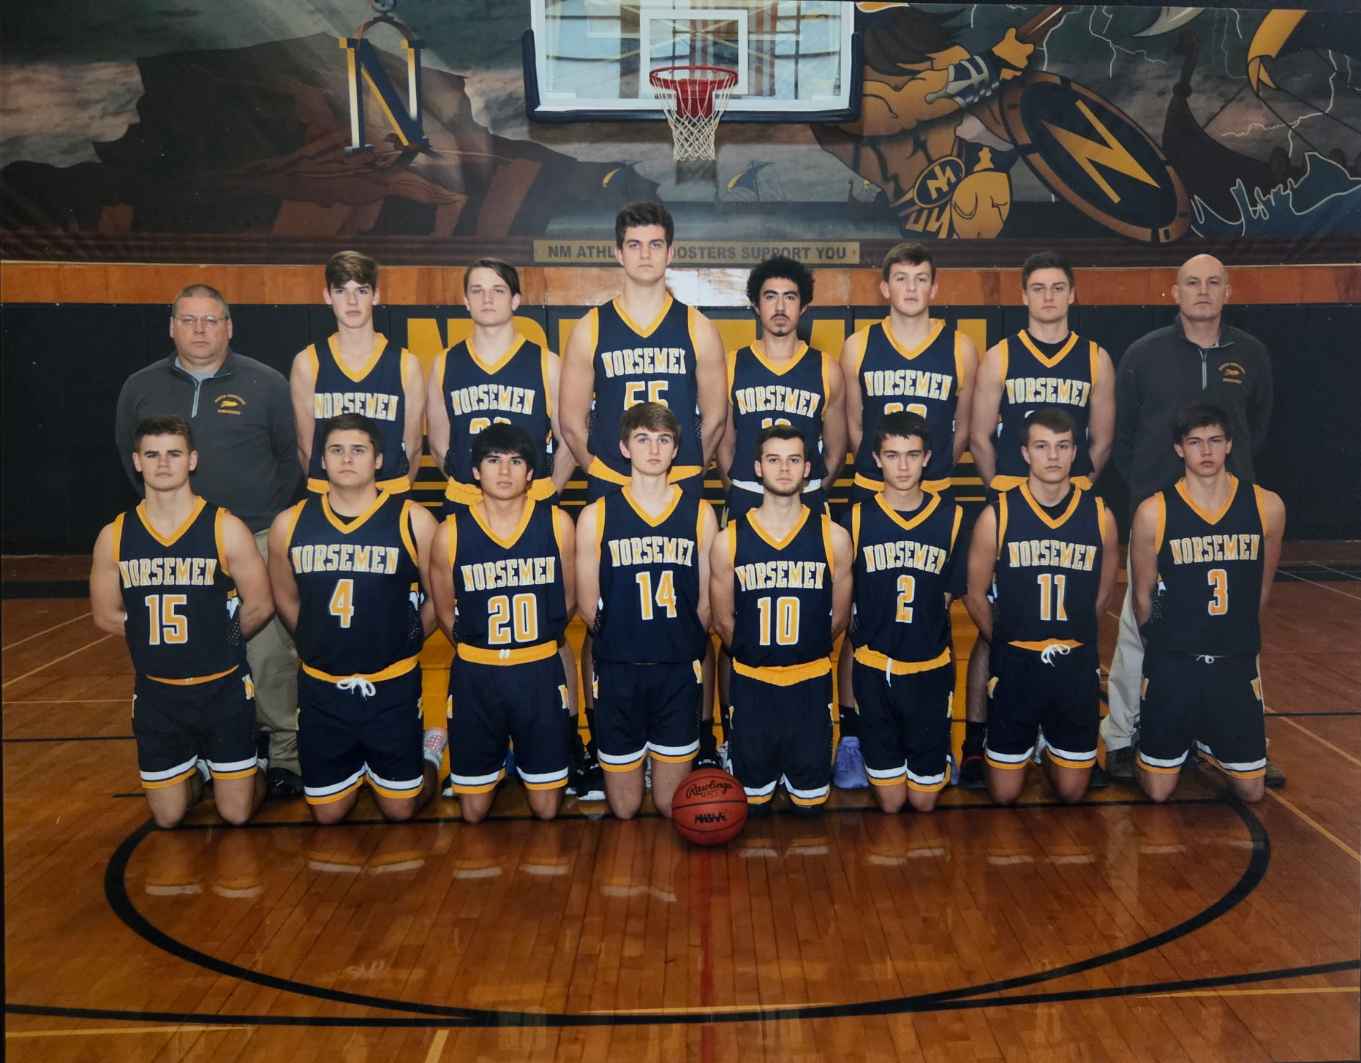
The 2019-20 NORSEMEN
Front Row L-R: Joey Tennant, Brenn Punicci, Evan Zubyrd, Trevor Schultz, Jack Dobb, Brenna McManus, Eric Eypstra, Braden Fleming
Back Row L-R: Coach Dave Nelson, Reilly Schotts, Will Gallo, Noah Stewart Marcello Rouse, John Hayhurst, Brendon Moat, Coach Rypstra

2020-21 (Coach Chuck Rypstra, 10-9 Whitehall WMC champs)

What a bizarre sports season for the State of Michigan in 2020-21. After sports in Michigan and even the entire world came to a crashing halt in March of 2020 with the Covid 19 pandemic, it would be months before any sense of normalcy would return. Michigan was especially hit hard as the governor was more than cautious for resuming sports at anywhere near a sense of normalcy. The Norsemen basketball team was anxiously awaiting to get the green light to return to action, but that didn’t come until February of 2021when NM played their first game in nearly a year with Ravenna. Meanwhile, down in Florida my Ponte Vedra High School team was playing their 23rd game of the season with virtually no limitations. Although fans were ‘encouraged’ to use safe distancing, wear masks, etc., the games in Florida were played just as they were in the past. Players in Michigan wore masks, as did the fans, and attendance was limited. Thankfully, play resumed in Michigan and as many games as possible were crammed into a two-month schedule. There was no March madness, but April madness. Although North Muskegon had trouble scoring points with a young team, they came on strong and found a way to win.
The Norsemen’s first game of the season was on February 11, 2021, as coaches and ADs feverishly attempted to put together some semblance of a schedule. NM’s opener was against a Ravenna team that was undefeated in regular season play in 2020 and defeated NM in all three games played, including eliminating NM from the playoffs. Coach Chuck Rypstra’s 2021 squad had nearly a complete turnover of players as nine of his players from 2020 had graduated. The Bulldogs used a big third quarter when they outscored NM 23-9 that proved to be the difference as Ravenna won 59-49. Brennen McManus led the Norse with 15 points, Will Gallo added 14 points and Marcellus Rouse posted a double-double with 10 points and 11 rebounds.
Montague held NM to a skimpy 30 points in posting a 43-30 win over the Norsemen. Montague completely dominated NM early by jumping out to a 22-4 lead. NM did chip away, but the early damage proved fatal to NM. Brennan McManus with 16 points, scored more than half of NM’s points.
NM averted a third straight setback with a comeback 46-40 victory over Hart. The Norse trailed 23-14 at halftime but heated up in the third quarter with a 22-12 run to take a 36-35 lead into the final quarter. Brennan McManus scored 17 points for the Norse while his younger brother Troy chipped in with nine.
NM and Ravenna didn’t have to wait long for their next meeting between the two squads, and the results were nearly identical as their first meeting, a 10-point win for the Bulldogs. Only the point totals were different as the Bulldogs won 56-46. Sophomore Troy McManus led NM with 19 points while Will Gallo added seven points and seven rebounds.
The following day NM lost a close decision to West Michigan Christian 55-49. NM was led by the McManus brothers, Brennen with 13 and Troy with 10 points.
Three sport star sophomore Denny Belmonte nailed a shot from half court at the buzzer to give NM a miracle 53-52 victory over Oakridge. The Eagles had taken the lead at 52-50 with 2.6 seconds left on a pair of free throws before Belmonte’s desperation bomb defeated the Eagles as the NM players swarmed Belmonte shortly after his heroics. Troy McManus with 14 and Brennen McManus with 13 led NM scorers.
NM then made it two victories in a row with a 57-48 victory over a winless Mason County Central team. The Norsemen were consistent as they led at all the stops enroute to their third win of the season against four defeats. Brennen McManus led all scorers with 21 points while a pair of sophomores also stood out for NM. Troy McManus added 12 points and four steals while Denny Belmonte recorded seven assists.
NM came our firing in their 61-54 win over Shelby as they nailed nine three-pointers in the first half to build an early lead over the Tigers. Brennen McManus had a huge game for NM with 27 points followed by his brother Troy with 11 as NM evens their season record at 4-4.
NM and Montague then played in the lowest combined score in 71 years between the two teams as Montague nipped NM 31-29. Not since NM edged Montague 24-23 back in 1950 did the two teams combine for fewer points than their first matchup in 2021. In a real oddity, Montague won the game despite not scoring a single point in the entire fourth quarter. Troy McManus had 10 points to lead NM.
The Norse needed a 21-8 run in the final quarter to defeat a pesky Holton team 47-40. NM trailed at all the stops except the most important quarter to even their record at 5-5. Leading the charge for NM was Troy McManus who had 16 points and the go-ahead three in the final quarter to give the Norse their first lead. Brennan McManus scored 12 points and Denny Belmonte 9.
NM, despite a very young team, showed their potential as they nearly upset undefeated Whitehall. NM kept nipping at Whitehall’s heels all night before losing 57-53 as Whitehall moved to a perfect 10-0 in conference play. Troy McManus had 12 points and four assists and Will Gallo eight points and six rebounds to lead the gallant Norsemen.
The next game with Shelby was one of those games the Norsemen would like to soon forget as Shelby snapped a nine-game losing streak to the Norsemen with a 20-point victory, 52-32. None of the cold-shooting Norsemen were in double figures although Will Gallo was close with nine.
NM completed their sweep over a Mason County team that went winless in WMC action 53-29. NM was in command all the way against a team with only one win during the season, leading 46-17 entering the final quarter. Brennen McManus netted 21 points to lead the Norsemen. Troy McManus and Rob Eckheart followed with eight points apiece for the Norse.
NM only played 14 regular season games as opposed to a possible 20 in the pre-pandemic era. The final game of the regular season saw Oakridge atone for an earlier loss to NM by edging the Norsemen 57-46. NM fell behind early as they were only able to score 14 points in the first half. Troy McManus with 17 points and Will Gallo with 12 led NM in scoring as they closed the regular season 6-8 and 5-7 in conference play.
With a record two games below .500 it was doubtful if NM would have a winning season with the playoffs looming ahead. The Norsemen would have to pull off a near miracle and must advance as far as the regional final to finish with a winning record.
NM opened the district against an unknown opponent in Morley Stanwood. In the first meeting in history between the two schools NM defeated Morley Stanwood 56-52. Only a three pointer at the buzzer by the losers kept the game close as NM earned the rights to once again play Ravenna in a district semi-final. The McManus Brothers, Brennen and Troy, each scored 14 for the winning NM squad.
After NM had a 25-game winning streak broken by Ravenna last season, the Bulldogs would win five straight against NM, including a pair of victories earlier in the 2021 season. NM denied a second Bulldog 3-peat as NM stunned the Bulldogs 65-55; the most points tallied by the Norsemen all season to advance to the district finals. NM trailed at halftime 29-27 but took the lead for good in the third quarter. Denny Belmonte scored a season high 16 points to lead the Norse while Troy McManus had a double-double, finishing with 16 points and 11 rebounds. Brennan Pannuci also was in double figures for the Norse with a season high 10 points.
NM was paired up for the second time in the season with a Holton team with a 15-5 record and winners of the Central State Activities conference. Holton would finish at 15-6 with two of those losses to the Norsemen who improved to 9-8 on the season. Defense was the key as they held Holton to 20 while scoring 36. The combined 56 points was even less than the earlier 31-29 win over Montague and again, the lowest combined points dating back to the 24-23 NM win over Montague in 1950; witnessed by your author who was in third grade. Brennen McManus had 24 and Will Gallo 10 in the low-scoring clash.
The district win advanced NM to the Class C regional where they would face Ithaca, a football powerhouse. Fortunately for NM Ithaca was not as good in basketball as they were in football as NM won 63-60 to improve to 10-8 on the season and ensure themselves of an improbable winning season. With the crowd at Fennville spread out and every fan, player, coach, and referee wearing a mask, they would see the game go right down to the wire. NM enjoyed a big lead at halftime of 39-24 but Ithaca outscored the Norse 26-11 in the third quarter to pull even. It was a see-saw battle that saw NM go on a 6-0 run only to see Ithaca battle back. It was 59-58 when a Will Gallo bucket gave NM a three-point lead at 61-58 with 1:58 remaining. Ithaca scored to cut the lead to one. With 20.5 seconds left in the game, Will Gallo went to the line and calmly made both free throws that made the final score 63-60. In the only meeting to date between the two teams the McManus brothers scored two-thirds of NM’s points: Troy with 22 and Brennen with 18.
NM’s Cinderella season came to a crushing halt at the hands of a Grand Rapids Covenant Christian squad that ended NM’s season at 10-9. It was the first time NM had made it all the way to the regional finals since 2003. NM struggled from the field against Covenant making only 14 of 43 shots and never threatened the Chargers after trailing 14-8 at the end of the first quarter. Troy McManus led NM with nine points.
NM loses eight seniors, but coach Rypstra will return some talented underclassmen, with even more talent lurking back in middle school that bodes for a good future for NM basketball.

N Muskegon 49 Ravenna 59 Brennan McManus 15, Will Gallo 14
N Muskegon 30 Montague 43 B McManus 16
N Muskegon 46 Hart 40 B McManus 17, Troy McManus 9
N Muskegon 46 Ravenna 56 T McManus 19, Gallo 7
N Muskegon 49 WMC 55 N McManus 13, T McManus 10
N Muskegon 53 Oakridge 52 T McManus 14, B McManus 13
N Muskegon 57 Mason Co 48 B McManus 21, T McManus 12
N Muskegon 61 Shelby 54 B McManus 27, T McManus 11
N Muskegon 29 Montague 31 T. McManus 10
N Muskegon 47 Holton 40 T. McManus 16, M McManus 12,
N Muskegon 53 Whitehall 57 T McManus 12, Gallo 8
N Muskegon 32 Shelby 52 Gallo 9
N Muskegon 53 Mason Co 29 B McManus 21, T McManus & Rob Eckeart 8
N Muskegon 46 Oakridge 57 T McManus 17, Gallo 12
N Muskegon* 56 Morley Stanwood 52 T McManus & B McManus 14
N Muskegon* 65 Ravenna 55 Belmonet 15, T McManus 13, Brennan Pannuci 10
N Muskegon* 36 Holton 20 B McManus 14, Gallo 10
N Muskegon* 63 Ithaca 60 T McManus 22, B McManus 18
N Muskegon*38 GR Cov. Christ. 70 T McManus 9

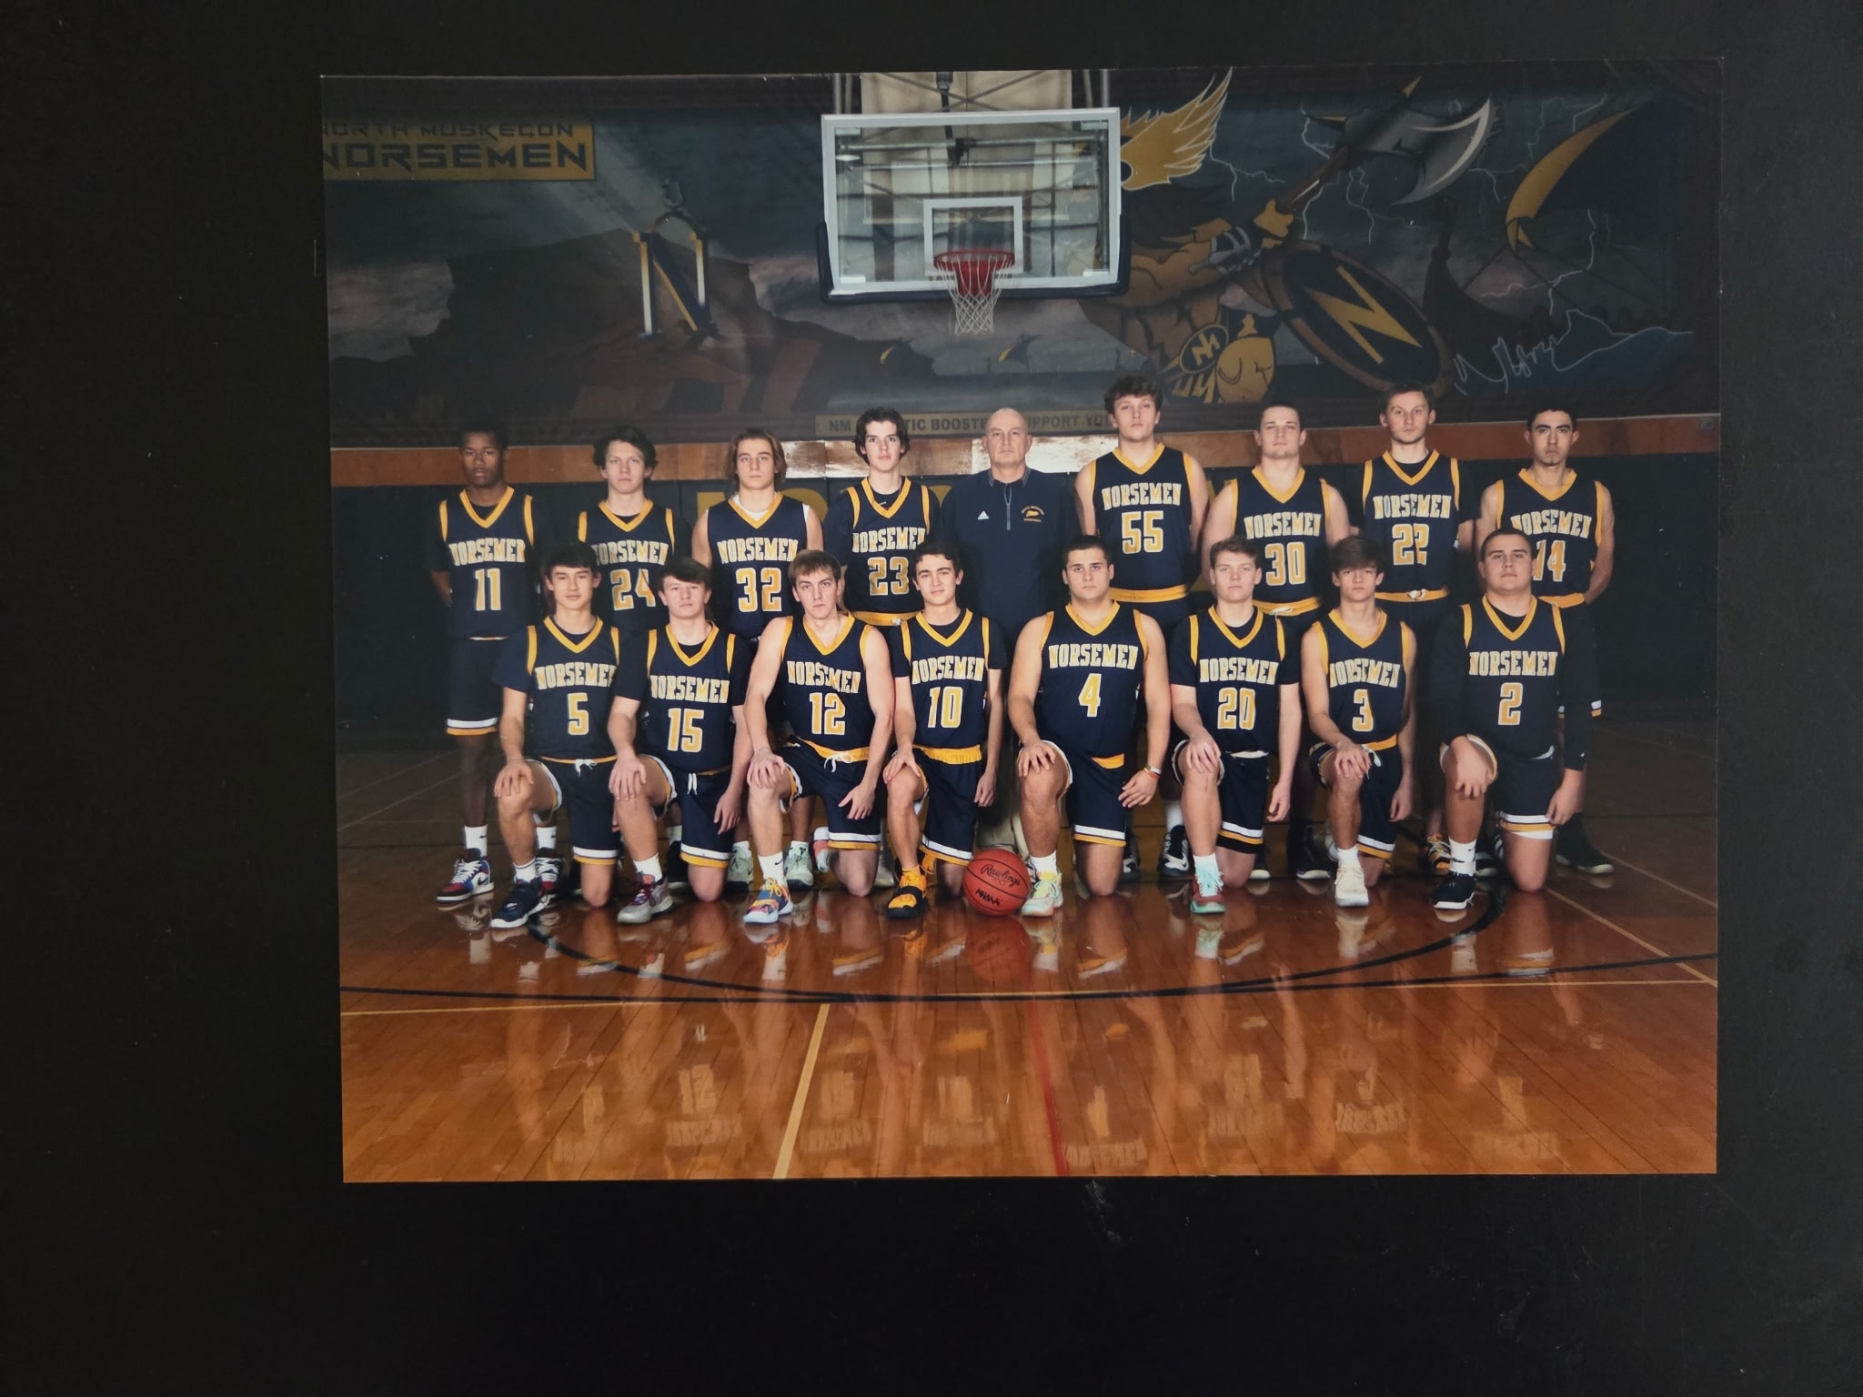

The 2020-21 NORSEMEN
Front Row L-R: Troy McManus, Brandon Rypstra, Robin Eckheart, Brenn McManus, Brenna Punicci, Quinn Kersman, Bo Nedeau, Champ Young
Back Row: Amarion Dickinson, Brady Babcock, Denny Belmonte, Reilly Schotts, Coach Rypstra, Jason Bogue, Will Gallo, Chris Erdtman, Marcello Rouse

2021-22 (Coach Chuck Rypstra, 15-9 Whitehall WMC champ

The 2021-22 Norsemen didn’t set the world on fire with their offense, but they were stingy from permitting their opponents lighting up the scoreboard. Only twice did a rival put up more than 60 points in a game vs. the Norsemen. NM held their opponents to an average of but 45 points per game. The Norse would finish with a more than respectable record of 15-9 and would earn some more hardware for the trophy case with a district championship.

NM made quick work of Muskegon Catholic in their traditional opener as NM jumped out to a 17-5 first quarter lead and then cruised to a 63-23 win over the Crusaders. Troy McManus scored a game high 18 points, grabbed eight rebounds and had three assists to lead the charge. Jason Bogue and Sam Gallo were in double figures with nine. Sophomore Ben Meyers was everywhere with four points, three rebounds, three assists and two steals and helped hold MCC to a low point total of 23 points.
NM would score a season low 34 points in a 40-34 loss at Shelby. Both teams had trouble scoring points as the score was only 14-14 at halftime. A 5-0 spurt by Shelby gave the host Tigers a lead that could not be caught as NM falls to 1-1 on the season. Troy McManus was easily the NM leader with 18 points and 10 rebounds as no other Norsemen scored more than five points.
The Norse let a possible victory get away from them as Whitehall overcame a 14-point NM lead to rally and down the Norse 55-51. It was NM on top 36-22 at halftime, but the host Vikings went on a 15-4 third quarter run following the break to cut the Norse lead down to 40-37. Whitehall, the defending WMC champs, kept the momentum and outscored the Norse 18-11 in the final quarter. Four underclassmen led the Norse with junior Troy McManus leading the way with 18 points, followed by Brandon Rypstra, Sam Gallo and freshman James Young who each scored eight points.
The Norsemen are still searching to score more points, but their defense is doing just fine as they limited West Michigan Christian to just 29 points in a 44-29 victory. The 29 points was easily the fewest points scored by the Warriors in the 73 meetings thus far in their rivalry. Again, leading NM’s attack was junior guard Troy McManus. The left-handed shooting McManus had 11 points and eight rebounds. James Young added eight points, and Jason Bogue grabbed seven rebounds.
Playing in their first game in the Muskegon Area Sports Hall of Fame Classic since the inaugural back in 2003, NM represented themselves well but fell short to Orchard View 61-53. OV kept themselves in front of NM with some deadly out court shooting as they connected on 12 3-pointers as well as hitting on 10-of-12 free throws in the last quarter to keep NM at bay. Just as they did in their earlier loss to Whitehall, NM let a lead get away from them as OV caught fire in the fourth quarter to outscore NM 24-10 in the comeback win. “Close game throughout, difference was from 3-point range,” said NM head coach Chuck Rypstra following the game. “Plus, they made almost all their free throws down the stretch.” Jason Bogue’s modest 10 points led the Norsemen with Troy McManus close behind with nine points.
NM then started the New Year of 2022 on a nice winning streak with the first win a 56-41 victory over Ravenna. “We surprised them as we played a great game, reminisced coach Rypstra years later. NM got great balance in the victory with Troy McManus scoring 15, James Young 14, and Brandon Rypstra 10 as NM protected their lead down the stretch by making 8-9 free throws.
It took a comeback and then a run in overtime for North Muskegon to defeat Montague 53-48. NM trailed by five entering the fourth quarter, but a 14-9 scoring run sent the game into overtime. Troy McManus made a big bucket in overtime on his way in totaling a game high 18 points to lead the Norse while James Young scored 10. James Young’s older brother Champ chipped in with eight and Brandon Rypstra seven as NM improved to 4-3.
NM then won their 28th in a row over Hart with another defensive gem in defeating the Pirates 52-24. After a closely fought opening quarter NM outscored the Pirates 19-6 in the second eight minutes of the contest to take a commanding 28-12 lead into the halftime break. The second half was pretty much the same as coach Rypstra was able to insert many of his backups in the fray. Troy McManus led the balanced NM offense with 11 points, while also filling up the stat sheet with eight rebounds, four steals and three assists. The Young brothers had seven points apiece as NM improves to 5-3.
It was another comeback, the second in the last three games for the Norsemen in their 52-47 win at home vs. Oakridge. Trailing 37-30 entering the final quarter NM went on a huge run to go up by 10 points. However, the Eagles had a rally of their own to tie the game with 2:30 left to play. NM then pulled away with some clutch free throw shooting while Oakridge missed numerous 3-point attempts that led to NM walking off the court victorious. Troy McManus posted a double-double with 14 points and 11 rebounds. Brandon Rypstra made his head coach Chuck Rypstra happy with 10 points and four rebounds.
Overtime games treated NM well in 2022 as NM defeated Mason County Central 58-56 in the extra session to earn their fifth straight victory. After NM had a couple of comeback victories, the Spartans nearly flipped the script as the Spartans once trailed the Norsemen by as many as 11 points. NM led 28-17 at the half, thanks to a desperation half-court shot at the buzzer by Quinn Kersman. The Spartans, with their highly successful former coach Tim Genson returning to once again take over the head coaching duties for the Spartans, MCC scored 20 points to NM’s 10 to grab a one-point edge going into the final quarter. After both teams traded baskets, Brandon Rypstra hit a corner 3-pointer to send the Norse ahead where they would hold on for the victory. Husky football lineman Sam Gallo paced the Norsemen with 13 points, Rypstra added 11 and James Young tallied nine. High scoring Troy McManus was held to five points but helped in the win with seven rebounds and five assists.
After losing two games in a row to NM, the Muskegon Heights Tigers, a perennial power over the years, handed NM a 48-43 loss. The loss also stopped NM’s modest winning streak at five games. The game was close from start to finish. NM had an opportunity to tie or take the lead with a 3-pointer with 25 seconds left in the game, but the Tigers came up with a steal and held on for the victory. With points at a premium in the defensive contest Troy McManus managed to tally 13 points and Sam Gallo 10.
NM made the long bus ride to Manistee on a school night well worth the drive as they defeated the Chippewas 56-50. After a tight first half with NM leading 20-17, the visiting Norsemen exploded in the third quarter to outscore the hosts by 16 points to take a commanding 19-point lead into the fourth quarter. Troy McManus led NM with 16 points, with the rest of the points well spread out among several Norsemen.
NM atoned for an earlier loss to Shelby by winning the second contest vs. the Tigers 57-51. NM led 26-22 at halftime and never gave up the lead but they had to withstand a couple of Shelby runs that tightened the gap. At one point NM led 48-30 before Shelby made a run that fell seven points short. Troy McManus had a season high to date of 20 points to lead the Norsemen as the remaining points were well spread around. James Young tossed in eight points, Ben Gallo and Ben Meyers netted six. The win improved NM’s record to 9-4 overall and 6-2 in the conference, putting them in second place in the race for the WMC title.
Led by an extraordinary young freshman, Whitehall was able to defeat North Muskegon 69-61 to remain in first place in the West Michigan Conference. Camden Thompson was just beginning to terrorize his opponents in three sports but perhaps basketball might be his best sport. The freshman scored 32 points while grabbing 18 rebounds to almost single-handedly beat the Norsemen. Thompsons grandfather, Ron Farmer, was a two-year starting center for NMHS in 1957 and 58. Maybe having to face Thompson was a partial reason why NM and Whitehall did not play each other in the next three years after a major merger was initiated in the WMC. NM was led in scoring once again by junior guard Troy McManus who scored 19 points while Sam Gallo and James Young had 12 and nine points respectively.
Ravenna lost an earlier game to NM by 15 points but turned the tables on the Norse in their second game by defeating the Norse 59-53. The game was a shootout between Ravenna’s Kyle Beebe and NM’s Troy McManus. Beebe had 28 for the host Bulldogs while McManus had a season high 25 in a losing cause. Ravenna led at all the stops to improve their league record to 8-2 while NM falls to 6-2 in the WMC.
NM was mired in a little slump as they fell to Montague in a low-scoring game 48-40. NM coach Rypstra lamented about his team’s shooting woes: “It just wasn’t our night from a shooting standpoint. Montague made a decisive run in the third quarter, and we kept working but couldn’t get the ball through the hoop enough times,” said the disconsolate coach. Troy McManus had 14 of NM’s 40 points with no other Norsemen scoring more than six.
Who better for NM to play to break a little three game slump than Hart? After all, NM had defeated the Pirates in 28 straight games. Make that now 29, the longest winning streak against any opponent in NM annals. NM jumped out to an early 19-5 lead after the first quarter was in the books and were never threatened by the Pirates. “We got good contributions from everyone,” said NM coach Rypstra in NM’s 62-32 win over Hart. The Norse had four players in double figures and received some good play from those who didn’t. Brandon Ryspstra led all NM scorers with 15 points, while Troy McManus, James Young and Troy McManus all had 12 points apiece. Ben Meyers added three steals and five assists while Sam Gallo grabbed 8 rebounds. Hart had been moored seemingly forever with poor teams on the male side, but thankfully for those disheartened Pirates fans, things were about to get better in Hart country.
NM’s ‘winning streak’ ended at one while Oakridge won their 6th in a row with a 59-49 win over NM. A big third quarter when the Eagles outscored NM 19-10 proved to be the downfall of the Norse. James Young and 19 and Sam Gallo 11 to pace NM.
Jason Bogue had a career high 20 points to lead NM to a 53-37 road victory over Mason County Central. NM led by a single point 36-35 going into the fourth quarter but the final period was all North Muskegon as they outscored the hosts 17-2. Sam Gallo was also in double figures with 10 points while Troy McManus, James Young, and Brandon Rysptra all had seven markers as NM improved to 11-8.
NM traveled to face a new opponent for the first time in program history and came away with a dramatic 51-50 victory over Wyoming Potters House Christian. Trailing Potters House 50-48 with only seconds remaining, Troy McManus sank a go-ahead 3-pointer with 12 seconds left for the win. Potters House attempted a couple of possible game winning shots, but both were off the mark and NM concluded their regular season with a 12-8 record. It was a comeback victory all the way for the Norsemen as they trailed 30-21 at the half and need a 13-5 run in the fourth quarter to come all the way back for the win. McManus finished with a game high 15 points, while Rypstra and James Young added 11 and 10.
After losing an unfathomable 17 post season playoff games in a row to West Michigan Christian, NM has now won three playoff games in a row following their opening 56-48 district win over the host Warriors. The Norse rode the hot hand of Troy McManus to victory as the junior scored 24 points, one shy of his season high. The Norse also got some good inside play from Jason Bogue who used his 6’5 frame to score 13 points. The win sets up a district semi-final between NM and Shelby who split their two games during the regular season.
Troy McManus continued his hot shooting with 20 points as NM led from start to finish to defeat Shelby 50-40. NM helped their own cause by connecting on 17 of 21 free throw attempts to win the game and the season series over the Tigers. NM held the Tigers to but 40 points and forced 17 turnovers. Jason Bogue was also in double figures for NM with 11 points as NM earns a berth in the Class C district finals hosted by West Michigan Christian.
NM used both a good start and good defense in defeating Holton 48-33 to win the Class C district championship. NM jumped out to a 13-5 lead at the end of the first quarter and doubled their lead to 28-14 at halftime. NM continued their steady play to pad their lead in the third quarter and cruised to their 10th straight win over Holton and the sixth time they had defeated the Red Devils in the playoffs without suffering a loss. Troy McManus continued his steady play with 15 points while Jason Bogue was in double figures for his third consecutive game with 14 points and six rebounds.
NM and their fellow West Michigan Conference foe Ravenna had to travel to Carson City to play one another in the first game of the regional. Both teams split their games in the regular season with the rubber game going to Ravenna 43-40 in a low-scoring clash. NM led 19-13 in the first half and, after being outscored 15-10 in the third quarter still took a slim 29-28 lead into the final quarter. Some may find this hard to believe but Ravenna shot 12 of 18 from the free throw line while the Norsemen never went to the line all night. “It was their attacking in transition, which led to the free throws, said NM head coach Rypstra. “We fought hard, but had a few too many turnovers, and missed shots.” NM ended the season at 15-9 but with several players returning the following year, the record would get even better.

N Muskegon 63 Musk Catholic 23 Troy McManus 18, Jason Bogue & Sam Gallo 10
N Muskegon 34 Shelby 40 McManus 18
N Muskegon 51 Whitehall 55 McManus 18, Brandon Rypstra, Gallo & Young 8
N Muskegon 44 WMC 29 McManus 11, James Young 8
N Muskegon 53 Orchard View 61 Bogue 10, McManus 9
N Muskegon 56 Ravenna 41 McManus 15, J Young 14. Rypstra 10
N Muskegon 53 Montague (ot) 48 McManus 18, J Young 10, Champ Young 8
N Muskegon 52 Hart 24 McManus 11, The Young brothers 7
N Muskegon 52 Oakridge 47 McManus 14, Rypstra 10
N Muskegon 58 Mason Co (ot) 56 Gallo 13, Rypstra 11, J Young 9
N Muskegon 43 Musk Heights 48 McManus 13, Gallo 10
N Muskegon 56 Manistee 40 McManus 16
N Muskegon 57 Shelby 51 McManus 20
N Muskegon 61 Whitehall 69 McManus 19, Gallo 12, J Young 9
N Muskegon 53 Ravenna 58 McManus 25, Bogue 9
N Muskegon 40 Montague 48 McManus 14
N Muskegon 62 Hart 32 Rypstra 15, McManus 12, Bogue &Young 12
N Muskegon 49 Oakridge 59 J Young 12, Gallo 11, Bogue 8
N Muskegon 53 Mason Co 37 Bogue 20, Gallo 10
N Muskegon 51 Potters House 50 McManus 15, Rypstra 11, Young 10
N Muskegon * 56 WMC 48 McManus 24, Bogue 13
N Muskegon* 50 Shelby 40 McManus 20, Bogue 11
N Muskegon* 48 Holton 33 McManus 15, Bogue 14
N Muskegon* 40 Ravenna 43 Rypstra 10, McManus 8, J Young 7

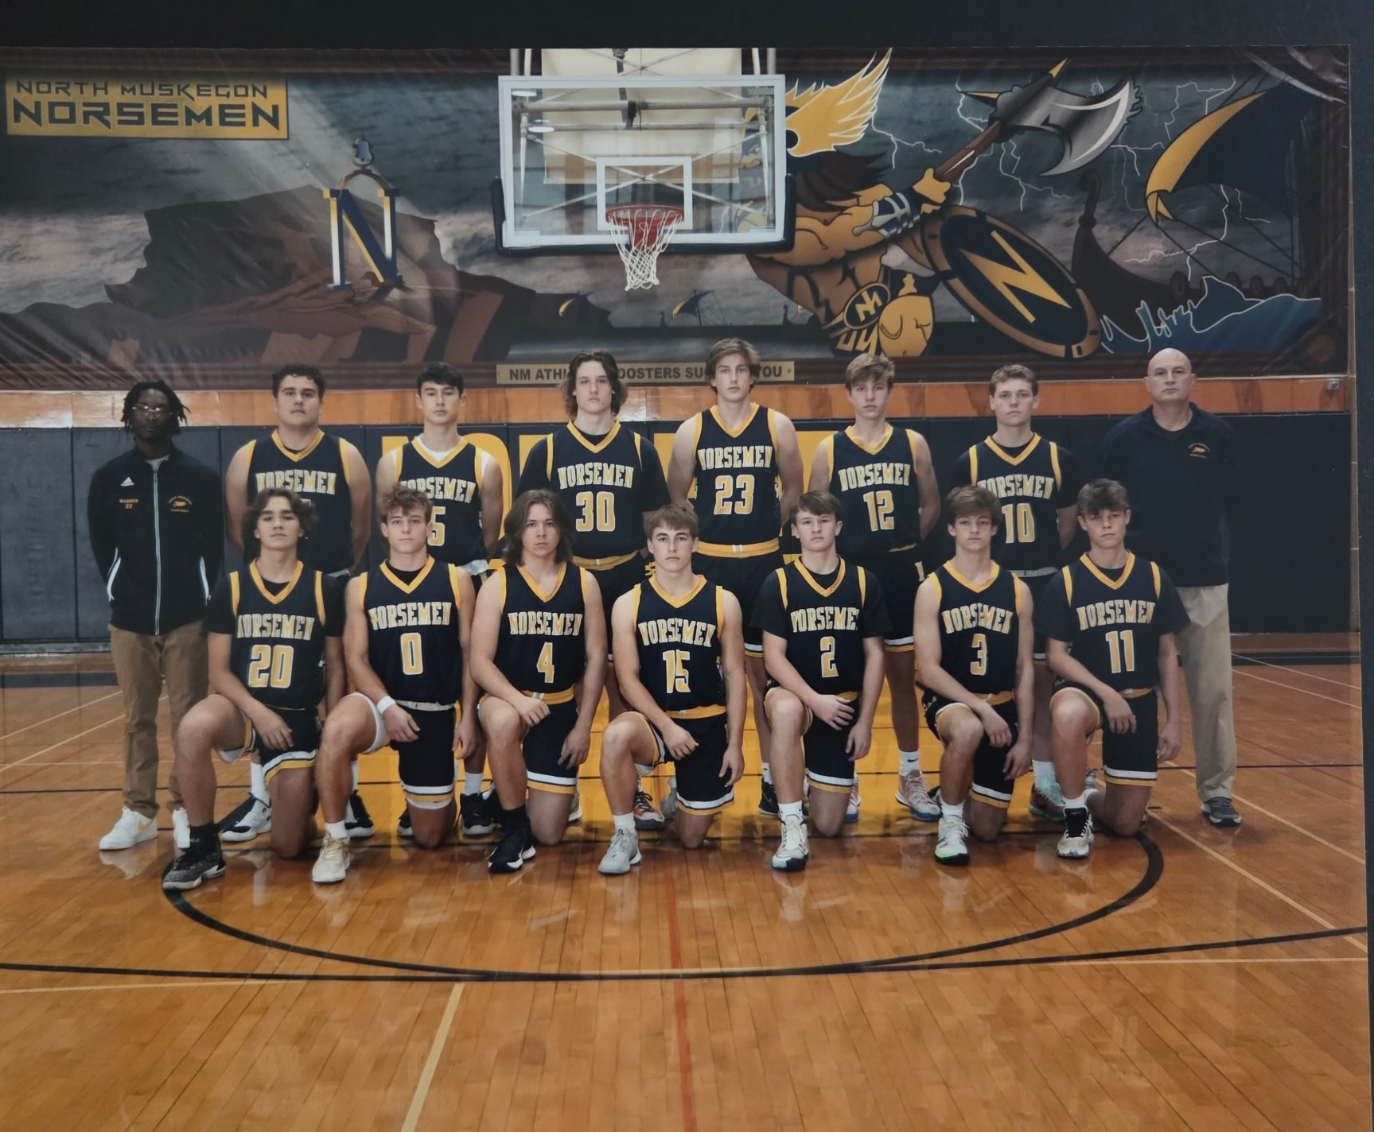

The 2021-22 NORSEMEN

Bottom Row L-R: James Young, Denny Belmonte, Kyle Huff, Ben Meyers, Brandon Rypstra, Bo Nedeau, Ben Hoffer
Top: Coach Warren, Champ Young, Troy McManus, Sam Gallo, Carsen Moat, John Caliando, Quinn Kersman, Coach Rypstra

2022-23 (Coach Chuck Rypstra, 19-5 Hart WMC Rivers champ= Whitehall Lakes)

There was a major change in the venerable West Michigan Conference that one can view as good or bad. For this author I go with the bad part as the Norsemen would now face much weaker opposition. Instead of playing Whitehall, a team the Norse had faced in every year since 1936, a period of 86 years, the Norse would now schedule weak sisters that were now in the Rivers portion of the divided WMC such as Holton and Hesperia. NM defeated the two schools by a combined score of 263-95, an average of 42 points per contest. There was one plus addition to the schedule that did please your author – Fremont. The meeting in this season would be the first between the two long-time rivals in 40 years. Whether it was a NM patient offense, good defense or weak opposition, NM allowed only 40 points per game. This was the lowest points allowed per game since the WMC champs of 1950-51 held their opponents to 38.5 ppg.

One would have to go back 82 years to find an opponent who scored less than the 11 points Muskegon Catholic scored against the Norsemen in NM’s 52-11 opening game defeat of Muskegon Catholic. In February of 1940 the Norsemen defeated Scottville 31-10, that’s even before your author was born. So tough was the NM defense – or how bad was the MCC offense – NM led 12-2 at the end of the first quarter and 17-4 at halftime. MCC’s ‘best’ quarter was the third when they scored four points as NM led 46-8 heading into the final quarter with a running clock in effect the rest of the game. Sophomore James Young turned in a double-double for the Norse with 16 points and 11 rebounds. Junior Jaxon Lisinski had 12 points on four made 3-pointers with senior Troy McManus added nine points and five assists.
Mason County Central then defeated NM in the Norse gymnasium 51-44, the first win for the Spartans contested at the NM gymnasium since 2014. NM trailed by only a point (35-34) heading into the final quarter but were outscored by the boys from Scottville 16-12 in the final eight minutes. Chase Young led NM with 13 points followed by Troy McManus who chipped in with 12.
The Norsemen bounced back to throttle West Michigan Christian 76-45, easily the most one-sided win by a NM team over the Warriors in the 72 games played between the two teams in program history. NM was hot from the outside in the early going as they connected on six 3-pointers in the first half that helped propel the Norse to a commanding 43-26 lead at halftime. James Young had 22 points to lead the Norse followed by Troy McManus with 17. Also in double figures for the balanced NM attack was senior Sam Gallo with 12 points and junior Lamarkis Graham who put up 11 points.
Hesperia was no match for NM as they thumped the lowly Panthers 60-15 in the first conference game between the two teams. NM only allowed Hesperia eight points in the first half, but it didn’t get any better for the Panthers in the second half as they only scored seven in the final two quarters.
James Young led NM with 11 points, five rebounds, five steals and five assists as coach Chuck Rypstra was able to empty his bench early in the rout. Troy McManus added nine, Sam Gallo eight, Brandon Rypstra eight and Jaxon Lisinski seven as NM improved to 3-1 while Hesperia was still looking for their first win.
There was a changing of the guard in Oceana County as Hart would now be the kingpins of the county as Shelby had dropped down a notch (or two) in talent. NM had no trouble in defeating Shelby in their first meeting of the season with an easy 66-41 victory over the once proud Tigers. NM jumped out to an early 19-8 lead at the end of the opening quarter and coasted to victory the rest of the way. Brandon Rypstra had his outside shot working as he made 4-of-5 shots from behind the 3-point arc to account for a team leading 16 points. Also, in double figures for NM were Lamarkis Graham with 13 and Sam Gallo with 10. Only a 18-9 run by Shelby against the NM bench players made the score even remotely respectable.
North Muskegon and Orchard View again met up for the second consecutive year in the Muskegon Area Sports Hall of Fame Classic but this time it was the Norsemen coming out of the game victorious 59-28 over Orchard View. Troy McManus led NM with 20 points, five rebounds, four assists and three steals. Sam Gallo had a strong performance with 15 points and 10 rebounds as NM completed the 2022 year with a very good 5-1 record.
After losing 29 straight games to North Muskegon the Hart Pirates handedly downed the Norsemen 61-44 to move to a perfect 8-0 on the season. Hart’s Parker Hovey netted 26 points for the Pirates who were off to their best start in many decades. Sam Gallo’s 13 points led the Norse while James Young netted 11 and Troy McManus 10 as NM dropped their second game of the season, both losses occurring in the WMC.
Once again NM was stingy with their defense as they held Montague to only 34 points in a 49-34 win over the Wildcats. It would be the only game played during the season with Montague who are currently in the Lakes Division of the WMC. “Shots were not falling tonight, credit to NM’s defense,” said Montague coach Dave Osborne. Troy Mc Manus was one player who did see several of his shots go in the bucket as he scored 20 points. James Young added nine points and Sam Gallo chipped in with eight rebounds as the Norse came away with another low-scoring victory, 42-36. NM had to overcome a one-point deficit heading into the final quarter but canned just enough free throws in the game’s final eight minutes to come away with a victory. Troy McManus had a dozen points to lead NM with Sam Gallo adding nine.
For the third time this season NM held an opponent to under 20 points in a game. You would have to go back to 1943 to find a season when NM held three opponents to under 20 per game. That 1943 team however, was comprised of many of NM’s undefeated, untied, and unscored upon football team that was used to shutting down opponents. NM shut down a hapless Holton team, 58-14 to earn their 8th victory of the season. So dominant were the Norsemen that they outscored Holton 29-4 in the third quarter before there was mercifully a running clock in the fourth quarter. Although limited in minutes played, three Norse players reached double figures: Sam Gallo with 13, Jaxon Lisinski 12, and Troy McManus 10.
Troy McManus dominated NM’s 64-35 win over Ravenna on both ends of the floor. The senior had 24 points, five steals and four assists in leading his team to victory. Joining McManus in double figures were James Young with 12 points and Jaxon Lisinski with 11. The win was tempered with the news that one of NM’s starters, coach Rypstra’s son Brandon was going to have season-ending knee surgery.
NM then earned a rare win in their series with Muskegon Heights as the Norse edged the Tigers 57-54. Trailing 30-27 at the halftime break, NM used a big third quarter to procure the win with a 16-9 advantage over the host Tigers. Jaxon Lisinski hit a big 3-pointer with three minutes to go that gave NM a little breathing room vs. the Heights. Four players scored in double figures for the Norse: Sam Gallo (13), Troy McManus and James Young (12) and Lisinski (11).
NM won their 6th straight victory as they held on to win a low-scoring 43-40 victory over Oakridge. The third quarter found both teams having trouble finding points as both teams combined to score but six points in the period with NM on top 33-29. Troy McManus and Lamarkis Graham led NM with 10 points. Three-sport standout Denny Belmonte added nine for the Norsemen.
Both NM and Mason County Central entered their game with winning records, NM at 11-2 and the Spartans at 10-3. It was the Norsemen who came out on top, and rather easily at that, with a 58-40 win. Troy McManus scored 19 to lead the Norsemen while Jaxon Lisinski added 14.
NM then paid a visit of the unknown when they traveled to Grand Rapids to take on West Michigan Aviation, a charter school located in the Furniture City. The Aviators came out flying, while the Norsemen were grounded with poor shooting as West Michigan jumped out to an 18-6 first quarter lead and the Norse could never catch up. “We did not show up in the first quarter,” said NM coach Rypstra. Lamarkis Graham had his best showing on the season with 18 points on 8-of-11 shooting. Troy McManus tossed in 15 points and dished out seven assists for NM while Sam Gallo scored 12 points and hauled down nine rebounds. It was one of only three games all season whereby an opponent scored 60 or more points against NM.
NM then scored 94 points in a 94-38 rout of a totally outmatched Hesperia team: the most points scored by NM in a game in 29 years. Ironically, there were only two other games during that 29 years span where NM scored 90 or more points in a game, both against Hesperia. NM scored 55 points in the second half making your author more than curious if there was a running clock in the second half. Every player suited up for the Norse scored, including a recent call-up from the JV team, freshman Adam Dugener who scored nine points. Dugener showed off his playmaking skills with five assists. Sophomore three sport standout TJ Byard was able to hit double figures with 11 points. Troy McManus connected on six 3-pointers to lead all scorers with a career high 28 points followed by Lamarkis Graham with 13. In more than 90 years of NM basketball it was the most one-sided win over an opponent in program history.
It was not the prettiest of games, but the Norsemen came away with a 49-39 victory over Ravenna to improve their record to a stellar 14-3. Ravenna, losers by 29 points in their first game with NM, kept the score much closer in the second encounter but a big third quarter gave NM a safe cushion as they held off the host Bulldogs. Troy McManus led NM with 14 points, the only Norsemen in double figures. Jaxon Lisinski had nine points while Ben Meyers had seven assists and three steals.
NM had little problem in defeating Shelby 62-39 as three Norsemen were in double figures, including a freshman who according to a new 5th quarter ruling started in 2022 could play both on the JV and varsity if one didn’t play more than three quarters in the JV game. Adam Dugener scored 10 points enroute to what promises to be one of NM’s all-time best roundballers before his career is over at NMHS. Troy McManus had 14 and Jaxon Lisinski 11 in limited minutes before giving way to Dugener and more bench players.
After NM defeated Shelby to improve their record, the table was set for the key matchup of the season in the Rivers Division of the WMC. NM was 15-3 and Hart was a perfect 17-0, their best record in school history.
The start of the game was as good as advertised until Hart’s 6’5 point guard Parker Hovey took over. The Hope college bound senior sparked a 10-0 run by Hart early into the start of the third period that turned a 28-28 tie into a 10-point Hart lead from which NM was never able to recover. Junior sharpshooter Jaxon Lisnski kept NM in the game with 20 points, 18 of those tallied coming on six made 3-pointers. Hovey was the difference in this contest as he recorded a triple-double with 32 points, 11 rebounds and 10 assists. The win clinches the WMC rivers division conference title for the Pirates as they move to a perfect 18-0 on the season while the Norse drop to a still impressive 15-4. The two wins during the season over NM were the only two victories for the Pirates against NM in the past 33 games.
During the early days NM’s number one rival was the Fremont Packers. The two schools faced each other in football and basketball on a regular basis from the 1930s until 1966. NMs 66-41 victory over Fremont was only the 5th meeting between the two foes since 1966. In 66 total meetings between the Norsemen and the Packers the 66-41 win by NM was the most one-sided victory in the long series. Troy McManus bounced back from a season low five-point outing in NM’s loss to Hart by scoring 24 points, 14 in the third quarter to lead NM to victory. Carsen Moat and freshman Adam Dugener had eight points apiece for the Norse.
Holton didn’t fare much better against NM in their second meeting as they did in the first as NM prevailed 41-28 over the Red Devils in the final game of the regular season. Lamarkis Graham led NM with 19 points and Sam Gallo 11 as NM ends the regular season with an outstanding record of 17-4 heading into the tournament.
NM opened the playoffs with a commanding 69-43 victory over Ravenna, their third win on the season over the Bulldogs. Troy McManus scored 25 points in the tournament game played in Holton as NM made 10 3-pointers in the win. Ravenna started the game putting NM in a 5-0 hole as they hit two technical foul free throws and a 3-pointer. After that the game belonged to the Norsemen as they bounced back to lead 22-17 after the first quarter and kept adding to their lead until the final buzzer. McManus was the only NM player in double figures but there was a lot of balance for the Norsemen. Lamarkis Graham added nine, Adam Dugener and Sam Gallo eight and Denny Belmonte had seven points as NM advances to play Kent City for the district title.
NM made a statement early as they roared out to a 32-10 halftime lead and cruised to their third straight Class C district title with a 61-34 victory over Kent City. Although NM’s leading scorer on the season Troy McManus was held in check, his teammates came through in a big way. The foursome of Lamrkis Graham (16), Jaxon Lsiniski (14) and Sam Gallo and Adam Dugener with 10 apiece scored 50 of NM’s 61 points to send the Norse to the Class C regional in Kent City.
NM then faced Pewamo-Westphalia in what would begin an epic rivalry in both football and basketball for the next three seasons. P-W’s one-man gang of Jamison Ecklund proved to be too much for NM as the Pirates edged NM in a tight battle 49-46. Junior Jaxon Lisiniski scored 15 of his game high 19 points in the first half as the two teams played dead even at 25-25 at halftime. The 6’5 Ecklund scored 16 of his 29 points in the first half with the second half being a see-saw affair. NM had a two-point lead with two minutes remaining at 44-42 but a three-point play by Ecklund gave P-W a lead they would not give up as NM’s season ended at 19-5. Troy McManus ended his career with seven points. Denny Belmonte and Adam Dugener were next in line in scoring with six points apiece.

N Muskegon 52 Musk Catholic 11 James Young 16, Jaxson Lisinski 12
N Muskegon 44 Mason Co 51 Chase Young 13, McManus 12
N Muskegon 76 WMC 45 J Young 22, McManus 17, Sam Gallo 12
N Muskegon 60 Hesperia 15 J Young 11, McManus & Gallo 9
N Muskegon 66 Shelby 41 Brandon Rypstra 16, Lamarkis Graham 13
N Muskegon 59 Orchard View 28 McManus 20, Gallo 15
N Muskegon 44 Hart 61 Gallo 13, J Young 11, McManus 10
N Muskegon 49 Montague 34 McManus 20, J Young 9
N Muskegon 42 Potters House 36 McManus 12, Gallo 9
N Muskegon 58 Holton 14 Gallo 13, Lisinski 12, McManus 10
N Muskegon 64 Ravenna 35 McManus 24, J Young 12, Lisinski 11
N Muskegon 57 Musk Heights 54 Gallo 13, Young and McManus 12
N Muskegon 43 Oakridge 40 McManus & Graham 10
N Muskegon 58 Mason Co 40 McManus 19, Lasinski 14
N Muskegon 55 W Mich. Av 63 Graham 18. McManus 15, Gallo 12
N Muskegon 94 Hesperia 38 McManus 28, Graham 13, TJ Byard 11
N Muskegon 49 Ravenna 39 McManus 14, Lisinski 9
N Muskegon 62 Shelby 29 McManus 14, Lisinski 11, Adam Dugener 10
N Muskegon 51 Hart 67 Lisiniski 20, Graham & Gallo 11
N Muskegon 66 Fremont 41 McManus 25, Carsen Moat & Dugener 8
N Muskegon 51 Holton 28 Graham 19, Gallo 11
N Muskegon*68 Ravenna 43 McManus 25, Graham 8
N Muskegon*61 Kent City 34 Graham 16, Lisinski 14, Gallo. Dugener 10
N Muskegon*46 Pewamo-West 49 Lasinski 19, McManus 7

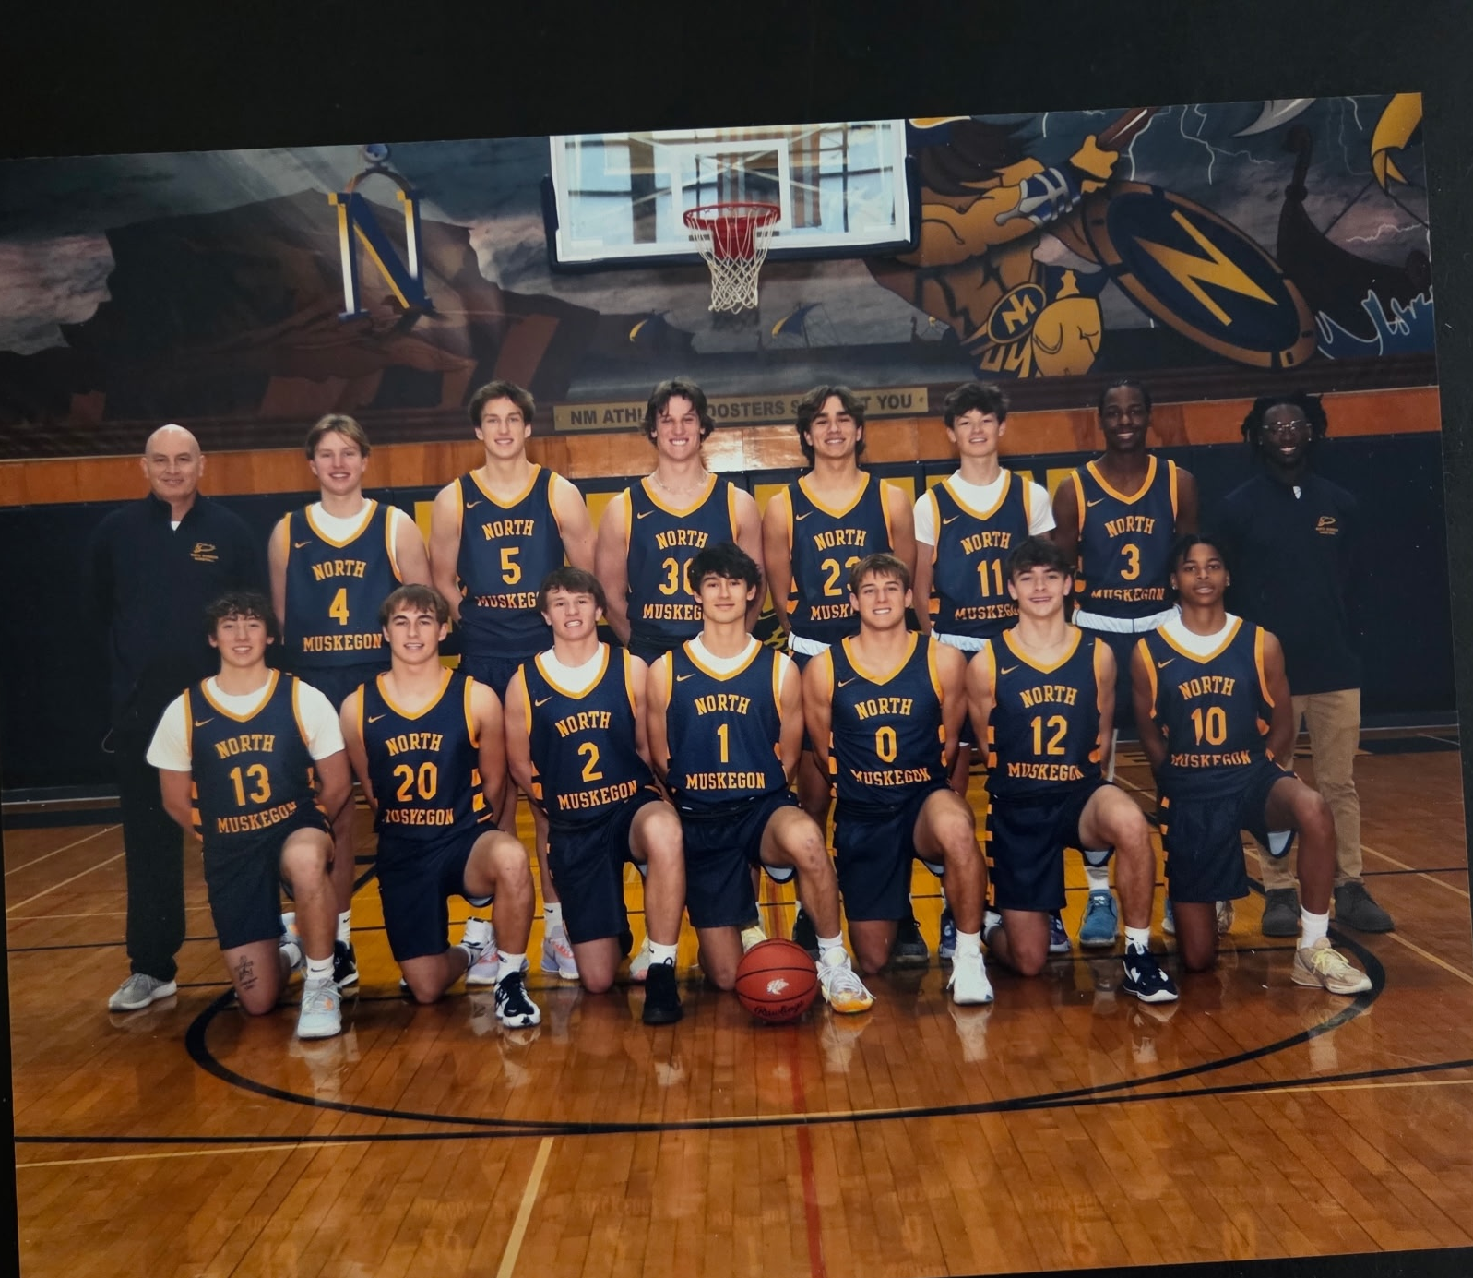

The 2022–23 NORSEMEN
Bottom Row L-R: Leighton Hunt, Ben Meyers, Brandon Rypstram, Troy McManus, Denny Belmonte, Talen Thompson, Lemarkis Graham
Top Row L-R: Coach Rypstra, John Caliando, Carsen Moat, Sam Gallo, James Young, Jaxon Lisinski, Jaccari Edwards, Coach Warren

2023–24 (Coach Chuck Rypstra, 24–1 NM --WMC Rivers champ, Whitehall Lakes)

NM would race through the 2023-24 season by winning their first 24 games, the first undefeated regular season in NM history. Coach Chuck Rypstra would welcome back five players who all played major minutes in the previous season, including a late call up from the junior varsity team who would finish the 2023-24 season as NM’s top scorer as a sophomore. Adam Dugener would lead NM in scoring with 360 points, an average of more than 14 points per game. The Norse would feature a front line comprised of Jaxson Lisinski, Lamarkis Graham and TJ Byard, all standing about 6’4 on height. Also returning was 6’2 junior James Young, a starter since his freshman season. This fivesome would command most of the minutes with guard Landen Grimm seeing a great deal of playing time. The one drawback to NM’s season, that was no-fault of their own, was an extremely soft schedule that forced them to play some very poor teams that were recently added to the West Michigan Conference. One notable omission from the schedule for the last two seasons was former long-time rival Whitehall, an opponent NM faced more than 160 times since 1932. Whitehall was placed in the Lakes Division of the WMC, and although NM did have a handful of crossover games in the WMC, Whitehall was not included that left WMC fans starved to see how these teams would have fared as they each breezed through their regular season undefeated.

NM had no trouble in handing Muskegon Catholic their 8th straight loss vs. the Norsemen with a 74-30 rout of the Crusaders. NM jumped out to a big 24-11 lead after the first quarter and breezed to a win in their traditional season opener with MCC. NM showed early that they had several weapons their opponents would have to deal with in the upcoming season. Lemarkis Graham led the balanced Norse attack with 18 points. Sophomore guard Adam Dugener, who had an older brother play for Muskegon Catholic, added 16 points and four assists. Junior James Young was in double figures with 11 points while Jaxon Lisinski had nine points and five assists.
The Norse then opened the Rivers Division of the West Michigan Conference with a 62-47 decision over Ravenna. All five starters contributed to the NM victory, a starting five that would be consistent all season long for coach Chuck Rypstra’s Norsemen. James Young posted a double-double with 12 points and 10 rebounds. Adan Dugener also had 12 points and Lemarkis Graham chipped in with 11 points and eight rebounds. The final two players on the starting five also contributed with Jason Lisinski scoring nine points and TJ Byard filled up the stat sheet with seven points, five rebounds, two steals and two blocks.
The Norsemen lost eight of the first nine games ever played against Manistee in a rivalry that dates to the 1930s. However, the tables have turned in recent vintage as the Norse with their 52-47 win over Manistee have now won the last four in the short 13 game series. The Chippewas/er now the Mariners made the long trek to NM with a perfect 3-0 record and gave NM one of their toughest games of the season. NM’s 18-6 run in the second quarter was the difference in the contest and were never threatened until very late when Manistee made a late run that came up short. Jaxon Lisinski led NM with 12 points while Adam Dugener and Lamarkis Graham each netted 10.
NM made their annual journey to Scottville a success as they won their fourth straight game of the season 60-50 over Mason County Central. The game was never a runaway as the Norse had a slim 29-25 lead at halftime against the Spartans. Only a 14-7 NM fourth quarter run made the game more comfortable for the winning Norsemen. Sophomore Adam Dugener led three NM players in double figures with 16 points. Jaxon Lisinski contributed 13 and Lamarkis Graham 12.
Adam Dugener, who had yet another older brother who played for West Michigan Christian, tormented his brother’s alma mater with 21 points in NM’s 51-44 win over the Warriors. Although NM led 29-18 the Warriors came storming back to tie the game at 36-all with seven minutes remaining before NM pulled away. Lamarkis Graham added 17 points and grabbed 6 rebounds while TJ Byard had a strong performance with eight points, five rebounds, three steals and three assists.
NM then continued their complete domination in recent years with Hesperia with a 65-17 whipping of the outclassed Panthers. Several Norsemen contributed to the onslaught as coach Chuck Rypstra was able to empty his bench early. Adam Dugener and reserve Talan Thompson each scored 11 points, Lamarkis Graham scored 10 points with five steals while James Young added nine rebounds and five assists as NM stays perfect at 6-0.
NM would go into the New Year of 2024 with a 7-0 record following a convincing 77-42 victory over Shelby. After a tight first quarter NM exploded with a 26-6 second quarter to break the game wide open. Jaxon Lisinski led NM with 19 points while NM’s steady sophomore guard Adam Dugener added 15. Lamarkis Graham chipped in with 10 points and had a near double-double with nine rebounds.
After losing to West Michigan Aviation Academy in their first ever meeting in Grand Rapids last season, NM returned the favor with a comfortable 55-33 win over the low-flying Aviators. Jaxon Lisinski and Adam Dugener paced NM scorers with 16 points apiece. Close behind in scoring was Lamarkis Graham with 15 points while TJ Byard played his usual steady role with eight rebounds, four assists and three steals.
Perhaps Hart couldn’t stand success as NM had no trouble in disposing of a Hart team that finished last season with a perfect regular season record of 22-0. NM more than doubled up on the Pirates with a 72-34 spanking of the Pirates. NM had the 3-pointers on target during the game, especially Lamarkis Graham and Jaxon Lisinski who combined for 7 of NM’s 14 three pointers. Graham finished with a season high 27 points and Lisinski 20. Adam Dugener had nine points and five assists.
Holton fell to the Norsemen in NM’s next contest, losing by 56 points in a one-sided 79-23 Norse victory. The starting five of James Lasinski (16), James Young, Adam Dugener and TJ Byard had 10 points apiece while Lamarkis Graham was one point shy of double-digit figures with nine.
NM made it 11 in a row to start the season with a 60-51 win over Ravenna. The Norse got huge games from Adam Dugener (19), Lamarkis Graham (18) and TJ Byard (15) to stay perfect on the season and the Rivers Division of the WMC.
NM journeyed to Grand Rapids and defeated Potters House Christian 61-35 in a non-league contest, the third win in as many games in the short series with Potters House. Balanced scoring, a trademark for the entire season for the Norsemen was again in effect in this contest. Jason Lisinski led NM with 14 points, closely followed by James Young and Adam Dugener with 13 points and Lemarkis Graham with 12. Young’s 11 rebounds gave him a double double.
It has always been a competitive series between Fremont and North Muskegon, a pair of old-time rivals that played one another every year but two from 1935 through 1966. With NM’s 53-39 win over the Packers, NM leads the series 34-32. It did not look promising early for the Norsemen as they fell behind 15-4 after the first quarter before the Norse buckled down to earn the win. Lamarkis Graham tallied 14 points, grabbed seven rebounds and made four steals for the victors. Adam Dugener had his usual well-rounded game with 13 points six rebounds, five assists and four steals. Jaxon Lisinski with 11 points and James Young with nine added to the well-balanced NM attack.
James Young had a season high 20 points and eight rebounds to lead NM to their 14th straight win on the season with a 65-47 win over Oakridge. With Oakridge now being in another division of the WMC, the two longtime rivals would only meet once during the season. Young had plenty of help from his teammates as Lemarkis Graham added 14 points as did Jaxon Lisinski. Adam Dugener had 11 points with TJ Byard scoring six points with five rebounds and three blocked shots.
It surely looked like NM was about to see their perfect season come to an end as they trailed Montague for most of the game but managed to use some last second magic to pull one out of their hat. NM scored four points in the game’s final seconds to come away with the win. After a NM bucket tied the score with just a few ticks left on the clock Lamarkis Graham stole the Wildcats inbounds pass, was fouled and sank two free throws to give the Norse a 47-45 win. Graham finished with 15 points; James Young added 13 points and Adam Dugener tallied 10 in the low-scoring contest.
NM bolted out to an early 15-point lead after the first quarter and then cruised to a 58-40 win over Mason County Central. Reserve guard Landen Grimm had a memorable game with 13 points, 12 of those markers coming on four made 3-pointers. James Young contributed 12 points and a team-high eight rebounds and four assists while Jaxon Lisinski was in double figures with 11 points.
It was another rout against Hesperia as NM walloped the outclassed Panthers 74-32 to earn their 17th straight win and all but clinched the rivers division of the WMC at a perfect 9-0. Jaxon Lisinski led NM with 15 points, followed by Lamarkis Graham with 14, while Adam Dugener and Landen Grimm each chipped in with 12.
Although NM had admittedly a soft schedule with two games each against outmanned opponents in a very weak Rivers division, the Norse would face their strongest opponent during the regular season with a game at Grand Rapids Covenant Christian. NM trailed the host Chargers 30-24 at halftime but came out of the halftime break on fire by outscoring Covenant 23-7 in the third quarter. Covenant made a run at the Norse in the game’s final moments, but NM made their free throws and enough timely baskets to hold off Covenant to earn a 62-54 victory. Adam Dugener was the man of the hour for Norse as the sophomore displayed the skills that could put him amongst some of the best to ever suit up for the Blue & Gold. Dugener was the best player on the floor with 26 points. Also helping in the victory was Jaxon Lisinski with13 points while Lamarkis Graham added 10.
White Cloud entered their game with NM with an excellent record of 15-2 and posed a possible threat to ending NM’s impressive winning streak. However, one of their two losses was to Shelby, a team with only three wins at the time. White Cloud kept within range of the Norse for three quarters but a 19-8 scoring edge for NM in the final quarter led to a 57-38 win for the Blue & Gold. Adam Dugener continued his fine play with 18 points to lead the Norse while James Young chipped in with 10 points, eight assists, six assists and four steals.
NM then then stayed perfect at 20-0 with a 57-35 victory over Shelby. Getting better every time out, Adam Dugener led NM with 18 points, five rebounds and four assists. Lamarkis Graham added 15 points and Jaxon Lisinski 14. The once proud Shelby Tigers, for years the scourge of the West Michigan Conference fall to 3-15 on the season. The Tigers would win only two games in the WMC, both against lowly Holton.
So dominant was NM in the Rivers Division of the WMC that Hart would end up in second place in the division. NM manhandled the Pirates 71-47 enroute to another easy victory in the very weak Rivers Division as Adan Dugnener once again led all NM scorers with 26 points. “North Muskegon has a bevy of guys that can put the ball in the hole.” said Hart coach Nick Bronsema following the game. Four Norsemen were in double figures. Following Dugener in double digits for NM were Lamarkis Graham (13), Jaxon Lisinski (!2) and TJ Byard with 10 points.
NM completed their regular season with yet another rout of an overmatched team, an 83-36 win over a very poor Holton team that failed to even win a game in the Rivers Division of the WMC. It was no contest with sharp shooting Jaxon Lisinski leading the way with a career high 23 points. Lamarkis Graham scored 18 while Adam Dugener chipped in with 16 points as the subs played most of the second half for NM.
NM would then play in a very favorable district against teams NM had soundly defeated during the regular season. NM’s opener was against Shelby and, as expected, the Tigers were not up for the challenge against a much stronger NM team that entered the MHSAA playoffs rated number 2 in the state in Division 3 (Think Class C for you old timers). After a tight first quarter where NM led by only one at 15-14 the Norse then settled things quickly in the second period by taking a 34-21 lead at halftime. Jaxon Lisinski scored 18 points for the balanced Norsemen followed by Adam Dugeners with 17 and Lamarkis Graham with 12.
NM then made it four district titles in a row with a 54-39 win over White Cloud, their second victory in just a few shorts days over the Indians. White Cloud kept in range of pulling off the upset but a 21-12 Norse advantage in the final quarter provided enough separation to secure the victory. Lamarkis Graham led NM with 20 points while Adam Dugener was the other NM player in double figures with 10.
With a perfect 24-0 record NM then had the misfortune of playing their first game in the regional against Pewamo-Westphalis on P-W’s home court. In a game that screamed for a shot clock for high school basketball the Pirates played patient basketball against NM’s zone defense that surely frustrated the NM players. With the Norsemen refusing to leave their zone defense they had been using all year to compile a 24-0 record P-W often took a minute or more off the clock to make sure they got off a good shot on every possession. Pewamo-Westphalia took a 31-24 lead heading into the fourth quarter, a seven-point lead that with the current tempo of the game felt like a 20-point margin. NM clawed back and outscored P-W 12-5 in the final quarter to force overtime. The Pirates had the last possession in overtime with the score tied at 40-all. Kash Poel hoisted an off-balanced desperation 3-pointer as time expired that somehow fell through the hoop to end NM’s season at 24-1. Adam Dugener’s 15 points led NM in a losing cause while Jaxon Lisinski and Lamarkis Graham scored 12 and seven points respectively.
The loss to Pewamo-Westphalia would be the final game for seniors Jaxon Lisinski and Lemarkis Graham who would join veteran coach Gene Gifford’s Muskegon Community College Jayhawks at the next level. Also leaving the Norse was three-year starting guard James Young, who would transfer to Muskegon High School to play football. Young’s favorite receiver during the football season at NM, three-sport standout TJ Byard would return for the 2024-25 season as would NM’s best player in 2023-24, rising junior Adam Dugener. In a very mysterious schedule when the MHSAA permitted teams to play 22 games during the regular season, basketball fans were left with the empty feeling on why both undefeated teams in each division, Whitehall and North Muskegon never played one another to truly decide an overall WMC champion. The Vikings and Norsemen both experienced an untimely early exit in the playoffs with Whitehall shockingly losing the first game in the tournament to Spring Lake.

N Muskegon 74 Musk Catholic 30 LaMarkis Graham 16, Adam Dugener 16
N Muskegon 62 Ravenna 47 James Young & Dugener 12, Graham 11
N Muskegon 52 Manistee 47 Jaxon Lisinski 12, Dugener, Graham 10
N Muskegon 60 Mason Co 50 Dugener 16, Lisinski 13, Graham 12
N Muskegon 51 WMC 44 Dugener 21, Graham 17, TJ Byard 8
N Muskegon 65 Hesperia 17 Dugener & Talan Thompson 11, Graham 10
N Muskegon 77 Shelby 42 Lisiniski 19, Dugener 15, Graham 10
N Muskegon 55 W Mich. Av 33 Lisinski & Dugener 16, Graham 15
N Muskegon 72 Hart 34 Graham 27, Lisinski 20, Dugener 9
N Muskegon 79 Holton 23 Lasinski 16, Young, Dugener, Byard 10
N Muskegon 60 Ravenna 51 Dugener 19, Graham 18, Byard 15
N Muskegon 61 Potters House 35 Lasinski 14, Young & Dugener 13
N Muskegon 53 Fremont 39 Graham 14, Dugener 13, Kisinski 11
N Muskegon 65 Oakridge 47 Young 20, Graham & Lisinski 14, Dugener 11
N Muskegon 47 Montague 45 Graham 15, Young 13, Dugener
N Muskegon 58 Mason Co 40 Landen Grimm 13, Young 12, Lisisnki 11
N Muskegon 74 Hesperia 32 Lisinski 15, Graham 14, Dugener & Grimm 12
N Muskegon 62 GR Cov. Christ. 54 Dugener 26, Lisinski 13, Graham 10
N Muskegon 57 White Cloud 38 Dugener 18, Young 10, Byard 8
N Muskegon 57 Shelby 35 Dugener 18, Graham 15, Lisinski 14
N Muskegon 74 Hart 43 Dugener 26. Graham 13, Lisinski 12
N Muskegon 83 Holton 36 Lisinski 26, Graham 18, Dugener 16
N Muskegon*65 Shelby 29 Lisinski 18, Dugener 17, Graham 12
N Muskegon*54 White Cloud 39 Graham 20, Dugener 10
N Muskegon 40 Pewamo-West. 43 Dugener 15, Lasinski 12

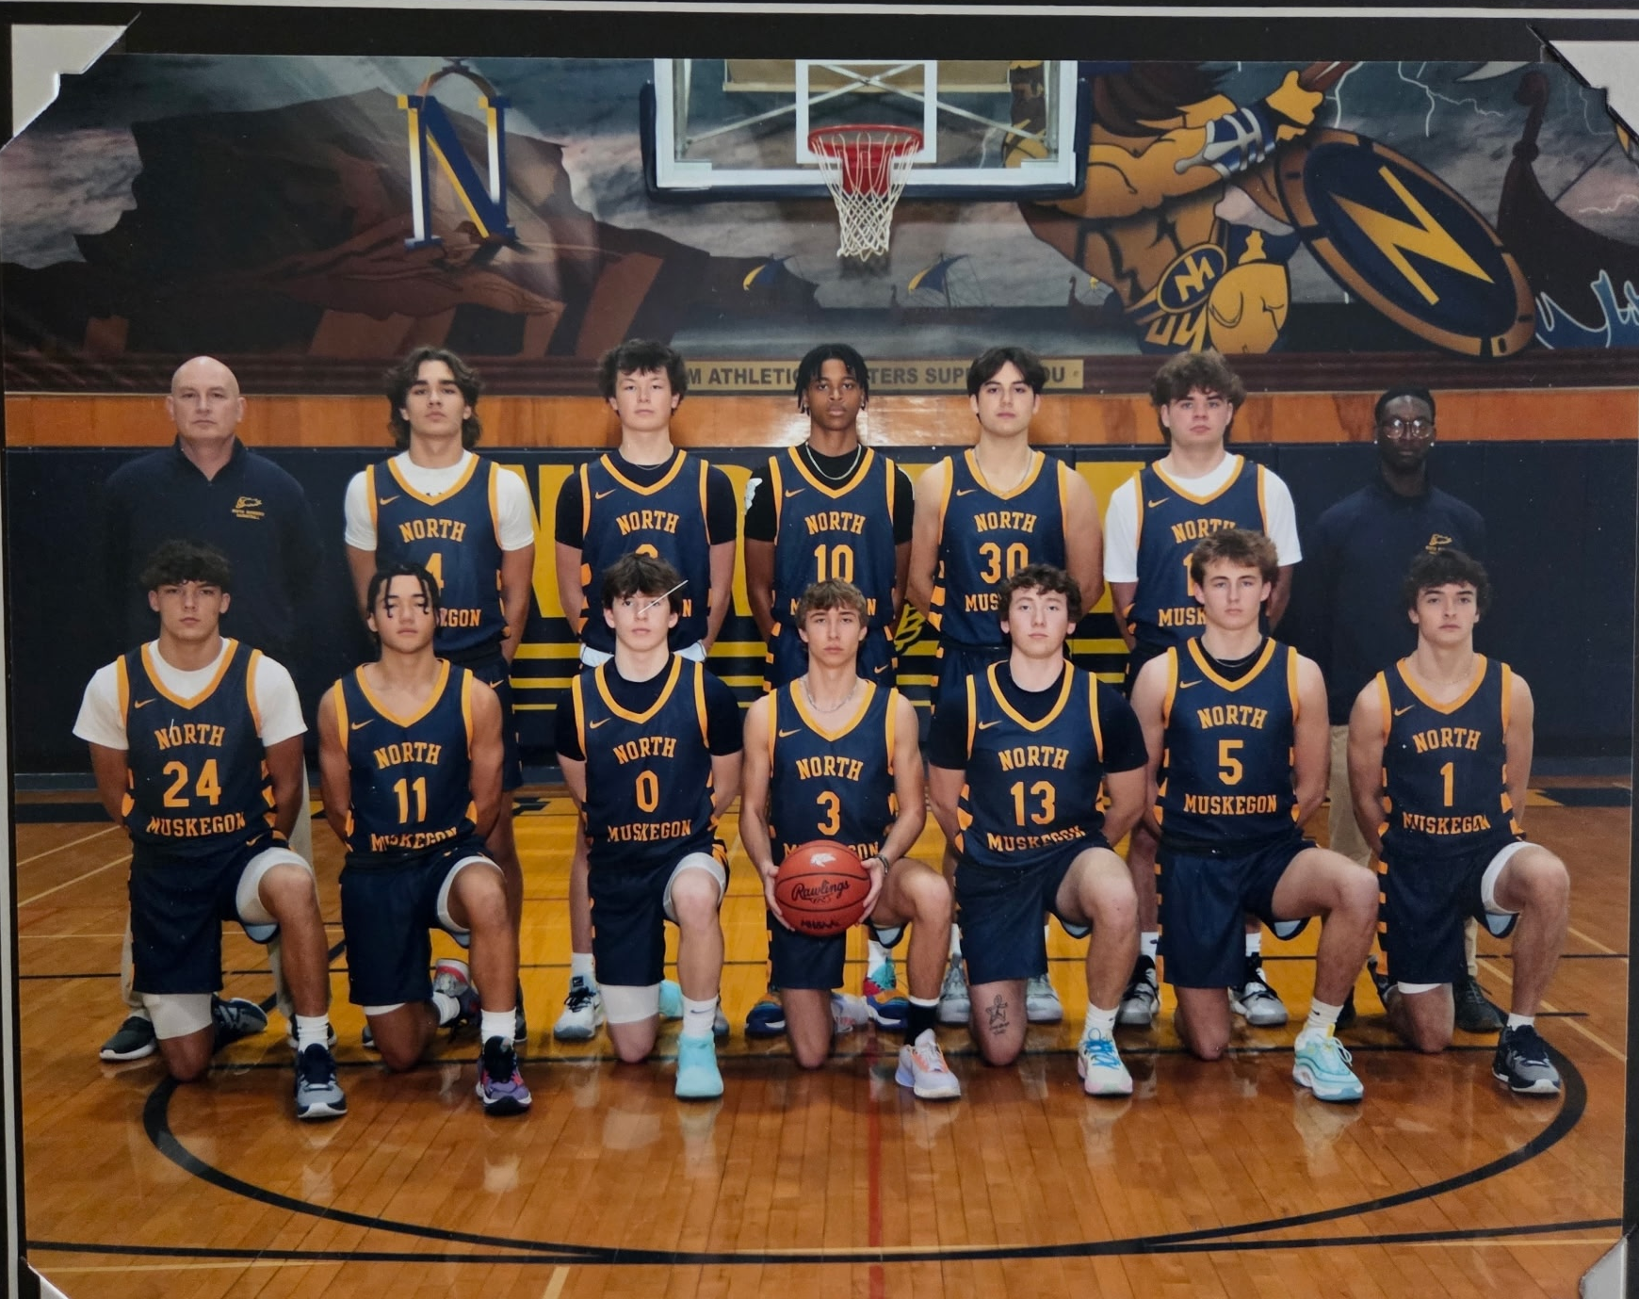

The 2023-24 NORSEMEN
Bottom Row L-R: TJ Byard, Jaden Villapando, Adam Dugener, Laden Grimm, Leighton Hunt, Chuck Meyers, Talen Thompson

Top Row L-R: Coach Rypstra, James Young, Jaxon Lisinski, Lamarkis Graham, Jack McNally, Lucas Dye, Coach Warren

2024-25 (Coach Chuck Rypstra, 23-2 NM --WMC Rivers champ, Whitehall Lakes)

With only Adam Dugener and TJ Byard, the only starters returning for the upcoming season, surely no one could realistically expect the Norsemen to have another run in 2024-24? However, stepping in to replace the departing seniors, and one junior who left the program as a transfer, seniors Chuck Meyers, Jaden Villapando, and Landen Grimm, along with junior Braylen Burrell and freshmen David Markiewicz joined Adam and TJ to lead the Norsemen to another amazing season.
NM began the 2024-25 season with a dubious start as the Norsemen saw host Mason County Central score the games first 11 points. It was then Adam Dugener time as he almost single-handedly brought the Norsemen back from the dead as he scored 18 od his 24 points in the first half to close the gap at halftime with the Norse trailing by only a single point. Mason County then went into a box and one to prevent Dugener from going ballistic, but the rest of the Norsemen stepped up to pull away in the second half to claim their first win of the season 47-39. Jaden Villapando tossed in nine points for the victors while Chuck Meyers was a force on the boards with nine.
The Norse then made the long journey up North to Benzonia, Michigan to participate in the Will Lynch classic sponsored by Benzie Central High School. After playing Menominee High just three weeks prior to capture a regional title in football, the Norse played the Maroons in basketball. It was the first time in the 92 years of NM basketball the Norse would play a UP team in the roundball sport. And, for the second time in three weeks NM would defeat Menominee 49 to 37. This was not the same caliber of a Menominee team that won a State Class B championship in 1967 nor as talented as a Maroon team just two years earlier had advanced to the State Division 3 championship. Adam Dugener filled up the stat sheet with 14 points, nine rebounds and seven assists. Braylen Burrell was also in double figures in the low scoring contest with 13 points.
NM then advanced to the championship game on the Benzie Central court in front of a sparse crowd on a late Saturday afternoon in Benzonia. The Norsemen would then play Lapeer, a division 1 school from the East side of the state. Lapeer produced a pair of starting quarterbacks for MSU in the 1950s in Pat Wilson and his brother Tom, who became good friends with your author from his days in Traverse City. Lapeer could have used the Wilson brothers, especially Pat who was a starting guard on the Spartans 1957 final four team as they were no match for the Norsemen. When Adam Dugener left the game with 2:34 left in the contest the NM junior guard has scored 24 points, just two less than the entire Lapeer team. NM would finish with 52 points to but 34 for Lapeer as NM begins the 2024-25 season with three straight victories.
Maybe it was the Norse finally getting into basketball shape as the Norse, who had several football players on their roster, had their best offensive output of the season in a 67-42 rout of Fremont. It was the 67th game played between the two rivals, and the win gives the Norsemen a 34-33 edge over the Packers in a rivalry that dates back into the 1930s. High scoring Adam Dugener scored 13 points, but he had plenty of help from his teammates. Braylen Burrell scored a game high 20 points while Landen Grimm netted 13, and TJ Byard had 11 points. After a close game at half with NM leading 31-24, the Norsemen put this contest securely away with a 20-2 run in the third quarter.
The Norse continued their undefeated season and their dominance over a once proud Shelby team with an easy 61-31 romp over the winless on the season Tigers. Adam Dugener popped in 21 points while grabbing 10 rebounds for the victors. So dominant was the victory that at the end of the third quarter the Norsemen enjoyed a whopping 45-16 advantage over Shelby. Braylen Burrell was also in double figures for the Norse with 13 points. Yet another milestone was achieved for the Norse as it was the 900th victory in the 92nd season of NM basketball.
Adam Dugener put on a show in NM’s 72-32 pounding of Hart. The junior guard joined the 30-point club as he became the 28th Norse cager in program history to top the 30-point mark and he did it in a big way with 39 markers, 21 of those points coming in the second quarter. After missing his first two 3-point attempts the Norse sharpshooter would then mesh a program tying eight long toms enroute to his 39 points. If not for a running clock and NM coach Chuck Rypstra using subs for all but one minute of the final quarter, Dugener would surely have broken the 40-point barrier. The 39 points equals the NM record for points scored in a game by a Norse player against Hart now shared with NM legend Drew Naymick.
NM moved to 7-0 with a dominating 65-22 thrashing of a very weak Montague team. It was the most lopsided win over Montague in the 190 meetings between the two long-time rivals. Montague’s 22 points was the fewest points scored over NM in 81 years. Oddly enough, Montague’s 18 points in 1944 were two points more than the Norse were able to muster in that contest played during the midst of WWII. The Norse left no doubt as to who was going to be victorious in this game as they burst out to an early 11-0 lead and never looked back. The Norse created many steals that led to easy baskets with Adam Dugener pilfering errant Montague passes eight times enroute to a game high 25 points. Braylen Burrell continued his fine shooting with a career high 19 points.
NM was then faced with their first big test of the season, and they came through in flying colors with a dramatic 61-49 win over Ludington. Unlike NM’s overtime loss to the Orioles (62-60) in the 1958-59 season, the Norse outscored the host Birds 15-3 in the extra session to secure their 8th straight victory of the current season. Adam Dugener, although posting a rare 0-6 from three-point country, was content to utilize his driving skills to attack the basket and finished with a game high 30 points. Braylen Burrell chipped in with 14 points, 12 of his tallies coming on three-pointers. The Norse got a big boost from rapidly improving 6-4 freshman David Markiewicz who had eight points and was a force on defense with three blocked shots.
NM then cruised as expected with a resounding 74-22 victory over an outclassed Holton team. The 54-point win was the second most lopsided win in NM history and the 13th straight conquest of the Red Devils. NM, after taking a 40-8 lead at halftime forced a running clock for much of the second half as coach Rypstra was able to empty his bench. Adam Dugener in limited minutes still was able to notch 20 points for the Norse while Braylen Burrell and Landen Grimm hit double figures with 10 points each.
NM then traveled to Oakridge where NM anticipated a hard-fought contest with the Eagles. And indeed, it was --- for 16 minutes, as Oakridge led the visiting Norsemen 28-25 at halftime. However, the second half was all NM as the Norse overwhelmed Oakridge in the second half 44-20 to earn their 10th straight win on the season. After scoring an average of less than 50 points in their first three games, with many of the NM players coming off a long football season, the NM offense has shown vast improvement by scoring 60 or more points in seven consecutive games. Adam Dugener again topped all scorers with 21 tallies with TJ Byard and Landen Grimm each chipping in with 10 points.
With their star player Adam Dugener sitting on the bench after being struck with the flu bug, his NM teammates took up the slack and raced out to an early 21-5 lead enroute to a 69-34 win over Ravenna. Braylen Burrell was deadly from the outside for NM as he knocked down 3 quick three pointers during the run and would finish with a game high 22 points, despite sitting on the bench during the final quarter while the subs took over. Dugener, who entered the game with two minutes left in the opening quarter, did score 11points but notched a double double as he also recorded 10 assists in limited minutes. TJ Byard had a monster game for the Norse with 10 rebounds, eight assists, four blocked shots and four steals as the 3-sport start ignited the NM tempo with his hurry up play. Ten Norsemen scored in the contest as the Norse won their 11th straight contest.
To no one’s surprise the Norsemen rolled over Hesperia 73-31 to earn their 36th straight regular season victory without tasting defeat, far and away a program record. Sharp shooting Braylen Burrell led the Norse with 20 points with Adam Dugener continuing his exceptional play with 19 tallies and pilfered 11 steals. The quick handed Dugener was just one steal from equaling the program record of 12 set by Dante Hutcherson back in 1987. TJ Byard played his usual steady all-around game with 16 points, five rebounds, four assists, and four steals. The game was played in Hesperia even though heavy snow in West Michigan had cancelled school for three consecutive days.
The Norse all but clinched the Rivers Division of the WMC with a 65-52 victory over Mason County Central, the only team that had any chance of dethroning NM. Adam Dugener set a school record with nine three-pointers as the junior sniper poured in 38 points, just one shy of his career high. Three Norsemen each scored six points led by TJ Byard who also stuffed the stat sheet with eight rebounds, four assists, three blocks and an equal number of steals as NM goes to 13-0 on the season.
In a series that was dominated in the early years by Hart, the recent years have been controlled by the Norse as they have now won 33 of the last 35 meetings with the Pirates following their 56-45 road win. NM’s worst fears nearly occurred with just seconds left to play in the opening quarter when Adam Dugener was sprawled on the court writhing in pain. Just a few minutes later after being assisted off the court Dugener surprisingly returned to action without a limp. The junior would finish with 20 points to lead NM to their 14th straight victory on the season over a feisty Hart team who lost earlier in the season to the Norse by 40 points. Braylen Burrell added 13 points for NM while TJ Byard had his usual fine all-around game with 7 points, 8 rebounds and a like number of assists.
TJ Byard celebrated his earlier signing during the day to play football at Lawrence Tech by scoring a career high 16 points to lead the Norse to their 15th consecutive victory, a 47-34 win over Manistee. Byard also led the Norse in rebounds with eight as NM won for their fifth straight tight against Manistee. Adam Dugener was in double figures with 11 points while dishing off six assists.
The Norsemen pulled away in the fourth quarter in defeating West Michigan Christian 59-39. Adam Dugener hit the 30-game plateau for the fourth time during the season with 30 tallies to lead NM to their fifth straight win over their one-time nemesis. Braylen Burrell added 11 points while rapidly improving frosh David Maekiewicz had nine points and six rebounds as NM moves to a perfect 16-0 on the season.
As it has been so often said, good things must come to an end. NM’s incredible streak of winning 40 games in a row came to a crushing end with a 58-35 loss to perennial powerhouse Grand Rapids Covenant Christian. “Covenant shot the ball extremely well and played great defense,” said North Muskegon coach Chuck Rypstra. “We had a poor shooting night, but mostly because of their ball pressure. They beat us pretty good today. We will learn from this as we move forward. I think we are pretty good, but they humbled us today.” Adam Dugener led NM with 16 points while TJ Byard added nine, accounting for 25 of NM’s 35 points.
The Norse quickly recovered from their first loss of the season, and they did it in a big way. NM handed Shelby their worst loss in their long rivalry as they pounded the Tigers 74-30. The Blue and Gold shared the wealth led by Adam Dugener’s 18 points, six assists and four steals. Landen Grimm added 11, Jaden Villapando 10 while TJ Byard did his normal yeoman like work with nine points, six rebounds and five assists.
NM defeated Holton by 52 points in an earlier game this season that would rank as the second largest win in program history. Not anymore. In their second meeting the Norse destroyed a hapless Holton team by 54 points and only a running clock for most of the second half prevented even a more lopsided win. Adam Dugener paced the rout with 19 points with Landen Grimm and Chuck Meyers also in double figures with 10. So decisive was the win that the Norse led Holton at the half 37-3.
It was déjà vu for the Norsemen in their recent history with Hesperia. The last three contests between these two squads have resulted in near identical final scores. For the second time in the past two seasons NM defeated the Panthers 74-32 and nearly made at a three peat as they thumped Hesperia 73-31 earlier in the season. This game was over quickly as NM bolted out to a 41-8 lead at halftime. Adam Dugener was ‘kind’ to the visitors as he scored 21 points in less than three quarters of action as subs played much of the game. Braylen Phillips tossed in 17 while reserve Brodie Frees had a season high 11 points.
The Norsemen closed their regular season with 20 victories against but one setback, but Ravenna didn’t make it easy for NM. The Norse took a slim 25-21 lead into the fourth quarter before they pulled away. Adam Dugener led NM with 15 points with Braylen Burrell close behind with 13. The game was a far cry from NM’s earlier contest with the visiting Bulldogs when the Norse won by 35 points.
Adam Dugener scored more than half of NM’s points as NM held off West Michigan Christian as the Norse opened the playoffs with a 54-44 victory. Playing the districts at Grand Rapids North Point Christian, the Warriors didn’t make it easy for the Norse as they rallied to force a tie at 26-26 at halftime. A big 18-6 advantage in the third quarter gave NM some breathing room to earn their second win on the season over WMC.
The Norse earned their first win over Grandville Calvin Christian in four meetings to earn their fourth straight district title. Adam Dugener netted 25 points in the 59-43 victory as the junior became the third Norsemen in school history to score 500 points or more in a season. TJ Byard was all over the stat sheet for the Norse with 10 points, six assists and six steals while committing no turnovers. Never counted on to score a bunch of points, Jaden Villapando was a real pest in the contest with his defense, rebounding and hustle.
The Norsemen advanced to the D3 Regional finals with a commanding 72-32 victory over Ravenna in a playoff game held in Kent City. The Bulldogs hung around in the first half as they trailed NM by eight 27-19 but the second half was all North Muskegon as they outscored Ravenna 49-13. It was the second most lopsided defeat over Ravenna in the 151st meeting between the two schools in a rivalry that dates to 1932. Junior Adam Dugener once again led the Norse with 20 points and six steals, but it was far from a one-man show. Braylen Phillips drilled in 19 points while TJ Byard, who plays at only one speed --- fast --- filled up the stat sheet with 11 points, 8 rebounds, 5 assists, 3 steals, one block shot and zero turnovers. Coach Chuck Rypstra got some excellent help from his bench as 6'5 freshman David Markiewicz had five points and five rebounds while Landen Grimm was a pest vs. the Bulldogs with five steals and four assists.
A NM milestone was reached in this game as the win was the 190th of coach Chuck Rypstra’s career at NM, one more than Jeff Cooke.
For the third consecutive season the Norsemen’s season came to an end with a loss to Pewamo-Westphalia 46-39. The Norse dug themselves in a hole by falling behind 31-16 at the half. The gritty Norse battled back in the second half and closed the gap to five points late in the game, but it was not enough to overcome that lopsided first half deficit. Despite an all-out attempt to stop Adam Dugener, the brilliant NM guard still managed to pour in 23 points in the loss. Dugener, who is closing in on joining six other former Norsemen in the 1000-point club, scored 546 points for the season, the second highest single season point scorer in Norse history. Dugener, who has the quick and skillful hands of a 1940s safecracker, now has 980 points career points.
During the four years the graduating seniors have been a part of Norsemen basketball, NM has posted a record of 81 wins and 17 losses, with an unreal mark of 47-3 the past two campaigns. Dugener, Burrell and Markiewicz headline the returning Norsemen for the following season that will attempt to continue the amazing success the Norsemen have enjoyed of late.

N Muskegon 47 Mason Co 37 Adam Dugener 24, Jaden Villapando 9
N Muskegon 49 Menominee 37 Dugener 14, Braylen Burrell
N Muskegon 52 Lapeer 34 Dugener 24, Burrell 9, TJ Byard 6
N Muskegon 67, Fremont 42 Burrell 20, Landen Grimm 13, Dugener 12, Byard 11
N Muskegon 61, Shelby 31 Dugener 21, Burrell 13, WIN # 900
N Muskegon 72, Hart 32 Dugener 39, Grimm and Burrell 9
N Muskegon 65, Montague 22 Dugener 25, Burell 19
N Muskegon 61, Ludington 49 Dugener 30, Burell 14, David Markiewicz 8
N Muskegon 74, Holton 22 Dugener 20, Burrell & Grimm 10
N Muskegon 70, Oakridge 48 Dugener 21, Byard & Grimm 10
NMuskegon 69, Ravenna 34 Burrell 22, Dugener 10, Byard 10 Reb, 8 steals
NMuskegon 73, Hesperia 31 Burrell 20, Dugener 19 (11 assists), Byard 16
NMuskegon 65 Mason Co 52 Dugener 38, school record 9 3’s
NMuskegon 56, Hart 45 Dugener 20, Burrell 13, Byard 8 assts, 8 rebounds
N Muskegon 47, Manistee 34 Byard 16, Dugener 11
N Muskegon 59, WMC 39 Dugener 30, Burrell 11, Markiewicz 9
N Muskegon, 35 GR Cov. Christ. 58 Dugener 16, Byard 9
N Muskegon 70, Shelby 30 Dugener 18, Grimm 11, Villapando 10
N Muskegon 67, Holton 13 Dugener 19, Grimm & Meyers 10
N Muskegon 74, Hesperia 32 Dugener 21, Burell 17, B. Frees 11
N Muskegon 41, Ravenna 31 Dugener 15, Burrell 13
N Muskegon 54, WMC 44 Dugener 28, Burrell 10
N Muskegon 59 Grandville Cal. 43 Dugener 25, Byard 10
N Muskegon 72, Ravenna 32 Dugener 20, Burrell 19, Byard 11
N Muskegon 39, Pewamo-West. 46 Dugener 23, Byard 8 reb.

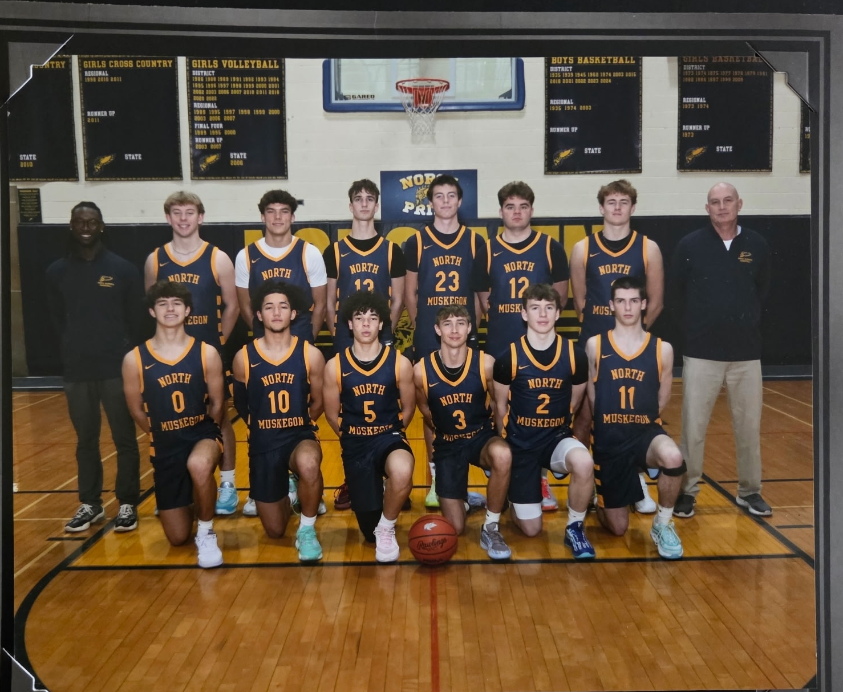

The NORSEMEN OF 2024–25

Bottom Row L-R:Bryce Colbert, Jaden Villapando, Brylen Burrel, Landen Grimm, Adam Dugener, Brody Frees
Top Row L-T: Coach Warren, Drew Bartos, TJ Byard, Marco Garcia, David Markiewicz, Lucas Dye, Chuck Meyers
Coach Charles Rypstra.

2025-26 (Coach Chuck Rypstra)

The Norsemen have now played nearly 2,000 games (1806 to be exact). The Norsemen’s 77-11 win over a hapless Holton team was the most one-sided in more than 90 years of NM basketball. It was the 17th straight win over Holton during this run with the average score a margin of 30 points - 64-34. One can only speculate what might the margin have been if not for a running clock and the quick emptying of his bench by coach Chuck Ryspstra. The highlight of the evening came in the third quarter when NM’s Adam Dugener scored a two-pointer, his 19th point of the game. The contest was halted at that time and NM’s veteran PA announcer Bill Marietti proclaimed that Dugener had just become the 7th Norsemen in history to score 1000 points in his career. The game was never in doubt as NM raced out to a startling 28-3 lead after eight minutes of action. The scoreboard showed the Norse on top an overwhelming 53-5 at halftime, forcing a running clock the rest of the way. Braylen Burrel quickly showed that he was able to make the quick transition from football to basketball as he scored 17 of his game high 23 points in the first quarter. Twelve Norsemen scored in the game as reserves played much of the game against their outmanned opponent.
The Norsemen ventured north on snow covered highways to the town of Benzonia to play a pair a contests in the tiny Northwest Michigan metropolis. Their first opponent in the weekend series hosted by Benzie Central High was against Charlevoix in the first meeting ever between the two schools. I recall broadcasting the state final at the turn of the century and our first game was a Charlevoix win over Detroit DePorres. Charleviox was the alma mater of one of my boyhood heroes Bob Carey, the last Michigan State Spartan to win nine letters. So talented was the 6’5 football All-American who would play in the NFL for the Los Angelas Rams, that Carey was also a starter on the MSU basketball team and a school record holder in the shot out.
Unfortunately for Charlevoix, this is not the 2001 Charlevoix state finalist team and certainly the Rayders did not have anything resembling a player like Carey. The Norsemen raced out to an astounding 20-2 lead after the first quarter enroute to a 54-17 whipping of the outmanned Northern Michigan five. The regulars hardly broke a sweat as coach Chuck Rypstra played his entire 15-man squad in a game that was played with a running clock as early as the 5:32 mark in the third quarter after the Norse had taken a 48-8 lead.
The 2025-26 NM team will feature one of best twosomes in the backcourt in their proud school’s history in Braylen Burrel and Adam Dugener. Playing about half of the game Burrel had 16 points, many of those markers coming on one of Dugener’s seven assists. Dugener had 13 points while 6’6 sophomore David Markiewicz had 12 points, 10 of his points coming in the opening quarter.
One would have to go back 82 years when the Norse would hold teams under 20 points in successive games. After holding Holton to 11 points two days earlier, the stifling NM defense held Charlevoix to but 17.
The Norsemen have surely enjoyed their past two trips to Benzie Central as again they swept their two opponents with both of their final victories coming against Division one opponents. After defeating Lapeer last year, the Norse defeated Walled Lake Western in 2025 64-44.
The Norse put their third straight win in the books with a near perfect fourth quarter when they outscored their foes from the Detroit suburb 22-7 in the final eight minutes to pull away for yet another double-digit victory.
Adam Dugener led the Norsemen with 25 points and he had pretty of help from his teammates. In seems that coach Chuck Rypstra was constantly pushing the right buttons as several of his reserves played important roles in the victory. When 6’6 sophomore David Markiewicz got in foul trouble he inserted Bronson Hurst and the NM baseball star in the spring came through with six valuable points. Teddy Lammiman hit both of his three-point attempts, Ameere Layton played a big floor game and hit a clutch three pointer when the game was tight in the third period. When coach Rypstra needed that spark and needed somebody who would fight for rebounds than who better to insert into the contest than NM’s brilliant football star Cullen Bartos. Just as he had a nose for the football in the Fall Bartos came through with four much-needed rebounds. After sitting out much of the game with foul trouble Markiewicz had s monster fourth quarter with four assists and as many rebounds while Braylen Burrel had another steady game with 10 points. The Norsemen took care of the ball as they had only six turnovers while the Norsemen --- err Adam Dugener had all six steals.
North Muskegon took care of business with a 67-47 defeat of Mason County Central in a game that was never in doubt on the Northside court. In a series that was once dominated by the Spartans, the tide has turned in recent years as NM, who once lost 38 of 39 games played between the two long time WMC rivals from 1981-2001, have now won 17 of the last 18 encounters between the two schools.
Only in the fourth quarter, when NM coach Chuck Rypstra was playing mostly his reserves, did the Spartans outscore the Norse. NM enjoyed a 61-35 lead over the outmanned northerners from Scottville entering the game’s final eight minutes before Mason County made the final score a little more respectable.
NM’s big three of seniors Adam Dugener (19) and Braylen Burrell (13) and 6’6 sophomore David Markiewicz (13) were in double figures for the Norse with coach Rypstra getting some great play from his bench, especially from junior guard Ameere Layton. Coming off the bench Layton led the Norsemen in assists with seven and steals with six.
The win now sets up an eagerly awaited contest for the Norsemen when they play at Whitehall next Tuesday, December 16. The two rivals have played 162 games since they first met 93 years ago but oddly enough this will be the first meeting since the 2021-22 season.
After playing Whitehall for 87 straight seasons from 1935 through 2022, the two longtime rivals finally met up once again after a mysterious scheduling snafu the past three seasons. It was the Norsemen who came out on top in the 163rd meeting between the two schools with their 54-41 win over the host Vikings.
The game was undecided until the start of the second half with the score knotted up at 25-25 at halftime. That quickly changed as Adam Dugener with a steal, made layup and free throw gave the Norsemen a three-point lead and they would pull away for a 13-point victory over the Vikings.
Coach Chuck Rypstra had to be pleased with NM’s balanced attack and their limited turnovers as they won their fifth straight game on the season. Braylen Burrel had 15 points, and no turnovers to lead NM with Dugener close behind with 14 markers as well as six game leading steals. Brody Frees had eight, David Markiewicz 7, and Bryce Colbert six points as NM committed but six turnovers in the contest.
The Norsemen will attempt to make it six wins in a row when they travel to Hesperia Thursday to take on a Panther team that hasn’t come within 30 points of the Norse in their last nine meetings.
A sparse crowd was on hand in Hesperia to watch their Panthers face the undefeated Norsemen. Perhaps the Hesperia faithful were concerned with their team incurring yet another blowout loss to the Norse. They were right. For the 10th consecutive game between the two teams, it was another 30 plus point lopsided win for NM as they downed Hesperia 74-28.
The game was never in doubt as NM raced out to a 21-10 lead after the first eight minutes were in the books. The 10 points would prove to be the most points scored in a quarter for the Panthers for the game. The quick hands of the Norse defenders had 14 steals in the first half alone, many of those steals turned into easy layups. NM poured in 31 points in the second quarter to take a 52-18 lead at halftime, just one point shy of ensuring a running clock in the second half. It took only one trip down the court to start the second half to force a running clock when Bryce Colbert rebounded his own missed shot and scored. However, it wasn’t until there was 3:40 left in the third quarter before the official signaled to the scorekeeper to keep the clock running. NM led 64-23 at the time and NM coach Chuck Rypstra had emptied his bench.Despite sitting out much of the final half NM’s pair of sensational backcourt players, Adam Dugner and Braylen Phillips had each scored 20 points. Ameere Layton continued his improved play with 11 points as 10 Norse players dented the scoring column.
The Norsemen will now head into the New Year with a perfect 7-0 record after yet another lopsided win, this time over long time WMC rival Oakridge 66-35. The Norse have now outscored their first seven opponents by an average score of 65-31 as Norse Head coach Chuck Rypstra has produced yet another Norse powerhouse.
The Norse let the large NM home crowd know that this game was never in question as NM bolted out to an early 15-2 lead over the outmanned Eagles. There was no letup in the second quarter as NM had increased their lead at halftime to 32-11 as the NM backcourt duo of seniors Braylan Burrel and Adam Dugener combined for 21 of the Norse total points. Oakridge did show a little life early in the third quarter as they opened the second half on a 7-0 run before the Norse got serious and rang up 20 points to Oakridge 16. Dugener led the barrage with 10 third quarter points with nine of those tallies coming on made 3-pointers.
The 22 points scored by Dugener now moves him up to 5th all time in Norsemen career scoring as he surpassed Cam Balash and is rapidly closing on 4th place. Sophomore David Markiewicz and Teddy Lamiman chipped in with 8 and 7 points respectively.
NM for the second straight season routed Montague 72-30 in the 191st meeting between the two rivals. Oddly enough, in the longtime series dating back to the 1932-33 season, whereby the Norse only hold a slim 97-94 advantage over the Wildcats, the last two games won by the Norsemen were the most lopsided in the very long series. The game was played in the massive new Montague gymnasium, a far cry from when your author played his first ever game against Montague at the Tannery in Whitehall back in 1956. The game was over quickly as the Norsemen had a 46-16 lead at halftime. Adam Dugener lit up the stat sheet once again for the undefeated Norsemen with 21 points, Seven assists, 5 steals and 5 rebounds in less than 20 minutes of action as once again NM coach Chuck Rypstra was able to empty his bench early. When the officials informed the clock operator in Montague to begin a running clock with about three minutes to play in the third quarter and the Norse leading 61-18, Rypstra pulled his starting five and was able to play his entire roster the rest of the contest. Braylen Burrell added 16 points while the Norse also got some outstanding play from Bryce Colbert, David Markiewicz and Ameere Layton who each tallied eight points.
The Norse continued their early season dominance with a rout of a visiting Manistee team
who traveled to North Muskegon with an impressive 7-2 record. The Norse won their 6th straight game against the visiting Chippewas /err Mariners and they won decisively 60-32. The offense for NM, but not their defense, got off to a rusty start following the Holiday break as NM led 22-10 after a low scoring first half. Adam Dugener, who was held to but two field goals in the first half, regained his shooting touch after halftime as he drilled four three-pointers in the third quarter to give NM a commanding 43-20 lead heading into the final quarter. Dugener finished with 18 points before exiting the contest with four minutes remaining as Norse coach Chuck Rypstra emptied his bench. Braylen Burrel was the other Norsemen in double figures with 11 points while Brody Frees came off the bench to chip in with eight. The chairman of the boards during the contest was 6’5 sophomore David Markiewicz who pulled down 14 rebounds as NM improves to a perfect 9-0 on the season.
The Norsemen stay perfect with their 10th win of the season as well as their 10th straight win over Shelby as they soundly defeated the Tigers 58-37 on the NM home court. The Norse had to rely on their defense as their three-point shots were not falling against the Tigers. The Norse would finish by making but 5 of 20 attempts behind the arc with four of those bombs coming in the second half after making but 1 of 9 in the first half. Only in the second quarter were the Tigers able to stay close with NM but thanks to a 18-8 first quarter blitz, NM led 32-22 at halftime. The potent NM trio of Adam Dugener (19), Braylen Burrel (17) and David Markiewiz (10) all were in double figures for the Norse. Bronson Hurst, who is improving each game, led all NM rebounders with seven while Dugener was the leading assist man with seven.
NM made program history when they defeated Ravenna 48-42, the first school that NM has defeated 100 times since their first game back in 1932. However, after soundly defeating all their previous ten opponents Ravenna made the Norse work hard to secure their 11th straight contest on the season. The Bulldogs held a 24-22 lead at halftime before NM broke out of their shell and turned the tide with a 14-4 scoring advantage in the third period. Adam Dugener paced the Norse with 21 points. The 6’0 senior guard has now scored 1192 points in his career and moved into fourth place all time in NM career scoring, passing TL McKenzie with his 1184 in his NM career. It was an off-shooting night for the Norsemen has they connected on but 5 of 18 three pointers.
The final score of NM’s 68-54 does not reflect how tight this game was in front of a large crowd at the Hart gymnasium. With 4:43 left in the game the Norsemen held a slim one-point lead at 52-51. Ignited by a driving layup by Adam Dugener the Norse ended the game with a 16-3 run to pull away from a Hart team that dropped only their second game of the season. The victory gives NM a nice foothold on winning yet another WMC championship in the Rivers Division with the two leaders in the Rivers set to face one another again down the road. Dugener led the Norsemen with 24 points with David Markiewicz and Bronson Hurst chipping in with 10 points each. The Norsemen move to a perfect 12-0 on the season but that streak will be severely challenged tomorrow when NM plays one of the top Division 2 teams in the state in Freeland. The game will be played at Fowler High School with the tip off slated at 4:40 PM.
The final score may read Freeland 75 North Muskegon but that does not at all reflect on how tight this game was for the first 28
minutes of play. With four minutes left in the game the Norsemen trailed by only one point at 57-58. Freeland, a highly rated team in division 2 than sealed the deal with a 10-0 run to pull away from the Norse and hand the blue and gold only their first setback of the season. Braylan Burrel was outstanding for NM with a career high 28 points while his sidekick in the backcourt Adam Dugener kicked in with 21 points and six assists. The duo accounted for 49 of the NM total but it wasn't to pull off the victory. David Markiewicz chipped in with six points and as many rebounds in a game that was played Saturday afternoon at a neutral site in Fowler.

One would have to travel back several years to find a matchup with more at stake at the Northside gym than Tuesday’s game between undefeated Ludington and once beaten North Muskegon. The Orioles were perfect on the season and highly rated in the state rankings in Division 2, while the Norsemen had dropped but one game, just three days earlier to a top ranked Freeland team. It was the Norsemen who came out on top with a hard-earned 64-53 triumph over Ludington behind yet another brilliant performance from guard Adam Degener. The Norse sharpshooter had a season high 32 points as the Orioles had no answer for the Alma College commit.
It appeared that NM was headed for a walkaway victory over the Orioles as they built up a second half lead that at one time stretched to 17 points. The Birds would not go away, however and stormed back in the games exciting final quarter to trail by only one point at 50-49 with still five minutes left in regulation. It was than Dugner’s time to shine and when the senior guard drilled a three-pointer with 4:20 left on the clock the Norse showed their mettle and kept their poise to hang on for the win. A big play in the game’s final minutes that help clinch the W was a basket by Bronson Hurst, who received a nifty pass from sophomore David Markiewicz that gave the Norsemen a comfortable seven-point bulge late in the game. Markiewicz was a monster on the boards for coach Chuck Rypstra’s Norsemen as he tallied nine points while dominating the boards with 13 rebounds. Braylen Burrel kept up his stellar play with 15 points as the NM trio of Dugener, Burrel and Markiewicz tallied all but seven of NM’s total points.

Even after the Norsemen had run off 11 consecutive victories to begin the 2025-26 season, the jury had to be still out as to how good this North Muskegon truly was after playing a less than stellar schedule. Those concerns by any skeptics can now be erased after head coach Chuck Rypstra’s Norsemen survived a gauntlet of playing four top-notch and highly rated teams by winning three of those four games, with three of those games played on the road. With many games in the state cancelled due to perilous driving conditions the Norsemen decided to brave the elements and travel to Grand Rapids to play a Covenant Christian squad that handed the Norse their only regular season loss the previous season. “The conditions were not great, but drivable,” said first year AD Cody Liverance. We ran into some whiteout conditions near Coopersville and never got above 50 mph on the highway, but we made it there and back in one piece.”
With a large crowd on hand on Covenant Christians home court, with only a few (probably fool-hearted) Norse fans in attendance, the Norsemen rose to the occasion and defeated a talented Division 2 Covenant team 70-64. The Norsemen not only got sensational play from their talented backcourt duo of Adam Dugener and Braylen Burrel, but NM received some excellent play from some vastly improving role players. Burrel and Dugener were once again spectacular. Burrel, for the second time in three games against division 2 opponents tallied a game high 28 points, connecting on six of his nine three-pointers while also adding four conventional two-pointers. Dugener’s 19 points doesn’t begin to portray his importance in this contest as he also had 10 assists while pulling down four rebounds. The cinch all-stater is earning a reputation as Mr. Buzzer Beater. After ending a pair of quarters in Tuesday’s game with long three-pointers with the buzzer going off, it was déjà vu against Covenant Christian. Dugener ended the first period, that at one point saw NM trailing 20-11 by making a 35-foot bomb but it was his buzzer beater in the third quarter that bordered on the spectacular. After a Burrel steal and a nifty pass Dugener put up a soft underhand floater while in full speed that softly nestled through the net to give NM a 56-50 lead heading into the final period. It was in the fourth quarter when coach Rypstra’s role players stepped up in a big way. Heading into the deciding period Burrel and Dugener had combined for 46 points, but the duo only made 1 of the final 14 points tallied by the victors. Sophomore Teddy Lamiman, (who had 10 points) thanks to pinpoint passes from Dugener, nailed a couple of layups. Bryce Colbert hit a big three-pointer from the corner and a free throw; Sophomore David Markiewicz added four points and Brody Frees made a free throw as NM held off the hosts. The Norse put on a clinic in the game’s final moments with some outstanding ball handling and passes that kept offensive possessions from Covenant. The victory improves NM’s record to 14-1 but will have little time to celebrate as they have a Saturday afternoon game against a long-time antagonist in the Warriors of West Michigan Christian.
The Norsemen completed a 3-game gauntlet vs. some very good competition with a win over a traditional basketball powerhouse with their 53-46 win over West Michigan Christian. With the temperature hovering around zero outside the action was much warmer inside the cozy confines of the ageless North Muskegon gymnasium as the large gathering of fans, with many still wearing their heavy overcoats witnessed a close contest. A pesky and fundamentally sound Warrior team employed a tight man to man defense that gave the Norsemen concerns throughout the contest. The Warriors stunned the favored Norsemen by taking a 12-7 lead after the first stop with the only NM points coming on a pair of three pointers by Adam Dugener and a free throw from David Markiewicz. The Norse kept their poise, tightened up their own defense and outscored the visitors 17=9 in the second period to take a 24-21 lead at halftime. The Norse upped their margin to 40-31 at the end of the third quarter with the Norsemen’s final three points coming on a miraculous buzzer beater from beyond midcourt by Ameere Layton. The closest WMC would come in the final quarter was at 50-44 but some good NM ball handling and passing in the game’s final moments was good enough to hold off the Warriors as the Norsemen improve to an astounding 15-1 on the season. In a series that was once dominated by West Michigan Christian, the Norsemen have now won seven straight games against a Warrior program that has numerous state championship trophies in their bulging trophy case. Leading the way in the low-scoring contest for NM were Braylen Burrell (16) and Adam Dugener with 15 points. There was one stat that must pose some concern for the Norsemen as they were only able to procure one offensive rebound the entire game.
Following contests against six tough opponents the Norsemen found a weak opponent, and weak just might be an understatement as the Norsemen demolished a hapless Holton team 70-16. In my years of following NM basketball, (since 1946) I can’t recall a NM team leading an opponent 60-7 at halftime. With a running clock for the entire second half and NM coach Chuck Rypstra having long emptied his bench it didn’t get any better for the host Red Devils as they went scoreless in the third period. Scarcely breaking a sweat, the NM backcourt duo of Braylen Burrel and Adam Dugener led the way with 22 and 17 points respectively. Burrel attempted six three-pointers in the first half and made all six before joining his backcourt buddy on the bench for about half of the game. Dugener made it easy for Burrel as he had eight assists along with three steals as NM improves to 16-1 on the season. So dominant have the Norsemen been against Holton that they outscored the Red Devils 147-27 in the two regular season games this season. When the dust had cleared and stats were tabulated, the Norsemen’s 15 made 3-pointers in the game were a new NM record, breaking the record of 14 made against Whitehall in 2019.
Fans attending many NM games this year might feel they’re not getting a ‘bang for their buck.’ Once again, a lopsided Norse victory was shortened because of a running clock for the second half in another 67-26 blowout win over Hesperia. NM regulars played but three minutes into the second half before coach Chuck Rypstra emptied his bench with the Norsemen leading by 50 points. Once thing that this old time Norse fan has noticed is this year’s NM team does not use the school issued Chuck Taylor Converse shoes that we used back in the 1950s. Among the shoes I observed were the red (or was it pink shoes) worn by Adam Dugener; gold shoes adorned by center David Markiewicz; sharp shooting guard Barlen Burrel had blue shoes and reserve Ameere Leyton beat them all with two-tone shoes. One player (Kandaro Houston) would have made Floridians proud as his shoes were a bright orange. My --- how times have changed. Back to the game ---- This game was no contest as the 18-1 Norsemen led 46-10 at halftime. Playing less than half the game Adam Dugener had 22 points and his backcourt teammate Braylen Burrel had 19 before finding a seat on the bench for much of the game. The Norse 8-man rotation during their time on the court committed but one turnover while coming up with 16 steals. One thing that is apparent with coach Rypstra’s team is that they always keep their foot on the gas, especially on the defensive end with their relentless pressure. Hesperia’s veteran coach, who may have been coaching when your author played for NM in the 1950’s, surely didn’t adding any years to his lifetime with yet another blowout loss to the Norsemen. The Panthers can take some solace as they outscored NM 9-6 in the third quarter as the NM coach went far down the bench to get players into the contest.
The Norsemen rolled to yet another win against West Michigan Conference foes with their 70-48 victory over Mason County Central. It was the 51st straight victory in a row against WMC opponents, an incredible streak that shows no signs of being broken. After the host Spartans took a very early 6-5 lead, a David Markiewicz basket gave the Norse the lead and they never looked back to earn their 18th win on the season against but one setback. Adam Dugneer was again brilliant in the NM victory. So efficient was the NM senior that he was perfect on all 8 of his two pointers taken while canning three of his five three-pointers and making his only free throw. Dugener has been renown for hitting long buzzer-beater shots at the end of each quarter but the show he made with the horn sounding at the end of the 3rd quarter while his shot was in the air took on an extra special meaning. It was the 1366th point in his NM career and put him in third place in NM history in career scoring as he passed former Norseman Lee Kakaty who now moves down to 4th in NM annals. Dugener also added six assist and five rebounds while his backcourt mate Braylen Burrel tallied 17 points. Reserve guard Ameere Layton came off the bench to add six points while coming up with five rebounds, all offensive rebounds, and adding three assists.
Unlike their first contest when the Norse connected on but 5 of 20 three-point attempts, this was not the case in the second contest with Shelby as NM drilled 13 of 22 shots beyond the arc enroute to a smashing 70-33 victory. The Norse were near perfect in the first quarter as they made 8 of 10 three pointers in the opening quarter to take a commanding 28-12 lead over the Tigers. NM widened the gap to 45-17 by halftime and after Adam Dugener potted a three pointer with only a couple of minutes played in the third quarter, veteran Shelby coach Rick Zoulek called a time out, and when he looked at the scoreboard at Shelbys large, but nearly empty gym, he was staring at a 55-19 deficit. With a running clock and still 2:11 to be played in the third quarter NM coach Chuck Rypstra began emptying his bench. Playing less than three quarters the NM backcourt duo of Dugener (24) and Braylan Burrel (20) had accounted for 44 of NM’s 63 points while Shelby had but 24. The win was the 19th of the season for the Norsemen who seem to get better as the season progresses. One stat that personifies this NM team is their deadly three-point shooting. As a team the Norse are shooting at 42% from beyond the arc with Dugener leading the way with a ridiculous 53% on 68 of 128 attempts. Bryan Burrel has netted 54 of 120 shots while Teddy Lamiman has come off the bench to connect on better than half of his 41 attempts.
For the first time in many years, the Norsemen played a game without their Mr. Basketball candidate, Adam Dugener. Sidelined due to an illness and playing a team who earlier in the season came within six points of defeating NM, the Norse still prevailed and won by a bigger margin than their first encounter with a 58-42 victory over Ravenna. The Norse were never in trouble of dropping their first WMC game in 52 contests as they bolted to an early 16-8 lead that expanded even more by halftime as the Norse had a commanding 33-17 lead. After the Norse led by nearly 20 points, only in the fourth quarter did the visiting Bulldogs outpoint the Norse, but only by a slim 15-12 margin. The win now sets up a regular season finale that will surely fill the NM gym to capacity when they play Hart and a chance to clinch he outright WMC championship. Not since the early 1950s as a game between Hart and North Muskegon had a bearing on the WMC championship. Your author vividly remembers the hardship the Pirates of the late 1940s and early 1950s put on the Norsemen. From 1948 until 1954, the Pirates won 13 of 14 games played between the longtime rivals, with many of those contests determining the WMC champions. The only Norse victory during that span came in 1951 when the Norse edged the Pirates 35-32 with my long ago NM idol Bill Duplissis scoring 20 of the Norsemen’s points. It wasn’t until 1954 would the Norsemen again prevail over their nemesis with big Walt Busker scoring a school record at the time 30 points to lead NM to an 84-69 victory over Hart. Coach Chuck Rypstra’s Norsemen have now won 20 or more games for the third consecutive year and are an astounding 67-4 over that span. With a healthy Adam Dugener expected back in the lineup for Friday’s big game, the Norse are confident of coming out on top.
The now ancient North Muskegon gym, that dates back nearly 70 years to December of 1957, has seen some great performances. One would have to go back to the Drew Naymick era to witness an individual performance that NM’s sensational senior guard Adam Dugener gave the Norse fans in their 73-56 victory over a very good Hart team.
Despite missing a game and time off from school due to an illness during the week, Dugener put on a show for the ages as NM closes out the regular season with their third straight WMC Rivers championship and 53rd win in a row over WMC opponents. Ironically it was Hart, who are now 2-35 vs. the Norse since 2008, who handed NM their last defeat in the WMC. The Alma College commit, who saves his best when NM plays their toughest opponents, tallied 37 points, that included a buzzer beater for the ages that nearly brought the roof down from the packed house at NMHS. With time running down in the third quarter and NM leading 53-44, Dugener snared a rebound and drained a shot from 75 feet out that took the starch out of any hopes for a Pirate victory.
“You looked and they all just went (gesturing head and shoulders slumping)” said NM coach Chuck Rypstra of the Hart players following the contest. Dugener made seven three-pointers enroute to his 37 points, many of them from NBA range. For the season Adam has connected on an amazing 75 of 138 attempts for an insanely good 54%.
NM defeated a Hart team that has dropped only three games all season, two of those to the Norsemen. This might be the strongest Hart team since the heyday of 1943 that featured a pair of 6’6 stars, Stan Kapulak and Walter ‘Stretch’ Hansen. It took a 24-point third period for the Norsemen to put away Hart as the Pirates had enjoyed a 35-32 lead at halftime.
Dugener’s backcourt mate Braylen Burrel added 15 points, with nine of those tallies coming in the early part of the pivotal third quarter. Coach Rypstra also received strong performances from 6’5 sophomore center David Markiewicz who had a team high seven rebounds and four assists. All-State football star Bryce Colbert had seven points while 6’1 sophomore Teddy Lamiman continues his steady play coming off the bench to score five points and a like number of rebounds.
NM, due to a quirk in their schedule will have next week off before embarking on what they hope to be a long playoff run when the MHSAA tournament begins the week of Feb 23-28.
NM got off offensively to a slow start but that changed in a hurry in a 78-48 rout of Shelby in the district tournament played in Scottville. After scoring 16 first quarter points, the Norsemen began the second quarter with an 11-0 run and would score 55 points over the nest 16 minutes of action to force a running clock for the game’s final quarter. NM scored a blazing 34 points in the third quarter even though Adam Dugner scored only three of those 34 markers. But don’t be misled as it was Dugener who was the catalyst behind the big run. The senior phenom had what surely was a NM record in the quarter as he had nine of his game high 14 assists, just one off the unofficial school record. If not for a running clock and subs playing nearly all the final quarter surely Dugener would have passed the reported record of 15. Dugener was content to take but one shot in the period (and naturally he made his only shot: a 3-ponter). Taking full advantage of Dugener’s pinpoint passing and unselfish play were his teammates Braylen Burrel and David Markiewicz. Burrel had 15 of his game high 23 points in the quarter while Markiewicz had eight of his seasons high 16 points during that span. Markiewicz was a perfect 8-8 from the field while his sophomore buddy Teddy Lamiman, who continues to get better every game had eight points. Despite taking only 10 shots, Dugener still tallied 17 points. The victory was the 22nd of the season against but one defeat, a close loss to the state’s number two ranked team in Division 2 Freeland. The Norsemen will return to Scottville Friday night to play a familiar playoff foe West Michigan Christian for the district title. The two teams met early in the year, and the Warriors gave the Norse a challenge as they only lost 53-46.
North Muskegon’s season game to a crashing end as they were stunned by an old playoff nemesis to deny the Norsemen their sixths straight district championship. West Michigan Christian, who had one point in time had eliminated NM from the playoffs 12 consecutive times worked their magic once again to end the Norsemen’s season at 22-2 with a 49-43 upset win. The Warriors came into the game with confidence as they lost to NM by only seven points midway through the season. WMC played patiently against the NM zone defense that created some easy baskets near the rim. Even more impressive was their switching man-to-man defense that denied Norse sharpshooters easy looks at the basket. NM was well below their season average of better than 40 percent on 3-pointers but much of the credit goes to the Warriors defense. After the first half ended with the score knotted up at 20-20, the Warriors scored early into the second half to take a 24-22 lead and never trailed the rest of the game. WMC at one time enjoyed an eight-point lead over the Norsemen before NM made a modest rally. A Teddy Lamiman 3-pointer with four minutes left in the contest drew NM within two points of Christian but that would be the closest the frustrated Norsemen would come until the final buzzer. Leading the Norsemen in scoring was Adam Dugener with 19 points, the only Norsemen in double figures.

N Muskegon 77 Holton 11 Adam Dugener 19 (1000 points), Braylen Burrel 23
N Muskegon 54 Charlevoix 17 Dugener 13, Braylen Burrel, 16 David Markiewicz 12
N Muskegon 64 Walled Lake Western 44 Dugener 25 Burrel 10
N Muskegon 67 Mason Co Central 47 Dugerner 19, Markiewicz & Burrel 13
N Muskegon 54 Whitehall 41 Burrel 15, Dugener 14
N Muskegon 74 Hesperia 58 Dugener & Burrel 20, Ameere Layton 11
N Muskegon 66 Oakridge 35 Dugener 22, Burrel 11, Markiewicz 8, Teddy Lamiman 7
N Muskegon 72, Montague 30 Dugener 21, Burel 16, Markiewicz, Bruce Colbert, Layton 8
N Muskegon 60 Manistee 32 Dugerner 18, Burrel 11, Markiewicz 14 rebounds
N Muskegon 58 Shelby 37 Dugener 19, Burrel 17, Markiewicz 10, Bronson Hurst 7 reb.
N Muskegon 48 Ravenna 42 Dugener 21, NM winns for 100th time vs Ravenn
N Muskegon 68 Hart 46 Dugener 24, Markiewicz & Bronson Hurst 10
N Muskegon 63 Freeland 75 Bureel 28, Dugener 21
N Muskegon 63 Ludington 54 Dugener 32, Burrel 15
N Muskegon 70 GR Covenant 64 Burrel 28, Dugener 19, Lamiman 10
N Muskegon 53 WMC 46 Burell 16, Dugener 15
N Muskegon 70 Holton 16 Burrel 22, Dugener 17 & 8 assists.
N Muskegon 67 Hesperia 26 Dugener, 22, Burrel 19
N Muskegon 70 Mason Co Central 48 Dugener 26, Burrel 17
N Muskegon 73 Shelby 33 Dugener 24, Burrel 20
N Muskegon 58 Ravenna 42 Burrel 18, Markiewicz 13
N Muskegon 73 Hart 56 Dugener 37, Burrel 15
N Muskegon 78 Shelby 38 Burrel 23, Dugener 17 & 14 assists, Markiewicz 16
N Muskegon 43 WMC 49 Dugnener 19, Markiewicz 9

