Floor | Still Rings | Mushroom and Vault | Parallel Bars  and High Bar | Tumbl Trak | Strength  and Flexibility
Scale, hold for 5 seconds | Chin hold for 5 seconds | Straddle support for 10 seconds | Crab walk back and forth | Safe Landing Position (SLP) | Tucked hollow, hold 30 seconds
Candlestick, roll up, jump | Hanging tuck, hold | Reverse plank for 10 seconds | Support hold for 20 seconds | Straight jumps w/ arm circles | Table position for 30 seconds
Tuck jump, stick | Turn rings out and in 5 times | ¼ hops around the mushroom | Straddle travel on p-bars | Straight jumps backwards | Push-up position for 30 seconds
Jump backward, up on to mat | 10 arch rocks | Circle walk around | Safety dismount: 2 hands to 1 bar | Tuck jumps | Bridge for 5 seconds
Lunge hold,  ¾ handstand | 3 swings, straight arms | Half circle, walk around | 3 support swings | Straddle jumps | Pike, touch toes with straight legs
Headstand, hold | Inverted arch, hold 3 seconds | Vault  Skips, knees up | High Bar  3 Casts | 3 Donkey kicks | Straddle, elbows down to floor
Forward roll | Inverted pike, hold 3 seconds | Accelerated run on toes | 3 glide swings with re-grip | Full turn (arms out, then up) | 5 Push-Ups
Backward roll, down mat | German hang, hold 3 seconds | Bounce back on springboard | Long hang travel | Combination of jumps | 10 Lemon Squeezes
“Spider-Man” Handstand | German hang, pull back up | Run, tuck jump on to resi mat | Hanging pike for 5 seconds | Seat Drop | 2 pull-ups/  chin-ups
Cartwheel | German hang, let go, stick | Straight jump on to 8” mat, stick | Pullover | Straight jump, stick the landing | Climb half way up the rope
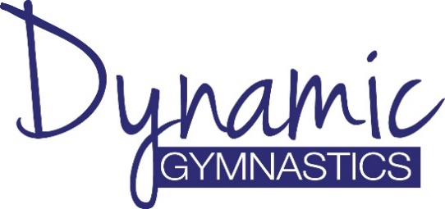
Boys Beginner Sticker Chart
Gymnast: ______________________
Day: _________ Time: ___________

