Livestock Rollover Crash in Utah
November 22, 2017
I84 & I15 Interchange Near Ogden Utah

The crash happened on the morning of the 22nd of November in good weather conditions and on dry pavement. The semitruck hauling cattle was southbound on I15 and took the righthand exit ramp to connect to I84 eastbound. The trailer of the semitruck rolled over to the right onto the concrete guard rail which resulted in a rupture to the right side of the trailer. Some of the cattle were discharged through the rupture and fell from the overpass to the surface of I15 below. Approximately 25 head of cattle were killed by the fall. One passing vehicle was hit by a falling cow but fortunately no one in the vehicle was seriously injured or killed.
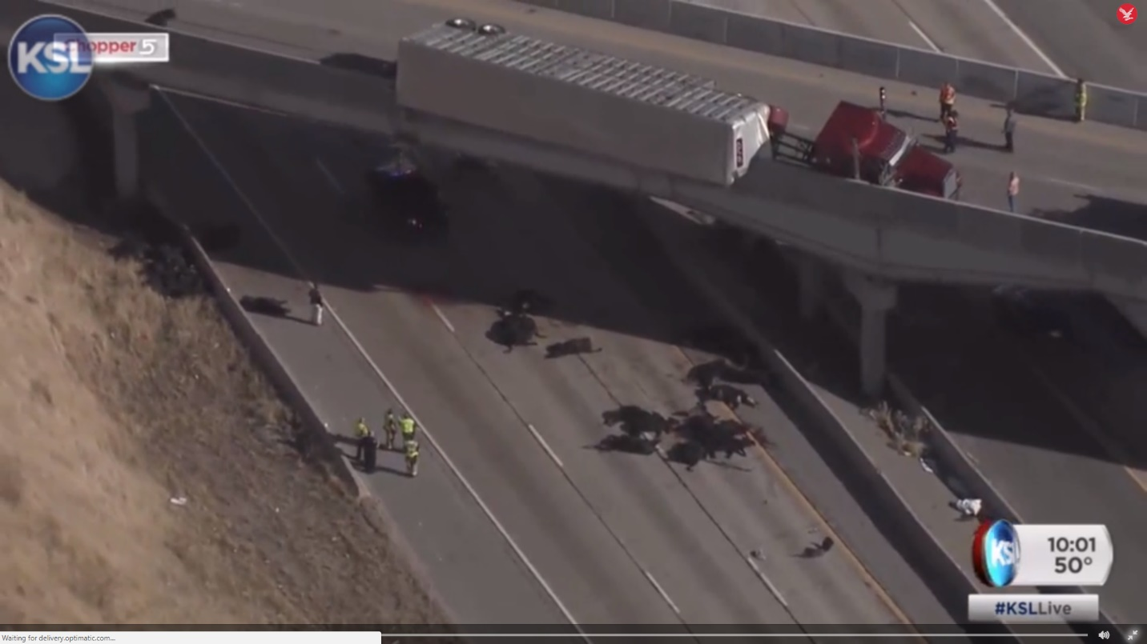
The trooper that responded to the scene stated that the semitruck was speeding and that caused the rollover. While it is apparent that the semi driver was driving too fast for the load that was being carried it does not necessarily follow that the semitruck was speeding. The news articles indicated that the posted speed for the connector ramp is 45 mph. From an analysis of the geometry of the ramp coupled with the unstable nature of a load with a high center of gravity, it is likely that the rollover would have occurred even at speeds below the posted speed.

Ramp Geometry:
This is an aerial view of the crash site.
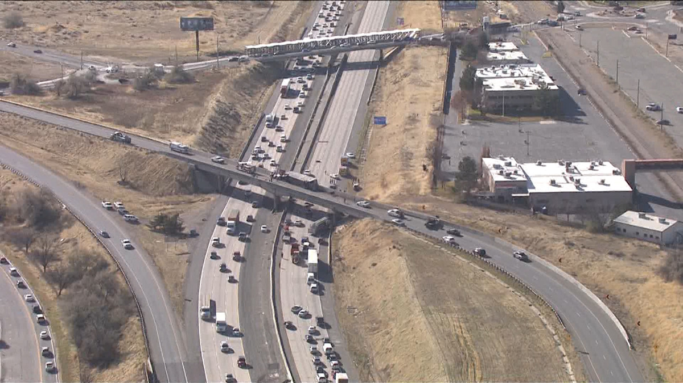
From this view it is easy to see that driving conditions were favorable at the time of the crash – dry road surface and no visibility impairments. The radius of the curve approaching the flyover was extracted from aerial imagery on Google Earth and is approximately 740 ft. The radius of curvature is an important factor since the side force on the vehicle is related to the speed of the vehicle and the curvature.

Vehicle Dynamics:
Another critical factor in determining the propensity of a vehicle to roll over is the height, above the road surface, of the center of gravity of the trailer. A typical livestock trailer has two decks with livestock loaded in each deck. If the number of animals is the same in both levels and if the total weight on both levels is about equal, a calculation of the height of the center of gravity would yield a result of about 105 to 110 inches above the road surface. This is puts the center of gravity among the highest in loads carried by a semitruck.
A typical livestock trailer is shown below to illustrate the estimate of the height of the center of gravity:
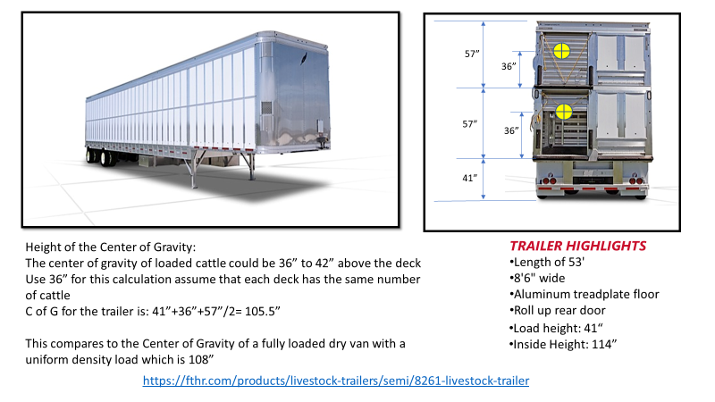
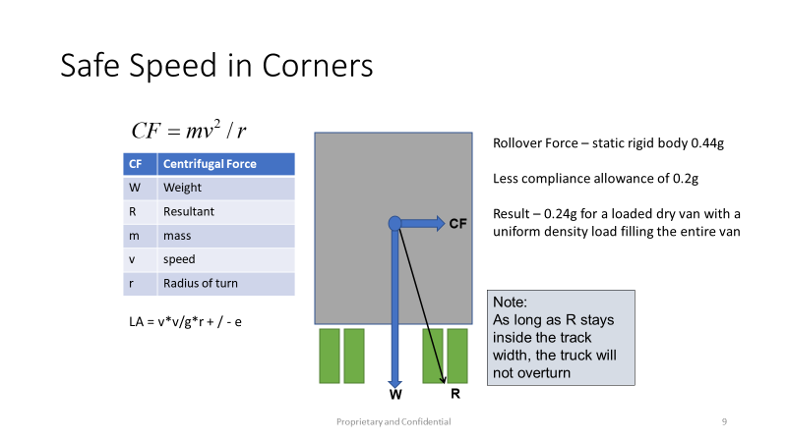
A review of the literature and published test results for the rollover threshold of a fully loaded dry van suggests that 0.44g is sufficient side force to roll a semi-trailer with a uniform density load. The literature also suggests that the side force needs to be reduced by 0.2g to allow for compliance in the trailer which includes tire compression, spring compression, twist in the trailer frame and lash in the fifth wheel. Thus, a stable load could rollover with a side force as low as 0.24g.

Unstable Loads:
It has been noted that the rate of “driver at fault” single vehicle crashes for livestock carriers (85%) is more than 3 times higher than the average for the total trucking industry (25%). Previous articles have suggested that driver fatigue may be one of the causal factors. However, this analysis suggests that vehicle dynamics which couple a high center of gravity with a load that can sway, or slosh is also a major contributor.
In the case of a load that can slosh or sway to the outside of the curve, the literature suggests that the rollover side force be reduced by another 0.1g which results in a potential rollover with a side force as low as 0.14g.
Conclusion:
Using the max side load as 0.14g and a radius of the curve at 740 ft., the calculated roll over threshold speed is 39 mph. Thus, the driver could have been driving at or below the posted speed and still have rolled over.
Drivers of high center of gravity loads and particularly loads that can slosh or sway need to slow down on ramps, connectors and curves. Truck drivers need to remember that posted speeds and curve advisory speeds are calculated for passenger vehicles and are too fast for a loaded truck. A good rule of thumb is to take the curve or ramp at half of the advisory speed.
Road-Aware Safety Systems LLC will soon offer a product that will calculate precise safe speeds for upcoming road geometries and feed them to the driver in the form of alerts and recommended safe speeds. In this case the calculated rollover threshold speed would have been 39 mph and the recommended safe speed for the driver would have been given as 27 mph.
References:
- High rate of driver at fault livestock crashes – James Menzies, Feb 1, 2008 https://www.trucknews.com/features/exploring-the-causes-of-livestock-trucking-accidents/
- Rollover of Heavy Commercial Vehicles study – UMTRI Oct-Dec 2000 Chris Winkler
- Analysis of Large Truck Rollover Crashes, A. James McKnight, Ph.D. and George T. Bahouth, D.Sc.
- Images and story courtesy of KSL https://www.ksl.com/?sid=46203442&nid=148

