CLARIFING YOUR VALUES

Deep down inside, what is important to you? What do you want your life to stand for? What sort of qualities do you want to cultivate as a person? How do you want to be in your relationships with others? Values are our heart's deepest desires for the way we want to interact with and relate to the world, other people, and ourselves. They are leading principles that can guide us and motivate us as we move through life.

Values reflect what you want to do, and how you want to do it. They are about how you want to behave towards your friends, your family, yourself, your environment, your work, etc. Values are not the same as goals. Values involve ongoing action; they are like directions we keep moving in, whereas goals are what we want to achieve along the way. A value is like heading West; a goal is like the river or mountain or valley we aim to cross while traveling in that direction. Goals can be achieved or ‘crossed off’, whereas values are ongoing. (No matter how far West you go, you never reach it!) For example, if you want to be a loving, caring, supportive partner, that is a value: it involves ongoing action. In contrast, if you want to get married, that’s a goal - it can be ‘crossed off’ or achieved. If you want a better job, that’s a goal. Once you’ve got it - goal achieved. But if you want to fully apply yourself at work, contribute your best, and engage fully in what you’re doing, that’s a value: it involves ongoing action.

THE BULL’S EYE
The ‘Bull’s Eye’ is a values-clarification exercise. The dartboard on the last page is divided into four important domains of life: work/education, leisure, relationships and personal growth/health. To begin with, please write down your values in these 4 areas of life. Not everyone has the same values, and this is not a test to see whether you have the "correct" ones. Think in terms of general life directions, rather than in terms of specific goals. There may be values that overlap – e.g. if you value studying psychology, that may come under both Education and Personal Growth. Write down what you would value if there were nothing in your way, nothing stopping you. What’s important? What do you care about? And what you would like to work towards? Your value should not be a specific goal but instead reflect a way you would like to live your life over time. For example, to accompany your son to a football game might be a goal; to be an involved and interested parent might be the underlying value.

** Note! Make sure they are your values, not anyone else’s. It is your personal values that are important! ***

1. Work/Education: refers to your workplace & career, education and knowledge, skills development. (This may include volunteering and other forms of unpaid work). How do you want to be towards your clients, customers, colleagues, employees, fellow workers? What personal qualities do you want to bring to your work? What skills do you want to develop?

2. Relationships: refers to intimacy, closeness, friendship and bonding in your life: it includes relationships with your partner, children, parents, relatives, friends, co-workers, and other social contacts. What sort of relationships do you want to build? How do you want to be in these relationships? What personal qualities do you want to develop?

3. Personal Growth/Health: refers to your ongoing development as a human being. This may include include: organized religion, personal expressions of spirituality, creativity, developing life skills, meditation, yoga, getting out into nature; exercise, nutrition, and addressing health risk factors like smoking.

4. Leisure: refers to how you play, relax, stimulate, or enjoy yourself; your hobbies or other activities for rest, recreation, fun and creativity.

THE BULL’S EYE:

Read through your values, then make an X in each area of the dart board, to represent where you stand today. An X in the Bull’s Eye (the centre of the board) means that you are living fully by your values in that area of life. An X far from Bull’s Eye means that you are way off the mark in terms of living by your values.

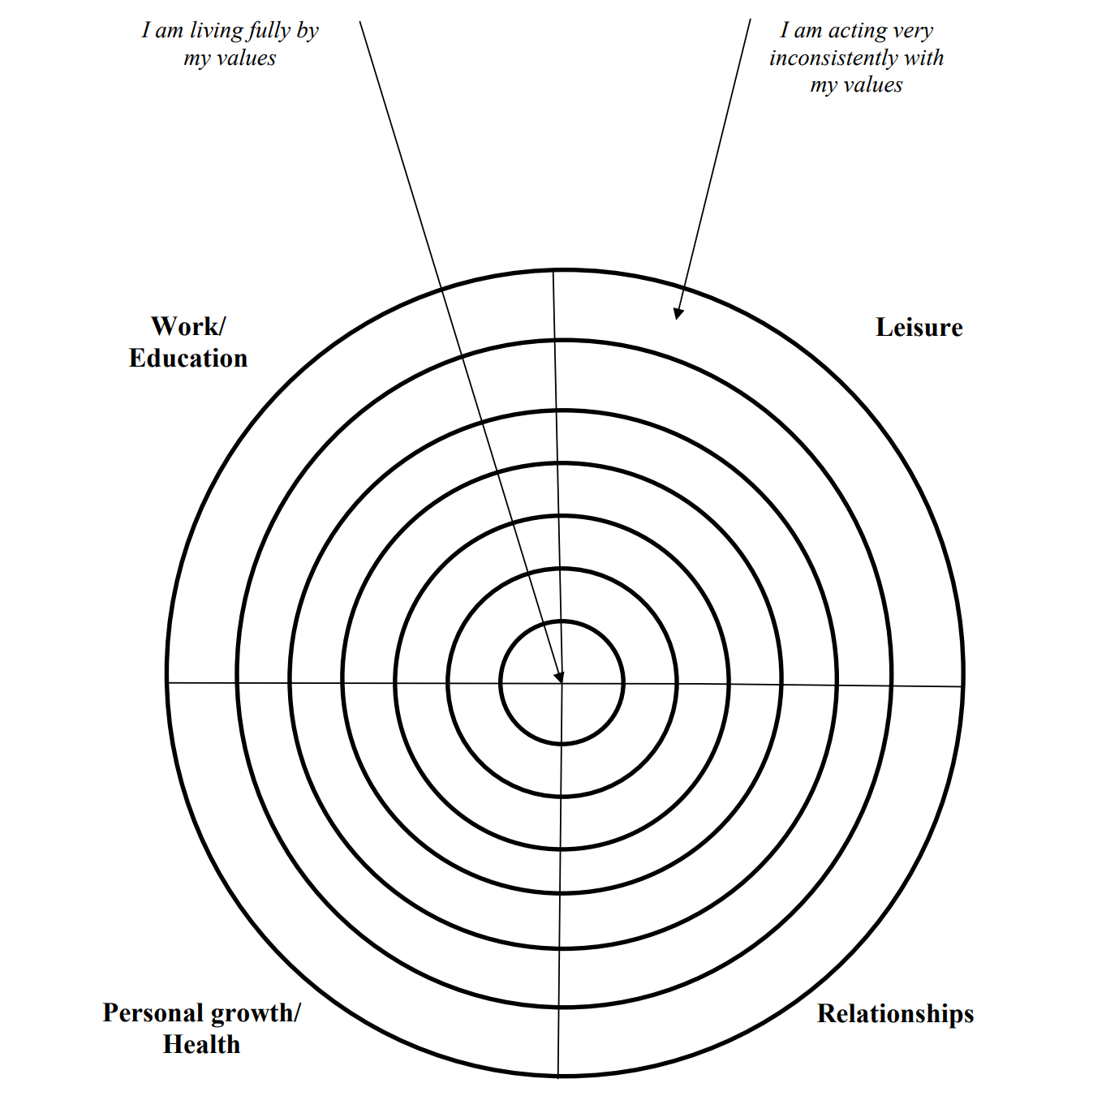
Since there are four areas of valued living, you should mark four Xs on the dart board.

