Emotions

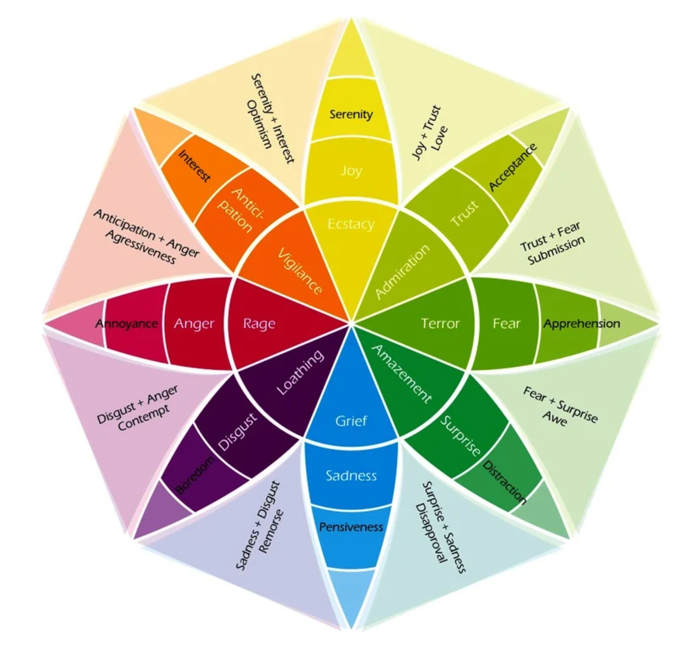

Here is a short here is a short list of emotions and our responses:

- Happiness
  - a pleasant state of joy, contentment, satisfaction., and overall wellbeing
  - we respond with facial experiences like smiling or maybe laughing and a relaxed body stance/demure
- Sadness
  - state of grief, hopelessness, sorrow
  - we respond by crying, staying quiet, or withdrawing from people/isolating ourselves
- Disgust
  - mainly a reaction to something that is bad or evil—can be something that is as simple as rotten food to as extreme as a dead body
  - we respond by turning away, vomiting, wrinkling our nose
- Anger
  - a powerful emotion that can also play a part in your fight or flight response
  - we respond with frowning, glaring, a change in the tone of voice, turning red, sweating, or aggressively lashing out

Here is a long list of emotions you might be feeling, including core emotions and secondary emotions and tertiary emotions:

Happiness
Pride
Excitement
Peace
Satisfaction
Acceptance
Affection
Joy
Compassion
Adoration
Desire
Grateful
Love
Humble
Contentment
Empathetic
Amusement
Appreciative
Confident
Optimistic
Cheerful
Carefree
Sweet
Kind
Loyal
Lust
Gladsomeness
Goofy
Inspired
Enchanted
Funny
Friendly
Calm
Sensual
Awe
Warm
Romantic
Aware
Comfortable
Free
Courageous
Hopeful
Fascinated
Tender
Proud
Relief
Eager
Sexy
Understanding
Patient
Surprised
Craving
Wonder
Amazed
Sentimental
Focused
Determined
Fearful
Grieved
Distracted
Baffled
Needy
Lost
Self-pity
Pessimistic
Hysteria
Withdrawal
Worried
Doubtful
Frazzled
Sorrow
Curious
Guilt
Apologetic
Horrified
Overwhelmed
Nervous
Anxious
Terrified
Cautious
Panicked
Alienated
Challenged
Jealous
Fraud (feeling like a)
Stressed
Agony
Umpty
Shock
Desperate
Confused
Alone
Tense
Curious
Suspicious
Paranoid
Reluctant
Skeptical
Sulkiness
Horror
Sadness
Unhappy
Emptiness
Misery
Aching
Insecure
Apathetic
Defeated
Pity
Submissive
Lonely
Melancholy
Heartbroken
Depressed
Worn out
Glum
Cowardly
Gloomy
Hurting
Disappointed
Tired
Lovesick
Left out
Resigned
Miserable
Shy
Vulnerable
Yearning
Nostalgia
Remorse
Pensive
Protective
Dismay
Distress
Wanderlust
Anger
Annoyed
Bitter
Frustrated
Dislike
Spite
Uncomfortable
Offended
Bitter
Infuriated
Rage
Cheated
Vengeful
Impatient
Disgust
Animosity
Insulted
Cold
Envy
Uneasy
Loathe
Hopeless
Troubled
Embarrassed
Boredom
Wrath
Disapproval
Craving
Outrage
Awkward
Hatred
Resentment
Lazy
Mean
Hatred
Cranky
Aggressive
Horror
Vigilant
Pity
Cruel
Resentful
Disgust
Delirious
Denial
Obsessed
Defensive
Destructive

