Interrupting the Anxiety/Worrying Loop
• Literally say “stop” either out loud or inside your mind to yourself.
• Visualize “stop”, a stop sign or a red light.
• Use a physical reminder – elastic band on your wrist, “worry” rock in your pocket.

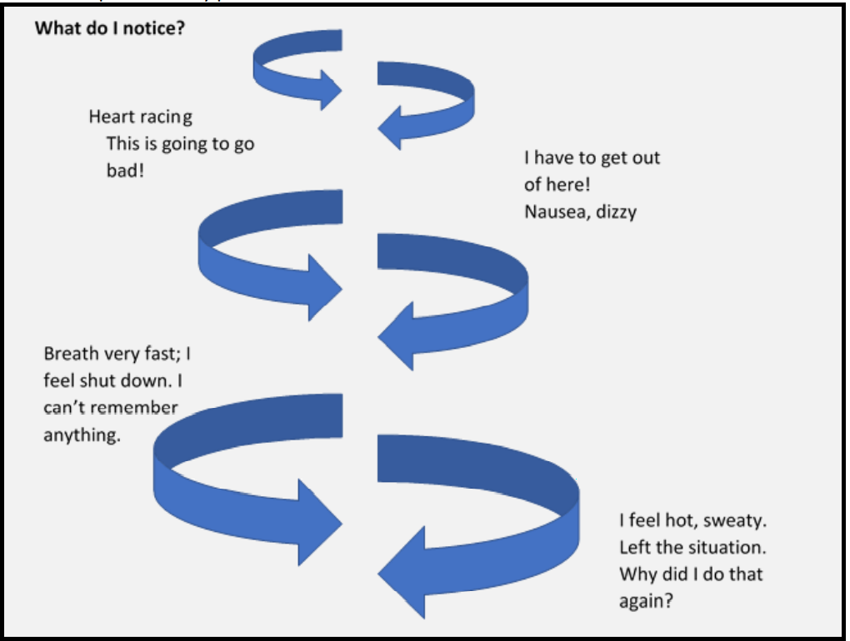
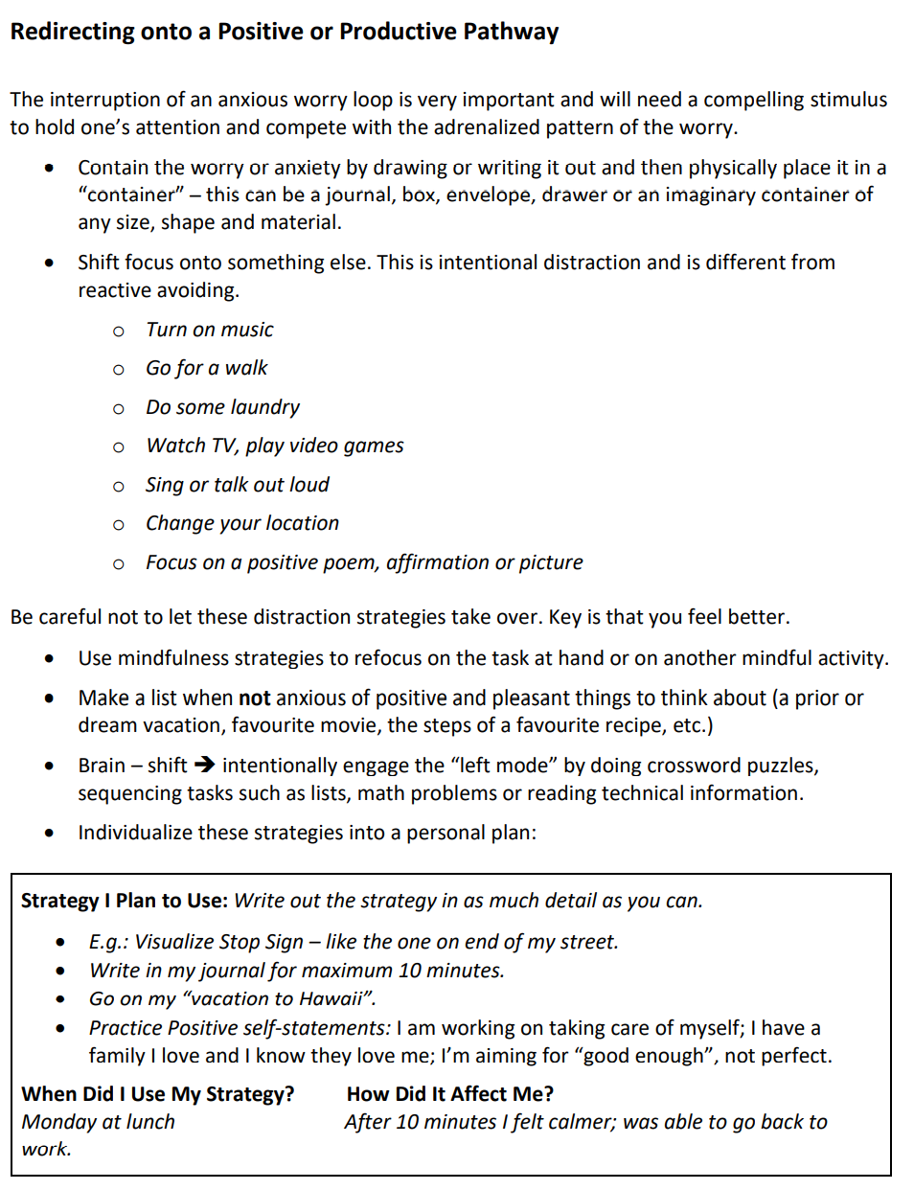
Monitor the new strategies you are trying.
Strategy I am trying | When did I try it? | How did it affect my day? | General level of distress (0-10)

