Self-Regulation Techniques

Acupressure Breathing
- Locate the muscle between your thumb and index finger.
- Firmly and slowly massage the muscle with the thumb and index finger of your other hand.
- Massage and breathe in rhythm.
- Practice by cueing up a memory of a recent disturbance, then shift to using the acupressure breathing.
- Tap in any positive sensations that you experience.
- Extend, i.e., rescript and rehearse.

Belly Breathing
- Stand, sit, or lie down comfortably in a quiet place.
- Close your eyes and loosen any tense muscles. Make sure to relax your shoulders.
- Place one hand on your upper chest and the other on your belly button.
- Breathe in slowly through your stomach, letting it expand like blowing up a balloon. Your chest should remain still.
- Breathe out slowly through your mouth. Feel your stomach move back.
- Repeat this several times, gradually increasing the time you take to breathe in and out.
- Practice by cueing up a memory of a recent disturbance then shift to the belly breathing.
- Tap in any positive sensations that you experiences.
- Extend, i.e., rescript and rehearse.

Butterfly Hug Breathing
- Cross your arms at the wrists, interlocking thumbs to form a butterfly’s body, fingers to form the butterfly’s wings.
- Rest the butterfly on your chest, wings pressing on the soft spots just below your collarbone on each side of your chest.
- Begin your deep calm breathing and have the butterfly’s wings gently tap (one tap per slow second) on the soft spots below your collarbone.
- Practice by cueing up a memory of a recent disturbance, then shift to the butterfly breathing.
- Tap in any positive sensations that you experience.

Tap ten to twenty times and then…

Take 5-10 deep belly breathes: 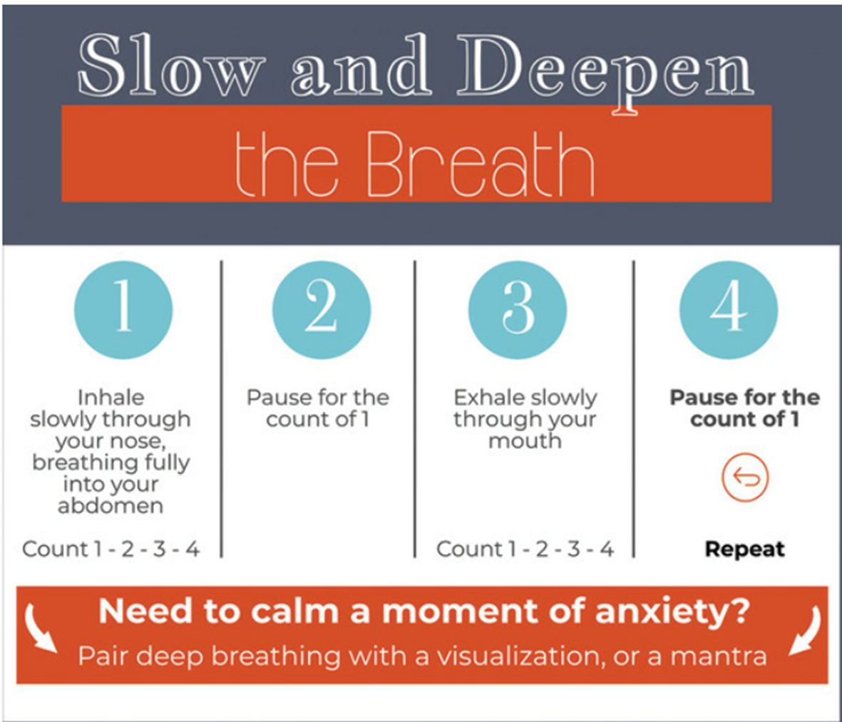

Return to the Butterfly hug gentle tapping…then breathing…then back to butterfly hug tapping. Keep doing this until you find yourself returning to a state closer to calm.

Variations to Butterfly
- Arms crossed, tapping on elbows/tapping the biceps.
- Tapping on knees; toes up and down in shoes; heels moving up and down.

Don’t forget to practice, practice, practice!!!

