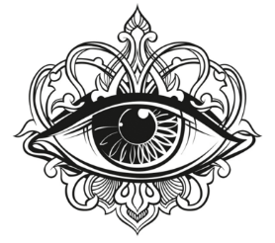
Beneath the Skin Lash Studio – Lash Artist Cassie
Eyelash Extension Intake & Consent Form

Name:_______________________________________________________Date:_________________________________
Address:___________________________________________________________________________________________
City:________________________________ State:_______________ Zip Code:_________________________________
Phone Number: _____________________________________________________________________________________
How did you hear about us? _____________________________________ REFER a friend and receive $5 OFF!
Please read and circle the following:
Have you ever had eyelash extensions before? YES NO
Do you wear contacts or glasses? YES NO
Are you extremely sensitive or have allergies to adhesives or synthetics? YES NO
Do your eyes water often or easily? YES NO
Good things take time! Are you aware the process can take 2 hours for the application? YES NO
Do you have seasonal allergies or general sensitivity? YES NO
What side do you tend to sleep on? LEFT RIGHT BACK STOMACH
*Please remember to answer your texts/calls prior to your service and use the restroom immediately to save as much lashing/appointment time as possible.
*Please consult to your artist now about any concerns and what you may have used to clean your lashes with prior.
- If you are on any medications that could affect your retention, please feel comfortable to consult with your artist about. Some include hormonal medication, thyroid meds, blood thinners, Retin a, diabetes, menopause, pregnancy, vitamin take, diet pills, etc., have all been known to alter lash retention due to changes in body chemistry. There can be more oil present, so constant thorough cleansing is important. Stress can also cause natural lashes to shed at a quicker rate, along with pregnancy.
Please read and initial the following:
________I am 18+ years old and acknowledge the policy requirements given on the website.
________I followed all pre-instructions that my artist provided to me, including washing my natural lashes thoroughly right prior to the service. I understand that if I did not cleanse to the best of my ability or with the right products, that there could still be skin, makeup residue or oils present, causing the lash extensions to not bond.
________I agree to the follow-up, aftercare and maintenance instructions provided by the artist during the client consultation and aftercare cards given to me. All statements are also provided to me at an accessible online website. I understand that not following these procedures will affect the longevity of eyelash extensions or health of my natural lashes if I’m neglecting to cleanse daily or doing things against my artists’ instructions.
________ I agree that neglecting to purchase cleanser or proper makeup products suggested & approved by my artist will not ensure the health of my lashes, especially if not cleansed properly and thoroughly. This will cause the risk of blepharitis, eye infections or bacterial buildup.
________ I agree that drugstore foundation, powder, concealer, bottom mascara, eyeliner, eyeshadow, and setting spray will affect the retention of my lashes and can clog my lash line and follicles. I understand I need to purchase eyelash extension friendly products from or recommended by my artist and invest in my lashes. This includes makeup remover even if it is oil free. Liquid makeup remover will always be oily. We have some great products we can recommend to you!
________I agree to all policy requirements, and understand I can be held accountable if I do not follow these requirements, regarding same-day cancellations (after 8PM night before), no call no show (could result in fee & termination of client acceptance), late arrivals, etc. Overall, I understand that I can be required to owe a fee in order to reschedule if I neglect the policy.
________I understand that there are risks associated with the application and/or removal of artificial eyelashes. These risks include, but are not limited to: eye irritation, eye pain, discomfort, swelling, and in rare cases, excessive allergic reaction. (would need possible physician care/ER). I understand that the artist is not responsible to cover any costs for emergency care visits or products due to any potential reaction, irritation, or emergency circumstance elsewhere.
________As part of this procedure, I understand that a certain amount of eyelash adhesive will be used to apply each extension to my existing natural eyelash. I am aware that the adhesive being used on me contains cyanoacrylate and other ingredients.
_______I understand that moving at all, talking, twitching or pinching the eyes will affect my service, the amount of lashes my artist will be able to get on in time, and my artist could be unable to apply due to constant movement. I understand this is tedious work and I need to be still and minimize facial movements. This can also produce watery eyes and will affect the service and retention of the lashes. I agree to keep my eyes fully closed the entire time my artist will be lashing and understand if I open on accident or can not fully keep my eyes closed or free of twitching, that these things can affect retention or cause the eyes to burn after being exposed to the adhesive fumes.
________I agree that there are no refunds or free appointments, due to neglect of pre/post recommendations or instructions. Consult with your artist in 24 hours if an excess number of lashes are falling off and we will do our best to accommodate the issue. I understand the only excuse to waive the fee is proof of an emergency visit or incident. Removal fee can be waived if major reaction occurs.
________ I understand and agree that unconscious bad sleep patterns can damage my eyelashes if I am not careful.
________ I understand the dangers of self-removal and the need to be removed always by a professional and agree to tell my artist immediately if I take them off myself.
________I agree and understand the cost of all procedures and 5% service fee charged for online transactions.
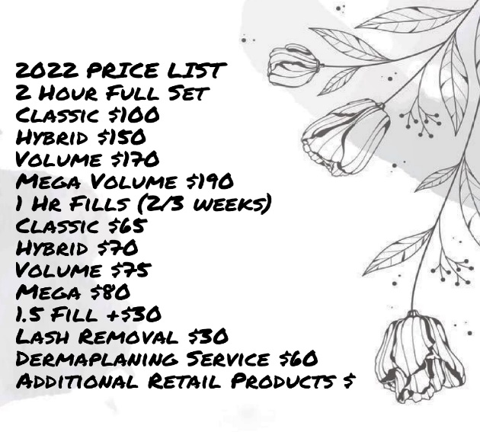
________I consent to have “Before” and “After” photographs of my lash application. Photographs may be used and promoted by the lash artist. Therefore, I agree that my photographs may be used for the purpose of documentation, and/or advertising purposes.
- Check here if you do NOT want your photos shared
________ At any time, I understand that my artist may not be able to not accept me as a client if I neglect any of the aftercare maintenance or neglect the policy. I have read and completed the form in full and in its entirety. I have been informed of potentially harmful or negative side effects that may be caused by the application and/or removal of eyelash extensions by the certified eyelash extension professional. I have shared any concerns I have with my artist. By signing this form, I agree with the waiver and will not hold my artist responsible for any fault.

Signature of Client: _______________________________________________ Date:______________________________

