**Declawing**

The most current consensus statements regarding declaws is they are strongly opposed and discouraged (AVMA 2020, AAFP 2017, and AAHA 2015). We at Sylvan want you to understand the procedure as well as the risks associated with onychectomy (declaws).

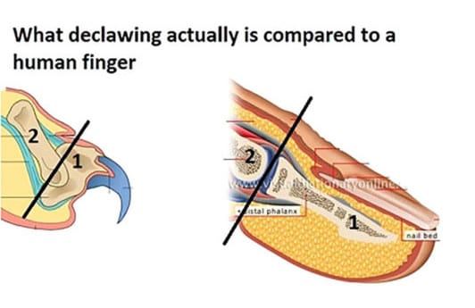**Onychectomy (declaw)**: The last bone on each toe is removed (P3) at the joint. Multiple tendons and vessels are cut in the process changing the way the cat will bear weight on the paws. The toes are then surgically glued or sutured to close the wounds after the tip of the toes are removed. Though in the past this has been treated as a mild or routine procedure, it is not. It is an amputation and is a serious procedure that should not be taken lightly.

**In most cases, this is not a medically necessary procedure. Scratching is a normal feline behavior**.

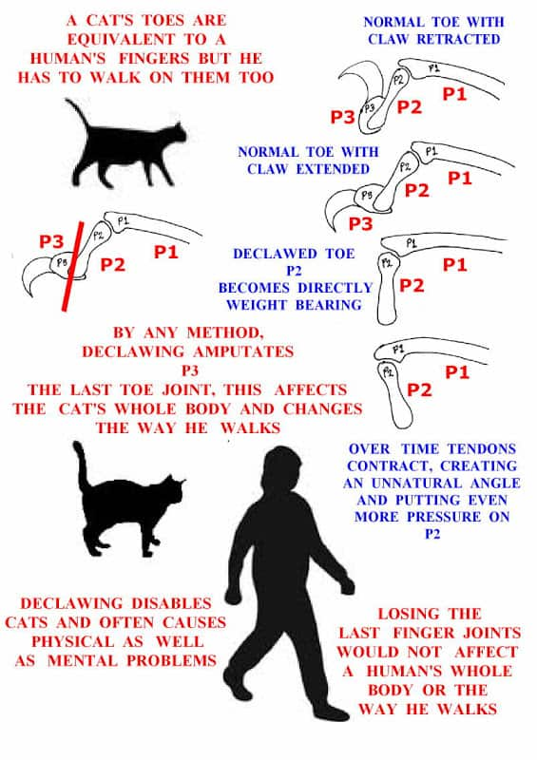**Cats scratch to:**

1. Condition their claws by removing old nail sheaths.
2. Scent mark objects with the glands on their paws
3. Visually mark objects by leaving shredded matter as evidence
4. Stretch and exercise their forelegs
5. Enjoy a pleasant sensation

**Risks of declawing:**

1. Pain: both immediate (even with pain medications) and long term (both bone and nerve pain)
2. Increased risk of inappropriate urinations and defecations
3. Increased likelihood of lameness/arthritis
4. Increased likelihood of biting and aggressive behaviors as a form of defense

**Cats can be trained to scratch in appropriate areas using various training techniques, such as positive reinforcement, cat attractants, nail trimming, and other behavior modifications.**

**Alternatives to declawing:**

1. Routine nail trims (every 2-4 weeks)
2. Claw caps (rubberized nail covers that come in various colors)
3. Positive reinforcement of preferred behavior or scratching on preferred surfaces
4. Blocking or putting undesirable materials on surfaces being scratched (generally a temporary not permanent change to break the habit)
5. Providing different surfaces (both horizontal and vertical) for your cat to scratch

AVMA: 2020 statement: The AVMA discourages declawing of domestic cats as an elective procedure. The Association encourages the use of alternatives but says professional judgment is key when making a decision as to whether to declaw a cat.

AAHA statement 2015: The American Animal Hospital Association strongly opposes the declawing of domestic cats and supports veterinarians’ efforts to educate cat owners and provide them with effective alternatives.

AAFP 2017 statement: The American Association of Feline Practitioners (AAFP) strongly opposes declawing (onychectomy) as an elective procedure. It is the obligation of veterinarians to provide cat owners with alternatives to declawing. If owners are considering declawing, they must be provided with complete education about feline declawing.

Sources: AAHA, AVMA. AAFP