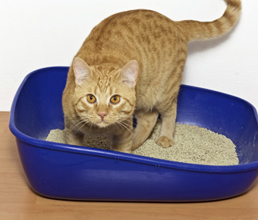
Feline Lower Urinary Tract Disease
What is FLUTD?
Has your cat been making frequent trips to the litter box? Have you noticed him/her vocalizing in the litter box? What about straining to urinate? Are the litter clumps a lot smaller all of a sudden? FLUTD (the acronym for feline lower urinary tract disease, also commonly referred to as FIC) is one of the most common presenting complaints in cats. Typically FLUTD is considered idiopathic, meaning we don’t know exactly what causes it, and it is usually due to a sterile inflammation of the bladder caused by a multitude of factors. These factors may include abnormalities in the bladder or nervous system. These cats are often also highly sensitive to stress. Stressors can include environmental events such as unfamiliar places or people, decreased interaction with owner and poor litter box management.
Symptoms and Diagnosis
The most common signs of FLUTD are straining to urinate, vocalizing while urinating, urinating small frequent amounts, urinating outside the litter box, blood in the urine, painful abdomen, and vomiting. FLUTD is usually diagnosed by exclusion and first making sure there is nothing else causing the lower urinary tract signs, such as bladder stones, a bacterial urinary tract infection (UTI), or cancer of the bladder. Your veterinarian may run a urinalysis if they are able to get a urine sample from the bladder to check for a UTI, and radiographs or an ultrasound may be performed to look for sediment or stones in the bladder.
Treatment
It is difficult to determine exactly what treatment, if any, is most effective in treating cats with FLUTD. Providing proper pain control is essential, as well as increasing the amount of water intake, environmental enrichment, and proper litter box management.
What can I do at home?
Multimodal environmental modifications (MEMO) can really benefits cats with FLUTD. The goal is to alter the cat’s environment in a positive way in order to decrease stress, therefore hoping to decrease the severity and frequency of FLUTD episodes. Environmental modification is typically recommended before prescribing a long term medication. Having a scratching post, perching and viewing areas, and using cat nip or pheromone sprays are all recommended. Proper litter box hygiene is essential. You should have one litter box per cat, plus one. Litter boxes should be large, uncovered and cleaned daily. Increasing water intake can be done by feeding your cat canned food, or adding water to their dry food. Changes as small as food can be stressful for your cat, so you should offer them the new food (if you are switching to canned or trying to add water to the dry food) in a separate bowl next to their regular food so they can decide which they would like. Cats like being in control. Adding extra water bowls or water fountains can also encourage increased water consumption, helping to flush the bladder. You can also check out The Ohio State Indoor Cat Initiave at indoorpet.osu.edu/cats for even more information on feline stressors and environmental enrichment.

