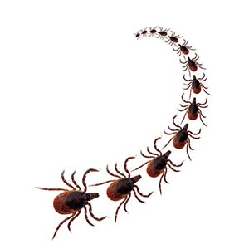
LYME DISEASE

What is Lyme disease?
Lyme disease is an illness caused by the bacterium Borrelia burgdorferi, which is transmitted to dogs and humans through the bite of an infected Ixodes scapularis tick (deer tick). Lyme disease is actually one of the most common tick transmitted diseases in the United States, and Pennsylvania is number one in the nation for the most confirmed cases of Lyme disease. Interestingly enough, many dogs will test positive for Lyme disease but never become ill from the infection. In fact, only a small percentage (~5-10%) of dogs will actually develop clinical signs. Clinical signs are usually mild and resolve quickly, but in some cases they can progress and cause serious life threatening complications. Lyme disease, fortunately, is a condition that can be tested for in the hospital and in most cases treated successfully. The key to keeping our pets (and ourselves!) safe is prevention! Preventing Lyme disease is a multifaceted approach involving tick control, vaccination, and education from your veterinarian.


Canine Lyme Disease Prevalence





Reported cases:
- East coast,
- Pennsylvania
- Blair County
What does a deer tick look like?
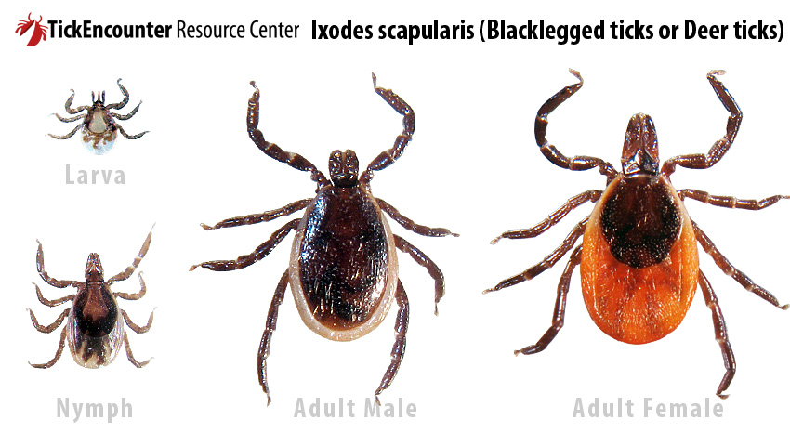
Ticks are parasites, which feed on the blood of unassuming hosts. They are members of the arachnid family (which also contains spiders), which means they have 8 legs when they are adults. They typically range in size from 3mm-5mm. The size, shape, and color of the tick’s body can vary greatly after it has been feeding. To the right are pictures of the Ixodes (deer) tick, which spreads Lyme disease. It’s important to note that the larva only has six legs before it becomes an adult, and the males and females look vastly different from each other.

How did my dog get Lyme disease from a tick?
The life cycle of the tick takes approximately two years to complete – from egg to when the tick matures, reproduces, and then finally dies. Understanding the tick life cycle gives you a better idea of how and when your dog can get infected.

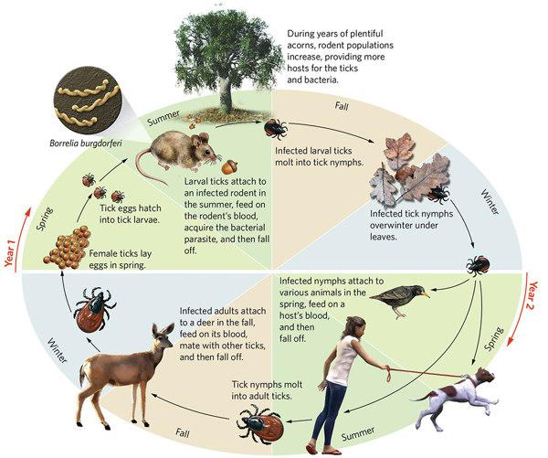
The bacterium that causes Lyme disease, Borrelia burgdorferi, normally resides in small mammals (such as the mouse). These natural hosts do not become ill from the infection of Borrelia burgdorferi and merely act as a reservoir for the bacteria. When Ixodes tick larvae hatch, they feed on these small mammals and acquire the Borrelia burgdorferi bacteria. The infected larval tick then molts and becomes a nymph. The infected nymph feeds on various mammals (dogs, humans, etc) and while attached to the mammal, it can transmit the bacteria through its saliva, which results in Lyme disease. The tick must be attached for at least 48hrs to transmit the Borrelia burgdorferi bacteria and infect the animal with Lyme disease. After feeding, the nymph (still infected) then molts to an adult tick and attaches to a deer, where it further spreads the bacteria into the deer population.
What symptoms will my dog experience?
Lyme disease is a well-known condition in humans, but the symptoms that are seen in humans are not the same in dogs. Common human symptoms include a rash (“bulls-eye”) and flu-like symptoms, which can progress to joint pain and neurologic abnormalities. Most humans (>90%) exposed to Borrelia burgdorferi will develop clinical signs, but luckily, most dogs will not develop clinical signs (and when they do, they are usually very mild and easily treatable). Unfortunately some dogs may develop more serious complications from Lyme – one of the most common complication being kidney disease. Kidney problems result from the body’s immune response to the bacteria which can eventually result in kidney failure. Labrador retrievers, golden retrievers, Bernese mountain dogs, and Shetland sheepdogs appear to be more susceptible to developing kidney complications from Lyme disease than other breeds. Also, rarely, Lyme disease can result in heart or nervous system disease.

COMMON SYMPTOMS
- Lameness (shifting leg lameness)
- Swollen and painful joints
- Stiff
- Fever
- Loss of appetite

- Lethargy
- Swollen lymph nodes
SIGNS OF COMPLICATIONS
- Vomiting
- Diarrhea
- Loss of appetite
- Weight loss
- Increased urination
- Increased thirst
- Accumulation of fluid

How do I know if my dog has Lyme disease?
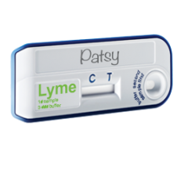
Fortunately, testing for Lyme disease is simple and can be done in the hospital. If you have found a tick on your dog, you should wait 4-6 weeks before having your dog tested for Lyme disease. Testing your dog earlier than this could result in a falsely negative test result. Unlike humans, treating for Lyme disease with antibiotics before a positive test result is not recommended. Testing requires just 1-2 drops of blood, and the results can be read within ten minutes. If positive, a treatment plan can be initiated immediately.


My dog tested positive for Lyme… Now what?
When a dog tests positive for Lyme disease it is important to obtain prompt treatment. Your veterinarian will assess your dog and pick a treatment plan that is appropriate for your pet’s needs.

IF YOUR DOG IS….

SUBCLINICAL (not sick from Lyme) CLINICAL (sick from Lyme)

Treat your dog anyway! Treatment with antibiotics (30 days)
Hopefully he won’t get sick from - Doxycycline is commonly used
Lyme disease in the future!

Treatment with NSAID (nonsteroidal
anti-inflammatory) for joint pain

Check a urine sample from the dog
(Assesses basic kidney function)

NORMAL urine sample: ABNORMAL urine sample:
- Continue treatment as - Additional diagnostics
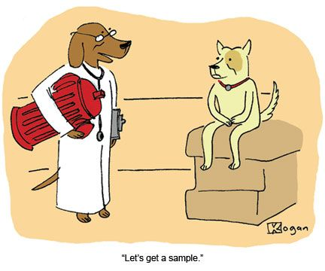
previously described are necessary

- CBC and Chemistry (in-house bloodwork)
- Urine Protein/Creatinine ratio (UPC)
- Ultrasound of kidneys
- Hospitalization (See Lyme Nephritis)

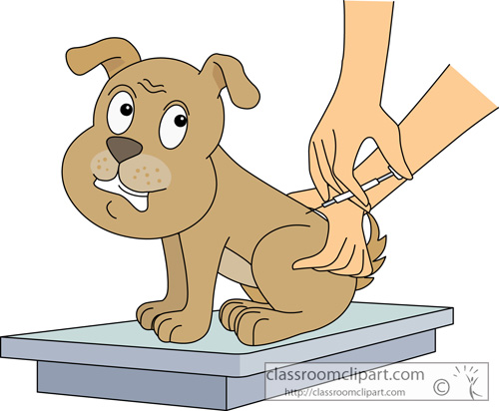

VACCINATE for Lyme disease!
After dog has recovered and/or
finished taking all medications

Will my dog always be Lyme positive?
The Borrelia burgdorferi bacteria is very good at hiding in the body, which therefore makes it difficult to completely eradicate. With proper treatment, the bacterial numbers can be greatly diminished, and hopefully over the next several years the body can clear the rest of the bacteria. Re-testing the dog immediately after finishing antibiotics will still show positive results and yield no new information. The best way to decide whether or not your dog is recovering from Lyme is to assess him clinically – if he appears like he is back to his normal self, then that is a successful treatment.

Lyme Nephritis
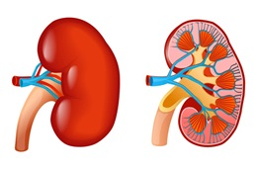
Lyme nephritis is a serious condition that will occasionally develop as a complication of Lyme disease. The Borrelia burgdorferi bacteria contain proteins that the dog’s immune system reacts to, and the body then creates large amounts of antibodies (the type of protein that fights infection). This may sound like a good response, but these antibodies do not adequately destroy the Lyme bacteria, and the excessive amounts of antibodies formed create large complexes. These large complexes then get trapped in the filtering system of the kidneys. Once trapped, this causes inflammation and the kidneys cannot adequately filter and cleanse the blood. Dogs with Lyme nephritis are typically very sick (see symptoms listed above) and need intensive supportive care such as hospitalization and IV fluids, antibiotics, anti-emetics etc. Unfortunately, many dogs do not recover from Lyme nephritis.

How do I pull a tick off of my dog safely?
Pulling a tick off is easier than it sounds! The only materials needed are a pair of tweezers. There are devices created specifically for tick removal that you can purchase at a store if you would prefer.
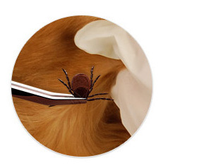
- Using the tweezers, grab the tick as close to your dog’s skin as possible.
- Using gentle, steady traction pull outward and turn in a counter-clockwise motion until the tick releases (you may feel a slight “pop” as the tick is removed).
  - Hint: Sometimes applying alcohol to the tick before pulling it out will help it release easier.
- Check the spot where the tick was attached to make sure no parts of the tick (ie. its head) are left behind.
- Dispose of the tick either by flushing it down the toilet or submerging it in alcohol.

V.E.T. - The key to keeping your pet Lyme-free!
Prevention is the key! Good preventative strategies are extremely important in helping your pet remain Lyme negative (and not become re-infected after a previous infection).

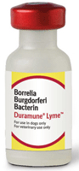
V is for Vaccinate!
Vaccinating your dog yearly for Lyme disease can greatly reduce the chances of your dog becoming Lyme positive. In fact, the Lyme vaccine has been proven to be 92.2% effective at preventing natural Lyme infection. The vaccine is also proven effective in Lyme positive dogs so thus will prevent re-infection! The vaccine works by targeting proteins in the Borrelia burgdorferi bacteria so the bacteria can then be destroyed by the body’s immune system. The first Lyme vaccination is a series of two injections one month apart. After the initial vaccinations, dogs should be vaccinated yearly for Lyme.


E is for Educate!
Having knowledge about Lyme disease and how it is acquired is an important factor in preventing the disease in your dog. Understanding the life cycle of the tick, risk factors (ie. living in endemic areas), and knowing when to have your dog tested for Lyme can help your dog live a long and Lyme-free life. Your veterinarian is always available to answer any questions you may have regarding Lyme disease, prevention, and treatment.

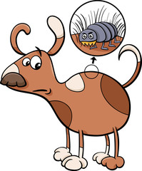
T is for Tick control!
Perhaps one of the most important ways you can help prevent the spread of Lyme disease is by practicing good tick control. The best way to prevent ticks from attaching to your dog (and subsequently bringing them into your house) is by using quality flea/tick preventatives on your dog. It’s also extremely important to check your dog regularly for ticks and promptly pull any ticks that are attached.

Flea and Tick Preventatives
 | Kills Fleas & Ticks | Treats Demodectic Mange | Waterproof | Repels | Dosage | Usage
 |    |  |  |  | Oral Chewable | Monthly
 |  |  |  |  | Oral Chewable | Every 3 months
   |  |  |  |  | Collar | Every 8 months
 |  |  |  |  | Topical | Monthly
*Bravecto is not labeled for puppies under 6 months of age
Why buy from your vet?

Manufacturers will only guarantee the product if bought from a veterinarian
Special rebates offered only through your veterinarian
Easy return of product if dissatisfied
Helps keep the prices of other services lower (i.e. vaccines, office visits, etc.)
Resources:
- http://www.health.pa.gov
- http://www.dogsandticks.com
- http://www.duramunelyme.com

