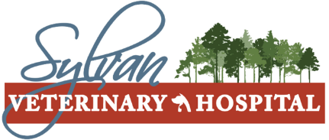

Surgery Release Form

To help expedite our admissions process, we kindly ask that your respond to the following questionnaire:
Owner Name:_____________________________________ Phone Number:________________________________
Patient Name_____________________________________ Surgery being performed:________________________
Date and time of last meal: _________________ Email:________________________________
Current medications including dosages_______________________________
And when they were last given: _______________________________
Pertinent past medical history (i.e. heart murmur, diabetes, arthritis, renal failure):
__________________________________________________________________________________________
Pre-operative blood testing:
Accept Decline Performed at pre-operative consultation

Microchip:
Accept Decline Already microchipped

If the Microchip to be implanted is to be registered under a different Name, Address, Phone Number, or Email than what is in our system please list those below:
__________________________________________________________________________________
__________________________________________________________________________________
Alternate contact for Microchip (if applicable): Name: ________________________________ Phone: Histopathology (if applicable):
Accept Decline

Will you provide your own means of protecting your pet from licking his/her surgery site?
E-collar ($10-$23, based on size) Recovery Suit ($34-$39, based on size) I will provide my own

Special considerations that you would like to notify your pet’s surgical team:
__________________________________________________________________________________________
I, the undersigned, do hereby certify that I am the owner (duly authorized agent for the owner) of the animal described above, that I do hereby give Dr. Brad Kissell, VMD, Dr. Andrew Weikert, DVM, Dr. Sarah Barefoot, DVM, & Dr. Sara Litzinger, DVM, their agents, servants, and/or representatives full and complete authority to perform the surgical procedure described above and to perform any other procedure that, at their discretion, may be useful to promote the health of the above described pet, and I do hereby and by the presents forever release the said Doctor, his agents, servants, or representatives from any and all liability arising from said surgery on said animal. I have also been informed that there are certain risks and complications associated with any operation or procedure of this type, and they have been explained to me well. I further understand that during the course of the operations or procedures, unforeseen conditions may arise that may necessitate the performance of additional procedures. I hereby consent and authorize the performance of such procedures as necessary and desirable in the exercise of the veterinarian’s professional judgment. I have been advised of the nature of the service and procedures, as well as the risks involved, and I also realize that results cannot be guaranteed.

Signature______________________________________________________ Date:_____________________________

