When to Take a Puppy to the Vet for the First Time
Congratulations! You’ve just adopted a new puppy and want to have them established with a veterinarian. Adopting a new puppy can be an exciting yet overwhelming experience. It is our job to guide you into the smoothest transition with your newest addition to the family.
Most dog shelters and breeders will send paperwork home with new pet parents. This paperwork usually consists of care that has already been provided such as a vet visit, health certificate, vaccines, and dewormer.
Regardless of what the shelter or breeder has already done, it is always advised to schedule a vet visit within a few days of picking up your new puppy. This will allow the clinic to review your puppy’s records, perform a physical exam, and provide any overdue care. Due to Puppy Lemon Law, new puppies should be examined within 10 days before any health guarantees the breeder provides expire.
A typical vet schedule for puppies is for appointments to occur every 3 to 4 weeks starting when puppies are 6 to 8 weeks old and ending when they are at least 16 weeks of age.
For more details on the individual prices of our vaccines, please visit our website under the services tab.

WHAT TO BRING for Your Puppy’s First Vet Visit
Records from the breeder or dog shelter. Providing the appropriate documentation will help our veterinary team gauge what your puppy may need during their first visit. Usually, the paperwork consists of a previous vaccine schedule, de-wormer, and possible microchip information.
A stool sample. We recommend bringing a small, fresh stool sample to test for intestinal parasites common in puppies. You will receive your puppy’s results 24-48 hours after submitting the sample.
A list of questions & concerns. Are you starting to notice behavioral problems as your puppy settles in? Is potty training proceeding as you expected? What brand of food are you feeding and how much each feeding? Collecting as much information as possible prior to your puppy’s first vet visit will provide a more rewarding experience for you and your veterinarian.

What to Expect During Your Puppy’s First Vet Visit

Your first puppy visit will consist of one-on-one time with the vet and technician. They will provide answers to any of your questions, perform a physical exam, and give any vaccines that your puppy may be due for at the time. Some other topics our staff will discuss with you at the time of the visit may consist of
- Behavior, socialization, and puppy classes
- When to spay or neuter your pet
- Grooming needs
- Nutrition
- Flea, tick, heartworm, and intestinal parasite control
- Vaccination schedule

Age: 6-8 Weeks
Age: 12-14 Weeks

Age: 10-12 Weeks

1st DA2PP:
DA2PP Booster:
Rabies:

Age: 16-18 Weeks
Optional Vaccination
Age: 20-22 Weeks

Final DA2PP:

Lyme(Optional):
Lyme booster:
(3-4 weeks after 1st Lyme)
Oral Bordetella:

- The DA2PP vaccine, commonly referred to as just the Distemper vaccine or Distemper/Parvo vaccine, protects against Distemper virus, Adenoviruses Type 1 and Type 2, Parainfluenza virus and Parvovirus.
  - All of these viruses are highly contagious among dogs. They are all usually transmitted either via respiratory or fecal secretions.
- The Rabies vaccine protects against Rabies and is required by law.
- The Lyme/Leptospirosis vaccine protects against both Lyme disease, which is transmitted by ticks, and Leptospirosis, which is a bacteria transmitted in the urine of wild animals.
- The Bordetella vaccine, commonly referred as the “kennel cough vaccine,” is not required of all puppies, but some groomers, puppy preschools, and kennels may require it. It is now an oral vaccine.

Flea and Tick Preventatives:

 | Kills Fleas & Ticks | Treats Demodectic Mange | Waterproof | Repels | Dosage | Usage
 |  |  |  |  | Oral Chewable | Monthly
 |  |  |  |  | Oral Chewable | Every 3 months
 |  |  |  |  | Collar | Every 8 months
 |  |  |  |  | Topical | Monthly
*Bravecto is not labeled for puppies under 6 months of age
**The Seresto collar would be a good choice after your puppy has reached his or her adult weight, so that you don’t have to buy 2 collars
Why buy from your vet?
Manufacturers will only guarantee the product if bought from a veterinarian
Special rebates offered only through your veterinarian
Easy return of product if dissatisfied
Helps keep the prices of other services lower (i.e. vaccines, office visits, etc.)



What is Heartworm Disease?
How do dogs acquire Heartworm Disease?
Heartworm Disease is a preventable disease!
Heartgard Plus is a monthly chewable that prevents heartworm and also treats and controls roundworms and hookworms.

Heartworm disease is when dogs become infected with heartworms that live in the heart and lungs causing severe lung disease, heart failure, and damage to other organs in the body.
It takes about seven months from the time a dog is bitten by an infected mosquito for the larvae to mature into adult heartworms. They then migrate to the heart, lungs, and surrounding blood vessels and begin reproducing.


When should I have my dog spayed or neutered?
Why spay/neuter at 6 months of age?
- No burden of heat cycles
- Eliminates unwanted pregnancy
- Prevents developing unwanted behaviors
  - Marking, roaming
- Cheaper surgery cost since medications and anesthetics are based on weight
- Nearly eliminates the risk of mammary cancer in females

Why spay/neuter after puberty?
- Reduce the risk of hip dysplasia
- Reduce the risk of ACL tears
- Reduces the risk of urinary incontinence
- Decrease the risk of bone cancer
What do you do to keep my dog safe during surgery and anesthesia?

- We have a trained technician monitoring your dog’s heart rate, breathing, and anesthetic depth at all times
- We have an ECG monitor and pulse oximetry monitor on your dog at all times to measure their heart rate, heart rhythm, and blood oxygen levels
- We use a sterile surgery pack on each individual animal
- Every surgery patient is given pain medication during and after surgery

The dog food aisle just might be the most overwhelming place on Earth.
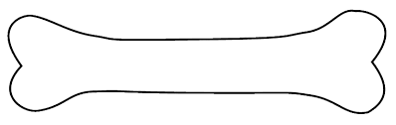
Top food brands recommended by Sylvan Veterinary Hospital
- Hills Science Diet
- Royal Canin
- Purina ProPlan

- The most important thing about your dog’s diet is how they are tolerating (i.e. inconsistent stools, chronic vomiting)
- Puppies should be fed on a schedule. They should get a specific amount 2-3 times a day. This will also help with housetraining.
- Regular adult foods are inadequate for large breed puppies. They should be fed specifically a large breed puppy food.
- Toy breed puppies should have small, frequent high protein meals.
  - A meal before bed is highly recommended.
- Puppies should eat puppy food until one year of age. Giant breed puppies should eat puppy food until 18-24 months of age.
  - The transition from puppy food to adult food should be a gradual change, and should happen over the course of 7-10 days.
- It is recommended to feed your puppy approximately ½ cup per 10 lb of body weight divided among 2-3 feedings, but just like humans, every puppy has a different metabolism. It is important that you feed to the body condition, not to the bag label. It is recommended that your veterinarian assess their body condition and make feeding adjustments at each visit.

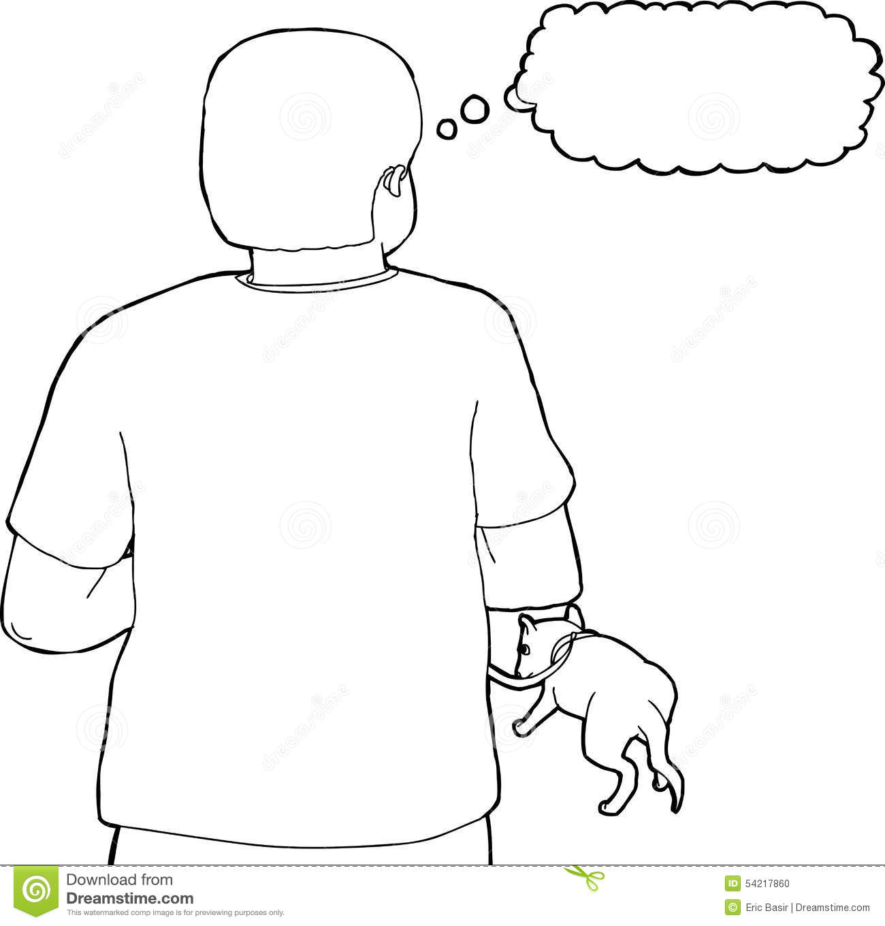
What about training?

We highly recommend doing the following training exercises:
- Puppy preschool
- Crate Training
- Basic commands (Sit, Stay, Come)
- Positive reinforcement with treats and attention
- Ignoring attention seeking behaviors (jumping up, barking, etc)
- Only begin using pee pads if you are okay with your dog using them indefinitely
- Socialization with other dogs at a young age



The Blair County Dog Park in Martinsburg, PA offers a great place for dogs to run off energy and socialize!

“You are going to have this dog for the next 12-14 years and you want that time to be enjoyable. It is best to teach them good habits at a young age, rather than try to undo bad habits the rest of the dog’s life.” –Dr. Brad
Sylvan Vet Pet Portal:

To sign into your pet portal, visit our website at Sylvanvet.biz and click book online. Opt in to receive text messages to start getting reminders for your pets’ services.

- Access your pets vaccine history and see when they are due for their next vaccines
- Request refills of medications- including flea and tick preventatives!
- Schedule appointments
- Request copies of vaccine certificates

How to set up the portal*:
- Visit our website at sylvanveterinaryhopsital.com
- Click the pet portal button about half- way down the main page
- Since you have already visited the practice, click find your account
- Enter your email and one of your pets names, click search
- You will then be sent a temporary password that you can change later
*You must have an email address in order to have access to your pet portal

Do you have a smart phone? There is also an app!
To download the app, go to your app store on your smart phone and type in “MyPetsWellness”. Download the free app and you now have access to your pets’ information right at your fingertips! *


*before you can use the app you will need to visit our website and get your portal set up

